|  |
| --- |
| oceans and atmosphere flagship |
| Australian & Global Emissions of Ozone Depleting Substances  P. J. Fraser, B. L. Dunse, P. B. Krummel, L. P. Steele and N. Derek  June 2015  Report prepared for the Australian Government Department of the Environment |

|  |
| --- |
|  |

CSIRO Oceans and Atmosphere Flagship / Collaboration for Australian Weather and Climate Research

Citation

Fraser P. J., B. L. Dunse, P. B. Krummel, L. P. Steele and N. Derek, Australian and Global Emissions of Ozone Depleting Substances, Report prepared for Department of the Environment*,* CSIRO Oceans and Atmosphere Flagship, Collaboration for Australian Weather and Climate Research, Aspendale, Australia, iii, 29 pp., 2015

Copyright and disclaimer

© 2015 CSIRO To the extent permitted by law, all rights are reserved and no part of this publication covered by copyright may be reproduced or copied in any form or by any means except with the written permission of CSIRO.

Important disclaimer

CSIRO advises that the information contained in this publication comprises general statements based on scientific research. The reader is advised and needs to be aware that such information may be incomplete or unable to be used in any specific situation. No reliance or actions must therefore be made on that information without seeking prior expert professional, scientific and technical advice. To the extent permitted by law, CSIRO (including its employees and consultants) excludes all liability to any person for any consequences, including but not limited to all losses, damages, costs, expenses and any other compensation, arising directly or indirectly from using this publication (in part or in whole) and any information or material contained in it.

Contents

Figures ii

Tables iii

Acknowledgments iv

1 Introduction 1

2 Measurements of synthetic and natural ODSs at Cape Grim, Tasmania 1

2.1 CFCs 5

2.2 HCFCs 5

2.3 Chlorocarbons 5

2.4 Halons 6

2.5 Other organobromine species 6

2.6 Total chlorine and bromine: impact on stratospheric ozone 6

2.7 Global radiative forcing from ODSs, HFCs and other SGGs 7

3 Global emissions of ODSs 8

4 Australian ODS imports and banks 10

5 Estimated Australian ODS emissions from Cape Grim data 12

5.1 CFCs 16

5.2 HCFCs 16

5.3 Halons 18

5.4 Methyl bromide 18

5.5 Carbon tetrachloride & methyl chloroform (Montreal Protocol chlorocarbons) 19

5.6 Other chlorocarbons 20

5.7 GWP-weighted ODS emissions 20

5.8 Total ODS emissions 21

Summary 23

References 25

Figures

**Figure 1.** Cape Grim *in situ* and Air Archive observations of CFCs, HCFCs, halons, CT, MC, methyl chloride, dichloromethane, chloroform, TCE, PCE, MB, dibromomethaneand bromoform (1978 – 2014) showing baseline monthly mean data (Medusa - dark green; ADS - purple; ECD – dark blue; archive data – orange) and total data (Medusa - light green; ADS – pink; ECD – light blue) obtained from the GC-MS-Medusa, GC-MS-ADS and GC-ECD instruments at Cape Grim and Aspendale. The CFC-112, -112a, -113a, -216ba, -216ca and HCFC-133a data are from UEA and Empa measurements on the Cape Grim Air Archive (see text above and CSIRO unpublished data). 4

**Figure 2.** Total chlorine from CFCs, HCFCs, CTC: CCl4, MC: CH3CCl3 and other chlorine-containing ODSs (Table 1) as measured at Cape Grim. 6

**Figure 3.** Total bromine from MB: CH3Br, halons and other bromine-containing ODSs (dibromomethane - CH2Br2 and bromoform - CHBr3) as measured at Cape Grim. 7

**Figure 4.** Total column ozone (DU) changes at Halley Station, Antarctica (76oS), and Melbourne, Australia (38oS) and Equivalent Effective Stratospheric Chlorine (EESC, ppb) changes at polar and mid-latitudes. 7

**Figure 5.** Global abundance (ppb, left) and radiative forcing (W/m2, right) of synthetic greenhouse gases (SGGs: HFCs, HCFCs, CFCs, others). 7

**Figure 6.** Global emissions of ODSs (CFCs, chlorinated solvents (MC: CH3CCl3, CTC: CCl4), methyl chloride, dichloromethane, chloroform, halons, MB: CH3Br, HCFCs) derived from global AGAGE data by inverse modelling using the 12-box AGAGE global transport model, by forward modelling using a 2-D atmospheric chemistry-transport model and by Bayesian inverse modelling using the FLEXPART dispersion model. For MB, pre-1998 emissions are scaled from global atmospheric concentrations. 9

**Figure 7**. Global emissions (ODP tonnes) of the Montreal Protocol ODSs and global equivalent chlorine (ppt), both derived from AGAGE data (Fraser *et al*., 2014a; Rigby *et al*., 2014 and subsequent updates) using the 12-box AGAGE model. For MB, pre-1998 emissions are scaled to post-1998 from global atmospheric concentrations, 1978-2014. 10

**Figure 8.** Australian imports (tonnes) of ODSs (CFCs, HCFCs, halons, MC: CH3CCl3, MB: CH3Br – total left, MB: CH3Br – nQPS right) (A. Gabriel, DoE, private communication, 2015). The 2012-2014 data are from the OLaRS data base, 2010 and earlier are pre-OLaRS data, and 2011 is a mixture of OLaRS and pre-OlaRS data; also shown are estimates of the Australian HCFC-22 bank (Brodribb & McCann, 2013, 2014). 12

**Figure 9.** Annual average (3-yr running means) Australian emissions of CFCs, MB, halons, HCFCs, halons and chlorocarbons (MC, CTC, chloroform, dichloromethane, TCE, PCE) from Cape Grim AGAGE data, using ISC techniques. Australian emissions are scaled from SE Australian emissions on a population basis; MB emissions are for SE Australia only. NAME emissions are show in green. 13

**Figure 10.** Declining Australian CFC, HCFC, halon and CTC emissions (k tonnes). 16

**Figure 11.** Australian HCFC-22 emissions (k tonnes) as a function of the HCFC-22 bank (k tonnes). The dashed line is a linear regression: slope = 0.22 tonnes/tonne banked; a linear regression through the origin gives 0.15 tonnes/tonne banked. The corresponding years for each (emission, bank) point are shown. 17

**Figure 12.** Australian MB emissions calculated from Australian MB import data and the modified UNEP emissions model (UNEP, 2007). 19

**Figure 13.** Australian MB emissions calculated (see text for details) by ISC from Cape Grim *in situ* AGAGE MB data (blue) and from the modified UNEP (2007) emissions model (orange) based on MB imports. 19

**Figure 14.** Australian CTC emissions calculated from Cape Grim *in situ* AGAGE data by ISC and inverse modelling (NAME). 20

**Figure 15.** Total Australian ODS emissions; without other chlorocarbons (left) and with other chlorocarbons (right). 21

**Figure 16.** Australian emissions (GWP-weighted: M tonnes CO2-e) of ODSs (Montreal Protocol species: CFCs, HCFC, halons, MB, MC, CTC) and the GHGs reported to UNFCCC (carbon dioxide, methane, nitrous oxide, Kyoto Protocol synthetics: HFC, PFCs and sulfur hexafluoride), including and excluding GHG emissions due to land-use/land-use change and forestry (LULUCF). 22

**Figure 17.** Global (since 1978) and Australian (since 1995) ODS emissions (CFCs, HCFCs, others, M tonne CO2-e). 22

Tables

**Table 1.** Southern Hemisphere concentrations (2013, 2014) and growth rates (2013-2014) for CFCs, HCFCs, halons, CTC, MC, methyl chloride, dichloromethane, chloroform, TCE, PCE, MB, dibromomethane and bromoform measured *in situ* at Cape Grim, Tasmania and/or in the Cape Grim Air Archive (references: see text above and CSIRO unpublished data). 3

**Table 2.** Australian imports (bulk and pre-charged equipment, tonnes) of ODSs (CFCs, HCFCs, MC: CH3CCl3, halons, MB: CH3Br) 1991-2014; 2012, 2013 and 2014 data are from the OLaRS data base, 2010 and earlier are pre-OLaRS data, and 2011 is a mixture of OLaRS and pre-OlaRS data (A. Gabriel, DoE, private communication, 2014). The only significant CTC (CCl4) imports were ~0.5 tonnes in 1995/1996 (not listed). ODS imports less than 0.1 tonne are not listed, but included in total ODS. MB imports are listed as for QPS and non-QPS uses. Small quantities of MB imports are exported (do not influence Australian emissions); significant quantities HCFC-123 imports are exported or used as feedstock (do not influence Australian emissions) – for example 10 tonnes exported and 3 tonnes used for feedstock in 2014). 11

**Table 3.** Annual average (3-yr running means, i.e. 2013 = average of 2012, 2013, 2014) Australian emissions (metric tonnes unless otherwise stated) of ODSs (CFCs, HCFCs, halons, MB and chlorocarbons) from Cape Grim AGAGE data, using ISC techniques. Australian emissions are scaled from SE Australian emissions on a population basis; Australian halon emissions are from SE Australian emissions adjusted for the impact of emissions from the National Halon Bank in Melbourne; Australian MB emissions are from SE Australian emissions scaled to Australian emissions using a DPI-modified UNEP model of MB emissions based on QPS and non-QPS MB consumption (see text). GWPs (to calculate CO2-e emissions) are from Forster & Ramaswamy (2007); ODPs (to calculate ODP-weighted emissions) are from Montzka & Reimann (2011); assumed GWPs for TCE (0.67) and PCE (0.53). Pre-1999 emissions of CFC-114, -115, HCFCs, halons and dichloromethane (shown in red) are assumed equal to 1999 emissions; pre-2005 emissions of TCE and PCE (shown in red) are assumed equal to 2005 emissions. 14

Acknowledgments

The authors would like to thank the Cape Grim staff for the maintenance and operation of the AGAGE (Advanced Global Atmospheric Gases Experiment) instruments at Cape Grim and for the collection of the Cape Grim Air Archive; Dr D. Ivy (MIT USA), Dr B. R. Miller (SIO USA and NOAA USA), Dr D. E. Oram (UEA UK), Dr M. K. Vollmer (Empa, Switzerland) and the late Mr L. W. Porter (BoM) for gas chromatography-mass spectrometry analyses of the Cape Grim Air Archive; Dr A. Manning (UKMO) for synthetic greenhouse gas (SGG) emissions calculations (NAME-InTEM); Dr M. Rigby (U. Bristol UK) for SGG emissions calculations (AGAGE 12-box model); Dr I. Porter (DPI Victoria) for methyl bromide emissions information; Mr M. Hunstone (Department of the Environment) for SGG emission data; Ms. A. Gabriel (Department of the Environment) for SGG import data; Mr S. Walsh (EPA Victoria) for Port Phillip carbon monoxide emission and concentration data; CSIRO, BoM, NASA/MIT, Department of the Environment and RRA (Refrigerant Reclaim Australia) for funding in support of the Cape Grim AGAGE program.

# Introduction

Chlorofluorocarbons (CFCs), hydrochlorofluorocarbons (HCFCs), halons, carbon tetrachloride (CTC: CCl4), methyl chloroform (MC: CH3CCl3) and methyl bromide (MB: CH3Br) are all ozone depleting substances (ODSs), whose production and consumption, and resulting emissions from the developed world, have been significantly reduced by national actions to comply with the Montreal Protocol. However, significant, persistent ODS emissions remain (Montzka & Reimann, 2011; Carpenter and Reimann, 2014), particularly in the developing world. If these emissions could be reduced to zero by 2015, then ozone recovery dates at mid-latitudes and over Antarctica could be brought forward by more than a decade (2047 → 2036, mid-latitudes; 2073 → 2061, Antarctic; Bekki & Bodeker, 2011; Dameris & Godin-Beekmann, 2014; Harris & Wuebbles, 2014).

Methyl chloride (CH3Cl), dichloromethane (CH2Cl2), chloroform (CHCl3), trichloroethylene (TCE: CHClCl2), perchloroethylene (PCE: CCl2CCl2), dibromomethane (CH2Br2), bromoform (CHBr3) and methyl iodide (CH3I) are not formally listed as ODSs in a Montreal Protocol context, because methyl chloride, chloroform, dibromomethane, bromoform and methyl iodide are predominantly natural in origin, and dichloromethane, TCEand PCE,although largely anthropogenic in origin, have relatively short atmospheric lifetimes (<0.5 yr, Montzka & Reimann, 2011) and therefore relatively low Ozone Depletion Potentials (ODPs). They are considered in this report in the context of their potential contribution to Equivalent Effective Stratospheric Chlorine (EESC), the ultimate driver of stratospheric ozone depletion (Bekki & Bodeker, 2011; Montzka & Reimann, 2011; Carpenter and Reimann, 2014; Fraser *et al*., 2014a;).

The most dramatic demonstration of the environmental impact of EESC is the annual appearance of the Antarctic ozone hole (AOH). In a companion report (Krummel *et al*., 2015) we review the development and decline of the 2014 AOH, and review its metrics in light of the ongoing decline of EESC in the atmosphere. The overall ranking of the 2014 AOH is quantified in that report. In addition, ODS emissions play an important role globally in contributing to radiative forcing by greenhouse gases (GHGs), and have made a significant contribution to climate change over the past 50 years (Forster & Ramaswamy, 2007; Myhre & Schindell, 2013; Carpenter & Reimann, 2014).

CFCs, halons, CTC and MC are no longer imported into Australia in any significant quantities, however small amounts can still be used. Nevertheless, long-term atmospheric observations at Cape Grim, Tasmania, show that there are measurable past and current emissions of these chemicals from the Melbourne-Port Phillip-SE Australian region, and presumably from all the major Australian urban regions (Dunse *et al*., 2005; Fraser *et al*., 2014b). Previous research (Fraser *et al*., 2013; 2014b) suggested that the emissions are likely from ‘banks’ of these species, in the form of old ODS-containing equipment and materials still in use (for example refrigerators, aerosol cans, fire extinguishers, foam plastics) or from leaking landfills, containing the aggregated emissions from buried ODS-containing equipment and materials. ODS emissions are not regulated as part of the Montreal Protocol. However, ODS emissions in Australia are controlled directly by actions taken by the Australian government to control ODS production and consumption under the Montreal Protocol – for example banning the venting of ODSs in the main end-use sectors: air conditioning, refrigeration and fire fighting. In addition, mitigation of Australian emissions of these species is supported by government and industry initiatives in ODS capture, followed by recycling or destruction.

HCFCs, MB, dichloromethane, TCE and PCE are imported into Australia and used in maintaining existing HCFC-containing refrigeration and air conditioning equipment, for quarantine and pre-shipment (QPS) uses of MB, such as grain fumigation immediately prior to international export, some exempted non-QPS uses of MB (largely for growing strawberry runners), and for solvent use (dichloromethane, TCE, PCE). HCFC and non-QPS MB consumptions are controlled by Australia’s commitments under the Montreal Protocol and are declining, whereas QPS-uses of MB are outside the regulatory domain of the Montreal Protocol and consequently MB emissions from QPS-use have the potential to increase. MB use for fumigation of grain prior to transport within Australia is declining, where phosphine (PH3) and sulfuryl fluoride (SO2F2) are seen as suitable, but not universal, alternative or replacement chemicals. There are no controls over the use of dichloromethane, TCE, PCE from climate change or ozone depletion perspectives, but emissions of these chlorinated solvents are regulated in Australia due to their hazardous nature (toxicity) as volatile organic compounds (VOCs; EPA 1998).

# Measurements of synthetic and natural ODSs at Cape Grim, Tasmania

The concentrations of synthetic (CFCs, HCFCs, halons, CTC, MC, dichloromethane, TCE, PCE, MB) and natural (methyl chloride, chloroform, dibromomethane, bromoform, methyl iodide) ODSs have been measured in the background (baseline) Southern Hemisphere atmosphere using air samples collected at Cape Grim, Tasmania. Measurements have been made on baseline air in the Cape Grim Air Archive (1978-2014) at CSIRO (Aspendale), at the Scripps Institution for Oceanography (SIO, USA), at the University of East Anglia (UEA, UK) and at Eidgenössische Materialprüfungs und Forschungsanstalt (Empa, Switzerland). Other flask air samples from Cape Grim and over SE Australia have been analysed at CSIRO, the Oregon Graduate Center (OGC, USA), SIO, the National Oceanographic and Atmospheric Administration (NOAA, USA), UEA, and the National Institute for Environmental Research (NIES, Japan). The synthetic and natural ODSs have been measured by CSIRO *in situ* in the atmosphere (baseline and non-baseline) at Cape Grim, Tasmania, since 1976 (CFC-11, CTC, MC), since 1978 (CFC-12, chloroform), since the early 1980s (CFC-113), since the late-1990s (CFC-114, CFC-115, several HCFCs, halons), since the mid-2000s (several more HCFCs, methyl chloride, dichloromethane, TCE, PCE, MB) and more recently dibromomethane and bromoform.

Examples of new ODSs that have been measured recently in the Cape Grim Air Archive and/or *in situ* at Cape Grim, for which estimates of global emissions have been made, include CFC-112 (CCl2FCCl2F), CFC-112a (CClF2CCl3), CFC-113a (CCl3CF3), CFC-216ba (CClF2CClFCF3), CFC-216ca (CClF2CF2CClF2), HCFC-31 (CH2ClF), HCFC-133a (CH3CClF2) and HCFC-225ca (CHCl2CF2CF3) (Kloss *et al*., 2014; Laube *et al*., 2014; Vollmer *et al*., 2015; Schoenenberger *et al*., 2015; CSIRO unpublished data). Other new ODSs recently measured at Cape Grim include HCFC-21 (CHCl2F, commencing 2015), HCFC-132b (CHCl2CHF2, commencing 2015) and HCFC-1233zd (or HFO-1233zd: CHClCHCF3, commencing 2014). We expect to show concentration data at Cape Grim for these four species in the 2016 Report.

These data are used, in conjunction with similar data collected from other Northern and Southern Hemispheric sites, to estimate both global and regional concentration trends, atmospheric lifetimes and emissions for these species, which have been reported in the peer-reviewed scientific literature:

CFCs Fraser *et al*., 1977, 1983, 1996; Fraser & Pearman, 1978a,b; Hyson *et al*., 1980; Rasmussen *et al*., 1982; Cunnold *et al*., 1983; 1986, 1994, 1997; Oram, 1999; Fraser, 2000; Prinn *et al*., 2000; Sturrock *et al*., 2002; Dunse *et al*., 2005; Laube *et al.*, 2013, 2014; Rigby *et al*., 2013, 2014; Kloss *et al*., 2014

HCFCs Rasmussen *et al*., 1982; Montzka *et al*., 1994; Oram *et al*., 1995; Miller, 1998; Miller *et al*., 1998, 2010; Oram, 1999; Prinn *et al*., 2000; Sturrock *et al*., 2002; O’Doherty *et al*., 2004; Stohl *et al*., 2009; Saikawa *et al*., 2012; Laube *et al.*, 2013, 2014; Kloss *et al*., 2014; Rigby *et al*., 2014; Chirkov *et al*., 2015; Vollmer *et al*., 2015a; Schoenenberger *et al*., 2015

halons Butler *et al*., 1994; Fraser & Prather, 1999; Fraser *et al*., 1999; Oram, 1999; Fraser, 2000; Sturrock *et al*., 2002; Newland *et al*., 2013; Vollmer *et al*., 2015b

CTC Fraser & Pearman, 1978a; Rasmussen *et al*., 1982; Simmonds *et al*., 1988, 1998; Prinn *et al*., 2000; Sturrock *et al*., 2002; Dunse *et al*., 2005; Xiao, 2008; Xiao *et al*., 2010a; Laube *et al.*, 2013; Fraser *et al*., 2014b; Rigby *et al*., 2014

MC Fraser & Pearman, 1978a; Rasmussen *et al*., 1982; Fraser *et al*., 1986; Prinn *et al*., 1987, 1992, 1995, 2000, 2001, 2005; Oram, 1999; Sturrock *et al*., 2002; Dunse *et al*., 2005; Laube *et al.*, 2013; Rigby *et al*., 2013, 2014; Patra *et al*., 2014

CH3Cl Rasmussen *et al*., 1982; Prinn *et al*., 2000; Cox, 2001; Cox *et al*., 2003a; Cox *et al*., 2004; Simmonds *et al*., 2004; Trudinger *et al*., 2004; Xiao, 2008; Xiao *et al*., 2010b

CH2Cl2 Cox *et al*., 2000, 2003a,b; Cox, 2001; Trudinger *et al*., 2004; Simmonds *et al*., 2006; Xiao, 2008

CHCl3 Rasmussen *et al*., 1982; Prinn *et al*., 2000; O’Doherty *et al*., 2001; Cox, 2001; Cox *et al*., 2003b; Cox *et al*., 2004; Trudinger *et al*., 2004; Xiao, 2008; Hossaini *et al*., 2015

TCE Simmonds *et al*., 2006

PCE Rasmussen *et al*., 1982; Simmonds *et al*., 2006

MB Cox, 2001; Sturrock *et al*., 2002, 2003a,b; Cox *et al*., 2004; Simmonds *et al*., 2004; Trudinger *et al*., 2004; Porter *et al*., 2006, 2009, 2010

CH2Br2 Yokouchi *et al*., 2005

CHBr3 Yokouchi *et al*., 2005

CH3I Cox, 2001; Cohan *et al*., 2003; Cox *et al*., 2004

The abundances and trends of CFCs, HCFCs, halons, CTC, MC, MB, methyl chloride, dichloromethane, chloroform, TCE, PCE, dibromomethane and bromoform in the global background atmosphere, as measured at Cape Grim, Tasmania, or in the Cape Grim air archive, are shown in Table 1 (2012-2014) and Figure 1 (1978-2014).

**Table 1.** Southern Hemisphere concentrations (2013, 2014) and growth rates (2013-2014) for CFCs, HCFCs, halons, CTC, MC, methyl chloride, dichloromethane, chloroform, TCE, PCE, MB, dibromomethane and bromoform measured *in situ* at Cape Grim, Tasmania and/or in the Cape Grim Air Archive (references: see text above and CSIRO unpublished data).

|  |  |  |  |  |  |  |  |  |  |  |  |
| --- | --- | --- | --- | --- | --- | --- | --- | --- | --- | --- | --- |
| Species | Formula | Concentration (ppt) | | Growth | | Species | Formula | Concentration (ppt) | | Growth | |
|  |  | 2013 | 2014 | ppt/yr | %/yr |  |  | 2013 | 2014 | ppt/yr | %/yr |
| **CFCs** |  |  |  |  |  | **Halons** |  |  |  |  |  |
| CFC-11 | CCl3F | 232.5 | 230.9 | -1.7 | -0.72 | Halon-1211 | CBrClF2 | 3.87 | 3.77 | -0.10 | -2.5 |
| CFC-12 | CCl2F2 | 524.2 | 521.0 | -3.2 | -0.61 | Halon-1301 | CBrF3 | 3.31 | 3.32 | 0.01 | 0.3 |
| CFC-13 | CClF3 | 3.0 | 3.0 | 0.01 | 0.4 | Halon-2402 | CBrF2CBrF2 | 0.43 | 0.42 | -0.01 | -2.2 |
| CFC-112 | CCl2FCCl2F | 0.43a | 0.42a | -0.01 | -1.1 | **total halons** |  | **7.63** | **7.52** | **-0.11** | **-1.5** |
| CFC-112a | CClF2CCl3 | 0.07 a | 0.07 a | 0.00 | 0.0 | **total halon (Cl)** |  | **3.87** | **3.77** | **-0.10** | **-2.6** |
| CFC-113 | CCl2FCClF2 | 73.5 | 73.0 | -0.48 | -0.66 | **total halon (Br)** |  | **8.04** | **7.93** | **-0.11** | **-1.4** |
| CFC-113a | CCl3CF3 | 0.52 a | 0.53 a | 0.04 | 8.0 | **Other ODSs** |  |  |  |  |  |
| CFC-114 | CClF2CClF2 | 16.3 | 16.3 | -0.01 | -0.09 | carbon tetrachloride (CTC) | CCl4 | 82.4 | 81.2 | -1.12 | -1.4 |
| CFC-115 | CClF2CF3 | 8.4 | 8.4 | 0.01 | 0.12 | methyl chloroform (MC) | CH3CCl3 | 4.4 | 3.8 | -0.63 | -15 |
| CFC-216ba | CClF2CClFCF3 | 0.04 a | 0.04 a | 0.00 | 0.0 | methyl chloride | CH3Cl | 509.4 | 514.3 | 4.9 | 1.0 |
| CFC-216ca | CClF2CF2CClF2 | 0.02 a | 0.02 a | 0.00 | 0.0 | dichloromethane | CH2Cl2 | 12.6 | 14.2 | 1.61 | 12 |
| **total CFCs** |  | **859.0** | **853.7** | **-5.3** | **-0.62** | chloroform | CHCl3 | 5.4 | 5.5 | 0.12 | 2.2 |
| total CFC (Cl) |  | **2014.1** | **2001.4** | **-12.7** | **-0.63** | trichloroethylene (TCE) | CHClCCl2 | 0.026 | 0.029 | 0.003 | 11 |
| **HCFCs** |  |  |  |  |  | perchloroethylene (PCE) | CCl2CCl2 | 0.40 | 0.41 | 0.01 | 2.4 |
| HCFC-22 | CHClF2 | 214.6 | 219.3 | 4.8 | 2.2 | **total other Cl-ODS** |  | **614.6** | **619.4** | **4.8** | **0.8** |
| HCFC-31 | CH2ClF | 0.07 | 0.06 | -0.01 | -1.2 | **total other Cl-ODS (Cl)** |  | **895.3** | **897.1** | **1.8** | **0.02** |
| HCFC-124 | CHClFCF3 | 1.2 | 1.1 | -0.06 | -5.2 | methyl bromide (MB) | CH3Br | 6.5 | 6.3 | -0.24 | -3.8 |
| HCFC-133a | CH2ClCF3 | 0.41 | 0.39 | -0.02 | -4.8 | dibromomethane | CH2Br2 | 1.03 | 1.06 | 0.02 | 2.2 |
| HCFC-141b | CH3CCl2F | 21.8 | 22.5 | 0.67 | 3.0 | bromoform | CHBr3 | 1.58 | 2.01 | 0.42 | 24 |
| HCFC-142b | CH3CClF2 | 21.4 | 21.6 | 0.22 | 1.0 | **total other Br-ODSs** |  | **9.11** | **9.37** | **0.26** | **2.8** |
| HCFC-225ca | CHCl2CF2CF3 | 0.02a | 0.02a | -0.01 | -11 | **total other Br-ODSs (Br)** |  | **13.3** | **14.5** | **1.06** | **8.3** |
| **total HCFCs** |  | **259.5** | **265.0** | **5.5** | **2.1** | **total Cl** |  | **3194.6** | **3188.5** | **-6.1** | **-0.19** |
| **total HCFC (Cl)** |  | **281.3** | **287.5** | **6.2** | **2.2** | **total Br** |  | **21.3** | **22.4** | **0.95** | **4.3** |
| a from 2012 concentration and growth rate | | | | | | | | | | | |

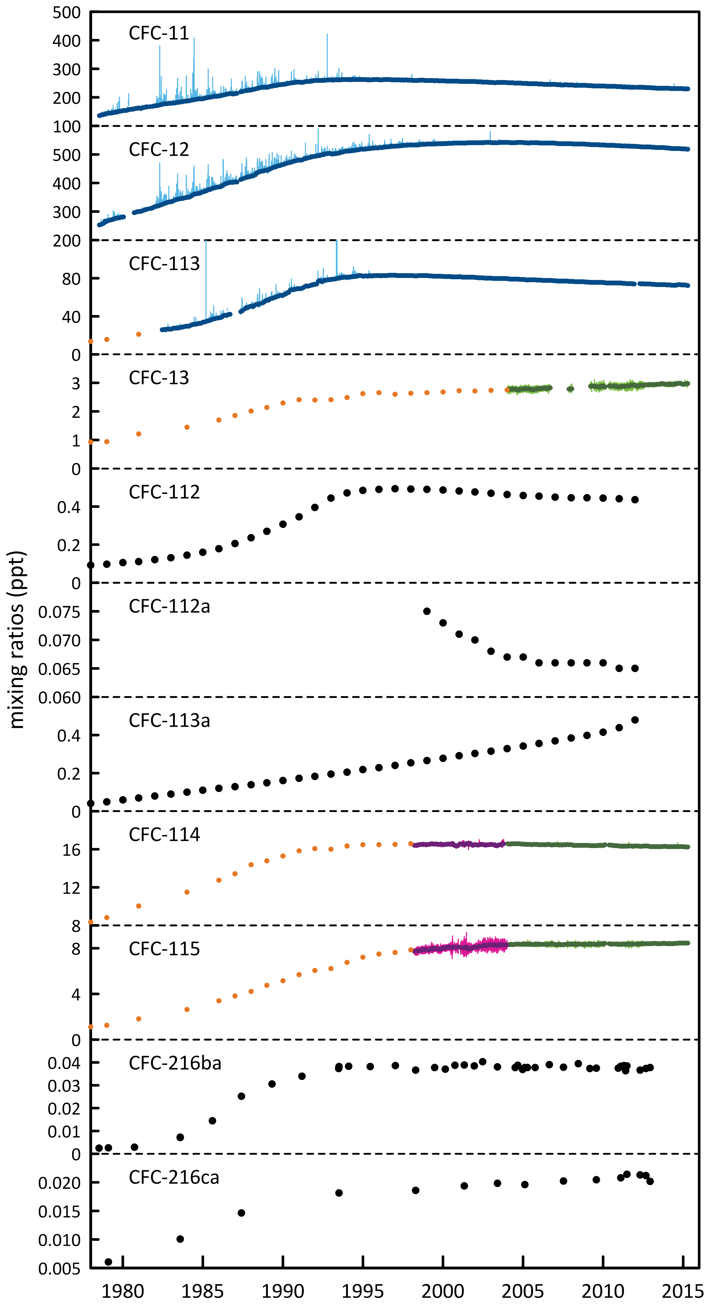

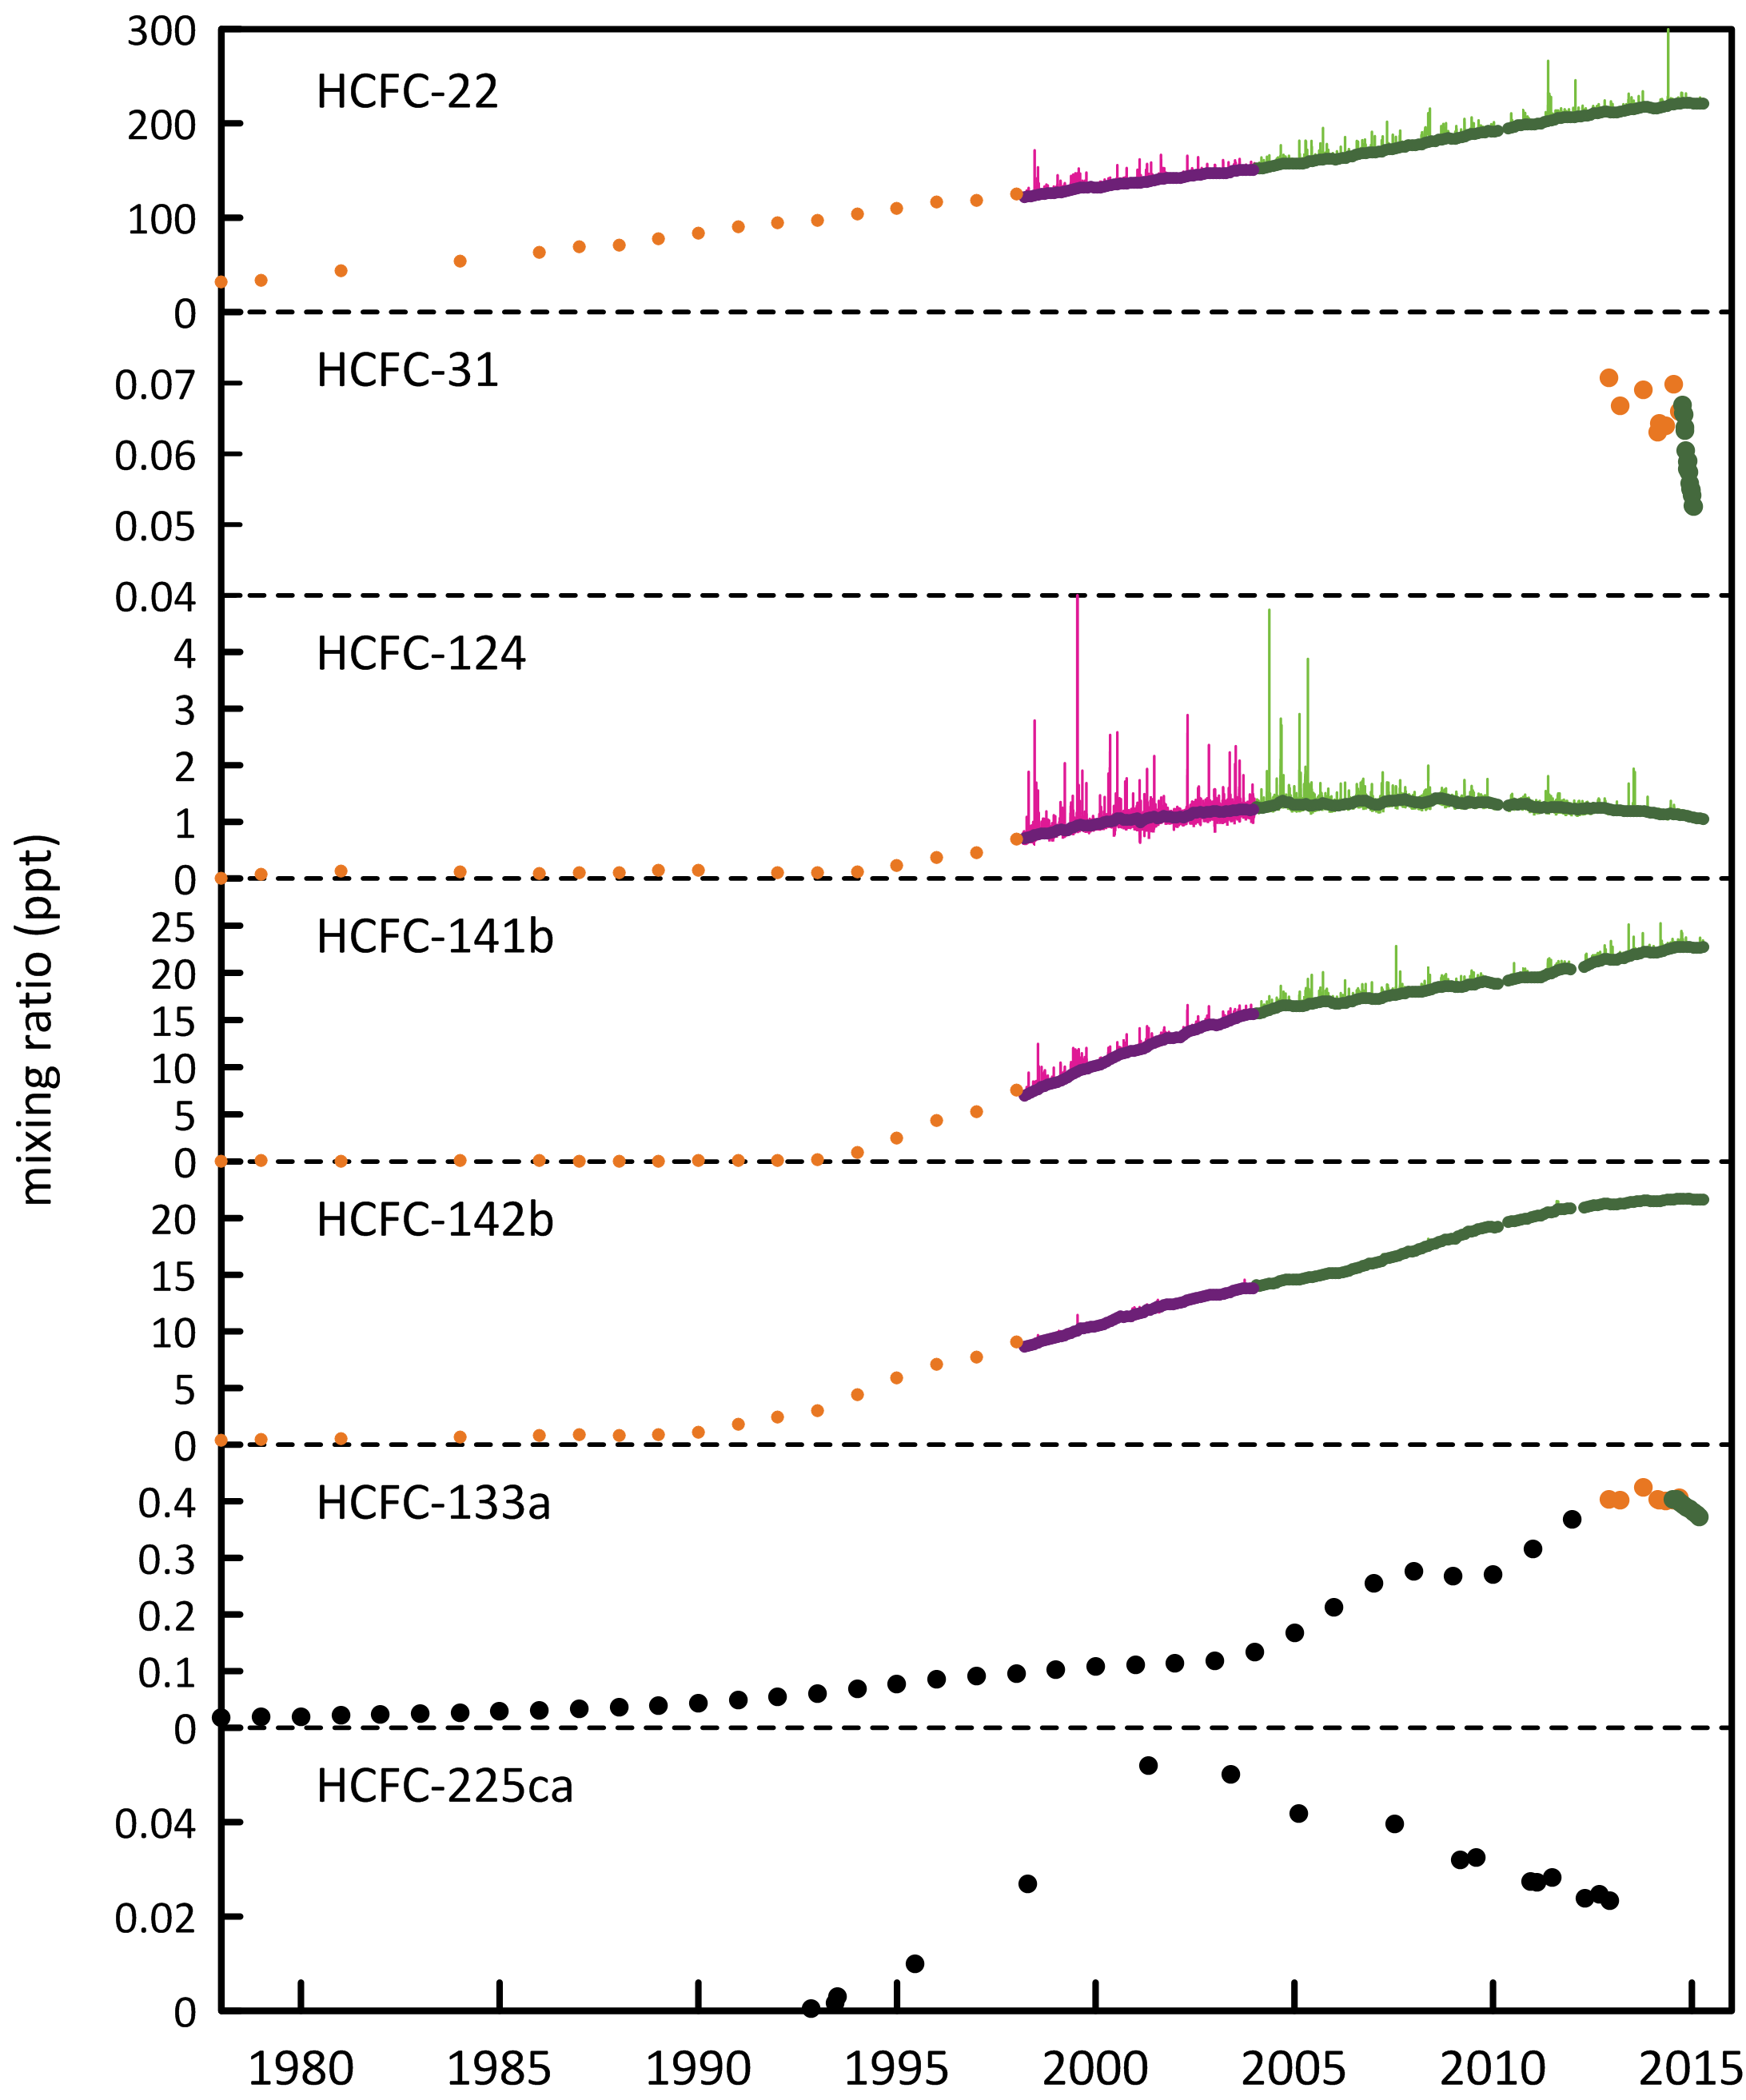

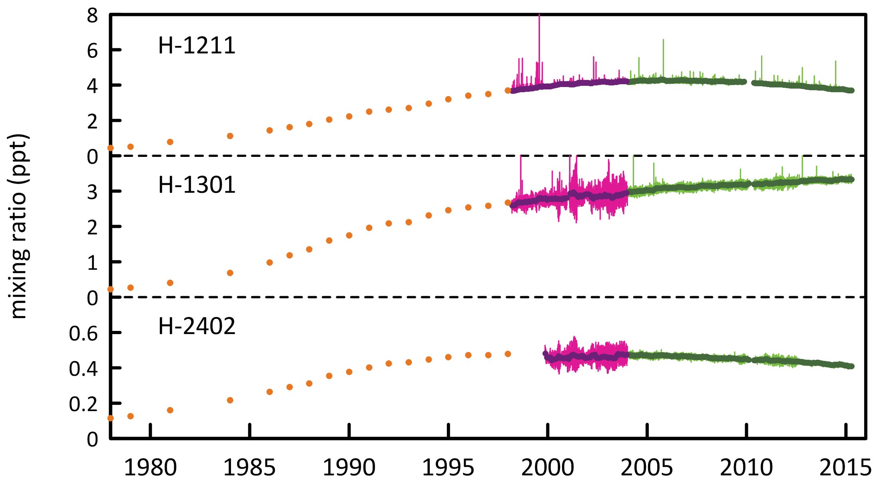

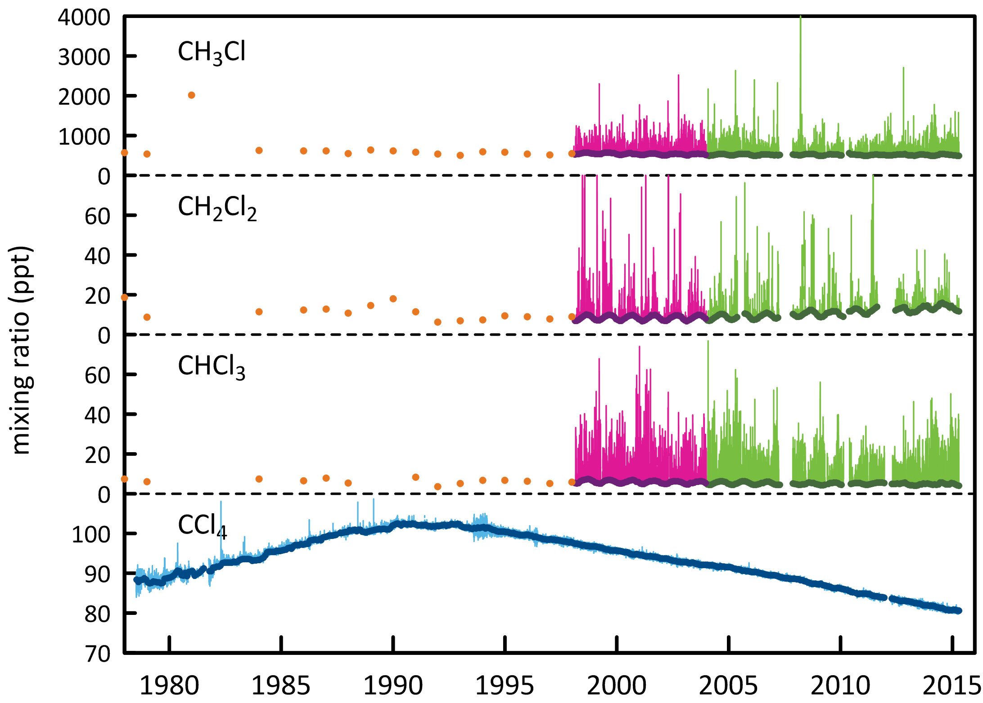

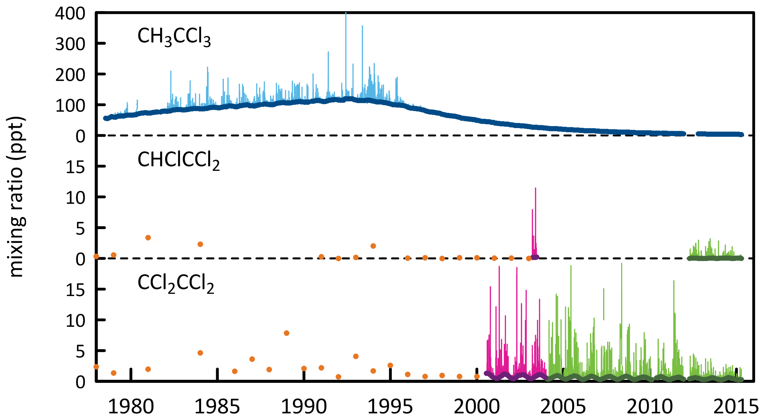

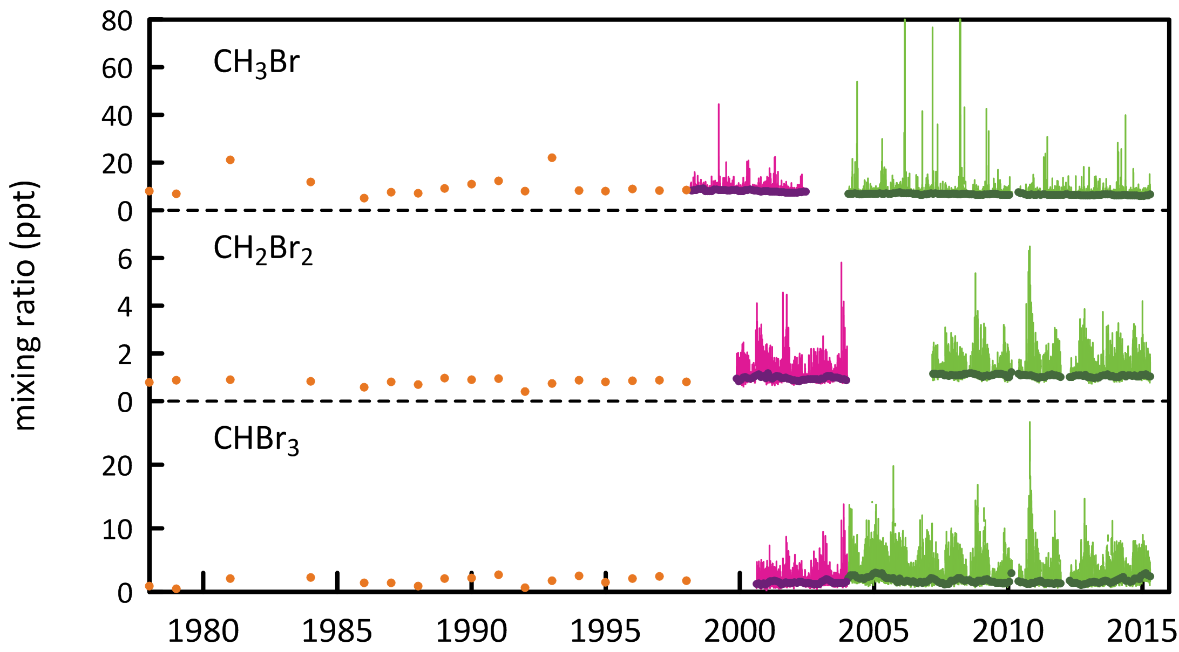

**Figure 1.** Cape Grim *in situ* and Air Archive observations of CFCs, HCFCs, halons, CT, MC, methyl chloride, dichloromethane, chloroform, TCE, PCE, MB, dibromomethaneand bromoform (1978 – 2014) showing baseline monthly mean data (Medusa - dark green; ADS - purple; ECD – dark blue; archive data – orange) and total data (Medusa - light green; ADS – pink; ECD – light blue) obtained from the GC-MS-Medusa, GC-MS-ADS and GC-ECD instruments at Cape Grim and Aspendale. The CFC-112, -112a, -113a, -216ba, -216ca and HCFC-133a data are from UEA and Empa measurements on the Cape Grim Air Archive (see text above and CSIRO unpublished data).

## 

## CFCs

CFC-11 and CFC-12 are the dominant CFCs in the atmosphere, constituting 88% of all CFCs in 2014. CFC-113, CFC-114 and CFC-115 constitute 11% of CFCs, the remaining minor CFCs about 1%. The CFCs account for 63% of chlorine from all ODSs in the background atmosphere.

As a result of measures undertaken within the Montreal Protocol framework, all of the CFCs (CFC-11, CFC-12, CFC-13, CFC-112, CFC-112a, CFC-113, CFC-114, CFC-115) measured in the atmosphere in 2012, 2013 and 2014 at Cape Grim have stopped growing or are in decline, the possible exception being CFC-113a, which showed a small growth (Table 1) in 2012, which may have continued. Total CFCs are declining by 0.6% per year due to declining emissions (see below); chlorine from CFCs in the atmosphere decreased by 13 ppt (2013-2014, 0.6%).

The summed concentration of the minor CFCs (CFC-112, CFC-112a, CFC-113a, CFC-216ba and CFC-216ca; Kloss *et al.*, 2014, Laube *et al.*, 2014) in 2014 is likely only ~1 ppt, while the other CFCs in the background atmosphere sum to 854 ppt in 2014. The summed growth of these minor CFCs in the atmosphere is 0.03-0.04 ppt/yr, virtually entirely due to the growth in CFC-113a (0.04 ppt/yr). These low abundance CFCs are thought to be used as chemical feedstocks, or produced as by-products, with some fugitive emissions, or used as specialised solvents (Kloss *et al.*, 2014, Laube *et al.*, 2014).

## HCFCs

The major HCFCs (HCFC-22, HCFC-141b, HCFC-142b) measured in the atmosphere in 2014 at Cape Grim are still growing with reduced growth rates compared to 2013; the minor HCFCs (HCFC-124, HCFC-225ca - based on 2012 data and HCFC-31, HCFC-133a) are declining (Table 1). The dominant HCFC is HCFC-22 (219 ppt in 2014), 83% of the abundance and 87% of the growth of all HCFCs. HCFC-141b and HCFC-142b constitute 17% of HCFCs, the remaining minor HCFCs less than 1%. Total HCFCs are increasing by 2.1% per year, due to growing global emissions, largely from the developing world (see below). Chlorine in the atmosphere from HCFCs (288 ppt in 2014, 9% of total chlorine from all ODSs) increased by 6 ppt (2.2%, 2013-2014), the only ODS sector showing an increase in chlorine.

HCFC-31 (CH2ClF) and HCFC-133a (CH2ClCF3) have only recently been identified in the Cape Grim Air Archive (Laube *et al*., 2014; Schoenenberger *et al*., 2015; Vollmer *et al*., 2015). The background concentrations of HCFC-31 and HCFC-133a are low (0.06 and 0.39 ppt respectively in 2014). There are no clearly identified sources of these HCFCs, but it is possible they are emitted to the atmosphere from an inadvertent by-product emission (Laube *et al*., 2014; Schoenenberger *et al*., 2015; Vollmer et al., 2015). The concentrations of both of these HCFCs peaked in the background atmosphere in 2011-2012 and are now in rapid decline. It has been suggested that there has been a change in the industrial processes that result in their release to the atmosphere (Schoenenberger *et al*., 2015; Vollmer *et al*., 2015).

Measurements of HCFC-21 (CHCl2F) and HCFC-1233zd (sometimes referred to as HFC-1233zd, CHClCHCF3 – an olefinic HCFC) have recently commenced at Cape Grim (2014-2015) and resultant data will be shown and discussed in our 2016 Report.

## Chlorocarbons

The most abundant chlorocarbon in the background atmosphere is the largely naturally-occurring methyl chloride (CH3Cl, 514 ppt, 2014), accounting for 83% of all chlorocarbons and 57% of chlorine from chlorocarbons. The next most abundant chlorocarbon is anthropogenic CTC (81 ppt, 2014), accounting for 36% of chlorine from chlorocarbons. The remaining minor chlorocarbons, including MC, contribute 7% of chlorocarbon chlorine. The chlorocarbons account for 28% of total chlorine from all ODSs in the background atmosphere.

Apart from CTC and MC, every chlorocarbon measured at Cape Grim showed increasing concentrations in 2014 compared to 2013, contrasting with decreasing concentrations in 2013 compared to 2012. Significant inter-annual variability is expected for naturally emitted methyl chloride and chloroform, which have oceanic and biomass burning sources. The largest increase in the chlorocarbons was 5 ppt for methyl chloride, accounting for the majority of the increase in chlorocarbon chlorine.

The rate of decline of MC is consistent with its relatively short atmospheric lifetime and near-zero global emissions, whereas the rate of decline of CTC in the atmosphere suggests there are remaining, significant CTC sources outside the control of the Montreal Protocol (Fraser *et al*., 2014).

## Halons

H-1211 is the most abundant halon in the background atmosphere (3.8 ppt, 2014), followed by H-1301 (3.3 ppt) and H-2402 (0.4 ppt). H-1211 and H-2402 are in decline in the atmosphere (-0.1 ppt/yr and -0.01/yr respectively, 2013-2014); however H-1301 continues to increase (0.01 ppt/yr, 2013-2014), compared to 0.05 ppt/yr, 2012-2013). It is likely, based on its observed dimininishing growth rate, that H-1301 will stop growing in the atmosphere in 2015. Presumably this is in response to a declining global bank for all halons (Newland *et al*., 2013). Overall halons are in decline by 1.5% per year (compared to 0.7%/yr 2012-2013), now a larger rate of decline (in percentage terms) compared to the CFCs. Bromine in the atmosphere from halons decreased by 0.11 ppt/yr (1.4%), which equates to about a 6-7 ppt/yr decline in equivalent chlorine. This is significant – chlorine from CFCs is declining currently by 12-13 ppt/yr. The decline in bromine from halons is a significant driver of likely ozone recovery (see Krummel *et al*., 2015).

## Other organobromine species

Methyl bromide is the most abundant (6.3 ppt, 2014) organobromine ODS in the background atmosphere in 2014, followed by H-1211 (3.8 ppt), H-1301 (3.3 ppt), bromoform (2.0 ppt) and dibromomethane (1.1 ppt).

Methyl bromide showed a significant decrease (0.2 ppt/yr, 2013-2014) in the background atmosphere, continuing the overall long-term decrease in MB in the atmosphere, which briefly halted in 2012-2013. Natural bromoform showed a large increase (0.4 ppt/yr) and natural dibromomethane showed a small increase (0.02 ppt/yr). Overall bromine from all non-halon ODSs increased by 1.1 ppt/yr (2013-2014), an 8.3%/yr increase, largely due to the increase in bromine from natural bromoform (0.4 ppt, 2013-2014). This is the second consecutive year of increasing background levels of dibromomethane and bromoform. Significant inter-annual variability is expected for naturally emitted dibromomethane and bromoform, which have oceanic sources. Long-term trends have not been found for these species (Carpenter and Reimann, 2014).

## Total chlorine and bromine: impact on stratospheric ozone

Total chlorine from ODSs (Figure 2) decreased from 3195 ppt in 2013 to 3189 ppt in 2014, a decline of 6 ppt (0.2%). The overall decline in chlorine from CFCs was 13 ppt (2013-2014), whereas chlorine from other chlorocarbons increased by 1-2 ppt and HCFC chlorine increased by 6 ppt.

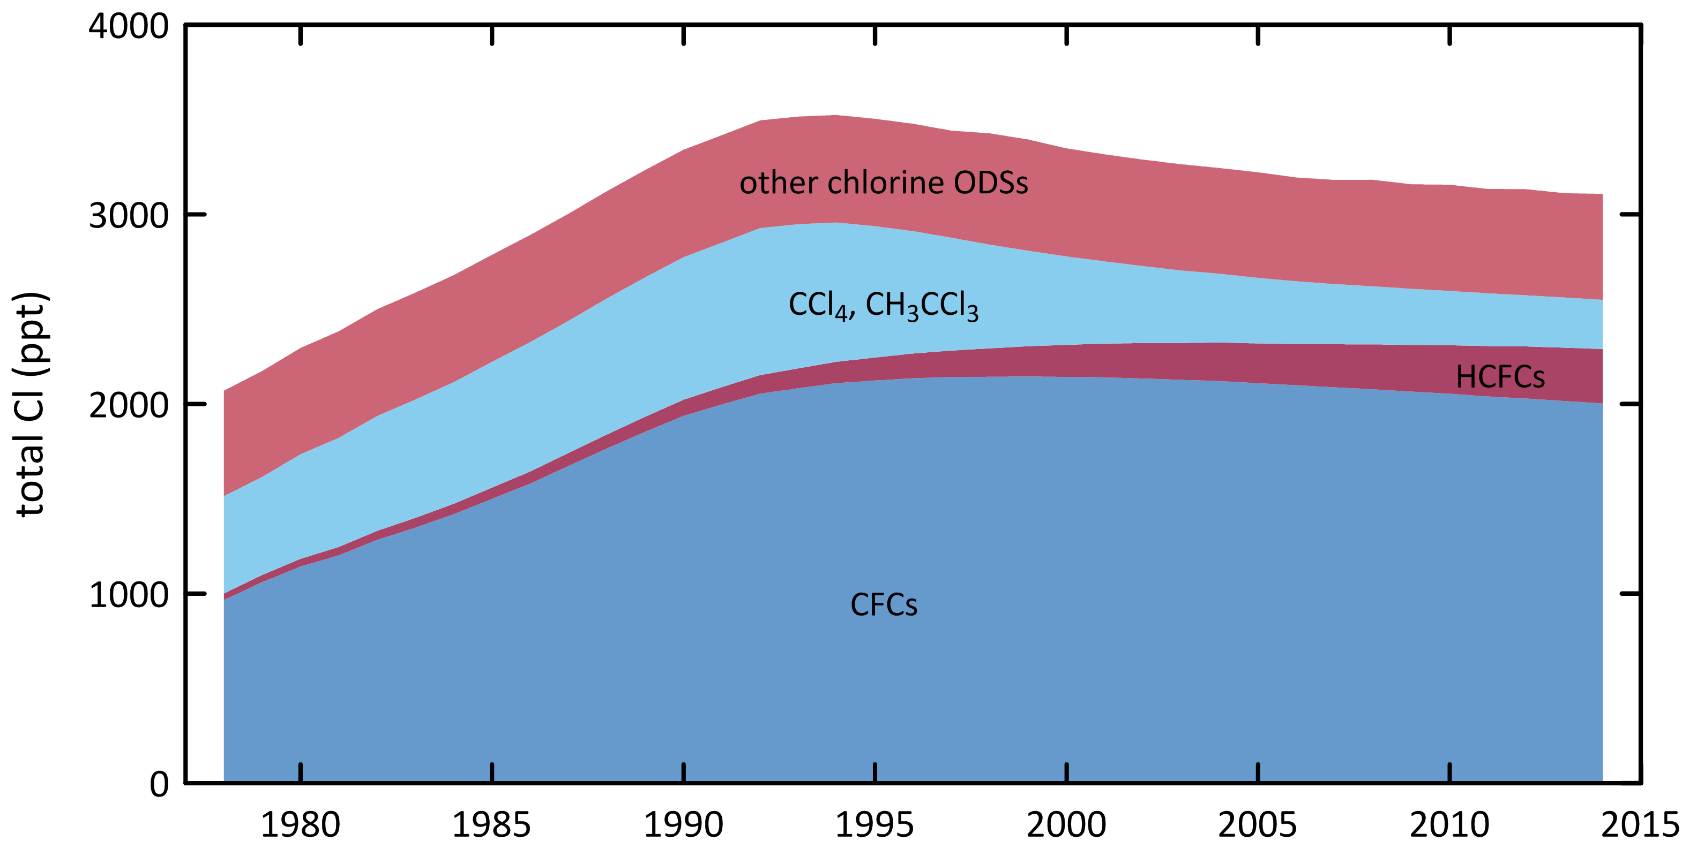

**Figure 2.** Total chlorine from CFCs, HCFCs, CTC: CCl4, MC: CH3CCl3 and other chlorine-containing ODSs (Table 1) as measured at Cape Grim.

Total bromine from organobromine ODSs (Figure 3) was 22 ppt (2014) – 35% from halons, 28% from MB, 27% bromoform and 10% dibromomethane. Bromine from all ODSs increased by 0.95 ppt (2013-2014, 4.3%), due to -0.11 ppt/yr from the halons and 1.06 ppt/yr from the non-halon ODSs.

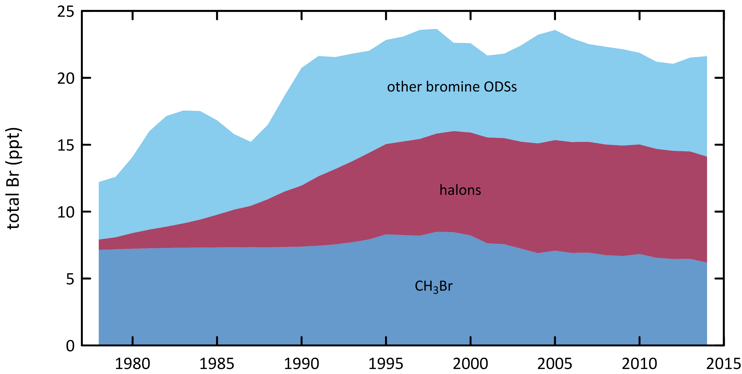

**Figure 3.** Total bromine from MB: CH3Br, halons and other bromine-containing ODSs (dibromomethane - CH2Br2 and bromoform - CHBr3) as measured at Cape Grim.

The impact of total chlorine and bromine from ODSs on stratospheric ozone at polar and mid-latitudes is discussed in detail in the companion Report on the 2014 Antarctic Ozone Hole (Krummel *et al*., 2015). Figure 4 shows the strong correlation between ozone depletion over Antarctica (Halley Station) and at mid-latitudes in the Southern Hemisphere (Melbourne). In both regions there is a strong indication of the onset of significant ozone recovery.

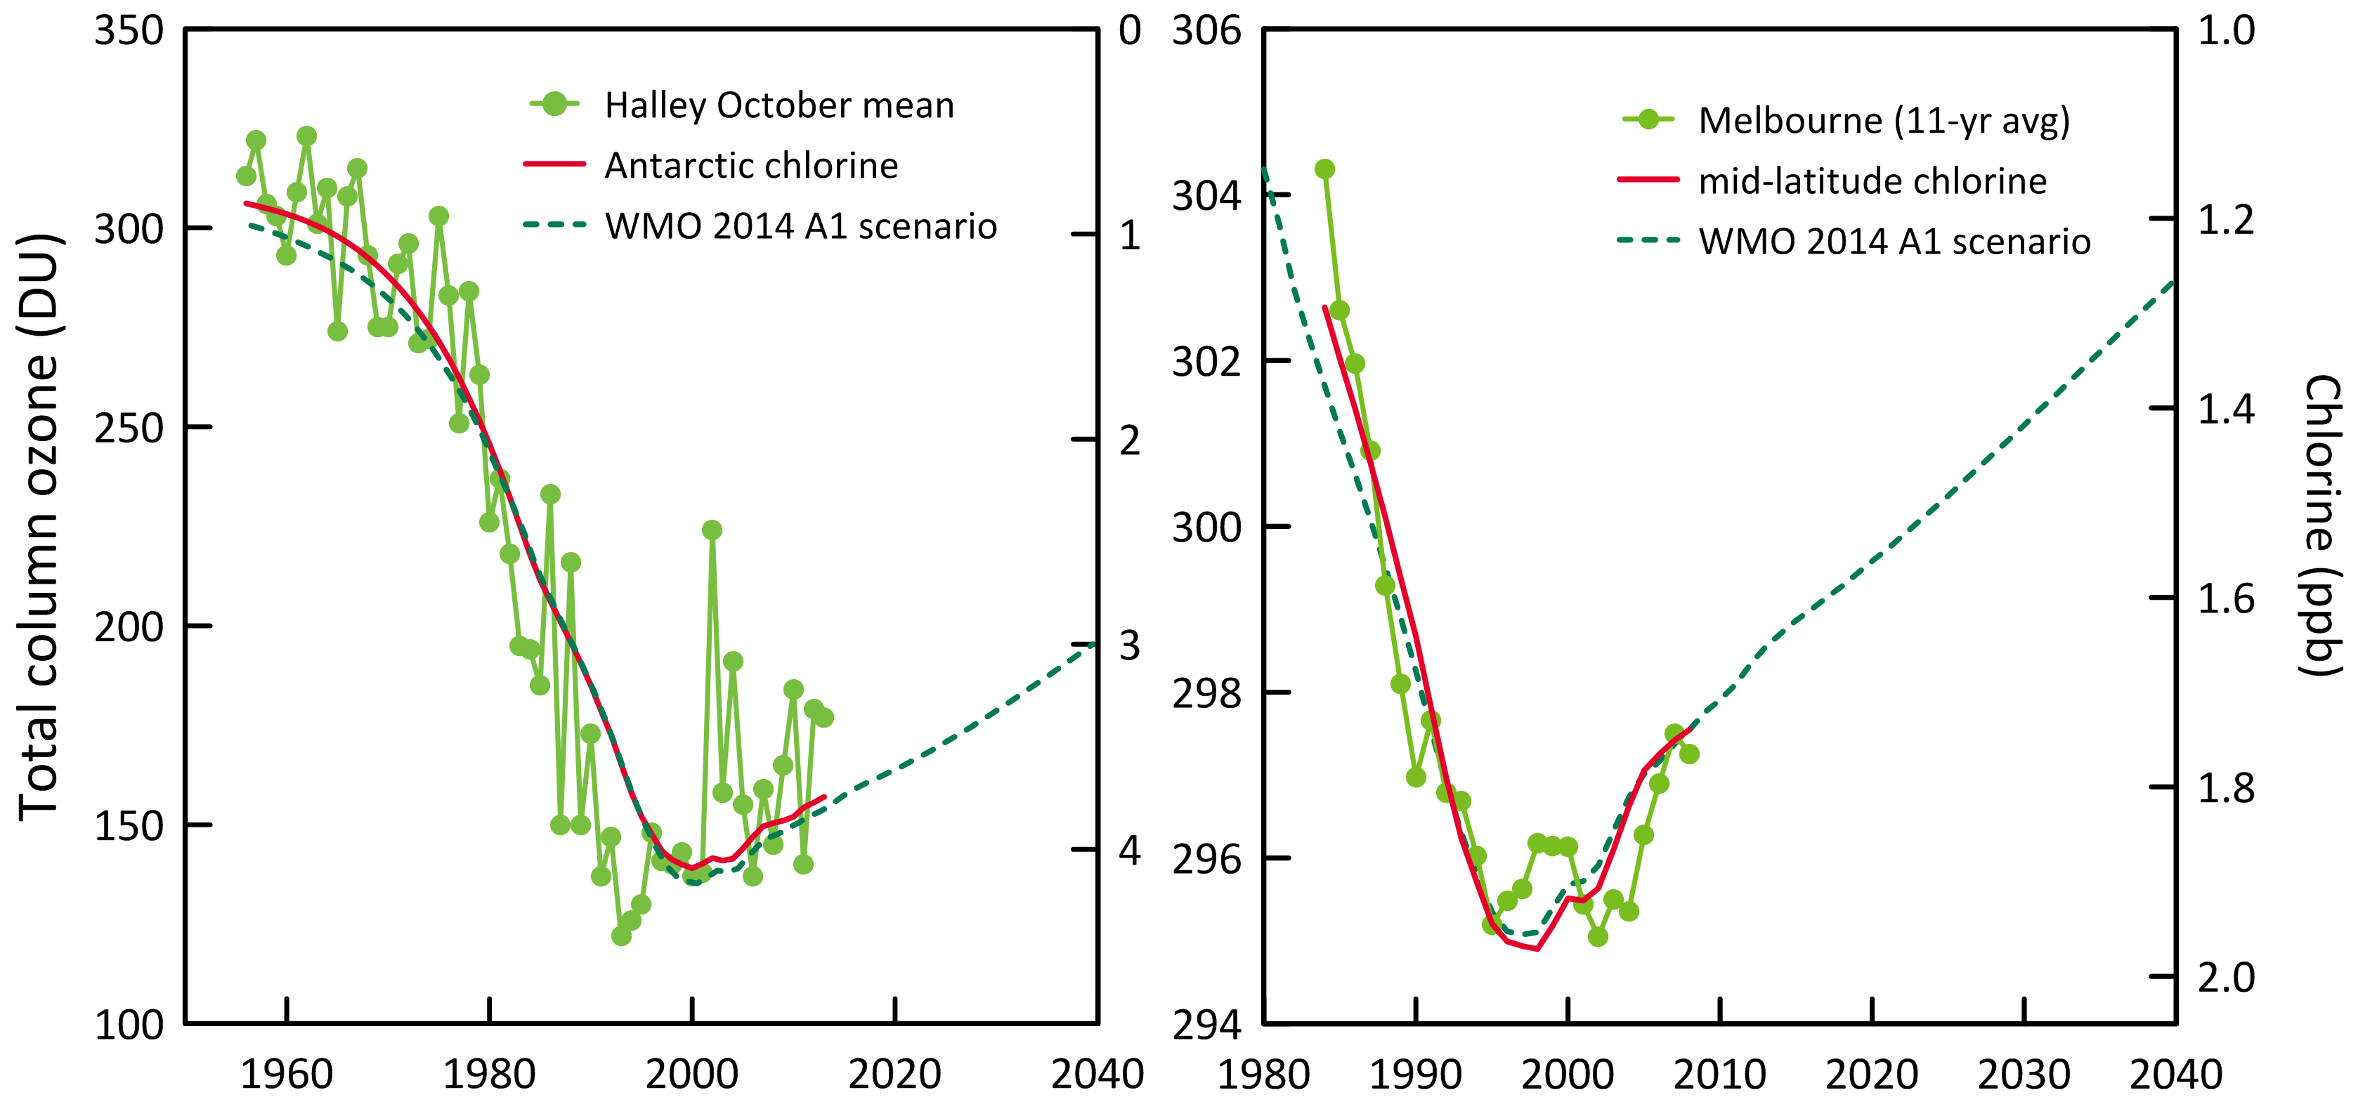

**Figure 4.** Total column ozone (DU) changes at Halley Station, Antarctica (76oS), and Melbourne, Australia (38oS) and Equivalent Effective Stratospheric Chlorine (EESC, ppb) changes at polar and mid-latitudes.

## Global radiative forcing from ODSs, HFCs and other SGGs

ODSs and other synthetic greenhouse gases (SGGs, for example hydrofluorocarbons – HFCs) make a significant contribution to global radiative forcing (Figure 5). SGGs have been the second most important driver of climate change after carbon dioxide since the 1950s. Radiative forcing from total SGGs almost stopped growing in the background atmosphere in the 1990s, due to the overall success of the Montreal Protocol, but recommenced growing in the 2000s due to growing global emissions of HFCs and growing emissions of HCFCs in the developing world. Montreal Protocol HCFC controls will impact these emissions from the developing world from 2015 onwards and global HFC emissions should also commence to be restrained as HFC-replacements are adopted in the developed world. Hopefully this will lead to another ‘plateau’ in radiative forcing from SGGs in the next 5-10 years.

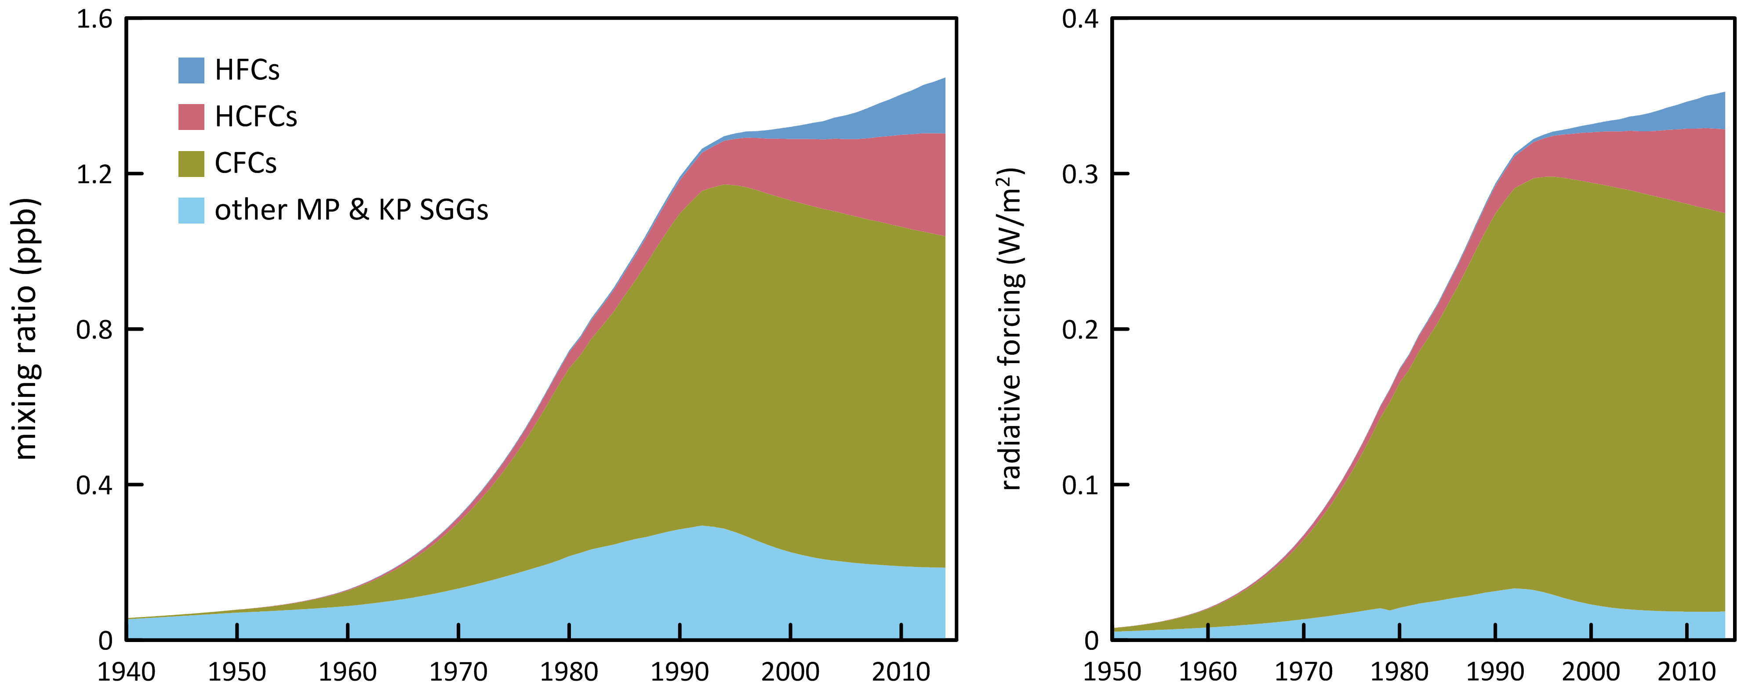

**Figure 5.** Global abundance (ppb, left) and radiative forcing (W/m2, right) of synthetic greenhouse gases (SGGs: HFCs, HCFCs, CFCs, others).

# 

# Global emissions of ODSs

Background ODS observations at Cape Grim and from other AGAGE stations in the Northern and Southern Hemispheres have been used to calculate global ODS emissions up to 2014 (Figure 6; Rigby *et al*., 2014 and updates; Vollmer *et al*., 2015b). These emissions are derived using the AGAGE 12-box global model of atmospheric chemistry and transport (Rigby *et al*., 2013) and a Bayesian inverse method based on Rigby *et al*. (2011, 2013). ODS emissions have been calculated for recently identified ODSs in the Cape Grim Air Archive using forward modelling in a 2-D atmospheric chemistry-transport model (Laube *et al*., 2014; Kloss *et al*., 2014) and Bayesian inverse modelling based using the FLEXPART dispersion model (Laube *et al*., 2014; Kloss *et al*., 2014; Rigby *et al*., 2014 and updates; Schoenenberger *et al*., 2015; Vollmer *et al*., 2015a).

Total global CFC emissions continued to decline (133 k tonnes in 2013, 127 k tonnes in 2014, 4.7%), dominated (93%) by emissions of CFC-11 (71 k tonnes) and CFC-12 (47 k tonnes) in 2014. Since the peak emissions of CFCs in the late 1980s (1130 k tonnes, 1987-1988), overall CFC emissions have declined by 8%/yr, attesting to the success of the Montreal Protocol controls on CFC production and consumption. CFC-11 became the dominant CFC emitted globally in 2012, taking over from CFC-12, whose emissions had previously always been larger than CFC-11 emissions (since 1979 based on AGAGE data, and earlier based on production data). Presumably this reflects a different pattern of CFC use in developing countries compared to past use in developed countries. In the previous Report (Fraser *et al*., 2014), it was reported that global CFC-11 emissions were declining in recent years (51 k tonnes in 2011, 50 k tonnes in 2012 and 48 k tonnes in 2013). The latest analysis of global AGAGE data shows an increase in CFC-11 emissions from 61 k tonnes in 2011 to 71 k tonnes in 2015, whereas CFC-12 emissions continue to decline (69 k tonnes in 2011 to 47 k tonnes in 2014). A significant, 4 year increase (2011-2014) in global CFC-11 emissions is quite unexpected and of concern for future ozone recovery and is being investigated further (the first step is to ensure that the emissions estimate is reliable – this will be reported to DoE as soon as confirmed). The emissions of the other CFCs (CFC-113, -114, -115), including the minor CFCs, continue to decline from a total of 11.7 k tonnes in 2013 to 10.9 k tonnes in 2014.

Global CTC emissions increased slightly (57 k tonnes 2013, 59 k tonnes in 2014). Long-term, global CTC emissions declined slowly from a peak of around 150 k tonnes/yr in the late 1970s-early 1980s declining to below 60 k tonnes/yr by and after 2009, a long-term decline of about 4%/yr. Since 2009 global CT emissions have remained approximately constant at 59±1 k tonnes/yr through to 2014. The decline in global CTC emissions is not as rapid as anticipated under the Montreal Protocol (Montzka and Reimann, 2011; Carpenter and Reimann, 2014). As pointed out by Fraser *et al*. (2014), a partial explanation may be that global emissions of CTC from land-fills and possibly chlor-alkali plants may be significant, and not yet accounted for, in global budgets.

Global MC emissions stopped declining in 2012 (1.6 k tonnes), with emissions increasing during 2012-2014, reaching 3.2 k tonnes in 2014. Over the past 4 years (2011-2014) global emissions have averaged 2.4±0.8 k tonnes/yr. This is only the second pause in the decline of MC emissions from their peak of 670 k tonnes in 1990, the other being in 2002-2003 (13 and 14 k tonnes respectively). As suggested in Fraser *et al*. (2013), this could mean that global sources now approximately equal global sinks and MC emissions will not fall to zero in the next few years as anticipated. The long term decline in MC emissions is in excess of 20%/yr, which is about what is expected for an ODS with low (~zero) emissions and an atmospheric lifetime of about 5 years.

Summed emissions of CTC and MC peaked at about 800 k tonnes in the late 1980s (84% MC), falling by more than a factor of 10 to 65-70 k tonnes by 2008 (97% CTC) and hovering above 60 K tonnes/yr until 2014. Summed emissions of methyl chloride, dichloromethane and chloroform likely approached 4700 tonnes in the early-1990s, declining to about 4300 k tonnes around 2000 before rising again to around just under 5000 k tonnes currently in 2014.

Global HCFC emissions, including the minor HCFCs, peaked in 2010 (483 k tonnes) and have since declined (3.5%) to 466 k tonnes in 2014, a decline of about 1%/yr. Global HCFC emissions were lower (459 tonnes) in 2013, suggesting that the decline since 2010 may have stalled – 2015 emissions will be instructive. This decline is statistically significant and is encouraging in relation to the overall long-term decline in ODSs that will bring about, possibly hasten, ozone layer recovery. Throughout the period from the late-1970s to 2010, total HCFC emissions increased by about 4%/yr. Now the emissions of all of the major HCFCs are in decline: HCFC-22 emissions peaked in 2011 at 383 k tonnes declining to 373 k tonnes in 2014; HCFC-141b: 68 k tonnes (2012) to 64 k tonnes (2014); HCFC-142b: 39 k tonnes (2008) to 26 k tonnes (2014). Declining HCFC emissions cause the observed slowing of the recent HCFC concentration growth rates in the atmosphere (see Section 2.2). If HCFC emissions continue to decline, HCFC concentrations will peak and then also start to decline over the next few years.

Data on halon emissions are now available back to the 1960s, based on AGAGE *in situ* and Cape Grim Air Archive data (Vollmer *et al*., 2015b). Total global halon emissions continue to decline (7.6 k tonnes in 2012, 7.2 k tonnes in 2013, 7.0 k tonnes in 2014), dominated (~80%) by halon-1211 emissions, which declined by 0.5 k tonnes over the same period. Peak total halon emissions (19 k tonnes) occurred in 1990 and have declined to current emissions by ~4%/yr (H-1211: 4%/yr, H-1301: 5%/yr, H-2402: 4%/yr).

Global MB emissions have been estimated from AGAGE data, including Cape Grim (Rigby *et al*., 2014) and these have been updated. The new emission estimates start in 1998 (125 k tonnes), the largest emissions were recorded in 1999 (138 k tonnes), declining, with significant inter-annual variability, to 99 k tonnes in 2014, a long-term decline of ~2%/yr. The increase in emissions in 2013 compared to 2012 noted in the 2014 Report is not present in the revised emissions. Encouragingly, from an ozone depletion point of view, global MB emissions continue to fall.

The total ODS global emissions for the Montreal Protocol ODSs (CFCs, HCFCs, halons, MC, CTC and MB) in ODP tonnes are shown in Figure 7, together with the global atmospheric concentration data for these species expressed as equivalent chlorine. The combined global emissions of the Montreal Protocol ODSs peaked at 1460 k tonnes (1.46 M tonnes) in the late 1980s, declining, thanks to the Montreal Protocol restrictions on ODS production and consumption, at 10% per year to 314 tonnes in 2014. The total global concentrations of ODSs, expressed as equivalent chlorine, peaked later in the mid-1990s at over 4040 ppt (4.04 ppb) declining slowly (0.5% per year) to 3630 ppt by 2014, resulting largely from the long (50-100+ years) lifetimes for CTC and CFCs in the atmosphere.

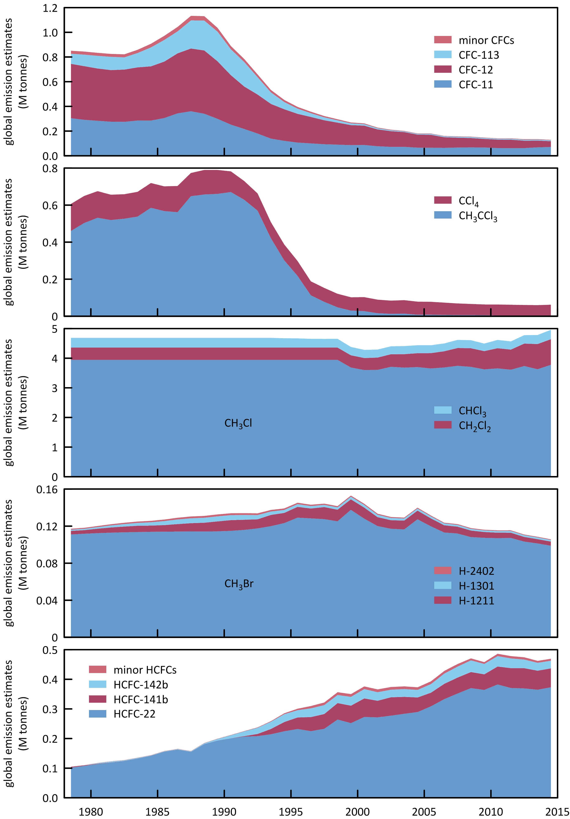

**Figure 6.** Global emissions of ODSs (CFCs, chlorinated solvents (MC: CH3CCl3, CTC: CCl4), methyl chloride, dichloromethane, chloroform, halons, MB: CH3Br, HCFCs) derived from global AGAGE data by inverse modelling using the 12-box AGAGE global transport model, by forward modelling using a 2-D atmospheric chemistry-transport model and by Bayesian inverse modelling using the FLEXPART dispersion model. For MB, pre-1998 emissions are scaled from global atmospheric concentrations.

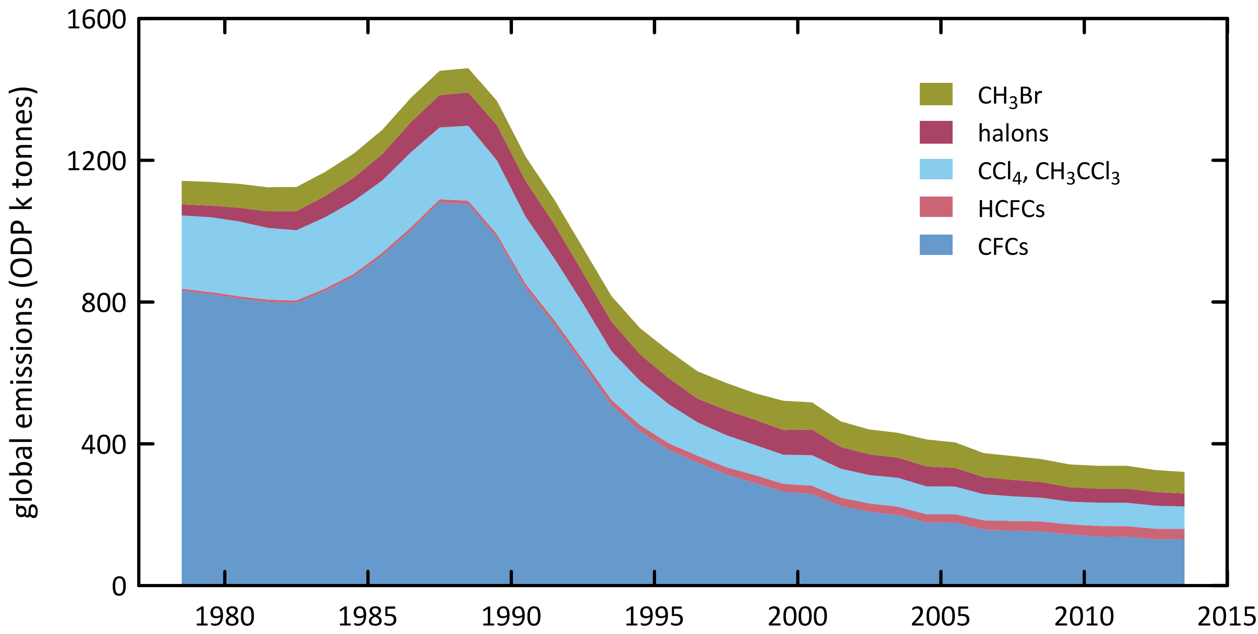

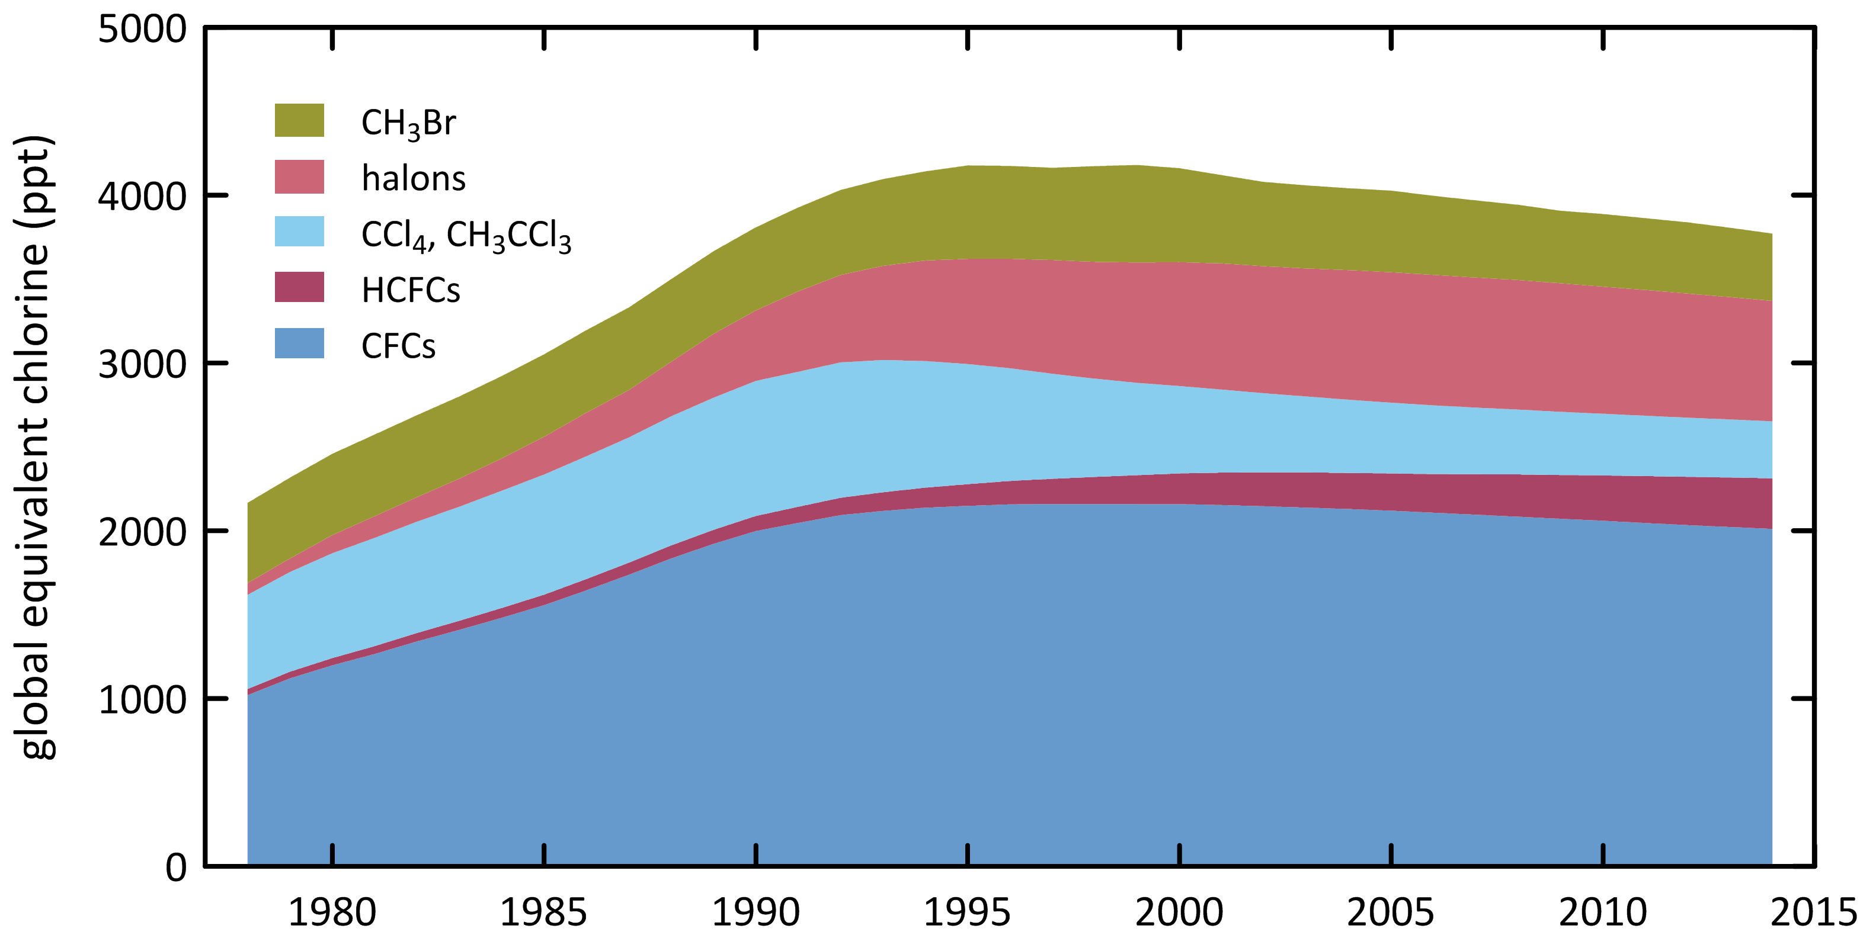

**Figure 7**. Global emissions (ODP tonnes) of the Montreal Protocol ODSs and global equivalent chlorine (ppt), both derived from AGAGE data (Fraser *et al*., 2014a; Rigby *et al*., 2014 and subsequent updates) using the 12-box AGAGE model. For MB, pre-1998 emissions are scaled to post-1998 from global atmospheric concentrations, 1978-2014.

# Australian ODS imports and banks

Data on Australian imports of ODSs are reported to the Australian Government (Department of the Environment - DoE) under licensing arrangements in the *Ozone Protection and Synthetic Greenhouse Gas Management Act, 1989*, with the requirement being established under the Act in 1989. Australian imports are documented in the DoE *Ozone Licensing and Reporting System* (OLaRS: A. Gabriel, DoE, private communication, May 2014), which was introduced during 2011, replacing previous import data recording systems. OLaRS details imports of bulk and pre-charged HCFCs (individual HCFCs or HCFC blends) and other ODSs (in particular carbon tetrachloride - CTC and methyl bromide - MB).

For 2012 – 2014 (January – December) imports are reported entirely via the OLaRS protocol. For 2011, OLaRS data are only available for October – December, and the annual imports reported here for 2011 are estimated by scaling the October-December data to the entire year, assuming that the October-December data are representative in volume and composition for all of 2011. MB data are reported separately from OLaRS. For 2008-2010, the ODS imports are reported using the pre-OLaRS protocol. Imports of ODSs are shown in Table 2 and Figure 8.

There is an overall decline in Australian ODS imports from over 15,000 tonnes in 1991 to 780 tonnes in 2014, a long-term decline of about 12% per year, 9.4% per year since 1999. In 1991 CFCs were the major ODS imports (7,144 tonnes), but they declined rapidly to close to zero imports by 1996 (372 tonnes), an overall decline of about 50% per year. By 2003 CFC imports were virtually zero. Methyl chloroform (MC) was the second largest ODS import in 1991 (4,700 tonnes) but imports ceased by 1996. HCFCs imports nearly doubled between 1991 (2,400 tonnes) and 1998 (4,200 tonnes); since 1998 there has been a long term decline in HCFC imports, falling to less than 200 tonnes by 2014, a long-term decline of around 17% per year. Methyl bromide (MB) imports were just over 1,000 tonnes per year in the early 1990s, falling to about 350 tonnes in 2007, a long-term decline of 8% per year, driven by the reduction in non-QPS use of MB. After 2007, MB imports increased and by 2011 had reached over 730 tonnes, twice as large as the 2007 imports. Since 2011, imports have declined again to 586 tonnes in 2014. The increase in MB imports since 2007 has been driven by an increase in QPS use of MB. Variations in QPS demand for MB in Australia will likely follow overall grain and wood products production trends, trading partner requirements and the use of MB alternatives (for example phosphine and sulfuryl fluoride). Grain production increased from about 20 M tonnes at the height of the recent drought (2006/2007) to 50 M tonnes in 2012/2013 (ABARE, 2014).

Imports of MB for non-QPS use fell to close to zero by the mid-2000s. Figure 8 shows Australian imports of Montreal Protocol ODSs – imports of total Montreal Protocol ODSs were close to zero in 2014 having fallen by about 14% per year since 1999.

The Australian CFC bank (in operational equipment) is estimated to be less than 450 tonnes. The Australian HCFC-22 bank has been estimated at 12033 tonnes (2006), declining to 11227 tonnes in 2012 and 9562 tonnes in 2013 (Brodribb & McCann, 2013, 2014).

**Table 2.** Australian imports (bulk and pre-charged equipment, tonnes) of ODSs (CFCs, HCFCs, MC: CH3CCl3, halons, MB: CH3Br) 1991-2014; 2012, 2013 and 2014 data are from the OLaRS data base, 2010 and earlier are pre-OLaRS data, and 2011 is a mixture of OLaRS and pre-OlaRS data (A. Gabriel, DoE, private communication, 2014). The only significant CTC (CCl4) imports were ~0.5 tonnes in 1995/1996 (not listed). ODS imports less than 0.1 tonne are not listed, but included in total ODS. MB imports are listed as for QPS and non-QPS uses. Small quantities of MB imports are exported (do not influence Australian emissions); significant quantities HCFC-123 imports are exported or used as feedstock (do not influence Australian emissions) – for example 10 tonnes exported and 3 tonnes used for feedstock in 2014).

|  |  |  |  |  |  |  |  |  |  |  |  |  |  |  |  |  |  |  |  |  |  |  |  |  |
| --- | --- | --- | --- | --- | --- | --- | --- | --- | --- | --- | --- | --- | --- | --- | --- | --- | --- | --- | --- | --- | --- | --- | --- | --- |
|  | 1991 | 1992 | 1993 | 1994 | 1995 | 1996 | 1997 | 1998 | 1999 | 2000 | 2001 | 2002 | 2003 | 2004 | 2005 | 2006 | 2007 | 2008 | 2009 | 2010 | 2011 | 2012 | 2013 | 2014 |
| CFC-11 | 1759 | 1786 | 1443 | 927 | 498 | 69 | 52 | 90 | 90 |  |  |  | 1 |  |  |  |  |  |  |  |  |  |  |  |
| CFC-12 | 4049 | 3054 | 3205 | 2784 | 2229 | 181 | 129 | 182 | 182 | 8 | 8 | 8 |  |  |  |  |  |  |  |  |  |  |  |  |
| CFC-113 | 999 | 808 | 485 | 168 | 236 | 118 |  |  |  |  |  |  |  |  |  |  |  |  |  |  |  |  |  |  |
| CFC-114 | 6 | 19 | 6 | 11 | 7 | 3 | 3 | 3 | 3 | 1 | 1 | 1 |  |  |  |  |  |  |  |  |  |  |  |  |
| CFC-115 | 331 | 84 | 172 | 64 | 46 |  |  |  |  |  |  |  |  |  |  |  |  |  |  |  |  |  |  |  |
| **Total CFCs** | **7144** | **5751** | **5311** | **3954** | **3071** | **372** | **184** | **275** | **275** | **9** | **9** | **10** | **1** |  |  |  |  |  |  |  |  |  |  |  |
| HCFC-22 | 2402 | 2252 | 2940 | 1368 | 1663 | 2626 | 3056 | 2900 | 2955 | 2160 | 2228 | 2557 | 2054 | 2053 | 1979 | 1843 | 1808 | 1773 | 1878 | 1224 | 1288 | 758 | 714 | 178 |
| HCFC-123 |  | 17 | 60 | 67 | 74 | 59 | 52 | 72 | 76 | 20 | 7 | 34 | 11 | 31 | 28 | 15 | 18 | 21 | 48 | 26 | 13 | 28 | 22 | 12 |
| HCFC-124 |  |  | 8 | 2 | 49 | 93 | 195 | 189 | 140 | 56 | 60 | 46 | 64 | 43 | 29 | 15 | 18 | 20 | 13 | 30 | 5 | 4 | 3 | 0.5 |
| HCFC-141b |  | 30 | 269 | 411 | 522 | 579 | 639 | 827 | 813 | 892 | 301 | 446 | 473 | 396 | 428 | 241 | 198 | 155 | 76 | 49 | 3 |  | 1 |  |
| HCFC-142b |  | 3 | 23 | 14 | 29 | 89 | 130 | 141 | 87 | 59 | 52 | 40 | 54 | 27 | 84 | 40 | 26 | 12 | 8 | 4 | 3 | 2 |  | 0.3 |
| HCFC-225ca |  |  |  |  |  |  |  |  |  |  |  |  |  |  |  |  |  |  | 0.5 | 0.3 | 0.3 | 0.5 |  |  |
| **Total HCFCs** | **2402** | **2302** | **3301** | **1823** | **2338** | **3497** | **4154** | **4158** | **4105** | **3187** | **2648** | **3123** | **2656** | **2551** | **2548** | **2156** | **2068** | **1981** | **2023** | **1333** | **1313** | **793** | **740** | **191** |
| **CH3CCl3** | **4680** | **5086** | **3586** | **2273** | **846** |  |  |  |  |  |  |  |  |  |  |  |  |  |  |  |  |  |  |  |
| H-1211 | 111 | 14 |  |  |  |  |  |  |  |  |  |  |  |  |  |  |  |  |  |  |  |  | 0.1 | 0.4 |
| H-1301 | 11 | 39 |  |  |  |  |  |  |  |  |  |  |  |  |  |  |  |  |  |  |  |  | 1 | 2.6 |
| **Total halon** | **122** | **53** |  |  |  |  |  |  |  |  |  |  |  |  |  |  |  |  |  |  |  |  | **1.1** | **3.0** |
| MB-nQPS | **876** | **799** | **921** | **704** | **664** | **631** | **679** | **570** | **507** | **451** | **340** | **323** | **183** | **207** | **119** | **55** | **46** | **41** | **33** | **34** | **33** | **33** | **31** | **30** |
| MB-QPS | **172** | **160** | **165** | **172** | **168** | **276** | **259** | **352** | **425** | **517** | **475** | **415** | **441** | **390** | **361** | **361** | **294** | **417** | **509** | **472** | **690** | **676** | **618** | **556** |
| **Total MB** | **1048** | **959** | **1087** | **876** | **833** | **907** | **1031** | **921** | **932** | **968** | **815** | **738** | **624** | **597** | **490** | **427** | **351** | **477** | **557** | **522** | **734** | **719** | **649** | **586** |
| **Total ODSs** | **15396** | **14151** | **13285** | **8926** | **7033** | **4776** | **5257** | **5354** | **5312** | **4164** | **3467** | **3870** | **3281** | **3148** | **3038** | **2583** | **2419** | **2458** | **2580** | **1859** | **2039** | **1512** | **1390** | **780** |

# 

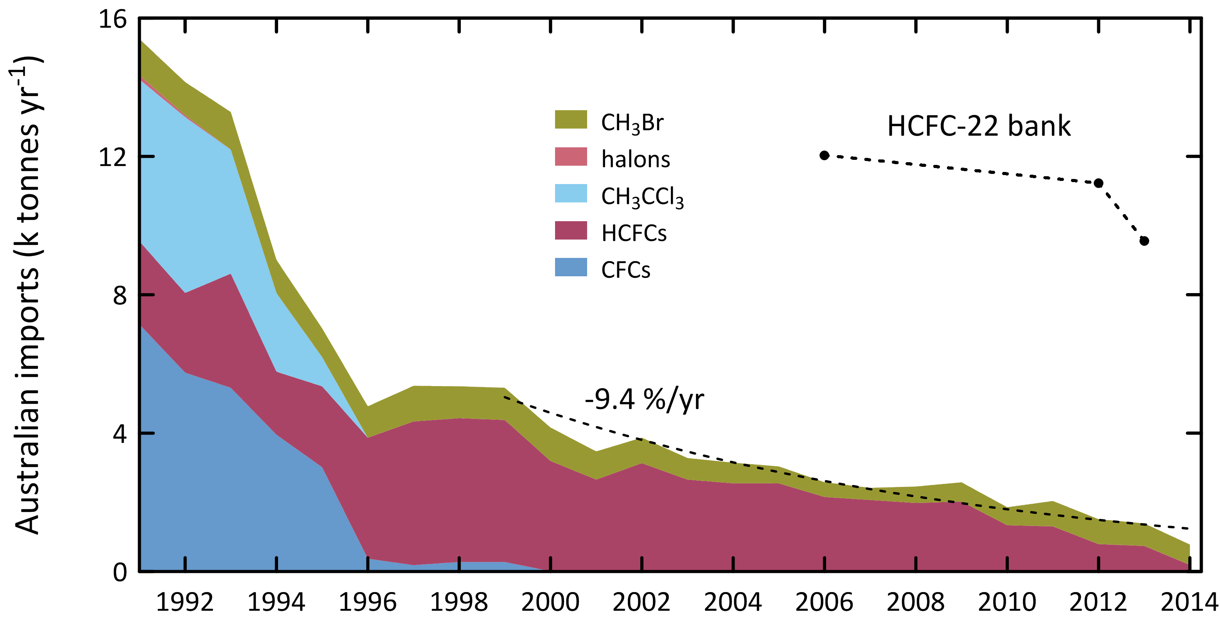

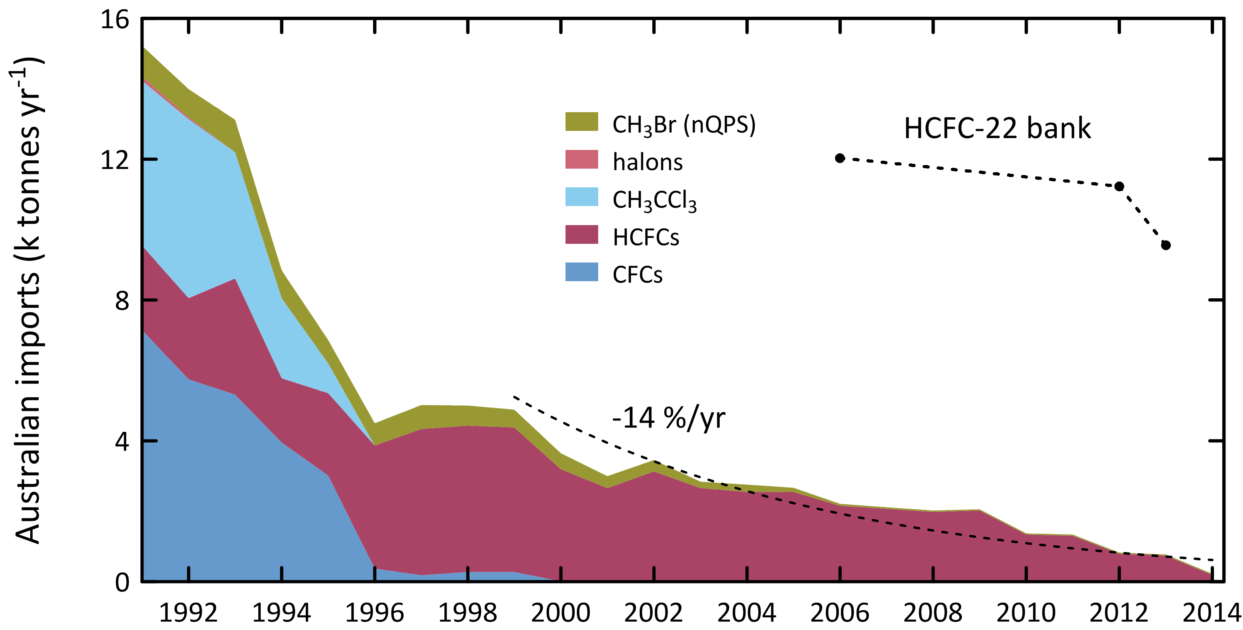

**Figure 8.** Australian imports (tonnes) of ODSs (CFCs, HCFCs, halons, MC: CH3CCl3, MB: CH3Br – total left, MB: CH3Br – nQPS right) (A. Gabriel, DoE, private communication, 2015). The 2012-2014 data are from the OLaRS data base, 2010 and earlier are pre-OLaRS data, and 2011 is a mixture of OLaRS and pre-OlaRS data; also shown are estimates of the Australian HCFC-22 bank (Brodribb & McCann, 2013, 2014).

# Estimated Australian ODS emissions from Cape Grim data

Estimates of emissions of CFCs, HCFCs, MC, CTC, halons and MB from the Melbourne/Port Phillip region (Dunse *et al*., 2001, 2005; Dunse 2002; Fraser *et al*., 2012, 2013, 2014b), have been made utilising *in situ* measurements from the Cape Grim Baseline Air Pollution Station in Tasmania and an interspecies correlation (ISC) technique with co-incident carbon monoxide (CO) measurements.

The original ISC emission estimates were based on an average CO emissions from the Melbourne/Port Phillip region (600 k tonnes/yr) which were assumed to have been relatively constant during 2004-2009 (EPA, 1998). In Fraser *et al*. (2012), revised estimates of the Port Phillip region CO emissions were used (Delaney & Marshall, 2011) with 2002 emissions estimated at 605 k tonnes and 2006 emissions at 645 tonnes. Carbon monoxide emissions were assumed constant after 2006 for the Port Phillip region. There has been a further revision of CO emissions from the Port Phillip region (S. Walsh, Victorian EPA, unpublished data, 2013). The 2006 Port Phillip CO emissions are now estimated to have been 796 k tonnes, with the increase in emissions compared to earlier estimates due to increased emissions from vehicles and reduced emissions from wood heaters. The time-dependence of Port Phillip CO emissions has been estimated from EPA CO concentration observations throughout the Port Phillip region. Using the revised data on CO emissions, Port Phillip ODS emissions have been calculated, for 1994-2014, using Cape Grim *in situ* data and ISC, obtained from the GC-ECD and GC-MS instruments at Cape Grim, and scaled to Australian emissions, where appropriate, on a population basis (using a population-based scale factor of 5.4). NOAA air mass back trajectory analyses (Draxler & Hess, 1997) are used to ensure that the pollution events at Cape Grim used to derive Port Phillip emissions are imbedded in air masses that only pass over the Port Phillip region and do not include other possible carbon monoxide source regions, in particular the Latrobe Valley.

SE Australian ODS emissions can be calculated from Cape Grim data using the NAME model. NAME (**N**umerical **A**tmospheric Dispersion **M**odelling **E**nvironment) is a Lagrangian particle dispersion model (O’Doherty *et al*., 2009; Manning *et al*., 2003, 2011) driven by 3-dimensional wind fields from numerical weather predictions models. NAME has a horizontal resolution (grid boxes 40 km x 40 km) and a minimum boundary layer height of 100 m. NAME operates in a backward mode, so, for example, it identifies, within a 3 hr period at Cape Grim, which grid boxes in a prescribed domain impact on Cape Grim over the previous 12 days. NAME releases 33000 particles at Cape Grim over a 3 hr period and the resultant 12 day integrated concentrations in each of the domain boxes are calculated. Operating NAME in the backward mode is numerically very efficient and is a very close approximation to the forward running mode, which is what is used to identify emission sources impacting on Cape Grim. In the inverse calculation, NAME identifies pollution episode data at Cape Grim, and starts with randomly-generated emission maps and searches for the emission map that leads to a modelled pollution time series that most accurately mimics the observations. The inversion method assumes that baseline air enters the inversion domain regardless of direction i.e. it assumes that sources outside the specified domain do not impact significantly on Cape Grim. One of the major advantages of the NAME method, especially when using Cape Grim data, is that it does not require a prior estimate of emissions. Other inversion methods used to estimate regional emissions using Cape Grim data often derive emissions that are not significantly different to the prior estimates.

The NAME model ‘sees’ emissions from Victoria/Tasmania or Victoria/Tasmania/New South Wales (depending on the domain used in the model) and are presented as 3-yr running averages of emissions (i.e. 2008 annual emissions are derived from 2007-2009 data). The Australian emissions are calculated from NAME Victorian/Tasmanian or Victorian/Tasmanian/NSW emissions using population based scale factors of 3.7 and 1.7 respectively, when appropriate, and are also shown in Table 3 and Figure 9.

Australian halon emissions are derived from SE Australian emissions (ISC), assuming ~10% of SE Australian emissions are from the National Halon Bank located in Melbourne (Fraser *et al*., 2013). The SE Australian (non-Halon Bank) halon emissions are scaled to Australian emissions based on population.

Australian MB emissions (QPS) are scaled from SE Australian emissions (ISC), less non-QPS SE Australian emissions derived from non-QPS imports and a non-QPS emission factor applicable to MB use in Australia (100% of Australian non-QPS MB is assumed to originate in SE Australia); the QPS scaling factor is based on the assumption that 35% of Australian QPS MB originating from SE Australia grain export ports (35% of Australia’s grain exports originate from SE Australian ports). Australian MB emissions (QPS plus non-QPS) are the sum of Australian MB emissions (QPS) plus SE Australian MB emissions (non-QPS).

The Australian emissions of ODSs - CFCs, HCFCs, halons, MB, Montreal Protocol chlorocarbons (MC, CTC) other chlorocarbons (dichloromethane, chloroform, TCE, PCE) - are presented as 3-year running averages (1995-2012: Table 3, Figure 9).

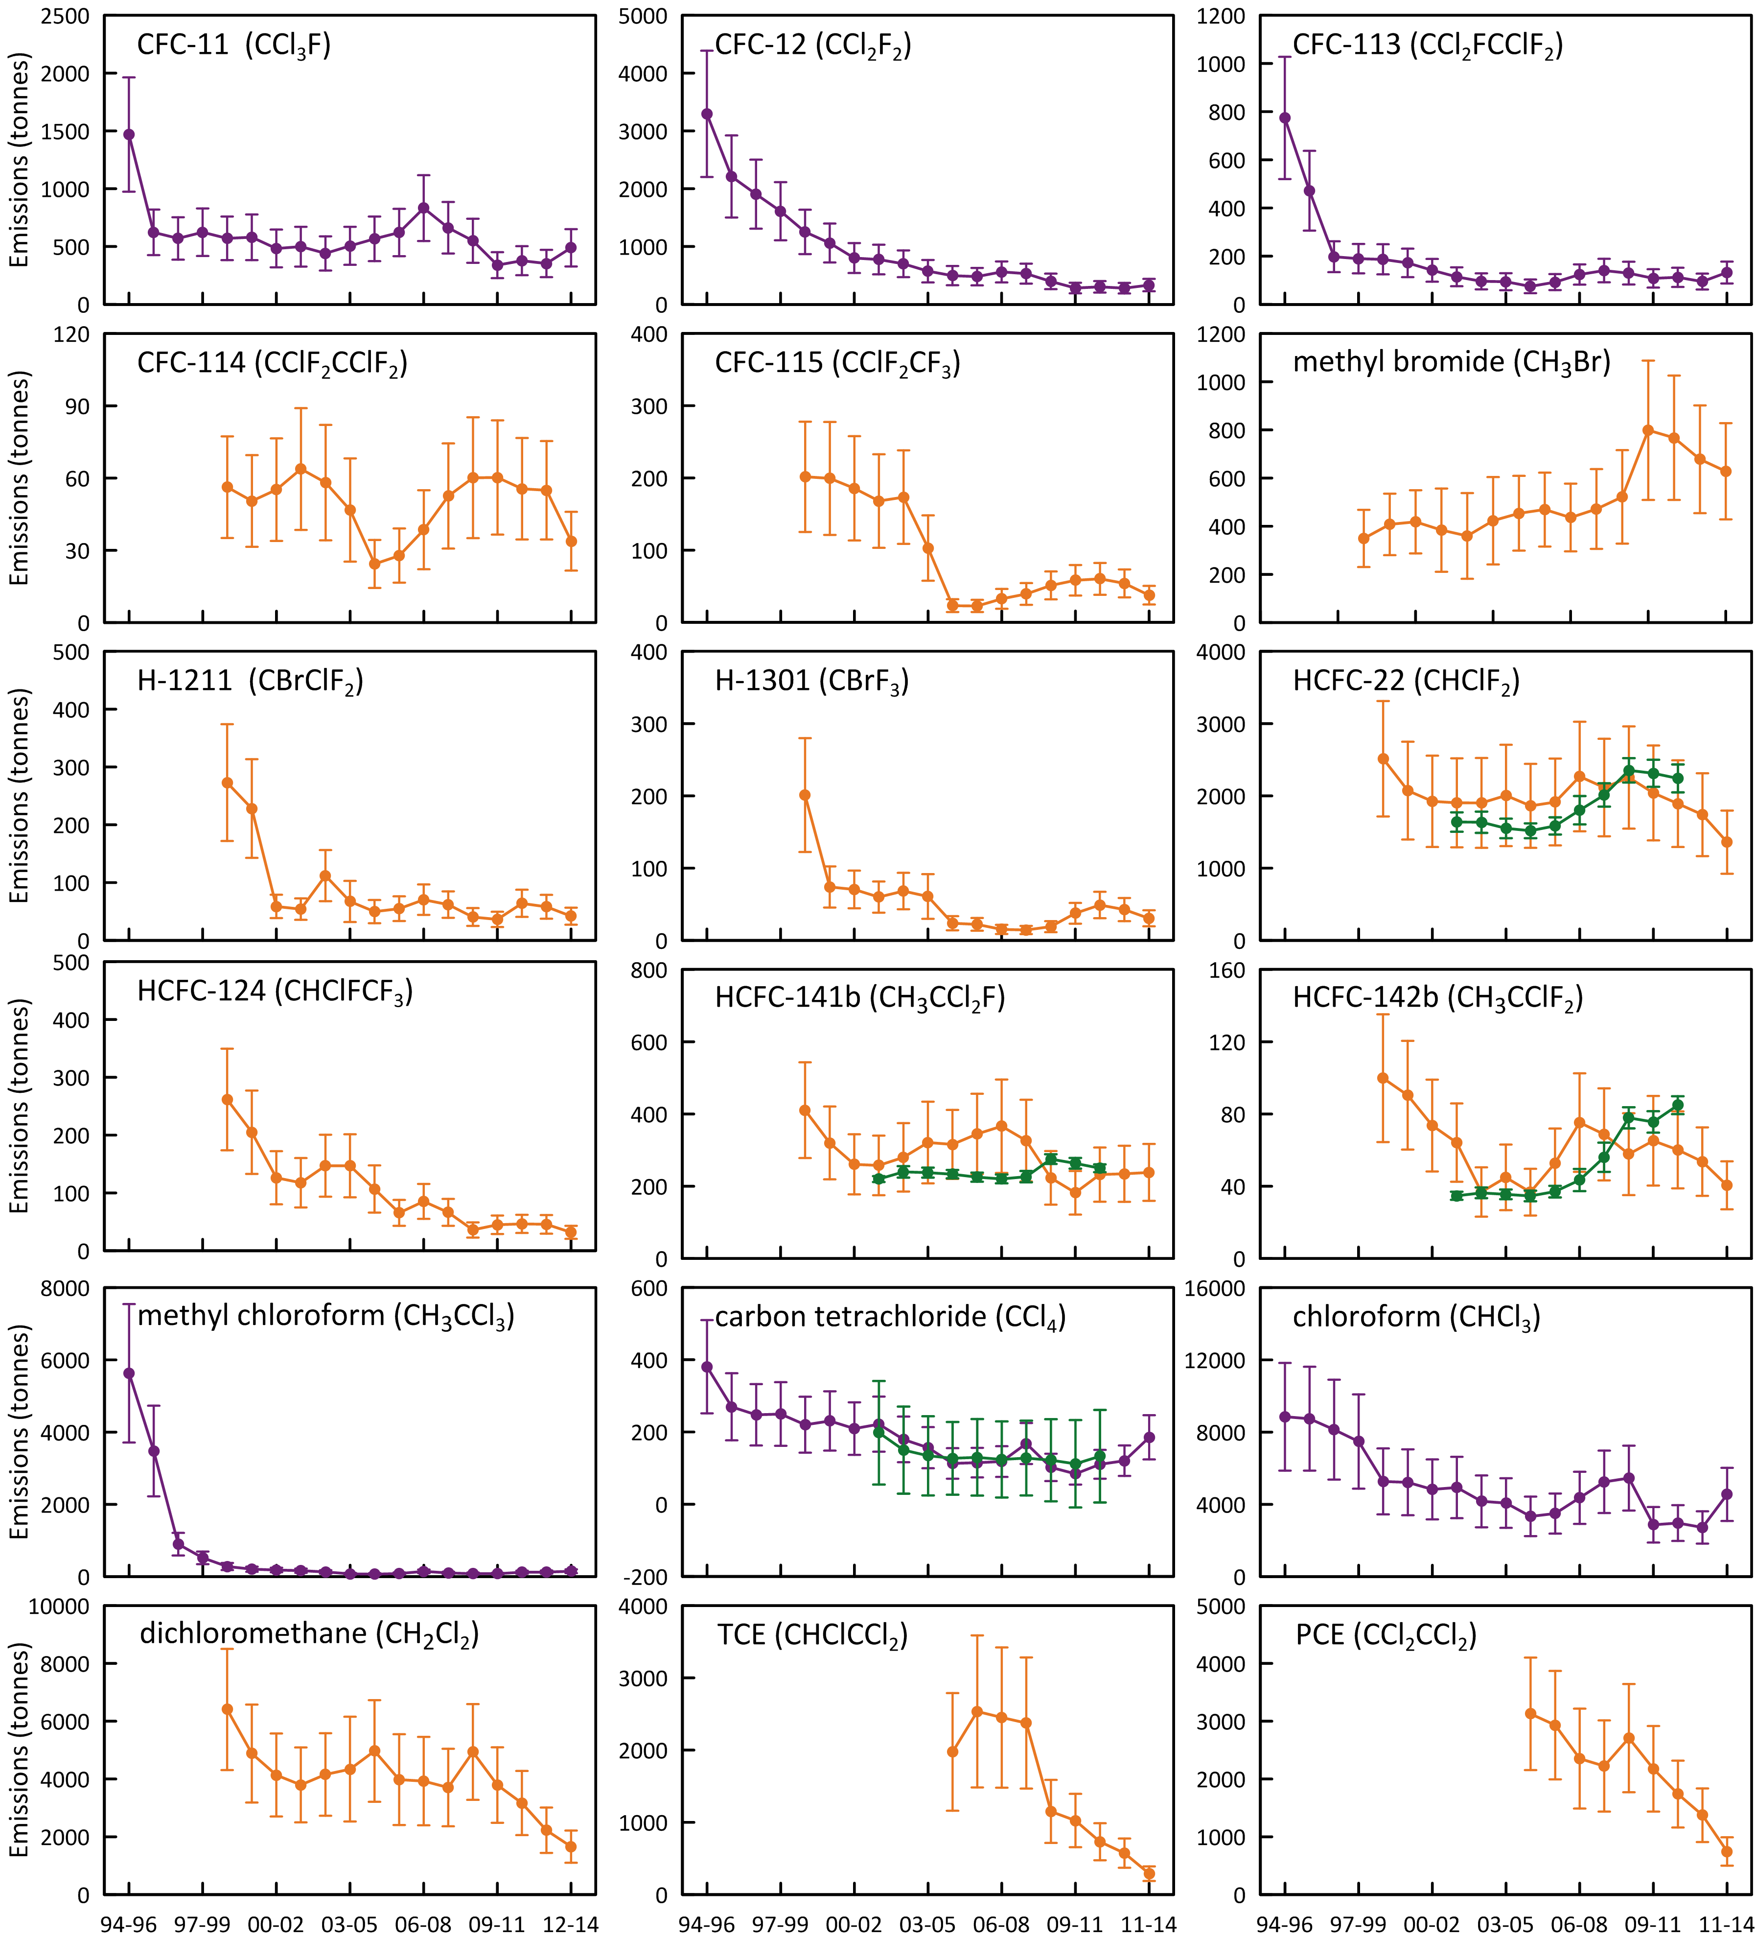

**Figure 9.** Annual average (3-yr running means) Australian emissions of CFCs, MB, halons, HCFCs, halons and chlorocarbons (MC, CTC, chloroform, dichloromethane, TCE, PCE) from Cape Grim AGAGE data, using ISC techniques. Australian emissions are scaled from SE Australian emissions on a population basis; MB emissions are for SE Australia only. NAME emissions are show in green.

**Table 3.** Annual average (3-yr running means, i.e. 2013 = average of 2012, 2013, 2014) Australian emissions (metric tonnes unless otherwise stated) of ODSs (CFCs, HCFCs, halons, MB and chlorocarbons) from Cape Grim AGAGE data, using ISC techniques. Australian emissions are scaled from SE Australian emissions on a population basis; Australian halon emissions are from SE Australian emissions adjusted for the impact of emissions from the National Halon Bank in Melbourne; Australian MB emissions are from SE Australian emissions scaled to Australian emissions using a DPI-modified UNEP model of MB emissions based on QPS and non-QPS MB consumption (see text). GWPs (to calculate CO2-e emissions) are from Forster & Ramaswamy (2007); ODPs (to calculate ODP-weighted emissions) are from Montzka & Reimann (2011); assumed GWPs for TCE (0.67) and PCE (0.53). Pre-1999 emissions of CFC-114, -115, HCFCs, halons and dichloromethane (shown in red) are assumed equal to 1999 emissions; pre-2005 emissions of TCE and PCE (shown in red) are assumed equal to 2005 emissions.

|  | 1995 | 1996 | 1997 | 1998 | 1999 | 2000 | 2001 | 2002 | 2003 | 2004 | 2005 | 2006 | 2007 | 2008 | 2009 | 2010 | 2011 | 2012 | 2013 |
| --- | --- | --- | --- | --- | --- | --- | --- | --- | --- | --- | --- | --- | --- | --- | --- | --- | --- | --- | --- |
| **CFCs** | | | | | | | | | | | | | | | | | | | |
| CFC-11 | 1468 | 622 | 570 | 624 | 571 | 580 | 483 | 499 | 440 | 506 | 566 | 621 | 831 | 662 | 550 | 339 | 377 | 353 | 489 |
| CFC-12 | 3295 | 2212 | 1907 | 1611 | 1253 | 1060 | 801 | 775 | 701 | 574 | 496 | 479 | 561 | 532 | 395 | 282 | 302 | 279 | 333 |
| CFC-113 | 774 | 471 | 198 | 190 | 187 | 172 | 141 | 114 | 95 | 94 | 75 | 92 | 124 | 140 | 130 | 108 | 112 | 94 | 132 |
| CFC-114 | 56 | 56 | 56 | 56 | 56 | 50 | 55 | 64 | 58 | 47 | 24 | 28 | 39 | 53 | 60 | 60 | 56 | 55 | 34 |
| CFC-115 | 202 | 202 | 202 | 202 | 202 | 199 | 186 | 168 | 173 | 103 | 23 | 23 | 33 | 39 | 51 | 58 | 60 | 54 | 38 |
| total | 5538 | 3305 | 2674 | 2424 | 2011 | 1813 | 1425 | 1388 | 1237 | 1174 | 1137 | 1192 | 1516 | 1334 | 1075 | 729 | 792 | 726 | 954 |
| ODP tonnes | 5560 | 3388 | 2812 | 2564 | 2150 | 1948 | 1563 | 1530 | 1380 | 1263 | 1160 | 1215 | 1550 | 1382 | 1140 | 803 | 861 | 795 | 984 |
| M tonnes CO2-e | 49.7 | 32.0 | 26.7 | 23.7 | 19.6 | 17.3 | 13.8 | 13.4 | 12.2 | 10.5 | 9.0 | 9.2 | 11.4 | 10.6 | 8.7 | 6.4 | 6.8 | 6.2 | 7.4 |
| **HCFCs** | | | | | | | | | | | | | | | | | | | |
| HCFC-22 | 2514 | 2514 | 2514 | 2514 | 2514 | 2073 | 1924 | 1904 | 1903 | 2007 | 1861 | 1915 | 2269 | 2116 | 2254 | 2041 | 1892 | 1740 | 1360 |
| HCFC-124 | 262 | 262 | 262 | 262 | 262 | 205 | 126 | 118 | 147 | 147 | 107 | 66 | 85 | 66 | 36 | 45 | 47 | 46 | 32 |
| HCFC-142b | 100 | 100 | 100 | 100 | 100 | 90 | 74 | 64 | 37 | 45 | 37 | 53 | 75 | 69 | 58 | 65 | 60 | 54 | 41 |
| HCFC-141b | 411 | 411 | 411 | 411 | 411 | 320 | 261 | 258 | 280 | 321 | 316 | 345 | 366 | 326 | 223 | 182 | 232 | 234 | 238 |
| total | 3286 | 3286 | 3286 | 3286 | 3286 | 2689 | 2384 | 2344 | 2367 | 2520 | 2321 | 2379 | 2795 | 2578 | 2571 | 2333 | 2231 | 2074 | 1670 |
| ODP tonnes | 196 | 196 | 196 | 196 | 196 | 160 | 142 | 140 | 141 | 152 | 142 | 148 | 172 | 158 | 153 | 137 | 135 | 126 | 104 |
| M tonnes CO2-e | 5.2 | 5.2 | 5.2 | 5.2 | 5.2 | 4.3 | 3.9 | 3.9 | 3.8 | 4.1 | 3.7 | 3.9 | 4.6 | 4.3 | 4.4 | 4.0 | 3.8 | 3.5 | 2.7 |
| **Halons** | | | | | | | | | | | | | | | | | | | |
| H-1211 | 273 | 273 | 273 | 273 | 273 | 228 | 59 | 54 | 112 | 67 | 50 | 55 | 70 | 62 | 41 | 36 | 64 | 58 | 42 |
| H-1301 | 201 | 201 | 201 | 201 | 201 | 74 | 70 | 60 | 68 | 61 | 24 | 22 | 15 | 14 | 19 | 38 | 49 | 43 | 31 |
| total | 474 | 474 | 474 | 474 | 474 | 302 | 129 | 114 | 180 | 128 | 74 | 77 | 86 | 76 | 60 | 74 | 113 | 101 | 72 |
| ODP tonnes | 2830 | 2830 | 2830 | 2830 | 2830 | 1425 | 881 | 762 | 1019 | 810 | 387 | 387 | 363 | 330 | 312 | 485 | 682 | 601 | 431 |
| M tonnes CO2-e | 1.7 | 1.7 | 1.7 | 1.7 | 1.7 | 0.81 | 0.56 | 0.48 | 0.62 | 0.51 | 0.23 | 0.22 | 0.20 | 0.18 | 0.18 | 0.31 | 0.42 | 0.37 | 0.27 |
| **methyl bromide** | | | | | | | | | | | | | | | | | | | |
| methyl bromide (MB) | 297 | 326 | 337 | 349 | 372 | 433 | 434 | 397 | 341 | 424 | 492 | 507 | 435 | 484 | 535 | 790 | 778 | 678 | 627 |
| ODP tonnes | 178 | 196 | 202 | 210 | 223 | 260 | 261 | 238 | 204 | 254 | 295 | 304 | 261 | 290 | 321 | 474 | 467 | 407 | 376 |
| k tonnes CO2-e | 1.5 | 1.6 | 1.7 | 1.7 | 1.9 | 2.2 | 2.2 | 2.0 | 1.7 | 2.1 | 2.5 | 2.5 | 2.2 | 2.4 | 2.7 | 3.9 | 3.9 | 3.4 | 3.1 |
| **chlorocarbons (MP)** | | | | | | | | | | | | | | | | | | | |
| carbon tetrachloride (CTC) | 381 | 270 | 248 | 250 | 220 | 231 | 209 | 222 | 179 | 156 | 113 | 115 | 118 | 168 | 102 | 84 | 110 | 120 | 185 |
| methyl chloroform (MC) | 5629 | 3477 | 899 | 519 | 282 | 205 | 184 | 165 | 130 | 78 | 71 | 87 | 145 | 103 | 82 | 79 | 120 | 125 | 149 |
| total | 6009 | 3747 | 1147 | 769 | 502 | 436 | 393 | 386 | 309 | 234 | 184 | 202 | 264 | 271 | 184 | 164 | 231 | 246 | 334 |
| ODP tonnes | 981 | 644 | 362 | 327 | 270 | 274 | 249 | 260 | 210 | 180 | 131 | 135 | 145 | 195 | 121 | 101 | 134 | 145 | 218 |
| M tonnes CO2-e | 1.5 | 0.99 | 0.58 | 0.53 | 0.44 | 0.44 | 0.40 | 0.42 | 0.34 | 0.29 | 0.21 | 0.22 | 0.23 | 0.32 | 0.20 | 0.16 | 0.22 | 0.24 | 0.35 |
| **Montreal Protocol (MP) ODSs** | | | | | | | | | | | | | | | | | | | |
| MP ODSs (k tonnes) | 16 | 11 | 7.9 | 7.3 | 6.6 | 5.7 | 4.8 | 4.6 | 4.4 | 4.5 | 4.2 | 4.4 | 5.1 | 4.7 | 4.4 | 4.1 | 4.1 | 3.8 | 3.7 |
| ODP (k tonnes) | 9.7 | 7.3 | 6.4 | 6.1 | 5.7 | 4.1 | 3.1 | 2.9 | 3.0 | 2.7 | 2.1 | 2.2 | 2.5 | 2.4 | 2.0 | 2.0 | 2.3 | 2.1 | 2.1 |
| M tonnes CO2-e | 58 | 40 | 34 | 31 | 27 | 23 | 19 | 18 | 17 | 15 | 13 | 14 | 16 | 15 | 13 | 11 | 11 | 10 | 11 |
| **other chlorocarbons** | | | | | | | | | | | | | | | | | | | |
| dichloromethane | 6406 | 6406 | 6406 | 6406 | 6406 | 4881 | 4137 | 3798 | 4154 | 4340 | 4970 | 3979 | 3928 | 3706 | 4933 | 3790 | 3168 | 2228 | 1660 |
| chloroform | 8852 | 8742 | 8137 | 7480 | 5270 | 5224 | 4831 | 4934 | 4167 | 4072 | 3336 | 3492 | 4363 | 5247 | 5455 | 2868 | 2967 | 2724 | 4554 |
| perchloroethylene (PCE) | 3128 | 3128 | 3128 | 3128 | 3128 | 3128 | 3128 | 3128 | 3128 | 3128 | 3128 | 2931 | 2354 | 2224 | 2707 | 2176 | 1740 | 1374 | 747 |
| trichloroethylene (TCE) | 1974 | 1974 | 1974 | 1974 | 1974 | 1974 | 1974 | 1974 | 1974 | 1974 | 1974 | 2535 | 2451 | 2375 | 1151 | 1025 | 731 | 574 | 290 |
| total (k tonnes) | 20 | 20 | 20 | 19 | 17 | 15 | 14 | 14 | 13 | 14 | 13 | 13 | 13 | 14 | 14 | 9.9 | 8.6 | 6.9 | 7.3 |
| ODP tonnes | 159 | 158 | 152 | 146 | 127 | 112 | 102 | 100 | 96 | 97 | 96 | 88 | 91 | 96 | 112 | 75 | 67 | 54 | 61 |
| M tonnes CO2-e | 0.37 | 0.37 | 0.35 | 0.33 | 0.26 | 0.25 | 0.23 | 0.23 | 0.21 | 0.21 | 0.19 | 0.19 | 0.21 | 0.23 | 0.24 | 0.15 | 0.14 | 0.12 | 0.16 |
| **all ODSs** | | | | | | | | | | | | | | | | | | | |
| all ODS (k tonnes) | 36 | 31 | 28 | 26 | 23 | 21 | 19 | 18 | 18 | 18 | 18 | 17 | 18 | 18 | 19 | 14 | 13 | 11 | 11 |
| ODP k tonnes | 9.9 | 7.4 | 6.6 | 6.3 | 5.8 | 4.2 | 3.2 | 3.0 | 3.1 | 2.8 | 2.2 | 2.3 | 2.6 | 2.5 | 2.2 | 2.1 | 2.3 | 2.1 | 2.2 |
| M tonnes CO2-e | 59 | 40 | 35 | 32 | 27 | 23 | 19 | 18 | 17 | 16 | 13 | 14 | 17 | 16 | 14 | 11 | 11 | 10 | 11 |

## CFCs

Apart from 1995, when Australian CFC-11 emissions were likely above 1400 tonnes, CFC-11 emissions have averaged about 550 tonnes from 1996 to 2013 (Table 3, Figure 9). CFC-11 emissions increased from 2003 (440 tonnes) to 2007 (831 tonnes) - the cause of this increase is unclear. Since 2007 CFC-11 emissions have declined to about 400 tonnes per year (2010-2012), rising again in 2013 to 489 tonnes. CFC-12 emissions have declined steadily since 1995 (3295 tonnes) to just over 300 tonnes by 2013, a long-term decline of 13% per year. CFC-113 emissions declined rapidly from over 750 tonnes in 1995 to about 150 tonnes in the early 2000s, averaging close to 100 tonnes per year from over the past decade (2003-2013).

Why would the pattern of the decline in Australian CFC-11 emissions look different than that for CFC-12? CFC-12 emissions are likely largely from old (but still functional) and discarded refrigeration and air-conditioning equipment and aerosol cans, whereas CFC-11 emissions are likely from existing and discarded aerosol cans and equipment with foam insulation. The CFC-12 emissions can be, and may have been, mitigated (captured) to some extent, whereas the CFC-11 emissions from foams and aerosol cans are unlikely to have been mitigated. This may offer an explanation for the observed behaviour, with CFC-12 emissions declining relatively smoothly and monotonically, while CFC-11 emissions show a local maximum in 2007, which may have corresponded to the year when old CFC equipment/products were reaching the end-of-life.

Total Australian CFC, HCFC, halon and CTC emissions are shown in Figure 10. The overall decline in CFC emissions from 1995 (5500 tonnes) to 2013 (954 tonnes) is 8% per year. ODP weighted CFC emissions have fallen from 5560 tonnes in 1995 to 984 tonnes in 2013 (8% per year). Australian ODP-weighted CFC emissions in 2013 (984 tonnes) were 1.2% of global CFC emissions (84 k tonnes - 2013). Australian ODP-weighted CFC emissions (984 tonnes) are currently (2013) about 47% of Australia’s Montreal Protocol ODS (ODP-weighted) emissions (2100 tonnes).

CFC emissions are presumed to be from CFC-containing appliances/materials (refrigeration/ac equipment, foams, aerosol cans), either existing or buried (land-fills). If the current total emissions (~950 tonnes/yr) continue to decline at 8%/yr, it will take 28 years for Australian CFC emissions to drop below 100 tonnes/yr.

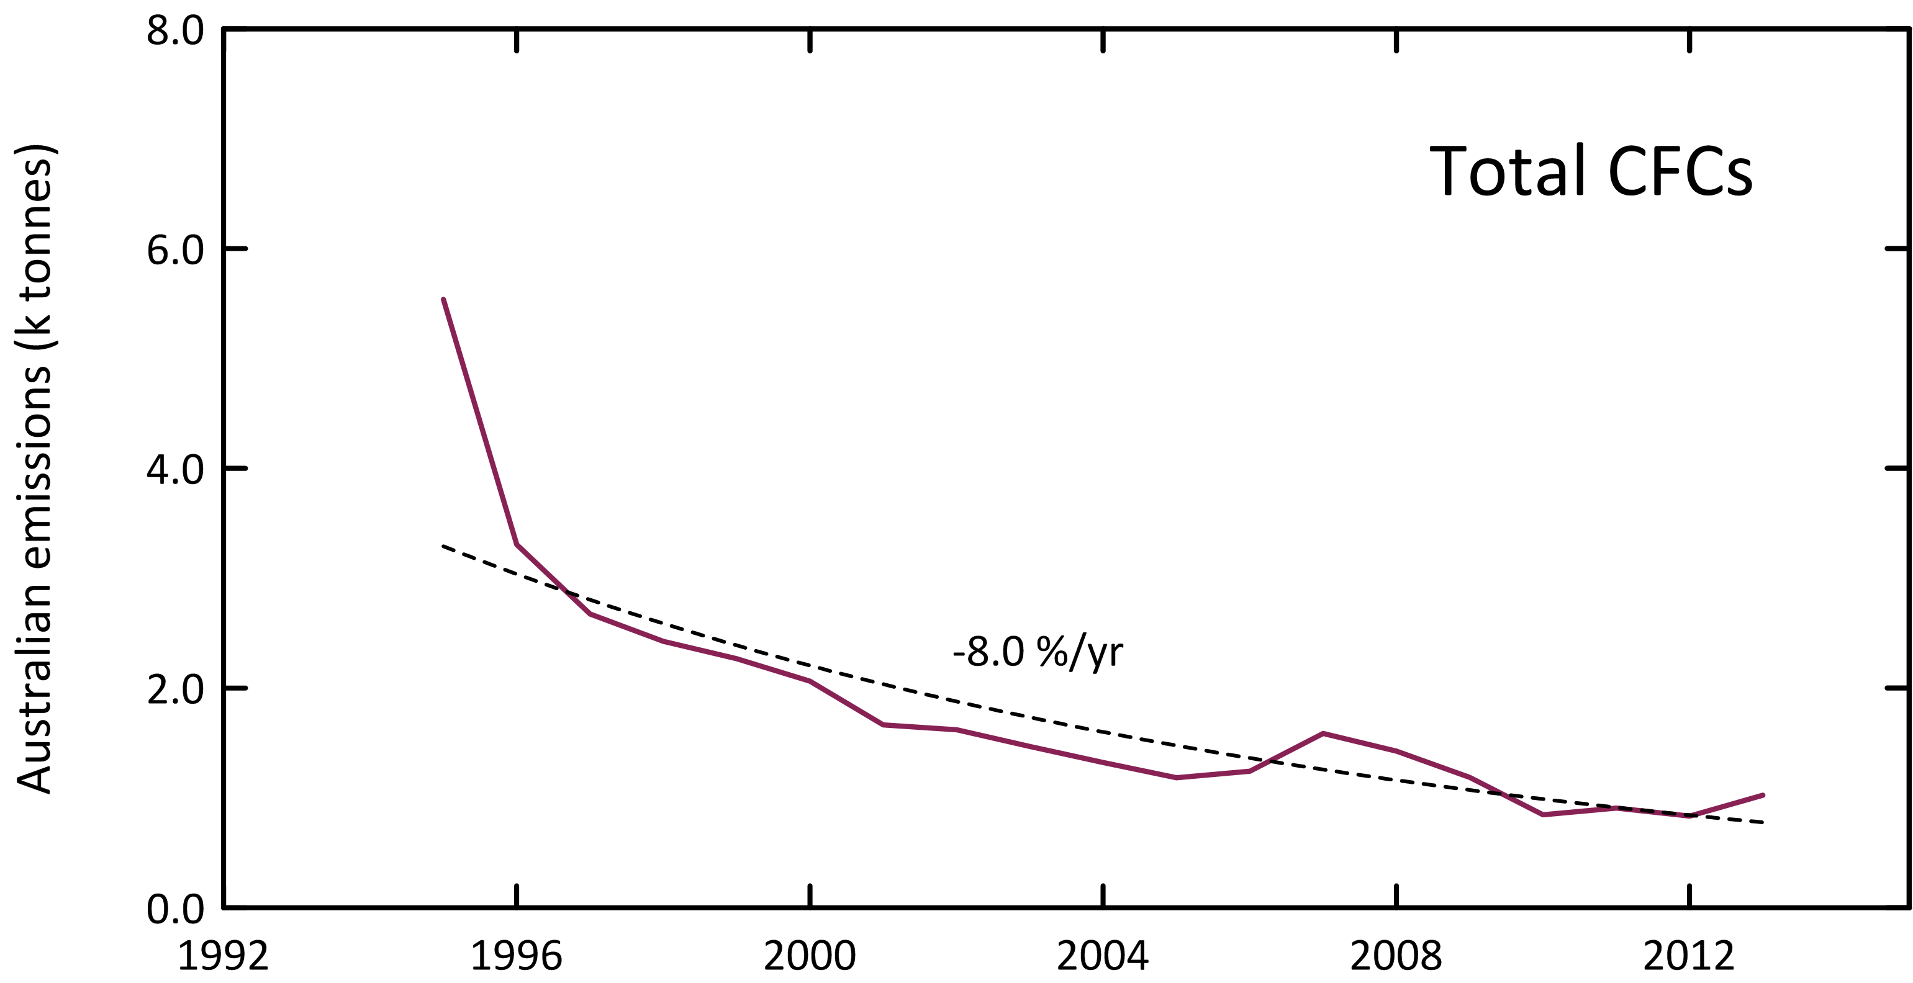

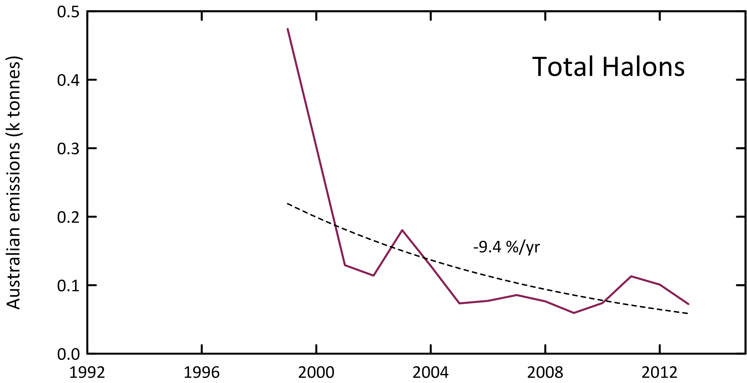

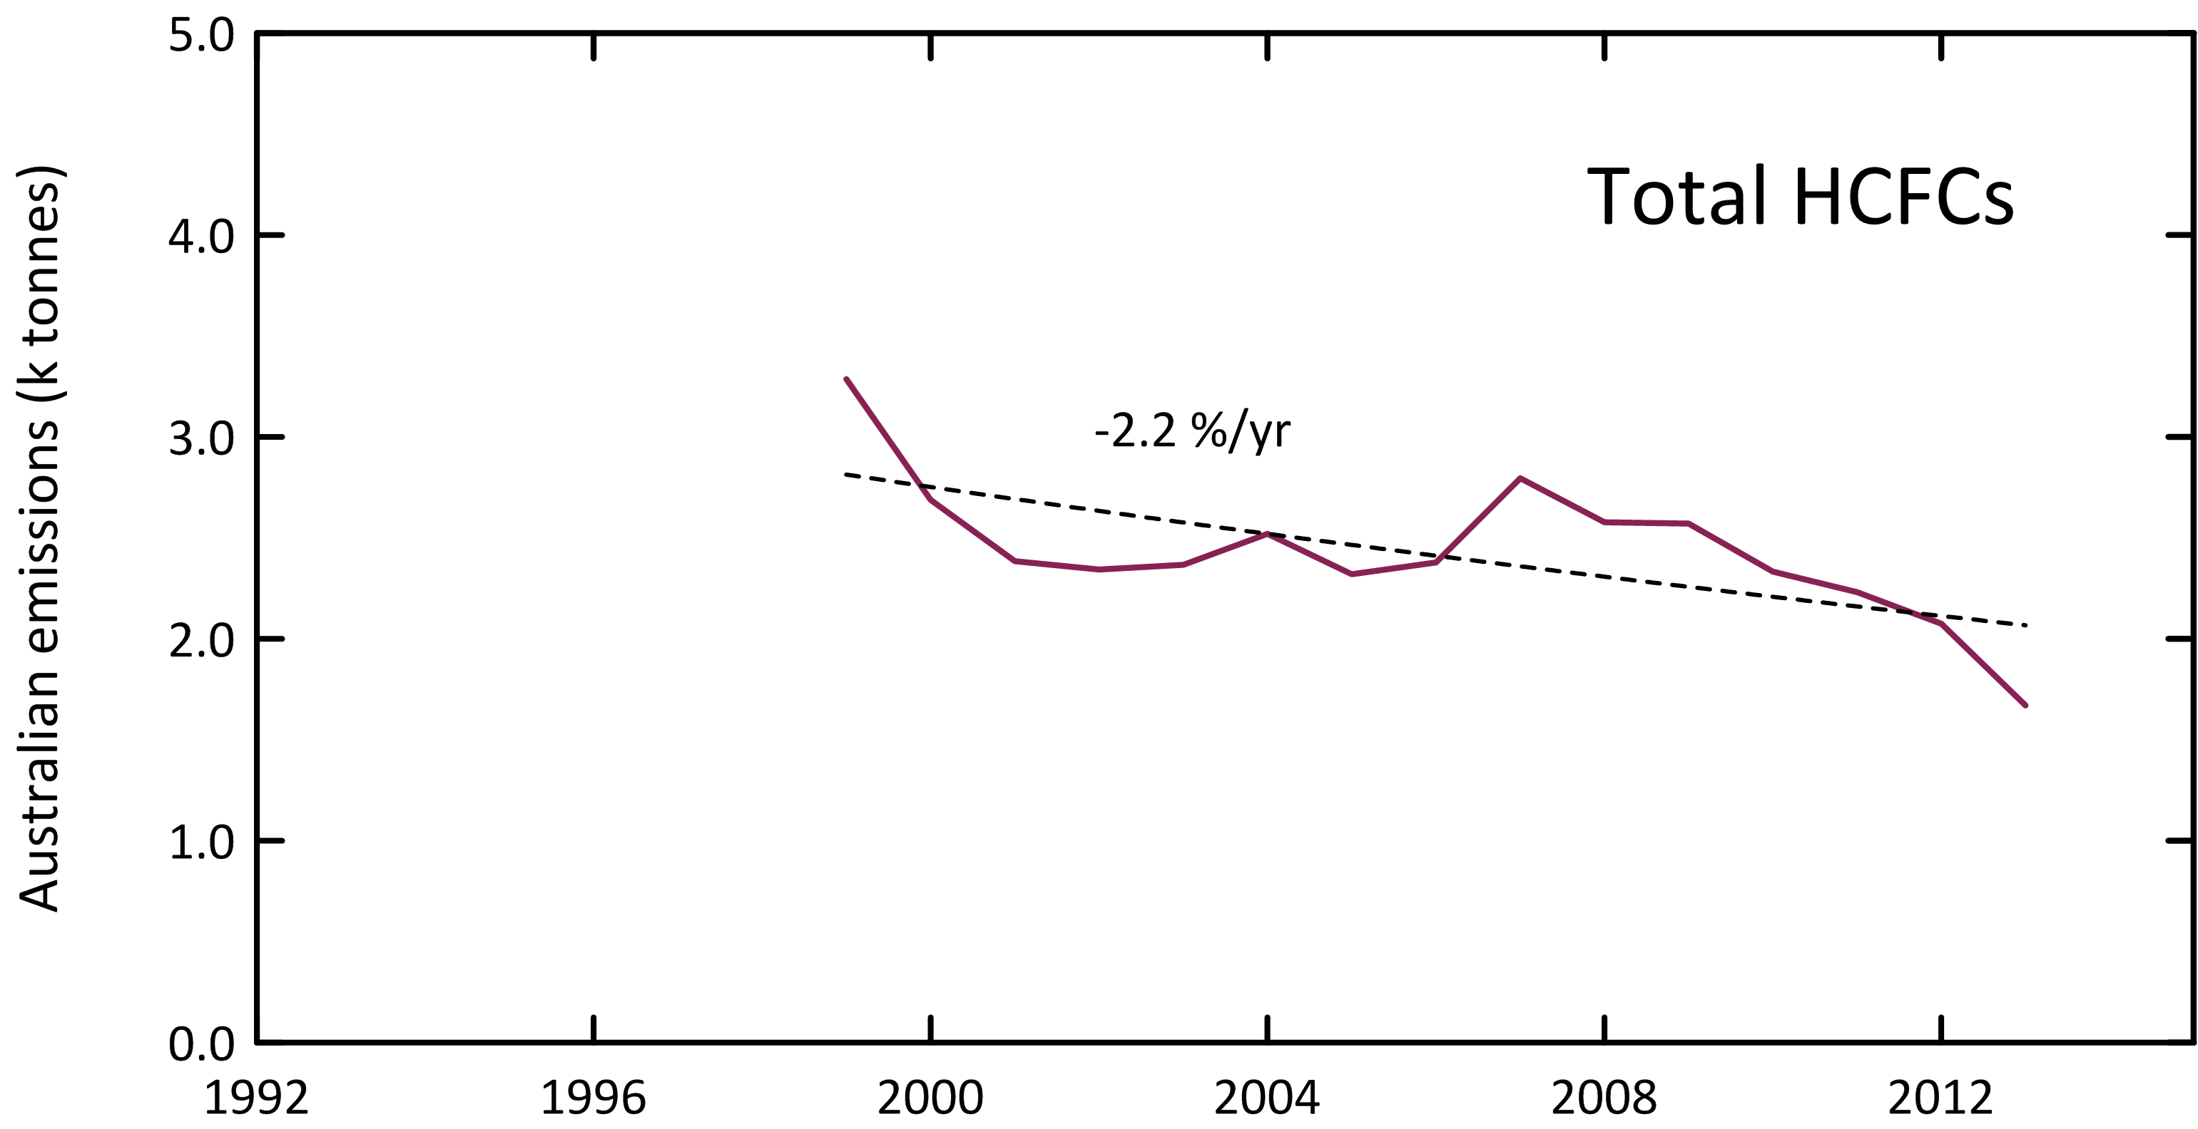

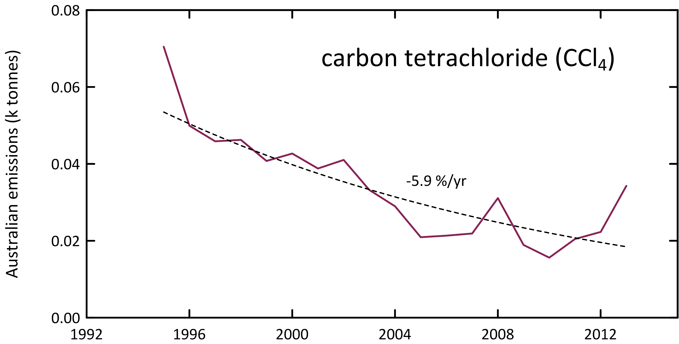

**Figure 10.** Declining Australian CFC, HCFC, halon and CTC emissions (k tonnes).

## HCFCs

There has been an overall decline in Australian HCFC-22 emissions from 2,500 tonnes in 1999 to under 1,400 tonnes in 2013 (4% per year over this period) (Table 3, Figure 9). HCFC-22 emissions increased between 2005 (1,860 tonnes) and 2009 (2,250 tonnes) before declining rapidly (8% per year) to the 2013 level (1,360 tonnes). Australian HCFC-22 emissions for 2013 (1,360 tonnes) were about 20% lower than 2012 emissions. This is consistent with the 15% decline in the installed HCFC-22 bank estimated for 2012-2013. Australian HCFC-22 emissions have been estimated by inverse modelling (NAME, Figure 9) for the period 2002-2011. The overall agreement with ISC estimates is good, with average NAME emissions being 10% lower than ISC emissions.

Australian consumption of HCFC-22 in the refrigeration/air conditioning (ac) industry in 2012-2013 (which likely are approximately equal to emissions from refrigeration/ac has been estimated at 800-900 tonnes/yr with about 200 tonnes/yr sourced from recycled HCFC-22 (Brodribb & McCann, 2013, 2014), the remaining 600-700 tonnes presumably sourced from imports, which is consistent with Australia import data (Table 2).

The Australian HCFC-22 bank in operational refrigeration/air conditioning equipment has been estimated at ~10,000 tonnes (an implied leak rate of ~10%/yr) (Brodribb & McCann, 2013, 2014). Presumably the additional HCFC-22 emissions implied from the Cape Grim data are from non-operational refrigeration/ac equipment and other HCFC-22-containing products (plastic foams, aerosol cans), emanating largely from landfills. The HCFC-22 bank has dropped by 15% from 2012 to 2013 (~11,200 tonnes to ~9,600 tonnes).

HCFC-22 emissions as a function of the HCFC-22 bank are shown in Figure 11. There is a linear relationship between emissions and bank size, with an implied overall emission factor from operational refrigeration equipment of 15%/yr, if all HCFC-22 emissions are from the bank (i.e. zero bank = zero emissions). This is the upper limit of HCFC-22 emissions from the bank, assuming zero emissions from landfills.

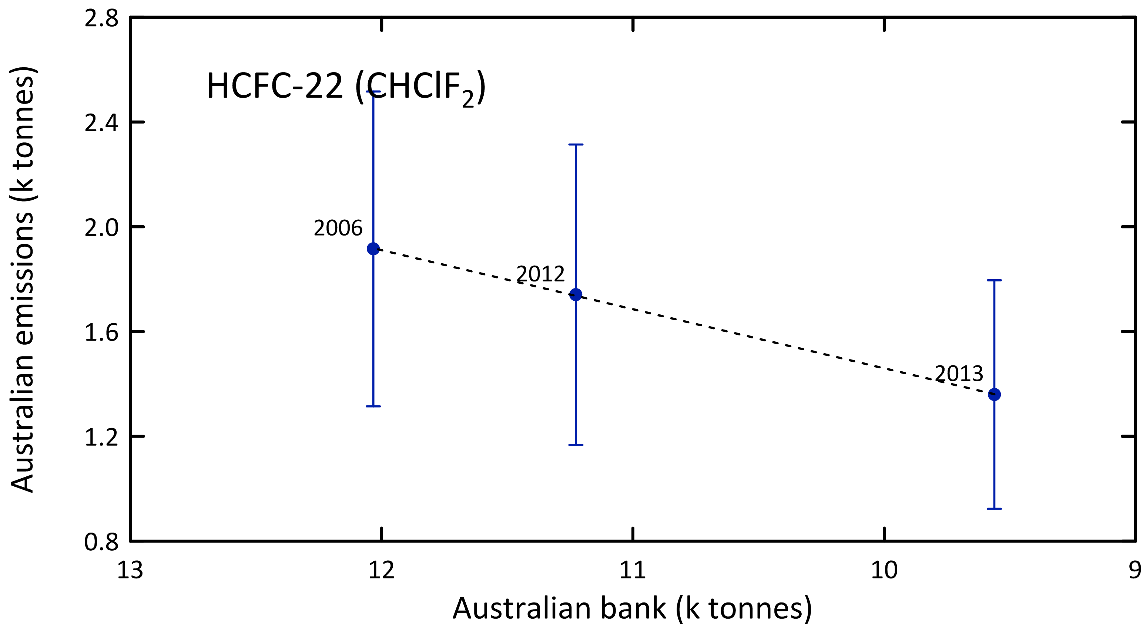

**Figure 11.** Australian HCFC-22 emissions (k tonnes) as a function of the HCFC-22 bank (k tonnes). The dashed line is a linear regression: slope = 0.22 tonnes/tonne banked; a linear regression through the origin gives 0.15 tonnes/tonne banked. The corresponding years for each (emission, bank) point are shown.

HCFC-124 emissions have declined steadily from 260 tonnes in 1999 to under 40 tonnes in 2009 (a decline of nearly 20% per year), staying steady at about 40 tonnes per year (2009-2013).

HCFC-141b emissions have fluctuated over the period 1999-2014, falling from over 400 tonnes in 1999 to 260 tonnes in 2002, rising again to 370 tonnes in 2007 before falling to about 230 tonnes in 2011, and remaining at that level for 2012, 2013. Australian HCFC-141b emissions have been estimated by inverse modelling (NAME, Figure 9) for the period 2002-2011. The overall agreement with ISC estimates is reasonable, with average NAME emissions being 20% lower than ISC emissions.

HCFC-142b emissions have followed a somewhat similar pattern, falling from 100 tonnes in 1999 to 40 tonnes in 2003, rising to 75 tonnes in 2007 before falling back to 40 tonnes in 2013. Australian HCFC-141b emissions have been estimated by inverse modelling (NAME, Figure 9) for the period 2002-2011. The overall agreement with ISC estimates is reasonable, with average NAME emissions being 20% lower than ISC emissions (the same as the HCFC-141b comparison).

Total HCFC emissions (Figure 10) have fallen by about 50% from 3,300 tonnes in 1999 to under 1,700 tonnes in 2013, an overall decline of 2.2% per year. ODP-weighted HCFC emissions have fallen from 196 tonnes in 1999 to 104 tonnes in 2013, 5% of Australia’s Montreal Protocol ODS (ODP-weighted) emissions in 2013 (2,100 tonnes). GWP-weighted HCFC emissions have fallen from 5.2 M tonnes CO2-e in 1999 to 2.7 M tonnes CO2-e in 2013, an overall decline of about 50%.

Australian HCFC emissions are likely from a combination of service and malfunction leaks from existing refrigeration/ac equipment and from land-fills. Australian HCFC emissions in 2013 (1,670 tonnes) were 0.4% of global HCFC emissions (470 k tonnes) on a metric tonne basis.

## Halons

Australian halon emissions fell from over 300 tonnes in 1999-2000 to 100-150 tonnes in 2001-2004 to 75±10 tonnes in 2005-2010, rising again to 100-110 tonnes in 2011-2012, before falling again to about 75 tonnes in 2013 (Figure 9, Figure 10). Approximately 65% of SE Australian halon emissions are H-1211, 35% H-1301. The reason for the increase in halon emissions during 2011-2012 is not obvious. SE Australian halon emissions are likely to show significant inter-annual variability (see discussion below).

Australian halon emissions are likely to originate from existing building fire-fighting systems (largely H-1301) and existing portable fire extinguishers (largely H-1211). It is not appropriate to directly scale the SE Australian halon emissions (as determined from Cape Grim data) to Australian emissions on a population basis. This is because the Melbourne/Port Philip region contains an additional likely halon source, the National Halon Bank. The Bank collected about 5 tonnes of halon in 2014, with a loss rate of less than 2% (100 kg) and has stored a total of about 550 tonnes of halons by 2013 (140 tonnes H-1211, 410 tonnes H-1301) (E. Nigido, A-Gas (Australia) Pty. Ltd., personal communications, May 2014 and August 2015). Assuming that typical leaks from the storage of halons are of the order of 1-2%/yr, then halon emissions from the Halon Bank could be 5-10 tonnes/year. This is a significant component (perhaps 10%) of SE Australian halon emissions. The Australian halon emissions shown in Table 3 are the sum of Halon Bank emissions and Australian non-Halon Bank emissions. The SE Australian non-Halon Bank emissions are obtained from SE Australian Halon emissions (from Cape Grim data) by subtracting the Halon Bank emissions. Australian non-Halon Bank emissions equal SE Australian non-Halon Bank emissions scaled by population.

Recent data suggest that emissions from the stored halons in the National Halon Bank are significantly less than 1% per year (E. Nigido, A-Gas (Australia) Pty. Ltd., personal communication, August 2015). This interpretation of Australian halon emissions based on Cape Grim data and these low halon emissions from the Bank will be revisited in the 2016 Report.

## Methyl bromide

Methyl bromide (MB) is used in Australia as a fumigant for cereals, such as wheat, and for cottonseed and timber logs prior to export and also as a soil sterilant, during the production of strawberry runners. The former uses are QPS, which are exempted from Montreal Protocol controls, and the latter use is non-QPS (n-QPS), which is restricted by the Montreal Protocol and for which Australia has to apply for a Critical Use Exemption (CUE) under the Montreal Protocol on an annual basis.

Grain exported from SE Australian grain terminals account for 35-40% of Australia’s grain exports (National Transport Commission, 2008; GrainCorp, 2012) and thus likely 35-40% of Australia’s QPS use of MB. A UNEP model of MB emissions suggests that 80-90% of MB QPS use escapes to the atmosphere (UNEP, 2007). This suggests that about 30±10% of Australia’s QPS imports are emitted into the SE Australian atmosphere 100% of Australia’s current n-QPS MB use occurs around Toolangi, NE of Melbourne, for growing strawberry runners as a previous use for rice fumigation has now ceased (unlikely to be seen in the Cape Grim data). The UNEP model above assumes that 60-70% of MB n-QPS use is emitted to the atmosphere and thus perhaps 60-70% of Australia’s n-QPS MB use is emitted into the SE Australian atmosphere.

The UNEP MB emissions model may not be suitable for Australian MB consumption. It has been suggested (I. Porter, DPI Victoria, private communication) that close to 95% of QPS and about 50% of n-QPS MB are emitted to the atmosphere under Australian conditions, resulting in emissions of 625 tonnes in 2013 and 504 tonnes in 2014 (0.9%-1.1% of global emissions). Note that both models do not take into account some recapture of MB which likely occurs as a result of local requirements.

The results from the modified UNEP model of Australian MB emissions are shown in Figure 12 and compared to Australian emissions calculated from Cape Grim data by ISC in Figure 13 (also Table 3, Figure 9). It is also worth noting that using imports in any given year as a basis for estimating emissions may in unrealistic year-to year variability in calculated emissions as the amount of MB used in any year can be a sourced from both imports and stock-in-hand. However, long term growth in MB stock is unlikely – in order to diminish the impact of short-term impacts of MB stock changes, 3-yr average emissions from the model are also shown in Figure 12. The emissions from the model and derived from atmospheric data for SE Australia show reasonable overall agreement (within 15%, model lower) over the period 2003-2013. Prior to 2004, the model MB emissions were 40% higher than MB emissions derived from Cape Grim observations. Around 2004 there was a change in the Cape Grim instrument measuring MB and these early estimates of MB emissions from Cape Grim data will be re-assessed. Australian MB emissions based on ISC data increased from about 300 tonnes in 1995 to just under 800 tonnes in 2010 (a long-term increase of 6-7% per year), falling to close to 600 tonnes in 2013 (Figure 13), in excellent agreement with the emissions model. Emissions in the model fall to ~500 tonnes in 2014. It will be interesting to compare this prediction to emissions based on Cape Grim data, which will be reported next year (2014 emissions use data from 2013-2015). The 376 ODP tonnes in 2013 are about 18% of Australia’s Montreal Protocol ODS emissions in ODP tonnes.

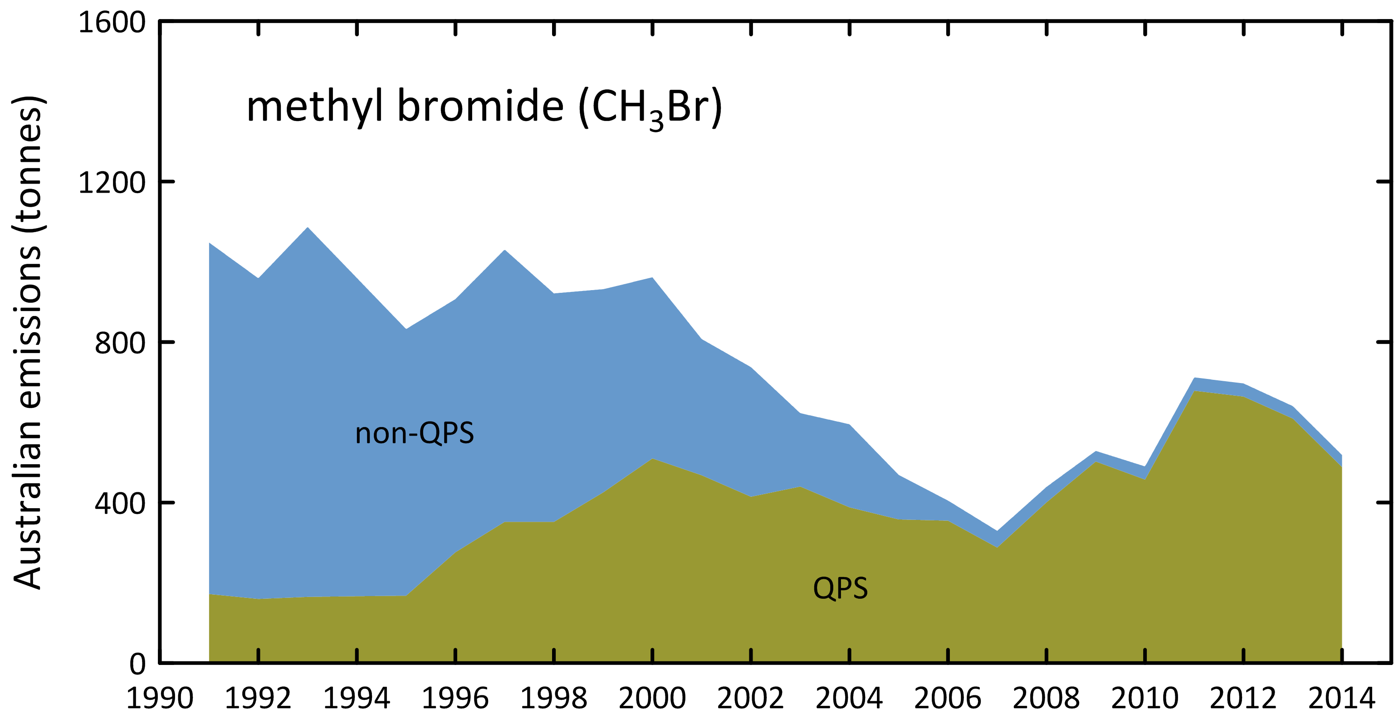

**Figure 12.** Australian MB emissions calculated from Australian MB import data and the modified UNEP emissions model (UNEP, 2007).

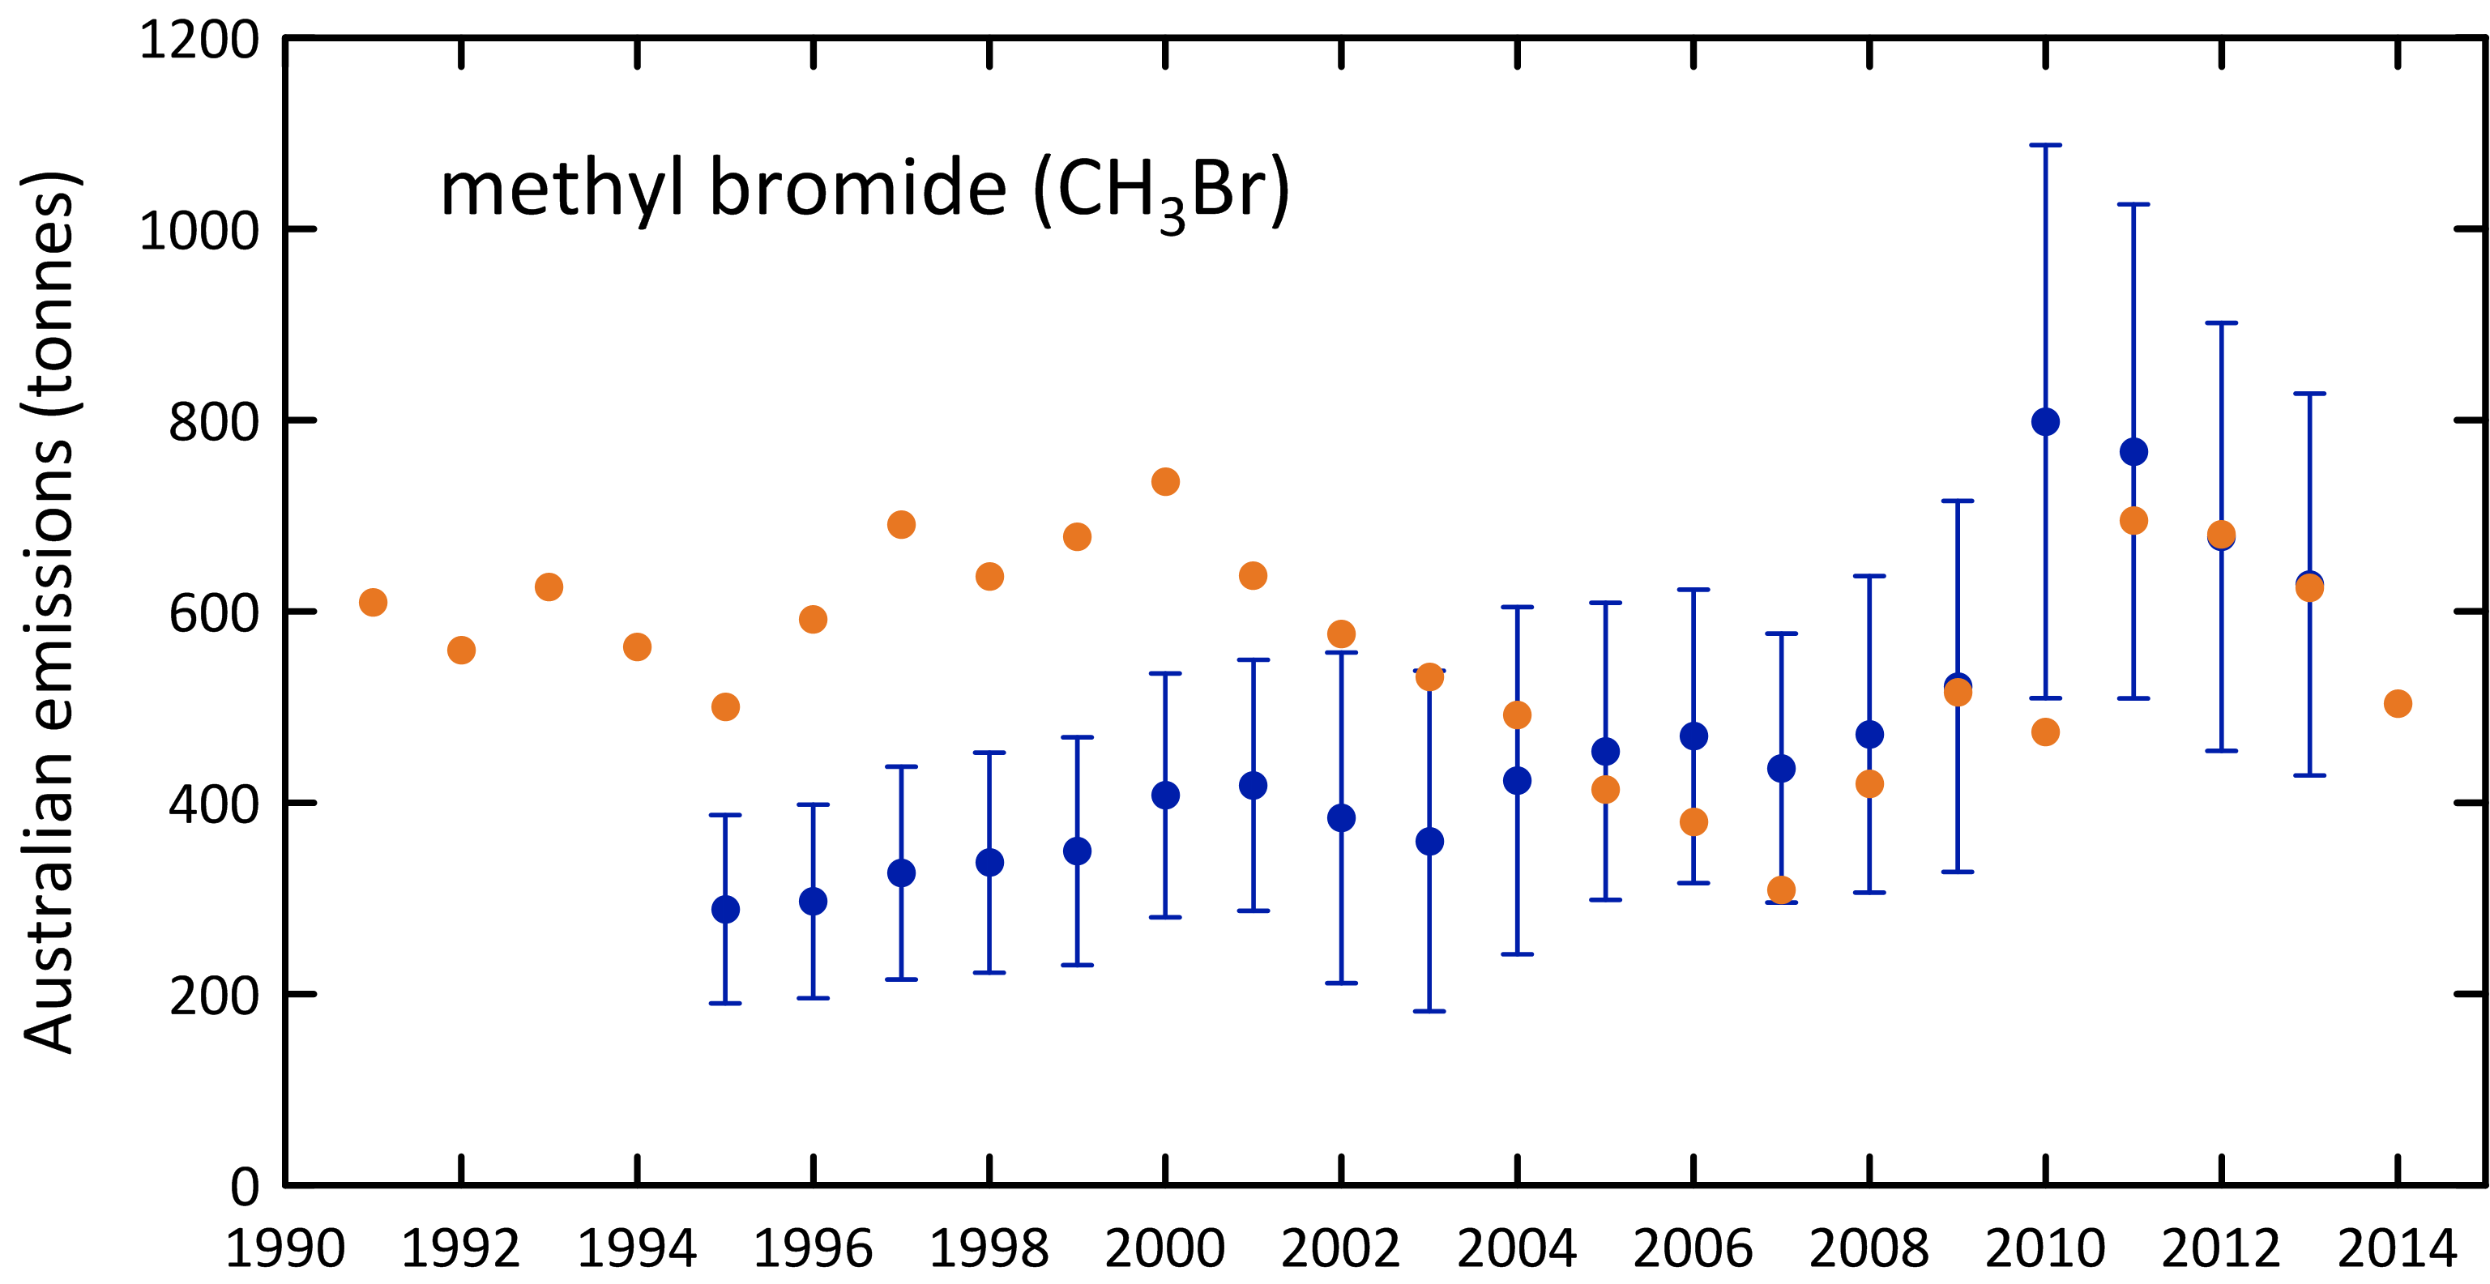

**Figure 13.** Australian MB emissions calculated (see text for details) by ISC from Cape Grim *in situ* AGAGE MB data (blue) and from the modified UNEP (2007) emissions model (orange) based on MB imports.

## Carbon tetrachloride & methyl chloroform (Montreal Protocol chlorocarbons)

Carbon tetrachloride (CTC) emissions are calculated from Cape Grim *in situ* GC-ECD data (reliable CTC data are not collected on the Cape Grim GC-MS Medusa instrument). The GC-ECD CTC data have been reprocessed for use with the recalculated Port Phillip CO emissions. The latest available estimates of Australian CTC emissions by ISC and NAME are shown in Figure 14.

Carbon tetrachloride emissions estimated by ISC were estimated to be over 370 tonnes in 1995, declining by 8% per year until falling below 100 tonnes per year for 2009-2010, remaining at about 110 tonnes per year for the period 2009-2012, rising to 185 tonnes in 2013, the highest CTC emissions obtained from Cape Grim CTC data over the past decade. Carbon tetrachloride emissions estimated using the NAME model were 198 tonnes in 2002, declining by 5% per year to 133 tonnes in 2011. Over the same period CTC emissions estimated by ISC fell by 6% per year. Overall ISC and NAME estimates of CTC emissions obtained from Cape Grim data agree to within 0.5% over this period, NAME higher.

The ISC and NAME estimates of Australian CTC emissions have been published in the peer-reviewed literature and used to identify possible ‘missing’ CTC sources on a global scale (Fraser *et al*., 2014b). These findings have been incorporated into the *Scientific Assessment of Ozone Depletion: 2014* (Carpenter & Reimann, 2014).

Australian MC emissions declined from over 5,500 tonnes in 1995 to less than 100 tonnes by 2004-2005, an overall decline of 40% per year. Methyl chloroform emissions stabilised post-2003 at about 110 tonnes per year. In 2011-2012 Australian MC emissions were 115-120 tonnes per year, 5% of global emissions in 2011-2012. In 2013 Australian MC emissions rose to just under 150 tonnes, like CTC, the highest emissions over the past decade.

The combined CTC/MC emissions totalled over 960 ODP tonnes in 1995, declining to about 120-130 tonnes in 2009-2012, an overall decline of about 12% per year. The combined CTC/MC emissions rose to just over 200 ODP tonnes in 2013. In 2011-2012 Australian MC/CTC emissions were, like HCFCs, about 6% of Australian Montreal Protocol ODS emissions.

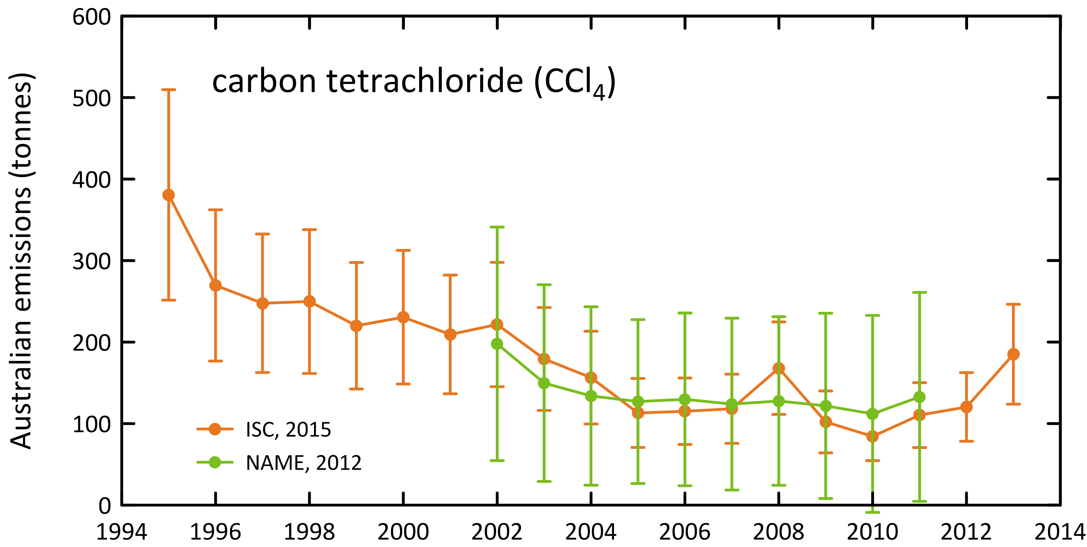

**Figure 14.** Australian CTC emissions calculated from Cape Grim *in situ* AGAGE data by ISC and inverse modelling (NAME).

## 

## Other chlorocarbons

Dichloromethane (CH2Cl2), chloroform (CHCl3), CHClCCl2 (TCE) and CCl2CCl2 (PCE) are short-lived ODSs whose production and consumption are not controlled by the Montreal Protocol. Significant emissions of all these ODSs are seen in the Cape Grim data (Figure 1).

Australian dichloromethane emissions were over 6,400 tonnes in 1999 declining by 8% per year to just over 2,200 tonnes in 2012, declining to ~1,650 tonnes in 2013. During 2000-2010 Australian dichloromethane emissions were relatively constant at about 4,000 tonnes per year. Since 2009, Australian emissions of dichloromethane have fallen by 25%/yr.

Australian chloroform emissions were over 8,600 tonnes in 1995 declining overall by 7% per year to about 2,800 tonnes in 2012, rising to over 4,000 tonnes in 2013. Emissions fell to 3,400 tonnes in 2005, rising to 5,300 tonnes in 2009 before falling to 2,800 tonnes in 2012. There are large, natural soil emissions of chloroform and it is possible that the chloroform emissions calculated from Cape Grim data contain a large, natural, difficult to quantify, component.

Australian PCE emissions were over 3,100 tonnes in 2005 declining by about 15% per year to about 750 tonnes in 2013. TCE emissions were about 2,500 tonnes in 2006 falling by 25% per year to below 300 tonnes in 2013.

Total emissions for these short-lived ODSs were 13k tonnes (96 ODP tonnes) in 2005, falling by 7% per year to 7 k tonnes (61 ODP tonnes) in 2013. The ODP-weighted emissions of these short-lived ODSs were about 2-3% of total ODS emissions (ODP weighted).

## GWP-weighted ODS emissions

The overall decline in GWP-weighted CFC emissions from 1995 (50 M tonnes CO2-e) to 2013 (7 M tonnes CO2-e) is 11% per year. Australian GWP-weighted CFC emissions in 2013 (7 M tonnes CO2-e) were 1.3 % of Australia’s total GHG emissions (538 M tonnes CO2-e, including land use change, 2013). CFC emissions are not included in Australia’s national GHG emissions, as CFCs have been phased-out under the Montreal Protocol and are therefore not subject to separate controls under the Kyoto Protocol. Nevertheless, the 43 M tonnes CO2-e decline in GWP-weighted CFC emissions since 1995 is significant compared to other changes in Australian GHG emissions over the same period: Australian emissions of GHGs (CO2, CH4, N2O, HFCs, PFCs, SF6 including land use change), as reported to UNFCCC, have increased by a net 38 M tonnes CO2-e from 1995 to 2013. The decrease in Australian CFC emissions alone over the same period (43 M tonnes CO2-e) can be seen as negating all of this increase in Australia’s reported net GHG emissions.

HCFC emissions, like CFC emission, are not included in Australia’s national GHG emissions (538 M tonnes CO2-e in 2013) as HCFCs have been phased-out under the Montreal Protocol and are therefore not subject to separate controls under the Kyoto Protocol. The overall decline in GWP-weighted HCFC emissions from 1999 (5.2 M tonnes CO2-e) to 2013 (2.7 M tonnes CO2-e) is 5% per year; CO2-e weighted HCFC emissions in 2013 are 0.5% of Australia’s reported net GHG emissions.

The CO2-e weighted emissions of other ODSs (halons, MB, other chlorocarbons) totalled 0.9 M tonnes in 2013, <0.2% of Australia’s reported net GHG emissions.

## Total ODS emissions

Total Australian ODS emissions (CFCs, HCFCs, halons, MB, CTC, MC, ODP- and GWP-weighted), with and without other chlorocarbons are shown in Figure 15. From 1999 the emissions for all species are calculated from Cape Grim data, except for PCE and TCE whose observations commenced in 2005 (1999 to 2005 PCE and TCE emissions are assumed equal to 2005 emissions). This is unlikely to introduce significant errors in the calculations of ODP- and GWP-weighted emissions, since the impacts of these two short lived species are quite small. From 1995 the emissions are based on Cape Grim data for the major CFCs (CFC-11, -12, -113), MC and CTC. For the minor CFCs, HCFCs, halons and MB it is assumed that annual emissions from to 1995-1999 equal 1999 emissions. This could lead to a significant underestimate of emissions during this period (the ISC method is limited to the period when CO data were measured at Cape Grim - 1994 onwards). Methodologies are being investigated to extend ODS emissions estimates prior to 1994 – these will be evaluated in a future report.

The other chlorocarbons make a very significant contribution (55%-65%) to total emissions, but negligible contributions to ODP or GWP weighted emissions (or ozone depletion and climate change), because of their low ODPs and GWPs.

ODP-weighted ODS emissions fell by about 13% per year from 9.7 k tonnes in 1995 to 2.4 k tonnes in 2005, remaining relatively constant at about 2.2-2.6 k tonnes from 2005 to 2013.

GWP weighted ODS emissions fell by about 10% per year from 59 M tonnes CO2-e in 1995 to 11 M tonnes CO2-e in 2013. As discussed above the fall due to CFCs alone is 42 M tonnes CO2-e, about 90% of the overall decline in GWP-weighted ODS emissions.

The significance of the decline of GWP-weighted ODS emissions compared to GWP-weighted emissions of the GHGs reported to UNFCCC (CO2, CH4, N2O, HFCs, PFCs, SF6) are shown in Figure 16. The 46 M tonnes CO2-e decline in GWP-weighted ODS emissions since 1995 is significant compared to other changes in Australian GHG emissions over the same period: as discussed above, Australian emissions of GHGs (carbon dioxide, methane, nitrous oxide, HFCs, PFCs and SF6, including land use change emissions), as reported to UNFCCC, increased by a net 54 M tonnes CO2-e from 1995 to 2013. The decrease in Australian ODS emissions negated nearly all of this increase and, if ODS emissions were included in Australia’s GHG accounts, then Australia would record a net increase in GHG emissions 6 M tonnes CO2-e from 1995 to 2013, compared to the 54 M tonne increase as reported to UNFCCC.

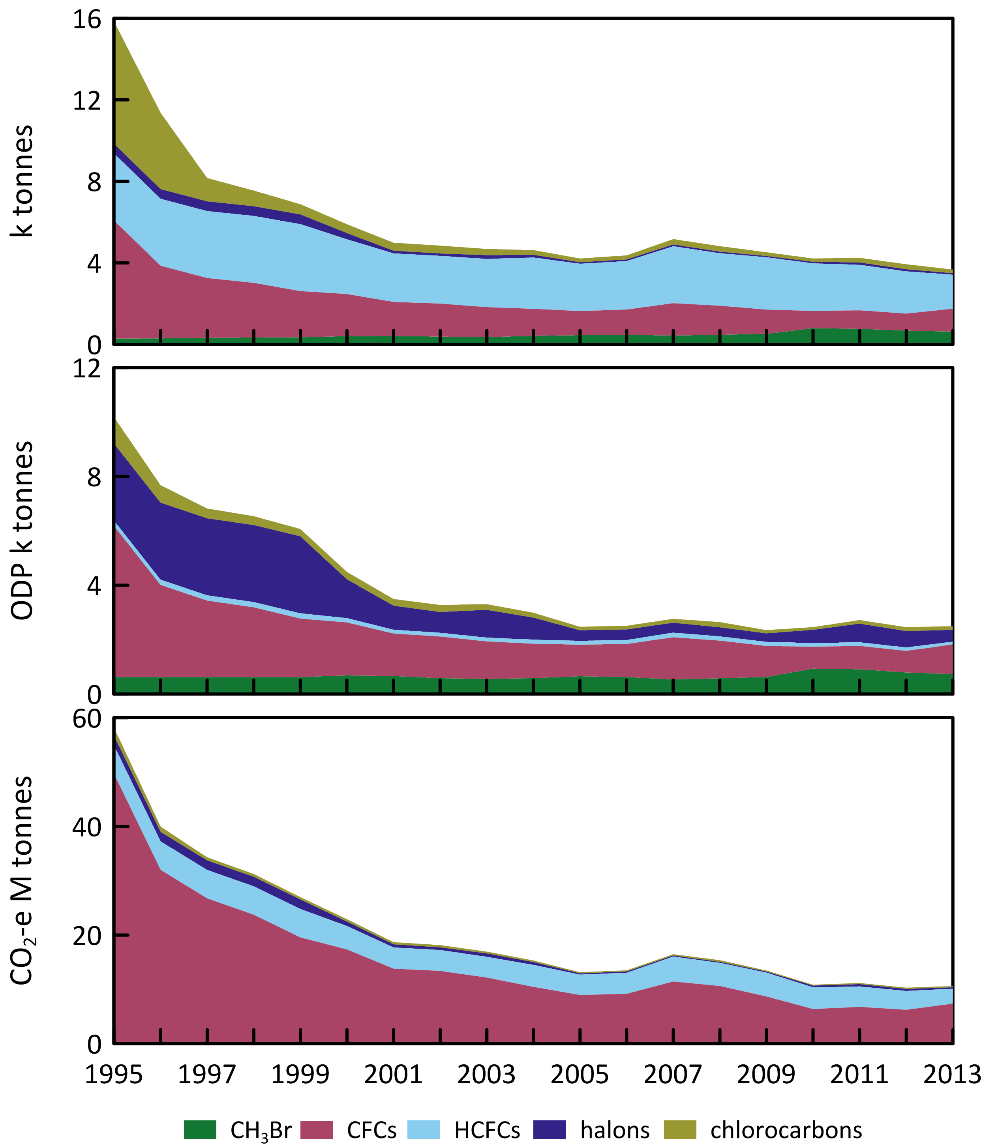

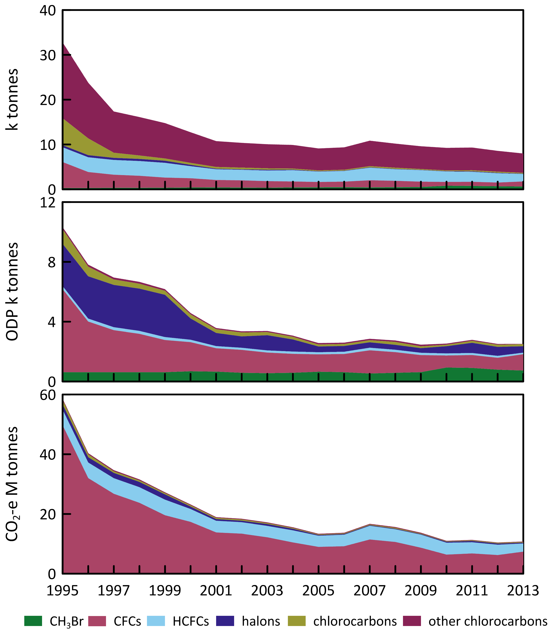

**Figure 15.** Total Australian ODS emissions; without other chlorocarbons (left) and with other chlorocarbons (right).

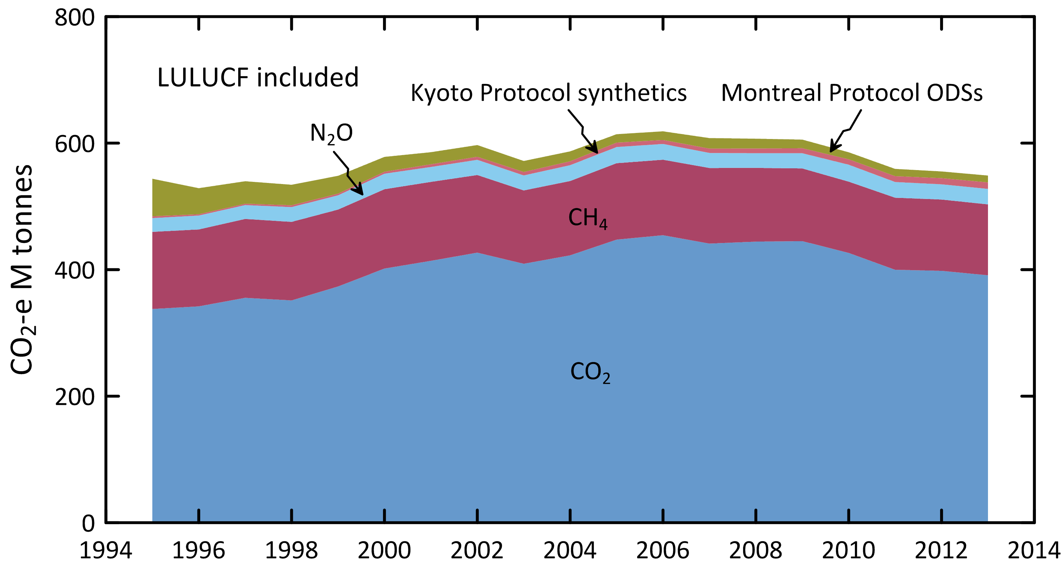

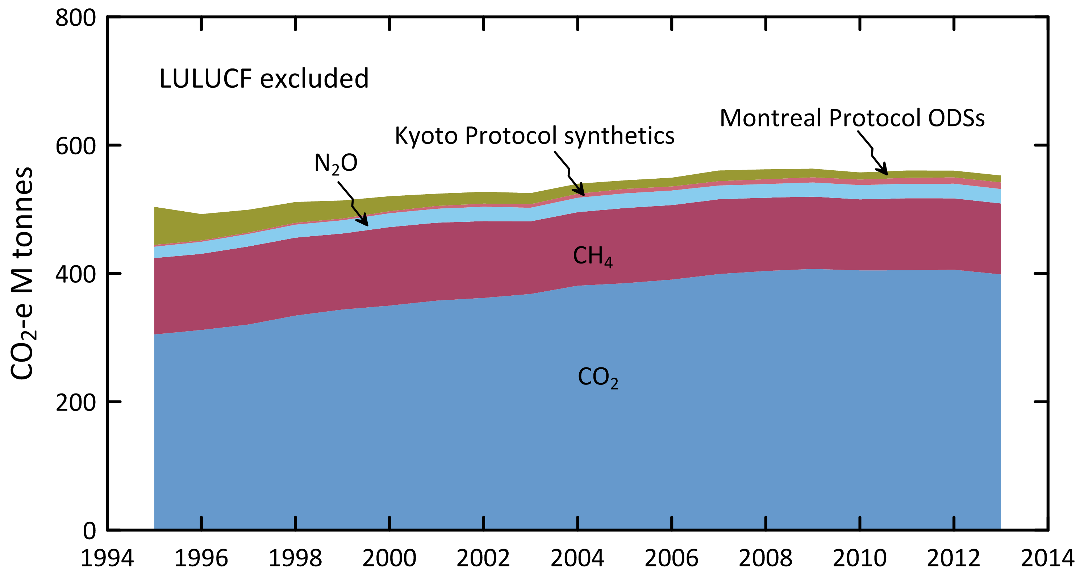

**Figure 16.** Australian emissions (GWP-weighted: M tonnes CO2-e) of ODSs (Montreal Protocol species: CFCs, HCFC, halons, MB, MC, CTC) and the GHGs reported to UNFCCC (carbon dioxide, methane, nitrous oxide, Kyoto Protocol synthetics: HFC, PFCs and sulfur hexafluoride), including and excluding GHG emissions due to land-use/land-use change and forestry (LULUCF).

Figure 17 shows a comparison of global and Australian ODS emissions in M tonnes CO2-e from atmospheric abundance data. There has been about a 85% decline in global ODS emissions since their peak in the late 1990s and about an 80% decline in Australian ODS emissions since 1995. Australian ODS emissions are typically 1%-1.5% of global emissions. Globally, HCFC emission are now more important than CFC emissions in their climate impact, but in Australia CFC emissions remain the dominant SGG emissions. The decline in Australian SGG emissions has stalled at about 10 M tonnes CO2-e since 2010, but global SGG emission continue to fall significantly. Since Australian emissions are almost entirely from existing banks, then continued declining emissions are expected.

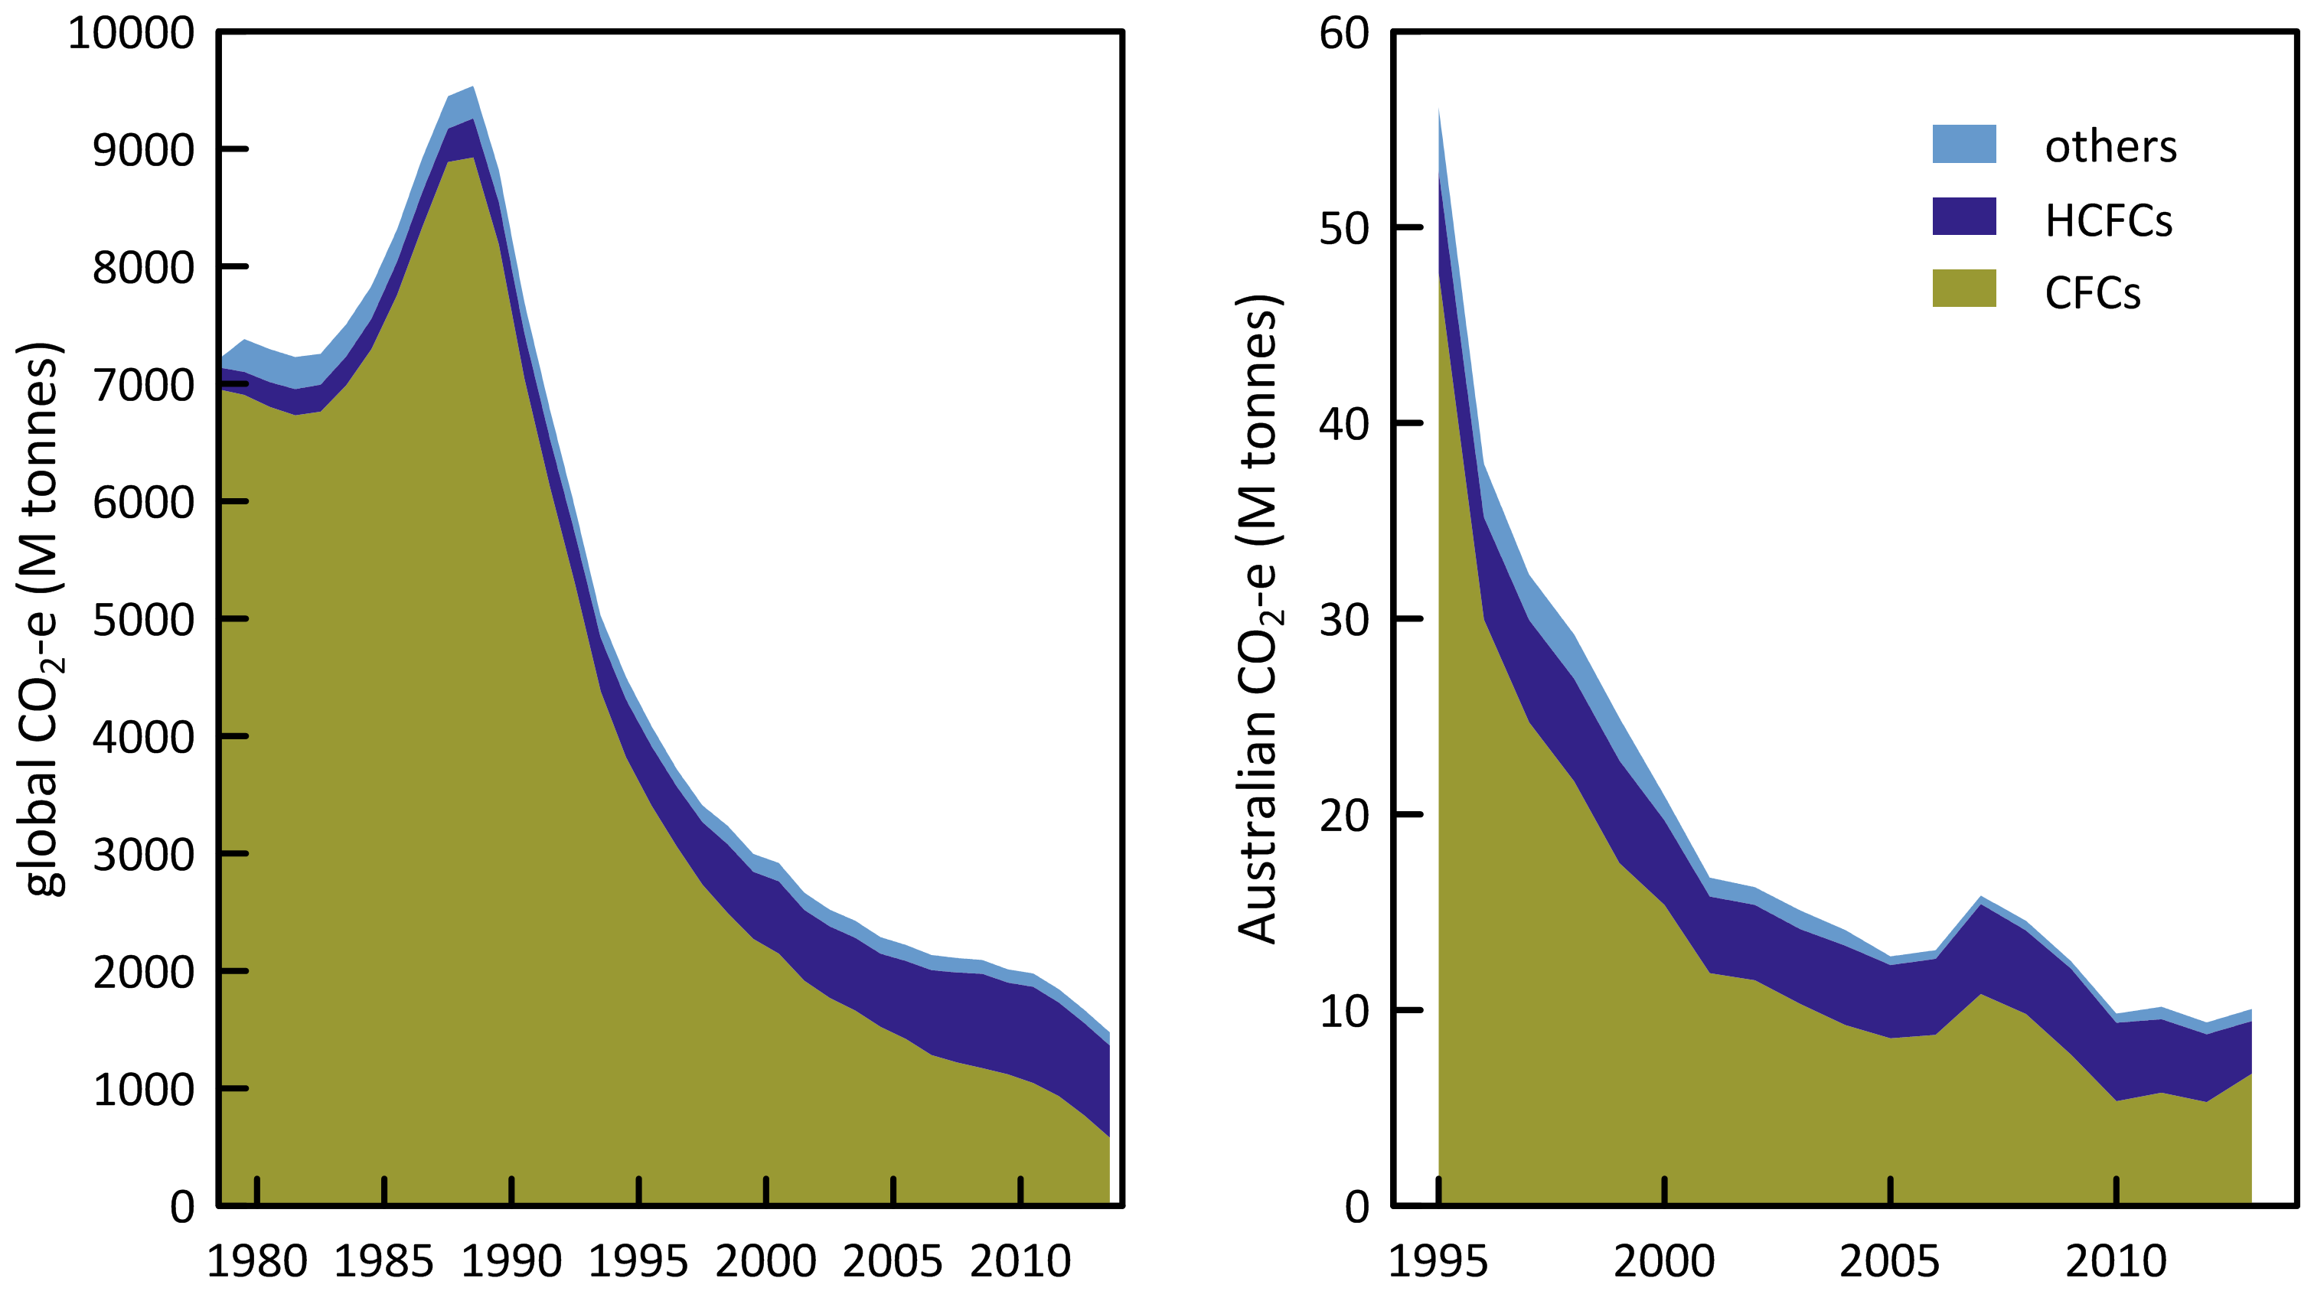

**Figure 17.** Global (since 1978) and Australian (since 1995) ODS emissions (CFCs, HCFCs, others, M tonne CO2-e).

Summary

* CSIRO and collaborating laboratories measure the abundances and trends of thirty one (31) ODSs at Cape Grim, comprising eleven CFCs (CFC-11, -12, -13, -112, -112a, -113, -113a, -114, -115, -216ba, -216ca), seven HCFCs (HCFC-22,-31, -124, -133a, -141b, -142b, -225ca), three halons (H-1211, -1301,-2402), seven chlorocarbons (CH3Cl, CH2Cl2, CHCl3, CCl4, CH3CCl3, CHClCCl2, CCl2CCl2) and three bromocarbons (CH3Br, CH2Br2, CHBr3). Cape Grim has the most comprehensive list of measured ODSs anywhere in the world.
* As a result of measures undertaken within the Montreal Protocol framework, most of the controlled CFCs (CFC-11, CFC-12, CFC-112, CFC-112a, CFC-113, CFC-114) measured in the atmosphere at Cape Grim have stopped growing or are in decline, the exceptions being CFC-13 and CFC-115, which are growing slowly, and CFC-113a, which shows significant growth in 2012, although at a very low concentration. The growth rate of CFC-113a in 2014 has not been measured. Total CFCs in the background atmosphere declined by 0.6% (2013-2014), as did chlorine from CFCs. The rate of decline in CFC concentrations has slowed, especially CFC-11, and this is reflected in CFC emissions (see below).
* The atmospheric abundance of all of the major HCFCs (HCFC-22, HCFC-141b, HCFC-142b), HCFC-133a) measured in the atmosphere at Cape Grim are growing, but their rate of growth is slowing; the minor HCFCs (HCFC-31, HCFC-124, HCFC-133a) are declining slowly. Total HCFCs increased by 2.1% (2013-2014). Chlorine in the atmosphere from HCFCs increased by 2.2% (2013-2014), the only ODS sector showing an increase in chlorine or effective chlorine.
* The most abundant chlorocarbon in the background atmosphere is the largely naturally-occurring methyl chloride (CH3Cl); there are no significant long-term changes in the background concentration of CH3Cl. The next most abundant chlorocarbon is anthropogenic CTC. The chlorocarbons account for 28% of total chlorine from all ODSs in the background atmosphere. CTC and MC continued to show declining concentrations at Cape Grim in 2014, whereas the other chlorocarbons measured at Cape Grim all showed increasing concentrations in 2014 compared to 2013, but only dichloromethane shows a persistent long-term increase. Overall chlorine from chlorocarbons increased by 0.02% from 2013 to 2014.
* H-1211 and H-2404 continued to show declining concentrations from 2013 to 2014, whereas H-1301 continued to increase, but H-1301 will likely stop growing in the atmosphere soon, based on its slowing growth rate. Overall bromine from halons is in decline by 1.4% per year (0.11 ppt/yr). This equates to about a 6-7 ppt per year decline in equivalent chlorine.
* Methyl bromide (MB) continued to decrease (0.2 ppt, 3.8%, 2013-2014) in the background atmosphere, maintaining the long-term decline in MB in the atmosphere since the late 1990s.
* Total chlorine from the Montreal Protocol ODSs decreased by 0.3% (8.4 ppt, 2013-2014), continuing a decline that started in the mid-1990s. The overall decline in total chlorine results from declining CFCs, CTC and MC and increasing HCFCs.
* Total bromine from the Montreal Protocol ODSs decreased significantly (2.5%, 0.35 ppt, 2013-2014), continuing a decline that started in about 2000, resulting from a net, long-term decline in halons and MB.
* Global emissions of all of the major MP ODSs have now stopped growing or are in decline – CFC emissions declined by 5% from 2013 to 2014, halons by 3%, MB by 2% and CTC/MC emissions have remained approximately constant since 2010 (after declining by 12%/yr from 1988). HCFC emissions declined from 2010 to 2013 by 5% before increasing by 2% in 2014. MC emissions are now close to zero and CTC/MC emissions are now dominated by CTC emissions. The rate of decline in CFCs emissions has slowed, due to declining emissions of CFC-12 (15%, 2013-2014) and now increasing emissions of CFC-11 (4%, 2013-2014). The recorded increase in CFC-11 and total HCFC emissions may be close to the uncertainty in estimating these emissions. This is being further investigated. Montreal Protocol ODS emissions in 2013 and 2014 were 760 k tonnes, ~65% below peak emissions in 1988. ODP-weighted ODS emissions were 321 and 314 k tonnes in 2013 and 2014 respectively, nearly 80% below peak ODP-weighted emissions in 1988.
* Australian imports of ODSs (in tonnes) declined significantly, falling by 45% from 2013 to 2014. Significant year-to-year variability in ODS imports is likely and the long-term decline in ODS imports is 11%/yr since peak imports in 1998. Methyl bromide and the HCFCs accounted for 75% and 25% respectively of Australia’s ODS imports in 2014, with halons <1%. The surge in MB imports seen in 2011 and 2012 has been reversed in 2013-2014, probably reflecting inter-annual variability in Australian grain and wood products production. There has been a very large drop in HCFC-22 imports from over 700 tonnes in 2013 to less than 200 tonnes in 2014. There has also been a significant drop in emissions (2012-2013, see below). It is unlikely that HCFC-22 use has dropped as significantly as imports and presumably some HCFC-22 service requirements have been met with stockpiled or re-used HCFC-22.
* Australian CFC emissions, based on Cape Grim data, have declined by 10% per year from 1995 to 2013, 7% per year since 1996. Current emissions (2013: 950 tonnes) are 0.7% of global CFC emissions and 45% of Australia’s Montreal Protocol ODP-weighted ODS emissions.
* There has been a very significant decline (22%) in Australian HCFC-22 emissions: 1,740 tonnes (2012) to 1,360 tonnes (2013), consistent with an estimated 15% decline in the HCFC-22 bank over the same period. Australian total HCFC emissions have declined by 5% per year from 1999 to 2013, with a very significant (19% drop) from 2012 to 2013, dominated (~95%) by the drop in HCFC-22 emissions. Current HCFC emissions (2013: 2,100 tonnes) are 0.5% of global emissions and 6% of Australia’s Montreal Protocol ODP-weighted ODS emissions.
* Australian halon emissions, estimated from Cape Grim data, are uncertain because of the problem of speciating emissions between the National Halon Bank in Melbourne and other SE Australian halon emissions from installed and portable fire suppression systems. With an uncertain assumption that 5%-15% of SE Australian halon emission are from the Halon Bank, it is possible to crudely estimate Australian halon emissions from Cape Grim data. Australian halon emissions have declined by about 10-15% per year from 1999 to 2013 and are about 20% of Australia’s Montreal Protocol ODP-weighted ODS emissions. Australian halon emissions in 2013 are 1.0% of global emissions, consistent with typical ratios of Australian ODS emissions compared to global emissions suggesting that the estimates of Australian halon emissions from Cape Grim data are within ±50%.
* Australian total MB emissions show significant year-to-year variability, typical of a chemical whose consumption is significantly linked to agricultural grain and timber production and exports. MB emissions have shown a long-term increase of 6-7% per year from 1995-2000 (300 tonnes) to 2010-2011 (800 tonnes), falling to under 700 tonnes in 2012-2013, currently contributing about 20% of Australia’s Montreal Protocol ODP-weighted ODS emissions. This is not entirely consistent with modelled emissions, based on MB imports, which were approximately constant (600 tonnes/yr) from 1990 to 2000 (non-QPS driven), declining to 300 tonnes in 2007 (QPS and non-QPS driven), then increasing again to 700 tonnes in 2012 (QPS driven), falling to just above 500 tonnes in 2014. The MB emissions from Cape Grim data are consistent with the model emissions over the past decade, but model emissions are about 60% higher than emissions based on Cape Grim data prior to 2004. This is being investigated further.
* Australian CTC emissions fell by 8% per year from 370 tonnes (1995) to under 100 tonnes (2009-2010), remaining at about 110 tonnes per year through to 2011, rising to 185 tonnes in 2014, the highest emissions over the past decade. Australian MC emissions fell by 40% per year from 1995 (5,500 tonnes) to 2004-2006 (less than 100 tonnes). Emissions have since stabilised at about 110 tonnes per year, with emissions being <100 tonnes in 2009-2010s. Methyl chloroform emissions rose to ~150 tonnes in 2013, the highest emissions in a decade. Total CTC and MC emissions account for about 6% of Australia’s Montreal Protocol ODP-weighted ODS emissions.
* ODP-weighted total Australian ODS emissions fell by 13% per year from 1995 (9,700 tonnes) to 2005 (2,400 tonnes), followed by a period of much slower decline in emissions since 2005 (2% per year, averaging 2,200 tonnes over the past decade. In general it appears that the Montreal Protocol consumption controls have had little impact on emissions since 2005. This is because some consumption is outside the Montreal Protocol ‘umbrella’ – QPS MB consumption, or emissions that are not a function of current consumption (emissions from the ODS bank and ODS disposal - landfills etc).
* GWP-weighted total Australian ODS emissions fell by about 10% per year from 59 M tonnes CO2-e in 1995 to 11-12 M tonnes CO2-e in 2010, remaining at that level through to 2013. Of the 47 M tonnes decline, 42 M tonnes (85%) were due to declining CFC emissions. Australian emissions of GHGs (carbon dioxide, methane, nitrous oxide, HFCs, PFCs and SF6), as reported to UNFCCC, increased by a net 38 M tonnes CO2-e from 1995 to 2013. The decrease in Australian ODS emissions negated all of this increase and if ODS emissions were included in Australia’s GHG accounts then Australia would record a net decline (8 M tonnes CO2-e) in GHG emissions from 1995.
* In Australia (as elsewhere) the Montreal Protocol has been very effective in controlling the consumption, and therefore the emissions, of ODSs that cause stratospheric ozone depletion to the extent that ozone recovery is being detected at mid- and polar latitudes. In addition, the reduction in emissions of ODSs has significantly slowed the growth in overall GHG emissions that drive climate change.

References

ABARES, Australian Crop Report, Australian Bureau of Agricultural and Resource Economics and Sciences, No. 169, 21 pp, February 2014.

Bekki, S. & G. Bodeker, Coordinating Lead Authors, Future Ozone and Its Impact on Surface UV, Chapter 3 in *Scientific Assessment of Ozone Depletion: 2010*, WMO Global Ozone Research and Monitoring Project – Report No. 52, 3.1-3.60, 2011.

Brodribb, P. & M. McCann*, Cold Hard Facts 2: a study of the refrigeration and air conditioning industry in Australia*, Expert Group and Thinkwell Australia, Canberra, ACT, Australia, 134 pp., 2013.

Brodribb, P. & M. McCann*, A study into HFC consumption in Australia*, Expert Group, Canberra, ACT, Australia, 129 pp., 2014.

Butler, J., J. Elkins, B. Hall, S. Montzka, S. Cummings, P. Fraser & L. Porter, Recent trends in the global atmospheric mixing ratios of Halon-1301 and Halon-1211 in *Baseline Atmospheric Program Australia 1991*, A. Dick & J. Gras (eds.), Department of the Environment, Sport and Territories, Bureau of Meteorology and CSIRO Division of Atmospheric Research, 29-32, 1994.

Carpenter, L. & S. Reimann, Lead Authors, Update on Ozone-Depleting Substances (ODSs) and Other Gases of Interest to the Montreal Protocol, Chapter 1 in *Scientific Assessment of Ozone Depletion: 2014*, Global Ozone Research and Monitoring Project – Report No. 55, 416 pp., Geneva, Switzerland, 2014.

Chirkov, M., G. Stiller, A. Laeng, S. Kellmann, T. von Clarmann, C. Boone, J. Elkins, A. Engel, N. Glatthor, U. Grabowski, C. Harth, M. Kiefer, F. Kolonjari, P. Krummel, C. Lunder, B. Miller, S. Montzka, J. Mühle, S. O’Doherty, J. Orphal, R. Prinn, G. Toon, M. Vollmer, K. Walker, R. Weiss, A. Wiegele & D. Young, Global HCFC-22 measurements with MIPAS: retrieval, validation, climatologies and trends, *Atmos. Chem. Phys. Discuss*.,15, 14783-14841, 2015.

[Cohan, D. , G. Sturrock, A. Biazar & P. Fraser, Atmospheric methyl iodide at Cape Grim, Tasmania, from AGAGE observations, *J. Atmos. Chem.*, 44 (2), 131-150, doi: 10.1023/A:1022481516151, 2003.](https://ejournal.csiro.au/cgi-bin/sciserv.pl?collection=journals&journal=01677764&issue=v44i0002&article=131_amiacgtfao%20)

Cox, M., P. Hurley, P. Fraser & W. Physick, Investigation of Melbourne region pollution events using Cape Grim data, a regional transport model (TAPM) and the EPA Victoria carbon monoxide inventory, *Clean Air*, 34(1), 35-40, 2000.

Cox, M., A regional study of the natural and anthropogenic sinks of the major halomethanes, *PhD thesis*, School of Mathematical Sciences, Monash University, Clayton, Victoria, Australia, 2001.

Cox, M., G. Sturrock, P. Fraser, S. Siems, P. Krummel & S. O'Doherty, Regional sources of methyl chloride, chloroform and dichloromethane identified from AGAGE observations at Cape Grim, Tasmania, 1998-2000, *J. Atmos. Chem,* 45(1), 79-99, doi: 10.1023/A:1024022320985, 2003a.

Cox, M. , S. Siems, P. Fraser, P. Hurley & G. Sturrock, TAPM modelling studies of AGAGE dichloromethane observations at Cape Grim in *Baseline Atmospheric Program Australia 1999-2000*, N. Tindale, N. Derek & P. Fraser (eds.), Melbourne: Bureau of Meteorology and CSIRO Atmospheric Research, 25-30, 2003b.

[Cox, M., P. Fraser, G. Sturrock, S. Siems & L. Porter, Terrestrial sources and sinks of halomethanes near Cape Grim, Tasmania, *Atmos. Environ.*, 38(23), 3839-3852, doi:10.1016/j.atmosenv.2004.03.050, 2004.](https://ejournal.csiro.au/cgi-bin/sciserv.pl?collection=journals&journal=13522310&issue=v38i0023&article=3839_tsasohncgt%20)

Cunnold, D. , R. Prinn, R. Rasmussen, P. Simmonds, F. Alyea, C. Cardelino, A. Crawford, P. Fraser& R. Rosen, The Atmospheric Lifetime Experiment, 2: Lifetime methodology and application to three years of CFCl3 data, *J. Geophys. Res.,* 88(C13), 8379-8400, doi:10.1029/JC088iC13p08379, 1983.

Cunnold, D., R. Prinn, R. Rasmussen, P. Simmonds, F. Alyea, C. Cardelino, A. Crawford, P. Fraser& R. Rosen, Atmospheric lifetime and annual release estimates for CFCl3 and CF2Cl2 from 5 years of ALE data, *J. Geophys. Res.,* 91(D10), 10797-10817, doi:10.1029/JD091iD10p10797, 1986.

Cunnold, D., P. Fraser, R. Weiss, R. Prinn, P. Simmonds, F. Miller, F. Alyea & A. Crawford, Global trends and annual releases of CCl3F and CCl2F2 estimated from ALE/GAGE and other measurements from July 1978 to June 1991, *J. Geophys. Res.,* 99(D1): 1107-1126, doi:10.1029/93JD02715, 1994.

Cunnold, D., R. Weiss, R. Prinn, D. Hartley, P. Simmonds, P. Fraser, B. Miller, F. Alyea & L. Porter, GAGE/AGAGE measurements indicating reductions in global emissions of CCl3F and CCl2F2 in 1992-1994, *J. Geophys. Res.,* 102(D1), 1259-1269, doi:10.1029/96JD02973, 1997.

Dameris, M. & S. Godin-Beekmann, Lead Authors ,Update on Polar Ozone: Past, Present and Future, Chapter 3 in *Scientific Assessment of Ozone Depletion: 2014*, Global Ozone Research and Monitoring Project – Report No. 55, 416 pp., Geneva, Switzerland, 2014.

Delaney, W. & A. Marshall, Victorian air emissions inventory for 2006, Proceedings, *20th International Clean Air and Environment Conference*, 30 July – 2 August, 2011, CASANZ, Auckland, NZ., 2011.

Dunse, B., P. Steele, P. Fraser & S. Wilson, An analysis of Melbourne pollution episodes observed at Cape Grim from 1995-1998 in *Baseline Atmospheric Program (Australia) 1997-98*, N. Tindale, R. Francey, and N. Derek (eds.), Bureau of Meteorology and CSIRO Atmospheric Research, Melbourne, Australia, 34-42, 2001.

Dunse, B., Investigation of urban emissions of trace gases by use of atmospheric measurements and a high-resolution atmospheric transport model, *PhD thesis*, Wollongong University, Wollongong, NSW, Australia, 2002.

Dunse, B., P. Steele, S. Wilson, P. Fraser & P. Krummel, Trace gas emissions from Melbourne Australia, based on AGAGE observations at Cape Grim, Tasmania, 1995-2000, *Atmos. Environ.*, 39, 6334-6344, doi:10.1016/j.atmosenv.2005.07.014 , 2005.

Draxler, R. & D. Hess, Description of the HYSPLIT_4 Modeling 389 System, NOAA Technical Memorandum ERL ARL-224, 24 pp., NOAA, 1997.

EPA, Air Emissions Inventory: Port Phillip Region, *EPA Publication 632*, 48 pp., 1998.

Expert Group, *Cold Hard Facts 2: a study of the refrigeration and air conditioning industry in Australia*, prepared for DSEWPac, 134pp, July 2013.

Expert Group, *HFC Consumption in Australia in 2013 and an Assessment of the Capacity of Industry to Transition to Nil and Lower GWP Alternatives* , prepared for DE, 129 pp, April 2014.

Forster, P. & V. Ramaswamy, Coordinating Lead Authors, Changes in Atmospheric Constituents and in Radiative Forcing, Chapter 2 in: *Climate Change 2007: The Physical Basis. Contribution of Working Group I to the Fourth Assessment Report of the Intergovernmental Panel on Climate Change*, Solomon, S., D. Qin, M. Manning, Z. Chen, M. Marquis, K. Averyt, M. Togor & H. Miller (eds.), Cambridge University Press, Cambridge, UK & New York, NY, USA, 129-234, April 2007.

Fraser, P., B. Sawford & P. Manins, CCl3F (Freon-11) as an indicator of transport processes in an urban atmosphere: a case study in Melbourne, *Atmos. Environ*., 11(11), 1025-1028, doi:10.1016/0004-6981(77)90231-1, 1977.

Fraser, P. & G. Pearman, Atmospheric halocarbons in the southern hemisphere, *Atmos. Environ.,* 12(4), 839-844, doi:10.1016/0004-6981(78)90021-5, 1978a.

Fraser, P. & G. Pearman, The fluorocarbon-ozone theory – II. Tropospheric lifetimes - an estimate of the tropospheric lifetime of CCl3F, *Atmos. Environ.,* 12(8), 1807-1808, doi:10.1016/0004-6981(78)90332-3, 1978b.

Fraser, P.,P. Hyson, I. Enting & G. Pearman, Global distribution and southern hemispheric trends of atmospheric CCl3F, *Nature,* 302(5910), 692-695, doi:10.1038/302692a0, 1983.

Fraser, P., P. Hyson, R. Rasmussen, A. Crawford & A. Khalil, Methane, carbon monoxide and methylchloroform in the southern hemisphere, *J. Atmos. Chem.*, 4(1), 3-42, doi:10.1007/BF00053771, 1986.

Fraser, P., D. Cunnold, F. Alyea, R. Weiss, R. Prinn, P. Simmonds, B. Miller & R. Langenfelds, Lifetime and emission estimates of 1,1,2-trichlorotrifluorethane (CFC-113) from daily global background observations June 1982-June 1994, *J. Geophys. Res.,* 101(D7), 12585-12599, doi:10.1029/96JD00574, 1996.

Fraser, P. & M. Prather, Uncertain road to ozone recovery, *Nature,* 398(6729), 663-664, doi:10.1038/19418, 1999.

Fraser, P., D. Oram, C. Reeves, S. Penkett & A. McCulloch, Southern Hemisphere halon trends (1978-1998) and global halon emissions, *J. Geophys. Res.,* 104(D13), 15985-15999, doi:10.1029/1999JD900113, 1999.

[Fraser, P., Will illegal trade in CFCs and halons threaten ozone layer recovery? *Atmos. Environ.*, 34(18), 3038-3039, doi:10.1016/S1352-2310(00)00094-7, 2000.](https://ejournal.csiro.au/cgi-bin/sciserv.pl?collection=journals&journal=13522310&issue=v34i0018&article=3038_witicahtolr%20)

Fraser, P., P. Steele, P. Krummel, C. Allison, S. Coram, B. Dunse & M. Vollmer, DSEWPaC Research Projects 2011/2012, Final Report October 2012, 14 pp., 2012.

Fraser, P., B. Dunse, P. Krummel, P. Steele & N. Derek, SGGs and Stratospheric Ozone, DSEWPaC Projects 2012-2013, Report prepared for Department of Sustainability, Environment, Water, Populations and Communities, CSIRO Marine and Atmospheric Research, September 2013, 30 pp, 2013.

Fraser, P., P. Krummel, P. Steele, C. Trudinger, D. Etheridge, S. O'Doherty, P. Simmonds, B. Miller, J. Mühle, R. Weiss, D. Oram, R. Prinn & R. Wang, Equivalent effective stratospheric chlorine from Cape Grim Air Archive, Antarctic firn and AGAGE global measurements of ozone depleting substances, *Baseline Atmospheric Program (Australia) 2009-2010*, N. Derek, P. Krummel & S. Cleland (eds.), Australian Bureau of Meteorology and CSIRO Marine and Atmospheric Research, Melbourne, Australia, 17-23, 2014a.

Fraser, P., B. Dunse, A. Manning, R. Wang, P. Krummel, P. Steele, L. Porter, C. Allison. S. O’Doherty, P. Simmonds, J. Mühle & R. Prinn, Australian carbon tetrachloride (CCl4) emissions in a global context, *Environ. Chem*., 11, 77-88, doi:10.1071/EN13171, 2014b.

Harris, N. & D. Wuebbles, Lead Authors, Scenarios and Information for Policy Makers, Chapter 5 in *Scientific Assessment of Ozone Depletion: 2014*, Global Ozone Research and Monitoring Project – Report No. 55, 416 pp., Geneva, Switzerland, 2014.

Hossaini, R., M. Chipperfield, A. Saiz-Lopez, J. Harrison, R. von Glasow, R. Sommariva, E. Atlas, M. Navarro, S. Montzka, W. Feng, S. Dhomse, C. Harth, J. Mühle, C. Lunder, S. O’Doherty, D. Young, S. Reimann, M. Vollmer, P. Krummel & P. Bernath, Growth in stratospheric chlorine from short-lived chemicals not controlled by the Montreal Protocol, *Geophys. Res. Lett.*, 42, 4573-4580, doi:10.1002/2015GL063783, 2015.

Hyson, P., P. Fraser& G. Pearman, A two-dimensional transport simulation model for trace atmospheric constituents, *J. Geophys. Res.,* 85(C8), 4443-4456, doi:10.1029/JC085iC08p04443, 1980.

Kloss, C., M. Newland, D. Oram, P. Fraser, C. Brenninkmeijer, T. Röckmann & J. Laube, Atmospheric abundances, trends and emissions of CFC-216ba, CFC-216ca and HCFC-225ca, *Atmosphere, Special Issue: Ozone Depletion and Climate Change*, 5(2), 420-434, doi:10.3390/atmos5020420, 2014.

Krummel, P., P. Fraser & N. Derek, *The 2014 Antarctic Ozone Hole and Ozone Science Summary: Final Report*, Australian Government Department of the Environment, CSIRO Oceans and Atmosphere Flagship, Australia, iv, 26 pp., June 2015.

Laube, J., A. Kiel, H. Bonisch, E. Engel, M. Newland, T. Röckmann , C. Volk, W. Sturges, P. Fraser & D. Oram, Supplementary information to ‘Observation-based assessment of stratospheric fractional release, lifetimes and Ozone Depletion Potentials of ten important trace gases’, *Atmos. Chem. Phys.*, 13, 2779-2791, doi:10.5194/acp-13-2779-2013, 2013.

Laube, J., M. Newland, C. Hogan, C. Brenninkmeijer, P. Fraser, P. Martinerie, D. Oram, C. Reeves, T. Röckmann, J. Schwander, E. Witrant & W. Sturges, Newly detected ozone depleting substances in the atmosphere, *Nature Geoscience*, 7, 266-269, doi:10.1038/ngeo2109, 2014.

Manning, A., D. Ryall, R. Derwent, P. Simmonds & S. O’Doherty, Estimating European ozone depleting and greenhouse gases using observations and a modelling attribution technique, *J. Geophys. Res*., 108, 4405, doi:10.1029/2002JD002312, 2003.

Manning, A., S. O’Doherty, A. R. Jones, P. G. Simmonds & R. G. Derwent, Estimating UK methane and nitrous oxide emissions from 1990 to 2007 using an inversion modeling approach, *J. Geophys. Res*., 116(D2): D02305, doi:10.1029/2010JD004763, 2011.

Miller, B., Abundances and trends of atmospheric chlorofluoromethane and bromomethane, *PhD thesis*, University of California at San Diego, La Jolla, California, USA, 149 pp, 1998.

Miller, B., J. Huang, R. Weiss, R. Prinn & P. Fraser, Atmospheric trend and lifetime of chlorodifluoromethane (HCFC-22) and the global tropospheric OH concentration, *J. Geophys. Res.,* 103(D11), 13237-13248, doi:10.1029/98JD00771, 1998.

Miller, B., M. Rigby, L. Kuijpers, P. Krummel, P. Steele, M. Leist, P. Fraser, A. McCulloch, C. Harth, P. Salameh, J. Mühle, R. Weiss, R. Prinn, R. Wang, S. O’Doherty, B. Greally & P. Simmonds, CHF3 (HFC-23) emission trend response to CHClF2 (HCFC-22) production and recent CHF3 emissions abatement measures, *Atmos. Chem. Phys.*, 10, 7875-7890, doi:10.5194/acp-10-7875-2010, 2010.

Montzka, S. , M. Nowick, R. Myers, W. Elkins, J.Butler, S. Cummings, P. Fraser& L. Porter, NOAA-CMDL chlorodifluoromethane (HCFC-22) observations at Cape Grim, in: *Baseline Atmospheric Program Australia* 1991, A. Dick & J. Gras (eds.), Melbourne: Department of the Environment, Sport and Territories, Bureau of Meteorology and CSIRO Division of Atmospheric Research, 25-28, 1994.

Montzka, S. & S. Reimann, Coordinating Lead Authors, Ozone-Depleting Substances (ODSs) and Related Chemicals, Chapter 1 in *Scientific Assessment of Ozone Depletion: 2010*, WMO Global Ozone Research and Monitoring Project – Report No. 52, 1.1-1.108, 2011.

Myhre, G. & D. Schindell, Anthropogenic and Natural Radiative Forcing, Chapter 8 in Climate Change 2013 – The Physical Science Basis, Working Group I Contribution to the Fifth Assessment Report of the Intergovernmental Panel on Climate Change, IPCC (ed.), Cambridge University Press, Cambridge, UK & New York, NY, USA, 8.1-8.139, 2014.

National Transport Commission, Grain Supply Chain Pilot Study, Stage One Final Report, prepared by Strategic Design and Development, Epping, NSW, for the National Transport Commission, 62 pp., 2008.

Newland, M., C. Reeves, D. Oram, J. Laube, W. Sturges, C. Hogan, P. Begley & P. Fraser, Southern hemispheric halon trends and global halon emissions, 1978-2011, *Atmos. Chem. Phys.,* 13, 5551-5565, doi:10.5194/acp-13-5551-2013, 2013.

[O'Doherty, S., P. Simmonds, D. Cunnold, R. Wang, G. Sturrock, P. Fraser, D. Ryall, R. Derwent, R. Weiss, P. Salameh, B. R. Miller & R. Prinn, *In situ* chloroform measurements at Advanced Global Atmospheric Gases Experiment atmospheric research stations from 1994 to 1998, *J. Geophys. Res.*, 106(D17), 20429-20444, doi:10.1029/2000JD900792, 2001.](http://www.agu.org/journals/jd/jd0117/2000JD900792/pdf/2000JD900792.pdf%20)

O'Doherty, S., D. Cunnold, A. Manning, B. Miller, R. Wang, P. Krummel, P. Fraser, P. Simmonds, A. McCulloch, R. Weiss, P. Salameh, L. Porter, R. Prinn, J. Huang, G. Sturrock, D. Ryall, R. Derwent & S. Montzka, Rapid growth of hydrofluorocarbon 134a and hydrochlorofluorocarbons 141b, 142b, and 22 from Advanced Global Atmospheric Gases Experiment (AGAGE) observations at Cape Grim, Tasmania, and Mace Head, Ireland, *J. Geophys. Res.*, 109(D6): doi:10.1029/2003JD004277, 2004.

O’Doherty, S., D. Cunnold, B. Miller, J. Mühle, A. McCulloch, P. Simmonds, A. Manning, S. Reimann, M. Vollmer, B. Greally, R. Prinn, P. Fraser, P. Steele, P. Krummel, B. Dunse, L. Porter, C. Lunder, N. Schmidbauer, O. Hermansen, P. Salameh, C. Harth, R. Wang & R. Weiss, Global and regional emissions of HFC-125 (CHF2CF3) from *in situ* and air archive observations at AGAGE and SOGE observatories, *J. Geophys. Res.*, 114(D23): D23304, doi:10.1029/2009JD012184, 2009.

Oram, D., C. Reeves, S. Penkett & P. Fraser, Measurements of HCFC-142b and HCFC-141b in the Cape Grim air archive: 1978-1993, *Geophys. Res. Letts.,* 22(20): 2741-2744, doi:10.1029/95GL02849, 1995.

Oram, D., Trends in long-lived anthropogenic halocarbons in the Southern Hemisphere and model calculations of global emissions, *PhD thesis*, University of East Anglia, Norwich, UK, 1999.

Patra, P., M. Krol, S. Montzka, T. Arnold, E. Atlas, B. Lintner, B. Stephens, B. Xiang, J. Elkins, P. Fraser, A. Ghosh, E. Hintsa, D. Hurst, K. Ishijima, P. Krummel, B. Miller, K. Miyazaki, F. Moore, J. Mühle, S. O’Doherty, R. Prinn, P. Steele, M. Takigawa, H. Wang, R. Weiss, S. Wofsy & D. Young, Inter-hemispheric gradient of hydroxyl in the troposphere, *Nature*, 513, 219-223, doi:10.1038/nature13721, 2014.

Porter, I., S. Mattner, J. Banks & P. Fraser,Impact of global methyl bromide phase-out on the sustainability of strawberry industries, *Acta Horticulturae*, 708, 179-185, 2006.

Porter, I., J. Banks, S. Mattner & P. Fraser, Global phase-out of methyl bromide under the Montreal Protocol: implications for bioprotection, biosecurity and the ozone layer, in *Plant Pathoogy in the 21st Century: Recent Developments in Management of Plant Diseases*, 1, 293-309, Springer-Verlag Berlin, doi:10.1007/978-1-4020-8804-9_21, 2009.

Porter, I., M. Pizano, M. Besri & P. Fraser, Progress in the global phase-out of methyl bromide and the relative effectiveness of soil disinfestations strategies, *Acta Horticulturae*, 883, 59-66, 2010.

Prinn, R., D. Cunnold, R. Rasmussen, P. Simmonds, F. Alyea, A. Crawford, A. J., P. Fraser & R. Rosen, Atmospheric trends in methylchloroform and global average for the hydroxyl radical, *Science,* 238(4829), 945-950, doi: 10.1126/science.238.4829.945, 1987.

Prinn, R., D. Cunnold, P. Simmonds, F. Alyea, R. Boldi, A. Crawford, P. Fraser, D. Gutzler, D. Hartley, P. Rosen & R. Rasmussen, Global average concentration and trend for hydroxyl radicals deduced from ALE/GAGE trichloroethane (methyl chloroform) data for 1978-1990, *J. Geophys. Res.*, 97(D2), 2445-2461, doi: 10.1029/91JD02755, 1992.

Prinn, R., R. Weiss, B. Miller, J. Huang, F. Alyea, D. Cunnold, P. Fraser**,** D. Hartley & P. Simmonds, Atmospheric trends and lifetime CH3CCl3 and global OH concentrations, *Science,* 269(5221), 187-192, doi:10.1126/science.269.5221.187, 1995.

[Prinn, R., R. Weiss, P. Fraser, P. Simmonds, D. Cunnold, F. Alyea, S. O'Doherty, P. Salameh, B. Miller, J. Huang, R. Wang, D. Hartley, C. Harth, P. Steele, G. Sturrock, P. Midgley & A. McCulloch, A history of chemically and radiatively important gases in air deduced from ALE/GAGE/AGAGE, *J. Geophys. Res.,*105(D14), 17751-17792, doi:10.1029/2000JD900141, 2000.](http://www.agu.org/journals/jd/jd0014/2000JD900141/0.html%20)

[Prinn, R., J. Huang, R. Weiss, D. Cunnold, P. Fraser, P. Simmonds, A. McCulloch, C. Harth, P. Salameh, S. O'Doherty, R. Wang, L. Porter & B. Miller, Evidence of substantial variations of atmospheric hydroxyl radicals in the past two decades, *Science*, 292(5523), 1882-1888, doi:10.1126/science.1058673, 2001.](http://www.sciencemag.org/cgi/content/abstract/292/5523/1882%20)

Prinn, R., J. Huang, R. Weiss, D. Cunnold, P. Fraser, P. Simmonds, A. McCulloch, C. Harth, S. Reimann, P. Salameh, S. O’Doherty, R. Wang, L. Porter, B. Miller & P. Krummel, Evidence for variability of atmospheric hydroxyl radicals over the past quarter century, *Geophys. Res. Letts.*, 32(7): L07809, doi:10.1029/2004GL022228, 2005.

Rasmussen, R., A. Khalil, A. Crawford & P. Fraser, Natural and anthropogenic trace gases in the southern hemisphere, *Geophys. Res. Lett.,* 9(6), 704-707, doi:10.1029/GL009i006p00704, 1982.

Rigby,M., A. Ganesan & R. Prinn, Deriving emissions time series from sparse atmospheric mole fractions, *J.* *Geophys. Res.*, 116, D08306, doi:10.1029/2010JD01540, 2011.

Rigby, M., R. Prinn, S. O'Doherty, S. Montzka, A. McCulloch, C. Harth, J. Mühle, P. Salameh, R. Weiss, D. Young, P. Simmonds, B. Hall, G. Dutton, D. Nance, D. Mondeel, J. Elkins, P. Krummel, P. Steele & P. Fraser, Re-evaluation of the lifetimes of the major CFCs and CH3CCl3 using atmospheric trends, Re-evaluation of the lifetimes of the major CFCs and CH3CCl3 using atmospheric trends, *Atmos. Chem. Phys*., 13, 1-11, doi:10.5194/acp-13-2691-2013, 2013.

Rigby, M., R. Prinn, S. O’Doherty, B. Miller, D. Ivy, J. Muhle, C. Harth, P. Salameh, T. Arnold, R. Weiss, P. Krummel, P. Steele, P. Fraser, D. Young & P. Simmonds, Recent and future trends in synthetic greenhouse gas radiative forcing, *Geophys. Res. Lett.*, 41, 2623-2630, doi: \10.1002/2013GL059099, 2014.

Saikawa, E., M. Rigby, R. Prinn, S. Montzka, B. Miller, L. Kuijpers, P. Fraser, M. Vollmer, T. Saito, Y. Yokouchi, C. Harth, J. Mühle, R. Weiss, P. Salameh, J. Kim, S. Li, S. Park, K.-R. Kim, D. Young, S. O’Doherty, P. Simmonds, A. McCulloch, P. Krummel, P. Steele, C. Lunder, O. Hermansen, M. Maione, J. Arduini, B Yao, L. Zhou, H. Wang, J. Elkins & B. Hall, Global and regional emissions estimates for HCFC-22, *Atmos. Chem. Phys.*, 12, 10033-10050, doi:10.5194/acp-12-10033-2012, 2012.

Schoenenberger, F., M. Vollmer, M. Rigby, M. Hill, P. Fraser, P. Krummel, P. Steele, T. Rhee, T. Peter & S. Reimann, First observations and emissions of HCFC-31 (CH2ClF) in the global atmosphere, *Geophys. Res. Lett*., submitted (May 2015).

Simmonds, P., D. Cunnold, F. Alyea, C. Cardelino, A. Crawford, R. Prinn, P. Fraser**,** R. Rasmussen & R. Rosen, Carbon tetrachloride lifetimes and emissions determined from daily global measurements during 1978-1985, *J. Atmos. Chem.*, 7(1), 35-58, doi:10.1007/BF00048253, 1988.

Simmonds, P., D. Cunnold, R. Weiss, B. Miller, R. Prinn, P. Fraser, A.McCulloch, F. Alyea & S. O'Doherty, Global trends and emission estimates of CCl4 from in situ background observations from July 1978 to June 1996, *J. Geophys. Res.,* 103(D13), 16017-16027, doi:10.1029/98JD01022, 1998.

[Simmonds, P., R. Derwent, A. Manning, P. Fraser, P. Krummel, S. O'Doherty, R. Prinn, D. Cunnold, B. Miller, R. Wang, D. Ryall, L. Porter, R. Weiss & P. Salameh, AGAGE observations of methyl bromide and methyl chloride at Mace Head, Ireland, and Cape Grim, Tasmania, 1998-2001, *J. Atmos. Chem.*, 47(3), 243-269, doi:10.1023/B:JOCH.0000021136.52340.9c, 2004.](https://ejournal.csiro.au/cgi-bin/sciserv.pl?collection=journals&journal=01677764&issue=v47i0003&article=243_aoombaiacgt1%20)

Simmonds, P., A. Manning, D. Cunnold, A. McCulloch, S. O’Doherty, R. Derwent, P. Krummel, P. Fraser, B. Dunse, L. Porter R. Wang, B. Greally, B. Miller P. Salameh, R. Weiss & R. Prinn, Global trends, seasonal cycles, and European emissions of dichloromethane, trichloroethene and tetrachloroethene from AGAGE observations at Mace Head Ireland and Cape Grim, Tasmania, *J. Geophys. Res*., 111(D18), D18304, doi:10.1029/2006JD007082, 2006.

Stohl, A., P. Seibert, J. Arduini, S. Eckhardt, P. Fraser, B. Greally, C. Lunder, M. Miaone, J. Mühle, S. O’Doherty, R. Prinn S. Reimann, T. Saito, N. Schmidbauer, P. Simmonds, M. Vollmer, R. Weiss & Y. Yokouchi, An analytical inversion method for determining regional and global emissions of greenhouse gases: sensitivity studies and application to halocarbons, *Atmos. Chem. Phys.*, 9, 1597-1620, doi:10.5194/acp-9-1597-2009, 2009.

[Sturrock, G., D. Etheridge, C. Trudinger, P. Fraser & A. Smith, Atmospheric histories of halocarbons from analysis of Antarctic firn air: major Montreal Protocol species, *J. Geophys. Res.*, 107 (D24): 4765, doi:10.1029/2002JD002548, 2002.](http://www.agu.org/pubs/crossref/2002/2002JD002548.shtml%20)

Sturrock, G., R. Parr, C. Reeves, S. Penkett, P. Fraser & N. Tindale, Methyl bromide saturations in surface seawater off Cape Grim, in: *Baseline Atmospheric Program Australia 1999-2000*, N. Tindale, N. Derek & P. Fraser (eds.), Melbourne: Bureau of Meteorology and CSIRO Atmospheric Research, 85-86, 2003a.

Sturrock, G., C. Reeves, G. Mills, S. Penkett, R. Parr, A. McMinn, G. Corno, N. Tindale & P. Fraser, Saturation levels of methyl bromide in the coastal waters off Tasmania, *Global Biogeochemical Cycles*, 17 (4), 1101, doi:10.1029/2002GB002024, 2003b.

[Trudinger, C., D. Etheridge, G. Sturrock, P. Fraser, P. Krummel & A. McCulloch, Atmospheric histories of halocarbons from analysis of Antarctic firn air: methyl bromide, methyl chloride, chloroform, and dichloromethane, *J. Geophys.* *Res. - Atmospheres*, 109 (D22), 22310, doi:10.1029/2004JD004932, 2004.](http://www.agu.org/pubs/crossref/2004/2004JD004932.shtml%20)

Vollmer, M., M. Rigby, J. Laube, S. Henne, T. Rhee, L. Gooch, A. Wenger, D. Young, P. Steele, R. Langenfelds, C. Brenninkmeijer, J.-L. Wang, C.-F. Ou-Yang, S. Wyss, M. Hill, D. Oram, P. Krummel, F. Schoenenberger, C. Zellweger, P. Fraser, W. Sturges, S. O’Doherty & S. Reimann, Abrupt reversal of HCFC-133a (CF3CH2Cl) in the atmosphere, *Geophys. Res. Lett*., submitted (May 2015).

Vollmer, M., J. Muhle, C. Trudinger, M. Rigby, S. Montzka, C. Harth, B. Miller, S. Henne, P. Krummel, B. Hall, J. Arduini, D. Young, J. Kim, A. Wenger, S. Reimann, S. O’Doherty, M. Maione, D. Etheridge, S. Li, S. Park, G. Dutton, P. Steele, C. Lunder, T. Rhee, O. Hermansen, N. Schmidbauer, R. Wang, M. Hill, P. Salameh, R. Langenfelds, J. Elkins, P. Simmonds, R. Weiss, R. Prinn & P. Fraser, Atmospheric histories and global emissions of the halons H-1211(CBrClF2), H-1301 (CBrF3), and H-2402 (CBrF2CBrF2), *J. Geophys. Res*., submitted (June 2015).

Xiao, X., Optimal estimation of the surface fluxes of chloromethanes using a 3-D global atmospheric transport model, *PhD thesis*, Massachusetts Institute of Technology, 2008.

Xiao,X., R. Prinn,P. Fraser, R. Weiss, P. Simmonds,S. O’Doherty, B. Miller,P. Salameh,C. Harth,P. Krummel, A. Golombek, L. Porter, J. Elkins, G. Dutton, B. Hall, P. Steele, R. Wang & D. Cunnold, Atmospheric three-dimensional inverse modeling of regional industrial emissions and global oceanic uptake of carbon tetrachloride, *Atmos. Chem. Phys.*, 10, 10421-10434, doi:10.5194/acp-10-10421-2010, 2010a.

Xiao,X., R. Prinn,P. Fraser,P. Simmonds,R. Weiss, S. O’Doherty, B. Miller,P. Salameh,C. Harth,P. Krummel, L. Porter, J.Mühle, B. Greally,D. Cunnold,R. Wang,S. Montzka,J. Elkins, G. Dutton, T. Thompson, J. Butler, B. Hall,S. Reimann. M. Vollmer, F. Stordal, C. Lunder, M. Maione, J. Arduini & Y. Yokouchi, Optimal estimation of the surface fluxes of methyl chloride using a 3-D global chemical transport model, *Atmos. Chem. Phys.*, 10, 5515-5533, doi:10.5194/acp-10-5515-2010, 2010b.

Yokouchi, Y., F. Hasebe, M. Fujiwara, H. Takashima, M. Shiotani, N. Nishi, Y. Kanaya, S. Hashimoto, S., P. Fraser, D. Toom-Sauntry, H. Mukai & Y. Nojiri, Correlations and emission ratios among bromoform, dibromochloromethane, and dibromomethane in the atmosphere. *J. Geophys. Res.*, 110 (D23), 23309, doi:10.1029/2005JD006303, 2005.

|  |  |  |
| --- | --- | --- |
|  | | |
| CONTACT US  t 1300 363 400  +61 3 9545 2176  e enquiries@csiro.au  w www.csiro.au  Your CSIRO  Australia is founding its future on science and innovation. Its national science agency, CSIRO, is a powerhouse of ideas, technologies and skills for building prosperity, growth, health and sustainability. It serves governments, industries, business and communities across the nation. |  | For further information  Oceans and Atmosphere Flagship  Paul Fraser  t +61 3 9239 4526  e paul.fraser@csiro.au  w www.csiro.au/en/Research/OandA  Paul Krummel  t +61 3 9239 4568  e paul.krummel@csiro.au  w www.csiro.au/en/Research/OandA |