+

|  |
| --- |
| marine and atmospheric research |
| Australian & Global Emissions of Ozone Depleting Substances  P. Fraser, B. Dunse, P. Krummel, P. Steele and N. Derek  July 2014  Report prepared for the Department of the Environment |

|  |
| --- |
|  |

CSIRO Marine and Atmospheric Research / Centre for Australian Weather and Climate Research

Citation

Fraser P, B Dunse, P Krummel, P Steele and N Derek (2014), Australian Atmospheric Measurements and Emissions of Ozone Depleting Substances and Synthetic Greenhouse Gases, *Report prepared for Department of the Environment,* CSIRO Marine and Atmospheric Research, Centre for Australian Weather and Climate Research, Aspendale, Australia, iii, 29 pp.

Copyright and disclaimer

© 2014 CSIRO To the extent permitted by law, all rights are reserved and no part of this publication covered by copyright may be reproduced or copied in any form or by any means except with the written permission of CSIRO.

Important disclaimer

CSIRO advises that the information contained in this publication comprises general statements based on scientific research. The reader is advised and needs to be aware that such information may be incomplete or unable to be used in any specific situation. No reliance or actions must therefore be made on that information without seeking prior expert professional, scientific and technical advice. To the extent permitted by law, CSIRO (including its employees and consultants) excludes all liability to any person for any consequences, including but not limited to all losses, damages, costs, expenses and any other compensation, arising directly or indirectly from using this publication (in part or in whole) and any information or material contained in it.

Contents

Acknowledgments iii

1 Introduction 4

2 Measurements of synthetic and natural ODSs at Cape Grim, Tasmania 4

2.1 CFCs 8

2.2 HCFCs 8

2.3 Chlorocarbons 8

2.4 Halons 8

2.5 Other organobromine species 8

2.6 Total chlorine and bromine 9

3 Global emissions of ODSs 10

4 Australian SGG imports 11

5 Australian SGG emissions from Cape Grim data 14

5.1 CFCs 17

5.2 HCFCs 18

5.3 Halons 18

5.4 Methyl bromide 19

5.5 Carbon tetrachloride & methyl chloroform (Montreal Protocol chlorocarbons) 20

5.6 Other chlorocarbons 21

5.7 Total ODS emissions 21

Summary 23

References 25

Figures

**Figure 1.** Cape Grim *in situ* and Air Archive observations of CFCs, HCFCs, halons, CT, MC, CH3Cl, CH2Cl2, CHCl3, TCE, PCE, MB, CH2Br2 and CHBr3 (1978 – 2013) showing baseline monthly mean data (Medusa - dark green; ADS - purple; ECD – dark blue; archive annual means – orange) and total data (Medusa - light green; ADS – pink; ECD – light blue) obtained from the GC-MS-Medusa, GC-MS-ADS and GC-ECD instruments at Cape Grim and Aspendale. The CFC-112, -112a, -113a, -216ba, -216ca and HCFC-133a data are from UEA measurements on the Cape Grim Air Archive (references: see text above and CSIRO unpublished data). 7

**Figure 2.** Total chlorine from CFCs, HCFCs, CTC: CCl4, MC: CH3CCl3 and other chlorine-containing ODSs (Table 1) 9

**Figure 3.** Total bromine from MB: CH3Br, halons, CH2Br2 and CHBr3 10

**Figure 4.** Global emissions of ODSs (CFCs, chlorinated solvents (MC: CH3CCl3, CTC: CCl4), CH3Cl, CH2Cl2, CHCl3, halons, MB: CH3Br, HCFCs) derived from global AGAGE data using the 12-box AGAGE global transport model (Laube *et al*., 2014; Kloss *et al*., 2014; Rigby *et al*., 2014). For the halons, emissions prior to the mid-1990s are based on AGAGE data and the 12 box model ( R. Wang, GIT, USA, unbublished data). For MB, pre-1998 emissions are scaled from global atmospheric concentrations. 11

**Figure 5**. Global emissions (ODP tonnes) of the Montreal Protocol ODSs and global equivalent chlorine (ppt, both dervived from AGAGE data (Rigby et al., 2014) using the 12-box AGAGE model. For the halons, emissions prior to the mid-1990s are based on AGAGE data and the 12 box model ( R. Wang, GIT, USA, unbublished data). For MB, pre-1998 emissions are scaled to post-1998 from global atmospheric concentrations, 1978-2013. 12

**Figure 6.** Australian imports (tonnes) of ODSs (CFCs, HCFCs, halons, MC: CH3CCl3, MB: CH3Br) (DE, private communication, 2014). The 2012 and 2013 data are from the OLaRS data base, 2010 and earlier are pre-OLaRS data, and 2011 is a mixture of OLaRS and pre-OlaRS data. 13

**Figure 7.** Annual average (3-yr running means) Australian emissions of CFCs, MB, halons, HCFCs, halons and chlorocarbons (MC, CTC, chloroform, dichloromethane, TCE, PCE) from Cape Grim AGAGE data, using ISC techniques. Australian emissions are scaled from SE Australian emissions on a population basis; MB and halon emissions are for SE Australia only. 18

**Figure 8.** Australian MB emissions calculated from Australian MB import data and the modified UNEP emissions model (UNEP, 2007). 21

**Figure 9.** Australian MB emissions calculated by ISC from Cape Grim *in situ* AGAGE MB data (blue) and from the modified UNEP (2007) emissions model (orange). 21

**Figure 10.** Australian CTC emissions calculated from Cape Grim *in situ* AGAGE data by ISC and inverse modelling (NAME). 22

**Figure 11.** Total Australian ODS emissions (M tonnes CO2-e, with (left) and without (right) other chlorcarbons. 23

**Figure 12.** Australian emissions (GWP-weighted: M tonnes CO2-e) of ODSs (Montreal Protocol species: CFCs, HCFC, halons, MB, MC, CTC) and the GHGs reported to UNFCCC (CO2, CH4, N2O, Kyoto Protocol synthetics: HFC, PFCs and SF6). 23

Tables

**Table 1.** Southern Hemisphere concentrations (2012, 2013) and growth rates (2012-2013) for CFCs, HCFCs, halons, CTC, MC, CH3Cl, CH2Cl2, CHCl3, TCE, PCE, MB, CH2Br2 and CHBr3 measured at Cape Grim, Tasmania (references: see text above and CSIRO unpublished). 6

**Table 2.** Australian imports (bulk and pre-charged equipment, tonnes) of ODSs (CFCs, HCFCs, MC: CH3CCl3, halons, MB: CH3Br) 1991-2013; 2012 and 2013 data are from the OLaRS data base, 2010 and earier are pre-OLaRS data, and 2011 is a mixture of OLaRS and pre-OlaRS data (DE, private communication, 2014). The only significant CTC: CCl4 imports were ~0.5 tonnes in 1995/1996 (not listed). 2013 MB imports are assumed equal to 2012. ODS imports less than 0.1 tonne are not listed, but included in total ODS. 14

**Table 3.** Annual average (3-yr running means) Australian emissions (metric tonnes unless otherwise stated) of ODSs (CFCs, HCFCs, halons, MB and chlorocarbons) from Cape Grim AGAGE data, using ISC techniques. Australian emissions are scaled from SE Australian emissions on a population basis; Australian halon emissions are from SE Australian emissions adjusted for the impact of emissions from the National Halon Bank in Melbourne; Australian MB emissions are from SE Australian emissions scaled to Australian emission using a DPI-modified UNEP model of MB emissions based on QPS and non-QPS MB consumption (see text). GWPs (to calculate CO2-e emissions) are Forster & Ramaswamy (2007); ODPs (to calculate ODP-weighted emissions) are from Montzka & Reimann (2011); assumed GWPs for TCE (0.67) and PCE (0.53). 16

Acknowledgments

The authors would like to thank the Cape Grim staff for the maintenance and operation of the AGAGE (Advanced Global Atmospheric Gases Experiment) instruments at Cape Grim and for the collection of the Cape Grim Air Archive; Dr D. Ivy (MIT USA), Dr B. Miller (SIO USA and NOAA USA), Dr D. Oram (UEA UK) and the late Mr L. Porter (BoM) for gas chromatography-mass spectrometry analyses of the Cape Grim Air Archive; Dr A. Manning (UKMO) for synthetic greenhouse gas (SGG) emissions calculations (NAME-InTEM); Dr M. Rigby (U. Bristol UK) for SGG emissions calculations (AGAGE 12-box model); Dr I. Porter (DPI Victoria) for methyl bromide emissions information; Mr M. Hunstone (Department of the Environment) for SGG emission data; Ms. A. Gabriel (Department of the Environment) for SGG import data; Mr S. Walsh (EPA Victoria) for Port Phillip carbon monoxide emission and concentration data; CSIRO, BoM, NASA/MIT, Department of the Environment and RRA (Refrigerant Reclaim Australia) for funding in support of the Cape Grim AGAGE program.

# Introduction

Chlorofluorocarbons (CFCs), hydrochlorofluorocarbons (HCFCs), halons, carbon tetrachloride (CTC: CCl4), methyl chloroform (MC: CH3CCl3) and methyl bromide (MB: CH3Br) are all ozone depleting substances (ODSs), whose production and consumption, and resulting global emissions, from the developed world have been significantly reduced by national actions to comply with the Montreal Protocol. However, significant persistent ODS emissions remain (Montzka & Reimann, 2011; Carpenter and Reimann, 2014), particularly in the developing world. If these emissions could be reduced to zero by 2015, then ozone recovery dates at mid-latitudes and over Antarctica could be brought forward by more than a decade (2047 → 2036, mid-latitudes; 2073 → 2061, Antarctic; Bekki & Bodeker, 2011; Dameris & Godin-Beekmann, 2014; Harris & Wuebbles, 2014). Methyl chloride (CH3Cl), dichloromethane (CH2Cl2), chloroform (CHCl3), trichloroethylene (TCE: CHClCl2), perchloroethylene (PCE: CCl2CCl2), dibromomethane (CH2Br2) and bromoform (CHBr3) are not formally listed as ODSs in a Montreal Protocol context, because CH3Cl, CHCl3, CH2Br2 and CHBr3 are predominantly natural in origin, and CH2Cl2, TCEand PCE,although largely anthropogenic in origin, have relatively short atmospheric lifetimes (<0.5 yr, Montzka & Reimann, 2011) and therefore relatively low Ozone Depletion Potentials (ODPs). They are considered in this report in the context of their potential contribution to Equivalent Effective Stratospheric Chlorine (EESC), the ultimate driver of stratospheric ozone depletion (Bekki & Bodeker, 2011; Carpenter and Reimann, 2014; Fraser *et al*., 2014a; Montzka & Reimann, 2011). In addition, ODS emissions play an important role globally in contributing to radiative forcing by greenhouse gases (GHGs), and have made a significant contibution to climate change over the past 50 years (Carpenter and Reimann, 2014; Forster & Ramaswamy, 2007; Myhre & Schindell, 2013).

The most dramatic demonstration of the environmental impact of EESC is the annual appearance of the Antarctic ozone hole (AOH). In a companion report we review the development and decline of the 2013 hole, and review its metrics in light of the ongoing decline of EESC in the atmosphere. The overall ranking of the 2013 AOH is quantified in that report.

CFCs, halons, CTC and MC are no longer used or imported into Australia in any significant quantities. Nevertheless, long-term atmospheric observations at Cape Grim, Tasmania, show that there are measurable past and current emissions of these chemicals from the Melbourne-Port Phillip-SE Australian region, and presumably from all the major Australian urban regions (Dunse *et al*., 2005; Fraser *et al*., 2014b). Previous research (Fraser *et al*., 2013; 2014b) has suggested that the emissions are likely from ‘banks’ of these species, in the form of old ODS-containing equipment and materials still in use (for example refrigerators, aerosol cans, fire extinguishers, foam plastics) or from leaking landfills, containing the aggregated emissions from buried ODS-containing equipment and materials. ODS emissions are not regulated as part of the Montreal Protocol. However, ODS emissions in Australia are controlled directly by actions taken by the Australian government to control ODS production and consumption under the Montreal Protocol – for example banning the venting of ODSs in the main end use sectors: air conditioning, refrigeration and fire fighting. In addition, mitigation of Australian emissions of these species is supported by government and industry initiatives in ODS capture, followed by recycling or destruction.

HCFCs, MB, dichloromethane, TCE and PCE are imported into Australia and used in maintaining existing HCFC-containing refrigeration and air conditioning equipment, for quarantine and pre-shipment (QPS) uses of MB, such as grain fumigation immediately prior to international export, exempted non-QPS uses of MB (largely for growing strawberry runners), and for solvent use (dichloromethane, TCE, PCE). HCFC and non-QPS MB consumptions are controlled by Australia’s commitments under the Montreal Protocol and are declining, whereas QPS-uses of MB are outside the regulatory domain of the Montreal Protocol and consequently MB emissions from QPS-use have the potential to increase. MB use for fumigation of grain prior to transport within Australia is declining, where phosphine (PH3) and sulfuryl fluoride (SO2F2) are seen as suitable, but not universal, alternative or replacement chemicals. There are no controls over the use of dichloromethane, TCE, PCE from climate change or ozone depletion perspectives, but emissions of these chlorinated solvents are regulated in Australia due to their hazardous nature (toxicity) as volatile organic compounds (VOCs; EPA 1998).

# Measurements of synthetic and natural ODSs at Cape Grim, Tasmania

The concentrations of synthetic ODSs (CFCs, HCFCs, halons, CTC, MC, CH2Cl2, TCE, PCE, MB) and natural ODSs (CH3Cl, CHCl3, CH2Br2, CHBr3, CH3I) have been measured in the background (baseline) Southern Hemisphere atmosphere using air samples collected at Cape Grim, Tasmania. Measurements have been made on the Cape Grim Air Archive (1978-2012) at CSIRO (Aspendale), at the Scripps Institution for Oceanography (SIO, USA), and at the University of East Anglia (UEA, UK). Other flask air samples from Cape Grim and over SE Australia have been analysed at CSIRO, the Oregon Graduate Center (OGC, USA), SIO, the National Oceanographic and Atmospheric Administration (NOAA, USA), UEA, and the National Institute for Environmental Research (NIES, Japan). The SGGs have been measured by CSIRO *in situ* in the atmosphere (baseline and non-baseline) at Cape Grim, Tasmania, since 1976 (CFC-11, CTC, MC), since 1978 (CFC-12, CHCl3), since the early 1980s (CFC-113), since the late-1990s (CFC-114, CFC-115, several HCFCs, halons), since the mid-2000s (several more HCFCs, CH3Cl, CH2Cl2, TCE, PCE, MB) and more recently CH2Br2 and CHBr3. Examples of new ODSs that have been measured recently in the Cape Grim Air Archive (and may be measured *in situ* at Cape Grim in the future), for which estimates of global emissions and atmospheric lifetimes have been made, include CFC-112 (CCl2FCCl2F), CFC-112a (CClF2CCl3), CFC-113a (CCl3CF3), CFC-216ba (CClF2CClFCF3), CFC-216ca (CClF2CF2CClF2), HCFC-133a (CH3CClF2) and HCFC-225ca (CHCl2CF2CF3) (Fraser *et al*., 2014c; Kloss *et al*., 2014; Laube *et al*., 2014).

These data are used, in conjunction with similar data collected from other Northern and Southern Hemispheric sites, to estimate both global and regional concentration trends, atmospheric lifetimes and emissions for these species, which have been reported in the peer-reviewed scientific literature:

CFCs Fraser *et al*., 1977, 1983, 1996; Fraser & Pearman, 1978a,b; Hyson *et al*., 1980; Rasmussen *et al*., 1982; Cunnold *et al*., 1983; 1986, 1994, 1997; Oram, 1999; Fraser, 2000; Prinn *et al*., 2000; Sturrock *et al*., 2002; Dunse *et al*., 2005; Laube *et al.*, 2013, 2014; Rigby *et al*., 2013, 2014; Kloss *et al*., 2014

HCFCs Rasmussen *et al*., 1982; Montzka *et al*., 1994; Oram *et al*., 1995; Miller, 1998; Miller *et al*., 1998, 2010; Oram, 1999; Prinn *et al*., 2000; Sturrock *et al*., 2002; O’Doherty *et al*., 2004; Stohl *et al*., 2009; Saikawa *et al*., 2012; Laube *et al.*, 2013, 2014; Rigby *et al*., 2014; Kloss *et al*., 2014

halons Butler *et al*., 1994; Fraser & Prather, 1999; Fraser *et al*., 1999; Oram, 1999; Fraser, 2000; Sturrock *et al*., 2002; Newland *et al*., 2013

CTC Fraser & Pearman, 1978a; Rasmussen *et al*., 1982; Simmonds *et al*., 1988, 1998; Prinn *et al*., 2000; Sturrock *et al*., 2002; Dunse *et al*., 2005; Xiao, 2008; Xiao *et al*., 2010a; Laube *et al.*, 2013; Fraser *et al*., 2014b; Rigby *et al*., 2014

MC Fraser & Pearman, 1978a; Rasmussen *et al*., 1982; Fraser *et al*., 1986; Prinn *et al*., 1987, 1992, 1995, 2000, 2001, 2005; Oram, 1999; Sturrock *et al*., 2002; Dunse *et al*., 2005; Laube *et al.*, 2013; Rigby *et al*., 2013, 2014; Patra *et al*., 2014

CH3Cl Rasmussen *et al*., 1982; Prinn *et al*., 2000; Cox, 2001; Cox *et al*., 2003a; Cox *et al*., 2004; Simmonds *et al*., 2004; Trudinger *et al*., 2004; Xiao, 2008; Xiao *et al*., 2010b

CH2Cl2 Cox *et al*., 2000, 2003a,b; Cox, 2001; Trudinger *et al*., 2004; Simmonds *et al*., 2006; Xiao, 2008

CHCl3 Rasmussen *et al*., 1982; Prinn *et al*., 2000; O’Doherty *et al*., 2001; Cox, 2001; Cox *et al*., 2003b; Cox *et al*., 2004; Trudinger *et al*., 2004; Xiao, 2008

TCE Simmonds *et al*., 2006

PCE Rasmussen *et al*., 1982; Simmonds *et al*., 2006

MB Cox, 2001; Sturrock *et al*., 2002, 2003a,b; Cox *et al*., 2004; Simmonds *et al*., 2004; Trudinger *et al*., 2004; Porter *et al*., 2006, 2009, 2010

CH2Br2 Yokouchi *et al*., 2005

CHBr3 Yokouchi *et al*., 2005

CH3I Cox, 2001; Cohan *et al*., 2003; Cox *et al*., 2004

The abundances and trends of CFCs, HCFCs, halons, CTC, MC, MB, CH3Cl, CH2Cl2, CHCl3, TCE2, PCE, CH2Br2, CHBr3 in the global background atmosphere, as measured at Cape Grim, Tasmania, or in the Cape Grim air archive, are shown in Table 1 (2012-2013) and Figure 1 (1978-2013).

**Table 1.** Southern Hemisphere concentrations (2012, 2013) and growth rates (2012-2013) for CFCs, HCFCs, halons, CTC, MC, CH3Cl, CH2Cl2, CHCl3, TCE, PCE, MB, CH2Br2 and CHBr3 measured at Cape Grim, Tasmania (references: see text above and CSIRO unpublished).

|  |  |  |  |  |  |  |  |  |  |  |  |
| --- | --- | --- | --- | --- | --- | --- | --- | --- | --- | --- | --- |
| Species | Formula | Concentration (ppt) | | Growth | | Species | Formula | Concentration (ppt) | | Growth | |
|  |  | 2012 | 2013 | ppt/yr | %/yr |  |  | 2012 | 2013 | ppt/yr | %/yr |
| **CFCs** |  |  |  |  |  | **Halons** |  |  |  |  |  |
| CFC-11 | CCl3F | 234 | 233 | -1.9 | -0.82 | Halon-1211 | CBrClF2 | 4.0 | 3.9 | -0.09 | -2.3 |
| CFC-12 | CCl2F2 | 527 | 524 | -2.9 | -0.54 | Halon-1301 | CBrF3 | 3.3 | 3.3 | 0.05 | 1.5 |
| CFC-13 | CClF3 | 2.9 | 3.0 | 0.04 | 1.4 | Halon-2402 | CBrF2CBrF2 | 0.44 | 0.43 | -0.01 | -2.1 |
| CFC-112 | CCl2FCCl2F | 0.44 | 0.43a | -0.01 | -1.1 | **total halons** |  | **7.7** | **7.6** | **-0.05** | **-0.66** |
| CFC-112a | CClF2CCl3 | 0.07 | 0.07 a | 0.00 | 0.0 | **total halon Cl** |  | **4.0** | **3.9** | **-0.09** | **-2.3** |
| CFC-113 | CCl2FCClF2 | 74.4 | 73.6 | -0.80 | -1.1 | **total halon Br** |  | **8.1** | **8.0** | **-0.06** | **-0.74** |
| CFC-113a | CCl3CF3 | 0.48 | 0.52 a | 0.04 | 8.0 | **Other ODSs** |  |  |  |  |  |
| CFC-114 | CClF2CClF2 | 16.3 | 16.3 | -0.04 | -0.24 | carbon tetrachloride | CCl4 | 83.2 | 82.3 | -0.87 | -1.1 |
| CFC-115 | CClF2CF3 | 8.4 | 8.4 | 0.02 | 0.24 | methyl chloroform | CH3CCl3 | 5.1 | 4.5 | -0.60 | -12 |
| CFC-216ba | CClF2CClFCF3 | 0.04 | 0.04 a | 0.00 | 0.0 | methyl chloride | CH3Cl | 517 | 509 | -8.1 | -1.6 |
| CFC-216ca | CClF2CF2CClF2 | 0.02 | 0.02 a | 0.00 | 0.0 | dichloromethane | CH2Cl2 | 13.0 | 12.7 | -0.29 | -2.2 |
| **total CFCs** |  | **864** | **859** | **-5.5** | **-0.64** | chloroform | CHCl3 | 5.5 | 5.4 | -0.10 | -1.9 |
| total CFC Cl |  | **2028** | **2014** | **-14** | **-0.68** | trichloroethylene | CHClCCl2 | 0.03 | 0.02 | -0.01 | -13 |
| **HCFCs** |  |  |  |  |  | perchlorethylene | CCl2CCl2 | 0.48 | 0.41 | -0.07 | -17 |
| HCFC-22 | CHClF2 | 210 | 215 | 4.9 | 2.3 | **total other ODS** |  | **624** | **614** | **-10** | **-1.6** |
| HCFC-124 | CHClFCF3 | 1.2 | 1.2 | -0.05 | -3.8 | **total other ODS Cl** |  | **910** | **895** | **-15** | **-1.6** |
| HCFC-141b | CH3CCl2F | 21.2 | 21.8 | 0.68 | 3.2 | methyl bromide | CH3Br | 6.5 | 6.5 | 0.02 | 0.24 |
| HCFC-142b | CH3CClF2 | 21.2 | 21.5 | 0.31 | 1.5 | dibromomethane | CH2Br2 | 1.1 | 1.0 | -0.02 | -2.1 |
| HCFC-133a | CH3CClF2 | 0.37 | 0.42 a | 0.05 | 13 | bromoform | CHBr3 | 1.4 | 1.6 | 0.22 | 15 |
| HCFC-225ca | CHCl2CF2CF3 | 0.03 | 0.02 | -0.01 | -11 | **total other ODSs Br** |  | **12.7** | **13.3** | **0.64** | **4.9** |
| **total HCFCs** |  | **254** | **259** | **5.9** | **2.3** | **total Cl** |  | **3216** | **3194** | **-22** | **-0.68** |
| **total HCFC Cl** |  | **275** | **281** | **6.6** | **2.4** | **total Br** |  | **20.8** | **21.3** | **0.58** | **2.8** |
| afrom 2012 concentration and growth rate | | | | | | | | | | | |

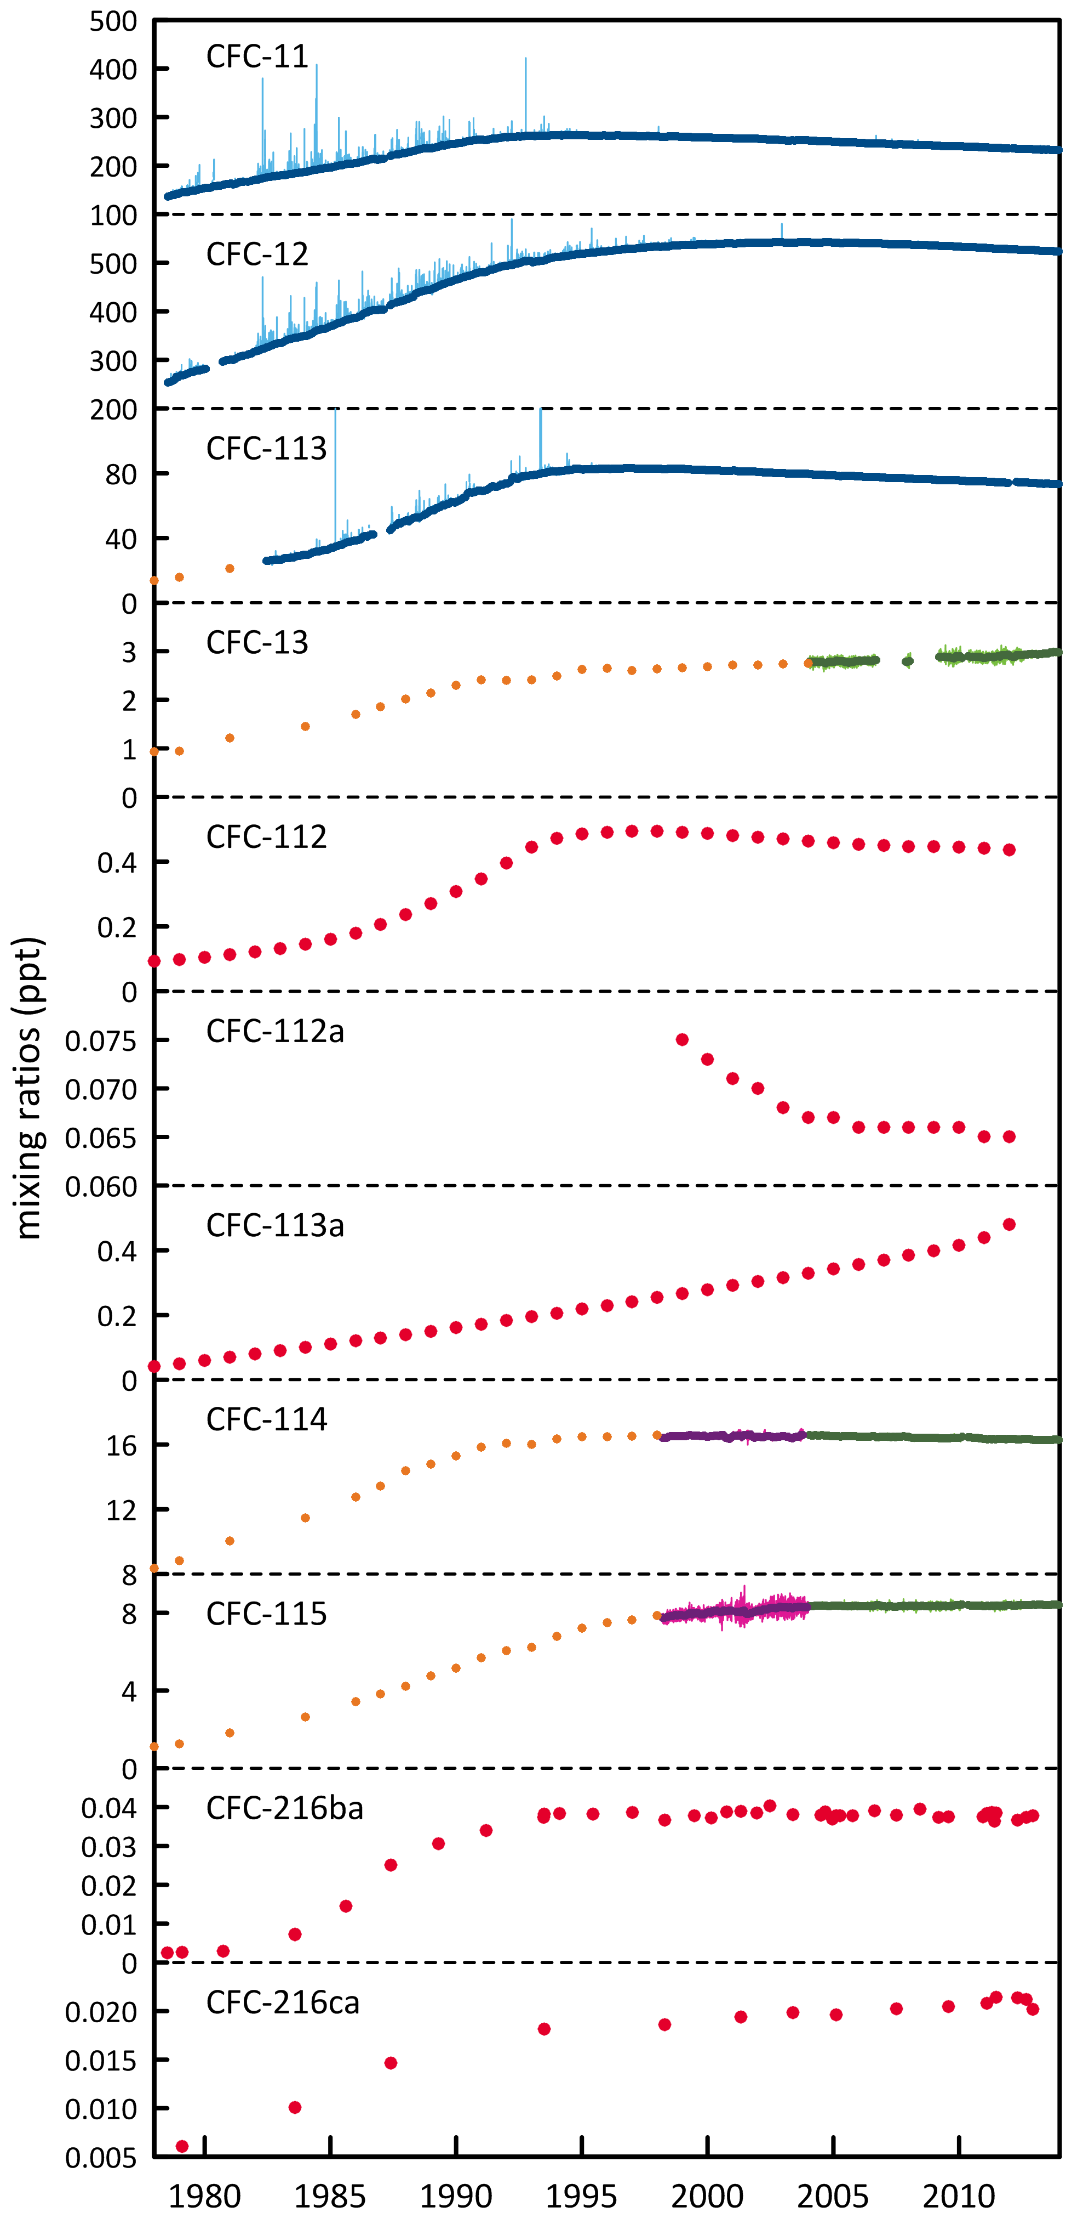

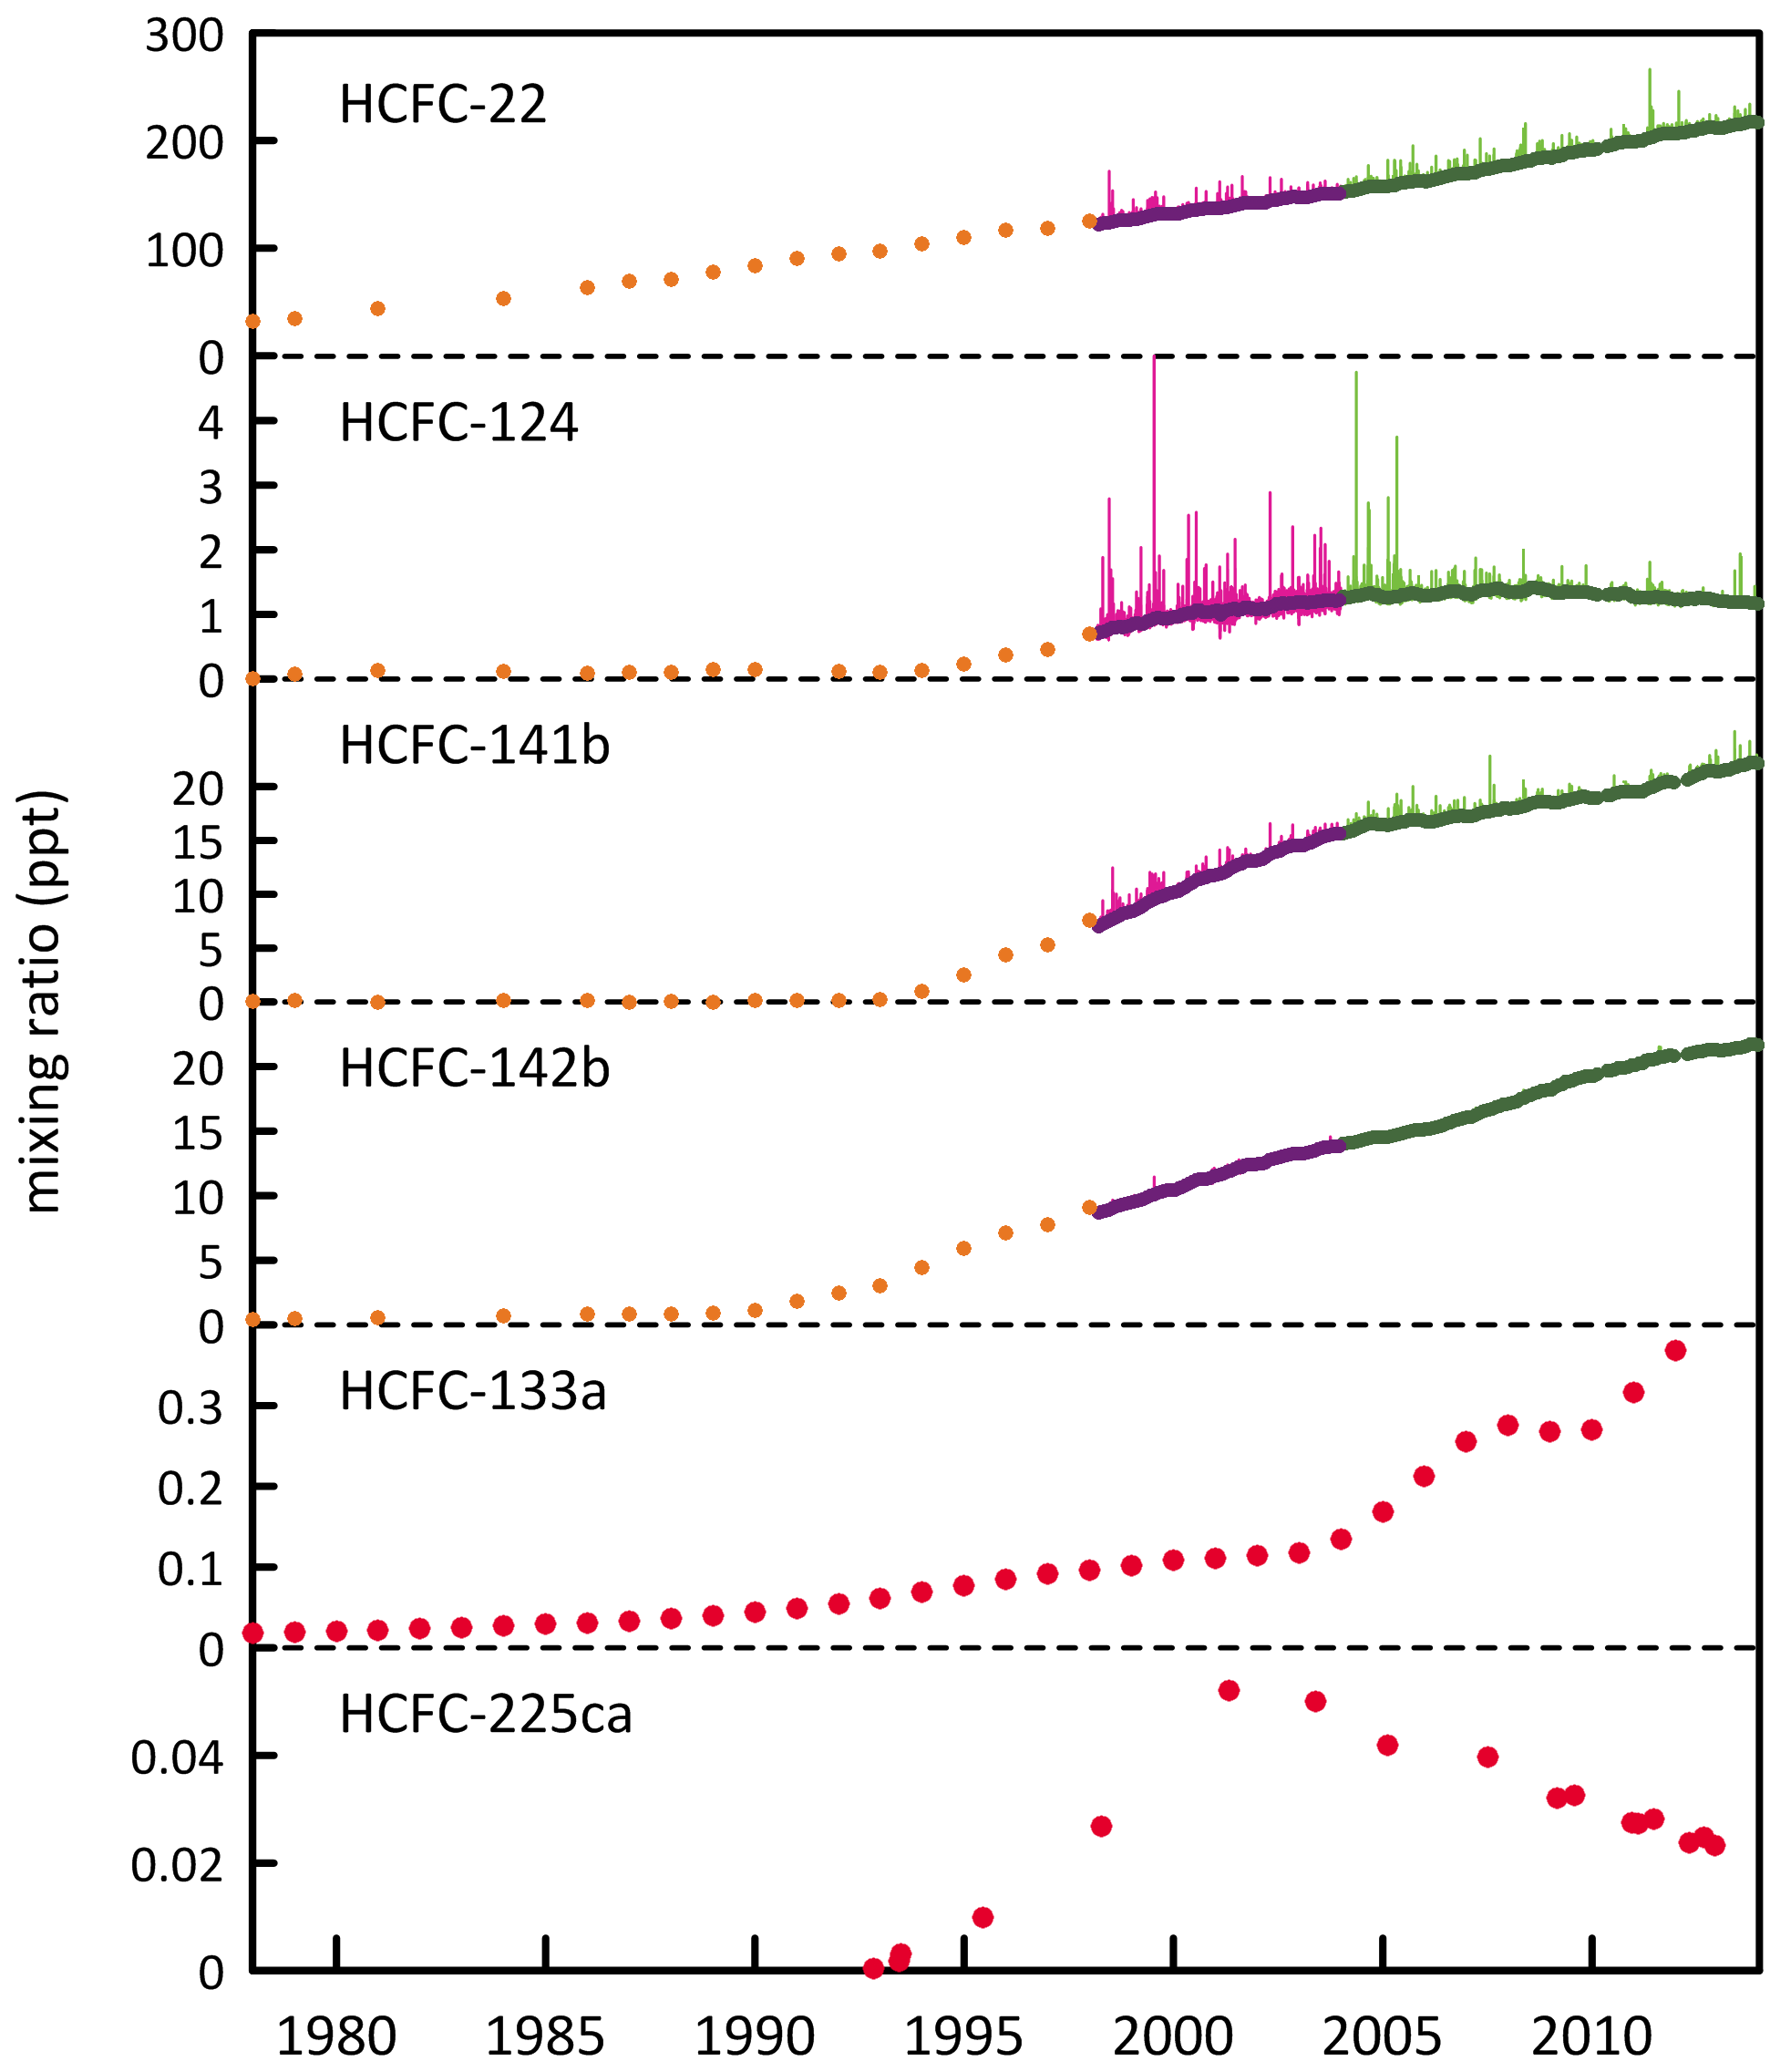

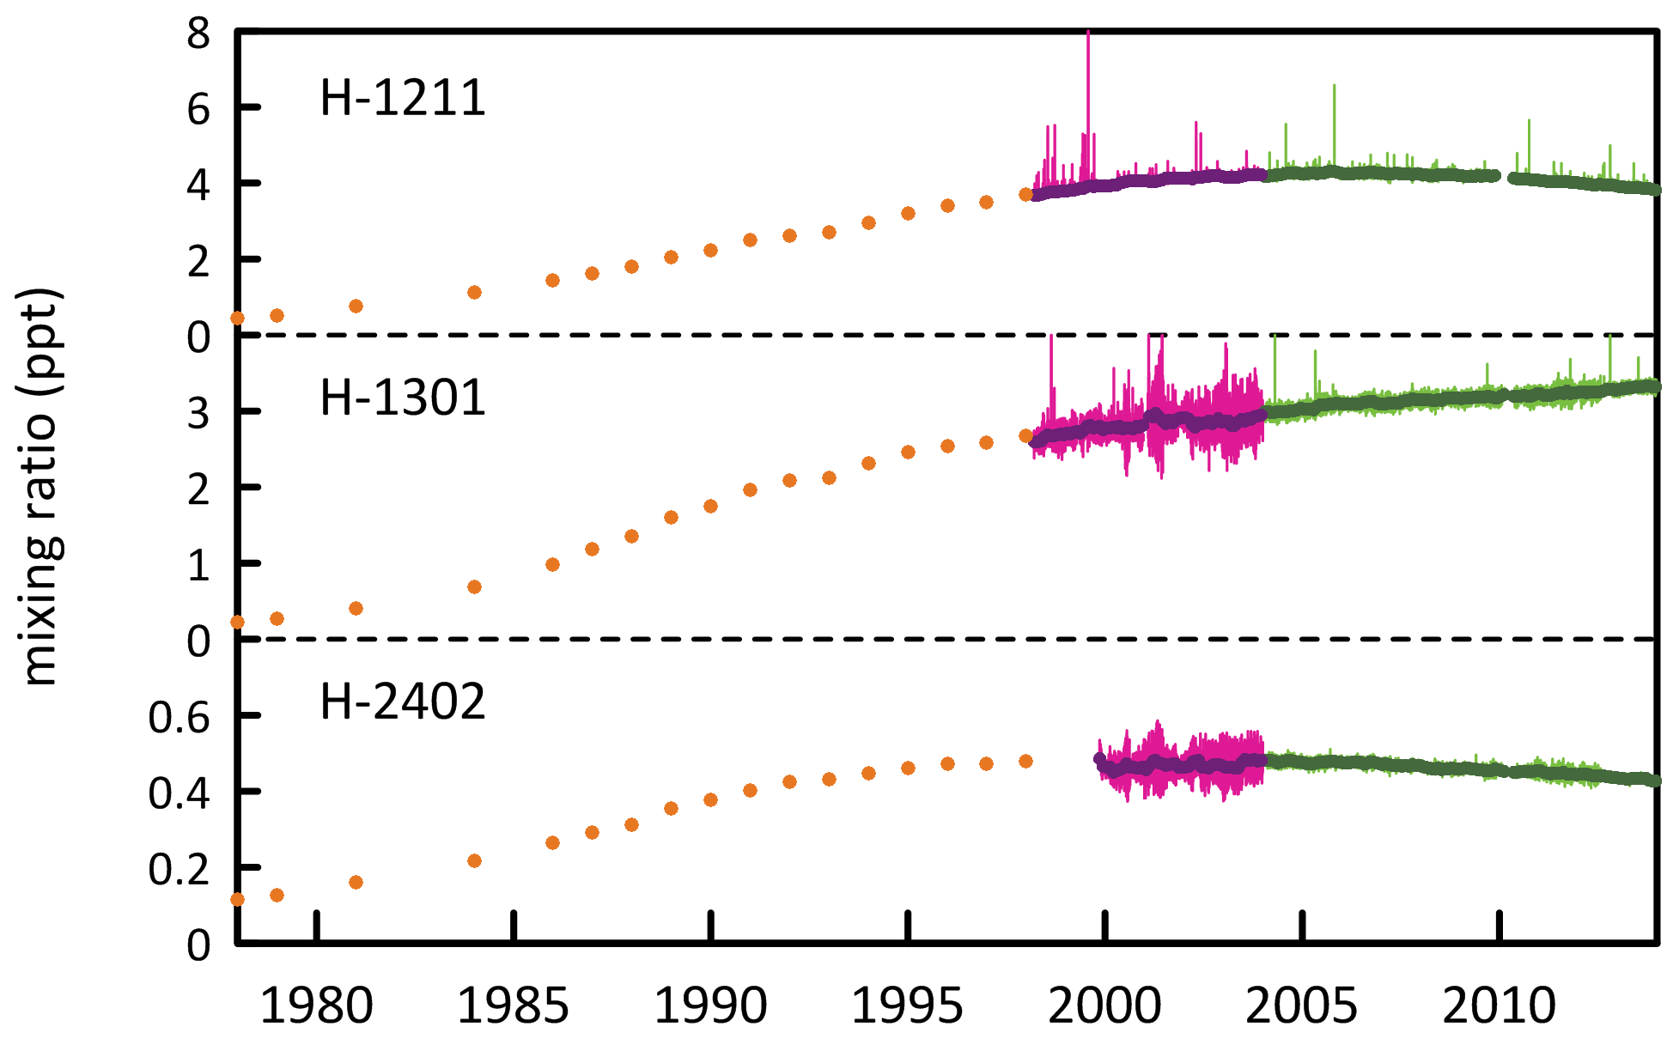

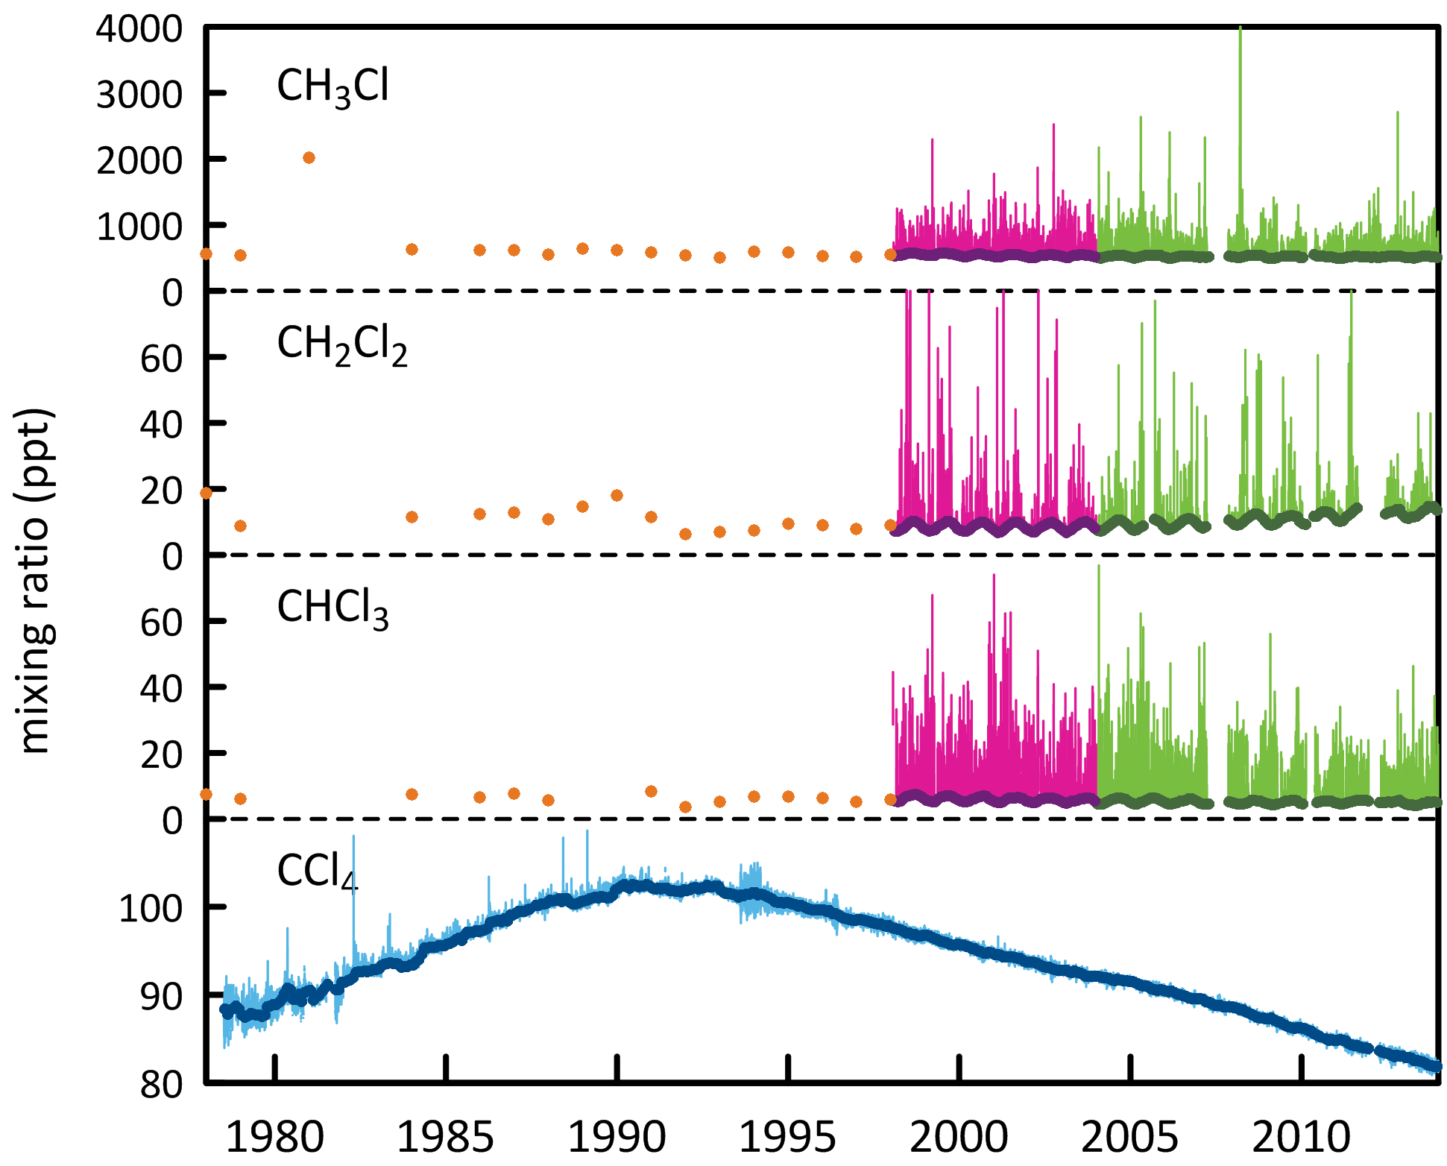

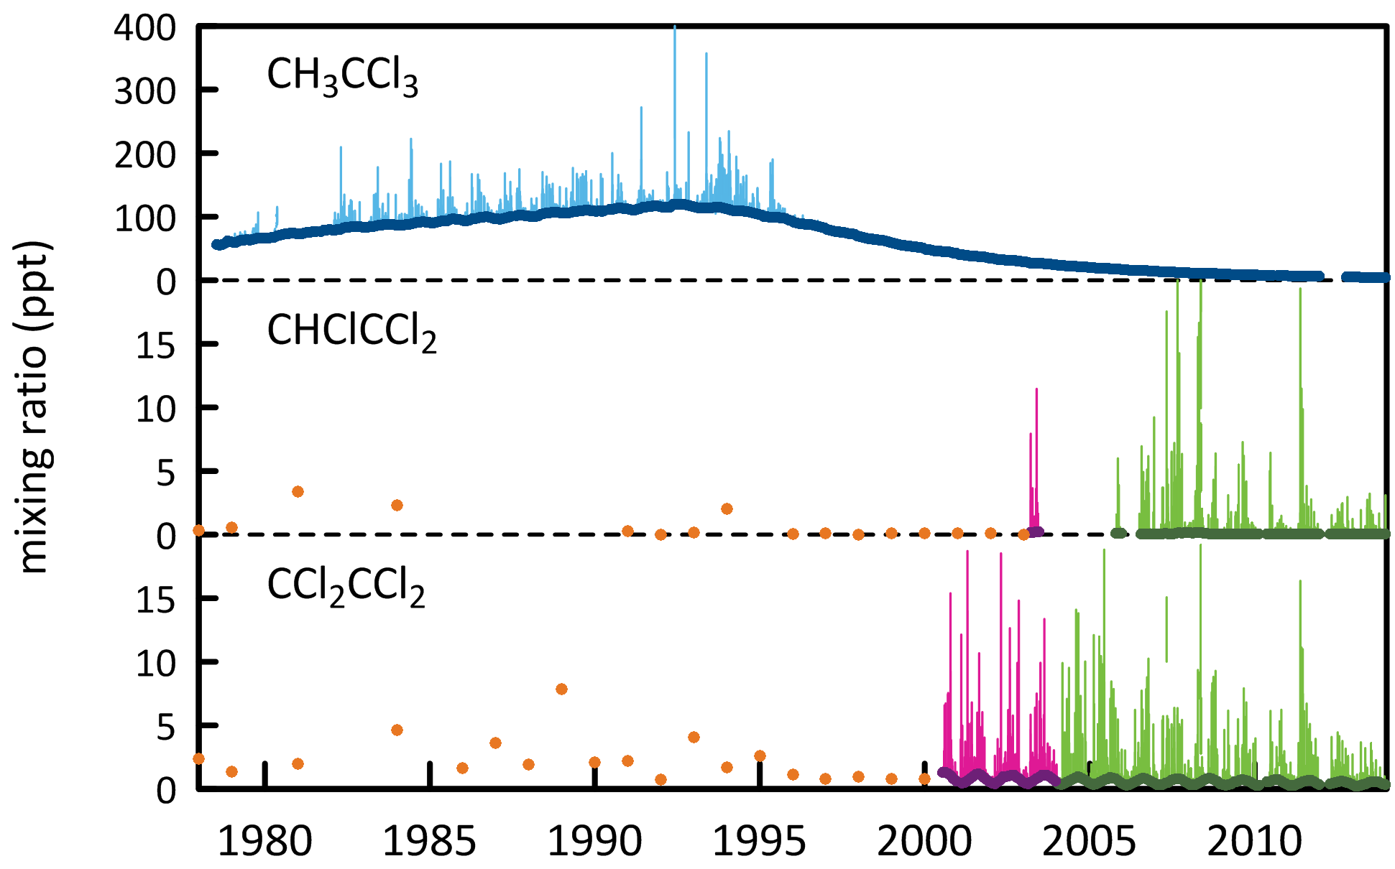

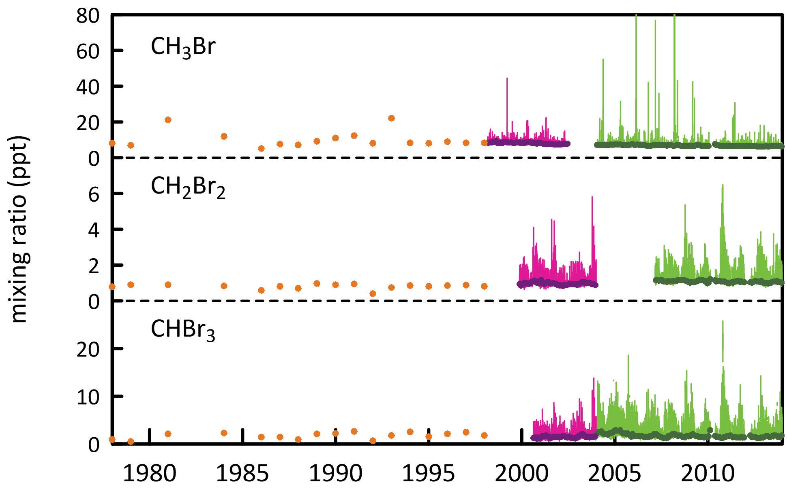

**Figure 1.** Cape Grim *in situ* and Air Archive observations of CFCs, HCFCs, halons, CT, MC, CH3Cl, CH2Cl2, CHCl3, TCE, PCE, MB, CH2Br2 and CHBr3 (1978 – 2013) showing baseline monthly mean data (Medusa - dark green; ADS - purple; ECD – dark blue; archive annual means – orange) and total data (Medusa - light green; ADS – pink; ECD – light blue) obtained from the GC-MS-Medusa, GC-MS-ADS and GC-ECD instruments at Cape Grim and Aspendale. The CFC-112, -112a, -113a, -216ba, -216ca and HCFC-133a data are from UEA measurements on the Cape Grim Air Archive (references: see text above and CSIRO unpublished data).

## 

## CFCs

CFC-11 and CFC-12 are the dominant CFCs in the atmosphere, constituting 88% of all CFCs in 2013. CFC-113, CFC-114 and CFC-115 constitute 11% of CFCs, the remaining minor CFCs about 1%. The CFCs account for 63% of chlorine from all ODSs in the background atmosphere.

As a result of measures undertaken within the Montreal Protocol framework, most of the CFCs (CFC-11, CFC-12, CFC-112, CFC-112a, CFC-113, CFC-114) measured in the atmosphere in 2012 and 2013 at Cape Grim have stopped growing or are in decline, the exceptions being CFC-13 and CFC-115, which are growing slowly, and CFC-113a, which shows significant growth (Table 1), although at a very low concentration. CFC-13 sources are likely to be small, possibly produced as a by-product, but, with an atmospheric lifetime approaching 700 years, any emissions are likely to cause a growth in its atmospheric abundance. Significant emissions of CFC-115 resulted from its past use in the refrigerant blend R-502 (515% CFC-115, 49% HCFC-22) and any continuing emissions (for example from landfills) will result in growth in the atmosphere because of its very long atmospheric lifetime (>1000 years). CFC-113a emissions are discussed below. Total CFCs are declining by 0.6% per year due to declining emissions (see below); chlorine from CFCs in the atmosphere decreased by 14 ppt (2012-2013, 0.7%).

The previously unidentified CFCs in the Cape Grim air archive are CFC-112, CFC-112a, CFC-113a, CFC-216ba and CFC-216ca (Kloss *et al.*, 2014, Laube *et al.*, 2014). Their summed concentration in 2013 is only ~1 ppt, while the other CFCs in the background atmosphere sum to 858 ppt in 2013. Their summed growth in the atmosphere is 0.03-0.04 ppt per year, virtually entirely due to the growth in CFC-113a (0.04 ppt per year). These low abundance CFCs are thought to be used as chemical feedstocks, or produced as by-products, with some fugitive emissions, or used as specialized solvents. A detailed discussion of these recently discovered (Kloss *et al.*, 2014, Laube *et al.*, 2014) CFCs has been tabled with the Department of the Environment (Fraser et al., 2014c).

## HCFCs

All of the HCFCs (HCFC-22, HCFC-141b, HCFC-142b, HCFC-133a) measured in the atmosphere at Cape Grim are growing, except the minor HCFC-124, which is declining slowly (Table 1). The dominant HCFC is HCFC-22 (215 ppt in 2013), 83% of both the abundance and growth of all HCFCs. HCFC-141b and HCFC-142b constitute 17% of HCFCs, the remaining minor HCFCs less than 1%. Total HCFCs are increasing by 2.3% per year, due to growing global emissions, largely from the developing world (see below). Chlorine in the atmosphere from HCFCs (281 ppt in 2013, 9% of total chlorine from all ODSs) increased by 7 ppt (2.4%, 2012-2013), the only ODS sector showing an increase in chlorine.

HCFC-133a (CH2ClCF3) has recently been identified in the Cape Grim Air Archive (Laube *et al*., 2014). The background concentration of HCFC-133a is low (0.4 ppt in 2013) but it is growing rapidly (13% per year). There is no clearly identified source of this HCFC, but it is possible that it has appeared in the atmosphere from an inadvertent by-product emission (Laube *et al*., 2014; Fraser *et al*., 2014c).

## Chlorocarbons

The most abundant chlorocarbon in the background atmosphere is the largely naturally-occurring CH3Cl (509 ppt, 2013), accounting for 83% of all chlorocarbons and 57% of chlorine from chlorocarbons. The next most abundant chlorocarbon is anthropogenic CTC (82 ppt, 2013), accounting for 37% of chlorine from chlorocarbons. The remaining minor chlorocarbons, including MC, contribute 6% of chlorocarbon chlorine. The chlorocarbons account for 28% of total chlorine from all ODSs in the background atmosphere.

Every chlorocarbon measured at Cape Grim showed declining concentrations in 2013 compared to 2012. The largest decline in the chlorocarbons was 8 ppt for CH3Cl, accounting for 55% of the decline in chlorocarbon chlorine; CTC accounted for 24% of the decline, MC 12%, CH2Cl2 4% and CHCl3 2%.

## Halons

H-1211 is the most abundant halon in the background atmosphere (3.9 ppt, 2013), followed by H-1301 (3.3 ppt) and H-2402 (0.4 ppt). H-1211 and H-2402 are in decline in the atmosphere (-0.1 ppt per year and -0.01 per year respectively, 2012-2013); however H-1301 continues to increase (0.05 ppt per year, 2012-2013). With H-1301, because its long atmospheric lifetime (65 years), its emissions from the H-1301 banks remain larger than the atmospheric sink. The other halons have lifetimes <20 years, so their emissions from the halon banks are less than their atmospheric sinks and their concentrations are thus decreasing. Overall halons are in decline by 0.7% per year, similar to the rate of decline of the CFCs. Bromine in the atmosphere from halons decreased by 0.06 ppt per year (0.7%), which equates to about a 3-4 ppt per year decline in equivalent chlorine.

## Other organobromine species

Methyl bromide is the most abundant (6.5 ppt, 2013) organobromine ODS in the background atmosphere, followed by H-1211 (3.9 ppt), H-1301 (3.3 ppt), CHBr3 (1.6 ppt) and CH2Br2 (1.0 ppt).

Methyl bromide showed a small increase (0.02 ppt per year, 2012-2013) in the background atmosphere, the first increase observed since Montreal Protocol restrictions came into force, suggesting an increase in overall MB emissions. This is likely due to emissions from sources not controlled by the Montreal Protocol (see discussion below). Natural bromoform showed the largest increase 0.2 ppt per year and natural CH2Br2 showed a small decline (-0.02 ppt per year). Overall bromine from all non-halon ODSs increased by 0.64 ppt per year (2012-2013), a 4.9% per year increase, largely due to the increase in bromine from natural CHBr3 (0.66 ppt, 2012-2013).

## Total chlorine and bromine

Total chlorine from ODSs (Figure 2) decreased from 3216 ppt in 2012 to 3194 ppt in 2013, a decline of 22 ppt (0.7%). The overall decline in chlorine from CFCs was 14 ppt (2012-2013), for chlorocarbons the decline was 15 pp and HCFC chlorine increased by 7 ppt.

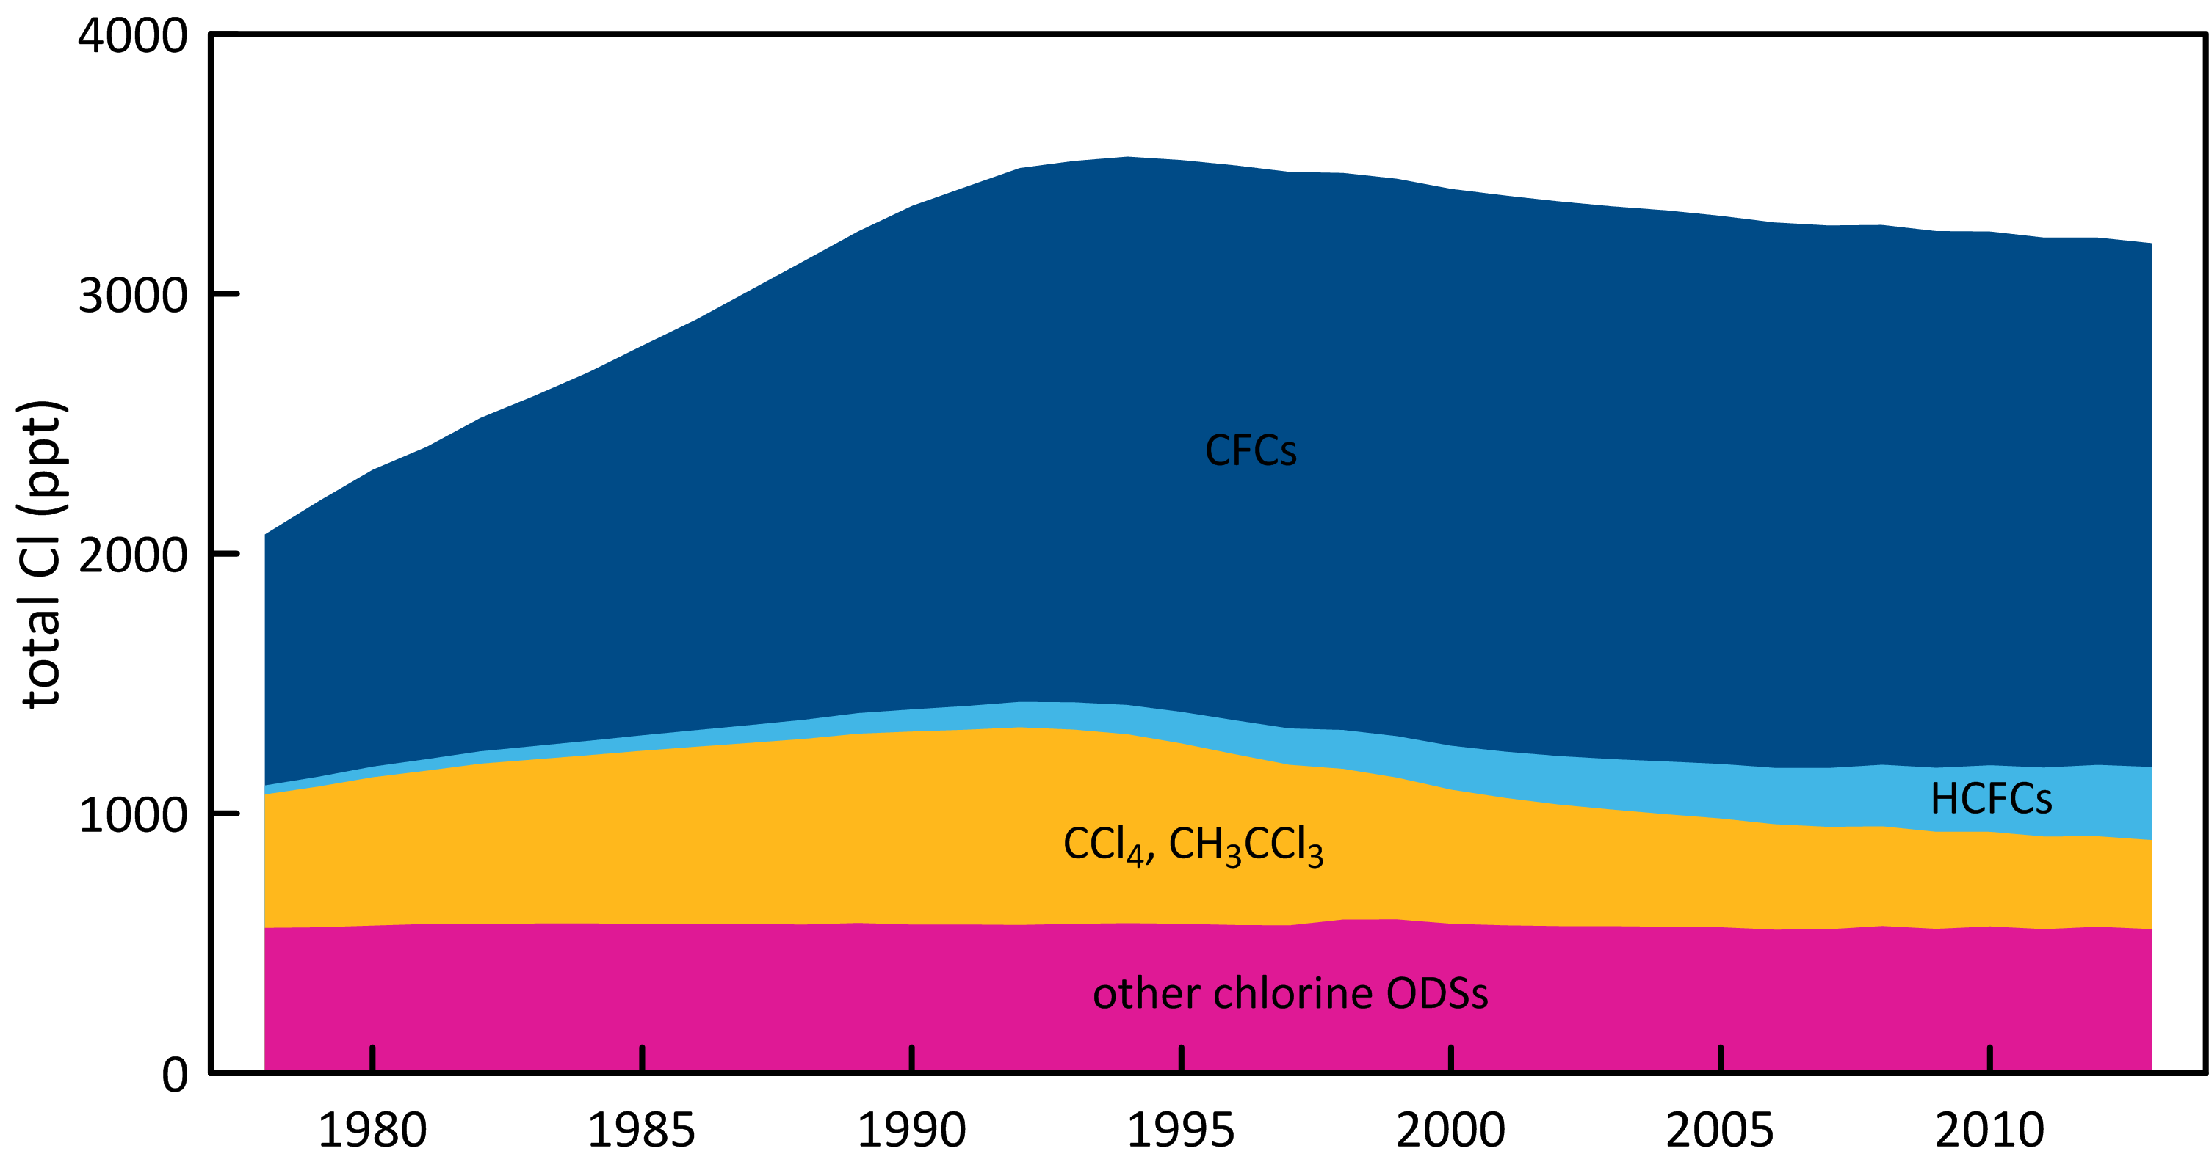

**Figure 2.** Total chlorine from CFCs, HCFCs, CTC: CCl4, MC: CH3CCl3 and other chlorine-containing ODSs (Table 1)

Total bromine from organobromine ODSs (Figure 3) was 21 ppt (2013) - 31% from MB, 23% CHBr3, 18% H-1211, 15% due to H-1301, 9% CH2Br2 and 4% H-2402. Bromine from all ODSs increased by 0.58 ppt (2012-2103, 2.8%), due to -0.06 ppt per year from the halons and 0.64 ppt per year from the non-halon ODSs.

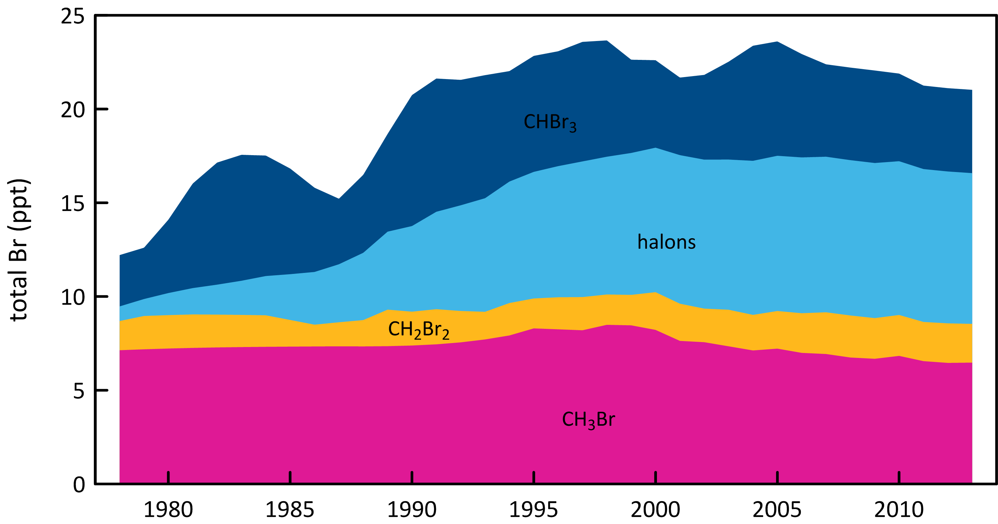

**Figure 3.** Total bromine from MB: CH3Br, halons, CH2Br2 and CHBr3

# Global emissions of ODSs

Background ODS observations at Cape Grim and from other AGAGE stations in the northern and southern hemispheres have been used to calculate global ODS emissions up to 2012 (Figure 4; Rigby *et al*., 2014). These emissions are derived using the AGAGE 12-box global model of atmospheric chemistry and transport (Rigby *et al*., 2013) and a Bayesian inverse method based on Rigby *et al*. (2011, 2013). ODS emissions have also been calculated for recently identified ODSs in the Cape Grim Air Archive by collegues at U. East Anglia (Laube *et al*., 2014; Kloss *et al*., 2014) using forward modelling in a 2-D atmospheric chemistry-transport model.

Total global CFC emissions continued to decline (102 k tonnes in 2012, 84 k tonnes in 2013), dominated (93%) by emissions of CFC-11 (48 k tonnes) and CFC-12 (30 k tonnes) in 2013. Since the peak emissions of CFCs in the late 1980s (1120 ktonnes, 1986-1987), overall CFC emissions have declined by 10% per year, attesting to the success of the Montreal Protocol controls on CFC production and consumption. CFC-11 became the dominant CFC emitted globally in 2012, taking over from CFC-12, whose emissions had previously always been larger than CFC-11 emissions (since 1979 based on AGAGE data, and earlier based on production data). Presumably this reflects a different pattern of CFC use in developing countries compared to past use in developed countries. In the previous CSIRO report to the Department of the Environment (Fraser *et al*., 2013), it was reported that global CFC-11 emissions in 2011 (72 k tonnes) were larger than CFC-11 emissions in 2010 (70 k tonnes). This result has not been seen in this latter, more rigorous, re-analysis of global AGAGE data, with 2011 global CFC-11 emissions at 51 k tonnes, 2012 at 50 k tonnes and 2013 at 48 k tonnes. The corresponding decline in global CFC-12 emissions at 60, 46 and 30 k tonnes respectively, is significantly greater than the decline in CFC-11 emissions. The decline in CFC-11 emissions from 1978 to 1982 is likely due to the early (pre-Montreal Protocol) phase-out of CFC-11 as an aerosol propellant.

Global CTC emissions increased slightly (63 k tonnes 2012, 64 k tonnes in 2013). Long-term, global CTC emissions declined slowly from a peak of around 150 k tonnes per year in the late 1970s-early 1980s until the minimum emissions recorded to date (62 k tonnes per year) were seen in 2009 and 2010, a long-term decline of about 4% per year. Since then emissions have slowly increased to 64 k tonnes in 2013. The decline in global CTC emissions is not as rapid as anticipated under the Montreal Protocol (Montzka & Reimann, 2011) and the increase in CTC emissions since 2009/2010 of about 1% per year is also unexpected. As pointed out by Fraser *et al*. (2014), a partial explanation may be that global emissions of CTC from land-fills and possibly chlor-alkali plants may be significant and not yet accounted for in global budgets.

Global MC emissions stopped declining in 2013 (2.1 k tonnes), with 2012 emissions at 2.0 k tonnes. This is only the second pause in the decline of MC emissions from their peak of 670 k tonnes in 1990, the other being in 2009-2010 (5.3 and 4.6 k tonnes respectively). As suggested in Fraser *et al*. (2013), this could mean that global sources now approximately equal global sinks and MC emissions will not fall to zero in the next few years as anticipated. The 2014 emissions will be instructive on this issue. The long term decline in MC emissions is in excess of 20% per year, which is about what is expected for an ODS with low emissions and an atmospheric lifetime of about 5 years.

Summed emissions of CTC and MC peaked at about 800 k tonnes in the late 1980s (84% MC), falling by more than a factor of 10 to 65-70 k tonnes by 2008 (97% CTC) and hovering around that level until 2013. Summed emissions of CH3Cl, CH2Cl2 and CHCl3 likely approached 4700 tonnes in the early-1990s, declining to about 4200 k tonnes around 2000 before rising again to around 4800 k tonnes currently (2012-2013).

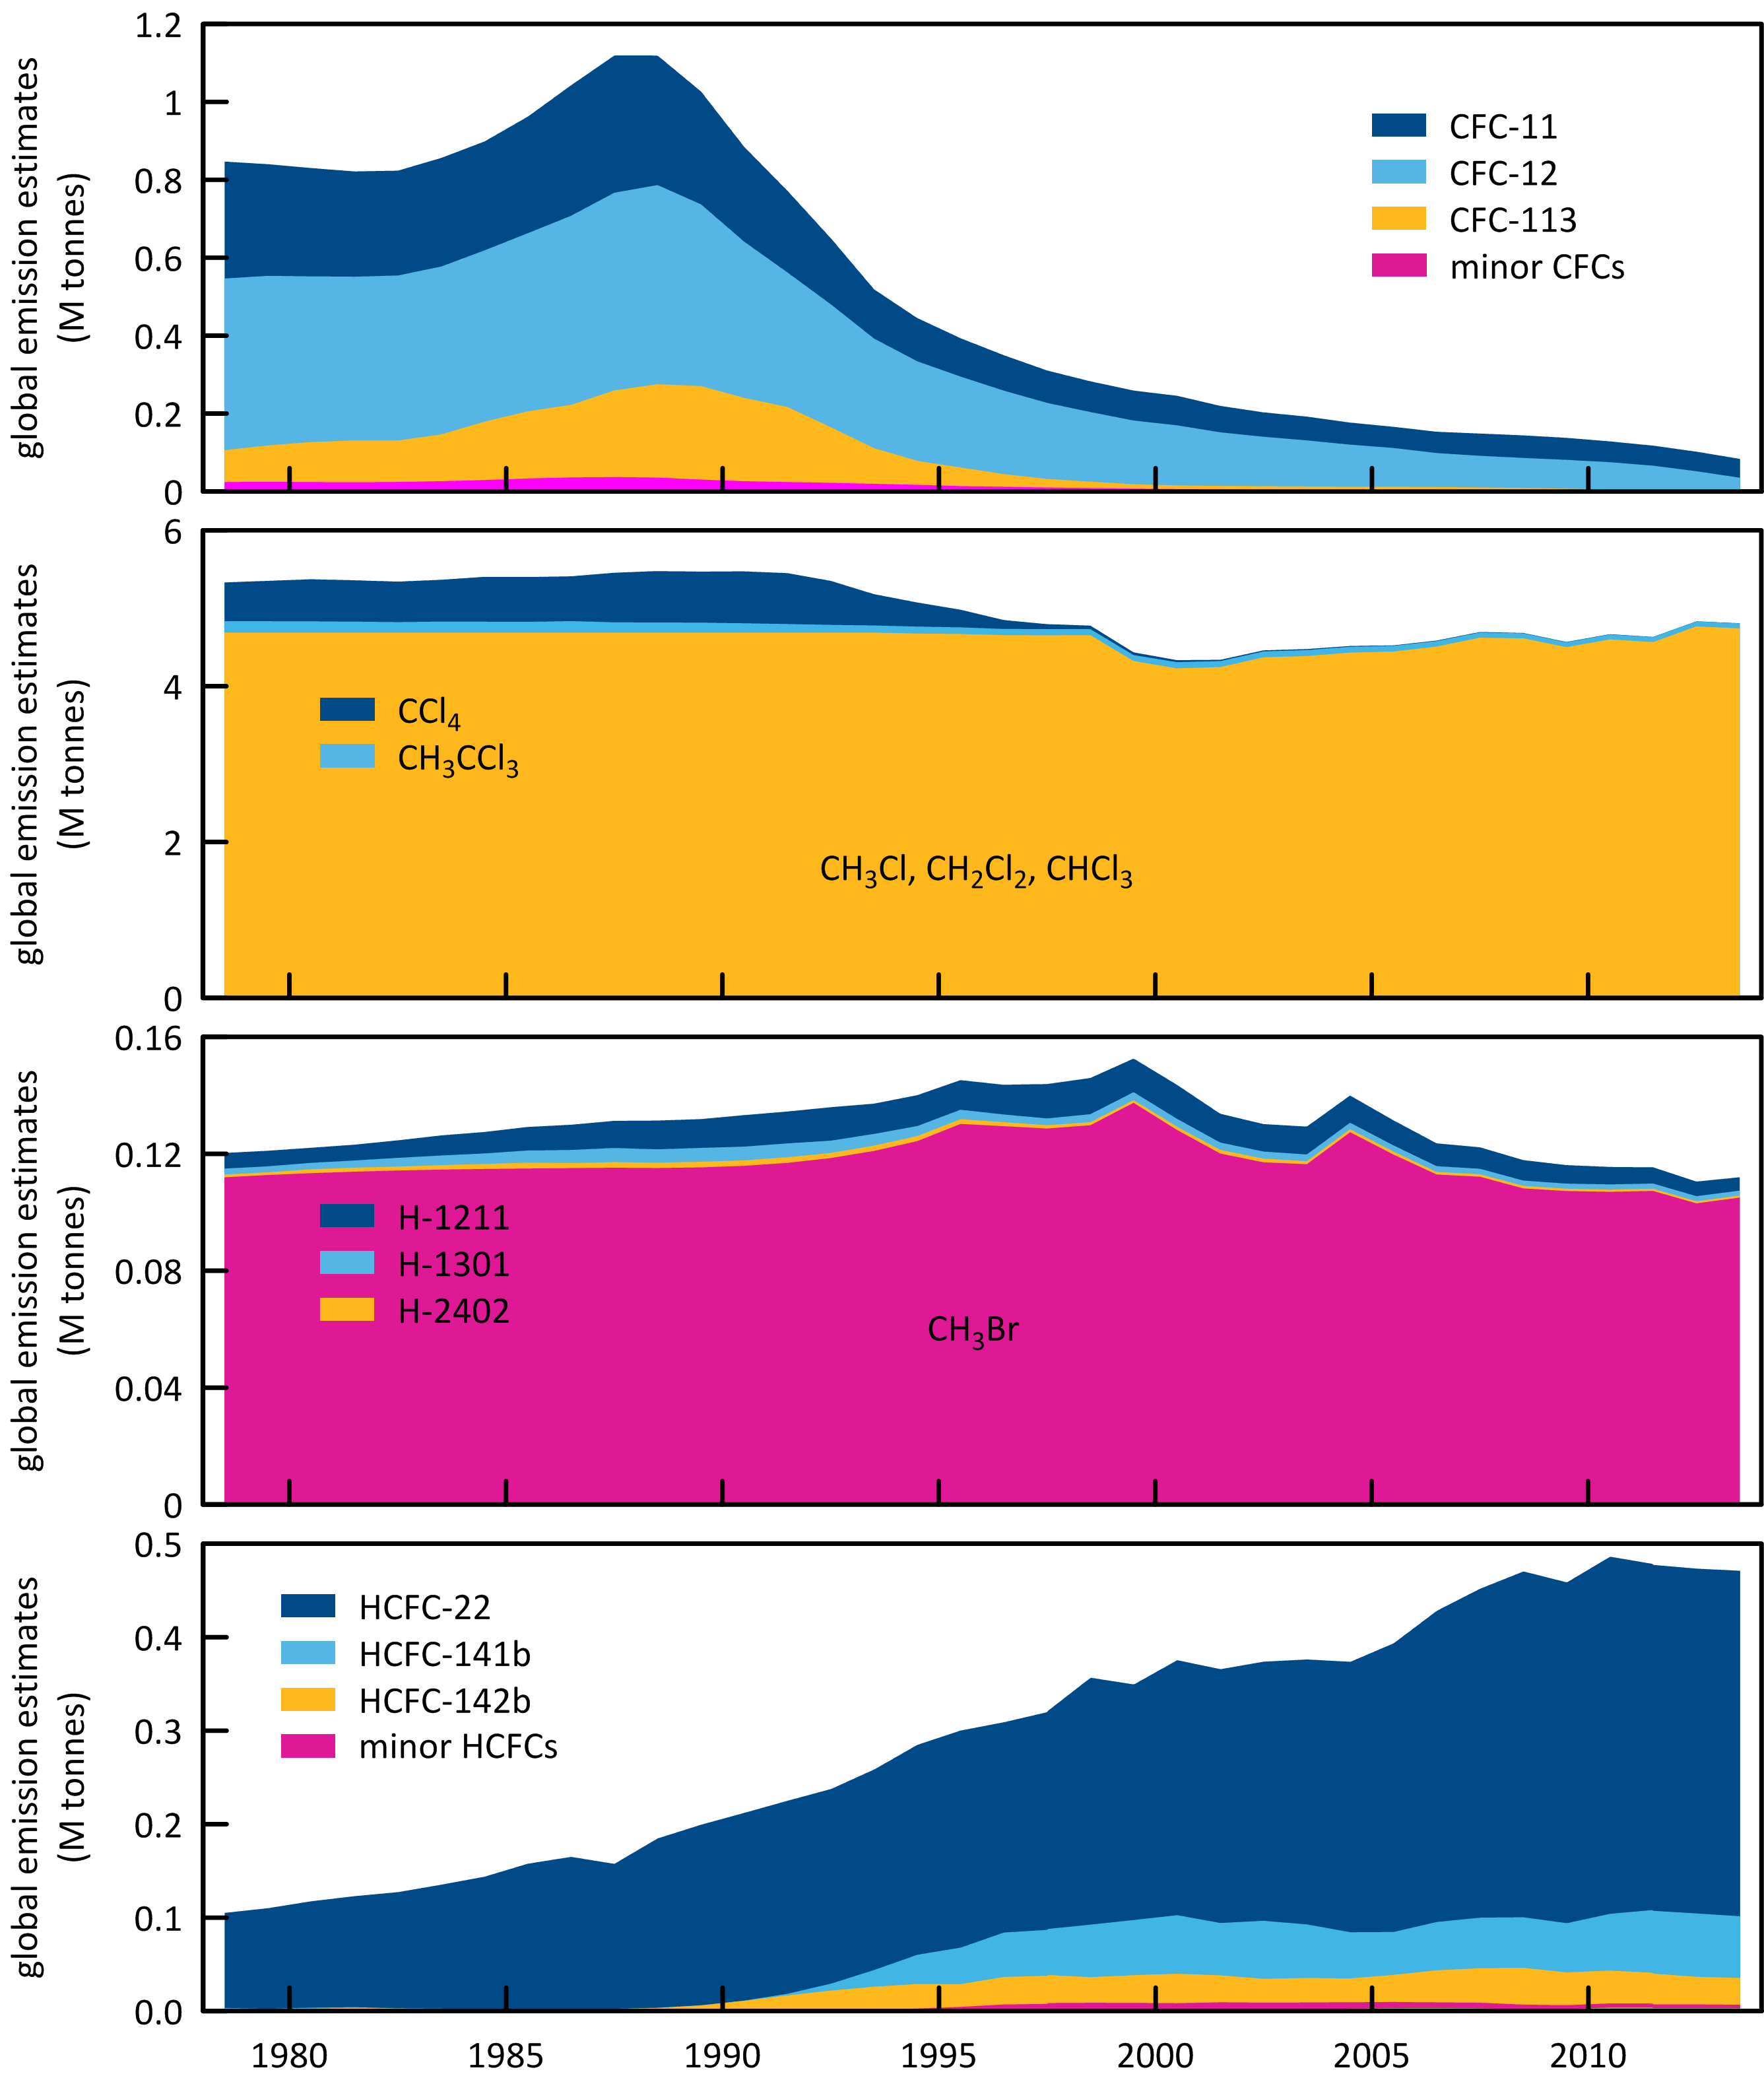

**Figure 4.** Global emissions of ODSs (CFCs, chlorinated solvents (MC: CH3CCl3, CTC: CCl4), CH3Cl, CH2Cl2, CHCl3, halons, MB: CH3Br, HCFCs) derived from global AGAGE data using the 12-box AGAGE global transport model (Laube *et al*., 2014; Kloss *et al*., 2014; Rigby *et al*., 2014). For the halons, emissions prior to the mid-1990s are based on AGAGE data and the 12 box model ( R. Wang, GIT, USA, unbublished data). For MB, pre-1998 emissions are scaled from global atmospheric concentrations.

Global HCFC emissions peaked in 2010 (482 k tonnes) and have since declined steadily to 468 k tonnes in 2013, a decline of about 1% per year. This decline is now statistically significant and is encouraging in relation to the overall long-term decline in ODSs that will bring about ozone layer recovery. Throughout the period from the late-1970s to 2010, total HCFC emissions increased by about 4% per year. The overall decline in total HCFC emissions since 2010 (14 k tonnes, 1% per year) is made up of a decline in HCFC-22 emissions (12 k tonnes), a decline in HCFC-142b emissions (7 k tonnes) and an increase in HCFC-141b emissions of 5 k tonnes. Presumably this pattern of HCFC emission changes is driven largely by emissions in developing countries.

Total global halon emissions continue to decline (7.5 k tonnes in 2012, 7.0 tonnes in 2013), dominated (80%) by halon-1211 emissions, which declined by 0.4 k tonnes over the same period. Data on the three halons (H-1211, H-1301, H-2402) are only available from 2003. In 2003 global halon emissions totalled 12 k tonnes falling to 7 k tonnes in 2013, a decline of 6% per year.

As anticipated in the previous report (Fraser *et al*., 2013), new estimates of global MB emissions have been made from AGAGE data (including Cape Grim) (Rigby *et al*., 2014). The new emission estimates start in 1998 (130 k tonnes), the largest emissions were recorded in 1999 (138 k tonnes), declining, with significant inter-annual variability, to 103 k tonnes in 2012, a long-term decline of 2% per year. Emissions in 2013 were 105 k tonnes, higher than emissions in 2012. It is too early to say whether this signals a significant increase in global MB emissions – as stated above there is significant, but likely real, inter-annual variability in global MB emissions. The 2014 and subsequent data will be very instructive in relation to this issue.

The total ODS global emissions for the Montreal Protocol ODSs (CFCs, HCFCs, halons, MC, CT and MB) in ODP tonnes are shown in Figure 5, togther with the global atmospheric concentration data for these species expressed as equivalent chlorine. The combined global emissions of the Montreal Protocol ODSs peaked at 1440 k tonnes (1.44 M tonnes) in the late 1980s, declining, thanks to the Montreal Protocol restrictions on ODS production and consumption, at 10% per year to 280 tonnes in 2012. The total global concentrations of ODSs, expressed as equivalent chlorine, peaked later in the mid-1990s at over 4050 ppt (4.1 ppb) declining slowly ( 0.5% per year) to 3750 ppt by 2013, resulting largely from the long (50-100+ years) lifetimes for CT and CFCs in the atmosphere.

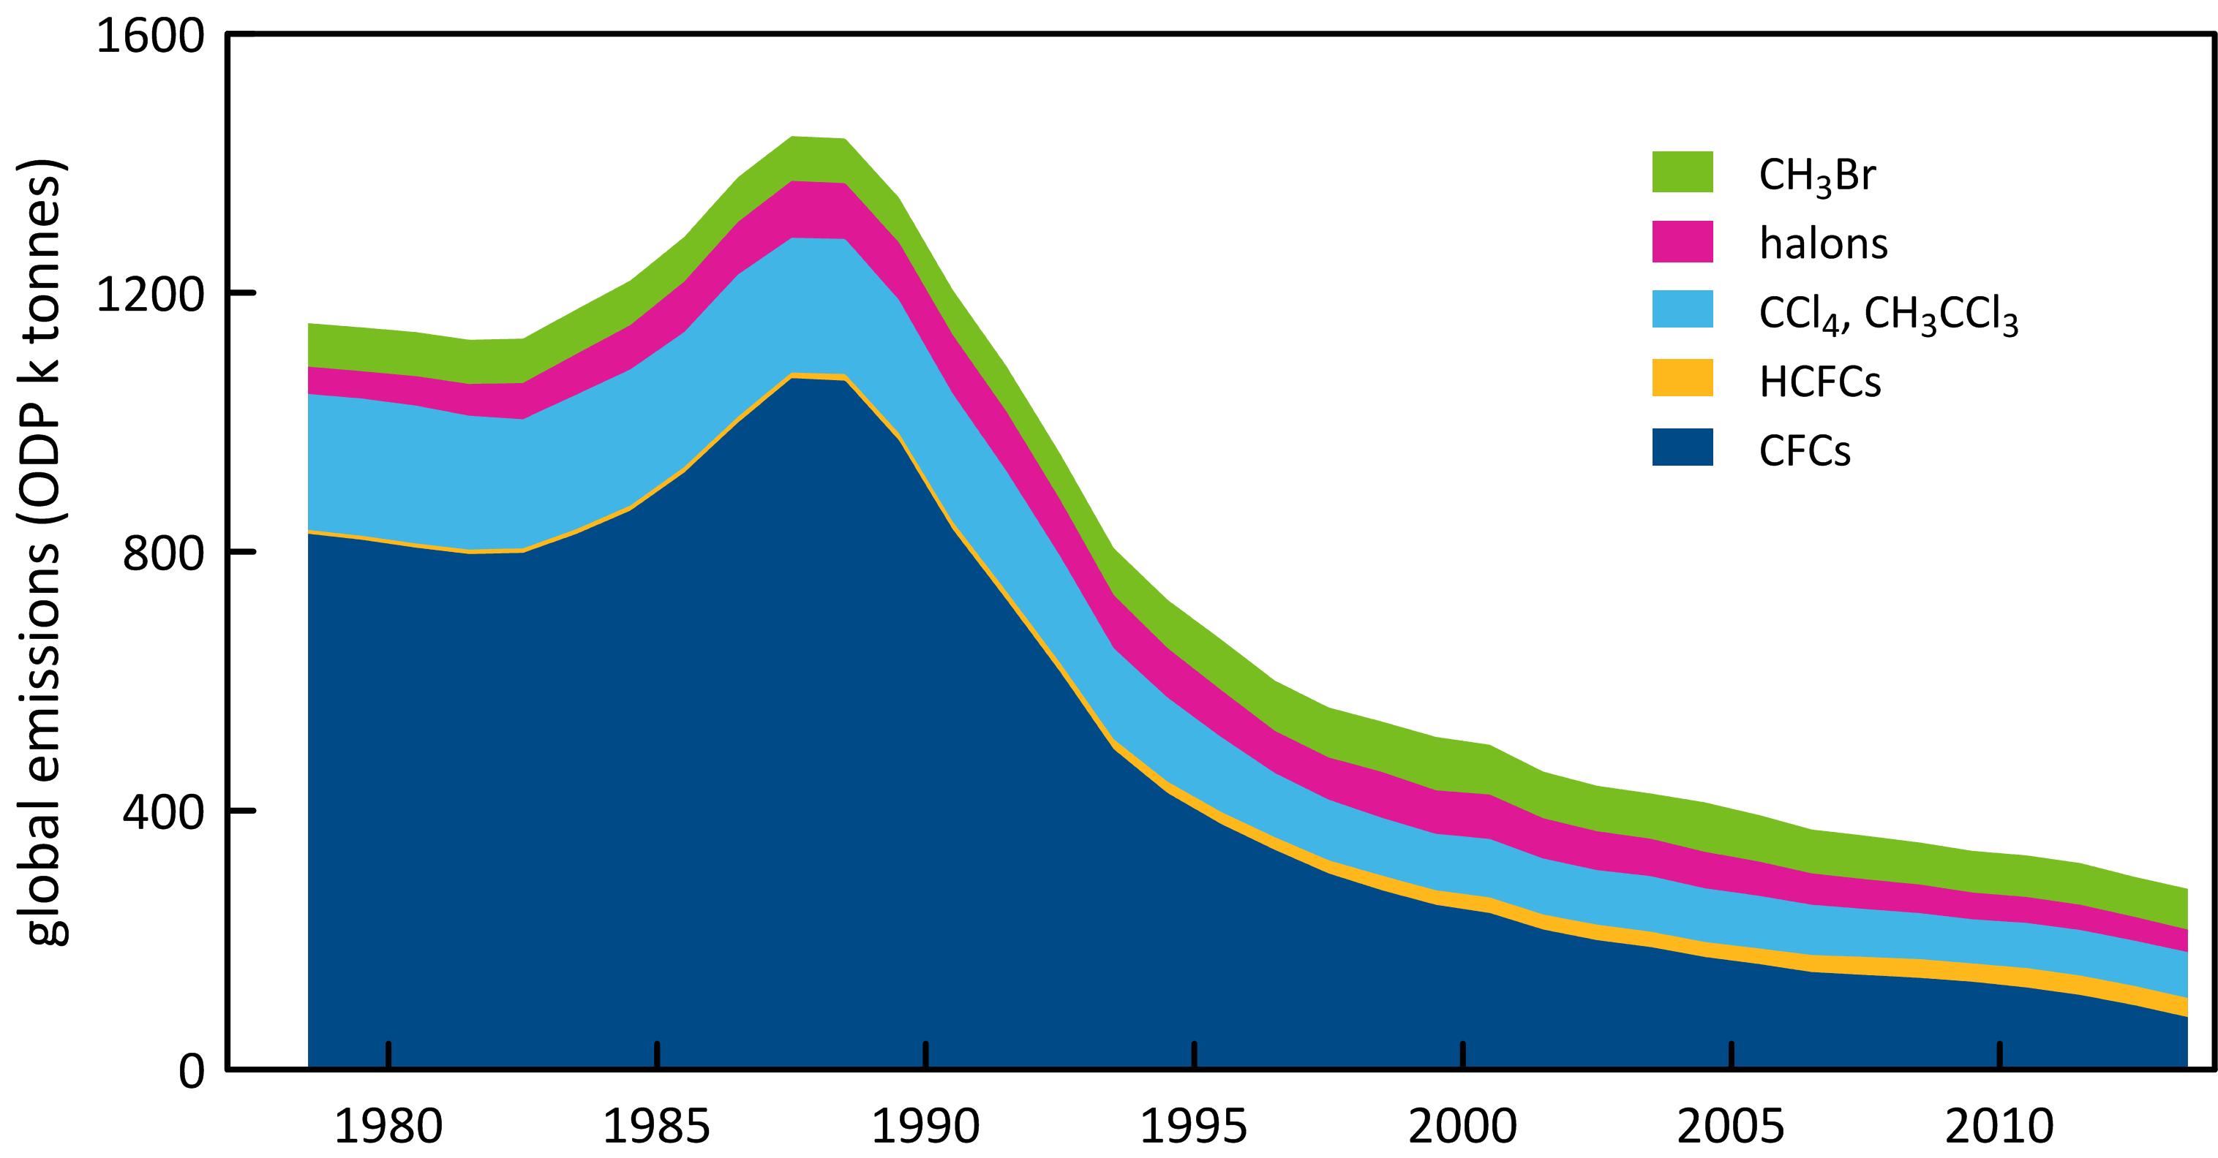

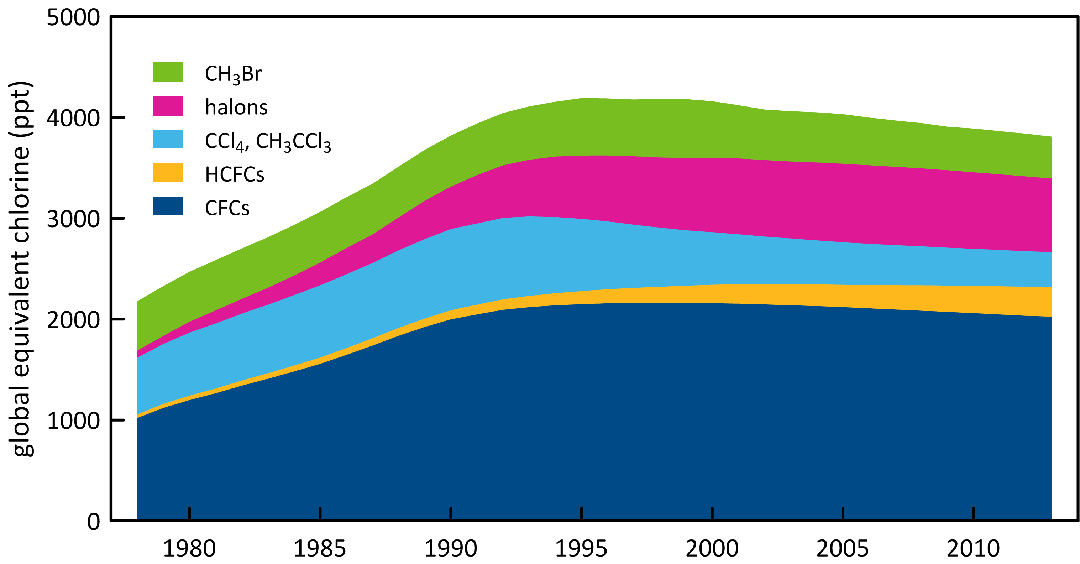

**Figure 5**. Global emissions (ODP tonnes) of the Montreal Protocol ODSs and global equivalent chlorine (ppt, both derived from AGAGE data (Rigby *et al*., 2014) using the 12-box AGAGE model. For the halons, emissions prior to the mid-1990s are based on AGAGE data and the 12 box model ( R. Wang, GIT, USA, unbublished data). For MB, pre-1998 emissions are scaled to post-1998 from global atmospheric concentrations, 1978-2013.

# Australian ODS imports

Data on Australian imports of ODSs are reported to the Australian government’s Department of the Environment under licensing arrangements in the *Ozone Protection and Synthetic Greenhouse Gas Management Act 1989*, with the requirement being established under the Act in 2003. Australian imports are documented in the Department’s *Ozone Licensing and Reporting System* (OLaRS: A. Gabriel, DoE, private communication, May 2014), which was introduced during 2011. OLaRS details imports of bulk and pre-charged HCFCs (individual HCFCs or HCFC blends) and other ODSs (in particular carbon tetrachloride – CTC and MB).

For 2012 and 2013 (January – December) imports were reported entirely via the OLaRS protocol. For 2011, OLaRS data are only available for October – December, and the annual imports reported here for 2011 are estimated by scaling the October-December data to the entire year, assuming that the October-December data are representative in volume and composition for all of 2011. Thus, the resultant 2011 data are more uncertain than the 2012 and 2013 data. For 2008-2010, the ODS imports are reported using the pre-OLaRS protocol. Imports of ODSs are shown in Table 2 and Figure 6.

There is an overall decline in Australian ODS imports from a over 15000 tonnes in 1991 to less than 1500 tonnes in 2013, a long-term decline of about 10% per year. In 1991 CFCs were the major ODS imports, but they declined rapidly to virtually zero imports by 2001, an overall decline of about 50% per year. Methyl chloroform was the second largest ODS import in 1991 (4700 tonnes) but imports ceased by 1996. HCFCs imports nearly doubled between 1991 (2400 tonnes) and 1998 (4200 tonnes); since 1998 there has been a long term decline in HCFC imports, falling to less than 750 tonnes by 2013, a long-term decline of just over 10% per year. MB imports were just over 1000 tonnes per year in the early 1990s, falling to about 350 tonnes in 2007, a long-term decline of 8% per year, driven by the reduction in non-QPS use of MB. Since 2007, MB imports have increased and by 2011 had reached over 730 tonnes, twice as large as the 2007 imports. Since 2011, imports have declined to under 650 tonnes in 2013. The increase in MB imports since 2007 has been driven by an increase in QPS use of MB. Variations in QPS demand for MB in Australia will likely follow overall grain and wood products production trends Grain production increased from about 20 M tonnes at the height of the recent drought (2006/2007) to 50 M tonnes in 2012/2013 (ABARE, 2014).

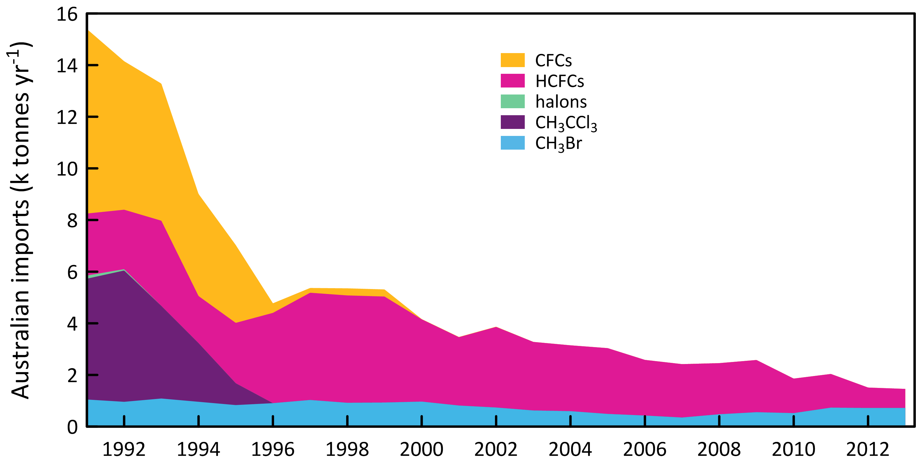

**Figure 6.** Australian imports (tonnes) of ODSs (CFCs, HCFCs, halons, MC: CH3CCl3, MB: CH3Br) (A. Gabriel, DoE, private communication, 2014). The 2012 and 2013 data are from the OLaRS data base, 2010 and earlier are pre-OLaRS data, and 2011 is a mixture of OLaRS and pre-OlaRS data.

**Table 2.** Australian imports (bulk and pre-charged equipment, tonnes) of ODSs (CFCs, HCFCs, MC: CH3CCl3, halons, MB: CH3Br) 1991-2013; 2012 and 2013 data are from the OLaRS data base, 2010 and earlier are pre-OLaRS data, and 2011 is a mixture of OLaRS and pre-OlaRS data (A. Gabriel, DoE, private communication, 2014). The only significant CTC: CCl4 imports were ~0.5 tonnes in 1995/1996 (not listed). 2013 MB imports are assumed equal to 2012. ODS imports less than 0.1 tonne are not listed, but included in total ODS.

|  |  |  |  |  |  |  |  |  |  |  |  |  |  |  |  |  |  |  |  |  |  |  |  |
| --- | --- | --- | --- | --- | --- | --- | --- | --- | --- | --- | --- | --- | --- | --- | --- | --- | --- | --- | --- | --- | --- | --- | --- |
|  | 1991 | 1992 | 1993 | 1994 | 1995 | 1996 | 1997 | 1998 | 1999 | 2000 | 2001 | 2002 | 2003 | 2004 | 2005 | 2006 | 2007 | 2008 | 2009 | 2010 | 2011 | 2012 | 2013 |
| CFC-11 | 1759 | 1786 | 1443 | 927 | 498 | 69 | 52 | 90 | 90 |  |  |  | 1 |  |  |  |  |  |  |  |  |  |  |
| CFC-12 | 4049 | 3054 | 3205 | 2784 | 2229 | 181 | 129 | 182 | 182 | 8 | 8 | 8 |  |  |  |  |  |  |  |  |  |  |  |
| CFC-113 | 999 | 808 | 485 | 168 | 236 | 118 |  |  |  |  |  |  |  |  |  |  |  |  |  |  |  |  |  |
| CFC-114 | 6 | 19 | 6 | 11 | 7 | 3 | 3 | 3 | 3 | 1 | 1 | 1 |  |  |  |  |  |  |  |  |  |  |  |
| CFC-115 | 331 | 84 | 172 | 64 | 46 |  |  |  |  |  |  |  |  |  |  |  |  |  |  |  |  |  |  |
| **Total CFCs** | **7144** | **5751** | **5311** | **3954** | **3071** | **372** | **184** | **275** | **275** | **9** | **9** | **10** | **1** |  |  |  |  |  |  |  |  |  |  |
| HCFC-22 | 2402 | 2252 | 2940 | 1368 | 1663 | 2626 | 3056 | 2900 | 2955 | 2160 | 2228 | 2557 | 2054 | 2053 | 1979 | 1843 | 1808 | 1773 | 1878 | 1224 | 1280 | 758 | 714 |
| HCFC-123 |  | 17 | 60 | 67 | 74 | 59 | 52 | 72 | 76 | 20 | 7 | 34 | 11 | 31 | 28 | 15 | 18 | 21 | 48 | 26 | 12 | 20 | 16 |
| HCFC-123a |  |  |  |  |  |  |  |  |  |  |  |  |  |  |  |  |  |  |  |  | 1 | 8 | 6 |
| HCFC-124 |  |  | 8 | 2 | 49 | 93 | 195 | 189 | 140 | 56 | 60 | 46 | 64 | 43 | 29 | 15 | 18 | 20 | 13 | 32 | 5 | 4 | 3 |
| HCFC-141b |  | 30 | 269 | 411 | 522 | 579 | 639 | 827 | 813 | 892 | 301 | 446 | 473 | 396 | 428 | 241 | 198 | 155 | 76 | 49 | 3 |  | 1 |
| HCFC-142b |  | 3 | 23 | 14 | 29 | 89 | 130 | 141 | 87 | 59 | 52 | 40 | 54 | 27 | 84 | 40 | 26 | 12 | 8 | 5 | 3 | 2 |  |
| HCFC-225ca |  |  |  |  |  |  |  |  |  |  |  |  |  |  |  |  |  |  | 0.5 | 0.3 | 0.3 | 0.5 |  |
| **Total HCFCs** | **2402** | **2302** | **3301** | **1823** | **2338** | **3497** | **4154** | **4158** | **4105** | **3187** | **2648** | **3123** | **2656** | **2551** | **2548** | **2156** | **2068** | **1981** | **2023** | **1337** | **1305** | **793** | **740** |
| **CH3CCl3** | **4680** | **5086** | **3586** | **2273** | **846** |  |  |  |  |  |  |  |  |  |  |  |  |  |  |  |  |  |  |
| H-1211 | 111 | 14 |  |  |  |  |  |  |  |  |  |  |  |  |  |  |  |  |  |  |  |  | 0.1 |
| H-1301 | 11 | 39 |  |  |  |  |  |  |  |  |  |  |  |  |  |  |  |  |  |  |  |  | 1 |
| **Total halon** | **122** | **53** |  |  |  |  |  |  |  |  |  |  |  |  |  |  |  |  |  |  |  |  |  |
| **CH3Br** | **1048** | **959** | **1087** | **876** | **833** | **907** | **1031** | **921** | **932** | **968** | **815** | **738** | **624** | **597** | **490** | **427** | **351** | **477** | **557** | **522** | **734** | **719** | **649** |
| **Total ODSs** | **15396** | **14151** | **13285** | **8926** | **7033** | **4776** | **5257** | **5354** | **5312** | **4164** | **3467** | **3870** | **3281** | **3148** | **3038** | **2583** | **2419** | **2458** | **2580** | **1859** | **2039** | **1512** | **1389** |

# 

# Estimated Australian ODS emissions from Cape Grim data

Estimates of emissions of CFCs, HCFCs, MC, CTC, halons and MB from the Melbourne/Port Phillip region (Dunse *et al*., 2001, 2005; Dunse 2002; Fraser *et al*., 2012, 2013, 2014b), have been made utilising *in situ* measurements from the Cape Grim Baseline Air Pollution Station in Tasmania and an interspecies correlation (ISC) technique with co-incident carbon monoxide (CO) measurements.

The original emission estimates were based on an average CO emissions from the Melbourne/Port Phillip region (600 k tonnes per year) which were assumed to have been relatively constant during 2004-2009 (EPA, 1998). In Fraser *et al*. (2012), revised estimates of the Port Phillip region CO emissions were used (Delaney & Marshall, 2011) with 2002 emissions estimated at 605 k tonnes and 2006 emissions at 645 tonnes. Carbon monoxide emissions were assumed constant after 2006 for the Port Phillip region. There has been a further revision of CO emissions from the Port Phillip region (S. Walsh, Victorian EPA, unpublished data, 2013). The 2006 Port Phillip CO emissions are now estimated to have been 796 k tonnes, with the increase in emissions compared to earlier estimates due to increased emissions from vehicles and reduced emissions from wood heaters. The time-dependence of Port Phillip CO emissions has been estimated from EPA CO concentration observations throughout the Port Phillip region. Using the revised data on CO emissions, Port Phillip ODS emissions have been calculated, for 1994-2013, using Cape Grim *in situ* data and ISC, obtained from the GC-ECD and GC-MS instruments at Cape Grim, and scaled to Australian emissions, where appropriate, on a population basis (using a population-based scale factor of 5.4). NOAA air mass back trajectory analyses (Draxler & Hess, 1997) are used to ensure that the pollution events at Cape Grim used to derive Port Phillip emissions are imbedded in air masses that only pass over the Port Phillip region and do not include other possible carbon monoxide source regions, in particular the Latrobe Valley.

SE Australian ODS emissions can be calculated from Cape Grim data using the NAME model. NAME (**N**umerical **A**tmospheric Dispersion **M**odelling **E**nvironment) is a Lagrangian particle dispersion model (O’Doherty *et al*., 2009; Manning *et al*., 2003, 2011) driven by 3-dimensional wind fields from numerical weather predictions models. NAME has a horizontal resolution (grid boxes 40 km x 40 km) and a minimum boundary layer height of 100 m. NAME operates in a backward mode, so, for example, it identifies, within a 3 hr period at Cape Grim, which grid boxes in a prescribed domain impact on Cape Grim over the previous 12 days. NAME releases 33000 particles at Cape Grim over a 3 hr period and the resultant 12 day integrated concentrations in each of the domain boxes are calculated. Operating NAME in the backward mode is numerically very efficient and is a very close approximation to the forward running mode, which is what is used to identify emission sources impacting on Cape Grim. In the inverse calculation, NAME identifies pollution episode data at Cape Grim, and starts with randomly-generated emission maps and searches for the emission map that leads to a modelled pollution time series that most accurately mimics the observations. The inversion method assumes that baseline air enters the inversion domain regardless of direction i.e. it assume that sources outside the specified domain do not impact significantly on Cape Grim. One of the major advantages of the NAME method, especially when using Cape Grim data, is that it does not require a prior estimate of emissions. Other inversion methods used to estimate regional emissions using Cape Grim data often derive emissions that are not significantly different to the prior estimates.

The NAME model ‘sees’ emissions from Victoria/Tasmania or Victoria/Tasmania/New South Wales (depending on the domain used in the model) and are presented as 3-yr running averages of emissions (i.e. 2008 annual emissions are derived from 2007-2009 data). The Australian emissions are calculated from NAME Victorian/Tasmanian or Victorian/Tasmanian/NSW emissions using population based scale factors of 3.7 and 1.7 respectively, when appropriate, and are also shown in Table 3 and Figure 7.

Australian halon emissions are derived from SE Australian emissions, assuming ~50% of SE Australian emissions are from the National Halon Bank located in Melbourne (Fraser *et al*., 2013). The SE Australian (non-Halon Bank) halon emissions are scaled to Australian emissions based on population.

Australian MB emissions are based on DPI QPS and non-QPS emissions factors applicable to MB use in Australia; 100% of Australian non-QPS MB is assumed to originate in SE Australia; 35% of Australian QPS MB is assumed to originate from SE Australia grain export ports (35% of Australia’s grain exports are assumed to originate from SE Australian ports).

The Australian emissions of ODSs - CFCs, HCFCs, halons, MB, Montreal Protocol chlorocarbons (methyl chloroform, CTC) other chlorocarbons (CH2Cl2, CHCl3, TCE, PCE) - are presented as 3-year running averages (1995-2012: Table 3, Figure 7).

**Table 3.** Annual average (3-yr running means, i.e. 2012 = average of 2100, 2012, 2013) Australian emissions (metric tonnes unless otherwise stated) of ODSs (CFCs, HCFCs, halons, MB and chlorocarbons) from Cape Grim AGAGE data, using ISC techniques. Australian emissions are scaled from SE Australian emissions on a population basis; Australian halon emissions are from SE Australian emissions adjusted for the impact of emissions from the National Halon Bank in Melbourne; Australian MB emissions are from SE Australian emissions scaled to Australian emission using a DPI-modified UNEP model of MB emissions based on QPS and non-QPS MB consumption (see text). GWPs (to calculate CO2-e emissions) are from Forster & Ramaswamy (2007); ODPs (to calculate ODP-weighted emissions) are from Montzka & Reimann (2011); assumed GWPs for TCE (0.67) and PCE (0.53).

|  | 1995 | 1996 | 1997 | 1998 | 1999 | 2000 | 2001 | 2002 | 2003 | 2004 | 2005 | 2006 | 2007 | 2008 | 2009 | 2010 | 2011 | 2012 |
| --- | --- | --- | --- | --- | --- | --- | --- | --- | --- | --- | --- | --- | --- | --- | --- | --- | --- | --- |
| **CFCs** |  |  |  |  |  |  |  |  |  |  |  |  |  |  |  |  |  |  |
| CFC-11 | 1420 | 574 | 533 | 584 | 542 | 549 | 459 | 472 | 417 | 565 | 662 | 738 | 843 | 663 | 552 | 378 | 415 | 370 |
| CFC-12 | 3219 | 2083 | 1807 | 1526 | 1188 | 1003 | 761 | 736 | 669 | 677 | 589 | 568 | 573 | 519 | 388 | 310 | 330 | 291 |
| CFC-113 | 753 | 542 | 181 | 171 | 171 | 160 | 143 | 121 | 100 | 92 | 71 | 92 | 122 | 135 | 102 | 98 | 95 | 100 |
| CFC-114 | 56 | 56 | 56 | 56 | 56 | 50 | 55 | 64 | 58 | 47 | 24 | 28 | 39 | 53 | 60 | 60 | 56 | 55 |
| CFC-115 | 202 | 202 | 202 | 202 | 202 | 199 | 186 | 168 | 173 | 103 | 23 | 23 | 33 | 39 | 51 | 58 | 60 | 54 |
| total | 5651 | 3458 | 2779 | 2339 | 2158 | 1962 | 1604 | 1561 | 1417 | 1484 | 1370 | 1449 | 1610 | 1408 | 1153 | 904 | 955 | 870 |
| ODP tonnes | 5419 | 3268 | 2662 | 2424 | 2043 | 1850 | 1501 | 1469 | 1328 | 1424 | 1347 | 1422 | 1572 | 1365 | 1112 | 861 | 912 | 828 |
| M tonnes CO2-e | 48.5 | 30.8 | 25.4 | 22.5 | 18.6 | 16.5 | 13.3 | 12.9 | 11.7 | 11.9 | 10.4 | 10.7 | 11.6 | 10.4 | 8.5 | 6.8 | 7.1 | 6.5 |
| **HCFCs** |  |  |  |  |  |  |  |  |  |  |  |  |  |  |  |  |  |  |
| HCFC-22 | 2514 | 2514 | 2514 | 2514 | 2514 | 2073 | 1924 | 1904 | 1903 | 2007 | 1861 | 1915 | 2269 | 2116 | 2254 | 2041 | 1892 | 1740 |
| HCFC-124 | 262 | 262 | 262 | 262 | 262 | 205 | 126 | 118 | 147 | 147 | 107 | 66 | 85 | 66 | 36 | 45 | 47 | 46 |
| HCFC-141b | 411 | 411 | 411 | 411 | 411 | 320 | 261 | 258 | 280 | 321 | 316 | 345 | 366 | 326 | 223 | 182 | 232 | 234 |
| HCFC-142b | 100 | 100 | 100 | 100 | 100 | 90 | 74 | 64 | 37 | 45 | 37 | 53 | 75 | 69 | 58 | 65 | 60 | 54 |
| total | 3286 | 3286 | 3286 | 3286 | 3286 | 2689 | 2384 | 2344 | 2367 | 2520 | 2321 | 2379 | 2796 | 2578 | 2571 | 2333 | 2231 | 2074 |
| ODP tonnes | 196 | 196 | 196 | 196 | 196 | 160 | 142 | 140 | 141 | 152 | 142 | 148 | 172 | 158 | 153 | 137 | 135 | 126 |
| M tonnes CO2-e | 5.2 | 5.2 | 5.2 | 5.2 | 5.2 | 4.3 | 3.9 | 3.9 | 3.9 | 4.1 | 3.7 | 3.9 | 4.6 | 4.3 | 4.4 | 4.0 | 3.8 | 3.5 |
| **Halons** |  |  |  |  |  |  |  |  |  |  |  |  |  |  |  |  |  |  |
| H-1211 | 273 | 273 | 273 | 273 | 273 | 228 | 59 | 54 | 112 | 67 | 50 | 55 | 70 | 62 | 41 | 36 | 64 | 58 |
| H-1301 | 201 | 201 | 201 | 201 | 201 | 74 | 70 | 60 | 68 | 61 | 24 | 22 | 15 | 14 | 19 | 38 | 49 | 43 |
| total | 474 | 474 | 474 | 474 | 474 | 302 | 129 | 114 | 180 | 128 | 74 | 77 | 86 | 76 | 60 | 74 | 113 | 101 |
| ODP tonnes | 2830 | 2830 | 2830 | 2830 | 2830 | 1425 | 881 | 762 | 019 | 810 | 387 | 387 | 363 | 330 | 312 | 485 | 682 | 602 |
| M tonnes CO2-e | 1.7 | 1.7 | 1.7 | 1.7 | 1.7 | 0.81 | 0.56 | 0.48 | 0.62 | 0.51 | 0.23 | 0.22 | 0.20 | 0.18 | 0.18 | 0.31 | 0.42 | 0.37 |
| **methyl bromide (MB)** |  |  |  |  |  |  |  |  |  |  |  |  |  |  |  |  |  |  |
| MB | 297 | 326 | 337 | 349 | 372 | 433 | 434 | 379 | 401 | 407 | 492 | 507 | 435 | 484 | 535 | 790 | 785 | 685 |
| ODP tonnes | 178 | 196 | 202 | 210 | 223 | 260 | 261 | 227 | 241 | 244 | 295 | 304 | 261 | 290 | 321 | 474 | 471 | 411 |
| k tonnes CO2-e | 1.5 | 1.6 | 1.7 | 1.7 | 1.9 | 2.2 | 2.2 | 1.9 | 2.0 | 2.0 | 2.5 | 2.5 | 2.5 | 2.2 | 2.4 | 2.7 | 3.9 | 3.4 |
| **chlorocarbons (MP**) |  |  |  |  |  |  |  |  |  |  |  |  |  |  |  |  |  |  |
| carbon tetrachloride (CTC) | 372 | 294 | 264 | 264 | 211 | 218 | 197 | 208 | 166 | 148 | 121 | 128 | 164 | 165 | 99 | 92 | 117 | 124 |
| methyl chloroform (MC) | 5530 | 3299 | 854 | 492 | 265 | 197 | 178 | 158 | 123 | 91 | 91 | 108 | 149 | 118 | 97 | 92 | 116 | 118 |
| total | 5903 | 3593 | 1118 | 756 | 476 | 416 | 376 | 366 | 289 | 240 | 212 | 236 | 313 | 283 | 196 | 184 | 233 | 242 |
| ODP tonnes | 963 | 654 | 376 | 339 | 258 | 260 | 235 | 245 | 195 | 172 | 142 | 151 | 196 | 194 | 119 | 111 | 140 | 148 |
| M tonnes CO2-e | 1.5 | 1.0 | 0.60 | 0.55 | 0.42 | 0.42 | 0.38 | 0.40 | 0.32 | 0.28 | 0.23 | 0.25 | 0.32 | 0.32 | 0.19 | 0.18 | 0.23 | 0.24 |
| **MP ODSs** |  |  |  |  |  |  |  |  |  |  |  |  |  |  |  |  |  |  |
| MP ODSs (k tonnes) | 16 | 11 | 8.0 | 7.4 | 6.8 | 5.8 | 4.9 | 4.8 | 4.7 | 4.8 | 4.5 | 4.6 | 5.2 | 4.8 | 4.5 | 4.3 | 4.3 | 4.0 |
| ODP (k tonnes) | 9.6 | 7.1 | 6.3 | 6.0 | 5.6 | 4.0 | 3.0 | 2.8 | 2.9 | 2.8 | 2.3 | 2.4 | 2.6 | 2.3 | 2.0 | 2.1 | 2.3 | 2.1 |
| M tonnes CO2-e | 56 | 38 | 32 | 29 | 25 | 21 | 18 | 17 | 16 | 16 | 14 | 15 | 17 | 15 | 13 | 11 | 11 | 10 |
| **other chlorocarbons** |  |  |  |  |  |  |  |  |  |  |  |  |  |  |  |  |  |  |
| dichloromethane | 6406 | 6406 | 6406 | 6406 | 6406 | 4881 | 4137 | 3798 | 4154 | 4340 | 4970 | 3979 | 3928 | 3706 | 4933 | 37902 | 3168 | 2228 |
| chloroform | 8626 | 8235 | 7698 | 7074 | 5001 | 4919 | 4571 | 4656 | 3958 | 4079 | 3381 | 3607 | 4432 | 5175 | 5332 | 3175 | 3209 | 2821 |
| PCE | 3128 | 3128 | 3128 | 3128 | 3128 | 3128 | 3128 | 3128 | 3128 | 3128 | 3128 | 2931 | 2354 | 2224 | 2707 | 2176 | 1740 | 1373 |
| TCE | 1974 | 1974 | 1974 | 1974 | 1974 | 1974 | 1974 | 1974 | 1974 | 1974 | 1974 | 2535 | 2451 | 2375 | 1151 | 1025 | 731 | 574 |
| total (k tonnes) | 20 | 20 | 19 | 19 | 17 | 15 | 14 | 14 | 13 | 14 | 13 | 13 | 13 | 13 | 14 | 10 | 8.8 | 7.0 |
| ODP tonnes | 157 | 153 | 148 | 143 | 124 | 110 | 100 | 98 | 95 | 97 | 97 | 89 | 92 | 96 | 111 | 73 | 69 | 55 |
| M tonnes CO2-e | 0.36 | 0.35 | 0.33 | 0.32 | 0.25 | 0.24 | 0.22 | 0.22 | 0.21 | 0.21 | 0.19 | 0.19 | 0.21 | 0.21 | 0.24 | 0.16 | 0.15 | 0.12 |
| **all ODSs** |  |  |  |  |  |  |  |  |  |  |  |  |  |  |  |  |  |  |
| all ODS (k tonnes) | 36 | 31 | 27 | 26 | 23 | 21 | 19 | 18 | 18 | 18 | 18 | 18 | 18 | 18 | 19 | 14 | 13 | 11 |
| ODP k tonnes | 9.7 | 7.3 | 6.4 | 6.1 | 5.7 | 4.1 | 3.1 | 2.9 | 3.0 | 2.9 | 2.4 | 2.5 | 2.7 | 2.4 | 2.1 | 2.1 | 2.4 | 2.2 |
| M tonnes CO2-e | 56 | 38 | 32 | 29 | 25 | 22 | 18 | 18 | 16 | 17 | 15 | 15 | 17 | 15 | 13 | 11 | 11 | 10 |

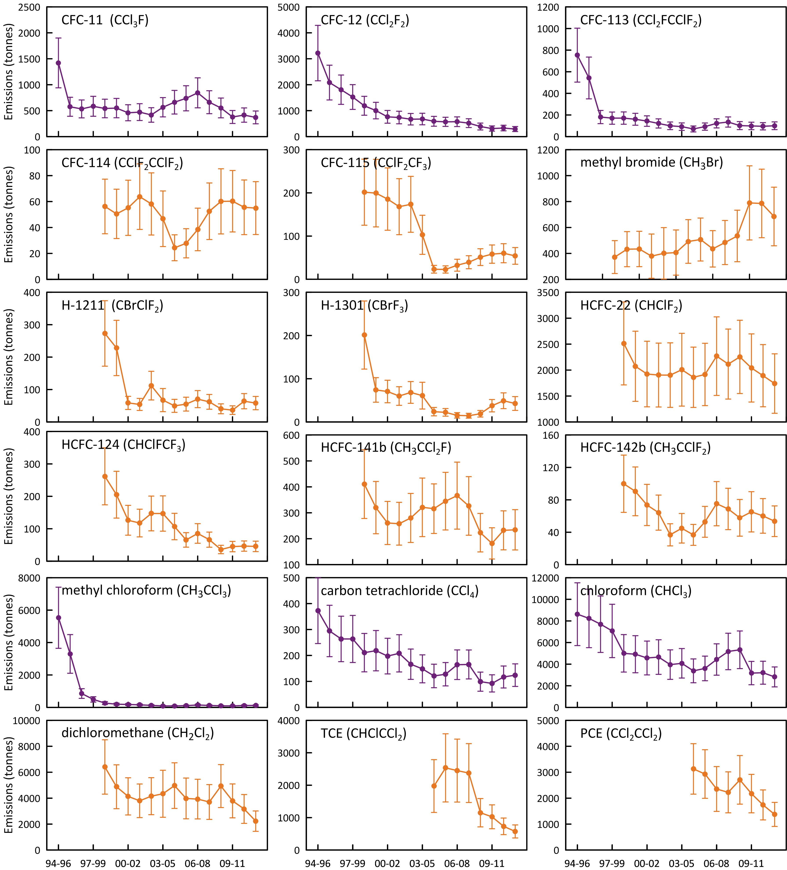

**Figure 7.** Annual average (3-yr running means) Australian emissions of CFCs, MB, halons, HCFCs, halons and chlorocarbons (MC, CTC, chloroform, dichloromethane, TCE, PCE) from Cape Grim AGAGE data, using ISC techniques. Australian emissions are scaled from SE Australian emissions on a population basis; MB and halon emissions are for SE Australia only.

## CFCs

Apart from 1995, when Australian CFC-11 emissions were likely above 1400 tonnes, CFC-11 emissions have averaged about 550 tonnes from 1996 to 2012 (Table 3, Figure 7). CFC-11 emissions increased from 2003 (420 tonnes) to 2007 (840 tonnes) - the cause of this increase is unclear. Since 2007 CFC-11 emissions have declined to about 400 tonnes per year (2010-2012). CFC-12 emissions have declined steadily since 1995 (3200 tonnes) to under 300 tonnes by 2012, a long-term decline of 13% per year. CFC-113 emissions declined rapidly from over 750 tonnes in 1995 to about 150 tonnes in the early 2000s, averaging close to 100 tonnes per year from over the past decade (2003-2012).

Why would the pattern of the decline in Australian CFC-11 emissions look different than that for CFC-12? CFC-12 emissions are likely largely from old (but still functional) and discarded refrigeration and air-conditioning equipment and aerosol cans, whereas CFC-11 emissons are likely from existing and discarded aerosol cans and equipment with foam insulation. The CFC-12 emissions can be, and may have been, mitigated (captured) to some extent, whereas the CFC-11 emissions from foams and aeroosl cans are unliklely to have been mitigated. This may offer an explanation for the observed behaviour, with CFC-12 emission declining relatively smoothly and monotonically, while CFC-11 emissions show a local maximum in 2007, which may have corresponded to the year when old CFC equipment/products were reaching the end-of-life.

The overall decline in CFC emissions from 1995 (5700 tonnes) to 2012 (870 tonnes) is 10% per year. ODP weighted CFC emissions have fallen from 5400 tonnes in 1995 to 830 tonnes in 2012 (10% per year). Australian ODP-weighted CFC emissions in 2012 (870 tonnes) were 0.9% of global CFC emissions (102 k tonnes). Australian ODP-weighted CFC emissions (840 tonnes) are currently (2012) about 40% of Australia’s Montreal Protocol ODS (ODP-weighted) emissions (2100 tonnes).

The overall decline in GWP-weighted CFC emissions from 1995 (49 M tonnes CO2-e) to 2012 (7 M tonnes CO2-e) is 11% per year. Australian GWP-weighted CFC emissions in 2012 (7 M tonnes CO2-e) were 1.1% of Australia’s total GHG emissions (544 M tonnes CO2-e, 2012). CFC emissions are not included in Australia’s national GHG emissions, as CFCs have been phased-out under the Montreal Protocol and are therefore not subject to separate controls under the Kyoto Protocol. Nevertheless, the 42 M tonnes CO2-e decline in GWP-weighted CFC emissions since 1995 is significant compared to other changes in Australian GHG emissions over the same period: Australian emissions of GHGs (CO2, CH4, N2O, HFCs, PFCs and SF6), as reported to UNFCCC, increased by 107 M tonnes CO2-e from 1995 to 2012 (1.3% per year). The decrease in Australian CFC emissions negated about 40% of this increase.

CFC emissions are presumed to be from CFC-containing appliances/materials (refrigeration/ac equipment, foams, aerosol cans), either existing or buried (land-fills). If the current total emissions (870 tonnes per year) continue to decline at 10% per year, it will take 20 years for Australian CFC emissions to drop below 100 tonnes per year.

## HCFCs

There has been an overall decline in Australian HCFC-22 emissions from 2500 tonnes in 1999 to under 1750 tonnes in 2012 (3% per year) (Table 3, Figure 7). HCFC-22 emission increased between 2005 (1860 tonnes) and 2009 (2250 tonnes) before declining rapidly (8% per year) to the 2012 level (1750 tonnes). HCFC-124 emissions have declined steadily from 260 tonnes in 1999 to under 40 tonnes in 2009 (a decline of nearly 20% per year), staying steady at about 40 tonnes per year (2009-2012). HCFC-141b emissions have fluctuated over the period 1999-2012, falling from over 400 tonnes in 1999 to 260 tonnes in 2002, rising again to 370 tonnes in 2007 before falling to about 230 tonnes in 2011-2012. HCFC-142b emissions have followed a similar pattern, at about 25% of HCFC-141b emissions.

Total HCFC emissions have fallen from 3300 tonnes in 1999 to under 2100 tonnes in 2012, a decline of 3-4% per year. ODP-weighted HCFC emissions have fallen from 196 tonnes in 1999 to 126 tonnes in 2012, 6% of Australia’s Montreal Protocol ODS (ODP-weighted) emissions in 2012 (2100 tonnes). GWP-weighted HCFC emissions have fallen from 5.2 M tonnes CO2-e in 1999 to 3.5 M tonnes CO2-e in 2012, a decline of 3% per year.

HCFC emissions are not included in Australia’s national GHG emissions (544 M tonnes CO2-e in 2012) as HCFCs have been phased-out under the Montreal Protocol and are therefore not subject to separate controls under the Kyoto Protocol.

Australian HCFC emissions are likely from a combination of service and malfunction leaks from existing refrigeration/ac equipment and from land-fills. Australian HCFC emissions in 2012 (2074 tonnes) were 0.4% of global HCFC emissions (470 k tonnes).

## Halons

SE Australian halon emissions fell from about 150 tonnes in 1999 to 20 tonnes in 2009 (a decline of nearly 20% per year), rising again to over 30 tonnes in 2011-2012 (Figure 7). Approximately 60% of SE Australian halon emissions are H-1211, 40% H-1301. The reason for the recent increase in halon emissions is not obvious, but it is driven by an increase in H-1301 emissions. SE Australian halon emissions are likely to show significant inter-annual variability (see discussion below).

Australian halon emissions are likely to originate from existing building fire-fighting systems (largely H-1301) and existing portable fire extinguishers (largely H-1211). It is not appropriate to scale these SE Australian halon emissions (as determined from Cape Grim data) to Australian emissions on a population basis. This is because the Melbourne/Port Philip region contains an additional likely halon source, the National Halon Bank. The Bank collected about 3-4 tonnes of halon in 2013 and has stored a total of about 550 tonnes of halons by 2013 (140 tonnes H-1211, 410 tonnes H-1301) (E. Nigido, A-Gas (Australia) Pty. Ltd., personal communication, May 2014). Assuming that typical leaks from the decanting, transfer and storage of halons are of the order of 1-3% per year, then halon emissions from the Halon Bank could be 5-20 tonnes per year. This is a significant component (perhaps 40%) of SE Australian halon emissions. The Australian halon emissions shown in Table 3 are the sum of Halon Bank emissions and Australian non-Halon Bank emissions. The SE Australian non-Halon Bank emissions are obtained from SE Australian Halon emissions (from Cape Grim data) by subtracting the Halon Bank emissions. Australian non-Halon Bank emissions equal SE Australian non-Halon Bank emissions scaled by population.

This is clearly a very uncertain emissions calculation and, if we are going to use Cape Grim data to infer Australian halon emission, we need an accurate estimate of the halon leak rate from the Halon Bank. A clearer picture of Australian halon emissions will emerge once data are collected from the proposed Lucas Heights facility south of Sydney, commencing in late-2014 or 2015. These halon data will not be affected by possible halon emissions from the National Halon Bank in Melbourne.

## Methyl bromide

Methyl bromide is used in Australia as a fumigant for cereals, such as wheat, and for cottonseed and timber logs prior to export and also as a soil sterilant, during the production of strawberry runners. The former uses are QPS, which are not covered by the Montreal Protocol, and the latter use is non-QPS (n-QPS), which is restricted by the Montreal Protocol and for which Australia has to apply for a Critical Use Exemption (CUE) under the Montreal Protocol on an annual basis.

Grain exported from SE Australian grain terminals account for 35-40% of Australia’s grain exports (National Transport Commission, 2008; GrainCorp, 2012) and thus likely 35-40% of Australia’s QPS use of MB. A UNEP model of MB emissions suggests that 80-90% of MB QPS use escapes to the atmosphere (UNEP, 2007). This suggests that about 30±10% of Australia’s QPS imports are emitted into the SE Australian atmosphere. Close to 100% of Australia’s current n-QPS MB use occurs around Toolangi, NE of Melbourne, for growing strawberry runners, with a few % used for rice fumigation (unlikely to be seen in the Cape Grim data). The UNEP model above assumes that 60-70% of MB n-QPS use is emitted to the atmosphere and thus perhaps 60-70% of Australia’s n-QPS MB use is emitted into the SE Australian atmosphere.

The UNEP MB emissions model may not be suitable for Australian MB consumption. It has been suggested (I. Porter, DPI Victoria, private communication) that close to 95% of QPS and about 50% of n-QPS MB are emitted to the atmosphere under Australian conditions, resulting in emissions of 675 tonnes in 2012 (0.7% of global emissions). Note that both models do not take into account some recapture of MB which likely occurs as a result of local requirements.

The results from the modified UNEP model of Australian MB emissions are shown in Figure 8 and compared to Australian emissions calculated from Cape Grim data by ISC in Figure 9 (also Table 3, Figure 7). The emissions from the model and derived from atmospheric data for SE Australia show reasonable overall agreement (within 15%, model lower) over the period 2003-2012. Prior to 2003, the model MB emissions were 40% higher than MB emissions derived from Cape Grim observations. Australian MB emissions based on ISC data increased from about 300 tonnes in 1995 to just under 800 tonnes in 2010 (a long-term increase of 6-7% per year), falling to under 700 tonnes in 2012 (Figure 9). The 410 ODP tonnes in 2012 are about 20% of Australia’s Montreal Protocol ODS emissions in ODP tonnes, but do not contribute to any significant extent to Australian CO2-e emissions from SGGs, given than MB has a low GWP.

## Carbon tetrachloride & methyl chloroform (Montreal Protocol chlorocarbons)

Carbon tetrachloride emissions are calculated from Cape Grim *in situ* GC-ECD data (reliable CTC data are not collected on the Cape Grim GC-MS Medusa instrument). The GC-ECD CTC data have been reprocessed for use with the recalculated Port Phillip CO emissions. The latest available estimates of Australian CTC emissions by ISC and NAME are shown in Figure 10.

Carbon tetrachloride emissions estimated by ISC were estimated to be over 370 tonnes in 1995, declining by 8% per year until falling below 100 tonnes per year for 2009-2010, remaining at about 110 tonnes per year for the period 2009-2012. Carbon tetrachloride emissions estimated using the NAME model were 198 tonnes in 2002, declining by 5% per year to 133 tonnes in 2011. Over the same period CTC emissions estimated by ISC fell by 6% per year. Overall ISC and NAME estimates of CTC emissions obtained from Cape Grim data agree to within 3% over this period, ISC higher.

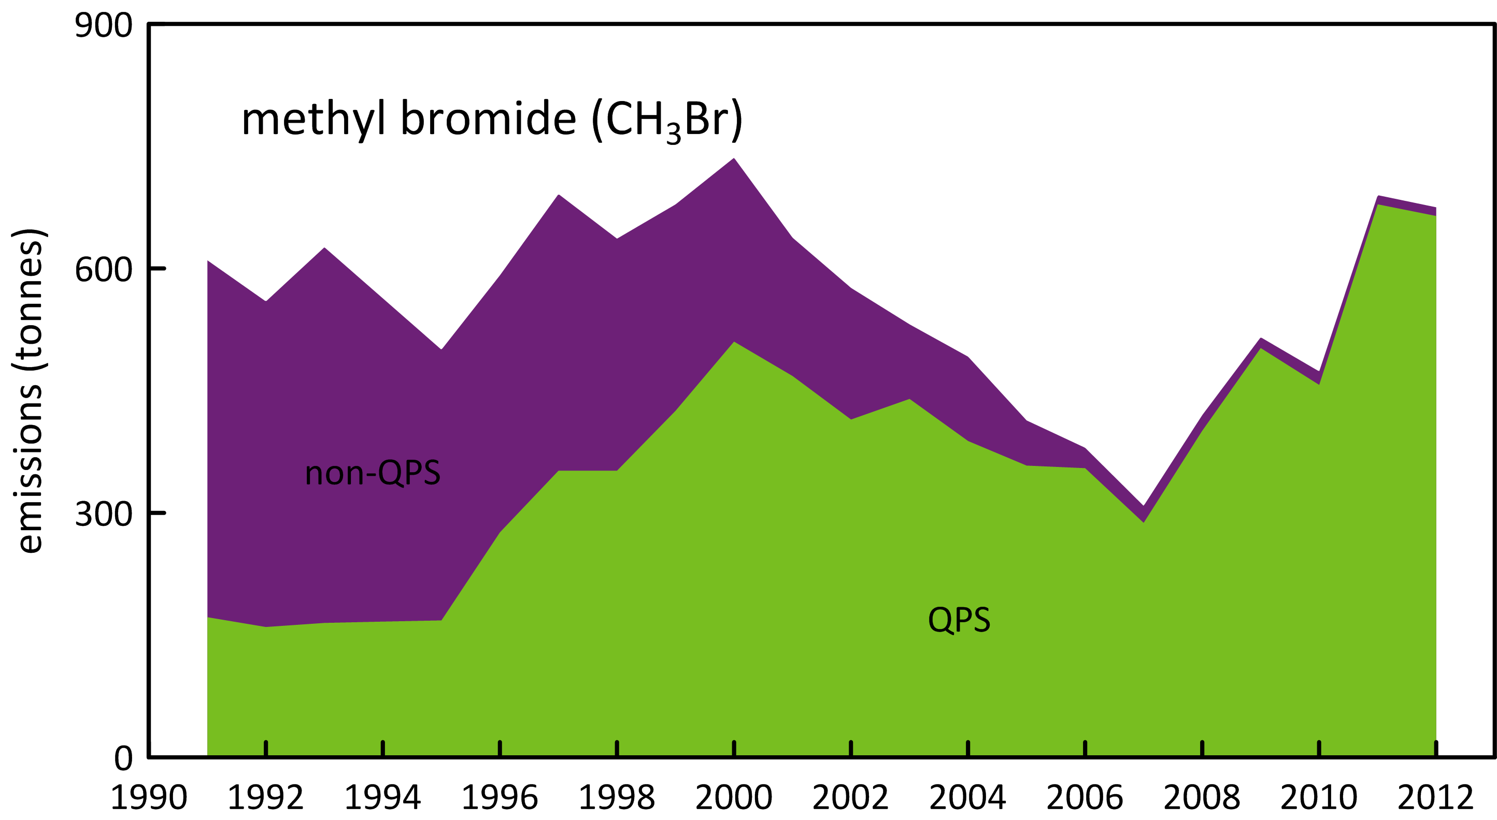

**Figure 8.** Australian MB emissions calculated from Australian MB import data and the modified UNEP emissions model (UNEP, 2007).

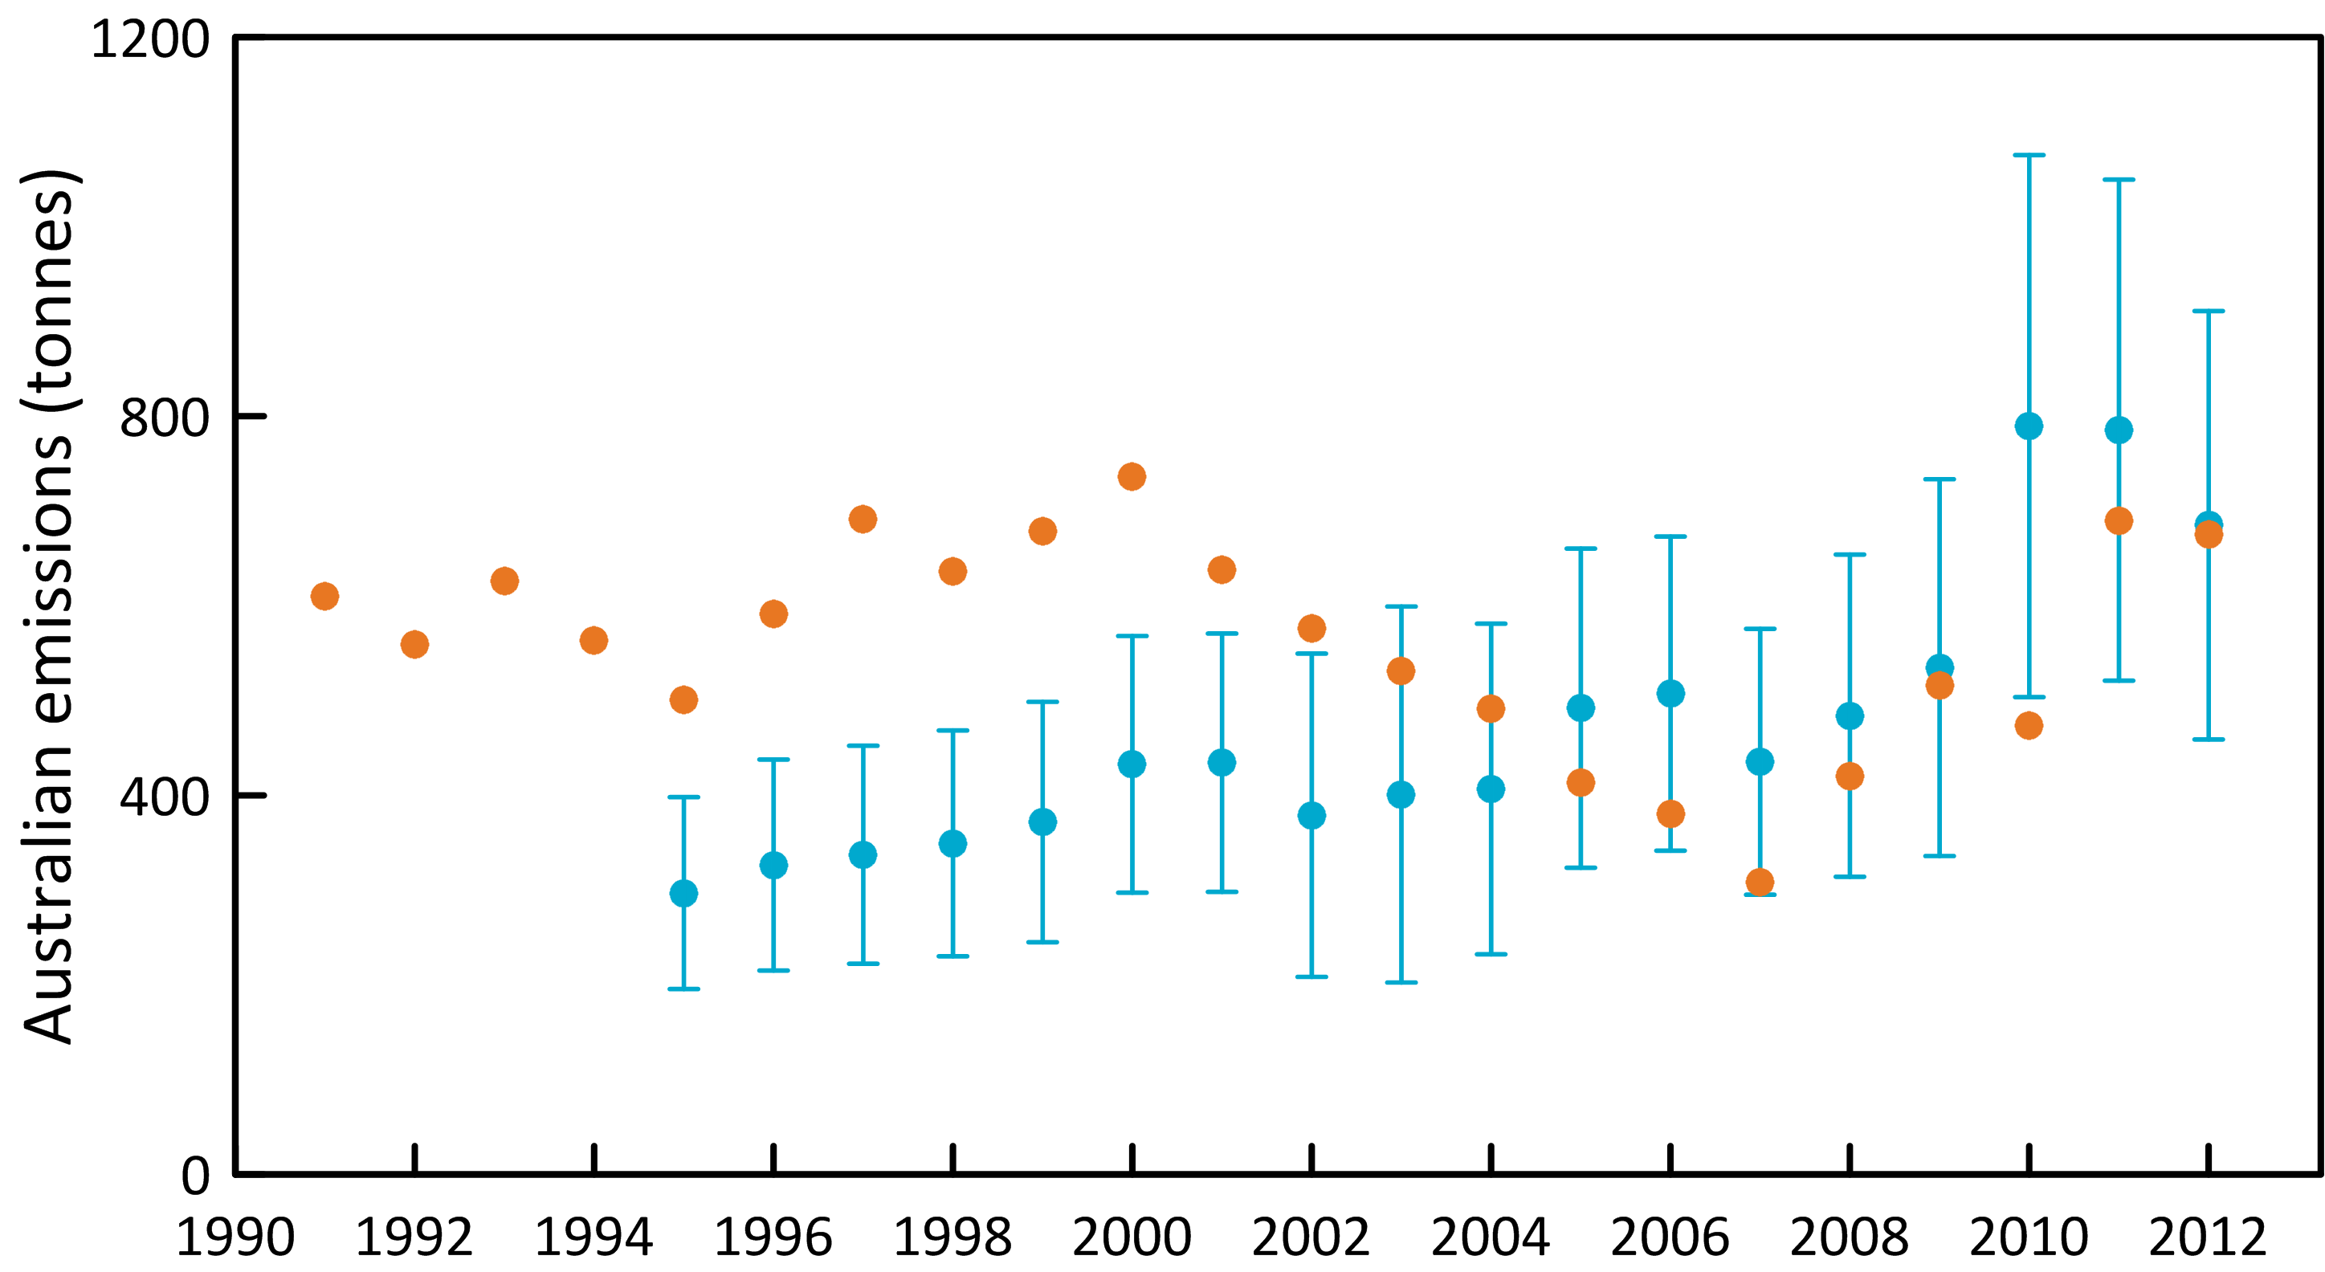

**Figure 9.** Australian MB emissions calculated by ISC from Cape Grim *in situ* AGAGE MB data (blue) and from the modified UNEP (2007) emissions model (orange).

The ISC and NAME estimates of Australian CTC emissions have been published in the peer-reviewed literature and used to identify possible ‘missing’ CTC sources on a global scale (Fraser *et al*., 2014b). These findings have been incorporated into the forthcoming *Scientific Assessment of Ozone Depletion: 2014*, due to be published in late 2014 or early 2015.

Australian MC emissions declined from over 5500 tonnes in 1995 to less than 100 tonnes by 2004-2005, an overall decline of 40% per year. Methyl chloroform emissions have stabilised post-2003 at about 110 tonnes per year. In 2011-2012 Australian MC emissions were 115-120 tonnes per year, about 6% of global emissions.

The combined CTC/MC emissions totalled over 960 ODP tonnes in 1995, declining to about 120-130 tonnes in 2009-2012, an overall decline of about 12% per year. In 2011-2012 Australian MC/CTC emissions were, like HCFCs, about 6% of Australian Montreal Protocol ODS emissions.

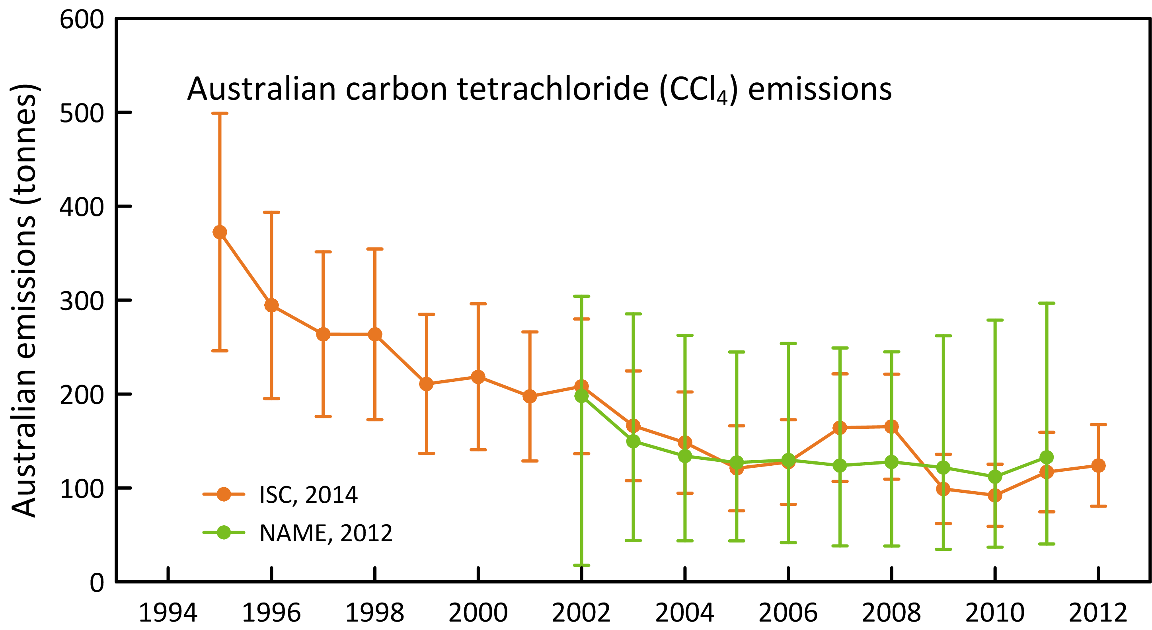

**Figure 10.** Australian CTC emissions calculated from Cape Grim *in situ* AGAGE data by ISC and inverse modelling (NAME).

## Other chlorocarbons

Dichloromethane, chloroform, CHClCCl2 (TCE) and CCl2CCl2 (PCE) are short-lived ODSs whose production and comsumption are not controlled by the Montreal Protocol. Significant emissions of all these ODSs are seen in the Cape Grim data (Figure 7).

Australian CH2Cl2 emissions were over 6400 tonnes in 1999 declining by 8% per year to just over 2200 tonnes in 2012. During 2000-2010 Australian CH2Cl2 emissions were relatively constant at about 4000 tonnes per year.

Australian CHCl3 emissions were over 8600 tonnes in 1995 declining overall by 7% per year to about 2800 tonnes in 2012. Emissions fell to 3400 tonnes in 2005, rising to 5300 tonnes in 2009 before falling to 2800 tonnes in 2012. There are large, natural soil emissions of CHCl3 and it is possible that the CHCl3 emissions calculated from Cape Grim data contain a natural, difficult to quantify, component.

Australian PCE emissions were over 3100 tonnes in 2005 decling by 10% per year to under 1400 tonnes in 2012. TCE emissions were about 2000 tonnes in 2005 falling by 15% per year to below 600 tonnes in 2012

Total emissions for these short-lived ODSs were 13k tonnes (97 ODP tonnes) in 2005, falling by 8% per year to 7 k tonnes (55 ODP tonnes) in 2012. The ODP-weighted emissions of these short-lived ODSs were about 2-3% of total ODS emissions (ODP weighted).

## Total ODS emissions

Total Australian ODS emissions (CFCs, HCFCs, halons, MB, CTC, MC, ODP- and GWP-weighted), with and without other chlorocarbons are shown in Figure 11. From 1999 the emissions for all species are calculated from Cape Grim data, except for PCE and TCE whose observations commenced in 2005 (1999 to 2005 PCE and TCE emissions are assumed equal to 2005 emissions). This is unlikely to introduce significant errors in the calculations of ODP- and GWP-weighted emissions, since the impacts of these two short lived species are quite small. From 1995 the emissions are based on Cape Grim data for the major CFCs (CFC-11, -12, -113), MC and CTC. For the minor CFCs, HCFCs, halons and MB it is assumed that annual emissions from to 1995-1999 equal 1999 emissions. This could lead to a significant underestimate of emissions during this period (the ISC method is limited to the period when CO data were measured at Cape Grim - 1994 onwards). Methodologies are being investigated to extend ODS emissions estimates prior to 1994 – these will be evaluated in a future report.

The other chlorocarbons make a very significant contribution (55-65%) to total emissions, but negligible contributions to ODP or GWP weighted emissions (or ozone depletion and climate change), because of their low ODPs and GWPs.

ODP-weighted ODS emissions fell by about 13% per year from 9.7 k tonnes in 1995 to 2.4 k tonnes in 2005, remaining relatively constant at about 2.2-2.6 k tonnes from 2005 to 2012.

GWP weighted ODS emissions fell by about 10% per year from 56 M tonnes CO2-e in 1995 to 10 M tonnes CO2-e in 2012. As discussed above the fall due to CFCs alone is 42 M tonnes CO2-e, about 90% of the overall decline in GWP-weighted ODS emissions.

The significance of the decline of GWP-weighted ODS emissions compared to GWP-weighted emissions of the GHGs reported to UNFCCC (CO2, CH4, N2O, HFCs, PFCs, SF6) are shown in Figure 12. The 46 M tonnes CO2-e decline in GWP-weighted ODS emissions since 1995 is significant compared to other changes in Australian GHG emissions over the same period: as discussed above, Australian emissions of GHGs (CO2, CH4, N2O, HFCs, PFCs and SF6), as reported to UNFCCC, increased by 107 M tonnes CO2-e from 1995 to 2012 (1.3% per year). The decrease in Australian ODS emissions negated about 43% of this increase.

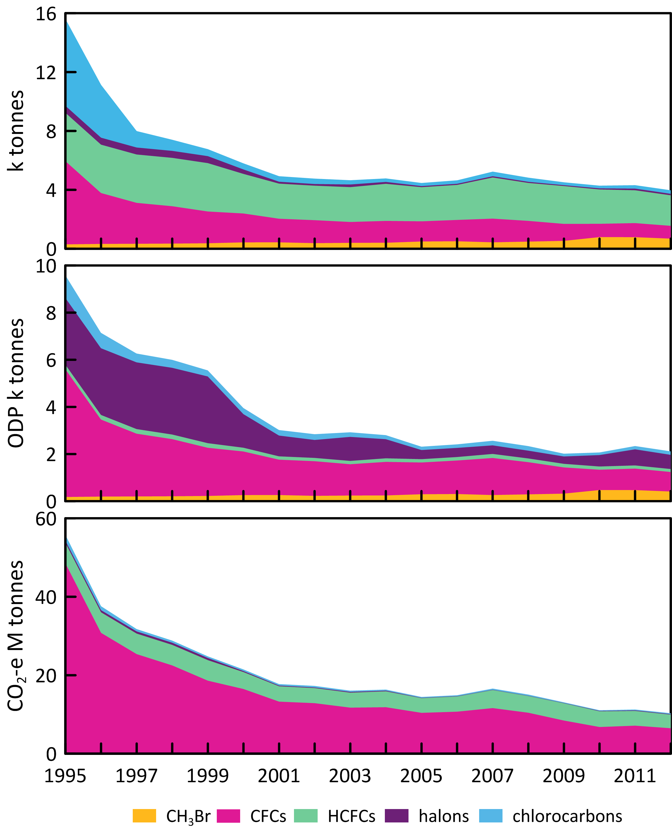

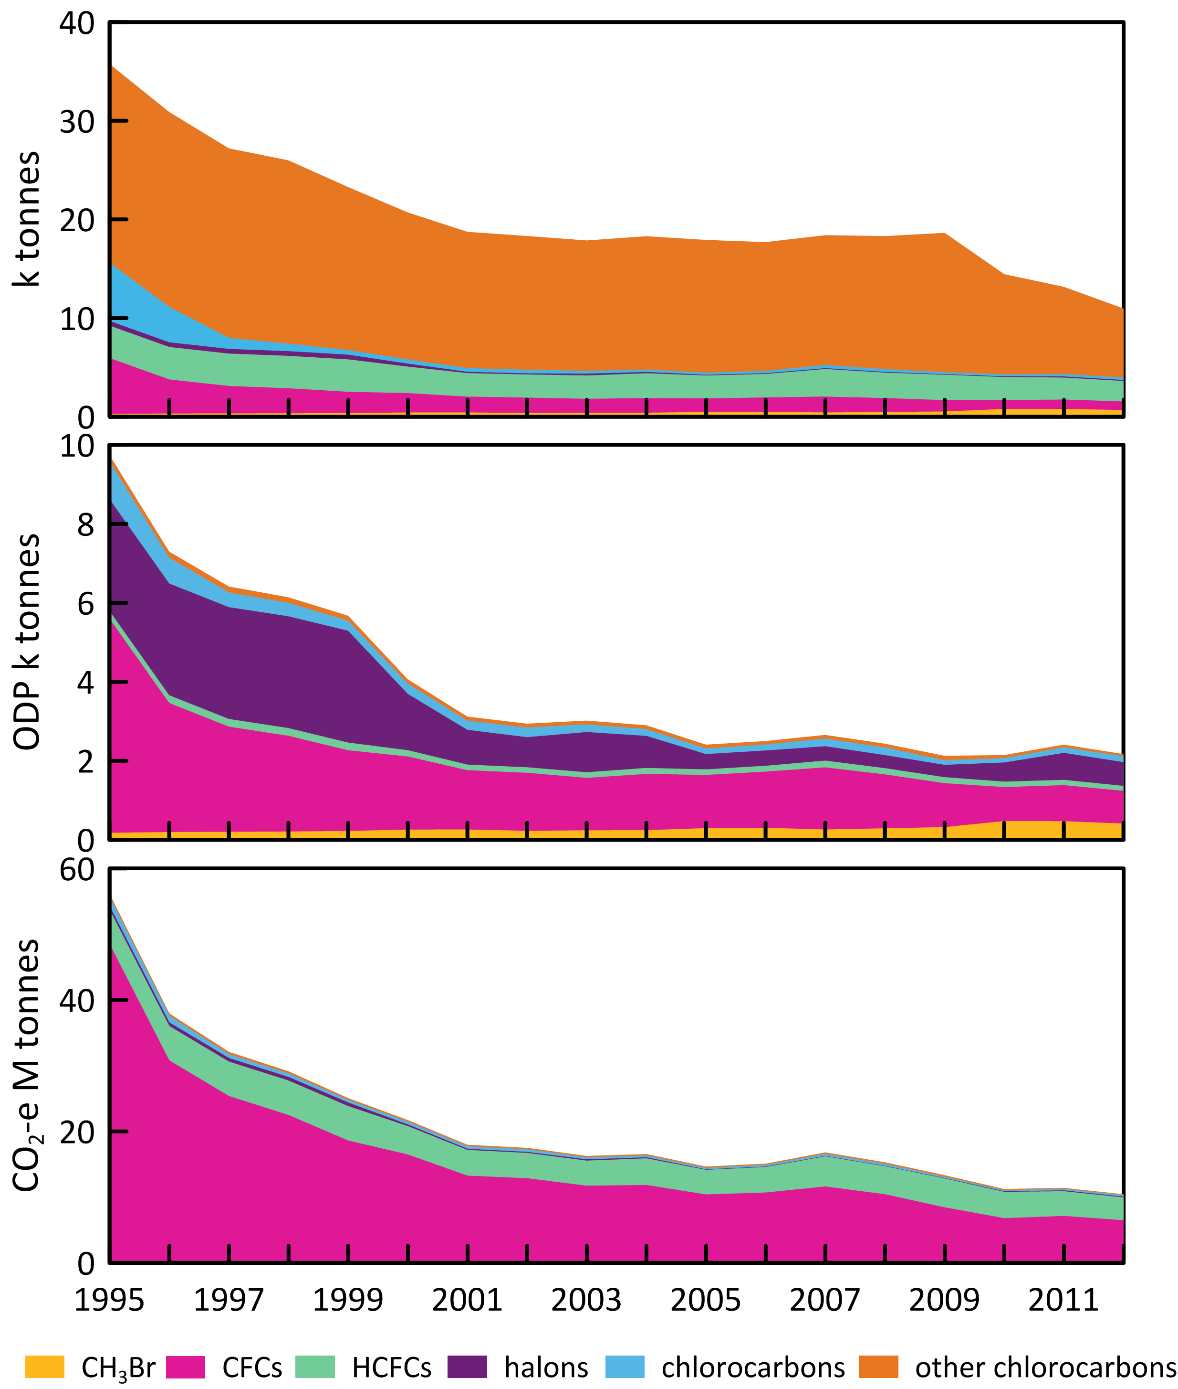

**Figure 11.** Total Australian ODS emissions (M tonnes CO2-e, with (left) and without (right) other chlorocarbons.

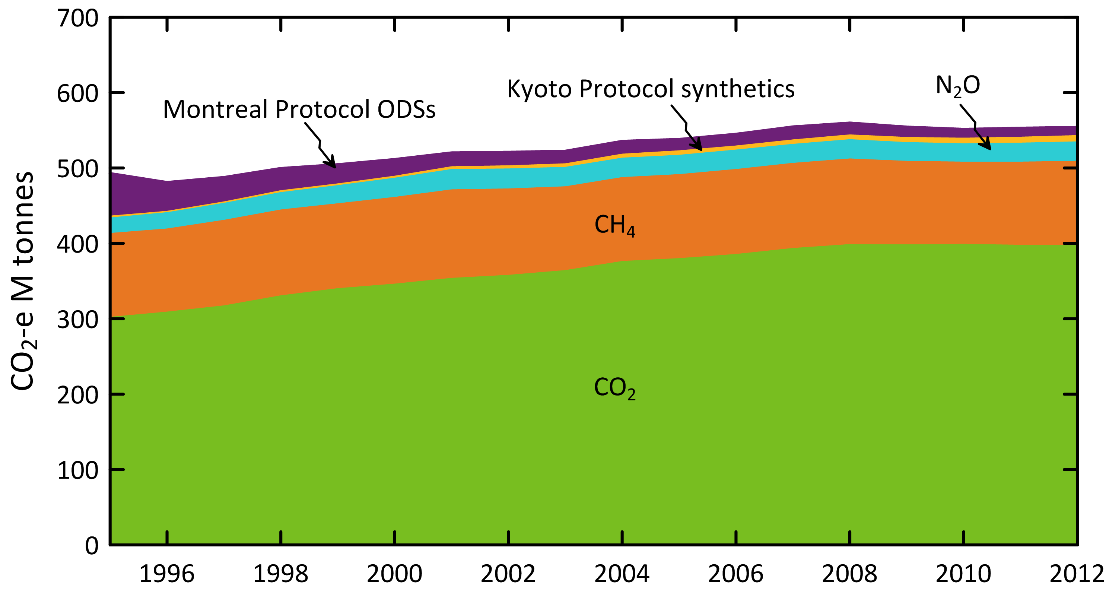

**Figure 12.** Australian emissions (GWP-weighted: M tonnes CO2-e) of ODSs (Montreal Protocol species: CFCs, HCFC, halons, MB, MC, CTC) and the GHGs reported to UNFCCC (CO2, CH4, N2O, Kyoto Protocol synthetics: HFC, PFCs and SF6).

Summary

* CSIRO and collaborating laboratories measure the abundances and trends of thirty ODSs at Cape Grim, comprising eleven CFCs (CFC-11, -12, -13, -112, -112a, -113, -113a, -114, -115, -216ba, 216ca), six HCFCs (HCFC-22, -124, -133a, -141b, -142b, -225ca), three halons (H-1211, -1301,-2402), seven chlorocarbons (CH3Cl, CH2Cl2, CHCl3, CCl4, CH3CCl3, CHClCCl2, CCl2CCl2) and three bromocarbons. Cape Grim has the most comprehensive list of measured ODSs anywhere in the world.
* As a result of measures undertaken within the Montreal Protocol framework, most of the CFCs (CFC-11, CFC-12, CFC-112, CFC-112a, CFC-113, CFC-114) measured in the atmosphere at Cape Grim have stopped growing or are in decline, the exceptions being CFC-13 and CFC-115, which are growing slowly, and CFC-113a, which shows significant growth, although at a very low concentration. Total CFCs in the background atmosphere are declining by 0.6%; chlorine from CFCs in the atmosphere decreased by 0.7% (2012-2013).
* All of the HCFCs (HCFC-22, HCFC-141b, HCFC-142b, HCFC-133a) measured in the atmosphere at Cape Grim are growing, except the minor HCFC-124, which is declining slowly. Total HCFCs are increasing by 2-3% per year. Chlorine in the atmosphere from HCFCs increased by 2.4% (2012-2013), the only ODS sector showing an increase in chlorine.
* The most abundant chlorocarbon in the background atmosphere is the largely naturally-occurring CH3Cl. The next most abundant chlorocarbon is anthropogenic CTC. The chlorocarbons account for 28% of total chlorine from all ODSs in the background atmosphere. Every chlorocarbon measured at Cape Grim showed declining concentrations in 2013 compared to 2012. The largest decline was for CH3Cl, followed by CTC, MC, CH2Cl2 and CHCl3.
* H-1211 and H-2404 are in decline in the atmosphere, whereas H-1301 continues to increase. Overall halons are in decline by 0.7% per year, similar to the rate of decline of the CFCs. This equates to about a 3-4 ppt per year decline in equivalent chlorine.
* Methyl bromide showed a small increase in the background atmosphere, the first increase observed since Montreal Protocol restrictions came into force, which had previously resulted in a long-term decline in MB in the atmosphere since the late 1990s.
* Total chlorine from the Montreal Protocol ODSs decreased by 1.6% (2012-2013), continuing a decline that started in the mid-1990s. The overall decline in total chlorine results from declining CFCs and chlorocarbons and increasing HCFCs.
* Total bromine from the Montreal Protocol ODSs also decreased (0.3%, 2012-2013), continuing a decline that started in about 2000, resulting from a net, long-term decline in halons and MB.
* Global emissions of the major Montreal Protocol ODSs continue to decline – CFC emissions declined by 15% from 2012 to 2013, halons by 7%, and HCFCs by 1%. Emission declines for CTC, MC and MB have stalled – suggesting that the remaining emissions for these ODSs are outside the impact of the Montreal Protocol consumption controls (emissions from ODS production - direct or indirect, transport and disposal - landfills etc).
* Australian imports of ODSs continue to decline, falling by 10% from 2012 to 2013, maintaining the long-term decline (10% per year) seen since the early 1990s. Methyl bromide and the HCFCs account for 47% and 53% respectively of Australia’s ODS imports in 2013. The recent surge in MB imports seen in 2011 and 2012 seems to have been reversed in 2013, probably reflecting inter-annual variability in Australian grain and wood products production.
* Australian CFC emissions, based on Cape Grim data, have declined by 10% per year from 1995 to 2012. Current emissions (870 tonnes) are 0.9% of global CFC emissions and 40% of Australia’s Montreal Protocol ODP-weighted ODS emissions.
* Australian HCFC emissions have declined by 3-4% per year from 1999 to 2012. Current emissions (2100 tonnes) are 0.4% of global emissions and 6% of Australia’s Montreal Protocol ODP-weighted ODS emissions.
* Australian halon emissions, estimated from Cape Grim data, are uncertain because of the problem of speciating emissions between the National Halon Bank in Melbourne and other SE Australian halon emissions. SE Australian halon emissions have declined by about 10-15% per year from 1999 to 2012. SE Australian halon emissions are about 30% of Australia’s Montreal Protocol ODP-weighted ODS emissions.
* Based on Cape Grim data, Australian total MB emissions have shown a long-term increase of 6-7% per year from 1995 (300 tonnes) to 2010 (800 tonnes), falling to under 700 tonnes in 2012-2013, currently contributing about 20% of Australia’s Montreal Protocol ODP-weighted ODS emissions. This is not entirely consistent with MB imports (and resultant modelled emissions) which increased from 1990 to 2000 (non-QPS driven), declined to 2007 (QPS and non-QPS driven), and then increased again to 2012 (QPS driven).
* Australian CTC emissions fell by 8% per year from 1995 (370 tonnes) to 2009-2010 (under 100 tonnes), remaining at about 110 tonnes per year through to 2012. Australian MC emissions fell by 40% per year from 1995 (5500 tonnes) to 2004-2005 (less than 100 tonnes). Emissions have since stabilised at about 110 tonnes per year, likely from landfills. Total CTC and MC emissions account for about 6% of Australia’s Montreal Protocol ODP-weighted ODS emissions.
* ODP-weighted total Australian ODS emissions fell by 13% per year from 1995 (9700 tonnes) to 2005 (2400 tonnes), followed by a period of much slower decline in emissions since 2005 (2% per year). In general it appears that the Montreal Protocol consumption controls have had little impact on emissions since 2005. This is because some consumption is outside the Montreal Protocol ‘umbrella’ – QPS MB consumption, or emissions that are not a function of current consumption (emissions from indirect ODS production, the ODS bank and ODS disposal - landfills etc).
* GWP-weighted total Australian ODS emissions fell by about 10% per year from 56 M tonnes CO2-e in 1995 to 10 M tonnes CO2-e in 2012. Of the 46 M tonnes decline, 42 M tonnes (90%) were due to declining CFC emissions. Over the same period Australia’s GHG emissions reported to UNFCCC increased by 107 M tonnes CO2-e (437 to 544 M tonnes CO2-e 1995 to 2012). The decline in ODS emission negated about 43% of this overall increase in Australia’s GHG emission over this period.
* In Australia (as elsewhere) the Montreal Protocol has been very effective in controlling the consumption of ODSs that cause stratospheric ozone depletion and, in addition, has significantly slowed the increase in GHG emissions that drive climate change.

References

ABAREs, Australian Crop Report, Australian Bureau of Agricultural and Resource Economics and Sciences, No. 169, 21 pp, February 2014.

Bekki, S. & G. Bodeker, Coordinating Lead Authors, Future Ozone and Its Impact on Surface UV, Chapter 3 in *Scientific Assessment of Ozone Depletion: 2010*, WMO Global Ozone Research and Monitoring Project – Report No. 52, 3.1-3.60, 2011.

Butler, J., J. Elkins, B. Hall, S. Montzka, S. Cummings, P. Fraser & L. Porter, Recent trends in the global atmospheric mixing ratios of Halon-1301 and Halon-1211 in *Baseline Atmospheric Program Australia* 1991, A. Dick & J. Gras (eds.), Department of the Environment, Sport and Territories, Bureau of Meteorology and CSIRO Division of Atmospheric Research, 29-32, 1994.

Carpenter, L. & S. Reimann, Lead Authors, Update on Ozone-Depleting Substances (ODSs) and Other Gases of Interest to the Montreal Protocol, Chapter 1 in *Scientific Assessment of Ozone Depletion: 2014*, in preparation.

[Cohan, D. , G. Sturrock, A. Biazar & P. Fraser, Atmospheric methyl iodide at Cape Grim, Tasmania, from AGAGE observations, *J. Atmos. Chem.*, 44 (2): 131-150, 2003.](https://ejournal.csiro.au/cgi-bin/sciserv.pl?collection=journals&journal=01677764&issue=v44i0002&article=131_amiacgtfao%20)

Cox, M., P. Hurley, P. Fraser & W. Physick, Investigation of Melbourne region pollution events using Cape Grim data, a regional transport model (TAPM) and the EPA Victoria carbon monoxide inventory, *Clean Air*, 34(1): 35-40, 2000.

Cox, M., A regional study of the natural and anthropogenic sinks of the major halomethanes, PhD thesis, School of Mathematical Sciences, Monash University, Clayton, Victoria, Australia, 2001.

Cox, M., G. Sturrock, P. Fraser, S. Siems, P. Krummel & S. O'Doherty, Regional sources of methyl chloride, chloroform and dichloromethane identified from AGAGE observations at Cape Grim, Tasmania, 1998-2000, *J. Atmos. Chem,* 45 (1): 79-99, 2003a.

Cox, M. , S. Siems, P. Fraser, P. Hurley & G. Sturrock, TAPM modelling studies of AGAGE dichloromethane observations at Cape Grim in *Baseline Atmospheric Program Australia 1999-2000*, N. Tindale, N. Derek & P. Fraser (eds.), Melbourne: Bureau of Meteorology and CSIRO Atmospheric Research, 25-30, 2003b.

[Cox, M., P. Fraser, G. Sturrock, S. Siems & L. Porter, Terrestrial sources and sinks of halomethanes near Cape Grim, Tasmania, *Atmos. Environ.*, 38(23): 3839-3852, 2004.](https://ejournal.csiro.au/cgi-bin/sciserv.pl?collection=journals&journal=13522310&issue=v38i0023&article=3839_tsasohncgt%20)

Cunnold, D. , R. Prinn, R. Rasmussen, P. Simmonds, F. Alyea, C. Cardelino, A. Crawford, P. Fraser& R. Rosen, The Atmospheric Lifetime Experiment, 2: Lifetime methodology and application to three years of CFCl3 data, *J. Geophys. Res.,* 88(C13): 8379-8400, 1983.

Cunnold, D., R. Prinn, R. Rasmussen, P. Simmonds, F. Alyea, C. Cardelino, A. Crawford, P. Fraser& R. Rosen, Atmospheric lifetime and annual release estimates for CFCl3 and CF2Cl2 from 5 years of ALE data, *J. Geophys. Res.,* 91(D10): 10797-10817, 1986.

Cunnold, D., P. Fraser, R. Weiss, R. Prinn, P. Simmonds, F. Miller, F. Alyea & A. Crawford, Global trends and annual releases of CCl3F and CCl2F2 estimated from ALE/GAGE and other measurements from June 1978 to July 1991, *J. Geophys. Res.,* 99(D1): 1107-1126, 1994.

Cunnold, D., R. Weiss, R. Prinn, D. Hartley, P. Simmonds, P. Fraser, B. Miller, F. Alyea & L. Porter, GAGE/AGAGE measurements indicating reductions in global emissions of CCl3F and CCl2F2 in 1992-1994, *J. Geophys. Res.,* 102(D1): 1259-1269, 1997.

Dameris, M. & S. Godin-Beekmann, Lead Authors, Polar Ozone: Past, Present and Future, Chapter 3 in *Scientific Assessment of Ozone Depletion: 2014*, in preparation.

Delaney, W. & A. Marshall, Victorian air emissions inventory for 2006, Proceedings, *20th International Clean Air and Environment Conference*, 30 July – 2 August, 2011, CASANZ, Auckland, NZ., 2011.

Dunse, B., P. Steele, P. Fraser & S. Wilson, An analysis of Melbourne pollution episodes observed at Cape Grim from 1995-1998 in *Baseline Atmospheric Program (Australia) 1997-98*, N. Tindale, R. Francey, and N. Derek (eds.), Bureau of Meteorology and CSIRO Atmospheric Research, Melbourne, Australia, 34-42, 2001.

Dunse, B., Investigation of urban emissions of trace gases by use of atmospheric measurements and a high-resolution atmospheric transport model, *PhD thesis*, Wollongong University, Wollongong, NSW, Australia, 2002.

Dunse, B., P. Steele, S. Wilson, P. Fraser & P. Krummel, Trace gas emissions from Melbourne Australia, based on AGAGE observations at Cape Grim, Tasmania, 1995-2000, *Atmos. Environ.*, 39, 6334-6344, 2005.

Draxler, R. & D. Hess, Description of the HYSPLIT_4 Modeling 389 System, NOAA Technical Memorandum ERL ARL-224, 24 pp., NOAA, 1997.

EPA, Air Emissions Inventory: Port Phillip Region, *EPA Publication 632*, 48 pp., 1998.

Expert Group, *Cold Hard Facts 2: a study of the refrigeration and air conditioning industry in Australia*, prepared for DSEWPac, 134pp, July 2013.

Expert Group, *HFC Consumption in Australia in 2013 and an Assessment of the Capacity of Industry to Transition to Nil and Lower GWP Alternatives* , prepared for DE, 129 pp, April 2014.

Forster, P. & V. Ramaswamy, Coordinating Lead Authors, Changes in Atmospheric Constituents and in Radiative Forcing, Chapter 2 in: *Climate Change 2007: The Physical Basis. Contribution of Working Group I to the Fourth Assessment Report of the Intergovernmental Panel on Climate Change*, Solomon, S., D. Qin, M. Manning, Z. Chen, M. Marquis, K. Averyt, M. Togor & H. Miller (eds.), Cambridge University Press, Cambridge, UK & New York, NY, USA, 129-234, April 2007.

Fraser, P., B. Sawford & P. Manins, CCl3F (Freon-11) as an indicator of transport processes in an urban atmosphere: a case study in Melbourne, *Atmos. Environ*., 11(11): 1025-1028, 1977.

Fraser, P. & G. Pearman, Atmospheric halocarbons in the southern hemisphere, *Atmos. Environ.,* 12(4), 839-844, 1978a.

Fraser, P. & G. Pearman, The fluorocarbon-ozone theory, II: tropospheric lifetimes: an estimate of the tropospheric lifetime of CCl3F, *Atmos. Environ.,* 12(8): 1807-1808, 1978b.

Fraser, P.,P. Hyson, I. Enting & G. Pearman, Global distribution and southern hemispheric trends of atmospheric CCl3F, *Nature,* 302(5910), 692-695, 1983.

Fraser, P., P. Hyson, R. Rasmussen, A. Crawford & A. Khalil, Methane, carbon monoxide and methychloroform in the southern hemisphere, *J. Atmos. Chem.*, 4(1): 3-42, 1986.

Fraser, P., D. Cunnold, F. Alyea, R. Weiss, R. Prinn, P. Simmonds, B. Miller & R. Langenfelds, Lifetime and emission estimates of 1,1,2-trichlorotrifluorethane (CFC-113) from daily global background observations June 1982-June 1994, *J. Geophys. Res.,* 101(D7): 12585-12599, 1996.

Fraser, P. & M. Prather, Uncertain road to ozone recovery, *Nature,* 398 (6729): 663-664, 1999.

Fraser, P., D. Oram, C. Reeves, S. Penkett & A. McCulloch, Southern Hemisphere halon trends (1978-1998) and global halon emissions, *J. Geophys. Res.,* 104(D13): 15985-15999, 1999.

[Fraser, P., Will illegal trade in CFCs and halons threaten ozone layer recovery? *Atmos. Environ.*, 34(18): 3038-3039, 2000.](https://ejournal.csiro.au/cgi-bin/sciserv.pl?collection=journals&journal=13522310&issue=v34i0018&article=3038_witicahtolr%20)

Fraser, P., P. Steele, P. Krummel, C. Allison, S. Coram, B. Dunse & M. Vollmer, DSEWPaC Research Projects 2011/2012, Final Report October 2012, 14 pp., 2012.

Fraser, P., B. Dunse, P. Krummel, P. Steele & N. Derek, SGGs and Stratospheric Ozone, DSEWPaC Projects 2012-2013, Report prepared for Department of Sustainability, Environment, Water, Populations and Communities, CSIRO Marine and Atmospheric Research, September 2013, 30pp, 2013.

Fraser, P., P. Krummel, P. Steele, C. Trudinger, D. Etheridge, S. O'Doherty, P. Simmonds, B. Miller, J. Mühle, R. Weiss, D. Oram, R. Prinn & R. Wang, Equivalent effective stratospheric chlorine from Cape Grim Air Archive, Antarctic firn and AGAGE global measurements of ozone depleting substances, *Baseline Atmospheric Program (Australia) 2009-2010*, P. Krummel & N. Derek (eds.), Australian Bureau of Meteorology and CSIRO Marine and Atmospheric Research, Melbourne, Australia, in press, 2014a.

Fraser, P., B. Dunse, A. Manning, R. Wang, P. Krummel, P. Steele, L. Porter, C. Allison. S. O’Doherty, P. Simmonds, J. Mühle & R. Prinn, Australian carbon tetrachloride (CCl4) emissions in a global context, *Environ. Chem*., 11, 77-88, 2014b.

Fraser, P., P. Krummel, P. Steele & N. Derek, New ODSs and synthetic GHGs discovered in the Cape Grim Air Archive, a confidential report prepared for Department of the Environment, CSIRO Marine and Atmospheric Research, 6 pp, February 2014c.

Harris, N. & D. Wuebbles, Lead Authors, Scenarios, Information and Options for Policy Makers, Chapter 5 in *Scientific Assessment of Ozone Depletion: 2014*, in preparation.

Hyson, P., P. Fraser& G. Pearman, A two-dimensional transport simulation model for trace atmospheric constituents, *J. Geophys. Res.,* 85 (C8): 4443-4456, 1980.

Kloss, C., J. Laube, D. Oram, P. Fraser, C. Brenninkmeijer, T. Rockmann & M. Newland, Atmospheric trends, abundances and emissions of CFC-216ba, CFC-216ca and HCFC-225ca, *Atmosphere*, *Special Issue: Ozone Depletion and Climate Change*, submitted (February 2014).

Laube, J., A. Kiel, H. Bonisch, E. Engel, M. Newland, T. Rockmann , C. Volk, W. Sturges, P. Fraser & D. Oram, Supplementary information to ‘Observation-based assessment of stratospheric fractional release, lifetimes and Ozone Depletion Potentials of ten important trace gases’, *Atmos. Chem. Phys.*, 13, 2779-2791, 2013.

Laube, J., M. Newland, C. Hogan, C. Brenninkmeijer, P. Fraser, P. Martinerie, D. Oram, C. Reeves, T. Rockmann, J. Schwander, E. Witrant & W. Sturges, Newly detected ozone depleting substances in the atmosphere, *Nature Geoscience*, 7, 266-269, 2014.

Manning, A., D. Ryall, R. Derwent, P. Simmonds & S. O’Doherty, Estimating European od ozone depleting and greenhouse egases using observations and a modelling attribution technique, *J. Geophys. Res*., 108, 4405, doi:10.1029/2002JD002312, 2003.

Manning, A., S. O’Doherty, A. R. Jones, P. G. Simmonds & R. G. Derwent, Estimating UK methane and nitrous oxide emissions from 1990 to 2007 using an inversion modeling approach, *J. Geophys. Res*., 116(D2): D02305, doi:10.1029/2010JD004763, 2011.

Miller, B., Abundances and trends of atmospheric chlorofluoromethane and bromomethane, PhD thesis, University of California at San Diego, La Jolla, California, USA, 149 pp, 1998.

Miller, B., J. Huang, R. Weiss, R. Prinn & P. Fraser**,** Atmospheric trend and lifetime of chlorodifluoromethane (HCFC-22) and the global tropospheric OH concentration, *J. Geophys. Res.,* 103(D11): 13237-13248, 1998.

Miller, B., M. Rigby, L. Kuijpers, P. Krummel, P. Steele, M. Leist, P. Fraser, A. McCulloch, C. Harth, P. Salameh, J. Mühle, R. Weiss, R. Prinn, R. Wang, S. O’Doherty, B. Greally & P. Simmonds, CHF3 (HFC-23) emission trend response to CHClF2 (HCFC-22) production and recent CHF3 emissions abatement measures, *Atmos. Chem. Phys.*, 10, 7875-7890, 2010.

Montzka, S. , M. Nowick, R. Myers, W. Elkins, J.Butler, S. Cummings, P. Fraser& L. Porter, NOAA-CMDL chlorodifluoromethane (HCFC-22) observations at Cape Grim, in: *Baseline Atmospheric Program Australia* 1991, A. Dick & J. Gras (eds.), Melbourne: Department of the Environment, Sport and Territories, Bureau of Meteorology and CSIRO Division of Atmospheric Research, 25-28, 1994.

Montzka, S. & S. Reimann, Coordinating Lead Authors, Ozone-Depleting Substances (ODSs) and Related Chemicals, Chapter 1 in *Scientific Assessment of Ozone Depletion: 2010*, WMO Global Ozone Research and Monitoring Project – Report No. 52, 1.1-1.108, 2011.

Myhre, G. & D. Schindell, Anthropogenic and Natural Radiative Forcing, Chapter 8 in Climate Change 2013 – The Physical Science Basis, Working Group I Contribution to the Fifth Assessment Report of the Intergovernmental Panel on Climate Change, IPCC (ed.), Cambridge University Press, Cambridge, UK & New York, NY, USA, 8.1-8.139, 2014.

National Transport Commission, Grain Supply Chain Pilot Study, Stage One Final Report, prepared by Strategic Design and Development, Epping, NSW, for the National Transport Commission, 62 pp, 2008.

Newland, M., C. Reeves, D. Oram, J. Laube, W. Sturges, C. Hogan, P. Begley & P. Fraser, Southern hemispheric halon trends and global halon emissions, 1978-2011, *Atmos. Chem. Phys.,* 13, 5551-5565, 2013.

[O'Doherty, S., P. Simmonds, D. Cunnold, R. Wang, G. Sturrock, P. Fraser, D. Ryall, R. Derwent, R. Weiss, P. Salameh, B. R. Miller & R. Prinn, *In situ* chloroform measurements at Advanced Global Atmospheric Gases Experiment atmospheric research stations from 1994 to 1998, *J. Geophys. Res.*, 106(D17): 20429-20444, 2001.](http://www.agu.org/journals/jd/jd0117/2000JD900792/pdf/2000JD900792.pdf%20)

O'Doherty, S., D. Cunnold, A. Manning, B. Miller, R. Wang, P. Krummel, P. Fraser, P. Simmonds, A. McCulloch, R. Weiss, P. Salameh, L. Porter, R. Prinn, J. Huang, G. Sturrock, D. Ryall, R. Derwent & S. Montzka, Rapid growth of hydrofluorocarbon 134a and hydrochlorofluorocarbons 141b, 142b, and 22 from Advanced Global Atmospheric Gases Experiment (AGAGE) observations at Cape Grim, Tasmania, and Mace Head, Ireland, *J. Geophys. Res.*, 109(D6): doi:10.1029/2003JD004277, 2004.

O’Doherty, S., D. Cunnold, B. Miller, J. Mühle, A. McCulloch, P. Simmonds, A. Manning, S. Reimann, M. Vollmer, B. Greally, R. Prinn, P. Fraser, P. Steele, P. Krummel, B. Dunse, L. Porter, C. Lunder, N. Schmidbauer, O. Hermansen, P. Salameh, C. Harth, R. Wang & R. Weiss, Global and regional emissions of HFC-125 (CHF2CF3) from *in situ* and air archive observations at AGAGE and SOGE observatories, *J. Geophys. Res.*, 114(D23): D23304, doi:10.1029/2009JD012184, 2009.

Oram, D., C. Reeves, S. Penkett & P. Fraser**,** Measurements of HCFC-142b and HCFC-141b in the Cape Grim air archive: 1978-1993, *Geophys. Res. Letts.,* 22(20): 2741-2744, 1995.

Oram, D., Trends in long-lived anthropogenic halocarbons in the Southern Hemisphere and model calculations of global emissions, *PhD thesis*, University of East Anglia, Norwich, UK, 1999.

Patra, P., M. Krol, S. Montzka, T. Arnold, E. Atlas, B. Lintner, B. Stephens, B. Xiang, J. Elkins, P. Fraser, A. Ghosh, E. Hintsa, D. Hurst, K. Ishijima,P. Krummel, B. Miller, K. Miyazaki, F. Moore, J. Mühle, S. O’Doherty, R. Prinn, P. Steele, M. Takigawa, H. Wang, R. Weiss, S. Wofsy & D. Young, Inter-hemispheric gradient of hydroxyl in the troposphere, *Nature*, in press, 2014.

Porter, I., S. Mattner, J. Banks & P. Fraser**,** Impact of global methyl bromide phase-out on the sustainability of strawberry industries, *Acta Horticulturae*, 708, 179-185, 2006.

Porter, I., J. Banks, S. Mattner & P. Fraser, Global phase-out of methyl bromide under the Montreal Protocol: implications for bioprotection, biosecurity and the ozone layer, in: *Plant Pathoogy in the 21st Century: Recent Developments in Management of Plant Diseases*, Volume 1, 293-309, doi10.1007/978-1-4020-8804-9_21, Springer-Verlag Berlin, 2009.

Porter, I., M. Pizano, M. Besri & P. Fraser, Progress in the global phase-out of methyl bromide and the relative effectiveness of soil disinfestations strategies, *Acta Horticulturae*, 883, 59-66, 2010.

Prinn, R., D. Cunnold, R. Rasmussen, P. Simmonds, F. Alyea, A. Crawford, A. J., P. Fraser & R. Rosen, Atmospheric trends in methylchloroform and global average for the hydroxyl radical, *Science,* 238(4829): 945-950, 1987.

Prinn, R., D. Cunnold, P. Simmonds, F. Alyea, R. Boldi, A. Crawford, P. Fraser, D. Gutzler, D. Hartley, P. Rosen & R. Rasmussen, Global average concentration and trend for hydroxyl radicals deduced from ALE/GAGE trichloroethane (methyl chloroform) data for 1978-1990, *J. Geophys. Res.*, 97(D2): 2445-2461, 1992.

Prinn, R., R. Weiss, B. Miller, J. Huang, F. Alyea, D. Cunnold, P. Fraser**,** D. Hartley & P. Simmonds, Atmospheric trends and lifetime CH3CCl3 and global OH concentrations, *Science,* 269(5221): 187-192, 1995.

[Prinn, R., R. Weiss, P. Fraser, P. Simmonds, D. Cunnold, F. Alyea, S. O'Doherty, P. Salameh, B. Miller, J. Huang, R. Wang, D. Hartley, C. Harth, P. Steele, G. Sturrock, P. Midgley & A. McCulloch, A history of chemically and radiatively important gases in air deduced from ALE/GAGE/AGAGE, *J. Geophys. Res.,*105(D14): 17751-17792, 2000.](http://www.agu.org/journals/jd/jd0014/2000JD900141/0.html%20)

[Prinn, R., J. Huang, R. Weiss, D. Cunnold, P. Fraser, P. Simmonds, A. McCulloch, C. Harth, P. Salameh, S. O'Doherty, R. Wang, L. Porter & B. Miller, Evidence of substantial variations of atmospheric hydroxyl radicals in the past two decades, *Science*, 292(5523): 1882-1888, 2001.](http://www.sciencemag.org/cgi/content/abstract/292/5523/1882%20)

Prinn, R., J. Huang, R. Weiss, D. Cunnold, P. Fraser, P. Simmonds, A. McCulloch, C. Harth, S. Reimann, P. Salameh, S. O’Doherty, R. Wang, L. Porter, B. Miller & P. Krummel, Evidence for variability of atmospheric hydroxyl radicals over the past quarter century, *Geophys. Res. Letts.*, 32(7): L07809, doi:10.1029/2004GL022228, 2005.

Rasmussen, R., A. Khalil, A. Crawford & P. Fraser**,** Natural and anthropogenic trace gases in the southern hemisphere, *Geophys. Res. Letts.,* 9(6): 704-707, 1982.

Rigby,M., A. Ganesan & R. Prinn, Deriving emissions time series from sparse atmospheric mole fractions,

*J. Geophys. Res.*, 116, D08306, doi:10.1029/2010JD01540, 2011.

Rigby, M., R. Prinn, S. O'Doherty, S. Montzka, A. McCulloch, C. Harth, J. Mühle, P. Salameh, R. Weiss, D. Young, P. Simmonds, B. Hall, G. Dutton, D. Nance, D. Mondeel, J. Elkins, P. Krummel, P. Steele & P. Fraser, Re-evaluation of the lifetimes of the major CFCs and CH3CCl3 using atmospheric trends, Re-evaluation of the lifetimes of the major CFCs and CH3CCl3 using atmospheric trends, *Atmos. Chem. Phys*., 13, 1-11, 2013.

Rigby, M., R. Prinn, S. O’Doherty, B. Miller, D. Ivy, J. Muhle, C. Harth, P. Salameh, T. Arnold, R. Weiss, P. Krummel, P. Steele, P. Fraser, D. Young & P. Simmonds, Recent and future trends in synthetic greenhouse gas radiative forcing, *Geophys. Res. Letts.*, 41, 2623-2630, 2014.

Saikawa, E., M. Rigby, R. Prinn, S. Montzka, B. Miller, L. Kuijpers, P. Fraser, M. Vollmer, T. Saito, Y. Yokouchi, C. Harth, J. Mühle, R. Weiss, P. Salameh, J. Kim, S. Li, S. Park, K.-R. Kim, D. Young, S. O’Doherty, P. Simmonds, A. McCulloch, P. Krummel, P. Steele, C. Lunder, O. Hermansen, M. Maione, J. Arduini, B Yao, L. Zhou, H. Wang, J. Elkins & B. Hall, Global and regional emissions estimates for HCFC-22, *Atmos. Chem. Phys.*, 12, 10033-10050, 2012.

Simmonds, P., D. Cunnold, F. Alyea, C. Cardelino, A. Crawford, R. Prinn, P. Fraser**,** R. Rasmussen & R. Rosen, Carbon tetrachloride lifetimes and emissions determined from daily global measurements during 1978-1985, *J. Atmos. Chem.*, 7(1): 35-58, 1988.

Simmonds, P., D. Cunnold, R. Weiss, B. Miller, R. Prinn, P. Fraser, A.McCulloch, F. Alyea & S. O'Doherty, Global trends and emission estimates of CCl4 from in situ background observations from July 1978 to June 1996, *J. Geophys. Res.,* 103(D13): 16017-16027, 1998.

[Simmonds, P., R. Derwent, A. Manning, P. Fraser, P. Krummel, S. O'Doherty, R. Prinn, D. Cunnold, B. Miller, R. Wang, D. Ryall, L. Porter, R. Weiss & P. Salameh, AGAGE observations of methyl bromide and methyl chloride at Mace Head, Ireland, and Cape Grim, Tasmania, 1998-2001, *J. Atmos. Chem.*, 47(3): 243-269, 2004.](https://ejournal.csiro.au/cgi-bin/sciserv.pl?collection=journals&journal=01677764&issue=v47i0003&article=243_aoombaiacgt1%20)

Simmonds, P., A. Manning, D. Cunnold, A. McCulloch, S. O’Doherty, R. Derwent, P. Krummel, P. Fraser, B. Dunse, L. Porter R. Wang, B. Greally, B. Miller P. Salameh, R. Weiss & R. Prinn, Global trends, seasonal cycles, and European emissions of dichloromethane, trichloroethene and tetrachloroethene from AGAGE observations at Mace Head Ireland and Cape Grim, Tasmania, *J. Geophys. Res*., 111(D18): D18304, doi:10.1029/2006JD007082, 2006.

Stohl, A., P. Seibert, J. Arduini, S. Eckhardt, P. Fraser, B. Greally, C. Lunder, M. Miaone, J. Mühle, S. O’Doherty, R. Prinn S. Reimann, T. Saito, N. Schmidbauer, P. Simmonds, M. Vollmer, R. Weiss & Y. Yokouchi, An analytical inversion method for determining regional and global emissions of greenhouse gases: sensitivity studies and application to halocarbons, *Atmos. Chem. Phys.*, 9, 1597-1620, 2009.

[Sturrock, G., D. Etheridge, C. Trudinger, P. Fraser & A. Smith, Atmospheric histories of halocarbons from analysis of Antarctic firn air: major Montreal Protocol species, *J. Geophys. Res. - Atmospheres*, 107 (D24): 4765, doi:10.1029/2002JD002548, 2002.](http://www.agu.org/pubs/crossref/2002/2002JD002548.shtml%20)

Sturrock, G., R. Parr, C. Reeves, S. Penkett, P. Fraser & N. Tindale, Methyl bromide saturations in surface seawater off Cape Grim, in: *Baseline Atmospheric Program Australia 1999-2000*, N. Tindale, N. Derek & P. Fraser (eds.), Melbourne: Bureau of Meteorology and CSIRO Atmospheric Research, 85-86, 2003a.

Sturrock, G., C. Reeves, G. Mills, S. Penkett, R. Parr, A. McMinn, G. Corno, N. Tindale & P. Fraser, Saturation levels of methyl bromide in the coastal waters off Tasmania, *Global Biogeochemical Cycles*, 17 (4): 1101, doi:10.1029/2002GB002024, 2003b.

[Trudinger, C., D. Etheridge, G. Sturrock, P. Fraser, P. Krummel & A. McCulloch, Atmospheric histories of halocarbons from analysis of Antarctic firn air: methyl bromide, methyl chloride, chloroform, and dichloromethane, *J. Geophys.* *Res. - Atmospheres*, 109 (D22): 22310, doi:10.1029/2004JD004932, 2004.](http://www.agu.org/pubs/crossref/2004/2004JD004932.shtml%20)

Xiao, X., Optimal estimation of the surface fluxes of chloromethanes using a 3-D global atmospheric transport model, *PhD thesis*, Massachusetts Institute of Technology, 2008.

Xiao,X., R. Prinn,P. Fraser, R. Weiss, P. Simmonds,S. O’Doherty, B. Miller,P. Salameh,C. Harth,P. Krummel, A. Golombek, L. Porter, J. Elkins, G. Dutton, B. Hall, P. Steele, R. Wang & D. Cunnold, Atmospheric three-dimensional inverse modelling of regional industrial emissions and global oceanic uptake of carbon tetrachloride, *Atmos. Chem. Phys.*, 10, 10421-10434, 2010a.

Xiao,X., R. Prinn,P. Fraser,P. Simmonds,R. Weiss, S. O’Doherty, B. Miller,P. Salameh,C. Harth,P. Krummel, L. Porter, J.Mühle, B. Greally,D. Cunnold,R. Wang,S. Montzka,J. Elkins, G. Dutton, T. Thompson, J. Butler, B. Hall,S. Reimann. M. Vollmer, F. Stordal, C. Lunder, M. Maione, J. Arduini & Y. Yokouchi, Optimal estimation of the surface fluxes of methyl chloride using a 3-D global chemical transport model, *Atmos. Chem. Phys.*, 10, 5515-5533, 2010b.

Yokouchi, Y., F. Hasebe, M. Fujiwara, H. Takashima, M. Shiotani, N. Nishi, Y. Kanaya, S. Hashimoto, S., P. Fraser, D. Toom-Sauntry, H. Mukai & Y. Nojiri, Correlations and emission ratios among bromoform, dibromochloromethane, and dibromomethane in the atmosphere. *J. Geophys. Res.*, 110 (D23): 23309, doi:10.1029/2005JD006303, 2005.

|  |  |  |
| --- | --- | --- |
|  | | |
| CONTACT US  t 1300 363 400  +61 3 9545 2176  e enquiries@csiro.au  w www.csiro.au  Your CSIRO  Australia is founding its future on science and innovation. Its national science agency, CSIRO, is a powerhouse of ideas, technologies and skills for building prosperity, growth, health and sustainability. It serves governments, industries, business and communities across the nation. |  | For further information  Marine and Atmospheric Research  Paul Fraser  t +61 3 9239 4526  e paul.fraser@csiro.au  w www.csiro.au/ businessunit -flagshipname |