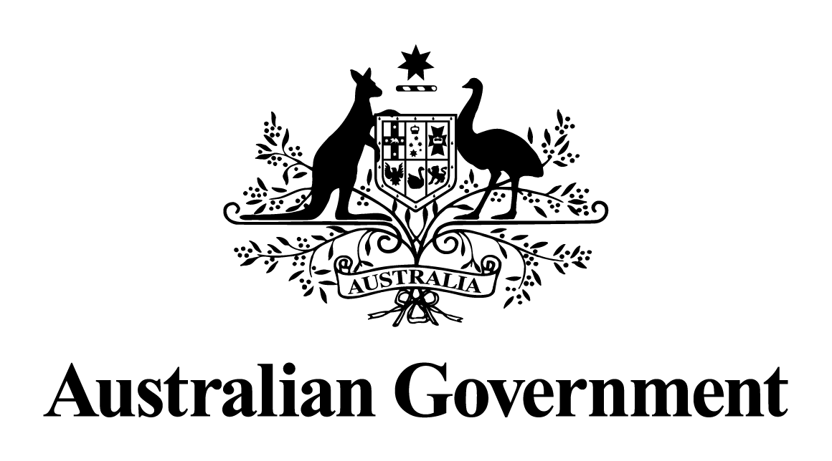

Australian Government response to the Environment and Communications References Committee report:

Continuation of construction of the Perth Freight Link in the face of significant environmental breaches

june 2017

**INTRODUCTION**

On 6 March 2017, the Senate Environment and Communications References Committee tabled   
a report into an inquiry entitled *Continuation of construction of the Perth Freight Link in the face of significant environmental breaches* (also referred to as Roe 8). The report made four recommendations.

Although the project has been placed on hold by the current Western Australian Government, the *Environment Protection and Biodiversity Conservation Act 1999* (EPBC Act) approval will remain in place until it expires on 31 December 2022.

**RESPONSE TO COMMITTEE REPORT**

**Recommendation 1:**

*Pursuant to subsection 144(2A) of the Environment Protection And Biodiversity Conservation Act 1999 (EPBC Act), the Minister for the Environment suspends the Roe 8 construction works until he has ascertained that all the conditions of the approval issued for the Roe 8 works have been met.*

**Australian Government response: Not agreed.**

Section 144(2A) of the EPBC Act states that:

*The Minister may, by written instrument, suspend the effect of an approval under this Part for the purposes of a specified provision of Part 3 for a specified period (which must not start before the day on which the instrument is made) if:*

*(a)  either:*

*(i) the Minister believes on reasonable grounds that there has been a contravention of   
a condition attached to the approval; or*

*(ii if a condition attached to the approval is to the effect that the approval is subject to   
a thing being done within a particular time—the Minister believes on reasonable grounds that the thing has not been done within that time; and*

*b)  the Minister is satisfied that:*

*(i)  the approval would not have been granted without that condition being attached; or*

*(ii) because of the failure to comply with the requirement, the suspension is reasonably necessary to protect a matter protected by a provision of Part 3 for which the approval has effect.*

After construction commenced in mid-December 2016, the Department of the Environment and Energy investigated allegations of non-compliance with conditions of the EPBC Act approval for the project. The Department conducted two compliance monitoring inspections of the project, as well as requested information from Main Roads Western Australia, project contractors, and the Western Australian Environmental Protection Authority.

The Department considers that all the relevant approval conditions are now met and that there has been no evidence of non-compliance warranting suspension of the EPBC Act approval.

Although all work on the project has ceased, the EPBC Act approval remains valid.

**Recommendation 2:**

*Following the outcome of the state election, the Commonwealth works with the Western Australian state government and other stakeholders to develop productive and economically viable infrastructure projects in Western Australia that incorporate rigorous environmental assessments and conditions.*

**Australian Government response: Noted.**

The Australian Government works closely with all state governments and other stakeholders to develop productive and economically viable infrastructure projects and to ensure that agreed projects undergo rigorous environmental assessments.

The Australian Government continues to work constructively with the Western Australian Government to plan and deliver infrastructure that meets the land transport infrastructure needs of Western Australia.  On 7 May 2017, the Australian Government agreed to partner with the Western Australian Government to deliver the new Western Australian Infrastructure Package, which included $1.2 billion in Australian Government funding previously allocated to Perth Freight Link.

Consistent with Government policy, any project where the Western Australian Government seeks Australian Government funding of more than $100 million will need to be assessed by Infrastructure Australia.

The Australian Government’s commitment of $1.2 billion to Perth Freight Link remains for any future Western Australian Government willing to commit to this nationally significant project.

**Recommendation 3:**

*The Commonwealth government act urgently to amend the EPBC Act to provide for emergency listings of threatened species and ecological communities, and to consider addressing the effect of section 158A of the EPBC Act which currently prevents consideration of threatened species or ecological communities which are listed after the time a referral is made.*

**Australian Government response: Not agreed.**

Section 158A of the EPBC Act operates as an important mechanism that balances the protection of nationally listed matters with the need for clarity and certainty to proponents in the environmental assessment process.

A revision to section 158A of the EPBC Act is not currently being considered.

**Recommendation 4:**

*The committee recommends that the Australian National Audit Office conduct an audit of the Perth Freight Link project.*

**Australian Government response: Noted.**

This recommendation is a matter for the Auditor-General.