

Prepared for

Department of the Environment

Subject

Australian Motor Vehicle Emission Inventory for the National Pollutant Inventory (NPI)

Author

Dr Robin Smit

2 August 2014

UniQuest Project No: C01772

**Title**

Australian Motor Vehicle Emission Inventory for the

National Pollutant Inventory (NPI)

**Disclaimer**

This report and the data on which it is based are prepared solely for the use of the person or corporation to whom it is addressed. It may not be used or relied upon by any other person or entity. No warranty is given to any other person as to the accuracy of any of the information, data or opinions expressed herein. The author expressly disclaims all liability and responsibility whatsoever to the maximum extent possible by law in relation to any unauthorised use of this report.

The work and opinions expressed in this report are those of the Author.

**TABLE OF CONTENTS**

GLOSSARY 2

EXECUTIVE SUMMARY 3

1. INTRODUCTION 5

2. COPERT 6

3. TECHNICAL BACKGROUND 7

4. METHOD 8

4.1 Input data overview 8

4.2 Base year 9

4.3 Vehicle population, annual travel and total fuel use 9

4.4 Fuel parameters 17

4.5 Meteorology and climate 20

4.6 Driving and traffic conditions 23

5. RESULTS 27

5.1 Total annual emissions – industry versus motor vehicles 28

5.2 Further analysis of sixteen air pollutants 29

5.3 Greenhouse gas emissions 35

5.4 NPI emissions and population exposure 36

6. DISCUSSIONS AND CONCLUSIONS 38

7. REFERENCES 40

# GLOSSARY

ABS Australian Bureau of Statistics

ACT Australian Capital Territory

AUS Australia

BoM Bureau of Meteorology

CNG Compressed natural gas

COPERT Computer Programme to calculate Emissions from Road Transport

E10 Petrol-ethanol fuel blend (10 vol% ethanol)

GHG Greenhouse gas

GMA Greater Metropolitan Area (NSW)

LCV Light commercial vehicle

LDDV Light-duty diesel vehicle

LDV Light-duty vehicle

LPG Liquefied Petroleum Gas

HCV Heavy commercial vehicle (rigid)

HDDV Heavy-duty diesel vehicle

HHV Higher Heating Value

LHV Lower Heating Value

MCV Medium commercial vehicle (rigid)

MVC Motor Vehicle Census

MVEI Motor Vehicle Emission Inventory

NMVEI National Motor Vehicle Emission Inventory

NPI National Pollutant Inventory

NSW New South Wales

NT Northern Territory

PC Passenger car

PM Particulate matter

PJ Peta joule

PULP Premium unleaded petrol

RVP Reid Vapour Pressure

QLD Queensland

SMVU Survey of Motor Vehicle Use

SA South Australia

SUV Sport utility vehicle

VIC Victoria

VOC Volatile organic compound

VKT Vehicle Kilometres Travelled

TAS Tasmania

ULP Unleaded petrol

WA Western Australia

# EXECUTIVE SUMMARY

This study developed a national motor vehicle emission inventory using the Computer Programme to calculate Emissions from Road Transport (COPERT) Australia software. A whole-of-Australia study ensures consistency in input data preparation and emission estimation methods. To account for differences in vehicle fleet mix, climate and fuel quality Motor Vehicle Emissions Inventory (MVEIs) were developed for each state/territory individually, and then aggregated to estimate total national emissions.

COPERT Australia generates comprehensive vehicle emissions data. For example it estimates emissions for 226 vehicle classes, 116 pollutants and different types of emissions (hot running, cold start, evaporative, non-exhaust). A major part of the work focussed on generating the detailed input data that are required for the emission simulations.

The COPERT input data was calibrated through an iterative process to ensure that predicted fuel consumption by fuel type is equivalent to reported fuel use by credible independent sources. This calibration step is essential to the development of a robust National Motor Vehicle Emission Inventory (NMVEI).

The NMVEI shows that the relative contributions of industry and motor vehicle emissions are highly variable, and are dependent on the pollutant. Motor vehicles emissions in relation to industry emissions vary from dominant (acrolein, benzene, etc.) to important (VOCs, NOx, PM2.5, etc.) to insignificant (SO2, selenium, etc.).

Annual emissions from motor vehicles, as reported in this study and by the National Pollutant Inventory (NPI), do not necessarily reflect community exposure to the air pollutants. The actual contribution of motor vehicle emissions to population exposure (and thus health effects) is likely to be substantially greater than equivalent emission levels from industrial sources. This is because motor vehicle emissions are released close to ground level and, typically, in close proximity to where people live and work. In contrast, industrial emissions are typically emitted through vents and stacks, and are generally located some distance from populated areas.

This means that industrial emissions are often dispersed significantly before they reach the population. As a consequence, relatively minor levels of motor vehicle emissions can lead to significant exposure to pollutants and associated health impacts.

COPERT Australia modelling in this study shows that New South Wales and Victoria consistently make the largest contributions to total emissions for all pollutants (combined varying from about 50 to 60% of total national motor vehicle emissions), Queensland contributes about 20%, and Western Australia and South Australia contribute about 10% each. Tasmania, ACT and the Northern Territory combined make up about 5% of national motor vehicle emissions.

These contributions are roughly in line with the total vehicle population and total travel (VKT) in each jurisdiction. Variations are caused by differences in fleet composition (fuel types, vehicle age mix, etc.), climate and fuel parameters.

The NMVEI predicts that hot running emissions generally dominate total emissions from road transport, but that cold start emissions are significant for a number of pollutants (CO, VOCs). In addition evaporative VOC emissions and non-exhaust PM emissions are both significant contributors to total emissions (23% and 26%, respectively).

The NMVEI shows that the relative contribution of individual vehicle classes to emissions varies substantially, depending on the air pollutant that is considered. Petrol vehicles dominate emissions of CO, VOCs, NH3 and heavy metals whereas diesel vehicles (light-duty diesel vehicles and heavy-duty diesel vehicles) dominate motor vehicle emissions of PM2.5 and NOx.

# INTRODUCTION

Australian states and territories have developed motor vehicle emission inventories (MVEIs) for their jurisdictions at specific, but uncoordinated points in time. The Bureau of Infrastructure, Transport and Regional Economics (previously the Bureau of Transport and Regional Economics) published national vehicle emission estimates for a limited number of pollutants for each state in the past (BTRE, 2002; 2003). However, no comprehensive and up-to-date MVEI has been developed for each jurisdiction at the same time using a consistent method.

A nationally consistent vehicle emission inventory is an important element of developing strategies to manage emissions from this sector and improve air quality. It facilitates meaningful comparisons of emissions between jurisdictions and with other sources. In order to address this gap, the Australian Government Department of the Environment commissioned UniQuest to develop a national MVEI for each state and territory, using COPERT Australia. This software has been adopted by the National Pollutant Inventory (NPI) as the tool for calculating emissions from motor vehicles.

COPERT is a software tool that is designed to develop:

1. national or state level motor vehicle emission inventories (MVEIs), and
2. emission factors as a function of vehicle speed for road-based emission calculations.

This report presents MVEIs for each state in Australia using COPERT Australia. Much of this work focussed on the development of the COPERT input files for each state and territory. A brief description of the tasks undertaken to develop the inputs for COPERT modelling are discussed in Section 4.

COPERT Australia has capability to generate comprehensive information on vehicle emissions, including emissions estimates for 226 vehicle classes, 116 pollutants and different types of emissions (hot running, cold start, evaporative, non-exhaust).

It is beyond the scope of this report to present, analyse and discuss all these different aspects. Instead, Section 5 presents results for a limited number of pollutants. The COPERT input files for each state/territory are available on request from the NPI team ([npi@environment.gov.au](mailto:npi@environment.gov.au)) of the Australian Government Department of the Environment and will allow COPERT Australia users to conduct more detailed analyses to address specific policy or research questions or to develop motor vehicle emission factors for local area or road level impact assessments. COPERT software can be downloaded at: [www.emisia.com/copertaustralia/General.html](http://www.emisia.com/copertaustralia/General.html).

# COPERT

COPERT was first released in 1989, as part of a European initiative to develop emission inventory methodologies to characterise emissions from vehicles at country and regional level, rather than at local level (Eggleston et al., 1993). The European Environment Agency coordinates the development of COPERT, and the European Commission manages the scientific developments. COPERT 4 is the latest version and is used world-wide to calculate air pollutant and greenhouse gas emissions from road transport. For example, COPERT was used to calculate national road transport inventories to satisfy the requirements of the Convention on Long Range Trans-boundary Air Pollution and the UN Framework Convention on Climate Change.

Although individual State Departments (e.g. QLD EPA, 2003; NSW EPA, 2012) and Australian Government agencies (BITRE, 2010) actively develop and maintain MVEIs, there is no Australian vehicle emissions software that has been actively developed and maintained, as is the case overseas.

While it would be convenient to use well-known and established vehicle emission software tools such as COPERT, MOBILE and MOVES directly in Australia, previous studies (Smit and McBroom, 2009a; 2009b) have demonstrated that any overseas software packages needs to be based on (or at least calibrated with) Australian emissions data. Otherwise substantial estimation errors will occur, sometimes up to more than two orders of magnitude (Smit and Ntziachristos, 2013).

Therefore, motor vehicle emissions software used in Australia needs to reflect the local fleet composition, fuel quality, climate and driving characteristics in order to provide robust vehicle emission estimates for the Australian situation. These were the key factors driving the development of a dedicated Australian version of COPERT called ‘COPERT Australia’.

# TECHNICAL BACKGROUND

It is beyond the scope of this project to provide a detailed discussion of the technical background of the COPERT Australia software. However, more information about the software and its scientific background can be found in the following publications:

* Mellios, G., Smit, R., Ntziachristos, L., 2013. Evaporative emissions: developing Australian emission algorithms, *Proceedings of the CASANZ Conference*, Sydney, 7-11 September 2013.
* Ntziachristos, L., Samaras, C., Smit, R., Tooker, T., Mellios, G., 2013. Air pollutant and greenhouse gas road transport inventory using COPERT Australia, *Proceedings of the CASANZ Conference*, Sydney, 7-11 September 2013.
* Smit, R., 2013. A procedure to verify large modal vehicle emissions databases, *Proceedings of the CASANZ Conference*, Sydney, 7-11 September 2013.
* Smit, R., Ntziachristos, L., 2013. Cold start emission modelling for the Australian petrol fleet, *Air Quality and Climate Change*, 47 (3).
* Smit, R., Casas, J., Torday. A., 2013. Simulating fuel consumption and vehicle emissions in an Australian context, *Australasian Transport Research Forum 2013*, 2 - 4 October 2013, Brisbane, Australia.
* Smit, R., Ntziachristos, L., 2012. COPERT Australia: Developing Improved Average Speed Vehicle Emission Algorithms for the Australian Fleet, *19th International Transport and Air Pollution Conference*, Thessaloniki, Greece, 26-27 November 2012.
* Smit, R., Ntziachristos, L., 2013. COPERT Australia: a new software to estimate vehicle emissions in Australia, *Australasian Transport Research Forum 2013*, 2 - 4 October 2013, Brisbane, Australia.

# METHOD

Development of a national or state level motor vehicle emission inventories requires a comprehensive set of input data with a high level of detail to adequately account for the range of variables that can influence vehicle emissions and fuel consumption.

This Section discusses the main elements of the required input data.

## Input data overview

COPERT Australia requires the following input data:

* + Base year
  + Hourly meteorological data:
    - ambient temperature
    - relative humidity
  + Total fuel use (tonnes/year) by type of fuel (ULP, PULP, Diesel, LPG, CNG, biodiesel, bioethanol)
  + Fuel parameters:
    - monthly average Reid Vapour Pressure (RVP)
    - sulfur content (mass %) by type of fuel
    - lead content (grams/litre) by type of fuel
    - hydrogen to carbon and oxygen to carbon ratios by type of fuel
    - heavy metal content (ppm-mass) by type of fuel
    - petrol fuel parameters as vol% (E100, E150, aromatics, olefins, benzene)
    - diesel fuel parameters (vol% PAHs, CN, density in kg/m3, T95 in oC)
  + Proportion of travel in urban, rural and highway conditions
  + Average speed (km/h) in urban, rural and highway conditions
  + On-road vehicle population, i.e. number of vehicles broken down by 226 vehicle classes
  + Mean annual mileage in km/year for 226 vehicle classes
  + Mean accumulated mileage in km for 226 vehicle classes
  + Fuel tank size in litres for 132 vehicle classes (petrol/E10 vehicles)
  + Carbon canister size in litres 132 vehicle classes (petrol/E10 vehicles)
  + Proportion of fuel-injected vehicles for 132 vehicle classes (petrol/E10 vehicles)
  + Proportion vehicles with evaporative emissions control for 132 vehicle classes (petrol/E10 vehicles)
  + Proportion of evaporative emissions in urban, rural and highway conditions

## Base year

2010 was selected as the base year for the MVEI. This will provide slightly conservative estimates of vehicle emissions for more recent years. Section 5 compares the data with 10/11 NPI industry emissions data for Australia.

## Vehicle population, annual travel and total fuel use

Australian data regarding fleet composition, fuel use and vehicle use (total travel) are available from a number of sources. However, developing a COPERT input file from these data is a significant challenge for two reasons:

1. the available data reflect different vehicle class definitions, and
2. the available data are often too aggregated to be useful.

A fleet model (TER, 2014) is therefore used to create consistent and accurate input information for COPERT Australia regarding:

* total fuel use
* vehicle population, and
* annual travel.

The most important input to COPERT Australia is a detailed breakdown of the total number of on-road vehicles and corresponding average annual travel (km/year) for 226 vehicle classes and for each state and territory. Multiplication of vehicle numbers with annual mileage provides an estimate of ‘vehicle activity’ or total travel (by vehicle class and state/territory), which is expressed as vehicle kilometres travelled or VKT. The information on VKT is then directly multiplied with emission factors (g/km or g/VKT) to estimate emission levels through COPERT software.

Another measure of vehicle activity is total fuel consumption by fuel type and by state. This metric is significantly more accurate than estimates of VKT. Therefore, fuel consumption is used in this study to calibrate vehicle class dependent age-mileage relationships, which are used to create COPERT input files.

The overall approach is to create state level input files, including the information that is discussed in the following Sections, run the software for each state and calibrate (through an iterative process) computed annual mileage values to ensure that predicted total fuel consumption by fuel type (petrol, diesel, LPG) corresponds to total reported values from independent sources. The process is shown in Figure 1 (next page).

**Fuel data**

Australian fuel consumption or energy data for road transport are available, or can be derived from a number of sources, namely the Survey of Motor Vehicle Use or SMVU (ABS, 2011a), Australian Petroleum Statistics (DRET, 2010) and Australian Energy Statistics (BREE, 2013). These data have different levels of detail. For example, the SMVU combines petrol and E10 into a category called “petrol” and does not distinguish between ULP and PULP. DRET does distinguish between ULP, PULP and E10, but combines data for the Australian Capital Territory (ACT) and New South Wales (NSW).



**Figure 1** Development of representative vehicle population and annual travel input data for COPERT Australia

To enable comparison of these data sources, a number of computations were made. Firstly, fuel data were converted to mass units (tonne) using fuel density and higher heating values (HHVs) for each type of fuel[1]. Financial year data was then converted to calendar year data by taking the average of the overlapping financial years, i.e. 2010 is the average of 2009-2010 and 2010-2011 financial years. The data sources were then combined to derive estimates of total fuel consumption by fuel type and by state at the appropriate level of detail for this study.

The results are shown in Table 1 and Table 2.

**Table 1** 2010 Road transport fuel consumption by fuel type and state/territory (tonne/year)

|  |  |  |  |  |  |  |  |  |  |
| --- | --- | --- | --- | --- | --- | --- | --- | --- | --- |
| Fuel type | NSW | VIC | QLD | SA | WA | TAS | NT | ACT | AUS |
| ULP | 2,419,103 | 3,153,655 | 1,661,743 | 822,343 | 1,207,740 | 248,682 | 80,967 | 129,198 | 9,714,415 |
| PULP | 558,837 | 298,202 | 255,145 | 64,594 | 171,230 | 39,668 | 15,393 | 29,846 | 1,441,931 |
| Diesel | 2,326,554 | 2,347,521 | 2,290,490 | 601,348 | 1,329,340 | 209,675 | 137,547 | 56,193 | 9,298,667 |
| LPG | 284,688 | 472,015 | 101,474 | 122,340 | 89,360 | 6,718 | 3,608 | 31,707 | 1,111,910 |
| CNG | 17,451 | 1,163 | 8,726 | 12,798 | 5,817 | 0 | 0 | 0 | 45,955 |
| Biodiesel | 22,157 | 5,539 | 7,386 | 12,002 | 17,541 | 0 | 923 | 0 | 65,547 |
| E10 | 1,231,970 | 98,863 | 665,122 | 13 | 0 | 0 | 0 | 65,796 | 2,061,764 |
| Total | **6,860,760** | **6,376,959** | **4,990,085** | **1,635,437** | **2,821,028** | **504,743** | **238,438** | **312,740** | **23,740,189** |

*(Source: TER, 2014)*

**Table 2** 2010 Road transport fuel consumption by fuel type and state/territory (million litres/year)

|  |  |  |  |  |  |  |  |  |  |
| --- | --- | --- | --- | --- | --- | --- | --- | --- | --- |
| Fuel type | NSW | VIC | QLD | SA | WA | TAS | NT | ACT | AUS |
| ULP | 3,314 | 4,320 | 2,276 | 1,126 | 1,654 | 341 | 111 | 177 | 13,307 |
| PULP | 766 | 408 | 350 | 88 | 235 | 54 | 21 | 41 | 1,975 |
| Diesel | 2,774 | 2,799 | 2,731 | 717 | 1,585 | 250 | 164 | 67 | 11,087 |
| LPG | 527 | 874 | 188 | 227 | 165 | 12 | 7 | 59 | 2,059 |
| CNG | 109 | 7 | 55 | 80 | 36 | 0 | 0 | 0 | 287 |
| Biodiesel | 25 | 6 | 8 | 14 | 20 | 0 | 1 | 0 | 74 |
| E10 | 1,675 | 134 | 904 | 0 | 0 | 0 | 0 | 89 | 2,803 |
| Total | **9,190** | **8,550** | **6,512** | **2,252** | **3,696** | **657** | **304** | **433** | **31,593** |

*(Source: TER, 2014)*

Fuel use data reported by the three agencies (SMVU, DRET and BREE) can differ substantially. For example, DRET and BREE data include diesel that is not used by road transport. The differences are clearly observed for the states where mining activity is significant, i.e. Queensland and Western Australia (WA). Total SMVU diesel use for Queensland and WA are around 50% and 35%, respectively, of total diesel use reported by the Australian Energy Statistics. Although there are specific issues that affect estimates for total fuel consumption in each state and territory (e.g. Skutenko, Cosgrove and Mitchell, 2006), the fuel consumption estimates in Table 1 and 2 are expected to be reasonably accurate. Litres

Table 1 and 2 show that the Australian on-road fleet use mainly petrol fuel (including E10), and that there are significant differences in the fuel mix at state level:

* E10 is predominantly used in light-duty vehicles and only used significantly as a transport fuel[2] in NSW, ACT and Queensland[3].
* Diesel fuelled vehicles typically consume about one third of total fuel (litres), but a few states and territories have a higher proportion of diesel fuel use (WA, Queensland and the Northern Territory (NT)) up to about 55% of total fuel use.
* Road transport in Victoria, South Australia (SA) and the ACT consume a substantial amount of LPG, up to about 15%, whereas some other states and territories hardly use LPG as a transport fuel.
* CNG[4] and biodiesel[5] are not used significantly in Australian road transport, but they are included in the NMVEI.

**Motor vehicle population**

COPERT Australia uses emission factors for 226 vehicle classes. The vehicle classification is shown in Table 3.

**Table 3** COPERT Australia vehicle classification

|  |  |  |  |
| --- | --- | --- | --- |
| **Main category** | **Sub category** | **Fuel type** | **Emission control standard** |
| Passenger car | Small (<2.0 l); Medium (2.0-3.0 l); Large (≥ 3.0 l) | Petrol; Diesel; LPG; E10 | Uncontrolled; ADR27;ADR37/00-01; ADR79/00-05 |
| SUV | Compact (≤ 4.0 l); Large (> 4.0 l) | Petrol; Diesel; E10 | Similar to PC; +ADR36 (SUV-L); +ADR30; (SUV-Diesel) |
| Light Commercial Vehicle (LCV) | GVM ≤ 3.5 t | Petrol; Diesel | Uncontrolled; ADR36 (P); ADR30 (D); ADR37/00-01; ADR79/00-05 |
| Heavy Duty Truck | Medium (MCV 3.5-12.0 t); Heavy (HCV 12.0-25.0 t); Articulated (AT > 25 t) | Petrol; Diesel; LPG | Uncontrolled; ADR30; ADR70; ADR80/00; ADR80/02-05 |
| Bus | Light bus (≤ 8.5 t);  Heavy bus(>8.5 t) | Diesel |
| Moped | 2-stroke; 4 stroke | Petrol | Conventional; Euro 1-3 |
| Motorcycle | 2-Stroke; 4-S <250 cm3; 4-S 250-750 cm3; 4-S ≥750 cm3 |

Note that (Australian Design Rule) or ADR emission standard is used as a proxy for ‘emission control technology level’. ADRs are the emission standards adopted in Australia. The COPERT Australia software considers 22 ADR categories, including future ones. ADR categories are defined in terms of a specific range of years of manufacture. For example, ADR37-00 petrol passenger cars are vehicles that were manufactured between 1986–1998.

The Motor Vehicle Census (MVC) data from the Australian Bureau of Statistics (ABS, 2011b) provides detailed time-series data regarding the number of registered vehicles for each state/territory. The MVC provides information on the number of registered vehicles by year of manufacture at a particular date for the reporting year for the following vehicle classes: passenger vehicles, light commercial vehicles (LCVs), motorcycles, light rigid trucks, heavy rigid trucks, articulated trucks, buses, campervans and non-freight carrying trucks.

Vehicle class definitions used by the ABS differ from those used in COPERT Australia. For example, there is no ‘Campervans’ or ‘Non-freight carrying trucks’ category in COPERT Australia, and the ‘Bus’ category in COPERT Australia is divided into a light and heavy bus category. Although the ‘Light rigid trucks’ Motor Vehicle Census category (GVM of 3.5-4.5t) falls entirely in the medium commercial vehicle (MCV) category in COPERT Australia, the ‘Heavy rigid trucks’ MVC category (GVM > 4.5t) overlaps with both the MCV and heavy commercial vehicle (HCV) category used in COPERT Australia. The ‘Passenger vehicle’ category in the MVC includes both passenger cars and SUVs, which are separate classes in COPERT Australia.

More detailed vehicle sales data and other information was used to develop a splitting factor matrix, which quantifies the proportion of a particular vehicle class (e.g. small diesel passenger car) and year of manufacture within a particular vehicle type (e.g. passenger cars). Various additional data and information sources were used and combined, including ABS (2012), BITRE (2009; 2010), VFACTS (FCAI, 2012), Gas Energy Australia (2013) and ARRB (2008). For example, the category ‘passenger vehicles’ was split into two categories, passenger cars (PC) and SUVs, using vehicle sales data (ABS, 2012). The vehicle sales data were used to determine the proportion of SUVs for each year of manufacture. These proportions were then multiplied with the number of registered passenger vehicles by model year to create two new data tables for each state or territory (SUVs and PCs).

Combining the MVC on-road fleet population data matrix, showing the number of registered vehicles by year of manufacture by state, with the splitting factor matrix then creates the required population data matrix, i.e. number of on-road vehicles by year of manufacture for 40 vehicle classes:

* PCs by size (small, medium, large) and fuel type (petrol, diesel, LPG, E10)
* SUVs by size (compact, large) and fuel type (petrol, diesel, LPG, E10)
* light commercial vehicles (LCVs) by fuel type (petrol, diesel, LPG, E10)
* trucks by size (medium/heavy commercial, articulated) and fuel type (petrol, diesel, LPG/CNG)
* buses by size (light, heavy) and fuel type (petrol, diesel, LPG/CNG)
* motorcycles (petrol)

It is noted that determination of the number of E10 vehicles was achieved through an iterative process that considered both total E10 fuel consumption and suitability of vehicles for E10 by year of manufacture. Pre-1986 light-duty vehicles (LDVs) are not ethanol compatible and nearly all post-2003 LDVs are ethanol compatible, with a rising portion of 1986-1998 vehicles being ethanol compatible (DEWHA, 2008) as a function of year of manufacture. About 50% and 75% of ADR37/00 and ADR37/01 vehicles are ethanol compatible, respectively.

The aggregated results for Australia shown in Table 4.

**Table 4** Vehicle population summary table for Australia, 2010

|  |  |  |  |  |  |
| --- | --- | --- | --- | --- | --- |
| **Vehicle class** | **Petrol** | **Diesel** | **LPG** | **E10** | **Total** |
| PC-S | 22.9% | 0.6% | 0.0% | 4.8% | 28.3% |
| PC-M | 10.6% | 0.4% | 0.1% | 1.9% | 13.0% |
| PC-L | 16.7% | 0.1% | 1.6% | 3.0% | 21.3% |
| SUV-C | 4.2% | 0.0% | 0.6% | 1.0% | 5.8% |
| SUV-L | 3.4% | 3.3% | 0.4% | 0.9% | 8.0% |
| LCV | 7.5% | 7.0% | 1.2% | 0.0% | 15.7% |
| MCV/HCV | 0.1% | 2.7% | 0.1% | - | 2.9% |
| AT | 0.0% | 0.5% | 0.0% | - | 0.5% |
| BUS-L | 0.1% | 0.2% | 0.0% | - | 0.4% |
| BUS-H | 0.0% | 0.1% | 0.0% | - | 0.1% |
| MCY | 4.1% | - | - | - | 4.1% |
| **Total** | **69.6%** | **14.8%** | **4.0%** | **11.6%** | **0.0%** |

It is noted that COPERT Australia population data input file has a finer level of detail than the data presented in Table 4. The population data are also broken up by vehicle year of manufacture, resulting in 1,280 vehicle classes (40 fuel/vehicle types and 0-30 years of vehicle age). This level of detail is required to account for age-dependent annual mileage, as will be discussed in the next section, and for accurate apportioning of E10 vehicles. Note that these data are aggregated to ADR level (emission standard) to estimate population data for the 226 vehicle classes in COPERT Australia.

The combination of census data with vehicle sales data inherently assumes that the proportions for a particular year of manufacture (model year) in vehicle sales data remain constant as the vehicle population ages and vehicles are scrapped. This seems a reasonable first-order assumption. The main issue is that national vehicle sales information are applied to all states and territories, whereas there can be significant differences between the states and territories in terms of, for example, the distribution of fuel types. In compiling this report, it was problematic to obtain sufficient data and information to make an accurate estimate of the number of LPG vehicles in the Australian on-road fleet (both dedicated and retro-fitted). This should be addressed when updating the NMVEI.

It is recommended that further analysis is conducted using state-specific data (e.g. using vehicle registration data from the transport department) to verify the population input files and to further improve the accuracy at state and territory level.

**Mean Annual Mileage / VKT**

Mean annual mileage information is required for each of the 226 vehicle classes in COPERT Australia to estimate VKT, as discussed earlier. VKT cannot be measured directly, but can be estimated using different methods, such as:

* combination of traffic volume and road length data (traffic counts and/or transport models), and
* combination of mean annual mileage and vehicle population data.

Mean annual mileage may be estimated from reported vehicle mileage in a specific period, analysis of odometer databases and household travel surveys. It is, however, difficult to determine the accuracy of VKT estimates, particularly for the detailed vehicle classification used in COPERT. Mean annual mileage is not only a function of vehicle type (car, truck, light-commercial vehicle, etc.), but also vehicle age. For example, older vehicle are driven significantly less than newer vehicles, larger vehicles are driven more than smaller vehicles and diesel vehicles are driven more than petrol cars, as shown in Figure 2. As a consequence, average annual mileage for a particular class (e.g. small ADR79/00 petrol passenger car) is a function of the base year and will change over time.



**Figure 2** Example of age-dependent annual mileage relationships for passenger cars

Age-mileage functions are required to estimate total travel (expressed as VKT) for each vehicle class. In addition, accumulated mileage is required to estimate the impacts of emissions deterioration due to ageing. For the NMVEI age-mileage algorithms were adopted from TER (2014) for 40 vehicle classes using different data and information sources, including odometer data (Rosevaer, 2013) and other relevant information (e.g. ABS, 2011a; BTCE, 1996a and 1996b).

## Fuel parameters

Fuel characteristics affect vehicle emissions. The quality of fuel in Australia is regulated by the *Fuel Quality Standards Act 2000* (the Act) and the Fuel Quality Standards Regulations 2001 (DoE, 2014). The Act places an obligation on the fuel industry, including fuel suppliers, to supply fuels that meet specific requirements. The Act provides a legislative framework for setting national fuel quality and fuel quality information standards for Australia. Fuel quality standards have been established for petrol, diesel, biodiesel, auto-gas (LPG) and ethanol. Information labelling standards have been established for ethanol (in petrol) and ethanol as E85.

COPERT Australia has input tables that specify a range of fuel parameters that allow local fuel quality to be characterised.

Table 5 and 6 present an overview of national standards for a number of petrol and diesel fuel parameters, which were used for the vehicle emission simulations in this report. The tables also include Australian fuel information from other data sources, which are discussed below. The default (European) COPERT 4 fuel parameter values for 2009 (Ntziachristos et al., 2012) are also included for comparative purposes.

**Table 5** Petrol fuel parameters

|  |  |  |  |  |
| --- | --- | --- | --- | --- |
| **Fuel parameter** | **National standard** | **In-service** | **National fuel sampling** | **COPERT 4** |
| RVP (kPa) | - | - | - | 60 (summer) / 70 (winter) |
| Sulfur (mg/kg) | < 150 (ULP),  < 50 (PULP) | 103 (ULP) | 66 (ULP),  31 (PULP) | 40 |
| Benzene (vol%) | < 1.0% | 0.4% | 0.7% | 0.8% |
| Aromatics (vol%) | < 45.0% | 28.1% | 26% (ULP),  35% (PULP) | 33.0% |
| Olefins (vol%) | < 18.0% | 16.1% | 13% (ULP),  10% (PULP) | 10.0% |
| E100 | - | 46% | - | 52% |
| E150 | - | 84% | - | 86% |
| Lead (mg/l) | < 5 | 1 (ULP),  2 (PULP) * | 1.25 ** | 0.02 |

*\* Those values were measured before the petrol fuel standard became effective*

*\*\* 97% of the samples had values below the detection limit for lead, the value represents half the detection limit*

**Table 6** Diesel fuel parameters

|  |  |  |  |  |
| --- | --- | --- | --- | --- |
| **Fuel parameter** | **National standard** | **In-service** | **National fuel sampling** | **COPERT 4** |
| Sulfur (mg/kg) | < 10 | - | 7 | 8 |
| Cetane index | > 46 | - | 54 | 53 |
| Density (g/l) | 820-850 | - | 839 | 835 |
| PAHs (% by mass) | < 11.0% | - | 3.9% | 5% |
| Total Aromatics | - | - | - | 24% |
| T95 | 360-370 ºC | - | 347 ºC | 320 ºC |

The national fuel quality standards set limits for a range of fuel parameters. However these do not accurately reflect the actual fuel specifications of in-service transport fuels. “In-service” fuel quality is required for the accurate modelling of vehicle emissions.

Vehicle emission testing programs generally use commercially available fuels. These studies often report actual test fuel specifications. However, given the changes in fuel standards, recent studies are much more useful for the purposes of developing vehicle emission inventories. The NISE2 study (RTA, 2009) provided measured fuel parameter information for summer grade commercial ULP fuel in WA. This data is shown in the “in-service” column in Tables 1 and 2..

The Australian Government administers a fuel sampling program to monitor the quality of fuels sold in Australia and ensure compliance with the Act. Through this fuel testing programme, fuel samples are taken throughout the fuel supply chain, including at service station forecourts. However, this information is currently not available publicly. The Australian Government was requested to provide averaged national fuel quality data[6]. The Australian Government provided averaged values for 855 tests on compliant fuel, which were collected in the 2011 and 2012 calendar years. The averaged results are shown in Table 5 and 6.

The NISE2 study does not provide data on the heavy metal content, including for lead, of test fuels. The CVES study (DTRS, 2001) lists a lead content of 1 and 2 mg/l for ULP and PULP, respectively. The NISE1 study (FORS, 1996) also reported 2 mg/l for ULP. However, these values were measured before the maximum lead limit of 5 mg/l was imposed through the Australian petrol standard from 1 January 2002. The current value of 1.25 mg/l in the National Fuel Sampling Programme is possibly an overestimate of current lead content in petrol fuels. The majority (97%) – but not all – fuel samples had values below the detection limit for lead (2.5 mg/l), and the value in Table 1 represents half the detection limit. It is noted that this value is substantially higher than the value used in Europe of 0.02 mg/l. Further research is needed is determine a more accurate lead content values for Australian petrol fuels.

It is important to note that heavy metal emissions, like lead, are not only a function of heavy metal content in the fuel. Metal emissions from motor vehicle exhaust are also caused by combustion of small amounts of engine oil in the engine (approximately 0.1% of fuel consumption) and engine wear. COPERT has developed a method to indirectly estimate metal emissions from all three mechanisms (fuel combustion, lube oil combustion and engine wear) and back-calculate a derived metal content of the fuel (Gkatzoflias et al., 2011). COPERT Australia also estimates emissions of cadmium, copper, chromium, nickel, selenium and zinc. Due to a lack of information regarding heavy metal content in Australian fuels, the COPERT 4 metal content values have been used, after correction for density of Australian fuels. Further research is needed is determine a more accurate heavy metal content value for Australian fuels.

In addition, analysis of Australian particulate matter (PM) speciation data is recommended to verify the adequacy of the European emission factors for Australian conditions. Previous studies (e.g. Cohen et al., 2005) have shown that the contribution of motor vehicles to local heavy metal concentrations, and actual concentration levels in Australia, can be quite different when compared to overseas studies.

Finally, further work needs to be conducted to include emission estimates for NPI heavy metals that are not yet included in COPERT Australia, such as manganese. Ideally, this work should also include studies to determine the speciation of non-exhaust PM emissions (zinc, nickel, aluminium, vanadium, etc.), which are not yet included in COPERT.

Fuel volatility is regulated at the state and territory level. For example, in Queensland, the *Environmental Protection Act 1994* provides limit values with respect to the RVP of petrol fuels for the summer period (15 November - 15 March) for a “low volatility zone”, which is effectively South East Queensland. The Act stipulates that the maximum average monthly RVP for non-E10 fuels ("other fuel") must not be higher than 67 kPa, and not more than 74 kPa for E10. RVP regulatory limits, however, are not a reliable indicator of the actual RVP for fuels used in Queensland throughout the year. The Caltex and BP refineries in Brisbane were therefore contacted directly, and based on the information these companies provided, actual monthly RVP values were estimated for Queensland. A similar approach was adopted by some jurisdictions, and the results are shown in Figure 4.



**Figure 4** Average monthly Reid Vapour Pressure (petrol) by jurisdiction

It is noted that the estimated fuel parameter values were discussed with the Australian Institute of Petroleum, and that initial feedback is reflected in the fuel parameter values. It is recommended that the estimated monthly RVP values and other parameters are further verified with the fuel suppliers.

## Meteorology and climate

Meteorological variables affect vehicle emissions. The NMVEI requires ‘representative’ meteorological data for each jurisdiction for both ambient temperature and relative humidity. Ambient temperature affects cold start emissions. Ambient temperature and relative humidity affect air conditioning use and therefore emission levels.

Australia is a vast continent with local climate varying from tropical to temperate, as shown in Figure 5.

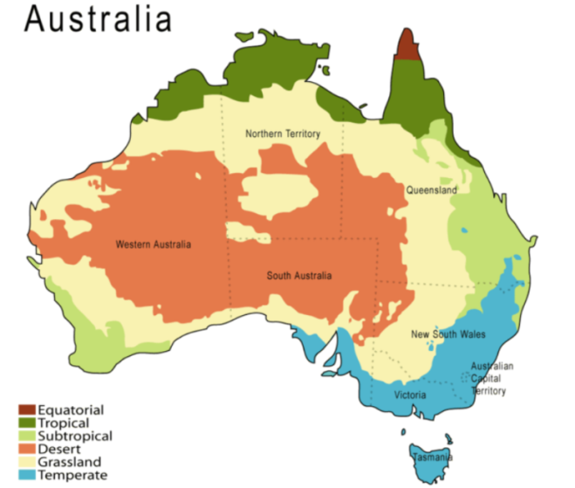

**Figure 5** Australian climate zones (Source: http://en.wikipedia.org/wiki/Climate_of_Australia)

The NMVEI requires a single meteorological input file for each state. This requires expert judgement by air quality professionals to what is considered a representative meteorological year for each state. As the bulk of VKT will generally be generated in the capital cities, meteorological data was collected and verified for these cities.

Pacific Environment (2014) was appointed to select and reformat representative Bureau of Meteorology (BoM) data for all states and territories for input into COPERT Australia. Hourly temperature and relative humidity data for a 12 year period (1998-2009) was sourced from the BoM. Temperature and relative humidity were compared to long term averages and the non-parametric Mann-Whitney test was used to determine the most representative year for each major city.

The following BoM stations and years, with representative temperature and relative humidity, were selected for each city:

* Brisbane Airport (BoM ID: 040842): 2006
* Sydney Observatory Hill (BoM ID: 066062): 2004
* Melbourne Regional Office (BoM ID: 086071): 2009
* Adelaide Airport (BoM ID: 023034): 2009
* Perth Metro (BoM ID: 009225): 2006
* Hobart Ellerslie Rd (BoM ID: 094029): 2005
* Canberra Airport (BoM ID: 014015): 2008
* Darwin Airport (BoM ID: 070014): 2008

Figure 6 and 7 show the monthly variation of temperature and relative humidity for each state/territory.



**Figure 6** Average monthly ambient temperature by jurisdiction



**Figure 7** Average monthly relative humidity by jurisdiction

The above graphs show that there is substantial spatial variability in temperature and relative humidity within states and territories, and even across certain larger centres such as Brisbane and Sydney, where the range in temperatures and relative humidity (i.e. lower minima in winter and higher maxima in summer) is generally greater in the western suburbs than the eastern suburbs. Consequently, a dataset based on a single station per city cannot be representative of all areas within a state or territory.

It should be noted that COPERT Australia can be run for smaller and more homogeneous areas with respect to climate (e.g. splitting the states in smaller modelling areas). However, this modelling work is outside the scope of this project. To develop motor vehicle emission factors for such smaller areas (e.g. local government areas), it is recommended that local meteorological data are used as an input to COPERT. The NMVEI will reflect the main climate differences between the states and territories.

## Driving and traffic conditions

COPERT Australia defines three road types, namely “urban”, “rural” and “highway”, which broadly characterise driving and traffic conditions. It uses average speed to quantify driving conditions. Average speed is used as a proxy for congestion levels in state road networks.

Accurate determination of the proportion of total travel in “urban”, “rural” and “highway” conditions, and actual definition of these conditions in terms of average speed of travel, is challenging. This is because the available information on traffic performance uses different and more aggregated definitions, which are also loosely defined.

For example, the ABS SMVU (ABS, 2011a) reports total VKT by state and by vehicle type, and uses the categories “capital city”, “other urban areas”, “other areas” and “interstate” to split the data. However, these data are not directly useful for the assignment of VKT contributions to the three COPERT Australia road types. For example, the ABS urban area definition will include a range of road types such as residential roads, arterial roads and highways. Furthermore, the SMVU does not include data on average driving speeds in the ABS categories. These issues apply to other potentially useful data sources (e.g. DCCEE, 2012).

Austroads (2013) includes information on the network performance of major Australian cities. The network average speed provided by the state agencies is based on travel time monitoring data. The data are assumed to reflect a true representative sample of routes and travel environments within the metropolitan area and reflect the arterial road network (i.e. highways, primary and secondary arterials). The publication of this performance information enables Australian state and territory and New Zealand road authorities to benchmark at both national and international level. The time-series data provides information on the average daily travel speed in urban areas in NSW, Victoria, Queensland, WA, SA and ACT, but not in Tasmania and the NT, as is shown in Figure 8.



**Figure 8** Average urban network speeds

The figure shows that average urban speed has remained fairly constant over the years for each state, and, on average, dropped from about 46 km/h in 1998 to 42 km/h in 2012. There are differences between the states with the ACT having the lowest average network speeds (around 32 km/h) and WA having the highest (around 48 km/h). This demonstrates that urban structure, travel demand and road network will affect local/regional traffic conditions. These data, however, cannot be used for COPERT Australia for two reasons:

1. The network speeds cannot be split into the required COPERT Australia road types.
2. COPERT Australia emission factors (g/km) have a different spatial resolution, i.e. they reflect driving and emissions on short road segments (about 100m) and not travel journeys (several kilometres, typically).

In fact, COPERT Australia is designed to interface readily with output from (macroscopic) transport models (Smit and Ntziachristos, 2012). These models provide detailed information for thousands of road segments (“links”) in major urban networks on traffic volumes by basic vehicle type (e.g. LDV and HDV), time of day (e.g. morning peak, afternoon peak, off-peak and night-time), congestion level (average speed) and other useful data (e.g. speed limits).

State transport agencies and transport departments typically develop and use these transport models for major urban areas. This information can be used to compute average network speed and the share of the three driving modes “urban”, “rural” and “highway”.

A number of jurisdictions provided detailed output data from strategic transport models:

* NSW Greater Metropolitan Area (GMA): 60,269 road links
* South East Queensland (SEQ): 44,892 road links
* Adelaide: 11,834 road links
* Perth: 10,454 road links

This data was analysed to create road speed distributions showing the percentage of total network VKT for each average speed bin, as is shown in the figure below.



**Figure 9** Average urban network speeds

The speed ranges for the three driving modes are (arbitrarily) defined as 0-64 km/h for “urban”, 65-94 km/h for “rural” and > 95 km/h for “highway”. Following these definitions, the following average network speeds and VKT shares were computed:

* GMA: “urban” (41 km/h; 78%), “rural” (75 km/h; 17%), “highway” (99 km/h; 4%)
* SEQ: “urban” (46 km/h; 56%), “rural” (82 km/h; 22%), “highway” (101 km/h; 22%)
* Adelaide: “urban” (51 km/h; 66%), “rural” (78 km/h; 26%), “highway” (106 km/h; 8%)
* Perth: “urban” (46 km/h; 62%), “rural” (76 km/h; 37%), “highway” (97 km/h; 1%)

Again, there are substantial differences between the metropolitan areas. The proportion of high speed “highway” driving is significantly higher in SEQ (22%) as compared with GMA, Adelaide and Perth (1-8%). However, other sources indicate that other Australian cities may have similarly higher proportions of highway driving. For example, Vicroads (2011) reports that 25% of travel occurs on highways in the Melbourne metropolitan area. Total fuel consumption for a road network can be predicted in two ways:

* Computing fuel consumption for each road link (bottom up), then aggregating to network level.
* Using the average network speeds for each road type in COPERT Australia and run the software.

The last approach is used in this study. However, comparison of these two values showed that a lower average network speed for “urban” should be used in COPERT Australia to reproduce the bottom-up network predictions. This effect is caused by the non-linear relationship between emission factors (g/km) and average speed. Therefore an “equivalent” average speed was computed that accounts for this underestimation effect, as well as for a similar (and additional) underestimation effect of real-world speed distributions on road links (Smit, Poelman, and Schrijver, 2008). The COPERT “equivalent” average speed for urban conditions is about 5-10 km/h lower than the aggregated average speed (VKT weighted average) that is derived from analysis of macroscopic transport model output.

One potential issue is the representativeness of the capital city road network for the whole of the state. It is possible, for example, that a significantly larger proportion of rural and highway driving occurs outside the metropolitan areas. However, no further information could be located for the jurisdictions.

The available data sources (ABS, 2011a; Vicroads, 2011; DCCEE, 2012) clearly show that VKT shares by road type vary substantially between vehicle types. For example, medium commercial vehicles (MCVs, rigid trucks) and buses have a share of urban driving that is similar to light-duty vehicles (passenger cars, LCVs). Heavy duty trucks, on the other hand, have a distinctly larger share in “non-urban driving”, which is interpreted as “highway” conditions. This variation needs to be reflected in the COPERT input file. All available data sources were considered in the development of a final input table for COPERT Australia. A summary of the range of speeds and VKT shares is presented in Table 7.

**Table 7** Range of network traffic conditions in Australian jurisdictions

|  |  |  |  |  |  |  |
| --- | --- | --- | --- | --- | --- | --- |
| Vehicle class | Equivalent average network speed (km/h) | | | VKT share (%) | | |
| Urban | Rural | Highway | Urban | Rural | Highway |
| PC | 30 – 40 | 75 - 80 | 100 | 60 – 80 | 0 - 35 | 5 - 25 |
| LCV | 30 – 40 | 75 - 80 | 100 | 60 – 80 | 0 - 35 | 5 - 20 |
| MCV | 30 – 40 | 75 - 80 | 90 | 60 – 80 | 0 - 35 | 5 - 20 |
| HCV | 30 – 40 | 75 - 80 | 90 | 60 – 80 | 0 - 35 | 5 - 20 |
| AT | 30 – 40 | 75 - 80 | 90 | 15 – 35 | 0 - 70 | 5 - 85 |
| BUS | 30 – 40 | 75 - 80 | 90 | 60 – 75 | 0 - 35 | 5 - 30 |
| MCY | 30 – 40 | 75 - 80 | 100 | 60 – 70 | 0 - 35 | 5 - 30 |

# RESULTS

This section presents the results of the COPERT Australia runs using the input that was discussed in section 4. COPERT Australia creates a substantial amount of vehicle emissions information that can be analysed in various ways and with different levels of detail to address different research or policy questions. The software can create output in the form of either Excel spread-sheets or report (pdf) format with different options regarding the required breakdown of emissions. An example of a report is shown in Figure 10.

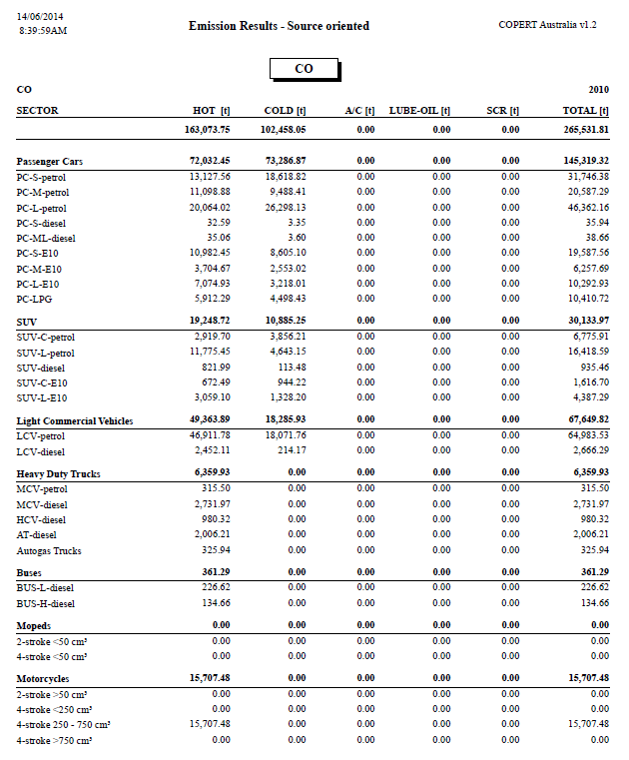

**Figure 10** Example of COPERT Australia output report

## Total annual emissions – industry versus motor vehicles

COPERT Australia provides emissions for 116 air pollutants and greenhouse gases, as shown in Table 8.

**Table 8** List of pollutants for which COPERT Australia predicts emissions

|  |  |  |
| --- | --- | --- |
| 1,2,3 trimethylbenzene | 1,2,4 trimethylbenzene | 1,3,5 trimethylbenzene |
| 1,3-butadiene | 1-butene | 1-butine |
| 1-hexene | 1-pentene | 2-butene |
| 2-methylheptane | 2-methylhexane | 2-methylpentane |
| 2-pentene | 3,6-dimethyl-phenanthrene | 3-methylheptane |
| 3-methylhexane | 3-methylpentane | acenaphthylene |
| acenapthene | acetaldahyde | acetone |
| acetylene | acrolein | alkanes C>13 |
| alkanes C10-C12 | anthanthrene | anthracene |
| aromatics C>13 | aromatics C10 | aromatics C9 |
| benzaldehyde | benzene | benzo(a)anthracene |
| benzo(a)pyrene | benzo(b)fluoranthene | benzo(b)fluorene |
| benzo(e)pyrene | benzo(ghi)perylene | benzo(j)fluoranthene |
| benzo(k)fluoranthene | butane | butyraldehyde |
| cadmium | CH4 | chromium |
| chrysene | CO | CO2 |
| copper | coronene | crotonaldehyde |
| cycloalkanes | decane | dibenzo(a,j)anthacene |
| dibenzo(a,l)pyrene | dibenzo(ah)anthracene | dimethylhexene |
| dioxins | EC (elemental carbon) | ethane |
| ethylbenzene | ethylene | fluoranthene |
| fluorene | formaldehyde | fuel consumption |
| furans | heptane | hexanal |
| hexane | indeno(1,2,3-cd)pyrene | Isobutanaldehyde |
| isobutane | isobutene | isopentane |
| i-valeraldehyde | lead | m,p-xylene |
| methacrolein | methylethlketone | m-tolualdehyde |
| N2O | napthalene | NH3 |
| nickel | NMVOC | NO |
| NO2 | nonane | NOx |
| octane | OM (organic matter) | o-tolualdehyde |
| o-xylene | pentane | perylene |
| phenanthrene | PM10 exhaust | PM10 non-exhaust |
| PM2.5 exhaust | PM2.5 non-exhaust | propadiene |
| propane | propine | propionaldehyde |
| propylene | p-tolualdehyde | pyrene |
| selenium | SO2 | Styrene |
| toluene | triphenylene | valeraldehyde |
| VOCs | zinc |  |

However, the focus of this study is on developing motor vehicle emission estimates for the NPI, which has its own list of 93 pollutants. COPERT does not predict emissions for all 93 NPI pollutants as not all of them are relevant for road transport.

An overview of total emissions from industry (as reported by the NPI) and estimates of total motor vehicle emissions from this study is shown in Table 9 for all (29) relevant NPI air pollutants. The table also shows the contribution of motor vehicles to the combined total emissions of industry and road transport in the last column.

Table 9 shows that motor vehicles and industry have quite a different emissions profile. Motor vehicle emissions are insignificant (< 5%) for some pollutants as compared with industry (e.g. heavy metals, SO2, PM10), but for other pollutants it is the other way around (e.g.   
1,3-Butadiene, PAHs, benzene, acrolein, toluene). For the criteria pollutants, motor vehicle contribute significantly to CO, NOx and PM2.5, but not significantly to total emissions of SO2 and PM10. For some pollutant total annual motor vehicle emissions are of similar magnitude as for industry (e.g. TVOCs, styrene, n-hexane).

It is emphasised, however, that total annual emission levels are not the same as exposure levels. The actual contribution of motor vehicle emissions to population exposure (and thus health effects) is typically much larger than for industrial sources (e.g. Caiazzo et al., 2013). This is because motor vehicle emissions are released close to ground level and in close proximity to where people live and work. In contrast, industrial emissions are typically emitted through vents and stacks, and are generally separated from populated areas. This means that industrial emissions are often significantly diluted before they reach the population.

**Table 9** Total annual Australian NPI emissions (kg/yr) for industry and motor vehicles (2010)

|  |  |  |  |
| --- | --- | --- | --- |
| Pollutant | NPI industry | NMVEI | MV Contribution |
| Acetaldehyde | 411,765 | 886,969 | 68.29% |
| Acetone | 691,837 | 301,465 | 30.35% |
| Acrolein | 11 | 314,000 | 100.00% |
| Ammonia | 120,860,415 | 6,313,888 | 4.96% |
| Benzene | 1,197,423 | 4,099,173 | 77.39% |
| 1,3-Butadiene | 14,635 | 971,856 | 98.52% |
| Cadmium | 32,053 | 237 | 0.73% |
| Carbon monoxide | 1,388,700,000 | 936,869,323 | 40.29% |
| Chromium | 590,406 | 502 | 0.08% |
| Copper | 677,884 | 794 | 0.12% |
| Cyclohexane | 473,055 | 664,516 | 58.42% |
| Dioxins/Furans (i-TEQ) | 0.194 | 0.005 | 2.75% |
| Ethylbenzene | 138,330 | 3,116,430 | 95.75% |
| Formaldehyde | 2,922,758 | 2,005,013 | 40.69% |
| Lead | 687,463 | 17,171 | 2.44% |
| Methylethylketone (MEK) | 700,618 | 77,818 | 10.00% |
| n-Hexane | 1,709,621 | 1,322,489 | 43.62% |
| Nickel | 772,525 | 267 | 0.03% |
| Oxides of Nitrogen | 1,396,900,000 | 305,601,721 | 17.95% |
| PAHs (BaP-equivalents) | 23,709 | 627 | 2.58% |
| Particulate Matter ≤ 10.0 µm | 1,238,329,933 | 14,461,823 | 1.15% |
| Particulate Matter ≤ 2.5 µm | 56,532,376 | 11,684,995 | 17.13% |
| Selenium | 6,348 | 4 | 0.06% |
| Styrene | 393,246 | 470,431 | 54.47% |
| Sulfur dioxide | 2,509,400,000 | 1,310,884 | 0.05% |
| Toluene | 2,525,696 | 8,243,841 | 76.55% |
| Total Volatile Organic Compounds | 157,006,103 | 107,329,985 | 40.60% |
| Xylenes | 1,882,125 | 8,085 | 0.43% |
| Zinc | 1,597,971 | 47,352 | 2.88% |

## Further analysis of sixteen air pollutants

Sixteen air pollutants were selected for further analysis.

* commonly assessed air pollutants (CO, VOCs, NOx, PM2.5)
* organic air toxics (benzene, formaldehyde, ethylbenzene, toluene, xylenes,   
  1,3-butadiene, PAHs)
* inorganic air pollutants (NH3)
* dioxins/furans, and
* heavy metals (cadmium, lead, zinc).

The following aspects are analysed and the results are presented in this section.

* Contribution of motor vehicle emissions to total reported NPI industry emissions.
* Contribution of different States/Territories to total motor vehicle emissions.
* Contribution of different types of emissions to total motor vehicle emissions.
* Contribution of different vehicle types to total motor vehicle emissions.

The results are graphically shown in pie charts and bar plots in Figure 11-14 on the following pages.

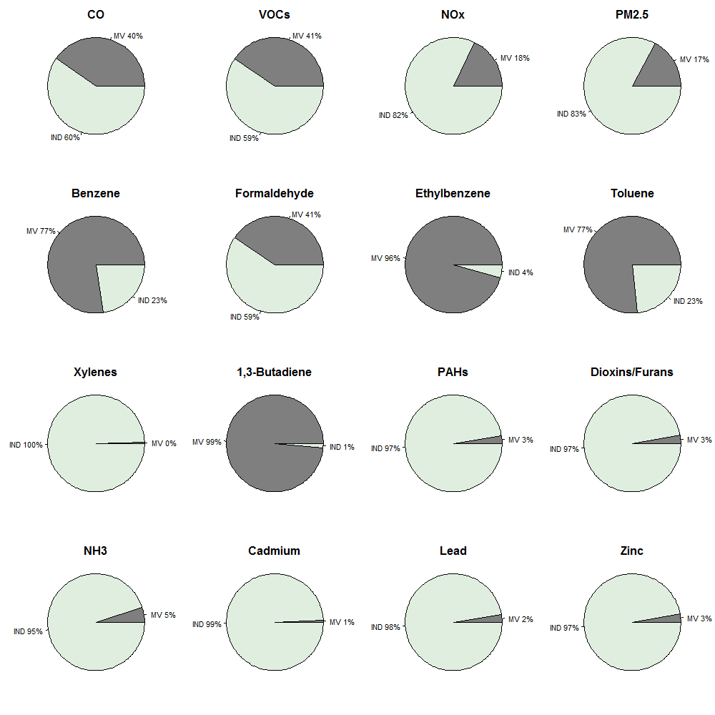**Figure 11** Contribution of motor vehicle (MV) and industry (IND) emissions to their combined total emissions

Figure 11 shows the contribution of industry and motor vehicles to their combined total emission levels for the 16 selected pollutants. The emissions data are also presented in Table 9, which was discussed before. The relative contributions of industry and motor vehicles are highly variable and the relevance of motor vehicle emissions depends on the pollutant that is considered. This is important data for the NPI as it puts total industry emissions in perspective of another significant source of air pollution.

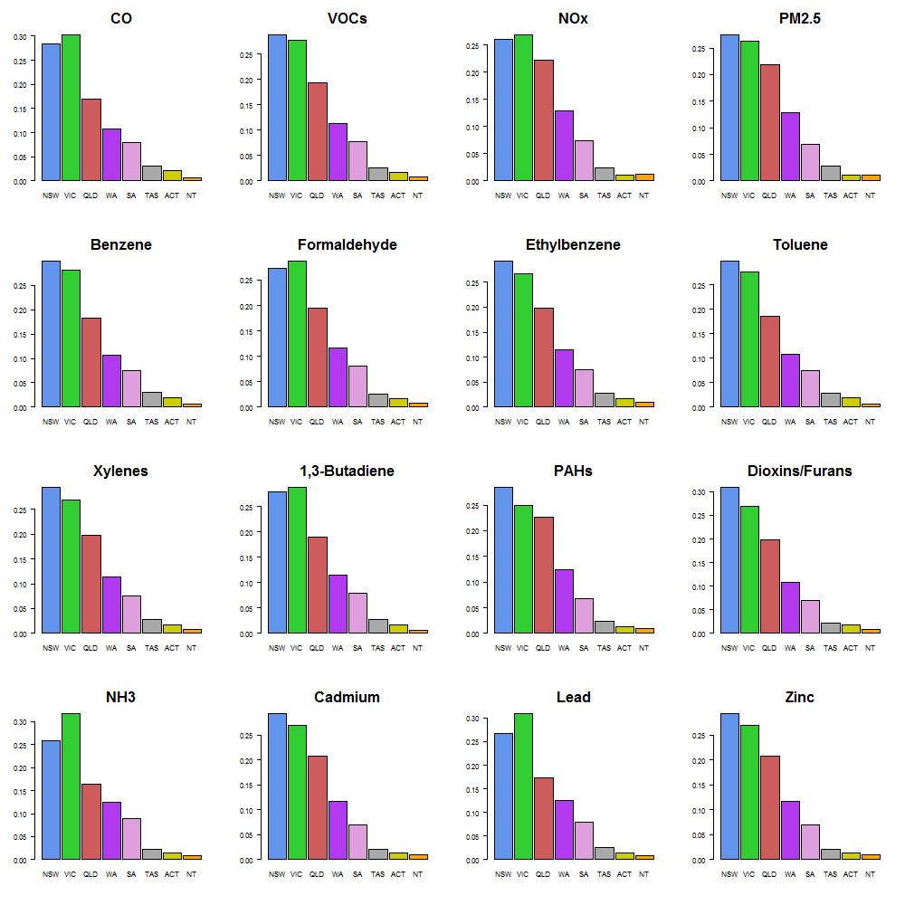**Figure 12** Contribution of states/territories to total motor vehicle emissions

Figure 12 shows the contribution of the different jurisdictions to total Australian motor vehicle emissions. NSW and Victoria make the largest contributions to total emissions, and combined together emit 50-60% of total national motor vehicle emissions. Queensland contributes about 20%, and WA and SA contribute about 10% each. Tasmania, ACT and the NT combined, make up about 5% of national motor vehicle emissions. These contributions are roughly in line with the total vehicle population and VKT in each jurisdiction. Variations are caused by differences in fleet composition (fuel types, vehicle age, etc.), climate and fuel parameters.

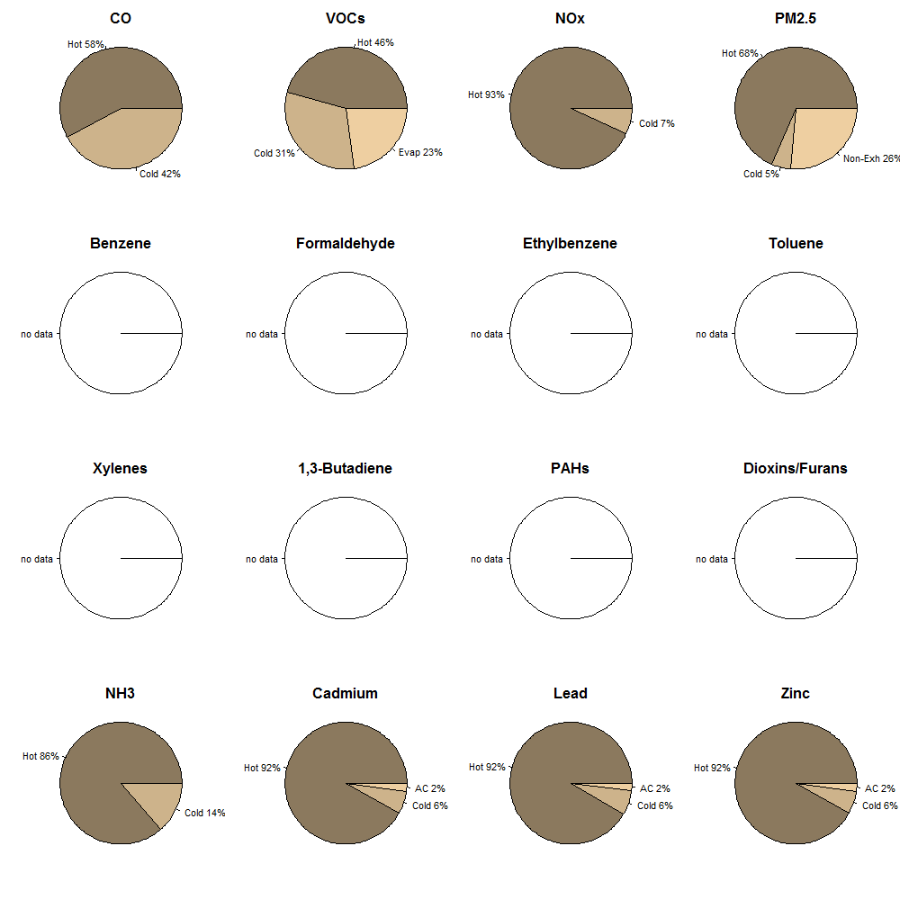

**Figure 13** Contribution of emission types to total motor vehicle emissions

*(“Hot” = hot running emissions, “Cold” = cold start emissions, “Evap” = evaporative (VOC) emissions, “Non-Exh” = non-exhaust (PM) emissions, “AC” = air-conditioning related emissions)*

Figure 13 shows the contributions of the different types of emissions to total motor vehicle emissions in Australia. Note that the breakdown by emission type is not provided for all pollutants by COPERT Australia as standard output. Analysis of the breakdown of total emissions by ‘type of emission’ (hot, cold, evaporative, air-conditioning and non-exhaust) is important as type of emission has a strong spatial and temporal component, and therefore has implications for population exposure to air pollutants.

Hot running (exhaust) emissions occur when vehicles are moving and the engine and the emission control system (e.g. catalytic converter) have reached their typical operating temperatures. Cold start (exhaust) emissions also occur when vehicles are moving, and when engines and catalysts are not (fully) warmed up and operate in a non-optimal manner.

These additional emissions typically occur within the first few minutes of driving (Smit and Ntziachristos, 2013b). Cold start emissions occur when vehicles are started such as in and around residential areas, parking lots and shopping centres. Evaporative emissions are non-exhaust hydrocarbon losses through the vehicle's fuel system, and occur mainly when vehicles are parked. Air-conditioning emissions are additional emissions due to operation of the air-con system. Non-exhaust (PM) emissions are emissions due to tyre, brake and road surface wear.

Figure 13 shows that:

* hot running emissions generally dominate total emissions
* cold start emissions are substantial for a number of pollutants (CO, VOCs)
* additional emissions due to air conditioning make only a small contribution to total emission levels
* evaporative VOC emissions are substantial (23%), and
* non-exhaust PM emissions are substantial (26%).

An analysis of the magnitude of different types of emissions can provide input and direction to policy development. For example the results show that ‘residential/parking’ emissions are particularly important for CO and VOCs. This implies that policy measures that aim to reduce the number of trips (vehicle starts) will particularly affect emissions of these pollutants. In contrast, cold start emissions for NOx and PM2.5 are significantly less important with a proportion of about 5% of total motor vehicle emissions. Reduction of VKT will have the largest effect on total emissions for all pollutants.

Figure 14 shows the contribution of a few aggregated vehicle classes to total emission levels. Note that the breakdown by vehicle type is not provided for all pollutants by COPERT Australia as standard output. The vehicle classes are:

* petrol vehicles including petrol trucks and motor cycles
* E10 passenger vehicles
* LPG vehicles including cars and trucks
* light-duty diesel vehicles (LDDV), and
* heavy-duty diesel vehicles (HDDV).

Figure 14 shows that the importance of those vehicle classes varies substantially, depending on the air pollutant that is considered:

* petrol vehicles dominate emissions of CO, VOCs, NH3 and heavy metals
* E10 and LPG vehicles have roughly a similar emissions profile as petrol vehicles
* LPG and E10 contributions align with their proportion of total travel[7], and
* diesel vehicles (LDDV and HDDV) dominate motor vehicle emissions of PM2.5 and NOx.

A much more detailed analysis of vehicle class contributions can be conducted. For example, the impact of different technology levels or vehicle age classes on total emissions can be derived from the COPERT Australia output. This can aid with cost-effective policy development and assessment of vehicle emission improvement programs (e.g. inspection and maintenance programs, scrappage programs, retrofit programs). This is however outside the scope of this project. 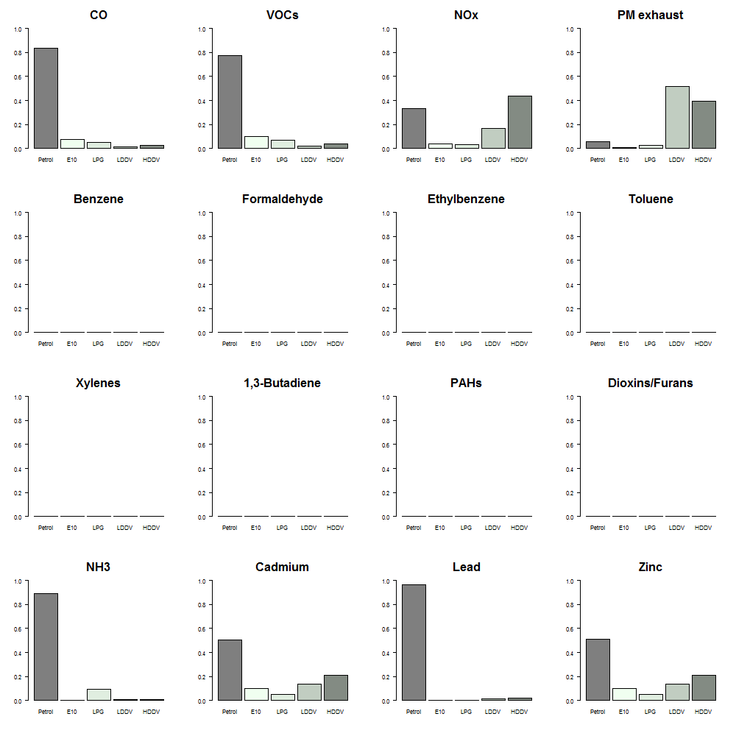**Figure 14** Contribution of vehicle types to total motor vehicle emissions

## Greenhouse gas emissions

The NPI does not require emissions information regarding greenhouse gases. However, COPERT Australia provides emission predictions for greenhouse gases CO2, N2O and CH4. Given the importance of greenhouse gas emissions, these emissions are presented in   
Table 10.

**Table 10** Total greenhouse gas emissions from motor vehicles (2010)

|  |  |  |  |  |
| --- | --- | --- | --- | --- |
| **State/Territory** | **CO2 (tonne)** | **CH4 (tonne)** | **N2O (tonne)** | **CO2-eq (tonne)** |
| NSW | 21,075,435 | 3,054 | 657 | 21,375,147 |
| VIC | 19,932,801 | 3,258 | 760 | 20,270,131 |
| QLD | 15,434,763 | 1,912 | 425 | 15,626,430 |
| WA | 8,851,421 | 1,205 | 292 | 8,979,425 |
| SA | 5,124,622 | 896 | 199 | 5,214,310 |
| TAS | 1,585,091 | 269 | 57 | 1,611,364 |
| ACT | 953,129 | 163 | 35 | 969,174 |
| NT | 748,983 | 79 | 20 | 757,642 |
| Australia | 73,706,245 | 10,836 | 2,446 | 74,803,623 |

Total greenhouse gas emissions are estimated to be 74,804 Gg CO2-eq, which is 1.5% higher than the value of 73,724 Gg reported by BITRE (2010) and 2.7% higher than the value of 72,872 Gg reported by the National Inventory Report for base year 2010 (CoA, 2012).

Note that emissions of CFC/HFCs are not estimated by COPERT Australia and have to be estimated separately. Those greenhouse gas emissions are related to the air conditioning system and can occur either by leakage or incidental releases (e.g. traffic accidents).

A recent international study (IEA, 2011) examined fuel economy of light-duty vehicles in   
43 countries around the world. Australia has the second highest CO2 emission per kilometre of travel after the USA. European countries are reported to have LDV CO2 emission levels varying from 140 to 180 g CO2/km, Japan about 150 g/km, India about 140 g/km, Indonesia about 170 g/km and Argentina about 175 g/km. Australia has a reported emission of about 208 g/km and the USA about 212 g/km. However, those results are based on the legislative NEDC test cycle, which is known to substantially underestimate emission levels.

In this study COPERT Australia predicts an average CO2 emission rate of 251 g/km for light-duty vehicles (cars, SUVs and LCVs), which is 21% higher than the values reported in GFEI (2011). This is similar to differences reported in other studies (e.g. Transport and Environment, 2013). The Australian fleet average emission rate is estimated to be 306 g CO2/km for 2010.

## NPI emissions and population exposure

There is an increased international (and Australian) focus on the reduction of population exposure to air pollution and (health) risk (e.g. NEPC, 2011). Due to the vicinity of roads to residential areas, population exposure to road transport pollution is often more important than other local sources.

Although this is beyond the scope of this study, COPERT Australia can be used to generate vehicle emission factors (g/km), which can be combined with output from macroscopic transport models and/or other traffic data (e.g. traffic counts, travel time surveys) to generate time and space resolved traffic emissions data. This traffic emissions information can then be fed into air quality models, which simulate dispersion and chemical conversion processes to predict air pollution concentration levels, exposure and health risks in urban areas.

This type of analysis can be used to identify air pollution ‘hot spots’, or even greenhouse gas emission hot spots. A population density overlay can then be added to assess if hot spots coincide with areas where people live. This information can then be used for policy development and focus assessment of specific traffic management measures.

Although motor vehicle emissions are substantially affected by local driving conditions, vehicle mix, weather conditions and local fuel quality, traffic volume (VKT) – and its temporal variation – is generally the most important variable determining local emission levels. Local road emissions can therefore be roughly estimated using the following fleet average emission factors for a number of selected key pollutants:

* 3.9 g CO per VKT
* 1.3 g NOx per VKT
* 0.4 g VOC per VKT
* 49 mg PM2.5 per VKT, and
* 17 mg benzene per VKT.

These emission factors have simply been computed as total annual fleet emissions divided by total travel (VKT/annum) for Australia for 2010. A first order estimate of total road emissions is provided by multiplying these highly aggregated emission factors with the number of vehicles and road length for each daytime period. Note that the emission factors only provide an average value for Australian conditions reflecting a mix of different levels of congestion, different fuel parameters, different climates, etc.

COPERT Australia can be used to develop more disaggregated emission factors, for example by vehicle class and congestion level (average speed) for local areas reflecting local meteorology and fuel quality. This is highly recommended to improve the accuracy of local emission estimates and to improve the spatial and temporal resolution of road transport emissions in urban areas. The input files created in this study can be downloaded and used to create detailed emission factors with COPERT Australia for each state and territory

# DISCUSSIONS AND CONCLUSIONS

This study developed a national motor vehicle emission inventory using the COPERT Australia software. A whole-of-Australia study ensures consistency in input data preparation and emission estimation methods. To account for differences in vehicle fleet mix, climate and fuel quality MVEIs were developed for each state/territory individually, and then aggregated to estimate total national emissions.

COPERT Australia generates comprehensive vehicle emissions data. For example it estimates emissions for 226 vehicle classes, 116 pollutants and different types of emissions (hot running, cold start, evaporative, non-exhaust). A major part of the work focussed on generating the detailed input data that are required for the emission simulations.

The COPERT input data was calibrated through an iterative process to ensure that predicted fuel consumption by fuel type is equivalent to reported fuel use by credible independent sources. This calibration step is essential to the development of a robust NMVEI.

The COPERT input files for each state/territory are available on request from the NPI team ([npi@environment.gov.au](mailto:npi@environment.gov.au)) of the Australian Government Department of the Environment and will allow COPERT Australia users to conduct more detailed analyses to address specific policy or research questions or to develop motor vehicle emission factors for local area or road level impact assessments.

The NMVEI shows that the relative contributions of industry and motor vehicle emissions are highly variable, and are dependent on the pollutant. Motor vehicles emissions in relation to industry emissions vary from dominant (acrolein, benzene, etc.) to important (VOCs, NOx, PM2.5, etc.) to insignificant (SO2, selenium, etc.).

It should be emphasised that annual emissions from motor vehicles, as reported in this study and by the NPI, do not necessarily reflect community exposure to the air pollutants. The actual contribution of motor vehicle emissions to population exposure (and thus health effects) is likely to be substantially greater than equivalent emission levels from industrial sources. This is because motor vehicle emissions are released close to ground level and, typically, in close proximity to where people live and work. In contrast, industrial emissions are typically emitted through vents and stacks, and are generally located some distance from populated areas. This means that industrial emissions are often dispersed significantly before they reach the population. As a consequence, relatively minor levels of motor vehicle emissions can lead to significant exposure to pollutants and associated health impacts.

COPERT Australia modelling in this study shows that NSW and Victoria consistently make the largest contributions to total emissions for all pollutants (combined varying from about   
50 to 60% of total national motor vehicle emissions), Queensland contributes about 20%, and WA and SA contribute about 10% each. Tasmania, ACT and the NT combined make up about 5% of national motor vehicle emissions. These contributions are roughly in line with the total vehicle population and total travel (VKT) in each jurisdiction. Variations are caused by differences in fleet composition (fuel types, vehicle age mix, etc.), climate and fuel parameters.

The NMVEI predicts that hot running emissions generally dominate total emissions from road transport, but that cold start emissions are significant for a number of pollutants (CO, VOCs). In addition evaporative VOC emissions and non-exhaust PM emissions are both significant contributors to total emissions (23% and 26%, respectively).

The NMVEI shows that the relative contribution of individual vehicle classes to emissions varies substantially, depending on the air pollutant that is considered. Petrol vehicles dominate emissions of CO, VOCs, NH3 and heavy metals whereas diesel vehicles (LDDV and HDDV) dominate motor vehicle emissions of PM2.5 and NOx.

Future updates of the NMVEI would benefit from implementing the following recommendations:

* analysis of state-specific vehicle registration data to improve the vehicle population breakdown
* collection and analysis of odometer and other information to improve age-mileage relationships
* verifying estimated Australian fuel parameters such as RVP with the Australian Institute of Petroleum
* addressing current gaps in Australian fuel quality data, such as heavy metal content
* further analysis of transport model data from cities that have not yet been included (e.g. Melbourne)
* further collection of travel (VKT) data on the highway system and in non-urban areas, and
* estimation of NPI emissions that are currently not included in COPERT Australia (e.g. H2S, manganese).

# REFERENCES

ABS, 2011a. Survey of Motor Vehicle Use: Data Cubes, 12 months ended 31 October 2010.

ABS, 2011b, Motor Vehicle Census, 9309.0, Australian Bureau of Statistics, 31 January 2011.

ABS, 2012, Sales of New Motor Vehicles, 9314.0, Australian Bureau of Statistics, 31 January 2012.

ARRB, 2008. Australia’s New Car Fleet: Fuel Consumption Trade-Offs 1985-2005, Thoresen, T., ARRB Group Ltd, Vermont South, Victoria, Australia, Research Report ARR 371, May 2008, ISBN 1 876592 53 2.

Austroads, 2013. National Performance Indicators, accessed 15 December 2013, http://algin.net/austroads/site/index.asp?id=2.

BITRE, 2009. Fuel Consumption by New Passenger Vehicles in Australia 1979-2008, Information Sheet 30, ISSN 1440-9593.

BITRE, 2010. Long-Term projections of Australian Transport Emissions Base Case 2010, Australian Government, Department of Infrastructure and Transport, Bureau of Infrastructure, Transport and Regional Economics (BITRE), November 2010.

BTCE, 1996a. Costs of Reducing Greenhouse Gas Emissions from Australian Cars: An Application of the BTCE CARMOD Model, Working Paper 24, Bureau of Transport and Communications Economics (BTCE). ISBN 0 642 24807 9.

BTCE, 1996b. Costs of Reducing Greenhouse Gas Emissions from Australian Road Freight Vehicles: An Application of the BTCE TRUCKMOD Model, Working Paper 22, Bureau of Transport and Communications Economics (BTCE). ISBN 0 642 24569 X.

BTRE, 2002. Greenhouse Gas Emissions from Transport: Australian Trends To 2020, Bureau of Transport and Regional Economics, Report 107.

BTRE, 2003. Urban Pollutant Emissions from Motor Vehicles: Australian Trends to 2020, Bureau of Transport and Regional Economics. Caiazzo, F., Ashok, A., Waitz, I.A., Yim, S.H.L., Barrett, S.H.R., Air pollution and early deaths in the United States. Part I: Quantifying the impact of major sectors in 2005, Atmospheric Environment, 79, 198-208.

Cohen, D.D., Gulson, B.L., Davis, J.M., Stelcer, E., Garton, D., Hawas, O., Taylor, A., 2005. Fine-particle Mn and other metals linked to the introduction of MMT into gasoline in Sydney, Australia: results of a natural experiment, Atmospheric Environment, 39, 6885-6896.

CoA, 2014. National Inventory Report 2012 Volume 1, Commonwealth of Australia (CoA), http://www.environment.gov.au/system/files/resources/6b894230-f15f-4a69-a50c-5577fecc8bc2/files/national-inventory-report-2012-vol1.pdf

DCCEE, 2012. Australian National Greenhouse Accounts, Department of Climate Change and Energy Efficiency (DCCEE), April 2012, ISBN 978 1 922003 28 7.

DEWHA, 2008. Evaluating the Health Impacts of Ethanol Blend Petrol, Commonwealth of Australia, Department of Environment, Water, Heritage and the Arts (DEWHA), Final Report KW48/17/F3.3F, June 2008.

DoE, 2014. Fuel Quality Standards, Australian Government, Department of Environment, http://www.environment.gov.au/topics/environment-protection/fuel-quality/standards.

DTRS, 2001. Comparative Vehicle Emissions Study, Department of Transport and Regional Services (DTRS), February 2001.

Eggleston, H.S., Gaudioso, D., Gorissen, N., Joumard, R., Rijkeboer, R.C., Samaras, Z. & Zierock, K.-H. (1993) CORINAIR Working Group on Emission Factors for Calculating 1990 Emissions from Road Traffic, Volume 1: Methodology and Emission Factors, Final Report, Commission of the European Communities, ECSC-EEC-EAEC, Brussels, Luxembourg, ISBN 92 826 5771 X.

FCAI, 2012, VFACTS National Report – New Vehicle Sales, Federal Chamber of Automotive Industries (FCAI), December 2012.

FORS, 1996. Motor Vehicle Pollution in Australia – National In-Service Vehicle Emissions Study, Federal Office of Road Safety (FORS), May 1996.

Gas Energy Australia, 2013. pers. comm. John Griffiths with Robin Smit, September 2013.

Gkatzoflias, D., Kouridis, C., Ntziachristos, L., 2011. Description of New Elements in COPERT 4 v9.0, EMISIA SA Report No 11.RE.005.V1.

IEA, 2011. International comparison of light-duty vehicle fuel economy and related characteristics, Global Fuel Economy Initiative (GFEI), International Energy Agency (IEA), Working Paper 5/10, Prepared by F. Cuenot and L. Fulton, Paris, France.

Mellios, G., Smit, R., Ntziachristos, L., 2013. Evaporative emissions: developing Australian emission algorithms, *Proceedings of the CASANZ Conference*, Sydney, 7-11 September 2013.

NEPC, 2011. National Environment Protection (Ambient Air Quality) Measure Review, May 2011, National Environment Protection Council Service Corporation (NEPC).

NSW EPA, 2012. Air Emissions Inventory for the Greater Metropolitan Region in New South Wales, 2008 Calendar Year, On-Road Mobile Emissions: Results, NSW Environment Protection Authority (NSW EPA), Technical Report 7, August 2012.

Ntziachristos, L., Samaras, Z., Kouridis, C., Hassel, D., McCrae, I., Hickman, J., Zierock, K.H., Keller, M., Andre, M., Winther, M., Gorissen, N., Boulter, P., Joumard, R., Rijkeboer, R., Geivanidis, S., Hausberger, S., 2012. EMEP/EEA emission inventory guidebook 2009 (passenger cars, light-duty trucks, heavy-duty vehicles including buses and motorcycles), update May 2012.

Ntziachristos, L., Samaras, C., Smit, R., Tooker, T., Mellios, G., 2013. Air pollutant and greenhouse gas road transport inventory using COPERT Australia, *Proceedings of the CASANZ Conference*, Sydney, 7-11 September 2013.

Pacific Environment, 2014. Reformatting Bureau of Meteorology data for input into the COPERT Australia transport emissions model, Job ID 8870.

QLD EPA, 2003. Air Emissions Inventory South East Queensland Region, Queensland Environment Protection Authority (QLD EPA).

Rosevaer, 2013. Quality Dynamics in the Light Vehicle Fleet, 16 September 2013, Outcome Management Services, New Zealand.

RTA, 2009. Second National In-Service Emissions Study (NISE2) Light Duty Petrol Vehicle Emissions Testing, by Roads and Traffic Authority of NSW, RTA.07.2828.0309, March 2009.

Skutenko, D., Cosgrove, D. and Mitchell, D., 2006. Survey of Motor Vehicle Use – An Investigation into Coherence, ABS Research Paper 9208.0.55.005.

Smit, R., McBroom, J., 2009a. Use of overseas emission models to predict traffic emissions in urban areas - Technical Note, Road and Transport Research, 18 (3), 52-60.

Smit, R., McBroom, J., 2009b. Use of microscopic simulation models to predict traffic emissions – Technical Note, Road and Transport Research, 18 (2), 49-54.

Smit, R., 2013. A procedure to verify large modal vehicle emissions databases, *Proceedings of the CASANZ Conference*, Sydney, 7-11 September 2013.

Smit, R., Ntziachristos, L., 2012. COPERT Australia: Developing Improved Average Speed Vehicle Emission Algorithms for the Australian Fleet, *19th International Transport and Air Pollution Conference*, Thessaloniki, Greece, 26-27 November 2012.

Smit, R., Ntziachristos, L., 2013a. COPERT Australia: a new software to estimate vehicle emissions in Australia, *Australasian Transport Research Forum 2013*, 2 - 4 October 2013, Brisbane, Australia.

Smit, R., Ntziachristos, L., 2013b. Cold start emission modelling for the Australian petrol fleet, *Air Quality and Climate Change*, 47 (3).

Smit, R., Casas, J., Torday. A., 2013. Simulating fuel consumption and vehicle emissions in an Australian context, *Australasian Transport Research Forum 2013*, 2 - 4 October 2013, Brisbane, Australia.

Smit, R., Poelman, M. & Schrijver, J., 2008. Improved road traffic emission inventories by adding mean speed distributions, Atmospheric Environment, 42 (5), 916-926.

TER, 2014. FCM: a New Australian Fleet Model for Vehicle Emission Assessment, Transport Emission Research (TER), by Robin Smit, Report FCM.14.1, Clontarf, Australia, 1 February 2014 (unpublished).

Transport and Environment, 2013. Mind the Gap! Why official car fuel economy figures don’t match up to reality, March 2013.

Vicroads, 2011. Traffic Monitor 2009/2010, May 2011, http://www.vicroads.vic.gov.au/Home/Moreinfoandservices/RoadManagementAndDesign/RoadUseAndPerformance/NetworkPerformanceMonitoring.htm

1. It is noted that lower heating values (LHVs) would be the appropriate heating values to use for road transport as there is no heat recovery in this sector. For consistency with Australian government data, HHVs had to be used.
2. E10 is a mixture of petrol with 10 volume percent of ethanol added. It is noted that E10 does not exactly contain 10% ethanol. Under the NSW Biofuels Regulation 2007, E10 should contain not less than 9% ethanol, while the National Petrol Fuel Quality Standard imposes a maximum of 10% ethanol (volume basis). The NSW Government tested E10 for ethanol content, and the results indicate that, on average, E10 contains 9.5% ethanol on a volume basis (NSW Government, 2014). This corresponds to 10.2% on a mass basis.
3. Note that E10 use varies greatly by state. NSW has a biofuel mandate of 6% and 2% for ethanol and biodiesel (2011 and beyond), respectively, and has the largest use of ethanol. Next are Queensland, Victoria and Canberra. The other states are not reported to use E10. Total E10 use in Australia accounts for 15% of total petrol/E10 use.
4. 2.4 PJ of natural gas was used in the transport sector in the 2010-2011 financial year, which is only 0.3% of total natural gas consumption in Australia. The majority of NG is used in the mining and industry sectors. CNG is mainly used in local bus fleets in the five largest states.
5. Typically, biodiesel is available in commercial quantities to customers, rather than being available at public browsers.
6. http://www.environment.gov.au/protection/fuel-quality/compliance/monitoring/national-fuel-sampling-programme
7. About 7% and 10% of total VKT, respectively.