

# Australian National Report to the 19th JAMBA, 13th CAMBA and 6th ROKAMBA Consultative Meetings

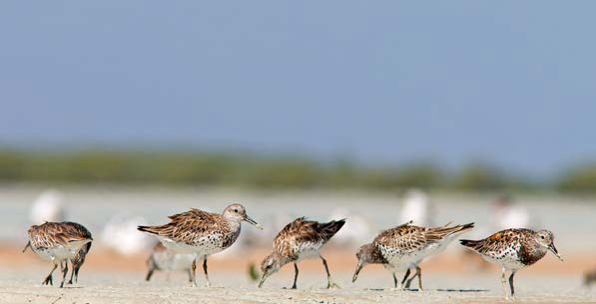

Okinawa, Japan

27 to 30 November 2018

**Agreement between the Government of Australia and the Government of Japan for the Protection of Migratory Birds and Birds in Danger of Extinction and their Environment Nineteenth Consultative Meeting**

and the

**Agreement between the Government of Australia and the Government of the People’s Republic of China for the Protection of Migratory Birds and their Environment Thirteenth Consultative Meeting**

and the

**Agreement between the Government of Australia and the Government of the Republic of Korea on the Protection of Migratory Birds and their Environment Sixth Consultative Meeting**

Front cover: Great Knot *(Calidris tenuirostris)* at Crab Creek, South Australia © Copyright Chris Purnell

Back cover: Eastern Curlew *(Numenius madagascariensis)* in Merimbula, New South Wales © Copyright Dan Weller

**© Commonwealth of Australia, 2018.**



*Australian National Report to the 19th JAMBA, 13th CAMBA and 6th ROKAMBA Consultative Meetings* is licensed by the Commonwealth of Australia for use under a Creative Commons Attribution 4.0 International licence with the exception of the Coat of Arms of the Commonwealth of Australia, the logo of the agency responsible for publishing the report, content supplied by third parties, and any images depicting people. F[or licence conditions see: http://creativecommons.org/licenses/](http://creativecommons.org/licenses/) by/4.0/au/

This report should be attributed as ‘*Australian National Report to the 19th JAMBA, 13th CAMBA and 6th ROKAMBA Consultative Meetings*, Commonwealth of Australia 2018’.

The Commonwealth of Australia has made all reasonable efforts to identify content supplied by third parties using the following format ‘© Copyright, [name of third party] ’.

**Disclaimer**

The views and opinions expressed in this publication are those of the authors and do not necessarily reflect those of the Australian Government or the Minister for the Environment and Energy.

# Contents

Contents 3

Introduction 5

Implementation of the Agreements by the Australian Government 9

Implementation of the Agreements by State and Territory Governments 30

Update on species or subspecies of birds in danger of extinction 45

Take of migratory birds or their eggs in accordance with Article II 49

Coordination of Bird and Bat Banding in Australia 52

BirdLife Australia’s activities 2016 - 2018 68

Key results of migratory bird research at the University of Queensland 2016 - 2018 77

National Avian Influenza Wild Bird Surveillance Program 84

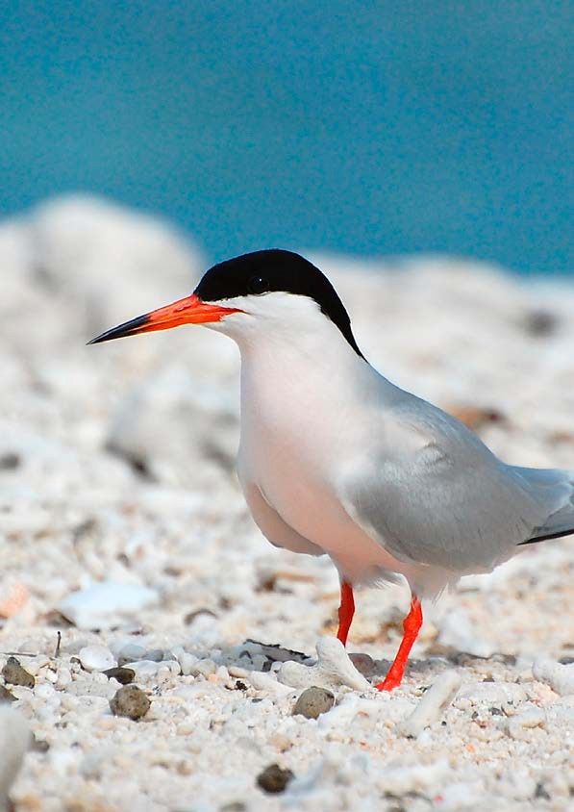

Adult Roseate Tern *(Sterna dougallii*) on Lady Elliot Island in the Great Barrier Reef, Queensland © Copyright Department of the Environment and Energy

# Introduction

The *Environment Protection and Biodiversity Conservation Act 1999* (the EPBC Act) is the Australian Government’s central piece of environmental legislation. The EPBC Act provides a legal framework to protect and manage nationally and internationally important flora, fauna, ecological communities and heritage places — defined in the EPBC Act as matters of national environmental significance. This complements state and territory responsibilities and laws protecting native species.

Migratory species listed under the EBPC Act are also matters of national environmental significance. Migratory species are those animals that migrate to Australia and its external territories, or pass though or over Australian waters during their annual migrations. Examples of migratory species are species of birds (e.g. albatrosses and petrels), mammals (e.g. whales) or reptiles (e.g. marine turtles). Listed migratory species are those listed on the appendices of the Convention on the Conservation of Migratory Species of Wild Animals (the CMS or Bonn Convention), the Japan-Australia Migratory Bird Agreement (JAMBA), the China-Australia Migratory Bird Agreement (CAMBA) and the Republic of Korea-Australia Migratory Bird Agreement (ROKAMBA).

Matters of national environmental significance are important to all Australians and, given the interconnectedness of the global biosphere, internationally as well. The EPBC Act aims to balance the protection of these crucial environmental and cultural values with our society’s economic and social needs by creating a legal framework and decision-making process based on the guiding principles of ecologically sustainable development.

Specifically, the EPBC Act aims to:

* provide for the protection of the environment, especially matters of national environmental significance
* conserve Australia’s biodiversity
* protect biodiversity internationally by controlling the international movement of wildlife
* provide a streamlined environmental assessment and approvals process where matters of national environmental significance are involved
* protect our world and national heritage
* promote ecologically sustainable development

As migratory species are matters of national environmental significance, an action will require approval if the action has, will have, or is likely to have, a significant impact on a listed migratory species. The action must be referred to the Environment Minister and undergo an environmental assessment and approval process.

For over 40 years, Australia has played an important role in international cooperation to conserve migratory birds in the East Asian - Australasian Flyway, entering into bilateral migratory bird agreements with Japan in 1974, China in 1986 and the Republic of Korea in 2006. Each of these agreements provides for the protection and conservation of migratory birds and their important habitats, protection from take or trade except under limited circumstances, the exchange of information, and building cooperative relationships. Our four countries were instrumental in the development and establishment of the East Asian – Australasian Flyway Partnership in 2006.

The Australian Government recognises that habitat loss and degradation is a significant threat to many of our migratory birds, and the conservation of important sites both within Australia and along their migration routes is essential to their survival. Many pressures are contributing to this degradation, of which population growth and associated coastal development and unsustainable hunting are of particular concern. The JAMBA, CAMBA and ROKAMBA provide an important mechanism for pursuing conservation outcomes for migratory birds in each country. However, efforts to conserve migratory birds in one country can only be effective with cooperation and complementary actions in all countries that these birds visit.

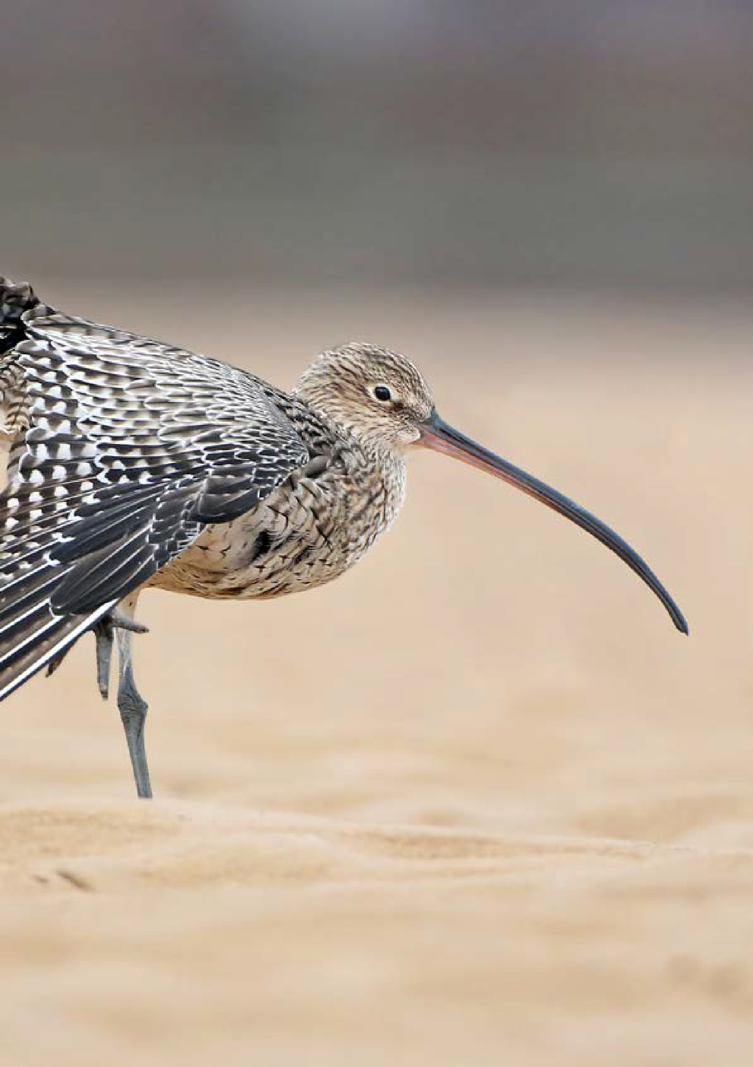

Eastern Curlew *(Numenius madagascariensis*) in Merimbula, New South Wales © Copyright Dan Weller

# Implementation of the Agreements by the Australian Government

### Australian Government Department of the Environment and Energy

**Relevant JAMBA Articles:** II, III, IV, V, VI   
**Relevant CAMBA Articles:** II, III, IV   
**Relevant ROKAMBA Articles:** 2, 3, 4, 5

### Summary

Australia provides critical habitat for millions of migratory birds each year. To ensure their conservation, the Australian Government has fostered international cooperation through a range of important agreements, including bilateral migratory bird agreements with Japan, China and the Republic of Korea, the Convention on Migratory Species (CMS), the Ramsar Convention on Wetlands, the Agreement on the Conservation of Albatrosses and Petrels (ACAP), and through the voluntary, non-binding initiative, the East Asian - Australasian Flyway Partnership (EAAFP). A range of important activities are also undertaken within Australia to conserve migratory bird populations and their habitats. These activities have largely focused on migratory waterbirds, including shorebirds and seabirds as their tendency to aggregate in flocks in coastal areas makes them particularly vulnerable to habitat loss and disturbance.

Since the last bilateral migratory bird consultative meetings in October 2016, the Australian Government has pursued a number of policy initiatives, including the implementation of the Wildlife Conservation Plan for Migratory Shorebirds. The plan outlines a national framework identifying research and management actions to protect migratory shorebirds in Australia. The plan also outlines national actions to support migratory shorebird conservation, and will be used to ensure these activities are integrated and remain focused on the long-term survival of migratory shorebird populations and their habitats. Habitat protection and restoration in Australia has been advanced under the National Landcare Programme for projects that will directly benefit migratory birds and their habitat. The Commonwealth Environmental Water Office, Parks Australia and Great Barrier Reef Marine Park Authority are also working to improve the habitats of migratory birds and reduce or eliminate known threats to these birds such as invasive weeds and feral cats.

As some migratory bird populations decrease, there is a growing need to minimise threats to the remaining habitats that are critical for their ongoing survival. This need is occurring in the face of ever-increasing human development and loss of habitat. The Australian Government recognises that efforts to conserve migratory birds in one country can only be effective with the cooperation and complementary actions in all countries that these birds visit. Without urgent action to reduce or eliminate threats, further declines leading to extinctions are to be expected.

## Commonwealth policy initiatives related to migratory birds and their habitat

### Australian Government’s Wildlife Conservation Plan for Migratory Shorebirds

The Australian Government’s *Wildlife Conservation Plan for Migratory Shorebirds* covers 35 species of migratory shorebird that regularly visit Australia. The plan outlines a national framework identifying research and management actions to protect migratory shorebirds in Australia. All 35 species covered by the plan are listed migratory species under the EPBC Act as they are listed on the appendices to the CMS and Australia’s migratory bird agreements with Japan, China and the Republic of Korea. The plan includes a summary of Australia’s commitments under international conventions and agreements and outlines key aspects of identifying ‘important habitat’ as described in the *EPBC Act Policy Statement 3.21 – Industry Guidelines for avoiding, assessing and mitigating impacts on EPBC Act listed migratory shorebird species*. The plan also outlines national actions to support migratory shorebird conservation, and will be used to ensure these activities are integrated and remain focused on the long-term survival of migratory shorebird populations and their habitat. The plan will be used to engage bilaterally with Japan, China and the Republic of Korea on how threats in the Yellow Sea region can be managed through practical action and community participation. The plan was made in consultation with all state and territory agencies, BirdLife Australia and the research community. There was widespread support for the new plan amongst key stakeholders. Actions included in the *Wildlife Conservation Plan for Migratory Shorebirds* will also benefit a number of shorebird species that were listed as threatened in 2015 and 2016. The plan will be reviewed in 2020.Further information on the Australian Government’s *Wildlife Conservation Plan for Migratory Shorebirds* can be accessed here: <http://www.environment.gov.au/biodiversity/migratory-species/migratory-birds>

### Conservation Advices for Threatened Migratory Birds

When a native species or ecological community is listed as threatened under the Commonwealth EPBC Act, conservation advice is developed to assist its recovery.

Conservation advice provides guidance on immediate recovery and threat abatement activities that can be undertaken to ensure the conservation of a newly listed species or ecological community.

##### Recovery activities

Conservation advice includes practical on-ground activities that can be implemented by local communities, natural resource management groups or interested individuals, such as landholders. Examples of such on-ground activities may include:

* monitor known sites to identify key threats
* prevent damage to habitats at known sites such as on private property

Conservation advice may also include broader management actions which can be undertaken by organisations such as local councils, government agencies or non-government organisation’s, to protect the species or ecological community on a regional level. Examples of such management actions may include:

* protect areas which contain populations or which could support populations in the future
* develop a management plan for the control and eradication of feral species in the local region

For some species and ecological communities, recovery plans may also be developed to assist in recovery.

### Australian Government’s Threatened Species Strategy

Australia is a country rich in unique plants and animals. They are core to the identity of Australians, culturally significant to Indigenous peoples, important to the health of our environment and a strong contributor to our economy. Australia’s distinctive plants and animals are a gift and are important to protect. The Australian Government has established an additional national approach to threatened species. The *Threatened Species Strategy* is a plan for how we will prioritise effort and work in partnership with the community and state and territory governments. The Strategy sets out a road map and highlights how Australia’s approach of science, action and partnership can be used to achieve the long-term goal of reversing species declines and supporting species recovery.

Dr Sally Box began in the role of Threatened Species Commissioner in January 2018. The Commissioner continues to act as a champion for threatened species and oversees the implementation of Australia’s Threatened Species Strategy which includes the Eastern Curlew as one of 20 target bird species. An additional initiative for the Christmas Island Frigatebird (*Fregata andrewsi*) has also been included.

In 2017, three projects were funded through the Threatened Species Recovery Fund to support threatened migratory birds.

##### Community Conservation of Eastern Curlew project

Project activities include restoring key habitats, reducing human disturbance and promoting best practice management at priority Eastern Curlew sites from Darwin to Wollongong.

Investment: $204,590

##### French Island Cat Free project

Project seeks to manage the impacts of feral cats on French Island, Victoria. Part of the Western Port Ramsar site.

Investment: $160,000

##### Hunter Wetlands National Park project

The project aims to remove and exclude invasive mangroves from saltmarsh and shorebird habitat.

Investment: $20,000

Further information on the Australian Government’s *Threatened Species Strategy* can be accessed here: [http://www.](http://www.environment.gov.au/biodiversity/threatened/publications/strategy-home) [environment.gov.au/biodiversity/threatened/publications/strategy-hom](http://www.environment.gov.au/biodiversity/threatened/publications/strategy-home)e

### National Reserve System

The National Reserve System is Australia’s network of protected areas, conserving examples of our natural landscapes and native plants and animals for future generations. Based on a scientific framework, it is the nation’s natural safety net against our biggest environmental challenges.

The reserve system includes more than 10,500 protected areas covering 19 per cent of the country - over 150 million hectares. It is made up of Commonwealth, state and territory reserves, Indigenous lands and protected areas run by non-profit conservation organisations, through to ecosystems protected by farmers on their private working properties.

There are 75 dedicated Indigenous Protected Areas (IPAs) in Australia covering more than 67 million hectares or 44.6% of the National Reserve System. Many IPAs include migratory bird habitat. At least 20 IPA Management Plans address threats to migratory birds and the protection of migratory bird habitats.

### Threat Abatement Plan for the incidental catch (or bycatch) of seabirds during oceanic longline fishing operations

The *Threat Abatement Plan for the incidental catch (or bycatch) of seabirds during oceanic longline fishing operations* includes a range of actions that help to avoid or minimise the bycatch of certain shearwater species included under JAMBA, CAMBA and ROKAMBA. The threat abatement plan applies to all Commonwealth-managed longline fisheries and has reduced seabird bycatch in relevant fisheries significantly. The shearwater species that directly benefit from the implementation of the threat abatement plan include: *Ardenna pacifica* (Wedge-tailed Shearwater), *Ardenna carneipes* (Flesh-footed Shearwater), *Ardenna griseus* (Sooty Shearwater), *Ardennatenuirostris* (Short-tailed Shearwater).

### Threat Abatement Plan for the impacts of marine debris on the vertebrate wildlife of Australia’s coasts and oceans

The *Threat Abatement Plan for the impacts of marine debris on the vertebrate wildlife of Australia’s coasts and oceans* (2018) identifies the following species adversely impacted by marine debris that are included under JAMBA, CAMBA and ROKAMBA: *Ardenna pacifica* (Wedge-tailed Shearwater), *Ardenna tenuirostris* (Short- tailed Shearwater), *Oceanites oceanicus* (Wilson’s Storm Petrel), *Ardenna carneipes* (Flesh-footed Shearwater), *Sula leucogaster* (Brown Booby). Implementation of the plan will mitigate the impacts of marine debris on these species.

### National Environmental Management Light Pollution Guidelines for Marine Turtles and Migratory Birds

The Department of the Environment and Energy, in collaboration with the Western Australian Department of Biodiversity, Conservation and Attractions, is developing *National Environmental Management Light Pollution Guidelines for Marine Turtles and Migratory Birds*.

Artificial light has been recognised as a threat to marine turtles and seabirds. The project will review the mechanisms by which artificial light affects turtles and seabirds, and assess the potential impact of light on migratory shorebirds in Australia.

The guidelines will provide best practice light pollution mitigation strategies to ameliorate the impacts of light pollution on wildlife.

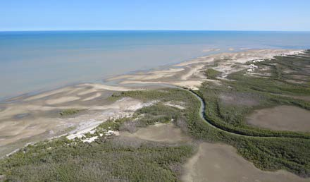

View of coastline at Delta Downs, south-east Gulf of Carpentaria, Queensland © Roger Jaensch and CLCAC

## Commonwealth investment in migratory birds and their habitats

### Parks Australia

Australia’s six Commonwealth National Parks, the Australian National Botanic Gardens and 58 Commonwealth Marine Reserves protect some of the country’s most stunning natural areas and Aboriginal heritage. They are managed by Parks Australia.

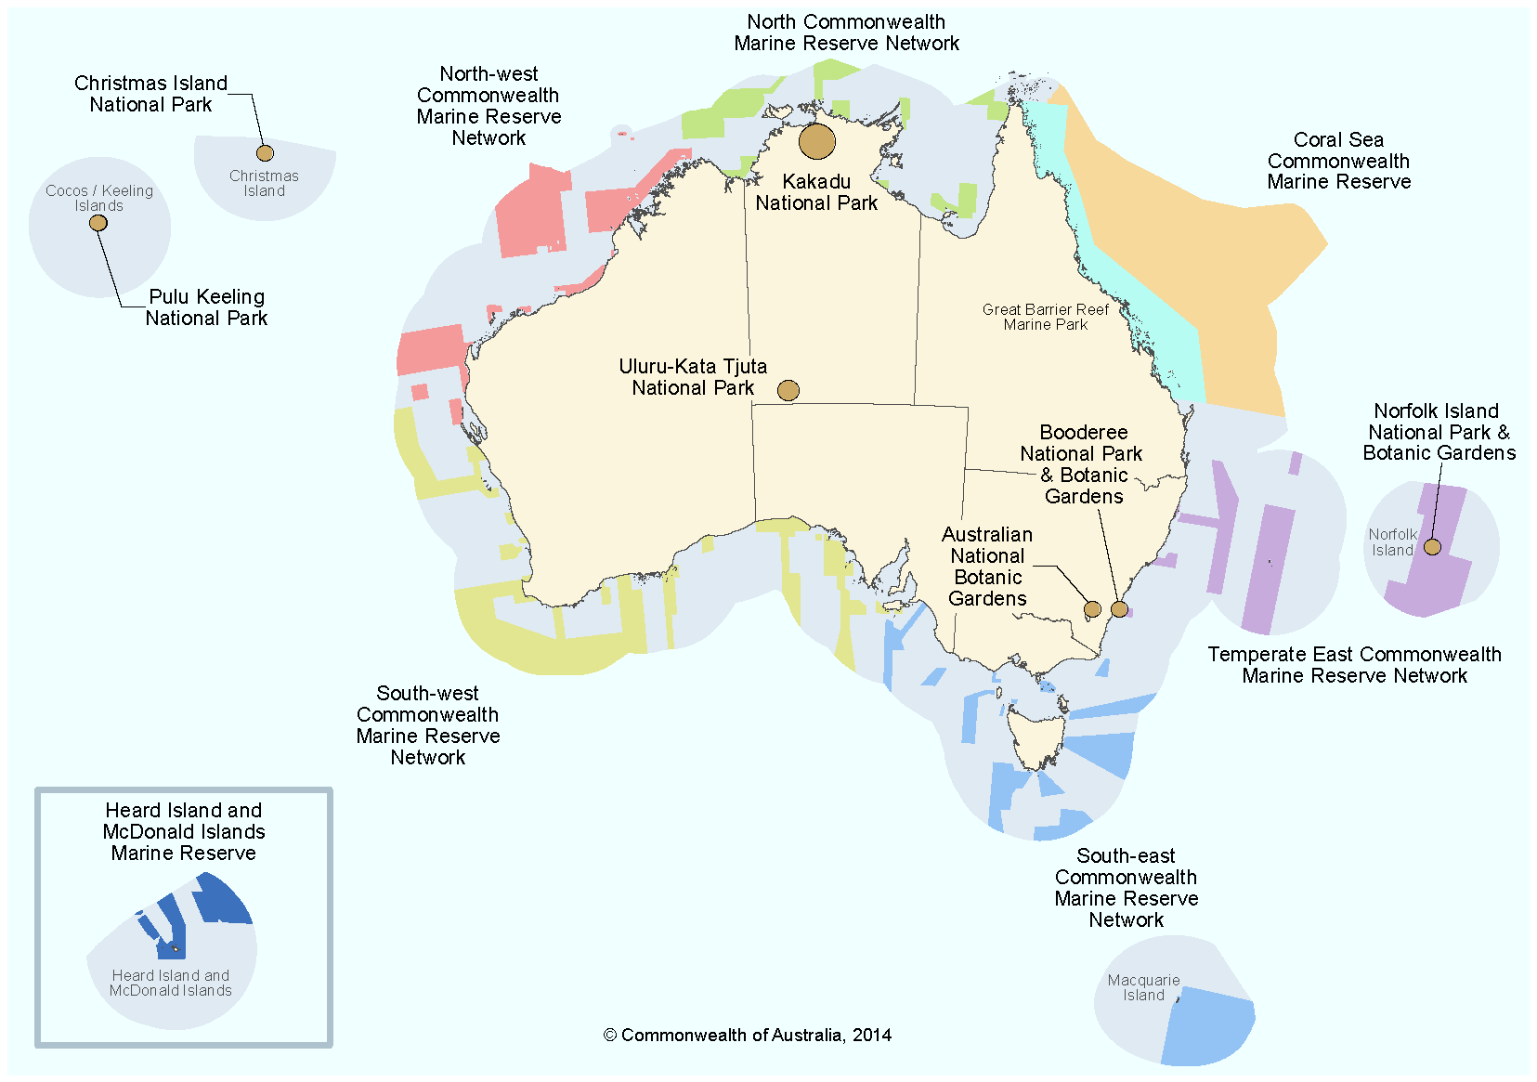

Under the EPBC Act, the Director of National Parks’ responsibilities include:

Gardens

* Managing Commonwealth reserves and conservation zones
* Protecting biodiversity and heritage in Commonwealth reserves and conservation zones
* Carrying out research relevant to Commonwealth reserves
* Cooperating with other countries to establish and manage national parks and nature reserves in those countries
* Making recommendations to the Australian Government Minister for the Environment and Energy

Commonwealth reserves that are wholly or partly on Indigenous people’s land are managed in conjunction with a Board of Management. The Board’s role is to prepare reserve management plans, make decisions to implement those plans, monitor management and provide advice to the Minister. A majority of board members must

be Aboriginal people nominated by the traditional owners of that reserve. These boards play crucial roles in determining the policies and priorities for the management of each protected area.

Since October 2016, a number of projects undertaken by Parks Australia have benefited a number of migratory birds and their habitat. Examples of these projects include:

##### Christmas Island Cat Eradication and Rat Control Project 2015-2020

This project has removed stray and feral cats as well as introduced black rats from the Christmas Island ecosystem. This includes foreshore, grassland and forested areas utilised by migratory species.

***Investment:*** Project funded in 2015 by $400,000 supported by the Threatened Species Commissioner and an offset contribution by Phosphate Resources Limited of $1.35 million throughout the life of the project (e.g. $250,000 p.a. for six years). Additional funding of $650,000 for 2016 provided by the Director of National Parks.

##### Christmas Island Frigatebird *(Fregata andrewsi)*

A National Environmental Science Programme funded workshop was held to gain a better understanding of Christmas Island Frigatebird population trends and their main drivers to increase the probability of ameliorating the threats; develop measures to mitigate or eliminate the main current and potential future threats; develop a conservation advice or recovery plan that will, in association with other conservation planning for Christmas Island, provide a guide for future policy with respect to managing the frigatebird. This brought together relevant Australian and Indonesian experts.

Investment: $10,000

##### Norfolk Island Rat Control Program 2015 – 2018

Expansion of the previously existing rat baiting program across Norfolk Island National Park. One thousand additional bait stations have been added to the original 800. All stations are baited on a bi-monthly basis.

***Investment:*** This is a Threatened Species Commissioner supported project ($300,000). Additional in kind funding contribution of $133,000 provided by Parks Australia.

##### Feral Cat Control Program within Norfolk Island National Park

Ongoing cat trapping and removal from within Norfolk Island National Park. A total of 53 cats were trapped in 2015. A further 90 individuals were caught between January 2016 and June 2018. A draft management plan for managing feral cats on Norfolk Island has been developed.

##### Tarler Bird (*Porphyrio porphyrio*) Control Program

Control activities continue on Phillip Island in response to community raised concerns regarding the predation of eggs and young seabirds.

##### Weed Control and Habitat Restoration on both Norfolk Island and Phillip Island

Ongoing weed control activities occurring on both Norfolk Island and Phillip Island and ongoing propagation and revegetation works on Norfolk Island with current nursery stocks (June 2018) of over 1800 plants.

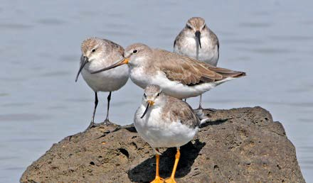Terek *(Xenus cinereus)* and Curlew Sandpipers *(Calidris ferruginea)* © Copyright Department of the Environment and Energy

##### Seabird Research Support on Phillip Island

Parks Australia continue to support researchers investigating migration patterns and nest predation threats of seabirds on Phillip Island.

##### Booderee National Park

Intensive fox control benefits roosting migratory shorebirds known to visit Booderee National Park including CAMBA, JAMBA and ROKAMBA listed species. These species include Whimbrel (*Numenius phaeopus*)*,* Bar- tailed Godwit (*Limosa lapponica*)*,* Ruddy Turnstone (*Arenaria interpres*)*,* Oriental Plover (*Charadrius asiaticus*) and Latham’s Snipe (*Gallinago hardwickii*).

Weed control on Bowen Island benefits JAMBA, CAMBA and ROKAMBA listed species such as: Short-tailed Shearwater (*Ardenna tenuirostris*)*,* Wedge-tailed Shearwater (*Ardenna pacificus*) and possibly the Sooty Shearwater (*Ardenna griseus*)*.*

##### Coral Sea Clean-up and Biodiscovery Voyage 2016

This project reduced the threat of marine debris on nesting and migratory seabirds from the Coringa-Herald and Lihou Reefs Ramsar sites. This project removed over 2 tonnes of marine debris from 11 isolated islands and cays in 2016.

Parks Australia continues to monitor marine debris, and promote marine debris removal in the Marine Park by tourism operators.

***Investment:*** Parks Australia and Bush Blitz funded the voyage at a cost of $330,000.

## National Landcare Programme

The National Landcare Program (NLP) is a key part of the Australian Government’s commitment to protect and conserve Australia’s water, soil, plants, animals and ecosystems, as well as support the productive and sustainable use of these valuable resources.

### NLP Phase One

From July 2014 to June 2018, the Australian Government invested $1 billion to continue its longstanding commitment to delivering on-ground biodiversity and sustainable agriculture outcomes that benefit our community and environment.

### NLP Phase Two

The Australian Government is investing a further $1 billion in the second phase of the National Landcare Program. The majority of the investment will be delivered over a period of five years—from July 2018 to June 2023—while some elements of the program began during the 2017-18 financial year.

The investment will primarily be delivered by the Department of the Environment and Energy and the Department of Agriculture and Water Resources and will include a range of measures to support natural resource management and sustainable agriculture, and to protect Australia’s biodiversity.

With its investment in the next phase of the National Landcare Program, the Australian Government aims to work in partnership with governments, industry, communities and individuals to protect and conserve Australia’s water, soil, plants, animals and ecosystems, as well as support the productive and sustainable use of these valuable resources.

The National Landcare Program is a nationwide effort to address problems such as:

* loss of vegetation;
* soil degradation;
* the introduction of pest weeds and animals;
* changes in water quality and flows; and
* changes in fire regimes.

The next phase of the National Landcare Program includes funding for new programs as outlined below.

### Smart Farms Program

The Australian Government is allocating $134 million to support the development and uptake of best practice management, tools and technologies that help farmers, fishers, foresters and regional communities improve the protection, resilience and productive capacity of our soils, water and vegetation, and in turn support successful primary industries and regional communities. The Smart Farming Partnerships and Smart Farm Small Grants programs are open to a range of Australian legal entities.

### Regional Land Partnerships

From July 2018, the Regional Land Partnerships component of the program will deliver $450 million over five years Australia-wide to deliver national priorities at a regional and local level.

### National Landcare Regional Investments 2015-2018

##### Reef Catchments Mackay Whitsunday Isaac - Protecting Species, Ecosystems, Coasts and Communities

Activities include coastal weed reduction and removal of marine debris which indirectly benefit migratory bird species including the *Numenius madagascariensis* (Eastern Curlew)

##### Southern Gulf NRM - Building resilience in critical habitats across the Southern Gulf – wetlands project

Seeks to improve the condition of 12,000 hectares of the Wetland through coordinated fencing, weed management, pest animal management and condition monitoring helping to reduce wet season grazing pressure and feral pig damage. The project serves to promote conservation and increase the area of threatened species habitat/significant area protected, which includes habitat for migratory bird species such as the Eastern Curlew.

##### Fitzroy Basin Association - Preserving the ecological character and cultural heritage of the Shoalwater and Corio Bay Ramsar site project

Seeks to address threats to the ecological character of the Shoalwater and Corio Bays Ramsar wetlands, including pest plants and animals and erosion to improve habitat for threatened species, native waterbirds, migratory shorebirds, turtles, dugong and fish, which use the area at different life history stages.

##### Burnett Mary Regional Group - Keeping it Great project

Seeks to address priority threats including pest plants and animals and inappropriate land use practices in the Great Sandy Strait Ramsar Site and the Fraser Island World Heritage Area. Rehabilitation activities will protect and enhance biodiversity for the primary purpose of conservation. Implementation activities will benefit threatened species including migratory birds.

### Environment Small Grants

The Australian Government is providing $5 million in small grants to community, landcare, environment and other natural resource management groups to deliver natural resource management activities that improve the quality of the local environment. The small grants were allocated through a one-off grant round in the 2017-18 financial year.

### Continuing to deliver the Reef 2050 Plan

An updated Reef 2050 Plan was released by the Australian and Queensland Governments in July 2018 and is the overarching framework for protecting and managing the Great Barrier Reef until 2050. The Plan sets clear

actions, targets, objectives and outcomes to drive and guide the short, medium and long-term management of the Reef. The Plan firmly responds to the pressures facing the Reef and will address cumulative impacts and increase the Reef’s resilience to longer term threats such as climate change.

The second phase of the National Landcare Program provides additional funding towards meeting the Government’s commitment to the Reef 2050 Long-Term Sustainability Plan.

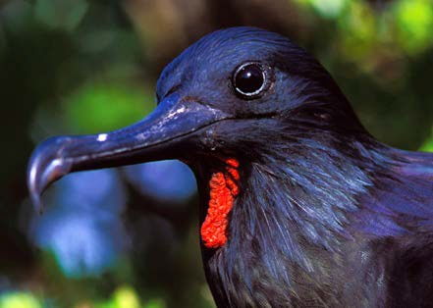Great Frigatebird *(Fregata minor*) on North Keeling Island © Copyright Department of the Environment and Energy

### Caring for our World Heritage places

World heritage sites that are nominated for World Heritage listing are inscribed on the list only after they have been carefully assessed as representing the best examples of the world’s cultural and natural heritage. Australia currently has 19 properties on the World Heritage List.

The second phase of the National Landcare Program provides help with the management of Australia’s treasured World Heritage sites. A particular focus will be addressing critical threats such as feral animals and weeds, and changed fire regimes.

### Support for Indigenous Protected Areas

The Australian Government will provide $15 million for Indigenous Protected Areas, in addition to an investment of $93 million for the ongoing support of existing Indigenous Protected Areas. Indigenous Protected Areas perform a number of important roles which deliver benefits to our environment and our local communities, such as:

* safeguarding the biodiversity of the nation’s remote areas for present and future generations;
* protecting the cultural heritage of Aboriginal and Torres Strait Islander people in their region; and
* providing employment, education and training opportunities for Aboriginal and Torres Strait Islander people in remote areas.

### Centre for Invasive Species Solutions

The Australian Government is supporting the Invasive Animals Cooperative Research Centre’s (IACRC) transition into the new Centre for Invasive Species Solutions. The new Centre is focusing on invasive species management and this investment supports the Centre and its efforts to carry out research, development and extension activities aimed at managing invasive animals and weeds. Following the conclusion of the CRC Program funding in June 2017, the Centre has continued the collaborative investment that Invasive Animals Cooperative Research Centre had begun in invasive species management.

## Commonwealth Environmental Water Office

### Murray-Darling Basin

The Murray-Darling Basin Environmental Water Knowledge and Research Project aims to improve the science available to support environmental water management. Through consultation with jurisdictions, water managers and scientific organisations priority research questions were identified that covered four themes: Vegetation; Fish; Food webs; and Waterbirds.

As part of the waterbirds theme the key knowledge gap identified was in-relation to which flow regimes best support recruitment of waterbirds and how do threats and pressures affect recruitment outcomes for waterbirds.

The research will focus on monitoring nests of three colonially-breeding waterbird species: Australian White Ibis; Straw-necked Ibis; and Royal Spoonbill at one of the priority research sites per year: (Macquarie Marshes, Barmah-Millewa or Narran Lakes).

The waterbird research component aims to produce information that will allow managers to better target water, vegetation and feral animal management actions to ensure ‘event readiness’ at nesting sites between flooding events and to maximise recruitment of waterbirds during flooding events.

***Investment:*** $10 million over five years (to 2018/19) across four research themes, including waterbirds.

### Great Barrier Reef Marine Park Authority

The Great Barrier Reef Marine Park Authority (GBRMPA) undertakes a number of activities that contribute to the conservation of migratory birds. Examples include:

* Development of the *Reef 2050 Long-term Sustainability Plan*, which includes actions to identify, protect and manage the habitats that support migratory birds, as well as monitor seabird populations.
* Informed by the 2012 Informing the Outlook for Great Barrier Reef Coastal Ecosystems (a technical report on the current status of the catchment and the threats it faces):
* Development of hydrological spatial layer to identify catchment connections to support management of Great Barrier Reef coastal ecosystems (including migratory bird habitat).
* Development of an ecological tool to establish a metric for valuing the biological, biogeochemical and physical processes occurring in the Great Barrier Reef catchment (including migratory bird habitat).
* Development and implementation of the *Seabird Monitoring Strategy for the East Coast of Queensland 2015- 2020* with Queensland Parks and Wildlife Service
* Development and implementation of The adaptive management strategy for seabirds on Raine Island National Park (Scientific) with Queensland Parks and Wildlife Service

## Commonwealth investment in science and research

### National Environmental Science Programme

The National Environmental Science Programme is a long-term commitment to environment and climate research with funding of $25.5 million per year during the life of the programme.

The programme is built on its predecessors—the National Environmental Research Program and the Australian Climate Change Science Programme —to support decision-makers to understand, manage and conserve Australia’s environment with the best available information, based on world-class science.

The $142.5 million National Environmental Science Programme is being delivered through six research hubs.

* the **Clean Air and Urban Landscapes Hub** supports environmental quality in urban areas with funding of $8.88 million.
* the **Earth Systems and Climate Change Hub** is furthering our understanding of the drivers of Australia’s climate with funding of $23.9 million.
* the **Marine Biodiversity Hub** is researching Australian oceans and marine environments, including temperate coastal water quality and marine species, with funding of $23.88 million.
* the **Northern Australia Environmental Resources Hub** is supporting the sustainable development of our northern landscapes with funding of $23.88 million.
* the **Threatened Species Recovery Hub** is supporting the management of threats and improving recovery of threatened species with funding of $29.98 million.
* the **Tropical Water Quality Hub** is researching coastal water quality and coastal management focused on the Great Barrier Reef and other tropical waters with funding of $31.98 million.

Projects currently funded that include migratory birds include:

##### Research and management priorities for Christmas Island Frigatebirds

The Christmas Island Frigatebird (*Fregata andrewsi)* is listed as Endangered under the EPBC Act. It is currently one of the most threatened species on Parks Australia’s estate and has been added to the list of priority bird species within the Threatened Species Strategy. Reasons for its decline and how to recover the species are poorly understood. This project aims to provide direction for the ongoing management, monitoring and research requirements necessary for the recovery of the species.

Early indications from current monitoring are suggesting the species has declined significantly since the last monitoring effort in 2003-04. At this stage the reasons for its decline, or even how to investigate them, are unresolved. While action is urgently required, a careful assessment of current evidence will allow more effective and efficient use of funds for research and management.

Investment: $35,407

##### Saving Threatened Species on Australian Islands (2015 – 2019)

Australia has over 9,300 islands supporting hundreds of threatened and migratory species. Although islands can be important havens for biodiversity, more species extinctions have occurred on Australia’s islands than on mainland Australia and when islands are invaded by invasive species the consequences to native species and ecosystems can be catastrophic.

With so many islands, Australian policy makers and planners need evidence to determine and prioritise the most effective and efficient conservation actions. The project has developed a national database for threatened species on Australian islands and worked with partners on several priority case study islands. The project will continue to build on this strong base, by advancing the case studies, analysing the database collated to provide management and policy advice, and analysing relationships between feral species and threatened species across all Australian islands in order to prioritise optimal on ground actions.

The project is comprised of five sub projects, including:

* Threatened species and their threats on Australian islands
* Actions for saving threatened species on “priority islands”
* Post eradication monitoring and translocation on islands
* Saving threatened plants on Norfolk Island
* Understanding cane toad threats to Kimberley Islands

Investment: $1,391,773

##### Strategic Planning for the Far Eastern Curlew

The Far Eastern Curlew (*Numenius madagascariensis*) is one of the largest migratory shorebirds in the world. It has experienced one of the most acute declines of any Australian shorebird species: a 5.8 per cent annual rate of decline. If this trend persists, the global population will fall to 10 per cent of its 1993 abundance by 2035. It is listed as Endangered on the IUCN Red List and Critically Endangered under Australia’s EPBC Act.

It is endemic to the East Asian-Australasian Flyway and is heavily impacted by mudflat loss and degradation in north-east Asia. Loss of habitat in this region can make birds more sensitive to impacts in other regions of the flyway, such as Australia.

Around three quarters of the population is estimated to spend the non-breeding season in Australia, where it is impacted by coastal development and disturbance. Very little is known about the exact habitat requirements of Far Eastern Curlew at non-breeding sites, making it extremely difficult to provide appropriate guidance on development proposals affecting Far Eastern Curlew habitat.

Coastal development can negatively affect Far Eastern Curlew populations. However, they are also known to use some artificial habitats for roosting, sometimes incorporating developed areas into local movements. This behaviour provides opportunities and obligations to consider and manage artificial sites as part of local conservation efforts. This project will analyse Far Eastern Curlew feeding and roosting habitat and the relationship between the two in order to develop evidence based strategic guidelines for Far Eastern Curlew

conservation. The guidelines will give certainty to policy makers, conservation planners, developers and regulators about habitat requirements and offsets.

A large number of Far Eastern Curlew and other migratory shorebirds roost on land belonging to Darwin Port, where they feed on surrounding mudflats. The numbers of Far Eastern Curlew roosting at the port, where the birds are protected from disturbance, has increased substantially. The maximum count recorded at the port is 264 birds which is about 0.85% of the total flyway population. Darwin Port are planning to expand operations in future, and seek to understand how to achieve this without negatively impacting the quality of habitats available to migratory birds visiting the Port lands.

The project will be undertaken in close cooperation with Darwin Port who are also providing financial support for the research. The project will assess the overall availability of suitable habitats, the impacts of developments within Darwin Harbour and the port and the ways in which these impacts could be mitigated.

Investment: $372,456

##### Vulnerability of food supplies for migratory shorebirds to altered flow in the southern Gulf of Carpentaria

Migratory shorebirds are present in vast numbers along the Gulf of Carpentaria’s south-east coastline, especially from September to April. These shallow and productive tidal environments are important resting and feeding areas, as well as staging areas for birds that fly north or south. The critically endangered Great Knot and Far Eastern Curlew are among the many migratory bird species using the Gulf coast, and food and rest are vital

to their continued survival. The south-east Gulf’s significance for shorebirds has been recognised through its inclusion as a site in the international East Asian-Australasian Flyway Site Network.

Rivers flowing into the Gulf deliver freshwater, sediments and nutrients to estuaries and nearby coastal areas, nourishing the mudflats where shorebirds rest and forage for shellfish, crustaceans and worms. Developments that use significant water or changes in climate that alter river flows may therefore impact the survival of the shorebirds.

This project aims to quantify and compare the shorebird food resources produced by three Gulf river systems that flow alteration may affect – the Flinders, Gilbert and Mitchell Rivers. It will identify the relative importance of the estuaries and adjacent mudflats in terms of food resources for shorebirds. This information will inform future water planning, environmental impact assessments, and migratory shorebird habitat protection and management.

This project will:

* improve our understanding of the role of freshwater, associated nutrient loads and benthic animals in providing sufficient food of the right quality and quantity to support shorebird species
* inform water resource planning especially in the Flinders, Gilbert and Mitchell Rivers, and the environmental assessment of development proposals in the region
* improve shorebird habitat protection and management, for example through contributions to priority actions in the Australian Government’s *Wildlife Conservation Plan for Migratory Shorebirds*, to actions for the Far Eastern Curlew in the Threatened Species Strategy, and to the East Asian-Australasian Flyway Site Network
* help inform management of other relevant EPBC Act listed species and Ramsar wetlands

Project activities include:

* Examining previous reports on shorebird distribution, abundance and diversity in the region
* Sample the benthic organisms that provide food for shorebirds in the Flinders, Gilbert and Mitchell Rivers, in both the wet and dry seasons, to examine densities and diversity
* Assess key shorebird species’ food preferences, the kinds of food available relative to their needs, and what kind of developments are most likely to impact on shorebirds
* Analyse field and experimental data to determine how different flows affect densities of benthic organisms, and the implications for different shorebird species, eg. those with longer bills or shorter bills feeding at different depths in the substrate
* Compare the results to those from other studies in comparable locations

Anticipated outputs:

* Conceptual models of flow regime, food webs and shorebird use of intertidal habitats
* Decision tree or guide outlining the implications of the findings for decision making
* Referral guidelines and conservation advice to improve species management in the Gulf of Carpentaria
* Report, scientific papers and factsheets summarising key research findings

Investment: $210,000

##### Contribution of rivers to the productivity of floodplains and coastal areas of the southern Gulf of Carpentaria

The Flinders, Gilbert and Mitchell Rivers flow into the southern Gulf of Carpentaria, supporting healthy ecosystems and nationally significant wetlands as well as important recreational and commercial fisheries.

With increasing interest in developing water resources in northern Australia, further information is needed to understand how such developments will impact on the health and productivity of floodplains and coastal areas. Specifically, we need to know which flow characteristics of the rivers earmarked for future development are most important for the region’s plants and animals so we can make informed management decisions.

This study will help us to better understand the downstream impacts of water resource development in Gulf of Carpentaria catchments. Information from the study will enable State and Federal Government decision makers to identify which flows make the biggest contributions to aquatic production, wetland and coastal ecosystems, and biodiversity within the Gulf. The research will help inform future water allocation and improve our ability to ensure that development in the region is environmentally sustainable.

Investment: $851,600

Information about [current projects being undertaken by NESP research hubs](http://www.environment.gov.au/science/nesp/current-projects).

## International engagement in relation to migratory birds and their habitats

### Convention on the Conservation of Migratory Species of Wild Animals

The Convention on the Conservation of Migratory Species (CMS) is an intergovernmental treaty that is concerned with the conservation of wildlife and habitats on a global scale.

The Convention came into force generally in 1983 and Australia has been a Party to the Convention since 1991. There are currently 126 Parties to the Convention in total.

The Convention seeks to conserve avian, terrestrial and marine species that migrate across or outside national jurisdictional boundaries. Parties to the Convention must protect migratory species listed on its Appendices that live within, or pass through, their jurisdiction. The Convention includes two Appendices:

* Appendix I lists migratory species which are in danger of extinction throughout all or a significant proportion of their range. Once a species is listed on Appendix I, Parties are obliged to “endeavour to conserve and restore habitats, remove barriers to migration, control factors that are endangering the species and prohibit the taking of the species”;
* Appendix II lists migratory species which are not endangered but have an “unfavourable conservation status”, and which require international agreements for their management, as well as species with a conservation status that would benefit from international cooperation. Once listed on Appendix II, Parties are obliged to “endeavour to conclude agreements where these would benefit the species”.

The EPBC Act imposes a domestic requirement that species listed in either Appendix must be added to the list of migratory species under the Act. The EPBC Act also makes it an offence to kill, injure, take or move listed migratory species in Commonwealth waters.

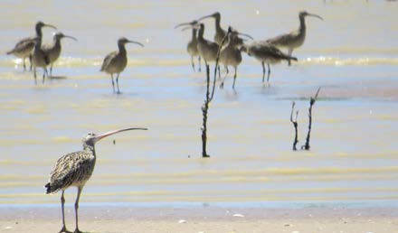

Eastern Curlew *(Numenius madagascariensis*) and Whimbrels (Numenius phaeopus) in the South-east Gulf of Carpentaria © Roger Jaensch and CLCAC

Historically, the Convention has always had a strong interest in the conservation of migratory birds. This is evidenced through the recent appointment of two individual experts to cover scientific and technical issues associated with migratory birds. The Convention has always had a number of specially appointed experts (referred to as CoP-Appointed Councillors) to address specific themes. There are currently 10 such Councillors covering a range of issues such as marine turtles, by-catch and climate change, with two experts devoted to birds.

While a great many migratory birds were included in the Appendices to the Convention at the outset, two bird species have been recently moved from Appendix II to Appendix I as a reflection of the concern surrounding their conservation status:

* Eastern Curlew, (*Numenius madagascariensis*), was included in Appendix I in 2011; and
* Great Knot, (*Calidris tenuirostris*), was included in Appendix I in 2014.

Following its inclusion on Appendix I, the Eastern Curlew was included on the list of species designated for concerted action under the Convention. Concerted actions were established under the Convention in 1991 and are designed to recommend initiatives to benefit a selected number of Appendix I species. Australia accepted the role of focal point for the Eastern Curlew and is progressing the implementation of an international Single Species Action Plan for the species through a number of forums.

At the 12th Conference of Parties, held in the Philippines from 23 – 28 October 2017, the Single Species Action Plan for the Far Eastern Curlew was adopted. The Parties also adopted two other Single Species Action Plans (Baer’s Pochard and the European Roller), a Multi-Species Action Plan for African-Eurasian Vultures and an Action Plan for Migratory Landbirds in the Africa-Eurasian Region.

A number of resolutions were also adopted that are of relevance to a number of migratory bird species, including a resolution designed to tack illegal hunting, take and trade of migratory birds in the East Asian – Australasian Flyway, one calling for greater protection of critical intertidal habitats, and a standard bird taxonomy was also adopted. A full list of the resolutions adopted at the recent meeting can be accessed here:

<https://www.cms.int/documents/cop-resolutions>

### Agreement on the Conservation of Albatrosses and Petrels

The Agreement on the Conservation of Albatrosses and Petrels (ACAP) has developed a range of best practice advice and guidance designed to mitigate the threats to seabirds on land and at sea. ACAP conservation guidelines including about biosecurity, tissue sampling following a disease outbreak, conducting a census, eradication, field collection protocols for DNA dietary analysis of seabird scats, and translocation are applicable to the shearwater species included under JAMBA, CAMBA and ROKAMBA.

ACAP best practice advice and facts sheets for fisheries help to mitigate seabird bycatch during fishing operations and are applicable to the shearwater species included under JAMBA, CAMBA and ROKAMBA.

### Ramsar Convention

Australia is a signatory to the Convention on Wetlands of International Importance (see www.ramsar.org). The Ramsar Convention, as it is commonly known, is an intergovernmental treaty dedicated to the conservation and ‘wise use’ of wetlands.

The Ramsar Convention focuses on conservation of important habitats rather than species. Parties are committed to identifying wetlands that qualify as internationally significant against a set of criteria, nominating these wetlands to the List of Wetlands of International Importance (the Ramsar List) and ensuring the maintenance of the ecological character of each listed Ramsar site.

As at August 2018, Australia has 66 Wetlands of International Importance that cover a total of approximately 8.1 million hectares. Many of Australia’s Ramsar sites were nominated and listed using waterbird-based criteria, and in some of these cases migratory shorebirds are a major component of the waterbird numbers (e.g. Roebuck Bay and Eighty-mile Beach Ramsar Sites in Western Australia).

One new Ramsar site was added to the Australian reserve system since the last report in 2016. Glenelg Estuary and Discovery Bay was approved for listing by the Australian Government as a wetland of international significance under the Ramsar Convention. The site covers more than 22,000 ha and has diverse aquatic habitats, including intertidal sandy beaches, estuarine habitat, freshwater swamps and permanent lakes. The site supports nationally threatened coastal saltmarsh, and eight nationally or internationally listed species of conservation significance, such as the Eastern Curlew and Australasian Bittern, which are both critically endangered. The site also includes part of the Discovery Bay Shorebird Site, which is an internationally important non-breeding area for Sanderling and regularly supports 1 per cent of the flyway population.

### East Asian – Australasian Flyway Partnership

The Partnership for the Conservation of Migratory Waterbirds and the Sustainable Use of their Habitats in the East Asian–Australasian Flyway (East Asian— Australasian Flyway Partnership) was launched on 6 November 2006. A Ramsar regional initiative, the Partnership is an informal and voluntary collaboration of effort focusing on protecting migratory waterbirds, their habitat and the livelihoods of people dependant on them.

The EAAF is one of nine major migratory waterbird flyways around the globe. It extends from within the Arctic Circle in Russia and Alaska, southwards through East and South-east Asia, to Australia and New Zealand in

the south, encompassing 22 countries. Migratory waterbirds share this flyway with 45 per cent of the world’s human population. The EAAF is home to over 50 million migratory waterbirds—including shorebirds, Anatidae (ducks, geese and swans), seabirds and cranes—from 207 species, including 33 globally threatened and 13 near threatened species.

Flyway Partners include countries, intergovernmental agencies, international non-government organisations and the international business sector. The Partnership operates via working groups and task forces, many of which focus on migratory shorebirds and seabirds. A cornerstone of the Partnership is the establishment of a network of internationally important sites for migratory waterbirds throughout the EAAF.

##### East Asian - Australasian Flyway Site Network

The East Asian — Australasian Flyway Site Network is a voluntary, non-binding, collaborative project involving over 130 sites across 22 countries. The Flyway Site Network has been operating since 1996 under the Asia-Pacific Migratory Waterbird Conservation Strategy and is now supported by the East Asian — Australasian Flyway Partnership.

# Implementation of the Agreements by State and Territory Governments

### Compiled by state and territory representatives of the Wetlands and Aquatic Ecosystems sub-Committee

**Relevant JAMBA Articles**: II, IV, V, VI   
**Relevant CAMBA Articles**: II, III, IV   
**Relevant ROKAMBA Articles:** 2, 3, 4, 5

### Summary

Australia has a Federal Government with 8 separate State or Territory Governments. The State and Territory agencies have primary responsibility for land and wildlife management within their jurisdictions.

The Australian Government has responsibility for matters in the national interest, and for non-state/territory areas, which includes the marine environment from 3 nautical miles out to the edge of the Exclusive Economic Zone (EEZ). The State and Territory agencies have primary responsibility for the management of wildlife, including migratory species, which occur within their jurisdictional borders, including State/Territory waters.

State and territory agencies undertake a range of activities in their jurisdictions which protect migratory birds and their habitat. Since October 2016 activities have included: nomination of important migratory waterbird areas

to the East Asian-Australasian Flyway Site Network; assessments and surveys of important habitat and important bird populations; completion of ecological character descriptions for Ramsar sites; habitat restoration and management programs; conservation assessments; management planning; weed and feral animal control activities; conservation status reviews; and educational activities.

## Western Australia

### Legislation

The *Biodiversity Conservation Act 2016* received Royal Assent on 21 September 2016. Once fully proclaimed, the Act will replace the *Wildlife Conservation Act 1950* and will provide significant changes in the legislated ability for the Western Australian Government to protect and conserve biodiversity and biodiversity components.

These include a formal listing process for threatened species; recognition and listing of threatened ecological communities and identification and highest level protection of critical habitats. Full proclamation of the Act is dependent on the drafting of Biodiversity Conservation Regulations, which is currently underway. It is anticipated that the Regulations will come into effect on 1 January 2019.

### Policy initiatives

The Pilbara Conservation Strategy was released in February 2017. The strategy outlines a landscape-scale approach to conservation across the Pilbara bioregion and identifies opportunities for partnerships to mitigate threats across tenure boundaries to protect conservation values, including threatened and other important species, communities and ecosystems, like the Fortescue Marsh.

The *Western Australian Biosecurity Strategy 2016-2035* was released in November 2016 to provide strategic direction for the management of emerging and ongoing biosecurity issues that impact WA agriculture, fisheries, forests and the environment.

The *Wetlands Conservation Policy for Western Australia* (1997) continued to be implemented, which includes an objective to maintain the abundance of waterbird populations, particularly migratory species.

The Department of Biodiversity, Conservation and Attractions (DBCA) continued to work with other states and the Australian Government in developing a national wetlands policy regarding the implementation of international agreements. Toolkits for identifying, classifying and managing high ecological value aquatic ecosystems were finalised and made publicly available.

### Conservation reserve system

In January 2018, 1,001 hectares of Class A conservation reserve was created over an enclave within Yalgorup National Park, providing an improved buffer to wetlands within the Peel-Yalgorup System Ramsar site that provide important habitat for migratory shorebirds. The buffer zone adjacent to the Vasse-Wonnerup System Ramsar Site was also extended through reservation for conservation.

In the Kimberley region, the Yawuru Nagulagun / Roebuck Bay marine park was created and its management plan was finalised. The terrestrial coastal strip of Eighty Mile Beach and Walyarta Conservation Park were created and jointly vested between the relevant Aboriginal Corporations and the Conservation and Parks Commission.

Work is underway to add Morley Beach on the Wilson Inlet to the conservation reserve system, involving a change of tenure from unallocated Crown Land to Conservation Park. This will provide improved protection for this important migratory shorebird site on Western Australia’s south coast.

### Management

DBCA provides advice to regulatory authorities for development proposals that have the potential to impact on conservation significant species, including migratory shorebirds and threatened species. Management plans for conservation reserves, including marine and national parks, also assist in managing threats to migratory shorebird habitat in reserves. DBCA also assists the Australian Government with the identification of environmental values and potential impacts from proposed developments within and adjacent to Ramsar sites that include migratory shorebird habitat.

DBCA has provided financial assistance and advice to the Department of the Environment and Energy to develop *National Environmental Management Light Pollution Guidelines for Marine Turtles and Migratory Birds* to provide guidance to proponents, local governments and government assessors of development proposals.

The Western Australian Oiled Wildlife Response Plan provides guidance to an oiled wildlife response and a series of regional plans are in development. DBCA has also provided oiled wildlife response training to its staff, community members and industry. The plans and training include considerations for the mitigation of, and response to, impacts of an oil spill on migratory birds. In 2017, DBCA also acquired an oiled wildlife response container to better equip the State to respond to an oil spill.

The *Western Shield* wildlife recovery program continued to implement broadscale fox and feral cat control for native animal conservation across a network of sites in WA. Feral herbivore control was also undertaken, including in areas adjacent to Fortescue Marsh.

*Healthy Wetland Habitats*, a voluntary off- reserve conservation program that provides technical and financial assistance to private land managers for the management of wetlands of high conservation value, supported the installation of 1,343m of fencing on two properties abutting the Vasse Wonnerup System Ramsar site to provide protection from grazing and delineate between areas managed for agriculture and conservation.

Preliminary assessments to determine the status of the ecological character of two Ramsar sites of importance for migratory and threatened species (Muir-Byenup System and Lake Gore) have been completed and a third assessment (Vasse-Wonnerup System) is underway. An Operational Plan is being developed to guide future management of the Vasse-Wonnerup System Ramsar Site.

### Monitoring and research

Key sites have been identified on remote islands in the Pilbara region, including four new sites for the Critically Endangered Eastern Curlew (*Numenius madagascariensis*). About 63,000 shorebirds and seabirds were counted between 2014 and 2018 with results indicating migratory shorebirds are present year-round. Recreational usage of these sites has been recorded using a combination of aerial surveys, social surveys, vessel patrols and visitor boxes, which has been used to determine the profile of the average island visitor to inform targeted education and interpretation strategies.

DBCA undertook shorebird surveys of the Montebello Islands and Bedout Island off the Pilbara coast in 2017 and 2018. Information collected from these surveys will be used to identify areas of importance to shorebirds and potential threats, and inform management actions (e.g. signage and interpretation, and designation of no camping zones).

In February and March 2017, aerial waterbird surveys were undertaken by DBCA staff, traditional owners from the Indigenous Desert Alliance and Bennelongia Environmental Consultants over the ephemeral lakes of the Western Desert (including Lake Disappointment and Lake Mackay), Roebuck Plains, Walyarta Conservation Park and Lake Gregory following a significant rainfall event. Migratory shorebirds were recorded during the surveys, as were several significant Banded Stilt (*Cladorhynchus leucocephalus*) breeding colonies.

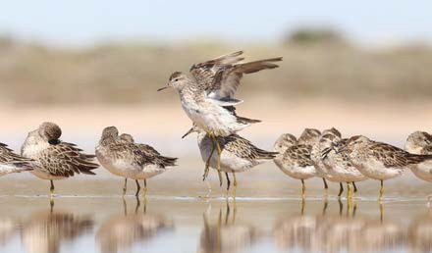Sharp-tailed Sandpiper *(Calidris acuminata*) at Lake Tuchewop, Victoria © Chris Purnell

In May 2018 a survey of waterbirds using the Parry Lagoons area of the Ord River Floodplain Ramsar site was undertaken by DBCA staff.

DBCA staff participated in, and provided logistical support for, Shorebirds 2020 surveys at various sites across WA, including Roebuck Bay and Eighty Mile Beach (through the Monitoring Yellow Sea Migrants in Australia project), Barrow Island, Exmouth Gulf and islands and the Ningaloo coast, and the Peel-Yalgorup System and Vasse-Wonnerup System Ramsar sites and sites on the south coast.

Migratory bird presence data was included in a re-evaluation of wetlands within the Perth and Peel area in collaboration with the Department of Water and Environmental Regulation. Migratory bird survey data has been included in a review of the condition of the Forrestdale and Thomsons Lakes, Peel-Yalgorup, Vasse-Wonnerup and the Muir-Byenup systems Ramsar sites as part of a mid-term review of the *Forest Management Plan 2014-2023*.

DBCA collaborated with State agencies and the Commonwealth to conduct a trial of a national methodology for assessing condition of wetlands: the *Integrated Ecological Condition Assessment*, which is intended to become a fifth module of the national Aquatic Ecosystems Toolkit. A case study was prepared for the Peel-Yalgorup System Ramsar site using the methodology to present to other states for future take up in assessing condition changes in nationally and internationally important wetlands.

DBCA continued to work in partnership with other State agencies, the City of Busselton, Water Corporation, GeoCatch and the South West Catchments Council to manage and monitor the Vasse-Wonnerup System Ramsar site. Two years of monthly waterbird monitoring was completed and several PhD studies were supported. Possible impacts of recent water level management on waterbird numbers at this site are to be assessed.

Surface water depth and quality monitoring was undertaken monthly for the Lake Warden system including monthly lake depth measurements, increased to fortnightly and then weekly when trigger levels for operating the Lake Wheatfield pipeline were approached.

DBCA continued to monitor water levels, salinity and pH of 105 wetlands across south-western Australia (Geraldton to Esperance), including numerous sites of international, national and regional importance to resident and migratory shorebirds. The *South West Wetlands Monitoring Program*, which ran from 1977 to 2018, provided context for management and revealed and tracked impacts of threatening processes, in particular long-term water level declines and salinity increases associated with regional rainfall decline.

### Education and engagement

A Regional Communication Strategy and an Interpretive and Information Action Plan has been developed to raise awareness of threatened and migratory species and safeguard important habitat in response to a potential increase in recreational disturbance on the Pilbara coast and islands. The strategy identifies key user groups, and achievements include:

Development of a [Shorebirds and seabirds of the Pilbara coast and islands identification guid](https://www.dpaw.wa.gov.au/images/documents/conservation-management/wetlands/20170167_pilbara_shorebirds_and_seabirds_of_the_pilbara_coast_and_islands_web.pdf)e to be distributed through the local and broader community*.*

A [*Threatened and protected species education manual*](https://www.dpaw.wa.gov.au/get-involved/nearer-to-nature/schools/teachers/resources/526-threatened-and-protected-species-of-western-australia-s-marine-and-coastal-habitats) for years 4-6 is has been developed and will be made available to all schools in WA in 2018.

Engagement and education activities have occurred through school-based activities with Bush Ranger Cadet Units in Exmouth and Onslow, school holiday program activities within Exmouth District and in collaboration with Shire of Exmouth, Shire of Ashburton and the Wheatstone Indigenous Sea Ranger Program, and broader community engagement through local festivals and community events in Exmouth, Karratha and Onslow. In 2017 over 3,000 people took part in activities in the Pilbara region.

A shorebird identification workshop was held in Exmouth in January 2018 for the local community. The workshop was facilitated by DBCA and presented by BirdLife Australia with funding from the National Government’s Landcare Program Threatened Species Recovery Fund. The workshop provided an opportunity for tourism operators, pastoralists, other government agencies and the local community to develop a greater understanding of shorebirds, important habitat and potential threats in the region.

DBCA promotes shorebird conservation through its w[ebsites (Parks and Wildlife Service](https://www.dpaw.wa.gov.au/management/wetlands/migratory-waterbirds) and [Explore Parks](https://parks.dpaw.wa.gov.au/)) and shorebird articles are occasionally posted via the Department’s social media platforms ([Twitter](https://twitter.com/WAParksWildlife), [Facebook](https://www.facebook.com/WAParksWildlife/) and Instagram). Shorebird conservation is also promoted through occasional media and newsletter articles.

Stakeholders are involved in the preparation and implementation of management plans for conservation reserves, which include management strategies and actions for protecting shorebird habitat. DBCA scientists publish articles relating to shorebird conservation, including recent publications concerning trends in numbers of the Eastern Curlew in south-western Australia.

## Queensland

### Protected Areas

The Queensland Government has worked with key non-government partners to successfully nominate and support management of East Asian-Australasian Flyway Partnership sites in the Gulf (Delta Downs and Tarrant) and raise community awareness of their importance as habitat for shorebird species. For example, the Department of Environment and Science worked with Indigenous rangers from the Carpentaria Land Council Aboriginal Corporation (CLCAC), researchers from the University of Queensland (UQ), and the Queensland Wader Study Group (QWSG) to promote migratory shorebird conservation work within the Gulf of Carpentaria at the World Science Festival Brisbane on the 24 March 2018. The Gulf is one of the most important sites in Australia for shorebird conservation, providing habitat for roughly 50% of migratory shorebirds passing through Australia.

Progression of updates to the Ramsar documentation for Queensland’s five Ramsar sites Moreton Bay, Shoalwater and Corio Bays Area, Currawinya Lakes, Great Sandy Strait and Bowling Green Bay, is currently underway.

Documentation includes Ecological Character Description (ECD), Ramsar Information Sheets (RIS) and Ramsar Management Summaries (RMS). To date RISs for Shoalwater and Corio Bays Area and Currawinya Lakes Ramsar sites have been finalised, with Moreton Bay and Bowling Green Bay in advanced stages of development. Great Sandy Strait will be completed in the near future. Flyway Site Information Sheets as part of the East Asian- Australasian Flyway Partnership, are also being updated for each site.

Queensland is developing an Intertidal and subtidal Classification Scheme to standardise classification using biophysical characteristics of the water column and sea floor. The scheme directly relates to shorebird

management through facilitating a more comprehensive understanding of ecological values and representativeness of particular ecosystems with which to inform management and development decisions. More information on the Scheme is available at [https://wetlandinfo.ehp.qld.gov.au/wetlands/what-are-wetlands/definitions-classification/](https://wetlandinfo.ehp.qld.gov.au/wetlands/what-are-wetlands/definitions-classification/classification-systems-background/intertidal-subtidal/) [classification-systems-background/intertidal-subtidal/](https://wetlandinfo.ehp.qld.gov.au/wetlands/what-are-wetlands/definitions-classification/classification-systems-background/intertidal-subtidal/)

A new management framework, the *Values Based Management Framework* (VBMF), for high priority National Parks within Queensland is being finalised and management plans for Currawinya and Bowling Green Bay, important areas for migratory shorebirds, have been drafted. These plans consider biodiversity values, which includes shorebird conservation and management.

Non-government organisations play a key role in conserving migratory shorebirds and Conservation Volunteers Australia (CVA) is leading a project, *Community Conservation of Eastern Curlew*. The project includes five locations in Australia, one of which covers Moreton Bay and the Broadwater area in south east Queensland and involves on-ground works (i.e. weed control), a community awareness and shorebird monitoring.

The Fuller Lab (UQ) is leading the *Recovering Australia’s Migratory Shorebirds Project* funded through the Australian Research Linkage Projects Scheme. The project aims to investigate the drivers of decline in Australia’s shorebird populations to determine the most effective management activities to safeguard the future of Australia’s shorebirds. The Fuller Lab are currently analysing migratory shorebird population statuses and trends in Great Sandy Strait. This includes examining distribution of shorebirds in relation to disturbance sources and intertidal foraging habitat, and whether these local factors can explain variation in trends across roost sites. Results of these analyses will help to prioritize management actions within the Great Sandy Strait. More information on the project can be found at [https://wetlandinfo.ehp.qld.gov.au/resources/static/pdf/resources/fact-sheets/fs-arc-sb-](https://wetlandinfo.ehp.qld.gov.au/resources/static/pdf/resources/fact-sheets/fs-arc-sb-project.pdf) [project.pdf](https://wetlandinfo.ehp.qld.gov.au/resources/static/pdf/resources/fact-sheets/fs-arc-sb-project.pdf)

### Climate change and migratory shorebirds

As part of the *Queensland Climate Adaptation Strategy*, Queensland is developing biodiversity and ecosystem sector adaptation plans, in which wetlands and waterbirds will be considered. Further information is available at <https://www.qld.gov.au/environment/assets/documents/climate/qld-climate-adaptation-strategy.pdf>

Currawinya Lakes and Great Sandy Strait have been nominated for assessment as part of the Australian Government’s Climate Change Vulnerability Assessment. Both sites support important shorebird habitat, with Great Sandy Strait the focus of QWSG biannual shorebird surveys.

### Shorebird populations in Australia

As part of the ARC Linkage Project (see above), the Fuller Lab (UQ) are evaluating harvest of migratory shorebirds in the East Asian-Australasian Flyway (EAAF); this includes collating historical hunting records from the flyway, estimating historical and recent levels of harvest, and evaluating potential population-level impacts of hunting on migratory shorebirds.

The Fuller lab are also updating the national migratory shorebird population trends (previous trends from Clemens et al. 2016 were current to 2014). A component of this analysis will examine whether population trends differ between natural and artificial roost sites from across Australia.

### Wetland rehabilitation and management

Queensland has developed and maintains a wide range of wetland rehabilitation and management tools and guidelines on its webpage *WetlandInfo* (see [https://wetlandinfo.ehp.qld.gov.au/wetlands/ management/wetland-](https://wetlandinfo.ehp.qld.gov.au/wetlands/%20management/wetland-management/) [management/](https://wetlandinfo.ehp.qld.gov.au/wetlands/%20management/wetland-management/)).

This includes information specific to management of shorebirds and other waterbirds (see [https://wetlandinfo.](https://wetlandinfo.ehp.qld.gov.au/wetlands/management/bird-management/) [ehp.qld.gov.au/wetlands/management/bird-management/](https://wetlandinfo.ehp.qld.gov.au/wetlands/management/bird-management/))

### Research and monitoring

Shorebird related research priorities and activities have been identified through a number of processes including DES published science priorities.

As part of the ARC Linkage Project, the Fuller Lab (UQ) in collaboration with QWSG, have equipped four Far Eastern Curlews with GPS/Argos tracking devices between November 2017 and March 2018. This component of the project will provide detailed information on non-breeding movements and habitat use, migratory routes, and stopover biology for this critically endangered species.

Carpentaria Land Council Aboriginal Corporation (CLCAC) and research institutes currently undertake shorebird surveys within the Gulf of Carpentaria. A Gulf stakeholder workshop explored ways to better integrate monitoring between all parties.

Griffith University is currently undertaking a research project in partnership with Queensland Government and Northern Australia Environmental Resource Hub on the effects of flow alteration on estuaries in the Gulf of Carpentaria. The project aims to identify the food resources present in important estuarine habitats that support shorebirds and how these food sources may be affected by water extraction in Catchment Rivers.

### Education and engagement

*WetlandInfo* continues to be the storehouse for public material related to wetland management in Queensland. The website has pages dedicated to promoting internationally significant events such as World Wetlands Day as well as state based pages on shorebird management and conservation, including linkages to other key partners in Queensland. It also contains information on: legislation, policies and programs administered to manage wetlands; on state, national and international conventions, partnerships, agreements, legislation and strategies that protect waterbirds and their habitats; and information on shorebird locations in Queensland.

For further information: <https://wetlandinfo.ehp.qld.gov.au/wetlands/>

The Fuller Lab (UQ) are evaluating governance of migratory shorebird conservation in the EAAF; includes identifying institutional arrangements across nations, identifying actors involved in such arrangements, and evaluating effectiveness of those arrangements.

## New South Wales

### Saving our Species program

The Saving our Species (SoS) program is the NSW Government’s threatened species conservation program. Actions under the program include developing conservation strategies, on-ground projects, monitoring, community awareness raising and education.

The SoS program is currently developing conservation strategies and on-ground projects for threatened migratory species including shorebirds, seabirds, marine mammals, and turtles.

Under the program, 11 priority Little Tern (*Sterna albifrons*) sites along the NSW coast have received funding. Actions implemented include: fox control, community liaison and compliance, managing risk of inundation and avian predation and monitoring of breeding.

SoS is currently developing a strategic approach to managing migratory species through the ‘partnership species’ management stream of the program. The stream prioritises the management of migratory species that have sites or populations of high conservation value in the state. This includes developing strategies for species such as the Black-tailed Godwit (*Limosa limosa*), Curlew Sandpiper (*Calidris ferruginea*), Terek Sandpiper (*Xenus cinereus*), Greater Sand Plover (*Charadrius leschenaultii*), Lesser Sand Plover (*Charadrius mongolus*), Great Knot (*Calidris tenuirostris*), Loggerhead turtle (*Caretta caretta*), Green turtle (*Chelonia mydas*), and Southern-right whale (*Eubalaena australis*).

### Little Terns (Sterna albifrons)

Since 2001 NSW has monitored fledging rates of little terns and other threatened beach-nesting shorebirds at over 25 major nesting sites along the NSW coast.

Where feasible, primary threats to fledgling have been managed at these sites, including introduced Red Foxes (*Vulpes vulpes*), human disturbance, domestic dogs, inundation and native avian predators (corvids and gulls).

Observed fledging rates have been variable irrespective of management, but estimated rates at sites with management such as fox control are 50 per cent higher than unmanaged sites. Despite management efforts, the number of breeding pairs across all sites has been declining at about 3 per cent per year since 2001.

### Hunter Estuary Wetlands Ramsar Site

The wetlands restoration at Tomago within the Hunter Estuary Wetlands Ramsar site, is now a key site in the East Asian-Australasian Flyway, with over 5,000 Sharp-tailed Sandpipers (*Calidris acuminata*) recorded during the 2014/15 summer (which was almost 2 per cent of the world population), and the shorebird diversity has increased threefold since 2009, as a result of the habitat restoration efforts.

Significant sections of key migratory shorebird roosting habitat on the Kooragang Dykes have been repaired and raised, and significant amount of estuarine habitat within Hexham Swamp has been restored. Mangrove seedlings are being removed from 500 ha (Ash Island, Tomago, Stockton Sandspit, Kooragang Dykes, Smiths and Sandy Island) from within Hunter Wetlands National Park) to improve wader habitat and 18 ha of saltmarsh has been restored as migratory shorebird habitat through mature mangrove removal.

NSW has removed 95 per cent and treated approximately 500 ha of Spiny Rush (*Juncus acutus)* at Tomago, Ash Island and Hexham Swamp, and has restored 50 ha of mudflat and 10 ha of saltmarsh at Tomago.

### Towra Point Ramsar Site

Following indications of changed ecological character at the site, in 2014 a Ramsar preliminary assessment noted a reduction of shorebird diversity and numbers. In 2017, NSW collaborated with the Australian Government to undertake a formal assessment of the Ramsar site, to determine whether there had been a change in ecological character. The assessment indicated that there has been a change in the diversity of bird species at the site and for Little Tern breeding success. These changes were linked largely to reduced habitat availability and increased threats from pests, human disturbance and vegetation encroachment. NSW is currently working with the Australian Government to develop a Response Strategy to assist in developing key management actions to help provide greater protection of the site.

### Programs to support waterbirds

Environmental watering of key waterbird habitat in NSW is carried out annually to maintain and enhance migratory shorebird habitat in iconic wetlands across five key catchments. These habitats support many migratory bird species including Latham’s Snipe and Sharp-tailed Sandpiper.

Long-term watering plans are being prepared for NSW Murray-Darling Catchments, which will set targets for maintaining habitats for waterbirds within key wetland systems such as the Macquarie Marshes, Gwydir Wetlands, Lowbidgee wetlands and the Murray River.

Maintenance of migratory bird habitat is supported through statutory water sharing plans which aim to maintain system health. This provides important water flow protection for numerous inland habitats. These include Narran Lakes and Menindee Lakes which provide critical habitat for very high numbers of migratory birds.

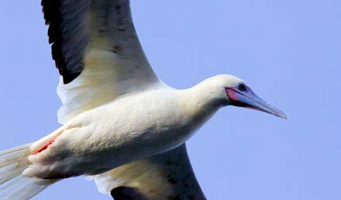

Red-footed Booby *(Sula sula)* over North Keeling Island © Copyright Department of the Environment and Energy

### Environmental Water

By the end of 2016-17, OEH delivered almost 1,400,000 megalitres of water (from state, Commonwealth and The Living Murray accounts) within the Murrumbidgee, Murray, Lachlan, Macquarie and Gwydir systems. This supported migratory bird species, including; Sharp-tailed Sandpiper, Latham’s Snipe, Common Greenshank and Marsh Sandpiper.

### Waterbird monitoring

The Aerial Waterbird Surveys of Eastern Australia (AWSEA) contributes to 33 years of data collected across six survey bands in Eastern Australia including major wetland sites in the Murray-Darling Basin. This program is coordinated by the University of New South Wales with contributions made by the NSW Government for the NSW portion.

The NSW Government undertakes counts of waterbirds in the Macquarie Marshes, Gwydir Wetlands, Lower- and Mid-Murrumbidgee Wetlands, Central Murray Forests and Narran Lakes, to complement data collected through the AWSEA, and to support the adaptive management of environmental water by the NSW and Commonwealth Governments. Many of these areas support Ramsar wetlands that contain significant habitat for migratory species listed under JAMBA, CAMBA and/or ROKAMBA.

Annual survey reports can be found here: [https://www.ecosystem.unsw.edu.au/content/rivers-and-wetlands/](https://www.ecosystem.unsw.edu.au/content/rivers-and-wetlands/waterbirds/eastern-australian-waterbird-survey) [waterbirds/eastern-australian-waterbird-survey](https://www.ecosystem.unsw.edu.au/content/rivers-and-wetlands/waterbirds/eastern-australian-waterbird-survey)

## Victoria

### Glenelg Estuary and Discovery Bay Ramsar Site

Glenelg Estuary and Discovery Bay was approved for listing by the Australian Government as a wetland of international significance under the Ramsar Convention. The site covers more than 22,000 ha and has diverse aquatic habitats, including intertidal sandy beaches, estuarine habitat, freshwater swamps and permanent lakes. The site supports nationally threatened coastal saltmarsh, and eight nationally or internationally listed species of conservation significance, such as the Eastern Curlew and Australasian Bittern, which are both critically

endangered. The site also includes part of the Discovery Bay Shorebird Site, which is an internationally important non-breeding area for Sanderling and regularly supports 1% of the flyway population.

### Victorian Ramsar Estate

Ramsar site Ecological Character Descriptions (ECD) and corresponding Ramsar Information Sheets (RIS) are currently being updated. ECD addendum have been published for the Corner Inlet, Edithvale Seaford Wetlands, Kerang Wetlands and Western Port Ramsar sites. The ECD addenda include improvements to limits of acceptable change and incorporate a range of recent data and information relating to waterbirds.

Victoria is improving the way in which Ramsar sites are managed in response to recommendations of an audit by the Victorian Auditor General’s Office (VAGO) - *Meeting obligations to protect Ramsar wetlands*. This work will have positive effects for the conservation of migratory birds through improvements to management and monitoring of Ramsar values at Victorian Ramsar sites. VAGO audit response actions include:

* Agreed roles, responsibilities, and accountabilities of each agency responsible for the management of the states Ramsar sites.
* Establishment of a Ramsar Site Coordinating Committee for each site. These committees are responsible for the implementation of Ramsar Site management plans.
* Improved tracking of ecological character status and management plan implementation through the development of an online monitoring tool and annual action planning and reporting via the site coordinating committees.
* Development of a state-wide monitoring, evaluation, reporting and improvement framework.

Five Victorian Ramsar sites have standalone Ramsar Site Management plans which are all now current. These are Glenelg Estuary and Discovery Bay, Kerang Lakes, Western Port, Edithvale Seaford Wetlands, and Port Phillip Bay (Western Shoreline) and Bellarine Peninsula Ramsar sites. The seven sites that have a Ramsar Site Management Plan embedded within their Regional Waterway Strategies (developed by catchment management authorities) will be strengthened to ensure that activities are focused on high priority threats that impact critical components, processes and services (which include migratory birds).

## South Australia

### The Coorong, Lake Alexandrina and Albert

In January 2018, annual monitoring of waterbirds by University of Adelaide researchers counted approximately 187,500 waterbirds from 60 species in the Coorong. Approximately 100,000 of the waterbirds present were in the Coorong’s Southern Lagoon. These abundances were considerably greater than in January 2017, but similar to abundances recorded in 2016, when approximately 185,000 waterbirds from 57 species were recorded in

the Coorong.

As outlined in the 2018 condition monitoring report (Paton *et al*, unpublished) abundances for many piscivorous (fish-eating) species and shorebirds increased in the Coorong in 2018. The report however indicates that although “there were also more shorebirds present in the Coorong in January 2018 than January 2017, their abundances (in the Coorong) generally remained below their long-term median abundances” (Paton *et al,* unpublished).

In January 2018, 12 migratory waterbird species were recorded across the Coorong with five of these species observed in the Southern Lagoon. Three species exceeded 10,000 individuals across the whole Coorong, including the migratory Red-necked Stint (*Calidris ruficollis*). Although this species was one of the most abundant during the 2018 survey, with an increase in numbers compared to 2017, there is still concern that there has been an overall decline in abundance of this species and the Curlew Sandpiper (*C. ferruginea*) at the site. There were a further six species that were recorded in numbers greater than 5,000 across the Coorong, including the Sharp- tailed Sandpiper (*C. acuminata*), with 906 individuals recorded in the Southern Lagoon.

The 2018 monitoring report by Professor Paton states that “a number of shorebird species continued to spend more than 70 per cent of their time foraging” and that the “high rates of foraging are indicative of low resource levels”. Resource levels are based on chironomid larvae and *Ruppia tuberosa* seeds and turions (a small shoot that stores starch and functions as a propagule for the adult plant) which monitoring indicates were in relatively small numbers throughout the Southern Lagoon, linked to the continued degraded condition of the Coorong. The South Australian Government continues to work with the Australian Government on the delivery of environmental water to the Coorong for environmental benefit, which has resulted in substantive improvement across much of the site.

Of concern is the continued presence of filamentous green algae throughout the southern Coorong. The algae is an issue due to its deleterious effects on the ecology, including smothering shorelines, suppressing the emergence of chironomids and limiting access to mudflat foraging habitat for shorebirds. A report titled *Optimising Ruppia habitat* is due to be published shortly summarising the investigations undertaken into *R. tuberosa* requirements, filamentous algae and their interaction.

The South Australian Government has assembled an independent scientific expert panel to provide scientific advice on the status of the Coorong, immediate threats and key knowledge gaps in supporting maintenance of the site’s ecological character, including the protection and enhancement of waterbird populations, their habitat and key food resources. Additionally, a community summit on the Coorong was held on 5 June 2018, attended by 80 key stakeholders, including community members and scientists to explore future management of the Coorong.

The South Australian Government is presently preparing a plan of action with a number of potential on-ground interventions and investigations aimed at improving the ecological function of the Coorong Southern Lagoon as a migratory shorebird habitat to compliment the continued provision of environmental water from the Murray- Darling system.

##### Milang Foreshore Habitat Restoration Project

The Milang Foreshore Habitat Restoration Project has recently been completed in the Coorong and Lakes Alexandrina and Albert Ramsar site. The project co-developed with the local community, seeks to maintain and continue the recovery of native habitat and feeding grounds for threatened migratory waterbird species at Milang, specifically the Latham’s Snipe *(Gallinago hardwickii)*. The habitat restoration project has focused on infrastructure and ecological works in and around the wetland to improve the snipe habitat, together with awareness raising of the environmental significance of this Ramsar wetland and its relationship to social and cultural values of the area.

##### South East Flows Restoration Project

A large construction project is currently underway to restore inflows from the south east of South Australia to the Coorong South Lagoon aimed at assisting to maintain salinity in the Southern Lagoon within target levels and prevent ecological degradation during periods of low flows from the Murray-Darling Basin.

Flows to maintain salinity levels in the Coorong from the south east are complementary to River Murray Flows over the barrages. Flow will be adjusted annually to account for the Coorong requirements and delivery of flows to en route wetlands for increased environmental outcomes. These flows will support the important waterbird habitat of the Coorong.

Historically, quantities of freshwater flowed into the Southern Lagoon from the South East and this source of freshwater has been reduced by drainage works in the region over the past 150 years. The South East Flows Restoration Project involves constructing a new flow path to connect existing elements of the South East Drainage Network, to deliver additional water directly into the Southern Lagoon.

Construction works commenced in March 2017 and are scheduled for completion in 2018 whereupon additional flows of between 5.0 - 45.3 GL (1GL = 1 billion litres) annually are estimated to reach the Coorong.

### Adelaide International Bird Sanctuary

##### On Ground Activities in the Adelaide International Bird Sanctuary

A Risk Analysis was undertaken in 2016 to determine the highest threats to shorebirds and their habitat. Disturbance impacts from Off Road Vehicles (ORV) including motor bikes, four wheel drives, and dogs off leads, were identified as the most significant threat to shorebirds in the short to medium term.

A multi-pronged approach to the management of shorebird disturbance activities is being undertaken in the Adelaide International Bird Sanctuary, including development and placement of community signage, strategic and targeted revegetation projects, community stewardship of key areas, development of visitor facilities to help promote passive recreational activities and change the type of person that visits and uses these coastal areas.

In addition, in 2017 the Department for Environment and Water developed a compliance plan for the Adelaide International Bird Sanctuary. Since the implementation and commencement of the Compliance program in April 2017 (which has a significant educational focus), over 400 people have been spoken to about their behaviours and activities and some reduction in beach disturbance has been observed.

##### Mutual Agreement between Department of Defence and Department of Environment and Water

A Mutual Agreement between Department of Defence and Department for Environment and Water (Northern and Yorke Region and Adelaide Mount Lofty Ranges Regions) was signed in late 2017 for the delivery of on ground actions in the Upper St Vincent Gulf. The Department of Defence Proof Experimental Establishment, Port Wakefield incorporates a large proportion of the shorebird habitat in Upper St. Vincent Gulf.

The Department of Defence has recognised the role of community (individuals and groups) in the delivery of

on-ground actions, including wader surveys and will foster community participation in protecting and managing their landscapes and seascapes. In relation to this, Birds SA are now able to access the Department of Defence land at Port Wakefield to undertake shorebird surveys enhancing monitoring of shorebirds in the vicinity of the Adelaide International Bird Sanctuary.

### Formation of the South Australian Shorebird Alliance

The South Australian Shorebird Alliance (SASA) is a collaboration involving multiple government and not-for- profit organisations to support community efforts in South Australia aimed at protecting resident and migratory shorebirds, including beach-nesting birds. Shorebird Alliance partners include representatives from across

South Australia, BirdLife Australia, Birds SA, Friends of Shorebirds South East, Local Government Association (Councils), and the Department for Environment and Water. Alliance affiliates and other supporters include organisations and groups such as Adelaide University, Australian Wildlife Conservancy, the Adelaide International Bird Sanctuary Collective and Friends groups.

SASA formally commenced the partnership in November 2017, with the formation of a Working Group to assist with the implementation of Birdlife Australia’s Shorebird Conservation Action Plan across priority areas of the state. National priorities involved include: threatened Far Eastern Curlew, Curlew Sandpiper, Hooded Plover, Wetlands of International Importance (Ramsar) and the Australian Government’s Wildlife Conservation Plan for Migratory Shorebirds. The Alliance aims to work with communities through collaborative awareness

raising, information exchange, on ground works and engagement activities to minimise disturbance and breeding impacts to shorebirds in South Australia. The SASA and Birdlife Australia will co-host a Migratory Shorebird Conservation Action Planning process in September 2018.

## Australian Capital Territory

### Migratory Species Action Plan

The *Nature Conservation Act 2014* (ACT) requires the development of an Action Plan for Migratory Species to cover those listed species likely to occur in the ACT, as regular or opportunistic migrants. Listed migratory species are those species listed under the *Environment Protection and Biodiversity Conservation Act 1999* that are subject to international agreements.

The Action Plan will help inform environmental impact assessment processes, but also identify strategies to improve management of the habitat of migratory species. An Action Plan for migratory species maps their known critical and potential habitats and proposes management strategies to ensure their persistence.

The Migratory Species Action Plan is at [http://www.environment.act.gov.au/ data/assets/pdf_](http://www.environment.act.gov.au/__data/assets/pdf_file/0009/1168704/Migratory-Species-Action-Plan_ACCESS.pdf) [file/0009/1168704/Migratory-Species-Action-Plan_ACCESS.pdf](http://www.environment.act.gov.au/__data/assets/pdf_file/0009/1168704/Migratory-Species-Action-Plan_ACCESS.pdf).

Funding has been provided to the Wetlands and Woodlands Trust and the ACT Parks and Conservation Service who manage the key site at Jerrabomberra Wetlands Nature Reserve to commence implementation of the plan.

### Latham’s Snipe monitoring project

The 201 hectare Jerrabomberra Wetlands Nature Reserve is a unique wetlands complex in the heart of Canberra, popular for bird watching, education and walking. Some areas have restricted access to protect important habitat for birds such as the Latham’s Snipe.

Funding has been provided to the Woodlands and Wetlands Trust (the Trust) to monitor Latham’s Snipe at Jerrabomberra and other ACT wetlands. Latham’s Snipe is one of many bird species that regularly migrate to the ACT each year that are listed in international conservation agreements and conventions. The funding is part of a larger Japanese–Australian Latham’s Snipe Project.

# Update on species or subspecies of birds in danger of extinction

### Australian Government Department of the Environment and Energy

**Relevant JAMBA Articles**: III, IV, V, VI   
**Relevant CAMBA Articles**: III   
**Relevant ROKAMBA Articles:** 3

### Summary

The *Environment Protection and Biodiversity Conservation Act 1999* (the EPBC Act) is the national environmental law for Australia. The EPBC Act promotes the conservation of biodiversity by, amongst other things, providing strong protection for nationally threatened species and sub-species. These can be listed as Extinct in the Wild, Critically Endangered, Endangered, Vulnerable or Conservation Dependant. State and Territory governments also have similar legislation which provide for listing of species and subspecies considered threatened within their jurisdictions.

Any person may nominate a native species for listing under any of the threatened species categories of the EPBC Act. Nominations are forwarded to the Threatened Species Scientific Committee, which is a committee established to advise the Minister for the Environment and Energy. Once the Threatened Species Scientific Committee has conducted an assessment of the conservation status of nominated species, its advice and subsequent recommendations are forwarded to the Minister who makes the final decision. After a species or subspecies is listed under the EPBC Act their recovery is promoted using Conservation Advice, Recovery or Threat Abatement Plans.

Since October 2016, no new bird species have been listed under the threatened species provisions of the EPBC Act, and seven other bird species were transferred between categories (see Table 1).

To date, there are 155 birds listed on the EPBC Act threatened species list. Of those, 22 are listed extinct, 17 critically endangered, 54 endangered and 62 vulnerable. The list of threatened species listed under the EPBC Act is maintained on the internet at:

<http://www.environment.gov.au/cgi-bin/sprat/public/publicthreatenedlist.pl>

## General background information about listing threatened species

The Australian Government helps protect species at risk of extinction by listing them as threatened under Part 13 of the EPBC Act. Once listed under the EPBC Act, the species becomes a Matter of National Environmental Significance (MNES) and must be protected from significant impacts through the assessment and approval provisions of the EPBC Act. More information about threatened species is available on the Department’s website at: <http://www.environment.gov.au/biodiversity/threatened/index.html>.

Public nominations to list threatened species under the EPBC Act are received annually by the Department. In order to determine if a species is eligible for listing as threatened under the EPBC Act, the Threatened Species Scientific Committee (the Committee) undertakes a rigorous scientific assessment of its status to determine if the species is eligible for listing against a set of criteria. These criteria are available on the Department’s website at: <http://www.environment.gov.au/biodiversity/threatened/pubs/guidelines-species.pdf>.

As part of the assessment process, the Committee consults with the public and stakeholders to obtain specific details about the species, as well as advice on what conservation actions might be appropriate. Information provided through the consultation process is considered by the Committee in its assessment. The Committee provides its advice on the assessment (together with comments received) to the Minister regarding the eligibility of the species for listing under a particular category and what conservation actions might be appropriate. The Minister decides to add, or not to add, the species to the list of threatened species under the EPBC Act. More detailed information about the listing process is at: [http://www.environment.gov.au/biodiversity/threatened/](http://www.environment.gov.au/biodiversity/threatened/nominations.html) [nominations.html](http://www.environment.gov.au/biodiversity/threatened/nominations.html).

To promote the recovery of listed threatened species and ecological communities, conservation advices and where required, recovery plans, are made or adopted in accordance with Part 13 of the EPBC Act. Conservation advices provide guidance at the time of listing on known threats and priority recovery actions that can be undertaken at a local and regional level. Recovery plans describe key threats and identify specific recovery actions that can be undertaken to enable recovery activities to occur within a planned and logical national framework. Information about recovery plans is available on the Department’s website at: [http://www.environment.gov.au/biodiversity/](http://www.environment.gov.au/biodiversity/threatened/recovery.html) [threatened/recovery.html](http://www.environment.gov.au/biodiversity/threatened/recovery.html).

**Table 1:** Birds listed under the threatened species provisions of the *Environment Protection and Biodiversity Conservation Act 1999* since the October 2016 JAMBA, CAMBA and ROKAMBA meeting.

|  |  |  |  |
| --- | --- | --- | --- |
| **Genus, species, subspecies** | **Common Name** | **Conservation Status** | **Effective from** |
| *Fregata andrewsi* | Christmas Island Frigatebird | from Vulnerable to Endangered | 7-Dec-16 |
| *Hypotaenidia sylvestris* | Lord Howe Woodhen | from Vulnerable to Endangered | 15-Aug-17 |
| *Atrichornis clamosus* | Noisy Scrub-bird, Tjimiluk | from Vulnerable to Endangered | 15-Feb-18 |
| *Calyptorhynchus baudinii* | Baudin's Cockatoo, Long-billed Black-Cockatoo | from Vulnerable to Endangered | 15-Feb-18 |
| *Dasyornis longirostris* | Western Bristlebird | from Vulnerable to Endangered | 15-Feb-18 |
| *Neochmia phaeton evangelinae* | Crimson Finch (white-bellied) | from Vulnerable to Endangered | 15-Feb-18 |
| *Melanodryas cucullata melvillensis* | Tiwi Islands Hooded Robin | from Endangered to Critically Endangered | 11-May-18 |

# Take of migratory birds or their eggs in accordance with Article II

### Department of Primary Industries, Parks, Water and Environment, Tasmanian Government

**Relevant JAMBA Articles**: II   
**Relevant CAMBA Articles:** II   
**Relevant ROKAMBA Articles:** 2

### Summary

Migratory birds, including all species listed on the annexes of JAMBA, CAMBA and ROKAMBA, are protected as a matter of national environmental significance under Australia’s *Environment Protection and*

*Biodiversity Conservation Act 1999* (EPBC Act). They are further protected under State and Territory (provincial) environmental laws. There are permits issued to capture birds for the purposes of scientific research, but also for traditional hunting which is consistent with the Articles of the migratory bird agreements. The only migratory bird species harvested in significant numbers in Australia is the Short-tailed Shearwater *(Ardenna tenuirostris)* in Tasmania.

Tasmania’s Department of Primary Industries, Parks, Water and Environment (DPIPWE) maintains a long term cultural harvest of Short-tailed Shearwaters, known as Muttonbirding, on Commonwealth land at South Arm in southern Tasmania. Seventy-two permits were issued to recognised indigenous individuals for the 2016/17 breeding season. Each permit allowed a maximum take of 25 birds. Forty-four permit holders harvested under their permits taking a total of 1,008 birds. During the 2017/18 breeding season 67 cultural muttonbirding permits were issued and 37 utilised with a total harvest of 878 birds. During this period a further two permits were issued each year allowing recognised indigenous groups to take no more than 10 Short-tailed Shearwaters. At this stage, no returns have been received for these permits.

DPIPWE permits an indigenous commercial harvest, with birds predominately taken from three islands; Big Dog, Trefoil and Babel Islands. These islands contain some of the largest Short-tailed Shearwater colonies

in Tasmania. Commercial take has been reported as 93,500, 81,000 and 63,500 in 2015, 2016 and 2017 respectively. DPIPWE’s Wildlife Management Branch has not yet received reported take for 2018.

DPIPWE also manage a recreational harvest of Short-tailed Shearwaters. Members of the public can purchase a permit to harvest from 38 sites around Tasmania’s Bass Strait Islands and two sites on Tasmania’s west coast. These permits allow take of up to 25 birds per day (15 on the West Coast sites) for a period of 15 days.

As previously reported 834 Recreational Game Licences were issued to take Short-tailed Shearwater in 2016, returns received indicate a maximum total take of 53, 677. During the 2016/17 breeding season 845 Recreational Game Licences were issued allowing the take of Short-tailed Shearwaters. Thus far, returns have been received and processed from 460 licence holders, indicating a take of 28,168 birds. Extrapolation on this initial return data suggests a total of around 52,000 Short-tailed Shearwaters were harvested.

During the 2017/18 breeding season, 865 Recreational Game Licences allowing take Short-tailed shearwaters were issued. At this stage, the recreational harvest returns for the 2017/2018 breeding season have not been processed.

# Coordination of Bird and Bat Banding in Australia

### Australian Government Department of the Environment and Energy

**Relevant JAMBA Articles**: I, IV, IV, VII   
**Relevant CAMBA Articles**: I, III, III   
**Relevant ROKAMBA Articles:** 3

### Summary

Through the Australian Bird and Bat Banding Scheme (ABBBS), the Australian Government Department of the Environment and Energy coordinates training and accreditation of researchers doing banding studies in

Australia. There are 939 accredited banders and banding groups currently operating in Australia. Bands, literature, equipment and data storage have also been provided to scientists in the South East Asian/Pacific region who

are conducting research in countries that do not have a banding scheme, with the agreement of the countries involved. Four projects in Papua New Guinea, and one project in French Polynesia are currently, or have been, supported during the reporting period.

Around 3.32 million banding and 634,000 recovery records generated since 1953 are now stored electronically, enabling sophisticated analysis and efficient responses to requests for data. A major project to convert the remaining paper-based records into electronic format has seen over one million banding and recovery records added since 2005. These data, accumulated over more than 65 years, are available to government and the research community.

### Noteworthy Recoveries

Some interesting recoveries of species listed on JAMBA, CAMBA and/or ROKAMBA reported in 2016-2018 are outlined below.

##### Longevity

Caspian Tern, *Hydroprogne caspia*, 091-06283, banded at Mann’s Beach, Corner Inlet, Victoria on 11.02.1989. Trapped in fishing gear and released alive at Wellington Point, Queensland on 23.02.2018, 29 years 0 months and 12 days after banding. Distance moved is 1383km. This is the longest time elapsed between banding and recovery recorded for this species.

Bridled Tern, *Onychoprion anaethetus*, 061-77336, banded at Penguin Island, Western Australia on 26.03.1988. Retrapped and released alive at the banding site on 10.12.2017, 29 years 8 months and 14 days after banding. Distance moved is 0km. This is the longest time elapsed between banding and recovery recorded for this species.

Crested Tern, *Thalasseus bergii*, 071-83405, banded at Mann’s Beach, Corner Inlet, Victoria on 10.01.1988. Re- sighted in the field on 11 occasions between July 2016 and June 2018 at Flat Rock, Ballina, New South Wales. The most recent sighting was made on 02.06.2018, 30 years 4 months and 23 days after banding. Distance moved is 1260km.

Bar-tailed Godwit, *Limosa lapponica*, 072-32851, banded at Roebuck Bay, Broome, Western Australia on 06.09.1993. Retrapped and released alive at the banding site on 01.03.2018, 24 years 5 months and 23 days after banding. Distance moved is 0km. This is the second longest time elapsed between banding and recovery recorded for this species.

Wedge-tailed Shearwater, *Ardenna pacifica*, 161-70890, banded at Muttonbird Island, Coffs Harbour, New South Wales on 22.03.1986. Retrapped and released alive at the banding site on 06.09.2016, 30 years 5 months and 15 days after banding. Distance moved is 0km.

##### Long distance movements

Roseate Tern, *Sterna dougallii*, 052-20713 and 052-46482, banded at Gannet Cay, Great Barrier Reef, Queensland on 10.01.2002 and 13.01.2008. Both birds retrapped and released alive at Keise Island, Okinawa, Japan on 15.07.2017, 15 years 6 months and 5 days (052-20713) and 9 years 6 months and 2 days (052-46482) after banding. Distance moved for both birds is 5998km.

Curlew Sandpiper, *Calidris ferruginea*, 042-63460 (Leg Flag Yellow ‘JPH’), banded at Roebuck Bay, Broome, Western Australia on 25.07.2010. Re-sighted at Ying Kou City, Liaoning, China on 10.05.2017, 6 years 9 months and 15 days after banding. Distance moved is 6455km.

Bar-tailed Godwit, *Limosa lapponica*, 073-70281 (Leg Flag Orange ‘CRW’), banded at Barry Beach, Corner Inlet, Victoria on 17.06.2015. Re-sighted at St Paul Island, Alaska, USA on 21.05.2017, 1 year 11 months and 4 days after banding. Distance moved is 11403km.

Far Eastern Curlew, *Numenius madagascariensis*, 091-45128 (Leg Flag Yellow ‘Z9’), banded at Roebuck Bay, Broome, Western Australia on 22.02.2016. Re-sighted at Namyang Bay (Unpyong-Ri), Republic of Korea on 15.07.2017, 1 year 4 months and 23 days after banding. Distance moved is 6139km. This is the third record of an individually identifiable Far Eastern Curlew banded in Australia and re-sighted in the Republic of Korea.

Little Tern, *Sternula albifrons*, 3E05279*, banded at Tamashima Harbour Island, Kurashiki, Japan on 21.06.2006. Re-sighted at Patches Beach, Ballina, New South Wales on 04.03.2016, 9 years, 8 months and 12 days after banding. Re-sighted again at Flat Rock, Ballina, New South Wales on 26.02.2017, 10 years 8 months and 5 days after banding. Distance moved is 7305km.

* Bird Migration Research Centre, Yamashina Institute for Ornithology

Little Tern, *Sternula albifrons*, C285387*, banded at Huanghua Port, Cangzhou City, China on 11.08.2013.

Re-sighted at Flat Rock, Ballina, New South Wales on 22.02.2017, 3 years, 6 months and 11 days after banding. Distance moved is 8338km. This is the first record of a Little Tern banded in China and re-sighted in Australia.

* National Bird Banding Centre of China

##### Summary of banding and recoveries

The following tables provide information about banding for the period 1 July 1953 to 30 June 2018. Table 1 provides an aggregated list of bird band recoveries for JAMBA, CAMBA and ROKAMBA species,

between Australia and Japan, Australia and the People’s Republic of China and Australia and the Republic of Korea. It provides figures for the total number of recoveries in the period 1953 – 2018.

Table 2 provides a list of banding projects operating during 2016-2018 on species listed under JAMBA, CAMBA and/or ROKAMBA.

**Table 1:** Summary of bird band recoveries for JAMBA, CAMBA and ROKAMBA species between Australia and Japan/People’s Republic of China/Republic of Korea.

|  |  |  |  |  |  |  |  |  |  |  |  |  |
| --- | --- | --- | --- | --- | --- | --- | --- | --- | --- | --- | --- | --- |
| **SPECIES** | **Species listed under:**  JAMBA J CAMBA – C ROKAMBA - R | | | | **Number of birds banded**  1 July 2016 –  30 June 2018 | **Number of birds banded**  1953-2018 | Total recoveries 1953-2018 | | | | | |
| Australia to Japan | Japan to Australia | Australia to China | China to Australia | Australia to Republic of Korea | Republic of Korea to Australia |
| Garganey | J | C | | R | - | - | - | - | - | - | - | - |
| Streaked Shearwater | J | C | | R | - | - | - | 2 | - | - | - | - |
| Wedge-tailed Shearwater | J | |  |  | 570 | 92079 | - | - | 1 | - | - | - |
| Flesh-footed Shearwater | J |  | | R | 332 | 16430 | 21 | - | 1 | - | 45 | - |
| Sooty Shearwater | J | |  |  | 1 | 263 | 1 | - | - | - | - | - |
| Short-tailed Shearwater | J | C | | R | 809 | 123182 | 29 | - | - | - | 1 | - |
| Bulwer’s Petrel | J | |  |  | - | 1 | - | - | - | - | - | - |
| Swinhoe’s Storm-Petrel | J | C | |  | - | - | - | - | - | - | - | - |
| Matsudaira’s Storm-Petrel | J | |  |  | - | - | - | - | - | - | - | - |
| Wilson’s Storm-Petrel | J | |  |  | - | 40 | - | - | - | - | - | - |
| Red-tailed Tropicbird | J | C | |  | 51 | 3778 | - | - | - | - | - | - |
| White-tailed Tropicbird | J | C | |  | 1 | 99 | - | - | - | - | - | - |
| Masked Booby | J |  | | R | - | 18334 | - | - | - | - | - | - |
| Red-footed Booby | J | C | |  | - | 1353 | - | - | - | - | - | - |
| Brown Booby | J | C | | R | - | 8524 | - | - | - | - | - | - |
| Great Frigatebird | J | C | |  | - | 479 | - | - | - | - | - | - |
| Lesser Frigatebird | J | C | | R | - | 1828 | - | - | - | - | - | - |
| Christmas Island Frigatebird | C | | | | - | 46 | - | - | - | - | - | - |
| Latham’s Snipe | J |  | | R | 154 | 1212 | 1 | 6 | - | - | - | - |
| Pin-tailed Snipe | J | C | | R | - | 31 | - | - | - | - | - | - |
| **SPECIES** | **Species listed under:**  JAMBA J CAMBA – C ROKAMBA - R | | | | **Number of birds banded**  1 July 2016 –  30 June 2018 | **Number of birds banded**  1953-2018 | Total recoveries 1953-2018 | | | | | |
| Australia to Japan | Japan to Australia | Australia to China | China to Australia | Australia to Republic of Korea | Republic of Korea to Australia |
| Swinhoe’s Snipe | J | C | | R | - | 87 | - | - | - | - | - | - |
| Black-tailed Godwit | J | C | | R | 8 | 1408 | - | - | 9 | 9 | 9 | - |
| Bar-tailed Godwit | J | C | | R | 665 | 25693 | 77 | 2 | 311 | 69 | 198 | 2 |
| Little Curlew | J | C | | R | - | 1549 | - | - | - | - | - | - |
| Whimbrel | J | C | | R | 162 | 1110 | 2 | - | 2 | 2 | - | - |
| Far Eastern Curlew | J | C | | R | 9 | 1559 | 27 | - | 10 | - | 15 | - |
| Common Redshank | J | C | | R | - | 20 | - | - | - | - | - | - |
| Marsh Sandpiper | J | C | | R | - | 647 | - | - | 1 | - | - | - |
| Common Greenshank | J | C | | R | 15 | 1396 | - | 1 | - | 3 | - | - |
| Wood Sandpiper | J | C | | R | - | 192 | - | - | - | - | - | - |
| Terek Sandpiper | J | C | | R | 151 | 8990 | 2 | 3 | 29 | 4 | 8 | 2 |
| Common Sandpiper | J | C | | R | - | 259 | - | - | - | - | - | - |
| Grey-tailed Tattler | J | C | | R | 347 | 10589 | 62 | 19 | 32 | 9 | 3 | - |
| Wandering Tattler | J | |  |  | - | 2 | - | - | - | - | - | - |
| Ruddy Turnstone | J | C | | R | 524 | 8959 | 19 | 4 | 211 | 3 | 4 | - |
| Asian Dowitcher | J | C | | R | 3 | 150 | - | - | 1 | - | - | - |
| Great Knot | J | C | | R | 1283 | 36936 | 23 | - | 869 | 120 | 138 | 10 |
| Red Knot | J | C | | R | 217 | 16161 | 1 | 5 | 891 | 19 | 3 | 1 |
| Sanderling | J | C | | R | 146 | 6836 | 57 | 1 | 36 | 1 | 4 | - |
| Red-necked Stint | J | C | | R | 3581 | 167288 | 26 | 12 | 109 | 12 | 3 | - |
| Long-toed Stint | J | C | | R | - | 165 | - | - | - | - | - | - |
| Pectoral Sandpiper | J |  | | R | - | 30 | - | - | - | - | - | - |
| Sharp-tailed Sandpiper | J | C | | R | 301 | 18070 | - | - | 19 | 1 | 3 | - |
| Curlew Sandpiper | J | C | | R | 1163 | 48363 | 1 | - | 229 | 20 | - | - |
| Broad-billed Sandpiper | J | C | | R | 19 | 1765 | - | 1 | 8 | 2 | 1 | - |
| Ruff | J | C | | R | - | 8 | - | - | - | - | - | - |
| Red-necked Phalarope | J | C | | R | 1 | 24 | - | - | - | - | - | - |
| Pacific Golden Plover | J | C | | R | 16 | 916 | - | - | 1 | 1 | - | - |
| Grey Plover | J | C | | R | 10 | 662 | 10 | - | 1 | 12 | 2 | - |
| Little Ringed Plover | J | C | | R | - | 21 | - | - | - | - | - | - |
| Lesser Sand Plover | J | C | | R | 89 | 1514 | 2 | - | 4 | 2 | - | - |
| Greater Sand Plover | J | C | | R | 850 | 17708 | - | - | 42 | 29 | - | - |
| Oriental Plover | J | C | | R | 5 | 799 | - | - | - | - | - | - |
| Oriental Pratincole | J | C | | R | - | 1359 | - | - | 5 | - | - | - |
| South Polar Skua | J | |  |  | - | 426 | - | - | - | - | - | - |
| Pomarine Jaeger | J | C | |  | - | 4 | - | - | - | - | - | - |
| Arctic Jaeger | J | C | | R | - | 3 | - | - | - | - | - | - |
| Long-tailed Jaeger | J | C | |  | - | 1 | - | - | - | - | - | - |
| Caspian Tern | J | |  |  | 144 | 4735 | - | - | - | - | - | - |
| Roseate Tern | J | C | |  | - | 10473 | 46 | 89 | 17 | 20 | - | - |
| Black-naped Tern | J | C | |  | - | 1281 | - | - | - | - | - | - |
| Common Tern | J | C | | R | - | 3268 | 1 | - | - | - | - | - |
| Little Tern | J | C | | R | 25 | 7310 | 12 | 11 | 1 | 2 | 3 | 1 |

|  |  |  |  |  |  |  |  |  |  |  |  |  |
| --- | --- | --- | --- | --- | --- | --- | --- | --- | --- | --- | --- | --- |
| **SPECIES** | **Species listed under:**  JAMBA J CAMBA – C ROKAMBA - R | | | | **Number of birds banded**  1 July 2016 –  30 June 2018 | **Number of birds banded**  1953-2018 | Total recoveries 1953-2018 | | | | | |
| Australia to Japan | Japan to Australia | Australia to China | China to Australia | Australia to Republic of Korea | Republic of Korea to Australia |
| Gull-billed Tern | C | | | | 4 | 1589 | - | - | 5 | - | - | - |
| Crested Tern | J | |  |  | 4778 | 239637 | - | - | - | - | - | - |
| Bridled Tern | J | C | |  | 246 | 11361 | - | - | - | - | - | - |
| White-winged Black Tern | J | C | | R | 168 | 580 | - | - | - | - | - | - |
| Common Noddy | J | C | |  | 258 | 7888 | - | - | - | - | - | - |
| Oriental Cuckoo | J | C | | R | - | 28 | - | - | - | - | - | - |
| White-throated Needletail | J | C | | R | 1 | 31 | - | - | - | - | - | - |
| Fork-tailed Swift | J | C | | R | - | 4 | - | - | - | - | - | - |
| Yellow Wagtail | J | C | | R | - | 10 | - | - | - | - | - | - |
| Grey Wagtail | J | C | | R | - | - | - | - | - | - | - | - |
| Barn Swallow | J | C | | R | - | 4 | - | - | - | - | - | - |
| Red-rumped Swallow | J | C | | R | - | - | - | - | - | - | - | - |
| Oriental Reed-Warbler | J | C | |  | - | 7 | - | - | - | - | - | - |
|  | Totals | | | | 17,107 | 937,554 |  | | | | | |

**Table 2:** Banding projects operating during 2016-2018, relevant to JAMBA/CAMBA/ROKAMBA

| **SPECIES GROUP** | **RESEARCHER** | **PROJECT** |
| --- | --- | --- |
| COMMUNITY | A/P A LILL | Seasonal physiological adjustments in birds |
| LARIDAE | DR CA SURMAN | Population Biology of Seabirds on Pelsaert Island, Houtman Abrolhos, WA |
|  | DR JN DUNLOP | Caspian Terns as indicators of Coastal Seagrass and Estuarine Food Chains |
| PHAETHONTIDAE | MR C J HASSELL | Effect of artificial nest shelters on Red-tailed Tropicbirds at Bedwell Island, Rowley Shoals, WA |
|  | THE ANPWS-DOE CORAL SEA PROJECT | Red-tailed Tropicbird (Phaethon rubricauda) - aspects of breeding biology |
|  | THE CHRISTMAS ISLAND NATIONAL PARK | Cat control and its ecological consequences for Christmas Island indicator species |
| PROCELLARIIDAE | DR DA STEWART | The effects of vegetation on the breeding success of Wedge-tailed Shearwaters on Mudjimba Island, SEQ |
|  | DR CA SURMAN | Monitoring of fledgling Wedge-tailed Shearwater activity at Varanus Island, NW Shelf, WA |
|  | DR J L LAVERS | Status and trends of Flesh-footed Shearwater populations across Australia |
|  | DR JPY ARNOULD | At sea movements of Short-tailed and Wedge-tailed Shearwaters |
|  | DR JN DUNLOP | Survivorship in two petrels with sympatric breeding populations on islands off the south coast of WA |
|  | DR MA HINDELL | Investigating the relationship between marine resources and foraging and reproductive success in two sympatrically breeding seabird species in  S. Tasmania |
|  | F.I.R.M. - FRENCH IS MUTTONBIRD RESEARCH | Population Dynamics and Telemetry Studies on Shearwaters of French Island, Vic |
|  | MR MC HOLDSWORTH | Fisher Island Short-tailed Shearwater colony |
|  | MR RG CAMERON | Phillip Island Nature Park Shearwater Banding Project |
|  | MS NM SWANSON | Wedge-tailed Shearwaters - Mutton Bird & Solitary Islands, Coffs Harbour |
|  | SOSSA - SOUTHERN OCEAN SEABIRD STUDY | SOSSA NSW Seabird Study (Petrels and Shearwaters) |
|  | DR BC CONGDON | Global climate change: identifying impacts at upper trophic levels in tropical marine ecosystems |
|  | DR CA SURMAN | An ecological study of the seabird communities of the Lowendal Islands, WA |
| SEABIRDS | DR BC CONGDON | Global climate change: identifying impacts at upper trophic levels in tropical marine ecosystems |
|  | DR CA SURMAN | An ecological study of the seabird communities of the Lowendal Islands, WA |
|  | DR CA SURMAN | Investigating the breeding and foraging behaviour of seabirds on the Lacepede Islands to determine their vulnerability to impacts associated with potential oil spills and their ability to recover |
|  | DR DA STEWART | Does variation in the diet of seabirds breeding in the Great Barrier Reef reveal drivers of population declines? |
|  | DR JN DUNLOP | The population dynamics of tropical seabirds in the eastern Indian Ocean |
|  | DR L J MCLEAY | Assessing population status and ecology of marine threatened, endangered and protected species: mitigation and management of threats and interactions with marine resource users |
|  | DR R H CLARKE | Marine Resource Use by Tropical Seabirds |
|  | THE CHRISTMAS ISLAND NATIONAL PARK | Seabirds of Christmas Island |
|  | THE NSW NPWS SEABIRD PROJECT | Demography and resource use of seabirds |
| SHOREBIRDS | DR GP CLANCY | North Coast Wader and Tern Banding Survey |
|  | DR J T COLEMAN | Long Term Monitoring of Body Condition and Habitat Utilisation by Wading Birds in Queensland |
|  | MISS A LILLEYMAN | Ecology of the Far Eastern Curlew and associated shorebird species on non-breeding grounds |
|  | THE AUSTRALASIAN WADER STUDY GROUP | Studies of Waders & Terns throughout Australia & Asia |
|  | THE NSW WADER STUDY GROUP | Charadriiformes |
|  | THE VICTORIAN WADER STUDY GROUP | A Comprehensive Long Term Study of Waders & Terns in South-East Australia |
|  | THE WA WADER STUDY GROUP | Waders in the South-West of Western Australia - Movements & Population Dynamics |
| SULIDAE | MRS MJ MCCOY | Movements of Boobies and Gannets through the Pacific region |
|  | THE ANPWS-DOE CORAL SEA PROJECT | Population monitoring of Masked Booby on NE Herald Cay, Coral Sea |
|  | DR JL LAVERS | Population status of Masked Booby on Bedout Island, Pilbara |

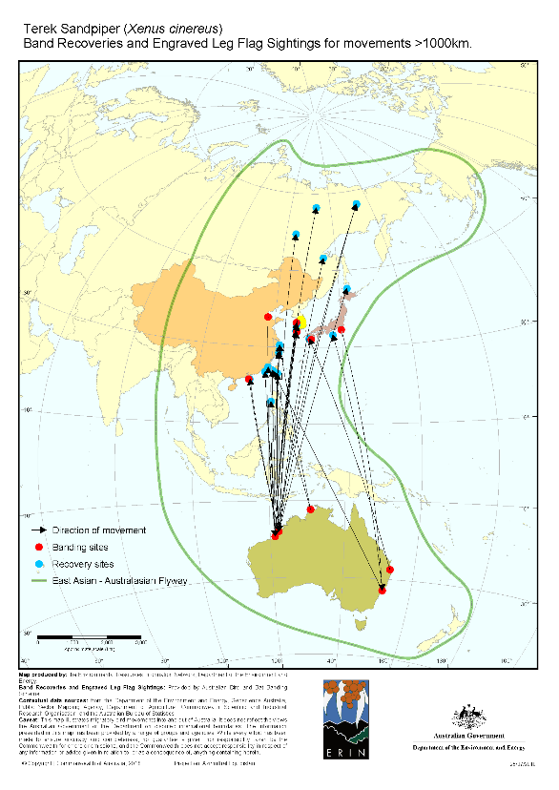

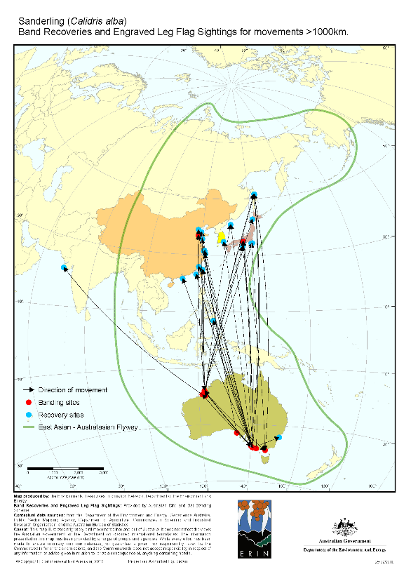

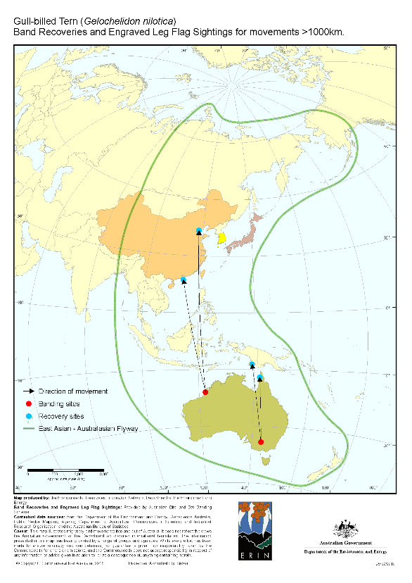

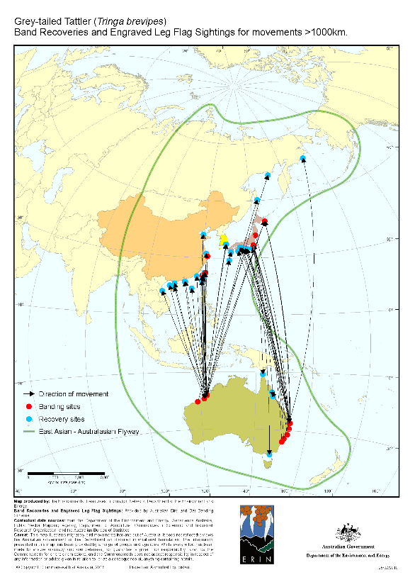

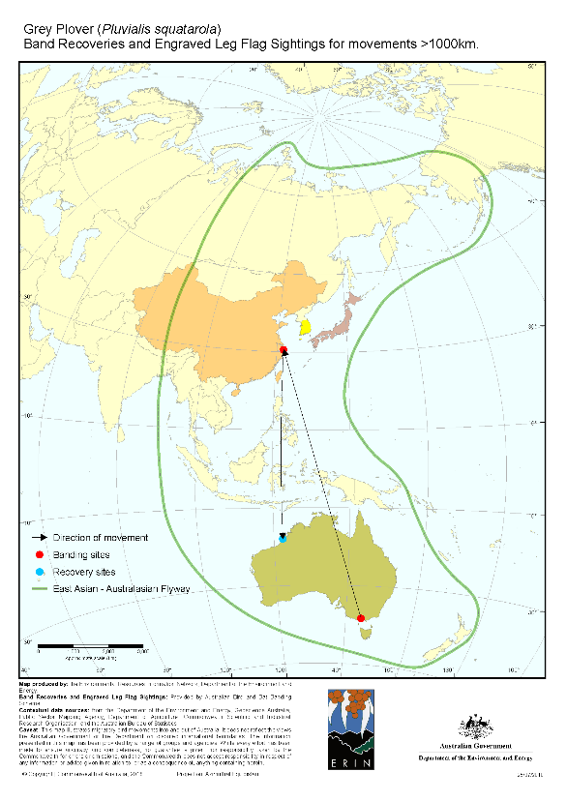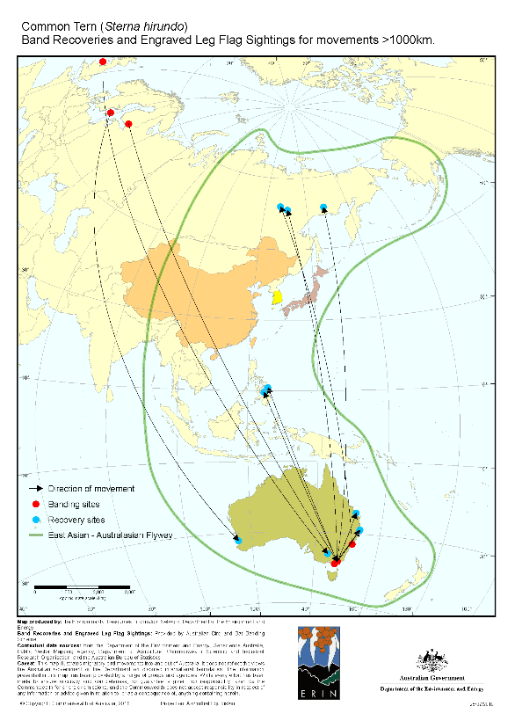

# BirdLife Australia’s activities 2016 - 2018

### BirdLife Australia

**Relevant JAMBA Articles**: I, IV, VI   
**Relevant CAMBA Articles**: I, III, IV   
**Relevant ROKAMBA Articles:** 1, 3

### Summary

BirdLife Australia is Australia’s largest bird conservation organisation. As an independent, not-for-profit organisation, their aim is clear: to create a bright future for Australia’s birds.

BirdLife Australia has been a voice for Australia’s birdlife for well over a century, protecting birds and their habitats through its robust programs and informed advocacy. It is the passion of members and supporters which keeps the organisation moving forward. With active branches and groups across the country, BirdLife Australia is able to tap into local issues as well as understanding the bigger picture.

Over the years BirdLife Australia’s conservation work has achieved beneficial results for a wide range of different species. BirdLife’s experience and specialised knowledge, combined with their ability to unite and inspire the bird- loving community, means that it can act quickly and decisively at local, state and national levels.

### Shorebirds 2020 Update

Shorebirds 2020 (S2020) was the name given to BirdLife Australia’s migratory shorebird project, which commenced in 2007 on the foundations of work undertaken by the Australasian Wader Study Group (AWSG). It has been maintained and continues under the same name, although Shorebirds 2020 now refers to the monitoring program component within BirdLife Australia’s new Migratory Shorebird Program – which itself is underpinned by the Migratory Shorebird Conservation Action Plan.

Brief summary of program statistics:

* 496 mapped shorebird areas nationwide; 2,790 count areas nationwide;
* 1,454 registered online database users, 302 active users in last 18 months
* 54,000 shorebirds ID booklets printed; 38,600 distributed thus far
* 2,300 shorebird posters distributed thus far
* 26,000 shorebirds “wing thing” kids activity education booklets in circulation

##### Survey Coverage and Site Network

With the inclusion of five indigenous ranger groups around the Gulf of Carpentaria, Queensland (Mapoon, Napranum, Pormpuraaw, Borroloola, Millingimbi), as well as numerous other additions to the S2020 site network, such as the Exmouth Gulf, BirdLife Australia are slowly working at filling in the gaps around coastal areas. Inland wetland systems remain generally poorly covered and continue to be a major gap in S2020 coverage, especially for Curlew Sandpiper and Sharp-tailed Sandpiper in wet years (eg 09/10, 10/11).

A number of additional interested Indigenous groups have been identified through BirdLife Australia’s Indigenous Grant Program. Some of these are in strategic locations where we do not have survey coverage at the moment (Maningrida, Milingimbi, Injinoo, Nhulunbuy, Normanton/Karumba).

Through the delivery of the update of Flyway Population Estimates project, several survey coverage gaps have become more apparent than ever (eg. Northern Territory, Kimberley Coast, Gulf of Carpentaria, Inland Australia). The data collation process that was instigated by this project has also highlighted a number of

important sites around the country which now have patchy survey coverage, or ceased survey coverage. A key focus of the program will be addressing these gaps in the upcoming months.

Given S2020 and NAILSMA involvement thus far in initiating training for four ranger groups around the Gulf of Carpentaria, it is paramount that support for these groups continues to be available through further training and on-ground involvement.

It is important that we maintain communication and involvement with these groups to foster relationships. Other groups have expressed interest in the Shorebirds 2020 program around the Gulf of Carpentaria. An additional five groups have expressed interest in receiving shorebird monitoring training.

The ranger groups are uniquely placed to assist with bridging the coverage gaps across northern Australia given their location, resources, interest and knowledge on country.

##### Prioritising workshop program to main Shorebird Areas

S2020 workshops are held in the vicinity of those shorebird areas with long time-series data to make sure these areas continue to be counted on a consistent biannual basis.

The majority of shorebird areas with long time-series count data are those areas in proximity to population centres such as Westernport, Swan River Estuary, and Cairns Foreshore. As such, there are proportionally much larger numbers of potential counters in these areas compared to other shorebird areas which may only have a handful

of counters. Workshops are strategically delivered to areas that currently have a counter shortage, and where local coordinators are asking for additional resources.

##### BirdLife Data Portal - Birdata

BirdLife Australia’s new Birdata web portal is ready. The new Birdata portal incorporates the existing Shorebirds 2020 database and from 7 September 2018, all Shorebirds 2020 count data will need to be entered into the new Birdata portal, rather than the current Shorebirds 2020 database portal, which will be decommissioned in the not-too-distant future. The web address for the new data portal is [http://birdata.birdlife.org.au](http://birdata.birdlife.org.au/)

The new Birdata includes a dedicated app for your handheld Apple or Android device, which allows for data entry in the field for a number of key BirdLife Australia monitoring programs.

### National Migratory Shorebirds Conservation Action Plan Update

Over a series of two workshops (April and December 2016), stakeholders from government, research institutions, NGOs and the international community met to develop detailed strategies to implement the high and very high priority actions from the Australian Government’s Wildlife Conservation Plan for Migratory Shorebirds using the conservation action planning (CAP) approach.

The Migratory Shorebird CAP Steering Committee oversees the implementation of the CAP and is supported by ad hoc working groups where appropriate. Membership on the Steering Committee is made up of BirdLife Australia representatives, government and research institutions. The Committee has been designed to leverage cooperation from stakeholders across government, research institutions and NGOs to capitalise on funding opportunities, ensure relevant expertise and coordinate actions.

BirdLife Australia has undertaken the following actions to support the implementation of the Migratory Shorebird CAP.

##### International engagement

BirdlLife Australia attended the 12th Conference of the Parties of the Convention of Migratory Species (CMS COP12) in Manila as part of the Australian Delegation.

As part of BirdLife Australia’s role as the Coordinator on the EAAFP Far Eastern Curlew Task Force, BirdLife Australia co-hosted a side event at CMS COP12 showcasing Single Species Action Plans in the EAAF, with a particular focus on the two being considered for adoption at COP12 - Far Eastern Curlew and Baer’s Pochard. The Australian Government (Chair, Far Eastern Curlew Task Force), presented on the Single Species Action Plan for Far Eastern Curlew, which was successfully adopted at COP12.

COP12 also adopted a number of resolutions that will be beneficial for migratory shorebird conservation in the EAAF, including a resolution on *Promoting the Conservation of Critical Intertidal Habitats for Migratory Species*, proposed by the Government of the Philippines.

BirdLife International and partners are currently developing a strategy to have a similar resolution adopted under other international agreements, including the Convention on Biological Diversity and the Ramsar Convention.

Attendance at this international meeting also presented an opportunity for discussions with BirdLife International about how BirdLife Australia can best contribute to protecting important habitat in the EAAF outside Australia.

As of January 2018, BirdLife International Asia have been working on coastal bird conservation in the EAAF. BirdLife International Asia is currently looking for ways to strengthen collaboration between the actions of domestic BirdLife partners in the flyway.

BirdLife International organised “A Summit for the Flyways” in Abu Dhabi in April 2018. BirdLife Australia was invited to speak about migratory shorebird conservation in Australia. A key focus of the summit was to discuss strategies for conserving coastal wetlands for migratory shorebirds.

##### Habitat management in Australia

BirdLife Australia is currently completing a Directory of Important Habitat for Migratory Shorebirds for the Australian Government, using national and international significance criteria. This project is due to be

completed in 2018 and will include both species accounts, identifying all sites around Australia that are nationally or internationally significant for a species, and site accounts, which will list all species for which the site is significant. This project is funded by the Australian Government and will be developed in consultation with state governments and local S2020 count coordinators.

BirdLife Australia has been working with the eight Natural Resource Management (NRM) regions in South Australia, along with other key stakeholders such as local councils and Birds South Australia to establish a South Australian Shorebird Alliance to coordinate conservation and management actions for both migratory and resident shorebirds. This alliance facilitated a coordinated approach across South Australia in terms of shorebird related projects that were included in National Landcare Program bids. A Terms of Reference is currently being developed for the Alliance that will be presented to SA NRM boards for approval. The work program for the Alliance is being directly guided by the CAP and represents the first application of the CAP priority actions at a regional/local scale.

BirdLife Australia has received funding from the Helen Macpherson Smith Trust to develop site action plans for migratory shorebirds at 10 priority sites in Victoria, selected from the Directory. This project will include

consultation with site managers and local communities, the creation of a shorebird specific site managers network and a state-wide symposium for site managers in Victoria.

BirdLife Australia has consulted with multiple NRMs around Australia as part of National Landcare Program bids to include funding for revising/creating management plans for migratory shorebirds at key sites, from Tasmania to the Torres Strait.

Following the completion of the Directory, BirdLife Australia will develop a workshop schedule for priority sites to identify relevant site managers, explore options for revising/creating management plans and implementation of site specific on-ground management actions.

BirdLife Australia has received funding ($200,000) under the Port Phillip Bay Fund for ecological and hydrological assessments and on-ground remediation works at Avalon Coastal Park (including Snake Island) in partnership with Parks Victoria. The site includes Snake Island which benefited from the Australian Government’s Threatened Species Commissioner’s funding in 2015. Actions that will be implemented under the funding include:

* Engage surveyors to determine land tenure boundary (currently unknown)
* Undertake baseline ecological assessment to determine values and threats
* Install fencing/repair existing boundary fencing where appropriate (based on outcomes of land survey) to exclude stock from neighbouring properties
* Undertake hydrological study of entire site
* Undertake repair works to existing hydrological management infrastructure based on outcomes of hydrological study
* Repair existing bridge (Snake Island) and outfall gate to allow for water level management (based on outcomes of hydrological survey)
* Undertake pest control to enhance and protect values of the site (plant & animal) and monitor results
* Litter, hard rubbish and asbestos removal across entire site
* Deliver community awareness and volunteer upskilling workshops, facilitate creation of a ‘Friends of Avalon Coastal Reserve’ community group
* Installation and repairing of visitor access infrastructure, such as gates, access tracks and signage
* Investigate opportunities for roost site augmentation for migratory shorebirds and potential roost/nesting site creation/improvement for Little and Fairy Tern
* Develop strategic Plan for long-term management priorities and strategies for Avalon Coastal Reserve

##### Addressing threats to migratory birds

BirdLife Australia has consulted multiple NRMs around the country to facilitate the development of educational materials or workshops to raise awareness about the impacts of recreational disturbance. Birdlife Australia will be working closely with the Beach-nesting Bird Team in the second half of 2018 to refine the work plan for this strategy.

Restoration and remediation works at Avalon Coastal Park (including Snake Island) in partnership with Parks Victoria will provide a case study for wetland habitat rehabilitation guidelines, specifically the restoration of artificial wetlands such as decommissioned salt production facilities.

BirdLife Australia has advocated for protection of important shorebird habitat in Australia under threat from inappropriate development, including a proposed development at a number of important sites.

##### Knowledge exchange to inform decision makers, land managers and the public

BirdLife Australia attended a workshop in Sydney lead by NSW OEH to discuss securing strategically important populations of ‘partnership species’ in NSW. Partnership species primarily occur outside NSW, with less than 10% of their distribution in the state. There are 8 species listed under NSW legislation, six of those have been determined as priority species which have led to the identification of priority sites (as a result of a BLA led project delivered last year).

Focus species are, Curlew Sandpiper, Black-tailed Godwit, Greater Sand-plover, Lesser Sand-plover, Great Knot, and Terek Sandpiper. Two other species, Sanderling and Broad-billed Sandpiper do not have important populations in NSW so have not been considered priority species. Eastern Curlew, Red Knot and Bar-tailed Godwit have not been considered as they are not listed under state legislation.

BirdLife Australia attended a workshop in Brisbane lead by Queensland to discuss opportunities for improved coverage in the Gulf of Carpentaria including the capacity development of local indigenous communities to undertaken ongoing monitoring and on-ground site management in future.

BirdLife Australia is currently conducting a network audit to identify survey coverage and capacity gaps in Shorebirds 2020 Monitoring network. This will inform BLA’s workshop schedule for the coming year and will be completed before 2018/19 Summer Count. BirdLife Australia has a $25,000 budget for workshops in 2018. There is potential for more workshops where external funding is available (e.g. South Coast NRM funded workshops and school visits in Esperance, DBCA funded workshop in Exmouth).

The second half of 2018 will involve updating all Migratory Shorebird Program educational materials including program brochures, ID booklets, school education toolkits/manuals, revising the primary school student/kids Wing Thing, creation of a Birdlife branch specific shorebird program manual and migratory shorebird conservation statement (last updated 2009).

### Directory of Important Habitat for Migratory Shorebirds

Thirty-seven species of migratory shorebird regularly and predictably visit Australia during their non-breeding season, from the Austral spring to autumn. In late 2016, a revision of the flyway population estimates of the 37 migratory shorebirds species routinely visiting Australia was completed by a team of migratory shorebird experts (Hansen et al. 2016).

As the population estimates form the basis for threshold-based conservation designations, their accuracy will better improve conservation decisions (e.g. to guide identification of important habitat under the Australian Wildlife Conservation Plan for Migratory Shorebirds).

The previous assessments of sites of importance focused on international significance criteria only (Watkins 1993, Bamford et al. 2008), and the most recent identified 118 areas of international importance within the country (Bamford et al. 2008). With a significant increase in the number of monitoring sites included in the Shorebirds 2020 program, and subsequent increase in amount of contemporary population monitoring data, there are likely to be many additional sites meeting the importance criteria.

The criteria used to identify an internationally important area, is that the site regularly supports:

* 1%of the individuals in a population of one species or subspecies of waterbird; or,
* a total abundance of at least 20 000 shorebirds.

Nationally important habitat for migratory shorebirds is defined if it regularly supports:

* 0.1 per cent of the flyway population of a single species of migratory shorebird; or,
* 2000 migratory shorebirds; or,
* 15 migratory shorebird species.

The S2020 database will be updated prior to a complete database extraction. Similar to the Flyway Population Estimates revision (Hansen et al. 2016), this will include targeted engagement with regional counters to:

* instigate surveys in areas which had not been covered in recent years;
* obtain and enter current data from areas which had been surveyed in recent years but not yet been submitted; and
* seek current data for areas that are housed in alternative or other regional and state databases.

### Colour Flagging Migration Research

The Australasian Wader Studies Group (AWSG) is a special interest group of BirdLife Australia formed to coordinate and focus studies on shorebirds in Australia and along their migration routes. The AWSG aims to ensure the future of shorebirds and their habitats in Australia through research and conservation programs and to encourage and assist similar programs in the rest of the East Asian-Australasian Flyway.

Migration and habitat research using leg flags are key ongoing activities of the AWSG. Plastic (Darvic or similar) leg flags are attached to the birds. Re-sightings of flagged birds along the flyway are recorded in a central database and analysed to determine migration routes, destinations and stopover locations.

This report includes data on flag sightings in Australia of shorebirds banded in Japan, China and Republic of Korea, and the numbers of flag sightings in these three countries of shorebirds banded in Australia based on data collected to December 2017.

##### About the Project

Marking of shorebirds with PVC plastic leg flags is an important part of research into shorebird migration. The AWSG is involved in this activity in Australia, both in application of flags to birds and in recording and analysis of sightings of flagged birds. As of August 2018, the leg-flagging database contained a total of 183,340 records (further records pending as several Australian databases are in the process of amalgamation). Of these, 158,015 were from birds originally flagged in Australia (103,689 resighted within Australia and 54,326 resighted overseas). It also contained 25,325 reports of birds flagged overseas (13,684 resighted within Australia and 11,641 resighted overseas).

Lists of flag sightings relating to Australian flagged shorebirds are provided in Tables 1 and 2 below.

The AWSG and the Australian Government appreciate the cooperation from researchers and banding schemes in Japan, China and Republic of Korea in providing sighting records.

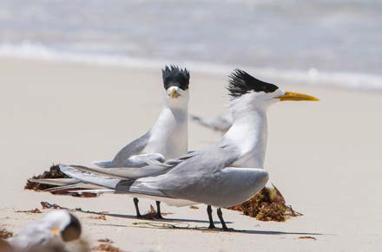

Greater Crested Tern *(Thalasseus bergii*), Rottnest Island, Western Australia © Georgina Steytler

**Table 1.** Flag sightings in Australia of shorebirds flagged in Japan, Republic of Korea and China (to December 2017).

|  |  |  |  |  |  |  |
| --- | --- | --- | --- | --- | --- | --- |
| **Year** | **Japan** | **Republic of Korea** | **China** | **mainland** | **Hong Kong** | **Chinese Taipei** |
| 1995 | 7 |  |  |  |  |  |
| 1996 | 14 |  |  |  |  |  |
| 1997 | 8 |  |  |  |  |  |
| 1998 | 14 |  |  |  |  |  |
| 1999 | 15 |  |  |  |  |  |
| 2000 | 11 | 4 |  |  |  |  |
| 2001 | 28 | 5 |  |  |  |  |
| 2002 | 34 | 11 | 12 | 8 | 2 | 2 |
| 2003 | 16 | 15 | 15 | 9 | 0 | 6 |
| 2004 | 14 | 14 | 47 | 38 | 4 | 5 |
| 2005 | 12 | 7 | 249 | 232 | 1 | 16 |
| 2006 | 26 | 4 | 457 | 445 | 1 | 11 |
| 2007 | 49 | 2 | 676 | 661 | 1 | 14 |
| 2008 | 43 | 0 | 555 | 541 | 1 | 13 |
| 2009 | 51 | 2 | 702 | 686 | 1 | 15 |
| 2010 | 39 | 14 | 1033 | 1003 | 2 | 28 |
| 2011 | 38 | 6 | 919 | 899 | 6 | 14 |
| 2012 | 45 | 5 | 860 | 811 | 27 | 22 |
| 2013 | 43 | 9 | 1265 | 1185 | 30 | 50 |
| 2014 | 80 | 7 | 1318 | 1226 | 34 | 58 |
| 2015 | 84 | 5 | 1197 | 1120 | 9 | 68 |
| 2016 | 98 | 1 | 1060 | 1017 | 2 | 41 |
| 2017 | 94 | 0 | 831 | 815 | 13 | 3 |

**Table 2.** Australian flagged shorebirds sighted in Japan, Republic of Korea and China.

|  |  |  |  |  |  |  |
| --- | --- | --- | --- | --- | --- | --- |
| **Year** | **Japan** | **Republic of Korea** | **China** | **mainland** | **Hong Kong** | **Chinese Taipei** |
| 2012 | 39 | 187 | 4141 | 3840 | 91 | 210 |
| 2013 | 55 | 193 | 2859 | 2611 | 113 | 135 |
| 2014 | 50 | 253 | 3820 | 3589 | 94 | 137 |
| 2015 | 47 | 316 | 3271 | 3136 | 49 | 86 |
| 2016 | 74 | 396 | 3268 | 3112 | 68 | 88 |
| 2017 | 59 | 234 | 595 | 488* | 1 | 106 |

*exceedingly low shorebird numbers present during annual Bohai Bay counts

# 

# Key results of migratory bird research at the University of Queensland 2016 - 2018

### Professor Richard Fuller, University of Queensland

**Relevant JAMBA Articles**: IV   
**Relevant CAMBA Articles**: III   
**Relevant ROKAMBA Articles:** 3

### Summary

Each bilateral migratory bird agreement encourages the exchange of data and publications regarding research on migratory birds and birds in danger of extinction. Parties are also encouraged to develop joint research programs that would benefit the conservation and management of migratory birds and their habitats.

Research efforts from the University of Queensland continue to focus on migratory shorebirds and their habitats. Please contact Professor Richard Fuller ([r.fuller@uq.edu.au](mailto:r.fuller@uq.edu.au)) with any enquiries about these projects, or suggestions for further work or collaborations

### Telling the story of shorebird monitoring in Australia: A successful long-term collaboration among citizen scientists, governments and researchers

From its beginnings in the 1960s, shorebird monitoring in Australia has grown into a national effort generating high quality information about a large group of migratory and non-migratory waterbirds. Robust information on trends, combined with detailed demographic monitoring and studies of bird movements, has revealed drastic

declines, particularly among the migratory species. From the start, monitoring focused on a broad range of species meaning that the reasons for these declines could be understood through comparative analyses in partnership with researchers. Threats to migratory and non-migratory species, and the actions necessary for their recovery,

are increasingly well resolved. Shorebird monitoring in Australia has been a largely decentralised, volunteer- driven effort, funded from both public and private sources. It exemplifies how the public and private sectors can work together to achieve long term monitoring. We tell the story of the history and development of shorebird monitoring in Australia, together with reflections on lessons learnt in this book chapter.

*Reference:* Hansen BD, Clemens RS, Gallo-Cajiao E, Jackson MV, Maguire GS, Maurer G, Milton D, Rogers DI, Weller DR, Weston MA, Woehler EJ & Fuller RA (2018) Shorebird monitoring in Australia: a successful long-term collaboration between citizen scientists, governments and researchers. *In* Legge S, Robinson N, Scheele B, Lindenmayer D, Southwell D & Wintle B (eds) *Monitoring Threatened Species and Ecological Communities*.

CSIRO, Canberra.

### Discovering why migratory shorebirds are declining in the East Asian- Australasian Flyway

Migratory shorebirds are threatened by human-induced global change, and many species are in rapid decline in the East Asian-Australasian Flyway. Although it has long been suspected that habitat loss in stopover areas has been causing these declines, it has been difficult to demonstrate this scientifically. Using 20 years of continent- wide citizen science data, we assessed population trends of ten shorebird species that refuel on Yellow Sea tidal mudflats, a threatened ecosystem that has shrunk by >65% in recent decades (discussed below in ‘Seawalls and biodiversity’). Seven of the taxa significantly declined (*menzbieri* Bar-tailed Godwit, Far Eastern Curlew, Curlew Sandpiper, Great Knot, Red Knot, Lesser Sand Plover, *baueri* Bar-tailed Godwit). Taxa with the greatest reliance on the Yellow Sea as a stopover site showed the greatest declines, whereas those that stop primarily in other regions had slowly declining or stable populations. Decline rate was unaffected by shared evolutionary history among taxa and was not predicted by migration distance, breeding range size, non-breeding location, generation time or body size. These results suggest that threats operating in the Yellow Sea are driving declines in migratory shorebird populations in the East Asian-Australasian Flyway, and points to the central importance of efforts to stop threats from worsening in this region.

*Reference:* Studds CE, Kendall BE, Murray NJ, Wilson HB, Rogers DI, Clemens RS, Gosbell K, Hassell CJ, Jessop R, Melville DS, Milton DA, Minton CDT, Possingham HP, Riegen AC, Straw P, Woehler EJ & Fuller RA (2017) Rapid population decline in migratory shorebirds relying on Yellow Sea tidal mudflats as stopover sites. Nature Communications, 8, 14895.

### Case study: causes of decline in Bar-tailed Godwits in the East Asian- Australasian Flyway

The two sub-species of Bar-tailed Godwit both travel tens of thousands of kilometres each year, but spend different parts of their annual cycle in geographically distinct locations. The geographic separation but shared evolutionary history, migration distance, and morphology of the two sub-species provides an opportunity to isolate the factors driving variability in abundance in the Bar-tailed Godwit *Limosa lapponica*. We compiled a spatially and temporally explicit dataset of three remotely-sensed environmental variables to identify conditions at each stage of the annual cycle (breeding, non-breeding and staging) for the two sub-species and related this information to 18 years of monthly count data from 21 sites across Australia and New Zealand. We found that the abundance of subspecies *menzbieri* in the nonbreeding range was related to climate conditions in breeding grounds, and detected sustained population declines between 1995 and 2012 in both subspecies (*menzbieri* -6.7%, *baueri* -2.1% per year). To investigate the possible causes of the declines, we quantified changes in habitat extent at 22 migratory staging sites in the Yellow Sea, East Asia, over a 25-year period and found -1.7% and -1.2% per year loss of habitat at staging sites used by *menzbieri* and *baueri*, respectively. This highlights the need to identify environmental and anthropogenic drivers of population change across all stages of migration to allow the formulation of effective conservation strategies.

*Reference:* Murray NJ, Studds CE, Fuller RA, Clemens RS, Dhanjal-Adams KL, Gosbell KB, Hassell CJ, Iwamura T, Minton CDT, Riegan AC, Rogers DI, Woehler EJ & Marra PP (2018) The large-scale drivers of population declines in a long-distance migratory shorebird. *Ecography*, 41, 867-876.

### Seawalls and biodiversity

Coastal armouring and the reclamation of intertidal areas through the use of seawalls and other artificial structures has been practiced for thousands of years, but its recent expansion in China and elsewhere in Asia has been unprecedented in its rate and intensity. One result has been the loss of nearly two-thirds of tidal flats in the Yellow Sea, a globally unique ecosystem of high ecological value. The severe effects on biodiversity of large-scale coastal land claim activities in China are well documented, yet some recent studies have emphasized the ecological opportunities provided by such artificial coastal infrastructure in China, in some cases suggesting that the ecological impacts of coastal infrastructure should be reconsidered due to benefits to some rocky shore species in a changing climate. This is cause for concern because, while studying the “new ecology” arising from coastal modification is useful, broad conclusions around the ecological role or conservation gains from seawall construction without adequate contextualization underplays the ecological consequences of large-scale coastal land claim, and could potentially undermine efforts to achieve conservation of biodiversity, including migratory shorebirds and other waterbirds. In a recent study, we clarified the characteristics of seawall construction in China and summarized the environmental damage and some broad-scale impacts caused by this type of infrastructure expansion on the endangered Yellow Sea tidal flats ecosystem. Through this and other ongoing work, we continue to highlight the urgent need for all coastal development plans to consider how coastal wetlands and ecosystem functionality can be maximally retained within the development precinct.

*Reference:* Choi C-Y, Jackson MV, Gallo-Cajiao E, Murray NJ, Clemens RS, Gan X & Fuller RA (2018) Biodiversity and China’s new Great Wall. *Diversity and Distributions*, 24, 137-143.

### Measuring the global distribution and status of tidal flats

As evidenced in the previous sections, tidal flats are a critical habitat for migratory birds and also a key ecosystem underpinning the functioning of coastal ecosystems and the protective capacity for the human population that they provide. Yet they have never been mapped on a large scale. A UQ team, led by Dr Nicholas Murray and funded by Google, have mapped tidal flats globally at a 30-metre resolution, using Landsat data. The project has analysed 700,000 Landsat satellite images, to map the global extent and change of the tidal flats over 33 years, 1984−2016. The final intertidal dataset, which is publicly available, consists of 11 global maps of tidal flats at

30-m pixel resolution for set time-periods (1984−1986; 1987−1989; 1990−1992; 1993−1995; 1996−1998; 1999−2001; 2002−2004; 2005−2007; 2008−2010; 2011−2013; 2014−2016). A set of quality assurance layers indicating the depth of the image stacks used to classify each pixel of the intertidal layer are also provided (“qa”), and the team is expecting to update the mapping every three years. Soon to be published, the data will be made available open access so that analyses of tidal flat change can be performed for any area around the world. The data could, for example, be used to monitor natural changes in tidal flat distributions across seasons or between years, or to investigate how tidal flats respond to anthropogenic impacts such as mangrove removal, coastal development or reclamation. They could also be used to monitor the effectiveness of coastal protected areas in maintaining tidal flats, and to investigate where large expanses of unprotected tidal flats might occur. Countries can use the data to assess performance against Sustainable Development Goals and Convention of Biological Diversity targets for intertidal ecosystems, something that has not previously been possible.

*Reference:* Study submitted to a journal, but not yet published (July 2018).

### Protecting intertidal habitats in Australia

As a precursor to measuring the intertidal environment globally, we utilised freely available satellite imagery to produce the first map and quantify protection status of intertidal habitats across Australia. We estimated a minimum intertidal area of 9,856 km2, with Queensland and Western Australia supporting the largest areas.

Thirty-nine percent of intertidal habitats were protected in Australia, with some primarily within marine protected areas (e.g. Queensland) and others within terrestrial protected areas (e.g. Victoria). Three percent of all intertidal habitats were protected by both marine and terrestrial protected areas. To achieve conservation targets, protected area boundaries must align more accurately with intertidal habitats. Shorebirds use intertidal areas to forage and supratidal areas to roost, so a coordinated management approach is required to account for movement of birds between terrestrial and marine habitats. Ultimately, shorebird declines are occurring despite high levels of habitat protection in Australia. There is a need for a concerted effort both nationally and internationally to map and understand how intertidal habitats are changing, and how habitat conservation can be implemented more effectively.

*Reference:* Dhanjal-Adams KL, Hanson JO, Murray NJ, Phinn SR, Wingate VR, Mustin K, Lee JR, Allan JR, Cappadonna JL, Studds CE, Clemens RS, Roelfsema CM & Fuller RA (2016) The distribution and protection of intertidal habitats in Australia. *Emu*, 116, 208-214.

### Managing disturbance to migratory shorebirds

Protected areas often need to provide recreational opportunities whilst conserving biodiversity. Recreation brings important benefits to human well-being, and allowing people to experience nature in protected areas can also provide revenue and support for conservation objectives. However, not all recreational activities are compatible with environmental management goals. We conducted a research project to determine how a coastal protected area can be zoned to satisfy both recreational and conservation objectives. We collected empirical data on the effect of recreational disturbance to foraging shorebirds in Moreton Bay Marine Park, Queensland, Australia, and calculated the benefit of alternative protected area zone types on shorebird representation using a zero- inflated negative binomial model. The predictions from this model were used to optimize a zoning plan in a linear programming framework that balances recreational use with shorebird conservation. Costs reflect foregone recreational opportunity, thereby facilitating solutions that minimize restrictions on recreational use of the coastline.

We discovered a consistent negative effect of recreational use of the foreshore on shorebird occupancy and abundance and show that, despite this, zoning can be used to achieve shorebird representation targets with only a small cost to recreational opportunity. When dog recreation is permitted at all sites, a 91% shorebird

representation target can be met, indicating that de facto patterns of recreation were rather well segregated from areas used by shorebirds. By restricting dog recreation to five sites and allowing people to access all other foreshore sites, shorebird representation increased to 97%.

Our approach of calculating the contribution of each zone type towards conservation objectives results in zoning plans with robust estimates of conservation benefit that can be readily implemented by managers. Specifically, we estimated the effects of removing people and domestic dog recreation within each intertidal site on shorebird abundance to inform coastal zoning plans. Incorporating cost as foregone recreational opportunity results in zoning plans that minimize the number of people required to make a behavioural change. Compliance to zone

types is often ultimately voluntary so integrating the current intensity of recreational use is more likely to generate workable zoning plans.

In a second study we showed that where enforcement activity (e.g. ranger patrols) is needed to ensure compliance with conservation zoning, visiting a range of enforcement sites at varying rates yields a greater return on investment than visiting only a fixed number of sites. Assuming an exponential reduction in disturbance from enforcement, the greatest benefit can be achieved by patrolling many sites a small number of times. Assuming a linear reduction in disturbance from enforcement, repeatedly patrolling a small number of sites where return on investment is high is best. If we only prioritize sites where wildlife is disturbed most often, or where abundance

is greatest, we will not achieve an optimal solution. The choice of patrol location and frequency is not a trivial problem, and prudent investment can substantially improve conservation outcomes.

*References:* Stigner MG, Beyer HL, Klein CJ, & Fuller RA (2016) Reconciling recreational use and conservation values in a coastal protected area. *Journal of Applied Ecology*, 53, 1206-1214; Dhanjal-Adams KL, Mustin K, Possingham HP & Fuller RA (2016) Optimizing disturbance management for wildlife protection: The enforcement allocation problem. *Journal of Applied Ecology*, 53, 1215-1224.

### Climate change is reducing the amount of breeding habitat for EAAF shorebirds

Although habitat loss in the Yellow Sea has been and continues to be a primary driver of shorebird declines in the EAAF, rapid climate change in the Arctic could emerge as an increasingly important threat by influencing where species are able to breed and disrupting migratory connections globally. We modelled the climatically suitable breeding conditions of 24 Arctic specialist shorebirds and projected them to 2070 and to the mid-Holocene climatic optimum, the world’s last major warming event ~6000 years ago. We show that climatically suitable breeding conditions could shift, contract and decline over the next 70 years, with 66–83% of species losing the majority of currently suitable area. This exceeds, in rate and magnitude, the impact of the mid-Holocene climatic optimum. Suitable climatic conditions are predicted to decline acutely in the most species rich region, Beringia (western Alaska and eastern Russia), and become concentrated in the Eurasian and Canadian Arctic islands.

These predicted spatial shifts of breeding grounds could affect the species composition of the world’s major flyways. Encouragingly, protected area coverage of current and future climatically suitable breeding conditions generally meets target levels; however, there is a lack of protected areas within the Canadian Arctic where resource exploitation is a growing threat. Our results emphasize the urgency of mitigating climate change and protecting Arctic biodiversity.

*Reference:* Wauchope HS, Shaw JD, Varpe Ø, Lappo EG, Boertmann D, Lanctot RB & Fuller RA (2017) Rapid climate-driven loss of breeding habitat for Arctic migratory birds. *Global Change Biology*, 23, 1085-1094.

### Which sites need to be protected to maintain migratory shorebird populations?

With the rapid growth in our understanding of threats that have driven population declines in the EAAF it is increasingly essential that this information be applied to develop conservation strategies to reverse declines and stabilize future populations. Conserving migratory shorebirds requires protecting connected habitat along the pathways they travel. Despite recent improvements in tracking shorebird movements through on-board devices, migratory connectivity remains poorly resolved at a population level for the vast majority of species, making it difficult to identify a critical network of sites for shorebird conservation. To address this data limitation, we developed a novel approach to spatial prioritization based on a model of potential connectivity derived from empirical data on species abundance and distance travelled between sites during migration. Conservation strategies that prioritized sites based on connectivity and abundance metrics together maintained larger populations of birds than strategies that prioritized sites based only on abundance metrics. The conservation value of a site therefore depended on both its capacity to support migratory animals and its position within the migratory pathway; the loss of crucial sites led to partial or total population collapse. We suggest that

conservation approaches that prioritize sites supporting large populations of migrants should, where possible, also include data on the spatial arrangement of sites.

*Reference:* Dhanjal-Adams KL, Klaassen M, Nicol S, Possingham HP, Chadès I & Fuller RA (2017) Setting conservation priorities for migratory networks under uncertainty. *Conservation Biology*, 31, 646-656.

# National Avian Influenza Wild Bird Surveillance Program

### National Avian Influenza Wild Bird Steering Group

**Compiled by:**

Tiggy Grillo & Silvia Ban, Wildlife Health Australia

on behalf of Australia’s National Avian Influenza Wild Bird Steering Group

**Relevant JAMBA Articles:** III, IV, VI   
**Relevant CAMBA Articles:** III, IV, V   
**Relevant ROKAMBA Articles:** 3, 5, 7

### Summary

Activities under the [National Avian Influenza Wild Bird (NAIWB) Surveillance Program](http://www.wildlifehealth.org.au/ProgramsProjects/AvianInfluenzaWildBirdSurveillance.aspx) are conducted Australia- wide. The Program has two main components: Targeted surveillance: pathogen-specific, risk-based surveillance via convenience sampling of apparently healthy, live and hunter-killed wild birds, and General (passive) surveillance: investigation of significant, unexplained morbidity / mortality events in wild birds, including captive and wild birds within zoo grounds. During 2017, targeted surveillance activities included testing of samples for avian paramyxoviruses (APMVs), predominantly targeting APMV-1.

Targeted surveillance focuses on sampling predominantly from Anseriformes (waterfowl) and a small number of Charadriiformes (shorebirds), specifically from locations where there is known mixing of Charadriiformes and Anseriformes and in locations in close proximity to poultry and humans. Where possible, surveillance will continue in locations previously sampled to obtain longitudinal data. Samples are collected through State and Territory government agency programs, the Northern Australia Quarantine Strategy (NAQS) Program and university research projects. There continues to be an emphasis on virus isolation and genotyping of avian influenza viruses (AIVs) in order to inform risk and allow ongoing assay development for influenza testing.

Surveillance activities will continue through to the end of 2018.

General surveillance focuses on exclusion of AI and virulent APMV-1 from mass mortality and morbidity events in wild birds around Australia and the Australian Antarctic Territory. The wild bird program is part of a larger national program involving domestic bird surveillance, research and international responsibilities, and ongoing communication to industry.

The NAIWB Surveillance Program continues to provide Australia with important outcomes. These include to:

* Detect avian influenza^ in wild birds,
* Contribute to a better understanding of AI^ phylogeny and gene flow of subtypes, ecology and epidemiology to support industry and human and wildlife health strategic risk assessment and management,
* Maintain national avian influenza laboratory diagnostic capacity and capability,
* Sharing and communication of data nationally and globally,
* Contribute to One Health through regular communication of AIV data to the Department of Health with specific analysis of wild bird AIVs for likelihood of infection and transmission in humans, and
* Exclude AIV and APMV-1, specifically H5 and H7, in mass mortality events in wild birds. Footnote: ^and APMV-1 during 2017.

Since 2005, over 104,000 wild birds have been sampled as part of active wild bird surveillance at sites in New South Wales, Queensland, Victoria, Tasmania, South Australia, Northern Territory and Western Australia, with 9,997 wild birds sampled between July 2016 and June 2018, of which 5,062 samples were also tested for APMV-1. In addition, over 3,200 wild bird mortality / morbidity events have been investigated and reported since 2005, with over 600 events investigated and reported between July 2016 and June 2018.

No highly pathogenic AIVs nor virulent strains of APMV-1 have been identified. Almost all AIV subtypes have been detected, including LPAI H5 and H7 subtypes in wild birds in Australia.

Recent avian influenza and other avian virus publications from Australia include:

* Scott AB et al (2018). Low-and high-pathogenic avian influenza H5 and H7 spread risk assessment within and between Australian commercial chicken farms. *Frontiers in Veterinary Science*, *5*, 63. [https://www. frontiersin.org/articles/10.3389/fvets.2018.00063/full](https://www.frontiersin.org/articles/10.3389/fvets.2018.00063/full)
* Singh M et al (2018). Assessing the probability of introduction and spread of avian influenza (AI) virus in commercial Australian poultry operations using an expert opinion elicitation. *PloS one*, *13*(3), e0193730. http://journals.plos.org/plosone/article?id=10.1371/journal.pone.0193730
* Vibin J et al (2018). Metagenomics detection and characterisation of viruses in faecal samples from Australian wild birds. *Scientific Reports (Nature Publisher Group)*, *8*, 1-23. <https://www.nature.com/articles/s41598-018-26851-1>
* Chamings A et al (2018). Detection and characterisation of coronaviruses in migratory and non-migratory Australian wild birds. *Scientific reports*, *8*(1), 5980. <https://www.nature.com/articles/s41598-018-24407-x>

Every three months general wildlife disease surveillance information submitted to the national [electronic Wildlife](https://www.wildlifehealthaustralia.com.au/ProgramsProjects/eWHISWildlifeHealthInformationSystem.aspx) [Health Information System (eWHIS)](https://www.wildlifehealthaustralia.com.au/ProgramsProjects/eWHISWildlifeHealthInformationSystem.aspx) is collated and submitted by Wildlife Health Australia to a quarterly publication called Animal Health Surveillance Quarterly (AHSQ), which is produced by [Animal Health](http://www.animalhealthaustralia.com.au/)  [Australia](http://www.animalhealthaustralia.com.au/) as part of Australia’s national animal health information system or NAHIS. Each quarter, AHSQ contains a section on the main wildlife disease incidents that have occurred around Australia and includes a specific section on Wild bird mortality event summary — APMV-1 and AI exclusions. During the October to December 2017 quarter, a special report was included in AHSQ on seabird and shorebird mortalities. The full article is available here: <http://www.sciquest.org.nz/elibrary/download/143098/Wildlife_Health_Australia.pdf> (also attached)

See WHA website: <https://www.wildlifehealthaustralia.com.au/ProgramsProjects/WildBirdSurveillance.aspx>for a list of references and a link to AHSQ reports here: [https://www.wildlifehealthaustralia.com.au/DiseaseIncidents/](https://www.wildlifehealthaustralia.com.au/DiseaseIncidents/HistoricIncidents.aspx) [HistoricIncidents.aspx](https://www.wildlifehealthaustralia.com.au/DiseaseIncidents/HistoricIncidents.aspx)

Given Australia’s geographic and ecological isolation, it is recognised that assumptions about AIV and APMV- 1 epidemiology in Australia should not be based entirely on studies from overseas. The NAIWB Surveillance Program continues to provide valuable ecological and epidemiological background information to assist strategic risk management to minimise the economic, environmental and social impacts of AI (or HPAI) and virulent APMV-1 on human health, poultry industry and wildlife in Australia.

In particular, it is extremely important to maintain and update the capacity to rapidly and reliably test for AIV and APMV-1 in Australian poultry and wild birds as these viruses undergo constant evolution. Samples from the NAIWB Surveillance Program provide a principle source of AIV (and APMV-1 in 2017) sequence data necessary to monitor the ongoing evolution of Australian-specific lineages. These detections also allow regular evaluation of primer target sequence variability.

This provides continued confidence that the tests being used in Australia will detect any strains of highly pathogenic avian influenza H5 or H7 or virulent APMV-1.

The multi-agency and cross-jurisdictional approach of this project provides a forum for collaboration on technical aspects of influenza in humans, animals and wildlife.

##### Background:

The National Avian Influenza Wild Bird Steering Group (the NAIWB Steering Group) was established in January 2006 to facilitate collaboration between State and Territory programs and non-government organisations

undertaking surveillance for avian influenza. Primary Industry agencies agreed to strengthen national surveillance for avian influenza in both poultry and wild birds.

The NAIWB Steering Group comprises representation from:

* Australian Department of Agriculture and Water Resources (DAWR)
* Australian Department of the Environment and Energy
* Australian Department of Health
* CSIRO Australian Animal Health Laboratory
* DAWR’s Northern Australia Quarantine Strategy (NAQS) Program
* State and Territory government animal health departments in NSW, Qld, SA, Tas, Vic and WA
* World Health Organisation Collaborative Centre for Influenza in Melbourne
* Birdlife Australia
* Rural Industries Research and Development Corporation (RIRDC) / Poultry Industry representation
* Deakin University, University of Newcastle, James Cook University

The NAIWB Steering Group is responsible for development and implementation of a yearly operating plan and coordination of surveillance activities for AI and in 2017, APMV-1, in wild birds in Australian states and territories.

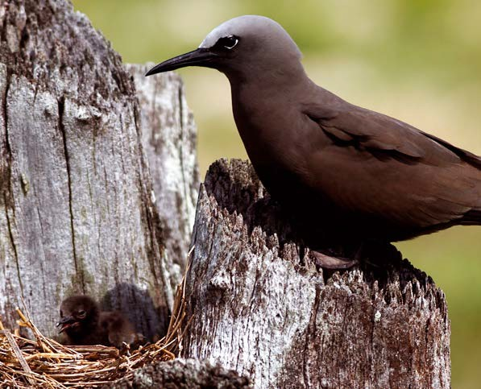Nationally coordinated activities have been conducted since 2006, with funding provided by the Australian Government Department of Agriculture and Water Resources and significant in-kind support provided by the jurisdictional agencies, researchers and representative’s institutions.

A combination of healthy, live and hunter-killed wild birds (targeted surveillance) and sick or dead wild birds (general surveillance) are sampled for surveillance. Sources for targeted wild bird surveillance data include state and territory government laboratories, universities and samples collected under Australia’s Northern Australia Quarantine Strategy (NAQS) Program. Samples from sick birds include submissions from members of the public, private practitioners, universities, zoos and sanctuaries. Wildlife Health Australia manages the Program.

Results from the NAIWB Surveillance Program are used to inform policy development and planning by Australian government and state/territory government agencies and contribute to Australia’s National Animal Health Information System (NAHIS). The data also informs Australia’s international reporting; and summary data are provided to industry at regular intervals through each sampling year.

Common Noddy *(Anous stolidus*) on North Keeling Island © Copyright Department of the Environment and Energy

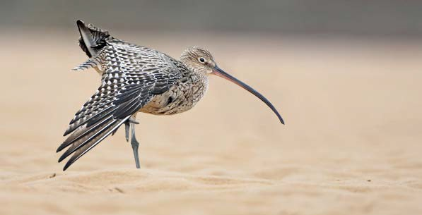

MAR358_0916

**environment**.gov.au