

Australian National Report to the 18th JAMBA, 12th CAMBA and 5th ROKAMBA Consultative Meetings

Cairns, Queensland, Australia  
25 to 28 October 2016

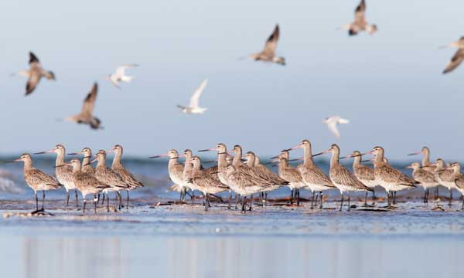

**Agreement between the Government of Australia and the Government of Japan for the Protection of Migratory Birds and Birds in Danger of Extinction and their Environment Eighteenth Consultative Meeting**

and the

**Agreement between the Government of Australia and the Government of the People’s Republic of China for the Protection of Migratory Birds and their Environment Twelfth Consultative Meeting**

and the

Agreement between the Government of Australia and the Government of the Republic of Korea on the **Protection** of Migratory Birds and their Environment Fifth Consultative Meeting

© Commonwealth of Australia, 2016.



Australian National Report to the 18th JAMBA, 12th CAMBA and 5th ROKAMBA Consultative Meetings is licensed by the Commonwealth of Australia for use under a Creative Commons Attribution 4.0 International licence with the exception of the Coat of Arms of the Commonwealth of Australia, the logo of the agency responsible for publishing the report, content supplied by third parties, and any images depicting people. For licence conditions click [here](http://creativecommons.org/licenses/by/4.0/au/%20).

This report should be attributed as ‘Australian National Report to the 18th JAMBA, 12th CAMBA and 5th ROKAMBA Consultative Meetings, Commonwealth of Australia 2016’.

The Commonwealth of Australia has made all reasonable efforts to identify content supplied by third parties using the following format ‘© Copyright, [name of third party] ’.

**Disclaimer**  
The views and opinions expressed in this publication are those of the authors and do not necessarily reflect those of the Australian Government or the Minister for the Environment and Energy.

# Contents

Introduction 4

Implementation of the Agreements by the Australian Government 6

Commonwealth 10

State and Territory Governments 36

Update on species or subspecies of birds in danger of extinction 53

Take of migratory birds or their eggs in accordance with Article II 55

Coordination of the Australian Bird and Bat Banding Scheme 56

Migration Research through Colour Flagging 74

National Avian Influenza Wild Bird Surveillance Program update 77

# Introduction

The *Environment Protection and Biodiversity Conservation Act 1999* (the EPBC Act) is the Australian Government’s central piece of environmental legislation. The EPBC Act provides a legal framework to protect and manage nationally and internationally important flora, fauna, ecological communities and heritage places—defined in the EPBC Act as matters of national environmental significance.

Migratory species listed under the EBPC Act are also matters of national environmental significance. Migratory species are those animals that migrate to Australia and its external territories, or pass though or over Australian waters during their annual migrations. Examples of migratory species are species of birds (e.g. albatrosses and petrels), mammals (e.g. whales) or reptiles (e.g. marine turtles). Listed migratory species are those listed on the appendices of the Convention on the Conservation of Migratory Species of Wild Animals (the CMS or Bonn Convention), the Japan-Australia Migratory Bird Agreement (JAMBA), the China-Australia Migratory Bird Agreement (CAMBA) and the Republic of Korea-Australia Migratory Bird Agreement (ROKAMBA).

Matters of national environmental significance are important to all Australians and, given the interconnectedness of the global biosphere, internationally as well. The EPBC Act aims to balance the protection of these crucial environmental and cultural values with our society’s economic and social needs by creating a legal framework and decision-making process based on the guiding principles of ecologically sustainable development. Specifically, the EPBC Act aims to:

* provide for the protection of the environment, especially matters of national environmental significance
* conserve Australia’s biodiversity
* protect biodiversity internationally by controlling the international movement of wildlife
* provide a streamlined environmental assessment and approvals process where matters of national environmental significance are involved
* protect our world and national heritage
* promote ecologically sustainable development.

All species on the list of migratory species are matters of national environmental significance under the EPBC Act. An action will require approval if the action has, will have, or is likely to have, a significant impact on a listed migratory species. The action must be referred to the Minister and undergo an environmental assessment and approval process.

For over 40 years, Australia has played an important role in international cooperation to conserve migratory birds in the East Asian - Australasian Flyway, entering into bilateral migratory bird agreements with Japan in 1974, China in 1986 and the Republic of Korea in 2006. Each of these agreements provides for the protection and conservation of migratory birds and their important habitats, protection from take or trade except under limited circumstances, the exchange of information, and building cooperative relationships.

The Australian Government recognises that habitat loss and degradation is a significant threat to many of our migratory birds, and the conservation of important sites both within Australia and along their migration routes is essential to their survival. Many pressures are contributing to this degradation, of which population growth and associated coastal development are of particular concern. The JAMBA, CAMBA and ROKAMBA provide an important mechanism for pursuing conservation outcomes for migratory birds in each country. However, efforts to conserve migratory birds in one country can only be effective with cooperation and complementary actions in all countries that these birds visit.

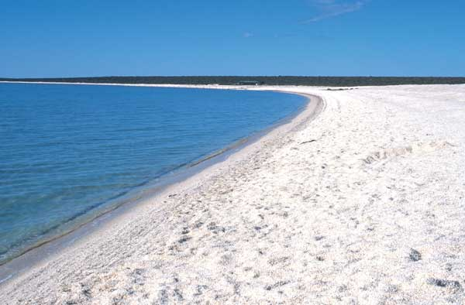

View along Shell Beach at the Shark Bay World Heritage Area, Western Australia © John Cleary (CALM)

## Implementation of the Agreements by the Australian Government

### Australian Government Department of the Environment and Energy

**Relevant JAMBA Articles**: II, III, IV, V, VI  
**Relevant CAMBA Articles**: II, III, IV  
**Relevant ROKAMBA Articles**: 2, 3, 4, 5

### Summary

Australia provides critical habitat for millions of migratory birds each year. To ensure their conservation the Australian Government has fostered international cooperation through a range of important agreements, including bilateral migratory bird agreements with Japan, China and the Republic of Korea, the CMS, the Ramsar Convention on Wetlands, the Agreement on the Conservation of Albatrosses and Petrels (ACAP), and through the voluntary, non-binding initiative, the East Asian - Australasian Flyway Partnership. A range of important activities are also undertaken within Australia to conserve migratory bird populations and their habitats. These activities have largely focused on migratory waterbirds, shorebirds and seabirds as their tendency to aggregate in flocks in coastal areas makes them particularly vulnerable to habitat loss and disturbance.

Since the last bilateral migratory bird consultative meetings in November 2014, the Australian Government has pursued a number of new policy initiatives such as the development of the *Wildlife Conservation Plan for Migratory Shorebirds*. The plan outlines a national framework identifying research and management actions to protect migratory shorebirds in Australia. The plan also outlines national actions to support migratory shorebird conservation, and will be used to ensure these activities are integrated and remain focused on the long-term survival of migratory shorebird populations and their habitat. Habitat protection and restoration in Australia has been advanced by the approval of approximately $26 million dollars under the National Landcare Programme for projects that will directly benefit migratory birds and their habitat. The Commonwealth Environmental Water Office, Parks Australia and Great Barrier Reef Marine Park Authority are also working to improve the habitats of migratory birds and reduce or eliminate known threats to these birds such as invasive weeds and feral cats.

As some migratory bird populations decrease, there is a growing need to minimise threats to the remaining habitats that are critical for their ongoing survival. This need is occurring in the face of ever-increasing human development and loss of habitat. The Australian Government recognises that efforts to conserve migratory birds in one country can only be effective with the cooperation and complementary actions in all countries that these birds visit. This is particularly important as the Australian Government recently listed eight migratory shorebirds as threatened species – four of which are critically endangered. Without urgent action to reduce or eliminate threats, further declines leading to extinctions are to be expected.

### Threatened migratory shorebirds in Australia

Recent evidence of significant declines of migratory shorebird numbers, driven largely by habitat loss at their migratory staging points around the Yellow Sea region, led the Minister for the Environment to list two species - Eastern Curlew and Curlew Sandpiper - as critically endangered in May 2015. A further six species/subspecies were added to the threatened species list in May 2016 after their assessments were completed. All eight shorebirds are protected under the EPBC Act as matters of national environmental significance. The current status of the eight shorebirds are as follows:

* Eastern Curlew (*Numenius madagascariensis*) as critically endangered
* Curlew Sandpiper (*Calidris ferruginea*) as critically endangered
* Great Knot (*Calidris tenuirostris*) as critically endangered
* Bar-tailed Godwit (northern Siberian) (*Limosa lapponica menzbieri*) as critically endangered
* Red Knot (*Calidris canutus*) as endangered
* Lesser Sand Plover (*Charadrius mongolus*) as endangered
* Greater Sand Plover (*Charadrius leschenaultii*) as vulnerable
* Bar-tailed Godwit (western Alaskan) (*Limosa lapponica baueri*) as vulnerable

Australian Government representatives have raised these declines with our bilateral migratory bird partners and, with their support, have initiated the development of an *International Action Plan for the Conservation of Far Eastern Curlew* through the East Asian – Australasian Flyway Partnership. The Eastern Curlew was included in a list of 20 priority bird species in the Australian Government’s *Threatened Species Strategy* published in 2015.

### Threatened Species Strategy

Australia is a country rich in unique plants and animals. They are core to the identity, culturally significant to Indigenous peoples, important to the health of its environment and a strong contributor to our economy. Australia’s distinctive plants and animals are a gift and are important to protect. The Australian Government has established an additional national approach to threatened species. The *Threatened Species Strategy* is a plan for how we will prioritise effort and work in partnership with the community and state and territory governments over the next five years. The Strategy sets out a road map and highlights how Australia’s approach of science, action and partnership can be used to achieve the long-term goal of reversing species declines and supporting species recovery.

The Action Plan 2015-16 is the first instalment of a five-year Australian Government response to the risk of species extinction. Based on principles for prioritisation outlined in the Strategy, the best available knowledge and technology, and the immediate needs of Australia’s threatened species, this plan sets out areas where the Australian Government will focus its efforts to achieve significant, positive impacts. The plan includes key action areas and targets to measure success. It is flexible and adaptive and will be monitored and reviewed annually by the Department of the Environment and Energy in consultation with delivery partners.

The Action Plan 2015-16 identifies 10 threatened mammals and 10 threatened birds for action that will grow their populations by 2020. A further two mammals and two birds have been identified for emergency intervention. The remaining eight mammals and eight birds, including Eastern Curlew, were announced on 22 January 2016 as part of Year 1 commitments under the Strategy. An Additional Initiative for the Christmas Island Frigatebird (*Fregata andrewsi*) was also announced.

The Australian Government is partnering with states and territories to deliver $6.6 million for threatened species projects that will contribute to the targets and action areas identified in the Threatened Species Strategy. The projects focus on tackling feral cats, improving habitat, creating safe havens and intervening in emergencies to protect our rare and remarkable animals and plants.

Further information on the Australian Government’s Threatened Species Strategy can be accessed [here](http://www.environment.gov.au/biodiversity/threatened/publications/strategy-home).

### Wildlife Conservation Plan for Migratory Shorebirds

The Australian Government’s *Wildlife Conservation Plan for Migratory Shorebirds* covers 35 species of migratory shorebird that regularly visit Australia. The plan outlines a national framework identifying research and management actions to protect migratory shorebirds in Australia. All 35 species covered by the plan are listed migratory species under the EPBC Act as they are listed on the appendices to the CMS and Australia’s migratory bird agreements with Japan, China and the Republic of Korea. The plan includes a summary of Australia’s commitments under international conventions and agreements and outlines key aspects of identifying ‘important habitat’ as described in the *EPBC Act Policy Statement 3.21 – Industry Guidelines for avoiding, assessing and mitigating impacts on EPBC Act listed migratory shorebird species*. The plan also outlines national actions to support migratory shorebird conservation, and will be used to ensure these activities are integrated and remain focused on the long-term survival of migratory shorebird populations and their habitat. The plan will be used to engage bilaterally with Japan, China and the Republic of Korea on how threats in the Yellow Sea region can be managed through practical action and community participation. The plan was made in consultation with all state and territory agencies, BirdLife Australia and the research community. There was widespread support for the new plan amongst key stakeholders. Actions included in the *Wildlife Conservation Plan for Migratory Shorebirds* will also benefit a number of shorebird species that were listed as threatened in 2015 and 2016.

Further information on the Australian Government’s Wildlife Conservation Plan for Migratory Shorebirds can be accessed [here](http://www.environment.gov.au/biodiversity/migratory-species/migratory-birds).

### Referral guidelines for 14 terrestrial birds listed as migratory species under the EPBC Act

This draft guideline applies to 14 terrestrial birds listed as migratory species under the EPBC Act. Given these birds have widespread distributions and occupy relatively broad habitats, these species or their habitats are often detected during surveys for environmental impact assessments. This guideline aims to outline the circumstances where a significant impact on one or more of these species is likely and assist in determining whether approval of the Minister for the Environment and Energy is needed. The guideline also outlines conservation objectives for these species, important habitat definitions, survey guidelines and recommends mitigation measures.

The guideline was developed in consultation with Charles Darwin University and Birdlife Australia as well as other individuals with experience and knowledge on one or more of these migratory species. They were published in September 2015 and are available [here](http://www.environment.gov.au/biodiversity/threatened/publications/epbc-act-referral-guidelines-migratory-birds).

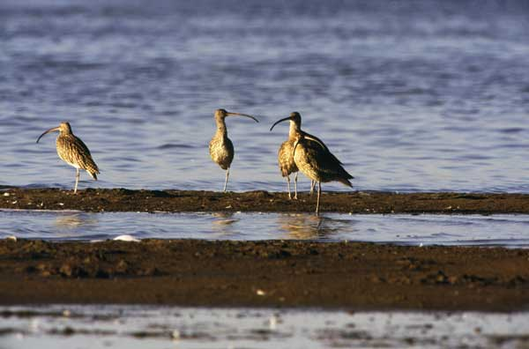

Critically endangered Eastern Curlew (*Numenius madagascariensis*) at Penrice Salt field, South Australia. ©Brian Furby

### Threat abatement plan for predation by feral cats

This threat abatement plan (TAP), made in July 2015, establishes a national framework to guide and coordinate Australia’s response to the impacts of feral cats on biodiversity. It identifies the research, management and other actions needed to ensure the long-term survival of native species and ecological communities affected by predation by feral cats.

The TAP outlines the following migratory species which may be affected by predation by feral cats:

* *Anous stolidus*
* *Apus pacificus*
* *Ardenna grisea*
* *Ardenna pacifica*
* *Ardenna tenuirostris*
* *Calidris tenuirostris*
* *Calonectris leucomelas*
* *Fregata andrewsi*
* *Phaethon lepturus*
* *Phaethon rubricauda*
* *Sternula albifrons*

These species were determined from profiles in the Australian Government’s Species Profile and Threats Database (SPRAT) that identified predation by feral cats as a threatening process. Note: species listed as marine or migratory are only threatened by feral cats when on shore. This includes predation of juveniles from on shore nests. The plan is available [here](http://www.environment.gov.au/biodiversity/threatened/publications/tap/threat-abatement-plan-feral-cats).

## Commonwealth investment in migratory birds and their habitat

### Parks Australia

Australia’s six Commonwealth National Parks, the Australian National Botanic Gardens and 58 Commonwealth Marine Reserves protect some of the country’s most stunning natural areas and Aboriginal heritage. They are managed by Parks Australia.

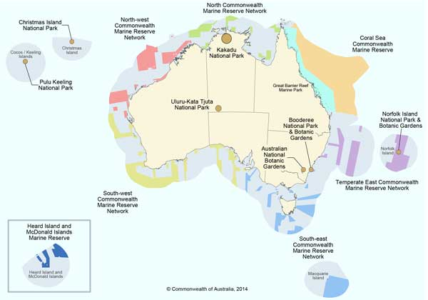

Under the EPBC Act, the Director of National Parks’ responsibilities include:

* Managing Commonwealth reserves and conservation zones
* Protecting biodiversity and heritage in Commonwealth reserves and conservation zones
* Carrying out research relevant to Commonwealth reserves
* Cooperating with other countries to establish and manage national parks and nature reserves in those countries
* Making recommendations to the Australian Government Minister for the Environment and Energy

Commonwealth reserves that are wholly or partly on Indigenous people’s land are managed in conjunction with a Board of Management. The Board’s role is to prepare reserve management plans, make decisions to implement those plans, monitor management and provide advice to the Minister. A majority of board members must be Aboriginal people nominated by the traditional owners of that reserve. These boards play crucial roles in determining the policies and priorities for the management of each protected area.

Since November 2014, a number of projects undertaken by Parks Australia have benefited a number of migratory birds and their habitat. Examples of these projects include:

#### Christmas Island Cat Eradication and Rat Control Project 2015-2020

This project has removed stray and feral cats as well as introduced black rats from the Christmas Island ecosystem. This includes foreshore, grassland and forested areas utilised by migratory species.

**Investment:** Project funded in 2015 by $500,000 supported by the Threatened Species Commissioner and an offset contribution by Phosphate Resources Limited of $1.35 million throughout the life of the project (e.g. $250,000 p.a.). Additional funding of $650,000 for 2016 provided by the Director of National Parks.

#### Norfolk Island Rat Control Program 2015 – 2017

Expansion of the previously existing rat baiting program across Norfolk Island National Park. One thousand additional bait stations have been added to the original 800. All stations are operational.

**Investment:** This is a Threatened Species Commissioner supported project ($300,000 approved funding; $172,000 currently utilised). Additional in kind funding contribution of $133,000 provided by Director of National Parks.

#### Feral Cat Control Program within Norfolk Island National Park

Ongoing cat trapping and removal from within Norfolk Island National Park. A total of 53 cats were trapped in 2015; whilst 32 cats have been caught to date in 2016. A draft management plan for managing feral cats on Norfolk Island has been developed.

#### Tarler Bird (Porphyrio porphyrio) Control Program

Control activities have commenced on Phillip Island in response to community raised concerns regarding the predation of eggs and young seabirds.

#### Weed Control and Habitat Restoration on both Norfolk Island and Phillip Island

1. Ongoing weed control activities occurring on both Norfolk Island and Phillip Island
2. Ongoing propagation and revegetation works on Norfolk Island with current nursery stocks (June 2016) of over 1900 plants

New nursery constructed on Phillip Island, where propagation and revegetation works are ongoing. The projected outcome of propagating and planting 500 plants on Phillip Island is likely to be achieved within the next 12 months.

**Investment:** The Foundation for National Parks and Wildlife provided $15,000 for the construction of a nursery on Phillip Island. In kind support from the Director of National Parks totals $40,000.

#### Booderee National Park

Intensive fox control probably benefits roosting migratory shorebirds known to visit Booderee National Park including CAMBA, JAMBA and ROKAMBA listed species: Whimbrel (*Numenius phaeopus*), Bar-tailed Godwit (*Limosa lapponica*), Ruddy Turnstone (*Arenaria interpres*), Oriental Plover (*Charadrius asiaticus*) and Latham’s Snipe (*Gallinago hardwickii*).

Weed control on Bowen Island benefits JAMBA, CAMBA and ROKAMBA listed species such as: Short-tailed Shearwater (*Ardenna tenuirostris*), Wedge-tailed Shearwater (*Ardenna pacificus*) and possibly the Sooty Shearwater (*Ardenna griseus*).

### National Landcare Programme

The National Landcare Programme is a key part of the Australian Government’s commitment to natural resource management. The National Landcare Programme complements funding for the Reef 2050 Plan, the Green Army Programme and the Land Sector Package.

The Australian Government is investing $1 billion through the National Landcare Programme, including support for the Landcare Networks, 20 Million Trees and Australia’s 56 regional natural resource management (NRM) organisations. This funding helps support local environmental and sustainable agriculture projects.

#### The Regional Stream

The regional funding stream will invest funding through Australia’s 56 natural resource management organisations, recognising the vitally important role these organisations play in delivering local and regional activities.

Australia’s NRM organisations have also committed at least 20 per cent of their National Landcare Programme funding to help support local organisations, such as local landcare groups, to undertake a range of projects that help protect their local environment and deliver more sustainable agriculture.

#### The National Stream

The national funding stream supports a number of important initiatives that will protect and restore the environment and make agriculture more sustainable and productive. These initiatives will be directly funded by the Australian Government.

They include a range of commitments such as the 20 Million Trees Programme, the 25th Anniversary Landcare Grants, as well as continuing commitments such as World Heritage and Indigenous Protected Areas.

Projects funded under the National Landcare Programme that directly benefits migratory birds and their habitat is valued at approximately $26 million dollars and includes projects such as:

#### Myall River Corrie Island Rehabilitation

The Myall River Corrie Island rehabilitation project and the tripartite cooperative approach will improve the management and protection of threatened and migratory bird species on the Corrie Island Ramsar site and the lower Myall estuary. The outcomes will include the development of a rehabilitation plan; implementation of pest animal monitoring and control, and weed control; and the reduction of human impact, feral predator access and erosion to Corrie Island via the eastern channel of the Myall River.

**Investment:** $750,000

#### Hunter Local Land Services

The Hunter Local Land Services (LLS) project ‘Protecting and Enhancing National Priorities and Assets’ will deliver a range of activities that will enhance and protect nationally threatened species and ecological communities, migratory and marine species. Areas of national environmental significance in the Hunter region include the Myall Lakes and the Hunter Estuary Wetlands Ramsar sites, the Gondwana Rainforests of the Barrington Tops Area, and the northern extent of the Greater Blue Mountains World Heritage Area. Hunter LLS will be partnering with landholders, community groups, local government and state agencies to undertake conservation activities in and adjacent to areas of national significance.

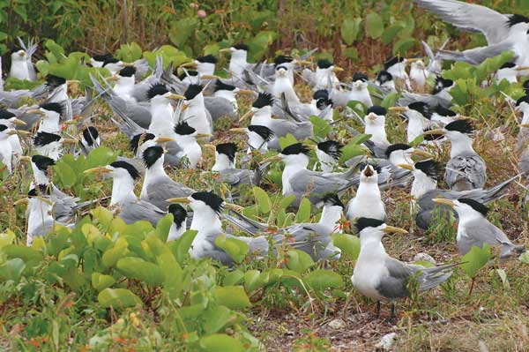

Crested Tern (*Thalasseus bergii*) colony on Lady Elliot Island, Great Barrier Reef, Queensland © Graeme Chapman

#### Biodiversity Fund – Hastings River

A habitat restoration project, targeting invasive weeds on an island in the Hastings River, being a roosting area for the shorebirds that migrate from the northern hemisphere in summer. Feral predator control, fox and rat, will reduce the predation of JAMBA, CAMBA and ROKAMBA listed shorebirds.

*Investment:* $55,200

#### Riversmart Australia Ltd

The Ramsar listed Macquarie Marshes, New South Wales support high levels of endemic biodiversity, as do the lowland and slopes portions of the Macquarie River upstream to Burrendong Dam. The ‘Maintaining and enhancing the lowland-upland wildlife adaptation corridor’ project will identify high value remnants and prioritise works to see these protected and connected.

Investment: $1,681,000

#### Shortland Wetlands Ramsar site: Habitat recreation and restoration project

At the Shortland Ramsar site the project will include planting, weeding and pest control. The process will improve site bushland connectivity and connectivity with Hexham Swamp and surrounding bushland, habitat for native birds, animals and reptiles and food source availability for them.

**Investment:** $417,000

#### Protect biodiversity in the coastal corridor of the Myall Lakes Ramsar site

This project will protect the ecological character of the Myall Lakes Ramsar Site, the threatened ecological community Littoral Rainforest, migratory and threatened species, by working co-operatively with partners to reduce threats to biodiversity across the coastal landscape. It will deliver a strategic weed management program for transformer weeds and priority weed species identified in the ecological character description including weeds of national significance - bitou bush, lantana and asparagus species. The project will also work to reduce threats to coastal habitats on public and private lands to enhance linkages and protect biodiversity along the Myall coastal corridor.

**Investment:** $780,000

#### Connecting River Corridors for Landscape Resilience – Peel-Harvey Catchment Council, Western Australia

In the face of climate change and increased fragmentation, the project aims to improve long term ecological function and ecosystem services across the Peel-Harvey catchment. It will do this by retention and restoration of ecological and cultural corridors from the headwaters of our major rivers to the receiving waters of the internationally recognised Ramsar 482 listed Peel-Yalgorup System by June 2017. The Peel-Yalgorup Ramsar wetland management plan lists 39 CAMBA, JAMBA and/or ROKAMBA migratory waterbird species that may benefit from this project.

#### Protecting the Peel-Harvey’s Natural Assets, Western Australia

In partnership with its community, the Peel-Harvey Catchment Council contributes to the protection of migratory shorebirds in the Peel-Yalgorup Ramsar wetlands through:

* Working at 18 Peel-Yalgorup sites to maintain or enhance the ecological character of the 1,292 hectare Ramsar wetland.
* Maintaining or improving the condition of 40 hectares of migratory species habitat.
* Funding and facilitating annual BirdLife Australia Shorebird 2020 counts and training community groups and volunteers in shorebird identification and protection, specifically species such as the Fairy Tern.

#### South West Environment, Western Australia

The South West Catchments Council contributes to the protection of migratory shorebirds in the Vasse-Wonnerup Ramsar wetlands through:

* Funding support for the Vasse Wonerup Task Force which coordinates and oversees the delivery of a range of projects and actions across the Geographe Catchment to improve water quality and management of key water assets. Outcomes will have both a direct and indirect benefit for the Vasse-Wonnerup wetlands as it supports many thousands of native Australian and migratory waterbird species as well as the largest breeding population of Black Swans in Western Australia. At nearly 50 birds per hectare during peak times the wetlands support one of the highest concentrations of waterbirds in Western Australia.
* Funding the Vasse Wonnerup Wetlands System Research Program which includes three PhDs and one Honours project to assist in the development of management recommendations for the Vasse Wonnerup wetland management plan. This research into the ecological and social sciences aims to provide an integrative solution to the management of the Vasse Wonnerup Wetland System. The outcomes of the research will be used to help determine the likely ecological consequences for bird fauna from different environmental and management scenarios that alter the abundance of key food types and sources for birds.
* Working with the WA Department of Parks and Wildlife to restore habitat (revegetation, weed and pest control) at three sites within the Vasse Wonnerup Ramsar wetland system (Sabina Rivermouthsite, Sabina Cardinal Bywaters site and Bemax site). Three consecutive years of planting and weed control are taking place under the current National Landcare Programme (from 2015-18).

#### Restoring and Protecting Values of Coastal Environments, Waterways and Ramsar wetlands in the South Coast of Western Australia

In partnership with its community, South Coast NRM contributes to the protection of migratory shorebirds in estuaries and wetlands across the south coast of WA (including Lakes Warden and Gore Ramsar wetlands) through:

* Delivering rehabilitation works (fencing, revegetation and weed control) in priority areas across 45 hectares of the Lake Warden and Lake Gore catchments that will assist to restore the ecological character and abate threats to Ramsar values identified in Lake Warden and Gore Ecological Character Description reports, thus maintaining habitat condition for migratory shorebirds.
* Funding and facilitating annual BirdLife Australia Shorebird 2020 counts across south coast estuaries and coastal wetlands, and training community groups and volunteers in migratory bird identification and protection.

#### Living Wetlands, Western Australia

The Living Wetlands project focuses on protecting, restoring and connecting nationally and internationally significant assets through local community action. These environment assets include the Thomsons Lake and Forrestdale Lake Ramsar site. By June 2018, this project will have contributed to the ecological health of Ramsar and Nationally important wetlands in the Swan Region by enhancing/maintaining the ecological character of 20 hectares of Ramsar and Nationally important wetlands. The Forrestdale and Thomson Lake Ecological Character Description includes 28 wetland bird species on the CAMBA, ROKAMBA and JAMBA lists that have been recorded at the lake.

#### Rangelands Natural Resource Management Co-ordinating Group, Western Australia – Kimberley Project

This project will deliver targeted on ground works on private lands and will enhance connectivity, maintain biodiversity and protect identified EPBC Act listed threatened species and communities across 160,000 km2 of the Kimberley region. Within the Kimberley, threatened species such as the Gouldian Finch, the Purple-crowned Fairy-wren, and the Monsoon Vine Thickets of the Dampier Peninsula and the Ramsar listed Roebuck Bay are under threat from ever increasing pressures and impacts. Loss of habitat due to uncontrolled wildfires, weed encroachment, lack of nesting and general habitat are of major concern to these endangered species. Loss of water quality through pollution and sedimentation and an increase in the amount of algal blooms present within Roebuck Bay are all contributing factors that Rangelands NRM, together with partner organisations, aims to address. Together with the Roebuck Bay Working Group, threats to Roebuck Bay will be monitored and activities will be undertaken to address the amount of nutrient and sediment entering the bay via overland flows from adjoining pastoral land and through urban drainage systems. It is intended to analyse results from recent sampling programs to determine where remedial works will be focused. A strong community education and awareness program also forms part of this work.

#### Lake Woods Wetland - Biodiversity Asset Protection, Northern Territory

Lake Woods is one of the largest inland draining freshwater lakes in the Northern Territory and is internationally important for waterbird migration, breeding and populations. The most significant threat to the biodiversity values of this high conservation value aquatic ecosystem is the Weeds of National Significance species *Parkinsonia aculeata*. The project aims to reduce the impact of this weed primarily through on-ground chemical control works, augmented with support for biological control trial work. Regular fixed site and aerial survey techniques will be used to monitor impact of works. Biodiversity surveys will be undertaken, building on previous work undertaken on the Lake.

**Investment:** $1,030,000

#### Protecting our Natural Environment – Northern Territory

This project will support activities in specific Sites of Conservation Significance (SOCS) across the Northern Territory and in areas where environmental impacts are most significant and where control is most likely to be effective and lead to improved environmental and economic outcomes. The project will include strategic management to protect and conserve Wetlands of National Significance, SOCS and sensitive habitats. Wetland habitat degradation is a significant threat to migratory waterbirds. Identified threats to the integrity and sustainability of these areas include invasive weeds (prickle bushes) and pests. Activities will concentrate on the strategic management of these threats and address actions identified under international bilateral migratory bird agreements (JAMBA, CAMBA and the ROKAMBA).

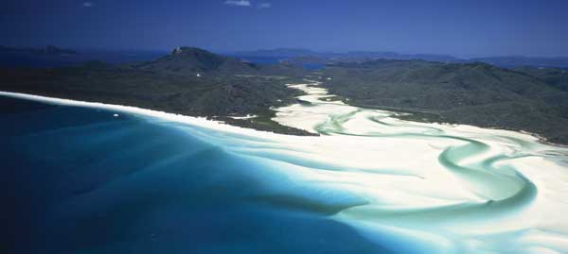

Aerial view of Hill Inlet at Whitehaven Beach on Whitsunday Island, Queensland © Department of the Environment and Energy

#### Managing our Landscapes – Northern Territory

This project will focus on coordinated landscape-scale management to reduce environmental threats and pressures so as to improve ecosystem services and provide long-term social and economic benefits to the environment. The project will engage and work with community and pastoral land management groups, pastoral land managers and Indigenous groups across the Northern Territory to increase awareness and adoption of improved land management practices. It will support planning for and coordination of collaborative activities to implement on ground actions to improve NRM outcomes at both local and regional landscape scales, and increase the capacity, knowledge and skills of land managers to manage natural resources and priority assets.

#### Finniss Reynolds Catchment Group (FRCG): Management of Invasive Species – Northern Territory

FRCG land manager members including Traditional Owners, National Parks and pastoralists, will work collaboratively to physically control the threat posed by feral pigs and Weeds of National Significance *Mimosa pigra* at a catchment scale on sites of high biodiversity value; the Finniss River and Anson Bay catchments. The project will identify and map the scale of the infestation; produce a catchment management plan; physically remove large scale infestations; control feral animals; and employ a Weeds Officer to manage and coordinate activities. The outcome will be an increase in native vegetation, capacity building of land managers, employment and improved land productivity, plus improved habitat for migratory species.

#### Samphire Coast Icon Project – South Australia

The Samphire Coast is a significant but highly threatened and undervalued remnant coastal corridor north of Adelaide, South Australia. The project seeks to implement conservation and community stewardship actions to maintain and rehabilitate coastal samphire, shorebird and coastal bird, reptile and butterfly habitats. The project will provide a framework to boost strategic efforts across agency, local government and community and industry partners to address the long recognised need to better conserve and protect this area for the future.

#### Implementing the Limestone Coast and Coorong Coastal Action Plan – South Australia

This project will implement the priority actions detailed in the Caring For Our Country funded Limestone Coast and Coorong Coastal Action Plan and Conservation Priority Study 2011 (LCCCAP), South Australia’s Naturelinks program and the Habitat 141 Coastal Conservation Action Plan.

The project will focus on a coordinated program to enhance the extent (200 ha), ecological integrity and connectivity of coastal habitats (26,825 ha) in the South East of South Australia against current and future threats including weed and feral animal invasion, habitat fragmentation, and the impacts of climate change. This project will involve stakeholders by building on the relationships developed in previous Caring For Our Country funded projects.

#### Limestone Coastwatchers – South Australia

This program will win the hearts and minds of the community, improve the health and report on the condition of our coast. Key outcomes; - a coastal education program at six towns to approximately 1000 participants each year - school coastal education program in five schools - support to 15 community groups undertaking conservation activities - marine debris removal and monitoring program along 250 km of coast - control 200 ha of erosion and protect 300 ha of native vegetation - a Limestone Coast Health Check on the health of the intertidal zone, shorebirds, waterfowl and three vegetation types and threatened orchids - develop model visitor access plans for two coastal towns - develop signage and interpretive standards.

Restoring and protecting nationally significant wetlands and river systems – Kangaroo Island Natural Resources Management Board, South Australia

The project will improve the condition, health, extent and connectivity of 1,172 ha of four nationally important wetlands and riparian vegetation on Kangaroo Island through habitat restoration and biodiverse plantings, in conjunction with weed and pest animal control activities.

#### Restoring the Piccaninnie Karst Wetlands – South Australia

The Piccaninnie Ponds Karst wetland system is a Ramsar-listed wetland in the South East of South Australia. The ecological condition of at least 175 ha of the wetland complex was enhanced through the project by restoring the natural connectivity between the eastern and western sections of the complex. This was achieved by removing artificial impediments to water flows and re-establishing the natural movement of water and species through the eastern wetland and to the sea. The wetlands support 61 species of conservation significance including the critically endangered Orange-bellied Parrot and provides habitat for 20 migratory bird species.

#### Kangaroo Island Community Shorebirds Project – South Australia

This project will continue to collect data for Birdlife Australia’s Shorebirds 2020 project, providing information to help address key and emerging threats to shorebirds. Remapping Kangaroo Island shorebird areas and ongoing ID training will give volunteers the technical skills they require to conduct project work, thus ensuring high retention rates and ongoing success of the group’s projects. The biannual/national Hooded Plover Census, development of a Kangaroo Island Shorebirds website, and ongoing newsletters and articles will continue to educate and engage the wider Kangaroo Island community.

#### Restoring and Protecting Values of Coastal Environments, Waterways and Ramsar wetlands in the South Coast of Western Australia

This sub project supports the community and partners to protect coastal environments and urban waterways, ecological communities, and EPBC Act species across coastal environments of the South Coast NRM Region. The project will be delivered over 5 years in priority sites identified by the community and partner organisations under the guidance of the Regional NRM Strategy ‘Southern Prospects’ and the Regional Coastal Strategy ‘Southern Shores’.

**Investment:** $2,591,970

#### Conserving Alinytjara Wilurara’s coastline through enhanced Indigenous capacity – South Australia

This project seeks to conserve and protect many nationally threatened species and significant coastal ecosystems along the Far West Coast of South Australia. The overall health and resilience of this remote coastline will be improved on-ground actions that reduce threats.

#### Protecting Ramsar values through rehabilitation works for Lake Warden and Lake Gore

This project will deliver targeted rehabilitation works in priority areas within the Lake Warden and Lake Gore catchments to restore ecological character and abate threats to Ramsar values identified in Lake Warden and Gore Ecological Character Description reports and by the Lake Warden and Gore Technical Advisory Group. Activities will include: biodiverse planting to restore habitats for significant flora and fauna and mitigate altered hydrology and salt loads, protection fencing to reduce grazing pressure on remnant vegetation and waterways, monitoring migratory bird populations to assist conservation measures, engagement and participation of the community including Indigenous in the protection of Ramsar wetlands.

#### Ecosystems and Coastal Management on Eyre Peninsula – South Australia

A component of this broader project has focussed on a partnership with Birdlife Australia for the provision of workshops for teachers on beach nesting and migratory bird species. The project also part funded a week long field trip which was primarily focussed upon the banding of Hooded Plovers and training in the use of remote sensing cameras which are used in the monitoring of a wider group of bird species including both beach nesting and migratory species.

#### Pilbara Pastoral Region - Protecting Against the Weed Invasion – Western Australia

This project has worked towards the eradication of two geographically separate weed threats in the Pilbara. In the East Pilbara, the project worked with neighbouring land managers towards eradicating a discrete infestation of *Parkinsonia* located on the Fortescue River. This will reduce the threat to the internationally recognised Fortescue Marshes, renowned as a vital breeding habitat for migratory birds. In the West Pilbara, the project has undertaken wider surveillance and follow-up treatment of the largest infestation of Coral Cactus in the Pilbara.

*Investment:* $20,000

#### The East Gippsland Rail Trail Community Engagement Project - Victoria

This project has been working to conserve the natural habitat of a number of endangered and threatened native fauna and flora species along the East Gippsland Rail Trail against the threat of invasive plant species, flooding, erosion, and human interference. The focus has been on revegetating sectors of the Trail in the vicinity of East Bairnsdale, Nicholson and Bumberrah, including rehabilitation of a small section of remnant temperate littoral rainforest on the west bank of the Nicholson River adjacent to the Trail. The project has included installation of nesting boxes for migratory and sedentary bird species.

**Investment:** $20,000

#### Upper Paroo Catchment Pest and Weed Control - Queensland

This project controlled the spread of a number of weeds (Mother of Millions, Hudson Pear and Coral Cactus) down the Paroo River High Ecological Value Aquatic Ecosystem by addressing them at the source. The project’s actions will also assist properties downstream eradicate these weeds from their grazing system and reduce the potential impacts they may have on the Ramsar listed Currawinya Lakes (Currawinya National Park) and its associated threatened and migratory species.

**Investment:** $8,000

#### Survey Fauna and Flora - Enrich Wetland Biodiversity - Yowie Park Hopetoun

This project is conducting flora and fauna surveys of two freshwater storage lakes and the surrounding land areas of the Yowie Park precinct. The species identified will be featured on informative all-weather display signage that will be erected and will assist visitors and community members identify the diverse local flora and fauna of Yowie Park, which includes migratory species. Complementary planting of endemic water tolerant species between the two water storages by volunteers and school students will be employed to enhance the habitat for fauna.

**Investment:** $10,450

#### Gurriba Island - Targeting Invasive Weeds on a Remote Island Sanctuary, Northern Territory

This project will support the Crocodile Islands Rangers to combine modern methods with Traditional Knowledge to target the invasive weed Caltrop (*Tribulus terrestris*) on the remote offshore Gurriba Island in North-East Arnhem Land. Works will improve the habitat of Gurriba Island which is both environmentally and culturally significant and is a nationally significant nesting site for threatened Flatback, Green and endangered Olive Ridley turtles as well as numerous species of migratory birds.

*Investment:* $18,000

#### Gunbalanya Station - Integrated Mimosa Control Project, Northern Territory

The Gunbalanya Station Indigenous Land Corporation is undertaking this project with the sponsorship of Territory Natural Resource Management Incorporated. This project is continuing efforts to control *Mimosa pigra* (a highly invasive Weed of National Significance and a declared weed in the NT) over 1,200 ha on the Gunbalanya floodplain. This area borders downstream Kakadu National Park wetlands that are Ramsar listed and are a World Heritage Area. Gunbalanya Station will use an integrated approach to control the weed, including aerial spraying; ground control; grazing management; fire control; vehicle hygiene; and control of feral pigs and horses to reduce spread. This will benefit habitat for listed migratory and threatened species.

*Investment:* $20,000

#### Corner Inlet, Victoria - Protecting the Ramsar Site and Streams from Blackberry Invasion

Corner Inlet Blackberry Action Group (CIBAG) is undertaking this project with the sponsorship of Yarram Yarram Landcare Network Inc. This project is removing 350 hectares of Blackberry from the Corner Inlet Ramsar and the adjacent lands and waterways that feed into it. This will be done in conjunction with the efforts of landholders and managers of public lands in adjacent areas. Landholders will gain new knowledge and skills to increase the effectiveness of their weed control and will be encouraged to enter into landholder agreements to keep Blackberry in check for at least 3 years. The concerted effort across the landscape will result in: reduced fox numbers and predation upon migratory birds; better wildlife movement and natural revegetation; improved status of the threatened salt marsh, mangrove and other vegetation communities that surround Corner Inlet; and greatly reduced chance of re-infestation.

**Investment:** $20,000

#### Pelican Island - Restoration of Wading Bird Habitat and Littoral Rainforest

This project is building on past work to help restore the rainforest and other habitats of Pelican Island by: targeting the reduction of invasive weeds (especially Weeds of National Significance) and feral animal control, to reduce the predation upon migratory shorebirds and threatened resident birds. This project will also help maintain the suitability of the high tide shorebird roosting sites for birds that migrate from the northern hemisphere. This project complements existing projects (funded by other grants) of weed and animal control on adjoining natural areas by the Macquarie Hastings Council.

**Investment:** $17,580

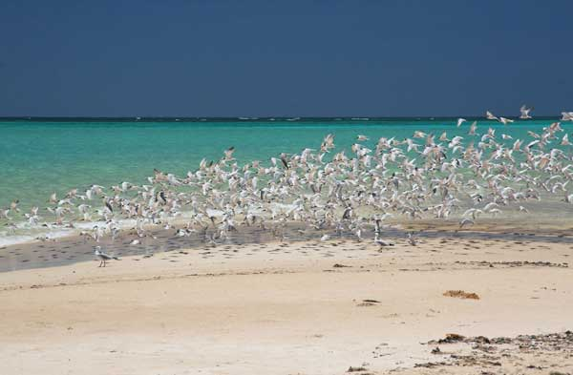

Terns at Winderabandi Point, Ningaloo Marine Area © Tony Howard

#### Urban Riparian Corridor Restoration of Oxley Creek Common, Queensland

This project will plant and maintain 27,000 native shrubs and trees on 6 ha of the Oxley Creek Common, a unique 115 ha open space on the lower and highly urbanised reaches of Oxley Creek. The Common is key to maintaining a riparian corridor that includes specimens of the endangered *Gossia gonoclada* and provides valuable bird habitat. Over 190 bird species have been recorded at the Oxley Creek Common, including Latham’s Snipe, an EPBC Act listed migratory bird species. The project will assist the rehabilitation of Lowland Riparian Forest to improve habitat condition and connectivity, to reduce the impact of weeds and to improve water quality.

**Investment:** $99,500

#### Conservation actions for enhancing wetlands of national significance, springs and waterways

This project contributes to several national and international priorities by maintaining and/or enhancing the ecological characteristics of Wetlands of National significance, including mitigating impacts on the Great Barrier Reef, regionally significant species (including migratory species) and their habitats. The project is engaging the NRM community in undertaking flora and fauna surveys and natural resource management actions addressing fire, soils, pests, weeds and water that reduce threats to wetlands, springs and waterways. The project will improve the protection, rehabilitation and/or restoration of up to 300 000 ha of prioritised environmental assets, wetlands, threatened species, ecological communities and migratory species.

**Investment:** $464,821

#### Restoration of habitat for declining migratory shorebirds at Snake Island, Victoria

A recent collapse of EPBC Act listed species within this Ramsar site is mainly due to the damage to a single culvert which led to the drying out of the site and the creation of toxic acid-sulphate soils. The damage can be reversed easily and cheaply if the culvert is replaced and flows to the system are re-instated. The site contains EPBC Act listed saltmarsh ecological communities and habitat for the critically endangered Orange-bellied Parrot. Partner organisations: Birdlife Australia; Department of Environment and Primary Industries (Victorian Government); Arthur Rylah Institute; Corangamite CMA; Geelong Field Naturalists.

**Investment:** $32,000

#### Protecting Corangamite Ramsar sites and Orange-bellied Parrot

The Protecting Corangamite Ramsar Sites and values (Port Phillip Bay (Western Shoreline) and Bellarine Peninsula) project will be delivered through a direct targeted approach to protect and enhance 265 ha for those wetlands within the region, and with a particular bias to the protection and enhancement of the recently nominated EPBC Act listed Coastal Saltmarsh vegetation community. Conservation actions will also occur for a range of avifauna and migratory shorebirds with 135 species being recorded. The project will support strategic management of fox and rabbit control to protect migratory waders in line with key seasonal requirements and priority locations. Opportunities to conduct feral cat control will be investigated, however it is generally considered to be too difficult to undertake at the scale necessary to be effective given the current technical challenges of effective baiting of the species.

**Investment:** $631,460

#### Corangamite coastal environment and ecological communities, Victoria

The Ecosystems and Coastal Environments project will work with a range of partners and landholders to protect and enhance existing nationally listed ecological communities over the Corangamite region, along with associated coastal ecological assets. There are six threatened species and one Ecological Community that will be targeted through this project. Two primary delivery mechanisms will be utilised namely; 1) a directed targeted approach and 2) the application of Coastal Tender (Round 3) through a market based instrument (MBI) approach. Round three of the Coastal Tender will be implemented to contract land managers under five year contracts through a single MBI round. The direct target approach will remain available to take advantage of investment opportunities throughout the remainder of the program (up to 2018), subject to funding in that allocation remaining available, i.e. if it has not been already allocated in full to good value proposals. These instruments will be used to maximise community engagement and the uptake and contracting of best-value for money sites to achieve the most appropriate balance / optimisation of outcomes. Threatened species management will be prioritised using DEPI’s NaturePrint GIS modelling process, to maximise outcomes for multiple species and / or the most critical habitat for single species of interest. In addition, the actions for biodiversity conservation (ABC) database will be used to prioritise actions from national recovery plans for individual populations to be managed, i.e. the highest priority actions will be implemented at the highest priority locations.

**Investment:** $980,435

#### Victorian Volcanic Plains (VVP) and Western District Lakes Recovery Program

This project is being implemented through the utilisation of a community grants process. The objective of the program is to support community/landholder involvement in protecting, enhancing or promoting VVP biodiversity assets with a focus on on-ground outcomes and community awareness/engagement. The assets on the VVP that this project aims to assist in restoring or enhancing are; remnant vegetation (including paddock trees) and wetlands. The VVP Small Grants Program is designed to contribute to the following:

* Facilitate on ground biodiversity activities on the VVP.
* Enhance and maintain the capacity of private landholders to undertake biodiversity activities on their property.
* Increase community interest and knowledge of the VVP’s natural assets.
* Relationships and partnerships are fostered, built, maintained and strengthened.
* Provide a catalyst for changing VVP land management behaviour/practices.

**Investment:** $1,214,955

#### Restoring and maintaining urban waterways and coastal environments

Building on foundational work undertaken over the past two years, Cradle Coast NRM will contribute to the restoration and maintenance of coastal environments and urban waterways by protecting and/or enhancing 250 hectares of vegetation.

**Investment:** $1,038,289

#### Protecting Ramsar sites in the Gippsland Lakes

This project will undertake work at two Gippsland Lakes Ramsar sites. One is at Jones Bay on the Gippsland Lakes, the other is at Lake Tyers. Both sites are part of an important habitat for a number of significant plant and bird species as well as bird species subject to obligations under JAMBA, CAMBA and ROKAMBA.

**Investment:** $177,224

#### Restoring Eucalyptus Woodlands to the Victorian Volcanic Plains Landscape

Remnant vegetation comprises less than 0.01% of the Victorian Volcanic Plains (VVP) area and is threatened by clearing and fragmentation. This project will revegetate 37 hectares of cleared agricultural land across the Corangamite Lakes Landcare Network area with VVP eucalypt woodland species to increase habitat area, improve landscape resilience, establish 20kms of connecting corridors and enhance areas of adjacent remnant E.camaldulensis woodland and Poa tussock grassland. Fencing of waterways and revegetation of riparian zones will protect habitat for Corangamite Water Skink and improve water quality into Ramsar wetlands and lakes. Contributions from participating landholders will provide a 5.6 to 1 benefit-cost for grant funds.

**Investment:** $63,570

#### Coastal Connections – Victoria

The Coastal Connections project will work with community groups and public and private land managers in the high priority coastal zone of Habitat 141 to protect and restore 520 ha of coastal vegetation and wetlands. The project will focus on increasing connectivity of vegetation communities at nationally significant wetlands (Lower Merri and Yambuk Lake) and enhance critical habitat for EPBC Act-listed species including the Orange-bellied Parrot. A range of targeted engagement activities and incentive types will be utilised to maximise uptake and ensure best-value sites are protected and secured into the future.

**Investment:** $1,466,226

#### Building the resilience of the Barmah Forest Ramsar Site to protect its ecological character

The ecological character of Barmah Forest Ramsar Site is threatened by incursions of high priority pest plants and animals (e.g. Cabomba, Arrowhead, Blackberry, Feral Pigs, Foxes and Rabbits). This project will focus on the control of identified high priority pest plant and animals to maintain the ecological integrity of this Ramsar site. Work will be undertaken in partnership with land and water managers, local and state government agencies, traditional owners and landholders. In addition, the capacity of Barmah Forest Traditional Owners (Yorta Yorta Nation) to undertake natural resource management will be built through direct involvement in the planning, delivery, and reporting of the project. To achieve these outcomes, the project will achieve the following:

* Communities are protecting species and natural assets of the Barmah Forest Ramsar Site through restoration and rehabilitation of the natural environment;
* Increased engagement and participation of the community, including landcare, farmers and indigenous people, in sustainable NRM.

**Investment:** $1,956,913

#### Supporting the protection of values for the Hattah Lakes Ramsar site during the restoration of an appropriate water regime

This project will restore and protect key ecological attributes of the Hattah-Kulkyne Lakes Ramsar site by reducing the critical threats posed by pest plant and animal species. On ground activities will be strategically targeted across 6,000 hectares of riparian and aquatic habitat contained within the 12 Ramsar listed lake sites. Delivery over five years will further secure the environmental benefits of complementary Living Murray investment, with invasive species representing a major risk to the ability of this basin plan targeted habitat to respond to favourable conditions through the restoration of appropriate water regimes.

**Investment:** $1,956,913

#### Gunbower Forest Key Asset Protection Project

Gunbower Forest, situated on the Murray River floodplain downstream of Echuca, is an internationally (Ramsar) important river red gum wetland complex. Spanning 20,000 hectares, the forest is home to many endangered plants and animals, contains numerous sites of Indigenous cultural significance and is popular for recreational activities such as kayaking, fishing and bushwalking. The Gunbower Forest Key Asset Protection Project (the Project) will focus activities which address the critical threats impacting on the forest’s ability to support and maintain its ecological character, particularly relating to native habitat and vegetation condition and pest animal control. The Project will complement and integrate previous works to maintain and improve the values at key sites within the forest and undertake a range of activities both within the forested environment and specific areas which adjoin the forest, principally along and adjacent to Gunbower Creek. Key assets within the forest and adjoining landscape will be targeted for intervention and prioritised according to their ability to support matters of national environmental significance including endangered, vulnerable and /or depleted Ecological Vegetation Classes (EVC’s), EPBC Act vegetation communities, threatened flora species and fauna species. The support and contribution of individuals and the local communities which adjoin the Gunbower Forest are critical to the success in achieving project outcomes. Opportunities to share, learn from and empower others to achieve these outcomes will occur through a range of events, workshops and field days. This will encompass the sustainable use of natural resources, environmental and cultural protection and restoration and ongoing management regimes.

**Investment:** $1,774,208

#### Kerang Priority Wetlands Protection Project

The Kerang Priority Wetlands Protection Project (the Project) consists of 6 out of 23 internationally significant (Ramsar) wetlands. Lake Bael Bael, the Avoca Marshes, Lake Kelly, Lake William, Lake Tutchewop and Reedy Lakes have been prioritised according to their ability to support matters of national environmental significance including:

* Endangered, vulnerable and /or depleted Ecological Vegetation Classes (EVC’s)
* Threatened flora species
* Threatened fauna species
* Invasive species impacts

The wetlands are recognised for their representativeness of Victorian wetlands, valuable flora and fauna values and are all on various public land tenure. The wetlands support a high diversity of waterbird species and several species are listed under migratory bird bilateral agreements (JAMBA, CAMBA, ROKAMBA). The project incorporates four of the eight Victorian wetland categories: deep freshwater marsh, permanent open freshwater, permanent saline and semi-permanent saline. Of these, deep freshwater marshes are considered one of the most depleted wetland categories in Victoria. The wetlands also contain hundreds of registered sites of Indigenous cultural heritage significance including mounds, scarred trees, middens, burials, hearths, surface scatters and a range of isolated artefacts. The Project will focus on the implementation of activities which address the critical threats impacting on the ability of the defined wetlands to support and maintain their ecological character, particularly relating to native habitat and vegetation condition and pest animal control. Local communities and visitors to the region will be encouraged learn, appreciate and value their international significance and advocate for their ongoing protection and maintenance and sustainable use.

**Investment:** $1,267,230

#### Protecting the ecological values of the Port Phillip Bay - Western Shoreline Ramsar site

This project aims to maintain the ecological character of the Port Phillip Bay (Western Shoreline) section of the internationally significant Ramsar wetland through:

* Targeted management of pest plants and animals
* Targeted management of recreational use
* Maintaining and strengthening partnerships between Ramsar site managers to facilitate further collaboration in the delivery of activities to protect the values of the site
* Targeted engagement with local community and environment groups to improve their knowledge about site values and to build their skills and capacity to participate in activities that will protect these values. It builds on a recent similar project that has made sound progress towards addressing these issues.

**Investment:** $348,800

#### Protecting the ecological values of the Western Port Ramsar site, Victoria

This project aims to maintain the ecological character of the internationally important Western Port Ramsar site through:

* Targeted management of invasive plants and animals, and stock access, at priority locations within and adjacent to the site
* Maintaining and strengthening partnerships between Ramsar site managers to facilitate further collaboration to protect the values of the site
* Targeted engagement with local community and environment groups to improve their knowledge about the site and to build their skills and capacity to help protect these values. It builds on a recent very successful work on the Ramsar site that has made strong progress addressing these issues.

**Investment:** $1,337,200

#### Waterways and coastal areas -Tasmania

This project will run until June 2018 and will deliver a regional engagement program to 350 local community members, volunteers and visitors to Tasmania on coastal issues, Ramsar sites and resident and migratory shorebirds. It will conduct on ground activities to improve habitat condition over 17 hectares in and around 5 EPBC Act listed species and communities: Coastal Saltmarsh; Swift Parrot; Forty Spotted Pardalote; Hooded Plover; migratory shorebirds; and Little Penguin and wetland environments including seagrass and reeds. Activities will also be directed to support priority action within 2 coastal Ramsar sites- Moulting Lagoon and Pitt Water Orielton lagoon through landholder management plan development or implementation. The project will be delivered through externally employed Local (NRM) Facilitators, community groups and landholders and coastal organisations and be supported by a South East Regional Shorebirds Alliance. Activities will be delivered by the South East Regional Shorebirds Alliance, local government, industry and community groups.

**Investment:** $698,453

#### Corner Inlet Connections – Victoria

Valued for its marine and coastal parks, productive fishing and agricultural industries, and thriving local communities, the Corner Inlet catchment is renowned for its diversity and landscape. In the inlet’s sheltered, shallow waters a range of marine, estuarine and coastal ecosystems support wildlife, such as migratory shorebirds, that contribute to its international significance as a Ramsar-listed wetland. Protecting the environmental, productivity and community values associated with this regional treasure is a key priority of the Corner Inlet Connections project. The project is underpinned by an established partnership of agencies, community groups and industry bodies. Its approach focuses on community participation, knowledge and skill sharing, and practical on-farm improvements that bring benefits to landholders and to water quality within the Corner Inlet catchment. This work is guided by the Corner Inlet Water Quality Improvement Plan which will prioritise project work to address the threats to Corner Inlet from sediment and nutrient run-off from the surrounding catchment and will ensure that other threats within the inlet are also attended to.

**Investment:** $2,022,000

#### Protecting Lake Albacutya Ramsar Site Values – Victoria

The ecological and cultural values of the Lake Abacutya Ramsar Site of north western Victoria will be protected and enhanced through targeted threat abatement works involving Parks Victoria, Traditional Owners, and the Rainbow Landcare Group. On-ground works will reduce critical threats posed by rabbits in culturally sensitive areas. This is a priority for helping to meet Australia’s international obligations to protect native species and ecological communities, cultural heritage and cultural diversity at the site, facilitating natural regeneration and recruitment of the Pine Buloke woodland and other flora species that provide habitat for the large number and variety of waterfowl that rely on the Ramsar Site during wet periods.

**Investment:** $264,353

### The 20 Million Trees Programme

The Australian Government is working with the community to plant 20 million trees by 2020, to re-establish green corridors and urban forests. The 20 Million Trees Programme is part of the national stream of the National Landcare Programme, and has four strategic objectives:

* **20 million trees** – 20 million trees and associated understorey planted by 2020.
* **Environmental conservation** – support local environmental outcomes by improving the extent, connectivity and condition of native vegetation that supports native species
* **Community engagement** – work cooperatively with the community
* **Carbon reduction** – contribute to Australia reducing its greenhouse gas emissions.

The 20 Million Trees Programme complements and aligns with other Australian Government environmental initiatives, such as the Green Army Programme and the work of the Threatened Species Commissioner.

The Australian Government has committed $70 million over six years to the 20 Million Trees Programme, with funding from 2014-15. The programme involves competitive grants, delivered by individuals and organisations, and larger-scale plantings, delivered by service providers.

To date, eight projects relating to migratory birds and their habitat have been funded totally approximately $652,201. Examples of these projects include:

#### Derriwong/Ootha - Connecting Ecological Communities

This project will see a large corridor of farm land restored to native vegetation in central New South Wales. The activities will engage passionate landholders, Landcare, the Condobolin Green Army team and community in undertaking revegetation activities that will connect two threatened ecological communities, providing a significant area of native vegetation established within biodiversity corridors. The project will provide multi-beneficial conservation and agricultural outcomes in this productive grain, lamb and wool region, including provision of habitat and refuges for threatened woodland, migratory birds and other wildlife, connectivity with existing remnant vegetation, a valuable seed collection resource, stock shelter & improved grazing management.

**Investment:** $100,000

#### Pelican Island - Revegetation of Littoral Rainforest and Sand Swales

Pelican Island, part of Woregore Nature Reserve, is in the Hastings River near Port Macquarie, New South Wales. It is important feeding and roosting habitat for critically endangered shorebirds and contains endangered ecological communities, including littoral rainforest. Restoration has been ongoing for some years, most recently the past 3 years, with federal grant funds. Native vegetation is regenerating well and weed loads have been substantially reduced. However, there are areas of the island where disturbance from weeds was very high or where native vines are suppressing regeneration. We will plant and/or direct seeding these areas to assist in their restoration. Being an island, we can only gain access on certain days due to the tides.

**Investment:** $21,451

#### Mid West Estuaries - Creating Corridors for Wildlife

The Chapman River and Greenough River estuaries in the Geraldton area are included in one of 34 internationally recognised national biodiversity hotspots and support temperate coastal saltmarsh communities which provide habitat for birds including migratory species listed under the EPBC Act. This project will enable the City of Greater Geraldton to restore 78 hectares of a degraded riparian zone within these estuaries.

**Investment:** $59,500

#### Hexham Swamp – Revegetation

Hunter Water Corporation owns a Waste Water Treatment Works adjoining Hexham Swamp, Newcastle. Hexham Swamp adjoins and flows into the Hunter Estuary Wetlands Ramsar Site. It is listed in the Directory of Important Wetlands of Australia, and is an Important Bird Area. The Treatment Works site covers 85 hectares. It includes a waste-water treatment plant, remnant and riparian vegetation, a creek and open paddocks. This project will reinstate Coastal Foothills Spotted Gum – Ironbark Forest in the paddocks closest to Hexham Swamp & improve the riparian zone. The resulting vegetation will increase the extent of terrestrial woodland fringing Hexham Swamp, improve habitat for avifauna and arboreal mammals and improve water quality in Hexham Swamp.

**Investment:** $99,000

#### Hexham Swamp - reinstating native vegetation communities at Tank Paddock

Hexham Swamp on the edge of Newcastle is part of the Hunter Wetlands National Park. It is listed in the Directory of Important Wetlands of Australia, is an Important Bird Area and flows into the Hunter Estuary Wetlands Ramsar Site. It is also part of the Stockton-Watagans Regional Green Corridor, connecting the Great Eastern Ranges to the coast. The Swamp has a perimeter of 53 km, of which almost 90% has been cleared. A major project reinstating tidal flows to the swamp is underway. This 20 Million Trees proposal will reinstate Coastal Foothills Spotted Gum – Ironbark Forest in Tank Paddock adjacent to Hexham Swamp. The project will add value to the current 20 Million Tree project, further increasing the extent of terrestrial woodland fringing Hexham Swamp.

**Investment:** $97,805

#### Revegetation of Priority Corridors and Bushland in Perth’s Eastern Region

Precedence is given to revegetating a priority north-south corridor in the City of Swan and a wildlife corridor for Carnaby’s Black Cockatoos in the Shire of Mundaring. The project reconnects high value remnant vegetation identified in the National Wildlife Corridors Plan. Direct seeding and planting maintains high ecological values of the sites. A partnership with a local Aboriginal group has been established to revegetate a site with native trees and understorey species, to connect an adjacent Bush Forever site in Kensington Bushland. The project revegetates wetlands of significance frequented by endangered migratory bird populations in the City of Bayswater. South Perth sites will be revegetated for landscape resilience.

**Investment:** $100,000

#### Little Llangothlin Lagoon Ramsar Site - Restoring Critically Endangered Woodland

This project will restore 45ha of New England Peppermint Woodland Threatened Ecological Community within the Little Llangothlin Nature Reserve Ramsar Site. Revegetating previously cleared areas will link existing remnants of the terrestrial nationally critically endangered ecological community New England Peppermint Woodland with the aquatic nationally endangered ecological community Upland Wetland present at Little Llangothlin Lagoon. Little Langothlin Lagoon is internationally significant wetland (Ramsar site) supporting migratory waterbirds and threatened fauna. Restoring native vegetation will help to protect and maintain these habitat values. This project will expand a recent successful trial to re-establish 2.5ha New England Peppermint Woodland at the site.

**Investment:** $74,945

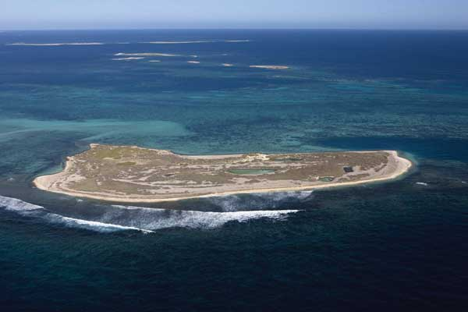

Aerial view of the Houtman Abrolhos Islands (Easter Group) off the coast of Western Australia © Department of the Environment and Energy

### The Green Army

The Green Army is a hands-on, practical environmental action program that supports local environment and heritage conservation projects across Australia. The Australian Government has allocated more than $360 million for the programme over four years from 1 July 2015 to support 500 projects each year.

Community organisations, Landcare groups, natural resource management organisations, environmental groups, Indigenous organisations, local councils and others can apply to host a Green Army project.

To date eight Green Army Projects have been approved that directly benefits migratory birds and their habitat. The total investment on these projects is $1,728,000.

#### Protection and enhancement of habitat in Bass Coast - Phillip Island Nature Park, Victoria

The ongoing protection and re-establishment of penguin habitat across the Summerland Peninsula, focusing on revegetation and weed control works. The reduction/eradication of invasive weeds, such as boxthorn and kikuyu grass, from Short-tailed Shearwater (*Ardenna tenuirostris*) and other migratory bird habitats and the reintroduction of habitat-suitable vegetation. The reintroduction and preservation of Koala habitat, with a focus on revegetation with indigenous eucalyptus species. Mangrove rehabilitation and foreshore revegetation along the Western Port Ramsar site at Grantville, Corinella, Coronet Bay and Phillip Island. Protection and enhancement of native remnant vegetation across the Bass hills through revegetation and weed control works.

#### Reviving South Coast Wetlands (South) - Conservation Volunteers Australia

This project aims to improve the condition, extent and connectivity of coastal wetlands in the South East region. Project outcomes include establishing, improving and maintaining native vegetation, managing invasive weeds, basic vegetation and fauna surveys, and planting native vegetation. On-ground works at Wollumboola, Comerong Island and the Shoalhaven Estuary will help preserve breeding sites of the EBPC Act listed Little Tern and other migratory birds, and improve connectivity to surrounding National Parks.

#### Stage two and three biodiversity and habitat improvements works / Braeside Park - Parks Victoria

Native restoration activities throughout the Braeside Park will enhance biodiversity values, protect significant species and engage the community to foster improvements and sustainably utilise the Park’s natural assets. Braeside Park is a diverse ecosystem of Red Gum Grassy Woodlands, heathland and wetlands and provides shelter for the Purple Diuris Orchid (*Diuris punctata*) and nationally significant migratory birds including the Latham’s Snipe.

#### Hays Inlet Restoration Project 2 - Redcliffe Environmental Forum Inc.

This project will: (1) Restore regional ecosystems through weed control and replanting with local species; (2) Enhance and protect migratory bird habitats; and (3) Restore habitat for nationally-listed threatened species such as the Koala, Eastern Curlew and Australian Painted Snipe.

#### Improving Wetland Habitat for Mornington Peninsula’s Threatened Species Project 1 - Mornington Peninsula Shire Council

Enhance habitat & connectivity for Eastern Curlew and Orange-bellied Parrot. Planting of suitable indigenous species at a range of sites, mostly in conjunction with Friends Group working bees.

An additional 22 Green Army Projects were approved which identified activities to preserve and/or protect migratory birds.

Activities included:

* Surveys
* Revegetation
* Community Engagement
* Habitat/Nature Reserve Building
* Weed control
* Fencing
* Feral cat control

### Commonwealth Environmental Water Office

#### Murray-Darling Basin

The Murray-Darling Basin Environmental Water Knowledge and Research Project aims to improve the science available to support environmental water management. Through consultation with jurisdictions, water managers and scientific organisations priority research questions were identified that covered four themes: Vegetation; Fish; Food webs; and Waterbirds.

As part of the waterbirds theme the key knowledge gap identified was in-relation to which flow regimes best support recruitment of waterbirds and how do threats and pressures affect recruitment outcomes for waterbirds.

The research will focus on monitoring nests of three colonially-breeding waterbird species: Australian White Ibis; Straw-necked Ibis; and Royal Spoonbill at one of the priority research sites per year: (Macquarie Marshes, Barmah-Millewa or Narran Lakes).

The waterbird research component aims to produce information that will allow managers to better target water, vegetation and feral animal management actions to ensure ‘event readiness’ at nesting sites between flooding events and to maximise recruitment of waterbirds during flooding events.

**Investment:** $10 million over five years (to 2018/19) across four research themes, including waterbirds.

#### Macquarie catchment

Commonwealth environmental water (in conjunction with New South Wales environmental water) was delivered to the Macquarie Marshes in spring 2014 and winter-spring 2015.

Environmental water inundated approximately 7,683 ha and 10,145 ha of wetland habitat in the Northern and Southern Marshes subsystems in 2014 and 2015 respectively.

This provided refuge habitat in an otherwise dry catchment for a range of waterbirds, including internationally recognised migratory species. Four migratory bird species were observed in 2014 – the Sharp-tailed Sandpiper, Marsh Sandpiper, Common Greenshank, and Latham’s Snipe were observed in 2014. Sharp-tailed Sandpiper and Latham’s Snipe were also observed in 2015.

Commonwealth environmental water has also helped to support a range of wetland vegetation such as reedbeds and water couch, which provide important feeding and nesting habitat for waterbirds. In particular, lagoon habitats and mudflats have provided important feeding habitat for migratory shorebird species.

**Investment:** $361,607.56 for water use fees and charges associated with the delivery of Commonwealth environmental water in the Macquarie 2014–15 and 2015–16.

#### Gwydir catchment

Commonwealth environmental water (in conjunction with New South Wales environmental water) was delivered to the Gwydir Wetlands (including the Gingham Watercourse), and Mallowa Watercourse during 2014-15 and 2015-16 benefiting migratory bird species in the valley.

Waterbird observations are conducted as a joint effort between the NSW Office of Environment and Heritage and Commonwealth Long Term Intervention Monitoring. Monitoring in December 2014 and March 2015 observed 59 waterbird species in the Gingham and Lower Gwydir wetlands survey period including: six species (Common Greenshank, Latham’s Snipe, Sharp-tailed Sandpiper, Glossy Ibis, Cattle Egret, Eastern Great Egret, and White-bellied Sea Eagle) listed under one or more international migratory bird agreements.

A relatively large flock of Latham’s Snipe (19 birds) was recorded in the flooded sedgeland at Little Lagoon in the upper Gingham as well as two threatened species (Brolga and Magpie Goose) listed under the *NSW Threatened Species Conservation Act*.

Monitoring in November 2015 and March 2016 observed 45 waterbird species including: seven species listed under international migratory bird agreements (Common Greenshank, Latham’s Snipe, Sharp-tailed Sandpiper, Marsh Sandpiper, Black-tailed Godwit, Eastern Great Egret, and Cattle Egret). One endangered species (Black-necked Stork) and two vulnerable species (Brolga and Magpie Goose) under *NSW Threatened Species Act*.

Commonwealth environmental water has also helped to support a range of wetland vegetation such as reedbeds and water couch, which provide important feeding and nesting habitat for waterbirds. In particular, lagoon habitats and mudflats have provided important feeding habitat for migratory shorebird species.

**Investment:** $595,528 in water use fees and charges associated with the delivery of Commonwealth environmental water in the Gwydir/Gingham Wetlands and Mallowa Watercourse during 2014-15 and 2015-16.

#### Great Barrier Reef Marine Park Authority

The Great Barrier Reef Marine Park Authority (GBRMPA) undertakes a number of activities that contribute to the conservation of migratory birds. Examples include:

* Development of *the Reef 2050 Long-term Sustainability Plan*, which includes actions to identify, protect and manage the habitats that support migratory birds, as well as monitor seabird populations.
  + Informed by the 2012 Informing the Outlook for Great Barrier Reef Coastal Ecosystems (a technical report on the current status of the catchment and the threats it faces):
  + Development of hydrological spatial layer to identify catchment connections to support management of Great Barrier Reef coastal ecosystems (including migratory bird habitat).
* Development of an ecological tool to establish a metric for valuing the biological, biogeochemical and physical processes occurring in the Great Barrier Reef catchment (including migratory bird habitat).
* Development and implementation of the *Seabird Monitoring Strategy for the East Coast of Queensland 2015-2020* with Queensland Parks and Wildlife Service
* Development and implementation of *The adaptive management strategy for seabirds on Raine Island National Park (Scientific)* with Queensland Parks and Wildlife Service
* Congdon, B.C., McDuie, F., Miller, M.G.R., Weeks, S.J., Steinberg, C. (2014) [Critical seabird foraging locations and trophic relationships for the Great Barrier Reef. (*Project 6.3 Final Report - Critical seabird foraging locations and trophic relationships for the Great Barrier Reef* )](http://www.nerptropical.edu.au/publication/project-63-final-report-critical-seabird-foraging-locations-and-trophic-relationships)

### National Environmental Science Programme

The National Environmental Science Programme is a long-term commitment to environment and climate research with funding of $25.5 million per year during the life of the programme.

The programme is building on its predecessors—the National Environmental Research Program and the Australian Climate Change Science Programme —to support decision-makers to understand, manage and conserve Australia’s environment with the best available information, based on world-class science.

The $142.5 million National Environmental Science Programme is being delivered through six research hubs.

* the **Clean Air and Urban Landscapes Hub** supports environmental quality in urban areas with funding of $8.88 million.
* the **Earth Systems and Climate Change Hub** is furthering our understanding of the drivers of Australia’s climate with funding of $23.9 million.
* the **Marine Biodiversity Hub** is researching Australian oceans and marine environments, including temperate coastal water quality and marine species, with funding of $23.88 million.
* the **Northern Australia Environmental Resources Hub** is supporting the sustainable development of our northern landscapes with funding of $23.88 million.
* the **Threatened Species Recovery Hub** is supporting the management of threats and improving recovery of threatened species with funding of $29.98 million.
* the **Tropical Water Quality Hub** is researching coastal water quality and coastal management focused on the Great Barrier Reef and other tropical waters with funding of $31.98 million.

Information about current projects being undertaken by NESP research hubs.

### International engagement in relation to migratory birds

#### Convention on the Conservation of Migratory Species of Wild Animals

The Convention on the Conservation of Migratory Species (CMS) is an intergovernmental treaty that is concerned with the conservation of wildlife and habitats on a global scale.

The Convention came into force generally in 1983 and Australia has been a Party to the Convention since 1991. There are currently 124 Parties to the Convention in total.

The Convention seeks to conserve avian, terrestrial and marine species that migrate across or outside national jurisdictional boundaries. Parties to the Convention must protect migratory species listed on its Appendices that live within, or pass through, their jurisdiction. The Convention includes two Appendices:

* Appendix I lists migratory species which are in danger of extinction throughout all or a significant proportion of their range. Once a species is listed on Appendix I, Parties are obliged to “endeavour to conserve and restore habitats, remove barriers to migration, control factors that are endangering the species and prohibit the taking of the species”;
* Appendix II lists migratory species which are not endangered but have an “unfavourable conservation status”, and which require international agreements for their management, as well as species with a conservation status that would benefit from international cooperation. Once listed on Appendix II, Parties are obliged to “endeavour to conclude agreements where these would benefit the species”.

The EPBC Act imposes a domestic requirement that species listed in either Appendix must be added to the list of migratory species under the Act. The EPBC Act also makes it an offence to kill, injure, take or move listed migratory species in Commonwealth waters.

Historically, the Convention has always had a strong interest in the conservation of migratory birds. This is evidenced through the recent appointment of two individual experts to cover scientific and technical issues associated with migratory birds. The Convention has always had a number of specially appointed experts (referred to as CoP-Appointed Councillors) to address specific themes. There are currently 10 such Councillors covering a range of issues such as marine turtles, by-catch and climate change, with two experts devoted to birds.

While a great many migratory birds were included in the Appendices to the Convention at the outset, two bird species have been recently moved from Appendix II to Appendix I as a reflection of the concern surrounding their conservation status:

* Eastern Curlew, (*Numenius madagascariensis*), was included in Appendix I in 2011; and
* Great Knot, (*Calidris tenuirostris*), was included in Appendix I in 2014.

Following its inclusion on Appendix I, the Eastern Curlew was included on the list of species designated for concerted action under the Convention. Concerted actions were established under the Convention in 1991 and are designed to recommend initiatives to benefit a selected number of Appendix I species. Australia accepted the role of focal point for the Eastern Curlew and is progressing the development of an international Single Species Action Plan for the species through a number of forums.

#### Ramsar Convention

Australia is a signatory to the Convention on Wetlands of International Importance (see www.ramsar.org). The Ramsar Convention, as it is commonly known, is an intergovernmental treaty dedicated to the conservation and ‘wise use’ of wetlands.

The Ramsar Convention focuses on conservation of important habitats rather than species. Parties are committed to identifying wetlands that qualify as internationally significant against a set of criteria, nominating these wetlands to the List of Wetlands of International Importance (the Ramsar List) and ensuring the maintenance of the ecological character of each listed Ramsar site.

As at August 2016, Australia has 65 Wetlands of International Importance that cover a total of approximately 8.1 million hectares. Many of Australia’s Ramsar sites were nominated and listed using waterbird-based criteria, and in some of these cases migratory shorebirds are a major component of the waterbird numbers (e.g. Roebuck Bay and Eighty-mile Beach Ramsar Sites in Western Australia).

#### East Asian – Australasian Flyway Partnership

The Partnership for the Conservation of Migratory Waterbirds and the Sustainable Use of their Habitats in the East Asian–Australasian Flyway (East Asian— Australasian Flyway Partnership) was launched on 6 November 2006. A Ramsar regional initiative, the partnership is an informal and voluntary collaboration of effort focusing on protecting migratory waterbirds, their habitat and the livelihoods of people dependant on them.

The EAAF is one of nine major migratory waterbird flyways around the globe. It extends from within the Arctic Circle in Russia and Alaska, southwards through East and South-east Asia, to Australia and New Zealand in the south, encompassing 22 countries. Migratory waterbirds share this flyway with 45 per cent of the world’s human population. The EAAF is home to over 50 million migratory waterbirds—including shorebirds, Anatidae (ducks, geese and swans), seabirds and cranes—from 207 species, including 33 globally threatened and 13 near threatened species.

Flyway partners include countries, intergovernmental agencies, international non-government organisations and the international business sector. A cornerstone of the partnership is the establishment of a network of internationally important sites for migratory waterbirds throughout the EAAF. The partnership operates via working groups and task forces, one working group and a number of task forces focus on migratory shorebirds.

##### International Single Species Action Plan for the Conservation of Eastern Curlew (Numenius madagascariensis)

The Eastern Curlew (Numenius madagascariensis) is the largest shorebird in the world. Its very large size (900 g) and very long bill (19cm) distinguish it from other similar species in Australian and the East Asian – Australasian Flyway. It is endemic to the flyway, breeding in Russia, Mongolia and China and migrating as far as New Zealand. Declining numbers at the species’ staging and non-breeding sites prompted the Australian Government to list the species as ‘Critically Endangered’ under EPBC Act in May 2015. If the main threats continue, further decline or extinction is expected.

Acknowledging the severe decline of Eastern Curlew, the Australian Government initiated the development of an International Single Species Action Plan under the auspices of the East Asian – Australasian Flyway Partnership (EAAFP) with the support of Australia’s bilateral migratory bird agreement partners Japan, China and the Republic of Korea and the *Convention on the Conservation of Migratory Species of Wild Animals* (CMS). International Single Species Action Plans are an important instrument to promote and coordinate activities that seek to protect and restore habitat, and to mitigate obstacles to migration and other controlling factors that might endanger species. Australia also recently developed an International Single Species Action Plan for Loggerhead Turtles in the South Pacific Ocean that was unanimously endorsed by relevant Range States and CMS in November 2014.

For the past two years, all Range States, CMS Parties, EAAFP Partners, relevant non-government organisations and researchers have been actively engaged in developing the Action Plan for Eastern Curlew. The Action Plan is designed to outline an internationally agreed list of activities necessary along the flyway, to improve the understanding of the species’ status, to halt its decline and support its long-term survival. The Action Plan addresses key threats at important sites along the flyway, ranging from the breeding grounds, stop-over (or staging) and non-breeding sites. The mechanism of an International Single Species Action plan has been proven to be effective in improving and coordinating conservation efforts. The Action Plan is coordinated by the Far Eastern Curlew Task Force established under the EAAFP and is designed to be implemented by governments and non-government bodies.

The Single Species Action Plan provides an important tool for promoting and coordinating conservation at an international, national and regional level. The Action Plan provides guidance for Range States, CMS Parties, EAAFP Partners, conservationists, researchers and habitat managers over the next decade, while also providing a model for further advancing migratory bird conservation throughout the flyway.

## Implementation of the Agreements by State and Territory Governments

Complied by state and territory representatives of the Wetlands and Aquatic Ecosystems sub-Committee

**Relevant JAMBA Articles**: II, IV, V, VI  
**Relevant CAMBA Articles:** II, III, IV  
**Relevant ROKAMBA Articles**: 2, 3, 4, 5

### Summary

State and Territory agencies undertake a range of activities in their jurisdictions which protect migratory birds and their habitat. Since November 2014 activities have included: nomination of important migratory shorebird areas to the East Asian-Australasian Flyway Site Network; assessments and surveys of important habitat and important bird populations; completion of ecological character descriptions for Ramsar sites; habitat restoration and management programs; conservation assessments; management planning; weed and feral animal control activities; conservation status reviews; and educational activities.

### Queensland

### Policy initiatives

#### Queensland Parks and Wildlife Service (QPWS) Adaptive Management Strategy for Seabirds on Raine Island National Park (Scientific)

Strategy drafted to set out a direction to protect this important seabird rookery and guide improved management and monitoring. Strategy drafted and approved by Raine Island Science Advisory Group. Who: Queensland’s Department of Environment and Heritage Protection (EHP), Great Barrier Reef Marine Park Authority (GBRMPA).

#### Seabirds 2015-2020

Identifies sites and visitation strategy for improving the quality of seabird monitoring data, some sites are also significant seabird sites as previously described in the Coastal Bird Monitoring and Information Strategy.

#### Updates to Ramsar site documentation

Understanding of Queensland’s five Ramsar sites, including their waterbird values, is being improved with updates underway to the Ramsar Information Sheets for each site, including Moreton Bay, Great Sandy Strait, Shoalwater and Corio Bays Area and Bowling Green Bay. EHP is preparing Ramsar Management Summaries for Ramsar sites. These summaries include the general principles for management and outline the ecological character of the wetlands within the site for consideration when managing Queensland protected areas containing Ramsar sites. The summaries will help inform future management plans as they are developed or reviewed. Data and information on waterbirds and their habitats are included in these summaries. Draft Ecological Character Descriptions have been completed for all Ramsar sites in Queensland and are presently being finalised for release. Updated fact sheets outlining the values of the Ramsar sites are being produced for all Queensland Ramsar sites for communication and education purposes. These include a subsection on significant waterbird and habitat values.

EHP is currently in the process of reviewing the status of threatened migratory shorebird species given changes in status at a federal level for several species.

##### Management, awareness and education initiatives

#### Addition of the South-East Gulf of Carpentaria: Karumba-Smithburne (Delta Downs) site to the Network for the East Asian-Australasian Flyway Partnership – Jan 2015

The successful nomination of this site is recognition of its significant migratory shorebird values and the East Asian-Australasian Flyway Partnership as an important mechanism helping to protect migratory waterbirds and their habitats. Nomination onto the Network brings local and international recognition of key sites, enhanced opportunities for collaboration and increased opportunities for education and management, as well as research. The Queensland Wader Study Group initially proposed that the EHP support the inclusion of the South East Gulf of Carpentaria in the Network and the Study Group’s data has been integral to the nomination. The preparation of the nomination was supported through an EHP Protection Indigenous Land and Sea Grant. The Morr Morr Pastoral Company Pty Ltd, with the support of the Traditional Owners, Carpentaria Shire Council and the Carpentaria Land Council Aboriginal Corporation proposed nomination of the site, which includes one of the most important sections of the larger South East Gulf of Carpentaria shorebird area.

The site supports over 20,000 migratory waterbirds of at least 20 species, including internationally important numbers of a range of species. It incorporates approximately 20,000 hectares of intertidal wetland (including Unallocated State Land and land of the Delta Downs pastoral lease).

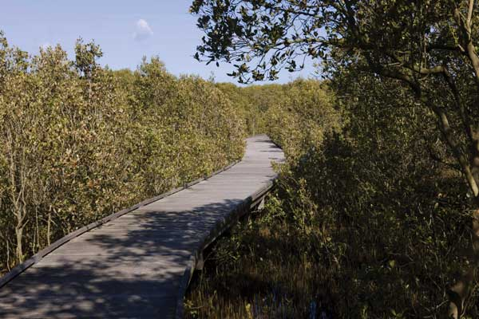

Mangrove boardwalk through Kooragang Island, near Newcastle New South Wales © Department of the Environment and Energy

#### QPWS Great Barrier Reef region habitat restoration projects

The purpose of the project is to restore or maintain breeding habitat for seabirds and includes: Boydong Island rat eradication, Three Isles guinea grass control, Capricorn Cays mice eradication, Rocky Isles Mossman River grass and lantana control, Quoin Island Pisonia restoration, Frankland/Barnards rats planned for destruction, Frankland Islands ants control, Low Isles ants control, Eshelby guinea grass control, Lady Elliot Island weed control, Shoalwater CP/Capricorn Coast MP pig control and Tryon big headed ant eradication.

#### Marine Park Management

Education and enforcement of Zoning Plan provisions (QPWS). Time frame: ongoing

Description: maintenance of shorebird signage and repositioning of shorebird signage at Lota Esplanade. Marine Park patrols incorporating education on shorebird disturbance provisions. Advice and support to public regarding roost site protection at Wynnum.

#### Marine Park licensing

Protection and management of shorebirds and their habitat (QPWS). Time frame - ongoing

Description: assessment of potential impacts to shorebirds from proposals affecting the marine park (e.g. tourism programs, research, organised events) and management of potential impacts by negotiating details of proposal and applying permit conditions.

Other initiatives include: A range of pages on shorebirds and other waterbirds have been released on EHP’s WetlandInfo website – Queensland’s first stop shop for wetland management resources. This includes pages on managing for ecological requirements, assessment, monitoring and ecology.

##### Monitoring and research initiatives

#### Name: Smart Seabird Monitoring

Researching “autonomous” methods for monitoring remote seabird breeding locations. Several trials have been completed, most data analysed, first operational deployment (North West Island, wedge-tailed shearwaters) completed. Who: DEHP, GBRMPA, Conservation Metrics

#### Michaelmas Cay: evaluating the effects of changes in topography and vegetation on seabirds, culture and ecotourism values

Determine if changes in shape and size of the Cay are of concern or just seasonal or longer term fluctuations. It also aims to determine the impact of these changes on natural, cultural and ecotourism values and to make recommendation for future management of the Cay.

Who: QPWS, GBRMPA, DNRM, Dawul Wuru Aboriginal Corporation, commercial tourism operators. Initially a 5 year project 2015-2020.

#### Identify and map coastal bird breeding sites in Moreton Bay

Monitor four sites as being, or having potential for, breeding sites particularly for Little Tern, (*Sterna albifrons*), during October to January. Enter all data on Coastal bird atlas. Compliance and education patrols will also be undertaken by QPWS marine rangers in critical areas. Aim: locate and protect vulnerable resident coasted bird breeding sites from impacts such as beach vehicular traffic. Who: QPWS, EHP, Queensland Wader Study Group (QWSG). Time frame: 4 sites twice per year – reviewed annually.

#### Counts at critical HAT sites in Moreton Bay

Support the work of QWSG in their regular high tide count program for normally inaccessible locations within the bay and to evaluate management measures at specific locations. Program has been running since 2006 and undertakes full shorebird counts at several locations. It evaluates and documents disturbance events and issues as well as conducting education and compliance. All records submitted to Wildnet. Who: QPWS and QWSG. Time frame: Ongoing and conducted on a quarterly basis

#### Eastern Australia Waterbird Aerial Survey – Queensland component supported by the Queensland Government

The information from the survey is used to monitor waterbird fluctuations over time and represents one of Australia’s most important long-term data sets. It provides vital data and information on waterbird species, informing jurisdictions about waterbird abundance, distribution and population trends in eastern Australia. Who: NSW Office of Environment and Heritage, Victoria Department of Environment and Primary Industries, Government of South Australia Department of Environment Water and Natural Resources, University of New South Wales and Queensland Government. Time frame: 1983-2017. Description: The aerial surveys of waterbirds in eastern Australia are a cross-jurisdictional collaborative program that monitors ten survey bands that intersect Queensland, New South Wales, Victoria and South Australia. It is a research project that has been conducting extensive surveys of waterbirds in eastern Australia for 30 years. An area of 2,697.00Km2 is systematically sampled with ten survey bands 30km in width, spaced every 2° of latitude.

#### Recovering Australia’s migratory shorebirds’ - Australian Research Council (ARC) Linkage project

Developed to address significant declines in migratory shorebirds (some species more than 75% in 20 years), with several species changing status to critically endangered under the EPBC Act. Specifically, the project will deliver a number of benefits, including determining population status and understanding threatening processes, understanding what management interventions can be implemented, prioritisation of management efforts and evaluation of the effectiveness of current policy, planning and management initiatives. Who: The ARC Linkage project was developed collaboratively between the University of Queensland, the Queensland Department of Environment and Heritage Protection, the Queensland Wader Study Group and the Burnett Mary Regional Group. The proposed project is centred on recovering Queensland’s shorebirds and includes the Great Sandy Strait as a case study area.

Other initiatives: The Queensland Government is working with the University of Queensland and the QWSG to update the available data sets on shorebirds as surveyed by the Queensland Wader Study Group, a citizen science group that undertakes regular surveys of shorebirds in Queensland.

### New South Wales

#### Saving our Species (SoS) program

The NSW Government launched the Saving our Species (SoS) program to meet the conservation requirements of selected species. Actions under the program include targeted conservation projects, monitoring, community awareness raising and education. Conservation of listed threatened migratory species such as the Sanderling (*Calidris alba*), Black-tailed Godwit (*Limosa limosa*), Broad-billed Sandpiper (*Limicola falcinellus*), Curlew Sandpiper (*Calidris ferruginea*), Terek Sandpiper (*Xenus cinereus*), Greater Sand Plover (*Charadrius leschenaultii*), Lesser Sand Plover (*Charadrius mongolus*), Masked Booby (*Sula dactylatra*) and Little Tern (*Sternula albifrons*) will be assisted under this program. NSW is currently developing a targeted approach for managing partnership species (Terek Sandpipers, Broad-billed Sandpipers, Curlew Sandpipers, Black-tailed Godwit, Sanderlings).

In the interim, management actions identified for these threatened migratory shorebird species include:

* Undertake regular 2-yearly coordinated survey to assess distribution and population size of partnership species.
* Review survey data to identify key foraging sites along the NSW coast.
* Increase community awareness of migratory waders
* Liaise with planning authorities to minimise the loss of habitat from development.

Under the program, 11 priority Little Tern sites along the NSW coast have received funding. Actions being implemented include: pest control, weed removal, community education and engagement, monitoring of breeding success, and active management of nests to avoid tidal inundation, human disturbance and egg/chick predation.

#### Little Terns (Sterna albifrons)

Since 2012 NSW has monitored fledging rates of little terns and other threatened beach-nesting shorebirds at over 25 major nesting sites along the NSW coast. Where feasible, primary threats to fledgling have been managed at these sites, including introduced red foxes (*Vulpes vulpes*), human disturbance, domestic dogs, inundation and native avian predators (corvids and gulls). Observed fledging rates have been variable irrespective of management, but estimated rates at sites with management such as fox control are 50% higher than unmanaged sites. Despite management efforts, the number of breeding pairs across all sites has been declining at about 2.5% per year since 2001.

#### Hunter Estuary Wetlands

The Tomago Wetlands within the Hunter Estuary Wetlands Ramsar site is a key site in the East Asian-Australasian Flyway, with over 5000 Sharp-tailed Sandpipers (*Calidris acuminata*) recorded during the 2014/15 summer. Significant sections of key migratory shorebird roosting habitat on the Kooragang Dykes have been repaired and raised. Mangrove seedlings are being removed and 18 hectares of saltmarsh has been restored as migratory shorebird habitat through mangrove removal.

#### Towra Point Ramsar Site

Following indications of changed ecological character at the site, in 2014 a Ramsar preliminary assessment noted a reduction of shorebird diversity and numbers. NSW is working with the Australian Government to start the formal assessment in 2016. The site is closed to public access, it operates a threat abatement program for foxes and a monitoring program for Little Terns.

#### Extension of Ramsar site at Narran Lake Nature Reserve

In February 2016, the Ramsar site was extended by 3,104 hectares to a total of 8,447 hectares. The extension captures the full nature reserve floodplain and includes more breeding and feeding habitat for waterbirds. The site can support more than 68 waterbird species, 12 of which are listed under international agreements.

#### Programs to support waterbirds

Environmental watering of key waterbird habitat in NSW is carried out annually to maintain and enhance migratory shorebird habitat in iconic wetlands across five key catchments. These habitats support many migratory bird species including Eastern Great Egret, Cattle Egret, Latham’s Snipe and Sharp-tailed Sandpiper. Long-term Watering Plans are being prepared for NSW Murray-Darling Catchments, which will set targets for maintaining habitats for waterbirds within key wetland systems such as the Macquarie Marshes, Gwydir Wetlands, Lowbidgee wetlands and the Murray River. Maintenance of migratory bird habitat is supported through statutory water sharing plans which aim to maintain system health. This provides important water flow protection for numerous inland habitats. These include Narran Lakes and Menindee Lakes which provide critical habitat for very high numbers of migratory birds.

#### Environmental Water

OEH managed the delivery of environmental water specifically to provide foraging habitat for migratory shorebird species in the Western Lakes (Lower Murrumbidgee), Fivebough-Tuckerbil Ramsar site (mid-Murrumbidgee), Macquarie Marshes and Gwydir Wetlands in 2014-16.

#### Waterbird monitoring

The Aerial Waterbird Surveys of Eastern Australia (AWSEA) contributes to 33 years of data collected across six survey bands in Eastern Australia including major wetland sites in the Murray-Darling Basin. This program is coordinated by the University of New South Wales with contributions made by the NSW Government for the NSW portion.

The NSW Government undertakes counts of waterbirds in the Macquarie Marshes, Gwydir Wetlands, Lower- and Mid-Murrumbidgee Wetlands, Central Murray Forests and Narran Lakes, to complement data collected through the AWSEA, and to support the adaptive management of environmental water by the NSW and Commonwealth Governments. Many of these areas support Ramsar wetlands that contain significant breeding habitat for colonial waterbird species listed under JAMBA, CAMBA and/or ROKAMBA.

### Australian Capital Territory

#### Migratory Species Action Plan

The Nature Conservation Act 2014 (ACT) requires the development of an Action Plan for Migratory Species to cover those listed species likely to occur in the ACT, as regular or opportunistic migrants. Listed migratory species are those species listed under the *Environment Protection and Biodiversity Conservation Act* 1999 that are subject to international agreements.

The Action Plan will help inform environmental impact assessment processes, but also identify strategies to improve management of the habitat of migratory species. An Action Plan for migratory species maps their known critical and potential habitats and proposes management strategies to ensure their persistence.

A draft Migratory Species Action Plan has been prepared for listed migratory species. There are 31 listed migratory species that are known to have occurred in the ACT. Consultation on the Migratory Species Action Plan will occur early in 2016-2017.

#### Latham’s Snipe monitoring project

The 201 hectare Jerrabomberra Wetlands Nature Reserve is a unique wetlands complex in the heart of Canberra, popular for bird watching, education and walking. Some areas have restricted access to protect important habitat for birds such as the Latham’s Snipe.

Funding of $25,000 has been provided to the Woodlands and Wetlands Trust (the Trust) to help with a joint Japanese–Australian project to monitor the migration of Latham’s Snipe. Latham’s Snipe is one of many bird species that regularly migrate to the ACT each year that are listed in international conservation agreements and conventions. The funding is part of the larger Japanese–Australian Latham’s Snipe Project and will enable the Trust to fit satellite trackers to three birds at Jerrabomberra Wetlands in spring and summer late 2016 early 2017.

### Victoria

Understanding of Victoria’s 11 Ramsar sites, including their waterbird values, is being improved with updates underway to the Ramsar Information Sheets and Ecological Character Descriptions (ECD) for each site.

Each site will have an ECD addenda that includes:

* a summary of the amendments made,
* the criteria met at the time of listing and that are currently met,
* a review of the critical components, processes and services (including additional critical CPS at some sites),
* a review of Limits of Acceptable Change (including additional LAC for some sites),
* a review of threats to ecological character (including updates), and
* an assessment of site status against the LAC (Ramsar Rolling Review).

The addenda incorporate a range of recent data and information relating to waterbirds. The Victorian government is also reviewing the monitoring requirements for the states Ramsar sites and updating boundary descriptions for each site.

Seven of the 11 Victorian sites have updated management plans that are embedded in regional waterway strategies which were completed in 2014. The regional waterway strategies provide a single, overarching planning document for waterway management in each region, they were developed by waterway managers (catchment management authorities) in partnership with other regional agencies and boards involved in natural resource management as well as Traditional Owners and regional communities.

Regional waterway strategies include all waterway types (wetlands, rivers and estuaries) and are based on a standard risk assessment and prioritisation process that identifies high value waterways, and the threats impacting them and prioritises management activities, which may aim to reduce threats or protect high value waterways. A wetland was higher priority if it was a Ramsar Site, migratory shorebird site, colonial nesting bird site, an Important Bird Area or supported threatened wetland dependent flora and fauna (including waterbirds).

The remaining Ramsar sites have stand-alone plans. Gippsland Lakes Ramsar Site Management Plan was renewed in 2015. Western Port Ramsar Management Plan is nearing completion and will be published before the end of 2016. Edithvale-Seaford Wetlands and the Port Phillip Bay (Western Shoreline) and Bellarine Peninsula Ramsar site management plans are currently being renewed.

Support has been provided to the University of New South Wales’ cross-jurisdictional Eastern Australia Waterbird Aerial Surveys, which provides a significant long term data set on waterbirds and their habitats.

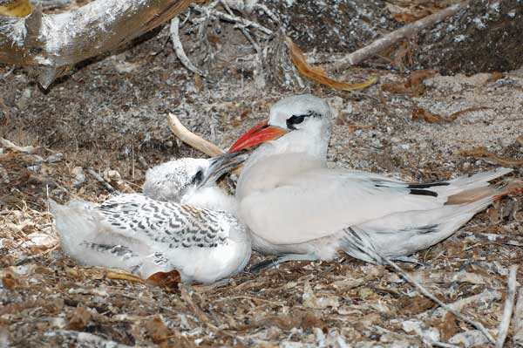

Adult and young Red-tailed Tropicbirds in their nest on Lady Elliot Island in the Great Barrier Reef, Queensland © Graeme Chapman

### Tasmania

#### Wildlife Management Branch, Department of Primary Industries, Parks, Water and Environment

Annual surveys have been conducted and monitoring of migratory shorebirds continue, with statewide waterbird surveys conducted in February 2016. Ramsar sites that are included, or partly included, in these surveys are; Moulting Lagoon, Apsley Marshes, Logan Lagoon, Orielton Lagoon and Interlaken (Lake Crescent). Annual winter bird surveys of the Moulting Lagoon and Apsley Marshes Ramsar sites have been conducted each July. Monitoring of Short-tailed Shearwater breeding colonies continues, with twice yearly surveys at sites in the Furneaux Islands and other locations across Tasmania.

#### BirdLife Tasmania

BirdLife Tasmania has contributed to the implementation of the three bilateral migratory bird agreements in the following ways:

* Ongoing Summer and Winter Shorebird counts (migratory and resident species) have been undertaken in the southeast, east, northeast, north and northwest of Tasmania as part of BirdLife Australia’s Shorebirds 2020 project. The southeast Tasmania data set extends from 1963 to the present, making it the longest time series of population data on migratory shorebirds in Australia.
* Submissions to Federal Department of Environment regarding EPBC listing and up-listing of migratory birds (three species of shorebirds and two species of woodland birds present in Tasmania, based on historical data set).
* Inventories of migratory shorebirds undertaken during mapping surveys of beach-nesting shorebirds. These surveys are of sandy beaches around Tasmania, with more than 350 beaches now surveyed, many at approximately 5-yearly intervals.
* Contributed to national efforts to estimate population sizes of 37 species of migratory shorebirds recently included in 2015 Wildlife Conservation Plan for Migratory Shorebirds under EPBC Act.
* Contributed to waterfowl and shorebird counts in Moulting Lagoon organised by DPIPWE.
* Contributed to banding and geo-locator attachment on migratory shorebirds on King Island organised by the Australasian Wader Studies Group of BirdLife Australia.
* Ongoing surveys of wetlands on King Island and inter-tidal areas on Flinders Island for migratory shorebirds.
* Ongoing surveys and limited monitoring of Fairy and Little Terns at breeding colonies.
* Supported higher-degree students’ research efforts into Short-tailed Shearwaters in Tasmania, including supervision of one PhD study.
* Extensive community engagement efforts regarding dog management, weed and marine debris removal in coastal areas, providing educational and interpretive materials to participants.
* Extensive community engagement efforts with Coastcare groups to educate members about resident and migratory shorebirds.
* Supported community groups removing invasive plants from shearwater colonies in southeast Tasmania.
* Collaborated with NRM South and University of Tasmania in development and promotion of saltmarsh monitoring app for smart phones.
* Supporting material comprised saltmarsh bird poster and plant identification book.
* [Collaborated with five southern Tasmania Councils and NRM S in “South East Regional Shorebird Alliance” (SERSA). SERSA won Tasmanian Landcare award for Government Partnerships with Landcare](http://www.nrmsouth.org.au/south-east-regbirds-alliance/)

Prepared by Janet Smith, Private Land Conservation Program, Natural and Cultural Heritage Division, Department of Primary Industries, Parks, Water and Environment

### South Australia

South Australia is committed to the conservation and protection of migratory shorebirds through both government led and community-driven initiatives. The Department of Environment, Water and Natural Resources (DEWNR) supports migratory shorebirds through a series of initiatives including the Samphire Coast Icon Project (SCIP), funded through the Natural Resources, Adelaide & Mount Lofty Ranges and Australian Government, the Adelaide International Bird Sanctuary initiative (AIBS), funded through State Government and the Coorong, Lower Lakes and Murray Mouth Recovery Project (CLLMM) funded through the Australian and South Australian Governments. Additionally, DEWNR supports migratory birds and their habitat through the development of environmental watering proposals submitted to water holders and environmental watering actions targeting migratory birds.

A number of organizations in South Australia lead the community-based contributions towards supporting migratory shorebirds, such as the Friends of Shorebirds South East (FOSSE), the Friends of Adelaide International Bird Sanctuary (FOAIBS), the Australasian Wader Study Group (AWSG) and several universities, who provide critical research and student-based projects to better understand the shorebird related ecosystems.

Activities across these groups and smaller community teams provide information on annual shorebird populations, site utilization, habitat identification, mapping of important sites and threats along the coast of South Australia (focused on the South East of the state, the Adelaide Coastline and Eyre Peninsula). A few key highlights of this work include:

* In the South East, protection of shorebirds has been incorporated in works programs through expansion of a fox threat abatement program to over 90,000 Ha aimed at protecting beach nesting shorebirds. Additionally, FOSSE has undertaken some work examining the impact of disturbance on shorebirds to help provide further evidence of this and its role in population decline.
* Natural Resources, Adelaide & Mount Lofty Ranges shorebird population monitoring within Gulf St Vincent (the greater Adelaide region) – [click here](http://birdlife.org.au/documents/SC-Shorebird_population_monitoring_report_GSV-2015.pdf) for further information.
* Habitat mapping across the AIBS with an overlay of Off-Road Vehicle usage.
* Natural Resources Eyre Peninsular, Natural Resource Management Alinytjara Wilurara, and the Eyre Peninsula Local Government Association have instigated a project to prepare a cohesive, region wide strategy for the sustainable management of visitor access to coastal areas of the Eyre Peninsula and Far West Coast to limit the potential disturbance of shore nesting birds.
* A joint project of FOSSE, the Victorian Wader Study Group and Natural Resources, Adelaide & Mount Lofty Ranges to attach geolocators to migratory shorebird species has identified important local habitats and movement, departure dates and migration routes.

This activity provides evidence and information for better management of migratory shorebirds and their habitats in the state. In the future, this information could permit the identification of additional valuable migratory shorebirds sites in the state. An important outcome of this work has been a recent decision to revise the commercial harvesting of beach wrack on the coasts of the South-East to minimize the disturbance of nesting shorebirds by avoiding harvesting during peak use periods and avoiding specific locales.

Importantly a number of education events aimed at raising awareness of shorebirds, their habitats and the threats to them are undertaken in South Australia. The events include:

* The Adelaide Flyway Festival, held in October to celebrate the arrival of migratory birds back to the Adelaide region for the summer. Approximately 2,500 to 3,000 people attended and supported local businesses demonstrating social and economic benefits associated with the Adelaide International Bird Sanctuary initiative.
* “the dog’s breakfast” – an event in the South East aimed at dog owners in the region who visit the beach to learn the best ways to share the beach with beach-nesting and migratory shorebirds.
* Annual workshops with a focus on reaching out to managers and planners in the Adelaide region about migratory shorebirds to co-design changes needed to protect shorebirds.
* Annual workshops for tourism stakeholders and training observers to participate in population counts in the Adelaide region.
* Installation of awareness raising posters highlighting the species that use beaches and guidelines users can adopt to protect shorebirds and their habitat.

A community project about to get underway in the region is the Milang Foreshore and Snipe Sanctuary Project on the shores of Lake Alexandrina. The project, co-developed with the local community, seeks to maintain and continue recovery of native habitat and feeding grounds for threatened migratory waterbird species at Milang, specifically the Japanese Snipe (Gallinago hardwickii). Key actions to be undertaken by the project aim to limit invasive species encroachment in the area through weed control, fencing, signage, revegetation and infrastructure to allow future environmental watering of the wetland habitats. The project will also build an interpretive trail through the site, including a viewing platform and bird hide, to improve community understanding and awareness of waterbirds and values of the Ramsar Wetland building their capacity to support. The project is jointly funded by the Australian and South Australian Governments.

#### Adelaide International Bird Sanctuary (AIBS)

The Adelaide International Bird Sanctuary has a number of activities seeking to deliver protection for migratory shorebirds through the creation of the Adelaide International Bird Sanctuary. Much of the sanctuary lies adjacent to the Upper Gulf St Vincent Marine Park and is second only to the Coorong as the longest continuous coastal reserves in the state. Since the last update there are a number of activities that have occurred.

In addition to a [Facebook page](https://www.facebook.com/adelaideinternationalbirdsanctuary/), the AIBS team use social media and e-newsletters to regularly communicate with over 1000 members of the public. Throughout 2015 several public events were held to raise awareness and inspire people about the migratory shorebird story and the significance of the AIBS. This has included a two day ecology summit, attended by over 250 people and the Inaugural Adelaide Flyway Festival held in October 2015 at St Kilda.

Importantly, a national park and management plan is being created for the AIBS to ensure long term protection to support and give effect to its proposed nomination and inclusion in the East Asian-Australasian Flyway Partnership, to become an EAAF Network site in 2016. The creation of a National Park for the AIBS is being undertaken in collaboration with the four local councils and Kaurna, Aboriginal community leaders.

To develop the management plan a series of four expert workshops are being held to consider the community and stakeholder input to protect shorebirds of the AIBS. An important outcome is the development of expert-advised shorebirds indicators to assist with understanding critical ecological processes needed for shorebird habitat and the tracking of these indicators to understand the effectiveness of the AIBS.

#### The Coorong and migratory shorebirds

January 2016 monitoring of waterbirds in the Coorong undertaken by Associate Professor Paton of the University of Adelaide has counted over 185,000 waterbirds from 57 species. More than half (over 93,000) of these waterbirds were using the South Lagoon, with numbers of Red-necked Stints (*Calidris ruficollis*) exceeding 10,000 birds although this is about half that of the previous year. The abundance of Curlew Sandpiper (*Callidris ferruginea*), were below the long-term median with numbers at about 30% of the 2015 abundance. This is consistent with a long term decline in the numbers of this species being observed locally. Positively, more than a thousand Sharp-tailed Sandpipers (*Calidris acuminata*) were observed in the South Lagoon, higher than the previous year. Also, 2016 was the first year since the end of the millennium drought in 2010 when Common Greenshanks (*Tringa nebularia)* exceeded their long-term median abundance in the Coorong.

Of concern were the observations that various shorebirds (sandpipers, stints) continued to spend 80-90% of their time foraging, indicative of poor food resources within the site. The presence of a small number of dead, emaciated shorebirds (red necked stints) in the southern Coorong was consistent with some birds failing to secure sufficient food.

Associate Professor Paton has indicated that the poor performances of some of the shorebirds and herbivorous waterfowl in the southern Coorong is linked to the poor condition of Ruppia tuberosa. Abundances of seeds and turions in January 2016 were around 1% and 20% of their historic levels, respectively. Associate Professor Paton has concluded that in order to effectively support migratory shorebirds and other waterbird species in the site, action to improve the inundation of habitats in the Coorong is required in addition to the provision of environmental water. The South Australian Government is presently considering the need for further activities to support the health of the Coorong.

### Western Australia

This report provides an update on actions across government and non-government organisations conducted since November 2014.

#### Planning, Policy, Protection

In 2015 a revision of the threatened species notices and update of the conservation status of migratory birds protected under international agreements, which are listed as ‘fauna in need of special protection’ under the *Wildlife Conservation Act*. The listing seeks to maintain consistency with the listing of migratory species under the *Commonwealth Environment Protection and Biodiversity Conservation Act 1999.*

In 2015, the State Government prepared Condition Statements for the Becher Point, Forestdale and Thomson Lakes, and Peel-Yalgorup System Ramsar sites. These Condition Statements provided updated information on condition, pressures and management response as well as an assessment of condition against the Ramsar listing criteria and the Limits of Acceptable Change, and identification of knowledge and management gaps. The Ramsar site evaluations which lead to the preparation of these Condition Statements is the most extensive conducted since the publication of the Ecological Character Descriptions for Becher Point and Peel-Yalgorup System Ramsar sites in 2007 and for Forrestdale and Thomsons Lakes Ramsar site in 2009.

The State Government released the draft *Perth and Peel Green Growth Plan for 3.5 million* (strategic assessment) for public comment in December 2015. The draft Plan includes a conservation program for protection of MNES and State environmental values including a suite of actions to protect Ramsar wetlands, migratory birds and wetlands of regional and State significance

The Esperance Recherche Parks and Reserves Management Plan was completed which includes a number of management actions that pertain to managing, protecting and monitoring the Ramsar listed wetlands with respect to their hydrology and biological assets (though note that resources to conduct these actions have been significantly reduced with minimal recurrent allocation to under ‘care and maintenance’ of the bore monitoring system).

Other activities include:

* A 5 Year Threatened Species Information and Protection Program (TSIPP) commenced in 2015. The program aims to mitigate the impacts of threatened and migratory species including shorebird and seabirds from the potential impacts of recreational activities and associated impacts along the Exmouth Gulf, Pilbara coast and offshore islands.
* Commenced a CALM Act management plan for 50 inshore Pilbara Islands Nature Reserves involving migratory shorebird surveys and mapping key feeding and high tide roost sites.
* Developed island quarantine procedures for the Pilbara Islands Nature Reserves including fit out of a quarantine building for storing field equipment.
* Commenced updating Island Quarantine Protocol and State wide Conserving WA’s Islands brochure which includes actions for achieving reduced quarantine risks to island habitats. The brochure will be available electronically and in hard copy in late 2016.
* Creation of a multi-agency planning team to oversee the creation of a detailed wetlands management operational plan ahead of the system becoming a formal conservation reserve in the next few years.
* Land tenure acquisitions totalling approx. 40ha for conservation purposes to buffer expanding urban subdivision and rural developments adjacent to the Vasse-Wonnerup Ramsar site.
* Local area conservation strategy developed for Owingup/Boat harbour Complex with Conservation Council and planning has begun for a conservation reserve to protect habitat of Fairy terns.

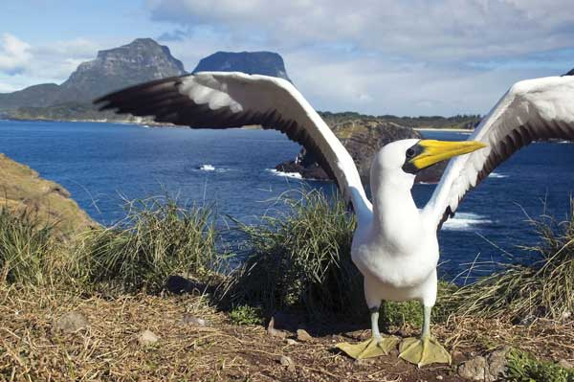

Masked Booby (*Sula dactylatra*) on Roach Island, Lord Howe Island Group © Ian Hutton

#### On-ground Management

Activities include:

* Feral pig and goat control along the Lesueur National Park (A42032) western wetlands and lagoon system.
* African Boxthorn weed eradication program and rehabilitation of Turquoise Coast Island Nature Reserves including; Boullanger, Whitlock, Favorite, Tern and Osprey Island Nature Reserve (A29251), Beagle Islands Nature Reserve (A26411), Lipfert Milligan Etc. Island Nature Reserve (A29259).
* Weed control on Lancelin & Edward Islands Nature Reserve (A24979).
* Ongoing rehabilitation and weed control at Lake Thetis TEC – Nambung National Park (A24522).
* A feral animal control program has reduced the abundance of camels, donkeys and horses.
* A broadscale 1080 aerial baiting program has significantly reduced feral cats occupying the Fortescue Marsh.
* The Pilbara Mesquite Management Committee is managing an 18 km infestation of Parkinsonia (Parkinsonia aculeata) upstream of the Fortescue Marsh. Over 40,000 individual Parkinsonia plants were treated during the 2015/16 FY.
* Over 300 hectares of priority invasive weed species have been controlled at the Fortescue Marsh.
* Temporary fencing installed at Point Walter Spit (Swan River) to minimise the impact of recreational disturbance on nesting and roosting birds. Undertaken by City of Melville in collaboration with BirdLife Australia and Swan River Trust.
* Typha control and other weed control conducted at Thomsons Lake.
* Dune restoration works at Becher Point.
* Fence maintenance to restrict unauthorised access into the sites at Thomsons Lake and Becher Point.
* Water supplementation at Thomsons Lake –water quality and invertebrate data has been collated from the monitoring undertaken by other agencies.
* Fox and rabbit control at Thomsons Lake.
* Weed control on ‘Manners Block’ to the north of Esperance Lakes system.
* Weed control and herbivore fencing at Vasse-Wonnerup Ramsar site associated with fringing vegetation revegetation programs – average approx. 8-10ha per year and 40ha total since 2008.
* Monthly fox baiting on those portions over the Vasse-Wonnerup Ramsar site overlying the Tuart Forest National Park – approx. 300ha.
* Experimental trials over the summer months over the Vasse-Wonnerup Ramsar site using a portable Oxygenation Plant to alleviate water quality parameters conducive to algal blooms and mass fish deaths.
* Feral animal control, deer, pigs, foxes at Owingup/Boat harbour Complex.
* Temporary fencing of nesting colonies of Fairy Terns.
* Weed and feral pig and fox control at Muir Byenup Ramsar site.

#### Monitoring

Monitoring activities undertaken in Western Australia include:

Monitoring and management of Fairy Tern breeding and roosting colonies involving citizen science participation through the SW Fairy Tern Monitoring Program (Conservation Council of WA)

Annual beach cast marine debris surveys. 2016 target – remove and classify marine debris from >50km of coastline (assessment of micro plastics to be included in next survey)

Intertidal reef condition monitoring (algae and invertebrates) of coastal and offshore island reef platforms.

29 shorebird surveys have been conducted in the Ningaloo Marine Park and the Exmouth Gulf between Dec 2014 and July 2016

Annual Shorebirds 2020 counts continue at the following sites: Roebuck Bay and 80 Mile Beach (see MYSMA below), Barrow Island, Exmouth Gulf and Ningaloo Coast, Shark Bay and Carnarvon, Geraldton, Hutt Lagoon, Leeman Lakes, Jurien coast, Guilderton, Swan Coastal Plain lakes, Swan and Canning Rivers, Rottnest Island, Garden Island, Peel-Yalgorup, Wagin and Katanning lakes, Leschenault Estuary (new site added in 2016), Vasse-Wonnerup and Broadwater, Muir-Unicup, Hardy Inlet, Albany, Wilson Inlet, Upper Kent River Catchment, Hopetoun, Parry, Irwin, Walpole and Broke Inlets, Owingup Swamp, Lake Gore, Warden Lakes, Esperance, Nuytsland Nature Reserve. Some of these sites are counted more often than annually.

Monitoring Yellow Sea Migrants in Australia (MYSMA) annual shorebird counts at Roebuck Bay and Eighty Mile beach continued. Undertaken by the Australasian Wader Study Group, with support from Parks and Wildlife. In 2015 these counts were extended to cover the full length of Eighty Mile Beach for comparison with the last full count in 2008.

[Ongoing surveys by Global Flyway Network at Roebuck Bay and Eighty Mile Beach (and China)](http://globalflywaynetwork.com.au/).

Annual North West Australia Wader and Tern Expedition continued at Roebuck Bay and Eighty Mile Beach. Undertaken by the Australasian Wader Study Group, with some support from Parks and Wildlife.

Hydrological monitoring of the Lake Warden system has been maintained through bore monitoring.

Migratory shorebird surveys and mapping key feeding and high tide roost sites, targeting migratory seabirds/ shorebirds, are facilitated by offset funding in Exmouth Gulf and islands, targeting locations listed as Nationally Important Wetlands (Exmouth Gulf East) and Islands listed on the Register of the National Estate. Data entered onto the Pilbara Islands Conservation Planning database.

Commenced Island habitat threat assessment focusing on introduced species, involving remote cameras, Elliot trapping and small cage trapping. Black rats (*Rattus rattus*) have been detected on three of 50 islands; fox footprints on one island and house mouse (*Mus musculus*) on three islands. The infected islands generally lie close to the mainland, have some mangrove habitat and are locally important over wintering sites used by a number of species of migratory shorebird, including the Eastern Curlew and Great Knot.

Mapped the occurrence and spread of weeds by local Parks and Wildlife staff; engaged a botanist to undertake vegetation association mapping; and assisted research staff with habitat mapping in order to improve understanding and inform the management plan.

Monthly water birds counts across the entire Vasse-Wonnerup system by regional DPAW staff – commenced Sept 2014.

Fortnightly water quality monitoring and regulation of marine inflows at the Vasse-Wonnerup Ramsar site through the Vasse-Wonnerup Collaboration Committee.

Biophysical and water monitoring at Owingup/Boat harbour Complex.

Annual survey for shorebirds 2020 project from Broke inlet to Wilson Inlet.

Ongoing monthly bird and water chemistry monitoring Muir - Byenup Ramsar site.

Annual community surveys conducted for nesting colonies of Fairy Terns at Wilsons Inlet.

#### Education/Research

* ‘Farewell Shorebirds’ community education events at Barrow Island. Undertaken by Parks and Wildlife in association with BirdLife Australia, with logistical support from Chevron Australia.
* Brochure developed to minimise the impact of recreational disturbance on shore and waterbirds at Point Walter Spit (see attached). Developed by Swan River Trust (now Parks and Wildlife) and BirdLife Australia, funded by Swan River Trust.
* Shorebirds 2020 workshop at Swan River 14-15/5/16 for River Guardians. Presented by BirdLife Australia, facilitated and funded by Swan River Trust.
* Shorebirds 2020 workshop in Esperance 28/4/15 for local community. Presented by BirdLife Australia, facilitated and funded by South Coast NRM.
* Shorebirds 2020 workshop in Port Hedland 19-20/3/16 for local community. Presented by BirdLife Australia, facilitated and funded by Care for Hedland.
* South Coast Festival of the Birds included community shorebird events in 2015. Presented by BirdLife Australia, facilitated and funded by Greenskills WA.
* Shorebird presentation for local community in Busselton to support local artist Sue Kalab’s exhibition at ArtGeo on 23/5/15. Presented by BirdLife Australia.
* TSIPP has commenced engagement with Local government, Wheatstone Indigenous Sea Ranger Group, Tour operators and community to raise awareness and implement education programs of shorebird species within the region.
* Interpretive signage is planned to be implemented at a minimum of 4 boat launching facilities along the Exmouth gulf and Pilbara coast in 2016/2017. This action aims to raise awareness of significant habitat and minimise impacts such as human disturbance on shorebird and seabird species on offshore islands, including five International Important Bird Areas.
* Regular community stakeholder meetings to provide input and advice to the Collaboration Committee agencies re: management issues at the Vasse-Wonnerup Ramsar site.
* Creation of a Science Advisory Committee to provide agency and tertiary research input into the management of the Vasse-Wonnerup system.
* Creation of hydrodynamic models to assist in the evaluation of alternative water management regimes for the Vasse-Wonnerup system.
* Public education program started to raise awareness of nesting colonies of Fairy Terns at Wilsons Inlet.
* Research project in second year to better understand peat wetland resilience: evaluating the impact of climate and land use change on the hydrodynamics and hydrogeochemistry of peat wetlands in the Warren (Muir-Byenup) District.

## Update on species or subspecies of birds in danger of extinction

### Australian Government Department of the Environment and Energy

**Relevant JAMBA Articles**: III, IV, V, VI  
**Relevant CAMBA Articles:** III  
**Relevant ROKAMBA Articles**: 3

### Summary

The *Environment Protection and Biodiversity Conservation Act 1999* (the EPBC Act) is the national environmental law for Australia. The EPBC Act promotes the conservation of biodiversity by, amongst other things, providing strong protection for nationally threatened species and sub-species. These can be listed as Extinct in the Wild, Critically Endangered, Endangered, Vulnerable or Conservation Dependant. State and Territory governments also have similar legislation which provide for listing of species and subspecies considered threatened within their jurisdictions.

Any person may nominate a native species for listing under any of the threatened species categories of the EPBC Act. Nominations are forwarded to the Threatened Species Scientific Committee, which is a committee established to advise the Minister for the Environment and Energy. Once the Threatened Species Scientific Committee has conducted an assessment of the conservation status of nominated species, its advice and subsequent recommendations are forwarded to the Minister who makes the final decision. After a species or subspecies is listed under the EPBC Act their recovery is promoted using Conservation Advice, Recovery or Threat Abatement Plans.

Since November 2014, 16 bird species have been listed under the threatened species provisions of the EPBC Act, and four other bird species were transferred between categories (see Table 1).

To date, there are 155 birds listed on the EPBC Act threatened species list. Of those, 22 are listed extinct, 16 critically endangered, 49 endangered and 68 vulnerable. The list of threatened species listed under the EPBC Act is maintained on the internet at [this address](http://www.environment.gov.au/cgi-bin/sprat/public/publicthreatenedlist.pl).

#### Table 1: Birds listed under the threatened species provisions of the *Environment Protection and Biodiversity Conservation Act 1999* since the November 2014 consultative meetings.

|  |  |  |  |
| --- | --- | --- | --- |
| **Genus, species, subspecies** | **Common Name** | **Conservation Status** | **Effective from** |
| *Calidris ferruginea* | Curlew Sandpiper | Critically Endangered | 26 May 15 |
| *Numenius madagascariensis* | Eastern Curlew | Critically Endangered | 26 May 15 |
| *Acanthiza iredalei rosinae* | Slender-billed Thornbill (Gulf St Vincent) | Vulnerable | 8 Jul 15 |
| *Anthochaera phrygia* | Regent Honeyeater | from Endangered to Critically Endangered | 8 Jul 15 |
| *Grantiella picta* | Painted Honeyeater | Vulnerable | 8 Jul 15 |
| *Mirafra javanica melvillensis* | Horsfield’s Bushlark (Tiwi Islands) | Vulnerable | 8 Jul 15 |
| *Pedionomus torquatus* | Plains-wanderer | from Vulnerable to Critically Endangered | 8 Jul 15 |
| *Zoothera lunulata halmaturina* | Bassian Thrush (South Australian) | Vulnerable | 8 Jul 15 |
| *Malurus coronatus coronatus* | Purple-crowned Fairy-wren (western) | from Vulnerable to Endangered | 31 Oct 15 |
| *Platycercus caledonicus brownii* | Green Rosella (King Island) | Vulnerable | 31 Oct 15 |
| *Probosciger aterrimus macgillivrayi* | Palm Cockatoo (Australian) | Vulnerable | 31 Oct 15 |
| *Strepera fuliginosa colei* | Black Currawong (King Island) | Vulnerable | 31 Oct 15 |
| *Amytornis dorotheae* | Carpentarian Grasswren | Endangered | 5 May 16 |
| *Calidris canutus* | Red Knot | Endangered | 5 May 16 |
| *Calidris tenuirostris* | Great Knot | Critically Endangered | 5 May 16 |
| *Charadrius leschenaultii* | Greater Sand Plover | Vulnerable | 5 May 16 |
| *Charadrius mongolus* | Lesser Sand Plover | Endangered | 5 May 16 |
| *Lathamus discolor* | Swift Parrot | from Endangered to Critically Endangered | 5 May 16 |
| *Limosa lapponica baueri* | Bar-tailed Godwit (Western Alaskan) | Vulnerable | 5 May 16 |
| *Limosa lapponica menzbieri* | Bar-tailed Godwit (Northern Siberian) | Critically Endangered | 5 May 16 |

## Take of migratory birds or their eggs in accordance with Article II

### Department of Primary Industries, Parks, Water and Environment, Tasmanian Government

**Relevant JAMBA Articles**: II  
**Relevant CAMBA Articles**: II  
**Relevant ROKAMBA Articles**: 2

### Summary

Migratory birds, including all species listed on the annexes of JAMBA, CAMBA and ROKAMBA, are protected as a matter on national environmental significance under Australia’s *Environment Protection and Biodiversity Conservation Act 1999* (EPBC Act). They are further protected under State and Territory (provincial) environmental laws. There are permits issued to capture birds for the purposes of scientific research, but also for traditional hunting which is consistent with the Articles of the migratory bird agreements. The only migratory bird species harvested in significant numbers in Australia is the Short-tailed Shearwater (*Ardenna tenuirostris*).

The Department of Primary Industries, Parks, Water and Environment has long-term arrangements in place to allow members of the Tasmanian Aboriginal community to take shearwaters from a colony in south-eastern Tasmania for cultural purposes (also known as ‘muttonbirding’). As a result of concerns over the sustainability of harvest on this colony, no cultural harvest was permitted during the 2010/11 and 2013/14 breeding seasons. Monitoring showed breeding returned to levels that allow for a sustainable harvest for the 2014/15 and 2015/16 breeding seasons and harvest was undertaken in these years. Seventy nine cultural muttonbirding permits were issued for the 2014/15 breeding season and a reported 1,975 chicks harvested. During the 2015/16 breeding season, 1,384 chicks were harvested by 58 Cultural muttonbirding permit holders. Another small colony on the east coast was opened to allow an indigenous family to undertake cultural muttonbirding in their traditional harvest area in 2016. No harvest return data has been received on this small harvest.

The Department also manages a recreational harvest of Short-tailed Shearwaters. Members of the public can purchase a permit to harvest from 38 sites around Tasmania’s Bass Strait Islands and two sites on Tasmania’s west coast. These permits allow take of up to 25 birds per day (15 on the West Coast sites) for a period of 15 days. In 2014/15, 933 recreational harvesting permits for shearwater were issued, 62 percent of all permit holders submitted returns to the Department reporting a take of 33,571 birds. Based on extrapolation of these returns the recreational take for the 2014/15 breeding season was estimated at 46,300 chicks. In 2015/16, a total of 834 recreational harvest permits were issued. At this stage, the harvest returns for the 2015/16 breeding season have not processed.

## Coordination of the Australian Bird and Bat Banding Scheme

### Australian Government Department of the Environment and Energy

**Relevant JAMBA Articles**: I, IV, VI  
**Relevant CAMBA Articles:** I, III, IV  
**Relevant ROKAMBA Articles:** 1, 3

### Summary

Through the Australian Bird and Bat Banding Scheme (ABBBS), the Australian Government Department of the Environment and Energy coordinates training and accreditation of researchers doing banding studies in Australia. There are 832 accredited banders and banding groups currently operating in Australia. Bands, literature, equipment and data storage have also been provided to scientists in the South East Asian/Pacific region who are conducting research in countries that do not have a banding scheme, with the agreement of the countries involved. Four projects in Papua New Guinea are currently, or have been, supported during the reporting period.

Around 3.14 million banding and 582,000 recovery records generated since 1953 are now stored electronically, enabling sophisticated analysis and efficient responses to requests for data. A major project to convert the remaining paper-based records into electronic format has seen over one million banding and recovery records added since 2005. These data, accumulated over more than 60 years, are available to government and the research community.

### Noteworthy Recoveries

Some interesting recoveries of species listed on JAMBA, CAMBA and/or ROKAMBA reported in 2014-2016 are included below. Some recoveries relate to the last reporting period, however these details have only recently been submitted to the ABBBS.

### Longevity

Wedge-tailed Shearwater, *Ardenna pacifica*, 161-70290, banded at Muttonbird Island, Coffs Harbour, New South Wales on 09.04.1981. Recovered dead at Bonny Hills Beach, New South Wales on 28.11.2015, 34 years 7 months and 19 days after banding. Distance moved is 146km. This is the oldest individual recorded for this species.

Bar-tailed Godwit, *Limosa lapponica*, 071-86894, banded at Crab Creek, Roebuck Bay, Broome, Western Australia on 18.07.1991. Recaptured in 2006 and 2012 at the banding place, then re-sighted at the banding place on 05.11.2014, 23 years, 3 months and 18 days after banding. This is the second oldest individual recorded for this species.

Bar-tailed Godwit, *Limosa lapponica*, 072-33180, banded on the Shores of 80 Mile Beach, Western Australia on 12.03.1994. Recaptured at banding place on 16.02.2016, 21 years, 9 months and 4 days after banding.

Great Knot, *Calidris tenuirostris*, 062-33249, banded on the Shores of the 80 Mile Beach, Western Australia on 03.04.1996. Recaptured at the banding site on 13.02.2016, 19 years, 10 months and 10 days after banding.

Bridled Tern, *Onychoprion anaethetus*, 061-76060, banded at Penguin Island, Western Australia on 01.01.1988. Recaptured on 26.09.2015 at the banding place, 27 years, 8 months and 25 days after banding. This is the oldest individual recorded for this species.

Crested Tern, *Thalasseus bergii*, 071-79527 and 071-79558, both banded together at Troubridge Island, South Australia on 26.12.1987. Both birds recaptured together on 08.12.2015 at the banding place, 27 years, 11 months and 12 days later.

Of particular note, there have been 792 recoveries of Crested Tern (Thalasseus bergii) reported since 2014 where the time elapsed between banding and recovery is greater than 10 years. Of these individuals, 134 have a time elapsed between banding and recovery greater than 20 years.

#### Long distance movements

Bar-tailed Godwit, *Limosa lapponica*, 073-36953 banded at Mann’s Beach, Corner Inlet, Victoria on 09.02.2009. 073-63920 banded at Mann’s Beach Corner Inlet, Victoria on 01.02.2011. Both birds captured together at the banding place on 01.02.2011, where both had readable orange leg flags placed upon them. 073-36953 was re-sighted at Arao Beach, Kumamoto, Japan on 03.05.2011, 2 years, 2 months and 24 days after banding. Distance moved is 8145km. Both birds re-sighted together on 26.04.2016 at Arao Beach, Kumamoto, Japan, 7 years 2 months and 17 days after banding (073-36953), and 5 years, 2 months and 25 days after banding (073-63920). Distance moved for both birds is 8145km.

Great Knot, *Calidris tenuirostris*, 063-16218 and 063-16220, both banded at Crab Creek, Roebuck Bay, Western Australia on 06.03.2012. Both birds recaptured at Chongming Dontan, Shanghai, China on 31.03.2014, 2 years and 25 days after banding. Distance moved is 5497km. 063-16220 also retrapped back at the banding place on 13.02.2015, 2 years 11 months and 7 days after banding.

Red-necked Stint, *Calidris ruficollis*, 2T25803* banded at Lake Komuke, Hokkaido, Japan on 09.09.2013. Recaptured at Werribee Sewerage Farm, Victoria on 16.01.2015, 1 year, 4 months and 7 days after banding. Distance moved is 9155km.

* Bird Migration Research Centre, Yamashina Institute for Ornithology

Sanderling, *Calidris alba*, 042-69021, banded at Canunda National Park, South Australia on 02.12.2012. Re-sighted at Beidaihe, Qinhuangodau City, Hebei, China on 24.11.2014, 1 year, 11 months and 22 days after banding. Distance moved is 8870km.

Little Tern, *Sternula albifrons*, 3E05279*, banded at Tamashima Harbour Island, Kurashiki, Japan on 21.06.2006. Re-sighted at Patches Beach, Ballina, New South Wales on 04.03.2016, 9 years, 8 months and 12 days after banding. Distance moved is 7354km.

* Bird Migration Research Centre, Yamashina Institute for Ornithology

Roseate Tern, *Sterna dougallii*, 052-30619, banded at Bacchi Cay, Swain Reefs, Great Barrier Reef, Queensland on 16.01.2003. Recaptured at Henza Island, Okinawa, Japan on 23.07.2015, 12 years, 6 months and 7 days after banding. Distance moved is 5946km.

### Summary of banding and recoveries

The following tables provide information about banding for the period 1 July 1953 to 30 June 2016.

Table 1 provides an aggregated list of bird band recoveries for JAMBA, CAMBA and ROKAMBA species, between Australia and Japan, Australia and the People’s Republic of China and Australia and the Republic of Korea. It provides figures for the total number of recoveries in the period 1953 2016.

Table 2 provides a list of banding projects operating during 2014-2016 on species listed under JAMBA, CAMBA and/or ROKAMBA.

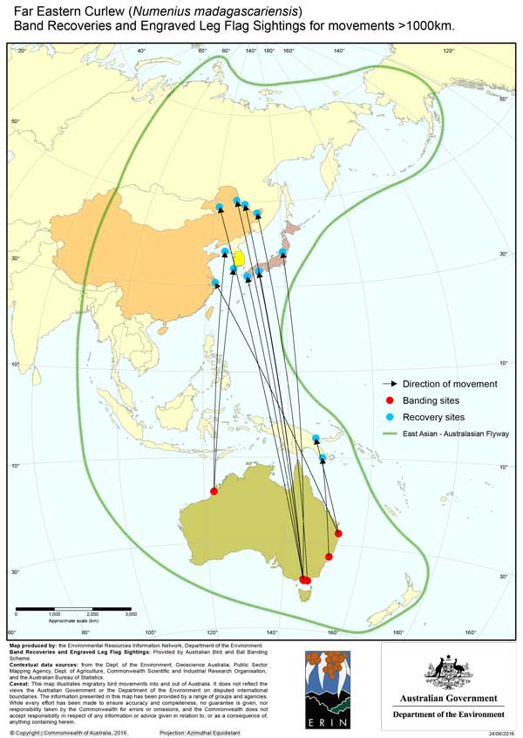

M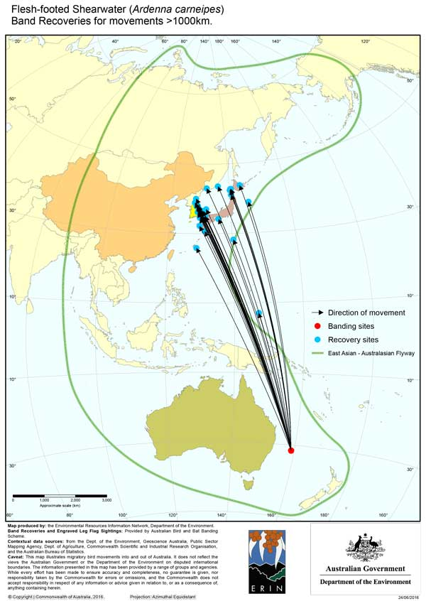

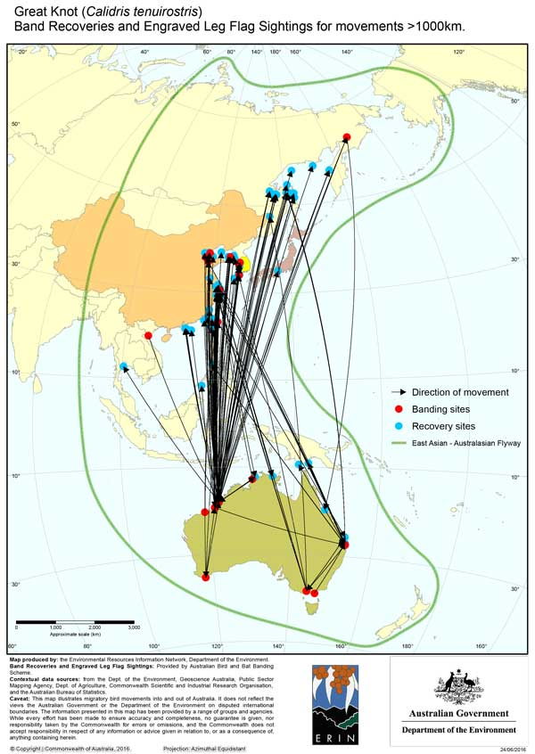

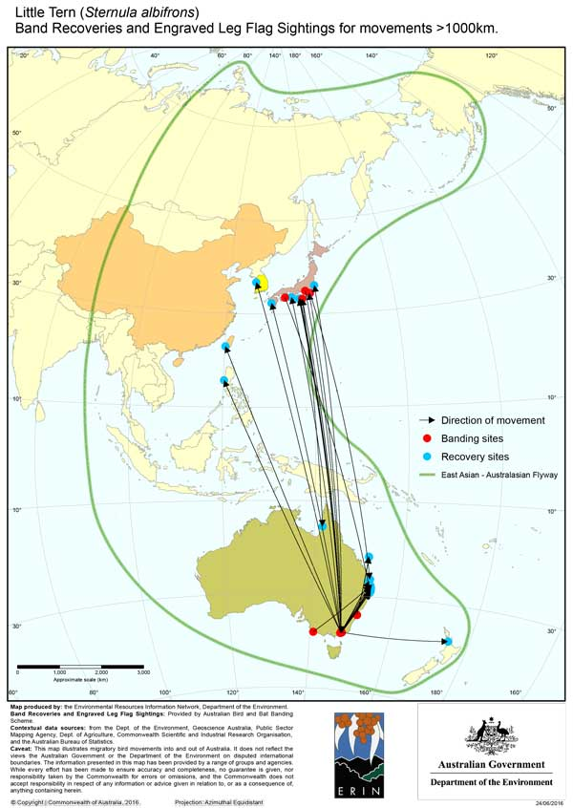

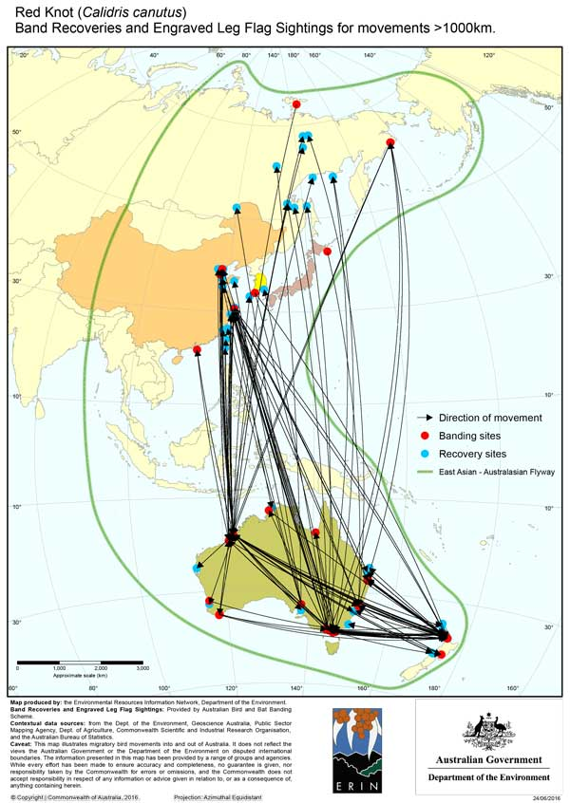

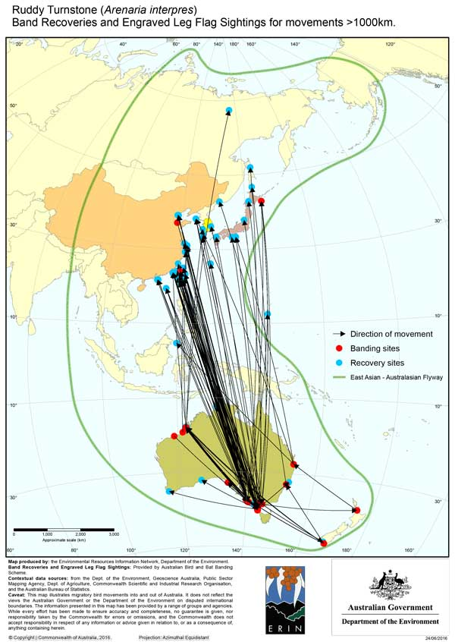

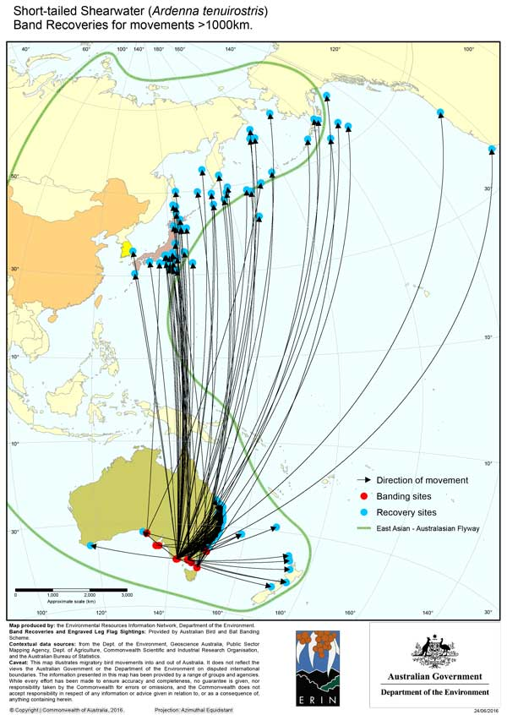

#### Table 1. Summary of bird band recoveries for JAMBA, CAMBA and ROKAMBA species between Australia and Japan/People’s Republic of China/Republic of Korea.

| **SPECIES** | **Species listed under:**  **JAMBA J**  **CAMBA – C**  **ROKAMBA - R** | | | **Number of birds banded**  **1 November 2014 – 30 June 2016** | **Number of birds banded**  **1953-2016** | **Total recoveries** | | | | | |
| --- | --- | --- | --- | --- | --- | --- | --- | --- | --- | --- | --- |
| **Australia to Japan** | **Japan to Australia** | **Australia to China** | **China to Australia** | **Australia to Republic of Korea** | **Republic of Korea to Australia** |
| Garganey | J | C | R | - | - | - | - | - | - | - | - |
| Streaked Shearwater | J | C | R | - | - | - | 2 | - | - | - | - |
| Wedge-tailed Shearwater | J |  |  | 571 | 91412 | - | - | 1 | - | - | - |
| Flesh-footed Shearwater | J |  | R | 222 | 16092 | 21 | - | 1 | - | 45 | - |
| Sooty Shearwater | J |  |  | 1 | 262 | 1 | - | - | - | - | - |
| Short-tailed Shearwater | J | C | R | 439 | 122135 | 29 | - | - | - | 1 | - |
| Bulwer’s Petrel | J |  |  | 1 | - | - | - | - | - | - | - |
| Swinhoe’s Storm-Petrel | J | C |  | - | - | - | - | - | - | - | - |
| Matsudaira’s Storm-Petrel | J |  |  | - | - | - | - | - | - | - | - |
| Wilson’s Storm-Petrel | J |  |  | - | 40 | - | - | - | - | - | - |
| Red-tailed Tropicbird | J | C |  | 57 | 3687 | - | - | - | - | - | - |
| White-tailed Tropicbird | J | C |  | - | 98 | - | - | - | - | - | - |
| Masked Booby | J |  | R | 57 | 18283 | - | - | - | - | - | - |
| Red-footed Booby | J | C |  | 12 | 1326 | - | - | - | - |  |  |
| Brown Booby | J | C | R | - | 8480 | - | - | - | - | - | - |
| Great Frigatebird | J | C |  | - | 479 | - | - | - | - |  |  |
| Lesser Frigatebird | J | C | R | 77 | 1828 | - | - | - | - | - | - |
| Christmas Island Frigatebird |  | C |  | - | 46 | - | - | - | - |  |  |
| Latham’s Snipe | J |  | R | 3 | 1044 | 1 | 6 | - | - | - | - |
| Pin-tailed Snipe | J | C | R | - | 31 | - | - | - | - | - | - |
| Swinhoe’s Snipe | J | C | R | 1 | 87 | - | - | - | - | - | - |
| Black-tailed Godwit | J | C | R | 10 | 1377 | - | - | 9 | 9 | 9 | - |
| Bar-tailed Godwit | J | C | R | 534 | 25153 | 77 | 2 | 310 | 69 | 198 | 2 |
| Little Curlew | J | C | R | 10 | 1549 | - | - | - | - | - | - |
| Whimbrel | J | C | R | 12 | 947 | 2 | - | 2 | 2 | - | - |
| Far Eastern Curlew | J | C | R | 70 | 1599 | 27 | - | 10 | - | 14 | - |
| Common Redshank | J | C | R | - | 20 | - | - | - | - | - | - |
| Marsh Sandpiper | J | C | R | 1 | 647 | - | - | 1 | - | - | - |
| Common Greenshank | J | C | R | 55 | 1379 | - | 1 | - | 3 | - | - |
| Wood Sandpiper | J | C | R | 1 | 192 | - | - | - | - | - | - |
| Terek Sandpiper | J | C | R | 224 | 8841 | 2 | 3 | 29 | 4 | 8 | 2 |
| Common Sandpiper | J | C | R | - | 260 | - | - | - | - | - | - |
| Grey-tailed Tattler | J | C | R | 527 | 10271 | 62 | 19 | 32 | 9 | 3 | - |
| Wandering Tattler | J |  |  | - | 2 | - | - | - | - | - | - |
| Ruddy Turnstone | J | C | R | 585 | 8424 | 19 | 4 | 205 | 3 | 4 | - |
| Asian Dowitcher | J | C | R | 6 | 147 | - | - | 1 | - | - | - |
| Great Knot | J | C | R | 2179 | 35059 | 23 | - | 852 | 115 | 138 | 10 |
| Red Knot | J | C | R | 549 | 15883 | 1 | 5 | 891 | 19 | 3 | 1 |
| Sanderling | J | C | R | 176 | 6742 | 57 | 1 | 34 | 1 | 4 | - |
| Red-necked Stint | J | C | R | 6250 | 163380 | 26 | 12 | 109 | 11 | 3 | - |
| Long-toed Stint | J | C | R | 6 | 165 | - | - | - | - | - | - |
| Pectoral Sandpiper | J |  | R | - | 28 | - | - | - | - | - | - |
| Sharp-tailed Sandpiper | J | C | R | 708 | 17737 | - | - | 19 | 1 | 3 | - |
| Curlew Sandpiper | J | C | R | 1210 | 47303 | 1 | - | 226 | 20 | - | - |
| Broad-billed Sandpiper | J | C | R | 58 | 1736 | - | 1 | 8 | 2 | 1 | - |
| Ruff | J | C | R | - | 8 | - | - | - | - | - | - |
| Red-necked Phalarope | J | C | R | - | 23 | - | - | - | - | - | - |
| Pacific Golden Plover | J | C | R | 50 | 900 | - | - | 1 | 1 | - | - |
| Grey Plover | J | C | R | 33 | 659 | 10 | - | 1 | 12 | 2 | - |
| Little Ringed Plover | J | C | R | - | 21 | - | - | - | - | - | - |
| Lesser Sand Plover | J | C | R | 59 | 1407 | 2 | - | 4 | 1 | - | - |
| Greater Sand Plover | J | C | R | 840 | 16624 | - | - | 42 | 29 | - | - |
| Oriental Plover | J | C | R | 136 | 794 | - | - | - | - | - | - |
| Oriental Pratincole | J | C | R | 108 | 1359 | - | - | 5 | - | - | - |
| South Polar Skua | J |  |  | - | 426 | - | - |  | - | - | - |
| Pomarine Jaeger | J | C |  | 1 | 4 | - | - | - | - | - |  |
| Arctic Jaeger | J | C | R | - | 3 | - | - | - | - | - | - |
| Long-tailed Jaeger | J | C |  | - | 1 | - | - | - | - | - | - |
| Caspian Tern | J |  |  | 80 | 4581 | - | - | - | - | - | - |
| Roseate Tern | J | C |  | - | 10475 | 43 | 89 | 17 | 20 | - | - |
| Black-naped Tern | J | C |  | - | 1281 | - | - | - | - |  |  |
| Common Tern | J | C | R | - | 3314 | 1 | - | - | - | - | - |
| Little Tern | J | C | R | 86 | 7105 | 12 | 8 | 1 | - | 3 | 1 |
| Gull-billed Tern |  | C |  | 5 | 1561 | - | - | 4 | - | - | - |
| Crested Tern | J |  |  | 9136 | 234857 | - | - | - | - | - | - |
| Bridled Tern | J | C |  | 237 | 10768 | - | - | - | - | - | - |
| White-winged Black Tern | J | C | R | 43 | 412 | - | - | - | - | - | - |
| Common Noddy | J | C |  | 151 | 7180 | - | - | - | - |  |  |
| Oriental Cuckoo | J | C | R | - | 28 | - | - | - | - | - | - |
| White-throated Needletail | J | C | R | - | 30 | - | - | - | - | - | - |
| Fork-tailed Swift | J | C | R | - | 4 | - | - | - | - | - | - |
| Yellow Wagtail | J | C | R | - | 10 | - | - | - | - | - | - |
| Grey Wagtail | J | C | R | - | - | - | - | - | - | - | - |
| Barn Swallow | J | C | R | - | 4 | - | - | - | - | - | - |
| Red-rumped Swallow | J | C | R | - | - | - | - | - | - | - | - |
| Oriental Reed-Warbler | J | C |  | - | 7 | - | - | - | - | - | - |
|  | Totals | | | 25,576 | 918,018 |  |  |  |  |  |  |

#### Table 2. Banding projects operating during 2014-2016, relevant to JAMBA/CAMBA/ROKAMBA

| **SPECIES GROUP** | **RESEARCHER** | **PROJECT** |
| --- | --- | --- |
| COMMUNITY | A/P A LILL | Seasonal physiological adjustments in birds |
| LARIDAE | DR CA SURMAN | Population Biology of Seabirds on Pelsaert Island, Houtman Abrolhos, WA |
|  | DR JN DUNLOP | Caspian Terns as indicators of Coastal Seagrass and Estuarine Food Chains |
| PHAETHONTIDAE | MR C J HASSELL | Effect of artificial nest shelters on Red-tailed Tropicbirds at Bedwell Island, Rowley Shoals, WA |
|  | THE ANPWS-DOE CORAL SEA PROJECT | Red-tailed Tropicbird (Phaethon rubricauda) - aspects of breeding biology |
| PROCELLARIIDAE | DR DA STEWART | The effects of vegetation on the breeding success of Wedge-tailed Shearwaters on Mudjimba Island, SEQ |
|  | DR J L LAVERS | Status and trends of Flesh-footed Shearwater populations across Australia |
|  | DR JN DUNLOP | Flesh-footed Shearwater by-catch in the South Coast Purse Seine Fishery |
|  | DR MA HINDELL | Investigating the relationship between marine resources and foraging and reproductive success in two sympatrically breeding seabird species in S. Tasmania |
|  | F.I.R.M. - FRENCH IS MUTTONBIRD RESEARCH | Population Dynamics and Telemetry Studies on Shearwaters of French Island, Vic |
|  | MR MC HOLDSWORTH | Fisher Island Short-tailed Shearwater colony |
|  | MR RG CAMERON | Phillip Island Nature Park Shearwater Banding Project |
|  | MS NM SWANSON | Wedge-tailed Shearwaters - Mutton Bird & Solitary Islands, Coffs Harbour |
|  | SOSSA - SOUTHERN OCEAN SEABIRD STUDY | SOSSA NSW Seabird Study (Petrels and Shearwaters) |
|  | THE NSW NPWS SEABIRD PROJECT | Breeding ecology and management of petrels and shearwaters in NSW |
| SEABIRDS | DR BC CONGDON | Global climate change: identifying impacts at upper trophic levels in tropical marine ecosystems |
|  | DR CA SURMAN | An ecological study of the seabird communities of the Lowendal Islands, WA |
|  | DR CA SURMAN | Investigating the breeding and foraging behaviour of seabirds on the Lacepede Islands to determine their vulnerability to impacts associated with potential oil spills and their ability to recover |
|  | DR DA STEWART | Does variation in the diet of seabirds breeding in the Great Barrier Reef reveal drivers of population declines? |
|  | DR JN DUNLOP | The population dynamics of tropical seabirds in the eastern Indian Ocean |
|  | DR L J MCLEAY | Assessing population status and ecology of marine threatened, endangered and protected species: mitigation and management of threats and interactions with marine resource users |
|  | DR R H CLARKE | Marine Resource Use by Tropical Seabirds |
|  | MR P M DAVIDSON | Genetic characterisation and distribution of Norfolk Island seabirds |
|  | THE CHRISTMAS ISLAND NATIONAL PARK | Seabirds of Christmas Island |
|  | THE NSW NPWS SEABIRD PROJECT | Demography and resource use of seabirds |
| SHOREBIRDS | DR GP CLANCY | North Coast Wader and Tern Banding Survey |
|  | DR J T COLEMAN | Long Term Monitoring of Body Condition and Habitat Utilisation by Wading Birds in Queensland |
|  | MR G ROSS | Botany Bay Shorebird Action Plan |
|  | MR WL KLAU OAM | Wader Movement, northern Spencers Gulf |
|  | PROF M J LAWES | Ecology of migratory shorebirds in Darwin Harbour |
|  | THE AUSTRALASIAN WADER STUDY GROUP | Studies of Waders & Terns throughout Australia & Asia |
|  | THE NSW WADER STUDY GROUP | Charadriiformes |
|  | THE VICTORIAN WADER STUDY GROUP | A Comprehensive Long Term Study of Waders & Terns in South-East Australia |
|  | THE WA WADER STUDY GROUP | Waders in the South-West of Western Australia - Movements & Population Dynamics |
| SULIDAE | MRS MJ MCCOY | Movements of Boobies and Gannets through the Pacific region |
|  | THE ANPWS-DOE CORAL SEA PROJECT | Population monitoring of Masked Booby on NE Herald Cay, Coral Sea |

## Migration Research through Colour Flagging

### Australasian Wader Studies Group, BirdLife Australia

**Relevant JAMBA Articles:** I, IV, VI  
**Relevant CAMBA Articles:** I, III, IV  
**Relevant ROKAMBA Articles:** 1, 3

### Summary

The Australasian Wader Studies Group (AWSG) is a special interest group of BirdLife Australia formed to coordinate and focus studies on shorebirds in Australia and along their migration routes. The AWSG aims to ensure the future of shorebirds and their habitats in Australia through research and conservation programs and to encourage and assist similar programs in the rest of the East Asian-Australasian Flyway.

Migration and habitat research using leg flags are key ongoing activities of the AWSG. Plastic (Darvic or similar) leg flags are attached to the birds. Re-sightings of flagged birds along the flyway are recorded in a central database and analysed to determine migration routes, destinations and stopover locations.

This report includes data on flag sightings in Australia of shorebirds banded in Japan, China and Republic of Korea, and the numbers of flag sightings in these three countries of shorebirds banded in Australia during northward and southward migration (based on data collected to July 2015).

### About the Project

Marking of shorebirds with PVC plastic leg flags is an important part of research into shorebird migration. The AWSG is leading this activity in Australia, both in application of flags to birds and in recording and analysis of sightings of flagged birds. As of October 2014, the leg-flagging database contained a total of 55,260 records. Lists of flag sightings relating to Australian flagged shorebirds are provided in Tables 1 and 2 below.

The AWSG and the Australian Government appreciate the cooperation from researchers and banding schemes in Japan, China and Republic of Korea in providing sighting records.

#### Table 1. Flag sightings in Australia of shorebirds flagged in Japan, Republic of Korea and China (to July 2015).

|  |  |  |  |  |  |  |
| --- | --- | --- | --- | --- | --- | --- |
| **Year** | **Japan** | **Republic of Korea** | **China** | **mainland** | **Hong Kong** | **Chinese Taipei** |
| 1995 | 7 |  |  |  |  |  |
| 1996 | 14 |  |  |  |  |  |
| 1997 | 8 |  |  |  |  |  |
| 1998 | 14 |  |  |  |  |  |
| 1999 | 15 |  |  |  |  |  |
| 2000 | 11 | 4 |  |  |  |  |
| 2001 | 28 | 5 |  |  |  |  |
| 2002 | 34 | 11 | 12 | 8 | 2 | 2 |
| 2003 | 16 | 15 | 15 | 9 |  | 6 |
| 2004 | 14 | 14 | 47 | 38 | 4 | 5 |
| 2005 | 12 | 7 | 248 | 231 | 1 | 16 |
| 2006 | 26 | 4 | 456 | 444 | 1 | 11 |
| 2007 | 49 | 2 | 664 | 652 | 1 | 11 |
| 2008 | 43 | 0 | 545 | 533 | 1 | 11 |
| 2009 | 51 | 2 | 684 | 669 | 1 | 14 |
| 2010 | 38 | 14 | 999 | 978 | 2 | 19 |
| 2011 | 28 | 6 | 864 | 855 | 1 | 8 |
| 2012 | 35 | 9 | 600 | 554 | 26 | 20 |
| 2013 | 40 | 0 | 707 | 668 | 30 | 33 |
| 2014 | 77 | 7 | 878 | 816 | 34 | 28 |
| 2015 | 76 | 5 | 849 | 785 | 8 | 56 |

#### Table 2. Australian flagged shorebirds sighted in Japan, Republic of Korea and China.

|  |  |  |  |  |  |  |  |
| --- | --- | --- | --- | --- | --- | --- | --- |
| **Year** |  | **Japan** | **Republic of Korea** | **China** | **mainland** | **Hong Kong** | **Chinese Taipei** |
| 2014 | total | 48 | 231 | 2989 | 2765 | 87 | 137 |
| 2015 | total | 47 | 304 | 2751 | 2622 | 43 | 86 |

## National Avian Influenza Wild Bird Surveillance Program update

### National Avian Influenza Wild Bird Steering Group

**Compiled by:**  
Tiggy Grillo PhD   
Australia’s National Avian Influenza Wild Bird Steering Group

**Relevant JAMBA Articles:** III, IV, VI  
**Relevant CAMBA Articles:** III, IV  
**Relevant ROKAMBA Articles:** 3, 5

### Summary

Activities under the **National Avian Influenza Wild Bird (NAIWB) Surveillance Program** are conducted Australia-wide. Surveillance for avian influenza in wild birds comprises two sampling components: targeted surveillance via sampling of apparently healthy and hunter-killed wild birds, and general surveillance via investigation of significant unexplained morbidity and mortality events in wild birds, including captive and wild birds within zoo grounds. Targeted surveillance will continue to focus on sampling from Anseriformes (waterfowl), specifically from locations where there is known mixing with birds from the Charadriiformes (shorebirds) Order and that bring waterfowl into close proximity to poultry and humans. Where possible, surveillance will continue in locations previously sampled to obtain longitudinal data. There will continue to be an emphasis on virus isolation and genotyping of avian influenza viruses (AIVs) in order to inform risk and allow ongoing assay development for influenza testing. General (passive) surveillance focuses on exclusion of AI from mass mortality and morbidity events in wild birds around Australia and the Australian Antarctic Territory. The wild bird program is part of a larger national program involving domestic bird surveillance, research and international responsibilities, and ongoing communication to industry.

The NAIWB Surveillance Program continues to provide Australia with important outcomes. These include to:

1. Detect avian influenza in wild birds,
2. Contribute to a better understanding of AI phylogeny and gene flow of subtypes, ecology and epidemiology to support industry and human and wildlife health strategic risk assessment and management,
3. Maintain national avian influenza laboratory diagnostic capacity and capability,
4. Sharing and communication of data nationally and globally,
5. Contribute to One Health through regular communication of AIV data to the Department of Health with specific analysis of wild bird AIVs for likelihood of infection and transmission in humans, and
6. Exclude AIV, specifically H5 and H7, in mass mortality events in wild birds.

Since 2005, over 90,000 wild birds have been sampled as part of active wild bird surveillance at sites in New South Wales, Queensland, Victoria, Tasmania, South Australia, Northern Territory and Western Australia, with 10,641 wild birds sampled between July 2014 and June 2016. In addition, over 2,500 wild bird mortality / morbidity events have been investigated and reported since 2005, with over 600 events investigated and reported between July 2014 and June 2016.

No HPAI AIV has been detected. Almost all AIV subtypes have been detected, including LPAI H5 and H7 subtypes in wild birds in Australia.

Recent avian influenza publications from Australia include:

* Curran et al., (2014) Evaluation of avian influenza serologic and virologic diagnostic methods in wild Anseriformes and Charadriiformes. *Avian Diseases*, 58(1): 53-59.
* Curran et al., (2015) Serological surveillance of wild waterfowl in Northern Australia for avian influenza virus shows variations in prevalence and a cyclical periodicity of infection. *Avian Diseases*, 59(4): 492-497.
* Hoque et al., (2015) Epidemiology of avian influenza in wild aquatic birds in a biosecurity hotspot, North Queensland, Australia. *Preventive Veterinary Medicine*, 118 (1): 169-181.
* Grillo (2015) Contribution to the 2012 Avian Influenza in Wild Birds Surveillance Program. RIRDC Publication No. 15/016. Project No. PRJ-008337. ISBN 978-1-74254-760-2.
* Grillo et al., (2015) Avian influenza in Australia: a summary of 5 years of wild bird surveillance. *Australian Veterinary Journal*. 93 (11): 387–393. Additional supporting information can be found in the online version of this article at the publisher’s [website](http://onlinelibrary.wiley.com/doi/10.1111/avj.12379/suppinfo): [PDF Attached]
* Ferenczi et al., (2016) Avian influenza infection dynamics under variable climatic conditions, viral prevalence is rainfall driven in waterfowl from temperate, south-east Australia. Veterinary Research, 47 (1): 23.
* Also see [WHA website](https://www.wildlifehealthaustralia.com.au/ProgramsProjects/AvianInfluenzaWildBirdSurveillance.aspx) for a list of references

The NAIWB Surveillance Program continues to provide valuable ecological and epidemiological background information to assist strategic risk management to minimise the economic, environmental and social impacts of AI (or HPAI) on human health, the poultry industry and wildlife in Australia. Importantly, this program is a key source of samples that are positive for avian influenza viruses, which are used to maintain and develop current and specific diagnostic primers and probes. These are essential for continued confidence that the tests being used in Australia will detect any strains of highly pathogenic avian influenza H5 or H7 in the event of an outbreak of these subtypes in poultry. The multi-agency and cross-jurisdictional approach of this project provides a forum for collaboration on technical aspects of influenza in humans, animals and wildlife.

### Background:

The National Avian Influenza Wild Bird Steering Group (the NAIWB Steering Group) was established in January 2006 to facilitate collaboration between State and Territory programs and non-government organisations undertaking surveillance for avian influenza. Primary Industry agencies agreed to strengthen national surveillance for avian influenza in both poultry and wild birds.

* The NAIWB Steering Group comprises representation from:
* Australian Department of Agriculture and Water Resources (DAWR)
* Australian Department of the Environment and Energy
* Australian Department of Health
* CSIRO Australian Animal Health Laboratory
* DAWR’s Northern Australia Quarantine Strategy (NAQS) Program
* State and Territory government animal health departments in NSW, Qld, SA, Tas, Vic and WA
* World Health Organisation Collaborative Centre for Influenza in Melbourne
* Birdlife Australia
* Rural Industries Research and Development Corporation (RIRDC) / Poultry Industry representation
* Deakin University, University of Newcastle, James Cook University

The NAIWB Steering Group is responsible for development and implementation of a yearly operating plan and coordination of surveillance activities for AI in wild birds in Australian states and territories.

Nationally coordinated activities have been conducted since 2006, with funding provided by the Australian Government Department of Agriculture and Water Resources and significant in-kind support provided by the jurisdictional agencies, researchers and representative’s institutions.

A combination of healthy, live and hunter-killed wild birds (targeted surveillance) and sick or dead wild birds (general surveillance) are sampled for surveillance. Sources for targeted wild bird surveillance data include state and territory government laboratories, universities and samples collected under Australia’s Northern Australia Quarantine Strategy (NAQS) Program. Samples from sick birds include submissions from members of the public, private practitioners, universities, zoos and sanctuaries. Wildlife Health Australia manages the Program.

Results from the NAIWB Surveillance Program are used to inform policy development and planning by Australian government and state/territory government agencies and contribute to Australia’s National Animal Health Information System (NAHIS). The data inform Australia’s international reporting; as well summary data are provided to industry at regular intervals through each sampling year.