|  |
| --- |
| marine and atmospheric research |
| Australian Atmospheric Measurements & Emissions Estimates of Ozone Depleting Substances and Synthetic Greenhouse Gases  Department of the Environment Projects 2012-2013  P. Fraser, B. Dunse, P. Krummel, P. Steele and N. Derek  December 2013  Report prepared for Department of the Environment |

|  |
| --- |
|  |

CSIRO Marine and Atmospheric Research / Centre for Australian Weather and Climate Research

Citation

Fraser P, B Dunse, P Krummel, P Steele and N Derek (2013), Australian Atmospheric Measurements and Emissions of Ozone Depleting Substances and Synthetic Greenhouse Gases, *Report prepared for Department of the Environment,* CSIRO Marine and Atmospheric Research, Centre for Australian Weather and Climate Research, Aspendale, Australia, iv, 42 pp.

Copyright and disclaimer

© 2013 CSIRO To the extent permitted by law, all rights are reserved and no part of this publication covered by copyright may be reproduced or copied in any form or by any means except with the written permission of CSIRO.

Important disclaimer

CSIRO advises that the information contained in this publication comprises general statements based on scientific research. The reader is advised and needs to be aware that such information may be incomplete or unable to be used in any specific situation. No reliance or actions must therefore be made on that information without seeking prior expert professional, scientific and technical advice. To the extent permitted by law, CSIRO (including its employees and consultants) excludes all liability to any person for any consequences, including but not limited to all losses, damages, costs, expenses and any other compensation, arising directly or indirectly from using this publication (in part or in whole) and any information or material contained in it.

Contents

Acknowledgments iv

1 Introduction 1

2 Measurements of synthetic ODSs, natural ODSs and other SGGs in the Southern Hemisphere 2

2.1 CFCs 3

2.2 HCFCs 3

2.3 Halons 4

2.4 Chlorocarbons 4

2.5 Other organobromine species 4

2.6 Controlled SGGs: HFCs, PFCs & sulfur hexafluoride 4

2.7 Uncontrolled SGGs 4

2.8 Total chlorine, bromine and fluorine 4

3 Global emissions of ODSs and SGGs 7

3.1 ODS emissions 8

3.2 SGG emissions 9

4 Milestone #1 & #5: Global EESC & the 2012 Antarctic Ozone Hole 9

4.1 Equivalent Effective Stratospheric Chlorine 9

4.2 2012 Antarctic Ozone Hole 10

5 Australian SGG imports 11

6 Australian HFC, PFC and SF6 emisions: the National Greenhouse Accounts 12

7 Milestones #2, #4, #6, #7, #9: CSIRO estimates of Australian SGG emissions including carbon tetrachloride 16

7.1 CFCs 20

7.2 HCFCs 20

7.3 Halons 21

7.4 Methyl bromide 21

7.5 Carbon tetrachloride & methyl chloroform (Montreal Protocol chlorocarbons) 22

7.6 Other chlorocarbons 23

7.7 Total ODS emissions 23

7.8 HFCs 24

7.9 PFCs 27

7.10 SF6 emissions 29

7.11 SO2F2 emissions 29

7.12 Total HFC, PFC and SF6 emissions 30

7.13 Total HFC, PFC, SF6 and SO2F2 emissions (GWP weighted) 30

7.14 Total GWP-weighted emissions: ODSs, HFCs, PFC, SF6 and SO2F2 30

Summary 32

References 34

Figures

Figure 1. *In situ* observations of CFCs, HCFCs, halons, CCl4, CH3CCl3, CH3Cl, CH2Cl2, CHCl3, CHClCCl2, CCl2CCl2, CH3Br, CH2Br2 and CHBr3 (1978 – 2012) showing baseline monthly mean data (Medusa - dark green; ADS - purple; ECD – dark blue; archive annual means – orange) and total data (Medusa - light green; ADS – pink; ECD – light blue) obtained from the GC-MS-Medusa, GC-MS-ADS and GC-ECD instruments at Cape Grim and Aspendale (references: see text above and CSIRO unpublished data). 6

Figure 2. *In situ* observations of HFCs, PFCs, SF6, SO2F2, CF3SF5 and NF3 (1998 – 2012) showing baseline monthly mean data (dark green, Medusa; pink, ADS), total data (light green, Medusa; purple, ADS) and archive annula means (orange) obtained from the GC-MS-Medusa and GC-MS-ADS instruments at Cape Grim and Aspendale (references: see text above and CSIRO unpublished data). 7

Figure 3. Global emissions of ODSs (CFCs, chlorinated solvents (MC, CTC), halons, HCFCs) and SGGs (HFCs) derived from global AGAGE data using the 12-box AGAGE global transport model (Montzka & Reimann, 2011; R. Wang, GIT, unpublished data). Note: data on global MB emissions in 2011 are not yet available. 8

Figure 4. Global EESC (ppb, parts per 109 molar) calculated from AGAGE/CSIRO/ SIO/UEA data (see text) and from scenario A1 (WMO, 2011), for the Antarctic springtime stratosphere (age-of-air 5.5±2.8 yr, α = 60), the mid-latitude lower stratosphere (age-of-air 3.0±1.5 yr, α = 60) and the mid-latitude upper stratosphere (age-of-air 4.3±2.1 yr, α = 60). 10

Figure 5. Australian imports (tonnes) of ODSs (HCFCs, CH3Br) and HFCs (DSEWPaC, private communication, 2013). The 2012 data are from the OLaRS data base, 2010 and earier are pre-OLaRS data, and 2011 is a mixture of OLaRS and pre-OlaRS data. 11

Figure 6. Australian emissions (tonnes) of HFC-32, HFC-125, HFC-134a, HFC-143a from the major source categories as reported in the NGGI (ageis.cliamtechnage.gov.au), except for HFC-32 emissions obtained directly from DIICCSRTE (2013b). 13

Figure 7. Australian HFC, PFC and sulfur hexafluoride emissions (M tonne CO2-e) (ageis.cliamtechange.gov.au). Dashed lines are exponential best fits. 16

Figure 8. Annual average (3-yr running means) Australian emissions of CFCs, HCFCs, halons and chlorocarbons (MC, CTC) from Cape Grim AGAGE data, using ISC techniques. Australian emissions are scaled from SE Australian emissions on a population basis; MB emissions are for SE Australia only. 19

Figure 9. Australian HFC-32, -125, -134a, -143a, -152a, -227ea, -236fa, -245fa, -365mfc, PFC-14, -116 and sulfur hexafluoride emissions (NGA: DIICCSRTE, 2013; DCCEE, 2012) compared to emissions calculated from Cape Grim data by interspecies correlation (ISC) and from the UK Met. Office NAME particle dispersion model. In the ISC calculations, Australian emissions are scaled from Melbourne/Port Phillip emissions on a population basis (a factor of 5.4). In the NAME calculations, Australian emissions are scaled from Victorian/Tasmanian emissions on a population basis (a factor of 3.7). For PFC-14 emissions aluminium production based scale factors are used. 19

Figure 10. Australian MB emissions calculated from Australian MB import data and the UNEP emissions model (UNEP, 2007). 22

Figure 11. SE Australian MB emissions calculated from Cape Grim *in situ* AGAGE MB data and from the UNEP (2007) CH3Br emissions model. 22

Figure 12. Australian CTC emissions calculated form Cape Grim *in situ* AGAGE data by ISC techniques and inverse modelling (NAME). 23

Figure 13. Australian ODS emissions (CFCs, HCFCs, halons, MB, CTC, MC, other chlorocarbons), ODP-weighted (k tonnes) and GWP-weighted (M tonnes CO2-e). Note the impact of halons on the 2011 ODP-weighted emissions – halon emissions overall may be an over-estimate (see text). 24

Figure 14. Australian emissions of NGGI/NGA specified HFCs (-125, -134a, -143a), plus HFC-32, estimated from atmospheric data (ISC/NAME) measured at Cape Grim, and in the NGGI, expressed in units of CO2-e. HFC-32 inventory data were obtained directly from DIICCSTRE (M. Hunstone). 27

Figure 15. Australian emissions of PFC-14 as recorded in the *National Inventory Report 2011* (DIICCSRTE, 2013; 27% uncertainty) and as obtained by TAPM and NAME modelling. 28

Figure 16. SE Australian SO2F2 emissions (tonnes) from Cape Grim data using ISC and NAME. 29

Figure 17. Australian HFC, PFC, SF6 emissions from Cape Grim observations (ISC) and in the NGGI/NGA (ageis.climatechange.gov.au) in Mt CO2-e. 30

Figure 18. Australian total SGG emissions (M tonnes CO2-e), comprising emissions of HFCs, CFCs, HCFCs, SF6/SO2F2, halons/CH3Br, PFCs and chlorocarbons (Montreal Protocol and others). 31

Tables

Table 1. Southern Hemisphere concentrations (2011, 2012) and growth rates (2011-2012) for CFCs, HCFCs, halons, CTC, MC, CH3Cl, MB, HFCs, PFCs, SF6, SO2F2, CF3SF5 and NF3 measured at Cape Grim, Tasmania (references: see text above and CSIRO unpublished). 5

Table 2. Australian imports (tonnes) of ODSs (HCFCs, CH3Br), HFCs, PFCs and SF6 (DSEWPaC, private communication, 2013). The 2012 data are from the OLaRS data base, 2010 and earier are pre-OLaRS data, and 2011 is a mixture of OLaRS and pre-OlaRS data. 12

Table 3. Australian sulfur hexafluoride emissions from the existing stock of electrical equipment, from new electrical equipment manufacture or import and from other sources, such as metallurgical and medical uses etc. (DIICCSRTE, 2013b). 14

Table 4. Australian HFC, PFC and SF6 emissions in the NGGI [ageis.climatechange.gov.au] 15

Table 5. Annual average (3-yr running means) Australian emissions (metric tonnes unless otherwise stated) of ODSs (CFCs, HCFCs, halons and chlorocarbons) from Cape Grim AGAGE data, using ISC techniques. Australian emissions are scaled from SE Australian emissions on a population basis; MB emissions are for SE Australia. GWPs (to calculate CO2-e emissions) are Forster & Ramaswamy (2007); ODPs (to calculate ODP-weighted emissions) are from Montzka & Reimann (2011); assumed GWPs for TCE (10) and PCE (140). 17

Table 6. Australian HFC, PFC, sulfur hexafluoride and sulfuryl fluoride emissions (tonnes, 2005-2011) from atmospheric data, collected at Cape Grim, Tasmania - emissions calculated by interspecies correlation (ISC) and from inversions using the UK Met. Office NAME particle dispersion model. The emissions are 3-year running averages, i.e. ‘2010’ = average of 2009, 2010, 2011 emissions. Australian emissions are scaled from regional emissions by population except for PFC-14 (scaled by aluminium production), MB (scaled by QPS/non-QPS use) and sulfuryl fluoride (scaled by grain exports); GWPs (to calculate CO2-e emissions) are from the *National Inventory Report 2011* (DIICCSRTE, 2013) and in Forster & Ramaswamy (2007). 18

Acknowledgments

The authors would like to thank the Cape Grim staff for the maintenance and operation of the AGAGE instruments at Cape Grim and for the collection of the Cape Grim Air Archive; Dr B. Miller (SIO USA and NOAA USA), Dr D. Oram (UEA UK) and the late Mr L. Porter (BoM) for GC-MS analyses of the Cape Grim Air Archive; Dr A. Manning (UKMO) for SGG emissions calculations (NAME-InTEM); Dr R. Wang (GIT USA) for SGG emissions calculation (AGAGE 12-box model); Dr I. Porter (DPI Victoria) for CH3Br emissions information; Mr M. Hunstone (Department of the Environment) for SGG emission data; Ms. A. Gabriel (Department of the Environment) for SGG import data; Mr S. Walsh (EPA Victoria) for Port Phillip CO emission and concentration data; CSIRO, BoM, NASA/MIT, Department of the Environment and RRA for funding in support of the Cape Grim AGAGE program.

# Introduction

Chlorofluorocarbons (CFCs), hydrochlorofluorocarbons (HCFCs), halons, carbon tetrachloride (CTC: CCl4), methyl chloroform (MC: CH3CCl3) and methyl bromide (MB: CH3Br) are ozone depleting substances (ODSs), whose production and consumption (and thus global emissions) from the developed and developing world have been significantly reduced by national actions to comply with the Montreal Protocol. However, significant persistent global ODS emissions remain (Montzka & Reimann, 2011) and will potentially delay the recovery of the Antarctic ozone hole (Bekki & Bodeker, 2011). Methyl chloride (CH3Cl), dichloromethane (CH2Cl2), chloroform (CHCl3), trichloroethylene (TCE: CHClCl2), perchloroethylene (PCE: CCl2CCl2), dibromomethane (CH2Br2) and bromoform (CHBr3) are not formally listed as ODSs in a Montreal Protocol context, because CH3Cl, CHCl3, CH2Br2 and CHBr3 are predominantly natural in origin, and CH2Cl2, TCEand PCE,although largely anthropogenic in origin, have very short atmospheric lifetimes (<0.5 yr, Montzka & Reimann, 2011) and therefore relatively low Ozone Depletion Potentials (ODPs). They are considered in this report in the context of their potential contribution to Equivalent Effective Stratospheric Chlorine (EESC), the ultimate driver of stratospheric ozone depletion (Bekki & Bodeker, 2011; Fraser *et al*., 2013; Montzka & Reimann, 2011). In addition, ODS emissions are playing an important role globally in contributing to radiative forcing by GHGs, which largely drives climate change (Forster & Ramaswamy, 2007).

The most dramatic demonstration of the environmental impact of EESC is the annual occurrence of the Antarctic ozone hole (AOH). In a companion report we review the development and decline of the 2013 hole, and review its metrics in light of the ongoing decline of EESC in the atmosphere. The overall ranking of the 2013 AOH is quantified.

CFCs, halons, CTC and MC are no longer used or imported into Australia in any significant tonnages. Nevertheless, long-term atmospheric observations at Cape Grim, Tasmania, show that there are measurable emissions today of these chemicals from the Melbourne-Port Phillip region, and presumably from all the major Australian urban regions (Dunse *et al*., 2005). Previous research (Fraser *et al*., 2012a) has suggested that the emissions are likely from ‘banks’ of these species, in the form of old ODS-containing equipmentand materials still in use (for example refrigerators, aerosol cans, fire extinguishers, foam plastics) or from leaking landfills, containing the aggregated emissions from buried ODS-containing equipment and materials. ODS emissions are not regulated as part of the Montreal Protocol. However, ODS emissions in Australia are contolled directly by actions taken by the Australian government to control ODS production and consumption under the Montreal Protocol – for example banning the venting of ODSs in the main end use sectors: air conditioning, refrigeration and fire fighting. In addition, mitigation of Australian emissions of these species is supported by government and industry initiatives in ODS capture, followed by recycling or destruction.

HCFCs, MB, dichloromethane, TCE and PCE are imported into Australia and used in maintaining existing HCFC-containing refrigeration and air conditioning equipment, for quarantine and pre-shipment (QPS) uses of MB, such as grain fumigation immediately prior to international export, exempted non-QPS uses of MB (largely for growing strawberry runners), and for solvent use (dichloromethane, TCE, PCE). HCFC and non-QPS MB consumptions are controlled by Australia’s commitments under the Montreal Protocol and are declining, whereas QPS-uses of MB are outside the regulatory domain of of the Montreal Protocol and consequently MB emissions from QPS-use have the potential to increase. MB use for fumigation of grain prior to transport within Australia is declining, where phosphine (PH3) and sulfuryl fluoride (SO2F2) are seen as suitable, but not universal, alternative or replacement chemicals. There are no controls over the use of dichloromethane, TCE, PCE from climate change or ozone depletion perspectives, but emissions of these chlorinated solvents are regulated in Australia due to their hazardous nature (toxicity) as volatile organic compounds (VOCs; EPA 1998).

Hydrofluorocarbons (HFCs), with Global Warming Potentials (GWPs) ranging from 700 to 15,000, perfluorocarbons (PFCs: GWPs 7,000 – 10,000), and sulfur hexafluoride (SF6: GWP 23,900) are potent greenhouse gases (GHGs), whose emissions, from developed and developing countries, are mandated for control under the Kyoto Protocol, as part of a basket of GHGs which also includes carbon dioxide (CO2), methane (CH4) and nitrous oxide (N2O).

Emissions of HFCs, PFCs and sulfur hexafluoride continue to grow significantly, especially in the developing world (Forster & Ramaswamy, 2007; Fraser *et al*., 2013). Collectively, these GHGs, and the ODSs above, together with emerging new species such as sulfuryl fluoride (SO2F2, GWP ~5000; Mühle *et al*., 2009), trifluoromethyl sulfur pentafluoride (CF3SF5, GWP 18,000; Sturges *et al*., 2012) and nitrogen trifluoride (NF3, GWP 17,000; Weiss *et al*., 2008), are described, as synthetic GHGs (SGGs).

HFCs are used extensively in Australia, largely in air conditioning (60-70%) and in refrigeration (~30%), initially as ‘ozone-friendly’ replacements for CFCs and HCFCs. Minor HFCs uses (~5%) in Australia include as aerosol propellants, including metered dose inhalers (MDIs), as foam blowing agents and in fire extinguishers (DIICCSRTE, 2013a; *Cold Hard Facts 2* (Expert Grouup 2013).

PFCs are a by-product of the production of aluminium in Australia and overseas and, in addition, are used overseas in the electronics industry during the manufacture of integrated circuits and plasma screens. Refrigerants represent a very minor use of PFCs in Australia and overseas. Sulfur hexafluoride, the most potent GHG in the atmosphere, is used in Australia and overseas as a dielectric fluid in step-down transformers and as a cover gas in metal production, for example magnesium production.

There are a number SGGs that have been measured in the Cape Grim Air Archive (and are likely to be measured *in situ* at Cape Grim in the near future) that are not currently covered by the Kyoto Protocol. Examples include sulfuryl fluoride (Muhle *et al*., 2009), a replacement fumigant for MB, and trifluoromethyl sulfur pentafluoride, the second most potent GHG yet identified in the atmosphere, a by-product of the production of perfluoro-octanylsulphonate (PFOS) in the USA (Sturges *et al*., 2012). PFOS production in the USA ceased in about 2000 (Santaro *et al*., 2000) and was never produced in Australia; it is unlikely that there are significant emissions of trifluoromethyl sulfur pentafluoride in Australia. Another SGG not in the Kyoto Protocol is nitrogen trifluoride, the third most powerful GHG yet identified in the atmosphere, which is used in the electronics industry in commercial manufacture of semiconductor devices, photo-voltaic cells and plasma screens (Weiss *et al*., 2008). It is unlikely that there are significant emissions of nitrogen trifluoride in Australia. Examples of ODSs not included in the Montreal Protocol that have also been measured in the Cape Geim Air Archive (and may be measured *in situ* at Cape Grim in the future) include CFCs-112,-112a and -113a (CCl2FCCl2F, CClF2CCl3, CCl3CF3) and HCFC-133a (CH3CClF2) (Laube *et al*., 2013a). These latter CFCs and HCFC will be discussed in detail in the 2014 report.

Globally, SGGs have been the second most important GHG driver of climate change over the past 50 years, after carbon dioxide. Rapidly growing HFC-emissions are seen as a very significant driver of climate change over the next 50 years (Velders *et al.*, 2007, 2009) and projections suggest that unmitigated HFC growth could result in Global Warming Potential (GWP)-weighted emissions approaching 9 Gt CO2-e (equivalent) per year by 2050, comparable to the GWP-weighted emissions of CFCs at their peak in 1998 (Daniel & Velders, 2011). It has been suggested that an amended Montreal Protocol could phase down the production and consumption of HFCs (with high GWPs) to around 15% of current use in a time frame sooner than possible emission mitigation under a revised Kyoto Protocol or similar agreement (Molina *et al*., 2009). An early phase-out of HFC consumption will mitigate climate change significantly (Velders *et al*., 2013).

There are no mandated global or Australian targets to specifically phase-out HFC, PFC and SF6 emissions at present, except as a contributor to the ‘basket’ of GHGs (CO2, CH4, N2O, HFCs, PFCs, SF6) whose total emissions are targeted to be reduced unconditionally to 5% below 2000 emissions by 2020. In early 2010, Australia committed conditionally to reduce its GHG emissions by 5 % below 2000 levels by 2020, but will revisit this committment later depending on the extent of international action.

# Measurements of synthetic ODSs, natural ODSs and other SGGs in the Southern Hemisphere

The concentrations of synthetic ODSs (CFCs, HCFCs, halons, CTC, MC, CH2Cl2, CHClCCl2, CCl2CCl2, MB-synthetic), natural ODSs (CH3Cl, CHCl3, MB-natural, CH2Br2, CHBr3, CH3I), and other SGGs (HFCs, PFCs, SF6, SO2F2, CF3SF5, NF3) have been measured in the background (baseline) Southern Hemisphere atmosphere using air samples collected at Cape Grim, Tasmania. Measurements have been made on the Cape Grim Air Archive (1978-2012) at CSIRO (Aspendale), at the Scripps Institution for Oceanography (SIO, USA), and at the University of East Anglia (UEA, UK). Other flask air samples from Cape Grim and over SE Australia have been analysed at CSIRO, the Oregon Graduate Center (OGC, USA), SIO, the National Oceanographic and Atmospheric Administration (NOAA, USA), UEA, the National Institute for Environmental Research (NIES, Japan) and at the University of Heidelberg (UH, Germany). The SGGs have been measured by CSIRO *in situ* in the atmosphere (baseline and non-baseline) at Cape Grim, Tasmania, since 1976 (CFC-11, CTC, MC), since 1978 (CFC-12, CHCl3), since the early 1980s (CFC-113), since the late-1990s (HCFCs, halons, HFCs, PFC-116), since the mid-2000s (CH3Cl, CH2Cl2, TCE, PCE, MB, other PFCs, SF6, SO2F2) and more recently CH2Br2, CHBr3, CF3SF5 and NF3. These data are used, in conjunction with similar data collected from other Northern and Southern Hemispheric sites, to estimate both global and regional concentration trends, atmospheric lifetimes and emissions for these species:

CFCs Fraser *et al*., 1977, 1983, 1996; Fraser & Pearman, 1978a,b; Hyson *et al*., 1980; Rasmussen *et al*., 1982; Cunnold *et al*., 1983; 1986, 1994, 1997; Oram, 1999; Fraser, 2000; Sturrock *et al*., 2002; Dunse *et al*., 2005; Laube *et al.*, 2013a,b; Rigby *et al*., 2013, 2014

HCFCs Rasmussen *et al*., 1982; Montzka *et al*., 1994; Oram *et al*., 1995; Miller *et al*., 1998, 2010; Oram, 1999; Sturrock *et al*., 2002; O’Doherty *et al*., 2004; Stohl *et al*., 2009; Saikawa *et al*., 2012; Laube *et al.*, 2013a,b; Rigby *et al*., 2014

halons Butler *et al*., 1994; Fraser & Prather, 1999; Fraser *et al*., 1999; Oram, 1999; Fraser, 2000; Sturrock *et al*., 2002; Newland *et al*., 2013

CTC Fraser & Pearman, 1978a; Rasmussen *et al*., 1982; Simmonds *et al*., 1988, 1998; Sturrock *et al*., 2002; Dunse *et al*., 2005; Xiao *et al*., 2010a; Laube *et al.*, 2013b; Fraser *et al*., 2013; Rigby *et al*., 2014

MC Fraser & Pearman, 1978a; Rasmussen *et al*., 1982; Fraser *et al*., 1986; Prinn *et al*., 1987, 1992, 1995, 2001, 2005; Oram, 1999; Sturrock *et al*., 2002; Dunse *et al*., 2005; Laube *et al.*, 2013b; Rigby *et al*., 2013, 2014

CH3Cl Rasmussen *et al*., 1982; Cox, 2001; Cox *et al*., 2003b; Cox *et al*., 2004; Simmonds *et al*., 2004; Trudinger *et al*., 2004; Xiao *et al*., 2010b

CH2Cl2 Cox *et al*., 2000, 2003a,b; Cox, 2001; Trudinger *et al*., 2004; Simmonds *et al*., 2006

CHCl3 Rasmussen *et al*., 1982; O’Doherty *et al*., 2001; Cox, 2001; Cox *et al*., 2003b; Cox *et al*., 2004; Trudinger *et al*., 2004

TCE Simmonds *et al*., 2006

PCE Rasmussen *et al*., 1982; Simmonds *et al*., 2006

MB Cox, 2001; Sturrock *et al*., 2002, 2003a,b; Cox, 2004; Cox *et al*., 2004; Simmonds *et al*., 2004; Trudinger *et al*., 2004; Porter *et al*., 2006, 2009, 2010

CH2Br2 Yokouchi *et al*., 2005

CHBr3 Yokouchi *et al*., 2005

CH3I Cox, 2001; Cohan *et al*., 2003; Cox *et al*., 2004

HFCs Oram *et al*., 1996, 1998; Oram, 1999; O’Doherty *et al*., 2004, 2009; Greally *et al*., 2007; Stohl *et al*., 2009; Miller *et al*., 2010; Vollmer *et al*., 2011; Fortems-Cheney *et al*., 2013; Rigby *et al*., 2014; Arnold *et al.*, 2014

PFCs Oram, 1999; Fraser *et al*., 2007, 2011; Mühle *et al*., 2010; Ivy *et al*., 2012; Laube *et al*., 2012; Oram *et al*., 2012; Rigby *et al*., 2014

SF6 Maiss *et al*., 1996; Oram, 1999; Fraser *et al*., 2004; Rigby *et al*., 2010, 2114; Laube *et al.*, 2013b; Ganesan *et al*., 2013

SO2F2 Mühle *et al*., 2009

CF3SF5 Sturges *et al*., 2012;

NF3 Weiss *et al*., 2008; Arnold *et al*., 2013; Rigby *et al*., 2014

all SGGs Prinn *et al*., 2000; Greally *et al*., 2005; Velders & Madronich, 2005; Krummel *et al*., 2011, 2013; Montzka & Reimann, 2011; Rigby *et al*., 2014

The abundances and trends of CFCs, HCFCs, halons, CCl4, CH3CCl3, CH3Br, CH3Cl, CH2Cl2, CHCl3, CHClCCl2, CCl2CCl2, CH2Br2, CHBr3, HFCs, PFCs, SF6, SO2F2, CF3SF5 and NF3 in the global background atmosphere, as measured at Cape Grim, Tasmania, or in the Cape Grim air archive, are shown in Table 1 (2011-2012), and (1978-2012).

## CFCs

As a result of measures undertaken within the Montreal Protocol framework, all of the CFCs (CFC-11, -12, -113, -114, -115) measured in the atmosphere in 2011 and 2012 at Cape Grim are in decline, except the minor CFC-13, which is stationary or growing slowly (Table 1). Total CFCs are declining by 0.5% per year due to declining emissions (see below); chlorine from CFCs in the atmosphere decreased by 11 ppt (0.5%). A discussion on the newly-found CFCs at Cape Grim (CFC-112: CClF2CClF2, CFC-112a: CCl2FCF3, CFC-113a: CCl3CF3; Laube *et al*., 2013b) will be included in the 2014 Report.

## HCFCs

All of the HCFCs (HCFC-22, -141b, -142b) measured in the atmosphere at Cape Grim are growing, except the minor HCFC-124, which is stationary or declining slowly (Table 1). Total HCFCs are increasing by 3.2% per year, due to growing global emissions, largely from the developing world (see below). Chlorine in the atmosphere from HCFCs increased by 9 ppt, contributing a 0.3% increase in total chlorine. A discussion on the newly-found HCFC-133a (CH2ClCF3) at Cape Grim (Laube *et al*., 2013b) will be include in the 2014 Report.

## Halons

H-1211 and H-2404 are in decline in the atmosphere, however H-1301 continues to increase in the atmosphere. Overall halons are in decline by 0.5% per year, the same as the decline of CFCs. Bromine in the atmosphere from halons decreased by 0.05 ppt (0.6%).

## Chlorocarbons

Methyl chloroform and CTC are in decline in the atmosphere, with MC almost completely removed from the atmosphere. Methyl chloride increased in the atmosphere from 2011 to 2012, but there is significant year-to-year variability in the concentration of this largely-natural species in the background atmosphere. All of the chlorinated solvents (CH2Cl2, TCE, PCE2) increased in the background atmosphere, and the largely-natural CHCl3 decreased. Chlorine in the atmosphere from these species increased by 0.8 ppt (0.09%).

## Other organobromine species

Methyl bromide continued to decline in the atmosphere (1.5%). A small increase was observed in CH2Br2 and a small decrease in CHBr3. As with CH3Cl, there is significant year-to-year variability of the concentrations of these largely-natural organobromine species. Bromine in the atmosphere from these species decreased by 0.4 ppt (2.9%).

## Controlled SGGs: HFCs, PFCs & sulfur hexafluoride

All the measured HFCs increased in the atmosphere, with the total HFC increase being 11 ppt, or 9% per year. The largest contributor to the HFC growth was HFC-134a (6 ppt, 9%/yr). The fastest growing HFC in percentage term was HFC-32 growing at nearly 25% per year. Fluorine from HFCs increased by 41 ppt (~10%).

All four PFCs increased in concentration, with total PFCs increasing by 1 ppt, about 1% per year. Because a significant fraction of PFC-14 in the atmosphere is natural, and effectively constant in concentration, anthropogenic PFCs are increasing by about 2% per year. Fluorine from PFCs increased by 4 ppt (~1%).

Sulfur hexafluoride increased by 0.3 ppt (4% per year); fluorine from sulfur hexafluoride increased by 1.8 ppt. Total fluorine from HFCs, PFCs and sulfur hexafluoride increased by 46 ppt (5.5%)

## Uncontrolled SGGs

Sulfuryl fluoride increased by ~0.1 ppt (5% per year), whereas trifluoromethylsulfurpentafluoride is likely to have remained constant (based on UEA data). Nitrogen trifluoride increased by 0.1 ppt in the atmosphere, approximately 10% per year. Total fluorine from these uncontrolled SGGs increased by approximately 1 ppt (7%).

## Total chlorine, bromine and fluorine

Total chlorine decreased slightly (0.9 ppt, 0.03%), from 3212 ppt to 3211 ppt, in the atmosphere because the increases in chlorine due to HCFCs, CH3Cl and CH2Cl2 (19 ppt) were only just offset by the chlorine decreases due to CFCs, CTC, MC and CHCl3 (20 ppt).

Total bromine declined by 0.4 ppt (2.0%), from 21.2 ppt to 20.8 ppt, due largely to the decline in natural CHBr3 and also the overall decline in halon bromine and MB.

Total fluorine from ODSs and SGGs increased by 56 ppt (2%), from 2936 ppt to 2992 ppt, due largely to the fluorine increase (41 ppt, 10%) from HFCs.

Table 1. Southern Hemisphere concentrations (2011, 2012) and growth rates (2011-2012) for CFCs, HCFCs, halons, CTC, MC, CH3Cl, MB, HFCs, PFCs, SF6, SO2F2, CF3SF5 and NF3 measured at Cape Grim, Tasmania (references: see text above and CSIRO unpublished).

|  |  |  |  |  |  |  |  |  |  |  |  |  |
| --- | --- | --- | --- | --- | --- | --- | --- | --- | --- | --- | --- | --- |
| Species | Formula | Concentration (ppt) | | Growth | |  | Species | Formula | Concentration (ppt) | | Growth | |
|  |  | 2011 | 2012 | ppt/yr | %/yr |  |  |  | 2011 | 2012 | ppt/yr | %/yr |
| **ODSs** |  |  |  |  |  |  | **SGGs** |  |  |  |  |  |
| **CFCs** |  |  |  |  |  |  | **HFCs** |  |  |  |  |  |
| CFC-11 | CCl3F | 236 | 234 | -2.0 | -0.84 |  | HFC-23 | CHF3 | 23.6 | 24.4 | 0.80 | 3.3 |
| CFC-12 | CCl2F2 | 529 | 527 | -2.3 | -0.43 |  | HFC-32 | CH2F2 | 4.1 | 5.2 | 1.1 | 24 |
| CFC-13 | CClF3 | 2.9 | 2.9 | 0.024 | 0.83 |  | HFC-125 | CHF2CF3 | 8.7 | 10.3 | 1.6 | 17 |
| CFC-113 | CCl2FCClF2 | 74.5 | 74.4 | -0.13 | -0.18 |  | HFC-134a | CH2FCF3 | 57.9 | 63.5 | 5.6 | 9.2 |
| CFC-114 | CClF2CClF2 | 16.3 | 16.3 | -0.003 | -0.019 |  | HFC-143a | CH3CF3 | 11.2 | 12.5 | 1.3 | 11 |
| CFC-115 | CClF2CF3 | 8.4 | 8.4 | 0.025 | -0.30 |  | HFC-152a | CH3CHF2 | 4.3 | 4.4 | 0.16 | 3.7 |
| **total CFCs** |  | **867** | **863** | **-4.3** | **-0.50** |  | HFC-227ea | CHF2CF2CF3 | 0.60 | 0.68 | 0.084 | 13 |
| total CFC Cl |  | **2034** | **2024** | **-11** | **-0.53** |  | HFC-236fa | CH2FCF2CF3 | 0.072 | 0.088 | 0.017 | 21 |
| **HCFCs** |  |  |  |  |  |  | HFC-245fa | CH3CF2CF3 | 1.1 | 1.3 | 0.18 | 15 |
| HCFC-22 | CHClF2 | 203 | 210 | 6.3 | 3.1 |  | HFC-365mfc | CH3CH2CF2CF3 | 0.50 | 0.56 | 0.059 | 11 |
| HCFC-124 | CHClFCF3 | 1.3 | 1.2 | -0.021 | -1.7 |  | **total HFCs** |  | **112** | **123** | **11** | **9.3** |
| HCFC-141b | CH3CCl2F | 20.0 | 21.2 | 1.2 | 5.7 |  | **total HFC F** |  | **409** | **450** | **41.3** | **9.6** |
| HCFC-142b | CH3CClF2 | 20.6 | 21.1 | 0.55 | 2.7 |  | **PFCs** |  |  |  |  |  |
| **total HCFCs** |  | **245** | **253** | **7.9** | **3.2** |  | PFC-14 | CF4 | 78.5 | 79.3 | 0.85 | 1.2 |
| total HCFC Cl |  | **265** | **274** | **9.2** | **3.4** |  | PFC-14(a) | CF4 | 43.6 | 44.4 | 0.85 | 1.9 |
| **Halons** |  |  |  |  |  |  | PFC-116 | CF3CF3 | 4.1 | 4.2 | 0.067 | 1.6 |
| Halon 1211 | CBrClF2 | 4.0 | 4.0 | -0.067 | -1.7 |  | PFC-218 | CF3CF2CF3 | 0.55 | 0.56 | 0.011 | 2.0 |
| Halon-1301 | CBrF3 | 3.2 | 3.3 | 0.032 | 1.0 |  | PFC-318 | c-C4F8 | 1.3 | 1.3 | 0.042 | 3.3 |
| Halon 2402 | CBrF2CBrF2 | 0.45 | 0.44 | -0.006 | -1.3 |  | **total PFCs** |  | **84.4** | **85.4** | **1.0** | **1.1** |
| **total halons** |  | **7.7** | **7.7** | **-0.040** | **-0.52** |  | **total PFC(a)** |  | **49.5** | **50.5** | **1.0** | **1.9** |
| **total halon Br** |  | **8.2** | **8.1** | **-0.046** | **-0.56** |  | **total PFC F** |  | **353** | **357** | **4.2** | **1.2** |
| **Other ODSs** |  |  |  |  |  |  | **Other SGGs** |  |  |  |  |  |
| carbon tetrachloride | CCl4 | 84.4 | 83.2 | -1.2 | -1.4 |  | sulfur hexafluoride | SF6 | 7.1 | 7.4 | 0.30 | 4.2 |
| methyl chloroform | CH3CCl3 | 6.4 | 5.0 | -1.4 | -24 |  | sulfuryl fluoride | SO2F2 | 1.6 | 1.7 | 0.079 | 4.8 |
| methyl chloride | CH3Cl | 510 | 517 | 7.4 | 1.4 |  | trifluoromethyl sulfur pentafluoride | CF3SF5 | ~0.15 | ~0.15 | 0.0 | 0.0 |
| dichloromethane | CH2Cl2 | 11.8 | 13.0 | 1.2 | 10 |  | nitrogen trifluoride | NF3 | ~0.9 | ~1.0 | 0.1 | ~10 |
| chloroform | CHCl3 | 5.6 | 5.5 | -0.13 | -2.3 |  | **total other SGG F** |  | **49** | **51** | **2.3** | **4.5** |
| trichloroethylene | CHClCCl2 | 0.040 | 0.059 | 0.019 | 38 |  | **total SGG F** |  | **811** | **858** | **48** | **5.7** |
| perchlorethylene | CCl2CCl2 | 0.47 | 0.48 | 0.010 | 2.1 |  | **total ODS F** |  | **2126** | **2134** | **8.1** | **0.38** |
| **total other ODS Cl** |  | **909** | **910** | **0.81** | **0.09** |  | **Total ODS & SGG F** |  | **2937** | **2992** | **55.9** | **1.9** |
| methyl bromide | CH3Br | 6.6 | 6.5 | -0.009 | -1.5 |  | **Total Cl** |  | **3212** | **3211** | **-0.89** | **-0.03** |
| dibromomethane | CH2Br2 | 1.0 | 1.1 | 0.009 | 0.88 |  | **Total Br** |  | **21.2** | **20.8** | **-0.42** | **-2.0** |
| bromoform | CHBr3 | 1.5 | 1.4 | -0.096 | -6.8 |  |  |  |  |  |  |  |
| **total other species Br** |  | **13** | **13** | **-0.37** | **-2.9** |  |  |  |  |  |  |  |

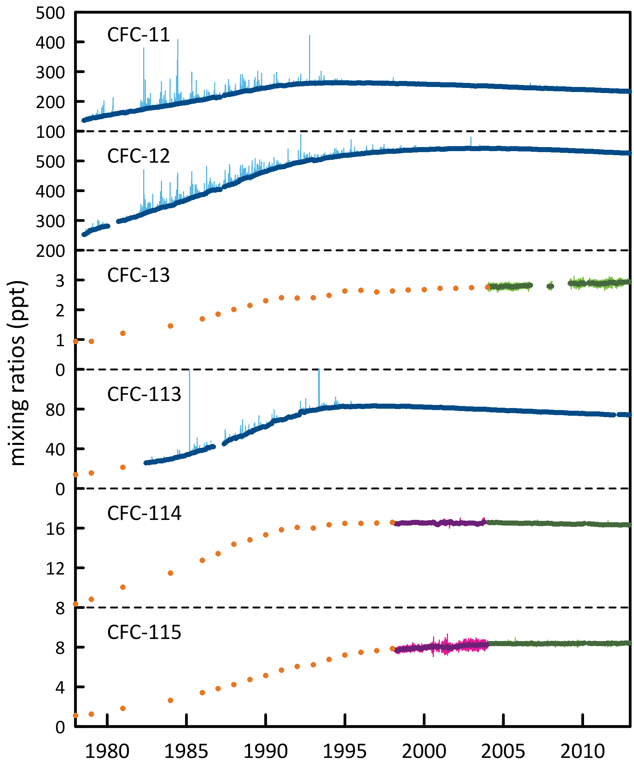

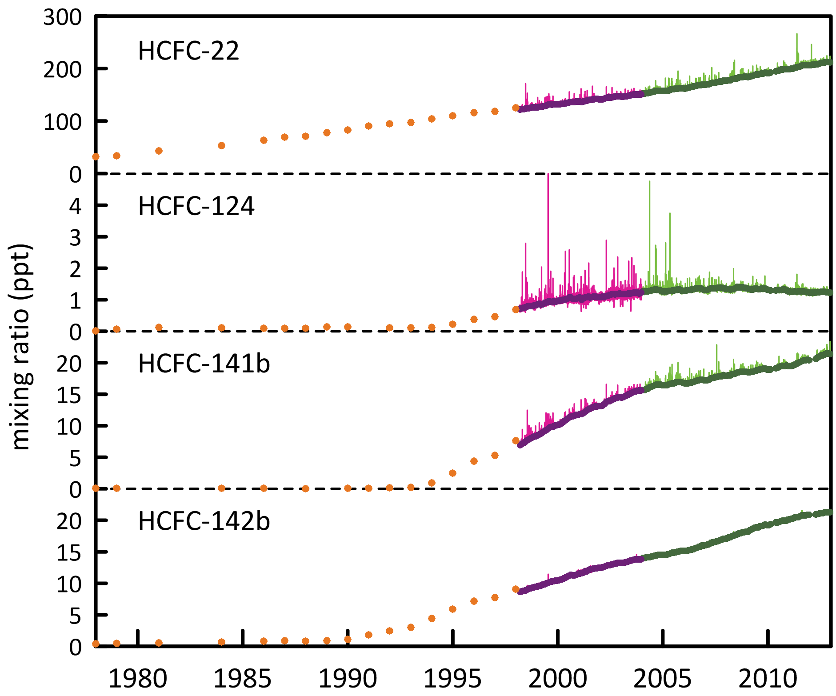

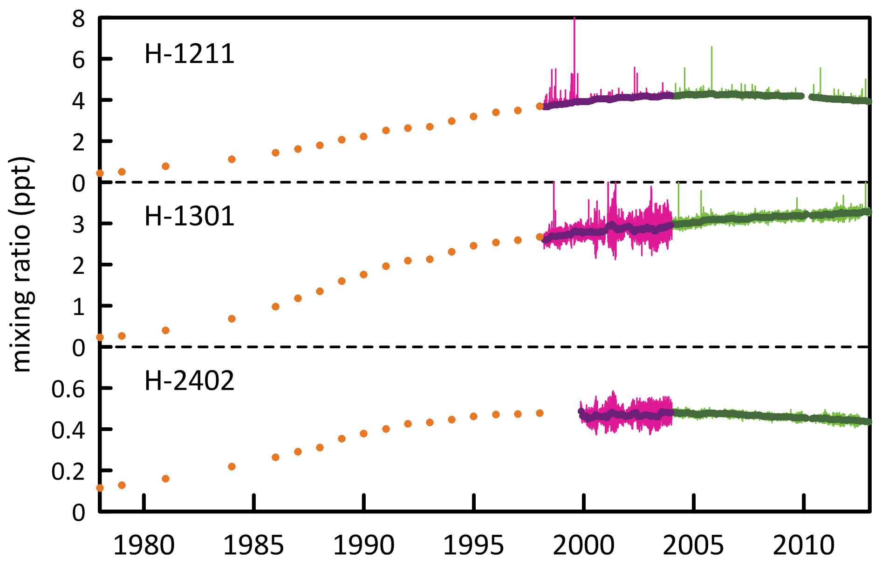

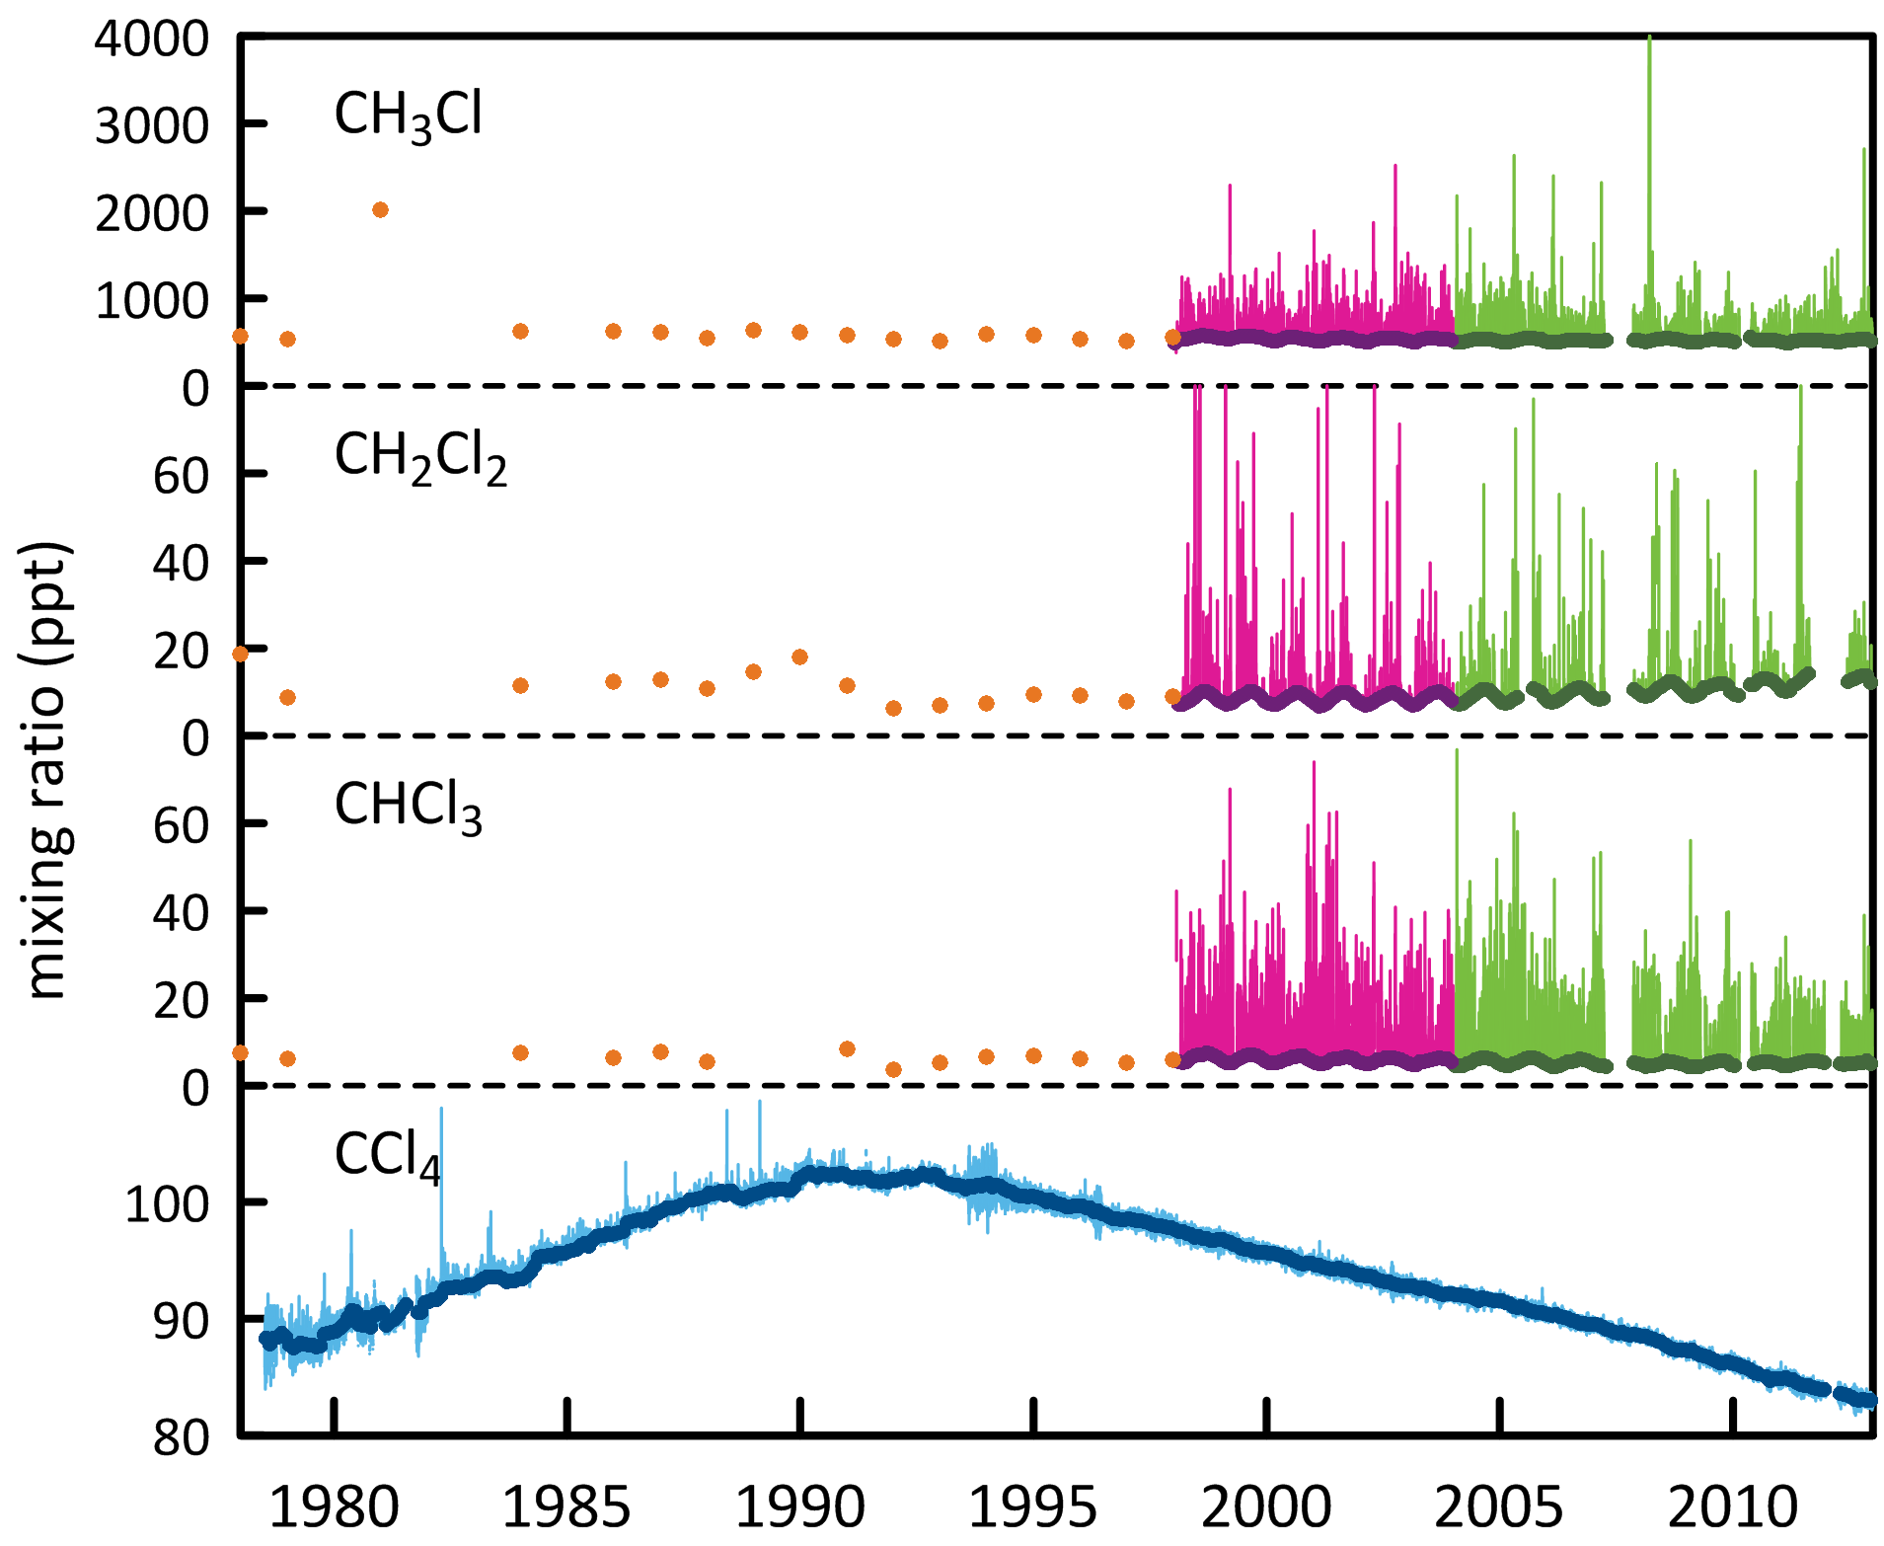

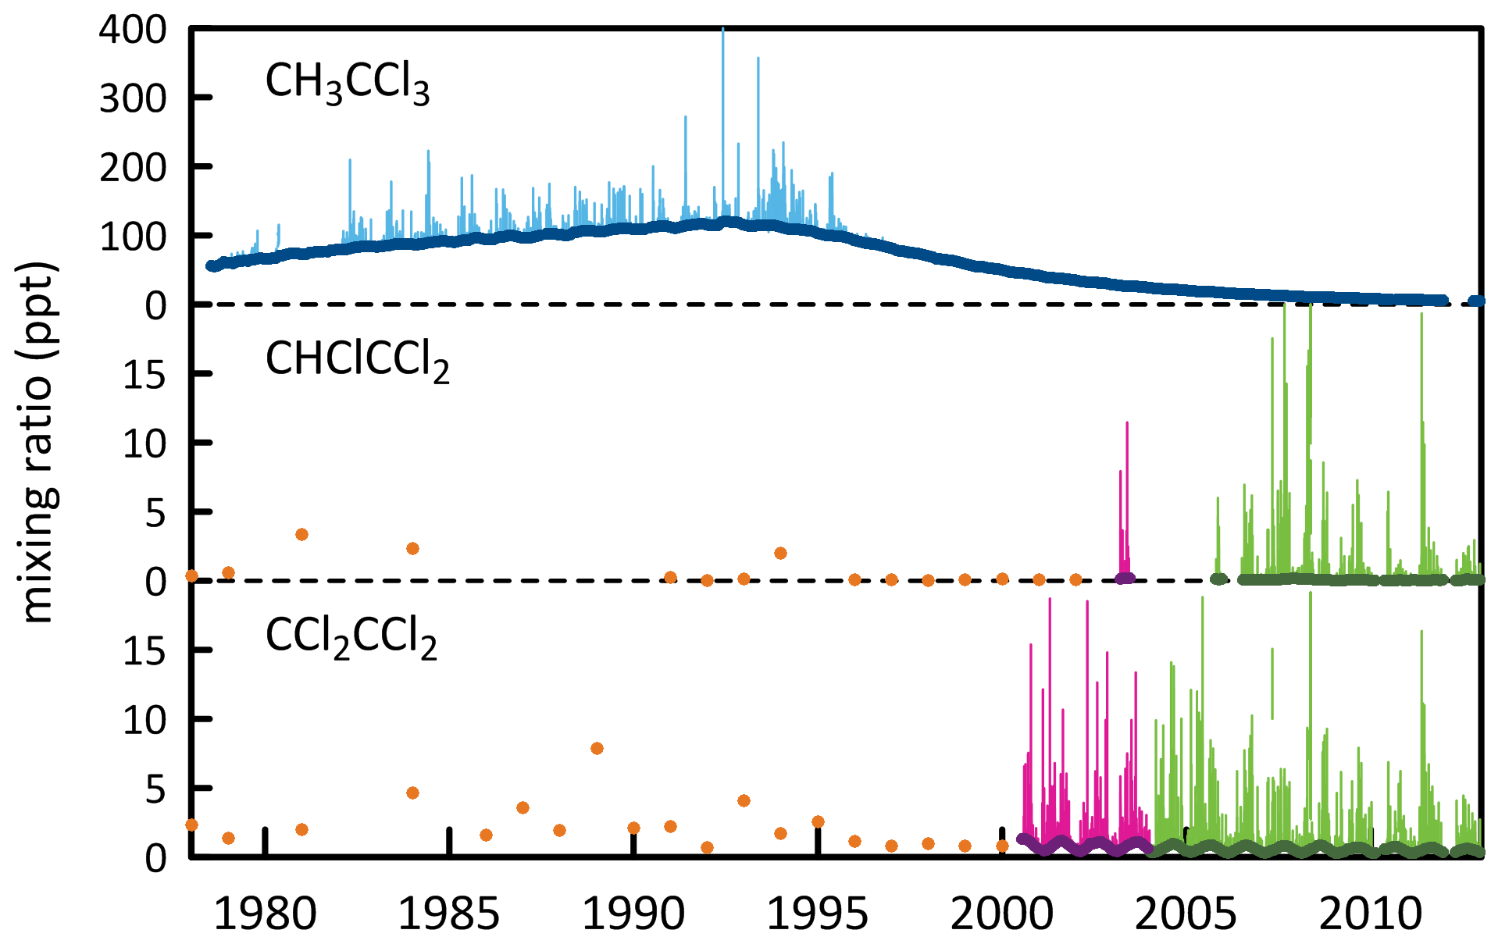

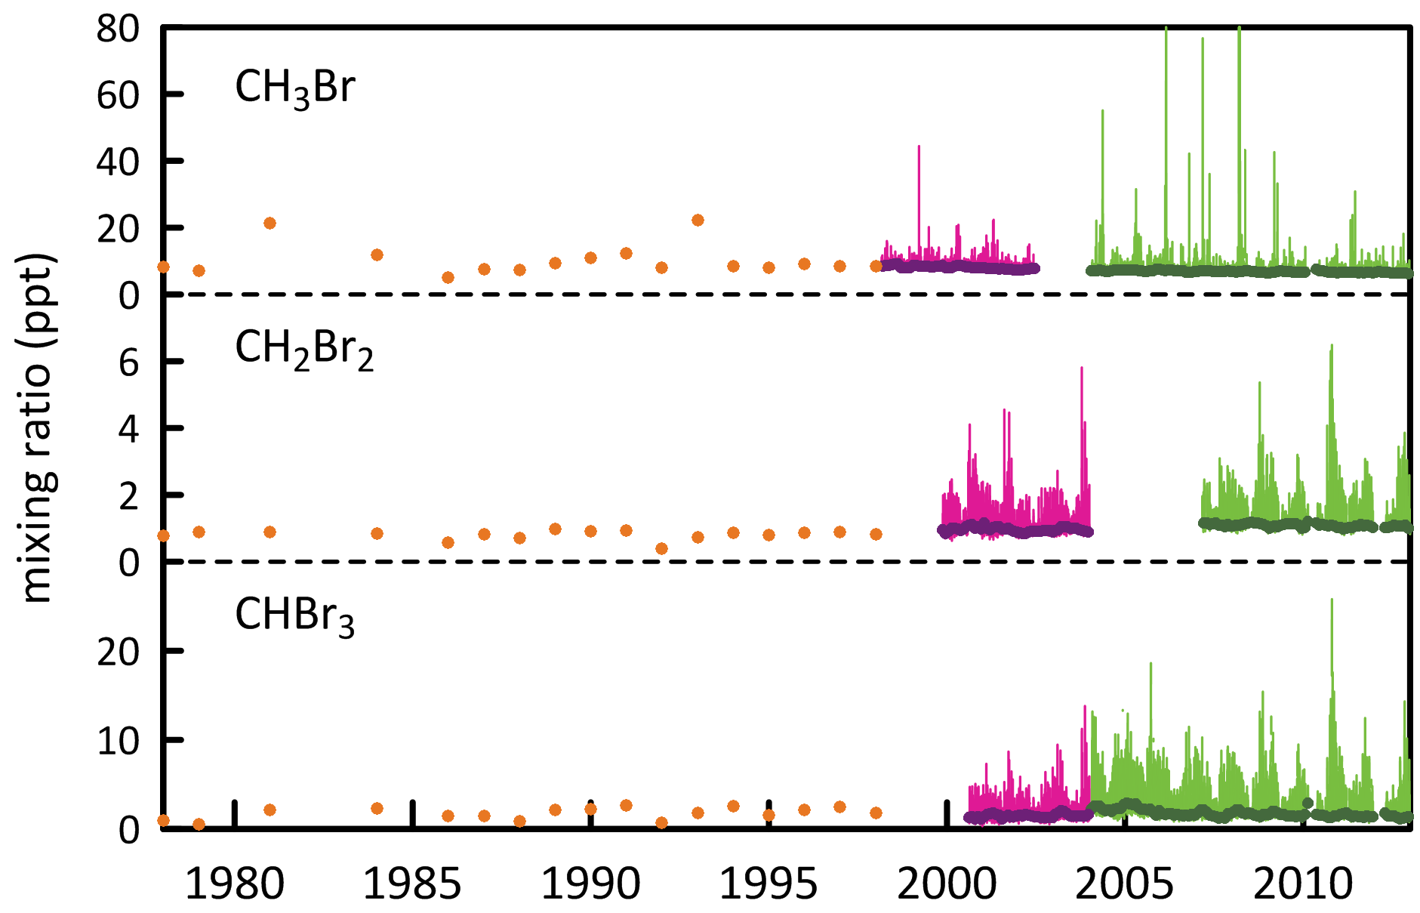

Figure 1. *In situ* observations of CFCs, HCFCs, halons, CCl4, CH3CCl3, CH3Cl, CH2Cl2, CHCl3, CHClCCl2, CCl2CCl2, CH3Br, CH2Br2 and CHBr3 (1978 – 2012) showing baseline monthly mean data (Medusa - dark green; ADS - purple; ECD – dark blue; archive annual means – orange) and total data (Medusa - light green; ADS – pink; ECD – light blue) obtained from the GC-MS-Medusa, GC-MS-ADS and GC-ECD instruments at Cape Grim and Aspendale (references: see text above and CSIRO unpublished data).

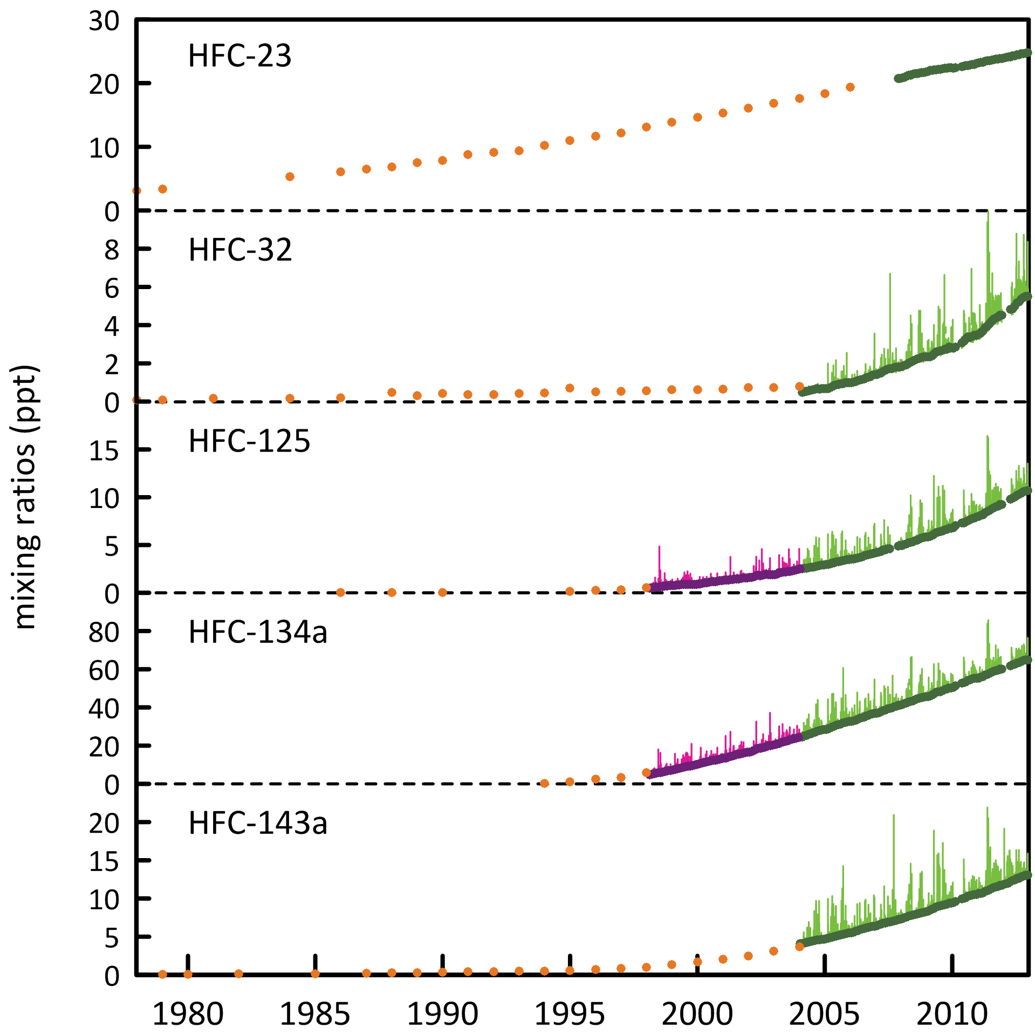

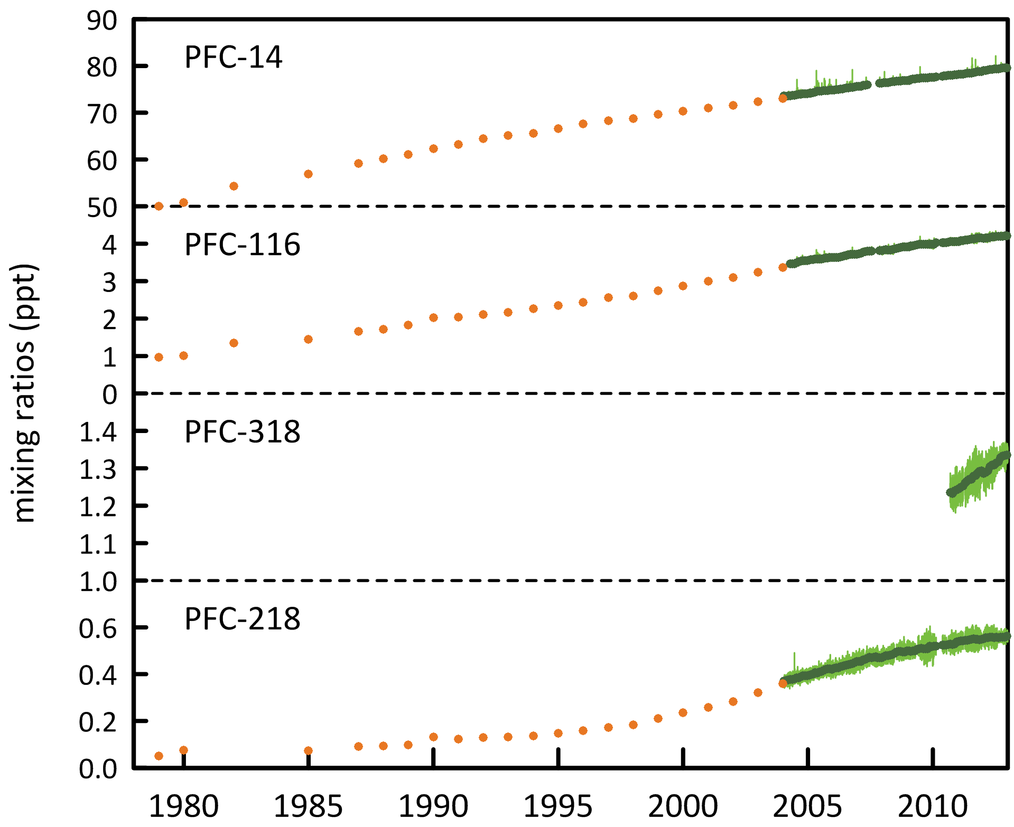

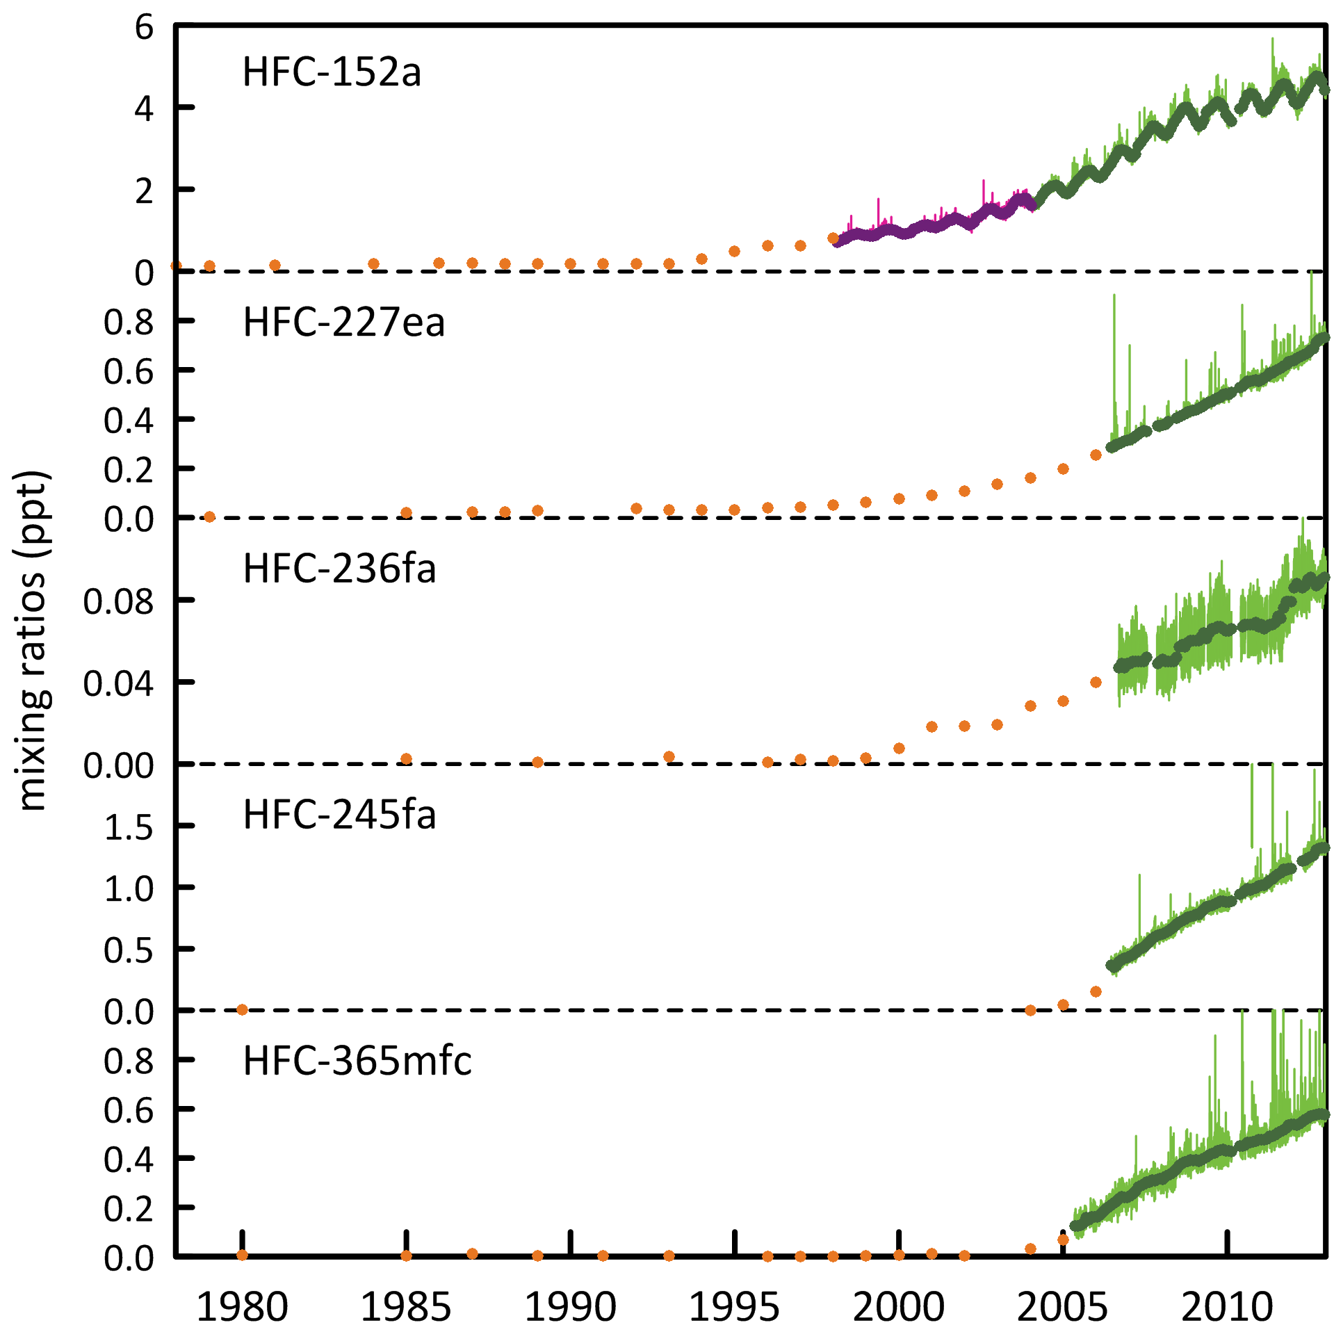

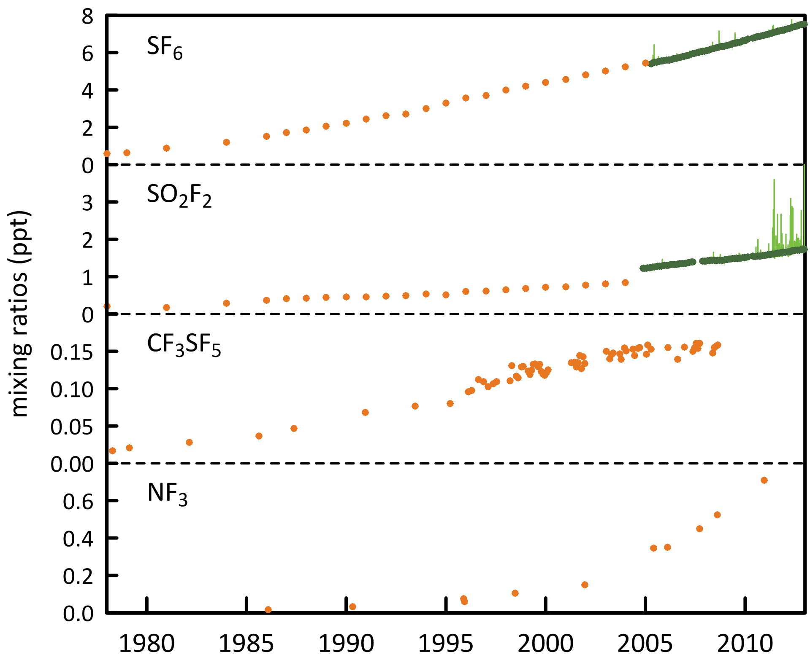

Figure 2. *In situ* observations of HFCs, PFCs, SF6, SO2F2, CF3SF5 and NF3 (1998 – 2012) showing baseline monthly mean data (dark green, Medusa; pink, ADS), total data (light green, Medusa; purple, ADS) and archive annula means (orange) obtained from the GC-MS-Medusa and GC-MS-ADS instruments at Cape Grim and Aspendale (references: see text above and CSIRO unpublished data).

# Global emissions of ODSs and SGGs

Background ODS and SGG observations at Cape Grim and from other AGAGE stations in the northern and southern hemispheres have been used to calculate global ODS and SGG emissions up to 2008 (Montzka & Reimann, 2011). These emission calculations have been updated (R. Wang, GIT, unpublished data) to 2011 and the results are shown in . These emissions are derived with the AGAGE 12-box global model.

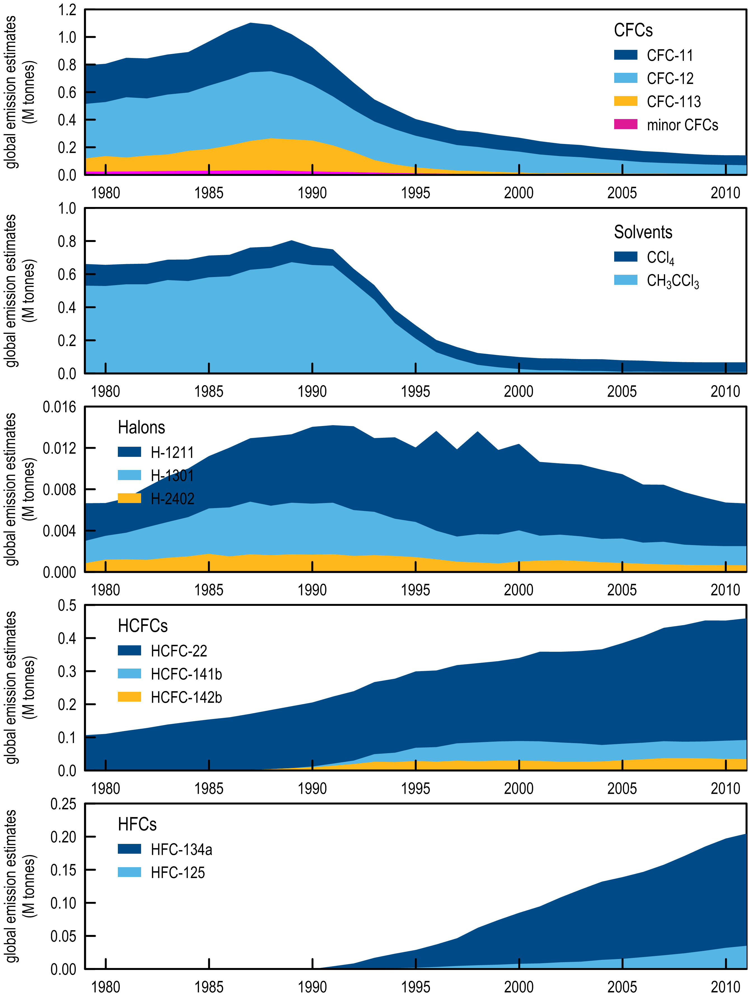

Figure 3. Global emissions of ODSs (CFCs, chlorinated solvents (MC, CTC), halons, HCFCs) and SGGs (HFCs) derived from global AGAGE data using the 12-box AGAGE global transport model (Montzka & Reimann, 2011; R. Wang, GIT, unpublished data). Note: data on global MB emissions in 2011 are not yet available.

## ODS emissions

In 2011, total global CFC emissions continued to decline (141.9 k tonnes in 2010, 141.6 k tonnes in 2011) dominated (96%) by emissions of CFC-11 (72 k tonnes) and CFC-12 (64 k tonnes) in 2011. Somewhat surprisingly, CFC-11 became the dominant CFC emitted globally in 2009, taking over from CFC-12, whose emissions had previously always been larger than CFC-11 emissions (since 1979 based on AGAGE data, and earlier based on production data). Presumably this change reflects a changing pattern of CFC use in developing countries, with increased use of CFC-11 in foams relative to CFC-12 used in refrigeration. Also surprisingly, CFC-11 emissions in 2011 (72 k tonnes) were larger than CFC-11 emissions in 2010 (70 k tonnes). This is the first increase in global annual CFC-11 emissions observed since the emissions peaked in 1987 at 360 k tonnes; however the observed increase is within the margin of observational error.

Carbon tetrachloride emissions increased slightly (58.3 k tonnes in 2009/2010, 58.6 k tonnes in 2011). Long-term, global CTC emissions are slowly declining and small year-to-year increases have been observed previously (1988/1989, 1992/1993, 1998/1999, 2000/2001, 2003/2004) since emissions peaked in 1987 at 134 k tonnes. The decline in global CTC emissions is not as rapid as anticipated under the Montreal Protocol (Montzka & Reimann, 2011). As pointed out by Fraser *et al*. (2012a) a partial explanation may be that global emissions of CTC from land-fills and possibly chlor-alkali plants may be significant and not yet accounted for in global budgets.

Global MC emissions continue to decline from 10.6 k tonnes in 2005 to 8.8 k tonnes in 2010 and 2011. For the first time in decades there has not been a measurable decline in global MC emissions in consecutive years (2010, 2011). This could mean that global sources now equal global sinks and CH3CCl3 emissions will not fall to zero as anticipated; 2012 data will be instructive on this issue.

Total global halon emissions continue to decline (7.4 k tonnes in 2010, 7.3 tonnes in 2011), dominated (65%) by halon-1211 emission, which also declined by 0.1 k tonnes over the same period.

Global HCFC emissions continue to increase (1.3%, 458 k tonnes in 2010, 464 k tonnes in 2011), dominated (~80%) by HCFC-22 emissions, which increased by 5 k tonnes over the same period.

There are currently no new estimates of global emissions of MB, but are being assessed currently, and will be reported as soon as the data are received. As reported in the *Scientific Assessment of Ozone Depeltion: 2010* (Montzka & Reimann 2011), global MB emissions declined from about 160 k tonnes in 2004 to about 140 k tonnes in 2009, based on global AGAGE MB data. Extrapolation of this downward trend would suggest global emissions of about 130 k tonnes in 2011.

## SGG emissions

Global emissions of HFCs continued their rapid increase (4%, 249 k tonnes in 2010, 258 k tonnes in 2011), dominated (~65%) by HFC-134a emissions, which increased by 5 k tonnes over the same period. However, the rate of increase in HFC emissions has been declining since the peak rate of increase of 17-18 k tonnes/yr was seen in 1998. A continuing, if not more rapid, decline in HFC emissions is anticipated over the next 5 years as global initiatives to phase-down the use of HFCs gain momentum.

# Milestone #1 & #5: Global EESC & the 2012 Antarctic Ozone Hole

## Equivalent Effective Stratospheric Chlorine

Equivalent Effective Stratospheric Chlorine (EESC) is a parameter developed to relate the Cl and/or Br composition and atmospheric lifetimes of ODSs to their resultant stratospheric ozone depletion (Daniel *et al*., 1995). The ODS atmospheric lifetimes in part determine the fractional release factors used in the derivation of EESC, which relate the amount of Cl and/or Br released in the stratosphere as a fraction of the amount entering the stratosphere. The fractional release factors at any location in the stratosphere quantifies the fraction of the ODS that has become photo-chemically degraded at that location. Fractional release factors used in EESC calculations have a typical uncertainty (95% confidence interval) of ±5% (Newman *et al*., 2007). Bromine released into the stratosphere from ODSs is 60±15 times more capable of ozone destruction than Cl and this is represented in the EESC calculation by a weighting factor (α, typically 60) applied to Br released in the stratosphere to convert it to an equivalent amount of Cl released (Daniel *et al*., 1995; Newman *et al*., 2007).

EESC is used with ODSs scenarios to anticipate future ozone loss/recovery at both mid- and polar-latitudes. EESC contains a lag time (or age-of-air) that represents the time taken for the ODS released at the surface to reach the lower stratosphere (where halogen-catalysed ozone destruction occurs) at mid- (typically 3 years) and Antarctic latitudes (typically 5-6 years). EESC has been used in the past 5 international assessments of stratospheric ozone depletion to relate predictions of future ODS abundances to future ozone depletion (WMO 1995, 1999, 2003, 2007, 2011).

In this report, EESC calculations, detailed in Fraser *et al*. (2013), relevant to ozone depletion at mid- and Antarctic latitudes, are based on AGAGE, CSIRO, SIO and UEA global, Cape Grim and Antarctic firn ODS observations and are compared to the new baseline scenario A1 from WMO (2011). The derived EESC values are compared to and correlated with ozone depletion at mid-latitudes and in the Antarctic polar region.

The new ODS scenario (A1) in WMO (2011) contains atmospheric abundances (measured or predicted) for sixteen (16) ODSs (CFCs-11, -12, -113, -114, -115; HCFCs-22, -141b, -142b; H-1202, 1211, -1301, -2402; CTC, MC, MB and methyl chloride) from 1955 to 2100. H-1202 is present in the atmosphere in very low abundances (<0.1 ppt, parts per 1012 molar) and only Cape Grim Air Archive data have been published (Fraser *et al*., 1999; Oram, 1999). The contribution that H-1202 makes to total EESC is small (<10 ppt) and is not considered further here.

The fifteen (15) remaining ODSs in scenario A1 are measured in the AGAGE global network (Prinn *et al*., 2000) and are available from the publically-accessible archive (http://agage.eas.gatech.edu/data.htm), except for halon-2402, and are used to calculate annual average global abundances for these 15 ODSs. The same 15 ODSs have been measured in the Cape Grim Air Archive, with only MC, CFC-113 and HCFC-22 published to date (Fraser *et al*., 1986, 1996; Miller *et al*., 2010).

Fourteen of 16 ODSs in scenario 1 (all except CH3Cl, MB) have been measured in the Cape Grim Air Archive at UEA (Oram *et al*., 1995; Fraser *et al*., 1999; Oram, 1999). The UEA data were converted to an interim AGAGE scale (Sturrock *et al*., 2002). Two (MB, HCFC-22) of the 16 ODSs in scenario 1 have been measured in the Cape Grim Air Archive at SIO (Miller, 1998; Miller *et al*., 1998). Fourteen of 16 ODSs (all except H-1202, H-2402) in scenario A1 have been measured by CSIRO at Cape Grim in the AGAGE scale, and in Antarctic firn air from Law Dome (Sturrock *et al*., 2001, 2002, Trudinger *et al*., 2004).

The following data are used to construct Cape Grim and Antarctic abundances of the 15 ODSs in scenario 1 (not including H-1202) from 1930 to 2011: CFC-11, -12, MC, CTC(Cape Grim *in situ* and Antarctic firn); CFC-113, -114, -115, all 3 HCFCs, all 3 halons (Cape Grim *in situ*, Archive and firn); MB, CH3Cl: Cape Grim *in situ* and firn. Global abundances of the 15 ODS have been constructed from *in situ* data from all, or a selection of, the AGAGE stations: Mace Head (Ireland), Cape Meares (Oregon), Trinidad Head (California), Ragged Point (Barbados), Cape Matatula (American Samoa) and Cape Grim (Tasmania). For those times when there are *in situ* data, proxy Cape Grim data have been generated from a Bayesian synthesis inversion (Trudinger *et al*., 2002) of Cape Grim *in situ*/Antarctic firn/Cape Grim Air Archive data (Sturrock *et al*., 2001, 2002), or *in situ*/firn data (Trudinger *et al*., 2004). The atmospheric history of H-2402 has been reconstructed from *in situ*/Archive data, with a short backward linear interpolation to zero abundances (about 1970). Global abundances are calculated from the synthesis inversion data by scaling the inversion data by the earliest global/Cape Grim ratio in the *in situ* data. It is important to note that EESC calculated from AGAGE/CSIRO/SIO/UEA data from 1930 to 2010 is based entirely on atmospheric and Antarctic firn observations – there has been no ‘filling-in’ of missing data with abundances calculated from an atmospheric model with assumed emissions.

Long-lived ODS species that have been measured in the AGAGE program and/or in the Cape Grim Air Archive that are not included in the ODSs contributing to EESC in this report or in the EESC calculation in WMO 2011 are CFC-13 (CClF3, UEA, AGAGE), CFC-112 (CCl2FCCl2F, UEA), CFC-112a (CClF2CCl3, UEA), CFC-113a (CCl3CF3, UEA), CFC-114a (CCl2FCF3, UEA - likely included in CFC-114 measurements by AGAGE and AOAA), HCFC-21 (CHCl2F, UEA), HCFC-123 (CHCl2CF3, UEA, AGAGE at Cape Grim), HCFC-124 (CHClFCF3, AGAGE) and HCFC-133a (CF3CH2Cl, UEA) (Oram, 1999; Krummel *et al*., 2004, 2011; Laube *et al*., 2013a). Together these species contribute only about 10-15 ppt of tropospheric chlorine and do not make a significant contribution to total EESC.

The EESC data, suitable for comparison to ozone loss at mid- and polar latitudes, from AGAGE, CSIRO, SIO and UEA ODS data, from CSIRO and NASA calculations based on scenario A1 (WMO, 2011) are shown in .

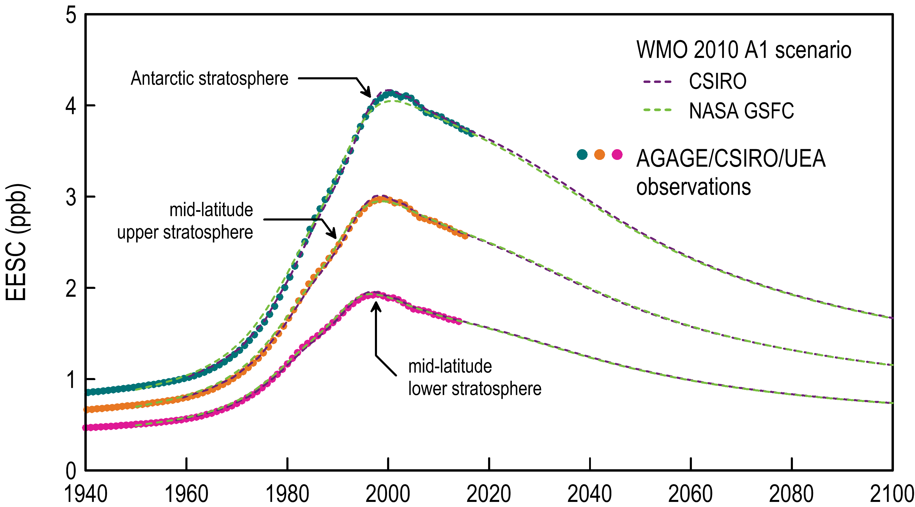

Figure 4. Global EESC (ppb, parts per 109 molar) calculated from AGAGE/CSIRO/ SIO/UEA data (see text) and from scenario A1 (WMO, 2011), for the Antarctic springtime stratosphere (age-of-air 5.5±2.8 yr, α = 60), the mid-latitude lower stratosphere (age-of-air 3.0±1.5 yr, α = 60) and the mid-latitude upper stratosphere (age-of-air 4.3±2.1 yr, α = 60).

## 2012 Antarctic Ozone Hole

Thirteen reports were sent to DSEWPaC during 2012 describing the growth and decay of the 2012 Antarctic Ozone Hole (AOH) (Krummel, P. & P. Fraser, The 2012 Antarctic Ozone Hole Summary, Report #1: 19 August, #2: 26 August, #3: 3 September, #4: 10 September, #5: 18 September, #6: 25 September), #7: 2 October, #8: 10 October, #9: 16 October, #10: 22 October, #1: 31 October, #12: 7 November), #13: 21 November. A final companion report summarising the 2013 AOH will be sent separately to DSEWPaC in September 2013.

# Australian SGG imports

Data on Australian imports of ODSs and HFCs, PFCs and sulfur hexafluoride are reported to DSEWPaC under licensing arrangements in the *Ozone Protection and Synthetic Greenhouse Gas Management Act, 1989* (the Act), with the requirement being established under the Act in 2003. Australian imports are documented in the DSEWPaC Ozone Licensing and Reporting System (OLaRS: A. Gabriel, DSEWPaC, private communication, May 2013), which was introduced by DSEWPaC during 2011. OLaRS details imports of bulk and pre-charged HFCs (individual and in blends), PFCs (individual/blends), sulfur hexafluoride, HCFCs (individual/blends) and other ODSs (in particular carbon tetrachloride – CTC and MB).

For 2012 (January – December) imports were reported entirely via the OLaRS protocol. For 2011, OLaRS data are only available for October – December, and the annual imports reported here for 2011 are estimated by scaling the October-December data to the entire year, assuming that the October-December data are representative in volume and composition for all of 2011. The resultant 2011 data are thus more uncertain than the 2012 data, especially given the legislation for the equivalent carbon price on SGGS passed Parliament in November 2011 and it would be expected that some importers may have commenced stockpiling SGGs in late 2011.

For 2008-2010, the SGG imports are reported using the pre-OLaARS protocol. HFC-134a and ODS imports are recorded directly, whereas other HFCs have to be derived from annual aggregate totals of HFCs (secondary and exotic). Speciation into individual HFCs uses factors (approximate) supplied by DSEWPaC. Imports of SGGs are shown in Table 2 and .

All import data (2008-2012) include SGGs precharged (PCE) into imported refrigeration and air conditioning (RAC) equipment. PCE SGGs imported in non-RAC equipment, which account for ~2% of total SGGs by weight (Department of the Environment, personal communication 2013) are not included in these import data.

There is an overall decline in Australian SGG imports from a peak in 2009 (11.6 k tonnes) to 2012 (9.7 k tonnes). The 2012 data may be abnormally high as a result of the carbon price being imposed in 2012. Both HFC and HCFC imports peaked in 2009 and have both been in decline since 2009, with a very significant decline (60%) in HCFC imports, due to Montreal Protocol phase-out, and a small decline (2%) in HFC imports. MB imports in 2012 (719 tonnes) were similar to 2011 (734 tonnes); both are higher than the minimium in MB imports (350 tonnes in 2007, not shown). The recent increase in MB imports has been due to increased demand for QPS use of MB in fumigating Australian commodity exports as the impact of the drought has waned. Such QPS use of MB is outside the Montreal Protocol controls on production/imports and consumption.

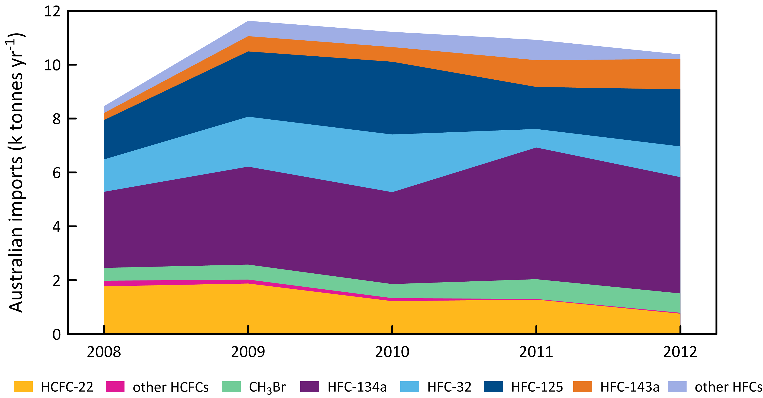

Figure 5. Australian imports (tonnes) of ODSs (HCFCs, CH3Br) and HFCs (DSEWPaC, private communication, 2013). The 2012 data are from the OLaRS data base, 2010 and earier are pre-OLaRS data, and 2011 is a mixture of OLaRS and pre-OlaRS data.

Table 2. Australian imports (tonnes) of ODSs (HCFCs, CH3Br), HFCs, PFCs and SF6 (DSEWPaC, private communication, 2013). The 2012 data are from the OLaRS data base, 2010 and earier are pre-OLaRS data, and 2011 is a mixture of OLaRS and pre-OlaRS data.

|  |  |  |  |  |  |  |  |  |  |  |  |  |
| --- | --- | --- | --- | --- | --- | --- | --- | --- | --- | --- | --- | --- |
|  | 2008 | 2009 | 2010 | 2011 | 2012 |  |  | 2008 | 2009 | 2010 | 2011 | 2012 |
| **ODSs** |  |  |  |  |  |  | **HFCs** |  |  |  |  |  |
| HCFC-22 | 1773 | 1878 | 1224 | 1280 | 758 |  | HFC-23 | 7.7 | 18 | 17 | 2.9 | 0.5 |
| HCFC-123 | 21 | 48 | 26 | 12 | 20 |  | HFC-32 | 1203 | 1855 | 2141 | 688 | 1141 |
| HCFC-123a |  |  |  | 1.0 | 7.6 |  | HFC-125 | 1461 | 2423 | 2700 | 1560 | 2119 |
| HCFC-124 | 20 | 13 | 32 | 5.3 | 3.6 |  | HFC-134 |  |  |  |  | 2.9 |
| HCFC-141b | 155 | 76 | 49 | 3.0 |  |  | HFC-134a | 2823 | 3634 | 3410 | 4887 | 4315 |
| HCFC-142b | 12 | 8.1 | 4.5 | 2.5 | 1.7 |  | HFC-143a | 261 | 566 | 545 | 994 | 1125 |
| HCFC-225ca |  | 0.5 | 0.3 | 0.3 | 0.5 |  | HFC-152a | 19 | 36 | 44 | 0.1 |  |
| **Total HCFCs** | **1981** | **2023** | **1337** | **1305** | **793** |  | HFC-227ea | 58 | 133 | 127 | 79 | 70 |
| CH3Br | 477 | 557 | 522 | 734 | 719 |  | HFC-236fa | 25 | 57 | 55 | 0.1 |  |
| **Total ODSs** | **2458** | **2580** | **1859** | **2039** | **1512** |  | HFC-245fa | 127 | 292 | 280 | 289 | 44 |
| **SGGs** |  |  |  |  |  |  | HFC-245ca | 19 | 34 | 42 |  |  |
| **PFCs** |  |  |  |  |  |  | HFC-365mfc |  |  |  | 372 | 53 |
| PFC-14 |  |  |  | 0.1 | 0.3 |  | HFC-43-10mee |  |  |  | 13 |  |
| PFC-116 |  |  |  |  | 0.5 |  | **Total HFCs** | **6004** | **9049** | **9360** | **8887** | **8870** |
| PFC-218 | 0.1 |  |  |  |  |  | SF6 |  |  |  |  | 36 |
| PFC-318 |  |  |  |  | 0.1 |  | **Total SGGs** | **6004** | **9049** | **9360** | **8887** | **8907** |
| PFC-4-1-12 |  |  |  |  |  |  | **Total ODSs, SGGs** | **8.5** | **11.6** | **11.2** | **10.9** | **10.4** |
| **Total PFCs** | **0.1** |  |  | **0.1** | **0.9** |  | **(k tonnes)** |  |  |  |  |  |
|  |  |  |  |  |  |  |  |  |  |  |  |  |

# Australian HFC, PFC and SF6 emisions: the National Greenhouse Accounts

The National Greenhouse Gas Inventory (NGGI: ageis.climatechange.gov.au) contains estimates of Australian emissions of HFCs (HFC-23, HFC-125, HFC-134a, HFC-143a), PFCs (PFC-14, PFC-116) and sulfur hexafluoride that underpin the *National Inventory Report 2011* (DIICCSRTE, 2013b), which is the Australian government submission to the United Nations Framework Convention on Climate Change (UNFCCC), and which forms a part of the Australian National Greenhouse Accounts (NGA). Emissions of HFC-32 are not reported in the NGGI, but are part of the NGA as supplied by DIICCSRTE (2013a). For HFC-23 emissions, the NGGI assumes that they stopped in 1995 when HCFC-22 production in Australia ceased. However, as seen in the atmospheric data below, there remains continuous, low-level emissions of HFC-23 in Australia following cessation of HCFC-22 production. Presumably these emissions are due to a non-HCFC-22 source, possibly as a fire suppressant (HFC-23 is marketed by DuPont as FE-13® – a fire suppressant). There may be some difficulty in identifying HFC imports in pre-charged fire fighting equipment.

Australian HFC emissions were less than 100 tonnes in the mid-1990s, rising to 5267 tonnes (7642 CO2-e tonnes) in 2011. HFCs are the dominant emissions in CO2-e terms in this sector (95% in 2010 and 2011). The long-term increase in total Australian emissions of HFCs is about 480 tonnes/yr. HFC-134a emissions increased by about 252 tonnes (7%) from 2010 to 2011, all other HFCs by about 176 tonnes (7%). Emissions of total HFCs (in CO2-e terms) in 2011 were 9% higher than in 2010. A gradual increase in HFC emissions is expected as the Austrlian economy/population grows; the current rapid increase in HFC emissions is due to this economic growth as well as HFC emissions from applications to replace HCFCs as they are phased-out under the Montreal Protocol.

shows the growth in HFC emissions for each of the HFC species from the major HFC sources: refrigeration, air-conditioning, foam blowing, aerosols/MDIs and fire suppression equipment. For each HFC, the major emission categories are refrigeration and air-conditioning. The dispersive uses of HFCs (aerosols, foams, fire extinguishers) are minor, clearly indicating the importance of minimizing HFC leaks in refrigeration and air-conditioning as a means of reducing HFC emissions.

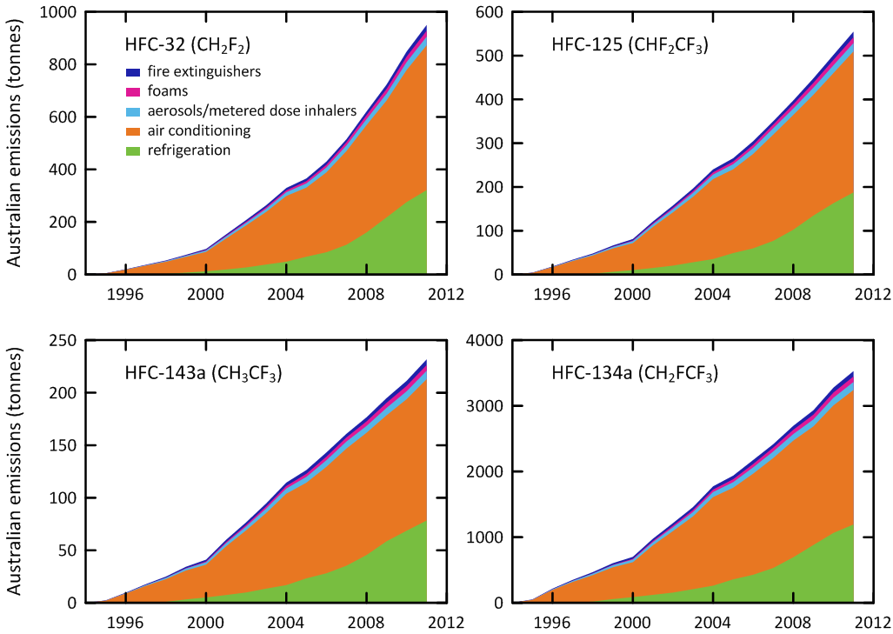

Figure 6. Australian emissions (tonnes) of HFC-32, HFC-125, HFC-134a, HFC-143a from the major source categories as reported in the NGGI (ageis.cliamtechnage.gov.au), except for HFC-32 emissions obtained directly from DIICCSRTE (2013b).

Australian PFC emissions were 190 tonnes in the mid-1990s, rising to 230 tonnes in the mid-2000s, before dropping to about 40 tonnes in 2011. Total PFC emissions increased by 5% from 2010 to 2011. Sulfur hexafluoride (SF6) emissions are estimated to have been 13 tonnes in 1995 falling to 6 tonnes in 2011.

Total HFC, PFC and sulfur hexafluoride emissions in CO2-e in 2011 were estimated at 8051 k tonnes, 9% higher than in 2010. The overall uncertainty on the PFC/HFC/sulfur hexafluoride emissions category in the NGGI is 25-30% (DCCEE, 2011). The HFC, PFC and sulfur hexafluoride contributions to total emissions from this sector are shown in . The significant impact on total emissions in 2005-2006 due to reduced PFC emissions (as a result of the Kurri Kurri smelter upgrade in 2005) can be clearly seen. Prior to the significant reduction in PFC emissions at Kurri Kurri in 2005, Australian HFC/PFC/sulfur hexafluoride emissions were growing at about 13%/yr (). After the Kurri Kurri smelter upgrade, these combined emissions grew at about 8%/yr.

Details of the Australian sulfur hexafluoride emissions estimates have been published by DIICCSRTE (2013). Sulfur hexafluoride was first used in electrical equipment in Australia during 1975-1979. Sulfur hexafluoride emissions each year are estimated as the sum of emissions from the existing stock of electrical equipment, whose contained sulfur hexafluoride is maintained by servicing, emissions from the manufacturing of new electrical equipment, and emissions from non-electrical equipment sources such as medicinal applications (eye surgery), tracer gas studies, as a cover gas in metal foundries (magnesium), in pneumatic tyres and some running shoes (all Nike ‘Air’ shoes manufactured from 1990 to 1996 contained sulfur hexafluoride as a shock absorbtion gas).

Prior to 2000, DIICCSRTE (2013b) uses the IPCC global default emission factor of 0.02 t/t for emissions from electrical equipment. From 2009, an Australian-specific value is assumed (0.0089 t/t), with assumed linear interpolation from 2000 to 2009. For new electrical equipment manufacture, DIICCSRTE uses the IPCC global default emission factors of 0.15 t/t prior to 1995 and 0.06 t/t after 1995. For other sulfur hexafluoride emission sources, DIICCSRTE assumes a population-dependent emission based on ~0.04 g sulfur hexafluoride/person/year. For 2012, emissions are based on linear interpolation from 2011 and earlier data. The DIICCSRTE Australian sulfur hexafluoride emission data are shown in and .

The sulfur hexafluoride import data suggest an inconsistency with this sulfur hexafluoride stock/emissions model. In 2012 (the first year of sulfur hexafluoride imports being controlled by the *Ozone Protection and Synthetic Greenhouse Gas Management Act 1989*) Australia imported 36 tonnes of sulfur hexafluoride. The sulfur hexafluoride imported each year goes into new stock (12 tonnes in 2012) or the servicing of existing stock (7 tonnes in 2012, replacing sulfur hexafluoride lost by fugitive emissions) and 1 tonne for other uses, a total of 20 tonnes (DIICCSRTE 2013b). Atmospheric observations below suggest that 2011 Australian emissions are significantly larger than the 6 tonnes/yr calculated with the DIICCSRTE (2013b) model. This would suggest that the emission factors used in the three categories of emissions in the DIICCSRTE model are possibly too low and/or there are other emissive uses of SF6 not included in the model.

In 2011, Australian importers may have anticipated that the application of an equivalent carbon price ($23/tonne CO2-e in 2012/2013) on sulfur hexafluoride imports (DSEWPaC, 2012), resulting in a sulfur hexafluoride price increase of $547,000/tonne (GWP of sulfur hexafluoride is 23,900), would significantly increase the value of sulfur hexafluoride brought into Australia. This may have led to a surge in imports prior to the application of the equivalent carbon price (from 1 July 2012) and stockpiling of sulfur hexafluoride in excess of requirements.

DIICCSRTE (2013b) estimates of HFC, PFC and sulphur hexafluoride emissions (Table 4, ) in the NGGI (ageis.climatechnage.gov.au) are compared to emissions estimated from atmospheric observations below.

Table 3. Australian sulfur hexafluoride emissions from the existing stock of electrical equipment, from new electrical equipment manufacture or import and from other sources, such as metallurgical and medical uses etc. (DIICCSRTE, 2013b).

|  |  |  |  |  |  |  |  |  |  |  |
| --- | --- | --- | --- | --- | --- | --- | --- | --- | --- | --- |
| Year | electrical equip.  stock | electrical equip. manufacture | other sources | total emissions |  | Year | electrical equip.  stock | electrical equip. manufacture | other sources | total emissions |
| 1975 | 0.1 | 0.2 | 0.6 | 0.9 |  | 1994 | 10.0 | 1.8 | 0.8 | 12.5 |
| 1976 | 0.2 | 0.2 | 0.6 | 1.0 |  | 1995 | 10.7 | 1.9 | 0.8 | 13.4 |
| 1977 | 0.4 | 0.2 | 0.6 | 1.2 |  | 1996 | 10.1 | 0.8 | 0.8 | 11.6 |
| 1978 | 0.5 | 0.2 | 0.6 | 1.3 |  | 1997 | 9.3 | 0.7 | 0.8 | 10.8 |
| 1979 | 0.6 | 0.2 | 0.6 | 1.4 |  | 1998 | 8.3 | 0.7 | 0.8 | 9.8 |
| 1980 | 1.3 | 1.2 | 0.6 | 3.1 |  | 1999 | 7.1 | 0.7 | 0.8 | 8.6 |
| 1981 | 2.1 | 1.2 | 0.6 | 3.9 |  | 2000 | 6.3 | 1.3 | 0.8 | 8.4 |
| 1982 | 2.8 | 1.3 | 0.6 | 4.7 |  | 2001 | 6.6 | 1.4 | 0.8 | 8.8 |
| 1983 | 3.5 | 1.3 | 0.6 | 5.5 |  | 2002 | 6.8 | 1.4 | 0.8 | 9.0 |
| 1984 | 4.2 | 1.4 | 0.7 | 6.3 |  | 2003 | 7.0 | 1.4 | 0.8 | 9.2 |
| 1985 | 4.6 | 1.0 | 0.7 | 6.3 |  | 2004 | 7.1 | 1.4 | 0.8 | 9.3 |
| 1986 | 5.1 | 1.0 | 0.7 | 6.8 |  | 2005 | 6.7 | 0.6 | 0.9 | 8.2 |
| 1987 | 5.5 | 1.0 | 0.7 | 7.2 |  | 2006 | 6.2 | 0.6 | 0.9 | 7.7 |
| 1988 | 5.9 | 1.1 | 0.7 | 7.7 |  | 2007 | 5.8 | 0.6 | 0.9 | 7.3 |
| 1989 | 6.3 | 1.1 | 0.7 | 8.2 |  | 2008 | 5.3 | 0.6 | 0.9 | 6.8 |
| 1990 | 7.1 | 1.6 | 0.7 | 9.4 |  | 2009 | 4.8 | 0.5 | 0.9 | 6.2 |
| 1991 | 7.8 | 1.7 | 0.7 | 10.2 |  | 2010 | 4.9 | 0.4 | 0.9 | 6.2 |
| 1992 | 8.5 | 1.7 | 0.7 | 11.0 |  | 2011 | 5.0 | 0.5 | 1.0 | 6.4 |
| 1993 | 9.2 | 1.8 | 0.7 | 11.8 |  | 2012 | 5.1 | 0.5 | 1.0 | 6.6 |

Table 4. Australian HFC, PFC and SF6 emissions in the NGGI [ageis.climatechange.gov.au]

|  |  |  |  |  |  |  |  |  |  |  |  |  |  |  |  |  |  |  |  |  |  |  |  |  |  |  |
| --- | --- | --- | --- | --- | --- | --- | --- | --- | --- | --- | --- | --- | --- | --- | --- | --- | --- | --- | --- | --- | --- | --- | --- | --- | --- | --- |
|  | HFC-32 | | HFC-125 | | HFC-134a | | HFC-143a | | total HFCs | | | | PFC-14 | | PFC-116 | | total PFCs | | | | SF6 | | | | total HFCs, PFCs, SF6 | |
|  | tonnes | | | | | | | | tonnes | | kt CO2-e | | tonnes | | | | tonnes | | kt CO2-e | | tonnes | | kt CO2-e | | kt CO2-e | |
|  | 2012 | 2013 | 2012 | 2013 | 2012 | 2013 | 2012 | 2013 | 2012 | 2013 | 2012 | 2013 | 2012 | 2013 | 2012 | 2013 | 2012 | 2013 | 2012 | 2013 | 2012 | 2013 | 2012 | 2013 | 2012 | 2013 |
| 1995 | 3 | 5 | 5 | 4 | 61 | 53 | 0 | 2 | 69 | 65 | 96 | 94 | 171 | 171 | 22 | 22 | 193 | 193 | 1313 | 1313 | 13 | 13 | 317 | 317 | 1725 | 1723 |
| 1996 | 8 | 20 | 16 | 19 | 188 | 217 | 1 | 10 | 212 | 265 | 296 | 384 | 157 | 157 | 20 | 20 | 178 | 178 | 1209 | 1209 | 12 | 11 | 283 | 274 | 1788 | 1867 |
| 1997 | 17 | 37 | 33 | 34 | 351 | 350 | 2 | 18 | 402 | 439 | 565 | 641 | 137 | 137 | 18 | 18 | 155 | 155 | 1053 | 1053 | 11 | 11 | 260 | 254 | 1879 | 1949 |
| 1998 | 26 | 54 | 53 | 48 | 533 | 467 | 2 | 25 | 615 | 594 | 868 | 872 | 185 | 185 | 24 | 24 | 209 | 209 | 1424 | 1424 | 10 | 10 | 234 | 230 | 2526 | 2526 |
| 1999 | 39 | 75 | 79 | 66 | 746 | 604 | 4 | 34 | 867 | 779 | 1230 | 1150 | 127 | 127 | 16 | 16 | 143 | 143 | 977 | 977 | 9 | 8 | 206 | 202 | 2412 | 2329 |
| 2000 | 51 | 97 | 111 | 81 | 974 | 700 | 5 | 41 | 1142 | 920 | 1629 | 1357 | 143 | 143 | 19 | 19 | 162 | 162 | 1104 | 1104 | 8 | 8 | 200 | 197 | 2933 | 2658 |
| 2001 | 67 | 153 | 153 | 121 | 1231 | 976 | 6 | 60 | 1457 | 1310 | 2096 | 1936 | 201 | 201 | 26 | 26 | 227 | 227 | 1545 | 1545 | 9 | 9 | 206 | 206 | 3847 | 3687 |
| 2002 | 82 | 207 | 194 | 158 | 1473 | 1214 | 8 | 77 | 1756 | 1656 | 2540 | 2447 | 193 | 193 | 25 | 25 | 218 | 218 | 1481 | 1481 | 9 | 9 | 212 | 212 | 4233 | 4140 |
| 2003 | 100 | 264 | 240 | 197 | 1756 | 1458 | 10 | 95 | 2106 | 2014 | 3057 | 2978 | 188 | 188 | 24 | 24 | 212 | 212 | 1444 | 1444 | 9 | 9 | 216 | 216 | 4717 | 4638 |
| 2004 | 116 | 329 | 285 | 240 | 2056 | 1775 | 11 | 114 | 2469 | 2459 | 3590 | 3629 | 191 | 191 | 25 | 25 | 216 | 216 | 1469 | 1469 | 9 | 9 | 218 | 218 | 5277 | 5316 |
| 2005 | 137 | 365 | 337 | 266 | 2402 | 1937 | 13 | 126 | 2889 | 2695 | 4205 | 3980 | 200 | 200 | 26 | 26 | 226 | 226 | 1536 | 1536 | 8 | 8 | 191 | 191 | 5932 | 5707 |
| 2006 | 147 | 430 | 368 | 305 | 2561 | 2176 | 14 | 143 | 3090 | 3054 | 4509 | 4506 | 77 | 77 | 10 | 10 | 87 | 87 | 589 | 589 | 8 | 8 | 181 | 181 | 5278 | 5276 |
| 2007 | 161 | 515 | 416 | 350 | 2773 | 2416 | 15 | 161 | 3364 | 3443 | 4931 | 5069 | 65 | 65 | 8 | 8 | 73 | 73 | 500 | 500 | 7 | 7 | 170 | 170 | 5601 | 5739 |
| 2008 | 168 | 621 | 457 | 398 | 2945 | 2697 | 16 | 177 | 3586 | 3892 | 5279 | 5695 | 50 | 50 | 6 | 6 | 56 | 56 | 381 | 381 | 7 | 7 | 158 | 158 | 5819 | 6234 |
| 2009 | 184 | 723 | 517 | 448 | 3195 | 2933 | 18 | 195 | 3914 | 4300 | 5787 | 6279 | 40 | 40 | 5 | 5 | 45 | 45 | 308 | 308 | 6 | 6 | 143 | 143 | 6238 | 6730 |
| 2010 | 190 | 849 | 556 | 502 | 3382 | 3278 | 18 | 211 | 4147 | 4841 | 6147 | 7022 | 32 | 32 | 4 | 4 | 36 | 36 | 244 | 244 | 6 | 6 | 145 | 145 | 6535 | 7411 |
| 2011 |  | 951 |  | 555 |  | 3530 |  | 232 |  | 5267 |  | 7642 |  | 35 |  | 4 |  | 38 |  | 259 |  | 6 |  | 149 |  | 8051 |
|  |  |  |  |  |  |  |  |  |  |  |  |  |  |  |  |  |  |  |  |  |  |  |  |  |  |  |

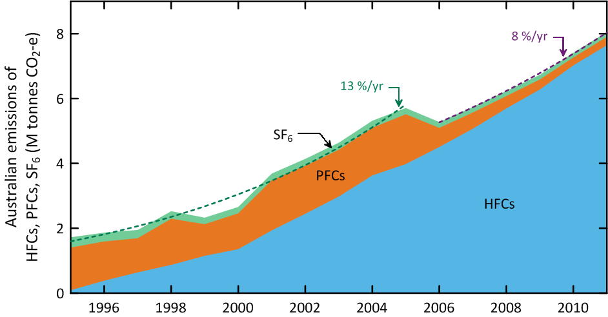

Figure 7. Australian HFC, PFC and sulfur hexafluoride emissions (M tonne CO2-e) (ageis.cliamtechange.gov.au). Dashed lines are exponential best fits.

# Milestones #2, #4, #6, #7, #9: CSIRO estimates of Australian SGG emissions including carbon tetrachloride

CSIRO has estimated emissions of a number of trace gases (methane, nitrous oxide, CFCs etc.) from the Melbourne/Port Phillip region (Dunse *et al*., 2001, 2005; Dunse 2002), utilising *in situ* measurements from the Cape Grim Baseline Air Pollution Station in Tasmania and employing the interspecies correlation (ISC) technique with co-incident carbon monoxide (CO) measurements. These original emission estimates were based on an average carbon monoxide emission from the Melbourne/Port Phillip region (600 k tonnes/yr) which was assumed to have been relatively constant during 2004-2009 (EPA, 1998).

In Fraser *et al*. (2012a), revised estimates of the Port Phillip region carbon monoxide emission were used (Delaney & Marshall, 2011) with 2002 emissions estimated at 605 k tonnes and 2006 emissions at 645 tonnes. Carbon monoxide emissions were assumed constant after 2006 for the Port Phillip region. There has been a further revision of carbon monoxide emissions from the Port Phillip region (S. Walsh, Victorian EPA, unpublished data, 2013). The 2006 Port Phillip emissions are now estimated to have been 796 k tonnes, with the increase in emissions due increased emissions from vehicles and reduced emissions from wood heaters.

As a result of revised data on carbon monoxide emissions, Port Phillip SGG emissions have been recalculated, from 2004-2011, using ISC and Cape Grim data, obtained from the GC-MS-Medusa instrument only (Krummel *et al*., 2013) at Cape Grim, and presented as 3-year running averages (2005-2011; Table 5, Figure 8: CFCs, HCFCs, chlorocarbons, halons, MB; Table 6, Figure 9: HFCs, PFCs, sulfur hexafluoride). The corresponding emissions from GC-ECD data and GC-ADS data will be recalculated and reported in 2014. The SGG emissions are derived from Port Phillip emissions, scaled to Australian emissions on a population basis (using a population-based scale factor of 5.4). NOAA air mass back trajectory analyses (Draxler & Hess, 1997) are used to ensure that the pollution events at Cape Grim used to derive Port Phillip emissions are imbedded in air masses that only pass over the Port Phillip region and do not include other possible carbon monoxide source regions, in particular the Latrobe Valley.

Table 5. Annual average (3-yr running means) Australian emissions (metric tonnes unless otherwise stated) of ODSs (CFCs, HCFCs, halons and chlorocarbons) from Cape Grim AGAGE data, using ISC techniques. Australian emissions are scaled from SE Australian emissions on a population basis; MB emissions are for SE Australia. GWPs (to calculate CO2-e emissions) are Forster & Ramaswamy (2007); ODPs (to calculate ODP-weighted emissions) are from Montzka & Reimann (2011); assumed GWPs for TCE (10) and PCE (140).

|  |  |  |  |  |  |  |  |
| --- | --- | --- | --- | --- | --- | --- | --- |
|  | 2005 | 2006 | 2007 | 2008 | 2009 | 2010 | 2011 |
|  | tonnes | | | | | | |
| CFCs |  |  |  |  |  |  |  |
| CFC-11 | 488±313 | 588±382 | 816±496 | 764±441 | 652±384 | 507±267 | 682±362 |
| CFC-12 | 532±341 | 537±339 | 617±360 | 552±318 | 548±326 | 409±227 | 411±224 |
| CFC-113 | 84±58 | 78±55 | 129±85 | 112±71 | 134±84 | 185±108 | 186±107 |
| total CFCs | 1103±250 | 1203±275 | 1562±370 | 1429±335 | 1335±315 | 1101±235 | 1280±280 |
| ODP tonnes | 1087±245 | 1188±275 | 1536±370 | 1406±335 | 1308±315 | 1064±230 | 1242±275 |
| M tonnes CO2-e | 8.6±2.1 | 9.1±2.2 | 11.4±2.7 | 10.3±2.5 | 9.9±2.5 | 8.0±1.8 | 8.9±2.0 |
| HCFCs |  |  |  |  |  |  |  |
| HCFC-22 | 1687±320 | 1748±340 | 2032±450 | 2061±411 | 2299±442 | 2381±458 | 2293±448 |
| HCFC-124 | 89±34 | 58±19 | 86±30 | 66±23 | 35±13 | 41±14 | 44±15 |
| HCFC-141b | 247±46 | 258±51 | 291±59 | 276±57 | 245±47 | 216±41 | 231±42 |
| HCFC-142b | 33±7 | 40±9 | 58±15 | 62±16 | 68±16 | 64±15 | 68±14 |
| total HCFCs | 2056±325 | 2104±345 | 2468±455 | 2466±415 | 2647±445 | 2702±460 | 2636±450 |
| ODP tones | 135±35 | 141±35 | 171±45 | 158±40 | 152±40 | 158±40 | 157±40 |
| M tonnes CO2-e | 3.4±0.6 | 3.5±0.6 | 4.1±0.8 | 4.1±0.7 | 4.5±0.8 | 4.6±0.8 | 4.5±0.8 |
| Halons |  |  |  |  |  |  |  |
| H-1211 | 74±53 | 84±58 | 119±73 | 104±62 | 68±41 | 58±32 | 103±58 |
| H-1301 | 35±24 | 33±23 | 26±17 | 24±15 | 32±20 | 56±32 | 77±44 |
| total halons | 109±35 | 116±35 | 114±45 | 129±40 | 100±30 | 114±30 | 180±45 |
| ODP tonnes | 569±165 | 579±160 | 612±170 | 557±150 | 525±150 | 734±225 | 1075±310 |
| M tonnes CO2-e | 0.34±0.10 | 0.34±0.10 | 0.33±0.091 | 0.34±0.08 | 0.31±0.09 | 0.46±0.15 | 0.66±0.20 |
| methyl bromide | | | | | | | |
| MB (SE Australia, DPI model) | 170 | 144 | 117 | 156 | 186 | 173 | 247 |
| MB (Australia, DPI model) | 413 | 380 | 309 | 420 | 516 | 474 | 690 |
| MB (SE Australia) | 176±59 | 171±55 | 165±53 | 179±63 | 193±72 | 226±81 | 239±81 |
| MB (Australia) | 429±145 | 451±146 | 434±140 | 484±170 | 534±199 | 618±222 | 668±227 |
| MB (Australia) ODP tonnes | 257±87 | 270±87 | 260±84 | 290±102 | 321±119 | 371±133 | 401±136 |
| MB (Australia) M tonnes CO2-e | 0.002±0.001 | 0.002±0.001 | 0.002±0.001 | 0.002±0.001 | 0.003±0.001 | 0.003±0.001 | 0.003±0.001 |
| chlorocarbons (Montreal Protocol) |  |  |  |  |  |  |  |
| CTC | 167±65 | 136±48 | 139±70 | 163±75 | 217±111 | 135±61 | 135±61 |
| MC | 117±83 | 100±68 | 86±59 | 105±65 | 103±66 | 68±39 | 67±37 |
| total chlorocarbons | 284±80 | 237±60 | 224±80 | 268±85 | 319±120 | 203±65 | 202±65 |
| ODP tonnes | 196±70 | 160±55 | 161±75 | 190±85 | 248±120 | 155±65 | 155±65 |
| M tonnes CO2-e | 0.32±0.12 | 0.26±0.09 | 0.26±0.13 | 0.31±0.14 | 0.40±0.20 | 0.25±0.11 | 0.25±0.11 |
| other chlorocarbons | | | | | | | |
| CH2Cl2 | 2894±1998 | 2403±1705 | 3920±2473 | 3703±2163 | 4932±2761 | 4116±2122 | 3666±1920 |
| CHCl3 | 2699±1729 | 2690±1725 | 3536±2102 | 4748±2723 | 5585±3190 | 4730±2521 | 5173±2695 |
| PCE | 2580±1635 | 2498±1577 | 2325±1421 | 2220±1282 | 2699±1541 | 2107±1091 | 1861±960 |
| TCE | 1970±1407 | 2531±1807 | 2451±1556 | 2383±1435 | 1387±831 | 1119±593 | 952±505 |
| total other chlorocarbons (k tonnes) | 10±2 | 10±2 | 12±2 | 13±2 | 15±3 | 12±2 | 12±2 |
| ODP tonnes | 68±15 | 64±15 | 84±20 | 92±20 | 113±25 | 94±20 | 92±20 |
| M tonnes CO2-e | 0.35±0.09 | 0.41±0.12 | 0.43±0.11 | 0.46±0.11 | 0.39±0.08 | 0.32±0.08 | 0.31±0.06 |
| **total ODSs** | 14.1±1.9 | 14.2±1.9 | 17.1±2.4 | 17.8±2.5 | 19.5±2.8 | 16.8±2.2 | 16.6±2.2 |
| ODP k tonnes | 2.3±0.3 | 2.4±0.3 | 2.8±0.4 | 2.7±0.4 | 2.7±0.4 | 2.6±0.4 | 3.1±0.4 |
| M tonnes CO2-e | 13.0±2.2 | 13.6±2.3 | 16.5±2.8 | 15.5±2.6 | 15.5±2.6 | 13.7±2.0 | 14.6±2.1 |
|  |  |  |  |  |  |  |  |

Table . Australian HFC, PFC, sulfur hexafluoride and sulfuryl fluoride emissions (tonnes, 2005-2011) from atmospheric data, collected at Cape Grim, Tasmania - emissions calculated by interspecies correlation (ISC) and from inversions using the UK Met. Office NAME particle dispersion model. The emissions are 3-year running averages, i.e. ‘2010’ = average of 2009, 2010, 2011 emissions. Australian emissions are scaled from regional emissions by population except for PFC-14 (scaled by aluminium production), MB (scaled by QPS/non-QPS use) and sulfuryl fluoride (scaled by grain exports); GWPs (to calculate CO2-e emissions) are from the *National Inventory Report 2011* (DIICCSRTE, 2013) and in Forster & Ramaswamy (2007).

|  |  |  |  |  |  |  |  |
| --- | --- | --- | --- | --- | --- | --- | --- |
| SGG | 2005 | 2006 | 2007 | 2008 | 2009 | 2010 | 2011 |
| HFCs |  |  |  |  |  |  |  |
| HFC-32 | 32±8 | 45±13 | 88±28 | 111±31 | 151±37 | 207±45 | 211±39 |
| HFC-125 | 321±61 | 324±65 | 431±115 | 534±133 | 662±135 | 809±152 | 794±135 |
| HFC-134a | 1515±287 | 1563±304 | 1827±385 | 1916±388 | 2210±400 | 2408±435 | 2330±427 |
| HFC-143a | 360±74 | 365±77 | 465±119 | 526±119 | 655±131 | 771±152 | 748±134 |
| HFCs specifieda | 2227±305 | 2297±320 | 2811±420 | 3087±430 | 3678±445 | 4195±485 | 4084±470 |
| HFC-23c | 36b | 36b | 36±11 | 30±7 | 38±9 | 35±9 | 45±10 |
| HFC-152a | 29±6 | 33±7 | 46±9 | 46±9 | 60±12 | 68±13 | 68±13 |
| HFC-227ead | 15±9 | 12±6 | 17±7 | 22±8 | 36±13 | 29±10 | 23±8 |
| HFC-236fad | 3±2 | 3±2 | 4±2 | 4±2 | 5±2 | 5±2 | 5±2 |
| HFC-245fad | 27±15 | 30±13 | 32±13 | 28±11 | 32±13 | 36±13 | 46±16 |
| HFC-365mfcc | 10±3 | 18±5 | 24±7 | 33±9 | 54±17 | 68±17 | 69±13 |
| HFCs unspecifiede | 121±20 | 132±20 | 160±20 | 162±20 | 224±30 | 242±30 | 257±30 |
| total HFCs | 2348±305 | 2429±320 | 2971±420 | 3249±430 | 3902±445 | 4437±490 | 4341±470 |
| M tonnes CO2-e | 4.8±0.5 | 4.9±0.5 | 6.0±0.8 | 6.6±0.8 | 8.0±0.8 | 9.1±0.9 | 9.0±0.9 |
| PFCs |  |  |  |  |  |  |  |
| PFC-14f | 182±65 | 157±78 | 68±55 | 45±29 | 45±30 | 47±31 | 51±31 |
| PFC-116 | 16±4 | 16±4 | 17±4 | 21±5 | 25±7 | 21±6 | 25±6 |
| PFCs specifiedg | 198±65 | 172±80 | 85±55 | 66±30 | 70±30 | 68±30 | 76±30 |
| PFC-218 (= PFCs unspecified) | 7±2 | 7±2 | 10±3 | 12±3 | 16±5 | 18±4 | 17±4 |
| total PFCs | 205±65 | 180±80 | 96±55 | 78±30 | 86±30 | 86±30 | 93±30 |
| M tonnes CO2-e | 1.4±0.4 | 1.2±0.5 | 0.69±0.36 | 0.59±0.20 | 0.66±0.21 | 0.65±0.22 | 0.71±0.22 |
| **sulfur hexafluoride**f | 40±9 | 41±10 | 36±13 | 34±10 | 39±9 | 47±9 | 46±9 |
| M tonnes CO2-e | 0.97±0.23 | 0.97±0.24 | 0.87±0.31 | 0.82±0.23 | 0.93±0.21 | 1.1±0.2 | 1.1±0.2 |
| total HFCs, PFCs, SF6 | 2594±310 | 2649±330 | 3102±425 | 3362±430 | 4027±445 | 4570±490 | 4480±470 |
| M tonnes CO2-e | 7.2±0.7 | 7.1±0.8 | 7.5±0.9 | 8.0±0.8 | 9.6±0.9 | 10.9±1.0 | 10.8±0.9 |
| **sulfuryl fluoride** |  |  |  |  |  |  |  |
| SO2F2 (SE Australia)f | 1.0±0.9 | 1.5±0.9 | 2.5±2.0 | 8.0±7.0 | 3.0±2.0 | 7.0±5.0 | 42±10 |
| SO2F2 (Australia) | 2.9±2.5 | 4.3±2.5 | 7.1±5.7 | 23±20 | 8.5±5.7 | 24±14 | 120±29 |
| M tonnes CO2-e | 0.01±0.01 | 0.02±0.01 | 0.04±0.01 | 0.11±0.10 | 0.04±0.03 | 0.12±0.07 | 0.60±0.14 |
| total HFCs, PFCs, SF6, SO2F2 | 2597±310 | 2653±330 | 3109±425 | 3385±430 | 4036±445 | 4594±490 | 4600±470 |
| M tonnes CO2-e | 7.2±0.7 | 7.1±0.8 | 7.5±0.9 | 8.1±0.8 | 9.6±0.9 | 11.0±1.0 | 11.4±0.9 |
| **all SGGs** |  |  |  |  |  |  |  |
| ODSs, HFCs, PFCs, SF6, SO2F2h | 16.7±1.9 | 16.8±1.9 | 20.2±2.4 | 21.2±2.5 | 23.5±2.8 | 21.4±2.3 | 21.1±2.3 |
| M tonnes CO2-e | 20.2±4.3 | 20.7±3.3 | 24.0±3.1 | 23.8±2.6 | 25.1±3.1 | 24.7±4.8 | 26.0±4.2 |
| 1. =sum(HFC-32,-125,-134a,-143a) 2. assumed = 2007 value 3. average of NAME and ISC 4. ISC only 5. =sum(HFC-23,-152a,-227ea,-236fa,-365mfc) 6. NAME only 7. =sum(PFC-14,-16)   h k tonnes | | | | | | | |

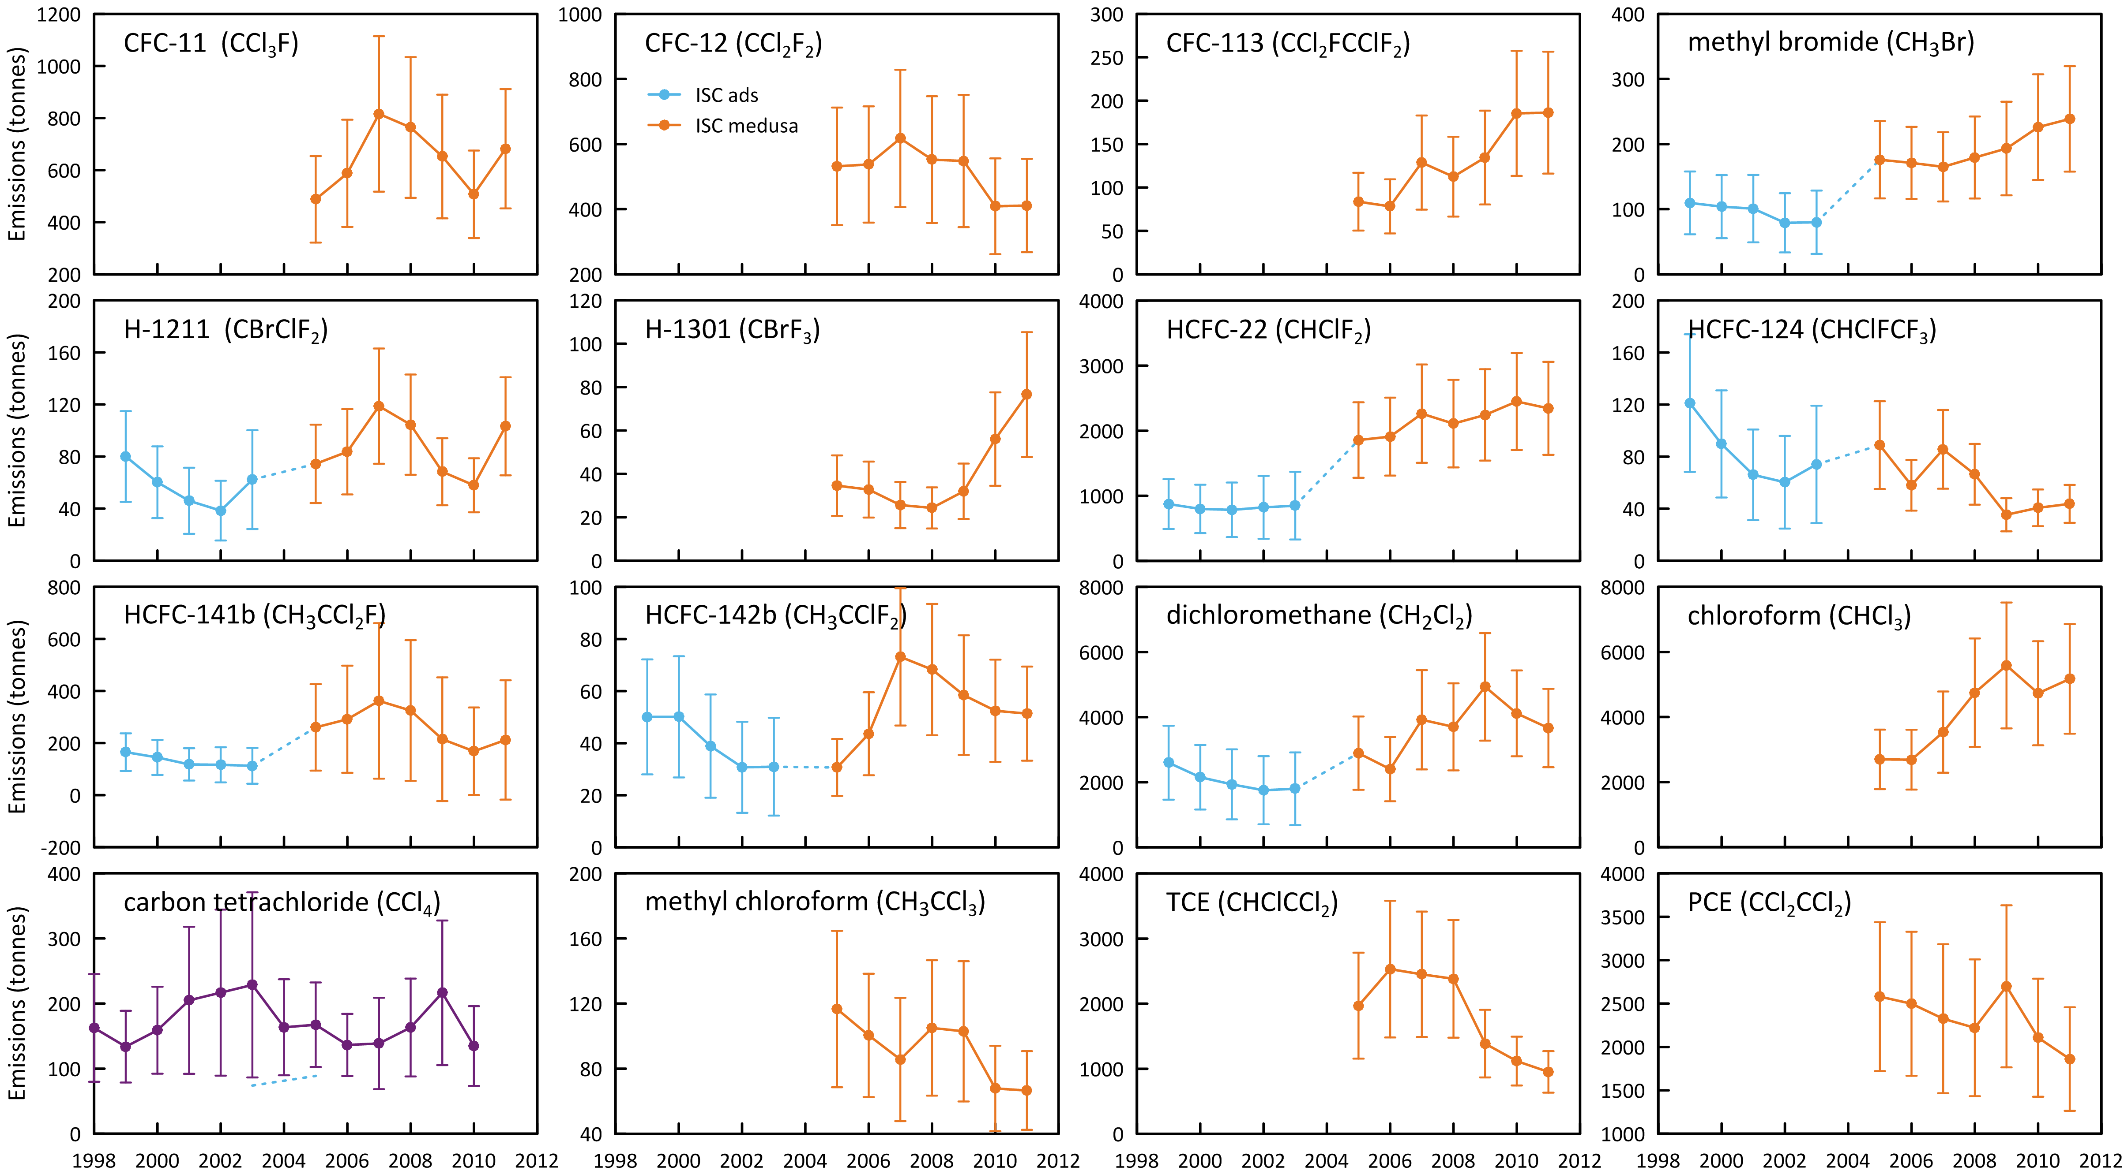

Figure . Annual average (3-yr running means) Australian emissions of CFCs, HCFCs, halons and chlorocarbons (MC, CTC) from Cape Grim AGAGE data, using ISC techniques. Australian emissions are scaled from SE Australian emissions on a population basis; MB emissions are for SE Australia only.

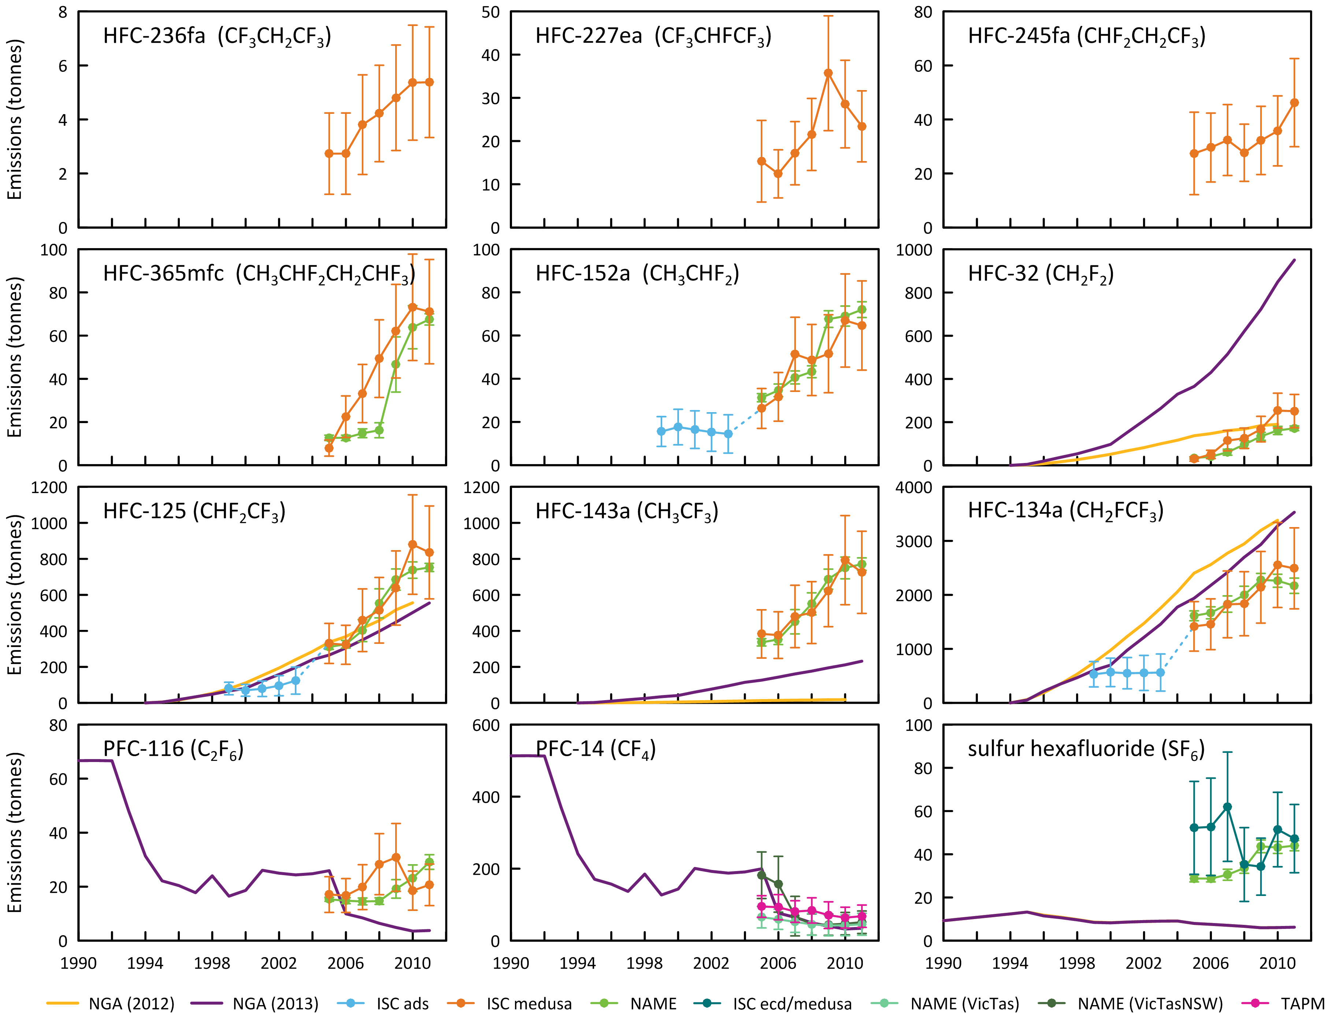

Figure . Australian HFC-32, -125, -134a, -143a, -152a, -227ea, -236fa, -245fa, -365mfc, PFC-14, -116 and sulfur hexafluoride emissions (NGA: DIICCSRTE, 2013; DCCEE, 2012) compared to emissions calculated from Cape Grim data by interspecies correlation (ISC) and from the UK Met. Office NAME particle dispersion model. In the ISC calculations, Australian emissions are scaled from Melbourne/Port Phillip emissions on a population basis (a factor of 5.4). In the NAME calculations, Australian emissions are scaled from Victorian/Tasmanian emissions on a population basis (a factor of 3.7). For PFC-14 emissions aluminium production based scale factors are used.

SE Australian SGG emissions can be calculated from Cape Grim data using the NAME model. NAME (**N**umerical **A**tmospheric Dispersion **M**odelling **E**nvironment) is a Lagrangian particle dispersion model (O’Doherty *et al*., 2009; Manning *et al*., 2003, 2011) driven by 3-dimensional wind fields from numerical weather predictions models. NAME has a horizontal resolution (grid boxes 40 km x 40 km) and a minimum boundary layer height of 100 m. NAME operates in a backward mode, so, for example, it identifies, within a 3 hr period at Cape Grim, which grid boxes in the prescribed domain impact on Cape Grim in the previous 12 days. NAME releases 33000 particles at Cape Grim over the 3 hr period and the resultant 12 day integrated concentrations in each of the domain boxes are calculated. Operating NAME in the backward mode is numerically very efficient and is a very close approximation to the forward running mode, which is what is used to identify emission sources impacting on Cape Grim. In the inverse calculation, NAME identifies pollution episode data at Cape Grim, and starts with randomly-generated emission maps and searches for the emission map that leads to a modelled pollution time series that most accurately mimics the observations. The inversion method assumes that baseline air enters the inversion domain regardless of direction i.e. it assume that sources outside the specified domain do not impact significantly on Cape Grim. One of the major advantages of the NAME method, especially when using Cape Grim data, is that it does not require a prior estimate of emissions. Other inversion methods used to estimate regional emissions using Cape Grim data often derive emissions that are not significantly different that the prior estimates.

The NAME model ‘sees’ emissions from Victoria/Tasmania or Victoria/Tasmania/New South Wales (depending on the domain used in the model) and are presented as 3-yr running averages of emissions (i.e. 2008 annual emissions are derived from 2007-2009 data). The Australian emissions are calculated from NAME Victorian/Tasmanian or Victorian/Tasmanian/NSW emissions using a population based scale factors of 3.7 and 1.7 respectively and are shown in Table 6 and Figure 9.

## CFCs

Over the period 2005-2011, Australian CFC emissions peaked at about 1560 tonnes in 2007, falling to 1280 tonnes in 2011, declining by about 20% since 2007 (5%/yr). ODP-weighted CFC emissions peaked in 2007 at 1540 ODP tonnes and are at 1240 ODP tonnes in 2011. CFC-11 emissions averaged about 640 tonnes over 2005-2011 and are declining slowly, CFC-12 emissions about 520 tonnes, with a slow decline, and CFC-113 emissions about 130 tonnes with a significant increase with time from 85 tonnes in 2005 to 185 tonnes in 2011. The origin of this increase is unknown but will be monitored in 2014 and checked against GC-ECD data from Cape Grim.

CFC emissions are presumed to be from CFC-containing appliances/materials (refrigeration/ac equipment, foams, aerosol cans), either existing or buried (land-fills). If the current total emissions (1280 tonnes/yr) continue to decline at 5%/yr, it will take 50 years for Australian CFC emissions to drop below 100 tonnes/yr. Australian CFC emissions in 2011 (1280 tonnes) were 0.9% of global CFC emissions (142 k tonnes). During 2005-2011, Australian ODP-weighted CFC emissions peaked at 1540 tonnes in 2007 declining to 1240 tonnes in 2011, and are currently (2011) about 40% of Australia’s ODS (ODP-weighted) emissions (3100 tonnes).

During 2005-2011, Australian GWP-weighted CFC emissions peaked at 11.4 M tonnes CO2-e in 2007, falling to 8.9 M tonnes CO2-e in 2011. CFC emissions totalled over 35% of Australia’s CO2-e emissions from SGGs (24.9 M tonnes in 2011, nearly 5% of national GHG emissions). CFC emissions are not included in Australia’s national GHG emissions, which totalled 552 M tonnes in 2011 (DIICCSRTE, 2013) as CFCs have been phased-out under the Montreal Protocol and are therefore not subject to separate controls under the Kyoto Protocol.

## HCFCs

Over the period 2005-2011, HCFC emissions peaked at 2700 tonnes in 2010, droping to 2640 tonnes in 2011. ODP-weighted HCFC emissions peaked at about 170 ODP tonnes in 2007, falling to about 160 ODP tonnes in 2011 and are currently (2011) just over 5% of Australia’s ODS (ODP-weighted) emissions (3100 tonnes). HCFC-22 emissions reached a poeak of about 2400 tonnes in 2010, falling to 2300 tonnes in 2011. Other HCFC emissions (HCFC-124, HCFC-141b, HCFC-142b) peaked in 2007 at about 440 tonnes falling to 320 tonnes in 2011.

Australian GWP-weighted HCFC emissions rose steadily from 3.6 M tonnes CO2-e in 2005 to 4.6 M tonnes CO2-e in 2010, falling to 4.5 M tonnes CO2-e in 2011, approximately 50% of Australia’s GWP-weighted emissions of CFCs. HCFC emissions in 2011 totalled 18% of Australia’s CO2-e emissions from SGGs (24.9 M tonnes in 2011). HCFC emissions are not included in Australia’s national GHG emissions (552 M tonnes in 2011) as HCFCs have been phased-out under the Montreal Protocol and are therefore not subject to separate controls under the Kyoto Protocol.

Australian HCFC emissions are likely from a combination of service and malfunction leaks from existing refrigeration/ac equipment and from land-fills. Australian HCFC emissions in 2011 (2640 tonnes) were 0.6% of global HCFC emissions (464 k tonnes).

## Halons

Halon emissions are variable, averaging 130 tonnes/yr over the period 2005-2011, but increasing with time. Peak emissions were in 2011 (estimated around 180 tonnes). This increase is dominated by the 2011 emissions and it will be interesting to see if 2012 emissions follow this trend. There is no obvious reason to anticipate larger-than-average emissions in 2011. The ODP-weighted halon emissions reached nearly 1080 ODP tonnes in 2011, similar to the 1280 ODP tonnes of CFCs in 2011. Halon GWP-weighted emissions reached 0.7 M tonnes CO2-e in 2011, a minor contribution to overall ODS or SGG CO2-e emissions.

Australian halon emissions are likely to originate from existing building fire-fighting systems (largely H-1301) and existing portable fire extinguishers (largely H-1211). Australian halon emissions in 2011 (about 180 tonnes) were 2.5% of global emissions in 2011 (7.3 k tonnes), 1.5% in 2010.

These Australian emissions of halons seem large when compared to global emissions. One reason may be that it is not appropriate to scale Port Phillip emissions (as determined from Cape Grim data) to Australian emissions on a population basis. This could be because the Melbourne/Port Philip region contains the National Halon Bank and an incorporated ODS destruction facility (Australia’s only ODS destruction facility). The facility collects about 135 tonnes of refrigerant for destruction in 2012, compared to 300 tonnes in 2011, and has stored about 550 tonnes of halons. Assuming that typical leaks from the decanting, transfer, destruction or storage of refrigerants and halons are of the order of 1-5%/yr, then refrigerant emissions in 2011 could have been 3-15 tonnes and halon emissions 6-30 tonnes. The former are a small component (of order 1%) of the 700+ tonnes of HCFCs and CFCs emitted from Port Phillip in 2011, but the latter are a significant component (of order 50%) of Port Phillip halon emissions (30+ tonnes in 2011).

Scaling Port Phillip halon emissions to Australian halon emissions (after allowing for the Halon Bank emissions) would suggest Australian emission of about 100 tonnes in 2011, which is more in line with what expected compared to global emissions. If we are going to use Cape Grim data to infer Australian halon emission, we need an accurate estimate of the halon leak rate from the Halon Bank. A clearer picture of Australian halon emissions will emerge once data are collected from the proposed Lucas Heights facility south of Sydney, commencing in 2014. These halon data will not be affected by possible emissions from the National Halon Bank in Melbourne.

## Methyl bromide

Australian emissions of MB cannot be calculated from SE Australian MB emissions derived from Cape Grim data using a simple scaling approximation based on population. Methyl bromide is used in Australia as a fumigant for cereals, such as wheat, for cottonseed, for timber logs prior to export and also as a soil sterilant, during the production of strawberry runners. The former uses are QPS, which are not covered by the Montreal Protocol, and the latter use is non-QPS (n-QPS), which is restricted by the Montreal Protocol and for which Australia has to apply for a Critical Use Exemption (CUE) under the Montreal Protocol legislation on an annual basis.

Grain exported from SE Australian grain terminals account for 35-40% of Australia’s grain exports (National Transport Commission, 2008; GrainCorp, 2012) and thus likely 35-40% of Australia’s QPS use of MB. A UNEP model of MB emissions suggests that 80-90% of MB QPS use escapes to the atmosphere (UNEP, 2007). This suggests that about 30±10% of Australia’s QPS imports are emitted into the SE Australian atmosphere. Close to 100% of Australia’s current n-QPS MB use occurs around Tooangi, NE of Melbourne, for growing strawberry runners. The same UNEP model (UNEP 2007) above suggests that 60-70% of MB n-QPS use is emitted to the atmosphere and thus 60-70% of Australia’s n-QPS MB imports are emitted into the SE Australian atmosphere. The UNEP model suggests that total Australian emissions of MB would be around 585 tonnes in 2010 (Figure 10), about 0.5% of global emissions (~130 k tonnes; see above).

The UNEP MB emissions model may not be suitable for Australian MB consumption. I. Porter (DPI, Victoria, private communication) has suggested that close to 95% of QPS and about 50% of n-QPS MB are emitted to the atmosphere under Australian conditions, resulting in emissions of 656 tonnes in 2011 (0.5% of global emissions). However, both views do not take into account some recapture of MBwhich occurs as a result of local requirements.

The results from the UNEP model of Australian and SE Australian MB emissions are shown in Figure 11 and compared to SE Australian emissions calculated from Cape Grim data by ISC. The emissions from the model and derived from atmospheric data for SE Australia show good overall agreement (within 15%, model lower) over the period 2005-2011. Australian MB emissions based on ISC were obtained from the SE Australian emissions (ISC) by scaling factors (Australia/SE Australian emission) obtained from the emissions model. Australian MB emissions based on ISC data are increasing from 430 tonnes (260 ODP tonnes) in 2005 to 670 tonnes (400 ODP tonnes) in 2011 and are shown in . The 400 ODP tonnes in 2011 are about 13% of Australia’s ODS emissions in ODP tonnes, but do not contribute to any extent to Australian CO2-e emissions from SGGs, given than MB has a low GWP.

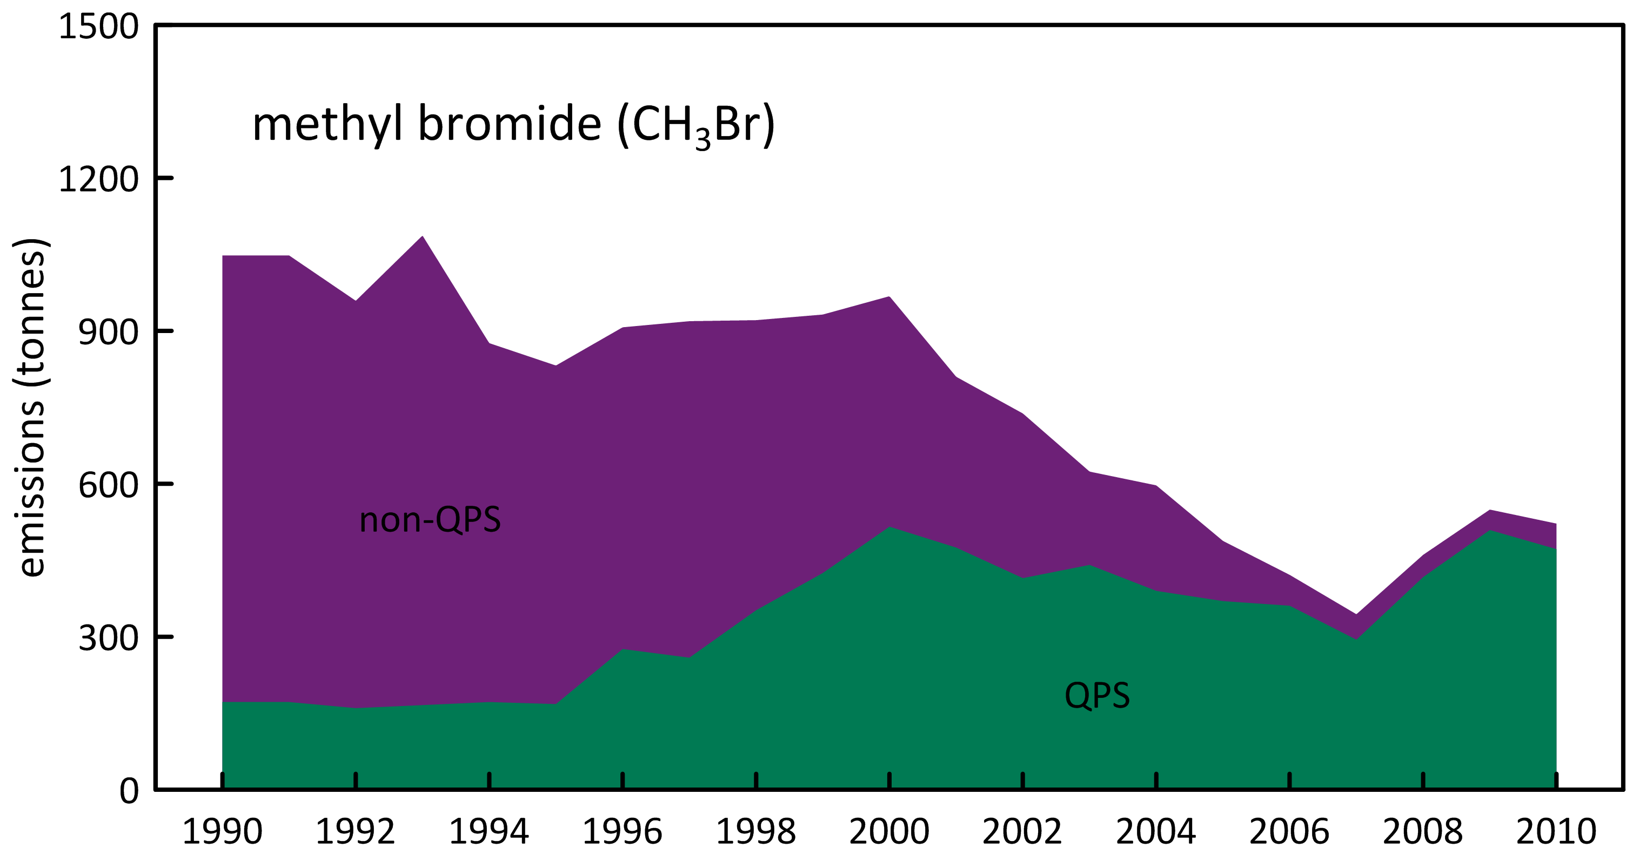

Figure 10. Australian MB emissions calculated from Australian MB import data and the UNEP emissions model (UNEP, 2007).

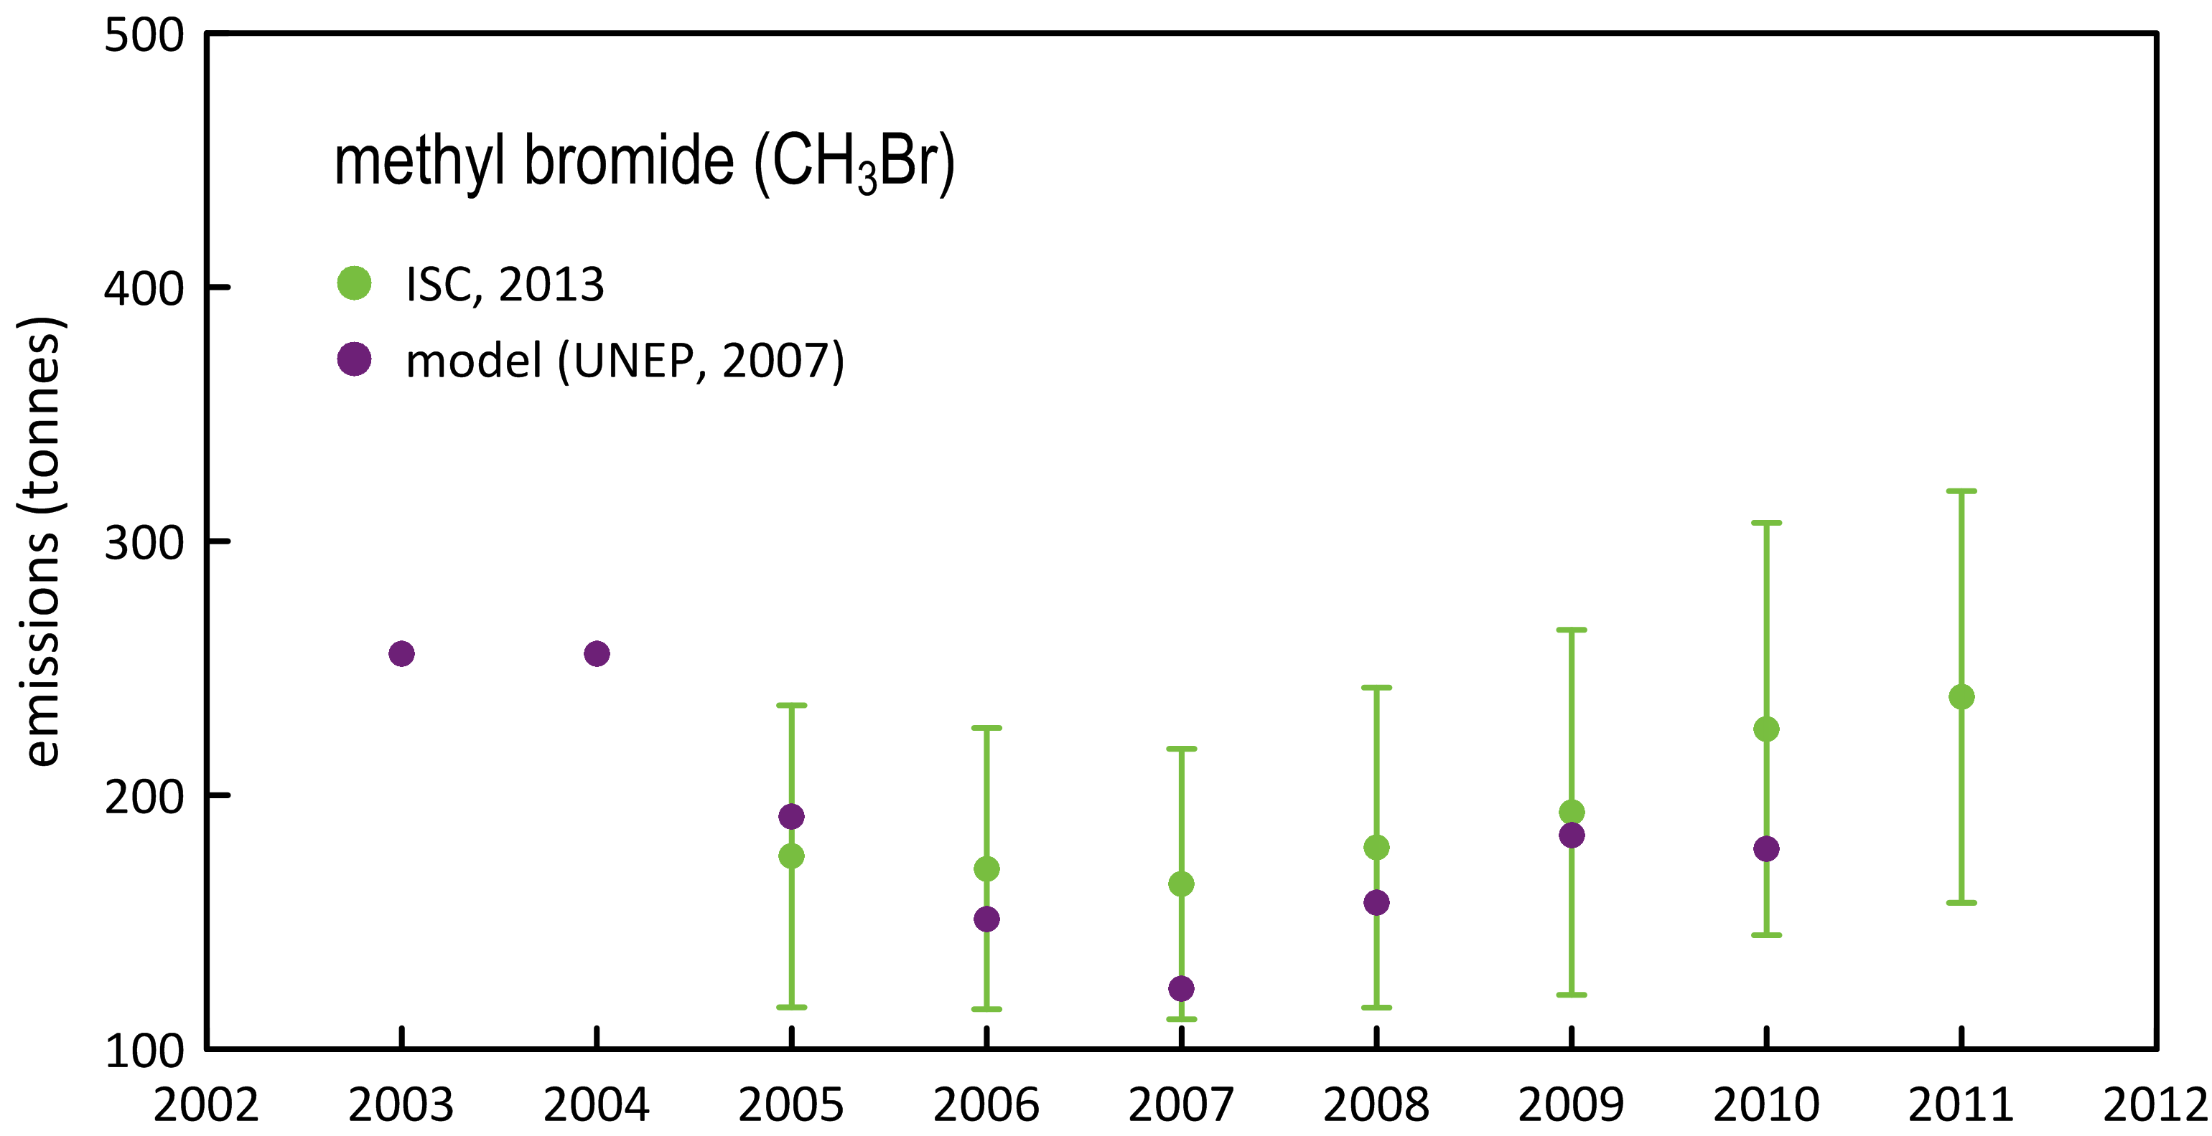

Figure 11. SE Australian MB emissions calculated from Cape Grim *in situ* AGAGE MB data and from the UNEP (2007) CH3Br emissions model.

## Carbon tetrachloride & methyl chloroform (Montreal Protocol chlorocarbons)

Carbon tetrachloride emissions are calculated from Cape Grim *in situ* GC-ECD data (reliable CTC data are not collected on the Cape Grim GC-MS Medusa instrument). The GC-ECD CTC data are being reprocessed for use with the recalculated Port Phillip CO emissions. The latest available estimates of Australian CTC emissions by ISC and NAME are shown in Figure 12. Carbon tetrachloride emissions by ISC were estimated to be 135 tonnes in 2010, and 160 tonnes/yr averaged over the period 2005-2010. NAME CTC emissions in 2010 were 120 tonnes and over the same period (2005-2010) averaged about 125 tonnes/yr.

Australian MC emissions continue to decline, falling from 117 tonnes in 2005 to 67 tonnes in 2011. Global MC emissions in 2011 were 8.8 ktonnes, Australian emissions in 2011 were estimated to be around 0.8% of global emissions.

The combined CTC/MC emissions totalled 155 ODP tonnes in 2010, about 6% of Australia’s ODS emissions. CTC/MC emissions make only a small contribution (less than 2%) to Australia’s CO2-e emissions from SGGs, as do halons (see above; less than 5%) and MB (see above; less than 0.1%).

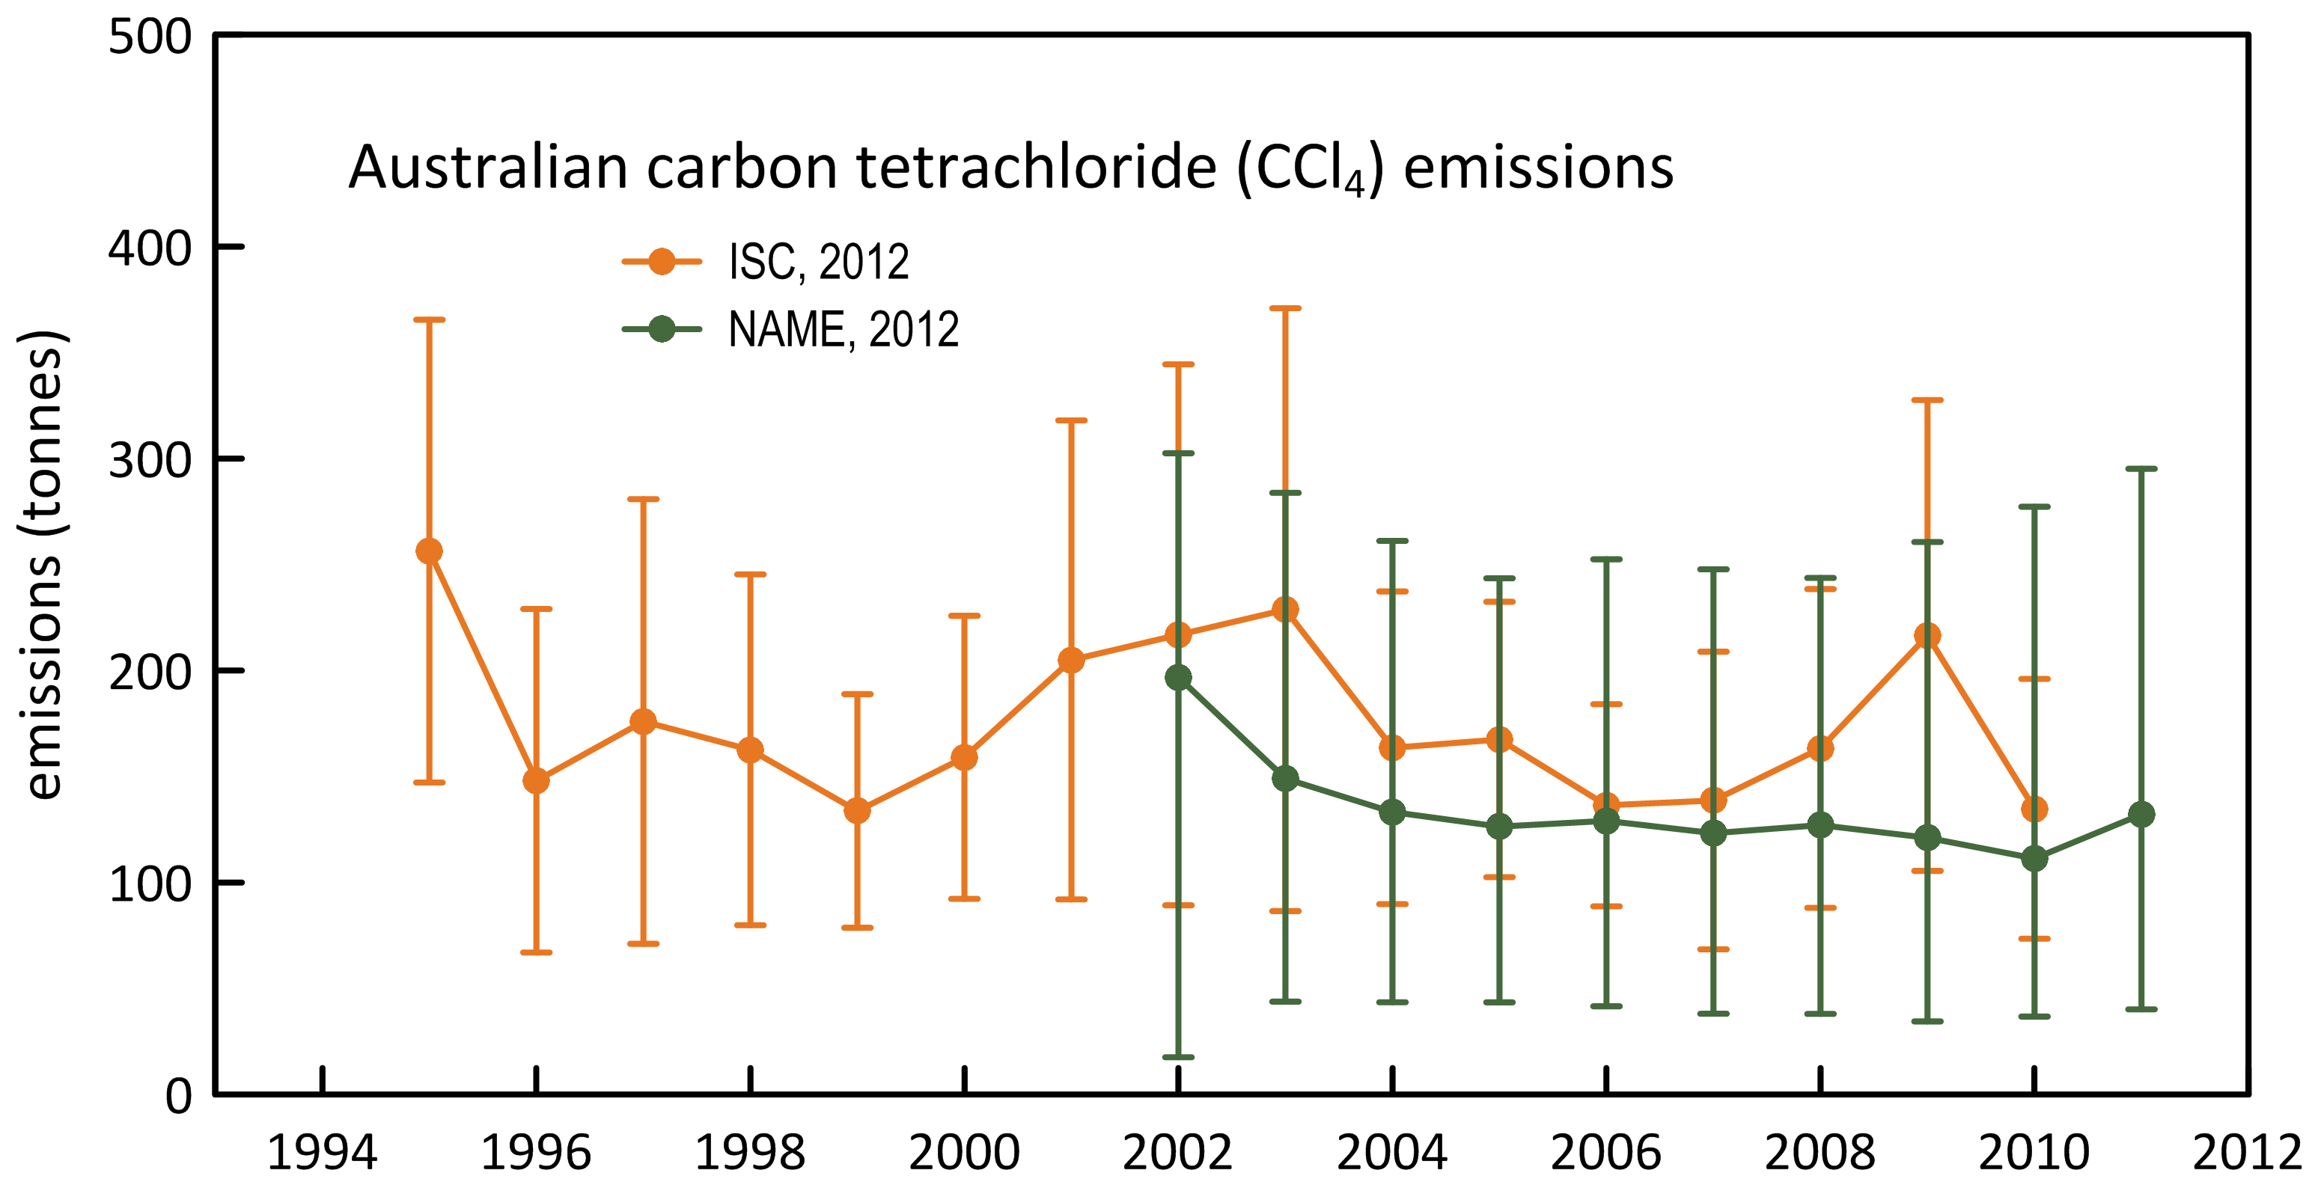

Figure 12. Australian CTC emissions calculated form Cape Grim *in situ* AGAGE data by ISC techniques and inverse modelling (NAME).

## Other chlorocarbons

Dichloromethane, CHCl3, CHClCCl2 (TCE) and CCl2CCl2 (PCE) are short-lived ODSs that are not controlled by the Montreal Protocol. Significant emissions of all these ODSs are seen in the Cape Grim data.

Australian CH2Cl2 emissions increased rapidly from 2.9 k tonnes in 2005 to 4.9 k tonnes in 2009, before falling to 3.7 k tonnes in 2011. Australian CHCl3 emissions appear to be increasing from under 3 k tonnes in 2005 to over 5 k tonnes in 2011. Peak CHCl3 emissions were 5.6 k tonnes in 2009. The combined emissions of TCE and PCE remained relatively constant at 4.6-5.0 k tonnes from 2005 to 2008, but then declined rapidly to 2.8 k tonnes in 2011.

Total emissions for these short-lived ODSs were 10 k tonnes (68 ODP tonnes) in 2005, growing to 15 k tonnes (113 ODP tonnes) in 2009 and falling to 12 k tonnes (92 ODP tonnes) in 2011. The ODP-weighted emissions of these short-lived ODSs were about 3% of total ODS emissions (ODP-weighted) and about 2% of total ODS emissions (GWP-weighted) in 2011.

## Total ODS emissions

Total Australian ODS emissions (CFCs, HCFCs, halons, MB, CTC, MC, other chlorocarbons, ODP- and GWP-weighted) are shown in Figure 13. Total ODS emissions (ODP-weighted) peaked at 3.1 k tonnes in 2011, with CFCs contributing 40% of ODS emissions, halons 34%, MB 13%, HCFCs 5%, CTC/MC 5%, other chlorocarbons 3%. As discussed above, the halon contribution could be lower if the national halon emissions are over-estimated due to the influence of the Halon Bank on SE Australian halon emissions. This will be investigated in the 2014 Report.

Total ODS emissions (GWP-weighted) peaked at 16.5 M tonnes CO2-e in 2007, falling to 14.6 M tonnes in 2011. Of which CFCs contributed 61%, HCFCs 31%, halons 5%, CTC/MC 1-2%, other chlorocarbons 2%, with a negligible contribution from MB. As above, halon emissions may be over-estimated. ODS emissions are not counted as not part of Australia’s GHG emissions, but contribute an additional 2-3% to Australian GHG emissions (522 M tonnes CO2-e in 2011).

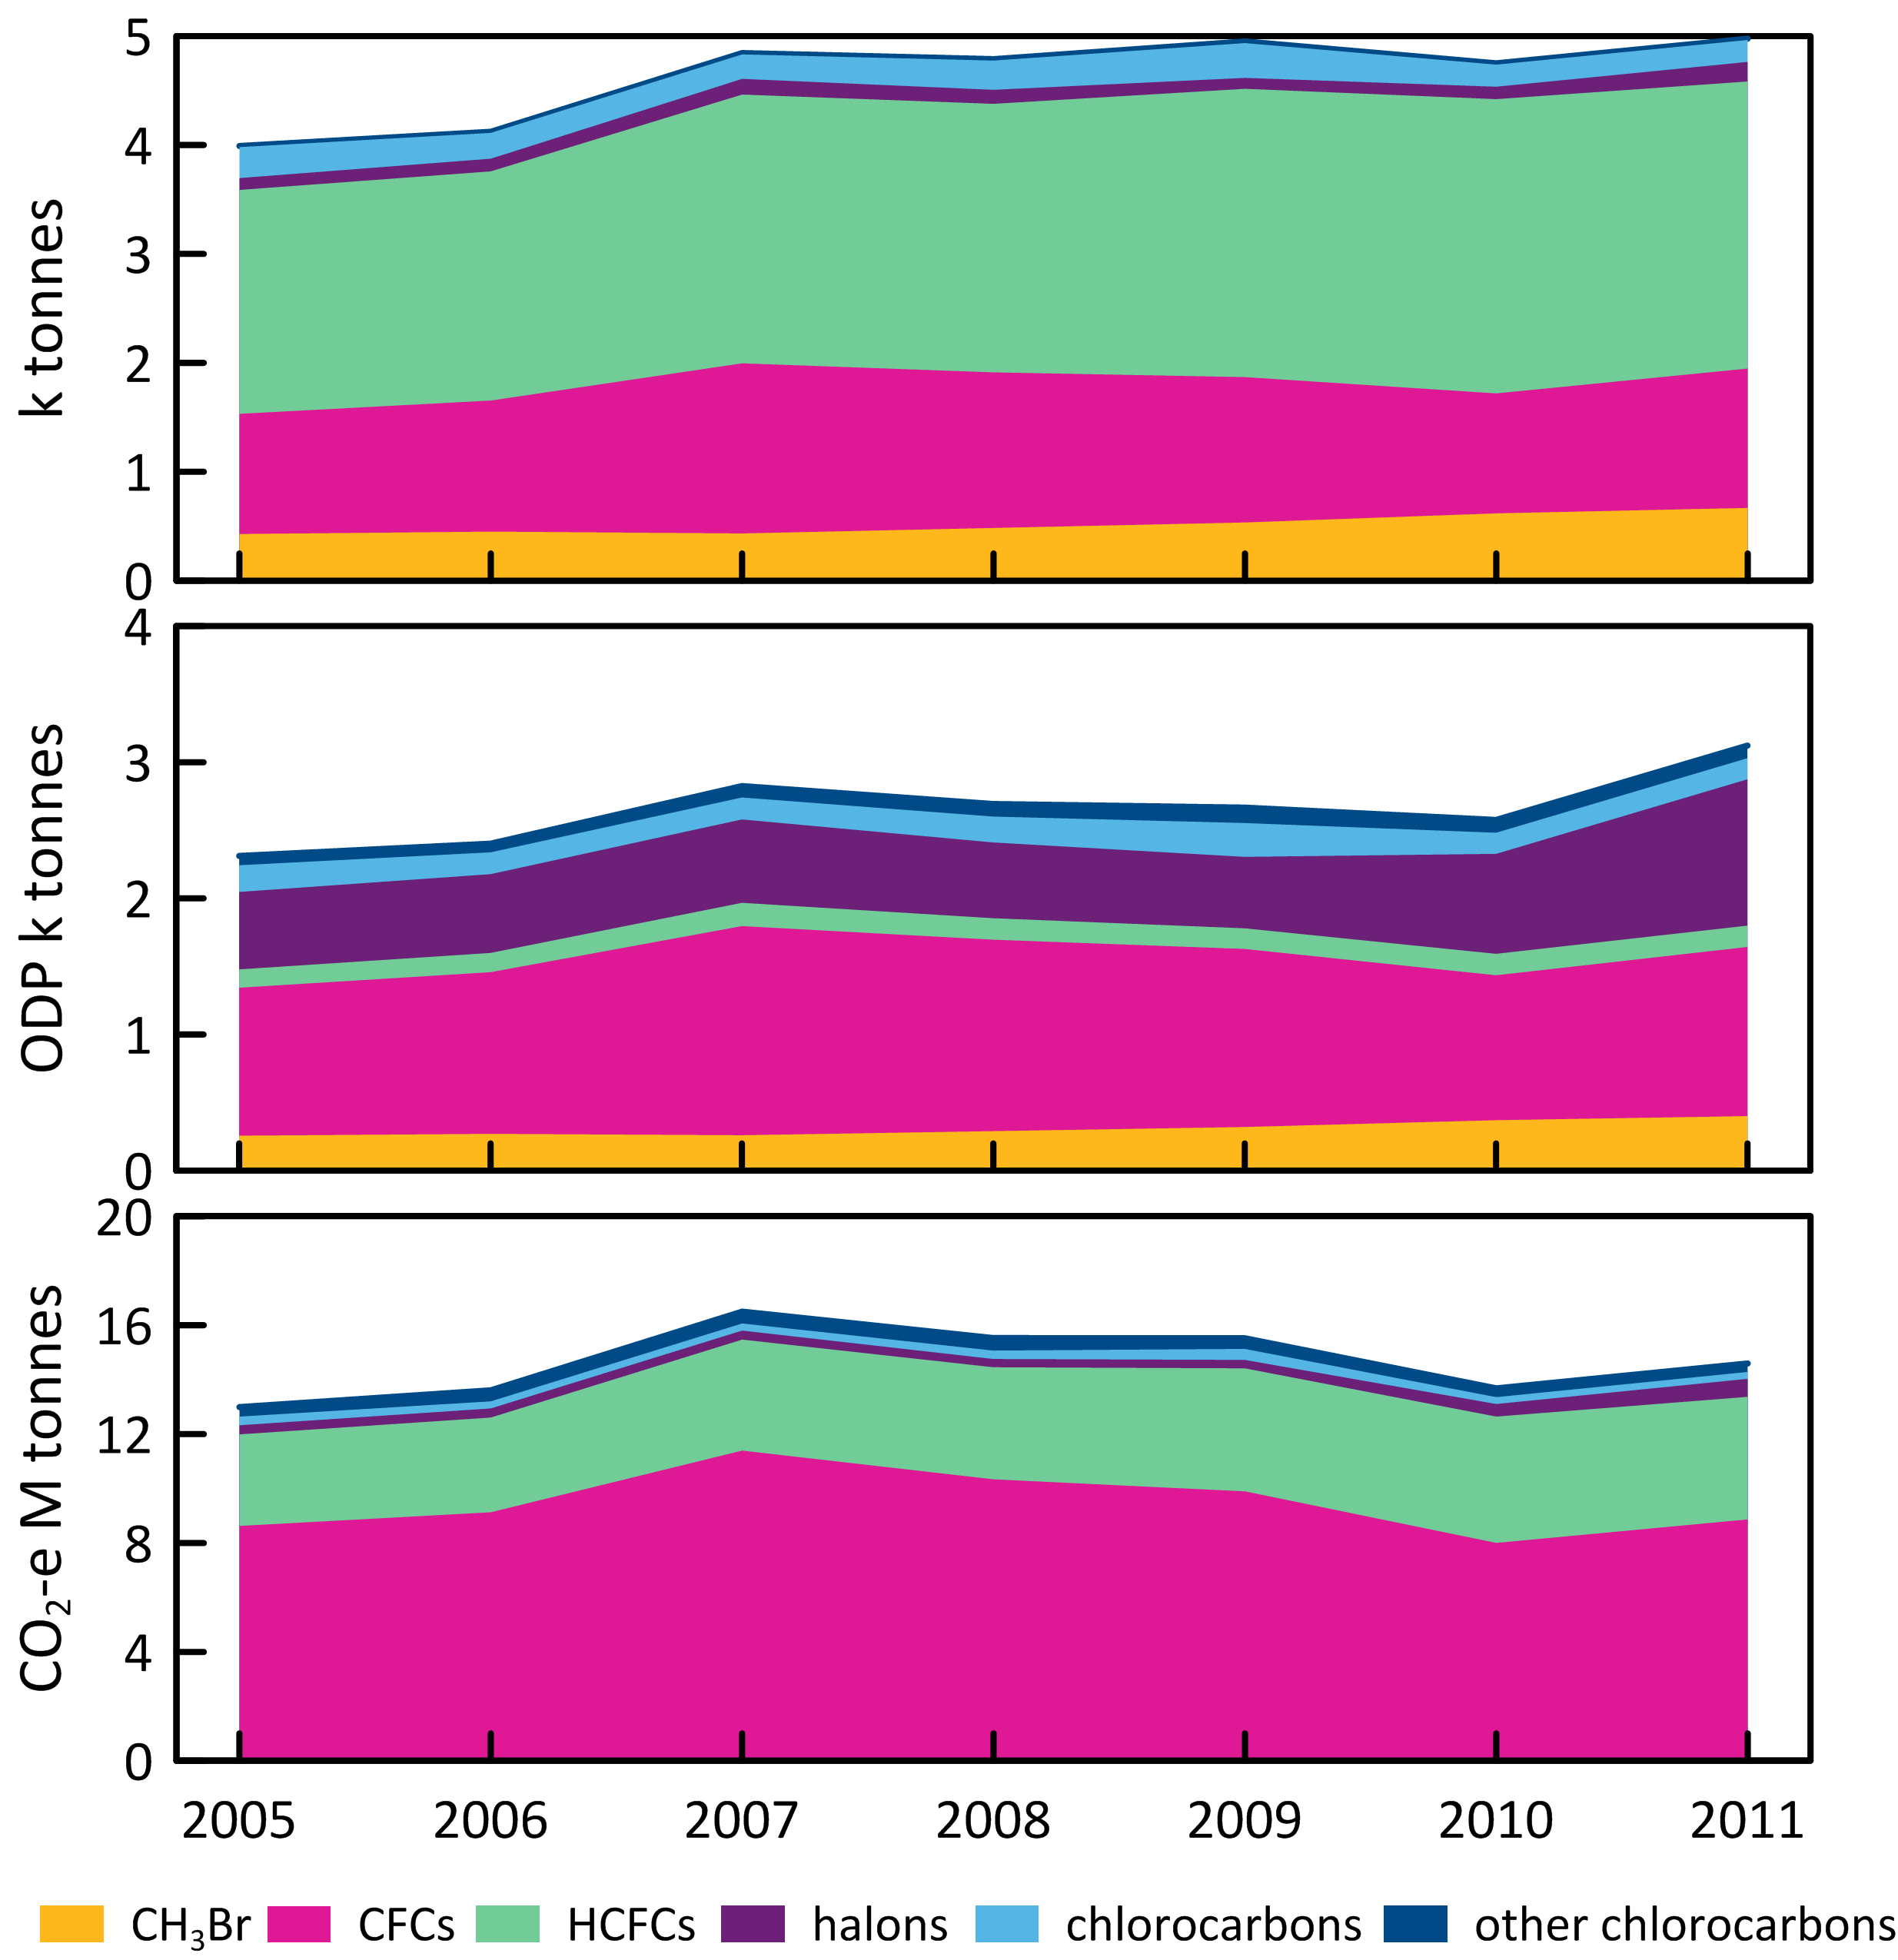

Figure 13. Australian ODS emissions (CFCs, HCFCs, halons, MB, CTC, MC, other chlorocarbons), ODP-weighted (k tonnes) and GWP-weighted (M tonnes CO2-e). Note the impact of halons on the 2011 ODP-weighted emissions – halon emissions overall may be an over-estimate (see text).

## HFCs

### HFC-134a

The major HFC in the NGGI (ageis.climatechange.gov.au) is HFC-134a, with estimated emissions in 2011 of 3530 tonnes. Based on Cape Grim data, Australian emissions of HFC-134a in 2011 were estimated to be about 2490±750 tonnes (ISC), ~30% lower than reported in the NGGI. These estimates are shown in Table 6 and Figure 9. Australian HFC-32, -125, -134a, -143a, -152a, -227ea, -236fa, -245fa, -365mfc, PFC-14, -116 and sulfur hexafluoride emissions (NGA: DIICCSRTE, 2013; DCCEE, 2012) compared to emissions calculated from Cape Grim data by interspecies correlation (ISC) and from the UK Met. Office NAME particle dispersion model. In the ISC calculations, Australian emissions are scaled from Melbourne/Port Phillip emissions on a population basis (a factor of 5.4). In the NAME calculations, Australian emissions are scaled from Victorian/Tasmanian emissions on a population basis (a factor of 3.7). For PFC-14 emissions aluminium production based scale factors are used.. For the 7-year period 2005-2011, the average Australian emissions of HFC-134a calculated from Cape Grim data (ISC/NAME, 1970 tonnes/yr) are about 27% lower than in the NGGI (2710 tonnes/yr). NAME and ISC estimates are within 2% for the period 2005-2011 (NAME higher). ISC/NAME estimates of HFC-134a emissions have grown from 1515 tonnes in 2005 to 2330 tonnes in 2011, a growth of 7-8 %/yr.

Based on atmospheric data, global emissions of HFC-134a were 149±27 k tonnes in 2008 (Montzka & Reimann, 2011) and 170±27 k tonnes in 2011 (R. Wang, GIT, 2013). Australian emissions are about 1.5% of global emissions based on ISC/NAME data, and 2.1% based on NGGI (NGA) data.

Approximately 60% of Australia’s HFC-134a emissions are from air conditioning, which may be climate dependent. If per capita HFC-134a emissions in SE Australia are lower than the national average then this could help explain why national emissions scaled from SE Australian emissions (based on Cape Grim data) are lower than the NGGI emissions.

### HFC-125

The next major HFC emitted into the Australian environment is HFC-125 with current (2011) emissions estimated to be about 555 tonnes (NGGI: ageis.climatechange.gov.au). Based on Cape Grim data, Australian emissions of HFC-125 in 2011 were ~840 tonnes (ISC) and ~750 tonnes (NAME), about 35-50% higher than NGA data (Table 6, Figure 9). For the period 2005-2011, the NGA estimates of average HFC-125 emissions are 40% lower than emission estimates based on Cape Grim data (ISC/NAME). Over the period 2005-2011, NAME and ISC emission estimates agree to within 5% (NAME lower). ISC/NAME estimates of HFC-125 emissions have grown from 320 tonnes in 2005 to nearly 800 tonnes in 2011, a growth of 16-17%/yr.

Based on atmospheric data, global emissions of HFC-125 were 24±2 k tonnes in 2008 (Montzka & Reimann, 2011) and 35±4 k tonnes in 2011 (R. Wang, GIT, 2013). Australian emissions would be about 2.1-2.4% of global emissions based on ISC/NAME data, and 1.6% based on NGGI data.

### HFC-143a

The next major HFC emitted into the Australian environment is HFC-143a with current (2011) emissions estimated to be about 232 tonnes (NGGI: ageis.climatechange.gov.au). Based on Cape Grim data, Australian emissions of HFC-143a in 2011 were 725±220 tonnes (ISC) and 771±35 tonnes (NAME), a factor of ~3 higher than NGGI estimates (Table 6, Figure 9). NAME and ISC data are within 15% for the period 2005-2011 (NAME lower). ISC/NAME estimates of HFC-143a emissions have grown from 360 tonnes in 2005 to 750 tonnes in 2011, a growth of 12-13%/yr.

Based on atmospheric data, global emissions of HFC-143a were 17 k tonnes in 2008 (Montzka & Reimann, 2011). Australian emissions would be about 3.1% of global emissions based on ISC/NAME data, and 1% based on NGGI data.

### HFC-32

HFC-32 emission estimates are estimated in the NGA (M. Hunstone, DIICCSTRE) to be 951 tonnes in 2011 (621 tonnes in 2008). The emissions based on Cape Grim data are lower than the NGA data: 251±77 from ISC data and 172±11 tonnes (NAME) in 2011, on average lower by a factor of 4-5 (Table 6, Figure 9). Over the period 2005-2011, ISC and NAME emission estimates agree to within 40% (NAME lower). ISC/NAME estimates of HFC-32 emissions have grown from 32 tonnes in 2005 to 210 tonnes in 2011, a growth of over 35%/yr.

Based on atmospheric data, global emissions of HFC-32 were 8.9 k tonnes in 2008 (Montzka & Reimann, 2011). Australian emissions were about 110 tonnes in 2008 (ISC/NAME), about 1.2% of global emissions based on ISC/NAME data, and 7% based on NGGI data. It would very unusual for Australian emissions of HFC-32 to be 7% of global emissions. The NGA HFC-32 emission data should be reviewed in light of the ISC and NAME results.

### HFC-152a

HFC-152a emissions are not listed separately in the NGGI. The 2011 emissions have been estimated from Cape Grim data at about 65 (ISC) – 72 (NAME) tonnes from Cape Grim data. Over the period 2005-2011, ISC and NAME estimates of Australian emissions agree to within 3% (NAME higher). ISC/NAME estimates of HFC-152a emissions have grown from 28 tonnes in 2005 to 69 tonnes in 2011, a growth of 16%/yr (Table 6, Figure 9).

Based on atmospheric data, global emissions of HFC-152a were 50 k tonnes in 2008 (Montzka & Reimann, 2011) and 53±3 k tonnes in 2011 (R. Wang, GIT, unpublished data). Australian emissions would be about 0.1% of global emissions based on ISC/NAME data. It would be unusual for Australian emissions of an industrial chemical to be less than 0.1% of global emissions. One suggestion (M. Bennett, RRA, 2011) is that a significant major-volume use in other parts of the world for HFC-152a is as an aerosol propellant, a use not taken up in Australia.

### HFC-365mfc, HFC-227ea, HFC-236fa, HFC-245fa

HFC-365mfc emissions are not listed separately in the NGGI. The 2011 emissions have been estimated from Cape Grim data at about 71 tonnes (ISC) and 68 tonnes (NAME), i.e. within 4%. However, over the period 2006-2011, ISC emissions are about 25% higher than NAME (Table 6, Figure 9). ISC/NAME estimates of HFC-365mfc emissions have grown from 18 tonnes in 2006 to 70 tonnes in 2011, a growth of 30%/yr. Based on atmospheric data, global emissions of HFC-365mfc were 3 k tonnes in 2008 (Montzka & Reimann, 2011). Australian emissions (ISC/NAME) would be therefore about 1.1% of global emissions based on Cape Grim data.

The combined emissions of these HFCs in 2011 was 74 tonnes compared to 45 tonnes in 2005 (from ISC estimates), a growth in emissions of 9%/yr (Table 6, Figure 9). There are currently no NAME estimates of emissions for these species. Based on atmospheric data, global emissions of HFC-227ea were 1.8 k tonnes in 2005 and 5.5 k tonnes for HFC-245fa in 2008 (Montzka & Reimann, 2011). Australian emissions (ISC) would be therefore about 0.8% and 0.5% of global emissions for these species (respectively) based on Cape Grim data.

### Total HFCs

Total estimated HFC emissions (Table 6, Figure 14Figure 14), based on Cape Grim observations have grown from just over 2300 tonnes in 2005 to over 4300 tonnes in 2011, an increase of 2000 tonnes over 6 years, or about 330 tonnes/yr (10%/yr). Total HFC emissions are 15-20% lower than in the NGGI, due largely to the 30-45% lower emissions of HFC-134a emissions from atmospheric data compared to NGGI data. Preliminary investigations suggest this may, in part, be due to the use of a population-based scaling factor (5.4) when deriving national emissions from Cape Grim HFC data. Since mobile air conditioning is the largest source of HFC-134a emissions, an automobile emissions-based scaling factor (5.9, BTRE 2002) is likely to be more appropriate to scale HFC-134a emissions. This will be investigated in the future.

Total HFC emissions in the NGGI in 2011 (8.1 Mt CO2-e) are lower (within 18%) than emissions (9.0±0.9 Mt CO2-e, ISC/NAME) based on Cape Grim data (Table 6, Figure 14). The uncertainties on the ISC/NAME emission estimates do not overlap the NGGI estimates (i.e. the ISC/NAME estimates are significantly higher than the NGGI).

Over the period 2005-2011, total HFC emissions in the NGGI are in reasonable agreement (within 17%) of total emissions based on Cape Grim data (ISC, NAME higher).

Although HFC-134a is the dominant HFC in terms of tonnes emitted, in terms of CO2-e, the contributions of HFC-125, HFC-134a and HFC-143a to climate change (radiative forcing) are approximately equal. The larger contributions of HFC-143a and HFC-125, with their relatively large GWPs compared to HFC-134a, to CO2-e weighted total HFC emissions (compared to total HFC emissions) is why there is a reversal, with CO2-e weighted total HFC emissions from atmospheric observation greater than NGGI, and total HFC emission (unweighted) from atmospheric observations less than the NGGI.

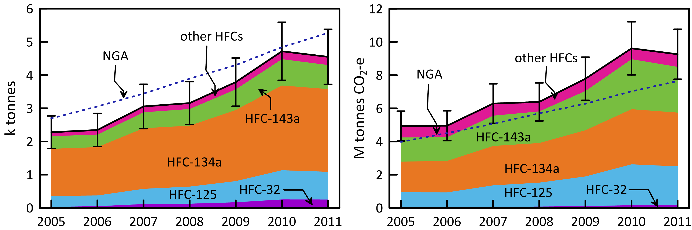

Figure 14. Australian emissions of NGGI/NGA specified HFCs (-125, -134a, -143a), plus HFC-32, estimated from atmospheric data (ISC/NAME) measured at Cape Grim, and in the NGGI, expressed in units of CO2-e. HFC-32 inventory data were obtained directly from DIICCSTRE (M. Hunstone).

## PFCs

### PFC-14

SE Australian emissions of PFC-14 (CF4) are evident in the PFC-14 data collected at Cape Grim (Figure 2). The pollution episodes at Cape Grim are typically less than 5 ppt above baseline. Inspection of shows an overall decline in intensity of PFC-14 pollution episodes due to declining emissions, with a possible increase in emissions (as indicated by the intensity of the pollution episodes) in 2011, continuing into 2012 (see below). The year-to-year variability of the number and intensity of PFC-14 episodes seen at Cape Grim is large, so 3-yr averaging is used when deriving PFC emissions from these data (so the latest annual emission calculated from these data is for 2011).

Detailed analysis of these PFC-14 pollution episodes shows that the Cape Grim PFC-14 pollution originates largely from southern Victoria (from the Point Henry and Portland smelters, with the possiblity of small non-aluminium contribution), with some contribution from Bell Bay, Tasmania. PFC-14 emissions from the Hunter Valley NSW aluminium smelters (Kurri Kurri, Tomago) and from Gladstone Qld (Boyne Island) are generally not observed at Cape Grim. The Cape Grim PFC-14 pollution episode data have been used to estimate PFC-14 emissions from these SE Australian smelters. A regional transport model (TAPM – The Air Pollution Model; Hurley, 2008; Hurley *et al*., 2008) is used to calculate emissions in which PFC-14 is released into the model atmosphere from the Point Henry, Portland and Bell Bay locations. The PFC emission rate for each smelter is determined from annual aluminium production data, and current Australian PFC-14 emission factors (DIICCSRTE 2013b). The mean ratio of modelled to observed PFC-14 pollution levels at cape Grimis used to scale the assumed emission factor. Smetlter-specific emissions are thencalcualted by multiplying the new emission factor by the smelter-specific annual aluminium production (Fraser *et al*., 2007, 2011).

The NAME particle dispersion model is also used to calculate PFC-14 emissions from Victoria/Tasmania (Portland/Pt Henry/Bell Bay) or from Victoria/Tasmania/NSW (Portland/Pt Henry/Bell Bay/Kurri Kurri/Tomago).

The TAPM and NAME estimates of regional PFC-14 emissions are scaled to derive Australian emissions on an aluminium production basis. For example, if the PFC-14 emissions derived for the SE Australian smelters, which account for about 35% of Australia’s aluminium production, are assumed to be representative of all Australian aluminium production, then PFC-14 emissions from all Australian aluminium production can be derived and compared to emissions in the *National Inventory Report 2011* (DIICCSRTE, 2013) (Table 4). The emissions calculated for the Point Henry, Portland and Bell Bay smelters are shown in Figure 9 (enhanced version Figure 15) and Table 6, together with national average emission factors and emissions as published in the *National Inventory Report 2011* (DIICCSRTE, 2013b).

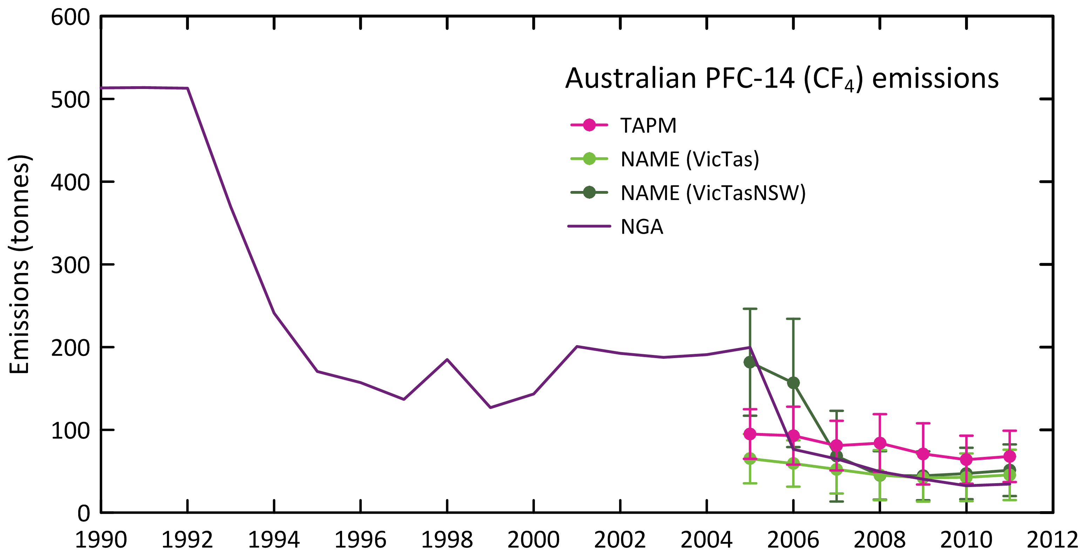

Figure 15. Australian emissions of PFC-14 as recorded in the *National Inventory Report 2011* (DIICCSRTE, 2013; 27% uncertainty) and as obtained by TAPM and NAME modelling.

The Australian emissions derived from atmospheric data prior to 2006, using TAPM or NAME (Vic/Tas) are likely to be underestimated due to the very significant PFC-14 emissions from a single pot-line (#1) at Kurri Kurri, which accounted for nearly half of all Australian PFC emissions from aluminium smelting in 2005. The pot-line was upgraded in 2006 and this accounts for the dramatic drop in PFC-14 emissions from 2005 to 2006 in the *National Inventory Report*. The large PFC emissions prior to 2006 are not seen in the TAPM estimates of emissions, as they are based on Bell Bay/Pt Henry/Portland data. The NAME inversion, based on the Vic/Tas/NSW domain, uses all pollution episode data, including any Kurri Kurri- or Tomago-affected data that may have impacted on Cape Grim. This is why the Australian PFC-14 estimates in 2005 (182 tonnes) based on the NAME (Vic/Tas/NSW) emissions are significantly greater than the TAPM estimates for 2005 (95 tonnes).

The average Australian PFC-14 emissions for 2005-2011 based on atmospheric data are similar: TAPM - 80 tonnes and NAME (Vic/Tas/NSW) - 85 tonnes, about 15% higher than reported in the *National Inventory Report 2011* (71 tonnes). The average Australian 2008-2011 PFC-14 emissions derived from atmospheric data using NAME (Vic/Tas/NSW) are 47 tonnes, 20% higher than in the *National Inventory Report 2011* (39 tonnes). The TAPM average for the same period is 71 tonnes. Arguably the NAME estimate is more accurate as it is based on 72% of Australian aluminium production (Portland, Pt Henry, Bell Bay, Kurri Kurri, Tomago), whereas the TAPM estimate is based on 35% of Australian aluminium production (Portland, Pt Henry, Bell Bay). These latter three SE Australian smelters could have higher average PFC-14 emission factors than the Australian average (see below) from all six Australin smelters (Portland, Pt Henry, Bell Bay, Kurri Kurri, Tomago, Boyne Island).

The overall agreement between the PFC emission factors in the *National Inventory Report 2011* and as derived from atmospheric data using TAPM/NAME over the period 2005-2011 is good (TAPM: 40 g CF4/tonne aluminium; NAME: 44 g/tonne; NGA: 37 g/tonne), with uncertainties overlapping throughout the record.

However, the atmospheric data (NAME) show a factor of 4 decline in the emission factors over the study period (2005-2011), whereas the NGA show a factor of 6 decline over the same period. This could be due to a larger than average decline in the emission factor at Boyne Island, which is not seen in the atmospheric data at Cape Grim.

### PFC-116

Australian PFC-116 emissions have been estimated from Cape Grim data using ISC and NAME (Table 6, Figure 9Figure 9). Over the period 2005-2011, PFC-116 emissions average 22±9 tonnes (ISC) and 19±2 (NAME), i.e. within 17%, compared to 9 tonnes in the NGGI over the same period (more than a factor of 2 lower than atmospheric-based estimates).

The NGGI data, based only on PFC-116 emissions from aluminium production, show the expected significant decline in emissions over this period, whereas the ISC/NAME data show near constant or growing emissions of about 20 tonnes/yr. This suggests there are additional contributors to PFC-116 emissions (i) declining emissions from the aluminium industry (10 tonnes declining to 4-5 tonnes), as reflected in the NGGI, and (ii) growing emissions from a non-aluminium sector, possibly refrigeration. Assuming the NGGI data are correct for PFC-116 emissions from the aluminium industry, then emissions of PFC-116 from this non-aluminium sector have grown rapidly from about 6 tonnes in 2006 to ~20 tonnes in 2011. This indicates that in the early part of the measurements, the aluminium industry was the dominant source of PFC-116 emissions in Australia, but now the non-aluminium sector may be the largest source of PFC-116 emissions.

## SF6 emissions

Sulfur hexafluoride emissions in the NGGI are calculated at about 6 tonnes/yr in 2011 (Table 6, Figure 9). The SF6 emissions (2005-2010) reported in 2013 are identical to those reported in 2012. Estimates using Cape Grim data (ISC/NAME) are 29 tonnes in 2006, increasing to 45 tonnes in 2011, an increase of about 9%/yr. NAME estimates of SF6 emissions are about 2% higher than ISC over the period 2008-2011, but ISC estimates are 65% higher than NAME over the period 2005-2007.

Based on atmospheric data, global emissions of SF6 were 7.2 k tonnes in 2008 (Montzka & Reimann, 2011). Australian emissions are about 0.5% of global emissions based on ISC/NAME data, but < 0.1% based on NGGI data. It would be unusual for Australian emissions of a widely-used industrial chemical to be <0.1% of global emissions.

A recent inversion study, using a combined Eulerian chemical transport model and a Lagrangian particle dispersion model (CTM-LPDM; Rigby *et al*., 2010) has been used to derive global and regional (including Australian) emissions. Using Cape Grim, the CTM-LPDM calculated emissions from Tasmania, Victoria and southern NSW (including Sydney). Scaling the results to Australian emissions on a population basis, results in average Australian emissions (2007-2009) of 19±12 tonnes. The combined ISC/NAME data over this period suggest emissions of 37 tonnes, whereas the NGGI suggests 6-7 tonnes/yr over this period.

Details of the NGA emissions model have been published (DIICCSRTE, 2013). CSIRO is intending to undertake a sensitivity study in future, varying the assumed SF6 emission factors in the model and comparing resultant emissions to those derived from atmospheric data (ISC and NAME).

## SO2F2 emissions

Australian SO2F2 emissions are shown in Table 6 and Figure 16. Australian SO2F2 emissions are scaled from SE Australian emissions (obtained from cape Grim data) based on Australian and SE Australian grain exports. Between 2005 and 2007, Australian SO2F2 emissions averaged 5 tonnes per year, growing to approximately 20 tonnes per year during 2008-2010, and then increasing dramatically to an estimated 120 tonnes/yr in 2011. With a GWP for SO2F2 of about 5000, this translates to a CO2-e emission in 2011 of 0.6 M tonnes CO2-e, nearly equal to Australia’s PFC CO2-e emissions in 2011 (0.7 M tonnes CO2-e).

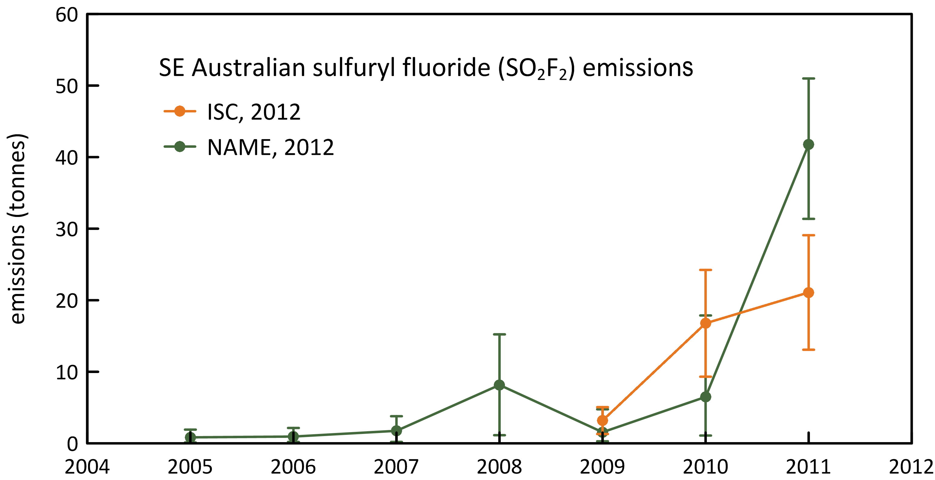

Figure 16. SE Australian SO2F2 emissions (tonnes) from Cape Grim data using ISC and NAME.

## Total HFC, PFC and SF6 emissions

Estimated total HFCs, PFCs, SF6 emissions are shown Table 6 and Figure 17.

Total Australian HFC, PFC and SF6 emissions in the NGGI are 5.3 k tonnes in 2011, higher (~20%) than estimates based on Cape Grim data: 4.4±0.4 k tonnes (ISC/NAME) (Figure 17). Over the period 2005-2011 the NGGI estimates are 17% higher than estimates based on Cape Grim data. Over this period, HFC, PFC and SF6 GWP-weighted annual emissions have grown from 7.2 to 10.8 M tonnes CO2-e, an increase of 7%/yr. Note that the GWP-weighted emissions in the NGGI are lower than the corresponding emissions calculated from Cape Grim data. This is due to the reversal noted above in Figure 15 for HFC and GWP-weighetd HFC emissions.

HFC/PFC/SF6 emissions are the fastest growing sector in Australia’s GHG emissions and in 2011 constitute nearly 2% of Australia’s total GHG emissions (522 M tonnes CO2-e), up from 0.3% in 1995.

As with HFCs above, total Australian HFC, SF6 and PFC emissions, expressed as CO2-e, in the NGGI are 8.1 Mt CO2-e in 2011, significantly lower (25%) compared to estimates based on Cape Grim data: 10.8±0.9 Mt CO2-e (ISC/NAME) (Figure 17). Over the period 2005-2011, total Australian emissions of HFCs, PFCs and SF6, based on Cape Grim data (61 Mt CO2-e) are about 35% higher than the same emissions in the NGGI (45 Mt CO2-e). In all categories (HFCs, PFCs, SF6) the atmospheric data give higher estimates of emissions than in the NGGI. The relative contributions to the difference (2.7 Mt CO2-e) in 2011 are HFCs (~50%), SF6 (~34%) and PFCs (16%).

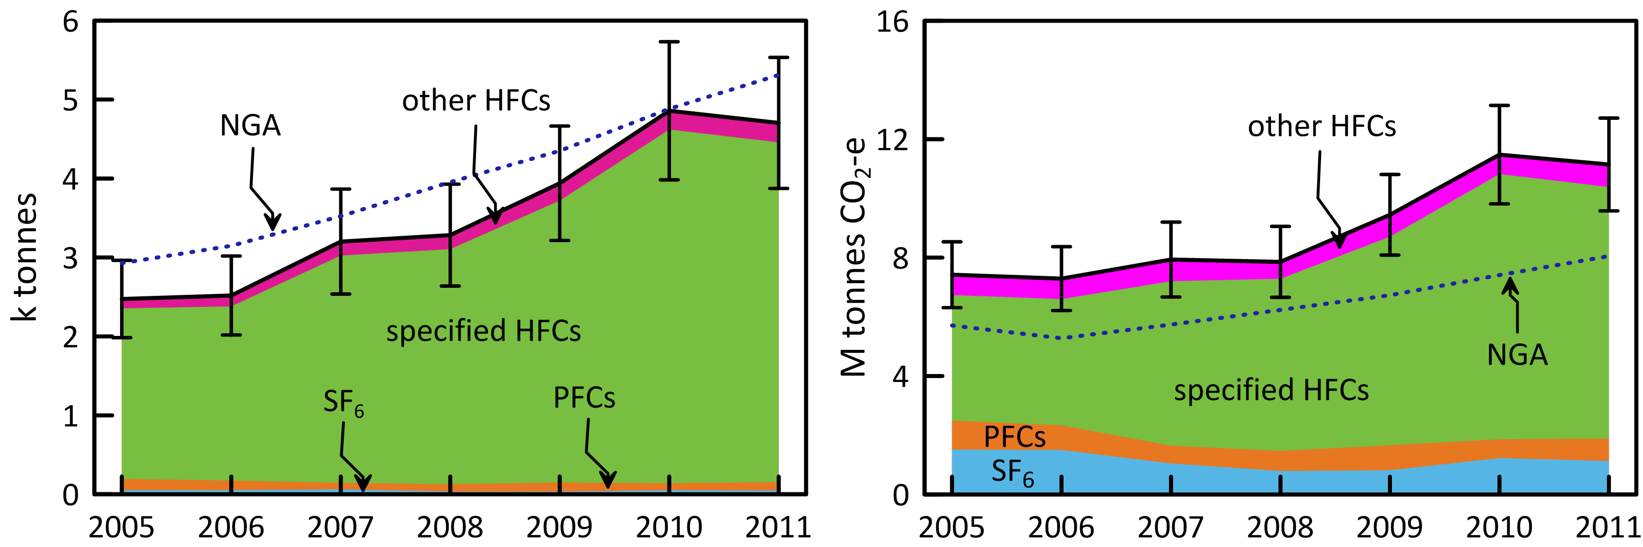

Figure 17. Australian HFC, PFC, SF6 emissions from Cape Grim observations (ISC) and in the NGGI/NGA (ageis.climatechange.gov.au) in Mt CO2-e.

## Total HFC, PFC, SF6 and SO2F2 emissions (GWP weighted)

Total HFC, PFC, SF6 and SO2F2 emissions, including gWP-weighted emissions, are shown in Table 6. From 2005 to 2011, GWP-weighted annual emissions of these SGGs have grown from 7.2 to 11.4 M tonnes CO2-e, and increase of 8% per year.

## Total GWP-weighted emissions: ODSs, HFCs, PFC, SF6 and SO2F2

Total ODS, HFC, PFC, SF6 and SO2F2 emissions, including GWP-weigthed emissions, are shown in Table 6 and Figure 18 (GWP-weighted). From 2005 to 2011, GWP-weighted annual emissions of these gases (nominally all SGGs) have grown from 20.2 to 26.0 M tonnes CO2-e, and increase of 4% per year. Currently HFCs comprise around 35% of total SGG emissions, CFCs 34%, HCFCs 17%, SF6/SO2F2 6%, halons/CH3Br 3%, PFCs 3% and chlorocarbons 2%. Total SGG emissions in 2011 were estimated to be around 26.0 M tonnes CO2-e based on Cape Grim observations (with HFCs, PFCs and SF6 = 10.8 M tonnes CO2-e) compared to the NGGI (8.1 M tonnes CO2-e for HFCs, PFCs, SF6). The total of these gases actually account for 4-5% of Australia’s GHG emissions, based on Cape Grim data. Note that in the Kyoto commitments, only HFC, PFC and SF6 emissions are considered. These constitute about 1-2% of Australia’s total GHG emissions.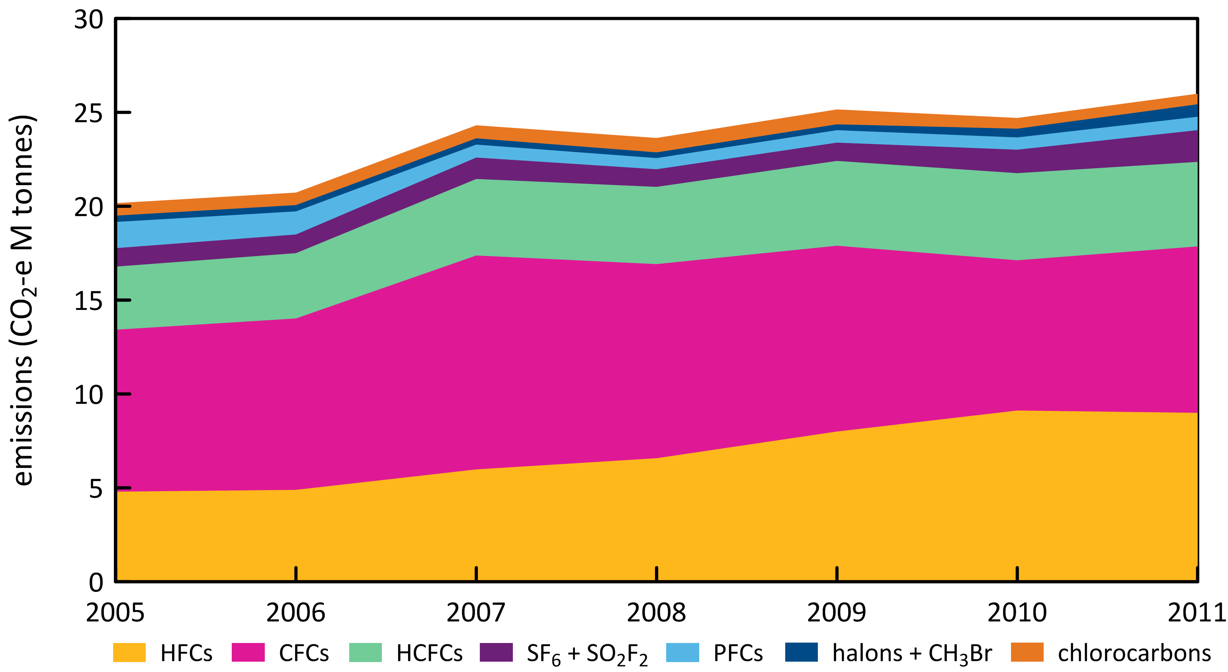

Figure 18. Australian total SGG emissions (M tonnes CO2-e), comprising emissions of HFCs, CFCs, HCFCs, SF6/SO2F2, halons/CH3Br, PFCs and chlorocarbons (Montreal Protocol and others).

Summary

* CSIRO measures the abundances and trends of forty-one ODSs and SGGs at Cape Grim, comprising six CFCs (CFC-11, -13, -13, -113, -114, -115), four HCFCs (HCFC-22, -124, -141b, -142b), three halons (H-1211, -1301,-2402), seven chlorocarbons (CH3Cl, CH2Cl2, CHCl3, CCl4, CH3CCl3, CHClCCl2, CCl2CCl2), three bromocarbons (CH3Br, CH2Br2, CHBr3), ten HFCs (HFC-23, -32, -125, -134a, -143a -227ea, -236fa, -245fa, -365mfc), four PFCs (PFC-14, -116, -218, -318), three sulfur-SGGs (SF6, SO2F2, CF3SF5) and one nitogen-SGG (NF3). Of these 41 SGGs, 31 show detectable SE Australian emissions whose magnitudes are estimated by a number of techniques – interspecies correlation, forward modelling and inverse modelling. Australian emission estimates of these ODSs and SGGs can be derived from SE Australian emissions by appropriate scaling parameters: population, industrial and agricultural activities.
* Over the period 2005-2011, based on Cape Grim data, Australian CFC emissions peaked at about 1560 tonnes in 2007, falling to 1280 tonnes in 2011, declining by about 20% since 2007 (5%/yr). Australian ODP-weighted CFC emissions peaked at 1540 tonnes in 2007 declining to 1240 tonnes in 2011, and are currently (2011) about 40% of Australia’s ODS (ODP-weighted) emissions (3100 tonnes). Australian CFC emissions on a GWP-weighted basis peaked at 11.4 M tonnes in 2007, falling to 8.9 M tonnes in 2011, which are currently about 35% of Australia’s CO2-e emissions from SGGs and ODSs (26 M tonnes in 2011). However CFC emissions are not included in Australia’s national GHG emissions because CFCs are not included in the Kyoto Protocol (they are included in the Montreal Protocol).

Australian CFC emissions are from old CFC-containing appliances/materials (refrigeration/ac equipment, foams, aerosol cans), existing or buried (land-fills). If the current total emissions (1280 tonnes/yr) continue to decline at 5%/yr, it will take 50 years for Australian CFC emissions to drop below 100 tonnes/yr. Australian CFC emissions in 2011 (1280 tonnes) were estimated to be 0.9% of global CFC emissions (142 k tonnes).

* Over the period 2005-2011, based on cape Grim data, HCFC emissions peaked in 2010 (2700 tonnes), dropping to 2640 tonnes in 2011. ODP-weighted HCFC emissions peaked at about 170 ODP tonnes in 2007, falling to about ODP 160 tonnes in 2011 and are currently (2011) just over 5% of Australia’s ODS (ODP-weighted) emissions (3100 tonnes). HCFC-22 emissions continue to increase (4-5%/yr), whereas the other HCFC emissions (HCFC-124, HCFC-141b, HCFC-142b) are in decline. Australian GWP-weighted HCFC emissions are rising steadily and in 2011 were 4.5 M tonnes CO2-e, approximately 50% of Australia’s GWP-weighted emissions of CFCs and 18% of Australia’s CO2-e emissions from all SGGs and ODSs (24.9 M tonnes in 2011). As with CFCs above, HCFC emissions are not included in Australia’s national GHG emissions calculations.

Australian HCFC emissions are likely from a combination of service and malfunction leaks from existing refrigeration/ac equipment and from land-fills. Australian HCFC emissions in 2011 (2636 tonnes) were estimated to be 0.6% of global HCFC emissions (464 k tonnes).

* Scaling Port Phillip halon emissions to Australian halon emissions (after allowing for possible Halon Bank emissions) would suggest Australian halon emissions of about 100 tonnes in 2011, which is in line with what is expected compared to global emissions. If we are going to use Cape Grim data to infer Australian halon emission, we need accurate estimates of the halon leak rates from the Halon Bank. A clearer picture of Australian halon emissions will emerge once data are collected from the proposed Lucas Heights facility south of Sydney, commencing in 2014.
* Australian MB emissions appear to be increasing: 430 tonnes (260 ODP tonnes) in 2005 to 670 tonnes (400 ODP tonnes) in 2011. The 400 ODP tonnes in 2011 are about 13% of Australia’s ODS emissions in ODP tonnes, but the GWP-weighted emissions do not contribute to any extent to Australian CO2-e emissions from SGGs. The increase in Australian MB emissions is driven by increased QPS-use of MB, not controlled by the Montreal Protocol, and this will vary from year to year depending on expoart and import quantities and requirements.
* CTC emissions were estimated at 135 tonnes (ISC) and 120 tonnes (NAME) in 2010, and 160 tonnes/yr (ISC) and 125 tonnes/yr (NAME) over the period 2005-2010. Australian CTC emissions in 2010 (120-135 tonnes) were estimated to be 0.2-0.25% of global emissions. Australian MC emissions continue to decline, falling from 117 tonnes in 2005 to 67 tonnes in 2011. Global MC emissions in 2010 were 8.9 k tonnes, Australian emissions were 68 tonnes, 0.8% of global emissions. The combined CTC/MC emissions totalled 155 ODP tonnes in 2010, about 6% of Australia’s ODP-weighted ODS emissions. CTC/MC emissions make only a small contribution (less than 2%) to Australia’ CO2-e emissions from all SGGs (including ODSs).
* CH2Cl2, CHCl3, TCE and PCE are short-lived ODSs that are not controlled by the Montreal Protocol. Significant emissions of all these ODSs are seen in the Cape Grim data. Total Australian emissions for these short-lived ODSs were estimated at 10 k tonnes (68 ODP tonnes) in 2005, growing to 15 k tonnes (113 ODP tonnes) in 2009 and falling to 12 k tonnes (92 ODP tonnes) in 2011. The ODP-weighted emissions of these short-lived ODSs were about 3% of total ODS emissions and about 2% of GWP-weighted emissions of ODSs in 2011; these species do not contribute significantly to ODP-weighted Australian SGG emissions.
* Total ODS emissions (ODP-weighted) peaked at around 3.1 k tonnes in 2011, with CFCs contributing 40% of ODS emissions, halons 34%, MB 13%, HCFCs 5%, CTC/MC 5%, other chlorocarbons 3%. Total ODS emissions (GWP-weighted) peaked at 16.5 M tonnes CO2-e in 2007, falling to 14.6 M tonnes in 2011, of which CFCs contributed 61%, HCFCs 31%, halons 5%, CTC?MC 1-2%, other chlorocarbons 2%. ODS emissions are not counted as part of Australia’s GHG emissions, but contribute an additional 2-3% to overall Australian GHG emissions (522 M tonnes CO2-e in 2011).
* Australian HFC emissions have been estimated from Cape Grim atmospheric data using two independent methods: ISC and NAME. ISC and NAME estimates for HFC emissions agree, on average over the period 2005-2011, to within 10% for HFC-125, HFC-134a, HFC-143a and HFC-152a, within 40% for HFC-23, HFC-32 and within 60% for HFC-365mfc. Over the period 2005-2011, total HFC emissions in the NGA are about 15% higher than total HFC emissions estimated from Cape Grim data (NAME/ISC), with the NGA reporting about 5270 tonnes emitted in 2011, compared to about 4340 tonnes estimated from Cape Grim data. Over the period 2005-2011, total HFC emissions, expressed as CO2-e emissions reported in the NGA, are about 20% lower than total HFC emissions (CO2-e) estimated from Cape Grim data (NAME/ISC), with the NGA reporting about 7640 tonnes emitted in 2011, compared to about 8995 tonnes estimated from Cape Grim data.
* Over the period 2005-2011, PFC-14 emissions in the NGA are about 27% lower than PFC-14 emissions estimated from Cape Grim data (NAME/ISC), with the NGA reporting 35 tonnes emitted in 2011, compared to 51 tonnes estimated from Cape Grim data. Over the period 2005 – 2011, Australian PFC-116 emission estimated from atmospheric data are a factor of 3-4 times higher than the NGGI data over the same period, with the NGGI reporting 4 tonnes in 2011, compared to 25 tonnes estimated from Cape Grim data. Assuming the NGGI data accurately reflect the actual PFC-116 emissions from the aluminium industry, then there must be significant emissions of PFC-116 from a non-aluminium sector which have grown rapidly from ~6 tonnes in 2006 to ~20 tonnes in 2011. Total PFC emissions declined from over 200 tonnes in 2005 to about 80 tonnes in 2008, reflecting the reduced emissions from the aluminium industry. However total estimated PFC emissions then increased to over 90 tonnes in 2011, due to increased emissions of PFC-14 and PFC-116 in 2011 compared to 2010. PFC emissions in 2011 (0.7 M tonnes CO2-e) were less than 3% of Australia’s GWP-weighted ODS emission (26 M tonnes CO2-e).
* Over the period 2005 – 2011, Australian SF6 emissions estimated from atmospheric data (40 tonnes) are a factor of 6 times higher than the NGA data over the same period, with NGA reporting 6 tonnes in 2011, compared to 46 tonnes estimated from Cape Grim data. This discrepancy and will be investigated further.

In 2012 Australia imported 36 tonnes of SF6, which goes into new stock (12 tonnes in 2012) or the servicing of existing stock (7 tonnes in 2012, replacing SF6 lost by fugitive emissions) and 1 tonne for other uses, a total of 20 tonnes. Atmospheric observations suggest that current Australian emissions are significantly larger than the 7 tonnes/yr calculated with the DIICCSRTE model. This would suggest that the emission factors used in the three categories of emissions in the DIICCSRTE model are possibly too low and/or there are other emissive uses of SF6 not included in the model. The 2012 SF6 imports could be distorted by the application of the equivalent carbon price for SF6 prior to the introduction of the price. Australian SF6 emissions in the NGA are estimated at less <0.1% of global emissions. It would be unusual for Australian emissions of a widely-used industrial chemical like SF6 to be <0.1% of global emissions and this may also require further investigation.

* Total Australian HFC, PFC and SF6 emissions, expressed as CO2-e emissions, over the period 2005-2011 estimated from atmospheric data (Cape Grim, ISC, NAME) are 35% higher than NGGI data, with the NGGI reporting 8051 tonnes in 2011 compared to 10801 tonnes from Cape Grim data. Over this period, HFC, PFC and SF6 GWP-weighted annual emissions have grown from an estimated 7.2 to 10.8 M tonnes CO2-e, an increase of 7%/yr. This is a fast-growing sector in Australia’s GHG emissions and in 2011 constituted 2% of Australia’s total GHG emission (522 M tonnes CO2-e).
* Emissions of SO2F2 are the fastest growing of any SGG in Australia, rising from 3 tonnes (0.01 M tonnes CO2-e) in 2005 to 120 tonnes (0.6 M tonnes CO2-e) in 2011.
* Over the period 2005-2011, the combined emissions of all SGGs (including all the ODSs) in Australia are growing by 4%/yr (20 M tonnes CO2-e in 2005, 26 M tonnes CO2-e in 2011), driven by increases in emissions of HFCs, HCFCs, SF6 and SO2F2; CFC and CTC emissions are steady and only PFC emissions show a decline over this period (although even PFC emissions have increased since 2008). Total SGG emissions (for ODSs plus HFCs/PFCs/SF6), based on Cape Grim data, actually account for 4-5% of Australia’s GHG emissions.

References

AGEIS (Australian Greenhouse Emissions Information System), http://www.ageis.greenhouse.gov.au, 2013.

Arnold, T., C. Harth, J. Mühle, P. Salameh, A. Manning, D. Ivy, P. Steele, J. Kim, V. Petrenko, J. Severinghaus, D. Baggenstos & R. Weiss, Nitrogen trifluoride global emissions estimated from updated atmospheric measurements, *PNAS*, 110, 2029-2034, doi:10.1073/pnas.1212346110, 2013.

Arnold, T., D. Ivy, C. Harth,M. Vollmer, J. Mühle, P. Salameh, P. Steele, P. Krummel, R. Wang, G. Young, C. Lunder, O. Hermansen, T. Rhee, M. Rigby, J. Kim, S. Reimann, S. O**’**Doherty**, P. Fraser**, P. Simmonds, R. Prinn & R. Weiss, HFC-43-10mee atmospheric abundances and global emission estimates, *Geophys. Res. Letts.*, submitted, 2014.

Barnett, A. G., Air pollution trends in four Australian cities 1996-2011, *Air Quality and Climate Change*, 46(4): 28-34, 2013.

Bekki, S. & G. Bodeker, Coordinating Lead Authors, Future Ozone and Its Impact on Surface UV, Chapter 3 in *Scientific Assessment of Ozone Depletion: 2010*, WMO Global Ozone Research and Monitoring Project – Report No. 52, 3.1-3.60, 2011.

BTRE, Greenhouse Gas Emissions from Transport: Australian Trends to 2020, Bureau of Transport and Regional Economics (BTRE), Report 107, Department of Transport and Regional Services, 254 pp., 2002.

Butler, J., J. Elkins, B. Hall, S. Montzka, S. Cummings, P. Fraser & L. Porter, Recent trends in the global atmospheric mixing ratios of Halon-1301 and Halon-1211 in *Baseline Atmospheric Program Australia* 1991, A. Dick & J. Gras (eds.), Department of the Environment, Sport and Territories, Bureau of Meteorology and CSIRO Division of Atmospheric Research, 29-32, 1994.

[Cohan, D. , G. Sturrock, A. Biazar & P. Fraser, Atmospheric methyl iodide at Cape Grim, Tasmania, from AGAGE observations, *J. Atmos. Chem.*, 44 (2): 131-150, 2003.](https://ejournal.csiro.au/cgi-bin/sciserv.pl?collection=journals&journal=01677764&issue=v44i0002&article=131_amiacgtfao%20)

Cox, M., P. Hurley, P. Fraser & W. Physick, Investigation of Melbourne region pollution events using Cape Grim data, a regional transport model (TAPM) and the EPA Victoria carbon monoxide inventory, *Clean Air*, 34(1): 35-40, 2000.

Cox, M., A regional study of the natural and anthropogenic sinks of the major halomethanes, PhD thesis, School of Mathematical Sciences, Monash University, Clayton, Victoria, Australia, 2001.

Cox, M. , S. Siems, P. Fraser, P. Hurley & G. Sturrock, TAPM modelling studies of AGAGE dichloromethane observations at Cape Grim in *Baseline Atmospheric Program Australia 1999-2000*, N. Tindale, N. Derek & P. Fraser (eds.), Melbourne: Bureau of Meteorology and CSIRO Atmospheric Research, 25-30, 2003a.

Cox, M. , G. Sturrock, P. Fraser, S. Siems, P. Krummel & S. O'Doherty, Regional sources of methyl chloride, chloroform and dichloromethane identified from AGAGE observations at Cape Grim, Tasmania, 1998-2000, *J. Atmos. Chem,* 45 (1): 79-99, 2003b.

[Cox, M., P. Fraser, G. Sturrock, S. Siems & L. Porter, Terrestrial sources and sinks of halomethanes near Cape Grim, Tasmania, *Atmos. Environ.*, 38(23): 3839-3852, 2004.](https://ejournal.csiro.au/cgi-bin/sciserv.pl?collection=journals&journal=13522310&issue=v38i0023&article=3839_tsasohncgt%20)

Cunnold, D. , R. Prinn, R. Rasmussen, P. Simmonds, F. Alyea, C. Cardelino, A. Crawford, P. Fraser& R. Rosen, The Atmospheric Lifetime Experiment, 2: Lifetime methodology and application to three years of CFCl3 data, *J. Geophys. Res.,* 88(C13): 8379-8400, 1983.

Cunnold, D., R. Prinn, R. Rasmussen, P. Simmonds, F. Alyea, C. Cardelino, A. Crawford, P. Fraser& R. Rosen, Atmospheric lifetime and annual release estimates for CFCl3 and CF2Cl2 from 5 years of ALE data, *J. Geophys. Res.,* 91(D10): 10797-10817, 1986.

Cunnold, D., P. Fraser, R. Weiss, R. Prinn, P. Simmonds, F. Miller, F. Alyea & A. Crawford, Global trends and annual releases of CCl3F and CCl2F2 estimated from ALE/GAGE and other measurements from June 1978 to July 1991, *J. Geophys. Res.,* 99(D1): 1107-1126, 1994.

Cunnold, D., R. Weiss, R. Prinn, D. Hartley, P. Simmonds, P. Fraser, B. Miller, F. Alyea & L. Porter, GAGE/AGAGE measurements indicating reductions in global emissions of CCl3F and CCl2F2 in 1992-1994, *J. Geophys. Res.,* 102(D1): 1259-1269, 1997.

Daniel, J., S. Solomon & D. Albritton, On the evaluation of halocarbon radiative forcing and global warming potentials*, J. Geophys. Res*., 100(D1): 1271-1285, doi:10.1029/94JD02516, 1995.

Daniel, J. & G. Velders *et al*., A Focus on Information and Options for Policymakers, Chapter 5 in Scientific Assessment of Ozone Depletion: 2010, WMO Global Ozone Research and Monitoring Project – Report No. 52, 5.1-5.56, 2011.

DCCEE 2011, *Australian National Greenhouse Accounts, National Inventory Report 2009, vol. 1,* Department of Climate Change and Energy Efficiency, 284 pp., April 2011.

DCCEE 2012, *Australian National Greenhouse Accounts, National Inventory Report 2010, vol. 1,* Department of Climate Change and Energy Efficiency, 292 pp., April 2012.

DIICCSRTE 2013a, data on Australian HFC imports, uses and emissions, M. Hunstone, Department of Industry, Innovation, Climate Change, Science, Research and Tertiary Education, private communication, March 2013.

DIICCSRTE 2013b, *Australian National Greenhouse Accounts, National Inventory Report 2011, vol. 1,* Department of Industry, Innovation, Climate Change, Science, Research and Tertiary Education, 299 pp., April 2013.

Delaney, W. & A. Marshall, Victorian air emissions inventory for 2006, Proceedings, *20th International Clean Air and Environment Conference*, 30 July – 2 August, 2011, CASANZ, Auckland, NZ., 2011.

DSEWPaC, Sulfur hexafluoride (SF6) and the equivalent carbon price, 2 pp., August 2012.

Dunse, B., P. Steele, P. Fraser & S. Wilson, An analysis of Melbourne pollution episodes observed at Cape Grim from 1995-1998 in *Baseline Atmospheric Program (Australia) 1997-98*, N. Tindale, R. Francey, and N. Derek (eds.), Bureau of Meteorology and CSIRO Atmospheric Research, Melbourne, Australia, 34-42, 2001.

Dunse, B., Investigation of urban emissions of trace gases by use of atmospheric measurements and a high-resolution atmospheric transport model, *PhD thesis*, Wollongong University, Wollongong, NSW, Australia, 2002.

Dunse, B., P. Steele, S. Wilson, P. Fraser & P. Krummel, Trace gas emissions from Melbourne Australia, based on AGAGE observations at Cape Grim, Tasmania, 1995-2000, *Atmos. Environ.*, 39, 6334-6344, 2005.

Draxler, R. & D. Hess, Description of the HYSPLIT_4 Modeling 389 System, NOAA Technical Memorandum ERL ARL-224, 24 pp., NOAA, 1997.

EPA, Air Emissions Inventory: Port Phillip Region, *EPA Publication 632*, 48 pp., 1998.

Expert Group, *Cold Hard Facts 2: a study of the refrigeration and air conditioning industry in Australia*, prepared for DSEWPac, 134pp, July 2013.

Forster, P. & V. Ramaswamy, Coordinating Lead Authors, Changes in Atmospheric Constituents and in Radiative Forcing, Chapter 2 in: *Climate Change 2007: The Physical Basis. Contribution of Working Group I to the Fourth Assessment Report of the Intergovernmental Panel on Climate Change*, Solomon, S., D. Qin, M. Manning, Z. Chen, M. Marquis, K. Averyt, M. Togor & H. Miller (eds.), Cambridge University Press, Cambridge, UK & New York, NY, USA, 129-234, April 2007.

Fortems-Cheiney, A., M. Saunois, I, Pison, F. Chevallier, P. Bousquet, C. Cressot, S. Montzka, P. Fraser, M. Vollmer, P. Simmonds, D. Young, S. O'Doherty, F. Artuso, B. Barletta, D. Blake, S. Li, C. Lunder, B. Miller, S. Park, R. Prinn, T. Saito, P. Steele & Y. Yokouchi, Increase in HFC-134a emissions in response to the success of the Montreal Protocol, *J. Geophys. Res*., submitted, 2013.

Fraser, P., B. Sawford & P. Manins, CCl3F (Freon-11) as an indicator of transport processes in an urban atmosphere: a case study in Melbourne, *Atmos. Environ*., 11(11): 1025-1028, 1977.

Fraser, P. & G. Pearman, Atmospheric halocarbons in the southern hemisphere, *Atmos. Environ.,* 12(4), 839-844, 1978a.

Fraser, P. & G. Pearman, The fluorocarbon-ozone theory, II: tropospheric lifetimes: an estimate of the tropospheric lifetime of CCl3F, *Atmos. Environ.,* 12(8): 1807-1808, 1978b.

Fraser, P.,P. Hyson, I. Enting & G. Pearman, Global distribution and southern hemispheric trends of atmospheric CCl3F, *Nature,* 302(5910), 692-695, 1983.

Fraser, P., P. Hyson, R. Rasmussen, A. Crawford & A. Khalil, Methane, carbon monoxide and methychloroform in the southern hemisphere, *J. Atmos. Chem,* 4(1): 3-42, 1986.

Fraser, P., D. Cunnold, F. Alyea, R. Weiss, R. Prinn, P. Simmonds, B. Miller & R. Langenfelds, Lifetime and emission estimates of 1,1,2-trichlorotrifluorethane (CFC-113) from daily global background observations June 1982-June 1994, *J. Geophys. Res.,* 101(D7): 12585-12599, 1996.

Fraser, P. & M. Prather, Uncertain road to ozone recovery, *Nature,* 398 (6729): 663-664, 1999.

Fraser, P., D. Oram, C. Reeves, S. Penkett & A. McCulloch, Southern Hemisphere halon trends (1978-1998) and global halon emissions, *J. Geophys. Res.,* 104(D13): 15985-15999, 1999.

[Fraser, P., Will illegal trade in CFCs and halons threaten ozone layer recovery? *Atmos. Environ.*, 34(18): 3038-3039, 2000.](https://ejournal.csiro.au/cgi-bin/sciserv.pl?collection=journals&journal=13522310&issue=v34i0018&article=3038_witicahtolr%20)

Fraser, P. J., L. W. Porter, S. B. Baly, P. B. Krummel, B. L. Dunse, L. P. Steele, N. Derek, R. L. Langenfelds, I. Levin, D. E. Oram, J. W. Elkins, M. K. Vollmer & R. F. Weiss, Sulfur hexafluoride at Cape Grim: long term trends and regional emissions in *Baseline Atmospheric Program Australia 2001-2002*, J. M. Cainey, N. Derek, and P. B. Krummel (eds.), Melbourne: Bureau of Meteorology and CSIRO Atmospheric Research, 18-23, 2004.

Fraser, P., C. Trudinger, B. Dunse, P. Krummel, P. Steele, D. Etheridge, N. Derek, L. Porter & B. Miller, PFC emissions from global and Australian aluminium production, *Proceedings, Ninth Australasian Aluminium Smelting Technology Conference and Workshops*, Skyllas-Kazacos, M. & B. Welch (eds.), Terrigal, NSW, Australia, 4-9 November 2007.

Fraser, P., B. Dunse, P. Steele, P. Krummel & N. Derek, Perfluorocarbon (PFC) emissions from Australian aluminium smelters, 2005-2009, *Proceedings of the 10th Australasian Aluminium Smelting Technology Conference*, Launceston, Tasmania, Australia, 9-14 October, 2011, B. Welch, G. Stephens, J. Metson & M. Skyllos-Kazacos (eds.), Copyright School of Chemical Engineering, University of New South Wales, ISBN: 978-0-7334-3054-1, 14 pp., 2011.

Fraser, P., P. Steele, P. Krummel, C. Allison, S. Coram, B. Dunse & M. Vollmer, DSEWPaC Research Projects 2011/2012, Final Report October 2012, 14 pp., 2012a.

Fraser, P., B. Dunse, P. Krummel, P. Steele & N. Derek, Australian PFC, HFC and SF6 emissions, report to DCCEE, Light Metals Flagship/CSIRO Marine and Atmospheric Research, March 2012, 19 pp., 2012b.

Fraser, P., P. Krummel, P. Steele, C. Trudinger, D. Etheridge, S. O'Doherty, P. Simmonds, B. Miller, J. Mühle, R. Weiss, D. Oram, R. Prinn & R. Wang, Equivalent effective stratospheric chlorine from Cape Grim Air Archive, Antarctic firn and AGAGE global measurements of ozone depleting substances, *Baseline Atmospheric Program (Australia) 2009-2010*, P. Krummel & N. Derek (eds.), Australian Bureau of Meteorology and CSIRO Marine and Atmospheric Research, Melbourne, Australia, in press, 2013.

Fraser, P., B. Dunse, A. Manning, R. Wang, P. Krummel, P. Steele, L. Porter, C. Allison. S. O’Doherty, P. Simmonds, J. Mühle & R. Prinn, Australian carbon tetrachloride (CCl4) emissions in a global context, *Environ. Chem*., in press, 2013.

Ganesan, A., M. Rigby, A. Zammit-Mangion, A. Manning, R. Prinn**,** P. Fraser, C. Harth, K-R. Kim, P. Krummel, S. Li, S. O’Doherty, S. Park, P. Salameh, P. Steele & R. Weiss, Characterisation of uncertainties in trace gas inversions using hierarchical Bayesian methods, *Atmos. Chem. Phys. Discuss*., submitted, 2013.

GrainCorp, GrainCorp Ports, [www.graincorp.com.au](http://www.graincorp.com.au), 16pp, 2012.

Greally, B. , P. Simmonds, S. O’Doherty, A. McCulloch, B. Miller, R. Weiss, P. Salameh, J. Mühle, T. Tanhua, P. Fraser, P.Krummel, B. Dunse, L. Porter & R. Prinn, Improved continuous *in situ* measurements of C1-C3 PFCs, HFCs, HCFCs, CFCs and SF6 in Europe and Australia, *Environ. Sci.*, 2(2-3): 253-261, 2005.

Greally, B., A. Manning, S. Reimann, A. McCulloch, J. Huang, B. Dunse, P. Simmonds, R. Prinn, P. Fraser, D. Cunnold, S. O’Doherty, L. Porter, K. Stemmler, M. Volmer, C. Lunder, N. Schmidbauer, O. Hermansen, J. Arduini, P. Salameh, P. Krummel, R. Wang, D. Folini, R. Weiss, M. Maione, G. Nickless, F. Stordal & R. Derwent, Observations of 1,1-difluoroethane (HFC-152a) at AGAGE and SOGE monitoring stations in 1994-2004 and derived global and regional emission estimates, *J. Geophys. Res*., 112(D6), D06308, doi:10.1029/2006JD007527, 2007.

Hurley, P., TAPM V4. Part 1: Technical description, CSIRO Marine and Atmospheric Research Paper No. 25, October 2008.

Hurley, P., M. Edwards & A. Luhar, TAPM V4. Part 2: Summary of some verification studies, CSIRO Marine and Atmospheric Research Paper No. 25, October 2008.

Hyson, P., P. Fraser& G. Pearman, A two-dimensional transport simulation model for trace atmospheric constituents, *J. Geophys. Res.,* 85(C8): 4443-4456, 1980.

Ivy, D., T. Arnold, C. Harth, P. Steele, J. Mühle, M. Rigby, P. Salameh, M. Leist, P. Krummel, P. Fraser, R. Weiss & R. Prinn, Atmospheric histories and growth trends of the high molecular weight perfluorocarbons: C4F10, C5F12, C6F14, C7F16 and C8F18, *Atmos. Chem. Phys.*, 12, 4313-4325, 2012.

Krummel, P. B., L. W. Porter, P. J. Fraser, S. B. Baly, B. L. Dunse & N. Derek, HCFCs, HFCs, halons, minor CFCs, PCE and halomethanes: the AGAGE in situ GC-MS program at Cape Grim, 1998-2002 in *Baseline Atmospheric Program (Australia) 2001-2002*, J. M. Cainey, N. Derek, & P. B. Krummel (eds.), Bureau of Meteorology and CSIRO Atmospheric Research, Melbourne, Australia, 57-64, 2004.

Krummel, P. B., P. J. Fraser, L. P. Steele, L. W. Porter, N. Derek, C. Rickard, J. Ward, B. L. Dunse, R. L. Langenfelds, S. Baly, M. Leist & S. McEwan, The AGAGE *in situ* program for non-CO2 greenhouse gases at Cape Grim, 2007–2008: methane, nitrous oxide, carbon monoxide, hydrogen, CFCs, HCFCs, HFCs, PFCs, halons, chlorocarbons, hydrocarbons and sulfur hexafluoride in *Baseline Atmospheric Program (Australia) 2007-2008*, N. Derek and P. B. Krummel (eds.), Australian Bureau of Meteorology and CSIRO Marine and Atmospheric Research, Melbourne, Australia, 67-80, 2011.

Krummel, P., P. Fraser, P. Steele, L. Porter, N. Derek, J. Ward, B. Dunse, R. Langenfelds, S. Baly, & S. McEwan, The AGAGE *in situ* program for non-CO2 greenhouse gases at Cape Grim, 2009-2010: methane, nitrous oxide, carbon monoxide, hydrogen, CFCs, HCFCs, HFCs, PFCs, halons, chlorocarbons, hydrocarbons and sulfur hexafluoride in *Baseline Atmospheric Program (Australia) 2009-2010*, N. Derek and P. B. Krummel (eds.), Australian Bureau of Meteorology and CSIRO Marine and Atmospheric Research, Melbourne, Australia, submitted, 2013.

Laube, J., C. Hogan, M. Newland, F. Mani, P. Fraser, C. Brenninkmeijer, P. Martinerie, D. Oram, T. Rockmann, J. Schwander, E. Witrant, G. Mills, C. Reeves & W. Sturges, Distributions, long-term trends and emissions of four perfluorocarbons in remote parts of the atmosphere and firn air, *Atmos. Chem. Phys.*, 12, 4081-4090, 2012.

Laube, J., A. Kiel, H. Bonisch, E. Engel, M. Newland, T. Rockmann , C. Volk, W. Sturges, P. Fraser & D. Oram, Supplementary information to ‘Observation-based assessment of stratospheric fractional release, lifetimes and Ozone Depletion Potentials of ten important trace gases’, *Atmos. Chem. Phys.*, 13, 2779-2791, 2013a.

Laube, J., M. Newland, C. Hogan, C. Brenninkmeijer, P. Fraser, P. Martinerie, D. Oram, C. Reeves, T. Rockmann, J. Schwander, E. Witrant & W. Sturges, Newly detected ozone depleting substances in the atmosphere, *Nature*, submitted, 2013b.

Maiss, M., L. P. Steele, R. J. Francey, P. J. Fraser, R. L. Langenfelds, N. B. A. Trivett & I. Levin, Sulfur hexafluoride: a powerful new atmospheric tracer, *Atmos. Environ.,* 30(10/11): 1621-1629, 1996.

Manning, A., D. Ryall, R. Derwent, P. Simmonds & S. O’Doherty, Estimating European od ozone depleting and greenhouse egases using observations and a modelling attribution technique, *J. Geophys. Res*., 108, 4405, doi:10.1029/2002JD002312, 2003.

Manning, A., S. O’Doherty, A. R. Jones, P. G. Simmonds & R. G. Derwent, Estimating UK methane and nitrous oxide emissions from 1990 to 2007 using an inversion modeling approach, *J. Geophys. Res*., 116(D2): D02305, doi:10.1029/2010JD004763, 2011.

Miller, B., Miller, B., Abundances and trends of atmospheric chlorofluoromethane and bromomethane, *PhD thesis*, University of California at San Diego, La Jolla, California, USA, 149 pp, 1998.

Miller, B., J. Huang, R. Weiss, R. Prinn & P. Fraser**,** Atmospheric trend and lifetime of chlorodifluoromethane (HCFC-22) and the global tropospheric OH concentration, *J. Geophys. Res.,* 103(D11): 13237-13248, 1998.

Miller, B., M. Rigby, L. Kuijpers, P. Krummel, P. Steele, M. Leist, P. Fraser, A. McCulloch, C. Harth, P. Salameh, J. Mühle, R. Weiss, R. Prinn, R. Wang, S. O’Doherty, B. Greally & P. Simmonds, CHF3 (HFC-23) emission trend response to CHClF2 (HCFC-22) production and recent CHF3 emissions abatement measures, *Atmos. Chem. Phys.*, 10, 7875-7890, 2010.

Molina, M., D. Zaelke, K. Sharma, S. Andersen, V. Ramanathan & D. Kaniaru, Reducing abrupt climate change risk using the Montreal Protocol and other regulatory actions to complement cuts in CO2 emissions, *Proc. Nat. Acad. Sci*., 106(49): 20615-20621, 2009.

Montzka, S. , M. Nowick, R. Myers, W. Elkins, J.Butler, S. Cummings, P. Fraser& L. Porter, NOAA-CMDL chlorodifluoromethane (HCFC-22) observations at Cape Grim, in: *Baseline Atmospheric Program Australia* 1991, A. Dick & J. Gras (eds.), Melbourne: Department of the Environment, Sport and Territories, Bureau of Meteorology and CSIRO Division of Atmospheric Research, 25-28, 1994.

Montzka, S. & S. Reimann, Coordinating Lead Authors, Ozone-Depleting Substances (ODSs) and Related Chemicals, Chapter 1 in *Scientific Assessment of Ozone Depletion: 2010*, WMO Global Ozone Research and Monitoring Project – Report No. 52, 1.1-1.108, 2011.

Mühle, J., J. Huang, R. Weiss, R. Prinn, B. Miller, P. Salameh, C. Harth, P. Fraser, L. Porter, B. Greally, S. O’Doherty, P. Simmonds, P. Steele & P. Krummel, Sulfuryl fluoride in the global atmosphere, *J. Geophys. Res.*, 114(D5): D05306, doi:10.1029/2008JD011162, 2009.

Mühle, J., A. Ganesan, B. Miller, P. Salameh C. Harth, B. Greally, M. Rigby, L. Porter, P. Steele, C. Trudinger, P. Krummel, S. O’Doherty,P. Fraser, P. Simmonds, R. Prinn & R. Weiss, Perfluorocarbons in the global atmosphere: tetrafluoromethane, hexafluoroethane and octofluoropropane, *Atmos. Chem. Phys.,* 10, 5145-5164*,* 2010.

National Transport Commission, Grain Supply Chain Pilot Study, Stage One Final Report, prepared by Strategic Design and Development, Epping, NSW, for the National Transport Commission, 62 pp, 2008.

Newland, M., C. Reeves, D. Oram, J. Laube, W. Sturges, C. Hogan, P. Begley & P. Fraser, Southern hemispheric halon trends and global halon emissions, 1978-2011, *Atmos. Chem. Phys.,* 13, 5551-5565, doi:10.5194/acp-13-5551-2013, 2013.

Newman, P., J. Daniel, D. Waugh & E. Nash, A new formulation of equivalent effective stratospheric chlorine (EESC), *Atmos. Chem. Phys*., 7, 4537-4552, 2007.

[O'Doherty, S., P. Simmonds, D. Cunnold, R. Wang, G. Sturrock, P. Fraser, D. Ryall, R. Derwent, R. Weiss, P. Salameh, B. R. Miller & R. Prinn, *In situ* chloroform measurements at Advanced Global Atmospheric Gases Experiment atmospheric research stations from 1994 to 1998, *J. Geophys. Res.*, 106(D17): 20429-20444, 2001.](http://www.agu.org/journals/jd/jd0117/2000JD900792/pdf/2000JD900792.pdf%20)

O'Doherty, S., D. Cunnold, A. Manning, B. Miller, R. Wang, P. Krummel, P. Fraser, P. Simmonds, A. McCulloch, R. Weiss, P. Salameh, L. Porter, R. Prinn, J. Huang, G. Sturrock, D. Ryall, R. Derwent & S. Montzka, Rapid growth of hydrofluorocarbon 134a and hydrochlorofluorocarbons 141b, 142b, and 22 from Advanced Global Atmospheric Gases Experiment (AGAGE) observations at Cape Grim, Tasmania, and Mace Head, Ireland, *J. Geophys. Res.*, 109(D6): doi:10.1029/2003JD004277, 2004.

O’Doherty, S., D. Cunnold, B. Miller, J. Mühle, A. McCulloch, P. Simmonds, A. Manning, S. Reimann, M. Vollmer, B. Greally, R. Prinn, P. Fraser, P. Steele, P. Krummel, B. Dunse, L. Porter, C. Lunder, N. Schmidbauer, O. Hermansen, P. Salameh, C. Harth, R. Wang & R. Weiss, Global and regional emissions of HFC-125 (CHF2CF3) from *in situ* and air archive observations at AGAGE and SOGE observatories, *J. Geophys. Res.*, 114(D23): D23304, doi:10.1029/2009JD012184, 2009.

Oram, D., C. Reeves, S. Penkett & P. Fraser**,** Measurements of HCFC-142b and HCFC-141b in the Cape Grim air archive: 1978-1993, *Geophys. Res. Letts.,* 22(20): 2741-2744, 1995.

Oram, D., C. Reeves, W. Sturges, S. Penkett, P. Fraser & R. Langenfelds, Recent tropospheric growth rate and distribution of HFC-134a (CF3CH2F), *Geophys. Res. Letts.,* 23(15): 1949-1952, 1996.

Oram, D., W. Sturges, S. Penkett, A. McCulloch & P. Fraser, Growth of fluoroform (CHF3, HFC-23) in the background atmosphere, *Geophys. Res. Letts.,* 25(1): 35-38, 1998.

Oram, D., Trends in long-lived anthropogenic halocarbons in the Southern Hemisphere and model calculations of global emissions, *PhD thesis*, University of East Anglia, Norwich, UK, 1999.

Oram, D., F. Mani, J. Laube, M. Newland, C. Reeves, W. Sturges, S. Penkett, C. Brenninkmeijer, T. Röckmann & P. Fraser, Long-term tropospheric trend of octafluorocyclobutane (c-C4F8 or PFC-318), *Atmos. Chem. Phys*., 12, 261-269, 2012.

Porter, I., S. Mattner, J. Banks & P. Fraser**,** Impact of global methyl bromide phase-out on the sustainability of strawberry industries, *Acta Horticulturae*, 708, 179-185, 2006.

Porter, I., J. Banks, S. Mattner & P. Fraser, Global phase-out of methyl bromide under the Montreal Protocol: implications for bioprotection, biosecurity and the ozone layer, in: *Plant Pathoogy in the 21st Century: Recent Developments in Management of Plant Diseases*, Volume 1, 293-309, doi10.1007/978-1-4020-8804-9_21, Springer-Verlag Berlin, 2009.

Porter, I., M. Pizano, M. Besri & P. Fraser, Progress in the global phase-out of methyl bromide and the relative effectiveness of soil disinfestations strategies, *Acta Horticulturae*, 883, 59-66, 2010.

Prinn, R., D. Cunnold, R. Rasmussen, P. Simmonds, F. Alyea, A. Crawford, A. J., P. Fraser & R. Rosen, Atmospheric trends in methylchloroform and global average for the hydroxyl radical, *Science,* 238(4829): 945-950, 1987.

Prinn, R., D. Cunnold, P. Simmonds, F. Alyea, R. Boldi, A. Crawford, P. Fraser, D. Gutzler, D. Hartley, P. Rosen & R. Rasmussen, Global average concentration and trend for hydroxyl radicals deduced from ALE/GAGE trichloroethane (methyl chloroform) data for 1978-1990, *J. Geophys. Res.*, 97(D2): 2445-2461, 1992.

Prinn, R., R. Weiss, B. Miller, J. Huang, F. Alyea, D. Cunnold, P. Fraser**,** D. Hartley & P. Simmonds, Atmospheric trends and lifetime CH3CCl3 and global OH concentrations, *Science,* 269(5221): 187-192, 1995.

[Prinn, R., R. Weiss, P. Fraser, P. Simmonds, D. Cunnold, F. Alyea, S. O'Doherty, P. Salameh, B. Miller, J. Huang, R. Wang, D. Hartley, C. Harth, P. Steele, G. Sturrock, P. Midgley & A. McCulloch, A history of chemically and radiatively important gases in air deduced from ALE/GAGE/AGAGE, *J. Geophys. Res.,*105(D14): 17751-17792, 2000.](http://www.agu.org/journals/jd/jd0014/2000JD900141/0.html%20)

[Prinn, R., J. Huang, R. Weiss, D. Cunnold, P. Fraser, P. Simmonds, A. McCulloch, C. Harth, P. Salameh, S. O'Doherty, R. Wang, L. Porter & B. Miller, Evidence of substantial variations of atmospheric hydroxyl radicals in the past two decades, *Science*, 292(5523): 1882-1888, 2001.](http://www.sciencemag.org/cgi/content/abstract/292/5523/1882%20)

Prinn, R., J. Huang, R. Weiss, D. Cunnold, P. Fraser, P. Simmonds, A. McCulloch, C. Harth, S. Reimann, P. Salameh, S. O’Doherty, R. Wang, L. Porter, B. Miller & P. Krummel, Evidence for variability of atmospheric hydroxyl radicals over the past quarter century, *Geophys. Res. Letts.*, 32(7): L07809, doi:10.1029/2004GL022228, 2005.

Rasmussen, R., A. Khalil, A. Crawford & P. Fraser**,** Natural and anthropogenic trace gases in the southern hemisphere, *Geophys. Res. Letts.,* 9(6): 704-707, 1982.

Rigby, M., J. Mühle, B. Miller, R. Prinn, P. Krummel, P. Steele,P. Fraser, P. Salameh, C. Harth, R. Weiss, B. Greally, S. O’Doherty, P. Simmonds, M. Vollmer, S. Reimann, J. Kim, K. Kim, R. Wang, J. Olivier, E. Dlugokencky, G. Dutton, B. Hall & J. Elkins, History of atmospheric SF6 from 1973 to 2008, *Atmos. Chem. Phys.*, 10, 10305-10320, 2010.

Rigby, M., R. Prinn, S. O'Doherty, S. Montzka, A. McCulloch, C. Harth, J. Mühle, P. Salameh, R. Weiss, D. Young, P. Simmonds, B. Hall, G. Dutton, D. Nance, D. Mondeel, J. Elkins, P. Krummel, P. Steele & P. Fraser, Re-evaluation of the lifetimes of the major CFCs and CH3CCl3 using atmospheric trends, Re-evaluation of the lifetimes of the major CFCs and CH3CCl3 using atmospheric trends, *Atmos. Chem. Phys*., 13, 1-11, 2013.

Rigby, M., R. Prinn, S. O’Doherty, B. Miller, D. Ivy, J. Muhle, C. Harth, P. Salameh, T. Arnold, R. Weiss, P. Krummel, P. Steele, P. Fraser, D. Young & P. Simmonds, Recent and future trends in synthetic greenhouse gas radiative forcing, *Proc. NY. Acad. Sci.*, submitted (2014).

Saikawa, E., M. Rigby, R. Prinn, S. Montzka, B. Miller, L. Kuijpers, P. Fraser, M. Vollmer, T. Saito, Y. Yokouchi, C. Harth, J. Mühle, R. Weiss, P. Salameh, J. Kim, S. Li, S. Park, K.-R. Kim, D. Young, S. O’Doherty, P. Simmonds, A. McCulloch, P. Krummel, P. Steele, C. Lunder, O. Hermansen, M. Maione, J. Arduini, B Yao, L. Zhou, H. Wang, J. Elkins & B. Hall, Global and regional emissions estimates for HCFC-22, *Atmos. Chem. Phys.*, 12, 10033-10050, 2012.

Simmonds, P., D. Cunnold, F. Alyea, C. Cardelino, A. Crawford, R. Prinn, P. Fraser**,** R. Rasmussen & R. Rosen, Carbon tetrachloride lifetimes and emissions determined from daily global measurements during 1978-1985, *J. Atmos. Chem.*, 7(1): 35-58, 1988.

Simmonds, P., D. Cunnold, R. Weiss, B. Miller, R. Prinn, P. Fraser, A.McCulloch, F. Alyea & S. O'Doherty, Global trends and emission estimates of CCl4 from in situ background observations from July 1978 to June 1996, *J. Geophys. Res.,* 103(D13): 16017-16027, 1998.

[Simmonds, P., R. Derwent, A. Manning, P. Fraser, P. Krummel, S. O'Doherty, R. Prinn, D. Cunnold, B. Miller, R. Wang, D. Ryall, L. Porter, R. Weiss & P. Salameh, AGAGE observations of methyl bromide and methyl chloride at Mace Head, Ireland, and Cape Grim, Tasmania, 1998-2001, *J. Atmos. Chem.*, 47(3): 243-269, 2004.](https://ejournal.csiro.au/cgi-bin/sciserv.pl?collection=journals&journal=01677764&issue=v47i0003&article=243_aoombaiacgt1%20)

Simmonds, P., A. Manning, D. Cunnold, A. McCulloch, S. O’Doherty, R. Derwent, P. Krummel, P. Fraser, B. Dunse, L. Porter R. Wang, B. Greally, B. Miller P. Salameh, R. Weiss & R. Prinn, Global trends, seasonal cycles, and European emissions of dichloromethane, trichloroethene and tetrachloroethene from AGAGE observations at Mace Head Ireland and Cape Grim, Tasmania, *J. Geophys. Res*., 111(D18): D18304, doi:10.1029/2006JD007082, 2006.

Stohl, A., P. Seibert, J. Arduini, S. Eckhardt, P. Fraser, B. Greally, C. Lunder, M. Miaone, J. Mühle, S. O’Doherty, R. Prinn S. Reimann, T. Saito, N. Schmidbauer, P. Simmonds, M. Vollmer, R. Weiss & Y. Yokouchi, An analytical inversion method for determining regional and global emissions of greenhouse gases: sensitivity studies and application to halocarbons, *Atmos. Chem. Phys.*, 9, 1597-1620, 2009.

Sturges, W., D. Oram, J. Laube, C. Hogan, C. Reeves, M. Newland, P. Martinerie, E. Witrant, C. Brenninkmeijer, T. Schuck & P. Fraser, Emissions halted of the potent greenhouse gas CF3SF5, *Atmos. Chem. Phys.,* 12, 3653-3658, 2012.

Sturrock, G., L. Porter, P. Fraser, N. Derek & P. Krummel, HCFCs, HFCs, halons, minor CFCs and halomethanes - the AGAGE *in situ* GC-MS program, 1997-1998, and related measurements on flask air samples collected at Cape Grim, in: *Baseline Atmospheric Program Australia 1997-1998*, N. W. Tindale, N. Derek and R. J. Francey (editors), Melbourne: Bureau of Meteorology and CSIRO Atmospheric Research, 97-107, 2001.

[Sturrock, G., D. Etheridge, C. Trudinger, P. Fraser & A. Smith, Atmospheric histories of halocarbons from analysis of Antarctic firn air: major Montreal Protocol species, *J. Geophys. Res. - Atmospheres*, 107 (D24): 4765, doi:10.1029/2002JD002548, 2002.](http://www.agu.org/pubs/crossref/2002/2002JD002548.shtml%20)

Sturrock, G., R. Parr, C. Reeves, S. Penkett, P. Fraser & N. Tindale, Methyl bromide saturations in surface seawater off Cape Grim, in: *Baseline Atmospheric Program Australia 1999-2000*, N. Tindale, N. Derek & P. Fraser (eds.), Melbourne: Bureau of Meteorology and CSIRO Atmospheric Research, 85-86, 2003a.

Sturrock, G., C. Reeves, G. Mills, S. Penkett, R. Parr, A. McMinn, G. Corno, N. Tindale & P. Fraser, Saturation levels of methyl bromide in the coastal waters off Tasmania, *Global Biogeochemical Cycles*, 17 (4): 1101, doi:10.1029/2002GB002024, 2003b.

[Trudinger, C., D. Etheridge, P. Rayner, I. Enting, G. Sturrock & R. Langenfelds, Reconstructing atmospheric histories from measurements of air composition and firn, *J. Geophys. Res. - Atmospheres*, 107 (D24): 4780, doi:10.1029/2002JD002545, 2002.](http://www.agu.org/pubs/crossref/2004/2004JD004932.shtml%20)

[Trudinger, C., D. Etheridge, G. Sturrock, P. Fraser, P. Krummel & A. McCulloch, Atmospheric histories of halocarbons from analysis of Antarctic firn air: methyl bromide, methyl chloride, chloroform, and dichloromethane, *J. Geophys.* *Res. - Atmospheres*, 109 (D22): 22310, doi:10.1029/2004JD004932, 2004.](http://www.agu.org/pubs/crossref/2004/2004JD004932.shtml%20)

UNEP, *2006 Report of the Methyl Bromide Technical Options Committee 2006 Assessment*, coordinated by M. Pizano, I. Porter, M. Marcotte, M. Besri, & J. Banks, UNEP, Nairobi, Kenya, 2007.

Velders, G. & S. Madronich, Coordinating Lead Authors, Chemical and Radiative Effects of Halocarbons and Their Replacement Compounds, Chapter 2 in *Safeguarding the Ozone Layer and the Global Climate System – Issues Related to Hydrofluorocarbons and Perfluorocarbons*, B. Metz *et al*. (eds)., WG I and III, IPCC TEAP, Cambridge University Press, 133-180, 2005.

Velders, G., S. Anderson J. Daniel, D. Fahey & M. McFarland, The importance of the Montreal Protocol in protecting climate, *Proc. Nat. Acad. Sci*., 104 (12), 4814-4819, 2007.

Velders, G., D. Fahey, J. Daniel, M. McFarland & S. Anderson, The large contribution of projected HFC emissions to future climate forcing, *Proc. Nat. Acad. Sci*., 106, 10949-10954, 2009.

Velders, G., S. Solomon & J. Daniel, Growth of climate change commitments from HFC banks and emissions, *Atmos. Chem., Phys. Discuss.*, 13, 32989-33012, 2013.

Vollmer, M., B. Miller, M. Rigby, S. Reimann, J. Mühle, P. Krummel, S. O’Doherty, J. Kim, T.-S. Rhee, R. Weiss, P. Fraser, P. Simmonds, P. Salameh, C. Harth, R. Wang, P. Steele, D. Young, C. Lunder, O. Hermansen, D. Ivy, T. Arnold, N. Schmidbauer, K.-R. Kim, B. Greally, M. Hill, M. Leist, A. Wenger & R. Prinn, Atmospheric histories and global emissions of the anthropogenic hydrofluorocarbons (HFCs) HFC-365mfc, HFC-245fa, HFC-227ea and HFC-236fa*, J. Geophys. Res.*, 116, D08304, doi:10.1029/2010JD015309, 2011.

Weiss, R., J. Mühle, P. Salameh, & C. Harth, Nitrogen trifluoride in the global atmosphere, *Geophys. Res. Lett*., 35, L20821, 2008.

WMO, Scientific Assessment *of Ozone Depletion: 1994*, Global Ozone Research Project – Report No. 37, xxx pp., Geneva, Switzerland, 1995.

WMO, *Scientific Assessment of Ozone Depletion: 1998*, Global Ozone Research Project – Report No. 44, xxx pp., Geneva, Switzerland, 1999.

WMO, *Scientific Assessment of Ozone Depletion: 2002*, Global Ozone Research Project – Report No. 47, xxx pp., Geneva, Switzerland, 2003.

WMO, *Scientific Assessment of Ozone Depletion: 2006*, Global Ozone Research Project – Report No. 50, xxx pp., Geneva, Switzerland, 2007.

WMO, *Scientific Assessment of Ozone Depletion: 2010*, Global Ozone Research Project – Report No. 52, 516 pp., Geneva, Switzerland, 2011.

Xiao,X., R. Prinn,P. Fraser, R. Weiss, P. Simmonds,S. O’Doherty, B. Miller,P. Salameh,C. Harth,P. Krummel, A. Golombek, L. Porter, J. Elkins, G. Dutton, B. Hall, P. Steele, R. Wang & D. Cunnold, Atmospheric three-dimensional inverse modelling of regional industrial emissions and global oceanic uptake of carbon tetrachloride, *Atmos. Chem. Phys.*, 10, 10421-10434, 2010a.

Xiao,X., R. Prinn,P. Fraser,P. Simmonds,R. Weiss, S. O’Doherty, B. Miller,P. Salameh,C. Harth,P. Krummel, L. Porter, J.Mühle, B. Greally,D. Cunnold,R. Wang,S. Montzka,J. Elkins, G. Dutton, T. Thompson, J. Butler, B. Hall,S. Reimann. M. Vollmer, F. Stordal, C. Lunder, M. Maione, J. Arduini & Y. Yokouchi, Optimal estimation of the surface fluxes of methyl chloride using a 3-D global chemical transport model, *Atmos. Chem. Phys.*, 10, 5515-5533, 2010b.

Yokouchi, Y., F. Hasebe, M. Fujiwara, H. Takashima, M. Shiotani, N. Nishi, Y. Kanaya, S. Hashimoto, S., P. Fraser, D. Toom-Sauntry, H. Mukai & Y. Nojiri, Correlations and emission ratios among bromoform, dibromochloromethane, and dibromomethane in the atmosphere. *J. Geophys. Res.*, 110 (D23): 23309, doi:10.1029/2005JD006303, 2005.

|  |  |  |
| --- | --- | --- |
|  | | |
| CONTACT US  t 1300 363 400  +61 3 9545 2176  e enquiries@csiro.au  w www.csiro.au  Your CSIRO  Australia is founding its future on science and innovation. Its national science agency, CSIRO, is a powerhouse of ideas, technologies and skills for building prosperity, growth, health and sustainability. It serves governments, industries, business and communities across the nation. |  | For further information  Marine and Atmospheric Research  Paul Fraser  t +61 3 9239 4526  e paul.fraser@csiro.au  w www.csiro.au/ businessunit -flagshipname |