


2017–18 Australian Plastics Recycling Survey
National report
Final report

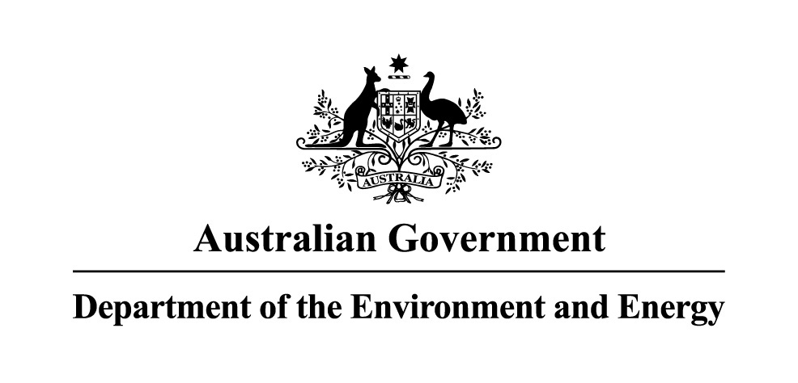
 | 


Project name: | 2017–18 Australian Plastics Recycling Survey
Report title: | National report
Author: | Kyle O’Farrell
Reviewers: | Peter Allan
Project reference: | A21505 | Envisage Works (ABN 12 584 231 841)  PO Box 7050, Reservoir East VIC 3073  admin@envisageworks.com.au
Document reference: | R01-02-A21505
Date: | 30 January 2019
Disclaimer
This report has been prepared on behalf of and for the exclusive use of the Department of the Environment and Energy, and is subject to and issued in accordance with the agreement between the Department of the Environment and Energy and Envisage Works. Envisage Works accepts no liability or responsibility whatsoever for any use of or reliance upon this report by any third party.

Acknowledgements
This report has been commissioned and funded by the following organisations:
- Australian Government Department of the Environment and Energy
- New South Wales Environment Protection Authority
- Sustainability Victoria
- Western Australia Department of Water and Environmental Regulation.
We acknowledge the time and effort that companies around Australia put into completing this survey year-on-year. This support allows the survey to be completed each year, with the outcome being one of the most long-running and comprehensive studies of its type in Australia. We would like to acknowledge and sincerely thank the following organisations for their input and support of the 2017–18 Australian Plastics Recycling Survey:
- Plastics reprocessors — for the provision of extensive data on plastics reprocessing activity in Australia.
- Waste plastics exporters — for the provision of information on the scrap plastics export market activity.
- Australian polymer producers and major importers — for the provision of resin production and consumption data.
- Supermarket industry and plastic bag manufacturers – for the provision of detailed information and advice on plastic bag consumption nationally.
- Green Industries SA for the provision of South Australian plastics recycling data.

Contents
Glossary / Abbreviations iv
Executive summary 1
1 Introduction 8
1.1 Definition of ‘plastic’ 9
1.2 Definitions of ‘recycling’, ‘reprocessing’ and ‘recovery’ 10
1.3 Changes in scope inclusions and exclusions in 2017–18 11
1.4 Data limitations and assumptions 11
2 Survey method 12
2.1 Data sources 12
2.2 Determination of plastics consumption 13
2.3 Determination of plastics recovery 13
2.4 Reporting categories 14
3 Australian consumption and recovery of plastics 17
3.1 Annual consumption and recovery of plastics 17
3.2 Plastics consumption in 2017–18 21
3.3 Plastics recovery in 2017–18 26
3.4 Impact of using consumption as a proxy for end-of-life arisings 34
4 Consumption and recycling by state/territory 36
4.1 Plastics consumption by state/territory 36
4.2 Plastics recycling and recycling rates by source state/territory 38
4.3 Cross border recyclate flows 42
4.4 Reprocessor numbers by state/territory 44
5 Recovery options for plastic products 46
5.1 Product repair, reuse or remanufacture 46
5.2 Mechanical recycling 46
5.3 Feedstock recycling 47
5.4 Biological recycling 47
5.5 Energy recovery 47
6 Key trends in plastics 48
6.1 Impact of Chinese import restrictions 48
6.2 Collection and processing 48
6.3 Market conditions for sale of recyclate 48
6.4 End market uses 49
7 References 50

Glossary / Abbreviations
ABS/SAN/ASA | Acrylonitrile butadiene styrene, styrene acrylonitrile and/or acrylonitrile styrene acrylate (PIC 7).
Bioplastics | Plastics that are biobased, biodegradable or both. Bioplastics fall into three broad groupings, which are: biobased (but not biodegradable); biodegradable (but not biobased); or biobased and biodegradable. Conventional polymers (e.g. PET and HDPE) can also be fully or partially ‘biobased’.
Commercial and Industrial (C&I) | Material from all commercial and industry sources other than construction and demolition (C&D) related sources.
Construction and Demolition (C&D) | Material from the construction, refurbishment and building demolition industries.
Consumption | Total use of product by Australian industry and consumers. Includes locally made and used product, imported product and locally utilised recyclate. Does not include locally made product that is exported for sale.
Converter | Company which converts polymer resin, either virgin resin or recycled content resin, into plastic products.
Diversion rate | Recovery as a proportion of end-of-life disposal.
Domestic | Material from domestic (household) sources.
Energy recovery | Combustion of waste plastics as either a fuel substitute (e.g. in cement kilns), or in specialised waste combustion facilities to create heat, which is then generally used for steam production. The steam is then used directly in industrial processes and/or used to generate electricity.
Export for reprocessing | Material sent for reprocessing overseas.
Feedstock (chemical) recycling | The use of chemical processes such as pyrolysis to convert scrap plastics into a hydrocarbon gas or liquid (often a polymer to monomer conversion) that is usable as a fuel or as an input for manufacturing plastics resins.
Flexible plastics | Plastic material that does not hold a three-dimensional shape during sorting and transport.
Household | Material from domestic (household) sources.
In the gate | Material entering a facility for reprocessing. This may include material that is unusable due to contamination. In the gate material that is subsequently sent to landfill is generally either a combination of gross contamination (i.e. materials that should not have been presented and are not recyclable at the receiving facility) and/or designated scrap plastics that were not recovered into product due to cross contamination with unrecyclable materials or losses due to other types of production inefficiencies (e.g. losses to trade waste). Also see ‘Out the gate’.
Internal use | Recyclate processed and used within the one company.
Local use | Recyclate used within Australia by an Australian company in the manufacture of a new product.
Local/Locally | In Australia.
Material flow analysis (MFA) | Material flow analysis (MFA) is a mass balanced based analytical method to quantify flows and stocks of materials or substances for a well-defined system and time period. MFA is also referred to as substance flow analysis (SFA).
Mechanical recycling | The use of physical processes such as sorting, chipping, grinding, washing and extruding to convert scrap plastics to a usable input for the manufacture of new products.
MRF | Material Recovery Facility – a facility for the sorting of recyclables (typically packaging) into various product streams.
Municipal | Household material plus material from public place recycling and other council services.
NTCRS | National Television and Computer Recycling Scheme.
Non-packaging / durable | Long-term use item; not designed to be single use or disposable within a 12-month period.
Other | Other polymers types not specifically defined, including various acrylics, acetals, polyethylene oxide, polyisobutylene and other polymers of propylene (other than PP), and polymers of styrene (other than PS, P-ES and ABS/SAN).
Out the gate | Material leaving a facility following reprocessing and excluding most contamination. Also see ‘In the gate’.
Packaging | Plastic material used for the containment, protection, marketing or handling of product. Includes primary, secondary and tertiary/freight packaging in both consumer and industrial packaging applications.
PE-HD or HDPE | High density polyethylene (PIC 2). Typically referred to as HDPE.
PE-LD/LLD or LDPE/LLDPE | Both low density polyethylene and linear low density polyethylene (PIC 4). Typically referred to as LDPE/LLDPE.
PE-LD or LDPE | Low density polyethylene (PIC 4). Typically referred to as LDPE.
PE-LLD or LLDPE | Linear low density polyethylene (PIC 4). Typically referred to as LLDPE.
PET | Polyethylene terephthalate (PIC 1).
PIC | Plastics identification code. Also known overseas as the Resin Identification Code (RIC).
PU or PUR | Polyurethane (PIC 7).
Post-consumer domestic | Used material from household sources. Mostly packaging material from kerbside recycling collections.
Post-consumer industrial | Used material from non-household sources.
PP | Polypropylene (PIC 5).
Pre-consumer industrial | Scrap off-cuts and off-specification items in the manufacturing industry which are not used by the consumer which are collected for reprocessing at a different site. Does not include material that is recycled directly back into manufacturing processes at the same site. Does not include material that has reached the end consumer, whether domestic or industrial.
PS | Polystyrene (PIC 6).
PS-E or EPS | Expanded polystyrene (PIC 6). Typically referred to as EPS.
PVC | Polyvinyl chloride (PIC 3).
Recovery | The term ‘recovery’ as used in this study is defined as the amount of material collected for reprocessing (i.e. in-the-gate of reprocessors or to export). Typically recovery includes some contaminate materials and also materials intended for reprocessing but which are lost during overall recycling process.
Recyclate | Scrap material either before or after reprocessing.
Recycling | A general term covering the process chain of collection, sorting, reprocessing and the manufacture of new products. In this report where the terms ‘recycling’ or ‘recycling rate’ are used this typically refers to recyclate at the point of entering a plastics reprocessing facility, or when sent directly to export.
Recycling rate | See ‘Recycling’.
Reprocess(ing) | Process(es) by which aggregated end-of-life materials are converted into a raw material that can be used as an input into new product manufacturing.  For this study the applied definition of Australian based reprocessing is the off-site sourcing of waste plastics (including returned product, e.g. EPS waffle pod off-cuts from building sites) which are then converted into either a finished or semi-finished product, or into a chipped format or similar. In-house recovery/regrind, or the baling and compaction of plastics where further reprocessing is required (e.g. size reduction) before the recyclate can be used to manufacture a new product is not reported as reprocessing.
Resin | Raw polymer material.
Rubber – natural | A group of biobased polyisoprenes primarily made from latex harvested from the rubber tree. Typically made into products containing other additives, for example tyres with a partial or fully natural rubber component may also contain steel wire, plastic fibres and fabrics (typically nylon or polyester based), carbon black, silica, zinc oxide, sulfur and other additives.
Rubber – synthetic | A broad group of petrochemical based elastomers such as styrene-butadiene rubbers (SBR). Typically made into products containing other additives, for example tyres with a partial or fully synthetic rubber component may also contain steel wire, plastic fibres and fabrics (typically nylon or polyester based), carbon black, silica, zinc oxide, sulfur and other additives.
Sorting | A process typically between collection (recovery) and reprocessing in which collected end-of-life materials are sorted (or disassembled) into more usable and economically valuable material fractions.
Virgin | All-new polymer material containing no recycled material.
Waste plastics export | Export of (typically baled) scrap plastics material sent off-shore for reprocessing.
XPS | Extruded polystyrene (PIC 6).

Executive summary
In 2018, the Australian Government Department of the Environment and Energy, and New South Wales, Victorian and Western Australian state agencies commissioned the annual Australian Plastics Recycling Survey (APRS) to capture the consumption and recovery of plastics in Australia during the 2017–18 financial year.
This information is collected through a detailed survey of Australian reprocessors, Australian resin manufacturers and importers, and extensive interrogation of Australian Customs data, sourced from the Department of Foreign Affairs and Trade (DFAT).
Green Industries SA performs its own survey of South Australian plastics reprocessors and material recovery facility operators, and the data from that survey is incorporated into this report.
The 2018 survey has been conducted by the partnership of Envisage Works and Sustainable Resource Use (SRU), and the survey results are aggregated and analysed within this report. This research started in 1997 and has been undertaken annually since 2000.
The survey provides a comprehensive picture of the consumption, flow and recycling of plastics in Australia, the state of reprocessing markets and helps to inform product stewardship developments. The survey is a valuable tool for promotion, knowledge of the industry and forward planning. The survey informs policy development and supports the tracking of policy outcomes. It also supports programs to further improve plastics resource efficiency over product life cycles.

Key survey findings
The key findings of the Australian Plastics Recycling Survey assessing the 2017–18 financial year are:
- A total of 3.4 million tonnes of plastics were consumed in Australia.
- A total of 320 000 tonnes of plastics were recovered.
- The national plastics recycling rate was 9.4%.
- Of the 320 000 tonnes of plastics collected for reprocessing, 145 700 tonnes (46%) was reprocessed in Australia and 174 300 tonnes (54%) was exported for reprocessing.

Annual consumption and recovery of plastics
Table E-1 – Annual Australian consumption and recovery of plastics
Year | Plastics consumption | Plastics recovery | Plastics recycling rate
 | (tonnes) | (tonnes) | (%)
2000 | N/A | 167 700 | N/A
2001 | N/A | 160 900 | N/A
2002 | N/A | 157 300 | N/A
2003 | N/A | 189 400 | N/A
2004 | N/A | 191 000 | N/A
2005 | N/A | 232 000 | N/A
2006 | N/A | 244 000 | N/A
2007 | N/A | 261 100 | N/A
2008 | N/A | 282 000 | N/A
2009–10 | N/A | 288 200 | N/A
2010–11 | N/A | 287 400 | N/A
2011–12 | N/A | 302 600 | N/A
2012–13 | N/A | 307 300 | N/A
2013–14 | N/A | 313 700 | N/A
2014–15 | 3 167 000 | 341 800 | 10.8%
2015–16 | 2 912 000 | 328 900 | 11.3%
2016–17 | 2 955 400 | 291 000 | 9.8%
2017–18 | 3 407 300 | 320 000 | 9.4%

Presented in Figure E-1 is the quantity of plastics recovered in Australia across the period between 2000 to 2017–18. The proportion of plastics exported for reprocessing in 2017–18 was 54%.

Figure E-1 – Annual Australian plastics recovery 2000 to 2017–18, by location of reprocessing (tonnes)
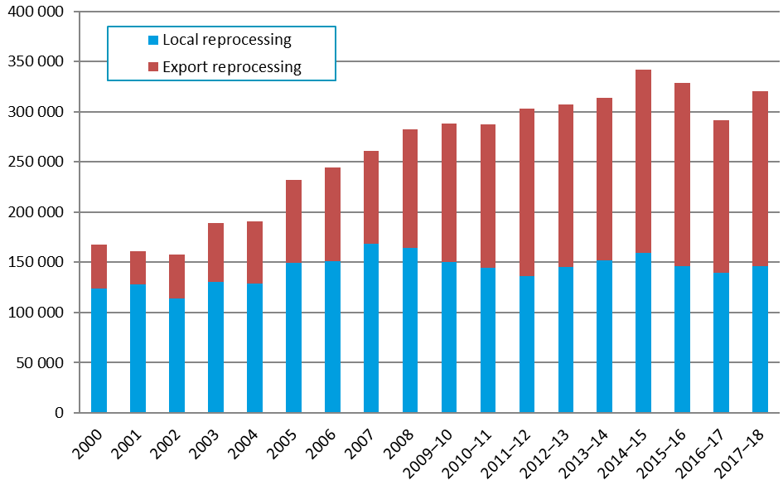
Presented in the Figure E-2 are the annual plastics recycling rates across the period from 2014–15 to 2017–18.

Figure E-2 – Annual Australian plastics recycling rates 2014–15 to 2017–18
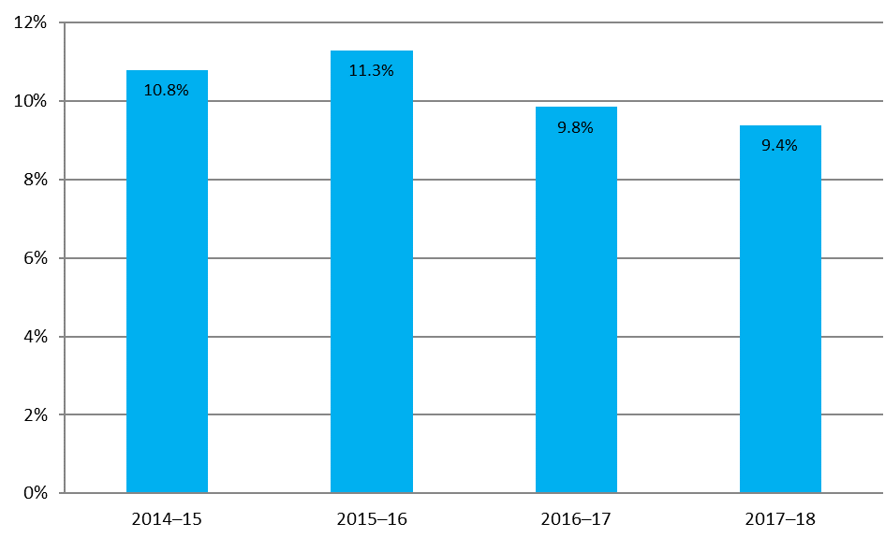

Overall plastics consumption in 2017–18
Around 58% of plastics consumption was through imported finished and semi-finished goods, with only 38% of consumption through local manufacturing using virgin resins (either locally manufactured or imported), and 4% of consumption using locally processed recyclate based resins.

Figure E-3 – Australian plastics consumption by polymer type and source in 2017–18 (tonnes)
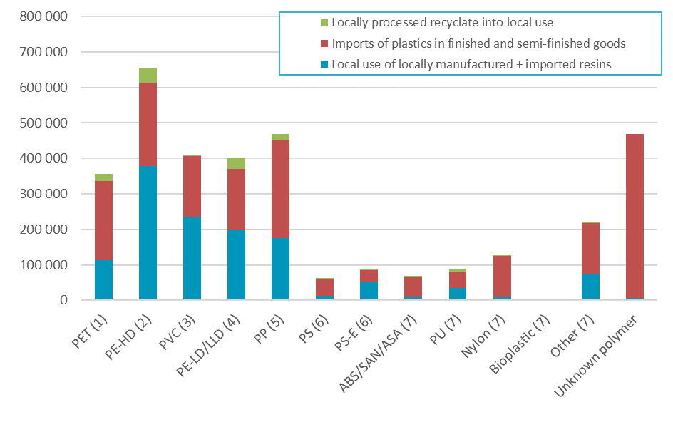

Plastics consumption and recovery by polymer type in 2017–18
The highest recycling rate observed in 2017–18 was for PET at 21.1% (primarily sourced from packaging), followed by HDPE (also primarily from packaging) at 15.0%. The recovery of these polymers is underpinned by the Australian Packaging Covenant, which is the national product stewardship scheme for packaging.
Following PET and HDPE the next highest recycling rates were for LDPE/LLDPE (14.3%), PS (11.5%) and ABS/SAN/ASA (8.7%). The recovery of PS and ABS/SAN/ASA is supported by another product stewardship scheme, which is the National Television and Computer Recycling Scheme (NTCRS).

Figure E-4 – Plastics consumption and recovery by polymer type in 2017–18 (tonnes and % recycling rate)
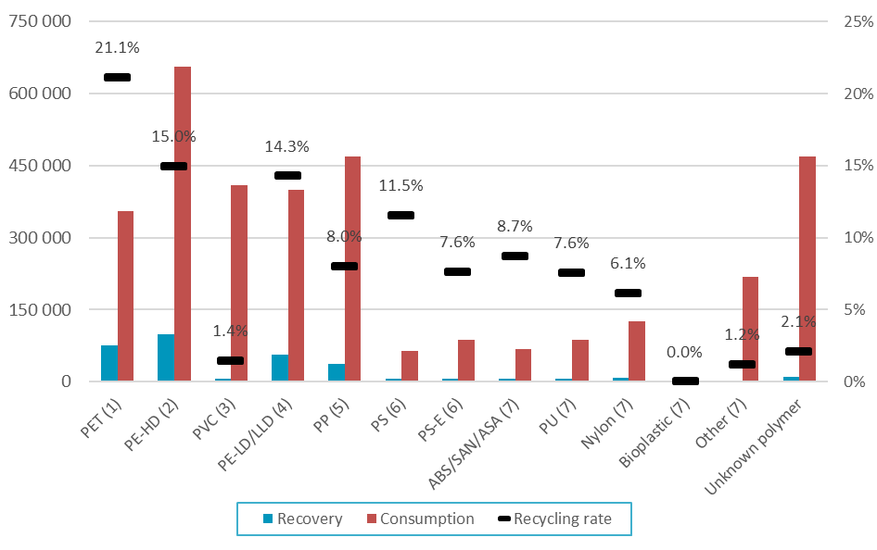

Plastics consumption and recovery by application area in 2017–18
Plastics recovery from packaging applications dominates overall recovery, with packaging from municipal and commercial and industrial (C&I) sources making up 51% and 19% of total recovery in terms of weight. Recovery from all other application areas contribute around 29% of the total, with major recovery routes being e-waste recycling and the export of used clothing.
Plastic packaging had a recycling rate of 20.6% (combined municipal and C&I), which was relatively good compared to all other application areas for plastics. At 7.0% the recycling rates for plastics recovered from the agricultural and ‘other’ application areas are the next highest. The recycling rates across all application areas continue to be poor to very poor.

Figure E-5 – Plastics consumption and recovery by application area in 2017–18 (tonnes and % recycling rate)
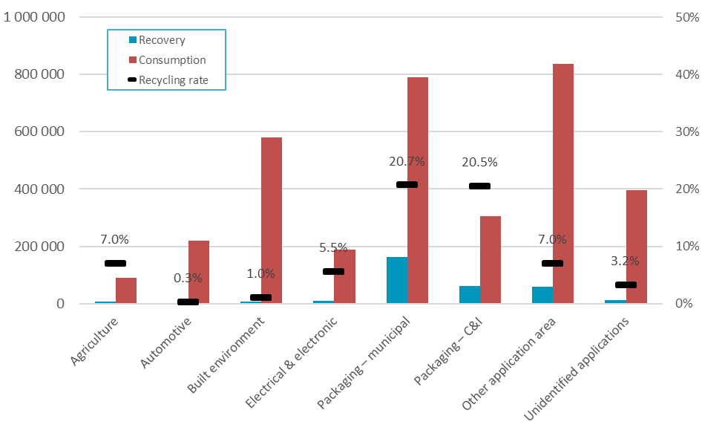

Plastics recovery by waste stream in 2017–18
In 2017–18 of all plastics recovered in Australia, 51% of plastics were recovered from the municipal sector, 47% from the C&I sector, and 2% from the construction and demolition (C&D) sector.

Figure E-6 – Waste stream sources of recyclate by polymer type in 2017–18 (tonnes)
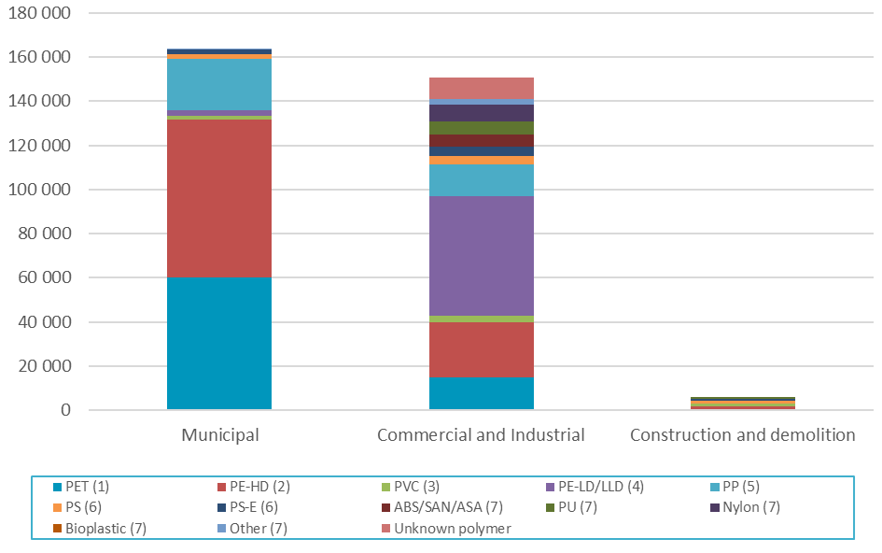

Introduction
Since 2000, the Australian Plastics Recycling Survey (APRS) has been conducted each year to collect data on plastics manufacturing, imports, local reprocessing and exports destined for reprocessing. In 2018 this study has been commissioned by the Australian Government Department of the Environment and Energy, and state government agencies in New South Wales, Victoria and Western Australia.
This report is the national data report for the 2017–18 financial year, and reports on plastics consumption and recovery Australia-wide, across polymer types and the application areas of plastics use.
The survey provides a comprehensive picture of the consumption, flow and recycling of plastics in Australia, the state of reprocessing markets and the status of product stewardship commitments. The survey is a valuable tool for promotion, knowledge of the industry and forward planning. The survey informs policy development and supports the tracking of policy outcomes. It also supports programs to further improve plastics resource efficiency over product life cycles. In more detail this up-to-date and reliable plastics flow data provides:
- an understanding of the current state of demand, use, recovery and recycling across a broad range of sectors and polymer types
- reliable and year-on-year consistent data to governments, industry and the broader community
- information for responses to international surveys
- information on plastic recycling rates by application area for interested stakeholders
- information on the import and export flows of plastics
- information on the use and destination of recovered plastics materials, and
- information to support the development and tracking of policies and programs to assist further improvement of plastics resource efficiency over whole of life.
In 2015, the methodology for determining plastics consumption was updated and expanded to include estimates of consumption of plastics through imported finished and semi-finished plastic goods, including packaging on imported goods. Prior to the 2014–15 year, the methodology only included imported virgin plastics, and no other plastic product imports. However, the market for plastics products in Australia has shifted significantly in the nearly 20 years (1997) since the superseded methodology was developed, with local manufacturing decreasing and an ongoing increase in imported finished and semi-finished goods and plastic packaging. For this reason, plastics consumption estimates prior to 2014–15 are not directly comparable with later estimates and are not provided in this report.
Consumption data is estimated from a variety of sources including:
- Australian based resin manufacturers.
- Australian based resin importers.
- Customs import and export data.
- Plastics reprocessors (returning end-of-life plastics back into use).
As this project was undertaken as a national study and there is currently insufficient data available to break down consumption by jurisdiction, consumption has been split by jurisdiction based on per capita allocations. As such, estimates for jurisdiction based consumption do not include the varying intensity of industry across different jurisdictions nor allow for any variable patterns of domestic consumption.
For all plastic products, recovery is often an important stage of the product life cycle. While there are a range of current technologies available for recovery, in Australia mechanical recycling is the primary process used to recover plastic materials, with energy recovery accounting for minimal recovery during 2017–18 (around 3–4%).
The life-span of plastic products varies from short-term single-use items, to long-term durable products which may remain in use for many years before reaching end-of-life. This creates a challenge for estimating the recycling rates of plastic products with a lifespan of more than 1–2 years as consumption is not equivalent to the quantity of plastics reaching end-of-life (waste arisings) and are thus available for recovery. This issue and how it is handled is discussed in more detail in Section 3.4 of this report.
The demand for some types of recovered plastics, used in the production of new products, has grown only slowly in strength both domestically and internationally over the last ten years. Reasonably well-developed plastics collection through the kerbside recycling system enables the recovery of many post-consumer household recyclables. There are also established systems for the collection and reprocessing of pre-consumer industrial scrap and many types of post-consumer industrial plastics.
However, away-from-home plastic packaging collection systems, and systems for the recovery of many types of non-packaging plastic items, both residential and non-residential, continue to be underdeveloped, and most of these products continue to be disposed to landfill at end of life.

Definition of ‘plastic’
For clarity, the definition of a ‘plastic’ that has been applied in the survey scope coverage and this report is:
A plastic material is any of a wide range of synthetic or semi-synthetic organic solids that are mouldable. Plastics are typically organic polymers of high molecular mass, but they often contain other substances. They are usually synthetic, most commonly derived from petrochemicals, but many are either partially natural or fully natural (i.e. biobased).
The polymer types covered in the study are summarised in the following table.
Table 1 – Polymer types and PIC
PIC | Polymer type | Main applications
1 | Polyethylene terephthalate (PET) | Rigid packaging and clothing.
2 | High density polyethylene (PE-HD) | Rigid and flexible packaging applications, and many other significant applications as well.
3 | Poly-vinyl chloride (PVC) | Piping and conduit into the built environment.
4 | Low / linear low density polyethylene (PE-LD/LLD) | Flexible packaging formats.
5 | Polypropylene (PP) | Packaging, vehicles and many other significant applications as well.
6 | Polystyrene (PS) and expanded polystyrene (PS-E) | Packaging, built environment, electrical & electronic devices.
7 | Acrylonitrile butadiene styrene / styrene acrylonitrile / acrylonitrile styrene acrylate (ABS/SAN/ASA) | Vehicles and electrical & electronic devices.
7 | Polyurethanes (PU) | Vehicles, the built environment and many other applications.
7 | Nylons (polyamides) | Clothing, vehicles, the built environment and many other applications.
7 | Bioplastics | Rigid and flexible packaging applications.
7 | Other aggregated polymer types | -
Refer to Table 8 on page 23 for a detailed breakdown on the main application areas for each polymer type.
The plastic resin types which make up most of the ‘other aggregated’ category are various acrylics, acetals, polyethylene oxide, polyisobutylene and other polymers of propylene (other than PP), and polymers of styrene (other than PS, P-ES and ABS/SAN).

Definitions of ‘recycling’, ‘reprocessing’ and ‘recovery’
In the plastics industry, the term ‘recycling’ is used to cover a range of activities including collection, sorting, reprocessing, export for reprocessing and manufacture of new products. To avoid double-counting of material flowing through the system to local reprocessors, the focus of data gathering in this survey was placed on the reprocessing stage of the plastics life cycle.
The applied definition of Australian based reprocessing for the survey is the off-site sourcing of waste plastics (including returned product, e.g. EPS waffle pod off-cuts from building sites) which are then converted into either a finished or semi-finished product, or into a chipped format or similar. In-house recovery/regrind, or the baling and compaction of plastics where further reprocessing is required (e.g. size reduction) before the recyclate can be used to manufacture a new product is not reported as reprocessing.
Plastic scrap that is collected and exported for reprocessing and use overseas is defined as reprocessed. Sorting, reprocessing and manufacturing losses that occur overseas are not estimated.
The term ‘recovery’ is also used in this report and is defined as the amount of material collected for reprocessing (i.e. in-the-gate of reprocessors or to export). Typically, recovered material includes some contaminate materials and also materials intended for reprocessing, but which are lost during the overall recycling process.

Changes in scope inclusions and exclusions in 2017–18
This year all plastics reprocessor reported data has been standardised to an ‘in-the-gate’ basis for the first time. While most reprocessors have historically reported recovery data on an in-the-gate basis, not all have done so, so this adjustment will have the impact of increasing apparent total recovery by a small amount (estimated to be around 1–2% nationally). All surveyed reprocessors are requested to state both the basis of their reporting (either in-the-gate or out-the-gate), and an estimate of the percentage of received material that is sent to landfill. This data enables the determination of the uniform in-the-gate estimates.
The tyres product group were provisionally included in the APRS project scope in 2016–17. However, due to duplicated data collection and reporting of tyres recovery with other waste and recycling data collection exercises nationally, and double reporting issues that arose, tyres have been excluded from the APRS scope this year, along with natural and synthetic rubbers more generally. To improve year on year comparability any 2016–17 data provided in this report excludes tyres and rubbers consumption and recovery.
For the first time this year estimates of recovery of plastics in exported used clothing and footwear is incorporated into the APRS estimates.
Paints, adhesives and other coatings continue to be excluded from the scope of the APRS.

Data limitations and assumptions
This report provides data on plastics reprocessing from Australian sources for the 2017–18 financial year. Data for 58 reprocessing facilities nationally, out of 66 reprocessors known to be active during 2017–18, has been obtained either through surveys or estimated (three facilities) and incorporated into the survey dataset. This is a coverage rate of nearly 90% by number, and is estimated to account for >95% of local reprocessing by weight. Considering individual reprocessor stated response accuracies, nationwide it is estimated that local reprocessing quantities provided in this report are within ±6% of actual reprocessing.
Plastics consumption at the state/territory level are estimated based on per capita allocations, as there is no other good quality data available to break down consumption by jurisdiction. As such, estimates for consumption are approximations only, and do not account for any variations in intensity of industry across different jurisdictions, nor allow for any variable patterns of domestic consumption.
The National Television and Computer Recycling Scheme (NTCRS) data incorporated into the study is for the 2016–17 financial year, as 2017–18 data was not available at the time of reporting.
To avoid overstating the accuracy of the data and the subsequent calculations, data in this report has generally been rounded to the nearest 100 tonnes.
In the tables presented in this report, minor discrepancies may occur between summed totals presented in tables, and the apparent sums of the component items in tables, as summed totals are calculated using component item values prior to rounding.

Survey method

Data sources
Plastics consumption and recovery data was obtained from a combination of sources, primarily:
- Australian resin producers (survey).
- Resin importers (survey).
- Australian import and export data (Australian Customs import/export Harmonized Tariff Item Statistical Code (HTISC) data extract).
- Australian plastics reprocessors (survey).
- Australian plastics export brokers (survey).
Resin producers and importers, reprocessors and exporters of used plastics were identified through previous survey contacts, the project team’s industry knowledge, state agency consultation and industry sources.
Import and export flows of plastics were primarily determined through the review and analysis of 2200 Customs import codes and 1300 export codes.
Domestic reprocessing figures were obtained from surveying individual Australian plastics reprocessing businesses, and export of recyclate was estimated from data provided by reprocessors and exporters, and review and analysis of the relevant Customs export codes.
The recovered plastics data published throughout this report does include scrap plastics being burnt in cement kilns for energy recovery. This type of recovery, in any significant quantity during 2017–18, was restricted to South Australia. However, significant scrap plastics processing for energy recovery will take place in NSW, starting in the 2018–19 financial year.
Population data was sourced from the Australian Bureau of Statistics (2018a; 2018b) for all states and territories, and was used to support the estimation of plastics consumption for each jurisdiction on a per capita basis.
Table 2 – State/territory populations at 30 June 2018
Jurisdiction | Population | % of national population
ACT | 420 700 | 1.7%
NSW | 8 001 200 | 32.0%
NT | 249 800 | 1.0%
QLD | 5 013 400 | 20.0%
SA | 1 735 200 | 6.9%
TAS | 526 900 | 2.1%
VIC | 6 465 900 | 25.9%
WA | 2 598 100 | 10.4%
Total | 25 011 200 | 100.0%
Sources: ABS (2018a; 2018b)

Determination of plastics consumption
Plastics consumption is determined using the approach outlined in Table 3.

Table 3 – Determination of plastics consumption and related information sources
 | Consumption flow | Primary information sources
 | Local resin production | Local resin manufacturers
+ | Imported resin | Customs import data
+ | Imported plastics in finished and semi-finished goods | Customs import data
+ | Plastic recyclate (local use) | Local reprocessors
+ | Scrap import | Customs import data
- | Exported plastics in finished and semi-finished goods | Customs export data
- | Export of locally produced resin | Customs export data / Local resin manufacturers
= | Domestic consumption

Determination of plastics recovery
Plastics recovery is determined using the approach outlined in Table 4.

Table 4 – Determination of plastics recovery and related information sources
 | Material flow | Primary information sources
 | Recyclate to local reprocessors (to local use) | Local reprocessors
+ | Recyclate to local reprocessors (to export) | Local reprocessors
+ | Recyclate (unprocessed scrap) to overseas reprocessors | Customs export data
= | Total recovery

Reporting categories

Polymer types
The polymer types covered by this survey, and the identifying Plastics Identification Code (PIC) have been previously outlined in Table 1 on page 10 of this report.

Application areas
The application area destinations (for consumption) and sources (for recovery) used in this report are:
- Agriculture
- Automotive
- Built environment
- Electrical & electronic
- Packaging – municipal
- Packaging – C&I
- Other application area
- Unidentified applications
The major applications within each application area are summarised in Table 5.
Table 5 – Major product types in each application area
Application area | Product types
Agriculture | Flexible film
 | Twine and rope
 | Irrigation pipe
 | Other agricultural applications
Automotive | Vehicle body
 | Tyres
 | Other automotive
Built environment | Pipes and cables
 | Windows and doors
 | Insulation
 | Fit-out
 | Carpet and other floor coverings
 | Other built environment
Electrical & electronic | TVs and computers
 | Power tools
 | Toys
 | White goods and small appliances
 | Other electrical and electronic
Packaging – municipal | Flexible packaging
 | Rigid packaging
 | Other packaging
Packaging – C&I | Flexible packaging
 | Rigid packaging
 | Other packaging
Other application area | Household products
 | Furniture
 | Clothing and footwear
 | Rope, cable, twine and thread
 | Textiles
 | All other applications
Unidentified applications | Unidentified applications

Waste streams
In this report waste stream sources of recyclate are reported, in terms of the municipal, commercial & industrial (C&I), and construction & demolition (C&D) sectoral waste streams.

Australian consumption and recovery of plastics

Annual consumption and recovery of plastics
Data for total annual plastics consumption (2014–15 to 2017–18) and total annual plastics recovery (2000 to 2017–18) are presented in Table 6.
The total consumption of plastics in Australia in 2017–18 was 3 407 300 tonnes with recovery of 320 000 tonnes, giving a recycling rate in 2017–18 of 9.4%.

Table 6 – Annual Australian plastics consumption and recovery 2000 to 2017–18
Year | Plastics consumption | Plastics recovery | Plastics recycling rate
 | (tonnes) | (tonnes) | (%)
2000 | N/A | 167 700 | N/A
2001 | N/A | 160 900 | N/A
2002 | N/A | 157 300 | N/A
2003 | N/A | 189 400 | N/A
2004 | N/A | 191 000 | N/A
2005 | N/A | 232 000 | N/A
2006 | N/A | 244 000 | N/A
2007 | N/A | 261 100 | N/A
2008 | N/A | 282 000 | N/A
2009–10 | N/A | 288 200 | N/A
2010–11 | N/A | 287 400 | N/A
2011–12 | N/A | 302 600 | N/A
2012–13 | N/A | 307 300 | N/A
2013–14 | N/A | 313 700 | N/A
2014–15 | 3 167 000 | 341 800 | 10.8%
2015–16 | 2 912 000 | 328 900 | 11.3%
2016–17 | 2 955 400 | 291 000 | 9.8%
2017–18 | 3 407 300 | 320 000 | 9.4%

Figure 1 – Annual Australian plastics consumption and recovery 2014–15 to 2017–18 (tonnes)
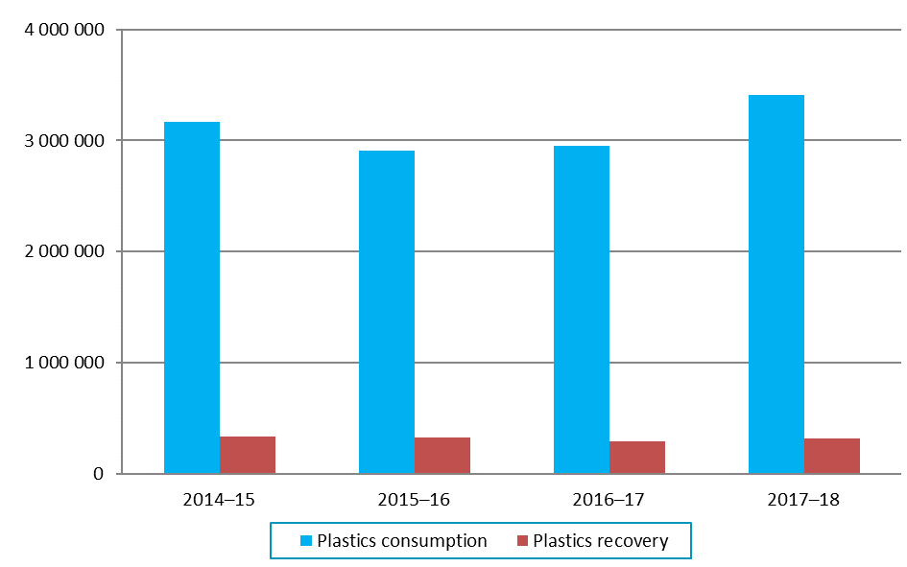

Presented in Figure 2 is the quantity of plastics recovered in Australia across the period from 2000 to 2017–18. The level of export for reprocessing determined for 2017–18 (56.6%) is the highest yet observed. For comparative purposes, in 2000 the level of export for reprocessing was 26.0%.

Figure 2 – Annual Australian plastics recovery 2000 to 2017–18

Presented in Figure 3 are the annual plastics recycling rates across the period from 2014–15 to
2017–18.

Figure 3 – Annual Australian plastics recycling rates 2014–15 to 2017–18
It is important to note that the ‘recycling rate’ is an approximation calculated by dividing plastics recovery in any given year, by consumption in that year. A true recycling rate (or diversion rate) is calculated by dividing recovery by end-of-life arisings (i.e. the quantity of plastics that is available to be diverted to recovery from landfill). The approximation of dividing recovery by consumption is adequate for short lived plastic applications, such as packaging, however it is less appropriate for plastics going into longer lived applications, such as the built environment as it would be generally anticipated that less plastic is reaching end-of-life, than is going into use.
For this reason, the estimated recycling rates are probably conservative and the true recycling rate is likely to be somewhat higher. More detailed analysis and discussion on the recycling rate approximation approach and implications are provided in Section 3.4 of this report.

Plastics consumption in 2017–18
Australian plastics consumption data for 2017–18 is summarised in Table 7 and Figure 4. Consumption estimates of under 100 tonnes are reported as “<100”.

Table 7 – Australian plastics consumption by polymer type and source in 2017–18 (tonnes)
Polymer type | Local use of locally manufactured + imported resins | Imports of plastics in finished and semi-finished goods | Locally processed recyclate into local use | Australian consumption
PET (1) | 114 100 | 223 000 | 18 200 | 355 300
PE-HD (2) | 377 600 | 235 600 | 43 300 | 656 500
PVC (3) | 233 900 | 172 000 | 4 300 | 410 200
PE-LD/LLD (4) | 198 800 | 172 400 | 28 800 | 399 900
PP (5) | 176 300 | 274 000 | 18 500 | 468 900
PS (6) | 12 900 | 48 700 | 1 900 | 63 600
PS-E (6) | 50 500 | 34 900 | 1 700 | 87 100
ABS/SAN/ASA (7) | 9 500 | 56 900 | 800 | 67 300
PU (7) | 35 600 | 44 500 | 6 500 | 86 600
Nylon (7) | 10 800 | 114 500 | 200 | 125 500
Bioplastic (7) | <100 | <100 | 0 | <100
Other (7) | 75 300 | 141 900 | 800 | 218 000
Unknown polymer | 5 800 | 462 500 | 0 | 468 400
Total | 1 301 200 | 1 981 000 | 125 100 | 3 407 300

In 2017–18, around 58% of plastics consumption was through imported finished and semi-finished goods, with only 42% of consumption through local manufacturing using either virgin resins (both locally manufactured and imported) or recyclate based resins. The last decade has seen the local manufacturers of PET, PVC, PS and EPS resins cease production, and at the current time the only major resin types still produced in Australia are HDPE, LDPE and PP.

Figure 4 – Australian plastics consumption by polymer type and source in 2017–18 (tonnes)

Presented in Table 8, Table 9 and Figure 5 is the consumption of plastics nationally in 2017–18, by application area.

Table 8 – Application area destinations of all plastics by polymer type in 2017–18 (tonnes)
Polymer type | Agriculture | Automotive | Built environment | Electrical & electronic | Packaging – municipal | Packaging – C&I | Other applic. area | Unidentified applications | Total
PET (1) | 2 600 | 4 500 | 26 300 | <100 | 116 700 | 11 700 | 144 800 | 48 600 | 355 300
PE-HD (2) | 26 300 | 7 400 | 85 900 | 9 500 | 229 700 | 134 400 | 124 500 | 38 900 | 656 500
PVC (3) | 100 | 20 400 | 277 300 | 37 400 | 20 800 | <100 | 38 100 | 16 100 | 410 200
PE-LD/LLD (4) | 51 400 | <100 | 11 100 | 6 100 | 144 300 | 139 500 | 27 200 | 20 400 | 399 900
PP (5) | 6 900 | 78 900 | 27 100 | 18 600 | 163 000 | 6 100 | 117 500 | 50 800 | 468 900
PS (6) | <100 | <100 | 7 100 | 33 600 | 14 600 | <100 | 7 500 | 700 | 63 600
PS-E (6) | <100 | <100 | 35 700 | 24 800 | 9 800 | 12 600 | 3 000 | 1 100 | 87 100
ABS/SAN/ASA (7) | <100 | 37 400 | 1 200 | 17 200 | 3 400 | <100 | 7 900 | 200 | 67 300
PU (7) | <100 | 24 100 | 24 900 | 1 100 | <100 | <100 | 34 700 | 1 900 | 86 600
Nylon (7) | 2 600 | 15 900 | 17 400 | <100 | <100 | <100 | 76 800 | 12 700 | 125 500
Bioplastic (7) | <100 | <100 | <100 | <100 | <100 | <100 | <100 | <100 | <100
Other (7) | 400 | 21 500 | 44 200 | 2 600 | 7 800 | <100 | 39 600 | 101 800 | 218 000
Unknown polymer | 500 | 9 500 | 21 200 | 37 900 | 80 000 | <100 | 215 900 | 103 400 | 468 400
Total | 90 800 | 219 600 | 579 400 | 188 800 | 790 100 | 304 300 | 837 500 | 396 600 | 3 407 300

Table 9 – Application area destinations of all plastics by polymer type in 2017–18 (%)
Polymer type | Agriculture | Automotive | Built environment | Electrical & electronic | Packaging – municipal | Packaging – C&I | Other applic. area | Unidentified applications | Total
PET (1) | 0.7% | 1.3% | 7.4% | 0.0% | 32.9% | 3.3% | 40.8% | 13.7% | 100.0%
PE-HD (2) | 4.0% | 1.1% | 13.1% | 1.4% | 35.0% | 20.5% | 19.0% | 5.9% | 100.0%
PVC (3) | 0.0% | 5.0% | 67.6% | 9.1% | 5.1% | 0.0% | 9.3% | 3.9% | 100.0%
PE-LD/LLD (4) | 12.8% | 0.0% | 2.8% | 1.5% | 36.1% | 34.9% | 6.8% | 5.1% | 100.0%
PP (5) | 1.5% | 16.8% | 5.8% | 4.0% | 34.8% | 1.3% | 25.1% | 10.8% | 100.0%
PS (6) | 0.1% | 0.0% | 11.1% | 52.8% | 23.0% | 0.0% | 11.9% | 1.0% | 100.0%
PS-E (6) | 0.0% | 0.0% | 41.0% | 28.5% | 11.2% | 14.5% | 3.5% | 1.3% | 100.0%
ABS/SAN/ASA (7) | 0.0% | 55.6% | 1.8% | 25.6% | 5.1% | 0.0% | 11.7% | 0.2% | 100.0%
PU (7) | 0.0% | 27.8% | 28.8% | 1.2% | 0.0% | 0.0% | 40.0% | 2.2% | 100.0%
Nylon (7) | 2.1% | 12.7% | 13.9% | 0.0% | 0.1% | 0.0% | 61.2% | 10.1% | 100.0%
Bioplastic (7) | 0.0% | 0.0% | 0.0% | 0.0% | 80.0% | 0.0% | 0.0% | 20.0% | 100.0%
Other (7) | 0.2% | 9.9% | 20.3% | 1.2% | 3.6% | 0.0% | 18.2% | 46.7% | 100.0%
Unknown polymer | 0.1% | 2.0% | 4.5% | 8.1% | 17.1% | 0.0% | 46.1% | 22.1% | 100.0%
Total | 2.7% | 6.4% | 17.0% | 5.5% | 23.2% | 8.9% | 24.6% | 11.6% | 100.0%

Figure 5 – Application area destinations of all plastics by polymer type in 2017–18 (tonnes)
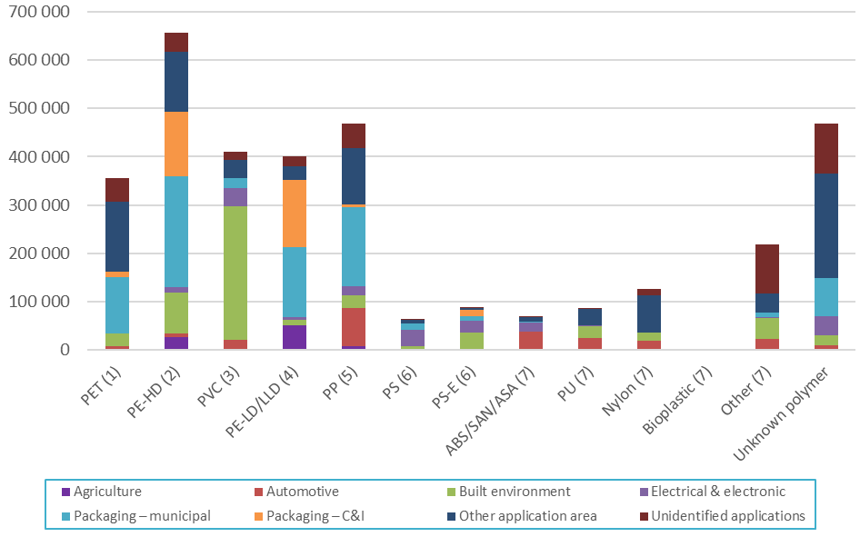

Table 9 shows that the consumption of PET is predominately split between packaging and other applications (mainly clothing and textiles). HDPE and LDPE are predominately consumed in packaging applications, with PVC consumption dominated by built environment applications. PP consumption is dominated by automotive (imports), packaging and other application areas. A large proportion of PS goes into electrical and electronic applications, and EPS is spread more evenly across built environment, electrical & electronic and packaging applications.

Plastics recovery in 2017–18

Recovery quantities
Presented in Table 10 and Figure 6 is overall plastics recovery, in terms of the destination of recovered recyclate for reprocessing (i.e. local reprocessing or export for reprocessing).

Table 10 – Australian plastics reprocessing destination by polymer type in 2017–18 (tonnes)
Polymer type | Locally reprocessed to local use | Locally reprocessed to export | Direct to overseas | Total recovery
PET (1) | 18 200 | 1 200 | 55 500 | 74 900
PE-HD (2) | 43 300 | 7 600 | 47 300 | 98 100
PVC (3) | 4 300 | 100 | 1 500 | 5 900
PE-LD/LLD (4) | 28 800 | 6 600 | 21 600 | 57 100
PP (5) | 18 500 | 700 | 18 300 | 37 500
PS (6) | 1 900 | 600 | 4 800 | 7 300
PS-E (6) | 1 700 | 2 700 | 2 200 | 6 600
ABS/SAN/ASA (7) | 800 | 100 | 4 900 | 5 900
PU (7) | 6 500 | 0 | 0 | 6 500
Nylon (7) | 200 | 200 | 7 300 | 7 700
Bioplastic (7) | 0 | 0 | 0 | 0
Other (7) | 800 | 700 | 1 000 | 2 600
Unknown polymer | 0 | 0 | 9 800 | 9 800
Total | 125 100 | 20 500 | 174 300 | 320 000

Figure 6 – Australian plastics reprocessing destination by polymer type in 2017–18 (tonnes)
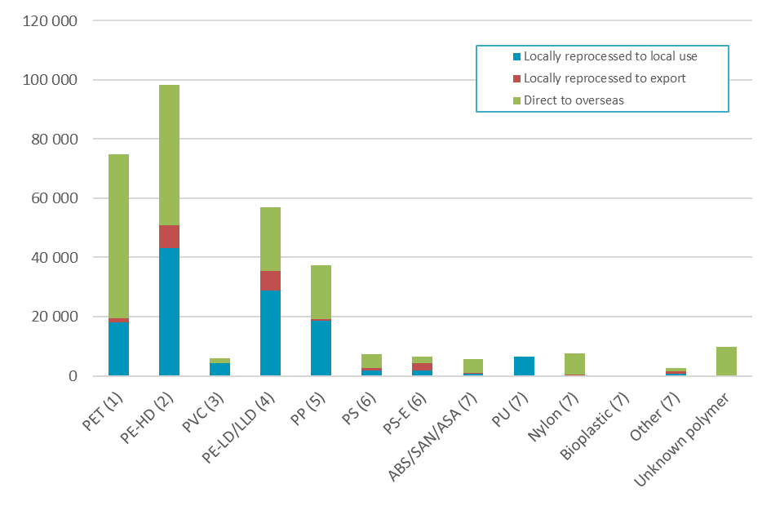
Presented in Table 11 and Figure 7 are national sources of recyclate in 2017–18 by polymer type and application area.
Plastics recovery from packaging applications dominates overall recovery, with packaging from municipal and C&I sources making up 51% and 19% of total recovery in terms of weight. Recovery from all other application areas contribute around 29% of the total, with major recovery routes being e-waste recycling and the export of used clothing.

Table 11 – Application area sources of recyclate by polymer type in 2017–18 (tonnes)
Polymer type | Agriculture | Automotive | Built environment | Electrical & electronic | Packaging – municipal | Packaging – C&I | Other applic. area | Unidentified applications | Total
PET (1) | 0 | 0 | 0 | 200 | 60 100 | 100 | 14 600 | 0 | 74 900
PE-HD (2) | 1 900 | 0 | 1 700 | 0 | 71 600 | 10 100 | 11 300 | 1 500 | 98 100
PVC (3) | 0 | 0 | 1 200 | 0 | 1 500 | 0 | 3 100 | 0 | 5 900
PE-LD/LLD (4) | 2 700 | 0 | 200 | 0 | 2 500 | 46 900 | 1 400 | 3 200 | 57 100
PP (5) | 1 600 | 100 | 0 | 0 | 23 300 | 500 | 6 000 | 6 100 | 37 500
PS (6) | 100 | 100 | 1 200 | 2 800 | 2 300 | 700 | 0 | 300 | 7 300
PS-E (6) | 0 | 0 | 600 | 0 | 2 000 | 3 300 | 400 | 200 | 6 600
ABS/SAN/ASA (7) | 0 | 500 | 0 | 5 000 | 0 | 0 | 400 | 0 | 5 900
PU (7) | 0 | 0 | 900 | 0 | 0 | 0 | 5 700 | 0 | 6 500
Nylon (7) | 0 | 0 | 0 | 0 | 0 | 0 | 7 700 | 0 | 7 700
Bioplastic (7) | 0 | 0 | 0 | 0 | 0 | 0 | 0 | 0 | 0
Other (7) | 0 | 0 | 0 | 0 | 0 | 600 | 400 | 1 500 | 2 600
Unknown polymer | 0 | 0 | 0 | 2 500 | 0 | 0 | 7 300 | 0 | 9 800
Total | 6 400 | 600 | 5 800 | 10 500 | 163 400 | 62 300 | 58 300 | 12 800 | 320 000

Figure 7 – Application area sources of recyclate by polymer type in 2017–18 (tonnes)
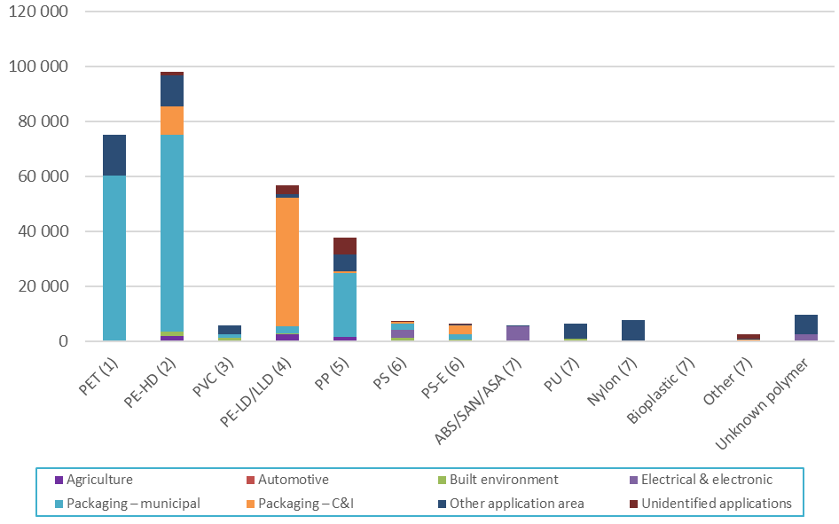

Recycling rates by polymer type
Presented in Table 12 and Figure 8 are plastics recycling rates by polymer type during 2017–18. The overall national recycling rate was 9.4%, a small decrease on the 2016–17 rate of 9.8%.
The highest recycling rate observed in 2017–18 was for PET at 21.1% (primarily sourced from packaging), followed by HDPE (also primarily from packaging) at 15.0%. The recovery of these polymers is underpinned by the Australian Packaging Covenant, which is the national product stewardship scheme for packaging.
Following PET and HDPE the next highest recycling rates were for LDPE/LLDPE (14.3%), PS (11.5%) and ABS/SAN/ASA (8.7%). The recovery of PS and ABS/SAN/ASA is supported by another product stewardship scheme, which is the NTCRS.
Table 12 – Plastics consumption and recovery by polymer type in 2017–18 (tonnes and % recycling rate)
Polymer type | Recovery | Consumption | Recycling rate
PET (1) | 74 900 | 355 300 | 21.1%
PE-HD (2) | 98 100 | 656 500 | 15.0%
PVC (3) | 5 900 | 410 200 | 1.4%
PE-LD/LLD (4) | 57 100 | 399 900 | 14.3%
PP (5) | 37 500 | 468 900 | 8.0%
PS (6) | 7 300 | 63 600 | 11.5%
PS-E (6) | 6 600 | 87 100 | 7.6%
ABS/SAN/ASA (7) | 5 900 | 67 300 | 8.7%
PU (7) | 6 500 | 86 600 | 7.6%
Nylon (7) | 7 700 | 125 500 | 6.1%
Bioplastic (7) | 0 | <100 | 0.0%
Other (7) | 2 600 | 218 000 | 1.2%
Unknown polymer | 9 800 | 468 400 | 2.1%
Total | 320 000 | 3 407 300 | 9.4%

Figure 8 – Plastics consumption and recovery by polymer type in 2017–18 (tonnes and % recycling rate)

Recycling rates by application area
Presented in Table 13 and Figure 9 is summary data of plastics consumption and recovery across all application areas of plastics. This illustrates that the quantity of plastic packaging recovery and the recycling rate of 20.6% (combined municipal and C&I) are relatively good compared to all other application areas for plastics. At 7.0% the recycling rates for plastics recovered from agricultural and ‘other’ applications are the next highest. The recycling rates across all application areas continue to be poor to very poor.

Table 13 – Plastics consumption and recovery by application area in 2017–18 (tonnes and % recycling rate)
Application area | Recovery | Consumption | Recycling rate
Agriculture | 6 400 | 90 900 | 7.0%
Automotive | 600 | 219 700 | 0.3%
Built environment | 5 800 | 579 300 | 1.0%
Electrical & electronic | 10 500 | 188 900 | 5.5%
Packaging – municipal | 163 400 | 790 200 | 20.7%
Packaging – C&I | 62 300 | 304 300 | 20.5%
Other application area | 58 300 | 837 500 | 7.0%
Unidentified applications | 12 800 | 396 500 | 3.2%
Total | 320 000 | 3 407 300 | 9.4%

Figure 9 – Plastics consumption and recovery by application area in 2017–18 (tonnes and % recycling rate)

Recovery by waste stream
When assessed from a waste/disposal stream perspective, discarded materials are often divided into three waste streams, which are:
- Municipal sector – this sector is dominated by kerbside collections.
- C&I sector – this sector includes both manufacturing scrap and post-consumer industrial recovery (e.g. LDPE pallet film).
- C&D sector.
Presented in Table 14 and Figure 10 is plastics recovery by waste stream during 2017–18. In aggregate, 51% of plastics were recovered from the municipal sector, 47% from the C&I sector, and 2% from the C&D sector.

Table 14 – Waste stream sources of recyclate by polymer type in 2017–18 (tonnes)
Application area | Municipal | Commercial and Industrial | Construction and demolition | Total
PET (1) | 60 100 | 14 800 | 0 | 74 900
PE-HD (2) | 71 600 | 24 900 | 1 700 | 98 100
PVC (3) | 1 500 | 3 100 | 1 200 | 5 900
PE-LD/LLD (4) | 2 500 | 54 300 | 200 | 57 100
PP (5) | 23 300 | 14 200 | 0 | 37 500
PS (6) | 2 300 | 3 900 | 1 200 | 7 300
PS-E (6) | 2 000 | 4 000 | 600 | 6 600
ABS/SAN/ASA (7) | 0 | 5 900 | 0 | 5 900
PU (7) | 0 | 5 700 | 900 | 6 500
Nylon (7) | 0 | 7 700 | 0 | 7 700
Bioplastic (7) | 0 | 0 | 0 | 0
Other (7) | 0 | 2 600 | 0 | 2 600
Unknown polymer | 0 | 9 800 | 0 | 9 800
Totals | 163 400 | 150 800 | 5 800 | 320 000

Figure 10 – Waste stream sources of recyclate by polymer type in 2017–18 (tonnes)
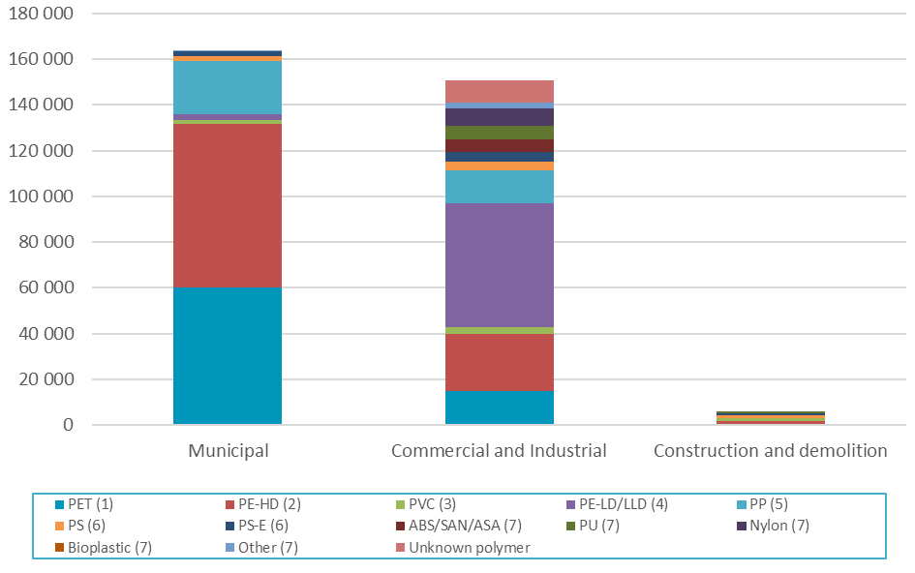

Impact of using consumption as a proxy for end-of-life arisings
In the calculations undertaken for this report the ‘recycling rate’ is an approximation calculated by dividing plastics recovery in any given year, by consumption in that year. A true recycling rate (or diversion rate) is calculated by dividing recovery by end-of-life arisings (i.e. the quantity of plastics that is available to be diverted to recycling from landfill). The approximation of dividing recovery by consumption is adequate for short-lived plastic applications, such as packaging. However, it is less appropriate for plastics going into longer lived applications, such as the built environment, as it would be generally anticipated that in any given year less plastic is reaching end-of-life, than is going into use. For this reason, the estimated recycling rates are probably conservative and the true recycling rate is likely to be somewhat higher.
This is supported by the plastics recycling rate for 2016–17 reported in the Australian National Waste Report 2018 (Blue Environment, 2018, p. viii) of 12%, in which end-of-life plastics arising are estimated based on audits of plastics to landfill, plus plastics recovered for recycling. This compares with the recycling rate of 9.8% for 2016–17 presented in Section 3.1 of this report.
Presented in Table 15 and Figure 9 are the application area recycling rates by polymer type in 2017–18 with the impact of using consumption as a proxy for end-of-life arisings highlighted.
The recycling rates for plastics coming out of agricultural and packaging applications are likely to be fairly accurate, and the recycling rate for plastics coming out of automotive and electrical & electronic applications useful indicators of the actual recycling rates. The recycling rates for plastics coming out of built environment applications are not accurate and in particular may be understating the true recycling rates. This is due to both the increase in use of these products, the generally increasing proportion of plastics in these products over time, and the potentially long lag time before they enter the waste stream.
In future years it is planned that a material flow analysis approach will be incorporated into the modelling to provide more accurate estimates of annual end-of-life arisings, and thus more accurate estimates of recycling rates as well. However, this update was not possible within the scope of the 2017–18 project.

Table 15 – Application area recycling rates by polymer type in 2017–18 (%)
Polymer type |  | Agriculture | Automotive | Built environment | Electrical & electronic | Packaging – municipal | Packaging – C&I | Other applic. area | Unidentified applications | Polymer recycling rate
PET (1) |  | 0.0% | 0.0% | 0.0% | NR | 51.5% | 0.6% | 10.1% | 0.0% | 21.1%
PE-HD (2) |  | 7.3% | 0.0% | 2.0% | 0.4% | 31.2% | 7.5% | 9.1% | 3.8% | 15.0%
PVC (3) |  | 0.0% | 0.0% | 0.4% | 0.0% | 7.3% | 0.0% | 8.2% | 0.0% | 1.4%
PE-LD/LLD (4) |  | 5.3% | 0.0% | 2.1% | 0.0% | 1.7% | 33.7% | 5.3% | 15.9% | 14.3%
PP (5) |  | 23.5% | 0.1% | 0.0% | 0.0% | 14.3% | 7.7% | 5.1% | 12.0% | 8.0%
PS (6) |  | NR | 0.0% | 16.8% | 8.2% | 15.6% | NR | 0.1% | 39.6% | 11.5%
PS-E (6) |  | 0.0% | 0.0% | 1.7% | 0.0% | 20.8% | 26.5% | 13.6% | 16.4% | 7.6%
ABS/SAN/ASA (7) |  | 0.0% | 1.3% | 0.0% | 29.0% | 0.0% | 0.0% | 4.5% | 0.0% | 8.7%
PU (7) |  | 0.0% | 0.0% | 3.4% | 0.0% | 0.0% | 0.0% | 16.4% | 0.0% | 7.6%
Nylon (7) |  | 0.0% | 0.0% | 0.0% | 0.0% | 0.0% | 0.0% | 10.0% | 0.0% | 6.1%
Bioplastic (7) |  | 0.0% | 0.0% | 0.0% | 0.0% | 0.0% | 0.0% | 0.0% | 0.0% | 0.0%
Other (7) |  | 0.0% | 0.0% | 0.0% | 0.0% | 0.4% | 0.0% | 1.1% | 1.5% | 1.2%
Unknown polymer |  | 0.0% | 0.0% | 0.0% | 6.6% | 0.0% | 0.0% | 3.4% | 0.0% | 2.1%
Applic. recycling rate |  | 7.0% | 0.3% | 1.0% | 5.5% | 20.7% | 20.5% | 7.0% | 3.2% | 9.4%
Green values | Consumption is a good proxy for end-of-life arisings
Orange values | Consumption is probably an adequate proxy for end-of-life arisings
Red values | Consumption is a poor or unknown proxy for end-of-life arisings
NR – ‘Not reported’. Where consumption for a given polymer/application area combination is under 100 tonnes the recycling rate is not reported as the uncertainty in the quantity of consumption for these values is typically too high to provide a reliable estimate. Also where underlying calculation sensitivities are too high to reliably report a recycling rate.
Note: Zero (0%) recycling rate values in the table above are effectively ‘green’ cells, as no recovery for recycling has been reported, and therefore uncertainty in relation to consumption has no impact on the recycling rate calculation.

Consumption and recycling by state/territory
This section contains the analysis of each Australian jurisdiction’s consumption and recycling of plastics, as well as data on reprocessor numbers in each jurisdiction and interstate flows of waste plastics for reprocessing.

Plastics consumption by state/territory
Throughout this report consumption data for each jurisdiction is estimated based upon the jurisdiction’s population as a proportion of the national population. The population data used for this purpose is provided in Table 2 on page 12.
Presented in Figure 11 and Table 16 is plastics consumption by jurisdiction and polymer type in 2017–18.

Figure 11 – Plastics consumption by jurisdiction and polymer type in 2017–18 (tonnes)
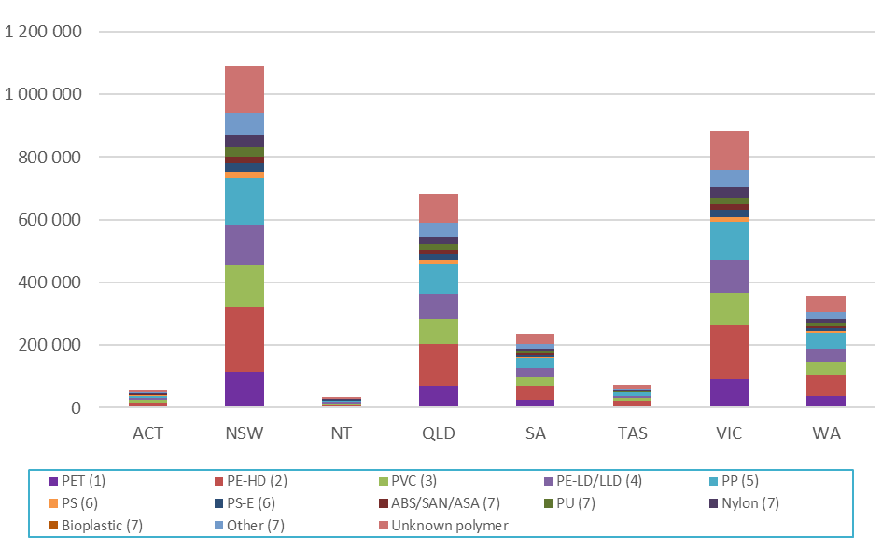

Table 16 – Plastics consumption by jurisdiction and polymer type in 2017–18 (tonnes)
Polymer type | ACT | NSW | NT | QLD | SA | TAS | VIC | WA | Total
PET (1) | 6 000 | 113 700 | 3 500 | 71 200 | 24 700 | 7 500 | 91 900 | 36 900 | 355 300
PE-HD (2) | 11 000 | 210 000 | 6 600 | 131 600 | 45 500 | 13 800 | 169 700 | 68 200 | 656 500
PVC (3) | 6 900 | 131 200 | 4 100 | 82 200 | 28 500 | 8 600 | 106 000 | 42 600 | 410 200
PE-LD/LLD (4) | 6 700 | 127 900 | 4 000 | 80 200 | 27 700 | 8 400 | 103 400 | 41 500 | 399 900
PP (5) | 7 900 | 150 000 | 4 700 | 94 000 | 32 500 | 9 900 | 121 200 | 48 700 | 468 900
PS (6) | 1 100 | 20 400 | 600 | 12 800 | 4 400 | 1 300 | 16 400 | 6 600 | 63 600
PS-E (6) | 1 500 | 27 900 | 900 | 17 500 | 6 000 | 1 800 | 22 500 | 9 000 | 87 100
ABS/SAN/ASA (7) | 1 100 | 21 500 | 700 | 13 500 | 4 700 | 1 400 | 17 400 | 7 000 | 67 300
PU (7) | 1 500 | 27 700 | 900 | 17 400 | 6 000 | 1 800 | 22 400 | 9 000 | 86 600
Nylon (7) | 2 100 | 40 100 | 1 300 | 25 200 | 8 700 | 2 600 | 32 400 | 13 000 | 125 500
Bioplastic (7) | <100 | <100 | <100 | <100 | <100 | <100 | <100 | <100 | <100
Other (7) | 3 700 | 69 700 | 2 200 | 43 700 | 15 100 | 4 600 | 56 400 | 22 600 | 218 000
Unknown polymer | 7 900 | 149 800 | 4 700 | 93 900 | 32 500 | 9 900 | 121 100 | 48 700 | 468 400
Total | 57 300 | 1 090 000 | 34 000 | 683 000 | 236 400 | 71 800 | 880 900 | 353 900 | 3 407 300

Plastics recycling and recycling rates by source state/territory
Presented in Figure 12 and Table 17 is plastics recycling by source jurisdiction and polymer type in 2017–18. The high level of recycling in Victoria is contributed to by the disproportionally large plastics manufacturing sector based in Victoria. Out of the 52 100 tonnes of plastics recovered from Victoria and reprocessed in Australia, 33 900 tonnes were manufacturing scrap (or ‘pre-consumer’ scrap) sourced from the plastics manufacturing sector. This compares with only 15 400 tonnes of manufacturing scrap recovery reported as recovered from NSW.

Figure 12 – Recycling by source jurisdiction and polymer type in 2017–18 (tonnes)
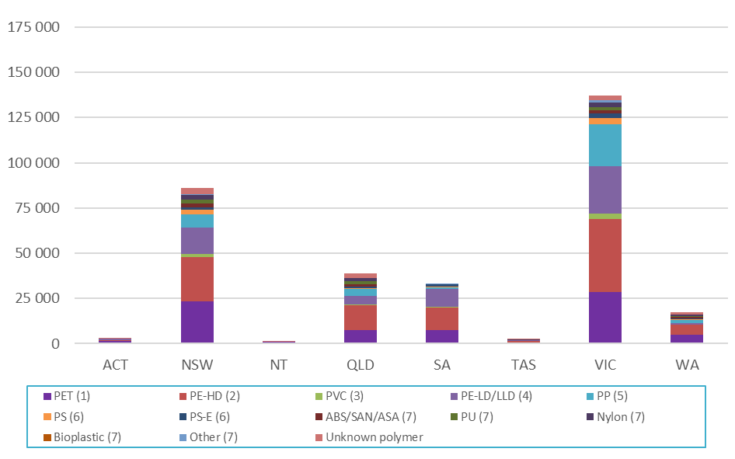

Table 17 – Recycling by source jurisdiction and polymer type in 2017–18 (tonnes)
Polymer type | ACT | NSW | NT | QLD | SA | TAS | VIC | WA | Australia
PET (1) | 1 300 | 23 400 | 1 000 | 7 500 | 7 500 | 500 | 28 600 | 5 100 | 74 900
PE-HD (2) | 700 | 24 400 | <100 | 13 800 | 12 600 | 1 000 | 40 100 | 5 500 | 98 100
PVC (3) | <100 | 1 900 | <100 | 200 | 200 | <100 | 3 200 | 100 | 5 900
PE-LD/LLD (4) | 800 | 14 600 | <100 | 4 800 | 9 800 | 300 | 26 200 | 500 | 57 100
PP (5) | 100 | 7 300 | <100 | 3 800 | 1 000 | 100 | 23 100 | 2 000 | 37 500
PS (6) | <100 | 2 300 | <100 | 800 | 300 | <100 | 3 400 | 500 | 7 300
PS-E (6) | <100 | 1 500 | <100 | 800 | 1 300 | <100 | 2 600 | 300 | 6 600
ABS/SAN/ASA (7) | <100 | 1 900 | <100 | 1 100 | <100 | 100 | 1 900 | 700 | 5 900
PU (7) | <100 | 2 400 | <100 | 1 600 | 100 | 100 | 1 800 | 500 | 6 500
Nylon (7) | 100 | 2 400 | <100 | 1 800 | <100 | 200 | 2 300 | 800 | 7 700
Bioplastic (7) | <100 | <100 | <100 | <100 | <100 | <100 | <100 | <100 | <100
Other (7) | <100 | 500 | <100 | 100 | 400 | <100 | 1 400 | 100 | 2 600
Unknown polymer | 200 | 3 300 | 100 | 2 400 | <100 | 200 | 2 600 | 1 100 | 9 800
Recycling totals | 3 500 | 86 100 | 1 200 | 38 700 | 33 300 | 2 800 | 137 200 | 17 100 | 320 000

Presented in Figure 13 is per capita recycling in each jurisdiction nationally. The national average of recovery for recycling was 12.8 kg/person in 2017–18 (compared with 11.8 kg/person in 2016–17).

Figure 13 – Per capita recycling by source jurisdiction in 2017–18 (tonnes)
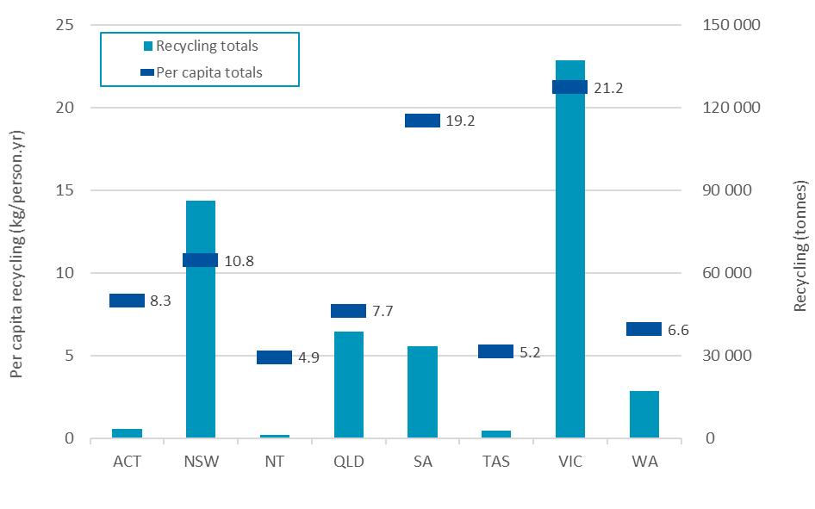

Presented in Table 18 and Figure 14 are recycling rates by source jurisdiction and polymer type in 2017–18. Victoria has the highest recycling rate at 15.6%, followed by SA on 14.1%. As previously discussed, the Victorian rate is contributed to by the relatively large amounts of manufacturing scrap generated in and recovered from Victoria.

Table 18 – Recycling rates by source jurisdiction and polymer type in 2017–18 (tonnes)
Polymer type | ACT | NSW | NT | QLD | SA | TAS | VIC | WA | Australia
PET (1) | 22.0% | 20.6% | 27.0% | 10.5% | 30.6% | 6.9% | 31.1% | 13.8% | 21.1%
PE-HD (2) | 6.5% | 11.6% | 0.4% | 10.4% | 27.7% | 7.2% | 23.6% | 8.1% | 15.0%
PVC (3) | 0.2% | 1.5% | 0.0% | 0.3% | 0.8% | 0.6% | 3.1% | 0.3% | 1.4%
PE-LD/LLD (4) | 12.3% | 11.4% | 0.0% | 6.0% | 35.4% | 4.0% | 25.3% | 1.2% | 14.3%
PP (5) | 1.9% | 4.9% | 0.0% | 4.0% | 3.2% | 1.3% | 19.1% | 4.1% | 8.0%
PS (6) | 5.9% | 11.2% | 2.7% | 6.4% | 5.8% | 4.6% | 20.4% | 7.2% | 11.5%
PS-E (6) | 1.8% | 5.5% | 0.0% | 4.7% | 20.9% | 3.1% | 11.7% | 3.1% | 7.6%
ABS/SAN/ASA (7) | 8.2% | 8.9% | 8.2% | 8.1% | 0.1% | 8.2% | 11.1% | 9.5% | 8.7%
PU (7) | 0.0% | 8.7% | 0.0% | 9.2% | 2.1% | 7.0% | 8.0% | 5.7% | 7.6%
Nylon (7) | 5.9% | 6.0% | 5.9% | 7.3% | 0.0% | 5.9% | 7.2% | 5.9% | 6.1%
Bioplastic (7) | 0.0% | 0.0% | 0.0% | 0.0% | 0.0% | 0.0% | 0.0% | 0.0% | 0.0%
Other (7) | 0.4% | 0.8% | 0.0% | 0.2% | 2.8% | 0.1% | 2.4% | 0.6% | 1.2%
Unknown polymer | 2.2% | 2.2% | 2.2% | 2.5% | 0.0% | 2.2% | 2.2% | 2.2% | 2.1%
Recycling rate | 6.1% | 7.9% | 3.6% | 5.7% | 14.1% | 3.8% | 15.6% | 4.8% | 9.4%

Figure 14 – Recycling rates by source jurisdiction in 2017–18 (tonnes)
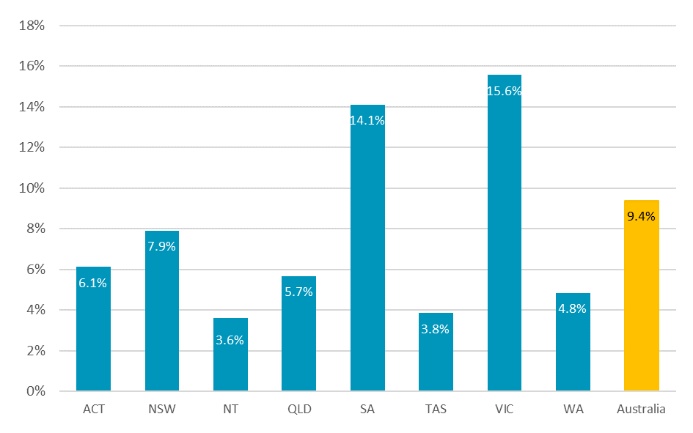

Cross border recyclate flows
Presented in Table 19 and Figure 15 is data on recyclate movements to intrastate (same state), interstate and overseas reprocessors by source jurisdiction in 2017–18. Victoria and NSW have the largest reprocessing sectors with both jurisdictions locally reprocessing around one third of recyclate that is recovered in each jurisdiction. SA and Queensland have smaller reprocessing sectors but reprocess around 61% and 53% respectively, of recyclate generated locally within each state.

Table 19 – Recyclate to intrastate (same state), interstate and overseas reprocessors by source jurisdiction in 2017–18 (tonnes)
Destination jurisdiction | Source jurisdiction
 | ACT | NSW | NT | QLD | SA | TAS | VIC | WA | Total
ACT | 0 | 0 | 0 | 0 | 0 | 0 | 0 | 0 | 0
NSW | 600 | 26 100 | 0 | 3 400 | 3 600 | 100 | 1 300 | 300 | 35 500
NT | 0 | 0 | 0 | 0 | 0 | 0 | 0 | 0 | 0
QLD | 0 | 0 | 0 | 20 500 | 0 | 0 | 0 | 0 | 20 500
SA | 0 | 1 200 | 0 | 0 | 20 300 | 0 | 100 | 0 | 21 600
TAS | 0 | 0 | 0 | 0 | 0 | 900 | 0 | 0 | 900
VIC | 0 | 2 000 | 0 | 200 | 1 700 | 300 | 50 700 | 600 | 55 500
WA | 0 | 0 | 0 | 0 | 0 | 0 | 0 | 4 000 | 4 000
Overseas | 2 800 | 56 800 | 1 200 | 14 600 | 7 700 | 1 500 | 85 000 | 12 300 | 182 000
Total | 3 500 | 86 100 | 1 200 | 38 700 | 33 300 | 2 800 | 137 200 | 17 100 | 320 000

Figure 15 – Recyclate to intrastate (same state), interstate and overseas reprocessors by source jurisdiction in 2017–18 (tonnes)
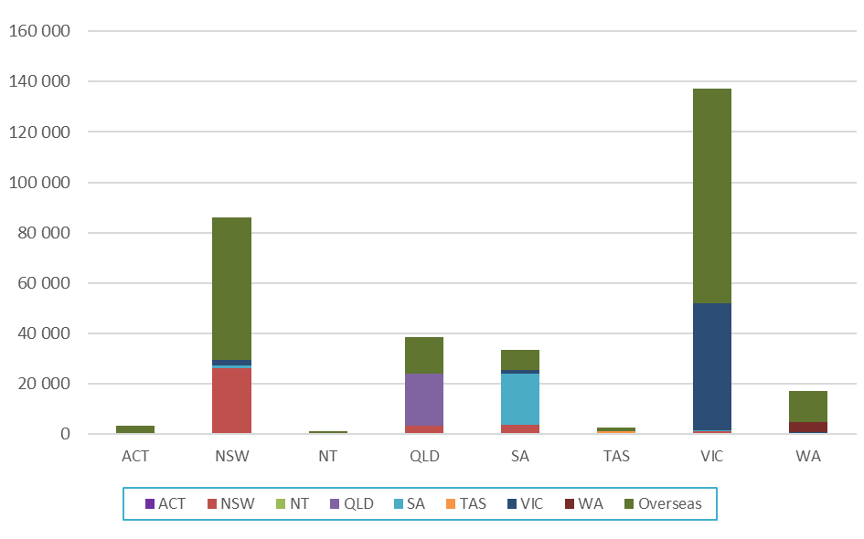

Reprocessor numbers by state/territory
Presented in Table 20 and Error! Reference source not found. is data on the numbers of reprocessors identified as operating in each state or territory. Data is provided for 58 reprocessing facilities nationally, out of 66 reprocessors known to be operating during 2017–18.
Many reprocessors handle more than one polymer type, resulting in improved depth to the reprocessing market. For example, in NSW there are 14 reprocessing facilities included in the survey dataset, however between them these facilities handled a total of 30 polymer types in aggregate across the facilities.

Table 20 – Reprocessor counts by facility location and polymer types reprocessed in 2017–18
 | ACT | NSW | NT | QLD | SA¹ | TAS | VIC | WA | Total
Number of reprocessors | 0 | 14 | 0 | 9 | 6 | 2 | 25 | 2 | 58
Polymer reprocessed | Number of reprocessors in the jurisdiction reprocessing the polymer type
PET (1) | 0 | 3 | 0 | 1 | N/A | 0 | 6 | 1 | 11
PE-HD (2) | 0 | 7 | 0 | 5 | N/A | 2 | 13 | 2 | 29
PVC (3) | 0 | 3 | 0 | 1 | N/A | 1 | 5 | 0 | 10
PE-LD/LLD (4) | 0 | 4 | 0 | 3 | N/A | 0 | 11 | 2 | 20
PP (5) | 0 | 3 | 0 | 4 | N/A | 1 | 10 | 2 | 20
PS (6) | 0 | 2 | 0 | 1 | N/A | 0 | 8 | 0 | 11
PS-E (6) | 0 | 3 | 0 | 3 | N/A | 1 | 4 | 1 | 12
ABS/SAN/ASA (7) | 0 | 2 | 0 | 1 | N/A | 0 | 6 | 1 | 10
PU (7) | 0 | 1 | 0 | 0 | N/A | 0 | 1 | 0 | 2
Nylon (7) | 0 | 1 | 0 | 0 | N/A | 0 | 3 | 0 | 4
Bioplastic (7) | 0 | 0 | 0 | 0 | N/A | 0 | 0 | 0 | 0
Other (7) | 0 | 1 | 0 | 0 | N/A | 0 | 2 | 2 | 5
Unknown polymer | 0 | 0 | 0 | 0 | N/A | 0 | 0 | 0 | 0
Total count | 0 | 30 | 0 | 19 | N/A | 5 | 69 | 11 | 134
1. SA data on the number of reprocessors handling each polymer type not available to be reported.

Recovery options for plastic products
The resource efficiency hierarchy (or waste hierarchy) provides a guide to the selection of waste minimisation and recovery strategies which maximise the conservation and efficient use of resources. Avoidance is always preferable to recovery, however there are a number of beneficial options available for the recovery of plastic products.
It is also important that recoverability should be considered at the design stage to minimise the product’s environmental impacts at end of life. This is now often considered during packaging design in Australia but is rarely considered for plastics used in other applications. Although gradual improvements in awareness in the building industry of the life cycle impacts of building products, illustrated by the increasing use of environmental product declarations for building products selection, may eventually lead to improvements in the end of life outcomes for plastics going into the built environment.
The following sections provide a summary of the current status of each recovery option for plastics products in Australia.
The feasibility and environmental benefit of each recovery option will depend on the design of the product, its durability and the availability of a suitable recovery system. For this reason, an important distinction needs to be made between short-life products such as packaging, and more durable products such as appliances, furniture and building products.
The environmental impacts and benefits of durable products such as electrical and electronic appliances, furniture, cars and building products over their life cycle are more likely to be associated with the use stage.

Product repair, reuse or remanufacture
Reuse is usually a preferable end of life option, however its feasibility will depend on the economic viability and environmental impacts of reuse, for example from cleaning or transport. Reuse is increasingly being used as a design for sustainability strategy for distribution packaging, for example returnable (or reusable) plastic crates are now commonly used for transporting fruit and vegetables from growers all the way to the supermarket shelf and have avoided the consumption of huge quantities of single-use cardboard boxes. There is some reuse of automotive parts, and significant export of used clothing for reuse overseas. Remanufacturing is undertaken on a smaller scale, usually for electrical or electronic products such as toner cartridges and photocopiers.

Mechanical recycling
Mechanical recycling is the focus of this report. The infrastructure for collection and reprocessing is relatively well established in Australia for some products such as packaging. It is also generally preferable to feedstock recycling because it maintains the economic value of the polymer at a relatively high level and reduces the amount of energy required to manufacture new plastic products.
This recovery option is most economically viable for plastics that are available in large quantities, in a clean and homogenous (or sortable) form, and in locations with reasonable access to recycling facilities. Mixed plastics can also be recycled, however they are more challenging as they either need to be separated or recycled into a reduced range of mixed polymer product types, such as bollards, decking and outdoor furniture. These mixed polymer products often have long lifespans and may be recycled back into similar products at end of life.

Feedstock recycling
Feedstock recycling (also referred to as chemical recycling) is the conversion of polymers back into a monomer or new raw materials by changing the chemical structure of the material and includes processes such as pyrolysis and gasification. Feedstock recycling back into monomers is undertaken on a small scale overseas but not currently in Australia.

Biological recycling
Biological recycling (i.e. through composting or anaerobic digestion) is undertaken on a very small scale for packaging made from compostable plastics, but facilities are limited, and contamination of compost products is a significant concern. National coverage of kerbside organics collection systems that accept compostable plastics is currently low.
The quantities of compostable plastics recovered into compost in Australia are unknown but would be very low nationally (i.e. <100 tonnes).

Energy recovery
Energy can be recovered from plastics through controlled combustion or conversion to a liquid fuel (which is subsequently burnt). Energy recovery may be a good option for plastics that are not suitable for mechanical recycling, such as contaminated products. There is now some controlled combustion occurring in Australia, however there is no known conversion to liquid fuels.
There is growing energy recovery from plastics in Australia, dominated by the manufacture of a C&D waste based fuel that is manufactured at the time of reporting in South Australia and New South Wales, for combustion in local and overseas cement kilns. Timber is the main energy source in this fuel.
There is also the thermal treatment of medical waste, which contains a reasonably high proportion of plastics, however this is typically undertaken without energy recovery.

Key trends in plastics

Impact of Chinese import restrictions
The new Chinese scrap import contamination standards entered fully into force from 1 March 2018, however started influencing imports into China 4–5 months prior to this date. The key change is a contamination threshold requirement of no more than 0.5% impurities for both scrap paper and scrap plastics. This Chinese initiative, originally referred to as the ‘National Sword’, is part of a broader suite of measures designed to shift away from imported wastes as a source of raw materials.
These Chinese import restrictions have resulted in a virtual ending of sales of unprocessed scrap plastics to Chinese based buyers across the second half of 2017 and across 2018. For context, in January 2017 around 71% of Australian exports of scrap paper/paperboard and scrap plastics went to China. However, across the full financial year of 2017–18 only 16% of exported mixed plastic scrap was sent to China, and even this was falling across the year, with only 8% of exported mixed plastic scrap going to China in June 2018.
The curtailment of China as a destination for global scrap recycling has resulted in the saturation of mixed scrap plastics in the international market, causing significant price falls in the value of these commodities, with the resulting well-publicised impacts on lower-grade scrap plastics markets. The import restrictions are now extending beyond China, with Vietnam, Thailand and Malaysia also applying their own restrictions on the imports of low-quality mixed scrap plastics.

Collection and processing
The following is a synthesis of comments received from plastics reprocessors, with respect to collection and processing related aspects for used plastics during the 2017–18 financial year:
- Export quality continues to be identified as a key challenge in 2017–18 and 2018–19 for recovered packaging plastics, particularly for mixed plastics.
- There is a growing focus in the packaging sector on reducing the use of some polymers such as PVC and PS from packaging, related to a major shift among major brand owners towards producing packaging that is 100% recyclable and containing high levels of recycled content.
- Running costs, particularly for energy and wages, grew at challenging levels.
- A number of local reprocessors are responding to the Chinese import restrictions by investing in new equipment to value-add local scrap and produce high-quality recovered resin for local and overseas markets.

Market conditions for sale of recyclate
The following is a summary of the feedback received from a number of plastics reprocessors with respect to the market conditions for the sale of plastic recyclate:
- Industry remains in some turmoil due to the Chinese import restrictions, along with follow-up restrictions by other south-east Asian countries. Generally only high-quality pelletised recycled polymer can be imported into China.
- Domestic demand generally remains strong for most processed scrap polymers, with good demand growth in the building sector, however prices are down because of Chinese import restrictions and the local buyers are still too limited in volume.

End market uses
After reprocessing, recycled plastics are used to manufacture new products, with new applications often quite different from those of the original use. Outlined in Table 21 are many of the typical uses of recycled plastics in Australia.

Table 21 – Typical uses of recycled plastics in Australia
Polymer | Major uses of recycled polymer | Minor uses of recycled polymer
PET | Beverage bottles | Timber substitutes, geo-textiles, pallets and fence posts.
PE-HD | Films, pallets, wheelie bins, irrigation hose and pipes | Cable covers, extruded sheet, moulded products, shopping and garbage bags, slip sheets, drip sheets for water, wood substitutes and mixed plastics products (e.g. fence posts, bollards, kerbing, marine structures and outdoor furniture), materials handling and roto-moulded water tanks.
PVC | Pipe, floor coverings | Hose applications and fittings, pipes including foam core pipes, profiles and electrical conduit, general extrusion and injection moulding, clothing, fashion bags and shoes.
PE-LD/LLD | Film (incl. builders’ and agricultural film, concrete lining, freight packaging, garbage bags, shopping bags), agricultural piping | Trickle products, vineyard cover, pallets, shrink wrap, roto-moulding, slip sheets, irrigation tube, timber substitutes, cable covers, builders’ film, garbage bags, carry bags, and other building industry applications.
PP | Crates boxes and plant pots | Electrical cable covers, building panels and concrete reinforcement stools (bar chairs and shims), furniture, irrigation fittings, agricultural and garden pipe, drainage products (such as drain gates) and tanks, builders film, kerbing, bollards, concrete reinforcing and a wide variety of injection moulded products.
PS | Bar chairs and industrial spools | Office accessories, coat hangers, glasses, building components, industrial packing trays, wire spools and a range of extrusion products.
PS-E | Waffle pods for under slab construction of buildings | Synthetic timber applications (including photo frames, decorative architraves, fence posts), XPS (extruded polystyrene) insulation sheeting, and lightweight concrete.
ABS/SAN/ASA | Injection moulded products | Automotive components, laminate edging, sheet extrusion, coffin handles, drainage covers, auto parts and a range of injection moulded products.
Polyurethane | Carpet underlay | Mattresses.
Nylon | Injection moulded products | Furniture fittings, wheels and castors and a range of injection moulded products.
Other and mixed | Timber substitute products in general and piping | Fence posts, bollards, garden stakes, kerbing, marine structures, post and rail systems, scaffold pads, piggery boards, shipping dunnage, rail bridge transoms.

References
ABS, 2018a. 3101.0 Australian Demographic Statistics. Table 4. Estimated Resident Population, States and Territories (Number) (released 20 September 2018). [Online] Available at: http://www.abs.gov.au/AUSSTATS/abs@.nsf/DetailsPage/3101.0Jun%202017?OpenDocument [Accessed 16 December 2018].
ABS, 2018b. 3222.0 Projected population (data cube), components of change and summary statistics – Australia, state/territory, greater capital city/balance of state, 2017 (base) to 2066 (released 22 November 2018). [Online] Available at: http://www.abs.gov.au/AUSSTATS/abs@.nsf/DetailsPage/3222.02017%20(base)%20-%202066?OpenDocument [Accessed 16 December 2018].
ACT NOWaste, 2018. ACT NOWaste Recycling Industry Survey (unpublished), Canberra: ACT NOWaste.
ANZRP, 2018. ANZRP Annual Report 2016/17 Regulator Version, Melbourne: Australia and New Zealand Recycling Platform.
Blue Environment, 2018. Australian National Waste Report 2018, Melbourne: Report prepared by Blue Environment and Randell Environmental Consulting on behalf of the Department of the Environment and Energy.
DFAT, 2018. Australian Customs Service – Plastics import and export data – 2017–18, Canberra: Department of Foreign Affairs and Trade.
Ecycle, 2018. Ecycle Solutions Annual Report 2016 - Co-regulatory Arrangement - National Television and Computer Recycling Scheme, Dandenong: Ecycle Solutions.
EPSA, 2018. Product Stewardship Televisions and Computers - Annual Report 2016/17, Villawood: Electronic Product Stewardship Australasia.
Green Industries SA, 2018. Survey of South Australian plastics reprocessors – 2017–18 data, Adelaide: Green Industries SA.
MRI PSO, 2018. MRI PSO Product Stewardship Arrangement 2016-17 Annual Report, Campbellfield: MRI PSO.

