|  |
| --- |
| *Australian Sea Lion Monitoring Framework: background document* |
| B. Pitcher - Prepared for the Department of the Environment |
| This monitoring framework was developed through consultation with, and contributions from, leading researchers, statisticians, state and federal government agencies. |
| March 2018 |

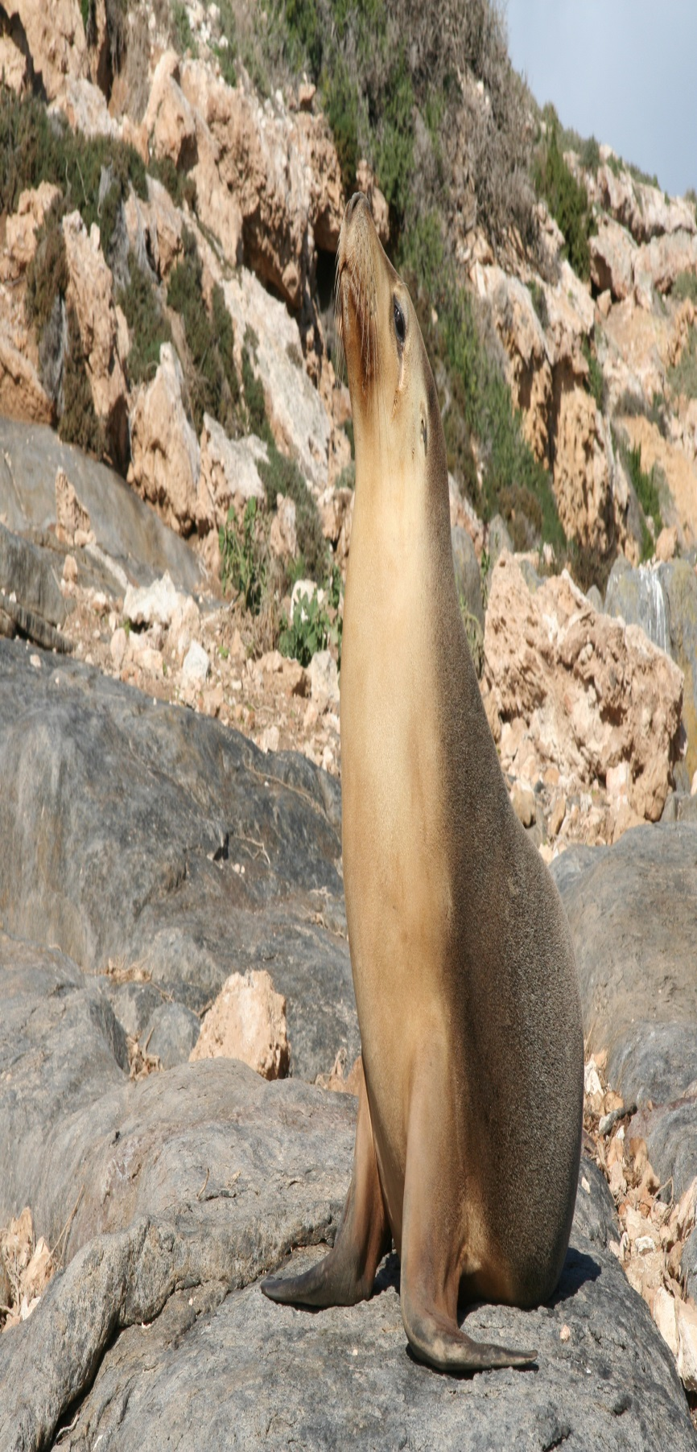

Contents

Executive Summary 2

Glossary 4

1. Introduction 5

1.1 Species information 5

1.2 Summary of previous monitoring efforts and population trends 9

1.3 Obstacles to monitoring the abundance and distribution of Australian sea lions 13

1.4 The objectives of the Recovery Plan for the Australian Sea Lion 15

1.5 The need for a national monitoring framework 16

1.6 The purpose of the monitoring framework and how it should be used 17

2. Vision 21

3. The objectives of the monitoring framework 22

4. Methods 23

4.1 Monitoring indicators 23

4.2 Representative regions of the Australian sea lion population 27

4.3 Representativeness of colonies within the metapopulations 29

4.4 Desirable features of colonies to be monitored 30

4.5 A simple statistical framework for Australian sea lion monitoring design and analysis 33

The model 34

Exploring designs and choosing one 36

5. Process for implementation 37

5.1 Steps for implementing the monitoring framework 37

5.2 Reporting and evaluation 38

6. Concluding remarks 38

7. Acknowledgements 40

8. References 41

9. Appendices 45

Appendix 1. Metapopulations and colonies of Australian sea lions 45

Appendix 2. Representative and desirable features of Australian sea lion colonies 46

# Executive Summary

The Australian sea lion (*Neophoca cinerea*) is Australia’s only endemic pinniped species. The present range of the species extends from The Pages Islands in South Australia to the Houtman Abrolhos in Western Australia. The species was previously exploited by commercial sealing activities but has failed to show a significant recovery since the end of sealing.

The Australian sea lion was listed as vulnerable under the Commonwealth *Environment Protection and Biodiversity Conservation Act 1999* (EPBC Act) in 2005, and is also listed as a threatened species in each state in its range (South Australia and Western Australia). The species was listed internationally as Endangered on the International Union for Conservation of Nature (IUCN) Red List in 2008.

The *Recovery Plan for the Australian Sea Lion* (*Neophoca cinerea*) (DSEWPaC 2013b) came into effect on 5 July 2013. The overarching objective of the Recovery Plan is to halt the decline and assist the recovery of the Australian sea lion throughout its range in Australian waters by increasing the total population size while maintaining the number and distribution of breeding colonies. Action 5.1 of the Recovery Plan requires managers and researchers to “*develop and apply a quantitative framework to assess the population status and potential recovery of the Australian sea lion across its range”*. This Monitoring Framework aims to address Action 5.1 of the Recovery Plan.

The vision of the Monitoring Framework is to give a level of assurance that the objectives of the Recovery Plan for the Australian Sea Lion are met with respect to long-term trends in abundance, distribution and threats. To achieve this vision the Monitoring Framework sets out three objectives:

1. That over any 10 year period there should be a probability of *p* that the monitoring framework can detect a trend in abundance and distribution in a unit of interest of X%. The units of interest (e.g. colony or metapopulation) are representative of the species based on biogeography, colony size and threatening processes.
2. To measure demographic and health (e.g. body condition) factors contributing to any observed change/decline in abundance.
3. To monitor, and where possible estimate mortality levels from, factors that could drive substantial changes in abundance, including:
   1. anthropogenic factors (direct, indirect and cumulative); and
   2. environmental factors.

Because of the difficulties of obtaining high quality population trend data from all colonies, it is recommended that monitoring efforts be concentrated on obtaining time series data from a subset of key and regionally representative breeding colonies. The Monitoring Framework recommends designating 13 metapopulations within the Australian sea lion distribution. Within these metapopulations a small number of representative colonies should be chosen to be monitored as proxies for the metapopulation. The Monitoring Framework recommends representative factors and desirable features that should be considered when selecting colonies for monitoring.

A simple statistical framework for Australian sea lion monitoring design and analysis is presented. This model can be used in choosing an effective and parsimonious monitoring design for Australian sea lions. It would allow the simulation of various trial designs (including colonies to monitor, survey methods and intervals) to see how precisely they would answer certain questions about Australian sea lion abundance.

This document should be read in conjunction with the associated document *Australian Sea Lion Monitoring Framework: statistical model* (Lawrence & Bravington 2016: <http://www.environment.gov.au/marine/marine-species/seals-and-sea-lions>) which implements and applies the statistical framework (outlined in Section 4.5) to different sampling scenarios, to illustrate how the model can be used to identify an appropriate monitoring design for the Australian sea lion.

This monitoring framework is written in response to the National *Recovery Plan for the Australian Sea Lion* (*Neophoca cinerea*) (DSEWPaC 2013b). As such it should also be read in conjunction with that document and the *Issues Paper for the Australian Sea Lion* (*Neophoca cinerea*) (DSEWPaC 2013a).

# Glossary

AAD Australian Antarctic Division

ABARES Australian Bureau of Agricultural and Resource Economics and Sciences, Department of Agriculture, Fisheries and Forestry

AFMA Australian Fisheries Management Authority

CSIRO Commonwealth Scientific and Industrial Research Organisation

DAFF Department of Agriculture, Fisheries and Forestry, Australian Government

DEWHA Department of Environment, Water, Heritage & the Arts – now Department of the Environment

DoEE Department of the Environment and Energy, Australian Government

DSEWPaC Department of Sustainability, Environment, Water, Population and Communities – now Department of the Environment and Energy

EPBC Act *Environment Protection and Biodiversity Conservation Act 1999* (Commonwealth)

GABMP Great Australian Bight Marine Park

GLMM Generalized Linear Mixed Model

MqU Macquarie University

PIRSA Department of Primary Industries and Regions, South Australia

SAM South Australian Museum

SARDI South Australian Research and Development Institute

TSSC Threatened Species Scientific Committee

WA DoF Department of Fisheries, Western Australia

WA DBCA Department of Biodiversity, Conservation and Attractions, Western Australia

# 1. Introduction

## 1.1 Species information

The Australian sea lion (*Neophoca cinerea*) is Australia’s only endemic pinniped species. The present breeding range of the species extends from The Pages, east of Kangaroo Island in South Australia, to the Houtman Abrolhos on the West Australian coast (Figure 1) (Dennis & Shaughnessy 1996, 1999; Gales et al. 1994; Shaughnessy et al. 2011). Prior to the early 1800s the population is thought to have extended east to the Furneaux, Kent and Anser Groups of islands in Bass Strait, and included the islands around Albany and Perth in Western Australia; however sealing is likely to have driven the Australian sea lion to extinction in these areas (Gales et al. 1994; Ling 1999; Warneke 1982).

Australian sea lion breeding is thought to occur at 76 sites: 28 in Western Australia and 48 in South Australia (DSEWPaC 2013b; Shaughnessy et al. 2011). At 58 of these sites more than five pups have been recorded during a breeding season and they are considered to be regular breeding colonies, the remaining 18 sites are considered haul-out sites with occasional pupping (DSEWPaC 2013b; Goldsworthy & Page 2009; Shaughnessy et al. 2011). Only nine colonies produce more than 100 pups per breeding season, all of which are located in South Australia, while 51 produce fewer than 30 pups (DEWHA 2010; Shaughnessy et al. 2011). Approximately 86% of pups are born in South Australian colonies and the remaining 14% in Western Australian colonies (Goldsworthy et al. 2009; Shaughnessy et al. 2011).

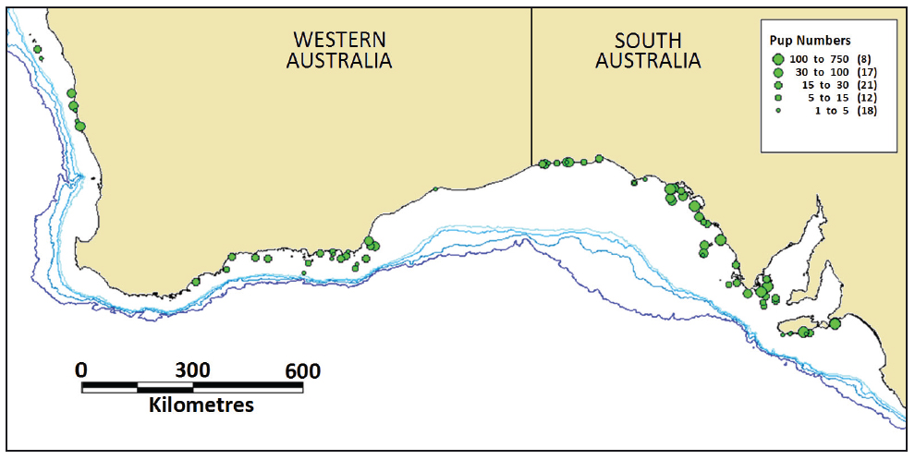

Figure 1. Breeding distribution of the Australian sea lion, indicating the location and approximate pup number range of the 76 sites where Australian sea lion pups have been recorded. The number of sites within each pup number range is given in parentheses. Depth contours of 200, 500, 1000 and 2000 m (light to dark blue) are indicated. From Goldsworthy et al. (2009).

Recent survey data suggest that 3119 pups per breeding cycle were born in South Australia and 503 pups per breeding cycle were born in Western Australia (Shaughnessy et al. 2011). Population estimates, based on a ‘pup multiplier’ of 4.08, suggest there are approximately 14 780 Australian sea lions across the species’ entire geographic range (Shaughnessy et al. 2011). Population estimates using a ‘pup multiplier’ imply overall population size based on population demographic data (Berkson & De Master 1985). However, the demographic data used to calculate this multiplier is derived from a single colony, Seal Bay at Kangaroo Island, where sufficient information is available to make such calculations (McIntosh 2007; McIntosh et al. 2011). Therefore this multiplier may not be representative of all colonies.

The Australian sea lion has a breeding biology that is unique among pinnipeds. Across its range the Australian sea lion exhibits a 17 to 18 month breeding cycle (Goldsworthy et al. 2014a). This is in contrast to most large mammals that exhibit an annual breeding cycle associated with seasonal changes (Gales et al. 1994). The pupping season lasts for approximately 4 to 5 months (Gales et al. 1992; Higgins 1993). At Seal Bay 90% of pups were born in a 5 month period during the 2013 season, however the total pupping season lasted for approximately 9 months (12 months if a single pup born 3.4 months later is included) (Goldsworthy et al. 2014a). It is likely that in smaller colonies the pupping season is shorter than the average due to the small number of pups born (see Gales et al. 1992). On average, the pupping season of the Australian sea lion is considerably longer than that of other otariids (King 1983). Further, the breeding cycle is asynchronous between colonies, with the pupping season of individual colonies occurring at various times of the year (Gales et al. 1992). Australian sea lions exhibit a post-partum oestrus of 4-10 days and a 15 to 18 month lactation period, after which most females give birth to their next pup (Higgins & Gass 1993). Gestation is characterised by a period of 3.5-5 months of embryonic diapause and a prolonged period of placental gestation of up to 14 months, the longest of any seal species (Gales et al. 1997).

Males grow to 2-2.5 m in length (nose to tail) and weigh approximately 220 kg (up to 300 kg; Walker & Ling 1981) while females grow to 1.7-1.8 m and weigh approximately 100 kg (King 1983; Marlow 1975; McIntosh 2007). Australian sea lion females reach sexual maturity at 4 – 6 years of age (Goldsworthy et al. 2014a) and males at 8 – 9 years (Shaughnessy 1999); however most males are older (approximately 14 years) before successfully mate-guarding females (McIntosh 2007). The oldest wild male was identified as 21.5 years and oldest wild female as 26 years, although breeding longevity appears to be approximately 24 years in females (McIntosh 2007).

The Australian sea lion is a specialised benthic forager. While breeding colonies are located in state waters, in South Australia Australian sea lions forage in both state and Commonwealth waters on the continental shelf at depths between 20 and 100 m (Goldsworthy et al. 2010). In Western Australia juveniles and adult females tend to forage in shallower waters, possibly due to differences in bathymetry, prey abundance, prey specificity and/or predator avoidance (Campbell et al 2008a). There appears to be marked individuality in the foraging effort both within and between breeding sites, with individuals focusing their foraging in either coastal or offshore habitats (DSEWPaC 2013a). Individuals typically travel around 60 km from their colony when foraging, and greater distances of up to 190 km when over shelf waters (Goldsworthy et al. 2010; Hamer et al. 2011).

Australian sea lions exhibit extreme natal site fidelity, or natal philopatry. Females typically breed in the colony in which they were born (Campbell 2003; Campbell et al. 2008b; Lowther et al. 2012). Males may disperse further, but their range is limited to approximately 200 km. This extreme natal philopatry may limit the ability of Australian sea lions to recolonise habitat or expand in range over the short to medium term (DSEWPaC 2013b). Such pronounced population subdivision over short distances (approximately 60 km) is unseen in any other social marine mammal (Campbell et al. 2008b).

The main anthropogenic threat that historically faced Australian sea lions was commercial exploitation through sealing activities. Since the cessation of sealing, the population has failed to recover to pre-exploitation levels. The life history characteristics of the species, including the slow maturation, low fecundity, extended breeding cycle and natal philopatry, contribute to the species’ susceptibility to current threats and the slow recovery of the population after the end of sealing (DSEWPaC 2013a).

The 2013 *Issues Paper for the Australian Sea Lion (Neophoca cinerea)* (DSEWPaC 2013a) identified a range of anthropogenic factors that may be impacting on the recovery of the species:

* Primary threats:
  + Fisheries bycatch, including demersal gillnet fishing for sharks and pot fishing for rock lobster.
  + Entanglement in marine debris (Figure 2).
* Secondary threats:
  + Marine finfish aquaculture, including loss of habitat and entanglement in equipment.
  + Habitat degradation caused by terrestrial and aquatic developments.
  + Human disturbance.
  + Direct killing.
  + Disease.
  + Pollution.
  + Oil spills.
  + Noise, particularly from seismic surveys, construction or marine operations.
  + Competition, and prey depletion, with humans and other marine predators.
  + Climate change, including sea level rise reducing the habitable area of colonies, and sea surface temperature and ocean acidity changes.

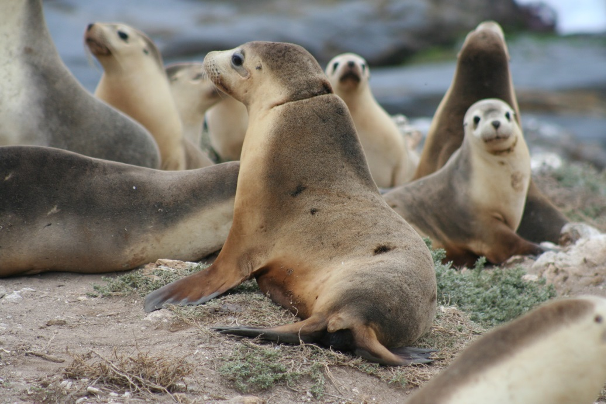

Figure 2. A juvenile Australian sea lion showing a scar caused by entanglement in marine debris. The debris was removed by researchers. Lewis Island, South Australia 2008. Photo by Benjamin Pitcher.

## 1.2 Summary of previous monitoring efforts and population trends

The high uncertainty of estimates of the size and status of subpopulations of Australian sea lions has been identified as one of the main impediments to their effective management (Goldsworthy et al. 2007c). The first survey over the entire range of the Australian sea lion was conducted by Gales et al. (1994); prior to that population estimates were based on *ad hoc* counts resulting in highly variable estimates. Since the mid-1990s efforts have been made to develop systematic and standardised methods for monitoring pup production as a means of estimating species abundance. Within South Australia, population trend data are limited as most colonies have only been subject to single counts over a small number of seasons. Reliable estimates of pup production are only available for a limited number of colonies, and time series data are only available for the largest colonies (Goldsworthy et al. 2007c). However, additional sites including a number of smaller colonies are now being monitored (Goldsworthy et al. 2013). In Western Australia, population monitoring has primarily focused on employing direct count methods, as small colonies with low to medium densities make mark-recapture methods (as described in Goldsworthy et al. 2013) unsuitable. Effective monitoring has been hampered by the difficulty in accessing many of the state’s colonies, coupled with the need to accurately determine the timing of the breeding season and to conduct multiple counts within a season.

The quality of data on pup production across the species’ range has been typically poor, primarily due to the protracted pupping period making accurate counts of pups difficult as individuals may have died, dispersed or moulted before counting (Goldsworthy et al. 2007c; 2009). High-quality pup census data from consecutive breeding seasons have been collected from eight key sites: Seal Bay and Seal Slide (Kangaroo Island), Dangerous Reef and English Island (Spencer Gulf), Olive Island and Jones Island (Chain of Bays), and Lilliput Island and Blefuscu Islands (Nuyts Archipelago) (Goldsworthy et al. 2015). Mark-recapture methods to estimate pup abundance have only been used at Seal Bay, Dangerous Reef, Olive Island, Lewis Island, North Page and South Page Islands, and Lilliput and Belfuscu Islands (Goldsworthy et al. 2015).

Typically when conducting direct counts, researchers aim to estimate the maximum number of pups present in the colony through either single or multiple counts combined with the accumulated number of dead pups in the colony (Goldsworthy et al. 2007c). These methods are likely to result in an underestimate of the true number of pups produced in the colony, but the extent of the underestimate and the variation between colonies is unknown (Goldsworthy et al. 2007c). A number of reports have focused on recommendations to improve the survey methodology and precision, and to tailor survey methods to colonies of various population sizes (Goldsworthy et al. 2007b; Goldsworthy et al. 2007c; Mackay et al. 2013; Shaughnessy & Dennis 2000).

Long-term population monitoring that allows for trend analysis of time series data has only been conducted at a limited number of the larger breeding colonies (DSEWPaC 2013a). Analysis of direct counting of pups over 14 breeding seasons (1989-90 to 2019-10) at The Pages Islands, South Australia, showed no significant trend (Figure 3) suggesting that the population was stable over that period (Shaughnessy et al. 2013). Monitoring data are available for 12 of the 22 breeding seasons between 1975 and 2007 for Dangerous Reef, Spencer Gulf, South Australia (Goldsworthy et al. 2007a). This population showed a 1.8% annual increase until 1999, increasing to 4.6-6.5% per annum increase after that (Figure 4) (Goldsworthy et al. 2007a). Goldsworthy et al. (2007a; 2014b) suggest that this observed increase in pup production rates can be attributed to the ban on shark gill netting in Spencer Gulf in 2001 and the subsequent decrease in Australian sea lion female mortality. In contrast to Dangerous Reef, counts of maximum live pups at Seal Bay, Kangaroo Island, South Australia, have shown a significant decline of 2% per breading season between 1985 and 2016 (Figure 5) (Goldsworthy et al. 2014a). Estimated declines in total pup production over the eight breeding seasons between 2004 and 2016 show a similar rate of decline of 2.2% per breeding season (Goldsworthy et al. 2017). Page et al. (2004) attributed the long-term trends at Seal Bay to fisheries bycatch and entanglement in fishing gear. Currently, insufficient long-term time series data are available to allow for estimation of trends in the Australian sea lion population as a whole.

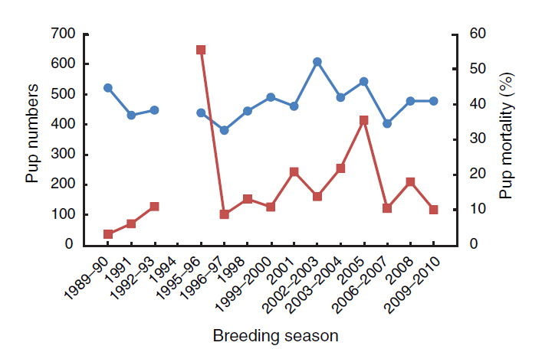

Figure 3. Australian sea lion pups at The Pages Islands for breeding seasons between 1989–90 and 2009–10: estimates of abundance (circles, top line) and pup mortality (x10; squares, bottom line). From Shaughnessy et al. (2013).

Fig 6.tif

Figure 4. Trends in Australian sea lion pup abundance for 8 breeding seasons between 1994 and 2007 at Dangerous Reef, Spencer Gulf. Note the marked increase in pup production after 2000, around the time that demersal gill netting for sharks was banned in Spencer Gulf. From Goldsworthy et al. (2014b).



Figure 5. Trends in the abundance of Australian sea lion pups at Seal Bay based on maximum live pup counts, for 22 breeding seasons between 1985 and 2016. Trends in the estimated pup production (based on cumulative pup births) and pup mortality are shown for eight of the last nine seasons up to 2015. From Goldsworthy et al. (2017).

## 1.3 Obstacles to monitoring the abundance and distribution of Australian sea lions

A number of aspects of the biology of Australian sea lions contribute to the difficulty of obtaining high quality data on pup production across the range of the species (McKenzie et al. 2005). The protracted pupping season seen at some colonies (e.g. nine months or more at Seal Bay; Goldsworthy et al. 2014a) potentially presents the greatest obstacle to data collection (Goldsworthy et al. 2008). Because of the long period of time between the first and last birth, there is greater opportunity for pups to disperse or die before an accurate estimate of the population can be made; this contrasts with the situation in other pinnipeds where pupping occurs over a shorter timeframe. Dispersal and death contribute to sightability bias (pups that are hidden from view) and availability bias (pups that are absent from the colony) during counts (Figure 6).

The duration of the pupping season, as well as the non-annual cycle and the asynchrony between colonies, also poses challenges to the monitoring of Australian sea lions at multiple locations. As the majority of colonies are located on islands without easy or regular access, it is difficult to accurately track the timing of the pupping season in many colonies. This then leads to difficulties in correctly timing surveys, and has implications for the cost and logistics of monitoring programs. Further, even when a survey is conducted during a pupping season, a poor understanding of the timing of the season can lead to complications determining at what point during the season the survey took place. This then has flow on effects to estimating the ages of pups and the stage of the breeding season, and accurately estimating the total number of pups from the actual count data (Figure 6).

There may be intrinsic factors that contribute to the difficulty of monitoring particular colonies, or make particular survey methods more suitable than others. For example, a colony with a smaller population that is spread over a very large area is likely to be more difficult to survey than a similar sized population in a smaller area. Similarly, pup detectability may be reduced in colonies with large amounts of vegetation, crevices or caves. Further, the accessibility of some colonies can make ‘on the ground’ counts difficult at best and impossible at worst. For example, in the Bunda Cliffs colonies animals are only observable from cliff tops, while Twilight Cove is extremely remote and can only be partially observed from a hovering helicopter or swimming in from a boat during the right conditions (which is risky). Drones are likely the safest option going forward, and have recently been used to survey the Bunda Cliffs colonies.

When designing a monitoring framework consideration must be given to these obstacles. It may be possible to manage some, but not all factors. For particular colonies these obstacles may be overcome through the use of technologies such as remote cameras and helicopter access. However, there is a trade-off between monitoring effort and outcome. Critical, practical and pragmatic consideration of the financial and logistic investment in monitoring and the power to detect population trends is required to design a meaningful monitoring framework. Section 4 outlines a number of indicators, representative regions and desirable features of colonies that should be considered when designing a monitoring framework. These factors should be accounted for when considering the model outlined in section 4.5.

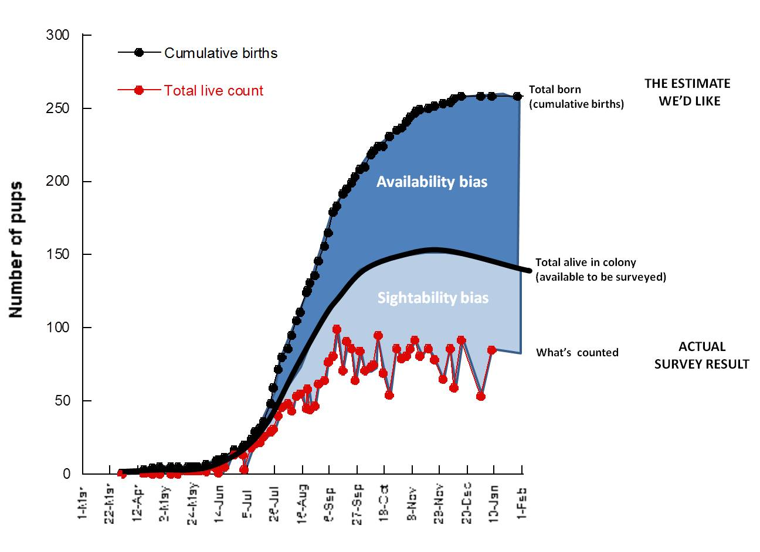

Figure 6. An example of survey data from multiple pup counts over a pupping season at Seal Bay. This example highlights the difference between the actual number of pups counted, the total number of pups alive in the colony (including pups that are hidden from view during the survey [sightability bias]), and the cumulative number of pups born in the colony (including pups that are absent from the colony during the survey [availability bias]). At colonies, other than Seal Bay, where continual monitoring does not occur, both the total number of pups alive in the colony and the total born must be estimated from the actual survey result. Further, failure to correctly determine at which point during the breeding season counts occur can lead to errors in the estimate of the total number of live pups and the total number born. For example in this figure, counts between September and January may lead to similar actual survey results, but may relate to very different estimates of the total number of pups born. Simon Goldsworthy, SARDI.

## 1.4 The objectives of the Recovery Plan for the Australian Sea Lion

The overarching objective of the Recovery Plan for the Australian Sea Lion (DSEWPaC 2013b) is to halt the decline and assist the recovery of the Australian sea lion throughout its range in Australian waters by increasing the total population size while maintaining the number and distribution of breeding colonies. The Recovery Plan has a view towards improving the population status leading to the future removal of the Australian sea lion from the threatened species list of the EPBC Act and ensuring that anthropogenic activities do not hinder recovery in the near future or impact on the conservation status of the species in the future.

In order to address this overarching objective a series of specific objectives and associated actions were identified and prioritised. Objective 5 of the Recovery Plan is to:

*Continue to develop and implement research and monitoring programs that provide outputs of direct relevance to the conservation of the Australian sea lion* (DSEWPaC 2013b)

Action 5.1 of the Recovery Plan requires managers and researchers to:

*Develop and apply a quantitative framework to assess the population status and potential recovery of the Australian sea lion across its range:*

* *Ensure sufficient and effective abundance and distribution monitoring is in place to adequately understand population size and trends at representative sites across the range of the Australian sea lion, including at the fringes of the species’ range* (DSEWPaC 2013b).

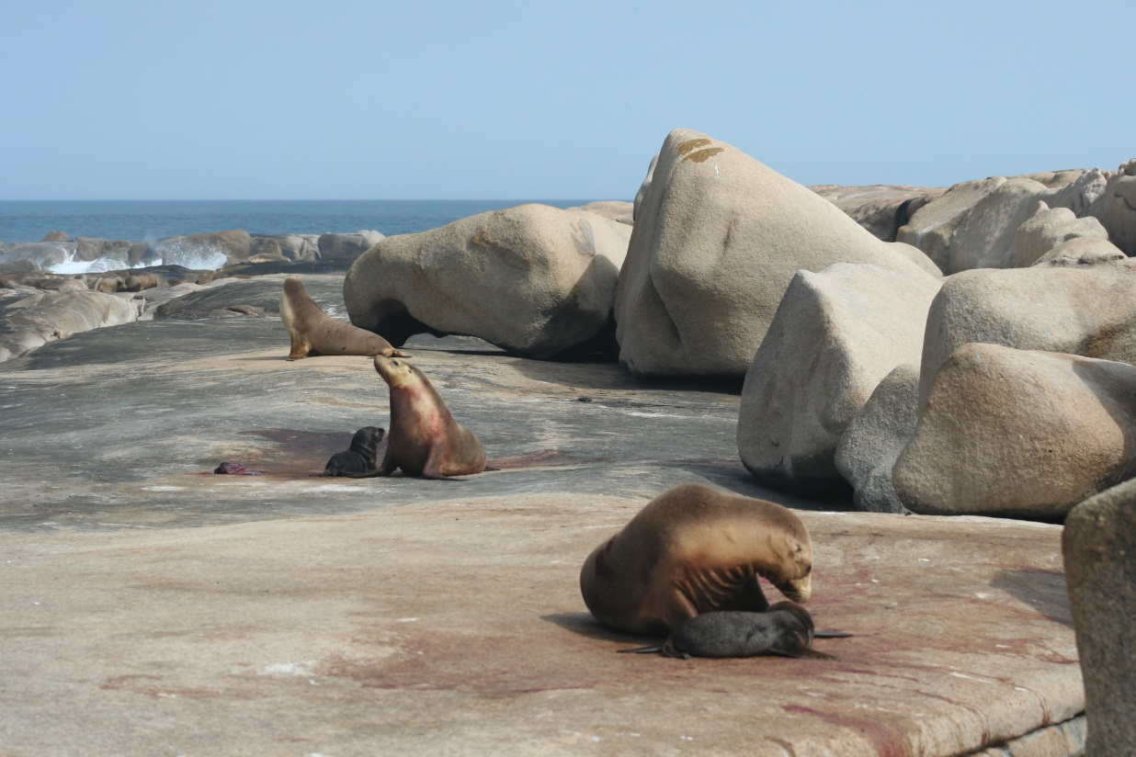

## 1.5 The need for a national monitoring framework

The Australian sea lion was listed as threatened (‘vulnerable’) under the EPBC Act on 14 February 2005, and listed internationally as Endangered on the International Union for Conservation of Nature (IUCN) Red List in 2008. In Western Australia the species was listed as ‘specially protected fauna’ under the Western Australian *Wildlife Conservation Act 1950 — Wildlife Conservation (Specially Protected) Fauna Notice 2003.* In South Australia the species was listed as Rare under the *National Parks and Wildlife Act 1972* in 2008. The Commonwealth Conservation Advice on the Australian Sea Lion (*Neophoca cinerea*) (2005) identified the development of a recovery plan as a high priority; the National *Recovery Plan for the Australian Sea Lion (Neophoca cinerea)* (DSEWPaC 2013b) was subsequently developed and came into effect on 5 July 2013. Both the Conservation Advice and the Recovery Plan highlighted the need for monitoring to determine the status of the species and the effectiveness of management actions.

At its most basic level, management for the recovery of Australian sea lions needs to be underpinned by the ability to detect changes in the abundance and distribution of subpopulations and the species as a whole (Goldsworthy et al. 2007c; McKenzie et al. 2005). To date monitoring priorities and activities have been set by agencies and researchers, and have focused primarily within state jurisdictions. Addressing the objectives and actions of the Recovery Plan for the Australian Sea Lion requires a coordinated and structured effort that is supported by a well-structured national monitoring framework. The monitoring framework must be representative of the population (or units of the population that are of interest), sufficiently rigorous to provide confidence in the data, and sustainable over the time scales necessary to detect population trends or changes in distribution. The collection of data will require significant financial and logistical resources. A coordinated, strategic national approach to long-term monitoring of Australian sea lions will enable the most cost-effective use of resources.

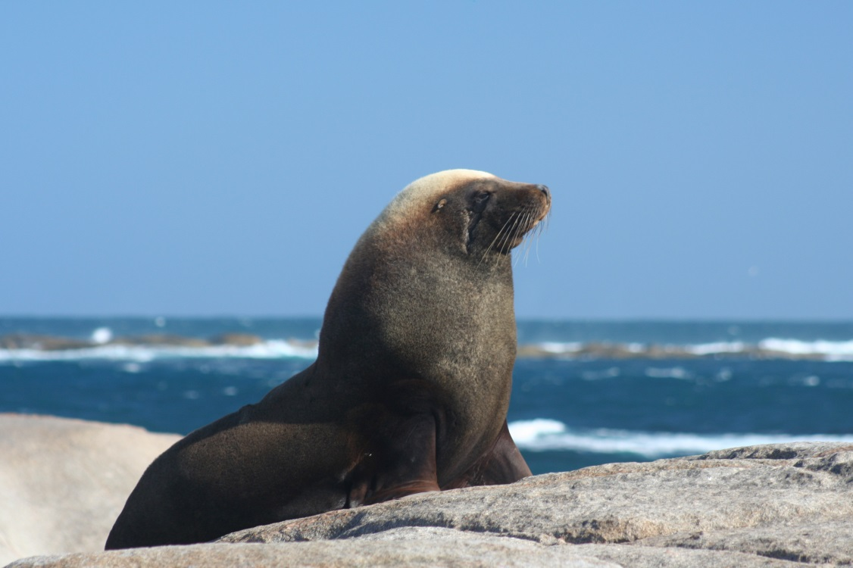

## 1.6 The purpose of the monitoring framework and how it should be used

The purpose of this monitoring framework is to address action 5.1 of the Recovery Plan for the Australian Sea Lion (DSEWPaC 2013b). Further, this monitoring framework should guide the development and implementation of monitoring efforts for the Australian sea lion, such that the data may be used to assess the distribution and abundance of the species, identify the causes of population trends where possible, and evaluate the effectiveness of management actions.

The monitoring framework aims to be the product of agreement between all relevant agencies, with a set of agreed objectives. It aims to assist managers and researchers at all levels to identify priorities when considering the management of Australian sea lions.

With strong management actions being implemented by agencies, that may have real or perceived economic and social impacts (e.g. the Australian Fisheries Management Authority’s (AFMA) spatial closures of the Southern and Eastern Scalefish and Shark Fishery), it is necessary to monitor and provide information on the effectiveness of actions. Further, it is necessary to accompany any monitoring program with realistic expectations about the timescales that are required to assess the effectiveness of management actions. This monitoring framework and its subsequent outputs should be used to provide this information.

Part of the role of a national monitoring framework is to highlight the timescales that are required to properly detect trends in the Australian sea lion population. The unusual life history characteristics of the Australian sea lion limit its recovery capability (TSSC 2005). The late maturation and extended breeding cycle of the species leads to a lower reproductive output compared to other pinnipeds. To illustrate the long timescales required to detect trends, a simulation was performed with a matrix population model based on population data from Seal Bay, Kangaroo Island, South Australia (data from Goldsworthy et al. 2013a and McIntosh et al. 2013). The population was projected forward, with random selection at each time step for survival and reproductive rates, based on the data. The variation generated over 100 simulations is shown in Figure 7. All show a long-term decline, but with considerable variation in the trajectory. Extracting out four 10-time step sequences from the same period (time steps 30-40, i.e. 15 years) in four different simulations highlights the difficulty in detecting trends over short periods of time (Figure 8).

While aiming to assess the effectiveness of management actions, the limitations of monitoring should also be recognised and acknowledged. While the aspiration is to attribute changes in population to management actions, and measure their effectiveness, this may not be possible due to the variety of factors influencing changes in abundance. Monitoring should aim to attribute changes to the correct factors. It may only be possible to examine likely drivers of trends, rather than showing the effects of management actions directly.

In order to properly understand the population size and trends, the monitoring framework may need to be mindful of two types of population change. The monitoring framework should have both an ability to detect large negative changes in the short term, and an ability to detect slower either positive or negative rates of change (recovery/decline) over a longer timeframe. The maximum rate of population recovery is limited by the biology of the species, while decline can be driven by threats at a much greater rate.

Trade-offs are important considerations when designing and implementing a monitoring program. Under ideal circumstances it might be desirable to monitor all colonies during every breeding season, in order to obtain an accurate assessment of the abundance and distribution of Australian sea lions. However, this is not possible; resources (both financial and personnel) are limited and the quality of data that can be obtained varies between colonies and sampling methods. It is therefore necessary to have trade-offs between sampling effort, logistic constraints and the power to detect trends. The model presented in section 4.5 aims to address these trade-offs by allowing simulations of different monitoring designs (including colonies, methods and intervals) to determine how these affect the ability to detect population trends or evaluate management actions. By using this approach it is possible to maximise the cost-effectiveness of a monitoring program while identifying the minimum effort that can provide a suitable level of confidence to assess trends in abundance and the status of the species. Further, this method allows management agencies to assess multiple monitoring approaches and develop an awareness of the risk of obtaining inaccurate population estimates.

Research identified to implement this monitoring framework is considered a high priority. Research outside of the scope of this framework is encouraged to continue the development of our understanding of Australian sea lions, but should be considered on a case-by-case basis.

This monitoring framework is written in response to the National *Recovery Plan for the Australian Sea Lion* (*Neophoca cinerea*) (DSEWPaC 2013b), and as such should be read in conjunction with that document and the *Issues Paper for the Australian Sea Lion* (*Neophoca cinerea*) (DSEWPaC 2013a).

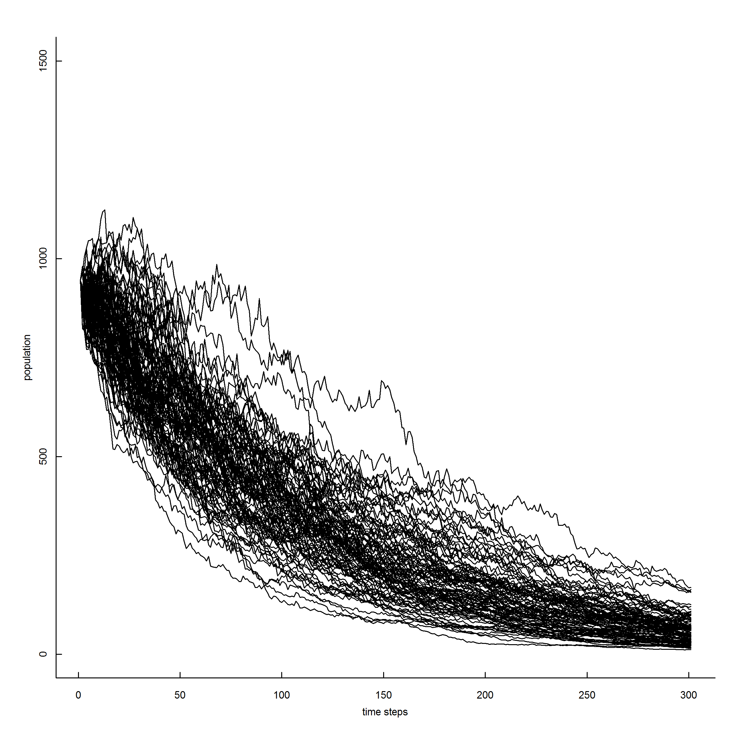

Figure 7. A matrix population model based on population data from Seal Bay, Kangaroo Island, South Australia. Tony Arthur, ABARES.

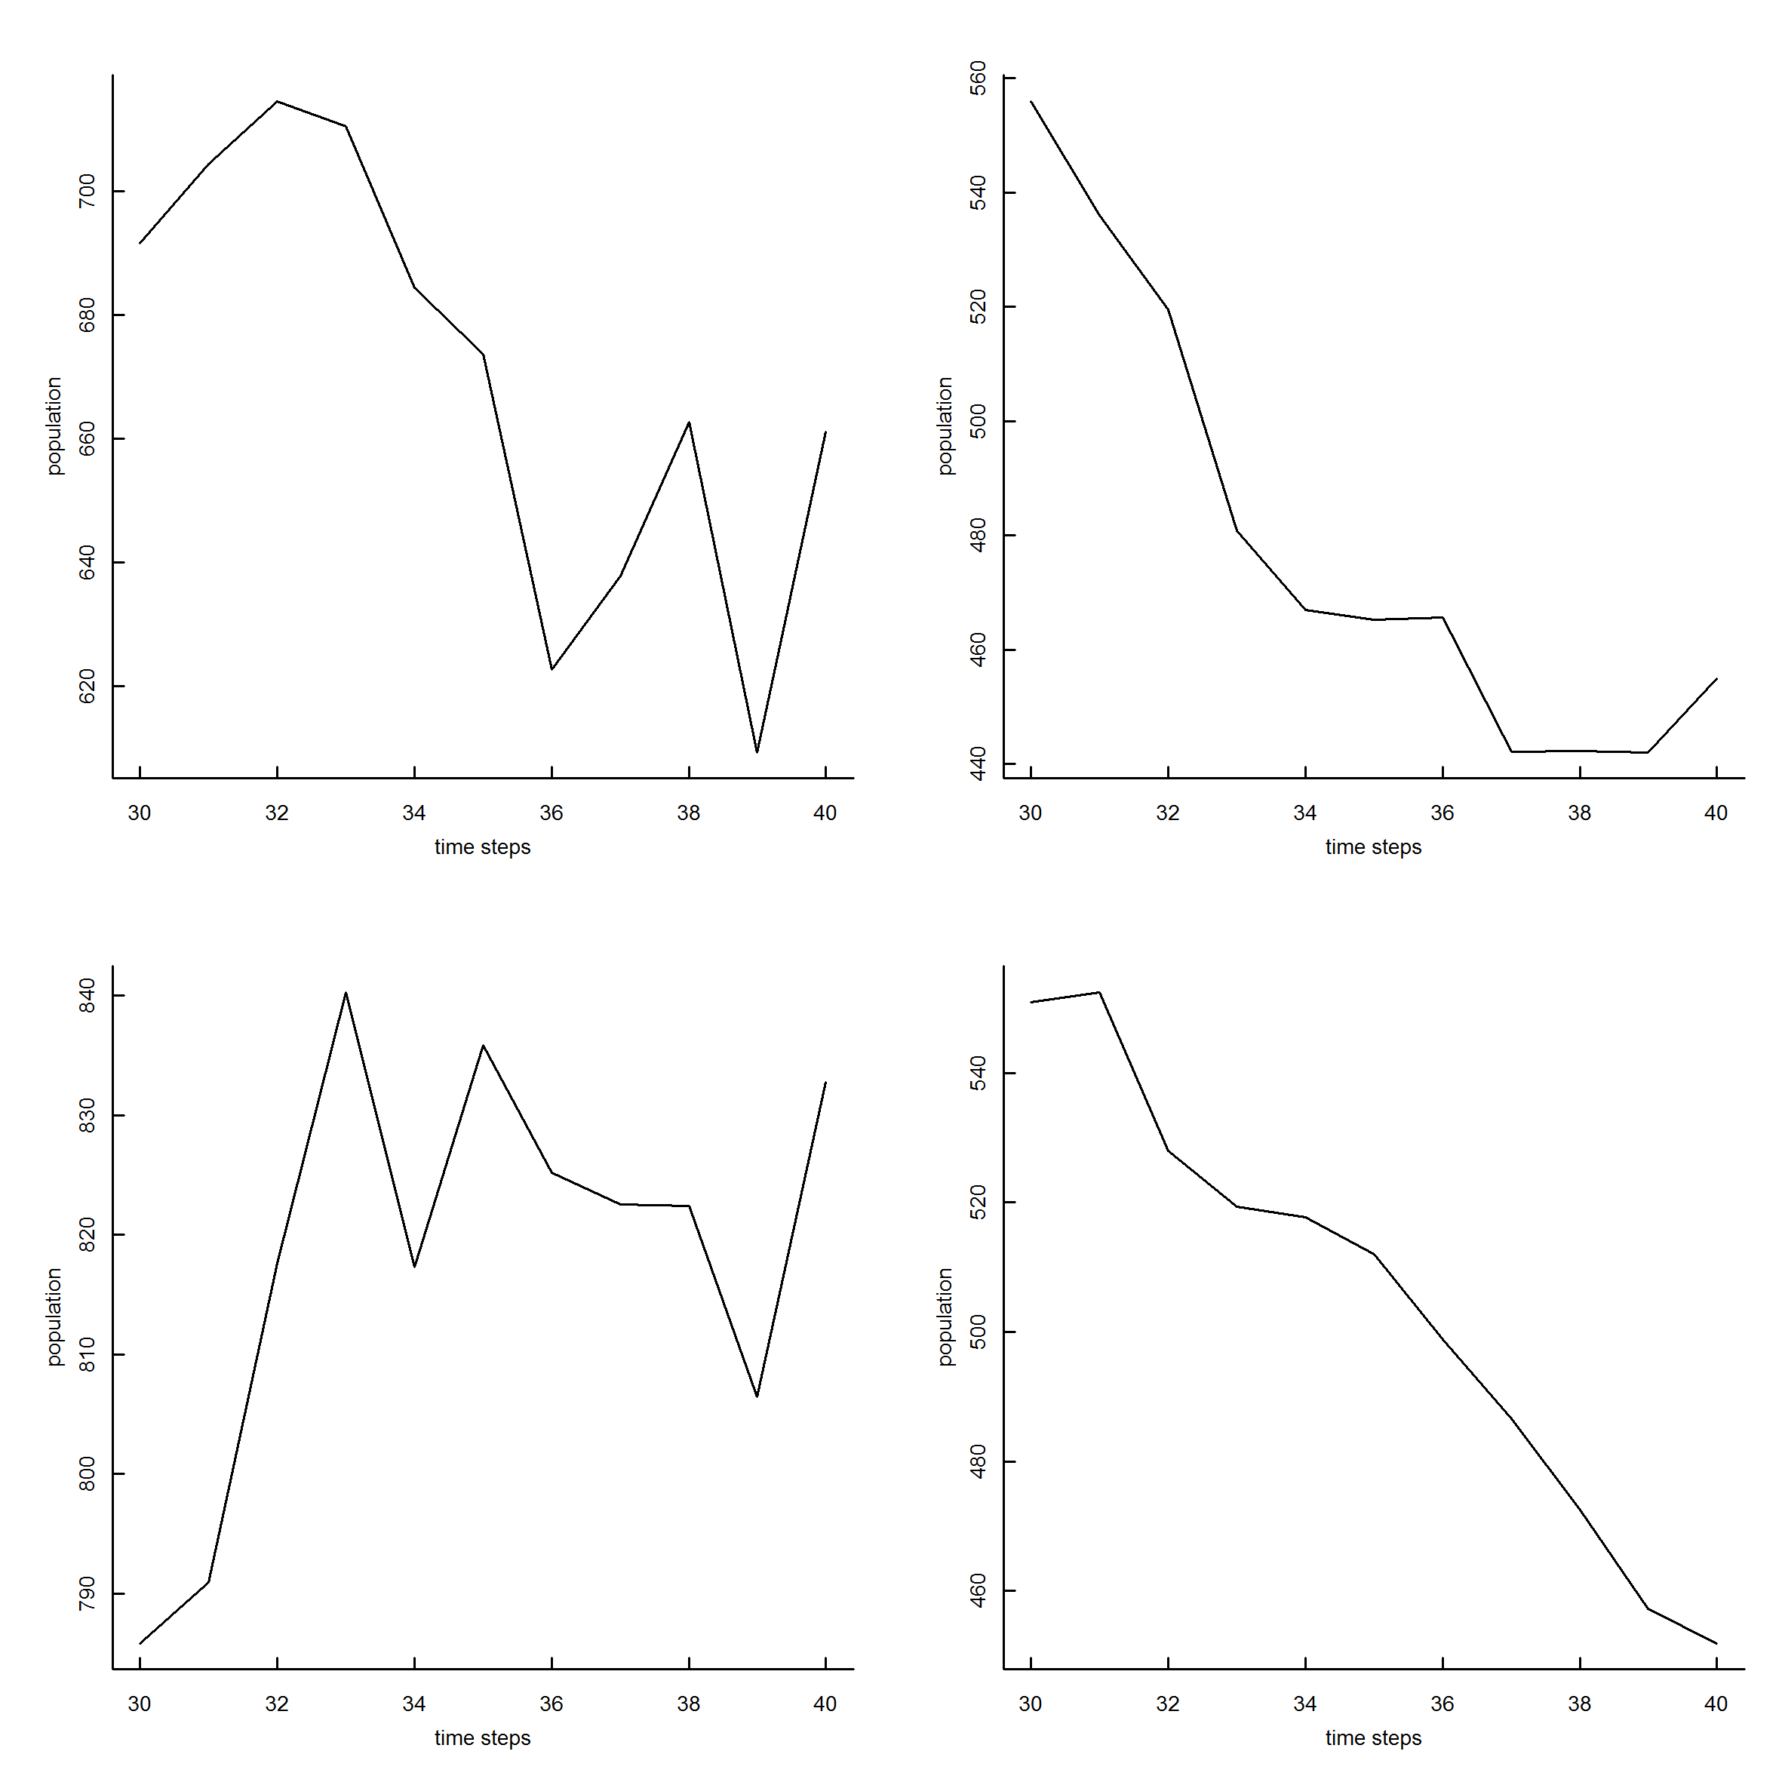

Figure 8. Four 10 time step sequences extracted from the same region (time steps 30-40, i.e. 15 years) of different runs of the model, highlighting the difficulty in detecting trends over short periods of time. Tony Arthur, ABARES.

# 2. Vision

The vision of this monitoring framework is:

*That the monitoring framework gives a level of assurance that the objectives of the National Recovery Plan for the Australian Sea Lion (DSEWPaC 2013b) are met with respect to long-term trends in abundance, distribution and threats.*

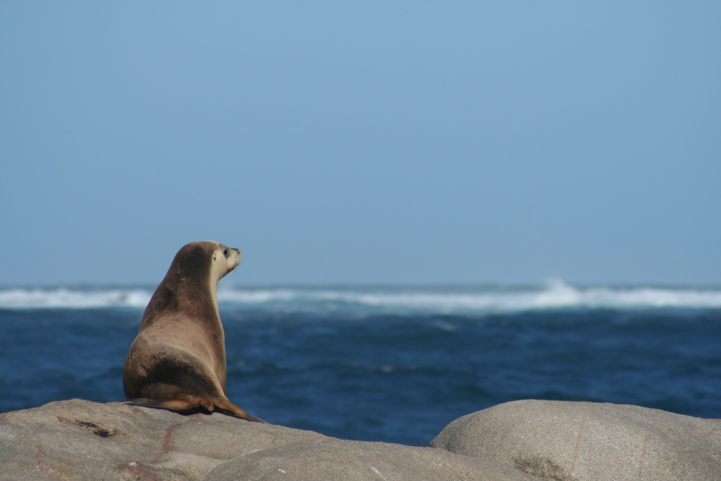

# 3. The objectives of the monitoring framework

The objectives[1] of this monitoring framework are:

1. That over any 10 year period[2] there should be a probability of *p* that the monitoring framework can detect a trend in abundance and distribution in a unit of interest of X%[3]. The units of interest (e.g. colony or metapopulation) are representative of the species based on biogeography, colony size and threatening processes.
2. To measure demographic and health (e.g. body condition) factors contributing to any observed change in abundance.
3. To monitor, and where possible estimate mortality levels from, factors that could drive substantial changes in abundance, including:
   1. anthropogenic factors (direct, indirect and cumulative); and
   2. environmental factors.

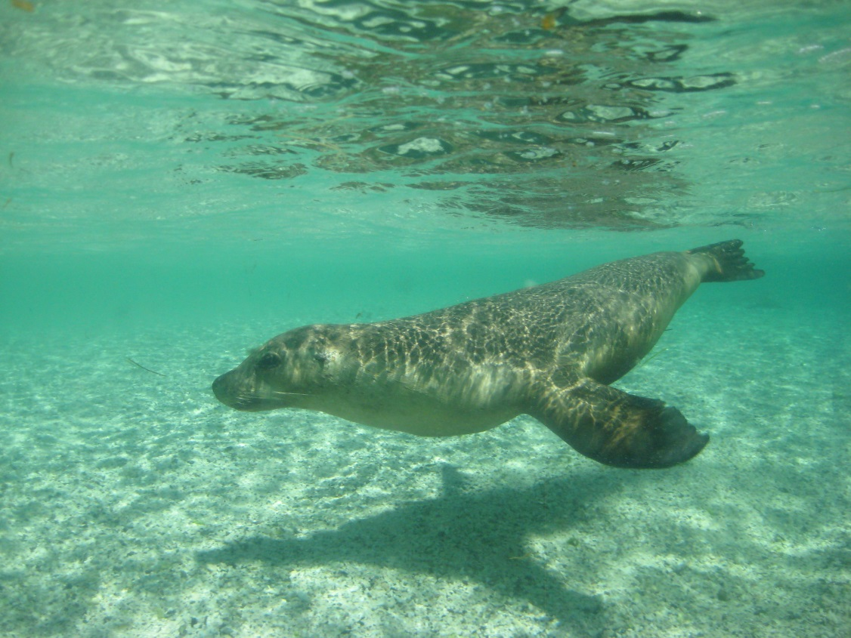

# 4. Methods

## 4.1 Monitoring indicators

Particular indicators should be monitored as part of this monitoring framework in order to achieve its objectives and to assess the efficacy of management actions. The following indicators should be considered as a minimum with other indicators included in, or removed from, the monitoring activities as they are identified through an adaptive management process. Further, opportunities may arise to include other indicators as resources become available.

1. The abundance of Australian sea lions

The abundance of Australian sea lions is a central indicator in this monitoring framework. Previous methods for estimating abundance have focused on counts or estimates of pup production and mortality within colonies. Pups form the only cohort that is easily identifiable and largely ashore in their entirety. For all other age classes, count data are difficult to interpret because an unknown proportion are at sea or at alternate sites at any given time. Pup numbers account for a variable portion of total populations, but total population size can be estimated using multiplication factors (Shaughnessy et al. 2011; Goldsworthy et al. 2015).

Recommended methods and intervals for monitoring abundance will be generated by the statistical framework outlined below. A number of reports have been prepared that review potential survey methods and make recommendations in relation to colony size. The following reports should be used when designing survey methods for use as part of this monitoring framework:

* Shaughnessy and Dennis (2000). Establishing monitoring guidelines and assessing abundance of Australian sea lions at key breeding colonies in South Australia. Final report to Marine Species Protection Program of Coasts and Clean Seas, Environment Australia
* Goldsworthy et al. (2007c). Developing population monitoring protocols for Australian sea lions. Final report to the Department of the Environment and Water Resources.
* Goldsworthy et al. (2007b). A population monitoring and research program to assist management of the Australian sea lion population at Seal Bay Conservation Park, Kangaroo Island.
* Goldsworthy et al. (2008). Developing population monitoring protocols for Australian sea lions: enhancing large and small colony survey methodology. Final report to the Australian Centre for Applied Marine Mammal Science (ACAMMS), Department of the Environment, Water, Heritage and Arts.
* Mackay et al. (2013). Australian sea lion abundance in the Bunda Cliffs region, GAB Marine Park. Final report to the Department of Environment, Water, and Natural Resources.

1. The distribution of Australian sea lions

The distribution of Australian sea lions is a central indicator in this monitoring framework. Monitoring activities should provide up-to-date information about the overall distribution of Australian sea lions in order to track any changes in the distribution. All jurisdictions have identified knowing the status of all the extant breeding colonies as a priority. Colonies that are monitored for abundance will automatically be included in distribution monitoring. However, other colonies should be monitored for the presence/absence of Australian sea lions. Initially, presence/absence monitoring may occur on an opportunistic basis, until such time that a sampling strategy is identified that allows for the systematic sampling of all colonies.

Such a strategy may involve the use of:

* Remote cameras.

Remote cameras (Figure 9) are currently being trialled in both South Australia and Western Australia (Goldsworthy et al. 2013). These units contain motion operated cameras, and store photos on removable memory for later retrieval and/or transmit the images via the mobile telephone network. The images can be used to both monitor the presence of Australian sea lions at a colony and to assess the timing of the breeding season through monitoring the presence and appearance of pups and mate-guarding males (Figure 10). Development of this technology is highly recommended for the monitoring of Australian sea lions as it allows for the remote monitoring of colonies at a comparatively low cost and also provides information about the timing of breeding seasons, which is vital in improving the accuracy of pup abundance counts (Goldsworthy et al. 2007c) as well as optimising logistics and planning to help maximise return for investment. The current limitation to deploying cameras at colonies is the availability of mobile network coverage to access the camera data remotely without the need to physically retrieve data.

* Helicopter surveys.

Aerial surveys have potential to provide information about the presence of Australian sea lions in colonies, as well as the timing of breeding seasons. Increasingly, researcher access to colonies is changing from boat to helicopter use. At the same time as accessing colonies for abundance counts, the opportunity may exist to survey nearby colonies to confirm the presence of Australian sea lions.

1. Demographic and body condition factors

Demographic information and body condition estimates may provide important information for interpreting the abundance of Australian sea lions and attributing causes of population trends. It is particularly important to assess demographic and health factors across a number of colonies in order to assess if change is driven by anthropogenic or natural factors. Where possible, researchers should collect appropriate demographic and body condition information.

1. Health (eg. disease and parasites)

The impact of disease and parasites on the growth of Australian sea lion populations is difficult to quantify, but it is suggested to be a significant cause of mortality (DSEWPaC 2013a). Hookworm and tuberculosis have been recorded in sea lion colonies, and small colonies may be particularly susceptible to population loss arising from disease outbreaks (DSEWPaC 2013a). Continued research into the potential impacts of disease and parasites is required, and where possible incorporated into the monitoring of Australian sea lions to determine the impact of this threat on population trends.

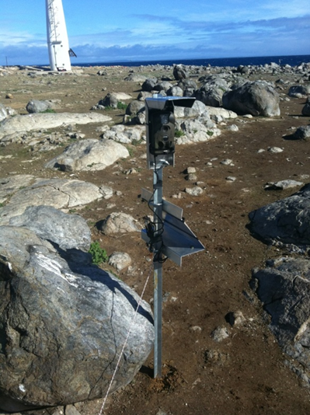

Figure 9. A remote camera deployed on Dangerous Reef, Spencer Gulf, South Australia. This system uses a motion activated camera and photos are stored on removable memory and/or transmitted via the mobile telephone network. Power is provided by a small solar panel. Photo by Mark Whelan, from Goldsworthy et al. (2013).

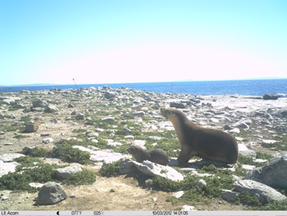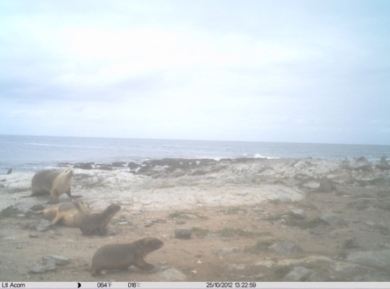

Figure 10. Photos taken by remote cameras deployed on Dangerous Reef, Spencer Gulf, South Australia. In the left photo a female with a black pup can be seen. In the right photo two females and two brown pups are present. The cameras also record information such as the time and date of the image. Photos supplied by Simon Goldsworthy, SARDI.

## 4.2 Representative regions of the Australian sea lion population

McKenzie et al. (2005) noted that the large number of breeding colonies, and their asynchrony in the timing of breeding, made obtaining high quality abundance trend data from all colonies unachievable. It is therefore recommended that efforts be concentrated on obtaining high-quality time series data from a subset of key and regionally representative breeding colonies (Goldsworthy et al. 2007c; McKenzie et al. 2005).

Goldsworthy et al. (2007c) proposed dividing the entire distribution of the Australian sea lion into smaller metapopulations (a group of spatially separated subpopulations/breeding colonies or sites of the same species which interact at some level) within which a subset of colonies could be monitored as a proxy for the metapopulation. Because of the high genetic subdivision between colonies and the species’ extremely limited dispersal, Goldsworthy et al. (2007c) developed a distance matrix as a proxy for genetic distance between 64 breeding colonies (Figure 11). They found a clear separation between the Western Australian and South Australian colonies. Within South Australia there was support for three major groupings (Bunda Cliffs, West Coast and Central Coast Regions) which could be further divided into seven metapopulations. In Western Australia they suggested three major groupings (West Coast, South Coast and Recherche Archipelago Regions), with a fourth consisting of the single colony Twilight Cove (identified as Bunda 10 in the analysis).

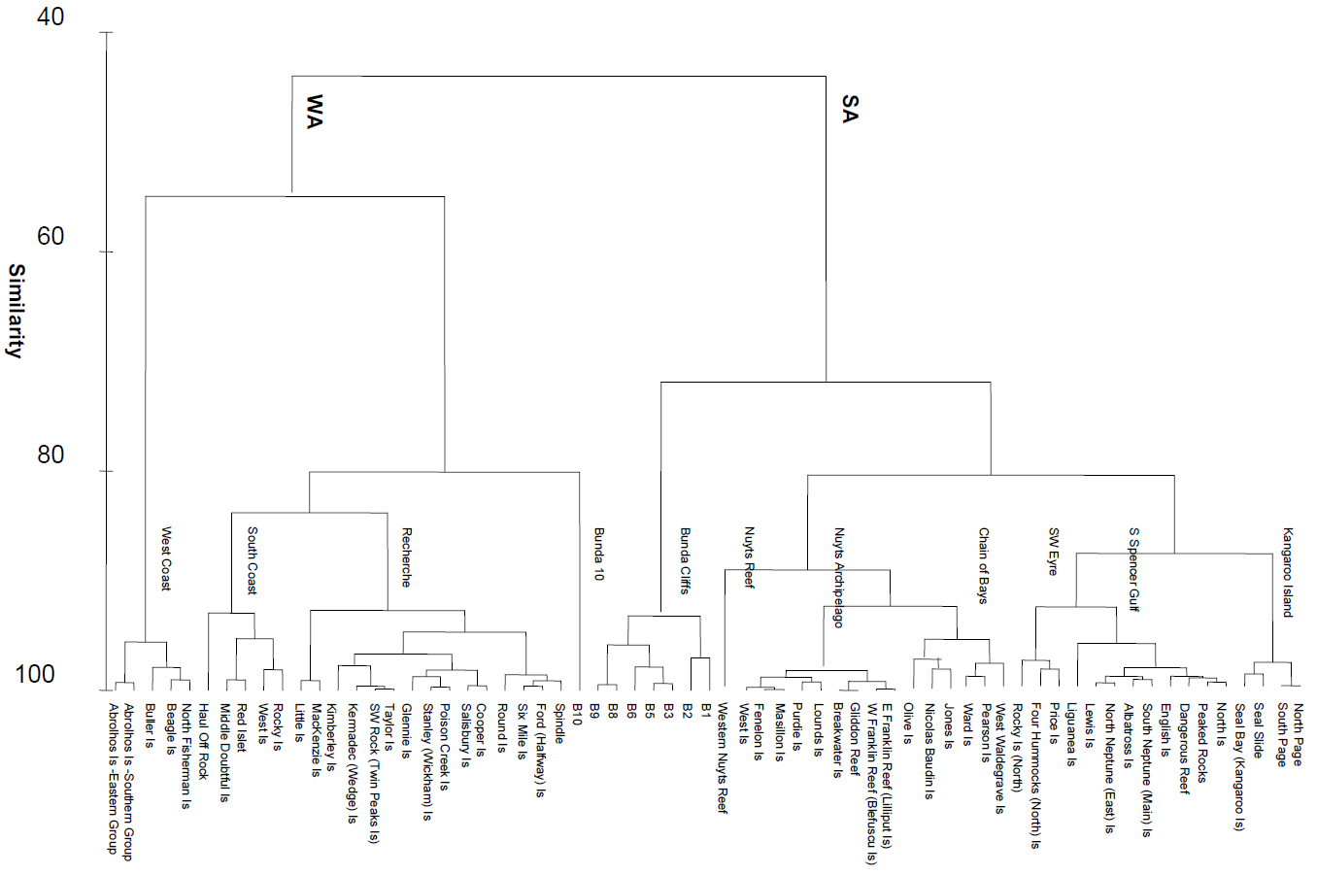

Figure 11. Dendrogram of subpopulation distance similarity of 64 South Australian and Western Australian breeding sites. Eleven metapopulations are identified. Note in this analysis Twilight Cove is identified as Bunda 10. From Goldsworthy et al. (2007c).

Following consultation with all agencies and the identification of further breeding sites, 13 metapopulations have been proposed (Figure 12). The seven metapopulations in South Australia were previously identified (Goldsworthy et al. 2007c) and correspond to the management regions identified by AFMA in the *Australian Sea Lion Management Strategy* (AFMA 2010). In Western Australia six metapopulations have been identified, two on the west coast and four on the south coast, including Nuyts Island which comprises the single colony of Twilight Cove. Although Twilight Cove has been allocated to a unique metapopulation, the remoteness, extremely difficult access and small population make it unsuitable for regular population monitoring. The assignment of colonies to metapopulations are listed in Appendix 1.

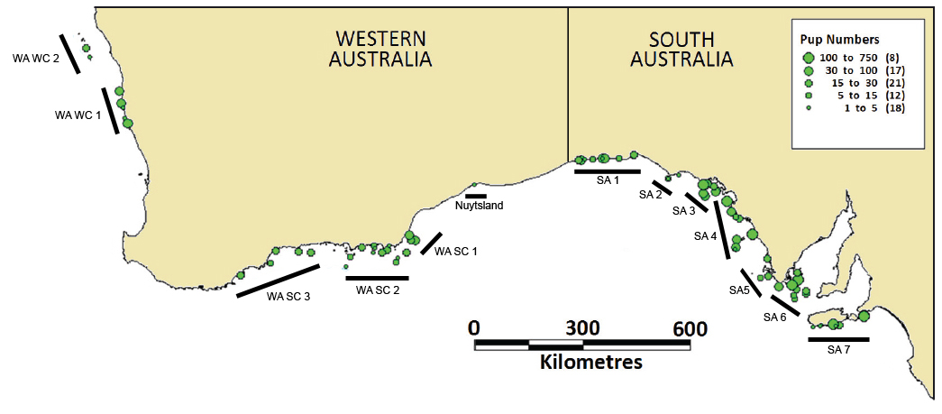

Figure 12. A map showing the approximate location of the 13 metapopulations of Australian sea lions for monitoring purposes.

## 4.3 Representativeness of colonies within the metapopulations

Within metapopulations it is necessary to identify a subset of colonies at which monitoring the abundance of Australian sea lions will be conducted. These colonies should be representative of the other colonies within the metapopulation, and should be chosen so that they account for the variation present in a group of key factors that could affect the rate of change in abundance in the metapopulation. It is anticipated that the framework will aim to monitor two colonies per metapopulation, however the actual number will be determined by the statistical framework (Section 4.5), the number of colonies within a metapopulation, the available resources and other reasons that may make monitoring a colony desirable.

The main factors when considering representativeness are:

1. Colony size
   * Goldsworthy et al. (2007c) recommended monitoring a representative large (>40 pups produced per season) and small (<40 pups produced per season) colony within each metapopulation, where there is a range of population sizes.
   * For the purpose of this monitoring framework, colonies will be classified by their pup production into four categories (<5, 5-40, 40-100, >100).
2. Inshore vs. offshore foraging strategy
   * Three foraging ecotypes have been identified for female Australian sea lions. Females show specialisation for foraging in inshore, offshore or intermediate regions (Lowther & Goldsworthy 2010; Lowther et al. 2012).
   * Foraging strategy may limit the dispersive capacity of adult female Australian sea lions (in turn driving population structure; Lowther et al. 2012), and may influence the susceptibility of some colonies to threats through the location of their foraging areas. Further, different foraging strategies may impart different demographics between colonies and lead to differences in the recovery potential of colonies.
3. The likelihood of impacts of threats

* When determining which colonies are representative of a metapopulation it is necessary to consider the potential for impacts from known threats.
* Representative colonies should include colonies that have historically been impacted, colonies that are currently impacted, and colonies without known impacts of threats.
* Impacts may be direct (e.g. fishing bycatch, human disturbance) or indirect (e.g. edges of metapopulation, prey depletion).

1. The potential for population expansion
   * There is variation in the carrying capacity of colonies across the current range of the Australian sea lion. Some colonies may have ample space and suitable habitat that allows for growth, while others may be closer to their carrying capacity. While further work is required to accurately quantify the potential for colonies to expand, attempts should be made to include this factor into any decisions about the representativeness of colonies.

An initial attempt to characterise these factors for each of the current Australian sea lion breeding colonies is shown in Appendix 2. These should be used when making decisions about a monitoring design (Section 4.5) and should be amended as new information becomes available.

## 4.4 Desirable features of colonies to be monitored

In addition to ensuring representativeness, colonies selected to be monitored for pup abundance should have a number of desirable features that may improve the feasibility and efficacy of a monitoring program, as well as reflect social reasons for monitoring a colony.

The desirable features of colonies to be monitored are:

* Little interchange of Australian sea lions between colonies, particularly pups (to maximise the availability of pups for detection and counting)
  + A major source of error in counting Australian sea lion pups comes from their “availability” during counts (Goldsworthy et al. 2007c). A large contributor to this is the dispersal of pups to nearby colonies or haul-outs before the end of the breeding season. Colonies with little or no interchange are less likely to give error during counts through availability bias than those with greater interchange, and so are more desirable for monitoring.
* Good accessibility to the colony
  + Considerations should be given to the logistical feasibility, cost effectiveness, practicality and safety of surveying each colony. Colonies that are easier to access provide the opportunity for more reliable and cost effective monitoring.
* The good detectability of Australian sea lions
  + Colonies vary in the ease of sighting animals. At the extreme, colonies such as the Bunda Cliff colonies may only be observable from the cliff tops, while others may be low lying islands were animals spend a greater amount of time in the shallow water around the island. Colonies such as these would be regarded as having relatively poor detectability and low reliability of count data. Sightability bias may also be caused by the level of cover (e.g. vegetation, crevices or caves) available to pups in the colonies (Figure 14).
* Relative “compactness” of a colony
  + The dispersion of animals within a colony can affect the ability of researchers to reliably locate animals when conducting counts. This factor aims to encompass the ease and reliability of sampling.
* The existence of prior time series data
  + Colonies that have been subject to previous monitoring and have prior time series data should be strongly considered for their suitability for continued monitoring. Prior time series data assists in the design of survey methods (see Section 4.5), and allows for the assessment of trends.
* Public interest in the colony
  + Colonies with high levels of public interest, such as Seal Bay (Figure 13), should be included in a monitoring program to provide a level of confidence to the public about the efficacy of Australian sea lion conservation efforts and to monitor any possible impacts from activities such as tourism.

As above, an initial attempt to characterise these factors for each of the current Australian sea lion breeding colonies is shown in Appendix 2. These should be used when making decisions about a monitoring design (Section 4.5) and should be amended as new information becomes available.

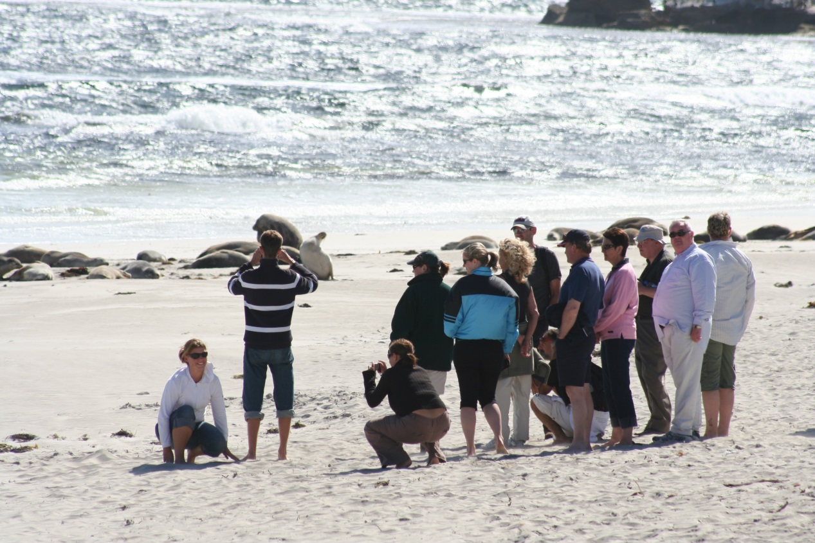

Figure 13. A guided tour of the Australian sea lion colony at Seal Bay Conservation Park, Kangaroo Island. Photo by Benjamin Pitcher.

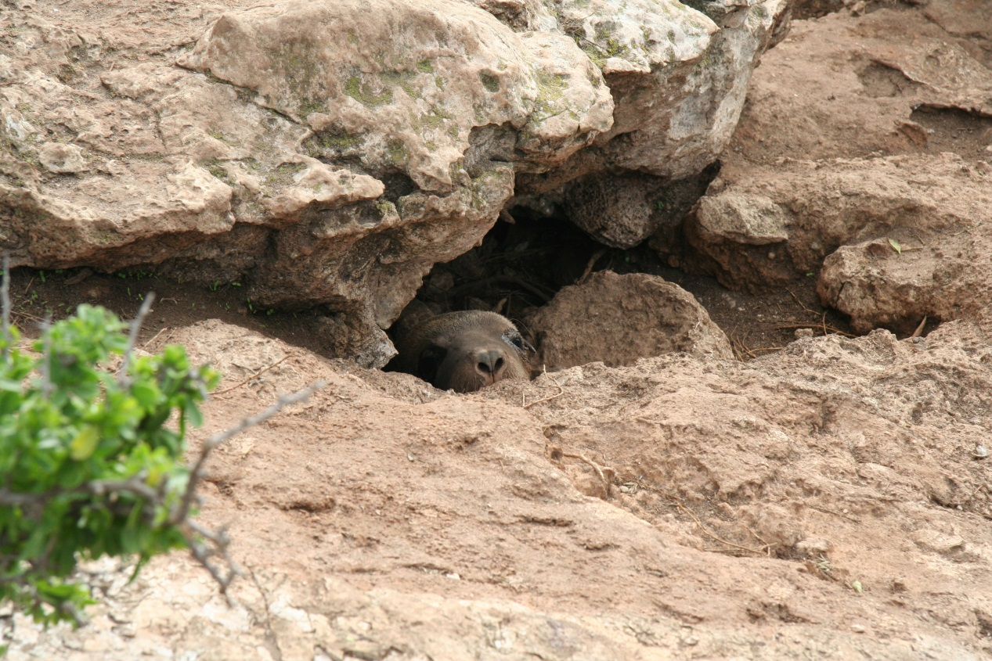

Figure 14. The detectability of pups varies depending on the type and density of cover in a colony. In this photo a pup is sheltered in a cave on Lewis Island, South Australia. Photo by Benjamin Pitcher.

## 4.5 A simple statistical framework for Australian sea lion monitoring design and analysis

This section describes a simple statistical framework that could be used in choosing an effective and parsimonious monitoring design for Australian sea lions. In this context, "monitoring design" means a planned schedule of which colonies to monitor at roughly which dates using which methods, over a defined (e.g. 5, 10 or 20 year) period. For example, a monitoring design could look like Table 1.

Table 1. A hypothetical monitoring design for Australian sea lions. This table indicates which colonies will be monitored at certain times and with what method.

|  |  |  |  |  |  |  |  |  |
| --- | --- | --- | --- | --- | --- | --- | --- | --- |
|  | 2015 Summer | 2015 Autumn | 2015 Winter | 2015 Spring | 2016 Summer | 2016 Autumn | … | 2036 Summer |
| Big Rocks | SDC |  |  |  |  |  |  | SDC |
| Grunt Point |  | MDC |  |  |  |  |  |  |
| Pyjama Bay |  |  |  |  | FMR |  |  |  |
| Droog Is. | FMR |  |  |  |  | CMC |  |  |
| … |  |  |  |  |  |  |  |  |

In Table 1, rows are colonies, columns are rough dates (year and season), and entries are survey method, e.g. Single/ Multiple Direct Count (S/MDC), Full Mark-Recapture (FMR), Cumulative Mark and Count (CMC), etc. A blank means "not surveyed then".

The statistical framework is centred on a statistical model for real or hypothetical abundance estimates collected at various colonies at various times. The framework also embodies a process in which the model is used to:

(i) explore different potential designs for a monitoring program; and

(ii) analyse existing abundance data, plus of course future data when it gets collected, in order to estimate abundance and trend for different groups of colonies.

To explore any particular design, the model is in principle applied to simulated data collected according to the design, to check how precisely we could then estimate quantities-of-interest: that is, abundances at particular times, cumulative changes in abundance, or rates-of-change in abundance, probably grouped across "nearby" colonies or colonies of a similar "type" in terms of, say, exposure to gillnet mortality. In practice, it should not actually be necessary to simulate data, because there is a well-established statistical theory to compute what the precision would be. This means it should be possible to quickly find out how well any particular design would do, e.g. interactively within a short workshop.

The model proposed below is very flexible, in that it does not require any particular rigid design (no need for equally-spaced sampling, etc). Also, if circumstances change and the monitoring design needs to be changed, there is no problem in accommodating the new data nor in re-planning future data collection. This flexibility does not, of course, mean that common-sense principles of good design can be discarded; "bad" designs (e.g. imbalanced and/or too sparse) will unavoidably give imprecise estimates, which will rapidly become apparent during the exploratory phase of design investigation.

### The model

The statistical model itself is a special case of a Generalized Linear Mixed Model (GLMM):

$$Y_{it}=q_{it}N_{i0}e^{r_{i}t}+ε_{it}$$

where:

* $i$ is the site label.
* $t$ is the sampling date (with 0 standing for an arbitrary "reference date" for the monitoring program, e.g. 1 Jan 1970).
* $Y_{it}$ is an abundance estimate obtained for that site in that year.
* $q_{it}$ is a "bias" factor that depends on the method of survey.
* $N_{i0}$ is the abundance of colony $i$ at the reference date.
* $r_{i}$ is the rate-of-change for colony $i$. A key point in the model is that $r_{i}$ can be allowed to depend on various general factors, e.g. large vs small colony (see below).
* $ε_{it}$ is the noise/error associated with that particular observation, which includes measurement error and process error, i.e. natural variability in abundance (e.g. proportion of females actually breeding that season). The likely magnitude of $ε_{it}$ will depend on the colony and the survey method used, as explained below.

Statistically, the $Y$’s are the observations, and the $ε$’s are the errors.

Fitting the model assuming a multiplicative error structure, the linear predictor is given by:

$$logE\left[Y_{it}\right]=logq_{it}+logN_{i0}+tr_{i}$$

$$r_{i}=X_{i}β+ζ_{i}$$

where:

* $logq_{it}$ is partly a pre-specified fixed offset, and partly a colony-specific fixed effect (i.e. estimable parameter) that allows for the systematic winter/summer differences that are clearly visible in some existing ASL time-series;
* $logN_{i0}$ is a colony-specific fixed effect;
* $r_{i}$ is a mixed effect that (i) allows for various factors such as colony size or exposure to gillnetting, as specified through a design matrix $X$ and captured through appropriate components of the estimable parameters $β$, and (ii) allows each colony to have its own additional trend $ζ_{i}$.

Note that the overall error variance $V\left[ε_{it}\right]$ is also affected by systematic uncertainty about the true value of $q_{it}$, which needs to be allowed for in setting up the correlation structure of the errors.

Implementing this model, whether for investigating designs or for analysing existing data, entails:

* deciding which factors to include in $r$, and then generating appropriate design matrices;
* deciding on an appropriate "error model" (probably Gaussian on the log-scale to reflect the multiplicative nature of many of the sources of noise, until and unless residual analysis suggests that something else is needed); and
* “off-line” analysis of existing data to estimate the $q$ and measurement error variance for different survey methods (based on retrospective comparisons of "ideal" full-season abundance estimates versus what would have been estimated if a simpler method had been used that time), plus the process noise (based on variability in observed time series after allowing for now-known measurement error variance).

The *precision* that the model will provide about some quantity-of-interest depends only on the model structure (i.e. model assumptions including assumed distributions), and on the variances (i.e. variances associated with factors known to influence abundance - at least if a Gaussian error model is reasonable - not on the particular values of the starting colony sizes, nor on the size of each ‑factor which is of course unknown in advance). The only variance that probably cannot be well-guesstimated beforehand is the colony-specific variability in rate-of-change, i.e. $V\left[ζ_{i}\right]$. A few different plausible values for $V\left[ζ_{i}\right]$ will need to be tried during the design-exploration phase, chosen on common-sense demographic considerations. Once enough monitoring data has been collected, $V\left[ζ_{i}\right]$ can be estimated as usual in any GLMM.

Estimates (including precision) of the effect of particular factors— e.g. how much the rate-of-change differs between big and small colonies— can be obtained directly from the usual summary statistics of GLMMs. Estimates about aggregate abundance or change for certain groups of colonies require a non-linear transformation (because the model naturally predicts just log-abundance), and the delta‑method can be used to find the corresponding approximate precision.

Note that it will be possible to make estimates (with quantified precision) about the abundance of individual "focus" colonies or groups of colonies, even in years when they were not surveyed directly. The statistical model automatically integrates the information on how *other* colonies have changed (giving more weight to colonies that are more similar to ones in focus) with the best available data for the focus colonies. Indeed, even without input from future monitoring, the model provides a way to synthesize existing data for hindcasting recent trends in abundance of this species.

Of course, the constant-rate model (i.e. where $r_{i}$ is not allowed to change over time) is inevitably a simplification, and may not be adequate for all time periods. If, for example, there was to be a major increase in gillnet effort close to some colonies, then the structure of the GLMM may need modifying to allow for a possible change in rate. Over very long timespans, it may become apparent that a constant-rate-of-change is simply not adequate to describe the data from some colonies, as density-dependent effects eventually become paramount. Such subtleties can be handled as and when they arise by tweaking the *details* of the GLMM (in particular, the design matrix $X$), without needing to change the basic setup. To begin with, from a design perspective it is essential to keep the job tractable by concentrating on how well we would be able to track *large*, i.e. biologically important, changes which can be described most simply in terms of constant rates.

It is worth emphasizing that this is a *very simple* statistical model— much simpler, for example, than any of the composite mark-recapture models currently used to estimate single-season abundances at some Australian sea lion colonies. GLMMs have been well-known in the statistical world since at least 1993, and nowadays there are a number of software packages that can fit them (e.g. the modelling software R). As with any use of GLMMs, some time would be required to set up the model appropriately and to write "wrappers" allowing designs to be evaluated and summary statistics to be extracted easily. However, this would likely take much less time than the preliminary analysis required to estimate method-specific $q$ and variances.

### Exploring designs and choosing one

Clearly, there is a large range of possible designs that *could* be explored using this framework. Although there is in principle a suite of techniques for "optimal design" which aim to choose *automatically* the best amongst possible designs, in practice such techniques are unlikely to be much use for designing an Australian sea lion monitoring framework. First, there will be a number of "givens" in the design process (e.g. desire to sample some colonies regularly for other reasons) that may be hard to incorporate into an optimal design algorithm, but that are easy to just impose manually. Second, optimality has to be aimed at one specific criterion, e.g. change in overall abundance of Australian sea lions, or detecting the effects of some management action. However, it is unlikely that there will be consensus in advance about what the criteria should be, and it is more important to be able to explore interactively the extent of trade-offs between different criteria. The different criteria should be explored through simulation to examine their feasibility. Third, optimality algorithms require either a predefined cost-benefit trade-off or an explicit budget; for Australian sea lion monitoring, though, there is currently no clear notion of how much money is "available" and how it might be broken down. Quite likely, this is something that can only be sensibly considered *after* an initial exploration of a few possible designs, to get a feel for what they might cost and how precisely they will provide information about what.

That whole process of exploration is best handled interactively, so that people can develop some feel for what precision about various quantities-of-interest is, and is not, actually achievable over various timescales, and at what financial cost. It is not necessary to churn through every possible design in order to come up with a small selection of different "types" that are worthy of further consideration. It will be obvious in advance that certain types of design would be useless, at least in terms of tracking overall abundance (surely a minimum requirement of any credible monitoring programme) — for example, omitting all the biggest colonies, or including only one metapopulation, or including only colonies that have never been exposed to appreciable nearby fishing. Beyond eliminating those, some common-sense and ad hoc exploration of candidate designs of different types should suffice.

# 5. Process for implementation

Implementation of the Monitoring Framework outlined in this document will require substantial time and resources. It is acknowledged that these resources may not be currently available. This section provides guidance on the steps that should be followed to implement the framework, for when resources become available. A coordinating team should be established to direct implementation. As monitoring will be undertaken over long time-scales, it should be ensured that the influence of personalities in the design/direction of the Monitoring Framework is minimised to provide consistency in the framework over time.

## 5.1 Steps for implementing the monitoring framework

Proposed steps for defining the representative colonies to be monitored, and the monitoring design, are as follows:

1. Prioritise potential sites for monitoring within each metapopulation, by assessing colonies against the representative and desirable factors outlined in Section 4. This should include identification of appropriate survey methods for each colony. The information provided in Appendix 2 should be used when prioritising sites, however it may be necessary to amend or add to this as new information becomes available.
2. Build and populate a variance matrix to determine how much noise might be associated with monitoring particular sites. This will require data, statistical support and analysis.

* Include two types of variances: sampling variability and random variability. There are errors/bias associated with determining when measurements are in the breeding season, and with data points and time-series.
* Create a matrix outlining colonies vs. available/feasible sampling methods.
* Where there are data gaps, estimate from other colonies but account for colony variabilities.
* Creation of this variance matrix is essential for designing a meaningful and efficient monitoring design, and would require consultation with executive members of management agencies to gain support and permission to access data and resources.

1. Build and trial monitoring designs (including colonies, methods and sampling intervals). This would include the simulation of various trial designs to see how precisely they would answer certain questions and how much they would cost. Consideration of trade-offs in the monitoring designs and the associated levels of confidence in answers is recommended.
2. It would be highly beneficial to hold a multi-stakeholder modelling workshop to agree on a monitoring design. Following the development of a number of potential monitoring designs, it is recommended that stakeholders be brought together to reach an agreement on a monitoring design to take forward. Such a workshop should address:
   * The desired probability of detecting a change and the magnitude of that change that should be detectable through the monitoring design (the *p* and X factors in Objective 1 of this monitoring framework).
   * The recommended colonies for continued abundance monitoring.
   * The recommended methods and intervals for conducting counts in each colony.
   * A recommended design for monitoring the distribution of the Australian sea lion at colonies that are not included in the monitoring design.
   * Recommendations of trigger points for management actions resulting from monitoring.
   * A reporting framework, including actions and associated performance criteria.

## 5.2 Reporting and evaluation

It is recommended that results from monitoring be reported to a coordinating team (including the Department of the Environment and Energy and relevant state agencies), so that data can be collated and shared, and learnings fed back into the monitoring design and implementation. A standardised reporting template should be developed so that comparisons can be made between data, and an overall picture can be gained for Australian sea lion abundance across its range.

It is recommended that reporting include the following information:

* Details on monitoring undertaken to date, including survey methods employed, the type of data collected and to what extent.
* Any trends identified from monitoring.
* Any issues arising from monitoring and any recommendations for the ongoing review of the Australian sea lion monitoring program.

In keeping with the principles of adaptive management, there should be ongoing review and improvement of the monitoring design (outlined in Section 4) based on information derived from the monitoring program. The coordinating team should periodically assess the progress of Australian sea lion monitoring against the objectives of this monitoring framework. This monitoring framework document may require updating post-implementation of the framework.

# 6. Concluding remarks

This *Australian Sea Lion Monitoring Framework: background document* outlines the considerations and principles underpinning an appropriate monitoring design for the Australian sea lion. It should be read in conjunction with the associated document *Australian Sea Lion Monitoring Framework: statistical model* (Lawrence & Bravington 2016: <http://www.environment.gov.au/marine/marine-species/seals-and-sea-lions>) which implements the statistical framework (outlined in Section 4.5) and applies it to different sampling scenarios, to illustrate how the model can be used to identify an appropriate monitoring design for the Australian sea lion.

The objectives and actions recommended in this document are not exhaustive, but serve as a guide for prioritising the research/monitoring required to assess the distribution and abundance of Australian sea lions. At all times the objectives of the National *Recovery Plan for the Australian Sea Lion* (*Neophoca cinerea*) (DSEWPaC 2013b) should be considered and actions tailored to support those objectives.

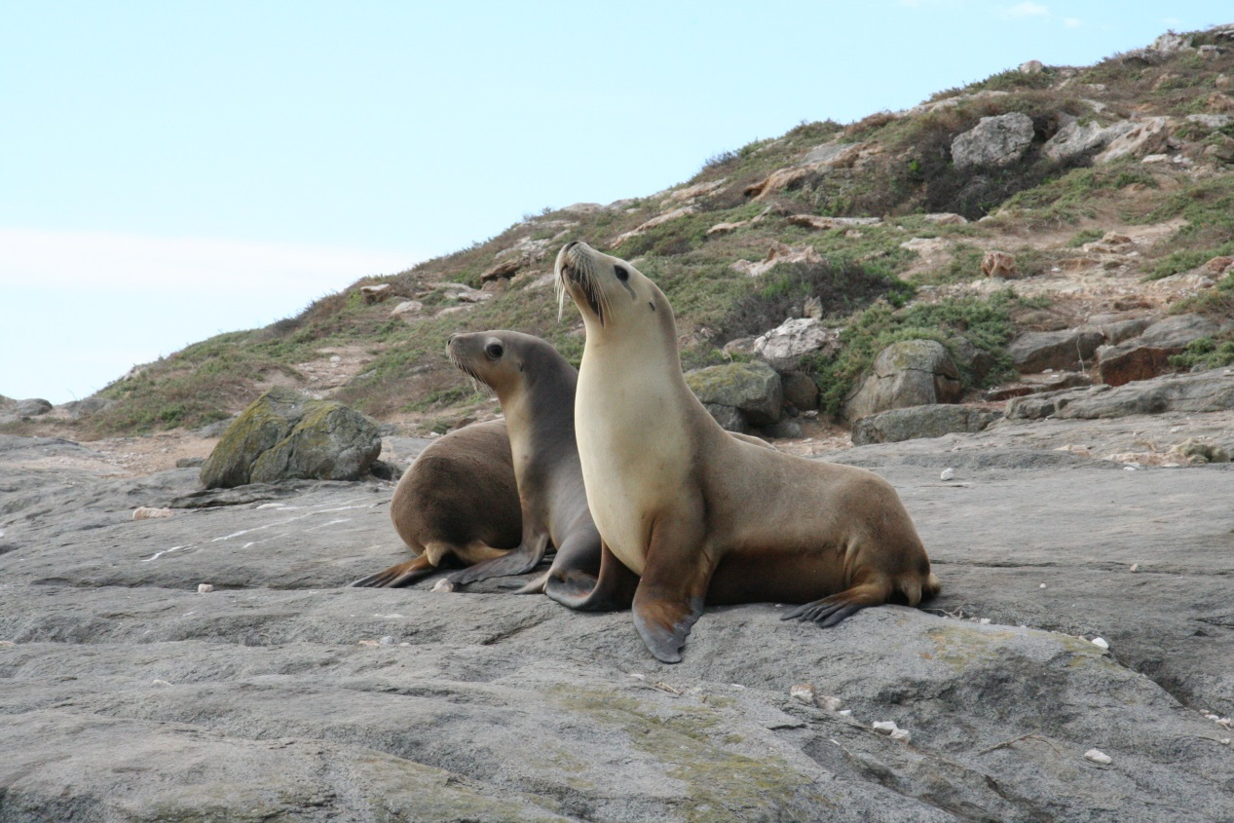

# 7. Acknowledgements

The Monitoring Framework outlined in this document is based on the views of a group of key researchers, statisticians and management stakeholders. It was developed from outcomes of the Australian Sea Lion Workshop, April 1-3, 2014, held at the Hotel Grand Chancellor on Hindley, Adelaide. We thank all the participants of the workshop for their contributions to the Monitoring Framework. In particular we thank Dr Ian Cresswell, Deputy Director, Wealth from Oceans Flagship, CSIRO, for chairing the workshop. We also thank Dr Mark Bravington, CSIRO, for contributing the statistical framework for the Australian sea lion monitoring design and analysis outlined in Section 4.5. Photos in this document, that are not individually attributed, are by Benjamin Pitcher.

Participants at the Australian Sea Lion Workshop:

Tony Arthur (ABARES), Michelle Besley (PIRSA), Fred Bailleul (SARDI), Mark Bravington (CSIRO), Kerry Cameron (DoEE), Richard Campbell (WA DBCA), Ian Cresswell (CSIRO), Bill de la Mare (AAD), Simon Goldsworthy (SARDI), Mandy Goodspeed (DAFF), Alex Hesp (WA DoF), Dirk Holman (SA DEWNR & GABMP), Deb Kelly (SA DEWNR), Sharon Koh (DoEE), Alice Mackay (SARDI), Tim Nicholas (WA DoF), Benjamin Pitcher (MqU), David Power (AFMA), Milena Rafic (DoEE), Holly Raudino (WA DBCA), Paul Ryan (AFMA), Peter Shaughnessy (SAM).

# 8. References

**AFMA**. 2010. Australian Sea Lion Management Strategy. Southern and Eastern Scalefish and Shark Fishery (SESSF). Australian Fisheries Management Authority, Australian Government, Canberra.

**Berkson, J. M. & De Master, D. P.** 1985. Use of pup counts in indexing population changes in pinnipeds. *Canadian Journal of Fisheries and Aquatic Sciences*, **42**, 873-879.

**Campbell, R.** 2003. Demographic and population genetic structure of the Australian sea lion, *Neophoca cinerea*, University of Western Australia.

**Campbell, R. A., Gales, N. J., Lento, G. M. & Baker, C. S.** 2008b. Islands in the sea: extreme female natal site fidelity in the Australian sea lion, *Neophoca cinerea*. *Biology Letters*, **4**, 139-142.

**Campbell, R. A., Holley, D., Christianopoulos, D., Caputi, N. & Gales, N.** 2008a. Mitigation of incidental mortality of Australian sea lions in the west coast rock lobster fishery. *Endangered Species Research*, **5**, 345-358.

**Dennis, T. E. & Shaughnessy, P. D.** 1996. Status of the Australian sea lion, Neophoca cinerea, in the Great Australian Bight. *Wildlife Research*, **23**, 741-754.

**Dennis, T. E. & Shaughnessy, P. D.** 1999. Seal survey in the Great Australian Bight region of Western Australia. *Wildlife Research*, **26**, 383-388.

**DEWHA**. 2010. Recovery Plan for the Australian Sea Lion (*Neophoca cinerea*), Technical Issues Paper. Australian Government, Canberra.

**DSEWPaC**. 2013a. Issues Paper for the Australian Sea Lion (*Neophoca cinerea*). Australian Government, Canberra.

**DSEWPaC**. 2013b. Recovery Plan for the Australian Sea Lion (*Neophoca cinerea*).

**Gales, N. J., Cheal, A. J., Pobar, G. J. & Williamson, P.** 1992. Breeding Biology and Movements of Australian Sea-lions, *Neophoca cinerea*, off the West Coast of Western Australia. *Wildlife Research*, **19**, 405-416.

**Gales, N. J., Shaughnessy, P. D. & Dennis, T. E.** 1994. Distribution, abundance and breeding cycle of the Australian sea-lion *Neophoca cinerea* (Mammalia: Pinnipedia). *Journal of Zoology (London)*, **234**, 353-370.

**Gales, N. J., Williamson, P., Higgins, L. V., Blackberry, M. A. & James, I.** 1997. Evidence of prolonged post-implantation period in the Australian sea lion (*Neophoca cinerea*). *Journal of Reproduction and Fertility*, **111**, 159-163.

**Goldsworthy, S. D., Bailleul, F., Shaughnessy, P. D., Stonnill, M., Lashmar, K. & Mackay, A. I.** 2017. Monitoring of Seal Bay and other pinniped populations on Kangaroo Island: 2016/2017. Report to the Department of Environment, Water and Natural Resources. South Australian Research and Development Institute (Aquatic Sciences), Adelaide. SARDI Publication No. F2014/000322-4. SARDI Research Report Series No. 951. 40pp.

**Goldsworthy, S. D., Kennedy, C., Shaughnessy, P. D., Mackay, A. I.** 2014a. Monitoring of Seal Bay and other pinniped populations on Kangaroo Island: 2012-2015. Adelaide: South Australian Research and Development Institute. SARDI Publication No. F2014/000332-1.

**Goldsworthy, S. D., Lowther, A., Shaughnessy, P. D., McIntosh, R. R. & Page, B.** 2007a. Assessment of pup production and maternal investment strategies of the Australian sea lion Neophoca cinerea at Dangerous Reef in the 2006-07 breeding season. Adelaide: South Australian Research and Development Institute. SARDI Publication No. F2007/000929-1.

**Goldsworthy, S. D., Lowther, A. D. & Shaughnessy, P. D.** 2013. Maintaining the monitoring of pup production at key Australian sea lion colones in South Australia (2011/12). Final report to the Australian Marine Mammal Centre. South Australian Research and Development Institute (Aquatic Sciences), Adelaide. SARDI Publication No. F2010/000665-3. SARDI Research Report Series No. 739. 51 pp.

**Goldsworthy, S. D., Mackay, A. I., Shaughnessy, P. D., Bailleul, F. & Holman, D.** 2015. Maintaining the monitoring of pup production at key Australian sea lion colones in South Australia (2014/15). Final report to the Australian Marine Mammal Centre. South Australian Research and Development Institute (Aquatic Sciences), Adelaide. SARDI Publication No. F2010/000665-5. SARDI Research Report Series No. 871. 73 pp.

**Goldsworthy, S. D., McKenzie, J., Shaughnessy, P. D., McIntosh, R. R., Page, B. & Campbell, R.** 2009. An update of the report: Understanding the impediments to the growth of Australian sea lion populations. Adelaide: South Australian Research and Development Institute. SARDI Publication No. F2008/00847-1.

**Goldsworthy, S. D. & Page, B.** 2009. A review of the distribution of seals in South Australia. Adelaide: South Australian Research and Development Institute (Aquatic Sciences). SARDI Publication No. F2009/000368-1.

**Goldsworthy, S. D., Page, B., Shaughnessy, P. D. & Linnane, A.** 2010. Mitigating Seal Interactions in the SRLF and the Gillnet Sector SESSF in South Australia. Final report to the Fisheries Research and Development Corporation. South Australian Research and Development Institute (Aquatic Sciences), Adelaide, South Australia. SARDI Publication No. F2009/000613-1.

**Goldsworthy, S. D., Shaughnessy, P. D., McIntosh, R. R. & Page, B.** 2007b. A population monitoring and research program to assist management of the Australian sea lion population at Seal Bay Conservation Park, Kangaroo Island. South Australian Research and Development Institute (Aquatic Sciences), Adelaide, South Australia. SARDI Publication No. F2007/000913-1.

**Goldsworthy, S.D., Shaughnessy, P.D., Page, B.** 2014b. Chapter 18. Seals in Spencer Gulf. In: Natural History of Spencer Gulf (Eds SA Shepherd, S. Madigan, BM Gillanders, S Murray-Jones, D Wiltshire) (Royal Soc of SA, Adelaide).

**Goldsworthy, S. D., Shaughnessy, P. D., Page, B., Dennis, T. E., McIntosh, R. R., Hamer, D., Peters, K. J., Baylis, A. M. M., Lowther, A. & Bradshaw, C. J. A.** 2007c. Developing population monitoring protocols for Australian sea lions. Final report to the Department of the Environment and Water Resources. Australian Government, Canberra.

**Goldsworthy, S. D., Shaughnessy, P. D., Page, B., Lowther, A. & Bradshaw, C. J. A.** 2008. Developing population monitoring protocols for Australian sea lions: enhancing large and small colony survey methodology. Final report to the Australian Centre for Applied Marine Mammal Science (ACAMMS), Department of the Environment, Water, Heritage and Arts.SARDI Aquatic Sciences Publication Number F2008/000633-1. In: *SARDI Research Report Series No. 297, 43pp.* Adelaide.

**Guiler, E. R.** 1978. Whale strandings in Tasmania since 1945 with notes on some seal reports. *Papers and Proceedings of the Royal Society of Tasmania*, **112**, 189-213.

**Hamer, D. J., Ward, T. M., Shaughnessy, P. D. & Clark, S. R.** 2011. Assessing the effectiveness of the Great Australian Bight Marine Park in protecting the endangered Australian sea lion (*Neophoca cinerea*) from by-catch mortality in shark gill-nets. *Endangered Species Research*, **14**, 203-216.

**Hesp, S. A., Tweedley, J. R., McAuley, R., Tink, C. J., Campbell, R. A., Chuwen, B. M. & Hall, N. G.** 2012. Informing risk assessment through estimating interaction rates between Australian sea lions and Western Australia's temperate demersal gillnet fisheries. Centre for Fish and Fisheries Research Murdoch University, Murdoch, Western Australia.

**Higgins, L. V.** 1993. The Nonannual, Nonseasonal Breeding Cycle of the Australian Sea Lion, *Neophoca cinerea*. *Journal of Mammalogy*, **74**, 270-274.

**Higgins, L. V. & Gass, L.** 1993. Birth to weaning: parturition, duration of lactation, and attendance cycles of the Australian sea lions (*Neophoca cinerea*) *Canadian Journal of Zoology*, **71**, 2047-2055.

**King, J. E.** 1983. *Seals of the world*, Second edn. St Lucia: University of Queensland Press.

**Lawrence, E. & Bravington, M.** 2016. Australian Sea Lion Monitoring Framework: statistical model. CSIRO, Canberra.

**Ling, J. K.** 1999. Exploitation of fur seals and sea lions from Australian, New Zealand and adjacent subantarctic islands during the eighteenth, nineteenth and twentieth centuries. *Australian Zoologist*, **31**, 323-350.

**Lowther, A. D. & Goldsworthy, S. D.** 2010. Detecting alternate foraging ecotypes in Australian sea lion (Neophoca cinerea) colonies using stable isotope analysis. *Marine Mammal Science*, **27**, 567-586.

**Lowther, A. D., Harcourt, R. G., Goldsworthy, S. D. & Stow, A.** 2012. Population structure of adult female Australian sea lions is driven by fine-scale foraging site fidelity. *Animal Behaviour*, **83**, 691-701.

**Mackay, A., Shaughnessy, P. D. & Goldsworthy, S. D.** 2013. Australian sea lion abundance in the Bunda Cliffs region, GAB Marine Park. Final report to the Department of Environment, Water, and Natural Resources. South Australian Research and Development Institute (Aquatic Sciences), Adelaide, South Australia. SARDI Publication No. F2013/000642-1.

**Marlow, B. J.** 1975. The comparative behaviour of the Australasian sea lions *Neophoca cinerea* and *Phocarctos hookeri* (Pinnipedia: Otariidae). *Mammalia*, **39**, 159-230.

**McIntosh, R. R.** 2007. Life history and population demographics of the Australian sea lion, La Trobe University.

**McIntosh, R. R., Arthur, A. D., Dennis, T., Berris, M., Goldsworthy, S. D., Shaughnessy, P. D. & Teixeira, C. E. P.** 2013. Survival estimates for the Australian sea lion: Negative correlation of sea surface temperature with cohort survival to weaning. *Marine Mammal Science*, **29**, 84-108.

**McIntosh, R. R., Goldsworthy, S. D., Shaughnessy, P. D., Kennedy, C. W. & Burch, P.** 2011. Estimating pup production in a mammal with an extended and aseasonal breeding season, the Australian sea lion (*Neophoca cinerea*). *Wildlife Research*, **39**, 137-148.

**McKenzie, J., Goldsworthy, S. D., Shaughnessy, P. D. & McIntosh, R. R.** 2005. Understanding the impediments to the growth of Australian sea lion populations. Final report to Department of the Environment and Heritage, Migratory and Marine Species Section. South Australian Research and Development Institute (Aquatic Sciences), Adelaide. SARDI Publication No. F2008/00847-1.

**Page, B., McKenzie, J., McIntosh, R., Baylis, A., Morrissey, A., Calvert, N., Haase, T., Berris, M., Dowie, D., Shaughnessy, P. D. & Goldsworthy, S. D.** 2004. Entanglement of Australian sea lions and New Zealand fur seals in lost fishing gear and other marine debris before and after Government and industry attempts to reduce the problem. *Marine Pollution Bulletin*, **49**, 33-42.

**Shaughnessy, P. D.** 1999. *The action plan for Australian seals*. Canberra: Environment Australia.

**Shaughnessy, P. D. & Dennis, T. E.** 2000. Establishing monitoring guidelines and assessing abundance of Australian sea lions at key breeding colonies in South Australia. Final report to Marine Species Protection Program of Coasts and Clean Seas, Environment Australia. Australian Government, Canberra.

**Shaughnessy, P. D., Goldsworthy, S. D., Burch, P. & Dennis, T. E.** 2013. Pup numbers of the Australian sea lion (*Neophoca cinerea*) at The Pages Islands, South Australia, over two decades. *Australian Journal of Zoology*, **61**, 112-118.

**Shaughnessy, P. D., Goldsworthy, S. D., Hamer, D. J., Page, B. & McIntosh, R. R.** 2011. Australian sea lions *Neophoca cinerea* at colonies in South Australia: distribution and abundance 2004 to 2008. *Endangered Species Research*, **13**, 87-98.

**TSSC**. 2005. Advice to the Minister for the Environment and Heritage from the Threatened Species Scientific Committee (TSSC) on Amendments to the list of Threatened Species under the Environment Protection and Biodiversity Conservation Act 1999 (EPBCAct). http://www.environment.gov.au/node/16447#conservation.

**Walker, G. E. & J.K. Ling** 1981. Australian sea lion Neophoca cinerea (Peron, 1816). In: Ridgway, S. H. & R.J. Harrison, eds. Handbook of marine mammals, vol. 1; the walrus, sea lions, fur seals and sea otter. Page(s) 99-118. London: Academic Press.

**Warneke, R. M.** 1982. The distribution and abundance of seals in the Australasian region, with summaries of biology and current research In: *Mammals in the Seas, FAO Fisheries Series, No 5*, pp. 431-475.

# 9. Appendices

## Appendix 1. Metapopulations and colonies of Australian sea lions

* **South Australia**
  + **SA7 - Kangaroo Is.**
    - The Pages
    - Seal Slide
    - Seal Bay
  + **SA6 - Spencer Gulf**
    - Peaked Rocks
    - North Is.
    - Dangerous Reef
    - English Is.
    - Albatross Is.
    - Sth Neptune Is
    - Nth Neptune Is
    - Lewis Is
    - Liguanea Is.
  + **SA5 – South West Eyre**
    - Price Is.
    - Cap Is.
    - Rocky Is. (Nth)
    - Little Hummock Is.
    - Four Hummocks Is.
    - Rocky Is. (Sth)
  + **SA4 - Chain of Bays**
    - West Waldegrave Is.
    - Jones Is.
    - Ward Is.
    - Pearson Is.
    - Point Labatt
    - Nicholas Baudin Is.
    - Olive Is.
  + **SA3 - Nuyts Archipelago**
    - Lilliput Is.
    - Blefuscu Is.
    - Gliddon Reef
    - Breakwater Is.
    - Lounds Is.
    - Fenelon Is.
    - West Is.
    - Purdie Is.
  + **SA2 Nuyts Reef**
    - Nuyts Reef
  + **SA 1 - Bunda Cliffs**
    - Bunda Cliffs B3
    - Bunda Cliffs B5
    - Bunda Cliffs B6
    - Bunda Cliffs B7
    - Bunda Cliffs B8
* **Western Australia**
  + **Nuytsland**
    - Twilight Cove
  + **WA SC1 - Eastern Recherche**
    - Spindle Is.
    - Ford Is.
    - Six Mile Is.
  + **WA SC2 – Esperance**
    - Round Is.
    - Cooper Is.
    - Salisbury Is.
    - Wickham Is.
    - George Is.
    - Glennie Is.
    - Taylor Is.
    - Kermadec Is.
    - Draper Is.
    - Kimberley Is.
    - McKenzie Is.
    - Termination Is.
  + **WA SC3 – Albany**
    - Investigator Is.
    - West Is.
    - Red Islet
    - Middle Doubtful Is.
    - Hauloff Rock
  + **WA WC1 – Jurien**
    - Buller Is.
    - North Fisherman Is.
    - Beagle Is.
  + **WA WC 2 - Abrolhos Islands**
    - Abrolhos Islands

## Appendix 2. Representative and desirable features of Australian sea lion colonies

Table 2. Representative and desirable features of Australian sea lion colonies and metapopulations. The vulnerability to substantial gillnet effort is based on estimates from Goldsworthy et al. (2010) and Hesp et al. (2012).

|  |  |  |  |  |  |  |  |  |  |  |  |  |  |  |  |  |  |  |  |  |  |  |  |  |  |  |  |  |
| --- | --- | --- | --- | --- | --- | --- | --- | --- | --- | --- | --- | --- | --- | --- | --- | --- | --- | --- | --- | --- | --- | --- | --- | --- | --- | --- | --- | --- |
| **Regional Cluster** | **Colony** | **Pup production** | | | | **Foraging area** | | | **Vulnerability to substantial gillnet effort** | | | **Proximity to substantially fished area (prey depletion)** | | | **Room for colony expan-sion** | | **Edge of metapo-pulation** | | **Subject to human disturb-ance?** | | **Accessibility for survey** | **Subject to pup immigration or emigration** | **Level of Public interest** | **Pup detectability** | **Colony compact** | **Prior time series** | **Previous survey methods** | **Overall evaluation** |
| **<5** | **5 to 40** | **40 to 100** | **>100** | **Inshore** | **Offshore** | **Unknown** | **High** | **Medium** | **Low** | **Close** | **Far** | **Unknown** | **Probably** | **Unlikely** | **Yes** | **No** | **High** | **Low** |
| **SA7**  **Kangaroo Is.** | The Pages |  |  |  | X | X | X |  | X |  |  | X |  |  | X |  | X |  |  | X | Heli | No | Mild | Yes | Good | Yes | Multiple direct counts |  |
| Seal Slide |  | X |  |  |  | X |  | X |  |  | X |  |  | X |  | X |  | X |  | Road | Yes | Low | Yes | Good | Yes | Multiple direct counts |  |
| Seal Bay |  |  |  | X |  | X |  | X |  |  | X |  |  | X |  | X |  | X |  | Road | Yes | High | Yes | Medium | Yes | All methods |  |
| **SA6**  **Spencer Gulf** | Peaked Rocks |  | X |  |  |  |  | X |  |  | X | X |  |  |  | X |  | X |  | X | Heli | Yes | Low | Good | Good | No | Direct count |  |
| North Is. |  | X |  |  |  |  | X |  |  | X | X |  |  | X |  |  | X |  | X | Heli/boat | Yes | Low | Moderate | Medium | No | Direct count |  |
| Dangerous Reef |  |  |  | X | X | X |  |  |  | X | X |  |  |  | X |  | X |  | X | Boat | Yes | High | Good | Good | Yes | All methods |  |
| English Is. |  | X |  |  | X | X |  |  |  | X | X |  |  | X |  |  | X |  | X | Boat | Yes | Low | Good | Good | Yes | Multiple direct counts |  |
| Albatross Is. |  | X |  |  |  |  | X |  | X |  | X |  |  |  | X |  | X |  | X | Heli | Unknown | Low | Good | Good | No | Direct count |  |
| Sth Neptune Is |  | X |  |  |  |  | X | X |  |  | X |  |  | X |  |  | X |  | X | Boat | Likely | Mild | Moderate | Medium | No | Direct count |  |
| Nth Neptune Is |  | X |  |  |  |  | X | X |  |  | X |  |  | X |  |  | X | X |  | Boat | Likely | Mild | Moderate | Medium | No | Direct count |  |
| Lewis Is |  |  |  | X | X | X |  |  |  | X | X |  |  |  | X |  | X |  | X | Heli | Yes | Low | Good | Good | No | Direct count and Mark recapture |  |
| Liguanea Is. |  |  | X |  | X | X |  | X |  |  | X |  |  | X |  |  | X |  | X | Boat | Unlikely | Low | Moderate | Medium | No | Direct count |  |

|  |  |  |  |  |  |  |  |  |  |  |  |  |  |  |  |  |  |  |  |  |  |  |  |  |  |  |  |  |
| --- | --- | --- | --- | --- | --- | --- | --- | --- | --- | --- | --- | --- | --- | --- | --- | --- | --- | --- | --- | --- | --- | --- | --- | --- | --- | --- | --- | --- |
| **Regional Cluster** | **Colony** | **Pup production** | | | | **Foraging area** | | | **Vulnerability to substantial gillnet effort** | | | **Proximity to substantially fished area (prey depletion)** | | | **Room for colony expan-sion** | | **Edge of metapo-pulation** | | **Subject to human disturb-ance?** | | **Accessibility for survey** | **Subject to pup immigration or emigration** | **Level of Public interest** | **Pup detectability** | **Colony compact** | **Prior time series** | **Previous survey methods** | **Overall evaluation** |
| **<5** | **5 to 40** | **40 to 100** | **>100** | **Inshore** | **Offshore** | **Unknown** | **High** | **Medium** | **Low** | **Close** | **Far** | **Unknown** | **Probably** | **Unlikely** | **Yes** | **No** | **High** | **Low** |
| **SA5**  **SW Eyre** | Price Is. |  | X |  |  |  |  | X | X |  |  | X |  |  |  | X |  | X |  | X | Heli | Likely | Low | Moderate | Medium | No | Direct count |  |
| Cap Is. |  | X |  |  |  |  | X | X |  |  | X |  |  |  | X |  | X |  | X | Heli | Unlikely | Low | Good | Good | No | Direct count |  |
| Rocky Is. (Nth) |  | X |  |  |  |  | X | X |  |  | X |  |  |  | X |  | X |  | X | Heli | Unlikely | Low | Good | Good | No | Direct count |  |
| Little Hummock Is. |  | X |  |  |  |  | X | X |  |  | X |  |  |  | X |  | X |  | X | Heli | Likely | Low | Good | Good | No | Direct count |  |
| Four Hummocks Is. |  | X |  |  |  |  | X | X |  |  | X |  |  | X |  |  | X |  | X | Heli | Likely | Low | Moderate | Medium | No | Direct count |  |
| Rocky Is. (Sth) |  | X |  |  |  |  | X | X |  |  | X |  |  |  | X |  | X |  | X | Heli | Likely | Low | Moderate | Medium | No | Direct count |  |
| **SA4**  **Chain of Bays** | West Waldegrave Is. |  |  |  | X | X | X |  | X |  |  | X |  |  | X |  |  | X |  | X | Boat | Unlikely | Low | Moderate | Dispersed | Yes | Multiple direct counts |  |
| Jones Is. |  | X |  |  |  |  | X | X |  |  | X |  |  |  | X |  | X |  | X | Boat | Yes | High | Good | Good | Yes | Multiple direct counts |  |
| Ward Is. |  |  | X |  |  |  | X | X |  |  | X |  |  |  | X |  | X |  | X | Heli/boat | Likely | Low | Moderate | Good | No | Direct count |  |
| Pearson Is. |  | X |  |  |  |  | X | X |  |  | X |  |  | X |  |  | X |  | X | Heli/boat | Unlikely | Low | Good | Dispersed | No | Direct count |  |
| Point Labatt |  | X |  |  |  |  | X | X |  |  | X |  |  |  | X |  | X |  | X | Road | Likely | High | Poor | Good | No | Direct count |  |
| Nicholas Baudin Is. |  |  | X |  |  |  | X | X |  |  | X |  |  |  | X |  | X | X |  | Heli | Yes | High | Moderate | Good | Yes | Multiple direct counts and Mark recapture |  |
| Olive Is. |  |  |  | X | X | X |  | X |  |  | X |  |  | X |  |  | X |  | X | Heli/boat | Unlikely | Mild | Good | Good | Yes | All methods |  |

|  |  |  |  |  |  |  |  |  |  |  |  |  |  |  |  |  |  |  |  |  |  |  |  |  |  |  |  |  |
| --- | --- | --- | --- | --- | --- | --- | --- | --- | --- | --- | --- | --- | --- | --- | --- | --- | --- | --- | --- | --- | --- | --- | --- | --- | --- | --- | --- | --- |
| **Regional Cluster** | **Colony** | **Pup production** | | | | **Foraging area** | | | **Vulnerability to substantial gillnet effort** | | | **Proximity to substantially fished area (prey depletion)** | | | **Room for colony expan-sion** | | **Edge of metapo-pulation** | | **Subject to human disturb-ance?** | | **Accessibility for survey** | **Subject to pup immigration or emigration** | **Level of Public interest** | **Pup detectability** | **Colony compact** | **Prior time series** | **Previous survey methods** | **Overall evaluation** |
| **<5** | **5 to 40** | **40 to 100** | **>100** | **Inshore** | **Offshore** | **Unknown** | **High** | **Medium** | **Low** | **Close** | **Far** | **Unknown** | **Probably** | **Unlikely** | **Yes** | **No** | **High** | **Low** |
| **SA3**  **Nuyts Archipelago** | Lilliput Is. |  |  | X |  | X | X |  |  |  | X | X |  |  |  | X |  | X |  | X | Heli | Yes | Low | Moderate | Good | Yes | All methods |  |
| Blefuscu Is. |  |  | X |  | X | X |  |  | X |  | X |  |  |  | X |  | X |  | X | Heli | Yes | Low | Good | Good | Yes | All methods |  |
| Gliddon Reef |  | X |  |  | X |  |  |  |  | X | X |  |  |  | X |  | X |  | X | Heli/boat | Yes | Low | Good | Good | No | Direct count |  |
| Breakwater Is. |  | X |  |  | X |  |  |  |  | X | X |  |  |  | X |  | X |  | X | Heli/boat | Yes | Low | Good | Good | No | Direct count |  |
| Lounds Is. |  | X |  |  | X |  |  |  |  | X | X |  |  |  | X |  | X |  | X | Heli | Yes | Low | Good | Good | No | Direct count |  |
| Fenelon Is. |  |  | X |  |  |  | X |  | X |  | X |  |  | X |  |  | X |  | X | Heli/boat | Yes | Low | Good | Good | No | Direct count |  |
| West Is. |  |  | X |  |  | X |  |  | X |  | X |  |  | X |  |  | X |  | X | Heli/boat | Yes | Low | Good | Good | No | Direct count |  |
| Purdie Is. |  |  |  | X |  | X |  |  | X |  | X |  |  | X |  |  | X |  | X | Heli | Yes | Low | Moderate | Dispersed | No | Direct count |  |
| **SA2 Nuyts Reef** | Nuyts Reef |  |  | X |  |  |  | X |  | X |  | X |  |  |  | X |  | X |  | X | Heli | Unlikely | Low | Good | Good | No | Direct count |  |

|  |  |  |  |  |  |  |  |  |  |  |  |  |  |  |  |  |  |  |  |  |  |  |  |  |  |  |  |  |
| --- | --- | --- | --- | --- | --- | --- | --- | --- | --- | --- | --- | --- | --- | --- | --- | --- | --- | --- | --- | --- | --- | --- | --- | --- | --- | --- | --- | --- |
| **Regional Cluster** | **Colony** | **Pup production** | | | | **Foraging area** | | | **Vulnerability to substantial gillnet effort** | | | **Proximity to substantially fished area (prey depletion)** | | | **Room for colony expan-sion** | | **Edge of metapo-pulation** | | **Subject to human disturb-ance?** | | **Accessibility for survey** | **Subject to pup immigration or emigration** | **Level of Public interest** | **Pup detectability** | **Colony compact** | **Prior time series** | **Previous survey methods** | **Overall evaluation** |
| **<5** | **5 to 40** | **40 to 100** | **>100** | **Inshore** | **Offshore** | **Unknown** | **High** | **Medium** | **Low** | **Close** | **Far** | **Unknown** | **Probably** | **Unlikely** | **Yes** | **No** | **High** | **Low** |
| **SA 1**  **Bunda Cliffs** | Bunda Cliffs B3 | X |  |  |  |  | X |  |  | X |  | X |  |  |  | X | X |  |  | X | Hard | Likely | Low | Poor | Good | Yes | Multiple direct counts |  |
| Bunda Cliffs B5 | X |  |  |  |  | X |  |  | X |  | X |  |  |  | X | X |  |  | X | Hard | Likely | Low | Poor | Good | Yes | Multiple direct counts |  |
| Bunda Cliffs B6 | X |  |  |  |  | X |  |  | X |  | X |  |  |  | X | X |  |  | X | Hard | Likely | Low | Poor | Good | Yes | Multiple direct counts |  |
| Bunda Cliffs B7 | X |  |  |  |  | X |  |  | X |  | X |  |  |  | X | X |  |  | X | Hard | Likely | Low | Poor | Good | Yes | Multiple direct counts |  |
| Bunda Cliffs B8 | X |  |  |  |  | X |  |  | X |  | X |  |  |  | X | X |  |  | X | Hard | Likely | Low | Poor | Good | Yes | Multiple direct counts |  |
| **Nuytsland** | Twilight Cove | X |  |  |  |  |  | X |  |  | X |  | X |  |  | X | X |  |  | X | Hardest | No | No | Poor | Yes | Poor | Two single direct counts |  |
| **WA SC1**  **Eastern Recherche** | Spindle Is. |  |  | X |  |  |  | X |  |  | X | X |  |  | X |  | X |  |  | X | Heli | Unknown | Low | Good | Good | No | Direct count |  |
| Ford Is. |  | X |  |  |  |  | X |  |  | X | X |  |  | X |  | X |  |  | X | Heli | Unknown | Low | Good | Good | No | Direct count | Yes |
| Six Mile Is. |  |  | X |  | X | X |  |  | X |  | X |  |  | X |  | X |  |  | X | Boat | Unknown | Low | Good | Good | No | Direct count | Yes |

|  |  |  |  |  |  |  |  |  |  |  |  |  |  |  |  |  |  |  |  |  |  |  |  |  |  |  |  |  |
| --- | --- | --- | --- | --- | --- | --- | --- | --- | --- | --- | --- | --- | --- | --- | --- | --- | --- | --- | --- | --- | --- | --- | --- | --- | --- | --- | --- | --- |
| **Regional Cluster** | **Colony** | **Pup production** | | | | **Foraging area** | | | **Vulnerability to substantial gillnet effort** | | | **Proximity to substantially fished area (prey depletion)** | | | **Room for colony expan-sion** | | **Edge of metapo-pulation** | | **Subject to human disturb-ance?** | | **Accessibility for survey** | **Subject to pup immigration or emigration** | **Level of Public interest** | **Pup detectability** | **Colony compact** | **Prior time series** | **Previous survey methods** | **Overall evaluation** |
| **<5** | **5 to 40** | **40 to 100** | **>100** | **Inshore** | **Offshore** | **Unknown** | **High** | **Medium** | **Low** | **Close** | **Far** | **Unknown** | **Probably** | **Unlikely** | **Yes** | **No** | **High** | **Low** |
| **WA SC2**  **Esperance** | Round Is. |  | X |  |  |  |  | X |  | X |  |  | X |  | X |  |  | X |  | X | Heli | Unlikely | Low | Good | Good | No | Direct count |  |
| Cooper Is. |  | X |  |  |  |  | X |  |  | X |  | X |  | X |  |  | X |  | X | Heli | Unlikely | Low | Good | Good | No | Direct count |  |
| Salisbury Is. |  | X |  |  |  |  | X |  |  | X |  | X |  | X |  |  | X |  | X | Heli or Boat | Unlikely | Low | Good | Good | Poor | Two direct counts |  |
| Wickham Is. |  | X |  |  |  |  | X | X |  |  | X |  |  | X |  |  | X |  | X | Boat | Unknown | Low | Good | Good | No | Direct count | Yes |
| George Is. |  | X |  |  |  |  | X |  |  | X | X |  |  | X |  |  | X |  | X | Heli | Unknown | Low | Good | Good | No |  |  |
| Glennie Is. |  | X |  |  |  |  | X | X |  |  | X |  |  | X |  |  | X |  | X | Heli | Unknown | Low | Good | Good | Poor | Three direct counts of limited accuracy | Yes |
| Taylor Is. |  | X |  |  |  |  | X | X |  |  | X |  |  | X |  |  | X |  | X | Boat | Likely | Low | Good | Good | poor | Three direct counts of limited accuracy |  |
| Kermadec Is. |  | X |  |  |  |  | X |  | X |  |  | X |  | X |  |  | X |  | X | Heli | Unknown | Low | Good | Good | No | Direct count |  |
| Draper Is. | X |  |  |  |  |  | X |  |  | X |  | X |  | X |  |  | X |  | X | Heli | Unknown | Low | Good | Good | No | Direct count |  |
| Kimberley Is. |  |  | X |  | X |  |  | X |  |  | X |  |  | X |  | X |  |  | X | Boat | Likely | Low | Good | Good | Yes | Some single and some multiple direct counts | Yes |
| McKenzie Is. |  | X |  |  |  |  | X | X |  |  |  | X |  | X |  |  | X |  | X | Boat | Unknown | Low | Good | Good | No |  |  |
| Termination Is. |  | X |  |  |  |  | X |  |  | X |  | X |  | X |  |  | X |  | X | Heli | Unlikely | Low | Good | Good | No |  |  |

|  |  |  |  |  |  |  |  |  |  |  |  |  |  |  |  |  |  |  |  |  |  |  |  |  |  |  |  |  |
| --- | --- | --- | --- | --- | --- | --- | --- | --- | --- | --- | --- | --- | --- | --- | --- | --- | --- | --- | --- | --- | --- | --- | --- | --- | --- | --- | --- | --- |
| **Regional Cluster** | **Colony** | **Pup production** | | | | **Foraging area** | | | **Vulnerability to substantial gillnet effort** | | | **Proximity to substantially fished area (prey depletion)** | | | **Room for colony expan-sion** | | **Edge of metapo-pulation** | | **Subject to human disturb-ance?** | | **Accessibility for survey** | **Subject to pup immigration or emigration** | **Level of Public interest** | **Pup detectability** | **Colony compact** | **Prior time series** | **Previous survey methods** | **Overall evaluation** |
| **<5** | **5 to 40** | **40 to 100** | **>100** | **Inshore** | **Offshore** | **Unknown** | **High** | **Medium** | **Low** | **Close** | **Far** | **Unknown** | **Probably** | **Unlikely** | **Yes** | **No** | **High** | **Low** |
| **WA SC3**  **Albany** | Investigator Is. |  | X |  |  | X | X |  |  | X |  | X |  |  | X |  | X |  |  | X | Boat | Unlikely | Low | Good | Good | Poor | Direct count |  |
| West Is. |  | X |  |  |  |  | X | X |  |  |  | X |  | X |  |  | X |  | X | Heli | Unknown | Low | Good | Good | No | Direct count |  |
| Red Islet |  | X |  |  | X |  |  | X |  |  | X |  |  | X |  |  | X |  | X | Boat | Unknown | Low | Good | Good | Yes, limited | Direct count | Yes |
| Middle Doubtful Is. | X |  |  |  |  |  | X | X |  |  | X |  |  | X |  |  | X |  | X | Boat | Unknown | Low | Good | Good | No | Direct count |  |
| Hauloff Rock |  | X |  |  |  |  | X | X |  |  | X |  |  | X |  | X |  |  | X | Boat | Unlikely | Low | Good | Good | Yes | A number of single and multiple direct counts | Yes |
| **WA WC1**  **Jurien** | Buller Is. |  | X |  |  | X |  |  |  |  | X | X |  |  | X |  |  | X |  | X | Boat | Unlikely | Low | Good | Good | Yes | Multiple direct counts | Yes |
| North Fisherman Is. |  |  | X |  | X |  |  | X |  |  | X |  |  | X |  |  | X | X |  | Boat | Unlikely | High | Moderate | Good | Yes | Multiple direct counts | Yes |
| Beagle Is. |  |  | X |  | X |  |  | X |  |  | X |  |  | X |  |  | X | X |  | Boat | Unlikely | Low | Moderate | Good | Yes | Multiple direct counts | Yes |
| **WA WC 2** | Abrolhos islands |  | X |  |  | X |  |  |  |  | X | X |  |  | X |  | X |  | X |  | Boat and plane | No | Low | Good | Dispersed | Yes | Direct count | ? |

1. The objectives of this monitoring framework are designed to be measurable goals rather than statements of aspiration.
2. A 10 year period has been chosen as the basic monitoring period based on an approximate generation time of the Australian sea lion, and reflecting that changes (including recovery) in Australian sea lion populations are not rapid.
3. At the time of writing the desired probability *p* and extent of a trend X were undefined. These parameters will be defined through the statistical framework described below (see section 4.5) and stakeholder consultation.