|  |
| --- |
| Australia's 2030 climate change emissions reduction target – abatement potential  Report to the Department of the Environment  May 2016 |

### Copyright

© 2016 Energetics. All rights reserved.

"Energetics" refers to Energetics Pty Ltd and any related entities.

This report is protected under the copyright laws of Australia and other countries as an unpublished work. This report contains information that is proprietary and confidential to Energetics and subject to applicable Federal or State Freedom of Information legislation, shall not be disclosed outside the recipient's company or duplicated, used or disclosed in whole or in part by the recipient for any purpose other than for which the report was commissioned. Any other use or disclosure in whole or in part of this information without the express written permission of Energetics is prohibited.

### Disclaimer

The information contained in this document is of a general nature only and does not constitute personal financial product advice. In preparing the advice no account was taken of the objectives, financial situation or needs of any particular person. Energetics is authorised to provide financial product advice on derivatives to wholesale clients under the Corporations Act 2001 AFSL No: 329935. In providing information and advice to you, we rely on the accuracy of information provided by you and your company. Therefore, before making any decision, readers should seek professional advice from a professional adviser to help you consider the appropriateness of the advice with regard to your particular objectives, financial situation and needs.

Australian Financial Services License (AFSL # 329935).

### Acknowledgements

Energetics would like to acknowledge the contribution of the following people and businesses to this report Telstra, GPT, Low Carbon Living CRC.

Contents

**Australia’s 2030 climate change target and the measures we can pursue to achieve it** 1

Australia’s emissions reduction potential 1

Emissions trajectory through to 2030 3

Leveraging Australian policies and programs to achieve the 2030 target 4

Australia’s abatement cost curve 5

**Attachment A – Opportunity case studies** 7

**About Energetics** 11

Report authors 11

Contact details 12

# 

**Australia’s 2030 climate change target and the measures we can pursue to achieve it**

At the UNFCCC 21st Conference of Parties (COP21) in Paris, December 2015, Australia formalised our Intended Nationally Determined Contribution (INDC) for inclusion in the Paris Agreement. This contribution is a target to reduce Australia’s domestic emissions by 26 to 28 per cent below 2005 levels by 2030.

To help illustrate a pathway for the Government to achieve the 2030 target, the Department of the Environment (the Department) engaged Energetics to analyse and model the emissions reduction opportunity.

Energetics’ analysis shows there is potentially significant low-cost abatement available to meet the 2030 target.

* Australia can reach its 2030 abatement target under the current policy framework. Large emitters must be effectively engaged and programs pursued without delay. Energetics’ modelling of over 70 emissions reduction measures has found that approximately 960 Mt CO2-eof abatement can be achieved by 2030.
* Modelling over the period 1993 – 2015 shows the emissions intensity of the Australian economy fell on average by 2.3 percent each year, suggesting that national emissions are decoupling from economic growth.
* Australia will achieve its 2020 cumulative abatement target under the Kyoto protocol, equivalent to 5 per cent below 2000 levels by 2020. Energetics has identified further abatement opportunities that can be pursued, to reach an absolute 2020 target.

Australia’s emissions reduction potential

To assess the potential for Australia to meet this abatement target, Energetics considered over 70 abatement opportunities that could be implemented by policies existing or under consideration by the Government. Abatement opportunities were identified across all major sectors and categorised into a range of project types including land use change, fuel switching, energy productivity, renewable energy and waste management.

Energetics’ modelling identified an abatement potential of 154 Mt CO2-e in 2030 relative to emissions in 2020. The total cumulative abatement opportunity in the period from 2021 to 2030 was estimated to be around 960 Mt CO2-e. The scale of the potential identified abatement is consistent with Australia meeting its 2030 target.

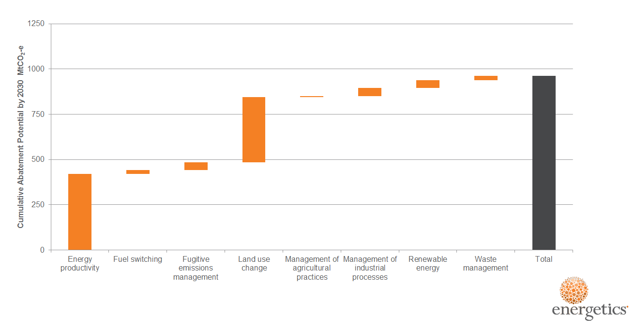

**Figure 1: Cumulative abatement potential categorised by abatement type**

Energetics’ analysis of the total abatement potential by opportunity type indicates that energy productivity and land use change can deliver a significant portion of Australia’s cumulative abatement requirement from 2021 to 2030 (as shown in Figure 1). Abatement opportunities identified for energy productivity accounts for 44 per cent of total abatement potential, while identified abatement from land use change opportunities can contribute a further 38 per cent in total.

Renewable energy and management of industrial processes can each contribute a further five per cent of the identified abatement potential. The remaining abatement potential has been identified in abatement opportunities related to fuel switching, agriculture, fugitive emissions and waste.

The abatement opportunities identified were allocated to one of 12 groups as shown in Figure 2. These groups were considered to provide an exhaustive coverage of all major areas of both established and emerging abatement opportunities in 2030.

Energetics’ analysis found that improved land management and low emissions farming practices (group 9) and low carbon transport (group 8) are capable of contributing the most to Australia’s total low-cost abatement by 2030. In total the two groups account for just over 50 per cent of Australia’s total identified abatement potential.

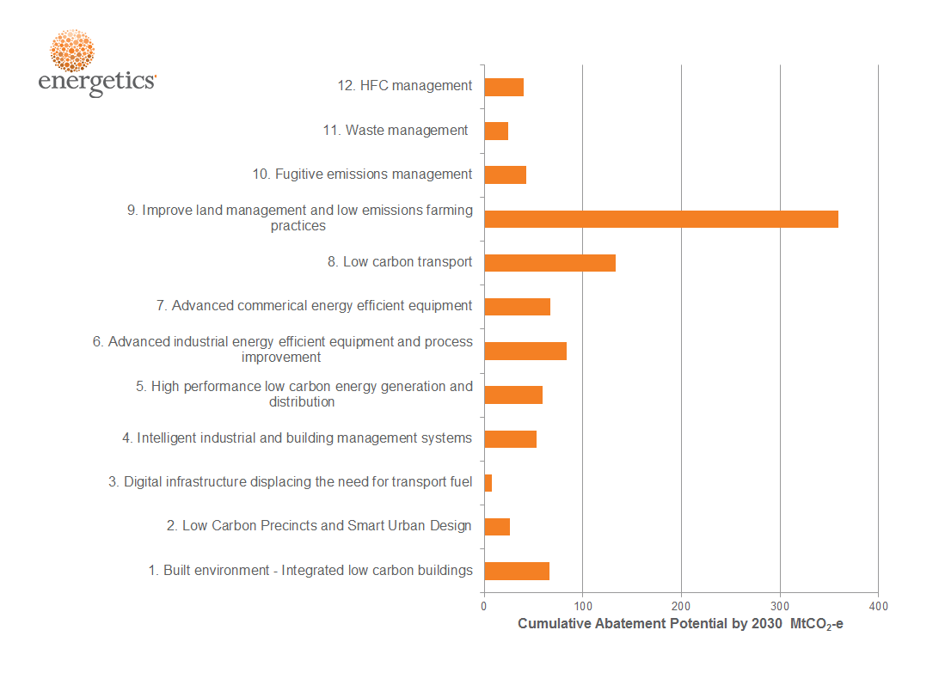

Figure 2: Cumulative abatement potential by grouping

Low carbon precincts (group 2) and digital infrastructure displacing transport fuel use (group 3) are likely to require additional support beyond that considered. These groups are forecast to deliver the lowest quantity of abatement on a per annum basis in 2030, but are likely to contribute a significant portion to the total abatement potential in the period from 2030 to 2050.

Emissions trajectory through to 2030

Energetics’ analysis of the period 1993 to 2015 revealed a consistent reduction in the intensity of emissions per unit of GDP (excluding those from the LULUCF[1] sector). The finding is robust despite the wide range of economic conditions, external shocks and climate change polices experienced over this period. The average year by year reduction in greenhouse gases per unit of GDP was 2.17 per cent[2].

The abatement potential identified by Energetics assumes a continuation of this trend in emissions intensity improvements.

Based on Australia’s emissions in 2020 being five per cent lower than in the year 2000 and a continuation of the emissions intensity reductions, Energetics estimates Australia’s domestic emissions will be 568 Mt CO2-e in 2030. This compares to the minus 28 per cent emissions reduction target of 440 Mt CO2-e in 2030. Energetics considers the difference between the emissions pathway and trajectory to the 2030 target can be achieved from the total 960 Mt CO2-e cumulative abatement potential identified.

Starting from an emissions level of 532 Mt CO2-e in 2020, Figure 3 below demonstrates how the abatement potential identified compares to Australia’s 2030 emissions reduction target as well as against Australia’s projected emissions in the absence of any abatement.

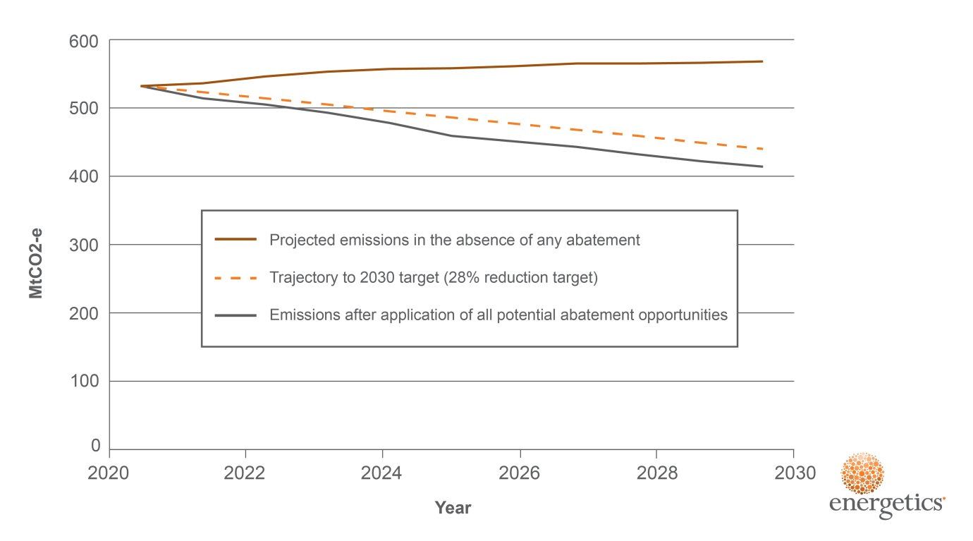

Figure 3: Australian emissions trajectory and impact of abatement

Leveraging Australian policies and programs to achieve the 2030 target

This analysis considered the potential for delivering Australia’s abatement under the following programs:

* The Emissions Reduction Fund and Safeguard Mechanism
* The National Energy Productivity Plan (energy efficiency)
* The National Energy Productivity Plan (vehicle efficiency)

The abatement opportunities were allocated to the most appropriate policy or program. Abatement opportunities that were considered to be business as usual were part of the baseline, with many attributed to technological advances.

The analysis also included emissions reduction activities that will continue to be delivered under other programs, such as ozone and HFC measures. For this assessment Energetics drew from abatement analysis undertaken by the Government.

Energetics also considered the impact of non-government movements that are capable of driving emissions reductions. For example, we see the impact of growing market and consumer pressure that influences business to reduce their carbon intensity.

Finally, where abatement opportunities achieved emissions abatement through improvements in energy productivity, they were generally allocated to the National Energy Productivity Plan (NEPP).

The contribution of potential abatement to meet the cumulative abatement potential is shown in Figure 4. Technology improvements play a key role as does the Emissions Reduction Fund (ERF) and Safeguard Mechanism.

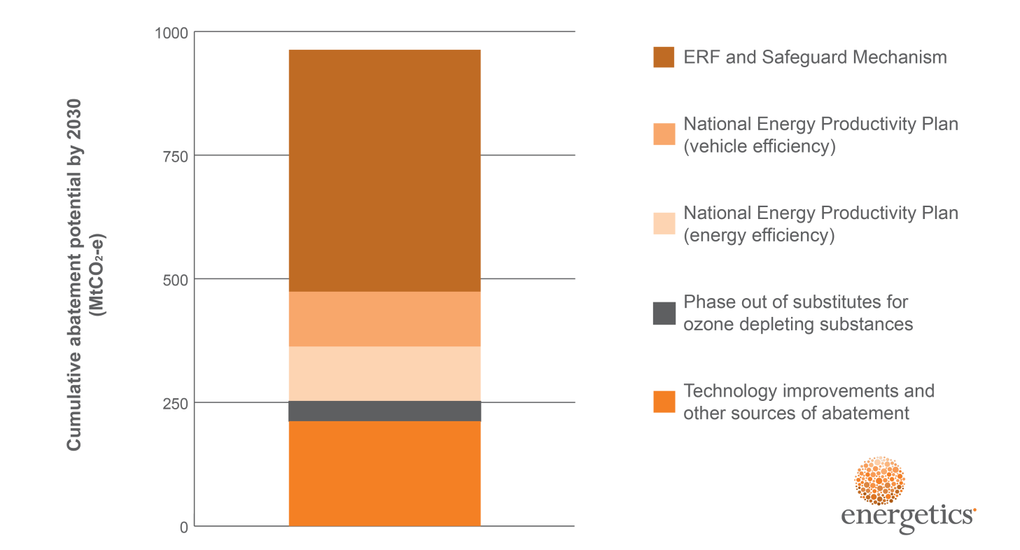

Figure 4: Cumulative abatement potential by 2030

above highlights the total domestic abatement opportunity identified by Energetics as can be delivered under existing policies or programs. This provides flexibility in the measures adopted, as well as room for future growth in Australia’s INDC.

Australia has world class policies and frameworks in place for calculating abatement from individual measures and for creating and managing Australian Carbon Credit Units (ACCUs). Supported by these robust frameworks, Energetics assumes that the ERF and Safeguard Mechanism are capable of generating the necessary cumulative abatement over the 2021 to 2030 period.

In addition, the NEPP is in the process of being formalised, and is expected to further drive a share of emissions reductions. Continued advances in technology and other, emerging market transformations to reduce greenhouse gases will deliver the remainder of Australia’s abatement.

Australia’s abatement cost curve

To assist with the ranking and prioritisation of more than 70 abatement opportunities identified and analysed, Energetics developed an Australian economy wide abatement cost curve. Abatement cost curves provide a useful tool, and visual guide, to demonstrate the total potential abatement for each sector, as well as the cost of the abatement in reducing Australia’s emissions.

The Australian domestic abatement cost curve for 2030 is shown in Figure 5 below – including each of the sectors considered capable of potentially contributing to Australia’s 2021 to 2030 abatement task. For each sector, Energetics considered the cost in projected 2030 AUD to the whole of Australia.

Based on this approach and due to the high net cost to Australia of imported transport fuels, the sectors that encourage improvements in the efficient use of those fuels have a high net benefit. Electricity savings have a lower net benefit to the Australian society, however many can still be achieved at a negative societal cost.

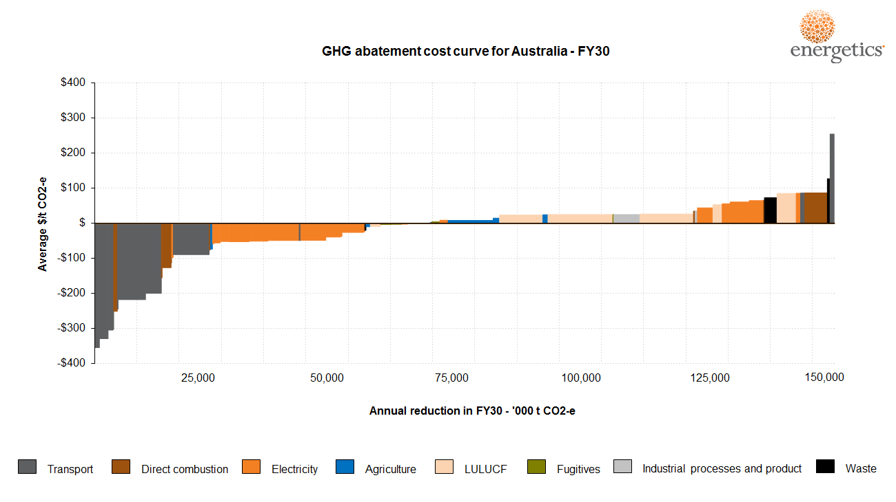

Figure 5: Australian 2030 abatement cost curve

Two examples of the measures considered in Energetics analysis are included below in Attachment A. The two case studies provide examples of the best practice energy management and emissions reduction currently being undertaken by leading Australian industry.

**Attachment A – Opportunity case studies**

|  |
| --- |
| Advanced buildings management systems – Australian cities in 2030  Of all the focus areas considered within the Paris Agreement, the built environment – and the impact that individual buildings and cities can play in disrupting locked-in energy and greenhouse gas (GHG) emissions patterns – is perhaps the most critical. Globally the commercial building sector alone contributes over 9% of human produced greenhouse gas[3]. In developing a strategic response to climate change, the design of our cities plays a vital role as ‘new roads, buildings and water systems built today are likely to influence living and consumption patterns for at least the next 50 to 100 years[4] .  In Australia, the Commercial Buildings sector alone was reported to have contributed over 27 MtCO2-e[5] to Australia’s emissions total over the 2014/15 financial year.  Energetics’ modelling demonstrated that there is significant potential for emissions reduction across the built environment, with the role for emissions reduction from cities, infrastructure and building development playing a vital role in helping Australia meet the 26-28% 2030 emissions reduction target. Measures that Energetics considered for reducing the built environment emissions profile include building retrofits and new innovative design measures, as well as the impact of increased distributed commercial solar PV.  A crucial requirement that will drive a number of these measures is the understanding, management and optimisation of energy consumption at a building level. Energetics estimated that between now and 2030 a cumulative abatement potential of over 12 MtCO2-e can arise purely from optimising building performance using data management systems.  **The GPT example**  GPT Group (GPT) is a leading property group with broad access to capital invested in quality Australian property assets. GPT’s office, shopping centre and logistics properties are used by millions of Australians every week.  At a company level, GPT recognises that greenhouse gas emissions globally are at unsustainable levels and the property sector accounts for a significant proportion arising from energy consumed in developing and managing buildings.  From 2005 to 2014, GPT reduced the average energy intensity of its portfolio from 571 MJ/m2 to 369 MJ/m2. In GHG emissions terms, this amounts to a reduction[6] of over 46kgCO2-e/m2. Around half of this reduction can be attributed to better energy data information and the use of it to manage buildings without the need for investment in new systems or energy efficient appliances. The remaining half of the savings would be attributed to system or appliance upgrades, but it is important to note that energy data management is the critical tool in maintaining and identifying those savings. |
| Ongoing building energy performance optimisation is achieved through better energy information management and diagnostic systems, augmented by smarter control strategies and a rolling program of lighting and air conditioning system upgrades.  At GPT, it is standard practice to undertake efficiency upgrades alongside any lifecycle or maintenance works, thus leveraging already budgeted expenditure. In cases where there are additional efficiency upgrades or upgrades that are separate to lifecycle works, a target payback period on the additional expenditure is five years or less. Whereas many efficiency gains have also come from improved energy management practices that have required little or no extra investment, which is important in an environment where competition for capital is fierce.  Further to energy reductions, GPT reduces emissions by switching from high carbon energy supplies to low and no carbon energy from on-site and off-site sources.  By the end of 2015 the emissions intensity of GPT’s operations reduced to 50% of the 2005 baseline.  Over the ten year journey of GPT’s energy and climate change response, a cumulative total of 0.63 Mt-CO2-e has been avoided. Compared to baseline energy intensity levels, GPT and its tenants have avoided energy costs of over $76 million**.** With improvements in energy efficiency in 2015 alone, GPT and its tenants avoided $24.3 million in energy costs  **Improving the uptake of data management**  A key facet of optimising building energy management systems is the analysis of energy consumption data. Smarter systems turn energy data into information and knowledge that property managers can use to benchmark building performance and identify anomalies. Continuous monitoring of data provides real-time insight to equipment performance, such as office lighting and heating, ventilation and air conditioning (HVAC), ensuring that required efficiency upgrades are identified early and addressed quickly.  The GPT example demonstrates that building managers and property owners can benefit significantly from better understanding of their building energy data. A focus on building comprehensive energy management systems can provide an easily implementable and scalable option for lowering energy consumption, reducing energy spend, and creating jobs across the Australian built environment. |
| Lower Emissions Aviation - Advanced transport to 2030  An important contribution that could be made towards achieving the 26-28% national emissions reduction target lies in improving the performance of Australia’s aircraft fleet. In assessing domestic emissions from Australia’s civil aviation fleet, Energetics identified over 20 MtCO2-e in cumulative potential abatement from improved aircraft performance. Broadly speaking, improved aircraft performance measures include:   * Fleet renewal and modernisation – including widespread adoption of the latest technology in jet engines; this drives a 1.5% efficiency year on year to 2020 and assumed beyond * Improved aircraft performance – including innovative route management and operational effectiveness to reduce fuel consumption.   While emissions from the two sources are traditionally accounted for and managed separately, realising the emissions reduction potential of the Australian aviation sector will require all fleet emissions to be addressed. Taking this responsibility would benefit the international community, as well as lower Australia’s domestic emissions profile.  **Qantas partners with market leaders to drive performance improvements**  An obvious major player in the Australian civil aviation space is Qantas. For the 2014/15 financial year, Qantas domestic operations reported 4.4 million tonnes[7] in Scope 1 CO2-e emissions[8]. Emissions from flying, which includes the burning of aviation fuel, constitutes the lion’s share of Qantas’ Scope 1 – over 99% of the total emissions.[9] To manage this, the Qantas Group has a strong focus on fuel efficiency and carbon emissions reduction is a cornerstone of its AU$2bn transformation strategy. This is supported by a 50% net Scope 1 emissions reduction target currently in place, based on 2005 levels, to be achieved by 2050[10].  In alignment with the International Air Transport Authority (IATA), Qantas has a vision to achieve carbon neutral growth by 2020.  To meet these targets, Qantas is exploring a number of innovative emissions reduction projects through partnerships with market leading companies and universities.  In 2012 Qantas entered into a four-year partnership with the University of Sydney to develop a flight planning system to allow the airline to fly optimised routes, reduce fuel consumption and improve operational effectiveness. The Qantas Future Flight Planning Project (QFFPP) included the integration of aerodynamics, flight mechanics, large-scale optimisation and machine-learning algorithms to design better flight planning routines and fuel prediction models[11].  Following on from the partnership with the University of Sydney, Qantas have also partnered with GE Aviation to reduce emissions through industry leading navigational techniques and technologies. GE Aviation’s Flight |
| Analytical System is currently leading the market in using a combination of flight data, with operational data, weather data, trajectory correction and the terrain of the flight region[12].  The adoption of international industry leading technology has allowed Qantas to gain improved insight into its operations and more easily identify and track efficiency opportunities. Through the partnership, GE is providing access to its Fuel Management product offering, which includes world-class operational efficiency data analytics and process improvement capabilities.  **Benefits are already being realised**  Qantas is already recognising the benefits of these industry leading measures, such as improvements to advanced navigation techniques, including Required Navigation Performance and User Preferred Routing which continues to be rolled out across the Qantas network. Qantas has increased the utilisation of available procedures which has resulted in total emissions savings of over 13 KtCO2e[13] annually with a less than one year payback; making business sense to reduce emissions.  The partnership with the University of Sydney has also influenced improvements in the technical performance of aircraft. For example, improving engine performance by lowering Exhaust Gas Temperature (EGT) through engine compressor wash activities has led to an annual emissions reduction of 55.6 ktCO2e[14] solely from reduction in aviation fuel use, and once again, with less than one year payback.  **How Australia can learn from this?**  Civil aviation, as an industry, is projected to continue to grow strongly out to 2030, with 279 million passengers expected to pass through Australian airports in 2030[15]. In the near term, fuel consumption will be dominated by traditional aviation fuel, as the biofuel market evolves – switching to lower emission fuel sources will be constrained by the advances made in the biofuel aviation market. In order to ensure that emissions do not grow comparatively with the projected increase in civil aviation, consistent innovation and improvements in aircraft performance and efficiency will be vital. Tailoring aviation fuel consumption at a flight specific level reduces fuel waste and emissions, while reducing operational costs. |

**About Energetics**

**We’re more than carbon neutral. Sustainability is core to Energetics’ business.**

In June 2008, Energetics became one of Australia’s first consulting firms to achieve carbon neutrality through the Australian Government’s Greenhouse Friendly Program. We offset 100% of the greenhouse gas emissions associated with the complete lifecycle of our services. We were one of the first signatories to join the CitySwitch program, winning Green Office awards in 2010 and 2011 for our Melbourne and Brisbane offices respectively.

In keeping with our Sustainability Policy, we drive continuous improvement by identifying and implementing internal carbon mitigation, sustainable procurement and behavioural change projects. Being an environmental role model is one of our core business values. Every employee is given two days personal development time to participate in environmental activities within their own community.

## Report authors

This report was prepared for the Department of the Environment by the following authors.

Name: Dr Gordon Weiss

Title: Associate

Email: [Gordon.Weiss@energetics.com.au](mailto:Gordon.Weiss@energetics.com.au)

Name: Emma Fagan

Title: Manager

Email: [Emma.Fagan@energetics.com.au](mailto:Emma.Fagan@energetics.com.au)

Name: Dr Peter Holt

Title: Associate

Email: [Peter.Holt@energetics.com.au](mailto:Peter.Holt@energetics.com.au)

# Contact details

Energetics is a carbon neutral company

**www.energetics.com.au**

|  |  |
| --- | --- |
| **Brisbane**  Level 12, 410 Queen St, Brisbane Qld 4000  Ph: +61 7 3230 8800  Fax: +61 2 9929 3922 | **Perth**  Level 3, 182 St Georges Tce, Perth WA 6000  Ph: +61 8 9429 6400  Fax: +61 2 9929 3922 |
| **Melbourne**  Level 6, 34 Queen St, Melbourne VIC 3000  PO Box 652, CSW Melbourne VIC 8007  Ph: +61 3 9691 5500  Fax: +61 2 9929 3922 | **Sydney**  Level 7, 132 Arthur St, North Sydney NSW 2060  PO Box 294 North Sydney NSW 2059  Ph: +61 2 9929 3911  Fax: +61 2 9929 3922 |
| abn 67 001 204 039  acn 001 204 039  afsl 329935 |  |



1. Land use, land use change and forestry
2. This figure excluded the years 2013 and 2014 when the carbon tax was in operation.
3. IPCC AR5, “WGIII - Chapter 9 Buildings”, available at http://www.ipcc.ch/pdf/assessment-report/ar5/wg3/ipcc_wg3_ar5_chapter9.pdf
4. Overseas Development Institute (2015) ‘Climate Finance for Cities’ Working Paper 419’ available at http://www.odi.org/sites/odi.org.uk/files/odi-assets/publications-opinion-files/9660.pdf
5. Based on NGER reported data and Energetics classification of Industry classifications into the Commercial Buildings sector.
6. Calculated using the NEM emissions factor, refer National Greenhouse Accounts Factors – August 2015, table 5(b)
7. Clean Energy Regulator, ‘Greenhouse and energy information 2014-15’
8. Scope 1 emissions relate to emissions arising directly from sources that are controlled by a particular entity. In aviation, this includes the burning of aviation fuel for domestic and international flights.
9. Qantas 2015 CDP Climate Change Response, available at https://www.cdp.net/en-US/Pages/HomePage.aspx
10. Qantas, ‘Our commitment to environmental sustainability’, available at https://www.qantas.com.au/infodetail/about/environment/our-commitment-to-environmental-sustainability.pdf
11. University of Sydney, “New partnership with Qantas will mean smarter flying”, available at http://sydney.edu.au/news/84.html?newsstoryid=10122
12. Aviation Business, “Qantas takes more services from GE”, available at http://www.aviationbusiness.com.au/news/qantas-takes-more-services-from-ge
13. Qantas 2015 CDP Climate Change Response
14. ibid
15. https://bitre.gov.au/publications/2012/files/report_133.pdf