Australia Government
Department of the environment and energy

Australia’s emissions projections 2017

December 2017

© Commonwealth of Australia, 2017.

CC By or CC By

Australia’s emissions projections 2017 is licensed by the Commonwealth of Australia for use under a Creative Commons By Attribution 3.0 Australia licence with the exception of the Coat of Arms of the Commonwealth of Australia, the logo of the agency responsible for publishing the report, content supplied by third parties, and any images depicting people. For licence conditions see: <http://creativecommons.org/licenses/by/3.0/au/>

This report should be attributed as ‘Australia’s emissions projections 2017, Commonwealth of Australia 2017’.

The Commonwealth of Australia has made all reasonable efforts to identify content supplied by third parties using the following format ‘© Copyright, [name of third party]’.

Further information about projections of greenhouse gas emissions is available on the Department of the Environment and Energy’s website: www.environment.gov.au. To contact the Projections team, please email emissions.projections@environment.gov.au

Disclaimer

The views and opinions expressed in this publication are those of the authors and do not necessarily reflect those of the Australian Government or the Minister for the Environment and Energy.

Image credit

Department of the Environment and Energy

Australia’s emissions projections 2017

# Executive summary

The 2017 emissions projections show Australia continues to make progress in reducing emissions.

## Australia’s 2020 target (5 per cent below 2000 levels)

* Australia is on track to overachieve on its 2020 target by 294 million tonnes of carbon dioxide equivalent (Mt CO2-e), inclusive of carryover, or 166 Mt CO2-e without carryover.
* This is an improvement on the 2016 projections, which estimated an overachievement of 224 Mt CO2-e.
* Emissions in 2020 are projected to be 551 Mt CO2-e, a downward revision of 8 Mt CO2-e since the 2016 projections. This change is due to:
  + higher projected carbon sequestration in regrowing forests
  + lower projected emissions from mining and manufacturing.
* The key drivers of emissions to 2020 are decreasing electricity emissions, expansions in Australia’s Liquefied Natural Gas (LNG) industry and growth in transport activity.

## Australia’s 2030 target (26–28 per cent below 2005 levels)

* Emissions in 2030 are projected to be 570 Mt CO2-e, a downward revision of 22 Mt CO2-e since the 2016 projections.
* This change is due to:
  + lower electricity demand and falling technology costs in the electricity sector
  + progress in implementing policies including the Government’s National Energy Productivity Plan (NEPP) and the legislated phase-down of hydrofluorocarbons (HFCs)
  + higher projected carbon sequestration in regrowing forests
  + lower demand for resources and lower than forecast emissions from mining and manufacturing than projected in 2016.
* The 2030 target will require:
  + 868-934 Mt CO2-e in cumulative emissions reductions between 2021 and 2030 to meet the 26 per cent and 28 per cent targets respectively.
  + This is a downwards revision of 122 Mt CO2-e since the 2016 projections.

These projections do not take account of abatement from policies under development including the National Energy Guarantee and fuel efficiency standards.

* The key drivers of emissions to 2030 are:
  + increases in transport activity linked to population and economic growth
  + increases in herd numbers in agriculture linked to international demand.

Contents

Executive summary 4

Australia’s 2020 target (5 per cent below 2000 levels) 4

Australia’s 2030 target (26–28 per cent below 2005 levels) 4

Introduction 6

Projection results 7

Australia’s progress toward meeting the 2020 target 7

Australia’s progress toward meeting the 2030 target 10

Sectoral Trends 15

Electricity 16

Direct combustion 19

Transport 21

Fugitives 23

Industrial processes and product use 25

Agriculture 27

Waste 29

Land use, land use change and forestry 31

Methodology 33

Accounting approach 33

Methodology for calculating Australia’s cumulative emissions reduction task to 2020 33

Methodology for calculating Australia’s cumulative emissions reduction task to 2030 33

Data sources 35

Consideration of policies 35

Institutional arrangements and quality assurance 36

# Introduction

Emissions projections are estimates of Australia’s future greenhouse gas emissions. They provide an indicative assessment of how Australia is tracking against its emissions reduction targets. They also provide an understanding of the expected drivers of future emissions.

The projections provide an estimate of what is required to meet Australia’s emissions reduction targets. Australia’s targets are tracked against an emissions budget and the cumulative emissions reduction task represents the total emissions that must be avoided or offset for Australia to achieve a target. If the emissions reduction task is a negative value, this indicates Australia is on track to overachieve on its commitment.

The 2017 projections include:

* A projection of emissions from 2017 to 2020[1], which provides an estimate of the emissions reduction task for Australia to meet its 2020 emissions reduction target.
* A projection of emissions from 2021 to 2030, which provides an estimate of the emissions reduction task for Australia to meet its 2030 emissions reduction target.

These projections update the baseline projections in Australia’s emissions projections 2016. A further update to the Projections will include emission trajectories under different sensitivities, projected estimates of abatement from existing Australian Government emissions reduction measures including results from the 6th Emissions Reduction Fund (ERF) auction, detailed description of the methodologies applied and key data inputs to the projections.

# Projection results

## Australia’s progress toward meeting the 2020 target

Australia has a target of reducing emissions to 5 per cent below 2000 levels by 2020.

Australia is expected to surpass the emissions reductions required to meet its 2020 target by 166 Mt CO2-e. These estimates are calculated against an emissions budget for the period 2013 to 2020 using Kyoto categories. They are adjusted for estimates of voluntary action[2] and units voluntarily transferred to the Commonwealth under the Waste Industry Protocol.[3]

Australia also holds 128 Mt CO2-e of surplus units from the Kyoto Protocol first commitment period (our ‘carryover’). The sum of these units and our projected overachievement for the 2013 to 2020 period is 294 Mt CO2-e.

Table Cumulative abatement task, 2013 to 2020

|  |  |
| --- | --- |
| Calculation of 2020 emissions reduction task | Emissions (Mt CO2-e) |
| Cumulative emissions 2013-2020 | 4354 |
| Target trajectory 2013-2020 | 4500 |
| Unadjusted emissions reduction task | -145 |
| Voluntary action | 8 |
| Waste Protocol units | -28 |
| Emissions reduction task | -166 |
| Carryover from 2008-2012 | -128 |
| Emissions reduction task with carryover | -294 |

totals do not sum due to rounding.

### Emissions to 2020

Australia’s emissions have risen in the past three years. A major factor in this growth has been the rapid expansion of the LNG sector. Although further growth is expected in the LNG sector as new plants come online in 2018, emissions are projected to decline slightly from current levels, reaching only 551 Mt CO2-e in 2020 (Figure 1). Increased emissions from LNG are largely offset by falling emissions in the electricity sector as a result of flat electricity demand, a decline in the emissions intensity of generation due to the Renewable Energy Target (RET) and the announced closures of coal power stations.

Emissions in 2020 are projected to be 551 Mt CO2-e. This is a reduction of 8 Mt CO2-e, or 1 per cent, from the estimate of 559 Mt CO2-e published in the 2016 projections. This continues the trend that sees the estimate for emissions in 2020 falling with each projections update.

Figure Projected emissions in 2020 over time

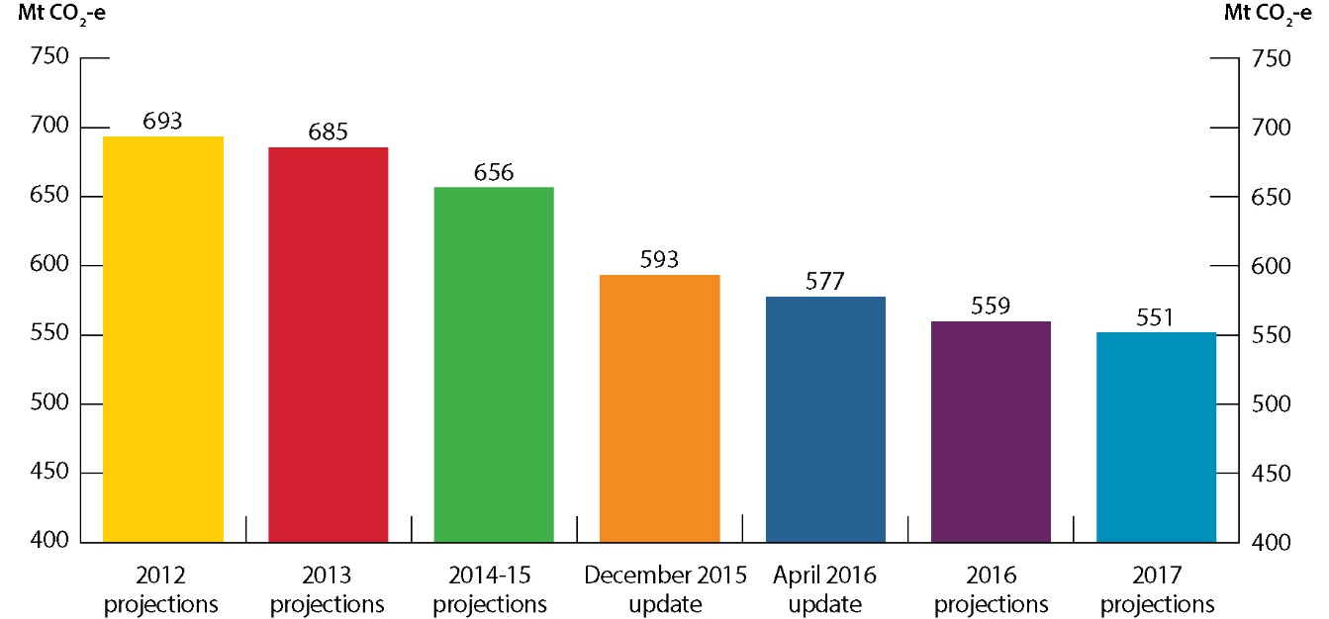

Emissions are projected using the information available in each publication and underlying assumptions and policy measures differ. Emissions accounting approaches to comply with international reporting standards and target trajectories are also different between projections.

### Changes since the 2016 projections

The increase in the overachievement of the 2020 target (Figure 2) is primarily due to lower emissions in the land use, land use change and forestry (LULUCF) and the direct combustion sectors. This is partially offset by higher emissions in the fugitives sector. In accordance with standard inventory reporting requirements, the full historical time series of Australia’s emissions (1990 to 2017) has been revised to account for improved methodologies and more accurate emission factors applied in the fugitive oil and gas and LULUCF sectors. These updates have resulted in upwards revisions in base years including 1990, 2000 and 2005, which has increased the emissions budget for Australia’s 2020 emissions reduction target.

Figure Change in the cumulative emissions reduction task for 2020 target

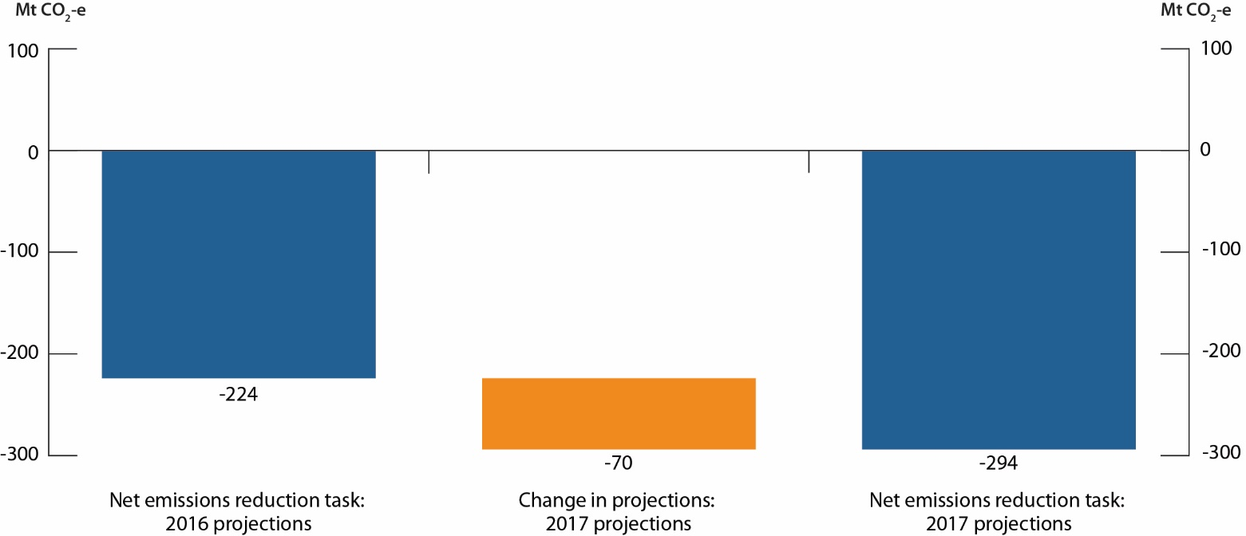

## Australia’s progress toward meeting the 2030 target

Australia has a target of reducing emissions to 26 to 28 per cent below 2005 levels in 2030.

The current estimate is that cumulative emissions reductions of 868 Mt CO2-e (26 per cent reduction) to 934 Mt CO2-e (28 per cent reduction) will be needed over the period 2021-2030 to meet Australia’s 2030 target.

Table Cumulative emissions reduction task, 2021 to 2030

|  |  |  |
| --- | --- | --- |
| Calculation of 2030 emissions reduction task | 26 per cent below 2005 levels in 2030 (Mt CO2-e) | 28 per cent below 2005 levels in 2030 (Mt CO2-e) |
| Cumulative emissions 2021-2030 | 5648 | 5648 |
| Target trajectory 2021-2030 | 4788 | 4722 |
| Voluntary action | 8 | 8 |
| Emissions reduction task | 868 | 934 |

The 2017 Projections show that the emission reduction task has continued to decline, with new policy measures driving the decrease between the 2016 and 2017 estimates.

It should be noted these projections do not take account of abatement from:

* the National Energy Guarantee
* the ongoing work of the Ministerial Forum on Vehicle Emissions, which is considering potential measures to improve the fuel efficiency of light vehicles
* other processes, for example, the work of the Council of Australian Governments (COAG) Energy Council.

Once implemented, these measures will drive additional emissions reductions to 2030.

### Emissions to 2030

Total emissions in 2030 are projected to be 570 Mt CO2-e, which is 5 per cent below 2005 levels (597 Mt CO2-e). This is a reduction of 22 Mt CO2-e from the estimate of 2030 total emissions published in the 2016 projections of 592 Mt CO2-e.

Without taking account of the measures discussed above, emissions in 2030 are projected to grow by 3.5 per cent above 2020 levels. Most of the projected growth in emissions is in the transport sector, led by increased heavy vehicles activity for freight, and the agriculture sector, driven by increased stocking numbers.

Emissions in other sectors are projected to stabilise or grow slowly after 2020 (Figure 3). Electricity emissions are expected to be flat as demand growth is offset by the effect of policies and initiatives under the NEPP.

Long-term emissions from industrial processes and product use are expected to be lower following the legislated phase-down of HFCs from 2018.

Figure Australia’s emissions, 1990 to 2030

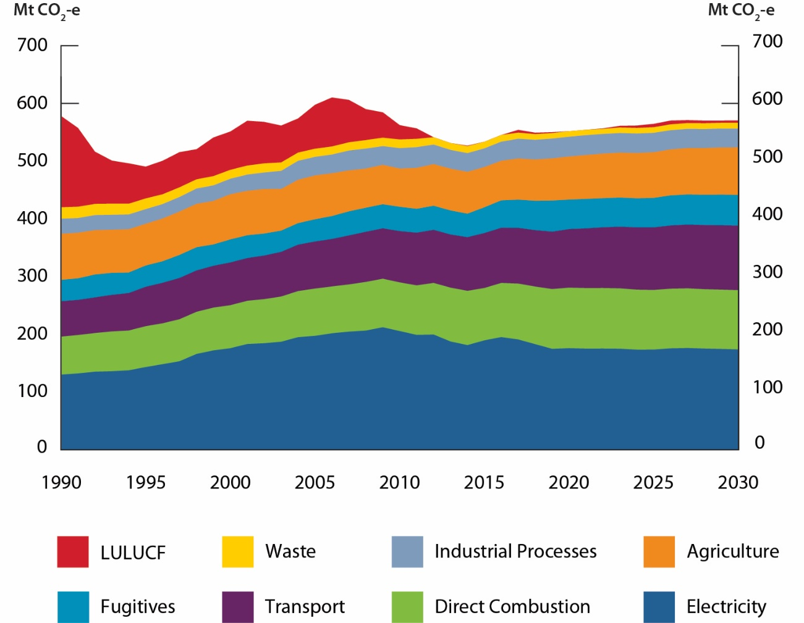

Table Sectoral breakdown of 2017 projections results to 2030

|  |  |  |  |  |  |
| --- | --- | --- | --- | --- | --- |
| Emissions by sector (Mt CO2-e | National Greenhouse Gas Inventory | | | Projection | |
| **2000** | **2005** | **2017**[4] | **2020** | **2030** |
| Electricity | 175 | 197 | 190 | 175 | 173 |
| Direct combustion | 75 | 82 | 97 | 105 | 103 |
| Transport | 74 | 82 | 96 | 101 | 112 |
| Fugitives | 40 | 39 | 49 | 51 | 53 |
| Industrial processes and product use | 27 | 32 | 34 | 34 | 32 |
| Agriculture | 78 | 76 | 72 | 75 | 82 |
| Waste | 16 | 14 | 11 | 10 | 10 |
| Land use, land use change and forestry | 66 | 76 | 5 | -1 | 4 |
| Total | 551 | 597 | 554 | 551 | 570 |

totals do not sum due to rounding.

### Changes since the 2016 projections

Australia’s emissions to 2030 are projected to be lower than estimated in the 2016 projections (Figure 4).

Figure Australia’s emissions trends, 1990 to 2030

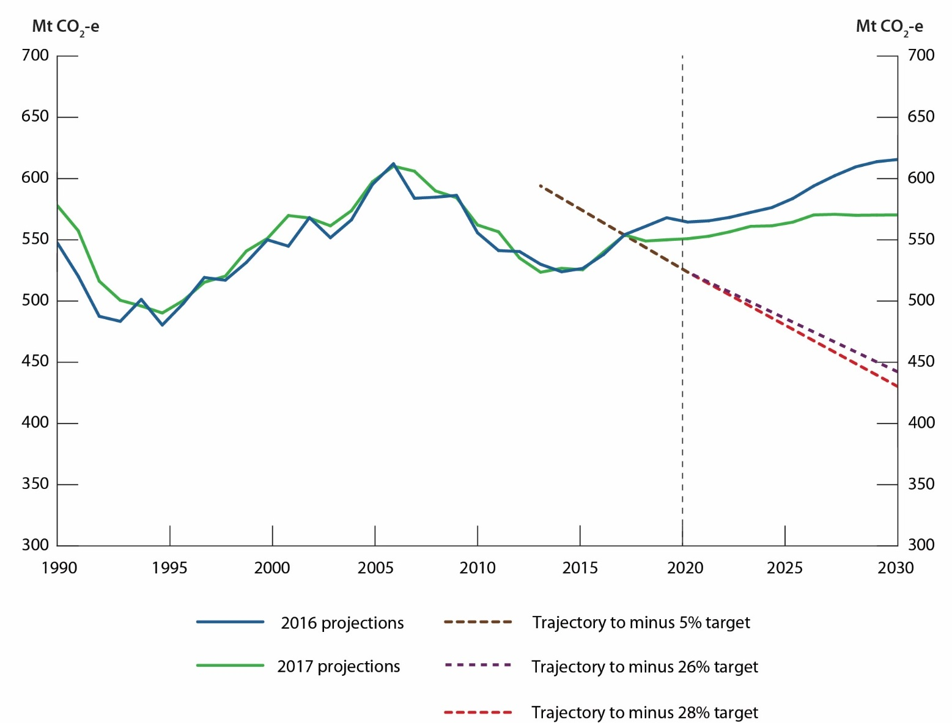

Figure Projected emissions in 2030 over time

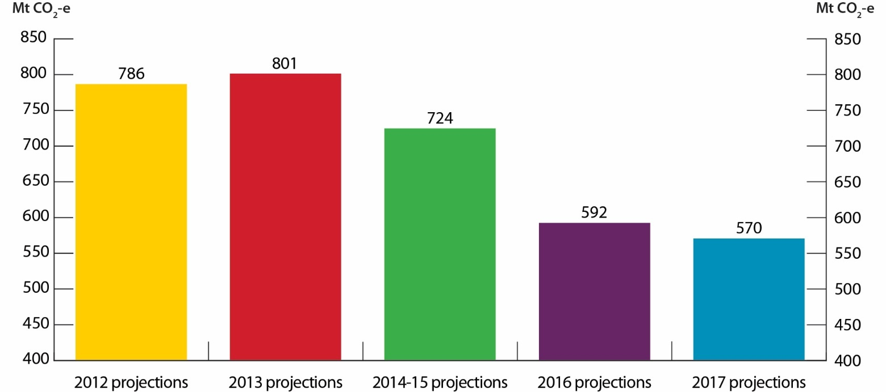

Emissions are projected using the information available in each publication and underlying assumptions and policy measures differ. Emissions accounting approaches to comply with international reporting standards and target trajectories are also different between projections.

Figure Change in the cumulative emissions reduction task for 2030 target

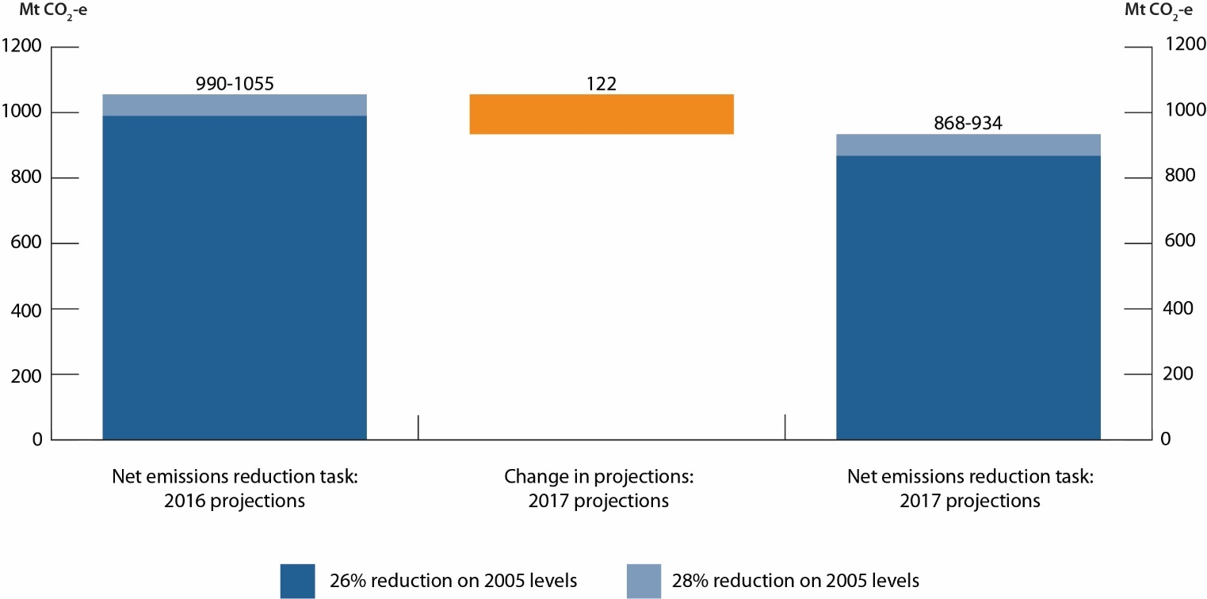

### Other metrics

The emissions intensity of the economy (GDP) has continued to decline and is projected to fall by 52 per cent in 2030 when compared to 2005. Emissions per person are also expected to fall steadily by 36 per cent in 2030 when compared to 2005.

Figure **Emissions per person and emissions intensity of GDP, 2005 to 2030**

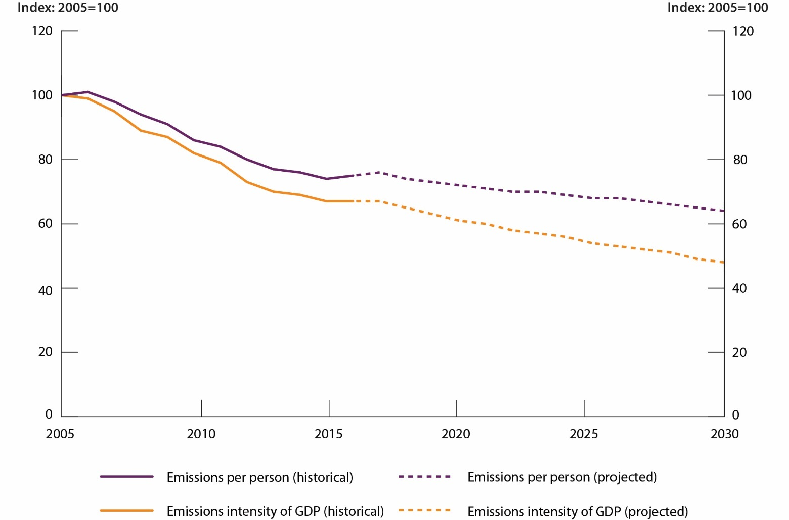

# Sectoral Trends

This chapter sets out the emissions projections associated with each sector. The sector breakdown is consistent with the international guidelines for reporting under the United Nations Framework Convention on Climate Change (UNFCCC). These sectors are described in Table 4 below:

Table Projections sector coverage

|  |  |
| --- | --- |
| Sector | Coverage |
| Electricity | * Emissions from the combustion of fuels to generate electricity |
| Direct combustion | * Emissions from the combustion of fuels to generate steam, heat or pressure, other than for electricity generation and transport |
| Transport | * Emissions from the combustion of fuels for transportation within Australia |
| Fugitives | * Emissions released during the extraction, processing and delivery of fossil fuels |
| Industrial processes and product use | * Emissions from non-energy related industrial production and processes Includes emissions from HFCs (used in refrigerants and air conditioning) |
| Agriculture | * Emissions from livestock, manure management and crop residue * Emissions from rice cultivation, application of nitrogen to soils, and burning of agricultural residues |
| Waste | * Emissions from the disposal of material to landfill and wastewater |
| Land use, land use change and forestry | * Emissions from activities occurring on forest lands, forests converted to other land uses, grasslands, croplands, wetlands and settlements |

## Electricity

Emissions from electricity generation are the result of fuel combustion for the production of electricity both on-grid and off-grid. Electricity generation represents the largest share of emissions in the national greenhouse gas inventory.

### Emissions to 2020

Electricity emissions are projected to be 175 Mt CO2-e in 2020, a decrease of 8 per cent below 2017 levels. This is in part due to the announced closures of Hazelwood power station and units at the Muja power station. Increases in renewable generation to meet the RET also drive emissions down to 2020.

### Emissions to 2030

Emissions are projected to be 173 Mt CO2-e in 2030, a decrease of 1 per cent below 2020 levels. While electricity demand is expected to grow by 1.2 per cent a year, much of the increase in demand is met by increased gas and renewable generation, particularly strong growth in solar generation. Liddell power station is assumed to close in the projections in 2022 as announced.

### Comparison to previous projections

Compared to the 2016 projections, emissions are marginally lower in 2020 by 0.4 Mt CO2-e and lower in 2030 by 13 Mt CO2-e. This is due to lower electricity demand, the inclusion of additional policies in the projections and lower technology costs for renewable wind and solar technology.

Figure Electricity emissions, 1990 to 2030

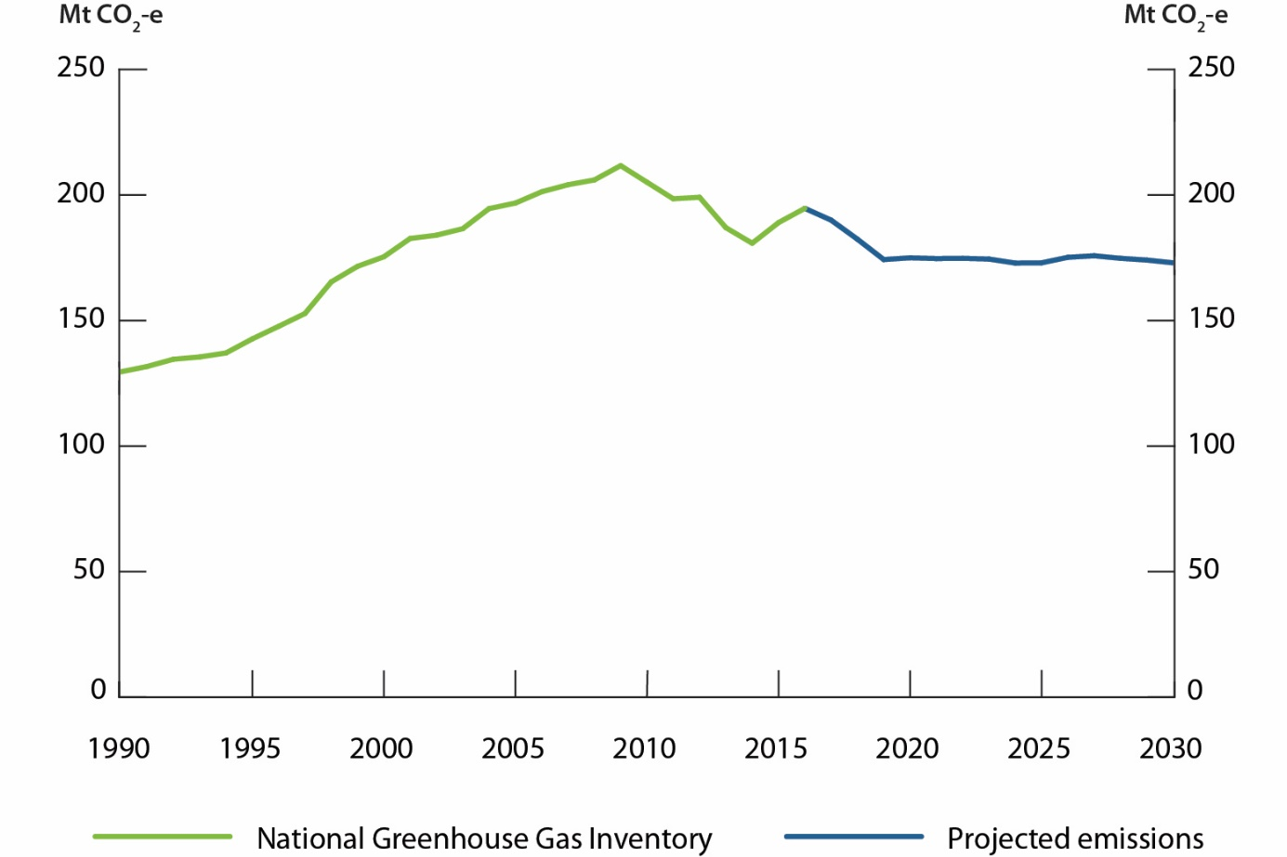

Table Electricity emissions, Mt CO2-e

|  |  |  |  |
| --- | --- | --- | --- |
| Emissions by sector (Mt CO2-e) | 2017[5] | 2020 | 2030 |
| Electricity | 190 | 175 | 173 |

Figure Projected sent-out electricity generation by fuel mix, 2017 to 2030

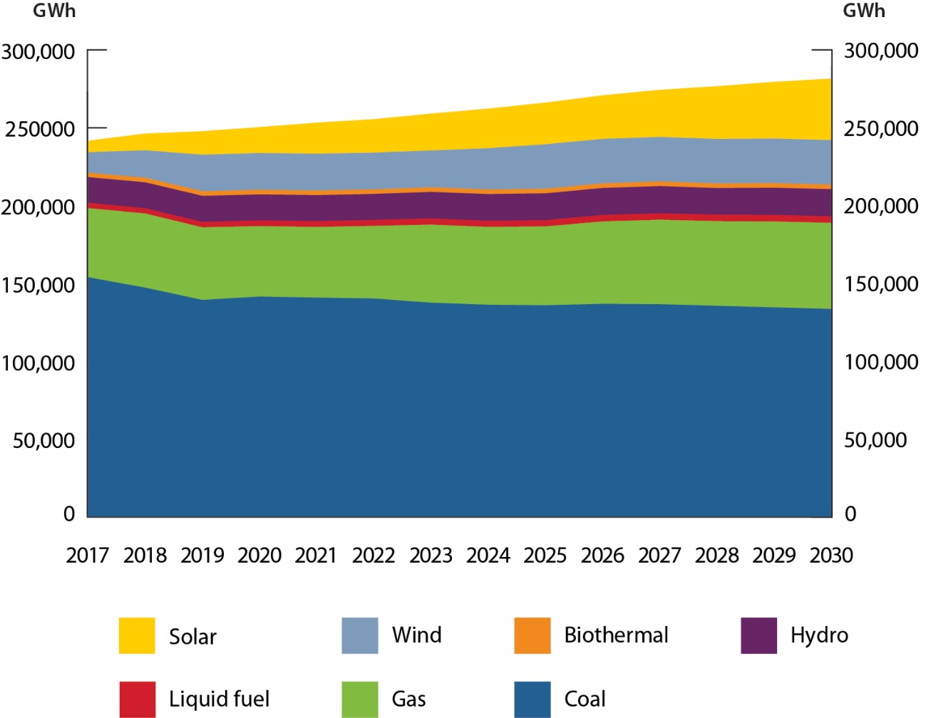

* + - * 1. Department of the Environment and Energy, and Jacobs analysis

## Direct combustion

Emissions from direct combustion are from the burning of fuels for energy used directly, in the form of heat, steam or pressure (excluding for electricity generation and transport). The direct combustion sector consists of six subsectors: energy, mining, manufacturing, buildings, agriculture, forestry and fishing and military. Fuel combusted in mobile equipment in mining, manufacturing, construction, agriculture, forestry and fishing is also included in direct combustion.

### Emissions to 2020

Direct combustion emissions are projected to be 105 Mt CO2-e in 2020, an increase of 8 per cent above 2017 levels. The largest growing sector in the short term is natural gas combusted at LNG plants, where production is projected to increase by nearly 200 per cent from 2015 to 2020. After this period of growth no further facility expansions are projected and LNG production is expected to remain stable. The mining subsector also grows strongly until 2022 and stabilises thereafter. This is due to an expected increase in coal, iron ore, gold and copper production to meet a projected increase in export demand for these commodities.

### Emissions to 2030

Direct combustion emissions are projected to be 103 Mt CO2-e in 2030, a decrease of 2 per cent below 2020 levels. Manufacturing is projected to continue to be the biggest contributor to sector emissions, however emissions are not projected to grow to 2030. Emissions from buildings are expected to fall over the projections period due to improvements in energy efficiency of new buildings and appliances as well as fuel switching from gas to electric appliances. Emissions from the agriculture, forestry and fishing sector are projected to grow steadily over the projections period due to a projected increase in diesel use in the agriculture sector.

### Comparison to previous projections

Compared to the 2016 projections, emissions are projected to be 3 Mt CO2-e lower in 2020 and 7 Mt CO2-e lower in 2030. This is due to lower than forecast emissions from mining and manufacturing sectors that flows through the projections period, lower demand for mining and resource commodities than previously projected and improvements in modelling methodology for the buildings and agriculture, forestry and fishing sectors.

Figure Direct combustion emissions, 1990 to 2030

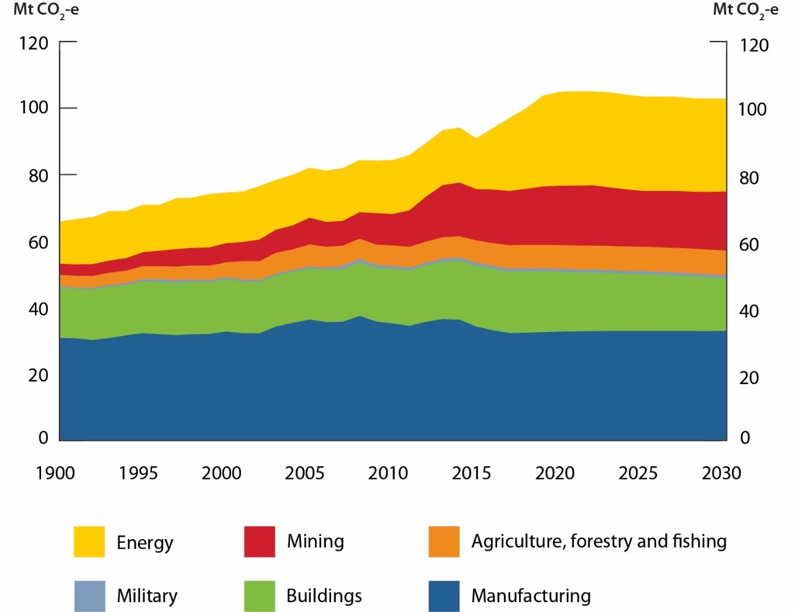

Table Direct combustion emissions, Mt CO2-e

|  |  |  |  |
| --- | --- | --- | --- |
| Emissions by sector (Mt CO2-e) | 2017[6] | 2020 | 2030 |
| Manufacturing | 32 | 33 | 33 |
| Buildings | 18 | 18 | 16 |
| Military | 1 | 1 | 1 |
| Agriculture, Forestry and Fishing | 7 | 7 | 7 |
| Mining | 16 | 18 | 18 |
| Energy | 22 | 28 | 28 |
| Total | 97 | 105 | 103 |

totals may not sum due to rounding.

## Transport

The transport sector consists of emissions from the combustion of fuels for transportation. This includes road, domestic aviation, rail, domestic shipping, off-road recreational vehicle activity and gas pipeline transport. Road transport includes cars, light commercial vehicles, motorcycles, rigid trucks, articulated trucks and buses. Emissions from electricity used in electric vehicles and rail are accounted for under the electricity sector. Emissions from the production and refining of oil-based fuels, including biofuels, are included in the direct combustion sector.

### Emissions to 2020

Transport emissions are projected to be 101 Mt CO2-e in 2020, an increase of 5 per cent above 2017 levels. Emissions are projected to steadily increase out to 2030 as transport activity grows due to population and economic growth. Cars and light commercial vehicles are projected to continue as the largest source of transport emissions.

### Emissions to 2030

Transport emissions are projected to be 112 Mt CO2-e in 2030, an increase of 10 per cent above 2020 levels. From 2025 onwards, cars and light commercial vehicles’ share of transport emissions is projected to fall due to improvements in vehicle efficiency, larger uptake of electric vehicles and growth in other sub-sector emissions such as heavy duty vehicles (articulated trucks, rigid trucks and buses). By 2025, the price of electric vehicles is expected to decline, reaching parity with traditional internal combustion engines vehicles. Electric vehicles are projected to comprise 15 per cent of new vehicle sales by 2030. This equates to about 4 per cent of the vehicle fleet in 2030. Steady growth in heavy vehicle emissions is projected in line with projected growth in GDP, rising demand for consumer goods resulting in an increased volume for freight carried, and limited uptake of low emissions fuels, such as biofuels.

Emissions from the non-road sector are projected to grow out to 2030, with most of the growth occurring in the domestic aviation sector. Growth in this sector is expected to remain strong due to increasing demand for air travel over other forms of medium-to-long distance travel. Emissions from rail transport are expected to grow slowly over the projections period in line with increases in iron ore production in Australia. Emissions from domestic shipping and pipeline transport are projected to remain flat throughout the projections period.

### Comparison to previous projections

Compared to the 2016 projections, transport emissions are broadly unchanged to 2020 and 2030.

Figure Transport emissions, 1990 to 2030

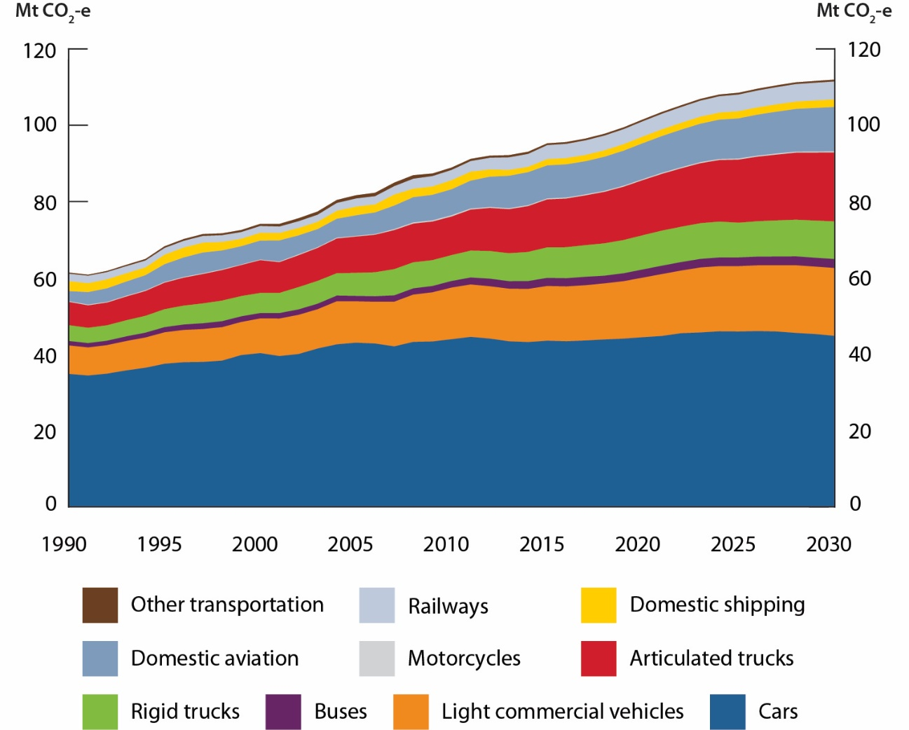

Table Transport emissions, Mt CO2-e

|  |  |  |  |
| --- | --- | --- | --- |
| Emissions by sector (Mt CO2-e) | 2017[7] | 2020 | 2030 |
| Cars | 44 | 44 | 45 |
| Light commercial vehicles | 14 | 16 | 18 |
| Buses | 2 | 2 | 2 |
| Rigid trucks | 8 | 9 | 10 |
| Articulated trucks | 13 | 14 | 18 |
| Motorcycles | <1 | <1 | <1 |
| Domestic aviation | 9 | 9 | 12 |
| Domestic shipping | 2 | 2 | 2 |
| Railways | 4 | 4 | 5 |
| Other transportation | <1 | <1 | <1 |
| Total | 96 | 101 | 112 |

totals may not sum due to rounding.

## Fugitives

Fugitive emissions are released during the extraction, processing and delivery of fossil fuels. Fugitive emissions do not include emissions from fuel combusted to generate electricity, operate mining plant and equipment, or transport fossil fuels by road, rail or sea.

### Emissions to 2020

Fugitive emissions are projected to be 51 Mt CO2-e in 2020, an increase of 5 per cent above 2017 levels.

Fugitive emissions from oil and gas are projected to increase from 22 Mt CO2-e in 2017 to 24 Mt CO2-e in 2020.Emissions from LNG production are projected to increase as the remaining LNG plants under construction come online and ramp up to full production. The Wheatstone project (WA) commenced production in October 2017 while the Ichthys project (NT) and Prelude Floating LNG project (WA) are expected to commence production during the 2018 calendar year. Emissions growth from LNG is projected to be partially offset by decreasing emissions from the Gorgon LNG project (WA) after the commencement of carbon capture and storage prior to 2020.

Fugitive emissions from coal mines are projected to increase from 26 Mt CO2-e in 2017 to 28 Mt CO2-e in 2020. Coal production is projected to increase due to strengthening coal prices and a return to higher production levels after Cyclone Debbie impacted coal production in 2017. Metallurgical coal production is forecast to increase by 4 per cent between 2017 and 2019 while thermal coal production is forecast to increase by 1 per cent.

### Emissions to 2030

Fugitive emissions growth is projected to slow over the period to 2030 to be 53 Mt CO2-e, an increase of 4 per cent above 2020 levels.

The International Energy Agency projects that Australian coal production will increase by 5 per cent between 2016 and 2030 in the 2017 World Energy Outlook New Policies Scenario. Fugitive coal emissions will be sensitive to changes in the global energy mix. This results in fugitive emissions from coal increasing by 9 per cent to 30 Mt CO2-e in 2030. The increase in coal is partially offset by a projected decline in emissions associated with Australian oil production over the period to 2030. Fugitive emissions from oil and gas are projected to fall by 2 per cent to 23 Mt CO2-e in 2030.

### Comparison to previous projections

Compared to the 2016 projections, fugitive emissions are higher as a result of improvements in inventory methods. Fugitive emissions are now estimated at a more disaggregated level for all leakages along the gas supply chain. The methods incorporate the results of CSIRO research and measurements from Australian gas wells and also draws from recent US empirical data where gaps in the Australian data exist[8]. These improvements have increased emissions in all years, however the recalculation is more pronounced from 2016 onwards when coal seam methane and LNG production accelerated.

Figure Fugitive emissions, 1990 to 2030

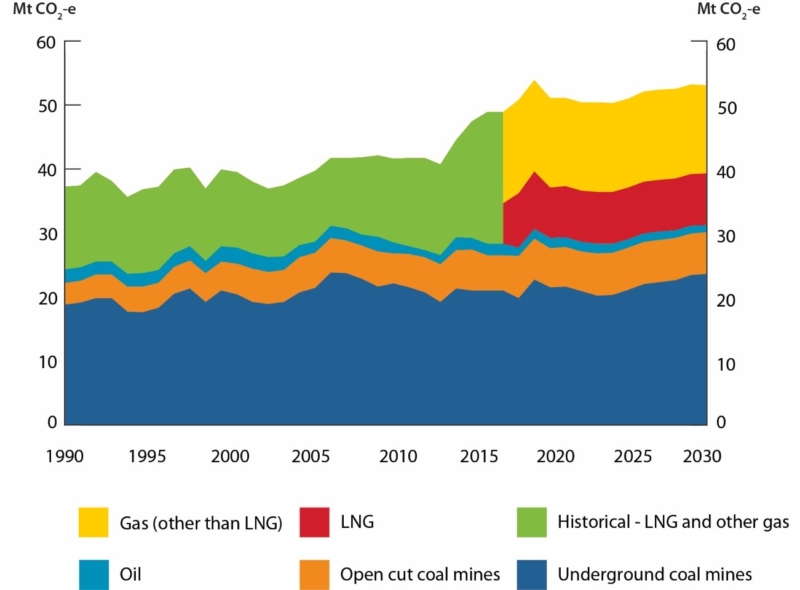

Table Fugitive emissions, Mt CO2-e

|  |  |  |  |
| --- | --- | --- | --- |
| Emissions by sector (Mt CO2-e) | 2017[9] | 2020 | 2030 |
| Underground coal mines | 21 | 22 | 24 |
| Open cut coal mines | 6 | 6 | 7 |
| Oil | 2 | 2 | 1 |
| Historical LNG and other gas | 21 | IE | IE |
| LNG | IE | 8 | 8 |
| Gas (other than LNG) | IE | 14 | 14 |
| Total | 49 | 51 | 53 |

totals may not sum due to rounding.

IE: Included elsewhere. To protect confidentiality fugitive emissions from LNG are combined with other gas from 1990-2017.

## Industrial processes and product use

The industrial processes and product use sector includes emissions from non-energy related production processes. Table 9 below lists the subsectors that comprise the industrial processes and product use sector and the main production processes that drive emissions from these subsectors.

Table Production processes in the industrial processes and product use sector

|  |  |
| --- | --- |
| Subsector | Main production processes |
| Metal industry | Iron and steel, and aluminium production |
| Chemical industry | Ammonia, nitric acid and titanium dioxide production |
| Mineral industry | Clinker and lime production |
| Product uses as substitutes for ozone depleting substances | HFCs used in refrigeration and air conditioning equipment, foams, fire protection and aerosols |
| Non-energy products from fuel and solvent use | Combustion of lubricant oils not used for fuel |
| Other production | Carbon dioxide generated in food production |
| Other product manufacture and use | Sulphur hexafluoride used in electrical switchgear |

### Emissions to 2020

Industrial processes and product use emissions are projected to be unchanged at 34 Mt CO2-e between 2017 and 2020.

### Emissions to 2030

Industrial processes and product use emissions are projected to be 32 Mt CO2-e in 2030, a decrease of 5 per cent below 2020 levels. The legislated phase-down of HFCs is the primary driver of the decline. The phase-down will reduce the amount of bulk HFC gas permitted to be imported into Australia from 2018.

### Comparison to previous projections

Compared to the 2016 projections, industrial processes and product use emissions are projected to be lower due to the inclusion of the HFC phase-down which has now been legislated, higher projected rates of HFC gas recovery and lower than anticipated actual emissions in the chemical industry.

Figure Industrial processes and product use emissions, 1990 to 2030

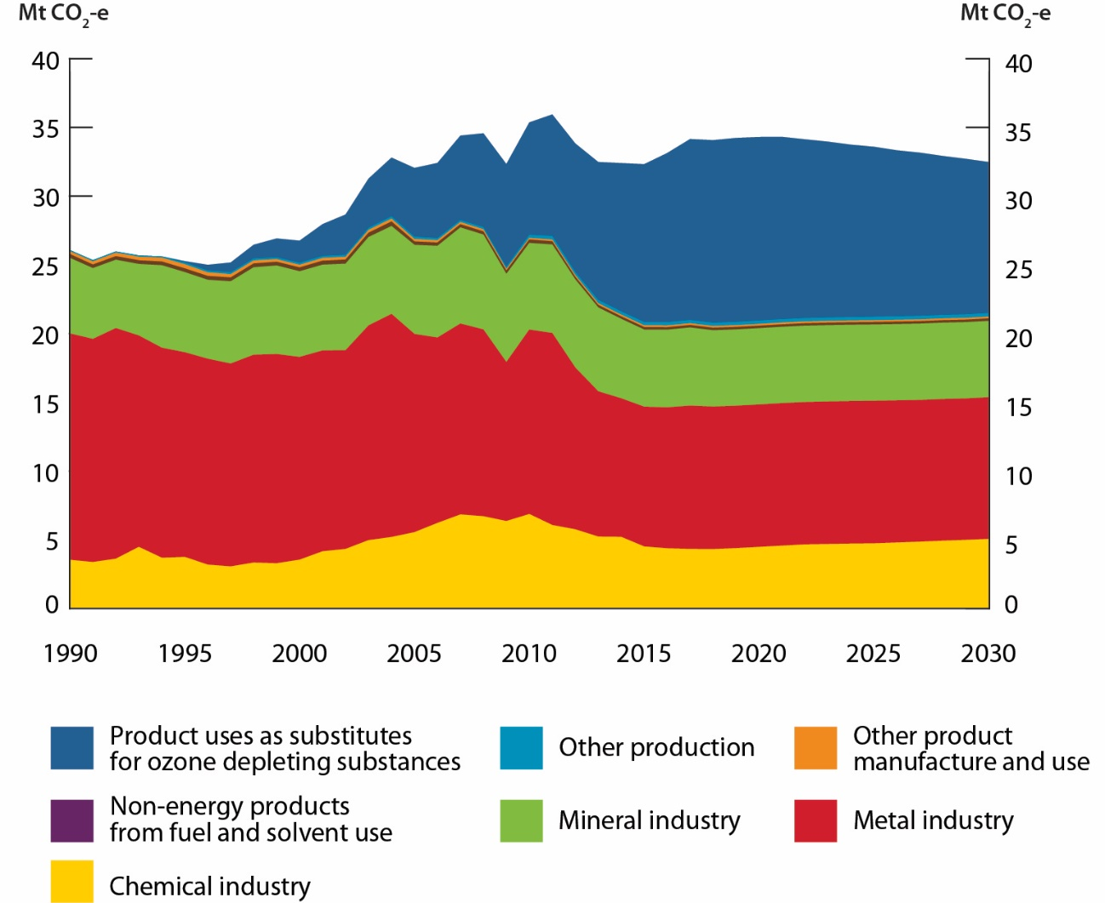

Table Industrial processes and product use emissions, Mt CO2-e

|  |  |  |  |
| --- | --- | --- | --- |
| Emissions by sector (Mt CO2-e) | 2017[10] | 2020 | 2030 |
| Product uses as substitutes for ozone depleting substances | 13 | 13 | 11 |
| Other production | <1 | <1 | <1 |
| Other product manufacture and use | <1 | <1 | <1 |
| Non-energy products from fuel and solvent use | <1 | <1 | <1 |
| Mineral industry | 6 | 6 | 6 |
| Metal industry | 10 | 10 | 10 |
| Chemical industry | 4 | 4 | 5 |
| Total | 34 | 34 | 32 |

## Agriculture

The agriculture sector includes emissions from enteric fermentation (the digestive process of some animals including cattle and sheep), manure management, rice cultivation, agricultural soils and field burning of agricultural residues. It does not include emissions from electricity use or fuel combustion from operating equipment, which are included in the electricity and direct combustion sectors. Most agriculture emissions are from methane and nitrous oxide rather than carbon dioxide. With the exception of carbon dioxide from the application of lime and urea, carbon dioxide emissions from agriculture are not counted because they are considered part of the natural carbon cycle.

### Emissions to 2020

Agriculture emissions are projected to increase to be 75 Mt CO2-e in 2020, an increase of 5 per cent above 2017 levels.

### Emissions to 2030

Agriculture emissions are projected to be 82 Mt CO2-e in 2030, an increase of 10 per cent above 2020 levels, underpinned by rising food demand and an assumed return to average seasonal conditions. This is a change from recent historical trends which saw periods of low rainfall, which reduced agricultural activity and therefore emissions.

Beef cattle is projected to continue to be the biggest contributor to sectoral emissions, followed by sheep and dairy cattle. Most emissions come from enteric fermentation from livestock, so fluctuations in these animal numbers has a major effect on emissions in this sector. While the majority of beef will continue to be fed by grazing on pasture, the projections have factored in an increase in grain fed beef cattle in feedlots due to these cattle being less susceptible to drought. Grain fed cattle are more emissions intensive, due to increased energy intake and increased concentration of manure in feedlots.

### Comparison to previous projections

Compared to the 2016 projections, emissions are higher in 2020 by 2 Mt CO2-e and higher in 2030 by 4 Mt CO2-e. Emissions are higher due in part to higher than projected actual emissions in 2016 for beef cattle, and stronger long-term growth in dairy and sheep activity, underpinned by expected growth in foreign demand.

Figure Agriculture emissions, 1990 to 2030

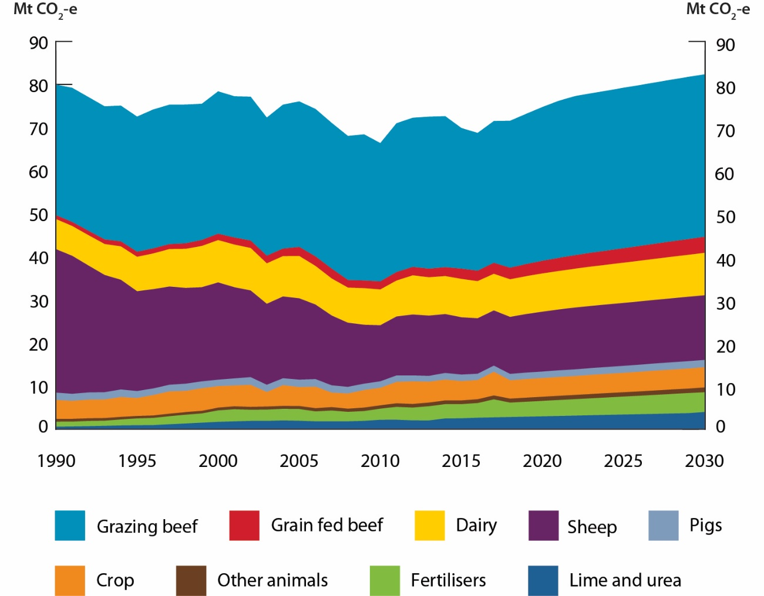

Table Agriculture emissions, Mt CO2-e

|  |  |  |  |
| --- | --- | --- | --- |
| Emissions by sector (Mt CO2-e) | 2017[11] | 2020 | 2030 |
| Lime and urea | 3 | 3 | 4 |
| Fertilisers | 4 | 4 | 5 |
| Other animals | 1 | 1 | 1 |
| Crop | 6 | 4 | 5 |
| Pigs | 1 | 2 | 2 |
| Sheep | 13 | 14 | 15 |
| Dairy | 9 | 9 | 10 |
| Grain fed beef | 3 | 3 | 4 |
| Grazing beef | 33 | 36 | 38 |
| Total | 72 | 75 | 82 |

totals may not sum due to rounding.

## Waste

The waste sector covers emissions from the disposal of organic materials to landfill and wastewater emissions from domestic, commercial and industrial sources. Emissions are predominantly methane, generated from anaerobic decomposition of organic matter.

### Emissions to 2020

Emissions in the waste sector are projected to be 10 Mt CO2-e in 2020, a decrease of 11 per cent below 2017 levels.

### Emissions to 2030

Emissions are projected to be 10 Mt CO2-e in 2030, broadly unchanged compared to 2020 levels.

The decrease in waste sector emissions to 2030 is predominately the result of the increase in recycling and methane capture rates over the period. This includes the methane capture and avoidance generated from the ERF.

Emissions in the waste sector dip in 2022, reflecting the projected peak in ERF contracted abatement. Post 2022, waste emissions are projected to gradually increase as population and industry production impacts begin to outpace growth in ERF abatement and methane capture rates.

### Comparison to previous projections

Emissions from the waste sector are projected to be slightly lower (less than 1 Mt CO2-e) in 2020 in comparison with the 2016 projections. Emissions from the waste sector are also projected to be lower (less than 1 Mt CO2-e) in 2030 in comparison with the 2016 projections.

The decrease in emissions in both 2020 and 2030 is predominately due to higher abatement from waste projects under the ERF than previously modelled.

Figure Waste emissions, 1990 to 2030

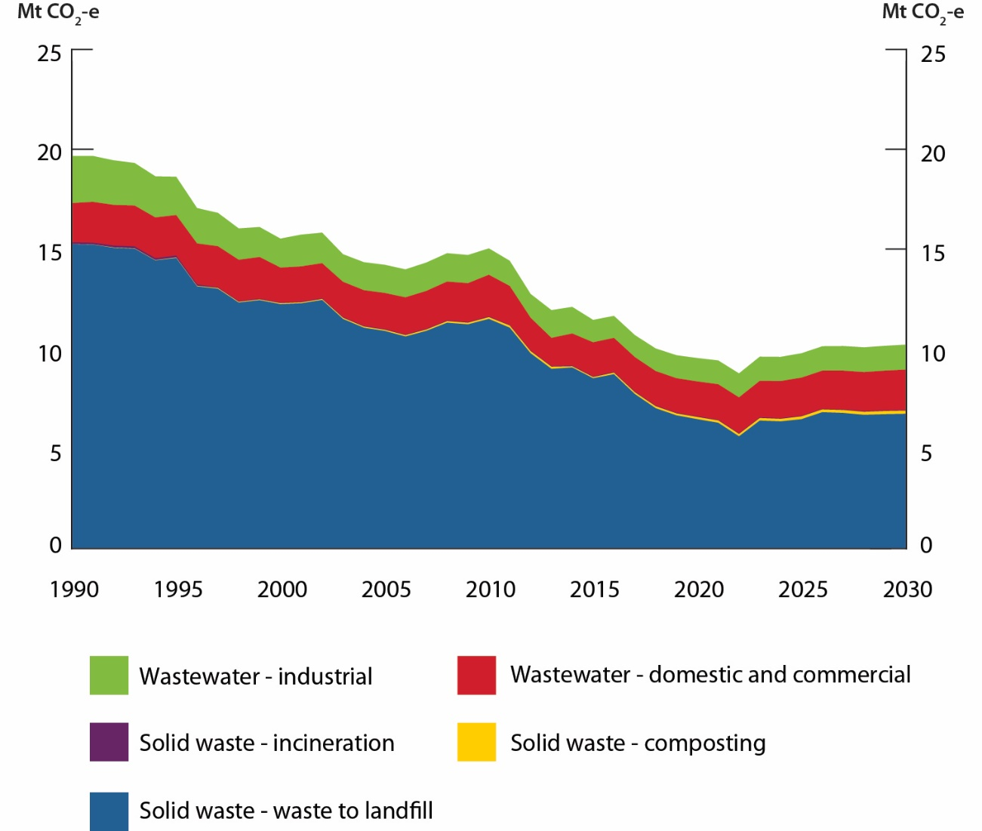

Table Waste emissions, Mt CO2-e

|  |  |  |  |
| --- | --- | --- | --- |
| Emissions by sector (Mt CO2-e) | 2017[12] | 2020 | 2030 |
| Solid waste - waste to landfill | 8 | 6 | 7 |
| Solid waste - composting | <1 | <1 | <1 |
| Solid waste - incineration | <1 | <1 | <1 |
| Wastewater - domestic and commercial | 2 | 2 | 2 |
| Wastewater - industrial | 1 | 1 | 1 |
| Total | 11 | 10 | 10 |

totals may not sum due to rounding.

## Land use, land use change and forestry

Unlike other sectors, management actions in the land use, land use change and forestry (LULUCF) sector can generate both sources of greenhouse gas emissions and sinks that remove or sequester carbon dioxide from the atmosphere. Net emissions from management actions are heavily influenced by biological processes, so can be complex and challenging to estimate.

The LULUCF sector projections are based on the UNFCCC inventory structure as described in Australia’s National Inventory Report 2015. The major categories used include:

* forest land, including forest land remaining forest and land converted to forest (e.g. harvest and regeneration of native forests and establishment and harvest of plantations) and includes sinks from regrowing forest on previously cleared land
* forest clearing (Emissions from the UNFCCC land-use classification of forest converted to other land uses, includes direct clearing-related emissions and delayed emissions from previous clearing) but excluding sinks from regrowing forests on previously cleared lands
* cropland (i.e. woody horticulture and changes in soil carbon under herbaceous crops)
* grasslands (e.g. changes in soil carbon through pastoral activities, fire management in savanna rangelands and changes in shrubby vegetation extent on grasslands) and
* wetlands and settlements (changes in shrubby vegetation extent on wetlands and within settlements, as well as aquaculture activities, and mangrove and tidal marsh conversions not already reported in forest land or forest conversions).

Figure 15 shows net LULUCF emissions are expected to remain broadly stable, generally as a small net source of emissions, across the period to 2030. The most influential source of emissions, forest clearing (grey), has been separated from the other land sector categories (grouped together as dark blue). The latter group covers the establishment and ongoing management of forests and grazing land with a minor contribution from cropland. Together, this group represents a significant carbon sink across the projections period.

Figure Land use, land use change and forestry emissions, 1990 to 2030

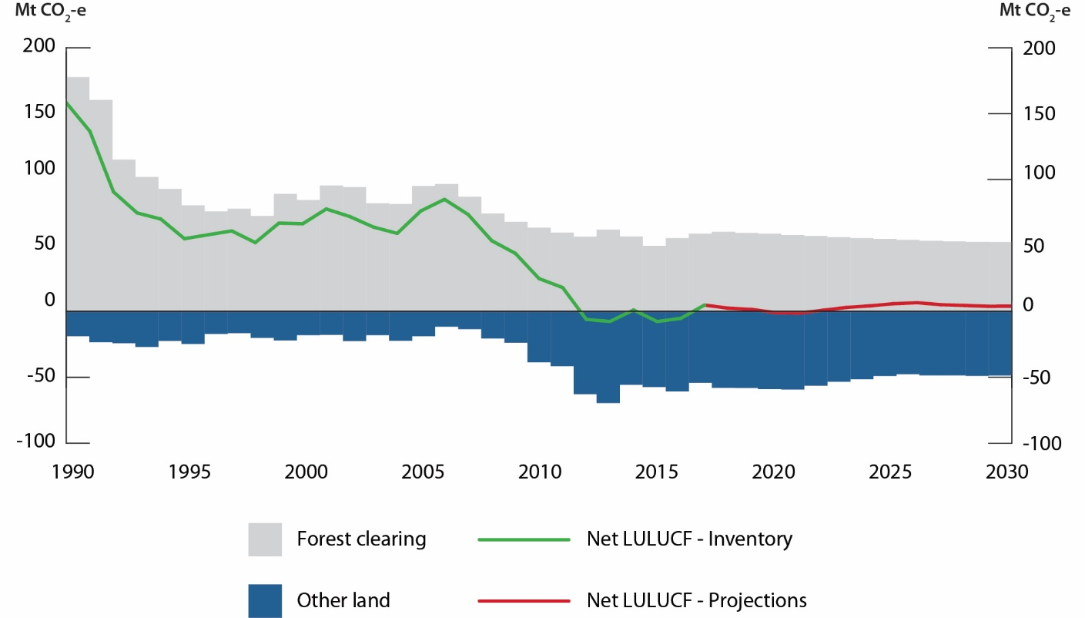

### Emissions to 2020

During the period to 2020, net emissions from the LULUCF sector are expected to decrease slightly to become a small net sink in 2020. A short-term rise in land clearing emissions to support additional grazing land is offset by higher carbon sinks from forests and plantations as post-harvest regrowth exceeds harvesting losses.

### Emissions to 2030

From 2021 to 2030, net emissions are projected to increase initially, before stabilising around 2025. This reflects two countervailing factors. Firstly, emissions from land clearing follow a declining trend, assuming a relatively stable clearing rate and a high proportion of clearing activity of young, less biomass-intensive, regrowth forest. Secondly, net emissions from other land categories are projected to rise. This mainly reflects continuing high rates of timber harvest from forest plantations and low rates of new plantation establishment (ABARES Outlook scenarios for Australia’s forestry sector), as well as a gradual return to long-term average emissions from changes in shrubby and other woody vegetation extent and soil carbon under grazing and crop lands.

### Comparison to previous projections

Compared to the 2016 projections, emissions are projected to be 11 Mt CO2-e lower in 2020 and 9 Mt CO2-e lower in 2030. This is due to a lower inventory baseline, reflecting modelling improvements in the most recent National Inventory Report submitted to the UNFCCC based on the latest available data and science from the CSIRO. Over the projections period these improvements increase the modelled carbon stocks sequestered in regrowing forest lands, resulting in an overall reduction in net LULUCF emissions.

Table Land use, land use change and forestry emissions, Mt CO2-e

|  |  |  |  |
| --- | --- | --- | --- |
| Emissions by sector (Mt CO2-e) | 2017[13] | 2020 | 2030 |
| Forest clearing | 59 | 59 | 53 |
| Other land | -54 | -59 | -49 |
| Total | 5 | -1 | 4 |

totals may not sum due to rounding.

# Methodology

## Accounting approach

The projections are prepared at the sectoral level consistent with international guidelines adopted by the UNFCCC. This includes projecting Australia’s emissions for Kyoto Protocol greenhouse gases. These are expressed in terms of CO2-e using the 100 year global warming potentials contained in the Intergovernmental Panel on Climate Change’s Fourth Assessment Report (IPCC 2007). As greenhouse gases vary in their radiative activity and in their atmospheric residence time, converting emissions into CO2-e allows the aggregate effect of emissions of the various gases to be considered.

Australia’s emissions projections are estimated on a UNFCCC accounting basis consistent with Australia’s accounting approach to the 2030 target. Australia’s national greenhouse gas inventory is prepared on both a UNFCCC and Kyoto Protocol classification basis. The difference between the two classification frameworks is the treatment of emissions sources and sinks from the land use, land use change and forestry sector. The UNFCCC inventory includes all sources and sinks where there is adequate data, while Kyoto provisions do not include sources and sinks from the wetlands sub-category of land use, land use change and forestry activities.

Unless stated otherwise, all years in this report align with the definition of reporting year used in the national greenhouse gas inventory. Reporting years are reported for financial years as key data sources are published on this basis. For instance, ‘2030’ refers to the financial year 2029-30.

## Methodology for calculating Australia’s cumulative emissions reduction task to 2020

Australia has a target of reducing emissions to 5 per cent below 2000 levels by 2020. This target has been communicated to the UNFCCC as a pledge under the Cancun Agreement.

Australia assesses its progress towards its 2020 target using an emissions budget approach for the period 2013 to 2020. A trajectory to achieve the emissions budget is calculated by taking a linear decrease from 2010 to 2020, beginning from the Kyoto Protocol first commitment period target level, which was 108 per cent of 1990 levels as calculated in Australia’s latest National Inventory Report submission, and finishing at five per cent below 2000 levels in 2020.

Australia’s 2020 target is based on the Kyoto Protocol classification system. It includes emissions and removals from the energy, industrial processes and product use, agriculture and waste sectors and the following Kyoto Protocol land use, land use change and forestry sub-classifications: deforestation, afforestation, reforestation, forest management, cropland management, grazing land management and revegetation.

## Methodology for calculating Australia’s cumulative emissions reduction task to 2030

The Australian Government is committed to reducing emissions by 26-28 per cent below 2005 levels by 2030, in its Nationally Determined Contribution submitted to the UNFCCC.

International rules and guidance on how to define an emissions budget associated with a target under the Paris Agreement have yet to be developed. For this report, the calculation of Australia’s 2030 emissions reduction task is based on the existing guidance developed in the context of the Cancun Agreement.

|  |
| --- |
| What is the difference between emissions projections and emissions forecasts? |
| The Department regularly prepares emissions projections using the latest data including production and activity levels, commodity prices and macroeconomic assumptions. The Department makes reasonable assumptions about this data into the future based on the advice of other government agencies and external consultants. These include macroeconomic forecasts by the Australian Treasury; activity forecasts by other government agencies such as the Australian Bureau of Agricultural and Resource Economics and Sciences and the Department of Industry, Innovation and Science; forecasts by other public bodies such as the Australian Energy Market Operator; and announced investment intentions by businesses.  The projections are modelled taking this data into account and indicate what Australia’s future emissions could be if the assumptions that underpin the projections continue to occur. For example, the projections presume that assumptions around the current rates of economic and population growth, the take up of certain technologies and the impacts of current government policies will remain valid. The projections do not attempt to account for the inevitable, but as yet unknown, changes that will occur in technology, energy demand and supply and the international and domestic economy.  In contrast, emissions forecasts speculate on the expectations or predictions of what will happen in the future and thus what future emissions will be. In a forecast the assumptions represent expectations of actual future events or changes. For example, this could mean forecasting emissions based on alternative predictions of how technology may evolve, how consumers and businesses will react to these technological changes and subsequently what impacts this would have on emissions. Alternatively this could mean forecasting emissions based on expectations about restructures in the Australian economy. Often a number of different scenarios that reflect different forecast assumptions are undertaken at the same time.  Both projections and forecasts are inherently uncertain, involving judgements about the future growth path of global and domestic economies, policies and measures, technological innovation and human behaviour. This uncertainty increases the further into the future emissions are projected (or forecast).  The distinction between forecasts and projections can also be seen in the Treasury’s economic estimates underlying Australian Government fiscal projections. The estimates divide the forecast horizon into two distinct periods: the near–term forecast period which covers the first two years beyond the current financial year; and the longer–term projection period which includes the last two years of the forward estimates, and up to 36 more years for intergenerational analysis. The economic estimates over the forecast period are based on a range of short–run forecasting methodologies, while those over the projection period are based on medium–to long–run rules. |

## Data sources

The projections are developed using a combination of top-down and bottom-up modelling prepared by the Department’s analysts and external consultants. The preparation of the projections is based on the following data sources:

* historical emissions data from National Inventory Report 2015, released in June 2017, and Quarterly Update of Australia’s National Greenhouse Gas Inventory*[14]*,
* macroeconomic assumptions of gross domestic product and exchange rates consistent with the Australian Government’s 2017–18 Budget,
* population growth from the Australian Bureau of Statistics; and
* commodity forecasts and activity levels informed by a number of publications and data from government agencies and other bodies, including:
  + the Department of Industry, Innovation and Science
  + the Australian Bureau of Agricultural and Resource Economics and Sciences
  + the Bureau of Infrastructure, Transport and Regional Economics
  + the Australian Energy Market Operator
  + announcements by business of investment intentions.

The Department applies consistent assumptions across all sectors of these projections.

Every effort is made to take account of available information and analysis. However, there are inevitably sources that become available too close to the release of the projections to allow for detailed integration into the projections.

## Consideration of policies

The projections are developed on the basis of current policies and measures. These include the:

* ERF, total funding allocated to the ERF is $2.55 billion and is projected to contribute 74 Mt CO2-e to 2020, and 243 Mt CO2-e over the period 2021 to 2030[15]
* Large-scale Renewable Energy Target of 33,000 GWh by 2020
* National Energy Productivity Plan
* legislated phase-down of HFCs

They do not take account of estimates of abatement from policies and initiatives that are still undergoing detailed development. These include:

* the National Energy Guarantee
* measures to improve the fuel efficiency of Australia’s vehicle fleet, currently being progressed by the Ministerial Forum on Vehicle Emissions
* proposed state renewable energy targets and plans
* the work of the COAG Energy Council

## Institutional arrangements and quality assurance

The projections are prepared by the Department of the Environment and Energy using the best available data and independent expertise to analyse Australia’s future emissions reduction task. The Department engages with a technical working group comprising of representatives from Commonwealth agencies to test the methodologies, assumptions and projections results. Australia makes formal submissions on its emissions projections to the United Nations and these are subject to UN expert review.

The preparation of the emissions projections underwent a performance audit by the Australian National Audit Office (ANAO) in 2016 and 2017. The audit found the arrangements for preparing, calculating and reporting on Australia’s greenhouse gas emission projections were largely effective. The audit report, Accounting and Reporting of Australia’s Greenhouse Gas Emissions Estimates and Projections is published on the ANAO website.

Environment.gov.au

1. All year references refer to Australian financial years unless otherwise stated. For example 2020 refers to the financial year 2019–20.
2. Voluntary action refers to individuals and companies offsetting their emissions to become ‘carbon-neutral’ and households buying GreenPower (a government-accredited program for energy retailers to purchase renewable energy on behalf of customers). Voluntary action achieves emissions reductions additional to—that is, above and beyond—national targets.
3. Under the carbon tax, many landfill facility operators charged their customers in relation to future carbon liabilities that were expected to accrue as the waste being deposited decayed over many decades. Now that the carbon tax has been repealed, the voluntary Waste Industry Protocol allows these landfill operators to acquit these charges by purchasing carbon abatement credits and voluntarily transferring them to the Commonwealth
4. The estimate for 2017 emissions is different by a small amount to that published in the Quarterly Update of Australia’s National Greenhouse Gas Inventory: June 2017 due to different emissions accounting treatments and the application of policies.
5. The estimate for 2017 emissions is different by a small amount to that published in the Quarterly Update of Australia’s National Greenhouse Gas Inventory: June 2017 due to different emissions accounting treatments and the application of policies.
6. The estimate for 2017 emissions is different by a small amount to that published in the Quarterly Update of Australia’s National Greenhouse Gas Inventory: June 2017 due to different emissions accounting treatments and the application of policies.
7. The estimate for 2017 emissions is different by a small amount to that published in the Quarterly Update of Australia’s National Greenhouse Gas Inventory: June 2017 due to different emissions accounting treatments and the application of policies.
8. Additional detail on the inventory updates on fugitive emissions are published in the Quarterly Update of Australia’s National Greenhouse Gas Inventory: December 2016 and Australia’s National Inventory Report 2015.
9. The estimate for 2017 emissions is different by a small amount to that published in the Quarterly Update of Australia’s National Greenhouse Gas Inventory: June 2017 due to different emissions accounting treatments and the application of policies.
10. The estimate for 2017 emissions is different by a small amount to that published in the Quarterly Update of Australia’s National Greenhouse Gas Inventory: June 2017 due to different emissions accounting treatments and the application of policies.
11. The estimate for 2017 emissions is different by a small amount to that published in the Quarterly Update of Australia’s National Greenhouse Gas Inventory: June 2017 due to different emissions accounting treatments and the application of policies.
12. The estimate for 2017 emissions is different by a small amount to that published in the Quarterly Update of Australia’s National Greenhouse Gas Inventory: June 2017 due to different emissions accounting treatments and the application of policies.
13. The estimate for 2017 emissions is different by a small amount to that published in the Quarterly Update of Australia’s National Greenhouse Gas Inventory: June 2017 due to different emissions accounting treatments and the application of policies.
14. Forthcoming June Quarter 2017
15. Abatement from the ERF includes the results of the first five auctions and projected abatement from the 6th and future auctions. Results from the 6th ERF auction were not available at the time of finalising these projections. Abatement includes contracted emission reductions and the continuation of some projects after the end of the contract period (post contract abatement).