

Background review

Hydraulic fracturing (‘fraccing’) techniques, including reporting requirements and governance arrangements

This background review was commissioned by the Department of the Environment on the advice of the Interim Independent Expert Scientific Committee on Coal Seam Gas and Coal Mining. The review was prepared by URS Australia Pty Ltd and revised by the Department of the Environment following peer review.

June 2014

Copyright

© Copyright Commonwealth of Australia, 2014.



*Hydraulic fracturing (‘fraccing’) techniques, including reporting requirements and governance arrangements, Background review* is licensed by the Commonwealth of Australia for use under a Creative Commons By Attribution 3.0 Australia licence with the exception of the Coat of Arms of the Commonwealth of Australia, the logo of the agency responsible for publishing the report, content supplied by third parties, and any images depicting people. For licence conditions see: <http://creativecommons.org/licenses/by/3.0/au/>

This report should be attributed as ‘Hydraulic fracturing (‘fraccing’) techniques, including reporting requirements and governance arrangements, Background review, Commonwealth of Australia 2014’.

The Commonwealth of Australia has made all reasonable efforts to identify content supplied by third parties using the following format ‘© Copyright, [*name of third party*] ’.

Enquiries concerning reproduction and rights should be addressed to:

Department of the Environment, Public Affairs

GPO Box 787 Canberra ACT 2601

Or by email to: public.affairs@environment.gov.au

This publication can be accessed at: www.iesc.environment.gov.au

Acknowledgements

This background review was commissioned by the Department of the Environment on the advice of the Interim Independent Expert Scientific Committee on Coal Seam Gas and Coal Mining. The review was prepared by URS Australia Pty Ltd with input from Tony Jong and Daymion Jenkins. The report was peer reviewed by Ian Falconer, Rob Jeffery (CSIRO), Stephen Kraemer, Andrew Gillespie, Bruce Kobelski and John Noel (US Environmental Protection Agency), and relevant Queensland, New South Wales and South Australian Government departments.

Disclaimer

The views and opinions expressed in this publication are those of the authors and do not necessarily reflect those of the Australian Government or the Minister for the Environment or the Interim Independent Expert Scientific Committee on Coal Seam Gas and Coal Mining or the statutory Independent Expert Scientific Committee on Coal Seam Gas and Large Coal Mining Development (IESC).   
  
While reasonable efforts have been made to ensure that the contents of this publication are factually correct, the Commonwealth and IESC do not accept responsibility for the accuracy or completeness of the contents, and shall not be liable for any loss or damage that may be occasioned directly or indirectly through the use of, or reliance on, the contents of this publication.

Addendum

Changes to state government departments have occurred since the finalisation of this report by the authors. The Queensland, New South Wales and South Australian Government agencies were contacted and updated information provided in September 2013; however, no guarantees can be made as to the completeness of these updates. Up-to-date information should be sourced from the relevant department.

On 1 January 2013, the Queensland Water Commission (QWC) ceased operations. The Office of Groundwater Impact Assessment (OGIA) retains the same powers as the former QWC under Chapter 3 of the *Water Act 2000* (Qld).

Contents

Copyright 2

Acknowledgements 2

Disclaimer 2

Addendum 2

Contents 4

Summary 6

Abbreviations 10

Glossary 11

1 Introduction 13

2 Coal seam gas in the Australian context 14

2.1 Understanding coal seam gas 14

2.2 Coal seam gas resources in Australia 14

2.3 How coal seam gas is extracted 15

2.4 Well installation and completion 16

2.5 Extraction of water and gas 18

3 Hydraulic fracturing techniques 19

3.1 What is hydraulic fracturing? 19

3.2 Why hydraulic fracturing? 20

3.3 How hydraulic fractures grow 20

3.4 The history of hydraulic fracturing 21

3.5 Hydraulic fracturing in Australia 21

3.6 Stages of hydraulic fracturing 22

3.6.1 Stage 1: pre-fracturing assessment 22

3.6.2 Stage 2: on-site activities 24

3.6.3 Stage 3: post-fracturing activities 28

4 Environmental concerns 32

4.1 Subsurface contamination 32

4.2 Well integrity 34

4.3 Fracturing fluid migration 35

4.4 Gas leakage 37

4.5 Migration of naturally occurring substances 37

4.6 Surface contamination 39

4.7 Induced seismicity 39

4.8 Water supply 41

5 Regulatory framework 43

5.1 Australian Government 43

5.2 State and territory governments 43

5.3 Queensland 44

5.4 New South Wales 46

5.5 Western Australia 47

5.6 Victoria 48

5.7 South Australia 48

5.8 Northern Territory 48

5.9 Tasmania 49

5.10 Regulation of industrial chemicals 49

6 Summary of key issues 51

7 References 53

Summary

This report provides an overview of Australian and international experiences with the use of hydraulic fracturing (‘fraccing’) in coal seam gas development, including techniques, environmental concerns, reporting requirements and existing governance arrangements.

Key points

* Of the 1844 coal seam gas wells drilled in Australia over 15 months during 2012 and 2013, six per cent were hydraulically fractured.
* The composition of fluids used in hydraulic fracturing activities vary depending on site requirements. Benzene, toluene, ethyl-benzene and xylenes (BTEX chemicals) are banned from use in hydraulic fracturing in New South Wales and Queensland.
* The main potential environmental concerns are surface and subsurface contamination, induced seismicity and water consumption.
* Fracture growth caused by hydraulic fracturing can increase connection between coal seams and aquifers – the magnitude and extent of this growth is dependent on local factors.
* Hydraulic fracturing programs are designed to suit local conditions, and to monitor and control fracture growth during operations.

The hydraulic fracturing process

Hydraulic fracturing is the creation and enhancement of fractures in rock using a gas or fluid injected at high pressure. It increases the ability of water and gas to flow through a coal seam, which enhances the removal of water and extraction of coal seam gas. Hydraulic fracturing is carried out where the natural permeability of the coal seam is insufficient to allow commercial recovery of coal seam gas, or to increase production rates.

Coal seam gas extraction does not always involve hydraulic fracturing. Of the 1844 coal seam gas wells drilled in Australia over 15 months during 2012 and 2013, six per cent were subject to hydraulic fracturing. In Queensland, this proportion could increase to 10-40 per cent as the industry expands.

Following the drilling of a production well, extensive assessment is carried out to evaluate the requirement for, and the optimisation of, the hydraulic fracturing process. The hydraulic fracturing process involves isolating the target coal seams through correct well construction and perforation of the well casing at specific intervals where the target coal seams are located. In instances where coal seams are limited in thickness, such as the Surat Basin where the individual seams within the coal measures are typically less than 50 cm thick, hydraulic fracturing may be used to connect separate seams over a target horizon of 2 to 5 m.

Use of fracturing chemicals

Fluids are used in hydraulic fracturing to both force fractures open, and to carry ‘proppant’ materials that help to keep the fractures open. The composition of hydraulic fracturing fluids varies depending on site specific conditions. It typically comprises around 97 to 99 per cent water and sand, with the remaining volume consisting of a variety of additives. These may include acid, gelling agents, biocides, pH buffers, and other chemicals. The use of benzene, toluene, ethyl-benzene and xylenes (BTEX) is banned in NSW and Queensland. Best practice requires that a larger volume of water (flowback water) is recovered from a well after hydraulic fracturing is completed, relative to the volume of injected fluid.

Issues and impacts

Hydraulic fracturing has attracted a large amount of community concern, especially in relation to potential risks to human health and the environment from the chemicals used. Concern has also been expressed about information disclosure, absence of baseline monitoring, inadequate testing of chemical additives and the recovery and disposal of used hydraulic fracturing fluids.

The main environmental concerns associated with hydraulic fracturing can be broadly divided into:

* subsurface contamination and risks to groundwater resources, their quality and use
* surface contamination, including exposure risk and toxicity of chemical additives
* induced seismicity
* water use.

The significance of these risks is geographically and geologically specific. For example, the risk of hydraulic fracturing fluid migrating through several hundred metres of low-permeability layered rock is low. Similarly, the toxicity of the chemicals used is dependent on the initial concentration of the chemical within the hydraulic fracturing fluid, any mixing effects of the combined chemicals, any reactions with the surrounding rocks and groundwater, attenuation over time as the chemicals move through the environment and the nature of exposure risks to these chemicals. Preliminary risk assessments by industry indicate that the residual concentrations of a chemical of potential concern are unlikely to pose a risk in coal seam groundwater or at the surface.

Subsurface contamination

Subsurface contamination can be minimised by limiting the use of toxic chemicals in hydraulic fracturing fluids, maximising the recovery of chemicals via flowback (discussed above), and preventing increased connection via fracture growth between coal seams and water supply aquifers.

Fracture growth is highly dependent on the conditions at the site, including the geology, in situ stress and injection pressure. Various methods can be used prior to and during hydraulic fracturing to design and control fracture growth. Greater disclosure of hydraulic fracture mapping results would enable critical assessment to determine if stimulated fractures are localised to the injection zone.

Surface contamination

At the surface, flowback water is either stored in temporary storage tanks or ponds, or is transported by pipeline to a water treatment plant. There is potential for accidental releases, leaks and spills due to pond or pipeline failure. Another surface contamination source is the accidental release or spill of hydraulic fracturing fluid. Assessments of the risks are generally undertaken by reviewing the existing site environment, assessing hazards to determine which chemicals are of most concern, assessing exposure pathways and then characterising the risks. Industry risk assessments do not include direct toxicity assessments of individual chemicals or the overall or cumulative effects of the hydraulic fracturing chemicals as a mixture.

Induced seismicity

Fracture stimulation can induce seismic activity, however, most of these seismic events are usually small (microseismic) and only able to be detected with local monitoring. Large seismic events can be induced by hydraulic fracturing in the presence of a pre-stressed fault, but these events are rare and more commonly associated with fracturing in shale gas developments. Seismicity induced by hydraulic fracturing is unlikely to exceed magnitude 3 on the Richter Scale. The risk of large seismic events occurring can be minimised by understanding the local subsurface fault system and seismic history of a region, appropriate site selection, and monitoring of pressure changes in a well before, during and after hydraulic fracturing.

Water supply

Hydraulic fracturing requires access to volumes of water that are generally not large compared to other uses, such as irrigation, and large industrial and town water supply. Typically, between 0.1 and 10 ML of water is required for hydraulic fracturing of a coal seam gas well, but 1 ML per fracturing event is common. Water is commonly sourced from nearby groundwater systems and rivers. In regions where local, natural water sources are scarce or fully committed for other purposes, hydraulic fracturing could require volumes of water that contribute to stress on local water resources. These situations may be managed in a variety of ways, including re-use or recycling of water from coal seam gas operations.

Regulation

State and territory governments are responsible for the legislative framework, licensing and decision making processes governing coal seam gas activities. Regulation is well advanced in Queensland and NSW where environmental requirements impose operating conditions on coal seam gas and hydraulic fracturing including provision of details of planned hydraulic fracturing, assessment of zonal isolation, records of stakeholder consultation, hydraulic fracturing design, predictions of fracture propagations, fate and transport assessment, and risk assessments relating to environmental and human health.

Of particular relevance to hydraulic fracturing are the:

* *Queensland code of practice for constructing and abandoning coal seam gas wells* (DNRM 2013)
* *Queensland coal seam gas water management policy* (DEHP 2012a)
* *New South Wales aquifer interference policy* (NSW Office of Water 2012) and water sharing plans
* *New South Wales* *code of practice for coal seam gas well integrity* (NSW T&I 2012a)
* *New South Wales code of practice for coal seam gas fracture stimulation activities* (NSW T&I 2012b)
* *Mineral Resources Tasmania mineral exploration code of practice,* 5th edition– appendix 1: *Schedule for onshore exploration for petroleum, shale gas, coal seam gas or geothermal substances* (DIER 2012).

The *Environment Protection and Biodiversity Conservation Act 1999* is the main Australian Government environmental legislation. It provides a legal framework to protect and manage impacts upon matters of national environmental significance, which include water resources in relation to coal seam gas and large coal mining development. In addition, in 2013 the Council of Australian Governments’ Standing Council on Energy and Resources published a national harmonised regulatory framework covering the coal seam gas industry.

Abbreviations

| General abbreviations | Description |
| --- | --- |
| AICS | Australian Inventory of Chemical Substances |
| API | American Petroleum Institute |
| BTEX | Benzene, toluene, ethylbenzene and xylene. |
| CBL | Cement bond log |
| COPC | Chemical of potential concern |
| EDR | Economic demonstrated resources |
| FSMP | Fracture Stimulation Management Plan |
| IESC | Independent Expert Scientific Committee on Coal Seam Gas and Large Coal Mining Development |
| LNG | Liquefied natural gas |
| mg/L | Milligrams per litre |
| ML | Megalitre |
| NICNAS | National Industrial Chemicals Notification and Assessment Scheme |
| NSW | New South Wales |
| PJ | Petajoule |
| UK | United Kingdom |
| US | United States of America |
| USD | United States of America dollars |
| δ13C | Carbon-13 (a measure of the ratio of carbon-13 to carbon-12) |
| δ2H | Deuterium (a measure of the ratio of hydrogen-2 to hydrogen-1) |

Glossary

| Term | Description |
| --- | --- |
| Aquifer | Rock or sediment in formation, group of formations or part of a formation, that is saturated and sufficiently permeable to transmit quantities of water to wells and springs. |
| Aquitard | A saturated geological unit that is less permeable than an aquifer and incapable of transmitting useful quantities of water. Aquitards often form a confining layer over an artesian aquifer |
| Baseline survey | A survey carried out prior to any disturbance to determine the natural background levels of certain substances. |
| Biogenic methane | Methane produced by bacteria. |
| Bore/borehole | An artificially constructed hole or cavity used to intercept groundwater to enable extraction or passive observation of groundwater information. Also known as a well. |
| Casing | A temporary or permanent lining for a bore. |
| Casing string | The entire length of all the sections of casing in a well. |
| Coal measure | A sequence of coal bearing units. |
| Coal seam | Sedimentary layers consisting primarily of coal. Coal seams store both groundwater and gas, and generally contain poorer quality groundwater than aquifers that are used for drinking water or agriculture. |
| Coal seam gas | A form of natural gas (generally 95 to 97 per cent pure methane, CH4) typically extracted from permeable coal seams at depths of 300 to 1000 m. |
| Conventional gas | Natural gas found in relatively permeable rock. |
| Co-produced water | The water that is pumped out of coal seams in order to extract coal seam gas. Over time, the volume of co-produced water normally decreases and the volume of produced gas increases. Also referred to as produced water, associated water and coal seam gas water. |
| Dewatering | The lowering of static groundwater levels through complete extraction of all readily available groundwater, usually by means of pumping from one or several groundwater bores. |
| Economic demonstrated resources (EDR) | EDR is a measure of the resources that are established, analytically demonstrated or assumed with reasonable certainty to be profitable for extraction or production under defined investment assumptions. |
| Flowback water | The fluid that flows back, or is pumped back, to the surface following hydraulic fracturing but prior to gas production. |
| Fracture | A crack in a rock than can be natural or induced. |
| Fracturing fluid leak-off | The migration of injected fracturing fluid from the created fractures to other areas within the coal seam or adjacent stratigraphic unit. |
| Hydraulic fracturing | Also known as ‘fracking’, ‘fraccing’, or ‘fracture simulation’, is the process by which hydrocarbon (oil and gas) bearing geological formations are ‘stimulated’ to enhance the flow of hydrocarbons and other fluids towards the well. The process involves the injection of fluids, gas, proppant, and other additives under high pressure into a geological formation to create a network of small fractures radiating outwards from the well through which the hydrocarbon, and any associated water, can flow. |
| Hydraulic pressure | The total pressure that water exerts on the materials comprising the aquifer. Also known as pore pressure. |
| Hydrostatic pressure | The theoretical pore pressure that would be expected purely from the weight of the overlying rocks on the water in formations. |
| Liquefied natural gas | Natural gas compressed into a liquid state, typically for storage and transport. |
| Methane | The flammable gas (CH4), which forms the largest component of natural gas. |
| Microseismic | Very small earthquakes or seismic events. |
| Permeability | The measure of the ability of a rock, soil or sediment to yield or transmit a fluid. The magnitude of permeability depends largely on the porosity and the interconnectivity of pores and spaces in the ground. |
| Porosity | The proportion of the volume of rock consisting of pores, usually expressed as a percentage of the total rock or soil mass. |
| Proppant | Inert particles (normally sand) mixed with fracturing fluid injected into hydraulic fractures to hold fractures open after fracturing. |
| Shale gas | A natural gas found in shale formations. |
| Thermogenic methane | Methane produced by the alteration of organic matter under high temperatures and pressures over long time periods. |
| Unconventional gas | Natural gas found in a very low permeability rock, such as shale gas and coal seam gas. |
| Well | See bore. |
| Well integrity | The ability of the cased well to prevent fluid or gas inside the well from leaking into the surrounding environment. Also referred to as bore integrity. |

# Introduction

This review is one of a number commissioned by the Department of the Environment on the advice of the Interim Independent Expert Scientific Committee on Coal Seam Gas and Coal Mining. These reviews aim to capture the state of knowledge on the water-related impacts of coal seam gas extraction and large coal mining, but do not aim to provide detailed analysis and evaluation of methods for identifying and managing impacts, or to develop such methods.

The focus of this report is hydraulic fracturing issues associated with coal seam gas extraction, including the techniques involved, the risks and how they are managed, and the regulatory environment. While hydraulic fracturing is used in a number of industries, including shale gas, conventional gas, ore mining, coal mining and geothermal energy, the scope of this review is limited to hydraulic fracturing in the coal seam gas industry in Australia.

The report provides a summary and synthesis of the relevant and available literature and the expert opinions of the authors, and does not describe the results of a specific study or research project. The focus is primarily on hydraulic fracturing in Australia, although the review includes an international context. Reference is also made to other forms of unconventional gas such as shale gas to illustrate where the fracturing processes and impacts differ. This review is limited to information available in the public domain. Industry operators and government regulators were invited to provide information for this review. The list of source materials include:

* journal articles
* conference proceedings
* scientific text books
* government department reports
* industry and consulting reports.

The report commences with a general overview of the coal seam gas industry in Australia and the processes used for extracting coal seam gas. Hydraulic fracturing techniques are detailed in Chapter 2. The review then outlines the concerns associated with hydraulic fracturing. Chapter 4 summarises the arrangements across Australia for regulating coal seam gas extraction. The final chapter provides a summary of the key issues.

# Coal seam gas in the Australian context

## Understanding coal seam gas

Coal seam gas is a naturally occurring gas held in the pore spaces and fractures of underground coal seams. It consists predominantly of methane, heavier hydrocarbons such as propane and butane as well as carbon dioxide (Miyazaki 2005). Coal seams are porous and contain fractures and small pores. The fractures and pore spaces are also typically fully saturated with water. The hydrostatic pressure from the water in the coal seams and the overlying saturated rock helps to hold the gas in place. Due to their large internal surface area, coal seams can store six to seven times more gas per unit volume than conventional gas reservoirs (Nuccio 2000).

Coal seam gas is classed as an unconventional gas because it requires more advanced technology to extract than conventional gas. Other examples of unconventional gas are shale gas and gas from tight sands. The source of both conventional and unconventional gas is organic matter such as plants that were deposited in sedimentary Basins millions of years ago. Similarly to other sources of natural gas, coal seam gas is used for domestic and industrial purposes around Australia. It can also be pumped to a facility where it can be transformed into liquefied natural gas (LNG) for export.

## Coal seam gas resources in Australia

The estimate in 2012 of economic demonstrated resources (EDR) of coal seam gas in Australia was 35 905 Petajoules (PJ) (Figure 1). This is equivalent to nearly 10 times the total yearly energy use in Australia based on 2007 total energy use (DEWHA 2008). Resources are considered as EDRs if there is at least a 50 per cent probability that they can be commercially extracted. Figure 1 shows that Queensland has the vast majority of EDR coal seam gas with 92 per cent of Australia’s EDR in the Surat and Bowen Basins. The remainder is in New South Wales (NSW) in the Clarence-Moreton, Gunnedah, Gloucester and Sydney Basins.

Commercial production of coal seam gas began in Queensland in 1996 (Baker & Slater 2008). Since then, approximately three per cent of the total EDR has been extracted with 97 per cent of this from the Surat and Bowen Basins (GA & BREE 2012). Coal seam gas has also been produced in the Sydney Basin since 2001 (AGL 2013a). This produces approximately five per cent of natural gas supplies in NSW (AGL 2013a). It is estimated that there is sufficient coal seam gas in Australia to continue production rates for approximately 175 years, compared to 66 years remaining for conventional gas (CEDA 2012).

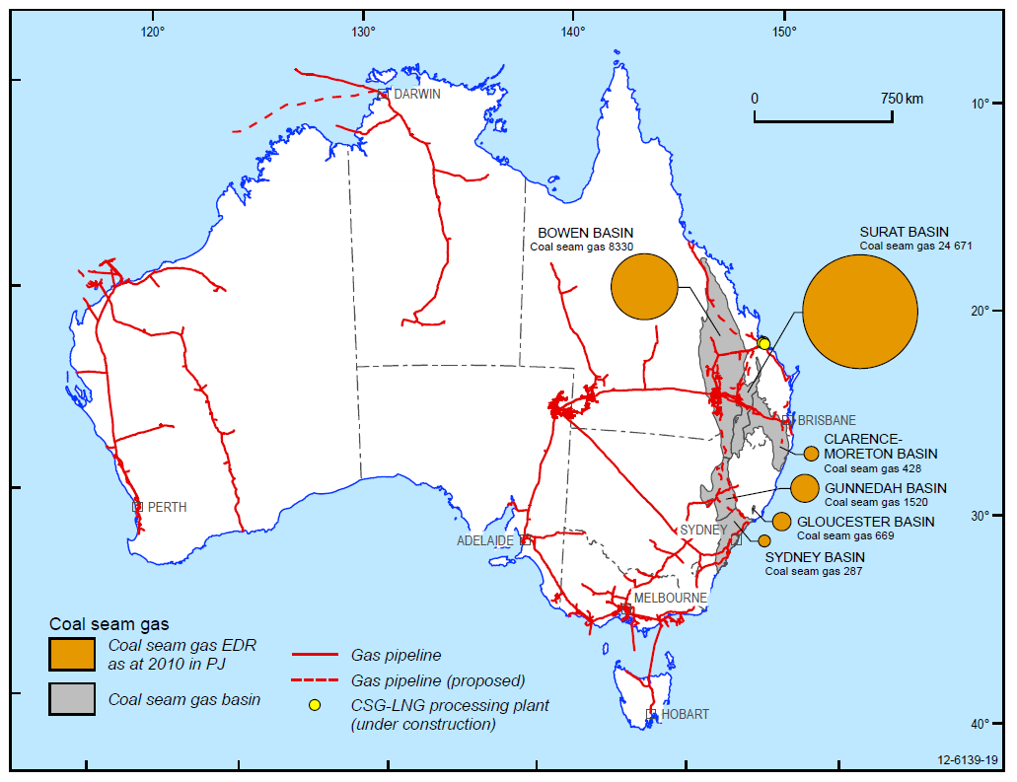

Figure 1 Coal seam gas deposits in Australia (© Copyright, GA & BREE 2012).

Exploration for further coal seam gas EDRs is continuing in coal basins in Queensland and NSW. Other areas subject to exploration (Lloyd-Smith & Senjen 2011; Baker & Slater 2008) are:

* Otway and Gippsland Basins in Victoria
* Tasmania Basin in Tasmania (not currently subject to exploration for coal seam gas)
* Arckaringa and Willochra Basins in South Australia
* Pedirka Basin in the Northern Territory
* Perth and Canning Basins in Western Australia.

Exploration in Victoria has yielded very little success due to low gas flows from exploration wells (Baker & Slater 2008). The distribution of coal seam gas resources in relation to coal Basins in Australia is shown in Figure 2.

## How coal seam gas is extracted

Coal seam gas is extracted by drilling into a coal seam and then extracting water. This is termed dewatering. Extracting water reduces the hydrostatic pressure acting on the gas and allows it to detach from the coal and move within pore spaces and fractures towards the well where it is then produced to the surface. Coal seam gas extraction involves installation and completion of wells followed by extraction of water and gas. A summary of the well installation, completion, and gas and water extraction process is given below.

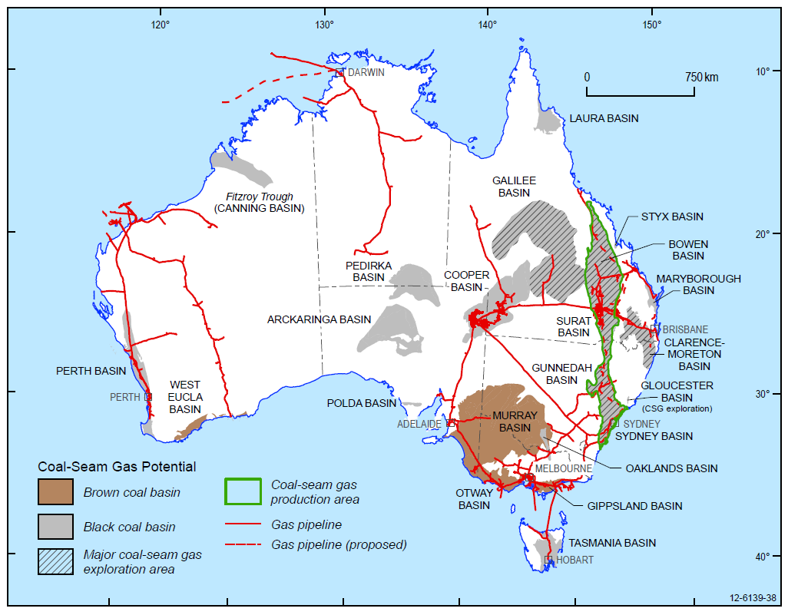

Figure 2 Coal Basins with known economic coal seam gas resources (© Copyright, GA & BREE 2012).

## Well installation and completion

Coal seam gas extraction involves the installation of wells at a relatively high density. Drilling non-vertical wells, illustrated in Figure 3, is a common drilling technique. Horizontal in-seam wells are gaining in popularity because they provide greater contact area with the coal seam and allow more gas to be extracted (Maricic et al. 2005). These include directional, horizontal and multilateral wells. Horizontal wells in the United States of America (US) commonly produce three to 10 times more gas than vertical wells but are only approximately twice as expensive to drill (Palmer 2010). Horizontal and multilateral wells also have the advantage of reducing the impact of surface infrastructure because fewer wells need to be drilled. Horizontal wells are in use in Australia, for example 30 horizontal wells have been drilled in the Camden Gas Project, NSW (Ross 2012).

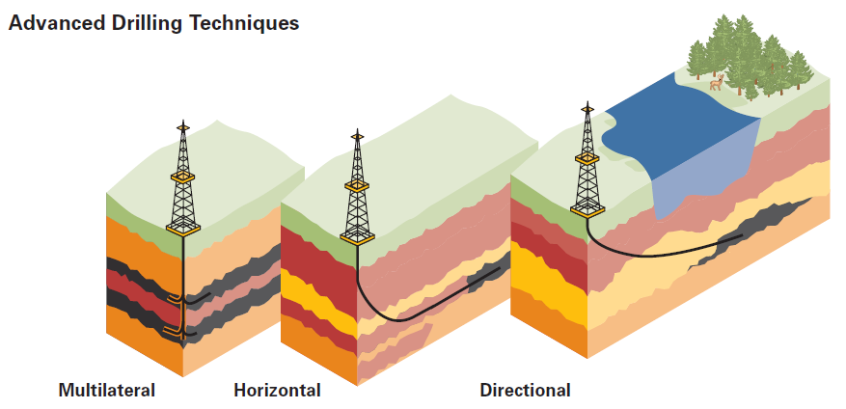

Figure 3 Non-vertical drilling (© Copyright, US DoE 1999).

Well design and completion is an important aspect of coal seam gas extraction. Wells are designed to prevent gas or water leakage from the well into the subsurface. This mechanical isolation of the well from the subsurface is described as well integrity (API 2009). The Australian Petroleum Institute (API) provides very specific guidelines on the proper design and construction of coal seam gas wells, particularly for those that will be hydraulically fractured. The *Code of practice for coal seam gas well integrity* was released by the Department of Trade and Investment, Regional Infrastructure and Services (NSW Trade & Investment 2012a) and a *Code of practice for constructing and abandoning coal seam gas wells* operates in Queensland (DNRM 2013). This code of practice includes both mandatory requirements and ‘good industry practice’ guidance.

Mandatory requirements include:

* the use of a ‘Blow Out Preventor’ to stop any sudden and uncontrolled release of fluid at the surface
* specifications related to casing design including conductor, surface, intermediate and production strings, to be installed according to specific site conditions and best practice requirements
* the use of casing centralisers to ensure the casing strings are positioned correctly within the bore hole
* cement to completely fill the space between the casing and the rock, known as the annulus
* down hole logging to measure bore hole conditions and to provide added information for proper casing design.

API (2009) suggests that well integrity should be monitored over time. Even correctly completed wells can eventually fail due to down hole stresses and corrosion (Bellabarba et al. 2008). A study of well integrity in the oil and gas industry in Canada, covering the range of conventional and unconventional oil and gas wells, found that many older wells leaked but approximately 0.5 per cent of wells constructed since 2000 leaked (The Royal Society & Royal Academy of Engineering 2012; Watson & Bachu 2009). There is no evidence that on-going integrity testing of any types of wells such as groundwater observation bores and exploration bores is carried out in Australia, although this may be a function of reporting requirements.

## Extraction of water and gas

Coal seam gas production involves the extraction of groundwater from the coal seam, in some cases this can be relatively large (e.g. the Walloon coal measures in Queensland) and in others it can be minimal (e.g. Southern Sydney Basin in NSW). Hydraulic fracturing is a flow enhancement or ‘well stimulation’ technique used in the oil and gas industry to increase the flow of trapped [oil and gas] hydrocarbons by creating or enhancing pathways (referred to as ‘fractures’) for the gas and water to flow through. Water and natural gas are extracted from the well and transported to the surface in pipes. The ratio of gas to water changes with time and involves three phases: dewatering, stable production and decline (Figure 4). Water production decreases with time, whereas gas production initially increases to a peak in the ‘stable’ phase and then gradually declines.

The dewatering phase can take days or years. This water is also known as co-produced water, produced water, associated water or coal seam gas water. In Queensland, the volume of co-produced water generated at each well is approximately 7 ML per year on average over the life of the well (CSIRO 2012b), whilst in the Camden Gas Project, water production rates for about 80 per cent of production wells are less than 0.05 ML per year per well. Changes in the water production rate over time (Figure 4) can differ between coal seams. In the Camden Gas Project in NSW for example, the rate of water production decreases rapidly, whereas in Queensland projects the decrease is more gradual (AGL 2013a).

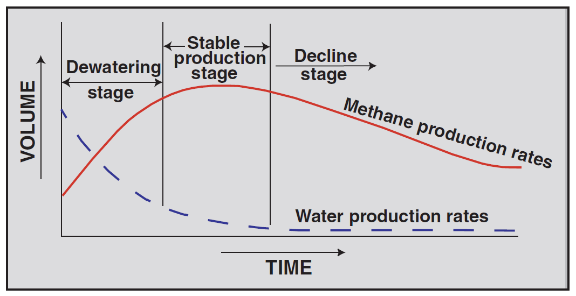

Figure 4 Typical production of water and gas over time in a coal seam gas well (© Copyright, Nuccio 2000).

A coal seam gas well is only commercially viable if the permeability and gas content of the coal seam are sufficiently high. If the natural fracture network is not well developed it is difficult to extract sufficient gas from the well (Maricic et al. 2005). To increase the permeability of coal seams and extract more gas, some coal seam gas wells are hydraulically fractured.

# Hydraulic fracturing techniques

## What is hydraulic fracturing?

Hydraulic fracturing, also known as fraccing or hydraulic stimulation, is the process of injecting fluid under high pressure into a coal seam to widen existing fractures and create new ones. A ‘proppant’ such as sand is mixed with the injected fluid, carried into the fracture and serves to keep the fractures open once the fracture treatment is complete and the pressure is released. The fractures created or widened are generally 1 to 20 mm thick (APLNG 2013a). Hydraulic fracturing is often performed sequentially at multiple depths, or stages, in a well corresponding with the location of the coal seams. Hydraulic fracturing is also sometimes repeated during the life of a well to boost declining gas productivity. Hydraulic fracturing is illustrated in Figure 5.

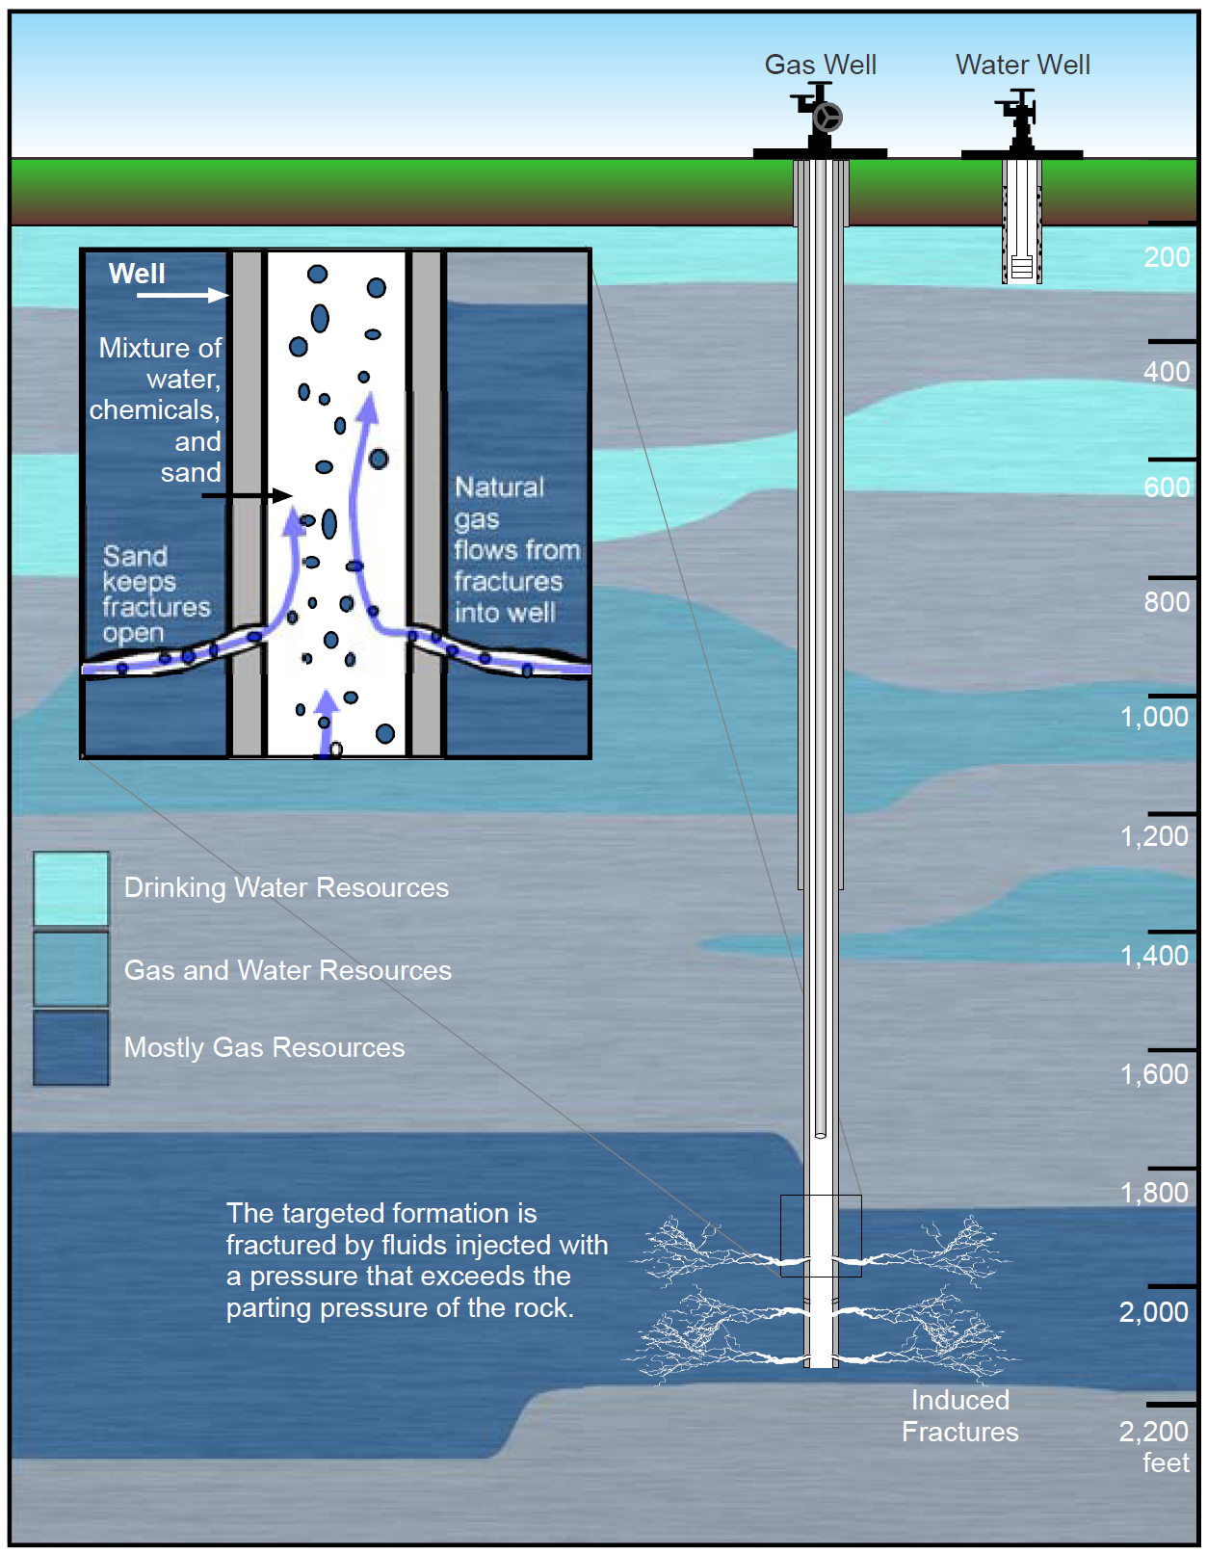

Figure 5 Hydraulic fracturing (© Copyright, US EPA 2011).

## Why hydraulic fracturing?

Hydraulic fracturing allows gas to be extracted up to 10 times faster than from un-stimulated wells and may not be warranted in all wells. Fracturing adds to the expense of coal seam gas extraction and generally is only conducted if gas production from a well is otherwise too low to be economic. The permeability of the fracture network typically decreases over time because proppant flows back to the well during production. This is termed proppant flowback and in extreme flowback cases fractures may partially close up (Stephenson et al. 2003). Other damage to the fracture may occur from proppant crushing or embedment into the coal, from precipitation of minerals in the fracture and from partial plugging of the well perforations. For these reasons, coal seam gas wells are sometimes re-fractured over the course of their life.

## How hydraulic fractures grow

Hydraulic fractures grow, or propagate, in the direction of least resistance. Fracture growth depends on the conditions at the site, including the geology, stress magnitudes and other factors. This can be difficult to predict because the direction of least resistance changes according to the mechanical properties of the rock, the stress regime of forces acting on the rock and the natural pre-existing fracture pattern. In situ stress measurements can be used to determine local and regional trends for the stress directions that can then be reliably used to predict hydraulic fracture growth direction. An example of a natural fracture network in coal is shown in Figure 6.

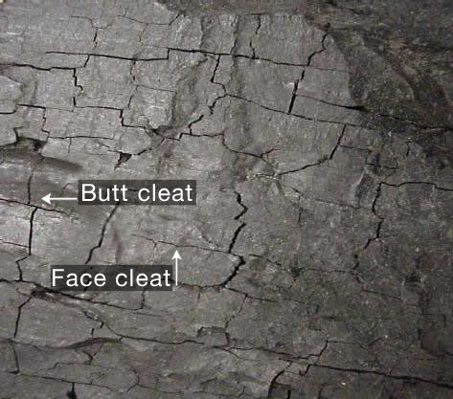

Figure 6 An example of natural fractures in coal (© Copyright, AGL 2012).

Fractures can grow vertically and horizontally. Pressure-time data collected from 372 wells during coal seam testing in the Powder River Basin, Wyoming, showed that the direction of least resistance was variable throughout the Basin (Colmenares & Zoback 2007) with both horizontal and vertical fracture growth inferred, though the stimulation treatment used is not typical of Australian practice. The study also found that lowest water production rates were observed where fracturing was predominantly horizontal, and maximum water production rates occurred where fracturing was inferred to be vertical.

There is scope for more research to better understand fracture growth in coal seam gas basins in Australia.

Fracture growth due to hydraulic fracturing can be very complex, however, studies in the US and Australia have shown that fractures in coal at large scales are generally planar. Economides and Martin (2007) show that hydraulically stimulated fractures may not be confined to the target zone. They state that differences between predicted and actual fracture growth can occur due to:

* complex interactions between natural and induced fractures
* bifurcation of the fracture by splitting at boundaries with different mechanical properties
* fracture reorientation due to induced stress changes from fluid injection
* fracture reorientation due to changes in fracture fluid properties such as viscosity during injection.

General practice is to restrict fracturing to zones close to the well in areas where the fracture growth can be reasonably well predicted.

## The history of hydraulic fracturing

Hydraulic fracturing began in 1949 in the oil and gas industry in the US. Initially the injected fluid was crude oil or kerosene oil. Water was used as a fracturing fluid in 1953 (Montgomery & Smith 2010). Since then, hydraulic fracturing has been performed approximately 2.5 million times worldwide (Montgomery & Smith 2010). Hydraulic fracturing began in coal seams in Australia in the 1970s (APLNG 2013b).

The use of hydraulic fracturing in the unconventional gas sector increased rapidly after 2000 due to advances in technology and changes in energy markets. There is no reliable data available on the number of hydraulic fracturing treatments performed per year. A good indication comes from the use of proppant, including sand, resin-coated sand and ceramics. Proppant production in the US rose from approximately 1.4 million tonnes in 1999 to over 9 million tonnes in 2009 (Beckwith 2010). Similarly, it is estimated that the economic value of the hydraulic fracturing industry rose from nearly three billion United States of America Dollars (USD) in 1999 to nearly 13 billion USD in 2007 (Beckwith 2010). The vast majority of hydraulic fracturing occurs in the US and Canada and accounts for approximately 85 per cent of use worldwide (Beckwith 2010). The extent of fracturing undertaken in Australia does not necessarily reflect the situation in US, due to the differing geology.

## Hydraulic fracturing in Australia

Companies undertaking or planning hydraulic fracturing in Australia include Santos, Origin Energy, Arrow Energy, Westside Corporation, AGL, Queensland Gas Company and a joint venture between Origin Energy, ConocoPhillips and Sinopec. Data from APPEA (2013) indicates that 1844 coal seam gas wells (comprising 1341 exploration and 3731 production wells) were drilled in Australia over 15 months from April 2012 to June 2013, and that 111 of these (6 per cent) were subject to hydraulic fracturing. DEHP (2013d) estimates that in Queensland this proportion could increase to 10-40 per cent as the industry expands. Counter to this, submissions to the NSW Inquiry into coal seam gas suggested that hydraulic fracturing requirements would reduce over time as new technologies emerged (NSW Parliament 2012). Proposed coal seam gas operations involving hydraulic fracturing are summarised in Table 1 below.

Table 1 Coal seam gas operations in Australia.

| Coal seam gas project | Operator | State | Basin | Number of wells planned | Wells to be fractured | Reference |
| --- | --- | --- | --- | --- | --- | --- |
| Australian Pacific LNG Project | Origin Energy | Qld | Surat | ~10 000 | ~3000 | APLNG (2013a); URS (2010) |
| Gladstone LNG Project | Santos | Qld | Bowen, Surat | 2650 | 50-70% | URS (2009); Golder Associates (2010b) |
| Queensland Curtis LNG Project | Queensland Gas Company | Qld | Surat | >1,000 now and 6000 by 2030 | N.D. | QGC (2012) |
| Bowen Gas Project | Arrow Energy | Qld | Bowen | 600 in the first stage of development (by 2017) | 4% so far | Arrow (2013); DEHP (2013c) |
| Surat Gas Project | Arrow Energy | Qld | Surat, Clarence-Moreton | 300 now, plan for 400 more per year up to a total of 6500 | None | Arrow (2012a); Coffey (2012) |
| Narrabri Gas Project | Santos | NSW | Gunnedah | Only exploration so far – number of production wells not known at present | None at this stage – directional drilling will be used instead | Santos (2012) |
| Camden Gas Project | AGL | NSW | Sydney | 137 | 117 (as of 2011) | AGL (2011) |

## Stages of hydraulic fracturing

### Stage 1: pre-fracturing assessment

Operators investigate the subsurface to design the hydraulic fracturing program during the pre-fracture assessment. This subsurface characterisation aims to understand the hydrogeological and mechanical properties of the coal seams and surrounding units. Key aspects of subsurface characterisation are provided in Beckwith (2010) and NSW Trade & Investment (2012b). They are:

* describing all geological units, particularly the coal seam and units directly above and below
* assessing coal seam permeability to enable an understanding of how easily gas and water flow through, and to define a primary factor determining if hydraulic fracture stimulation is needed
* analysing the subsurface distribution of stresses and faults
* assessing the fluid loss characteristics of the naturally fractured coal.

Operators design the hydraulic fracturing program after the subsurface characterisation is complete. Part of this design is the prediction of fracture growth within the target zone. Hydraulic fracture simulation software is used to predict the geometry of fractures, while the orientation is determined from the in situ stress field. Typical inputs to numerical models are described by Bennett et al. (2005) as:

* volume and properties of the fluid and proppant
* closure stress, which is the pressure required to just keep a hydraulic fracture open in the coal
* pressure within pores in the coal seam
* coal seam permeability
* mechanical properties of the coal seam and adjacent rock layers
* layer geometry of the coal and adjacent rock layers.

Modelling physical processes in the environment always introduces uncertainty because the system can never be completely characterised. Bennett et al. (2005) in discussing fraccing in both the conventional and unconventional oil and gas industries stated that:

*“…all hydraulic fracture models fail to predict fracture behaviour precisely, and in many cases, models fail completely, largely because of incorrect information and assumptions used in the models. Nevertheless, modelling is a necessary tool in fracture engineering.”*

© Copyright, Bennett et al. (2005)

Halliburton (2011) also notes that hydraulic fracture growth is not always ‘predictable’. All mining activities, including coal seam gas, carry some level of risk and the pre-fracturing assessment is aimed at identifying and reducing the risks involved.

#### Reporting and notification

The *NSW code of practice for fracture stimulation activities* (NSW Trade & Investment 2012b) requires that proponents submit a Fracture Stimulation Management Plan (FSMP) prior to any hydraulic fracturing activities. A FSMP must include the following:

* details of the planned hydraulic fracturing including location, timing, duration
* summary of the consultation activities to ensure that stakeholders are fully informed
* description of the fracture design including fracture growth predictions
* a risk assessment to identify all potential risks, their likelihood of occurrence, potential consequences and management controls
* details of the Safety Management Plan to ensure the safety of workers, visitors and the general public
* a list of all chemicals to be used in fracturing, including their Chemical Abstract Service (CAS) number, volumes, concentrations, potential risks and how they will be stored and transported
* details of how water will be managed according to consent conditions
* monitoring arrangements before during and after fracturing.

The Queensland Department of Environment and Heritage Protection (DEHP 2013b) also requires a similar risk assessment prior to approving fracturing. In addition, the Department also requires departmental and independent audits of fracturing (DEHP 2013b). In Queensland and NSW it is mandatory to provide notification to government and landholders at least 10 business days before fracturing (DEHP 2013b; NSW Trade & Investment 2012b).

### Stage 2: on-site activities

The on-site activities include site setup, perforation of the well casing into the target coal seams, injection of hydraulic fracturing fluid and ‘flowback’ of the injected fluid. A summary of the on-site activities is provided below.

#### Site setup

Temporary storage facilities are used to contain the source water for fracturing and for the flowback water. Storage requirements for flowback water are specified in project approval conditions (NSW Trade & Investment 2012b) and can include plastic-lined storage ponds. Purpose-built mobile units are used onsite for storage of materials such as sand and chemicals and for blending of fracturing fluids.

#### Perforation

Once the well is drilled and the casing cemented, small holes approximately 5 to 15 mm in diameter are made through the casing and cement at the depth of the coal seam target zone. Perforations are usually created using small explosive charges. Once the perforations are made and the well is connected with the target zone the well is regarded as completed.

#### Injection of fluids and proppant

The next step is the injection of fluids and particles (proppant) into the well to initiate fracturing in the coal seam and to keep the fractures open so that gas and water can flow to the well. Injection takes from tens of minutes to a few hours (Taleghani 2009). It is usually intended that fluids and particles are only injected into the target coal seam and not the units above and below. This is achieved through accurate subsurface characterisation so that perforation and subsequent injection only occurs at the target coal seam. However, some fracture treatments are designed to produce a fracture that grows vertically through several adjacent thin seams because stimulating each seam individually would not be cost effective.

Water makes up the majority of the fracturing fluid, with the next largest component being the proppant (Figure 7), which is transported into the fractures to prevent them from closing once the high fluid pressure is removed. Proppant is typically sand but can also be nut shells, ceramics or bauxite (Beckwith 2010).

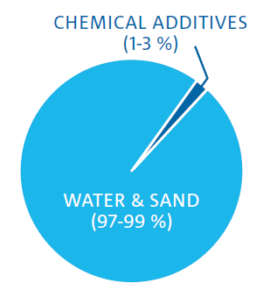

Figure 7 Average composition of ‘water’ fracturing fluid (© Copyright, CSIRO 2012a).

Some hydraulic fracturing fluids also contain either a gel mixed in with the water to increase viscosity or a friction-reducing additive. Viscosity is a measure of a fluid’s resistance to flow. The main difference between fracturing with water or ‘slickwater’, which is water with a friction reducing additive, or a water-gel mixture, is that the increase in viscosity from the addition of gel allows more proppant to be carried into the fractures. Fracturing with gel may require a volume of up to 1.2 per cent of additives, compared to water fracturing which typically contains a 0.1 per cent volume of additives (APLNG 2013b). Most operators in Australia use water-gel mixtures (APLNG 2013b; Golder Associates 2010b). The most common gelling agents are natural polymers such as guar gum derived from the pods of the guar bean (Economides & Martin 2007). A range of other chemicals are used including acid, friction reducers, biocides, stabilisers, pH buffers and breakers. A summary of the fracturing fluids and proppants used is provided in Table 2.

The fluid composition and volume changes during injection and is tailored to suit the site‑specific condition at each well. The general order of operations involves the following considerations:

* If there is significant calcium carbonate present in the coal, then a dilute mix of acid and corrosion inhibitors is injected to dissolve it. Acid is also used to stabilise pH and to clean the perforation tunnels.
* High pressure water to initiate fracturing using corrosion inhibitors, clay stabilisers, biocides and optionally gelling agents occurs until a drop in pressure is recorded that signifies initiation of fracturing.
* The same fluid as above but with the addition of proppant and then called a slurry.
* If a gelling agent was used then ‘breaker’ chemicals are progressively added to the slurry to breakdown the gel and reduce the viscosity close to that of water to make it easier to extract the injected fluid back.
* A small volume of water or uncrosslinked gel injected at the end of the treatment to flush the last slurry to the perforations so that no proppant is left in the well. This is called the ‘flush volume’.

There have been significant concerns about disclosure of chemical additives used in hydraulic fracturing in Australia. Operators in the US were given an exemption from the *Emergency Planning and Community Right to Know Act 1986*, meaning they were not required to disclose chemicals to the US EPA (The Royal Society & Royal Academy of Engineering 2012). However, in NSW and Queensland operators must submit a complete list of chemicals for approval to state regulators along with their volumes, concentrations, and potential toxicity prior to gaining approval for hydraulic fracturing (DEHP 2013b; NSW Trade & Investment 2012b).

Table 2 Summary of the fluids and particles used in hydraulic fracturing fluid in Australia (© Copyright, Economides & Martin 2007; Golder Associates 2010b; DEHP 2012b; APLNG 2011; AGL 2011; Santos 2011; QGC 2011; Arrow Energy 2012b).

| Injected substance | Purpose | Products used | CAS number | Notes |
| --- | --- | --- | --- | --- |
| Water | Fractures the coal when injected under high pressure | Bore water, farm pond water or groundwater previously extracted from coal seams is often used | 7732-18-5 | Volume of water required is ~0.2 to 1.3 ML per well (USEPA 2011) |
| Proppant | Keeps the fractures open once the high pressure fluid is removed | Sand  Resin-coated sand  Ceramics  Bauxite (aluminium ore) | 99439-28-8  None or proprietary  66402-68-4  90669-62-8 | The latest technology advances in proppants include high strength ceramics and sintered bauxite |
| Acid | Dissolves calcite in the coal prior to fracturing | Hydrochloric acid  Muriatic acid  Acetic acid | 7647-01-0  75-00-3  64-19-7 | Not all wells require this treatment because coal seams do not always contain calcite |
| Gelling agent  or  Clay stabilisers | Increases the viscosity of the fluid, to allow more proppant to be carried into fractures | Guar gum  Starches  Cellulose derivatives  Polydimethyldiallylammonium chloride  (Claytrol)  Tetramethylammonium chloride  (Claytreat 3C) | None or proprietary  9005-25-8  9004-34-6  26062-79-3  75-57-0 | Not all hydraulic fracturing uses a gel; gel-free fracturing is termed ‘slickwater’ |
| Crosslinker | Increase the viscosity of gelling agents | Borate salt  Ethyl glycol  Isopropanol  Disodium octaborate tetrahydrate  Boric acid  Boric oxide | 1330-43-4  107-21-1  67-63-0  12280-03-4  52869-79-1  1303-86-2 | There are different crosslinkers for different gelling agents |
| Biocide | Limits or prevents growth of bacteria that could damage the gelling agent | Glutaraldehyde  2,2-Dibromo-2-cyanoacetamide (DBNPA)  Tetrakis(hydroxymethyl)phosphonium sulfate (THPS, Magnacide 575)  bronopol (2-bromo-2-nitropropane-1,3-diol)  Sodium hypochlorite  Sodium thiosulfate  Boric acid  Caustic soda | 111-30-8  10222-01-2  55566-30-8  52-51-7  7681-52-9  7681-52-9  7772-98-7  10043-35-3 | The natural polymer gelling agents are good food for bacteria so they encourage bacterial growth - biocides kill these bacteria |
| pH buffer | Keeps the pH of the fluid in a specified range | Acetic acid  Sodium hydroxide  Potassium carbonate  Sodium carbonate, | 64-19-7  1310-73-2  584-08-7  497-19-8 | Required for the stability of crosslinked polymers |
| Breaker | Chemically break the bonds of the gel in order to reduce the viscosity back to that of water | Hydrogen peroxides  Sodium persulfate  Diammonium peroxidisulphate | 7722-84-1  7775-27-1  7727-54-0 | Only required if a gel is used |
| Corrosion scale inhibitors |  | Aloe resin  n,n-dimenthyl formamide  Methanol  Nonyl phenol | None or proprietary  68-12-2  67-56-1  68152-92-1 |  |
| Friction reducers | Reduce fluid surface tension | Oxyalkylated alcohol | None or proprietary |  |
| Other additives | Includes foamers, gel stabilisers, clay stabilisers, preservatives, surfactants | Terpenes and terpenoids  Sweet orange oil  Polyacrylamide  Alcohols  n,n-dimenthyl formanide  Citric acid  Ammonium bisulfite  Ethylene glycol  Potassium chloride | 65996-96-5  68647-72-3  25085-02-3  None or proprietary  68-12-2  77-92-9  7803-63-6  107-21-1  7447-40-7 | Operators in NSW and Queensland are required to disclose a full list of additives prior to hydraulic fracturing |

#### Flowback

Best practice requires a larger volume of flowback fluid to be recovered from a well relative to the volume of injected fluid after hydraulic fracturing is completed (Golder Associates 2010b). The Queensland Government suggests that the quality and quantity of the flowback fluid must be monitored until a volume is removed equivalent to 150 per cent of the fluid used in the fracc, to ensure that all water used for the fracc is removed (DEHP 2013a). As this flowback fluid contains much of the injected substances it must be properly contained and managed at the surface. An environmental risk assessment for hydraulic fracturing in Australia estimated that up to 40 per cent of the injected fluid, including chemical additives may remain in the coal seam after flow back but prior to production pumping (Golder Associates 2010b); however this estimate was not verified.

Most of the remaining fracturing fluid is likely to be extracted in the co-produced water over the life of the well; however, a proportion of injected fluid and chemicals retained in the coal seam after production because some chemicals adsorb onto the surface of the coal (Rogers et al. 2007). Some fractures also close shortly after being created and are cut off from the rest of the fracture network (Economides & Martin 2007). It is possible that some chemicals will be retained in these isolated fractures.

There is no published information on actual flowback volumes in Australia, or estimates of the percentage of chemical additives remaining in coal seams after production. This would be a suitable topic for further research. Further analysis and reporting of data would give greater clarity on the amount of chemicals recovered during flow back, along with an assessment of geochemical changes within injection fluids and formation water.

### Stage 3: post-fracturing activities

After fracturing has been carried out, measurement, reporting and monitoring is conducted. A summary of the post-fracturing activities is provided below.

#### Fracture growth measurements

Fracture growth is measured after a hydraulic fracturing treatment, with the results then used to improve predictions for future fracturing. There are many methods for directly or indirectly measuring fracture growth. However, all have limitations in resolution, practical requirements and the range of measurable fracture properties. Bennett et al. (2005) list the following methods:

* detection of radioactive tracers, if they have been used, in the hydraulic fracturing fluid or proppant
* temperature surveys to detect fracturing fluid which is typically a different temperature to the water in the well
* production logs or down hole video to assess where most water is entering the well; and
* tiltmeter and microseismic mapping.

These methods can only assess the fracture height in the area immediately around the well. They cannot measure how far the fractures extend into the coal or the fracture height further away from the well. Tiltmeter mapping involves measuring the small deformations that result from fracturing. Measuring equipment can be deployed in shallow boreholes, each approximately 10 m deep, surrounding the fracturing well for surface tilt meter mapping, or in deep offset wells at approximately the same depth as the fractured coal for down hole tilt meter mapping. The placement of measuring equipment is important in this technique. For example, the distance between the measuring point and fracturing well for down hole tiltmeter mapping should be no greater than three times the height of the fracture (Bennett et al. 2005) if the height growth is being monitored. Otherwise, the tiltmeter array can only be used to measure the fracture orientation and volume.

Microseismic mapping involves measuring the very small earthquakes, termed microseismic events that occur during fracturing. These microseismic events result from the stress placed on the coal and adjacent rock from the injection of high pressure fluids and opening of hydraulic fractures. This should not be confused with ‘induced seismicity’, which is a term that refers to seismic events of higher magnitude and is discussed further below. Sensitive seismic measuring equipment can detect the position of the event by measuring the time taken for stress waves to travel between the event and the receiver (Figure 8). Since the microseismic events tend to occur at and behind the fracture tip, or growing edge, this gives an indication of the extent of fracture growth in three dimensions.

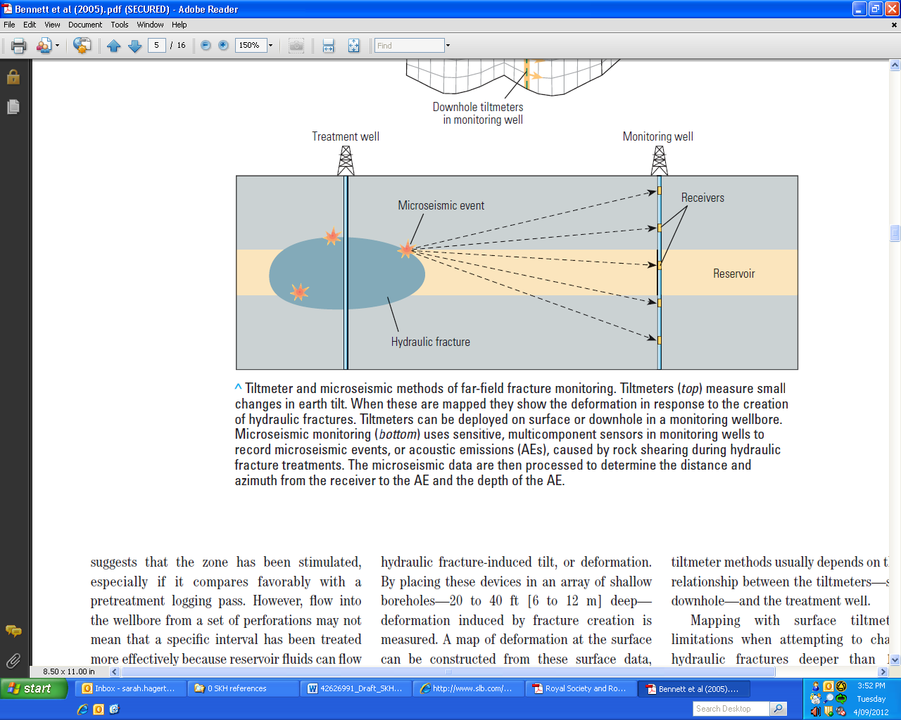

Figure 8 Microseismic monitoring of fracture growth (© Copyright, Bennett et al. 2005).

An array of receivers is placed in a monitoring well at approximately the same depth as the target zone and within approximately 600 m to the treatment well (Bennett et al. 2005). However, the optimal configuration of the monitoring equipment depends on the site-specific subsurface conditions (Bennett et al. 2005). Microseismic results can be displayed in three dimensions, from which plan views or cross section views can be obtained. Figure 9 is an example of a vertical cross section of microseismic events recorded during four stages of fracturing in a shale gas operation. Each dot is a separate microseismic event and the events form a cloud around the main hydraulic fracture, outlining its extent and orientation. The figure shows four stages or individual fracture treatments pumped into a horizontal well in the Barnett shale and, in this case, each fracturing stage extended approximately 380 m vertically. It is noted that this example relates to a shale gas fracturing operation and is not typical of results from coal seam gas fracturing operations, where the vertical range of fracture growth is much more restricted.

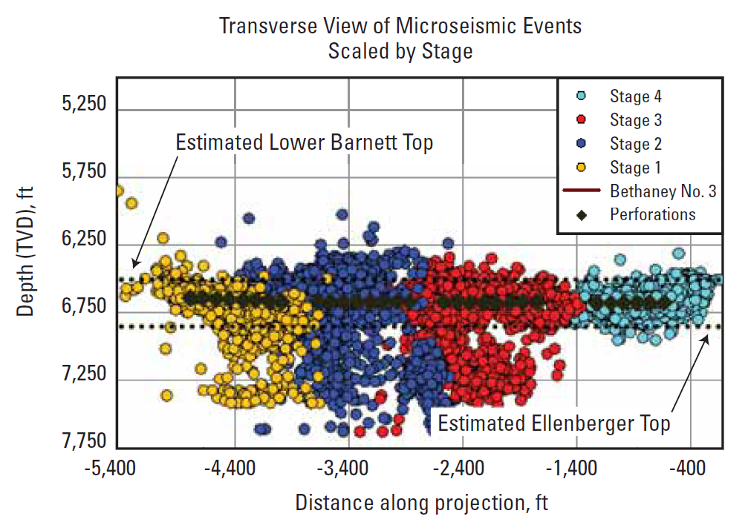

Figure 9 Microseismic monitoring cross section in the Barnett Shale, US (© Copyright, Schlumberger 2007).

Some of these monitoring techniques have been employed in the Walloon Coal Measures of the Surat Basin in Queensland where surface tilt meter mapping, down hole microseismic mapping, examination of pressure data and radioactive tracers were used to investigate fracture patterns (Denney 2011). It was found that multiple monitoring methods are useful to properly understand the complexities of the fracture growth. This should be considered in regulator monitoring requirements. At present, monitoring fracture growth in real-time is listed as ‘leading practice’ in the NSW code of practice but it is not a mandatory requirement (NSW Trade & Investment 2012b).

#### Completion reporting

Operators in NSW are required to submit a completion report, or a post fracturing report, to the regulator within 30 days of cessation of fracturing (NSW Trade & Investment 2012b). Operators in Queensland commonly also submit a completion report. A completion report can include real-time data acquired during fracturing such as injected volumes and pressures. It can also include any post-fracturing down hole logging and results from tilt meter or microseismic mapping.

Data sharing between operators can improve future fracture growth prediction, however operators are often reluctant to do this (Beckwith 2010).

#### Monitoring for impacts

The impacts of hydraulic fracturing include; contamination of surface water resources and associated aquatic ecosystems, induced seismicity, increased water use and impacts on the quantity and quality of groundwater resources.

Monitoring impacts resulting from hydraulic fracturing should be undertaken to determine a baseline prior to fracturing then during and after the fracturing event through to after the well has been decommissioned. This includes monitoring well integrity and monitoring the environment surrounding the well for any changes. Well integrity is tested through pressure tests and running cement bond logging (CBL) equipment down the well to check that the cement is still intact.

Groundwater is analysed for methane and other contaminants both prior to and following fracturing. Methane in groundwater originates from a variety of sources, including both natural and anthropogenic sources. If baseline data is not collected prior to hydraulic fracturing and methane is detected in groundwater afterwards it can be difficult to determine whether it is a result of hydraulic fracturing (The Royal Society & Royal Academy of Engineering 2012). Some researchers have used radiocarbon dating or stable isotope analysis using Carbon-13 (δ13C) and Deuterium (δ2H) to determine whether the methane was formed by bacteria known as biogenic methane or through high pressures and temperatures called thermogenic methane. This is not conclusive because natural gas from coal seams can contain both types of methane (The Royal Society & Royal Academy of Engineering 2012). Determining the source of methane detected in groundwater outside the coal seams is the subject of on-going research.

In a recent review of hydraulic fracturing in the shale gas industry in the United Kingdom (UK), the Royal Society and Royal Academy of Engineering (2012) made the following recommendations regarding post-fracturing monitoring:

* well integrity testing using pressure testing and CBL should be carried out by an independent well examiner with the results submitted to the relevant government agency
* aquifer sampling for methane and other contaminants should continue every few years post-abandonment
* ground gas monitoring surrounding the well should be continued after abandonment at a reduced frequency similarly to gas monitoring at former landfills
* consideration should be given to developing a common liability fund to ensure there are sufficient financial resources to respond to well failure post-abandonment.

Post-fracturing compliance monitoring in Australia is not usually reported publicly. However, the NSW code of practice states that submission of fracture completion reports are a mandatory requirement and these may be published for public view on the relevant agency’s website (NSW Trade & Investment 2012b).

# Environmental concerns

Hydraulic fracturing was explored in the NSW Inquiry into Coal Seam Gas (New South Wales Parliament 2012) and the Senate Rural Affairs and Transport References Committee report (Parliament of Australia 2011). Concerns were raised by inquiry participants about the health risks and impact on the environment of the chemicals used. There was added concern about lack of disclosure, absence of baseline monitoring, inadequate testing of chemical additives and the recovery and disposal of used hydraulic fracturing fluids.

The main environmental concerns associated with hydraulic fracturing can be broadly divided into subsurface contamination and risks such as impacts on groundwater resources, their quality and use, induced seismicity, and surface contamination which encapsulates exposure risk and toxicity of chemical additives, and water supply.

## Subsurface contamination

The US EPA (2011) identified the following four mechanisms or pathways through which hydraulic fracturing could cause or increase the chances of impacting the surrounding subsurface formations due to contamination:

* well failure may provide pathways for groundwater pollution by allowing contaminants to flow into overlying aquifers through either casing failure or incorrect isolation of target coal seams
* fracturing fluid leak-off, which is the migration of injected fracturing fluid from the created fractures to other areas within the coal seam or adjacent geologic formations
* gas leakage through the unintentional migration of methane gas along the well and creating connectivity with adjacent aquifers (predominantly a well integrity issue)
* increased mobility and migration of naturally occurring substances from the coal seam into adjacent aquifers.

The impact hydraulic fracturing could have on the subsurface formations depends on their geology and hydrogeology, and also on the size and length of time fracturing is conducted. Figure 10 is a diagrammatic representation of the aquifers and aquitards in the Surat Basin and the southern Bowen Basin (Queensland Water Commission 2012a). There will usually be some degree of interconnectivity between aquifers in the Great Artesian Basin even if they are separated by low permeability rock layers (Queensland Water Commission 2012b). The extent or degree of interconnectivity between coal seams and these aquifers is mainly dependent on the thickness and the permeability of the separating layers (Queensland Water Commission 2012b) and the hydraulic gradient between the coal seams and aquifers.

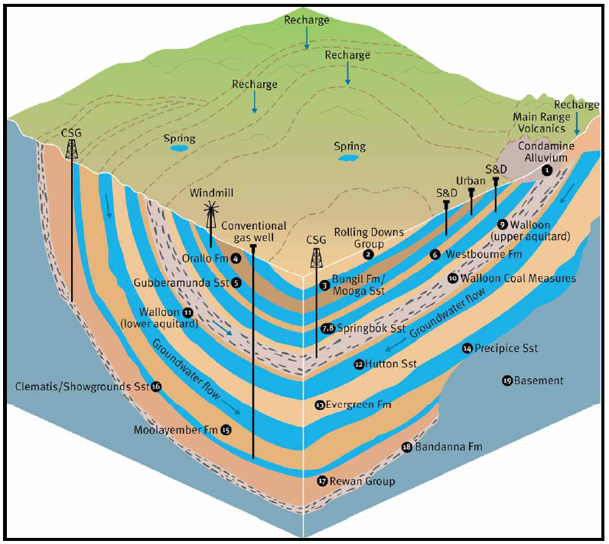

Figure 10 Aquifers and aquitards in the Surat Basin and Southern Bowen Basin (© Copyright, Queensland Water Commission 2012b). Note: aquifers are shaded in blue.

The target zone for coal seam gas in the Surat Basin is the Walloon Coal Measures. The Walloon Coal Measures are in most places overlain and underlain by low permeability aquitards and therefore the subsurface contamination risks associated with hydraulic fracturing are reduced due to hydraulic isolation. However, the potential for vertical growth of the hydraulic fractures through these low permeability layers depends strongly on the in situ stress acting in the various layers. The potential for fracturing height growth and its implications should be assessed on a site-by-site basis.

At the margins of the Surat Basin where there is less restriction to connectivity between the overlying Condamine River alluvium and the Walloon Coal Measures, the potential for groundwater to migrate from one aquifer to another is increased and requires specific assessment and management. Hillier (2010) suggests that there is a likelihood of movement of groundwater between the Walloon Coal Measures to the Condamine River alluvium based on the analysis of water levels and groundwater quality. However, there was insufficient information available to calculate the volumes of water or flows that could be involved (Hillier 2010).

The rate of groundwater transfer from the Condamine Alluvium into the Walloon Coal Measures as a result of coal seam gas activities was estimated by the Queensland Water Commission, now known as the Office of Groundwater Impact Assessment (Queensland Water Commission 2012a). The declining water level in the Walloon Coal Measures was predicted to start affecting the Condamine Alluvium at about year 2017 based on regional groundwater flow modelling. The average net loss from the Condamine Alluvium to the Walloon Coal Measures was estimated to be approximately 1100 ML per year over the next 100 years. This indicates that potential issues relate more to flow of groundwater from the Condamine Alluvium to the Walloon Coal Measures due to production pumping rather than to migration of fracturing chemicals in the reverse direction.

In the south of the Bowen Basin near Roma, the target coal seam gas seam is the Bandanna Formation which may be in contact with the overlying Precipice Sandstone aquifer, therefore there is a risk of contamination due to the potential for inter-aquifer migration of groundwater to occur (Queensland Water Commission 2012a). The above example illustrates that assessment, monitoring and management of hydraulic fracturing are regionally specific issues.

According to the National Water Commission (2011) the practice of hydraulic fracturing may induce cross contamination between aquifers with impacts on groundwater quality. Geoscience Australia (2010) reported that the likelihood of cross contamination of aquifers was low for coal seam gas in the Surat Basin. This was based on the assumption that higher quality water from adjacent underlying and overlying sandstone aquifers would migrate into the coal measures containing lower quality water, and therefore no contamination from the coal seam to adjacent would occur (Geosciences Australia 2010). Evidence provided by Santos (2011) during the NSW Inquiry into Coal Seam Gas (New South Wales Parliament 2012) suggested that if hydraulic fracturing is conducted properly, it does not lead to the fracturing of aquitards or cause aquifer interconnectivity and cross contamination.

Properly undertaken, with careful site characterisation included as part of the well and fracture design, hydraulic fracturing is unlikely to create connections between previously unconnected aquifers as tools and monitoring processes are available to sufficiently manage the risks.

## Well integrity

Well failure can occur due to incorrect well construction, incorrectly sealed wells, or through deterioration due to pressure, stresses and corrosion (US EPA 2012; Bellabarba et al. 2008). If the cement or casing around the well fails then contaminants can migrate through them and cause groundwater pollution to overlying aquifers (US EPA 2012). Therefore, the correct construction of a well, especially the casing and cementing process, is crucial in containing contaminants and protecting groundwater by isolating the coal seam formation from overlying aquifers. A properly constructed well reduces the likelihood of contaminating zones adjacent to the well because both fluids and gases are confined within the casing.

Well integrity relies on the performance of barriers used to achieve zonal isolation. Zonal isolation involves constructing coal seam gas wells to prevent the flow of flow of gas or water between different geological layers. This ensures isolation of hydraulic fracturing fluids and formation fluids from non-target layers and formations. Barrier performance is influenced by well preparation, drilling fluid operations, casing material procurement, casing installation, cement mixture, preparation and cement placement. Wells should be constructed and decommissioned based on international standards such as the API standards or guidelines such as the Queensland *Code of practice for constructing and abandoning coal seam gas wells* (DEEDI 2011; API 2009; API 2002) and the NSW *Draft code of practice for coal seam gas exploration* (NSW Government 2012), both of which set minimum standards to achieve long term well integrity. Several coal seam gas proponents in Australia state that their coal seam gas wells are designed and constructed based on the above standards and/or guidelines (Santos 2013b; AGL 2012; Arrow Energy 2011; Origin Energy 2011).

Despite these safeguards and the coal seam gas industry insisting that wells are constructed to the highest standards, concerns are still being raised about whether the design and construction of coal seam gas wells are of a high enough standard to protect groundwater resources from contamination. Several witnesses in the NSW Inquiry into Coal Seam Gas, such as Nankivell (2011) and Namoi Water (2011) raised concerns about well integrity (NSW Parliament 2012).

Well integrity can be determined by Mechanical Integrity Tests, for both mechanical and tubular portions of the constructed well, and the effectiveness of the cementing by measuring the absence or presence of fluid movement past the cement. CBLs simply measure whether cement is present or absent and the quality of the cement bond.

Well integrity can be checked using CBLs, as recommended by DEEDI (2011). These logs are produced by a tool that uses sound waves to measure the quality of the bond between the casing and the cement placed in the annulus between the casing and the well. Periodic well integrity testing over the lifetime of the project may minimise the risk of well failure. It is unclear whether coal seam gas operators are routinely conducting regular checks to ensure well integrity.

Coal seam gas wells represent major technical and financial investment. A great deal of effort goes into design and construction to ensure they are sufficiently robust to retain integrity over the entire lifetime of a project. Coal seam gas wells are constructed and completed to a significantly higher standard than water bores to ensure well isolation and control (Australian Petroleum, Production & Exploration Association 2013).

Well integrity plays an important role in ensuring contamination from hydraulic fracturing activities are minimised or avoided. Monitoring and inspections of coal seam gas wells during the construction and decommissioning phases is important. The public disclosure of the results of these inspections would improve the community’s understanding and confidence in coal seam gas well design and construction.

## Fracturing fluid migration

It is useful to consider the fate of water and solutes that are originally injected into coal seam during fracture stimulation. Some fluid is recovered during the flowback phase (and in some instances during final flushing) and some fracturing fluid may be recovered during any subsequent production phase. The total fracture fluid recovery should be considered across these two activities.

Fracturing fluid leak-off during the fracturing phase occurs because the pressure in the fracture at this time is higher than the fluid pressure in the coal seam. Thus, in some cases, a fraction of the hydraulic fracturing fluid flows from the fracture into the permeable coal seam formation. However, it is important to realise that leak-off water is not water lost from the overall fracturing activity; leak-off water may be fully recovered during the production phase once fluid pressure regimes are reversed. Various estimates of leak-off rates have been reported over the last 30 years or so; it is important to consider the year that these rates were reported as fracturing fluid use efficiency has increased over time. Penny et al. (1985) suggest that under certain conditions, fluid leak-off during hydraulic fracturing can exceed 70 per cent of the injected volume if not controlled. A conservative value of 40 per cent of fracturing fluid recovery was used to estimate the concentrations of chemicals remaining in wells located in the Surat Basin and Bowen Basin following hydraulic fracturing and in the flowback water (Golder Associates 2010a).

The aim for coal seam gas operators is to recover the vast majority of hydraulic fracturing fluid to ensure it does not impede gas flow (Santos 2013a; Metgasco 2011). There is general concern within the community about the ultimate fate of chemicals used in hydraulic fracturing (Wollongong City Council 2011). The risk of fracturing fluid leak-off to groundwater resources is largely dependent on the nature of the fracturing activity, the distance to the water resources and the geochemical and transport processes occurring in the intermediate strata (US EPA 2011) and to the degree of connectivity between the coal seams and the aquifers. The fate and transport of potential contaminants in the subsurface are affected by chemical, physical, and biological processes (US EPA 2011). The first step in fate and transport modelling is to conduct an initial screening assessment of the hydraulic fracturing additives to determine which chemicals are of most concern (Golder Associates 2010a). This analysis makes no assumption about whether a pathway exists due to fracture stimulation. Chemicals may also have high environmental hazard ranking if they are specified as a chemical of potential concern (COPC).

Most fate and transport modelling of hydraulic fracturing chemicals has been conducted on organic compounds on the basis that the inorganic chemical components are readily soluble and dissociate in aqueous solutions such as calcium chloride or have limited mobility within an aquifer.

The modelling is typically based on the residual COPC concentration after hydraulic fracturing. Models typically account for dispersion and sorption processes but assume no degradation of the organic COPC over time. They also assume no biodegradation processes occur in the subsurface and natural groundwater flow conditions immediately following the injection of the hydraulic fracturing fluid. These are some of the limitations in using simple one dimensional flow models to evaluate the migration of residual chemical additives. However, fate and transport modelling indicates potential impacts of hydraulic fracturing chemical migration scenarios for assessments and management.

The chance of migration of organic compounds in groundwater has been assessed by using one-dimensional fate and transport modelling software, such as BIOSCREEN (US EPA 1997) and ConSim (Golder Associates 2010b). Recognising the uncertainty inherent in the model input values, software such as ConSim use probabilistic simulation techniques allowing a range of values for each parameter rather than a single number. These modelling results represent the probability of a given chemical concentration reaching a distance from a coal seam gas well over a time period.

Golder Associates (2010a) conducted fate and transport modelling in the Surat and Bowen Basins for the Gladstone Liquefied Natural Gas (GLNG) project. It assessed the migration of the two organic COPC, oxyalkylated alcohol and the drilling mud ‘Puredrill’. The modelling suggested that both compounds would migrate less than 5 m beyond the hydraulic fracturing radius of influence that is assumed to be 20 m around the injection well over 1000 years simulation. This work assumed that natural groundwater flow conditions are established immediately following the injection of the hydraulic fracturing fluid. In reality, groundwater extraction during coal seam gas production means that the hydraulic gradient and fluid flow is towards the well. Provided the well is correctly constructed it is likely to limit the migration of residual hydraulic fracturing fluids to adjacent aquifers.

Hydraulic fluid injection points are usually tightly located over the mid-point of the coal seam (Golder Associates 2010a). This allows hydraulic fracturing to occur in a focused regime and provided that injection pressure, slurry rate, proppant concentration, fluid rate, and proppant rate are continuously monitored there is a low risk of fluid loss because of a failure of the wellbore (US EPA 2011). Risk is reduced by ensuring that a volume equivalent to at least 150 per cent of the amount of the fluid used in hydraulic fracturing has been returned to the surface as flowback (DEHP 2013a).

A number of the individual chemical additives cannot be measured using routine laboratory techniques and therefore require measurement of a surrogate compound (T Jong [Senior Associate Geochemist, URS Australian Pty Ltd] 2012, pers. comm., 4 October). A surrogate compound has similar properties to that of the target compound. For example, potassium chloride is measured as either the potassium ion (K+) or chloride ion (Cl-). Given these ions may occur naturally in groundwater it is difficult discriminating between natural levels and anthropogenic contributions. To this end, there is a need to identify a set of chemical indicators associated with hydraulic fracturing fluids. The development or refinement of analytical methods to detect, characterise and quantify individual constituents or compounds added to hydraulic fracturing fluids and their concentrations in flowback is an important research topic.

Concern about the recovery of hydraulic fracturing fluids may be exacerbated by the view that coal seam gas proponents are doing little to evaluate the volume and composition of flowback water and the residual COPC. This may be unjustified (NSW Parliament 2012) given that Geoscience Australia (2010) concluded that hydraulic fracturing associated with some specific coal seam gas development proposals in the Surat Basin posed a low risk to aquifers and groundwater where the activities were properly managed within current industry standards. Further, they concluded that fracturing associated with these developments is unlikely to cause connections and cross-contamination between previously unconnected aquifers and that the proponents had identified activities tools to manage any risks to water resources.

## Gas leakage

The high injection pressures of hydraulic fracturing may increase the mobility of methane (US EPA 2011). In undisturbed coal seams, gas is generated by a variety of processes and migrates to areas of lower pressure or diffuses due to chemical gradients – usually to minor natural fractures termed cleats. Once in the fracture system it is held (adsorbed) on the feature under natural conditions. When the pressure in the coal seam is lowered during development, the gas desorbs from the cleat/fracture and migrates to the area of lowest pressure. The stimulated fracture system offers a pathway of high permeability for collecting the methane from the coal and carrying it to the well. The methane can also migrate or leak into adjacent aquifers (US EPA 2011; Eco Logical Australia 2011) when a combination of conditions enable it to do so. See section on fracture growth in Chapter 3.

There are instances where methane gas migration has occurred leading to subsurface contamination. The US EPA (2004) reported methane migration from coal seams into shallow underground sources of drinking water in the San Juan Basin of Colorado and New Mexico. Poorly constructed, sealed or cemented wells, used for a variety of purposes provided conduits for methane migration for at least some of the incidents (US EPA 2004).

## Migration of naturally occurring substances

Hydraulic fracturing could increase mobility of naturally occurring substances in the subsurface, particularly within the coal seam. Acids and carbonates are a common component of hydraulic fracturing fluids that can mobilise naturally occurring substances out of rock. Naturally occurring substances found in coal seams include brine, gases such as methane, ethane, carbon dioxide, hydrogen sulfide, nitrogen and helium, heavy metals such as mercury, lead and arsenic, radioactive elements such as radium, thorium and uranium, and organic compounds such as organic acids, polycyclic aromatic hydrocarbons, and volatile and semi-volatile organic compounds (US EPA 2011).

If the induced hydraulic fractures connect with pre-existing natural faults or major fracture systems that directly extend into aquifers, or if the casing or cement around a well fails, some of these naturally occurring substances have the potential to migrate to adjacent aquifers under the right pressure conditions.

Other chemical and biological processes or mechanisms can equally reduce the mobility of naturally occurring substances (US EPA 2011). For example, a change in the redox conditions may decrease the mobility of naturally occurring substances (Walther 2009; Eby 2004; Stumm & Morgan 1996; Sparks 1995; Sposito 1989). The mobility of naturally occurring substances can be reduced by microbes, by binding to metals or organic substances (Gadd 2004; McLean & Beveridge 2002; Southam 2000).

The Royal Society and Royal Academy of Engineering (2012) recommended that comprehensive national baseline surveys for methane and other contaminants be carried out, overseen by the relevant government agency. While this report addresses hydraulic fracturing in the shale gas industry, its recommendations are relevant also to coal seam gas. Ideally, this baseline data should be collected from the same well that will also be hydraulically fractured. However, the collection of water quality data from non-hydraulically fractured wells located in the same coal formation and in close proximity to the hydraulically fractured well may also be suitable, provided it is located upstream or upgradient of the predicted natural groundwater flow.

Australian coal seam gas proponents are collecting large amounts of baseline data. For example, Santos (2011) advised that it is undertaking an extensive scientific program around Gunnedah and Narrabri including initial assessment of the groundwater system and a baseline study of water bores. Greater disclosure of such information would enable the broader scientific community to assess whether hydraulic fracturing has any impact on coal seam water geochemistry. Baseline assessments would assist to manage the impact on water supply bores from the extraction of groundwater by coal seam gas.

There has been limited research on the mobility of naturally occurring substances associated with coals in Australia. CSIRO (2011) found that water soluble constituents of Permian coal were produced by the breakdown of the chemical structures within the coal matrix. Based on the analysis of coal seam gas co-produced water many of the compounds may have been naturally released from coals. These water soluble compounds include phenols, aldehydes, ketones, and various carboxy-, hydroxyl- and methoxy- bearing compounds, nitrogen-bearing compounds (pyridines and amines), polycyclic aromatic hydrocarbons (PAHs), low molecular weight aliphatic hydrocarbons, and mono aromatic hydrocarbons such as benzene, toluene, ethylbenze and xylenes (BTEX). In contrast, other detected compounds, such as nitrophenol and chlorophenols, have no known biological origin and hence are not of coal origin (CSIRO 2011).

More research would be of benefit to determine the naturally occurring substances that may be released from coal formations during hydraulic fracturing. This could be achieved by exposing coal core samples to hydraulic fracturing fluids using either a batch or continuous flow system in reaction vessels that are capable of simulating fracturing conditions such as temperature and pressure. Samples would be taken after specific exposure times or conditions for chemical, mineralogical, and/or microbiological testing.

## Surface contamination

Once above ground, flowback water is either stored in temporary storage tanks or ponds or is conveyed by a pipeline to a water treatment plant. There is potential for accidental releases, leaks and spills due to pipeline failure or failure of pond integrity. This could lead to contamination of nearby surface water and seepage through the soil profile into shallow aquifers. Another surface contamination source is the accidental release or spill of hydraulic fracturing fluid, which may pose a greater contamination risk than hydraulic fracturing itself (The Royal Society & Royal Academy of Engineering 2012; Groat & Grimshaw 2012).

Various reviews have indicated the impact of any accidental releases, leaks and/or spills of flowback water and hydraulic fracturing fluid may be mitigated by adopting standard or best practice management practices (The Royal Society & Royal Academy of Engineering 2012; API 2010). Such practices include conducting regular maintenance of infrastructure and equipment associated with managing flowback, ensuring ground pits are of sufficient size to store the volume of flowback and lining storage ponds to minimise seepage to shallow groundwater aquifers (DEEDI 2011). A prevalent concern relates to the risks that chemical additives in hydraulic fracturing fluids could pose to humans and ecological receptors such as livestock and native flora and fauna (NSW Parliament 2012; Neal 2011; NTN 2011; Doctors for the Environment 2011). The BTEX compounds have been particularly controversial given that they have been linked to serious health issues. However, the use of BTEX chemicals in hydraulic fracturing has been banned in Queensland, NSW, Western Australia and Northern Territory.

One of the key issues associated with hydraulic fracturing is the identity and toxicity of chemical additives. This concern has been exacerbated in the past particularly in the US by the lack of disclosure, either perceived or real by coal seam gas proponents. In the US, coal seam gas proponents routinely publish a list of the chemicals used in their hydraulic fracturing fluids, which differ from the chemicals used in Australia (FracFocus 2013). In Queensland, this practice is a regulatory condition.

Coal seam gas operators have noted that chemical additives used in hydraulic fracturing are also widely used by other industrial purposes and should therefore not be of concern (NSW Parliament 2012). Notwithstanding, the safety of these chemicals has been questioned by community groups such as NTN (2011) and Doctors for the Environment (2011). The lack of appropriate testing of the chemical additives in hydraulic fracturing fluids was also a concern including the effects of the combined chemical mixtures (NTN 2011; Doctors for the Environment 2011; NSW Farmers' Association 2011).

The chemicals typically added to hydraulic fracturing fluids vary in toxicity. For example, sand, guar gum and sodium chloride are relatively benign compared to hydrochloric acid and bases like sodium hydroxide, which may produce an irritant response through dermal and inhalation exposure pathways. Compounds such as ethylene glycol are known to be associated with chronic toxicity at certain concentrations. The toxicity is dependent on the concentration within the hydraulic fracturing fluid and the risk of exposure to these chemicals. Most hydraulic fracturing chemical risk assessments evaluate both human health and environmental risks. The toxicity of hydraulic fracturing fluids is assessed largely through concentration exposures of COPC in the receiving environment and flowback.

## Induced seismicity

As hydraulic fracturing is undertaken in coal seams and shales, movement and stress changes occur within the formation (Beck Engineering 2013). When fractures in rock are generated or deformed, the existing stress state in the rock changes resulting in some seismic activity (Beck Engineering 2013). This is referred to as seismicity induced by hydraulic fracturing.

The majority of these induced seismic events are usually small and accordingly referred to as microseismic events that can only be detected with sensitive equipment. Larger seismic events can be induced by hydraulic fracturing in the presence of a pre-stressed fault but these events are rare (The Royal Society & Royal Academy of Engineering 2012). Green et al. (2012) suggested that magnitude 3 ML n the Richter Scale is probably a realistic upper limit for seismicity induced by hydraulic fracturing in an assessment of the Preece Hall seismic event in the UK.

The changes to rock fractures and deformation due to hydraulic fracturing induced seismicity may change the pathways for groundwater, gas and contaminant flow (Beck Engineering 2013). This could result in the migration of contaminants from the coal seam formation into adjacent aquifers via these new fractures.

The Blackpool area in the UK experienced a seismic event of magnitude 2.3 ML after a shale gas well (the Preece Hall well) in the Bowland Shale was hydraulically fractured on 1 April 2011 (The Royal Society & Royal Academy of Engineering 2012). On 27 May 2011, another seismic event of magnitude 1.5 ML occurred following renewed hydraulic fracturing of the same well.

de Pater and Baisch (2011) reported that induced seismicity at the Preece Hall well only occurred following hydraulic fracturing when larger volumes of fluid were injected and/or where there was minimal or no return of flowback . Any unexpected level of induced seismicity event should be followed by assessing the integrity of the well (The Royal Society & Royal Academy of Engineering 2012).

Geological and Nuclear Sciences Limited (2012) assessed whether hydraulic fracturing in conventional oil and gas wells triggered seismic activity in the Taranaki region, on the north island of New Zealand. The assessment was based on the analysis of seismic data stored in the New Zealand National Earthquake Information Database between 2001 and mid-2011. Most of the hydraulic fracturing in Taranaki was conducted at depths of between 3 and 5 km (Geological and Nuclear Sciences Limited 2012). They found no evidence that it had triggered or had any observable effect on natural earthquake activity and that any induced seismicity in the region was unlikely to have a significant effect.

Factors that affect the magnitude of induced seismicity include the properties of the coal or shale formation, the structural properties of the area to be fractured and the magnitude of the stress fields that occur in the formation near to the well (The Royal Society & Royal Academy of Engineering 2012). Coal and shale are relatively weak and this provides a natural constraint on the magnitude of seismicity induced by hydraulic fracturing (The Royal Society & Royal Academy of Engineering 2012).

Since the structural properties of an area can affect the magnitude of an induced seismic event, understanding the local structure and seismicity is important to help mitigate induced seismicity. Detailed surface mapping, development of geological models and obtaining seismic reflection survey data are recommended to help predict the presence of subsurface faults (Hennings et al. 2012). Coal seam gas proponents should consider carrying out site-specific seismicity assessments as part of their hydraulic fracturing risk assessment prior to hydraulic fracturing activities to characterise and identify nearby faults. In Queensland, some Environmental Authority conditions issued to coal seam gas proponents have a requirement to assess the seismic history of the region as a component of their hydraulic fracturing risk assessment.

Majer et al. (2009) assessed hydraulic fracturing in Enhanced Geothermal Systems and associated induced seismicity. A traffic light monitoring system was implemented as best practice. A similar system could be adopted for hydraulic fracturing of coal or shale formations. Based on seismic events measured in the Bowland Shale, de Pater and Baisch (2011) suggested the seismic thresholds values shown in Table 3. The seismic threshold values should be site specific reflecting the local geology, local population density and historical seismicity activity. As such, the threshold values should be updated when data are available from local operation experience. Green et al. (2012) in assessing the broader work reported by de Pater and Baisch disagreed with what they saw as a conservative value of 1.7 ML and suggested that this should be set at 0.5 ML until better data for the region was available.

A better understanding of the structure and seismicity of the local region of interest, combined with careful control of pressure changes in a well before, during and after hydraulic fracturing and mitigation of events by immediate flowback, may help to reduce the risk of deleterious seismic events from occurring. The potential and significance of induced seismicity should be assessed within the context of the environmental or land use setting.

Table 3 Induced seismicity thresholds in the Bowland Shale, UK (© Copyright, de Pater & Baisch 2011).

| Magnitude of seismic event | Action |
| --- | --- |
| ML <0 | Regular operations |
| 0 ≤ ML ≤ 1.7* | Continue monitoring after injection for at least two days until seismicity rate falls below one event per day |
| ML > 1.7 | Stop injection and employ flowback, while continuing monitoring |

* This magnitude has been disputed by Green et al. (2012) as being conservative.

## Water supply

The volume of water used during hydraulic fracturing is dependent on several factors including the type of well (i.e. whether vertical or horizontal), the number of zones to be fractured, extent of the fracture propagation and extent of naturally occurring fractures in the coal seam (Department of Mines & Petroleum 2012a). Generally, between 0.1 and 10 ML of water is required for hydraulic fracturing a coal seam gas well but 1 ML is common (Gas Industry Social & Environmental Research Alliance 2012). Approximately 1.05 and 1.11 ML of water was used to hydraulically fracture two vertical well in coal seam gas tenements in the Surat Basin (B Gray [Department of the Environment] 2012, pers. comm., 25 October; URS 2010). Comparatively more water is required for hydraulic fracturing of shale formations, such as those in Western Australia, where up to 5 ML may be required for vertical wells and 20 ML for horizontal wells (Department of Mines & Petroleum 2012a).

Water used in fracturing is commonly obtained from nearby bores and surface water. Consequently, in regions where local, natural water sources are scarce or used for other purposes hydraulic fracturing could require volumes of water that deplete or stress local water resources (Entrekin et al. 2011; Gregory et al. 2011). The water requirements for hydraulic fracturing may be offset by using groundwater drawn from coal seam gas wells (B Gray [Department of the Environment] 2012, pers. comm., 25 October) as treated recycled co-produced water (US EPA 2011; Bryant et al. 2010). There are also opportunities to re-use fracturing fluids on multiple wells.

# Regulatory framework

State and territory governments are mainly responsible for the legislative framework, licensing and decision making processes governing coal seam gas. Australian, state and territory governments have also published a harmonised framework to regulate the coal seam gas industry, the National Harmonised Regulatory Framework for Natural Gas from Coal Seams (SCER 2013).

## Australian Government

The *Environment Protection and Biodiversity Conservation Act 1999* (EPBC Act 1999) is the main piece of Commonwealth Government environmental legislation. It provides a legal framework to protect and manage impacts upon matters of national environmental significance which include water resources in relation to coal seam gas and large coal mining development.

The Australian Government has also established the Independent Expert Scientific Committee on Coal Seam Gas and Large Coal Mining Development (IESC) as a statutory body under the EPBC Act 1999. The IESC provides advice to Commonwealth and state government regulators on the water-related impacts of coal seam gas and large coal mining development proposals. These arrangements are supported by a National Partnership Agreement on Coal Seam Gas and Large Coal Mining Development, a joint initiative of the Commonwealth Government and participating States (NSW, Victoria, Queensland and South Australia) (IESC 2013).

In 2013, the Council of Australian Governments’ (COAG) Standing Council on Energy and Resources published a national harmonised regulatory framework covering the coal seam gas industry (National Harmonised Regulatory Framework for Natural Gas from Coal Seams) to address concerns based on four key areas (SCER 2013):

* water management and monitoring
* well integrity and aquifer protection
* hydraulic fracturing
* chemical use.

## State and territory governments

The regulatory framework for the coal seam gas industry in Queensland and NSW is more developed compared to the other states and territories. However, generally the exploration and extraction of coal seam gas in Australia is governed by onshore petroleum Acts (Committee for Economic Development of Australia 2012), Each of the Acts defines petroleum as one of the following:

* any naturally occurring hydrocarbon, whether in a gaseous, liquid or solid state
* any naturally occurring mixture of hydrocarbons, whether in a gaseous, liquid or solid state
* any naturally occurring mixture of one or more hydrocarbons, whether in a gaseous, liquid or solid state, and one or more of the following, hydrogen sulphide, nitrogen, helium and carbon dioxide.

The exception is Tasmania, which regulates onshore petroleum, coal seam gas and shale gas through the *Mineral Resources Development Act 1995* (Tas). This Act defines petroleum and coal seam gas separately (Tasmanian Government 2014):

* *petroleum* means naturally occurring hydrocarbon or mixture of hydrocarbons, whether in a gaseous, liquid or solid state; or mixture of one or more such hydrocarbons and gas – but does not include coal seam gas
* *coal seam gas* means the gas known as coal bed methane and includes any naturally occurring hydrocarbon, or mixture of hydrocarbons, that is within a deposit of coal or oil shale.

## Queensland

The main regulatory framework in Queensland is the *Petroleum Act 1923* and *Petroleum and Gas (Production and Safety) Act 2004*. These are supported by a number of legislation, and codes of practice and policy (Table 4).

Table 4 Summary of Queensland regulatory framework for coal seam gas developments.

| Act/Code of Practice/Policy | Description/Purpose |
| --- | --- |
| *Petroleum Act 1923* | Regulates the exploration and mining for petroleum and natural gas in the State and the conveying of petroleum and natural gas, wherever recovered. |
| *Petroleum and Gas (Production and Safety) Act 2004* (including the Land Access Code) | Addresses the interests of the agricultural and resource sectors to address issues related to land access for resource exploration and development. |
| *Environmental Protection Act 1994* | Primarily concerned with environmental pollution. Sets out a program for the identification and protection of important elements of the environment and by creating a range of regulatory tools for controlling the activities of individuals and companies. |
| *Petroleum Regulation 2004* | Regulatory system for the carrying out of responsible petroleum activities and the development of a safe, efficient and viable petroleum, coal seam gas, pipeline and fuel gas industry. |
| *Water Act 2000* | Vests all rights to the use, flow and control of Queensland's water with the state government. Amended in 2010 to improve management of water in the petroleum and gas industry. Created a new role for the Queensland Water Commission (now known as the Office of Groundwater Impact Assessment), who is tasked to manage cumulative impacts on groundwater via the declaration of cumulative management areas. |
| *Strategic Cropping Land Act 2011* | Legislative and planning framework commenced on 30 January 2012 designed to protect Queensland Strategic Cropping Land (SCL) from developments (including coal seam gas activities) that lead to permanent impact or diminished productivity on important cropping lands |
| *Water Supply (Safety and Reliability) Act 2008* | Further strengthen the safety and reliability of Queensland's water supplies. |
| *Water and Other Legislation Amendment Act 2010* | Introduced in November 2010 to address the issue of impacts on groundwater resources from coal seam gas water extraction by petroleum tenure holders. |
| *Waste Reduction and Recycling Act 2011* | Beneficial use of resources. |
| *Code of practice for constructing and abandoning coal seam gas wells* | Introduced in December 2011 and updated in October 2013 to ensure that all coal seam gas wells are constructed to a minimum standard resulting in long term well integrity. |
| *Coal Seam Gas Water Management Policy* | In December 2012, the Queensland government approved the Coal Seam Gas Water Management Policy 2012. This policy supersedes the 2010 Coal Seam Gas Water Management Policy. |

The regulatory approach to coal seam gas extraction and its impacts in Queensland is based on adaptive environmental management (DEHP 2013a). Some critics claim this is more about dealing with impacts, rather than preventing impacts from occurring in the first place (Dalby Landholder & Basin Sustainability Alliance 2011).

The *Environmental Protection Act 1994* was amended in October 2010 to regulate the use of BTEX chemicals in hydraulic fracturing processes. Under the new laws, BTEX chemicals are not allowed to be added to hydraulic fracturing fluids. As BTEX chemicals occur naturally in underground water sources, the government has restricted the use of BTEX in hydraulic fracturing processes to maintain nationally set environmental and human health standards. The amendments also improved notice requirements of incidents that may cause serious or material environmental harm to affected landholders.

The maximum BTEX concentrations must not exceed limits set by the Australian Drinking Water Guidelines for benzene (0.001 milligrams per litre (mg/L)), and the Australia and New Zealand Environment Conservation Council Guidelines for Fresh and Marine Water Quality (ANZECC & ARMCANZ 2000) for toluene (0.18 mg/L), ethylbenzene (0.08 mg/L), meta-xylene (0.075 mg/L), ortho-xylene (0.35 mg/L) and para-xylene (0.2 mg/L). One milligram is equal to 0.001 grams.

The *Petroleum Regulation 2004* and *Petroleum and Gas (Production and Safety) Act 2004* were amended in April 2011. Coal seam gas companies are now required to notify the government and landholders when carrying out or completing hydraulic fracturing. Companies must lodge a report with the Queensland Government, within two months of any hydraulic fracturing activity, detailing the composition of the fracturing fluid used at each well and its potential impact.

Under the *Petroleum and Gas (Production and Safety) Act 2004*, coal seam gas proponents are able to withdraw an unlimited amount of groundwater without requiring a water entitlement. This leaves coal seam gas activities open to criticism for benefiting from privileges that are not available to other water-using industry sectors such as agriculture.

Coal seam gas in Queensland is licensed under the *Environmental Protection Act 1994,* which imposes strict operating conditions to reduce or avoid potential environmental impacts that must be complied with before any activity can begin. Although the exact Environmental Authority conditions applicable to hydraulic fracturing are project specific, some common conditions imposed on coal seam gas operations include:

* prohibiting the use of hydraulic fracturing fluids containing BTEX, naphthalene, phenanthrene or diesel
* conducting a risk assessment to ensure that the hydraulic fracturing activity is managed to prevent environmental harm
* providing a detailed hydraulic fracturing impact monitoring program that considers the findings of the risk assessment to the government for review, prior to carrying out hydraulic fracturing activities, to ensure any adverse impacts to water quality are detected
* providing publically available details of the composition of the fracturing fluid to be used, and undertaking a hydraulic fracturing chemical risk assessment which must be submitted for review prior to carrying out hydraulic fracturing
* undertaking baseline bore assessment to collect sufficient water quality data to accurately represent the water in the well prior to hydraulic fracturing
* conducting long-term monitoring of wells that have been hydraulically fractured
* monitoring groundwater and all active landholder bores within a two kilometre horizontal radius prior to and following hydraulic fracturing.

## New South Wales

The extraction of coal seam gas in NSW is regulated under the *Petroleum (Onshore) Act 1991,* which is supported by legislation and codes of practice and policy (Table 5). On 6 March 2012, NSW implemented a policy banning the use of BTEX compounds in coal seam gas drilling and hydraulic fracturing under the *Petroleum (Onshore) Act 1991* (Department of Trade & Investment 2012).

Table 5 Summary of NSW regulatory framework for coal seam gas developments.

| Act/Code of Practice/Policy | Description/Purpose |
| --- | --- |
| *Petroleum (Onshore) Act 1991* | Regulates onshore exploration and production of petroleum oil and gas. Creates exploration and production titles and also addresses environmental protection, royalties and compensation. |
| *Environmental and Planning Assessment Act 1979* | All petroleum production and most exploration requires prior environmental assessment under this Act. |
| *Water Management Act 2000* | Provides the basis for the sustainable management of water by providing a legal basis for water planning, the allocation of water resources and water access entitlements. |
| *Protection of the Environment Operations Act 1997* | Primary environmental protection legislation providing a statutory framework for preventing pollution and licensing waste discharges. |
| *Aquifer Interference Policy* and Water Sharing Plans | Requires petroleum exploration titleholders to hold a water access licence if more than 3 ML of water is taken per year from a petroleum title. |
| *Strategic Regional Land Use Policy* | Addresses the growth of the coal and coal seam gas industries and potential land use conflicts. |
| *State Environmental Planning Policy (Mining, Petroleum Production and Extractive Industries) 2007* | Establishes exclusion zones where coal seam gas development is prohibited. |
| *Draft code of practice for coal seam gas exploration* | Introduced in March 2011 to establish a best practice framework for coal seam gas exploration companies in dealing with NSW landholders and communities. |
| *Code of practice for coal seam gas well integrity* | Practical guide for coal seam gas titleholders on how to comply with a condition of title for coal seam gas exploration, extraction or production under the *Petroleum (Onshore) Act 1991* and the *Petroleum (Onshore) Regulation 2007.* |
| *Code of practice for coal seam gas fracture stimulation activities* | Introduced September 2012. Ensures that fracture stimulation activities are conducted in a safe manner and that communities, the environment and water resources are protected. |

This policy is part of the NSW Government’s Strategic Regional Land Use Policy and prohibits the adding of BTEX chemicals in coal seam gas drilling and hydraulic fracturing fluids. For the same reasons as in Queensland, it sets threshold levels for BTEX chemicals to ensure they are not at a level that will exceed the nationally set environmental and human health standards.

The NSW code of practice states that submission of fracture completion reports are a mandatory requirement and these may be published for public view on its website (NSW Government 2012).

## Western Australia

As there are no coal seam gas activities in Western Australia, the most relevant legislation is the *Petroleum and Geothermal Energy Resources Act 1967* and the associated *Schedule of Onshore Exploration and Production Requirements 1991*. These are supported by other legislation and regulations (Table 6).

Table 6 Summary of Western Australia regulatory framework.

| Act/Code of Practice/Policy | Description/Purpose |
| --- | --- |
| *Petroleum and Geothermal Energy Resources Act 1967* | Provides the regulatory framework for all onshore oil and gas exploration and production and in the internal waters. |
| *Petroleum (Submerged Lands) (Environment) Regulations 2012* | Provides the regulatory framework for the exploration and production of petroleum resources and certain other resources of certain submerged lands adjacent to the coast of Western Australia and includes pipelines. |
| *Environmental Protection Act 1986* | Provides for the formation of the Environment Protection Authority. It also provides for the prevention, control and abatement of pollution and environmental harm and for the conservation, preservation, protection, enhancement and management of the environment. |
| *Rights in Water and Irrigation Act 1914* | Provides the statutory basis for planning and allocation of water. |
| Conservation and Land Management Act 1984 | Provisions of conservation and land management matters. It established a number of statutory bodies, including the Conservation Commission of Western Australia, the Marine Parks and Reserves Authority, and the Marine Parks and Reserves Scientific Advisory Committee. |

The following three new petroleum environment regulations came into force in August 2012:

* *Petroleum and Geothermal Energy Resources (Environment) Regulations 2012*
* *Petroleum (Submerged Lands) (Environment) Regulations 2012*
* *Petroleum Pipelines (Environment) Regulations 2012.*

The Western Australia Department of Mines and Petroleum had required all chemicals to be used in hydraulic fracturing to be disclosed in a Drilling Application and Environment Management Plan (Department of Mines and Petroleum 2012b). There is now full public disclosure required for products, additives, chemicals and other substances that may be used in drilling, hydraulic fracturing or other ‘down-well’ petroleum related activities.

## Victoria

Coal seam gas exploration and mining in Victoria is regulated under the *Mineral Resources (Sustainable Development) Act* *1990*. This is supported by other legislation such as the *Environment Protection Act 1970* and *Water Act* *1989*. No hydraulic fracturing activities have been approved in Victoria. On 24 August 2012, the Victorian Government announced regulatory reforms to provide more certainty for industry and regional communities in the lead up to the development of a national harmonised regulatory framework for the coal seam gas industry through the National Partnership Agreement.

The reforms include a moratorium on hydraulic fracturing approvals related to onshore gas exploration and issuing of new exploration licenses for coal seam gas until the national harmonised regulatory framework has been considered. This involves banning the use of BTEX chemicals in hydraulic fracturing together with strengthening policy and legislation to ensure better consideration of mixed land use issues during coal seam gas exploration applications.

## South Australia

Coal seam gas exploration, development and production in South Australia are regulated under the *Petroleum and Geothermal Energy Act 2000* and the associated *Petroleum and Geothermal Energy Regulations 2000*. Since 1969, over 700 wells in South Australia have been hydraulically fractured, which has largely been conducted in reservoirs at significantly greater depths than aquifers being accessed for other purposes, and far exceeds the depth of potable fresh water aquifers (DMITRE 2012).

## Northern Territory

The exploration and extraction of coal seam gas is regulated in the Northern Territory under the *Petroleum Act 2013*. This is supported by other legislation such as the *Water Act 1992* and *Environmental Assessment Act 2013*. Water use is not subject to regulation under the *Water Act 1992* when used for extracting petroleum resources. The Northern Territory government requires an application to conduct hydraulic fracturing (Northern Territory Department of Mines & Energy 2012). The application must address:

* water management
* type and quantities of chemicals used in the hydraulic fracturing
* well integrity
* communication
* reporting.

Hydraulic fracturing is used on deep shale wells, under regulation by the Northern Territory Department of Mines and Energy.

## Tasmania

While there are currently no coal seam gas activities in Tasmania, the relevant legislation is the *Mineral Resources Development Act 1995* (MRDA) (including the *Mineral exploration code of practice,* and *Schedule for onshore exploration for petroleum, shale gas, coal seam gas, or geothermal substances*). This Act and the associated Code and Schedule provide the regulatory framework for all petroleum and gas exploration and development activities within the State. This is supported by the *Environmental Management and Pollution Control Act 1994*, and *Land Use Planning and Approvals Act 1993*.

Any proposal to undertake on-ground work, including works associated with hydraulic fracture stimulation, must first be assessed and approved by the State Government. No approvals would be given under current policies on hydraulic fracture stimulation, without provision of information and details including - full public disclosure of chemical use, no BTEX use, baseline environmental and hydrological studies, water management and details of well integrity (Tasmanian Government 2014, pers comm. 2 July).

## Regulation of industrial chemicals

The regulatory arrangements for chemicals are complex, involving some 140 pieces of legislation with numerous policy departments, assessment agencies, and regulatory decision-makers at Commonwealth, state and territory and local levels (Department of Health & Ageing and Department of Finance & Deregulation 2012).

Industrial chemicals are regulated by the National Industrial Chemicals Notification and Assessment Scheme (NICNAS). It undertakes evidence-based risk assessments of industrial chemicals to public health, occupation health and safety and the environment. It relies on assessments in other countries with similar regulatory systems and standards to Australia (Parliament of Australia 2011). An assessment certificate or permit issued under the *Industrial Chemicals (Notification and Assessment) Act 1989* (*ICNA Act 1989*) is required to allow the introduction of a new industrial chemical into Australia. Enforcement of NICNAS recommendations occurs through state and territory legislation.

Chemical additives used in hydraulic fracturing fluids are required to be notified to, and assessed by, NICNAS and listed on the Australian Inventory of Chemical Substances (AICS). There is no requirement for a secondary notification if the chemicals are listed on AICS and companies can use those chemicals without having to inform NICNAS. However, any person or company intending to use that chemical for a new application may be required to submit a secondary notification to NICNAS for assessment. For example, if a chemical listed on the AICS has been assessed by NICNAS for other uses and a coal seam gas proponent wants to use it for hydraulic fracturing, then the company is required to notify NICNAS and a secondary notification assessment may be conducted.

The Commonwealth Government recognises that a large number of hydraulic fracturing chemical additives on the AICS have not been assessed for their intended use in hydraulic fracturing by NICNAS (Senator Ludwig 2011). NTN (2011) estimates that only two out of the 23 most commonly used chemical additives in hydraulic fracturing fluids in Australia have been specifically assessed by NICNAS for their intended use. To address the issue, NICNAS is leading a National Assessment of Chemicals Associated with Coal Seam Gas Extraction (NICNAS 2013).

# Summary of key issues

Hydraulic fracturing is a long established process with significant international and Australian development in relation to regulation, including the restriction and management of chemicals, drilling and well construction processes. BTEX compounds are banned for use in hydraulic fracturing fluids in NSW, Queensland, Western Australia and the Northern Territory and are unlikely to be approved for use in other jurisdictions under current policy settings (e.g. Tasmania). Regulators require a full list of chemical additives to be provided before fracturing is approved (EHP 2013b; NSW Trade & Investment 2012b). Many of the hydraulic fracturing risk assessments completed by industry for coal seam gas extraction projects (such as Golder Associates 2010b and URS 2010) indicate that operations are unlikely to pose an environmental risk in the event that specified processes and standards are followed.

These conclusions have been based on assessments, fate and transport models and assumptions from international studies. However there is further research required into the proportion of chemical additives returned in flowback, as well as the likely fate and persistence of fracturing chemicals in coal seams. Collection of data that is specific to Australian conditions is critical.

Hydraulic fracturing assessments are typically generic because they cover a wide geographic area with geological and environmental variability. The Queensland Environmental Authority conditions and the *NSW Code of practice on fracture stimulation activities* (NSW Trade & Investment 2012b) provide a good framework for the planning, execution and monitoring of hydraulic fracturing through a risk assessment process, specifically in relation to reporting of site-specific fracture analyses.

This review on coal seam gas hydraulic fracturing in Australia indicates:

* from an International perspective, there have been significant developments in the management and regulation of fracturing and this has influenced operators and procedures in Australia, as most of the contractors are large international organisations
* international experience has shaped the regulatory framework
* risk assessments completed by industry for coal seam gas extraction projects suggest that hydraulic fracturing does not pose a significant risk to the environment, subject to implementation of controls and standards
* region-specific fracturing assessments would be of benefit because many of the risks are geographic and geology specific
* operators are collecting large amounts of data on hydraulic fracturing including geological assessment, isolation, and flowback chemistry but this information has not been routinely reported. The new mandatory requirement in the *Code of practice for coal seam gas fracture stimulation activities* (NSW Trade & Investment 2012b) to submit a detailed completion report after fracturing will greatly improve reporting requirements in NSW.

Key knowledge gaps include:

* What happens to the chemistry of coal seam water when it is mixed with fracturing fluid in Australian coal seam gas fields, over both short and long times? Are the degradation pathways for organic constituents well understood, including all metabolites?
* What are the naturally occurring chemical constituents of water in coal seams of the major Australia coal seam gas basins?
* What rates of recovery are obtained for fracturing fluids in Australian conditions and work practices? Can this be characterised between fluids recovered during flow back and those recovered during production? Can these be used to estimate residual fracturing fluid retained in the coal seam?
* What impact does fracture stimulation activities have on well integrity?
* What are the failure rates on coal seam targeting during perforation?
* What well integrity monitoring is undertaken after hydraulic fracturing?
* There is a reliance on fracture growth modelling once fracture growth parameters are understood within an area. Further investigation is recommended on the need for leading practice guidelines for fracture growth modelling.
* There is scope for more research to determine the amount and types of naturally occurring substances released from the coal formation during hydraulic fracturing.
* There would be benefits from more research to develop or improve analytical laboratory methods for detecting and quantifying the chemical additives in hydraulic fracturing fluids and their concentrations in flowback and co-produced water.
* Further research could also focus on the percentage of fracturing chemicals that are recovered in flowback and co-produced water and the persistence of those chemicals in the coal seam.

# References

AGL. 2013a. AGL Camden Gas Project Available at: http://www.agl.com.au/~/media/AGL/About%20AGL/Documents/How%20We%20Source%20Energy/coalseamgas%20Community%20News/Camden/Factsheets/2013/January/Camden _horizontaldrilling_factsheet.pdf [Accessed 21 January 2014].

AGL. 2013b. AGL Hunter Gas Project: Hydraulic Fracturing Fact sheet. Available at: http://www.agl.com.au/about-agl/how-we-source-energy/natural-coal-seam-gas/hunter-gas-project [Accessed 11 December 2013].

AGL. 2012. Coal Seam Gas –the real water management issues here in NSW. Presentation to the International Association of Hydrogeologists, NSW Branch, 11th September 2012. Available at: http://www.iah.org.au/coal-seam-gas-the-real-water-management-issues-here-in-nsw/

AGL. 2011. AGL Hunter Gas Project: Hydraulic Fracturing Fact sheet. Available at: http://www.agl.com.au/about-agl/how-we-source-energy/natural-coal-seam-gas/hunter-gas-project

American Petroleum Institute (API). 2010. HF2 – Water management associated with hydraulic fracturing. API Guidance Document HF2, 1st Edition, June 2010, Washington, D.C.

American Petroleum Institute (API). 2009. Hydraulic Fracturing Operations – Well Construction and Integrity Guidelines. 1st edition, API Guidance Document HF1, API Publishing Services, Washington, USA.

American Petroleum Institute (API). 2002. Recommended Practice (RP) 65 - Cementing Shallow Water Flow Zones in Deep Water Wells.

ANZECC and ARMCANZ. 2000. Australian and New Zealand Guidelines for Fresh and Marine Water Quality. Australian and New Zealand Environment Conservation Council and Agriculture and Resource Management Council of Australia and New Zealand, Canberra, ACT.

APLNG 2011. Summary of Chemical found in Australia Pacific LNG’s hydraulic fracturing fluid. Available at: http://www.originenergy.com.au/files/Fraccing_chemical_summary.pdf. Accessed 2 November 2012.

APLNG 2013a. Australia Pacific LNG: Fraccing. Available at: http://www.aplng.com.au/home/fraccing [Accessed on 12 December 2013].

APLNG 2013b. Hydraulic fracture stimulation: A safe way to extract coal seam gas. Fact sheet. Available at: http://www.aplng.com.au/pdf/factsheets/Factsheet_Fraccing-APLNG.pdf [Accessed on 12 December 2013].

Arrow Energy. 2013. Fraccing: What you need to know Available at: http://www.arrowenergy.com.au/__data/assets/pdf_file/0007/1888/Fraccing.pdf [Accessed on 11 December 2013].

Arrow Energy. 2012a. Surat Gas Project. Available at: http://www.arrowenergy.com.au/__data/assets/pdf_file/0016/2248/Surat-Gas-Project-Overview-factsheet-Nov-2013.pdf [Accessed on 11 December 2013].

Arrow Energy. 2012b. What fraccing fluids are used by Arrow? Available at: http://www.arrowenergy.com.au/page/Community/FAQs/General_FAQs/What_fraccing_fluids_are_used_by_Arrow. [Accessed 2 November 2012].

Arrow Energy. 2011. Well integrity – What you need to know Fact Sheet, May 2011. Available at: http://www.arrowenergy.com.au/__data/assets/pdf_file/0013/1273/Well-Integrity.pdf [Accessed on 11 December 2013].

Australian Petroleum Production and Exploration Association (APPEA). 2013. http://www.appea.com.au/wp-content/uploads/2013/12/Q2-2013-Total-coal seam gas-Industry-Data.pdf [Accessed 20 January 2014].

Baker, G. and Slater, S. 2008. The increasing significance of coal seam gas in eastern Australia. PESA Eastern Australasian Basins Symposium III, Sydney, 14-17 September 2008.

Beck Engineering. 2013. Coal seam gas, induced earthquakes and underground water. Available at: http://www.beckengineering.com.au/web/downloads/BECKENG2011%20BECK%20COAL%20SEAM%20GAS.pdf [Accessed 12 December 2013].

Beckwith, R. 2010. Hydraulic fracturing: the fuss, the facts, the future. Society of Petroleum Engineers Report.

Bellabarba, M., Bulte-Loyer, H., Froelich, B., Le Roy-Delage, S., Kujik, R., Zerouy, S., Guillot, D., Meroni, N., Pastor, S. and Zanchi, A. 2008. Ensuring zonal isolation beyond the life of the well. *Oilfield Review*, p. 18-31.

Bennett, L., Calvez, J.L., Sarver, D.R., Tanner, K., Birk, W.S., Waters, G., Drew, J., Michaud, G., Primiero, P., Eisner, L., Jones, R., Leslie, D., Williams, M.J., Govenlock, J., Klem, R.C. and Tezuka K. 2005. The Source for Hydraulic Fracture Characterization. *Oilfield Review* 17:42-57.

Bryant, J., Welton, T., and Haggstrom, J. 2010. Will flowback or produced water do? Available at: http://www.epmag.com/Technology-Completion/Will-flowback-produced-water-do_65818. [Accessed 12 December 2013].

Coffey Environments. 2012. Surat Gas Project – Environmental Impact Statement. Available at: <http://www.arrowenergy.com.au/page/Community/Project_Assessment_EIS/Surat_Gas_Project_EIS> [Accessed on 11 December 2013].

Colmenares L.B., and Zoback, M.D. 2007. Hydraulic fracturing and wellbore completion of coalbed methane wells in the Powder River Basin, Wyoming: Implications for water and gas production. *AAPG Bulletin* vol 91 no 1 p51-67.

Committee for Economic Development of Australia (CEDA) 2012. Australia’s Unconventional Energy Options. Available at: http://www.ceda.com.au/research-and-policy/other-research/energy-and-climate-policy/past-work/2012/09/australia's-unconventional-energy-options [Accessed on 12 December 2013].

CSIRO. 2012a. Hydraulic fracturing – fraccing. Available at: <http://www.csiro.au/news/coal-seam-gas> [Accessed on 12 December 2013].

CSIRO. 2012b. Coal seam gas - produced water and site management. CSIRO Fact Sheet Available at: <http://www.csiro.au/news/coal-seam-gas> [Accessed on 12 December 2013].

CSIRO. 2011. A desktop study of the occurrence of Total Petroleum Hydrocarbon (TPH) and partially water-soluble organic compounds in Permian coals and associated coal seam groundwater. A report for AGL Energy, Petroleum and Geothermal Research Portfolio, Open File Report EP-13-09-11-11.

Dalby Landholder and Basin Sustainability Alliance. 2011. Get this right or we all lose, Queensland Country Life, 10 March 2011. Available at: http://www.Basinsustainabilityalliance.org/cms-assets/documents/Media%20Clips/18009-182913.mediaclipget-this-right-or-we-all-lose [Accessed 3 October 2012].

de Pater and Baisch. 2011. Geomechanical study of Bowland Shale seismicity: synthesis report, Cuadrilla Resources Ltd. Available at: http://www.cuadrillaresources.com/wp- content/uploads/2012/02/ Geomechanical-Study-of-Bowland-Shale-Seismicity_02-11-11.pdf [Accessed 6 September 2012].

Department of Employment, Economic Development and Innovation (DEEDI). 2011. Code of practice for constructing and abandoning coal seam gas wells in Queensland, Version 1.0, Queensland Government, November 2011, pp 1-37.

Department of Environment and Heritage Protection (DEHP). 2013a. Available at: http://www.ehp.qld.gov.au/management/non-mining/disposal-fraccing-fluid.html [Accessed on 9 December 2013].

Department of Environment and Heritage Protection (DEHP). 2013b. Regulating Fraccing. Available at: http://www.ehp.qld.gov.au/management/non-mining/regulating-fraccing.html [Accessed on 12 December 2013].

Department of Environment and Heritage Protection (DEHP). 2013c. Notice of Draft Terms of Reference for an Environmental Impact Statement (EIS) Proposed Bowen Gas Project. Available at: <http://www.arrowenergy.com.au//content/Document/s42%20Notice%20FINAL%20comms%20approved%20single.pdf> [Accessed on 12 December 2013].

Department of Environment and Heritage Protection (DEHP). 2013d. Chemicals used in Fraccing. Available at: <http://www.ehp.qld.gov.au/management/coal-seam-gas/fraccing-chemicals.html>.

Department of Environment and Heritage Protection (DEHP). 2012a. Coal Seam Gas Water Management Policy 2012. December 2012.

Department of Environment and Heritage Protection (DEHP). 2012b. Chemicals used in Fraccing. Available at: <http://www.ehp.qld.gov.au/management/coal-seam-gas/fraccing-chemicals.html>

Department of the Environment, Water, Heritage and the Arts (DEWHA). 2008. Energy Use in the Australian Residential Sector 1986-2020. Available at: http://ee.ret.gov.au/sites/default/files/documents/04_2013/energy-use-australian-residential-sector-1986-2020-part1.pdf [Accessed on 8 April 2014].

Department of Health and Ageing and Department of Finance and Deregulation. 2012. Review of the National Industrial Chemicals Notification and Assessment Scheme (NICNAS), Discussion Paper, Australian Government, June 2012.

Department of Infrastructure, Energy and Resources (DIER). 2012. Mineral Exploration Code of Practice, Mineral Resources Tasmania, 5th edition. Available at: http://www.mrt.tas.gov.au/portal/exploration-code-of-practice

Department for Manufacturing, Innovation, Trade, Resources and Energy (DMITRE). 2012. Primary Industries and Regions South Australia (2012) http://www.pir.sa.gov.au/petroleum/prospectivity/Basin_and_province_information/unconventional_gas/frequently_asked_questions#Has%20hydraulic%20fracturing [Accessed 3 September 2012].

Department of Mines and Petroleum. 2012a. Gas Fact Sheet – Hydraulic fracture stimulation, Government of Western Australia. Available at: http://www.dmp.wa.gov.au/documents/121983_Gas_Fact_ Sheet_Hydraulic_ Stimulation.pdf [Accessed 30 August 2012].

Department of Mines and Petroleum. 2012b. What controls are placed on the use of hydraulic stimulation chemicals in Western Australia? Government of Western Australia. Available at: http://www.dmp. wa.gov.au/12872 .aspx#12875 [Accessed 2 September 2012].

Department of Natural Resources and Mines (DNRM). 2013. Code of Practice for constructing and abandoning coal seam gas wells and associated bores in Queensland. Edition 2.0. October 2013.

Department of Trade and Investment, Regional Infrastructure and Services. 2012. Ban on use of BTEX compounds in CSG activities policy, New South Wales Government. Available at: http://www.trade.nsw.gov.au/policy/TI-O-120 [Accessed 2 September 2012].

Denney, D. 2011. Evaluating Hydraulic Fracture Effectiveness in a Coal-Seam-Gas Reservoir From Surface Tiltmeter and Microseismic Mapping. *Journal of Petroleum* *Technology*, March 2011:59-62.

Doctors for the Environment Australia, Inc. 2011. Submission No. 412 to General Purpose Standing Committee No. 5 inquiry into coal seam gas, New South Wales Parliament, Sydney, Australia.

Eby, G. N. 2004. Principles of environmental geochemistry. Pacific Grove, CA: Thompson-Brooks/Cole.

Eco Logical Australia. 2011. Proposed Framework for Assessing the Cumulative Risk of Mining on Natural Resource Assets in the Namoi Catchment. Project 11COFNRM-0006 prepared for Namoi CMA. September 2011.

Economides, M.J. and Martin, T. 2007. Modern Fracturing: Enhancing Natural GasProduction. ET Publishing, Houston, Texas.

FracFocus Chemical Disclosure Registry. 2013. Available at: http://fracfocus.org/ [Accessed on 12 December 2013].

Entrekin, S., Evans-White, M., Johnson, B. and Hagenbuch, E. 2011. Rapid expansion of natural gas development poses a threat to surface waters. *Frontiers in Ecology*, 9 (9), 503–511.

Gadd, G. M. 2004. Microbial influences on metal mobility and application for bioremediation. *Geoderma*, 122, 109–119.

Gas Industry Social and Environmental Research Alliance (GISERA). 2012. Frequently Asked Questions - What is hydraulic fracturing? http://www.gisera.org.au/publications/factsheets/hydraulic-fracturing.pdf [Accessed on 19 December 2013].

Geological and Nuclear Sciences Limited. 2012. An assessment of the effects of hydraulic fracturing on seismicity in the Taranaki Region, GNS Science Consultancy Report 2012/50, February 2012.

Geosciences Australia. 2012. Australian mines atlas: Coal seam gas fact sheet. Geosciences Australia (GA). Available at: <http://www.australianminesatlas.gov.au/education/fact_sheets/coal_seam_gas.html>

Geosciences Australia. 2010. Summary of advice in relation to the potential impacts of coal seam gas extraction in the Surat and Bowen Basins, Queensland. Geosciences Australia (GA), for Australian Government Department of Sustainability, Environment, Water, Population and Communities, 29 September 2010.

GA & BREE. 2012. Australian Gas Resource Assessment 2012, Geosciences Australia (GA) and Bureau of Resources and Energy Economics (BREE), Canberra.

Golder Associates. 2010a. ConSim software, version 2.5, United Kingdom.

Golder Associates. 2010b. Response to the Coordinator-General requirements for coal seam gas operations in the Surat and Bowen Basins Queensland. Report produced for Santos Ltd. Available at: <http://www.santos.com/library/Roma_Shallow_Gas_East_EMP_AppD.pdf> [Accessed on 16 December 2013].

Green, C.A., Styles, P. and Baptie, B.J. 2012. Preese Hall shale gas fracturing: review and recommendations for induced seismic mitigation, Department of Energy and Climate Change, London.

Gregory, K. B., Vidic, R. D. and Dzombak, D. A. 2011. Water management challenges associated with the production of shale gas by hydraulic fracturing, *Elements*, 7, 181‑186.

Groat, C.G. and Grimshaw, T.W. 2012. Fact-Based Regulation for Environmental Protection in Shale Gas Development. The Energy Institute, University of Texas at Austin. Available at: http://coldsparkdev.com/oogeep/wp-content/uploads/2013/02/UT-Study-HF.pdf [Accessed on 18 December 2013].

Halliburton. 2011. Tilt Fracture Mapping. Halliburton Fact Sheet, pp.2 Available at: <http://www.halliburton.com/public/pe/contents/Data_Sheets/web/H/H08316.pdf>

Hennings, P., [Allwardt](http://aapgbull.geoscienceworld.org/search?author1=Patricia+Allwardt&sortspec=date&submit=Submit), P., [Paul](http://aapgbull.geoscienceworld.org/search?author1=Pijush+Paul&sortspec=date&submit=Submit), P., [Zahm](http://aapgbull.geoscienceworld.org/search?author1=Chris+Zahm&sortspec=date&submit=Submit), C., [Reid](http://aapgbull.geoscienceworld.org/search?author1=Ray+Reid&sortspec=date&submit=Submit), R., [Alley](http://aapgbull.geoscienceworld.org/search?author1=Hugh+Alley&sortspec=date&submit=Submit), H., [Kirschner](http://aapgbull.geoscienceworld.org/search?author1=Roland+Kirschner&sortspec=date&submit=Submit), R., [Lee](http://aapgbull.geoscienceworld.org/search?author1=Bob+Lee&sortspec=date&submit=Submit), B. and [Hough](http://aapgbull.geoscienceworld.org/search?author1=Elliott+Hough&sortspec=date&submit=Submit), E. 2012. Relationship between fractures, fault zones, stress, and reservoir productivity in the Suban gas field, Sumatra, Indonesia, *The American Association of Petroleum Geologists Bulletin*, 96, (4), 753-772.

Hillier, J. R. 2010. Groundwater connections between the Walloon Coal Measures and the Alluvium of the Condamine River, A report for the Central Downs Irrigators Limited, August 2010.

Independent Expert Scientific Committee on Coal Seam Gas and Large Coal Mining Development (IESC). 2013. Available at: http://www.environment.gov.au/coal-seam-gas-mining/ [Accessed at 10 December 2013].

Lloyd-Smith, M. and Senjen, R. 2011. Hydraulic Fracturing in Coal Seam Gas Mining: The Risks to Our Health, Communities, Environment and Climate. Report for the National Toxics Network.

Majer, E., Baria, R. and Stark, M. 2009. Protocol for induced seismicity associated with Enhanced Geothermal Systems, IEA-GIA Executive Committee document. Available at: http://www.iea-gia.org/documents/Protocolfor InducedSeismicityEGS-GIADoc25Feb09.pdf [Accessed 6 September 2012].

Maricic, N., Mohaghegh, S.D. and Artun, E. 2005. A Parametric Study on the Benefits of Drilling Horizontal and Multilateral Wells and in Coalbed Methane Reservoirs. Society of Petroleum Engineers Annual Technical Conference and Exhibition, Dallas, Texas, 9-12 October 2005.

McLean, J. S. and Beveridge, T. J. 2002. Interactions of bacteria and environmental metals, fine-grained mineral development, and bioremediation strategies. In: P. M. Haung, et al. (Eds.), *Interactions between soil particles and microrganisms*, Wiley, New York.

Metgasco. 2011. Evidence provided (by O’Brien, M., Chief Operations Officer) to the General Purpose Standing Committee No. 5 inquiry into coal seam gas, 9 December 2011.

Miyazaki, S. 2005. Coal seam gas exploration, development and resources in Australia: a national perspective. *Australian Petroleum Production and Exploration Association Journal,* 45:131-142.

Montgomery, C.T. and Smith, M.B. 2010. Hydraulic Fracturing: History of an Enduring Technology. *Society of Petroleum Engineers Report*.

Namoi Water. 2011. Submission No. 351 to General Purpose Standing Committee No. 5 inquiry into coal seam gas, New South Wales Parliament, Sydney, Australia.

Nankivell, R. 2011. Caroona Coal Action Group and Mullaley Gas Pipeline Accord, Evidence provided to the General Purpose Standing Committee No. 5 inquiry into coal seam gas, 16 November 2011.

National Industrial Chemicals Notification and Assessment Scheme (NICNAS). 2013. Information Sheet - National Assessment of Chemicals Associated with Coal Seam Gas Extraction in Australia Available at: http://www.nicnas.gov.au/communications/issues/fracking-hydraulic-fracturing-coal-seam-gas-extraction [Accessed on 9 December 2013].

National Toxics Network (NTN). 2011. Submission No. 202 to the General Purpose Standing Committee No. 5 inquiry into coal seam gas, New South Wales Parliament, Sydney, Australia.

National Water Commission. 2011. Submission No. 100 to the General Purpose Standing Committee No. 5 inquiry into coal seam gas, New South Wales Parliament, Sydney, Australia.

Neal, P. 2011. Member, NSW Farmers Dairy Committee, Evidence provided to the General Purpose Standing Committee No. 5 inquiry into coal seam gas, 31 October 2011.

Northern Territory Department of Mines and Energy (2012) Regulation of hydraulic fracturing. Available at: http://www.nt.gov.au/d/Minerals_Energy/index.cfm?header=Regulation%20of%20Hydraulic%20Fracturing. [Accessed 3 October 2012].

NSW Farmers' Association. 2011. Submission No. 335 to General Purpose Standing Committee No. 5 inquiry into coal seam gas, New South Wales Parliament, Sydney, Australia.

NSW Government. 2012. Draft Code of Practice for Coal Seam Gas Exploration, Department of Trade and Investment, Regional Infrastructure and Services, March 2011.

NSW Office of Water. 2012. NSW Aquifer Interference Policy. NSW Government policy for the licensing and assessment of aquifer interference activities. NSW Department of Primary Industries.

NSW Parliament. 2012. Inquiry into coal seam gas, Legislative Council, General Purpose Standing Committee No. 5, Report No. 35, 1 May 2012, Sydney, Australia.

NSW Trade and Investment. 2012a. NSW Code of Practice for Coal Seam Gas – Well Integrity. Available at: <http://www.nsw.gov.au/strategicregionallanduse>

NSW Trade and Investment. 2012b. NSW Code of Practice for Coal Seam Gas – Fracture Stimulation Activities. Available at: <http://www.nsw.gov.au/strategicregionallanduse>

Nuccio, V. F. 2000. Coal-Bed Methane: Potential and Concerns. USGS Fact Sheet 123-00. Available at: [http://pubs.er.usgs.gov/publication/fs12300#](http://pubs.er.usgs.gov/publication/fs12300)

Origin Energy. 2011. Coal seam gas drilling and well integrity Fact Sheet. Available at: http://www.aplng.com.au/pdf/factsheets/CSG_Drilling_and_Well_Integrity.pdf. [Accessed 3 October 2012].

Palmer, I. 2010. Coalbed methane completions: A world view. *International Journal of Coal* *Geology*, 82:184-195.

Parliament of Australia. 2011. The impact of mining coal seam gas on the management of the Murray Darling Basin, Interim Report, November 2011, Senate Standing Committee on Rural Affairs and Transport, Department of the Senate, Parliament House, Canberra.

Penny, G.S., Conway, M.W. and Wellington, L. 1985. Control and modelling of fluid leak-off during hydraulic fracturing. *Journal of Petroleum Technology*, vol 37 no. 6.

Queensland Gas Company Pty Ltd (QGC). 2012. Fast Facts, pp.4. Briefing notes produced by QGC. Available at: http://www.qgc.com.au/media/312881/bg_qgc_background_briefing_october13.pdf [Accessed on 16 December 2013].

Queensland Gas Company Pty Ltd (QGC). 2011. Fact Sheet No. 4, Hydraulic fracturing. Available at: http://www.qgc.com.au/media/100557/04--hydraulic_fracturing.pdf. [Accessed 2 November 2012].

Queensland Water Commission (QWC). 2012a. Draft Underground Water Impact Report: Surat Cumulative Management Area. Consultation Draft. Prepared by Coal Seam Gas Water, Queensland Water Commission.

Queensland Water Commission (QWC). 2012b. Coal Seam Gas Groundwater Management, http://www.dnrm.qld.gov.au/ogia/coal-seam-gas-groundwater-management [Accessed 16 December 2013].

Rogers, R., Ramurthy, M., Rodvelt, G. and Mullen, M. 2007 Coalbed methane: principles and practices, 3rd edition, report by Halliburton.

Ross, J.  2012.  Coal seam gas – the real water management issues here in NSW.  Presentation to IAH, NSW Branch. 11 September 2012.  AGL, Sydney.

Santos. 2013a. Hydraulic Fracturing: Stimulating the coal seam to generate gas flow, Fact Sheet, GLNG Project. Available at: http://www.santosglng.com/media/pdf3154/gas_field_development_fact_sheet_final.pdf [Accessed 18 December 2013].

Santos. 2013b. NSW coal seam gas Drilling and Fraccing FAQ. Available at: http://www.santosglng.com/faqs.aspx

Santos. 2012. Supplementary questions letter to General Purpose Standing Committee No. 5 inquiry into coal seam gas. http://www.parliament.nsw.gov.au/Prod/parlment/committee.nsf/0/082cf4a62377eb68ca2579b300161b3f/$FILE/AQON%20-%20%20Santos%20Limited%20-%2031%20Jan%202012.PDF [Accessed 18 December 2013].

Santos. 2011. Submission No. 337 to the General Purpose Standing Committee No. 5 inquiry into coal seam gas, New South Wales Parliament, Sydney, Australia.

Schlumberger. 2007. Improve Production With Optimum Fracture Design in Real Time. Case study brochure, pp.2. Available at: <http://www.slb.com/~/media/Files/stimulation/case_studies/stimmap_improve_production_cs.pdf>

Senator Ludwig, J. 2011 ‘Coal seam gas projects’, Question Without Notice, Senate Hansard 14 June 2011.

Standing Council on Energy and Resources (SCER). 2013. National Harmonised Regulatory Framework for Natural Gas from Coal Seams Available at: http://www.scer.gov.au/workstreams/land-access/coal-seam-gas/ [Accessed on 10 December 2013].

Stephenson, C.J., Crabb, T.M., Orrego, G.V. and Khachatrian, M.B. 2003. Effective proppant flowback control following hydraulic fracturing treatments in shallow reservoirs. SPE Annual Technical Conference and Exhibition, 5-8 October 2003, Denver, Colorado.

Southam, G. 2000. Bacterial surface-mediated mineral formation. In: D. R. Lovely (Ed.), Environmental Microbe-Metal Interactions, American Society of Microbiology, Washington, D.C.

Sparks, D. L. 1995. Environmental soil chemistry. Academic Press, San Diego, California.

Sposito, G. 1989 The chemistry of soils. Oxford University Press, New York.

Stumm, W. and Morgan, J. J. 1996. Chemical equilibria and rates in natural waters. Third edition. John Wiley and Sons, New York.

Taleghani, A.D. 2009. Analysis of hydraulic fracture propagation in fractured reservoirs: an improved model for the interaction between induced and natural fractures. PhD Thesis. University of Texas at Austin.

Tasmanian Legislation. 2014. *Mineral Resources Development Act 1995,* Tasmanian Government. Available at: http://www.thelaw.tas.gov.au/tocview/index.w3p;cond=;doc_id=116%2B%2B1995%2BAT%40EN%2B20140728000000;histon=;prompt=;rec=;term=

The Royal Society and Royal Academy of Engineering. 2012. Shale gas extraction in the UK: a review of hydraulic fracturing. Available at: http://royalsociety.org/policy/projects/shale-gas-extraction/report/

URS. 2010. Hydraulic Fracturing Environmental Assessment. Report for APLNG. Available at: <http://www.aplng.com.au/pdf/condabri/Report_Hydraulic_Fracturing_Environmental_Assessment.pdf> [Accessed on 18 December 2013].

URS. 2009. Santos GLNG Environmental Impact Statement, Section 3 Project Description, 31 March 2009. Available at: http://www.glng.com.au/library/EIS/03%20Project%20Description%20%28Section%203%29%20FINAL%20PUBLIC.pdf [Accessed 2 November 2012].

US Department of Energy (DoE). 1999. Environmental Benefits of Advanced Oil and Gas Exploration and Production Technology. Prepared by the Office of Fossil Energy.

US Environment Protection Agency (EPA). 2012. Study of the potential Impacts of Hydraulic Fracturing on Drinking Water Resources: Progress Report.  EPA/601/R-12/011.  United States Environmental Protection Agency, Washington, D.C. Available at http://www2.epa.gov/sites/production/files/documents/hf-report20121214.pdf [Accessed 22 Jan 2014].

US Environment Protection Agency (EPA). 2011. Plan to Study the Potential Impacts of Hydraulic Fracturing on Drinking Water Resources. Office of Research and Development, report number EPA/600/R-11/122.

US Environment Protection Agency (EPA).. 2004. Evaluation of impacts to underground sources of drinking water by hydraulic fracturing of coalbed methane reservoirs, No. EPA/816/R-04/003. Washington, DC: U.S. Environmental Protection Agency, Office of Water.

US Environment Protection Agency (EPA). 1997. Natural Attenuation Decision Support System (BIOSCREEN), Ground Water and Ecosystems Restoration Division, Cincinnati, Ohio.

Walther, J. V. 2009. Essentials of geochemistry. Second edition. Jones and Bartlett Publishers, Boston, Massachusetts.

Watson, T.L. and Bachu, S. 2009. Evaluation of the potential for gas and CO2 leakage along well bores. Society of Petroleum Engineers Drilling & Completion.

Wollongong City Council. 2011. Submission No. 901 to the General Purpose Standing Committee No. 5 inquiry into coal seam gas, New South Wales Parliament, Sydney, Australia.