# Bacterial kidney disease (BKD)

Also known as infection with Renibacterium salmoninarum

From Aquatic animal diseases significant to Australia: identification field guide, 5th edition

Figure 1 Ventral view of adult chinook salmon (Oncorhynchus tshawytscha) infected with Renibacterium salmoninarum

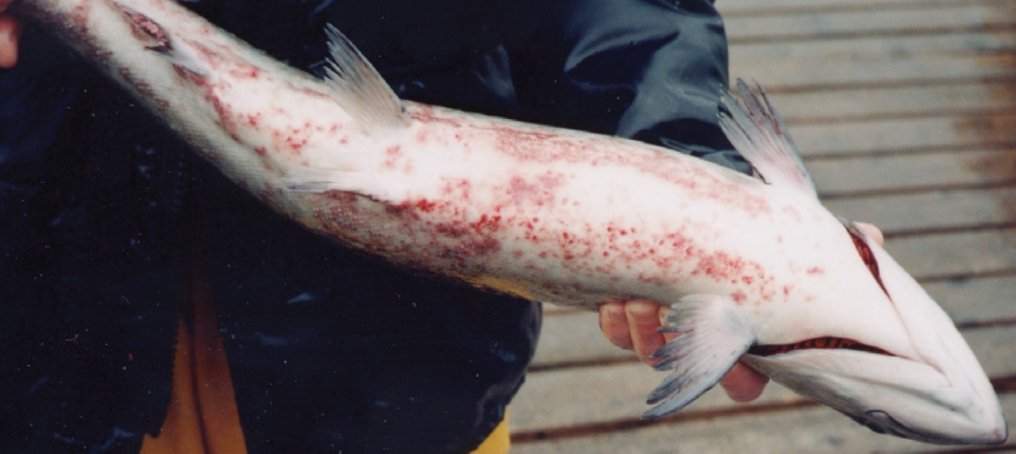

Note: Dermatitis (spawning rash) typical of BKD on bottom of fish.

Source: R Pascho and D Elliott

Figure 2 Kidneys of Juvenile chinook salmon (Oncorhynchus tshawytscha) affected by BKD

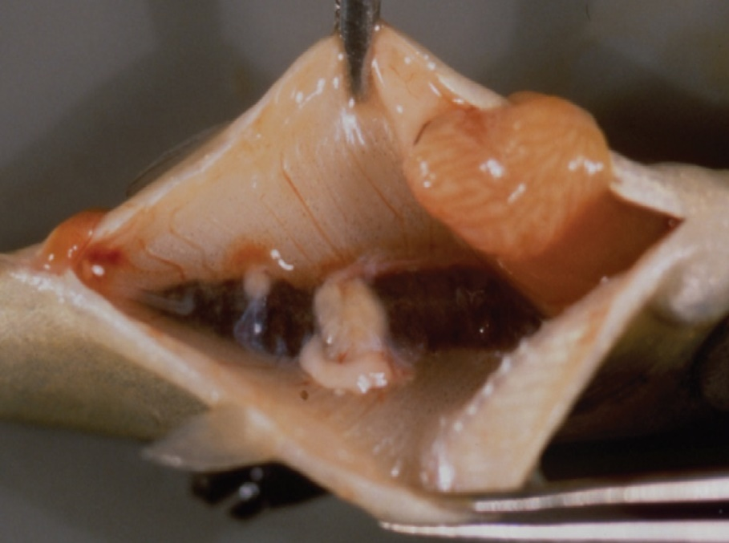

Note: Multiple kidney lesions.

Source: R Pascho and C O’Farrell

## Signs of disease

Important: Animals with this disease may show one or more of these signs, but the pathogen may still be present in the absence of any signs.

Disease signs at the farm, tank or pond level are:

* lethargy
* Increasing mortality.

Gross pathological signs are:

* exophthalmos (popeye)
* swollen abdomen and skin blisters (spawning rash) or shallow ulcers (remnants of ruptured blisters)
* darkening of skin and pale gills
* haemorrhages at the base of the fins or at the vent
* creamy-white, granulomatous, nodular lesions in the kidney and sometimes in the liver and spleen, which may be encapsulated
* ascites (fluid in the abdominal cavity)
* haemorrhages on the abdominal wall and in the viscera
* diffuse, white membranous layer on one or more internal organs
* enlarged spleen
* cystic cavities in skeletal muscle.

Microscopic pathological signs are:

* focal or diffuse granulomatous reaction in the kidneys, liver and spleen
* small, rod-shaped bacteria (Renibacterium salmoninarum) in histological sections of skin lesions.

## Disease agent

BKD is caused by infection with R. salmoninarum, a member of the family Micrococcaceae. BKD is a slow, progressive and frequently fatal infection of cultured and wild salmonids in both fresh and marine waters.

## Host range

Table 1 Species of salmonid fish known to be susceptible to BKD

| Common name | Scientific name |
| --- | --- |
| Arctic char | Salvelinus alpinus |
| Atlantic salmona | Salmo salar |
| Black sea salmon | Salmo labrax |
| Brook trouta | Salvelinus fontinalis |
| Brown trouta | Salmo trutta |
| Chinook salmona | Oncorhynchus tshawytscha |
| Chum salmon | Oncorhynchus keta |
| Coho salmona | Oncorhynchus kisutch |
| Cutthroat trouta | Oncorhynchus clarkii |
| Danube salmona | Hucho hucho |
| Masu salmona | Oncorhynchus masou |
| Pink salmona | Oncorhynchus gorbuscha |
| Rainbow trouta | Oncorhynchus mykiss |

**a** Naturally susceptible. Note: Other species have been shown to be experimentally susceptible.

Table 2 Species of non-salmonid fish known to be susceptible to BKD

| Common name | Scientific name |
| --- | --- |
| Ayu | Plecoglossus altivelis |
| Burbot | Lota lota |
| Common shiner | Luxilus cornutus |
| Fathead minnow | Pimephales promelas |
| Grayling | Thymallus thymallus |
| Pacific herring | Clupea pallasii |
| Sablefish | Anoplopoma fimbria |
| Sea lamprey | Petromyzon marinus |
| Shiner perch | Cymatogaster aggregata |

Table 3 Non-salmonid carriers

| Common name | Scientific name |
| --- | --- |
| Bartail flathead | Platycephalus indicus |
| Greenling | Hexagrammos otakii |
| Japanese scallop | Patinopecten yessoensis |

## Presence in Australia

Exotic disease—not recorded in Australia.

Map 1 Presence BKD, by jurisdiction

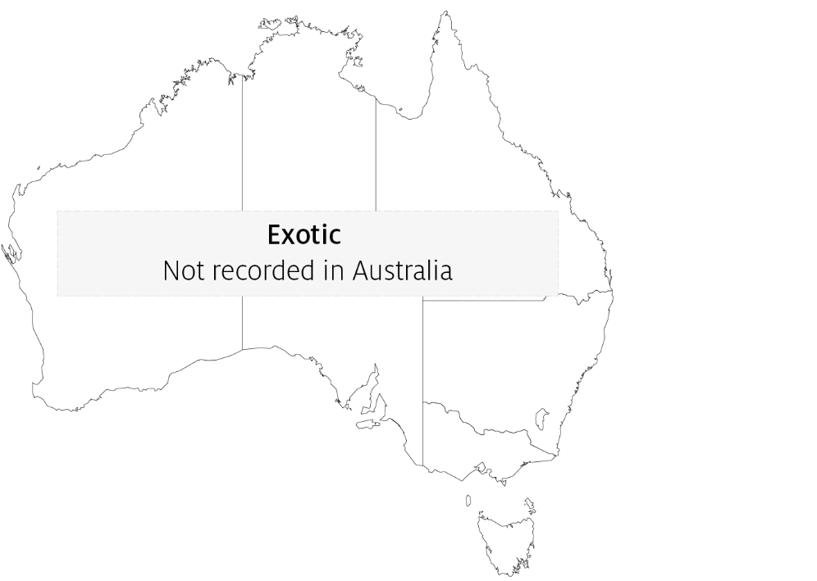

## Epidemiology

* The causative bacterium is likely to persist only within salmonids and not in the environment. However, as R. salmoninarum is often endemic in wild salmon populations, hatcheries can be constantly exposed to bacteria shed into the water by wild fish upstream.
* Other non-salmonid species have been demonstrated susceptible to infection with R. salmoninarum, but only when raised in proximity to highly infected salmonids.
* The bacterium is transmitted both horizontally (between fish via the water) and vertically (parent to offspring via eggs). Surface disinfection of eggs does not prevent vertical transmission.
* Advanced infection becomes apparent only after the first year of the fish's life.
* Coho (Oncorhynchus kisutch) and chinook (O. tshawytscha) salmon are the most important worldwide sources of infection.

## Differential diagnosis

The list of similar diseases in the next section refers only to the diseases covered by this field guide. Gross pathological signs may also be representative of diseases not included in this guide. Do not rely on gross signs to provide a definitive diagnosis. Use them as a tool to help identify the listed diseases that most closely account for the observed signs.

## Similar diseases

Piscirickettsiosis and viral haemorrhagic septicaemia (VHS).

## Sample collection

Only trained personnel should collect samples. Using only gross pathological signs to differentiate between diseases is not reliable, and some aquatic animal disease agents pose a risk to humans. If you are not appropriately trained, phone your state or territory hotline number and report your observations. If you have to collect samples, the agency taking your call will advise you on the appropriate course of action. Local or district fisheries or veterinary authorities may also advise on sampling.

## Emergency disease hotline

See something you think is this disease? Report it. Even if you’re not sure.

Call the Emergency Animal Disease Watch Hotline on **1800 675 888**. They will refer you to the right state or territory agency.

## Microscope images

Figure 3 Histological section of skin lesion of juvenile chinook salmon (Oncorhynchus tshawytscha) infected with Renibacterium salmoninarum

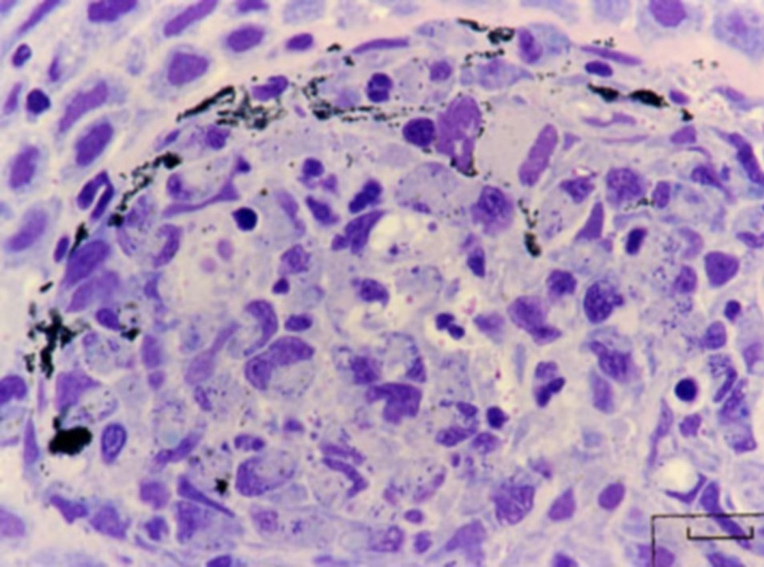

Note: Most of the small, rod-shaped R. salmoninarum are visible within the cytoplasm of macrophages. In this Giemsa-stained preparation, bacteria are purple–blue and melanin granules are black.

Source: R Pascho

Figure 4 Histological section of granulomas of juvenile chinook salmon (Oncorhynchus tshawytscha) affected by BKD

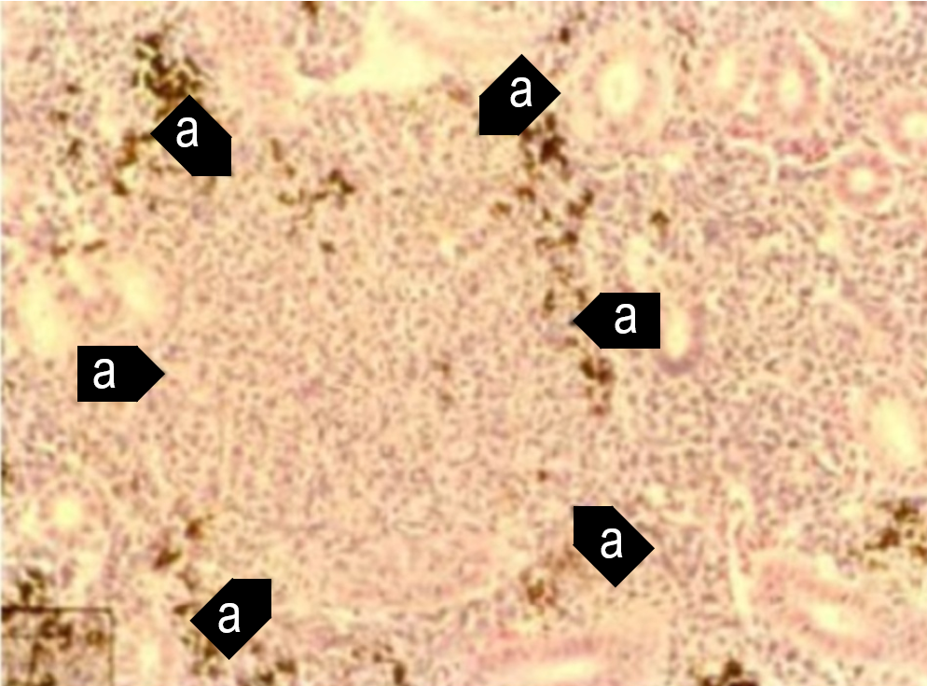

Note: Focal granulomatous inflammation (a).

Source: R Pascho and C O’Farrell

Figure 5 Histological section of granulomas of juvenile chinook salmon (Oncorhynchus tshawytscha) affected by BKD

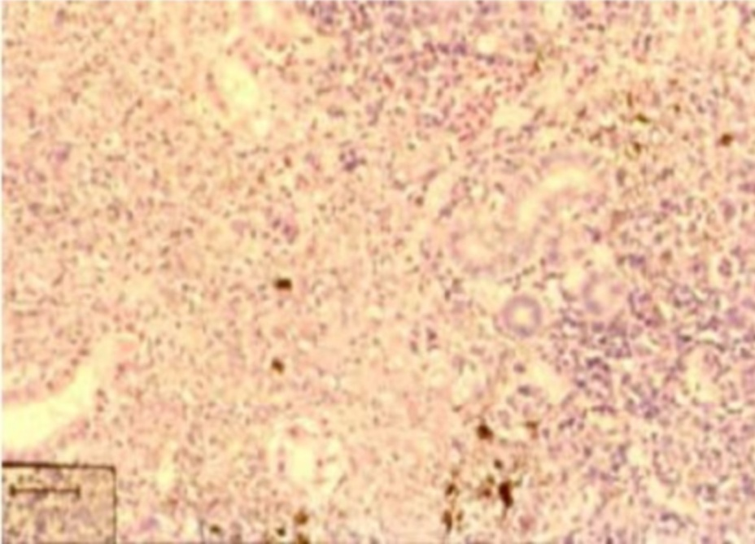

Note: Diffuse granulomatous inflammation.

Source: R Pascho and C O’Farrell

Figure 6 Gram-stained histological section of pancreatic tissue of juvenile chinook salmon (Oncorhynchus tshawytscha) with systemic BKD

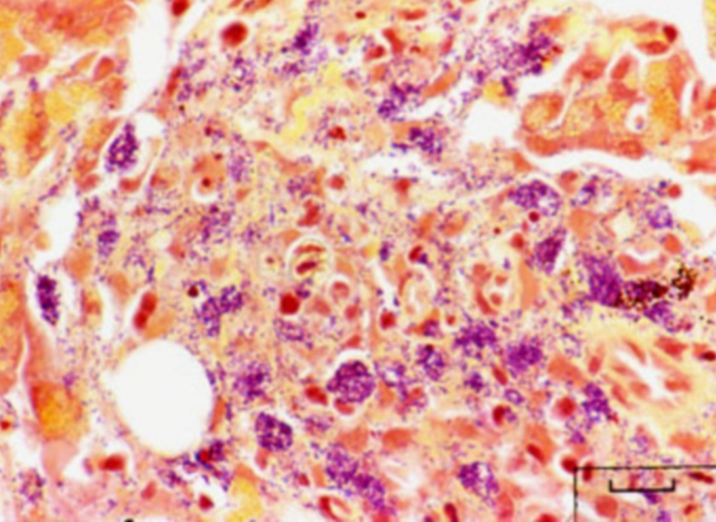

Note: Gram-positive (purple–blue) cells of R. salmoninarum are present extracellularly and intracellularly within macrophages, in contrast to brown–black melanin granules.

Source: R Pascho

## Further reading

CABI Invasive Species Compendium [‘Renibacterium salmoninarum’](https://www.cabi.org/ISC/datasheet/66866)

CEFAS International Database on Aquatic Animal Diseases [Bacterial Kidney Disease (‘Renibacterium salmoninarum’)](https://www.cefas.co.uk/international-database-on-aquatic-animal-diseases/disease-data/?id=14)

World Organisation for Animal Health [Manual of diagnostic tests for aquatic animals](http://www.oie.int/en/international-standard-setting/aquatic-manual/access-online)

These hyperlinks were correct at the time of publication.

## Contact details

Emergency Animal Disease Watch Hotline 1800 675 888

Email [AAH@agriculture.gov.au](mailto:AAH@agriculture.gov.au)Website [agriculture.gov.au/pests-diseases-weeds/aquatic](http://www.agriculture.gov.au/pests-diseases-weeds/aquatic)

© Commonwealth of Australia 2020

This work is copyright. It may be reproduced in whole or in part subject to the inclusion of an acknowledgement of the source and no commercial usage or sale.