WA INTERIM RECOVERY PLAN NO. 278

ALDERSYDE BANKSIA

(Banksia ionthocarpa subsp. chrysophoenix)

RECOVERY PLAN

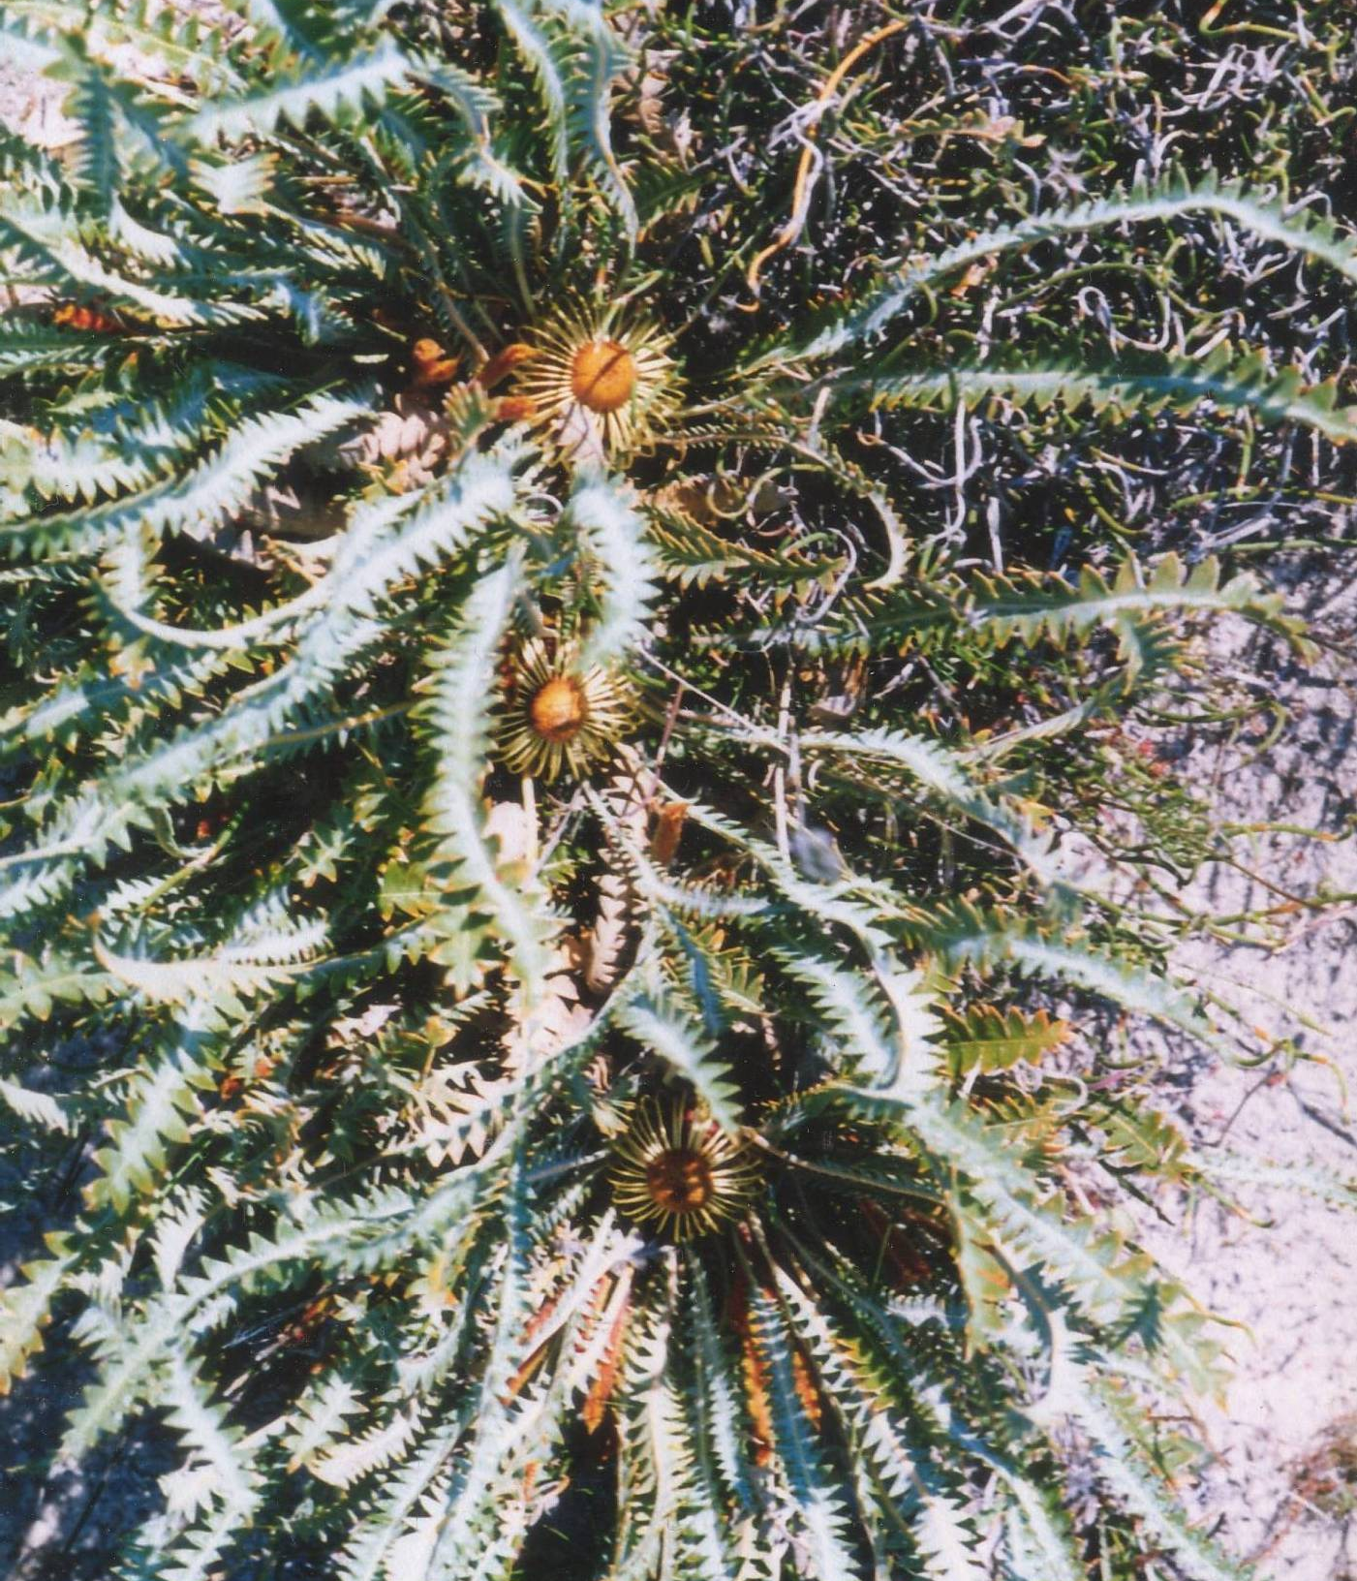

Department of Environment and Conservation
Kensington

 |  | 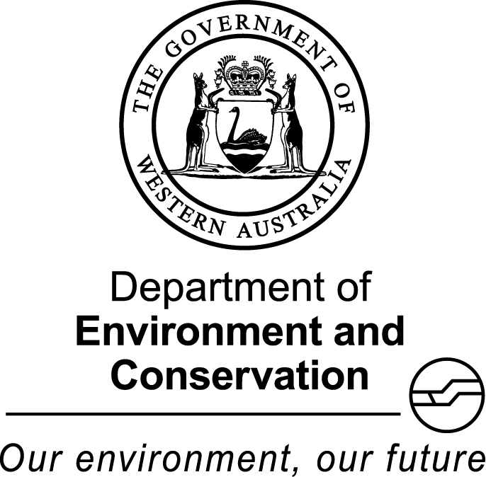

FOREWORD

Recovery Plans (RPs) and Interim Recovery Plans (IRPs) are developed within the framework laid down in Department of Conservation and Land Management (CALM) Policy Statements Nos. 44 and 50. Note: the Department of CALM formally became the Department of Environment and Conservation (DEC) in July 2006. DEC will continue to adhere to these Policy Statements until they are revised and reissued.

Plans outline the recovery actions that are required to urgently address those threatening processes most affecting the ongoing survival of threatened taxa or ecological communities, and begin the recovery process.

DEC is committed to ensuring that Threatened taxa are conserved through the preparation and implementation of plans and by ensuring that conservation action commences as soon as possible and, in the case of Critically Endangered (CR) taxa, always within one year of endorsement of that rank by the Minister.

This plan will remain in force until withdrawn or replaced. It is intended that, if the species is still ranked as CR (IUCN) at the end of the five-year term, this plan will be reviewed and the need for further recovery actions assessed.

This plan was given regional approval on 19 August 2008 and was approved by the Director of Nature Conservation on 12 September 2008. The provision of funds identified in this plan is dependent on budgetary and other constraints affecting DEC, as well as the need to address other priorities.

This plan was written and endorsed as an IRP in Western Australia, and it is also the National Recovery Plan for this Ecological Community as listed under the Commonwealth Environment Protection and Biodiversity Conservation Act 1999.

Information in this plan has been updated and is accurate as at March 2010.

IRP PREPARATION

This Plan was prepared by Craig Douglas¹, Marie Strelein² and Amanda Fairs³

¹ Project Officer, Species and Communities Branch, DEC, 17 Dick Perry Ave, Technology Park, Western Precinct, Kensington, WA 6151
² Flora Conservation Officer, Great Southern District, DEC, PO Box 100, Narrogin, WA, 6312.
³ Project Officer, Species and Communities Branch, DEC, 17 Dick Perry Ave, Technology Park, Western Precinct, Kensington, WA 6151

ACKNOWLEDGMENTS

The following people have provided assistance and advice in the preparation of this Plan:

Amanda Shade Assistant Curator, Nursery, Botanic Gardens Parks Authority
Andrew Brown Threatened Flora Coordinator, Species and Communities Branch, DEC
Andrew Crawford Technical Officer, Threatened Flora Seed Centre, DEC
Luke Sweedman Curator, Western Australian Seed Technology Centre, Botanic Gardens and
Parks Authority
Margaret Pieroni Leader, Australian Society for Growing Australian Plants (ASGAP) Dryandra Study Group, Denmark, WA
Thanks also to the staff of the W.A. Herbarium for providing access to Herbarium databases and specimen information, and DEC's Species and Communities Branch for assistance.

Cover photograph by Margaret Pieroni.

CITATION

This Plan should be cited as:
Department of Environment and Conservation (2007). Banksia ionthocarpa subsp. chrysophoenix, Interim Recovery Plan 2007-2012. Interim Recovery Plan No. 278. Department of Environment and Conservation, Western Australia.

SUMMARY

Scientific Name | Banksia ionthocarpa subsp. chrysophoenix | Common Name | Aldersyde Banksia
Family | Proteaceae | Flowering Period | September - November
DEC Region | Wheatbelt | DEC District | Great Southern
Shire | Pingelly, Brookton | Recovery Team | Great Southern District Threatened Flora Recovery Team
NRM Region | Avon | Recovery Team | Great Southern District Threatened Flora Recovery Team

Illustrations and/or further information: George, A.S. (2005). Further new taxa in Dryandra R. Br. (Proteaceae: Grevilleoideae). Nuytsia. 15(3): 337-346; Cavanagh, T. and Pieroni, M. (2006) The Dryandras, Wildflower Society of Western Australia, WA and Australian Plants Society (SGAP Victoria); DEC (2007) Western Australian Herbarium FloraBase 2 – Information on the Western Australian Flora (Accessed 2007). Department of Environment and Conservation, Western Australia. http://www.calm.wa.gov.au/science/.

Current status: Banksia ionthocarpa subsp. chrysophoenix was declared as Rare Flora in 2004 under the Western Australian Wildlife Conservation Act 1950 and ranked as Critically Endangered (CR) in Western Australia against World Conservation Union (IUCN 2001) Red List criterion D, due to there being fewer than 50 mature individuals known at that time. Additional mature plants have since been found and, as the subspecies no longer meets CR under criterion D, it is recommended in Recovery Action 2 that the Western Australian Threatened Species Scientific Committee (WATSSC) review the ranking of Banksia ionthocarpa subsp. chrysophoenix and amend to CR B1ab(iii,v)+2ab(iii,v) based on the extent of occurrence being less than 100 km², populations being severely fragmented and one population in decline. The species Banskia ionthocarpa is listed as Endangered under the Commonwealth Environment and Biodiversity Protection Act 1999, and although subspecies are not listed they are covered by this listing.

The main threats are rabbit activity, weed invasion, invasion by Allocasuarina huegeliana and road maintenance.

Banksia ionthocarpa subsp. chrysophoenix is currently known from four populations (one comprising two subpopulations), and a total of 862 mature plants. Populations are found east and south east of Brookton with an extent of occurrence of approximately 57 km².

Description: Banksia ionthocarpa subsp. chrysophoenix is a shrub to 40 cm high with underground stems. Leaves are rigid, with straight margins. Floral bracts are approximately 4 mm long, elongating to 6 to 7 mm when in fruit. The purple-red perianth is 52 to 60 mm long including the 6 to 11.5 mm long, flattened golden-orange limb. The pistil is 63 to 65 mm long and the pollen presenter 3 to 5.5 mm long. Follicles (not seen when mature) are obovate, 9 to 11 mm long, covered in a felt-like covering of cottony hairs on the stylar edge, as well as having the prominent apical tuft characteristic of the species (Pieroni 2000, George 2005, Cavanagh and Pieroni 2006).

Banksia ionthocarpa subsp. chrysophoenix differs from B. ionthocarpa subsp. ionthocarpa in having fire-tolerant underground stems capable of re-sprouting and straighter leaf lobes (George 2005, Cavanagh and Pieroni 2006).

Habitat requirements: Banksia ionthocarpa subsp. chrysophoenix occurs on sandy loam or sandy clay over laterite or granite in kwongan vegetation (dense heath and shrub thickets, with isolated small trees).

Habitat critical to the survival of the species, and important populations: Habitat critical to the survival of D. ionthocarpa subsp. chrysophoenix includes the area of occupancy of populations, areas of similar habitat surrounding and linking populations (these providing potential habitat for population expansion and for pollinators), additional occurrences of similar habitat that may contain undiscovered populations of the subspecies or be suitable sites for future translocations and the local catchment for the surface and/or groundwater that maintains the habitat of the subspecies. The species B. ionthocarpa is listed as Endangered under the EPBC Act and it is therefore considered that all known habitat for this species and its subspecies is habitat critical to the survival of the species and all wild populations are important populations.

Benefits to other species or ecological communities: Recovery actions implemented to improve the quality or security of the habitat of Banksia ionthocarpa subsp. chrysophoenix will also improve the status of associated native vegetation. One threatened and three priority flora taxa occur in association with Banksia ionthocarpa subsp. chrysophoenix, these being listed in the table below.

Conservation-listed flora species occurring in habitat of Banksia ionthocarpa subsp. chrysophoenix
Species name | Conservation Status (Western Australia) | Conservation Status (EPBC Act 1999)
Verticordia fimbrilepis subsp. fimbrilepis | DRF, Vulnerable | Endangered
Banksia dallanneyi subsp. agricola | Priority 2 | -
Acacia anarthros | Priority 3 | -
Calothamnus brevifolius | Priority 4 | -
DRF – Declared Rare Flora; for a description of the priority categories see Atkins (2009)

International obligations: This plan is fully consistent with the aims and recommendations of the Convention on Biological Diversity, ratified by Australia in June 1993, and will assist in implementing Australia’s responsibilities under that convention. Banksia ionthocarpa subsp. chrysophoenix is not listed under any specific international treaty however, and this plan does not affect Australia’s obligations under any other international agreements.

Indigenous consultation: Involvement of the Indigenous community has been sought through the South West Aboriginal Land and Sea Council (SWALSC) and the Department of Indigenous Affairs to assist in the identification of cultural values for land occupied by Banksia ionthocarpa subsp. chrysophoenix, or groups with a cultural connection to land that is important for the subspecies’ conservation and to determine whether there are any issues or interests identified in the plan. A search of the Department of Indigenous Affairs Aboriginal Heritage Sites Register has identified that there are no sites of Aboriginal significance at or near populations of the subspecies. Opportunities for indigenous involvement in implementation of the recovery plan will be encouraged and may exist through cultural interpretation and awareness of the subspecies. Continued liaison between DEC and the indigenous community will identify areas in which collaboration will assist implementation of recovery actions.

Social and economic impact: The implementation of this recovery plan is unlikely to cause significant adverse social and economic impacts.

Affected interests: One population occurs in a Shire gravel reserve and two populations occur on Shire road reserves. Their protection may potentially impact on Shire operations.

Evaluation of the plan’s performance: The Department of Environment and Conservation, in conjunction with the Great Southern District Threatened Flora Recovery Team (GSDTFRT) will evaluate the performance of this IRP. In addition to annual reporting on progress and evaluation against the criteria for success and failure, the plan will be reviewed following four years of implementation.

Existing Recovery Actions: The following recovery actions have been or are currently being implemented:
- The Shire of Brookton has been made aware of the threatened nature of this subspecies, its location on land under their management, and their legal obligations to protect the subspecies.
- Staff from DEC’s Great Southern District are monitoring all known populations.
- Declared Rare Flora (DRF) markers have been installed at Population 2 and replaced at Population 4.
- The GSDTFRT is overseeing the implementation of this Recovery plan and will include it in its annual report to DEC’s Corporate Executive and funding bodies.

Recovery Plan objective: The objective of this plan is to abate identified threats and maintain or enhance viable in situ populations to ensure the long-term preservation of the subspecies in the wild.

Recovery criteria
Criteria for success: The number of populations has increased and/or the number of mature individuals in populations has increased by ten percent or more over the term of the plan.
Criteria for failure: The number of populations has decreased and/or the number of mature individuals in populations has decreased by ten percent or more over the term of the plan.

Recovery actions

- Coordinate recovery actions | - Implement rabbit control
- Propose Western Australian ranking change | - Obtain biological and ecological information
- Liaise with relevant land managers and Indigenous groups | - Promote awareness
- Monitor populations | - Conduct further surveys
- Replace DRF markers | - Develop and implement a fire management strategy
- Collect seed to preserve genetic diversity | - Map habitat critical to the survival of Banksia ionthocarpa subsp. chrysophoenix
- Undertake weed control and follow-up with additional control if required | - Review the Plan and the need for further recovery actions

1. BACKGROUND

History

Banksia ionthocarpa was first collected near Kamballup by P. Luscombe in 1988 and was formally described by Alex George in 1996 as Dryandra ionthocarpa (George 1996, Cavanagh and Pieroni 2006, DEC 2007). The species was thought to be represented by a single population near Albany. However, whilst conducting a flora survey in a Nature Reserve east of Pingelly in 1998, staff from the Western Australian Herbarium discovered an unusual form of Banksia ionthocarpa (Obbens et al, 2001). As part of a revision by Alex George in 2005 it was provided subspecies status and named D. ionthocarpa subsp. chrysophoenix (George 2005).

Alex George described Banksia ionthocarpa subsp. chrysophoenix in 2005 as being lignotuberous and apparently clonal. However observations in the field suggest that the species re-sprouts from underground stems following fire and, rather than being clonal, the same plant produces many shoots above ground (Margaret Pieroni pers. comm. 2007).

Surveys of the Nature Reserve where Banksia ionthocarpa subsp. chrysophoenix was first collected resulted in the discovery of Subpopulation 1b in 1999 and further surveys of the surrounding areas in 1999 and 2000 resulted in the discovery of three additional populations of D. ionthocarpa subsp. chrysophoenix.

Population 2 was burnt in 1996 but other populations have not been burnt for a long period of time.

Banksia ionthocarpa subsp. chrysophoenix is currently known from four populations (one comprising two subpopulations), totaling 862 mature plants.

Description

Banksia ionthocarpa subsp. chrysophoenix is a shrub to 40 cm high with underground stems. Leaves are rigid, with straight leaf lobe margins. Floral bracts are approximately 4 mm long, elongating to 6 to 7 mm in fruit. The purple-red perianth is 52 to 60 mm long including the 6 to 11.5 mm long, flattened golden-orange limb. The pistil is 63 to 65 mm long and the pollen presenter 3 to 5.5 mm long. Follicles (not seen when mature) are obovate, 9 to 11 mm long, covered in a felt-like covering of cottony hairs on the stylar edge, as well as having the prominent apical tuft characteristic of the species (Pieroni 2000, George 2005, Cavanagh and Pieroni 2006).

Banksia ionthocarpa subsp. chrysophoenix differs from D. ionthocarpa subsp. ionthocarpa in having straighter leaf lobes and fire-tolerant underground stems that are capable of re-sprouting (George 2005, Cavanagh and Pieroni 2006).

Distribution and habitat

Banksia ionthocarpa subsp. chrysophoenix has a restricted geographic range over approximately 57 km² in the Shires of Brookton and Pingelly.

Habitat is sandy loam or sandy clay over laterite or granite in kwongan vegetation, sometimes with an overstorey of Allocasuarina huegeliana.

Species associated with Banksia ionthocarpa subsp. chrysophoenix include Hakea incrassata, H. trifurcata, H. lissocarpha, Lepidobolus preissianus, Caustis dioica, Mesomelaena pseudostygia, Acacia stenoptera, Allocasuarina microstachya, A. huegeliana, Calothamnus brevifolius, Verticordia fimbrilepis subsp. fimbrilepis, V. densiflora, Loxocarya collina, Jacksonia racemosa, Synaphea petiolaris and Leptospermum erubescens.

Summary of population land vesting, purpose and management

Pop. No. & Location | DEC District | Shire | Vesting | Purpose | Manager
1a. SE of Brookton (Nature Reserve) | Great Southern | Pingelly | Conservation Commission of Western Australia | Conservation of Flora and Fauna | DEC
1b. SE of Brookton (Nature Reserve) | Great Southern | Pingelly | Conservation Commission of Western Australia | Conservation of Flora and Fauna | DEC
2. E of Brookton | Great Southern | Brookton | Shire of Brookton | Gravel Reserve | Shire of Brookton
3. E of Brookton | Great Southern | Brookton | Unvested Reserve | Road Reserve | Shire of Brookton
4. E of Brookton | Great Southern | Brookton | Unvested Reserve | Road Reserve | Shire of Brookton
Populations in bold text are considered to be important populations

Biology and ecology

Very little is known about the biology and ecology of Banksia ionthocarpa subsp. chrysophoenix. However, the subspecies has a lignotuber from which it is known to regenerate following fire.

Banksia ionthocarpa subsp. chrysophoenix flowers from September to November.

Threats

Banksia ionthocarpa subsp. chrysophoenix was declared as Rare Flora in 2004 under the Western Australian Wildlife Conservation Act 1950 and ranked as Critically Endangered (CR) in Western Australia against World Conservation Union (IUCN 2001) Red List criterion D, due to there being fewer than 50 mature individuals known at that time. Additional mature plants have since been found and the subspecies no longer meets CR under criterion D. It is therefore proposed in Recovery Action 2 to recommend to the Western Australian Threatened Species Scientific Committee (WATSSC) that the ranking of Banksia ionthocarpa subsp. chrysophoenix in Western Australia be amended from CR D to CR B1ab(iii,v)+2ab(iii,v) based on the extent of occurrence being less than 100 km², populations being severely fragmented and one population in decline. The species, Banskia ionthocarpa is listed as Endangered under the Commonwealth Environment and Biodiversity Protection Act 1999 and although subspecies are not listed, they are covered by this listing.

Threats to the subspecies include:

- Rabbit activity. Rabbits threaten all populations of Banksia ionthocarpa subsp. chrysophoenix through soil disturbance, grazing and increased nutrient levels.
- Weed invasion. Weed species compete for space, nutrients, water and light. Weed competition is likely to reduce recruitment.
- Invasion by Allocasuarina huegeliana. Allocasuarina huegeliana is dominating vegetation at population 4 and is competing for space and shading out Banksia ionthocarpa subsp. chrysophoenix.
- Road maintenance. Populations 3 and 4 are threatened by herbicide spraying and road verge grading.

Summary of population monitoring information and threats

Pop. No. & Location | Land Status | Year/No. plants | Current Condition | Threats
1a. SE of Brookton | Nature Reserve | 2001 299* | Healthy | Weeds, rabbit activity
1b. SE of Brookton | Nature Reserve | 2001 299* | - | Weeds, rabbit activity
2. E of Brookton | Gravel Reserve | 1999 215  2001 370 [3]  2005 425 | Moderate | Weeds, rabbit activity
3. E of Brookton | Road Reserve | 2000 17 (3)  2001 22 (2) [1]  2005 41  2010 41 | Moderate | Weeds, rabbit activity, road maintenance
4. E of Brookton | Road Reserve | 2000 282 [58]  2001 250 [92]  2005 97 | Poor | Weeds, rabbit activity, road maintenance, invasion by Allocasuarina huegeliana
Populations in bold text are considered to be important populations; * = subpopulations combined, ( ) = number of seedlings, [ ] = number dead

Guide for decision-makers

Section 1 provides details of current and possible future threats. Developments and/or land clearing in the immediate vicinity of any Banksia ionthocarpa subsp. chrysophoenix populations require assessment. No developments or clearing should be approved unless the proponents can demonstrate that their actions will not have a significant impact on the subspecies, its habitat or potential habitat or on the local surface hydrology, such that drainage in the habitat of the subspecies would be altered.

Habitat critical to the survival of the species, and important populations

Habitat critical to the survival of B. ionthocarpa subsp. chrysophoenix includes the area of occupancy of populations, areas of similar habitat surrounding and linking populations (these providing potential habitat for population expansion and for pollinators), additional occurrences of similar habitat that may contain undiscovered populations of the subspecies or be suitable sites for future translocations and the local catchment for the surface and/or groundwater that maintains the habitat of the subspecies.

The species B. ionthocarpa is listed Endangered under the EPBC Act and it is therefore considered that all known habitat for this species and its subspecies is habitat critical to its survival and all wild populations are important populations.

Benefits to other species or ecological communities

Recovery actions implemented to improve the quality or security of the habitat of Banksia ionthocarpa subsp. chrysophoenix will also improve the status of associated native vegetation.

One threatened and three priority flora taxa occur in association with Banksia ionthocarpa subsp. Chrysophoenix. These taxa are listed in the table below:

Conservation-listed flora taxa occurring in habitat of Banksia ionthocarpa subsp. chrysophoenix

Species name | Conservation Status (Western Australia) | Conservation Status (EPBC Act 1999)
Verticordia fimbrilepis subsp. fimbrilepis | DRF, Vulnerable | Endangered
Banksia dallanneyi subsp. agricola | Priority 2 | -
Acacia anarthros | Priority 3 | -
Calothamnus brevifolius | Priority 4 | -
DRF – Declared Rare Flora; for a description of the priority categories see Atkins (2009)

International obligations

This plan is fully consistent with the aims and recommendations of the Convention on Biological Diversity, ratified by Australia in June 1993, and will assist in implementing Australia’s responsibilities under that convention. Banksia ionthocarpa subsp. chrysophoenix is not listed under any specific international treaty however, and this IRP does not affect Australia’s obligations under any other international agreements.

Indigenous consultation

Involvement of the Indigenous community has been sought through the South West Aboriginal Land and Sea Council (SWALSC) and the Department of Indigenous Affairs to assist in the identification of cultural values for land occupied by Banksia ionthocarpa subsp. chrysophoenix, or groups with a cultural connection to land that is important for the subspecies’ conservation and to determine any issues or interests identified in the plan. A search of the Department of Indigenous Affairs Aboriginal Heritage Sites Register has identified that there are no sites of Aboriginal significance at or near populations of the subspecies. Opportunities for Indigenous involvement in implementation of the Recovery Plan will be encouraged and may exist through cultural interpretation and awareness of the subspecies.

Continued liaison between DEC and the indigenous community will identify areas in which collaboration will assist implementation of recovery actions.

Social and economic impact

The implementation of this recovery plan is unlikely to cause any significant adverse social and economic impacts.

Affected interests

One population occurs in a Shire gravel reserve and two populations occur on Shire road reserves. Their protection may potentially impact on Shire operations.

Evaluation of the plan’s performance

The Department of Environment and Conservation, in conjunction with the Great Southern District Threatened Flora Recovery Team (GSDTFRT) will evaluate the performance of this plan. In addition to annual reporting on progress and evaluation against the criteria for success and failure, the plan will be reviewed following four years of implementation.

2. RECOVERY OBJECTIVE AND CRITERIA

Objective

The objective of this Recovery plan is to abate identified threats and maintain or enhance viable in situ populations to ensure the long-term preservation of the subspecies in the wild.

Criteria for success: The number of populations has increased and/or the number of mature individuals has increased by ten percent or more over the term of the plan.
Criteria for failure: The number of populations has decreased and/or the number of mature individuals has decreased by ten percent or more over the term of the plan.

3. RECOVERY ACTIONS

Existing recovery actions

The Shire of Brookton has been made aware of the threatened nature of this subspecies, its location on land under their management and their legal obligations to protect the subspecies.

Staff from DEC’s Great Southern District continue to monitor all known populations.

Declared Rare Flora (DRF) markers have been installed at Population 2 and replaced at Population 4.

The GSDTFRT is overseeing the implementation of this Recovery plan and will include it in its annual report to DEC’s Corporate Executive and funding bodies.

Future recovery actions

Where recovery actions are implemented on lands other than those managed by DEC, permission has been or will be sought from the appropriate land managers prior to actions being undertaken. The following recovery actions are roughly in order of descending priority, influenced by their timing over the term of the plan. However this should not constrain addressing any recovery action if funding is available and other opportunities arise.

Coordinate recovery actions

The Great Southern District Threatened Flora Recovery Team (GSDTFRT) will coordinate recovery actions for Banksia ionthocarpa subsp. chrysophoenix and other Declared Rare Flora in their District. They will include information on progress in their annual report to DEC’s Corporate Executive and funding bodies.

Action: Coordinate recovery actions
Responsibility: DEC (Great Southern District), through the GSDTFRT
Cost: $1,500 annually.

Propose Western Australian ranking change

Propose to the Western Australian Threatened Species Scientific Committee (WATSSC) that the ranking of Banksia ionthocarpa subsp. chrysophoenix be amended from CR D to CR B1ab (iii,v)+2ab(iii,v) (IUCN 2001). The subspecies no longer meets Criteria for CR D as there are now more than 50 plants known.

Action: Propose Western Australian ranking change
Responsibility: DEC (Species and Communities Branch and Great Southern District) through the GSDTFRT
Cost: $1,000 in year 1.

3. Liaise with relevant land managers and Indigenous groups

Staff from DEC’s Great Southern District will liaise with appropriate land managers to ensure that populations are not accidentally damaged or destroyed. Input and involvement will continue to be sought from indigenous groups that have an active interest in areas that are habitat for Banksia ionthocarpa subsp. chrysophoenix.

Action: Liaise with relevant land managers and Indigenous groups
Responsibility: DEC (Great Southern District), through the GSDTFRT
Cost: $1,500 annually.

4. Monitor populations

Annual monitoring of factors such as habitat degradation (including any possible impacts from roadside grading and spraying, weed invasion, invasion by Allocasuarina huegeliana and rabbit activity), population stability (expansion or decline), pollination activity, seed production, recruitment, longevity and predation is essential and will be met under this action.

Action: Monitor populations
Responsibility: DEC (Great Southern District) through GSDTFRT
Cost: $1,000 annually.

5. Replace Declared Rare Flora (DRF) markers

DRF markers need replacing at Population 3.

Action: Replace DRF markers
Responsibility: DEC (Great Southern District) through the GSDTFRT
Cost: $500 in year 1.

6. Collect seed to preserve genetic diversity

Preservation of genetic material is essential to guard against extinction of the subspecies if wild populations are lost. It is therefore recommended that seed be collected and stored. Collections should aim to sample and preserve the maximum range of genetic diversity possible from all populations. The germplasm conservation guidelines for Australia produced by the Australian Network for Plant Conservation (ANPC) should be used to guide this process (Offord & Meagher 2009).

Action: Collect seed for preservation
Responsibility: DEC (Great Southern District) and Botanic gardens and Parks Authority (BGPA) through GSDTFRT
Cost: $3,000 in each of years 1, 3 and 5.

7. Undertake weed control and follow-up with additional control if required

Weeds are a major threat to all populations of Banksia ionthocarpa subsp. chrysophoenix. The following actions will be implemented.

- Select an appropriate herbicide after determining which weeds are present.
- Control invasive weeds by hand removal or spot spraying around D. ionthocarpa subsp. chrysophoenix plants when weeds first emerge.

The tolerance of associated native plant species to herbicides at the sites of D. ionthocarpa subsp. chrysophoenix is not known and weed control programs will be undertaken in conjunction with research.

Action: Undertake weed control and follow up with additional control if required
Responsibility: DEC (Great Southern District, Science Division) through the GSDTFRT
Cost: $3,500 annually.

8. Implement rabbit control

Rabbits are a threat to all populations of Banksia ionthocarpa subsp. chrysophoenix. Control strategies will be developed and implemented in consultation with relevant land managers.

Action: Implement rabbit control
Responsibility: DEC (Great Southern District) through the GSDTFRT
Cost: $3,000 in year 1 and $2,500 in years 2 to 5.

9. Obtain biological and ecological information

Improved knowledge of the biology and ecology of Banksia ionthocarpa subsp. chrysophoenix will provide a better scientific basis for management of the wild populations. An understanding of the following is particularly necessary for effective management:

- Investigate the subspecies’ response to disturbance including fire.
- Investigate seed longevity and viability.
- Investigate clonal, genetic diversity.
- Investigate conditions necessary for germination.
- Determine longevity of plants and time taken to reach maturity.
- Investigate the subspecies’ pollination biology.

Actions: Obtain biological and ecological information
Responsibility: DEC (Science Division, TFSC, Great Southern District) and BGPA through the GSDTFRT
Cost: $13,000 in years 1 to 3 and $18,000 in year 4.

10. Promote awareness

The importance of biodiversity conservation and the protection of Banksia ionthocarpa subsp. chrysophoenix will be promoted to the public. This will be achieved through an information campaign using local print and electronic media and by setting up poster displays. An information brochure that provides a description of the subspecies with information about threats and recovery actions will be developed for this subspecies and will be distributed to local land owners, relevant authorities and volunteer organisations. Promotion and awareness raising activities may result in the discovery of new populations. Formal links with local naturalist groups and interested individuals should also be encouraged.

To minimise the risk of malicious destruction, it is recommended that the exact location of D. ionthocarpa subsp. chrysophoenix be kept from the general public. Such information should, however, be provided to the Shire of Brookton and relevant government authorities.

Action: Promote awareness
Responsibility: DEC (Great Southern District, SCB and Strategic Development and Corporate Affairs Division) through the GSDTFRT

Cost: $1,500 in year 1 and $1,000 in years 2 to 5.

11. Conduct further surveys

It is recommended that areas of potential habitat be surveyed for the presence of this subspecies during its flowering period between July and September. All surveyed areas will be recorded and the presence or absence of the subspecies documented to increase survey efficiency and reduce unnecessary duplicate surveys. Where possible, volunteers from the local community, wildflower societies and naturalists clubs should be invited to assist.

Action: Conduct further surveys
Responsibility: DEC (Great Southern District) through GSDTFRT

Cost: $4,000 in years 1, 3 and 5.

12. Develop and implement a fire management strategy

Banksia ionthocarpa subsp. chrysophoenix is believed to regenerate from lignotubers but frequent fires may weaken mature plants and eventually kill them, as well as kill seedlings and exhaust the seed bank, reducing future recruitment. A fire management strategy will be developed by DEC’s Great Southern District in consultation with relevant land managers and the GSDTFRT. This will include the maintenance of firebreaks and actions to reduce the impact of frequent wildfires on populations.

Action: Develop and implement a fire management strategy
Responsibility: DEC (Great Southern District) through the GSDTFRT, and relevant authorities
Cost: $3,000 in year 1.

13. Map habitat critical to the survival of Banksia ionthocarpa subsp. chrysophoenix

While this subspecies is not currently listed under the EPBC Act, it is expected that such a listing will occur. It is a requirement of the EPBC Act to determine spatial data relating to habitat critical to the survival of Banksia ionthocarpa subsp. chrysophoenix. The areas described in Section 1 have not yet been mapped and that will be addressed under this recovery action. If additional populations are located, then habitat critical to their survival will also be determined and mapped.

Action: Map habitat critical to the survival of Banksia ionthocarpa subsp. chrysophoenix
Responsibility: DEC (Great Southern District, Species and Communities Branch (SCB)) through GSDTFRT

Cost: $3,500 in year 1.

14. Review the Plan and the need for further recovery actions

At the end of the five-year term of this plan, it will be reviewed and the need for further recovery actions will be assessed.

Action: Review the Plan and the need for further recovery actions
Responsibility: DEC (SCB, Great Southern District) through GSDTFRT
Cost: $1,500 in year 5.

Summary of recovery actions

Total DEC: | $79,100
Total other: | $17,000
Total EXT: | $47,400
TOTAL COSTS: | $142,500

Recovery Actions | Priority | Responsibility | Completion date
Coordinate recovery actions | High | GSDTFRT | Ongoing
Propose ranking change | High | DEC (Species and Communities Branch and Great Southern District) through the GSDTFRT | Year 3
Liaise with relevant land managers and Indigenous groups | High | DEC (Great Southern District), through the GSDTFRT | Ongoing
Monitor populations | High | DEC (Great Southern District) through GSDTFRT | Ongoing
Replace DRF markers | High | DEC (Great Southern District) through the GSDTFRT | Year 1
Collect seed to preserve genetic diversity | High | DEC (Great Southern District) and BGPA through GSDTFRT | Year 5
Undertake weed control and follow-up with additional control if required | High | DEC (Great Southern District, Science Division) through the GSDTFRT | Ongoing
Implement rabbit control | High | DEC (Great Southern District) through the GSDTFRT | Year 5
Obtain biological and ecological information | High | DEC (Science Division, TFSC, Great Southern District) and BGPA through the GSDTFRT | Year 4
Promote awareness | High | DEC (Great Southern District, SCB and Strategic Development and Corporate Affairs Division) through the GSDTFRT | Year 5
Conduct further surveys | Moderate | DEC (Great Southern District) through GSDTFRT | Year 5
Develop and implement a fire management strategy | Moderate | DEC (Great Southern District) through the GSDTFRT, and relevant authorities | Developed by year 1 with implementation ongoing
Map habitat critical to the survival of Banksia ionthocarpa subsp. chrysophoenix | Moderate | DEC (Great Southern District, Species and Communities Branch (SCB)) through GSDTFRT | Year 1
Review the Plan and the need for further recovery actions | Moderate | DEC (SCB, Great Southern District) through GSDTFRT | Year 5

4. TERM OF PLAN

Western Australia
This Recovery plan will operate from September 2008 to August 2013 but will remain in force until withdrawn or replaced. If Banksia ionthocarpa subsp. chrysophoenix is still ranked by the Western Australian Government as CR (IUCN 2001) after five years, the need for further recovery actions and an update of the plan will be assessed. The plan was updated in March 2010.

Commonwealth
In accordance with the provisions of the Commonwealth Environment Protection and Biodiversity Conservation Act 1999 (EPBC Act) this adopted recovery plan will remain in force until revoked.

The recovery plan must be reviewed at intervals of not longer than 5 years.

5. REFERENCES

Atkins, K. (2009). Declared Rare and Priority Flora List for Western Australia. Department of Conservation
and Land Management, Perth, Western Australia
CALM (1992). Policy Statement No. 44 Wildlife Management Programs Department of Conservation and Land Management, Perth, Western Australia.
CALM (1994). Policy Statement No. 50 Setting Priorities for the Conservation of Western Australia’s Threatened Flora and Fauna. Department of Conservation and Land Management, Perth, Western Australia.
Cavanagh, T. and Pieroni M. (2006) The Dryandras, Wildflower Society of Western Australia, WA and Australian Plants Society (SGAP Victoria)
DEC. (2007). Western Australian Herbarium FloraBase 2 – Information on the Western Australian Flora (Accessed 2007). Department of Environment and Conservation, Western Australia. http://www.calm.wa.gov.au/science/.
George, A.S. (1996). New taxa and a new infrageneric classification in Dryandra R.Br. (Proteaceae: Grevilleoideae). Nuytsia 10(3): 376.
George, A.S. (2005). Further new taxa in Dryandra R. Br. (Proteaceae: Grevilleoideae). Nuytsia. 15(3): 337-346.
Obbens, F.J., Davis, R.W. and Sage, L.W. (2001). Vegetation, flora and recommendations for conservation management of Jingaring Nature Reserve: A “botanical gem” in the Western Australian wheat-belt. Journal of the Royal Society of Western Australia. 84: 53-61.
Offord, C.A. and Meagher, P.F. (eds.) (2009) Plant Germplasm Conservation in Australia: Strategies and Guidelines for developing, managing and using ex situ collections. Australian Network for Plant Conservation Inc. (ANPC) in partnership with Australian Seed Conservation and Research (AuSCaR).
Pieroni, M. (2000) Two more undescribed taxa? in Dryandra Study Group Newsletter, Issue 39, July 2000
World Conservation Union (IUCN) (2001) IUCN Red List Categories: Version 3.1. Prepared by the IUCN Species Survival Commission. IUCN, Gland, Switzerland and Cambridge, UK.

6. TAXONOMIC DESCRIPTION

Excerpt from: George, A.S. (2005). Further new taxa in Dryandra R. Br. (Proteaceae: Grevilleoideae). Nuytsia. 15(3): 337-346. Note: the subspecies has since been placed in Banksia.

Shrub with lignotuber, apparently clonal. Margins of leaf lobes almost straight. Floral bracts approximately 4 mm long, elongating to 6-7 mm in fruit. Perianth 52-60 mm long including limb 6-11.5 mm long; claws purple-red; limb golden. Pistil 63-65 mm long; pollen presenter 3-5.5 mm long. Follicles (not seen mature) obovate, 9-11 mm long, tomentose on stylar edge, as well as having the prominent apical tuft characteristic of the species.

Dryandra ionthocarpa subsp. chrysophoenix closely allies with. D. ionthocarpa subsp. ionthocarpa in all aspects of its morphology, differing mainly in having a fire-tolerant rootstock while the later is non-lignotuberous. The margins of the leaf lobes are straighter than those of the subsp. ionthocarpa which are gently curved. Generally its flowers are larger than those of typical D. ionthocarpa subsp. ionthocarpa, but several collections of the latter have large flowers. It appears to set mature fruit very rarely, examination of the plants showing only a few follicles that appeared to be immature.

The account of D. ionthocarpa subsp. ionthocarpa in Flora of Australia vol. 17B stated that the floral bracts do not elongate as the fruit develops, but that may not be the case as some elongation was noted in subsp. chrysophoenix.

Margaret Pieroni - Leader, Australian Society for Growing Australian Plants (ASGAP), Dryandra Study Group

