



Banksia Woodlands of the Swan Coastal Plain: a nationally



protected ecological community

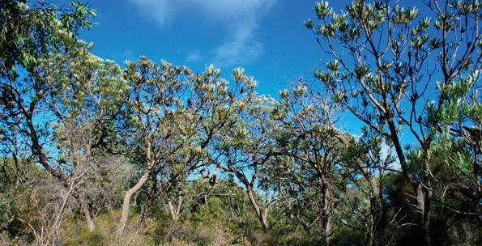

2 / Banksia Woodlands of the Swan Coastal Plain: a nationally protected ecological community

This guide is designed to assist land managers, owners and occupiers, as well as environmental assessment officers and consultants, to identify, assess and manage the Banksia Woodlands of the Swan Coastal Plain ecological community; a threatened ecological community, listed as endangered under the *Environment Protection and Biodiversity Conservation Act 1999* (EPBC Act), Australia’s national environment law.

This guide is a companion document to the approved Conservation Advice, which can be found on the Australian Government’s species profile and threats (SPRAT) database at: [www.environment.gov.au/cgi-bin/sprat/public/](http://www.environment.gov.au/cgi-bin/sprat/public/publiclookupcommunities.pl)  [publiclookupcommunities.pl](http://www.environment.gov.au/cgi-bin/sprat/public/publiclookupcommunities.pl). On this webpage, click on the details link—alongside the ecological community name—to download the documents and the map for the listed ecological community.

**© Commonwealth of Australia, 2016.**

*Banksia Woodlands of the Swan Coastal Plain: a nationally protected ecological community* is licensed by the Commonwealth of Australia for use under a Creative Commons Attribution 4.0 International licence with the exception of the Coat of Arms of the Commonwealth of Australia, the logo of the agency responsible for publishing the report, content supplied by third parties, and any images depicting people. For licence conditions see: <http://creativecommons.org/licenses/by/4.0/au/>

This guide should be attributed as ‘*Banksia Woodlands of the Swan Coastal Plain: a nationally-protected ecological community*, Commonwealth of Australia 2016’.

The Commonwealth of Australia has made all reasonable efforts to identify content supplied by third parties using the following format ‘© Copyright, [name of third party] ’.

**Disclaimer**

The views and opinions expressed in this publication are those of the authors and do not necessarily reflect those of the Australian Government or the Minister for the Environment and Energy.

While reasonable efforts have been made to ensure that the contents of this publication are factually correct, the Commonwealth does not accept responsibility for the accuracy or completeness of the contents, and shall not be liable for any loss or damage that may be occasioned directly or indirectly through the use of, or reliance on, the contents of this publication.

**Images**

Front cover—Banksia Woodlands of the Swan Coastal Plain © Rob Davis.

Back cover—Banksia Woodlands of the Swan Coastal Plain, Cardup Nature Reserve © Department of the Environment and Energy.

# The Banksia Woodlands of the Swan Coastal Plain ecological community—What it is?

Why it is threatened? What does national protection mean for people in the region?

* The unique collection of plants and animals that make up this Banksia Woodlands ecological community are only found together around the Swan Coastal Plain of Western Australia, within the Southwest Australia global biodiversity hotspot.
* The ecological community was listed as endangered under Australia’s national environment law, the *Environment Protection and Biodiversity Conservation Act 1999* (EPBC Act), on 16 September 2016.
* The national Threatened Species Scientific Committee classified the ecological community as Endangered as its extent has declined significantly. It was once common and formed almost a continuous band of large bushland patches around Perth and other near coastal areas, but it has been lost by about 60 per cent overall, with most remaining patches small

in size. This fragmentation is leading to the decline of many plants, animals and ecosystem functions. Therefore it is very important to protect, manage and restore the best surviving remnants for future generations.

* National listing is an important step in securing the future of the Banksia Woodlands by:
  + raising awareness of the ecological community and priority actions to combat threats
  + requiring consideration of the impact of new developments on the best quality woodlands
  + encouraging priority support for conservation and recovery efforts, including through Australian Government funding initiatives.
* The ecological community typically has a prominent tree layer of *Banksia* sometimes with scattered eucalypts and other tree species within

or above the Banksia canopy. The understorey is species rich with many wildflowers, including sclerophyllous shrubs, sedges and herbs.

* Banksia Woodlands vary in their structure (height, cover, density) and species composition across the Swan Coastal Plain. These variations can occur over small distances, but the woodlands are united by having a generally dominant Banksia component, which includes at least one of four key species—*Banksia attenuata* (candlestick banksia), *B. menziesii* (firewood banksia), *B. prionotes* (acorn banksia) and/or

*B. ilicifolia* (holly-leaved banksia).

* The listing covers a number of sub-communities. These have been combined into a single nationally-significant ecological community because they are similar, adjacent and/or intergrade and share key threats that benefit from complementary management.
* Banksia Woodlands provide vital habitat for over 20 nationally threatened species such as Carnaby’s and forest red-tailed black cockatoos, chuditch (western quoll) and western ringtail possum; as well as many wildflowers unique to

the south-west and other animals that depend on them, such as the honey possum.

* The ecological community also provides ecosystem services and contributes to the health and wellbeing of local residents. For example, the woodlands help cool temperatures in the surrounding region; store carbon; filter and maintain aquifers, including those supplying drinking water for Perth; mitigate local flooding,

soil loss, and pollution; and, provide amenity and recreation such as scenic areas for bushwalking. The ecological community also can support soil health, crop pollination and pest management.

* + A national [Conservation Advice](http://www.environment.gov.au/cgi-bin/sprat/public/publicshowcommunity.pl?id=126&amp;status=Endangered) identifies current threats to the ecological community, including land clearing for development, mining for basic raw materials and associated fragmentation, dieback diseases (e.g. *Phytophthora*), invasive weeds and

feral animals, changes to fire regimes, hydrological degradation (including changes to groundwater), climate change and other disturbances to remaining patches. Given the great extent of past damage to the ecological community, these threats are likely to lead

to the loss of many species and ecosystem functions, unless it is protected and restored.

* + Listing the Banksia Woodlands ecological community under the EPBC Act means that an activity that is likely to have a significant impact on the ecological community needs to

be considered and approved at the national level before proceeding—activities such as major new developments, works or infrastructure.

For example, clearing large areas of intact and high-quality native vegetation for mining or residential subdivision. These activities will need to now avoid or mitigate impacts on highest quality woodlands.

* The Conservation Advice includes minimum condition thresholds to help identify when national consideration may be necessary. Degraded, low quality patches below these thresholds do not need national approval.
* Routine property maintenance and other established practices (e.g. most farming activities and routine roadworks)— particularly if carried out in line with state laws covering native vegetation— do not typically require consideration under national environmental law.
* Activities with EPBC Act approval prior to the listing of this ecological community, also do not need to seek further approval.
* The Conservation Advice outlines a range of priority research and management actions that provide guidance on how to protect, manage and restore the ecological community. It encourages local actions and a co-ordinated, ecosystem-scale approach to threat

abatement in the region and for the many threatened species that are found within the ecological community.

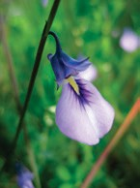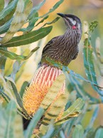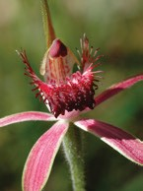

Photo: (from left) Native violet (*Hybanthus calycinus*) is common across the range of Banksia woodlands and unlike most violet relatives is a small sub-shrub (Copyright K Dixon). Wattle birds are aggressive defenders of the nectar sources in Banksia Woodlands and will actively defend nectar resources, sometimes to the detriment of other honey eater species (Copyright B Knott). Carousel spider orchid (*Caladenia arenicola*) is found through Banksia Woodlands and with its specialist sexually deceptive system of pollination requires high quality woodlands to ensure pollinator presence (Copyright K Dixon).

## National ecological communities

Australia’s national environment law, the EPBC Act, provides a legal framework to protect and manage Matters of National Environmental Significance (MNES), which include nationally threatened species and ecological communities.

The EPBC Act defines an ecological community as an assemblage of native species which inhabits a

particular area in nature. In other words, ecological communities are groups of native plants, animals and other organisms that naturally occur together

and interact in a unique habitat. They include forests, grasslands, shrublands, wetlands, woodlands, ground springs, cave and marine communities.

The native plants and animals in an ecological community have different roles and relationships that, together, contribute to a healthy functioning natural environment.

Listed ecological communities may become extinct, through loss of extent, loss of characteristic species, and/or loss of natural function, unless threats are removed or better managed. However, remnants retain important natural values and have the potential to provide more habitat and ecosystem services, if threats are eliminated or managed to reduce their impacts, and the natural composition and function of the ecological communities are restored.

Protecting ecological communities also protects ecosystem services such as clean air, healthy soils and water. These benefit people and society both within and beyond the local area and are essential to the greater productivity of our land and water.

National (EPBC Act) protection complements other conservation measures and is particularly vital for ecological communities such as the Banksia Woodlands, as only a low proportion of remnants are protected in conservation reserves.

## What is the Banksia Woodlands ecological community?

The ecological community is a woodland associated with the Swan Coastal Plain (and some adjacent areas) of southwest Western Australia. It typically has a prominent tree layer of *Banksia* sometimes with scattered eucalypts and other tree species present within or above the Banksia canopy. The understorey is species rich and has many wildflowers, including sclerophyllous shrubs, sedges and herbs.

The ecological community can be identified by these general features:

* It typically occurs on well drained, low nutrient soils in sands of dune landforms, in particular deep Bassendean and Spearwood sands, or occasionally on Quindalup sands. It is also common on

sandy colluvium and aeolian (wind-blown) sands of the Ridge Hill Shelf, Whicher Scarp and Dandaragan Plateau.

* Banksia Woodlands vary in their structure (height, cover, density) and species composition across

the region where they occur. These variations can occur over small distances, but the woodlands are united by having a generally dominant Banksia component, which includes at least one of four key species—*Banksia attenuata* (candlestick banksia),

1. *menziesii* (firewood banksia), *B. prionotes* (acorn banksia) and/or *B. ilicifolia* (holly-leaved banksia).

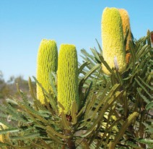

Photo: *Banksia attenuata* or candle Banksia is a dominant, summer flowering tree of woodland communities across their range (Copyright K Dixon)

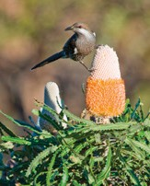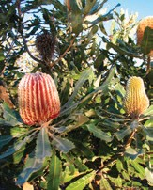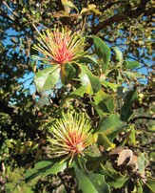

Photo: (from left) Honey-eaters depend upon the abundant nectar resources and seasonal flowering of *Banksia* species in the woodland communities—with flowering in *Banksia prionotes* (acorn Banksia) providing important food in the sparse autumn flowering period (Copyright B Knott). A flagship species of Banksia Woodlands is

*Banksia menziesii* or firewood Banksia, so-called as it was a favoured wood for burning by settlers (Copyright K Dixon). *Banksia ilicifolia* is a key ‘nectar-bridging’ species for many nectar feeding birds and honey possums in Banksia woodland. The species is however highly sensitive to depletion of the water table through water extraction. (Copyright Department of the Environment and Energy).

*Banksia littoralis* (swamp banksia) and *B. burdettii* (Burdett’s banksia) may be co-dominant in some areas, but where they become dominant, they typically form other communities and are not considered the Banksia Woodlands of the Swan Coastal Plain ecological community.

* + Other trees of a medium height that may be present, and may be co-dominant with the *Banksia* species across a patch, include *Eucalyptus todtiana* (blackbutt, pricklybark), *Nuytsia floribunda* (Western Australian Christmas tree), *Allocasuarina fraseriana* (western sheoak), *Callitris arenaria* (sandplain cypress), *Callitris pyramidalis* (swamp cypress) and *Xylomelum occidentale* (woody pear).
  + Emergent taller trees that can occur above the *Banksia* canopy may include *Corymbia calophylla* (marri), *Eucalyptus gomphocephala* (tuart) and

*E*. *marginata* (jarrah).

* + Key species in the sclerophyllous shrub layer include members of the families Asteraceae, Dilleniaceae, Ericaceae, Fabaceae, Myrtaceae and Proteaceae. Widespread species include

*Adenanthos cygnorum* (woolly bush), *Allocasuarina humilis* (dwarf sheoak), *Bossiaea eriocarpa* (common brown pea), *Conostephium pendulum* (pearl flower), *Daviesia* spp., *Eremaea pauciflora*, *Gompholobium tomentosum* (hairy yellow pea),

*Hibbertia hypericoides* (yellow buttercups), *Hypolaena exsulca*, *Jacksonia* spp., *Kunzea glabrescens*, *Petrophile linearis* (pixie mops), *Phlebocarya ciliata*, *Philotheca spicata* (pepper and salt), *Stirlingia latifolia* (blueboy) and *Xanthorrhoea preissii* (balga, grass tree).

* Key species in the herbaceous ground layer include members of the families Cyperaceae, Droseraceae, Haemodoraceae, Orchidaceae, Restionaceae and “lilies” from various families. Widespread species include *Amphipogon turbinatus* (tufted beard grass), *Burchardia congesta* (milkmaids), *Caladenia* spp. (spider orchids), *Dasypogon bromeliifolius* (pineapple bush), *Desmocladus flexuosus*, *Drosera erythrorhiza* (red ink sun dew), *Lepidosperma squamatum*

(a tufted sedge), *Lomandra hermaphrodita*, *Lyginia barbata* (southern rush), *Lyginia imberbis*, *Mesomelaena pseudostygia* (semaphore sedge), *Patersonia occidentalis* (purple flag), *Podolepis* spp., *Stylidium brunonianum* (pink fountain trigger plant), *Stylidium piliferum* (common butterfly trigger plant), *Trachymene pilosa* (dwarf

parsnip), and *Xanthosia huegelii* (heath xanthosia). The development of a ground layer may vary depending on the density of the shrub layer and disturbance history.

## Why is the Banksia Woodlands ecological community important?

The Banksia Woodlands ecological community only occurs on or adjacent to the Swan Coastal Plain of Western Australia, which stretches to the north and south of Perth. The broader region—Southwest Australia—is recognised as one of only two global biodiversity hotspots in Australia.

The ecological community provides habitat for many native plants and animals that rely on Banksia Woodlands for their homes and food. Remaining patches of the ecological community provide important wildlife corridors and refuges in a mostly fragmented landscape.

Since the 19th century, the region has been heavily cleared for agriculture, housing and associated infrastructure. In total, about 60% of the original extent of the ecological community has been cleared.

When native vegetation is cleared, habitat which was once continuous becomes divided into smaller separate fragments. This makes it harder for animals

to roam or migrate and for plants to disperse. Many fragments of the ecological community are small islands—isolated from each other by roads, houses and other developments.

The remaining patches of the ecological community are typically small over much of its range but especially around Perth. Small sizes make remnants more vulnerable to disturbances such as invasion by weeds or feral animals. The separation between the patches also causes problems for ecological processes that support the health of the ecological community, for example, the transfer of pollen and seed across its range. This

can interfere with the regeneration of the ecological community. Many fauna are also unable to cross gaps between patches of suitable habitat, or may face hazards in doing so, for example, birds, mammals and reptiles are lost from areas where there is not enough native vegetation nearby. The small populations held within patches are also vulnerable to local extinction.

Opportunities exist for improving connectivity between patches (e.g. through replanting and restoration activities), to improve habitat availability for other species and ecological functioning of the Banksia Woodlands and other native vegetation.

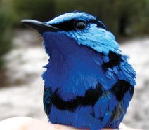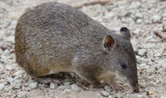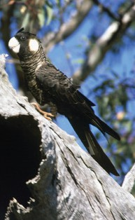

Photo: (clockwise) Splendid fairy wren (*Malurus splendens*) (Copyright Rob Davis). Carnaby’s cockatoo (*Calyptorhynchus latirostris*) (Copyright Brian Furby). Quenda (*Isoodon obesulus*) (Copyright Ken Glasson).

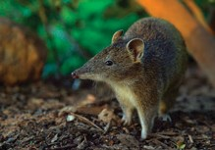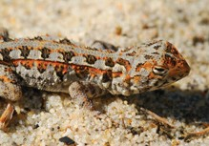

Photo: (from left) Quenda (*Isoodon obesulus*) (Copyright Simon Cherriman). Western heath dragon (*Ctenophorus adelaidensis*) (Copyright Department of Parks and Wildlife, WA).

Many animal species found in the ecological community also benefit from other native vegetation across the landscape. The greater effective area of habitat supports larger populations of many species, and greater total diversity. Landscape connections may also allow better recovery of populations to disturbances such as fire, if burnt patches can be easily re-colonised. Even small remnants of Banksia Woodlands within urban areas can retain high floral diversity and be important “stepping stones” or pollination/dispersal routes between larger native vegetation remnants.

The ecological community includes valuable habitat features, such as nectar producing Banksia trees.

These food sources are important for mammals and birds. At least 20 nationally-threatened animal and plant species are present, including *Dasyurus geoffroii* (chuditch, western quoll), *Calyptorhynchus latirostris* (Carnaby’s cockatoo),

*Calyptorhynchus banksii naso* (forest red-tailed black cockatoo), native bees, *Banksia aurantia* (orange dryandra), *Caladenia huegelii* (king spider-orchid), *Drakaea elastica* (glossy-leafed hammer orchid), and *Drakaea micrantha* (dwarf hammer orchid).

The ecological community also contributes toward the area’s air and water quality and helps protect soils from erosion. The woodlands help cool temperatures in the surrounding region; store carbon; filter and maintain aquifers, including those supplying drinking water

for Perth; mitigate local flooding, damaging winds, soil loss, and pollution; and, provide amenity and recreation such as scenic areas for bushwalking.

The ecological community is of great significance to many locals, including the original inhabitants of the area, the Noongar people, and their language groups.

It is important to help prevent further decline by promoting recovery through government, landholder and community efforts. Listing this ecological community protects it from future damage and creates opportunities for its management and restoration.

## Where does the Banksia Woodlands ecological community occur?

The Banksia Woodlands ecological community is restricted to areas in and immediately adjacent to the Swan Coastal Plain IBRA bioregion (Interim

Biogeographic Regionalisation of Australia), including the Dandaragan plateau. This coastal plain stretches from around Jurien Bay in the north, to Dunsborough in the south, with adjacent areas including the lower Whicher and Darling escarpments.

The Banksia Woodlands are the most prominent type of bushland around Perth and the surrounding area. They once formed an almost continuous band with a median (most common) patch size estimated at 146 hectares. They are now heavily fragmented, with a median patch size estimated at 1.6 hectares.

The number of patches has been divided from around 132 into over 12,000 patches.

This map is available at: [**www.environment.gov.au/**](http://www.environment.gov.au/biodiversity/threatened/communities/pubs/131-indicative-distribution-map.pdf) [**biodiversity/threatened/communities/pubs/131-ind**](http://www.environment.gov.au/biodiversity/threatened/communities/pubs/131-indicative-distribution-map.pdf) [**icative-distribution-map.pdf**](http://www.environment.gov.au/biodiversity/threatened/communities/pubs/131-indicative-distribution-map.pdf)

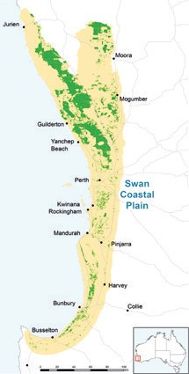

This map represents the indicative present distribution of the Banksia Woodlands ecological community.

Some mapping units represent vegetation mosaics, and are not necessarily entirely the Banksia Woodlands ecological community. At this resolution and scale many of data points blend together to give an artificial impression of larger intact areas than actually remain. In addition, when the quality of the vegetation is taken into account, the areas of protected ecological community will be fewer and even smaller. Therefore the likely to occur areas on the map overestimate

how much of the ecological community remains. Ground-truthing (e.g. an on-ground survey) is required to verify if a particular site meets the required key diagnostic characteristics and minimum condition thresholds to be the described ecological community.

Minimum condition thresholds help determine when a patch is considered too degraded to be protected as a ‘matter of national environmental significance’ under the EPBC Act, see Are all patches protected under the EPBC Act listing?



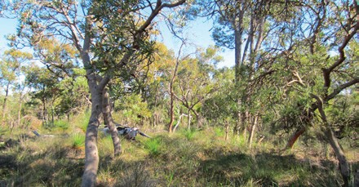

Photo: Banksia Woodlands, Cardup Nature Reserve (Copyright Department of the Environment and Energy).

## Why does the ecological community need national protection?

In September 2016, the Australian Government Minister for the Environment and Energy listed the Banksia Woodlands ecological community after considering the advice of the Threatened Species Scientific Committee. A rigorous assessment of the scientific evidence supported listing as endangered as it met the eligibility criteria under national environment law.

The Committee found that:

* + the ecological community has undergone a decline of about 60 per cent in its extent
  + almost all of the ecological community that remains, occurs as highly fragmented patches less than 10 ha in size. It is estimated that over 12 000 patches now exist, compared to

132 previously, with the median (most common) patch size now being only 1.6 hectares.

* it has experienced a severe reduction in its community integrity due to the combined effects of substantial clearing and fragmentation, dieback diseases (e.g. *Phytophthora* root rot fungal disease), invasive weeds and feral animals, changes to fire regimes, hydrological degradation (including changes to groundwater levels), climate change, and other disturbances to remaining patches.

This has lead to direct loss of populations of native species in many parts of the range, and associated loss of key habitat features such as mature trees and their food resources; reduced capacity to support fauna with loss of some faunal species’ key ecological functions (e.g. pollination) already occurring; and, reduced resilience to future disturbance.

The overall aim of nationally listing the ecological community is to prevent further decline and support on-ground efforts to ensure its long-term survival.

The Conservation Advice for the ecological community outlines a range of priority research and management actions that provide guidance on how to manage, restore and protect it. This Conservation Advice can be found on the Department’s website:

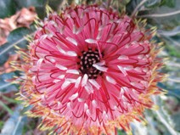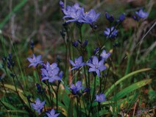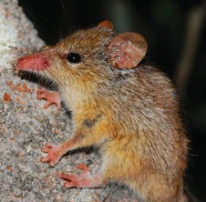

[www.environment.gov.au/biodiversity/threatened/](http://www.environment.gov.au/biodiversity/threatened/communities/pubs/131-conservation-advice.pdf)

[communities/pubs/131-conservation-advice.pdf](http://www.environment.gov.au/biodiversity/threatened/communities/pubs/131-conservation-advice.pdf)

Photo: (clockwise) *Banksia menziesii* (Copyright Department of the

Environment and Energy). Honey possum (*Tarsipes rostratus*) in woolly bush (Copyright Department of Parks and Wildlife, WA). Blue squill (*Chamaescilla corymbosa*) is a small and delicate geophytic lily that flowers in late winter to early spring and requires intact, non-weedy woodlands (Copyright K Dixon).

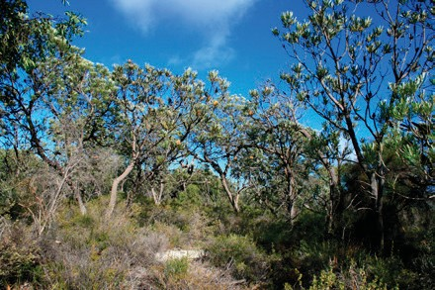

Photo: Healthy banksia woodland: Note the dominant layer of Banksia trees over a native understorey of diverse shrubs and herbs (Copyright: Rob Davis)

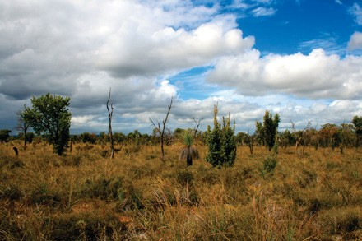

Photo: Degraded Banksia Woodland: Some Banksia Woodlands have been infected by dieback for over 50 years, and have lost the tree canopy layer with most understorey shrubs species lost. Only native sedges (Cyperaceae) and rushes (Restionaceae) survive dieback disease however these wind pollinated species provide few pollen and no nectar resources (Copyright: Rob Davis)

## Are all patches protected under the EPBC Act listing?

No; national listings of ecological communities specify condition thresholds that help to identify patches

that are too degraded for the purposes of protection under national environment law. This allows national protection to focus on the best and most intact patches that remain of a listed ecological community.

### Condition thresholds

The condition thresholds mean that small and degraded patches—such as remnants where the understorey has been largely replaced by weeds—are excluded from a listed ecological community and any actions do not need to be considered under the EPBC Act.

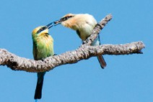

Photo: Seasonal visitors to Banksia Woodlands include the rainbow bee-eater that depends upon predator free areas and bare sand for supporting its ground nesting behaviour (Copyright B Knott)

A patch should first be identified as being the ecological community using the diagnostic features listed in the [**Conservation Advice**](http://www.environment.gov.au/biodiversity/threatened/communities/pubs/131-conservation-advice.pdf)document on the Department’s website. The condition thresholds are applied—the Banksia Woodlands ecological community is only protected under national environment law when it remains in relatively good condition. The Keighery vegetation condition scale, which is widely used in southwestern WA, is used to help determine condition of a patch. The listed ecological community is comprised of all ‘Pristine’ condition patches, ‘Excellent’ condition patches greater than 0.5 ha, ‘Very Good’ condition patches over 1 ha, and ‘Good’ condition patches

over 2 ha.

Although not part of the protected ecological community listed under the EPBC Act, it is recognised that patches which do not meet the minimum condition thresholds for ‘Good’ quality, or higher, may still retain important natural values; particularly if they are near patches which do meet the minimum condition thresholds. As such, these patches

should not be excluded from recovery and other management actions.

For further details of how to determine whether a patch of vegetation meets the definition and condition thresholds for the national ecological community

see the Conservation Advice at: [www.environment.](http://www.environment.gov.au/biodiversity/threatened/communities/pubs/131-conservation-advice.pdf)  [gov.au/biodiversity/threatened/communities/](http://www.environment.gov.au/biodiversity/threatened/communities/pubs/131-conservation-advice.pdf)  [pubs/131-conservation-advice.pdf](http://www.environment.gov.au/biodiversity/threatened/communities/pubs/131-conservation-advice.pdf)

## What are the benefits of listing the ecological community as nationally threatened?

There are a number of benefits of listing ecological communities under Australia’s national environment law:

* It can help to protect the ecological connections essential for the ecological function, health and biodiversity of the region’s landscapes. It can protect habitat resources critical for refuge and recruitment of the native species of the region, including threatened species, other species under local pressure and species important for ecosystem function. In turn, this helps foster the ecosystem services associated with the ecological community.
* It helps protect ecological communities from future significant human impacts causing further decline. The aim of the national environment law is to ensure the matters of national environmental significance are given due consideration, along with broader economic, social and other issues in the planning of any large projects. Where possible, significant adverse impacts to the environment should be avoided. If the impacts are unavoidable, they must be mitigated, reduced or, as a last resort, offset.

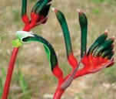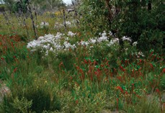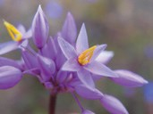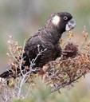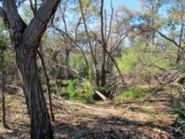

Photo: (top row, from left) The State floral emblem for WA, the red and green kangaroo paw (*Anigozanthos manglesii*) is also a common though declining species in Perth’s Banksia Woodlands and an important nectar resource for honey eater species (Copyright K Dixon). Vanilla lily (*Sowerbaea laxiflora*) is a common low growing herb through woodlands (Copyright K Dixon). Carnaby’s cockatoo feeds upon canopy stored seed in a number of Banksia species in the woodland community, seen here on *B. sessilis* (Copyright B Knott); (bottom row, from left) After a summer fire, Banksia Woodlands burst into bloom with resprouting flowering on smoke bush (*Conospermum stoechadis*), with smoke from the fire stimulating germination and flowering in red and green kangaroo paws (*Anigozanthos manglesii*) (Copyright K Dixon). Banksia Woodlands, Lowlands is an excellent example of privately owned and managed woodland that has a mixture of wet inter-woodland damplands and upland woodland in outstanding condition (Copyright Department of the Environment and Energy).

* + It encourages agencies and community groups to apply for funding opportunities for conservation and recovery works that will address threats to the ecological community. The Australian Government has a variety of funding programmes to assist

land managers to conserve biodiversity and ecosystem services.

* + A [**Conservation Advice**](http://www.environment.gov.au/biodiversity/threatened/communities/pubs/131-conservation-advice.pdf), published at the time of listing, provides guidance for environmental decision-making, including priority research,

conservation management and restoration actions.

* + In the case of the Banksia Woodlands ecological community, the listing will:
    - provide landscape-scale protection that complements existing national and state protection for both threatened species that are found within the ecological community and nearby threatened ecological communities.
    - protect the environmental values, including the ecosystem functions and services associated

with the ecological community, contributing to the long-term productivity of the landscape

* + - raise awareness about the ecological community and the threats it faces.

## What does the listing mean for landholders?

### Business as usual for most routine activities

It is important to note that the EPBC Act is only triggered if a particular activity has, or will have, a significant impact on a Matter of National Environmental Significance— in this instance,

a listed nationally threatened ecological community.

The normal activities of individual landholders, residents and councils will typically not be affected by a listing. Routine property maintenance and other established practices such as most farming activities and ongoing road maintenance works—particularly if carried out in line with state laws covering native vegetation—are unlikely to have a significant impact and so do not typically require referral or other consideration under national environment law.

For instance, the following actions are unlikely to trigger the EPBC Act:

* continuation of grazing, horticultural or cropping activities
* maintenance of existing roads, fences, access tracks and firebreaks
* maintenance of existing farm gardens, orchards, dams or water storages
* maintenance of existing pumps and clearing drainage lines
* replacement and maintenance of sheds, other buildings, yards and fences
* control of weeds and management of pest animals on individual properties or roadside verges.

In all these cases, landholders are encouraged to avoid any impacts on patches of the ecological community where possible and to help restore remnants.

Please note that human settlements and infrastructure where the ecological community formerly occurred do not form part of the natural environment and are therefore not considered to be part of the protected ecological community. This also applies to sites that have been replaced by crops and exotic pastures,

or where the ecological community exists in a

highly-degraded or unnatural state. The Conservation Advice explains the definition of patches as well as the condition thresholds that apply to national protection of the ecological community.

Fire management activities should seek to minimise impacts to the ecological community. Fires must be managed to ensure that where possible, prevailing fire regimes do not disrupt the life cycles of the component species of the ecological community

(including avoiding management burning in flowering and nesting seasons, wherever possible), that they support rather than degrade the habitat necessary to the ecological community, that they do not promote invasion of exotic species, and that they do not increase impacts of other disturbances such as grazing or predation by feral predators.

Activities with EPBC Act approval prior to the listing of this ecological community, do not need to seek further approval.

### Referral required for actions likely to have a significant impact

The EPBC Act is triggered if an action is likely to have a significant impact on the Banksia Woodlands ecological community. If a proposed action would have such an impact, it would require:

* a referral to determine whether the action is likely to have a significant impact on the ecological community
* assessment (the scope of the assessment depends on the complexity of the proposed action

and impacts)

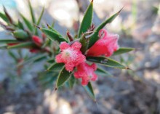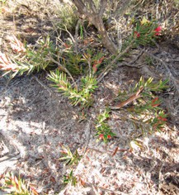

**The likelihood that an action will have a significant**

**impact on the ecological community depends on local conditions, the quality of the patch, and upon the intensity, duration, magnitude and geographic extent of the impacts.**

Photo: *Astroloma stomarrhena* (red swamp cranberry) one of a suite of Ericaceae (native blueberry family) species that are fundamental nectar and pollen providers for native invertebrates during later autumn and winter when flowering plants are scarce. The family is particularly sensitive to habitat changes including winter/spring burning (Copyright Department of the Environment and Energy).

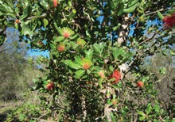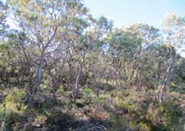

Photo: (from left) *Banksia ilicifolia* (matchstick Banksia) (Copyright Department of the Environment and Energy). Banksia Woodlands, Bullsbrook Nature Reserve is representative of woodland developed on Bassendean sands (Copyright Department of the Environment and Energy).

* + a decision by the Minister on approval and conditions. Through the EPBC Act approvals process, the Minister may also consider social and economic matters relevant to individual

projects that may have a significant impact on the ecological community.

* + Strict timeframes apply to assessments to ensure decisions are made as quickly as possible.

The key diagnostics and condition thresholds for the ecological community exclude many patches on properties or along roadside verges that are

considered too degraded for protection. In addition, the EPBC Act provides exemptions for continuing (routine) use or where legal permission has previously been given.

The activity that is likely to have a significant impact on the ecological community is clearing large or otherwise important areas of intact or high-quality native vegetation. For example:

* + mining, residential, commercial or other industrial development
  + construction of new roads or projects to widen existing roads
  + conversion of large areas into new pastures or cropping fields.

To help reduce the significance of actions and referral under the EPBC Act, avoidance and mitigation to reduce clearing and associated impacts is needed in the early planning stage.

Further guidance on the information required to help determine significant impact is available on the Department’s website (see Where can I get further information?).

## How have the Banksia Woodlands been taken into account in the Perth and Peel Strategic Assessment?

In 2011 the Australian Government and Western Australian Government decided to undertake a Strategic Assessment of the Perth and Peel region under the EPBC Act, corresponding with the Western Australian Government’s draft “Perth and Peel Green Growth Plan for 3.5 million” released in 2015–16.

The strategic assessment is aimed at determining at a regional scale areas to be protected from development and areas where sustainable development can occur, the type of development that will be allowed and the conditions under which development may proceed.

The Banksia Woodlands ecological community was included as a potential Matter of National Environmental Significance in the draft Impact Assessment Report by the WA Government, which was available for public comment from December 2015 to May 2016. As at December

2016, submissions received are being considered by the State Government as part of the preparation of the final documents. Further information can be found at: [https://www.dpc.wa.gov.au/Consultation/](https://www.dpc.wa.gov.au/Consultation/StrategicAssessment/Pages/Default.aspx)  [StrategicAssessment/Pages/Default.aspx](https://www.dpc.wa.gov.au/Consultation/StrategicAssessment/Pages/Default.aspx)

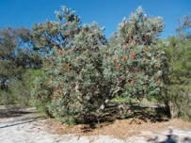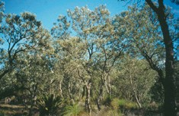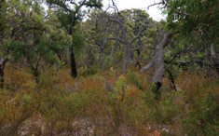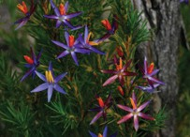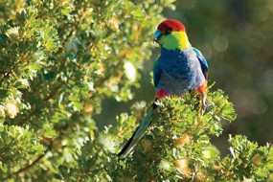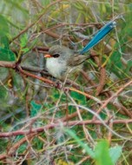

Photo: (top row, from left) *Banksia menziesii* as young trees before developing the more typical tree form (Copyright Department of the Environment and Energy). Long term unburnt Banksia Woodlands can maintain species richness and structure for long periods without fire—this woodland is 40 years without fire and exhibits healthy trees and a vibrant understorey (Copyright K Dixon). (middle row, from left) Blue tinsel lily or Star of Bethlehem (*Calectasia narragara*), is winter flowering and widespread through woodland communities (Copyright K Dixon). Typical Banksia Woodlands north of Perth showing various age structures in trees, dead trees that provide important foraging habitat for animals and regrowth following a fire three years earlier (Copyright K Dixon). (bottom row, from left) Red capped parrot (*Purpureicephalus spurius*) feeding on *Banksia sessilis* (Copyright B Knott). Splendid wrens (*Malurus splendens*) occur in many parts of Banksia Woodlands (Copyright B Knott).

## What can I do to look after the ecological community?

To support the health and function of the ecological community it is important to protect, manage and restore native vegetation across the landscape. This is because many of the ecological functions supporting the ecological community occur at a larger scale,

or require populations of plants and animals to interact across the various remnants of vegetation. For example, transfer of seeds and pollen between remnants protects the health of plant populations by promoting genetic diversity and greater resilience to pests, diseases and other threats such as climate change.

You can protect and promote the recovery of bush remnants in your area. You can:

* + avoid further clearance and fragmentation of the ecological community and surrounding native vegetation, with high-quality and relatively unmodified areas being particularly important
  + minimise unavoidable impacts from any developments or other activities adjacent to the ecological community that might result in

further degradation—for example, by applying a minimum 30 m buffer zone around patches of the ecological community and avoiding hydrological and nutrient enrichment impacts

* + plant local native plants that occur in local threatened ecological communities
  + remove non-native species from your property and don’t plant or spread potential environmental weeds (e.g. avoid non-native grasses; check with your local authority)
  + avoid fertilisers in or near bush remnants
  + practise recommended hygiene procedures to avoid the spread of dieback diseases (e.g. *Phytophthora*)
  + walk, ride or drive on established roads and paths, avoiding the removal or trampling of plants
* report illegal or damaging behaviour (e.g. unauthorised fires or dumping) to appropriate authorities
* support local efforts to conserve native vegetation and wildlife in your area (e.g. by joining or establishing a local organisation such as a Landcare or catchment care group, natural history or a ‘friends of ’ group; learn about the ecological community, and participate in activities such as tree planting and weeding)
* contact your local NRM Region body or Catchment Council for support in bush management activities.

The Conservation Advice gives further details of priority conservation actions for the ecological community. This can be found on the Department’s website: [www.environment.gov.au/cgi-bin/sprat/](http://www.environment.gov.au/cgi-bin/sprat/public/publiclookupcommunities.pl)  [public/publiclookupcommunities.pl](http://www.environment.gov.au/cgi-bin/sprat/public/publiclookupcommunities.pl)

## Do state or local environment laws also apply?

Yes, however such state and local laws do not replace or stop the operation of the national environment law. Information about state-listed communities and vegetation management laws are available from these Western Australian agencies:

* WA Department of Environment Regulation: [https://www.der.wa.gov.au/our-work/](https://www.der.wa.gov.au/our-work/clearing-permits) [clearing-permits](https://www.der.wa.gov.au/our-work/clearing-permits)
* WA Department of Parks and Wildlife: [https://www.dpaw.wa.gov.au/plants-and-animals/](https://www.dpaw.wa.gov.au/plants-and-animals/threatened-species-and-communities) [threatened-species-and-communities](https://www.dpaw.wa.gov.au/plants-and-animals/threatened-species-and-communities)
* WA Regional NRM groups
* Northern Agricultural Catchments Council
* Perth Region NRM
* Peel Harvey Catchment Council
* South West Catchments Council

## Where can I get further information?

The Conservation Advice for the Banksia Woodlands ecological community is the definitive source

of information on the listing of this ecological community. This, and additional information on the EPBC Act is available on the Department’s website:

* + A comprehensive Conservation Advice for the ecological community is on the Department’s species profile and threats

(SPRAT) database, at: [www.environment.gov.au/](http://www.environment.gov.au/) cgi-bin/sprat/public/publicshowcommunity. pl?id=131&status=Endangered

* + EPBC listing process: [www.environment.gov.au/epbc/what-is-protected/](http://www.environment.gov.au/epbc/what-is-protected/threatened-species-ecological-communities)  [threatened-species-ecological-communities](http://www.environment.gov.au/epbc/what-is-protected/threatened-species-ecological-communities)
  + EPBC referral, assessment and approval process (including Significant Impact Guidelines): [www.environment.gov.au/protection/](http://www.environment.gov.au/protection/environment-assessments)  [environment-assessments](http://www.environment.gov.au/protection/environment-assessments)
  + EPBC Act environmental offsets policy: [https://www](http://www.environment.gov.au/epbc/).envir[onment.go](http://www.environment.gov.au/epbc/)v[.au/epbc/](http://www.environment.gov.au/epbc/) publications/epbc-act-environmental-offsets-policy
  + Australian Government natural resource management initiatives: [www.nrm.gov.au](http://www.nrm.gov.au/)

Enquiries can also be made through the Department’s Community Information Unit by phone on **1800 803 772** (freecall), or email at [**ciu@environment.gov.au**](mailto:ciu@environment.gov.au)

If you need help to identify if Matters of National Environmental Significance may be present in your area of interest:

* Check the protected matters search tool at: [www.environment.gov.au/epbc/pmst/](http://www.environment.gov.au/epbc/pmst/)
* Check the species profile and threats (SPRAT) database at : [www.environment.gov.au/cgi-bin/](http://www.environment.gov.au/cgi-bin/sprat/public/sprat.pl)  [sprat/public/sprat.pl](http://www.environment.gov.au/cgi-bin/sprat/public/sprat.pl)
* Consult with relevant experts, such as an ecological consultant or local NRM agency (e.g. catchment group). They may be useful to help identify the ecological community and its condition, or
* Contact the Department’s Community Information Unit, by phone on

**1800 803 772** (freecall), or email to [ciu@environment.gov.au](mailto:ciu@environment.gov.au)

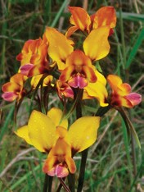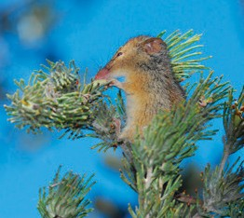

Photo: (from left) Orchids are surprisingly abundant and diverse through Banksia Woodlands, with the pansy orchid, *Diuris magnifica* having the largest and most colourful flowers of all of Australia’s donkey orchids (Copyright K Dixon). Honey possum (*Tarsipes rostratus*) in woolly bush (Copyright Department of Parks and Wildlife, WA).

19

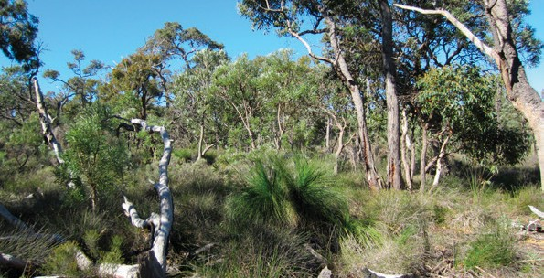

BIO573.1116

**environment**.gov.au