Barbarea australis

Flora Recovery Plan

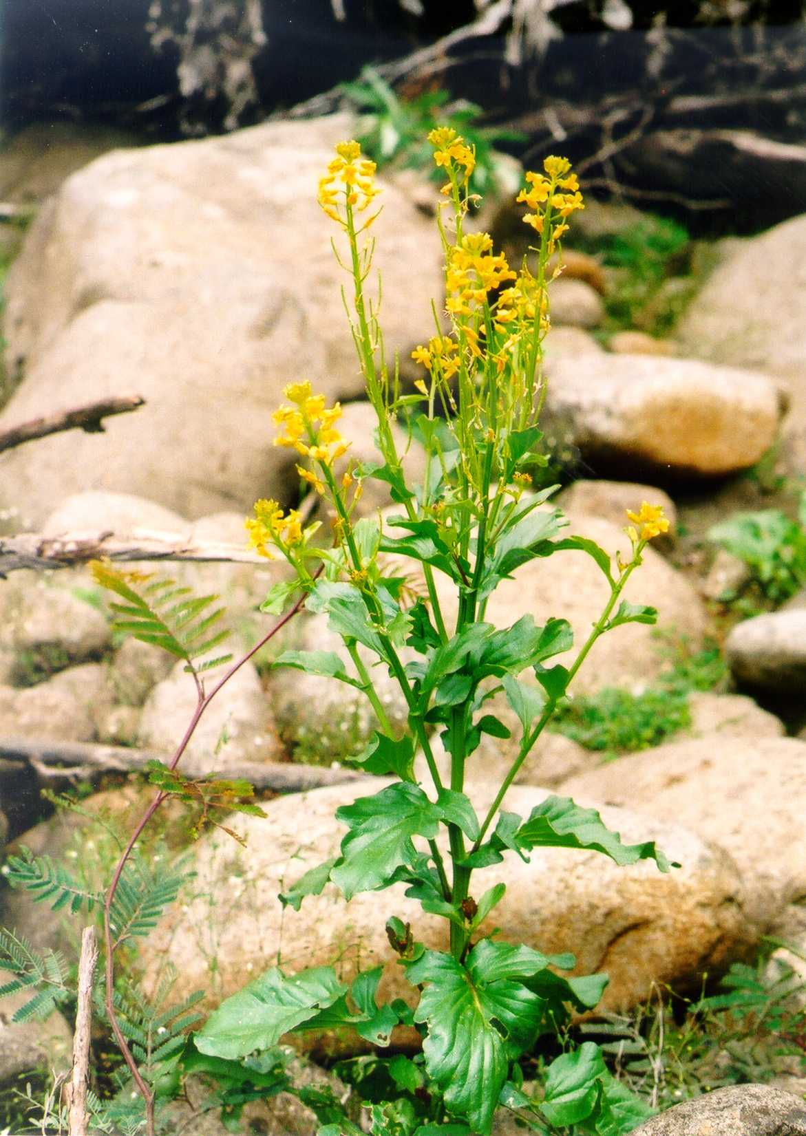

 | 

ACKNOWLEDGMENTS
This Plan was prepared by personnel with the Threatened Species Section, Resource Management and Conservation Division, Department of Primary Industries, Parks, Water and Environment, Hobart. The Plan draws upon previous Recovery Plans (Gilfedder 1994, Potts & Gilfedder 2000) and a Listing Statement (Threatened Species Unit 2001). The preparation of this Plan was funded by the Australian Government Department of Sustainability, Environment, Water, Population and Communities.

Cover Photo: Mick Ilowski

Citation: Threatened Species Section (2011). Barbarea australis Flora Recovery Plan, Department of Primary Industries, Parks, Water and Environment, Hobart.

© Threatened Species Section
This work is copyright. It may be produced for study, research or training purposes subject to an acknowledgment of the sources and no commercial usage or sale. Requests and enquires concerning reproduction and rights should be addressed to the Section Head, Threatened Species Section, Biodiversity Conservation Branch, Department of Primary Industries, Parks, Water and Environment, Hobart.

ISBN: 978-0-7246-6602-7 (web) 978-0-7246-6593-8 (book)

Abbreviations
DPIPWE Department of Primary Industries and Water (Tasmania)
DSEWPaC Department of Sustainability, Environment, Water, Population and Communities (Australian Government)
EPBC Act Commonwealth Environment Protection and Biodiversity Conservation Act 1999
NC Act Tasmanian Nature Conservation Act 2002
NRM Natural Resource Management
RTBG Royal Tasmanian Botanical Gardens (DPIPWE)
TSP Act Tasmanian Threatened Species Protection Act 1995
TSS Threatened Species Section, Biodiversity Conservation Branch (DPIPWE)

Taxonomy follows Buchanan (2009) except where otherwise noted; common names are consistent with Wapstra et al. (2005).
CONTENTS

species information 1
Description and taxonomy 1
Life history and ecology 1
Distribution and habitat 2
Population estimate 3
Reservation status 4
Threats, limiting factors and management issues 4
Conservation status 6
Habitat critical to the survival of the species 6
Recovery 6
Existing conservation measures 6
Strategy for recovery and progress evaluation 7
Recovery objectives, performance criteria and actions needed 7
Recovery actions 8
1. Manage and protect subpopulations 8
2. Boost numbers in subpopulations 9
3. Verify new records and survey 9
4. Manage habitat 9
5. Monitor 10
6. Manage the species for the long term 10
Duration and cost 11
Management practices 11
International obligations 12
Affected interests and social and economic impacts 12
Roles and interests of indigenous people 13
Biodiversity benefits 13
BIBLIOGRAPHY 14

species information
Scientific name: Barbarea australis Hook.f., Fl. Nov.-Zel. 1: 14 (1852)
Common Name: native wintercress (Wapstra et al. 2005)
Group: vascular plant, dicotyledon, family Brassicaceae
Status: Threatened Species Protection Act 1995: endangered
Environment Protection and Biodiversity Conservation Act 1999: Critically Endangered
Distribution: Endemic status: Endemic to Tasmania
Tasmanian NRM Region: Cradle Coast, North, South

Description and taxonomy
Barbarea australis is an annual or short-lived perennial in the Brassicaceae family (Curtis & Morris 1975, Hewson 1982). It is an erect plant up to 50 to 100 cm high. The lower stem leaves are 8 to 10 cm long and form a basal rosette or radiating cluster. They are stalked, broader at the ends and develop 2 to 3 small lateral lobes on the leaf stalk below the main part of the leaf. The leaves on the upper stem are simple with wavy margins. The flowers are yellow with 2 to 8 mm long petals and the many seed capsules or pods are 20 to 40 mm long and 2 to 2.5 mm wide. The seeds are broad and oval, 1.5 mm long and have irregular edges or narrow wings.
Three species of Barbarea occur in Tasmania (Buchanan 2009), two of them being introductions from the northern hemisphere (Barbarea intermedia and Barbarea verna). The introduced Barbarea species can be distinguished from Barbarea australis by their deeply-divided upper stem leaves and by seeds that lack a defined edge and that are relatively rounded.
The Brassicaceae family has its greatest concentration of species in the temperate regions of the Northern Hemisphere (Hewson 1982). In Australia, the Brassicaceae are represented by 375 genera. There are two species of Barbarea endemic to Australia, Barbarea australis and Barbarea grayi, the latter being an alpine species in Victoria and New South Wales.
The Brassicaceae family is represented in Tasmanian by sixty-eight taxa (Buchanan 2009). Twenty-one of these are considered to be native to Tasmania, including two endemics (Barbarea australis and Cheesemania radicata). The Brassicaceae is a family with a relatively high concentration of rare and threatened plant species in Tasmania, with seven species listed on schedules of the TSP Act in 2009.

Life history and ecology
Barbarea australis is an annual or short lived perennial. The species appears to be a poor competitor, growing opportunistically in open areas but it is also occasionally found amongst vegetation on the river edge. Peak flowering occurs from November through to February (Kirkpatrick & Gilfedder 1998). It is a prolific seed producer and after disturbance such as flooding, hundreds of seedlings may emerge in the resultant gaps in winter and early spring, though few generally survive to maturity. Bare ground formed after disturbance such as flooding is generally required for recruitment. The species can also reproduce vegetatively, with a new plant growing from the base of an existing plant, extending the longevity of some plants in some patches. The species is known to be highly palatable to browsers, snails and insects.
In cultivation seed is readily germinated, requiring a relatively rich soil mix to develop through to flowering. Cultivated plants have been prone to infestation by root aphids.

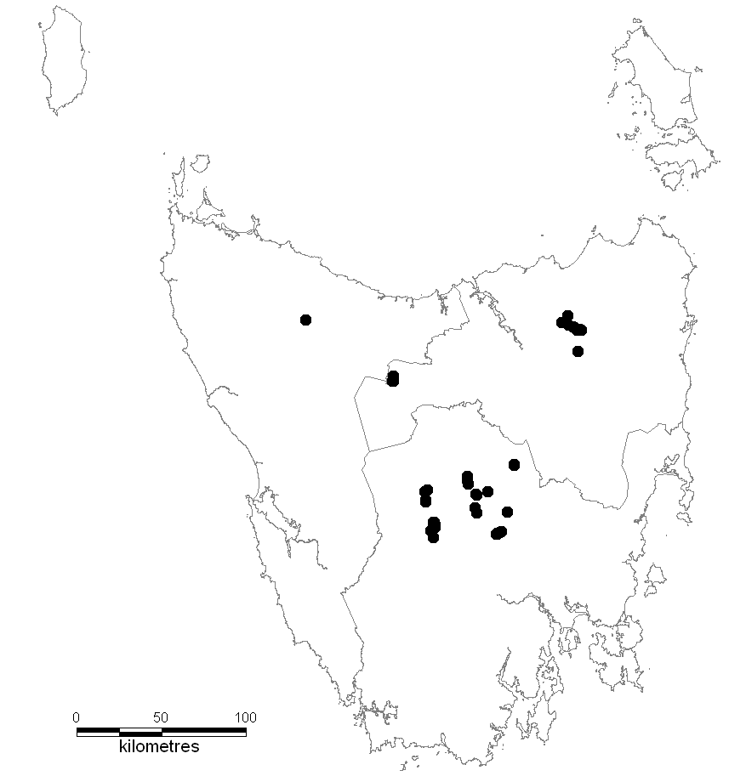

Figure 1. Distribution of Barbarea australis
● = extant sites; ‘presumed extinct’ sites (as per Table 1) not shown due to a lack of location details
(NRM regions: North, top right; Cradle Coast, top left; South, bottom.)

Distribution and habitat
Barbarea australis is endemic to Tasmania and is known from about 23 subpopulations in 10 rivers and creeks extending from northern Tasmania to rivers flowing south from the Central Highlands (see Figure 1 for general distribution). The species occurs in the Northern Slopes, Central Highlands, Southern Ranges, Ben Lomond and South East IBRA bioregions and all three Tasmanian NRM regions. Where it occurs it is usually sparse, with a few plants being scattered along a stretch of riverbank. There are only a few areas where dense patches persist. The number of individuals within subpopulations is highly variable between years. In total, the species occupies about 0.2 km².
Barbarea australis is a riparian species found in open areas near river margins, creek beds, and along flood channels adjacent to rivers. The species tends to occur along slower, shallower reaches, rather than on steep riverbanks. Plants occur in shallow alluvial silt deposited on rock slabs or rocky ledges, or between large exposed cobbles on sites frequently disturbed by fluvial processes. It is also occasionally found amongst vegetation on the river edge. Underlying geologies may be dolerite, basalt or granite. A number of the localities are associated with watercourses along contact zones between Permian mudstone and either dolerite or basalt.
Some of the known sites are a considerable distance from the river in flood channels on sites where channels had been scoured by previous flood action, exposing river pebbles. One site occurs on bare soil at the base of a cliff approximately 40 m from the river and 3 to 4 m above a secondary stream. Sites range in elevation from 260 to 700 m above sea level.
Barbarea australis is found at the margins of riparian scrub with Leptospermum lanigerum, Dodonaea viscosa and Pomaderris racemosa, and in forest communities dominated by Eucalyptus delegatensis, Eucalyptus dalrympleana, Eucalyptus pauciflora and Eucalyptus ovata. Adjacent sites often consist of tussock grassland or grassy woodland dominated by Poa labillardierei or Themeda triandra. At most sites the species grows in open rocky situations with little competition from other plants, although at some localities it grows amongst large Poa tussocks in relatively dense vegetation (Gilfedder 1994, Potts & Gilfedder 1999).

Population estimate
Barbarea australis was considered extinct until rediscovered in the 1980s. The close similarity of Barbarea australis with introduced Barbarea species may have caused it to be overlooked by collectors in the past. As well, the species is typically locally uncommon. With dedicated searches conducted during the implementation of preceding Recovery Plans (Gilfedder 1994, Potts & Gilfedder 2000), Barbarea australis is now known from about 23 subpopulations in 10 locations (defined as rivers or creeks). As the species is short-lived and recruitment is largely by seed, particularly following disturbance, numbers in subpopulations can fluctuate widely from year to year. However, the number of mature plants in subpopulations is typically low. About 850 mature individuals have been recorded to date, with approximately 115 individuals in the largest subpopulation along the upper reaches of the St Patricks River, and subpopulations with over 100 mature individuals known from the River Ouse near Waddamana, River Clyde and Nive River (Table 1). Some subpopulations have been monitored on an annual basis to determine how numbers fluctuate. The number of subpopulations is also likely to fluctuate according to suitability of local conditions, especially for those sites with low abundance.

Table 1. Population summary for Barbarea australis
 | Subpopulations | Tenure | NRM Region | 1:25000 mapsheet | Year last (first) seen | Area occupied (ha) | Number of mature plants
1 | River Clyde  (north of Bothwell) | Private land | South | Dennistoun | 1999 | 0.0003 | 3 (seedlings)
2 | River Clyde  (south of Falls of Clyde) | Private land | South | Cawood | 2007  (1994) | 0.011 | 111
3 | River Derwent  (north of Wayatinah Dam) | State Forest & Hydro Tasmania | South | Wayatinah | 2000 | 0.0001 | 1
4 | River Derwent  (north of Wayatinah Dam) | State Forest & Hydro Tasmania | South | Wayatinah | 2001 | 0.001 | 2
5 | Mersey River  (south of Lake Parangana) | Mersey River Forest Reserve, Mole Creek Karst National Park | South | Liena | 2002  (1997) | 0.006  (along 2.8 km of river) | 63 (1999)
6 | Micks Creek  (Silver Plains) | Private land | South | Penny | 1999  (1984) | 0.002 | 20
7 | Nive River  (Clarence Pipeline north of Liapootah Dam) | Private land & Hydro Tasmania | South | D’Arcys | 1999 | 0.0003 | 3
8 | Nive River  (west of Bradys Lake) | Wentworth Creek Forest Reserve & private land | South | D’Arcys | 1999  (1996) | 0.01  (over >1 km of river) | 104
9 | Nive River  (south of Liapootah Dam) | State Forest & Hydro Tasmania | South | Wayatinah,  Tarraleah | 2005  (1999) | 0.004  (over 3.5 km of river) | 50 (in 2001)
10 | North Esk River  (north of Blessington) | North Esk Forest Reserve | North | Ben Nevis | 2000 | 0.0002 | 2
11 | River Ouse  (north of Waddamana) | Private land | South | Waddamana | 1999 | 0.01 | 104
12 | River Ouse (Waddamana) | Private land & Crown land | South | Waddamana | 2005  (1982) | 0.002 | 23 (2001)
13 | River Ouse  (south of Waddamana) | Private land | South | Waddamana | 2009  2002  (1984) | 0.0005 | 6  60
14 | River Ouse  (near Shannon River) | Private land | South | Cluny | 2002  (1984) | 0.005 | 50
15 | River Ouse  (northwest of Carrot Hill) | Private land | South | Hermitage | 2002  (1984) | 0.0025 | 100
16 | Shannon River  (near Blackburn Creek) | Private land | South | Hermitage | 2002  (2001) | 0.0045 | seedlings
17 | Shannon River  (near Ouse River) | Private land | South | Cluny | 2002  (1984) | 0.005 | 50 (1991)
18 | Clarence River (near Nive River) | Hydro Tasmania | South | D’Arcys | 1986 | Unknown | Unknown
19 | St Patricks River  (Diddleum Plains) | River reserve & private land | North | Patersonia | 2000 | 0.0016 | 16 *
20 | St Patricks River  (Diddleum Plains) | River reserve | North | Maurice | 2000 | ? | ?
21 | St Patricks River  (Corkerys Road) | State Forest | North | Patersonia | 2000 | 0.0001 | 1
22 | St Patricks River  (upper reaches) | State Forest | North | Maurice | 2009  (2004) | ? | 115  11
23 | Hellyer River | River Reserve near Hellyer Gorge State Reserve | Cradle Coast | Parrawe | 2002 | 0.0001 | 1
24 | Hampshire Hills | Private land | North-west | ? | 1837 | Presumed extinct
25 | Woolnorth | Private land | North-west | ? | 1835 | Presumed extinct
* numbers boosted to 100s at times by redistributing seed in situ, though numbers are curtailed by browsing (Chris Calverly, pers. comm.)

Reservation status
Barbarea australis is reserved within Mole Creek Karst National Park, Mersey River Forest Reserve and North Esk Forest Reserve. Some protection is also afforded by its occurrence in water and river reserves. None of these reserves are actively managed for the species.

Threats, limiting factors and management issues
Barbarea australis is a riparian species, and in consequence the most significant threat to its survival has been, and continues to be, changes in river flows. Many of the rivers in which the species occurs have been dammed for electricity production and irrigation, and are subject to regulated flows. The processes (flood flows) required to maintain habitat for the species are much rarer, and overall flows have also been reduced significantly. Dams may have an adverse impact on seed dispersal and availability of suitable habitat for recruitment, particularly if the frequency and intensity of flooding is reduced, leading to a reduction in the creation of bare ground favoured for recruitment. In the longer term, damming will also lead to a reduction in silt levels below the dam walls, thereby further reducing recruitment niches.
Habitat loss has also occurred through invasion by exotic plants, mainly willows (Salix species) and gorse (Ulex europaeus). These weeds pose a direct threat to Barbarea australis as they occupy areas of bare ground required for recruitment from seed. Willows also pose a significant indirect effect due to alterations of river channels and flows. Willow invasion results in the accumulation of woody debris, influencing stream and channel morphology, with increased siltation and sediment instability, and altered river flow. This in turn leads to reduced streambed scour, altered silt deposition rates, stream bank erosion, channel straightening and altered flooding regimes. This affects the availability of bare ground for recruitment and modifies seed dispersal patterns downstream. Willow removal may have adverse impacts due to the bank disturbance and channel modification that occurs following removal.
With the increase in agricultural activities following European settlement, Barbarea australis has suffered from increased grazing pressure from introduced herbivores such as sheep, cattle and rabbits. As more pasture has been created, the numbers of native browsers have also increased. As with many species of the Brassicaceae, the species is palatable to animals, as well as snails and insects. Despite the potential emergence of hundreds of seedlings following disturbance, high grazing pressure may prevent plants from setting seed. Established plants have been observed to have been so heavily browsed at some sites that seed production is unlikely, despite ongoing persistence of individuals. Grazing pressure is highest for subpopulations on private property where domestic stock can access riparian areas, e.g., subpopulations along the Ouse and Clyde Rivers.
Barbarea australis has suffered a significant loss of suitable habitat since European settlement. Habitat loss has been largely due to land clearance through early exploitation of accessible and relatively fertile ecosystems, including the riparian ecosystems, for agricultural purposes. Habitat loss is an ongoing threat, particularly as most occurrences are on private land.
Forestry activities are a potential threat to unreserved sites, either directly from physical impacts of operations or indirectly via alterations to flow regimes of adjacent rivers and streams. However, there are policy mechanisms in place within the Tasmanian forest industry to ensure that known subpopulations of threatened flora are managed in wood production forests (Orr & Gerrand 1998, Forest Practices Board 2000).
Whilst fencing to prevent stock access to the riparian strip can reduce grazing pressure, the habitat of Barbarea australis is in or beside rivers where flooding is likely, and so protection of plants from native browsers by caging or fencing is impractical. However, without some form of physical protection, there is a low likelihood for success of in-planting attempts. Brush coverings may be able to be used to afford some protection to germinants and boost seed production from established plants. This is preferable to the use of wire exclosures that would cause problems if dislodged by floods. The supplementation of subpopulations with nursery-grown plants or even seed produced ex situ runs the risk of introducing seed-borne disease or insect pests into natural subpopulations. Nursery grown plants easily become infected with aphids or root aphids and it is highly likely that seed-borne diseases of Brassica crops will also affect Barbarea australis. Attempts to supplement numbers are therefore best restricted to collection of seed produced in situ and dispersal into suitable recruitment niches in or near the same subpopulation. This will also prevent genetic contamination by introduction of material from other subpopulations.
Being a short-lived species, Barbarea australis is largely reliant on germination of seed for recruitment and persistence of subpopulations. It appears to require patches of bare ground for germination and is therefore reliant on gap producing disturbance such as flooding, growing opportunistically in newly created open areas. It also appears to be a poor competitor. As such, numbers of individuals can fluctuate widely from year to year though sizes of subpopulations are typically no more than 50 mature individuals, often much smaller, and it is likely that Barbarea australis has always been relatively locally uncommon. Such small subpopulations have an increased risk of becoming extinct through chance stochastic events.

Conservation status
Barbarea australis was listed as Critically Endangered under the EPBC Act in October 2001 under Criterion 2, because, ‘The geographic distribution of the species is precarious for the survival of the species and is restricted. The area of occupancy is 0.2 ha. The species is considered to be subject to extreme fluctuations in the number of mature individuals due to its annual or biennial lifecycle with high seed production and germination but varied survival rates. Continuing decline in the area, extent and quality of habitat, the number of populations and the number of mature individuals is projected due to grazing, agriculture and loss of habitat to weed species’. In view of the discovery of new locations in recent years, the status of Barbarea australis on the EPBC Act is currently under review as part of a Species Information Partnership (SIP) between the Australian and Tasmanian Governments.
Barbarea australis was listed as endangered on the commencement of the TSP Act in 1995. A change in status was not recommended when reviewed in 2008 because of the potential for habitat loss downstream of proposed dams.

Habitat critical to the survival of the species
Given the conservation status, fluctuating and small size of all subpopulations, all are considered critical to survival. Habitat critical to the survival of the species comprises all stretches of river or creek edge in which the species has been found including the area of occupancy of subpopulations and surrounding similar habitat suitable for the species, additional occurrences of similar habitat which could contain the species, and the local catchment for the surface and/or groundwater that maintains the habitat of the species. The location of the area of occupancy of most subpopulation is known though similar habitat and the local catchment have not been mapped.

Recovery

Existing conservation measures
Recovery actions undertaken as part of the previous Recovery Plan for Barbarea australis (Potts & Gilfedder 2000) have included:
- Transects were monitored along a number of significant rivers (Ouse, Nive, Mersey rivers) to assess population fluctuation over time. The study has shown that abundance in subpopulations is extremely variable over time.
- Management prescriptions and a decision-making support manual were written for land managers and authorities controlling areas that support Barbarea australis and were distributed to relevant agencies including the Hydro Electric Corporation, Forestry Tasmania, Forest Practices Authority, Department of Primary Industries and Water and Environment and the Tasmanian Parks and Wildlife Service.
- Numerous rivers have been surveyed to determine species presence and condition of subpopulations with observations recorded in the DPIPWE’s Natural Values Atlas.
- An identification guide has been completed and updated and a Listing Statement has been prepared and is freely available on the DPIPWE web site (Threatened Species Unit 2001).
- A management agreement has been signed with one landowner.
- Plants have been established as seed orchards for seed input into the wild at one site.
- Where individuals were found, active management was undertaken by placing tree branches over plants which offers protection from grazing, but does not damage the plants in flood events.
- Seed has been collected in situ and manually dispersed to several nearby sites along the St Patricks River successfully increasing the size of the subpopulation (see Table 1).
- Information on the species distributed by the Threatened Species Section has prompted new observations for the species by consultants and members of the public and the observations have been confirmed where necessary and observations recorded in the DPIPWE’s Natural Values Atlas.
- Seed has been collected for long term conservation storage at the Tasmanian Seed Conservation Centre.
- The status of Barbarea australis on the EPBC Act is currently under review for possible downlisting as part of a Species Information Partnership (SIP) between the Australian and Tasmanian Governments.
Actions recommended in the previous Recovery Plan for Barbarea australis (Potts & Gilfedder 2000) that have not been fully implemented are addressed below:
- The discovery of new subpopulations has reduced the need to reintroduce the species into 2 new sites.
- Supplementation by planting has proved difficult due to recurrent flooding and possible pest and disease introduction.
- The listing of ‘riparian scrub’, a vegetation community listed as threatened under the NC Act has reduced the need for co-ordination with Landcare groups regarding river care issues.
- The listing of ‘riparian scrub’, a vegetation community listed as threatened under the NC Act has reduced the need to pursue streamside reserves as the clearing of sites is regulated by the Forest Practices Authority, DPIPWE and local government.
- The priority for monitoring subpopulations in the recommended detail has decreased with the discovery of new locations and subpopulations.
- No subpopulations were identified that were considered feasible or a high priority for fencing to exclude stock.

Strategy for recovery and progress evaluation
The Barbarea australis Recovery Plan will run for five years and is based on strategies to manage and protect known subpopulations, increase plant numbers and to manage subpopulations in the long term. This will be achieved by improving security against a change in land use, protection from grazing, appropriate care of river systems, survey and monitoring, in situ seed translocation and provision for long term management.
This Plan has been prepared in consultation with various representatives of the Biodiversity Conservation Branch of the DPIPWE, and various experts. It incorporates management issues and strategies outlined in earlier Recovery Plans (Gilfedder 1994, Potts & Gilfedder 2000) and the Listing Statement (Threatened Species Unit 2001) and takes existing conservation measures into account.
The Threatened Species Section will guide implementation, monitoring and review of this Plan or parts thereof if funding is secured. Evaluation of the success or failure of the Recovery Plan can be measured against the performance criteria. A formal review within 5 years of adoption is required under the EPBC Act. Significant developments will be communicated to the general public through Listing Statement updates, websites, newsletters and reports.
This Plan is consistent with the aims of the Threatened Species Strategy for Tasmania (Parks & Wildlife Service 2000) and Tasmania’s Nature Conservation Strategy (Nature Conservation Branch 2002).

Recovery objectives, performance criteria and actions needed
The overall objective of the Recovery Plan is to reduce the extinction risk to Barbarea australis by protecting known subpopulations, increasing plant numbers and managing subpopulations and habitat.
Specific objectives are to:
- maintain or increase representation in catchments from which the species is known through protection of known subpopulations and survey,
- increase the number of mature individuals in at least one subpopulation to greater than 250 using translocation of seed into suitable recruitment niches and protection of germinants from browsing and other threats;
The performance criteria for achieving the objectives constitute a quantifiable decrease in the risk of extinction over 5 years of Recovery Plan implementation. They are:
- over the duration of the Plan, no decline in the area occupied by known subpopulations due to land clearance as defined by the EPBC Act (determined by monitoring in suitable years);
- survey completed of potential habitat in an additional creek or river each year and verification of any new records;
- the number of mature individuals increased to greater than 250 in at least one subpopulation by year 3;
The actions required for achieving the objectives are:
- manage and protect subpopulations;
- boost numbers in subpopulations;
- verify new records and survey;
- manage habitat;
- monitor;
- manage the species for the long term.

Recovery actions

1. Manage and protect subpopulations
Most subpopulations of Barbarea australis are on private land and are at risk of inadvertent destruction by land clearance through pasture development, timber-harvesting activities, weed invasion or damming. Grazing by domestic stock is also a risk to subpopulations. This action is to manage the subpopulations and to pursue options with landowners/managers to protect subpopulations against land use that would be detrimental to the species.
This action includes:
- raising awareness of current landowners and managers of legislative responsibilities in year 1;
- developing a process to alert new or potential landowners to the presence of protected species on private land in year 2;
- negotiating conservation covenants and/or management agreements with land managers, including incentives, in years 1 to 5;
- providing advice and assistance to landowners for management of subpopulations;
- recommending appropriate areas for reservation;
- developing a process for surveying potential habitat prior to application and approval for subdivision, or damming activities in year 1.
To prevent the inadvertent destruction or decline of subpopulations, current landowners and managers need to be made aware of their responsibilities under the TSP Act, if not already informed. Landowners should be notified of subpopulations that occur on their property.
Various options and associated incentives need to be explored with landowners to encourage suitable management. One option is a voluntary management agreement with the State Government. These are usually for a fixed term e.g. five or ten years and specify management obligations that are binding both on landowners and on DPIPWE.
There is currently no general provision to alert new or potential landowners to the presence of protected species on private land. There are some mechanisms available to register this information on the land title to enable it to travel with the title to future owners. This would be beneficial to the species, as it would help prevent the inadvertent destruction of subpopulations with a change of ownership. The mechanisms are either a conservation covenant or creation of a private reserve. These are voluntary conservation agreements between the State Government and the landowner. Conservation covenants under the NC Act can only be modified or revoked with the agreement of the landowner and relevant Minister(s). One type of private reserve, a Private Sanctuary, can be revoked at the request of the landowner. The other type of private reserve, a Private Nature Reserve, can only be revoked with the consent of both Houses of Parliament
If landowners are not willing to enter into a conservation agreement, advice and assistance can be provided to landowners for management of subpopulations. Management agreements should be negotiated for the conservation of subpopulations in State forests, Forest Reserves or private forests. Where Forestry Tasmania is involved, the Management Decision Classification System (a system for zoning land) should be applied (Orr & Gerrand 1998). Management guidelines will be prepared for subpopulations on reserved or uncommitted crown land and in areas administered by local governments. Recommendations for reservation will be made where appropriate. Management will be re-assessed as new situations arise or the environment changes. Officers with the Private Land Conservation Program (DPIPWE) will conduct reviews and updates of the Covenant Management Plans between landowners and the Tasmanian Government, with recourse to TSS expertise and advice.
Should further wild plants be found on unprotected private land, protection should be pursued, preferably through perpetual conservation covenants under the NC Act, or if not via fixed-term covenants, or Part 5 agreements on title and management agreements with landowners.

2. Boost numbers in subpopulations
This action is ongoing for the life of the plan and involves: encouraging seed production in situ and distributing seed into suitable recruitment niches; monitoring seed germination success; and protecting seedlings from grazing through fencing and brush coverings.
While there are about 23 known subpopulations of Barbarea australis, most are small in terms of both area occupied and abundance of mature individuals. Supplementation of numbers would lessen the extinction risk. Supplementation by planting has proved difficult due to recurrent flooding and possible pest and disease introduction. Reintroduction of seed bulked off site is also problematical because of possible introduction to the wild of black spot (a seed borne disease of the Brassicaceae) and genetic contamination issues. The most feasible way of boosting numbers is to encourage seed production in situ and distributing seed into suitable recruitment niches within subpopulations. Sites to be targeted for this action include those sites with low grazing pressure, those that are not likely to become invaded by willows or gorse and sites in protected areas. During this process seed germination success will need to be monitored to determine the most appropriate conditions and time to promote expansion of subpopulations.
This action also involves the protection of seedlings from grazing to allow the successful production of seed in small subpopulations threatened by grazing. Fencing to exclude domestic stock from accessing the river edges will be encouraged where practical. Fencing of subpopulations on the actual river edges has proved unsuccessful because of damage by floods. Generally, the only plants to set fruit successfully are those afforded some protection from grazing by fallen branches. Brush coverings will be used in order to boost seed production and afford some protection to germinants. This is preferable to the use of wire exclosures that would cause problems if washed away by floods. Bushland buffers will be promoted where practicable in order to reduce grazing pressure on subpopulations.

3. Verify new records and survey
In the preceding Recovery Plan (Potts & Gilfedder 2000), emphasis was placed on survey for new subpopulations given the likelihood of success. This was because of the similarity of Barbarea australis with introduced Barbarea weeds, which would have caused the species to be overlooked by collectors in the past. As a result of increased awareness of the species by the public and amongst the wider botanical community, as well as dedicated surveys with Recovery Plan implementation, the number of known subpopulations and extent of occurrence has increased significantly. This action involves: identifying and mapping potential habitat in year 1; surveying at least one new creek or river each year; and verifying reports of any new occurrences of Barbarea australis.

4. Manage habitat
Invasion by willows and gorse pose a direct threat to Barbarea australis because they occupy areas of bare ground required for recruitment from seed. Willows also pose a significant indirect effect due to alterations of river channels and flows. Prevention of willow invasion is more achievable than removal of willows, which leads to bank disturbance, erosion and channel modification so that habitat restoration is difficult.
This action is ongoing for the life of the plan and involves: control of willows where feasible; control of gorse in subpopulations threatened; and prevention of the invasion or further invasion by willows in all subpopulations.

5. Monitor
Most Barbarea australis subpopulations are small (about 50 to 100 individuals) and with seed set inhibited by grazing herbivores. On occasion, hundreds of seedlings have been noted in small areas demonstrating large fluctuations in the number of individuals over time. This action involves monitoring of each subpopulation during the flowering period at least once over the life of the plan.
Monitoring of subpopulations and surrounding habitat aims to:
- identify conditions that promote recruitment;
- better understand the dynamics of subpopulations;
- enable more accurate assessment of numbers of subpopulations and mature individuals;
- measure the area of occupancy;
- identify areas of similar habitat surrounding the subpopulations;
- determine the impacts of grazing and other threats;
- gauge the success of actions;
- determine whether management intervention is required.

6. Manage the species for the long term
This action involves:
- the collation and interpretation of data on Barbarea australis;
- the dissemination of this information to stakeholders and other interest groups;
- implementing mechanisms to facilitate community participation in, and ownership of, the recovery program.
The availability of the up to date information is a necessary base for formulating management advice, as well as informing the allocation of resources and the assessment of the impact of development proposals.
Ongoing data and data interpretation requirements as new information becomes available are:
- entry of spatial, population, disturbance and threat information into the Natural Values Atlas (DPIPWE);
- regular reassessment and documentation of the species’ extinction risk, and preparation of nominations for a change in the conservation status for State and Commonwealth legislation as required;
- regular interpretation of data, including research data, to inform, adapt and prioritise on-ground management; and
- lodgement of specimens of any new subpopulation with the Tasmanian Herbarium in case of future taxonomic treatments.
Requirements for the dissemination of information are:
- update the Barbarea australis listing statement (Threatened Species Unit 2001) as new information becomes available, and include on the DPIPWE website to allow access to the wider botanical community and the general public;
- review the Recovery Plan every five years and update if required, circulate to libraries and the wider botanical community, and include on the DPIPWE and DSEWPaC websites to allow access to the general public;
- prepare written management advice for any new subpopulations or update existing advice for known sites as necessary and provide to landowners/managers;
- circulate spatial information to relevant users including the three Tasmanian NRM regions, and regulators including relevant councils, the Forest Practices Authority, the Development and Conservation Assessment Branch and Water Resources Division of DPIPWE, the Environment Division (DPIPWE), the Tasmanian Planning Commission and DSEWPaC;
- investigate additional processes to alert potential landowners as to possible occurrences of threatened flora species and associated responsibilities.
Mechanisms to facilitate community participation and ownership are:
- assist landowners/managers to implement on ground recovery actions;
- involve the 3 Tasmanian NRM regions in the recovery process
- make requests to volunteer networks to participate in specific recovery actions (groups might include Wildcare’s Threatened Plants Tasmania, Green Corps, Conservation Volunteers Australia and the Australian Plant Society);
- request participation in recovery actions by the wider botanical community through the Tasmanian Flora Network;
- provide advice to community groups on possible funding and assist with funding applications;
- promote threatened flora, threatened vegetation community and river condition issues in the community;
- when necessary, organise (1) permission from landowners/managers to access sites, and (2) permits from TSS for the collection of propagation material and/or herbarium specimens.

Duration and cost
The Plan will run for five years with the estimated cost being $130,000 (Table 2).
The Barbarea australis Recovery Plan may be supported, and may benefit from projects supported by DPIPWE, the three Tasmanian NRM regions, RTBG, Parks & Wildlife Service, Forestry Tasmania, relevant councils, Wildcare’s Threatened Plants Tasmania, Private Land Conservation Program (DPIPWE), National Reserve System Land Acquisition Program, voluntary reserve programs, Tasmanian Farmers and Graziers Association and the Tasmanian Land Conservancy.
Table 2. Estimated cost of recovery
Actions | Cost estimate | Timeframe | NRM Region
1. Manage and protect subpopulations | 30,000 | Years 1–5 | Years 1–5
2. Boost numbers in subpopulations | 25,000 | Years 1–5 | Years 1–5
3. Verify new records and survey | 15,000 | Years 1–5 | Years 1–5
4. Manage habitat | 25,000 | Years 1–5 | Years 1–5
5. Monitor | 15,000 | Years 1–5 | Years 1–5
6. Manage the species for the long term | 20,000 | Years 1–5 | State
Total | $130,000 |  | Years 1–5

Management practices
Management strategies necessary to avoid a significant impact on Barbarea australis include:
- manage existing State forest and reserved areas for conservation of Barbarea australis;
- ongoing weed and feral pest control and prevention by all land managers;
- continuation of private land conservation schemes;
- ongoing Landcare and river care activities;
- maintenance of the Natural Values Atlas (DPIPWE);
- maintenance of relevant information by TSS;
- continuation of private land conservation schemes;
- compliance with existing clearing, damming and water use restrictions and regulations;
- continuation of existing grazing management advice and incentive programs.
When determining the impact of a proposed dam site the following questions need to be considered:
- Does the river downstream of the proposed dam site support ephemeral environments? Does Barbarea australis occur in these environments between the proposed dam site and the known subpopulation?
- What will summer flow rates be and how far reaching are the effects of a change in flow rate? Will the known subpopulation be affected by a change in flow rate?
Actions which result in any of the following within habitat critical to survival of Barbarea australis may result in a significant impact:
- increase in grazing and/or browsing by stock, or feral or native herbivores;
- change in hydrological regime, including preventing flooding or increasing water extraction;
- increased use of fertilizers or herbicides;
- removal of native vegetation;
- introducing disease or pests;
- spread or increased density of willow or gorse infestation;
- increase in competition from other plants;
- removal of, or damage to, plants of Barbarea australis.

International obligations
Barbarea australis is not listed under any international agreement and the Plan does not affect Australia’s international responsibilities.

Affected interests and social and economic impacts
Barbarea australis has legal protection as a listed threatened species. This places an obligation on landowners and managers for its protection. Affected interests include DPIPWE, relevant councils, Parks & Wildlife Service, Hydro Tasmania, Tasmanian Irrigation Development Board, Forest Practices Authority (DIER), Forestry Tasmania, Inland Fisheries, Tasmanian Herbarium, Royal Tasmanian Botanical Gardens, Private Land Conservation Program (DPIPWE), Wildcare’s Threatened Plants Tasmania, Threatened Flora Network, and private landowners.
Recovery actions for Barbarea australis are unlikely to have any adverse social and economic impacts. As the protection of the plant’s habitat is, or should be, factored into new development approvals (particularly dam applications), there should be notification to potential developers that restrictions to development will apply.
The protection of natural riparian ecosystems has high priority and is increasingly seen to be beneficial to agriculture, water supply and public amenity as well as biodiversity. The implementation of recovery actions with potential economic implications for private landholders (eg. fencing and reduced grazing), will be done in consultation with landholders, with advice and assistance provided where appropriate.

Roles and interests of indigenous people
In the preparation of this Plan the important role Tasmanian Aboriginal people have played in land management was recognised, and the impact of European settlement on this role acknowledged.
The following Aboriginal organisations have been consulted on the significance of Barbarea australis in Aboriginal cultural tradition, and on their knowledge, role and interest in its management: Aboriginal Land Council of Tasmania, Tasmanian Aboriginal Centre, and Tasmanian Aboriginal Land and Sea Council.
Implementation of this Plan will involve:
- knowledge sharing;
- participation in education and training relevant to threatened species management; and
- engagement in recovery actions where relevant to Aboriginal land management and communities.
If, during any recovery activity, suspected evidence of Aboriginal heritage significance is found, this will be reported to Aboriginal Heritage Tasmania, and, if the evidence is to be disturbed, the activity will be suspended pending appropriate follow-up.

Biodiversity benefits
Implementation of this Recovery Plan will have several benefits to other species and ecological communities. The Plan highlights the need to control invasive weeds, limit stock grazing and restrict riverside clearing. By protecting riverside environment and its native vegetation riverbank erosion, water quality and loss of native fauna habitat are reduced, which will culminate in improved river system health.
Barbarea australis is variously associated with other listed species though the direct association with other threatened plants is generally quite weak (i.e. at the broader habitat rather than specific site level) although several threatened species are located close to known subpopulations, as follows:
- Clyde River: EPBC Act listed species include Epacris acuminata (VU);
- Hellyer Gorge: EPBC Act listed species include Asplenium hookerianum (VU) (weak association with close records but different habitat);
- North Esk River: EPBC Act listed species include Epacris exserta (EN);
- Shannon River (near Blackburn Creek): EPBC Act listed species include Epacris acuminata (VU);
- other subpopulations: no EPBC Act listed species within 2 km; nearby records of TSP Act listed species in similar and different habitats.
Barbarea australis is associated with ‘riparian scrub’, a vegetation community listed as threatened under the NC Act.

BIBLIOGRAPHY
Buchanan, A.M. (2009). A Census of the Vascular Plants of Tasmania & Index to The Student’s Flora of Tasmania. Tasmanian Museum and Art Gallery, Hobart.
(Web edition for 2009: http://www.tmag.tas.gov.au/Herbarium/TasVascPlants.pdf)
Curtis, W.M. & Morris D.I. (1975). The Students Flora of Tasmania Part 1. Government Printer, Hobart.
Forest Practices Board (2000). Forest Practices Code 2000. Forest Practices Board, Hobart, Tasmania.
Gilfedder, L. (1994). Barbarea australis Flora Recovery Plan: Management Phase. Wildlife Report 94/4, Parks and Wildlife Service, Tasmania.
Hewson, H.J. (1982). Brassicaceae. In Flora of Australia Vol 8 Lecythidales to Batales (A.S. George, editor). Australian Government Publishing Service, Canberra.
Kirkpatrick, J.B. & Gilfedder, L. (1998). Conserving weedy natives: Two Tasmanian endangered herbs in the Brassicaceae. Australian Journal of Ecology 23: 466–473.
Nature Conservation Branch (2002). Tasmania’s Nature Conservation Strategy 2002-2006. Department of Primary Industries, Water and Environment, Tasmania.
Orr, S. & Gerrand, A.M. (1998). Management Decision Classification: A system for zoning land managed by Forestry Tasmania. Tasforests 10: 1–14.
Parks and Wildlife Service (2000). Threatened Species Strategy for Tasmania Department of Primary Industries, Water and Environment, Tasmania.
Potts, W.C. & Gilfedder, L. (2000). Barbarea australis Recovery Plan. Department of Primary Industries, Water and Environment, Hobart.
Threatened Species Unit (2001). Listing Statement Native wintercress Barbarea australis. Department of Primary Industries, Water and Environment, Tasmania.
Wapstra, H., Wapstra, A., Wapstra, M. & Gilfedder, L. (2005). The Little Book of Common Names for Tasmanian Plants. Department of Primary Industries, Water and Environment, Tasmania.

