Barwon Darling Water Quality during the Northern Fish Flow March-August 2019

Commonwealth Environmental Water Office

|  |  |  |
| --- | --- | --- |
| **DOCUMENT TRACKING** | |  |
| **Project Name** | CEWO Barwon-Darling WQ sampling |  |
| **Project Number** | 12559 |  |
| **Project Manager** | Mark Southwell |  |
| **Prepared by** | Mark Southwell, Darren Ryder, Ronnie Hill, Matthew Elsely |  |
| **Reviewed by** | **Darren Ryder** |  |
| **Approved by** | **Mark Southwell** |  |
| **Status** | **Draft** |  |
| **Version Number** | **1** |  |
| **Last saved on** | **7 May 2020** |  |
| This report should be cited as ‘Eco Logical Australia 2020. Barwon Darling Water Quality during the Northern Fish Flow March-August 2019 . Prepared for Commonwealth Environmental Water Office.’  **Acknowledgements**  This document has been prepared by Eco Logical Australia Pty Ltd with support from DPI Fisheries and Darren Ryder at the University of New England. | | |
| Disclaimer This document may only be used for the purpose for which it was commissioned and in accordance with the contract between Eco Logical Australia Pty Ltd and Commonwealth Environmental Water Office. The scope of services was defined in consultation with Commonwealth Environmental Water Office, by time and budgetary constraints imposed by the client, and the availability of reports and other data on the subject area. Changes to available information, legislation and schedules are made on an ongoing basis and readers should obtain up to date information. Eco Logical Australia Pty Ltd accepts no liability or responsibility whatsoever for or in respect of any use of or reliance upon this report and its supporting material by any third party. Information provided is not intended to be a substitute for site specific assessment or legal advice in relation to any matter. Unauthorised use of this report in any form is prohibited.  Template 2.8.1 | |  |

Contents

1. Introduction 5

2. The Northern Fish Flow 5

3. Methods and study sites 6

3.1 Pre event water quality and algal sampling 6

3.2 Longer term monitoring 11

4. Findings 12

4.1 Pre event water quality and algal sampling 12

4.1.1 Mungindi 12

4.1.2 Collarenebri and surrounding waterholes 12

4.1.3 Brewarrina 14

4.1.4 Walgett 15

4.1.5 Bourke 15

4.1.6 Depth and water volume in Collarenebri weir pool 16

4.1.7 Summary of pre event sampling 18

4.2 Water Quality Spot measures over time 18

4.3 July Algal sampling 24

4.4 Temperature and Dissolved Oxygen Loggers 24

4.5 Summary of longer term water quality monitoring 35

5. Conclusions and recommendations 36

6. References 37

List of Figures

Figure 1: Discharge rates (ML/d) of the Barwon and Darling Rivers at various stations during the Northern Fish Flow identified by the green arrow. 6

Figure 2: Map of sampling locations 8

Figure 3: Installing temperature and dissolved oxygen loggers in the Bourke weir pool 9

Figure 4: Deploying loggers in the Darling River 9

Figure 5: Locations for targeted sampling around Collarenebri in mid-March 10

Figure 6: Extent of Collarenebri weir pool during survey (14-15 March 2019) and the location of sampling sites. 11

Figure 7: Dissolved Oxygen profiles at sites in Collarenebri weir pool. Shaded box represents DO levels dangerous to aquatic biota 13

Figure 8: Average temperature (left) and dissolved oxygen (right) profiles for Devils hole and waterholes in the Barwon River below the Collarenebri weir 14

Figure 9: Dissolved oxygen profiles at sites within the Brewarrina weir pool. Shaded box represents DO levels dangerous to aquatic biota 14

Figure 10: Rock bar at the upstream extent of Collarenebri weir pool 17

Figure 11: Long profile of Collarenebri weir pool measured 14/3/2019 17

Figure 12: Spot temperature readings recorded at sites within weir pools along the Barwon-Darling River during 2019 20

Figure 14: Spot dissolved oxygen (DO) readings recorded at sites within weir pools along the Barwon-Darling River during 2019 21

Figure 15: Spot pH readings recorded at sites within weir pools along the Barwon-Darling River during 2019 22

Figure 16: Spot Electrical conductivity (EC) readings recorded at sites within weir pools along the Barwon-Darling River during 2019 23

Figure 17: Algal growth on dissolved oxygen sensor at Collarenebri weir pool 25

Figure 18: Hourly water temperature (top), daily average dissolved oxygen (DO, middle) and daily air temperature (bottom) measured at the Mungindi 2 site during the study period. River flow data for the Barwon River @ Mungindi gauge also presented. 28

Figure 19: Hourly water temperature (top), daily average dissolved oxygen (DO, middle) and daily air temperature (bottom) measured at the Collarenebri (Colli) 2 site during the study period. River flow data for the Barwon River @ Collarenebri gauge also presented. 29

Figure 20: Hourly water temperature (top), daily average dissolved oxygen (DO, middle) and daily air temperature (bottom) measured at the Collarenebri (Colli) spot 3 site during the study period. River flow data for the Barwon River @ Collarenebri gauge also presented. 30

Figure 21: Hourly water temperature (top), daily average dissolved oxygen (DO, middle) and daily air temperature (bottom) measured at the Walgett site during the study period. River flow data for the Barwon River @ Dangar Bridge gauge also presented. 31

Figure 22: Hourly water temperature (top), daily average dissolved oxygen (DO, middle) and daily air temperature (bottom) measured at the Brewarrina (Bre) 1 site during the study period. River flow data for the Barwon River @ Brewarrina gauge also presented. 32

Figure 23: Hourly water temperature (top), daily average dissolved oxygen (DO, middle) and daily air temperature (bottom) measured at the Bourke 1 site during the study period. River flow data for the Darling River @ Bourke town gauge also presented. 33

Figure 24: Hourly water temperature (top), daily average dissolved oxygen (DO, middle) and daily air temperature (bottom) measured at the Bourke 2 site during the study period. River flow data for the Darling River @ Bourke town gauge also presented. 34

List of Tables

Table 1: Site locations surveyed as part of the study along the Barwon-Darling River during 2019 7

Table 2: Estimated volumes within the Collarenebri weir pool and average dissolved oxygen and temperature for each 1m depth increment 18

Executive Summary

In early 2019, the northern Murray Darling Basin in southern QLD, northern NSW was in the grip of an extended drought. The Barwon-Darling River had ceased to flow along much of its length, with some weir pools, such as Bourke, being at their lowest levels in recorded history (nearly 50 years). With significant poor water quality related fish kills already occurring in some southern areas of the system around Menindee, there were concerns that this may start to occur in other areas. In response, the Commonwealth Environmental Water Office, in consultation with the Gwydir ECAOAC started planning for the delivery of a northern refuge replenishment flow (named the Northern Fish Flow – NFF) from the Macintyre and Gwydir River catchments. Eco logical Australia was engaged by the Commonwealth Environmental Water Office to undertake initial water quality monitoring to help a risk assessment surrounding the planning for the NFF along the Macintyre, Barwon and Darling Rivers.

Findings from the initial water quality monitoring found several risks associated with the release of the NFF including the mixing of anoxic (oxygen depleted) layers of water that had become established within several of the pools located above the weirs along the Barwon channel. In some of the deeper weir pools, anoxic layers of water could be found at depths below around 3m. However, given that the proportion of poor-quality water in each of the pools was low, and that the quantity of water in the planned release was relatively high, the risk of poor-quality water post flow would be low. In addition, it was determined that once the pools filled and water started to flow over the weirs and the downstream rock bars, mixing with the atmosphere would increase dissolved oxygen levels of the water downstream.

The NFF occurred through the system during April-July 2019 with spot water quality sampling and in-situ loggers recorded data through to August 2019 at 5 locations along the river. This monitoring suggested that the NFF was successful in replenishing the weir pools and improving their water quality. No negative effects were noted on water quality, and algal concentrations were reduced.

Most weir pools monitored over the duration of the study showed some degree of stratification, driven by the prolonged period of no-flow in the system. As a result, dissolved oxygen concentrations also showed marked variation through the water column of these pools, with concentrations near the bed of most pools being anoxic and at dangerously low levels for aquatic biota. Monitoring clearly showed the benefit of the delivery of the NFF to water quality in the pools, especially to improving dissolved oxygen conditions of near bed water. Interestingly, anoxic layers of water near the bed of the weir pools were relatively quick to re-establish once flows ceased, suggesting that these pools thermally stratify even under mild temperature conditions and that the flows delivered were of insufficient magnitude to transport the stores of organic material driving bacterial deoxygenation processes.

The degree of stratification in these pools was also influenced by atmospheric conditions, with the occurrence of cold snaps appearing to reduce stratification. While this was not always reflected in an improvement of dissolved oxygen at depth, it does suggest that if flows are timed to coincide with cold fronts, then potentially less water might be needed to break the already weakened stratification and promote full water column mixing.

# Introduction

In February/March 2019, the northern Murray Darling Basin in southern QLD, northern NSW was in the grip of an extended drought. The Barwon-Darling River had ceased to flow along much of its length, with some weir pools, such as Bourke, being at their lowest levels in recorded history (nearly 50 years). Many of the natural water holes in between weir pools had dried to very low levels or dried completely. In addition, significant fish kills had recenrly occurred in some waterholes near Minindee at the end of the Darling River, and so there were concerns that this may also happen in other waterholes throughout the system. In response, the Commonwealth Environmental Water Office, in consultation with the Gwydir ECAOAC started planning for the delivery of a northern refuge replenishment flow (named the Northern Fish Flow – NFF) from the Macintyre and Gwydir River catchments. Eco logical Australia was engaged by the Commonwealth Environmental Water Office to undertake initial water quality monitoring to help a risk assessment surrounding the planning for the NFF along the Macintyre, Barwon and Darling Rivers.

Findings from the initial water quality monitoring found several risks associated with the release of the NFF including the mixing of anoxic water that had become stratified within several of the pools located above the weirs along the Barwon channel. However, given that the proportion of poor-quality water in each of the pool was low, and that the quantity of water in the planned release was relatively high, the risk of poor-quality water post flow would be low. In addition, it was determined that once the pools filled and water started to flow over the weirs and the downstream rock bars, mixing with the atmosphere would increase dissolved oxygen levels of the water downstream.

The NFF occurred through the system during April-July 2019 with spot water quality sampling and in-situ loggers recorded data through to August at 5 locations along the river.

This report outlines the findings of water quality monitoring undertaken within various weir-pools from Mungindi on the NSW-QLD border, downstream to Bourke in NW NSW. The aim of the monitoring was to initially assess the quality of water within a selection of waterholes and the risks to fish populations of the prevailing conditions, then to monitor the response of water quality to the delivery of the northern fish flow during and after the flow event moved through the system.

# The Northern Fish Flow

As part of the Northern Fish Flow 7,400 ML of regulated flows were released form Glenlyon Dam into the Barwon River system on the 24 April 2019. Following this 28,600 ML of both state and Federally managed water was released from Copeton dam of which 25,883 ML entered the Mehi River Channel May 2019. This flow reconnected the lower Mehi River and flowed into the Barwon River upstream of Collarenebri. This flow continued downstream as far as the Culgoa River junction. While the flow released from Glenlyon Dam provided a flush in the Macintyre and Barwon Rivers above Collarenebri, due to high losses, the flow did not quite make Collarenebri weir pool, therefore it did not contribute to flows downstream of this point.

The Northern Fish flow peaked on 12 June 2019, with 489 ML/d passing Gauge 422003 at Collarenebri. The flow continued above 300 ML/d for 30 days at Collarenebri, with stations downstream still peaking until the 10 July 2019 when Gauge 422002 at Brewarrina recorded a peak of 172 ML/d (Figure 1).

Figure 1: Discharge rates (ML/d) of the Barwon and Darling Rivers at various stations during the Northern Fish Flow identified by the green arrow.

# Methods and study sites

## Pre event water quality and algal sampling

Water quality parameters were measured at 10 locations within the Bourke, Brewarrina, Walgett, Collarenebri and Mungindi weir pools on the Barwon-Darling River during 25-28 February 2019 to assess the water quality present in each weir pool (Table 1; Figure 2). Two sites were located within each weir pool – site 1 being towards the weir wall and site 2 further upstream, but still in the weir pool. Parameters including temperature, conductivity, dissolved oxygen and pH were directly measured at the surface and 1m depth intervals down to 4m at each site using an YSI 556 MPS multi-probe. In addition, turbidity was directly measured at the surface at each site.

At a selection of sites (denoted by a * in Table 1), temperature and dissolved oxygen loggers were placed at various depths from the surface to within 1m of the bed (Figure 3). These recorded measurements every 30 minutes, to allow tracking of diurnal and long-term changes in these parameters. A mixture of Deopto and Mini-Dot dissolved oxygen and temperature loggers were deployed at the surface and within 1m of the channel bed at each site. Between these, two hobo temperature loggers were deployed at even intervals throughout the water column at each site. Loggers were suspended off a buoy using wire and were tethered to a besser block to keep them in place at each location. Enough slack was left in the wire during initial deployment to allow for variation in water levels over time.

In addition to water quality parameters, algal samples were collected using an algal tow with samples preserved using a lugols solution. The net used to collect samples was approximately 300mm in diameter and a 5m tow was undertaken at each site. In the laboratory, either the first 500 cells, or the number of cells in 3mL for each concentrated sample were identified at 400x and 600x magnification by phase contrast microscopy. Cells were identified to genus level, where possible, and some common taxa to species level. These samples yielded relative abundance and taxonomic Richness measures of the algal communities. Information of total concentrations of algae at sites during the project were gained from the routine Algal monitoring undertaken and reported by waterNSW (<https://www.waternsw.com.au/water-quality/algae>).

Table 1: Site locations surveyed as part of the study along the Barwon-Darling River during 2019

|  |  |  |  |  |  |  |  |  |  |  |
| --- | --- | --- | --- | --- | --- | --- | --- | --- | --- | --- |
| Location | | Site | Site depth^ | Latitude | Longitude | Mar | May | Jul | Aug | |
| Mungindi weir pool | | Mung 1 | 3.5m | 28°58'32.82"S | 148°58'55.82"E | X | - | X | X | |
| Mung 2* | 4m | 28°57'57.28"S | 149° 0'17.41"E | X | X | X | X | |
| Collarenebri weir pool | | Colli 1 | 2m | 29°33'11.69"S | 148°34'13.30"E | X | X | X | X | |
| Colli 2* | 5m | 29°33'7.75"S | 148°37'18.82"E | X | X | X | X | |
| Walgett weir pool | | Walgett 1 | 3m | 29°59'57.00"S | 148° 5'56.52"E | X | - | X | X | |
| Walgett 2* | 3m | 29°59'58.33"S | 148° 6'12.41"E | X | - | X | X | |
| Brewarrina weir pool | | Bre 1* | 5.7m | 29°58'12.66"S | 146°52'47.96"E | X | - | X | X | |
| Bre 2 | 9.3m | 29°59'5.20"S | 146°55'0.33"E | X | - | X | X | |
| Bourke weir pool | | Bourke 1* | 2.3m | 30° 5'14.44"S | 145°53'44.71"E | X | X | X | X | |
| Bourke 2* | 2.3m | 30° 2'22.70" | 146° 1'24.36"E | X | - | X | X | |
|  | **\*** Denotes site with logger installed. X denotes that data was collected during period  **^** Depth at site measured in March 2019 | | | | | | | | |

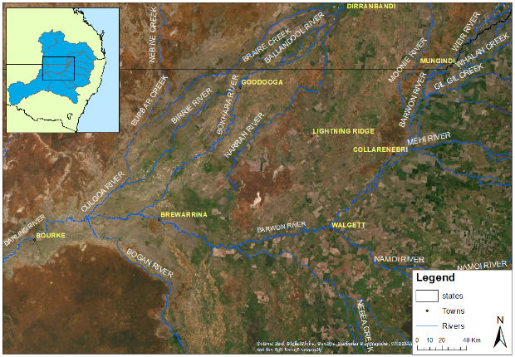

Figure 2: Map of sampling locations

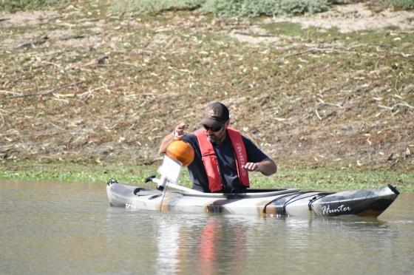

Figure 3: Installing temperature and dissolved oxygen loggers in the Bourke weir pool

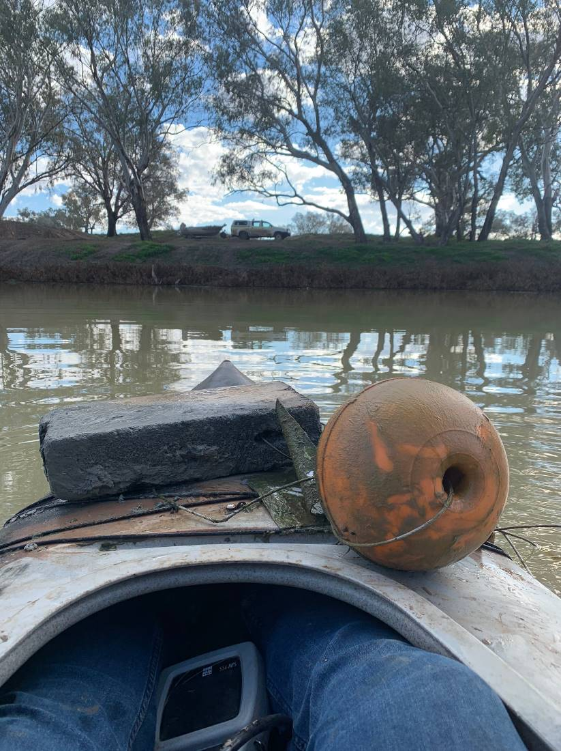

Figure 4: Deploying loggers in the Darling River

Additional sampling was undertaken during 14-15 March 2019, which was targeted on Collarenebri weir pool, and several waterholes upstream and downstream of Collarenebri (Figure 5). Within the weir pool, water depth data were collected at 50-100m intervals along the weir pool for approximately 9.3km using a handheld depth sounder. Water quality profiles were also recorded at 17 locations along the length of the weir pool. Parameters included temperature, electrical conductivity, dissolved oxygen (DO % and concentration) and pH. Measurements were taken at the surface and then 0.5 – 1 m intervals down the water column. Temperature and dissolved oxygen sensors were deployed at an additional site within Collarenebri weir pool (Colli spot 3 (29o32’46.21”S, 148o34”59.01E); Figure 6). Water quality profiles and spot samples were recorded at ‘Devils hole’ on the Barwon River upstream of the Mehi River confluence and at several waterholes approx. 2.5 km downstream of the Weir pool (Figure 5).

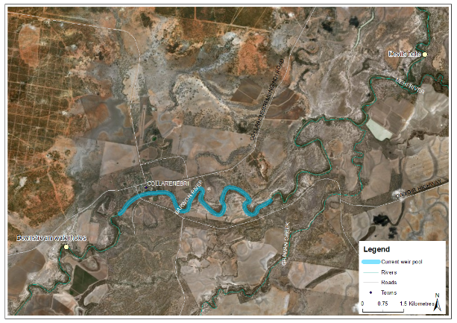

Figure 5: Locations for targeted sampling around Collarenebri in mid-March

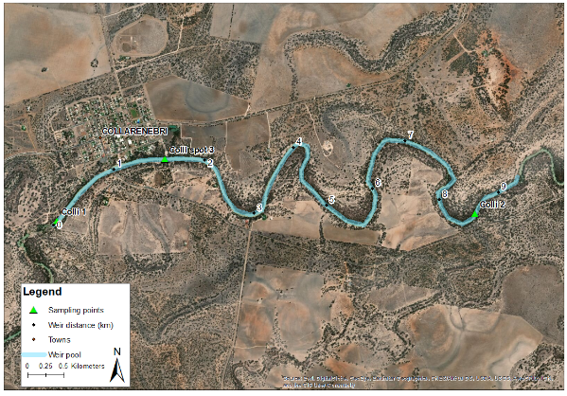

Figure 6: Extent of Collarenebri weir pool during survey (14-15 March 2019) and the location of sampling sites.

## Longer term monitoring

Following the initial sampling round in March, water quality measurements were subsequently collected on 27-28 May, 5-7 July and August to assess temporal changes in the weir-pools during and following the delivery of the NFF. Dissolved Oxygen and temperature loggers were downloaded and cleaned before being re deployed during the May and July fieldtrips. Algal samples were again collected in July 2019.

# Findings

## Pre event water quality and algal sampling

### Mungindi

Water depth ranged from 3.5m at Mung 1 to 4m at Mung 2. Temperature showed a decreasing trend at Mung 1 from 29 oC at the surface to 24.8 oC at a depth of 3m. Temperature at Mung 2 was more consistent ranging from 24.4 – 24.45 oC. Conductivity was stable at both sites being around 0.26 mS/cm. Dissolved oxygen was relatively low throughout the water column at Mung 1 ranging from 4.4 – 4.9 mg/l. Dissolved oxygen was higher at Mung 2 increasing from 9.3 mg/l at the surface to 9.9 mg/l at a depth of 3m. pH showed small but consistent reductions with depth, dropping from 7.9 to 7.45 at Mung 1 and 7.65 to 7.5 at Mung 2. At the time of sampling the there was no algal alert current for Mungindi, with the algal community dominated by *bacillariophyta* diatoms, and the presence of the potentially toxic Chrysporum cyanobacteria was also present at Mungindi 1 at very low concentrations.

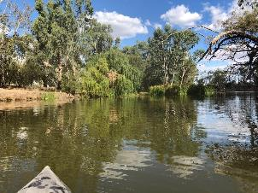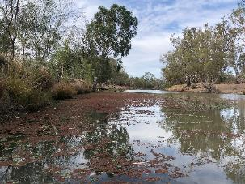

Mungindi site 1 Mungindi site 2

### Collarenebri and surrounding waterholes

#### February sampling

Depth varied from 2m at Colli 1 near the weir to 5m at Colli 2 at the upstream extent of the weir pool. Temperatures showed a reduction with depth at all sites. At Colli 1 surface temperature was 29.4 oC and 28.2 oC at a depth of 1m. Colli 2 showed a consistent reduction in temperature from 28.3 oC at the surface to 23oC at a depth of 4 m. Conductivity varied from 0.3 mS/cm to 0.35 mS/cm. At Colli 1 dissolved oxygen increased with depth from 5.9 mg/l at the surface to 6.8 mg/l at a depth of 1m. Colli 2 showed a decrease in dissolved oxygen below a depth of 2m with dissolved oxygen ranging from 5.4-6.8 mg/l above this depth but 1.8mg/l at 3m and 0.8 mg/l at a depth of 4m (Figure 2). Additional sampling at a depth of 3m along a 300 m reach at this site showed temperatures of around 24.6 oC and dissolved oxygen of less than 2.9 mg/l. Dissolved oxygen levels below 4 mg/l are considered to place aquatic organisms under stress because they have trouble in moving oxygen across their gills at lower dissolved oxygen concentrations.

Figure 7: Dissolved Oxygen profiles at sites in Collarenebri weir pool. Shaded box represents DO levels dangerous to aquatic biota

Given this thermal stratification, an additional site (Colli spot 3) was sampled in the middle of the weir pool (Figure 6), around 400 m downstream of the DPI fisheries aerators. Here, the depth was 4.3m and temperature dropped from 29.7oC at the surface to 25.2 oC at a depth of 4m. Dissolved oxygen showed a similar vertical trend to Colli 2, ranging from 5.9 – 7mg/l above 2m but dropping to 3.4 mg/l at 3m and 0.5 mg/l at a depth of 4m. pH showed similar trends to dissolved oxygen at the Colli 2 and spot 3 sites, reducing from 8.2 at 2m depth at Colli 2 to 6.9 at 4m depth. At Colli spot 3, pH dropped from 8.4 at 1m depth to 7.4 at 4m. An amber algal alert was present at the time of sampling with algal concentrations around 0.05 mm3/l (WaterNSW 2019a), with communities dominated by Cyanobacteria and *bacillariophyta* diatoms, including some potentially toxic species at low concentrations.

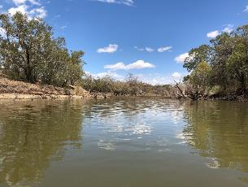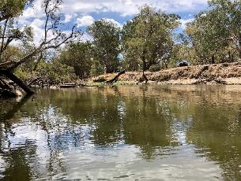

Collarenebri site 1 Collarenebri site 2

#### March sampling

Similar temperature stratification was observed at Devils hole upstream of the Collarenebri weir pool (Figure 8). This location also showed a reduction in dissolved oxygen at a depth of 3m and below (Figure 8). In the pool downstream of Collarenebri weir, temperature was similar and dissolved oxygen higher than in the upper water column of Devils hole.

Figure 8: Average temperature (left) and dissolved oxygen (right) profiles for Devils hole and waterholes in the Barwon River below the Collarenebri weir

### Brewarrina

Depth was 5.7m at Bre 1 and 9.3m at the Bre 2 site upstream. Temperature showed a slight decline at Bre 1 from 27.5oC at the surface to 26.2oC at a depth of 4m. At Bre 2 temperature dropped consistently with depth from 29.8oC at the surface to 25.9 oC at a depth of 4m. Conductivity was consistent at both sites, being around 7-7.4 mS/cm. Both sites showed an increasing trend in dissolved oxygen from the surface to 3m and then a decrease at a depth of 4m (Figure 4). DO ranged from 8 – 8.7 mg/l at Bre 1 and from 6.3 – 7.9 mg/l at Bre 2. pH ranged from 7.8 – 8.4. Brewarrina was on red alart with an algal concentration of 13.06 mm3/l (WaterNSW 2019a). Communities were dominated by cyanobacteria and *bacillariophyta* diatoms, including some potentially toxic species at low concentrations.

Figure 9: Dissolved oxygen profiles at sites within the Brewarrina weir pool. Shaded box represents DO levels dangerous to aquatic biota

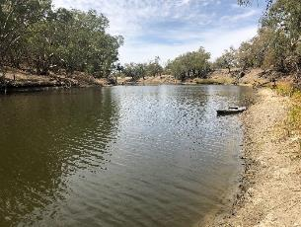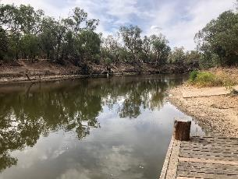

Brewarrina site 1 Brewarrina Site 2

### Walgett

Depth was 3m at both survey sites. Temperature was consistent through the water column at both sites being around 25.2 oC at Walgett 1 and 24.5 oC at Walgett 2. Conductivity was stable at both sites at around 0.46 mS/cm. Dissolved oxygen showed inconsistent trends between sites, increasing from 7.5 – 8.7 mg/l with depth at Walgett 1 and decreasing from 8.35 – 8 mg/l with depth at Walgett 2. pH ranged from 8.2 – 8.4. No algal alert was present at Walgett and communities were dominated by *bacillariophyta* diatoms. At Walgett 1 site, the toxic cyanobacteria *Dolichospermum circinale* was found in low concentration.

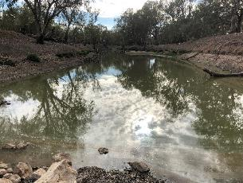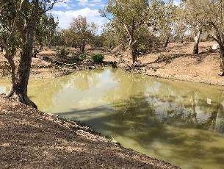

Walgett site 1 Walgett site 2

### Bourke

Depth was around 2.3 m at both survey sites. Temperature was consistent with depth through the water column at around 27 oC near the weir wall and 25 oC at Mays Bend upstream (Bourke 2). Conductivity at the Bourke 1 site near the weir was around 1.26 mS/cm, which was the highest recorded at all sites. It was lower at Bourke 2 at around 0.73 mS/cm. Dissolved oxygen was generally acceptable, ranging from 7.8 – 12.2 mg/l at Bourke 1, and 9 mg/l at the surface of the Bourke 2 site. Generally dissolved oxygen concentrations above 10 mg/l are inductive of algal production of oxygen, hence the 12.2 mg/l result at Bourke 1 suggests the presence of algal activity. There was lower dissolved oxygen at depth at Bourke 2, being 5.03 mg/l at a depth of 2m. pH ranged from 7.8 – 8.6. The algal rating for Bourke in March was amber (algal concentrations 5.35 mm3/l near the boat ramp and 2.14 mm3/l near the weir, (Water NSW 2019a)) with communities dominated by cyanobacteria and *bacillariophyta* diatoms, including some potentially toxic species at low concentrations.

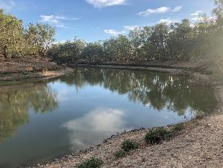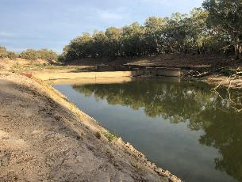

Bourke weir pool

### Depth and water volume in Collarenebri weir pool

The average depth recorded within the Collarenebri weir pool was 2.9m for the 9.2 km of weir pool monitored, which extended upstream to a rock bar crossing the river (Figure 10). The deepest section recorded was in the upstream reaches of the weir at the ‘3 mile’ fishing reserve, with a depth of 4.5 m at the time of survey (Figure 11).

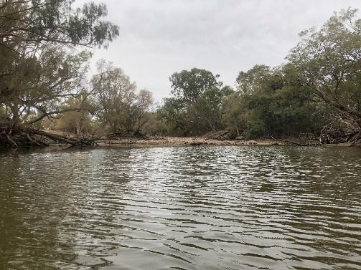

Figure 10: Rock bar at the upstream extent of Collarenebri weir pool

Figure 11: Long profile of Collarenebri weir pool measured 14/3/2019

To gain an understanding of the volume of water within the weir pool, an average weir pool width was estimated from aerial imagery and this was then multiplied by the area of each 1m increment on the long profile. It should be noted that this assumes the sides of the weir are vertical much like a swimming pool, so potentially overestimates the volume within deeper pools. The average width of the weir pool was 38.9m. This analysis suggests that there is 1 039 ML of water in the weir pool at the time of sampling, with 66% of the volume in the top 2 metres of the water column (Table 2). Water below a depth of 3 metres makes up less than 10% of the total water column.

Table 2: Estimated volumes within the Collarenebri weir pool and average dissolved oxygen and temperature for each 1m depth increment

|  |  |  |  |  |
| --- | --- | --- | --- | --- |
| Depth (m) | Volume (ML) | % total volume | Av DO | Av temp |
| 0-1 | 353 | 34% | 7.69 | 26.31 |
| 1-2 | 333 | 32% | 7.58 | 25.75 |
| 2-3 | 256 | 25% | 5.61 | 25.48 |
| 3-4 | 93 | 9% | 1.32 | 24.65 |
| 4-4.5 | 5 | 0% | 0.76 | 23.49 |
| total volume | 1039 |  | | |

### Summary of pre event sampling

During this survey period, the Barwon River was flowing at Mungindi and downstream to at least the Little Weir River confluence. Flows hadn’t reached Mogil Mogil yet. The water level in all other weir pools was low. Water quality in most weir pools still seemed within acceptable levels, with no odours of note, no visible algal blooms and turbidity generally low for this region (< 60 NTU in Barwon-Darling, 205 NTU in Mehi). Thermal stratification was present in Collarenebri weir pool and appeared to extend along most of the weir pool. Dissolved Oxygen followed this vertical profile with concentrations below 2m at <3 mg/l (30% SAT). Sampling suggests the potential for lower dissolved oxygen below 3m at Brewarrina, though at the time of measuring still >7 mg/l at 4m. Generally, there was reduced temperature with depth, but either minimal or gradual change in most weir pools. Upstream sites at Brewarrina and Collarenebri showed greatest reductions in temperature of around 4-5 oC from surface to a depth of 4m. Algal concentrations varied at sites before the NFF ranging from no alert with low concentrations at Walgett and Mungindi to red alert levels at Brewarrina. Some sites showed the presence of toxic algal species but these were in low concentration. The volume analysis carried out in Collarenebri weir pool suggested that there was only around 10% of the weir pool by volume that contained low quality anoxic water, therefore the risks of causing poor water quality throughout the pool but the delivery of the NFF was low.

## Water Quality Spot measures over time

Water quality parameters measured in March (pre flow), May, July and August showed variations between parameters, sample times, sites and depths within sites.

Water temperatures over the study period ranged from 10.4 – 29.8 oC (Figure 12). Temperatures typically dropped between sample times at most sites, and tended to be warmer on the surface. Stratification was evident at all sites except the Bourke and Walgett sites with little change in temperature throughout the water column. This is most likely due to the relatively shallow nature of both these weir pools. At Mungindi 1 and Collarenebri 2 the reduction in temperature was most noticeable between the surface and 1m depth intervals during March, and between 1m and 2m intervals in March at Brewarrina 2 (Figure 12). Similar patterns of stratification were evident at both Mungindi sites and Brewarrina 2 in July and August. At both Collarenebri sites, but especially Collarenebri 2, stratification was evident in the March – July surveys, but then was almost not existent in the August survey (Figure 12).

Dissolved oxygen (DO) concentrations over the study period ranged from 0.45 – 12.51 mg/l (Figure 13). DO content also showed variation over time and with depth within the weir pools of the Barwon-Darling River, but didn’t always appear to be related to temperature differences. In March, DO content was within the range of 4-10 mg/l at every site, apart from at Collarenebri 2 where it was below 2 mg/l at depths greater than 3m (Figure 13). Lower DO levels at depth were also observed at the Bourke 2 site in March, with near bed levels being around 4 mg/l lower (5 mg/l) than at the surface (9-10 mg/l). In July, DO within the Mungindi weir pool showed a decrease with depth, from around 7 mg/l to 2 mg/l at a depth of 3m at Mungindi 1. Similarly, at Mungindi 2, DO dropped from 10 mg/l on the surface to 2 mg/l at a depth of 3m. All other weir pools showed DO concentrations in the normal range (5 – 12 mg/l) at this time. DO concentrations appeared to be more stable with depth at all sites during the August survey time, being within a range of 6-10 mg/l at all sites (Figure 13).

pH tended to decrease at all sites over time and showed less variation with depth that temperature and DO. pH levels were generally within ANZECC guidelines (6.5 – 8) ranging from 6.18 – 8.81 (Figure 14). Collarenebri 2 showed the greatest variation in pH with depth reducing from 8.2 on the surface to 6.87 at a depth of 4m in March. Generally pH showed a reduction over time at all sites (Figure 14).

Electrical conductivity (EC) ranged from 0.199 – 2.786 mS/cm (Figure 15), which is generally within the ANZECC guidelines of 0.125 – 2.2 mS/cm. EC was much more stable with depth that other parameters, and showed less variation over time except within the Brewarrina weir pool where EC increased from around 0.7 mS/cm in March to 2.5 mS/cm in August (Figure 15). This may be a reflection of concentration of salts following the flow pulse which occurred in July.

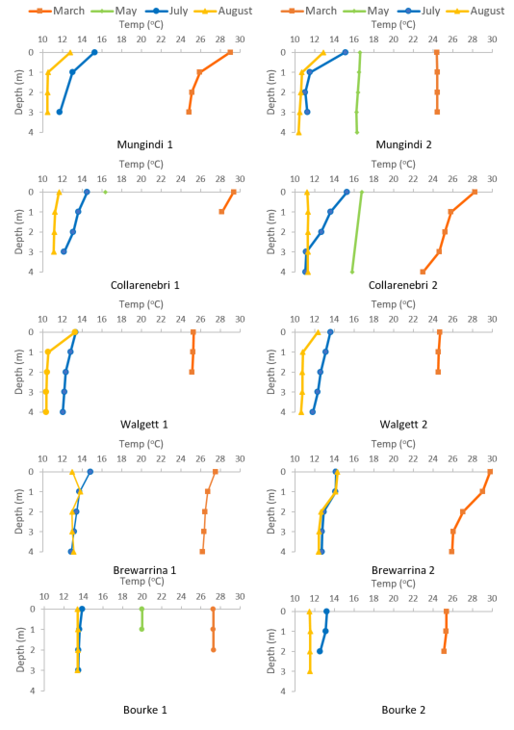

Figure 12: Spot temperature readings recorded at sites within weir pools along the Barwon-Darling River during 2019

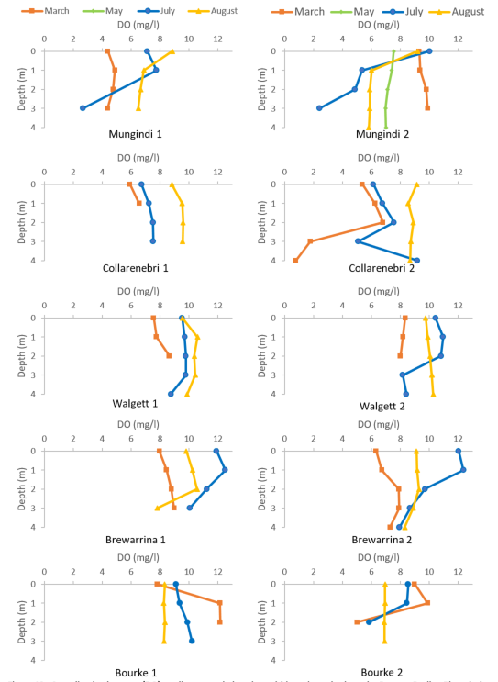

Figure 13: Spot dissolved oxygen (DO) readings recorded at sites within weir pools along the Barwon-Darling River during 2019

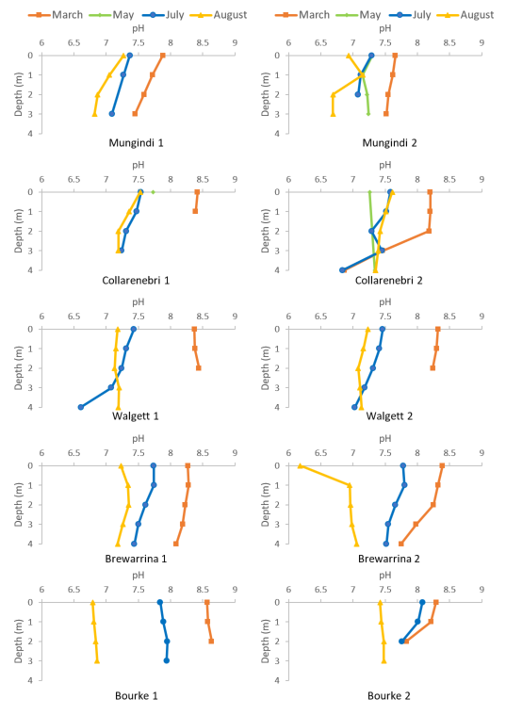

Figure 14: Spot pH readings recorded at sites within weir pools along the Barwon-Darling River during 2019

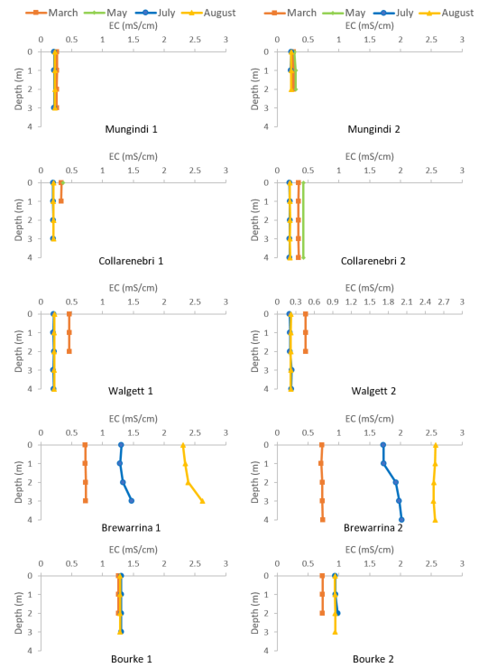

Figure 15: Spot Electrical conductivity (EC) readings recorded at sites within weir pools along the Barwon-Darling River during 2019

## July Algal sampling

During July there was no algal alerts present at any of the monitored weir pools with concentrations of blue green algae below the green alert threshold of 0.04 mm3/l. The highest concentration of algae was observed at Brewarrina (0.31 mm3/l) (WaterNSW 2019b).

In comparison with March samples, July samples were dominated by diatoms ( >90% Bacillariophyta). Samples from both Walgett Weir sites, Mungindi 1, both Brewarrina sites, and Collarenebri 1 and 2, were predominantly the common filamentous diatoms, *Aulocoseira granulata and Fragillaria sp*. At these sites there was < 1% Cyanobacteria in the samples. Both Bourke weir pool sites had > 50% diatoms, again dominated by *Aulocoseira granulata,* and both sites had 28 and 17 % respectively of the Chroococales,Cyanophyte*, Snowella sp*. which were absent from samples in March. The Chlorophyte *Gonium* sp. (Volvocaceae) dominated the sample from Mungindi 2 in July (Table 1b, Table 3). The *Aulocoseira granulata* and Vovocales are not typically considered harmful blooming taxa. Notably, the potentially toxic cyanobacteria, *Dolichospermum circinale, Chrysporum*, *Cylindrospermum* and *Planktothrix,* (EPA, 2014) were absent from all samples collected in July.

The overall species richness of phytoplankton was dramatically lower in the July compared with March samples. March samples ranged from 7- 19 taxa, but only 3-4 taxa were identified in samples from July. Dominant phyla shifts from Cyanobacteria to Diatoms were seen between seasons at Walgett 1, both Bourke sites, at Mungindi 1 and Brewarrina 1. A shift from diatom to chlorophyte dominance was seen at Mungindi 2, and from euglenophytes to diatoms at Collarenebri 1 and 2. It is worth noting that at both Bourke sites, zooplankton (microcrustacea and rotifers) were predominant in the algal collections, and may have attributed to low abundances and phytoplankton richness at this time.

## Temperature and Dissolved Oxygen Loggers

The loggers deployed for this study generally provided a good longer term indication of dissolved oxygen concentrations and temperature within the weir pools of the Barwon Darling River over the study period. While loggers were checked, downloaded and cleaned at less than 2 month intervals, excessive algal growth on some of some of the DO loggers (Figure 16), particularly those deployed at the surface of the weir pools, undoubtedly influenced the accuracy of the readings. Some readings were outside of the detection range of the loggers (0 – 16 mg/l DO), and these were removed from the dataset before analysis. For future studies of this kind in rivers like the Barwon-Darling, we would suggest more regular (2 week – 1 month) cleaning of the loggers. Notwithstanding this, loggers placed at depth (presumably below the photic zone) appeared to record more accurately. As the spot sampling suggested there was variation in temperature and DO concentration in the weir pools through the water column and over time. The temporal variation observed appeared to be related to both flow events, including the northern fish flow and ambient temperature variations. Temperature of surface waters showed diurnal changes consistent with antecedent atmospheric conditions, whereas levels were more stable on a daily basis at depths below 1m.

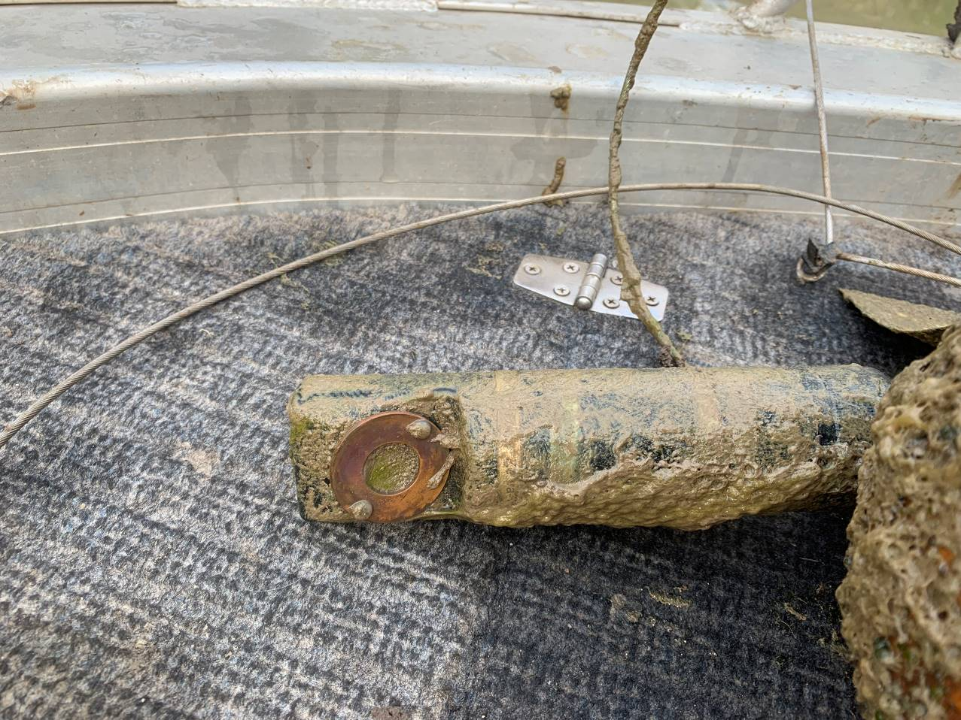

Figure 16: Algal growth on dissolved oxygen sensor at Collarenebri weir pool

Loggers were deployed on the 28 February 2019 in the Mungindi weir pool where the total depth was 4m. Over the 5 month period of logger deployment (28 February – 5 August 2019) there were two distinct flow events – the first in March/April resulting from unregulated flows, and the second in April-May as a result of environmental water deliveries as part of the NFF (Figure 17). The temperature data suggests that the weir pool remained stratified for much of the time with two periods of distinct stratification during the survey period. The first was several weeks after deployment following a small flow event. Soon after flow ceased, stratification increased, with water temperature at a depth of 4 m being around 5oC below surface temperatures. A sudden drop in atmospheric temperature around the 15March 2019 appears to have reduced the degree of stratification with all temperatures in the pool converging to within 1.5 oC of each other. Soon after this, the bottom most logger experienced a failure and data was not collected at a depth of 4m until 27 May 2019. The second period of pronounced stratification occurred around the 10 July 2019 following the cessation of the NFF event. Temperatures at 4m depth were around 3.5 oC lower than surface. Temperatures throughout the water column appeared to converge again on the 14 July, coinciding with a drop in atmospheric temperature (Figure 17). Given the break in data for the lowermost logger, it is difficult to assess the full influence of the flow events on temperature. During both flow peaks, temperature in the top half of the water column (above 2m) appeared to converge, but then diverge shortly after (Figure 17).

DO concentrations at the surface of the Mungindi weir pool oscillated between 3.8 – 8 mg/l during the time of deployment. Variation was greater than this at depth, with an initial drop from 3.2 mg/l at deployment to 0.24 mg/l. This coincided with the cessation of flow and an increase in stratification in the weir pool (Figure 17). DO stayed very low at depth until the logger failed on the 15 March 2019. Once this logger became functional again on the 28 May, DO at depth had improved to 6.2 mg/l, which was similar to surface concentrations. This again showed a drop to below 1 mg/l as NFF flows decreased back to no-flow. DO stayed low until 14 July when it spiked again to near surface levels of 4.12 mg/l. Again this coincided with a drop in atmospheric temperature and an apparent mixing of the weir pool at this site (Figure 17).

Patterns in temperature and DO concentration appeared similar at the two sites within the Collarenebri weir pool (Figure 18, Figure 19). The weir pool was initially stratified at both sites, though this was more apparent at Colli 2 with temperatures at a depth of 4m being 3-5 oC below surface temperatures. It appeared that the weir pool mixed following a colder snap in atmospheric temperature around the 1 April 2019. The Weir pool remained stratified until the arrival of the NFF in late May, with the degree of stratification driven by controlled by atmospheric conditions. With the arrival of the NFF, there was a clear convergence in water column temperature resulting from mixing. However, this was short lived with redevelopment of stratification as flows decreased through the weir pool (Figure 18, Figure 19). Again this stratification appeared to be reduced by a cold snap in atmospheric conditions.

At both sites within the Collarenebri weir pool, DO concentrations at depth were very low (<1.5 mg/l) until the arrival of the NFF in late May. This suggests that while the degree of stratification varied during this time, any water column mixing was not sufficient enough to break the pattern of DO concentration through the water column. With the arrival of the NFF, near the bed DO concentrations increased from around 1 mg/l up to above 6 mg/l (Figure 18, Figure 19). At both sites surface DO concentrations showed an initial decrease of around 3-5 mg/l as the flow entered the weir pool then an increase to above 7 mg/l as the peak of the flow passed. Surface DO concentrations remained high (between 8 – 12 mg/l) for the remainder of the survey period. At Colli spot 3, DO concentrations at 3m also remained relatively high (between 6-9 mg/l), whereas at Colli 2 DO concentrations decreased to 3 mg/l on the falling limb of the NFF, then showed fluctuations that followed variations in water temperature, before again falling to 1.2 mg/l early in August 2019 (Figure 18).

The Walgett weir pool appeared to show periodic changes in the degree of stratification throughout the water column driven by climatic variations (Figure 20). At the most extreme, surface and bottom temperatures (at a depth of 2.5m) showed a difference of around 8 oC in late September. The influence of the NFF was clear on water column temperature with a convergence of all loggers to within 0.5 oC for the duration of the flow. Unlike other weir pools further upstream, the redevelopment of stratification in this pool was more delayed, occurring around a month after the flow past through (Figure 20).

DO concentration was highly variable at both the surface and near bed over the deployment period in Walgett weir pool (Figure 20). Surface concentrations showed a general decreasing trend over March before a sharp decrease in concentrations around the 13 March. This coincided with a sharp increase in near bed DO from around 0.1 mg/l to 3 mg/l, suggesting fuller mixing of the water column. Given there appeared to be no sharp drop in atmospheric temperature, this may have been caused by wind driven physical mixing. DO concentration in the weir pool appeared to fluctuate between 0.1 and 4.7 mg/l over the next month before rising consistently through the water column to 9 mg/l with the arrival of the NFF. Near bed DO decreased to below 4 mg/l as the NFF flows reduced, but then fluctuated through to late August when levels again decreased down to 0.5 mg/l at the conclusion of deployment. Surface DO concentrations fluctuated between 3.5 and 11.4 mg/l following the NFF (Figure 20).

Differences in temperature through the water column in the Brewarrina weir pool were not as pronounced as in other pools monitored, owing primarily to more prolonged flows through this pool, but some degree of stratification was apparent. Due to upstream tributary inflows, the Barwon River at Brewarrina had flow from late April through to August, with the NFF contributing a noticeable peak in July of around 180 ML/d (Figure 21). Stratification in this weir pool was most notable in March, and less so following this time. The arrival of the NFF appeared to stabilise water temperatures throughout the water column.

DO concentrations in the Brewarrina weir pool were highly variable over the deployment period and were generally reflective of changes in stratification (Figure 21). Near bed DO showed a noticeable increase with the arrival of the NFF in early July, rising from 0.21 mg/l to 6.78 mg/l just preceding the flow peak. Near bed DO then dropped significantly as flows decreased back to very low levels (0.1 mg/l) at the conclusion of the flow (Figure 21).

Bourke weir pool showed the greatest degree of stratification of all the pools monitored, with only one short period of mixing noted at both sites in late May, when inflows increased the weir pool height by around 0.8 m (Figure 22, Figure 23). Stratification was most notable at the Bourke 1 site closest to the weir wall, with near bed temperatures 6-7 oC different to surface water temperatures. Stratification was periodically reduced with colder atmospheric conditions, but soon re-established.

DO concentrations were highly variable within the Bourke weir pool as well, with near bed concentrations appearing to be generally lower at the most upstream site. Near bed DO ranged between 1.6 - 10.6 mg/l at Bourke 1 site and was not as low as in some of the other pools monitored. This may be a reflection of the shallow depth at this site, perhaps letting light penetrate enough for photosynthesis to occur at depth. At this site, surface DO ranged from 3.1 – 10.3 mg/l and was also variable through time. Near Bed DO was lower at the Bourke 2 site dropping to <0.5 mg/l on a number of occupations. During the period of natural inflow in late July (not linked to the NFF), near bed DO increased to surface concentrations for several days, suggesting full water column mixing at this time. Levels then began to drop again and diverge from surface concentrations several days later (Figure 23).

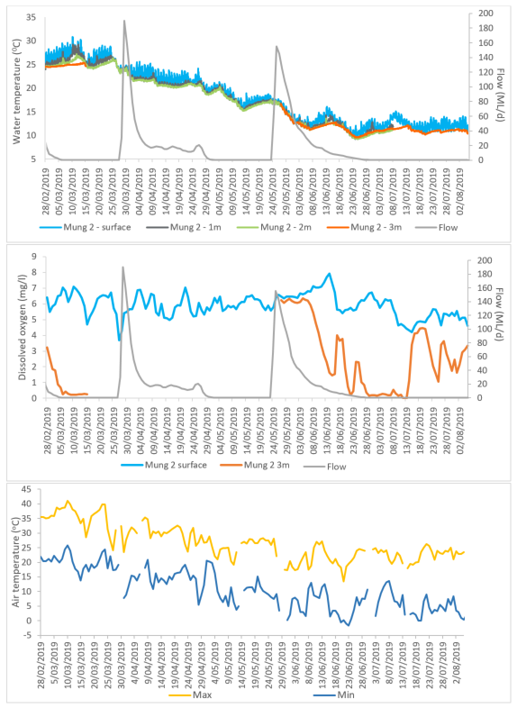

Figure 17: Hourly water temperature (top), daily average dissolved oxygen (DO, middle) and daily air temperature (bottom) measured at the Mungindi 2 site during the study period. River flow data for the Barwon River @ Mungindi gauge also presented.

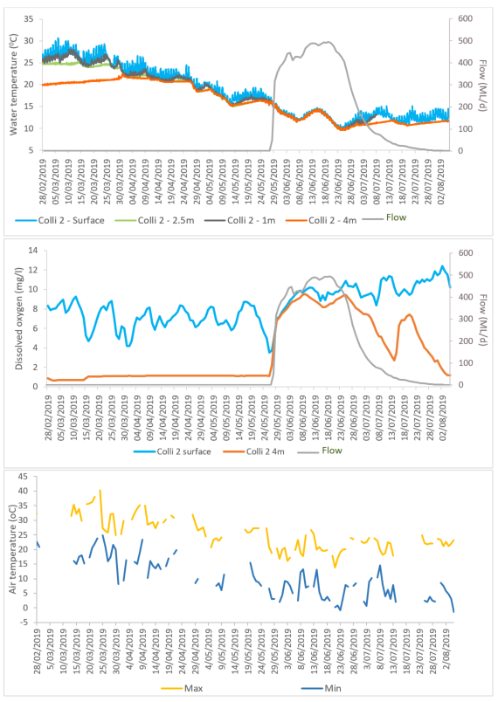

Figure 18: Hourly water temperature (top), daily average dissolved oxygen (DO, middle) and daily air temperature (bottom) measured at the Collarenebri (Colli) 2 site during the study period. River flow data for the Barwon River @ Collarenebri gauge also presented.

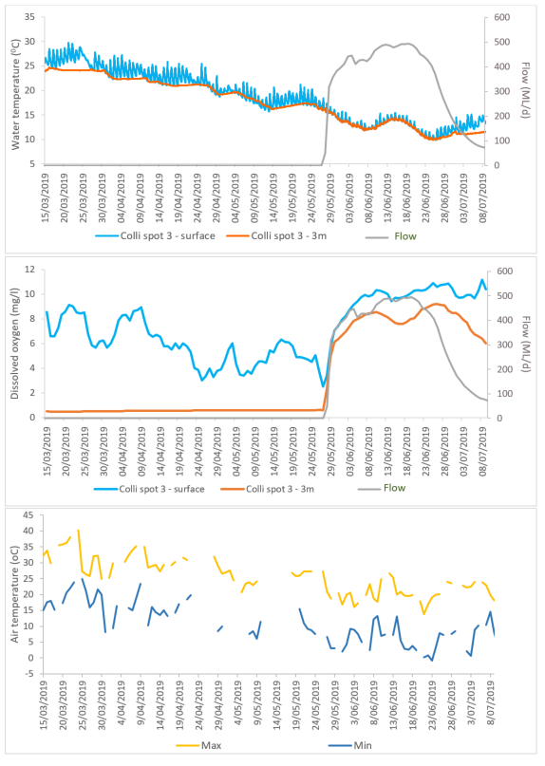

Figure 19: Hourly water temperature (top), daily average dissolved oxygen (DO, middle) and daily air temperature (bottom) measured at the Collarenebri (Colli) spot 3 site during the study period. River flow data for the Barwon River @ Collarenebri gauge also presented.

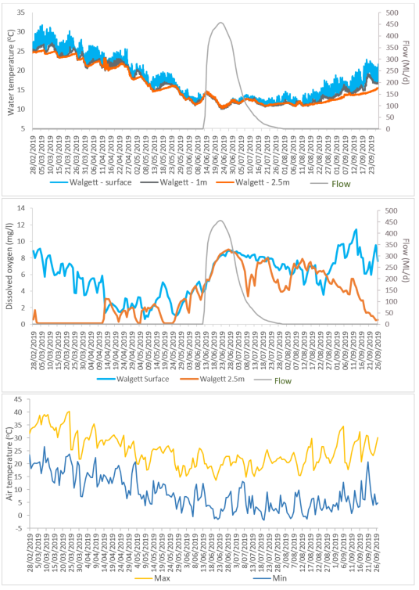

Figure 20: Hourly water temperature (top), daily average dissolved oxygen (DO, middle) and daily air temperature (bottom) measured at the Walgett site during the study period. River flow data for the Barwon River @ Dangar Bridge gauge also presented.

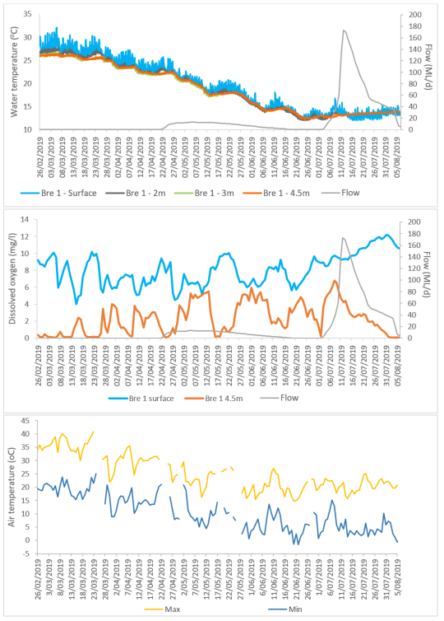

Figure 21: Hourly water temperature (top), daily average dissolved oxygen (DO, middle) and daily air temperature (bottom) measured at the Brewarrina (Bre) 1 site during the study period. River flow data for the Barwon River @ Brewarrina gauge also presented.

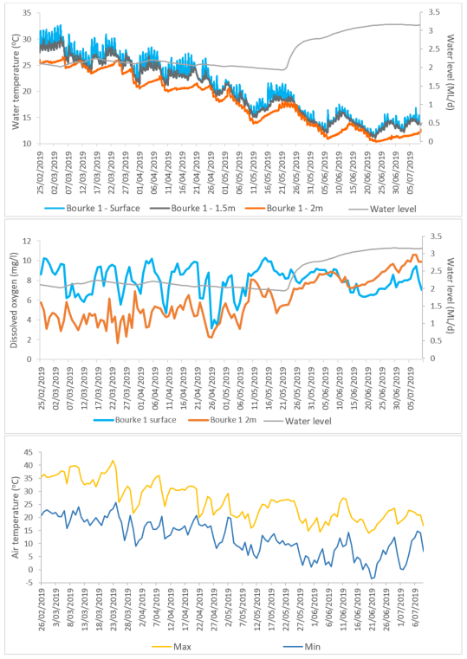

Figure 22: Hourly water temperature (top), daily average dissolved oxygen (DO, middle) and daily air temperature (bottom) measured at the Bourke 1 site during the study period. River flow data for the Darling River @ Bourke town gauge also presented.

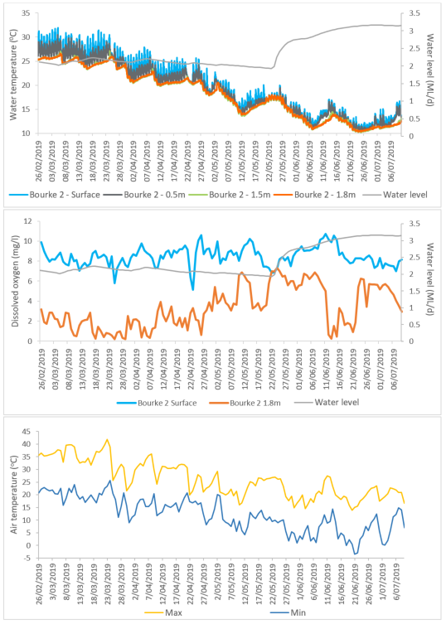

Figure 23: Hourly water temperature (top), daily average dissolved oxygen (DO, middle) and daily air temperature (bottom) measured at the Bourke 2 site during the study period. River flow data for the Darling River @ Bourke town gauge also presented.

## Summary of longer term water quality monitoring

Most weir pools monitored over the duration of the study showed some degree of stratification, driven by the prolonged period of no-flow in the system. As a result, DO concentrations also show marked variation through the water column of these pools, with concentrations near the bed of most pools being anoxic and at dangerously low levels for aquatic biota. Spot sampling showed that the anoxic water was primarily confined to the bottom of the pools and was more severe in deeper pools over 3m depth. The logger data suggested that near bed water also turned anoxic in some of the shallower pools as well like Walgett and Bourke at some times during the study. Other parameters measured like pH and electrical conductivity were generally within guideline values.

The logger data was effective at showing temporal variations in both temperature and DO concentrations within the weir pools. This clearly showed the benefit of the delivery of the NFF to water quality in the pools, especially to improving DO conditions of near bed water. However, this work also suggests that this benefit was relatively short lived in many pools, with near bed DO levels returning to dangerous levels on or shortly after flows ceased. Tareted survey of Collarelebri weir pool (Section 4.1.6) suggests that the volume of anoxic water in most of these weir pools was likely low compared to the overlying volume of better quality water, hence, the consequences for aquatic animals in the river is probably low. It is likely that this is how these pools naturally react during cease to flow periods. There are several explanations as to the propensity of these near bed areas to become anoxic, and are linked to the relative ease for these pools to thermally stratify, even in mild temperature conditions. First, it appears as if there is not sufficient light penetrating to depth to stimulate photosynthetic processes and replenish oxygen near the bed. This is not a surprise given the generally turbid nature of the Barwon-Darling River. Second, it appears as if the flow was not of sufficient magnitude to transport stores of organic matter and leaf litter on the bed of these pools that are driving the deoxygenation of the near bed water. Hence, once flow velocities reduced the oxygen in the near bed waters was stripped as bacteria began to again break down this organic material.

More positively, the delivery of the NFF did not cause any major declines in water quality, with surface waters remaining in good condition and no algal blooms noted following the flow delivery. In mixing the oxygen poor/nutrient rich water at the bottom of the pools with the surface waters where light penetration can stimulate algal growth, there was a risk that the flow event could have stimulated algal blooms in the weir pools. This did not occur in any of the pools assessed with algal monitoring suggesting that algal concentrations decreased, and the presence of potentially harmful algal species reduced post flow.

This monitoring also showed the influence of atmospheric temperature fluctuations on the degree of stratification of the pools. With sudden drops in atmospheric temperature causing mixing of the water column. However, this mixing did not always correspond to a breaking of the thermoclines that control DO concentration, with layers of low DO remaining in some pools (Collarenebri most notably) even with relatively large changes in water temperature. Thus is appears as if the physical mixing of the water through the flow delivery was more effective at improving DO conditions that atmospheric variations alone. It does suggest that if flow deliveries can be timed to coincide with colder periods where stratification is reduced, then there would be a better chance of achieving full water column mixing. In this way smaller amounts of water may be able to be delivered to achieve a similar purpose.

# Conclusions and recommendations

This study was effective at determining the prior water quality conditions in the weir pools of the Barwon Darling, and monitoring their changes following the delivery of the NFF. Initial sampling identified that some of the deeper weir pools (and sections within weir pools) were showing signs of thermal stratification and low DO (<2 mg/l) at depths below around 3m. These include Mungindi, Collarenebri, and likely Brewarrina weir pools, as well as Devils hole, a natural waterhole near the Mehi River confluence above Collarenebri. Water quality parameters were more consistent through the water profile within Bourke and Walgett weir pools, which were between 2-3m deep. Targeted sampling to quantify the extent of the low DO water in both Collarenebri weir pool and Devils hole was then undertaken. This showed that around 10 % of Collarenebri weir pool was low in DO. Similarly, Devils hole has a relatively small quantity of low DO water in it, compared to the size of the pool.

Ongoing monitoring suggested that the NFF was successful in replenishing the weir pools and improving their water quality. No negative effects were noted on water quality, and algal concentrations were reduced. Interestingly, anoxic layers of water near the bed of the weir pools were relatively quick to re-establish, suggesting that these pools thermally stratify even under mild temperature conditions and that the flows delivered were of insufficient magnitude to transport the stores of organic material driving bacterial deoxygenation processes.

The degree of stratification in these pools was also influenced by atmospheric conditions, with the occurrence of cold snaps appearing to reduce stratification. While this was not always reflected in an improvement of DO at depth, it does suggest that if flows are timed to coincide with cold fronts, then potentially less water might be needed to break the already weakened stratification and promote full water column mixing.

# References

EPA, United States 2014. Cyanobacteria and Cyanotoxins: Information for Drinking Water Systems. EPA-810F11001 <https://www.epa.gov/sites/production/files/2014-08/documents/cyanobacteria_factsheet.pdf>

WaterNSW 2019a. Far West – Algal Coordinating Committee (FW-RACC) Blue Green Algae Report. 8th March 2019.

WaterNSW 2019b. Far West – Algal Coordinating Committee (FW-RACC) Blue Green Algae Report. 19th July 2019.

|  |
| --- |
|  |

