Final

Basel summary report (2020 data)

8 March 2022

PREPARED FOR

[Company]

PREPARED IN ASSOCIATION WITH

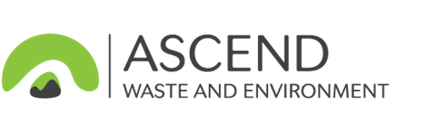

|  |  |
| --- | --- |
| Report title | Basel summary report (2020 data) |
| Client | [Company] |
| Status | Final |
| Author(s) | Department of Agriculture, Water and the Environment;Ascend Waste and Environment;Blue Environment |
| Reviewer(s) | Joe Pickin |
| Project number | P1121 |
| Report date | 8 March 2022 |
| Contract date | 20 December 2019 |
| Year of data | 2020 |
| Basel data report date | 9 December 2020 |
| Information current to | 31 December 2019 |
| Copyright | [Keywords] |

**Disclaimer**

This report has been prepared for the [Company] in accordance with the terms and conditions of appointment dated 20 December 2019, and is based on the assumptions and exclusions set out in our scope of work. Information in this document is current as of 31 December 2019. While all professional care has been undertaken in preparing this report, Blue Environment Pty Ltd cannot accept any responsibility for any use of or reliance on the contents of this report by any third party.

The mention of any company, product or process in this report does not constitute or imply endorsement by Blue Environment Pty Ltd.

© [Keywords]

Blue Environment Pty Ltd

ABN 78 118 663 997

Suite 209, 838 Collins St, Docklands Vic 3008

Email: blue@blueenvironment.com.au

Web: www.blueenvironment.com.au

Phone: +61 3 9081 0440 / +61 3 5426 3536

Total hazardous waste generation, Australia 2020

**In 2020 Australia generated about 9.2 million tonnes[1] of hazardous waste. This is about 12% of all waste generated[2] and is 4% lower than the tonnage reported to the Basel Secretariat for 2019.**

Classified into more than 70 detailed types, these wastes include –

|  |  |  |  |
| --- | --- | --- | --- |
| *Generation of hazardous waste by state and territory, Australia 2020-21**[3]* | | * contaminated soils and asbestos from development and demolition projects * wastes from the chemicals, manufacturing, resource and mining industries * emerging PFAS wastes * a range of hazardous wastes that arise from everyday sources, such as: * tyres/oils/oily waters (motor vehicles) * grease trap waste (commercial cooking) * lead-containing wastes such as lead acid batteries (motor vehicles) and leaded glass (used TVs and computers) * biosolids, which are not typically classified as hazardous wastes in state and territory data systems, but may contain contaminants such as heavy metals and organic chemicals. | |
| This is a bar chart of hazardous waste generation in millions of tonnes by state and territory. It shows that NSW generated the most (2.6 million tonnes) followed by Victoria (2.4), Queensland (2.0), WA (0.94), SA (0.65), Tasmania (0.39), NT (0.11) and the ACT (0.03). | |
| **The top 10 wastes produced by weight in 2020, were:**  1. Contaminated soils [27%]  2. Industrial residues incl. biosolids [22%]  3. Asbestos [16%]  4. Putrescible wastes incl. grease trap [7%]  5. Tyres [5%]  6. Waste oils [5%]  7. Oil/water mixtures [3%]  8. Lead compounds [3%]  9. Alkalis [3%]  10. Paints, resins, inks, organic sludges [3%] | *Generation of hazardous waste by type and management, Australia 2020-213* | |
| This is a bar chart showing the quantity of each of 29 waste types generated in Australia in 2020-21, with the bar colour-coded to show the management types in seven categories (recycling, chemical/physical treatment, landfill, biodegradation, thermal destruction, storage or transfer, and other). Landfill was the main management method for the biggest tonnage wastes (contaminated soils and asbestos). Landfill was largest management method overall (3.4 million tonnes) followed by chemical/physical treatment (1.2), recycling (1.1), storage and transfer (0.46), biodegradation (0.34), other (0.16) and thermal destruction (0.04). | | | |
| Excluding biosolids, the majority of these wastes were sent to landfill (51%). Another 22% was recycled, 18% underwent treatment to reduce or remove the hazard, 7% was stored for accumulation and later release into management infrastructure and 2% went to other infrastructure, a large portion of which was tyres going to export markets. |

Major hazardous waste flows 2020

Hazardous waste in Australia moves in three sub-markets, each associated with different wastes and with distinct scales and issues of interest: 95% of waste is managed in infrastructure *within the state/territory* where it was generated; 4% crosses *interstate borders*; and a little more than 1% is *exported* to or *imported* from overseas for management in specialised infrastructure unavailable or not viable within the generating jurisdiction (this excludes exports of tyres – see footnote 4).

*Illustration of hazardous waste sub-markets, Australia 2020 (% by weight)*

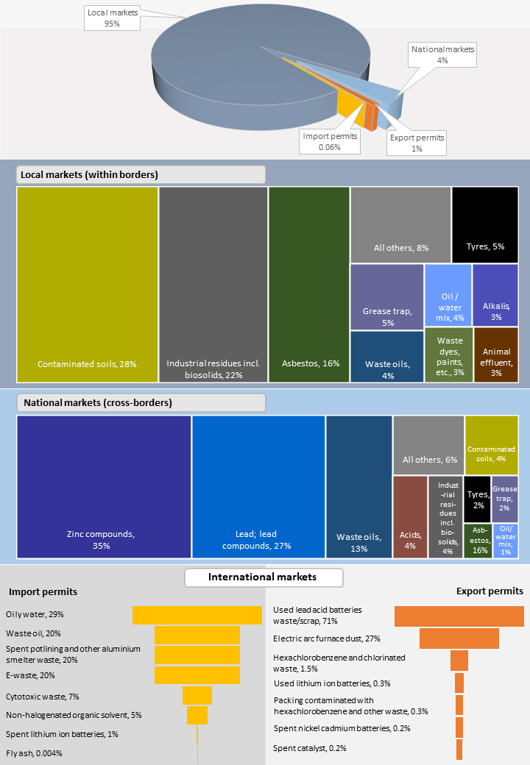

Hazardous waste imports into Australia and exports to other countries require approval from the Australian Government under the *Hazardous Waste (Regulation of Exports and Imports) Act 1989.* Approved imports and exports in 2020 are listed below[4]. The proportions are small compared to quantities produced and managed within Australia.

*Permits issued for imports and exports of hazardous wastes, Australia 2020*

|  |  |  |  |  |
| --- | --- | --- | --- | --- |
| **Cross international borders** | | | **Tonnes** | **%** |
| **Imports**  About 0.06% of total hazardous waste flows | 5,130 tonnes | Oily water  Waste oil  Spent potlining and other aluminium smelter waste  E-waste  Cytotoxic waste  Non-halogenated organic solvent  Spent lithium ion batteries  Fly ash | 1,500  1,000  1,000  1,000  350  250  27  0.2 | 29%  20%  20%  20%  7%  5%  1%  0.004% |
| **Exports**  About 1% of total hazardous waste flows | 112,000 tonnes4 | Used lead acid batteries waste/scrap  Electric arc furnace dust  Hexachlorobenzene and chlorinated waste  Used lithium ion batteries  Packing contaminated with hexachlorobenzene and other waste  Spent nickel cadmium batteries  Spent catalysts | 79,000  30,000  1,650  375  350  250  170 | 71%  27%  1.5%  0.3%  0.3%  0.2%  0.2% |

Hazardous waste trends

**Hazardous waste generation fell slightly in 2020** from the historically elevated 2019 quantities.

**The long-term trend is to growth in hazardous waste generation in Australia**, despite the fall in 2020, as portrayed in the chart to the right.

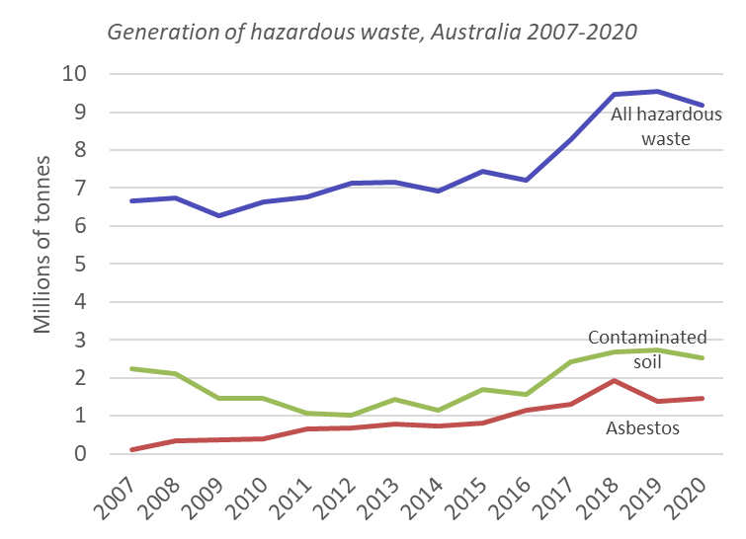

The major contributors to the post‑2016 surge were **asbestos** (almost all in NSW) and **contaminated soil** (mostly in Vic and Qld). The trend slowed in 2019 then slightly fell in 2020, due to reduced NSW asbestos volumes and a drop in Qld contaminated soil. Offsetting these 2020 falls was continued growth in Vic, driven by its contaminated soil volumes, on top of an already unprecedented growth period in that waste from around 2015.

Emerging hazardous waste issues

**Emerging wastes and issues continue to pose environmental challenges**.

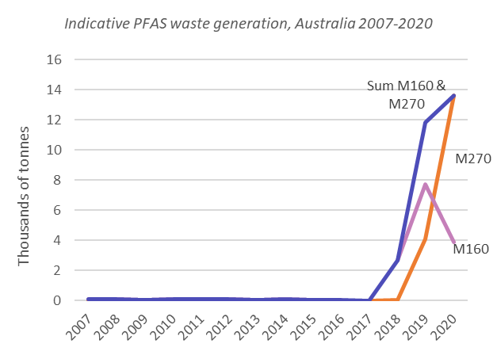

**PFAS‑contaminated waste** has risen from near-zero to the tens of thousands of tonnes in the last three years, as shown in the chart to the right[5]. The trend is shown most clearly in Vic and Qld – the states that house the main national infrastructure for managing PFAS waste.

Australia’s soil thermal treatment facilities, concentrated in Vic, experienced major growth in demand during 2019‑20. We attribute this rise to PFAS contaminated soils. While there is a growing number of options for PFAS management in Australia, there remains a high risk that arisings of PFAS contaminated soil, rubble and concrete over the near term will exceed market capacity.

Additional volumes of **COVID‑19** personal protective equipment (PPE) placed a heavy demand on clinical waste infrastructure in Australia in 2020, creating more interstate flows to manage it. Industry sources indicated that facility licences in south-eastern Australia had to be temporarily expanded to cope with the extra load. Operators and regulators appeared to act swiftly and cooperatively, particularly during Vic’s Covid second wave, and coped well with the unprecedented volumes and circumstances.

Waste **lithium‑ion batteries** are an unresolved problem in Australia, exemplified by increasing incidences of fire in waste management infrastructure. For example, Brisbane City Council suggests that waste lithium‑ion batteries from kerbside landfill collection bins caused eight Council garbage truck fires in late 2020 alone[6], while Visy Recycling, which manages the Council’s resource recovery centres, said that ‘dozens of battery‑related fire incidents’ had occurred in processing infrastructure throughout 2020. This is likely to be an issue at all Australian landfills, materials recovery facilities and other waste infrastructure that finds itself inadvertently dealing with lithium‑ion battery waste.

The economics of lithium‑ion battery recycling, as well as safe handling and insurance aspects, have not seen it take shape yet in Australia, at least not in a true value‑recovery sense. Valuable cathodic powders are exported offshore for recovery, as evidenced in Basel export permits, which means the value is realised by other countries.

1. This includes all biosolids, which are included in Australia’s report to Basel due to unresolved hazard classification issues.
2. Based on the 74 million tonnes of waste reported as generated in 2018-19 in the *National Waste Report 2020*.
3. Based on the 2020-21 data year, rather than the 2020 calendar year.
4. The data excludes end-of-life tyres, which are recognised as a hazardous waste in Australian classification frameworks and are consequently included in domestic hazardous waste data. However, tyres are expressly characterised as not hazardous in the Basel Convention, so their exports, although significant in tonnage terms, are not captured in the export permitting system and are excluded from this table.
5. A large Qld datapoint (43 kt) for M160 in 2017 has been removed, since this represents a regulatory reporting inconsistency for PFAS contaminated soil, which is reported as N120 in other jurisdictions.
6. *The Age* newspaper, February 23 2021, *Household batteries blamed for spate of Brisbane garbage truck fires*, available at: [https://www.theage.com.au/national/queensland/household‑batteries‑blamed‑for‑spate‑of‑brisbane‑garbage‑truck‑fires‑20210223‑p57519.html](https://www.theage.com.au/national/queensland/household-batteries-blamed-for-spate-of-brisbane-garbage-truck-fires-20210223-p57519.html)