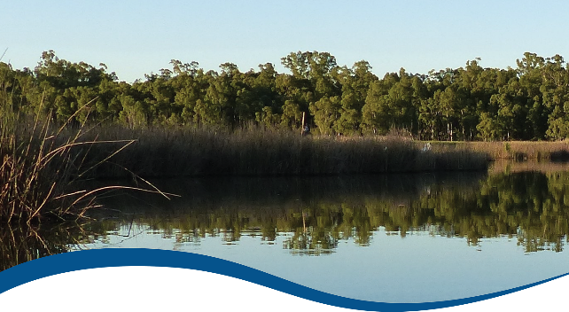
Basin-scale evaluation of 2019–20 Commonwealth environmental water: Ecosystem Diversity
  - Commonwealth Environmental Water Office (CEWO):
Monitoring, Evaluation and Research Program

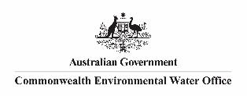
August 2021

Citation
Brooks S (2021) 2019-20 - Ecosystem Diversity Evaluation Report - Final Flow-MER Program. Commonwealth Environmental Water Office (CEWO): Monitoring, Evaluation and Research Program, Department of Agriculture, Water and the Environment, Australia. 81pp
Acknowledgements
The project team and the Commonwealth Environmental Water Office (CEWO) respectfully acknowledge the traditional owners of the land on which this work is conducted, their Elders past and present, their Nations of the Murray–Darling Basin, and their cultural, social, environmental, spiritual and economic connection to their lands and waters.
We would like to thank the CSIRO and University of Canberra teams for their efforts in report layout, editing, reviewing and formatting. Special mention to Emily Barbour, Ross Thompson, Di Flett, Susan Cuddy and Jackie O’Sullivan whose input, together with copy editor Dr Mary Webb and formatting specialist, Jill Sharkey, greatly improved the readability of the report. CSIRO’s Martin Nolan assisted with figures and GIS layers. A final thanks to Peter Davies for providing an expert independent review.
Copyright
 © Commonwealth of Australia 2021
With the exception of the Commonwealth Coat of Arms, partner logos and where otherwise noted, all material in this publication is provided under a Creative Commons Attribution 4.0 International Licence https://creativecommons.org/licenses/by/4.0/. The Flow-MER Program requests attribution as ‘© Commonwealth of Australia (Flow-MER Program, https://flow-mer.org.au)’.

Document submission history
30 June 2021 | Final draft
27 August 2021 | Final

Cover photograph
Reed beds at Millewa Forest.
Photo credit: Heather McGinness
Important disclaimer
The information contained in this publication comprises general statements based on scientific research. The reader is advised and needs to be aware that such information may be incomplete or unable to be used in any specific situation. No reliance or actions must therefore be made on that information without seeking prior expert professional, scientific and technical advice. To the extent permitted by law, the Flow-MER Program (including its partners and collaborators) excludes all liability to any person for any consequences, including but not limited to all losses, damages, costs, expenses and any other compensation, arising directly or indirectly from using this publication (in part or in whole) and any information or material contained in it.
The Flow-MER Program is committed to providing web-accessible content wherever possible. If you are having difficulties with accessing this document, please contact CEWOmonitoring@environment.gov.au

Overview of Flow-MER
Flow-MER is the Commonwealth Environmental Water Office’s (CEWO) Monitoring, Evaluation and Research Program. Its objective is to monitor and evaluate the ecological responses to the delivery of Commonwealth environmental water in the Murray–Darling Basin. It provides the CEWO with evidence to inform our understanding of how water for the environment is helping maintain, protect, and restore the ecosystems and native species across the Basin. This work will support environmental water managers, demonstrate outcomes, inform adaptive management and fulfil the legislative requirements associated with managing Commonwealth-owned environmental water.
The Program runs from 2019 to 2022 and consists of 2 components: monitoring and research in 7 Selected Areas (Selected Area projects); and Basin-scale evaluation and research (the Basin-scale project) (Figure 1). The Basin-scale project is led by CSIRO in partnership with the University of Canberra, and collaborating with Charles Sturt University, Deakin University, University of New England, South Australian Research & Development Institute, Arthur Rylah Institute, NSW Department of Planning, Industry and Environment, Australian River Restoration Centre and Brooks Ecology & Technology.
It builds on work undertaken through the Long Term Intervention Monitoring (LTIM) (2014–2019) and Environmental Water Knowledge and Research (EWKR) (2014–2019) projects.
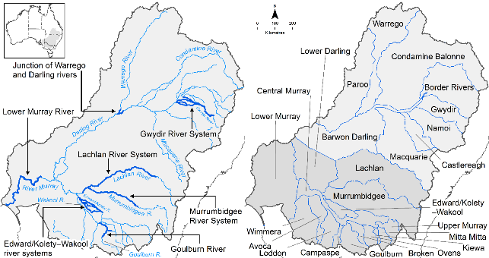
Figure 1 The 7 Selected Areas and 25 valleys established for long-term monitoring of the effects of environmental watering under the LTIM Project and Flow-MER Program (2014–15 to present)
The Flow-MER evaluation adopts an adaptive management framework to acknowledge the need for collectively building the information, networks, capacity and knowledge required to manage environmental water at Basin scale. While knowledge of ecological response to instream flow and inundation has advanced significantly in recent years, substantive challenges remain in understanding the similarities and differences in species’ response across time and space, as well as the interaction between species at a community and ecosystem scale.
The Basin-scale evaluation is being undertaken across 6 Basin Themes (Figure 2) based on ecological indicators developed for the LTIM Project and described in the Environmental Water Outcomes Framework. It is undertaken in conjunction with the Selected Area projects, which provide data, research and knowledge for ecological outcomes within the 7 Selected Areas. The Basin-scale evaluation integrates across Selected Areas, themes, datasets, approaches and different types of knowledge.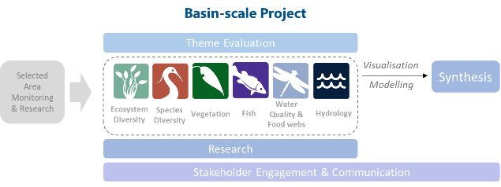
Figure 2 Basin-scale Project evaluation reports on Commonwealth environmental water outcomes for the 6 Basin Themes as well as a high-level Basin-scale synthesis
The evaluation is informed by Basin-scale research projects, stakeholder engagement and communication, including Indigenous engagement, visualisation and modelling, as well as the 7 Selected Area projects

About the Basin-scale evaluation
Water delivery and outcomes data provided by CEWO is used in conjunction with monitoring data provided by the 7 Selected Areas and other publicly available data to undertake the Basin-scale evaluation. The research and evaluation content is structured into 6 disciplinary themes. Technical reports for each of the 6 themes are available from the CEWO website.
The evaluation aims to address theme specific questions in relation to how Commonwealth environmental water contributed to, supported, or influenced environmental outcomes. Commonwealth environmental water is often delivered in conjunction with other environmental water holdings, and non-environmental water releases (such as for irrigation or during high-flow events). The evaluation consequently draws on available information to estimate (where possible) the specific contribution of Commonwealth environmental water to particular environmental outcomes. The way in which this contribution is assessed varies between the 6 themes depending on the data and tools currently available:
- modelling to estimate and compare outcomes both with and without Commonwealth environmental water (counterfactual modelling) – Hydrology (instream); Fish (multi-year evaluation)
- identification of ecological response in locations that received Commonwealth environmental water (potentially in conjunction with other sources of environmental water or non-environmental water), and where feasible, comparison with areas that did not receive Commonwealth environmental water – Ecosystem Diversity, Species Diversity, Vegetation
- use of flow and water quality metrics to infer likely outcomes – Hydrology (inundation); Food Webs and Water Quality
- synthesis of findings across Selected Areas – Fish (annual); Vegetation; Food Webs and Water Quality.

Summary
Strategic management of the Commonwealth environmental water by the Commonwealth Environmental Water Holder (CEWH) is key to achieving the environmental objectives of the Commonwealth’s (Murray-Darling) Basin Plan 2012. The 3-year Basin-scale Flow-MER Project aims to demonstrate Basin-scale outcomes of Commonwealth environmental water; support adaptive management of that water; and fulfil CEWH legislative requirements under the Basin Plan.
This evaluation reports on Ecosystem Diversity outcomes from Commonwealth environmental water for the most recent water year (2019–2020) and cumulatively since the beginning of the monitoring program in 2014. The evaluation also assesses the contribution of Commonwealth environmental water to Basin Plan objectives, as well as aspects of adaptive management of Commonwealth environmental water in the Basin.
This evaluation’s focus on ecosystems and ecosystem diversity is an efficient way to allow for evaluation at the Basin-scale. It is a high-level desktop assessment that quantifies water dependent ecosystems that receive Commonwealth environmental water. It interprets the diversity of Australian National Aquatic Ecosystem (ANAE) types supported by Commonwealth water at Basin scale and more specifically within the Basin’s ‘managed floodplain’ (the area of the Basin in which environmental water can be managed). The evaluation does not measure ecosystem responses directly. Other Flow-MER project themes (vegetation, fish, species diversity and food webs) report more specifically on responses of species, populations and ecosystem functions that occur within the Basin’s aquatic ecosystems.
The Basin aquatic ecosystems are classified into 67 ecosystem types using the ANAE classification. Ecosystem diversity as represented by the number of ecosystem types increases with catchment area, with no individual Basin valleys standing out as exceptionally rich or depauperate. Aquatic ecosystem diversity varies from a low of 19 ecosystem types in the Kiewa valley to a high of 56 in the Lower Murray.
Annual watering frequencies and inundation extents are used to examine the contribution of the whole portfolio of Commonwealth environmental water actions to ecosystem diversity in the Basin rather than outcomes from specific actions. The evaluation also tests alignment of Commonwealth environmental water management to Basin plan objective 8.05(3)(b) ‘to ensure that representative populations and communities of native biota are protected and, if necessary, restored.’
The evaluation is structured around 3 evaluation questions:
- What did Commonwealth environmental water contribute to ecosystem diversity?
- Are the ecosystems in scope for Commonwealth environmental water management representative of aquatic ecosystems in the Basin?
- Is Commonwealth environmental water supporting representative ecosystems?
Evaluation question 1 is addressed for the recent 2019-20 water year and for the multi-year monitoring record 2014-20. Answers to questions 2 and 3 evaluate the contribution of Commonwealth environmental water towards Basin plan objectives 8.05(3)(b) by estimating whether the subset of ecosystem diversity that environmental water is able to be delivered to (estimated by the extent of the Basin-wide environmental watering strategy managed floodplain) is representative of ecosystem diversity in the Basin as a whole. The cumulative record of Commonwealth environmental water use since long-term monitoring commenced in 2014 enables question 3 to be answered for the 6 years 2014–20.

Water year 2019–20
Q1: What did Commonwealth environmental water contribute to ecosystem diversity?
- Commonwealth environmental water supported0F more than 50% of the ecosystem types in the Lower Murray, Central Murray, Barwon Darling, Border Rivers, Murrumbidgee and Ovens River valleys.
- 11% of the permanent lake area on the managed floodplain (area that can be influenced by environmental water) received Commonwealth environmental water, with the largest area at Narran Lakes (5,200 ha).
- A significant allocation of Commonwealth environmental water was used to support 10,762 ha of marsh ecosystems, including the Great Cumbung Swamp at the terminus of the Lachlan River. This includes 52% of the tall marshes on the managed floodplain and is a significant contribution to maintaining these marsh ecosystems given 3 consecutive years of below-average rainfall.
- Inundation of Barmah forest using Commonwealth environmental water primarily benefited temporary River Red Gum swamp ecosystem types due to their proximity to the river. More than half of the wetland area influenced by Commonwealth environmental water was in temporary River Red Gum swamps representing 46% of all temporary River Red Gum swamps on the managed floodplain.
- 13,844 ha of floodplain was inundated in 2019–20, less than 50% of the average inundation by Commonwealth environmental water observed from 2014–15 to 2018–19. This reflected the dry conditions in the Basin and the focus of 2019–20 watering actions towards in-channel objectives related to increasing baseflows and freshes.

Water years 2014–20
Q1: What did Commonwealth environmental water contribute to ecosystem diversity?
- Of the 67 ANAE ecosystem types mapped in the Basin, 57 (85%) of ecosystem types were supported by Commonwealth environmental water at least once in the past 6 years. Of these, 43 (64%) ecosystem types were supported in 3 or more of the last 6 years.
- Across the 6 years, Commonwealth environmental water supported:
  - 22,239 ha1F of permanent lakes and 3,835 ha of temporary lakes representing 31% and 3% respectively of the lake area on the managed floodplain
  - 104,162 ha of palustrine wetlands from 20 ecosystem types, with the largest areas being temporary Red Gum swamp (35%), freshwater meadow (10%), temporary sedge/grass/forb marsh (15%) and permanent wetland (7%). In total 23% of the palustrine wetland area of the managed floodplain has been supported by Commonwealth environmental water at least once since 2014
  - 108,852 ha of 12 different floodplain ecosystems, totalling 7.5% of the managed floodplain but only 2% of the Basin floodplains. 62,725 ha (58%) of the area inundated was River Red Gum forest and woodland floodplains combined
  - flows to 28,426 km of rivers and streams, of which 91% were lowland rivers
  - 104,275 ha of Lake Alexandrina and Lake Albert and their fringing wetlands and 23,767 ha of estuarine habitat in the Coorong and Murray Mouth in each of the 6 years.
- The broad pattern of watering among ecosystem types is similar across all 6 years, with the following exceptions resulting from watering of single assets:
  - increased filling of lakes in 2017–18 as a result of Lake Victoria being filled
  - decreased inundation of temporary Red Gum swamp in the 2 years 2014–15 and 2016–17 that did not include inundation of Barmah-Millewa forest. In 2016-17 a major natural flood inundated the forest
  - increased watering of Lignum floodplains when water was delivered to Narran lakes (2015–16 and 2019–20)
  - increased inundation of River Cooba floodplain associated with floodplain watering of the Gwydir Wetlands in 2016–17 and 2017–18.

Key contributions to Basin Plan objectives
Q2: Are the ecosystems in scope for Commonwealth environmental water management representative of aquatic ecosystems in the Basin?
- Yes. 95.5% of the 67 ecosystem types in the Basin were represented on the managed floodplain with many wetlands, floodplains and estuarine ecosystems in similar proportions to the whole Basin.
Q3: Is Commonwealth environmental water supporting representative ecosystems?
- Yes. Evaluation of watering frequencies among ecosystem types shows that in the 6 years 2014–20 Commonwealth environmental water has supported 85% of all ecosystem types in the Basin influencing 104,162 ha of aquatic ecosystems equivalent to 66% of all types on the managed floodplain and 23% of the managed floodplain area. Ecosystems that have not received Commonwealth environmental water are either very wet systems (bog and fens, paperbark swamps, and springs) that likely do not require additional water, saline systems where delivering fresh water may be inappropriate, or where ecosystems are geographically isolated from the managed floodplain. The evaluation of watering frequencies over the 6 years shows Commonwealth environmental water is spread widely across different individual wetlands within each ecosystem type. Repeat watering occurs mostly in systems classified as permanent (e.g. permanent emergent tall marsh, permanent grass marshes) or in temporary River Red Gum swamps and woodland swamps that are closely associated with rivers.
Use of Commonwealth environmental water to support ecosystem diversity contributes directly to the Basin Plan biodiversity objective 8.05 (3)(a)(b) to ensure representative populations and communities of native biota are protected and restored (noting that there is not a specific objective in the Basin Watering Strategy which relates to ecosystem diversity).
- In 2019-20, Commonwealth environmental water supported 191,106 ha of lakes, wetlands and floodplain and 15,591 km of waterways representing 48 ecosystem types (72% of the ecosystem types currently mapped in the Basin).
- Over the period 2014–20, Commonwealth environmental water has supported 367,909 ha of lakes, wetlands and floodplain and 28,426 km of waterways, representing 57 ecosystem types (85% of the ecosystem types currently mapped in the Basin).

Improving management and evaluation
- Improvements to the ANAE ecosystem mapping and Commonwealth environmental water inundation mapping were incorporated into this evaluation and enabled the re-analysis of ecosystem diversity outcomes for all years of the LTIM project from 2014. This demonstrates the value of long-term (6-year) monitoring and allowed the construction of 6-year watering frequencies for ecosystem types receiving Commonwealth environmental water.
- The 6-years of monitoring to date has revealed patterns of watering by Commonwealth environmental water to Basin ecosystems paving the way to develop expected outcomes for ecosystem diversity with potential to contribute to multi-year water portfolio planning.
- Evaluation of outcomes from environmental water could be strengthened by developing a counterfactual hydrological regime for wetlands and floodplains (with and without environmental water). The Wetland Insights Tool developed by Geosciences Australia has potential to improve understanding of wetland and floodplain hydrological regimes, however attributing water sources and scaling up from individual wetlands to asset scales and ultimately to the Basin are significant challenges that have yet to be attempted.
- This evaluation is constrained by an incomplete understanding of hydrology at the Basin scale that is currently limited to the annual maximum extent of Commonwealth environmental water omitting timing of flows during the year and other sources of environmental water. Collaboration by Basin jurisdictions and agencies to establish a common resource to document water management actions, their expected outcomes and hydrology (timing, duration, extent and volumes) could greatly improve the efficiency and effectiveness of programs that evaluate responses to water management.

Contents
Overview of Flow-MER iii
About the Basin-scale evaluation iv
Summary v
Water year 2019–20 vi
Water years 2014–20 vi
Key contributions to Basin Plan objectives vii
Improving management and evaluation viii
1 Introduction 1
1.1 Evaluation objectives 2
2 Approach 4
2.1 What did Commonwealth environmental water contribute to ecosystem diversity? 4
2.2 Are the ecosystems in scope for Commonwealth environmental water management representative of aquatic ecosystems in the Basin? Is Commonwealth environmental water supporting representative ecosystems? 10
3 Water year 2019–20 12
3.1 Climatic and hydrological context 12
3.2 Contribution of Commonwealth environmental water to Ecosystem Diversity 2019–20 14
4 Water years 2014–20 21
4.1 Lake ecosystems 21
4.2 Wetland ecosystems (palustrine) 23
4.3 Floodplain ecosystems 26
4.4 River ecosystems 28
5 Contribution to Basin Plan objectives 31
5.1 Are ecosystems on the managed floodplain representative of the Basin? 31
5.2 Is Commonwealth environmental water supporting representative ecosystems? 34
5.3 Contribution to Basin Plan objectives 34
6 Adaptive management 36
6.1 Lessons learned 36
6.2 Improving environmental water management 36
6.3 Improving evaluation 37
7 References 40
Appendix A GIS Workflow 41
A.1 The area of ecosystems inundated by Commonwealth environmental water 41
A.2 The area of ecosystems influenced by Commonwealth environmental water 41
A.3 Length of waterways influenced by Commonwealth environmental water 42
Appendix B Evolution of the Basin ANAE classification 43
Appendix C ANAE wetland types influenced by Commonwealth environmental water by valley 45
Appendix D ANAE floodplain types inundated by Commonwealth environmental water by valley 56
Appendix E ANAE river channel types influenced by Commonwealth environmental water by valley 61

Figures
Figure 1 The 7 Selected Areas and 25 valleys established for long-term monitoring of the effects of environmental watering under the LTIM Project and Flow-MER Program (2014–15 to present) iii
Figure 2 Basin-scale Project evaluation reports on Commonwealth environmental water outcomes for the 6 Basin Themes as well as a high-level Basin-scale synthesis iv
Figure 1.1 Hierarchical levels of biodiversity in aquatic ecosystems [Source: Geist (2011)] 1
Figure 1.2 Flow-MER evaluation is undertaken in a number of themes that collectively assess the contribution of Commonwealth environmental water to Basin biodiversity, resilience and ecosystem function 2
Figure 2.1 Structure and levels of the Interim Australian National Aquatic Ecosystem (ANAE) Classification Framework [Source: Aquatic Ecosystems Task Group (2012)] 4
Figure 2.2 Revision history for the ANAE mapping in the Murray-Darling Basin showing the substantial area that was recently improved (green) prompting re-analysis of the cumulative Ecosystem Diversity evaluation 5
Figure 2.3 Aquatic ecosystem types of the Murray-Darling Basin [Source: Brooks (2021)] 6
Figure 2.4 ANAE riverine aquatic ecosystem types in the Murray–Darling Basin 6
Figure 2.5 Maximum extent of all Commonwealth environmental water in rivers, wetland and floodplains 2019–20 8
Figure 2.6 Inundation mapping from satellite captures Commonwealth environmental water in the main channels of the Great Cumbung Swamp but is unable to detect water under the thick canopy of the emergent reed beds. This evaluation therefore uses the full area of the reed beds mapped by the ANAE as permanent tall emergent marsh to represent the ecosystem area influenced by Commonwealth environmental water in the Great Cumbung Swamp 9
Figure 2.7 Valley boundaries within the Murray–Darling Basin used in this evaluation 10
Figure 2.8 Spatial extent of the Basin-wide environmental watering strategy (BWEWS) managed floodplain compared to that of all Basin ANAE wetland and floodplain ecosystem types 11
Figure 3.1 Annual rainfall deciles 2014–20 [Source: Bureau of Meteorology] 12
Figure 3.2 Map of ecosystem diversity by valley 14
Figure 3.3 Ecosystem diversity (number of ANAE ecosystem types) scaled with valley area (x-axis log scale) for each of the valleys 15
Figure 3.4 Map of ecosystem diversity supported by Commonwealth environmental water in 2019–20 expressed as the number of ANAE ecosystem types inundated by or influenced by Commonwealth environmental water in each valley with the percentage of valley total ecosystem diversity in parentheses (see also Appendices C to E) 16
Figure 4.1 Lake ecosystem types influenced by Commonwealth environmental water 2014–20 22
Figure 4.2 Lake ecosystem types influenced by Commonwealth environmental water at differing frequencies (1 in 6 years to 6 in 6 years) 2014–20 23
Figure 4.3 Palustrine wetland ecosystem types influenced by Commonwealth environmental water 2014–20 25
Figure 4.4 Frequency of palustrine wetland ecosystem types watered area influenced by Commonwealth environmental water (Cew) 2014–20 totalling 104,162 hectares 25
Figure 4.5 Annual watering frequencies of wetland ecosystem types (non-woody, woody, saline) influenced by Commonwealth environmental water 2014–20 totalling 104,162 hectares 26
Figure 4.6 Floodplain ecosystem types inundated by Commonwealth environmental water 2014–20 28
Figure 4.7 Floodplain ecosystem types inundated by Commonwealth environmental water at differing frequencies 2014–20 28
Figure 4.8 The length of river channels that included Commonwealth environmental water 2014–20 29
Figure 4.9 Map of annual frequency (from 1 in 6 years to 6 in 6 years) of Commonwealth environmental water in rivers 2014–20 30
Figure 4.10 Total length and frequency of Commonwealth environmental water within each riverine ecosystem type 2014–20 30
Figure 5.1 Comparison of the proportional representation of ANAE lake ecosystem types in the Basin to the subset (32%) that occurs on the managed floodplain that is potentially in scope for Commonwealth environmental water management 31
Figure 5.2 Comparison of the proportional representation of ANAE wetland (palustrine) ecosystem types in the Basin to the subset (37%) that occurs on the managed floodplain that is potentially in scope for Commonwealth environmental water management 32
Figure 5.3 Comparison of the proportional representation of ANAE floodplain ecosystem types in the Basin to the subset (25%) that occurs on the managed floodplain that is potentially in scope for Commonwealth environmental water management 33
Figure 5.4 Comparison of the proportional representation of ANAE river ecosystem types in the Basin to the subset (10%) that occurs on the managed floodplain that is potentially in scope for Commonwealth environmental water management 34
Figure 6.1 Geoscience Australia’s Wetland Insights tool can be used to quantify inundated extent of Commonwealth environmental water at individual wetlands. Scaling up from individual ANAE polygons to larger wetland complexes and to the whole Basin remains a significant challenge (Barmah Forest Ramsar site shown) 38

Figure B.1 ANAE v3.0 (right side map) reveals much higher ecosystem diversity of the Western Floodplain at Toorale (than ANAE v2.0 (left side map)) 43
Figure B.2 Northern Macquarie Marshes showing how the updated ANAE v3.0 (right side map) differentiates the northern tall emergent marsh (green) from the Red Gum floodplain (red) for the first time 44

Tables
Table 3.1 Major categories of aquatic ecosystems in each valley inundated or influenced by Commonwealth environmental water 2019–20 13
Table 3.2 Lake and wetland ecosystem types influenced* by Commonwealth environmental water at Basin-scale 2019–20, sorted by area influenced in 2019–20 18
Table 3.3 Floodplain ecosystem types inundated* by Commonwealth environmental water at Basin scale 2019–20, sorted by area inundated in 2019–20 19
Table 3.4 River channel types of the Basin inundated* by Commonwealth environmental water 2019–20, sorted by length of channel inundated in 2019–20 19
Table 3.5 Ecosystem types in the Coorong, Lower Lakes and Murray Mouth (CLLMM) influenced or inundated (floodplains only) by Commonwealth environmental water 2019–20, sorted by the area inundated/influenced by Commonwealth environmental water. All are on the managed floodplain 20
Table 4.1 Areas of lake types (upstream of the CLLMM) supported by Commonwealth environmental water 2014–20 22
Table 4.2 Areas of palustrine wetland types (upstream of the CLLMM) supported by Commonwealth environmental water 2014–20 24
Table 4.3 Areas of floodplain types supported by Commonwealth environmental water 2014–20 27
Table 4.4 Lengths of river ecosystem types (upstream of the CLLMM) supported by Commonwealth environmental water 2014–20 29
Table 5.1 Commonwealth Environmental Outcomes framework for ecosystem diversity (CEWH 2013) 35

Table C.1 Area of each lake and wetland ecosystem type and the contribution of Commonwealth environmental water to support wetland ecosystem diversity within each valley 2019–20 (shaded blue) 45
Table D.1 Area of each floodplain ecosystem type and the contribution of Commonwealth environmental water to support floodplain ecosystem diversity within each valley 2019–20 (shaded blue) 56
Table E.1 Length of river and stream ecosystem types influenced by the delivery of Commonwealth environmental water within each valley 2019–20 (shaded blue) 61

Abbreviations, acronyms and terms
Term | Definition
2019–20 | Water year, 1 July 2019 to 30 June 2020
ANAE | Australian National Aquatic Ecosystem
Basin Plan | (Murray–Darling) Basin Plan 2012 made under subparagraph 44 (3)(b)(i) of the Water Act 2007 Basin Plan 2012 (legislation.gov.au)
BOM | (Australian) Bureau of Meteorology
BWEWS | Basin-wide Environmental Watering Strategy
CEWH | Commonwealth Environmental Water Holder
CEWO | Commonwealth Environmental Water Office
CLLMM | Coorong, Lower Lakes and Murray Mouth
CSIRO | Commonwealth Scientific and Industrial Research Organisation csiro.au
DEM | Digital elevation model
Estuarine ecosystems | Ecosystems near the river mouth that are influenced by salty ocean water
EWKR | Environmental Water Knowledge and Research Project (2014–19)
Flow-MER | The CEWO Monitoring, Evaluation and Research Program (2019–22)
GA | Geoscience Australia
Influenced area | The entire area of a wetland that received environmental water including the inundated area and the adjacent terrestrial habitats that occur within the wetland boundary.
Inundated area | The area of a wetland or floodplain in direct contact with environmental water
Lake ecosystems | Wetlands that are mostly open water and typically greater than 2m in depth
LTIM | Long-Term Intervention Monitoring Project (2015–19)
Managed Floodplain | The area of the Basin that can be influenced by environmental water management as defined by the BWEWS
MDBA | Murray–Darling Basin Authority
MER | Monitoring, Evaluation and Research Program (2019–22)
NSW OEH | NSW Office of Environment and Heritage (now the Environment, Energy and Science group within NSW Department of Planning, Industry and Environment)
Palustrine wetlands | Shallow wetlands with a predominance of emergent vegetation (reeds, sedges, shrubs or trees)
Riverine ecosystems | Flowing water river and creek ecosystems. Applies also to temporary rivers that dry up to a sequence of pools that are not flowing
SA DEW | South Australian Department of Environment and Water

Introduction
Biological diversity describes the variety of living organisms and ecosystems on Earth. The concept of biodiversity is often understood in terms of numbers of species of plants, animals and microbes, but increasingly the definition is expanded to include other forms of biological variation including genetic diversity, ecosystem diversity and diversity of ecosystem function (Figure 1.1).
Figure 1.1 Hierarchical levels of biodiversity in aquatic ecosystems [Source: Geist (2011)]
In the Basin, environmental water is delivered to support water-dependent species and a diversity of critical functions, processes and ecosystem services (Junk et al. 1989; MDBA 2019; Poff 1997; Thorp et al. 2006). These include biogeochemical processes, critical habitats and fluxes of energy.
The Ecosystem Diversity evaluation reported here is conducted at a whole-of-Basin scale, including monitored and unmonitored catchments, to evaluate the contribution of Commonwealth environmental water management towards biodiversity objectives outlined in the Commonwealth Environmental Water Outcomes Framework (CEWH 2013) and the Basin Plan. It does this by quantifying the ecosystem diversity potentially supported by Commonwealth environmental water during the 2019–20 water year and over the 6 years of monitoring that began with the LTIM project in 2014–15.
This is a high-level desktop analysis that catalogues the number and extent of different ecosystem types in the Basin that have received Commonwealth environmental water. It collectively evaluates the entire portfolio of Commonwealth environmental water management, rather than assessing or making technical recommendations for individual watering actions. It presumes that environmental water is of benefit to water-dependent ecosystems without measuring the ecosystem response to water directly. Other Flow-MER project themes (vegetation, fish, species diversity and food webs) report more specifically on responses of species, populations and ecosystem functions that occur within the aquatic ecosystems of the Basin (Figure 1.2).
This evaluation extends the evaluation that commenced with LTIM. Some of the methods described below repeat or adapt text from Brooks (2020).
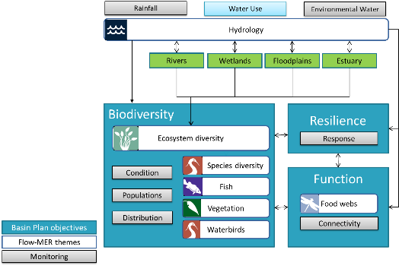
Figure 1.2 Flow-MER evaluation is undertaken in a number of themes that collectively assess the contribution of Commonwealth environmental water to Basin biodiversity, resilience and ecosystem function
Ecosystem Diversity is directly influenced by hydrology and provides the diverse array of water dependent habitats that supports Basin species and food webs

Evaluation objectives
This evaluation answers the following evaluation question for the 2019–20 water year, and for the 6 years of monitoring from 2014–15 to 2019–20:
What did Commonwealth environmental water contribute to ecosystem diversity?
This question was developed under the Commonwealth Environmental Water Outcomes Framework (CEWH 2013) to meet the broader objectives of the Basin Plan.
This evaluation also examines the contribution of Commonwealth environmental water management towards Basin Plan objective Section 8.05(3)(b):
“An objective [of the Plan] is to protect and restore biodiversity that is dependent on Basin water resources by ensuring that representative populations and communities of native biota are protected and, if necessary, restored.”
We address this using two additional evaluation questions addressing short-term (Question 2) and long-term outcomes (Question 3):
- Are the ecosystems in scope for Commonwealth environmental water management representative of aquatic ecosystems in the Basin?
This evaluation question addresses whether those ecosystems able to be watered by Commonwealth environmental water include representatives of the major aquatic ecosystems in the Basin.
- Is Commonwealth environmental water supporting representative ecosystems?
This evaluation question addresses whether those ecosystems able to be watered by Commonwealth environmental water are receiving benefit from this management.

Approach
This evaluation continues the sequence of annual and cumulative evaluation established during the LTIM project (described by Brooks 2020). While the approach has not changed substantively from that developed in previous years, the data sets and mapping have improved, prompting a re-analysis of all previous hydrological inundation and ecosystem mapping data since monitoring began in 2014 to incorporate these improvements and to ensure results are comparable among years.

What did Commonwealth environmental water contribute to ecosystem diversity?
The contribution of Commonwealth environmental water to ecosystem diversity is evaluated by intersecting detailed mapping of all water dependent ecosystems in the Basin with the distribution of Commonwealth environmental water that was delivered in the basin during 2019–20 and cumulatively over the six-year period 2014–20. The evaluation is conducted at the scale of the whole Basin, which is divided into 25 major river valleys. The ecosystem diversity in each valley is quantified using ANAE ecosystem types (described below) and the diversity that received Commonwealth environmental water is assessed for the recent water year 2019–20 and cumulatively over the period of monitoring 2014–20.

Ecosystem diversity is defined by the ANAE classification of the Murray-Darling Basin
Ecosystem types in the Basin are defined by the Australian National Aquatic Ecosystems (ANAE) Classification Framework (Aquatic Ecosystems Task Group 2012). The framework was designed to help support adaptive management of water dependent ecosystems across the multiple jurisdictions in the Basin by providing a common language for describing and naming aquatic ecosystem types (Figure 2.1).
Figure 2.1 Structure and levels of the Interim Australian National Aquatic Ecosystem (ANAE) Classification Framework [Source: Aquatic Ecosystems Task Group (2012)]
The ANAE classification framework was first applied to the best available mapping for Basin lakes, wetlands, rivers and estuarine ecosystems by Brooks et al. (2014). Mapped ecosystems were classified into different ecosystem types using landscape and habitat attributes (ANAE Level 2 and 3, Figure 2.1). Two subsequent revisions have added detailed mapping for floodplains, included new wetland mapping and attribute data from jurisdictions and improved the resolution of river mapping (Brooks 2021, 2017). The current version (v3.0; Brooks 2021) filled a significant gap in the mapping of floodplains in Western NSW and updated floodplain mapping in NSW and Qld (Figure 2.2). Additional detail of the relevant changes to the ANAE data set is provided in Appendix B.
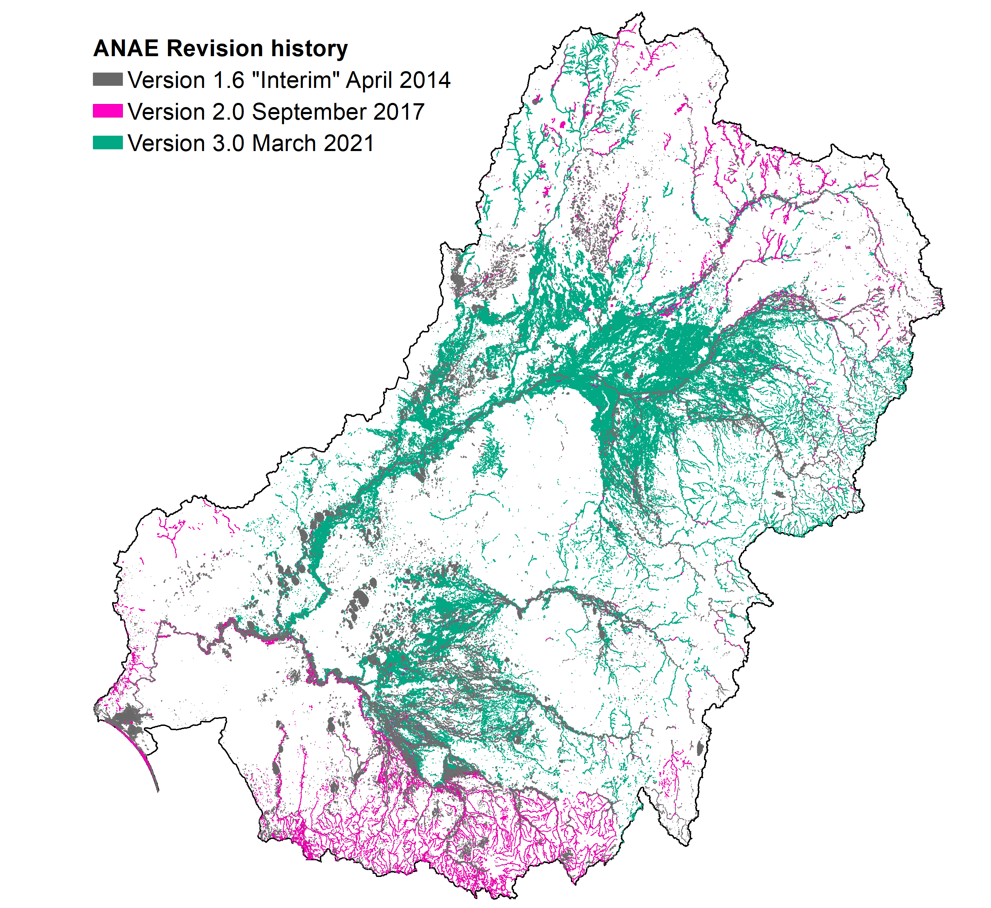
Figure 2.2 Revision history for the ANAE mapping in the Murray-Darling Basin showing the substantial area that was recently improved (green) prompting re-analysis of the cumulative Ecosystem Diversity evaluation
The Murray–Darling Basin ANAE data set v3.0 provides the most complete contemporary mapping of the distribution and extent of water dependent ecosystems in the Basin (Brooks 2021). The areas of approximately 300,000 aquatic ecosystems have been mapped and classified into 67 ANAE types, including 8 types of lake, 29 types of palustrine wetland, 12 floodplain types, 9 river types (including waterholes) and 9 estuarine ecosystem types. This provides the unit of currency in this evaluation to quantify ecosystem diversity as the number of different ANAE types and their area that received Commonwealth environmental water.
Only the larger rivers are mapped as areas. To provide a comprehensive map of all rivers and smaller streams the ANAE v3.0 uses the Geofabric v3.2 Network Streams line mapping (BOM 2020) (Figure 2.4). The Geofabric line mapping was generated consistently for the Australian continent using a 1 second (30m) resolution DEM. This consistency is important because river length measurement is highly dependent on the level of mapping detail, with higher resolution mapping capturing more bends in the river planform and increasing river length between two points. The Geofabric river line mapping provides greater consistency than can be achieved by aggregating mapping from each Basin jurisdiction that use different scales. There are approximately 200,000 river features mapped representing 50,000 km of perennial flowing rivers and more than 400,000 km of temporary flowing rivers and streams; each further divided using slope and altitude into lowland, transitional and upland rivers. Because they are mapped as line segments, the ecosystems receiving Commonwealth environmental water are quantified by their length.
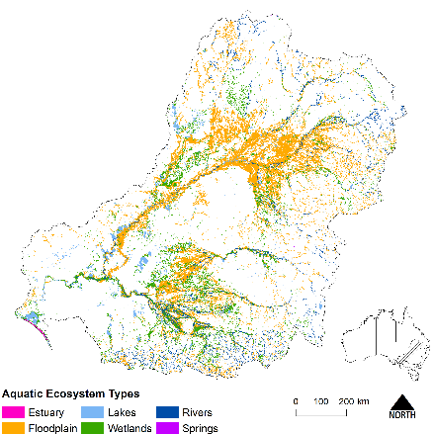
Figure 2.3 Aquatic ecosystem types of the Murray-Darling Basin [Source: Brooks (2021)]
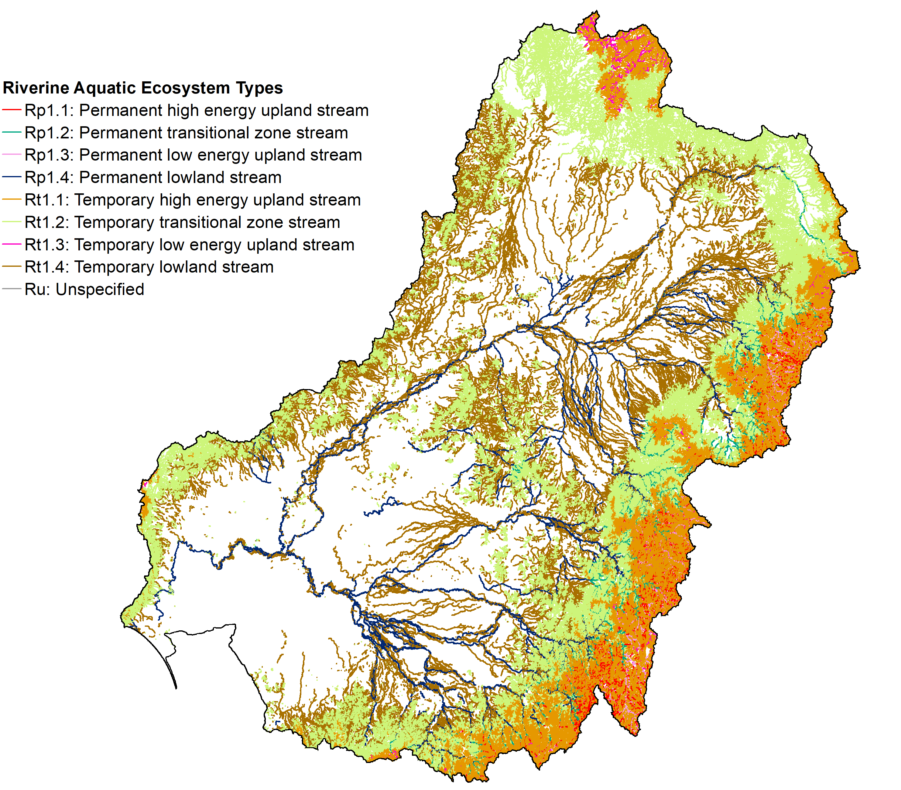
Figure 2.4 ANAE riverine aquatic ecosystem types in the Murray–Darling Basin

Commonwealth environmental water inundation 2019–20
A spatial representation of maximum watering extent for all Commonwealth environmental water delivered in the 2019–20 water year has been prepared by Guarino and Sengupta (2021). The mapping (Figure 2.5) contains the maximum extent of all inundation that included Commonwealth environmental water within the water year. It was not possible for this evaluation to consider the details of individual watering events such as the specific timing and duration of Commonwealth environmental water within the year in different locations. Where Commonwealth environmental water is provided in conjunction with other environmental water (e.g. from State agencies) in a combined delivery, the extent mapped is the combined extent. A comprehensive evaluation including watering actions delivered by other stakeholders (‘other environmental water’) and from natural floods is currently beyond the scope of the Basin-scale project. Most wetlands are not gauged and information on the extent and duration of other environmental water is either not collected by other jurisdictions or is difficult to source. This is a limitation of the current evaluation and a recommendation to improve the capture of all environmental water is included in the Adaptive management section of this report (Section 6).
Commonwealth environmental water inundation mapping is in 2 data sets which are combined in Figure 2.5:
- a raster data set representing inundation of environmental water outside of river channels
- a subset of the ANAE river line mapping including all river segments that contained environmental water during the water year.
River reaches that received in-channel pulses, freshes and passing flows are identified; however, the river channel inundation mapping is not of sufficient resolution to quantify increases in river width nor to identify inundation of riverbanks, benches or fringing habitats along channel margins.
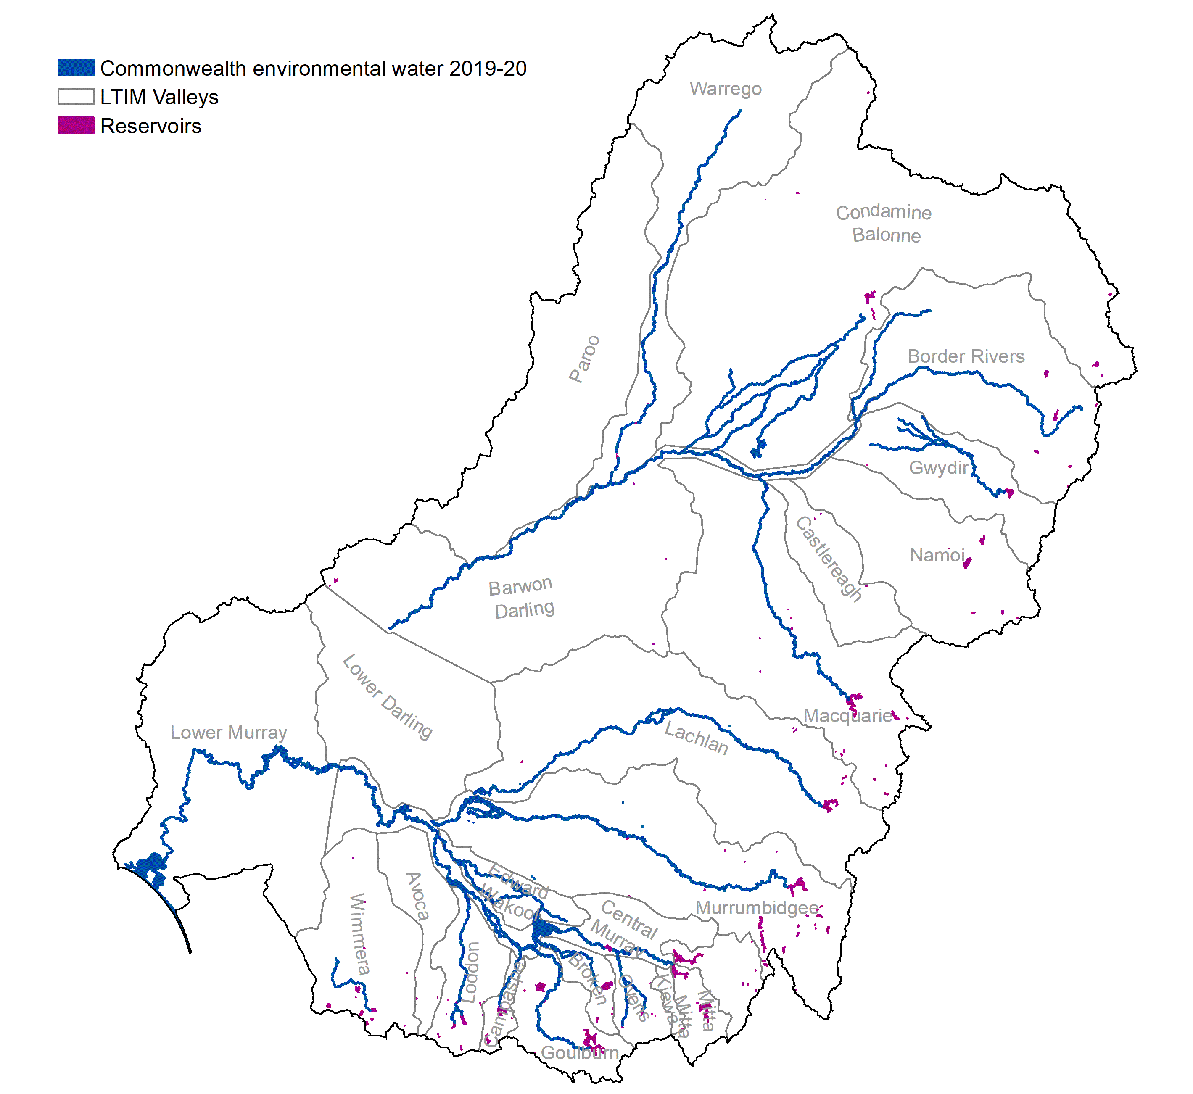
Figure 2.5 Maximum extent of all Commonwealth environmental water in rivers, wetland and floodplains 2019–20
Two different approaches are used to quantify the area of the different aquatic ecosystems that have received Commonwealth environmental water:
- Area inundated by Commonwealth environmental water is used for floodplains and rivers. The inundated area is the sum of the floodplain area that is overlapped by the mapped extent of inundation (excluding the areas that were not inundated). Floodplains occur as broad continuous expanses and most ecosystem responses are limited to the wetted area. For rivers, the sum length of all channel segments containing Commonwealth environmental water is calculated directly using the inundation mapping (Figure 2.5).
- Area influenced by Commonwealth environmental water is used for lakes and palustrine wetlands that received water even if the inundation mapping showed that only a portion of the wetland was inundated. For lakes, this accounts for connectivity among individual wetland components in systems receiving environmental water (e.g. water entering part of a lake raises the entire lake level). For palustrine wetlands this measure acknowledges that the ecosystem boundary does not start and stop at the water’s edge. Filling a wetland depression will also raise local water tables, wetting surrounding soils to benefit fringing vegetation and provides feeding habitat for waterbirds that roost elsewhere in the wetland vegetation that was not inundated. Quantifying the total area of the wetland influenced also addresses the underestimation of inundation extent in wetlands where water is obscured by the thick overstorey of emergent wetland vegetation and is not reliably mapped from satellite imagery. This is particularly notable in tall marsh, grass marshes, sedgelands and meadows where green vegetation obscures a high proportion of the water such that inundation may only show a few scattered pixels of water when the entire wetland is filled (Figure 2.6).
GIS workflows for calculating these two measures are provided in Appendix A.
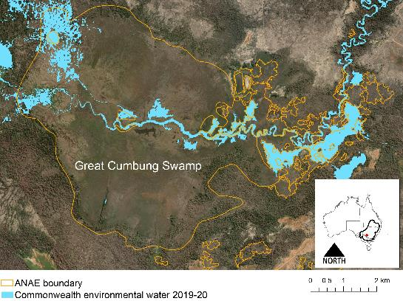
Figure 2.6 Inundation mapping from satellite captures Commonwealth environmental water in the main channels of the Great Cumbung Swamp but is unable to detect water under the thick canopy of the emergent reed beds. This evaluation therefore uses the full area of the reed beds mapped by the ANAE as permanent tall emergent marsh to represent the ecosystem area influenced by Commonwealth environmental water in the Great Cumbung Swamp
Commonwealth environmental water reaching the end of the Murray-Darling system contributes to the maintenance of the Coorong, Lake Alexandrina, Lake Albert and the Murray Mouth ecosystems (the CLLMM). The large lake area and volume relative to annual volumes of Commonwealth environmental water mean the influence of Commonwealth environmental water on lake levels is small. Current inundation modelling is not sensitive enough to quantify lake level influences on the fringing palustrine ecosystems that might be attributed to Commonwealth environmental water. For this evaluation the extent of inundation is estimated from the mapped extent of the CLLMM. This estimate is considered satisfactory because the lakes are managed for a relatively constant water level of 0.5 to 0.8 m AHD by regulating outflows through the barrages. Below the barrages, water levels in the Murray Mouth and Coorong are maintained near sea level. This means that the reported influence of Commonwealth environmental water varies little from year to year (as the system is always receiving end-of-system flows containing Commonwealth environmental water). The evaluation of Commonwealth environmental water outcomes for Basin ecosystem diversity separates the CLLMM system from the rest of the Basin to prevent the constant water levels and dominant lake area from masking the detection of ecosystem diversity outcomes elsewhere in the Basin.

Basin valleys
A spatial layer was developed for the LTIM project that subdivides the Basin into 25 major river valleys (Figure 2.7). These boundaries were derived from the Sustainable Rivers Audit (SRA) (2008) catchment boundaries with a modification to separate the Edward/Kolety-Wakool valley from the Central Murray and to assign wetlands near valley boundaries to the valley to which they are allocated by water managers and Commonwealth environmental water accounting procedures (Stewardson and Guarino 2016).
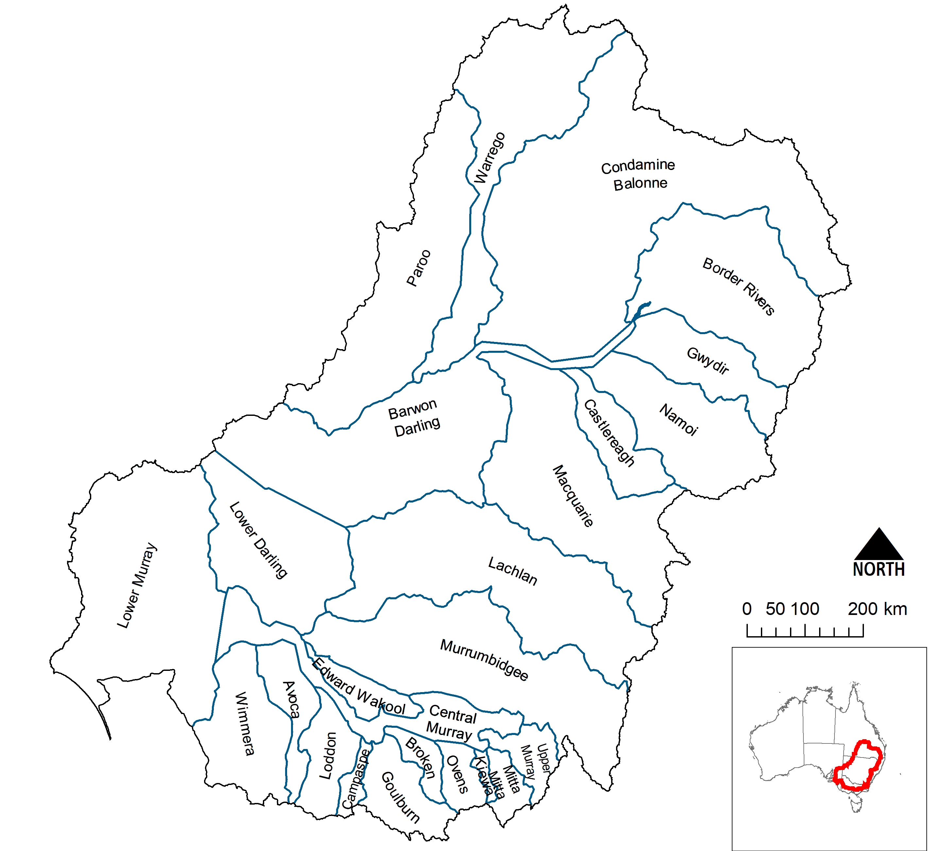
Figure 2.7 Valley boundaries within the Murray–Darling Basin used in this evaluation

Are the ecosystems in scope for Commonwealth environmental water management representative of aquatic ecosystems in the Basin? Is Commonwealth environmental water supporting representative ecosystems?
These two evaluation questions are used to assess the contribution of Commonwealth environmental water management towards Basin Plan objective 8.05(3)(b). Firstly, estimating the subset of the Basin’s ecosystem diversity (as represented by the number and total area of ANAE types) that is in scope for environmental water management provides critical context for the second question to determine if the Commonwealth environmental water is reaching a representative subset of Basin ecosystems. Some ecosystem types occur upstream of storages, in highlands (e.g. alpine peat bogs) or in rain-fed or spring-fed depressions away from rivers or water infrastructure where environmental water management may not be required or is not possible. We therefore first determine the ecosystems that are able to be managed by environmental water and examine qualitatively whether they are similar or distinct from the rest of the Basin. The ecosystems inundated or influenced by Commonwealth environmental water management from 2014–20 were compared to the manageable subset to evaluate whether Commonwealth environmental water management is supporting ecosystem diversity that is representative of the Basin as a whole.
The managed floodplain estimates the area that can be managed by environmental water
The Basin-wide environmental watering strategy (BWEWS) ‘managed floodplain’ (MDBA 2014, 2019, Figure 2.8) is the current best estimate of the area of the Basin that is able to be influenced with the 2,075 GL of environmental water allocated to the environment under the Basin Plan (MDBA 2019). It includes actively managed areas that can receive environmental water delivered from large headwater storages or via the MDBA’s The Living Murray ‘environmental works’ sites on the River Murray floodplain. It also includes passively managed areas that receive environmental water via flow rules in water resource plans or via natural events. Approximately 32% of the Basin’s total area of lakes occurs on or adjacent to the managed floodplain, as well as 37% of total Basin palustrine wetland area, 25% of floodplains and 10% of river lengths (Figure 2.8).
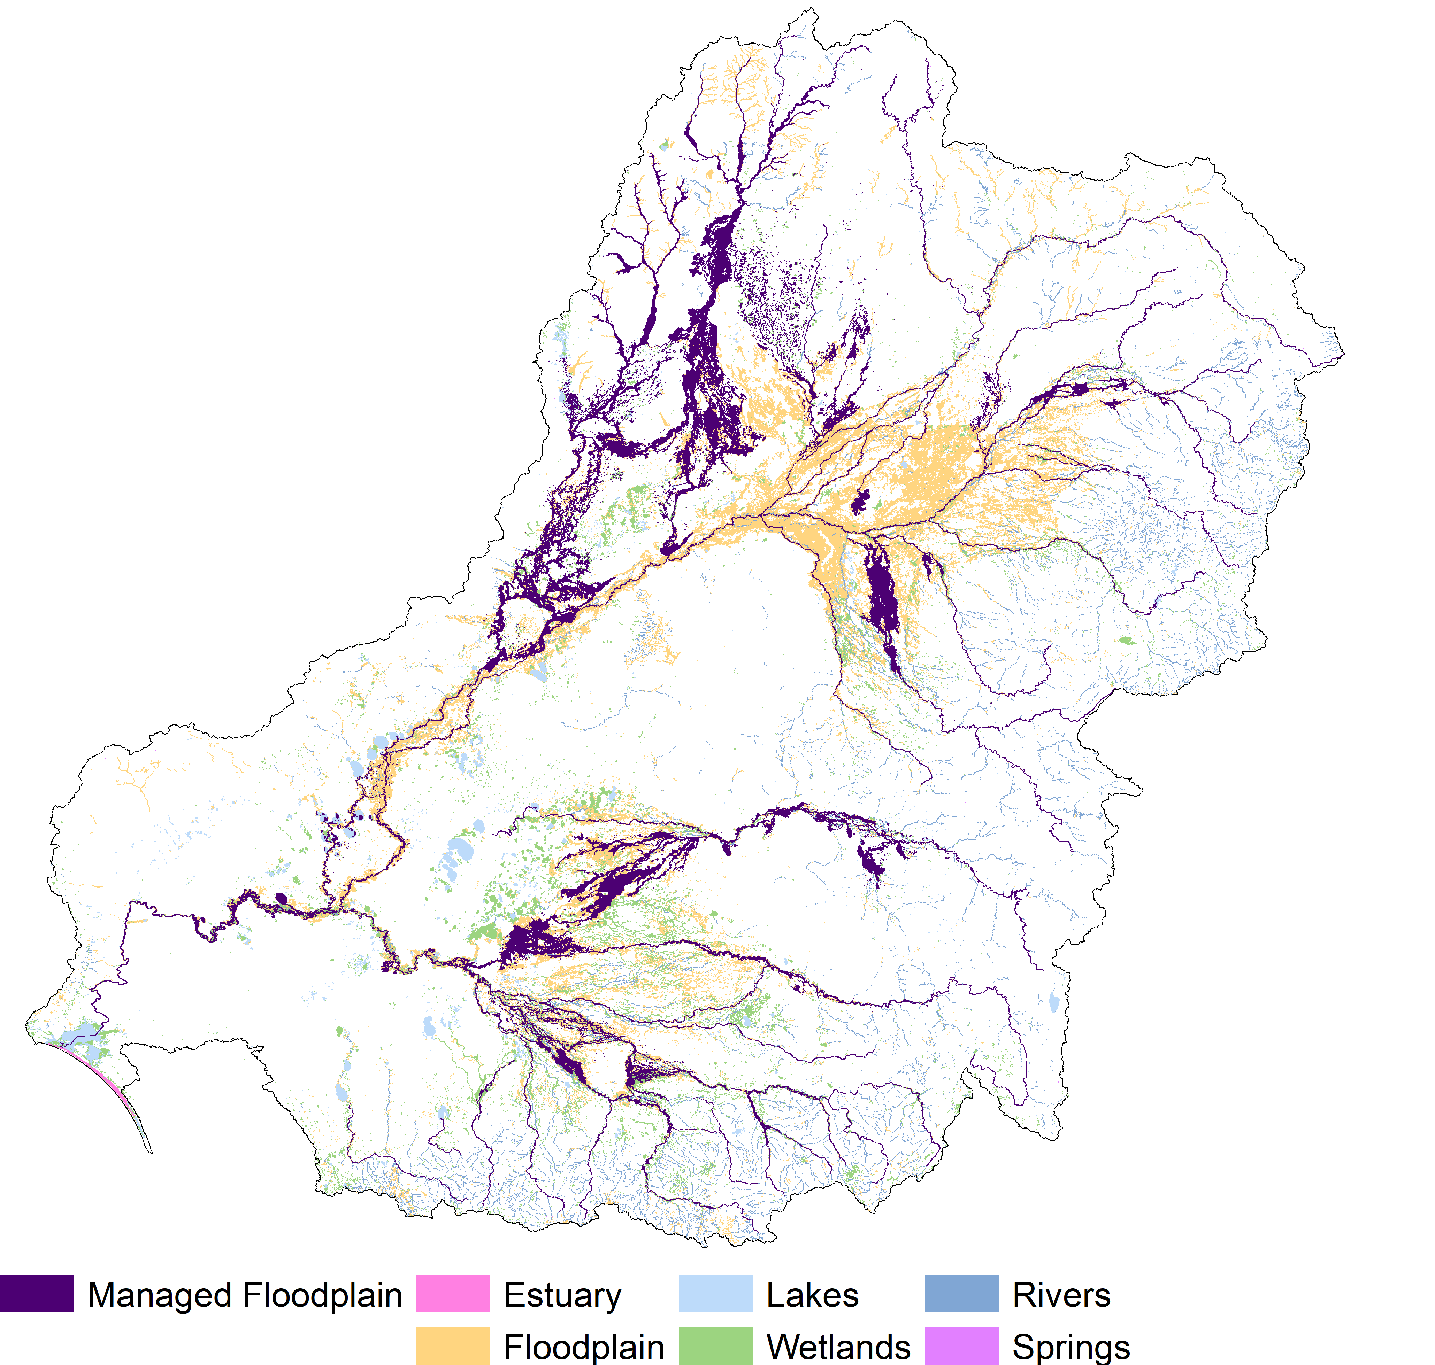
Figure 2.8 Spatial extent of the Basin-wide environmental watering strategy (BWEWS) managed floodplain compared to that of all Basin ANAE wetland and floodplain ecosystem types

Water year 2019–20

Climatic and hydrological context
The period July 2019 to June 2020 was the third consecutive year of below average rainfall (Figure 3.1) and total inflows in 2019–20 were below the average for the last 20 years.
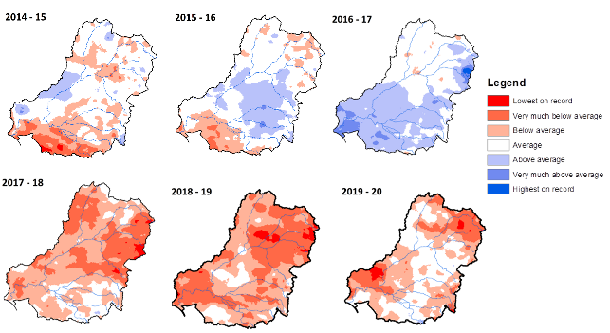
Figure 3.1 Annual rainfall deciles 2014–20 [Source: Bureau of Meteorology]
Watering actions targeting floodplains and floodplain wetlands occurred in 6 of the 25 valleys of the Basin (Figure 2.5, Table 3.1) with the 3 ha of floodplain inundation recorded in the Edward/Kolety-Wakool being the northern extension of inundation of the Barmah-Millewa Forest in the Central Murray Valley. A single billabong received Commonwealth environmental water in the Ovens River Valley. Commonwealth environmental water was used more extensively for in-channel actions in 17 of the 25 valleys (Figure 2.5, Table 3.1).
Over the year, 125 watering actions provided Commonwealth environmental water to lakes, wetlands and rivers throughout the Basin. Most of the water was delivered in-channel (94% by volume; Guarino and Sengupta 2021) providing predominantly base flows and freshes to 15,591 km of river. Two actions that included an over-bank component were delivered in the Central Murray. There were 65 watering actions targeting wetlands and 8 specifically directed to combinations of channels with connected wetlands. Freshwater lakes and saline habitats in the Coorong, Lower Lakes and Murray Mouth (CLLMM) received end-of-system flows containing Commonwealth environmental water.
Of the 17 valleys that received Commonwealth environmental water, 45% of the delivered volume was attributed to actions in the Lower Murray, 19% in the Goulburn, 15% in the Central Murray, 10% in the Condamine Balonne and 3% in the Murrumbidgee. The remaining valleys received 2% or less of total delivered volume of Commonwealth environmental water. See Guarino and Sengupta (2021) for details of individual watering actions.
Table 3.1 Major categories of aquatic ecosystems in each valley inundated or influenced by Commonwealth environmental water 2019–20
Valley | Selected Area | Lake and wetland area (ha) | Floodplain area (ha) | Length of waterways (km)
Avoca |  | - | - | -
Barwon Darling |  | - | - | 1,858
Border Rivers |  | - | - | 935
Broken |  | - | - | 280
Campaspe |  | - | - | 112
Castlereagh |  |  | -- | -
Central Murray |  | 30,171 | 1,157 | 2,143
Condamine Balonne |  | 5,725 | 4,528 | 1,627
Edward/Kolety–Wakool | Edward/Kolety–Wakool river system | 3 | 7 | 789
Goulburn | Goulburn River | - | - | 406
Gwydir | Gwydir river system | - | - | 623
Kiewa |  | - | - | -
Lachlan | Lachlan river system | 4,134 | 943 | 1,488
Loddon |  | - | - | 365
Lower Darling |  | 45 | 4 | 9
Lower Murray* | Lower Murray River* | 3,518 | 1,097 | 1,187
Lower Murray  (Coorong, Lakes Alexandrina and Albert and Murray Mouth) |  | Fresh: 103,422  Estuarine: 23,768 | 65 | -
Macquarie |  | - | - | 667†
Mitta Mitta |  | - | - | -
Murrumbidgee | Murrumbidgee river system | 6,470 | 6,043 | 1,495
Namoi |  | - | - | -
Ovens |  | 4 | - | 252
Paroo |  | - | - | -
Upper Murray |  | - | - | -
Warrego | Junction of the Warrego and Darling rivers | - | - | 1,176
Wimmera |  | - | - | 179
Total |  | 177,260 | 13,844 | 15,591
* excludes the Coorong, Lakes Alexandrina and Albert and the Murray Mouth
†Commonwealth environmental water in the Macquarie River provided supplementary water to the Macquarie Marshes that were extensively inundated by natural rainfall and river flows.

Contribution of Commonwealth environmental water to Ecosystem Diversity 2019–20
Ecosystem diversity, expressed as the number of ANAE types or ‘richness’ of ecosystem types, is shown by valley in Figure 3.2. Diversity in the Lower Murray is elevated by the 9 estuarine ecosystem types located in the CLLMM system (lower lakes, Murray Mouth and Coorong). If estuarine types are omitted, the ecosystem diversity of the Lower Murray is 47 ANAE types, equal to the Condamine Balonne. Ecosystem diversity in the Basin increases with valley area (Figure 3.3). It is highest in the largest 2 valleys, the Lower Murray (94,000 km², 56 types of aquatic ecosystem) and Condamine Balonne (164,000 km², 47 types), and lowest in the Kiewa (19 ecosystem types) – the valley with the smallest area (1,700 km²).
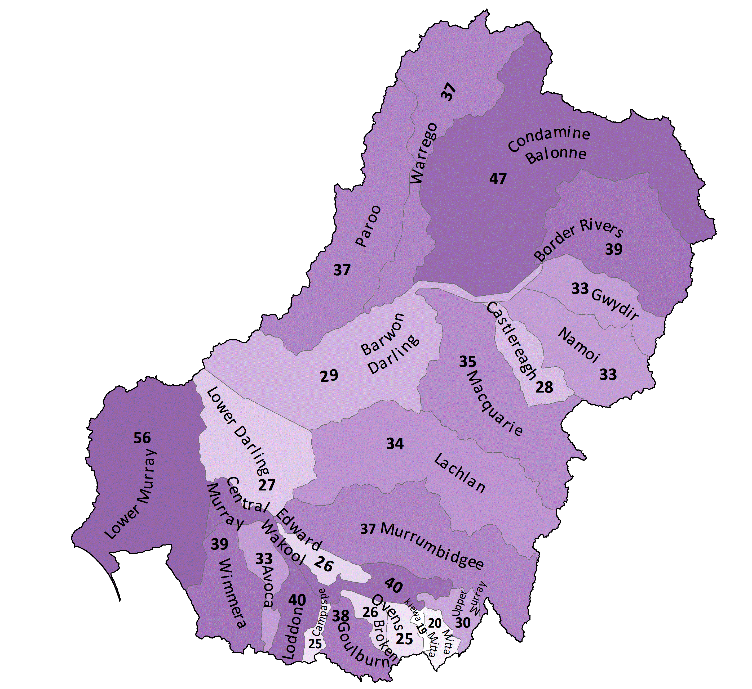
Figure 3.2 Map of ecosystem diversity by valley
Numbers (e.g. 37 Paroo) indicate the number of mapped ANAE types in each valley. Depth of shading indicates lowest to highest
Figure 3.3 Ecosystem diversity (number of ANAE ecosystem types) scaled with valley area (x-axis log scale) for each of the valleys
Within individual valleys, Commonwealth environmental water delivered in 2019–20 inundated or influenced (see Section 2.1) more than 50% of the ecosystem types present in each of the Lower Murray, Central Murray, Barwon Darling, Border Rivers, Murrumbidgee and Ovens River valleys (Figure 3.4). In another 12 valleys, Commonwealth environmental water was delivered to between 20% and 50% of the ecosystem types present. There were no water management actions in the remaining 7 valleys2F. The high contribution of Commonwealth environmental water towards ecosystem diversity in the Lower Murray reflects the attribution of end-of-system flows to the Murray Mouth, Lower Lakes, Coorong and the estuarine ecosystems. It also reflects the fact that aquatic ecosystems in the Lower Murray valley are concentrated along the flow-path of the River Murray.
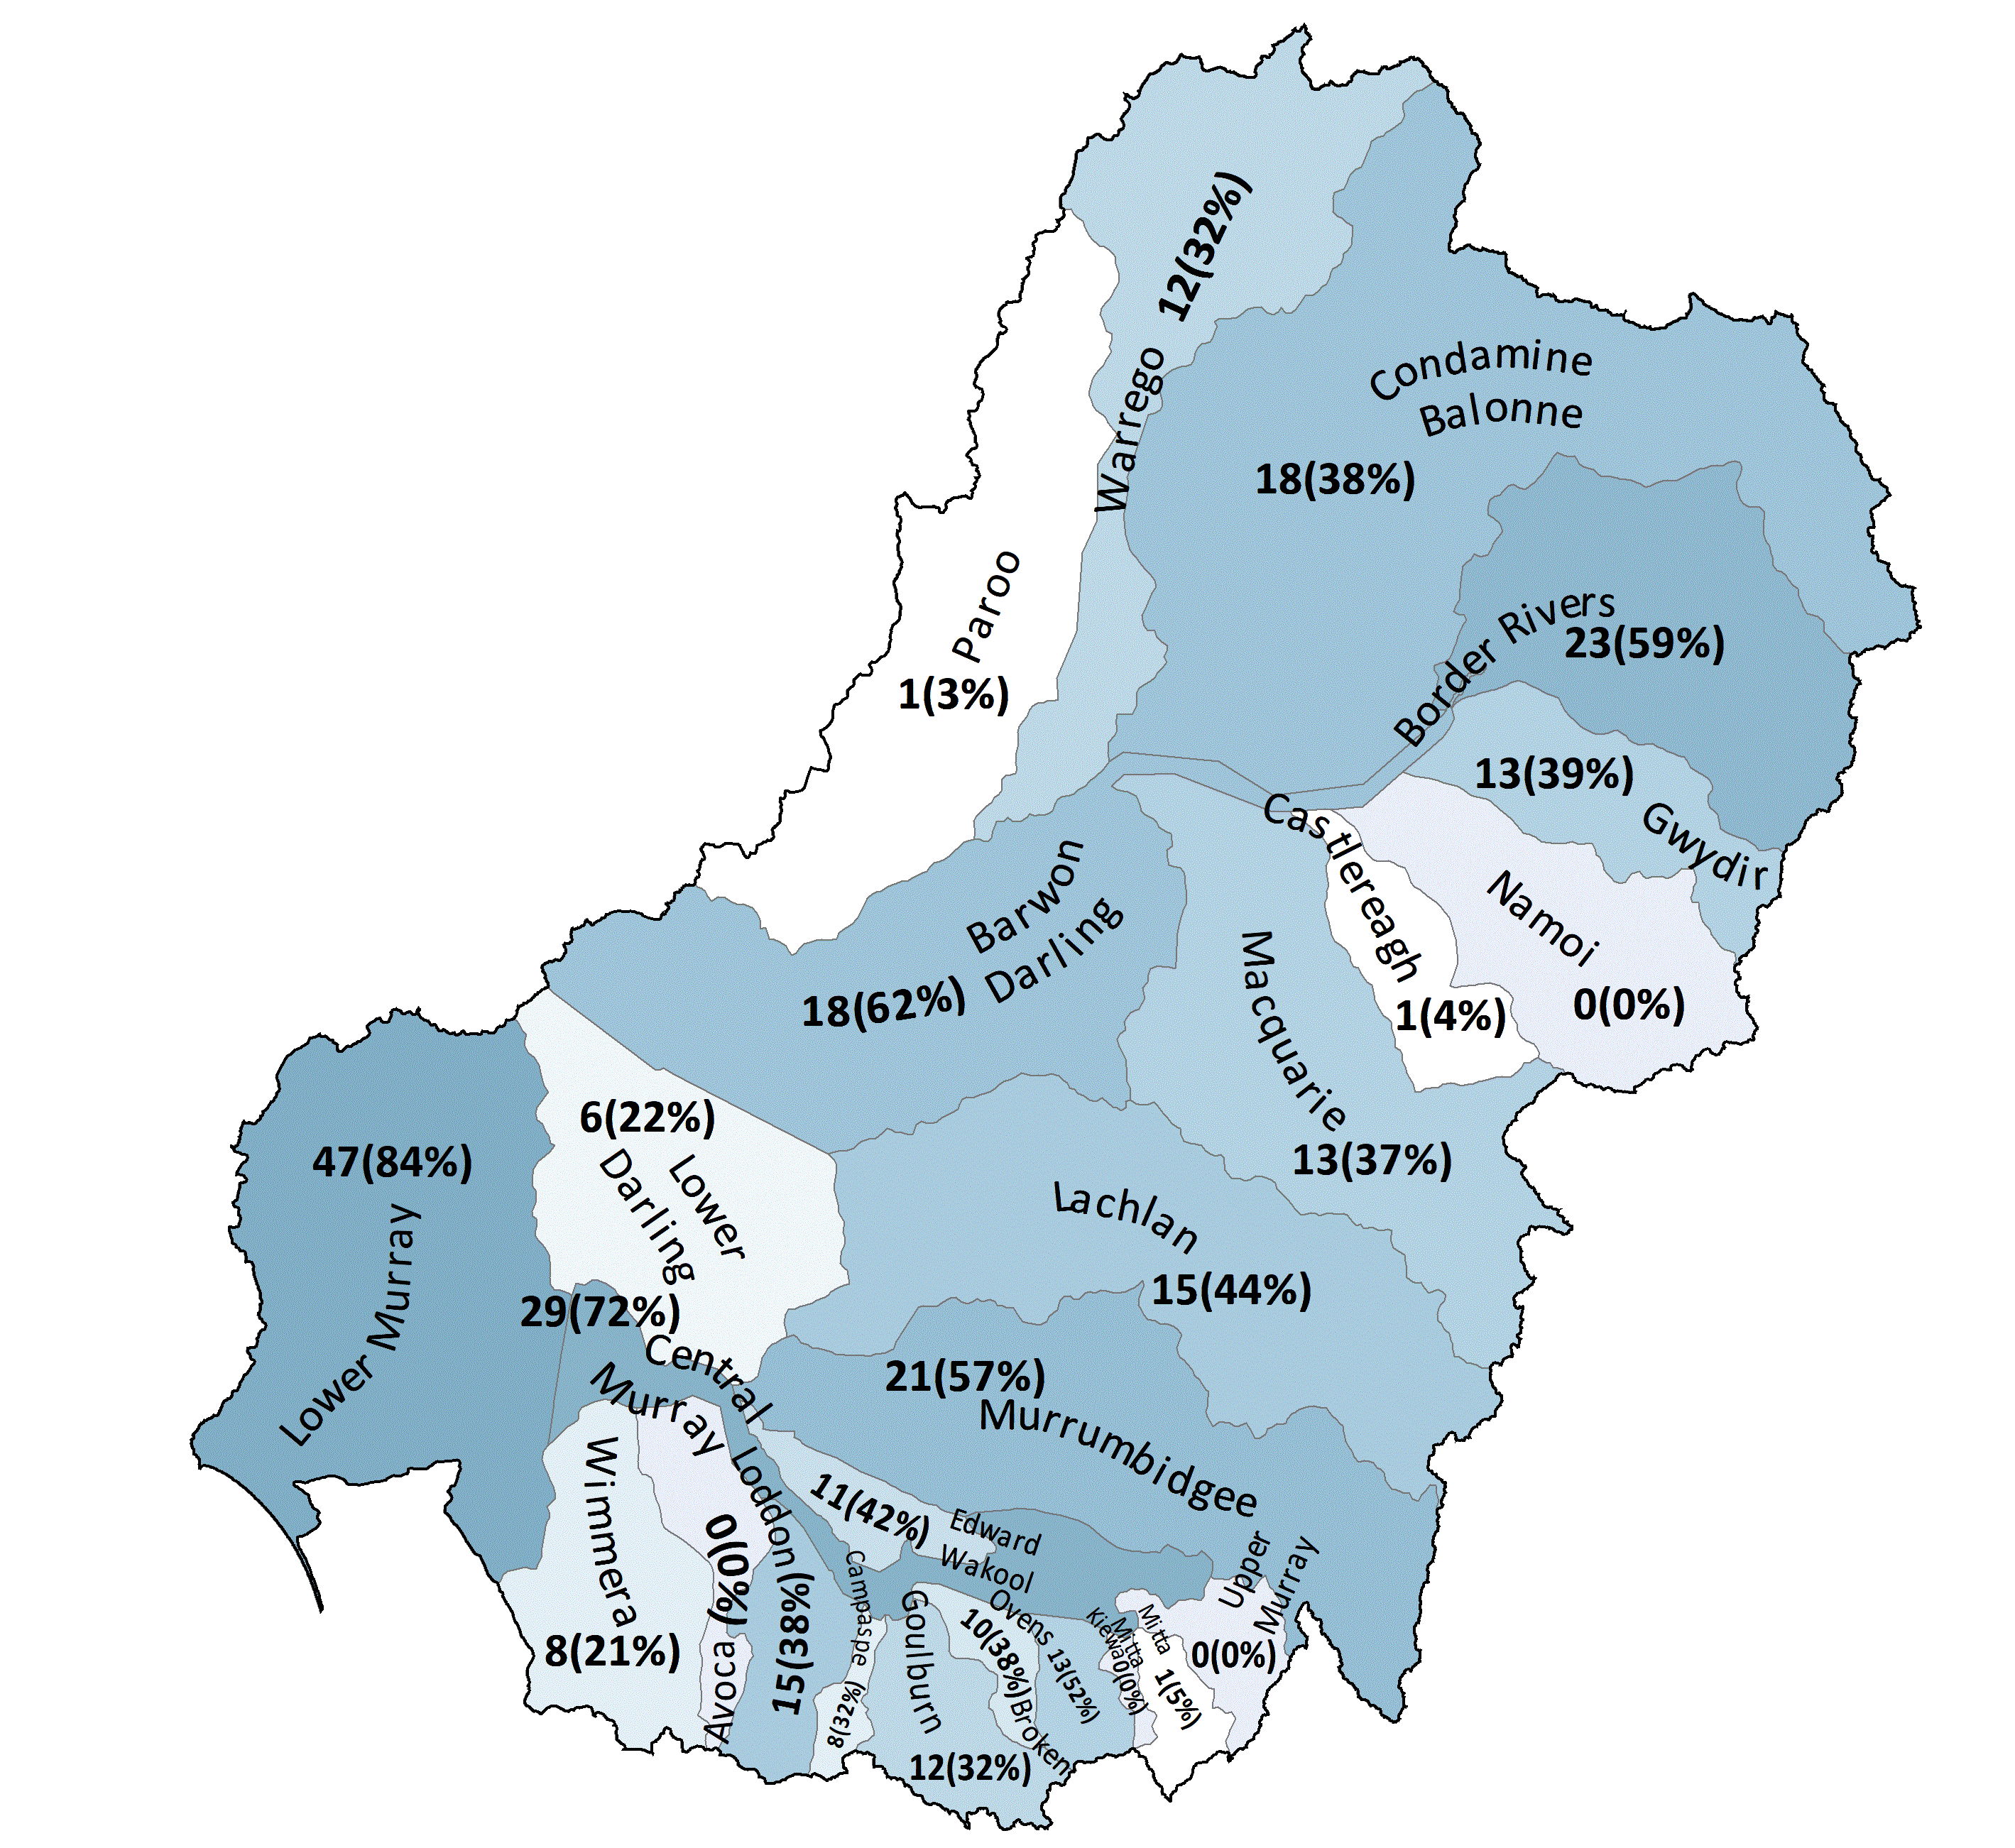
Figure 3.4 Map of ecosystem diversity supported by Commonwealth environmental water in 2019–20 expressed as the number of ANAE ecosystem types inundated by or influenced by Commonwealth environmental water in each valley with the percentage of valley total ecosystem diversity in parentheses (see also Appendices C to E)
The contribution of Commonwealth environmental water to ecosystem diversity upstream of Lake Alexandrina is tabulated in broad ecosystem categories for lakes and wetlands (Table 3.2), floodplains (Table 3.3) and river channels (Table 3.4). The contribution of Commonwealth environmental water to Ecosystem Diversity in the CLLMM (Coorong and Lakes Alexandrina and Albert and the Murray Mouth) are presented separately in Table 3.5 to prevent the large areas of Lakes Alexandrina and Albert from masking patterns of inundation of lakes elsewhere.
At the Basin-scale, Commonwealth environmental watering in 2019–20 contributed to the inundation of 57 of the 67 ecosystem types found in the Basin. This is similar to previous years and included 21 (57%) of all lakes and palustrine wetland types, 10 (83%) of different floodplain ecosystem types (Table 3.3), 7 of 8 (88%) of river channel types (Table 3.4), and all 9 estuarine ecosystem types in the CLLMM (Lower Lakes, Coorong and Murray Mouth) (Table 3.5). A detailed breakdown of ecosystem types receiving Commonwealth environmental water in each valley is provided in Appendix C (wetlands and estuarine ecosystems), Appendix D (floodplains) and Appendix E (river channels).
The ecosystem diversity supported by Commonwealth environmental water in 2019–20 was heavily skewed towards temporary River Red Gum swamps with 26,035 ha potentially benefitting from Commonwealth environmental water (Table 3.2). This is 52% of the combined area of all lakes and wetlands influenced by Commonwealth environmental water in 2019–20 and is nearly half (46%) of all temporary River Red Gum swamps on the managed floodplain. Much of the temporary River Red Gum swamp was watered through actions to flood Barmah forest with many smaller Red Gum swamps connected to the Murray, Murrumbidgee, Loddon and Goulburn Rivers benefitting from freshes in these systems. This is a similar pattern to that seen in previous years when Barmah forest is a recipient of Commonwealth environmental water.
A large component of water to top up permanent lakes (7,561 ha representing 11% of the permanent lakes on the managed floodplain; Table 3.2) was delivered primarily to Narran Lake in the Condamine-Balonne (5,200 ha), and Lake Benanee (760 ha) and Dry Lake (611 ha) in the Central Murray Valley.
Commonwealth environmental water supported a significant area (10,762 ha combined) of marshes, consisting of permanent and temporary tall emergent marshes, temporary sedge/grass/forb marsh, permanent grass marsh and permanent wetlands (which are often open-water patches associated with marshes in the ANAE data set). These watered marsh systems were clustered along the Murray, Macquarie and Murrumbidgee rivers and in the Great Cumbung Swamp at the terminus of the Lachlan River. The watered area also influenced 52% of all permanent tall emergent marsh in the Basin (54% of tall marsh on the managed floodplain) and 32% of the combined area of all permanent grass, forb, sedge/grass/forb and tall emergent marshes on the managed floodplain. Given the persistence of below average rainfall since 2017, environmental watering actions in 2019–20 were likely to have made a significant contribution to maintaining these permanent marsh ecosystems.
Commonwealth environmental water inundated less floodplain area in 2019–20 than in previous years, with 13,780 ha inundated (upstream of CLLMM, Table 3.3) compared to 30,000 ha in 2018–19 up to a maximum of 47,400 ha in 2015–16. Despite this, the largest inundation of Lignum dominated floodplain by Commonwealth environmental water (6,002 ha) occurred in 2019–20 since monitoring began in 2014. This represents 8% of all Lignum dominated areas on the managed floodplain (Table 3.3), including watering actions to the Narran lakes, the Lowbidgee, and smaller patches of Lignum floodplain along the Lower Murray. For the 2 most common floodplain types in the Basin (Coolibah woodland and Black Box woodland) Commonwealth environmental water inundated less than 0.1% and 0.5% respectively.
The pattern of Commonwealth environmental water supporting ecosystem diversity of river channels was similar to all previous years. The majority (74%) of watered channels (11,559 km of permanent lowland river and 3,492 km of temporary channels) that included Commonwealth environmental water were distributed primarily among the Warrego, Condamine Balonne and Border Rivers with anabranches and smaller channels in the Central Murray and Lower Murray valleys. The 35 km of upland stream carrying Commonwealth environmental water in 2019–20 (Table 3.4) were unregulated entitlements which maintained base flows in upper reaches of the Severn River (flowing downstream into the Dumaresq River on the NSW/Qld border).
Table 3.2 Lake and wetland ecosystem types influenced* by Commonwealth environmental water at Basin-scale 2019–20, sorted by area influenced in 2019–20
Australian National Aquatic Ecosystem (ANAE) wetland type | Total area (ex Coorong and Lower Lakes) (ha) | Area on managed floodplain  (ha) | Influenced*
Australian National Aquatic Ecosystem (ANAE) wetland type | Total area (ex Coorong and Lower Lakes) (ha) | Area on managed floodplain  (ha) | Area  (ha) | % of  total | % of managed floodplain
Pt1.1.2: Temporary River Red Gum swamp | 76,067 | 57,248 | 26,035 | 34.2% | 45.5%
Lp1.1: Permanent lake | 130,717 | 70,565 | 7,561 | 5.8% | 10.7%
Pp2.1.2: Permanent tall emergent marsh | 8,001 | 7,498 | 4,156 | 51.9% | 55.4%
Pp4.2: Permanent wetland | 57,996 | 22,462 | 2,486 | 4.3% | 11.1%
Pt2.2.2: Temporary sedge/grass/forb marsh | 333,813 | 123,962 | 2,155 | 0.6% | 1.7%
Pt2.1.2: Temporary tall emergent marsh | 72,636 | 55,196 | 1,854 | 2.6% | 3.4%
Lt1.1: Temporary lake | 462,489 | 117,820 | 1,616 | 0.3% | 1.4%
Pt1.8.2: Temporary shrub swamp | 189,980 | 52,328 | 1,333 | 0.7% | 2.5%
Pt1: Temporary swamps | 3,744 | 2,812 | 525 | 14.0% | 18.7%
Pt3.1.2: Clay pan | 121,839 | 36,969 | 518 | 0.4% | 1.4%
Psp4: Permanent saline wetland | 2,114 | 1,225 | 487 | 23.0% | 39.8%
Pt2.3.2: Freshwater meadow | 103,121 | 25,830 | 441 | 0.4% | 1.7%
Pt1.6.2: Temporary woodland swamp | 96,401 | 30,689 | 377 | 0.4% | 1.2%
Pt1.2.2: Temporary Black Box swamp | 61,058 | 20,222 | 214 | 0.4% | 1.1%
Pt4.2: Temporary wetland | 22,592 | 2,660 | 113 | 0.5% | 4.2%
Pp2.3.2: Permanent grass marsh | 329 | 226 | 91 | 27.7% | 40.3%
Pu1: Unspecified wetland | 63 | 58 | 48 | 76.2% | 82.8%
Pt1.7.2: Temporary Lignum swamp | 37,633 | 7,028 | 39 | 0.1% | 0.6%
Pp2.4.2: Permanent forb marsh | 740 | 149 | 17 | 2.3% | 11.4%
Pp2.2.2: Permanent sedge/grass/forb marsh | 4,395 | 384 | 3 | <0.1% | 0.8%
Pst2.2: Temporary salt marsh | 15,962 | 1,674 | 3 | <0.1% | 0.2%
Lt1.2: Temporary lake with aquatic bed | 9,052 | 8,177 | 0 | 0.0% | 0.0%
Lsp1.1: Permanent saline lake | 9,492 | 6,041 | 0 | 0.0% | 0.0%
Pt1.3.2: Temporary Coolibah swamp | 8,274 | 5,147 | 0 | 0.0% | 0.0%
Lst1.1: Temporary saline lake | 27,898 | 1,349 | 0 | 0.0% | 0.0%
Pst3.2: Salt pan or salt flat | 3,251 | 253 | 0 | 0.0% | 0.0%
Lp1.2: Permanent lake with aquatic bed | 2,067 | 196 | 0 | 0.0% | 0.0%
Pp3: Peat bog or fen marsh | 3,307 | 187 | 0 | 0.0% | 0.0%
Lst1.2: Temporary saline lake with aquatic bed | 2,238 | 180 | 0 | 0.0% | 0.0%
Pst4: Temporary saline wetland | 6,141 | 50 | 0 | 0.0% | 0.0%
Pst1.1: Temporary saline swamp | 7,369 | 9 | 0 | 0.0% | 0.0%
Pps5: Permanent spring | 123 | 2 | 0 | 0.0% | 0.0%
Pp1.1.2: Permanent paperbark swamp | 1 | 1 | 0 | 0.0% | 0.0%
Lsp1.2: Permanent saline lake with aquatic bed | 181 | - | 0 | 0.0% | -
Psp1.1: Saline paperbark swamp | 31 | - | 0 | 0.0% | -
Psp2.1: Permanent salt marsh | 249 | - | 0 | 0.0% | -
Pt1.5.2: Temporary paperbark swamp | 402 | - | 0 | 0.0% | -
* Area inundated/influenced by Commonwealth environmental water: see Section 2.1 for definitions
Table 3.3 Floodplain ecosystem types inundated* by Commonwealth environmental water at Basin scale 2019–20, sorted by area inundated in 2019–20
Australian National Aquatic Ecosystem (ANAE)  floodplain type | Total  area (ha) | Area on managed floodplain (ha) | Inundated*
 | Total  area (ha) | Area on managed floodplain (ha) | Area  (ha) | % of  total | % of managed floodplain
F2.2: Lignum shrubland riparian zone or floodplain | 291,051 | 76,181 | 6,002 | 2.1% | 7.9%
F1.2: River Red Gum forest riparian zone or floodplain | 625,611 | 294,874 | 4,521 | 0.7% | 1.5%
F1.8: Black Box woodland riparian zone or floodplain | 1,713,215 | 259,669 | 1,200 | <0.1% | 0.5%
F2.4: Shrubland riparian zone or floodplain | 461,257 | 136,499 | 836 | 0.2% | 0.6%
F1.10: Coolibah woodland and forest riparian zone or floodplain | 2,107,271 | 477,520 | 677 | <0.1% | 0.1%
F1.4: River Red Gum woodland riparian zone or floodplain | 297,969 | 140,718 | 334 | 0.1% | 0.2%
F4: Unspecified riparian zone or floodplain | 21,547 | 4,456 | 131 | 0.6% | 2.9%
F3.2: Sedge/forb/grassland riparian zone or floodplain | 62,784 | 6,335 | 39 | <0.1% | 0.6%
F1.12: Woodland riparian zone or floodplain | 152,751 | 42,978 | 22 | <0.1% | <0.1%
F1.11: River Cooba woodland riparian zone or floodplain | 16,898 | 3,889 | 18 | 0.1% | 0.5%
F1.6: Black Box forest riparian zone or floodplain | 2,815 | 432 | 0 | - | -
F1.13: Paperbark riparian zone or floodplain | 1,036 | 271 | 0 | - | -
* Area inundated/influenced by Commonwealth environmental water: see Section 2.1 for definitions
Table 3.4 River channel types of the Basin inundated* by Commonwealth environmental water 2019–20, sorted by length of channel inundated in 2019–20
Australian National Aquatic Ecosystem (ANAE) waterway type | Total | Length on managed floodplain (km) | Inundated*
Australian National Aquatic Ecosystem (ANAE) waterway type | length (km) | Length on managed floodplain (km) | Length  (km) | % of total | % on managed floodplain
Rp1.4: Permanent lowland stream | 28,876 | 18,715 | 11,559 | 40.0% | 61.8%
Rt1.4: Temporary lowland stream | 136,001 | 21,469 | 3,492 | 2.6% | 16.3%
Rp1.2: Permanent transitional zone stream | 10,553 | 1,829 | 251 | 2.4% | 13.7%
Rt1.2: Temporary transitional zone stream | 179,113 | 3,750 | 250 | 0.1% | 6.7%
Rt1.1: Temporary high energy upland stream | 110,649 | 288 | 17 | <0.1% | 5.9%
Rt1.3: Temporary low energy upland stream | 3,554 | 234 | 13 | 0.4% | 5.6%
Rp1.1: Permanent high energy upland stream | 11,106 | 320 | 5 | <0.1% | 1.6%
<Null> | 2 | 2 | 2 | 100.0% | 100.0%
* Area inundated/influenced by Commonwealth environmental water: see Section 2.1 for definitions
Table 3.5 Ecosystem types in the Coorong, Lower Lakes and Murray Mouth (CLLMM) influenced or inundated (floodplains only) by Commonwealth environmental water 2019–20, sorted by the area inundated/influenced by Commonwealth environmental water. All are on the managed floodplain
Australian National Aquatic Ecosystem (ANAE)  wetland type | Total area (ha) | Inundated*
Australian National Aquatic Ecosystem (ANAE)  wetland type | Total area (ha) | Area (ha) | % of total
Lp1.1: Permanent lake | 82,325 | 82,325 | 100.0%
Ewd1.3.2: Coastal lagoon | 18,855 | 18,855 | 100.0%
Pt3.1.2: Clay pan | 7,800 | 7,785 | 99.8%
Pt2.1.2: Temporary tall emergent marsh | 5,820 | 5,820 | 100.0%
Pt2.2.2: Temporary sedge/grass/forb marsh | 2,605 | 2,480 | 95.2%
Etd1.3.3: Tide dominated estuary | 2,240 | 2,240 | 100.0%
Lsp1.1: Permanent saline lake | 2,182 | 2,182 | 100.0%
Ewd1.2.4: Intertidal mudflat or sand bar | 924 | 924 | 100.0%
Rp1.4: Permanent lowland stream | 912 | 912 | 100.0%
Pst1.1: Temporary saline swamp | 787 | 787 | 100.0%
Etd1.2.2: Tide dominated mudflats and sandbar | 631 | 631 | 100.0%
Psp4: Permanent saline wetland | 601 | 601 | 100.0%
Ewd1.2.3: Intertidal saltmarsh | 482 | 482 | 100.0%
Pst4: Temporary saline wetland | 452 | 452 | 100.0%
Pst2.2: Temporary salt marsh | 371 | 371 | 100.0%
Etd1.2.1: Tide dominated saltmarsh | 324 | 324 | 100.0%
Ewd1.2.5: Intertidal rocky shoreline | 285 | 285 | 100.0%
Psp1.1: Saline paperbark swamp | 132 | 132 | 100.0%
Pst3.2: Salt pan or salt flat | 122 | 122 | 100.0%
Pp4.2: Permanent wetland | 91 | 91 | 100.0%
Pt4.2: Temporary wetland | 86 | 86 | 100.0%
Pt2.3.2: Freshwater meadow | 34 | 34 | 100.0%
F4: Unspecified riparian zone or floodplain | 328 | 29 | 8.8%
F2.4: Shrubland riparian zone or floodplain | 490 | 22 | 4.5%
Etd1.2.3: Tide dominated forest | 19 | 19 | 100.0%
Lt1.1: Temporary lake | 16 | 16 | 100.0%
F1.13: Paperbark riparian zone or floodplain | 109 | 11 | 10.1%
Pt1.8.2: Temporary shrub swamp | 8 | 8 | 100.0%
Etd1.1.1: Tide dominated rocky shoreline | 7 | 7 | 100.0%
Pt1.7.2: Temporary Lignum swamp | 3 | 3 | 100.0%
F1.12: Woodland riparian zone or floodplain | 39 | 2 | 5.1%
Psp2.1: Permanent salt marsh | 2 | 2 | 100.0%
F2.2: Lignum shrubland riparian zone or floodplain | 5 | 1 | 20.0%
Pp2.4.2: Permanent forb marsh | 1 | 1 | 100.0%
* Area inundated/influenced by Commonwealth environmental water: see Section 2.1 for definitions

Water years 2014–20
This cumulative evaluation qualitatively compares Commonwealth environmental water distribution to and support of aquatic ecosystem types in the Basin since monitoring began in July 2014 to June 2020. The evaluation presented here uses updated inundation mapping and the new v3.0 ANAE ecosystem mapping for all years to ensure comparability among years.
The consistency of inundation mapping among years has been improved by revisiting source materials from the LTIM project and rebuilding annual inundation mapping using the same process and river line mapping used to generate the 2019–20 inundation maps (Guarino pers comm. 2021). This retrospective analysis used information that was not available at the start of the LTIM project to improve the mapping of Commonwealth environmental water for 2014–15 by reducing the influence of natural rainfall.

Lake ecosystems
Commonwealth environmental water is consistently delivered to only 2 freshwater lake types (temporary and permanent lakes) which together make up 92% of the lakes by area in the Basin and on the managed floodplain (Table 4.1, Figure 4.2). Commonwealth environmental water is delivered more frequently to the maintenance of permanent lakes over temporary lakes in 5 of the last 6 years (Figure 4.2). This is likely to be consistent with the hydrological needs of these systems (e.g. it may not be appropriate for temporary lakes to receive Commonwealth environmental water too frequently as the dry spell is also important for maintaining the ecosystem).
Commonwealth environmental water delivery was spread across different lakes in different years, with 44% of the permanent lake area that received Commonwealth environmental water over the 6 years only receiving water once.
Four of the 5 lake ecosystem types that have not received Commonwealth environmental water in 6 years have lake beds supporting aquatic macrophytes (‘aquatic bed’ in the ANAE typology). Macrophyte beds are floristically biodiverse and important feeding and breeding habitats for fish and waterbirds. Further investigation of individual lakes is required to determine whether Commonwealth environmental water should prioritise these systems higher, or whether their water needs are being met by natural rainfall and groundwater. There are 23 of the 95 lakes with aquatic beds in the Basin occur on the managed floodplain – 2 in Victoria (Lake Buloke and Little Lake Buloke) in the Wimmera, and 21 in Queensland in the Border Rivers and Condamine Balonne systems.
The large increase in lake inundation in 2017–18 (Figure 4.1) was due to weir pool raising at Lock 8 and Lock 9 on the Murray River to push Commonwealth environmental water into Lake Victoria (10,738 ha) during a wet year.
Table 4.1 Areas of lake types (upstream of the CLLMM) supported by Commonwealth environmental water 2014–20
* Types that received Commonwealth environmental water in each year of the 6-year monitoring period are shaded blue
Australian National Aquatic Ecosystem (ANAE) wetland type | Total area in Basin (ha) | Area on managed floodplain (ha) | Area receiving Commonwealth environmental water (ha)
Australian National Aquatic Ecosystem (ANAE) wetland type | Total area in Basin (ha) | Area on managed floodplain (ha) | Y1  14–15 | Y2  15–16 | Y3  16–17 | Y4  17–18 | Y5  18–19 | Y6  19–20
Lt1.1: Temporary lake* | 462,489 | 117,820 | 714 | 3,472 | 2,188 | 3,076 | 1,279 | 1,616
Lp1.1: Permanent lake* | 131,046 | 70,889 | 6,745 | 3,993 | 7,972 | 15,001 | 3,392 | 7,561
Lt1.2: Temporary lake with aquatic bed | 9,052 | 8,177 | 0 | 0 | 0 | 0 | 0 | 0
Lsp1.1: Permanent saline lake | 9,492 | 6,041 | 0 | 0 | 0 | 0 | 0 | 0
Lst1.1: Temporary saline lake | 27,898 | 1,349 | 0 | 0 | 0 | 307 | 0 | 0
Lp1.2: Permanent lake with aquatic bed | 2,067 | 196 | 0 | 0 | 0 | 0 | 0 | 0
Lst1.2: Temporary saline lake with aquatic bed | 2,238 | 180 | 0 | 0 | 0 | 0 | 0 | 0
Lsp1.2: Permanent saline lake with aquatic bed | 181 | 0 | 0 | 0 | 0 | 0 | 0 | 0
TOTAL | 644,463 | 204,652 | 7,459 | 7,465 | 10,160 | 18,384 | 4,671 | 9,177
Figure 4.1 Lake ecosystem types influenced by Commonwealth environmental water 2014–20
Over the 6 years of monitoring, Commonwealth environmental water has supported 26,853 ha of lake ecosystems (Figure 4.2), excluding Lakes Alexandrina and Albert in South Australia which are inevitably supported by those environmental flows that reach the end of the system. The relatively small area of lake ecosystem that was supported annually by Commonwealth environmental water may reflect the fact that lakes are typically deeper than wetlands and hold water for longer, meaning Commonwealth environmental water may not be delivered as frequently as water from previous years watering may be present in following years. Above average rainfall in 2016–17 has helped maintain lake levels in the Basin naturally, despite 5 of 6 recent years being drier than average ((Guarino and Sengupta 2021). It is also important to remember that Commonwealth environmental water does not support ecosystems in isolation of other water management. Lakes in internationally significant Ramsar sites (Hattah Lakes, Kerang Lakes and Barmah Lake) were supported by Victoria and The Living Murray environmental water reserves in years when Commonwealth environmental water was not delivered (Hale et al. 2020).
Figure 4.2 Lake ecosystem types influenced by Commonwealth environmental water at differing frequencies (1 in 6 years to 6 in 6 years) 2014–20

Wetland ecosystems (palustrine)
In the 6 years 2014–20, Commonwealth environmental water supported 104,162 ha of palustrine wetlands of 20 different ANAE wetland types. Eleven wetland types received Commonwealth environmental water in every year, 9 types were supported more irregularly and 6 have not received Commonwealth environmental water at all (Table 4.2).
Temporary grass/sedge/forb marshes are the most common ecosystem type on the managed floodplain by area. These have been supported regularly, with 15,152 ha watered to varying frequencies over the 6 years, and between 2,155 ha and 7,535 ha watered in any one year (Table 4.2). There have been regular actions in the Gwydir wetlands and Macquarie Marshes that also regularly inundated permanent and temporary tall emergent marsh, permanent wetlands and permanent grass marshes. An even greater area of temporary River Red Gum swamps (36,049 ha) has been influenced by Commonwealth environmental water since 2014, with larger areas in 4 of the 6 years (Figure 4.3) corresponding to the watering of Barmah Millewa forest. The proximity and connectedness of River Red Gum swamps to lowland river channels means some of these wetlands receive water during channel freshes or weir pool raising actions, in addition to actions that specifically target River Red Gum swamps (e.g. weir pool raising at Locks 7-9 on the Murray River floods River Red Gum swamps and anabranches around Lindsay, Wallpolla and Mulcra islands).
The 9 types that have not received Commonwealth environmental water at all include salt flats and salt marsh (Table 4.2), and very wet ecosystems (e.g. permanent springs, paperback swamps, peat bogs and fen marshes).
Table 4.2 Areas of palustrine wetland types (upstream of the CLLMM) supported by Commonwealth environmental water 2014–20
* Types that received Commonwealth environmental water in each year of the 6-year monitoring period are shaded blue
Australian National Aquatic Ecosystem (ANAE) wetland type | Total area in Basin (ha) | Area on managed floodplain (ha) | Area receiving Commonwealth environmental water (ha)
Australian National Aquatic Ecosystem (ANAE) wetland type | Total area in Basin (ha) | Area on managed floodplain (ha) | Y1  14–15 | Y2  15–16 | Y3  16–17 | Y4  17–18 | Y5  18–19 | Y6  19–20
Pt2.2.2: Temporary sedge/grass/forb marsh* | 333,813 | 123,962 | 3,632 | 4,127 | 7,535 | 8,049 | 7,292 | 2,155
Pt1.1.2: Temporary River Red Gum swamp* | 76,067 | 57,248 | 3,217 | 28,342 | 7,471 | 35,132 | 32,986 | 26,035
Pt2.1.2: Temporary tall emergent marsh* | 72,636 | 55,196 | 5,575 | 6,041 | 5,282 | 6,681 | 6,630 | 1,854
Pt1.8.2: Temporary shrub swamp | 189,980 | 52,328 | 0 | 2,259 | 1,287 | 2,120 | 1,431 | 1,333
Pt3.1.2: Clay pan* | 121,839 | 36,969 | 649 | 3,145 | 1,585 | 1,494 | 1,029 | 518
Pt1.6.2: Temporary woodland swamp | 96,401 | 30,689 | 34 | 355 | 0 | 412 | 375 | 377
Pt2.3.2: Freshwater meadow* | 103,121 | 25,830 | 8,449 | 6,944 | 8,268 | 8,163 | 8,957 | 441
Pp4.2: Permanent wetland* | 57,996 | 22,462 | 1,681 | 3,535 | 2,422 | 5,365 | 4,470 | 2,486
Pt1.2.2: Temporary Black Box swamp* | 61,058 | 20,222 | 294 | 1,113 | 209 | 232 | 274 | 214
Pp2.1.2: Permanent tall emergent marsh | 8,001 | 7,498 | 3,449 | 4,156 | 0 | 3,451 | 4,156 | 4,156
Pt1.7.2: Temporary Lignum swamp* | 37,633 | 7,028 | 440 | 38 | 1,058 | 600 | 8 | 39
Pt1.3.2: Temporary Coolibah swamp | 8,274 | 5,147 | 0 | 0 | 0 | 0 | 0 | 0
Pt1: Temporary swamps* | 3,744 | 2,812 | 280 | 689 | 133 | 578 | 739 | 525
Pt4.2: Temporary wetland | 22,592 | 2,660 | 0 | 120 | 0 | 140 | 124 | 113
Pst2.2: Temporary salt marsh | 15,962 | 1,674 | 41 | 33 | 143 | 181 | 0 | 3
Psp4: Permanent saline wetland* | 2,114 | 1,225 | 538 | 802 | 173 | 631 | 640 | 487
Pp2.2.2: Permanent sedge/grass/forb marsh | 4,395 | 384 | 0 | 0 | 2 | 6 | 0 | 3
Pst3.2: Salt pan or salt flat | 3,251 | 253 | 0 | 0 | 0 | 0 | 0 | 0
Pp2.3.2: Permanent grass marsh* | 329 | 226 | 102 | 25 | 89 | 91 | 11 | 91
Pp3: Peat bog or fen marsh | 3,307 | 187 | 0 | 0 | 0 | 0 | 0 | 0
Pp2.4.2: Permanent forb marsh* | 740 | 149 | 21 | 3 | 30 | 20 | 3 | 17
Pu1: Unspecified wetland | 63 | 58 | 0 | 0 | 0 | 1 | 0 | 48
Pst4: Temporary saline wetland | 6,141 | 50 | 0 | 0 | 0 | 0 | 0 | 0
Pst1.1: Temporary saline swamp | 7,369 | 9 | 95 | 0 | 0 | 0 | 318 | 0
Pps5: Permanent spring | 123 | 2 | 0 | 0 | 0 | 0 | 0 | 0
Pp1.1.2: Permanent paperbark swamp | 1 | 1 | 0 | 0 | 0 | 0 | 0 | 0
Psp1.1: Saline paperbark swamp | 31 | 0 | 0 | 0 | 0 | 0 | 0 | 0
Psp2.1: Permanent salt marsh | 249 | 0 | 0 | 0 | 0 | 0 | 0 | 0
Pt1.5.2: Temporary paperbark swamp | 402 | 0 | 0 | 0 | 0 | 0 | 0 | 0
Total | 1,237,632 | 454,269 | 28,497 | 61,727 | 35,687 | 73,347 | 69,443 | 40,895
The proportion of palustrine wetland types supported by Commonwealth environmental water is similar across all 6 years (Figure 4.3) with 3 notable exceptions:
- reduced watering of temporary river redgum in swamp in 2014–15 and 2016–17, when Commonwealth environmental water is not used to flood the River Red Gum dominated Barmah-Millewa Forest (The Living Murray (TLM) delivered environmental water to Barmah-Millewa in these two years)
- reduced watering of temporary tall emergent marsh and freshwater meadows in 2019–20, when there were no significant overbank flows in the Gwydir wetlands and Macquarie Marshes
- permanent tall emergent marsh supported in all dry years, which is consistent with known water requirements for this ecosystem type but not watered in the single wet year 2016–17 due to widespread natural flooding.
Figure 4.3 Palustrine wetland ecosystem types influenced by Commonwealth environmental water 2014–20
For clarity only the 10 most extensive wetland types are presented, representing 98% of the wetland area on the managed floodplain
Of the 104,162 ha of palustrine wetlands influenced by Commonwealth environmental water from 2014–20, only 1,373 ha have been watered in all 6 years (Figure 4.4). While not knowing the watering frequencies from natural events and other managed flows, the watering regimes by Commonwealth environmental water broadly align with expected hydrological regimes with wetlands classed as permanent are being watered more frequently (5 or more years in the last 6) and temporary classes less frequently (Figure 4.5). No permanent springs, bogs, fens or permanent paperbark swamps have received Commonwealth environmental water in the last 6 years).
Figure 4.4 Frequency of palustrine wetland ecosystem types watered area influenced by Commonwealth environmental water (Cew) 2014–20 totalling 104,162 hectares
Figure 4.5 Annual watering frequencies of wetland ecosystem types (non-woody, woody, saline) influenced by Commonwealth environmental water 2014–20 totalling 104,162 hectares

Floodplain ecosystems
Limited water volumes and/or policy to avoid flooding built assets or agricultural land often constrain Commonwealth environmental water to in-channel flows and watering of floodplain wetlands through regulators and connecting channels rather than by overbank flows. On average, only 2% of the managed floodplain has received Commonwealth environmental water in any one year, with the total managed floodplain area inundated at least once over the 6 years to 2020 is 7.5% (2% of total floodplain area of the Basin).
River Red Gum forest riparian zone/floodplain was inundated by Commonwealth environmental water to the greatest extent, with 49,807 ha inundated over the 6 years at varying frequencies representing 17% of this ecosystem type on the managed floodplain (Table 4.3, Figure 4.6, Figure 4.7). River Red Gum forest and woodland floodplain types comprise between 35% and 82% of the floodplain area inundated in any one year over the last 6 years. This reflects the high value of this ecosystem type in priority assets (e.g. Barmah-Millewa Forest, the Lowbidgee floodplain and along the Murray-River channel) and the close proximity of River Red Gum to water providing greater opportunity for them to be inundated in association with in-channel flow pulses and watering that primarily targets wetland assets.
- Less than 15,000 ha of floodplain was inundated by Commonwealth environmental water in 2006–17 as this was a wet year with extensive natural flooding (Figure 4.6). The current water year 2019–20 inundated fewer floodplains (13,780 ha) with only 2 of 125 planned watering actions targeting overbank flows. This included the most extensive watering of Lignum shrubland floodplain by Commonwealth environmental water to date (Figure 4.6) occurring at Narran lakes and in the Lowbidgee. Increased inundation of River Cooba floodplain in 2016–17 and 2017–18 was associated with Commonwealth environmental water used to water floodplains associated with the Gwydir Wetlands.
Table 4.3 Areas of floodplain types supported by Commonwealth environmental water 2014–20
*Types that received Commonwealth environmental water in every year of the 6-year monitoring period are shaded blue
Australian National Aquatic Ecosystem (ANAE) wetland type | Total area in Basin (ha) | Area on managed floodplain (ha) | Area receiving Commonwealth environmental water (ha)
Australian National Aquatic Ecosystem (ANAE) wetland type | Total area in Basin (ha) | Area on managed floodplain (ha) | Y1  14–15 | Y2  15–16 | Y3  16–17 | Y4  17–18 | Y5  18–19 | Y6  19–20
F1.10: Coolibah woodland and forest riparian zone or floodplain* | 2,107,271 | 477,520 | 2,149 | 649 | 1,315 | 1,324 | 2,334 | 677
F1.2: River Red Gum forest riparian zone or floodplain* | 625,611 | 294,874 | 12,528 | 24,266 | 4,326 | 25,400 | 17,246 | 4,521
F1.8: Black Box woodland riparian zone or floodplain* | 1,713,215 | 259,669 | 5,992 | 10,417 | 1,643 | 3,198 | 3,248 | 1,200
F1.4: River Red Gum woodland riparian zone or floodplain* | 297,969 | 140,718 | 3,651 | 2,322 | 5,989 | 9,752 | 3,624 | 334
F2.4: Shrubland riparian zone or floodplain* | 461,257 | 136,499 | 1,042 | 7,026 | 2,279 | 140 | 534 | 836
F2.2: Lignum shrubland riparian zone or floodplain* | 291,051 | 76,181 | 1,239 | 2,042 | 1,496 | 1,453 | 1,512 | 6,002
F1.12: Woodland riparian zone or floodplain* | 152,751 | 42,978 | 7 | 8 | 7 | 99 | 57 | 22
F3.2: Sedge/forb/grassland riparian zone or floodplain* | 62,784 | 6,335 | 130 | 44 | 38 | 137 | 10 | 39
F4: Unspecified riparian zone or floodplain* | 21,547 | 4,456 | 39 | 365 | 9 | 401 | 100 | 131
F1.11: River Cooba woodland riparian zone or floodplain* | 16,898 | 3,889 | 979 | 230 | 1,087 | 842 | 1,127 | 18
F1.6: Black Box forest riparian zone or floodplain | 2,815 | 432 | 9 | 0 | 0 | 0 | 2 | 0
F1.13: Paperbark riparian zone or floodplain | 1,036 | 271 | 0 | 0 | 0 | 0 | 0 | 0
Total | 5,754,205 | 1,443,822 | 27,765 | 47,369 | 18,189 | 42,746 | 29,794 | 13,780
Figure 4.6 Floodplain ecosystem types inundated by Commonwealth environmental water 2014–20
Figure 4.7 Floodplain ecosystem types inundated by Commonwealth environmental water at differing frequencies 2014–20

River ecosystems
The managed floodplain contains approximately 10% of total river length in the Basin. Lowland rivers and streams dominate, representing 85% of the 47,000 km of rivers that are potentially in scope for water management (Figure 5.4). Commonwealth environmental water primarily supports permanent and temporary lowland rivers, with 97% of flow delivery in any one year being in lowland reaches. The pattern of watering has been very consistent over time, with 14,089 to 17,386 km of waterways containing Commonwealth environmental water annually, with 74% to 78% of delivery annually being in permanent river reaches (Table 4.4, Figure 4.8). The longest total river length supported by Commonwealth environmental water was associated with the planned northern rivers connectivity flows in 2017–18 (Figure 4.8). This large environmental flow in early 2018 was delivered to support more than 2,000 km of drought-impacted lowland river along the Barwon-Darling from Glenlyon and Copeton dams near the Qld/NSW border downstream to the Menindee Lakes.
Over the 6 years, 28,426 km of river has been supported by Commonwealth environmental water, with half (48%, 13,692 km) watered in every year along permanent lowland sections of the Barwon, Macquarie, Lachlan, Murrumbidgee, Edward, Wakool, Murray, Ovens, Broken, Goulburn and Loddon Rivers (Figure 4.9). Permanent reaches in the lowland sections of the Bokhara, Culgoa, Darling and Campaspe Rivers and the smaller upland/transitional Severn River received Commonwealth environmental water in 5 of the 6 years. Temporary rivers received water less frequently, with the Lower Darling, Wimmera, Namoi rivers and Yanco Creek supported by Commonwealth environmental water 1 to 3 times during 2014–20 (Figure 4.9).
The upland streams that received Commonwealth environmental water during the project were mostly outflows from storages into the upper reaches of the Murrumbidgee, Lachlan, Macquarie, Gwydir, and Severn Rivers. However, there were some unregulated flows used infrequently to manage Commonwealth environmental water – once in the Peel River above Chaffy Dam and once in the Namoi River above Split Rock Dam, and in 5 of the last 6 years in the Severn River above Glenlyon Dam.
Table 4.4 Lengths of river ecosystem types (upstream of the CLLMM) supported by Commonwealth environmental water 2014–20
*Types that received Commonwealth environmental water in every year of the 6-year monitoring period are shaded blue
Australian National Aquatic Ecosystem (ANAE) wetland type | Total length in Basin (km) | Length on managed floodplain (km) |  | Length receiving Commonwealth environmental water (km)
Australian National Aquatic Ecosystem (ANAE) wetland type | Total length in Basin (km) |  |  | Y1  14–15 | Y2  15–16 | Y3  16–17 | Y4  17–18 | Y5  18–19 | Y6  19–20
Rt1.4: Temporary lowland stream* | 136,001 |  | 21,469 | 2,942 | 2,971 | 3,214 | 3,520 | 2,912 | 3,492
Rp1.4: Permanent lowland stream* | 28,876 |  | 18,715 | 11,776 | 12,404 | 13,516 | 13,753 | 10,716 | 11,559
Rt1.2: Temporary transitional zone stream* | 179,113 |  | 3,750 | 249 | 74 | 249 | 93 | 209 | 250
Rp1.2: Permanent transitional zone stream* | 10,553 |  | 1,829 | 254 | 248 | 372 | 460 | 246 | 251
Rp1.3: Permanent low energy upland stream | 4,726 |  | 621 | 0 | 0 | 0 | 0 | 0 | 0
Rp1.1: Permanent high energy upland stream | 11,106 |  | 320 | 5 | 5 | 5 | 6 | 5 | 5
Rt1.1: Temporary high energy upland stream | 110,649 |  | 288 | 17 | 17 | 17 | 18 | 1 | 17
Rt1.3: Temporary low energy upland stream | 3,554 |  | 234 | 13 | 13 | 13 | 13 | 0 | 13
Total | 484,578 |  | 47,226 | 15,256 | 15,732 | 17,386 | 17,863 | 14,089 | 15,587
Figure 4.8 The length of river channels that included Commonwealth environmental water 2014–20
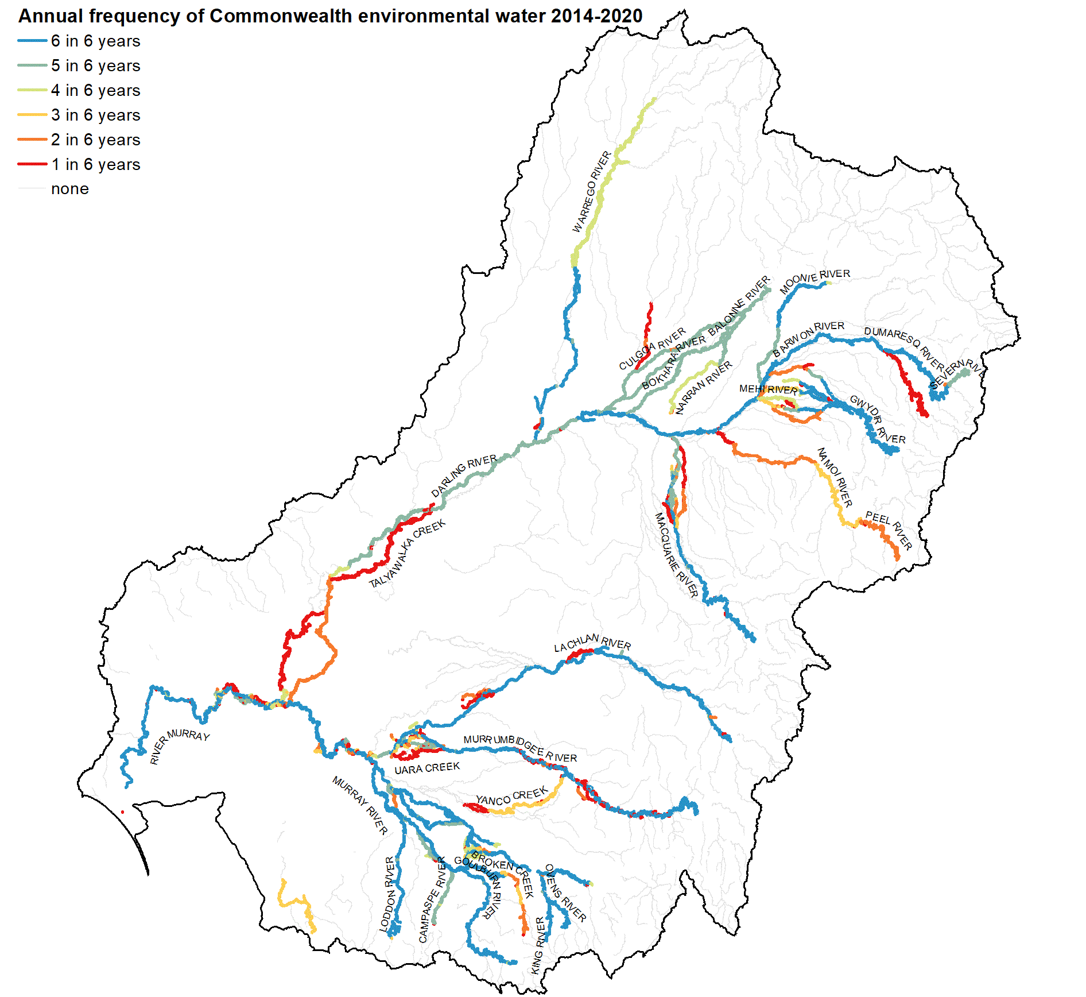
Figure 4.9 Map of annual frequency (from 1 in 6 years to 6 in 6 years) of Commonwealth environmental water in rivers 2014–20
Figure 4.10 Total length and frequency of Commonwealth environmental water within each riverine ecosystem type 2014–20

Contribution to Basin Plan objectives

Are ecosystems on the managed floodplain representative of the Basin?
The aquatic ecosystems that Commonwealth environmental water can potentially support were compared to all ecosystems in the Basin to test alignment of Commonwealth environmental water management to the Basin Plan objective s8.05(3)(b): ‘to protect and restore biodiversity that is dependent on Basin water resources by ensuring that representative populations and communities of native biota are protected and, if necessary, restored.’
Our analysis shows that aquatic ecosystems on the managed floodplain, as defined in the Strategy, are representative of Basin ecosystem diversity. A summary for each of the 4 aquatic system types is provided below.

Lake ecosystems
Thirty-two percent of the combined area of the Basin’s lakes (excluding Lake Alexandrina and Lake Albert), occurs on the managed floodplain, where 7 of the 8 (88%) of ANAE lake ecosystem types are represented (Figure 5.1).
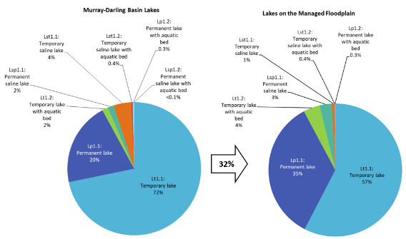
Figure 5.1 Comparison of the proportional representation of ANAE lake ecosystem types in the Basin to the subset (32%) that occurs on the managed floodplain that is potentially in scope for Commonwealth environmental water management
The managed floodplain contains a high proportion of permanent lakes (34% vs 20% in the Basin) possibly due to more frequent natural connections and elevated water tables on the valley floor near permanent lowland rivers, or because infrastructure (regulators and pumps) is installed to artificially maintain lake water levels from nearby rivers for water supplies and recreation. Lakes on the managed floodplain in scope for Commonwealth environmental water management are considered to be representative of lakes elsewhere in the Basin. The only lake ecosystem type not found on the managed floodplain is permanent saline lakes with aquatic macrophyte beds. These are rare in the Basin (only 181 ha) and delivery of fresh environmental water would likely be detrimental to these saline systems.

Palustrine wetlands
There are 29 ANAE palustrine wetland types in the Basin, with 15 of the most common representing 99% of the total Basin wetland area. The managed floodplain contains 37% of Basin wetland area, comprised of the same 15 common types in similar proportions to the whole of the Basin (Figure 5.2). The palustrine wetlands on the managed floodplain, in scope for Commonwealth environmental water, are therefore qualitatively representative of palustrine wetlands in the Basin.
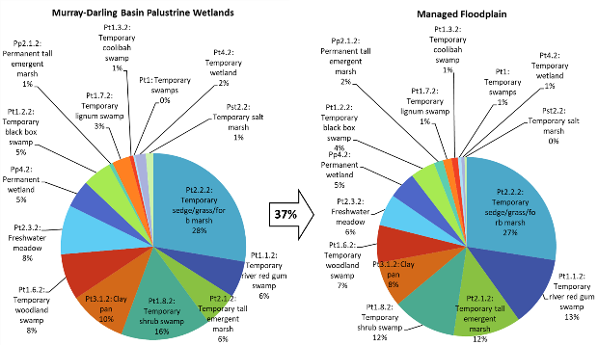
Figure 5.2 Comparison of the proportional representation of ANAE wetland (palustrine) ecosystem types in the Basin to the subset (37%) that occurs on the managed floodplain that is potentially in scope for Commonwealth environmental water management
For clarity only the 15 most common wetland types are represented that together occupy 99% of the Basin wetland area

Floodplain ecosystems
Approximately 25% of floodplains in the Basin align with the managed floodplain and all 12 Basin floodplain ANAE types are represented there (Figure 5.3). The most common floodplain ecosystem types in the Basin (Coolibah woodland and Black Box woodland floodplains) occur higher on the floodplain away from rivers, with only 22% of Basin Coolibah floodplain and 15% of Black Box woodland floodplain located on the managed floodplain. In contrast, River Red Gum has a higher water requirement and is found lower on the valley floors closer to rivers. Hence, 47% of the Basin’s Red Gum woodland and forest floodplain are located on the managed floodplain. Despite these differences, the floodplain ecosystems located on the managed floodplain are highly representative of Basin floodplains.
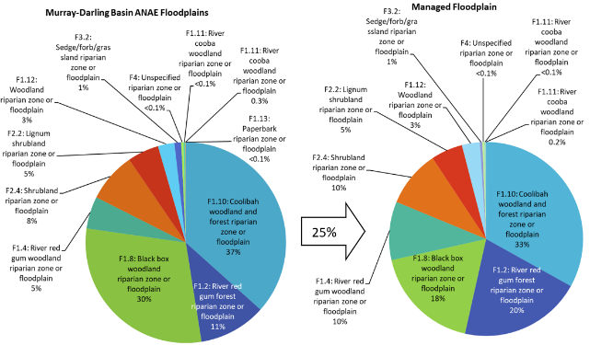
Figure 5.3 Comparison of the proportional representation of ANAE floodplain ecosystem types in the Basin to the subset (25%) that occurs on the managed floodplain that is potentially in scope for Commonwealth environmental water management

River ecosystems
Lowland rivers dominate the managed floodplain with 45% of the 47,226 km total river length being permanent lowland rivers and another 40% being temporary lowland rivers (Figure 5.4). The managed floodplain contains 65% of the total length of permanent lowland rivers in the basin and 16% of the temporary lowland river length (Table 4.4). Permanent lowland rivers are evenly split between the northern and southern Basin and the majority 75% of the temporary lowland rivers are in the Northern Basin which reflects the distribution of this ecosystem types in the Basin. With such a high proportion of these classes present on the managed floodplain it is likely these ecosystems are representative of other lowland rivers in the Basins.
The 14% (7,042 km) of combined transitional and high energy stream lengths on the managed floodplain is a mixture of these upland areas and high-energy outflow channels from storages before they flow out into the flat lowlands of the central and western Basin. The small number of these streams managed with Commonwealth environmental water using unregulated licence rules in the northern Basin are likely to have flow regimes that differ from similar waterways in the southern Basin.
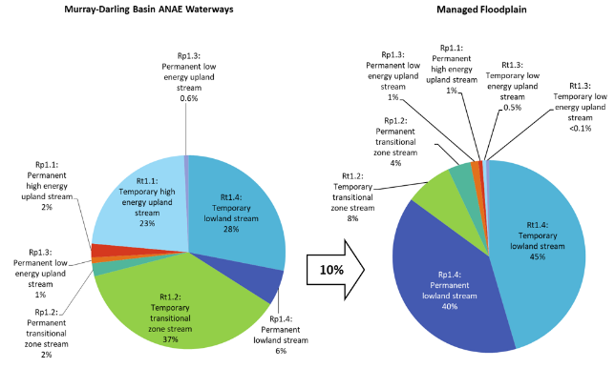
Figure 5.4 Comparison of the proportional representation of ANAE river ecosystem types in the Basin to the subset (10%) that occurs on the managed floodplain that is potentially in scope for Commonwealth environmental water management

Is Commonwealth environmental water supporting representative ecosystems?
The comparison between the ecosystems in the Basin and on the managed floodplain above shows that ecosystems that are in scope for environmental water management are broadly representative of ecosystem types elsewhere in the Basin. Evaluation of watering frequencies from Commonwealth environmental water shows that in the 6 years 2014–20 Commonwealth environmental water has supported a wide range of ecosystem types 85% of all ecosystem types in the Basin influencing 104,162 ha of aquatic ecosystems equivalent to 91% of the ecosystem types found on the managed floodplain and 23% of the managed floodplain area.
Management of Commonwealth environmental water is distributed widely across different individual wetlands within each ecosystem type. During the 2014–20, repeated watering has occurred mostly in systems classified as permanent (e.g. permanent emergent tall marsh, permanent grass marshes) or in temporary River Red Gum swamps and woodland swamps that are closely associated with rivers.
Ecosystems that have not received Commonwealth environmental water are either very wet systems (bog and fens, paperbark swamps, and springs) that likely do not require additional water, saline systems where delivering fresh water may be inappropriate, or they are geographically isolated from the managed floodplain.

Contribution to Basin Plan objectives
The Ecosystem Diversity component of the Flow-MER Basin evaluation contributes to the Basin Plan objective for Biodiversity under Section 8.05 of the Basin Plan.
The Commonwealth outcomes framework (CEWH 2013) does not include 1-year or 5-year expected outcomes for ecosystem diversity. This evaluation provides a foundation from which expected outcomes for ecosystem diversity may be developed in the future as the spatial and temporal patterns of watering to different ecosystem types under current management regimes are better understood.
The Basin Plan objective Protection and restoration of water-dependent ecosystems (s8.05) is considered supported by this evaluation on the basis that Commonwealth environmental water inundated river channels and floodplains and influenced lakes and wetlands that together are broadly representative of aquatic ecosystems in Basin. More specifically:
- In 2019–20 Commonwealth environmental water supported 191,104 ha of lakes, wetlands, floodplain and estuary and 15,591 km of waterways representing 48 ecosystem types (72% of the ecosystem types currently mapped in the Basin)
- Over the period 2014–20 Commonwealth environmental water supported 367,909 ha of lakes, wetlands and floodplain and 28,426 km of waterways at least once during the 6 years representing 57 ecosystem types (85 % of the ecosystem types currently mapped in the Basin).
Table 5.1 Commonwealth Environmental Outcomes framework for ecosystem diversity (CEWH 2013)
Basin Plan objectives | Basin outcomes | Long-term expected outcomes | 1-year expected outcomes | 1-year outcomes  2019–20 | Long-term outcomes  2014–20
Biodiversity  (Basin Plan  s 8.05) | Ecosystem diversity | None identified | None identified | 191,104 hectares of mapped wetland and floodplain supported  15,591 km of rivers supported  48 ecosystem types supported  No negative impacts identified | 367,909 ha of lakes, wetlands and floodplain supported  28,426 km of waterways supported  57 ecosystem types supported  No negative impacts identified

Adaptive management

Lessons learned
The 6 years of continued evaluation of ecosystem diversity supported by Commonwealth environmental water is clarifying:
- the spatial pattern of watering actions in the landscape, which in combination with information on ecological responses, provides important learnings for adaptive management.
- the distribution of Commonwealth environmental water to the different ecosystem types (e.g. with a greater proportion of actions/volume) supporting temporary River Red Gum swamps and marsh ecosystems). This allows identification of any ecosystems which are under-represented in watering actions, and which may be a priority for the future.
- watering frequencies, at ecosystem, wetland complex, and valley scales, which in combination with information on ecological responses, provides important learnings for adaptive management.
The evaluation has iteratively improved throughout the last 6 years, due to improvements in CEWO acquittal reporting, improvements in the methods and consistency of documenting inundation from Commonwealth environmental water, and three major leaps forward in the mapping of water-dependent ecosystems in the Basin via improvements to ANAE data. These improvements contribute greatly to our ability to assess the extent (by area and river length) of aquatic ecosystems receiving Commonwealth environmental water.
The ability of this evaluation to re-analyse the long-term data back to 2014–15 to incorporate new and improved knowledge is an example of adaptive management in action, enabled by the long-term monitoring and evaluation plan that CEWO commenced with the LTIM project continuing into Flow-MER.
The ANAE mapping for the Basin is now considered complete, and future improvements will tweak accuracy rather than fundamentally alter our understanding of the distribution of ecosystems in the Basin that Commonwealth environmental water is delivered to. A remaining challenge is now to improve the definition of ecosystem hydrology to better understand the role of Commonwealth environmental water in supporting ecosystem diversity relative to natural and other sources of managed water. This is discussed in more detail below (section 6.3).

Improving environmental water management
This evaluation is a high-level interpretation of Commonwealth environmental water use at the scale of the whole Basin river system and its managed floodplain. The evaluation aims to evaluate the ensemble of environmental watering actions in the context of the Basin Plan objectives. It does not assess or make technical recommendations towards improving delivery of individual watering actions.
At the Basin scale, the current short-term (annual) and longer-term (6-year) regime of using Commonwealth environmental water to support Basin ecosystems appears to be appropriate and is supporting representative ecosystems that contribute to biodiversity at the Basin scale, in accordance with the Basin Plan. No outliers or biases have been identified to suggest that Commonwealth environmental water should be allocated differently at the Basin scale. Examination of watering frequencies over the previous 6 years suggests that Commonwealth environmental water management is broadly concordant with current understanding of ecosystem watering frequency requirements.
There are a small number of rare ecosystem types that are strongly water-dependent that are currently not managed, namely: permanent paperbark swamps, permanent springs and peat and bog and fen marshes. These commonly wet ecosystems are likely to be sensitive to water regime change that decreases the abundance or frequency of water in these ecosystems (e.g. from climate change or changing land use). They are, however, typically located away from the managed floodplain and hence currently out of scope for Commonwealth environmental water management.

Expected outcomes for ecosystem diversity
Neither the CEWO nor the BWEWS currently have expected outcomes for ecosystem diversity. It is hoped that realistic and relevant ecosystem objectives can be trialled in the near future, detailing areal and length requirements for inundation and/or influence, as well as timing and frequency, and aspects of ecosystem condition. These might be trialled first in the evaluation space and later contribute to Commonwealth environmental water planning when predicting ecosystem outcomes is more certain.

Improving evaluation

Detailed hydrology for wetlands
This report considers ecosystems to be potentially supported by Commonwealth environmental water provided there was evidence of watering at some point during the year. The annual timestep and aggregated inundation mapping currently constrains our evaluation to an interpretation of annual watering frequencies for target ecosystems that that are recipients of Commonwealth environmental water only. A comprehensive evaluation including watering actions delivered by other stakeholders (‘other environmental water’) and from natural floods is currently beyond the scope of the Basin-scale project, primarily because most wetlands are not gauged and information on the extent and duration of water is not collected by other jurisdictions or is difficult to source. The risk of misinterpreting insufficient Commonwealth environmental water is high when other sources are not accounted for. We can however be more confident if evidence points to Commonwealth environmental water being too frequent (as additional water sources will only exacerbate the problem of having too much water). Some foundation work is underway in the Flow-MER research program to explore ways of improving the spatial and temporal resolution of the inundation mapping to inform future evaluation (Flow-MER research project E3: Scaling the evaluation of Ecosystem Diversity; Pollino et al. 2020).
Improving knowledge of wetland hydrology must now be given high priority. Understanding the role of Commonwealth environmental water in maintaining ecosystem diversity could be improved by counterfactual analyses comparing how ecosystem diversity is supported with and without Commonwealth environmental water. In rivers, the counterfactual flow regime (with and without Commonwealth environmental water) can be estimated using models calibrated to river gauges to estimate flows in the absence of environmental water (Guarino and Sengupta 2021). Hydrological models exist for individual wetlands (e.g. Narran Lakes; Rayburg and Thoms 2008) but not for wetlands in general because each has unique topography, soils and bathymetry. Models that attempt to predict wetland water levels from nearby river gauges are currently being investigated by the MDBA Water and Environment Research Program but these are likely to only be reliable for a subset of wetlands with high connectivity nearby rivers. Many of the Basin wetlands are disconnected from river flows during low flow periods entirely or are inundated through regulators or pumps. While comparisons to counterfactuals are not currently possible this will become feasible in the coming year.
Satellite image analysis is being used increasingly to monitor the timing, duration and extent of natural and managed inundation events (Figure 6.1). Tools and capability exist to map inundation for local areas with some recent initiatives showing promise for quantifying inundation patterns on larger spatial scales. For example, Geoscience Australia’s Wetland Insights Tools can use the 30 years of Landsat image library to analyse inundation in ANAE wetlands. Scaling these tools to the whole Basin (some 400,000 ANAE mapping units) is a challenge that has not yet been attempted but is an active area of research that should ultimately improve definition of the timing, magnitude and extent of watering actions within the context of the background hydrological regime. This has potential to:
- improve the ANAE classification of temporary and permanent wetland classes
- improve evaluation of whether Commonwealth environmental water use is appropriate given the antecedent water history and knowledge of how wetlands respond to inundation (depth, extent, residency times)
- provide fundamental data to establish a counterfactual for wetland inundation in the Basin to strengthen evaluation of the role of Commonwealth environmental water in maintaining, protecting or restoring ecosystem diversity in the Basin.
There is currently interest in the Wetland Insights Tool from jurisdictions, MDBA and CEWO for these purposes. Given this interest, it is recommended that a working group of committed stakeholders be established to coordinate development of a resource for wetland hydrology that has potential to transform water planning and evaluation in the Basin through improved understanding of wetland hydrological regimes.
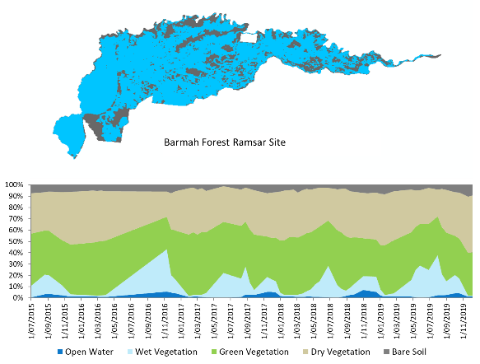
Figure 6.1 Geoscience Australia’s Wetland Insights tool can be used to quantify inundated extent of Commonwealth environmental water at individual wetlands. Scaling up from individual ANAE polygons to larger wetland complexes and to the whole Basin remains a significant challenge (Barmah Forest Ramsar site shown)

A unified register of all water management
Commonwealth environmental water is strategically managed in collaboration with other water holders in the Basin. Actions may be delivered cooperatively to elevate flow magnitudes and durations, or water holders may cooperate towards shared objectives with different actions delivered at different times. For example, Barmah Forest and Hattah Lakes are two priority assets in the Basin that were watered using Victorian environmental water and MDBA (The Living Murray) water in years when Commonwealth environmental water has not been used.
Evaluation of both Commonwealth environmental water and other managed sources of water will improve interpretation of outcomes from cooperative actions and may be able to give more targeted adaptive management advice regarding long-term watering regimes that multiple agencies are contributing towards. Such an evaluation is currently difficult because water management information is fragmented across jurisdictions. MDBA collate Basin Plan implementation reports as required under schedule 12 of the Basin Plan (e.g. link to: Basin Plan implementation reports 2019–20), but these are not compiled across jurisdictions nor across years and sometimes contain information that conflicts with CEWO acquittal reporting. LTIM and now Flow-MER construct a water use table annually to support Basin-scale evaluation, but this is constrained to Commonwealth environmental water because other jurisdictional data has proved difficult to source and conflicting water accounting is not easily resolved.
An agreed resource for all environmental water information in the Basin would strengthen evaluation of all environmental water. A definitive and agreed ‘one-stop shop’ describing the timing, duration, extent of all water management along with the objectives, observed outcomes and any unintended consequences would empower evaluation with a more realistic hydrological context for understanding outcomes, and a more direct line of sight to inform the collaborative planning process. Inter-agency communication will likely need to improve for the resource to be collated in a timely manner, ideally within the water year to provide opportunity for evaluation to inform near-term water planning in subsequent years.

References
Aquatic Ecosystems Task Group (2012) Aquatic Ecosystems Toolkit. Module 2 Interim Australian National Aquatic Ecosystems (ANAE) Classification Framework. Department of Sustainability, Environment, Water Population and Communities, 32pp.
BOM (2020) Australian Hydrological Geospatial Fabric (Geofabric) v3.2.
Brooks S (2016) 2014–15 Basin-scale evaluation of Commonwealth environmental water – Ecosystem Diversity. Report prepared for the Department of Agriculture, Water and the Environment, Commonwealth Environmental Water Office. La Trobe University, Centre for Freshwater Ecosystem, 57pp.
Brooks S (2020) 2018–19 Basin-scale evaluation of Commonwealth environmental water – Ecosystem Diversity. Report prepared for the Department of Agriculture, Water and the Environment, Commonwealth Environmental Water Office by La Trobe University, Centre for Freshwater Ecosystems, Report No. 248, 51pp.
Brooks SS (2017) Classification of aquatic ecosystems in the Murray-Darling Basin: 2017 update. Report to the Murray-Darling Basin Authority and Commonwealth Environmental Water Office, 73pp.
Brooks SS (2021) Australian National Aquatic Ecosystem (ANAE) Classification of the Murray-Darling Basin: Technical Report, Revision 3.0, March 2021. Report for the Commonwealth Environmental Water Office, Department of Agriculture, Water and the Environment, Australia., 73pp.
Brooks SS, Cottingham P, Butcher R, Hale J (2014) Interim classification of aquatic ecosystems in the Murray-Darling Basin: Stage 2 report. Peter Cottingham & Associates report to the Commonwealth Environmental Water Office and Murray-Darling Basin Authority.
CEWH (2013) Commonwealth Environmental Water – The Environmental Water Outcomes Framework v1.1.
Geist J (2011) Integrative freshwater ecology and biodiversity conservation. Ecol. Indic. 11(6), 1507–1516.
Guarino F, Sengupta A (2021) 2019–20 Basin-scale evaluation of Commonwealth environmental water — Hydrology (Final Report prepared for the Commonwealth Environmental Water Office). CSIRO. CSIRO.
Hale J, Bond, Nick, Brooks, Shane (2020) 2018–19 Basin-scale evaluation of Commonwealth environmental water – Biodiversity. (Final Report prepared for the Commonwealth Environmental Water Office). CFE Publication 252. La Trobe University Centre for Freshwater Ecosystems.
Junk J, Bayley P, Sparks R (1989) The flood pulse concept in river floodplain systems. Can. Spec. Publ. Fish. Aquat. Sci. 106, 110–127.
MDBA (2019) Basin-wide environmental watering strategy. Murray–Darling Basin Authority, Report No. 42/19, 154pp.
Poff NL (1997) Landscape filters and species traits: towards mechanistic understanding and prediction in stream ecology. J. North Am. Benthol. Soc. 16(2), 391–409.
Pollino CA, Thompson R, Flett D (2020) Flow-MER Basin-scale Evaluation and Research Plan. Commonwealth Environmental Water Office (CEWO): Monitoring, Evaluation and Research Program, Department of Agriculture, Water and the Environment. 108pp.
Rayburg S, Thoms M (2008) A real time hydrological model for the Narran Lakes Floodplain Wetland Ecosystem. Murray-Darling Basin Auth. Canberra.
Stewardson MJ, Guarino F (2016) 2014–15 Basin-scale evaluation of Commonwealth environmental water — Hydrology (Final Report prepared for the Commonwealth Environmental Water Office). MDFRC Publication 104/2016. The Murray–Darling Freshwater Research Centre.
Thorp JH, Thoms MC, Delong MD (2006) The riverine ecosystem synthesis: biocomplexity in river networks across space and time. River Res. Appl. 22(2), 123–147.

GIS Workflow
All spatial layers use the 1994 Geocentric Datum of Australia (GDA94). Areas in this report are in hectares and have been calculated using the Australia Albers Equal Area Conic projection which minimises distortion from map projection so that areas measurements are comparable across the full extent of the Basin.
- The area of ecosystems inundated by Commonwealth environmental water
The area of ecosystems inundated by Commonwealth environmental water is the fraction of the wetland area that intersects the Commonwealth environmental water inundation extent. The inundated area is used in this evaluation for floodplains and rivers to quantify the proportion of the floodplain that was influenced by Commonwealth environmental water.
- Intersect:
  - The Basin ANAE classification mapping
  - Commonwealth environmental water Inundation
  - LTIM Valleys
- Calculate polygon area in hectares for the intersected areas using equal area GDA94 Australian Albers projection.
- Sum the area of inundated ANAE wetland types per valley.
For rivers, the inundated length of river channel is obtained directly from the inundation mapping and aggregated for each valley.
- The area of ecosystems influenced by Commonwealth environmental water
The area of ecosystems influenced by Commonwealth environmental water is defined as the sum of the areas of mapped features that are partially or fully overlapped by the mapped extent of Commonwealth environmental water inundation. The influenced area is use for depressional wetlands and lakes to incorporate fringing water dependent vegetation growing in wet soils adjacent to waterbodies and the wet areas where inundation mapping from satellite imagery underestimates the area of water obscured by thick vegetation in marshes, meadows and sedgelands.
- Select by location all ANAE wetland polygons that intersect the Commonwealth environmental water Inundation.
- Intersect the selected wetlands with the valley boundaries.
- Calculate polygon area in hectares using equal area GDA94 Australian Albers projection for each ecosystem polygon.
- Sum the area of each ANAE wetland type per valley.
- Length of waterways influenced by Commonwealth environmental water
The area of ecosystems influenced by Commonwealth environmental water is defined as the sum of the Geofabric segment line length that are designated as holding Commonwealth environmental water during the water year (July 1 to June 30).
- Intersect:
  - The Basin ANAE Geofabric v3 Waterways
  - Commonwealth environmental water Inundation
  - LTIM Valleys
- Calculate the length of inundated segments for each riverine ecosystem type in kilometres using equal area GDA94 Australian Albers projection.
- Calculate summary statistics to sum the length of each river ecosystem type per valley.

Evolution of the Basin ANAE classification
Confidence in the accuracy of mapping and the Basin ANAE classification was examined in the development of the ANAE classification (Brooks et al. 2014) and during the LTIM project (Brooks 2020, 2016). There was generally good agreement between the ecosystem types identified by the Basin ANAE classification when compared to ground-truthed monitoring locations in Selected Areas(Brooks 2016). Most discrepancies were related to inaccuracies in the mapping of wetland boundaries rather than fundamental disagreement with the ANAE classification itself.
Since the monitoring program began in 2014 the ANAE mapping in the Basin has had 2 significant updates (Brooks 2021, 2017). These updates dramatically improved the mapping of floodplain systems but also incorporated improvements to river mapping and corrections to attributes used to define the ecosystem type (for example water regime and vegetation community type).
A small number of very large wetland boundaries derived from older mapping sources distorted previous ecosystem diversity evaluations in the Macquarie Marshes and Western Floodplain at Toorale, both sites receiving Commonwealth environmental water several times since 2014. The updated ANAE v3.0 has more detailed mapping that reveals the true ecosystem diversity (Figure B.1, Figure B.2). The cumulative evaluation of this report re-analyses all previous years of ecosystem diversity outcomes from 2014 to ensure the outcomes are consistent and comparable among all years.
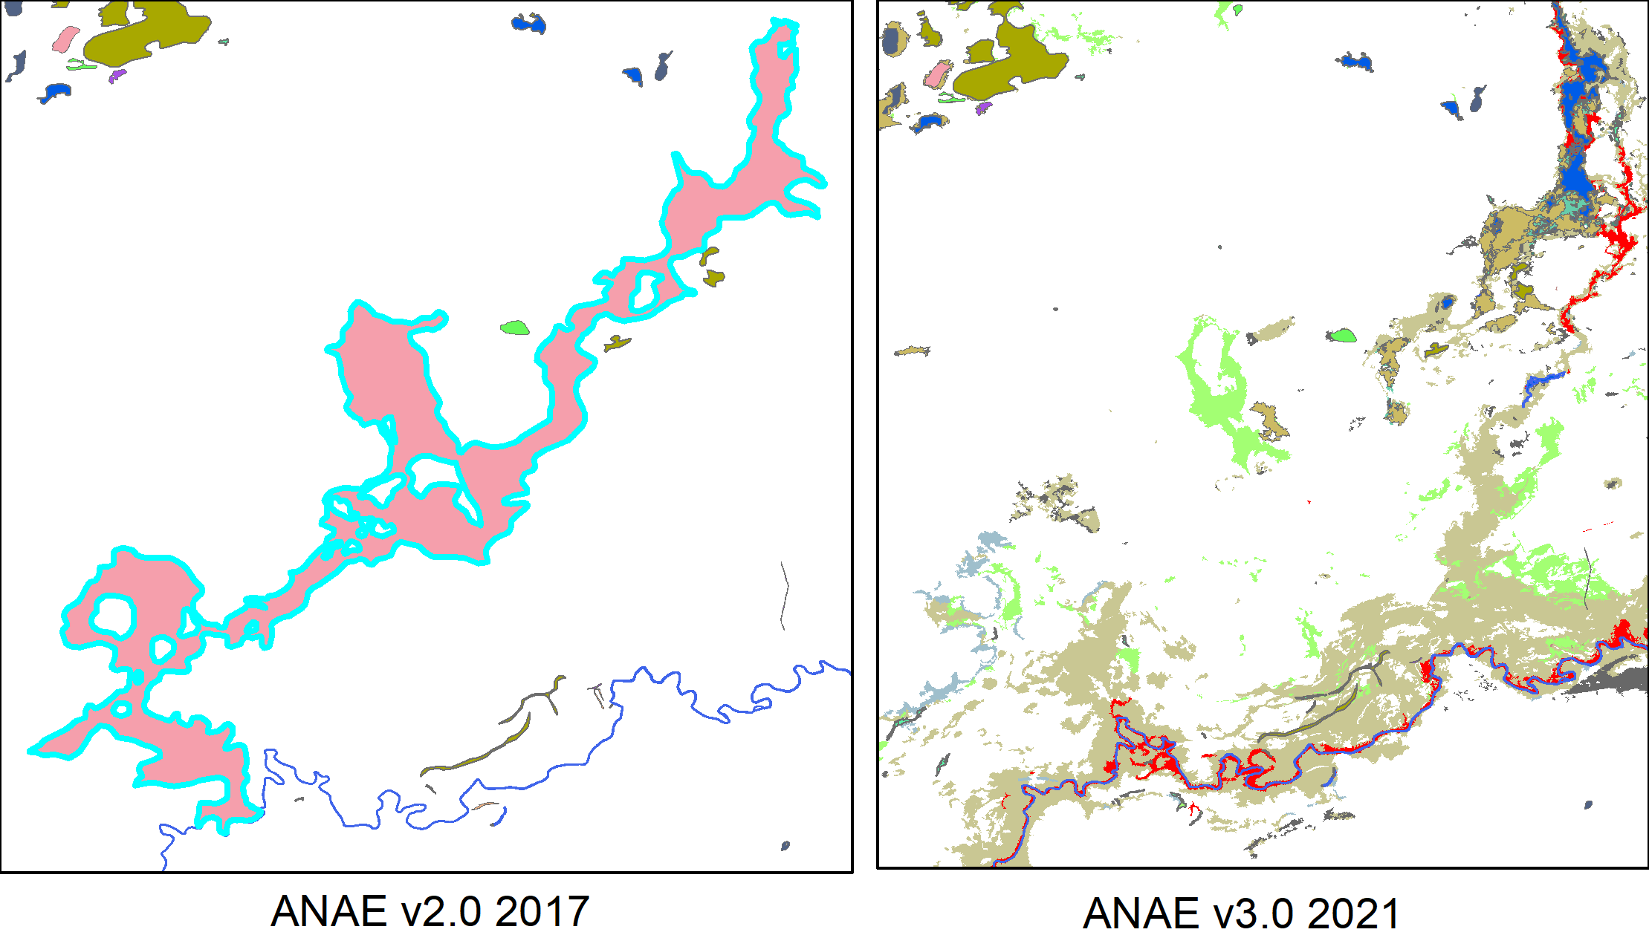
Figure B.1 ANAE v3.0 (right side map) reveals much higher ecosystem diversity of the Western Floodplain at Toorale (than ANAE v2.0 (left side map))
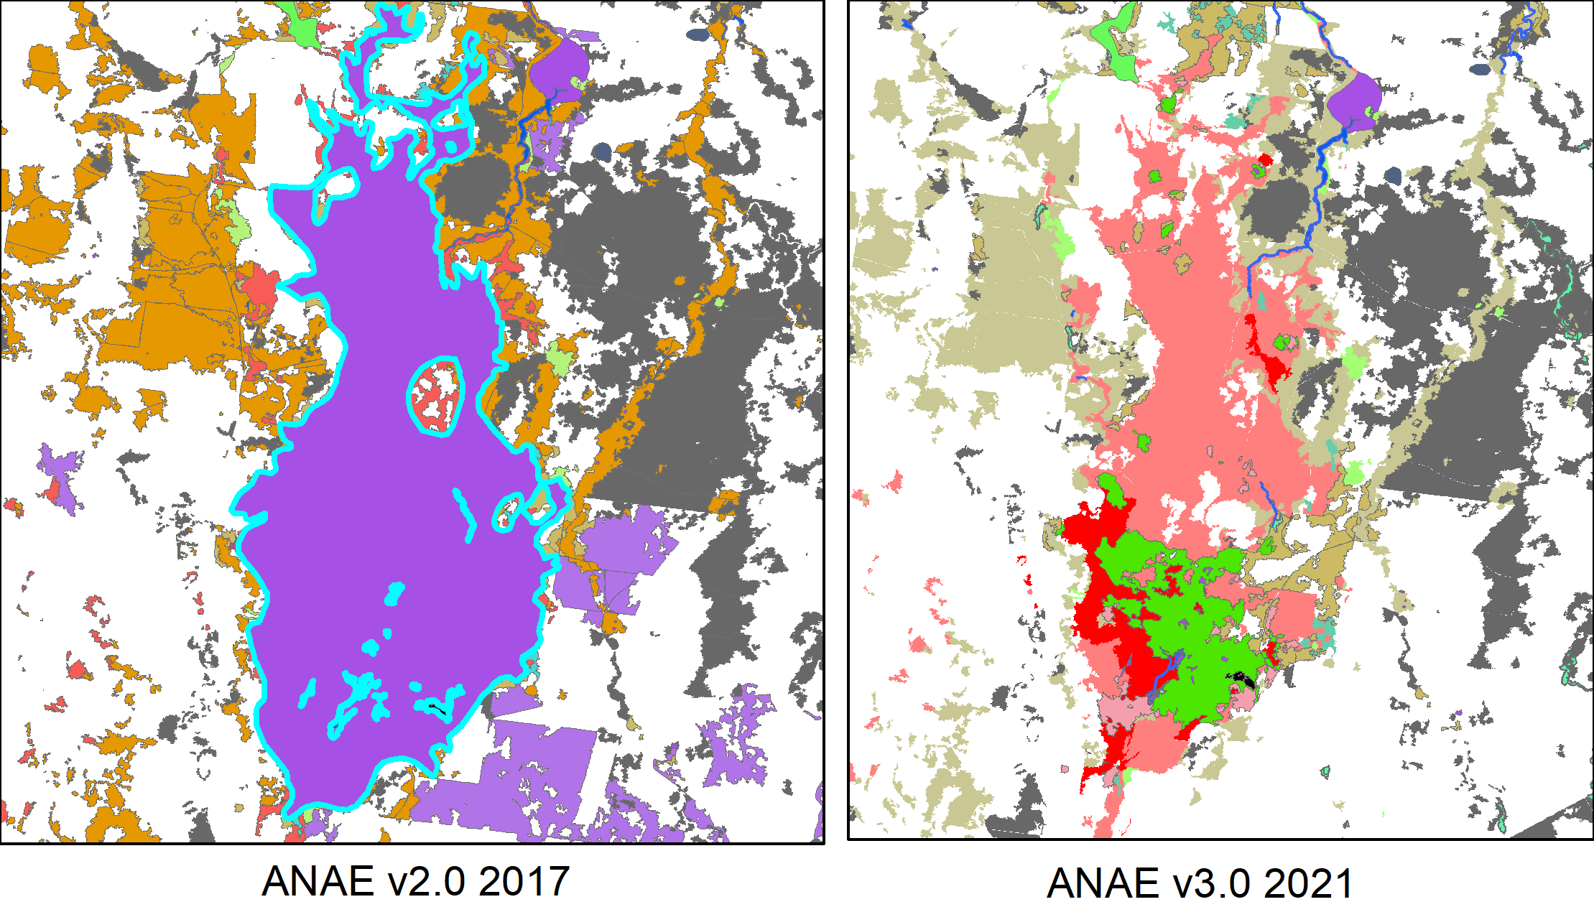
Figure B.2 Northern Macquarie Marshes showing how the updated ANAE v3.0 (right side map) differentiates the northern tall emergent marsh (green) from the Red Gum floodplain (red) for the first time
The mapping of the ANAE is now considered to be ‘complete’ for the Basin for the first time since the Commonwealth long-term monitoring and evaluation program started with LTIM in 2014. It represents the best available mapping for all jurisdictions and there are no known knowledge gaps associated with the mapping. Future revision is expected to refine rather than make radical changes to the mapping layers.
There is considerable uncertainty in the attribution of ANAE water regime because most wetlands are ungauged, and satellite observations has to date struggled to resolve inundation in vegetated wetlands. The current attribution of ‘commonly wet’ or ‘periodically inundated’ is derived from existing data sets with low confidence or in most cases defined using crude assumptions. There is now potential to use Geoscience Australia’s Wetland Insights Tool to provide watering extent histories for every ANAE polygon to define wetland hydrological regimes with much greater confidence. This should be high priority for any future updates to the ANAE data set.

ANAE wetland types influenced by Commonwealth environmental water by valley
Lake and wetland types influenced by Commonwealth environmental water are represented by the entire wetland when any portion of the wetland was recorded as having been inundated. The contribution of Commonwealth environmental water to supporting wetland ecosystem diversity within each valley is presented below in Table C.1 excluding the Coorong, Lower Lakes and Murray Mouth which are presented in Table 3.5.
Table C.1 Area of each lake and wetland ecosystem type and the contribution of Commonwealth environmental water to support wetland ecosystem diversity within each valley 2019–20 (shaded blue)
Valley name | Australian National Aquatic Ecosystem (ANAE) lake and wetland types |  | Total area (ha) | Cew area (ha) | Cew area (%)
Avoca | Lst1.1: Temporary saline lake |  | 19,829 | 0 | 0%
Avoca | Pt3.1.2: Clay pan |  | 18,398 | 0 | 0%
Avoca | Pt1.2.2: Temporary Black Box swamp |  | 5,108 | 0 | 0%
Avoca | Lt1.1: Temporary lake |  | 4,232 | 0 | 0%
Avoca | Lst1.2: Temporary saline lake with aquatic bed |  | 1,821 | 0 | 0%
Avoca | Pst1.1: Temporary saline swamp |  | 1,541 | 0 | 0%
Avoca | Pst2.2: Temporary salt marsh |  | 1,174 | 0 | 0%
Avoca | Pt1.6.2: Temporary woodland swamp |  | 803 | 0 | 0%
Avoca | Pt2.3.2: Freshwater meadow |  | 715 | 0 | 0%
Avoca | Pst3.2: Salt pan or salt flat |  | 309 | 0 | 0%
Avoca | Psp2.1: Permanent salt marsh |  | 209 | 0 | 0%
Avoca | Pt4.2: Temporary wetland |  | 208 | 0 | 0%
Avoca | Pt1.1.2: Temporary River Red Gum swamp |  | 143 | 0 | 0%
Avoca | Lsp1.1: Permanent saline lake |  | 137 | 0 | 0%
Avoca | Lp1.1: Permanent lake |  | 61 | 0 | 0%
Avoca | Pp4.2: Permanent wetland |  | 50 | 0 | 0%
Avoca | Pst4: Temporary saline wetland |  | 50 | 0 | 0%
Avoca | Pt1.8.2: Temporary shrub swamp |  | 41 | 0 | 0%
Avoca | Pt1.7.2: Temporary Lignum swamp |  | 33 | 0 | 0%
Barwon Darling | Lt1.1: Temporary lake |  | 57,643 | 0 | 0%
Barwon Darling | Lp1.1: Permanent lake |  | 32,029 | 0 | 0%
Barwon Darling | Pt2.2.2: Temporary sedge/grass/forb marsh |  | 16,827 | 0 | 0%
Barwon Darling | Pt1.6.2: Temporary woodland swamp |  | 16,302 | 0 | 0%
Barwon Darling | Pt1.8.2: Temporary shrub swamp |  | 10,944 | 0 | 0%
Barwon Darling | Pt1.2.2: Temporary Black Box swamp |  | 2,961 | 0 | 0%
Barwon Darling | Pp4.2: Permanent wetland |  | 2,551 | 0 | 0%
Barwon Darling | Pt2.3.2: Freshwater meadow |  | 859 | 0 | 0%
Barwon Darling | Pt1.1.2: Temporary River Red Gum swamp |  | 378 | 0 | 0%
Barwon Darling | Pt3.1.2: Clay pan |  | 179 | 0 | 0%
Barwon Darling | Pt1.3.2: Temporary Coolibah swamp |  | 64 | 0 | 0%
Barwon Darling | Pp2.2.2: Permanent sedge/grass/forb marsh |  | 5 | 0 | 0%
Barwon Darling | Pst2.2: Temporary salt marsh |  | 3 | 0 | 0%
Border Rivers | Pt4.2: Temporary wetland |  | 3,006 | 0 | 0%
Border Rivers | Pt1.6.2: Temporary woodland swamp |  | 2,484 | 0 | 0%
Border Rivers | Pt2.3.2: Freshwater meadow |  | 1,942 | 0 | 0%
Border Rivers | Pp2.2.2: Permanent sedge/grass/forb marsh |  | 1,230 | 0 | 0%
Border Rivers | Lp1.1: Permanent lake |  | 935 | 0 | 0%
Border Rivers | Pt2.2.2: Temporary sedge/grass/forb marsh |  | 763 | 0 | 0%
Border Rivers | Pt1.1.2: Temporary River Red Gum swamp |  | 726 | 0 | 0%
Border Rivers | Pp4.2: Permanent wetland |  | 660 | 0 | 0%
Border Rivers | Lt1.1: Temporary lake |  | 645 | 0 | 0%
Border Rivers | Pt1.3.2: Temporary Coolibah swamp |  | 494 | 0 | 0%
Border Rivers | Pp3: Peat bog or fen marsh |  | 491 | 0 | 0%
Border Rivers | Lp1.2: Permanent lake with aquatic bed |  | 227 | 0 | 0%
Border Rivers | Pt3.1.2: Clay pan |  | 214 | 0 | 0%
Border Rivers | Pt2.1.2: Temporary tall emergent marsh |  | 96 | 0 | 0%
Border Rivers | Pp2.3.2: Permanent grass marsh |  | 26 | 0 | 0%
Border Rivers | Lt1.2: Temporary lake with aquatic bed |  | 12 | 0 | 0%
Border Rivers | Pt1.2.2: Temporary Black Box swamp |  | 9 | 0 | 0%
Border Rivers | Pt1.8.2: Temporary shrub swamp |  | 3 | 0 | 0%
Border Rivers | Pst1.1: Temporary saline swamp |  | 2 | 0 | 0%
Broken | Lp1.1: Permanent lake |  | 3,305 | 0 | 0%
Broken | Pt3.1.2: Clay pan |  | 2,935 | 0 | 0%
Broken | Pt1.1.2: Temporary River Red Gum swamp |  | 1,926 | 0 | 0%
Broken | Pt1.6.2: Temporary woodland swamp |  | 431 | 0 | 0%
Broken | Pt2.3.2: Freshwater meadow |  | 269 | 0 | 0%
Broken | Pt1.7.2: Temporary Lignum swamp |  | 192 | 0 | 0%
Broken | Lt1.1: Temporary lake |  | 104 | 0 | 0%
Broken | Pt2.1.2: Temporary tall emergent marsh |  | 98 | 0 | 0%
Broken | Pt1.2.2: Temporary Black Box swamp |  | 98 | 0 | 0%
Broken | Pt2.2.2: Temporary sedge/grass/forb marsh |  | 77 | 0 | 0%
Broken | Pp4.2: Permanent wetland |  | 45 | 0 | 0%
Broken | Pps5: Permanent spring |  | 0 | 0 | 0%
Campaspe | Pt3.1.2: Clay pan |  | 1,789 | 0 | 0%
Campaspe | Pt1.1.2: Temporary River Red Gum swamp |  | 397 | 0 | 0%
Campaspe | Pt1.6.2: Temporary woodland swamp |  | 168 | 0 | 0%
Campaspe | Lt1.1: Temporary lake |  | 49 | 0 | 0%
Campaspe | Pt2.1.2: Temporary tall emergent marsh |  | 38 | 0 | 0%
Campaspe | Lp1.1: Permanent lake |  | 12 | 0 | 0%
Campaspe | Pt2.3.2: Freshwater meadow |  | 10 | 0 | 0%
Campaspe | Pp4.2: Permanent wetland |  | 4 | 0 | 0%
Campaspe | Pt1.7.2: Temporary Lignum swamp |  | 2 | 0 | 0%
Campaspe | Pps5: Permanent spring |  | 0 | 0 | 0%
Castlereagh | Pt2.2.2: Temporary sedge/grass/forb marsh |  | 10,520 | 0 | 0%
Castlereagh | Lt1.1: Temporary lake |  | 456 | 0 | 0%
Castlereagh | Pt1.8.2: Temporary shrub swamp |  | 51 | 0 | 0%
Castlereagh | Pt1.6.2: Temporary woodland swamp |  | 35 | 0 | 0%
Castlereagh | Pt3.1.2: Clay pan |  | 30 | 0 | 0%
Castlereagh | Pt1.2.2: Temporary Black Box swamp |  | 26 | 0 | 0%
Castlereagh | Pt2.1.2: Temporary tall emergent marsh |  | 16 | 0 | 0%
Castlereagh | Pp4.2: Permanent wetland |  | 16 | 0 | 0%
Castlereagh | Pp2.2.2: Permanent sedge/grass/forb marsh |  | 7 | 0 | 0%
Castlereagh | Lp1.1: Permanent lake |  | 5 | 0 | 0%
Castlereagh | Pt1.1.2: Temporary River Red Gum swamp |  | 1 | 0 | 0%
Castlereagh | Pt2.3.2: Freshwater meadow |  | 1 | 0 | 0%
Central Murray | Pt1.1.2: Temporary River Red Gum swamp |  | 39,297 | 23,088 | 58.8%
Central Murray | Lp1.1: Permanent lake |  | 4,523 | 1,785 | 39.5%
Central Murray | Lt1.1: Temporary lake |  | 13,062 | 1,524 | 11.7%
Central Murray | Pp4.2: Permanent wetland |  | 9,020 | 1,001 | 11.1%
Central Murray | Pp2.1.2: Permanent tall emergent marsh |  | 1,183 | 707 | 59.8%
Central Murray | Pt2.1.2: Temporary tall emergent marsh |  | 1,223 | 704 | 57.6%
Central Murray | Pt2.2.2: Temporary sedge/grass/forb marsh |  | 5,706 | 611 | 10.7%
Central Murray | Pt1.6.2: Temporary woodland swamp |  | 1,477 | 377 | 25.5%
Central Murray | Pt4.2: Temporary wetland |  | 144 | 113 | 78.5%
Central Murray | Pt2.3.2: Freshwater meadow |  | 1,548 | 87 | 5.6%
Central Murray | Pt1.2.2: Temporary Black Box swamp |  | 4,340 | 76 | 1.8%
Central Murray | Pt1.8.2: Temporary shrub swamp |  | 638 | 56 | 8.8%
Central Murray | Pt3.1.2: Clay pan |  | 10,990 | 28 | 0.3%
Central Murray | Pp2.4.2: Permanent forb marsh |  | 136 | 12 | 8.8%
Central Murray | Pp2.3.2: Permanent grass marsh |  | 75 | 2 | 2.7%
Central Murray | Pst2.2: Temporary salt marsh |  | 2,123 | 0 | 0%
Central Murray | Pst4: Temporary saline wetland |  | 2,099 | 0 | 0%
Central Murray | Pt1.7.2: Temporary Lignum swamp |  | 1,603 | 0 | 0%
Central Murray | Lst1.1: Temporary saline lake |  | 1,303 | 0 | 0%
Central Murray | Pst3.2: Salt pan or salt flat |  | 732 | 0 | 0%
Central Murray | Psp4: Permanent saline wetland |  | 642 | 0 | 0%
Central Murray | Lsp1.1: Permanent saline lake |  | 462 | 0 | 0%
Central Murray | Pp2.2.2: Permanent sedge/grass/forb marsh |  | 37 | 0 | 0%
Central Murray | Pst1.1: Temporary saline swamp |  | 37 | 0 | 0%
Condamine Balonne | Lp1.1: Permanent lake |  | 6,498 | 5,227 | 80.4%
Condamine Balonne | Pp4.2: Permanent wetland |  | 3,763 | 445 | 11.8%
Condamine Balonne | Pt2.1.2: Temporary tall emergent marsh |  | 38,344 | 51 | 0.1%
Condamine Balonne | Pt1.7.2: Temporary Lignum swamp |  | 111 | 1 | 0.9%
Condamine Balonne | Pt1.8.2: Temporary shrub swamp |  | 29,285 | 0 | 0%
Condamine Balonne | Pt1.6.2: Temporary woodland swamp |  | 13,236 | 0 | 0%
Condamine Balonne | Lt1.1: Temporary lake |  | 11,623 | 0 | 0%
Condamine Balonne | Pt2.2.2: Temporary sedge/grass/forb marsh |  | 8,452 | 0 | 0%
Condamine Balonne | Pt4.2: Temporary wetland |  | 6,404 | 0 | 0%
Condamine Balonne | Pt1.2.2: Temporary Black Box swamp |  | 4,684 | 0 | 0%
Condamine Balonne | Pt2.3.2: Freshwater meadow |  | 4,437 | 0 | 0%
Condamine Balonne | Pp2.1.2: Permanent tall emergent marsh |  | 2,522 | 0 | 0%
Condamine Balonne | Pt1.3.2: Temporary Coolibah swamp |  | 2,425 | 0 | 0%
Condamine Balonne | Pt3.1.2: Clay pan |  | 1,934 | 0 | 0%
Condamine Balonne | Lp1.2: Permanent lake with aquatic bed |  | 1,648 | 0 | 0%
Condamine Balonne | Lst1.1: Temporary saline lake |  | 1,624 | 0 | 0%
Condamine Balonne | Pt1.1.2: Temporary River Red Gum swamp |  | 1,121 | 0 | 0%
Condamine Balonne | Pst2.2: Temporary salt marsh |  | 986 | 0 | 0%
Condamine Balonne | Lt1.2: Temporary lake with aquatic bed |  | 684 | 0 | 0%
Condamine Balonne | Pt1.5.2: Temporary paperbark swamp |  | 95 | 0 | 0%
Condamine Balonne | Pp2.3.2: Permanent grass marsh |  | 23 | 0 | 0%
Condamine Balonne | Pps5: Permanent spring |  | 4 | 0 | 0%
Condamine Balonne | Lsp1.1: Permanent saline lake |  | 3 | 0 | 0%
Condamine Balonne | Pp2.2.2: Permanent sedge/grass/forb marsh |  | 2 | 0 | 0%
Condamine Balonne | Pst4: Temporary saline wetland |  | 1 | 0 | 0%
Edward/Kolety-Wakool | Pp4.2: Permanent wetland |  | 795 | 3 | 0.4%
Edward/Kolety-Wakool | Pt3.1.2: Clay pan |  | 3,583 | 0 | 0%
Edward/Kolety-Wakool | Pt1.2.2: Temporary Black Box swamp |  | 1,663 | 0 | 0%
Edward/Kolety-Wakool | Pt1.1.2: Temporary River Red Gum swamp |  | 1,319 | 0 | 0%
Edward/Kolety-Wakool | Lt1.1: Temporary lake |  | 886 | 0 | 0%
Edward/Kolety-Wakool | Pt2.3.2: Freshwater meadow |  | 604 | 0 | 0%
Edward/Kolety-Wakool | Pt1.6.2: Temporary woodland swamp |  | 421 | 0 | 0%
Edward/Kolety-Wakool | Pt2.2.2: Temporary sedge/grass/forb marsh |  | 409 | 0 | 0%
Edward/Kolety-Wakool | Pt1.8.2: Temporary shrub swamp |  | 280 | 0 | 0%
Edward/Kolety-Wakool | Pt1.7.2: Temporary Lignum swamp |  | 175 | 0 | 0%
Edward/Kolety-Wakool | Lp1.1: Permanent lake |  | 130 | 0 | 0%
Edward/Kolety-Wakool | Pt2.1.2: Temporary tall emergent marsh |  | 47 | 0 | 0%
Edward/Kolety-Wakool | Pp2.3.2: Permanent grass marsh |  | 19 | 0 | 0%
Edward/Kolety-Wakool | Psp4: Permanent saline wetland |  | 6 | 0 | 0%
Edward/Kolety-Wakool | Pst1.1: Temporary saline swamp |  | 5 | 0 | 0%
Edward/Kolety-Wakool | Pp2.1.2: Permanent tall emergent marsh |  | 4 | 0 | 0%
Goulburn | Pt3.1.2: Clay pan |  | 10,285 | 0 | 0%
Goulburn | Pt1.1.2: Temporary River Red Gum swamp |  | 5,522 | 0 | 0%
Goulburn | Lt1.1: Temporary lake |  | 1,598 | 0 | 0%
Goulburn | Lp1.1: Permanent lake |  | 1,087 | 0 | 0%
Goulburn | Pt2.1.2: Temporary tall emergent marsh |  | 853 | 0 | 0%
Goulburn | Pt1.6.2: Temporary woodland swamp |  | 850 | 0 | 0%
Goulburn | Pt2.3.2: Freshwater meadow |  | 801 | 0 | 0%
Goulburn | Pt1.7.2: Temporary Lignum swamp |  | 632 | 0 | 0%
Goulburn | Pp2.4.2: Permanent forb marsh |  | 571 | 0 | 0%
Goulburn | Lst1.2: Temporary saline lake with aquatic bed |  | 238 | 0 | 0%
Goulburn | Pp4.2: Permanent wetland |  | 234 | 0 | 0%
Goulburn | Pt2.2.2: Temporary sedge/grass/forb marsh |  | 172 | 0 | 0%
Goulburn | Pt1.2.2: Temporary Black Box swamp |  | 76 | 0 | 0%
Goulburn | Lsp1.1: Permanent saline lake |  | 46 | 0 | 0%
Goulburn | Lst1.1: Temporary saline lake |  | 25 | 0 | 0%
Goulburn | Pt4.2: Temporary wetland |  | 19 | 0 | 0%
Goulburn | Pp2.1.2: Permanent tall emergent marsh |  | 4 | 0 | 0%
Goulburn | Pt1.8.2: Temporary shrub swamp |  | 3 | 0 | 0%
Goulburn | Pst4: Temporary saline wetland |  | 2 | 0 | 0%
Goulburn | Pps5: Permanent spring |  | 0 | 0 | 0%
Gwydir | Pt2.3.2: Freshwater meadow |  | 9,214 | 0 | 0%
Gwydir | Pp2.2.2: Permanent sedge/grass/forb marsh |  | 1,255 | 0 | 0%
Gwydir | Lt1.1: Temporary lake |  | 878 | 0 | 0%
Gwydir | Pt2.2.2: Temporary sedge/grass/forb marsh |  | 475 | 0 | 0%
Gwydir | Pt2.1.2: Temporary tall emergent marsh |  | 372 | 0 | 0%
Gwydir | Pt4.2: Temporary wetland |  | 365 | 0 | 0%
Gwydir | Pp4.2: Permanent wetland |  | 242 | 0 | 0%
Gwydir | Pt3.1.2: Clay pan |  | 236 | 0 | 0%
Gwydir | Pt1.6.2: Temporary woodland swamp |  | 183 | 0 | 0%
Gwydir | Pp3: Peat bog or fen marsh |  | 167 | 0 | 0%
Gwydir | Pt1.8.2: Temporary shrub swamp |  | 92 | 0 | 0%
Gwydir | Lp1.1: Permanent lake |  | 77 | 0 | 0%
Gwydir | Pt1.1.2: Temporary River Red Gum swamp |  | 13 | 0 | 0%
Gwydir | Pt1.3.2: Temporary Coolibah swamp |  | 9 | 0 | 0%
Gwydir | Pt1.2.2: Temporary Black Box swamp |  | 4 | 0 | 0%
Gwydir | Pp1.1.2: Permanent paperbark swamp |  | 1 | 0 | 0%
Kiewa | Pp4.2: Permanent wetland |  | 746 | 0 | 0%
Kiewa | Pt3.1.2: Clay pan |  | 265 | 0 | 0%
Kiewa | Pt1.6.2: Temporary woodland swamp |  | 81 | 0 | 0%
Kiewa | Lp1.1: Permanent lake |  | 37 | 0 | 0%
Kiewa | Pt2.2.2: Temporary sedge/grass/forb marsh |  | 26 | 0 | 0%
Kiewa | Pt1.1.2: Temporary River Red Gum swamp |  | 23 | 0 | 0%
Kiewa | Pt2.1.2: Temporary tall emergent marsh |  | 3 | 0 | 0%
Kiewa | Pps5: Permanent spring |  | 0 | 0 | 0%
Lachlan | Pp2.1.2: Permanent tall emergent marsh |  | 3,449 | 3,449 | 100.0%
Lachlan | Pt2.1.2: Temporary tall emergent marsh |  | 618 | 407 | 65.9%
Lachlan | Lp1.1: Permanent lake |  | 7,385 | 116 | 1.6%
Lachlan | Pt2.2.2: Temporary sedge/grass/forb marsh |  | 43,325 | 115 | 0.3%
Lachlan | Lt1.1: Temporary lake |  | 32,285 | 45 | 0.1%
Lachlan | Pp4.2: Permanent wetland |  | 2,871 | 1 | <0.1%
Lachlan | Pt1.1.2: Temporary River Red Gum swamp |  | 2,207 | 1 | <0.1%
Lachlan | Pt1.7.2: Temporary Lignum swamp |  | 22,242 | 0 | 0%
Lachlan | Pt1.8.2: Temporary shrub swamp |  | 16,010 | 0 | 0%
Lachlan | Pt1.2.2: Temporary Black Box swamp |  | 15,302 | 0 | 0%
Lachlan | Pt3.1.2: Clay pan |  | 14,941 | 0 | 0%
Lachlan | Pt2.3.2: Freshwater meadow |  | 13,422 | 0 | 0%
Lachlan | Pt1.6.2: Temporary woodland swamp |  | 3,318 | 0 | 0%
Lachlan | Pt4.2: Temporary wetland |  | 348 | 0 | 0%
Lachlan | Pst2.2: Temporary salt marsh |  | 218 | 0 | 0%
Lachlan | Pp2.2.2: Permanent sedge/grass/forb marsh |  | 84 | 0 | 0%
Lachlan | Pp2.3.2: Permanent grass marsh |  | 21 | 0 | 0%
Lachlan | Pps5: Permanent spring |  | 7 | 0 | 0%
Loddon | Pt3.1.2: Clay pan |  | 12,175 | 0 | 0%
Loddon | Lp1.1: Permanent lake |  | 5,978 | 0 | 0%
Loddon | Pt1.2.2: Temporary Black Box swamp |  | 5,619 | 0 | 0%
Loddon | Pt1.7.2: Temporary Lignum swamp |  | 3,996 | 0 | 0%
Loddon | Pt2.3.2: Freshwater meadow |  | 3,515 | 0 | 0%
Loddon | Lst1.1: Temporary saline lake |  | 1,478 | 0 | 0%
Loddon | Pt1.6.2: Temporary woodland swamp |  | 1,423 | 0 | 0%
Loddon | Pst1.1: Temporary saline swamp |  | 1,379 | 0 | 0%
Loddon | Lsp1.1: Permanent saline lake |  | 1,252 | 0 | 0%
Loddon | Pt1.1.2: Temporary River Red Gum swamp |  | 1,181 | 0 | 0%
Loddon | Lt1.1: Temporary lake |  | 417 | 0 | 0%
Loddon | Pp4.2: Permanent wetland |  | 196 | 0 | 0%
Loddon | Lsp1.2: Permanent saline lake with aquatic bed |  | 181 | 0 | 0%
Loddon | Pt1.8.2: Temporary shrub swamp |  | 109 | 0 | 0%
Loddon | Pst3.2: Salt pan or salt flat |  | 109 | 0 | 0%
Loddon | Pst4: Temporary saline wetland |  | 55 | 0 | 0%
Loddon | Lt1.2: Temporary lake with aquatic bed |  | 55 | 0 | 0%
Loddon | Pt2.1.2: Temporary tall emergent marsh |  | 54 | 0 | 0%
Loddon | Psp2.1: Permanent salt marsh |  | 37 | 0 | 0%
Loddon | Pst2.2: Temporary salt marsh |  | 28 | 0 | 0%
Loddon | Pps5: Permanent spring |  | 3 | 0 | 0%
Lower Darling | Pt1.8.2: Temporary shrub swamp |  | 70,384 | 26 | <0.1%
Lower Darling | Pp4.2: Permanent wetland |  | 1,226 | 19 | 1.5%
Lower Darling | Lt1.1: Temporary lake |  | 187,388 | 0 | 0%
Lower Darling | Pt2.2.2: Temporary sedge/grass/forb marsh |  | 46,111 | 0 | 0%
Lower Darling | Lp1.1: Permanent lake |  | 9,739 | 0 | 0%
Lower Darling | Pt2.3.2: Freshwater meadow |  | 8,060 | 0 | 0%
Lower Darling | Pt1.6.2: Temporary woodland swamp |  | 4,429 | 0 | 0%
Lower Darling | Pt1.2.2: Temporary Black Box swamp |  | 1,921 | 0 | 0%
Lower Darling | Pst2.2: Temporary salt marsh |  | 1,718 | 0 | 0%
Lower Darling | Pt3.1.2: Clay pan |  | 1,477 | 0 | 0%
Lower Darling | Pt1.1.2: Temporary River Red Gum swamp |  | 879 | 0 | 0%
Lower Darling | Lst1.1: Temporary saline lake |  | 509 | 0 | 0%
Lower Darling | Pst4: Temporary saline wetland |  | 161 | 0 | 0%
Lower Darling | Pt4.2: Temporary wetland |  | 53 | 0 | 0%
Lower Darling | Pp2.3.2: Permanent grass marsh |  | 26 | 0 | 0%
Lower Darling | Pt2.1.2: Temporary tall emergent marsh |  | 1 | 0 | 0%
Lower Murray | Pt1: Temporary swamps |  | 3,744 | 525 | 14.0%
Lower Murray | Pp4.2: Permanent wetland |  | 4,370 | 509 | 11.6%
Lower Murray | Psp4: Permanent saline wetland |  | 1,450 | 487 | 33.6%
Lower Murray | Pt2.1.2: Temporary tall emergent marsh |  | 5,542 | 440 | 7.9%
Lower Murray | Lp1.1: Permanent lake |  | 21,875 | 423 | 1.9%
Lower Murray | Pt2.3.2: Freshwater meadow |  | 4,444 | 354 | 8.0%
Lower Murray | Pt2.2.2: Temporary sedge/grass/forb marsh |  | 5,055 | 286 | 5.7%
Lower Murray | Pt3.1.2: Clay pan |  | 9,108 | 225 | 2.5%
Lower Murray | Pp2.3.2: Permanent grass marsh |  | 102 | 89 | 87.3%
Lower Murray | Pt1.1.2: Temporary River Red Gum swamp |  | 523 | 69 | 13.2%
Lower Murray | Pu1: Unspecified wetland |  | 63 | 48 | 76.2%
Lower Murray | Pt1.7.2: Temporary Lignum swamp |  | 2,674 | 37 | 1.4%
Lower Murray | Pt1.8.2: Temporary shrub swamp |  | 2,998 | 13 | 0.4%
Lower Murray | Pp2.4.2: Permanent forb marsh |  | 34 | 5 | 14.7%
Lower Murray | Pt1.2.2: Temporary Black Box swamp |  | 409 | 4 | 1.0%
Lower Murray | Pst2.2: Temporary salt marsh |  | 4,530 | 3 | <0.1%
Lower Murray | Lt1.1: Temporary lake |  | 32,432 | 0 | 0%
Lower Murray | Pt4.2: Temporary wetland |  | 5,267 | 0 | 0%
Lower Murray | Pst1.1: Temporary saline swamp |  | 1,979 | 0 | 0%
Lower Murray | Lst1.1: Temporary saline lake |  | 1,530 | 0 | 0%
Lower Murray | Pt1.6.2: Temporary woodland swamp |  | 859 | 0 | 0%
Lower Murray | Pt2.2: Temporary sedge/grass/forb marsh |  | 532 | 0 | 0%
Lower Murray | Lsp1.1: Permanent saline lake |  | 505 | 0 | 0%
Lower Murray | Pst3.2: Salt pan or salt flat |  | 467 | 0 | 0%
Lower Murray | Pst4: Temporary saline wetland |  | 192 | 0 | 0%
Lower Murray | Pt1.5.2: Temporary paperbark swamp |  | 125 | 0 | 0%
Lower Murray | Pp2.1.2: Permanent tall emergent marsh |  | 10 | 0 | 0%
Lower Murray | Pps5: Permanent spring |  | 2 | 0 | 0%
Lower Murray | Psp2.1: Permanent salt marsh |  | 1 | 0 | 0%
Macquarie | Pt2.2.2: Temporary sedge/grass/forb marsh |  | 34,581 | 0 | 0%
Macquarie | Lt1.1: Temporary lake |  | 9,214 | 0 | 0%
Macquarie | Pt2.3.2: Freshwater meadow |  | 8,382 | 0 | 0%
Macquarie | Pt1.1.2: Temporary River Red Gum swamp |  | 5,784 | 0 | 0%
Macquarie | Pt2.1.2: Temporary tall emergent marsh |  | 5,546 | 0 | 0%
Macquarie | Pt1.6.2: Temporary woodland swamp |  | 2,639 | 0 | 0%
Macquarie | Pt1.2.2: Temporary Black Box swamp |  | 1,905 | 0 | 0%
Macquarie | Pt3.1.2: Clay pan |  | 1,901 | 0 | 0%
Macquarie | Pt1.8.2: Temporary shrub swamp |  | 1,705 | 0 | 0%
Macquarie | Pp4.2: Permanent wetland |  | 1,583 | 0 | 0%
Macquarie | Pt1.3.2: Temporary Coolibah swamp |  | 1,434 | 0 | 0%
Macquarie | Lp1.1: Permanent lake |  | 833 | 0 | 0%
Macquarie | Pp2.2.2: Permanent sedge/grass/forb marsh |  | 28 | 0 | 0%
Macquarie | Pps5: Permanent spring |  | 15 | 0 | 0%
Macquarie | Pst2.2: Temporary salt marsh |  | 13 | 0 | 0%
Macquarie | Pt4.2: Temporary wetland |  | 8 | 0 | 0%
Macquarie | Pp3: Peat bog or fen marsh |  | 4 | 0 | 0%
Mitta Mitta | Pp4.2: Permanent wetland |  | 985 | 0 | 0%
Mitta Mitta | Pt2.3.2: Freshwater meadow |  | 626 | 0 | 0%
Mitta Mitta | Pt3.1.2: Clay pan |  | 581 | 0 | 0%
Mitta Mitta | Pt1.6.2: Temporary woodland swamp |  | 570 | 0 | 0%
Mitta Mitta | Pt1.8.2: Temporary shrub swamp |  | 450 | 0 | 0%
Mitta Mitta | Lp1.1: Permanent lake |  | 88 | 0 | 0%
Mitta Mitta | Pt4.2: Temporary wetland |  | 56 | 0 | 0%
Mitta Mitta | Pt1.1.2: Temporary River Red Gum swamp |  | 5 | 0 | 0%
Murrumbidgee | Pt1.1.2: Temporary River Red Gum swamp |  | 7,392 | 2,872 | 38.9%
Murrumbidgee | Pt1.8.2: Temporary shrub swamp |  | 22,730 | 1,238 | 5.4%
Murrumbidgee | Pt2.2.2: Temporary sedge/grass/forb marsh |  | 45,277 | 1,144 | 2.5%
Murrumbidgee | Pp4.2: Permanent wetland |  | 8,822 | 507 | 5.7%
Murrumbidgee | Pt3.1.2: Clay pan |  | 17,198 | 265 | 1.5%
Murrumbidgee | Pt2.1.2: Temporary tall emergent marsh |  | 589 | 251 | 42.6%
Murrumbidgee | Pt1.2.2: Temporary Black Box swamp |  | 4,799 | 134 | 2.8%
Murrumbidgee | Lt1.1: Temporary lake |  | 30,617 | 47 | 0.2%
Murrumbidgee | Lp1.1: Permanent lake |  | 1,479 | 9 | 0.6%
Murrumbidgee | Pp2.2.2: Permanent sedge/grass/forb marsh |  | 15 | 3 | 20.0%
Murrumbidgee | Pt2.3.2: Freshwater meadow |  | 29,900 | 0 | 0%
Murrumbidgee | Pt1.6.2: Temporary woodland swamp |  | 1,615 | 0 | 0%
Murrumbidgee | Pt4.2: Temporary wetland |  | 1,473 | 0 | 0%
Murrumbidgee | Pt1.7.2: Temporary Lignum swamp |  | 1,464 | 0 | 0%
Murrumbidgee | Pp3: Peat bog or fen marsh |  | 1,371 | 0 | 0%
Murrumbidgee | Pp2.1.2: Permanent tall emergent marsh |  | 181 | 0 | 0%
Murrumbidgee | Pp2.3.2: Permanent grass marsh |  | 36 | 0 | 0%
Murrumbidgee | Pps5: Permanent spring |  | 19 | 0 | 0%
Murrumbidgee | Pst2.2: Temporary salt marsh |  | 6 | 0 | 0%
Namoi | Pp4.2: Permanent wetland |  | 11,300 | 0 | 0%
Namoi | Pt3.1.2: Clay pan |  | 5,326 | 0 | 0%
Namoi | Lp1.1: Permanent lake |  | 5,122 | 0 | 0%
Namoi | Pt2.2.2: Temporary sedge/grass/forb marsh |  | 3,624 | 0 | 0%
Namoi | Pt1.6.2: Temporary woodland swamp |  | 3,427 | 0 | 0%
Namoi | Pt4.2: Temporary wetland |  | 2,900 | 0 | 0%
Namoi | Lt1.1: Temporary lake |  | 2,604 | 0 | 0%
Namoi | Pt1.2.2: Temporary Black Box swamp |  | 1,771 | 0 | 0%
Namoi | Pt1.1.2: Temporary River Red Gum swamp |  | 1,618 | 0 | 0%
Namoi | Pt2.3.2: Freshwater meadow |  | 752 | 0 | 0%
Namoi | Pt1.3.2: Temporary Coolibah swamp |  | 609 | 0 | 0%
Namoi | Pt1.8.2: Temporary shrub swamp |  | 567 | 0 | 0%
Namoi | Pp2.2.2: Permanent sedge/grass/forb marsh |  | 248 | 0 | 0%
Namoi | Pt1.7.2: Temporary Lignum swamp |  | 16 | 0 | 0%
Namoi | Pp3: Peat bog or fen marsh |  | 15 | 0 | 0%
Ovens | Pt1.1.2: Temporary River Red Gum swamp |  | 472 | 4 | 0.8%
Ovens | Pt3.1.2: Clay pan |  | 1,800 | 0 | 0%
Ovens | Pt1.6.2: Temporary woodland swamp |  | 955 | 0 | 0%
Ovens | Pt2.3.2: Freshwater meadow |  | 953 | 0 | 0%
Ovens | Pp4.2: Permanent wetland |  | 164 | 0 | 0%
Ovens | Lp1.1: Permanent lake |  | 80 | 0 | 0%
Ovens | Pt2.1.2: Temporary tall emergent marsh |  | 67 | 0 | 0%
Ovens | Pt2.2.2: Temporary sedge/grass/forb marsh |  | 60 | 0 | 0%
Ovens | Pp2.1.2: Permanent tall emergent marsh |  | 36 | 0 | 0%
Ovens | Lt1.1: Temporary lake |  | 4 | 0 | 0%
Ovens | Pps5: Permanent spring |  | 0 | 0 | 0%
Paroo | Pt2.2.2: Temporary sedge/grass/forb marsh |  | 100,117 | 0 | 0%
Paroo | Lt1.1: Temporary lake |  | 45,512 | 0 | 0%
Paroo | Pt1.6.2: Temporary woodland swamp |  | 32,249 | 0 | 0%
Paroo | Pt1.8.2: Temporary shrub swamp |  | 23,768 | 0 | 0%
Paroo | Lp1.1: Permanent lake |  | 20,145 | 0 | 0%
Paroo | Pt2.1.2: Temporary tall emergent marsh |  | 12,491 | 0 | 0%
Paroo | Pt1.2.2: Temporary Black Box swamp |  | 8,428 | 0 | 0%
Paroo | Pt2.3.2: Freshwater meadow |  | 7,466 | 0 | 0%
Paroo | Lsp1.1: Permanent saline lake |  | 5,868 | 0 | 0%
Paroo | Pp4.2: Permanent wetland |  | 4,488 | 0 | 0%
Paroo | Pt1.7.2: Temporary Lignum swamp |  | 3,471 | 0 | 0%
Paroo | Pt1.3.2: Temporary Coolibah swamp |  | 1,932 | 0 | 0%
Paroo | Pst2.2: Temporary salt marsh |  | 1,477 | 0 | 0%
Paroo | Pp2.1.2: Permanent tall emergent marsh |  | 586 | 0 | 0%
Paroo | Lst1.1: Temporary saline lake |  | 371 | 0 | 0%
Paroo | Pp2.2.2: Permanent sedge/grass/forb marsh |  | 294 | 0 | 0%
Paroo | Pt1.1.2: Temporary River Red Gum swamp |  | 111 | 0 | 0%
Paroo | Pst4: Temporary saline wetland |  | 77 | 0 | 0%
Paroo | Pt3.1.2: Clay pan |  | 31 | 0 | 0%
Paroo | Pt4.2: Temporary wetland |  | 17 | 0 | 0%
Paroo | Pps5: Permanent spring |  | 7 | 0 | 0%
Upper Murray | Pt3.1.2: Clay pan |  | 1,401 | 0 | 0%
Upper Murray | Pp2.2.2: Permanent sedge/grass/forb marsh |  | 1,173 | 0 | 0%
Upper Murray | Pp3: Peat bog or fen marsh |  | 1,127 | 0 | 0%
Upper Murray | Pt2.2.2: Temporary sedge/grass/forb marsh |  | 542 | 0 | 0%
Upper Murray | Pp4.2: Permanent wetland |  | 406 | 0 | 0%
Upper Murray | Pt1.1.2: Temporary River Red Gum swamp |  | 304 | 0 | 0%
Upper Murray | Pt1.6.2: Temporary woodland swamp |  | 143 | 0 | 0%
Upper Murray | Lp1.1: Permanent lake |  | 92 | 0 | 0%
Upper Murray | Pps5: Permanent spring |  | 63 | 0 | 0%
Upper Murray | Pt4.2: Temporary wetland |  | 50 | 0 | 0%
Upper Murray | Lt1.1: Temporary lake |  | 50 | 0 | 0%
Upper Murray | Pt2.1.2: Temporary tall emergent marsh |  | 7 | 0 | 0%
Upper Murray | Pp2.1.2: Permanent tall emergent marsh |  | 5 | 0 | 0%
Upper Murray | Pt2.3.2: Freshwater meadow |  | 0 | 0 | 0%
Warrego | Pt2.2.2: Temporary sedge/grass/forb marsh |  | 11,163 | 0 | 0%
Warrego | Pt1.6.2: Temporary woodland swamp |  | 4,618 | 0 | 0%
Warrego | Pt2.1.2: Temporary tall emergent marsh |  | 4,443 | 0 | 0%
Warrego | Lp1.1: Permanent lake |  | 4,433 | 0 | 0%
Warrego | Pt1.8.2: Temporary shrub swamp | 3,686 |  | 0 | 0%
Warrego | Pp4.2: Permanent wetland | 3,232 |  | 0 | 0%
Warrego | Lt1.1: Temporary lake | 2,338 |  | 0 | 0%
Warrego | Pt2.3.2: Freshwater meadow | 1,396 |  | 0 | 0%
Warrego | Pt1.3.2: Temporary Coolibah swamp | 1,307 |  | 0 | 0%
Warrego | Pt3.1.2: Clay pan | 654 |  | 0 | 0%
Warrego | Pt4.2: Temporary wetland | 265 |  | 0 | 0%
Warrego | Pst2.2: Temporary salt marsh | 244 |  | 0 | 0%
Warrego | Pp2.1.2: Permanent tall emergent marsh | 21 |  | 0 | 0%
Warrego | Pp2.2.2: Permanent sedge/grass/forb marsh | 13 |  | 0 | 0%
Warrego | Pt1.1.2: Temporary River Red Gum swamp | 12 |  | 0 | 0%
Warrego | Pst1.1: Temporary saline swamp | 2 |  | 0 | 0%
Warrego | Pps5: Permanent spring | 2 |  | 0 | 0%
Warrego | Psp2.1: Permanent salt marsh | 2 |  | 0 | 0%
Wimmera | Lt1.1: Temporary lake | 25,070 |  | 0 | 0%
Wimmera | Lt1.2: Temporary lake with aquatic bed | 8,300 |  | 0 | 0%
Wimmera | Pt1.8.2: Temporary shrub swamp | 5,801 |  | 0 | 0%
Wimmera | Pt1.1.2: Temporary River Red Gum swamp | 4,710 |  | 0 | 0%
Wimmera | Pt3.1.2: Clay pan | 4,388 |  | 0 | 0%
Wimmera | Pt2.3.2: Freshwater meadow |  | 3,768 | 0 | 0%
Wimmera | Pt1.6.2: Temporary woodland swamp |  | 3,310 | 0 | 0%
Wimmera | Pst4: Temporary saline wetland |  | 3,120 | 0 | 0%
Wimmera | Pst1.1: Temporary saline swamp |  | 2,424 | 0 | 0%
Wimmera | Pt1.2.2: Temporary Black Box swamp |  | 1,935 | 0 | 0%
Wimmera | Pst3.2: Salt pan or salt flat |  | 1,634 | 0 | 0%
Wimmera | Lp1.1: Permanent lake |  | 1,541 | 0 | 0%
Wimmera | Lst1.1: Temporary saline lake |  | 1,132 | 0 | 0%
Wimmera | Pt4.2: Temporary wetland |  | 559 | 0 | 0%
Wimmera | Pst2.2: Temporary salt marsh |  | 405 | 0 | 0%
Wimmera | Lp1.2: Permanent lake with aquatic bed |  | 192 | 0 | 0%
Wimmera | Pt1.5.2: Temporary paperbark swamp |  | 183 | 0 | 0%
Wimmera | Lst1.2: Temporary saline lake with aquatic bed |  | 180 | 0 | 0%
Wimmera | Pt1.7.2: Temporary Lignum swamp |  | 174 | 0 | 0%
Wimmera | Pp4.2: Permanent wetland |  | 148 | 0 | 0%
Wimmera | Pt2.1.2: Temporary tall emergent marsh |  | 121 | 0 | 0%
Wimmera | Psp1.1: Saline paperbark swamp |  | 31 | 0 | 0%
Wimmera | Lsp1.1: Permanent saline lake |  | 24 | 0 | 0%
Wimmera | Psp4: Permanent saline wetland |  | 16 | 0 | 0%

ANAE floodplain types inundated by Commonwealth environmental water by valley
For floodplains, the area inundated by out-of-channel delivery of Commonwealth environmental water is presented in Table D.1.
Table D.1 Area of each floodplain ecosystem type and the contribution of Commonwealth environmental water to support floodplain ecosystem diversity within each valley 2019–20 (shaded blue)
Valley | Australian National Aquatic Ecosystem (ANAE) floodplain types | Total area  (ha) | Cew area  (ha) | CEW area  (%
Avoca | F1.8: Black box woodland riparian zone or floodplain | 2,354 | 0 | 0%
Avoca | F1.6: Black box forest riparian zone or floodplain | 891 | 0 | 0%
Avoca | F1.12: Woodland riparian zone or floodplain | 415 | 0 | 0%
Avoca | F1.4: River Red Gum woodland riparian zone or floodplain | 381 | 0 | 0%
Avoca | F4: Unspecified riparian zone or floodplain | 182 | 0 | 0%
Avoca | F2.2: Lignum shrubland riparian zone or floodplain | 68 | 0 | 0%
Avoca | F2.4: Shrubland riparian zone or floodplain | 2 | 0 | 0%
Barwon Darling | F1.8: Black box woodland riparian zone or floodplain | 277,050 | 0 | 0%
Barwon Darling | F1.10: Coolibah woodland and forest riparian zone or floodplain | 269,537 | 0 | 0%
Barwon Darling | F1.2: River Red Gum forest riparian zone or floodplain | 51,625 | 0 | 0%
Barwon Darling | F2.4: Shrubland riparian zone or floodplain | 35,956 | 0 | 0%
Barwon Darling | F2.2: Lignum shrubland riparian zone or floodplain | 19,463 | 0 | 0%
Barwon Darling | F1.12: Woodland riparian zone or floodplain | 3,376 | 0 | 0%
Barwon Darling | F1.4: River Red Gum woodland riparian zone or floodplain | 3,211 | 0 | 0%
Barwon Darling | F1.11: River Cooba woodland riparian zone or floodplain | 63 | 0 | 0%
Border Rivers | F1.10: Coolibah woodland and forest riparian zone or floodplain | 101,412 | 0 | 0%
Border Rivers | F1.2: River Red Gum forest riparian zone or floodplain | 28,879 | 0 | 0%
Border Rivers | F3.2: Sedge/forb/grassland riparian zone or floodplain | 12,713 | 0 | 0%
Border Rivers | F1.12: Woodland riparian zone or floodplain | 3,841 | 0 | 0%
Border Rivers | F1.11: River Cooba woodland riparian zone or floodplain | 2,259 | 0 | 0%
Border Rivers | F2.2: Lignum shrubland riparian zone or floodplain | 2,245 | 0 | 0%
Border Rivers | F1.8: Black box woodland riparian zone or floodplain | 1,585 | 0 | 0%
Border Rivers | F2.4: Shrubland riparian zone or floodplain | 1,231 | 0 | 0%
Border Rivers | F1.4: River Red Gum woodland riparian zone or floodplain | 369 | 0 | 0%
Border Rivers | F4: Unspecified riparian zone or floodplain | 151 | 0 | 0%
Broken | F1.4: River Red Gum woodland riparian zone or floodplain | 2,388 | 0 | 0%
Broken | F1.12: Woodland riparian zone or floodplain | 700 | 0 | 0%
Broken | F4: Unspecified riparian zone or floodplain | 90 | 0 | 0%
Broken | F1.8: Black box woodland riparian zone or floodplain | 60 | 0 | 0%
Broken | F1.2: River Red Gum forest riparian zone or floodplain | 19 | 0 | 0%
Broken | F2.2: Lignum shrubland riparian zone or floodplain | 2 | 0 | 0%
Campaspe | F1.12: Woodland riparian zone or floodplain | 1,068 | 0 | 0%
Campaspe | F1.4: River Red Gum woodland riparian zone or floodplain | 744 | 0 | 0%
Campaspe | F4: Unspecified riparian zone or floodplain | 35 | 0 | 0%
Campaspe | F1.2: River Red Gum forest riparian zone or floodplain | 2 | 0 | 0%
Campaspe | F2.2: Lignum shrubland riparian zone or floodplain | 1 | 0 | 0%
Castlereagh | F1.10: Coolibah woodland and forest riparian zone or floodplain | 40,463 | 0 | 0%
Castlereagh | F1.8: Black box woodland riparian zone or floodplain | 36,173 | 0 | 0%
Castlereagh | F1.2: River Red Gum forest riparian zone or floodplain | 6,954 | 0 | 0%
Castlereagh | F1.12: Woodland riparian zone or floodplain | 2,874 | 0 | 0%
Castlereagh | F2.2: Lignum shrubland riparian zone or floodplain | 100 | 0 | 0%
Castlereagh | F1.11: River Cooba woodland riparian zone or floodplain | 57 | 0 | 0%
Central Murray | F1.2: River Red Gum forest riparian zone or floodplain | 138,582 | 823 | 0.6%
Central Murray | F1.8: Black box woodland riparian zone or floodplain | 103,948 | 215 | 0.2%
Central Murray | F1.4: River Red Gum woodland riparian zone or floodplain | 17,801 | 65 | 0.4%
Central Murray | F3.2: Sedge/forb/grassland riparian zone or floodplain | 1,039 | 27 | 2.6%
Central Murray | F1.12: Woodland riparian zone or floodplain | 6,349 | 21 | 0.3%
Central Murray | F4: Unspecified riparian zone or floodplain | 6,999 | 7 | 0.1%
Central Murray | F2.2: Lignum shrubland riparian zone or floodplain | 7,045 | 0 | 0%
Central Murray | F1.6: Black box forest riparian zone or floodplain | 1,383 | 0 | 0%
Central Murray | F2.4: Shrubland riparian zone or floodplain | 324 | 0 | 0%
Condamine Balonne | F2.2: Lignum shrubland riparian zone or floodplain | 58,749 | 3,536 | 6.0%
Condamine Balonne | F1.10: Coolibah woodland and forest riparian zone or floodplain | 802,670 | 677 | <0.1%
Condamine Balonne | F2.4: Shrubland riparian zone or floodplain | 15,153 | 264 | 1.7%
Condamine Balonne | F1.2: River Red Gum forest riparian zone or floodplain | 49,652 | 34 | <0.1%
Condamine Balonne | F1.11: River Cooba woodland riparian zone or floodplain | 5,207 | 16 | 0.3%
Condamine Balonne | F1.12: Woodland riparian zone or floodplain | 18,958 | 1 | <0.1%
Condamine Balonne | F1.8: Black box woodland riparian zone or floodplain | 195,242 | 0 | 0%
Condamine Balonne | F3.2: Sedge/forb/grassland riparian zone or floodplain | 43,341 | 0 | 0%
Condamine Balonne | F1.4: River Red Gum woodland riparian zone or floodplain | 13,508 | 0 | 0%
Condamine Balonne | F4: Unspecified riparian zone or floodplain | 328 | 0 | 0%
Condamine Balonne | F1.13: Paperbark riparian zone or floodplain | 5 | 0 | 0%
Edward Wakool | F1.2: River Red Gum forest riparian zone or floodplain | 65,647 | 7 | <0.1%
Edward Wakool | F1.8: Black box woodland riparian zone or floodplain | 73,185 | 0 | 0%
Edward Wakool | F2.2: Lignum shrubland riparian zone or floodplain | 3,638 | 0 | 0%
Edward Wakool | F2.4: Shrubland riparian zone or floodplain | 48 | 0 | 0%
Goulburn | F1.12: Woodland riparian zone or floodplain | 13,164 | 0 | 0%
Goulburn | F1.4: River Red Gum woodland riparian zone or floodplain | 11,518 | 0 | 0%
Goulburn | F1.2: River Red Gum forest riparian zone or floodplain | 5,800 | 0 | 0%
Goulburn | F4: Unspecified riparian zone or floodplain | 507 | 0 | 0%
Goulburn | F1.8: Black box woodland riparian zone or floodplain | 129 | 0 | 0%
Goulburn | F2.2: Lignum shrubland riparian zone or floodplain | 26 | 0 | 0%
Goulburn | F3.2: Sedge/forb/grassland riparian zone or floodplain | 20 | 0 | 0%
Gwydir | F1.10: Coolibah woodland and forest riparian zone or floodplain | 157,780 | 0 | 0%
Gwydir | F1.8: Black box woodland riparian zone or floodplain | 17,947 | 0 | 0%
Gwydir | F1.2: River Red Gum forest riparian zone or floodplain | 9,688 | 0 | 0%
Gwydir | F1.12: Woodland riparian zone or floodplain | 4,542 | 0 | 0%
Gwydir | F1.11: River Cooba woodland riparian zone or floodplain | 4,429 | 0 | 0%
Gwydir | F2.2: Lignum shrubland riparian zone or floodplain | 613 | 0 | 0%
Gwydir | F2.4: Shrubland riparian zone or floodplain | 202 | 0 | 0%
Kiewa | F1.12: Woodland riparian zone or floodplain | 1,423 | 0 | 0%
Kiewa | F1.4: River Red Gum woodland riparian zone or floodplain | 1,140 | 0 | 0%
Kiewa | F4: Unspecified riparian zone or floodplain | 4 | 0 | 0%
Lachlan | F1.2: River Red Gum forest riparian zone or floodplain | 80,034 | 885 | 1.1%
Lachlan | F2.2: Lignum shrubland riparian zone or floodplain | 10,091 | 24 | 0.2%
Lachlan | F2.4: Shrubland riparian zone or floodplain | 319,884 | 19 | <0.1%
Lachlan | F1.8: Black box woodland riparian zone or floodplain | 129,741 | 14 | <0.1%
Lachlan | F1.12: Woodland riparian zone or floodplain | 173 | 0 | 0%
Lachlan | F1.11: River Cooba woodland riparian zone or floodplain | 3 | 0 | 0%
Loddon | F1.8: Black box woodland riparian zone or floodplain | 6,893 | 0 | 0%
Loddon | F2.2: Lignum shrubland riparian zone or floodplain | 5,773 | 0 | 0%
Loddon | F1.12: Woodland riparian zone or floodplain | 1,805 | 0 | 0%
Loddon | F1.4: River Red Gum woodland riparian zone or floodplain | 1,748 | 0 | 0%
Loddon | F4: Unspecified riparian zone or floodplain | 125 | 0 | 0%
Loddon | F1.2: River Red Gum forest riparian zone or floodplain | 76 | 0 | 0%
Loddon | F1.6: Black box forest riparian zone or floodplain | 30 | 0 | 0%
Loddon | F2.4: Shrubland riparian zone or floodplain | 17 | 0 | 0%
Loddon | F3.2: Sedge/forb/grassland riparian zone or floodplain | 1 | 0 | 0%
Lower Darling | F1.2: River Red Gum forest riparian zone or floodplain | 15,955 | 4 | <0.1%
Lower Darling | F1.8: Black box woodland riparian zone or floodplain | 224,327 | 0 | 0%
Lower Darling | F2.4: Shrubland riparian zone or floodplain | 10,164 | 0 | 0%
Lower Darling | F2.2: Lignum shrubland riparian zone or floodplain | 1,252 | 0 | 0%
Lower Darling | F1.4: River Red Gum woodland riparian zone or floodplain | 900 | 0 | 0%
Lower Darling | F1.12: Woodland riparian zone or floodplain | 12 | 0 | 0%
Lower Murray | F1.4: River Red Gum woodland riparian zone or floodplain | 34,353 | 266 | 0.8%
Lower Murray | F1.2: River Red Gum forest riparian zone or floodplain | 10,183 | 201 | 2.0%
Lower Murray | F2.2: Lignum shrubland riparian zone or floodplain | 19,438 | 198 | 1.0%
Lower Murray | F1.8: Black box woodland riparian zone or floodplain | 56,966 | 194 | 0.3%
Lower Murray | F4: Unspecified riparian zone or floodplain | 11,081 | 124 | 1.1%
Lower Murray | F2.4: Shrubland riparian zone or floodplain | 12,677 | 99 | 0.8%
Lower Murray | F3.2: Sedge/forb/grassland riparian zone or floodplain | 4,410 | 12 | 0.3%
Lower Murray | F1.11: River Cooba woodland riparian zone or floodplain | 278 | 2 | 0.7%
Lower Murray | F1.12: Woodland riparian zone or floodplain | 1,342 | 1 | <0.1%
Lower Murray | F1.13: Paperbark riparian zone or floodplain | 248 | 0 | 0%
Lower Murray | F1.6: Black box forest riparian zone or floodplain | 8 | 0 | 0%
Macquarie | F1.8: Black box woodland riparian zone or floodplain | 300,499 | 0 | 0%
Macquarie | F1.10: Coolibah woodland and forest riparian zone or floodplain | 152,426 | 0 | 0%
Macquarie | F1.4: River Red Gum woodland riparian zone or floodplain | 40,760 | 0 | 0%
Macquarie | F1.2: River Red Gum forest riparian zone or floodplain | 37,037 | 0 | 0%
Macquarie | F2.2: Lignum shrubland riparian zone or floodplain | 11,562 | 0 | 0%
Macquarie | F1.11: River Cooba woodland riparian zone or floodplain | 2,763 | 0 | 0%
Macquarie | F1.12: Woodland riparian zone or floodplain | 2,483 | 0 | 0%
Macquarie | F2.4: Shrubland riparian zone or floodplain | 1,724 | 0 | 0%
Mitta Mitta | F1.12: Woodland riparian zone or floodplain | 3,456 | 0 | 0%
Mitta Mitta | F1.4: River Red Gum woodland riparian zone or floodplain | 82 | 0 | 0%
Mitta Mitta | F2.4: Shrubland riparian zone or floodplain | 14 | 0 | 0%
Murrumbidgee | F1.2: River Red Gum forest riparian zone or floodplain | 105,414 | 2,568 | 2.4%
Murrumbidgee | F2.2: Lignum shrubland riparian zone or floodplain | 76,255 | 2,243 | 2.9%
Murrumbidgee | F1.8: Black box woodland riparian zone or floodplain | 122,422 | 777 | 0.6%
Murrumbidgee | F2.4: Shrubland riparian zone or floodplain | 45,919 | 453 | 1.0%
Murrumbidgee | F1.4: River Red Gum woodland riparian zone or floodplain | 2 | 2 | 100.0%
Murrumbidgee | F1.12: Woodland riparian zone or floodplain | 115 | 0 | 0%
Murrumbidgee | F1.11: River Cooba woodland riparian zone or floodplain | 25 | 0 | 0%
Murrumbidgee | F1.10: Coolibah woodland and forest riparian zone or floodplain | 23 | 0 | 0%
Namoi | F1.10: Coolibah woodland and forest riparian zone or floodplain | 85,310 | 0 | 0%
Namoi | F1.8: Black box woodland riparian zone or floodplain | 16,471 | 0 | 0%
Namoi | F1.12: Woodland riparian zone or floodplain | 7,677 | 0 | 0%
Namoi | F1.2: River Red Gum forest riparian zone or floodplain | 5,842 | 0 | 0%
Namoi | F2.2: Lignum shrubland riparian zone or floodplain | 2,235 | 0 | 0%
Namoi | F1.11: River Cooba woodland riparian zone or floodplain | 1,391 | 0 | 0%
Namoi | F2.4: Shrubland riparian zone or floodplain | 230 | 0 | 0%
Namoi | F1.13: Paperbark riparian zone or floodplain | 14 | 0 | 0%
Ovens | F1.4: River Red Gum woodland riparian zone or floodplain | 4,620 | 0 | 0%
Ovens | F1.12: Woodland riparian zone or floodplain | 6,007 | 0 | 0%
Ovens | F1.2: River Red Gum forest riparian zone or floodplain | 1,908 | 0 | 0%
Ovens | F4: Unspecified riparian zone or floodplain | 90 | 0 | 0%
Paroo | F1.10: Coolibah woodland and forest riparian zone or floodplain | 138,247 | 0 | 0%
Paroo | F1.4: River Red Gum woodland riparian zone or floodplain | 99,433 | 0 | 0%
Paroo | F1.8: Black box woodland riparian zone or floodplain | 97,261 | 0 | 0%
Paroo | F2.2: Lignum shrubland riparian zone or floodplain | 58,871 | 0 | 0%
Paroo | F1.12: Woodland riparian zone or floodplain | 40,896 | 0 | 0%
Paroo | F2.4: Shrubland riparian zone or floodplain | 17,084 | 0 | 0%
Paroo | F1.2: River Red Gum forest riparian zone or floodplain | 4,358 | 0 | 0%
Paroo | F4: Unspecified riparian zone or floodplain | 1,197 | 0 | 0%
Paroo | F1.13: Paperbark riparian zone or floodplain | 871 | 0 | 0%
Paroo | F1.11: River Cooba woodland riparian zone or floodplain | 30 | 0 | 0%
Upper Murray | F1.2: River Red Gum forest riparian zone or floodplain | 1,583 | 0 | 0%
Upper Murray | F1.12: Woodland riparian zone or floodplain | 1,224 | 0 | 0%
Upper Murray | F1.4: River Red Gum woodland riparian zone or floodplain | 569 | 0 | 0%
Upper Murray | F2.4: Shrubland riparian zone or floodplain | 350 | 0 | 0%
Upper Murray | F4: Unspecified riparian zone or floodplain | 54 | 0 | 0%
Upper Murray | F2.2: Lignum shrubland riparian zone or floodplain | 9 | 0 | 0%
Warrego | F1.10: Coolibah woodland and forest riparian zone or floodplain | 359,400 | 0 | 0%
Warrego | F1.4: River Red Gum woodland riparian zone or floodplain | 60,147 | 0 | 0%
Warrego | F1.8: Black box woodland riparian zone or floodplain | 46,742 | 0 | 0%
Warrego | F1.12: Woodland riparian zone or floodplain | 17,446 | 0 | 0%
Warrego | F2.2: Lignum shrubland riparian zone or floodplain | 13,479 | 0 | 0%
Warrego | F1.2: River Red Gum forest riparian zone or floodplain | 6,049 | 0 | 0%
Warrego | F3.2: Sedge/forb/grassland riparian zone or floodplain | 1,260 | 0 | 0%
Warrego | F4: Unspecified riparian zone or floodplain | 453 | 0 | 0%
Warrego | F1.11: River Cooba woodland riparian zone or floodplain | 394 | 0 | 0%
Warrego | F2.4: Shrubland riparian zone or floodplain | 137 | 0 | 0%
Warrego | F1.13: Paperbark riparian zone or floodplain | 7 | 0 | 0%
Wimmera | F1.12: Woodland riparian zone or floodplain | 13,210 | 0 | 0%
Wimmera | F1.8: Black box woodland riparian zone or floodplain | 4,221 | 0 | 0%
Wimmera | F1.4: River Red Gum woodland riparian zone or floodplain | 4,186 | 0 | 0%
Wimmera | F2.4: Shrubland riparian zone or floodplain | 615 | 0 | 0%
Wimmera | F4: Unspecified riparian zone or floodplain | 539 | 0 | 0%
Wimmera | F1.6: Black box forest riparian zone or floodplain | 502 | 0 | 0%
Wimmera | F2.2: Lignum shrubland riparian zone or floodplain | 142 | 0 | 0%
Wimmera | F3.2: Sedge/forb/grassland riparian zone or floodplain | 1 | 0 | 0%

ANAE river channel types influenced by Commonwealth environmental water by valley
The lengths of river and stream channels of differing ANAE type with Commonwealth environmental water in 2019–20 are presented in Table E.1 as an in indicator of the contribution of Commonwealth environmental water towards riverine ecosystem diversity within each valley. River length measurement is highly dependent on the resolution of the mapping with higher resolution capturing more twists and turns in the river that increase the measured river length along the flow path. The ANAE river mapping is based on the Geofabric v3.2 Network Streams which are derived from a 1 arc-second DEM with an approximate resolution of 30m.
Table E.1 Length of river and stream ecosystem types influenced by the delivery of Commonwealth environmental water within each valley 2019–20 (shaded blue)
Valley | Australian National Aquatic Ecosystem (ANAE) lake and wetland types | Total Length (km) | Cew Length (km) | Percent
Avoca | Rt1.2: Temporary transitional zone stream | 1,950 | 0 | 0
Avoca | Rt1.4: Temporary lowland stream | 1,370 | 0 | 0
Avoca | Rt1.1: Temporary high energy upland stream | 139 | 0 | 0
Barwon Darling | Rp1.4: Permanent lowland stream | 3,438 | 1,818 | 52.9
Barwon Darling | Rt1.4: Temporary lowland stream | 16,242 | 23 | 0.1
Barwon Darling | Rp1.2: Permanent transitional zone stream | 85 | 13 | 15.3
Barwon Darling | Rp1.1: Permanent high energy upland stream | 4 | 4 | 100.0
Barwon Darling | Rt1.2: Temporary transitional zone stream | 11,089 | 0 | 0
Barwon Darling | Rt1.1: Temporary high energy upland stream | 12 | 0 | 0
Border Rivers | Rp1.4: Permanent lowland stream | 1,135 | 475 | 41.9
Border Rivers | Rt1.4: Temporary lowland stream | 10,767 | 310 | 2.9
Border Rivers | Rp1.2: Permanent transitional zone stream | 675 | 79 | 11.7
Border Rivers | Rt1.2: Temporary transitional zone stream | 12,764 | 40 | 0.3
Border Rivers | Rt1.1: Temporary high energy upland stream | 10,265 | 17 | 0.2
Border Rivers | Rt1.3: Temporary low energy upland stream | 310 | 13 | 4.2
Border Rivers | Rp1.1: Permanent high energy upland stream | 1,151 | 0 | 0
Border Rivers | Rp1.3: Permanent low energy upland stream | 708 | 0 | 0
Broken | Rp1.4: Permanent lowland stream | 338 | 159 | 47.0
Broken | Rt1.4: Temporary lowland stream | 984 | 121 | 12.3
Broken | Rp1.2: Permanent transitional zone stream | 33 | 0 | 0
Broken | Rt1.2: Temporary transitional zone stream | 1,056 | 0 | 0
Broken | Rt1.1: Temporary high energy upland stream | 439 | 0 | 0
Broken | Rp1.1: Permanent high energy upland stream | 9 | 0 | 0
Broken | Rt1.3: Temporary low energy upland stream | 1 | 0 | 0
Campaspe | Rp1.4: Permanent lowland stream | 130 | 110 | 84.6
Campaspe | Rp1.2: Permanent transitional zone stream | 50 | 2 | 4.0
Campaspe | Rt1.2: Temporary transitional zone stream | 1,915 | 0 | 0
Campaspe | Rt1.1: Temporary high energy upland stream | 570 | 0 | 0
Campaspe | Rt1.4: Temporary lowland stream | 566 | 0 | 0
Campaspe | Rt1.3: Temporary low energy upland stream | 63 | 0 | 0
Campaspe | Rp1.3: Permanent low energy upland stream | 3 | 0 | 0
Campaspe | Rp1.1: Permanent high energy upland stream | 2 | 0 | 0
Castlereagh | Rt1.2: Temporary transitional zone stream | 4,204 | 0 | 0
Castlereagh | Rt1.4: Temporary lowland stream | 2,726 | 0 | 0
Castlereagh | Rt1.1: Temporary high energy upland stream | 2,346 | 0 | 0
Castlereagh | Rp1.4: Permanent lowland stream | 488 | 0 | 0
Castlereagh | Rp1.2: Permanent transitional zone stream | 449 | 0 | 0
Castlereagh | Rt1.3: Temporary low energy upland stream | 85 | 0 | 0
Castlereagh | Rp1.1: Permanent high energy upland stream | 25 | 0 | 0
Castlereagh | Rp1.3: Permanent low energy upland stream | 20 | 0 | 0
Central Murray | Rp1.4: Permanent lowland stream | 2,714 | 1,720 | 63.4
Central Murray | Rt1.4: Temporary lowland stream | 3,658 | 405 | 11.1
Central Murray | Rt1.2: Temporary transitional zone stream | 2,720 | 10 | 0.4
Central Murray | Rp1.2: Permanent transitional zone stream | 120 | 9 | 7.5
Central Murray | Rt1.1: Temporary high energy upland stream | 493 | 0 | 0
Central Murray | Rp1.1: Permanent high energy upland stream | 1 | 0 | 0
Central Murray | Rt1.3: Temporary low energy upland stream | 0 | 0 | 0
Condamine Balonne | Rp1.4: Permanent lowland stream | 1,563 | 886 | 56.7
Condamine Balonne | Rt1.4: Temporary lowland stream | 14,853 | 724 | 4.9
Condamine Balonne | Rt1.2: Temporary transitional zone stream | 29,029 | 12 | <0.1
Condamine Balonne | Rp1.2: Permanent transitional zone stream | 467 | 5 | 1.1
Condamine Balonne | Rt1.1: Temporary high energy upland stream | 8,197 | 0 | 0
Condamine Balonne | Rt1.3: Temporary low energy upland stream | 963 | 0 | 0
Condamine Balonne | Rp1.1: Permanent high energy upland stream | 25 | 0 | 0
Condamine Balonne | Rp1.3: Permanent low energy upland stream | 16 | 0 | 0
Edward Wakool | Rp1.4: Permanent lowland stream | 1,642 | 715 | 43.5
Edward Wakool | Rt1.4: Temporary lowland stream | 1,554 | 72 | 4.6
Edward Wakool | Rp1.2: Permanent transitional zone stream | 6 | 2 | 33.3
Edward Wakool | Rt1.2: Temporary transitional zone stream | 8 | 0 | 0
Goulburn | Rp1.4: Permanent lowland stream | 868 | 402 | 46.3
Goulburn | Rp1.2: Permanent transitional zone stream | 397 | 3 | 0.8
Goulburn | Rp1.1: Permanent high energy upland stream | 113 | 1 | 0.9
Goulburn | Rt1.2: Temporary transitional zone stream | 5,887 | 0 | 0
Goulburn | Rt1.1: Temporary high energy upland stream | 4,527 | 0 | 0
Goulburn | Rt1.4: Temporary lowland stream | 2,168 | 0 | 0
Goulburn | Rt1.3: Temporary low energy upland stream | 24 | 0 | 0
Goulburn | Rp1.3: Permanent low energy upland stream | 23 | 0 | 0
Gwydir | Rp1.4: Permanent lowland stream | 1,206 | 498 | 41.3
Gwydir | Rt1.4: Temporary lowland stream | 3,513 | 69 | 2.0
Gwydir | Rp1.2: Permanent transitional zone stream | 855 | 53 | 6.2
Gwydir | Ru1: Unspecified River | 2 | 2 | 100.0
Gwydir | Rt1.2: Temporary transitional zone stream | 3,296 | 1 | <0.1
Gwydir | Rp1.1: Permanent high energy upland stream | 1,028 | 0 | 0
Gwydir | Rt1.1: Temporary high energy upland stream | 6,935 | 0 | 0
Gwydir | Rp1.3: Permanent low energy upland stream | 637 | 0 | 0
Gwydir | Rt1.3: Temporary low energy upland stream | 68 | 0 | 0
Kiewa | Rt1.1: Temporary high energy upland stream | 1,033 | 0 | 0
Kiewa | Rt1.2: Temporary transitional zone stream | 378 | 0 | 0
Kiewa | Rp1.4: Permanent lowland stream | 97 | 0 | 0
Kiewa | Rt1.4: Temporary lowland stream | 84 | 0 | 0
Kiewa | Rp1.1: Permanent high energy upland stream | 46 | 0 | 0
Kiewa | Rp1.2: Permanent transitional zone stream | 29 | 0 | 0
Kiewa | Rt1.3: Temporary low energy upland stream | 9 | 0 | 0
Kiewa | Rp1.3: Permanent low energy upland stream | 1 | 0 | 0
Lachlan | Rp1.4: Permanent lowland stream | 3,334 | 1,390 | 41.7
Lachlan | Rt1.4: Temporary lowland stream | 11,645 | 79 | 0.7
Lachlan | Rp1.2: Permanent transitional zone stream | 1,826 | 18 | 1.0
Lachlan | Rt1.2: Temporary transitional zone stream | 15,080 | 0 | 0
Lachlan | Rp1.1: Permanent high energy upland stream | 1,621 | 0 | 0
Lachlan | Rt1.1: Temporary high energy upland stream | 12,660 | 0 | 0
Lachlan | Rp1.3: Permanent low energy upland stream | 676 | 0 | 0
Lachlan | Rt1.3: Temporary low energy upland stream | 210 | 0 | 0
Loddon | Rp1.4: Permanent lowland stream | 602 | 361 | 60.0
Loddon | Rp1.2: Permanent transitional zone stream | 5 | 4 | 80.0
Loddon | Rt1.2: Temporary transitional zone stream | 4,024 | 0 | 0
Loddon | Rt1.4: Temporary lowland stream | 3,320 | 0 | 0
Loddon | Rt1.1: Temporary high energy upland stream | 374 | 0 | 0
Loddon | Rt1.3: Temporary low energy upland stream | 8 | 0 | 0
Lower Darling | Rt1.4: Temporary lowland stream | 2,626 | 6 | 0.2
Lower Darling | Rp1.4: Permanent lowland stream | 1,534 | 3 | 0.2
Lower Darling | Rt1.2: Temporary transitional zone stream | 1,141 | 0 | 0
Lower Darling | Rp1.2: Permanent transitional zone stream | 24 | 0 | 0
Lower Darling | Rt1.1: Temporary high energy upland stream | 0 | 0 | 0
Lower Murray | Rp1.4: Permanent lowland stream | 1,393 | 863 | 62.0
Lower Murray | Rt1.4: Temporary lowland stream | 4,958 | 321 | 6.5
Lower Murray | Rt1.2: Temporary transitional zone stream | 13,317 | 2 | <0.1
Lower Murray | Rp1.2: Permanent transitional zone stream | 22 | 1 | 4.5
Lower Murray | Rt1.1: Temporary high energy upland stream | 1,279 | 0 | 0
Lower Murray | Rt1.3: Temporary low energy upland stream | 42 | 0 | 0
Macquarie | Rp1.4: Permanent lowland stream | 3,114 | 646 | 20.7
Macquarie | Rp1.2: Permanent transitional zone stream | 1,802 | 16 | 0.9
Macquarie | Rt1.4: Temporary lowland stream | 10,363 | 5 | <0.1
Macquarie | Rp1.1: Permanent high energy upland stream | 1,877 | 0 | 0
Macquarie | Rt1.1: Temporary high energy upland stream | 18,603 | 0 | 0
Macquarie | Rt1.2: Temporary transitional zone stream | 13,506 | 0 | 0
Macquarie | Rp1.3: Permanent low energy upland stream | 942 | 0 | 0
Macquarie | Rt1.3: Temporary low energy upland stream | 194 | 0 | 0
Mitta Mitta | Rt1.1: Temporary high energy upland stream | 3,960 | 0 | 0
Mitta Mitta | Rt1.2: Temporary transitional zone stream | 435 | 0 | 0
Mitta Mitta | Rp1.1: Permanent high energy upland stream | 188 | 0 | 0
Mitta Mitta | Rp1.4: Permanent lowland stream | 130 | 0 | 0
Mitta Mitta | Rp1.2: Permanent transitional zone stream | 111 | 0 | 0
Mitta Mitta | Rp1.3: Permanent low energy upland stream | 79 | 0 | 0
Mitta Mitta | Rt1.3: Temporary low energy upland stream | 37 | 0 | 0
Mitta Mitta | Rt1.4: Temporary lowland stream | 25 | 0 | 0
Murrumbidgee | Rp1.4: Permanent lowland stream | 3,420 | 1,249 | 36.5
Murrumbidgee | Rt1.4: Temporary lowland stream | 7,283 | 227 | 3.1
Murrumbidgee | Rp1.2: Permanent transitional zone stream | 1,257 | 17 | 1.4
Murrumbidgee | Rt1.2: Temporary transitional zone stream | 12,784 | 1 | <0.1
Murrumbidgee | Rt1.1: Temporary high energy upland stream | 14,155 | 0 | 0
Murrumbidgee | Rp1.1: Permanent high energy upland stream | 2,956 | 0 | 0
Murrumbidgee | Rp1.3: Permanent low energy upland stream | 1,094 | 0 | 0
Murrumbidgee | Rt1.3: Temporary low energy upland stream | 195 | 0 | 0
Namoi | Rt1.1: Temporary high energy upland stream | 10,759 | 0 | 0
Namoi | Rt1.2: Temporary transitional zone stream | 10,593 | 0 | 0
Namoi | Rt1.4: Temporary lowland stream | 5,022 | 0 | 0
Namoi | Rp1.2: Permanent transitional zone stream | 1,594 | 0 | 0
Namoi | Rp1.1: Permanent high energy upland stream | 1,015 | 0 | 0
Namoi | Rp1.4: Permanent lowland stream | 898 | 0 | 0
Namoi | Rp1.3: Permanent low energy upland stream | 421 | 0 | 0
Namoi | Rt1.3: Temporary low energy upland stream | 33 | 0 | 0
Ovens | Rp1.4: Permanent lowland stream | 344 | 221 | 64.2
Ovens | Rp1.2: Permanent transitional zone stream | 180 | 30 | 16.7
Ovens | Rt1.1: Temporary high energy upland stream | 2,714 | 0 | 0
Ovens | Rt1.2: Temporary transitional zone stream | 2,139 | 0 | 0
Ovens | Rt1.4: Temporary lowland stream | 880 | 0 | 0
Ovens | Rp1.1: Permanent high energy upland stream | 78 | 0 | 0
Ovens | Rp1.3: Permanent low energy upland stream | 3 | 0 | 0
Ovens | Rt1.3: Temporary low energy upland stream | 2 | 0 | 0
Paroo | Rt1.4: Temporary lowland stream | 21,399 | 0 | 0
Paroo | Rt1.2: Temporary transitional zone stream | 11,842 | 0 | 0
Paroo | Rp1.4: Permanent lowland stream | 16 | 0 | 0
Paroo | Rt1.1: Temporary high energy upland stream | 6 | 0 | 0
Upper Murray | Rt1.1: Temporary high energy upland stream | 6,008 | 0 | 0
Upper Murray | Rt1.2: Temporary transitional zone stream | 1,570 | 0 | 0
Upper Murray | Rp1.1: Permanent high energy upland stream | 967 | 0 | 0
Upper Murray | Rp1.2: Permanent transitional zone stream | 567 | 0 | 0
Upper Murray | Rp1.4: Permanent lowland stream | 352 | 0 | 0
Upper Murray | Rt1.4: Temporary lowland stream | 168 | 0 | 0
Upper Murray | Rp1.3: Permanent low energy upland stream | 102 | 0 | 0
Upper Murray | Rt1.3: Temporary low energy upland stream | 20 | 0 | 0
Warrego | Rt1.4: Temporary lowland stream | 6,726 | 952 | 14.2
Warrego | Rt1.2: Temporary transitional zone stream | 15,048 | 180 | 1.2
Warrego | Rp1.4: Permanent lowland stream | 106 | 43 | 40.6
Warrego | Rt1.1: Temporary high energy upland stream | 4,669 | 0 | 0
Warrego | Rt1.3: Temporary low energy upland stream | 1,291 | 0 | 0
Wimmera | Rt1.4: Temporary lowland stream | 3,100 | 176 | 5.7
Wimmera | Rt1.2: Temporary transitional zone stream | 3,340 | 3 | <0.1
Wimmera | Rt1.1: Temporary high energy upland stream | 505 | 0 | 0
Wimmera | Rp1.4: Permanent lowland stream | 16 | 0 | 0
Wimmera | Rt1.3: Temporary low energy upland stream | 0 | 0 | 0

https://flow-mer.org.au



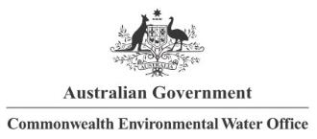








Partners

Collaborators

For this report, ‘supported’ refers to areas and ecosystems that received inundation from Commonwealth environmental water. Consistent with collaborative water delivery across the Basin, Commonwealth environmental water can be delivered in conjunction with other sources of water, and hence observed responses can be due to the combined effect of this water. More information is provided in Section 2.1.2.
For the cumulative evaluation, the area referred to as being supported was either inundated or influenced at least once during the 6-year period from 2014 to 2020.
There were incidental contributions towards ecosystem diversity recorded in the Mitta Mitta, Castlereagh, Paroo and Lower Darling due to alignment of the valley boundary mapping overlapping Commonwealth environmental water in the River Murray and the Darling River channels

