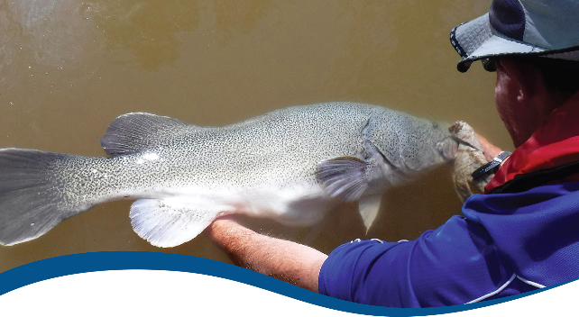
2019-20 - Fish Evaluation Report - Technical Supplement - Final
  - Commonwealth Environmental Water Office (CEWO):
Monitoring, Evaluation and Research Program

August 2021


Citation
Fanson B (2021) 2019-20 - Fish Evaluation Report - Technical Supplement - Final. Flow-MER Program. Commonwealth Environmental Water Office (CEWO): Monitoring, Evaluation and Research Program, Department of Agriculture, Water and the Environment, Australia. 80pp
Acknowledgements
The project team and the Commonwealth Environmental Water Office (CEWO) respectfully acknowledge the traditional owners of the land on which this work is conducted, their Elders past and present, their Nations of the Murray–Darling Basin, and their cultural, social, environmental, spiritual and economic connection to their lands and waters.
We acknowledge the development of the LTIM and Flow-MER project and experimental design by Drs Rick Stoffels, Ben Gawne, and more recent contributions by Drs Alison King and Nick Bond. We also thank the fish leads of the Selected Area Monitoring and Evaluation Providers who are not co-authors on this report but undertook all field work and data collation, data entry and management, technical input and Selected Area annual reports. These fish experts are: Ben Broadhurst, Daniel Wright and Nicole McCasker. We also thank Skye Wassens for her contributions regarding the Murrumbidgee watering actions table. We thank Martin Nolan for construction of the fish sampling sites map. Sincere thanks to Shane Brooks and Julia Mynott for data management and quality assurance checks. We thank the Flow-MER hydrology team, Enzo Guarino and Ashmita Sengupta for processing and verifying the CEWO-supplied hydrology data for use in the Basin evaluation.
The Fish Basin Team would also like to acknowledge Emily Barbour, Dianne Flett, Susan Cuddy and Jill Sharkey for reviewing, proof reading and copy editing the report.
Copyright
 © Commonwealth of Australia 2021
With the exception of the Commonwealth Coat of Arms, partner logos and where otherwise noted, all material in this publication is provided under a Creative Commons Attribution 4.0 International Licence https://creativecommons.org/licenses/by/4.0/. The Flow-MER Program requests attribution as ‘© Commonwealth of Australia (Flow-MER Program, https://flow-mer.org.au’.

Document submission history
2 July 2021 | Final draft
27 August 2021 | Final

Cover photograph
Releasing a Murray cod
Photo credit: Arthur Rylah Institute
Important disclaimer
The information contained in this publication comprises general statements based on scientific research. The reader is advised and needs to be aware that such information may be incomplete or unable to be used in any specific situation. No reliance or actions must therefore be made on that information without seeking prior expert professional, scientific and technical advice. To the extent permitted by law, the Flow-MER Program (including its partners and collaborators) excludes all liability to any person for any consequences, including but not limited to all losses, damages, costs, expenses and any other compensation, arising directly or indirectly from using this publication (in part or in whole) and any information or material contained in it.
The Flow-MER is committed to providing web accessible content wherever possible. If you are having difficulties with accessing this document please contact CEWOmonitoring@environment.gov.au

Overview of Flow-MER
Flow-MER is the Commonwealth Environmental Water Office’s (CEWO) Monitoring, Evaluation and Research Program. Its objective is to monitor and evaluate the ecological responses to the delivery of Commonwealth environmental water in the Murray–Darling Basin. It provides the CEWO with evidence to inform our understanding of how water for the environment is helping maintain, protect, and restore the ecosystems and native species across the Basin. This work will support environmental water managers, demonstrate outcomes, inform adaptive management and fulfil the legislative requirements associated with managing Commonwealth-owned environmental water.
The Program runs from 2019 to 2022 and consists of 2 components: monitoring and research in 7 Selected Areas (Selected Area projects); and Basin-scale evaluation and research (the Basin-scale project) (Figure 1). The Basin-scale project is led by CSIRO in partnership with the University of Canberra, and collaborating with Charles Sturt University, Deakin University, University of New England, South Australian Research and Development Institute, Arthur Rylah Institute, NSW Department of Planning, Industry and Environment, Australian River Restoration Centre and Brooks Ecology & Technology.
It builds on work undertaken through the Long Term Intervention Monitoring (LTIM) (2014–2019) and Environmental Water Knowledge and Research (EWKR) (2014–2019) projects.
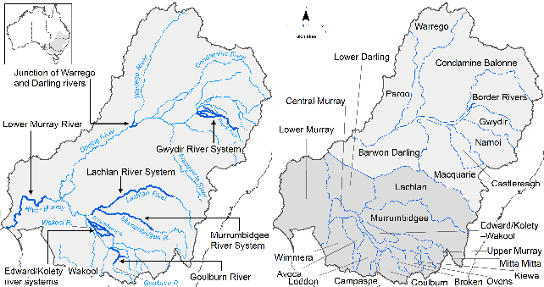
Figure 1 The 7 Selected Areas and 25 valleys established for long-term monitoring of the effects of environmental watering under the LTIM Project and Flow-MER Program (2014–15 to present)
The Flow-MER evaluation adopts an adaptive management framework to acknowledge the need for collectively building the information, networks, capacity and knowledge required to manage environmental water at Basin scale. While knowledge of ecological response to instream flow and inundation has advanced significantly in recent years, substantive challenges remain in understanding the similarities and differences in species’ response across time and space, as well as the interaction between species at a community and ecosystem scale.
The Basin-scale evaluation is being undertaken across 6 Basin Themes (Figure 2) based on ecological indicators developed for the LTIM Project and described in the Environmental Water Outcomes Framework. It is undertaken in conjunction with the Selected Area projects, which provide data, research and knowledge for ecological outcomes within the 7 Selected Areas. The Basin-scale evaluation integrates across Selected Areas, themes, datasets, approaches and different types of knowledge.
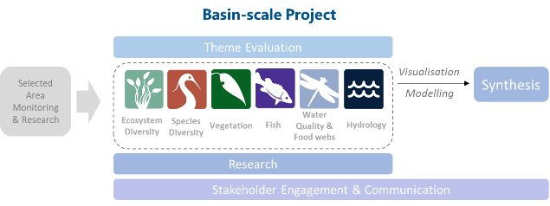
Figure 2 Basin-scale Project evaluation reports on Commonwealth environmental water outcomes for the 6 Basin Themes as well as a high-level Basin-scale synthesis
The evaluation is informed by Basin-scale research projects, stakeholder engagement and communication, including Indigenous engagement, visualisation and modelling, as well as the 7 Selected Area projects.

About the Basin-scale evaluation
Water delivery and outcomes data provided by CEWO is used in conjunction with monitoring data provided by the 7 Selected Areas and other publicly available data to undertake the Basin-scale evaluation. The research and evaluation content is structured into 6 disciplinary themes. Technical reports for each of the 6 themes are available from the Commonwealth Environment Water Office’s website.
The evaluation aims to address theme specific questions in relation to how Commonwealth environmental water contributed to, supported, or influenced environmental outcomes. Commonwealth environmental water is often delivered in conjunction with other environmental water holdings, and non-environmental water releases (such as for irrigation or during high-flow events). The evaluation consequently draws on available information to estimate (where possible) the specific contribution of Commonwealth environmental water to particular environmental outcomes. The way in which this contribution is assessed varies between the 6 themes depending on the data and tools currently available:
- modelling to estimate and compare outcomes both with and without Commonwealth environmental water (counterfactual modelling): hydrology (instream); fish (multi-year evaluation)
- identification of ecological response in locations that received Commonwealth environmental water (potentially in conjunction with other sources of environmental water or non-environmental water), and where feasible, comparison with areas that did not receive Commonwealth environmental water: ecosystem diversity, species diversity, vegetation
- use of flow and water quality metrics to infer likely outcomes: hydrology (inundation); food webs and water quality
- synthesis of findings across Selected Areas: fish (annual); vegetation; food webs and water quality.

This report
This report is a Technical Supplement to the 2021 Basin-scale evaluation of Commonwealth environmental water: Fish (Hladyz et al. 2021). It contains details of the analyses that are summarised and presented in that report.

Abbreviations, acronyms and terms used in this report
Term | Description
CEWO | Commonwealth Environmental Water Office
CPUE | Catch per unit effort
Crl | Credible intervals
fyke | A bag net for catching fish
GLMM | Generalised linear mixed model
LMM | Linear mixed model
STAN | A type of statistical language
ZINB | Zero-inflated negative binomial (mixture model)

Contents
Overview of Flow-MER iii
About the Basin-scale evaluation iv
This report iv
Abbreviations, acronyms and terms used in this report v
1 Summary 1
1.1 Graphical summary of analyses 1
1.2 Recommendations for future analyses 3
1.3 Current status of analysis pipeline 4
2 Fish analyses 6
2.1 Overview 6
2.2 Selecting flow metrics 8
2.3 Analysis: Spawning analysis 13
2.4 Analysis: Larval abundance analysis 18
2.5 Analysis: Recruit analysis 21
2.6 Analysis: Catch curve analysis 25
2.7 Analysis: Adult abundance 29
2.8 Analysis: Adult body condition 31
3 General summary 37
3.1 Summary of flow metric effects for all analyses 37
3.2 Summary of counterfactual predictions metrics 38
3.3 Probability of effect of Commonwealth environmental water being greater than without Commonwealth environmental water 43
4 References 48
Appendix A Details of analyses 49
A.1 Summary of key species 49
A.2 Statistical tables for all analyses 54

List of figures
Figure 1 The 7 Selected Areas and 25 valleys established for long-term monitoring of the effects of environmental watering under the LTIM Project and Flow-MER Program (2014–15 to present) iii
Figure 2 Basin-scale Project evaluation reports on Commonwealth environmental water outcomes for the 6 Basin Themes as well as a high-level Basin-scale synthesis iv
Figure 1.1 Legend for graphical summary diagram 1
Figure 1.2 Map showing the magnitude of Commonwealth environmental water effects on flow metrics (top panel) and on fish responses in each Selected Area (bottom panel) 2
Figure 2.1 Flow profiles for each program 8
Figure 2.2 Correlation matrix for annual flow metric. Numbers show Spearman rank correlations 9
Figure 2.3 Differences in Commonwealth environmental water flows and counterfactual flows for each flow variable kept for each program 10
Figure 2.4 Exploratory plots looking for extrapolation in flow metrics 11
Figure 2.5 Correlation matrix for event-based flow metrics, with the addition of daily discharge to elucidate its relationships to the metrics 12
Figure 2.6 Differences in Commonwealth environmental water flows and counterfactual flows for each flow variable kept and program 12
Figure 2.7 Exploratory plots looking for extrapolation in flow metrics 13
Figure 2.8 Sampling dates for spawning surveys (red dots) in relation to water year windows for each program 14
Figure 2.9 Exploratory graph showing temporal pattern in proportion of sites with spawning events 15
Figure 2.10 Exploratory graph for spawning analysis showing relationships between flow metrics and spawning rates 15
Figure 2.11 Effect of each flow variable on spawning occurrence for each species on the logit scale 16
Figure 2.12 Predicted change (logit scale) on spawning rates with and without Commonwealth environmental water for each species, broken up by year and program 17
Figure 2.13 Predicted spawning rates with and without Commonwealth environmental water for each species, broken up by year and program 17
Figure 2.14 Contribution of each flow variable on the predicted Commonwealth environmental water effect 18
Figure 2.15 Average number of larva across all sites for each water year by program 19
Figure 2.16 Exploratory graph showing relationships between flow metrics and larval CPUE 19
Figure 2.17 Effect of each flow variable on larval abundance for each species 20
Figure 2.18 Predicted percentage change in recruit abundance without Commonwealth environmental water for each species, broken up by year and program 21
Figure 2.19 Contribution of each flow variable on the predicted Commonwealth environmental water effect on recruit abundance 21
Figure 2.20 Sampling methods used for each species and total catch for each method (for each water year) 22
Figure 2.21 Average number of recruits per site across all sites for each water year by program 23
Figure 2.22 Exploratory graph showing relationships between flow metrics and recruit CPUE 23
Figure 2.23 Effect of each flow variable on recruit CPUE for each species 24
Figure 2.24 Predicted percentage change in recruit CPUE without Commonwealth environmental water for each species (except Australian smelt see Figure 2.25) broken up by year and program 24
Figure 2.25 Predicted percentage change for Australian smelt in recruit CPUE without Commonwealth environmental water for each species, broken up by year and program 25
Figure 2.26 Contribution of each flow variable on the predicted Commonwealth environmental water effect on recruit abundance 25
Figure 2.27 Histogram showing distribution of ages across the selected areas 27
Figure 2.28 Recruitment strength estimates for each species 28
Figure 2.29 Effect of each flow variable on growth rate for each species 30
Figure 2.30 Predicted percentage change in growth rate without Commonwealth environmental water for each species, broken up by year and program 30
Figure 2.31 Contribution of each flow variable on the predicted Commonwealth environmental water effect on growth rate 31
Figure 2.32 Sampling dates for body condition (red dots) in relation to water year windows for each program 32
Figure 2.33 Exploratory graph looking for potential outliers 33
Figure 2.34 Main exploratory graph for body condition analysis 34
Figure 2.35 Effect of each flow variable on body condition for each species 35
Figure 2.36 Predicted effect of Commonwealth environmental water on body condition for each species, broken up by year and program 35
Figure 2.37 Contribution of each flow variable on the predicted Commonwealth environmental water effect for body condition 36

Figure A.1 Golden perch summary 49
Figure A.2 Murray cod summary 50
Figure A.3 Bony herring summary 51
Figure A.4 Silver perch summary 52
Figure A.5 Common carp summary 53

List of tables
Table 2.1 Summary of statistical formulas used for each analysis 7
Table 2.2 Summary of sample sizes for spawning dataset 14
Table 2.3 Summary of sample sizes for larval abundance dataset 18
Table 2.4 Summary of sample sizes for recruit dataset 22
Table 2.5 Summary of sample sizes for catch curve dataset 26
Table 2.6 Summary of sample sizes for adult abundance dataset 29
Table 2.7 Summary of sample sizes for body condition dataset 32
Table 3.1 Summary of flow metric effects for all analyses 37
Table 3.2 Summary of predicted Commonwealth environmental water effect for all analyses 38
Table 3.3 Summary of the probability of Commonwealth environmental water effect for all analyses 43

Table A.1 Statistical results for fish spawning occurrence 54
Table A.2 Statistical results for larval abundance 54
Table A.3 Statistical results for recruit abundance 55
Table A.4 Statistical results for Bony herring catch curve model 56
Table A.5 Statistical results for Murray cod catch curve model 58
Table A-6 Statistical results for Golden perch catch curve model 63
Table A-7 Statistical results for adult abundance 66
Table A-8 Statistical results for body condition 68

Summary

Graphical summary of analyses
The effects of Commonwealth environmental water on fish are presented graphically using the metrics shown in Figure 1.1, with results for each Selected Area shown in Figure 1.2.
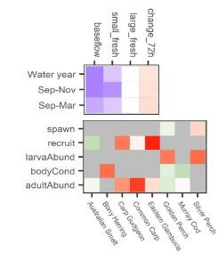
Figure 1.1 Legend for graphical summary diagram
The top panel shows the relative change in each flow metric (x-axis: baseflows, small freshes, large freshes, flow variability - as change_72h) during key time periods for fish life stages (y-axis: water year [July to June], September to November, September to March). Flow colour legend shows direction and relative effect size, with darker purple colours indicating larger positive effects, white indicating no effect, and redder indicating negative effects.
The bottom panel shows the strength of support for a positive (green) or negative (red) effect of Commonwealth environmental water on a given life stage (y-axis) for each species (x-axis). Confidence colour legend indicates relative magnitude and direction, white indicates no confidence (probability of a positive effect near 0.5), light colours denote low confidence (probability of an effect between 0.5-0.8), medium colours denote moderate confidence (probability between 0.8 and 0.95), and dark colours denote high confidence (probability greater than 0.95) noting that effects can be positive (green) or negative (red). Grey squares indicate no data for that cell (e.g. a species not sampled for that life stage or insufficient data for an analysis).

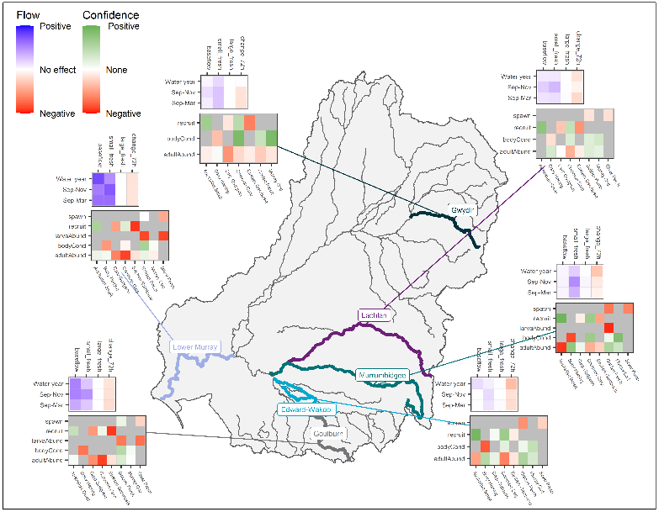
Figure 1.2 Map showing the magnitude of Commonwealth environmental water effects on flow metrics (top panel) and on fish responses in each Selected Area (bottom panel)

Recommendations for future analyses

Adjustments to flow metrics
As noted in the sections below, the analyses presented here may be improved by better temporal alignment of flow metrics with the response variable. Rather than using coarse temporal alignment (e.g. by season or whole water year), the flow metric could be fine-tuned based on sampling date to ensure only flow events in the relevant past are included and not future events. Part of this process would be ensuring that all sampling date information was available (e.g. missing recruitment sampling dates). Then using flow data for each program, a flow algorithm could calculate a specific metric based on each sampling date for each response variable. Explicit conceptual models of the population processes for each species would facilitate this process, as would the development of generalizable flow metrics linked to specific sampling events. These adjustments to flow metrics would be supported by event-based monitoring and the availability of more-resolved hydrodynamic information (e.g., river hydraulics).

Improvement to database
One major issue with the current database was the lack of a sampling/survey table. As part of the analysis, it was necessary to infer if a sampling event occurred and, if it did occur, which fish species were sampled with which fishing method. This step was essential as not catching any fish (zeroes) is fundamentally different from not sampling for that fish. Therefore, ensuring that the data used in the statistical models are reflecting the actual sampling design is essential. The SRA database (and other large fish databases) can provide an example of the survey table needed.

Analysis improvements
For spawning and larva data, it may be preferable to run a mixture model (e.g. zero-inflated negative binomial (ZINB)) in which annual flow metrics dictate the probability of spawning and event-based flow metrics dictate larval abundances. The substantial presence of zeroes required modification to the larval abundance model, essentially treating it (with the spawning data) as a two-step hurdle model. The ZINB approach would be a more natural approach to these data. Similarly, recruitment models could benefit from a ZINB model and potentially some integration might be possible among the models, though this would require custom scripts using STAN (Stan Development Team 2020) or an appropriate wrapper package, such as brms.
Catch curves were performed without flow metrics due to the lack of flow data prior to 2014. Once these data are obtained, these models can be re-run to include flow metrics to predict year class strength.
For adult abundance, the analysis focused on growth rate as the response variable to reflect the population process. The ratio of 2 random variables can lead to distributional issues, which were mitigated through transformations in the analyses here. These models conflate observation and process errors, discussing power to detect process-level flow effects. With some assumptions, it may be possible to implement state-based population models (in sensu Kery and Schaub) to dissect process and observation level errors. However, these models would require additional work to fully incorporate into the current analysis pipeline and it should be discussed whether the potential benefits offset the additional work. The development of such models would directly support efforts to develop population models for these systems.

Quantifying/interpreting effect sizes
As the analyses here dealt with multiple response variables (e.g. spawning rates, larval abundance) related to important population processes (e.g. reproduction, survival), it may be desirable to improve interpretation of the analysis results by integrating this study with current efforts with population models. A complicating aspect with the analysis here is translating estimated counterfactual predictions into population consequences. Is a 5% increase in spawning rate comparable to 5% in adult growth rate? Does a statistically significant 1% affect the population dynamics?
The following analyses provided estimated effect sizes on the measured response metric (e.g. spawning presence, CPUE) and focused on the magnitude of change. Translating these effect sizes to population processes is unclear, as well as they may differ by the species life history strategies (r vs. K-species). Possibly as a first step, consultation with a population modeler may provide initial insights into the sensitivity of each population process explored here for each species. Using these sensitivities, it may then be possible to weigh effect sizes differently to allow for better comparison between response variables, and hence making management decisions.
A possible next step would be using purpose-built population models to simulate fish populations for each species and then overlay a similar sampling design used for the study here to map the results here to likely simulated scenarios. Such integration would greatly improve how to interpret the finding here, as well as be useful to delineating strengths/weaknesses of the sampling used here for understanding population processes for each species.

Extending analysis to include unmonitored locations
A possible extension of this study is extrapolating the findings to other systems not sampled. Our assessment of this extension can be viewed from two main viewpoints: mechanics (e.g. writing the analysis code) and statistical (e.g. interpretation).
From a mechanics viewpoint, the amount of additional work to create predictions from the current model is minimal (1 or 2 days), requiring only the hydrological data with predicted counterfactuals and some minor edits to analysis scripts.
From a statistical viewpoint, such an extension could prove to being useful, if accompanied by field data to assess the predictions. Predicting to other river systems would require extrapolation beyond the sampling frame of the study. As noted in this report, the initial selection of the Selected Areas unlikely reflect a random sample and hence care is needed in extrapolating beyond the sites. In particular, careful consideration about whether the flow metrics used here can be extrapolated the new Selected Areas, as well if the ecology of the different species. If the extrapolations likely have some validity (following the assessments), these extrapolations could provide very beneficial as a validation of the current models if field data could be incorporated as well. A desktop analysis of the hydrology of large swath river systems could identity systems that have large effect sizes with Commonwealth environmental water events. Using this analysis, it would be possible to strategically delineate river systems for testing unique predictions from the models.

Current status of analysis pipeline
For this report, an analysis pipeline was created that can be used for future analyses. This process included import and cleaning of data, separate analysis programs that set-up analysis-ready datasets, produce exploratory graph outputs, run models for each selected species, display model fit plots, and finally collate the key results for the report. The current report code updates figures, tables, and select variables of interest; however, text is not updated and left as a manual process.
At this point, the main future improvements are:
- The import process relies on intermediate datasets extracted from the database. Direct communication with the database would streamline this process.
- The incorporation of a flow metric function into the analysis pipeline to improve temporal alignment of flow metrics to sampling dates.
- If a ZINB model for spawning/larval data is implemented, some minor modifications of analysis script and reporting scripts will be needed to concatenate two response variables, one using an annual metric and another using an event-based metric, into a single script.
- It would be ideal to convert the body condition model to a Bayesian framework for consistency and interpretation benefits. Currently, the computation time is prohibitively long for this set of data, likely due to the complex random-effects structure. With more time, it should be possible to identify possible remedies to this issue.

Fish analyses

Overview

Background
These fish analyses explore the effect of Commonwealth environmental water events on key population processes for a range of species. As the study design lacks controls (e.g. comparable river systems that did not receive the Commonwealth environmental water), the study design relies on using variation flow events over multiple years and areas to build a model of how flow may affect key population processes (Figure 2.1). Then, the potential consequences of Commonwealth environmental water are predicted from those models by using estimated counterfactual flows (e.g. likely flow conditions if Commonwealth environmental water was not provided). The models predict the change in response variable by the reduction in flow and this change is used as a prediction of the Commonwealth environmental water effect. This approach is static and does not explore knock-on effects for population dynamics. The research theme F1: Fish population models will investigate this component further.

General analyses
All analyses in this report were performed using R v3.6 (R Core Team (2019)) using rstanarm package (Goodrich et al. 2020), except for the body condition data which was analysed using lme4 package (Bates et al. 2015) due to prohibitively long computation times. A Bayesian linear model approach was used to better deal with estimation issues with some generalised model due to limited data (e.g. zero spawning in some programs). Specific details about each analysis are outlined in the sections below, but the models had similar basic structures and these shared similarities are outlined directly below.
First, each species was modelled separately for each response variable of interest. The model structure was broken into 3 components:
- response variable (possibly transformed; described in each section below)
- flow covariates (annual or event metrics; see section 2.2)
- spatial/temporal effects that were either fixed or random.
As the first 2 components (response variable and flow metrics) are described in the specific analysis sections, only the spatiotemporal component is delineated here.
For the spatial/temporal effects, the following logic was adopted. Program (assumed to be Basin as listed in the analysis brief) was treated as a fixed effect as it appears the experimental design is not random (the Basins were selected nonrandomly (based on certain attributes and locations) and hence extrapolation is likely dubious). Within each program, site (aka sample point) was assumed to be roughly randomly selected and hence treated as random effect. For simplicity, constant site variation across programs was assumed (this could be looked more at in the future). For the temporal component, water year was assumed to be nested in program (i.e. assumed independence across basins conditioned on the flow metrics). Again, constant variability across programs was assumed. Finally, sites were assumed to vary independently across years (even within program) and, where appropriate, there is a site-by-year random effect.
After fitting the model, validity of model assumptions was assessed through graphical analysis of Pearson residuals testing main assumptions: normality (where appropriate), heteroscedasticity, nonlinearities (residuals vs. each predictor), posterior predictive checks (except body condition) and looking for potential outliers (high leverage points). Variable transformations (noted in each analysis section) were used to correct if appropriate or a different statistical distribution if possible.
To model the counterfactual scenario, I used the final model to predict change in mean response using the provided counterfactual flows. For the annual flow models, I estimated the difference between predicted flows with and without Commonwealth environmental water using posterior_linpred(), conditioning on the random effects (Goodrich et al. 2020). For event-based models, it is less clear as to how the counterfactual scenario can be approached. For instance, with spawning, the sampling only records a fraction of the Commonwealth environmental water events that did occur and I may have missed the largest Commonwealth environmental water effects. For this report, I took the maximum Commonwealth environmental water scenario for each water year in each program (basin). I did this by getting the difference between with and without Commonwealth environmental water for each flow metric and then ranked for flow metric the magnitude of the difference. Then I summed the ranks and chose the sampling conditions that had the highest rank. Thus, I weighed each flow variable equally, even if the best model suggests unequal effects (this could be improved in the future). A similar approach was taken for body condition, except I used parametric bootstrapping rather than the posterior distributions.
Finally, I present model results with 95% credible intervals (95% CrI) [or 95% CI confidence intervals for body condition].
Table 2.1 Summary of statistical formulas used for each analysis
Rationale for approach is explained in each section below this table
Analysis | Species | Equation | Link function | Family
spawn | golden perch  silver perch | cbind(n_spawned, n_survey - n_spawned)~baseflow_sep_nov + small_fresh_sep_nov + large_fresh_sep_nov + change_72h_sep_nov + program + tot_effort + (1 | program: water year) | logit | binomial
larvaAbund | golden perch  silver perch | cpue~seven_day_range + days_increasing + seven_day_median + program + ad_cpue + (1 | program: water year) + (1 | samplepoint) | log | gaussian
recruit | Australian smelt  carp gudgeon  common carp  eastern gambusia | count~baseflow_sep_mar + small_fresh_sep_mar + large_fresh_sep_mar + change_72h_sep_mar + n_sites + program | log | poisson
catchCurveAge | Murray cod  golden perch  bony herring | n_fish~age + program + (1 | program:birthyear) | log | negative binomial
adultAbund | golden perch  Murray cod  carp gudgeon  bony herring  common carp  eastern gambusia  Australian smelt | r~baseflow_water_year + small_fresh_water_year + large_fresh_water_year + change_72h_water_year + program + do_last_year + (1 | program: water year) + (1 | samplepoint) | log | gaussian
bodyCond | bony herring  common carp  Murray cod  golden perch | fulton_index~baseflow_water_year + small_fresh_water_year + large_fresh_water_year + change_72h_water_year + program + (1 | program: water year) + (1 | samplepoint) + (1 | samplepoint: water year) | identity | gaussian

Selecting flow metrics
To prevent redundant flow metrics and overly parameterised models, I explored the relationships between proposed flow metrics to reduce the list of metrics included in the models. First, I show the daily flow without and with Commonwealth environmental water events. Next, I focus on 2 sets of flow metrics: annual and event-based. I assessed each group separately. I used correlations >0.7 as a coarse threshold of redundant information. Sections below give a brief overview of the process and results.

Flow profiles for each region
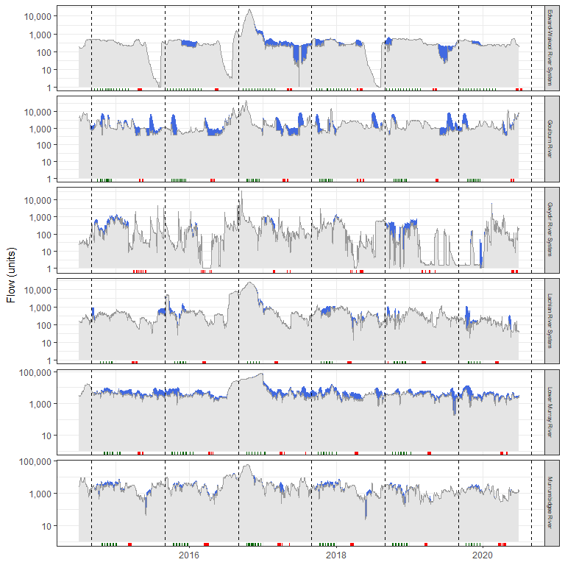
Figure 2.1 Flow profiles for each program
Grey area shows flow when no Commonwealth environmental water is present. Blue areas show added Commonwealth environmental water amount. Green rug shows timing of larval surveys and red show adult surveys. Vertical dotted lines are temporal boundaries for each water year. Note that y-axis is logged scaled.

Annual metrics

Selecting main metrics
Comparing correlations between groups of annual metrics (baseline_xxx, xxx_fresh_xxx, overbank_xxx,change_xxx) revealed several key results.
- baseflow_xxx: baseflow_water_year was correlated with every metric >0.7. Thus, I only kept baseflow_water_year from this group.
- small_fresh_xxx: small_fresh_water_year was correlated with every small_fresh_xxx >0.7. It was positively correlated with large_fresh_xxx at ~0.5. Thus, I kept just _small_fresh_water_year__ and looked at large_fresh_xxx as a separate group.
- large_fresh_xxx: large_fresh_water_year was correlated strongly with spring fresh variables but not summer/autumn. Surprisingly, large_fresh_jan_jun and large_fresh_mar_may were weakly correlated. Therefore, I kept large_fresh_water_year, large_fresh_jan_jun, and large_fresh_mar_may.
- overbank_xxx: overbank was strongly correlated with large_fresh, except for overbank_jan_jul. Thus, I kept overbank_jan_jul.
- change_xxx: change_72h_water_year was moderately to strongly correlated (>0.6) with all other change_xxx metrics. Given the large redundancy in information, I kept just change_72h_water_year.
Thus, the final list and their correlations are shown in Figure 2.2.
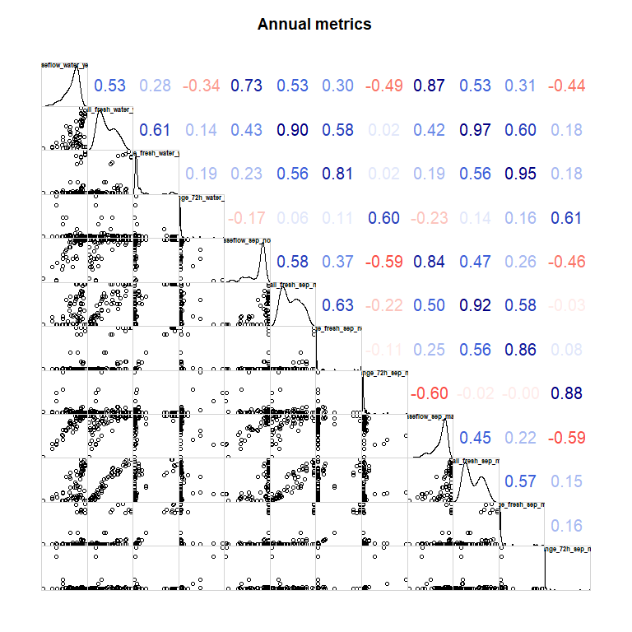
Figure 2.2 Correlation matrix for annual flow metric. Numbers show Spearman rank correlations

Counterfactual effect sizes
Prior to the analysis, it is essential to understand the magnitude of effect sizes between actual and counterfactual flows. I summarised those effect sizes in Figure 2.3. For proportion scale variables (e.g. baseflow_xxx, small_fresh_xxx), I used raw scale (here) and for discharge variables (change_xxx), I used log-scale as proportional change is likely more ecologically relevant.
As expected, Commonwealth environmental water flows had positive effect on all metrics, sans change_72h_water_year. Checking Figure 2.1, I can see that Commonwealth environmental water flows appears to have prevented rapid drops in water conditions. Large_fresh_xxx and overbank_xxx have only a few instances in which they differed (e.g. a single large_fresh_mar_may).
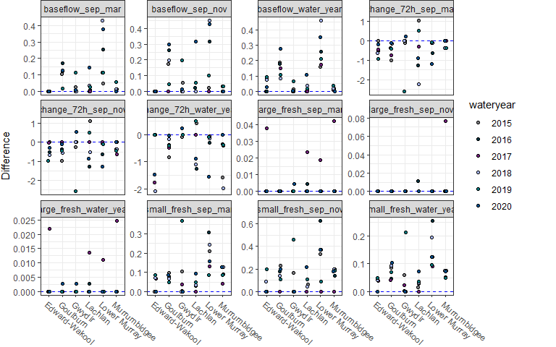
Figure 2.3 Differences in Commonwealth environmental water flows and counterfactual flows for each flow variable kept for each program
Each point (slightly jittered) shows the difference for each year.

Extrapolation potential
Furthermore, it is important to understand if and where extrapolation in flow metrics may occur to delineate potential red flags for predictions. Here, I take a simplistic approach and look for extrapolation univariately (rather than multivariate parameter space). Extrapolation cases are shown in Figure 2.4.
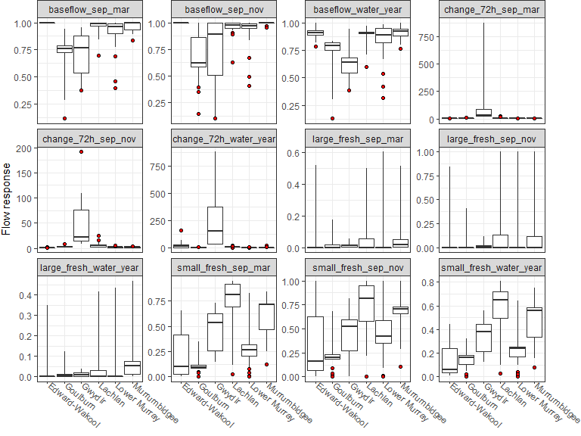
Figure 2.4 Exploratory plots looking for extrapolation in flow metrics
Red dots show instances that the counterfactual lies outside the sampling range for that program

Event-based metrics
There were fewer event-based metrics. None of the event metrics were correlated above 0.7 (Figure 2.5) Actual_seven_day_range was strongly correlated with daily discharge, as would be expected.
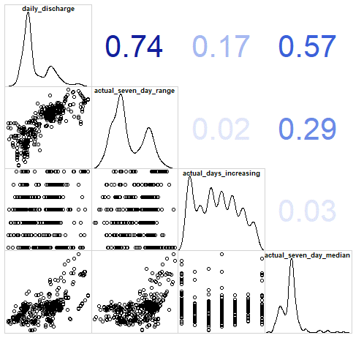
Figure 2.5 Correlation matrix for event-based flow metrics, with the addition of daily discharge to elucidate its relationships to the metrics
Numbers show Spearman rank correlations. Note - Daily discharge, seven day range and seven day median were log-transform.

Counterfactual effect sizes
Prior to the analysis, it is essential to understand the magnitude of effect sizes between actual and counterfactual flows. I summarised those effect sizes in Figure 2.6. For proportion scale variables (e.g. baseflow_xxx, small_fresh_xxx), I used raw scale (here) and for discharge variables (change_xxx) I used log-scale as proportional change is likely more ecologically relevant.
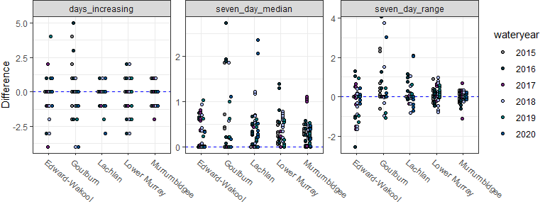
Figure 2.6 Differences in Commonwealth environmental water flows and counterfactual flows for each flow variable kept and program

Extrapolation potential
No Commonwealth environmental water prediction conditions were outside the sampling range (Figure 2.7).
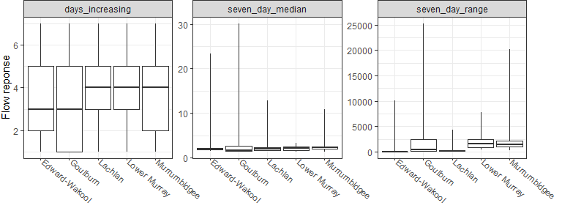
Figure 2.7 Exploratory plots looking for extrapolation in flow metrics
If red dots are present, they show extrapolation outside the observed range for that program and that flow variable.

Analysis: Spawning analysis

Logic, study design, and data trimming

Logic
For flow-cued spawners, flow conditions affect the spawning triggers and survival of recruits. Triggers likely include rapid changes in flow conditions as well as baseline flow levels.

Study design
One key aspect to check is the temporal alignment of annual flow metrics alignment with sampling dates for body condition for each program and assess whether the alignment is appropriate for the biological hypotheses.
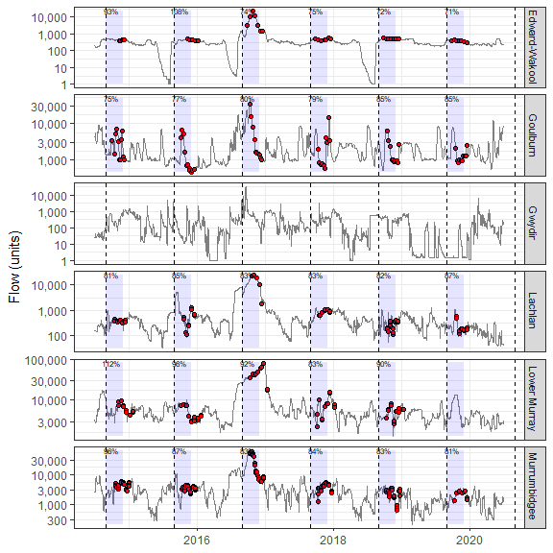
Figure 2.8 Sampling dates for spawning surveys (red dots) in relation to water year windows for each program
Percentage shows the proportion of the water year fish experienced prior to the first sampling date (i.e. 70% means that the fish experienced 70% of the flow data included in the flow metrics at the time of first sampling event). Blue bands show the range for the flow metric.

Data trimming
Total samples sizes are shown in Table 2.2. Two flow-cued spawning species were selected for the analysis: Macquaria ambigua and Bidyanus bidyanus.
Table 2.2 Summary of sample sizes for spawning dataset
Species | Programs | Sites | Years | Percentage zero catch
Silver perch | Edward-Wakool | 9 | 6 | 100.0%
Silver perch | Goulburn | 6 | 6 | 94.0%
Silver perch | Lachlan | 6 | 6 | 100.0%
Silver perch | Lower Murray | 6 | 5 | 99.1%
Silver perch | Murrumbidgee | 6 | 6 | 100.0%
Golden perch | Edward-Wakool | 9 | 6 | 100.0%
Golden perch | Goulburn | 6 | 6 | 90.2%
Golden perch | Lachlan | 6 | 6 | 100.0%
Golden perch | Lower Murray | 6 | 5 | 93.8%
Golden perch | Murrumbidgee | 6 | 6 | 97.5%

Key exploratory graph(s)
To explore patterns in the data, I looked at temporal patterns in the proportion of sites that recorded spawning each water year (Figure 2.9).
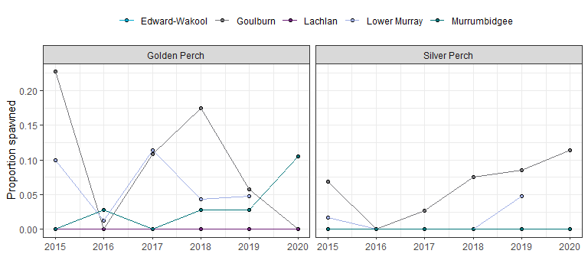
Figure 2.9 Exploratory graph showing temporal pattern in proportion of sites with spawning events
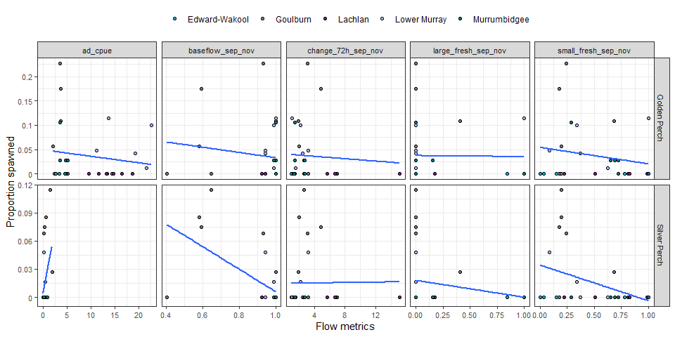
Figure 2.10 Exploratory graph for spawning analysis showing relationships between flow metrics and spawning rates
Each dot represents proportion of sites with spawning. Blue line shows exploratory regression line (not corrected for other covariates).

Data analysis
To test for the effects of flow metrics on spawning, I modelled the probability that a spawning event is detected based on flow conditions.
Using the above approach, a GLMM (generalised linear mixed model) was run with a binomial distribution (in a Bayesian framework). As the metrics were the same within a program, I summed together all sampling events within a program and used total number of spawning events detected as the response variable. I included the selected annual flow metrics, total volumetric effort (log-scaled), current water year’s adult CPUE, and program as fixed effects. Program-by-water year was included as a random effect, which helps account for potential overdispersion in the data.

Results

Flow coefficients
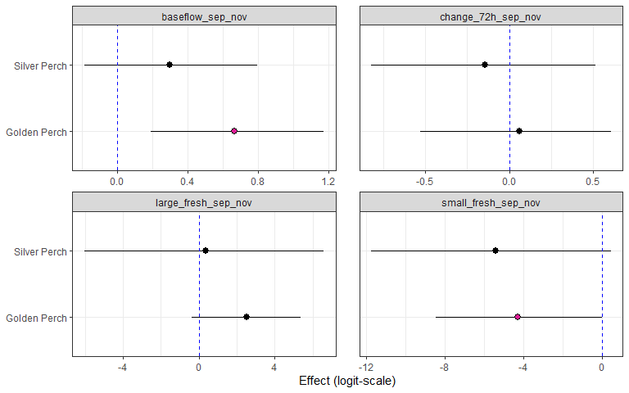
Figure 2.11 Effect of each flow variable on spawning occurrence for each species on the logit scale
Spawning rates lead to large standard errors and hence easier to present on logit scale. Error bars are 95%CrI. Pinkish dots indicate 95%CrI does not overlap 0.

Counterfactual predictions
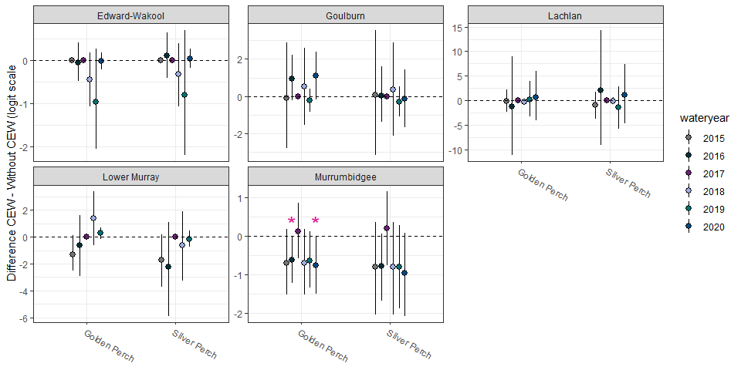
Figure 2.12 Predicted change (logit scale) on spawning rates with and without Commonwealth environmental water for each species, broken up by year and program
* indicates the 95%CrI of the difference between with and without Commonwealth environmental water does.
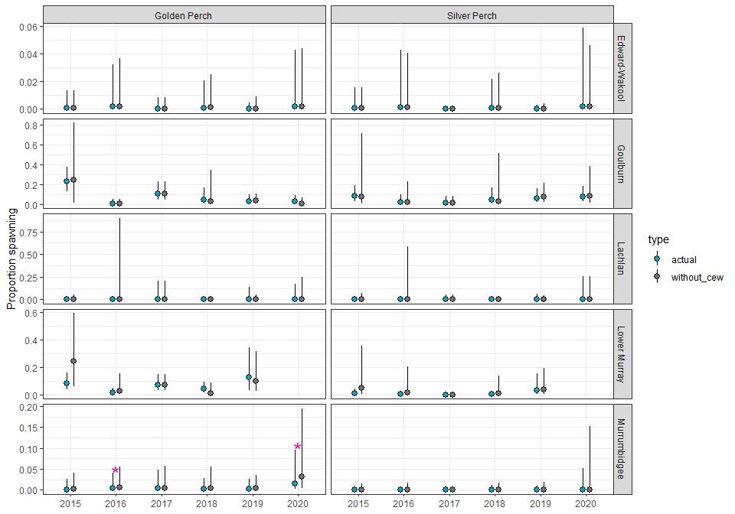
Figure 2.13 Predicted spawning rates with and without Commonwealth environmental water for each species, broken up by year and program
* indicates the 95%CrI of the difference between with and without Commonwealth environmental water does not include zero. Error bars are 95%CrI.
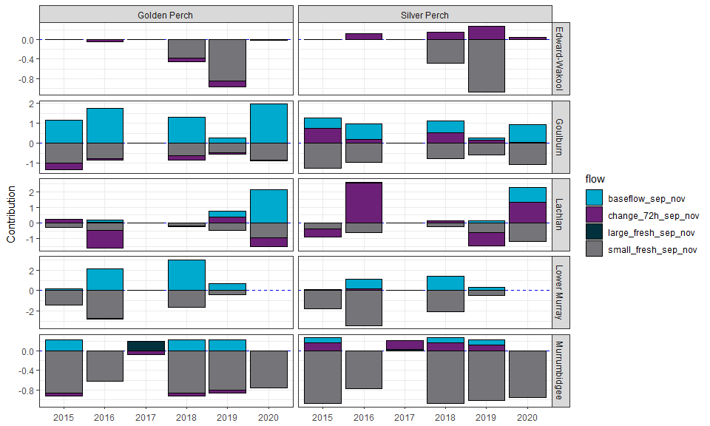
Figure 2.14 Contribution of each flow variable on the predicted Commonwealth environmental water effect
Negative effects are shown as bars below 0 and positive effects above. Effect sizes are on link scale.

Analysis: Larval abundance analysis

Logic, study design, and data trimming

Logic
The previous section estimated the effect of flow on spawning rates across sites, investigating if Commonwealth environmental water increased spawning occurrence. This section looks specifically at larval abundance, given that a site had a spawning event. I dropped non-spawning sites as this information was contained in the previous section and it leads to distribution issues due to the excess zeros.

Study design
The sampling design follows the spawning design (see Figure 2.8), though the flow metrics are event-based in this design and hence temporal alignment is different.
Total samples sizes are shown in Table 2.3. The analysis includes 2 flow-cued spawning species: Macquaria ambigua and Bidyanus bidyanus.
Table 2.3 Summary of sample sizes for larval abundance dataset
Note - this is basically same as spawning, except displaying percentage of surveys with nonzero CPUE (and dropped effort == 0 surveys).
Species | Programs | Sites | Years | Percentage nonzero CPUE
Silver perch | Edward-Wakool | 9 | 6 | 0.0%
Silver perch | Goulburn | 6 | 6 | 6.0%
Silver perch | Lachlan | 6 | 6 | 0.0%
Silver perch | Lower Murray | 6 | 5 | 0.9%
Silver perch | Murrumbidgee | 6 | 6 | 0.0%
Golden perch | Edward-Wakool | 9 | 6 | 0.0%
Golden perch | Goulburn | 6 | 6 | 9.8%
Golden perch | Lachlan | 6 | 6 | 0.0%
Golden perch | Lower Murray | 6 | 5 | 6.2%
Golden perch | Murrumbidgee | 6 | 6 | 2.5%

Key exploratory graph(s)
To explore patterns in the data, I looked at temporal patterns in the average number of larva for each water year (Figure 2.15).
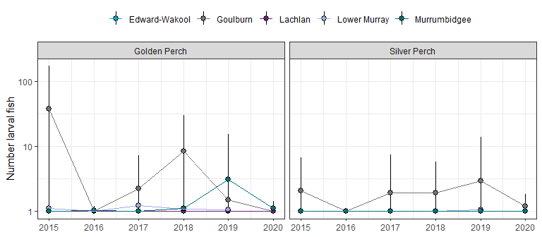
Figure 2.15 Average number of larva across all sites for each water year by program
Each panel shows a different species. Error bars are ±SD.
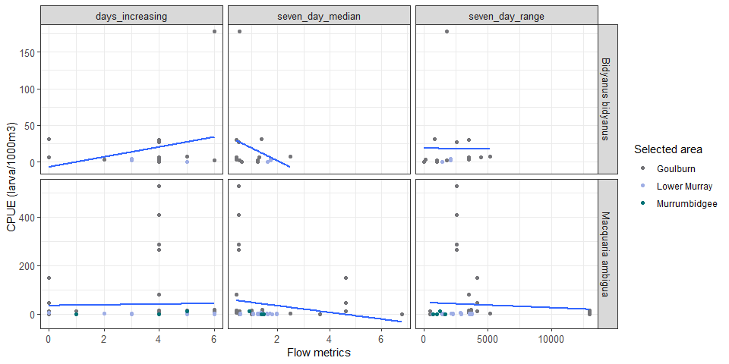
Figure 2.16 Exploratory graph showing relationships between flow metrics and larval CPUE
Each dot represents number of larva (per 1000 m³). Blue line shows exploratory regression line (not corrected for other covariates).

Data analysis
As noted above, larval abundance data were mostly zeros and as expected, these zeros (plus some high numbers) led to model fitting issues with negative binomial. After assessing potential alternatives and keeping the analysis plan structure the same (keep spawning analysis separate instead of incorporating into a zero-inflated model), I focused solely on data in which I knew that spawning had occurred (count > 0). Using just this data, I ran a linear mixed model using CPUE (log-transformed; number fish/1000 m³) as the response variable. Event flow variables were included as predictors (correlations between flow metrics with reduced dataset all <0.3). Program was included as a fixed effect. Water year (nested in program) and site were included as random effects.0F

Results

Flow coefficients
Surprisingly, increasing the seven_day_median was associated with decrease in larval CPUE for Golden perch (Figure 2.17).
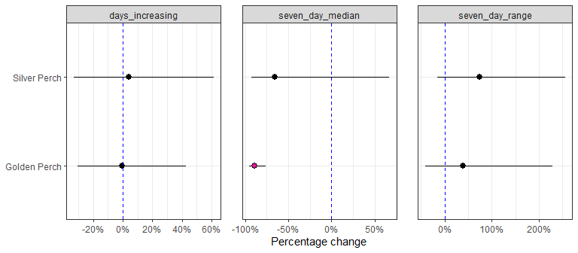
Figure 2.17 Effect of each flow variable on larval abundance for each species
Error bars are 95%CrI. Pinkish dots indicate 95%CrI does not overlap 0

Counterfactual predictions
The percentage change in larval CPUE without Commonwealth environmental water is shown. The positive changes show Commonwealth environmental water improved larval abundances (Figure 2.18).
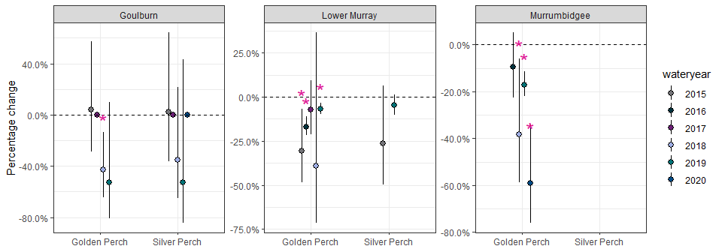
Figure 2.18 Predicted percentage change in recruit abundance without Commonwealth environmental water for each species, broken up by year and program
Positive changes indicate Commonwealth environmental water improved larval abundance. Error bars are 95%CrI. * indicates the 95%CrI of the difference between with and without Commonwealth environmental water does not include zero.
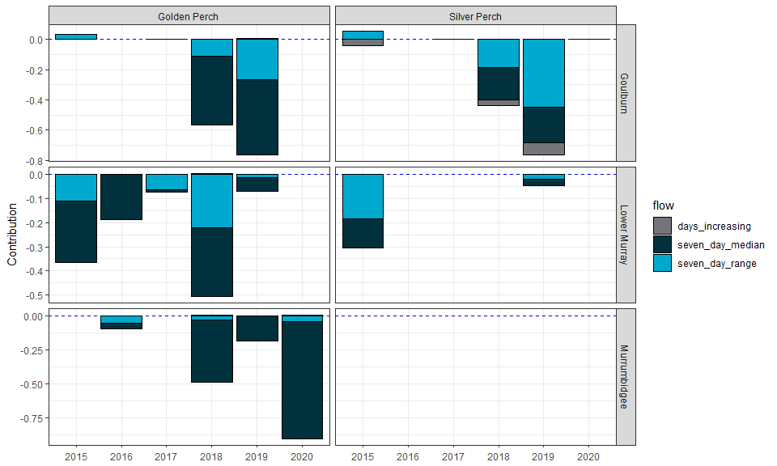
Figure 2.19 Contribution of each flow variable on the predicted Commonwealth environmental water effect on recruit abundance
Negative effects are shown as bars below 0 and positive effects above. Effect sizes are on link scale.

Analysis: Recruit analysis

Logic, study design, and data trimming

Logic
Recruits numbers reflect multiple population processes: reproductive output and larval survival. The annual flow metrics were included as predictors affecting these processes.

Study design
The recruit data lacked information on effort and sampling dates. Furthermore, multiple sampling methods were used as well. Therefore, a few assumptions were necessary. First, I looked at sampling methods used and which water years (Figure 2.20). As coarse fyke was only used in 2019/2020, I dropped this method from further consideration. As I did not have any information about total effort, I simplified the dataset by summarising across all methods for a given water year and selected area. Effort was then number of sites that water year.
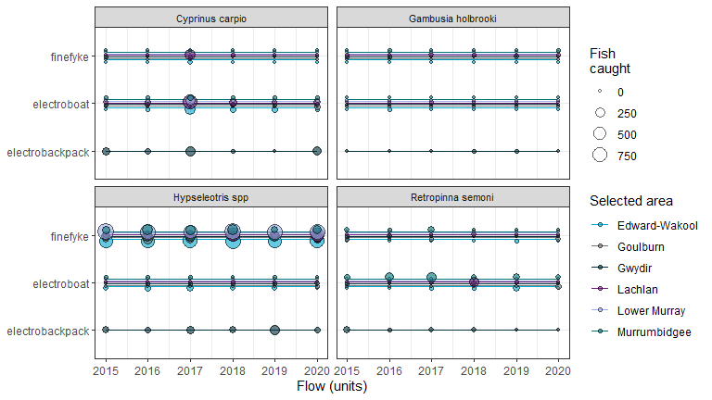
Figure 2.20 Sampling methods used for each species and total catch for each method (for each water year)
Table 2.4 Summary of sample sizes for recruit dataset
Species | Total fish | Method | No. fish | No. programs | No. sites | No. years | Percentage zero CPUE
Carp gudgeon | 15,658 | coarsefyke | 21 | 1 | 9 | 2 | 60.0%
Carp gudgeon | 15,658 | finefyke | 14,681 | 6 | 61 | 6 | 5.7%
Carp gudgeon | 15,658 | electroboat | 329 | 6 | 61 | 6 | 75.6%
Carp gudgeon | 15,658 | electrobackpack | 648 | 1 | 9 | 6 | 22.7%
Common carp | 3,015 | coarsefyke | 450 | 1 | 9 | 2 | 6.7%
Common carp | 3,015 | finefyke | 404 | 6 | 61 | 6 | 89.9%
Common carp | 3,015 | electroboat | 1,953 | 6 | 61 | 6 | 53.9%
Common carp | 3,015 | electrobackpack | 658 | 1 | 9 | 6 | 36.4%
Australian smelt | 1,321 | coarsefyke | 2 | 1 | 9 | 2 | 86.7%
Australian smelt | 1,321 | finefyke | 200 | 6 | 61 | 6 | 83.9%
Australian smelt | 1,321 | electroboat | 987 | 6 | 61 | 6 | 73.3%
Australian smelt | 1,321 | electrobackpack | 134 | 1 | 9 | 6 | 63.6%
Eastern gambusia | 144 | coarsefyke | 0 | 1 | 9 | 2 | 100.0%
Eastern gambusia | 144 | finefyke | 115 | 6 | 61 | 6 | 85.7%
Eastern gambusia | 144 | electroboat | 16 | 6 | 61 | 6 | 97.5%
Eastern gambusia | 144 | electrobackpack | 13 | 1 | 9 | 6 | 86.4%

Key exploratory graph(s)
To explore patterns in recruit CPUE data, I investigated temporal patterns among species and programs (Figure 2.21).
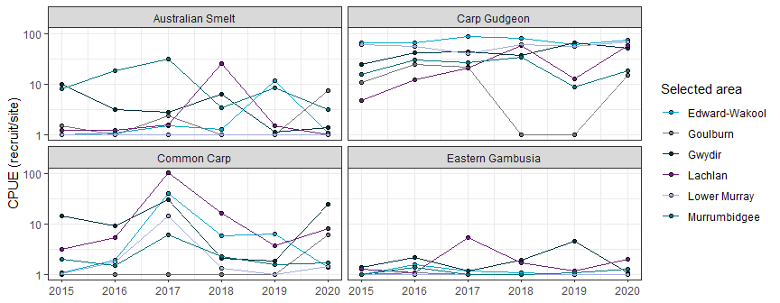
Figure 2.21 Average number of recruits per site across all sites for each water year by program
Each panel shows a different species.
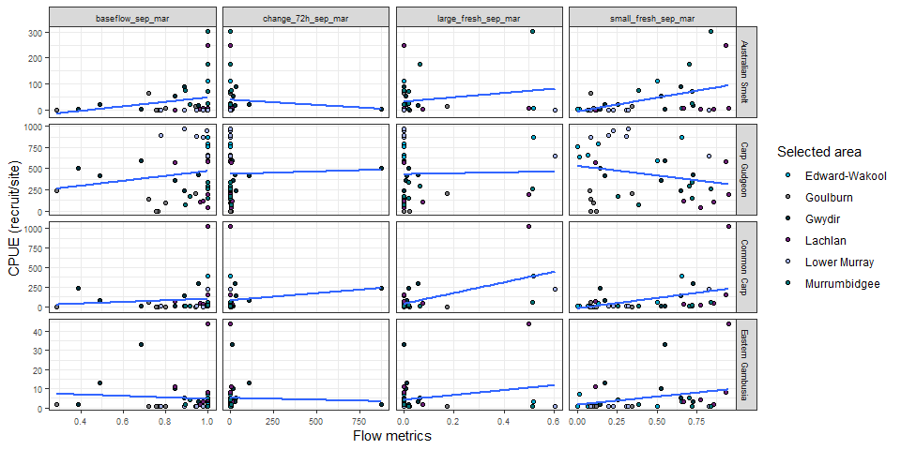
Figure 2.22 Exploratory graph showing relationships between flow metrics and recruit CPUE
Each dot represents number of recruits per site. Blue line shows exploratory regression line (not corrected for other covariates).

Data analysis
Using the total recruits (per water year in each program) as the response variable, I ran a GLMM assuming a Negative Binomial distribution. For the fixed factors, I included flow metrics, program, and number of sites (log-transformed). Water year nested in program was the random effect.

Results

Flow coefficients
Estimates of flow coefficients for each species in shown in Figure 2.23.
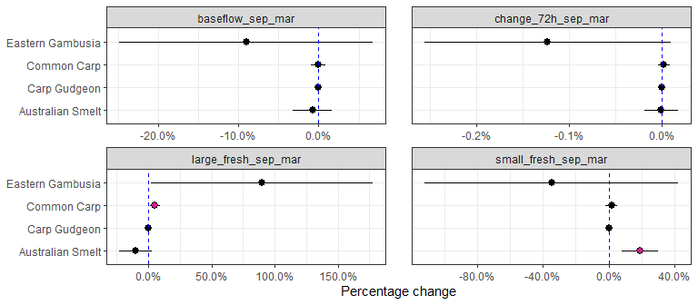
Figure 2.23 Effect of each flow variable on recruit CPUE for each species
Error bars are 95%CrI. Pinkish dots indicate 95%CrI does not overlap 0

Counterfactual predictions
Australian smelt are split from the other fish species for better visual clarity.
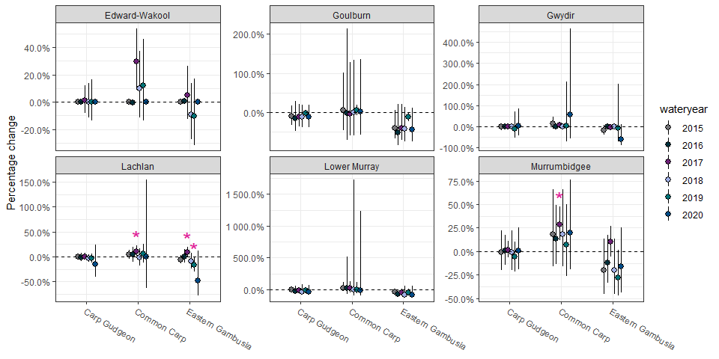
Figure 2.24 Predicted percentage change in recruit CPUE without Commonwealth environmental water for each species (except Australian smelt see Figure 2.25) broken up by year and program
Positive changes indicate Commonwealth environmental water improved recruit abundance. Error bars are 95%Crl.
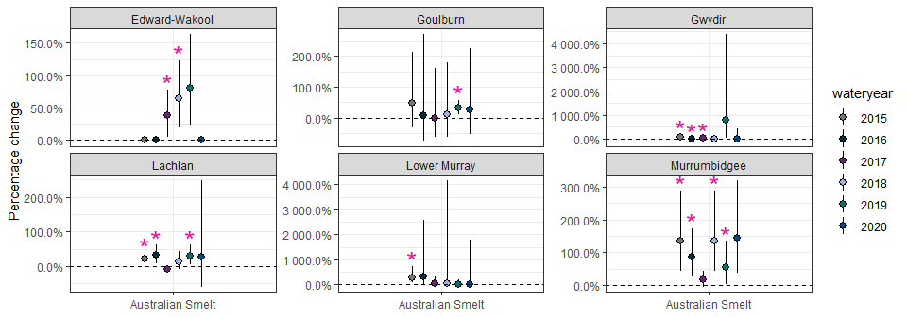
Figure 2.25 Predicted percentage change for Australian smelt in recruit CPUE without Commonwealth environmental water for each species, broken up by year and program
Positive changes indicate Commonwealth environmental water improved recruit abundance. Error bars are 95%Crl. * indicates the 95%Crl of the difference between with and without Commonwealth environmental water does not include zero.
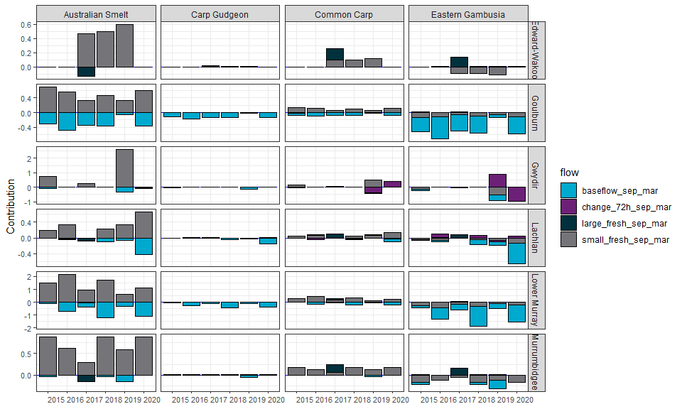
Figure 2.26 Contribution of each flow variable on the predicted Commonwealth environmental water effect on recruit abundance
Negative effects are shown as bars below 0 and positive effects above. Effect sizes are on link scale.

Analysis: Catch curve analysis

Logic, study design, and data trimming

Logic
- No statistical analysis relating annual flow metrics with recruitment strength was run for the following reasons: 1) no access to water data prior to 2014; 2) catch curve regressions work best above a threshold age when mortality and detection rates become constant; and 3) sample sizes were sparse once fish born before 2014.
- Instead, a standard catch curve regression was performed to quantity high (and low) recruitment years for the following species: Maccullochella peelii, Macquaria ambigua, Nematalosa erebi.

Study design
Overall sample sizes caught per water year by selected areas is shown in Table 2.5. Distribution of ages are shown in Figure 2.27.
Table 2.5 Summary of sample sizes for catch curve dataset
Species | Selected areas | 2014 | 2015 | 2016 | 2017 | 2018 | 2019 | 2020
Murray cod | Edward-Wakool | 11 | 64
Murray cod | Goulburn | 35 | 16
Murray cod | Lachlan |  | 54
Murray cod | Lower Murray |  | 10 | 12 | 7 | 9 | 18 | 157
Murray cod | Murrumbidgee |  | 51
Golden perch | Edward-Wakool | 7 | 38
Golden perch | Goulburn | 19 | 29 | 1 |  | 44
Golden perch | Gwydir |  | 58 |  |  | 64
Golden perch | Lachlan |  | 61
Golden perch | Lower Murray |  | 137 | 128 | 111 | 105 | 113 | 121
Golden perch | Murrumbidgee |  | 8 |  |  | 78
Bony herring | Edward-Wakool |  | 46
Bony herring | Gwydir | 10 | 49 | 117 | 100 | 105 | 76
Bony herring | Lachlan |  | 53 | 109 | 103 | 108 | 100 | 98
Bony herring | Lower Murray |  |  | 124 | 114 | 119 | 122 | 100
Bony herring | Murrumbidgee |  | 51 | 113 | 110 | 101 | 100 | 100
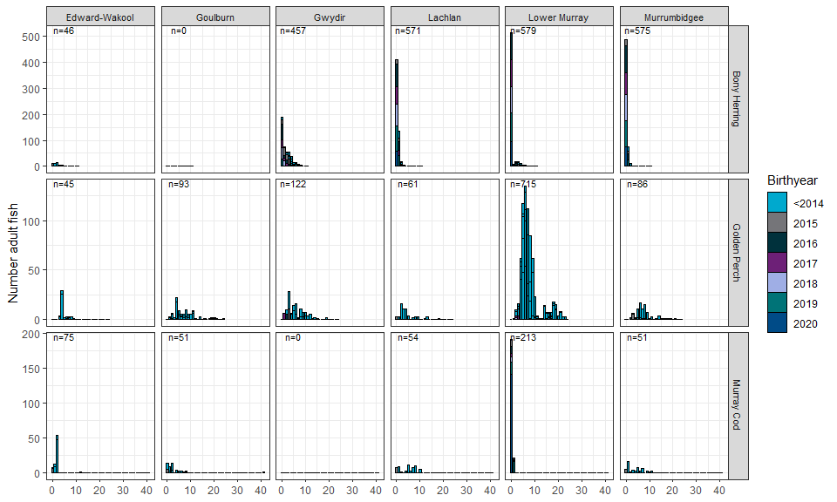
Figure 2.27 Histogram showing distribution of ages across the selected areas
Each panel shows the total number of fish aged (n=XX).

Data trimming
As mortality rates and detection rates can vary with younger fish, I developed a cutoff threshold for each species. For Murray cod and golden perch, the age cutoff was 4+. This criterion was based on a large combined data of golden perch data showing the characteristic hump around 4 years old. For now, I assumed a similar pattern for Murray cod since was a large body fish as well. As for Bony herring, threshold information was limiting, so I kept 2+ fish.

Data analysis methods
For the analysis, I ran a catch curve regression on each species. For each species, the dataset was expanded to include all possible ages for sampling, up to the max age caught (for that species). The response variable was number of fish caught at each age and was assumed to follow a negative binomial distribution. The fixed effects were age and program. Birthyear nested in program was included as a random effect.

Key results

Estimated mortality rates
As part of the catch curve, I can estimate annual survival rates. Annual survival rates were 0.51 (0.44, 0.58), 0.79 (0.71, 0.85), 0.78 (0.74, 0.82) for bony herring, Murray cod, golden perch, respectively.

Recruitment strength
Recruitment strengths for each birthyear were estimated for each species. Model results only delineated varying recruitment strengths in only Golden perch (Figure 2.28), mainly in the Lower Murray where I had substantial data and hence higher statistical power.
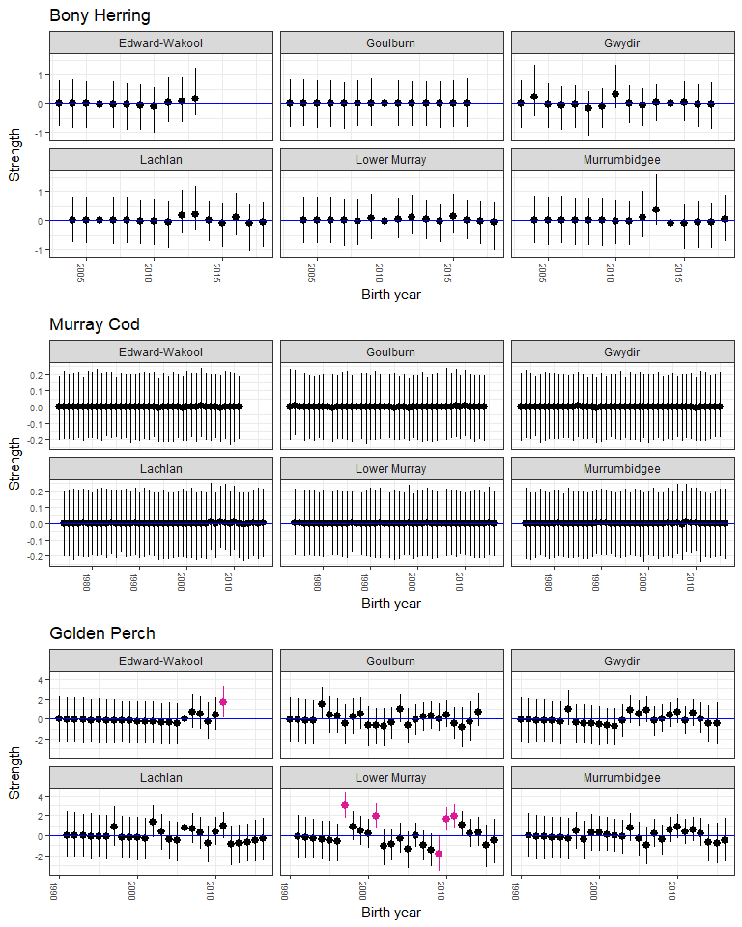
Figure 2.28 Recruitment strength estimates for each species
Coloured dots show estimates in which credible interval does not include zero. Error bars are 95%CrI.

Analysis: Adult abundance

Logic
- Flow metrics may affect adult survival across the years.

Survey design and modification
Following the analysis plan, I only kept the following species: Macquaria ambigua, Maccullochella peelii, Hypseleotris spp, Nematalosa erebi, Cyprinus carpio, gambusia holbrooki, Retropinna semoni. Basic sampling information about each species can be found in Table 2.6.
Table 2.6 Summary of sample sizes for adult abundance dataset
Species | Fish | Programs | Sites | Years | Percent zero catch
Carp gudgeon | 178,565 | 6 | 61 | 6 | 3.9%
Bony herring | 73,098 | 6 | 61 | 6 | 23.1%
Eastern gambusia | 22,779 | 6 | 61 | 6 | 23.5%
Common carp | 12,578 | 6 | 61 | 6 | 0.0%
Murray cod | 2,928 | 6 | 61 | 6 | 14.4%
Golden perch | 2,270 | 6 | 61 | 6 | 14.4%
Australian smelt | 1,063 | 6 | 61 | 6 | 62.3%

Data analysis methods
For the analysis, the main hypotheses are focused on the effect of flow on growth rate between years. Consequently, I modelled log growth rate as the following:
$ R =log( {CPUE_{t-1}+1} )$ (1)
expect for Bony herring, Australian smelt, and Eastern gambusia, which used the following:
$ R =log( {CPUE_{t-1}+0.01} )$ (2)
This difference was purely statistical convenience to satisfy statistical assumptions.
A linear mixed model (LMM) in a Bayesian framework was run and included annual flow metrics as the continuous predictors. Program and if last year was a DO event were included as fixed factors. Water year (nested in program) and site were included as random effects.

Key results

Flow coefficients
Estimates of flow coefficients for each species are shown in Figure 2.29.
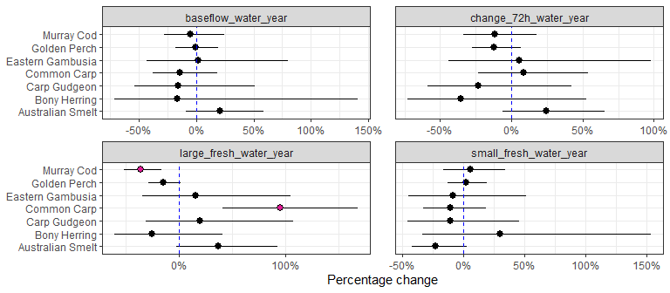
Figure 2.29 Effect of each flow variable on growth rate for each species
Error bars are 95%CrI. Pinkish dots indicate 95%CrI does not overlap 0.

Counterfactual predictions
Here, I show the percentage change in growth rate with the added Commonwealth environmental water (Figure 2.30).
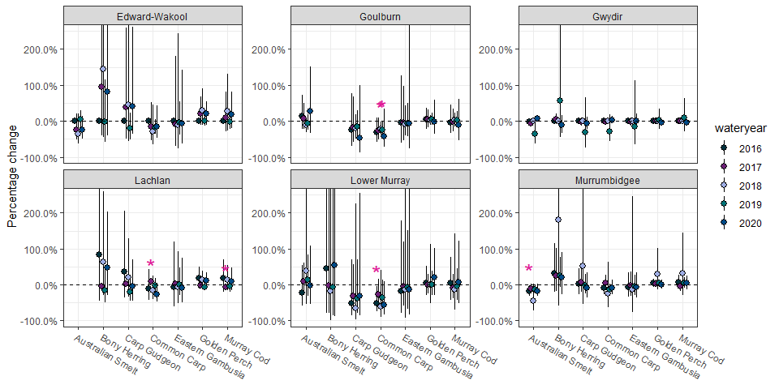
Figure 2.30 Predicted percentage change in growth rate without Commonwealth environmental water for each species, broken up by year and program
Positive changes indicate Commonwealth environmental water improved growth rate. Error bars are 95%CrI. * indicates the 95%CrI of the difference between with and without Commonwealth environmental water does not include zero. Y-axes has been truncated to help better show the less variable results.
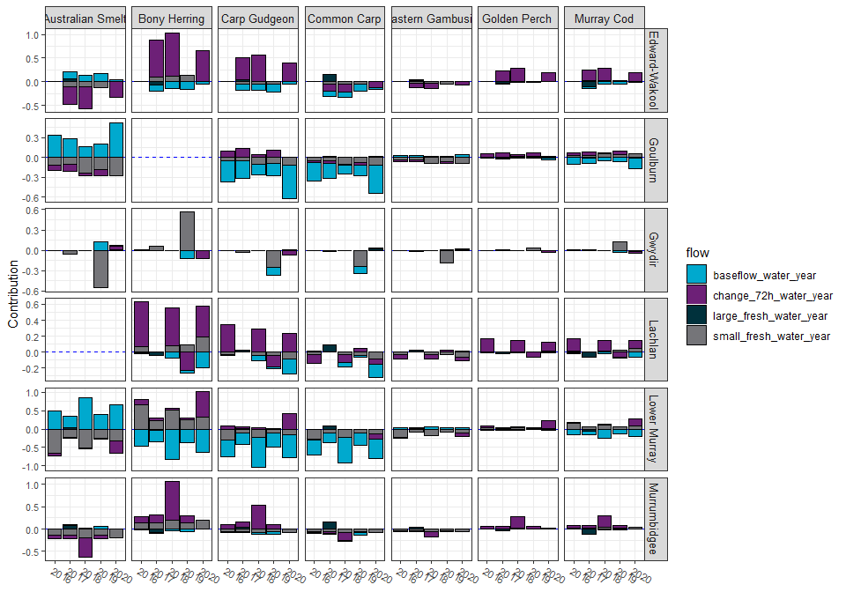
Figure 2.31 Contribution of each flow variable on the predicted Commonwealth environmental water effect on growth rate
Negative effects are shown as bars below 0 and positive effects above. Effect sizes are on link scale.

Analysis: Adult body condition

Logic, study design, and data trimming

Logic
- Flow conditions affect river productivity and hence have knock-on effects for fish condition.
- Body condition can be assessed similarly for all species using Fulton index: $FI=100*\frac{Weight}{Length^{3}}$
- I assumed that sampled body condition represents roughly the last 6–12 months of river conditions (beginning of water year to sampling date).

Study design
One key aspect to check is the temporal alignment of annual flow metrics alignment with sampling dates for body condition for each program and assess whether the alignment is appropriate for the biological hypotheses. Overall, the sampling dates were roughly between 50 to 85% of the water year so the flow metrics should be viewed in that perspective.
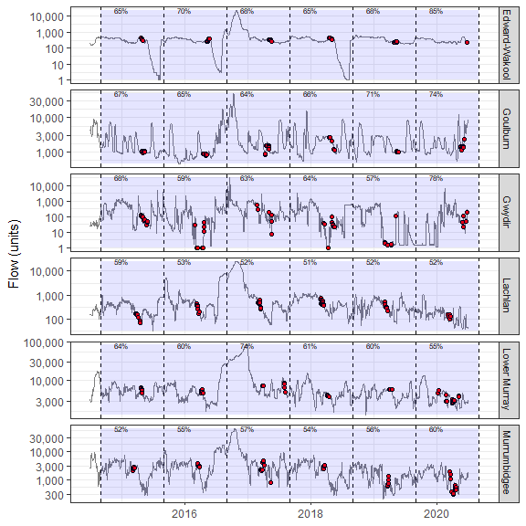
Figure 2.32 Sampling dates for body condition (red dots) in relation to water year windows for each program
Percentage shows the proportion of the water year fish experienced prior to the first sampling date (i.e. 70% means that the fish experienced 70% of the flow data included in the flow metrics at the time of first sampling event.)

Data trimming
Total samples sizes are shown in Table 2.7. Because of low sample sizes, Hypseleotris spp was dropped from further analyses, thus leaving 4 species for the analysis: Nematalosa erebi, Cyprinus carpio, Maccullochella peelii, Macquaria ambigua.
Table 2.7 Summary of sample sizes for body condition dataset
Species | Fish | Programs | Sites | Years
Bony herring | 16,977 | 6 | 56 | 6
Common carp | 4,675 | 5 | 41 | 6
Murray cod | 2,805 | 6 | 61 | 6
Golden perch | 2,268 | 6 | 56 | 6
Carp gudgeon | 1 | 1 | 1 | 1

Key exploratory graph(s)
First, the relationship between length and weight was explored to assess any outliers in the data. As there were obvious outliers, I used the four times the standardised residuals method to identity those outliers. Therefore, a linear regression was run for each species (log(weight) ~ log(length)) and identified outliers (Figure 2.33). The method worked well, though could be improved for N. erebi. N. erebi had decreasing variance on log-scale, which likely reflects measurement error becoming proportionally larger at small sizes. For now (time-limitations), the outlier criteria were kept the same, but model improvements could be had with future refinements to N. erebi, such as using weighted regression approaches.
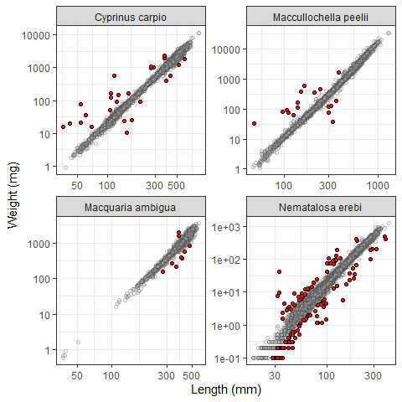
Figure 2.33 Exploratory graph looking for potential outliers
Red dots show outliers using four times the standardised residuals method. Black circles show non-outlier data
To explore patterns in the data, I regressed data against each flow metric.
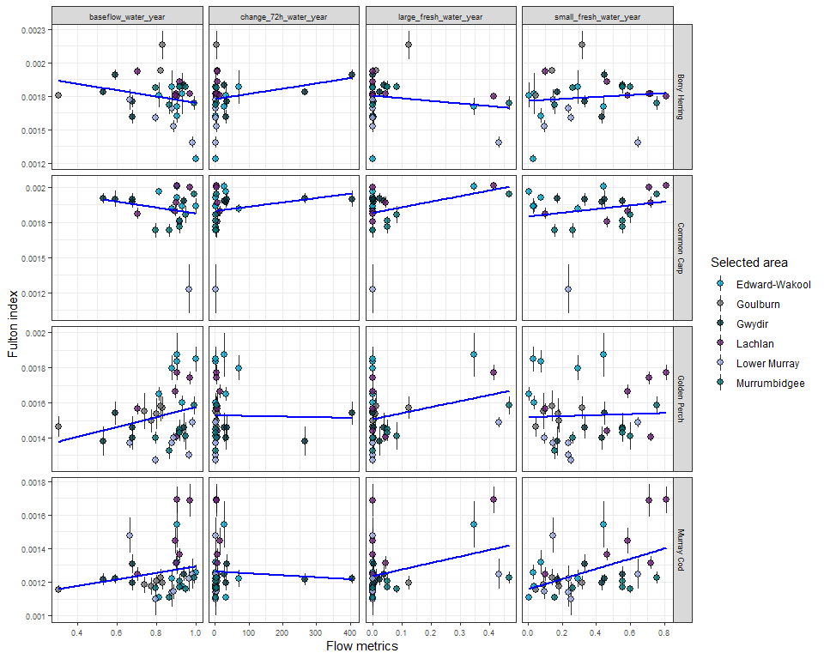
Figure 2.34 Main exploratory graph for body condition analysis
Each dot represents the mean Fulton index for each program. Black line shows exploratory regression line (not corrected for other covariates). Error bars are 95%CI for the mean.

Data analysis
As noted above, I removed outliers from the analysis using four times the standardised residual method. With the remaining data, I undertook the following approach.
To test for the effects of flow metrics on body condition, the Fulton Index (proxy for body condition) was modelled in relation to the kept annual flow metrics. A linear mixed model (LMM) with an untransformed Fulton Index was used and included annual flow metrics as the continuous predictors. Program was included as a fixed factor. Water year (nested in program), site, and site-by-year were included as random effects. Due to computation slowness using a Bayesian approach, lmer() from the lme4 package (Bates et al. 2015) was used.

Results

Flow coefficients
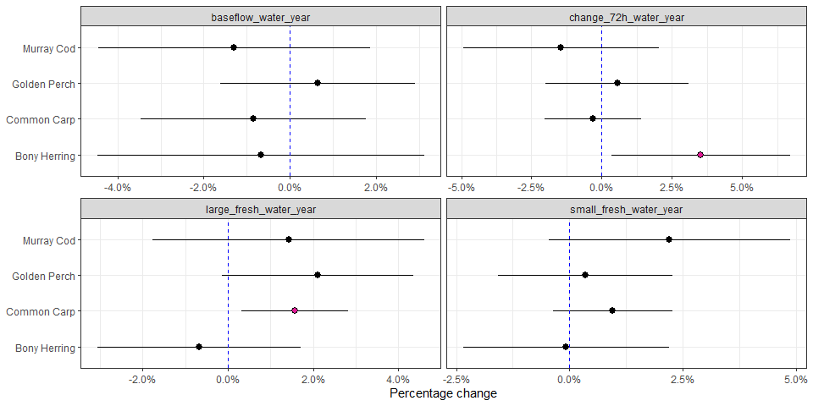
Figure 2.35 Effect of each flow variable on body condition for each species
Error bars are 95%CI. Pink dots indicate significant effects at p<0.05 threshold.

Counterfactual predictions
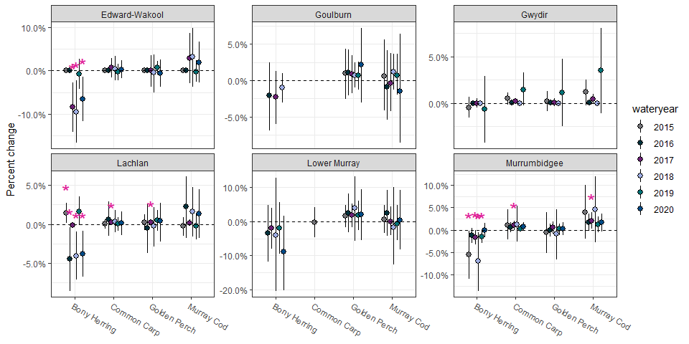
Figure 2.36 Predicted effect of Commonwealth environmental water on body condition for each species, broken up by year and program
Effect sizes have been scaled to percentage of mean Fulton Index for each species. Error bars are 95% C.I
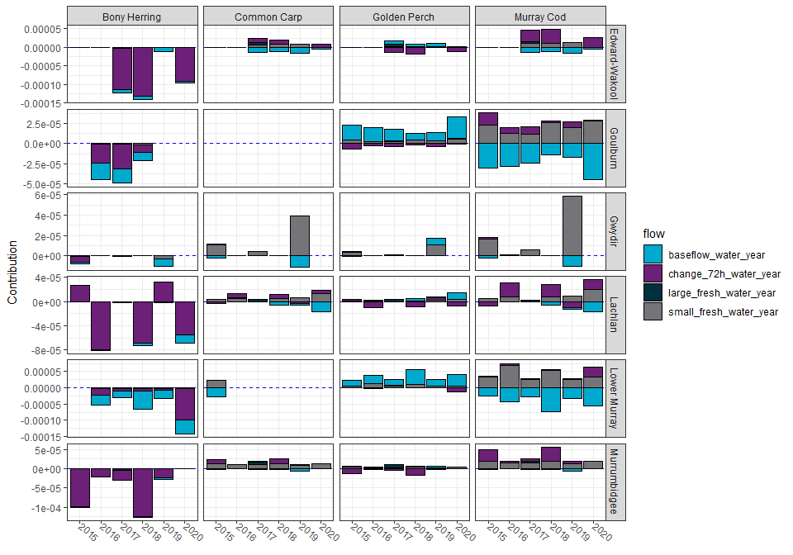
Figure 2.37 Contribution of each flow variable on the predicted Commonwealth environmental water effect for body condition
Negative effects are shown as bars below 0 and positive effects above. Effect sizes are on raw scale.

General summary

Summary of flow metric effects for all analyses
A summary of all the analysis indicating significant positive and negative results is provided at Table 3.1.
Table 3.1 Summary of flow metric effects for all analyses
Green indicates a positive ‘significant’ relationship (‘+’), grey no relationship (‘0’), and red a negative relationship (‘-’). White cells indicate no analysis run. Significant defined as 95%CrI not overlapping zero
Species |  | Term | adultAbund | bodyCond | larvaAbund | recruit | spawn
Australian smelt | baseflow |  | 0 |  |  | 0
Australian smelt | change_72h |  | 0 |  |  | 0
Australian smelt | large_fresh |  | 0 |  |  | 0
Australian smelt | small_fresh |  | 0 |  |  | +
Bony herring | baseflow |  | 0 | 0
Bony herring | change_72h |  | 0 | +
Bony herring | large_fresh |  | 0 | 0
Bony herring | small_fresh |  | 0 | 0
Carp gudgeon | baseflow |  | 0 |  |  | 0
Carp gudgeon | change_72h |  | 0 |  |  | 0
Carp gudgeon | large_fresh |  | 0 |  |  | 0
Carp gudgeon | small_fresh |  | 0 |  |  | 0
Common carp | baseflow |  | 0 | 0 |  | 0
Common carp | change_72h |  | 0 | 0 |  | 0
Common carp | large_fresh |  | + | + |  | +
Common carp | small_fresh |  | 0 | 0 |  | 0
Eastern gambusia | baseflow |  | 0 |  |  | 0
Eastern gambusia | change_72h |  | 0 |  |  | 0
Eastern gambusia | large_fresh |  | 0 |  |  | 0
Eastern gambusia | small_fresh |  | 0 |  |  | 0
Golden perch | baseflow |  | 0 | 0 |  |  | +
Golden perch | change_72h |  | 0 | 0 |  |  | 0
Golden perch | days_increasing |  |  |  | 0
Golden perch | large_fresh |  | 0 | 0 |  |  | 0
Golden perch | seven_day_median |  |  |  | -
Golden perch | seven_day_range |  |  |  | 0
Golden perch | small_fresh |  | 0 | 0 |  |  | -
Murray cod | baseflow |  | 0 | 0
Murray cod | change_72h |  | 0 | 0
Murray cod | large_fresh |  | - | 0
Murray cod | small_fresh |  | 0 | 0
Silver perch | baseflow |  |  |  |  |  | 0
Silver perch | change_72h |  |  |  |  |  | 0
Silver perch | days_increasing |  |  |  | 0
Silver perch | large_fresh |  |  |  |  |  | 0
Silver perch | seven_day_median |  |  |  | 0
Silver perch | seven_day_range |  |  |  | 0
Silver perch | small_fresh |  |  |  |  |  | 0

Summary of counterfactual predictions metrics
Below shows a table of all the analysis indicating significant positive and negative results.
Table 3.2 Summary of predicted Commonwealth environmental water effect for all analyses
Green indicates a positive ‘significant’ relationship (‘+’), grey no relationship (‘0’), and red a negative relationship (‘-’). White cells indicate no analysis run. Significant defined as 95%CrI not overlapping zero
Species | Selected area | Water year | adultAbund | bodyCond | larvaAbund | recruit | spawn
Australian smelt | Edward-Wakool | 2015 |  |  |  | 0
Australian smelt | Edward-Wakool | 2016 | 0 |  |  | 0
Australian smelt | Edward-Wakool | 2017 | 0 |  |  | +
Australian smelt | Edward-Wakool | 2018 | 0 |  |  | +
Australian smelt | Edward-Wakool | 2019 | 0 |  |  | +
Australian smelt | Edward-Wakool | 2020 | 0 |  |  | 0
Australian smelt | Goulburn | 2015 |  |  |  | 0
Australian smelt | Goulburn | 2016 | 0 |  |  | 0
Australian smelt | Goulburn | 2017 | 0 |  |  | 0
Australian smelt | Goulburn | 2018 | 0 |  |  | 0
Australian smelt | Goulburn | 2019 | 0 |  |  | +
Australian smelt | Goulburn | 2020 | 0 |  |  | 0
Australian smelt | Gwydir | 2015 |  |  |  | +
Australian smelt | Gwydir | 2016 | 0 |  |  | +
Australian smelt | Gwydir | 2017 | 0 |  |  | +
Australian smelt | Gwydir | 2018 | 0 |  |  | 0
Australian smelt | Gwydir | 2019 | 0 |  |  | +
Australian smelt | Gwydir | 2020 | 0 |  |  | 0
Australian smelt | Lachlan | 2015 |  |  |  | +
Australian smelt | Lachlan | 2016 |  |  |  | +
Australian smelt | Lachlan | 2017 |  |  |  | 0
Australian smelt | Lachlan | 2018 |  |  |  | 0
Australian smelt | Lachlan | 2019 |  |  |  | +
Australian smelt | Lachlan | 2020 |  |  |  | 0
Australian smelt | Lower Murray | 2015 |  |  |  | +
Australian smelt | Lower Murray | 2016 | 0 |  |  | 0
Australian smelt | Lower Murray | 2017 | 0 |  |  | 0
Australian smelt | Lower Murray | 2018 | 0 |  |  | 0
Australian smelt | Lower Murray | 2019 | 0 |  |  | 0
Australian smelt | Lower Murray | 2020 | 0 |  |  | 0
Australian smelt | Murrumbidgee | 2015 |  |  |  | +
Australian smelt | Murrumbidgee | 2016 | - |  |  | +
Australian smelt | Murrumbidgee | 2017 | 0 |  |  | 0
Australian smelt | Murrumbidgee | 2018 | 0 |  |  | +
Australian smelt | Murrumbidgee | 2019 | 0 |  |  | +
Australian smelt | Murrumbidgee | 2020 | 0 |  |  | +
Bony herring | Edward-Wakool | 2015 |  | 0
Bony herring | Edward-Wakool | 2016 | 0 | 0
Bony herring | Edward-Wakool | 2017 | 0 | -
Bony herring | Edward-Wakool | 2018 | 0 | -
Bony herring | Edward-Wakool | 2019 | 0 | 0
Bony herring | Edward-Wakool | 2020 | 0 | -
Bony herring | Goulburn | 2016 |  | 0
Bony herring | Goulburn | 2017 |  | 0
Bony herring | Goulburn | 2018 |  | 0
Bony herring | Gwydir | 2015 |  | 0
Bony herring | Gwydir | 2016 | 0 | 0
Bony herring | Gwydir | 2017 | 0 | 0
Bony herring | Gwydir | 2018 | 0 | 0
Bony herring | Gwydir | 2019 | 0 | 0
Bony herring | Gwydir | 2020 | 0
Bony herring | Lachlan | 2015 |  | +
Bony herring | Lachlan | 2016 | 0 | -
Bony herring | Lachlan | 2017 | 0 | 0
Bony herring | Lachlan | 2018 | 0 | -
Bony herring | Lachlan | 2019 | 0 | 0
Bony herring | Lachlan | 2020 | 0 | -
Bony herring | Lower Murray | 2016 | 0 | 0
Bony herring | Lower Murray | 2017 | 0 | 0
Bony herring | Lower Murray | 2018 | 0 | 0
Bony herring | Lower Murray | 2019 | 0 | 0
Bony herring | Lower Murray | 2020 | 0 | 0
Bony herring | Murrumbidgee | 2015 |  | -
Bony herring | Murrumbidgee | 2016 | 0 | 0
Bony herring | Murrumbidgee | 2017 | 0 | -
Bony herring | Murrumbidgee | 2018 | 0 | -
Bony herring | Murrumbidgee | 2019 | 0 | -
Bony herring | Murrumbidgee | 2020 | 0 | 0
Carp gudgeon | Edward-Wakool | 2015 |  |  |  | 0
Carp gudgeon | Edward-Wakool | 2016 | 0 |  |  | 0
Carp gudgeon | Edward-Wakool | 2017 | 0 |  |  | 0
Carp gudgeon | Edward-Wakool | 2018 | 0 |  |  | 0
Carp gudgeon | Edward-Wakool | 2019 | 0 |  |  | 0
Carp gudgeon | Edward-Wakool | 2020 | 0 |  |  | 0
Carp gudgeon | Goulburn | 2015 |  |  |  | 0
Carp gudgeon | Goulburn | 2016 | 0 |  |  | 0
Carp gudgeon | Goulburn | 2017 | 0 |  |  | 0
Carp gudgeon | Goulburn | 2018 | 0 |  |  | 0
Carp gudgeon | Goulburn | 2019 | 0 |  |  | 0
Carp gudgeon | Goulburn | 2020 | 0 |  |  | 0
Carp gudgeon | Gwydir | 2015 |  |  |  | 0
Carp gudgeon | Gwydir | 2016 | 0 |  |  | 0
Carp gudgeon | Gwydir | 2017 | 0 |  |  | 0
Carp gudgeon | Gwydir | 2018 | 0 |  |  | 0
Carp gudgeon | Gwydir | 2019 | 0 |  |  | 0
Carp gudgeon | Gwydir | 2020 | 0 |  |  | 0
Carp gudgeon | Lachlan | 2015 |  |  |  | 0
Carp gudgeon | Lachlan | 2016 | 0 |  |  | 0
Carp gudgeon | Lachlan | 2017 | 0 |  |  | 0
Carp gudgeon | Lachlan | 2018 | 0 |  |  | 0
Carp gudgeon | Lachlan | 2019 | 0 |  |  | 0
Carp gudgeon | Lachlan | 2020 | 0 |  |  | 0
Carp gudgeon | Lower Murray | 2015 |  |  |  | 0
Carp gudgeon | Lower Murray | 2016 | 0 |  |  | 0
Carp gudgeon | Lower Murray | 2017 | 0 |  |  | 0
Carp gudgeon | Lower Murray | 2018 | 0 |  |  | 0
Carp gudgeon | Lower Murray | 2019 | 0 |  |  | 0
Carp gudgeon | Lower Murray | 2020 | 0 |  |  | 0
Carp gudgeon | Murrumbidgee | 2015 |  |  |  | 0
Carp gudgeon | Murrumbidgee | 2016 | 0 |  |  | 0
Carp gudgeon | Murrumbidgee | 2017 | 0 |  |  | 0
Carp gudgeon | Murrumbidgee | 2018 | 0 |  |  | 0
Carp gudgeon | Murrumbidgee | 2019 | 0 |  |  | 0
Carp gudgeon | Murrumbidgee | 2020 | 0 |  |  | 0
Common carp | Edward-Wakool | 2015 |  | 0 |  | 0
Common carp | Edward-Wakool | 2016 | 0 | 0 |  | 0
Common carp | Edward-Wakool | 2017 | 0 | 0 |  | +
Common carp | Edward-Wakool | 2018 | 0 | 0 |  | 0
Common carp | Edward-Wakool | 2019 | 0 | 0 |  | 0
Common carp | Edward-Wakool | 2020 | 0 | 0 |  | 0
Common carp | Goulburn | 2015 |  |  |  | 0
Common carp | Goulburn | 2016 | 0 |  |  | 0
Common carp | Goulburn | 2017 | 0 |  |  | 0
Common carp | Goulburn | 2018 | - |  |  | 0
Common carp | Goulburn | 2019 | - |  |  | 0
Common carp | Goulburn | 2020 | 0 |  |  | 0
Common carp | Gwydir | 2015 |  | 0 |  | 0
Common carp | Gwydir | 2016 | 0 | 0 |  | 0
Common carp | Gwydir | 2017 | 0 | 0 |  | 0
Common carp | Gwydir | 2018 | 0 | 0 |  | 0
Common carp | Gwydir | 2019 | 0 | 0 |  | 0
Common carp | Gwydir | 2020 | 0 |  |  | 0
Common carp | Lachlan | 2015 |  | 0 |  | 0
Common carp | Lachlan | 2016 | 0 | 0 |  | 0
Common carp | Lachlan | 2017 | + | + |  | +
Common carp | Lachlan | 2018 | 0 | 0 |  | 0
Common carp | Lachlan | 2019 | 0 | 0 |  | 0
Common carp | Lachlan | 2020 | 0 | 0 |  | 0
Common carp | Lower Murray | 2015 |  | 0 |  | 0
Common carp | Lower Murray | 2016 | - |  |  | 0
Common carp | Lower Murray | 2017 | 0 |  |  | 0
Common carp | Lower Murray | 2018 | 0 |  |  | 0
Common carp | Lower Murray | 2019 | 0 |  |  | 0
Common carp | Lower Murray | 2020 | 0 |  |  | 0
Common carp | Murrumbidgee | 2015 |  | 0 |  | 0
Common carp | Murrumbidgee | 2016 | 0 | 0 |  | 0
Common carp | Murrumbidgee | 2017 | 0 | + |  | +
Common carp | Murrumbidgee | 2018 | 0 | 0 |  | 0
Common carp | Murrumbidgee | 2019 | 0 | 0 |  | 0
Common carp | Murrumbidgee | 2020 | 0 | 0 |  | 0
Eastern gambusia | Edward-Wakool | 2015 |  |  |  | 0
Eastern gambusia | Edward-Wakool | 2016 | 0 |  |  | 0
Eastern gambusia | Edward-Wakool | 2017 | 0 |  |  | 0
Eastern gambusia | Edward-Wakool | 2018 | 0 |  |  | 0
Eastern gambusia | Edward-Wakool | 2019 | 0 |  |  | 0
Eastern gambusia | Edward-Wakool | 2020 | 0 |  |  | 0
Eastern gambusia | Goulburn | 2015 |  |  |  | 0
Eastern gambusia | Goulburn | 2016 | 0 |  |  | 0
Eastern gambusia | Goulburn | 2017 | 0 |  |  | 0
Eastern gambusia | Goulburn | 2018 | 0 |  |  | 0
Eastern gambusia | Goulburn | 2019 | 0 |  |  | 0
Eastern gambusia | Goulburn | 2020 | 0 |  |  | 0
Eastern gambusia | Gwydir | 2015 |  |  |  | 0
Eastern gambusia | Gwydir | 2016 | 0 |  |  | 0
Eastern gambusia | Gwydir | 2017 | 0 |  |  | 0
Eastern gambusia | Gwydir | 2018 | 0 |  |  | 0
Eastern gambusia | Gwydir | 2019 | 0 |  |  | 0
Eastern gambusia | Gwydir | 2020 | 0 |  |  | 0
Eastern gambusia | Lachlan | 2015 |  |  |  | 0
Eastern gambusia | Lachlan | 2016 | 0 |  |  | 0
Eastern gambusia | Lachlan | 2017 | 0 |  |  | +
Eastern gambusia | Lachlan | 2018 | 0 |  |  | 0
Eastern gambusia | Lachlan | 2019 | 0 |  |  | -
Eastern gambusia | Lachlan | 2020 | 0 |  |  | 0
Eastern gambusia | Lower Murray | 2015 |  |  |  | 0
Eastern gambusia | Lower Murray | 2016 | 0 |  |  | 0
Eastern gambusia | Lower Murray | 2017 | 0 |  |  | 0
Eastern gambusia | Lower Murray | 2018 | 0 |  |  | 0
Eastern gambusia | Lower Murray | 2019 | 0 |  |  | 0
Eastern gambusia | Lower Murray | 2020 | 0 |  |  | 0
Eastern gambusia | Murrumbidgee | 2015 |  |  |  | 0
Eastern gambusia | Murrumbidgee | 2016 | 0 |  |  | 0
Eastern gambusia | Murrumbidgee | 2017 | 0 |  |  | 0
Eastern gambusia | Murrumbidgee | 2018 | 0 |  |  | 0
Eastern gambusia | Murrumbidgee | 2019 | 0 |  |  | 0
Eastern gambusia | Murrumbidgee | 2020 | 0 |  |  | 0
Golden perch | Edward-Wakool | 2015 |  | 0 |  |  | 0
Golden perch | Edward-Wakool | 2016 | 0 | 0 |  |  | 0
Golden perch | Edward-Wakool | 2017 | 0 | 0 |  |  | 0
Golden perch | Edward-Wakool | 2018 | 0 | 0 |  |  | 0
Golden perch | Edward-Wakool | 2019 | 0 | 0 |  |  | 0
Golden perch | Edward-Wakool | 2020 | 0 | 0 |  |  | 0
Golden perch | Goulburn | 2015 |  | 0 | 0 |  | 0
Golden perch | Goulburn | 2016 | 0 | 0 |  |  | 0
Golden perch | Goulburn | 2017 | 0 | 0 | 0 |  | 0
Golden perch | Goulburn | 2018 | 0 | 0 | - |  | 0
Golden perch | Goulburn | 2019 | 0 | 0 | 0 |  | 0
Golden perch | Goulburn | 2020 | 0 | 0 |  |  | 0
Golden perch | Gwydir | 2015 |  | 0
Golden perch | Gwydir | 2016 | 0 | 0
Golden perch | Gwydir | 2017 | 0 | 0
Golden perch | Gwydir | 2018 | 0 | 0
Golden perch | Gwydir | 2019 | 0 | 0
Golden perch | Gwydir | 2020 | 0
Golden perch | Lachlan | 2015 |  | 0 |  |  | 0
Golden perch | Lachlan | 2016 | 0 | 0 |  |  | 0
Golden perch | Lachlan | 2017 | 0 | + |  |  | 0
Golden perch | Lachlan | 2018 | 0 | 0 |  |  | 0
Golden perch | Lachlan | 2019 | 0 | 0 |  |  | 0
Golden perch | Lachlan | 2020 | 0 | 0 |  |  | 0
Golden perch | Lower Murray | 2015 |  | 0 | - |  | 0
Golden perch | Lower Murray | 2016 | 0 | 0 | - |  | 0
Golden perch | Lower Murray | 2017 | 0 | 0 | 0 |  | 0
Golden perch | Lower Murray | 2018 | 0 | 0 | 0 |  | 0
Golden perch | Lower Murray | 2019 | 0 | 0 | - |  | 0
Golden perch | Lower Murray | 2020 | 0 | 0
Golden perch | Murrumbidgee | 2015 |  | 0 |  |  | 0
Golden perch | Murrumbidgee | 2016 | 0 | 0 | 0 |  | -
Golden perch | Murrumbidgee | 2017 | 0 | 0 |  |  | 0
Golden perch | Murrumbidgee | 2018 | 0 | 0 | - |  | 0
Golden perch | Murrumbidgee | 2019 | 0 | 0 | - |  | 0
Golden perch | Murrumbidgee | 2020 | 0 | 0 | - |  | -
Murray cod | Edward-Wakool | 2015 |  | 0
Murray cod | Edward-Wakool | 2016 | 0 | 0
Murray cod | Edward-Wakool | 2017 | 0 | 0
Murray cod | Edward-Wakool | 2018 | 0 | 0
Murray cod | Edward-Wakool | 2019 | 0 | 0
Murray cod | Edward-Wakool | 2020 | 0 | 0
Murray cod | Goulburn | 2015 |  | 0
Murray cod | Goulburn | 2016 | 0 | 0
Murray cod | Goulburn | 2017 | 0 | 0
Murray cod | Goulburn | 2018 | 0 | 0
Murray cod | Goulburn | 2019 | 0 | 0
Murray cod | Goulburn | 2020 | 0 | 0
Murray cod | Gwydir | 2015 |  | 0
Murray cod | Gwydir | 2016 | 0 | 0
Murray cod | Gwydir | 2017 | 0 | 0
Murray cod | Gwydir | 2018 | 0 | 0
Murray cod | Gwydir | 2019 | 0 | 0
Murray cod | Gwydir | 2020 | 0
Murray cod | Lachlan | 2015 |  | 0
Murray cod | Lachlan | 2016 | 0 | 0
Murray cod | Lachlan | 2017 | - | 0
Murray cod | Lachlan | 2018 | 0 | 0
Murray cod | Lachlan | 2019 | 0 | 0
Murray cod | Lachlan | 2020 | 0 | 0
Murray cod | Lower Murray | 2015 |  | 0
Murray cod | Lower Murray | 2016 | 0 | 0
Murray cod | Lower Murray | 2017 | 0 | 0
Murray cod | Lower Murray | 2018 | 0 | 0
Murray cod | Lower Murray | 2019 | 0 | 0
Murray cod | Lower Murray | 2020 | 0 | 0
Murray cod | Murrumbidgee | 2015 |  | 0
Murray cod | Murrumbidgee | 2016 | 0 | 0
Murray cod | Murrumbidgee | 2017 | 0 | +
Murray cod | Murrumbidgee | 2018 | 0 | 0
Murray cod | Murrumbidgee | 2019 | 0 | 0
Murray cod | Murrumbidgee | 2020 | 0 | 0
Silver perch | Edward-Wakool | 2015 |  |  |  |  | 0
Silver perch | Edward-Wakool | 2016 |  |  |  |  | 0
Silver perch | Edward-Wakool | 2017 |  |  |  |  | 0
Silver perch | Edward-Wakool | 2018 |  |  |  |  | 0
Silver perch | Edward-Wakool | 2019 |  |  |  |  | 0
Silver perch | Edward-Wakool | 2020 |  |  |  |  | 0
Silver perch | Goulburn | 2015 |  |  | 0 |  | 0
Silver perch | Goulburn | 2016 |  |  |  |  | 0
Silver perch | Goulburn | 2017 |  |  | 0 |  | 0
Silver perch | Goulburn | 2018 |  |  | 0 |  | 0
Silver perch | Goulburn | 2019 |  |  | 0 |  | 0
Silver perch | Goulburn | 2020 |  |  | 0 |  | 0
Silver perch | Lachlan | 2015 |  |  |  |  | 0
Silver perch | Lachlan | 2016 |  |  |  |  | 0
Silver perch | Lachlan | 2017 |  |  |  |  | 0
Silver perch | Lachlan | 2018 |  |  |  |  | 0
Silver perch | Lachlan | 2019 |  |  |  |  | 0
Silver perch | Lachlan | 2020 |  |  |  |  | 0
Silver perch | Lower Murray | 2015 |  |  | 0 |  | 0
Silver perch | Lower Murray | 2016 |  |  |  |  | 0
Silver perch | Lower Murray | 2017 |  |  |  |  | 0
Silver perch | Lower Murray | 2018 |  |  |  |  | 0
Silver perch | Lower Murray | 2019 |  |  | 0 |  | 0
Silver perch | Murrumbidgee | 2015 |  |  |  |  | 0
Silver perch | Murrumbidgee | 2016 |  |  |  |  | 0
Silver perch | Murrumbidgee | 2017 |  |  |  |  | 0
Silver perch | Murrumbidgee | 2018 |  |  |  |  | 0
Silver perch | Murrumbidgee | 2019 |  |  |  |  | 0
Silver perch | Murrumbidgee | 2020 |  |  |  |  | 0

Probability of effect of Commonwealth environmental water being greater than without Commonwealth environmental water
Table 3.3 Summary of the probability of Commonwealth environmental water effect for all analyses
If the probability is < 50%, then cell is white. Light green = 50-80%, medium green = 80-95%, dark green = ≥95%
Species | Selected area | Water year | adultAbund | bodyCond | larvaAbund | recruit | spawn
Australian smelt | Edward-Wakool | 2015 |  |  |  | 0.00
Australian smelt | Edward-Wakool | 2016 | 0.00 |  |  | 0.52
Australian smelt | Edward-Wakool | 2017 | 0.12 |  |  | 0.99
Australian smelt | Edward-Wakool | 2018 | 0.07 |  |  | 1.00
Australian smelt | Edward-Wakool | 2019 | 0.67 |  |  | 1.00
Australian smelt | Edward-Wakool | 2020 | 0.09 |  |  | 0.52
Australian smelt | Goulburn | 2015 |  |  |  | 0.85
Australian smelt | Goulburn | 2016 | 0.75 |  |  | 0.55
Australian smelt | Goulburn | 2017 | 0.67 |  |  | 0.48
Australian smelt | Goulburn | 2018 | 0.16 |  |  | 0.58
Australian smelt | Goulburn | 2019 | 0.26 |  |  | 1.00
Australian smelt | Goulburn | 2020 | 0.78 |  |  | 0.68
Australian smelt | Gwydir | 2015 |  |  |  | 1.00
Australian smelt | Gwydir | 2016 | 0.04 |  |  | 1.00
Australian smelt | Gwydir | 2017 | 0.04 |  |  | 1.00
Australian smelt | Gwydir | 2018 | 0.00 |  |  | 0.00
Australian smelt | Gwydir | 2019 | 0.06 |  |  | 0.99
Australian smelt | Gwydir | 2020 | 0.96 |  |  | 0.46
Australian smelt | Lachlan | 2015 |  |  |  | 1.00
Australian smelt | Lachlan | 2016 |  |  |  | 0.99
Australian smelt | Lachlan | 2017 |  |  |  | 0.08
Australian smelt | Lachlan | 2018 |  |  |  | 0.89
Australian smelt | Lachlan | 2019 |  |  |  | 0.99
Australian smelt | Lachlan | 2020 |  |  |  | 0.67
Australian smelt | Lower Murray | 2015 |  |  |  | 1.00
Australian smelt | Lower Murray | 2016 | 0.23 |  |  | 0.94
Australian smelt | Lower Murray | 2017 | 0.70 |  |  | 0.90
Australian smelt | Lower Murray | 2018 | 0.73 |  |  | 0.61
Australian smelt | Lower Murray | 2019 | 0.70 |  |  | 0.74
Australian smelt | Lower Murray | 2020 | 0.49 |  |  | 0.51
Australian smelt | Murrumbidgee | 2015 |  |  |  | 1.00
Australian smelt | Murrumbidgee | 2016 | 0.02 |  |  | 1.00
Australian smelt | Murrumbidgee | 2017 | 0.06 |  |  | 0.93
Australian smelt | Murrumbidgee | 2018 | 0.03 |  |  | 1.00
Australian smelt | Murrumbidgee | 2019 | 0.03 |  |  | 0.97
Australian smelt | Murrumbidgee | 2020 | 0.04 |  |  | 1.00
Bony herring | Edward-Wakool | 2015 |  | 0.00
Bony herring | Edward-Wakool | 2016 | 0.00 | 0.00
Bony herring | Edward-Wakool | 2017 | 0.86 | 0.00
Bony herring | Edward-Wakool | 2018 | 0.88 | 0.00
Bony herring | Edward-Wakool | 2019 | 0.47 | 0.34
Bony herring | Edward-Wakool | 2020 | 0.85 | 0.00
Bony herring | Goulburn | 2016 |  | 0.19
Bony herring | Goulburn | 2017 |  | 0.11
Bony herring | Goulburn | 2018 |  | 0.15
Bony herring | Gwydir | 2015 |  | 0.22
Bony herring | Gwydir | 2016 | 0.79 | 0.46
Bony herring | Gwydir | 2017 | 0.79 | 0.46
Bony herring | Gwydir | 2018 | 0.00 | 0.00
Bony herring | Gwydir | 2019 | 0.82 | 0.37
Bony herring | Gwydir | 2020 | 0.17
Bony herring | Lachlan | 2015 |  | 0.99
Bony herring | Lachlan | 2016 | 0.85 | 0.02
Bony herring | Lachlan | 2017 | 0.18 | 0.28
Bony herring | Lachlan | 2018 | 0.89 | 0.00
Bony herring | Lachlan | 2019 | 0.25 | 0.97
Bony herring | Lachlan | 2020 | 0.87 | 0.01
Bony herring | Lower Murray | 2016 | 0.65 | 0.22
Bony herring | Lower Murray | 2017 | 0.48 | 0.27
Bony herring | Lower Murray | 2018 | 0.46 | 0.32
Bony herring | Lower Murray | 2019 | 0.47 | 0.31
Bony herring | Lower Murray | 2020 | 0.63 | 0.06
Bony herring | Murrumbidgee | 2015 |  | 0.02
Bony herring | Murrumbidgee | 2016 | 0.87 | 0.07
Bony herring | Murrumbidgee | 2017 | 0.85 | 0.02
Bony herring | Murrumbidgee | 2018 | 0.87 | 0.02
Bony herring | Murrumbidgee | 2019 | 0.92 | 0.01
Bony herring | Murrumbidgee | 2020 | 0.79 | 0.46
Carp gudgeon | Edward-Wakool | 2015 |  |  |  | 0.00
Carp gudgeon | Edward-Wakool | 2016 | 0.00 |  |  | 0.50
Carp gudgeon | Edward-Wakool | 2017 | 0.74 |  |  | 0.61
Carp gudgeon | Edward-Wakool | 2018 | 0.74 |  |  | 0.52
Carp gudgeon | Edward-Wakool | 2019 | 0.15 |  |  | 0.52
Carp gudgeon | Edward-Wakool | 2020 | 0.80 |  |  | 0.50
Carp gudgeon | Goulburn | 2015 |  |  |  | 0.21
Carp gudgeon | Goulburn | 2016 | 0.25 |  |  | 0.21
Carp gudgeon | Goulburn | 2017 | 0.29 |  |  | 0.20
Carp gudgeon | Goulburn | 2018 | 0.13 |  |  | 0.21
Carp gudgeon | Goulburn | 2019 | 0.23 |  |  | 0.31
Carp gudgeon | Goulburn | 2020 | 0.18 |  |  | 0.21
Carp gudgeon | Gwydir | 2015 |  |  |  | 0.39
Carp gudgeon | Gwydir | 2016 | 0.31 |  |  | 0.52
Carp gudgeon | Gwydir | 2017 | 0.31 |  |  | 0.52
Carp gudgeon | Gwydir | 2018 | 0.00 |  |  | 0.00
Carp gudgeon | Gwydir | 2019 | 0.20 |  |  | 0.36
Carp gudgeon | Gwydir | 2020 | 0.20 |  |  | 0.49
Carp gudgeon | Lachlan | 2015 |  |  |  | 0.53
Carp gudgeon | Lachlan | 2016 | 0.77 |  |  | 0.42
Carp gudgeon | Lachlan | 2017 | 0.74 |  |  | 0.59
Carp gudgeon | Lachlan | 2018 | 0.72 |  |  | 0.17
Carp gudgeon | Lachlan | 2019 | 0.11 |  |  | 0.31
Carp gudgeon | Lachlan | 2020 | 0.43 |  |  | 0.20
Carp gudgeon | Lower Murray | 2015 |  |  |  | 0.40
Carp gudgeon | Lower Murray | 2016 | 0.12 |  |  | 0.23
Carp gudgeon | Lower Murray | 2017 | 0.17 |  |  | 0.22
Carp gudgeon | Lower Murray | 2018 | 0.17 |  |  | 0.21
Carp gudgeon | Lower Murray | 2019 | 0.16 |  |  | 0.21
Carp gudgeon | Lower Murray | 2020 | 0.31 |  |  | 0.21
Carp gudgeon | Murrumbidgee | 2015 |  |  |  | 0.46
Carp gudgeon | Murrumbidgee | 2016 | 0.53 |  |  | 0.52
Carp gudgeon | Murrumbidgee | 2017 | 0.66 |  |  | 0.61
Carp gudgeon | Murrumbidgee | 2018 | 0.73 |  |  | 0.46
Carp gudgeon | Murrumbidgee | 2019 | 0.43 |  |  | 0.25
Carp gudgeon | Murrumbidgee | 2020 | 0.31 |  |  | 0.52
Common carp | Edward-Wakool | 2015 |  | 0.00 |  | 0.00
Common carp | Edward-Wakool | 2016 | 0.00 | 0.00 |  | 0.22
Common carp | Edward-Wakool | 2017 | 0.28 | 0.73 |  | 1.00
Common carp | Edward-Wakool | 2018 | 0.16 | 0.63 |  | 0.81
Common carp | Edward-Wakool | 2019 | 0.06 | 0.39 |  | 0.81
Common carp | Edward-Wakool | 2020 | 0.26 | 0.60 |  | 0.22
Common carp | Goulburn | 2015 |  |  |  | 0.59
Common carp | Goulburn | 2016 | 0.07 |  |  | 0.51
Common carp | Goulburn | 2017 | 0.07 |  |  | 0.49
Common carp | Goulburn | 2018 | 0.02 |  |  | 0.52
Common carp | Goulburn | 2019 | 0.02 |  |  | 0.79
Common carp | Goulburn | 2020 | 0.09 |  |  | 0.55
Common carp | Gwydir | 2015 |  | 0.93 |  | 0.83
Common carp | Gwydir | 2016 | 0.21 | 0.92 |  | 0.81
Common carp | Gwydir | 2017 | 0.21 | 0.92 |  | 0.81
Common carp | Gwydir | 2018 | 0.00 | 0.00 |  | 0.00
Common carp | Gwydir | 2019 | 0.09 | 0.96 |  | 0.55
Common carp | Gwydir | 2020 | 0.73 |  |  | 0.78
Common carp | Lachlan | 2015 |  | 0.53 |  | 0.86
Common carp | Lachlan | 2016 | 0.29 | 0.71 |  | 0.73
Common carp | Lachlan | 2017 | 1.00 | 1.00 |  | 0.99
Common carp | Lachlan | 2018 | 0.15 | 0.66 |  | 0.46
Common carp | Lachlan | 2019 | 0.41 | 0.53 |  | 0.77
Common carp | Lachlan | 2020 | 0.03 | 0.56 |  | 0.53
Common carp | Lower Murray | 2015 |  | 0.47 |  | 0.84
Common carp | Lower Murray | 2016 | 0.02 |  |  | 0.65
Common carp | Lower Murray | 2017 | 0.09 |  |  | 0.72
Common carp | Lower Murray | 2018 | 0.07 |  |  | 0.53
Common carp | Lower Murray | 2019 | 0.06 |  |  | 0.56
Common carp | Lower Murray | 2020 | 0.04 |  |  | 0.50
Common carp | Murrumbidgee | 2015 |  | 0.75 |  | 0.83
Common carp | Murrumbidgee | 2016 | 0.17 | 0.85 |  | 0.81
Common carp | Murrumbidgee | 2017 | 0.73 | 0.98 |  | 1.00
Common carp | Murrumbidgee | 2018 | 0.23 | 0.73 |  | 0.83
Common carp | Murrumbidgee | 2019 | 0.04 | 0.82 |  | 0.68
Common carp | Murrumbidgee | 2020 | 0.21 | 0.92 |  | 0.81
Eastern gambusia | Edward-Wakool | 2015 |  |  |  | 0.00
Eastern gambusia | Edward-Wakool | 2016 | 0.00 |  |  | 0.96
Eastern gambusia | Edward-Wakool | 2017 | 0.44 |  |  | 0.71
Eastern gambusia | Edward-Wakool | 2018 | 0.42 |  |  | 0.19
Eastern gambusia | Edward-Wakool | 2019 | 0.43 |  |  | 0.20
Eastern gambusia | Edward-Wakool | 2020 | 0.43 |  |  | 0.96
Eastern gambusia | Goulburn | 2015 |  |  |  | 0.03
Eastern gambusia | Goulburn | 2016 | 0.47 |  |  | 0.06
Eastern gambusia | Goulburn | 2017 | 0.47 |  |  | 0.07
Eastern gambusia | Goulburn | 2018 | 0.35 |  |  | 0.05
Eastern gambusia | Goulburn | 2019 | 0.38 |  |  | 0.02
Eastern gambusia | Goulburn | 2020 | 0.46 |  |  | 0.04
Eastern gambusia | Gwydir | 2015 |  |  |  | 0.06
Eastern gambusia | Gwydir | 2016 | 0.36 |  |  | 0.18
Eastern gambusia | Gwydir | 2017 | 0.36 |  |  | 0.18
Eastern gambusia | Gwydir | 2018 | 0.00 |  |  | 0.00
Eastern gambusia | Gwydir | 2019 | 0.34 |  |  | 0.45
Eastern gambusia | Gwydir | 2020 | 0.58 |  |  | 0.04
Eastern gambusia | Lachlan | 2015 |  |  |  | 0.10
Eastern gambusia | Lachlan | 2016 | 0.42 |  |  | 0.52
Eastern gambusia | Lachlan | 2017 | 0.70 |  |  | 0.97
Eastern gambusia | Lachlan | 2018 | 0.41 |  |  | 0.10
Eastern gambusia | Lachlan | 2019 | 0.50 |  |  | 0.01
Eastern gambusia | Lachlan | 2020 | 0.38 |  |  | 0.05
Eastern gambusia | Lower Murray | 2015 |  |  |  | 0.05
Eastern gambusia | Lower Murray | 2016 | 0.36 |  |  | 0.02
Eastern gambusia | Lower Murray | 2017 | 0.44 |  |  | 0.03
Eastern gambusia | Lower Murray | 2018 | 0.45 |  |  | 0.05
Eastern gambusia | Lower Murray | 2019 | 0.44 |  |  | 0.04
Eastern gambusia | Lower Murray | 2020 | 0.44 |  |  | 0.06
Eastern gambusia | Murrumbidgee | 2015 |  |  |  | 0.11
Eastern gambusia | Murrumbidgee | 2016 | 0.36 |  |  | 0.18
Eastern gambusia | Murrumbidgee | 2017 | 0.42 |  |  | 0.91
Eastern gambusia | Murrumbidgee | 2018 | 0.40 |  |  | 0.11
Eastern gambusia | Murrumbidgee | 2019 | 0.34 |  |  | 0.02
Eastern gambusia | Murrumbidgee | 2020 | 0.36 |  |  | 0.18
Golden perch | Edward-Wakool | 2015 |  | 0.00 |  |  | 0.00
Golden perch | Edward-Wakool | 2016 | 0.00 | 0.00 |  |  | 0.41
Golden perch | Edward-Wakool | 2017 | 0.88 | 0.51 |  |  | 0.41
Golden perch | Edward-Wakool | 2018 | 0.92 | 0.41 |  |  | 0.08
Golden perch | Edward-Wakool | 2019 | 0.49 | 0.81 |  |  | 0.06
Golden perch | Edward-Wakool | 2020 | 0.91 | 0.35 |  |  | 0.41
Golden perch | Goulburn | 2015 |  | 0.70 | 0.57 |  | 0.45
Golden perch | Goulburn | 2016 | 0.61 | 0.73 |  |  | 0.95
Golden perch | Goulburn | 2017 | 0.68 | 0.73 | 0.00 |  | 0.00
Golden perch | Goulburn | 2018 | 0.66 | 0.80 | 0.01 |  | 0.69
Golden perch | Goulburn | 2019 | 0.76 | 0.73 | 0.04 |  | 0.20
Golden perch | Goulburn | 2020 | 0.48 | 0.79 |  |  | 0.97
Golden perch | Gwydir | 2015 |  | 0.66
Golden perch | Gwydir | 2016 | 0.58 | 0.64
Golden perch | Gwydir | 2017 | 0.58 | 0.64
Golden perch | Gwydir | 2018 | 0.00 | 0.00
Golden perch | Gwydir | 2019 | 0.58 | 0.75
Golden perch | Gwydir | 2020 | 0.10
Golden perch | Lachlan | 2015 |  | 0.73 |  |  | 0.48
Golden perch | Lachlan | 2016 | 0.89 | 0.37 |  |  | 0.38
Golden perch | Lachlan | 2017 | 0.04 | 0.98 |  |  | 0.00
Golden perch | Lachlan | 2018 | 0.91 | 0.42 |  |  | 0.19
Golden perch | Lachlan | 2019 | 0.13 | 0.79 |  |  | 0.56
Golden perch | Lachlan | 2020 | 0.89 | 0.63 |  |  | 0.60
Golden perch | Lower Murray | 2015 |  | 0.82 | 0.01 |  | 0.03
Golden perch | Lower Murray | 2016 | 0.61 | 0.82 | 0.00 |  | 0.26
Golden perch | Lower Murray | 2017 | 0.48 | 0.83 | 0.20 |  | 0.41
Golden perch | Lower Murray | 2018 | 0.50 | 0.79 | 0.10 |  | 0.93
Golden perch | Lower Murray | 2019 | 0.51 | 0.80 | 0.00 |  | 0.90
Golden perch | Lower Murray | 2020 | 0.77 | 0.70
Golden perch | Murrumbidgee | 2015 |  | 0.41 |  |  | 0.06
Golden perch | Murrumbidgee | 2016 | 0.82 | 0.50 | 0.10 |  | 0.02
Golden perch | Murrumbidgee | 2017 | 0.64 | 0.79 |  |  | 0.63
Golden perch | Murrumbidgee | 2018 | 0.90 | 0.39 | 0.01 |  | 0.06
Golden perch | Murrumbidgee | 2019 | 0.88 | 0.62 | 0.00 |  | 0.05
Golden perch | Murrumbidgee | 2020 | 0.58 | 0.64 | 0.00 |  | 0.02
Murray cod | Edward-Wakool | 2015 |  | 0.00
Murray cod | Edward-Wakool | 2016 | 0.00 | 0.00
Murray cod | Edward-Wakool | 2017 | 0.66 | 0.83
Murray cod | Edward-Wakool | 2018 | 0.80 | 0.81
Murray cod | Edward-Wakool | 2019 | 0.42 | 0.43
Murray cod | Edward-Wakool | 2020 | 0.80 | 0.78
Murray cod | Goulburn | 2015 |  | 0.57
Murray cod | Goulburn | 2016 | 0.45 | 0.36
Murray cod | Goulburn | 2017 | 0.47 | 0.43
Murray cod | Goulburn | 2018 | 0.61 | 0.81
Murray cod | Goulburn | 2019 | 0.61 | 0.69
Murray cod | Goulburn | 2020 | 0.37 | 0.34
Murray cod | Gwydir | 2015 |  | 0.95
Murray cod | Gwydir | 2016 | 0.69 | 0.94
Murray cod | Gwydir | 2017 | 0.69 | 0.94
Murray cod | Gwydir | 2018 | 0.00 | 0.00
Murray cod | Gwydir | 2019 | 0.67 | 0.93
Murray cod | Gwydir | 2020 | 0.13
Murray cod | Lachlan | 2015 |  | 0.36
Murray cod | Lachlan | 2016 | 0.80 | 0.86
Murray cod | Lachlan | 2017 | 0.00 | 0.82
Murray cod | Lachlan | 2018 | 0.81 | 0.83
Murray cod | Lachlan | 2019 | 0.26 | 0.41
Murray cod | Lachlan | 2020 | 0.76 | 0.79
Murray cod | Lower Murray | 2015 |  | 0.60
Murray cod | Lower Murray | 2016 | 0.56 | 0.76
Murray cod | Lower Murray | 2017 | 0.34 | 0.49
Murray cod | Lower Murray | 2018 | 0.41 | 0.38
Murray cod | Lower Murray | 2019 | 0.42 | 0.40
Murray cod | Lower Murray | 2020 | 0.57 | 0.52
Murray cod | Murrumbidgee | 2015 |  | 0.89
Murray cod | Murrumbidgee | 2016 | 0.80 | 0.95
Murray cod | Murrumbidgee | 2017 | 0.31 | 0.98
Murray cod | Murrumbidgee | 2018 | 0.81 | 0.88
Murray cod | Murrumbidgee | 2019 | 0.80 | 0.91
Murray cod | Murrumbidgee | 2020 | 0.69 | 0.94
Silver perch | Edward-Wakool | 2015 |  |  |  |  | 0.00
Silver perch | Edward-Wakool | 2016 |  |  |  |  | 0.67
Silver perch | Edward-Wakool | 2017 |  |  |  |  | 0.67
Silver perch | Edward-Wakool | 2018 |  |  |  |  | 0.20
Silver perch | Edward-Wakool | 2019 |  |  |  |  | 0.13
Silver perch | Edward-Wakool | 2020 |  |  |  |  | 0.67
Silver perch | Goulburn | 2015 |  |  | 0.53 |  | 0.50
Silver perch | Goulburn | 2016 |  |  |  |  | 0.52
Silver perch | Goulburn | 2017 |  |  | 0.00 |  | 0.00
Silver perch | Goulburn | 2018 |  |  | 0.09 |  | 0.61
Silver perch | Goulburn | 2019 |  |  | 0.09 |  | 0.22
Silver perch | Goulburn | 2020 |  |  | 0.00 |  | 0.41
Silver perch | Lachlan | 2015 |  |  |  |  | 0.25
Silver perch | Lachlan | 2016 |  |  |  |  | 0.64
Silver perch | Lachlan | 2017 |  |  |  |  | 0.00
Silver perch | Lachlan | 2018 |  |  |  |  | 0.40
Silver perch | Lachlan | 2019 |  |  |  |  | 0.27
Silver perch | Lachlan | 2020 |  |  |  |  | 0.64
Silver perch | Lower Murray | 2015 |  |  | 0.06 |  | 0.04
Silver perch | Lower Murray | 2016 |  |  |  |  | 0.10
Silver perch | Lower Murray | 2017 |  |  |  |  | 0.67
Silver perch | Lower Murray | 2018 |  |  |  |  | 0.30
Silver perch | Lower Murray | 2019 |  |  | 0.06 |  | 0.30
Silver perch | Murrumbidgee | 2015 |  |  |  |  | 0.09
Silver perch | Murrumbidgee | 2016 |  |  |  |  | 0.04
Silver perch | Murrumbidgee | 2017 |  |  |  |  | 0.67
Silver perch | Murrumbidgee | 2018 |  |  |  |  | 0.09
Silver perch | Murrumbidgee | 2019 |  |  |  |  | 0.07
Silver perch | Murrumbidgee | 2020 |  |  |  |  | 0.04

References
Bates D, Mächler M, Bolker B, Walker S (2015) Fitting linear mixed-effects models using lme4. Journal of Statistical Software, 67(1), 1–48. https://doi.org/10.18637/jss.v067.i01
Goodrich B, Gabry J, Ali I, Brilleman S (2020) Rstanarm: Bayesian applied regression modeling via Stan. Retrieved from https://mc-stan.org/rstanarm
Hladyz S, Baumgartner L, Bice C, Butler G, Fanson B, Giatas G, Koster W, Lyon J, Stuart I, Thiem J, Tonkin, Z, Ye Q, Yen J and Zampatti B (2021) 2021 Basin-scale evaluation of Commonwealth environmental water: Fish. Flow-MER Program. Commonwealth Environmental Water Office (CEWO): Monitoring, Evaluation and Research Program, Department of Agriculture, Water and the Environment, Australia.
Stan Development Team (2020) RStan: the R interface to Stan. R package version 2.21.2. Retrieved from http://mc-stan.org/
R Core Team (2019) R: A language and environment for statistical computing. Retrieved from https://www.R-project.org/

Details of analyses
- Summary of key species
## [1] "res_adultAbund.rds"
## [1] "res_bodyCond.rds"
## [1] "res_recruit.rds"
## [1] "res_spawn.rds"
- Golden perch
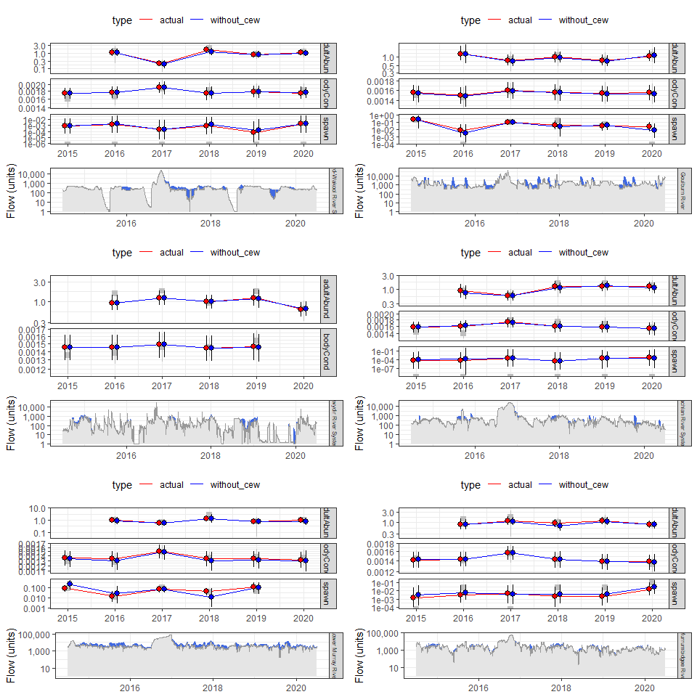
Figure A.1 Golden perch summary
- Murray cod
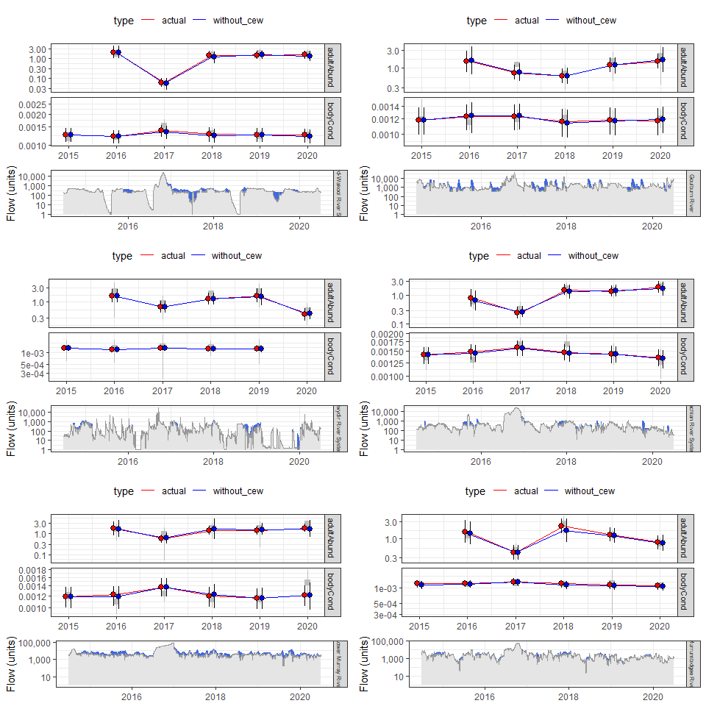
Figure A.2 Murray cod summary
- Bony herring
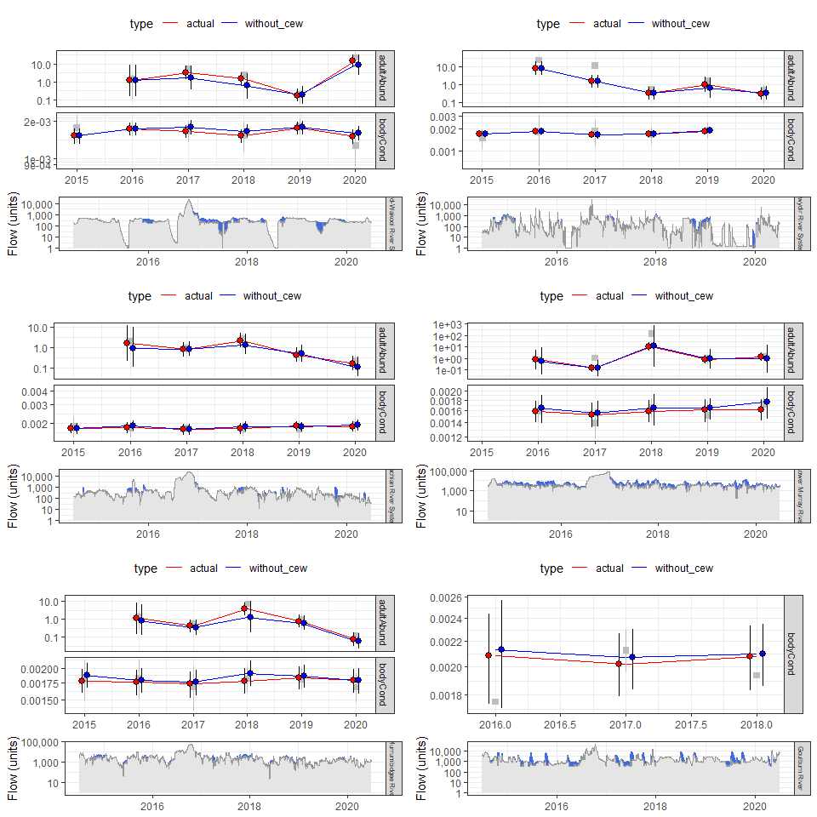
Figure A.3 Bony herring summary
- Silver perch
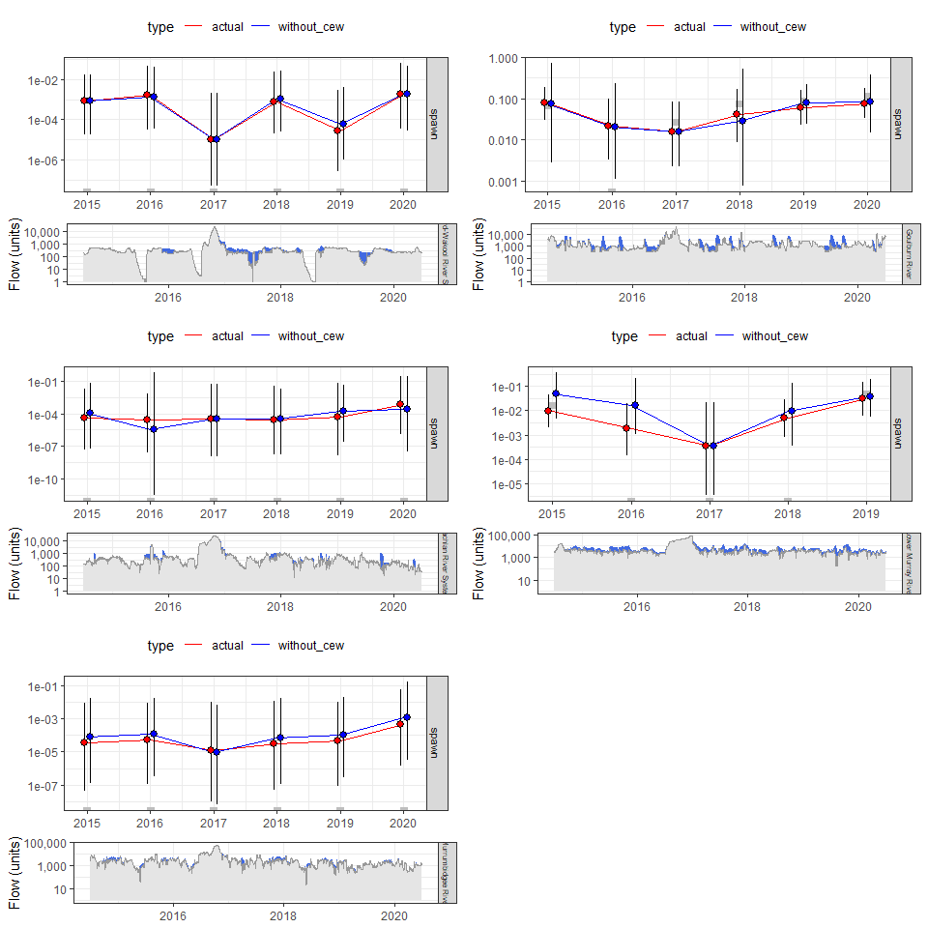
Figure A.4 Silver perch summary
- Common carp
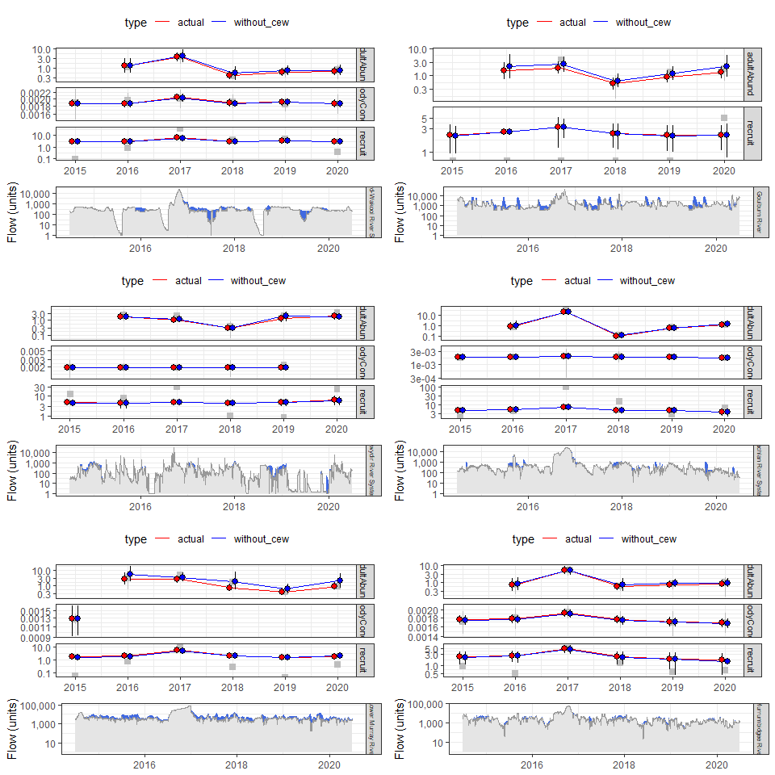
Figure A.5 Common carp summary
- Statistical tables for all analyses
- Spawning (analysis_id spawn)
Table A.1 Statistical results for fish spawning occurrence
* indicates C95%CrI does not include 0
speciesname | term | estimate | lower | upper | sig
Silver perch | (Intercept) | -19.94 | -59.23 | 16.56
Silver perch | baseflow_sep_nov | 0.30 | -0.19 | 0.79
Silver perch | small_fresh_sep_nov | -5.43 | -11.75 | 0.44
Silver perch | large_fresh_sep_nov | 0.35 | -6.02 | 6.59
Silver perch | change_72h_sep_nov | -0.14 | -0.82 | 0.52
Silver perch | programGoulburn | 5.65 | 2.33 | 9.54 | *
Silver perch | programLachlan | 1.48 | -6.64 | 8.60
Silver perch | programLower Murray | 3.40 | 0.20 | 7.32 | *
Silver perch | programMurrumbidgee | 0.28 | -6.34 | 6.37
Silver perch | tot_effort | 4.69 | -10.20 | 21.23
Golden perch | (Intercept) | -46.19 | -86.74 | -9.34 | *
Golden perch | baseflow_sep_nov | 0.66 | 0.19 | 1.17 | *
Golden perch | small_fresh_sep_nov | -4.31 | -8.45 | -0.01 | *
Golden perch | large_fresh_sep_nov | 2.53 | -0.36 | 5.39
Golden perch | change_72h_sep_nov | 0.06 | -0.53 | 0.61
Golden perch | programGoulburn | 5.97 | 2.81 | 9.76 | *
Golden perch | programLachlan | 0.16 | -8.17 | 7.54
Golden perch | programLower Murray | 5.00 | 1.98 | 8.77 | *
Golden perch | programMurrumbidgee | 2.79 | -0.12 | 6.76
Golden perch | tot_effort | 13.97 | -0.89 | 29.59
- Larval abundance (analysis_id larvaAbund)
Table A.2 Statistical results for larval abundance
* indicates C95%CrI does not include 0
speciesname | term | estimate | lower | upper | sig
Golden perch | (Intercept) | -0.34 | -7.56 | 6.12
Golden perch | seven_day_range | 0.33 | -0.52 | 1.18
Golden perch | days_increasing | -0.00 | -0.36 | 0.36
Golden perch | seven_day_median | -2.24 | -2.92 | -1.39 | *
Golden perch | programLower Murray | -2.38 | -8.72 | 3.54
Golden perch | programMurrumbidgee | -2.55 | -5.92 | 0.89
Golden perch | ad_cpue | 0.07 | -0.29 | 0.48
Silver perch | (Intercept) | -3.61 | -10.56 | 3.72
Silver perch | seven_day_range | 0.55 | -0.20 | 1.31
Silver perch | days_increasing | 0.04 | -0.42 | 0.48
Silver perch | seven_day_median | -1.06 | -2.79 | 0.64
Silver perch | programLower Murray | 0.12 | -3.54 | 3.71
Silver perch | ad_cpue | 0.57 | -1.85 | 2.76
- Recruit abundance (analysis_id recruit)
Table A.3 Statistical results for recruit abundance
* indicates C95%CrI does not include 0
speciesname | term | estimate | lower | upper | sig
Common carp | (Intercept) | 2.60 | -26.04 | 32.14
Common carp | baseflow_sep_mar | -0.06 | -0.88 | 0.68
Common carp | small_fresh_sep_mar | 1.40 | -1.68 | 4.46
Common carp | large_fresh_sep_mar | 4.43 | 0.83 | 8.26 | *
Common carp | change_72h_sep_mar | 0.00 | -0.00 | 0.01
Common carp | n_sites | 0.38 | -12.48 | 13.31
Common carp | programGoulburn | -0.99 | -3.53 | 1.40
Common carp | programGwydir | 0.79 | -1.85 | 3.33
Common carp | programLachlan | 0.50 | -1.58 | 2.49
Common carp | programLower Murray | -1.65 | -7.15 | 4.62
Common carp | programMurrumbidgee | -1.66 | -3.67 | 0.21
Eastern gambusia | (Intercept) | 28.60 | -6.28 | 67.85
Eastern gambusia | baseflow_sep_mar | -0.36 | -1.06 | 0.26
Eastern gambusia | small_fresh_sep_mar | -1.39 | -4.51 | 1.80
Eastern gambusia | large_fresh_sep_mar | 3.61 | -0.29 | 7.48
Eastern gambusia | change_72h_sep_mar | -0.00 | -0.01 | 0.00
Eastern gambusia | n_sites | -10.75 | -27.29 | 5.92
Eastern gambusia | programGoulburn | -3.78 | -8.56 | -0.46 | *
Eastern gambusia | programGwydir | 1.75 | -0.97 | 4.48
Eastern gambusia | programLachlan | 2.33 | 0.13 | 4.82 | *
Eastern gambusia | programLower Murray | -3.87 | -13.40 | 4.52
Eastern gambusia | programMurrumbidgee | 0.37 | -1.70 | 2.45
Carp gudgeon | (Intercept) | 8.97 | -10.92 | 28.83
Carp gudgeon | baseflow_sep_mar | -0.10 | -0.40 | 0.17
Carp gudgeon | small_fresh_sep_mar | 0.05 | -1.71 | 1.80
Carp gudgeon | large_fresh_sep_mar | 0.26 | -2.13 | 2.82
Carp gudgeon | change_72h_sep_mar | 0.00 | -0.00 | 0.00
Carp gudgeon | n_sites | -0.58 | -9.81 | 7.91
Carp gudgeon | programGoulburn | -2.13 | -3.48 | -0.83 | *
Carp gudgeon | programGwydir | -0.78 | -2.25 | 0.75
Carp gudgeon | programLachlan | -1.03 | -2.38 | 0.28
Carp gudgeon | programLower Murray | 0.42 | -3.19 | 4.86
Carp gudgeon | programMurrumbidgee | -1.23 | -2.54 | 0.01
Australian smelt | (Intercept) | 16.45 | -35.96 | 67.94
Australian smelt | baseflow_sep_mar | -0.29 | -1.21 | 0.57
Australian smelt | small_fresh_sep_mar | 7.03 | 2.56 | 11.32 | *
Australian smelt | large_fresh_sep_mar | -3.68 | -8.42 | 1.31
Australian smelt | change_72h_sep_mar | -0.00 | -0.01 | 0.01
Australian smelt | n_sites | -5.76 | -28.46 | 15.65
Australian smelt | programGoulburn | 1.02 | -1.59 | 3.62
Australian smelt | programGwydir | -0.47 | -3.53 | 3.19
Australian smelt | programLachlan | -2.46 | -5.40 | 0.49
Australian smelt | programLower Murray | -7.50 | -17.92 | 1.96
Australian smelt | programMurrumbidgee | 0.86 | -1.39 | 3.10
- Catch curve regression (analysis_id catchCurveAge)
Table A.4 Statistical results for Bony herring catch curve model
* indicates C95%CrI does not include 0
speciesname | term | estimate | lower | upper | sig
Bony herring | (Intercept) | 2.72 | 1.66 | 3.80 | *
Bony herring | age | -0.67 | -0.82 | -0.55 | *
Bony herring | programGoulburn | -7.52 | -15.35 | -2.83 | *
Bony herring | programGwydir | 1.79 | 0.73 | 2.89 | *
Bony herring | programLachlan | -1.01 | -2.17 | 0.10
Bony herring | programLower Murray | 0.34 | -0.73 | 1.44
Bony herring | programMurrumbidgee | -1.62 | -2.87 | -0.40 | *
Bony herring | b[(Intercept) program:birthyear:Edward-Wakool:2003] | -0.00 | -0.79 | 0.79
Bony herring | b[(Intercept) program:birthyear:Edward-Wakool:2004] | -0.01 | -0.85 | 0.83
Bony herring | b[(Intercept) program:birthyear:Edward-Wakool:2005] | -0.01 | -0.85 | 0.76
Bony herring | b[(Intercept) program:birthyear:Edward-Wakool:2006] | -0.02 | -0.87 | 0.78
Bony herring | b[(Intercept) program:birthyear:Edward-Wakool:2007] | -0.02 | -0.87 | 0.77
Bony herring | b[(Intercept) program:birthyear:Edward-Wakool:2008] | -0.05 | -0.92 | 0.72
Bony herring | b[(Intercept) program:birthyear:Edward-Wakool:2009] | -0.06 | -0.94 | 0.68
Bony herring | b[(Intercept) program:birthyear:Edward-Wakool:2010] | -0.09 | -1.03 | 0.57
Bony herring | b[(Intercept) program:birthyear:Edward-Wakool:2011] | 0.05 | -0.65 | 0.89
Bony herring | b[(Intercept) program:birthyear:Edward-Wakool:2012] | 0.07 | -0.63 | 0.89
Bony herring | b[(Intercept) program:birthyear:Edward-Wakool:2013] | 0.18 | -0.40 | 1.22
Bony herring | b[(Intercept) program:birthyear:Goulburn:2003] | 0.00 | -0.84 | 0.84
Bony herring | b[(Intercept) program:birthyear:Goulburn:2004] | -0.00 | -0.80 | 0.85
Bony herring | b[(Intercept) program:birthyear:Goulburn:2005] | -0.00 | -0.85 | 0.82
Bony herring | b[(Intercept) program:birthyear:Goulburn:2006] | 0.00 | -0.83 | 0.82
Bony herring | b[(Intercept) program:birthyear:Goulburn:2007] | -0.01 | -0.90 | 0.75
Bony herring | b[(Intercept) program:birthyear:Goulburn:2008] | 0.01 | -0.75 | 0.79
Bony herring | b[(Intercept) program:birthyear:Goulburn:2009] | 0.01 | -0.77 | 0.87
Bony herring | b[(Intercept) program:birthyear:Goulburn:2010] | 0.00 | -0.82 | 0.80
Bony herring | b[(Intercept) program:birthyear:Goulburn:2011] | -0.01 | -0.81 | 0.80
Bony herring | b[(Intercept) program:birthyear:Goulburn:2012] | -0.00 | -0.81 | 0.78
Bony herring | b[(Intercept) program:birthyear:Goulburn:2013] | 0.00 | -0.80 | 0.78
Bony herring | b[(Intercept) program:birthyear:Goulburn:2014] | -0.01 | -0.87 | 0.79
Bony herring | b[(Intercept) program:birthyear:Goulburn:2015] | -0.01 | -0.83 | 0.81
Bony herring | b[(Intercept) program:birthyear:Goulburn:2016] | 0.00 | -0.83 | 0.87
Bony herring | b[(Intercept) program:birthyear:Gwydir:2003] | -0.01 | -0.88 | 0.82
Bony herring | b[(Intercept) program:birthyear:Gwydir:2004] | 0.22 | -0.43 | 1.35
Bony herring | b[(Intercept) program:birthyear:Gwydir:2005] | -0.05 | -0.86 | 0.70
Bony herring | b[(Intercept) program:birthyear:Gwydir:2006] | -0.07 | -0.93 | 0.61
Bony herring | b[(Intercept) program:birthyear:Gwydir:2007] | -0.04 | -0.87 | 0.62
Bony herring | b[(Intercept) program:birthyear:Gwydir:2008] | -0.17 | -1.14 | 0.42
Bony herring | b[(Intercept) program:birthyear:Gwydir:2009] | -0.09 | -0.88 | 0.54
Bony herring | b[(Intercept) program:birthyear:Gwydir:2010] | 0.33 | -0.17 | 1.33
Bony herring | b[(Intercept) program:birthyear:Gwydir:2011] | -0.01 | -0.66 | 0.63
Bony herring | b[(Intercept) program:birthyear:Gwydir:2012] | -0.06 | -0.75 | 0.54
Bony herring | b[(Intercept) program:birthyear:Gwydir:2013] | 0.02 | -0.58 | 0.68
Bony herring | b[(Intercept) program:birthyear:Gwydir:2014] | -0.01 | -0.64 | 0.60
Bony herring | b[(Intercept) program:birthyear:Gwydir:2015] | 0.03 | -0.59 | 0.76
Bony herring | b[(Intercept) program:birthyear:Gwydir:2016] | -0.05 | -0.83 | 0.66
Bony herring | b[(Intercept) program:birthyear:Gwydir:2017] | -0.04 | -0.90 | 0.72
Bony herring | b[(Intercept) program:birthyear:Lachlan:2004] | -0.00 | -0.79 | 0.81
Bony herring | b[(Intercept) program:birthyear:Lachlan:2005] | -0.00 | -0.82 | 0.78
Bony herring | b[(Intercept) program:birthyear:Lachlan:2006] | -0.01 | -0.84 | 0.80
Bony herring | b[(Intercept) program:birthyear:Lachlan:2007] | -0.01 | -0.83 | 0.79
Bony herring | b[(Intercept) program:birthyear:Lachlan:2008] | -0.01 | -0.80 | 0.79
Bony herring | b[(Intercept) program:birthyear:Lachlan:2009] | -0.03 | -0.84 | 0.70
Bony herring | b[(Intercept) program:birthyear:Lachlan:2010] | -0.04 | -0.89 | 0.73
Bony herring | b[(Intercept) program:birthyear:Lachlan:2011] | -0.08 | -0.99 | 0.65
Bony herring | b[(Intercept) program:birthyear:Lachlan:2012] | 0.14 | -0.44 | 1.04
Bony herring | b[(Intercept) program:birthyear:Lachlan:2013] | 0.20 | -0.33 | 1.15
Bony herring | b[(Intercept) program:birthyear:Lachlan:2014] | -0.02 | -0.74 | 0.67
Bony herring | b[(Intercept) program:birthyear:Lachlan:2015] | -0.10 | -0.95 | 0.59
Bony herring | b[(Intercept) program:birthyear:Lachlan:2016] | 0.10 | -0.53 | 0.93
Bony herring | b[(Intercept) program:birthyear:Lachlan:2017] | -0.10 | -1.08 | 0.57
Bony herring | b[(Intercept) program:birthyear:Lachlan:2018] | -0.07 | -0.94 | 0.63
Bony herring | b[(Intercept) program:birthyear:Lower_Murray:2004] | -0.00 | -0.82 | 0.80
Bony herring | b[(Intercept) program:birthyear:Lower_Murray:2005] | -0.00 | -0.82 | 0.79
Bony herring | b[(Intercept) program:birthyear:Lower_Murray:2006] | -0.01 | -0.83 | 0.81
Bony herring | b[(Intercept) program:birthyear:Lower_Murray:2007] | -0.02 | -0.92 | 0.72
Bony herring | b[(Intercept) program:birthyear:Lower_Murray:2008] | -0.04 | -0.87 | 0.71
Bony herring | b[(Intercept) program:birthyear:Lower_Murray:2009] | 0.06 | -0.68 | 0.88
Bony herring | b[(Intercept) program:birthyear:Lower_Murray:2010] | -0.03 | -0.82 | 0.70
Bony herring | b[(Intercept) program:birthyear:Lower_Murray:2011] | 0.03 | -0.62 | 0.77
Bony herring | b[(Intercept) program:birthyear:Lower_Murray:2012] | 0.10 | -0.49 | 0.87
Bony herring | b[(Intercept) program:birthyear:Lower_Murray:2013] | 0.01 | -0.67 | 0.70
Bony herring | b[(Intercept) program:birthyear:Lower_Murray:2014] | -0.05 | -0.77 | 0.58
Bony herring | b[(Intercept) program:birthyear:Lower_Murray:2015] | 0.12 | -0.44 | 0.91
Bony herring | b[(Intercept) program:birthyear:Lower_Murray:2016] | -0.00 | -0.69 | 0.70
Bony herring | b[(Intercept) program:birthyear:Lower_Murray:2017] | -0.04 | -0.83 | 0.66
Bony herring | b[(Intercept) program:birthyear:Lower_Murray:2018] | -0.09 | -1.06 | 0.62
Bony herring | b[(Intercept) program:birthyear:Murrumbidgee:2004] | 0.00 | -0.80 | 0.82
Bony herring | b[(Intercept) program:birthyear:Murrumbidgee:2005] | -0.01 | -0.86 | 0.79
Bony herring | b[(Intercept) program:birthyear:Murrumbidgee:2006] | 0.00 | -0.82 | 0.83
Bony herring | b[(Intercept) program:birthyear:Murrumbidgee:2007] | -0.01 | -0.87 | 0.74
Bony herring | b[(Intercept) program:birthyear:Murrumbidgee:2008] | -0.02 | -0.88 | 0.76
Bony herring | b[(Intercept) program:birthyear:Murrumbidgee:2009] | -0.02 | -0.91 | 0.77
Bony herring | b[(Intercept) program:birthyear:Murrumbidgee:2010] | -0.03 | -0.84 | 0.71
Bony herring | b[(Intercept) program:birthyear:Murrumbidgee:2011] | -0.04 | -0.89 | 0.67
Bony herring | b[(Intercept) program:birthyear:Murrumbidgee:2012] | 0.08 | -0.58 | 1.00
Bony herring | b[(Intercept) program:birthyear:Murrumbidgee:2013] | 0.36 | -0.19 | 1.61
Bony herring | b[(Intercept) program:birthyear:Murrumbidgee:2014] | -0.11 | -1.01 | 0.57
Bony herring | b[(Intercept) program:birthyear:Murrumbidgee:2015] | -0.10 | -1.00 | 0.57
Bony herring | b[(Intercept) program:birthyear:Murrumbidgee:2016] | -0.09 | -0.99 | 0.65
Bony herring | b[(Intercept) program:birthyear:Murrumbidgee:2017] | -0.08 | -0.97 | 0.60
Bony herring | b[(Intercept) program:birthyear:Murrumbidgee:2018] | 0.02 | -0.75 | 0.86
Bony herring | reciprocal_dispersion | 0.71 | 0.44 | 1.12 | *
Bony herring | Sigma[program:birthyear:(Intercept),(Intercept)] | 0.15 | 0.00 | 0.68 | *
Bony herring | mean_PPD | 1.46 | 0.80 | 2.64 | *
Bony herring | log-posterior | -369.10 | -385.71 | -354.13 | *
Table A.5 Statistical results for Murray cod catch curve model
* indicates C95%CrI does not include 0
speciesname | term | estimate | lower | upper | sig
Murray cod | (Intercept) | -1.14 | -4.01 | 1.50
Murray cod | age | -0.24 | -0.34 | -0.16 | *
Murray cod | programGoulburn | 1.78 | -0.91 | 4.81
Murray cod | programGwydir | -3.87 | -10.46 | 0.78
Murray cod | programLachlan | 2.11 | -0.40 | 5.02
Murray cod | programLower Murray | -3.84 | -9.97 | 0.70
Murray cod | programMurrumbidgee | 1.78 | -0.79 | 4.77
Murray cod | b[(Intercept) program:birthyear:Edward-Wakool:1973] | -0.00 | -0.21 | 0.19
Murray cod | b[(Intercept) program:birthyear:Edward-Wakool:1974] | 0.00 | -0.20 | 0.22
Murray cod | b[(Intercept) program:birthyear:Edward-Wakool:1975] | -0.00 | -0.20 | 0.20
Murray cod | b[(Intercept) program:birthyear:Edward-Wakool:1976] | 0.00 | -0.21 | 0.21
Murray cod | b[(Intercept) program:birthyear:Edward-Wakool:1977] | 0.00 | -0.20 | 0.21
Murray cod | b[(Intercept) program:birthyear:Edward-Wakool:1978] | -0.00 | -0.21 | 0.19
Murray cod | b[(Intercept) program:birthyear:Edward-Wakool:1979] | 0.00 | -0.20 | 0.22
Murray cod | b[(Intercept) program:birthyear:Edward-Wakool:1980] | 0.00 | -0.20 | 0.21
Murray cod | b[(Intercept) program:birthyear:Edward-Wakool:1981] | 0.00 | -0.20 | 0.23
Murray cod | b[(Intercept) program:birthyear:Edward-Wakool:1982] | -0.00 | -0.21 | 0.21
Murray cod | b[(Intercept) program:birthyear:Edward-Wakool:1983] | 0.00 | -0.19 | 0.21
Murray cod | b[(Intercept) program:birthyear:Edward-Wakool:1984] | 0.00 | -0.19 | 0.22
Murray cod | b[(Intercept) program:birthyear:Edward-Wakool:1985] | -0.00 | -0.19 | 0.18
Murray cod | b[(Intercept) program:birthyear:Edward-Wakool:1986] | 0.00 | -0.20 | 0.21
Murray cod | b[(Intercept) program:birthyear:Edward-Wakool:1987] | 0.00 | -0.20 | 0.20
Murray cod | b[(Intercept) program:birthyear:Edward-Wakool:1988] | -0.00 | -0.22 | 0.20
Murray cod | b[(Intercept) program:birthyear:Edward-Wakool:1989] | 0.00 | -0.21 | 0.20
Murray cod | b[(Intercept) program:birthyear:Edward-Wakool:1990] | -0.00 | -0.21 | 0.21
Murray cod | b[(Intercept) program:birthyear:Edward-Wakool:1991] | 0.00 | -0.20 | 0.22
Murray cod | b[(Intercept) program:birthyear:Edward-Wakool:1992] | -0.00 | -0.21 | 0.21
Murray cod | b[(Intercept) program:birthyear:Edward-Wakool:1993] | 0.00 | -0.19 | 0.21
Murray cod | b[(Intercept) program:birthyear:Edward-Wakool:1994] | -0.00 | -0.22 | 0.18
Murray cod | b[(Intercept) program:birthyear:Edward-Wakool:1995] | -0.00 | -0.22 | 0.21
Murray cod | b[(Intercept) program:birthyear:Edward-Wakool:1996] | -0.00 | -0.22 | 0.19
Murray cod | b[(Intercept) program:birthyear:Edward-Wakool:1997] | -0.00 | -0.22 | 0.21
Murray cod | b[(Intercept) program:birthyear:Edward-Wakool:1998] | 0.00 | -0.20 | 0.20
Murray cod | b[(Intercept) program:birthyear:Edward-Wakool:1999] | -0.00 | -0.22 | 0.19
Murray cod | b[(Intercept) program:birthyear:Edward-Wakool:2000] | -0.00 | -0.21 | 0.22
Murray cod | b[(Intercept) program:birthyear:Edward-Wakool:2001] | 0.00 | -0.19 | 0.21
Murray cod | b[(Intercept) program:birthyear:Edward-Wakool:2002] | 0.00 | -0.22 | 0.21
Murray cod | b[(Intercept) program:birthyear:Edward-Wakool:2003] | 0.01 | -0.19 | 0.24
Murray cod | b[(Intercept) program:birthyear:Edward-Wakool:2004] | -0.00 | -0.21 | 0.21
Murray cod | b[(Intercept) program:birthyear:Edward-Wakool:2005] | -0.00 | -0.22 | 0.20
Murray cod | b[(Intercept) program:birthyear:Edward-Wakool:2006] | 0.00 | -0.20 | 0.20
Murray cod | b[(Intercept) program:birthyear:Edward-Wakool:2007] | -0.00 | -0.22 | 0.20
Murray cod | b[(Intercept) program:birthyear:Edward-Wakool:2008] | -0.00 | -0.20 | 0.22
Murray cod | b[(Intercept) program:birthyear:Edward-Wakool:2009] | -0.00 | -0.24 | 0.22
Murray cod | b[(Intercept) program:birthyear:Edward-Wakool:2010] | -0.00 | -0.22 | 0.21
Murray cod | b[(Intercept) program:birthyear:Edward-Wakool:2011] | -0.00 | -0.20 | 0.19
Murray cod | b[(Intercept) program:birthyear:Goulburn:1973] | 0.00 | -0.21 | 0.23
Murray cod | b[(Intercept) program:birthyear:Goulburn:1974] | 0.01 | -0.17 | 0.23
Murray cod | b[(Intercept) program:birthyear:Goulburn:1975] | 0.00 | -0.22 | 0.22
Murray cod | b[(Intercept) program:birthyear:Goulburn:1976] | 0.00 | -0.21 | 0.21
Murray cod | b[(Intercept) program:birthyear:Goulburn:1977] | -0.00 | -0.21 | 0.20
Murray cod | b[(Intercept) program:birthyear:Goulburn:1978] | -0.00 | -0.21 | 0.19
Murray cod | b[(Intercept) program:birthyear:Goulburn:1979] | -0.00 | -0.20 | 0.20
Murray cod | b[(Intercept) program:birthyear:Goulburn:1980] | 0.00 | -0.21 | 0.20
Murray cod | b[(Intercept) program:birthyear:Goulburn:1981] | -0.00 | -0.21 | 0.21
Murray cod | b[(Intercept) program:birthyear:Goulburn:1982] | -0.00 | -0.22 | 0.20
Murray cod | b[(Intercept) program:birthyear:Goulburn:1983] | -0.00 | -0.20 | 0.20
Murray cod | b[(Intercept) program:birthyear:Goulburn:1984] | 0.00 | -0.20 | 0.21
Murray cod | b[(Intercept) program:birthyear:Goulburn:1985] | 0.00 | -0.21 | 0.22
Murray cod | b[(Intercept) program:birthyear:Goulburn:1986] | 0.00 | -0.22 | 0.20
Murray cod | b[(Intercept) program:birthyear:Goulburn:1987] | 0.00 | -0.20 | 0.21
Murray cod | b[(Intercept) program:birthyear:Goulburn:1988] | 0.00 | -0.20 | 0.21
Murray cod | b[(Intercept) program:birthyear:Goulburn:1989] | -0.00 | -0.23 | 0.21
Murray cod | b[(Intercept) program:birthyear:Goulburn:1990] | -0.00 | -0.21 | 0.19
Murray cod | b[(Intercept) program:birthyear:Goulburn:1991] | 0.00 | -0.21 | 0.22
Murray cod | b[(Intercept) program:birthyear:Goulburn:1992] | 0.00 | -0.20 | 0.20
Murray cod | b[(Intercept) program:birthyear:Goulburn:1993] | -0.00 | -0.21 | 0.20
Murray cod | b[(Intercept) program:birthyear:Goulburn:1994] | -0.00 | -0.20 | 0.21
Murray cod | b[(Intercept) program:birthyear:Goulburn:1995] | -0.00 | -0.21 | 0.21
Murray cod | b[(Intercept) program:birthyear:Goulburn:1996] | -0.00 | -0.21 | 0.19
Murray cod | b[(Intercept) program:birthyear:Goulburn:1997] | -0.00 | -0.20 | 0.20
Murray cod | b[(Intercept) program:birthyear:Goulburn:1998] | -0.00 | -0.22 | 0.18
Murray cod | b[(Intercept) program:birthyear:Goulburn:1999] | -0.00 | -0.20 | 0.20
Murray cod | b[(Intercept) program:birthyear:Goulburn:2000] | -0.00 | -0.21 | 0.20
Murray cod | b[(Intercept) program:birthyear:Goulburn:2001] | -0.00 | -0.22 | 0.21
Murray cod | b[(Intercept) program:birthyear:Goulburn:2002] | -0.00 | -0.21 | 0.18
Murray cod | b[(Intercept) program:birthyear:Goulburn:2003] | -0.00 | -0.22 | 0.20
Murray cod | b[(Intercept) program:birthyear:Goulburn:2004] | -0.00 | -0.21 | 0.21
Murray cod | b[(Intercept) program:birthyear:Goulburn:2005] | -0.00 | -0.21 | 0.20
Murray cod | b[(Intercept) program:birthyear:Goulburn:2006] | 0.00 | -0.21 | 0.24
Murray cod | b[(Intercept) program:birthyear:Goulburn:2007] | 0.00 | -0.19 | 0.21
Murray cod | b[(Intercept) program:birthyear:Goulburn:2008] | 0.01 | -0.19 | 0.23
Murray cod | b[(Intercept) program:birthyear:Goulburn:2009] | 0.00 | -0.20 | 0.20
Murray cod | b[(Intercept) program:birthyear:Goulburn:2010] | 0.00 | -0.19 | 0.23
Murray cod | b[(Intercept) program:birthyear:Goulburn:2011] | -0.00 | -0.20 | 0.20
Murray cod | b[(Intercept) program:birthyear:Goulburn:2012] | -0.00 | -0.22 | 0.20
Murray cod | b[(Intercept) program:birthyear:Goulburn:2013] | -0.00 | -0.20 | 0.19
Murray cod | b[(Intercept) program:birthyear:Goulburn:2014] | -0.00 | -0.21 | 0.20
Murray cod | b[(Intercept) program:birthyear:Gwydir:1973] | 0.00 | -0.21 | 0.21
Murray cod | b[(Intercept) program:birthyear:Gwydir:1974] | 0.00 | -0.20 | 0.23
Murray cod | b[(Intercept) program:birthyear:Gwydir:1975] | 0.00 | -0.20 | 0.21
Murray cod | b[(Intercept) program:birthyear:Gwydir:1976] | 0.00 | -0.19 | 0.19
Murray cod | b[(Intercept) program:birthyear:Gwydir:1977] | -0.00 | -0.23 | 0.20
Murray cod | b[(Intercept) program:birthyear:Gwydir:1978] | 0.00 | -0.22 | 0.21
Murray cod | b[(Intercept) program:birthyear:Gwydir:1979] | 0.00 | -0.20 | 0.21
Murray cod | b[(Intercept) program:birthyear:Gwydir:1980] | 0.00 | -0.20 | 0.21
Murray cod | b[(Intercept) program:birthyear:Gwydir:1981] | 0.00 | -0.20 | 0.20
Murray cod | b[(Intercept) program:birthyear:Gwydir:1982] | 0.00 | -0.20 | 0.20
Murray cod | b[(Intercept) program:birthyear:Gwydir:1983] | -0.00 | -0.20 | 0.20
Murray cod | b[(Intercept) program:birthyear:Gwydir:1984] | -0.00 | -0.22 | 0.20
Murray cod | b[(Intercept) program:birthyear:Gwydir:1985] | 0.00 | -0.19 | 0.22
Murray cod | b[(Intercept) program:birthyear:Gwydir:1986] | -0.00 | -0.20 | 0.20
Murray cod | b[(Intercept) program:birthyear:Gwydir:1987] | -0.00 | -0.20 | 0.19
Murray cod | b[(Intercept) program:birthyear:Gwydir:1988] | -0.00 | -0.19 | 0.20
Murray cod | b[(Intercept) program:birthyear:Gwydir:1989] | -0.00 | -0.23 | 0.19
Murray cod | b[(Intercept) program:birthyear:Gwydir:1990] | 0.00 | -0.22 | 0.21
Murray cod | b[(Intercept) program:birthyear:Gwydir:1991] | -0.00 | -0.21 | 0.19
Murray cod | b[(Intercept) program:birthyear:Gwydir:1992] | 0.00 | -0.19 | 0.20
Murray cod | b[(Intercept) program:birthyear:Gwydir:1993] | 0.00 | -0.20 | 0.20
Murray cod | b[(Intercept) program:birthyear:Gwydir:1994] | 0.00 | -0.21 | 0.22
Murray cod | b[(Intercept) program:birthyear:Gwydir:1995] | 0.00 | -0.20 | 0.19
Murray cod | b[(Intercept) program:birthyear:Gwydir:1996] | 0.00 | -0.21 | 0.22
Murray cod | b[(Intercept) program:birthyear:Gwydir:1997] | -0.00 | -0.21 | 0.20
Murray cod | b[(Intercept) program:birthyear:Gwydir:1998] | 0.00 | -0.22 | 0.22
Murray cod | b[(Intercept) program:birthyear:Gwydir:1999] | 0.00 | -0.19 | 0.20
Murray cod | b[(Intercept) program:birthyear:Gwydir:2000] | -0.00 | -0.23 | 0.21
Murray cod | b[(Intercept) program:birthyear:Gwydir:2001] | -0.00 | -0.21 | 0.20
Murray cod | b[(Intercept) program:birthyear:Gwydir:2002] | 0.00 | -0.20 | 0.21
Murray cod | b[(Intercept) program:birthyear:Gwydir:2003] | -0.00 | -0.21 | 0.19
Murray cod | b[(Intercept) program:birthyear:Gwydir:2004] | 0.00 | -0.20 | 0.20
Murray cod | b[(Intercept) program:birthyear:Gwydir:2005] | -0.00 | -0.21 | 0.21
Murray cod | b[(Intercept) program:birthyear:Gwydir:2006] | 0.00 | -0.19 | 0.19
Murray cod | b[(Intercept) program:birthyear:Gwydir:2007] | -0.00 | -0.21 | 0.20
Murray cod | b[(Intercept) program:birthyear:Gwydir:2008] | 0.00 | -0.20 | 0.21
Murray cod | b[(Intercept) program:birthyear:Gwydir:2009] | 0.00 | -0.20 | 0.21
Murray cod | b[(Intercept) program:birthyear:Gwydir:2010] | -0.00 | -0.22 | 0.18
Murray cod | b[(Intercept) program:birthyear:Gwydir:2011] | -0.00 | -0.21 | 0.22
Murray cod | b[(Intercept) program:birthyear:Gwydir:2012] | 0.00 | -0.21 | 0.22
Murray cod | b[(Intercept) program:birthyear:Gwydir:2013] | -0.00 | -0.20 | 0.20
Murray cod | b[(Intercept) program:birthyear:Gwydir:2014] | 0.00 | -0.19 | 0.20
Murray cod | b[(Intercept) program:birthyear:Gwydir:2015] | 0.00 | -0.19 | 0.21
Murray cod | b[(Intercept) program:birthyear:Lachlan:1974] | -0.00 | -0.20 | 0.20
Murray cod | b[(Intercept) program:birthyear:Lachlan:1975] | 0.00 | -0.20 | 0.21
Murray cod | b[(Intercept) program:birthyear:Lachlan:1976] | -0.00 | -0.23 | 0.21
Murray cod | b[(Intercept) program:birthyear:Lachlan:1977] | 0.00 | -0.20 | 0.21
Murray cod | b[(Intercept) program:birthyear:Lachlan:1978] | 0.00 | -0.21 | 0.21
Murray cod | b[(Intercept) program:birthyear:Lachlan:1979] | 0.00 | -0.21 | 0.21
Murray cod | b[(Intercept) program:birthyear:Lachlan:1980] | -0.00 | -0.20 | 0.19
Murray cod | b[(Intercept) program:birthyear:Lachlan:1981] | 0.00 | -0.20 | 0.21
Murray cod | b[(Intercept) program:birthyear:Lachlan:1982] | 0.00 | -0.20 | 0.22
Murray cod | b[(Intercept) program:birthyear:Lachlan:1983] | -0.00 | -0.21 | 0.21
Murray cod | b[(Intercept) program:birthyear:Lachlan:1984] | 0.00 | -0.19 | 0.21
Murray cod | b[(Intercept) program:birthyear:Lachlan:1985] | -0.00 | -0.22 | 0.21
Murray cod | b[(Intercept) program:birthyear:Lachlan:1986] | 0.00 | -0.18 | 0.21
Murray cod | b[(Intercept) program:birthyear:Lachlan:1987] | -0.00 | -0.21 | 0.21
Murray cod | b[(Intercept) program:birthyear:Lachlan:1988] | -0.00 | -0.20 | 0.20
Murray cod | b[(Intercept) program:birthyear:Lachlan:1989] | 0.00 | -0.20 | 0.22
Murray cod | b[(Intercept) program:birthyear:Lachlan:1990] | -0.00 | -0.21 | 0.19
Murray cod | b[(Intercept) program:birthyear:Lachlan:1991] | 0.00 | -0.21 | 0.22
Murray cod | b[(Intercept) program:birthyear:Lachlan:1992] | -0.00 | -0.20 | 0.21
Murray cod | b[(Intercept) program:birthyear:Lachlan:1993] | -0.00 | -0.20 | 0.19
Murray cod | b[(Intercept) program:birthyear:Lachlan:1994] | -0.00 | -0.23 | 0.19
Murray cod | b[(Intercept) program:birthyear:Lachlan:1995] | -0.00 | -0.22 | 0.21
Murray cod | b[(Intercept) program:birthyear:Lachlan:1996] | -0.00 | -0.22 | 0.20
Murray cod | b[(Intercept) program:birthyear:Lachlan:1997] | -0.00 | -0.21 | 0.19
Murray cod | b[(Intercept) program:birthyear:Lachlan:1998] | -0.00 | -0.21 | 0.20
Murray cod | b[(Intercept) program:birthyear:Lachlan:1999] | -0.00 | -0.21 | 0.21
Murray cod | b[(Intercept) program:birthyear:Lachlan:2000] | -0.00 | -0.21 | 0.20
Murray cod | b[(Intercept) program:birthyear:Lachlan:2001] | -0.00 | -0.22 | 0.22
Murray cod | b[(Intercept) program:birthyear:Lachlan:2002] | -0.00 | -0.23 | 0.19
Murray cod | b[(Intercept) program:birthyear:Lachlan:2003] | -0.00 | -0.22 | 0.20
Murray cod | b[(Intercept) program:birthyear:Lachlan:2004] | -0.00 | -0.22 | 0.19
Murray cod | b[(Intercept) program:birthyear:Lachlan:2005] | 0.01 | -0.17 | 0.25
Murray cod | b[(Intercept) program:birthyear:Lachlan:2006] | -0.00 | -0.21 | 0.19
Murray cod | b[(Intercept) program:birthyear:Lachlan:2007] | 0.01 | -0.15 | 0.23
Murray cod | b[(Intercept) program:birthyear:Lachlan:2008] | 0.01 | -0.17 | 0.24
Murray cod | b[(Intercept) program:birthyear:Lachlan:2009] | -0.00 | -0.20 | 0.20
Murray cod | b[(Intercept) program:birthyear:Lachlan:2010] | 0.01 | -0.17 | 0.23
Murray cod | b[(Intercept) program:birthyear:Lachlan:2011] | -0.00 | -0.22 | 0.19
Murray cod | b[(Intercept) program:birthyear:Lachlan:2012] | -0.01 | -0.23 | 0.19
Murray cod | b[(Intercept) program:birthyear:Lachlan:2013] | -0.00 | -0.22 | 0.19
Murray cod | b[(Intercept) program:birthyear:Lachlan:2014] | 0.00 | -0.20 | 0.21
Murray cod | b[(Intercept) program:birthyear:Lachlan:2015] | -0.00 | -0.22 | 0.22
Murray cod | b[(Intercept) program:birthyear:Lachlan:2016] | 0.00 | -0.21 | 0.21
Murray cod | b[(Intercept) program:birthyear:Lower_Murray:1974] | 0.00 | -0.20 | 0.22
Murray cod | b[(Intercept) program:birthyear:Lower_Murray:1975] | 0.00 | -0.21 | 0.22
Murray cod | b[(Intercept) program:birthyear:Lower_Murray:1976] | -0.00 | -0.21 | 0.21
Murray cod | b[(Intercept) program:birthyear:Lower_Murray:1977] | 0.00 | -0.20 | 0.21
Murray cod | b[(Intercept) program:birthyear:Lower_Murray:1978] | -0.00 | -0.20 | 0.21
Murray cod | b[(Intercept) program:birthyear:Lower_Murray:1979] | -0.00 | -0.21 | 0.19
Murray cod | b[(Intercept) program:birthyear:Lower_Murray:1980] | -0.00 | -0.21 | 0.21
Murray cod | b[(Intercept) program:birthyear:Lower_Murray:1981] | -0.00 | -0.22 | 0.21
Murray cod | b[(Intercept) program:birthyear:Lower_Murray:1982] | -0.00 | -0.20 | 0.20
Murray cod | b[(Intercept) program:birthyear:Lower_Murray:1983] | -0.00 | -0.20 | 0.21
Murray cod | b[(Intercept) program:birthyear:Lower_Murray:1984] | -0.00 | -0.21 | 0.20
Murray cod | b[(Intercept) program:birthyear:Lower_Murray:1985] | -0.00 | -0.22 | 0.20
Murray cod | b[(Intercept) program:birthyear:Lower_Murray:1986] | 0.00 | -0.18 | 0.20
Murray cod | b[(Intercept) program:birthyear:Lower_Murray:1987] | 0.00 | -0.20 | 0.20
Murray cod | b[(Intercept) program:birthyear:Lower_Murray:1988] | 0.00 | -0.20 | 0.20
Murray cod | b[(Intercept) program:birthyear:Lower_Murray:1989] | 0.00 | -0.20 | 0.21
Murray cod | b[(Intercept) program:birthyear:Lower_Murray:1990] | 0.00 | -0.21 | 0.22
Murray cod | b[(Intercept) program:birthyear:Lower_Murray:1991] | -0.00 | -0.22 | 0.21
Murray cod | b[(Intercept) program:birthyear:Lower_Murray:1992] | 0.00 | -0.21 | 0.22
Murray cod | b[(Intercept) program:birthyear:Lower_Murray:1993] | 0.00 | -0.20 | 0.21
Murray cod | b[(Intercept) program:birthyear:Lower_Murray:1994] | 0.00 | -0.22 | 0.19
Murray cod | b[(Intercept) program:birthyear:Lower_Murray:1995] | -0.00 | -0.23 | 0.21
Murray cod | b[(Intercept) program:birthyear:Lower_Murray:1996] | -0.00 | -0.22 | 0.20
Murray cod | b[(Intercept) program:birthyear:Lower_Murray:1997] | -0.00 | -0.20 | 0.19
Murray cod | b[(Intercept) program:birthyear:Lower_Murray:1998] | 0.00 | -0.20 | 0.24
Murray cod | b[(Intercept) program:birthyear:Lower_Murray:1999] | -0.00 | -0.22 | 0.18
Murray cod | b[(Intercept) program:birthyear:Lower_Murray:2000] | -0.00 | -0.21 | 0.21
Murray cod | b[(Intercept) program:birthyear:Lower_Murray:2001] | -0.00 | -0.20 | 0.21
Murray cod | b[(Intercept) program:birthyear:Lower_Murray:2002] | 0.00 | -0.20 | 0.22
Murray cod | b[(Intercept) program:birthyear:Lower_Murray:2003] | -0.00 | -0.22 | 0.21
Murray cod | b[(Intercept) program:birthyear:Lower_Murray:2004] | -0.00 | -0.22 | 0.20
Murray cod | b[(Intercept) program:birthyear:Lower_Murray:2005] | -0.00 | -0.21 | 0.20
Murray cod | b[(Intercept) program:birthyear:Lower_Murray:2006] | -0.00 | -0.20 | 0.21
Murray cod | b[(Intercept) program:birthyear:Lower_Murray:2007] | -0.00 | -0.20 | 0.21
Murray cod | b[(Intercept) program:birthyear:Lower_Murray:2008] | 0.00 | -0.21 | 0.20
Murray cod | b[(Intercept) program:birthyear:Lower_Murray:2009] | 0.00 | -0.19 | 0.20
Murray cod | b[(Intercept) program:birthyear:Lower_Murray:2010] | -0.00 | -0.20 | 0.20
Murray cod | b[(Intercept) program:birthyear:Lower_Murray:2011] | -0.00 | -0.21 | 0.20
Murray cod | b[(Intercept) program:birthyear:Lower_Murray:2012] | -0.00 | -0.22 | 0.21
Murray cod | b[(Intercept) program:birthyear:Lower_Murray:2013] | 0.00 | -0.21 | 0.21
Murray cod | b[(Intercept) program:birthyear:Lower_Murray:2014] | -0.00 | -0.22 | 0.19
Murray cod | b[(Intercept) program:birthyear:Lower_Murray:2015] | 0.00 | -0.20 | 0.22
Murray cod | b[(Intercept) program:birthyear:Lower_Murray:2016] | 0.00 | -0.20 | 0.20
Murray cod | b[(Intercept) program:birthyear:Murrumbidgee:1974] | -0.00 | -0.22 | 0.22
Murray cod | b[(Intercept) program:birthyear:Murrumbidgee:1975] | -0.00 | -0.23 | 0.20
Murray cod | b[(Intercept) program:birthyear:Murrumbidgee:1976] | -0.00 | -0.22 | 0.19
Murray cod | b[(Intercept) program:birthyear:Murrumbidgee:1977] | 0.00 | -0.20 | 0.21
Murray cod | b[(Intercept) program:birthyear:Murrumbidgee:1978] | -0.00 | -0.21 | 0.20
Murray cod | b[(Intercept) program:birthyear:Murrumbidgee:1979] | -0.00 | -0.22 | 0.19
Murray cod | b[(Intercept) program:birthyear:Murrumbidgee:1980] | -0.00 | -0.21 | 0.20
Murray cod | b[(Intercept) program:birthyear:Murrumbidgee:1981] | 0.00 | -0.20 | 0.20
Murray cod | b[(Intercept) program:birthyear:Murrumbidgee:1982] | -0.00 | -0.21 | 0.18
Murray cod | b[(Intercept) program:birthyear:Murrumbidgee:1983] | 0.00 | -0.21 | 0.22
Murray cod | b[(Intercept) program:birthyear:Murrumbidgee:1984] | -0.00 | -0.21 | 0.20
Murray cod | b[(Intercept) program:birthyear:Murrumbidgee:1985] | -0.00 | -0.21 | 0.20
Murray cod | b[(Intercept) program:birthyear:Murrumbidgee:1986] | -0.00 | -0.22 | 0.20
Murray cod | b[(Intercept) program:birthyear:Murrumbidgee:1987] | -0.00 | -0.22 | 0.19
Murray cod | b[(Intercept) program:birthyear:Murrumbidgee:1988] | -0.00 | -0.21 | 0.20
Murray cod | b[(Intercept) program:birthyear:Murrumbidgee:1989] | 0.00 | -0.19 | 0.21
Murray cod | b[(Intercept) program:birthyear:Murrumbidgee:1990] | 0.00 | -0.20 | 0.21
Murray cod | b[(Intercept) program:birthyear:Murrumbidgee:1991] | 0.00 | -0.20 | 0.20
Murray cod | b[(Intercept) program:birthyear:Murrumbidgee:1992] | -0.00 | -0.19 | 0.20
Murray cod | b[(Intercept) program:birthyear:Murrumbidgee:1993] | -0.00 | -0.21 | 0.19
Murray cod | b[(Intercept) program:birthyear:Murrumbidgee:1994] | -0.00 | -0.22 | 0.20
Murray cod | b[(Intercept) program:birthyear:Murrumbidgee:1995] | -0.00 | -0.21 | 0.21
Murray cod | b[(Intercept) program:birthyear:Murrumbidgee:1996] | -0.00 | -0.20 | 0.19
Murray cod | b[(Intercept) program:birthyear:Murrumbidgee:1997] | 0.00 | -0.20 | 0.21
Murray cod | b[(Intercept) program:birthyear:Murrumbidgee:1998] | -0.00 | -0.21 | 0.21
Murray cod | b[(Intercept) program:birthyear:Murrumbidgee:1999] | -0.00 | -0.24 | 0.19
Murray cod | b[(Intercept) program:birthyear:Murrumbidgee:2000] | 0.00 | -0.20 | 0.20
Murray cod | b[(Intercept) program:birthyear:Murrumbidgee:2001] | 0.00 | -0.20 | 0.22
Murray cod | b[(Intercept) program:birthyear:Murrumbidgee:2002] | -0.00 | -0.22 | 0.19
Murray cod | b[(Intercept) program:birthyear:Murrumbidgee:2003] | -0.00 | -0.21 | 0.19
Murray cod | b[(Intercept) program:birthyear:Murrumbidgee:2004] | 0.00 | -0.20 | 0.22
Murray cod | b[(Intercept) program:birthyear:Murrumbidgee:2005] | -0.00 | -0.22 | 0.20
Murray cod | b[(Intercept) program:birthyear:Murrumbidgee:2006] | 0.00 | -0.19 | 0.25
Murray cod | b[(Intercept) program:birthyear:Murrumbidgee:2007] | -0.01 | -0.23 | 0.20
Murray cod | b[(Intercept) program:birthyear:Murrumbidgee:2008] | 0.01 | -0.18 | 0.24
Murray cod | b[(Intercept) program:birthyear:Murrumbidgee:2009] | 0.00 | -0.19 | 0.22
Murray cod | b[(Intercept) program:birthyear:Murrumbidgee:2010] | 0.01 | -0.18 | 0.22
Murray cod | b[(Intercept) program:birthyear:Murrumbidgee:2011] | -0.00 | -0.24 | 0.20
Murray cod | b[(Intercept) program:birthyear:Murrumbidgee:2012] | -0.00 | -0.21 | 0.19
Murray cod | b[(Intercept) program:birthyear:Murrumbidgee:2013] | -0.00 | -0.22 | 0.18
Murray cod | b[(Intercept) program:birthyear:Murrumbidgee:2014] | -0.00 | -0.21 | 0.20
Murray cod | b[(Intercept) program:birthyear:Murrumbidgee:2015] | -0.00 | -0.20 | 0.21
Murray cod | b[(Intercept) program:birthyear:Murrumbidgee:2016] | -0.00 | -0.22 | 0.21
Murray cod | reciprocal_dispersion | 0.07 | 0.04 | 0.13 | *
Murray cod | Sigma[program:birthyear:(Intercept),(Intercept)] | 0.01 | 0.00 | 0.07 | *
Murray cod | mean_PPD | 0.08 | 0.02 | 0.16 | *
Murray cod | log-posterior | -501.29 | -524.76 | -479.50 | *
Table A-6 Statistical results for Golden perch catch curve model
* indicates C95%CrI does not include 0.
speciesname | term | estimate | lower | upper | sig
Golden perch | (Intercept) | 1.42 | 0.32 | 2.55 | *
Golden perch | age | -0.25 | -0.30 | -0.20 | *
Golden perch | programGoulburn | 1.05 | -0.20 | 2.32
Golden perch | programGwydir | 0.37 | -0.84 | 1.62
Golden perch | programLachlan | -0.91 | -2.19 | 0.37
Golden perch | programLower Murray | 1.83 | 0.65 | 3.05 | *
Golden perch | programMurrumbidgee | 0.43 | -0.74 | 1.65
Golden perch | b[(Intercept) program:birthyear:Edward-Wakool:1990] | -0.02 | -2.30 | 2.23
Golden perch | b[(Intercept) program:birthyear:Edward-Wakool:1991] | -0.06 | -2.28 | 2.17
Golden perch | b[(Intercept) program:birthyear:Edward-Wakool:1992] | -0.08 | -2.33 | 2.11
Golden perch | b[(Intercept) program:birthyear:Edward-Wakool:1993] | -0.08 | -2.39 | 2.15
Golden perch | b[(Intercept) program:birthyear:Edward-Wakool:1994] | -0.12 | -2.33 | 1.92
Golden perch | b[(Intercept) program:birthyear:Edward-Wakool:1995] | -0.11 | -2.40 | 2.05
Golden perch | b[(Intercept) program:birthyear:Edward-Wakool:1996] | -0.15 | -2.37 | 2.00
Golden perch | b[(Intercept) program:birthyear:Edward-Wakool:1997] | -0.18 | -2.43 | 1.99
Golden perch | b[(Intercept) program:birthyear:Edward-Wakool:1998] | -0.17 | -2.26 | 1.80
Golden perch | b[(Intercept) program:birthyear:Edward-Wakool:1999] | -0.21 | -2.42 | 1.79
Golden perch | b[(Intercept) program:birthyear:Edward-Wakool:2000] | -0.24 | -2.39 | 1.73
Golden perch | b[(Intercept) program:birthyear:Edward-Wakool:2001] | -0.30 | -2.42 | 1.76
Golden perch | b[(Intercept) program:birthyear:Edward-Wakool:2002] | -0.31 | -2.42 | 1.73
Golden perch | b[(Intercept) program:birthyear:Edward-Wakool:2003] | -0.36 | -2.49 | 1.60
Golden perch | b[(Intercept) program:birthyear:Edward-Wakool:2004] | -0.38 | -2.45 | 1.62
Golden perch | b[(Intercept) program:birthyear:Edward-Wakool:2005] | -0.46 | -2.53 | 1.55
Golden perch | b[(Intercept) program:birthyear:Edward-Wakool:2006] | 0.03 | -1.82 | 1.95
Golden perch | b[(Intercept) program:birthyear:Edward-Wakool:2007] | 0.68 | -0.92 | 2.43
Golden perch | b[(Intercept) program:birthyear:Edward-Wakool:2008] | 0.53 | -1.03 | 2.21
Golden perch | b[(Intercept) program:birthyear:Edward-Wakool:2009] | -0.21 | -2.02 | 1.69
Golden perch | b[(Intercept) program:birthyear:Edward-Wakool:2010] | 0.41 | -1.15 | 2.10
Golden perch | b[(Intercept) program:birthyear:Edward-Wakool:2011] | 1.64 | 0.11 | 3.35 | *
Golden perch | b[(Intercept) program:birthyear:Goulburn:1990] | -0.06 | -2.31 | 2.11
Golden perch | b[(Intercept) program:birthyear:Goulburn:1991] | -0.12 | -2.30 | 2.06
Golden perch | b[(Intercept) program:birthyear:Goulburn:1992] | -0.20 | -2.50 | 1.95
Golden perch | b[(Intercept) program:birthyear:Goulburn:1993] | -0.21 | -2.50 | 1.89
Golden perch | b[(Intercept) program:birthyear:Goulburn:1994] | 1.51 | -0.07 | 3.17
Golden perch | b[(Intercept) program:birthyear:Goulburn:1995] | 0.41 | -1.41 | 2.23
Golden perch | b[(Intercept) program:birthyear:Goulburn:1996] | 0.32 | -1.46 | 2.08
Golden perch | b[(Intercept) program:birthyear:Goulburn:1997] | -0.41 | -2.47 | 1.43
Golden perch | b[(Intercept) program:birthyear:Goulburn:1998] | 0.25 | -1.56 | 2.08
Golden perch | b[(Intercept) program:birthyear:Goulburn:1999] | 0.54 | -1.02 | 2.18
Golden perch | b[(Intercept) program:birthyear:Goulburn:2000] | -0.63 | -2.75 | 1.26
Golden perch | b[(Intercept) program:birthyear:Goulburn:2001] | -0.69 | -2.61 | 1.07
Golden perch | b[(Intercept) program:birthyear:Goulburn:2002] | -0.75 | -2.74 | 1.08
Golden perch | b[(Intercept) program:birthyear:Goulburn:2003] | -0.40 | -2.04 | 1.18
Golden perch | b[(Intercept) program:birthyear:Goulburn:2004] | 0.96 | -0.40 | 2.42
Golden perch | b[(Intercept) program:birthyear:Goulburn:2005] | -0.61 | -2.38 | 1.12
Golden perch | b[(Intercept) program:birthyear:Goulburn:2006] | -0.12 | -1.58 | 1.43
Golden perch | b[(Intercept) program:birthyear:Goulburn:2007] | 0.18 | -1.18 | 1.72
Golden perch | b[(Intercept) program:birthyear:Goulburn:2008] | 0.33 | -1.00 | 1.78
Golden perch | b[(Intercept) program:birthyear:Goulburn:2009] | 0.07 | -1.27 | 1.53
Golden perch | b[(Intercept) program:birthyear:Goulburn:2010] | 0.44 | -0.84 | 1.84
Golden perch | b[(Intercept) program:birthyear:Goulburn:2011] | -0.46 | -2.03 | 1.20
Golden perch | b[(Intercept) program:birthyear:Goulburn:2012] | -0.84 | -2.87 | 1.20
Golden perch | b[(Intercept) program:birthyear:Goulburn:2013] | -0.23 | -2.21 | 1.80
Golden perch | b[(Intercept) program:birthyear:Goulburn:2014] | 0.75 | -0.70 | 2.51
Golden perch | b[(Intercept) program:birthyear:Gwydir:1990] | -0.02 | -2.27 | 2.14
Golden perch | b[(Intercept) program:birthyear:Gwydir:1991] | -0.08 | -2.35 | 2.05
Golden perch | b[(Intercept) program:birthyear:Gwydir:1992] | -0.12 | -2.32 | 1.97
Golden perch | b[(Intercept) program:birthyear:Gwydir:1993] | -0.15 | -2.34 | 1.92
Golden perch | b[(Intercept) program:birthyear:Gwydir:1994] | -0.20 | -2.31 | 1.80
Golden perch | b[(Intercept) program:birthyear:Gwydir:1995] | -0.27 | -2.44 | 1.74
Golden perch | b[(Intercept) program:birthyear:Gwydir:1996] | 1.04 | -0.67 | 2.85
Golden perch | b[(Intercept) program:birthyear:Gwydir:1997] | -0.35 | -2.41 | 1.51
Golden perch | b[(Intercept) program:birthyear:Gwydir:1998] | -0.42 | -2.43 | 1.46
Golden perch | b[(Intercept) program:birthyear:Gwydir:1999] | -0.49 | -2.50 | 1.42
Golden perch | b[(Intercept) program:birthyear:Gwydir:2000] | -0.55 | -2.63 | 1.29
Golden perch | b[(Intercept) program:birthyear:Gwydir:2001] | -0.62 | -2.60 | 1.12
Golden perch | b[(Intercept) program:birthyear:Gwydir:2002] | -0.70 | -2.72 | 1.12
Golden perch | b[(Intercept) program:birthyear:Gwydir:2003] | -0.14 | -1.80 | 1.48
Golden perch | b[(Intercept) program:birthyear:Gwydir:2004] | 0.89 | -0.41 | 2.32
Golden perch | b[(Intercept) program:birthyear:Gwydir:2005] | 0.54 | -0.79 | 1.90
Golden perch | b[(Intercept) program:birthyear:Gwydir:2006] | 0.91 | -0.34 | 2.29
Golden perch | b[(Intercept) program:birthyear:Gwydir:2007] | -0.20 | -1.72 | 1.28
Golden perch | b[(Intercept) program:birthyear:Gwydir:2008] | 0.06 | -1.32 | 1.50
Golden perch | b[(Intercept) program:birthyear:Gwydir:2009] | 0.40 | -0.84 | 1.70
Golden perch | b[(Intercept) program:birthyear:Gwydir:2010] | 0.75 | -0.46 | 2.07
Golden perch | b[(Intercept) program:birthyear:Gwydir:2011] | -0.17 | -1.55 | 1.25
Golden perch | b[(Intercept) program:birthyear:Gwydir:2012] | 0.56 | -0.79 | 1.98
Golden perch | b[(Intercept) program:birthyear:Gwydir:2013] | 0.06 | -1.40 | 1.63
Golden perch | b[(Intercept) program:birthyear:Gwydir:2014] | -0.46 | -2.29 | 1.34
Golden perch | b[(Intercept) program:birthyear:Gwydir:2015] | -0.42 | -2.62 | 1.68
Golden perch | b[(Intercept) program:birthyear:Lachlan:1991] | 0.01 | -2.24 | 2.37
Golden perch | b[(Intercept) program:birthyear:Lachlan:1992] | -0.00 | -2.20 | 2.30
Golden perch | b[(Intercept) program:birthyear:Lachlan:1993] | -0.01 | -2.25 | 2.15
Golden perch | b[(Intercept) program:birthyear:Lachlan:1994] | -0.07 | -2.42 | 2.25
Golden perch | b[(Intercept) program:birthyear:Lachlan:1995] | -0.07 | -2.24 | 2.04
Golden perch | b[(Intercept) program:birthyear:Lachlan:1996] | -0.13 | -2.40 | 2.04
Golden perch | b[(Intercept) program:birthyear:Lachlan:1997] | 0.84 | -1.09 | 2.86
Golden perch | b[(Intercept) program:birthyear:Lachlan:1998] | -0.17 | -2.33 | 1.91
Golden perch | b[(Intercept) program:birthyear:Lachlan:1999] | -0.18 | -2.33 | 1.82
Golden perch | b[(Intercept) program:birthyear:Lachlan:2000] | -0.22 | -2.47 | 1.83
Golden perch | b[(Intercept) program:birthyear:Lachlan:2001] | -0.26 | -2.41 | 1.69
Golden perch | b[(Intercept) program:birthyear:Lachlan:2002] | 1.39 | -0.16 | 2.97
Golden perch | b[(Intercept) program:birthyear:Lachlan:2003] | 0.38 | -1.48 | 2.17
Golden perch | b[(Intercept) program:birthyear:Lachlan:2004] | -0.40 | -2.41 | 1.40
Golden perch | b[(Intercept) program:birthyear:Lachlan:2005] | -0.46 | -2.59 | 1.37
Golden perch | b[(Intercept) program:birthyear:Lachlan:2006] | 0.82 | -0.68 | 2.38
Golden perch | b[(Intercept) program:birthyear:Lachlan:2007] | 0.67 | -0.81 | 2.21
Golden perch | b[(Intercept) program:birthyear:Lachlan:2008] | 0.24 | -1.34 | 1.80
Golden perch | b[(Intercept) program:birthyear:Lachlan:2009] | -0.74 | -2.73 | 1.00
Golden perch | b[(Intercept) program:birthyear:Lachlan:2010] | 0.42 | -0.96 | 1.85
Golden perch | b[(Intercept) program:birthyear:Lachlan:2011] | 0.98 | -0.31 | 2.34
Golden perch | b[(Intercept) program:birthyear:Lachlan:2012] | -0.87 | -2.95 | 0.94
Golden perch | b[(Intercept) program:birthyear:Lachlan:2013] | -0.77 | -2.79 | 1.08
Golden perch | b[(Intercept) program:birthyear:Lachlan:2014] | -0.66 | -2.64 | 1.18
Golden perch | b[(Intercept) program:birthyear:Lachlan:2015] | -0.51 | -2.65 | 1.54
Golden perch | b[(Intercept) program:birthyear:Lachlan:2016] | -0.29 | -2.51 | 1.78
Golden perch | b[(Intercept) program:birthyear:Lower_Murray:1991] | -0.11 | -2.35 | 2.03
Golden perch | b[(Intercept) program:birthyear:Lower_Murray:1992] | -0.18 | -2.29 | 1.86
Golden perch | b[(Intercept) program:birthyear:Lower_Murray:1993] | -0.28 | -2.33 | 1.66
Golden perch | b[(Intercept) program:birthyear:Lower_Murray:1994] | -0.40 | -2.44 | 1.46
Golden perch | b[(Intercept) program:birthyear:Lower_Murray:1995] | -0.51 | -2.61 | 1.41
Golden perch | b[(Intercept) program:birthyear:Lower_Murray:1996] | -0.60 | -2.57 | 1.17
Golden perch | b[(Intercept) program:birthyear:Lower_Murray:1997] | 2.99 | 1.78 | 4.38 | *
Golden perch | b[(Intercept) program:birthyear:Lower_Murray:1998] | 0.90 | -0.49 | 2.40
Golden perch | b[(Intercept) program:birthyear:Lower_Murray:1999] | 0.44 | -0.95 | 1.90
Golden perch | b[(Intercept) program:birthyear:Lower_Murray:2000] | 0.15 | -1.23 | 1.61
Golden perch | b[(Intercept) program:birthyear:Lower_Murray:2001] | 1.90 | 0.73 | 3.18 | *
Golden perch | b[(Intercept) program:birthyear:Lower_Murray:2002] | -1.09 | -2.97 | 0.61
Golden perch | b[(Intercept) program:birthyear:Lower_Murray:2003] | -0.83 | -2.47 | 0.68
Golden perch | b[(Intercept) program:birthyear:Lower_Murray:2004] | -0.31 | -1.74 | 1.21
Golden perch | b[(Intercept) program:birthyear:Lower_Murray:2005] | -1.39 | -3.27 | 0.35
Golden perch | b[(Intercept) program:birthyear:Lower_Murray:2006] | 0.04 | -1.19 | 1.30
Golden perch | b[(Intercept) program:birthyear:Lower_Murray:2007] | -0.99 | -2.52 | 0.49
Golden perch | b[(Intercept) program:birthyear:Lower_Murray:2008] | -1.43 | -3.09 | 0.16
Golden perch | b[(Intercept) program:birthyear:Lower_Murray:2009] | -1.80 | -3.56 | -0.11 | *
Golden perch | b[(Intercept) program:birthyear:Lower_Murray:2010] | 1.60 | 0.50 | 2.80 | *
Golden perch | b[(Intercept) program:birthyear:Lower_Murray:2011] | 1.88 | 0.73 | 3.10 | *
Golden perch | b[(Intercept) program:birthyear:Lower_Murray:2012] | 1.08 | -0.10 | 2.37
Golden perch | b[(Intercept) program:birthyear:Lower_Murray:2013] | 0.20 | -1.12 | 1.67
Golden perch | b[(Intercept) program:birthyear:Lower_Murray:2014] | 0.25 | -1.09 | 1.87
Golden perch | b[(Intercept) program:birthyear:Lower_Murray:2015] | -1.00 | -3.20 | 1.04
Golden perch | b[(Intercept) program:birthyear:Lower_Murray:2016] | -0.53 | -2.77 | 1.61
Golden perch | b[(Intercept) program:birthyear:Murrumbidgee:1991] | -0.02 | -2.27 | 2.25
Golden perch | b[(Intercept) program:birthyear:Murrumbidgee:1992] | -0.12 | -2.45 | 2.00
Golden perch | b[(Intercept) program:birthyear:Murrumbidgee:1993] | -0.12 | -2.42 | 1.92
Golden perch | b[(Intercept) program:birthyear:Murrumbidgee:1994] | -0.16 | -2.32 | 1.86
Golden perch | b[(Intercept) program:birthyear:Murrumbidgee:1995] | -0.22 | -2.31 | 1.80
Golden perch | b[(Intercept) program:birthyear:Murrumbidgee:1996] | -0.28 | -2.40 | 1.74
Golden perch | b[(Intercept) program:birthyear:Murrumbidgee:1997] | 0.50 | -1.39 | 2.36
Golden perch | b[(Intercept) program:birthyear:Murrumbidgee:1998] | -0.36 | -2.42 | 1.46
Golden perch | b[(Intercept) program:birthyear:Murrumbidgee:1999] | 0.32 | -1.59 | 2.09
Golden perch | b[(Intercept) program:birthyear:Murrumbidgee:2000] | 0.24 | -1.53 | 1.90
Golden perch | b[(Intercept) program:birthyear:Murrumbidgee:2001] | 0.12 | -1.59 | 1.83
Golden perch | b[(Intercept) program:birthyear:Murrumbidgee:2002] | 0.03 | -1.64 | 1.67
Golden perch | b[(Intercept) program:birthyear:Murrumbidgee:2003] | -0.11 | -1.87 | 1.53
Golden perch | b[(Intercept) program:birthyear:Murrumbidgee:2004] | 0.77 | -0.57 | 2.20
Golden perch | b[(Intercept) program:birthyear:Murrumbidgee:2005] | -0.31 | -2.04 | 1.31
Golden perch | b[(Intercept) program:birthyear:Murrumbidgee:2006] | -0.96 | -2.95 | 0.85
Golden perch | b[(Intercept) program:birthyear:Murrumbidgee:2007] | 0.22 | -1.21 | 1.66
Golden perch | b[(Intercept) program:birthyear:Murrumbidgee:2008] | -0.42 | -1.95 | 1.10
Golden perch | b[(Intercept) program:birthyear:Murrumbidgee:2009] | 0.53 | -0.69 | 1.86
Golden perch | b[(Intercept) program:birthyear:Murrumbidgee:2010] | 0.86 | -0.30 | 2.13
Golden perch | b[(Intercept) program:birthyear:Murrumbidgee:2011] | 0.39 | -0.86 | 1.66
Golden perch | b[(Intercept) program:birthyear:Murrumbidgee:2012] | 0.61 | -0.60 | 1.86
Golden perch | b[(Intercept) program:birthyear:Murrumbidgee:2013] | 0.23 | -1.10 | 1.70
Golden perch | b[(Intercept) program:birthyear:Murrumbidgee:2014] | -0.72 | -2.66 | 1.15
Golden perch | b[(Intercept) program:birthyear:Murrumbidgee:2015] | -0.77 | -2.85 | 1.21
Golden perch | b[(Intercept) program:birthyear:Murrumbidgee:2016] | -0.45 | -2.65 | 1.71
Golden perch | reciprocal_dispersion | 0.47 | 0.32 | 0.67 | *
Golden perch | Sigma[program:birthyear:(Intercept),(Intercept)] | 1.31 | 0.61 | 2.32 | *
Golden perch | mean_PPD | 1.77 | 1.04 | 3.06 | *
Golden perch | log-posterior | -799.59 | -825.87 | -774.40 | *
- Adult abundance (analysis_id adultAbund)
Table A-7 Statistical results for adult abundance
* indicates C95%CrI does not include 0.
speciesname | term | estimate | lower | upper | sig
Common carp | (Intercept) | 0.81 | -2.49 | 4.36
Common carp | baseflow_water_year | -0.15 | -0.49 | 0.19
Common carp | small_fresh_water_year | -0.11 | -0.41 | 0.16
Common carp | large_fresh_water_year | 0.67 | 0.34 | 0.99 | *
Common carp | change_72h_water_year | 0.08 | -0.27 | 0.44
Common carp | programGoulburn | 0.19 | -1.22 | 1.57
Common carp | programGwydir | 0.04 | -1.62 | 1.88
Common carp | programLachlan | 0.42 | -1.17 | 2.09
Common carp | programLower Murray | 0.22 | -1.10 | 1.45
Common carp | programMurrumbidgee | 0.21 | -1.25 | 1.53
Common carp | do_last_year | -0.22 | -1.06 | 0.52
Eastern gambusia | (Intercept) | -0.55 | -6.68 | 5.34
Eastern gambusia | baseflow_water_year | 0.01 | -0.58 | 0.61
Eastern gambusia | small_fresh_water_year | -0.09 | -0.60 | 0.39
Eastern gambusia | large_fresh_water_year | 0.15 | -0.44 | 0.74
Eastern gambusia | change_72h_water_year | 0.05 | -0.62 | 0.70
Eastern gambusia | programGoulburn | 0.41 | -2.10 | 2.61
Eastern gambusia | programGwydir | 0.68 | -2.14 | 3.94
Eastern gambusia | programLachlan | 0.91 | -2.04 | 3.60
Eastern gambusia | programLower Murray | 0.01 | -2.38 | 2.26
Eastern gambusia | programMurrumbidgee | 0.23 | -2.21 | 2.65
Eastern gambusia | do_last_year | 0.46 | -0.78 | 1.87
Carp gudgeon | (Intercept) | 2.31 | -3.64 | 8.36
Carp gudgeon | baseflow_water_year | -0.18 | -0.80 | 0.42
Carp gudgeon | small_fresh_water_year | -0.12 | -0.61 | 0.40
Carp gudgeon | large_fresh_water_year | 0.18 | -0.38 | 0.76
Carp gudgeon | change_72h_water_year | -0.27 | -0.87 | 0.35
Carp gudgeon | programGoulburn | -0.40 | -2.81 | 1.82
Carp gudgeon | programGwydir | 0.91 | -1.99 | 4.05
Carp gudgeon | programLachlan | 0.86 | -2.07 | 3.52
Carp gudgeon | programLower Murray | -0.49 | -2.81 | 1.74
Carp gudgeon | programMurrumbidgee | 0.03 | -2.52 | 2.35
Carp gudgeon | do_last_year | 0.53 | -0.66 | 1.81
Murray cod | (Intercept) | 0.81 | -1.65 | 3.89
Murray cod | baseflow_water_year | -0.06 | -0.34 | 0.21
Murray cod | small_fresh_water_year | 0.06 | -0.18 | 0.29
Murray cod | large_fresh_water_year | -0.45 | -0.72 | -0.18 | *
Murray cod | change_72h_water_year | -0.12 | -0.42 | 0.17
Murray cod | programGoulburn | -0.14 | -1.39 | 0.86
Murray cod | programGwydir | 0.01 | -1.38 | 1.47
Murray cod | programLachlan | -0.06 | -1.42 | 1.26
Murray cod | programLower Murray | 0.22 | -0.84 | 1.26
Murray cod | programMurrumbidgee | 0.20 | -0.98 | 1.30
Murray cod | do_last_year | -0.29 | -0.89 | 0.36
Golden perch | (Intercept) | 0.22 | -1.79 | 2.09
Golden perch | baseflow_water_year | -0.01 | -0.19 | 0.19
Golden perch | small_fresh_water_year | 0.02 | -0.15 | 0.17
Golden perch | large_fresh_water_year | -0.16 | -0.35 | 0.02
Golden perch | change_72h_water_year | -0.13 | -0.33 | 0.07
Golden perch | programGoulburn | -0.02 | -0.82 | 0.71
Golden perch | programGwydir | 0.38 | -0.61 | 1.35
Golden perch | programLachlan | 0.14 | -0.71 | 1.07
Golden perch | programLower Murray | -0.08 | -0.81 | 0.65
Golden perch | programMurrumbidgee | 0.08 | -0.67 | 0.86
Golden perch | do_last_year | 0.03 | -0.41 | 0.50
Bony herring | (Intercept) | 2.96 | -7.89 | 13.74
Bony herring | baseflow_water_year | -0.18 | -1.24 | 0.94
Bony herring | small_fresh_water_year | 0.26 | -0.44 | 0.87
Bony herring | large_fresh_water_year | -0.29 | -0.96 | 0.34
Bony herring | change_72h_water_year | -0.44 | -1.31 | 0.47
Bony herring | programGwydir | -0.35 | -4.05 | 3.45
Bony herring | programLachlan | -2.11 | -5.82 | 1.38
Bony herring | programLower Murray | -1.42 | -4.49 | 1.59
Bony herring | programMurrumbidgee | -2.08 | -5.41 | 0.93
Bony herring | do_last_year | -0.15 | -2.03 | 1.77
Australian smelt | (Intercept) | -1.82 | -4.41 | 1.16
Australian smelt | baseflow_water_year | 0.19 | -0.09 | 0.47
Australian smelt | small_fresh_water_year | -0.26 | -0.53 | 0.04
Australian smelt | large_fresh_water_year | 0.32 | -0.02 | 0.64
Australian smelt | change_72h_water_year | 0.22 | -0.09 | 0.51
Australian smelt | programGoulburn | 0.76 | -0.36 | 1.80
Australian smelt | programGwydir | 0.37 | -1.10 | 1.84
Australian smelt | programLower Murray | 0.47 | -0.60 | 1.56
Australian smelt | programMurrumbidgee | 0.62 | -0.61 | 1.76
Australian smelt | do_last_year | -0.24 | -0.97 | 0.44
- Body condition (analysis_id bodyCond)
Table A-8 Statistical results for body condition
* indicates C95%CI does not include 0. Note - body condition model was a Frequentist framework.
speciesname | term | estimate | lower | upper | sig
Bony herring | (Intercept) | 0.001609 | 0.000957 | 0.002262 | *
Bony herring | baseflow_water_year | -0.000012 | -0.000079 | 0.000055
Bony herring | small_fresh_water_year | -0.000001 | -0.000042 | 0.000039
Bony herring | large_fresh_water_year | -0.000012 | -0.000054 | 0.000030
Bony herring | change_72h_water_year | 0.000063 | 0.000006 | 0.000119 | *
Bony herring | programGoulburn | 0.000451 | 0.000156 | 0.000746 | *
Bony herring | programGwydir | -0.000024 | -0.000273 | 0.000226
Bony herring | programLachlan | 0.000198 | -0.000024 | 0.000420
Bony herring | programLower Murray | 0.000036 | -0.000149 | 0.000222
Bony herring | programMurrumbidgee | 0.000227 | 0.000027 | 0.000428 | *
Common carp | (Intercept) | 0.002025 | 0.001535 | 0.002515 | *
Common carp | baseflow_water_year | -0.000016 | -0.000067 | 0.000035
Common carp | small_fresh_water_year | 0.000018 | -0.000007 | 0.000044
Common carp | large_fresh_water_year | 0.000031 | 0.000006 | 0.000055 | *
Common carp | change_72h_water_year | -0.000006 | -0.000040 | 0.000027
Common carp | programGwydir | -0.000058 | -0.000204 | 0.000088
Common carp | programLachlan | -0.000124 | -0.000258 | 0.000010
Common carp | programLower Murray | -0.000631 | -0.000996 | -0.000266 | *
Common carp | programMurrumbidgee | -0.000222 | -0.000342 | -0.000102 | *
Murray cod | (Intercept) | 0.001398 | 0.001015 | 0.001782 | *
Murray cod | baseflow_water_year | -0.000016 | -0.000055 | 0.000023
Murray cod | small_fresh_water_year | 0.000027 | -0.000006 | 0.000061
Murray cod | large_fresh_water_year | 0.000018 | -0.000022 | 0.000057
Murray cod | change_72h_water_year | -0.000018 | -0.000061 | 0.000025
Murray cod | programGoulburn | -0.000112 | -0.000266 | 0.000042
Murray cod | programGwydir | -0.000080 | -0.000281 | 0.000121
Murray cod | programLachlan | 0.000065 | -0.000120 | 0.000250
Murray cod | programLower Murray | -0.000104 | -0.000252 | 0.000045
Murray cod | programMurrumbidgee | -0.000209 | -0.000375 | -0.000044 | *
Golden perch | (Intercept) | 0.001652 | 0.001320 | 0.001983 | *
Golden perch | baseflow_water_year | 0.000010 | -0.000024 | 0.000044
Golden perch | small_fresh_water_year | 0.000005 | -0.000024 | 0.000034
Golden perch | large_fresh_water_year | 0.000031 | -0.000002 | 0.000065
Golden perch | change_72h_water_year | 0.000008 | -0.000030 | 0.000046
Golden perch | programGoulburn | -0.000203 | -0.000344 | -0.000062 | *
Golden perch | programGwydir | -0.000321 | -0.000510 | -0.000132 | *
Golden perch | programLachlan | -0.000210 | -0.000375 | -0.000044 | *
Golden perch | programLower Murray | -0.000413 | -0.000544 | -0.000282 | *
Golden perch | programMurrumbidgee | -0.000373 | -0.000524 | -0.000223 | *

https://flow-mer.org.au











Partners

Collaborators

Notes: Time of year not yet included as nonlinear

