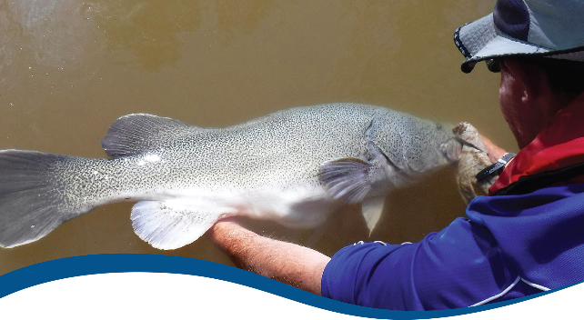

Basin-scale evaluation of
2019–20 Commonwealth environmental water: Fish
  - Commonwealth Environmental Water Office (CEWO):
Monitoring, Evaluation and Research Program

September 2021
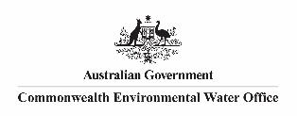

Citation
Hladyz S, Baumgartner L, Bice C, Butler G, Fanson B, Giatas G, Koster W, Lyon J, Stuart I, Thiem J, Tonkin, Z, Ye Q, Yen J and Zampatti B (2021) 2019-20 - Fish Evaluation Report - Final. Flow-MER Program. Commonwealth Environmental Water Office (CEWO): Monitoring, Evaluation and Research Program, Department of Agriculture, Water and the Environment, Australia. 106pp
Acknowledgements
The project team and the Commonwealth Environmental Water Office (CEWO) respectfully acknowledge the traditional owners of the land on which this work is conducted, their Elders past and present, their Nations of the Murray–Darling Basin, and their cultural, social, environmental, spiritual and economic connection to their lands and waters.
We acknowledge the development of the LTIM and Flow-MER project and experimental design by Rick Stoffels, Nick Bond, Carmel Pollino and Ben Gawne and more recent contributions from the LTIM Fish Basin Team Alison King, Luke McPhan, Nick Bond and Nikki Thurgate. We also thank the fish leads of the Selected Area Monitoring and Evaluation Providers who are not co-authors on this report but undertook all field work and data collation, data entry and management, technical input and Selected Area annual reports. These fish experts are: Ben Broadhurst, Daniel Wright and Nicole McCasker. We also thank Skye Wassens for her contributions regarding the Murrumbidgee watering actions table. We thank Martin Nolan for construction of the fish sampling sites map and associated tables. Sincere thanks to Shane Brooks and Julia Mynott for data management and quality assurance checks. We thank the Flow-MER Hydrology Basin Team, Enzo Guarino and Ashmita Sengupta for processing and verifying the CEWO-supplied hydrology data for use in the Basin evaluation.
The Fish Basin Team would also like to acknowledge Emily Barbour, Dianne Flett, Susan Cuddy, Jill Sharkey and Mary Webb for reviewing, proof reading, formatting and copy editing the report. Sincere thanks also to Irene Wegener, Mitchell Downey, Helen Owens, Anthony Moore, Raveen Ranawake, Daniel Wright, Nicole McCasker for reviewing and providing insightful comments that improved the report. Final thanks to Peter Davies for providing an expert independent review.
Copyright
 © Commonwealth of Australia 2021
With the exception of the Commonwealth Coat of Arms, partner logos and where otherwise noted, all material in this publication is provided under a Creative Commons Attribution 4.0 International Licence https://creativecommons.org/licenses/by/4.0/. The Flow-MER Program requests attribution as ‘© Commonwealth of Australia (Flow-MER Program, https://flow-mer.org.au)’.

Document submission history
3 July 2021 | Final draft
27 August 2021 | Final
27 September 2021 | Final with clarification revisions on pages 27, 50

Cover photograph
Releasing a Murray cod
Photo credit: Arthur Rylah Institute
Important disclaimer
The information contained in this publication comprises general statements based on scientific research. The reader is advised and needs to be aware that such information may be incomplete or unable to be used in any specific situation. No reliance or actions must therefore be made on that information without seeking prior expert professional, scientific and technical advice. To the extent permitted by law, the Flow-MER Program (including its partners and collaborators) excludes all liability to any person for any consequences, including but not limited to all losses, damages, costs, expenses and any other compensation, arising directly or indirectly from using this publication (in part or in whole) and any information or material contained in it.
The Flow-MER Program is committed to providing web-accessible content wherever possible. If you are having difficulties with accessing this document, please contact CEWOmonitoring@environment.gov.au

Overview of Flow-MER
Flow-MER is the Commonwealth Environmental Water Office’s (CEWO) Monitoring, Evaluation and Research Program. Its objective is to monitor and evaluate the ecological responses to the delivery of Commonwealth environmental water in the Murray–Darling Basin. It provides the CEWO with evidence to inform our understanding of how water for the environment is helping maintain, protect, and restore the ecosystems and native species across the Basin. This work will support environmental water managers, demonstrate outcomes, inform adaptive management and fulfil the legislative requirements associated with managing Commonwealth-owned environmental water.
The Program runs from 2019 to 2022 and consists of 2 components: monitoring and research in 7 Selected Areas (Selected Area projects); and Basin-scale evaluation and research (the Basin-scale project) (Figure 1). The Basin-scale project is led by CSIRO in partnership with the University of Canberra, and collaborating with Charles Sturt University, Deakin University, University of New England, South Australian Research and Development Institute, Arthur Rylah Institute, NSW Department of Planning, Industry and Environment, Australian River Restoration Centre and Brooks Ecology & Technology.
It builds on work undertaken through the Long Term Intervention Monitoring (LTIM) (2015–2019) and Environmental Water Knowledge and Research (EWKR) (2014–2019) projects.
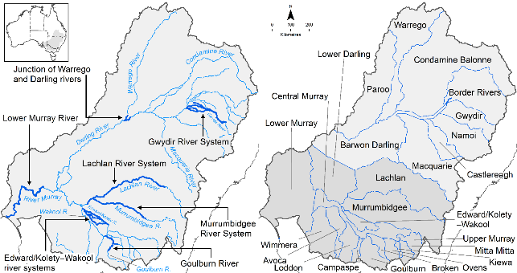
Figure 1 The 7 Selected Areas and 25 valleys established for long-term monitoring of the effects of environmental watering under the LTIM Project and Flow-MER Program (2014–15 to present)
The Flow-MER evaluation adopts an adaptive management framework to acknowledge the need for collectively building the information, networks, capacity and knowledge required to manage environmental water at Basin scale. While knowledge of ecological response to instream flow and inundation has advanced significantly in recent years, substantive challenges remain in understanding the similarities and differences in species’ response across time and space, as well as the interaction between species at a community and ecosystem scale.
The Basin-scale evaluation is being undertaken across 6 Basin Themes (Figure 2) based on ecological indicators developed for the LTIM Project and described in the Environmental Water Outcomes Framework. It is undertaken in conjunction with the Selected Area projects, which provide data, research and knowledge for ecological outcomes within the 7 Selected Areas. The Basin-scale evaluation integrates across Selected Areas, themes, datasets, approaches and different types of knowledge.
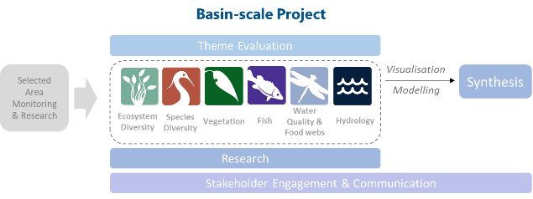
Figure 2 Basin-scale Project evaluation reports on Commonwealth environmental water outcomes for the 6 Basin Themes as well as a high-level Basin-scale synthesis
The evaluation is informed by Basin-scale research projects, stakeholder engagement and communication, including Indigenous engagement, visualisation and modelling, as well as the 7 Selected Area projects.

About the Basin-scale evaluation
Water delivery and outcomes data provided by CEWO is used in conjunction with monitoring data provided by the 7 Selected Areas and other publicly available data to undertake the Basin-scale evaluation. The research and evaluation content is structured into 6 disciplinary themes. Technical reports for each of the 6 themes are available from the CEWO website.
The evaluation aims to address theme specific questions in relation to how Commonwealth environmental water contributed to, supported, or influenced environmental outcomes. Commonwealth environmental water is often delivered in conjunction with other environmental water holdings, and non-environmental water releases (such as for irrigation or during high-flow events). The evaluation consequently draws on available information to estimate (where possible) the specific contribution of Commonwealth environmental water to particular environmental outcomes. The way in which this contribution is assessed varies between the 6 themes depending on the data and tools currently available:
- modelling to estimate and compare outcomes both with and without Commonwealth environmental water (counterfactual modelling) – Hydrology (instream); Fish (multi-year evaluation)
- identification of ecological response in locations that received Commonwealth environmental water (potentially in conjunction with other sources of environmental water or non-environmental water), and where feasible, comparison with areas that did not receive Commonwealth environmental water – Ecosystem Diversity, Species Diversity, Vegetation
- use of flow and water quality metrics to infer likely outcomes – Hydrology (inundation); Food Webs and Water Quality
- synthesis of findings across Selected Areas – Fish (annual); Vegetation; Food Webs and Water Quality.

Summary
Strategic management of Commonwealth environmental water by the Commonwealth Environmental Water Holder (CEWH) is key to achieving the Murray-Darling Basin Plan 2012 (Basin Plan) environmental objectives. The 3-year Basin-scale Flow-MER Project aims to demonstrate Basin-scale outcomes of Commonwealth environmental water; support adaptive management; and fulfil CEWH legislative requirements under the Basin Plan.
The evaluation presented here describes the fish outcomes (both native and introduced) from the use of Commonwealth environmental water for 2019–20 as well as the cumulative outcomes since monitoring began in 2014. In doing so, the evaluation considers the short-term (2019–20) and longer-term (2014–20) contribution of Commonwealth environmental water to answer the following evaluation question:
What did Commonwealth environmental water contribute to sustaining native fish at the Basin-scale?
The approach to the annual 2019–20 evaluation consists of 2 parts:
- a summary of Commonwealth environmental watering actions for expected fish outcomes across all regions/assets
- a synthesis of 2019–20 Selected Area findings to report on trends and variations to support basin-scale understanding of the influence of Commonwealth environmental watering actions across the Selected Areas.
The longer-term 6-year (2014–15 to 2019–20) evaluation consisted of both qualitative data exploration and quantitative analysis of the 2014–20 fish monitoring data. This is a novel analysis that has been developed for the purpose of this year’s evaluation and will be extended to the annual evaluation for the 2020–21 water year. To determine the Commonwealth environmental water contribution to fish populations, quantitative models were developed using the observed fish response to flows collected from the 6 years of monitoring data in 6 Selected Areas. Predictive models informed by the observed fish responses were then developed to separate the effects of Commonwealth environmental water from the effects of background hydrological variability using flow scenarios with and without Commonwealth environmental water. These models provide information on how fish population dynamics would have changed had Commonwealth environmental water not been delivered into a river system across the Selected Areas and support our attempts to quantify the contribution that Commonwealth environmental water makes to key fish outcomes.
The evaluation is based on fish data collected under the Long-Term Intervention Monitoring project (2014–2019) and Flow-MER program (2020–present) from riverine systems within the Basin Selected Areas. The evaluation is used to assess the contribution of Commonwealth environmental water to Basin Plan objectives for native fish and identify adaptive management opportunities for fish.

Water year 2019–20
- A total of 1,081 GL of Commonwealth environmental water contributed to the 64 Commonwealth environmental watering actions with specified expected outcomes for fish. In this climatically and hydrologically dry year, freshes characterised most water deliveries in riverine channels (30% of actions), followed by base flows (23% of actions), bankfull flows (2% of actions) and overbank flows (3% of actions). A total of 1,002 GL of Commonwealth environmental water was delivered to riverine channels (93% by volume). The main functional flow objectives of these watering actions were focused on enhancing native fish populations by improving habitat and providing cues for movement.
- In addition, Commonwealth environmental water deliveries (36% of actions) enabled wetland inundation, which was achieved by artificial pumping and via natural connections. The remaining watering actions supported both wetland and instream flow components (6% of actions). A total of 79 GL of Commonwealth environmental water was delivered to wetland systems (7% by volume). The main functional flow objectives for these watering actions were to enhance native fish populations by maintaining refuge habitat.
- There was continued recovery of Murray cod populations from the 2016–17 post-flood blackwater event, evidenced by increased adult abundances and/or successful recruitment in some Selected Areas (Goulburn River, Lachlan River System, Lower Murray River and the Edward/Kolety-Wakool river systems). Commonwealth environmental water contribution to Murray cod recruitment is unknown but contributions to natural spring pulses may increase the extent and duration of lotic habitat, potentially enhancing spawning habitat area and productivity, increasing survival of early life stages.
- Golden perch spawning and recruitment was limited, in most Selected Areas despite water delivery targeting this specific response. Nevertheless, there was evidence of golden perch spawning in the Murrumbidgee River and recruitment in the Warrego River. The Commonwealth environmental water contribution to these fish responses is unknown.
- Commonwealth environmental water flows facilitated hydrological connectivity and fish movement for several species at varying degrees, such as golden perch and pouched and short-headed lamprey. Wetland inundation with Commonwealth environmental water provided additional habitat for many small-bodied native fish such as Australian smelt and the nationally endangered Murray hardyhead.

Water years 2014–20
- Drought conditions were prevalent throughout 2014–20 and low flows dominated in all Selected Areas. Only one high flow event (overbank) occurred in 2016–17 and was recorded across most Selected Areas. This high-flow event was not Commonwealth environmental water but an unregulated natural flow event. This flow event led to post-flooding blackwater hypoxia and resulted in fish deaths across many of the Selected Areas (excluding Gwydir and Warrego-Darling rivers).
- During 2014–20, Commonwealth environmental water deliveries contributed primarily to increased baseflows and, to a lesser extent, small freshes in the Selected Areas. The delivery of Commonwealth environmental water contributed to hydrological variability in Selected Areas, which is a key driver of ecosystem processes that support native fish).
- The contributions of Commonwealth environmental water to large freshes and overbank flows were minimal in the Selected Areas. This is consistent with seeking to manage flows in a way which does not flood private land or damage infrastructure and reflective of the relatively small volumes of water available for environmental flows relative to the size of natural flows which connect to the floodplain. Absence of these types of functional flows in the flow regime constrains the fish outcomes across Selected Areas, as large freshes and overbank flows are important at enhancing native fish populations through the provision of increased habitat and food resources as well as cues for movement and spawning.
- In total, 13 native and 6 introduced species were detected during the 6-year monitoring program by in-channel ‘Category 1’ sampling of adult fish communities in the Selected Areas, which used standardised methods of electrofishing and fyke nets. The number of native species detected did not vary greatly among years. The number (min-max) of native species detected annually as adults was 8–9 in the Edward/Kolety-Wakool river systems, 7–9 in the Goulburn River, 8–9 in the Gwydir River System, 6–7 in the Lachlan River System, 8–11 in the Lower Murray River, and 7–9 in the Murrumbidgee River System.
- Golden perch, Murray cod, common carp, and carp gudgeons were most common within and among Selected Areas, whereas silver perch, unspecked hardyhead, freshwater catfish, and Australian smelt had patchier distributions.
- The counterfactual modelling which analysed the contribution of Commonwealth environmental water to fish response variables primarily tested the effects of baseflows and small freshes. These were the flow components most influenced by Commonwealth environmental water across the Selected Areas. Commonwealth environmental water contributions to large freshes were limited. Overbank flows were therefore excluded from analysis, as the proportion of overbank flows rarely differed between the observed (with Commonwealth environmental water) and counterfactuals (without Commonwealth environmental water) scenarios.
- Counterfactual modelling demonstrated that Commonwealth environmental water benefited several fish species and population processes by the provision of base flows. It also improved fish body condition by the provision of freshes. These findings are consistent with the expected outcomes for fish identified by the Commonwealth Environmental Water Office (CEWO) (e.g. improved condition, recruitment) for Commonwealth environmental watering actions across the Basin in 2019–20. There is considerable uncertainty in our conclusions. Only 6 years of condition monitoring data, and limited flow variability within the 6-years at the Selected Areas, has made it difficult to quantify specific fish responses to Commonwealth environmental water with high levels of confidence. Furthermore, there is additional uncertainty when modelling the effects of flow on fish and then extrapolating to a no-Commonwealth environmental water scenario.
- Spawning of Golden perch was limited but, when it occurred (presence/absence of larval fish), it was positively associated with the occurrence of consistent baseflows and large freshes. Counterfactual modelling indicated that spawning was more likely with Commonwealth environmental water, though findings differed greatly across Selected Areas and years. This result was driven primarily by the delivery of sustained baseflows given limited Commonwealth environmental water contributions to large freshes. Overall, few spawning events were detected for this flow-cued spawning fish at sites within Selected Areas, which may reflect the prevailing drought conditions, low flows during the monitoring program and/ or limited Commonwealth environmental water contributions to large freshes and overbank flows.
- Counterfactual modelling allows us to assess the effects of Commonwealth environmental water compared to a situation where this water was not available for management. Comparisons between the data and models without environmental water showed:
  - Positive effects on recruitment of Australian smelt (i.e. fish <40 mm) in some years at all Selected Areas, primarily due to the provision of small freshes.
  - Positive effect on individual body condition in golden perch, Murray cod, and common carp, due primarily to the provision of small freshes which may increase connectivity and therefore access to habitat and food resources.
  - Negative effect on abundance of adult common carp, although these findings differed among Selected Areas and years. In the Lower Murray and Goulburn rivers adult carp abundance was lower than predicted if environmental flows had not been provided. However, our findings suggest that Commonwealth environmental water may have improved common carp body condition.

Key contributions to Basin Plan objectives
Commonwealth environmental water has a critical role to play in meeting long-term objectives to protect and restore biodiversity that is dependent on Basin water resources (Basin Plan s8.05(3a, 3b)). The Basin-wide environmental watering strategy (MDBA 2020) (the Strategy) underpins and adds specificity to the biodiversity outcomes of the Basin Plan. The Strategy lists 5 ‘Expected Outcomes’ for fish to be achieved by 2024. Flow-MER evaluated 2 key species identified by the Strategy – golden perch and Murray Cod. We address 2 of the Strategy’s expected outcomes in this evaluation:
- ‘no loss of native species currently present within the Basin’ (MDBA 2020, p49)
  - No loss of native species was evident in the Selected Areas with 13 native fish species detected consistently over the monitoring period (2014–20).
- ‘improved population structure of key fish species through regular recruitment’ (MDBA 2020, p49)
  - There was evidence of golden perch spawning over the monitoring period, although recruitment (i.e. fish <75 mm) was minimal at most Selected Areas. Given golden perch recruitment is often associated with major flows or flood events, these findings may be indicative of the prevalent low flows and drought conditions and/or the limited Commonwealth environmental water contribution to large freshes and overbank flows at the Selected Areas. Golden perch have spatially and temporally episodic recruitment patterns so there were likely recruitment events in other areas of the Basin. Murray cod spawning and recruitment (i.e. fish <220 mm) occurred most years in the Selected Areas. The 2016–17 Murray River blackwater event and associated fish death events had an adverse impact on Murray cod populations with marked reductions in recruits and adults in some Selected Areas. Murray cod populations continue to recover from these blackwater events, with evidence of high recruitment relative to other years in most Selected Areas in 2020.

Key adaptive management outcomes
- The results for each reporting period should be considered in the context of antecedent flows. Base flows were low in all years during 2014-20, except in 2016-17. The majority of the evaluation results consequently provide guidance for the expected benefits from Commonwealth environmental water during low baseflow periods.
- The contribution of Commonwealth environmental water to baseflows supported a range of different processes such as juvenile survival, fish body condition and population growth for Murray cod, golden perch, Australian smelt and bony herring. The benefits of baseflows are also likely important in the context of extended drought. Our findings suggest that delivery of seasonal baseflows can be critical, especially for systems such as the Edward/Kolety-Wakool, where Commonwealth environmental water contributions to continuous baseflows, maintained connectivity and water quality, which are important for supporting fish communities.
- Small freshes delivered by Commonwealth environmental water improved body condition for several fish species in the Selected Areas, including Murray cod, golden perch and the introduced common carp. These findings suggest that delivery of freshes can improve the health of individual fishes, which is expected to improve fish spawning and recruitment and support population persistence. This is critical for building population resilience during low flow periods. There was, however, less information on fish responses to large fresh events and overbank flows, as these were rarely delivered during the monitoring period.
- Extrapolation of trends beyond Selected Areas is currently limited due to the small number of replicate flow years, limited flow variation in flow types among sites and the low abundance of many native fish species. This consequently reduces the degree of confidence in reporting on broader Basin-scale outcomes though Flow-MER research is addressing this gap for unmonitored areas. There is a need to further investigate flow-spawning relationships by conducting further event-based monitoring.
- Addition of new Selected Area sites within the fish monitoring program may assist in determining if trends observed at Selected Areas are representative of the broader Basin.

Contents
Overview of Flow-MER i
About the Basin-scale evaluation ii
Summary iii
Water year 2019–20 iii
Water years 2014–20 iv
Key contributions to Basin Plan objectives vi
Key adaptive management outcomes vi
1 Introduction 1
1.1 Evaluation objectives 2
1.2 Aims for the 2021 evaluation report 4
2 Approach 5
2.1 Evaluation method 5
2.2 Data and metrics 7
2.3 Data analysis 11
3 Basin-scale evaluation 2019–20 15
3.1 Climate and hydrological context 15
3.2 Commonwealth environmental watering actions for fish 16
3.3 Contribution of Commonwealth environmental water to sustaining native fish 17
4 Basin-scale longer-term evaluation 2014–20 20
4.1 Climate and hydrological context 20
4.2 Contribution of Commonwealth environmental water to sustaining native fish 22
5 Contribution to Basin Plan objectives 55
6 Adaptive management 58
6.1 Refining environmental flow management 58
6.2 Monitoring recommendations 58
Appendix A Summary of Commonwealth environmental water actions for fish within Selected Areas 61
Appendix B MDMS data used for evaluation 73
Appendix C Standardised counts of fish species across Selected Areas 74
Appendix D Statistical analyses 76
Appendix E Discharge details 83
References 85

Figures
Figure 1 The 7 Selected Areas and 25 valleys established for long-term monitoring of the effects of environmental watering under the LTIM Project and Flow-MER Program (2014–15 to present) i
Figure 2 Basin-scale Project evaluation reports on Commonwealth environmental water outcomes for the 6 Basin Themes as well as a high-level Basin-scale synthesis ii
Figure 1.1 Map of the Murray–Darling Basin showing the location of the 6 Selected Areas focusing on fish response to flows (Category 1 sites) and extent of Commonwealth environmental water deliveries to Selected Areas in 2019–20 2
Figure 3.1 Rainfall conditions (from lowest to highest on record) experienced in the Basin during the 2019–20 watering year 15
Figure 3.2 Commonwealth environmental watering actions in 2019–20 with expected outcomes for fish 16
Figure 3.3 Flow components of Commonwealth environmental watering actions in 2019–20 with expected outcomes for fish 17
Figure 4.1 Maps of annual rainfall conditions, 2014–20). The 2019-20 map is shown in detail in Figure 3.1 20
Figure 4.2 Mean flow metrics + SD (proportion of time flows were in the base flow, small and large freshes and overbank flow bands, and discharge variability values) among water years: Jun-Jul (for flow metrics associated with adult fish), Sep-Mar (for flow metrics associated with larval fish) and Jan-Jun (for flow metrics associated with recruitment) observed/modelled across 6 Selected Areas 21
Figure 4.3 Magnitude of Commonwealth environmental water effects on flow metrics (small panels) and on fish responses (larger panels) in each Selected Area 25
Figure 4.4 Abundance (catch per hour of electro fishing) of 7 large-bodied native fish species in each Selected Area for each year, 2014–20 29
Figure 4.5 Heat map of the proportion of sites at which a species occurs within each Selected Area for 7 native and 2 introduced large-bodied fish species for each year, 2014–20 30
Figure 4.6 Mean abundance (catch per hour of net soak) of 6 small-bodied native fish species at each Selected Area for each year, 2014–20 31
Figure 4.7 Heat maps of the proportion of sites at which a species occurs within a Selected Area for 5 native and 1 introduced small-bodied fish species at each Selected Area for each year, 2014–20 32
Figure 4.8 Mean abundance (catch per hour of electro fishing) of 5 introduced fish species at each Selected Area for each year, 2014–20 33
Figure 4.9 Effect (percentage change) of 4 observed to flow variables (base flow, change over 72 hours, large fresh, small fresh) on population growth rate for each of the 7 focal species 34
Figure 4.10 Predicted percentage change in population growth rate with the addition of Commonwealth environmental water for each species, year, and Selected Area 35
Figure 4.11 Contribution of each flow variable (base flow, change over 72 hours, large fresh, small fresh) to the predicted Commonwealth environmental water effect on population growth rate of the 7 focal species for each Selected Area 36
Figure 4.12 Length-frequency histogram of golden perch by Selected Area and water year 37
Figure 4.13 Length-frequency histogram of Murray cod by Selected Area and water year 38
Figure 4.14 Recruitment strength estimates for bony herring, Murray cod and golden perch across 6 Selected Areas 40
Figure 4.15 Effect of each flow variable on recruit CPUE for each species 41
Figure 4.16 Predicted percentage change in recruitment due to Commonwealth environmental water for each species (except Australian smelt; shown below), year, and Selected Area 42
Figure 4.17 Predicted percentage change in recruitment of Australian smelt due to Commonwealth environmental water in each year and Selected Area 42
Figure 4.18 Contribution of each flow variable (base flow, change over 72 hours, large fresh, small fresh) to the predicted Commonwealth environmental water effect on recruitment of Australian smelt, carp gudgeon, common carp and eastern gambusia over the 2014–20 water years 43
Figure 4.19 Ordination (nMDS) of large-bodied fish assemblages for each Selected Area and each water year 44
Figure 4.20 Ordination (nMDS) of small-bodied fish assemblages for each Selected Area and water year 45
Figure 4.21 Mean larval abundance (no. of larval fish captured per drift net/1000 m³) of large-bodied native fish species in each Selected Area over the 2014–20 water years 46
Figure 4.22 Mean larval abundance (no. of larval fish captured per light trap/24-hour period) of small-bodied native fish species in each Selected Area over the 2014–20 water years 47
Figure 4.23 Effect of each flow variable (base flow, change over 72 hours, large fresh, small fresh) on spawning occurrence of silver perch and golden perch on the logit scale 49
Figure 4.24 Predicted change (logit scale) in the occurrence of spawning of golden perch and silver perch due to Commonwealth environmental water in 5 Selected Areas over the 2014–20 water years 49
Figure 4.25 Contribution of 4 flow variables (base flow, change over 72 hours, large fresh, small fresh) to the predicted Commonwealth environmental water effect on spawning occurrence over the 2014–20 water years 50
Figure 4.26 Proportion of sites with spawning events in the 5 Selected Areas for each water year 50
Figure 4.27 Effect (as percentage change) of 3 flow variables (days increasing, 7 day median, 7 day range) on larval abundance for silver perch and golden perch 51
Figure 4.28 Predicted percentage change in larval abundance due to Commonwealth environmental water for each species, water year, and Selected Area 52
Figure 4.29 Contribution of 3 flow variables to the predicted Commonwealth environmental water effect on larval abundance 52
Figure 4.30 Effect of 4 flow variables (base flow, change over 72 hours, large fresh, small fresh) on body condition for Murray cod, golden perch, common carp, bony herring 53
Figure 4.31 Predicted effect of Commonwealth environmental water on body condition of Bony herring, common carp, golden perch, Murray cod in the 6 Selected Areas over the 2014–20 water years 54
Figure 4.32 Contribution of 4 flow variables (base flow, change over 72 hours, large fresh, small fresh) to the predicted Commonwealth environmental water effect on body condition of bony herring, common carp, golden perch, Murray cod 54

Figure C.1 Heat maps of standardised counts of 9 large-bodied fish species at each Selected Area for each water year 74
Figure C.2 Heat maps of standardised counts of 6 small-bodied fish species at each Selected Area for each water year 75
Figure D.1 Length-frequency histogram of bony herring by Selected Area and water year 78
Figure D.2 Length-frequency histogram of common carp by Selected Area and water year 79
Figure D.3 Length-frequency histogram of carp gudgeon by Selected Area and water year 80
Figure D.4 Length-frequency histogram of Australian smelt by Selected Area and water year 81
Figure D.5 Length-frequency histogram of eastern gambusia by Selected Areas and water year 82
Figure E.1 Mean daily discharge (ML day⁻¹) for key gauged sites in each Selected Area in 2014–20 showing observed discharge with Commonwealth environmental water and modelled discharge without CEW 83
Figure E.2 Mean daily discharge (ML day⁻¹ on log scale ) for key gauged sites in each Selected Area in 2014–20 showing observed discharge with Commonwealth environmental water and modelled discharge without CEW 84

Tables
Table 2.1 Fish species collected in Flow-MER adult fish population surveys using Category 1 methods across all Selected Areas between 2014-2020 6
Table 2.2 Description of annual discharge metrics and other descriptive metrics for use in analyses. Timing refers to specific periods within which metrics are calculated and are specific to each response variable 9
Table 2.3 Streamflow gauges and discharge thresholds for each Selected Area 10
Table 2.4 Description of event-based discharge metrics and other descriptive metrics for use in larval analyses 10
Table 2.5 Reported fish death events or hypoxia events at the Selected Areas 11
Table 2.6 Summary of statistical analyses: model description, relevant species and response variables, grouped by objective 13
Table 2.7 Confidence categories for statistical analyses 14
Table 4.1 Contribution of Commonwealth environmental water to native fish population persistence at Selected Areas averaged over 2014-20 23
Table 4.2 Number of native species recorded from Category 1 fish sampling in each Selected Area for each year, 2014–2020 29

Table A.1 Summary of 2019–20 Commonwealth environmental watering actions with expected outcomes for fish, reported by valley 61
Table A.2 Estimate of the effect of Commonwealth environmental water (Commonwealth environmental water effect) on population processes for each focal species 62
Table A.3 Summary of results from monitored watering actions with expected outcomes for fish in 2019–20 at Flow-MER Selected Areas 70
Table B.1 Summary of data from the MDMS used for evaluation analyses. Further details on evaluation analyses please refer to Fanson 2021 73
Table D.1 Terms and variables used in the model structure 76
Table D.2 Summary of statistical analyses: model type, relevant species and response variables, grouped by objective (expansion of Table 2.6) 77

Abbreviations, acronyms and terms
Term | Description
ANAE | Australian National Aquatic Ecosystem
Basin Plan | The (Murray-Darling) Basin Plan, enacted under the Water Act 2007
CEWH | Commonwealth Environmental Water Holder
CEWO | Commonwealth Environmental Water Office
cohort | The birth year of an individual fish
condition | Fulton body condition factor a metric calculated from individual fish length-weight to indicate the health of a fish
CPUE | Catch per unit effort
DELWP | (Victorian) Department of Environment, Land, Water and Planning
DPIE | (NSW) Department of Planning, Industry and Environment
EWKR | Environmental Water Knowledge and Research Project (2014–19)
Flow-MER | The CEWO Monitoring, Evaluation and Research Program (2019–22)
Fulton’s K | A metric to compare fish populations
hypoxia | Low oxygen in the water coincides with blackwater events and can lead to fish deaths
lotic | Rapidly moving fresh water
LTIM | Long-Term Intervention Monitoring Project (2015–19)
MDBA | Murray–Darling Basin Authority
MDMS | Monitoring Data Management System
MER | Monitoring, Evaluation and Research Program (2019–22)
nMDS | Non-metric multi-dimensional scaling
otolith | Inner ear bone used to determine the age of fish
SARDI | South Australian Research and Development Institute
SD | Standard deviation
SE | Standard error (e.g. ±1SE)
the Basin | Shortened term for the (Murray-Darling) Basin
the Strategy | Shortened term for the Basin-wide environmental watering strategy (MDBA 2019, 2020)
VEFMAP | Victorian Environmental Flows Monitoring and Assessment Program
VEWH | Victorian Environmental Water Holder

Introduction
Native fish in the Murray–Darling Basin (the Basin) contribute significantly to ecological, social, cultural and economic values (MDBA 2020). However, native fish populations have declined substantially in the last 50–100 years (Lintermans 2007). In the Basin, fish declines have been attributed to multiple causes such as altered flow regimes, barriers to fish movement, the introduction of alien species and for some fishery species overfishing (Koehn et al. 2020). One of the major threats to native fish populations is alteration to natural hydrology (i.e. discharge volume and distribution changes altered seasonality) and hydraulic regimes (i.e. changes to water velocity, depth, turbulence); together these are known hereafter as the ‘flow’ regime (Mallen-Cooper and Zampatti 2018; Thompson et al. 2018). The Basin is recognised as one of the worlds most regulated river basins (Nilsson et al. 2005). Alterations to natural flow regimes have resulted in major changes to riverine ecosystems, including changes to the magnitude, timing, frequency and duration of flows and major changes to hydraulics, often causing loss of lotic (flowing) habitats (Poff et al. 1997; Bunn and Arthington 2002).
Many of the critical life-history processes for fish (e.g. pre-spawning condition and maturation, spawning cues and movements, larval and juvenile dispersal, growth and survival) are intrinsically linked either directly or indirectly, to the flow regime (Stoffels et al. 2016; Mallen-Cooper and Zampatti 2018; Tonkin et al. 2019; Koehn et al. 2020; Tonkin et al. 2021). In the Basin, the delivery of environmental water is a key approach for sustaining and restoring native fish populations and supporting critical life-history processes (MDBA 2020; Stuart et al. 2019; Tonkin et al. 2020). Evaluating these life-history processes can help understand the benefits of environmental flows for native fish to achieve the biodiversity outcomes sought by the (Murray–Darling) Basin Plan and Basin-wide environmental watering strategy (Commonwealth of Australia, Basin Plan 2012; MDBA 2019, 2020).
For the Basin-scale evaluation this report uses fish data collected in 6 Selected Areas: the Edward/Kolety-Wakool river systems, Goulburn River, Gwydir River System, Lachlan River System, Lower Murray River and Murrumbidgee River System (Figure 1.1). Fish are a target indicator for reporting in 6 Selected Areas. The seventh Selected Area located at the junction of the Warrego and Darling rivers does not have a designated targeted indicator for fish and historically has not been included in Basin-scale analyses. Preliminary investigations into the feasibility of incorporating these fish data from the junction of the Warrego and Darling rivers, into the Basin-scale analysis were made, but due to differences in field collection methods and data inconsistencies this was unable to be performed for the current report. General fish outcomes are still reported for this Selected Area.
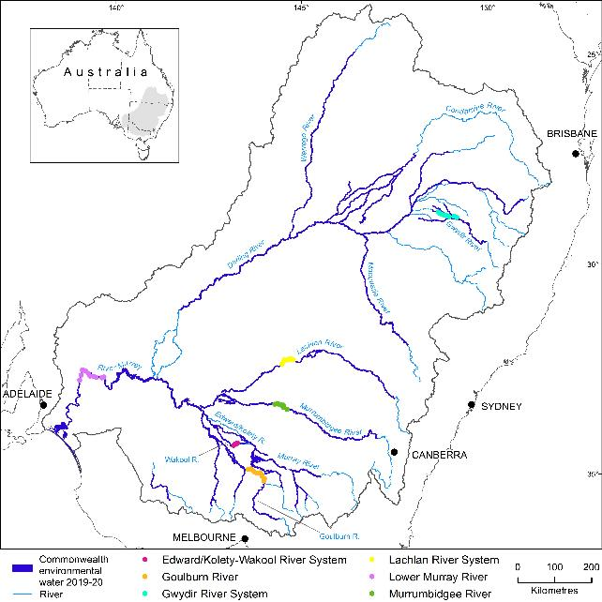
Figure 1.1 Map of the Murray–Darling Basin showing the location of the 6 Selected Areas focusing on fish response to flows (Category 1 sites) and extent of Commonwealth environmental water deliveries to Selected Areas in 2019–20

Evaluation objectives
The key Flow-MER evaluation question for fish was:
What did Commonwealth environmental water contribute to sustaining native fish at the Basin-scale?
The evaluation presented here describes the fish outcomes from the use of Commonwealth environmental water for 2019–20 as well as the cumulative outcomes since monitoring began in 2014. In doing so, the evaluation considers the short-term (2019–20) and longer-term (2014–20) contribution of Commonwealth environmental water to answer the evaluation question. The approach to the annual 2019–20 evaluation consists of 2 parts: firstly a summary of Commonwealth environmental watering actions for expected fish outcomes across all regions/assets; and secondly a synthesis of 2019–20 Selected Area findings to report on trends and variations to support basin-scale understanding of the influence of Commonwealth environmental watering actions across the Selected Areas. The longer-term 6-year (2014–15 to 2019–20) evaluation consisted of both qualitative data exploration and quantitative analysis of the 2014–20 fish monitoring data. This involved a novel analysis that has been developed for the purpose of this year’s evaluation and will be extended to the annual evaluation for the 2020–21 water year. The approach to the longer-term evaluation follows the strategy developed from the Foundation Report (King 2019) and applied in the previous annual evaluation report (King et al. 2020) as summarised below.
To determine the Commonwealth environmental water contribution to fish populations, quantitative models were developed using the observed fish response to flows based on the data collected from the 6 years of monitoring in the 6 Selected Areas. This approach used data for the models in relation to local flows in the river system, and environmental conditions that fish populations encounter across Selected Areas. Predictive models informed by the observed fish responses were then developed to separate the effects of Commonwealth environmental water from the effects of background hydrological variability using flow scenarios with and without Commonwealth environmental water. These models provide information on how fish population dynamics would have changed had Commonwealth environmental water not been delivered into a river system (the ‘counterfactual’ scenario). These findings then supported the evaluation of what Commonwealth environmental water achieved across Selected Areas. It must be noted that for the evaluation analysis, the entire Northern Basin fish community is thus only represented by results from the Gwydir River System.
The CEWO also requires information on what Commonwealth environmental water achieved outside of the Selected Areas and how this information can inform future Commonwealth environmental water management and delivery. This addresses the longer-term goals of being able to predict fish response in unmonitored areas and to hypothesised flow scenarios (King 2019; King et al. 2020). Extrapolating fish response from Selected Areas to unmonitored areas and hypothesised flow scenarios has presented a challenge over the duration of LTIM and Flow-MER.
This challenge is being investigated within the Flow-MER research program through research (Fish population models and Fish movement projects) which investigate regional and Basin-scale fish responses to variable hydrology. For the current evaluation, building predictive Basin-scale fish population models has been hampered by several technical and conceptual limitations. These include the small number of replicate flow years (6), non-random selection of the location of the Selected Areas, limited flow variability among years and Selected Areas for the duration of LTIM and Flow-MER, other confounding modifiers of population dynamics (e.g. fish stocking and recreational fishing) and low abundances of many native fish species. These make it difficult to estimate responses to Commonwealth environmental water under higher flows (King 2019; King et al. 2020). These limitations result in low confidence in any extrapolations beyond the Selected Areas. A key requirement would be monitoring or at least single surveys in some of these unmonitored areas to validate model predictions (for further discussion see 6.2).
Development of predictive quantitative fish population models for unmonitored areas and hypothesised flow scenarios should still be a longer-term goal of the annual fish evaluation; however, for the present report, the building of species population models for unmonitored areas and hypothesised flow scenarios is not yet achievable. In future years, the evaluation may incorporate other data sets (e.g. state agency data, other long-term Commonwealth data) or new monitoring sites to provide broader scale reporting to determine if trends observed at Selected Areas are representative of the broader Basin.
Flow-MER research (Projects F1: Fish population models and F2: Fish movement) is running concurrently and will be the main avenue for reporting on unmonitored areas via: (i) population modelling, (ii) otolith microchemistry and, (iii) acoustic fish tracking data. The research program aims to report at a whole of Basin-scale. The modelling underpinning these research initiatives aims to contextualise and allow transferability of analyses of environmental flow benefits for native fish populations across the Basin. Any general patterns or conclusions that apply at a Basin-scale are discussed in this Basin-scale evaluation.
In summary, the current 2019–20 Basin-scale evaluation aimed to:
- determine the influence of flow events and flow regimes, on measures of fish population persistence (spawning success, recruitment strength, population structure, fish condition) and community diversity in all Selected Areas
- determine the contribution of Commonwealth environmental water to the observed fish population response.

Aims for the 2021 evaluation report
The focus for the 2021 Basin-scale evaluation was to present and analyse fish data collected in all 6 Selected Areas in the first 6 years of the program using a revised analytical approach to determine the influence of Commonwealth environmental water (and more broadly flows and flow regimes) on fish population persistence. This analysis included reviewing hydrological and fish metrics to identify the most ecologically sensitive and meaningful flow-ecology relationships, informed by watering plans and objectives (e.g. VEWH 2020) and similar analyses such as the Victorian Environmental Flows Monitoring and Assessment Program (VEFMAP) and recent published literature (Stuart et al. 2019; Tonkin et al. 2019; Tonkin et al. 2020; Stoffels et al. 2020; Koster et al. 2021; Tonkin et al. 2021).
A secondary objective was to include fish data that had not been presented or analysed in the previous annual evaluation report (King et al. 2020) (due to validated data being unavailable) to provide new insights into the Basin-scale evaluation. This included the 2020 monitoring data; individual fish weights (to calculate body condition); estimated ages from otolith-derived information collected in previous years for a subset of species (to calculate year-class strength); and an ordination analysis of multi-species fish community structure.

Approach

Evaluation method

Water year 2019–20
The approach to the annual 2019–20 evaluation consisted of 2 parts: firstly, a summary of Commonwealth environmental watering actions for expected fish outcomes across all regions/assets; and secondly a synthesis of 2019–20 Selected Area findings to report on trends and variations to support basin-scale understanding of the influence of Commonwealth environmental watering actions across the Selected Areas. Annual Selected Area reports should be consulted for more details on field methods and findings on Selected Area monitoring (see references compiled in Table A.3). Reference to separate Commonwealth environmental water related research or other contemporary research is also made to assist in providing context to the Selected Area monitoring.
The summary of Commonwealth environmental watering actions for expected fish outcomes was compiled from the 2019-20 CEWO water use summary table. The targeted expected fish outcomes were categorised using 8 keywords which included condition, diversity, habitat, movement, recruitment, refuge, spawning and species (targeted species). Many watering actions had multiple expected outcomes, and exclusive and multiple outcomes were all included in a data visualisation.
Expected fish outcomes were also categorised into targeted flow components which included baseflows, freshes, bankfull, overbank, and wetland. In riverine systems 8 watering actions were listed as a combination of two or three flow components (e.g. baseflow, freshes, bankfull). In these instances, the highest target flow component for each watering action was used. For example, a watering action that included both baseflows and freshes was classified into the freshes category. Four watering actions included both wetland and instream flow components in these instances expected fish outcomes were included in both flow component categories. This information was summarised as a data visualisation.

Water years 2014–20
The rationale underlying the experimental design for the evaluation, including initial conceptual models linking generic and species-specific fish responses to flows is provided in the LTIM foundation report Stoffels et al. (2016). Briefly, the foundation report covers why fish should be included in the monitoring program, key evaluation questions, ecological concepts that underpin fish and flow ecology and justification for the prescribed monitoring approach for fish (Stoffels et al. 2016). The method used to monitor fish at Basin and Selected Area scales is described in Hale et al. (2014). There are 3 categories of methodology used in this monitoring program. Category 1 methods are standardised methods implemented across all 6 Selected Areas with an annual fish condition monitoring focus. Data generated from Category 1 methods are used for Basin-scale analyses of fish population trends and responses to flow management. These include boat and backpack electrofishing and fine-mesh fyke net to survey adult fish communities. Category 2 methods are standardised methods implemented across a subset of the Selected Areas used to inform Selected Area scale evaluation of flow impacts. These include methods to study fish movement with the use of hydroacoustic tags to detect movements of target species. Category 3 methods are not standardised across Selected Areas but are specific methods used within Selected Areas to inform Selected Area scale evaluation questions. Examples include a fish spawning study within the Edward/Kolety-Wakool River which uses drift nets and light traps and the collection of fish otoliths to determine movement history of target fish species in the Lower Murray, Edward/Kolety-Wakool River System and the Goulburn River. In some instances, Category 3 methods are similar to Category 1 methods and can be used for Basin-scale analyses (e.g. larval sampling monitoring).
Adult fish populations are monitored annually in autumn at fixed sites within the 6 Selected Areas using a standardised sampling regime (Category 1 methods). Large-bodied fish species are sampled using boat or backpack electrofishing whereas small-bodied fish species are sampled using fine mesh fyke nets (Table 2.1). Electrofishing efficiencies were not standardised among sites, and the analyses assumed equal detectability in all surveys which may limit our findings (Davies et al. 2010). Data recorded for all captured fish species included length and weight measurements, abundance and diversity. Fish were released back into the water after measurement.
Spawning was monitored during the key spawning period (spring-summer) for most species at 5 Selected Areas (Edward/Kolety-Wakool river systems, Goulburn River, Lachlan River System, Murrumbidgee River System and Lower Murray River). Spawning, as measured by the presence of fish larvae, was not explicitly monitored in the Lower Murray, though larval fish sampling was conducted as a component of a Category 3 golden perch recruitment project and larval data from all species was collected from 2014–15 and 2018–19. Spawning was measured by collecting eggs and fish larvae using drift nets, towed nets in the Lower Murray River and light traps. Sampling approaches differed in intensity and methods across the Selected Areas, therefore different sampling methodologies were combined to analyse fish spawning and different methods were deemed equivalent for analyses (Category 1 and 3 methods).
Fish movement and fish occurrence (Category 2 and 3 methods) were also monitored on floodplain habitats at some Selected Areas. These data can be found within relevant annual Selected Area reports and are excluded in the Basin-scale analysis of fish response.
Information on all fish species captured in Flow-MER (Table 2.1) is provided in this report, however more detailed analysis mainly concerns 7 focal fish species identified by Flow-MER. These species are Australian smelt, bony herring, carp gudgeon, common carp (introduced), eastern gambusia (introduced), golden perch, Murray cod. These species represent a range of life history strategies/guilds, are common as adults and larvae in the Selected Areas and across the Basin, represent both native and introduced species and they respond to flows (Hale et al. 2014; King et al. 2020).
The cumulative 2014–20 evaluation consisted of both qualitative data exploration and quantitative analysis of the 2014–20 fish monitoring data. In addition, where appropriate, reference to separate Commonwealth environmental water or other contemporary research provides context for Selected Area monitoring.
Table 2.1 Fish species collected in Flow-MER adult fish population surveys using Category 1 methods across all Selected Areas between 2014-2020
Alpha (^{α}) denotes focal fish species as identified by Flow-MER; Asterisk (*) denotes key freshwater species as identified by the Strategy excluding estuarine species (MDBA 2020)
Common name | Species name | Introduced/Native | Body size | Detected in Flow-MER | Collection method
Australian smeltα | Retropinna semoni | native | small | Y | fyke net
bony herringα | Nematalosa erebi | native | large | Y | electrofishing
carp gudgeonα | Hypseleotris spp | native | small | Y | fyke net
common carpα | Cyprinus carpio | introduced | large | Y | electrofishing
dwarf flathead gudgeon | Philypnodon macrostomus | native | small | Y | fyke net
eastern gambusiaα | Gambusia holbrooki | introduced | small | Y | fyke net
flathead galaxias* | Galaxias rostratus | native | small | N | -
flathead gudgeon | Philypnodon grandiceps | native | small | Y | fyke net
freshwater catfish* | Tandanus tandanus | native | large | Y | electrofishing
golden perch^{α}* | Macquaria ambigua | native | large | Y | electrofishing
goldfish | Carassius auratus | introduced | large | Y | electrofishing
Hyrtl’s tandan* | Neosilurus hyrtlii | native | large | N | -
Macquarie perch* | Macquaria australasica | introduced | large | N | -
Murray cod ^{α}* | Maccullochella peelii | native | large | Y | electrofishing
Murray hardyhead* | Craterocephalus fluviatilis | native | small | N | -
Murray river rainbowfish | Melanotaenia fluviatilis | native | small | Y | fyke net
Northern river blackfish* | Gadopsis marmoratus | native | large | N | -
olive perchlet* | Ambassis agassizii | native | small | N | -
oriental weatherloach | Misgurnus anguillicaudatus | introduced | large | Y | electrofishing
redfin perch | Perca fluviatilis | introduced | large | Y | electrofishing
Rendahl’s tandan* | Porochilus rendahli | native | small | N | -
river blackfish* | Gadopsis marmoratus | native | large | N | -
silver perch* | Bidyanus bidyanus | native | large | Y | electrofishing
southern purple- spotted gudgeon* | Mogurnda adspersa | native | small | N | -
southern pygmy perch* | Nannoperca australis | native | small | N | -
spangled perch | Leiopotherapon unicolor | native | large | Y | electrofishing
trout cod* | Maccullochella macquariensis | native | large | Y | electrofishing
two-spined blackfish* | Gadopsis bispinosus | native | small | N | -
unspecked hardyhead | Craterocephalus stercusmuscarum fulvus | native | small | Y | fyke net
Yarra pygmy perch* | Nannoperca obscura | native | small | N | -

Data and metrics

Fish data
Fish data were entered by Selected Area teams into the Monitoring Data Management System (MDMS). Data were checked by the MDMS database managers for quality assurance and quality control and then sent out for final approval to Selected Area teams. After this, a final review was undertaken for any errors or inconsistencies in the data before analysis. The final data used in this report were downloaded on 23 February 2021. All data were entered and analysed at the lowest level of replication available. Monitoring data collected in all 6 years at each Selected Area include, for each species, collected fish catch per electrofishing sample, fish catch per fyke net sample, fish length for each sampling method, fish weight for each sampling method, larval catch per drift net sample, larval catch per light trap sample and estimated age of a small subset individuals (age was estimated from sectioned otoliths for a limited number of species to construct age-length relationships). For detail on MDMS data that was used in the evaluation analyses see Table B.1.

Hydrological data and other data used
Observed hydrological data were collected from gauged sites (listed in Table 2.3) and collated. Modelled flow data without Commonwealth environmental water (referred to as counterfactual flow) were estimated by Guarino and Sengupta (2021). For this evaluation Commonwealth environmental water is defined separately to other forms of environmental water and non-environmental water. The use of observed and counterfactual flow data is useful in environmental flows research, where observed comparisons with and without an intervention are not always possible (Stewardson and Skinner 2018; King et al. 2020). Caution must be applied when interpreting predicted responses to counterfactual flow because these predictions are susceptible to model errors that would not occur if using observed flow measurements only. In addition, it can be difficult to link counterfactual flow sequences to other flow-dependent processes such as blackwater events, due to the complexity of causal and contextual factors.
Flow metrics were selected to encompass key aspects of the flow regime that influence fish population processes (see hypotheses in Table 2.2). The flow metrics were based on those used in the previous annual evaluation report, with some minor revisions to capture variability in discharge and differences between small and large fresh events (King et al. 2020). The flow metrics were: proportion of base flow days, proportion of small fresh flow days, proportion of large fresh flow days, proportion of overbank flow days, rate of change of discharge and discharge at time of sampling (Table 2.2).
Discharge thresholds at each gauging site were used to calculate the proportion of time discharge exceeded baseflow, small fresh, large fresh, and bankfull levels (Table 2.3). This approach allowed standardisation and comparison of discharge among Selected Areas with a range of channel structures. Discharge thresholds were based on Long Term Watering Plans in NSW (DPIE 2020a, 2020b, 2020c, 2020d) and were provided by Selected Area team leads in all other cases. Flow metrics were calculated for observed and counterfactual flow scenarios. Annual discharge metrics were calculated on biologically relevant time scales for each response variable. Adult fish data were assessed against annual flow metrics from the current water year, recruitment was assessed against flow metrics from the key period for fingerling survival (based on length thresholds) (September to March), and spawning data were assessed against flow metrics from the key period for spawning and egg and larval survival (September to November). Larval abundance data were assessed against event-based discharge metrics (Table 2.4) because spawning and early larval survival can be highly sensitive to short-term variability in discharge (Koster et al. 2018).
Two other variables were considered in the analyses. First, the adult population abundance in the year prior to sampling was considered for analyses of spawning and larval abundance because adult abundance is linked to the spawning potential of a population. Second, the time since the most recent fish death event in each river system was included to account for potentially slow population recovery following a fish death or hypoxia event. Fish communities can be heavily impacted by past blackwater hypoxia events, with widespread fish deaths in some cases (Baldwin and Whitworth 2009; King et al. 2012; Thiem et al. 2017). Blackwater hypoxia events and fish deaths were compiled from state jurisdictional and/or other fish death databases and Selected Area reports, with input from Selected Area team leads where required Table 2.5).
Table 2.2 Description of annual discharge metrics and other descriptive metrics for use in analyses. Timing refers to specific periods within which metrics are calculated and are specific to each response variable
Hypothesis | Metric | Description and calculation | Timing
Permanent baseflows enhance survival of native fish (all life stages from new recruits to adults) by maintaining water quality, food and habitat availability | Proportion of baseflows | Number of days with flows exceeding the baseflow discharge threshold divided by the number of days in a given time period. | - Adult abundance: Water years  - Recruitment: September to March  - Larval data: September to November  - Others: default to water year
Spring/summer freshes will enhance recruitment of golden perch, silver perch and Murray cod by promoting spawning; by increasing access to and the availability of important spawning habitat; or by providing additional food resources for larvae | Proportion of small freshes | Number of days with flows above a small-fresh discharge threshold divided by the number of days in a given time period. | - Adult abundance: Water years  - Recruitment: September to March  - Larval data: September to November  - Others: default to water year
As for small freshes | Proportion of large freshes | Number of days with flows above a large-fresh discharge threshold divided by the number of days in a given time period. | - Adult abundance: Water years  - Recruitment: September to March  - Larval data: September to November  - Others: default to water year
Overbank flows this year or in the previous year will enhance recruitment and populations of native fish by increasing access to and availability of suitable spawning and nursery habitat (floodplain species); or by providing additional food resources to enhance condition and subsequent reproductive output | Proportion of overbank flows | Number of days with flows exceeding the bankfull discharge threshold divided by the number of days in a given time period. | - Adult abundance: Water years  - Recruitment: September to March  - Larval data: September to November  - Others: default to water year
More recent fish death events negatively impact fish population recovery through losses of reproductive adults and reductions in body condition | Time since most-recent fish death event (substantial fish deaths) | Number of years since most-recent fish death event in that system. | Water years
Larger adult population size benefits native fish recovery through increased numbers of potentially spawning fish | Adult population abundance in previous year | Abundance of adult population in year prior to sampling. | Water years
High rate of change in river height can reduce recruitment of Murray cod, through nest abandonment, egg/larval mortality | Rate of change of discharge | Maximum difference in discharge over any 72-hour period in a given time period. | - Adult abundance: Water years  - Recruitment: September to March  - Larval data: September to November  - Others: default to water year
Discharge at the time of sampling can affect capture efficiency of fish survey methods, particularly electrofishing | Discharge at time of sampling | Daily discharge on the day of sampling | Daily
Table 2.3 Streamflow gauges and discharge thresholds for each Selected Area
Thresholds are used to calculate the proportion of time discharge exceeds minimum baseflow levels, is within lower and upper fresh bounds, or exceeds bankfull levels. Gauge names and numbers in boldface are gauges currently used in all analyses.
Selected Area | Gauge name | Gauge number | Minimum base flow (ML/day) | Small fresh threshold (ML/day) | Large fresh threshold (ML/day) | Bankfull (ML/day)
Edward/Kolety-Wakool | Barham-Moulamien | 409045 | 80 | 500 | 900 | 3,000
 | Wakool Offtake | 409019 | 50 | 100 | 500 | 1,800
 | Yallakool Offtake | 409020 | 80 | 500 | 900 | 2,100
Goulburn | McCoy’s Bridge | 405232 | 1,000 | 4,000 | 10,000 | 20,000
Gwydir | Boolooroo | 418036 | 50 | 250 | 1,500 | 3,500
 | Gingham Diversion | 418065 | 50 | 250 | 5,000 | 10,000
 | Tyreel | 418063 | 20 | 250 | 1,500 | 7,000
Lachlan | Willandra | 412038 | 115 | 280 | 2,200 | 3,500
 | Hillston | 412039 | 100 | 280 | 1,600 | 4,000
Lower Murray | Lock 1 | 4260903 | 3,000 | 7,000 | 20,000 | 45,000
 | Lock 3 | 4260517 | 3,000 | 7,000 | 20,000 | 45,000
Murrumbidgee | Carrathool | 410078 | 600 | 2,500 | 6,000 | 15,000
 | Darlington | 410021 | 800 | 4,000 | 12,000 | 28,000
Table 2.4 Description of event-based discharge metrics and other descriptive metrics for use in larval analyses
Metric | Description and calculation
Change in daily discharge prior to capture | Maximum minus minimum discharge in the week (7 days) prior to capture, divided by median daily flow in the water year. In the analysis this metric is referred to as seven_day_range
High discharge duration | Number of days in which daily discharge increased relative to the previous day in the week prior to capture. In the analysis this metric is referred to as days_increasing
Proportional discharge magnitude | Average daily discharge in week prior to capture divided by median discharge over the spawning period (September–March) in the water year. In the analysis this metric is referred to as seven_day_median
Daily water temperature | Water temperature on day of capture
Day of year | Day of year of capture
Table 2.5 Reported fish death events or hypoxia events at the Selected Areas
Selected Area | Date | Reference
Edward/Kolety–Wakool river systems | 29 Nov 2010  Oct 2016  6 Nov 2016 | NSW fish death database  Watts et al. 2017  NSW fish death database
Goulburn River | Dec 2010  Dec-Jan 2016 | Koster et al. 2012  Webb et al. 2017
Gwydir River System | 6 Nov 2009 | NSW fish death database
Lachlan River System | 5 July 2006  3 Oct 2015  8 Nov 2016 | NSW fish death database  NSW fish death database  NSW fish death database
Lower Murray River | Oct-Nov 2008  Nov-Dec 2016 | SA fish death database  Ye et al. 2018
Murrumbidgee River System | 31 Jan 2011  Sept-Dec 2016 | Wassens et al. 2018  Wassens et al. 2018
junction of Warrego and Darling rivers | 6 Jan 2011 | NSW fish death database

Data analysis

Exploratory data analysis
We used exploratory data visualisations to identify broad patterns in fish populations among species, Selected Areas, and water years. Specifically, we present spatial and temporal patterns in species abundance, based on both catch per unit effort (CPUE) and raw abundance, standardised by species maxima, as well as species distributions, represented by the proportion of sites occupied within each Selected Area. Patterns in abundance and distribution were displayed for all priority species, separated into large-bodied, small-bodied, and introduced species groups. We use histograms to display spatial and temporal variation in the distribution of fish lengths for 7 focal species: golden perch, Murray cod, bony herring, common carp, carp gudgeons, Australian smelt, and eastern gambusia. Last, we used non-metric multidimensional scaling to explore spatial and temporal patterns in fish communities. Ordinations were based on Bray-Curtis dissimilarities calculated from presence-absence data and were performed separately for large-bodied and small-bodied species groups. We fitted flow metrics onto community ordinations to relate variation in assemblage structure to the underlying flow conditions.
All data visualisations were performed in R 3.6.3 (R Core Team, 2019). Community ordinations were performed with the vegan R package version 2.5.6 (Oksanen et al. 2019). Community data were projected onto 3 dimensions, with the final ordination determined iteratively from a maximum of 100 random starting configurations. The final stress for both ordinations was 0.14, with values below 0.20 considered acceptable for the purposes of this analysis.

Statistical analysis
For all but one analysis, we used Bayesian linear models to relate fish populations to flow conditions and to predict fish responses to counterfactual flows. We used Bayesian linear models to minimise numerical errors that can occur in generalised linear models when data are limited (e.g. due to no spawning in some Selected Areas). We fitted a suite of models (Table 2.6), but all models had a similar structure, which is outlined here. The analysis of body condition data was computationally prohibitive in a Bayesian framework, so this analysis used the same general model structure but was fitted as a linear mixed model. Full details of individual analyses are in the Technical Supplement to this report (Fanson 2021). We fitted all Bayesian linear models with the rstanarm package version 2.21 (Goodrich et al. 2020) in R 3.6 (R Core Team, 2019), and used the lme4 package version 1.1 to fit the linear mixed model.
We analysed 6 response variables, representing a range of demographic processes and life stages (Table 2.6). Species were modelled separately for each response variable. The general model structure included a response variable, flow covariates, and spatial or temporal effects that were either fixed or random. The response variables were adult CPUE, spawning occurrence, larval CPUE, recruit abundance, recruitment strength, and body condition.
Flow covariates were based on observed flow conditions and reflected either annual or seasonal flow conditions (annual metrics) or the flow conditions in the 7 days prior to sampling (event-based metrics). We retained only those variables with absolute pairwise Pearson correlations less than 0.7, which necessitated the removal of discharge on the day of sampling from all analyses. We additionally assessed the difference between actual and counterfactual flows and removed overbank flows from all analyses because the proportion of overbank flows rarely differed between observed and counterfactual scenarios (due to the limited number of times Commonwealth environmental water delivered overbank flows during the 6 year study period). Last, we identified cases where prediction of fish responses under counterfactual scenarios required extrapolation beyond observed flows. These cases are flagged in the presentation of results. Full details of the preparation and selection of flow metrics are in the Technical supplement (Fanson et al 2021).
Spatial and temporal effects captured differences among Selected Areas, sample points, water years nested within Selected Areas, and sample points across water years. Spatial and temporal effects were included only where relevant to a given analysis, so that the final model structures differed among response variables (Table 2.6). Selected Area was treated as a fixed effect due to the non-random selection of basins, while sample points and water years were treated as random effects. The general model structure assumed constant variation among sample points and water years across programs and assumed that sites varied independently among water years.
The validity of model assumptions was assessed through graphical analysis of Pearson residuals, which tested for normality (where appropriate), heteroscedasticity, nonlinearities (residuals vs. each predictor), and potential outliers (high leverage points). Variable transformations were used to address violations of assumptions where required (Table 2.6).
To estimate fish responses under counterfactual scenarios, we used fitted models to predict the mean response under counterfactual flows. For models with annual flow metrics, we estimated the difference between fish responses with and without Commonwealth environmental water using the posterior_linpred() function in the rstanarm package, conditioning on random effects (Goodrich et al. 2020). For the model of larval abundance, which used event-based flow metrics, the definition of counterfactual scenarios was more challenging because sampling may not coincide with periods where Commonwealth environmental water contributed substantially to observed flows. In this case, we used the maximum Commonwealth environmental water scenario for each water year in each program, based on ranked differences between observed and counterfactual flows for each metric. The maximum Commonwealth environmental water scenario was that with the highest summed rank over all flow metrics. This approach weights each flow metric equally, even if the best model suggests that the metrics have unequal effects on fish responses.
All parameter estimates are presented as mean estimates with 95% credible intervals (except body condition which is presented as mean estimates with 95% confidence intervals). For each response variable, we also present the posterior probability that its value under observed conditions exceeds that under counterfactual conditions. This gives an estimate of confidence in the effect of Commonwealth environmental water, informed by the difference between observed and counterfactual conditions and the magnitude of and uncertainty in estimated fish responses to flow metrics. We present average confidence estimates for each response variable and species, aggregated over Selected Areas and water years, with individual estimates for each Selected Area and water year included in the Technical Supplement to this report (Fanson 2021). Categories of confidence were estimated for statistical analysis using the posterior probability that the value of a fish response (e.g., adult abundance, number of recruit abundances) is increased by the delivery of Commonwealth environmental water (Table 2.7). We also estimated the effect of Commonwealth environmental water on population processes for each focal species at Selected Areas over all survey years in the monitoring program (2014-20). The Commonwealth environmental water effect is the difference in each response between the observed data (with Commonwealth environmental water) and a counterfactual scenario (without Commonwealth environmental water), averaged over all survey years.
Statistical analyses are summarized in Table 2.6. Individual models were fitted to groups of species based on data availability and hypothesised similarities in responses to flow conditions. Model family and the link function (maps a non-linear relationship to a linear one, in order to fit a linear model to the data) are listed in the right-hand column of Table 2.6. Detail on model equations can be found in Table D.2.
Table 2.6 Summary of statistical analyses: model description, relevant species and response variables, grouped by objective
Objective | Response variable | Species | Model description
Determine influence of flow events and flow regimes across all Selected Areas on spawning success of native, flow-cued species | Spawning occurrence | golden perch  silver perch | Binomial linear model with logit link
 | Larval abundance (CPUE) | golden perch  silver perch | Gaussian linear model with log link
Determine influence of flow events and flow regimes across all Selected Areas on recruitment strength of all native fish species | Recruit abundance (length threshold) | Australian smelt  carp gudgeon  common carp  eastern gambusia | Poisson linear model with log link
 | Fish age (otolith data) | Murray cod  golden perch  bony herring | Catch curve regression; negative binomial linear model with log link
Determine influence of flow events and flow regimes across all Selected Areas on population composition (structure and condition) of abundant native species | Adult abundance (CPUE) | golden perch  Murray cod  carp gudgeon  bony herring  common carp  eastern gambusia  Australian smelt | Autoregressive Gaussian linear model with log link
Table 2.7 Confidence categories for statistical analyses
Confidence is the posterior probability that the value of a fish response is increased by the delivery of Commonwealth environmental water.
Value | Category | Description
0.0 - 0.05 | strong negative | Greater than 95 % probability that response was lower with Commonwealth environmental water than under a counterfactual scenario without Commonwealth environmental water
0.05 - 0.2 | weak negative | 80-95 % probability that response was lower with Commonwealth environmental water than under a counterfactual scenario without Commonwealth environmental water
0.2 - 0.5 | moderate negative | 50-80 % probability that response was lower with Commonwealth environmental water than under a counterfactual scenario without Commonwealth environmental water
0.5 - 0.5 | no association | Equal probability that response was lower or higher with Commonwealth environmental water than under a counterfactual scenario without Commonwealth environmental water
0.5 - 0.8 | weak positive | 50-80 % probability that response was higher with Commonwealth environmental water than under a counterfactual scenario without Commonwealth environmental water
0.8 - 0.95 | moderate positive | 80-95 % probability that response was higher with Commonwealth environmental water than under a counterfactual scenario without Commonwealth environmental water
0.95 - 1.0 | strong positive | Greater than 95 % probability that response was higher with Commonwealth environmental water than under a counterfactual scenario without Commonwealth environmental water

Basin-scale evaluation 2019–20

Climate and hydrological context
In 2019–20, the Goulburn River, Edward/Kolety-Wakool, Warrego, and Lachlan valleys experienced average rainfall conditions, while rainfall in the Gwydir, Lower Murray, Murrumbidgee, and Lower Darling valleys was below average (Figure 3.1). Dry conditions have been common in the Basin for the 6-years from mid-2014 to mid-2020; for the period of Commonwealth Basin-scale monitoring and evaluation to date. The first 2 years saw particularly dry conditions in the southern Basin. In the 2016–17 year, there were wetter conditions in the southern Basin and along the headwaters of the NSW tributaries in the northern Basin. However, conditions returned to dry over the period 2017–20 across the whole Basin.
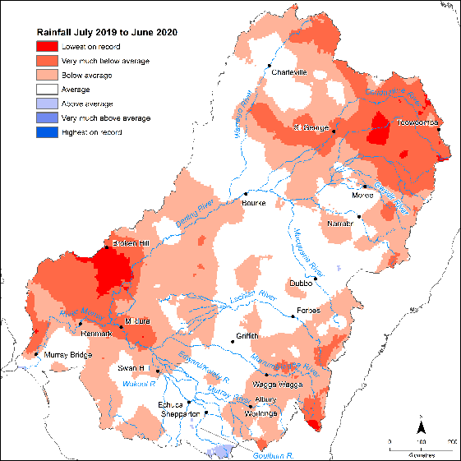
Figure 3.1 Rainfall conditions (from lowest to highest on record) experienced in the Basin during the 2019–20 watering year
Source: Guarino and Sengupta 2021
Total surface water inflows in the Basin for 2019-20 were 15,867 GL, slightly less than the 6-year average of 19,936 GL. Basin storages experienced net filling of approximately 1,954 GL. In the northern Basin, the total inflows were slightly below the average for the period since 2001, with northern Basin inflows falling within the first quartile of inflows since 2001. The inflow totals for the northern Basin were 80% of the average experienced since the Commonwealth's monitoring and evaluation program began. In the southern Basin, total inflows were slightly below the average for the period since 2001. The last 20 years have been a dry period for the southern Basin with persistent low inflows during the millennium drought and only a brief respite for 2 years (2010–11 and 2011–12) before returning to dry conditions, with some relief also in 2016–17. However, 2019–20 is still regarded as having low inflow compared with averages in the 21st century (Guarino and Sengupta 2021).

Commonwealth environmental watering actions for fish
During 2019–20, 64 Commonwealth environmental water actions targeting expected outcomes for fish were delivered throughout the Basin. These watering actions accounted for approximately 1,081 GL of Commonwealth environmental water delivered in that year. Commonwealth environmental water contributions to expected fish outcomes across the Basin and ecosystem types can be found in Table A.1. This volume includes watering actions where water was reused and so accounted for more than once. Many watering actions also included other sources of environmental water in addition to Commonwealth environmental water. The main functional flow objectives of these watering actions aimed at enhancing native fish populations were to improve habitat, enhance connectivity or provide cues for movement, and to a lesser extent maintain refuge habitat and fish condition (Figure 3.2). It is also important to note that many of these expected outcomes for fish are intrinsically linked. For example, freshes can provide cues for movement as well as spawning; refuge/habitat can enhance fish survival which can subsequently benefit diversity, species or spawning outcomes.
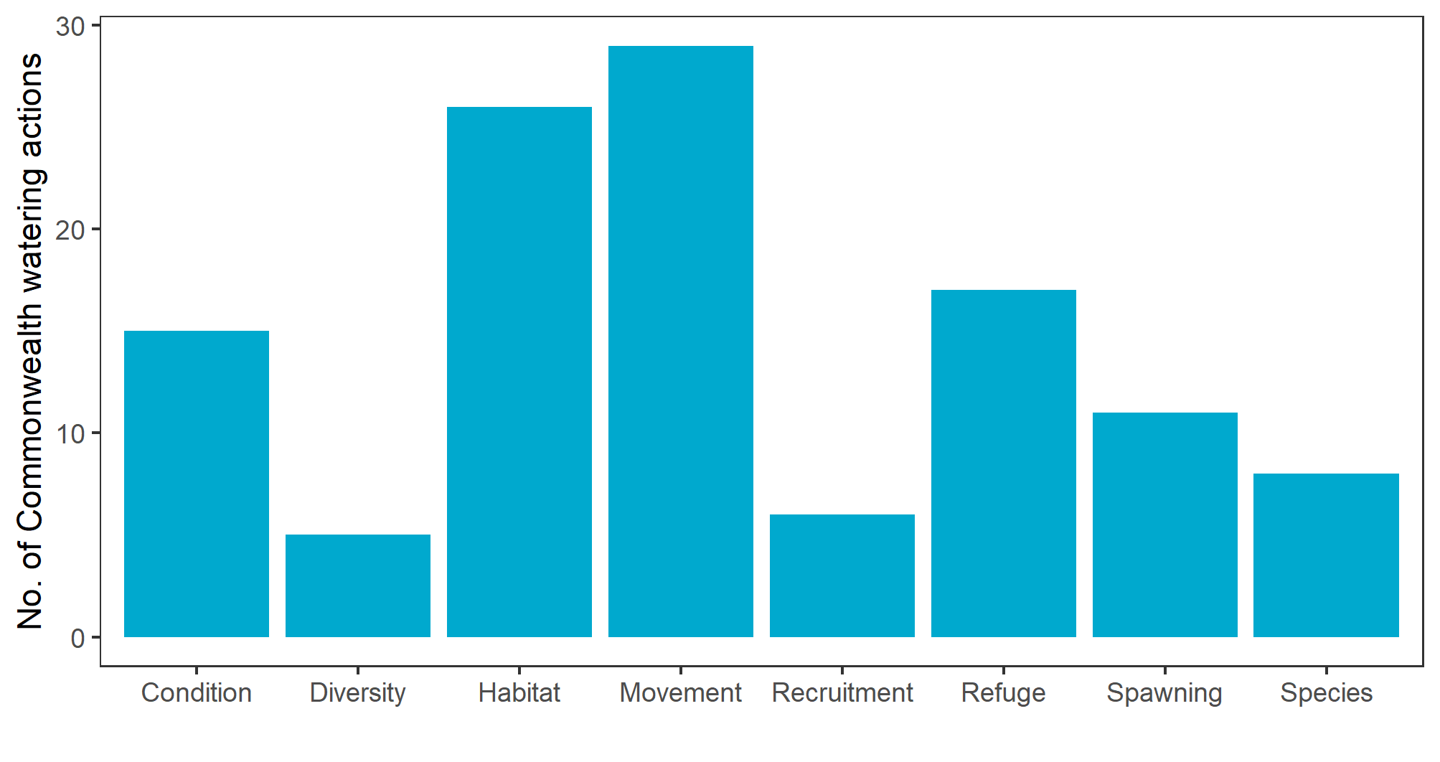
Figure 3.2 Commonwealth environmental watering actions in 2019–20 with expected outcomes for fish
Most watering actions have multiple expected outcomes; all fish expected outcomes for each watering action were included for the above summary (including a combination of exclusive and multiple fish outcomes)
In respect of flow components and fish expected outcomes, most Commonwealth environmental water was delivered to inundate wetlands (36% of actions) including the Murrumbidgee wetlands and Murray wetlands (which includes artificial pumping of wetlands as well as filling via natural connections). A total of 79 GL of Commonwealth environmental water was delivered to wetland systems (7% by volume). These flows to wetlands were delivered mainly for maintaining native fish refuge habitat (Figure 3.3). Flows were also delivered to Murray wetlands to support populations of the nationally endangered Murray hardyhead (EPBC Act 1999). These Commonwealth environmental watering actions in wetlands will likely concurrently benefit small-bodied species outcomes, fish condition or recruitment outcomes within main riverine channels. Watering actions that supported both wetland and instream flow components (6% of actions) were delivered to the Macquarie River and marshes to support native fish condition and provide cues for movement and the Lachlan River and Great Cumbung Swamp to maintain refuge habitat for native fish.
A total of 1,002 GL of Commonwealth environmental water was delivered to riverine channels (93% by volume). Freshes were delivered in many rivers (30% of actions) including the Borders rivers, Edward/Kolety-Wakool and the Lower Murray. These were usually delivered to provide cues for fish movement, spawning and/or improvement of habitat. Base flows were delivered in several rivers (23% of actions) including the Goulburn, Broken and Murray rivers for improvement of habitat, to provide cues for movement and to a lesser extent to promote spawning. Commonwealth environmental water contributed to two overbank flows (3% of actions) in the central Murray River to provide flows to support native fish condition and provide cues for movement in the Barmah-Millewa low lying creeks. Commonwealth environmental water contributed to a bankfull flow (2% of actions) in the Lower Moonie River to provide cues for fish movement and improvement of habitat.
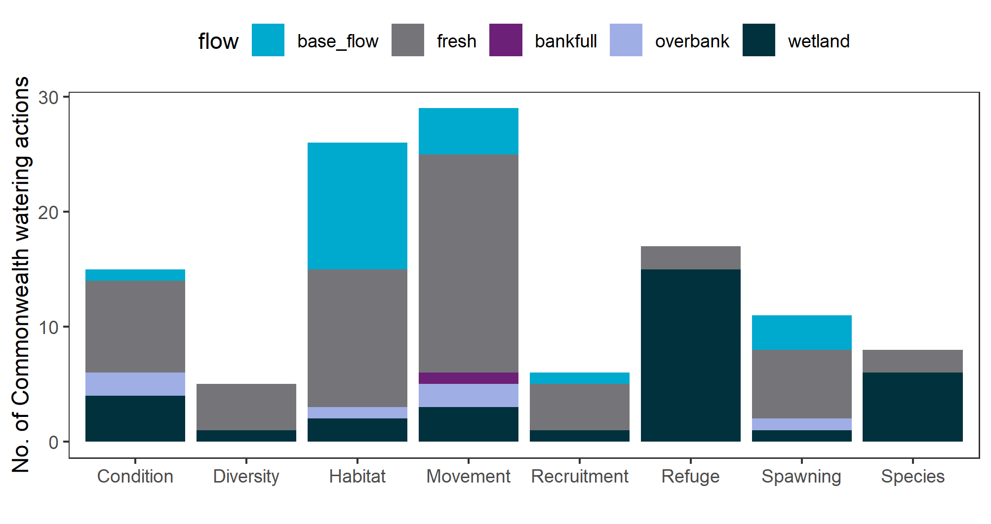
Figure 3.3 Flow components of Commonwealth environmental watering actions in 2019–20 with expected outcomes for fish
The highest target flow component for each watering action was used for the above summary

Contribution of Commonwealth environmental water to sustaining native fish
Of the total of 64 Commonwealth environmental watering actions in the Basin with expected outcomes for fish in 2019-20, 14 of these actions were monitored as part of the Flow-MER program within the Selected Areas (Table 2.6). A synthesis of findings from the 2019–20 Selected Area reports were used to answer the evaluation question:
What did Commonwealth environmental water contribute to sustaining native fish at the Basin-scale?
Key highlights within the Selected Areas monitoring programs are reported in Appendix A and Table A.1. The extent of the Commonwealth environmental water deliveries at the Selected Areas is also highlighted in Figure 1.1. It must be noted that the delivery of Commonwealth water often occurs in conjunction with other environmental water and/or natural flows in the Selected Areas. We therefore cannot quantitatively determine the specific contribution of Commonwealth environmental water for all fish responses discussed below. We can say however say that that Commonwealth environmental water contributed to the hydrological conditions that influenced the observed fish responses. Any general observations discussed below are based on the authors judgement of the findings from the Selected Area annual reports. Due to the significant variability between Selected Areas it is not possible to determine basin-scale trends from the 2019–20 Selected Area annual reports, but we can comment on similar findings that were found across the Selected Areas. There is uncertainty in extrapolating beyond the Selected Areas to estimate responses to Commonwealth environmental water for fish response at a basin-scale with only 1-year of condition monitoring data and limited flow variability detected at the Selected Areas. Furthermore, the 2019-20 fish monitoring data from the Selected Areas are included in the longer-term fish evaluation which includes a more quantitative analysis.
There was a continued recovery of Murray cod populations from the 2016–17 Murray River blackwater event, with increased adult abundances and/or successful recruitment reported in some Selected Areas (Goulburn River, Lachlan River System, Lower Murray River and the Edward/Kolety-Wakool river systems) though abundances are still generally lower than prior to the blackwater event. The Commonwealth environmental water contribution to Murray cod recruitment is unknown but contributions to natural spring pulses may increase the extent and duration of lotic habitat, potentially enhancing spawning habitat area, productivity and thus survival of early life stages. Golden perch spawning and recruitment was limited in most Selected Areas, despite water delivery targeting these specific responses. Nevertheless, there was evidence of golden perch spawning in the Murrumbidgee River and recruitment in the Warrego River. The Commonwealth environmental water contribution to these fish responses is unknown.
Commonwealth environmental water likely contributed to spawning of other fish species such as Australian smelt in the Edward/Kolety-Wakool River System, though the specific contribution is unknown. Commonwealth environmental water facilitated hydrological connectivity (Guarino and Sengupta 2021), increased available habitat and encouraged fish movement at varying degrees for several species such as golden perch, freshwater catfish, Murray cod and pouched and short-headed lamprey across some of the Selected Areas. Wetland inundation with Commonwealth environmental water provided habitat for small-bodied natives such as carp gudgeons, Murray River rainbowfish and flat headed gudgeons in the Murrumbidgee wetlands.
Beyond the Selected Area in-channel monitoring programs there were several other notable fish responses to Commonwealth environmental water. These included:
- Murray River channel system-scale watering (Yarrawonga to Murray mouth) in spring 2020 to promote spawning and recruitment of Murray cod, golden perch, silver perch, and other native fish species. This flow was notable in that it attempted to co-ordinate and synchronise environmental flows in several Victorian and NSW tributaries with the main river stem to promote productive conditions to maximise survival of early life-stages of fish. There was no targeted monitoring associated with the flow event so any fish outcomes remain unknown. At a hydraulic level, discharge into South Australia had an additional objective of reaching a minimum threshold to create flowing (lotic) conditions that potentially supports local spawning.
- Lower-Darling/Baaka environmental watering in spring 2020 to promote spawning and recruitment of Murray cod and golden perch, and other native fish species. In this case-study, a base flow and broad-scale connected lotic conditions were provided for Murray cod pre-spawning conditioning, spawning, nest guarding and recruitment. This baseflow was designed to inundate low-lying benches and physical habitat while also providing for longitudinal connectivity. A second flow component was an additional in-channel rise to stimulate spawning of golden perch in the lower Darling/Baaka and out-migration of young-of-year from the Menindee Lakes nursery into the lower Darling River. Ongoing monitoring has confirmed a substantial recruitment event of Murray cod from the spring 2020 Commonwealth environmental water flow event and out-migration of juvenile golden perch (Jason Thiem, NSW DPI Fisheries, pers. obs.) building on other recent recruitment events from previous years (Sharpe and Stuart 2018).
- In the Lower Murray continuous barrage flows (including for fishway operations) were maintained by Commonwealth environmental water (100%) in this dry year. In winter-spring 2019 Commonwealth environmental water contributed substantially to pouched and short-headed lamprey migration (between the ocean, Coorong Estuary and Murray River). Commonwealth environmental water substantially increased favourable fish habitat for estuarine species in the Coorong (e.g. 40% increase in the area of suitable habitat for mulloway in 2019-2020 due to environmental water deliveries from 2017–18 to 2019–20).
Other relevant learnings about Basin fish and flows came from the Victorian environmental flows monitoring and assessment program (VEFMAP, Stage 6 synthesis report). Based on 2 decades of fish monitoring, this report highlighted some important implications for environmental flow management for several fish species (Tonkin et al. 2020). VEFMAP population trends in 5 Northern Victorian rivers (Murray, Goulburn, Broken, Ovens, King, Campaspe, and Loddon rivers) demonstrated Murray cod, golden perch, Murray–Darling rainbowfish and carp declined during the millennium drought but then had increasing trends afterwards (Tonkin et al. 2020). VEFMAP identified key attributes of the flow regime from the 5 northern Victorian rivers that contributed to the abundance/biomass of fish species such as spring flows which were positively associated with Murray cod, trout cod and carp abundances/biomasses. The number of days with low flows had negative associations with most species, except silver perch. Summer flows had negative associations with Murray cod abundance/biomass and trout cod biomass, whereas winter flows had positive associations with abundance/biomass of golden perch (Tonkin et al. 2020).

Basin-scale longer-term evaluation 2014–20

Climate and hydrological context
Drought conditions were prevalent during much of the monitoring program (2014–20) (King et al. 2020) – the period of Commonwealth Basin-scale monitoring and evaluation (Figure 4.1). The first 2 years saw particularly dry conditions in the southern Basin. In the 2016–17 year, there were wetter conditions in the southern Basin and along the headwaters of the NSW tributaries in the northern Basin. However, conditions have returned to dry over the period 2017–20 across the whole Basin.
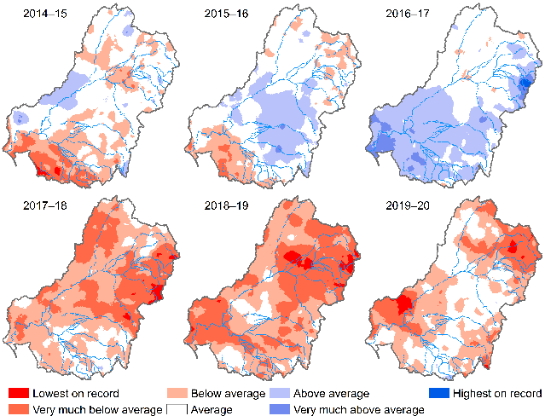
Figure 4.1 Maps of annual rainfall conditions, 2014–20). The 2019-20 map is shown in detail in Figure 3.1
Volumes and timing of flow events varied across the Selected Areas (Figure E.1.; Figure E.2). Flow conditions in Selected Areas were highly regulated and low flows occurred in 5 of the 6 years with high flows in one year only (2016–17) (Figure 4.2). Commonwealth environmental water delivery mostly contributed to baseflows and freshes. This pattern was most evident for the Lower Murray River and Goulburn River Selected Areas and to a lesser extent the Edward/Kolety-Wakool river systems, Lachlan River System and Murrumbidgee River System Selected Areas (Figure 4.2). Commonwealth environmental water delivery increased the proportion of small freshes in most Selected Areas (Figure 4.2). Commonwealth environmental water increased large freshes in some Selected Areas though the frequency of these contributions were markedly less than for small freshes and baseflows. Commonwealth environmental water contributions to overbank flow conditions were minimal (Figure 4.2). Commonwealth environmental water delivery had mixed effects on discharge variability, causing decreases in discharge variability in some Selected Areas and increases in others (Figure 4.2).
The Commonwealth environmental water contribution to large freshes and overbank flows to riverine channels in Selected Areas was limited (Figure 4.2). This is consistent with seeking to manage flows in a way which does not flood private land or damage infrastructure and reflective of the relatively small volumes of water available for environmental flows relative to the size of natural flows which connect to the floodplain. These limitations have important implications for the functionality of the flow regime for the fish outcomes identified by CEWO (Figure 3.2; Figure 3.3 ). Large freshes and overbank flows are important for enhancing native fish populations through the provision of increased habitat, food resources and providing cues for movement and spawning and examples include golden perch recruitment often being associated with major flows or overbank flood events (Zampatti et al. 2015; Cruz et al. 2020; Shams et al. 2020; Stuart and Sharpe 2020). Therefore, an absence of these types of functional flows as part of the flow regime will restrict the fish outcomes at Selected Areas.
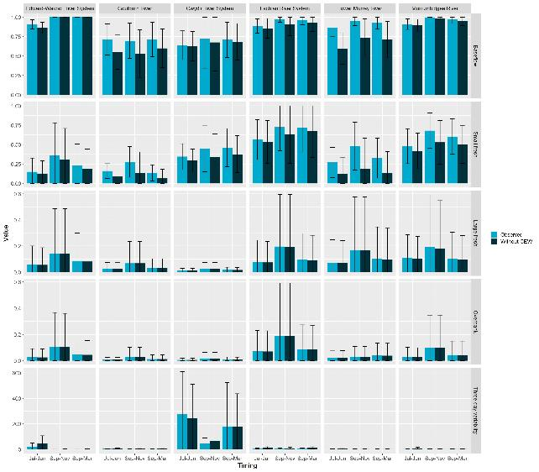
Figure 4.2 Mean flow metrics + SD (proportion of time flows were in the base flow, small and large freshes and overbank flow bands, and discharge variability values) among water years: Jul–Jun (for flow metrics associated with adult fish), Sep–Nov (for flow metrics associated with larval fish) and Sep–Mar (for flow metrics associated with recruitment) observed/modelled across 6 Selected Areas
See Table 2.2 for a description of each metric

Contribution of Commonwealth environmental water to sustaining native fish
The key Flow-MER evaluation question for fish was:
What did Commonwealth environmental water contribute to sustaining native fish at the Basin-scale?
Due to the variability in fish response to Commonwealth environmental water delivery at Selected Areas it was not possible to comment on basin-scale trends from the 2014–20 monitoring data, but we can comment on similar findings that were found across the Selected Areas. Any extrapolation beyond Selected Areas would be associated with low confidence due to several technical and conceptual limitations (for further discussion see Section 6.2). Therefore, our aim was to determine the contribution of Commonwealth environmental water to the observed fish population response at Selected Areas and report on similar findings across Selected Areas.
To address this aim, we examined a range of critical life-history processes that support native fish populations and are intrinsically linked with flow and flow regimes. These life-history processes provide a measure of population persistence at Selected Areas in relation to flow and flow regimes. We then used counterfactual modelling to determine the contribution of Commonwealth environmental water on these measures to inform how Commonwealth environmental water contributes to sustaining native fish at Selected Areas. The counterfactual modelling primarily tested the effects of baseflows and small freshes, as these were the flow components that were most influenced by Commonwealth environmental water across Selected Areas. Commonwealth environmental water contributions to large freshes were limited and overbank flows were excluded from analysis as the proportion of overbank flows rarely differed between observed and counterfactuals. The following sections provide qualitative investigations and formal analysis of Commonwealth environmental water effects on various measures of fish population persistence. These measures include:
- fish diversity and abundance (population growth)
- fish population structure to inform recruitment
- community dynamics
- spawning and larval abundance
- individual body condition.
Major results are summarised here (see Table 4.1; Figure 4.3) and described in detail in the following sections 4.2.3 to 4.2.11. The degree of confidence in our results was quantified by the probability that Commonwealth environmental water had a positive effect on a given fish response. These probabilities (Bayesian posterior probabilities) range from 0 to 1: values close to 1 indicate high confidence in a positive effect, values close to 0 indicate high confidence in a negative effect, and values close to 0.5 indicate no evidence of an effect.
Table 4.1 Contribution of Commonwealth environmental water to native fish population persistence at Selected Areas averaged over 2014-20
Level of confidence in evidence is the posterior probability that the response is greater with than without Commonwealth environmental water, with confidence categories assigning these values to broad classes as described in Table 2.7. Asterisk (*) Data on spawning and larval abundance was inadequate to make a reliable estimate due to a lack of observed spawning events, low larval abundances in some Selected Areas and the difficulty of defining counterfactual scenarios for event-based flow metrics. Therefore, these results should be interpreted with caution.
Selected Area | What did Commonwealth environmental water contribute to spawning and larval abundance?* | What did Commonwealth environmental water contribute to recruitment? | What did Commonwealth environmental water contribute to individual body condition? | What did Commonwealth environmental water contribute to fish abundance (population growth)?
Edward/Kolety-Wakool river systems | No positive associations with Commonwealth environmental water and spawning | There was weak evidence that Commonwealth environmental water contributed to increased recruits of Australian smelt and carp gudgeon | There was weak evidence that Commonwealth environmental water contributed to increased body condition of Murray cod and golden perch | There was weak evidence that Commonwealth environmental water contributed to increased population growth rates of bony herring, golden perch, Murray cod and carp gudgeon
Goulburn River | There was weak evidence that Commonwealth environmental water increased the likelihood of spawning for golden perch and no positive associations with larval abundance | There was weak evidence that Commonwealth environmental water contributed to increased recruits of Australian smelt | There was weak evidence that Commonwealth environmental water contributed to increased body condition of golden perch and Murray cod | There was weak evidence that Commonwealth environmental water contributed to increased population growth of Australian smelt and golden perch
Gwydir River System | Not measured in this Selected Area | There was weak evidence that Commonwealth environmental water contributed to increased recruits of Australian smelt | There was weak evidence that Commonwealth environmental water contributed to increased body condition of golden perch and Murray cod | There was weak evidence that Commonwealth environmental water contributed to increased population growth rates of bony herring
Lachlan River System | No positive associations with Commonwealth environmental water and spawning | There was weak evidence that Commonwealth environmental water contributed to increased recruits of Australian smelt | There was weak evidence that Commonwealth environmental water contributed to increased body condition of, golden perch and Murray cod | There was weak evidence that Commonwealth environmental water contributed to increased population growth rates of bony herring, carp gudgeon, golden perch and Murray cod
Lower Murray River | No positive associations with Commonwealth environmental water and spawning or larval abundance | There was weak evidence that Commonwealth environmental water contributed to increased recruits of Australian smelt | There was weak evidence that Commonwealth environmental water contributed to increased body condition of golden perch and Murray cod | There was weak evidence that Commonwealth environmental water contributed to increased population growth rates of Australian smelt, bony herring and golden perch
Murrumbidgee River System | No positive associations with Commonwealth environmental water and spawning or larval abundance | There was strong evidence that Commonwealth environmental water contributed to increased recruits of Australian smelt | There was moderate evidence that Commonwealth environmental water contributed to increased body condition of Murray cod and weak evidence for golden perch | There was moderate evidence that Commonwealth environmental water contributed to increased population growth rates of bony herring, and weak evidence for golden perch, Murray cod and carp gudgeon

Relative change in flow metrics
The flow panels in Figure 4.3 show the relative change in each flow metric (x-axis; baseflows, small freshes, large freshes, flow variability) during key time periods for each fish life stage (y-axis; spawning, September to November; recruitment, September to March; and adult survival, July to June [water year]). Flow colour legend shows direction and relative effect size, with darker purple colours indicating larger positive effects, white indicating no effect, and redder colours indicating larger negative effects.

Strength of support on life stage
The response panels in Figure 4.3 show the strength of support for a positive (green) or negative (red) effect of Commonwealth environmental water on a given life stage (y-axis) for each species (x-axis). Confidence colour legend indicates relative magnitude and direction, white indicates no confidence (probability of a positive effect near 0.5), light colours denote low confidence (probability of an effect between 0.5-0.8), medium colours denote moderate confidence (probability between 0.8 and 0.95), and dark colours denote high confidence (probability greater than 0.95) noting that effects can be positive (green) or negative (red). Grey squares indicate no data for that cell (e.g. a species not sampled for that life stage or insufficient data for an analysis).

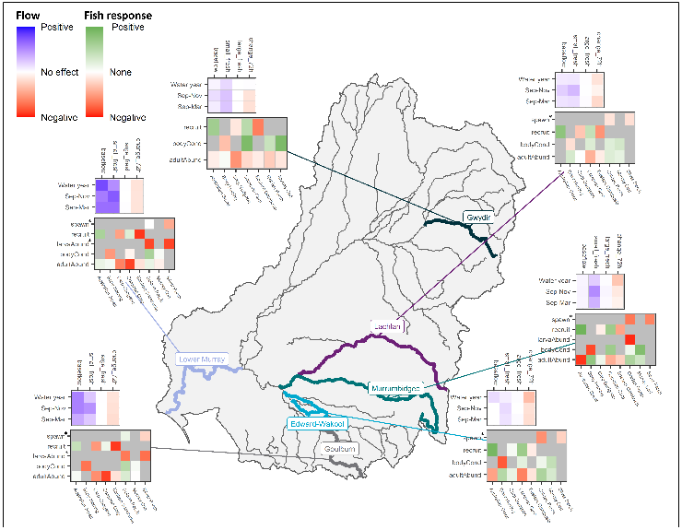
Figure 4.3 Magnitude of Commonwealth environmental water effects on flow metrics (small panels) and on fish responses (larger panels) in each Selected Area
Note: * Data on spawning and larval abundance was inadequate to make a reliable estimate due to a lack of observed spawning events, low larval abundances in some Selected Areas and the difficulty of defining counterfactual scenarios for event-based flow metrics. Therefore, these results should be interpreted with caution

Our analyses indicated that Commonwealth environmental water provided a range of benefits to native fish populations and supported critical life-history processes such as recruitment, body condition and population growth (Table 4.1). The effect of Commonwealth environmental water on focal species averaged over all survey years, lower and upper bounds of the effect, confidence, and associated confidence category are listed in Appendix A. Fish responses to Commonwealth environmental water differed among species, years, hydrological components, and Selected Areas. It must be noted that there is uncertainty in our analyses with only 6-years of condition monitoring data, limited flow variability among years and Selected Areas (e.g. a limited number of different flow scenarios), low abundances of many native fish species all contribute to the difficulty in estimating responses to Commonwealth environmental water for fish response. Furthermore, there is also uncertainty in modelling the effects of flow on fish and then in the extrapolation of this flow effect to a no-Commonwealth environmental water scenario.
Key results include positive associations between baseflows and multiple life-history processes and species, and positive associations between freshes and fish body condition (Table 4.1; Figure 4.3). Over all survey years, there was weak evidence that Commonwealth environmental water contributed to increased recruits of Australian smelt (except in the Murrumbidgee River System there was strong evidence). There was weak evidence that Commonwealth environmental water contributed to increased body condition of golden perch and Murray cod (except in Murrumbidgee River System there was moderate evidence for golden perch) and to population growth rates for a number of species (except in Murrumbidgee River System there was moderate evidence for bony herring). There was weak evidence that Commonwealth environmental water increased the likelihood of spawning for golden perch in the Goulburn River and no other positive associations were found in the analyses. It must be noted that the data on spawning and larval abundance was inadequate to make a reliable estimate due to a lack of observed spawning events, low larval abundances in some Selected Areas and the difficulty of defining counterfactual scenarios for event-based flow metrics.
Negative associations with fish response were also found (Figure 4.3; Appendix A), which may indicate that Commonwealth environmental water was insufficient for some life-history processes and species to elicit a positive response. Possible explanations may be that Commonwealth environmental water may maintain fish populations without eliciting a significant, positive response or reversing ongoing declines in these already stressed fish populations. Potentially due to the extensive drought conditions and low flows fish experienced during the monitoring program and/or the minimal contribution of Commonwealth environmental water to large freshes and overbank flows at Selected Areas. Other possible mechanisms that may explain the negative associations may be the constraints with modelling data with limited flow variability at Selected Areas, limited sample sizes in some cases (e.g. larval abundances) and modelling artefacts.
Major findings of the contribution of Commonwealth environmental water to measures of fish population persistence at Selected Areas are listed below.
- Changes in species abundances generally had varied associations with discharge with few strong associations. Counterfactual modelling indicated varied associations with Commonwealth environmental water (Figure 4.10), noting that Commonwealth environmental water primarily affected baseflows and discharge variability, and did not substantially alter the proportion of large freshes in these systems. There was strong evidence that the provision of Commonwealth environmental water reduced abundances of Common Carp in the Lower Murray and Goulburn rivers in some years. The underlying causal relationship for this was unclear but may have been related to increased baseflows under Commonwealth environmental water to which carp had a negative response. There was weaker evidence for associations between Commonwealth environmental water and the abundances of the remaining 6 species, with high levels of uncertainty.
- Counterfactual modelling indicated strong evidence that Commonwealth environmental water positively influences recruitment of Australian smelt (i.e. fish <40 mm) (based on length data) in some years at all Selected Areas, primarily due to the provision of small freshes (Figure 4.17).
- Spawning of golden perch was limited overall but, when it occurred, it was positively associated with consistent baseflows and large freshes. Counterfactual modelling indicated with moderate evidence that spawning was more likely with Commonwealth environmental water in the Goulburn River and Lower Murray River in some years though findings were variable across Selected Areas and years (Figure 4.24). This result was driven primarily by baseflows given limited Commonwealth environmental water contributions to large freshes. Overall, however, few spawning events were detected at Selected Areas monitoring sites, which reflects the prevailing drought conditions, low flows during the monitoring program and/or the absence of substantial Commonwealth environmental water contributions to large freshes and overbank flows.
- Larval abundances of golden perch and silver perch (with higher uncertainty) had a negative association with increases in proportional discharge magnitude in the week prior to sampling. Counterfactual modelling indicated that Commonwealth environmental water reduced golden perch larval abundances in some Selected Areas in some years (Lower Murray River and Murrumbidgee River System) (Figure 4.28). Whilst the model suggests a negative association between increases in proportional discharge magnitude with larval abundances of golden and silver perch, these results have high uncertainty given the limited available data. Very few spawning events were observed during the monitoring period, and we do not have the exact dates of the event. As such, we use the average 7-day discharge prior to sampling and compare this with the median discharge during the spawning period. In this case, the discharge prior to sampling was higher than the average over the entire spawning period, yet a lower larval abundance was associated with this sample period..
- Body condition of Murray cod, golden perch (with higher levels of uncertainty) and common carp, were positively associated with the provision of large freshes. Counterfactual modelling indicated there was moderate to strong evidence that the provision of Commonwealth environmental water, mainly through small freshes increased body condition of golden perch individuals in the Edward/ Kolety-Wakool River System, Lachlan River System and the Lower Murray River in some years and moderate to strong evidence of increases in the body condition of common carp in the Lachlan River System and Murrumbidgee River System in some years (Figure 4.31). There was also moderate to strong evidence that that the provision of Commonwealth environmental water increased body condition of Murray Cod individuals in the Murrumbidgee River System, Gwydir River System and the Lachlan River System in some years. Noting that Commonwealth environmental water contributions to large freshes were limited.

Effect on fish diversity and abundance
This section describes a qualitative investigation of fish diversity and abundance of large-bodied and small-bodied fish species across Selected Areas (as not all fish species had sufficient data for analysis). This is followed by a formal analysis of Commonwealth environmental water effects on the abundance of 7 focal species.
- The monitoring program detected 13 native fish species and 6 introduced species across all Selected Areas and all years (2014–20) (Table 2.1). This included 5 key freshwater species (as identified by the Strategy) whereas 12 key freshwater species were not detected in the monitoring program. Some key species not detected were wetland specialist species, those with limited distributions, threatened species and/or those with a northern Basin distribution. This may explain some of the missing key species identified by the Strategy as the Flow-MER program focuses on in-channel and southern Basin species, with only one northern Basin Selected Area represented (Gwydir River System).
- The number of native species detected varied among Selected Areas and years (Table 4.2). The highest native species number occurred in the Lower Murray River, with 11 native species detected in 4 of the 6 years during the monitoring period. The lowest native species number was found in the Lachlan River System, with 6–7 species detected during the monitoring period.
- Native large-bodied fish species detected in all Selected Areas included bony herring, golden perch, and Murray cod, along with the introduced common carp and goldfish (Figure 4.4; Figure C.1). Other large-bodied native fish species detected in most years at some but not all Selected Areas included freshwater catfish and silver perch. The nationally threatened species trout cod was only found in the Goulburn River.
- The abundance (as indicated by the catch per unit effort, or CPUE) of large-bodied native species varied among Selected Areas and years (Figure 4.4; Figure C.1). There were declines in Murray cod abundances in the Edward/Kolety-Wakool river systems, Goulburn River, Lachlan River System and Murrumbidgee River System following the 2016–2017 post-flood blackwater event. In recent years, Murray cod have increased in relative abundance in some Selected Areas, including the Edward/Kolety-Wakool river systems, Goulburn River and Lachlan River System. This shows that some populations are recovering but have not yet recovered completely to pre-blackwater event abundances. Golden perch, Murray cod, common carp, and to a lesser extent, bony herring occurred at a high proportion of sites within Selected Areas, whereas silver perch, unspecked hardyhead, redfin perch and freshwater catfish had patchier distributions within Selected Areas (Figure 4.5).
- Native small-bodied species detected across all Selected Areas included Australian smelt and carp gudgeons, as well as the introduced eastern gambusia (Figure 4.6; Figure C.2). The only small-bodied species detected in all years and Selected Areas was carp gudgeons. Other native small-bodied fish species detected in most years, but not in all Selected Areas, included Australian smelt, Murray River rainbowfish and unspecked hardyhead. Two small-bodied native fish species only detected in one Selected Area each, were the dwarf flathead gudgeon (Lower Murray River) and spangled perch (Gwydir River System).
- The CPUE of small-bodied native species differed among Selected Areas and years. Several small-bodied species declined in abundance in the Lower Murray River following the 2016–2017 post-flood blackwater event (declines may be attributed to blackwater hypoxia effects and or reduced habitat availability) (Figure 4.6; Figure C.2). Carp gudgeons, the introduced eastern gambusia, and to a lesser extent Murray River rainbowfish were detected at most sites within each Selected Area. Australian smelt, flathead gudgeons, and unspecked hardyhead were distributed more patchily within Selected Areas (Figure 4.6).
- CPUE of introduced species differed among Selected Areas and years (Figure 4.8). The 2016–17 post-flood blackwater event may have provided favourable conditions and appeared to benefit introduced species such as common carp, with abundances reaching their peak 6–12 months following this event (which occurred in summer, followed by autumn adult sampling). Eastern gambusia abundances also increased in the Lachlan River System and the Goulburn River following the 2016–17 blackwater event, although this pattern was not observed in other Selected Areas. Goldfish abundances appeared to increase early in the monitoring program in the Lower Murray River, but this trend has reversed in recent years. Redfin perch displayed no clear patterns in abundance during the monitoring program and were absent from the Edward/Kolety-Wakool river systems and Gwydir River System. Oriental weatherloach was detected only in the Goulburn River, with small increases in abundance over time.
Table 4.2 Number of native species recorded from Category 1 fish sampling in each Selected Area for each year, 2014–2020
Selected Area | 2014–15 | 2015–16 | 2016–17 | 2017–18 | 2018–19 | 2019–20
Edward/Kolety-Wakool river systems | 8 | 9 | 8 | 8 | 8 | 8
Goulburn River | 7 | 9 | 8 | 7 | 7 | 7
Gwydir River System | 8 | 9 | 9 | 9 | 9 | 9
Lachlan River System | 6 | 7 | 7 | 6 | 6 | 7
Lower Murray River | 11 | 11 | 8 | 10 | 11 | 11
Murrumbidgee River System | 8 | 7 | 9 | 8 | 9 | 8

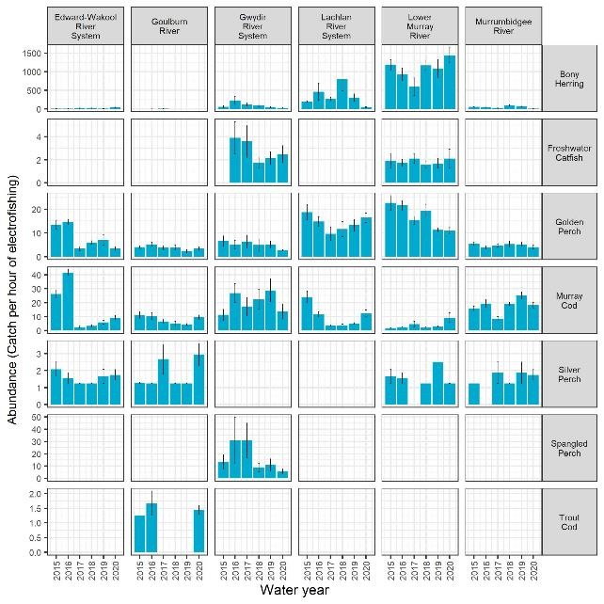
Figure 4.4 Abundance (catch per hour of electro fishing) of 7 large-bodied native fish species in each Selected Area for each year, 2014–20
Height of each bar is the mean and the whiskers show the ±1 standard error (SE). Y-axis scales differ among species. Fish were collected using boat and backpack electrofishing.
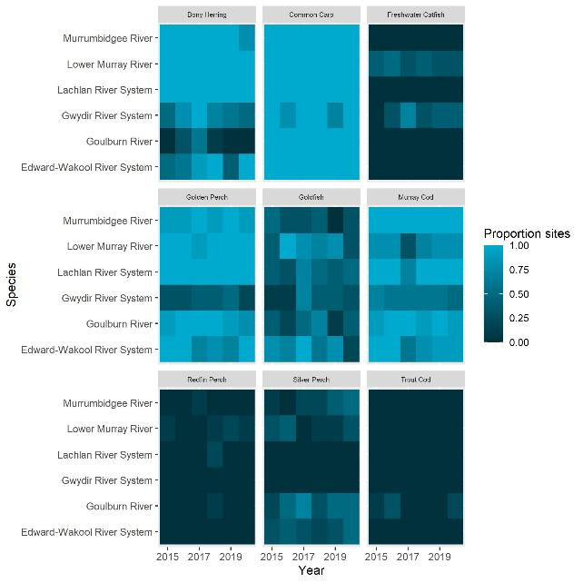
Figure 4.5 Heat map of the proportion of sites at which a species occurs within each Selected Area for 7 native and 2 introduced large-bodied fish species for each year, 2014–20
Colour change depicts the change in the proportion of sites a species occurs within a Selected Area with lighter colours depicting more sites where the species is present
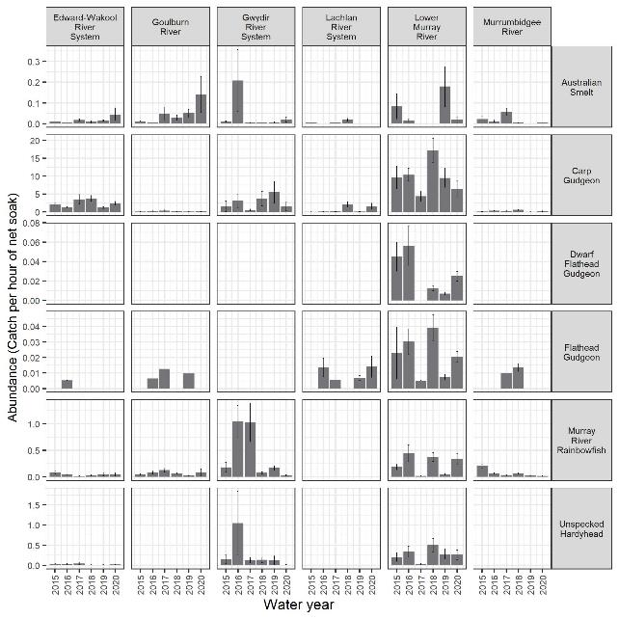
Figure 4.6 Mean abundance (catch per hour of net soak) of 6 small-bodied native fish species at each Selected Area for each year, 2014–20
Height of each bar is the mean and the whiskers show the ±1 standard error (SE). Y-axis scales differ among species. Fish were collected using fine-mesh fyke nets.
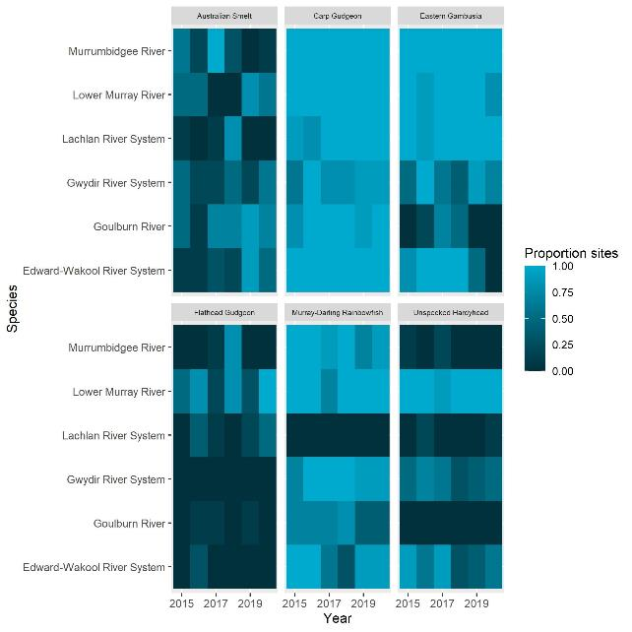
Figure 4.7 Heat maps of the proportion of sites at which a species occurs within a Selected Area for 5 native and 1 introduced small-bodied fish species at each Selected Area for each year, 2014–20
Colour change depicts the change in the proportion of sites a species occurs within a Selected Area with lighter colours depicting more sites where the species is present.
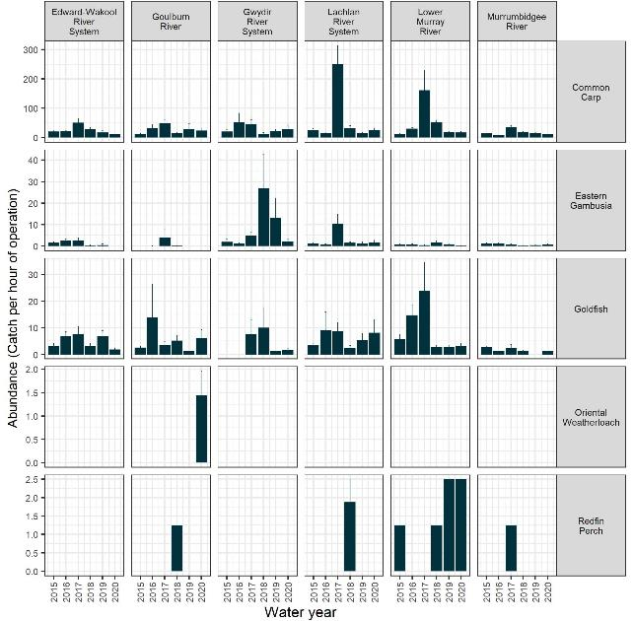
Figure 4.8 Mean abundance (catch per hour of electro fishing) of 5 introduced fish species at each Selected Area for each year, 2014–20
Height of each bar is the mean and the whiskers show the ±1 standard error (SE). Y-axis scales differ among species.
Eastern gambusia were collected using fine-mesh fyke nets, while common carp, goldfish, oriental weatherloach and redfin perch were collected using boat and backpack electrofishing. Note that the y-axis scales differ among species.

Effect on abundance of focal species
Seven focal fish species as identified by Flow-MER (Table 2.1) were selected for this analysis. These species are Australian smelt, bony herring, carp gudgeon, common carp (introduced), eastern gambusia (introduced), golden perch and Murray cod. These were selected as they represent a range of life history strategies/guilds, they are common as adults and larvae in the Selected Areas and across the Basin, they represent both native and introduced species and they respond to flows (Hale et al. 2014; King et al. 2020).
There were few strong associations between species abundance (population growth rates) and flow variables (95% credible intervals not overlapping zero) (Figure 4.9). The proportion of large freshes was associated negatively with abundances of golden perch (with high levels of uncertainty, 95% credible intervals overlapping zero) and Murray cod and positively with abundances of common carp (Figure 4.9). This may be related to reduced detectability of many fish species during high flows in cases where high flow conditions coincided with fish sampling (Lyon et al. 2014). Alternatively, relatively few golden perch were collected, contributing to uncertainty. Findings could also be an artifact of the blackwater event with large freshes in 2016-17 contributing to deaths of adult Murray cod (and potentially large golden perch) and recruitment of common carp which had multi-year effects in some Selected Areas (Thiem et al. 2021).
Counterfactual modelling indicated mixed associations with Commonwealth environmental water, noting that Commonwealth environmental water primarily affected base flows and discharge variability and did not substantially alter the proportion of large freshes in these systems (Figure 4.10).
There was strong evidence (95% credible intervals not overlapping zero) that the provision of Commonwealth environmental water reduced abundances of common carp in the Lower Murray River (1 year out of 6 years) and Goulburn River (2 years out of 6 years) (Figure 4.10), a result likely driven by Commonwealth environmental water-driven baseflows. There was weaker evidence for associations between Commonwealth environmental water and the abundances of the remaining 6 species, due to high levels of uncertainty in predicted effects of Commonwealth environmental water (Figure 4.10).
Responses to Commonwealth environmental water were driven primarily by discharge variability for bony herring, golden perch, Murray cod, eastern gambusia, discharge variability and baseflows for carp gudgeon, and baseflows for Australian smelt and common carp (Figure 4.11).
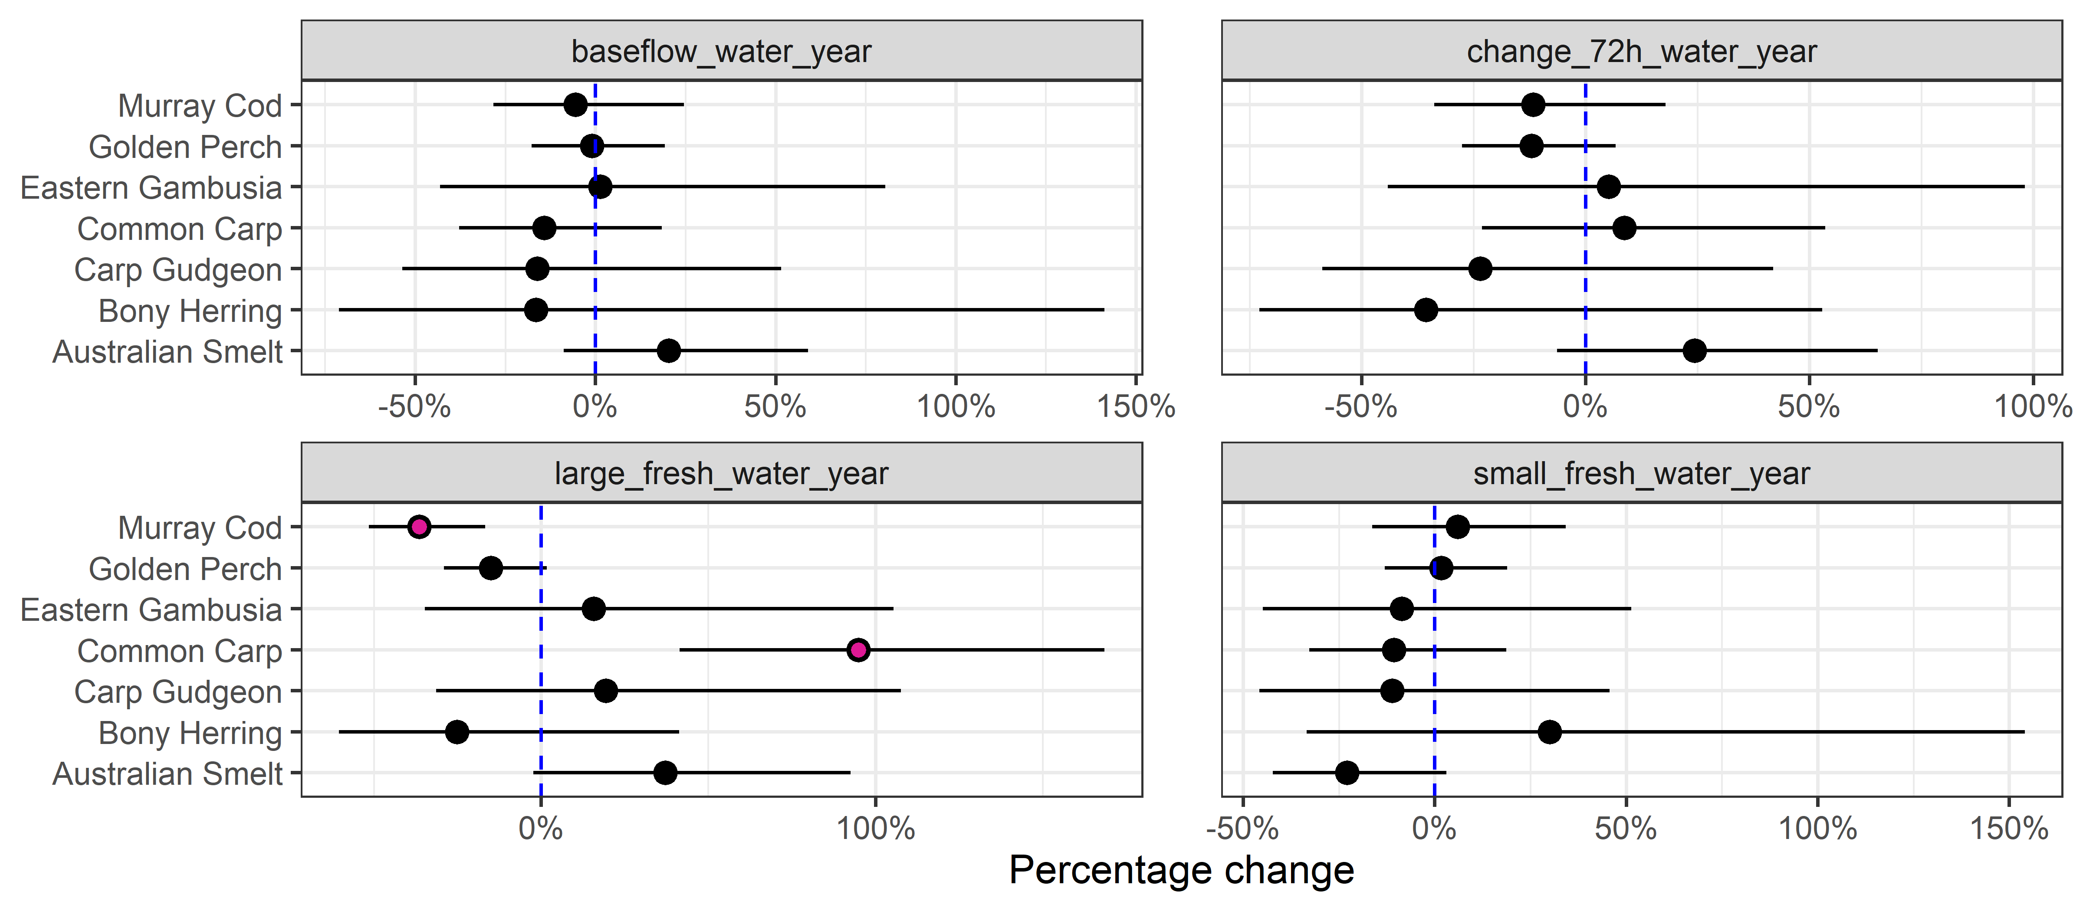
Figure 4.9 Effect (percentage change) of 4 observed to flow variables (base flow, change over 72 hours, large fresh, small fresh) on population growth rate for each of the 7 focal species
Error bars are 95% credible intervals. Vertical broken line denotes the line of no effect = 0. Pink dots indicate 95% credible intervals that do not overlap 0. Effects are based on observed flows at the gauges related to fish response
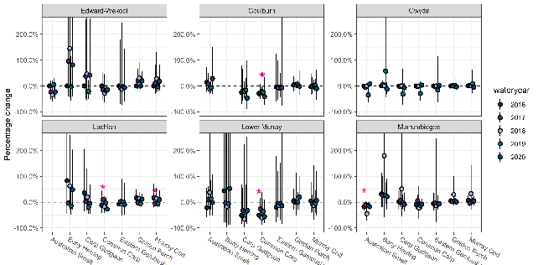
Figure 4.10 Predicted percentage change in population growth rate with the addition of Commonwealth environmental water for each species, year, and Selected Area
Model estimates growth rates between years. Hence the figure shows from 2016 onwards (e.g. 2016 data estimates population growth between 2015 and 2016 water years). Positive values indicate increases in population growth rates due to the delivery of Commonwealth environmental water. Error bars are 95% credible intervals. Asterisk (*) in each plot indicates the 95% credible intervals that do not include zero. Y-axes are truncated to improve visibility of less-variable results.
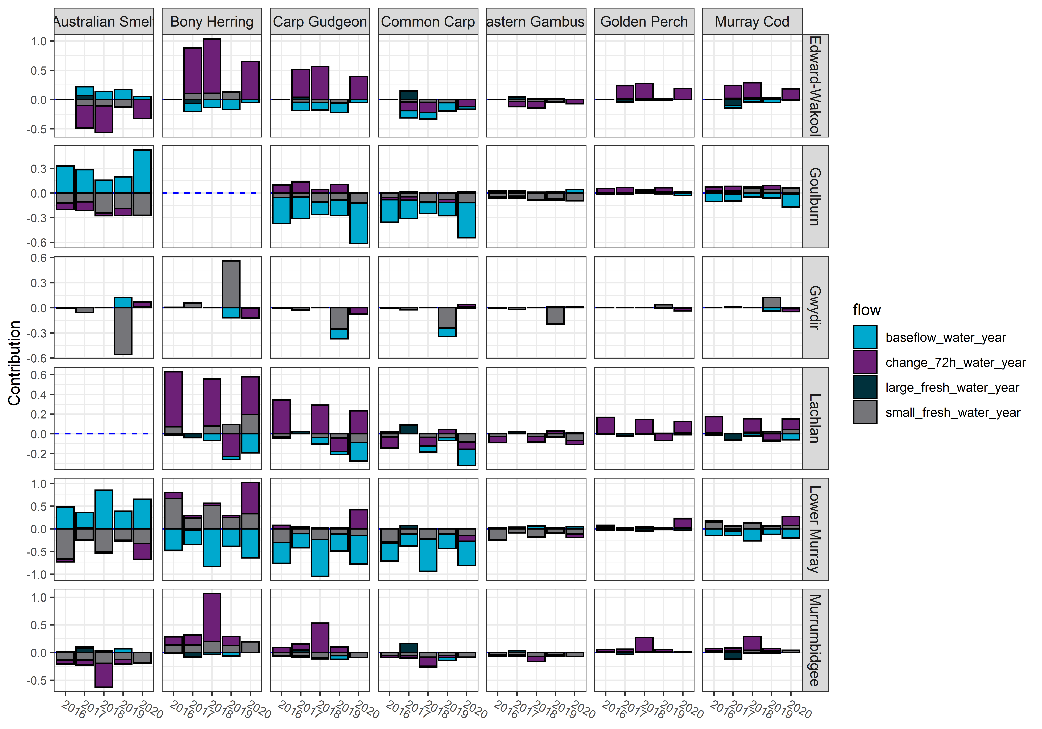
Figure 4.11 Contribution of each flow variable (base flow, change over 72 hours, large fresh, small fresh) to the predicted Commonwealth environmental water effect on population growth rate of the 7 focal species for each Selected Area
Negative effects of Commonwealth environmental water are shown as bars below 0 and positive effects of Commonwealth environmental water are bars above 0. Effect sizes are on the model link scale

Effect on fish population structure to inform recruitment
This section provides a qualitative interpretation of length-frequency data for 7 focal species. This is followed by a formal analysis of year-class strength for 3 focal species golden perch, Murray cod and bony herring using ages estimated from otolith-derived information collected in previous years. Finally, an analysis of Commonwealth environmental water effects on recruits of 4 focal species, common carp, Australian smelt, carp gudgeon and eastern gambusia based on length thresholds is presented where data were sufficient for analysis.
Golden perch population structure in most Selected Areas was dominated by adults, with fewer juvenile fish (<250 mm TL) (Figure 4.12). Golden perch recruits were not detected in fish-length data in most Selected Areas and years. Several young-of-year recruits were captured in the Goulburn River during the water years of 2016 and 2020 (Figure 4.14). These were most likely stocked fish, given that Fisheries Victoria stocking was immediately prior to the autumn sampling in 2016 that lack of spawning was observed in 2019 (Wayne Koster, DELWP, in Webb et al. 2017b; Treadwell et al. 2020). Recent studies suggest that golden perch have spatially patchy recruitment patterns, often associated with major flow or flood events in the Darling and mid/lower Murray systems (Zampatti et al. 2015; Zampatti et al. 2019; Cruz et al. 2020; Shams et al. 2020; Stuart and Sharpe 2020). Since 2016, there have been several successful cohorts in the Darling River, but these cohorts have not yet been detected in the connected Murray system (Sharpe and Stuart 2018).
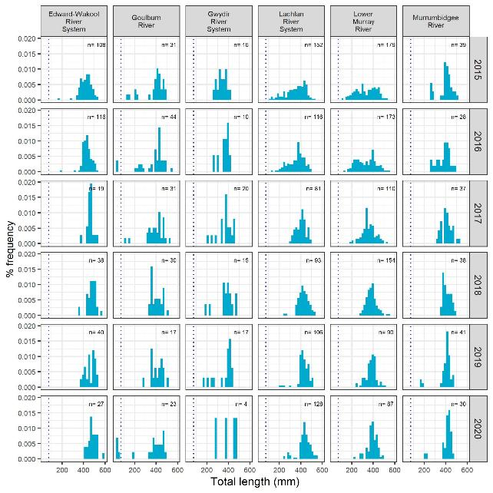
Figure 4.12 Length-frequency histogram of golden perch by Selected Area and water year
Dotted vertical line in each plot represents cut-off length used for recruits (<75 mm) less than one year old.
Murray cod population structure was comprised of a wide range of adult length classes and juvenile fish in most Selected Areas in most years (Figure 4.13). Murray cod recruits were present in most years at most Selected Areas. There were pronounced reductions in the number of recruits and the range of adult length classes in the Edward/Kolety-Wakool River System, Lachlan River System, Murrumbidgee River and, to a lesser extent, in the Goulburn River, post the 2016-17 blackwater event. Murray cod populations displayed evidence of recovery following the 2016-17 (Murray River) blackwater event with evidence of recruitment in most Selected Areas in 2020. The impact of blackwater on Murray cod populations is likely due to the high sensitivity of Murray cod to hypoxia, observed in simulated blackwater conditions (Small et al. 2014) and in the field (King et al. 2012).
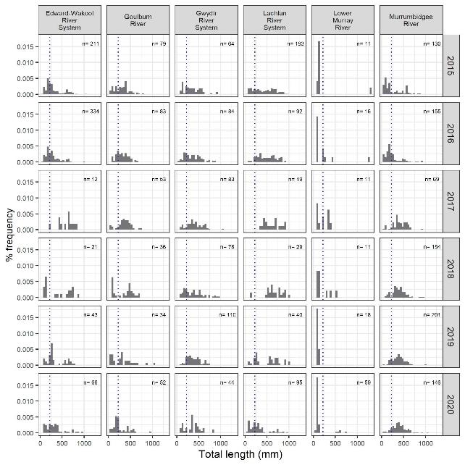
Figure 4.13 Length-frequency histogram of Murray cod by Selected Area and water year
Dotted line represents cut-off length used for recruits (<220 mm) less than one-year old
Bony herring population structure differed markedly among the Selected Areas (Figure D.1). Adult population abundances were an order of magnitude higher in the Lachlan River System than in other Selected Areas. Bony herring adults were present, and recruitment occurred in most years in the Lachlan River System, Gwydir River System, Lower Murray River and Murrumbidgee River System. Populations were generally less abundant in the Edward/Kolety-Wakool river systems, although there was some evidence of recruitment in this system in 2020. Bony herring were detected only rarely in the Goulburn River, likely due to unsuitable thermal conditions in southern tributaries (< 10˚C winter water temperatures) (Lintermans 2007).
Common carp population structure varied spatially and temporally (Figure D.2). Recruitment occurred in most Selected Areas and years, with especially high levels of recruitment following the 2016–2017 Murray River post flood blackwater event. This pattern was most evident in the Edward/ Kolety-Wakool river systems, the Lachlan River System and the Lower Murray River. Common carp can recruit during blackwater events and are tolerant of environmental stressors such as low oxygen levels (Koehn et al. 2000; King et al. 2012). In addition, the post-flooding may have also created more favourable conditions for spawning and recruitment of common carp. High levels of recruitment were observed in the Gwydir River System in 2020. Although the mechanisms driving this recruitment event is uncertain, a recent study found that common carp exceed density-impact thresholds for successful recruitment in up to 97% of large rivers (Stuart et al. 2021).
Carp gudgeon population structure was skewed to smaller adults, likely representing young cohorts (Figure D.3). Recruitment occurred in all Selected Areas and years.
Australian smelt population structure was comprised of both recruits and a wide range of adult length classes (Figure D.4). Recruitment was variable among Selected Areas and years, with consistent recruitment in the Murrumbidgee River System and relatively stable population structure in the Edward/Kolety-Wakool river systems and the Gwydir River System (Figure D.4).
Non-native eastern gambusia populations were present in most Selected Areas, with populations dominated by adults spanning the species’ full-size range (Figure D.5).
Flow-MER has the potential to improve our understanding of Commonwealth environmental water effects on recruitment through the collection of otolith-based age data. These data enable the calculation of recruitment strength using catch-curve regression analyses. Estimated recruitment strength can be linked to observed flow metrics (see Tonkin et al. 2019; 2021), which can inform scenarios-based modelling of population outcomes with and without Commonwealth environmental water, further clarifying the influence of water management on recruitment outcomes. For Flow-MER, relating annual flow metrics with recruitment strength is not yet achievable for 3 reasons:
- observed and counterfactual discharge sequences are not available prior to 2014
- catch curve regressions work best above a threshold age when mortality and detection rates become constant
- sample sizes were sparse for fish spawned before 2014.
The analysis revealed recruitment strength varied greatly among Selected Areas for golden perch, with the highest levels of variation observed in the Lower Murray River (Figure 4.14). Interestingly, strong recruitment years for golden perch corresponded with overbank flows and floods in the Lower Murray River and/or Darling catchment, and weak recruitment years corresponded with the cumulative effects of the millennium drought (Ye et al. 2020). These broad, qualitative observations highlight the importance of relating recruitment strength to annual flow metrics, which would allow full assessment of recruitment strength under observed and counterfactual flow conditions. Recruitment strength did not differ markedly among years for bony herring or Murray cod. Estimates of Murray cod recruitment strength were subject to high levels of uncertainty, possibly due to low sample sizes. In future years, age data on Murray cod could be supplemented by age estimates based on fish lengths and age-length keys specific to Selected Areas (e.g. Tonkin et al. 2021). Average annual survival rates over all age classes, calculated from catch curve regressions were 0.51 (mean + 95% credible interval 0.44, 0.58) for bony herring, 0.79 (0.71, 0.85) for Murray cod, and 0.78 (0.74, 0.82) for golden perch.
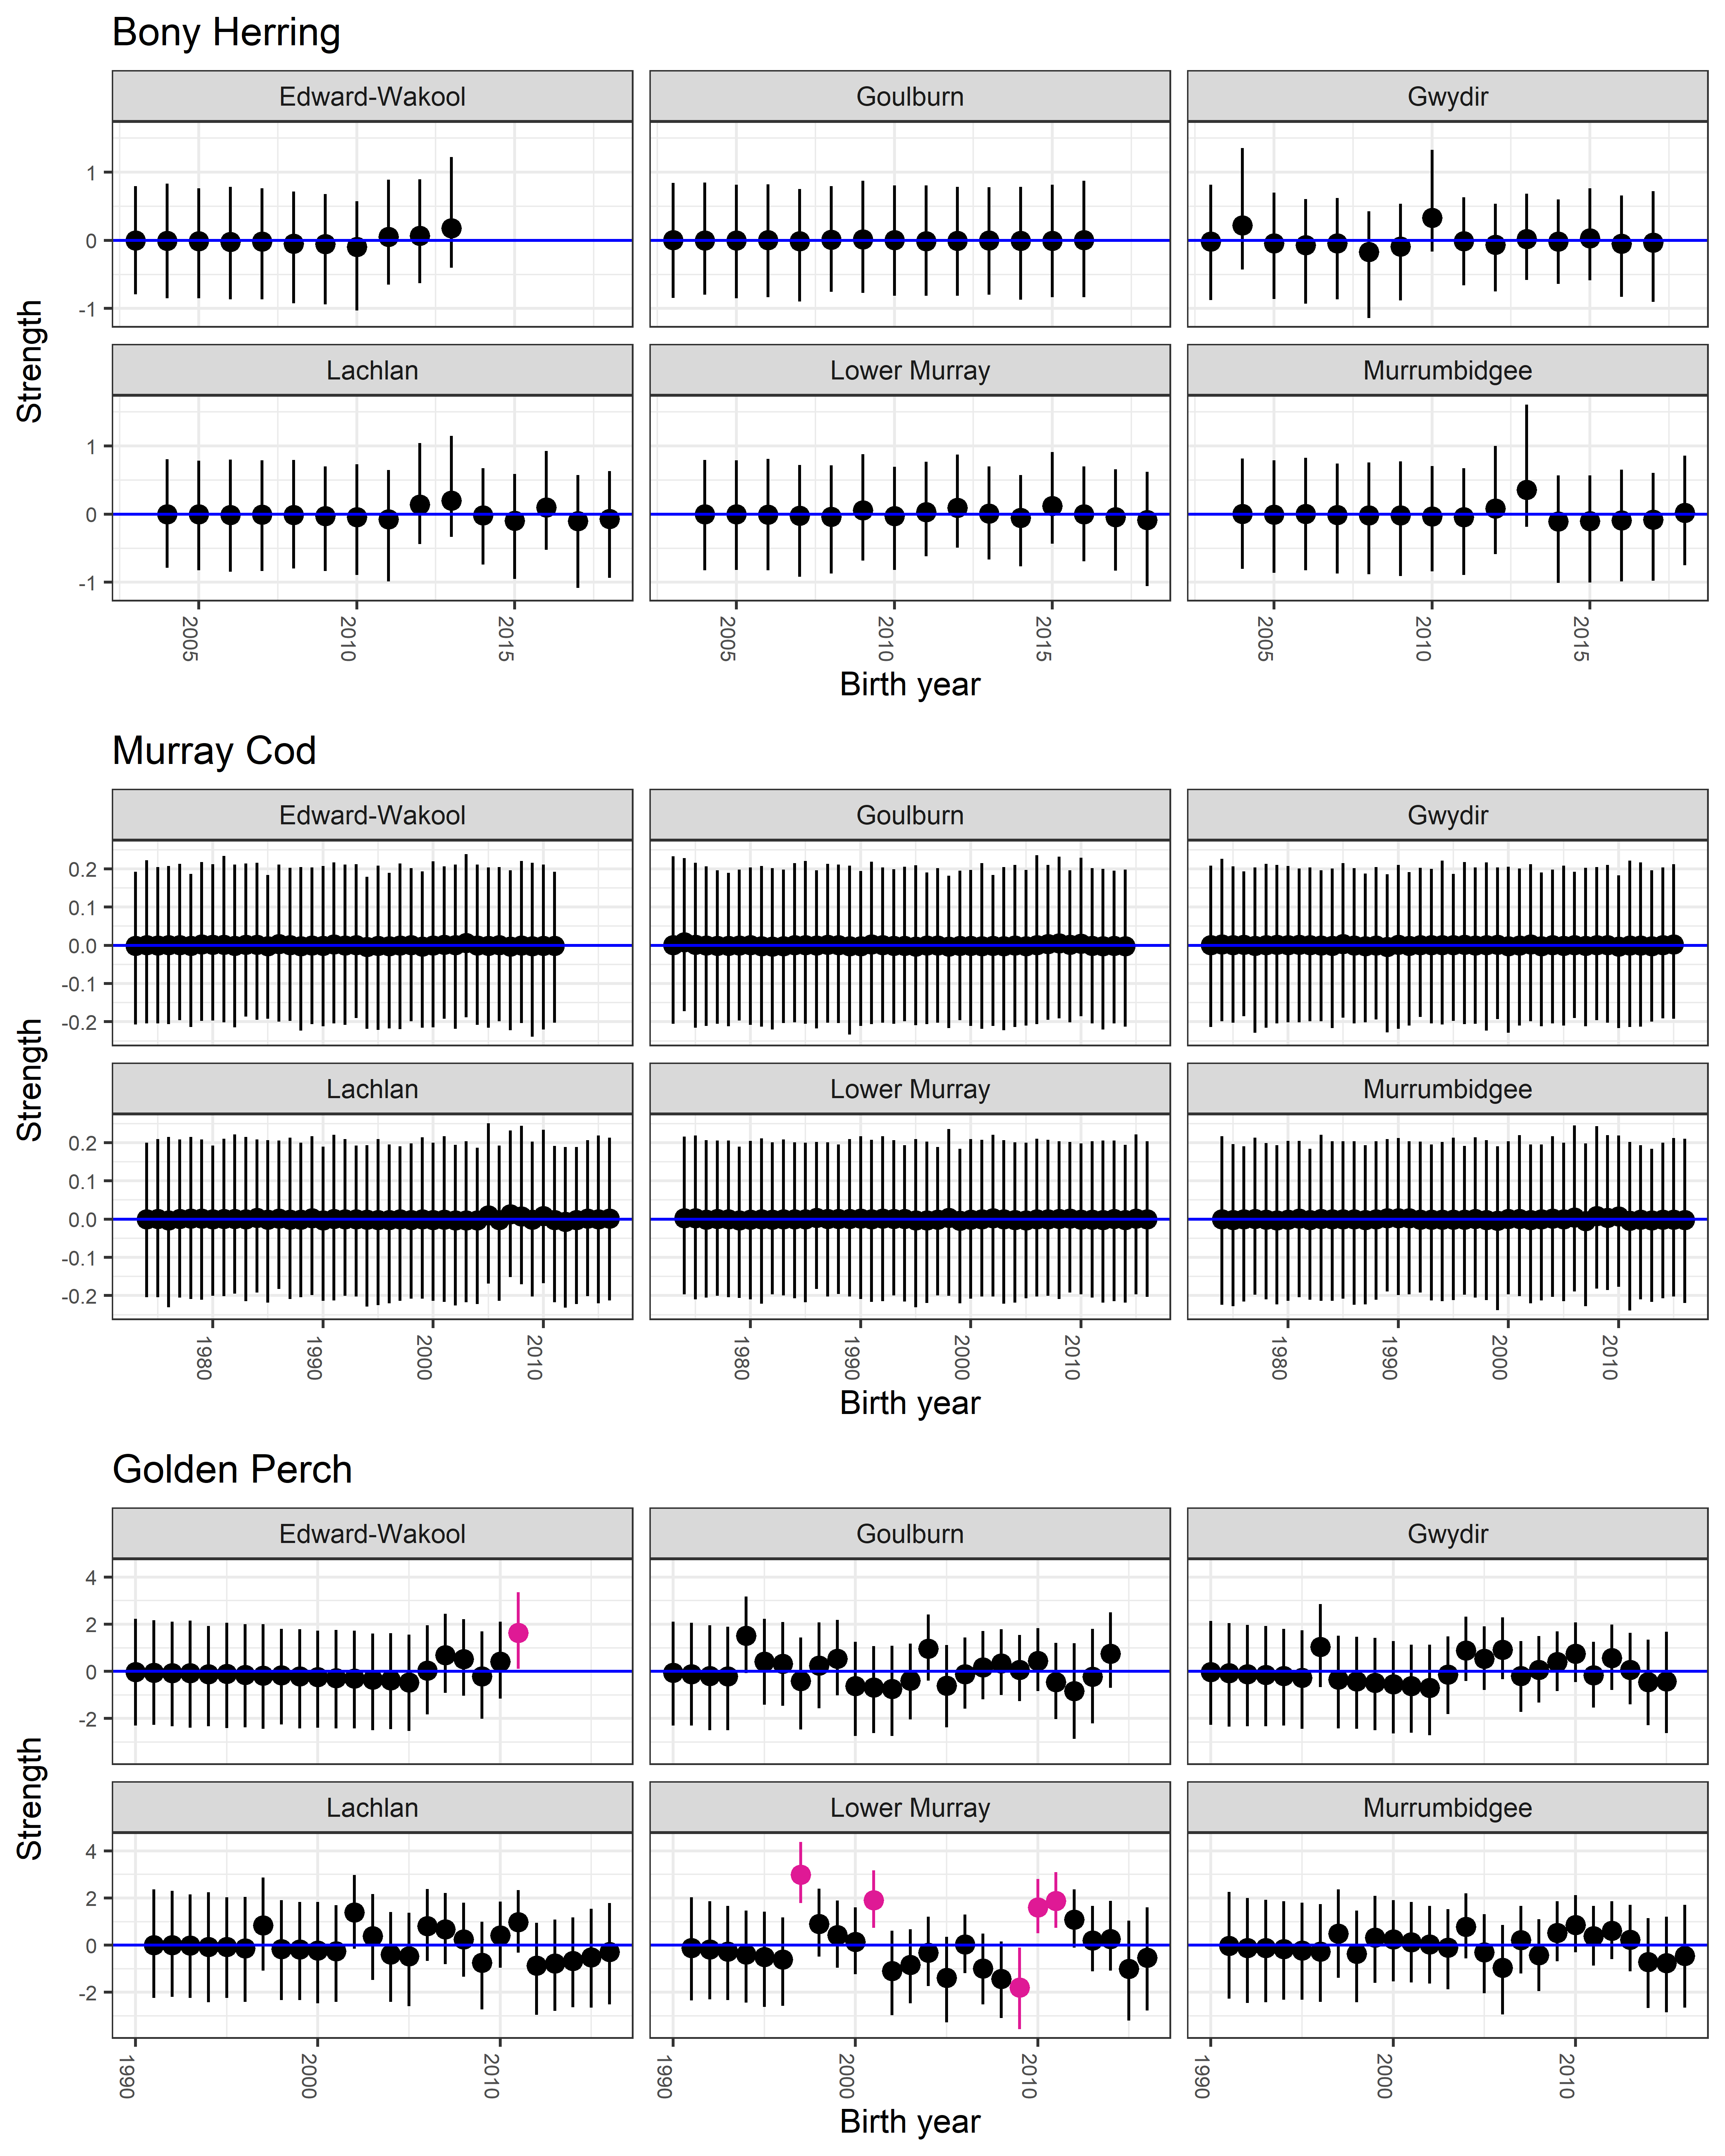
Figure 4.14 Recruitment strength estimates for bony herring, Murray cod and golden perch across 6 Selected Areas
X-axis is birth year and the year range is specific to each fish. Pink dots denote estimates in which the 95% credible interval does not include zero. Vertical black error bars are 95% credible intervals

Effect on recruits of focal species
Recruitment of Australian smelt and common carp was associated positively with the provision of freshes (Figure 4.15). Eastern gambusia recruits were negatively associated with decreases in discharge variability and baseflows and positively with large freshes (with high levels of uncertainty, 95% credible intervals overlapping zero). Carp gudgeon (with high levels of uncertainty; 95% credible intervals overlapping zero) recruitment was not associated strongly with any of the included discharge metrics.
Counterfactual modelling revealed mixed associations with Commonwealth environmental water, with differences among species, years, and Selected Areas (Figure 4.16). There was strong evidence (95% credible intervals not overlapping zero) from several Selected Areas in multiple years that the provision of Commonwealth environmental water increased recruitment of Australian smelt in the Edward/Kolety-Wakool River System (3 years out of 6 years), Lachlan River System (3 years out of 6 years), Murrumbidgee River System (5 years out of 6 years) and the Gwydir River System (4 years out of 6 years) (Figure 4.16, Figure 4.17). There was strong evidence in two Selected Areas from a single year that Commonwealth environmental water increased recruitment of common carp recruits in the Lachlan River System and Murrumbidgee River System, though there were high levels of uncertainty in the predicted effects of Commonwealth environmental water on these species during the monitoring program (Figure 4.16). Commonwealth environmental water had variable associations with eastern gambusia in the Lachlan River System (increased and decreased recruits; 1 year out of 6 years). There was no evidence of any strong associations between Commonwealth environmental water and carp gudgeon recruitment, noting that these fish usually recruit in wetlands which are not sampled for Flow-MER.
Responses to Commonwealth environmental water were driven primarily by base flows for all species, which suggests that antecedent flows are an important component of interpreting fish recruitment patterns (Rolls et al. 2013) (Figure 4.18).
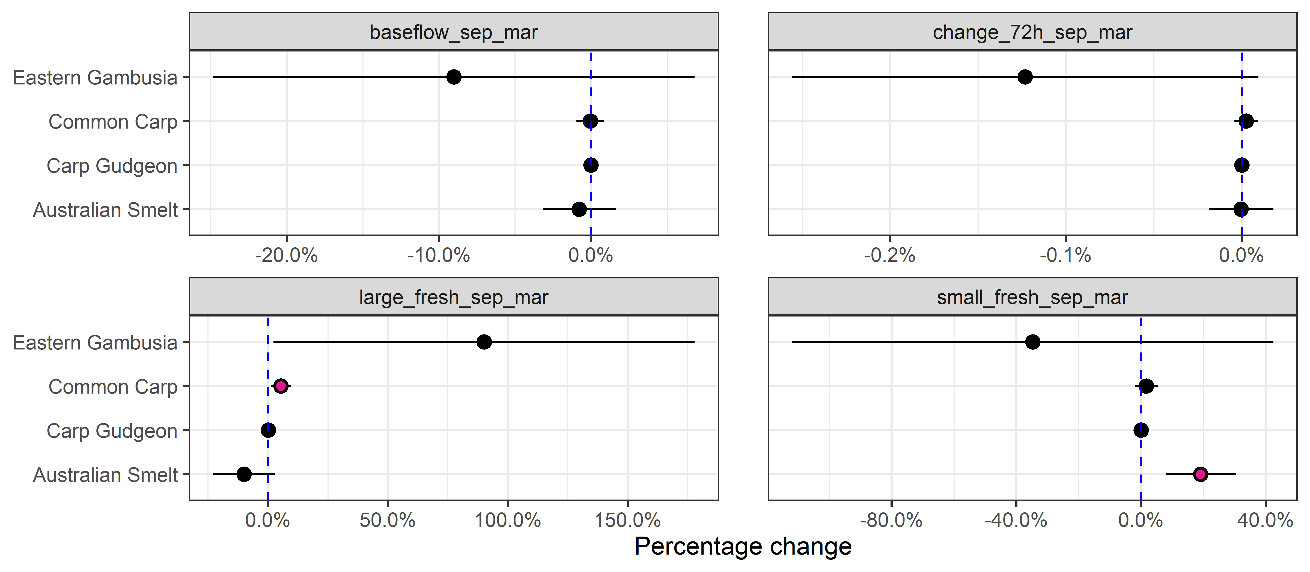
Figure 4.15 Effect of each flow variable on recruit CPUE for each species
Error bars are 95% credible intervals. Vertical broken line denotes the line of no effect = 0. Pink dots indicate 95% credible intervals that do not overlap 0
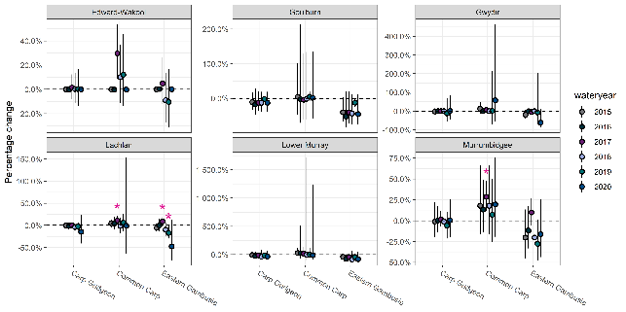
Figure 4.16 Predicted percentage change in recruitment due to Commonwealth environmental water for each species (except Australian smelt; shown below), year, and Selected Area
Positive values indicate increases in recruitment due to Commonwealth environmental water. Error bars are 95% credible intervals. Asterisk (*) indicates 95% credible intervals that do not include zero
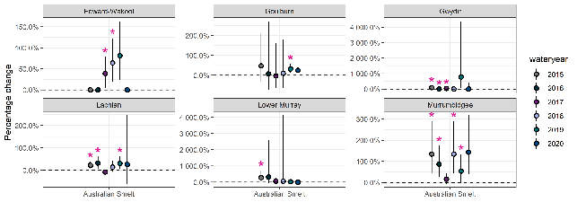
Figure 4.17 Predicted percentage change in recruitment of Australian smelt due to Commonwealth environmental water in each year and Selected Area
Positive changes indicate increases in recruitment due to Commonwealth environmental water. Error bars are 95% credible intervals. Asterisk (*) indicates 95% credible intervals that do not include zero. Note asterisks have been obscured due to long credible intervals for Australian smelt in 2019 Edward-Wakool River System, in 2020 Murrumbidgee River System and 2019 Gwydir River System
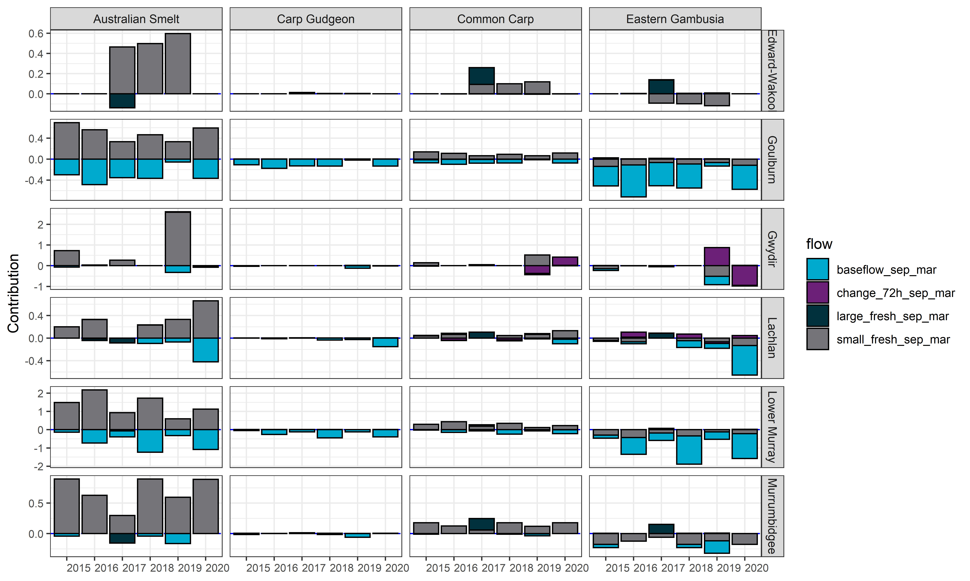
Figure 4.18 Contribution of each flow variable (base flow, change over 72 hours, large fresh, small fresh) to the predicted Commonwealth environmental water effect on recruitment of Australian smelt, carp gudgeon, common carp and eastern gambusia over the 2014–20 water years
Negative effects are shown as bars below 0 and positive effects are bars above 0. Effect sizes are on the link scale

Effect on community dynamics
An ordination of the large-bodied fish community revealed distinct assemblages in each Selected Area (Figure 4.19). Observed fish assemblages did not differ markedly among years within each Selected Area. Fish assemblages in the Lower Murray River and Lachlan River System were associated with less variable flows and more reliable baseflows. Fish assemblages in the Goulburn River and Murrumbidgee River System were associated with less frequent freshes. Fish assemblages in the Edward/Kolety-Wakool river systems and Gwydir River System were associated with more variable flows.
An ordination of small-bodied fish communities also showed unique assemblages in each Selected Area. These differences were less-pronounced than in the large-bodied fish communities (Figure 4.20). Fish assemblages in the Gwydir River System, Murrumbidgee River System and Goulburn River all were associated with variable flows, whereas those in the Lachlan River System, Lower Murray River and Edward/Kolety-Wakool river Systems were associated with base flows, freshes, and less variable flows.
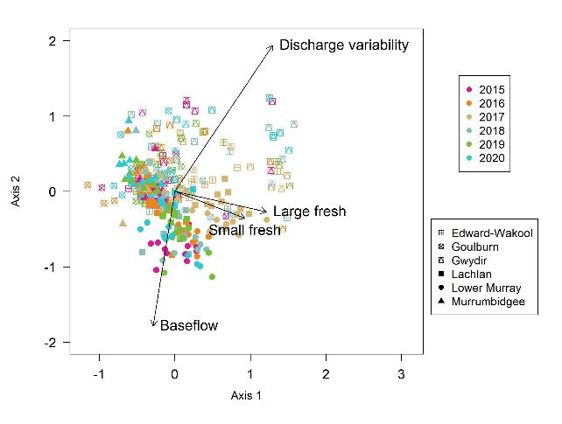
Figure 4.19 Ordination (nMDS) of large-bodied fish assemblages for each Selected Area and each water year
Hydrological predictor variables are projected onto observed assemblages, with arrow lengths representing the strength of association between a given fish assemblage and predictor variable. Large-bodied fish assemblages comprised bony herring, common carp, golden perch, goldfish, freshwater catfish, Murray cod, redfin perch, silver perch, spangled perch and trout cod
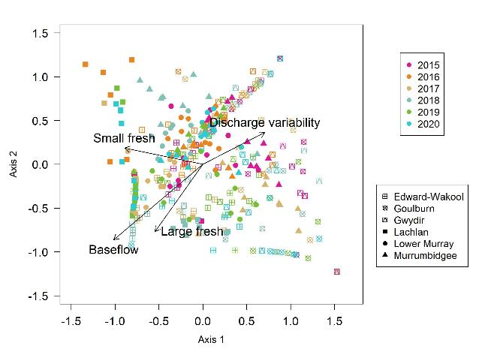
Figure 4.20 Ordination (nMDS) of small-bodied fish assemblages for each Selected Area and water year
Hydrological predictor variables are projected onto observed assemblages, with arrow lengths representing the strength of association between a given fish assemblage and predictor variable. Small-bodied fish assemblages comprised Australian smelt, carp gudgeon, dwarf flathead gudgeon, eastern gambusia, flathead gudgeon, Murray River rainbowfish, and unspecked hardyhead.

Effect on spawning and larval abundance
This section provides a qualitative interpretation of larval data for focal species. This is followed by a formal analysis of the effects of Commonwealth environmental water on flow-cued fish spawning and larval abundance.
Fish larval abundances differed among species, Selected Areas, and years (Figure 4.21; Figure 4.22). Larval abundances of three large-bodied species (bony herring, golden perch and trout cod) appeared to decrease through time in some Selected Areas. Larval abundances of Murray cod and silver perch were highly variable among years. For small-bodied species, peak larval abundances occurred in 2018 for Australian smelt and eastern gambusia in the Lachlan River System and in 2017 for carp gudgeons in the Edward/ Kolety-Wakool river systems.
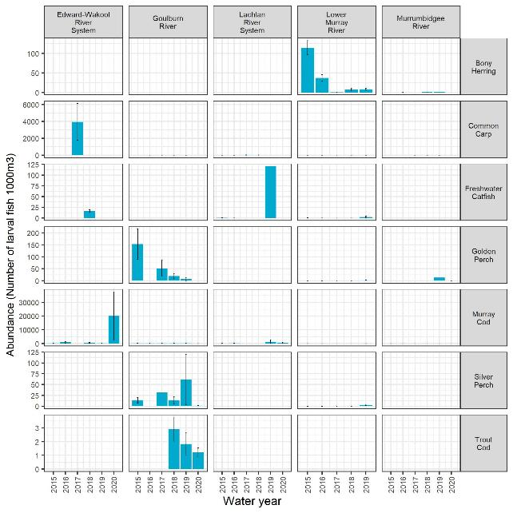
Figure 4.21 Mean larval abundance (no. of larval fish captured per drift net/1000 m³) of large-bodied native fish species in each Selected Area over the 2014–20 water years
Height of each bar is the mean and the whiskers show the ±1 standard error (SE). Y-axis scales differ among species. Bongo tow nets used for Lower Murray Selected Area
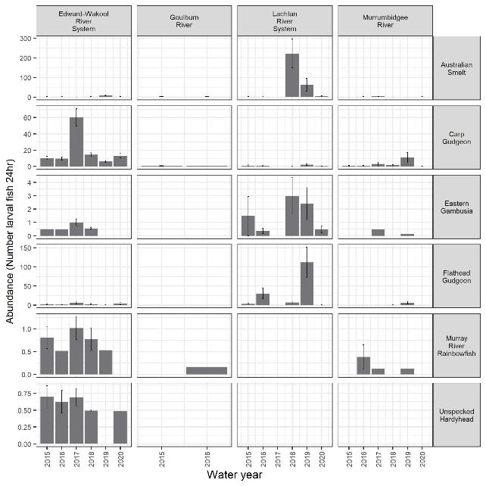
Figure 4.22 Mean larval abundance (no. of larval fish captured per light trap/24-hour period) of small-bodied native fish species in each Selected Area over the 2014–20 water years
Height of each bar is the mean and the whiskers show the ±1 standard error (SE). Y-axis scales differ among species.

Effect on flow-cued fish spawning
The occurrence of spawning in golden perch and silver perch (high uncertainty, 95% credible intervals overlapping zero) was associated positively with the provision of consistent baseflows and with weaker evidence positively with large freshes for golden perch (Figure 4.23). There was a negative association with spawning and the provision of small freshes, which is discussed in detail below (Figure 4.23). The degrees of associations between spawning and Commonwealth environmental water delivery were variable among Selected Areas and years (Figure 4.24). Counterfactual modelling indicated that golden perch would spawn more frequently with Commonwealth environmental water in the Goulburn River and Lower Murray River (moderate evidence; 2 years out of 6 years) and less frequently with Commonwealth environmental water in the Murrumbidgee River System (strong evidence; 2 years out of 6 years) (Figure 4.24). However, given the limited Commonwealth environmental water contribution to large freshes during the period of the monitoring program, these inferences were driven primarily by Commonwealth environmental water contributions to base flows in the Goulburn River and Lower Murray (positive effects) and small freshes in other systems (negative effects) (Figure 4.25).
These differing patterns across Selected Areas and years reflect the uncertainty in analyses with only 6-years of condition monitoring data, limited flow variability among years and Selected Areas. This paucity of data and flow variability makes it more difficult to estimate responses to Commonwealth environmental water for flow-cued spawning species. Furthermore, there is uncertainty in modelling the effects of flow on fish and then in the extrapolation of this flow effect to a no-Commonwealth environmental water scenario. Additionally, spawning events were detected at a low proportion of sites within Selected Areas (Figure 4.26), which may reflect the prevailing drought conditions experienced for much of the program and/or the limited Commonwealth environmental water contribution to large freshes and overbank flows.
Further confirmation is provided by the finding of negative associations with small freshes for some Selected Areas in some years. This suggests that when there was a higher proportion of small fresh flow days spawning was less likely. This should not be interpreted as small freshes do not promote spawning since the flow metrics used here were annual metrics and do not necessarily coincide with individual spawning events, nor do they take into account the magnitude of the freshes or discharge delivered into a system, or any association with large freshes delivered during the annual period which may have led to a spawning event. Better matching of the time period for which metrics are calculated to fish responses is needed in future analyses and is further discussed in the Adaptive Management section.
Freshes are critical for golden perch and silver perch spawning and there is an overwhelming body of evidence (outside of Flow-MER) that these species often spawn during spring fresh events and, for golden perch, during large flow events and overbank flows (Zampatti and Leigh 2013; Koster et al. 2017; King et al. 2020; Stuart and Sharpe 2020). Commonwealth environmental water contributions to large freshes were minimal between 2014 and 2020. Overbank flow conditions occurred only once (2016-17) over the 6-year monitoring period, and were accompanied by blackwater hypoxia events in most Selected Areas. For example, in the Lower Murray golden perch spawning (eggs and larvae) was detected after the overbank flow conditions in 2016-17 though recruitment was not evident potentially due to blackwater hypoxia effects on larval mortality (Ye et al. 2018). These predominant low flow conditions may explain the small number of detected spawning events and weak associations with Commonwealth environmental water, especially given the minimal Commonwealth environmental water contributions to large freshes and overbank flows during the monitoring program.
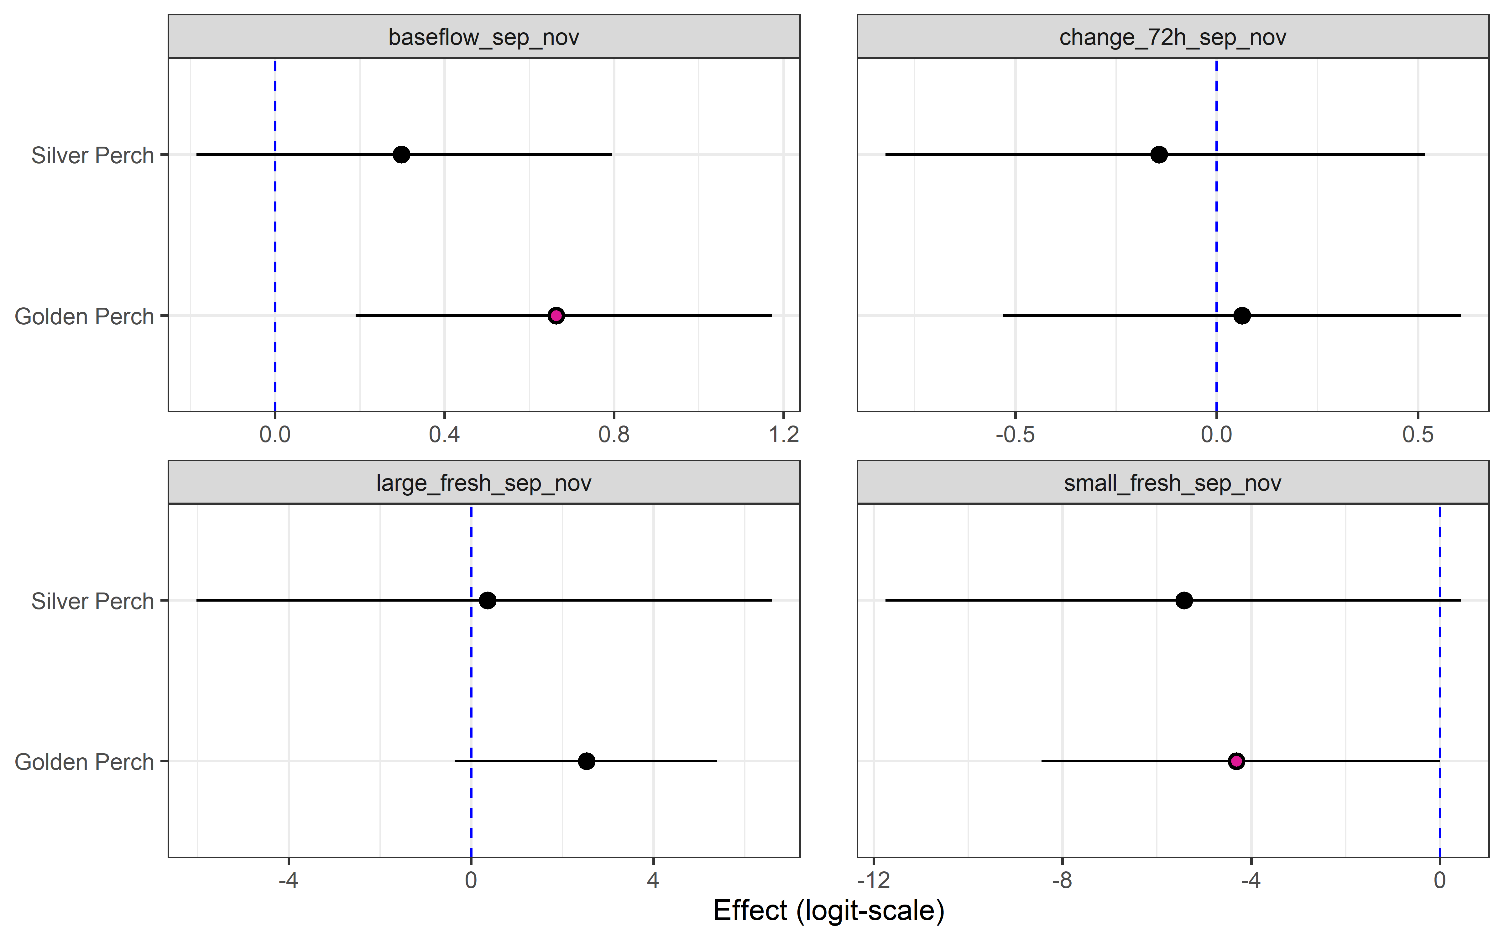
Figure 4.23 Effect of each flow variable (base flow, change over 72 hours, large fresh, small fresh) on spawning occurrence of silver perch and golden perch on the logit scale
Error bars are 95% credible intervals. Vertical broken line denotes the line of no effect = 0. Pink dots indicate 95% credible intervals that do not overlap 0
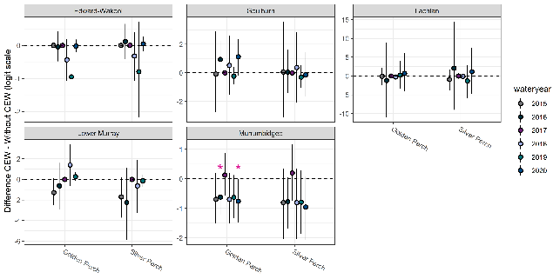
Figure 4.24 Predicted change (logit scale) in the occurrence of spawning of golden perch and silver perch due to Commonwealth environmental water in 5 Selected Areas over the 2014–20 water years
Asterisk (*) indicates 95% credible intervals that do not include zero. Error bars are 95% credible intervals
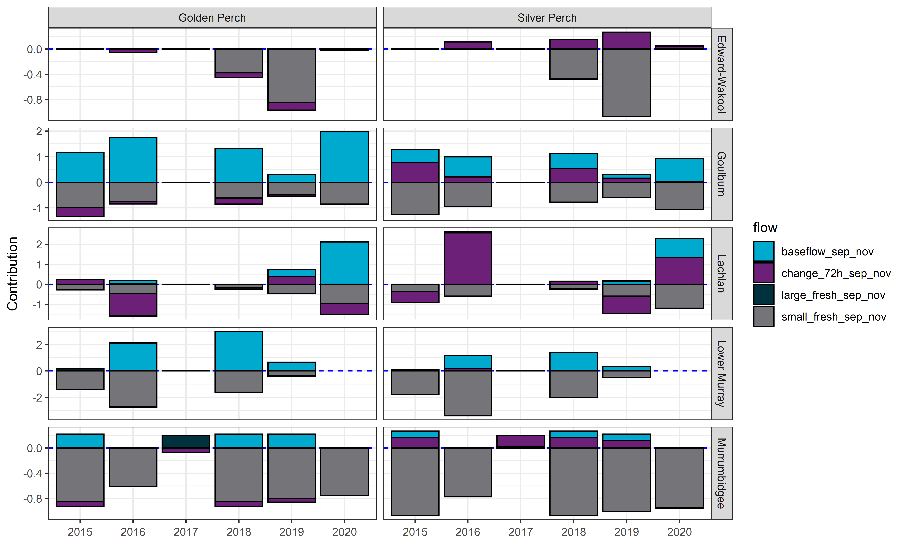
Figure 4.25 Contribution of 4 flow variables (base flow, change over 72 hours, large fresh, small fresh) to the predicted Commonwealth environmental water effect on spawning occurrence over the 2014–20 water years
Negative effects are shown as bars below 0 and positive effects as bars above 0. Effect sizes are on the link scale
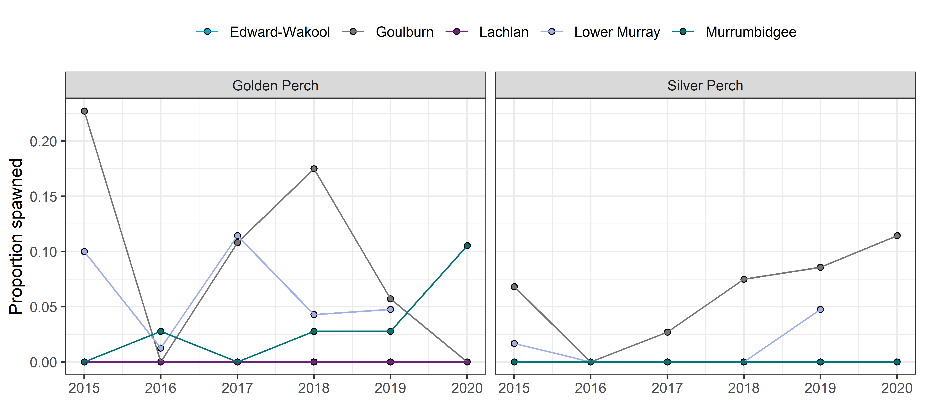
Figure 4.26 Proportion of sites with spawning events in the 5 Selected Areas for each water year

Effect on flow-cued fish larval abundance
Larval abundance of golden perch was negatively associated with increases in the proportion of discharge in the week prior to sampling relative to the median discharge during the spawning period (Figure 4.27, Figure 4.28) (see section 2.2.2 for further explanation). Responses of silver perch larval abundance to flow metrics mirrored those of golden perch, albeit with higher levels of uncertainty (95% credible intervals overlapping zero). Counterfactual modelling suggested that Commonwealth environmental water reduced golden perch larval abundances relative to counterfactual scenarios in the Lower Murray River and Murrumbidgee River System (strong evidence for both Selected Areas; 3 years out of 6 years) but there is substantial uncertainty when extrapolating to this hydrological scenario. Responses of golden perch and silver perch larval abundance to Commonwealth environmental water were driven primarily by increases in the magnitude and range of flows in the week prior to sampling and did not include the timing of spawning events in the analyses (Figure 4.29).
These findings were unexpected and the data on spawning and larval abundance was inadequate to make a reliable estimate due to the lack of spawning events observed in the monitoring program and the very low numbers of larval golden perch that were collected in the Lower Murray River due to the predominant drought conditions, even with Commonwealth environmental water deliveries. Given there were few spawning events during the monitoring period, the specific relationship described above might be Selected Area specific, or could it be a statistical artefact of the modelling approach. For models that incorporate event-based hydrological metrics it is less clear on how to approach the counterfactual scenario. Since, the sampling period for the larval abundance dataset only records a fraction of the Commonwealth environmental water events that occurred (metric is calculated as average discharge in the 7 days prior to sampling divided by median discharge over the spawning period, September–March) therefore our analyses may have missed the largest Commonwealth environmental water effects (Fanson 2021). Another caveat is that hydrological metrics used in the analysis were calculated a week prior to sampling and not a week prior to the spawning event which may also impact the findings. Better timing of metrics to fish life history events needs to be investigated in future (see the Adaptive Management section).
A potential explanation for these findings is that major changes (i.e. drops) in river height during the spring spawning season are linked to reduced recruitment of Murray cod and other species with parental care through nest abandonment and increases in egg or larval mortality (Stuart et al. 2019; Burndred et al. 2017). For golden perch and silver perch, increased egg and larval mortality under highly variable flows might explain the observed negative effects of Commonwealth environmental water on golden perch and silver perch larval abundances. Though spawning of these species is often associated with higher discharge variability (Koster et al. 2017) and with highly regulated systems such as the Lower Murray increases in discharge variability with higher flows are needed to elicit spawning events, so this observation should be interpreted cautiously.
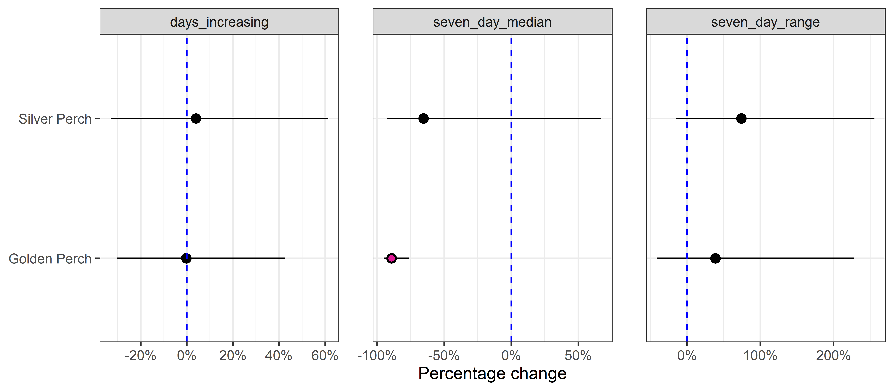
Figure 4.27 Effect (as percentage change) of 3 flow variables (days increasing, 7 day median, 7 day range) on larval abundance for silver perch and golden perch
Error bars are 95% credible intervals. Vertical broken line denotes the line of no effect = 0. Pink dots indicate 95% credible intervals that do not overlap zero
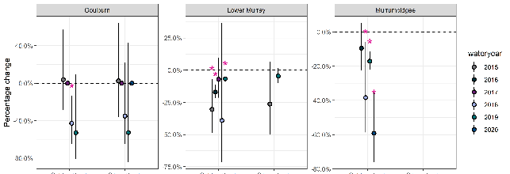
Figure 4.28 Predicted percentage change in larval abundance due to Commonwealth environmental water for each species, water year, and Selected Area
Positive values indicate increased larval abundance due to Commonwealth environmental water. Error bars are 95% credible intervals. Asterisk (*) indicates 95% credible intervals that do not include zero
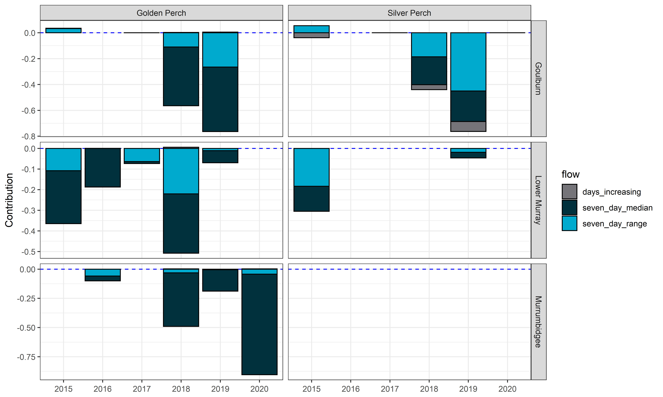
Figure 4.29 Contribution of 3 flow variables to the predicted Commonwealth environmental water effect on larval abundance
Negative effects are shown as bars below 0 and positive effects as bars above 0. Effect sizes are on the link scale

Effect on fish body condition
The effects of freshes on body condition of fish varied across species. There was some evidence of positive associations between small and large freshes and body condition of Murray cod and golden perch (noting that all 95% credible intervals overlapped zero). These observations are consistent with an earlier study on Murray cod, which found that large freshes increased growth rates and improved body condition (Stoffels et al. 2020). Common carp body condition was positively associated with the provision of large freshes (Figure 4.30). Counterfactual modelling indicated there was evidence from several Selected Areas that the provision of Commonwealth environmental water increased body condition of golden perch individuals in the Lower Murray River (moderate evidence; 3 years out of 6 years), Lachlan River System (strong evidence; 1 year out of 6 years), and Edward/Kolety-Wakool River System (moderate evidence; 1 year out of 6 years). There was also evidence that that the provision of Commonwealth environmental water increased body condition of Murray Cod individuals in the Murrumbidgee River System (strong evidence; 1 year out of 6 years; moderate evidence; 5 years out of 6 years), Gwydir River System (moderate evidence; 4 out of 5 years) and the Lachlan River System (moderate evidence; 3 years out of 6 years). There was evidence that that the provision of Commonwealth environmental water increased the body condition of common carp in both the Lachlan River System (strong evidence; 1 year out of 6 years) and Murrumbidgee River system (strong evidence; 1 year out of 6 years; moderate evidence 3 years out of 6 years) although these responses varied among years and Selected Areas indicating a large amount of uncertainty in these results (Figure 4.31). Body condition of bony herring had strong negative associations with discharge variability in the Murrumbidgee River System (4 years out of 6 years), Lachlan River System (4 years out of 6 years) and the Edward/Kolety River System (3 years out of 6 years). Responses to Commonwealth environmental water were driven primarily by small freshes for common carp, discharge variability for bony herring, and base flows and small freshes for golden perch and Murray cod noting that Commonwealth environmental water contributions to large freshes during the monitoring period were limited (Figure 4.32).
Condition metrics are based on the assumption that heavier fish relative to a fixed length are in better condition or health (Jones et al. 1999). Fulton’s K is a commonly used metric to compare fish populations (Nash et al. 2006). Though the use of this metric can sometimes be unreliable in instances where fish lengths vary, and fish do not show isometric growth which is a common phenomenon among fishes (Ogle 2016). Condition metrics are complementary to other fish population measures such as abundance estimates as they can provide insight into the relative health of individuals within populations. Flow regimes promote fish body condition through increased productivity, availability of food resources and habitat, and connectivity (Tonkin et al. 2011), all hydrological components supported by Commonwealth environmental water baseflows and freshes. It is also important to note that flooding events may affect fish condition of long-lived species across more than one year which our current analyses do not consider. For example, in the Lachlan River System, common carp and Murry cod were found to increase in body condition for up to 2 years post the 2016–17 post flood event (Daniel Wright, NSW DPI Fisheries, pers. comm.). The improvement of body condition metrics will be considered in future analysis.
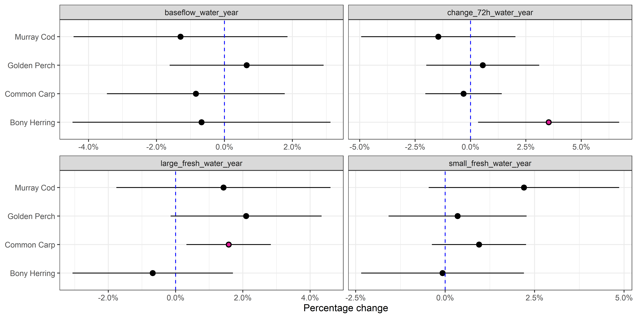
Figure 4.30 Effect of 4 flow variables (base flow, change over 72 hours, large fresh, small fresh) on body condition for Murray cod, golden perch, common carp, bony herring
Error bars are 95% confidence intervals. Vertical broken line denotes the line of no effect = 0. Pink dots indicate significant effects at p<0.5 threshold
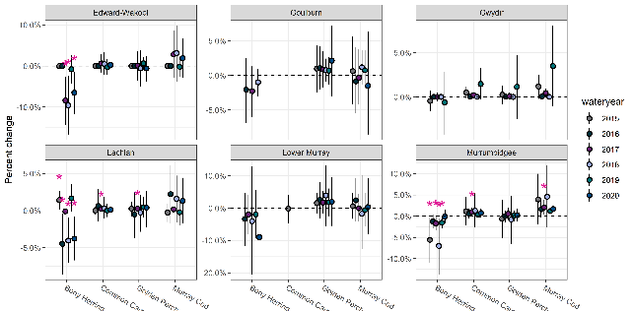
Figure 4.31 Predicted effect of Commonwealth environmental water on body condition of Bony herring, common carp, golden perch, Murray cod in the 6 Selected Areas over the 2014–20 water years
Effect sizes have been scaled to percentage of mean Fulton Index for each species. Error bars are 95% confidence intervals. Asterisk (*) indicate significant effects at p<0.05 threshold
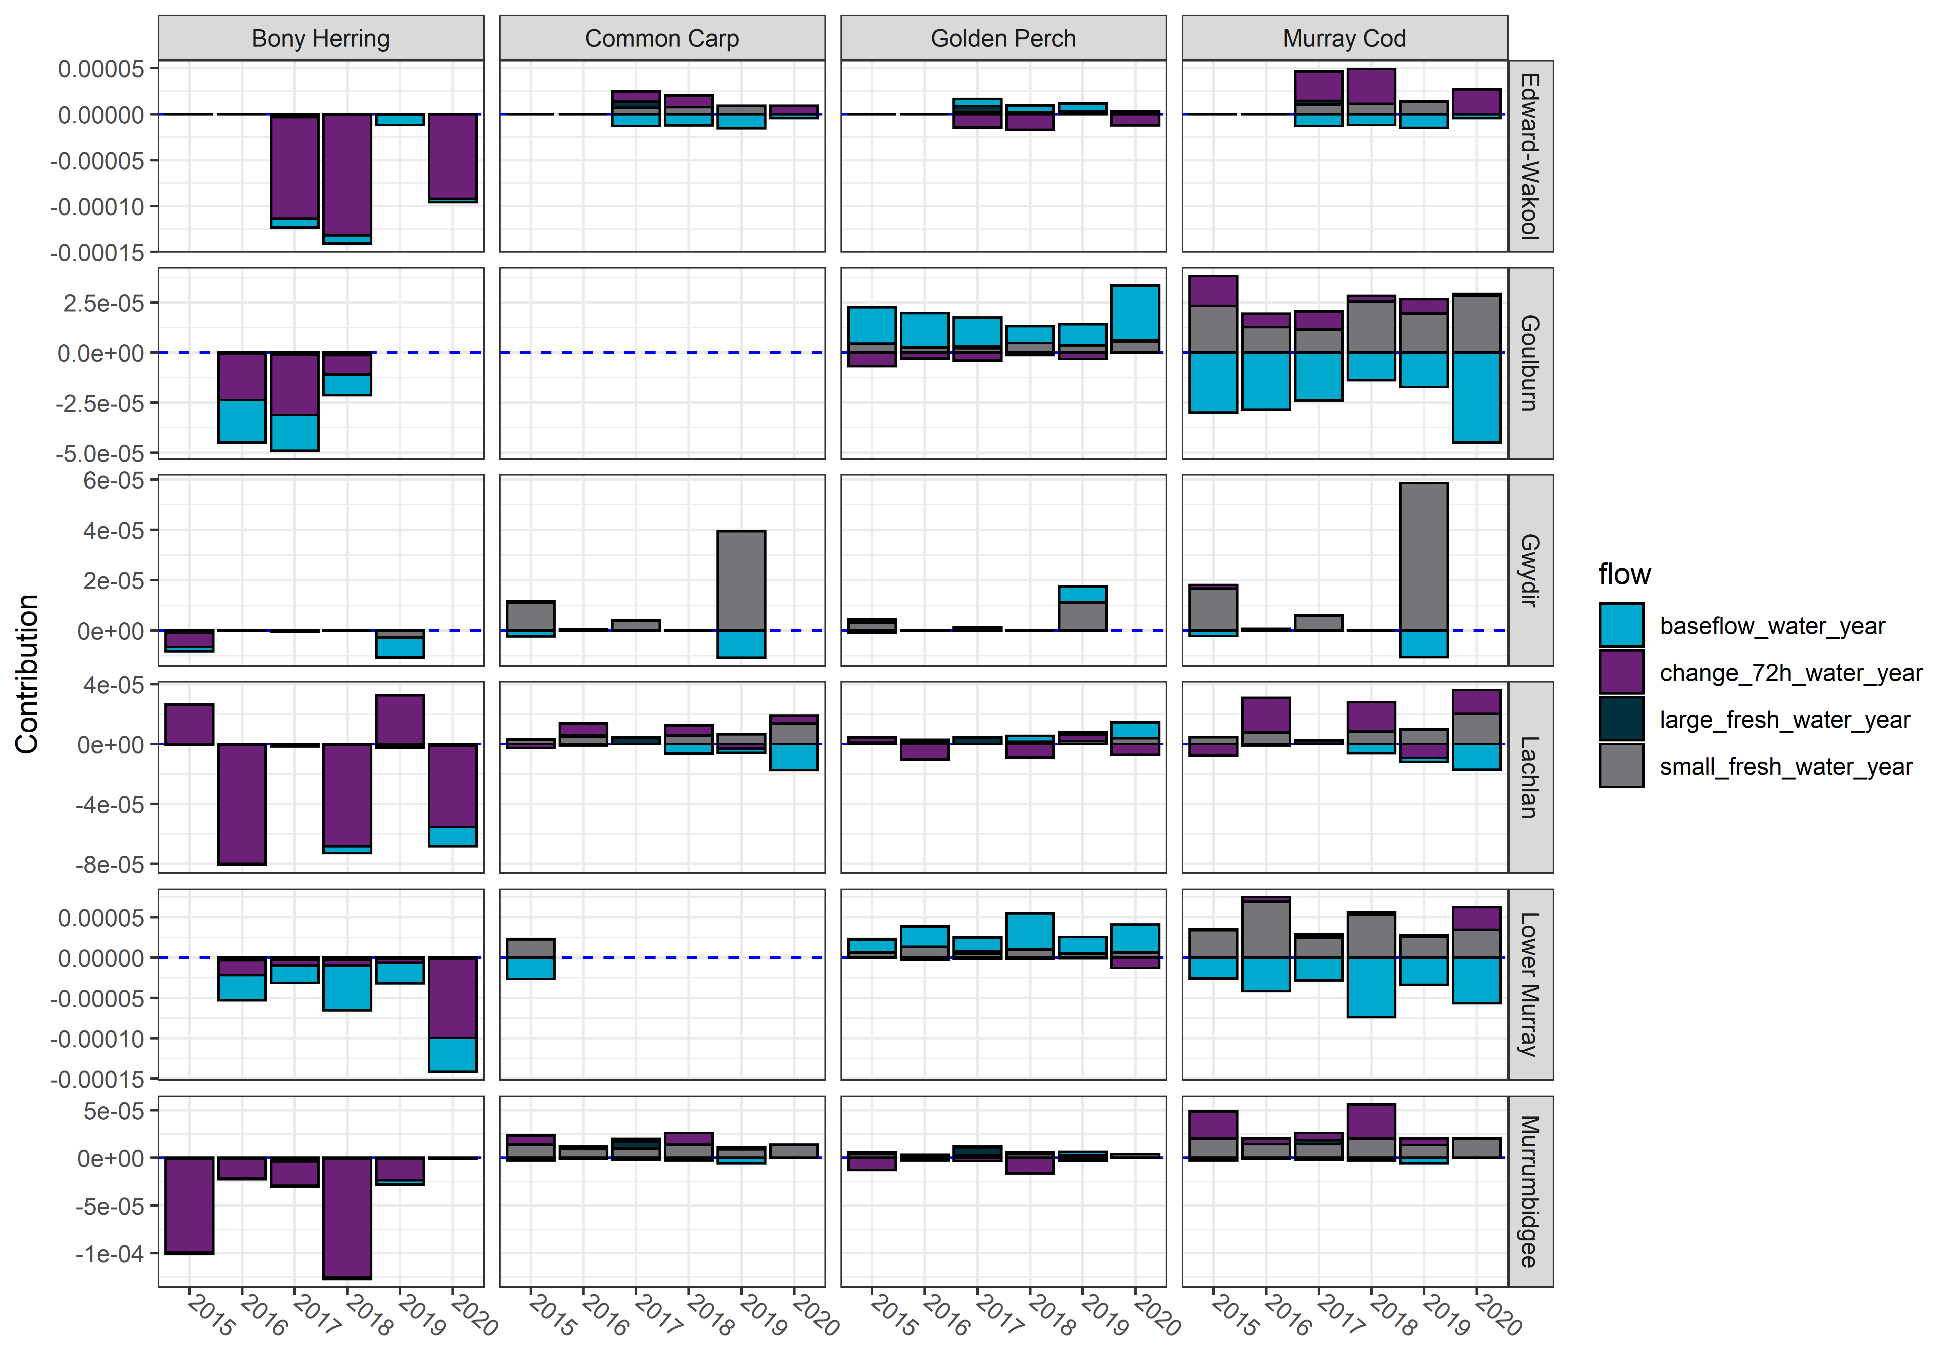
Figure 4.32 Contribution of 4 flow variables (base flow, change over 72 hours, large fresh, small fresh) to the predicted Commonwealth environmental water effect on body condition of bony herring, common carp, golden perch, Murray cod
Negative effects are shown as bars below 0 and positive effects as bars above zero. Effect sizes are on the observation scale

Contribution to Basin Plan objectives
Commonwealth environmental water has a critical role to play in meeting long-term Basin Plan objectives under section 8.05 (3a, 3b) (Commonwealth of Australia, Basin Plan 2012) to protect and restore biodiversity that is dependent on Basin water resources. Longer term targets identified in the Basin Plan to measure progress towards the overall environmental objectives for water-dependent ecosystems include improvements in recruitment and populations of native fish (Commonwealth of Australia, Basin Plan 2012). The evaluation was not specifically designed to comprehensively address the general fish objectives outlined in the Basin Plan. A stronger link, including developing specific quantifiable objectives and targets would be useful in closing this gap. The Basin-wide environmental watering strategy (the Strategy, MDBA 2020) elaborates some of these key biodiversity outcomes of the Basin Plan in more detail. The Strategy lists 5 expected outcomes for fish to be achieved by 2024, as summarised below.
Here we consider the evidence from the Flow MER program as it pertains to achieving the general targets of the Basin Plan (i.e. improvements in recruitment and populations of native fish) and the Strategy outcomes.
No loss of native species currently present within the Basin
In the Flow-MER program within the Selected Areas the number of adult native fish species detected has fluctuated over the monitoring period (i.e. since 2014), though these changes are relatively minor. Cumulatively, all 13 native fish species detected during the monitoring program were still present in 2020. Persistence of fish has likely been related to post-drought widespread rainfall and associated natural flows and supporting environmental flows.
Improved population structure of key fish species through regular recruitment
For improved population structure the Strategy lists annual recruitment events for key moderate- to long-lived species, including golden perch and Murray cod, as being at least 8 out of 10 years at 80% of key sites, with 4 of those being strong recruitment events (MDBA 2020).
In the Flow-MER program for golden perch there was evidence of spawning in the Goulburn River, Lower Murray River and Murrumbidgee River System during the monitoring program, however recruitment was minimal during the monitoring program in most Selected Areas. An exception to this was the junction of Warrego and Darling rivers where golden perch recruits commonly occur following flow events (Southwell et al. 2020). Note that this site was not included in Basin-scale analyses.
Several young-of-year recruits were collected in the Goulburn River during the water years of 2016 and 2020, however these were most likely stocked fish (Wayne Koster, DELWP, in Webb et al. 2017b; Treadwell et al. 2020). Since 2016, there have been several successful cohorts in the Darling River system supported by Commonwealth environmental water but these are yet to be detected in the connected Murray system (Sharpe and Stuart 2018). In the Murray system, recruitment strength calculated with regression catch curve analyses on age-data suggested 2 strong recruitment years were last evident in 2010 and 2011 in the Lower Murray which corresponded with high flows and large overbank floods (Ye et al. 2020).
Golden perch have spatially patchy recruitment patterns, often associated with major flows and flood events in the Darling and Lower/Mid Murray systems (Zampatti et al. 2015; Cruz et al. 2020; Shams et al. 2020; Stuart and Sharpe 2020). Nevertheless, flow conditions that are conducive to recruitment (large freshes and/or overbank flows) do not appear to have been met in most of the Flow-MER Selected Area sites (except for the Warrego River), helping to explain the lack of detectable golden perch recruitment.
It is also likely that spawning in some of the Selected Areas (i.e. lower Goulburn River) results in downstream drift of eggs and larvae into unmonitored areas of the mid Murray River below Torrumbarry Weir (Koster et al. 2017). This reach of the Murray River also likely has in situ spawning during within-channel flows and remains as a monitoring priority. In summary, for golden perch, improved population structure does not appear evident at any of the Selected Area sites. Though golden perch have spatially and temporally episodic recruitment patterns so there were likely recruitment events in other areas of the MDB. Potential integration of additional Selected Area sites along with investigation of recruitment patterns from the Research theme (via otolith microchemistry) of Flow-MER are high priorities for better understanding golden perch population dynamics.
In the Flow-MER program there was evidence of Murray Cod spawning in all Selected Areas. Recruitment occurred in most Selected Areas in most years. The 2016-17 (Murray River) and 2018-19 (Darling River) blackwater events and associated fish deaths had an adverse impact on Murray Cod populations with evident reductions in recruits and adults in the Edward/Kolety-Wakool River System, Lachlan River System, Murrumbidgee River and to a smaller extent in the Goulburn River (Thiem et al. 2017; Vertessy et al. 2019). Recruitment strength was calculated for Murray Cod. Substantial uncertainty due to the small age-data sample, prevented conclusions being made. Recent broad-scale analyses and population modelling (Flow-MER research project F1) are beginning to identify key hydrological and hydraulic components of the flow regime that contribute to Murray Cod ecology and population structure (Stuart et al. 2019; Tonkin et al. 2020).
Increased movement of key fish species
The Basin-scale evaluation was not designed to assess increased movement of fish species. However, valuable insights will be provided by the research program of Flow-MER with a major project on fish movement which will be investigating regional and Basin-scale fish response to Commonwealth environmental water (F2: Fish movement). Nevertheless, some movement studies described in annual Selected Area reports have shown movement with Commonwealth environmental water. A movement study in the Lower Murray River showed continuous barrage flows were maintained by Commonwealth environmental water (100%) in this dry year and contributed substantially to pouched and short-headed lamprey migration (between the ocean, Coorong Estuary and Murray River) (Ye et al. 2021). Another movement study in the Edward-Wakool reported that golden perch and silver perch movements during winter were typically localised for both species in 2019 (Watts et. al. 2020). In the Gwydir River System, Murray cod was found to be more likely to move during an environmental flow event (Mika et al. 2020). Further investigation of flow-fish movement relationships will be explored in the Flow-MER research theme.
Expanded distribution of key fish species and populations in the northern and southern Basins
Within Selected Areas, the Flow-MER monitoring data allowed us to examine the proportion of sites at which key species occur. These data provide an indication of changes in species distributions among sites within each Selected Area. Based on current monitoring data, no species have decreased substantially in distribution during the monitoring program (2014–present), with evidence of expanded distributions of several species in some Selected Areas (e.g., silver perch, Australian smelt; Figure 4.5; Figure 4.7).
The monitoring program was not designed to assess this objective, with standardised fish monitoring only occurring in 6 Selected Areas across the Basin. The LTIM/Flow-MER fish data could be used in conjunction with other Commonwealth and state agency monitoring programs (e.g. The Living Murray, VEFMAP, NSW Basin Plan Environmental Outcomes Monitoring) to help inform this objective. The development of predictive models to extrapolate beyond Selected Areas would provide some insight into distributional changes in response to Commonwealth environmental water. We discuss below (see 6.2) the steps required to develop such models, noting that the current monitoring program and available data would generate predictions with low confidence.
Improved community structure of key native fish species
The Basin-scale evaluation examined community structure of large-bodied and small-bodied native fish species in all Selected Areas and years using ordination analysis, based on species assemblages (presence-absence data only). Ordinations give insight into changes in community structure through time. Our analysis revealed that differences in fish assemblages were more evident among Selected Areas than years, noting that some Selected Areas were more similar than others. This suggests that fish assemblages did not change markedly within the Selected Areas during the monitoring program (i.e. 2014-present). Ordinations do not provide information on directional change in community structure, so do not identify potential improvements in fish community structure in the absence of a benchmark or reference condition. In addition, our analyses did not consider relative or absolute abundances of fish, and do not detect what may be significant changes in overall community structure due to relative or absolute changes in abundance of different species. Future analyses could potentially address this objective by extending the dissimilarity-based ordinations used here to consider quantitative measures of community structure and to include abundance (catch per unit effort) data. For future reference, there also needs to be greater clarity as to what constitutes an ‘improvement’ with well-defined benchmark conditions to then track recovery.

Adaptive management
The Basin-scale analyses revealed several adaptive management opportunities and these include:
- refining environmental flow management
- improving and informing future monitoring and analysis.

Refining environmental flow management
For environmental flow management, monitoring indicated that baseflows are important for native fish species. They affect juvenile survival, fish body condition and fish population growth. The benefits of base flows are also important during periods of drought, regulated annual winter low/zero flows in small systems, and frequent low summer flows during the monitoring program. Our findings suggest that delivery of seasonal baseflows can be especially critical, such as for the Edward/Kolety-Wakool river system, where Commonwealth environmental water contributes to continuous base flows, maintaining connectivity, and water quality - all important for supporting fish communities. Further monitoring is needed to inform provision and effectiveness of low flows (Thiem et al. 2017, Stuart et al. 2020).
The monitoring program demonstrated the benefits of seasonal small fresh events for a wide range of native fish species. Small fresh events have been incorporated into most watering plans. For the Selected Areas, however, there was less information on fish response to delivery of large fresh events and overbank flows. Hence, flow-ecology relationships, planning and monitoring of Commonwealth environmental water for these flow types need to be informed by other long-term studies which observed a broader range of flow conditions. One example is the long-term monitoring in the Murray River below Yarrawonga (Lyon et al. in press). This highlights the need for more integration of other data sets and learnings into the current program.

Monitoring recommendations
The monitoring data available to date has been limited by a small number of replicate flow years, limited flow variation in flow types among sites, and low abundance of many native fish species. This reduces confidence in extrapolating beyond the Selected Areas and the small range of flows observed to date. The modelling highlighted that annual sampling and analytical metrics do not necessarily coincide with fish spawning events, especially when large freshes are rare. Hence:
- Event-based monitoring is needed to improve the description of flow-spawning ecology relationships. To this end, there are potential synergies with other programs, such as the VEFMAP program (Tonkin et al. 2020) which also incorporates a long-term data series based on both annual sampling of sites and flow event-based monitoring. The aims of that program are broadly similar to Flow-MER: to investigate specific population processes, such as spawning, movement, recruitment and the influence of environmental water. Hence, going forward, incorporation of new sites and/or other studies (such as other species-specific CEWO monitoring programs throughout the MDB) may assist in determining if trends observed at Selected Areas are representative of the broader basin. Other potential sites are foreshadowed in the recommendations below. Drawing from a broader suite of data will help to define important flow-ecology relationships and thus refine environmental flow planning. This is especially the case for designing multi-year flow regimes, rather than seasonal flow components, and identifying linkages and opportunities among regions.
- We suggest a need to consider including or integrating other flow event-based CEWO monitoring (i.e. species specific intervention monitoring at various sites in the Basin) in future MER analyses and reporting. The incorporation of flow event-based monitoring (i.e. intervention monitoring) combined with existing condition monitoring will likely provide greater insight into flow-ecology relationships particularly for flow-cued species, such as golden perch and silver perch. This is especially true for Selected Areas where large flow events are relatively rare, such as the Lachlan system, so that event data (i.e. golden perch spawning) are a high priority. In these systems, Commonwealth environmental water contributions to large freshes were minimal during 2014-2020, largely due to widespread drought conditions. Future monitoring should take advantage of natural flow events with the deployment of well-designed event-based monitoring, including opportunities to piggyback Commonwealth environmental water deliveries onto these events with monitoring.
- New knowledge has recently been acquired about the spatial scales associated with Basin fish life-histories, with silver perch and golden perch requiring many hundreds of kilometres to complete life-history processes (Zampatti et al. 2015; Zampatti et al. 2019; Stuart and Sharpe 2020; Koster et al. 2021). Planning and delivery of Commonwealth environmental watering events has recently occurred over large spatial scales, such as the Murray connected event in spring 2020–21, peaking in mid-November 2020 in the central Murray (Barmah-Euston). This resulted in silver perch spawning in South Australia (Qifeng Ye, SARDI, unpublished data). Such connected flow events can be further refined in terms of timing, tributary synchronisation, primary productivity, fish response and field monitoring. We recommend that provision be made for monitoring the benefits of synchronised tributary-mainstem flows, especially given benefits may occur in locations much further downstream.
The Selected Area sites represent a valuable source of data and are emblematic of specific river reaches and management opportunities.
- Formal incorporation of the existing northern river site (the junction of the Warrego and Darling rivers site) or another similar site into Basin-scale analyses would be useful. The value of semi-unregulated systems such as the Warrego-Darling site is that their ecology is relatively intact (i.e. regular golden perch recruitment). Therefore, these systems provide an important opportunity to rapidly identify flow components that support major ecological processes absent in regulated systems. The Ovens River is an example of an unregulated southern river that could also be informative. A mid-Murray Selected Area site (i.e. within the Swan Hill to Hattah reach) is also worth future consideration.
- Given monitoring currently concentrates on riverine processes, we believe that adding floodplain monitoring will greatly improve our understanding of lateral links to off-stream habitats.
- Broad-scale monitoring programs, such as Flow-MER, necessarily make assumptions when implementing a standard sampling protocol and statistically comparing data across different regions of the Basin (Davies et al. 2010). Specifically, the Flow-MER program can produce a comparable baseline of relative abundance of fish at each site. To quantify and validate these assumptions we suggest a high priority experiment to determine the detection efficiency of electrofishing under different flow conditions in 3 or 4 key Selected Area regions. In this way data could be better standardised, providing greater precision around the benefits of Commonwealth environmental water to native fish communities.
- Our statistical approach may be improved in several ways:
  - Better alignment of flow metrics with response variables would provide greater clarity around the mechanisms underpinning species’ responses to Commonwealth environmental water. The development of generalisable flow metrics linked to specific sampling events would potentially strengthen observed links with fish responses. This would be supported by event-based monitoring and the availability of more-resolved hydrodynamic information (e.g., river hydraulics at specific Selected Areas or river gauges).
  - We assessed recruitment strength with a catch-curve regression that did not include flow metrics. This was necessitated by a lack of flow data prior to 2014. If observed and counterfactual flows were available for earlier years (e.g., 1970-2021), the catch-curve models could explicitly link year class strength to Commonwealth environmental water contributions, which would help assess Strategy recruitment outcomes for key species. An extension of the catch-curve approach would consider direct integration of monitoring data with dynamic population models (e.g. an integrated population model). This approach would support the development of predictive models that explicitly incorporate demographic and life-history processes, allowing greater interrogation and validation of the links between Commonwealth environmental water and population responses. We recommend the CEWO consider developing a dataset of observed and counter-factual flow data for a greater time series to assist these analyses.
  - CEWO requires information on the effects of Commonwealth environmental water outside of Selected Areas. Extrapolating fish responses from Selected Areas to unmonitored areas and hypothesised flow scenarios presents a key challenge for the monitoring program. Predictive models of this type are straightforward to develop but are hampered by several technical and conceptual limitations. These include the small number of replicate flow years (6), non-random selection of Selected Areas, limited flow variability among years and Selected Areas for the duration of LTIM and Flow-MER, and low abundances of many native fish species which makes it difficult to estimate responses to Commonwealth environmental water under high flows (King 2019; King et al. 2020). These limitations mean that predictions beyond Selected Areas are so far associated with only low levels of confidence and inferential strength. Preliminary investigations into predictive models would need to consider the relevance of flow metrics in new locations, potential changes in species’ responses or environmental conditions (e.g., river morphology) in new locations, and validation of model predictions through targeted monitoring. The development of predictive models is likely to prove beneficial not only as a validation of the current modelling approach but also to quantify the effects of Commonwealth environmental water and inform water management at all gauged locations across the Basin. The population models will enable the CEWO to select the trajectory that best recovers native fish populations and we recommend implementing the underlying flow scenario when these models are completed in 2022.

Summary of Commonwealth environmental water actions for fish within Selected Areas
Summary of 2019-20 Commonwealth environmental watering actions with expected outcomes for fish, reported by ecosystem type and valley are summarised in Table A.1. Key findings from the Selected Area monitoring of Commonwealth environmental watering events are summarised in Table A.3. More detail can be found in the Selected Area reports cited in that table. General highlights from the monitoring in 2019–2020 are listed below for each Selected Area.
Table A.1 Summary of 2019–20 Commonwealth environmental watering actions with expected outcomes for fish, reported by valley
Valley | Riverine (ML) | Wetland (ML)
Barwon Darling | 28,631 | 0
Border Rivers | 7,898 | 0
Broken | 15,120 | 0
Campaspe | 2,231 | 0
Central Murray | 255,300 | 2,308
Edward/Kolety-Wakool | 17,295 | 0
Goulburn | 12,798 | 0
Lachlan | 2,900 | 17,028
Loddon | 941 | 0
Lower Murray | 624,176 | 7,235
Murrumbidgee | 0 | 48,335
Macquarie | 0 | 3,896
Ovens | 53 | 20
Wimmera | 1,562 | 0
Warrego | 33,433 | 0
Total | 1,002,339 | 78,822

Table A.2 Estimate of the effect of Commonwealth environmental water (Commonwealth environmental water effect) on population processes for each focal species
The Commonwealth environmental water effect is the difference in each response between the observed data (with Commonwealth environmental water) and a counterfactual scenario (without Commonwealth environmental water), averaged over all survey years. Positive values reflect increases in a response due to Commonwealth environmental water. Lower and upper bounds are 10th and 90th percentiles over all survey years. Confidence is the posterior probability that the response is greater with than without Commonwealth environmental water, with confidence categories assigning these values to broad classes as described in Table 2.7
Species | Selected Area | Response | Commonwealth environmental water effect | Commonwealth environmental water effect lower | Commonwealth environmental water effect upper | Confidence | Category
Australian smelt | Edward-Wakool | Adult abundance | -0.18 | -0.43 | 0.04 | 0.19 | moderate negative
 | Edward-Wakool | Recruit abundance | 0.24 | 0.00 | 0.60 | 0.67 | weak positive
 | Goulburn | Adult abundance | 0.05 | -0.12 | 0.25 | 0.52 | weak positive
 | Goulburn | Recruit abundance | 0.18 | -0.02 | 0.40 | 0.69 | weak positive
 | Gwydir | Adult abundance | -0.09 | -0.43 | 0.07 | 0.22 | weak negative
 | Gwydir | Recruit abundance | 0.53 | -0.07 | 2.28 | 0.74 | weak positive
 | Lachlan | Recruit abundance | 0.17 | -0.09 | 0.29 | 0.77 | weak positive
 | Lower Murray | Adult abundance | 0.06 | -0.24 | 0.32 | 0.57 | weak positive
 | Lower Murray | Recruit abundance | 0.69 | 0.04 | 1.45 | 0.78 | weak positive
 | Murrumbidgee | Adult abundance | -0.25 | -0.60 | -0.13 | 0.04 | strong negative
 | Murrumbidgee | Recruit abundance | 0.63 | 0.14 | 0.89 | 0.98 | strong positive
Bony herring | Edward-Wakool | Adult abundance | 0.43 | -0.04 | 0.90 | 0.61 | weak positive
 | Edward-Wakool | Fulton’s K condition | -6.20E-05 | -1.41E-04 | 0.00 | 0.06 | moderate negative
 | Goulburn | Fulton’s K condition | -3.80E-05 | -4.90E-05 | -2.10E-05 | 0.15 | moderate negative
 | Gwydir | Adult abundance | 0.08 | -0.13 | 0.44 | 0.51 | weak positive
 | Gwydir | Fulton’s K condition | -4.00E-06 | -1.10E-05 | 0.00 | 0.30 | weak negative
 | Lachlan | Adult abundance | 0.26 | -0.16 | 0.61 | 0.61 | weak positive
 | Lachlan | Fulton’s K condition | -2.80E-05 | -8.10E-05 | 3.00E-05 | 0.38 | weak negative
 | Lower Murray | Adult abundance | 0.06 | -0.27 | 0.38 | 0.54 | weak positive
 | Lower Murray | Fulton’s K condition | -6.50E-05 | -1.42E-04 | -3.10E-05 | 0.24 | weak negative
 | Murrumbidgee | Adult abundance | 0.39 | 0.19 | 1.04 | 0.86 | moderate positive
 | Murrumbidgee | Fulton’s K condition | -5.20E-05 | -1.27E-04 | -1.00E-06 | 0.10 | moderate negative
Carp gudgeon | Edward-Wakool | Adult abundance | 0.17 | -0.22 | 0.38 | 0.51 | weak positive
 | Edward-Wakool | Recruit abundance | 3.43E-03 | -1.30E-05 | 0.01 | 0.56 | weak positive
 | Goulburn | Adult abundance | -0.29 | -0.61 | -0.17 | 0.22 | weak negative
 | Goulburn | Recruit abundance | -0.11 | -0.17 | -0.02 | 0.23 | weak negative
 | Gwydir | Adult abundance | -0.09 | -0.37 | 0.00 | 0.20 | weak negative
 | Gwydir | Recruit abundance | -0.02 | -0.10 | 1.87E-03 | 0.38 | weak negative
 | Lachlan | Adult abundance | 0.05 | -0.21 | 0.30 | 0.55 | weak positive
 | Lachlan | Recruit abundance | -0.03 | -0.15 | 0.01 | 0.37 | weak negative
 | Lower Murray | Adult abundance | -0.57 | -1.01 | -0.35 | 0.19 | moderate negative
 | Lower Murray | Recruit abundance | -0.22 | -0.44 | -0.04 | 0.25 | weak negative
 | Murrumbidgee | Adult abundance | 0.08 | -0.09 | 0.41 | 0.53 | weak positive
 | Murrumbidgee | Recruit abundance | -0.01 | -0.05 | 0.01 | 0.47 | weak negative
Common carp | Edward-Wakool | Adult abundance | -0.17 | -0.33 | 0.00 | 0.15 | moderate negative
 | Edward-Wakool | Fulton’s K condition | 3.00E-06 | -6.00E-06 | 1.20E-05 | 0.61 | weak positive
 | Edward-Wakool | Recruit abundance | 0.08 | 0.00 | 0.26 | 0.51 | weak positive
 | Goulburn | Adult abundance | -0.34 | -0.53 | -0.25 | 0.05 | moderate negative
 | Goulburn | Recruit abundance | 0.03 | -0.01 | 0.07 | 0.58 | weak positive
 | Gwydir | Adult abundance | -0.07 | -0.34 | 0.03 | 0.25 | weak negative
 | Gwydir | Fulton’s K condition | 9.00E-06 | 0.00E+00 | 2.90E-05 | 0.75 | weak positive
 | Gwydir | Recruit abundance | 0.11 | 0.00 | 0.41 | 0.63 | weak positive
 | Lachlan | Adult abundance | -0.11 | -0.32 | 0.09 | 0.38 | weak negative
 | Lachlan | Fulton’s K condition | 4.00E-06 | 0.00E+00 | 1.30E-05 | 0.67 | weak positive
 | Lachlan | Recruit abundance | 0.05 | 0.00 | 0.10 | 0.72 | weak positive
 | Lower Murray | Adult abundance | -0.64 | -0.93 | -0.31 | 0.06 | moderate negative
 | Lower Murray | Fulton’s K condition | -3.00E-06 | -3.00E-06 | -3.00E-06 | 0.47 | weak negative
 | Lower Murray | Recruit abundance | 0.15 | 0.00 | 0.29 | 0.63 | weak positive
 | Murrumbidgee | Adult abundance | -0.11 | -0.27 | 0.05 | 0.28 | weak negative
 | Murrumbidgee | Fulton’s K condition | 1.50E-05 | 5.00E-06 | 2.30E-05 | 0.84 | moderate positive
 | Murrumbidgee | Recruit abundance | 0.16 | 0.08 | 0.25 | 0.83 | moderate positive
Eastern gambusia | Edward-Wakool | Adult abundance | -0.06 | -0.13 | 0.00 | 0.34 | weak negative
 | Edward-Wakool | Recruit abundance | -0.02 | -0.11 | 0.05 | 0.50 | weak negative
 | Goulburn | Adult abundance | -0.06 | -0.08 | -0.04 | 0.43 | weak negative
 | Goulburn | Recruit abundance | -0.49 | -0.71 | -0.13 | 0.05 | strong negative
 | Gwydir | Adult abundance | -0.04 | -0.19 | 0.02 | 0.33 | weak negative
 | Gwydir | Recruit abundance | -0.21 | -0.96 | 0.00 | 0.15 | moderate negative
 | Lachlan | Adult abundance | -0.05 | -0.10 | 0.02 | 0.48 | weak negative
 | Lachlan | Recruit abundance | -0.14 | -0.61 | 0.09 | 0.29 | weak negative
 | Lower Murray | Adult abundance | -0.12 | -0.21 | -0.05 | 0.43 | weak negative
 | Lower Murray | Recruit abundance | -1.05 | -1.89 | -0.46 | 0.04 | strong negative
 | Murrumbidgee | Adult abundance | -0.08 | -0.16 | -0.03 | 0.38 | weak negative
 | Murrumbidgee | Recruit abundance | -0.16 | -0.31 | 0.09 | 0.25 | weak negative
Golden perch | Edward-Wakool | Adult abundance | 0.13 | 0.00 | 0.27 | 0.64 | weak positive
 | Edward-Wakool | Fulton’s K condition | -1.00E-06 | -9.00E-06 | 1.20E-05 | 0.52 | weak positive
 | Edward-Wakool | Spawning occurrence | -0.25 | -0.97 | 0.00 | 0.23 | weak negative
 | Goulburn | Adult abundance | 0.03 | -0.01 | 0.05 | 0.64 | weak positive
 | Goulburn | Fulton’s K condition | 1.70E-05 | 1.10E-05 | 3.30E-05 | 0.75 | weak positive
 | Goulburn | Larval abundance | -0.32 | -0.76 | 0.04 | 0.16 | moderate negative
 | Goulburn | Spawning occurrence | 0.34 | -0.25 | 1.10 | 0.54 | weak positive
 | Gwydir | Adult abundance | -5.58E-04 | -0.04 | 0.03 | 0.37 | weak negative
 | Gwydir | Fulton’s K condition | 5.00E-06 | 0.00E+00 | 1.80E-05 | 0.54 | weak positive
 | Lachlan | Adult abundance | 0.07 | -0.06 | 0.16 | 0.57 | weak positive
 | Lachlan | Fulton’s K condition | 2.00E-06 | -8.00E-06 | 8.00E-06 | 0.65 | weak positive
 | Lachlan | Spawning occurrence | -0.14 | -1.42 | 0.58 | 0.37 | weak negative
 | Lower Murray | Adult abundance | 0.05 | 0.00 | 0.19 | 0.57 | weak positive
 | Lower Murray | Fulton’s K condition | 3.10E-05 | 2.20E-05 | 5.40E-05 | 0.79 | weak positive
 | Lower Murray | Larval abundance | -0.24 | -0.50 | -0.07 | 0.06 | moderate negative
 | Lower Murray | Spawning occurrence | -0.07 | -1.29 | 1.36 | 0.50 | No association
 | Murrumbidgee | Adult abundance | 0.08 | 0.01 | 0.27 | 0.76 | weak positive
 | Murrumbidgee | Fulton’s K condition | 0.00E+00 | -1.10E-05 | 8.00E-06 | 0.56 | weak positive
 | Murrumbidgee | Larval abundance | -0.42 | -0.90 | -0.10 | 0.03 | strong negative
 | Murrumbidgee | Spawning occurrence | -0.55 | -0.76 | 0.12 | 0.14 | moderate negative
Murray cod | Edward-Wakool | Adult abundance | 0.10 | -0.02 | 0.24 | 0.54 | weak positive
 | Edward-Wakool | Fulton’s K condition | 1.50E-05 | -1.00E-06 | 3.70E-05 | 0.53 | weak positive
 | Goulburn | Adult abundance | -0.02 | -0.11 | 0.03 | 0.50 | No association
 | Goulburn | Fulton’s K condition | 1.00E-06 | -1.60E-05 | 1.50E-05 | 0.53 | weak positive
 | Gwydir | Adult abundance | 0.01 | -0.05 | 0.09 | 0.44 | weak negative
 | Gwydir | Fulton’s K condition | 1.40E-05 | 0.00E+00 | 4.80E-05 | 0.75 | weak positive
 | Lachlan | Adult abundance | 0.05 | -0.06 | 0.16 | 0.53 | weak positive
 | Lachlan | Fulton’s K condition | 1.10E-05 | -3.00E-06 | 3.00E-05 | 0.68 | weak positive
 | Lower Murray | Adult abundance | -0.03 | -0.14 | 0.06 | 0.46 | weak negative
 | Lower Murray | Fulton’s K condition | 4.00E-06 | -1.90E-05 | 3.30E-05 | 0.53 | weak positive
 | Murrumbidgee | Adult abundance | 0.08 | -0.04 | 0.28 | 0.68 | weak positive
 | Murrumbidgee | Fulton’s K condition | 3.00E-05 | 1.40E-05 | 5.40E-05 | 0.93 | moderate positive
Silver perch | Edward-Wakool | Spawning occurrence | -0.16 | -0.80 | 0.11 | 0.39 | weak negative
 | Goulburn | Larval abundance | -0.24 | -0.76 | 0.02 | 0.14 | moderate negative
 | Goulburn | Spawning occurrence | -0.01 | -0.31 | 0.35 | 0.38 | weak negative
 | Lachlan | Spawning occurrence | 0.14 | -1.31 | 2.03 | 0.37 | weak negative
 | Lower Murray | Larval abundance | -0.18 | -0.31 | -0.05 | 0.06 | moderate negative
 | Lower Murray | Spawning occurrence | -0.95 | -2.26 | 2.10E-05 | 0.28 | weak negative
 | Murrumbidgee | Spawning occurrence | -0.66 | -0.95 | 0.20 | 0.17 | moderate negative

- Edward/Kolety-Wakool river systems
- Commonwealth environmental water likely benefited spawning with significantly more bony herring larvae (response evident in some river sites; mid and lower Wakool River) and Australian smelt larvae (response evident in all study river sites; mid and lower Wakool River and Yallakool Creek) in study rivers that received Commonwealth environmental water compared to the Upper Wakool River which did not receive Commonwealth environmental water using drift nets (category 1 and 3 methods) and light traps sampling methods (category 3). There was no spawning of golden or silver perch.
- The collection of Murray cod young-of-year and 1+ recruits (estimated ages from otolith derived information) were found in all study river sites which had not been detected since 2015-16. Murray cod 1+ recruits were at their highest relative abundance since the commencement of the LTIM/MER program. Silver perch 1+ recruits had a low relative abundance and young-of-year were not found. There was no young-of-year or 1+ recruits captured for golden perch. There was limited common carp recruitment.
- Carp abundances decreased whereas Murray cod abundances continued to increase following the post flood blackwater and fish death events in 2016–2017. Bony Herring abundances were the highest since the commencement of the LTIM/MER program. Golden perch abundances were stable and comprised of large ageing adults.
- (Lower) Goulburn River
- Abundances of Murray cod, trout cod, silver perch and Murray River rainbowfish increased compared to previous years.
- Silver perch eggs were collected coinciding with increases in early summer flows associated with inter-valley transfer flows (Treadwell et al. 2020). The inter-valley transfer flows resulted in a rise in discharge in the Goulburn in December 2019 and concomitantly silver perch spawning was detected (Treadwell et al. 2020). A similar result also occurred in 2018 during the inter-valley transfer flow in December. These findings are compatible with silver perch spawning ecology with a rise in discharge in spring or summer coupled with appropriate water temperature. There was no spawning of Golden perch.
- The collection of the nationally threatened trout cod in both the drift surveys (as larvae) and electrofishing surveys (juvenile and adults) which has not been detected at the MER survey sites since 2016. Trout cod are known from other sites in the Goulburn River.
- Gwydir River System
- Blackwater and fish death events occurred in 2019 including a section in the Mehi River. The fish community which continues to be depauperate, did display some resilience with some sites returning high abundances of fish observed in the later part of the year (e.g. fyke netting at Gwydir River site 4 >2,500 fish). Spawning and recruitment were evident for most native species. No young-of-year were captured for golden perch.
- A long-term fish movement study (2016–20) using bio-telemetry showed Murray cod movement was found to be triggered by increased flow, including during environmental flow delivery. For freshwater catfish the main driver of movement was river discharge and movement with environmental flows was more likely to occur if the proceeding flow conditions were low or no-flow conditions which reflects the prevailing drought conditions and intermittent river conditions in the study.
- Lachlan River System
- Small increases in Murray cod and golden perch abundances suggested continued recovery since post flood conditions and the blackwater hypoxia event in 2016–2017. Native fish diversity restored to 7 native fish species which is an increase from the previous year with the detection of un-specked hardyhead in 2020 which was absent in 2019 but present in 2018.
- The spring pulse appeared to have benefited the spawning and early recruitment of Murray cod with the highest recorded abundances of larval fish since the commencement of the monitoring program. High abundances of juvenile Murray cod indicated 2020 to be a good recruitment year. There was no evidence of golden perch recruitment from either larval fish or 0+ recruits.
- Lower Murray River
- There was strong recruitment of Murray cod, indicated by high abundance of young-of-year collected. The increased extent of favourable (lotic) habitat by the spring flow pulse during the spawning/early larval period, and increased larval food resources, may have supported spawning and recruitment in this species.
- At Selected Area sites, Commonwealth environmental water did not have any significant effect on recruitment of golden and silver perch in 2019–20. The abundance of golden perch continues to decline as per previous years.
- Fish communities in 2019–20 were influenced by low flow conditions with continued high abundance of small-bodied fish and no measurable recruitment from native, flow-cued spawners.
- Continuous barrage flows (including for fishway operations) were maintained by Commonwealth environmental water (100%) in this dry year. In winter-spring 2019 Commonwealth environmental water contributed substantially to pouched and short-headed lamprey migration (between the ocean, Coorong Estuary and Murray River).
- Commonwealth environmental water substantially increased favourable fish habitat for estuarine species in the Coorong (e.g. 40% increase in the area of suitable habitat for mulloway in 2019–20 due to environmental water deliveries from 2017–18 to 2019–20).
- Murrumbidgee River System
- Commonwealth environmental watering actions increased inundation and maintained suitable wetland habitats for native fish communities. Wetland fish communities continue to be depauperate and dominated by generalist species. The young-of-year of native and introduced fish species were found at most wetlands. Proportions of juveniles for both native and introduced species remained consistent with previous years, except for Australian smelt which consisted of a higher proportion of juveniles in 2019–20. Murray cod juveniles were captured at one of the wetlands (Avalon Swamp). Silver perch and golden perch were not recorded at the main MER monitored wetlands.
- Commonwealth environmental watering actions were not targeted for in-channel fish spawning outcomes in 2019–2020. Spawning of golden and silver perch were detected in the river channel in 2019 but there was no indication of recruitment. Recruitment of Murray cod young-of-year was also at low levels.
- Junction of Warrego Darling rivers
- Golden perch populations in the lower Warrego River site were dominated by young-of-year and to a lesser extent in the Darling River site whereas catches of golden perch in the upper Warrego River site were dominated by larger and possibly older fish (1+). Murray cod was low in abundance which was consistent with prior years of sampling. Fish species richness was similar among the Warrego and Darling rivers but abundances differed markedly with the Darling having a higher total catch (7,431) compared to the lower Warrego (1,079).

Table A.3 Summary of results from monitored watering actions with expected outcomes for fish in 2019–20 at Flow-MER Selected Areas
Note that many of these actions involved multiple water sources (in addition to Commonwealth environmental water). Additional information on the portfolio of environmental water can be found in Guarino and Sengupta (2021). This table does not include monitoring of fish in Flow-MER Selected Areas that was not directly linked to a Commonwealth environmental watering action
Surface water region/asset | CEW volume (ML) | Dates¹ | Flow component | Expected ecological outcomes¹ | Observed ecological outcome | Influences | Reference
Edward/Kolety–Wakool:  Yallakool and Wakool Creek | 7,622 | 1/7/19-30/6/20 | Baseflow/fresh | Maintain native fish condition, encourage native fish movement, reproduction and recruitment.  Maintain native fish communities. | Facilitated movement of golden perch. Strong cohort of Murray cod 1+ detected. Bony Herring and Australian smelt positive spawning response. No silver perch spawning detected. | Temperatures may have been too low for spawning of golden and silver perch | Watts et al. (2020)
Goulburn:  Lower Goulburn River | 2,459 | 1/7/19-5/7/19 | Baseflow | Contribute to low flows to provide: slow shallow habitat for small-bodied fish and deep water habitat for large-bodied fish; submerge snags to provide habitat for fish | Abundances of some large-bodied natives increased including Murray cod and silver perch. No spawning of golden perch detected. Silver perch eggs detected with inter-valley water transfers | Flows in 2019 were not delivered for Golden and Silver perch spawning | Treadwell et al. (2020, 2021)
Lower Goulburn River | 794 | 14/3/20-7/4/20 | Baseflow | as above | as above | as above | as above
Gwydir:  Mehi River and Carole Creek | 6,000* | 9/10/19-19/1/20 | Baseflow | Support instream habitat (including refugial habitat) | Refuge pools were maintained, and connectivity established. The fish community showed resilience with high abundances of most fish species and recruitment evident. | Blackwater and fish death event in upper Mehi river in 2019 with first maintenance flow.  Low rainfall and drought. | Mika et al. (2020)
Lachlan:  Wyangala Dam to Great Cumbung, including Brewster Weir Pool | 17,028 | 16/9/19-31/5/20 | Fresh, overbank | Contribute to in-channel flows that maintain refuge areas for native fish, maintain native fish condition, maintain native fish communities | Watering action appears to have benefited spawning and recruitment of Murray cod in the lower Lachlan. No golden or silver perch new recruits were captured.  Native fish diversity restored to 7 species. | Continual recovery from blackwater event in 2016-17 | Dyer et al. (2020a, 2020b)
Mid Lachlan River, main channel and Booberoi Creek, main channel | 2,900 | 1/10/19-30/11/19 | Fresh | Maintain refuge habitat for native fish | All watering actions provided water to parts of the river system that would otherwise have been dry thus maintaining refuge habitat for native fish |  | as above
Lower Murray including, channel of LMR, Lower Lakes and Coorong | 624,528** | 1/7/2019–30/6/20 | Baseflow, fresh | Maintaining current species diversity, extending distributions and improving breeding success and numbers of short, moderate and long-lived native fish species by:  -Increasing the presence of fast flowing fish habitat along the Murray River and, where feasible, increased lateral connectivity with anabranches and low elevation floodplain wetlands.  -Providing in-stream habitat for fish and potentially supporting recruitment of fish by increasing the availability of food resources and habitat during periods where flows would be unnaturally low.  -Improving the body condition of mature fish during winter/spring (‘pre-spawning conditioning’) and providing opportunities for spawning during spring (subject to appropriate seasonal conditions).  -Maintaining sufficient flows through the barrage fishways to provide connectivity between the Murray River channel, Lower Lakes and Coorong enabling the seasonal movement of diadromous fish species.  -Maintaining suitable habitat conditions (salinity) for estuarine fish species within the Coorong North Lagoon.  -Contributing to the maintenance of critical habitat, water quality and the provision where possible of localised refuge sites as required. | Commonwealth environmental water contributed to negligible recruitment of Golden perch and Silver perch (to YOY, age 0+). Commonwealth environmental water contributions to Murray cod growth, condition and recruitment is unknown, but strong recruitment was evident and spring pulses may have contributed by increasing the extent and duration of lotic habitat, potentially enhancing spawning habitat area, productivity and thus survival of early life stages. Commonwealth environmental water significantly contributed to supporting migration of pouched and short-headed lamprey. Fish communities in the main channel of the Lower Murray River reflected low flow conditions (small-bodied species, lack of recruitment of native large-bodied flow-cued spawners).  Commonwealth environmental water significantly contributed to maintain and expanding fish habitat for estuarine species in the Coorong. Winter fish body condition was not monitored. | Low in-channel flows 2018-2020. | Ye et al. (2021)
Murrumbidgee: Gooragool and Mantangry Lagoons | 2,251 | 9/9/19-16/1/20 | Wetland | Maintain critical refuge habitat for native fish and other water dependent animals | Gooragool: Low abundance of carp-gudgeons and high abundance of common carp. No golden perch captured. Mantangry: 6 native species including adult golden perch and 4 introduced species were captured. | Gooragool Lagoon was previously dry to remove carp | Wassens et al. (2020,2021)
Murrumbidgee: Darlington Lagoon | 142 | 19/9/19-27/9/19 | Wetland |  | No fish | Pumped to exclude fish | Wassens et al. (2020,2021)
Murrumbidgee: Yarradda Lagoon | 2,000 | 15/9/19-10/12/20 |  |  | Native fish diversity high with small-bodied natives including carp gudgeon, rainbowfish, flat headed gudgeon and Australian smelt after pumped water delivery |  | Wassens et al. (2020,2021)
Murrumbidgee: Gayini Nimmie-Caira | 18,000 | 23/10/19-5/2/20 |  |  | Persistent/ regularly watered wetlands had higher proportions of juvenile native fish |  | Wassens et al. (2020,2021)
Murrumbidgee: Yanga National Park | 3,114 | 29/11/19-18/12/19  16/5/20-18/5/20 |  |  |  |  | Wassens et al. (2020,2021)
Murrumbidgee: Sunshower Lagoon | 514 | 1/12/19-27/1/20 |  | Provide critical refuge habitat for native fish and other water dependent animals | No fish captured | Dry before water delivery. Carp screens on pump and hypoxia blackwater during summer | Wassens et al. (2020,2021)
Warrego: Lower Warrego River and fringing wetland | 16,212 | 18/12/19 -5/6/20 | Baseflow | Supported fish migration and spawning opportunities especially large bodied species including Golden perch. | Fish were monitored in low flow conditions prior to flow event. Only 4 Murray cod collected and no silver perch. Warrego and Darling Rivers were found to comprise reasonable numbers of mature-sized golden perch, and varying numbers of young-of-year individuals. | Recent drought conditions, low flows, fish death events impacting fish community | Southwell et al. (2020)
Warrego: Upper Warrego River and fringing wetland | 17,221 | 1/7/19 – 30/6/20 | Fresh | Support fish migration and spawning opportunities especially large-bodied species including golden perch. | as above | as above | as above
¹ As reported by CEWO
* Not classified as a target ecological fish outcome but included in the table since supporting instream habitat (including refugial habitat) also benefits fish condition and survival
** excludes 125,553 ML barrage flows which did not have target ecological fish outcomes but allowed for opening of barrage fishways and facilitated connectivity between the Murray River, Coorong Estuary and Southern Ocean.

MDMS data used for evaluation
Table B.1 Summary of data from the MDMS used for evaluation analyses. Further details on evaluation analyses please refer to Fanson 2021
Response variable | Species | Data used | Field collection methods | Standardised
Spawning occurrence (larval fish presence/absence) | golden perch  silver perch | Category 1 + Category 3 | Drift nets/Bongo tow nets used in the Lower Murray for large-bodied species | Binary data
Larval abundance (CPUE) | golden perch  silver perch | Category 1 + Category 3 | Drift nets/Bongo tow nets used in the Lower Murray for large-bodied species | Catch-per-unit-effort
Recruit abundance (length threshold) | Australian smelt  carp gudgeon  common carp  eastern gambusia | Category 1 + Category 3 for Lower Murray | Boat and backpack electrofishing, fine-mesh fyke nets | Raw counts of recruits
Fish age (otolith data) | Murray cod  golden perch  bony herring | Category 1 + Category 3 | Boat and backpack electrofishing, fine-mesh fyke nets | Raw age of fish
Adult abundance (CPUE) | golden perch  Murray cod  carp gudgeon  bony herring  common carp  eastern gambusia  Australian smelt | Category 1 | Boat and backpack electrofishing for large-bodied species, fine-mesh fyke nets for small-bodied species | Catch-per-unit-effort
Fulton’s K condition factor (length and weight data) | bony herring  common carp  Murray cod  golden perch | Category 1 + Category 3 for Lower Murray | Boat and backpack electrofishing, fine-mesh fyke nets | Fulton’s K condition factor

Standardised counts of fish species across Selected Areas
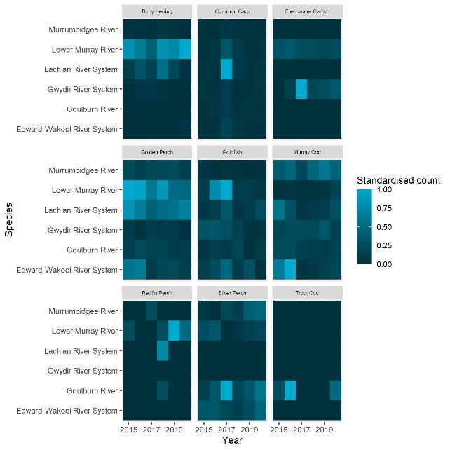
Figure C.1 Heat maps of standardised counts of 9 large-bodied fish species at each Selected Area for each water year
Standardised count is calculated by the raw count of a species divided by the maximum count for a given species over the duration of the monitoring program for each Selected Area. Colour change depicts the change in standardised count with lighter colours closer to the maximum standardised count and darker colours closer to the minimum standard count, 0
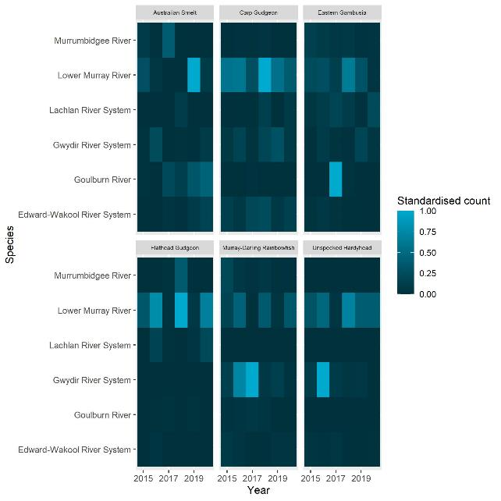
Figure C.2 Heat maps of standardised counts of 6 small-bodied fish species at each Selected Area for each water year
Standardised count is calculated by the raw count of a species divided by the maximum count for a given species over the duration of the monitoring program for each Selected Area. Colour change depicts the proportional change in standardised count with lighter colours closer to the maximum standardised count and darker colours closer to the minimum standard count, 0

Statistical analyses
This Appendix gives a brief overview on model structure and description (see Technical Supplement (Fanson 2021) for further details). Each species was modelled separately for each response variable of interest. The model structure was broken into 3 components: response variable, flow covariates (annual or event metrics), and spatial/temporal effects that were either fixed or random. Model structure was represented by the combination of the model equation and the link function and model family listed in the right-hand column of Table D.2. Model equations are in simplified R notation, where the notation (1|x) denotes a random intercept for each level of the variable x. Predictor variables are defined in Table 2.2 and Table 2.4. Terms defined in the model structures are as in Table D.1
Table D.1 Terms and variables used in the model structure
Term/variable | Used for
cbind | Spawning occurrence
n_spawned | number of spawning points at which spawning occurred in a Selected Area and water year
n_survey | number of surveys in a Selected Area and year
Flow covariates (where xxx refers to the different timings outlined in
baseflow_xxx | proportion of baseflow days
small_fresh_xxx | small freshes days
large_fresh_xxx | large freshes days
change_72_xxx | rate of change of discharge
Flow event-based covariates
seven_day_range | change in daily discharge prior to capture
days_increasing | high discharge duration
seven_day_median | proportional discharge magnitude
program | Selected Area site
tot_effort | sampling effort, either electrofishing time or volume filtered through fyke nets
wateryear | the water year in which a survey occurred
cpue | larval abundance catch-per-unit-effort
ad_cpue | current water year’s adult abundance catch-per-unit-effort
samplepoint | site within Selected Area
count | recruit abundance
n_sites | the number of sites sampled within a Selected Area
n_fish | number of fish caught at each age
age | fish age
birthyear | the birth year of an individual fish
r | adult abundance catch-per-unit-effort
do_last_year | indicator variable denoting time since most-recent fish death event or blackwater event at a sample point
fulton_index | Fulton’s K body condition factor.
Table D.2 Summary of statistical analyses: model type, relevant species and response variables, grouped by objective (expansion of Table 2.6)
Objective | Response variable | Species | Model structure | Model description
Determine influence of flow events and flow regimes across all Selected Areas on spawning success of native, flow-cued species | Spawning occurrence | golden perch  silver perch | cbind(n_spawned, n_survey - n_spawned)~baseflow_sep_nov + small_fresh_sep_nov + large_fresh_sep_nov + change_72h_sep_nov + program + tot_effort + (1 | program:wateryear) | Binomial linear model with logit link
 | Larval abundance (CPUE) | golden perch  silver perch | cpue~seven_day_range + days_increasing + seven_day_median + program + ad_cpue + (1 | program:wateryear) + (1 | samplepoint) | Gaussian linear model with log link
Determine influence of flow events and flow regimes across all Selected Areas on recruitment strength of all native fish species | Recruit abundance (length threshold) | Australian smelt  carp gudgeon  common carp  eastern gambusia | count~baseflow_sep_mar + small_fresh_sep_mar + large_fresh_sep_mar + change_72h_sep_mar + n_sites + program | Poisson linear model with log link
 | Fish age (otolith data) | Murray cod  golden perch  bony herring | n_fish~age + program + (1 | program:birthyear) | Catch curve regression; negative binomial linear model with log link
Determine influence of flow events and flow regimes across all Selected Areas on population composition (structure and condition) of abundant native species | Adult abundance (CPUE) | golden perch  Murray cod  carp gudgeon  bony herring  common carp  eastern gambusia  Australian smelt | r~baseflow_water_year + small_fresh_water_year + large_fresh_water_year + change_72h_water_year + program + do_last_year + (1 | program:wateryear) + (1 | samplepoint) | Autoregressive Gaussian linear model with log link
 | Fulton’s K condition factor (length and weight data) | bony herring  common carp  Murray cod  golden perch | fulton_index~baseflow_water_year + small_fresh_water_year + large_fresh_water_year + change_72h_water_year + program + (1 | program:wateryear) + (1 | samplepoint) + (1 | samplepoint:wateryear) | Linear mixed model with identity link (non-Bayesian)

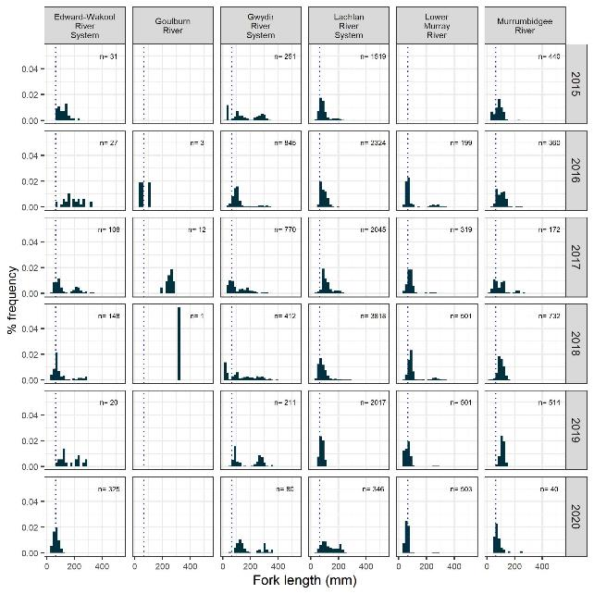
Figure D.1 Length-frequency histogram of bony herring by Selected Area and water year
Dotted line represents cut-off length used for recruits (<65 mm). Bony herring was absent in the Goulburn in 2015, 2019 and 2020 and lengths of bony herring were not measured in the Lower Murray River in 2015
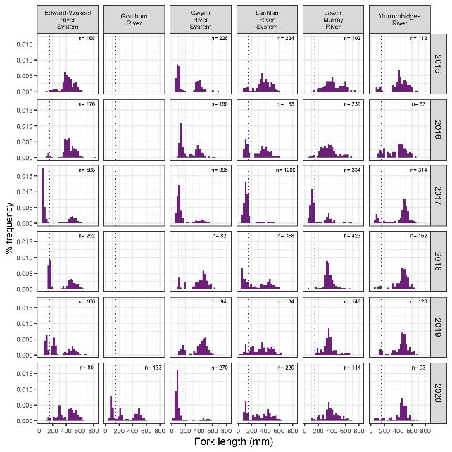
Figure D.2 Length-frequency histogram of common carp by Selected Area and water year
Dotted line represents cut-off length used for recruits (<150 mm), less than one year old. Note: lengths of common carp were not measured in the Goulburn River, each water year
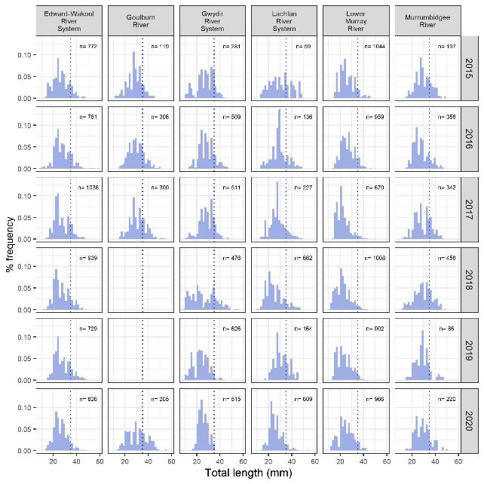
Figure D.3 Length-frequency histogram of carp gudgeon by Selected Area and water year
Dotted line represents cut-off length used for recruits (< 35 mm), less than one year old. Note: lengths of small-bodied species were not recorded in the Goulburn River for 2018 and 2019 water years
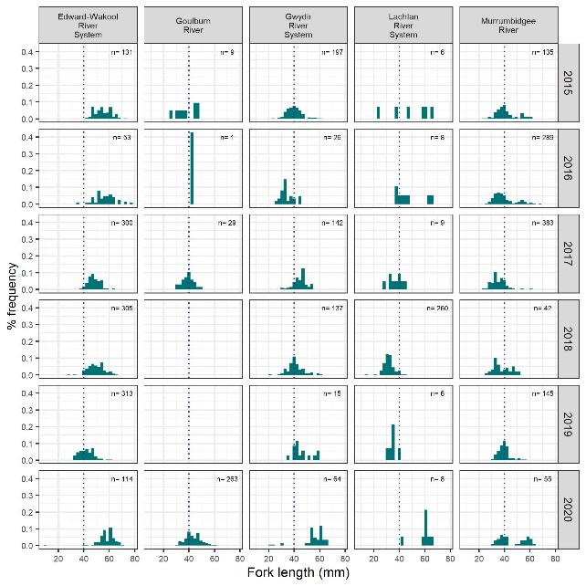
Figure D.4 Length-frequency histogram of Australian smelt by Selected Area and water year
Dotted line represents cut-off length used for recruits (<40 mm), less than one year old. Note lengths Australian smelt were not measured in the Lower Murray River, nor in the Goulburn River for 2018 and 2019 water years.
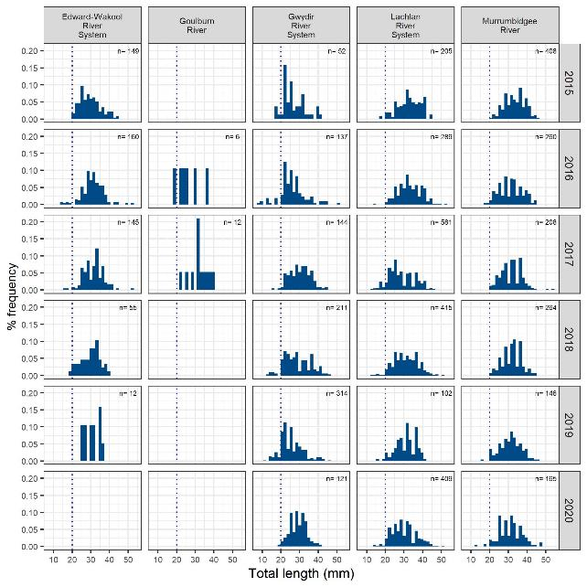
Figure D.5 Length-frequency histogram of eastern gambusia by Selected Areas and water year
Dotted line represents cut-off length used for recruits (<20 mm), less than one year old. Note: lengths of eastern gambusia were not measured in the Lower Murray River nor in the Goulburn River for 2015, 2018 and 2019. In 2020 Eastern Gambusia was absent in the Edward/Kolety-Wakool River System and in the Goulburn.

Discharge details
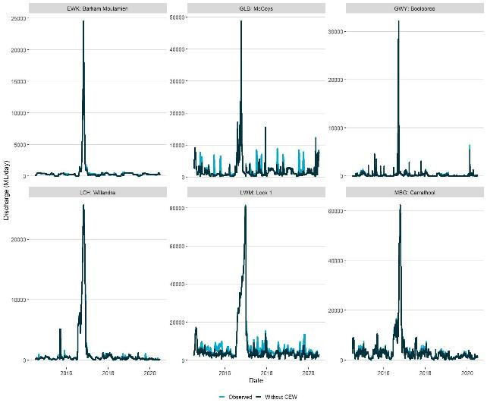
Figure E.1 Mean daily discharge (ML day⁻¹) for key gauged sites in each Selected Area in 2014–20 showing observed discharge with Commonwealth environmental water and modelled discharge without CEW
EWK = Edward/Kolety-Wakool river systems, GLB = Goulburn River, GWY = Gwydir River System, LCH = Lachlan River System, LWM = Lower Murray River, MBG = Murrumbidgee River System
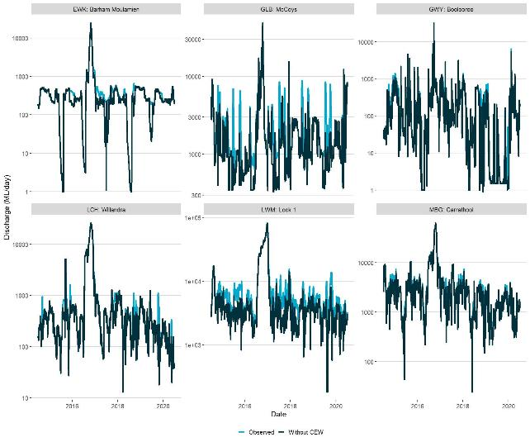
Figure E.2 Mean daily discharge (ML day⁻¹ on log scale ) for key gauged sites in each Selected Area in 2014–20 showing observed discharge with Commonwealth environmental water and modelled discharge without CEW
EWK = Edward/Kolety-Wakool river system, GLB = Goulburn River, GWY = Gwydir River System, LCH = Lachlan River System, LWM = Lower Murray River, MBG = Murrumbidgee River System

References
Commonwealth of Australia Co (2012) Basin Plan 2012. https://www.legislation.gov.au/Details/F2018C00451.
Baldwin DS and Whitworth K (2009) Current conditions in the Wakool River System and the potential for a blackwater event resulting in fish deaths. MDFRC Technical Report, Wodonga, Victoria, http://hdl.handle.net/1959.9/540042.
Bunn SE and Arthington AH (2002) Basic principles and ecological consequences of altered flow regimes for aquatic biodiversity. Environ Manage 30(4), 492-507. Doi: 10.1007/s00267-002-2737-0.
Burndred KR, Cockayne BJ and Lou DC (2017) Early development of eel-tailed catfish, Tandanus tandanus (Mitchell) (Teleostei : Plotosidae), with validation of daily otolith increment formation. Australian Journal of Zoology 65(1), 12-20. Doi: https://doi.org/10.1071/ZO16069.
Cruz DO, Kingsford RT, Suthers IM, Rayner TS, Smith JA and Arthington AH (2020) Connectivity but not recruitment: Response of the fish community to a large-scale flood on a heavily regulated floodplain. Ecohydrology 13(3), e2194. Doi: https://doi.org/10.1002/eco.2194.
Davies PE, Harris JH, Hillman TJ and Walker KF (2010) The Sustainable Rivers Audit: assessing river ecosystem health in the MurrayDarling Basin, Australia. Marine and Freshwater Research 61(7), 764-777. Doi: https://doi.org/10.1071/MF09043.
DPIE (2020a) Murray–Lower Darling Long Term Water Plan Part A: Murray–Lower Darling catchment. State of New South Wales and Department of Planning, Industry and Environment, https://www.environment.nsw.gov.au/research-and-publications/publications-search/murray-lower-darling-long-term-water-plan-part-a-catchment.
DPIE (2020b) Murrumbidgee Long-Term Water Plan Part A: Murrumbidgee catchment. State of New South Wales and Department of Planning, Industry and Environment, https://www.environment.nsw.gov.au/research-and-publications/publications-search/murrumbidgee-long-term-water-plan-part-a-catchment.
DPIE (2020c) Lachlan Long-Term Water Plan Part A: Lachlan catchment. State of New South Wales and Department of Planning, Industry and Environment, https://www.environment.nsw.gov.au/research-and-publications/publications-search/lachlan-long-term-water-plan-part-a-catchment.
DPIE (2020d) Gwydir Long-Term Water Plan Part A: Gwydir catchment. State of New South Wales and Department of Planning, Industry and Environment, https://www.environment.nsw.gov.au/research-and-publications/publications-search/gwydir-long-term-water-plan-part-a-catchment.
Dyer F, Broadhurst B, Tschierschke A, Higgisson W, Thiem J, Wright D, Kerezsy A and Thompson R (2020a) Commonwealth Environmental Water Office Monitoring, Evaluation and Research Project: Lachlan river system Selected Area 2019-20 Monitoring and Evaluation Summary Report. Commonwealth of Australia, 2020.
Dyer F, Broadhurst B, Tschierschke A, Higgisson W, Thiem J, Wright D, Kerezsy A and Thompson R (2020b) Commonwealth Environmental Water Office Long Term Intervention Monitoring Project: Lachlan river system Selected Area 2019-20 Monitoring and Evaluation Technical Report. Commonwealth of Australia, 2020.
Fanson B (2021) Flow-MER Program. Detailed description of 2021 fish evaluation and monitoring analysis: Technical supplement. Commonwealth Environmental Water Office (CEWO): Monitoring, Evaluation and Research Program, Department of Agriculture, Water and the Environment, Australia.
Goodrich B, Gabry J, Ali I and Brilleman S (2020) Rstanarm: Bayesian applied regression modeling via Stan. Viewed, https://mc-stan.org/rstanarm.
Guarino F and Sengupta A (2021) 2021 Basin-scale evaluation of Commonwealth environmental water: Hydrology Flow-MER Program. Commonwealth Environmental Water Office (CEWO): Monitoring, Evaluation and Research Program, Department of Agriculture, Water and the Environment, Australia.
Hale J, Stoffels R, Butcher R, Shackleton M, Brooks S, Gawne B and Stewardson M (2014) Commonwealth Environmental Water Office Long Term Intervention Monitoring Project – Standard Methods. Final Report prepared for the Commonwealth Environmental Water Office by The Murray Darling Freshwater Research Centre.
Jones RE, Petrell RJ and Pauly D (1999) Using modified length–weight relationships to assess the condition of fish. Aquacultural Engineering 20(4), 261-276. Doi: https://doi.org/10.1016/S0144-8609(99)00020-5.
King AJ, Tonkin Z and Lieshcke J (2012) Short-term effects of a prolonged blackwater event on aquatic fauna in the Murray River, Australia: considerations for future events. Marine and Freshwater Research 63(7), 576-586. Doi: https://doi.org/10.1071/MF11275.
King AJ (2019) Long Term Intervention Monitoring Basin Matter - Fish foundation report. Final Report prepared for the Commonwealth Environmental Water Office by The Centre for Freshwater Ecosystems.
King AJ, McPhan L, Bond N and Thurgate N (2020) Murray–Darling Basin Long Term Intervention Monitoring Project — 2018–19 Basin-scale evaluation of Commonwealth environmental water – Fish Report. Report prepared for the Department of Agriculture, Water and the Environment, Commonwealth Environmental Water Office by La Trobe University, Centre for Freshwater Ecosystems.
Koehn J, Brumley A and Gehrke P (2000) Managing the Impacts of Carp. Bureau of Rural Sciences. Department of Agriculture, Fisheries and Forestry - Australia, Canberra.
Koehn JD, Raymond SM, Stuart I, Todd CR, Balcombe SR, Zampatti BP, Bamford H, Ingram BA, Bice CM, Burndred K, Butler G, Baumgartner L, Clunie P, Ellis I, Forbes JP, Hutchison M, Koster WM, Lintermans M, Lyon JP, Mallen-Cooper M, McLellan M, Pearce L, Ryall J, Sharpe C, Stoessel DJ, Thiem JD, Tonkin Z, Townsend A and Ye Q (2020) A compendium of ecological knowledge for restoration of freshwater fishes in Australia’s Murray–Darling Basin. Marine and Freshwater Research 71(11), 1391-1463. Doi: https://doi.org/10.1071/MF20127.
Koster W, Crook D, Dawson D and Moloney P (2012) Status of fish populations in the lower Goulburn River (2003 - 2012). Arthur Rylah Institute for Environmental Research Client Report, Department of Sustainability and Environment, Heidelberg, Victoria.
Koster WM, Dawson DR, Liu C, Moloney PD, Crook DA and Thomson JR (2017) Influence of streamflow on spawning-related movements of golden perch Macquaria ambigua in south-eastern Australia. Journal of Fish Biology 90(1), 93-108. Doi: https://doi.org/10.1111/jfb.13160.
Koster WM, Crook DA, Dawson DR, Gaskill S and Morrongiello JR (2018) Predicting the Influence of Streamflow on Migration and Spawning of a Threatened Diadromous Fish, the Australian Grayling Prototroctes Maraena. Environ Manage 61(3), 443-453. Doi: 10.1007/s00267-017-0853-0.
Koster WM, Stuart I, Tonkin Z, Dawson D and Fanson B (2021) Environmental influences on migration patterns and pathways of a threatened potamodromous fish in a regulated lowland river network. Ecohydrology 14(2), e2260. Doi: https://doi.org/10.1002/eco.2260.
Lintermans M (2007) Fishes of the Murray-Darling Basin. An Introductory Guide. Murray-Darling Basin Commission, Canberra, ACT, Australia.
Lyon JP, Bird T, Nicol S, Kearns J, O’Mahony J, Todd Charles R, Cowx IG and Bradshaw CJA (2014) Efficiency of electrofishing in turbid lowland rivers: implications for measuring temporal change in fish populations. Canadian Journal of Fisheries and Aquatic Sciences 71(6), 878-886. Doi: 10.1139/cjfas-2013-0287.
Mallen-Cooper M and Zampatti BP (2018) History, hydrology and hydraulics: Rethinking the ecological management of large rivers. Ecohydrology 11(5), e1965. Doi: https://doi.org/10.1002/eco.1965.
MDBA (2020) Basin-wide environmental watering strategy. Murray-Darling Basin Authority, Canberra.
Mika S, Frazier P, Ryder D, Southwell M, Growns I, Debus S, Bower D, Butler G, Cameron L, Carpenter-Bundoo L, Winkle S, Oxley J, Vincent B and Lewis S (2020) Commonwealth Environmental Water Office Monitoring Evaluation and Research Program Gwydir River Selected Area: Evaluation Report 2019–20., Report prepared for the Commonwealth Environment Water Office- Monitoring, Evaluation and Research Project.
Nash RDM, Valencia AH and Geffen AJ (2006) The origin of Fulton's condition factor-setting the record straight. Fisheries 31, 236-238.
Nilsson C, Reidy CA, Dynesius M and Revenga C (2005) Fragmentation and flow regulation of the world's large river systems. Science 308(5720), 405-408. Doi: 10.1126/science.1107887.
Ogle DH (2016) Introductory Fisheries Analyses with R. Chapman and Hall/CRC, Florida, USA.
Oksanen J, Guillaume Blanchet F, Friendly M, Kindt R, Legendre P, McGlinn D, Minchin PR, O'Hara RB, Simpson GL, Solymos P, Henry M, Stevens H, Szoecs E and Wagner H (2019) Vegan: Community Ecology Package. R package version 2.5-6. Viewed, https://CRAN.R-project.org/package=vegan.
Poff NL, Allan JD, Bain MB, Karr JR, Prestegaard KL, Richter BD, Sparks RE and Stromberg JC (1997) The Natural Flow Regime. BioScience 47(11), 769-784. Doi: 10.2307/1313099.
Rolls RJ, Growns IO, Khan TA, Wilson GG, Ellison TL, Prior A and Waring CC (2013) Fish recruitment in rivers with modified discharge depends on the interacting effects of flow and thermal regimes. Freshwater Biology 58(9), 1804-1819. Doi: https://doi.org/10.1111/fwb.12169.
Shams F, Dyer F, Thompson R, Duncan RP, Thiem JD, Enge TG and Ezaz T (2020) Multiple Lines of Evidence Indicate Limited Natural Recruitment of Golden Perch (Macquaria ambigua) in the Highly Regulated Lachlan River. Water 12(6), 1636.
Sharpe C and Stuart I (2018) Environmental flows in the Darling River to support native fish populations. CPS Enviro report to The Commonwealth Environmental Water Office.
Small K, Kopf RK, Watts RJ and Howitt J (2014) Hypoxia, Blackwater and Fish Kills: Experimental Lethal Oxygen Thresholds in Juvenile Predatory Lowland River Fishes. PLOS ONE 9(4), e94524. Doi: 10.1371/journal.pone.0094524.
Southwell M, Frazier P, Ryder D, Mika S, Growns I, Debus S, Bower D, Winkle S, Oxley J, Vincent B, Lewis S, Butler G and Cameron L (2020) Commonwealth Environmental Water Office Monitoring, Evaluation and Research Program: Junction of the Warrego and Darling Rivers Selected Area Monitoring, Evaluation and Research Annual Summary Report 2019-2020. Commonwealth of Australia 2020.
Stewardson MJ and Skinner D (2018) Evaluating Use of Environmental Flows to Aerate Streams by Modelling the Counterfactual Case. Environ Manage 61(3), 390-397. Doi: 10.1007/s00267-017-0955-8.
Stoffels R, Bond N, Pollino C, Broadhurst B, Butler G, Kopf RK, Koster W, McCasker N, Thiem J, Zampatti B and Ye Q (2016) Long Term Intervention Monitoring Basin Matter - Fish foundation report. Final Report prepared for the Commonwealth Environmental Water Office by The Murray-Darling Freshwater Research Centre.
Stoffels RJ, Weatherman KE, Bond NR, Morrongiello JR, Thiem JD, Butler G, Koster W, Kopf RK, McCasker N, Ye Q, Zampatti B and Broadhurst B (2020) Stage-dependent effects of river flow and temperature regimes on the growth dynamics of an apex predator. Global Change Biology 26(12), 6880-6894. Doi: https://doi.org/10.1111/gcb.15363.
Stuart I, Sharpe C, Stanislawski K, Parker A and Mallen-Cooper M (2019) From an irrigation system to an ecological asset: adding environmental flows establishes recovery of a threatened fish species. Marine and Freshwater Research 70(9), 1295-1306. Doi: https://doi.org/10.1071/MF19197.
Stuart IG and Sharpe CP (2020) Riverine spawning, long distance larval drift, and floodplain recruitment of a pelagophilic fish: A case study of golden perch (Macquaria ambigua) in the arid Darling River, Australia. Aquatic Conservation: Marine and Freshwater Ecosystems 30(4), 675-690. Doi: https://doi.org/10.1002/aqc.3311.
Stuart IG, Fanson BG, Lyon JP, Stocks J, Brooks S, Norris A, Thwaites L, Beitzel M, Hutchison M, Ye Q, Koehn JD and Bennett AF (2021) Continental threat: How many common carp (Cyprinus carpio) are there in Australia? Biological Conservation 254, 108942. Doi: https://doi.org/10.1016/j.biocon.2020.108942.
Team RC (2019) R: A language and environment for statistical computing.
Thiem J, Baumgartner L, Fanson B, Sadekov A, Tonkin Z and Zampatti B (2021) Contrasting natal origin and movement history informs recovery pathways for three lowland river species following a mass fish kill. Marine and Freshwater Research in press.
Thiem JD, Wooden IJ, Baumgartner LJ, Butler GL, Forbes JP and Conallin J (2017) Recovery from a fish kill in a semi-arid Australian river: Can stocking augment natural recruitment processes? Austral Ecology 42(2), 218-226. Doi: https://doi.org/10.1111/aec.12424.
Thompson RM, King AJ, Kingsford RM, Mac Nally R and Poff NL (2018) Legacies, lags and long-term trends: Effective flow restoration in a changed and changing world. Freshwater Biology 63(8), 986-995. Doi: https://doi.org/10.1111/fwb.13029.
Tonkin Z, Stuart I, Kitchingman A, Thiem JD, Zampatti B, Hackett G, Koster W, Koehn J, Morrongiello J, Mallen-Cooper M and Lyon J (2019) Hydrology and water temperature influence recruitment dynamics of the threatened silver perch Bidyanus bidyanus in a regulated lowland river. Marine and Freshwater Research 70(9), 1333-1344. Doi: https://doi.org/10.1071/MF18299.
Tonkin Z, Jones C, Clunie P, Vivian L, Amtstaetter F, Jones M, Koster W, Mole B, O’Connor J, Brooks J, Caffrey L and Lyon J (2020) Victorian Environmental Flows Monitoring and Assessment Program. Stage 6 Synthesis Report 2016-2020. Technical Report Series No. 316. Department of Environment, Land, Water and Planning, Heidelberg, Victoria.
Tonkin Z, Yen J, Lyon J, Kitchingman A, Koehn JD, Koster WM, Lieschke J, Raymond S, Sharley J, Stuart I and Todd C (2021) Linking flow attributes to recruitment to inform water management for an Australian freshwater fish with an equilibrium life-history strategy. Science of The Total Environment 752, 141863. Doi: https://doi.org/10.1016/j.scitotenv.2020.141863.
Tonkin ZD, King AJ, Robertson AI and Ramsay DSL (2011) Early fish growth varies in response to components of the flow regime in a temperate floodplain river. Freshwater Biology 56(9), 1769-1782. Doi: https://doi.org/10.1111/j.1365-2427.2011.02612.x.
Treadwell S, Webb A, Hou X, Baker B, Casanelia S, Grace M, Greet J, Kellar C, Koster W, Lovell D, McMahon D, Morris K, Myers J, Pettigrove V, Sutton N and Vietz G (2020) Commonwealth Environmental Water Office Monitoring Evaluation and Research Program Goulburn River Selected Area: Annual Scientific Report 2019–20., Report prepared for the Commonwealth Environment Water Office - Monitoring, Evalaution and Research Project.
Treadwell S, Webb A, Hou X, Baker B, Casanelia S, Grace M, Greet J, Kellar C, Koster W, Lovell D, McMahon D, Morris K, Myers J, Pettigrove V, Sutton N and Vietz G (2021) Commonwealth Environmental Water Office Monitoring Evaluation and Research Program Goulburn River Selected Area: Summary Report 2019–20., Report prepared for the Commonwealth Environment Water Office- Monitoring, Evaluation and Research Project.
Vertessy R, Barma D, Baumgartner L, Mitrovic S, Sheldon F and Bond N (2019) Independent assessment of the 2018-19 fish deaths in the Lower Darling: Final report. Australian Government, https://www.mdba.gov.au/sites/default/files/pubs/Final-Report-Independent-Panel-fish-deaths-lower%20Darling_4.pdf.
VEWH (2020) Seasonal Watering Plan 2020-21. Victorian Environmental Water Holder.
Wassens S, Spencer J, Wolfenden B, Thiem J, Thomas R, Jenkins K, Brandis K, Lenon E, Hall A, Ocock J, Kobayashi T, Bino G, Heath J and Callaghan D (2018) Commonwealth Environmental Water Office Long-Term Intervention Monitoring project Murrumbidgee River System Selected Area evaluation report, 2014-17. Report prepared for Commonwealth Environmental Water Office. Commonwealth of Australia.
Wassens S, Michael D, Spencer J, Thiem J, Thomas R, Kobayashi T, Amos C, Hall A, Bourke G, Bino G, Davis T, Heath J, Turner A and Kuo W (2020) Commonwealth Environmental Water Office Monitoring Evaluation and Research Program Murrumbidgee River System Selected Area Summary Report 2014-2020. Commonwealth of Australia 2020.
Wassens S, Michael D, Spencer J, Thiem J, Thomas R, Kobayashi T, Wolfenden B, Hall A, Bourke G, Bino G, Davis T, Heath J, Kuo W, Amos C and Brandis K (2021) Commonwealth Environmental Water Office Long-term Intervention Monitoring project Murrumbidgee River System Selected Area evaluation report 2014-2020. Commonwealth of Australia 2021.
Watts RJ, McCasker N, Howitt JA, Thiem J, Grace M, Kopf RK, Healy S and Bond N (2017) Commonwealth Environmental Water Office Long Term Intervention Monitoring Project: Edward-Wakool River System Selected Area Evaluation Report, 2016-17. Report prepared for Commonwealth Environmental Water Office. Commonwealth of Australia.
Watts RJ, Bond NR, Healy S, Liu X, McCasker NG, Siebers A, Sutton N, Thiem JD, Trethewie JA, Vietz G and Wright DW (2020) Commonwealth Environmental Water Office Monitoring, Evaluation and Research Project: Edward/Kolety-Wakool River System Selected Area Technical Report, 2019-20. Report prepared for Commonwealth Environmental Water Office. Commonwealth of Australia.
Webb A, Baker B, Casanelia S, Grace M, King E, Koster W, Lansdown K, Lintern A, Lovell D, Morris K, Pettigrove V, Sharpe A, Townsend K and Vietz G (2017) Commonwealth Environmental Water Office Long-Term Intervention Monitoring Project – Goulburn River Selected Area evaluation report 2015-16. Report prepared for the Commonweatlh Environment Water Holder. Commonwealth of Australia.
Ye Q, Giatas G, Aldridge K, Busch B, Brookes J, Gibbs M, Hipsey M, Lorenz Z, Maas R, Oliver R, Shiel R, Woodhead J and Zampatti B (2018) Long-term intervention monitoring of the ecological responses to Commowealth environmental water delivered to the Lower Murray River Selected Area in 2016/2017. Report prepared for the Commonwealth Environment Water Office. Commonwealth of Australia.
Ye Q, Giatas G, Brookes J, Furst D, Gibbs M, Oliver R, Shiel R, Zampatti B, Aldridge K, Bucater L, Busch B, Hipsey M, Lorenz Z, Maas R and Woodhead J (2020) Commonwealth Environmental Water Office Long-Term Intervention Monitoring Project 2014-2019: Lower Murray River Technical Report. A report prepared for the Commonwealth Environmental Water Office by the South Australian Research and Development Institute, Aquatic Sciences.
Ye Q, Giatas G, Bice C, Brookes J, Furst D, Gibbs M, Nicol J, Oliver R, Shiel R, Zampatti B, Bucater L, Deane D, Hipsey M, Huang P, Lorenz Z and Zhai S (2021) Commonwealth Environmental Water Office Monitoring, Evaluation and Research Project: Lower Murray 2019-20 Technical Report. A draft report prepared for the Commonwealth Environmental Water Office by the South Australian Research and Development Institute, Aquatic Sciences.
Zampatti BP and Leigh SJ (2013) Within-channel flows promote spawning and recruitment of golden perch, Macquaria ambigua ambigua – implications for environmental flow management in the River Murray, Australia. Marine and Freshwater Research 64(7), 618-630. Doi: https://doi.org/10.1071/MF12321.
Zampatti BP, Wilson PJ, Baumgartner LJ, Koster WM, Livore JP, McCasker NG, Thiem JD, Tonkin Z and Ye Q (2015) Reproduction and recruitment of golden perch (Macquaria ambigua ambigua) in the southern Murray-Darling Basin in 2013-2014: an exploration of river-scale response, connectivity and population dynamics. SARDI Aquatic Sciences.
Zampatti BP, Fanson BG, Strawbridge A, Tonkin Z, Thiem J, Butler GL, Balcombe S, Koster W, King A, Crook D, Woods R, Brooks S, Lyon J, Baumgartner LJ and Doyle K (2019) Basin-scale population dynamics of Golden Perch and Murray Cod: relating flow to provenance, movement and recruitment in the Murray–Darling Basin. In: Price AE, Balcombe SR, Humphries P, King AJ and Zampatti BP (eds), Murray-Darling Basin Environmental Water Knowledge and Research Project - Fish Theme Research Report. Report prepared for the Department of the Environment and Energy, Commonwealth Environmental Water Office by La Trobe University, Centre for Freshwater, Wodonga, Victoria.

https://flow-mer.org.au



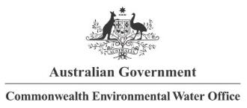








Partners

Collaborators

Table provided by CEWO to the Flow-MER team
presence/absence of larval fish not larval count)

