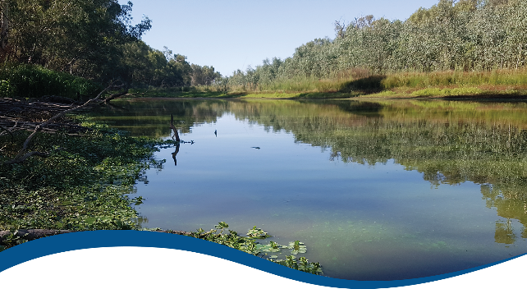

Basin-scale evaluation of  
2019–20 Commonwealth environmental water: Food Webs and Water Quality

Commonwealth Environmental Water Office (CEWO):   
Monitoring, Evaluation and Research Program

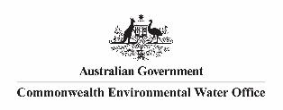August 2021

Citation

Ryder D, McInerney P, Giling D, Hitchcock J (2021) 2019-20 Foodwebs and Water Quality Evaluation Report - Final. Flow-MER Program. Commonwealth Environmental Water Office (CEWO): Monitoring, Evaluation and Research Program, Department of Agriculture, Water and the Environment, Australia.86pp.

Acknowledgements

The project team and the Commonwealth Environmental Water Office (CEWO) respectfully acknowledge the traditional owners of the land on which this work is conducted, their Elders past and present, their Nations of the Murray–Darling Basin, and their cultural, social, environmental, spiritual and economic connection to their lands and waters.

A big thank you for contributions from Selected Area Theme Leaders and team members: Mike Grace, Simon Treadwell, Yoshi Kobayashi, Gayleen Bourke, Xiaoying Liu, Nicole McCasker, Rod Oliver, Alica Tschierschke, Ross Thompson, Nick Bond, Andre Siebers, Sarah Mika, Ivor Growns and Nena Bulovic.

We would like to thank the CSIRO and University of Canberra teams for their efforts in report layout, editing, reviewing and formatting. Special mention to Emily Barbour, Ross Thompson, Di Flett, Susan Cuddy and Jackie O’Sullivan whose input, together with copy editor Dr Mary Webb and formatting specialist, Jill Sharkey, greatly improved the readability of the report. CSIRO’s Martin Nolan assisted with figures and GIS layers. A final thanks to Peter Davies for providing an expert independent review.

Copyright

Creative Commons [logo] © Commonwealth of Australia 2021  
With the exception of the Commonwealth Coat of Arms, partner logos and where otherwise noted, all material in this publication is provided under a Creative Commons Attribution 4.0 International Licence <https://creativecommons.org/licenses/by/4.0/>. The Flow‑MER Program requests attribution as ‘© Commonwealth of Australia (Flow‑MER Program, <https://flow-mer.org.au)>’.

Document submission history

|  |  |
| --- | --- |
| 30 June 2021 | Final draft |
| 27 August 2021 | Final |
|  |  |

Cover photograph

Murray River system near Albury, New South Wales   
Photo credit: Paul McInerney

Important disclaimer

The information contained in this publication comprises general statements based on scientific research. The reader is advised and needs to be aware that such information may be incomplete or unable to be used in any specific situation. No reliance or actions must therefore be made on that information without seeking prior expert professional, scientific and technical advice. To the extent permitted by law, the Flow-MER Program (including its partners and collaborators) excludes all liability to any person for any consequences, including but not limited to all losses, damages, costs, expenses and any other compensation, arising directly or indirectly from using this publication (in part or in whole) and any information or material contained in it.

The Flow-MER Program is committed to providing web accessible content wherever possible. If you are having difficulties with accessing this document, please contact [CEWOmonitoring@environment.gov.au.](mailto:CEWOmonitoring@environment.gov.au)

Overview of Flow-MER

Flow-MER is the Commonwealth Environmental Water Office’s (CEWO) Monitoring, Evaluation and Research Program. Its objective is to monitor and evaluate the ecological responses to the delivery of Commonwealth environmental water in the Murray–Darling Basin. It provides the CEWO with evidence to inform our understanding of how water for the environment is helping maintain, protect, and restore the ecosystems and native species across the Basin. This work will support environmental water managers, demonstrate outcomes, inform adaptive management and fulfil the legislative requirements associated with managing Commonwealth-owned environmental water.

The Program runs from 2019 to 2022 and consists of 2 components: monitoring and research in 7 Selected Areas (Selected Area projects); and Basin-scale evaluation and research (the Basin-scale project) (Figure 1 The 7 Selected Areas and 25 valleys established for long-term monitoring of the effects of environmental watering under the LTIM Project and Flow-MER Program (2014–15 to present)Figure 1). The Basin-scale project is led by CSIRO in partnership with the University of Canberra, and collaborating with Charles Sturt University, Deakin University, University of New England, South Australian Research and Development Institute, Arthur Rylah Institute, NSW Department of Planning, Industry and Environment, Australian River Restoration Centre and Brooks Ecology & Technology.

It builds on work undertaken through the Long Term Intervention Monitoring (LTIM) (2014–2019) and Environmental Water Knowledge and Research (EWKR) (2014–2019) projects.

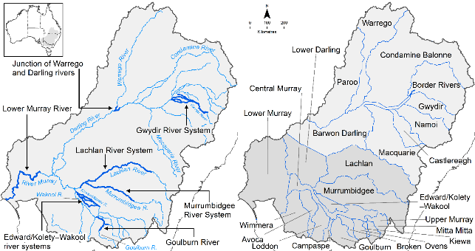

Figure The 7 Selected Areas and 25 valleys established for long-term monitoring of the effects of environmental watering under the LTIM Project and Flow-MER Program (2014–15 to present)

The Flow-MER evaluation adopts an adaptive management framework to acknowledge the need for collectively building the information, networks, capacity and knowledge required to manage environmental water at Basin scale. While knowledge of ecological response to instream flow and inundation has advanced significantly in recent years, substantive challenges remain in understanding the similarities and differences in species’ response across time and space, as well as the interaction between species at a community and ecosystem scale.

The Basin-scale evaluation is being undertaken across 6 Basin Themes (Figure 2) based on ecological indicators developed for the LTIM Project and described in the [Environmental Water Outcomes Framework](https://www.environment.gov.au/water/cewo/publications/environmental-water-outcomes-framework). It is undertaken in conjunction with the Selected Area projects, which provide data, research and knowledge for ecological outcomes within the 7 Selected Areas. The Basin-scale evaluation integrates across Selected Areas, themes, datasets, approaches and different types of knowledge.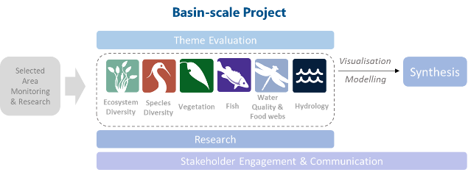

Figure Basin-scale Project evaluation reports on Commonwealth environmental water outcomes for the 6 Basin Themes as well as a high-level Basin-scale synthesis

The evaluation is informed by Basin-scale research projects, stakeholder engagement and communication, including Indigenous engagement, visualisation and modelling, as well as the 7 Selected Area projects

About the Basin-scale evaluation

Water delivery and outcomes data provided by CEWO is used in conjunction with monitoring data provided by the 7 Selected Areas and other publicly available data to undertake the Basin-scale evaluation. The research and evaluation content is structured into 6 disciplinary themes. Technical reports for each of the 6 themes are available from the [CEWO](https://www.environment.gov.au/water/cewo/publications/environmental-water-outcomes-framework) website.

The evaluation aims to address theme specific questions in relation to how Commonwealth environmental water contributed to, supported, or influenced environmental outcomes. Commonwealth environmental water is often delivered in conjunction with other environmental water holdings, and non-environmental water releases (such as for irrigation or during high-flow events). The evaluation consequently draws on available information to estimate (where possible) the specific contribution of Commonwealth environmental water to particular environmental outcomes. The way in which this contribution is assessed varies between the 6 themes depending on the data and tools currently available:

modelling to estimate and compare outcomes both with and without Commonwealth environmental water (counterfactual modelling) – Hydrology (instream); Fish (multi-year evaluation)

identification of ecological response in locations that received Commonwealth environmental water (potentially in conjunction with other sources of environmental water or non-environmental water), and where feasible, comparison with areas that did not receive Commonwealth environmental water – Ecosystem Diversity, Species Diversity, Vegetation

use of flow and water quality metrics to infer likely outcomes – Hydrology (inundation); Food Webs and Water Quality

synthesis of findings across Selected Areas – Fish (annual); Vegetation; Food Webs and Water Quality.

Summary

Strategic management of the Commonwealth environmental water by the Commonwealth Environmental Water Holder (CEWH) is fundamental to achieving the Commonwealth’s (Murray–Darling) Basin Plan 2012 environmental objectives. The 3-year Basin-scale Flow-MER Program aims to demonstrate Basin-scale outcomes of Commonwealth environmental water; support adaptive management; and fulfil CEWH legislative requirements under the Basin Plan.

A key objective of the Basin Plan (s8.06) is the ‘*protection and restoration of ecosystem functions of water-dependent ecosystems’.* This includes(s8.07) ‘*food webs that sustain water-dependent ecosystems, including by protecting energy, carbon and nutrient dynamics, primary production and respiration*’. Furthermore, the Basin Plan (s5.04) establishes objectives for maintaining adequate water quality, which underpins productive and diverse food webs. These objectives are highlighted for future consideration within the Basin-wide environmental watering strategy and will be further explored for inclusion in the next Strategy under Ecosystem functions as a sub-theme of the Flows and Connectivity theme.

This current Basin-scale Food Webs and Water Quality Theme investigates how environmental water impacts water quality and stream metabolism in rivers, floodplains and wetlands of the Murray–Darling Basin. The Basin Plan seeks to protect and restore biodiversity in the Basin’s aquatic ecosystems. Food webs are one of several critical ecosystem functions central to sustaining patterns of diversity along with connectivity and nutrient cycling. Improved understanding of the influence of flow on metabolism, energy production and food webs will complement our understanding of the influence of flow on habitat and connectivity. In combination, this knowledge will enable better management of environmental flows within the Basin.

We report on stream metabolism from each of the 7 Selected Areas for the 2019–20 water year (1 July 2019 –30 June 2020), and place this in the context of longer term (2014–20) patterns. Basin-scale inferences are also made for unmonitored rivers on the response of stream metabolism to water for the environment for this water year, and influence on energy production and food webs.

The evaluation is structured around answering 4 Basin-scale questions:

What did Commonwealth environmental water contribute to patterns and rates of ecosystem respiration?

What did Commonwealth environmental water contribute to patterns and rates of primary productivity?

What did Commonwealth environmental water contribute to dissolved oxygen levels?

What did Commonwealth environmental water contribute to salinity regimes?

Stream metabolism is used to answer the first 3 evaluation questions. Salinity is evaluated by the export of salt through the Lower Murray River Selected Area and in situ measurements of electrical conductivity at the other Selected Areas.

Water year 2019–20

* Of the 125 Commonwealth environmental watering actions in the 2019–20 water year, 29 targeted ecological outcomes were linked to water quality and food webs. These included outcomes targeting water quality, stream metabolism and productivity, and river function. Twenty primary watering actions were delivered to 6 of the 7 Selected Areas, with the exception being the Murrumbidgee River System where there were no watering actions whose primary target was water quality or food webs. While one watering action targeting food webs and water quality was delivered to the Gwydir River System Selected Area, no metabolic data were able to be collected for the 2019–20 water year due to challenges accessing the site during the COVID-19 pandemic.
* Our adoption of a new ‘metabolic fingerprint’ approach in this evaluation is designed to aid in the communication and interpretation of metabolic responses to flow and provides a visual assessment of whether responses are within the ‘typical’ metabolic regime of a Selected Area. This improves the capacity to identify how different flow types can provide carbon and nutrients for food webs and enables the estimation of metabolic outcomes from management interventions.
* Season was the primary driver of rates of stream metabolism, with the highest daily rates of gross primary production (GPP) and ecosystem respiration (ER) consistently recorded in summer.

Contribution to patterns and rates of ecosystem respiration and primary production

* Commonwealth environmental water can support ER rates and heterotrophic production if flows lead to increases in terrestrial carbon subsidies to the river channel (e.g. litter). The amount of litter incorporated into the river channel is governed primarily by flow type (e.g. bankfull and overbank flows may increase lateral connectivity and mobilise large quantities of litter, while freshes may be limited to incorporating small quantities of litter from in-channel features only) and antecedent patterns (e.g. climate, time since last flow, magnitude of last flow).
* Changes to rates of GPP and ER in 2019–20 were generally small among all Selected Areas in response to Commonwealth environmental water, as in previous years. However, Commonwealth environmental watering actions increased the total amount of organic carbon produced and consumed per day within riverine ecosystems, demonstrating a positive net increase in carbon availability for food webs. Nevertheless, it is likely that such increases in metabolic rates are still constrained by resources (nutrients) and greater increases would be possible with reconnection of backwaters and other off-channel habitats.
* The Lower Murray River and Murrumbidgee River System were the only Selected Areas in 2019–20 that had a net production of carbon[1] with the remaining Selected Areas consistently representing a net sink of carbon.[2] This highlights the importance of terrestrial organic carbon in the Basin, made available through channel and floodplain connectivity, as the dominant energy source in these systems.
* The increased discharge from Commonwealth environmental water reduced the volumetric rate of primary production but increased cross-sectional channel GPP, particularly in reaches where the channel broadens, by increasing the surface area of the photic zone.
* Changing nutrient concentrations and turbidity associated with Commonwealth environmental watering did not influence rates of stream metabolism in a predictable manner. There was evidence that Commonwealth environmental watering actions generated short, small pulses of stream metabolism, with primary production responses being larger when water deliveries occurred during warmer conditions. Relatively minor changes in nutrients and carbon associated with flows supported relatively larger (compared with background variability) responses in productivity, but were often tempered by increased turbidity.
* A valley-scale case study of an environmental water release in the Murray River – termed ‘the Southern Spring Flow’[3] – highlights that metabolic responses are highly context specific. An inability to detect a metabolic response to flow at a particular site or Selected Area scale does not necessarily mean that a response did not occur elsewhere in the river system as a consequence of the flow. This is because mobilisation of carbon generates productivity in a spatially and temporally variable manner. Rapid incorporation of terrestrial carbon from floodplains into riverine food webs observed in the case study highlights the dynamic nature of metabolic responses to flow and of spatial shifts between a location being a source of carbon (autotrophy) and a sink of carbon (heterotrophy).
* Limitations in existing methods – in this case, the Bayesian Single-station Estimation (BASE) model – for analysing stream metabolism data limit the capacity to understand and predict metabolism response to different flow scenarios. The highest level of confidence in observed data was achieved in the Lower Murray River (90% using 244 daily records) and the lowest was for the Junction of the Warrego and Darling rivers (12% using 24 daily records). These limitations are a consequence of the modelling approach (which can fail at higher flows) and the stringent criteria set by the Foundation reports for accepting model fits. The acceptance criteria for inclusion of modelled outcomes of raw dissolved oxygen (DO) (used to calculate GPP and ER) will be reviewed for the 2020–21 evaluation.
* There is scope to focus future Basin-scale reporting for food webs and water quality on improving our understanding of how the food supply for food webs is influenced by Commonwealth environmental water.

Contributions to dissolved oxygen levels

* Commonwealth environmental water was important for decreasing the likelihood of low DO, by increasing water mixing and oxygen exchange at the surface. This was highlighted in the slow-flowing Lower Murray River Selected Area where Commonwealth environmental water substantially improved DO levels for over 40 days, with other environmental water contributing to a total of 70 days where velocities were increased to > 0.18 m/s due to environmental water.

Contributions to salinity regimes

* The Basin Plan objective for salt export from the Basin (Basin Plan S. 9.09) aims to ensure adequate removal of salt from the Murray River system into the Southern Ocean. This target has been set at 2 million tonnes per year.
* Commonwealth environmental water was the only water that exited the barrages in South Australia in 2019–20, providing the only mechanism for salt export from the Basin. For 2019–20, all salt export over the barrages (623,999 tonnes) to the ocean was attributable entirely to Commonwealth environmental water. Without these flows, salt would have accumulated throughout the Basin on floodplains, wetlands and in channel environments. However salt export was well below the Basin Plan target of 2 million tonnes per year.

Water years 2014–20

* The comparison of stream metabolism in the 2019–20 water year with the longer term 2014–20 period demonstrated that rates of GPP and ER across all Selected Areas in the 2019–20 are broadly similar and comparable with the longer term patterns.
* Commonwealth environmental water decreased the likelihood of low DO by increasing water mixing and oxygen exchange at the surface by maintaining flow velocities above ~0.18 m/s (below which surface oxygen exchange is poor).
* Independent of Commonwealth environmental watering actions, rates of GPP are most strongly influenced by seasonal changes (e.g. light and temperature) and site-specific drivers, such as bioavailable nutrient concentrations and reduced light availability due to turbidity.
* Volumetric increase in water in rivers during Commonwealth environmental watering actions led to an increase in the total amount of organic carbon produced and consumed per day within riverine ecosystems. Increases to production and consumption of carbon are primarily an artefact of the volume of Commonwealth environmental water, since generally rate responses of GPP and ER to flows are small.
* Commonwealth environmental water has accounted for between 64% and 100% of total salt export to the Southern Ocean over the 2014–20 period.
* The metabolic fingerprints represent 14,029 daily records of GPP and ER from 2014–20, one of the largest riverine metabolic datasets available in the world.

Key contributions to Basin Plan objectives

Water year 2019–20

* **Section 8.06 (3c, 3d)** and **Section 9.09**:In 2019–20, Commonwealth environmental water was the only water that exited the barrages in South Australia, providing the only mechanism for salt export from the Basin. In all, 623,999 tonnes were exported to the ocean, equating to 31% of the 2 million tonnes per annum Plan target.
* **Section 8.06 (7)**: Data from 6 Selected Areas provided evidence that Commonwealth environmental water has contributed to protecting and restoring energy, carbon and nutrient dynamics, primary production and respiration for 2019–20. For example, the median total contribution of Commonwealth environmental water to carbon production during a single watering action in the Edward/Kolety–Wakool river systems Selected Area was 6,856 kg.[4]
* **Section 9.08**: Evidence that Commonwealth environmental water assisted in the maintenance and improvement of DO concentrations over the summer period 2019–20 in the zones receiving the additional flow (e.g. maintaining flow velocities above ~0.18 m/sec in the Lower Murray River Selected Area.

Water years 2014–2020

* **Section 8.06 (3c, 3d)**: Commonwealth environmental water has an important role to play in meeting long-term objectives to protect and restore connectivity within and between water-dependent ecosystems. Commonwealth environmental water can support heterotrophic production if it contributes to connectivity between river channels and floodplains by increasing the supply of allochthonous organic carbon to food webs.
* **Section 8.06 (7)**: Evidence from all Selected Areas that Commonwealth environmental water has a positive influence on protecting and restoring energy, carbon and nutrient dynamics, primary production and respiration for 2014–20. For example, even when changes in rates of GPP and ER are small, the volumetric increase in water volume provided by Commonwealth environmental water increases total production and consumption of carbon in riverine food webs.
* **Section 9.08**: Trends in water quality and relationships with environmental flow delivery are difficult to assess across the Basin due to the high level of spatial and temporal baseline variation and inadequate data to capture that variability. However, there is strong evidence that Commonwealth environmental water has played an important role in maintaining water quality during the 2014–20 period. For example, anoxic events in 2016 and the subsequent delivery of ameliorating flows that included Commonwealth environmental water demonstrated the utility of targeted watering actions designed to improve water quality (e.g. evidenced by counterfactual observations). Commonwealth environmental water has also contributed to the objective of meeting salt export (see **9.09** and **9.14 (5)c** below) targets.
* **Section 9.09**: Commonwealth environmental water accounted for 64–100% of total salt export to the Southern Ocean in 2014–20.
* **Section 9.14 (5)a**: Commonwealth environmental water can help reduce the likelihood of low DO concentrations in the Lower Murray River, if its contribution increases mean water velocities above a level of ~0.18 m/s. Below this level, surface oxygen exchange is poor. Reducing the likelihood of low DO can be achieved by increasing water mixing in otherwise low flow.
* **Section 9.14 (5)c**: Commonwealth environmental water contributed to maintenance of river salinity below 800 EC at Morgan over the period 2014–20. Salinity was maintained within the range required for potable water in the Murray River in 2014–20, but water was about 10% fresher with environmental flows.

Contents

Overview of Flow-MER iii

About the Basin-scale evaluation iv

Summary v

Water year 2019–20 v

Water years 2014–20 viii

Key contributions to Basin Plan objectives viii

Abbreviations, acronyms and terms xv

1 Introduction 1

1.1 Context 1

1.2 Defining food webs, metabolism and water quality 2

1.3 Evaluation objectives 3

1.4 Summary of 2019–20 watering actions for food webs and water quality 4

2 Approach 8

2.1 Conceptual model 8

2.2 Method 12

2.3 Selected Area data fingerprinting – a new approach for analysing and communicating stream metabolism responses for environmental watering actions 13

3 Water year 2019–20 16

3.1 Climate and hydrological context 16

3.2 Evaluation outcomes 17

4 Water years 2014–20 22

4.1 Climate and hydrological context 22

4.2 Evaluation outcomes 22

5 Case study: application of metabolic fingerprints to longitudinal change during an environmental watering event 24

6 Example of using metabolic fingerprints to predict responses in unmonitored rivers: Ovens River case study 26

7 Salinity export 29

8 Contribution to Basin Plan objectives 30

9 Adaptive management for water quality and food webs 33

9.1 Mechanisms for incorporation of adaption to the management cycle 34

9.2 Key adaptive management outcomes – what we have learned 34

9.3 Adaptive management within the theme monitoring and evaluation process 36

10 References 37

Appendix A Detailed information on outcomes for each Selected Area, 2019–20 40

A.1 Lower Murray River Selected Area 40

A.2 Goulburn River Selected Area 44

A.3 Edward/Kolety–Wakool river systems Selected Area 48

A.4 Murrumbidgee River System Selected Area 53

A.5 Lachlan River System Selected Area 55

A.6 Junction of Warrego and Darling rivers Selected Area 59

Appendix B Detailed information on outcomes for each Selected Area, 2014–20 64

B.1 Lower Murray River Selected Area 64

B.2 Goulburn River Selected Area 65

B.3 Edward/Kolety–Wakool river systems Selected Area 65

B.4 Murrumbidgee River System Selected Area 66

B.5 Lachlan River System Selected Area 67

B.6 Junction of Warrego and Darling rivers Selected Area 68

Figures

Figure 1 The 7 Selected Areas and 25 valleys established for long-term monitoring of the effects of environmental watering under the LTIM Project and Flow-MER Program (2014–15 to present) iii

Figure 2 Basin-scale Project evaluation reports on Commonwealth environmental water outcomes for the 6 Basin Themes as well as a high-level Basin-scale synthesis iv

Figure 1.1 Schematic of key elements of stream metabolism and water quality indicators 4

Figure 2.1 Conceptual diagram illustrating the effects of environmental flows on the movement of energy and resources across and between the 4 ecological themes 9

Figure 2.2 Conceptual model of the approach within the Flow-MER Basin-scale Food Webs and Water Quality Theme evaluation to measuring metabolic responses to Commonwealth environmental water 10

Figure 2.3 Hypothesised relationship between stream metabolism and secondary productivity by consumers at higher trophic levels 12

Figure 2.4 Metabolic fingerprint describes the bivariate probability distribution estimated to contain the top 25%, 50%, 75% and 90% of the gross primary production (GPP) and ecosystem respiration (ER) points 14

Figure 2.5 Metabolic fingerprints are an emerging tool for visualising and diagnosing change in stream metabolism across time or space and in response to hypothesised drivers 15

Figure 3.1 Rainfall conditions experienced in the Basin during the 2019–20 water year 16

Figure 3.2 Variation in metabolic fingerprints across Selected Areas for 2019–20 18

Figure 4.1 Maps of annual rainfall conditions over the 6-year monitoring period (2014–15 to 2019–20) 22

Figure 4.2 Longer term 2014–20 metabolic fingerprints (coloured red) overlaid with the 2019–20 metabolic fingerprint for Selected Areas 23

Figure 5.1 Metabolic fingerprints generated from the Southern Spring Flow 2020 in the Murray River 25

Figure 6.1 Metabolic fingerprint derived from Category 1 stream metabolism measurements from the 2014–20 LTIM and Flow-MER dataset from sites located in channel environments in southern Basin rivers 27

Figure 6.2 Hypothetical metabolic fingerprints generated for unmonitored 2019–20 Commonwealth environmental water events in the Buffalo (1A–1C) and King (2A–2C) rivers 28

Figure 9.1 The adaptive management cycle 33

Figure A.1 Daily gross primary production (GPP) and ecosystem respiration (ER) rates at each of the 3 monitoring sites in the Lower Murray River Selected Area 41

Figure A.2 Metabolic fingerprint for the Lower Murray SA based on 244 daily recordings across the 2019–20 water year 42

Figure A.3 Daily gross primary production (GPP) and ecosystem respiration (ER) rates for McCoy’s Bridge (Zone 2) from May 2019 to April 2020 45

Figure A.4 Metabolic fingerprint for the Goulburn River Selected Area based on 409 daily recordings across the 2019–2020 water year 46

Figure A.5 Plots of discharge, oxygen production (GPP), consumption (ER), net production (NPP) and production: consumption ratio (GPP / ER) over all sites in 5 hydrological zones in 2019–20 50

Figure A.6 Metabolic fingerprint for the Edward/Kolety–Wakool river systems Selected Area based on 714 daily recordings in the 2019–20 water year 51

Figure A.7 Metabolic fingerprint for the Murrumbidgee River System Selected Area based on 107 daily recordings in the 2019–20 water year 54

Figure A.8 Gross primary production (GPP), ecosystem respiration (ER), reaeration (K) and the GPP/ ER ratio from Lane’s Bridge in the Lower Lachlan, July 2019–June 2020 57

Figure A.9 Metabolic fingerprint for the Lachlan River System Selected Area based on 563 daily recordings during the 2019–20 water year 58

Figure A.10 Gross primary production (GPP), ecosystem respiration (ER), net primary productivity (NPP) and GPP:ER at sites in the Darling (DARPUMP and AKUNA) and Warrego Rivers (BOERA, BOOKA and ROSS) 61

Figure A.11 Metabolic fingerprint for the Junction of the Warrego–Darling rivers Selected Area based on 24 daily recordings from the 2019–20 water year 62

Figure B.1 Cumulative 2014–2020 metabolic fingerprint for the Lower Murray River (coloured red) overlaid with the 2019–2020 metabolic fingerprint (coloured black) 64

Figure B.2 Cumulative 2014–2020 metabolic fingerprint for the Goulburn River Selected Area (coloured red) overlaid with the 2019–2020 metabolic fingerprint (coloured black) 65

Figure B.3 Cumulative 2014–2020 metabolic fingerprint for the Edward/Kolety Wakool river systems Selected Area (coloured red) overlaid with the 2019–2020 metabolic fingerprint (coloured black) 66

Figure B.4 Cumulative 2014–2020 metabolic fingerprint for the Murrumbidgee River System Selected Area (coloured red) overlaid with the 2019–2020 metabolic fingerprint (coloured black) 67

Figure B.5 2014–20 metabolic fingerprint (coloured red) overlaid with the 2019–20 metabolic fingerprint (coloured black) for the Lachlan River System Selected Area 68

Figure B.6 Cumulative 2014–2020 metabolic fingerprint for the Junction of the Warrego and Darling rivers Selected Area (coloured red) overlaid with the 2019–2020 metabolic fingerprint (coloured black) 69

Tables

Table 1.1 Summary of 2019–20 watering actions with expected outcomes related to water quality and stream metabolism at Selected Areas 6

Table 3.1 Stream metabolism evaluation questions and answers relating to Commonwealth environmental water and environmental watering actions for 2019–20 19

Table 7.1 Six-year record of modelled salt export (tonnes) through the barrages to the Coorong estuary and through the Murray Mouth into the Southern Ocean (taken from Ye et al. 2021) 28

Table 8.1 Commonwealth environmental outcomes framework for food webs and water quality 29

Table A.1 Stream metabolism evaluation questions and answers relating to Commonwealth environmental water and environmental watering actions in the Lower Murray River Selected Area 44

Table A.2 Stream Metabolism evaluation questions and answers relating to Commonwealth environmental water and environmental watering actions in the Goulburn River Selected Area 48

Table A.3 Stream Metabolism evaluation questions and answers relating to Commonwealth environmental water and environmental watering actions in the Edward/Kolety–Wakool Selected Area 52

Table A.4 Stream Metabolism evaluation questions and answers relating to Commonwealth environmental water and environmental watering actions in the Murrumbidgee River System Selected Area 55

Table A.5 Stream Metabolism evaluation questions and answers relating to Commonwealth environmental water and environmental watering actions in the Lachlan Selected Area 59

Table A.6 Stream Metabolism evaluation questions and answers relating to Commonwealth environmental water and environmental watering actions in the Junction of Warrego and Darling rivers Selected Area 63

Abbreviations, acronyms and terms

| Abbreviation/acronym/terms | Description |
| --- | --- |
| allochthonous carbon | carbon that is produced outside the river, e.g. from terrestrial sources such as trees |
| autochthonous carbon | carbon that is generated within the river, e.g. via photosynthesis by algae |
| BASE | Bayesian Single-station Estimation |
| Basin Plan | shortened term for the (Murray–Darling) Basin Plan 2012 |
| BCR | bacterial respiration |
| CEWH | Commonwealth Environmental Water Holder |
| CEWO | Commonwealth Environmental Water Office |
| Chl *a* | chlorophyll *a* |
| CNP | Combined net production |
| diel DO | daily changes in dissolved oxygen in the water column |
| DO | dissolved oxygen |
| DOC | dissolved organic carbon |
| EC | electrical conductivity |
| ER | ecosystem respiration |
| EWKR | Environmental Water Knowledge and Research Project (2014–2019) |
| Flow-MER | the CEWO Monitoring, Evaluation and Research Program (2019–2022) |
| FRP | filterable reactive phosphorus |
| GPP | gross primary production |
| GPP:ER ratio | ratio of gross primary production to ecosystem respiration (P:R also used) |
| heterotrophy | a sink of carbon |
| IVT | inter-valley transfer |
| K | reaeration coefficient |
| KO2 | reaeration rate |
| LTIM | Long-Term Intervention Monitoring Project (2014–2019) |
| MDBA | Murray–Darling Basin Authority |
| metabolic fingerprint | a visualisation tool for contrasting annual patterns of metabolism across rivers or across years for the same river |
| NEP | net ecosystem production |
| NOx | oxides of nitrogen (nitrate and nitrite) |
| NTU | nephelometric turbidity units |
| PAR | photosynthetically active radiation |
| Southern Spring Flow | water for the environment used in the Murray River and coordinated with environmental flows from the Goulburn River as well as natural flows and operational flows aimed at providing ecological benefits |
| the Basin | shortened term for the Murray–Darling Basin |
| the Strategy | the Basin-wide environmental watering strategy (MDBA 2020) |
| TN | total nitrogen |
| TP | total phosphorus |
| VEWH | Victorian Environmental Water Holder |
| WAR | Watering Action Number |

# Introduction

## Context

‘Ecosystem functions’ are identified in the Basin-wide environmental watering strategy (the Strategy) (p 91 in MDBA 2020) for likely inclusion as a new theme with defined targets in the next Strategy (in 2022). The Strategy recognises that healthy populations of native fish, vegetation and waterbirds are reliant on a range of ecosystem functions being maintained and restored. The importance of ‘improved ecological processes’ based on productive and diverse food webs is also clearly articulated, as well as ecological communities supported by increased movement of carbon, nutrients and salt. Achieving productivity and water quality objectives will support the Basin Plan objectives of improving the life-cycle completion of key plants and animals, and meeting the needs of the fish and waterbird communities. Water quality and stream metabolism are both responsive to flow management. They interact to regulate rates of energy production that underpin many ecological processes and form the basis of riverine food webs. Therefore, key Strategy targets of successful fish and waterbird recruitment can only be achieved if environmental water delivers sufficient energy that is both available to, and accessible by, aquatic biota.

This theme report focuses on these fundamental ecosystem processes, linking environmental watering actions across the 7 Selected Areas to energy production, in order to understand the potential food web responses to Commonwealth environmental water at a Basin scale. These responses regulate the trophic carrying capacity (e.g. number of fish and waterbirds) of river and wetland systems across the Basin.

Stream metabolism is responsive to flow management and represents a measure of energy production that underpins many ecological processes addressed by the Strategy. Water quality is one of the principal objectives of the Basin Plan as it is known to respond to changes in flow, and it can be a significant influence on the outcome of a watering action for biota (e.g. fish and waterbirds). There are instances where the objective of a watering action is the amelioration of reduced water quality (e.g. dissolved oxygen, salinity, algal blooms) to prevent disturbance to an ecosystem.

This theme investigates how environmental water affects water quality and stream metabolism in rivers, floodplains and wetlands of the Basin and explicitly addresses 4 evaluation questions (Section 1.3). To do this, we report on the stream metabolism from each of the 7 Selected Areas for the 2019–20 water year (1 July 2019 to 30 June 2020) and place it in the context of longer term (2014–20) patterns. Basin-scale inferences are also made on the response of stream metabolism to water for the environment for 2019–20, and the influence on energy production and food webs.

The Flow-MER Basin Matter – Stream Metabolism and Water Quality foundation report (p 5 in Grace et al. 2020) describes the theme’s intention to develop qualitative and quantitative models of stream metabolism that will:

* estimate the rate of stream metabolism (as carbon production) in the absence of environmental watering at the reach scale for reaches that are monitored
* predict both environmental flow and non-flow rates of stream metabolism (as carbon production) at the reach scale for reaches that are not monitored
* support estimation of Basin-scale changes to stream metabolism in response to environmental watering.

Model development in this report refines existing qualitative conceptual models to provide a foundation for the quantitative model development for future stream metabolism evaluation. It is planned that existing data and expert elicitation will be used to convert our conceptual models into a quantitative model for subsequent estimation for the 2020–21 evaluation.

## Defining food webs, metabolism and water quality

Food webs provide a useful way to think about life in rivers and wetlands. Food webs describe the interactions between organisms – who is eating who, from the smallest bacteria to the largest Murray cod. They can illustrate how much energy is moving between organisms or groups, and the role of individual animals or connections in sustaining life across an ecosystem. Flows and flooding provide food and sustain life in river and wetland ecosystems. Inundating a wetland helps plants grow by wetting dry areas and creating habitat and places for algae to flourish. Flows bring organic matter into rivers, fuelling microbes and small zooplankton growth. They allow fish to move, forage and spawn, as well as helping insects grow which, in turn, enables birds to forage and boom.

The energy that drives riverine food webs is a fundamental requirement for all organisms. Without energy, organisms have no capacity for growth or reproduction. Food webs describe the pathways along which energy is transferred from resource to consumer. The strength and direction of these pathways are sensitive to impacts from changes to river flows and their landscapes. Although complex, food web studies can identify critical parts of an ecosystem that influence energy production and transfer, that in turn influence the size and structure of our iconic native fish and waterbird populations. Stream metabolism is the process by which energy (carbon) is produced and used and, along with water quality, provides the oxygen and environment for aquatic plants and animals to thrive. Both water quality and stream metabolism respond to flow management to provide the energy that fuels riverine food webs.

Whole stream metabolism measures the production and consumption of dissolved oxygen (DO) gas by the key ecological processes of photosynthesis and respiration (Odum 1956). Healthy aquatic ecosystems need both processes to generate new biomass (which becomes food for organisms higher up the food web) and to break down plant and animal detritus to recycle nutrients to enable growth to occur. Hence, metabolism assesses the energy base underpinning aquatic food webs. Stream metabolism comprises 2 key ecological processes: gross primary production (GPP) and ecosystem respiration (ER), which generate and recycle organic matter, respectively. These processes have a profound effect on ecosystem character and condition through their influence on the capacity of plants to complete their life cycles and the ability of animals to acquire the food resources needed to survive and reproduce. Stream metabolism measurements estimate the in-stream rates of GPP and ER by measuring changes in DO, providing information on the sources and utilisation of organic carbon by riverine food webs. Net ecosystem production (NEP) – the difference between GPP and ER – is considered a measure of the overall carbon balance, and frequently used as an estimate of the basal food resource supply.

Aquatic metabolism is defined by the increase (photosynthesis) or decrease (respiration) of DO concentration in water over a given time frame. This is most commonly expressed as milligrams of DO per litre per day (mg O2/L/day). Rates vary on a seasonal basis, as warmer temperatures and more direct, and longer hours of, sunlight contribute to enhancing primary production. Warmer temperatures and a supply of organic carbon usually result in higher rates of ER (Roberts et al. 2007). There is concern when process rates are too high. Greatly elevated primary production rates usually occur in response to algal blooms. When an algal bloom collapses (dies), a large biomass of labile organic material is consumed by bacteria (respired), often resulting in severe and extended periods of low oxygen (anoxia). Very low (or no) DO in the water can result in fish death events, toxic conditions and unpleasant odours. Sustainable rates of primary production will primarily depend on the characteristics of the aquatic ecosystem. Streams with higher concentrations of nutrients may have much higher rates of primary production, unless inhibited by factors such as high water column turbidity that lowers light penetration.

Water quality describes the condition of the water, including chemical, physical and biological characteristics with respect to its suitability for environmental and human uses. Water quality is a key indicator of aquatic ecosystem health, and flow plays an important role in the maintenance of water quality in river systems. A range of parameters can be measured as indicators of water quality; many are the subject of water quality targets under the Basin Plan and are directly or indirectly influenced by flow. For example, DO can be influenced by flow through changes in water volume and turbulence and through indirect processes, such as alterations in rates of bacterial metabolism and photosynthesis. This, in turn, will directly influence the suitability of water quality for aquatic organisms, such as fish. Nutrients and organic matter concentrations may be influenced by flow, either by dilution or through inputs associated with water contacting parts of the channel or floodplain that were previously dry, and which have stores of nutrients and carbon in both plant materials and the soil. The target for DO in the Basin Plan (s9.14(5)(a)) is to maintain it at a value of at least 50% saturation, which equates to a DO concentration of approximately 4 mg/L.

Continuous water quality monitoring integrated into the Flow-MER program is restricted to temperature and DO, collected in order to calculate the stream metabolism. Other water quality parameters, including pH, turbidity and electrical conductivity, as well as water column nutrients, including total and filterable nitrogen and phosphorus, are typically measured during visits to sites; hence, data often comprise single measurements made at intervals of a month or more.

This theme aims to understand and predict how environmental water influences water quality (nutrients, temperature, light and salinity) which, in turn, can regulate rates of stream metabolism and productivity (energy availability). It also aims to assess how this energy fuels the carrying capacity of food webs (including abundances of aquatic invertebrates, frogs, fish and birds) that are important food sources for predatory fish and waterbirds.

## Evaluation objectives

The evaluation addresses 4 Basin-scale evaluation questions (see also Table 1.1):

What did Commonwealth environmental water contribute to patterns and rates of ecosystem respiration?

What did Commonwealth environmental water contribute to patterns and rates of primary productivity?

What did Commonwealth environmental water contribute to dissolved oxygen levels?

What did Commonwealth environmental water contribute to salinity regimes?

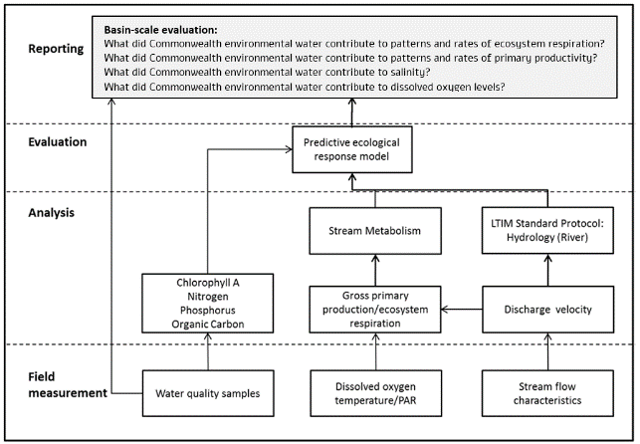

Figure . Schematic of key elements of stream metabolism and water quality indicators

Source: adapted from Hale et al. 2014

## Summary of 2019–20 watering actions for food webs and water quality

Of the 125 Commonwealth environmental watering actions in the 2019–20 water year, 29 had primary ecological outcomes targets linked to water quality and food webs – including water quality, stream metabolism and productivity, and river function – and 17 of these were delivered to 6 of the 7 Selected Areas (Table 1.1). Of the 14 watering actions in the Murrumbidgee River System in the 2019–20 water year, none had primary targets relevant to this theme.

While 1,705 GL of Commonwealth environmental water was delivered across the Basin in the 2019–20 water year, only 23% of the number of watering actions included expected ecological outcomes for water quality, productivity and river function, despite all of these actions having an influence on outcomes relevant to this theme. Of the 29 watering actions with outcomes relevant to this theme, 5 stated outcomes targetted ‘improvements’ and 11 targetted ‘maintenance’. Nine of the watering actions with expected ecological outcomes for water quality also included ‘process’ outcomes, and 5 with ‘process’ outcomes of biofilms and nutrients were not linked to water quality outcomes. Terms used to describe expected ecological outcomes were diverse, including maintenance of water quality, freshen lagoon, disruption and scouring of biofilms, support nutrient cycling, provide carbon to the channel and minimise the risk of hypoxic blackwater, minimise suspended sediment and refresh waterholes. Both improved clarity and consistency are needed in the use of terminology in reporting outcomes for Commonwealth environmental watering actions.

The Lower Murray River was the focus of 48 Commonwealth environmental watering actions in 2019–20, with volumes ranging from 0.1 ML to 344,093 ML, predominantly for wetland and vegetation ecological outcomes. Only 5 of these actions were targeted to water quality (particularly in the Lower Lakes), productivity and river function and are therefore evaluated in this report. Volumes ranged from 352 ML for a weir pool manipulation to a 344,093 ML spring fresh.

The Edward/Kolety–Wakool river systems had 4 Commonwealth environmental watering actions in 2019–20, 3 of which were base flow deliveries with targets for improved water quality. Releases ranged from 4,487 ML in the Colligen–Niemur to 7,622 ML in the Yallakool–Wakool system. A 10,371 ML base flow between 17-09-19 and 30-06-20 was a shared 50:50 contribution from Commonwealth environmental water and other environmental water sources.

Of the 7 watering actions delivered to the Goulburn River in 2019–20, 6 were relevant to this theme. Their targeted ecological outcomes included the maintenance of water quality, disruption and scouring of biofilms, provision of carbon to the channel and minimising the risk of hypoxic blackwater. The contribution of Commonwealth environmental water to these actions ranged from 794 ML (0.3% of total volume) to 136,618 ML (43% of total volume) and were generally associated with a duration of 6 weeks or less. Other environmental water contributions in these actions were predominantly made by the Victorian Environmental Water Holder (VEWH).

Of the 5 watering actions delivered to the Lachlan River System in 2019–20 using Commonwealth environmental water, 3 were deliveries with targets for improved water quality, particularly in wetland habitats. A 400 ML release to Yarrabandai Lagoon, a 2,900 ML release to Booberoi Creek and a 17,028 ML flow from Wyangala Dam to Great Cumbung were all delivered during the 2019 portion of the water year.

Of the 3 watering actions delivered to the Gwydir River System, only a 12,000 ML base flow (6,000 ML Commonwealth environmental water, 6,000 ML New South Wales environmental water) delivered over summer was targeted to improve water quality and replenish waterholes. Although these watering actions targeted ecological outcomes relevant to this theme, data on stream metabolism were not available due to data logger failures and exceptionally low acceptance rates (see Section 2.2 for detailed explanation of acceptance criteria) of data emerging from the analyses.

Of the 3 watering actions in the Junction of the Warrego and Darling rivers, 2 were targeted to improve waterhole refuge water quality in the Warrego channel and Darling River downstream of the confluence. Commonwealth environmental water accounted for 16,212 ML and 475 ML discharges from Boera Dam from December 2019 to June 2020.

In addition to Selected Areas, there were 12 Commonwealth environmental watering actions with expected ecological outcomes relevant to this theme across 6 unmonitored systems:

* 3 actions in the Border Rivers – 879 ML in the Severn, and 2,122 ML and 246 ML in the Dumaresq and Macintyre – to maintain water quality
* 2 in the Ovens River – 50 ML plus 39 ML from another source, and 53 ML – to maintain water quality and scour biofilms
* 2 in the Broken River – 1,226 ML and 13,782 ML – to maintain DO levels
* 2 events in Wimmera Creek – 745 ML plus 6,378 ML from VEWH and 100 ML from another source, and 817 ML plus 817 ML from VEWH and 690 ML from another source – to manage salinity
* 2 in the Loddon River – Serpentine Creek, 91 ML and 95 ML – to freshen water quality by diluting salt and oxygenating pools
* 1 in Central Murray – Gunbower Creek (21,231 ML) – to improve water quality.

Table . Summary of 2019–20 watering actions with expected outcomes related to water quality and stream metabolism at Selected Areas

| **Basin-scale evaluation watering action reference** | **Watering action Number (WAR)** | **Surface water region: asset** | **Commonwealth environmental water volume (ML)** | **Total watering action volume (ML)** | **Dates** | **Flow component** | **Expected ecological outcome\*** | **Evaluated by Flow-MER in Selected Area** |
| --- | --- | --- | --- | --- | --- | --- | --- | --- |
| 1920-LWM-10 | 10095-02 | Lower Murray channel and Coorong-Lower Lakes | LMR: 178,630  Barrage: 195,555 | 178,279 | Winter pulse:  01/07/19 – 31/08/19 | Fresh | River function and productivity Lower Lakes water quality | Lower Murray |
| 1920-LWM-11 | 10095-02 | Lower Murray channel and Coorong-Lower Lakes | LMR: 344,093  Barrage: 364,340 | 344,093 | Spring pulse:  18/09/19 – 30/11/19 | Fresh | River function and productivity Lower Lakes water quality | Lower Murray |
| 1920-LWM-13 | 10095-02 | Lower Murray channel and Coorong-Lower Lakes | LMR: 101,804  Barrage: 110,708 | 101,804 | Autumn flow:  01/03/20 – 30/06/20 | Base flow | River function and productivity Lower Lakes water quality | Lower Murray |
| 1920-LWM-40 | 10095-04 | Lower Murray: Paringa Paddock | 85 | 85 | 26/09/19 – 12/02/20 | Wetland | Freshen lagoon | Lower Murray |
| 1920-EWK-01 | 10094 | Edward Wakool: Yallakool-Wakool | 7,622 | 7,622 | 1/07/2019 – 30/06/20 | Base flow  Fresh | Maintain water quality | Edward/Kolety–Wakool |
| 1920-EWK-02 | 10094 | Edward Wakool: Colligen-Niemur | 4,487 | 4,487 | 1/07/2019 – 30/06/20 | Base flow  Fresh | Maintain water quality | Edward/Kolety–Wakool |
| 1920-EWK-03 | 10094 | Edward Wakool: Tuppal Creek | 5,186 | 10,371 | 17/09/2019 – 30/06/20 | Base flow  Fresh | Maintain water quality | Edward/Kolety–Wakool |
| 1920-GLB-01 | 10075-03 | Goulburn: Lower Goulburn River | 2,459 | 5,282 | 01/07/19 – 05/07/19 | Base flow | Maintain water quality Disrupt biofilms Production of Plankton | Goulburn |
| 1920-GLB-02 | 10075-03 | Goulburn: Lower Goulburn River | 136,618 | 163,395 | 06/07/19 – 06/08/19 | Fresh | Improve water quality Provide carbon to channel | Goulburn |
| 1920-GLB-05 | 10075-03 | Goulburn: Lower Goulburn River | 794 | 25,185 | 14/03/20 – 07/04/20 | Base flow | Maintain water quality Disrupt biofilms Production of plankton | Goulburn |
| 1920-GLB-06 | 10075-03 | Goulburn: Lower Goulburn River | 35,963 | 295,943 | 08/04/20 – 30/06/20 | Base flow | Minimise hypoxic blackwater | Goulburn |
| 1920-LCH-01 | 10081-04 | Lachlan: Wyangala Dam to Great Cumbung, including Brewster Weir Pool | 17,028 | 17,028 | 16/09/19 – 31/05/19 | Fresh  Wetland | Maintain water quality | Lachlan |
| 1920-LCH-02 | 10081-05 | Lachlan: Yarrabandai (formerly Burrawang West Lagoon) | 400 | 548 | 16/09/19 – 15/11/19 | Wetland | Maintain water quality | Lachlan |
| 1920-LCH-03 | 10081-06 | Lachlan: Booberoi Ck | 2,900 | 2,900 | 01/10/19 – 30/11/19 | Fresh | Maintain water quality | Lachlan |
| 1920-GWY-01 | 10100-01 | Gwydir: Mehi River and Carole Creek | 6,000 | 12,000 | 09/10/19 – 19/01/20 | Base flow | Support ecological functioning and nutrient cycling Water quality | Gwydir |
| 1920-WAR-01 | 00111-56 | Warrego: Upper Warrego River and fringing wetlands | 475 | 475 | 18/12/19 – 05/06/20 | Base flow | Improve waterhole refuge water quality | Warrego–Darling |
| 1920-WAR-02 | 00152-12 | Warrego: Lower Warrego River and fringing wetlands | 16,212 | 16,212 | 18/12/19 – 05/06/20 | Base flow | Improve waterhole refuge water quality | Warrego–Darling |

* As reported by the Commonwealth Environmental Water Office (CEWO)

# Approach

## Conceptual model

In the Murray–Darling Basin, the role of flow in disturbance dynamics and as a trigger of life-history events (such as breeding or dispersal) is well documented (e.g. Greet et al. 2011; Humphries et al. 1999). Over several decades, we have gained an understanding that persistent low flows can reduce biomass and change the composition of ecological communities, which contributes to biodiversity loss (Mac Nally et al. 2011; Thomson et al. 2012; Wedderburn et al. 2012). Flooding in the years following the Millennium Drought (2000–2010) has improved our understanding of the role of high flow disturbance, which can influence biota in multiple ways (Mac Nally et al. 2014). Similarly, work on a range of taxa, including native fish, floodplain vegetation, woodland birds, small mammals and amphibians, has shown that flow events are important triggers for life-history events that include flowering, seed set and breeding (Capon 2003; King et al. 2009; Kingsford and Auld 2005).

Much less clear is the role of flow in generating the required resources to both initiate and complete key life-history events that result in the successful recruitment of plants and animals into breeding populations (Shenton et al. 2012). For example, there are several documented cases of bird breeding events triggered by flow events where birds have either aggregated and then not nested, or nested and failed to raise chicks to independence. Once breeding has been initiated, metabolism and energetics are the key currency in determining success, along with the condition of the animals at the time of breeding, the size of the eggs and offspring, and availability of resources that allow all the life stages to be completed. Similarly, even where fish breeding is initiated by a flow event, we have limited evidence that the resulting fish larvae have access to the energy resources needed to allow them to grow to sexual maturity and therefore recruit into the population.

Environmental flows directly impact metabolism, and energy production and flux via a number of mechanisms. These include affecting the productivity and distribution of different types of resources that form the basis of food webs (e.g. aquatic plants, algae and phytoplankton). Increased flows can wet substrates that allow algal, fungal and bacterial growth, and cause resuspension of organic matter from upstream, in-channel benches or from the floodplain. Flow can also ‘wash out’ phytoplankton and concentrate resources into microhabitats such as backwater eddies. There are likely to be spaces in the landscape that are disproportionally important in space and time for primary and/or secondary production of resources (due to their location and productivity being influenced by flow.

Conceptually, the approach for this theme builds on work carried out in the preceding Environmental Water and Knowledge Research (EWKR) and Long Term Intervention Monitoring (LTIM) projects. Within EWKR, the Food Web Theme explored the conceptual link between the Waterbird, Fish and Vegetation themes (Figure 2.1), linking the production of resources to provision of food for consumers in response to environmental flows.

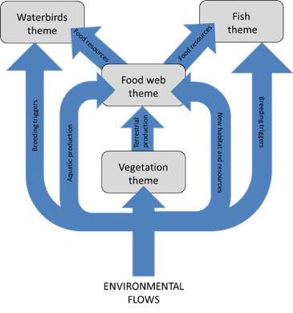

Figure . Conceptual diagram illustrating the effects of environmental flows on the movement of energy and resources across and between the 4 ecological themes

Diagram developed in the EWKR Project

Source: McInerney et al. 2019

Using the LTIM and EWKR project outcomes as the starting point, this Food Webs and Water Quality Basin Theme seeks to build on the framework displayed in Figure 2.1 and extend it to incorporate productivity responses of ecosystems to different types of environmental watering actions (Figure 2.2). Rates of GPP and ER can control and impose restrictions on the energy supply and energy dispersal through food webs. The balance of these 2 fluxes, measured as NEP, determines whether carbon accumulates or decreases in an ecosystem.

A significant challenge when interpreting responses of stream metabolism to environmental flows is determining what are levels of ‘desirable’ and ‘undesirable’ productivity. For example, a large overbank flow event has the potential to liberate substantial quantities of organic carbon from floodplains that can generate significant increases in heterotrophic in-channel productivity (measured as ER). However, such large productivity responses may be undesirable if they occur in concert with small GPP responses, potentially leading to blackwater events, where more oxygen is consumed from the water column than is produced, ultimately leading to hypoxia (acute lack of oxygen) for aquatic animals (large tan brown arrow in Figure 2.2). Equally, at the other extreme, a cease-to-flow/base flow event (depicted by the dark green arrow in Figure 2.2) coupled with high sunlight and high nutrient concentrations has the potential to generate high rates of GPP during daylight hours, and similarly high rates of ER overnight. However, if this occurs as a blue-green algal bloom, it is also a non-desired productivity response that may be harmful to aquatic animal and human health.

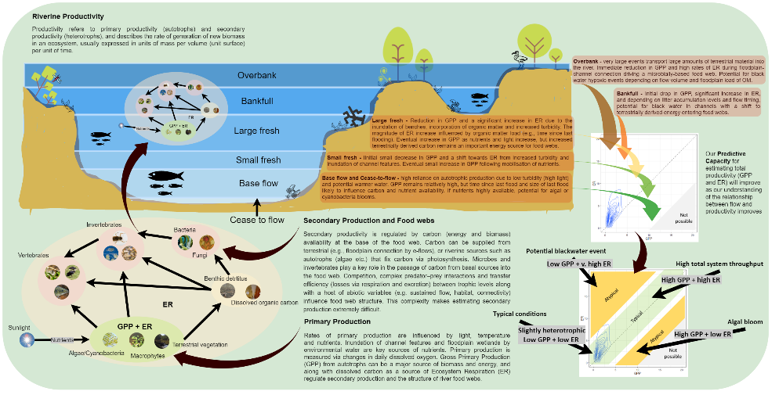

Figure . Conceptual model of the approach within the Flow-MER Basin-scale Food Webs and Water Quality Theme evaluation to measuring metabolic responses to Commonwealth environmental water

We use a metabolic fingerprinting approach (Bernhardt et al. 2018), an emerging tool for visualising and diagnosing change in stream metabolism across time or space and in response to hypothesised drivers. The method enables us to identify whether metabolic responses to a flow condition are within the typical metabolic regime of a site or represent atypical conditions at that site. Atypical metabolic conditions may indicate a desirable state (e.g. high gross primary production (GPP) and ecosystem respiration (ER); high system throughput) or an undesirable state (e.g. algal blooms, blackwater), providing an indication of how different flow types can provide carbon and nutrients for food webs. The approach can be scaled spatially (e.g. valley responses, northern or southern Basin) and temporally (e.g. fingerprints overlaid through time with multiple flows) to improve our understanding of environmental water – productivity relationships.

Conceptually, we are addressing whether metabolism at a particular place and time is inside the bounds of desirable productivity conditions, by generating metabolic fingerprints for each Selected Area. Metabolic fingerprints are a visualisation tool for contrasting annual patterns of metabolism across rivers or across years for the same river (Bernhardt et al. 2018). The metabolic fingerprint depicts the dominant metabolic regime at a site, presented as a kernel density plot of all daily estimates of GPP and ER rates (Figure 2.2, and explained in more detail in Section 2.3). Importantly, a metabolic fingerprint displays the dispersion of both GPP and ER in a single plot, allowing an examination of whether GPP and ER are in balance.

Measures of stream metabolism are highly informative to management because they integrate many ecological processes. However, a challenge for using stream metabolism as a management tool is that metabolic rates can have high and unexplained variability in space and time (Jankowski et al. 2021). We expect the metabolic regime for each Selected Area to be context dependent, varying according to the magnitude of biotic and abiotic drivers at each location. Armed with 6 years of stream metabolism data, we can now generate fingerprints from the long-term data collected at each Selected Area, which will represent the typical conditions of that Selected Area. These visualisations of the metabolic regime can serve to compare and contrast future annual and flow-event-specific metabolic responses. They can also track metabolic responses to environmental flows and assess whether they fall inside or outside the envelope of typical conditions or predicted responses.

Box 1 Relationship between stream metabolism and secondary productivity

Although rates of gross primary production (GPP) and ecosystem respiration (ER) are not direct estimates of consumer energy dynamics, ecological theory and existing empirical evidence suggest that these rates are correlated in aquatic ecosystems (Figure 2.3; Rüegg et al. 2021). GPP represents the building of biomass at the base of the food web, which primary consumers eat to gain energy (Figure 2.3). A proportion of this ingested energy will be transformed into biomass by the primary consumers, and then secondary consumers in turn (the rest is lost to cellular respiration, heat, excretion and to decomposers at each level). ER is the sum of respiration by autotrophic and heterotrophic organisms (both microorganisms and all multicellular consumers). A high ER thus likely indicates a high biomass and/or activity of heterotrophic organisms, and under some circumstances may be considered a proxy for secondary production.

There are likely exceptions to the expected correlation between rates of stream metabolism and secondary production. For example, if energy is recycled within the microbial loop, this energy is dissipated and not available to higher trophic levels. However, in streams it is known that much of the bacterial and fungal production occurring on detrital organic matter fuels the productivity of higher trophic levels. Uncertainties exist around the efficiencies of transfer between trophic levels, which depend on water quality variables such as temperature and nutrient availability. The spatial and temporal scales of correlations between stream metabolism and consumer dynamics is an area of ongoing research. Despite this, stream metabolism is a useful indicator of trophic dynamics, because measuring secondary production and energy transfer is much more difficult and cannot readily be performed at the practical scale and temporal resolution achievable for stream metabolism with modern dissolved oxygen loggers.

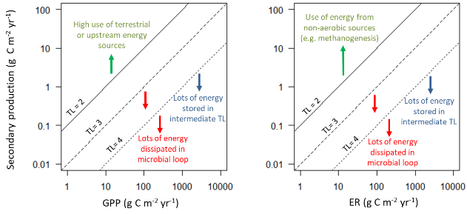

Figure . Hypothesised relationship between stream metabolism and secondary productivity by consumers at higher trophic levels

The amount of secondary productivity per unit gross primary production (GPP) or ecosystem respiration (ER) decreases with increasing trophic level (TL) because only approximately 10% of the energy is transferred to biomass production by the next level. Coloured arrows and text indicate scenarios for which a departure from this hypothesised relationship would be expected.

Source: modified from Rüegg et al. 2021

Metabolic fingerprints can also be used to compare and classify metabolic regimes across different sites. This could lead to the identification of sites that share similar metabolic regimes and potentially respond similarly to Commonwealth environmental watering actions. In this way, the metabolic regimes can also be used to scale up from Selected Area to valley scale or to group Selected Areas or individual rivers based on their metabolic fingerprint response. Generating environmental flows that promote desirable metabolic responses (when GPP and ER remain relatively well balanced, as designated by the middle (green) band on the bottom right plot in Figure 2.2) represent management for a set of conditions that are likely to support healthy communities of fish and waterbirds. This approach will improve our understanding of how different flow types interact with abiotic drivers (e.g. antecedent conditions, light, temperature) to influence aquatic metabolic responses and improve our predictive capacity for metabolic responses to Commonwealth environmental watering actions, as well as their influence on states of riverine organisms (e.g. vegetation, fish, birds).

## Method

Stream metabolism and water quality measurements were performed in accordance with the LTIM Standard Operating Procedure (Hale et al. 2014), which has remained essentially unchanged for the Flow-MER Program. Stream metabolism is a Category 1 indicator, defined as

‘… mandatory indicators and standard protocols which are required to inform quantitative Basin-scale evaluation. Indicators have been identified for each Selected Area in this category and must be applied in a consistent manner following standard protocols’.

The method has been designed to provide data appropriate for the evaluation of outcomes in response to Commonwealth environmental watering at the Selected Area and Basin scale (Grace et al 2020). Data on temperature (°C), electrical conductivity (mS/cm), dissolved oxygen (DO) (%), pH and turbidity (nephelometric turbidity units; NTU) are collected as part of the Standard Methods (Grace et al. 2020). They may be complemented by water quality monitoring data collected through other relevant programs, such as short-term monitoring instigated by the Commonwealth Environmental Water Office (CEWO) and/or the Murray–Darling Basin Authority (MDBA) in response to planned watering actions or a potential water-quality event.

Daily estimates of GPP, ER and reaeration rate (KO2) have been developed in each Selected Area from diel DO curves for each site, using the LTIM Category 1 Standard Method (Hale et al. 2014). The BASEv2 fitting routine (Grace et al. 2015)[5] is used to calculate rates of stream metabolism. As the Bayesian Single-station Estimation (BASE) model evolved during the 5 years of LTIM, all of the earlier LTIM data used for stream metabolism, and incorporated in this Flow-MER report, were re-run on the BASEv2 program to ensure a common method across time. This resulted in many more days that met the acceptance criteria for inclusion in the metabolic fingerprint analyses presented here. Acceptance criteria for inclusion of daily results in subsequent analyses were that the fitted model for a day must have:

* an R2 value of at least 0.90 and a coefficient of variation for the GPP, ER, and K parameters of <50%
* a reaeration coefficient (K) within the range 0.1 to 15.0
* model fit parameter PPfit within the range 0.1 to 0.9.

The fitting routine also provides an uncertainty estimate for each parameter that allows interrogation of the data included. The Standard Methods were updated for the 2019–20 water year (based on Song et al. 2016) to provide flexibility in acceptance criteria. This improved data acceptance rates where appropriate without substantially diminishing data quality or interpretability. Extreme events, such as algal blooms and hypoxic blackwater events, can generate data that fail to meet the uncertainty criteria specified within BASE. These periods are of ecological significance and Selected Area teams can modify the rejection criteria to allow specific investigation of extreme events. Deviations from the standard acceptance criteria by Selected Area teams are noted in their 2019–20 Annual Reports and in this report.

In addition to the daily estimates of GPP, ER and KO2, it is also expected that, at all sites where sampling is undertaken, Selected Area teams will provide data for the periods of measurement on:

* mean river water velocity
* mean daily discharge
* average river depth.

## Selected Area data fingerprinting – a new approach for analysing and communicating stream metabolism responses for environmental watering actions

Metabolic fingerprints are an emerging tool for visualising and diagnosing change in stream metabolism across time or space and in response to hypothesised drivers (Bernhardt et al. 2018). The metabolic fingerprint represents the entire distribution of daily estimates of GPP and ER that are observed for a river, summarised into kernel density plots that allow easy visualisation of both peak and median metabolic rates as well as variance in ratios (Figure 2.4).

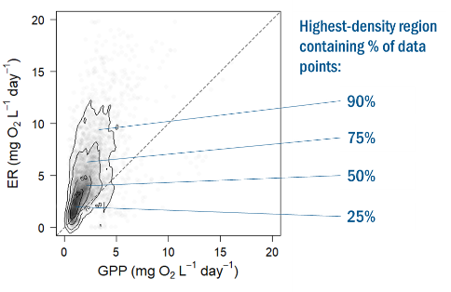

Figure . Metabolic fingerprint describes the bivariate probability distribution estimated to contain the top 25%, 50%, 75% and 90% of the gross primary production (GPP) and ecosystem respiration (ER) points

These diagrams consist of GPP and ER displayed with a kernel density plot. The contour lines indicate the areas estimated to contain the top 25%, 50%, 75% and 90% of the GPP and ER points (from the inner to outermost contour lines, respectively; Figure 2.4). This area represents the typical metabolic rates at a site, termed the metabolic regime. The dashed line indicates when GPP and ER are equal (i.e. net ecosystem production equals zero). Above the dashed line, the system is heterotrophic (a net consumer of carbon; ER > GPP) and below the line the system is autotrophic (net accumulator of carbon; GPP > ER). This representation of the rates allows a rapid inspection of the most typical rates of GPP and ER (the inner most contour), the balance between GPP and ER (position of the fingerprint relative to dashed line), the total variability in GPP and ER (the size of the outermost contour) and the correlation between GPP and ER.

An example of a ‘real world’ metabolic fingerprint is presented in Figure 2.5. Contour lines in the top left of the plot represent high ER and low GPP rates, and can be indicative of blackwater or hypoxic events, while contour lines in the bottom right of the plot represent high GPP and low ER and may be indicative of algal blooms or eutrophication. In both cases, contours that reside outside the central green band (solid lines) may cause non-desired shifts in metabolic patterns in response to changes in flow regime or watering actions. The central diagonal line represents a balance between GPP and ER (e.g. GPP:ER = 1) and contours in the associated green zone can indicate ‘good’ or desired productivity. Fingerprints that shift upwards along the diagonal line (i.e. high GPP and high ER) indicate an increase in overall ecosystem throughput and the rapid cycling of organic matter and nutrients through a riverine food web).

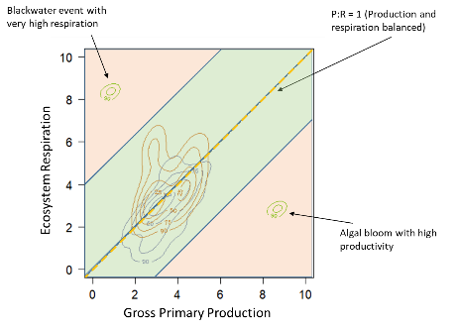

Figure . Metabolic fingerprints are an emerging tool for visualising and diagnosing change in stream metabolism across time or space and in response to hypothesised drivers

The fingerprints represent a useful tool for diagnosing ‘good’ and ‘bad’ metabolic responses to flow

Bernhardt et al. (2018) predict that increased light and nutrients will enlarge both the total area and the maximal rates represented by a river’s fingerprint, while increased sediment loading caused by hydrological disturbances will limit the metabolic fingerprint to values near the bases of both the GPP and ER axes. Thus, we expect that the area of each Selected Area’s fingerprint (its variation along both the 1:1 line and the X and Y axes) should be compressed by hydrological disturbances and expanded by the supply of either solar energy or carbon. It is expected that as more metabolic data are collected, predictable clusters and patterns in stream metabolism will become more recognisable. As mechanistic understanding of observed responses to environmental flows improves, flows can be tailored at different scales (rivers, basins or Selected Areas) to achieve specific metabolic outcomes.

# Water year 2019–20

## Climate and hydrological context

In 2019–20, the Border Rivers Valley was the only valley with rainfall conditions ‘very much below average’. In the remaining valleys where Commonwealth environmental water was delivered, rainfall was classified as ‘average’ or ‘below average’ conditions. The Broken, Campaspe, Edward/Kolety–Wakool, Goulburn, Lachlan, Loddon, Macquarie, Warrego and Wimmera valleys experienced average rainfall conditions, while rainfall in the Barwon Darling, Central Murray, Condamine Balonne, Gwydir, Lower Darling, Lower Murray, Murrumbidgee, Namoi and Ovens valleys was below the long-term average (Figure 3.1).

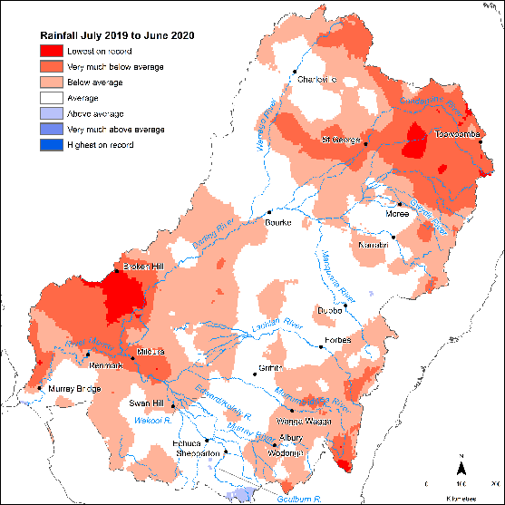

Figure . Rainfall conditions experienced in the Basin during the 2019–20 water year

The northern Basin experienced a severe drought through the first half of 2019–20, with well-below-average rainfall from August to December 2019. In contrast, early 2020 saw above-average rainfall. For example, the Warrego River experienced a large inundation event, connecting the Warrego and Darling rivers for over 4 months, inundating over 11,500 ha of the western floodplain and connecting the floodplain back to the Darling River downstream of the Selected Area for the first time since 2012.

## Evaluation outcomes

Stream Metabolism Category 1 data included in this report were collected from 26 sites across 6 of the 7 Selected Areas in 2019–20: Lower Murray River, 3 sites; Goulburn River, 5 sites; Edward/Kolety–Wakool river systems, 8 sites (in 4 zones); Murrumbidgee River System, 1 site; Lachlan River System, 4 sites; and Junction of Warrego and Darling rivers, 5 sites.

Rates of data that met output acceptance criteria from the BASEv2 routine remained very low in some Selected Areas. The Lower Murray River, characterised by water of relatively low turbidity, had the highest acceptance rates of over 90% (244 daily records included). The Goulburn River ranged from 16% to 67% (409 daily records included), Edward/Kolety–Wakool river systems from 3% to 63% (714 daily records included), Murrumbidgee River System at 71% (107 daily records included), Lachlan River System from 19% to 83% (563 daily records included) and the Junction of Warrego and Darling rivers from 7.6% to 16.6% representing 24 days of daily records included from a possible 157 days. In the Gwydir River System, Category 1 stream metabolism data were collected from 3 sites, but extended cease-to-flow periods and logger theft prevented data from being included. Poor model fit for photosynthetically active radiation (PAR) leading to low R2 values, and poor K (reaeration coefficient) constants arising from slow-moving water (e.g. locks of the Lower Murray River, cease-to-flow events in the northern Basin) were leading causes of low data acceptance rates. Improving flexibility in criteria for K and R2 model fits are essential to improve data acceptance.

Despite these limitations, seasonality was found to be the primary driver of rates of stream metabolism, with highest daily rates of GPP and ER consistently recorded in summer.

There was no demonstrated major influence of organic or inorganic nutrients on rates of stream metabolism due to changing concentrations (increased or diluted) resulting from Commonwealth environmental watering actions. Similarly, increases in turbidity had a minimal and inconsistent influence on rates of GPP and ER during Commonwealth environmental watering actions. This suggests that light and dissolved organic carbon (DOC) are potentially limiting both GPP and the development of microbial populations so that nutrient limitation was not being induced.

The Lower Murray River (mean GPP:ER 1.73) and Murrumbidgee River System (mean GPP:ER 1.14) were the only Selected Areas that were net autotrophic, with the Goulburn River (mean GPP:ER 0.52), Edward/Kolety–Wakool river systems (mean GPP:ER 0.62), Lachlan River System (mean GPP:ER 0.73) and Junction of Warrego and Darling rivers (mean GPP:ER 0.34) consistently heterotrophic, identifying the importance of terrestrial organic carbon from channel and floodplain connectivity as the dominant energy source in these systems.

Metabolic fingerprints for the 6 Selected Areas for 2019–20 are presented in Figure 3.2. The 25% kernel density regions (or area containing the top 25% of data points) for the Goulburn, Edward/Kolety–Wakool, Lachlan Rivers and Warrego–Darling reside above the 1:1 line, indicating that most of the time in 2019–20, riverine ecosystems in these Selected Areas were heterotrophic and consuming more carbon than they were producing. The 25% kernel density region for Murrumbidgee is equally distributed around the 1:1 line, indicating that, in 2019–20, this Selected Area alternated between heterotrophy and autotrophy depending on conditions (such as season).

In comparison to other Selected Areas, the Murrumbidgee River System fingerprint is unique for 2 reasons: (1) its position; and (2) the total area it occupies. In relation to the former, the fingerprint resides very low on the 1:1 line, suggesting some level of limitation to metabolic throughput. In relation to the latter, the fingerprint is very constrained in size, reflecting consistent metabolic patterns throughout 2019–20. In contrast, the Warrego–Darling fingerprint stretches a long way up the ER axis (note the scale), reflecting large swings towards heterotrophy (e.g. in 2019–20 this was reflective of high terrestrial litter inputs).

The 2019–20 25% kernel density region for the Lower Murray is also exceptional in that it is the only fingerprint that resides primarily below the 1:1 line, reflecting net carbon generation (autotrophy). These patterns are likely a product of the lentic character of sites within this Selected Area that support phytoplankton.

Stream metabolism evaluation questions and answers relating to Commonwealth environmental water and environmental watering actions are provided in Table 3.1. Detailed information on outcomes for each Selected Area is provided in Appendix A.

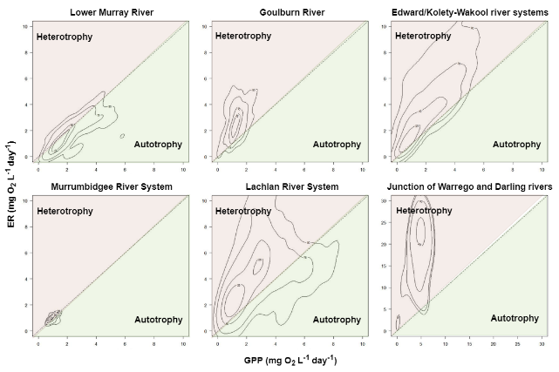

Figure . Variation in metabolic fingerprints across Selected Areas for 2019–20

Lower Murray River (244 daily recordings); Goulburn River (409 daily recordings); Edward/Kolety–Wakool river systems (714 daily recordings); Murrumbidgee River System (107 daily recordings); Lachlan River System (563 daily recordings); Junction of Warrego and Darling rivers (24 daily recordings, note different scale)

Table . Stream metabolism evaluation questions and answers relating to Commonwealth environmental water and environmental watering actions for 2019–20

| **Selected Area** | **What did Commonwealth environmental water contribute to dissolved oxygen levels?** | **What did Commonwealth environmental water contribute to patterns and rates of primary productivity?** | **What did Commonwealth environmental water contribute to patterns and rates of ecosystem respiration?** |
| --- | --- | --- | --- |
| Lower Murray River | * decreased likelihood of low dissolved oxygen (DO) by increasing water mixing and oxygen exchange at the surface * substantial improvement in DO levels for >40 days, with other environmental water contributing to a total of 70 days where velocities were increased to >0.18 m/s due to environmental water | * increased flows generally * increase in the overall ’carrying capacity’ of the river through increased total carbon available to the food web * negligible percentage increases in cross-sectional gross primary production (GPP) at Lower Murray River sites, due to the largely stable water levels induced by weirs | * Bacterial respiration (BCR), a measure of decomposition, is directly related to DOC concentrations. Modelling of the influence of flows on BCR assumed that for any given day, DOC concentrations were the same with and without Commonwealth environmental water * small percentage changes in river cross-sectional BCR at Lock 6, due to the constant water level maintained by the weir |
| Goulburn River | * small positive DO concentrations of 6–11 mg DO/L/day by maintaining physical water mixing and oxygen exchange processes during deliveries, and enhancing phytoplankton production | * negligible effect on primary production, driven by very low available nitrogen (N) and phosphorus (P) * small positive correlations between GPP and mean daily water temperature and photosynthetically reactive radiation (PAR) * increased flows that generally slightly reduced the volumetric rate of GPP but slightly increased the reach-scale rates of production. This increased the overall ‘carrying capacity’ of the river, however the GPP:ER ratio was predominantly heterotrophic (GPP:ER >1; mean 0.52) for most of the time | * limited seasonal variation in ecosystem respiration (ER) rates observed, with changes in net ecosystem production (NEP) driven by reduced rates of GPP * consistent low concentrations of DOC highlight that increases in ER metabolic rates would be possible with reconnection of backwaters and other off-channel habitats |
| Edward/ Kolety–Wakool river systems | * DO concentrations consistently higher during late summer and early autumn * concentrations of dissolved oxygen in Edward/Kolety, Wakool and Colligen–Niemur rivers consistently above the range of concern to fish populations (<4 mg/L). * improvement in DO levels through physical water mixing and oxygen exchange processes during deliveries at some sites; but negligible effect on overall DO concentrations | * no substantial effect on areal rates of GPP (mg O2/m2/day), which largely followed seasonal trends * beneficial effect when GPP calculated as the amount of organic carbon produced per day (kg C/day). The size of beneficial impact largely related to the proportion of total flow that came from the watering action, with greater proportional effects of environmental water in winter low flow periods * carbon production enhanced by 15–278% during the watering actions, with a median across all sites and watering actions of 50% more carbon produced during Commonwealth environmental watering actions compared with no Commonwealth environmental water | * areal rates of ER (mg O2/m2/day) largely driven by seasonal trends * beneficial effect when ER calculated as the amount of organic carbon consumed per day (kg C/day). Increased organic carbon consumed means more nutrient recycling and hence greater nutrient supply to fuel GPP * carbon consumption enhanced by 18–263% during the watering actions, with a median across all sites and watering actions of 51% more carbon consumed during Commonwealth environmental watering actions compared with no Commonwealth environmental water contribution |
| Murrumbidgee River System | * contribution to positive DO concentrations of 7.78–10.1 mg DO/L/day through maintaining physical water mixing and oxygen exchange processes during deliveries, and enhancing phytoplankton production | * had negligible effect on GPP, driven through very low available N and P * resulted in GPP positively correlated with discharge. The mean GPP:ER ratio ranged from 0.42 to 3.05, with the Murrumbidgee River System (and Lower Murray River) the only Selected Areas with mean GPP:ER > 1 | * negligible effect on ER * ER was positively correlated with discharge |
| Lachlan River System | * DO concentrations consistently lower in summer periods * longitudinal pattern in DO concentrations not evident * DO concentrations in the Lachlan River consistently above the range of concern to fish populations (<4 mg/L), except for a brief period in Jan 2020 at Whealbah * improvement in DO levels through physical water mixing and oxygen exchange processes during deliveries evident at some sites, though negligible effect overall | * no substantial effect on rates of GPP, which largely followed seasonal trends * generation of short pulses of increased GPP and ER, with GPP responses being larger in warmer conditions * relatively minor changes in nutrients and carbon supported relatively larger responses in productivity, particularly in autumn | * ER rates largely driven by seasonal trends * While the river was generally heterotrophic with a mean and median GPP:ER ratio <1 (dominated by external carbon respiration rather than in situ photosynthesis), it tended to be more autotrophic during Commonwealth environmental water deliveries. This may suggest generation of higher quality local production |
| Junction of Warrego and Darling rivers | * contribution to positive DO concentrations of 3–7 mg DO/L/day through maintaining physical water mixing and oxygen exchange processes during deliveries, and enhancing phytoplankton production | * negligible effect on GPP, with highly turbid waters creating a very shallow photic depth that appears to have limited GPP despite exceptionally high concentrations of total and available N and P, and dissolved organic carbon * no clear temporal patterns in GPP, ER or NEP overall or within any site to indicate that the inundation event influenced productivity rates within the Warrego or Darling rivers | * negligible effect on ER, with the Warrego and Darling channels remaining almost exclusively and strongly heterotrophic * GPP:ER ratios consistently very low, driven by very high rates of ER rather than reduced GPP, suggesting terrestrial sources of organic matter are fuelling a microbial-based food web |

# Water years 2014–20

## Climate and hydrological context

Dry conditions have been common in the Basin for the 6-years from mid-2014 to mid-2020, the period of Commonwealth Basin-scale monitoring and evaluation to date. The first 2 years saw particularly dry conditions in the southern Basin. In the 2016–17 year, there were wetter conditions in the southern Basin and along the headwaters of the New South Wales tributaries in the northern Basin. However, conditions have returned to dry over the period 2017–20 across the whole Basin (Figure 4.1).

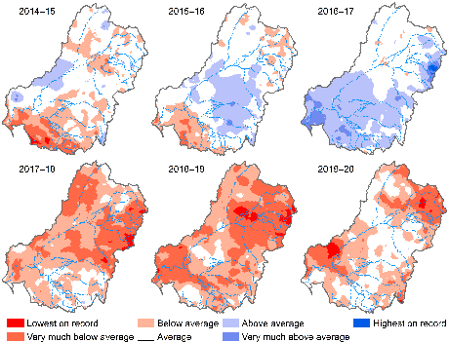

Figure . Maps of annual rainfall conditions over the 6-year monitoring period (2014–15 to 2019–20)

The 2019–20 map is shown in detail in Figure 3.1

## Evaluation outcomes

Similar to the annual evaluation, rates of GPP were strongly influenced by seasonal changes (e.g. light and temperature) and site-specific drivers such as bioavailable nutrient concentrations and reduced light availability due to turbidity. Increased flows can substantially decrease rates of both ecosystem GPP and ER, likely attributable to dilution effects of increased water volume and disturbance to microbial communities.

The 2014–20 metabolic fingerprints for Selected Areas overlaid with the 2019–20 metabolic fingerprints are presented in Figure 4.2. The kernel plots represent 14,029 daily records of GPP and ER from 2014–20, representing one of the largest riverine metabolic datasets available in the world.

The 2014–20 25% kernel density region (the area containing the top 25% of data points) for the Goulburn River, Edward/Kolety–Wakool river systems and Lachlan River System resides above the 1:1 line, indicating that most of the time these riverine ecosystems at these Selected Areas were heterotrophic and consuming more carbon than they were producing. The 2014–20 25% kernel density regions for the Murrumbidgee River System and Junction of the Warrego and Darling rivers are dispersed around the 1:1 line, indicating that they regularly alternated between heterotrophy and autotrophy depending on conditions (such as season), though they differ significantly in fingerprint area. The Murrumbidgee River System fingerprint is tightly grouped and low on the 1:1 line, reflecting more consistent metabolic patterns and some possible limitation to metabolic activity (e.g. bioavailable nutrients). In contrast, the Junction of the Warrego and Darling rivers fingerprint stretches further up the ER axis, reflecting large swings towards heterotrophy when suitable conditions prevail (e.g. non-desirable extremes, such as when sudden algal mortality following blooms or extensive channel inundation following long dry periods can lead to excessive consumption of oxygen by bacteria). In contrast to the other Selected Areas, the 2014–20 25% kernel density region for the Lower Murray resides primarily below the 1:1 line, reflecting net carbon generation (autotrophy) most of the time, driven by phytoplankton and relatively low turbidity in the slow-flowing channels of the Lower Murray. Detailed information on outcomes for each Selected Area is provided in Appendix B.

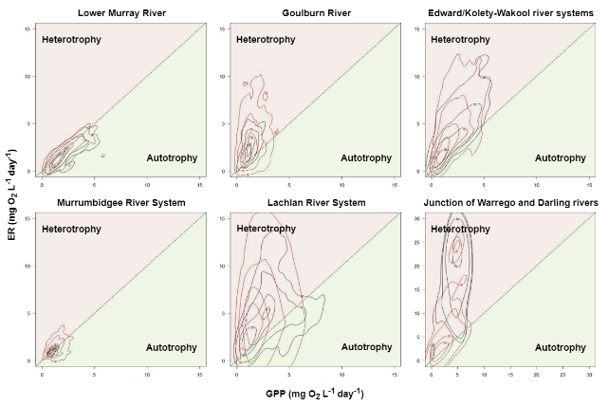

Figure . Longer term 2014–20 metabolic fingerprints (coloured red) overlaid with the 2019–20 metabolic fingerprint for Selected Areas

Note the different scale for Junction of Warrego and Darling rivers plot

# Case study: application of metabolic fingerprints to longitudinal change during an environmental watering event

Water for the environment was released from Hume Dam from September to December 2019 and in 2020 to support targeted wetlands and river channels from the mid-Murray to the Lower Lakes and Coorong. Referred to as the ‘Southern Spring Flow’, the release was coordinated with environmental releases from the Goulburn River, and natural and operational flows. The purpose of the Southern Spring Flow releases was to stimulate ecosystem productivity along the whole length of the Murray River, from Yarrawonga to the Coorong.

For the Southern Spring Flow 2019 event, a broad suite of metrics, that included water quality, nutrients, dissolved organic and carbon and zooplankton biomass, were collected to gauge ecosystem responses. The monitoring, conducted by consortia led by CSIRO and the University of Adelaide, showed that the Southern Spring Flow 2019 flow generated ‘new’ carbon and nutrients from the Barmah–Millewa Forest and this carbon and nitrogen drove biological processes in the Murray River for up to 100 km downstream. One of the recommendations to arise from that work was to consider deploying continuous DO loggers to give better accounts of instream productivity.

For the Southern Spring Flow 2020 event, the monitoring approach – funded by the MDBA and carried out by a CSIRO-led consortium (for full details, see Rees et al. 2020) – was modified to incorporate continuous logging of DO, so that stream metabolism could be estimated across time and space. The same methods used for Flow-MER evaluation of metabolism were adopted. This allowed valley-scale and reach-scale comparisons to be made with estimates of metabolic responses to environmental watering in Selected Areas (Box 2).

Box 2 Case study: Southern Spring Flow 2020

Here, as for the Selected Area data, we have used the metabolic fingerprinting approach to visualise ecosystem responses. Metabolic fingerprints are an emerging tool for visualising and diagnosing change in stream metabolism across time or space and in response to hypothesised drivers (Bernhardt et al. 2018).

Metabolic fingerprinting of the Southern Spring Flow 2020 at 8 locations in the Murray valley (Figure 5.1) highlight how metabolic patterns vary spatially in response to a flow pulse. Metabolism was dominated by autotrophy at the furthest upstream site at Tocumwal (Figure 5.1, plot A), with the fingerprint residing below the 1:1 line, indicating that the ecosystem is autotrophic – net accumulator of carbon; that is, gross primary production (GPP) greater than ecosystem respiration (ER).

As the pulse moved downstream and inundated the Barmah–Millewa floodplain, terrestrial carbon and nutrients were liberated from floodplain habitats and transported to the Murray and Edward rivers. The concentration of dissolved organic carbon (DOC) increased in the main river channel and was consumed by riverine heterotrophs, evidenced by the metabolic fingerprint shifting above the dashed line (i.e. the system was heterotrophic, a net consumer of carbon; ER > GPP) downstream of Barmah Forest (Figure 5.1, plots B) and increasing overall metabolic ‘throughput’ (e.g. shifting the fingerprint up the diagonal axis).

As terrestrial carbon was incorporated into the food web, DOC concentration gradually decreased with distance down the catchment, reflected by the metabolic fingerprint moving back towards autotrophy at the mid-Murray sites (Figure 5.1, plots C)). By the time the Southern Spring Flow 2020 reached the lower Murray (Figure 5.1, plots D), the metabolic fingerprints had returned to an autotrophically dominated state (net accumulator of carbon; GPP > ER) – implying that the terrestrial carbon liberated from Barmah had been completely incorporated into the food web.

The implications of metabolic patterns observed at the valley scale from the Southern Spring Flow 2020 monitoring are important for interpreting patterns detected at the reach or Selected Area scale. The Southern Spring Flow 2020 monitoring highlights the dynamic character of stream metabolism responses to flow and emphasises the importance of upstream or spatial drivers on responses. For example, if a particular Selected Area is downstream of a low-lying floodplain area that readily contributes carbon to the river channel, even with modest environmental flows (as seen with the 2 sites in Figure 5.1, plots B), we can expect to see strong heterotrophic responses at that Selected Area in its fingerprint. In contrast, metabolic responses to flow events may be more difficult to identify in highly channelised reaches (e.g. Figure 5.1, plot A) or in reaches that are spatially distant from any significant floodplain–river carbon and nutrient exchanges (e.g. Figure 5.1, plots D).

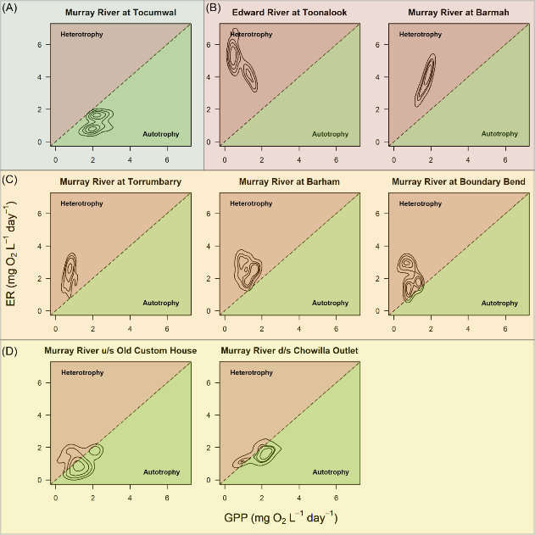

Figure . Metabolic fingerprints generated from the Southern Spring Flow 2020 in the Murray River

# Example of using metabolic fingerprints to predict responses in unmonitored rivers: Ovens River case study

As outlined in Section 1.4, in addition to Selected Areas, there were 12 Commonwealth environmental watering actions with expected ecological outcomes relevant to this theme across 6 unmonitored systems: 3 in the Border Rivers to maintain water quality; 2 in the Broken River to maintain DO levels; 2 in Wimmera Creek to manage salinity; 2 in the Loddon River to dilute salt and oxygenate pools; 1 in the Central Murray to improve water quality; and 2 in the Ovens River to maintain water quality and scour biofilms.

Using Selected Area data on driver co-variates as predictive variables, we use the Ovens River as an example of how a fingerprinting approach can be used to predict metabolic responses to Commonwealth environmental water in unmonitored rivers.

In the Ovens River there is a 123 ML environmental water entitlement held by the Commonwealth Environmental Water Holder (CEWH), of which 73 ML is held in Lake Buffalo on the Buffalo River and 50 ML is held in Lake William Hovell on the King River (NECMA 2020). This entitlement is aimed primarily at improving reaches immediately below the storages on the Buffalo and King rivers to provide variability in base flows in late summer and early autumn when flows are at their lowest. It also aims to improve water quality and provide connection to additional instream habitat (NECMA 2020).

The 123 ML of Commonwealth environmental water in the Ovens River was delivered in 4 separate events in 2019–20:

* 1 low flow autumn pulse delivered to the Buffalo River
* 1 low flow variability delivered to the King River below Lake William Hovell which also included a water transfer of 39 ML to the VEWH from the Taungurung Land and Waters Council
* 2 separate wetland top-up events delivered to Mullinmur Wetland near the township of Wangaratta.

Building on the Bernhardt et al. (2018) metabolic fingerprinting approach, we have partitioned the fingerprint plots into 4 quadrants (see Figure 6.2 for layout):

* Q1 – typical fingerprint area
* Q2 – region of high throughput, reflective of increased metabolic activity
* Q3 – atypical region of very high ER; could be reflective of blackwater events or periods of high ER rates, such as. incorporation of allochthonous carbon from floodplains during overbank flows
* Q4 – atypical region of very high GPP; could be reflective of cyanobacterial blooms and eutrophication, or periods of high GPP rates, such as return water from highly productive floodplain wetlands or seasonal extremes.

These quadrants are then used to make predictions about system metabolic character. The magnitude and location of plot quadrants can be derived from long-term datasets from across the Basin, with specific values associated with climatic region, river geomorphology, and channel or floodplain environments. For example, Figure 6.1 uses 2014–20 LTIM and Flow-MER metabolism data of over 14,000 individual measurements to create a metabolic fingerprint representative of channel environments in southern Basin rivers. Using this approach, we can tailor the predicted metabolic response to Commonwealth environmental water deliveries in unmonitored rivers and improve the confidence of predicted ecological outcomes.

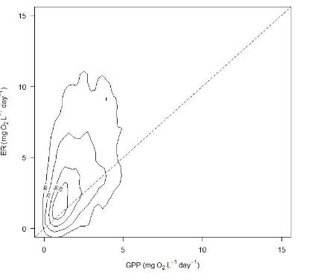

Figure . Metabolic fingerprint derived from Category 1 stream metabolism measurements from the 2014–20 LTIM and Flow-MER dataset from sites located in channel environments in southern Basin rivers

Kernel plot based on 11,905 daily records

We have placed a hypothetical baseline fingerprint for the Buffalo and King rivers, and then provided a series of plots that illustrate the expected metabolic response of the rivers to the first 2 flow events above (Figure 6.2), informed by evidence derived from the monitored Selected Area data (Figure 6.1). Both rivers share many functional similarities; they are upland rivers, have good water quality, relatively low turbidity, cobble substrates and they have target reaches for Commonwealth environmental water that are directly below small storages. Thus, hypothetical baseline fingerprints reside in the same space. The 2019–20 flows occurred in autumn when temperatures were warm, light was plentiful and low, and stable flows had allowed autotrophic biofilms to proliferate. Hence, baseline fingerprints are slightly autotrophic and sit at the upper end of the 1:1 line in Q1 (Figure 6.2, 1A & 2A).

Following low flow pulses, the fingerprint areas in both rivers reduce in size and move down the 1:1 line (Figure 6.2, 1B & 2B), reflecting in increases in turbidity and scouring of biofilms during the flow. We then expect that the Buffalo River fingerprint will enlarge and move up the ER axis into heterotrophy (Figure 6.2, 1C), due to the high load of ash and sediment in the river caused by the Black Summer fires. We expect the Commonwealth environmental water flow to mobilise some of this material and for this to elevate turbidity and drive bacterial microbial activity that consumes carbon. In contrast, we expect the pulse in the King River to mobilise small quantities of nutrients and to reset biofilms, but then for turbidity levels to rapidly drop. We then expect the fingerprint to shift toward autotrophy (Figure 6.2, 2C) as biofilms respond to increased nutrients in clear water and generate carbon. We would expect Commonwealth environmental water to ultimately have a beneficial influence on riverine ecosystems in both rivers, through maintaining ecosystems in a state which is best able to support fish and waterbird populations.

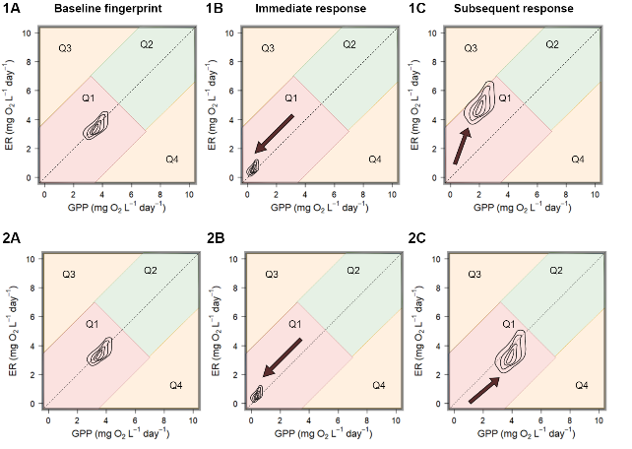

Figure . Hypothetical metabolic fingerprints generated for unmonitored 2019–20 Commonwealth environmental water events in the Buffalo (1A–1C) and King (2A–2C) rivers

Arrows indicate direction of change over time (between plots); for explanation of quadrats (Q1–Q4) and detailed explanation of the sequence of events, see main text

# Salinity export

This Food Webs and Water Quality Basin Theme is required to report on the contribution of Commonwealth environmental water to salinity regimes. Our focus is theexport of salinity through the Lower Murray River Selected Area. The addition of Commonwealth environmental water helps to maintain river salinity below 800 EC (electrical conductivity) at Morgan (a river management target of the MDBA and SA Water) by diluting salt in the Lower Murray River channel (Ye et al. 2021). In low flow years, Commonwealth environmental water has also become increasingly important for sustaining salt export from the Basin and for limiting salt import to the Coorong.

In 2019–20, Commonwealth environmental water was the only water that exited the barrages in South Australia, highlighting its importance for maintaining water quality and salinity regimes in this ecosystem (Table 7.1). As such, for 2019–20, all salt export over the barrages (623,999 tonnes) is attributable entirely to Commonwealth environmental water (Ye et al. 2021); without these flows, salt would have accumulated throughout the Basin on floodplains, wetlands and in channel environments. Consistent with other low flow years, in 2019–20 there was a net import of salt (335,926 tonnes) into the Coorong via the Murray Mouth; however, without Commonwealth environmental water, the net import of salt would have been much larger (2.3 million tonnes; Ye et al. 2021).

Table . Six-year record of modelled salt export (tonnes) through the barrages to the Coorong estuary and through the Murray Mouth into the Southern Ocean (taken from Ye et al. 2021)

|  |  |  |  |  |  |  |
| --- | --- | --- | --- | --- | --- | --- |
| Scenario | 2014–15 | 2015–16 | 2016–17 | 2017–18 | 2018–19 | 2019–20 |
| Barrages |  |  |  |  |  |  |
| All water | 446,855 | 288,516 | 1,504,541 | 349,893 | 228,293 | 623,999 |
| No Commonwealth environmental water | 161,791 | 36,884 | 1,383,674 | 109,171 | 67,396 | 0 |
| No environmental water | 152,406 | 31,031 | 1,317,791 | 48,923 | 0 | 0 |
| Murray Mouth |  |  |  |  |  |  |
| All water | −157,852 | −1,850,028 | 3,679,277 | −527,042 | −2,680,574 | −335,926 |
| No Commonwealth environmental water | −3,202,552 | −6,441,297 | 3,159,985 | −3,459,211 | −5,151,627 | −2,332,963 |
| No environmental water | −5,048,511 | −6,649,380 | 1,958,989 | −6,115,353 | −5,438,075 | −2,332,963 |

The salt export objective from the Basin Plan) aims to ensure adequate removal of salt from the Murray River system into the Southern Ocean, and this target has been set at 2 million tonnes per year. Work carried out by Ye et al. (2021), conducting the Flow-MER Lower Murray River Selected Area evaluation, has shown that in 5 of the 6 monitored years (2014–15, 2015–16, 2017–18, 2018–19, 2019–20) Commonwealth environmental water accounted for 64–100% of total salt export to the Southern Ocean. In these years, total salt export ranged from 228,293 to 623,999 tonnes per year, remaining well below the 2 million tonne Basin Plan target. In 2016–17 (a high flow year) 1.5 million tonnes were exported, of which 8% was attributable to Commonwealth environmental water.

# Contribution to Basin Plan objectives

A summary of contributions by Commonwealth environmental water to Basin Plan objectives relating to food webs and water quality is shown in Table 8.1.

Table . Commonwealth environmental outcomes framework for food webs and water quality

Bold numbers and letters refer to specific sections of the Basin Plan objectives

| Basin Plan objectives | Basin outcomes | Long-term expected outcomes | 1-year expected outcomes | Measured and predicted 1-year outcomes 2019–20 | Measured and predicted long-term outcomes 2014–20 |
| --- | --- | --- | --- | --- | --- |
| **8.06** Protection and restoration of ecosystem functions of water-dependent ecosystems  **(3)** An objective is to protect and restore connectivity within and between water-dependent ecosystems, including by ensuring that:  **(c)** the Murray Mouth remains open at frequencies, for durations, and with passing flows, sufficient to enable the conveyance of salt, nutrients and sediment from the Murray–Darling Basin to the ocean; and  **(d)** the Murray Mouth remains open at frequencies, and for durations, sufficient to ensure that the tidal exchanges maintain the Coorong’s water quality (in particular salinity levels) within the tolerance of the Coorong ecosystem’s resilience; and  **(7)** An objective is to protect and restore ecological community structure, species interactions and food webs that sustain water-dependent ecosystems, including by protecting and restoring energy, carbon and nutrient dynamics, primary production and respiration. | Water Quality and Food Webs | Longer term targets from 1 July 2019  (2) There are improvements in the following:  (a) flow regimes which include relevant flow components set out in paragraph 8.51(1)(b);  (b) hydrological connectivity between the river and floodplain and between hydrologically connected valleys;  (c) river, floodplain and wetland types, including the condition of priority environmental assets and priority ecosystem functions;  (d) condition of the Coorong and Lower Lakes ecosystems and Murray Mouth opening regime;  (e) condition, diversity, extent and contiguousness of native water-dependent vegetation;  (f) recruitment and populations of native water-dependent species, including vegetation, birds, fish and macroinvertebrates;  (g) the community structure of water-dependent ecosystems. | Intermediate targets up to 30 June 2019  (1) There is no loss of, or degradation in, the following:  (a) flow regimes which include relevant flow components set out in paragraph 8.51(1)(b);  (b) hydrological connectivity between the river and floodplain and between hydrologically connected valleys;  (c) river, floodplain and wetland types, including the condition of priority environmental assets and priority ecosystem functions;  (d) condition of the Coorong and Lower Lakes ecosystems and Murray Mouth opening regime;  (e) condition, diversity, extent and contiguousness of native water-dependent vegetation;  (f) recruitment and populations of native, water-dependent species, including vegetation, birds, fish and macroinvertebrates. | **8.06 (3) c & d**  In 2019–20, Commonwealth environmental water was the only water that exited the barrages in South Australia  **8.06 (7)**  Strong evidence from all Selected Areas that Commonwealth environmental water had a positive influence on protecting and restoring energy, carbon and nutrient dynamics, primary production and respiration in 2019–20. | **8.06 (3) c & d**  Commonwealth environmental water had an important role to play in meeting long-term objectives to protect and restore connectivity within and between water-dependent ecosystems, particularly in the Lower Murray River Selected Area (e.g. Ye et al. 2021).  **8.06 (7)**  Evidence from all Selected Areas that Commonwealth environmental water had a positive influence on protecting and restoring energy, carbon and nutrient dynamics, primary production and respiration in 2014–20. |
| **9.08** Maintenance of good levels of water quality | Water Quality | If the value of a water quality characteristic (e.g. salinity, nutrients, pesticides, pH, turbidity) is at a level that is better than the target value for water quality set out in Part 4, an objective is to maintain that level. |  | **9.08**  Strong evidence that Commonwealth environmental water assisted in the maintenance of dissolved oxygen concentrations over the summer period 2019–20 in the zones receiving the additional flow (Watts et al. 2020a; Ye et al. 2021). | **9.08**  Water quality is difficult to assess across the Basin due to the high level of spatial and temporal baseline variation. However, there is strong evidence that Commonwealth environmental water played an important role in maintaining good levels of water quality in 2014–20. For example, anoxic events in 2016 and the subsequent delivery of ameliorating flows (including through Commonwealth environmental water) demonstrated the utility of targeted watering actions designed to improve water quality (Grace et al. 2020). Commonwealth environmental water contribution to meeting salt export (see **9.09** and **9.14 (5) c** below) targets has also been significant. |
| **9.09** Salt export | Water Quality | The salt export objective is expected to be achieved by the discharge of an average of 2 million tonnes of salt from the Murray River system into the Southern Ocean each water accounting period. | None identified | **9.09**  623,999 tonnes of salt exported attributable to Commonwealth Environmental Water alone. | **9.09**  Commonwealth environmental water accounted for 64–100% of total salt export to the Southern Ocean from 2014–20. |
| **9.14** Targets for managing water flows  (**5)** For the purposes of subsections (1) to (4), the following targets apply:  **(a)** maintain dissolved oxygen at a target value of at least 50% saturation;  **(c)** the levels of salinity at the reporting sites set out in column 3 should not exceed the values set out in column 3 95% of the time | Water Quality | **9.14 (5) a**  This equates to approximately 50% oxygen saturation at 25°C and 1 atmosphere of pressure.  **9.14 (5) c**  Target values (EC) (µS/cm) from table:  Murray River at Murray Bridge – 830  Murray River at Morgan – 800  Murray River at Lock 6 – 580  Darling River at Burtundy – 830  Lower Lakes at Milang – 1,000 | None identified |  | **9.14 (5) a**  Commonwealth environmental water can help reduce the likelihood of low dissolved concentrations in the Lower Murray River, if their contribution increases water velocities above a level of ~0.18m/s, below which surface oxygen exchange is poor. Reducing the likelihood of low dissolved oxygen concentrations can be achieved by increasing water mixing in otherwise low flow.  **9.14 (5) c**  Commonwealth environmental water helped to maintain river salinity below 800 EC at Morgan by diluting salt in the Lower Murray River channel (Ye et al. 2021). |

# Adaptive management for water quality and food webs

Adaptive management can be summarised as ‘learning by doing’ within a robust framework that acknowledges uncertainty and allows for the incorporation of new knowledge as it becomes available. In doing so, adaptive management defines the problem, identifies the resilience of management interventions and, using an iterative process, seeks to reduce uncertainty over time via systematic monitoring, evaluation and learning (Holling 1978; Watts et al. 2020b) (Figure 9.1). Effective application of adaptive management is an objective of both the Basin Plan 2012 and the Flow-MER Program.

The Flow-MER Program is now in the position where it is able to learn from 6 years of monitoring, evaluation, and research under the LTIM, EWKR and Flow-MER programs, in addition to other sources of information and knowledge. This has helped to develop and adapt our understanding of both outcomes to Commonwealth environmental water, as well as our approaches in undertaking Basin-scale evaluation. We discuss each of these in the following sections.

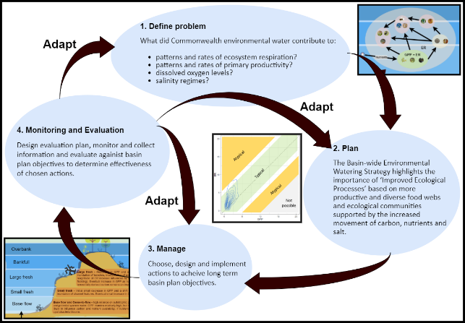

Figure . The adaptive management cycle

Source: modified from MDBA (2017)

Planning involves defining the problem, objectives, the link between objectives and proposed actions, and then selecting actions. Management consists of design and implementation of the actions and evaluation plan. Evaluation comprises the analysis and synthesis of monitoring and research to inform adaptation. Adaptation can happen at any of the steps

As discussed previously, generation of metabolic fingerprints from the long-term data collected at each Selected Area represents the typical conditions of a specific site influenced by context-dependent abiotic (e.g. water quality) and biotic (e.g. algal dynamics) drivers. These visualisations of the metabolic regime can be compared with fingerprints generated from specific flow events to trace metabolic responses to Commonwealth environmental water and assess whether they fall inside or outside the envelope of typical conditions. The metabolic fingerprints can also be used to compare and classify metabolic regimes across different sites. This could lead to the identification of sites that share similar metabolic regimes, which would potentially respond to flow events in similar ways. This information will be incorporated in future evaluation and planning of Commonwealth environmental water as the number of events monitored becomes adequate to confidently describe the desired metabolic responses.

## Mechanisms for incorporation of adaption to the management cycle

Adaptive management relies on clear pathways to incorporate information generated from actions to the adaptive cycle. Pathways within the Flow-MER framework include, but are not limited to:

* Selected Area evaluation reports – specific local-scale information and spatially explicit drivers of water quality and metabolic responses to Commonwealth environmental water generated from measured examples in Selected Areas
* Basin-scale evaluation report – synthesis of local-scale information from Selected Areas to a Basin-scale context; target to improve capacity to extend measured estimates to unmonitored areas of the Basin
* Flow-MER Water Quality and Food Webs research – incorporation of new knowledge generated from Flow-MER research that can be applied to Commonwealth environmental watering actions and extension of stream metabolism monitoring to food web responses
* CEWO ‘learning by doing’ workshops – opportunity for CEWO staff to request specific information from scientists that may not have been included within the reporting framework
* external projects to Flow-MER – incorporation of information or use of new products developed in other projects with strong synergies to Flow-MER Evaluation Basin-scale Water Quality and Food Webs Basin Theme e.g. MDBA/CSIRO Ecosystem Function Project, Southern Spring Flows Project, Murray–Darling Water and Environment Research Program and other CEWO-funded short-term intervention monitoring projects.

## Key adaptive management outcomes – what we have learned

### How can Commonwealth environmental water contribute to ‘improved ecological processes’ based on more productive and diverse food webs and ecological communities supported by the increased movement of carbon, nutrients and salt?

Contributions by Commonwealth environmental water to water quality and metabolic outcomes are heavily influenced by the type of flow delivered. As described conceptually in Figure 2.2, we have predicted generalised metabolic responses from the type of Commonwealth environmental water flow delivered. The variation in these responses is context dependent and driven by site-specific abiotic and biotic drivers:

* **base flow and cease-to-flow** – high reliance on autotrophic production due to low turbidity (high light) and potential warmer water. GPP remains relatively high, but time since last flood and size of last flood likely to influence carbon and nutrient availability. If nutrients highly available, potential for algal or cyanobacteria blooms
* **small fresh** – initial small decrease in GPP and a shift towards ER from increased turbidity and inundation of channel features. Eventual small increase in GPP following mobilisation of nutrients
* **large fresh** – reduction in GPP and a significant increase in ER due to the inundation of benches, incorporation of organic matter and increased turbidity. The magnitude of ER increase influenced by organic matter load (e.g. time since last flooding). Eventual increase in GPP as nutrients and light increase, but increased terrestrially derived carbon remains an important energy source for food webs
* **bankfull** – initial drop in GPP, significant increase in ER and, depending on litter accumulation levels and flow timing, potential for blackwater in channels with a shift to terrestrially derived energy entering food webs
* **Overbank** – very large events transport large amounts of terrestrial material into the river. Immediate reduction in GPP and high rates of ER during floodplain–channel connection drive a microbially based food web. Potential for blackwater hypoxic events depending on flow volume and floodplain load of organic matter.

The 2014–20 dataset provides a strong foundation for description of site-specific metabolic patterns, and as more data are collected and added to the metabolic fingerprint for a given Selected Area or combination of Selected Areas, our ability to tailor flows to deliver desired responses will increase.

The logical next step is to improve our understanding of how the food supply for food webs is influenced by Commonwealth environmental water and the relationship between stream metabolism and secondary productivity (e.g. build on theoretical concepts outlined in Box 1) and incorporate this information into Commonwealth environmental water planning. Ensuring that energy generated at the base of the food web is available to subsequent trophic levels and limiting significant dissipation of energy via the microbial loop are important considerations when seeking to maximise ecosystem benefits from Commonwealth environmental water. Work carried out in Flow-MER research that explores ‘link or sink’ relationships in food webs is key to unravelling relationships of energy transfer from GPP and ER to secondary heterotrophs. Making sure that the right type of food is available at the right time is critical for generating productive outcomes, such as timing with larval fish recruitment.

### How can Commonwealth environmental water contribute to patterns and rates of ecosystem respiration?

Commonwealth environmental water can support ER and heterotrophic production rates if flows increase lateral connection between the river channel and riparian, wetland or floodplain areas (e.g. bankfull and overbank flows), increasing the supply of allochthonous organic carbon to the food web. Improving our knowledge of ER responses to different flow types (e.g. keeping metabolic fingerprints within the typical region, Figure 2.2) will help prevent non-desired ER outcomes, such as blackwater events. Recognising that bankfull and overbank flows are not always possible, smaller flows (e.g. freshes) have demonstrated the potential to liberate new terrestrial carbon from in-channel benches (e.g. in the Goulburn River and Edward/Kolety–Wakool river systems Selected Areas) and newly inundated slack waters, but responses will be highly dependent on antecedent hydrological patterns (e.g. the amount of litter that has accumulated since the last fresh).

### How can Commonwealth environmental water contribute to patterns and rates of primary productivity?

Changes to volumetric rates of GPP in response to Commonwealth environmental water are generally small, and patterns in rates of GPP are primarily driven by seasonal changes (e.g. light, temperature) and site-specific variability in bioavailable nutrients and turbidity. A volumetric increase in water in rivers during Commonwealth environmental watering actions usually leads to an increase in the total amount of organic carbon produced per day, but these increases must be viewed with caution, since they are primarily an artefact of the increased water volume rather than any increase in rates of GPP. Future Basin-scale reporting for Water Quality and Food Webs should focus on improving our understanding of how the food supply (e.g. measures of the sources of net production that provide the energy underpinning the food web) is influenced by Commonwealth environmental water.

### How can Commonwealth environmental water contribute to dissolved oxygen levels?

Commonwealth environmental water is very important for decreasing the likelihood of low DO by increasing water mixing and oxygen exchange at the surface, particularly so in the Lower Murray River Selected Area where the river is dominated by slow-flowing locks and weirs. For example, in 2019–20, Commonwealth environmental water substantially improved DO levels in the Lower Murray River for >40 days. Commonwealth environmental water can also contribute to maintaining DO levels above desired thresholds during blackwater events, where flows can act to dilute low DO water and increase oxygen exchange at the surface. Commonwealth environmental water may also be used to maintain base flows to support aquatic ecosystem during low flow periods.

### How can Commonwealth environmental water contribute to salinity regimes?

Commonwealth environmental water is critical for maintaining salinity regimes within a desired range. Commonwealth environmental water has been used to:

* maintain river salinity below 800 EC at Morgan (a river management target of the MDBA and SA Water)
* maintain salt export from the Coorong in low flow years
* contribute to the Basin Plan’s target of exporting 2 million tonnes of salt from the Murray River system into the Southern Ocean each water accounting period.

## Adaptive management within the theme monitoring and evaluation process

As stated in the Food webs and Water Quality Foundation report (Grace et al. 2020) and described in Section 1.1, the intention of the Food webs and Water Quality Basin Theme is to develop qualitative and quantitative models of stream metabolism.

Model development as undertaken in the Flow-MER Program and reported herein has refined existing qualitative conceptual models to provide a foundation for the quantitative model development for evaluation in coming years. It is planned that existing data and expert elicitation will be used to convert our conceptual model into a quantitative model for the 2020–21 evaluation.

# References

Bernhardt ES, Heffernan JB, Grimm NB, Stanley EH, Harvey JW, Arroita M, Appling AP, Cohen MJ, McDowell WH, Hall RO, Read JS, Roberts BJ, Stets EG, Yackulic CB (2018) The metabolic regimes of flowing waters. Limnology and Oceanography 63, S99–S118.

Capon SJ (2003) Plant community responses to wetting and drying in a large arid floodplain. River Research and Applications 19(5‐6), 509–520.

Dyer F, Broadhurst B, Tschierschke, A, Higgisson W, Thiem J, Wright D, Kerezsy A, Thompson R (2020) Commonwealth Environmental Water Office Monitoring, Evaluation and Research Project: Lachlan River System Selected Area 2019–20 Monitoring and Evaluation Summary Report. Commonwealth of Australia.

Grace M, Ryder D, Rees G (2020) Flow-MER Basin Matter – Stream Metabolism and Water Quality Foundation report – revision 2020. Flow-MER Program. Commonwealth Environmental Water Office (CEWO): Monitoring, Evaluation and Research Program, Australia.

Grace MR, Giling DP, Hladyz S, Caron V, Thompson RM, Mac Nally R (2015) Fast processing of diel oxygen curves: estimating stream metabolism with BASE (BAyesian Single-station Estimation). Limnology and Oceanography Methods 13. doi:[10.1002/lom3.10011](http://dx.doi.org/10.1002/lom3.10011) 103–114.

Greet JOE, Webb J, Cousens RD (2011) The importance of seasonal flow timing for riparian vegetation dynamics: a systematic review using causal criteria analysis. Freshwater Biology 56(7), 1231–1247.

Hale J, Stoffels R, Butcher R, Shackleton M, Brooks S, Gawne B, Stewardson M (2014) Commonwealth Environmental Water Office Long Term Intervention Monitoring Project – Standard Methods. Report prepared for the Commonwealth Environmental Water Office p 175. Murray–Darling Freshwater Research Centre, Albury.

Holland A, McInerney PJ, Shackleton ME, Rees GN, Bond NR, Silvester E (2020) Dissolved organic matter and metabolic dynamics in dryland lowland rivers. Spectrochimica Acta Part A: Molecular and Biomolecular Spectroscopy 229, 117871.

Holling CS (1978) Adaptive environmental management and assessment. Wiley, Chichester, UK.

Humphries P, King AJ, Koehn JD (1999) Fish, flows and flood plains: links between freshwater fishes and their environment in the Murray–Darling river system, Australia. Environmental Biology of Fishes 56, 129–151. doi.org/10.1023/A:1007536009916.

Jankowski KJ, Mejia FH, Blaszczak JR, Holtgrieve GW (2021) Aquatic ecosystem metabolism as a tool in environmental management. WIREs Water; e1521. doi.org/10.1002/wat2.1521.

King AJ, Tonkin Z, Mahoney J (2009) Environmental flow enhances native fish spawning and recruitment in the Murray River, Australia. River Research and Applications 25(10), 1205–1218.

Kingsford RT, Auld KM (2005) Waterbird breeding and environmental flow management in the Macquarie Marshes, arid Australia. River Research and Applications 21(2–3), 187–200.

Mac Nally R, Cunningham SC, Baker PJ, Horner GJ, Thomson JR (2011) Dynamics of Murray–Darling floodplain forests under multiple stressors: the past, present, and future of an Australian icon. Water Resources Research, 47(12). doi.org/10.1029/2011WR010383.

Mac Nally R, Nerenberg S, Thomson JR, Lada H, Clarke RH (2014) Frogs and climate variability. Global Ecology and Biogeography 23, 223–234. doi.org/10.1111/geb.12104.

McInerney P, Bond N, Kopf K, Lester R, Ryder D, Thompson R, Baldwin D, Brandis K, Butler G, Drouart R, Frost L, Gawne B, Growns I, Holt G, Koster W, MacNally R, Macqueen A, McGinness H, Petrie R, Robson B, Rolls R, Thiem J, Thurgate N, Watson G, Zampatti B (2019) Murray‒Darling Basin Environmental Water Knowledge and Research Project — Food Webs Theme Research Report. Report prepared for the Department of the Environment and Energy, Commonwealth Environmental Water Office by La Trobe University, Centre for Freshwater Ecosystems (formerly Murray‒Darling Freshwater Research Centre), CFE Publication 224 June 2019 28p. [Appendices 119p.]

MDBA (Murray–Darling Basin Authority) (2017) Basin Plan Adaptive Management Framework. MDBA publication no: 07/18. MDBA, Canberra. ISBN (online): 978-1-925599-75-6.

MDBA (2020) Basin-wide environmental watering strategy (second edition, 22 November 2019 revised February 2020). MDBA, Canberra.

Mika S, Frazier P, Ryder D, Southwell M, Growns I, Debus S, Bower D, Butler G, Cameron L, Carpenter-Bundoo L, Winklel S, Oxley, J, Vincent, Band Lewis, S. (2020). Commonwealth Environmental Water Office Monitoring, Evaluation and Research Program: Gwydir River Selected Area 2019–20 Annual Summary Report, Commonwealth of Australia.

NECMA (North East Catchment Management Authority) (2020) 2020/21 seasonal watering proposal for the Ovens system. CMADOC 216–72. NECMA, Wodonga.

Odum HT (1956) Primary production in flowing waters. Limnology and oceanography 1(2), 102–117.

Oliver and Lorenz (2010)

Oliver RL, Merrick C (2006) Partitioning of river metabolism identifies phytoplankton as a major contributor in the regulated Murray River (Australia). Freshwater Biology 51, 1131–1148.

Oliver RL, Mitrovic SM, Rees C (2010) Influence of salinity on light conditions and phytoplankton growth in a turbid river. River Research and Applications 26, 894–903

Rees GN, Biswas TK, Gilling D, Watts RJ, Liu X, Oliver R, Pengelly J, Zygmunt L, Ye Q, McInerney P, Thompson R, Malthus T, Joehnk K (2020) River Murray channel productivity monitoring 2020–2021. CSIRO Land & Water, Canberra.

Roberts BJ, Mulholland JP (2007) In-stream biotic control on nutrient biogeochemistry in a forested stream, West Fork of Walker Branch. Journal of Geophysical Research 112, G04002.

Rüegg J, Conn CC, Anderson EP, Battin TJ, Bernhardt ES, Boix Canadell M, Bonjour SM, Hosen D, Marzolf NS, Yackulic CB (2021) Thinking like a consumer: linking aquatic basal metabolism and consumer dynamics. Limnology and Oceanography 6, 1–17. doi.org/10.1002/lol2.10172.

Shenton W, Bond NR, Yen JD, Mac Nall, R (2012) Putting the “ecology” into environmental flows: ecological dynamics and demographic modelling. Environmental Management 50(1), 1–10.

Song C, Dodds WK, Trentman MT, Rüegg J, Ballantyne F (2016) Methods of approximation influence aquatic ecosystem metabolism estimates. Limnology and Oceanography Methods 14(9), 557–569.

Thomson JR, Bond NR, Cunningham SC, Metzeling L, Reich P, Thompson RM, Mac Nally R (2012) The influences of climatic variation and vegetation on stream biota: lessons from the Big Dry in southeastern Australia. Global Change Biology 18, 1582–1596. doi.org/10.1111/j.1365-2486.2011.02609.x.

Treadwell S, Webb A, Hou X, Baker B, Casanelia S, Grace M, Greet J, Kellar C, Koster W, Lovell D, McMahon D, Morris K, Myers J, Pettigrove V, Sutton N, Vietz G (2020) Summary report 2019–20. Commonwealth Environmental Water Office Monitoring Evaluation and Research Program Goulburn River, Commonwealth of Australia.

Wassens S, Michael D, Spencer J, Thiem J, Thomas R, Kobayashi T, Turner A, Hall A, Bourke G, Bino G, Davis T, Heath J, Kuo W, Amos C, Brandis K (2021) Commonwealth Environmental Water Office Long-Term Intervention Monitoring project Murrumbidgee River System Selected Area evaluation. Technical Report, 2014–20. Report prepared for the Commonwealth Environmental Water Office.

Watts RJ, Bond NR, Healy S, Liu X, McCasker NG, Siebers A, Sutton N, Thiem JD, Trethewie JA, Vietz G, Wright DW (2020a) Commonwealth Environmental Water Office Monitoring, Evaluation and Research Project: Edward/Kolety–Wakool River System Selected Area Technical Report, 2019–20. Report prepared for Commonwealth Environmental Water Office. Commonwealth of Australia.

Watts RJ, Dyer F, Frazier P, Gawne B, Marsh P, Ryder DS, Southwell M, Wassens M, Webb JA, Ye Q (2020b) Learning from concurrent adaptive management in multiple catchments within a large environmental flows program in Australia. River Research and Applications 36, 668-680. doi.org/10.1002/rra.3620.

Wedderburn SD, Hammer MP, Bice CM (2012) Shifts in small-bodied fish assemblages resulting from drought-induced water level recession in terminating lakes of the Murray–Darling Basin, Australia. Hydrobiologia 691(1), 35–46.

Ye Q, Giatas G, Bice C, Brookes J, Furst D, Gibbs M, Nicol J, Oliver R, Shiel R, Zampatti B, Bucater L, Deane D, Hipsey M, Huang P Lorenz, Z, Zhai S (2021) Commonwealth Environmental Water Office Monitoring, Evaluation and Research Project: Lower Murray 2019–20 Technical Report. A draft report prepared for the Commonwealth Environmental Water Office by the South Australian Research and Development Institute, Aquatic Sciences.

Detailed information on outcomes for each Selected Area, 2019–20

* 1. Lower Murray River Selected Area

Stream metabolism and water quality were measured at 3 locations in the Lower Murray River Selected Area. One site was downstream of Lock 6 in the floodplain geomorphic zone, the second was downstream of Lock 4, and the third downstream of Lock 1 in the gorge geomorphic zone. Monitoring for Category 1 Metabolism occurred from 3 September 2019 to 19 February 2020. During this period, watering actions included a spring fresh of 344,093 ML of Commonwealth environmental water (1920-LWM-11; Table 1) and a summer base flow of 125,553 ML of Commonwealth environmental water (1920-LWM-12; Table 1) that were delivered to the channel habitats of the Lower Murray Selected Area. Expected ecological outcomes from Commonwealth environmental watering actions included in the Selected Area reporting relevant to this theme were ‘River function and productivity’ and ‘Lower Lakes water quality’.

* + 1. Water quality

Concentrations of dissolved organic carbon (DOC) were generally low, averaging 3 mg/L across the 3 sites during the sampling period, and showed little variability except for an increase at Lock 1 to peak at 4.6 mg/L during January. Turbidity increased with additional flow during October/November and in early January, but never exceeded 70 (nephelometric turbidity units) NTU. There were no inflows from the Darling River in the 19–20 water year, historically a major source of turbidity in the Lower Murray. Fluctuations in turbidity appeared to be associated with flows from either Lake Victoria or further up along the Murray River. The increased turbidity associated with the Commonwealth environmental watering action in October 2019 saw a marked decrease in the vertical attenuation coefficient for photosynthetically active radiation (PAR), yet there was no concomitant reduction in rates of gross primary production (GPP).

Although nutrients can influence rates of metabolism and phytoplankton productivity, there was no clear evidence that this occurred during 2019–20. Both total phosphorus (TP) and total nitrogen (TN) responded to flows in a similar manner to turbidity and increased substantially to peak concentrations of 0.74 mg N/L and 0.1 mg P/L at Lock 1, yet did not result in marked changes in metabolism. This suggests that phytoplankton metabolism is largely controlled by light, and heterotrophic metabolism by DOC concentrations. It is likely that these resources constrained population sizes such that nutrients were not reduced to limiting concentrations.

* + 1. Patterns of metabolism

Patterns of daily gross primary production (GPP) (photosynthesis) and ecosystem respiration (ER) were similar across sites over the monitoring period and comparable with rates measured in previous years. Despite large fluctuations in discharge, volumetric rates of metabolism over the monitoring period seemed largely unaffected by flows. Up to the 90th percentile of GPP recorded ranged from 1 to 5 mg O2/L/day, gradually increasing over the monitoring season associated with increased water temperatures and was mirrored by changes in ER. GPP ranged from 0.54 mg O2/L/day on the rising limb of the 2019 spring watering action a maximum of 15.27 mg O2/L/day in early January 2020 associated with a spike in metabolic activity at Lock 1 that was suspected as a result of biofouling of the probe. ER ranged from 0.09 mg O2/L/day in early spring to 10.04 mg O2/L/day in early January 2020.

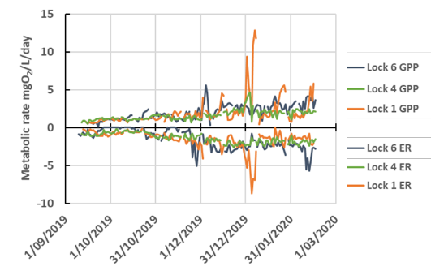

Figure . Daily gross primary production (GPP) and ecosystem respiration (ER) rates at each of the 3 monitoring sites in the Lower Murray River Selected Area

Source: 2019–20 Lower Murray Flow-MER Technical Report

The metabolic fingerprint (Figure A.2) demonstrates that the 3 study sites were predominately autotrophic (GPP:ER >1; mean value 1.73 ± 0.11 s.e.) for the majority of the study period, and that GPP and ER are closely linked. Shifts into heterotrophy (GPP:ER<1, left side of figure) are associated with rising limbs of freshes and increased DOC concentrations, and increased phytoplankton production in warmer summer months. If it is assumed that ER was largely associated with phytoplankton, then the average daily net ecosystem production (NEP) (mg O2/L/day) calculated as the difference in GPP and ER, was 0.54 at Lock 6, 0.23 at Lock 4, and 0.47 at Lock 1. The cumulative NEP over the monitoring period was 83, 34 and 69 mg O2/L, or approximately 31, 13 and 26 mg C/L, respectively.

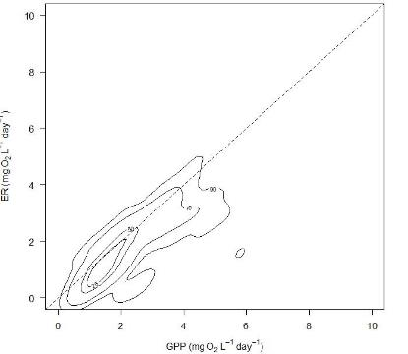

Figure . Metabolic fingerprint for the Lower Murray SA based on 244 daily recordings across the 2019–20 water year

The volumetric rate of GPP measures the concentration change in the supply of primary production but does not describe the total supply in the river, which will depend on the cross-sectional area of the flow. The cross-sectional production, or GPP per linear metre of river, is calculated from the volumetric production rate and the cross-sectional area. The GPP per metre of river increased at Lock 6 and Lock 1. These changes were small, at Lock 6 a maximum increase of 7% and at Lock 1 a maximum increase of 3%. In contrast the cross-sectional production at Lock 4 decreased in response to the high flows by a maximum of 3%. These opposite effects are a function of the relationships between depth and cross-sectional area at the different sites.

The effects of flow on the cumulative cross-section production over the monitoring period were small within sites. At Lock 6 Commonwealth environmental water increased production from 99.7 to 100.8g O2/m (37.4 to 37.8 g C/m) and at Lock 1 from 153.5 to 155.0 g O2/m (57.5 to 58.1 g C/m). Commonwealth environmental water had the opposite effect at Lock 4 with the cumulative cross-section production reducing from 111.6 to 111.1 g O2/m (41.9 to 41.7 g C/m) over the monitoring period.

* + 1. Mechanisms regulating rates of gross primary production (GPP) and ecosystem respiration (ER)

Critical velocities of 0.18–0.20 m/s have previously been used to identify periods when in- channel mixing was sufficient to ensure metabolism estimates were reliable (Oliver and Lorenz 2010; Ye et al. 2020). The analysis of 2019–20 GPP measurements from times when water velocities at the sites exceeded 0.18 m/s supported previous findings of a significant linear correlation between the chlorophyll specific rate of gross photosynthesis (GPP(b)) and the mean irradiance in the mixed water column (Im), with a linear regression slope equivalent to that calculated in previous analyses (Oliver and Merrick 2006; Ye et al. 2020). The relatively consistent relationship between K (reaeration coefficient) and velocities above 0.18 m/s breaks down once flows spread onto the floodplain, but this did not occur in the 2019–20 water year.

The effects of environmental flows on volumetric and cross-sectional GPP were small due to the weirs maintaining relatively constant water levels. The influence of flow on metabolism at river sites not regulated by weirs was estimated and showed significant increases in the cross-sectional production of up to 30% or more as flows increased (Ye et al. 2020). Conversely, although a reduction in depth reduced the cross-sectional rate of GPP, it increased the volumetric rate by almost 20%. It is evident that weirs have a major effect on metabolism because of their disruption of the relationships between flow, water level and cross-sectional area.

The combined net production (CNP) of phytoplankton and bacteria provided an estimated of their supply of organic carbon to the food web of between 0.16 and 0.52 mg C/L/day, with a mean of 0.3 mg C/L/day. These rates were similar to those reported for the previous 5 years of monitoring (Ye et al. 2020). These estimates of net production provide a different view of the carbon supplies to the river food webs compared to the traditional analyses of NEP which are close to zero over the 2019–20 monitoring period. The CNP estimates demonstrate that both heterotrophic and phytoplankton production are important sources of organic carbon to the Lower Murray River Selected Area. Improved supply of DOC through channel, wetland and floodplain connection remains critical to providing food webs with organic carbon food resources through the heterotrophic pathway.

Metabolism at the monitoring sites was influenced by water quality, especially turbidity and DOC. However, the data have not so far demonstrated a major influence of nutrients, with metabolism not responding to changing concentrations that have occurred as a result of altered flows. This suggests that light and DOC were limiting the development of microbial populations so that nutrient limitation was not being induced.

* + 1. Management implications

Commonwealth environmental water can:

* help reduce the likelihood of low DO concentrations in the Lower Murray Selected Area if watering actions contribute to increased water velocities above ~0.18 m/s, below which surface oxygen exchange is poor. Reducing the likelihood of low dissolved oxygen (DO) concentrations can be achieved by increasing water mixing in otherwise low flow zones except if flows carry excessive loads of organic carbon.
* enhance ecosystem respiration (ER) rates and heterotrophic production if flows better connect the channel with riparian, wetland or floodplain areas, increasing the supply of allochthonous organic carbon to the food web.
* increase discharge to alter the average depth and the cross-sectional area of flow, and affect the rate of volumetric and cross-sectional GPP. Depending on channel shape, using environmental flows to target water levels could increase river productivity, particularly where the channel broadens. The manipulation of weir pool levels could alter metabolic conditions within weir pools, potential shifting the interaction between volumetric and cross-sectional GPP.
* alter the attenuation of light through increased turbidity and DOC that will decrease GPP. Conversely, DOC concentrations are important to heterotrophic metabolism, with increased concentrations enhancing heterotrophic net production but potentially leading to DO depletion. These contrasting influences requires consideration of the sources of water supply, the volumes and rates of water delivery, and the timing of flows in the context of physicochemical conditions and channel morphology.
  + 1. Evaluation

Table . Stream metabolism evaluation questions and answers relating to Commonwealth environmental water and environmental watering actions in the Lower Murray River Selected Area

|  |  |
| --- | --- |
| What did Commonwealth environmental water contribute to dissolved oxygen levels? | Commonwealth environmental water decreased the likelihood of low DO by increasing water mixing and oxygen exchange at the surface. In the 2019–20 water year, Commonwealth environmental water substantially improved DO levels for over 40 days, with other environmental water contributing to a total of 70 days where velocities were increased to > 0.18 m/s due to environmental water. |
| What did Commonwealth environmental water contribute to patterns and rates of primary productivity? | Increased flows generally reduced the volumetric rate of primary production but increased the cross-sectional rates of production. This increased the overall ‘carrying capacity’ of the river through increased total carbon available to the food web. At the Lower Murray River sites, the percentage increases in cross-sectional GPP due to Commonwealth environmental water were negligible due to the largely stable water levels induced by weirs |
| What did Commonwealth environmental water contribute to patterns and rates of decomposition? | Bacterial respiration (BCR), a measure of decomposition, is directly related to DOC concentrations. Modelling of the influence of flows on BCR assumed that for any given day DOC concentrations were the same with and without Commonwealth environmental water. Percentage changes in river cross-sectional BCR due to the addition of Commonwealth environmental water at Lock 6 were small due to the constant water level maintained by the weirs |

* 1. Goulburn River Selected Area

Stream metabolism and water quality were measured at 5 locations in the Goulburn River Selected Area in the 2019–20 water year. From upstream, the sites are Murchison and Arcadia Downs above the confluence with the Broken River, and Shepparton Golf Club, Loch Garry and McCoys Bridge downstream of the confluence. Monitoring occurred from 1 May 2019 to 30th April 2020 across the majority of the study sites. High priority watering actions delivered in 2019–20 included continuous base flows throughout the year to support habitat; winter variable base flows; and freshes in winter, spring and autumn primarily to support bank vegetation. During 2019–20, around 369 GL of environmental water was delivered in the lower Goulburn River; the CEWO contributed 305.9 GL to this total. Interim operating arrangements introduced by the Victorian Water Minister limited inter-valley transfer (IVT) delivery volumes to around 50 GL/month over the 2019–20 summer, a substantial reduction on the previous 2 summers. Total IVT flows of 162 GL were released, compared to the 387 delivered in 2018-19 and 258 GL in 2017–18. The IVTs completely prevented the delivery of environmental water over the period between October and March, but were released in a pulsed way to reduce the amount of damage caused to lower banks and riparian vegetation. Unregulated high flow events provided greater than normal flow volumes in the lower Goulburn River over the period April-June. Environmental water was used to slow recession peaks for 2 of these events. Expected ecological outcomes relevant to this theme from these Commonwealth environmental watering actions were ‘production of plankton’, ‘to disrupt biofilms’ and ‘maintain water quality’.

* + 1. Water quality

Nutrient concentrations across the 5 sites in 2019–20 were consistent with the 5 previous years, with the concentrations of bioavailable nutrients very low throughout the Goulburn River. In particular, bioavailable phosphorus (measured as filterable reactive phosphorus; FRP), was consistently below 0.01 mg P/L, with a couple of exceptions in April 2020 at Shepparton and Murchison. These slightly higher concentrations occurred in mid-autumn, likely arising from organic matter breakdown originating from the summer growth period. Similar mid-late autumn ‘peaks’ in FRP have been observed previously at McCoy’s Bridge.

The pattern of seasonal variation in NOx (nitrate + nitrite) shows a major drawdown of concentrations during the warmer months (November 2019 to February 2020). This is consistent with the period of increased GPP, when autotrophs require a source of bioavailable N and P. These findings support earlier conclusions from the LTIM project that primary production is constrained in the Goulburn River by bioavailable nutrient concentrations. There is no upstream-downstream trend in FRP, indicating that there is no significant continual input of this nutrient into the river. EC and turbidity were generally lower in 2019–20 compared to the long term (30 year) data sets from this region of the lower Goulburn River. There was a substantial peak in turbidity in March and April 2020 associated with a Commonwealth environmental watering action, but it difficult to untangle the specific effects on GPP rates, as these rates would also be expected to fall due to the shorter number of hours and less intense sunlight during autumn compared to summer.

* + 1. Patterns of metabolism

Patterns of daily GPP (photosynthesis) and ER (respiration) were similar across sites and over the monitoring period, and comparable with rates measured in the previous 5 years of LTIM (Figure A.3). The percentage of days in 2019–20 that met the acceptance criteria at each site was lower than in the corresponding previous 2 years. McCoy’s Bridge fell to 67% of all days compared to the ca. 80% in 2017–18 and 2018– 19. Similar was the relatively low number of days available at the upstream sites, where days of accepted data ranged from 38% at Arcadia Downs down to a low of 16% at Loch Garry.

Median GPP values from all 5 sites fell within a very narrow range of 0.86 (Murchison) to 1.57 (Loch Garry) mg O2/L/day. The range of median ER values for the 5 sites is also relatively constrained, varying from 2.37 mg O2/L/day at McCoy’s Bridge up to 3.39 mg O2/L/day at the Shepparton Golf Club site.

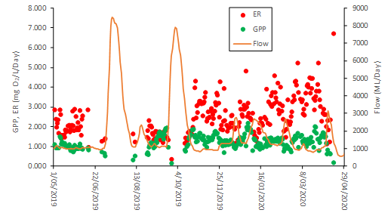

Figure . Daily gross primary production (GPP) and ecosystem respiration (ER) rates for McCoy’s Bridge (Zone 2) from May 2019 to April 2020

Source: 2019–20 Goulburn River Flow-MER Technical Report

The metabolic fingerprint (Figure A.4) demonstrates that the 5 study sites in the Goulburn River Selected Area were predominately heterotrophic (GPP:ER >1; mean 0.52) for the majority of the study period, and that GPP and ER are closely linked. This indicates that in general, significantly more oxygen is consumed in these reaches than is produced. Of the 5 study sites, 4 had maximum GPP:ER ratios above 1, indicating that on some occasions, oxygen production is as high (1.04 at Arcadia Downs) or much higher (2.18 at Murchison) compared with consumption via ecosystem respiration. In most cases, as observed in previous years, these high GPP:ER readings are typically due to lower ER rates rather than significantly increased GPP. This is exemplified by the large dataset from McCoy’s Bridge (n=244) where the maximum GPP rate was just 2.17 mg O2/L/day.

The 2 largest flow events in mid-July 2019 (peak flow 8,503 ML/day on 14 July) and late September to early October (peak flow 7,902 ML/day on 1 October) are both categorised as ‘freshes’. For days with rapidly changing, large flows, BASE v2 model fits are often poor and do not meet the acceptance criteria due to violating the assumptions of the BASEv2 model that discharge remains relatively constant. Figure A.3 shows the remarkable constancy in GPP values with small increases following the flow recessions, most notably in October 2019, mid-December 2019 and mid-February 2020. Conversely, the rising limb of the hydrograph tends to dampen GPP due probably due to simple dilution. This effect is evident with the last 4 smaller flow peaks in the year’s hydrograph. The rising hydrographs of these 4 flow peaks also lower ER rates, again due to dilution.

Commonwealth environmental watering actions contributed to the generation of nearly one quarter of all organic carbon created from GPP in the Goulburn SA around the McCoy’s Bridge site; 388 of 1,778 tonnes of organic carbon over the duration of the combined MER-LTIM monitoring (1 October 2014 to 30 April 2020). Commonwealth environmental water contributions in spring are particularly important, contributing 35–59% of all organic carbon created by GPP in this season, including 53% in Spring 2019. The optimum outcome for Commonwealth environmental water-assisted creation of organic carbon is found in the ‘Medium Fresh’ flow category in spring and autumn where an average additional 800–1100 kg organic carbon is created. The benefit of flow in this flow category is highest in autumn, where Commonwealth environmental water contributions in the lower flow categories are much more modest (an additional 100–200 kg of organic carbon). In spring, substantial increases occur in all flow categories above low flow.

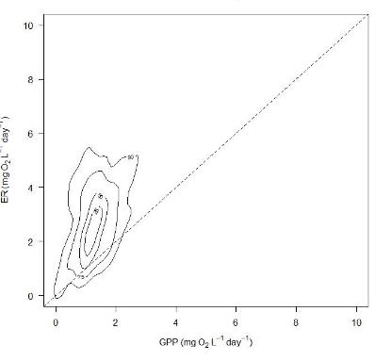

Figure . Metabolic fingerprint for the Goulburn River Selected Area based on 409 daily recordings across the 2019–2020 water year

* + 1. Mechanisms regulating rates of gross primary production (GPP) and ecosystem respiration (ER)

Metabolism was influenced by water quality, particularly turbidity and DOC. However, the data have not so far demonstrated a major influence of nutrients (especially given the very low and consistent concentrations of available N and P), with rates of metabolism not responding to changing concentrations associated with altered flows. Temperature has positive effects on GPP at Murchison and Shepparton, and a negative effect at Arcadia Downs.

Commonwealth environmental water has a positive effect on GPP at Shepparton (below the confluence with the Broken River) but negative effects on both GPP and ER volumetric rates at Arcadia Downs and Murchison above the confluence due to dilution effects. The positive effect of flow on GPP at Shepparton is surprising given the previous findings that additional water tends to dilute the GPP signal resulting in lower rates of GPP.

Counterfactual models (run without Commonwealth environmental water) demonstrate the minor effects of flow on rates of GPP and ER, with no strong effect of the additional environmental flows. Higher flows suppress volumetric rates (i.e. per litre of water, the amount of GPP and ER) of GPP and ER decreases. Unlike some other river systems in the Basin, there is only one source of environmental water in the Goulburn Selected Area, so differences of source water affecting metabolic rates is not relevant.

* + 1. Management implications
* A predominantly negative effect of increasing flow was recorded on rates of GPP and ER expressed on a per litre basis through simple dilution. Primary production is expected to respond to additional nutrients introduced via the higher flows circa 10–20 days following flow events, as this corresponds to sufficient time post nutrient addition to generate a significantly higher biomass of primary producers. It is extremely likely that the low rates of GPP are due to the extremely low bioavailable nutrient concentrations, especially the extremely low levels of filterable reactive phosphorus.
* It has been demonstrated that small increases in discharge increase the total mass of organic carbon in the stream through photosynthetic production. This is a positive finding as the initial paradigm was that no benefit to metabolism would accrue unless the water levels were sufficient to reconnect flood runners, backwaters and even the floodplain. Hence increasing flow from the very low to moderately low category means more energy (‘food’) being created to support the aquatic food web. There is also an increase in respiration rate with flow category thus greater nutrient regeneration to sustain increased primary production.
* From a management perspective, there is a positive benefit in increasing discharge, even by relatively small amounts when there are restrictions on the amount of water that can be delivered in watering actions. The optimum outcome for Commonwealth environmental water-assisted creation of organic carbon is found in the ‘Medium Fresh’ flow category in spring and autumn. The timing of Commonwealth environmental water deliveries can be matched to ecological need (e.g. fish recruitment) as well as operational constraints on such delivery. Nevertheless, it is likely that such increases in metabolic rates are still constrained by resources (nutrients) and much greater increases would be possible with reconnection of backwaters and other off-channel habitats.
  + 1. Evaluation

Table . Stream Metabolism evaluation questions and answers relating to Commonwealth environmental water and environmental watering actions in the Goulburn River Selected Area

|  |  |
| --- | --- |
| What did Commonwealth environmental water contribute to dissolved oxygen levels? | In the 19–20 water year, Commonwealth environmental water had a negligible effect on dissolved oxygen concentrations, contributing to positive DO concentrations between 6 and 11 mg DO/L/day through maintaining physical water mixing and oxygen exchange processes during deliveries, and enhancing phytoplankton production. |
| What did Commonwealth environmental water contribute to patterns and rates of primary productivity? | In the 19–20 water year, Commonwealth environmental water had a negligible effect on primary production, driven through very low available N and P. GPP is positively correlated with both mean daily water temperature and PAR. Increased flows generally reduced slightly the volumetric rate of primary production but slightly increased the reach-scale rates of production. This increased the overall “carrying capacity” of the river, however the GPP:ER ratio was predominately heterotrophic (GPP:ER >1; mean 0.52) for the majority of the study period. |
| What did Commonwealth environmental water contribute to patterns and rates of decomposition? | In the 19–20 water year, Commonwealth environmental water had a negligible effect ecosystem respiration. Limited season variation in ER rates was observed, with changes in NEP driven by reduced rates of GPP. Consistent low concentrations of DOC highlight that increases in ER metabolic rates would be possible with reconnection of backwaters and other off-channel habitats. |

* 1. Edward/Kolety–Wakool river systems Selected Area

Stream metabolism was measured at an upstream and downstream location within each of 4 river Zones, and water quality measured at 17 locations in the Edward/Kolety–Wakool River Selected Area. From July 2019 to June 2020 water quality parameters (temperature (°C), electrical conductivity (mS/cm), DO (%), pH, and turbidity (NTU)) were measured as spot recordings monthly at monitoring sites. Water samples were collected once per month from monitoring sites within each river/creek system, and from Stevens Weir on the Edward/Kolety River, and the Mulwala Canal (April, May and June 2019 data unavailable due to COVID-19 travel restrictions). The CEWO has used a trigger of 4.0 mg/L for the potential provision of refuge flows into the Edward/Kolety–Wakool River system.

Three watering actions were planned by the CEWO for the 2019–20 water year in the Wakool–Yallakool system and the Colligen–Niemur system. Watering action 1 was a winter base flow from 15 May to 9 August 2019 and Watering action 2 from 10 to 27 August 2019 were targeted to maintain connectivity and refuges during irrigation shut-down periods. Watering action 3 from 28 August to 22 December 2019 covered the winter–spring period, providing early season connectivity and pre-spawning conditions for native fish; spawning, nesting and dispersal periods for Murray Cod and Silver Perch; and habitat provision for instream vegetation. Some of the water during these actions was sourced as return flows from the SouthernConnected Flowin the Murray River. This influenced flows in the Edward/Kolety–Wakool system from 28 August to 9 September 2019, and 23 September to 1 October 2019. The return flows from Millewa Forest may have affected the water quality in the Edward/Kolety–Wakool system. Expected ecological outcomes relevant to this theme from these Commonwealth environmental watering actions were limited to ‘maintain water quality’.

* + 1. Water quality

Nutrient concentrations from across the monitored sites in 2019–20 were consistent with the 5 previous years of LTIM (with the exception of the 2015–16 bloom of cyanobacteria and the extensive unregulated overbank flooding in 2016–17). Both TP and TN increased during 2019–20 watering actions were likely associated with higher turbidity. TP and TN routinely exceeded the ANZECC (2000) trigger values but remained within the long-term range observed in this system. There were generally lower concentrations in Yallakool Creek zone 1 than in Wakool River (zones 2 to 6) suggesting slight increases in TP and TN as the water progresses through the system. Concentration of available nitrogen (NOx) remained below the trigger levels, and FRP concentrations remained at the very low concentrations normally seen in this system in the absence of overbank flooding. During 2019–20, DOC concentrations remained in the range normally observed in this system in the absence of overbank flows or excessive algal growth. Although a pulse of dark coloured water was observed in the system in January 2020, this corresponded with only a slight increase in DOC concentrations.

Chlorophyll-a (Chl *a*) concentrations remained stable and values were very similar between sites at below 20 µg/L from July to December 2019. Increases in Chl *a* concentrations along the Edward/Kolety River between January and February corresponded with excessive algae growth, suggesting increases in photosynthesis common during the summer months with high water temperatures and light levels. Excessive algae growth was also observed in the Wakool–Yallakool system in early January 2020, but there was no clear influence on other water quality parameters of this event. Increased Chl *a* levels and short-term poor water quality (particularly in the Colligen–Niemur system) are positively linked to climatic increases in temperature and light, suggesting increases in photosynthesis are associated with higher nutrient levels and low discharge during hot months.

Tuppal Creek consistently recorded the poorest water quality, with nutrients and DOC concentrations generally higher than the concentrations recorded in the Edward/Kolety–Wakool river systems in 2019–20 water year. Tuppal Creek is an ephemeral creek and received low base flows interspersed by a few larger pulsed flows and may be a localised source of increased carbon and nutrients to the Edward/Kolety–Wakool River system if connected to the main river channel.

Spot water quality parameters (electrical conductivity (EC), turbidity and pH) remained stable and within the acceptable range for this system throughout the study period. EC remained stable within the lower end of the range expected for lowland rivers indicating in ANZECC (2000). Turbidity measurements generally fluctuated above the ANZECC (2000) trigger level associated with increased flows, with values very similar between sites.

* + 1. Patterns of metabolism

Patterns of daily GPP (photosynthesis) and ER (respiration) were similar across sites over the monitoring period and comparable with rates measured in previous years. Using the acceptance criteria for diel DO curves, the acceptance rate ranged from a low of 3% of all days available for zone 3 (Wakool River) to a high of 63% at zone 1 (Yallakool Creek). Median GPP values for all 8 sites fell within a narrow range of 0.9 to 4.2 mg O2/L/day, similar to the range in 2018–19 (1.2 to 2.0 mg O2/L/day), 2017–18 (1.1 to 2.6 mg O2/L/day), 2015–16 (1.4 to 4.1 mg O2/L/day) and 2016–17 (1.6 to 3.9 mg O2/L/day). When converted to areal rates, the median GPP values had a similarly narrow range (from 0.9 to 2.9 g O2/m2/day).

There was a seasonal increase in GPP from spring into summer in all Zones. At all sites, GPP decreased from the end of summer into autumn. Warmer days, and more hours and higher intensity of sunshine during summer, likely drive this trend. Despite the constrained range of median values, there were many days at each site with higher rates of GPP and ER (from 10 to 30 gO2/m2/d), indicating that elevated rates were possible when conditions were conducive. Peaks were particularly noticeable in early summer in zone 1, 2 and 4 for both GPP and ER, coinciding with the drawdown period at the end of watering action 3. Zones 1 and 2, and Colligen Creek, showed additional pulses in ER in autumn coinciding with the unregulated flow pulse (Figure A.5).

Environmental watering action 1 in winter 2019 recorded GPP rates between 0 to 3 gO2/m2/d across all zones. ER rates were more variable, with notably higher rates at zones 2 and 3 than those at zones 1 and 4. This contributed to zones 2 and 3 being more strongly heterotrophic during the watering action. Delivery of environmental water resulted in noticeably increased production and consumption of carbon at zones 1 and 4.

During environmental watering action 3 in 2019, the recorded median GPP rates were relatively consistent across sites, but with a small number of higher-productivity days (> 5 g O2/m2/day) recorded at zones 1, 2 and 4. Median ER rates were slightly higher at zone 2, but zones 1 and 4 also had a number of high-ER days. Sites were still largely heterotrophic, although some net autotrophic days occurred particularly in zone 1. There was an increase in overall carbon production and consumption across all zones in response to the Commonwealth environmental water, and rates largely reflected the seasonal progression from spring into summer.

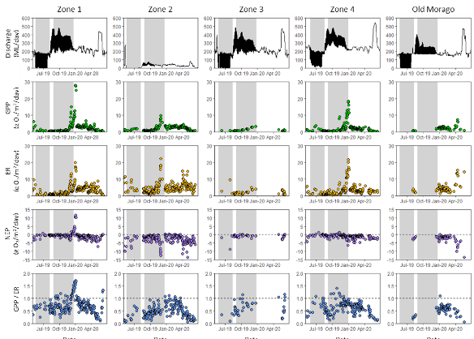

Figure . Plots of discharge, oxygen production (GPP), consumption (ER), net production (NPP) and production: consumption ratio (GPP / ER) over all sites in 5 hydrological zones in 2019–20

Watering action 1 (15/5/19–9/8/19) and 3 (28/8/19–22/12/19) are indicated by shaded bars. Shaded bars are adjusted for travel time for zones 3 (4 days) and 4 (9 days).

Source: 2019–20 Edward/Kolety–Wakool Selected Area Technical Report

The metabolic fingerprint (Figure A.6) demonstrates that the 5 study zones in the Edward/Kolety–Wakool Selected Area were predominately heterotrophic and highly variable (GPP:ER >1; mean 0.625 ± 0.011 s.e) throughout the 19–20 water year. For most of the time each system was strongly heterotrophic, even during early-summer GPP peaks. Zones 1, 2 and 4 also showed seasonal trends with GPP/ER increasing from winter into summer and then decreasing in autumn. The notable exception is the early summer peak in GPP at zone 1. This indicates that at most times, much more carbon is being consumed by respiration within the river than is being produced by photosynthesis, and that respiration rates do not decrease to the same extent as GPP. Flows were also likely too low during the 2019–20 period to connect anabranches or low-lying floodplains to provide shallow wetted habitat where primary production can often reach very high areal rates or high DOC in return flows.

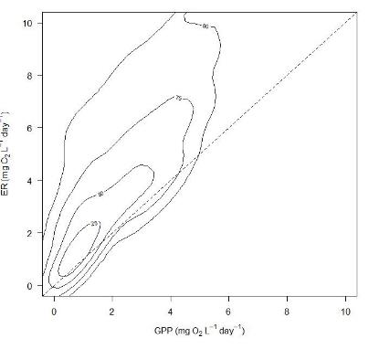

Figure . Metabolic fingerprint for the Edward/Kolety–Wakool river systems Selected Area based on 714 daily recordings in the 2019–20 water year

Commonwealth environmental watering actions resulted in both the increased production and consumption of carbon. Overall C production and consumption during watering action 3 was higher than in watering action 1 due to the longer period of the action (116 vs. 86 days) and the higher overall rates of GPP and ER reflecting the general increasing trend in GPP and ER rates from spring to summer. However, during watering action 1, the proportional contribution of Commonwealth environmental water to total production was greater than in watering action 3. This parallels the greater proportional contribution of Commonwealth environmental water to total discharge during winter low-flow periods.

* + 1. Mechanisms regulating rates of gross primary production (GPP) and ecosystem respiration (ER)

The substantial decrease in the rates of both volumetric GPP and ER through dilution from increased flow have been reported for multiple years in this system. Except in conditions of major phytoplankton growth (e.g. an algal bloom), much of the metabolism in the Edward/Kolety–Wakool system appears to be benthic biofilms and microbial communities on sediment and hard substrates within the channel. In 2019–20, conversion of volumetric rates (mg O2/L/day) to areal rates (g O2/m2/d) was introduced to account for this dilution effect. Areal rates of GPP and ER, as well as the ratio between them, showed little change during Commonwealth environmental watering actions. Consequently, increases and decreases in flow likely had little effect on production and consumption of carbon.

As with previous years, the strongest pattern in rates of GPP and ER was a seasonal trend. In particular, rates of GPP are higher and pulses appear more frequently during warmer summer months, indicating that temperature and light are major drivers of GPP rates in the Edward/Kolety–Wakool system.

Metabolism was influenced by water quality, especially high turbidity and low bioavailable nutrients. However, the data have not so far demonstrated a major influence of nutrients (especially given the very low and consistent concentrations of available N and P), with rates of metabolism not responding to changing concentrations associated with altered flows.

* + 1. Management implications
* Commonwealth environmental water contributed to total carbon production and consumption where water was delivered. Creating more ‘food’ at the base of the food web and more nutrients from ecosystem respiration is a positive outcome of these watering actions, even though water remained within the defined stream channel.
* The total additional production and consumption varied with (i) time of year (i.e. with season), (ii) the background flow (i.e. without Commonwealth environmental water), and (iii) the volume of Commonwealth environmental water being delivered. Season appears to be the strongest driver of overall rates, and is therefore also a strong influence on total carbon production and consumption.
* The median total contribution of Commonwealth environmental water to carbon production was higher during watering action 3 (6856 kg) than watering action 1 (3052 kg). These results reflect the higher overall rates of GPP during summer and the greater probability that pulsed events (i.e., days with very high rates) will occur. However, delivery of Commonwealth environmental water had the greatest proportional effect during winter low-flow periods. Maintaining discharge and wetted area during these periods likely helps maintain zooplankton and other invertebrates that feed on phytoplankton and periphyton, and in turn this increases food availability for fish and other higher order consumers during periods in which food availability might otherwise be low.
* From a management perspective, there is a positive benefit in increasing discharge, even by relatively small amounts to achieve enhanced carbon production for aquatic foodwebs. The timing of Commonwealth environmental water deliveries can be matched to ecological need (e.g. fish recruitment) as well as operational constraints on such delivery. Nevertheless, it is likely that such increases in metabolic rates are still constrained by resources (low available nutrients) and much greater increases would be possible with reconnection of backwaters, anabranch channel and other off-channel habitats.
  + 1. Evaluation

Table . Stream Metabolism evaluation questions and answers relating to Commonwealth environmental water and environmental watering actions in the Edward/Kolety–Wakool Selected Area

|  |  |
| --- | --- |
| What did Commonwealth environmental water contribute to dissolved oxygen levels? | In 2019–20 water year, dissolved oxygen concentrations were consistently higher during late summer and early autumn. Concentrations of dissolved oxygen in the Edward/Kolety River, Wakool River and the Colligen–Niemur River were consistently above the range of concern to fish populations (below 4 mg/L).  Although Commonwealth environmental water had a negligible effect on overall dissolved oxygen concentrations, improvement in DO through physical water mixing and oxygen exchange processes during deliveries was evident at some sites. |
| What did Commonwealth environmental water contribute to patterns and rates of primary productivity? | In the 19–20 water year, Commonwealth environmental watering action did not substantially affect areal rates of gross primary production (GPP) (mg O2/m2/d), which largely followed seasonal trends. However, when GPP was calculated as the amount of organic carbon produced per day (kg C/d), watering actions had a beneficial effect. The size of the beneficial impact was largely related to the proportion of total flow that came from the watering action, with greater proportional effects of environmental water in winter low-flow periods. Carbon production was enhanced by between 15% and 278% during the watering actions, with a median across all sites and watering actions of 50% more carbon produced during Commonwealth environmental watering actions compared to no Commonwealth environmental water. |
| What did Commonwealth environmental water contribute to patterns and rates of decomposition? | In the 19–20 water year, and as with GPP, areal rates of ecosystem respiration (ER)(mg O2/m2/d) were largely driven by seasonal trends. However, when ER was calculated as the amount of organic carbon consumed per day (kg C/d), then Commonwealth environmental watering actions had a beneficial effect. Increased organic carbon consumed means more nutrient recycling and hence greater nutrient supply to fuel GPP. Carbon consumption was enhanced by between 18% and 263% during the watering actions, with a median across all sites and watering actions of 51% more carbon consumed during Commonwealth environmental watering actions compared with no Commonwealth environmental water contribution. |

* 1. Murrumbidgee River System Selected Area

Although none of the 14 Commonwealth environmental watering actions in the Murrumbidgee River Selected Area had ecological outcomes relevant to the Water Quality and Food webs Theme, stream metabolism and water quality were measured at one main channel location (Carrathool) between October 2019 and April 2020. In 2019–20, the CEWO in partnership with NSW and the Murray–Darling Basin Authority delivered 48,335 ML of Commonwealth environmental water and 32,158 ML of NSW environmental water allocation as part of 15 watering actions targeting rivers, wetlands, and creek line habitats in the Murrumbidgee Selected Area.

* + 1. Water quality

During the 2019–20 water year, physicochemical conditions and water nutrient concentrations remained broadly within the expected range and were generally similar to the median figures for the previous 5 year period (2014–19) of LTIM monitoring. Concentrations of bioavailable nutrients were very low (Median of 1.25 µg/L FRP; 3.25 µg/L NOx) throughout the water year, with turbidity ranging from 44.9–85.6 NTU with increased values associated with higher flows.

* + 1. Patterns of metabolism

Patterns of daily GPP (photosynthesis) and ER (respiration) were similar over the monitoring period and comparable with rates measured in previous years. The percentage of days in 2019–20 that met the acceptance criteria was 71%. Overall, the rates of GPP and ER varied very little temporally, ranging from 0.55–1.94 and 0.37–1.91 mg O2/L/day, respectively over the study period. The relatively high mean GPP:ER ratio of 1.14 and positive NEP rates were observed from February 2020 onwards while the low GPP:ER ratio (<1) and negative NEP rates were observed frequently between December 2019 and January 2020 as temperature and respiration rates increased, and flow decreased. As such, the GPP:ER ratio was significantly negatively corrected with discharge. The overall NEP carbon load was approximately 987 kg C for the entire monitored period of the water year 2019–20. The metabolic fingerprint (Figure A.7) for the Murrumbidgee River System was the least dispersed and evenly proportioned for periods of autotrophy and heterotrophy.

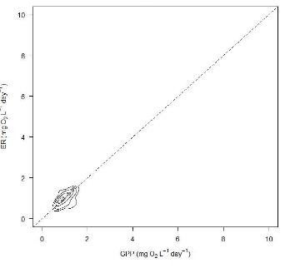

Figure . Metabolic fingerprint for the Murrumbidgee River System Selected Area based on 107 daily recordings in the 2019–20 water year

* + 1. Mechanisms regulating rates of gross primary production (GPP) and ecosystem respiration (ER)

Metabolism at the single monitoring site was influenced little by changes in water quality, particularly given the very low and consistent concentrations of available N and P that are likely the driver of very low rates of GPP and ER. There is no clear relationship between altered concentrations of nutrients and Commonwealth environmental watering actions and rates of metabolism.

Rates of GPP carbon loading and ER carbon usage were significantly positively correlated with the discharge rate. The GPP:ER ratio was, however, significantly negatively corrected with the discharge rate. The NEP carbon loading recorded fluctuated from both positive and negative, and irrespective of discharge rate. Thus, the net balance of organic carbon production and usage seems to be flow-independent.

* + 1. Management implications
* Unlike measures of stream metabolism in other Selected Areas, the Murrumbidgee River System has consistently recorded rates of GPP and ER that are exceptionally low, varied little with season or discharge, and showed no evidence for volumetric dilution with increased flows.
* It has been demonstrated that small increases in discharge increase the total mass of organic carbon in the stream through photosynthetic production. The cumulative NEP carbon load was approximately 987 kg C for the entire monitored period of the water year 2019–20, inclusive of the 48,335 ML of Commonwealth environmental water and 32,158 ML of NSW environmental water delivered during the 106-day period of available observations between September 2019 and April 2020.
  + 1. Evaluation

Table . Stream Metabolism evaluation questions and answers relating to Commonwealth environmental water and environmental watering actions in the Murrumbidgee River System Selected Area

|  |  |
| --- | --- |
| What did Commonwealth environmental water contribute to dissolved oxygen levels? | In the 19–20 water year, Commonwealth environmental water had a negligible effect on dissolved oxygen concentrations, contributing to positive DO concentrations between 7.78–10.1 mg DO/L/day through maintaining physical water mixing and oxygen exchange processes during deliveries, and enhancing phytoplankton production. |
| What did Commonwealth environmental water contribute to patterns and rates of primary productivity? | In the 19–20 water year, Commonwealth environmental water had a negligible effect on primary production, driven through very low available N and P. GPP was positively correlated with discharge. The mean GPP:ER ratio ranged from 0.42 to 3.05, with the Murrumbidgee River System (and Lower Murray River) the only Selected Areas to have a mean GPP:ER ratio above 1. |
| What did Commonwealth environmental water contribute to patterns and rates of decomposition? | In the 19–20 water year, Commonwealth environmental water had a negligible effect ecosystem respiration. ER was positively correlated with discharge. |

* 1. Lachlan River System Selected Area

Stream metabolism and water quality were measured at 4 sites in the Lachlan river Selected Area from July 2019 to June 2020. From upstream, the sites are Wallenthary downstream of Willandra Weir, Lanes Bridge downstream of Gonowlia Weir, Cowl Cowl downstream of Hillston Weir, and Whealbah at the end of the channel system before entering the Great Cumbung Swamp. Water samples were collected for nutrient analyses at intermittent intervals throughout the water year. The total Commonwealth environmental water delivered to the Lachlan SA in 2019–20 was 22, 026 ML and through a process of re-regulation, was used to target multiple locations and ecological objectives at different times of the year. A number of these watering actions were supplemented with 448 ML of NSW environmental water. The Lachlan SA had 5 Commonwealth environmental watering actions in the 2019-20 water year, 3 of which were deliveries with targets for improved water quality, particularly in wetland habitats. A 400 ML release to Yarrabandai Lagoon, a 2900 ML release to Booberoi Creek and a 17,028 ML flow from Wyangala Dam to Great Cumbung were all delivered during the 2019 portion of the water year. However, monitoring of the ecological outcomes by the SA only occurred for Watering Action 1 to the Great Cumbung Swamp. Watering Action 1 comprised a small spring fresh in the mid and lower Lachlan river system and a later autumn fresh in the Lower Lachlan river system. Expected ecological outcomes relevant to this theme from these Commonwealth environmental watering actions were limited to ‘maintain water quality’.

* + 1. Water quality

Environmental watering events did not have any substantial effects on water quality in 2019–20 water year. There was evidence of increased turbidity following the October fresh delivered from Lake Brewster as a component of Watering Action 1. TN was relatively high peaking over 800 µg/L following Watering Action 1, and was consistent across sampling events, while NOx was consistently very low. These values showed no clear association with Commonwealth environmental watering actions, although there is some evidence for a slight increase after the October watering events. Patterns for TP and FRP were broadly similar, although values were more variable. There is some evidence for increased total phosphorus and reactive phosphorus after the delivery of the environmental flow in June 2020. This is consistent with mobilisation of organic matter into the channel. There was no clear evidence for environmental flow deliver altering dissolved organic carbon (DOC) or chlorophyll (a measure of algal biomass). This is largely due to the sparse nature of the data at key periods of environmental water delivery. There is some evidence of higher DOC values during delivery of environmental flows in October, consistent with mobilisation of organic matter. There was very high variability in measurements through the periods of environmental flow delivery suggestive of patchiness of these resources.

* + 1. Patterns of metabolism

Patterns of daily GPP (photosynthesis) and ER (respiration) were similar across sites over the monitoring period and comparable with rates measured in previous years (Figure A.8). Using the acceptance criteria for each day’s diel DO curve, a total of 52% of data (ranging from 19% at Wallanthery to 83% at Lanes Bridge. In order to allow more days to be modelled for the analysis the R2 value was lowered from 0.9 to 0.75, including an additional 185 days (an average of 36% of the otherwise rejected data days). In order to model stream metabolism in some critical periods (e.g. at low flows) K values of up to 20 were accepted, understanding that high K values can lead to potential over-estimation of ER.

Commonwealth environmental watering actions undertaken in the lower Lachlan in 2019–20 took the form of relatively defined flow pulses. There is no strong evidence for an effect of watering actions on GPP or ER (Figure A.8). There is an observed increase in GPP and ER in the months after the environmental flow in October 2019, but it is not possible to attribute that to the effects of the environmental flow, as other factors such as increasing water temperatures and additional small flows are likely to also be confounding the metabolic responses from the initial watering action.

The metabolic fingerprint (Figure A.9) demonstrates that the 4 study sites in the Lachlan had highly variable and highly dispersed rates of GPP and ER that ranged from a GPP:ER ratio of 0.12 (highly heterotrophic) to 15.02 (highly autotrophic). A mean GPP:ER ratio of 0.73 and a median of 0.52, and ER rates that are generally substantially higher than the corresponding rates of GPP means sites are predominantly heterotrophic (GPP/ ER<1). Heterotrophic conditions indicate that metabolism is mainly driven by external sources of organic carbon rather than from photosynthesis within the site. The increases in GPP and ER are highly correlated, suggesting increased photosynthetic activity and mobilisation/consumption of organic matter. This is consistent with evidence from the water quality data which suggests mobilisation of both nutrients and carbon generating an increase in basal resources and phytoplankton productivity.

Estimates of carbon production arising from Commonwealth environmental watering actions were not recorded in the Lachlan SA. Similarly, only volumetric rates of GPP and ER are provided preventing some comparisons with other Selected Areas.

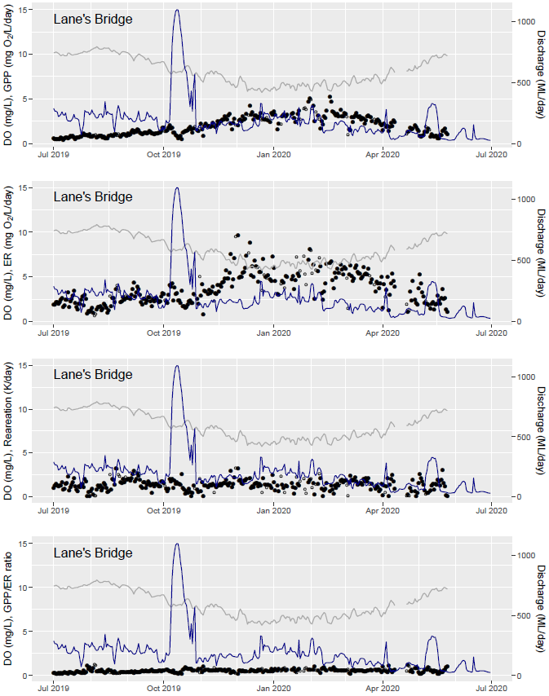

Figure . Gross primary production (GPP), ecosystem respiration (ER), reaeration (K) and the GPP/ ER ratio from Lane’s Bridge in the Lower Lachlan, July 2019–June 2020

Blue shaded vertical bars indicate watering actions.

Source: 2019–20 Lachlan river Selected Area Flow-MER Technical Report

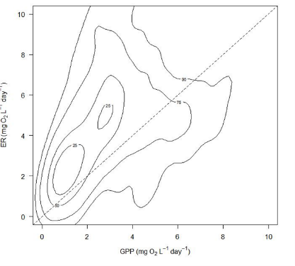

Figure . Metabolic fingerprint for the Lachlan River System Selected Area based on 563 daily recordings during the 2019–20 water year

* + 1. Mechanisms regulating rates of gross primary production (GPP) and ecosystem respiration (ER)

The spring fresh in October 2019 of Watering Action 1 targeted increased primary productivity to support improvements in fish condition in the mid and lower reaches of the Lachlan River. This event mobilised basal nutrient and carbon resources in the channel but did not translate to increases in algal biomass or measurable increases in GPP or ER.

The latter part of Watering Action 1, the autumn/winter fresh in May to June 2020 sought to maintain water quality and provide a small pulse of productivity. This event appeared to mobilise nutrients and carbon in channel, resulting in a small increase in ER. Consistent with previous flows provided during cooler times of year, there was no clear effect on GPP, and it seems likely that the response is largely due to mobilisation and processing of organic material from in-channel benches and the banks increasing rates of ER.

* + 1. Management implications
* There was no clear evidence for either positive or adverse effects of Commonwealth environmental water on water quality. Temperature was dominated by seasonal cycles, with consequent effects on dissolved oxygen. This is reflective of the lack of sources of nutrients to be mobilised by in-channel flows, and the relatively small volumes of water being applied. Larger volumes of water can be an effective management tool in terms of mobilising or diluting dissolved organic carbon, as has been evident in previous watering actions. Large natural flows can dramatically alter water chemistry parameters, but far exceed the volumes available for environmental watering.
* There was evidence for Commonwealth environmental watering actions generating short and very small pulses of GPP and ER, with GPP responses being larger in warmer conditions. Relatively minor changes in nutrients and carbon (relative to background variability) do appear to support relatively larger (compared to background variability) responses in productivity but were tempered by increased turbidity.
* There is evidence for productivity responses to environmental flow delivery in the lower Lachlan River, particularly when water temperatures are warmer. While the river was generally heterotrophic (dominated by external carbon rather than in situ photosynthesis), it tended to be more autotrophic during Commonwealth environmental watering actions. This may be suggestive of generating higher quality local production. Flows targeting productivity responses should be targeted to warmer conditions.
* Provision of Commonwealth environmental water as a short term, relatively small event in autumn appeared to meet the objective of generating a small resource pulse in-channel. These may be important ecologically in providing resources at a relatively resource poor period, supporting maintenance of fish condition into the winter period.
  + 1. Evaluation

Table . Stream Metabolism evaluation questions and answers relating to Commonwealth environmental water and environmental watering actions in the Lachlan Selected Area

|  |  |
| --- | --- |
| What did Commonwealth environmental water contribute to dissolved oxygen levels? | In 2019–20 water year, dissolved oxygen concentrations were consistently lower in summer periods. No longitudinal pattern in DO concentrations was evident. Concentrations of dissolved oxygen in the Lachlan River were consistently above the range of concern to fish populations (below 4 mg/L), except for a brief period in Jan 2020 at Whealbah. Although Commonwealth environmental water had a negligible effect on overall dissolved oxygen concentrations, improvement in DO through physical water mixing and oxygen exchange processes during deliveries was evident. |
| What did Commonwealth environmental water contribute to patterns and rates of primary productivity? | In the 19–20 water year, Commonwealth environmental watering action did not substantially affect rates of GPP (mg O2/m2/d), which largely followed seasonal trends. Commonwealth environmental watering actions generated short pulses of increased GPP and ER, with GPP responses being larger in warmer conditions. Relatively minor changes in nutrients and carbon supported relatively larger responses in productivity, particularly in Autumn. |
| What did Commonwealth environmental water contribute to patterns and rates of decomposition? | In the 19–20 water year, and as with GPP, rates of ER were largely driven by seasonal trends. While the river was generally heterotrophic with a mean and median GPP:ER ratio less than 1 (dominated by external carbon respiration rather than in situ photosynthesis), it tended to be more autotrophic during Commonwealth environmental water deliveries. This may be suggestive of generating higher quality local production. |

* 1. Junction of Warrego and Darling rivers Selected Area

Stream metabolism and water quality were measured at 5 locations in the Junction of the Warrego Darling river Selected Area. Two sites were on the Darling main channel; upstream of the confluence of the Warrego-Darling at Darling Pumps and downstream of the confluence at Akuna Homestead. A further 3 sites were located on the Warrego River main channel; from upstream to downstream they are Boera Dam at the northern boundary of the Selected Area, Booka Dam and Ross Billabong just above the confluence with the Darling. Three sampling events were undertaken in the 2019–20 water year: December 2019, March 2020 and June 2020. In relation to the flow and inundation that commenced February/March 2020, these sampling times acted as before, during and after the major flow event. Loggers were deployed during the December 2019 sampling trip and downloaded in March and June 2020.

As an unregulated system, the management of Commonwealth environmental water is through licence activation and management of gates at Boera Dam to sheppard water along the Warrego channel to the Darling River or alternatively move water to the Western Floodplain. Licenced volumes for the Warrego River are 8.1 gigalitres (GL) long term average annual yield (LTAAY), the Western Floodplain (accounted at Boera Dam) at 9.7 GL (LTAAY) and the Darling River at 7.6 GL (LTAAY). These licences are owned and managed by the CEWO in consultation with the NSW National Parks and Wildlife Service and the Kurnu–Barkindji Joint Management Advisory Committee. Conditions placed on these licences determine how Commonwealth environmental water can be managed within the Warrego–Darling Selected Area. This is especially true for the licences specified at Boera Dam. Before these licences can be accessed, downstream demand to the Darling River must be met during times of low flow. That is, if sustained inflows are entering Boera Dam, and the Darling River flow at Louth is below 330 ML/day, then water must be let through the regulator pipes on Boera Dam and all downstream dams on the Warrego to flow to the Darling River until flows at Louth have reached 330 ML/day. Once this has been achieved, the CEWO in consultation with the NSW National Parks and Wildlife Service and the Kurnu–Barkindji Joint Management Advisory Committee can choose whether to continue to release water down the lower Warrego channel, therefore activating their Warrego River licence, or close the regulator gates, and hold water in Boera Dam to divert water to the Western Floodplain. If flows in the Darling exceed 979 ML/day at Louth, the CEWO can access a high flow floodplain licence to divert water to the Western Floodplain.

The 2019–20 water year was marked by strong contrast in flow and inundation conditions. The first half of the water year was very dry with decreasing inundation in the Warrego River channel dams and pools on the Western Floodplain. A significant flood event commenced in early March 2020 and continued until late May in both the Warrego and Darling catchments. This event peaked at over 4,300 ML/day at Fords Bridge on the Warrego River upstream of the Selected Area and contained around 7% Commonwealth environmental water. This was the largest flow in the Warrego system since 2012. This flow provided significant inundation of the Western Floodplain and connected the Warrego River through to the Darling River for an extended period. During this time, the Boera Dam gates were open and 16,212 ML of water for the environment (36% of total flow volume) was released into the lower Warrego River below Boera Dam.

In the Darling River, a relatively large flow pulse peaking at over 15,000 ML/day at Bourke occurred in February–May 2020. This was the largest flow of the 2019–20 water year (478 GL total volume) and included 12 % environmental water from upstream take in the Border Rivers, Moonie, Condamine–Balonne, Macquarie–Castlereagh and Warrego catchments.

Expected ecological outcomes relevant to this theme from these Commonwealth environmental watering actions were to ‘refresh waterholes in the Warrego system and support long-term refuge values’.

* + 1. Water quality

Nutrient concentrations from the 5 sites in 2019–20 were consistent with the 5 previous years of LTIM, with the concentrations of total and bioavailable nutrients exceptionally high and consistently exceeding guideline trigger values at all sites. A short-lived algal bloom was observed on the Western Floodplain linked to elevated nutrient concentrations, high temperatures and receding water levels. Consistent with long-term trends, there were no adverse environmental outcomes recorded in response to high nutrient concentrations across the SA. Similarly, turbidity remained consistently high in the 19–20 water year, exceeding guideline trigger values by an order or magnitude with a mean of 816 ± 4.3 NTU. Reduced electrical conductivity and nutrient concentrations were observed in the Darling and Warrego rivers in response to higher flows that included Commonwealth environmental water. The improvement in water quality was most pronounced in the Darling River downstream of the confluence with the Warrego and within the Warrego channel refuge pools, highlighting the importance of these replenishing connection events in improving and sustaining good water quality within the Selected Area.

* + 1. Patterns of metabolism

Patterns of daily GPP (photosynthesis) and ER (respiration) were similar across sites over the monitoring period and comparable with rates measured from previous years. The acceptance rate for modelling each day’s diel DO curve ranged from 7.6 % of all days logged at Boera Dam (12 days from 157 possible days), to 16.6 % at Ross Billabong, and is consistent with the very low acceptance rates throughout LTIM and MER. In addition, there were limited days where acceptable metabolic data coincided with discharge > 0 ML/day. In 2019–20, only 24 out of a possible 157 daily measurements were included in the analyses.

Median GPP ranged from 0.48 mg O2/L/day at Ross Billabong to 8.88 mg O2/L/day at the upstream site on the Darling River (Figure A.10). GPP decreased longitudinally downstream in both the Darling and Warrego Rivers. ER was highest and most variable in the upstream Darling River, and this was significantly greater than in the lower Darling and the Warrego River. There were no clear temporal patterns in GPP, ER or NPP overall or within any site to indicate that February-May flows influenced productivity rates within the Warrego or Darling Rivers.

The metabolic fingerprint (Figure A.11) demonstrates that the 5 study sites in the Warrego Darling SA were almost exclusively heterotrophic (GPP:ER >1; mean 0.34, range from 0.1 to 1.49) during the 19–20 water year. This indicates that significantly more oxygen is consumed in these reaches than is produced. The magnitude of rates of ER in this SA was almost double the maxima recorded from all other SA’s. In all cases, as observed in previous years, these very low GPP:ER ratios are due to very high ER rates rather than significantly increased GPP. There was only one occasion where a GPP:ER ratio exceeded 1, associated with a localised algal bloom as water levels receded and Warrego River pools became disconnected.

Commonwealth environmental watering actions constituted 12.2 % of the February–May 2020 flow event in the Warrego–Darling SA, and the strong heterotrophic nature of the system meant that the Commonwealth environmental watering action contributed to the consumption of carbon. All sites were consistent carbon sinks, with net carbon consumption ranging from 2,416 – 255,957 kg C over the flow event.

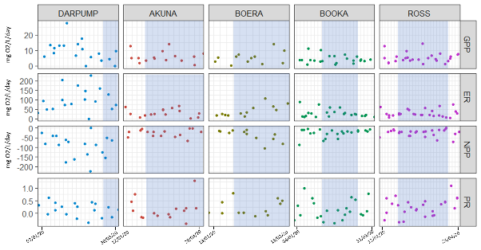

Figure . Gross primary production (GPP), ecosystem respiration (ER), net primary productivity (NPP) and GPP:ER at sites in the Darling (DARPUMP and AKUNA) and Warrego Rivers (BOERA, BOOKA and ROSS)

Blue time periods indicate the flow event.

Source: 2019–20 Junction of the Warrego–Darling Selected Area Flow-MER Technical Report

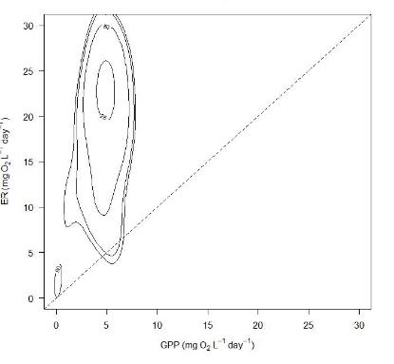

Figure . Metabolic fingerprint for the Junction of the Warrego–Darling rivers Selected Area based on 24 daily recordings from the 2019–20 water year

* + 1. Mechanisms regulating rates of gross primary production (GPP) and ecosystem respiration (ER)

Water quality was highly variable during the 2019–20 water year with no clear trends apparent in response to connection and inundation. There were no clear temporal patterns in GPP, ER or NPP overall or within any site to indicate that the inundation event consistently influenced productivity rates within the Warrego or Darling Rivers.

Despite extremely high nutrient concentrations at all sites that should theoretically drive positive primary productivity, rates of stream metabolism continued to be highly variable and strongly heterotrophic, regulated by very high turbidity and poor light availability at all sites and times.

Both the Darling and Warrego Rivers acted as carbon sinks, consuming significantly more carbon than they produced. Of particular interest is that GPP decreased longitudinally downstream in both the Darling and Warrego Rivers, suggesting the relatively lower nutrient and higher organic carbon concentrations in the water from the Warrego are enhancing ER in the Darling River downstream of the confluence.

ER and NEP both peaked in mid-February during the flow event when water temperatures remained high, which was consistent with the long term pattern showing that water temperature (along with increased turbidity) is a major regulator of primary production in these systems.

* + 1. Management implications
* The lower Warrego River forms an important nursery for fish recruits such as golden perch, which enter the reach via drift from upstream. Connection events are an important mechanism to maintain and improve water quality in remnant pools and in the Darling River downstream of the confluence with the Warrego. These events also contribute substantial amounts of energy (kg C/d) to the Warrego and Darling Rivers that can support a positive microbial food web response and contribute to successful larval recruitment.
* Understanding that the river channels in the SA are very strongly heterotrophic, that this heterotrophy is further enhanced by the use of Commonwealth environmental water, and that no detrimental ecological outcomes (fish kills, algal blooms) have been associated with Commonwealth environmental water-related inundation and connection events is essential for managing the licences in the Warrego–Darling Selected Area.
  + 1. Evaluation

Table . Stream Metabolism evaluation questions and answers relating to Commonwealth environmental water and environmental watering actions in the Junction of Warrego and Darling rivers Selected Area

|  |  |
| --- | --- |
| What did Commonwealth environmental water contribute to dissolved oxygen levels? | In the 19–20 water year, Commonwealth environmental water had a negligible effect on dissolved oxygen concentrations, contributing to positive DO concentrations between 3 and 7 mg DO/L/day through maintaining physical water mixing and oxygen exchange processes during deliveries, and enhancing phytoplankton production. |
| What did Commonwealth environmental water contribute to patterns and rates of primary productivity? | In the 19–20 water year, Commonwealth environmental water had a negligible effect on primary production, with highly turbid waters creating a very shallow photic depth that appears to limit GPP despite exceptionally high concentrations of total and available N and P, and DOC.  There were no clear temporal patterns in GPP, ER or NEP overall or within any site to indicate that the inundation event influenced productivity rates within the Warrego or Darling Rivers. |
| What did Commonwealth environmental water contribute to patterns and rates of decomposition? | In the 19–20 water year, Commonwealth environmental water had a negligible effect ecosystem respiration, with the Warrego and Darling channels remaining almost exclusively and strongly heterotrophic. GPP:ER ratios are consistently very low, and driven by very high rates of ER rather than reduced GPP, suggesting terrestrial sources of organic matter are fuelling a microbial-based food web. |

Detailed information on outcomes for each Selected Area, 2014–20

* 1. Lower Murray River Selected Area

The metabolic fingerprint for the Lower Murray River System has remained consistently autotrophic from 2014–20, and the similarity with the 2019–20 fingerprint overlayed in Figure B.1 highlights this consistency. The long-term fingerprint for the Lower Murray River System reflects the stable lentic-like conditions affected by locks and weirs, with metabolic patterns driven by phytoplankton that are generating more carbon than is consumed by heterotrophs. It is worth noting that evidence included in this report in Section 6 from the MDBA funded Southern Spring Pulse Project 2019 indicates that even during a flow pulse of ~15,000 ML/day that the metabolic fingerprint remained predominantly below the 1:1 line. Thus, it is unlikely that smaller flow volumes will instigate any detectible changes to carbon consumption and generation in the Lower Murray River.

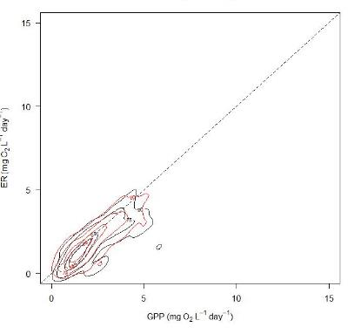

Figure . Cumulative 2014–2020 metabolic fingerprint for the Lower Murray River (coloured red) overlaid with the 2019–2020 metabolic fingerprint (coloured black)

Kernel plots represent 1113 daily records.

However, as suggested by Ye et al. (2021), Commonwealth environmental water has a valuable role in the Lower Murray River with respect to maintenance of dissolved oxygen (DO) concentration. In low flow weir pools where surface oxygen exchange is reduced, increased flows from Commonwealth environmental water can improve the DO conditions by increasing mixing and enhancing oxygen exchange at the surface. Ye et al. (2021) estimate that Commonwealth environmental water maintained surface gas exchange for 30–40 days longer than otherwise would have occurred). Despite long-term metabolic patterns being dominated by autotrophic production by phytoplankton in the Lower Murray River, Ye et al. (2021) also emphasise the importance of Commonwealth environmental water for supply of DOC to support heterotopic production (evidenced by their estimation Combined Net Production) of carbon in food webs. Indeed, long-term trends observed in the Lower Murray River suggest that light and DOC limit the development of microbial populations so that nutrient limitation does not appear to be a significant driver of metabolic patterns (Ye et al., 2021).

* 1. Goulburn River Selected Area

In comparison to the long-term 2014–20 fingerprint, the 2019–20 fingerprint retained the same general predominantly heterotrophic shape, though overall fingerprint area was reduced, suggesting some limitation to ecosystem productivity in 2019–20 (Figure B.2). Overall long-term metabolic patterns in the Goulburn River are similar to those observed in other southern Basin rivers (e.g. Edward–Kolety–Wakool and Lachlan Rivers) – generally heterotrophic, though with slightly lower through-put. Treadwell et al. (2020) attribute limitations to productivity in the Goulburn River to a lack of bioavailable nutrients, and in 2019–20 bioavailable phosphorus concentration was consistently below 0.01 µg P/L.

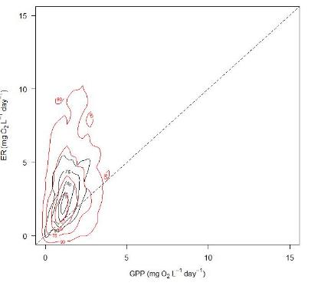

Figure . Cumulative 2014–2020 metabolic fingerprint for the Goulburn River Selected Area (coloured red) overlaid with the 2019–2020 metabolic fingerprint (coloured black)

Kernel plots represent 2459 daily records.

* 1. Edward/Kolety–Wakool river systems Selected Area

The long-term 2014–19 metabolic finger print for the Edward/Kolety–Wakool river systems was very similar to the 2019–20 fingerprint, suggesting typical conditions for the most recent monitoring period and persistent heterotrophic patterns, consistent with those reported in the literature (Figure B.3, Holland et al. 2020). Dominant heterotrophic patterns in the Edward/Kolety–Wakool river systems have been shown to be dominated by respiration occurring on and within benthic surfaces (e.g. decomposing litter - Holland et al. 2020) suggesting that allochthonous terrestrial carbon is an important contributor to food webs in this ecosystem.

As with previous years, Watts et al. (2020a) note that immediate effects of increased flows on metabolic patterns were to substantially decrease rates of both ecosystem GPP and ER, likely attributable to dilution effects of increased water volume and disturbance to microbial communities. Watts et al. (2020a) identify that while ‘actual’ rates of carbon generation and consumption may not change, the increased volume of water means that the metabolic signal (e.g. generation or consumption of DO) is diluted and that, overall, Commonwealth environmental water contributed significantly to total carbon production and consumption. Importantly, they note that the proportional contribution of Commonwealth environmental water in the Edward/Kolety–Wakool river systems to total production and consumption is higher during winter, when discharge is lower reflecting the influence of channel hydraulics and channel shape (e.g. higher proportional increases to photic zone).

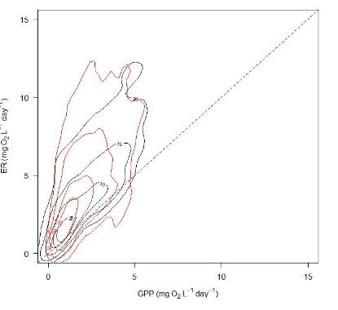

Figure . Cumulative 2014–2020 metabolic fingerprint for the Edward/Kolety Wakool river systems Selected Area (coloured red) overlaid with the 2019–2020 metabolic fingerprint (coloured black)

Kernel plots represent 4,731 daily records.

* 1. Murrumbidgee River System Selected Area

The metabolic fingerprint for the Murrumbidgee River System in 2019–20 reflected a similar a pattern to long-term 2014–19 metabolic dynamics (Figure B.4), though in 2019–20 the fingerprint was much reduced in area, indicating a higher than usual degree of ecosystem limitation (e.g. Bernhardt et al 2018) and slightly more autotrophic than in previous years (Wassens et al. 2020).

Exceptionally low FRP and DOC concentrations recorded in 2019–20 (medians 1.25 µg L-1 and 1.72 mg L-1 respectively) may have contributed to overall metabolic throughput limitation compared to long-term patterns, since other nutrient parameters remained similar to previous years. As with other Selected Areas, Commonwealth environmental water had limited direct detectible effect on metabolic patterns in the Murrumbidgee River System.

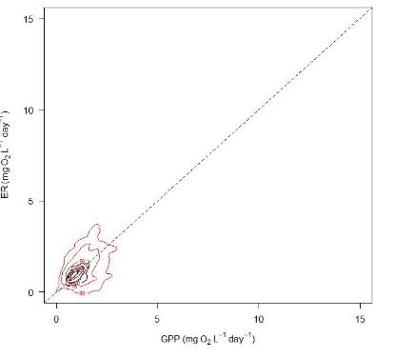

Figure . Cumulative 2014–2020 metabolic fingerprint for the Murrumbidgee River System Selected Area (coloured red) overlaid with the 2019–2020 metabolic fingerprint (coloured black)

Kernel plots represent ,1588 daily records.

* 1. Lachlan River System Selected Area

The long-term 2014–19 metabolic fingerprint (Figure B.5) in the Lachlan River System is similar to that observed in 2019–20, with the long-term centroid residing just above the 1:1 line. Long-term patterns in the Lachlan River are however slightly more heterotrophic than observed in 2019–20, with generally lower rates of GPP.

As with other similar southern Basin rivers (e.g. Goulburn and Edward/Kolety–Wakool) ongoing monitoring has shown that there are strong seasonal effects on patterns of GPP and ER. However, despite seasonal variation, both GPP and ER have been shown to increase during flow delivery, correlated with higher DOC and higher nutrient and algal concentrations (Dyer et al. 2020). High variability the physical process of reaeration (possibly due habitat complexity and microhabitat flow variability) in the Lachlan has also been identified as a major driver of metabolic patterns, complicating the determination of magnitude of metabolism responses to Commonwealth environmental water (Dyer et al. 2020).

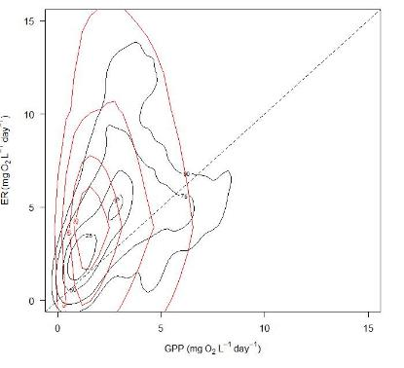

Figure . 2014–20 metabolic fingerprint (coloured red) overlaid with the 2019–20 metabolic fingerprint (coloured black) for the Lachlan River System Selected Area

Kernel plots represent 4,013 daily records.

* 1. Junction of Warrego and Darling rivers Selected Area

The centroid of long-term metabolic fingerprint for the Warrego–Darling river system (Figure B.6) resides much closer to the 1:1 line than does the 2019–20 fingerprint centroid, indicating that patterns observed in the most recent monitoring year were far more heterotrophic than is usual, likely associated with the extensive inundation and connection event experienced in early 2020. The long-term fingerprint also suggests that the system usually has much lower ecosystem throughput than the high rates of respiration observed during the large inundation events observed in the northern Basin in 2019–20.

The 25% density kernel for the long-term metabolic fingerprint for the Warrego–Darling river system actually resides in a very similar position to that of the Lower Murray (e.g. straddling the 1:1 line and ~ < 5 mg O2 L-1 for both GPP and ER, noting differences in scale for the 2 plots). However, unlike the Lower Murray fingerprint (which is relatively constrained), the Warrego Darling fingerprint shows that on occasion very high estimates of ER are detected (20–25 mg O2 L-1), as was observed in 2019–20 in response to large algal blooms followed by sudden algal mortality that led to large increases in bacterial consumption of oxygen. Thus, the bivariate 75 and 90% density kernels in the long-term fingerprint are reflective of these infrequent, but persistent spikes in rates of ER.

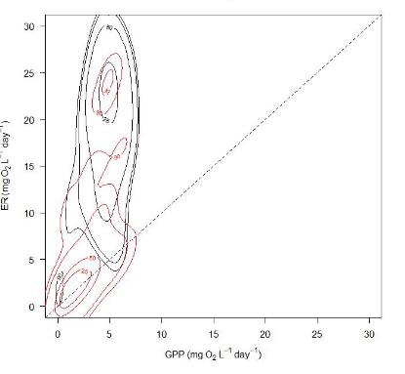

Figure . Cumulative 2014–2020 metabolic fingerprint for the Junction of the Warrego and Darling rivers Selected Area (coloured red) overlaid with the 2019–2020 metabolic fingerprint (coloured black)

Kernel plots represent 125 daily records.

[**https://flow-mer.org.au**](https://flow-mer.org.au)

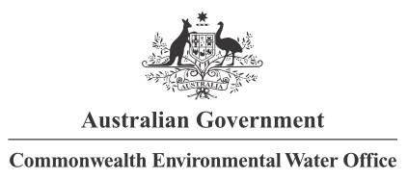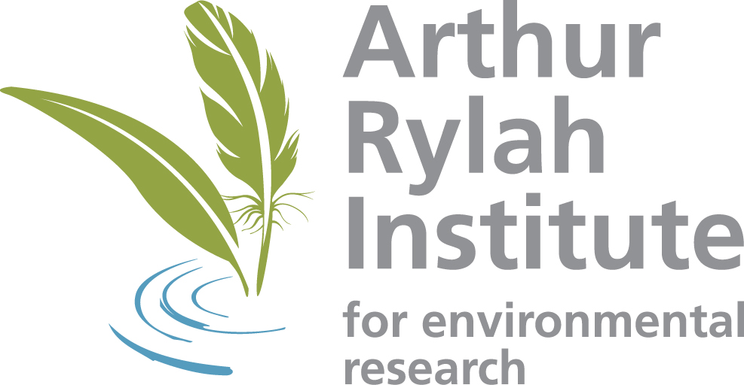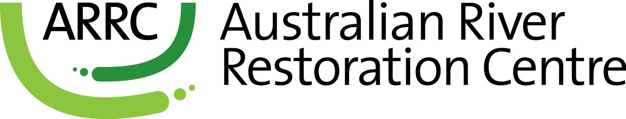

**Partners**

**Collaborators**

1. Ratio of gross primary production to ecosystem respiration (GPP:ER) > 1
2. Ratio of gross primary production to ecosystem respiration (GPP:ER) < 1
3. Water for the environment was released from Hume Dam from September to December 2019 and in 2020 to support targeted wetlands and river channels from the mid-Murray to the Lower Lakes and Coorong. The release was coordinated with environmental releases from the Goulburn River, and natural and operational flows. The purpose of the Southern Spring Flow releases was to stimulate ecosystem productivity along the whole length of the Murray River, from Yarrawonga to the Coorong.
4. Watts et al. (2020a)
5. The BASEv2 program, along with an extensive user manual, are available at [https://github.com/dgiling/BASE#base-v2](https://github.com/dgiling/BASE#base-v22)2