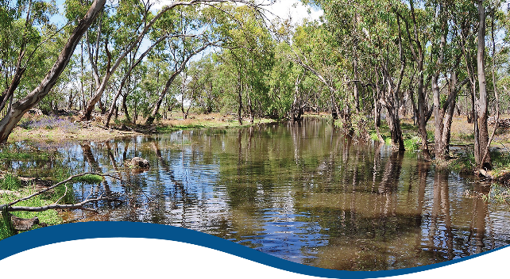

Basin-scale evaluation of  
2019–20 Commonwealth environmental water: Hydrology

Commonwealth Environmental Water Office (CEWO):   
Monitoring, Evaluation and Research Program

August 2021

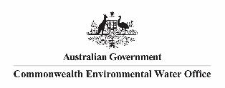

Citation

Guarino F, Sengupta A (2021) 2019-20 - Hydrology Evaluation Report - Final. Flow-MER Program. Commonwealth Environmental Water Office (CEWO): Monitoring, Evaluation and Research Program, Department of Agriculture, Water and the Environment, Australia. 58pp.

Acknowledgements

The project team and the Commonwealth Environmental Water Office (CEWO) respectfully acknowledge the traditional owners of the land on which this work is conducted, their Elders past and present, their Nations of the Murray–Darling Basin, and their cultural, social, environmental, spiritual and economic connection to their lands and waters.

We take this opportunity to thank the many individuals and agencies who provided data to support this evaluation. This includes officers within the CEWO, Victorian Environmental Water Holder (VEWH), WaterNSW, Goulburn-Murray Water (GMW), South Australian Department for Environment and Water (DEW), NSW Department of Planning, Industry and Environment (DPIE), Mallee Catchment Management Authority (CMA), North-Central CMA, Goulburn Broken CMA, the Murray–Darling Basin Authority (MDBA) and Geoscience Australia. The authors would also like to thank Jim Foreman, Aftab Ahmad and Matt Gibbs for assistance with modelling and review. We would like to thank the CSIRO and University of Canberra teams for their efforts in report layout, editing, reviewing and formatting. Special mention to Emily Barbour, Ross Thompson, Di Flett, Susan Cuddy and Jackie O’Sullivan whose input, together with copy editor Dr Mary Webb and formatting specialist, Jill Sharkey, greatly improved the readability of the report. CSIRO’s Martin Nolan assisted with figures and GIS layers. A final thanks to Peter Davies for providing an expert independent review.

Copyright

Creative Commons [logo] © Commonwealth of Australia 2021  
With the exception of the Commonwealth Coat of Arms, partner logos and where otherwise noted, all material in this publication is provided under a Creative Commons Attribution 4.0 International Licence <https://creativecommons.org/licenses/by/4.0/>. The Flow‑MER Program requests attribution as ‘© Commonwealth of Australia (Flow‑MER Program, <https://flow-mer.org.au)>’.

Document submission history

|  |  |
| --- | --- |
| 30 June 2021 | Final draft incorporating reviewer comments |
| 2 July 2021 | Final draft with minor corrections |
| 24 August 2021 | Final |

Cover photograph

Flooded creek in Yanga National Park, NSW  
Photo credit: Tanya Doody

Important disclaimer

The information contained in this publication comprises general statements based on scientific research. The reader is advised and needs to be aware that such information may be incomplete or unable to be used in any specific situation. No reliance or actions must therefore be made on that information without seeking prior expert professional, scientific and technical advice. To the extent permitted by law, the Flow-MER Program (including its partners and collaborators) excludes all liability to any person for any consequences, including but not limited to all losses, damages, costs, expenses and any other compensation, arising directly or indirectly from using this publication (in part or in whole) and any information or material contained in it.

The Flow-MER Program is committed to providing web-accessible content wherever possible. If you are having difficulties with accessing this document, please contact [CEWOmonitoring@environment.gov.au](mailto:CEWOmonitoring@environment.gov.au)

Overview of Flow-MER

Flow-MER is the Commonwealth Environmental Water Office’s (CEWO) Monitoring, Evaluation and Research Program. Its objective is to monitor and evaluate the ecological responses to the delivery of Commonwealth environmental water in the Murray–Darling Basin. It provides the CEWO with evidence to inform our understanding of how water for the environment is helping maintain, protect, and restore the ecosystems and native species across the Basin. This work will support environmental water managers, demonstrate outcomes, inform adaptive management and fulfil the legislative requirements associated with managing Commonwealth-owned environmental water.

The Program runs from 2019 to 2022 and consists of 2 components: monitoring and research in 7 Selected Areas (Selected Area projects); and Basin-scale evaluation and research (the Basin-scale project) (Figure 1 The 7 Selected Areas and 25 valleys established for long-term monitoring of the effects of environmental watering under the LTIM Project and Flow-MER Program (2014–15 to present)Figure 1). The Basin-scale project is led by CSIRO in partnership with the University of Canberra, and collaborating with Charles Sturt University, Deakin University, University of New England, South Australian Research & Development Institute, Arthur Rylah Institute, NSW Department of Planning, Industry and Environment, Australian River Restoration Centre and Brooks Ecology & Technology.

It builds on work undertaken through the Long Term Intervention Monitoring (LTIM) (2014–2019) and Environmental Water Knowledge and Research (EWKR) (2014–2019) projects.

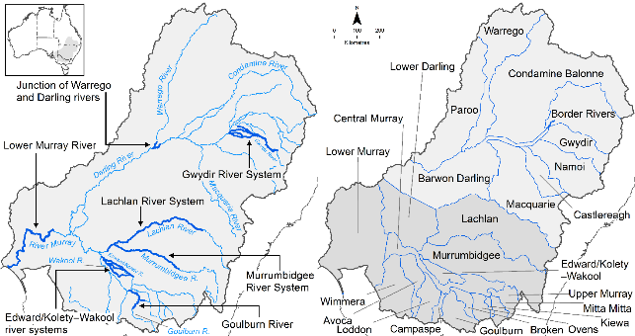

Figure The 7 Selected Areas and 25 valleys established for long-term monitoring of the effects of environmental watering under the LTIM Project and Flow-MER Program (2014–15 to present)

The Flow-MER evaluation adopts an adaptive management framework to acknowledge the need for collectively building the information, networks, capacity and knowledge required to manage environmental water at Basin scale. While knowledge of ecological response to instream flow and inundation has advanced significantly in recent years, substantive challenges remain in understanding the similarities and differences in species’ response across time and space, as well as the interaction between species at a community and ecosystem scale.

The Basin-scale evaluation is being undertaken across 6 Basin Themes (Figure 2) based on ecological indicators developed for the LTIM Project and described in the [Environmental Water Outcomes Framework](https://www.environment.gov.au/water/cewo/publications/environmental-water-outcomes-framework). It is undertaken in conjunction with the Selected Area projects, which provide data, research and knowledge for ecological outcomes within the 7 Selected Areas. The Basin-scale evaluation integrates across Selected Areas, themes, datasets, approaches and different types of knowledge.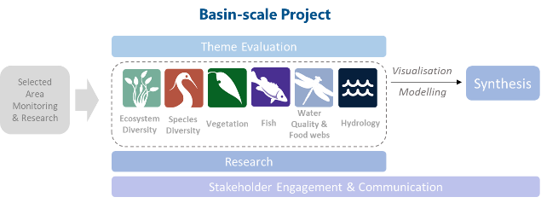

Figure Basin-scale Project evaluation reports on Commonwealth environmental water outcomes for the 6 Basin Themes as well as a high-level Basin-scale synthesis

The evaluation is informed by Basin-scale research projects, stakeholder engagement and communication, including Indigenous engagement, visualisation and modelling, as well as the 7 Selected Area projects

About the Basin-scale evaluation

Water delivery and outcomes data provided by CEWO is used in conjunction with monitoring data provided by the 7 Selected Areas and other publicly available data to undertake the Basin-scale evaluation. The research and evaluation content is structured into 6 disciplinary themes. Technical reports for each of the 6 themes are available from the [CEWO](https://www.environment.gov.au/water/cewo/publications/environmental-water-outcomes-framework) website.

The evaluation aims to address theme specific questions in relation to how Commonwealth environmental water contributed to, supported, or influenced environmental outcomes. Commonwealth environmental water is often delivered in conjunction with other environmental water holdings, and non-environmental water releases (such as for irrigation or during high-flow events). The evaluation consequently draws on available information to estimate (where possible) the specific contribution of Commonwealth environmental water to particular environmental outcomes. The way in which this contribution is assessed varies between the 6 themes depending on the data and tools currently available:

modelling to estimate and compare outcomes both with and without Commonwealth environmental water (counterfactual modelling) – Hydrology (instream); Fish (multi-year evaluation)

identification of ecological response in locations that received Commonwealth environmental water (potentially in conjunction with other sources of environmental water or non-environmental water), and where feasible, comparison with areas that did not receive Commonwealth environmental water – Ecosystem Diversity, Species Diversity, Vegetation

use of flow and water quality metrics to infer likely outcomes – Hydrology (inundation); Food Webs and Water Quality

synthesis of findings across Selected Areas – Fish (annual); Vegetation; Food Webs and Water Quality.

Summary

The 3-year Flow-MER Basin-scale Evaluation and Research Project (the Basin-scale project) aims to: demonstrate Basin-scale outcomes of Commonwealth environmental water; support adaptive management; and fulfil Commonwealth Environmental Water Holder (CEWH) legislative requirements under the Commonwealth’s Basin Plan 2012.

Strategic management of Commonwealth environmental water by the CEWH is key to achieving Basin Plan environmental objectives. The Flow-MER Hydrology theme seeks to evaluate the contribution of Commonwealth environmental water to the restoration of flow regimes and connectivity. A 3-step process is implemented to: (i) identify flow outcomes to support evaluation of Commonwealth environmental water effects on flow regimes; (ii) identify resultant inundation outcomes to enable evaluation of whether environmental flow management achieved the expected inundation and connectivity outcomes; and (iii) use the flow, inundation and connectivity outcomes to evaluate the environmental outcomes and, over time, improve our understanding of environmental water requirements.

This current Basin-scale evaluation covers the 2019–20 water year (1 July 2019 to 30 June 2020) and outcomes achieved over the 6-year period 1 July 2014 to 30 June 2020 in the valleys of the Basin where Commonwealth environmental water has been delivered. Although the Basin has 25 valleys, valley-based reporting is provided for the 19 valleys, of which 2 did not receive Commonwealth environmental water in 2019–20. Conditions are reported at 71 sites to show variations in hydrological outcomes throughout the Basin. Hydrological outputs are synthesised at the Basin scale.

The hydrological evaluation examines the contribution of Commonwealth environmental water to 4 features of the Basin’s hydrology: base flows; freshes; lateral hydrological connectivity with the floodplain; and longitudinal hydrological connectivity downstream through the Basin. These components were chosen as they align with the determination of the environmental watering requirements of environmental assets and ecosystem functions sought in the Basin Plan and the Basin-wide environmental watering strategy. They also represent the typical components of the hydrograph that environmental water managers can influence under flow delivery constraints:

* Base flows are low flows in the river that occur during drier conditions and are evaluated relative to conditions prior to water resource development.
* Freshes are short-term flow events that submerge lower parts of the river channel. Three levels of freshes are evaluated based on their occurrence relative to the frequency typically targeted by environmental flow programs.
* Lateral hydrological connectivity is the movement of water between the channel and floodplain. The contribution of environmental water is evaluated based on the area of floodplain that has been inundated.
* Longitudinal hydrological connectivity is the transport pathway along the whole length of the river. Improvements are reported as the increase in end-of-valley flows as a result of Commonwealth environmental water.

In 2019–20, the Border Rivers was the only valley where mean rainfall was ‘very much below average’ (8.5%). In the remaining valleys where Commonwealth environmental water was delivered, rainfall was classified as ‘average’ or ‘below average’ conditions. The Broken, Campaspe, Edward/Kolety–Wakool, Goulburn, Lachlan, Loddon, Macquarie, Warrego and Wimmera valleys experienced ‘average’ rainfall conditions, while rainfall in the Barwon Darling, Central Murray, Condamine Balonne, Gwydir, Lower Darling, Lower Murray, Murrumbidgee, Namoi and Ovens was ‘below average’. Total surface water inflows in the Basin were 15,867 gigalitres (GL), which was less than the 6-year average (19,936 GL). Basin storages experienced net filling of approximately 1,954 GL.

In the 2019–20 water year, 1,195 GL of Commonwealth environmental water was used from the Commonwealth’s environmental water holdings. This water was delivered to support restoration objectives of rivers, wetlands and floodplains across 17 valleys of the Basin. Through coordination with delivery partners and prerequisite policy measures availability in selected valleys, the Commonwealth Environmental Water Office (CEWO) was able to reuse water moving between valleys as return flows.[1] By using return flows, the 1,195 GL of Commonwealth environmental water resulted in the equivalent use of 1,705 GL across 125 watering actions: 53 targeted instream flow components, comprising 25 base flows, 17 freshes; 2 overbank flows and 9 combinations of base flows, freshes and overbank deliveries. A total of 65 watering actions supported wetlands and 7 actions supported a combination of wetland and/or instream flow components. The northern valleys received approximately 251 GL of environmental water, most of which was sourced from unregulated flow licences. The southern valleys received the majority of Commonwealth environmental water (1,454 GL). Despite a very dry start to the 2019–20 water year, wetland and floodplain inundation occurred in many parts of the Basin. Commonwealth environmental water made a substantial contribution to improved lateral connectivity, including 177,260 ha of lakes and wetlands and 13,844 ha of floodplain inundation.

Most of the Commonwealth environmental water delivered in the southern Basin was via dam releases during 3 periods: start July to end August, start September to mid-January, and April to June. In the 2019–20 water year, 2 large pulses were evident, one in winter and one in early spring. In 2019–20, annual streamflow totals were below the average volumes expected under pre–water resource development conditions. Flow volumes were particularly low in the northern tributaries of the Gwydir, Macquarie, Namoi and Warrego valleys and throughout the Barwon–Darling River. Across the Basin, flow volumes were typically higher at upstream sites but still well below the average volumes under pre-development conditions, while volumes at sites further downstream were very low, though this did vary due to large-scale isolated rain and coincident inflows.

Across the 6-year monitoring program, Commonwealth environmental water and other environmental water entitlement holders generally delivered water with the same seasonal patterns. Given the strong coordination between environmental water entitlement holders to deliver joint watering actions in many cases, any differences in timing will more likely be a result of this coordination rather than differing strategies. Over the 6 years of monitoring, environmental water entitlements have rarely contributed more than 80% of the annual flow volume. The influence of environmental water is evident across all valleys except the Ovens, some sites in the Border Rivers and upper Murray River where proportions are less than 10%. There is a general downstream gradient of increasing influence of environmental water in the Goulburn, Gwydir, Lachlan, Macquarie and Murray rivers. In some years, environmental water comprises 50% or more of the total volume at sites in the lower reaches of the Gwydir, lower Macquarie, lower Lachlan, Loddon, Darling Anabranch and lower Murray. The difference between northern and southern tributaries is largely a function of the larger entitlements held and delivered in the southern Basin and the diversity of strategies available for active management of water in the southern Basin.

Outcomes from the hydrology theme are used to support the analysis of the remaining 5 themes of the Flow-MER Basin-scale evaluation for the purpose of evaluating the ecological outcomes of Commonwealth environmental water.

Contents

Overview of Flow-MER i

About the Basin-scale evaluation ii

Summary iii

Abbreviations, acronyms and terms viii

1 Introduction 1

1.1 About this report 1

1.2 Evaluation objectives 2

2 Approach 5

3 Basin-scale evaluation 7

3.1 Climate and hydrology 7

3.2 Surface water inflows 8

4 Environmental water delivery 10

4.1 Water year 2019–20 10

4.2 Water years 2014–20 10

4.3 Timing of environmental water delivery 12

5 Streamflow volumes 14

6 Base flows 17

6.1 Very low flows 17

6.2 Low flows 18

7 Freshes 20

7.1 Low freshes 20

7.2 Medium freshes 21

7.3 High freshes 23

8 Lateral hydrological connectivity 24

8.1 Water year 2019–20 24

8.2 Water years 2014–20 26

9 Basin-wide watering strategy expected hydrological outcomes 28

9.1 Longitudinal connectivity 28

9.2 Lateral connectivity 30

9.3 The Coorong, Lower Lakes and Murray Mouth 31

Appendix A Details of evaluation methods 34

A.1 Data sources for evaluating contribution to flow regimes 34

References 44

Figures

Figure 1 The 7 Selected Areas and 25 valleys established for long-term monitoring of the effects of environmental watering under the LTIM Project and Flow-MER Program (2014–15 to present) i

Figure 2 Basin-scale Project evaluation reports on Commonwealth environmental water outcomes for the 6 Basin Themes as well as a high-level Basin-scale synthesis ii

Figure 1.1 Map showing the valleys assessed for the 2019–20 evaluation 3

Figure 1.2 Schematic of locations and names of the 71 hydrological indicator sites selected for evaluation 4

Figure 2.1 Conceptual diagram indicating threshold water levels corresponding to the 3 freshes and 2 base flows used in this evaluation 5

Figure 3.1 Map of annual rainfall condition 2019–20 7

Figure 3.2 Maps of annual rainfall condition 2014–20 8

Figure 3.3 Annual surface water inflows in the Basin over 20-year period, 2000–20 9

Figure 4.1 Aggregated environmental water volumes delivered by all environmental water entitlement holders, 2014–20, in the (left) northern Basin, and (right) southern Basin 13

Figure 5.1 Annual flow volumes, 2014–20, as a percentage of mean pre-development annual flow volume at each of the 71 hydrological indicator sites 14

Figure 5.2 Percentage of annual flow, 2014–20, sourced from an environmental water entitlement at each of the 71 hydrological indicator sites 15

Figure 5.3 Percentage of annual environmental water volume, 2014–20, provided by Commonwealth environmental water at each of the 71 hydrological indicator sites 16

Figure 6.1 Very low flow base flow annual scores, 2014–20, at each of the 71 hydrological indicator sites (circles) and the contribution of Commonwealth and other environmental water to the score for each valley (column charts) 18

Figure 6.2 Low flow base flow annual scores, 2014–20, at each of the 71 hydrological indicator sites (circles) and the contribution of Commonwealth and other environmental water to the score for each valley (column charts) 19

Figure 7.1 Low fresh annual scores, 2014–20, at each of the 71 hydrological indicator sites (circles) and the contribution of Commonwealth and other environmental water to the score for each valley (column charts) 21

Figure 7.2 Medium fresh annual scores, 2014–20, at each of the 71 hydrological indicator sites (circles), and the contribution of Commonwealth and other environmental water to the score for each valley (column charts) 22

Figure 7.3 High fresh annual scores, 2014–20, at each of the 71 hydrological indicator sites (circles) and the contribution of Commonwealth and other environmental water to the score for each valley (column charts) 23

Figure 8.1 Maps of inundation extent over the period 2014–20 to which Commonwealth environmental water contributed 27

Figure 9.1 Progress towards expected outcomes for base flows, as percentage duration of expected outcome for low or very low flows, reported for each valley 29

Figure 9.2 Percentage increase in annual flow volumes in (left) the Darling River at Louth and (right) the Murray River at the South Australian border, directly attributable to Commonwealth environmental water 30

Figure 9.3 Progress towards expected outcomes for increased freshes as a result of Commonwealth environmental water 2014–20 31

Figure 9.4 Contribution of Commonwealth environmental water towards maintaining water levels in Lake Alexandrina (one of the 2 Lower Lakes) above 0.4 m AHD, 2014–20 33

Tables

Table 4.1 2019–20 watering actions by valley and hydrological flow components supported by Commonwealth environmental water 11

Table 8.1 Areas of lakes and wetlands and floodplains and the length of waterways attributable to Commonwealth environmental watering actions in 2019–20, by valley 24

Table 8.2 Frequency (years) with which the same hectare was watered by Commonwealth environmental water, 2014–20, reported by valley 26

Table 9.1 Contribution of Commonwealth environmental water to barrage releases (gigalitres) with and without Commonwealth environmental water (Cew) over the 6-year monitoring period 32

Table A.1 Data sources for evaluating the contribution of Commonwealth environmental water to flow regimes at 126 streamflow sites in 2019–20 34

Table A.2 Data reliability scale 35

Table A.3 Reliability of raw data used in the evaluation 36

Table A.4 Websites used to source discharge data for 126 streamflow sites in the Murray–Darling Basin 36

Table A.5 Description of the method used to derive inundation across valleys where inundation was reported 38

Table A.6 Flow components included in the Basin Plan and those that are included in the Flow-MER Basin-scale evaluation 41

Abbreviations, acronyms and terms

| Abbreviation/ acronym/ term | Description |
| --- | --- |
| 2019–20 | water year, 1 July 2019 to 30 June 2020 |
| ANAE | Australian National Aquatic Ecosystem (a classification framework for aquatic ecosystems) |
| Basin Plan | (Murray–Darling) Basin Plan 2012 made under subparagraph 44 (3)(b)(i) of the Water Act 2007 [Basin Plan 2012 (legislation.gov.au)](https://www.legislation.gov.au/Details/F2018C00451) |
| Cew | Commonwealth environmental water (in figures/tables) |
| CEWH | Commonwealth Environmental Water Holder |
| CEWO | Commonwealth Environmental Water Office |
| CLLMM | Coorong, Lower Lakes and Murray Mouth |
| CMA | Catchment Management Authority |
| CSIRO | Commonwealth Scientific and Industrial Research Organisation ([csiro.au](http://www.csiro.au)) |
| DEM | digital elevation model |
| EWKR | Environmental Water Knowledge and Research Project (2014–2019) |
| Flow-MER | The CEWO Monitoring, Evaluation and Research Program (2019–2022) |
| GA | Geoscience Australia |
| GL | gigalitres |
| GMW | Goulburn-Murray Water |
| high fresh | flow spell that raises water levels at least half of the height of the bank above the low flow level |
| low flow base flow | flow that falls below the 95th percentile exceedance flow in the unimpacted monthly flow series or 10% of the mean unimpacted flow, whichever is greater |
| low flow base flow score | relates to the duration of flows below a level that might typically be used as a minimum environmental flow to maintain low flow habitats |
| low fresh | flow spell that raises water levels at least one-eighth of the height of the bank above the low flow level. Such freshes would be a very frequent occurrence in both the dry and wet seasons under pre-development conditions |
| LTIM | Long Term Intervention Monitoring (Project) (2015–2019) |
| MDBA | Murray–Darling Basin Authority |
| medium fresh | flow spell that raises water levels at least one-quarter of the height of the bank above the low flow level. This threshold would be a frequent occurrence in the pre-development regime maintaining moist soils |
| MIKE | a water modelling platform |
| NDVI | Normalized Difference Vegetation Index |
| NFSA | Nature Foundation South Australia |
| NRM | Natural Resource Management |
| SA DEWNR | South Australian Department of Environment, Water and Natural Resources |
| SARDI | South Australian Research and Development Institute |
| very low flow | flow spell that falls below the lowest flow in the unimpacted monthly flow series or 2% of mean unimpacted flow, whichever is greater. This threshold corresponds to exceptionally low flows at the lower end of the range that would normally occur in an unimpacted perennial river |
| very low flow base flow score | relates to the duration of flows below the very low flow threshold |

# Introduction

The Commonwealth Environmental Water Holder (CEWH) manages Commonwealth environmental water, one of the key means by which the Australian Government seeks to achieve the Commonwealth’s Murray–Darling Basin Plan 2012 environmental objectives. The Commonwealth’s environmental water holdings are released strategically towards specified environmental outcomes as described in the Basin-wide environmental watering strategy. This report seeks to evaluate the contribution of Commonwealth environmental water to the restoration of:

* flow regimes, including relevant flow components set out in the Basin Plan (Paragraph 8.51(1)(b))
* hydrological connectivity between the river and floodplain and between hydrologically connected valleys.

This Hydrology evaluation underpins the ecological outcomes analysis for indicators at the Basin scale (grouped within 6 Basin Themes: Ecosystem Diversity, Species Diversity, Vegetation, Fish, Food Webs and Water Quality; and Hydrology; see Figure 2). This is a 3-step process:

1. Identify flow outcomes to support evaluation of Commonwealth environmental water effects on flow regime.
2. Identify resultant inundation outcomes to enable evaluation of whether environmental flow management achieved the expected inundation and connectivity outcomes. This takes the form of inundation mapping across the Basin.
3. Use the inundation and connectivity outcomes to evaluate the environmental outcomes and, over time, improve our understanding of environmental water requirements. These evaluations are conducted separately within relevant ecological theme evaluations.

This evaluation is a collaborative undertaking between the Commonwealth Environmental Water Office (CEWO) with the evaluation team working across the University of Canberra and CSIRO Land and Water. The CEWO coordinates compilation of operational data to characterise Commonwealth environmental water delivery by valley. The evaluation team undertakes the analysis and interpretation of these data to evaluate Basin-scale hydrological outcomes. The work draws on that undertaken under LTIM (Stewardson and Guarino 2020) with updates to include the 2019–20 year.

## About this report

This report presents the outcomes of Commonwealth environmental watering for the most recent water year (1 July 2019 to 30 June 2020), as well as outcomes since the beginning of the monitoring program in 2014 (i.e. the 6 years from 1 July 2014 to 30 June 2020).

Hydrological outcomes inform the broader evaluation of biodiversity, ecosystem function and resilience at the Basin scale. The report refers only to specific outcomes within individual valleys where these provide important information on the Basin-wide outcomes. A systematic account of outcomes at the valley scale can be viewed in the Valley-scale hydrology report cards (Technical Supplement to this report, Guarino 2021).

The hydrological analysis methods and underpinning datasets have undergone improvement over the 6-year evaluation as anticipated in the initial program plan. For this report, results across all 6 years have been updated using best available information, data and methods. For this reason, these ‑6-year results and interpretation supersede results provided in our earlier reports, where they differ.

To maintain consistency with LTIM, much of the text and the majority of figures and tables in this report are in the same format as, or have been adapted from, Stewardson and Guarino (2020).

## Evaluation objectives

This report describes the short-term (1-year) and longer term (6-year) evaluation of:

What did Commonwealth environmental water contribute towards the restoration of the hydrological flow regime?

The evaluation is undertaken at the site, valley and Basin scale. Under this program, valleys evaluated for hydrological assessment are similar to the modified version of the Sustainable Rivers Audit (Davies et al. 2012) valley boundaries (Figure 1.1). These valley boundaries are the most closely aligned with regions targeted for environmental flow delivery. Note that the regulated portion of the Murray River is divided at Lake Victoria into the Central Murray Valley, extending from Hume Dam to Lock 10 (upstream of Lake Victoria); and the Lower Murray Valley, extending from Lake Victoria to the upstream extent of the Lower Lakes. Although the Basin encompasses 25 valleys, valley-based reporting is only provided for the 19 valleys (Figure 1.1) where environmental water has been delivered. Note that in 2019–20, 2 of these valleys (Lower Darling and Namoi) did not receive any Commonwealth environmental water. Hydrological outputs are also synthesised at the Basin scale.

We also report on conditions at 71 gauged sites (Figure 1.2) to represent variation in hydrological outcomes throughout the Basin. The 71 sites are a sample of a larger set of sites used for the valley and Basin evaluations. Detailed information for the full set of sites, including the time series of environmental water delivery, is provided in the Valley-scale hydrology report cards (Technical Supplement to this report, Guarino 2021). Although Commonwealth environmental water was delivered in the Wimmera River in 2019–20, we do not include this valley in our 71-site assessment due to the intermittent nature of environmental flow delivery in this valley.

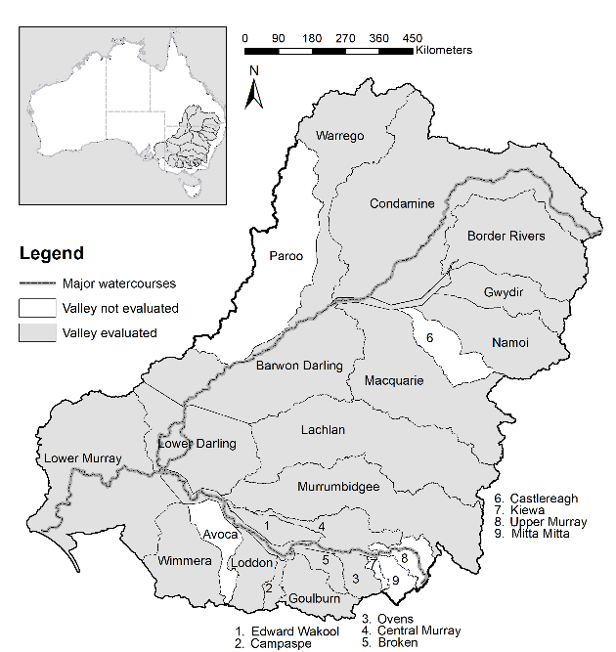

Figure . Map showing the valleys assessed for the 2019–20 evaluation

Hydrological indicator site names and locations are shown in Figure 1.2 Schematic of locations and names of the 71 hydrological indicator sites selected for evaluation.

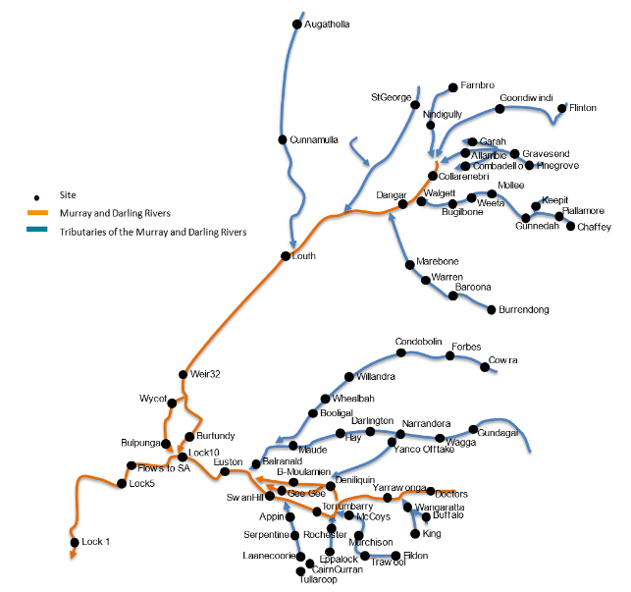

Figure 1. Schematic of locations and names of the 71 hydrological indicator sites selected for evaluation

Sites in the Wimmera Valley are not included due to the intermittent nature of environmental flows in that valley.

# Approach

The hydrological evaluation in this report examines the contribution of Commonwealth environmental water to 4 features of the Basin’s flow regimes:

* base flows
* freshes
* lateral hydrological connectivity with the floodplain
* longitudinal hydrological connectivity downstream through the Basin.

Here we provide a brief introduction to these features. The detail of the evaluation methods is provided in Appendix A.

In the case of base flows and freshes, scores are used to indicate improvements in the flow regimes with environmental water delivery. The scores are calculated using 2 base flow thresholds and 3 fresh thresholds (Figure ).

In the case of base flows, we are concerned with the duration of flows below these thresholds. For freshes, we are concerned with the occurrence of flows above these thresholds. We consider flow magnitude relative to these flow thresholds because: (a) they have environmental significance; and (b) it allows comparison of flow regimes across rivers of different size.

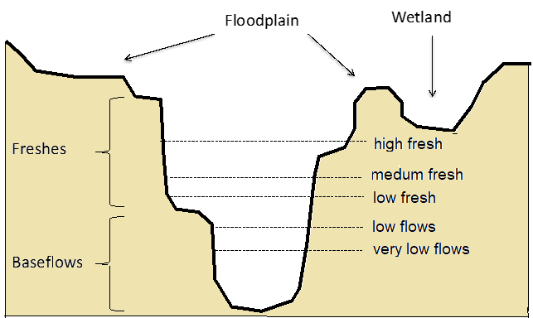

Figure 2. Conceptual diagram indicating threshold water levels corresponding to the 3 freshes and 2 base flows used in this evaluation

### Base flows

Environmental water is delivered across the Basin to maintain base flows. We report 2 base flow scores to evaluate the contribution of Commonwealth environmental water to the flow regime. Low flow base flow scores indicate excessive duration of low flow conditions relative to conditions before water resource development. The score varies between 0% and 100%. A low score indicates dry conditions with low flow conditions persisting much longer than would have occurred before development. A score of 100% indicates base flow conditions that are similar to pre-development. We use scores related to 2 base flow thresholds:

* A very low flow is defined as a flow that falls below the lowest flow in the unimpacted monthly flow series or 2% of mean unimpacted flow, whichever is greater. This threshold corresponds to exceptionally low flows at the lower end of the range that would normally occur in an unimpacted perennial river. The very low flow base flow score relates to the duration of flows below this threshold.
* The low flow base flow score relates to the duration of flows below a level that might typically be used as a minimum environmental flow to maintain low flow habitats. These are defined as flows that fall below the 95th percentile exceedance flow in the unimpacted monthly flow series or 10% of the mean unimpacted flow, whichever is greater. This flow threshold corresponds to a value that might typically be used as a minimum flow to maintain low flow habitats.

### Freshes

Three scores relate to the occurrence of freshes. A score of 0% indicates that very few or no freshes have occurred, and a score of 100% indicates that freshes have occurred at a frequency typically targeted by environmental flow programs (Stewardson and Guarino 2018). The 3 scores relate to freshes that exceed flow thresholds within the river channel:

* A low fresh is defined as a flow spell that raises water levels at least one-eighth of the height of the bank above the low flow level. Such freshes would be a very frequent occurrence in both the dry and wet seasons under pre-development conditions.
* A medium fresh is defined as a flow spell that raises water levels at least one-quarter of the height of the bank above the low flow level. This threshold would be a frequent occurrence in the pre-development regime maintaining moist soils.
* A high fresh is defined as a flow spell that raises water levels at least half of the height of the bank above the low flow level. Freshes of this magnitude would have occurred in most years in the unimpacted flow regime, often multiple times.

### Lateral hydrological connectivity

Environmental water is used to fill wetlands and water other habitats across the floodplains of the Basin using a variety of delivery methods. The movement of water between the channel and floodplain is described as lateral hydrological connectivity. This contribution of environmental water is evaluated based on the area of floodplain that has been inundated.

### Longitudinal hydrological connectivity

The low reaches of each river valley and the entire Basin are particularly vulnerable to upstream water withdrawals, with flows declining to severely low levels and even ceasing in some cases. The protection of environmental water entitlements in these valleys is intended to increase flow volumes passing down to these lower reaches. Improvements in longitudinal hydrological connectivity are evaluated by reporting the increase in end-of-valley flows as a result of Commonwealth environmental water.

The Coorong, Lower Lakes and Murray Mouth (CLLMM) are a unique feature of the Basin and dependent on longitudinal hydrological connectivity from upstream for the supply of fresh water. We include a close examination of the contribution of Commonwealth environmental water to the hydrology and related processes of this system.

# Basin-scale evaluation

## Climate and hydrology

In 2019–20, the Border Rivers was the only valley with ‘very much below average’ rainfall conditions. In the remaining valleys where Commonwealth environmental water was delivered, rainfall was classified as ‘average’ or ‘below average’ condition compared with the entire record held by the Australian Bureau of Meteorology (Figure 3.1). The Broken, Campaspe, Edward/Kolety–Wakool, Goulburn, Lachlan, Loddon, Macquarie, Warrego and Wimmera experienced average rainfall conditions, while rainfall in the Barwon Darling, Central Murray, Condamine Balonne, Gwydir, Lower Darling, Lower Murray, Murrumbidgee, Namoi and Ovens was below average.

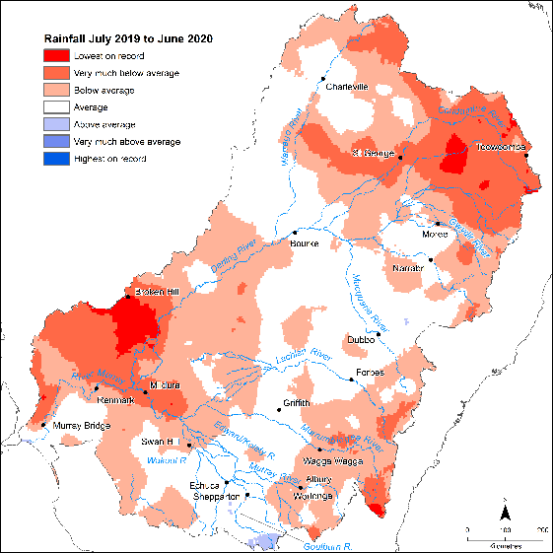

Figure 3. Map of annual rainfall condition 2019–20

Data sourced from the Bureau of Meteorology

Dry conditions were common in the Basin for the 6 years from mid-2014 to mid-2020 – the period of Commonwealth Basin-scale monitoring and evaluation (Figure 3.2). The first 2 years saw particularly dry conditions in the southern Basin. In 2016–17, there were wetter conditions in the southern Basin and along the headwaters of the New South Wales tributaries in the northern Basin. However, conditions have returned to dry over the period 2017–20 across the whole Basin.

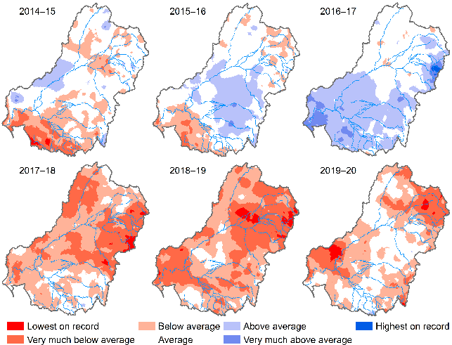

Figure . Maps of annual rainfall condition 2014–20

The 2019–20 map is shown in detail in Figure 3.1. Data sourced from the Bureau of Meteorology

## Surface water inflows

Total surface water inflows in the Basin were 15,867 GL in 2019–20, somewhat less than the 6-year average of 19,936 GL (Figure 3.3, top). Basin storages experienced net filling of approximately 1,954 GL.

In the northern Basin, total inflows were well below the average for the period since 2001 (Figure 3.3, bottom), with inflows falling within the first quartile of inflows. Northern Basin inflow totals were 80% of the average experienced since the Commonwealth’s monitoring and evaluation program began.

In the southern Basin, total inflows were slightly below the average for the period since 2001 (Figure 3.3, middle). The last 20 years have been a dry period for the southern Basin with persistent low inflows during the Millennium Drought and only a brief respite in 2 years (2010–11 and 2011–12) before returning to dry conditions, with some relief also in 2016–17. However, 2019–20 is still regarded as low inflow compared with averages in the 21st century.

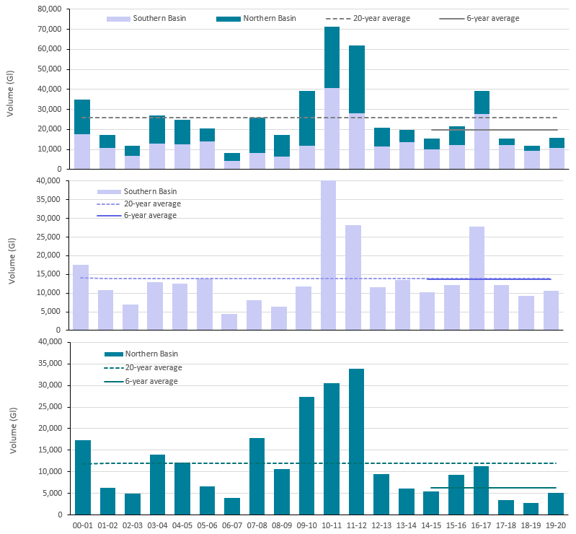

Figure . Annual surface water inflows in the Basin over 20-year period, 2000–20

Top chart shows total inflows for the Basin, middle chart shows southern Basin inflows, bottom chart shows northern Basin inflows. All charts include 20-year and 6-year averages (Data source: Australian Bureau of Meteorology National Water Account).

# Environmental water delivery

## Water year 2019–20

In the 2019–20 year, 1,195 GL of Commonwealth environmental water were debited from the CEWH environmental water holdings. The environmental water was delivered to support restoration objectives of rivers, wetlands and floodplains across 17 valleys of the Basin (Figure 1.1). Through coordination with delivery partners and prerequisite policy measures available in some valleys, the CEWH was able to reuse some of its debited water to deliver a total of 125 watering actions to the equivalent use of 1,705 gigalitres (GL) (Table 4.1).

Commonwealth environmental water supported 53 actions (42% of actions or 94% by volume) for instream flow component types: base flows (25 actions), freshes (17 actions), overbank flows (2 actions), combinations of base flows and freshes (7 actions) and combinations of base flow, freshes and overbanks (2 actions). Of the remaining actions, 65 (52% of actions) were delivered to support wetlands (3% by volume), while the remaining 7 actions were purposed as combination flows supporting both wetland and instream flow components (3% by volume).

The northern valleys received approximately 251 GL of environmental water, most of which was largely sourced from unregulated flow licences. The Condamine Balonne received the largest volume of approximately 67% of northern valley Commonwealth environmental water. The Gwydir was the only northern system that received water through active management.

The southern valleys received most of the 2019–20 Commonwealth environmental water, with some of the larger deliveries being to the Lower Murray (767 GL, 53% of the southern valley share), the Goulburn (316 GL, 22%) and the Central Murray (261 GL, 18%).

Despite a very dry start to the 2019–20 water year, Commonwealth environmental water was able to support specified areas across 15,591 km of watercourses watered.

## Water years 2014–20

Over the course of the 6 year Commonwealth monitoring program, 666 independent watering actions were delivered. These actions targeted various flow components from low to high flows and both within and out of the channel. Of these: 300 (45%) targeted delivery to wetlands – the most frequently targeted flow component; approximately 21% targeted base flows; 27% provided freshes; and 1% targeted bankfull and overbank flows. The remaining 6% of actions were flows which were combinations of these flow components.

The distribution of Commonwealth environmental water can also be examined as percentages of water volume across the flow components. Of the 9,510 GL of Commonwealth environmental water delivered over 6 years (since 2014–15), 44% supported base flows, 40% supported freshes, 8% supported wetlands, 6% supported overbank deliveries and <1% supported bankfull flows (excluding the flow combination deliveries of 2019–20).

Of the 17 valleys that have received Commonwealth environmental water at some time during the 6-year period, some of the larger delivered volumes were 45% in the Lower Murray, 14% in the Central Murray, 14% in the Goulburn and 8% in the Murrumbidgee. The remaining valleys received 4% or less of total delivered volume of Commonwealth environmental water.

Table 4.1 2019–20 watering actions by valley and hydrological flow components supported by Commonwealth environmental water

Cell values are number of actions and values in parentheses are volumes in megalitres (BF = base flow, F = fresh, BL = bankfull, O = overbank, W = wetland).

|  |  |  |  |  |  |  |  |  |  |  |
| --- | --- | --- | --- | --- | --- | --- | --- | --- | --- | --- |
| **Valley** | **BF** | **BF-F** | **BF-F-BL** | **BF-F-O-W** | **F** | **F-W** | **O** | **W** | **W-O** | **Total actions (volume)** |
| Northern Basin |  |  |  |  |  |  |  |  |  |  |
| Barwon Darling |  | 1 (28,631) |  |  |  |  |  |  |  | 1 (28,631) |
| Border Rivers |  | 3 (3,247) | 1 (4,651) |  |  |  |  |  |  | 4 (7,898) |
| Condamine Balonne | 2 (167,109) |  |  |  |  |  |  |  |  | 2 (167,109) |
| Gwydir | 1 (6,000) |  |  | 1 (250) |  |  |  |  | 1 (2,820) | 3 (9,070) |
| Macquarie |  |  |  |  |  | 3 (3,896) |  |  |  | 3 (3,896) |
| Warrego | 2 (16,687) |  |  |  | 1 (17,221) |  |  |  |  | 3 (33,908) |
| Southern Basin |  |  |  |  |  |  |  |  |  |  |
| Broken | 3 (15,120) |  |  |  |  |  |  |  |  | 3 (15,120) |
| Campaspe | 2 (1,712) |  |  |  | 3 (1,660) |  |  |  |  | 5 (3,372) |
| Central Murray | 6 (24,631) |  |  |  |  |  | 2 (230,669) | 5 (5,546) |  | 13 (260,847) |
| Edward/Kolety–Wakool |  | 3 (17,295) |  |  |  |  |  | 1 (2,000) |  | 4 (19,295) |
| Goulburn | 5 (77,482) |  |  |  | 2 (238,233) |  |  |  |  | 7 (315,715) |
| Lachlan |  |  |  |  | 2 (4,472) | 1 (17,028) |  | 2 (526) |  | 5 (22,026) |
| Loddon |  |  |  |  | 4 (1,127) |  |  |  |  | 4 (1,127) |
| Lower Murray | 3 (227,759) |  |  |  | 2 (522,372) |  |  | 43 (16,434) |  | 48 (766,565) |
| Murrumbidgee |  |  |  |  |  |  |  | 12 (19,325) | 2 (29,010) | 14 (48,335) |
| Ovens | 1 (50) |  |  |  | 1 (53) |  |  | 2 (20) |  | 4 (123) |
| Wimmera |  |  |  |  | 2 (1,562) |  |  |  |  | 2 (1,562) |
| Flow component summary number actions (volume) | 25 (536,550) | 7 (49,173) | 1 (4,651) | 1 (250) | 17 (786,700) | 4 (20,924) | 2 (230,669) | 65 (43,852) | 3 (31,830) | 125 (1,704,598) |

Note: Lower Darling and Namoi valleys did not receive Commonwealth environmental water in 2019–20

## Timing of environmental water delivery

Most of the Commonwealth environmental water delivered in the southern Basin during the 2019–20 water year was via dam releases during 3 periods: start July to end August, start September to mid-January, and April to June. This included 2 large pulses – one in winter and one in early spring (Figure 4.1, right).

The general seasonal pattern of water delivery in the southern Basin was consistent with previous years although overall volumes of water in the system were much lower. Despite lower flows and lower volumes from other environmental water contributors, the proportional Commonwealth environmental water contribution increased significantly from 50% in 2018–19 to 77% in 2019–20.

In the northern Basin, environmental water was primarily delivered as a single large pulse during the second half of the water year, reflecting the triggering of unregulated entitlements in the northern valleys, through the Condamine Balonne, Border Rivers and Warrego systems.

Across the 6 years of the monitoring program, Commonwealth environmental water and other environmental water entitlement holders generally delivered water with the same seasonal patterns. Given the strong coordination between environmental water entitlement holders to deliver joint watering actions in many cases, any differences in timing are more likely a result of this coordination rather than differences in strategies.

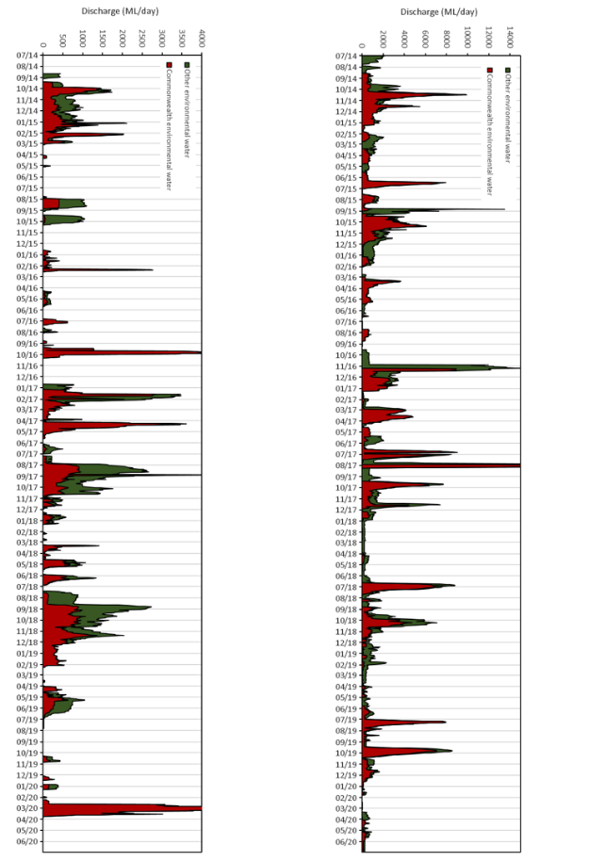

Figure . Aggregated environmental water volumes delivered by all environmental water entitlement holders, 2014–20, in the (left) northern Basin, and (right) southern Basin

# Streamflow volumes

In 2019–20, annual streamflow totals were below the average volumes expected under pre–water resource development conditions (Figure 5.1). Flow volumes were particularly low in the northern tributaries of Gwydir, Macquarie, Namoi and Warrego valleys and throughout the Barwon–Darling Valley.

Across the southern Basin, flow volumes were typically higher at upstream sites within valleys but they were still mostly well below the average volumes under pre-development conditions. Volumes at sites further downstream within valleys were very low, though this did vary due to large-scale isolated rain and coincident inflows. The upper reaches of the Central Murray and Ovens valleys experienced close to average pre-development flow volumes in 2019–20. However, volumes further downstream in the Murray Valley were well below pre-development flows, declining to very low flow volumes in South Australia relative to pre-development levels.

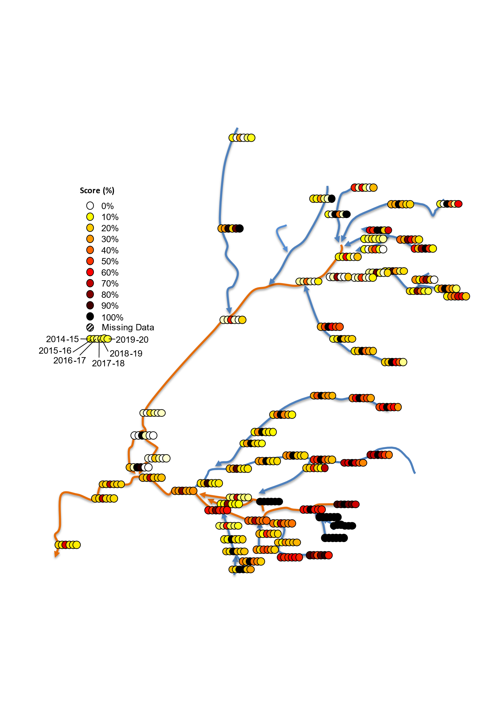

Figure . Annual flow volumes, 2014–20, as a percentage of mean pre-development annual flow volume at each of the 71 hydrological indicator sites

Site names are given in Figure 1.2.

Across the 6 years of the Commonwealth program, most sites in Queensland and throughout the Barwon–Darling Valley experienced low flow volumes (Figure 5.1). However, most of these valleys had at least 1 year (over the 6-year monitoring period) of flow volumes close to the average pre-development flow. The Goulburn, Campaspe and most sites in the Murray Valley downstream of the Ovens Valley confluence experienced well below average pre-development flows throughout the monitoring period. Valleys in New South Wales experienced some respite during the high flow volumes of 2016–17 but otherwise remained low. In contrast to the rest of the Basin, the upper Murray Valley experienced flow volumes close to the average pre-development flow volumes in most years.

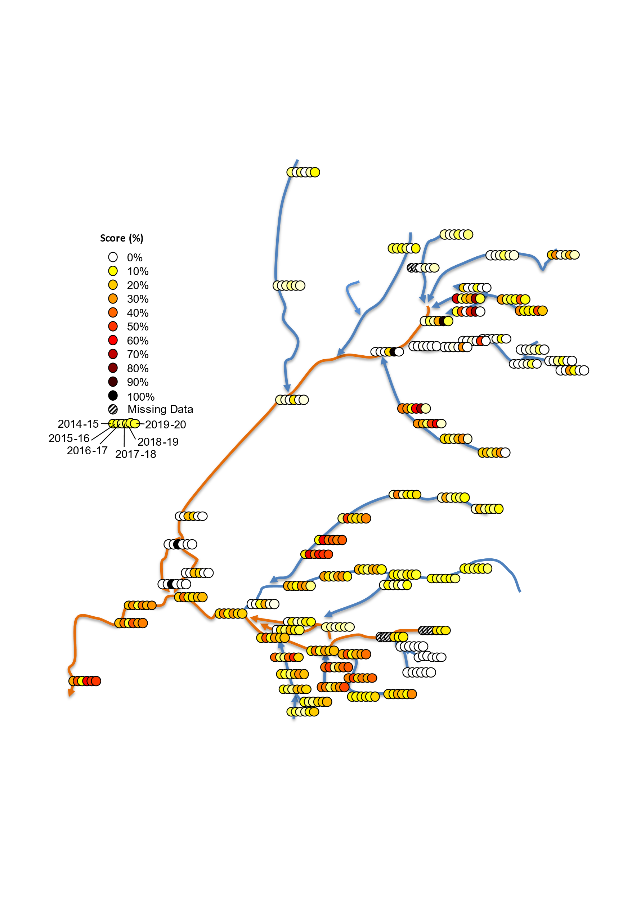

Figure . Percentage of annual flow, 2014–20, sourced from an environmental water entitlement at each of the 71 hydrological indicator sites

Over the 6 years of monitoring, it has been very rare for environmental water entitlements to contribute more than 80% of the annual flow volume (Figure 5.2). The influence of environmental water is, however, evident across all valleys – except in the Ovens, some sites in the Border Rivers and upper Murray Valley, where contributions are less than 10%. There is a general downstream gradient of increasing proportions of flows being environmental water in the Goulburn, Gwydir, Lachlan, Macquarie and Murray valleys. In some years, environmental water is around 50% of the total volume or greater at sites in the lower reaches of the Gwydir, lower Macquarie, lower Lachlan, Loddon, Darling Anabranch and lower Murray valleys. The difference between northern and southern tributaries is largely a function of the larger entitlements held and delivered in the southern Basin as well as the greater diversity of strategies available for active management. Both active environmental water delivery in northern tributaries and the shepherding of water through the downstream valleys are needed to enhance the hydrological regimes of the lower reaches of the northern Basin and particularly the upper Darling Valley.

Since mid-2014, Commonwealth environmental water has comprised almost 100% of the environmental flows in the Warrego, Condamine Balonne, Barwon Darling, Border Rivers, Namoi, Goulburn, Ovens and Edward/Kolety–Wakool valleys (Figure 5.3). In the other valleys, Commonwealth environmental water represents a significant portion in some years.

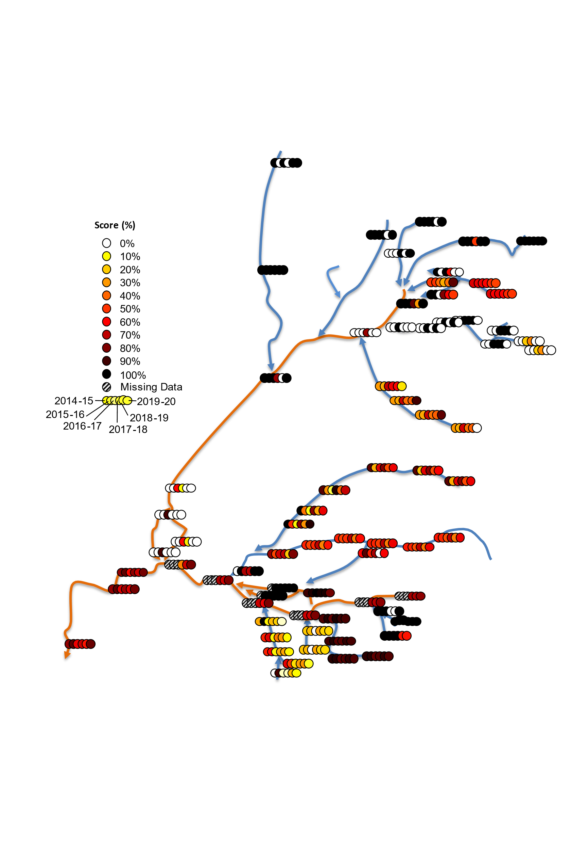

Figure . Percentage of annual environmental water volume, 2014–20, provided by Commonwealth environmental water at each of the 71 hydrological indicator sites

# Base flows

In this evaluation, we consider the contribution of environmental water to maintaining base flows, focussing on periods where flow drops below either the ‘very low flow’[2] or ‘low flow’2 base flow thresholds.

In 2019–20, excessive periods below the very low flow and low flow thresholds occurred at most sites in the northern Basin but were especially profound in the unregulated valleys of the Barwon Darling, Border Rivers, Condamine Balonne and Warrego. The base flows in the Barwon Darling and Condamine Balonne valleys were classified as extremely dry during 2019–20 relative to the pre-development flow regime.

The column charts in Figure 6.1 (very low flow) and Figure 6.2 (low flow) show the contribution of water sources (environmental water and other water) to the achievement of base flow scores.

## Very low flows

In the Barwon Darling Valley during 2019–20 (column 6 in Barwon Darling column chart in Figure 6.1), Commonwealth, other environmental water and other pass flows water made no contribution to the restoration of base flows relative to the pre-development flow series. Across all years, it is apparent that the Barwon Darling Valley has experienced extremely dry low base flow conditions since monitoring of Commonwealth environmental water began in 2014–15. Declining conditions have occurred in the Macquarie Valley in 2019–20 after 3 initial years when low flow conditions were maintained at an average level relative to the pre-development flow regime. The Namoi Valley continued to experience extremely dry conditions relative to the pre-development flow regime, with no contribution of Commonwealth environmental water (largely as a result of lack of water allocation due to the drought). Periods of low flows have generally become more severe in the northern Basin over the 6-year monitoring period. In particular, the Barwon Darling and Namoi have both experienced persistently severe low flow conditions throughout the 6-year monitoring period. The abovementioned valleys highlight the difficulties of actively enhancing base flows with flow entitlements that are passively triggered during high flow conditions.

In contrast, excessive periods of very low flows were largely avoided throughout the southern Basin, with contributions of Commonwealth environmental water (Figure 6.1) delivered to the Broken, Lower Murray, Edward/Kolety–Wakool, Goulburn, Lachlan, Lower Murray and Murrumbidgee valleys. For example, in the Lower Murray Valley, Commonwealth environmental water improved the very low flow base flow score by an increment of 10% (column 6 in Lower Murray column chart in Figure 6.1). In relation to very low flow periods, conditions have remained more or less stable over the 6-year monitoring period for many of the valleys, the contribution of Commonwealth environmental water in the Victorian tributaries was particularly important in avoiding extremely dry base flow conditions. For example, the very low flow base flow conditions in the Goulburn Valley would have been classified as very dry relative to the pre-development condition; however, contributions of Commonwealth environmental water improved the low base flows from ‘very dry’ to ‘dry’.

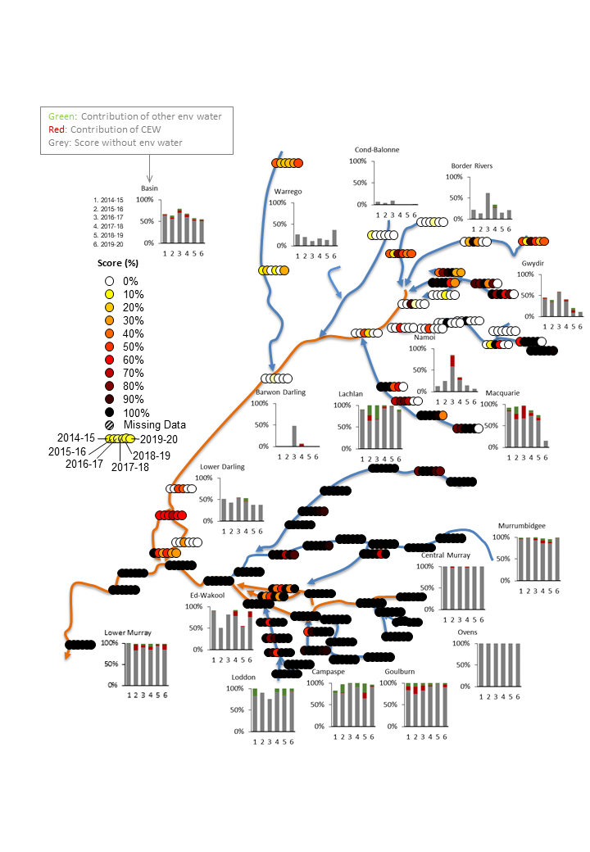

Figure . Very low flow base flow annual scores, 2014–20, at each of the 71 hydrological indicator sites (circles) and the contribution of Commonwealth and other environmental water to the score for each valley (column charts)

In the column charts, scores (y-axis) range from 0% (extremely dry) to 100% (average conditions). X-axis is water year, 1 being 2014–15 through to 6 for 2019–20. Broken and Wimmera valleys are not included as they do not have reliable pre-development simulation models available.

## Low flows

While very low flows were generally avoided, excessive periods below the low flow threshold were widespread throughout the Basin in 2019–20 (Figure 6.2). Increased periods of low flow occurred in the lower reaches of most southern Basin valleys, including the Lower Murray. The exceptions were the Ovens, Goulburn and Campaspe valleys where excessive periods of low flow were largely avoided. Improvements in low flow base flow metrics were seen in the Central Murray Valley and the upper reaches of the Loddon, Campaspe and Goulburn valleys.

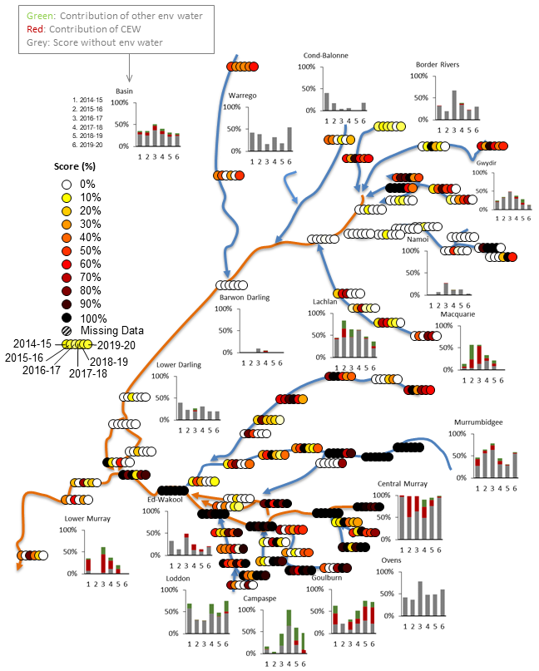

Figure . Low flow base flow annual scores, 2014–20, at each of the 71 hydrological indicator sites (circles) and the contribution of Commonwealth and other environmental water to the score for each valley (column charts)

In the column charts, scores (y-axis) range from 0% (extremely dry) to 100% (average conditions). X-axis is water year, 1 being 2014–15 through to 6 for 2019–20.Broken and Wimmera valleys are not included as they do not have reliable pre-development simulation models available

# Freshes

Freshes are generally understood to support a range of important ecological functions. Three flow thresholds are used to define the onset of a fresh: low fresh, medium fresh and high fresh.[3]

## Low freshes

In 2019–20, low freshes were observed across the Basin, with other passing flows the dominant contributor. In the southern Basin, Commonwealth environmental water enhanced low freshes in the Campaspe, Lachlan and Lower Murray valleys (Figure 7.1). Similarly, in the northern Basin, Commonwealth environmental water enhanced low freshes in the Gwydir and Warrego valleys.

The Lower Darling was the only valley in the Basin to be classified as experiencing extremely dry, low freshes, while the Condamine-Balonne, Namoi and Warrego were the only valleys to experience, very dry, low flow conditions.

In the Macquarie Valley, despite no contributions of Commonwealth environmental water to low freshes during 2019–20 (Figure 7.1), the occurrence and duration of low freshes was assessed as being dry relative to an average year in the pre-development flow series. In contrast, in the Gwydir Valley, where close to 42% of total streamflow was environmental water (of which Commonwealth environmental water contributed 52%), the occurrence and duration of low freshes was enhanced to somewhat dry relative to the pre-development flow series (Figure 7.1). Without environmental water contributions, the Gwydir Valley would have been reduced to a dry classification. More profoundly, in the Lower Murray Valley, low freshes would have scored very dry (relative to the pre-development flow series) without additions of environmental water. Contributions of Commonwealth (53%) and other environmental water (5.8%) were directly responsible for achieving the average score relative to the pre-development flow series (Figure 7.1). This is a profound enhancement of the flow regime in an end-of-system valley.

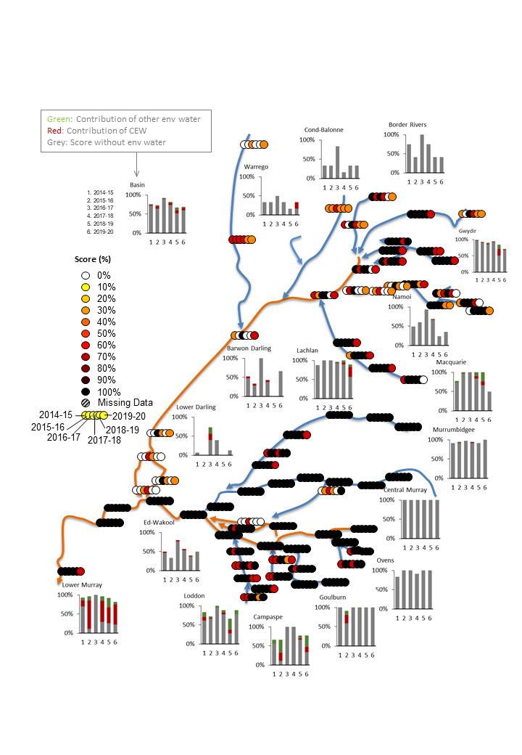

Figure . Low fresh annual scores, 2014–20, at each of the 71 hydrological indicator sites (circles) and the contribution of Commonwealth and other environmental water to the score for each valley (column charts)

In the column charts, scores (y-axis) range from 0% (extremely dry) to 100% (average conditions). X-axis is water year, 1 being 2014–15 through to 6 for 2019–20. Broken and Wimmera valleys are not included as they do not have reliable pre-development simulation models available.

## Medium freshes

Although medium freshes were common and widespread across the Basin (Figure 7.2), Commonwealth environmental water only supported medium freshes in 4 valleys: the Goulburn (average), Lower Murray (average), Gwydir (somewhat dry) and Lachlan (somewhat dry). Without additions of Commonwealth environmental water, the Lower Murray Valley would have experienced extremely dry conditions while the Goulburn and Lachlan valleys would have experienced dry conditions. The Gwydir Valley would have remained unchanged as the enhancements by Commonwealth environmental water were relatively minor (2.5%). Medium freshes elsewhere in the Basin were supported by other passing flows or other environmental water. The Lower Darling and Edward/Kolety–Wakool were the driest valleys, both classified as having a very dry frequency of medium freshes. The Border Rivers, Condamine Balonne, Namoi and Warrego valleys were classified as dry. The medium freshes in the remaining valleys were classified as either somewhat dry or average.

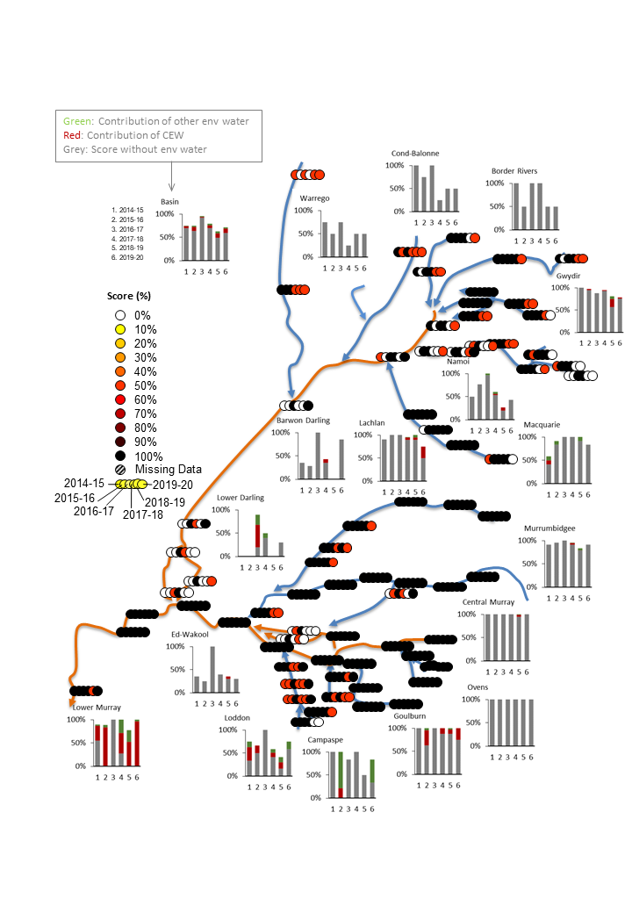

Figure . Medium fresh annual scores, 2014–20, at each of the 71 hydrological indicator sites (circles), and the contribution of Commonwealth and other environmental water to the score for each valley (column charts)

In the column charts, scores (y-axis) range from 0% (extremely dry) to 100% (average conditions). X-axis is water year, 1 being 2014–15 through to 6 for 2019–20. Broken and Wimmera valleys are not included as they do not have reliable pre-development simulation models available.

## High freshes

Across the Basin, more than 50% of sites had a high fresh and, with the exception of the Lower Murray and Campaspe, all valleys experienced a high fresh in 2019–20 (Figure 7.3). The Lower Murray is the only valley not to have experienced a high fresh since 2016–17. The high freshes in the Central Murray and lower Lachlan would not have occurred without the addition of environmental water. These higher magnitude flow freshes would normally be an important part of the flow regime supporting a healthy ecosystem.

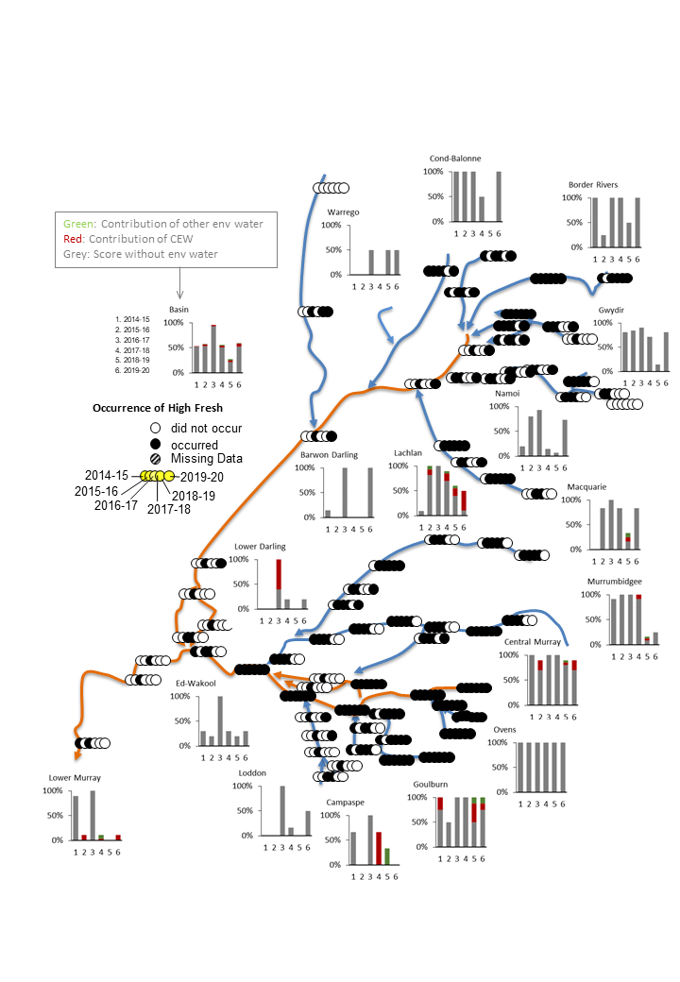

Figure . High fresh annual scores, 2014–20, at each of the 71 hydrological indicator sites (circles) and the contribution of Commonwealth and other environmental water to the score for each valley (column charts)

In the column charts, scores (y-axis) range from 0% (extremely dry) to 100% (average conditions). X-axis is water year, 1 being 2014–15 through to 6 for 2019–20. Broken and Wimmera valleys are not included as they do not have reliable pre-development simulation models available.

# Lateral hydrological connectivity

Lateral hydrological connectivity describes the movement of water between the channel and floodplain. Area of floodplain inundated is used to evaluate the contribution of Commonwealth environmental water. The area inundated is determined by identifying inundation events that included Commonwealth environmental water, and excluded inundation occurring from other passing flows or other environmental watering actions where there was no Commonwealth environmental water (more information is provided in Appendix A). Inundation events including Commonwealth environmental water can also include other sources of water, consistent with the collaborative approach used in water delivery across the Basin. This approach provides an assessment of the role of Commonwealth environmental water in supporting floodplain inundation based on current data and tools.

## Water year 2019–20

In 2019–20, Commonwealth environmental water inundated wetlands and floodplains in many parts of the Basin. This included inundating 177,260 ha of lakes and wetlands, and 13,844 ha of floodplains. Similarly, in-channel deliveries of Commonwealth environmental water affected 15,591 km of Basin waterways (Table 8.1 and Figure 8.1).

Table 8.1 Areas of lakes and wetlands and floodplains and the length of waterways attributable to Commonwealth environmental watering actions in 2019–20, by valley

| **Valley** | **Selected Area** | **Lakes and wetlands area (ha)** | **Floodplain area inundated (ha)** | **Length of  waterways (km)** |
| --- | --- | --- | --- | --- |
| Northern Basin |  |  |  |  |
| Barwon Darling |  | – | – | 1,858 |
| Border Rivers |  | – | – | 935 |
| Condamine Balonne |  | 5,725 | 4,528 | 1,627 |
| Gwydir | Gwydir River System | – | – | 623 |
| Macquarie |  | – | – | 667 |
| Warrego | Junction of Warrego and Darling rivers | – | – | 1,176 |
| Southern Basin |  |  |  |  |
| Broken |  | – | – | 280 |
| Campaspe |  | – | – | 112 |
| Central Murray |  | 30,171 | 1,157 | 2,143 |
| Edward/Kolety–Wakool | Edward/Kolety–Wakool river systems | 3 | 7 | 789 |
| Goulburn | Goulburn River | – | – | 406 |
| Lachlan | Lachlan River System | 4,134 | 943 | 1,488 |
| Lower Darling |  | 45 | 4 | 9 |
| Loddon |  | – | – | 365 |
| Lower Murray* | Lower Murray River | 3,518 | 1,097 | 1,187 |
| Lower Murray (CLLMM) |  | Fresh: 103,422  Estuarine: 23,768 | 65 | – |
| Murrumbidgee | Murrumbidgee River System | 6,470 | 6,043 | 1,495 |
| Namoi |  | – | – | – |
| Ovens |  | 4 | – | 252 |
| Wimmera |  | – | – | 179 |
| Total |  | 177,260 | 13,844 | 15,591 |

*excludes the Coorong, Lower Lakes and Murray Mouth (CLLMM) region

Commonwealth environmental water was attributed as directly contributing to approximately 31,328 ha of inundation in the Central Murray Valley. The inundation observations in the Central Murray Valley (Map 7, Figure 8.1) were achieved with 235,215 ML of Commonwealth environmental water via 2 overbank and 5 wetland actions (Table 4.1). The overbank actions included the ‘winter and spring pulses’. Both actions targeted flows in excess of 15,000 ML per day downstream of Yarrawonga and involved extensive coordination and contributions of water from other water holders. The actions contributed to inundation outcomes in the Barmah–Millewa forest system and other low-lying floodplain areas (see Brooks 2021 for further details). In the absence of Commonwealth environmental water and the coordinating efforts of interested stakeholders, the inundation outcomes observed in the Barmah–Millewa region would not have been realised – without the ‘spring pulse’ action, the high fresh flows, which lasted 34 days, would not have occurred and no other flows in the 2019–20 year achieved this flow threshold/duration (see Guarino 2021).

Commonwealth environmental water, together with water held by other entities, contributed to at least 12,513 ha of inundation in the Murrumbidgee Valley (Table 8.1). The flow component targeted in the Murrumbidgee Valley included 12 actions focussed on wetlands and 2 actions focussed on combination overbank and wetlands (Table 4.1). A total of 48,335 ML of Commonwealth environmental water was used in these actions. The inundated areas were spread between the mid and low regions of the Murrumbidgee Valley. River flows in the Murrumbidgee at Hay and Darlington Point remained below critical thresholds for inundating mid-Murrumbidgee wetlands, despite considerable top-ups from environmental water, which enhanced the medium flow fresh thresholds. In the absence of the coordinated effects of Commonwealth environmental water and other environmental water, the inundated areas of targeted wetlands in the Murrumbidgee would not have been observed. The natural process of water spilling over riverbanks and onto floodplains, flood runner creeks or connected wetlands was overcome through novel methods applied by environmental water practitioners (and their stakeholders) to get water to priority areas by diverting water out of the main river channel with irrigation infrastructure (such as via canals, pipes, levees and pumps).

Although Commonwealth environmental water was not observed as directly contributing to inundation in the Macquarie Marshes in 2019–20, a large unregulated flow event occurred towards the end of February 2020. During this flow event, other passing flows contributed to the broadscale inundation of the Macquarie Marshes. Commonwealth environmental water made an in-channel contribution to the unregulated event through its held supplementary licences. Its contribution was estimated between 2% and 2.5% of the total event flows. In the absence of the addition of Commonwealth environmental water, the inundation outcomes observed in the Macquarie Marshes would have been observed and so inundation was not attributed to Commonwealth environmental water.

Unregulated licences held by the Commonwealth in the Condamine Balonne Valley triggered 167,109 ML of Commonwealth environmental water (Table 4.1). This water was disbursed through 2 base flow actions (Table 4.1) and comprised approximately 10% of the measured in-channel flows at St George on the Balonne River. The Commonwealth environmental water contributions were directly attributed to inundation of approximately 10,253 ha in the Narran Lakes region of the Condamine Balonne (Table 8.1). However, an event-based mechanism was also implemented by the Commonwealth. This interim measure by the Commonwealth granted recipients (irrigators) to forego pumping during the 2019–20 mid-sized flow event (200–500 GL) in the Condamine Balonne. This saw an additional 8,963 ML of water kept in the river channels of the Narran. The Commonwealth environmental water delivery in the Condamine Balonne Valley was attributed as contributing to in-channel flows which affected 1,627 km of river length (through direct contributions to the Condamine, Balonne, Bokhara, Culgoa and Narran rivers) and at least 300 km of the Barwon River, which presumably provided replenishment flows to waterholes.

## Water years 2014–20

Over the course of the 6-year monitoring period, watering of 118,135 ha (excluding the Coorong and Lower Lakes) of wetlands, lakes and floodplains in 13 valleys (Figure 8.1 and Table 8.2) was directly attributable to Commonwealth environmental water: Border Rivers, Broken, Central Murray, Condamine Balonne, Edward/Kolety–Wakool, Gwydir, Lachlan, Lower Darling, Lower Murray, Macquarie, Murrumbidgee, Ovens and Warrego. The Murrumbidgee Valley was observed as having the largest 1-in-6-year inundation frequency, with an estimated 37,206 ha (map 5 in Figure 8.1). This was followed by the Lachlan (21,827 ha) (maps 5 and 8 in Figure 8.1) and the Lower Murray (19,272 ha) (Table 8.2).

The Murrumbidgee (155 ha) and the Lower Murray (551 ha) were the only valleys that had areas inundated in each of the 6 years, whereas 6 valleys (Central Murray, Gwydir, Lachlan, Lower Murray, Macquarie and Murrumbidgee) had the same areas inundated in 5 of the 6 years. Although the Lower Darling showed areas inundated at a frequency of 4 in 6 years, these inundation areas were a result of weir pool manipulations in the Murray River which pushed water into the Lower Darling.

Table 8.2 Frequency (years) with which the same hectare was watered by Commonwealth environmental water, 2014–20, reported by valley

|  |  |  |  |  |  |  |
| --- | --- | --- | --- | --- | --- | --- |
| **Valley** | **1 in 6** | **2 in 6** | **3 in 6** | **4 in 6** | **5 in 6** | **6 in 6** |
| Northern Basin |  |  |  |  |  |  |
| Border Rivers | 124 | 0 | 0 | 0 | 0 | 0 |
| Condamine Balonne | 8,242 | 1,241 | 26 | 0 | 0 | 0 |
| Gwydir | 5,399 | 3,507 | 2,497 | 1,538 | 581 | 0 |
| Macquarie | 9,065 | 6,205 | 3,733 | 2,788 | 5,552 | 0 |
| Warrego | 3,810 | 30 | 0 | 0 | 0 | 0 |
| Southern Basin |  |  |  |  |  |  |
| Broken | 109 | 54 | 0 | 0 | 0 | 0 |
| Central Murray | 12,890 | 9,257 | 6,957 | 2,811 | 1,863 | 0 |
| Edward/Kolety–Wakool | 52 | 26 | 10 | 0 | 0 | 0 |
| Lachlan | 21,827 | 4,850 | 1,052 | 520 | 263 | 0 |
| Lower Darling | 135 | 53 | 37 | 23 | 0 | 0 |
| Lower Murray | 19,272 | 3,924 | 3,275 | 2,463 | 501 | 551 |
| Murrumbidgee | 37,206 | 11,994 | 8,416 | 3,637 | 2,419 | 155 |
| Ovens | 4 | 0 | 0 | 0 | 0 | 0 |
| Total | 118,135 | 41,140 | 26,003 | 13,779 | 11,179 | 705 |

Frequency is in the heading (i.e. 1 in 6 to 6 in 6 years) and values under these headings are hectares (ha) inundated

Reporting excludes the Coorong and Lakes Albert and Alexandrina (Lower Lakes)

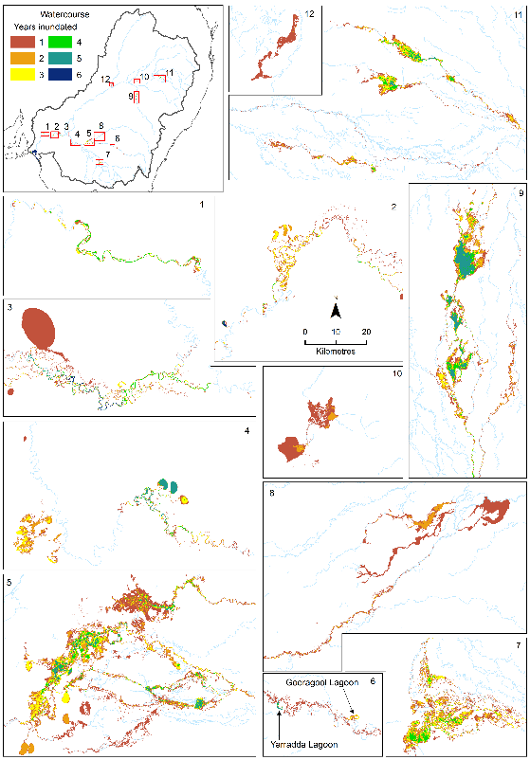

Figure . Maps of inundation extent over the period 2014–20 to which Commonwealth environmental water contributed

Numbered maps represent management areas across the Basin: 1 = Morgan to Moorook conservation parks; 2 = Riverland and Victorian border; 3 = Lake Victoria to Wallpolla Island Forest; 4 =Hattah–Kulkyne Lakes and Robinvale Lakes; 5 = Murrumbidgee and lower Lachlan; 6 = mid-Murrumbidgee; 7 = Barmah Forest – Millewa State Forest Group; 8 = upper Lachlan; 9 =Macquarie; 10 = Narran Lakes; 11 = junction of Warrego and Darling rivers; 12 = Gwydir Wetlands.

# Basin-wide watering strategy expected hydrological outcomes

## Longitudinal connectivity

### Increased base flows

The Basin-wide environmental watering strategy (the Strategy) (MDBA 2019, p 30) describes the expected environmental outcome for base flows as ‘to keep base flows at least 60% of the natural level’. However, the Strategy does not specify how ‘base flow level’ is defined. Nor does it explain how the ‘natural level’ is to be determined. Given no definitions are provided, a base flow metric was developed for reporting on this outcome, and applied at Louth (end of the Darling system) and the South Australian border (downstream of all the tributaries and high confidence in the data). This metric is relevant because it relates to the maintenance of base flows and compares observed base flow durations in each season with the pre-development durations of base flows. More specifically, valley-average values were used for both the very low flow and low flow thresholds. Performance was assessed against this outcome using the lower of these 2 metrics. A score of 0.6 was used as the threshold to indicate achievement of the Strategy outcome.

The results of this analysis (which excluded Wimmera and Broken valleys) are presented in Figure 9.1. In 2019–20, the Central Murray, Goulburn, Loddon, Murrumbidgee and Ovens achieved the expected outcome. By contrast, the Barwon Darling, Condamine Balonne, Macquarie, Namoi and, most significantly, the Lower Murray made poor progress (<20% of base flow durations) towards the expected outcomes in 2019–20.

Across the 6 years of monitoring (2014–20), there was only one valley, the Central Murray, where the expected outcome was achieved in every year. The Goulburn, Loddon, Lachlan and Murrumbidgee valleys achieved the expected outcome in 3 of the 6 years. The Ovens, Campaspe and Macquarie all achieved the expected outcome in 2 of the 6 years. The Border Rivers and Lower Murray achieved the expected outcome once, during the flood year of 2016–17.

The low rainfall across much of the Basin during the monitoring period has contributed to the low level of success in achieving the expected outcome base flows.

Our hydrological thresholds may not be fully reflecting the intended base flow level used in the preparation of the expected outcomes reported in the Strategy. We propose that the expected outcomes be reviewed for reporting in future years with advice from the Murray–Darling Basin Authority on the definition of this outcome in their Strategy, and that the Strategy outcome be well defined in its next version.

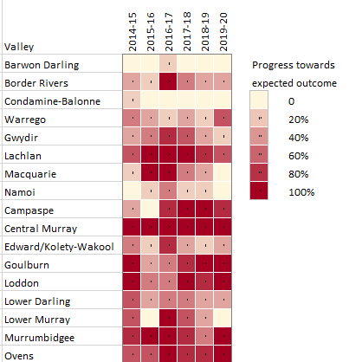

Figure . Progress towards expected outcomes for base flows, as percentage duration of expected outcome for low or very low flows, reported for each valley

Broken and Wimmera valleys were not included in this assessment.

### Increase in flow volumes

The Strategy includes expected outcomes related to increased flows[4] into the Murray and Darling rivers (MDBA 2019, p30):

* ‘a 10% overall increase in flows in the Barwon–Darling: from increased tributary contributions from the Condamine-Balonne, Border Rivers, Gwydir, Namoi and Macquarie-Castlereagh catchments [valleys] collectively’
* ‘a 30% overall increase in flows in the River Murray: from increased tributary contributions from the Murrumbidgee, Goulburn, Campaspe, Loddon and Lower Darling catchments [valleys] collectively’.

Contribution of Commonwealth environmental water at Louth is assessed in relation to the first outcome because it is the first Barwon Darling monitoring site downstream of all the northern tributaries that receives environmental water (Figure 9.2, left). The results indicate that this outcome was achieved in 5 out of 6 years of monitoring. The exception was in 2016–17, where inputs were estimated to be approximately 3%, largely due to high flow conditions. The large addition of Commonwealth environmental water in 2017–18 reflects the 2 large coordinated and protected flow actions (northern fish flow and northern connectivity), where Commonwealth and other environmental water was released from the Border Rivers and Gwydir valleys. Similarly, 2018–19 reflected contributions from high flow conditions in the Warrego Valley and the direction by the Commonwealth to prioritise longitudinal connectivity between the Warrego and Darling rivers. The contributions in 2019–20 were supported by a large flow event in the Condamine Balonne and to a lesser extent the Warrego. Overall in 2019–20, the Commonwealth environmental water contribution was 16% of additional flow (of the total volume) observed at Louth.

Contribution of Commonwealth environmental water to Murray River flows at the South Australian border is assessed in relation to the second outcome because it is a key accounting site and a short distance downstream of all the Murray River tributaries that receive environmental water Figure 9.2, right). Contributions of Commonwealth environmental water supported the achievement of expected outcome levels in 2015–16, 2017–18 and 2019–20, but outcomes were below the expected levels in the other 3 years. Over the 6 years of monitoring, Commonwealth environmental water contributed a total of 18% of additional flow (of the total flow volume) at the South Australian border, which is close to half of the expected outcome volume. And in 2019–20, the Commonwealth environmental water contribution was 33% of additional flow (of the total volume) at the South Australian border.

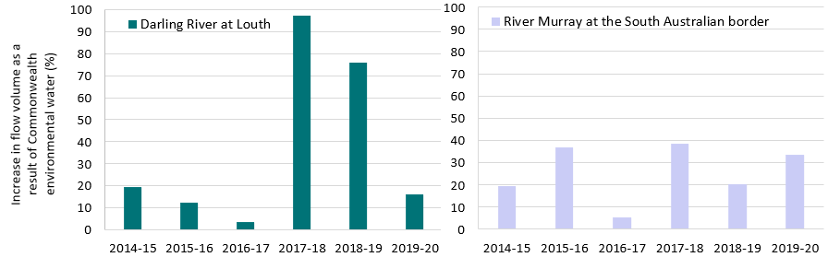

Figure . Percentage increase in annual flow volumes in (left) the Darling River at Louth and (right) the Murray River at the South Australian border, directly attributable to Commonwealth environmental water

## Lateral connectivity

### Increased freshes[5]

The Strategy (MDBA 2019, p31) includes outcomes related to freshes as an indicator of longitudinal connectivity. The expected outcomes are[6]:

* ‘a 30% to 60% increase in the frequency of freshes, bankfull and lowland floodplain flows in the Murray, Murrumbidgee, Goulburn-Broken and Condamine-Balonne catchments [valleys]’7
* ‘a 10% to 20% increase of freshes and bankfull events in the Border Rivers, Gwydir, Namoi, Macquarie‑Castlereagh, Barwon-Darling, Lachlan, Campaspe, Loddon and Wimmera catchments [valleys].’[7]

For these outcomes, the low, medium and high fresh scores (see Chapter 7) are used to assess achievement of the fresh outcome since this score relates to the frequency of fresh events. The frequency of bankfull and overbank events were not considered in this assessment since it is very rare for environmental flows to contribute to channel-filling events. Increment in score as a result of Commonwealth environmental water was considered as the measure of increased occurrence of freshes. The average of this increment was used across the low, medium and high fresh metrics for reporting on this outcome.

The results indicate that Commonwealth environmental water made some progress towards this intended outcome in some valleys and years (Figure 9.3; excludes Broken Valley). In 2019–20, this expected outcome was fully achieved in the Lachlan and Lower Murray. Both these valleys were the target of 2 significant environmental flow freshes. Progress was observed in the Warrego, Campaspe, Central Murray and Goulburn valleys.

Across the 6-year monitoring period, the expected outcome has only been fully achieved in the Lachlan, Gwydir, Lower Murray and Lower Darling valleys for isolated years.

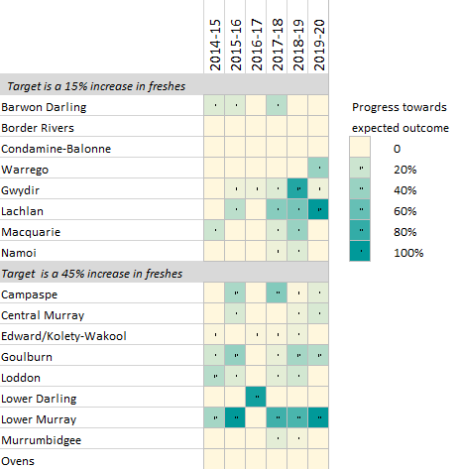

Figure . Progress towards expected outcomes for increased freshes as a result of Commonwealth environmental water 2014–20

Progress is defined as percentage of outcome levels achieved. Broken and Wimmera valleys were not included in this assessment

## The Coorong, Lower Lakes and Murray Mouth

The Strategy includes expected outcomes related to the CLLMM as an indicator of end-of-Basin flows. The evaluations against each of the end-of-Basin flows are documented progressively.

### Flow volume outcome

The Strategy’s minimum expected outcome (MDBA 2019, p30) for connection of the Murray River to its estuary (CLLMM) is:

* ‘the barrage flows are greater than 2,000 GL/year on a three-year rolling average basis for 95% of the time, with a two-year minimum of 600 GL at any time’.

To assess the contribution of Commonwealth environmental water towards achieving this expected outcome, we used the barrage releases with and without Commonwealth environmental water. Table 9.1 shows the annual contribution of Commonwealth environmental water to the barrage releases together with the barrage flows with and without Commonwealth environmental water. The results indicate that Commonwealth environmental water has been effective in ensuring that the 2-year minimum flows did not fall below 600 GL in 5 of the 6 years. Without Commonwealth environmental water this expected outcome would have only been achieved once in the last 6 years – in the flood year of 2016–17. Commonwealth environmental water was released through the barrages in every year of the monitoring program. In 2015–16, 2018–19 and 2019–20, Commonwealth environmental water accounted for 100% of water released through the barrages. Contributions of Commonwealth environmental water have supported the Strategy’s barrage flow expected outcome of 2,000 GL in all years, and its cumulative management is beginning to be realised.

Table 9.1 Contribution of Commonwealth environmental water to barrage releases (gigalitres) with and without Commonwealth environmental water (Cew) over the 6-year monitoring period

Values in parentheses are the 3-year rolling averages from 2013-14; NA = no earlier records available to calculate

|  | **2014–15** | **2015–16** | **2016–17** | **2017–18** | **2018–19** | **2019–20** |
| --- | --- | --- | --- | --- | --- | --- |
| Cew contribution | 453 | 736 | 811 | 755 | 377 | 685 |
| Total barrage release with Cew | 986 (NA) | 736 (1,073) | 6,558 (2,760) | 851 (2,715) | 377 (2,595) | 685 (637) |
| Total barrage release without Cew | 533 (NA) | 0 (500) | 5,747 (2,093) | 96 (1,948) | 0 (1,948) | 0 (32) |

### Water level outcome

The Strategy’s water level outcome in the CLLMM focusses on (MDBA 2019, p31):

* ‘the water levels in the Lower Lakes are maintained above:
  + sea level (0 m AHD) and
  + 0.4 m AHD, for 95% of the time, as far as practicable, to allow for barrage releases’.

For this outcome, water level at Lake Alexandrina was assessed using the pre-buyback counterfactual model. Figure 9.4 shows the water level in Lake Alexandrina both with and without the addition of Commonwealth environmental water. Contributions of Commonwealth environmental water kept water levels from falling below the 0.4 m AHD expected outcome threshold at all times. Since 2014, the water levels in Lake Alexandrina have been above the 0.4 m AHD expected outcome threshold for 100% of the time. Without Commonwealth environmental water, the model predicted that water levels in the Lower Lakes would have been less than 0.4 m AHD for 733 days over the 6‑year monitoring period (33% of the time).

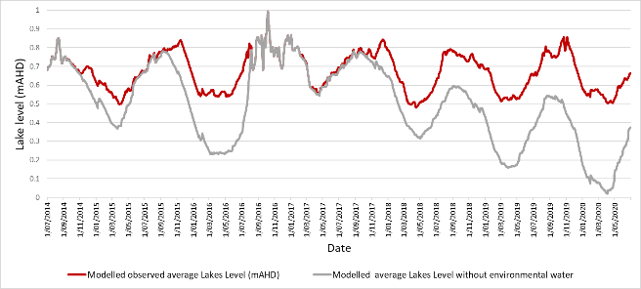

Figure . Contribution of Commonwealth environmental water towards maintaining water levels in Lake Alexandrina (one of the 2 Lower Lakes) above 0.4 m AHD, 2014–20

Details of evaluation methods

* 1. Data sources for evaluating contribution to flow regimes

The contribution of Commonwealth environmental water to flow regimes in the Basin is primarily evaluated using streamflow for the 2019–20 water year. Estimates of the contribution of Commonwealth environmental water were calculated at 126 streamflow sites within the Basin (Table A.1). The evaluation of flow regimes is based on a comparison of streamflows recorded at these sites during the 2019–20 year (actual case) with streamflows that would have occurred in the absence of the Commonwealth environmental water program (baseline case).

Table A.1 Data sources for evaluating the contribution of Commonwealth environmental water to flow regimes at 126 streamflow sites in 2019–20

Names of sites, baseline modelling approach, name of data owner or provider and number of sites within each valley are reported.

| **Valley name** | **Site count** | **Site name** | **Baseline modelling approach** | **Data owner or provider** |
| --- | --- | --- | --- | --- |
| Northern Basin |  |  |  |  |
| Barwon Darling | 7 | Bourke, Brewarrina, Louth, Collarenebri, Mungindi, Walgett, Wilcannia | Point derivation | CEWO |
| Border Rivers | 4 | Goondiwindi, Farnbro, Flinton, Nindigully | Point derived | CEWO |
| Condamine Balonne | 2 | Roseleigh, St George | Point derived | CEWO |
| Gwydir | 19 | Pallamallawa, Moree, Yarraman, Carole Offtake, Pinegrove, Gravesend, Boolooroo, Combadello, Tareelaroi, Mehi Offtake, Mallowa, Garah, Tyreel, Gingham Diversion, Brageen, Millewa, Allambie, Midkin, Gundare | Water accounting | WaterNSW |
| Macquarie | 6 | Dubbo, Warren, GinGin, Burrendong, Marebone, Baroona | Water accounting | WaterNSW |
| Namoi | 11 | Boggabri, Bugilbone, Carroll, Chaffey, Gunidgera, Gunnedah, Keepit, Mollee, Paradise, Piallamore, Weeta | Water accounting | WaterNSW |
| Warrego | 2 | Augathella, Cunnamulla | Point derivation | CEWO |
| Southern Basin |  |  |  |  |
| Broken | 4 | Rices Weir, Caseys Weir, Wagarandall, BackCk | Water accounting | GMW |
| Campaspe | 3 | Barnadown, Rochester, Eppalock | Water accounting | GMW |
| Central Murray | 10 | Doctors, Corowa, Barmah, Yarrawonga, Tocumwal, Torrumbarry, Wakool, Swan Hill, Euston, Lock 10 | Water planning | MDBA |
| Edward/Kolety–Wakool | 10 | Gee Bridge, Deniliquin, Yallakool Offtake, Colligen Offtake, Tuppal, Niemur R at Barham Rd, Wakool R at Barham Rd, Niemur R at Mallan School, Wakool at offtake regulator, Wakool at Coonamit | Water accounting | WaterNSW |
| Goulburn | 4 | Murchison, Trawool, Eildon, McCoys | Water accounting | GMW |
| Lachlan | 10 | Cowra, Forbes, Condobolin, Jemalong, Willandra, Brewster, Nanami, Hillston, Whealbah, Booligal | Water accounting | WaterNSW |
| Loddon | 6 | Laanecoorie, Cairn Curran, Loddon, Serpentine, Tullaroop, Appin South | Water accounting | GMW or provider |
| Lower Darling | 2 | Burtundy, Weir 32 | Water accounting | WaterNSW |
| Lower Murray | 8 | SA Border1, Lock 61, Lock 51, Lock 41, Lock 31, Lock 11, Wellington1, Barrages2 | 1Water planning  2Water accounting | MDBA1  CEWO2 |
| Murrumbidgee | 12 | Wagga, Gundagai, Narrandera, Yanco Offtake, Darlington, Berembed, Maude, Redbank, Carrathool, Gogelderie, Balranald, Hay | Water accounting | WaterNSW |
| Ovens | 4 | Buffalo, King, Peechelba, Wangaratta | Water accounting | GMW |
| Wimmera* | 2 | Lonsdale, Lake Taylor | Water accounting | GMW |
| Total | 126 |  |  |  |

* Wimmera is not included in the aggregated evaluation, but is evaluated elsewhere

CEWO = Commonwealth Environmental Water Office; GMW = Goulburn-Murray Water; MDBA = Murray–Darling Basin Authority

* + 1. Data reliability

We have followed the data reliability scale as reported in the 2020 Basin Plan evaluation (MDBA 2020). In this report, data reliability provides a consistently assured measure of accuracy and precision, providing an appropriate output (which is both spatially and temporally comprehensive and representative) for quantifying and/or identifying a response spatially and temporally. The data reliability scale as adapted from MDBA (2020) is given in Table A.2.

Table A.2 Data reliability scale

| **Data reliability scale** | **Description (adapted from MDBA 2020)** |
| --- | --- |
| High | Data are fit for purpose and have appropriate spatial and temporal coverage |
| Medium | Data have some uncertainty in their representation of the system or some limitations in spatial and/or temporal coverage |
| Low | Data have limitations in their ability to describe the system and in spatial and/or temporal coverage |

The data sources used in this evaluation and their reliability using the MDBA (2020a) reliability scale are reported in Table A.3.

Table A.3 Reliability of raw data used in the evaluation

| **Data source** | **Reliability** |
| --- | --- |
| Discharge data | High |
| Modelled streamflow data | Medium |
| Inundation observations | Medium |

* + 1. Observations of streamflows

Recorded streamflows were available online at the respective jurisdictional websites (Table A.4). It was assumed that the minimum requirements set by the International Organization for Standardization (ISO) standard (ICS.17.120:20) for flow measurement in open channels had been met by the custodians of the streamflow sites, so we provided no further assessment of data quality other than checking for complete records. It is important to note that in compiling our hydrological record, we have used provisional data and, in some instances, ratings adjustments have occurred, post analysis. Similarly, our hydrological record has been aggregated to daily values, where the start and end dates for the day differed, between sites and valleys. In most instances, our reported day was never midnight to midnight as reported on most jurisdictional websites.

Table A.4 Websites used to source discharge data for 126 streamflow sites in the Murray–Darling Basin

| Jurisdiction | Water monitoring website |
| --- | --- |
| New South Wales | <https://realtimedata.waternsw.com.au/> |
| South Australia | <https://www>.waterconnect.sa.gov.au |
| Queensland | <https://water>-monitoring.information.qld.gov.au |
| Victoria | <http://data>.water.vic.gov.au/monitoring.htm |

* + 1. Baseline hydrology scenarios

The evaluation was based on a comparison of observed hydrology (i.e. daily streamflow time series for the 2019–20 water year) with baseline hydrology represented by daily streamflows for the 2019–20 year in the absence of Commonwealth environmental water. In most cases, the baseline hydrology was estimated as actual flows minus flows delivered from an environmental water entitlement. However, in cases where the baseline was calculated using the water planning model method (described below), a further adjustment was made so that the baseline hydrology represented streamflows that would have occurred in the 2019–20 year if the Commonwealth water portfolio had never been procured (i.e. agricultural water entitlements resemble those before establishment of the Commonwealth environmental water program). This latter case allows evaluation of the combined consequences of the Commonwealth environmental water recovery and delivery program. In the future, we hope to work with data providers to extend the water planning model approach (see below) to more sites.

Baseline hydrology for the 2019–20 year was derived by several agencies using one of 3 approaches: water accounting model; water planning model; and point derivation.

Water accounting model

This approach is based on a mass balance of water in river reaches between streamflow sites with a fixed lag time to allow for travel times as well as estimates of losses and gains. Operators enter known factors, such as water orders and water taken, and use empirical data, such as actual unaccounted differences and meteorological data, to calculate saleable components of flow at nominated streamflow sites. Based on these data, the data provider estimates the Commonwealth environmental water and non–Commonwealth environmental water components of the observed time series. The baseline scenario is derived by subtracting the environmental water component from the observed hydrograph at the streamflow gauge. This approach is used by river operators Goulburn-Murray Water (GMW), WaterNSW and the Murray–Darling Basin Authority (MDBA) to provide baseline streamflow series in the Victorian tributaries (Goulburn, Broken, Campaspe, Loddon, Ovens, Murray) and regulated valleys of New South Wales (Murrumbidgee, Lachlan, Macquarie, Gwydir, Edward/Kolety–Wakool, Murray) and the South Australian Murray.

This approach is used to provide the time series of environmental water provided by the Commonwealth Environmental Water Office (CEWO) and other water holders separately.

Water planning model

The method was developed by the MDBA and applied in the Murray River. In this method, 2 scenarios were modelled using the MSM-BigMod modelling suite – ‘modelled pre-buyback’ and ‘modelled actual’ – for the period between July 2018 and June 2019. The initial conditions of the model were based on the 2014–15 model run. The difference between the 2 model runs measured the impact of environmental water recovery and use during 2019–20. The ‘modelled actual’ flow differs from the actual observed flow at streamflow gauges because of model error. To avoid artefacts associated with this error, we recalculated the ‘pre-buyback’ case by subtracting the difference (i.e. the modelled actual minus the modelled pre-buyback flows) from the actual observed flows. The resulting flow series is used as the baseline. In this model, the total environmental water entitlement is treated as a single component and there is no separate treatment of Commonwealth environmental water and non–Commonwealth environmental water.

Point derivation

This method was developed in-house by the CEWO and applies to the unregulated valleys of New South Wales and Queensland (Border Rivers, Condamine Balonne, Warrego, upper Darling rivers). The CEWO monitors real-time river data to detect when access to Commonwealth unregulated entitlements is triggered. Gauge data, in conjunction with official announcements of water-harvesting access in unregulated valleys (Border Rivers, lower Balonne and Warrego rivers), are used to estimate instream contributions. Volumes are accounted for in accordance with the licence (access) conditions of each entitlement in the same way that other water users manage their take (i.e. water is assumed to be used at all available opportunities when access conditions are triggered). This approach reflects the use patterns of most irrigators in unregulated systems and hence the volumes and pattern of flows that have been reinstated. The baseline scenario was derived by subtracting the Commonwealth environmental water component from the hydrograph.

Commonwealth environmental water delivery is often coordinated with delivery of water by other environmental water holders; hence, the evaluation considers the combined hydrological effect of all environmental water delivery. Where possible, we also indicate the contribution of the Commonwealth environmental water component to the total hydrological effect of all environmental water.

None of these methods comprehensively account for planned environmental water. The focus of this evaluation is on the contribution of Commonwealth environmental water, held environmental water allocations or other environmental water allocations delivered in coordination with this Commonwealth environmental water.

* + 1. Data sources for evaluating contribution to hydrological connectivity

Floodplain inundation extent (area)

Floodplain and wetland inundation extents in this evaluation are reported as mapped area hectares (ha) in the Australian National Aquatic Ecosystem (ANAE) classification framework and represent monitoring outputs from multiple providers using differing methods (Table A.5).

Table A.5 Description of the method used to derive inundation across valleys where inundation was reported

| **Valley name** | **Method** | **Data owner** | **Boundary definition** |
| --- | --- | --- | --- |
| Central Murray | Landsat and visual survey; MIKE hydrodynamic model; DEM + water level | Mallee CMA; MDBA; GA | Wet area boundaries denote contributions from both Commonwealth environmental water and natural rainfall/runoff processes |
| Gwydir | Landsat, Sentinel and visual survey | NSW DPIE; 2ROG; GA | Wet area boundaries denote contributions from both Commonwealth environmental water and natural rainfall/runoff processes |
| Lachlan | Visual survey; NDVI; Landsat, Sentinel | NSW DPIE; GA | Wet area boundaries denote contributions from both Commonwealth environmental water, other environmental water, other water and natural rainfall/runoff contributions |
| Lower Darling | MIKE hydrodynamic model; DEM + water level | MDBA; GA | Wet area boundaries denote contributions from both Commonwealth environmental water and natural rainfall/runoff processes |
| Lower Murray | Landsat, Sentinel, and visual survey; MIKE hydrodynamic model; DEM + water level | NFSA; SA DEWNR; NRM Board; MDBA; CEWO; GA | Wet area boundaries denote contributions from both Commonwealth environmental water and natural rainfall/runoff processes |
| Macquarie | Landsat, Sentinel and visual survey | NSW DPIE; GA | Wet area boundaries estimate contributions from both Commonwealth environmental water and natural rainfall/runoff processes |
| Murrumbidgee | Landsat, Sentinel; Tassel Cap and visual survey | NSW DPIE; GA | Wet area boundaries denote contributions from Commonwealth environmental water, other environmental water and natural rainfall/runoff processes |
| Warrego | Landsat and visual survey | NSW DPIE; 2ROGl; GA | Wet area boundaries denote contributions from both Commonwealth environmental water and natural rainfall/runoff processes |

Data owners, and boundary definition are reported

2ROG = 2ROG Consulting; CMA = Catchment Management Authority; DEM = digital elevation model; MDBA = Murray–Darling Basin Authority; NDVI = Normalised Difference Vegetation Index; NFSA = Nature Foundation South Australia; NRM = Natural Resource Management; NSW DPIE = NSW Department of Planning, Industry and Environment; SA DEWNR = South Australian Department of Environment, Water and Natural Resources; GA = Geoscience Australia (Digital Earth Australia).

The areas reported represent cumulative inundation over the course of the year. An attempt to attribute inundation as Commonwealth environmental water, other environmental water (where the watering actions were separate to Commonwealth actions) and other water (reflecting the inundation associated with natural events) was made. However, this attribution was not straightforward because the information required for attribution was not easily accessible nor determinable and on-ground validation was not comprehensive.

Inundation was classified as:

* other water (natural events, rainfall/runoff and so forth)
* Commonwealth environmental water (high or low certainty)
* other environmental water
* large on-farm storages, where known
* Coorong, Lower Lakes and Murray Mouth region.

High certainty classifications refer to actions such as pumping or where site validation data were provided by environmental water managers. Low certainty classifications represent inundation areas that included contributions from other environmental water and other water, making attribution difficult to disentangle. Attributing inundation Basin wide will remain this way until accurate, reliable and accessible inundation mapping is made available to support defensible and robust monitoring and evaluation.

Level of certainty (high or low) in the mapping of inundation extent over the 2014-20 period is provided in Figure A.1.

Watercourses watered (km)

The watercourses watered using Commonwealth environmental water were mapped using information provided via CEWO environmental water delivery personnel and other operational reports. In the regulated rivers where environmental water was ordered from a dam, the reaches downstream to the accounting point (in New South Wales) were marked as watered (i.e. reaches beyond the end-of-system were not included) whereas, in Victoria, the reaches watered were extended to the confluence with the Murray River. This distinction was justified on the basis that in Victoria, returning environmental flows are protected whereas in New South Wales they are not protected. In the unregulated rivers of the northern Basin, the CEWO provided advice on the estimated extents of watercourses influenced by Commonwealth environmental water.

* + 1. Evaluation of Basin-wide hydrological impacts

The hydrological evaluation is in 2 parts. The first part summarises the Basin-scale contribution of environmental water to general enhancements in flow regimes without reference to the expected outcomes of local watering. This is provided to fulfil 2 purposes:

* to support an evaluation against the Basin Plan objectives as described in the Basin Plan Section 8.51(1)(b). The Basin Plan identifies 7 flow components that must be considered in the determination of watering requirements of environmental assets and ecosystem functions. Only the relevant flow components are included in this evaluation (Table A.6)
* to provide the basis for evaluating ecological consequences of environmental watering at the Basin scale. In this part, we use hydrological measures related to standardised flow thresholds to indicate effects on base flows and freshes. It is important to note that this section is not for assessing the performance of environmental water delivery with respect to local hydrological outcomes (which is instead dealt with in Chapter 4 of this report).

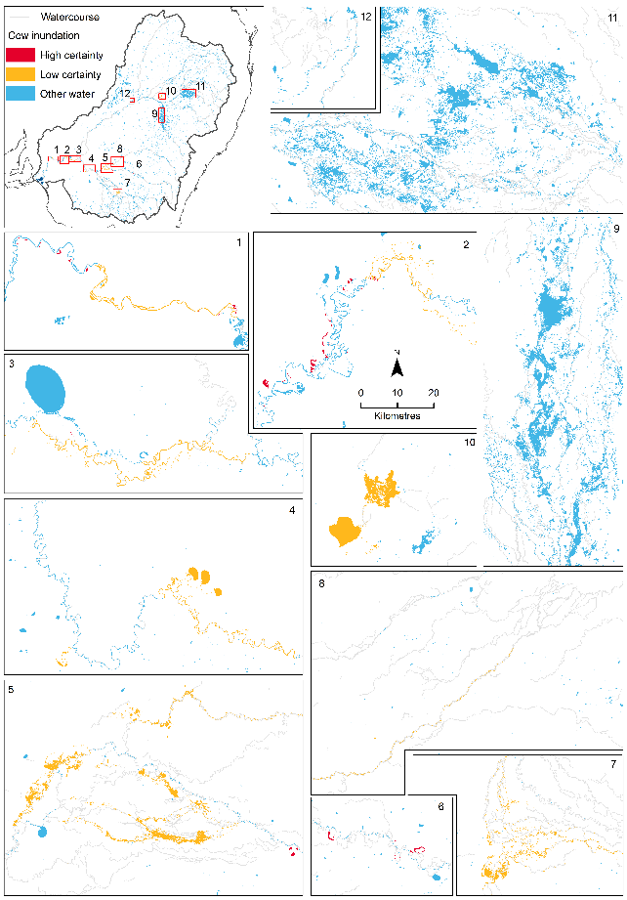

Figure . Maps of level of certainty (high, low) in the inundation extent mapping shown in Figure 8.1

Table A.6 Flow components included in the Basin Plan and those that are included in the Flow-MER Basin-scale evaluation

| **Basin Plan flow components** | **Included in Flow-MER evaluation?** | **Reason** |
| --- | --- | --- |
| Cease to flow | No | The focus of environmental water management is on avoiding excessively low flows |
| Low flow base flows | Yes | A component which can be actively managed with the quantity of flows held with minor impact to third party |
| High flow base flows | Yes | A component which can be actively managed with the quantity of flows held with minor impact to third party |
| Low flow season freshes | Yes | A component which can be actively managed with the quantity of flows held with minor impact to third party |
| High flow season freshes | Yes | A component which can be actively managed with the quantity of flows held with minor impact to third party |
| Bankfull flows | No | Constraints regarding the delivery of bankfull flows are largely out of scope for environmental flow managers |
| Overbank flows | No | Constraints regarding the delivery of overbank flows are largely out of scope for environmental flow managers |

We provide a summary of the hydrological outcomes across the Basin using data for streamflow sites, selected based on data availability rather than randomly sampled. As such, it is not possible to make statistically based inferences concerning the mean and variance of outcomes across the Basin because this sampling design does not support a spatially randomised sample. Also, streamflow sites included in this evaluation were not specifically targeted to receive environmental water. This means any outcomes at these sites are an inadvertent result of actions designed to meet environmental outcomes elsewhere in the Basin. This is important, as the Basin Plan sets principles on maximising environmental benefits, which are intended to ensure that the water achieves the best environmental outcomes (i.e. through considerations on multi-site watering enroute to an intended priority asset or enhancing existing flow events).

* + 1. Flow thresholds

The summary is based on the occurrence of low flows (very low and low) and freshes low, medium, high) as defined in Section 2.1.1 and Section 2.1.2.

The unimpacted flow is the expected flow series without development conditions under a historical climate. Unimpacted monthly flow series were provided by the MDBA for sites across the Basin representing the counterfactual scenario for comparative analysis. These were not always the same sites as used in this evaluation of Commonwealth environmental water delivery. In most of these cases, the nearest appropriate unimpacted flow data site was chosen. Unimpacted flow series were modelled at a small number of sites using the various water planning models across the Basin during the development of the Basin Plan. The bankfull discharge was estimated either as the fifth percentile exceedance in the monthly unimpacted flow (×1.5 as a rough estimate of peak daily flow based on the mean monthly value) or from channel dimensions available for sites across the Basin (these were data collected for the Sustainable Rivers Audit II – Physical Form Theme (Davies et al. 2012). Dimensions were taken from the site closest to each of our hydrological evaluation sites, and on the same river channel. Bankfull discharge was estimated from these dimensions using equation M15 in Stewardson et al. (2005). We generally used the larger of these 2 bankfull estimates with some exceptions based on individual site considerations. The estimates of discharge corresponding to the low, medium and high freshes levels (defined above) were based on widely accepted at-a-station hydraulic geometry equations (Stewardson et al. 2005).

* + 1. Flow regime score

We calculated a flow regime ‘score’ corresponding to each of the 5 flow thresholds (Stewardson and Guarino 2018). The score is a number equal to or between 0 and 1. The purpose of this score is to provide a summary of the flow regime and identify contributions of environmental water to protection and restoration of flow regimes across the Basin.

Low flows

In the case of the 2 low flow thresholds, the score relates to the maintenance of flows above the very low and low flow thresholds in each calendar season. Under unimpacted conditions, there would have been a broad range of base flow regimes across the Basin, including some intermittent rivers. To allow for this, the score was calculated based on a comparison of 2019–20 low flows with unimpacted low flows. The score measures the duration of flows exceeding our 2 low flow thresholds in each calendar season relative to the normal duration in the unimpacted state. If the average unimpacted base flow durations were maintained in 2019–20, then the site received the maximum score of 1. A reduction in the duration compared with unimpacted duration, in any of the 4 seasons, reduced the score. If we applied this score to an unimpacted regime, we could expect that, in dry years, we would get a lower score than in average and wet years. The score is not an environmental flow objective, rather an indication of the dryness of the low flow regime in 2019–20 and the components of the flow regime that are significantly affected by environmental watering actions.

Freshes

Similarly, a score was calculated for each of the 3 thresholds corresponding to low, medium and high freshes. However, we did not attempt to adjust these scores based on a comparison with the unimpacted flow regime. Instead, the score relates to the occurrence (or not) of flow freshes exceeding these fresh thresholds. For the low fresh threshold, the duration of flows above this threshold within a calendar season must have exceeded 3 days for a ‘fresh’ to be considered to have occurred. The maximum score (1) was achieved for the low fresh if a fresh occurred in 3 of the calendar seasons. For the medium fresh, the maximum score was achieved if a fresh occurred in at least 2 calendar seasons. For the high fresh, the maximum score was achieved if a fresh exceeded this threshold at some time over the year.

In the Technical Supplement to this report (Guarino 2021), we report scores for each site but simplify the results by combining the 2 low flow scores into a single base flow score and the 3 scores for the flow fresh thresholds into 1 freshes score. The freshes score (reported in Guarino 2021) weights the low, medium and high fresh scores according to the percentage weights 50:30:20, respectively.

We emphasise that these scores are not an evaluation of individual watering actions and their associated objectives. The scores are used to summarise the flow regime at sites across the Basin and support an evaluation of the overall effect of the management of Commonwealth environmental water on flow regimes at the Basin scale. For this reason, a number of the sites included in the analysis were not actually targeted with environmental watering actions.

* + 1. Attribution of Commonwealth environmental water

Commonwealth environmental water delivery is often coordinated with delivery of other environmental water to achieve a combined outcome. In such cases, it makes little sense to consider the contribution of the Commonwealth environmental water in isolation. For consistency, we have evaluated the aggregate hydrological outcome of all held environmental water.

The total contributions of all environmental water cannot be fully attributable to the Commonwealth environmental water in situations where there is coordinated delivery with other environmental water holders. To address this issue, we have developed a simple 4-step procedure for sharing score increases between Commonwealth environmental water and other environmental water:

1. calculate the total improvement in score with all environmental water entitlements (i.e. compare the score for the observed and baseline flow regimes)
2. calculate the improvement that would have been achieved if Commonwealth environmental water was delivered on its own
3. calculate the improvement if the non–Commonwealth environmental water had been delivered on its own
4. apportion the total improvement (from step 1) to Commonwealth environmental water and non–Commonwealth environmental water based on the ratio of improvements achieved in step 2 and step 3.

References

Brooks S (2021) Basin-scale evaluation of 2019–20 Commonwealth environmental water: Ecosystem Diversity. Flow-MER Program. Commonwealth Environmental Water Office (CEWO): Monitoring, Evaluation and Research Program, Department of Agriculture, Water and the Environment, Australia.

Davies PE, Stewardson MJ, Hillman TJ, Roberts JR, Thoms MC (2012) Sustainable Rivers Audit 2: the ecological health of rivers in the Murray–Darling Basin at the end of the Millennium Drought (2008–2010). Volume 1. MDBA Publication No. 72/12. Murray–Darling Basin Authority, Canberra.

Guarino F (2021) Valley-scale hydrology report cards: Technical Supplement to Hydrology Theme report. Flow-MER Program. Commonwealth Environmental Water Office (CEWO). Monitoring, Evaluation and Research Program, Department of Agriculture, Water and the Environment, Australia.

MDBA (2019) [Basin-wide environmental watering strategy](https://www.mdba.gov.au/sites/default/files/pubs/basin-wide%20environmental%20watering%20strategy%20November%202019_0.pdf). Second edition, revised February 2020. Murray–Darling Basin Authority, Canberra.

MDBA (2020b) [2020 Basin Plan evaluation.](https://www.mdba.gov.au/2020-basin-plan-evaluation) Murray–Darling Basin Authority, Canberra.

Stewardson MJ, DeRose R, Harman C (2005) Regional models of stream channel metrics. Technical Report 05/16. Cooperative Research Centre for Catchment Hydrology, Canberra.

Stewardson MJ, Guarino F (2018) Basin‐scale environmental water delivery in the Murray–Darling, Australia: a hydrological perspective. Freshwater Biology 63(8), 969–985. [doi.org/10.1111/fwb.13102](https://doi.org/10.1111/fwb.13102)

Stewardson MJ, Guarino F (2020) [2018–19 Basin-scale evaluation of Commonwealth environmental water – Hydrology](https://www.environment.gov.au/system/files/resources/d8142f55-a763-4c3b-bd95-4791a6340bb9/files/2018-19-basin-evaluation-hydrology-report.pdf). Final Report prepared for the Commonwealth Environmental Water Office by La Trobe University, Publication 246/2020, 58pp plus annex.

[**https://flow-mer.org.au**](https://flow-mer.org.au)

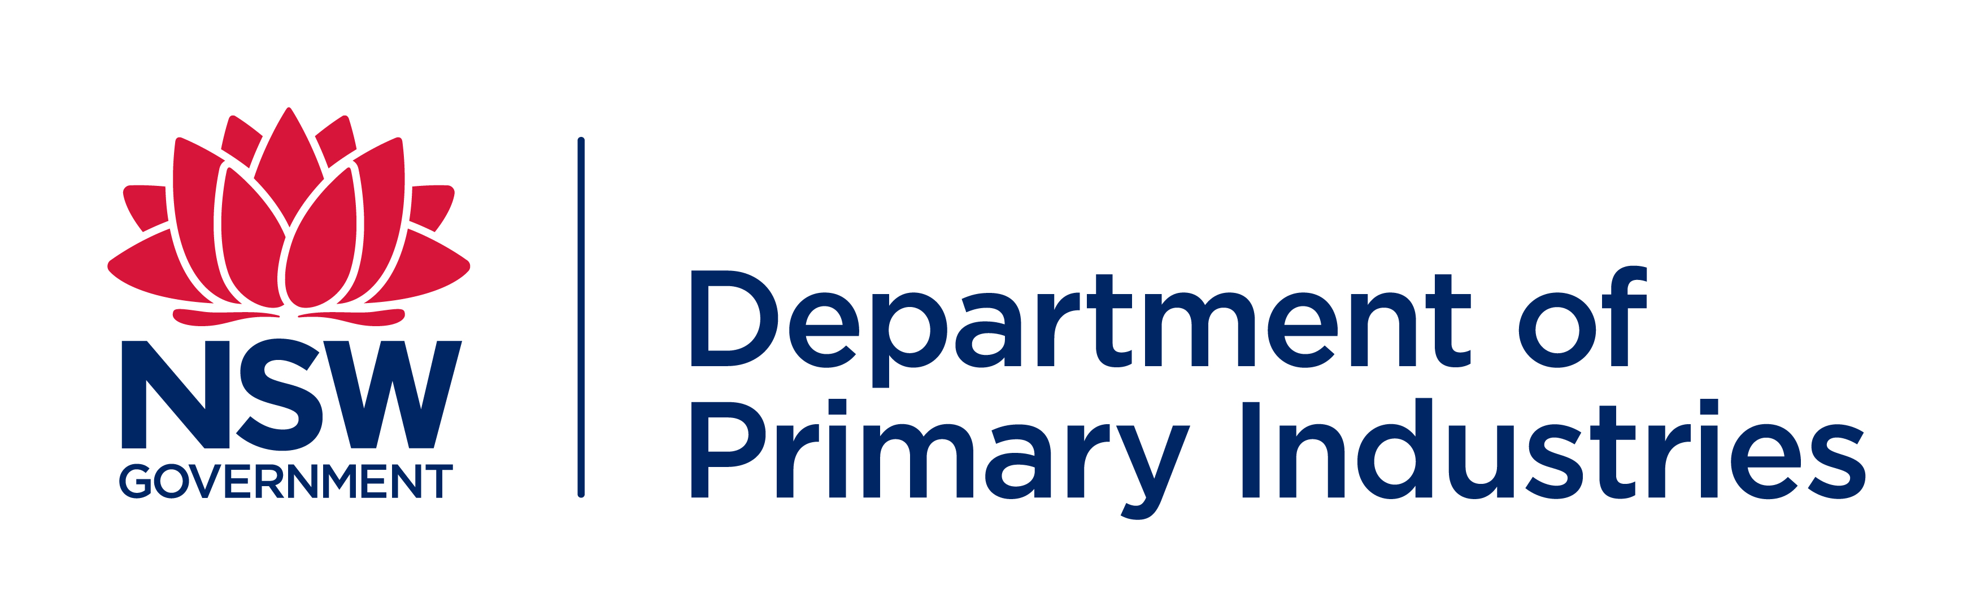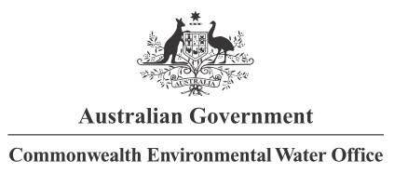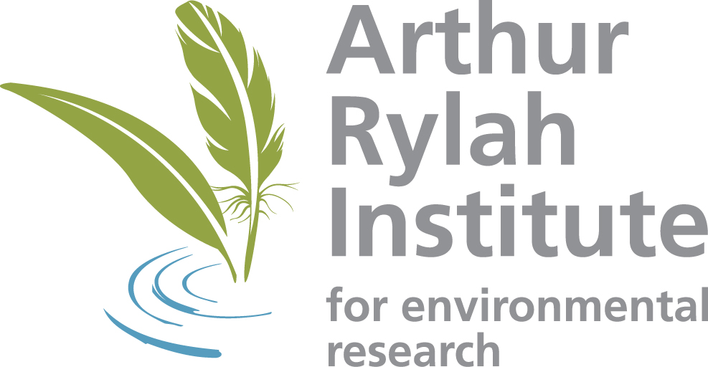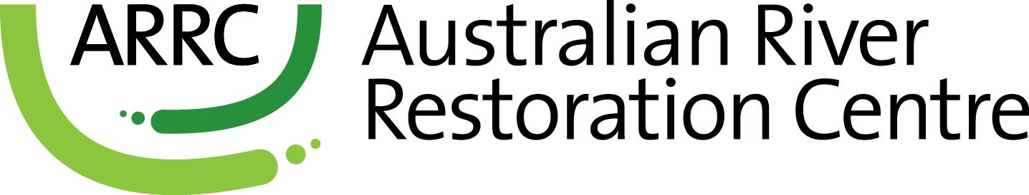

**Partners**

**Collaborators**

1. In the Basin, as water exits one valley and enters another, it goes back into the available bucket for allocation and use. In some valleys, prerequisite policy measures are ‘in effect’ which allow water to be protected through crediting arrangements and used for environmental purposes downstream.
2. A very low flow is defined as a flow that falls below the lowest flow in the unimpacted monthly flow series or 2% of mean unimpacted flow, whichever is greater. This threshold corresponds to exceptionally low flows at the lower end of the range that would normally occur in an unimpacted perennial river. The very low flow base flow score relates to the duration of flows below this threshold.

   The low flow base flow score is defined relates to the duration of flows below a level that might typically be used as a minimum environmental flow to maintain low flow habitats. These are defined as flows that fall below the 95th percentile exceedance flow in the unimpacted monthly flow series or 10% of the mean unimpacted flow, whichever is greater. This flow threshold corresponds to a value that might typically be used as a minimum flow to maintain low flow habitats.
3. A low fresh is defined as a flow spell that raises water levels at least one-eighth of the height of the bank above the low flow level. Such freshes would be a very frequent occurrence in both the dry and wet seasons under pre-development conditions.

   A medium fresh is defined as a flow spell that raises water levels at least one-quarter of the height of the bank above the low flow level. This threshold would be a frequent occurrence in the pre-development regime maintaining moist soils.

   A high fresh is defined as a flow spell that raises water levels at least half of the height of the bank above the low flow level. Freshes of this magnitude would have occurred in most years in the unimpacted flow regime, often multiple times.
4. Increases as set out in the Strategy are relative to 1 July 2019 and are expected to be achieved by 2024.
5. Increases as set out in the Strategy are relative to 1 July 2019 and are expected to be achieved by 2024.
6. Another expected outcome of the Strategy specifies maintenance of current levels of connectivity in the Paroo, Moonie, Nebine, Ovens and Warrego valleys. However, evaluation against this outcome is not included in this assessment as Commonwealth environmental water is not used for maintenance of flows in valleys such as the Paroo. Meeting this outcome would require restriction of water resource developments.
7. The middle of the intended outcome range was used for assessing the contribution of Commonwealth environmental water towards these expected outcomes.