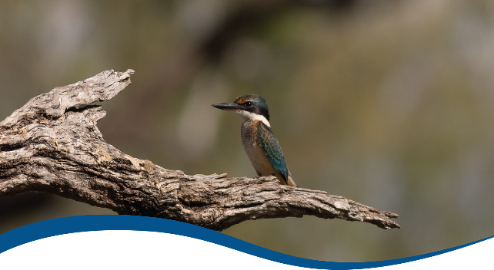

Basin-scale evaluation of 2019–20 Commonwealth environmental water: Species Diversity

Commonwealth Environmental Water Office (CEWO):   
Monitoring, Evaluation and Research Program

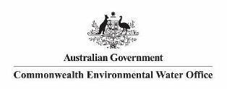August 2021

Citation

Wassens S, Poynter C, Brooks S, and McGinness H (2021) 2019-20 - Species Diversity (Biodiversity) Evaluation Report - Final. Flow-MER Program. Commonwealth Environmental Water Office (CEWO): Monitoring, Evaluation and Research Program, Department of Agriculture, Water and the Environment, Australia. 104pp

Contributors

|  |  |  |  |
| --- | --- | --- | --- |
| Carmen Amos | NSW DPIE-EES | Rupert Mathwin | Flinders University |
| Gilad Bino | University of NSW | Damian Michael | Charles Sturt University |
| Ali Borrell | Murray–Darling Wetlands Working Group | Courtney Monk | Landscapes South Australia |
| Deborah Bower | University of New England | Joanne Ocock | NSW DPIE-EES |
| Kate Brandis | University of NSW | Phil Papas | Vic DELWP |
| Geoff Brown | Vic DELWP | David Paton | University Adelaide |
| Anthony Conallin | NSW DPIE-EES | Stephanie Robinson | Landscapes South Australia |
| Jean Dind | Forestry NSW | Danny Rodgers | Vic DELWP |
| Louise K Durkin | Vic DELWP | Nella Smith | Murrumbidgee field naturalists |
| James Dyer | NSW DPIE-EES | Mark Southwell | Eco Logical Australia |
| Rob Hale | DELWP Vic | Jennifer Spencer | NSW DPIE-EES |
| Sam Hardy | Landscapes South Australia | Natalie Stalenberg | Forestry NSW |
| Katie M Howard | Vic DELWP | Sarah Treby | Forestry NSW |
| Jacqui J Brooks | Vic DELWP | Heremaia Tikito | Charles Sturt University |
| Tim O Kelly | NSW DPIE-EES | Anna Turner | Charles Sturt University |
| Annie Kriesl | Landscapes South Australia | James Van Dyke | La Trobe University |
| James Maguire | NSW DPIE-EES | Amelia Walcott | NSW DPIE-EES |
| Kate Mason | Landscapes South Australia | Richard Walsh | Landscapes South Australia |

Acknowledgements

The project team and the Commonwealth Environmental Water Office (CEWO) respectfully acknowledge the traditional owners of the land on which this work is conducted, their Elders past and present, their Nations of the Murray–Darling Basin, and their cultural, social, environmental, spiritual and economic connection to their lands and waters.

We take this opportunity to thank the contributors (listed above) and the many individuals and agencies who provided data to support this evaluation. We acknowledge the use of the Atlas of Living Australia, including NSW DPIE-EES, University of New South Wales, MDBA and TLM data as presented in the Atlas of NSW Wildlife and Atlas of Living Australia.

We would like to thank the CSIRO and University of Canberra teams for their efforts in report layout, editing, reviewing and formatting. Special mention to Emily Barbour, Ross Thompson, Di Flett, Susan Cuddy and Jackie O’Sullivan whose input, together with copy editor Dr Mary Webb and formatting specialist, Jill Sharkey, greatly improved the readability of the report. CSIRO’s Martin Nolan assisted with figures and GIS layers. A final thanks to Peter Davies for providing an expert independent review.

Copyright

Creative Commons [logo] © Commonwealth of Australia 2021

With the exception of the Commonwealth Coat of Arms, partner logos and where otherwise noted, all material in this publication is provided under a Creative Commons Attribution 4.0 International Licence <https://creativecommons.org/licenses/by/4.0/>. The Flow‑MER Program requests attribution as ‘© Commonwealth of Australia (Flow‑MER Program, <https://flow-mer.org.au)>’.

Document submission history

|  |  |
| --- | --- |
| 7 July 2021 | Final draft |
| 27 August 2021 | Final |

Cover photograph

Image: Sacred Kingfisher in the Gwydir.   
Photo credit: Commonwealth Environmental Water Office

Important disclaimer

The information contained in this publication comprises general statements based on scientific research. The reader is advised and needs to be aware that such information may be incomplete or unable to be used in any specific situation. No reliance or actions must therefore be made on that information without seeking prior expert professional, scientific and technical advice. To the extent permitted by law, the Flow-MER Program (including its partners and collaborators) excludes all liability to any person for any consequences, including but not limited to all losses, damages, costs, expenses and any other compensation, arising directly or indirectly from using this publication (in part or in whole) and any information or material contained in it.

The Flow-MER is committed to providing web accessible content wherever possible. If you are having difficulties with accessing this document please contact [CEWOmonitoring@environment.gov.au](mailto:CEWOmonitoring@environment.gov.au).

Overview of Flow-MER

Flow-MER is the Commonwealth Environmental Water Office’s (CEWO) Monitoring, Evaluation and Research Program. Its objective is to monitor and evaluate the ecological responses to the delivery of Commonwealth environmental water in the Murray–Darling Basin. It provides the CEWO with evidence to inform our understanding of how water for the environment is helping maintain, protect and restore the ecosystems and native species across the Basin. This work will support environmental water managers, demonstrate outcomes, inform adaptive management and fulfil the legislative requirements associated with managing Commonwealth-owned environmental water.

The Program runs from 2019 to 2022 and consists of 2 components: monitoring and research in 7 Selected Areas (Selected Area projects); and Basin-scale evaluation and research (the Basin-scale project) (Figure 1). The Basin-scale project is led by CSIRO in partnership with the University of Canberra, and collaborating with Charles Sturt University, Deakin University, University of New England, South Australian Research & Development Institute, Arthur Rylah Institute, NSW Department of Planning, Industry and Environment, Australian River Restoration Centre and Brooks Ecology & Technology.

It builds on work undertaken through the Long Term Intervention Monitoring (LTIM) (2014–2019) and Environmental Water Knowledge and Research (EWKR) (2014–2019) projects.

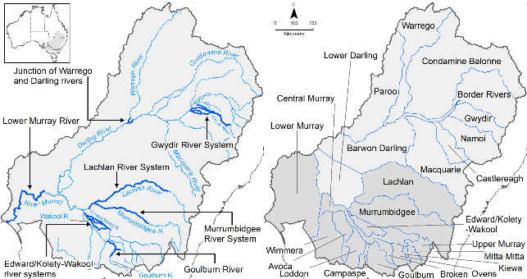

Figure The 7 Selected Areas and 25 valleys established for long-term monitoring of the effects of environmental watering under the LTIM Project and Flow-MER Program (2014–15 to present)

The Flow-MER evaluation adopts an adaptive management framework to acknowledge the need for collectively building the information, networks, capacity and knowledge required to manage environmental water at the Basin scale. While knowledge of ecological response to instream flow and inundation has advanced significantly in recent years, substantive challenges remain in understanding the similarities and differences in species’ response across time and space, as well as the interaction between species at a community and ecosystem scale.

The Basin-scale evaluation is being undertaken across 6 Basin Themes (Figure 2) based on ecological indicators developed for the LTIM Project and described in the Environmental Water Outcomes Framework.[1] It is undertaken in conjunction with the Selected Area projects, which provide data, research and knowledge for ecological outcomes within the 7 Selected Areas. The Basin-scale evaluation integrates across Selected Areas, themes, datasets, approaches and different types of knowledge.

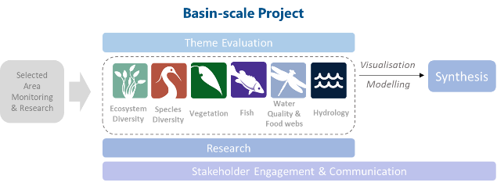

Figure Basin-scale Project evaluation reports on Commonwealth environmental water outcomes for the 6 Basin Themes as well as a high-level Basin-scale synthesis

The evaluation is informed by Basin-scale research projects, stakeholder engagement and communication, including Indigenous engagement, visualisation and modelling, as well as the 7 Selected Area projects.

About the Basin-scale evaluation

Water delivery and outcomes data provided by CEWO is used in conjunction with monitoring data provided by the 7 Selected Areas and other publicly available data to undertake the Basin-scale evaluation. Technical reports for each of the 6 themes are available from the Commonwealth Environment Water Office’s website.

The evaluation aims to address theme-specific questions in relation to how Commonwealth environmental water contributed to, supported or influenced environmental outcomes. Commonwealth environmental water is often delivered in conjunction with other environmental water holdings and non-environmental water releases (such as for irrigation or during high-flow events). The evaluation consequently draws on available information to estimate (where possible) the specific contribution of Commonwealth environmental water to particular environmental outcomes. The way in which this contribution is assessed varies between the 6 themes depending on the data and tools currently available:

* modelling to estimate and compare outcomes both with and without Commonwealth environmental water (counterfactual modelling) – hydrology (instream); fish (multi-year evaluation)
* identification of ecological response in locations that received Commonwealth environmental water (potentially in conjunction with other sources of environmental water or non-environmental water), and where feasible, comparison with areas that did not receive Commonwealth environmental water – ecosystem diversity; species diversity; vegetation
* use of flow and water quality metrics to infer likely outcomes – hydrology (inundation); food webs and water quality
* synthesis of findings across Selected Areas – fish (annual); vegetation; food webs and water quality.

Summary

Strategic management of Commonwealth water for the environment by the Commonwealth Environmental Water Holder (CEWH) is key to achieving the Commonwealth’s (Murray–Darling) *Basin Plan 2012*environmental objectives. The 3-year Basin-scale Flow-MER Program aims to demonstrate Basin-scale outcomes of Commonwealth environmental water, support adaptive management; and fulfil CEWH legislative requirements under the Basin Plan.

The Species Diversity evaluation focuses on Section 8.05 of the Basin Plan 2012 – *Protection and restoration of water-dependent ecosystems*. Section 8.05 sets out the objectives relating to the protection and restoration of water-dependent ecosystems in the context of species and populations, threatened taxa, communities and ecosystems listed under state and national legislation, and international agreements – Bonn Convention, China–Australia Migratory Bird Agreement (CAMBA), Japan–Australia Migratory Bird Agreement (JAMBA) or Republic of Korea–Australia Migratory Bird Agreement (ROKAMBA) – and declared Ramsar wetlands.

In this report, we focus on evaluating species diversity outcomes not covered in the evaluations of Fish, Vegetation and Ecosystem Diversity. We focus on waterbirds, frogs and turtles along with other water-dependent aquatic vertebrates including reptiles, platypus and rakali with reference to listed threatened species as defined under the Commonwealth Environment Protection Biodiversity Conservation Act (1999) (EPBC Act) and relevant state legislation. We also summarise Commonwealth environmental watering actions that influence the hydrology, and thus the species diversity, of Ramsar wetlands within the Murray–Darling Basin.

The evaluation addresses the overarching question:

What did Commonwealth environmental water contribute to species diversity?

This question is addressed through the following 4 sub-components:

* What was the contribution of Commonwealth environmental water to the diversity and abundance of waterbirds, frogs, turtles, and other water-dependent vertebrates?
* What was the contribution of Commonwealth environmental water to threatened species and ecological communities?
* What was the contribution of Commonwealth environmental to water migratory species listed under international agreements (Bonn Convention, CAMBA, JAMBA or ROKAMBA?
* What was the contribution of Commonwealth environmental water to Ramsar wetlands In the Murray–Darling Basin?

Water year 2019–20

* 296,244 ML of Commonwealth environmental water was delivered as part of 61 individual watering actions with objectives related to species diversity.
* While very dry climatic conditions in 2019–20 reduced the available habitat and abundance of focal species, Commonwealth environmental water was delivered to support[2]:
  + high ecological productivity, particularly for waterbirds in the Lower Murray and Murrumbidgee with 30,097 individuals reported, representing 65 waterbird and 5 raptor species
  + 18 frog and 3 turtle species across 3 valleys
  + the life cycles of national and state-listed threatened species, including regent parrot, Australasian bittern, Latham’s snipe, broad-shelled turtle, platypus and southern bell frog
  + 36 waterbird species of conservation significance. Of these, 34 are listed as threatened under state or national legislation and 21 are listed in the EPBC Act migratory waterbird list and/or international treaties[3]
  + successful recruitment by southern bell frogs across Murrumbidgee River System, Central and Lower Murray rivers; Australasian bitterns in the Murrumbidgee River System and the Central Murray River; and regent parrots in the Lower Murray River
  + partial inundation of 8 declared Ramsar sites.

Water years 2014–20

* There have been 378 watering actions with objectives related to waterbirds, frogs, turtles and other vertebrates. Watering actions targeting species diversity outcomes occurred more often in valleys that contained high value wetland and floodplain habitats
* 103 waterbird species from 17 families were likely to have benefited from Commonwealth environmental water delivery across the Basin
* Since 2014, 41 species of conservation significance, including waterbirds, frogs and turtles have potentially benefited from Commonwealth environmental water delivery
* Environmental water has successfully maintained and, in some areas, increased the abundance of southern bell frogs (listed as vulnerable under the EPBC Act)
* Broad-shelled turtles (listed as endangered in South Australia) were more frequently associated with areas inundated by Commonwealth environmental water across their range in the Southern Basin.

Contents

Overview of Flow-MER i

About the Basin-scale evaluation ii

Summary iii

Water year 2019–20 iii

Water years 2014–20 iv

Contents v

Abbreviations, acronyms and terms x

1 Introduction 1

1.1 Defining species diversity 1

1.2 Evaluation objectives 1

2 Approach 2

2.1 Method 2

3 Species diversity supported by Commonwealth environmental water 5

4 Outcomes for frogs 11

4.1 Introduction 11

4.2 Datasets 12

4.3 Commonwealth environmental watering actions for frogs 13

4.4 Water delivery approaches 15

4.5 Water year 2019–20 15

4.6 Water years 2014–20 18

4.7 Discussion 19

5 Outcomes for waterbirds 21

5.1 Introduction 21

5.2 Datasets 22

5.3 Commonwealth environmental watering actions for waterbirds 25

5.4 Water year 2019–20 26

5.5 Water years 2014–20 30

5.6 Species diversity 32

5.7 Species of conservation significance 35

5.8 Discussion 35

6 Outcomes for turtles and other vertebrate 40

6.1 Introduction 40

6.2 Dataset 41

6.3 Commonwealth environmental watering actions for other vertebrates 42

6.4 Water year 2019–20 45

6.5 Water years 2014–20 46

6.6 Turtle recruitment 47

6.7 Discussion 47

7 Outcomes for Ramsar wetlands 49

7.1 Introduction 49

7.2 Condamine–Balonne 50

7.3 Central Murray 51

7.4 Lower Murray 54

7.5 Murrumbidgee 58

7.6 Discussion 58

8 Contribution to Basin Plan objectives 59

9 Adaptive management 60

9.1 Frogs 60

9.2 Waterbirds 60

9.3 Other vertebrates 61

9.4 The way forward 62

Appendix A Detailed data tables 63

References 88

Figures

Figure 1 The 7 Selected Areas and 25 valleys established for long-term monitoring of the effects of environmental watering under the LTIM Project and Flow-MER Program (2014–15 to present) i

Figure 2 Basin-scale Project evaluation reports on Commonwealth environmental water outcomes for the 6 Basin Themes as well as a high-level Basin-scale synthesis ii

Figure 2.1 Conceptual layout of data aggregation for annual and multi-year evaluation of the influence on species diversity of environmental water, of which Commonwealth environmental water was a contributor 4

Figure 3.1 Relative percentage of environmental watering actions, of which Commonwealth environmental water (Cew) was a major contributor, that had at least one objective contributing to outcomes for species diversity, by valley, 2014–20 6

Figure 4.1 Hexagonal bins showing the number of frog species occurring within each 1,000 sq km bin that aligned with areas of mapped inundation by Commonwealth environmental water 2014–2020 13

Figure 4.2 Annual volume of Commonwealth environmental water with at least 1 objective related to frogs (refuge, habitat or breeding), across all valleys, 2014–20 14

Figure 4.3 Annual volume of Commonwealth environmental water with at least 1 objective related to frogs (refuge, habitat or breeding, by valley, 2014–20 14

Figure 4.4 Occurrence of frogs (number of records) from the combined ALA, NSW DPIE-EES and Selected Area monitoring data, by valley 2019–20. Plots on the right-hand side summarise records that coincide with Commonwealth and other environmental water (CEW). Plots on the left-hand side summarise records not aligned with Commonwealth environmental water (other water) 16

Figure 4.5 Relative percentages of frog occurrence (number of records) from the combined ALA and Selected Area monitoring data, 2014–20, by year and valley. Plots on thetop row summarise records that coincide with Commonwealth and other environmental water (CEW). Plots on the bottom row summarise records not aligned with Commonwealth environmental water (other water) 19

Figure 5.1 Hexagonal bins showing the number of waterbird species occurring within each 1,1000 sq km bin that aligned with Commonwealth environmental water delivery areas, 2014–20 24

Figure 5.2 Total annual volumes of Commonwealth environmental water delivered with at least one objective related to waterbirds outcomes (refuge, habitat, breeding), 2014–20 25

Figure 5.3 Total annual volumes of Commonwealth environmental water, delivered with at least one objective related to waterbird outcomes (refuge, habitat, breeding), by valley, 2014–20 26

Figure 5.4 Relative contribution of each valley to the total abundance of individuals within each functional group reported in 2019–20 29

Figure 5.5 Box plot of average species richness per survey site across the 6 valleys in spring (October–November 2019 (2019) and summer January–February 2020 (2020) 30

Figure 5.6 Relative proportion of waterbird functional groups making up waterbird communities within areas influenced (left) and not influenced (right) by Commonwealth environmental water (Cew), 2014–20 31

Figure 5.7 Proportional representation of waterbird functional groups within areas inundated with Commonwealth environmental water (left) and other water sources (right), by valley, 2014–20 32

Figure 5.8 Overall mean waterbird species richness with Commonwealth environmental water (CEW) and other habitats (including other water), by valley, 2014–20 33

Figure 5.9 Overall mean waterbird species diversity (Margalef) with Commonwealth environmental water (CEW) and without (Other water), 2014 –20 33

Figure 5.10 Scatter plot of mean waterbird species diversity (Margalef) against the volume of Commonwealth environmental water delivered with objectives related to waterbirds, by valley, 2014 –20 34

Figure 5.11 Predicted waterbird species diversity (Margalef) derived from linear modelling (forward stepwise) with valley and Commonwealth environmental watering actions volumes as predictor variables, by valley 34

Figure 6.1 Hexagonal bins showing the number of turtle species occurring within each 1,000 sq km bin that aligned with Commonwealth environmental water delivery areas, 2014–20 42

Figure 6.2 Total annual volumes of Commonwealth environmental water delivered with at least one objective (refuge, habitat, connectivity, breeding) related to other vertebrates, 2014–20 43

Figure 6.3 Total annual volumes of Commonwealth environmental water, per valley, delivered with at least one objective (refuge, habitat, connectivity, breeding) related to other vertebrates, 2014–20 44

Figure 6.4 The number of Commonwealth environmental watering actions, per valley, delivered with at least one objective related to other vertebrate outcomes, showing target taxa/species, 2014–20 45

Figure 6.5 Species composition of turtle records per valley aligning with areas of Commonwealth environmental water (CEW) (left) and areas of other water (right), 2014–20 47

Figure 7.1 Percentage of ANAE habitat types (see Ecosystem Diversity evaluation, Brooks 2021) within the Narran Lake Nature Reserve Ramsar area inundated by environmental water with a Commonwealth environmental water contribution, 2014–20 51

Figure 7.2 Percentage of ANAE habitat types within the NSW Central Murray Forests (left) and Barmah Forest (right) Ramsar area inundated by environmental water with a Commonwealth environmental water contribution, 2014–20 52

Figure 7.3 Inundation frequency of environmental water with a Commonwealth environmental water contribution 2014–20 (top) and 2019–20 (bottom) in the NSW Central Murray Forests Ramsar (a) and Barmah Forest Ramsar (b) sites 53

Figure 7.4 Percentage of ANAE habitat types within the Hattah–Kulkyne lakes Ramsar area inundated by environmental water with a Commonwealth environmental water contribution, 2014–20 54

Figure 7.5 Inundation frequency by environmental water with a Commonwealth environmental water contribution delivered to the Banrock Station wetland complex, 2014–20) (top) and 2019–20 (bottom) 55

Figure 7.6 Percentage of ANAE habitat types within Banrock Station Ramsar area inundated by environmental water with a Commonwealth environmental water contribution, 2014–20 55

Figure 7.7 Percentage of ANAE habitat types within the Riverland Ramsar area inundated by environmental water with a Commonwealth environmental water contribution , 2014–20 56

Figure 7.8 Percentage of ANAE habitat types within the Coorong, lakes Alexandrina and Albert wetland Ramsar area inundated by environmental water with a Commonwealth environmental water contribution , 2014–20 57

Figure 7.9 Percentage of ANAE habitat types within Fivebough and Tuckerbil Swamp Ramsar areas inundated by environmental water with a Commonwealth environmental water contribution, 2014–20 58

Tables

Table 3.1 Occurrence (*) of annual watering actions with objectives relevant to species diversity (frogs, waterbirds and other vertebrates) 2014–20, by surface water region 6

Table 3.2 Summary of occurrence (*) of Commonwealth environmental water (Cew) actions with objectives related to waterbirds, frogs and other vertebrate groups 2019–20, by surface water region 8

Table 4.1 Environmental watering actions and summary of key observations associated with watering objectives for frogs, by surface water region, 2019–20 17

Table 5.1 Summary of datasets and number of individual water birds reported for the Flow-MER and complementary NSW DPIE waterbird monitoring data, 2019–20 22

Table 5.2 Summary of the number of waterbird records available from key data sources contained within the ALA used in our analysis, 2014–20 23

Table 5.3 Summary of the number of waterbird records available, by valley, that were spatially aligned with mapped Commonwealth environmental water (Cew) inundation or aligned with other water sources (no Commonwealth environmental water) within the valley 23

Table 5.4 2019–20 water actions and summary of key themes associated with watering objectives for waterbirds and other listed threatened bird species 27

Table 5.5 Waterbird species of conservation significance in the Murray–Darling Basin (listed species) 37

Table 6.1 2019–20 water actions and summary of key observations associated with watering objectives for other vertebrates 46

Table 7.1 Summary of the areas (ha) of Ramsar sites inundated by Commonwealth environmental water 2014–20 50

Table 8.1 Observations associated with biodiversity objectives listed in section 8.05 of the Basin Plan 59

Table A.1 Summary of Atlas of Living Australia data downloads utilised for this project 63

Table A.2 Summary of CEWO watering actions with at least one objective related to waterbirds, frogs or other vertebrates (1), 2014–20 64

Table A.3 Frog occurrence across each valley based on ALA dataset 77

Table A.4 Frog species (and number recorded in ALA) commonly associated with sites in the Basin influenced by Commonwealth environmental water 79

Table A.5 Waterbird species associated with inundation by Commonwealth environmental water, 2019–20 80

Table A.6 Waterbird occurrences aligned with inundation by Commonwealth environmental water, 2014–20 84

Abbreviations, acronyms and terms

| **Term** | **Description** |
| --- | --- |
| 2014–20 | water years, 1 July 2014 to 30 June 2020 |
| 2019–20 | water year, 1 July 2019 to 30 June 2020 |
| ALA | Atlas of Living Australia |
| ANAE | Australian National Aquatic Ecosystem |
| Basin Plan | (Murray–Darling) Basin Plan 2012 made under subparagraph 44 (3)(b)(i) of the Water Act 2007 [Basin Plan 2012 (legislation.gov.au)](https://www.legislation.gov.au/Details/F2018C00451) |
| BDBSA | Biological Databases of South Australia |
| BOM | (Australian) Bureau of Meteorology |
| Bonn Convention | Convention on the Conservation of Migratory Species of Wild Animals |
| CAMBA | China–Australia Migratory Bird Agreement |
| CEWH | Commonwealth Environmental Water Holder |
| CEWO | Commonwealth Environmental Water Office |
| CSIRO | Commonwealth Scientific and Industrial Research Organisation [csiro.au](http://www.csiro.au/) |
| DEM | digital elevation model |
| DPIE | (NSW) Department of Planning, Industry and Environment |
| EES | (NSW DPIE) Energy, Environment and Science Division |
| EPBC Act | Environment Protection Biodiversity Conservation Act 1999 (Commonwealth) |
| EWKR | Environmental Water Knowledge and Research Project (2014) |
| Flow-MER | The CEWO Monitoring, Evaluation and Research Program (2019–22) |
| GLM | generalised linear model |
| GMW | Goulburn–Murray Water |
| IPA | Indigenous Protected Area |
| JAMBA | Japan–Australia Migratory Bird Agreement |
| LTIM | Long-Term Intervention Monitoring Project (2015–19) |
| MDBA | Murray–Darling Basin Authority |
| NSW DPIE-EES | NSW Department of Planning, Industry and Environment: Environment, Energy and Science |
| NSW OEH | NSW Office of Environment and Heritage (now the Environment, Energy and Science group within NSW Department of Planning, Industry and Environment) |
| ROKAMBA | Republic of Korea–Australia Migratory Bird Agreement |
| the Basin | the Murray–Darling Basin |
| the Strategy | Basin-scale environmental watering strategy (MDBA 2019, 2020) |
| TLM | The Living Murray |
| Vic DELWP | Victorian Department of Environment, Land, Water and Planning |
| UNSW | University of New South Wales |
| WetMAP | Victorian Wetland Monitoring and Assessment Program |

# Introduction

This report builds on previous Generic Diversity foundation reports (Baumgartner et al. 2015) and reporting undertaken as part of the Long Term Interim Monitoring (LTIM) Project analysis of biodiversity outcomes (Hale 2020) and references therein.

## Defining species diversity

Section 8.05 of the Basin Plan 2012 sets out the objectives relating to species diversity through the protection and restoration of water-dependent ecosystems. The Basin Plan Section 8.05 further considers diversity in the context of threatened taxa; communities and ecosystems listed under state and national legislation; the life cycles of species listed under international agreements of the Bonn Convention, China–Australia Migratory Bird Agreement (CAMBA), Japan–Australia Migratory Bird Agreement (JAMBA) and Republic of Korea–Australia Migratory Bird Agreement (ROKAMBA); and declared Ramsar wetlands.

An objective of the Basin Plan is to protect and restore a subset of all water-dependent ecosystems, by ensuring that: (Section 8.05(2))

‘(a) declared Ramsar wetlands that depend on Basin water resources maintain their ecological character  
 (b) water-dependent ecosystems that depend on Basin water resources and support the life cycles of species listed under the Bonn Convention, CAMBA, JAMBA or ROKAMBA continue to support those species  
(c) water-dependent ecosystems are able to support episodically high ecological productivity and its ecological dispersal.’

A second relevant objective of the Basin Plan is to protect and restore biodiversity that is dependent on Basin water resources by ensuring that: (Section 8.05(3))

‘(a) water-dependent ecosystems that support the life cycles of a listed threatened species or listed threatened ecological community, or species treated as threatened or endangered (however described) in State law, are protected and, if necessary, restored so that they continue to support those life cycles  
(b) representative populations and communities of native biota are protected and, if necessary, restored.’

## Evaluation objectives

We contribute to Basin Plan objectives through addressing the following overarching evaluation question in line with previous reports (Baumgartner et al. 2015; Hale 2020):

What did Commonwealth environmental water contribute to species diversity?

Given the objectives stated within the Basin Plan, this can be further subdivided as:

* What was the contribution of Commonwealth environmental water to:
  + the diversity and abundance of waterbirds, frogs, turtles and other water-dependent vertebrates?
  + threatened species and ecological communities?
  + migratory species listed under international agreements?
  + Ramsar wetlands in the Murray–Darling Basin?

# Approach

This evaluation considers outcomes for waterbirds, frogs and other vertebrates such as mammals (platypus and rakali), woodland birds (regent parrots) and reptiles (turtles and carpet python). Given variability in available datasets, specific details on data sources and data aggregation approaches are provided within the frog, waterbird and other vertebrates chapters with an overview of the general approach provided in this chapter.

This evaluation draws on 3 key sources of information:

* the Atlas of Living Australia (ALA) used to collate Basin-wide patterns of species diversity for frogs, waterbirds and turtles across the Basin
* data collected for LTIM 2014–19 and Flow-MER 2019–20 by Selected Area teams in collaboration with NSW Department of Planning, Industry and Environment: Environment, Energy and Science Group (DPIE-EES) in the Warrego–Darling, Gwydir, Lachlan and Murrumbidgee
* NSW DPIE-EES 2019–20 waterbird surveys of the lower Lachlan, mid-Lachlan, Gwydir and Macquarie Marshes and the Murray–Darling Basin Authority (MDBA) The Living Murray (TLM) 2019–20 waterbird surveys for Millewa Forest are used to complement Selected Area monitoring and support analysis of finer scale trends in species and community responses.

Additionally, a range of published and unpublished monitoring reports, watering action acquittal and operational reports are used to prepare summaries of outcomes against watering objectives.

## Method

Data collected under the LTIM Project and Flow-MER Program are limited with respect to waterbird, frog, and turtle outcomes. There was no mandated requirement for Selected Areas to monitor outcomes for waterbirds, frogs, or other vertebrates for LTIM and Flow-MER. The Murrumbidgee River System Selected Area has undertaken targeted monitoring of waterbird, frogs and turtles across multiple sites in all years, the Gwydir undertakes monitoring of waterbirds, and the Warrego Darling and Lachlan have data for frogs and waterbirds in some but not all years. This lack of coordinated monitoring in LTIM and Flow-MER required a focus on other available data sources including the ALA which captures species occurrences from multiple monitoring and research programs across Australia (Appendix A ).

The ALA is a high-quality database that aggregates species diversity data from multiple sources including state-based atlas programs and citizen science. The ALA contains presence-only point data (spatial coordinates) of species occurrences which can be overlayed with other spatial information including mapped inundation areas. The combination of mapped species distributions for waterbirds, frogs and turtles and the mapped inundation by environmental water, of which Commonwealth environmental water was a major contributor (Guarino and Sengupta 2021), forms the basis for this evaluation. Overlaying species records with areas of floodplain and rivers receiving Commonwealth environmental water (based on mapped inundation areas of floodplains and gauged water deliveries in channel) provides insights into the range of species that could reasonably be expected to occur and may have benefited from Commonwealth environmental water. While this approach lacks the robustness of a dedicated monitoring program, it allows us to extend the evaluation to areas not monitored for waterbirds, frogs or turtles as part of LTIM and Flow-MER. Intersecting the ALA species distributions and mapped areas influenced by Commonwealth environmental water gives us 2 groups:

* species records that coincide with mapped inundation (group 1)
* species records that are not associated with mapped inundation (group 0).

The focus of this evaluation is on identification of species records that coincide with environmental water delivery to describe communities and patterns of diversity that are likely to have been influenced by environmental water.

To aid the quality of our visualisations and accommodate variability in spatial accuracy of records within the ALA, we used hexagonal binning with a grid size of 1,000 sq km to aggregate the ALA point data (annually between 2014 and 2020). The annual time series was then aggregated to create thematic maps for frogs, waterbird and turtles. The resulting spatial data layers were then intersected with the annual mapped inundation by environmental water, of which Commonwealth environmental water was a major contributor (Guarino and Sengupta 2021). This allowed for annual classification of species records into 2 groups:

* those records that spatially aligned with mapped Commonwealth environmental water delivery undertaken in the same year
* those records that did not spatially align with Commonwealth environmental water delivery areas.

The resulting dataset classifies records into with and without environmental water groups based on their spatial location. ALA datasets were integrated with Selected Area and other complementary monitoring data (and checked for duplicate records) as an input to an evaluation of environmental watering outcomes across multiple valleys, including those not formally monitored for Flow-MER. The size and complexity of the ALA dataset made it difficult to integrate the 2019–20 annual ground waterbird counts collected by NSW DPIE-EES and Flow-MER. In this case the ALA dataset was used for cumulative 6-year evaluation only.

The steps in the method are visualised in Figure 2.1.

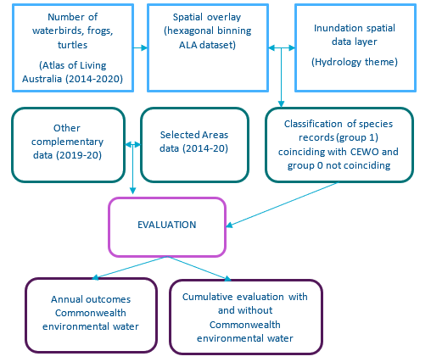

Figure . Conceptual layout of data aggregation for annual and multi-year evaluation of the influence on species diversity of environmental water, of which Commonwealth environmental water was a contributor

# Species diversity supported by Commonwealth environmental water

Since 2014 there have been 333 environmental watering actions of which Commonwealth environmental water was a major contributor with objectives related to waterbirds, frogs, turtles and other vertebrates (Table 3.1). Watering actions targeting waterbirds, frogs and other vertebrates were far more common in valleys undertaking floodplain and wetland inundation, including the Central and Lower Murray rivers, the Macquarie, Gwydir, Lachlan and Murrumbidgee (Table 3.1). There were no actions specifically targeting waterbird, frog or other vertebrate outcomes in the 2014–20 period in the Barwon Darling, Lower Darling, Namoi or Ovens rivers.

Commonwealth environmental water was also delivered for multiple objectives targeting maintenance of high-quality wetland habitats. In many valleys these included the provision of suitable habitat for a range of taxa including waterbirds, fish, frogs, turtles, other vertebrates and vegetation. The maintenance of refuge habitats was a common theme across multiple catchments and tended to target outcomes for multiple taxa. For example, the objectives to ‘Maintain refuge habitat for turtles and other water dependent animals’, and ‘Maintain refuge habitat for waterbirds’ were common. The maintenance and provision of habitats for multiple taxa – for example, objectives such as to ‘Provide habitat to support survival and maintain condition of waterbirds and other native biota (including turtles, frogs and invertebrates)’ were also common across multiple catchments and years. More detailed consideration of watering objectives is presented within the chapters on frogs, waterbirds, and turtles and other vertebrates (chapters 4, 5, and 6 respectively). In terms of water delivery, Commonwealth environmental watering actions targeting outcomes for frogs, waterbirds and other vertebrates made up a higher percentage of the overall delivery volume in valleys with more significant floodplain and wetland habitats, such as the Macquarie Marshes, Gwydir, Lachlan, Murrumbidgee and Central and Lower Murray (see Figure 3.1).

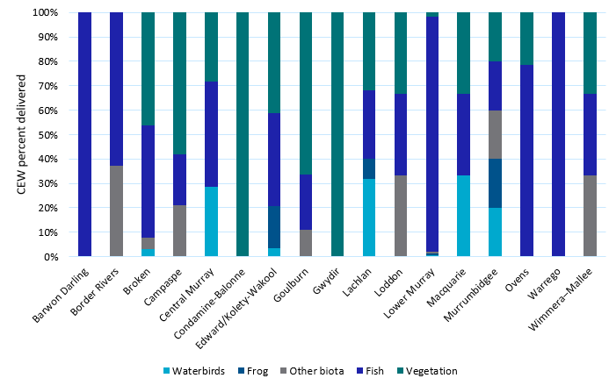

Figure . Relative percentage of environmental watering actions, of which Commonwealth environmental water (Cew) was a major contributor, that had at least one objective contributing to outcomes for species diversity, by valley, 2014–20

Table . Occurrence (*) of annual watering actions with objectives relevant to species diversity (frogs, waterbirds and other vertebrates) 2014–20, by surface water region

|  | **Waterbirds** | | | | | | **Frogs** | | | | | | **Other vertebrates** | | | | | |
| --- | --- | --- | --- | --- | --- | --- | --- | --- | --- | --- | --- | --- | --- | --- | --- | --- | --- | --- |
| **Surface water region** | **14–15** | **15–16** | **16–17** | **17–18** | **18–19** | **19–20** | **14–15** | **15–16** | **16–17** | **17–18** | **18–19** | **19–20** | **14–15** | **15–16** | **16–17** | **17–18** | **18–19** | **19–20** |
| Border Rivers |  |  |  |  |  |  |  |  |  |  |  |  |  |  |  | * |  |  |
| Broken |  |  |  | * | * | * |  |  |  |  |  |  |  |  |  |  |  | * |
| Campaspe |  |  |  |  |  |  |  |  |  |  |  |  |  |  |  |  | * | * |
| Central Murray | * | * |  | * | * | * |  | * |  | * |  |  |  | * |  |  |  |  |
| Condamine–Balonne |  |  | * |  |  |  |  |  |  |  |  |  |  |  |  |  |  |  |
| Edward/Kolety–Wakool |  |  |  |  | * | * |  |  |  | * |  | * |  |  |  |  |  |  |
| Goulburn | * |  |  |  |  |  |  |  |  |  |  |  |  |  |  |  |  |  |
| Gwydir | * | * | * | * | * |  |  |  | * |  | * |  | * | * |  |  | * |  |
| Lachlan |  | * | * |  | * | * |  |  | * |  | * | * |  |  |  |  |  |  |
| Lower Murray | * | * | * | * | * | * | * | * | * | * | * | * |  |  |  |  |  |  |
| Macquarie | * | * | * | * | * | * |  | * |  |  | * |  |  |  |  |  |  |  |
| Murrumbidgee | * | * | * | * | * | * | * | * | * | * | * | * | * | * | * | * | * | * |
| Warrego |  |  | * |  |  |  |  |  |  |  |  |  |  |  |  |  |  |  |
| Wimmera–Mallee |  |  |  | * |  |  |  |  |  |  |  |  |  |  |  |  |  |  |
| Barwon Darling |  |  |  |  |  |  |  |  |  |  |  |  |  |  |  |  |  |  |
| Loddon |  |  |  |  |  |  |  |  |  |  |  |  |  |  |  |  |  |  |
| Lower Darling |  |  |  |  |  |  |  |  |  |  |  |  |  |  |  |  |  |  |
| Namoi |  |  |  |  |  |  |  |  |  |  |  |  |  |  |  |  |  |  |
| Ovens |  |  |  |  |  |  |  |  |  |  |  |  |  |  |  |  |  |  |

In 2019–20 much of the Basin experienced severe dry conditions and environmental watering actions were undertaken within the context of dry to very dry water availability. Not surprisingly, given the dry conditions, watering objectives associated with species diversity outcomes focused heavily on the maintenance of refuge habitats.

A total of 392,518 ML (33%) of environmental water was delivered (including a Commonwealth contribution of 296,244 ML (25%)) as part of 61 individual watering actions with objectives related to species diversity outcomes (Table 3.2). These included wetland inundation actions targeting broader waterbird, frogs and freshwater turtle outcomes as well as targeted deliveries for threatened and migratory species including the southern bell frog (Litoria raniformis), Latham’s snipe (*Gallinago hardwickii*), regent parrot (*Polytelis anthopeplus*) and platypus (*Ornithorhynchus anatinus*). In many cases actions targeted multiple outcomes, particularly in the Murrumbidgee where all actions had objectives for waterbirds, frogs and freshwater turtles. Most watering actions targeting species diversity outcomes were on floodplains and included nationally significant wetlands and Ramsar sites.

Table . Summary of occurrence (*) of Commonwealth environmental water (Cew) actions with objectives related to waterbirds, frogs and other vertebrate groups 2019–20, by surface water region

| **Valley** | **Surface water region/asset** | **Cew (ML)** | **Total (ML)** | **Flow component** | **Waterbirds** | **Frogs** | **Other vertebrates** |
| --- | --- | --- | --- | --- | --- | --- | --- |
| Balonne | aLower Balonne and Narran Lakes | 164,675 | 164,675 | Fresh, wetland |  |  |  |
| Broken | Lower Broken Creek and fringing wetlands | 1,226 | 2,169 | Baseflow | * |  | * |
| Upper Broken Creek | 112 | 505 | Baseflow |  |  | * |
| Campaspe | Campaspe River | 571 | 6975 | Baseflow |  |  | * |
| Campaspe River | 535 | 1404 | Fresh |  |  | * |
| Campaspe River | 850 | 2252 | Fresh |  |  | * |
| Campaspe River | 275 | 866 | Fresh |  |  | * |
| Central Murray | River Murray Channel | 195,834 | 245,990 | Overbank | * |  |  |
| Wingillie Station | 61 | 61 | Wetland | * |  |  |
| Edward/Kolety–Wakool | Tuppal Creek | 5,186 | 10,371 | Baseflow, fresh |  | * |  |
| The Pollack (Koondrook | 2,000 | 2,000 | Wetland | * |  |  |
| Lachlan | Wyangala Dam to Great Cumbung, including Brewster Weir Pool | 17,028 | 17,028 | Fresh, wetland | * |  |  |
| Yarrabandai (formerly Burrawang West Lagoon) | 400 | 548 | Wetland | * | * |  |
| Booberoi Ck | 2,900 | 2,900 | Fresh | * | * |  |
| Noonamah black box woodlands | 126 | 220 | Wetland | * | * |  |
| Booberoi Ck | 1,572 | 2,100 | Fresh | * | * |  |
| Loddon | Loddon River | 431 | 515 | Fresh |  |  | * |
| Loddon River | 510 | 637 | Fresh |  |  | * |
| Lower Murray | Calperum Station Thookle Thookle | 186 | 186 | Wetland | * |  |  |
| Calperum Station Amazon floodplain | 149 | 149 | Wetland | * |  |  |
| Renmark Floodplain Wetlands Site 14 (Twentysixth Street) | 26 | 26 | Wetland | * | * |  |
| Renmark Floodplain Wetlands End Namoi Street | 51 | 51 | Wetland | * | * |  |
| Renmark Floodplain Wetlands - Plush's Bend | 69 | 69 | Wetland | * | * |  |
| South Australian River Murray and Coorong - Weir Pool Lock 6 (Raising) | 1502 | 1502 | Wetland | * |  |  |
| South Australian River Murray and Coorong - Weir Pools Lock 2 (Raising) | 5639 | 5639 | Wetland | * |  |  |
| Lower Murray Wetlands Morgan East | 170 | 170 | Wetland |  | * |  |
| Lower Murray Wetlands Morgan CP (North Lagoon and South Lagoon) | 344 | 344 | Wetland | * | * |  |
| Lower Murray Wetlands Wiela Temporary Wetlands | 487 | 487 | Wetland |  | * |  |
| Lower Murray Wetlands Bookmark Creek | 402 | 402 | Baseflow |  | * |  |
| Lower Murray Wetlands Gerard Lignum Basin | 119 | 119 | Wetland |  | * |  |
| Lower Murray Wetlands Murtho temporary | 405 | 405 | Wetland | * |  |  |
| Lower Murray Wetlands Martin Bend Temporary | 99 | 99 | Wetland | * |  |  |
| Lower Murray Wetlands Yabby Creek | 1,296 | 1,296 | Wetland |  | * |  |
| Lower Murray Wetlands Overland Corner Wetlands | 145 | 145 | Wetland |  | * |  |
| Lower Murray Wetlands Tolderol | 184 | 184 | Wetland | * |  |  |
| Lower Murray Wetlands Hogwash Bench (North and South) | 488 | 488 | Wetland |  | * |  |
| Banrock Station Eastern Lagoon | 1,424 | 1,424 | Wetland | * | * |  |
| South Australian Murray Hogwash Bend | 4 | 4 | Wetland | * |  |  |
| South Australian Murray Milang (MSN1) | 19 | 19 | Wetland | * |  |  |
| South Australian Murray Inner Mundic flood runner | 1 | 1 | Wetland |  | * |  |
| South Australian Murray Pike Lagoon flood runner | 87 | 87 | Wetland |  | * |  |
| South Australian Murray Qualco main temporary lagoon (QLC1) | 378 | 378 | Wetland | * |  |  |
| South Australian Murray Qualco temporary riparian swale wetlands | 52 | 52 | Wetland | * |  |  |
| Lower Murray Wetlands Molo Flat | 408 | 408 | Wetland |  | * |  |
| South Australian Murray wetland and floodplain Cadell Temporary Wetland | 264 | 264 | Wetland | * |  | * |
| Macquarie | Macquarie Marshes | 1,169 | 1,375 | Fresh, wetland | * |  |  |
| Macquarie Marshes | 1,346 | 1,583 | Fresh, wetland | * |  |  |
| Macquarie Marshes | 1,381 | 1,625 | Fresh, wetland | * |  |  |
| Murrumbidgee | Gooragool and Mantangry Lagoons | 2,251 | 2,451 | Wetland | * | * | * |
| Darlington Lagoon | 142 | 142 | Wetland | * | * | * |
| Yarradda Lagoon | 2,000 | 2,000 | Wetland | * | * | * |
| GNC Refuge, SBF Breeding and Tala Creek System Refuge | 18,000 | 41,313 | Wetland/ Overbank | * | * | * |
| North Redbank Refuge | 11,010 | 11,010 | Wetland/ Overbank | * | * | * |
| Waldaira Lagoon | 1500 | 1500 | Wetland | * | * | * |
| Mainie Swamp | 2,000 | 2,000 | Wetland | * | * | * |
| Toogimbie IPA | 500 | 1,000 | Wetland | * | * | * |
| Campbell's Swamp, McCaughey's, Tuckerbill and Turkey Flats | 3,612 | 3,612 | Wetland | * | * | * |
| Wanganella Swamp | 2,250 | 2,250 | Wetland | * | * | * |
| Yanga National Park | 2,963 | 2,963 | Wetland | * | * | * |
| Sunshower Lagoon | 514 | 514 | Wetland | * | * | * |
| North Redbank Refuge | 1,442 | 6,091 | Wetland | * | * | * |
| Yanga National Park | 151 | 151 | Wetland | * | * | * |

a no stated objectives for species diversity, however outcomes for waterbirds reported during waterbird ground surveys by NSW DPIE-EES

# Outcomes for frogs

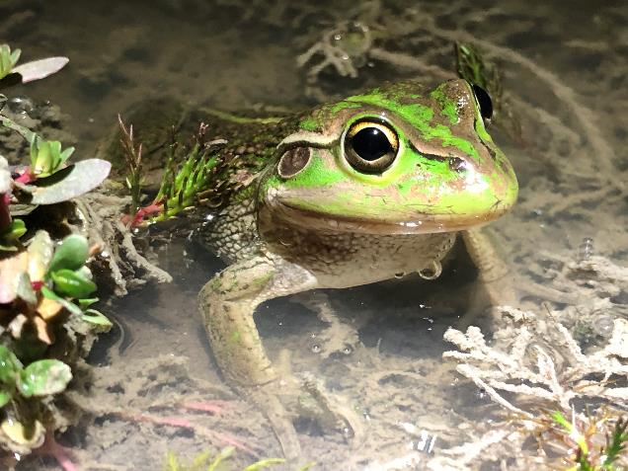

Male southern bell frog (Litoria raniformis) (listed as vulnerable under the EPBC Act) at a Commonwealth environmental watering site in the lower Murrumbidgee, January 2020

Photo credit: Damian Michael, Charles Sturt University

## Introduction

Globally, amphibians have the highest percentage of species at risk of extinction. In Australia, 22% of species are listed under the Commonwealth Environment Protection and Biodiversity Conservation Act 1999 (EPBC Act) and 4 frog species have become extinct in the past 40 years. While there are a range of threats facing Australian frog species, habitat loss and river regulation are key threats to many species in the Basin (Ocock and Wassens 2018; Wassens and Maher 2011). Environmental water can have direct benefits to frog diversity as well as waterbirds, freshwater turtles and wetland dependent snakes which feed on frogs and tadpoles.

Frogs have a range of life history strategies that influence how, or if, they respond to environmental water (Ocock and Wassens 2018). Flow-responsive species are those that are known to respond strongly to floodplain inundation and managed environmental flows, independent of local rainfall. They typically have longer tadpole development times and are often associated with larger, more frequently inundated waterbodies with longer hydroperiods( 3–6 months) (Ocock et al. 2014). A second groups of species (flow-ambivalent) have flexible breeding strategies and can respond to floodplain inundation during regulated (including environmental) flows but can also respond strongly to local rainfall. The third group are burrowing species that emerge only after heavy rains to breed in rainfed systems, so although they make up a significant component of frog diversity, especially in the northern basin, they are not expected to respond directly to environmental water delivery.

There are 66 frog species within the Basin. Many are restricted to the cooler high-altitude areas of the Great Dividing Range. Thirty-two species are expected to occur in the mid and lowland areas that may be influenced by environmental water (Table A.4). Ten species are known to respond strongly to environmental water delivery. These include the southern bell frog (Litoria raniformis, listed as vulnerable under the EBPC Act) which occur across multiple valleys in the southern connected Basin, lower Lachlan, Murrumbidgee, Lower Murray and Edward/Kolety–Wakool and are highly dependent on environmental water in these areas. Other widespread flow-responsive species include the spotted marsh frog (*Limnodynastes tasmaniensis*), Peron’s tree frog (*Litoria peronii*) and giant banjo frog (*Limnodynastes interioris*).

## Datasets

Monitoring frog response to environmental water was undertaken for Flow-MER in 2 areas – The junction of the Warrego and Darling rivers (CEWO 2020) and the Murrumbidgee (Wassens et al. 2021). Further monitoring of frog responses to environmental water was undertaken as part of state-based programs in the Gwydir and Macquarie Marshes (Walcott et al. 2019b) and in Victoria under the WetMAP program (Papas et al. 2021). There were monitoring activities undertaken through the central Murray in NSW and Victoria including monitoring of frog responses to environmental water delivery in the Koondrook–Perricoota (Dind 2020, Linke et al. 2020), and broad-scale surveys for southern bell frogs through the Murrumbidgee and Central Murray (Waudby et al. 2021). In South Australia, frog response to environmental water was assessed by Riverland by Landscape South Australia (Murraylands and Riverland) (Mason 2020), Nature Foundation (e.g. (Lescheid 2020) and Renmark Irrigation Trust and Banrock Station (Field 2020) which included monitoring for frogs either directly or through community-based programs.

Various monitoring approaches were undertaken including visual encounter surveys, audio surveys (either via active listening or the deployment of passive remote audio recorders) and tadpole surveys via sweep netting or trapping. Given the range of monitoring techniques employed across the Basin, it is not possible to undertake a direct comparison of frog outcomes between valleys. However, these data can be informative when evaluating frog outcomes with respect to environmental water delivery within valleys.

The combination of complementary state-based monitoring programs and those collected for Flow‑MER monitoring in the Murrumbidgee and Warrego–Darling resulted in relatively good coverage of frog communities in areas receiving Commonwealth environmental water (Figure 4.1). High diversity in the northern Basin reflects the higher numbers of burrowing species which respond strongly to local rainfall but have limited interaction with environmental water delivery. For this reason, we limited much of our consideration of species responses to flow-responsive and flow-ambivalent species within the Basin.

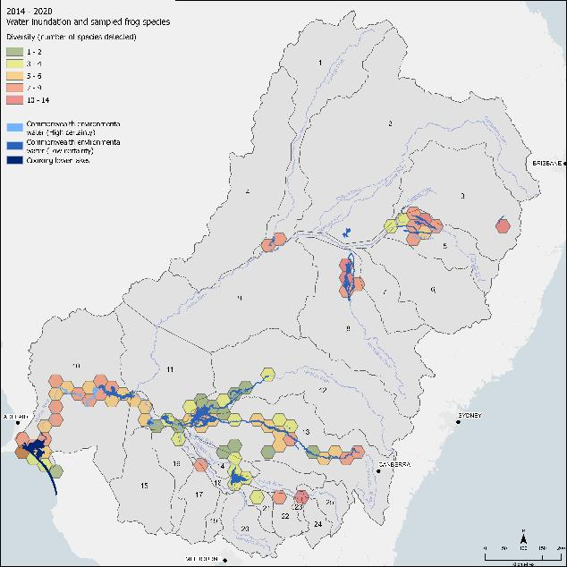

Figure . Hexagonal bins showing the number of frog species occurring within each 1,000 sq km bin that aligned with areas of mapped inundation by Commonwealth environmental water 2014–2020

## Commonwealth environmental watering actions for frogs

Over the 6-year monitoring period, Commonwealth environmental watering delivered 592,581 ML with at least one objective related to outcomes for frogs. Over the past 6 years there has been a shift in the wording of watering objectives from broader actions focused on habitat maintenance to more targeted objectives focused on frog breeding, connectivity and refuge (Figure 4.2). Broadly, environmental water delivery objectives for frogs were centred around 3 key themes:

* the provision and maintenance of aquatic habitat for frogs and associated wetland fauna (habitat)
* promotion of breeding (breeding)
* maintenance of critical refuge habitats (refuge).

As expected, given the dry conditions in 2019–20, the overall volume of Commonwealth environmental water delivered, at least in part, for frog outcomes (64,034ML) was slightly lower than previous years, although similar to 2015–16 (70,268 ML). There was a clear emphasis on the support of refuge habitats in 2019–20 (Figure 4.2). Volumes of water delivered with specific objectives related to breeding were slightly higher in 2019–20 compared to 2018–19, although still substantially lower than in 2017–18.

When broken down by valley, environmental watering actions targeting frogs occurred every year in the Murrumbidgee and Lower Murray Table 3.1) with both valleys targeting southern bell frog populations along with other taxa. Overall, the Murrumbidgee allocated the highest volumes of Commonwealth environmental water to support frogs and associated wetland taxa compared to other valleys, although lower volumes in the Lower Murray may also reflect water delivery methods with pumping frequently used to target individual wetlands (Table 3.2, Figure 4.3).

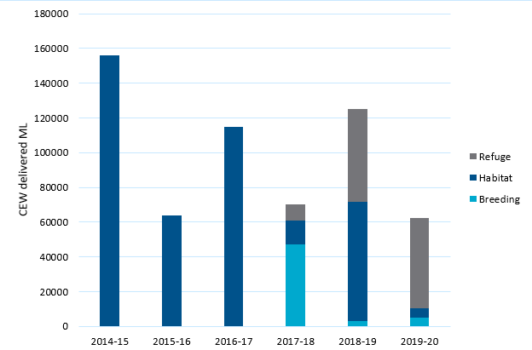

Figure . Annual volume of Commonwealth environmental water with at least 1 objective related to frogs (refuge, habitat or breeding), across all valleys, 2014–20

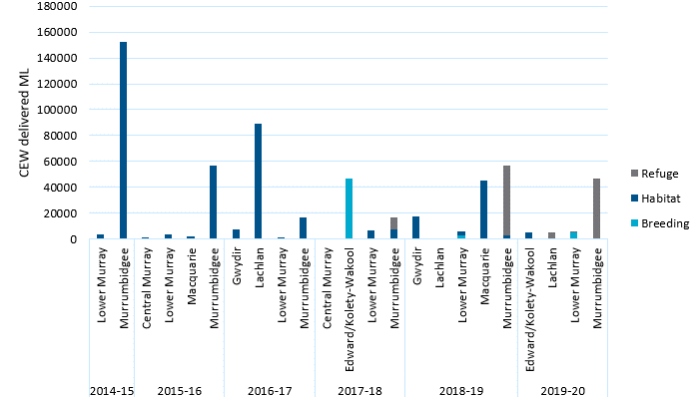

Figure . Annual volume of Commonwealth environmental water with at least 1 objective related to frogs (refuge, habitat or breeding, by valley, 2014–20

## Water delivery approaches

Most watering actions targeting frog outcomes were focused on wetland inundation (overbank). A range of delivery approaches were utilised. Pumping was common in the Lower Murray, Central Murray and at some locations in the mid-Murrumbidgee wetlands and one site in the Gwydir wetlands. Managed water diversions into floodplain wetlands via regulator structures were common through the northern and southern basins, particularly in the Lower Murrumbidgee floodplain, while instream freshes and weir manipulations were employed through the Edward/Kolety Wakool and Lower Murray.

## Water year 2019–20

Commonwealth environmental water with objectives linked to maintaining habitat and promoting breeding of frogs (see Table 3.2) was delivered as part of 32 individual watering actions. One action was undertaken in the Edward/Kolety–Wakool, 4 in the Lachlan and 14 actions each in the Lower Murray and Murrumbidgee. Due to the dry conditions, there was a clear focus on actions to maintain refuge habitat, particularly in the Murrumbidgee and Lachlan, and to support aquatic wetland habitat in the Lower Murray. Actions with objectives related to triggering local breeding of southern bell frogs were undertaken in the Murrumbidgee and Lower Murray. Actions in the Lower Murray and the Murrumbidgee had a specific objective related to supporting habitat and promoting breeding opportunities for the southern bell frog (CEWO Watering Action Acquittal Report 2020, unpublished).

The very dry conditions in 2019–20 are reflected in low frog abundances: 4,051 records in 2019–20 compared to a high of 14,336 in 2016–17, across key wetland systems in the Basin. However, environmental water delivery targeting frog outcomes in the Lower Murray and Murrumbidgee are reported as achieving objectives for frogs (see Table A.3) including the southern bell frog, with calling, tadpoles and recent metamorphs reported following environmental watering in both of these valleys (Figure 4.4, Table 4.1). There was limited monitoring of frog outcomes in areas not receiving environmental water and this is reflected in lower numbers of individuals reported in the ‘other water’ group. In the areas receiving environmental water, the patterns of abundance reflect both the timing of flows and the breeding phenology of the dominant species. For example, although there were no environmental watering actions specifically targeting frogs in the Central Murray there were generally strong frog responses by winter breeding species such as plains froglet (*Crinia parinsignifera*), eastern froglet (*C. signifera*) and Sudells froglet (*Neobatrachus sudellae*)) and an opportunistic species, spotted marsh frog (*Limnodynastes tasmaniensis*), following delivery of environmental water in late winter (Webster and Borrell 2020). In the Murrumbidgee, delivery of water in spring triggered responses from spring and summer active species, most notably southern bell frog, which increased in numbers over summer, in part due to successful recruitment events at sites in the lower Murrumbidgee ( see Wassens et al 2021). Southern bell frogs were also reported at environmental watering sites in the Lower Murray (see Figure 4.4)

The very dry conditions in the northern Basin contributed to very low abundances of frogs. There were no specific watering objectives for frogs in the Gwydir or Macquarie Marshes; however routine monitoring by NSW DPIE-EES demonstrated some positive outcomes for frogs in the Gwydir in response to a small environmental water delivery to Whittakers Lagoon (Walcott 2020).

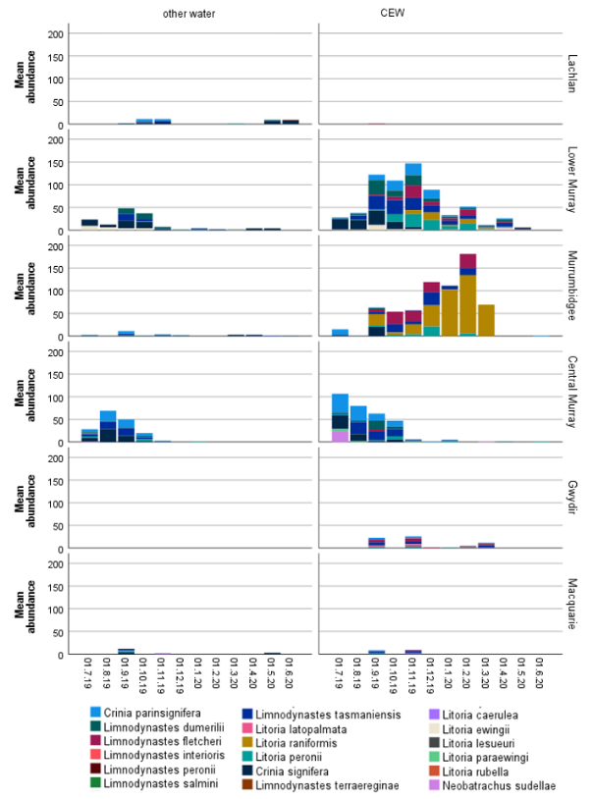

Figure . Occurrence of frogs (number of records) from the combined ALA, NSW DPIE-EES and Selected Area monitoring data, by valley 2019–20. Plots on the right-hand side summarise records that coincide with Commonwealth and other environmental water (CEW). Plots on the left-hand side summarise records not aligned with Commonwealth environmental water (other water)

Table . Environmental watering actions and summary of key observations associated with watering objectives for frogs, by surface water region, 2019–20

Although there were no specific environmental objectives for Commonwealth environmental water in the central Murray, Gwydir and Macquarie valleys, summaries of outcomes for these valleys have been included as these may be informative when planning future watering actions

| **Surface water region** | **Objective** | **Outcomes** |
| --- | --- | --- |
| Central Murray | No Commonwealth environmental watering objectives related to frogs | * The Koondrook–Perricoota Forest (KP Forest), one of The Living Murray (TLM) Icon Sites: no Commonwealth environment water in 2019–20. However TLM water was delivered and comprehensive monitoring of frog outcomes conducted within Forestry NSW controlled areas. The species reported as responsive to Commonwealth environmental watering actions were plains froglet*,* eastern froglet, barking marsh frog, spotted marsh frog, eastern banjo frog and Peron’s tree frog, Sudell’s frogletNeobatrachus sudelli and southern bell frog (Linke et al. 2020) |
| Edward/Kolety–Wakool | Maintain habitat for frogs | * No monitoring was undertaken directly associated with Tuppal Creek; however incidental recordings of frogs were undertaken at Pollack Swamp by Forestry NSW (Hutton 2020). Seven frogs were recorded calling in response to water delivery, including plains froglet *Crinia parinsignifera,* eastern froglet *C. signifera,* eastern banjo frog *Limnodynastes dumerilii,* barking marsh frog *L. fletcheri,* spotted marsh frog *L. tasmaniensis* and Peron’s tree frog *L. peronii* |
| Gwydir | No Commonwealth environmental watering objectives related to frogs | * Very low numbers of frogs were observed across the Gwydir Wetlands system, with adults likely seeking refuge. Overall 8 frog species were detected, including 5 flow-responsive species and 3 burrowing species (Walcott et al 2020) * NSW delivered high security water to Whittakers Lagoon via a pump in November 2019(Walcott 2020) * Species benefiting from environmental water included plains froglet, barking marsh frog , spotted marsh frog, Peron’s tree frog and board palmed frog *Litoria latopalmata* (Walcott 2020) |
| Lachlan | Maintain refuge habitat for frogs | * Incidental monitoring of frogs was undertaken at Yarrabandai in November 2019 and confirmed the presence of plains froglet, barking marsh frog, spotted marsh frog and Peron’s tree frog *(CEWO Watering Action Acquittal Report 2020, unpublished)* |
| Lower Murray | Supporting localised frog breeding for a range of species, including southern bell frog, at most of the pumping sites | * Frog counts revealed 5 species of frogs at Banrock Station, plains froglet*,* barking marsh frog , spotted marsh frog, eastern banjo frogand Peron’s tree frog.On this occasion no southern bell frogs were recorded at Banrock station (Field 2020) * Breeding calls were heard for all 6 frog species that are expected to be found in the Riverland areas, including the nationally threatened southern bell frog * Southern bell frogs were detected at 7 sites, including successful recruitment at 4 sites (not all sites were monitored for recruitment) |
| Macquarie | No Commonwealth environmental watering objectives related to frogs | * All wetlands routinely monitored across the Macquarie Marshes were dry in September and November 2019 and frog abundances were very low * 5 frog species were detected in 2019–20: plains froglet, barking marsh frog, spotted marsh frog, green tree frog Litoria caerulea, and Peron’s tree frog.One burrowing species knife-footed frog Cyclorana cultripes observed in rain-filled road-side depressions during the November 2019 surveys (Walcott et al. 2019b) |
| Murrumbidgee | Maintain refuge habitat for frogs  Provide opportunities for breeding and recruitment for southern bell frog | * Murrumbidgee MER – very strong response of frogs following environmental water including significant recruitment of southern bell frogs in the Gayini Nimmie–Caira. Also, abundant *Crinia parinsignifera, Limnodynastes interioris, L. fletcheri, L. tasmaniensis* and *Litoria peronii* (Wassens et al. 2021) * Save Our Species (SOS) monitoring identified southern bell frog occurrence and breeding at wetlands in the Murrumbidgee, Coleambally Irrigation district and Toogimbie Indigenous Protected Area following environmental water delivery (Waudby et al. 2021) |
| Warrego | No Commonwealth environmental watering objectives related to frogs | * 7 frog species detected; barking marsh frog, desert froglet Crinia deserticola*,* desert tree frog Litoria rubella*,* green tree frog , Peron’s tree frog, spotted marsh frog and Sudell’s froglet (CEWO 2020d) |

## Water years 2014–20

In this section we compare frog abundances based on the ALA records classified according to whether they coincided with areas with (1) and without (0) Commonwealth environmental watering. Note that differences in survey effort and reporting of data make comparisons between valleys unreliable. However, monitoring programs in the Murrumbidgee, Lower Murray, Central Murray, Gwydir and Macquarie all include wetlands influenced by Commonwealth environmental water and other water sources, including state environmental water delivery, consumptive water and natural unregulated inundation events . This allows some general comparisons between the with (1) and without (0) groups.

There are 61,443 records of frogs within the ALA database for the Basin. A total of 26,899 individuals from 32 frog species were reported from areas influenced by Commonwealth environmental water, compared with 31,768 individuals from areas without between 2014 and 2020 (Figure 4.5, Table A.1). Of the 32 species, 17 (2,6445 individual records) are classified as flow responsive or flow ambivalent (Table A.1). Despite the very wide distribution of many flow-responsive species, areas influenced by Commonwealth environmental water account for 83% of southern bell frog records, 89% of all giant banjo frog (Limnodynastes interioris), 88% of salmon striped frog *(Limnodynastes salmini)*,and 83% of barking marsh frog *(*Limnodynastes fletcheri*)* records contained within the ALA dataset for the Basin (Table A.3).

Another interesting occurrence is the endangered (EPBC Act) Booroolong frog *(*Litoria booroolongensis*)* which is a stream-dwelling species formerly widespread through rocky westward flowing streams of the Great Dividing Range. Although not normally considered as part of Commonwealth environmental watering objectives, the occurrence of this species in valleys that receive Commonwealth environmental water delivery warrants further consideration as the management of dam releases for both consumptive and environmental purposes have the potential to impact this species. The national recovery plan for Booroolong frog lists ‘*reinstate natural flow regimes in regulated rivers supporting the Booroolong Frog through the use of environmental flows’* as a key management practice recommended to support the recovery of this species (NSW OEH 2012). Further consideration of this relationship is presented in the adaptive management section of this report.

Despite drier than average conditions, repeat Commonwealth environmental watering actions targeting frogs were associated with the greatest proportion of frog records in the Murrumbidgee, Lower Murray, Gwydir and Macquarie. In contrast frog records in the Lachlan, Central Murray and Broken more often coincided with locations not receiving Commonwealth environmental water. It is important to note that Figure 4.4 shows the distribution of frog records relative to environmental water which included Commonwealth environmental water as a component; other sources of water including standalone environmental water from other programs, unregulated flows and artificial water sources can also support frog populations in areas not receiving Commonwealth environmental water.

Notable outcomes for frog communities over time include a steady increase in southern bell frog abundance in the Murrumbidgee and Lower Murray at locations influenced by Commonwealth environmental water. The southern bell frog is highly sensitive to environmental water management and has very narrow flow requirements – requiring shallow, well vegetated areas with longer duration of inundation. Pumping of wetlands has been used with considerable success to support southern bell frog populations in the Lower Murray (NSW) and Lower Murray (SA) and the mid-Murrumbidgee (Mason 2020, Waudby et al. 2021). There is evidence of an increase in southern bell frog occurrences coinciding with Commonwealth environmental watering in the Lower Murray and Murrumbidgee from 2016 onwards (see Figure 4.5).

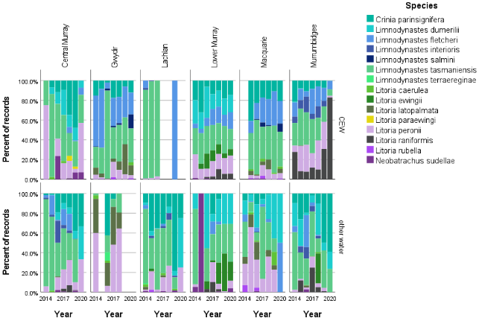

Figure . Relative percentages of frog occurrence from combined ALA and Selected Area monitoring data, 2014–20, by year and valley. Top row plots summarise records that coincide with Commonwealth and other environmental water (CEW). Bottom row plots summarise records not aligned with Commonwealth environmental water (other water)

Rain-responsive species have been excluded from this figure for clarity

## Discussion

This section considered frog responses to Commonwealth environmental water as part of the broader evaluation question:

What did Commonwealth environmental water contribute to species diversity?

For the evaluation of annual outcomes in 2019–20 we utilised monitoring undertaken for Flow-MER in the junction of the Warrego and Darling rivers (CEWO 2020d) and the Murrumbidgee (Wassens et al. 2021). We also drew on complementary data collected as part of NSW DPIE EES monitoring in the Central Murray, Gwydir and Macquarie Marshes (Walcott et al. 2019a, b). These used a broadly standard survey method and allowed us to present seasonal frog response to environmental watering actions in these areas.

We also mapped annual frog observations in relation to inundation by environmental water, which included Commonwealth environmental water as a major contributor, and included patterns of frog observations that occurred outside of these areas as reference. In the Murrumbidgee, southern bell frogs were reported to have responded strongly to targeted delivery of environmental water in in the Gayini-Nimmie–Caira region but responses to environmental water delivery to other areas were limited (Wassens et al. 2021). State and local monitoring programs also reported positive outcomes for southern bell frogs following environmental water delivery to support in the Murray (Hoffman 2017), and other parts of the Murrumbidgee and Central Murray in NSW (Waudby et al. 2020). While local outcomes are positive, lack of coordinated monitoring programs means that we have limited capacity to evaluate frog outcomes at the Basin scale. In addition, frogs are not currently considered in the Basin Water Strategy and their water needs are not always fully catered for under long-term water plans. A coordinated review of the water needs of frogs, with a particular focus on threatened species is needed.

# Outcomes for waterbirds

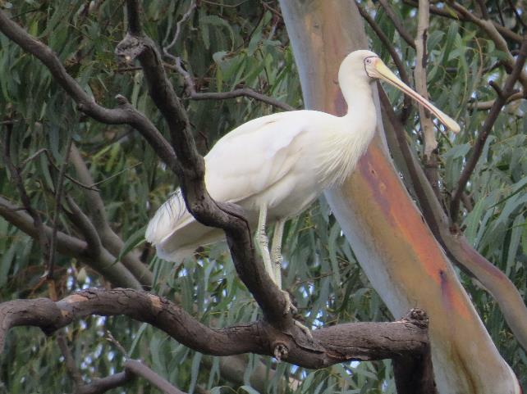

Yellow-billed spoonbills (*Platalea flavipes*) are strongly dependent on surface water for feeding, breeding, roosting and refuge

Photo credit Freya Robinson CSIRO

## Introduction

Waterbirds are a key component of species diversity in the Basin with over 100 species known to occur. This includes 16 species listed under the EPBC Act and 25 species listed under international migratory waterbird treaties (Bonn Convention, CAMBA, JAMBA and/or ROKAMBA) (MDBA 2017). There is growing evidence of the importance of environmental water to maintain waterbird populations in Australia, especially at the catchment scale (MDBA 2017), though populations of many species continue to decline (Kingsford et al. 2013, Porter et al. 2020). The high proportion of listed species, and ongoing population declines make waterbirds a key priority for environmental watering, particularly in floodplain and wetland habitats.

Critical waterbird habitats and multiple populations of listed waterbird species are associated with environmental water. Adaptive management of environmental water to support waterbird breeding sites, breeding events, foraging habitats and food sources is increasingly important in the context of climate change and increasing human demand for freshwater. There is also potential for other adaptive management actions to support the effectiveness of environmental water and ultimately waterbird recruitment. Environmental water, vegetation management and management of pressures and threats such as predation, disease and toxins, all interact with habitat availability and quality to affect waterbird movements, condition, growth, survival and mortality, as well as breeding initiation and frequency. These then determine population outcomes.

## Datasets

There are limited waterbird monitoring data available through LTIM or Flow-MER. In 2019–20, monitoring of waterbird responses to environmental water was undertaken for Flow-MER monitoring in 3 Selected Areas: the Junction of the Warrego–Darling rivers (CEWO 2020d), Gwydir River System (CEWO 2020c) and Murrumbidgee River System (Wassens et al. 2021). In addition to Selected Area data, complementary surveys using standard survey methods and effort were undertaken by NSW DPIE-EES in the Gwydir (Spencer 2020a), Macquarie (Spencer 2020b), Lachlan (Spencer et al. 2020), Murrumbidgee (Wassens et al. 2021) and NSW Central Murray (Webster and Borrell 2020) valleys.

The 2019–20 evaluation of responses to Commonwealth environmental water is based on combined Flow-MER datasets from the Gwydir, Warrego–Darling and Murrumbidgee valleys with complementary data from the Lachlan, Macquarie Marshes and Millewa (Central Murray) (used with permission from NSW DPIE-EES and National Parks Wildlife Service); refer CEWO (2020d, 2020e), Spencer 2020b, Webster and Borrell 2020, Wassens et al. 2021) (Table 5.1).

Table . Summary of datasets and number of individual water birds reported for the Flow-MER and complementary NSW DPIE waterbird monitoring data, 2019–20

|  |  |  |  |
| --- | --- | --- | --- |
| **Survey area** | **Survey number** | **Total individuals reported** | **Source** |
| Gwydir | 1 | 3,218 | CEWO 2020c |
| Gwydir | 2 | 9,075 | CEWO 2020c; Spencer 2020 |
| Junction of the Warrego and Darling Rivers | 1 | 75 | CEWO 2020d |
| Lachlan | 1 | 6,555 | Spencer et al. 2020 |
| Macquarie Marshes | 1 | 55 | Spencer et al. 2020b |
| Millewa | 1 | 3,041 | Webster and Borrell 2020 |
| Millewa | 2 | 945 | Webster and Borrell 2020 |
| Murrumbidgee River | 1 | 414 | Wassens et al. 2021 |
| Murrumbidgee River | 2 | 6,719 | Wassens et al. 2021 |

Longer term monitoring of waterbirds is also undertaken in other programs. For example, the East Australian Aerial Waterbird Survey (Kingsford et al. 2020, Porter et al. 2020) is a long-term project led by the UNSW and funded by the MDBA. This program provides a comprehensive long-term assessment of waterbird diversity and abundance for species visible from the air across south-eastern Australia.

The combination of data from these monitoring programs along with data from Flow-MER monitoring in the Murrumbidgee, Warrego–Darling and Gwydir contribute to relatively good coverage of sites receiving Commonwealth environmental water delivery across the Basin (Figure 5.1). There are some limitations in the time-series data, with surveys coordinated by the NSW DPIE-EES for the Gwydir, Macquarie Marshes, Lachlan, Millewa, Narran valleys, and some sites in the Murrumbidgee, not included in the ALA at the time of download. These data are presented separately in the evaluation of outcomes in 2019–20.

NSW DPIE-EES coordinated monitoring of waterbirds in the Gwydir, Macquarie, Lachlan Murrumbidgee and NSW Central Murray valleys which are reported in the ALA dataset between 2014 and 2019. In Victoria, waterbirds were monitored under the WetMAP program (Papas et al. 2021) and reported in the ALA database. Site-specific monitoring was also undertaken at multiple sites through the Lower Murray by Landscape SA (Mason 2020), Nature Foundation SA (e.g. Lescheid 2020) and Renmark Irrigation Trust and Banrock Station (Field 2020). Long-term monitoring of waterbirds in the Coorong and Lower Lakes in South Australia is undertaken by the University of Adelaide. Coorong and Lower Lakes waterbird census data are also available, from 2000 to 2019 (MDBA 2020). These data are also reported in the ALA database. Data sources that had fewer than 500 records within the ALA were excluded from the analysis (Table 5.2). Considering the distribution of records by valley and alignment with mapped areas of Commonwealth environmental watering, the availability of waterbird data varies considerable between valleys.

Table . Summary of the number of waterbird records available from key data sources contained within the ALA used in our analysis, 2014–20

|  |  |
| --- | --- |
| **Data source** | **Number of records 2014–20** |
| BirdLife Australia | 36,375 |
| eBird Australia | 213,407 |
| iNaturalist Australia | 2,077 |
| Murray–Darling Basin waterbird survey | 1,982 |
| NSW OEH Atlas of NSW Wildlife | 22,686 |
| SA Fauna (Biological Databases of South Australia (DBSA) | 9,222 |
| Victorian Biodiversity Atlas | 612 |
| Total | 286,361 |

We limited our evaluation of longer term outcomes of Commonwealth environmental water to valleys that received water delivery actions with objectives for waterbirds; and where records were available from both the Basin waterbird survey and/or the OEH Atlas of NSW Wildlife, SA Fauna (BDBSA) or Victorian Biodiversity Atlas (Table 5.3). We excluded valleys where these was limited reporting of waterbird outcomes and valleys where CEWO rarely delivers actions with objectives related to waterbirds. This includes the Loddon which despite having a high number of waterbird records, largely due to monitoring at the Ramsar-listed Kerang wetlands, is not targeted for waterbird outcomes by CEWO.

Table . Summary of the number of waterbird records available, by valley, that were spatially aligned with mapped Commonwealth environmental water (Cew) inundation or aligned with other water sources (no Commonwealth environmental water) within the valley

| **Valley** | **Number of records aligned with mapped Cew inundation** | **Number of records aligned with other water (no Cew)** |
| --- | --- | --- |
| Central Murray* | 21,034 | 11,539 |
| Gwydir* | 4,893 | 3,719 |
| Lachlan* | 1,281 | 18,962 |
| Lower Murray* | 49,506 | 12,331 |
| Macquarie* | 3,429 | 12,376 |
| Murrumbidgee* | 22,902 | 18,645 |
| Loddon | 3,864 | 30,416 |
| Goulburn | 8 | 14,448 |
| Wimmera | - | 9,132 |
| Namoi | - | 7,754 |
| Ovens | 1,434 | 6,256 |
| Border Rivers | 64 | 6,383 |
| Broken | 292 | 5,596 |
| Edward Wakool | 3,031 | 988 |
| Campaspe | - | 3,305 |
| Barwon Darling | 17 | 2,934 |
| Avoca | 5 | 2,820 |
| Condamine Balonne | 144 | 2,203 |
| Paroo |  | 1,349 |
| Upper Murray | 79 | 863 |
| Lower Darling | 85 | 515 |
| Warrego | 103 | 412 |
| Mitta Mitta | 274 | 215 |
| Castlereagh | - | 471 |
| Kiewa | 55 | 229 |
| Total | 112,500 | 173,861 |

*included in cumulative outcomes analysis of waterbird outcomes

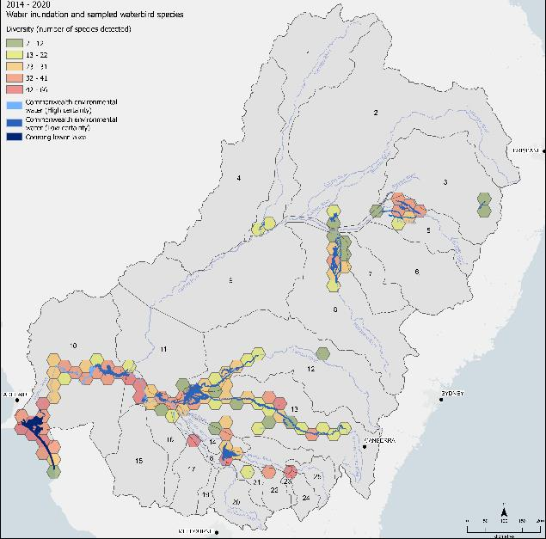

Figure . Hexagonal bins showing the number of waterbird species occurring within each 1,1000 sq km bin that aligned with Commonwealth environmental water delivery areas, 2014–20

## Commonwealth environmental watering actions for waterbirds

Since 2014, 3,641 GL of Commonwealth environmental water has been delivered to benefit waterbirds, either alone or in combination with objectives for other taxa and ecological processes. Across all years Commonwealth environmental watering objectives can be broadly grouped into 4 key themes.

* provision of habitat, including foraging opportunities and improving habitat condition
* provision of refuge habitat
* support of breeding opportunities
* secondary consideration of threatened and migratory species.

The volumes of environmental water delivered with an objective relating to waterbirds were highly variable across years, with smaller volumes delivered in 2014–15, 2018–19 and 2019–20 and larger volumes in 2015–16, 2016–17 and 2017–18 (Figure 5.2). The largest volumes of environmental water with at least one objective focused on waterbirds were delivered in the Central and Lower Murray, and the Macquarie and Murrumbidgee River Systems. Single actions with very low volumes occurred in the Broken, Condamine–Balonne and Warrego River Systems (Figure 5.3).

Watering actions targeting breeding occurred most years in the Murrumbidgee and Central Murray but were more common across multiple valleys during years of higher water availability. Smaller volumes were delivered to support rookery areas that had established following unregulated inundation in 2016–17 and larger volumes were used in 2017–18 in the Central Murray, Lower Murray and Murrumbidgee valleys. Drier conditions in 2018–19 and 2019–20 led to a shift towards watering actions targeting the general support and provision of habitats for waterbirds as well as provision of refuge habitats.

In 2019–20**,** there were 42 actions with a combined volume of 282,946 ML of Commonwealth environmental water with at least one objective related to waterbird outcomes (Figure 5.3, Table 3.2).

Although there is some variability in wording, Commonwealth watering objectives addressed 3 key themes:

* provision of refuge habitat
* provision of foraging habitat
* provision of habitat for listed migratory species including Latham's snipe and listed threatened species such as the Australasian bittern and regent parrot

As expected, given the dry conditions and low water availability throughout the Basin, there were no objectives linked specifically to waterbird breeding or recruitment in 2019–20.

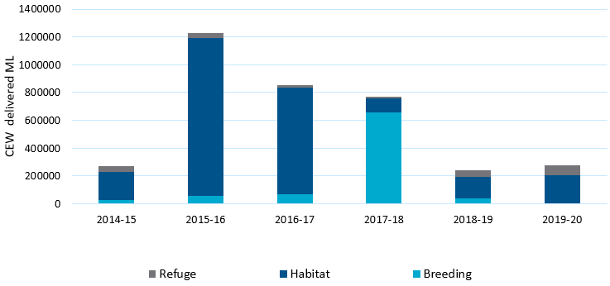

Figure . Total annual volumes of Commonwealth environmental water delivered with at least one objective related to waterbirds outcomes (refuge, habitat, breeding), 2014–20

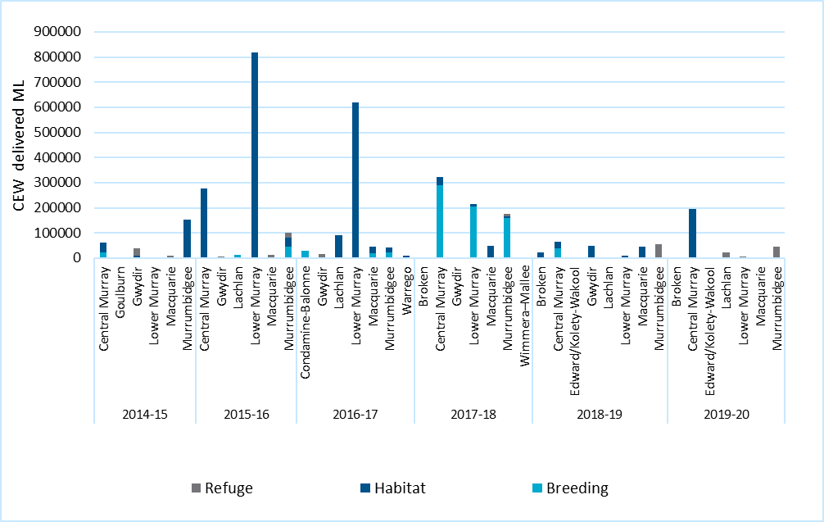

Figure . Total annual volumes of Commonwealth environmental water, delivered with at least one objective related to waterbird outcomes (refuge, habitat, breeding), by valley, 2014–20

## Water year 2019–20

In addition to the Flow-MER datasets for the Gwydir, Warrego–Darling and Murrumbidgee, complementary datasets were available from NSW DPIE-EES in the Macquarie Marshes, Lachlan and Central Murray Millewa (Spencer 2020a,b; Spencer et al. 2020, Webster and Borrell 2020). Given similarities in the survey approaches, these NSW survey datasets have been combined with the Flow-MER datasets to present a general overview of waterbird outcomes in selected wetland systems (Appendix A ).

Based on the combined dataset, in 2019–20, 30,097 individuals were reported, from 8 functional groups, 65 species of waterbirds and 5 raptor species. The highest abundances were reported after widespread rainfall led to unregulated flooding in the Gwydir (9,062 individuals) and after Commonwealth and NSW environmental water delivery in the Murrumbidgee (6,719 individuals) and Lachlan (5,466 individuals). Very low numbers were reported in the Warrego–Darling (74 individuals) and Macquarie Marshes (55 individuals) (see also Commonwealth Environmental Water Office 2020 a and b; Spencer 2020 b; Spencer et al. 2020; Wassens et al. 2021) (Table 5.4). For clarity, waterbird observations reported across these wetland systems are presented as a proportion of the total count of individuals in Figure 5.4. Very dry conditions through spring and summer in the Gwydir, Macquarie Marshes and Warrego–Darling are reflected in the lower proportion of records from each functional group (see Figure 5.4). The composition of species and functional groups differed between catchments with higher proportions of shoreline foragers occurring in the Lachlan and Gwydir, while the Murrumbidgee had a greater proportion of fish-eating waterbirds.

Across all valleys, species belonging to the dabbling duck, grazing waterfowl and deep-water forager functional groups were the most commonly reported, the most abundant species were the grey teal (9,396 individuals), pacific black duck (2,563) and Australian wood duck (1,035). The fish eaters, including the Australian pelican (3,408), and the shoreline forager, including the Eurasian coot (3,335) were also abundant. Conservation-significant species reported included Australasian bittern, brolga, magpie goose, Latham’s snipe, wood sandpiper, sharp-tailed sandpiper and freckled duck (Table 5.4).

Table . 2019–20 water actions and summary of key themes associated with watering objectives for waterbirds and other listed threatened bird species

Although there were no specific environmental objectives for Commonwealth environmental water in the Gwydir, a summary of outcomes for this valley has been included as it may be informative when planning future watering actions

| **Surface water region** | **Objective** | **Observations** |
| --- | --- | --- |
| Broken | * Provide flowing habitat for waterbirds | * Not monitored |
| Central Murray | * Support Australasian bittern (endangered) breeding by preventing water levels in key wetlands from dropping which would disrupt breeding * Increase availability of habitat and food for waterbirds * Support suitable habitat condition for waterbirds | * Water delivered to Barmah–Millewa low-lying creeks, with extended deliveries to Gulpa Creek wetlands (Coppingers Swamp and Duck Lagoon + Reed Beds Swamp) – to support Australasian bitterns that were breeding in these wetlands. 50 Australasian bitterns and 31 Australian little bitterns recorded at 7 of the 8 wetland sites (Ecosure 2020) * Waterbird surveys in Barmah–Millewa for 2019–20 recorded 32 species, including the eastern great egret (EPBC Act migratory species) and the white-bellied sea-eagle (Threatened NSW Biodiversity Conservation Act 2016). Species diversity and abundance were lower than average in 2019–20, reflecting dry conditions (Webster and Borrell 2020) * Small number of Australian white ibis started to form nests following delivery of environmental water at Boals Deadwoods in Barmah Forest and Reed Beds Swamp in Millewa Forest. Royal spoonbill, little pied cormorant and little black cormorant were observed nesting successfully |
| Condamine–Balonne | * No actions undertaken with objectives for waterbirds | * Over 30 waterbird species recorded at Narran Lakes including the listed freckled duck, blue-billed duck and black necked stork (Ocock et al. 2021) |
| Edward/Kolety–Wakool | * Provide waterbird foraging habitat | * Environmental water delivered to Pollack Swamp in the Gunbower Koondrook–Perricoota Icon Site. 40 waterbird species recorded during the watering event. Pair of Australian little bitterns recorded (threatened, Victorian Flora and Fauna Guarantee Act 1988) (Hutton 2020) |
| Gwydir | * No actions undertaken with objectives for waterbirds * In March 2020 natural flows occurred after widespread rainfall | * 2019 spring waterbird count of 17 species, the lowest recorded since 2012 * Notable species brolga (NSW Biodiversity Conservation Act 2016) at Goddards Lease Ramsar site * Following widespread rain, 40 waterbird species recorded in autumn after March 2020 unmanaged flows, as in previous years. Notable species included freckled duck, magpie goose and migratory shorebirds (Latham’s snipe, sharp-tailed sandpiper) (Spencer 2020a) |
| Lachlan | * Maintain refuge habitat for native birds * Provide drought refuge to native waterbirds | * 52 waterbird species detected during ground surveys through the mid and lower Lachlan in 2019–20 (CEWO 2020e, Spencer et al. 2020) * Key threatened species recorded were freckled duck, brolga, Australian little bittern, blue billed duck, and EPBC-listed migratory waterbird species (sharp-tailed sandpiper, Caspian tern, Latham’s snipe, common greenshank) (Spencer et al. 2020) * Booberoi Creek – 21 waterbird species recorded, including brolga and Australian little bittern. Several Australasian darter nests also recorded (Spencer et al. 2020) * Murphy’s Lake–4 species of conservation significance recorded, including sharp-tailed sandpipers and Caspian tern (EPBC Act migratory waters) and the NSW-listed freckled duck and white-bellied sea-eagle (NSW Biodiversity Conservation Act 2016) (Spencer et al. 2020) |
| Lower Murray  (Banrock) | * Establish more diverse and healthier habitat for both wetland and migratory bird species found in the surrounding Ramsar area * Provide appropriate habitat/drought refuge for the vulnerable regent parrot | * 32 waterbird species recorded including EPBC Act-listed migratory species, red-necked stint sharp-tailed sandpiper, wood sandpipers * 7 regent parrot nests identified which represents a decline in the number of nests by 10 since from 2018 (Field 2020) |
| Lower Murray | * Increase diversity and abundance of waterbirds through aquatic habitat improvements * Provide habitat for reed-dependent waterbirds * Provide waterbird habitat * Enable roosting and nesting for waterbirds * Support waterbirds | * 15 EPBC Act-listed migratory species supported across Tolderol Game Reserve, Berri Evaporation Basin and Murtho Temporary, including the critically endangered curlew sandpiper (Mason 2020) * Key species recorded at Pike Lagoon flood runner included EPBC Act-listed migratory waterbirds, wood sandpiper, great egret, spotless crake, Australasian shoveler, Caspian tern * Cadell Temporary Wetland and Qualco Lagoon – 32 species recorded as well as well as Regent Parrot (Waanders 2020) |
| Lower Murray | * Provide habitat for bird species listed in international bird agreements i.e. Latham's snipe | * Pike Lagoon – critically endangered-Latham's snipe and wood sandpiper recorded (Lescheid 2020) |
| Lower Murray | * Provide appropriate habitat/drought refuge for the vulnerable regent parrot | * Regent parrots observed at Kat Creek Flood runners, Wiela, Hogwash Bend, Overland Corner, Murtho Temporary (Mason 2020) * 6 regent parrots recorded at Cadell Temporary Wetland – 4 just before watering and 2 in September 2019 during watering |
| Lower Murray | * Provide temporary wetland for waterbirds that generates temporal and spatial diversity of wetland habitats across Calperum Station | * White-bellied sea-eagle, endangered in South Australia and EPBC Act-listed migratory species: great egret, sharp-tailed sandpiper, curlew sandpiper, red-necked stint, Caspian tern reported following Commonwealth environmental water delivery (CEWO 2020a) |
| Macquarie | * Provide additional waterbird feeding and foraging habitat | * Flow delivered in autumn 2020 not monitored for waterbird outcomes. The Macquarie Marshes were extremely dry in spring 2019 when surveys were undertaken. Wetland habitat was dry; 12 waterbird species recorded, the lowest since monitoring commenced (Spencer 2020b) |
| Murrumbidgee | * Maintain refuge habitat for waterbirds | * 65 waterbird species recorded * 7 waterbird species listed under international migratory bird agreements including sharp-tailed sandpiper, long-toed stint, common greenshank * 3 endangered waterbird species recorded – freckled duck, blue-billed duck, Australasian bittern * Small-scale colonial waterbird breeding recorded in 6 sites that received environmental water in 2019–20, including parts of North Redbank, Gayini (Nimmie–Caira) that received refuge flows and lagoons in the mid-Murrumbidgee and filled with environmental water through pumping actions (Wassens et al. 2021) |
| Warrego | * No actions undertaken with objectives for waterbirds | * 26 waterbird species recorded * One waterbird listed as vulnerable under the NSW Biodiversity Conservation Act 2016 recorded (brolga), and one nationally listed ‘migratory’ species on international treaties (CAMBA, JAMBA) recorded (great egret) |

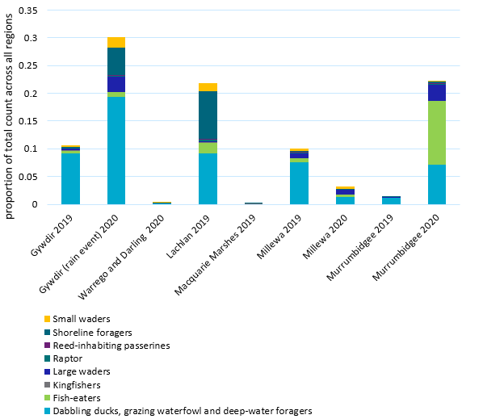

Figure . Relative contribution of each valley to the total abundance of individuals within each functional group reported in 2019–20

Proportions are based on the combined Flow-MER datasets from the Gwydir, Warrego–Darling and Murrumbidgee and complementary data from the Lachlan, Macquarie Marches and Millewa (used with permission from NSW DPIE-EES and National Parks Wildlife Service). Also see CEWO (2020d, 2020e), Spencer 2020b, Webster and Borrell 2020, Wassens et al. 2021

The number of species reported was similar between the Gwydir (53), Murrumbidgee (52) and Lachlan (49). Just 14 species were reported in the Warrego Darling and 16 in the Macquarie Marshes. When averaged across survey sites, the number of species was highest in February 2020 in the Murrumbidgee following targeted delivery of Commonwealth environmental water (Wassens et al. 2021) and in the Millewa Icon sites in spring 2019 following winter watering actions, mainly by TLM (Webster and Borrell 2020) (Figure 5.5). Waterbird diversity was low in the Gwydir system in spring 2019, but increased following heavy rainfall in February 2020 which contributed to widespread inundation (Spencer 2020). Extreme dry conditions contributed to very low waterbird species richness in the Macquarie Marches in 2019–20 (Spencer 2020).

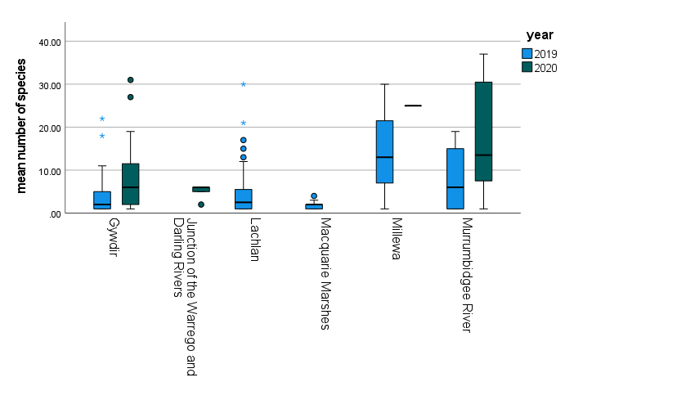

Figure . Box plot of average species richness per survey site across the 6 valleys in spring (October–November 2019 (2019) and summer January–February 2020 (2020)

Boxes show 1st and 3rd quartile, bar is median, whiskers show min–max excluding outliers, low potential outlier, *high potential outlier. Combined DPIE-EES and Flow-MER datasets from the Gwydir, Warrego–Darling and Murrumbidgee valleys with complementary data from the Lachlan, Macquarie Marches and Millewa (used with permission from NSW DPIE-EES and National Parks Wildlife Service). Also see CEWO (2020d, 2020e), Spencer 2020b, Webster and Borrell 2020, Wassens et al. 2021

## Water years 2014–20

Since 2014, 180,617 waterbird records representing 107 species were reported within key valleys receiving Commonwealth environmental water with objectives related to waterbirds (Lower Murray, Central Murray, Murrumbidgee, Lachlan, Gwydir, Macquarie). Within these valleys, 57% of individuals were reported for areas inundated by Commonwealth environmental water compared with 43% of individuals reported in other freshwater habitats (including areas managed through state environmental watering programs, unmanaged floodplain inundation and agricultural water). Nine species listed as threatened under the EPBC Act were only reported from areas receiving Commonwealth environmental water, including the great knot (*Calidris tenuirostris*), and the fairy tern (*Sternula nereis*). A further 23 migratory species listed under the EPBC Act were associated with areas inundated by Commonwealth environmental water (Table 5.5)

When considered across all 6 valleys receiving Commonwealth environmental water, the composition of waterbird communities varied over years and between areas inundated by Commonwealth environmental water and other habitats (PERMANOVA F = 42.969, p <0.001) (Figure 5.6). The dabbling ducks, grazing waterfowl and deep-water foragers (i.e. ducks and swans) typically represented the greatest proportion of waterbirds in both habitats receiving Commonwealth environmental water and those filled via other water sources. Shoreline Foragers also represented a greater proportion of waterbird communities in areas of habitat that were not influenced by Commonwealth environmental water while small waders represented a greater proportion of waterbird communities in habitats receiving Commonwealth environmental water in most years.

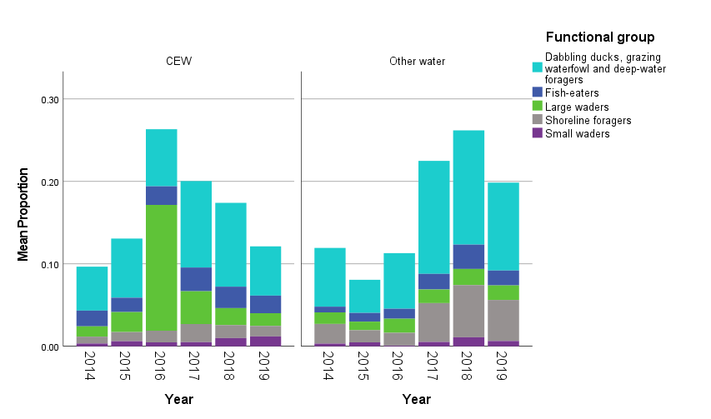

Figure . Relative proportion of waterbird functional groups making up waterbird communities within areas influenced (left) and not influenced (right) by Commonwealth environmental water (Cew), 2014–20

The overall trends in waterbird functional group composition varied between valleys (Figure 5.7). The composition of waterbird functional groups was similar between Commonwealth environmental water and non- Commonwealth environmental water habitats in the Central Murray. However, in the Lower Murray, the relative contribution of functional groups differed between habitat targeted with Commonwealth environmental water and other aquatic habitats. In particular, small waders and fish eaters made up a higher proportion of the total counts in Commonwealth environmental watered sites while ducks and shoreline foragers made up a greater proportion of individuals in the other habitats (Figure 5.7). Commonwealth environmental watered sites typically had higher proportions of large and small waders particularly in the Lower Murray, Murrumbidgee and Macquarie.

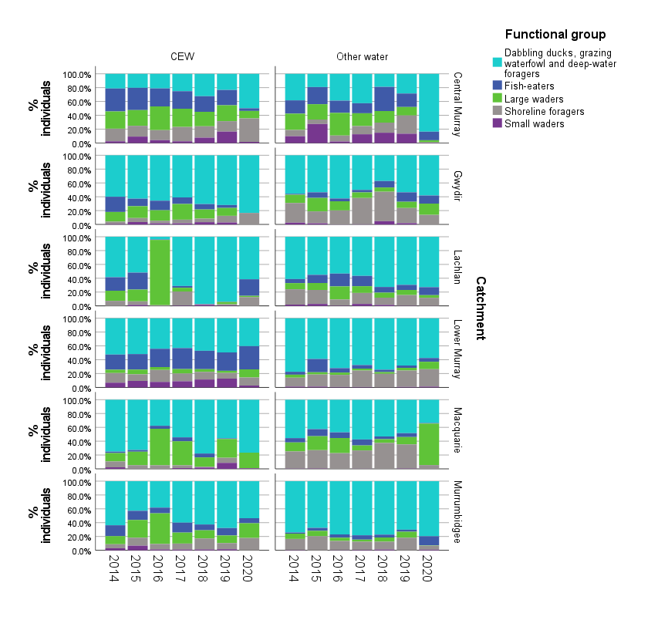

Figure . Proportional representation of waterbird functional groups within areas inundated with Commonwealth environmental water (left) and other water sources (right), by valley, 2014–20

Data based on ALA records

## Species diversity

Waterbird species diversity did not differ significantly between valleys (Margalef)(d=(S-1)/Log(N)) Generalised Linear Model (GLM) F=4.121, p=0.073) or between Commonwealth environmental watered and non- Commonwealth environmental watered habitats (F= 0.004, p = 0.952). There was a significant interaction between Commonwealth environmental water and valley (F=8.360, p<0.001) (Figure 5.8).

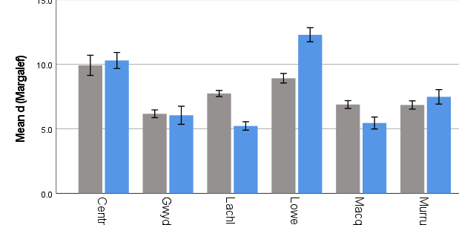

Figure . Overall mean waterbird species richness with Commonwealth environmental water (CEW) and other habitats (including other water), by valley, 2014–20

Data based on ALA records. Error bars are +/- 1 standard error

Waterbird diversity did not differ significantly over time (GLM F = 0.195, p =0.963) nor where there any interactions between Commonwealth environmental water delivery and year (GLM F=0.018, p=0.995) (Figure 5.9).

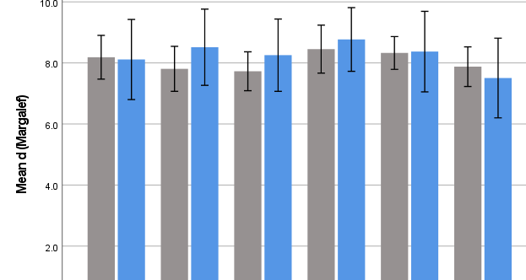

Figure . Overall mean waterbird species diversity (Margalef)[4] with Commonwealth environmental water (CEW) and without (Other water), 2014 –20

Data based on ALA records. Error bars are 90% confidence intervals

There was a significant linear relationship between the volume of Commonwealth environmental water delivered (with objectives targeting waterbirds) and waterbird species richness (R = 0.257, F= 11.763, p=0.002). However, there were also clear valley effects with the valleys in the northern Basin (Gwydir and Macquarie) delivering lower volumes of Commonwealth environmental water with objectives related to waterbirds and having overall lower species diversity. This is reflected in both mean species diversity (Figure 5.10) and modelled species diversity (Figure 5.11). The Central Murray and Lower Murray supported the highest diversity of waterbirds and received considerable volumes of Commonwealth environmental water with objectives targeting waterbirds.

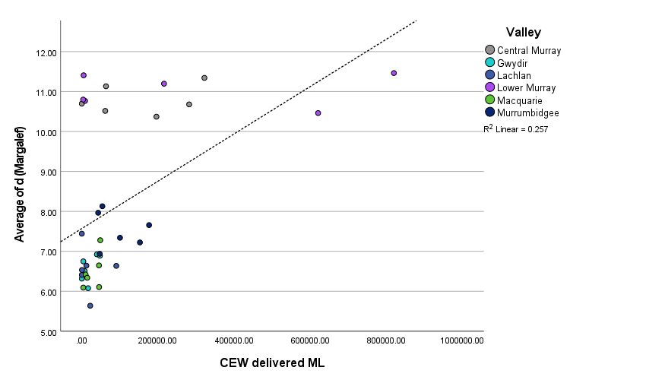

Figure . Scatter plot of mean waterbird species diversity (Margalef) against the volume of Commonwealth environmental water delivered with objectives related to waterbirds, by valley, 2014 –20

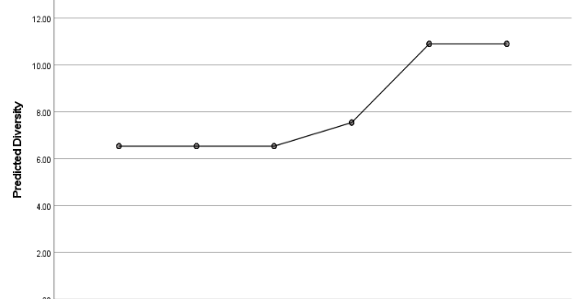

Figure . Predicted waterbird species diversity (Margalef) derived from linear modelling (forward stepwise) with valley and Commonwealth environmental watering actions volumes as predictor variables, by valley

## Species of conservation significance

In 2019–20, there were 36 waterbird species of conservation significance with records coinciding with areas inundated by Commonwealth environmental water (Table 5.4). Of these, 34 species are listed as threatened under state or national legalisation and 21 are listed in the EPBC Act’s migratory waterbird list and in the Bonn Convention and JAMBA, CAMBA and ROKAMBA international treaties (noting that several species appear across several lists). Since 2014, 41 species of conservation significance were recorded in areas with Commonwealth environmental water delivery. This includes 3 additional threatened species, the bush stone-curlew, the inland dotterel and Lewin's Rail, and 2 migratory species, the sharp-tailed sandpiper and the double-banded plover.

## Discussion

This section considers waterbird responses to Commonwealth environmental water as part of the broader evaluation question:

What did Commonwealth environmental water contribute to species diversity?

Using data available from a range of sources, we mapped waterbird observations in relation to inundation by Commonwealth environmental water and compared these with waterbird observations elsewhere. We described patterns of waterbird species diversity within and across valleys, focusing on areas where Commonwealth environmental water was delivered with objectives related to waterbirds and where there was known to be some form of standardised waterbird monitoring.

While there were some indications that waterbird diversity and numbers were higher at selected sites receiving Commonwealth environmental water, there were also reports of increases in waterbird diversity and numbers at sites naturally inundated, receiving other environmental water or combined sources of water, or receiving high rainfall. Such events are likely to have influenced waterbird responses in sites receiving Commonwealth environmental water because of the mobility of many waterbird species, however analysis of these potential interactions was not possible in the time available.

Given the comparatively small volumes of Commonwealth environmental water delivered within the Basin, we expected that some other areas not receiving Commonwealth environmental water would have at least the same abundances of waterbirds as areas inundated with Commonwealth environmental water. There were a few key drivers of this expectation – for example, we saw heavy rainfall in the Gwydir in 2019–20 leading to widespread unregulated inundation and subsequent increases in waterbird abundance and diversity independent of Commonwealth environmental watering actions. Additionally, many valleys utilise significant volumes of other environmental water sources, for example, the Central Murray where TLM and state environmental water sources are available. Consideration of broader patterns of waterbird diversity across multiple valleys even where Commonwealth environmental water does not have specific waterbird objectives can provide greater context on the ecological values within each valley and opportunities to expand watering actions to benefit a greater range of taxa.

Within key valleys where Commonwealth environmental water was delivered with objectives for waterbirds and where standardised waterbird monitoring was undertaken, we identified a significant relationship between the volume of Commonwealth environmental water delivered and waterbird diversity. This pattern also reflected differences between valleys, with the key northern Basin wetland habitats not currently receiving enough water to maintain species diversity and their ecological character. In the southern Basin, higher volumes of Commonwealth environmental water delivered to floodplain habitats in the Murrumbidgee, Central Murray and Lower Murray appear to be supporting waterbird diversity and abundance across each functional group.

Evaluating the direct effects of Commonwealth environmental water and particularly individual watering events on waterbird diversity is complex because many waterbird species interact with water at very large spatial scales, moving between a wide range of habitats within and across valleys, the Basin and Australia (Roshier et al. 2001). Additionally, some species of conservation concern are cryptic and difficult to detect. Accurate evaluation requires understanding of species presence, movements and population demographics at local, valley, basin and continental scales and over time. This understanding can then be used to help predict or explain outcomes at local scales or for individual watering events.

At present, waterbird population and movement monitoring and research methods vary, both spatially and temporally, across the Basin and Australia. This creates biases and makes it difficult to draw datasets together and conduct meaningful analyses. For example, survey effort is often inconsistent between surveys (e.g. the frequency, time or area surveyed, or the method used). Timing of surveys is also a critical variable (including time of day, time of year, wetland condition and inundation stage). All of these factors affect the number of species and individuals detected. Additionally, many sites are not surveyed at all, or are surveyed opportunistically, while others are frequently surveyed. Integrating all available data into a single dataset to demonstrate the outcomes of Commonwealth environmental water is difficult because key information on survey effort and wetland condition at the time of survey is often not available.

Where data from the ALA are available, records of species presence and numbers are strongly biased toward major cities, towns, rivers and roads and are relatively sparse elsewhere, reflecting the nature of a dataset dominated by citizen science records rather than scientific survey. Consequently, interpretation of results based on these data should be approached with caution, acknowledging that apparent ‘absence’ of the species in certain areas in the dataset may be simply because those areas have not been visited by observers or recorded. The accuracy of ALA data also varies because locations are often ascribed to wetland centroids, not the individual bird locations. When this occurs, multiple records are mapped to the same coordinates. Locations are also often the coordinates of the observer, not the target bird in the wetland, and latitude and longitude are recorded to varying decimal places.

Confidence and rigour in evaluation of Commonwealth environmental water effects would be increased by Basin-wide scientifically designed, regular, consistent and long-term monitoring of species presence, numbers, population demographics, breeding and movements at the same sites using the same methods over time, including before, during and after watering and the inclusion of ‘control’ sites. Commonwealth environmental water can play an important role in supporting waterbird habitats and critical life cycle stages including completion of nesting events and provision of food and refugia. While targeted local monitoring can evaluate the outcomes of Commonwealth environmental watering for some of this support at local scales (e.g. nesting success), more on-ground data are required for full evaluation and understanding of the broader scale influence of watering interventions.

Opportunities to improve the quality of data available for evaluation of waterbird diversity responses to Commonwealth environmental water are further discussed in Section 9.2.

Table . Waterbird species of conservation significance in the Murray–Darling Basin (listed species)

1 = species reported from areas likely to have been influenced by Commonwealth environmental water. LC=Least Concern, R=Rare, V=Vulnerable, T=Threatened, NT=Near Threatened, E=Endangered, CE=Critically Endangered; * = included in list/agreement. List is ordered by species scientific name (column 2)

| **Species common name** | **Species scientific name** |  | **EPBC Threat Status1** | **ACT NC Act 20142** | **NSW BC Act and FM Act3** | **NT TPWC Act4** | **Qld NC Act5** | **SA NPW Act6** | **Tas. TSP Act7** | **Vic. FFG Act8 (Advisory Lists)** | **WA BC Act9** | **EPBC Act Migratory List1** | **Bonn Convention** | **CAMBA** | **JAMBA** | **ROKAMBA** | **2019–20** | **2014–20** |
| --- | --- | --- | --- | --- | --- | --- | --- | --- | --- | --- | --- | --- | --- | --- | --- | --- | --- | --- |
| Common sandpiper | *Actitis hypoleucos* |  |  |  |  |  |  | R |  | (V) |  | * | B2C | * | * | * | 1 | 1 |
| Magpie goose | *Anseranas semipalmata* |  |  |  | V |  |  | E |  | T (NT) |  |  |  |  |  |  | 1 | 1 |
| Brolga | *Antigone rubicunda* |  |  |  | V |  |  | V |  | T (V) |  |  |  |  |  |  | 1 | 1 |
| Great egret | *Ardea alba* |  |  |  |  |  |  |  |  | T |  |  |  |  |  |  | 1 | 1 |
| Intermediate egret | *Ardea intermedia* |  |  |  |  |  |  |  |  | T (E) |  |  |  |  |  |  | 1 | 1 |
| Ruddy turnstone | *Arenaria interpres* |  |  |  |  |  |  |  |  | (V) |  | * | B2C | * | * | * | 1 | 1 |
| Hardhead | *Aythya australis* |  |  |  |  |  |  |  |  | (V) |  |  |  |  |  |  | 1 | 1 |
| Musk duck | *Biziura lobata* |  |  |  |  |  |  |  |  | (V) |  |  |  |  |  |  | 1 | 1 |
| Australasian bittern | *Botaurus poiciloptilus* |  | E | E | E |  | E | E |  | T (E) | E |  |  |  |  |  | 1 | 1 |
| Bush stone-curlew | *Burhinus grallarius* |  |  |  | E |  |  |  |  | (E) |  |  |  |  |  |  |  | 1 |
| Sharp-tailed sandpiper | *Calidris acuminata* |  |  |  |  |  |  |  |  |  |  | * | B2C | * | * | * |  | 1 |
| Red knot | *Calidris canutus* |  | E |  |  | V | E |  |  | (E) | E | * | B2C | * | * | * | 1 | 1 |
| Curlew sandpiper | *Calidris ferruginea* |  | CE |  | E | V | CE | E |  | T (E) | CE | * | B2C | * | * | * | 1 | 1 |
| Pectoral sandpiper | *Calidris melanotos* |  |  |  |  |  |  | R |  | (NT) |  | * | B2C |  | * | * | 1 | 1 |
| Red-necked stint | *Calidris ruficollis* |  |  |  |  |  |  |  |  |  |  | * | B2C | * | * | * | 1 | 1 |
| Long-toed stint | *Calidris subminuta* |  |  |  |  |  |  | R |  | (NT) |  | * | B2C | * | * | * | 1 | 1 |
| Great knot | *Calidris tenuirostris* |  | CE |  | V | V | CE | E |  | T (E) | CE | * | B2C | * | * | * | 1 | 1 |
| Inland dotterel | *Charadrius australis (Peltohyas australis)* |  |  |  |  |  |  |  |  | (V) |  |  |  |  |  |  |  | 1 |
| Double-banded plover | *Charadrius bicinctus* |  |  |  |  |  |  |  |  |  |  | * | B2C |  |  |  |  | 1 |
| Lesser sand plover | *Charadrius mongolus* |  | E |  | V | V | E |  |  | (CE) | E | * | B2C | * | * | * |  |  |
| Banded stilt | *Cladorhynchus leucocephalus* |  |  |  |  |  |  | V |  |  |  |  |  |  |  |  | 1 | 1 |
| Black-necked stork | *Ephippiorhynchus asiaticus* |  |  |  | E |  |  |  |  |  |  |  |  |  |  |  |  |  |
| Latham's snipe | *Gallinago hardwickii* |  |  |  |  |  |  | R |  | (NT) |  | * | B2C |  | * | * | 1 | 1 |
| Oriental pratincole | *Glareola maldivarum* |  |  |  |  |  |  |  |  |  |  | * |  | * | * | * |  |  |
| Australian little bittern | *Ixobrychus dubius* |  |  |  |  |  |  | E |  | T |  |  |  |  |  |  | 1 | 1 |
| Lewin's rail | *Lewinia pectoralis* |  |  |  |  |  |  |  |  | T |  |  |  |  |  |  |  | 1 |
| Broad-billed sandpiper | *Limicola falcinellus* |  |  |  | V |  |  |  |  |  |  | * | B2C | * | * | * |  |  |
| Bar-tailed godwit | *Limosa lapponica* |  |  |  |  | V |  |  |  |  |  | * | B2C | * | * | * | 1 | 1 |
| Black-tailed godwit | *Limosa limosa* |  |  |  | V |  |  |  |  | (V) |  | * | B2C | * | * | * | 1 | 1 |
| Eastern curlew | *Numenius madagascariensis* |  | CE |  |  | V | E | E | E | T (V) | CE | * | B1 | * | * | * | 1 | 1 |
| Little curlew | *Numenius minutus* |  |  |  |  |  |  |  |  |  |  | * | B2C | * | * | * |  |  |
| Whimbrel | *Numenius phaeopus* |  |  |  |  |  |  |  |  | (V) |  | * | B2C | * | * | * |  |  |
| Blue-billed duck | *Oxyura australis* |  |  |  | V |  |  | R |  | T (E) |  |  |  |  |  |  | 1 | 1 |
| Pied cormorant | *Phalacrocorax varius* |  |  |  |  |  |  |  |  | (NT) |  |  |  |  |  |  | 1 | 1 |
| Royal spoonbill | *Platalea regia* |  |  |  |  |  |  |  |  | (NT) |  |  |  |  |  |  | 1 | 1 |
| Glossy ibis | *Plegadis falcinellus* |  |  |  |  |  |  | R |  | (NT) |  | * | B2 |  |  |  | 1 | 1 |
| Grey plover | *Pluvialis squatarola* |  |  |  |  |  |  |  |  | (E) |  | * | B2C | * | * | * |  |  |
| Great crested grebe | *Podiceps cristatus* |  |  |  |  |  |  |  | V |  |  |  |  |  |  |  | 1 | 1 |
| Baillon's crake | *Porzana pusilla (Zapornia pusilla)* |  |  |  |  |  |  |  |  | T (V) |  |  |  |  |  |  | 1 | 1 |
| Australian painted snipe | *Rostratula australis* |  | E | E | E | V | E | E |  | T (CE) | E |  |  |  |  |  |  |  |
| Australian shoveler | *Spatula rhynchotis* |  |  |  |  |  |  | R |  | (V) |  |  |  |  |  |  |  |  |
| Common tern | *Sterna hirundo\** |  |  |  |  |  |  |  |  |  |  | * |  | * | * | * | 1 | 1 |
| Little tern | *Sternula albifrons\** |  |  |  | E |  |  | E |  |  |  | * | A2S | * | * | * | 1 | 1 |
| Fairy tern | *Sternula nereis \** |  |  |  |  |  |  | E |  |  |  |  |  |  |  |  | 1 | 1 |
| Freckled duck | *Stictonetta naevosa* |  |  |  | V |  |  | V |  | T (E) |  |  |  |  |  |  | 1 | 1 |
| Grey-tailed tattler | *Tringa brevipes* |  |  |  |  |  |  | R |  | T (CE) |  | * | B2C | * | * | * |  |  |
| Wood sandpiper | *Tringa glareola* |  |  |  |  |  |  | R |  | (V) |  | * | B2C | * | * | * | 1 | 1 |
| Wandering tattler | *Tringa incana* |  |  |  |  |  |  |  |  |  |  | * | B2C |  | * |  |  |  |
| Common greenshank | *Tringa nebularia* |  |  |  |  |  |  |  |  | (V) |  | * | B2C | * | * | * | 1 | 1 |
| Marsh sandpiper | *Tringa stagnatilis* |  |  |  |  |  |  |  |  | (V) |  | * | B2C | * | * | * | 1 | 1 |
| Terek sandpiper | *Xenus cinereus* |  |  |  | V |  |  | R |  | T (E) |  | * | B2C | * | * | * | 1 | 1 |
| Spotless crake | *Zapornia tabuensis* |  |  |  |  |  |  | R |  |  |  |  |  |  |  |  | 1 | 1 |

1. Environment Protection and Biodiversity Conservation Act 1999 (CWTH) No. C2020C00291 (accessed 30 April 2021 at 13:55). <https://www.legislation.gov.au/Details/C2020C00291>
2. Nature Conservation Act 2014 (ACT) No. A2014-59 (accessed 30 April 2021 at 13:52) <https://www.legislation.act.gov.au/a/2014-59>
3. Biodiversity Conservation Act 2016 (NSW) No 63 Current version for 25 March 2021 to date (accessed 30 April 2021 at 13:41) <https://www.legislation.nsw.gov.au/view/html/inforce/current/act-2016-063>
4. Territory Parks and Wildlife Conservation Act 1976 (NT) As in force at 7 November 2019. <https://legislation.nt.gov.au/en/Legislation/TERRITORY-PARKS-AND-WILDLIFE-CONSERVATION-ACT-1976>
5. Nature Conservation Act 1992 (QLD) Current from 13 February 2020 to date (accessed 30 April 2021 at 13:44) <https://www.legislation.qld.gov.au/view/html/inforce/current/act-1992-020>
6. National Parks and Wildlife Act 1972 (SA) (accessed 30 April 2021 at 13:44) <https://www.legislation.sa.gov.au/LZ/C/A/NATIONAL%20PARKS%20AND%20WILDLIFE%20ACT%201972.aspx>
7. Threatened Species Protection Act 1995 (TAS) Version current from 25 November 2020 to date (accessed 30 April 2021 at 13:47) <https://www.legislation.tas.gov.au/view/html/inforce/current/act-1995-083>
8. Flora and Fauna Guarantee Act 1988 (VIC) No. 47/1988 VERSION 046 (accessed 30 April 2021 at 13:47) <https://www.legislation.vic.gov.au/in-force/acts/flora-and-fauna-guarantee-act-1988/046>
9. Biodiversity Conservation Act 2016 (WA) No. 024 of 2016 (accessed 30 April 2021 at 13:53) <https://www.legislation.wa.gov.au/legislation/statutes.nsf/law_a147120.html>

# Outcomes for turtles and other vertebrates

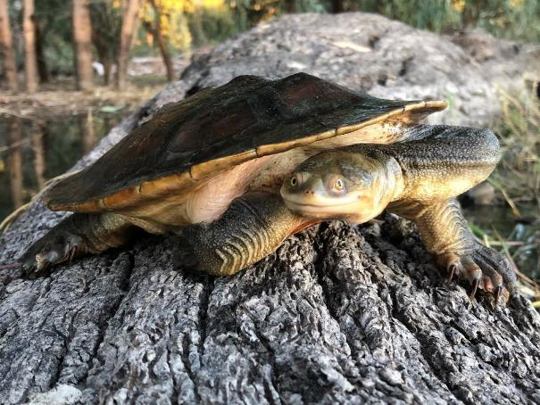

Broad shelled turtle (Chelodina expansa) Waraba in Gamilaraay /Gamilaroi/Kamilaroi, Wayamba in Yuwaalayaay

Endangered SA National Parks and Wildlife Act 1972

## Introduction

There are several aquatic vertebrates that may be influenced by the delivery of environmental water. These include water-dependent mammals such as native water rat (rakali), platypus and large-footed myotis (fisher-bat), freshwater turtles and wetland associated lizards and snakes. In general, the water requirements and responses of these other water-dependent vertebrates to environmental water delivery are poorly understood and to date, except for freshwater turtles, there has been limited monitoring and evaluation of the response of water-dependent mammals following environmental water delivery within LTIM, Flow-MER and other programs.

There is growing evidence that sustained high flows in summer, as well as periods of very low flow can negatively impact platypus populations both directly through decreased survival of young, and indirectly through declining food resources (Hawke et al. 2021). Adaptive management of environmental water may help support platypus populations in some regions although more investigation is required to better understand platypus responses to environmental water management.

The grey snake (*Hemiaspis damelii*) (Ngabi in Yuwaalayaay) largely preys on frogs and is found on floodplain environments of major westerly flowing rivers such as the Condamine, Gwydir, Namoi, Macquarie, Lachlan and lower Murrumbidgee system. It is listed as endangered in Queensland (Nature Conservation Act 1992), and on the IUCN Red List of Threatened Species and has been nominated for endangered status under the EBPC Act 1999. It is reported to have experienced a population decline throughout NSW and Qld, particularly from former strongholds in the Macquarie Marshes and Gwydir wetlands. Grey snakes are surveyed opportunistically during frog surveys for Flow-MER in the Murrumbidgee.

All 3 freshwater turtle species in the Basin have undergone significant declines due to altered flow regimes and high levels of fox predation (Chessman 2011, Van Dyke et al. 2019). Turtle distributions across flow-regulated floodplains are influenced by environmental water management (Ocock et al. 2018). Drying of permanent waterbodies leave adults vulnerable to predation, malnutrition and vehicle strike when they try to move in search of water (Chessman 2011). Environmental water can support turtles by maintaining persistent refuge habitats and supporting nurseries to give hatchlings the best chance of survival.

This evaluation focuses on turtles, due to the lack of data on other vertebrates likely to benefit from Commonwealth environmental water.

## Dataset

This section focuses on the 3 species of freshwater turtles that occur through the Basin – the broad-shelled turtle (*Chelodina expansa*) (n = 240), long-necked turtle (*Chelodina longicollis*) (n=1,653) and Macquarie river turtle (*Emydura macquarii*) (n=1,452). Flow-MER turtle data are available from 2014–15 to 2019–20 for the Lachlan and Murrumbidgee Rivers. Survey methods and effort are not comparable between these 2 regions and there were no records for turtles in the Lachlan in 2019–20. There are 3,346 turtle records in the ALA database (which includes data collected for Flow-MER and LTIM).

Turtles are often surveyed opportunistically within Selected Areas and across the Basin. As a result, turtle data recorded for Selected Areas and in ALA are patchy, particularly in the northern Basin (Figure 6.1). There are generally better data on turtle communities in the Central Murray, Lower Murray, Lower Darling, Macquarie, Murrumbidgee, Border Rivers and Namoi. Turtle records from Victorian catchments are under-represented in the ALA database, which reflects lower rates of integration of turtle datasets rather than lower overall abundances of turtles.

A research project on turtle movement being undertaken in the Edward/Kolety–Wakool will greatly increase knowledge of turtle responses to environmental water delivery. It is expected that turtle community data arising from this research will be available for the 2020–21 Basin evaluation (James Van Dyke, La Trobe University, pers. comms).

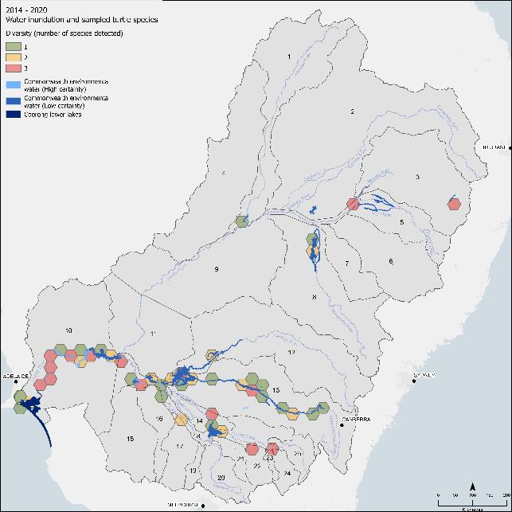

Figure . Hexagonal bins showing the number of turtle species occurring within each 1,000 sq km bin that aligned with Commonwealth environmental water delivery areas, 2014–20

## Commonwealth environmental watering actions for other vertebrates

Since 2014, 101 individual Commonwealth environmental watering actions (720,509 ML) had at least one objective related to supporting other vertebrates including mammals (platypus and rakali), woodland birds (regent parrots) (also see Chapter 5 Waterbirds) and reptiles (turtles and carpet python) (Figure 6.2). In many instances Commonwealth environmental watering objectives do not define specific target taxa but instead list a more generic objectives related to other ‘native species’ or ‘other fauna’; for example, from the Gwydir ‘*Provide habitat for waterbirds and native aquatic species, support survival of native birds, fish and other fauna’*. Despite the lack of nominated taxa, we included those watering actions with generic vertebrate objectives along with those specifying target taxa.

We focused on watering objectives that were broadly aligned with 4 key themes:

* provision of habitat, including foraging opportunities and improving habitat condition
* provision of refuge habitat
* support of breeding opportunities
* increase in connectivity and provision of dispersal opportunities.

The volumes of environmental water delivered with an objective relating to ‘other vertebrates’ are highly variable across years, with the smallest volumes delivered in 2016–17 and 2019–20 (see Figure 6.2). The largest volumes of environmental water with at least one objective focused on other vertebrates were delivered in the Murrumbidgee, Macquarie and Gwydir (Figure 6.3). Single actions with very low volumes occurred in the Broken, Condamine–Balonne and Warrego.

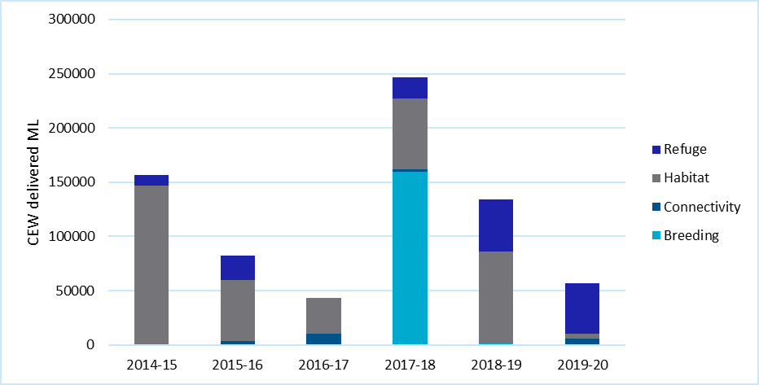

Figure . Total annual volumes of Commonwealth environmental water delivered with at least one objective (refuge, habitat, connectivity, breeding) related to other vertebrates, 2014–20

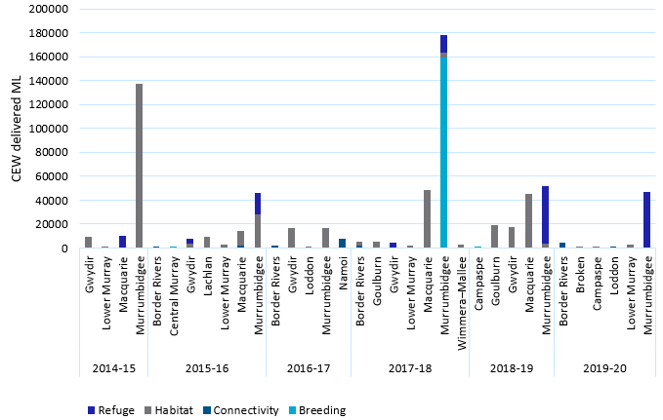

Figure . Total annual volumes of Commonwealth environmental water, per valley, delivered with at least one objective (refuge, habitat, connectivity, breeding) related to other vertebrates, 2014–20

Since 2014, Commonwealth environmental watering has been delivered with generic objectives as well as targeted objectives for mammals (platypus and rakali), woodland birds (regent parrots) (also see Chapter 5) and reptiles (turtles and carpet python). Environmental watering actions with objectives related to turtles were most common in the Murrumbidgee and were undertaken in most years, while individual actions were undertaken in the Macquarie (2015–16, Border Rivers (2017–18) and Gwydir (2018–19) valleys. Watering actions targeting platypus and/or rakali occurred in the Lower Murray, Wimmera–Mallee, Campaspe, Broken and Loddon valleys (Figure 6.4).

In 2019–20, 16 Commonwealth environmental watering actions were undertaken with specific objectives related to either turtles or platypus, and 2 others with nonspecific objectives related to ‘other aquatic biota’. Watering actions targeting turtles were most common in the Murrumbidgee and focused largely on the maintenance of key off-channel refuge habitats in the mid and lower Murrumbidgee floodplains. While in the Lower Broken and Loddon valleys, watering actions were undertaken with broad objectives related to the provision of habitat and to supporting movement and dispersal of fish, platypus and rakali.

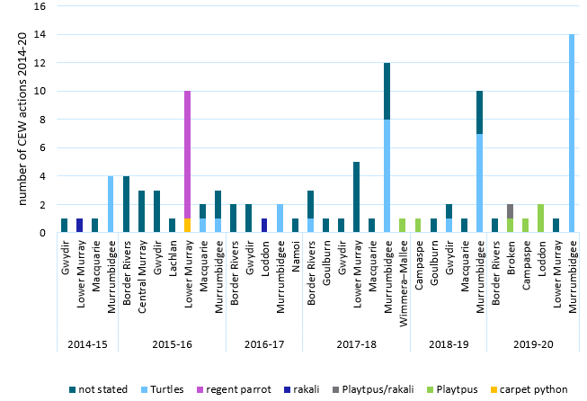

Figure . The number of Commonwealth environmental watering actions, per valley, delivered with at least one objective related to other vertebrate outcomes, showing target taxa/species, 2014–20

Only valleys with at least one relevant watering action are included

## Water year 2019–20

Objectives of watering actions for 2019–20 for ‘other vertebrates’ and observations are summarised in Table 6.1. Within Flow-MER Selected Areas, turtle data are reported for the Lachlan and Murrumbidgee valleys. In 2019–20, 39 turtles were reported in the Murrumbidgee only, with broad-shelled turtle *Chelodina expansa* (n = 11) and eastern long-necked turtle *Chelodina longicollis* (n = 28) reported at Commonwealth environmental watered sites, while no Macquarie turtles *Emydura macquarii* were reported (though there were records in previous years). No hatchling turtles were recorded in 2019–20, although there was incidental evidence of nesting in the Murrumbidgee Valley with several nests that had been raided by foxes observed. No turtles were reported in the Lachlan Valley in 2019–20.

In the Murrumbidgee Valley, 9 grey snakes were reported in 2019–20 in Basin wetland systems influenced by Commonwealth environmental water (Dr Damian Michael, Charles Sturt University, pers. comm).

Table . 2019–20 water actions and summary of key observations associated with watering objectives for other vertebrates

| **Surface water regions** | **Objectives** | **Observations** |
| --- | --- | --- |
| Broken | * Contribute to low flows to provide habitat and support movement for platypus and water rat (rakali) and provide flowing habitat for waterbugs, platypus and turtles | * Not monitored for platypus or rakali |
| Campaspe | * Habitat for zooplankton and support movement of platypus | * No outcomes reported |
| Loddon | * Contribute to winter/spring low fresh flows to increase water depth for habitat and dispersal of fish, platypus and native water rat (rakali) | * Not monitored for platypus or rakali |
| Murrumbidgee | * Maintain refuge habitat for turtles and other water dependent animals | * 2 species recorded Chelodina expansa (n=11) and Chelodina longicollis (n=28) * 0 Emydura macquarii recorded in the Murrumbidgee in 2019–20. No hatchling turtles were recorded * Persistent off channel lagoons supported higher diversity of species (Wassens et al. 2021) * 9 grey snakes recorded at wetlands receiving Commonwealth environmental water |

## Water years 2014–20

There has been limited monitoring of turtle populations across the Basin. Broadscale targeted annual monitoring of turtles at sites receiving environmental watering is undertaken as part of the MER and previous LTIM program in the Murrumbidgee only. There was some local monitoring programs of turtles undertaken in the in the Barmah-Millewa (Central Murray) between 2016 and 2020 (Howard et al 2020). While watering actions with objectives related to turtles have been undertaken in the Gwydir, Macquarie and Border Rivers there was limited monitoring of turtles during these events. Considering all records within the ALA, eastern long-necked turtles (*Chelodina longicollis*) were by far the most commonly reported species, although Macquarie turtles (*Emydura macquarii*) made up a high percentage of turtle catches in the Central Murray and Lower Murray, with a small number of records reported from the Lachlan River in 2015–16 (Figure 6.5). Commonwealth environmental water was delivered to areas in the Lower Murray that supported broad-shelled turtle (C. expansa) (listed as endangered under the South Australian National Parks and Wildlife Act 1972). Commonwealth environmental water was also delivered to maintain refuge habitats for turtles in the Murrumbidgee, with these sites supporting all 3 species.

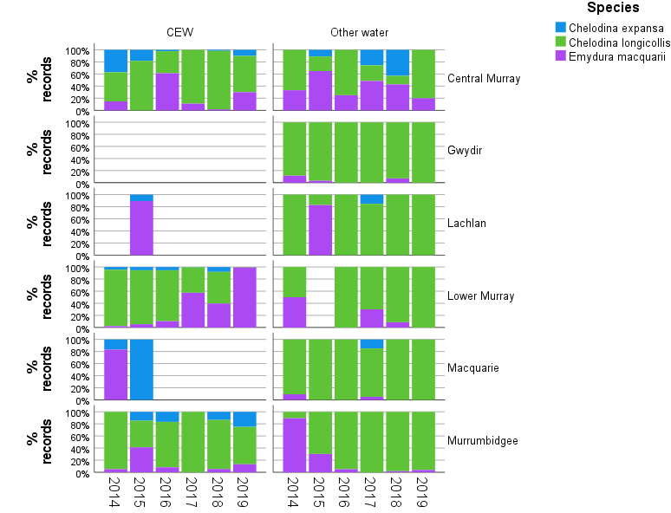

Figure . Species composition of turtle records per valley aligning with areas of Commonwealth environmental water (CEW) (left) and areas of other water (right), 2014–20

Note that there are insufficient data to visualise annual changes in turtle occurrence across all valleys

## Turtle recruitment

Turtle populations through the Basin are ageing, with very poor levels of recruitment, raising concerns for the long-term persistence of these 3 species (Chessman 2011, Van Dyke et al. 2019). Fox predation on nests is a serious threat to turtle populations (Van Dyke et al. 2019). Commonwealth environmental water could be used to support nursery habitats for turtle hatchlings, thereby increasing the likelihood of their survival.

Since 2014, there has been a small number of hatchlings and juveniles recorded from the Murrumbidgee valley, with hatchlings of *C. longicollis* reported in each year between 2014 and 2018 at wetlands influenced by Commonwealth environmental water (Wassens et al. 2021) (Figure 6.5). One juvenile of *C. expansa* was recorded in 2017–18, and *E. macquarii* hatchings were reported at wetlands influenced by Commonwealth environmental water in 2015–16 and 2016–17. No hatchling turtles have been reported in the Lachlan.

## Discussion

Turtle populations in the Basin are in serious decline (Chessman 2011, Ocock et al. 2018, Van Dyke et al. 2019). Turtles are threatened by loss of persistent refuge habitats and loss of nursery habitats (Chessman 2011, Ocock et al. 2018) as well as very high levels of fox predation on nests (Van Dyke et al. 2019). With the exception of the Murrumbidgee, the response of turtles to environmental water delivery is not included as part of monitoring of Commonwealth environmental water for LTIM or Flow-MER. There is data from the Murrumbidgee that show Commonwealth environmental water is supporting nursery habitats for turtles and maintaining refuges during dry periods (Ocock et al. 2018, Wassens et al. 2021). However the status of populations in other areas is poorly known and there are few environmental watering actions with objectives targeting turtles outside of the Murrumbidgee. Likewise, other water dependent vertebrates including the grey snake, platypus and large footed myotis are rarely considered as part of environmental water delivery even when these actions target known habitats.

# Outcomes for Ramsar wetlands

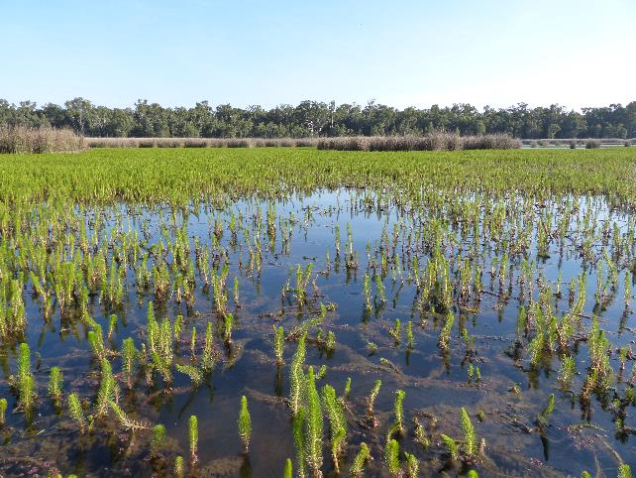

The Gulpa Creek Reed Beds Wetland in the Barmah–Millewa Forest Ramsar site (NSW Central-Murray Forest), an important breeding, feeding, resting and refuge area for waterbirds and many other water-dependent species

Photo credit Heather McGinness, CSIRO

## Introduction

Commonwealth environmental water has been delivered to 10 Ramsar areas since 2014, with the largest volumes delivered to the Coorong, and lakes Alexandrina and Albert, all of which have received Commonwealth environmental water each year (Table 7.1). In 2019–20, Commonwealth environmental water was delivered to 8 Ramsar areas across 4 valleys, inundating a total area of 114,854 ha (see Table 7.1). The following sections give a general overview of Ramsar watering actions undertaken in 2019–20.

Table . Summary of the areas (ha) of Ramsar sites inundated by Commonwealth environmental water 2014–20

Dash indicates no Commonwealth environmental water received

| **Ramsar site** | **Valley** | **14–15** | **15–16** | **16–17** | **17–18** | **18–19** | **19–20** |
| --- | --- | --- | --- | --- | --- | --- | --- |
| Barmah Forest | Central Murray | – | 7,294 | – | 6,947 | 7,549 | 1,746 |
| Hattah–Kulkyne lakes | Central Murray | 965 | 932 | – | 842 | – | 116 |
| NSW Central Murray State Forests | Central Murray | – | 5,018 | – | 4,809 | 5,725 | 1,598 |
| Narran Lake Nature Reserve (Dharriwaa) | Condamine-Balonne | – | – | 716 | – | – | 4,330 |
| Gwydir Wetlands: Gingham and Lower Gwydir (Big Leather) Watercourses | Gwydir | 573 | 211 | 341 | 523 | 476 | – |
| Banrock Station Wetland Complex | Lower Murray | 10 | 339 | – | 213 | 68 | 42 |
| Coorong, and Lakes Alexandrina and Albert Wetland | Lower Murray | 105,929 | 113,637 | 110,112 | 99,717 | 104,856 | 105,972 |
| Riverland | Lower Murray | 36 | 2,927 | 118 | 3,267 | 1,854 | 947 |
| Macquarie Marshes | Macquarie | 3,963 | 4,953 | 7,456 | 7,596 | 5,556 | – |
| Fivebough and Tuckerbil swamps | Murrumbidgee | – | – | – | 144 | 337 | 103 |
|  |  | 114,476 | 135,311 | 118,743 | 124,058 | 126,421 | 114,854 |

## Condamine–Balonne

### Narran Lake Nature Reserve (Dharriwaa)

In 2020, Commonwealth environmental water was delivered to the internationally significant Narran Lakes (Dharriwaa to the Yuwaalaraay/Euahlayi First Nations people). Around 163 GL of Commonwealth environmental water was delivered against permanent entitlements, including 95 GL from overland flow licences. An additional 9 GL reached Narran Lakes from a pilot project where an upstream licence holder was reimbursed for not pumping (CEWO Watering Action Acquittal Report 2020, unpublished). An estimated 4,330 ha (7%) of the Narran Lakes Ramsar wetland site was inundated with Commonwealth environmental water including areas of Lignum shrubland, woodland riparian vegetation and permanent lakes (Figure 7.1) that had not been inundated since April 2013. Waterbird monitoring in the Narran lakes Ramsar area identified over 30 waterbird species including species listed as threatened under the NSW Biodiversity Conservation Act 2006; freckled duck, blue-billed duck and black necked stork (CEWO 2020).

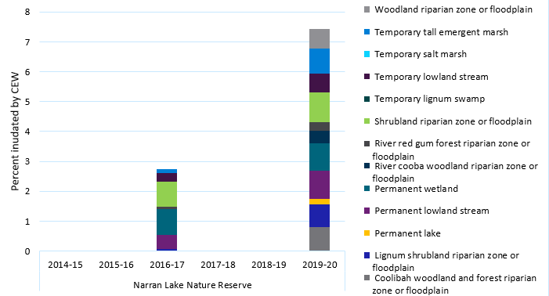

Figure . Percentage of ANAE habitat types (see Ecosystem Diversity evaluation, Brooks 2021) within the Narran Lake Nature Reserve Ramsar area inundated by environmental water with a Commonwealth environmental water contribution, 2014–20

## Central Murray

### NSW Central Murray Forests and Barmah Forest Ramsar

The NSW Central Murray Forests Ramsar site covers an area of 83,992 ha and consists of 3 subsites: Millewa Forests, Werai Forests and Koondrook Forests, while the Barmah Forest Ramsar site represents the Victorian section of the larger Barmah–Millewa complex. The Barmah–Millewa is influenced by flows from the Murray River. In 2019–20, 39,340 ML of Commonwealth environmental water was delivered in conjunction with additional water from the NSW Murray Additional Allowance Planned Environmental Water = 5,690 ML, The Living Murray (TLM) 3,460ML and River Murray Increased Flows = 22,080 ML. Flows inundated 4% of the Barmah Forest and 2% of the NSW Central Murray State Forest (see Table 7.1, Figure 7.2). Commonwealth environmental water has been delivered to both areas each year, except for 2014–15 when environmental water was delivered from other sources, and in 2016–17 when high rainfall and high river flows led to unregulated flows through both areas. Over the past 6 years, areas inundated by Commonwealth environmental water have remained small, with less than 10% of the Barmah Forest Ramsar site and less than 5% of the NSW Central Murray Forests Ramsar site inundated (Figure 7.3).

Key outcomes for species diversity following the combined delivery of environmental water included breeding by the endangered Australasian bittern (Ecosure 2020), Great Egret (Threatened Flora and Fauna Guarantee Act 1988, EPBC Act migratory species) and White-belled Sea Eagle vulnerable under the NSW Biodiversity Conservation Act 2016 (Webster and Borrell 2020) (Table A.1).

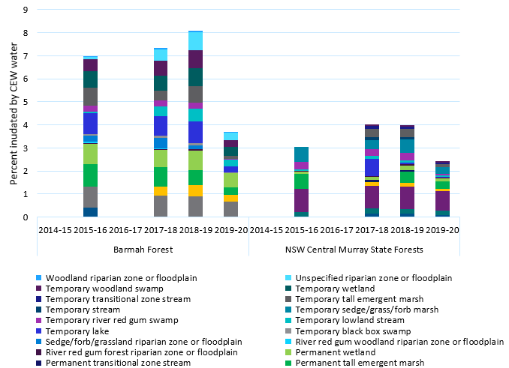

Figure . Percentage of ANAE habitat types within the NSW Central Murray Forests (left) and Barmah Forest (right) Ramsar area inundated by environmental water with a Commonwealth environmental water contribution, 2014–20

ANAE habitat types are described in Ecosystem Diversity evaluation report, Brooks 2021).

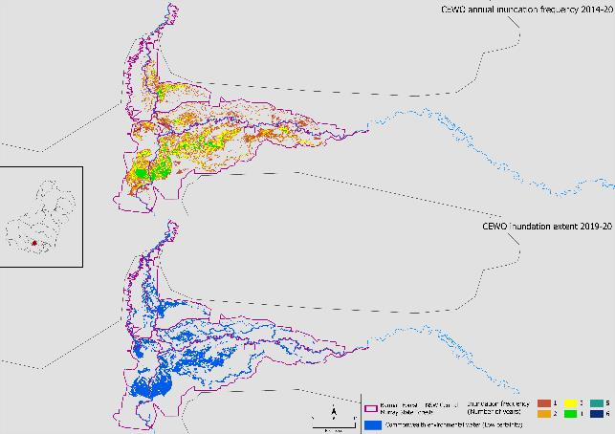

a

b

Figure . Inundation frequency of environmental water with a Commonwealth environmental water contribution 2014–20 (top) and 2019–20 (bottom) in the NSW Central Murray Forests Ramsar (a) and Barmah Forest Ramsar (b) sites

Note that all mapped inundation is ascribed a low certainty in this Ramsar area as multiple sources of environmental water are combined in this area

### Hattah–Kulkyne lakes

There were no specific actions targeting the Hattah–Kulkyne Lakes in 2019–20, however this system was influenced by the delivery of nearly 330,000 ML of environmental water (combination of Commonwealth, (230,669 ML), and The Living Murray and River Murray environmental flows). Flows was delivered from Hume Dam targeting environmental outcomes along 2,000 km of the River Murray (CEWO Watering Action Acquittal Report 2020, unpublished). This flow inundated a small section of the temporary lake habitat in the Hattah–Kulkyne lakes Ramsar area (less than 0.5%) (Figure 7.4). These flows were lower than reported during previous targeted deliveries in 2014–15, 2015–16 and 2016–17.

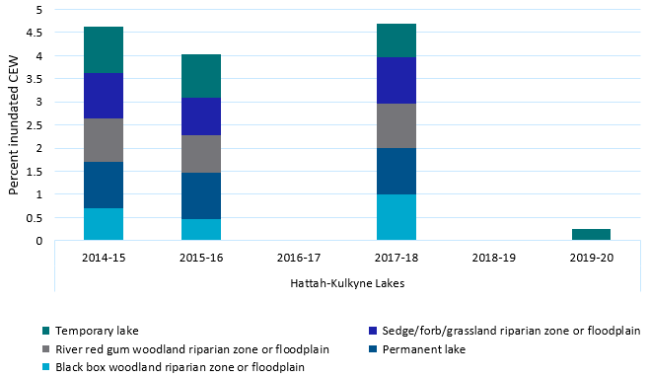

Figure . Percentage of ANAE habitat types within the Hattah–Kulkyne lakes Ramsar area inundated by environmental water with a Commonwealth environmental water contribution, 2014–20

ANAE habitat types are described in companion Ecosystem Diversity evaluation report (Brooks 2021)

## Lower Murray

### Banrock Station

In 2019, 1,471 ML of Commonwealth environmental water was delivered to Banrock Station, with multiple objectives related to improving vegetation condition, supporting southern bell frog populations and creating a diversity of habitats for wetland and migratory bird species associated with the surrounding Ramsar area (CEWO Banrock Station Watering Action Acquittal report 2020, unpublished). Water delivery in 2019–20 was restricted to the more frequently inundated creeks and lagoons. Approximately 42 ha were inundated with Commonwealth environmental water, representing 1.5% of the Ramsar area (Figure 7.5). This percentage of habitat inundated was lower than in 2017–18 and 2018–19 (Figure 7.6). Key species recorded during and following this Commonwealth environmental watering action in 2019–20 included the EPBC Act-listed regent parrot, wood sandpipers and red-necked stints (see also Table A.1).

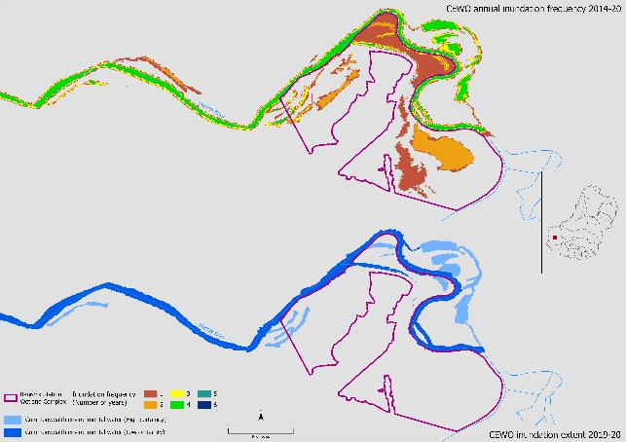

Figure . Inundation frequency by environmental water with a Commonwealth environmental water contribution delivered to the Banrock Station wetland complex, 2014–20) (top) and 2019–20 (bottom)

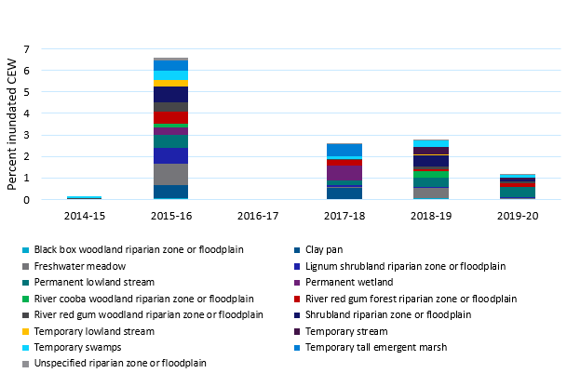

Figure . Percentage of ANAE habitat types within Banrock Station Ramsar area inundated by environmental water with a Commonwealth environmental water contribution, 2014–20

ANAE habitat types are described in companion Ecosystem Diversity evaluation report (Brooks 2021)

### Riverland

In 2019–20, approximately 341.1 ML of Commonwealth environmental water was delivered to wetlands in the Calperum Station Ramsar area within the Riverland Ramsar are of the Lower Murray valley, targeting multiple objectives: supporting temporary wetland for waterbird, generating temporal and spatial diversity of wetland habitats and supporting the recovery of vegetation including Lignum and Black Box (CEWO 2020). In 2019–20, Commonwealth environmental water inundated 947 ha, inundating just over 1% of the Ramsar area,, which is in the lower range of Commonwealth environmental water delivery to this system (Figure 7.7). The environmental water delivery influenced multiple habitats, including more persistent lowland streams and lakes as well as smaller areas of Lignum and Black Box. Key species reported following this environmental watering included the EPBC Act-listed great egret, sharp-tailed sandpiper, curlew sandpiper, red-necked Stint, Caspian tern and the white-bellied sea eagle (endangered in South Australia) (see also Table A.5).

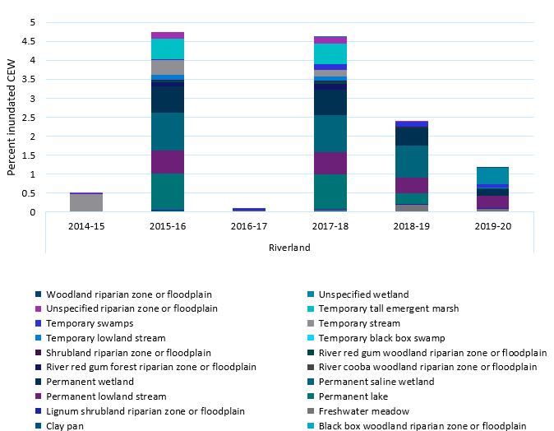

Figure . Percentage of ANAE habitat types within the Riverland Ramsar area inundated by environmental water with a Commonwealth environmental water contribution , 2014–20

ANAE habitat types are described in Ecosystem Diversity evaluation report (Brooks 2021).

### The Coorong and Riverland Ramsar sites

In 2019, 685,169 ML of Commonwealth environmental water was delivered to the barrages for the Lower River Murray channel, Coorong, Lower Lakes and Murray Mouth. Multiple objectives for this action related to native fish, including providing suitable habitats, increasing connectivity and recruitment opportunities, maintaining condition and extent of riparian and in-channel vegetation, maintaining current species diversity and breeding opportunities for waterbirds (CEWO Lower River Murray channel, Coorong, Lower Lakes and Murray Mouth Watering Action Acquittal report 2020, unpublished). In 2019–20, Commonwealth environmental water inundated 105,972 ha, covering approximately 12% of the Ramsar area. This was a slight increase from 2018–19, although lower than flows delivered in 2015–16 and 2016–17 (Figure 7.8).

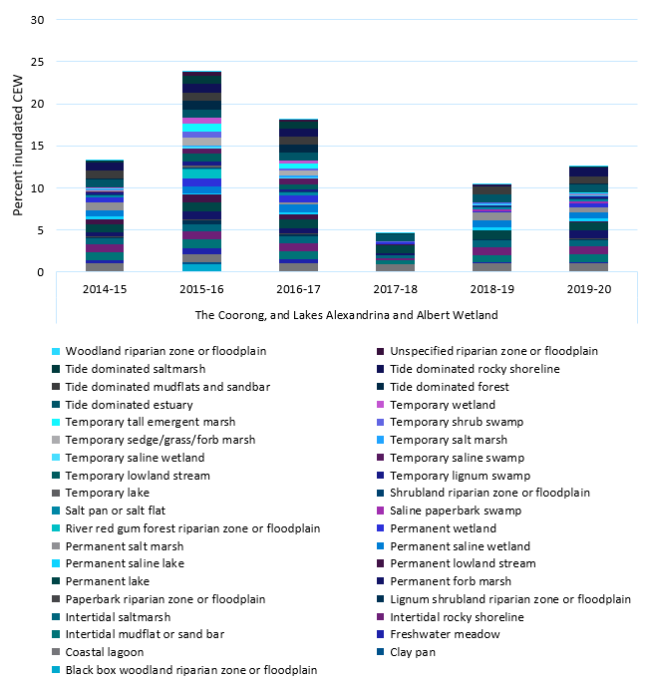

Figure . Percentage of ANAE habitat types within the Coorong, lakes Alexandrina and Albert wetland Ramsar area inundated by environmental water with a Commonwealth environmental water contribution , 2014–20

ANAE habitat types are described in Ecosystem Diversity evaluation report (Brooks 2021)

## Murrumbidgee

### Fivebough and Tuckerbil swamps

In 2019–20, 3,612 ML of Commonwealth environmental was delivered to a series of waterbodies in the Murrumbidgee Irrigation Area, including the Ramsar-listed Fivebough and Tuckerbil Swamps. Objectives related to maintaining refuge habitat for a range of aquatic vertebrates, including waterbirds, fish, frogs and turtles. The overall area of wetland inundated within the Ramsar listed sites was relatively small at 103 ha (see Table 7.1), representing less than 0.4% of the total Ramsar area (Figure 7.9). Overall, 55 waterbird species were recorded in the Fivebough–Tuckerbil Ramsar site following inundation by Commonwealth environmental water including several conservation significant species – Australasian bittern, brolgas, glossy ibis, wood sandpiper, sharp-tailed sandpiper, marsh sandpiper and red-necked stint.

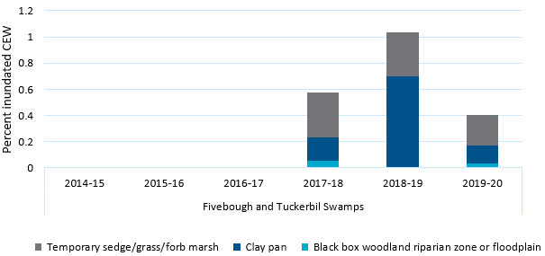

Figure . Percentage of ANAE habitat types within Fivebough and Tuckerbil Swamp Ramsar areas inundated by environmental water with a Commonwealth environmental water contribution, 2014–20

ANAE habitat types are described in companion Ecosystem Diversity evaluation report (Brooks 2021)

## Discussion

Since 2014 Commonwealth environmental water has been delivered to 10 Ramsar areas, with the largest volumes delivered to the Coorong, and Lakes Alexandrina and Albert Wetlands in the Lower Murray. In 2019–20, Commonwealth environmental water was delivered to 8 Ramsar areas across 4 valleys. In general the area inundated by Commonwealth environmental water is small (less than 10% of total Ramsar area) although it is important to note that other sources of environmental water are also delivered to Ramsar wetlands across the Basin.

# Contribution to Basin Plan objectives

Observations pertaining to the contribution of Commonwealth environmental water to Basin Plan objectives in 2019–20 is presented below. These are based on a range of data sources, including information from LTIM (Hale, 2020) for the 6-year 2014–20 period. Note that the Basin-wide environmental watering strategy (MDBA 2014, 2019) does not include objectives for frogs, turtles, or other vertebrates, threatened species or Ramsar wetlands.

Table 8.1 presents observations associated with those objectives listed in section 8.05 of the Basin Plan.

Table . Observations associated with biodiversity objectives listed in section 8.05 of the Basin Plan

| Basin outcomes | 1–year expected outcome | 6–year expected outcomes | 1-year observations in 2019–20 | Observations since 2014 |
| --- | --- | --- | --- | --- |
| Waterbirds |  | Maintained current species diversity | 65 waterbird species reported from annual waterbird counts | Overall waterbird diversity has remained stable between 2014–20 |
|  | Increased abundance | Small numbers of waterbirds reported breeding at Commonwealth environmental water sites in the Murrumbidgee | Waterbird abundances are in decline (Porter et al. 2019, Kingsford et al. 2020). Since 2014 Commonwealth environmental water was delivered to areas in the Murrumbidgee and Lachlan with large scale colonial nesting waterbird breeding in 2016 |
| Frogs * | None identified | None identified | Breeding and recruitment by flow-responding species including southern bell frog, Peron’s tree frog, barking and spotted marsh frogs, giant banjo frog, eastern banjo frog | Breeding and recruitment reported for all years across multiple catchments |
| 18 frog species associated with areas of Commonwealth environmental water inundation across 6 catchments | Persistence and in some instances increase of key populations of frogs including southern bell frogs |
| Turtles | None identified | None identified | 3 turtle species recorded in 2019–20, no hatching turtles were reported | Broad shell turtles (endangered SA) were more frequently associated with areas of Commonwealth environmental water inundation. Hatching turtles of all 3 species reported from Commonwealth environmental water influenced wetlands in the Murrumbidgee |
| Ramsar wetlands | None identified | None identified | Commonwealth environmental water delivered to 8 Ramsar areas inundating 114,854 ha | Commonwealth environmental water delivered to 10 Ramsar areas since 2014 |
| Migratory species | None identified | None identified | 19 EPBC Act-listed migratory species were associated with Commonwealth environmental water influenced sites | 23 EPBC listed migratory species were associated with Commonwealth environmental water influenced sites over the past 6 years |
| Threatened species | None identified | None identified | Breeding by Australasian bittern reported at Central Murray Ramsar sites  Successful recruitment and population increase of key southern bell frog populations  Regent parrot nesting reported at sites influenced by Commonwealth environmental water | 41 waterbirds, 1 frog (southern bell frog), 1 woodland bird (regent parrot), 1 turtle (broad-shell turtle) and one snake (grey snake) listed under state or Commonwealth conservation legalisation associated with Commonwealth environmental water influenced sites over the past 6 years |

# Adaptive management

## Frogs

Commonwealth environmental water is critical to the long-term survival of southern bell frogs in the Murrumbidgee (Bino et al. 2018, Wassens et al. 2021) where wetlands receiving environmental water across multiple years support substantially higher abundances of southern bell frogs than those without environmental water (see Wassens et al 2021). Environmental water is also used to support key southern bell frogs with success in the Central Murray (Waudby et al. 2021) and Lower Murray (Rupert Mathwin, Flinders University Pers. Comm). Monitoring and adaptive management are also contributing to improved recruitment outcomes for Southern bell frogs and other frog species (Wassens et al. 2021). This includes increased use of carp screens; implementing drying to reduce the abundance of exotic fish; and active management of water levels by pumping to achieve longer duration of inundation. In the Murrumbidgee (Wassens et al. 2021), these approaches are improving outcomes for southern bell frogs and other species and there are opportunities to implement these approaches in other regions.

Analysis of the ALA datasets has identified occurrences of the endangered Booroolong frog (*Litoria booroolongensis*) in areas in the upper Murrumbidgee which could be targeted with Commonwealth environmental water delivery. Altered water regimes are a known threat to this species and managed delivery of environmental water has been proposed as part of the national recovery plan for this species. However, the flow requirements and response to dam releases by this species are poorly known. Further investigation of the exact location of this population may identify opportunities to deliver environmental water in a manner that benefits Booroolong frogs.

## Waterbirds

Adaptive management of environmental water to support waterbird breeding sites, breeding events, refuges, foraging habitats and food sources is increasingly important in the context of climate change and increasing human demand for freshwater. There is potential for other adaptive management actions to support the effectiveness of environmental water and ultimately waterbird populations. Population outcomes can be driven by a combination of environmental water, vegetation management and management of pressures and threats. Pressures and threats include habitat change, predation, disease and toxins, which interact to affect waterbird movements, condition, growth, survival, mortality and breeding initiation and frequency.

The effectiveness of water management and other natural resource management actions varies depending on water resource availability, which is driven by interactions between climatic cycles and various water delivery constraints. Historically, management actions and monitoring efforts for waterbirds have focused heavily on completion of breeding events at important individual sites, with an emphasis on moderate to wet or very wet seasons when breeding events are large. This means that there has been a temporal gap in our understanding of how environmental water is supporting waterbird populations in the long-term and of the nature and importance of small-scale breeding events. Additionally, incorporation of monitoring and research at all important waterbird sites across their ranges is critical, due to the mobile nature of waterbirds. Introduction of monitoring, research and management that takes into account whole-of-life-cycle needs of waterbirds and their mobility has the potential to significantly improve recruitment outcomes and consequently to improve the chances of reaching waterbird population, abundance and diversity targets.

Monitoring conducted by other agencies (such as state governments) of waterbird species presence, numbers and breeding in response to environmental water is currently of high-quality, but variable in methods and spatial and temporal coverage. LTIM and Flow-MER Selected Areas have monitored species presence and numbers and, to a limited degree, bird breeding activity, with formal Basin-scale evaluation of outcomes focused on species diversity. Further work is required to identify commonalities in survey methods and survey effort across these programs and identify how these data can best support evaluation of Basin-wide outcomes.

Environmental watering objectives for waterbirds tend to be habitat-focused rather than population or life-cycle focused. More targeted objectives and expected outcomes are needed, that consider waterbird mobility and whole-of-life cycle needs. Managing to these improved objectives could significantly improve waterbird survival and recruitment, and improve the likelihood of achieving waterbird population, abundance and diversity targets.

## Other vertebrates

There are many vertebrate species of conservation concern that have distributions coinciding with areas of Commonwealth environmental water delivery, including the grey snake (Ngabi), larger footed myotis, and platypus. Platypus are in serious decline, particularly in regulated river systems where severe disruption of natural habitat has occurred (Bino et al. 2020, Hawke et al. 2021).

There is an urgent need to implement effective management, including targeted environmental water delivery to maintain extant populations and their habitats (Bino et al. 2020). To date there have been a small number of Commonwealth environmental water deliveries with objectives related to platypuses, but the success of these actions has not been evaluated. Greater consideration of the habitat requirements of platypuses will support their adaptive management in the Basin. This will need to be underpinned by effective monitoring and evaluation of the response to environmental water delivery.

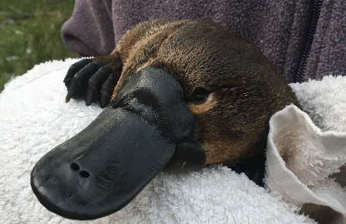

Platypus (*Ornithorhynchus anatinus*) (Buubumurr in Gamilaraay / Gamilaroi / Kamilaroi) are listed as endangered in South Australia

Note: Populations are in serious decline throughout regulated rivers in the Basin. Listing is proposed under the EPBC Act

Photo credit: Gilad Bino, University NSW

Small numbers of grey snakes were recorded in the Murrumbidgee, closely associated with wetlands that are frequently inundated with environmental water, particularly those with water regimes that support very high frog abundances. Little is known about the distribution and ecology of this small, wetland-dependent species but reduced inundation frequencies and declining native frog populations are likely to have impacted key populations across the Basin. Grey snakes are expected to occur at other wetland systems receiving Commonwealth environmental water, particularly in habitats of the Gwydir and Macquarie Marshes. However, there have been no formal systematic surveys for this species across its range. Targeted surveys are urgently required to determine its distribution, abundance, and conservation status across wetland systems receiving Commonwealth environmental water.

All 3 species of turtles that occur in the Basin can be influenced by environmental water and are of conservation concern. The most significant being the broad-shelled turtle (endangered in South Australia) which was more commonly associated with habitats influenced by Commonwealth environmental water delivery in the Murrumbidgee and Lower Murray. Lack of targeted monitoring for turtle responses to environmental watering limits opportunities to refine adaptive management. There is currently a research project on turtle movement being undertaken in the Edward/Kolety–Wakool which will greatly increase knowledge of turtle response to environmental water delivery. It is expected that turtle community data arising from this research will be available in 2020–21 (James Van Dyke, La Trobe University, pers. comms).

## The way forward

This evaluation considered multiple datasets to identify species likely to have been influenced by Commonwealth environmental water delivery. We mapped species distribution records occurring since 2014 and matched these against areas inundated by environmental water and compared these to other parts of the valley where no environmental water was delivered.

The ALA is considered to be a high-quality dataset (Belbin and Williams 2016); however there are some known limitations with the use of presence-only, specialist-biased, spatially biased datasets (Warton et al. 2013) and care must be taken when using these data and interpreting the results. The utility of this type of data can be quite limited when considering outcomes at small scales (within valleys), when comparing areas watered with Commonwealth environmental water with those that have not received environmental water or that may have received water via other mechanisms such as state environmental watering programs, unregulated inundation or for agriculture.

Monitoring of waterbird, frog, turtle and other vertebrate outcomes for Flow MER is spatially and temporally limited. It is mostly derived from the Murrumbidgee in the south and Gwydir in the north and a continuous time series for 2014–20 is only available for the Murrumbidgee. There are monitoring programs aimed at evaluating the outcomes of environmental water run by state agencies as well as the annual south-eastern Australian areal waterbird monitoring program managed by MDBA. While these data are included within the ALA datasets, a more robust dataset could be derived through greater collaborative and coordination between Flow MER and complimentary state-based programs. This approach is currently being employed in the Murrumbidgee and Gwydir selected areas and could be expanded into other valleys.

An absence of purpose designed monitoring for other vertebrates limits our capacity to make a rigorous evaluation of the outcomes of Commonwealth environmental water for biodiversity. We identify species that have been reported in the ALA that coincide with areas of Commonwealth environmental water inundation over the 6 year period. Our evaluation highlights the large number of taxa, including threatened and migratory species that occur in areas targeted by Commonwealth environmental water, but habitat requirements may not be specifically met by current watering objectives. In many valleys, lack of coordinated monitoring of these taxa makes it difficult to evaluate the suitability of current water delivery.

Detailed data tables

Table A.1 Summary of Atlas of Living Australia data downloads utilised for this project

| **Download** | **Date** | **Records** | **Datasets** |
| --- | --- | --- | --- |
| [DOI10.26197/ala.4b2d1ef1-d722-4153-b839-a584de41425b](https://doi.ala.org.au/doi/10.26197/ala.4b2d1ef1-d722-4153-b839-a584de41425b) | 2021-03-18 2:46 AM | 220,616 | 54 |
| [DOI10.26197/ala.586c25fc-3343-4f41-8230-cecc54aaca44](https://doi.ala.org.au/doi/10.26197/ala.586c25fc-3343-4f41-8230-cecc54aaca44) | 2021-03-18 12:34 AM | 270,825 | 76 |
| [DOI10.26197/ala.5ebfb5a0-f296-4bd1-9a7e-86713c6d56fc](https://doi.ala.org.au/doi/10.26197/ala.5ebfb5a0-f296-4bd1-9a7e-86713c6d56fc) | 2021-01-29 4:27 AM | 895,727 | 60 |
| [DOI10.26197/ala.65e46879-5830-4874-b6fa-702e3b871d3c](https://doi.ala.org.au/doi/10.26197/ala.65e46879-5830-4874-b6fa-702e3b871d3c) | 2021-03-01 12:06 PM | 59,144 | 47 |
| [DOI10.26197/ala.746ee660-a19f-4f7a-9b43-b4f5577f9e9e](https://doi.ala.org.au/doi/10.26197/ala.746ee660-a19f-4f7a-9b43-b4f5577f9e9e) | 2021-02-26 3:33 AM | 816,852 | 96 |
| [DOI10.26197/ala.772adf88-91c1-446c-a4a0-2f4ad8d0a4c3](https://doi.ala.org.au/doi/10.26197/ala.772adf88-91c1-446c-a4a0-2f4ad8d0a4c3) | 2021-03-18 1:21 AM | 702,806 | 86 |
| [DOI10.26197/ala.82a57ce0-12e2-4ea9-807c-7699975be1f3](https://doi.ala.org.au/doi/10.26197/ala.82a57ce0-12e2-4ea9-807c-7699975be1f3) | 2021-03-01 12:26 PM | 281,992 | 50 |
| [DOI10.26197/ala.8c8221f6-e37f-4311-9193-fee95b4756b3](https://doi.ala.org.au/doi/10.26197/ala.8c8221f6-e37f-4311-9193-fee95b4756b3) | 2021-01-29 1:52 AM | 16,655 | 57 |
| [DOI10.26197/ala.8e511e49-2b10-4531-8542-edd55c0e42c2](https://doi.ala.org.au/doi/10.26197/ala.8e511e49-2b10-4531-8542-edd55c0e42c2) | 2021-03-01 12:24 PM | 278,550 | 48 |
| [DOI10.26197/ala.927a8faa-fb0d-4a26-95d5-8d4b0e57ecf8](https://doi.ala.org.au/doi/10.26197/ala.927a8faa-fb0d-4a26-95d5-8d4b0e57ecf8) | 2021-02-28 10:42 PM | 278,550 | 48 |
| [DOI10.26197/ala.939a840b-d2c6-40f3-8c2e-138bb7c0fc95](https://doi.ala.org.au/doi/10.26197/ala.939a840b-d2c6-40f3-8c2e-138bb7c0fc95) | 2021-02-28 10:32 PM | 200,913 | 78 |
| [DOI10.26197/ala.a06f0190-33f1-4bdf-a210-5fd3bfacb8b5](https://doi.ala.org.au/doi/10.26197/ala.a06f0190-33f1-4bdf-a210-5fd3bfacb8b5) | 2021-03-17 11:22 PM | 144,349 | 54 |
| [DOI10.26197/ala.b4fe8a1c-45bb-4af7-a900-9f1f3abfb058](https://doi.ala.org.au/doi/10.26197/ala.b4fe8a1c-45bb-4af7-a900-9f1f3abfb058) | 2021-03-18 2:46 AM | 847,379 | 60 |
| [DOI10.26197/ala.b6db037a-618e-424e-bd30-8da92c0bda43](https://doi.ala.org.au/doi/10.26197/ala.b6db037a-618e-424e-bd30-8da92c0bda43) | 2021-03-01 12:02 PM | 90,486 | 49 |
| [DOI10.26197/ala.c0295690-0f31-4a0e-a3c4-4580232f448c](https://doi.ala.org.au/doi/10.26197/ala.c0295690-0f31-4a0e-a3c4-4580232f448c) | 2021-03-17 11:27 PM | 251,412 | 52 |
| [DOI10.26197/ala.c560239f-3b73-449c-8959-370710331893](https://doi.ala.org.au/doi/10.26197/ala.c560239f-3b73-449c-8959-370710331893) | 2021-03-01 12:17 PM | 182,078 | 60 |
| [DOI10.26197/ala.ccbe5606-6528-4c72-b6d5-ccc090afcc1b](https://doi.ala.org.au/doi/10.26197/ala.ccbe5606-6528-4c72-b6d5-ccc090afcc1b) | 2021-01-29 2:05 AM | 45,387 | 43 |
| [DOI10.26197/ala.d2a297d0-0c15-4016-b50d-1deb332b1459](https://doi.ala.org.au/doi/10.26197/ala.d2a297d0-0c15-4016-b50d-1deb332b1459) | 2021-01-29 5:23 AM | 850,496 | 62 |
| [DOI10.26197/ala.dd7c38c1-5dba-4ee9-90d6-37a2a9ae637e](https://doi.ala.org.au/doi/10.26197/ala.dd7c38c1-5dba-4ee9-90d6-37a2a9ae637e) | 2021-03-18 12:52 AM | 327,315 | 55 |
| [DOI10.26197/ala.efee19de-868d-44ec-ba47-fbd73744bbe7](https://doi.ala.org.au/doi/10.26197/ala.efee19de-868d-44ec-ba47-fbd73744bbe7) | 2021-01-29 5:13 AM | 2,691,148 | 134 |
| [DOI10.26197/ala.f6a5414f-d4e8-483b-9285-1e40332692e9](https://doi.ala.org.au/doi/10.26197/ala.f6a5414f-d4e8-483b-9285-1e40332692e9) | 2021-03-01 12:10 PM | 138,884 | 52 |
| [DOI10.26197/ala.f7123823-973a-4edf-b653-b6d7cdb12d91](https://doi.ala.org.au/doi/10.26197/ala.f7123823-973a-4edf-b653-b6d7cdb12d91) | 2021-03-17 11:35 PM | 316,021 | 73 |

Table A.2 Summary of CEWO watering actions with at least one objective related to waterbirds, frogs or other vertebrates (1), 2014–20

| **Surface water region** | **Asset** | **Cew (ML)** | **Total (ML)** | **Start date** | **Flow component** | **Waterbirds** | **Frogs** | **Other vertebrates** |
| --- | --- | --- | --- | --- | --- | --- | --- | --- |
| Border Rivers | Dumaresq–Macintyre River and Fringing Wetlands | 234.9 | 234.9 | 26/08/2015 | Fresh |  |  | 1 |
| Border Rivers | Dumaresq–Macintyre River and Fringing Wetlands | 243.5 | 243.5 | 7/11/2015 | Fresh |  |  | 1 |
| Border Rivers | Dumaresq–Macintyre River and Fringing Wetlands | 137.1 | 137.1 | 1/02/2016 | Fresh |  |  | 1 |
| Border Rivers | Dumaresq–Macintyre River and Fringing Wetlands | 3252.0 | 3252.0 | 26/09/2017 | Baseflow |  |  | 1 |
| Border Rivers | Lower Mollonie River | 4651.0 | 4651.0 | 18/12/2019 | Baseflow, fresh, bankfull |  |  | 1 |
| Border Rivers | Lower Moonie River and Fringing Wetlands | 201.0 | 201.0 | 28/08/2015 | Fresh |  |  | 1 |
| Border Rivers | Lower Moonie River and fringing wetlands | 1415.0 | 1415.0 | 25/08/2016 | Fresh |  |  | 1 |
| Border Rivers | Lower Moonie River and Fringing Wetlands | 1106.3 | 1106.3 | 21/10/2017 | Fresh |  |  | 1 |
| Border Rivers | Lower Moonie River and Fringing Wetlands | 1217.0 | 1217.0 | 3/02/2018 | Fresh |  |  | 1 |
| Border Rivers | Macintyre Brook and fringing wetlands | 919.2 | 919.2 | 19/09/2016 | Fresh |  |  | 1 |
| Broken | Lower Broken Creek | 3468.0 | 3637.0 | 9/08/2018 | Fresh | 1 |  |  |
| Broken | Lower Broken Creek | 19079.0 | 47307.0 | 1/01/2019 | Baseflow | 1 |  |  |
| Broken | Lower Broken Creek and fringing wetlands | 1226.0 | 1226.0 | 18/12/2019 | Baseflow | 1 |  | 1 |
| Broken | Upper Broken Creek | 112.0 | 505.0 | 9/05/2020 | Baseflow |  |  | 1 |
| Broken | Upper Broken Creek; Moodie Swamp | 498.0 | 600.0 | 18/04/2018 | Fresh, Wetland | 1 |  |  |
| Campaspe | Campaspe River | 1189.0 | 18260.0 | 12/09/2018 | Fresh |  |  | 1 |
| Campaspe | Campaspe River | 571.0 | 6975.0 | 1/12/2019 | Baseflow |  |  | 1 |
| Central Murray | Barham Lake | 115.0 | 115.0 | 19/01/2016 | Wetland | 1 | 1 |  |
| Central Murray | Barham Lake | 102.0 | 102.0 | 23/01/2018 | Wetland | 1 | 1 |  |
| Central Murray | Barmah–Millewa Forest | 172600.0 | 175100.0 | 25/07/2015 | Overbank | 1 |  |  |
| Central Murray | Barmah–Millewa Forest | 63900.0 | 67400.0 | 11/09/2015 | Overbank | 1 |  |  |
| Central Murray | Barmah–Millewa Forest | 30900.0 | 30900.0 | 4/10/2015 | Overbank | 1 |  |  |
| Central Murray | Barmah–Millewa Forest | 38527.0 | 86814.2 | 7/11/2018 | Overbank | 1 |  |  |
| Central Murray | Brickworks Billabong | 200.0 | 400.0 | 1/10/2015 | Wetland |  |  | 1 |
| Central Murray | Cardross Wetlands | 476.6 | 953.2 | 9/09/2015 | Wetland |  |  | 1 |
| Central Murray | Carrs, Capitts and Bunberoo Creek System | 950.0 | 950.0 | 4/04/2016 | Fresh, Wetland | 1 | 1 |  |
| Central Murray | Cowanna Billabong | 125.0 | 250.0 | 10/06/2015 | Wetland |  |  | 1 |
| Central Murray | Hattah Lakes | 34238.9 | 34238.9 | 26/05/2014 | Wetland | 1 |  |  |
| Central Murray | Hattah Lakes | 5347.5 | 6619.3 | 12/10/2015 | Wetland | 1 |  |  |
| Central Murray | Hattah Lakes | 32145.0 | 111933.0 | 3/07/2017 | Wetland | 1 |  |  |
| Central Murray | Millewa; Gukpa Creek and Reed Beds Swamp | 8000.0 | 8000.0 | 11/11/2015 | Overbank | 1 |  |  |
| Central Murray | Mulcra Island | 3760.9 | 3760.9 | 12/08/2014 | Wetland | 1 |  |  |
| Central Murray | Murray River | 289606.0 | 289606.0 | 1/07/2017 | Fresh, Overbank | 1 |  |  |
| Central Murray | Murray River | 24975.0 | 24996.0 | 6/07/2018 | Fresh, overbank | 1 |  |  |
| Central Murray | Murray River | 195834.0 | 245990.0 | 1/09/2019 | Overbank | 1 |  |  |
| Central Murray | River Murray | 23500.0 | 23500.0 | 22/06/2015 | Fresh | 1 |  |  |
| Central Murray | Wingillie Station | 61.4 | 61.4 | 5/11/2019 | Wetland | 1 |  |  |
| Condamine–Balonne | Lower Balonne floodplain system | 9454.9 | 9454.9 | 9/02/2016 | Fresh |  |  | 1 |
| Condamine–Balonne | Lower Balonne floodplain system | 28869.6 | 28869.6 | 21/09/2016 | Bankfull | 1 |  |  |
| Edward/Kolety–Wakool | Colligen–Neimur | 6370.0 | 6370.0 | 1/07/2017 | Baseflow |  | 1 |  |
| Edward/Kolety–Wakool | Colligen–Neimur | 13832.0 | 13832.0 | 1/09/2017 | Fresh |  | 1 |  |
| Edward/Kolety–Wakool | Koondrook–Pericoota, Pollack Swamp | 2000.0 | 2000.0 | 8/10/2018 | Wetland | 1 |  |  |
| Edward/Kolety–Wakool | Koondrook–Pericoota, Pollack Swamp | 2000.0 | 2000.0 | 16/09/2019 | Wetland | 1 |  |  |
| Edward/Kolety–Wakool | Tuppal Creek | 1641.0 | 3282.0 | 21/08/2017 | Baseflow |  | 1 |  |
| Edward/Kolety–Wakool | Tuppal Creek | 933.0 | 3712.0 | 29/03/2018 | Baseflow |  | 1 |  |
| Edward/Kolety–Wakool | Tuppal Creek | 5185.5 | 10371.0 | 17/09/2019 | Baseflow, fresh |  | 1 |  |
| Edward/Kolety–Wakool | Yallakool and Wakool Creek | 7915.0 | 7915.0 | 1/07/2017 | Baseflow |  | 1 |  |
| Edward/Kolety–Wakool | Yallakool and Wakool Creek | 16452.0 | 16452.0 | 1/09/2017 | Fresh |  | 1 |  |
| Goulburn | Moodies Swamp | 250.0 | 250.0 | 6/10/2014 | Wetland | 1 |  |  |
| Gwydir | Ballin Boora | 600.0 | 600.0 | 12/12/2018 | Wetland | 1 | 1 | 1 |
| Gwydir | Gwydir River | 2600.0 | 6000.0 | 10/04/2016 | Baseflow | 1 |  | 1 |
| Gwydir | Gwydir wetlands | 30000.0 | 30000.0 | 17/09/2014 | Wetland | 1 |  | 1 |
| Gwydir | Gwydir Wetlands | 1350.0 | 2700.0 | 9/01/2016 | Overbank | 1 |  | 1 |
| Gwydir | Gwydir Wetlands | 9000.0 | 30000.0 | 27/12/2016 | Wetland | 1 |  | 1 |
| Gwydir | Gwydir Wetlands | 4000.0 | 8000.0 | 19/12/2017 | Wetland | 1 |  | 1 |
| Gwydir | Gwydir Wetlands | 30000.0 | 60000.0 | 18/07/2018 | Wetland, fresh | 1 |  |  |
| Gwydir | Mallowa wetlands | 9667.0 | 9667.0 | 17/09/2014 | Wetland | 1 |  | 1 |
| Gwydir | Mallowa wetlands | 3486.0 | 3486.0 | 9/11/2015 | Wetland | 1 |  | 1 |
| Gwydir | Mallowa wetlands | 7496.0 | 7496.0 | 13/01/2017 | Wetland | 1 | 1 | 1 |
| Gwydir | Mallowa wetlands | 16950.0 | 16950.0 | 20/09/2018 | Wetland, fresh | 1 | 1 | 1 |
| Lachlan | Booberoi Creek | 2900.0 | 2900.0 | 1/10/2019 | Fresh | 1 | 1 |  |
| Lachlan | Booberoi Creek | 1572.0 | 2100.0 | 17/12/2019 | Fresh | 1 | 1 |  |
| Lachlan | Booligal wetlands | 1087.5 | 1450.0 | 2/09/2015 | Fresh | 1 |  |  |
| Lachlan | Booligal wetlands | 1497.0 | 1996.0 | 29/10/2015 | Fresh | 1 |  |  |
| Lachlan | Booligal wetlands | 1324.0 | 4895.0 | 9/01/2017 | Wetland | 1 |  |  |
| Lachlan | Lachlan River | 9378.5 | 12505.0 | 11/11/2015 | Fresh | 1 |  | 1 |
| Lachlan | Lower Darling– Great Darling Anabranch | 89204.0 | 100054.0 | 16/02/2017 | Fresh | 1 | 1 |  |
| Lachlan | Noonamah black box woodlands | 126.2 | 220.2 | 28/10/2019 | Wetland | 1 | 1 |  |
| Lachlan | Wyangala Dam to Great Cumbung, Brewster Weir Pool | 17028.0 | 17028.0 | 16/09/2019 | Fresh, wetland | 1 |  |  |
| Lachlan | Yarrabandai Lagoon | 412.0 | 412.0 | 18/03/2019 | Wetland | 1 | 1 |  |
| Lachlan | Yarrabandai Lagoon | 400.0 | 548.0 | 16/09/2019 | Wetland | 1 | 1 |  |
| Loddon | Loddon River | 479.0 | 5409.0 | 18/04/2017 | Baseflow |  |  | 1 |
| Loddon | Loddon River | 431.0 | 515.0 | 28/01/2020 | Fresh |  |  | 1 |
| Loddon | Loddon River | 510.0 | 637.0 | 16/03/2020 | Fresh |  |  | 1 |
| Lower Murray | Akuna | 125.0 | 125.0 | 26/11/2014 | Wetland |  | 1 |  |
| Lower Murray | Banrock Station | 20.4 | 20.4 | 10/11/2015 | Wetland | 1 | 1 | 1 |
| Lower Murray | Banrock Station | 571.9 | 571.9 | 10/11/2015 | Wetland | 1 | 1 | 1 |
| Lower Murray | Banrock Station | 1340.4 | 1340.4 | 17/11/2015 | Wetland | 1 | 1 | 1 |
| Lower Murray | Banrock Station | 15.5 | 15.5 | 3/12/2015 | Wetland | 1 | 1 | 1 |
| Lower Murray | Banrock Station | 52.5 | 52.5 | 20/01/2016 | Wetland | 1 | 1 | 1 |
| Lower Murray | Banrock Station | 23.5 | 23.5 | 11/12/2017 | Wetland | 1 |  | 1 |
| Lower Murray | Banrock Station | 24.4 | 24.4 | 11/12/2017 | Wetland | 1 |  | 1 |
| Lower Murray | Banrock Station | 395.5 | 395.5 | 11/12/2017 | Wetland | 1 |  | 1 |
| Lower Murray | Banrock Station | 1428.7 | 1428.7 | 11/12/2017 | Wetland | 1 |  | 1 |
| Lower Murray | Banrock Station | 131.9 | 131.9 | 16/05/2018 | Wetland | 1 |  | 1 |
| Lower Murray | Banrock Station | 570.0 | 570.0 | 19/11/2018 | Wetland | 1 | 1 |  |
| Lower Murray | Banrock Station | 1424.0 | 1424.0 | 18/12/2019 | Wetland | 1 | 1 |  |
| Lower Murray | Berri Evaporation Basin | 1241.0 | 1241.0 | 1/09/2014 | Wetland | 1 |  |  |
| Lower Murray | Bookmark Creek | 448.0 | 448.0 | 11/08/2017 | Wetland | 1 |  |  |
| Lower Murray | Bookmark Creek | 386.0 | 386.0 | 2/10/2018 | Wetland | 1 | 1 |  |
| Lower Murray | Cadell Ephemeral Wetlands | 249.8 | 249.8 | 23/11/2018 | Wetland | 1 | 1 | 1 |
| Lower Murray | Cadell Ephemeral Wetlands | 73.5 | 73.5 | 3/05/2019 | Wetland | 1 | 1 |  |
| Lower Murray | Calperum Station | 276.0 | 276.0 | 5/11/2014 | Wetland | 1 |  |  |
| Lower Murray | Calperum Station | 3894.3 | 3894.3 | 1/10/2017 | Wetland | 1 | 1 |  |
| Lower Murray | Calperum Station | 273.5 | 273.5 | 15/04/2019 | Wetland | 1 |  |  |
| Lower Murray | Calperum Station | 331.0 | 331.0 | 18/04/2019 | Wetland | 1 |  |  |
| Lower Murray | Calperum Station | 69.0 | 69.0 | 9/05/2019 | Wetland | 1 |  |  |
| Lower Murray | Calperum Station | 174.7 | 174.7 | 16/05/2019 | Wetland | 1 |  |  |
| Lower Murray | Calperum Station | 186.4 | 186.4 | 20/03/2020 | Wetland | 1 |  |  |
| Lower Murray | Calperum Station | 149.0 | 149.0 | 8/04/2020 | Wetland | 1 |  |  |
| Lower Murray | Clark’s Floodplain | 201.0 | 201.0 | 27/10/2014 | Wetland | 1 |  |  |
| Lower Murray | Clark’s Floodplain | 13.3 | 13.3 | 22/03/2018 | Wetland | 1 | 1 |  |
| Lower Murray | Coorong, Lower Lakes and Murray Mouth | 556000.0 | 556000.0 | 1/07/2015 | Baseflow | 1 |  |  |
| Lower Murray | Coorong, Lower Lakes and Murray Mouth | 242000.0 | 242000.0 | 1/12/2015 | Baseflow | 1 |  |  |
| Lower Murray | Coorong, Lower Lakes and Murray Mouth | 618476.0 | 995776.0 | 1/06/2016 | Baseflow, Fresh | 1 |  |  |
| Lower Murray | Coorong, Lower Lakes and Murray Mouth | 203279.0 | 203279.0 | 1/02/2018 | Baseflow | 1 |  | 1 |
| Lower Murray | Coorong, Lower Lakes and Murray Mouth | 9331.0 | 9331.0 | 1/06/2018 | Baseflow |  |  | 1 |
| Lower Murray | Greenways Landing | 20.0 | 20.0 | 1/04/2018 | Wetland | 1 | 1 |  |
| Lower Murray | Greenways Landing | 40.0 | 40.0 | 26/10/2018 | Wetland | 1 | 1 | 1 |
| Lower Murray | Gurra Gurra Lyrup Lagoon | 297.0 | 297.0 | 12/12/2017 | Wetland | 1 |  |  |
| Lower Murray | Hogwash Bend | 523.0 | 523.0 | 10/11/2018 | Wetland | 1 |  |  |
| Lower Murray | Hogwash Bend | 22.0 | 22.0 | 19/11/2018 | Wetland | 1 |  |  |
| Lower Murray | Johnson’s Waterhole | 162.0 | 162.0 | 2/09/2014 | Wetland | 1 |  | 1 |
| Lower Murray | Lake Alexandrina Milang Snipe Sanctuary | 4.0 | 4.0 | 2/03/2018 | Wetland | 1 |  |  |
| Lower Murray | Lock 15 | 5249.0 | 5249.0 | 1/07/2015 | Fresh | 1 |  |  |
| Lower Murray | Lock 15 | 0.0 | 0.0 | 4/07/2016 | Fresh | 1 |  |  |
| Lower Murray | Lock 15 | 409.3 | 1815.0 | 5/09/2017 | Overbank | 1 |  |  |
| Lower Murray | Lock 15 | 0.0 | 0.0 | 1/07/2018 | Fresh | 1 |  |  |
| Lower Murray | Lock 15 | 0.0 | 0.0 | 25/12/2018 | Fresh | 1 |  |  |
| Lower Murray | Lock 15 | 0.0 | 0.0 | 1/05/2019 | Fresh | 1 |  |  |
| Lower Murray | Lock 2 | 738.0 | 738.0 | 1/09/2015 | Fresh | 1 |  |  |
| Lower Murray | Lock 2 | 0.0 | 0.0 | 1/07/2016 | Fresh | 1 |  |  |
| Lower Murray | Lock 2 | 335.0 | 335.0 | 15/07/2017 | Overbank | 1 |  |  |
| Lower Murray | Lock 2 | 0.0 | 0.0 | 15/08/2018 | Fresh | 1 |  |  |
| Lower Murray | Lock 5 | 4346.0 | 4346.0 | 1/08/2015 | Fresh | 1 |  |  |
| Lower Murray | Lock 5 | 0.0 | 0.0 | 1/07/2016 | Fresh | 1 |  |  |
| Lower Murray | Lock 5 | 1265.5 | 1265.5 | 15/07/2017 | Overbank | 1 |  |  |
| Lower Murray | Lock 5 | 0.0 | 0.0 | 15/08/2018 | Fresh | 1 |  |  |
| Lower Murray | Lock 7 | 2739.0 | 2739.0 | 1/08/2015 | Fresh | 1 |  |  |
| Lower Murray | Lock 7 | 0.0 | 0.0 | 1/08/2016 | Fresh | 1 |  |  |
| Lower Murray | Lock 7 | 409.3 | 1569.0 | 8/09/2017 | Overbank | 1 |  |  |
| Lower Murray | Lock 7 | 0.0 | 0.0 | 1/09/2018 | Fresh | 1 |  |  |
| Lower Murray | Lock 7 | 0.0 | 0.0 | 1/01/2019 | Fresh | 1 |  |  |
| Lower Murray | Lock 8 | 0.0 | 0.0 | 1/08/2015 | Fresh | 1 |  |  |
| Lower Murray | Lock 8 | 0.0 | 0.0 | 20/07/2016 | Fresh | 1 |  |  |
| Lower Murray | Lock 8 | 409.3 | 1315.0 | 10/09/2017 | Overbank | 1 |  |  |
| Lower Murray | Lock 8 | 0.0 | 0.0 | 1/07/2018 | Fresh | 1 |  |  |
| Lower Murray | Lock 9 | 409.3 | 483.0 | 30/08/2017 | Overbank | 1 |  |  |
| Lower Murray | Lock 9 | 0.0 | 0.0 | 1/07/2018 | Fresh | 1 |  |  |
| Lower Murray | Lower Murray – Bookmark Creek | 239.0 | 239.0 | 1/01/2017 | Wetland | 1 |  |  |
| Lower Murray | Lower Murray – Calperum Station | 1276.7 | 1276.7 | 1/06/2016 | Wetland | 1 | 1 |  |
| Lower Murray | Lower Murray – Gurra Gurra– Lyrup Lagoon | 110.5 | 110.5 | 1/04/2017 | Wetland | 1 | 1 |  |
| Lower Murray | Lower Murray – Kroehn’s Landing | 2.6 | 2.6 | 1/06/2017 | Wetland | 1 | 1 |  |
| Lower Murray | Lower Murray – Loxton Riverfront Reserve | 32.3 | 32.3 | 1/04/2017 | Wetland | 1 | 1 |  |
| Lower Murray | Lower Murray – Pike River complex | 5.4 | 5.4 | 1/11/2016 | Wetland | 1 | 1 |  |
| Lower Murray | Lower Murray – Ramco River Terrace | 2.7 | 2.7 | 1/05/2016 | Wetland | 1 | 1 |  |
| Lower Murray | Lower Murray – Rillis Lagoons | 35.4 | 35.4 | 1/04/2017 | Wetland | 1 | 1 |  |
| Lower Murray | Lower Murray – Riversleigh Lagoon | 180.0 | 180.0 | 1/04/2017 | Wetland | 1 | 1 |  |
| Lower Murray | Lower Murray – Thieles Lagoon | 11.2 | 11.2 | 1/04/2017 | Wetland | 1 | 1 |  |
| Lower Murray | Lower Murray wetlands | 19.0 | 19.0 | 1/08/2015 | Wetland | 1 |  |  |
| Lower Murray | Lower Murray wetlands | 105.0 | 105.0 | 1/08/2015 | Wetland | 1 |  |  |
| Lower Murray | Lower Murray wetlands | 424.0 | 448.0 | 25/08/2015 | Wetland | 1 |  |  |
| Lower Murray | Lower Murray wetlands | 117.0 | 117.0 | 1/09/2015 | Wetland | 1 |  |  |
| Lower Murray | Lower Murray wetlands | 353.0 | 353.0 | 30/09/2015 | Wetland | 1 |  |  |
| Lower Murray | Lower Murray wetlands | 104.0 | 104.0 | 1/10/2015 | Wetland | 1 |  |  |
| Lower Murray | Lower Murray wetlands | 271.0 | 271.0 | 1/10/2015 | Wetland | 1 |  |  |
| Lower Murray | Lower Murray wetlands | 593.0 | 593.0 | 1/10/2015 | Wetland | 1 | 1 |  |
| Lower Murray | Lower Murray wetlands | 201.0 | 201.0 | 20/10/2015 | Wetland | 1 |  |  |
| Lower Murray | Lower Murray wetlands | 229.0 | 229.0 | 21/10/2015 | Wetland | 1 |  |  |
| Lower Murray | Lower Murray wetlands | 42.0 | 42.0 | 1/11/2015 | Wetland | 1 |  |  |
| Lower Murray | Lower Murray wetlands | 837.0 | 837.0 | 1/11/2015 | Wetland | 1 |  |  |
| Lower Murray | Lower Murray wetlands | 200.0 | 200.0 | 12/11/2015 | Wetland |  | 1 |  |
| Lower Murray | Lower Murray wetlands | 6.0 | 6.0 | 1/12/2015 | Wetland | 1 |  |  |
| Lower Murray | Lower Murray wetlands | 19.0 | 19.0 | 1/12/2015 | Wetland | 1 |  |  |
| Lower Murray | Lower Murray wetlands | 59.0 | 59.0 | 1/12/2015 | Wetland | 1 |  |  |
| Lower Murray | Lower Murray wetlands | 79.0 | 79.0 | 1/12/2015 | Wetland | 1 |  |  |
| Lower Murray | Lower Murray wetlands | 569.0 | 569.0 | 1/01/2016 | Wetland |  | 1 |  |
| Lower Murray | Lower Murray wetlands | 306.0 | 306.0 | 11/01/2016 | Wetland | 1 |  | 1 |
| Lower Murray | Lower Murray wetlands | 28.0 | 28.0 | 14/01/2016 | Wetland | 1 |  | 1 |
| Lower Murray | Lower Murray wetlands | 420.0 | 420.0 | 20/01/2016 | Wetland | 1 |  | 1 |
| Lower Murray | Lower Murray wetlands | 32.0 | 32.0 | 1/02/2016 | Wetland | 1 |  |  |
| Lower Murray | Lower Murray wetlands | 39.0 | 39.0 | 1/02/2016 | Wetland | 1 |  |  |
| Lower Murray | Lower Murray wetlands | 213.0 | 213.0 | 4/02/2016 | Wetland | 1 |  | 1 |
| Lower Murray | Lower Murray wetlands | 1290.0 | 1290.0 | 10/03/2016 | Wetland | 1 |  |  |
| Lower Murray | Lower Murray Wetlands | 402.0 | 402.0 | 17/09/2019 | Baseflow |  | 1 |  |
| Lower Murray | Lower Murray Wetlands | 144.8 | 144.8 | 9/10/2019 | Wetland |  | 1 |  |
| Lower Murray | Lower Murray Wetlands | 408.0 | 408.0 | 17/10/2019 | Wetland |  | 1 |  |
| Lower Murray | Lower Murray Wetlands | 1295.5 | 1295.5 | 22/10/2019 | Wetland |  | 1 |  |
| Lower Murray | Lower Murray Wetlands | 487.9 | 487.9 | 24/10/2019 | Wetland |  | 1 |  |
| Lower Murray | Lower Murray Wetlands | 170.1 | 170.1 | 4/11/2019 | Wetland |  | 1 |  |
| Lower Murray | Lower Murray Wetlands | 404.7 | 404.7 | 11/12/2019 | Wetland | 1 |  |  |
| Lower Murray | Lower Murray Wetlands | 486.6 | 486.6 | 12/12/2019 | Wetland |  | 1 |  |
| Lower Murray | Lower Murray Wetlands | 118.8 | 118.8 | 15/01/2020 | Wetland |  | 1 |  |
| Lower Murray | Lower Murray Wetlands | 184.0 | 184.0 | 1/03/2020 | Wetland | 1 |  |  |
| Lower Murray | Lower Murray Wetlands | 98.9 | 98.9 | 29/04/2020 | Wetland | 1 |  |  |
| Lower Murray | Loxton Floodplain lagoons | 39.0 | 39.0 | 25/09/2014 | Wetland | 1 |  |  |
| Lower Murray | Lucerne Day | 82.0 | 82.0 | 28/09/2017 | Wetland | 1 | 1 |  |
| Lower Murray | Lyrup Lagoon | 284.0 | 284.0 | 1/09/2015 | Wetland | 1 |  |  |
| Lower Murray | Markaranka | 1652.0 | 1652.0 | 1/12/2014 | Wetland | 1 |  |  |
| Lower Murray | Markaranka | 600.0 | 600.0 | 6/01/2015 | Wetland |  | 1 |  |
| Lower Murray | Markaranka | 1916.0 | 1916.0 | 14/11/2018 | Wetland | 1 |  |  |
| Lower Murray | Milang Snipe Sanctuary | 13.3 | 13.3 | 13/11/2018 | Wetland | 1 | 1 |  |
| Lower Murray | Molo Flat | 703.0 | 703.0 | 3/12/2014 | Wetland |  | 1 |  |
| Lower Murray | Morgan Lagoon | 200.0 | 200.0 | 24/10/2018 | Wetland | 1 | 1 |  |
| Lower Murray | Morgan Lagoon | 290.0 | 290.0 | 29/11/2018 | Wetland | 1 | 1 |  |
| Lower Murray | Morgan Lagoon | 46.0 | 46.0 | 7/01/2019 | Wetland | 1 | 1 |  |
| Lower Murray | Nikalapko Wetland | 800.0 | 800.0 | 10/11/2014 | Wetland | 1 | 1 |  |
| Lower Murray | Overland Corner | 842.0 | 842.0 | 17/12/2014 | Wetland |  | 1 |  |
| Lower Murray | Overland Corner | 1045.0 | 1045.0 | 9/10/2018 | Wetland | 1 | 1 |  |
| Lower Murray | Piggy Creek | 201.0 | 201.0 | 11/11/2014 | Wetland | 1 |  |  |
| Lower Murray | Pike River | 18.7 | 18.7 | 1/04/2018 | Wetland | 1 | 1 |  |
| Lower Murray | Pike River | 40.0 | 40.0 | 22/11/2018 | Wetland |  | 1 |  |
| Lower Murray | Pike River | 31.1 | 31.1 | 10/05/2019 | Wetland | 1 | 1 |  |
| Lower Murray | Pike River | 38.1 | 38.1 | 14/05/2019 | Wetland | 1 | 1 |  |
| Lower Murray | Qualco Lagoon | 58.6 | 58.6 | 7/09/2018 | Wetland | 1 | 1 |  |
| Lower Murray | Qualco Lagoon | 502.8 | 502.8 | 7/09/2018 | Wetland | 1 | 1 |  |
| Lower Murray | Ramco River Terrace | 8.0 | 8.0 | 6/11/2014 | Wetland | 1 |  |  |
| Lower Murray | Ramco River Terrace | 4.5 | 4.5 | 1/04/2018 | Wetland | 1 | 1 |  |
| Lower Murray | Renmark Floodplain Wetlands | 21.5 | 21.5 | 1/07/2017 | Wetland | 1 | 1 |  |
| Lower Murray | Renmark Floodplain Wetlands | 52.7 | 52.7 | 1/08/2017 | Wetland | 1 | 1 |  |
| Lower Murray | Renmark Floodplain Wetlands | 47.8 | 47.8 | 26/03/2018 | Wetland | 1 | 1 |  |
| Lower Murray | Renmark Floodplain Wetlands | 57.6 | 57.6 | 26/03/2018 | Wetland | 1 | 1 |  |
| Lower Murray | Renmark Floodplain Wetlands | 157.5 | 157.5 | 9/04/2018 | Wetland | 1 | 1 |  |
| Lower Murray | Renmark floodplain wetlands | 27.2 | 27.2 | 17/07/2018 | Wetland | 1 | 1 |  |
| Lower Murray | Renmark floodplain wetlands | 72.0 | 72.0 | 20/07/2018 | Wetland | 1 | 1 |  |
| Lower Murray | Renmark floodplain wetlands | 38.9 | 38.9 | 15/08/2018 | Wetland | 1 | 1 |  |
| Lower Murray | Renmark floodplain wetlands | 45.4 | 45.4 | 16/08/2018 | Wetland | 1 | 1 |  |
| Lower Murray | Renmark floodplain wetlands | 59.7 | 59.7 | 16/08/2018 | Wetland | 1 | 1 |  |
| Lower Murray | Renmark Floodplain Wetlands | 0.1 | 0.1 | 9/09/2019 | Wetland | 1 | 1 |  |
| Lower Murray | Renmark Floodplain Wetlands | 25.8 | 25.8 | 3/04/2020 | Wetland | 1 | 1 |  |
| Lower Murray | Renmark Floodplain Wetlands | 50.6 | 50.6 | 16/04/2020 | Wetland | 1 | 1 |  |
| Lower Murray | Rilli Lagoons | 25.0 | 25.0 | 19/11/2014 | Wetland | 1 |  |  |
| Lower Murray | Rilli Lagoons | 8.7 | 8.7 | 1/09/2017 | Wetland | 1 | 1 |  |
| Lower Murray | Riversleigh Lagoon | 649.9 | 649.9 | 1/10/2017 | Wetland | 1 | 1 |  |
| Lower Murray | Riversleigh Lagoon | 199.6 | 199.6 | 7/09/2018 | Wetland | 1 | 1 |  |
| Lower Murray | South Australian Murray wetland and floodplain | 264.1 | 264.1 | 30/08/2019 | Wetland | 1 |  | 1 |
| Lower Murray | South Australian Murray wetland and floodplain | 4.1 | 4.1 | 3/09/2019 | Wetland | 1 |  |  |
| Lower Murray | South Australian Murray wetland and floodplain | 51.8 | 51.8 | 10/09/2019 | Wetland | 1 |  |  |
| Lower Murray | South Australian Murray wetland and floodplain | 378.3 | 378.3 | 10/09/2019 | Wetland | 1 |  |  |
| Lower Murray | South Australian Murray wetland and floodplain | 87.4 | 87.4 | 22/11/2019 | Wetland |  | 1 |  |
| Lower Murray | South Australian Murray wetland and floodplain | 0.9 | 0.9 | 12/12/2019 | Wetland |  | 1 |  |
| Lower Murray | South Australian Murray wetland and floodplain | 18.8 | 18.8 | 16/12/2019 | Wetland | 1 |  |  |
| Lower Murray | South Australian River Murray and Coorong | 352.0 | 352.0 | 13/07/2019 | FRESH | 1 |  |  |
| Lower Murray | South Teringie | 136.0 | 136.0 | 25/11/2014 | Wetland | 1 |  | 1 |
| Lower Murray | Templeton | 38.0 | 38.0 | 10/10/2018 | Wetland | 1 | 1 |  |
| Lower Murray | Teringie South | 500.0 | 500.0 | 1/03/2019 | Wetland | 1 | 1 |  |
| Lower Murray | Thiele’s Flat | 33.0 | 33.0 | 2/09/2014 | Wetland | 1 |  |  |
| Lower Murray | Wella | 255.0 | 255.0 | 12/11/2014 | Wetland |  | 1 |  |
| Lower Murray | Whirlpool | 90.0 | 90.0 | 2/12/2014 | Wetland |  | 1 |  |
| Lower Murray | Whirlpool | 22.0 | 22.0 | 10/10/2018 | Wetland |  | 1 |  |
| Lower Murray | Wiela Temporary Wetlands | 596.0 | 596.0 | 29/11/2018 | Wetland | 1 | 1 |  |
| Lower Murray | Wigley | 310.0 | 310.0 | 13/11/2014 | Wetland |  | 1 |  |
| Lower Murray | Wigley | 413.0 | 413.0 | 3/12/2018 | Wetland |  | 1 |  |
| Lower Murray | Wingillie Station | 192.0 | 192.0 | 9/10/2015 | Wetland | 1 | 1 | 1 |
| Lower Murray | Wingillie Station | 1459.0 | 1459.0 | 28/09/2017 | Wetland | 1 | 1 |  |
| Lower Murray | Wingillie Station | 59.0 | 517.0 | 16/11/2018 | Wetland | 1 | 1 |  |
| Lower Murray | Woolenook Bend | 33.3 | 33.3 | 30/10/2017 | Wetland | 1 |  |  |
| Macquarie | Lower Macquarie River | 27583.0 | 27583.0 | 16/04/2017 | Fresh | 1 |  |  |
| Macquarie | Macquarie Marshes | 10000.0 | 10000.0 | 13/10/2014 | Baseflow, Fresh | 1 |  | 1 |
| Macquarie | Macquarie Marshes | 12114.0 | 52554.0 | 6/08/2015 | Fresh | 1 |  | 1 |
| Macquarie | Macquarie Marshes | 750.0 | 750.0 | 19/12/2016 | Wetland | 1 |  |  |
| Macquarie | Macquarie Marshes | 17039.0 | 46413.0 | 24/01/2017 | Wetland | 1 |  |  |
| Macquarie | Macquarie Marshes | 1168.8 | 1375.0 | 22/02/2020 | Fresh, wetland | 1 |  |  |
| Macquarie | Macquarie Marshes | 1345.6 | 1583.0 | 7/04/2020 | Fresh, wetland | 1 |  |  |
| Macquarie | Macquarie Marshes | 1381.3 | 1625.0 | 14/04/2020 | Fresh, wetland | 1 |  |  |
| Macquarie | Macquarie River; Macquarie Marshes | 48421.0 | 128438.0 | 15/08/2017 | Fresh, Wetland | 1 |  | 1 |
| Macquarie | Macquarie River; Macquarie Marshes | 45052.0 | 117407.0 | 25/08/2018 | Wetland | 1 | 1 | 1 |
| Macquarie | Mid-Macquarie River | 2125.0 | 2500.0 | 25/06/2016 | Fresh | 1 | 1 | 1 |
| Murrumbidgee | Campbell’s Swamp McCaughey’s Lagoon and Turkey Flats Swamp | 1594.0 | 1594.0 | 8/11/2018 | Wetland | 1 | 1 | 1 |
| Murrumbidgee | Coonancoocabil Lagoon | 900.0 | 900.0 | 11/12/2017 | Wetland | 1 | 1 | 1 |
| Murrumbidgee | Darlington Lagoon | 396.9 | 396.9 | 20/12/2018 | Wetland | 1 |  |  |
| Murrumbidgee | Darlington Lagoon | 142.2 | 142.2 | 19/09/2019 | Wetland | 1 | 1 | 1 |
| Murrumbidgee | Fivebough Swamp | 794.0 | 794.0 | 25/10/2018 | Wetland | 1 | 1 | 1 |
| Murrumbidgee | Gayini Nimmie–Caira | 18000.0 | 68528.0 | 17/10/2015 | Wetland | 1 | 1 | 1 |
| Murrumbidgee | Gayini Nimmie–Caira | 5425.0 | 5425.0 | 24/11/2016 | Wetland | 1 |  |  |
| Murrumbidgee | Gayini Nimmie–Caira | 2320.0 | 6243.0 | 28/11/2016 | Wetland | 1 |  |  |
| Murrumbidgee | Gayini Nimmie–Caira | 630.0 | 630.0 | 3/01/2017 | Wetland | 1 |  |  |
| Murrumbidgee | Gayini Nimmie–Caira | 5000.0 | 9903.0 | 10/02/2017 | Wetland | 1 |  |  |
| Murrumbidgee | Gayini Nimmie–Caira | 1738.0 | 1738.0 | 15/12/2017 | Baseflow | 1 | 1 | 1 |
| Murrumbidgee | Gayini Nimmie–Caira | 5000.0 | 13850.0 | 15/04/2018 | Wetland | 1 | 1 | 1 |
| Murrumbidgee | Gayini Nimmie–Caira | 1505.0 | 4300.0 | 1/12/2018 | Wetland | 1 | 1 | 1 |
| Murrumbidgee | Gayini Nimmie–Caira | 18000.0 | 41313.0 | 23/10/2019 | Wetland/Overbank | 1 | 1 | 1 |
| Murrumbidgee | Gooragool and Mantangry Lagoons | 2251.3 | 2451.3 | 9/09/2019 | Wetland | 1 | 1 | 1 |
| Murrumbidgee | Gooragool Lagoon | 1426.0 | 1426.0 | 18/07/2017 | Wetland | 1 |  | 1 |
| Murrumbidgee | Gooragool Lagoon | 750.0 | 1500.0 | 1/06/2018 | Wetland | 1 | 1 | 1 |
| Murrumbidgee | Gooragool Lagoon | 82.7 | 82.7 | 23/01/2019 | Wetland |  | 1 | 1 |
| Murrumbidgee | Hobblers Lake – Penarie Creek | 5000.0 | 5910.0 | 8/03/2016 | Fresh | 1 | 1 | 1 |
| Murrumbidgee | Juanbung | 5688.0 | 5688.0 | 4/05/2015 | Wetland | 1 | 1 |  |
| Murrumbidgee | Juanbung | 10000.0 | 10000.0 | 4/11/2015 | Wetland | 1 | 1 |  |
| Murrumbidgee | Lower Murrumbidgee Floodplain | 15507.0 | 15507.0 | 4/08/2016 | Wetland | 1 | 1 | 1 |
| Murrumbidgee | Mainie Swamp | 2000.0 | 2000.0 | 21/10/2019 | Wetland | 1 | 1 | 1 |
| Murrumbidgee | Mid-Murrumbidgee wetlands | 159283.0 | 236205.0 | 24/07/2017 | Fresh, Wetland | 1 |  | 1 |
| Murrumbidgee | Murrumbidgee Irrigation Area Wetlands | 3612.0 | 3612.0 | 14/10/2019 | Wetland | 1 | 1 | 1 |
| Murrumbidgee | Nap Nap – Wagourah | 2557.0 | 2557.0 | 6/05/2016 | Wetland | 1 | 1 |  |
| Murrumbidgee | Nap Nap – Wagourah | 7000.0 | 12717.0 | 6/05/2016 | Wetland | 1 | 1 |  |
| Murrumbidgee | North Redbank | 40000.0 | 40000.0 | 12/08/2014 | Wetland | 1 | 1 | 1 |
| Murrumbidgee | North Redbank | 20000.0 | 20000.0 | 1/10/2014 | Wetland | 1 | 1 | 1 |
| Murrumbidgee | North Redbank | 844.0 | 2790.0 | 27/10/2016 | Wetland | 1 |  |  |
| Murrumbidgee | North Redbank | 5528.0 | 5528.0 | 9/10/2017 | Wetland | 1 | 1 | 1 |
| Murrumbidgee | North Redbank | 500.0 | 500.0 | 18/09/2018 | Wetland | 1 | 1 | 1 |
| Murrumbidgee | North Redbank | 6000.0 | 27000.0 | 17/12/2018 | Wetland | 1 | 1 | 1 |
| Murrumbidgee | North Redbank | 11010.0 | 11010.0 | 28/11/2019 | Wetland/Overbank | 1 | 1 | 1 |
| Murrumbidgee | North Redbank | 1442.0 | 6091.0 | 16/05/2020 | Wetland | 1 | 1 | 1 |
| Murrumbidgee | Oak Creek | 620.0 | 620.0 | 28/12/2017 | Wetland | 1 | 1 | 1 |
| Murrumbidgee | Paika Lake | 8498.0 | 8498.0 | 25/05/2015 | Wetland | 1 | 1 |  |
| Murrumbidgee | Redbank | 25000.0 | 54000.0 | 21/10/2015 | Wetland | 1 |  |  |
| Murrumbidgee | Sandy Creek | 250.0 | 250.0 | 22/03/2015 | Wetland | 1 | 1 |  |
| Murrumbidgee | Sandy Creek | 105.0 | 270.0 | 1/04/2016 | Wetland | 1 | 1 |  |
| Murrumbidgee | Sandy Creek | 400.0 | 400.0 | 17/02/2018 | Wetland | 1 | 1 | 1 |
| Murrumbidgee | Sandy Creek | 400.0 | 400.0 | 29/09/2018 | Wetland | 1 | 1 | 1 |
| Murrumbidgee | South Redbank | 74512.0 | 74512.0 | 23/10/2014 | Wetland | 1 | 1 | 1 |
| Murrumbidgee | South Redbank | 10000.0 | 11605.0 | 17/11/2015 | Wetland | 1 | 1 | 1 |
| Murrumbidgee | South Redbank | 2155.0 | 2155.0 | 29/10/2016 | Wetland | 1 |  |  |
| Murrumbidgee | South Redbank | 10500.0 | 79794.0 | 20/08/2018 | Wetland | 1 | 1 | 1 |
| Murrumbidgee | South Redbank | 30000.0 | 30000.0 | 17/09/2018 | Wetland | 1 | 1 | 1 |
| Murrumbidgee | South Redbank | 2963.0 | 2963.0 | 29/11/2019 | Wetland | 1 | 1 | 1 |
| Murrumbidgee | South Redbank | 151.0 | 151.0 | 16/05/2020 | Wetland | 1 | 1 | 1 |
| Murrumbidgee | Sunshower Lagoon | 513.5 | 513.5 | 1/12/2019 | Wetland | 1 | 1 | 1 |
| Murrumbidgee | Toogimbie IPA | 933.0 | 933.0 | 15/03/2016 | Wetland | 1 | 1 |  |
| Murrumbidgee | Toogimbie IPA | 998.0 | 998.0 | 18/03/2017 | Wetland | 1 | 1 | 1 |
| Murrumbidgee | Toogimbie IPA | 1000.0 | 1000.0 | 7/11/2017 | Wetland |  | 1 |  |
| Murrumbidgee | Toogimbie IPA | 900.0 | 900.0 | 15/10/2018 | Wetland |  | 1 |  |
| Murrumbidgee | Toogimbie IPA | 500.0 | 1000.0 | 24/02/2020 | Wetland | 1 | 1 | 1 |
| Murrumbidgee | Tuckerbil Swamp | 609.6 | 609.6 | 24/10/2018 | Wetland | 1 | 1 | 1 |
| Murrumbidgee | Tuckerbill Swamp | 600.0 | 600.0 | 9/04/2018 | Wetland | 1 | 1 | 1 |
| Murrumbidgee | Waldaira Lagoon | 2000.0 | 2000.0 | 9/02/2016 | Wetland | 1 | 1 |  |
| Murrumbidgee | Waldaira Lagoon | 1500.0 | 1500.0 | 9/02/2018 | Wetland |  |  | 1 |
| Murrumbidgee | Waldaira Lagoon | 1700.0 | 1700.0 | 24/10/2018 | Wetland | 1 | 1 |  |
| Murrumbidgee | Waldaira Lagoon | 150.0 | 150.0 | 4/11/2019 | Wetland | 1 | 1 | 1 |
| Murrumbidgee | Wanganella Swamp | 2250.0 | 2250.0 | 13/10/2019 | Wetland | 1 | 1 | 1 |
| Murrumbidgee | Western Lakes | 5060.0 | 5060.0 | 7/11/2016 | Wetland | 1 |  |  |
| Murrumbidgee | Yanco Creek | 2460.0 | 2460.0 | 23/06/2015 | Wetland | 1 | 1 | 1 |
| Murrumbidgee | Yanco Creek | 18263.0 | 22829.0 | 21/07/2015 | Wetland | 1 |  | 1 |
| Murrumbidgee | Yanco Creek | 5000.0 | 5800.0 | 19/11/2016 | Wetland | 1 |  |  |
| Murrumbidgee | Yarradda Lagoon | 1150.0 | 1150.0 | 4/12/2014 | Wetland | 1 | 1 |  |
| Murrumbidgee | Yarradda Lagoon | 1394.3 | 1394.3 | 2/09/2015 | Wetland | 1 | 1 |  |
| Murrumbidgee | Yarradda Lagoon | 326.0 | 826.0 | 4/07/2017 | Wetland | 1 |  | 1 |
| Murrumbidgee | Yarradda Lagoon | 2013.7 | 2013.7 | 16/11/2018 | Wetland |  | 1 |  |
| Murrumbidgee | Yarradda Lagoon | 2000.0 | 2000.0 | 15/09/2019 | Wetland | 1 | 1 | 1 |
| Warrego | Toorale Western Floodplain | 5023.0 | 5023.0 | 19/07/2016 | Wetland | 1 |  |  |
| Warrego | Toorale Western Floodplain | 4697.0 | 4697.0 | 12/09/2016 | Wetland | 1 |  |  |
| Wimmera–Mallee | Mt William Creek | 374.0 | 748.0 | 9/04/2018 | Fresh | 1 |  |  |
| Wimmera–Mallee | Wimmera River | 2734.0 | 9196.0 | 12/02/2018 | Baseflow | 1 |  | 1 |

Table A.3 Frog occurrence across each valley based on ALA dataset

| **Species** | **Functional group** | **Barwon Darling** | **Border Rivers** | **Broken** | **Campaspe** | **Castlereagh** | **Central Murray** | **Edward Wakool** | **Goulburn** | **Gwydir** | **Kiewa** | **Lachlan** | **Loddon** | **Lower Darling** | **Lower Murray** | **Macquarie** | **Murrumbidgee** | **Namoi** | **Ovens** | **Warrego** | **Wimmera** |
| --- | --- | --- | --- | --- | --- | --- | --- | --- | --- | --- | --- | --- | --- | --- | --- | --- | --- | --- | --- | --- | --- |
| *Crinia parinsignifera* | Known to respond to environ-mental water |  | * | * | * |  | * | * | * | * | * | * | * |  | * | * | * | * | * |  | * |
| *Limnodynastes dumerilii* | * | * | * | * | * | * |  | * |  | * | * | * | * | * | * | * | * | * |  | * |
| *Limnodynastes fletcheri* |  | * | * |  |  | * | * | * | * |  | * | * |  | * | * | * | * |  | * |  |
| *Limnodynastes interioris* | * |  |  |  |  | * | * |  |  |  | * |  | * |  |  | * | * |  |  |  |
| *Limnodynastes peronii* |  | * | * | * |  | * |  | * |  | * | * | * |  | * | * | * | * | * |  |  |
| *Limnodynastes salmini* | * | * |  |  |  |  |  |  | * |  |  |  |  |  | * |  | * |  | * |  |
| *Limnodynastes tasmaniensis* | * | * | * | * | * | * | * | * | * | * | * | * | * | * | * | * | * | * | * | * |
| *Litoria latopalmata* | * | * |  |  | * | * |  |  | * |  | * |  |  |  | * | * | * |  | * |  |
| *Litoria peronii* |  | * | * | * | * | * | * | * | * | * | * | * | * | * | * | * | * | * | * | * |
| *Litoria raniformis\** |  |  | * | * |  | * | * | * |  |  |  | * | * | * |  | * |  | * |  |  |
| *Crinia signifera* | Respond to rainfall or environ-mental water |  | * | * | * | * | * | * | * | * | * | * | * |  | * | * | * | * | * |  | * |
| *Litoria paraewingi* |  |  | * |  |  | * |  | * |  | * |  |  |  |  |  |  |  | * |  |  |
| *Limnodynastes terraereginae* |  | * |  |  |  |  |  |  | * |  | * |  |  |  | * |  | * |  |  |  |
| *Litoria caerulea* | * | * |  |  | * | * |  |  | * |  | * |  |  |  | * | * | * |  | * |  |
| *Litoria ewingii* |  |  |  | * |  | * |  | * |  | * | * | * |  | * | * | * |  | * |  | * |
| *Litoria rubella* | * | * |  |  |  |  |  |  | * |  | * |  |  |  | * |  | * |  | * |  |
| *Neobatrachus sudellae* |  | * |  |  | * | * |  | * |  |  | * | * | * | * | * | * | * | * |  | * |
| *Crinia deserticola* | Respond to rainfall  Not likely to be influenced by environ-mental water |  | * |  |  |  |  |  |  |  |  |  |  |  |  |  |  |  |  | * |  |
| *Crinia sloanei* |  |  |  |  |  | * |  |  |  |  |  |  |  |  |  |  |  | * |  |  |
| *Cyclorana alboguttata* | * | * |  |  | * |  |  |  | * |  |  |  |  |  | * |  | * |  |  |  |
| *Cyclorana brevipes* |  |  |  |  |  |  |  |  |  |  |  |  |  |  |  |  | * |  |  |  |
| *Cyclorana cultripes* |  |  |  |  |  |  |  |  | * |  |  |  |  |  | * |  | * |  |  |  |
| *Cyclorana novaehollandiae* | * | * |  |  |  |  |  |  |  |  |  |  |  |  |  |  |  |  |  |  |
| *Cyclorana platycephala* | * | * |  |  |  |  |  |  | * |  |  |  |  |  | * |  | * |  |  |  |
| *Cyclorana verrucosa* |  | * |  |  |  |  |  |  | * |  |  |  |  |  |  |  | * |  |  |  |
| *Notaden bennettii* |  | * |  |  |  |  |  |  | * |  |  |  |  |  | * | * | * |  |  |  |
| *Platyplectrum ornatum* |  | * |  |  | * |  |  |  | * |  |  |  |  |  | * |  | * |  |  |  |
| *Pseudophryne bibronii* |  |  | * | * | * | * |  | * | * |  | * | * |  | * | * | * | * |  |  | * |
| *Uperoleia laevigata* |  | * |  |  |  |  | * |  | * |  | * |  |  |  | * | * | * |  |  |  |
| *Uperoleia rugosa* |  | * |  |  |  | * | * |  |  |  | * |  |  |  | * | * | * |  | * |  |

Table A.4 Frog species (and number recorded in ALA) commonly associated with sites in the Basin influenced by Commonwealth environmental water

Values represent number of records reported in the ALA between 2014 and 2020. fr flow responding species, fa flow ambivalent species. * species listed under the EPBC Act 1999. Colour gradient indicative of abundance

|  |  |  |  |
| --- | --- | --- | --- |
| **Species** | **Common name** | **Non Cew** | **Cew** |
| *Limnodynastes tasmaniensisfr* | spotted marshfrog | 6,924 | 9,214 |
| *Limnodynastes fletcherifr* | barking marsh frog | 842 | 4,107 |
| *Litoria peroniifr* | Peron's tree frog | 1,998 | 3,736 |
| *Crinia parinsigniferafr* | eastern sign-bearing froglet | 3,050 | 2,944 |
| *Litoria raniformisfr \** | southern bell frog | 467 | 2,342 |
| *Crinia signiferafa* | common froglet | 4,127 | 1,226 |
| *Limnodynastes interiorisfr* | giant banjo frog | 141 | 1,086 |
| *Limnodynastes dumerilifr* | eastern banjo frog | 1,354 | 885 |
| *Litoria ewingiifa* | brown tree frog | 597 | 336 |
| *Litoria latopalmatafr* | Gunther's frog | 870 | 263 |
| *Crinia sloanei* | Sloane's froglet | 67 | 178 |
| *Crinia deserticola* | desert froglet | 287 | 106 |
| *Litoria caeruleafa* | green tree frog | 72 | 96 |
| *Limnodynastes salminifr* | salmon striped frog | 11 | 78 |
| *Neobatrachus sudellaefa* | Sudell's frog | 277 | 65 |
| *Pseudophryne bibronii* | brown toadlet | 496 | 47 |
| *Litoria rubellafa* | red tree frog | 91 | 33 |
| *Litoria paraewingifa* | Victorian frog | 118 | 30 |
| *Uperoleia rugosa* | wrinkled toadlet | 124 | 27 |
| *Cyclorana alboguttata* | striped burrowing frog | 56 | 21 |
| *Litoria booroolongensis \** | Booroolong frog | 1,277 | 17 |
| *Platyplectrum ornatum* | ornate burrowing frog | 1,083 | 13 |
| *Notaden bennettii* | crucifix frog | 34 | 12 |
| *Uperoleia laevigata* | smooth toadlet | 251 | 9 |
| *Litoria wilcoxii* | Wilcox's frog | 2,254 | 7 |
| *Cyclorana cultripes* | knife-footed frog | 105 | 6 |
| *Cyclorana platycephala* | water-holding frog | 54 | 4 |
| *Litoria fallax* | eastern dwarf tree frog | 54 | 4 |
| *Cyclorana verrucosa* | rough frog | 32 | 2 |
| *Heleioporus australiacus* | giant burrowing frog | 1 | 2 |
| *Litoria verreauxii* | Verreaux's frog | 175 | 2 |
| *Limnodynastes peronii* | brown-striped frog | 81 | 1 |

Table A.5 Waterbird species associated with inundation by Commonwealth environmental water, 2019–20

* = recorded in valley; † = listed as conservation significant under state or national legislation

|  | **Species** | **Common name** | **Central Murray** | **Gwydir** | **Lachlan** | **Lower Murray** | **Macquarie** | **Murrum bidgee** |
| --- | --- | --- | --- | --- | --- | --- | --- | --- |
| Dabbling ducks, grazing waterfowl and deep-water foragers | *Anas castanea* | Chestnut teal | * | * | * | * | * | * |
| *Anas gracilis* | Grey teal | * | * | * | * | * | * |
| *Anas platyrhynchos* | Mallard | * |  |  | * |  |  |
| *Anas rhynchotis* | Australasian shoveler | * | * | * | * |  | * |
| *Anas superciliosa* | Pacific black duck | * | * | * | * | * | * |
| *Anseranas semipalmata\** | Magpie goose |  | * |  |  |  |  |
| *Aythya australis\** | Hardhead | * | * | * | * | * | * |
| *Biziura lobate\** | Musk duck | * |  | * | * | * | * |
| *Cereopsis novaehollandiae* | Cape Barren goose |  |  |  | * |  |  |
| *Chenonetta jubata* | Australian wood duck | * | * | * | * | * | * |
| *Cygnus atratus* | Black swan | * | * | * | * | * | * |
| *Dendrocygna eytoni* | Plumed whistling-duck |  | * |  |  | * | * |
| *Malacorhynchus membranaceus* | Pink-eared Duck | * | * | * | * | * | * |
| *Oxyura australis\** | Blue-billed duck | * |  | * | * |  | * |
| *Stictonetta naevosa\** | Freckled duck | * | * |  | * |  | * |
| *Tadorna radjah* | White-headed shelduck |  |  |  | * |  |  |
| *Tadorna tadornoides* | Australian shelduck | * |  | * | * | * | * |
| Fish-eaters | *Anhinga novaehollandiae* | Australasian darter | * | * | * | * |  | * |
| *Chlidonias hybrida* | Whiskered tern | * | * | * | * |  | * |
| *Chlidonias leucopterus* | White-winged black tern |  |  |  | * |  | * |
| *Chroicocephalus novaehollandiae* | Silver gull | * |  | * | * | * | * |
| *Gelochelidon nilotica* | Gull-billed tern |  | * |  | * |  | * |
| *Hydroprogne caspia* | Caspian tern | * | * |  | * |  | * |
| *Larus pacificus* | Pacific gull |  |  |  | * |  |  |
| *Microcarbo melanoleucos* | Little pied cormorant | * | * | * | * | * | * |
| *Nycticorax caledonicus* | Nankeen night-heron |  |  |  |  |  |  |
| *Pelecanus conspicillatus* | Australian pelican | * | * | * | * |  | * |
| *Phalacrocorax carbo* | Great cormorant | * | * | * | * | * | * |
| *Phalacrocorax fuscescens* | Black-faced Cormorant |  |  |  | * |  |  |
| *Phalacrocorax sulcirostris* | Little black cormorant | * | * | * | * |  | * |
| *Phalacrocorax varius\** | Pied cormorant | * | * | * | * |  | * |
| *Podiceps cristatus\** | Great crested grebe | * |  | * |  |  |  |
| *Poliocephalus poliocephalus* | Hoary-headed grebe | * | * | * | * |  | * |
| *Sterna hirundo* | Common tern |  |  |  | * |  |  |
| *Sternula albifrons\** | Little tern |  |  |  | * |  |  |
| *Sternula nereis\** | Fairy tern |  |  |  | * |  |  |
| *Tachybaptus novaehollandiae* | Australasian grebe | * | * | * | * |  | * |
| *Thalasseus bergii* | Crested tern |  |  |  | * |  |  |
| *Ardea alba\** | Great egret | * | * | * |  | * |  |
| *Ardea ibis* | Cattle egret | * | * |  | * |  |  |
| *Ardea intermedia\** | Intermediate egret | * | * | * |  | * | * |
| *Ardea modesta* | Eastern great egret | * |  |  |  |  | * |
| *Ardea pacifica* | White-necked heron | * | * | * | * | * | * |
| *Botaurus poiciloptilus\** | Australasian bittern | * |  |  |  |  |  |
| *Egretta garzetta* | Little egret | * | * | * |  |  |  |
| *Egretta novaehollandiae* | White-faced heron | * | * | * | * |  | * |
| *Grus rubicunda\** | Brolga |  | * | * |  |  |  |
| *Ixobrychus dubius\** | Australian little bittern | * |  |  |  |  |  |
| *Nycticorax caledonicus* | Nankeen night heron | * | * |  | * |  |  |
| *Platalea flavipes* | Yellow-billed spoonbill | * | * | * | * | * | * |
| *Platalea regia\** | Royal spoonbill | * | * | * | * | * | * |
| *Plegadis falcinellus\** | Glossy ibis | * | * | * | * | * | * |
| *Threskiornis moluccus* | Australian white ibis | * | * | * | * | * | * |
| *Threskiornis spinicollis* | Straw-necked Ibis | * | * | * | * | * | * |
| Reed-inhabiting | *Acrocephalus australis* | Australian reed-warbler | * | * | * |  | * | * |
| *Cisticola exilis* | Golden-headed cisticola |  |  | * |  |  | * |
| *Megalurus gramineus* | Little grassbird | * | * |  |  |  | * |
| Shoreline foragers | *Fulica atra* | Eurasian coot | * | * | * | * |  | * |
| *Gallinula tenebrosa* | Dusky moorhen | * | * | * | * | * | * |
| *Porphyrio porphyrio* | Purple swamphen | * | * |  | * | * | * |
| *Porzana fluminea* | Australian spotted crake | * |  |  | * | * | * |
| *Porzana pusilla\** | Baillon's crake |  |  |  |  | * | * |
| *Porzana tabuensis\** | Spotless crake |  |  |  | * |  |  |
| *Tribonyx ventralis* | Black-tailed native-hen | * | * | * | * | * | * |
| *Vanellus miles* | Masked lapwing | * | * | * |  |  | * |
| Small waders | *Actitis hypoleucos\** | Common sandpiper |  |  |  | * |  |  |
| *Arenaria interpres\** | Turnstone |  |  |  | * |  |  |
| *Calidris acuminate\** | Sharp-tailed sandpiper | * | * | * | * | * | * |
| *Calidris alba\** | Sanderling |  |  |  | * |  |  |
| *Calidris canutus\** | Red knot |  |  |  | * |  |  |
| *Calidris ferruginea\** | Curlew sandpiper |  |  |  | * |  |  |
| *Calidris melanotos\** | Pectoral sandpiper | * |  |  | * |  |  |
| *Calidris ruficollis\** | Red-necked stint | * |  |  | * |  | * |
| *Calidris subminuta\** | Long-toed stint |  |  |  | * |  |  |
| *Calidris tenuirostris\** | Great knot |  |  |  | * |  |  |
| *Charadrius ruficapillus* | Red-capped dotterel | * | * | * |  |  | * |
| *Cladorhynchus leucocephalus* | Banded stilt | * |  |  |  |  |  |
| *Elseyornis melanops* | Black-fronted dotterel | * | * | * | * |  | * |
| *Erythrogonys cinctus* | Red-kneed dotterel | * | * | * |  |  | * |
| *Gallinago hardwickii\** | Latham's snipe | * | * |  | * | * | * |
| *Himantopus himantopus\** | Black-winged stilt | * | * | * |  |  | * |
| *Limosa lapponica\** | Bar-tailed godwit |  |  |  | * |  |  |
| *Limosa limosa\** | Black-tailed godwit |  | * |  | * |  | * |
| *Numenius madagascariensis\** | Eastern curlew |  |  |  | * |  |  |
| *Recurvirostra novaehollandiae* | Red-necked avocet | * | * | * |  |  | * |
| *Tringa glareola\** | Wood sandpiper | * | * |  | * | * | * |
| *Tringa nebularia\** | Greenshank | * |  |  | * |  |  |
| *Tringa stagnatilis\** | Marsh sandpiper |  | * |  | * |  | * |
| *Vanellus tricolor* | Banded lapwing | * | * | * |  |  |  |
| *Xenus cinereus\** | Terek sandpiper |  |  |  | * |  |  |

Table A.6 Waterbird occurrences aligned with inundation by Commonwealth environmental water, 2014–20

* listed as conservation significant under State or Commonwealth legislation

|  | Species | Common name | 2014–15 | 2015–16 | 2016–17 | 2017–18 | 2018–19 | 2019–20 |
| --- | --- | --- | --- | --- | --- | --- | --- | --- |
| Dabbling ducks, grazing waterfowl and deep-water foragers | Anas castanea | Chestnut Teal | * | * | * | * | * | * |
| Anas gracilis | Grey teal | * | * | * | * | * | * |
| Anas platyrhynchos | Mallard | * | * | * | * | * | * |
| Anas rhynchotis | Australasian Shoveler | * | * | * | * | * | * |
| Anas superciliosa | Grey duck | * | * | * | * | * | * |
| Aythya australis | Hardhead | * | * | * | * | * | * |
| Biziura lobata | Musk Duck | * | * | * | * | * | * |
| Cereopsis novaehollandiae | Cape Barren goose | * | * | * | * | * | * |
| Chenonetta jubata | Maned Duck | * | * | * | * | * | * |
| Cygnus atratus | Black Swan | * | * | * | * | * | * |
| Dendrocygna arcuata | Whistling Duck | * | * | * | * | * |  |
| Dendrocygna eytoni | Grey Whistler | * | * | * | * | * | * |
| Malacorhynchus membranaceus | Pink-ear | * | * | * | * | * | * |
| Nettapus coromandelianus | Cotton Pygmy-goose | * |  |  |  |  |  |
| Oxyura australis | Blue-billed duck | * | * | * | * | * | * |
| Stictonetta naevosa | Freckled Duck | * | * | * | * | * | * |
| Tadorna tadornoides | Grunter | * | * | * | * | * | * |
| Fish-eaters | Anhinga melanogaster | Darter | * | * |  |  |  |  |
| Anhinga novaehollandiae | Australasian Darter | * | * | * | * | * | * |
| Chlidonias hybrida | whiskered tern | * | * | * | * | * | * |
| Chlidonias leucopterus | White-winged Black Tern | * | * | * | * | * | * |
| Chroicocephalus novaehollandiae | Silver Gull | * | * | * | * | * | * |
| Gelochelidon nilotica | Gull-billed Tern | * | * | * | * | * | * |
| Hydroprogne caspia | Caspian Tern | * | * | * | * | * | * |
| Larus dominicanus | Dominican Gull |  |  |  | * |  |  |
| Larus pacificus | Pacific gull | * | * | * | * | * | * |
| Pelecanus conspicillatus | Australian pelican | * | * | * | * | * | * |
| Phalacrocorax carbo | Great Cormorant | * | * | * | * | * | * |
| Phalacrocorax fuscescens | Black-faced Cormorant | * | * | * | * | * | * |
| Phalacrocorax melanoleucos | Little Pied Cormorant | * | * |  |  |  |  |
| Phalacrocorax sulcirostris | Little Black Cormorant | * | * | * | * | * | * |
| Phalacrocorax varius | Pied Cormorant | * | * | * | * | * | * |
| Podiceps cristatus | Crested Grebe | * | * | * | * | * | * |
| Poliocephalus poliocephalus | Hoary-headed Grebe | * | * | * | * | * | * |
| Sterna hirundo | Common Tern | * | * | * | * | * | * |
| Sterna striata | white-fronted tern | * |  | * |  |  |  |
| Sternula albifrons | Little Tern | * | * | * | * | * | * |
| Sternula nereis | fairy tern | * | * | * | * | * | * |
| Tachybaptus novaehollandiae | Australasian Little Grebe | * | * | * | * | * | * |
| Thalasseus bergii | Crested Tern | * | * | * | * | * | * |
| Large waders | Ardea alba | (blank) | * | * | * | * | * | * |
| Ardea ibis | Cattle Egret |  |  | * | * |  | * |
| Ardea intermedia | Intermediate Egret | * | * | * | * | * | * |
| Ardea modesta | Eastern Great Egret | * | * | * | * | * | * |
| Ardea pacifica | White-necked Heron | * | * | * | * | * | * |
| Botaurus poiciloptilus | Australasian Bittern |  |  | * | * | * | * |
| Egretta garzetta | Little Egret | * | * | * | * | * | * |
| Egretta novaehollandiae | White-faced Heron | * | * | * | * | * | * |
| Ixobrychus dubius | Australian Little Bittern |  | * | * | * | * | 7 |
| Nycticorax caledonicus | Nankeen night heron | * | * | * | * | * | * |
| Platalea flavipes | Yellow-billed Spoonbill | * | * | * | * | * | * |
| Platalea regia | Royal Spoonbill | * | * | * | * | * | * |
| Plegadis falcinellus | Glossy Ibis | * | * | * | * | * | * |
| Threskiornis moluccus | Australian White Ibis | * | * | * | * | * | * |
| Threskiornis spinicollis | Straw-necked Ibis | * | * | * | * | * | * |
| Shoreline foragers | Burhinus grallarius | Bush Stone-curlew |  |  |  | * |  |  |
| Fulica atra | Eurasian Coot | * | * | * | * | * | * |
| Gallinula tenebrosa | Dusky Moorhen | * | * | * | * | * | * |
| Gallirallus philippensis | Buff-banded Rail | * | * | * | * | * | * |
| Lewinia pectoralis | Lewin's Rail | * | * | * | * | * |  |
| Porphyrio porphyrio | Purple Swamphen | * | * | * | * | * | * |
| Porzana fluminea | Australian Spotted Crake | * | * | * | * | * | * |
| Porzana pusilla | Baillon's Crake | * | * | * | * | * | * |
| Porzana tabuensis | Spotless Crake | * | * | * | * | * | * |
| Tribonyx ventralis | Black-tailed Native-hen | * | * | * | * | * | * |
| Small waders | Actitis hypoleucos | Common Sandpiper | * | * | * | * | * | * |
| Arenaria interpres | Turnstone | * | * |  |  | * | * |
| Calidris acuminata | Sharp-tailed Sandpiper | * | * | * | * | * | * |
| Calidris alba | Sanderling | * | * |  | * | * | * |
| Calidris canutus | Red Knot | * |  | * |  | * | * |
| Calidris ferruginea | Curlew Sandpiper | * | * | * | * | * | * |
| Calidris fusicollis | White-rumped sandpiper |  |  |  | * |  |  |
| Calidris melanotos | Pectoral Sandpiper | * | * | * | * | * | * |
| Calidris minuta | Little Stint |  |  |  |  | * |  |
| Calidris ruficollis | Red-necked Stint | * | * | * | * | * | * |
| Calidris subminuta | Long-toed Stint |  | * |  |  | 5 | 15 |
| Calidris tenuirostris | Great Knot | * | * | * |  | 1 | 2 |
| Charadrius australis | Inland Dotterel | * |  | * |  |  |  |
| Charadrius bicinctus | Double-banded Plover |  |  | * |  |  |  |
| Charadrius ruficapillus | Red-capped Dotterel | * | * | * | * | * | * |
| Cladorhynchus leucocephalus | Banded Stilt | * |  | * | * | * | * |
| Elseyornis melanops | Black-fronted Dotterel | * | * | * | * | * | * |
| Erythrogonys cinctus | Red-kneed Dotterel | * | * | * | * | * | * |
| Gallinago hardwickii | Latham's Snipe | * | * | * | * | * | * |
| Himantopus himantopus | Australasian pied stilt | * | * | * | * | * | * |
| Limosa lapponica | Bar-tailed Godwit | * | * | * | * | * | * |
| Limosa limosa | Black-tailed Godwit | * | * | * | * | * | * |
| Numenius madagascariensis | Eastern curlew | * |  | * | * | * | * |
| Numenius phaeopus | Whimbrel |  | * |  | * |  |  |
| Phalaropus lobatus | Red-necked Phalarope |  | * | * |  |  |  |
| Philomachus pugnax | Ruff |  |  | * | * |  |  |
| Recurvirostra novaehollandiae | Red-necked Avocet | * | * | * | * | * | * |
| Stiltia isabella | Australian Pratincole |  | * |  |  |  |  |
| Tringa brevipes | Grey-tailed Tattler |  |  |  | * | * |  |
| Tringa glareola | Wood Sandpiper | * | * | * | * | * | * |
| Tringa nebularia | Greenshank | * | * | * | * | * | * |
| Tringa stagnatilis | Marsh sandpiper | * | * | * | * | * | * |
| Tringa totanus | Common Redshank | * |  |  |  |  |  |
| Vanellus miles | Masked Lapwing | * | * | * | * | * | * |
| Vanellus tricolor | Banded Lapwing |  | * | * | * | * | * |
| Xenus cinereus | Terek Sandpiper |  | * | * |  |  | * |

References

Baumgartner L, Hale J, Gawne B (2015) Commonwealth Environmental Water Office Long Term Intervention Monitoring Basin Matter – Aggregation of Selected Area biodiversity outcomes (generic diversity) foundation report Final Report prepared for the Commonwealth Environmental Water Office by The Murray–Darling Freshwater Research Centre Albury.

Belbin L, Williams KJ (2016) Towards a national bio-environmental data facility: experiences from the Atlas of Living Australia. International Journal of Geographical Information Science 30(1): 108–125.

Bino G, Kingsford RT, Wintle BA (2020) A stitch in time–Synergistic impacts to platypus metapopulation extinction risk. Biological Conservation 242: 108399.

Campbell M, Carlile L (2020) Watering Action Acquittal Report; Lower Murray wetlands (NRM Board) 2019–20 Commonwealth Environmental Water Office. Canberra

Chessman BC (2011) Declines of freshwater turtles associated with climatic drying in Australia's Murray–Darling Basin. Wildlife Research 38(8): 664–671.

CEWO (2020a) Commonwealth Environmental Water operational monitoring report 2019–20: Calperum Station. Unpublished report by Australian Landscape Trust for Commonwealth Environmental Water Office. Canberra

CEWO (2020b) Lower Balonne flow 2020 – Update # 6 (Wrap Up). Commonwealth Environmental Water Office. Canberra

CEWO (2020c) Monitoring, Evaluation and Research Program: Gwydir River Selected Area 2019–20 Annual Summary Report. Commonwealth of Australia Canberra

CEWO (2020d) Monitoring, Evaluation and Research Program: Warrego–Darling Selected Area 2019–20 Annual Summary Report. Commonwealth Environmental Water Office. Commonwealth of Australia. Canberra

CEWO (2020e) Watering Action Acquittal Report: Lachlan River System 2019–20 Commonwealth Environmental Water Office. Canberra

Dind J (2020) Koondrook–Perricoota Forest Monitoring – Tadpole Monitoring 2019–20., Unpublished report by Forestry Corporation of NSW. West Pennant Hills, NSW

Ecosure (2020) Australasian bittern and Australian little bittern presence and breeding surveys intervention monitoring in Barmah–Millewa forest 2019. Unpublished report. NSW Department of Planning, Industry and Environment. Sydney

Field T (2020) Commonwealth environmental water Operational monitoring report 2019–20 [Banrock station]. Commonwealth Environmental Water Office. Canberra

Guarino F, Sengupta A (2021) Basin-scale evaluation of Commonwealth environmental water: Hydrology. Flow-MER Program. Commonwealth Environmental Water Office (CEWO): Monitoring, Evaluation and Research Program, Department of Agriculture, Water and the Environment, Australia

Hale J (2020) Murray–Darling Basin Long Term Intervention Monitoring Project: 2018–19 Basin-scale evaluation of Commonwealth environmental water – Biodiversity. Report prepared for the Department of the Environment and Energy, Commonwealth Environmental Water Office by La Trobe University, Centre for Freshwater Ecosystems, Albury

Hawke T, Bino G, Kingsford RT (2021) Damming insights: Variable impacts and implications of river regulation on platypus populations. Aquatic Conservation: Marine and Freshwater Ecosystems, vol. 31, pp. 504–519, <http://dx.doi.org/10.1002/aqc.3523>

Heywood VH, Watson RT (1995) Global biodiversity assessment. Cambridge university press Cambridge

Hoffmann, E. P., 2017, Frog, fish and macro-invertebrate response to flooding of wetlands in the Lower Murray region, SA October 2016 – January 2017. Report prepared for: Natural Resources SA Murray-Darling Basin, Department of Environment, Water and Natural Resources, Berri.

Howard, K., Durkin, L., Beesley, L., Gwinn, D., Ward, K. (2020). The Living Murray – Turtle and Frog Condition Monitoring in Barmah-Millewa Forest. Report for the 2019/2020 survey season. Unpublished Client Report for the Goulburn-Broken CMA. Arthur Rylah Institute for Environmental Research, Department of Environment, Land, Water and Planning, Heidelberg, Victoria.

Hutton D (2020) The Pollack 19/20 Watering Event Report. Unpublished report to Forestry Corporation of NSW. Sydney

Kingsford RT, Bino G, Porter J, Brandis K (2013) Waterbird communities in the Murray–Darling Basin, 1983–2012. Final report by the Centre for Ecosystem Science, University of New South Wales to the Murray–Darling Basin Authority, Canberra.

Kingsford RT, Porter JL, Brandis KJ, Ryall S (2020) Aerial surveys of waterbirds in Australia. Scientific data. 7: 1–6.

Lescheid E (2020) Ecological response to environmental watering part of the Pike Lagoon floodrunner spring 2019–summer 2020. Report prepared for the Nature Foundation of South Australia. Adelaide

Linke S, Teixeira D, Turlington K (2020) Optimising call recognisers and evaluating watering response for amphibians in the Koondrook–Perricoota Forest: ARI Report No. 2020/008 to Forestry Corporation of NSW. Brisbane

Mason K (2020) Commonwealth Environmental Water Operational Monitoring Report 2019–20 SA Murray–Darling Basin Natural Resources Management Board, Unpublished report. Adelaide

MDBA (2020) Coorong and Lower Lakes waterbird census data. Murray–Darling Basin Authority. data.gov.au.

MDBA (2017) Waterbirds of the Murray–Darling Basin; 2017 Basin Plan Evaluation. Murray–Darling Basin Authority. Canberra ACT

NSW OEH (2012) National Recovery Plan for Booroolong Frog (Litoria booroolongensis). Office of Environment and Heritage (NSW). Hurstville

Ocock J, Bino G, Wassens S, Spencer J, Thomas R, Kingsford R (2018) Identifying critical habitat for Australian freshwater turtles in a large regulated floodplain: implications for environmental water management. Environmental management 61(3): 375–389.

Ocock J, Wassens S (2018) The Status of Decline and Conservation of Frogs in the Arid and Semi-arid Zones of Australia. Status of conservation and decline of amphibians: Australia, new Zealand and Pacific Islands. H. Heatwole and J. Rowley. Canberra, CSIRO Publishing. 11: 248.

Ocock JF, Kingsford RT, Penman TD, Rowley JJ (2014) Frogs during the flood: differential behaviours of two amphibian species in a dryland floodplain wetland. Austral Ecology 39(8): 929–940.

Papas P, Hale R, Amtstaetter F, Clunie P, Rogers D, Brown G, Brooks J, Cornell G, Stamation K, Downe J, Vivian L, Sparrow A, Frood D, Sim L, West M, Purdey D, Bayes E, Caffrey L, Clarke-Wood B, Plenderleith L (2021) Wetland Monitoring and Assessment Program for environmental water: Stage 3 Final Report. Department of Environment, Land, Water and Planning. Heidelberg, Victoria.

Porter J, Kingsford R, Brandis K (2019) Aerial Survey of Wetland Birds in Eastern Australia –October 2019 Annual Summary Report. Sydney.

Porter J, Kingsford R, Francis R, Brandis K (2020) Aerial Survey of Wetland Birds in Eastern Australia – October 2020 Annual Summary Report. Sydney.

Roshier DA, Whetton PH, Allan RJ, Robertson AI (2001) Distribution and persistence of temporary wetland habitats in arid Australia in relation to climate. Austral Ecology, 26, 371–384.

Spencer J (2020a) Waterbird surveys in the Gwydir Wetlands 2019–2020. NSW Department of Planning, Industry and Environment. Sydney

Spencer J (2020b) Waterbird surveys in the Macquarie Marshes, Oct 2019. NSW Department of Planning, Industry and Environment. Sydney

Spencer J, Amos C, McGrat, N, Lenehan J, Kuo W (2020) Results of waterbird surveys in the Lachlan Catchment in 2019–2020: Summary report – February 2020. NSW Department of Planning, Industry and Environment. Unpublished report. Sydney

Van Dyke JU, Spencer RJ, Thompson MB, Chessman B, Howard K, Georges A (2019) Conservation implications of turtle declines in Australia’s Murray River system. Scientific reports 9(1): 1–12.

Waanders P (2020) Final report on a bird survey of two SA River Murray Wetlands. Southern Birding Services. Berri, South Australia

Walcott A (2020) Frog monitoring outcomes in the Gwydir Wetlands system, spring 2019

Walcott A, Ocock J, Spencer J, Thomas R, Karunaratne S, Preston D, Heath J, Kuo W (2019a) Results of frog monitoring in the Northern Murray–Darling Basin: Evaluation of frog responses to flows over 2014 to 2019. Sydney.

Walcott A, Spencer J, Ocock J, Fitzpatrick K (2019b) Frog surveys in the Macquarie Marshes, spring 2019. NSW Department of Planning, Industry and Environment. Sydney

Warton DI, Renner IW, Ramp D (2013) Model-based control of observer bias for the analysis of presence-only data in ecology. PloS one 8(11): e79168.

Wassens S, Maher M (2011) River regulation influences the composition and distribution of inland frog communities. River Research and Applications 27(2): 238–246.

Wassens S, Michael D, Spencer J, Thiem J, Thomas R, Kobayashi T, Bourke G, Bino G, Brandis K, Turner A, Davis T, Heath J, Kuo W, Amos C, Hall A (2021) Commonwealth Environmental Water Office Monitoring, Evaluation and Research Program Murrumbidgee River System Technical Report 2014–2020. Commonwealth of Australia. Canberra

Waudby HP, Healy S, Dyer J, Amos C, Maguire J, Conallin A, Childs P (2021) Southern bell frog (Litoria raniformis) monitoring report: 2019/20. NSW Department of Planning, Industry and Environment. Albury, NSW.

Webster L, Borrell A (2020) Waterbird condition monitoring within Barmah–Millewa forest 2019–20. Report prepared for NSW DPIE as part of the Barmah–Millewa Forest Icon Site Condition Monitoring Program., Murray–Darling Basin Authority. Canberra

[**https://flow-mer.org.au**](https://flow-mer.org.au)

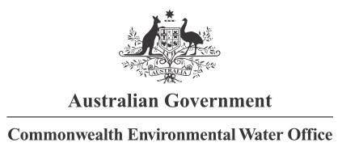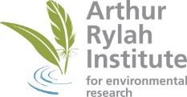

**Partners**

**Collaborators**

1. <https://www.environment.gov.au/water/cewo/publications/environmental-water-outcomes-framework>
2. For this report, ‘supported’ refers to areas that received inundation from Commonwealth environmental water that contain reported species or habitat. Consistent with collaborative water delivery across the Basin, Commonwealth environmental water can be delivered in conjunction with other sources of water, and hence observed responses can be due to the combined effect of this water.
3. International treaties referred to are the Bonn Convention, JAMBA, CAMBA and ROKAMBA
4. Formula that calculates species diversity as the ratio of the number of species divided by the number of individuals in the community.