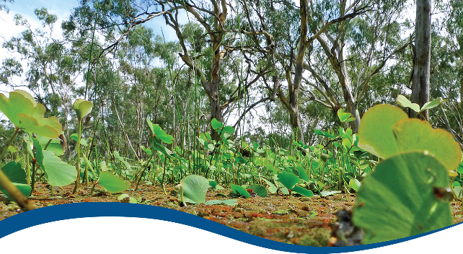

Basin-scale evaluation of 2019–20 Commonwealth environmental water: Vegetation

Commonwealth Environmental Water Office (CEWO):   
Monitoring, Evaluation and Research Program

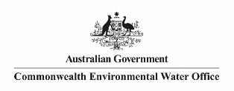August 2021

Citation

Dyer F, Campbell C, Higgisson W, Tschierschke A, Doody TM (2021) 2019-20 - Vegetation Evaluation Report - Final. Flow-MER Program. Commonwealth Environmental Water Office (CEWO): Monitoring, Evaluation and Research Program, Department of Agriculture, Water and the Environment, Australia. 152pp

Acknowledgements

The project team and the Commonwealth Environmental Water Office (CEWO) respectfully acknowledge the traditional owners of the land on which this work is conducted, their Elders past and present, their Nations of the Murray–Darling Basin, and their cultural, social, environmental, spiritual and economic connection to their lands and waters.

The Theme team also thanks the team of people who contributed data and advice to the project, in particular:

* field teams from each of the Selected Areas who collected the data and the data managers who uploaded it to the data management system
* Selected Area leads and the vegetation theme leads who answered questions of their data
* Ashmita Sengupta and Enzo Guarino who provided data and input to our hydrological analyses
* Shane Brooks who provided ANAE information, data layers and advice
* Martin Nolan who provided data layers and advice
* Richard Duncan who provided advice on data analysis
* Samantha Capon and Cassandra James for the previous evaluations and on whose shoulders we stand
* reviewers and editors for their detailed consideration of our evaluation
* our families for putting up with the fact that we were AWOL with ‘the big report’ for a considerable length of time.

Vegetation sampling was conducted under the following licences: NSW Scientific License SL102011 (Lachlan River System); SL100441 (Murrumbidgee River System); SL102012 (Gwydir and Warrego river systems); SL101403 (Edward/Kolety–Wakool river systems); Victorian Flora and Fauna Guarantee Act 1988 and National Parks Act 1975: Permits 10008220 (2017–2020), 10009567 (2020–2023) 10009828 (2021–2023) (Goulburn River system); DEW scientific research permit A26146-8 (Lower Murray River system).

Copyright

Creative Commons [logo] © Commonwealth of Australia 2021

With the exception of the Commonwealth Coat of Arms, partner logos and where otherwise noted, all material in this publication is provided under a Creative Commons Attribution 4.0 International Licence <https://creativecommons.org/licenses/by/4.0/>. The Flow‑MER Program requests attribution as ‘© Commonwealth of Australia (Flow‑MER Program) <https://flow-mer.org.au>’.

Document submission history

|  |  |
| --- | --- |
| 30 June 2021 | Final draft |
| 27 August 2021 | Final |
|  |  |

Cover photograph

Nardoo growth at Yanga National Park, New South Wales, during the 2010–2012 flood period.   
Photo credit: Tanya Doody

Important disclaimer

The information contained in this publication comprises general statements based on scientific research. The reader is advised and needs to be aware that such information may be incomplete or unable to be used in any specific situation. No reliance or actions must therefore be made on that information without seeking prior expert professional, scientific and technical advice. To the extent permitted by law, the Flow-MER Program (including its partners and collaborators) excludes all liability to any person for any consequences, including but not limited to all losses, damages, costs, expenses and any other compensation, arising directly or indirectly from using this publication (in part or in whole) and any information or material contained in it.

The Flow-MER is committed to providing web accessible content wherever possible. If you are having difficulties with accessing this document, please contact [CEWOmonitoring@environment.gov.au](mailto:CEWOmonitoring@environment.gov.au).

Overview of Flow-MER

Flow-MER is the Commonwealth Environmental Water Office’s (CEWO) Monitoring, Evaluation and Research Program. Its objective is to monitor and evaluate the ecological responses to the delivery of Commonwealth environmental water in the Murray–Darling Basin. It provides the CEWO with evidence to inform our understanding of how water for the environment is helping maintain, protect, and restore the ecosystems and native species across the Basin. This work will support environmental water managers, demonstrate outcomes, inform adaptive management and fulfil the legislative requirements associated with managing Commonwealth-owned environmental water.

The Program runs from 2019 to 2022 and consists of 2 components: monitoring and research in 7 Selected Areas (Selected Area projects); and Basin-scale evaluation and research (the Basin-scale project) (Figure 1 The 7 Selected Areas and 25 valleys established for long-term monitoring of the effects of environmental watering under the LTIM Project and Flow-MER Program (2014–15 to present)Figure 1). The Basin-scale project is led by CSIRO in partnership with the University of Canberra, and collaborating with Charles Sturt University, Deakin University, University of New England, South Australian Research and Development Institute, Arthur Rylah Institute, NSW Department of Planning, Industry and Environment, Australian River Restoration Centre and Brooks Ecology & Technology.

It builds on work undertaken through the Long Term Intervention Monitoring (LTIM) (2014–2019) and Environmental Water Knowledge and Research (EWKR) (2014–2019) projects.

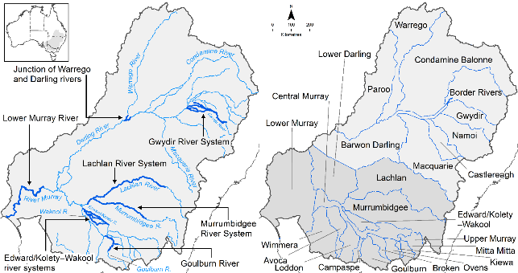

Figure The 7 Selected Areas and 25 valleys established for long-term monitoring of the effects of environmental watering under the LTIM Project and Flow-MER Program (2014–15 to present)

The Flow-MER evaluation adopts an adaptive management framework to acknowledge the need for collectively building the information, networks, capacity and knowledge required to manage environmental water at Basin scale. While knowledge of ecological response to instream flow and inundation has advanced significantly in recent years, substantive challenges remain in understanding the similarities and differences in species’ response across time and space, as well as the interaction between species at a community and ecosystem scale.

The Basin-scale evaluation is being undertaken across 6 Basin Themes (Figure 2) based on ecological indicators developed for the LTIM Project and described in the [Environmental Water Outcomes Framework](https://www.environment.gov.au/water/cewo/publications/environmental-water-outcomes-framework). It is undertaken in conjunction with the Selected Area projects, which provide data, research and knowledge for ecological outcomes within the 7 Selected Areas. The Basin-scale evaluation integrates across Selected Areas, themes, datasets, approaches and different types of knowledge.

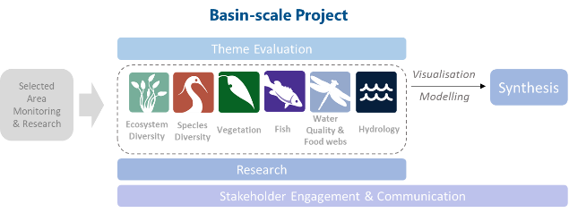

Figure Basin-scale Project evaluation reports on Commonwealth environmental water outcomes for the 6 Basin Themes as well as a high-level Basin-scale synthesis

The evaluation is informed by Basin-scale research projects, stakeholder engagement and communication, including Indigenous engagement, visualisation and modelling, as well as the 7 Selected Area projects

About the Basin-scale evaluation

Water delivery and outcomes data provided by CEWO is used in conjunction with monitoring data provided by the 7 Selected Areas and other publicly available data to undertake the Basin-scale evaluation. The research and evaluation content is structured into 6 disciplinary themes. Technical reports for each of the 6 themes are available from the [CEWO](https://www.environment.gov.au/water/cewo/publications/environmental-water-outcomes-framework) website.

The evaluation aims to address theme specific questions in relation to how Commonwealth environmental water contributed to, supported, or influenced environmental outcomes. Commonwealth environmental water is often delivered in conjunction with other environmental water holdings, and non-environmental water releases (such as for irrigation or during high-flow events). The evaluation consequently draws on available information to estimate (where possible) the specific contribution of Commonwealth environmental water to particular environmental outcomes. The way in which this contribution is assessed varies between the 6 themes depending on the data and tools currently available:

modelling to estimate and compare outcomes both with and without Commonwealth environmental water (counterfactual modelling) – Hydrology (instream); Fish (multi-year evaluation)

identification of ecological response in locations that received Commonwealth environmental water (potentially in conjunction with other sources of environmental water or non-environmental water), and where feasible, comparison with areas that did not receive Commonwealth environmental water – Ecosystem Diversity, Species Diversity, Vegetation

use of flow and water quality metrics to infer likely outcomes – Hydrology (inundation); Food Webs and Water Quality

synthesis of findings across Selected Areas – Fish (annual); Vegetation; Food Webs and Water Quality.

Summary

Strategic management of Commonwealth environmental water by the Commonwealth Environmental Water Holder (CEWH) is key to achieving the Commonwealth’s (Murray–Darling) Basin Plan 2012 environmental objectives. The 3-year Basin-scale Flow-MER Program aims to demonstrate Basin-scale outcomes of Commonwealth environmental water, support adaptive management and fulfil CEWH legislative requirements under the Basin Plan.

This evaluation describes groundcover vegetation outcomes from the use of Commonwealth environmental water for 2019–20, as well as the cumulative outcomes from the use of Commonwealth environmental water since monitoring began in 2014. In doing so, the evaluation considers the latest annual (2019–20) and 6-year (2014–20) contribution of Commonwealth environmental water to answer the following questions:

* What did Commonwealth environmental water contribute to plant species diversity?
* What did Commonwealth environmental water contribute to vegetation community diversity?

In addressing the questions, we consider responses to all types of environmental water, which includes Commonwealth environmental water as well as state holdings of environmental water. Thus, the evaluation reflects the outcomes from the combined management of environmental water[1].

The evaluation is based on vegetation data collected under the Long Term Intervention Monitoring Project (2045–15 to 2018–19) and Flow-MER Program (2019–present) from floodplain–wetlands and river channels. Descriptions of the vegetation responses to environmental water are framed in terms of species and community responses and are described in terms of a range of structural and functional attributes. For the purposes of the evaluation:

* species diversity encompasses the presence and abundance of individual plant species; here, we use species richness (number of species) instead of a more formal measure of species diversity
* community diversity includes the composition and structure of vegetation assemblages occurring in different habitat types (riverine and floodplain–wetland).

Structural and functional attributes include water plant functional groups (submerged, amphibious, damp, woody flood dependent and terrestrial), species growth forms (e.g. forbs, grasses, ferns), native and exotic species, rare and threatened species as well as species which are known to have been used by Aboriginal people.

The data are evaluated in the context of watering history (both natural and managed) and patterns of observed responses are used to infer responses in vegetation across the Basin. Our inference is based on patterns and observations of vegetation at monitoring locations in 2 ways:

* comparing locations that received or did not receive environmental water (annual evaluation)
* comparing locations that are classified into different hydrological groups reflecting the degree to which they received environmental water (6-year evaluation).

This applies the same logic as is applied in standard comparative bioassessment practice, where it is recognised that that if environmental water has been provided then it has, in part, contributed to the plant species present at that location. The outcomes from the evaluation are used to surmise the contribution of Commonwealth environmental water to Basin Plan objectives and identify adaptive management responses to issues raised in the evaluation.

Water year 2019–20

Of the total 125 watering actions delivered by the CEWO during the 2019–20 water year (1 July 2019–30 June 2020), 90 actions, comprising a total of 738,207 ML, were delivered for expected outcomes associated with vegetation across the Basin.

More than 400 plant taxa were recorded in 2019–20 across all wetland and riverine monitoring locations, including 304 and 125 identifiable native and exotic species, respectively. Environmental water has been important in maintaining the number (richness) of plant species in the Basin in 2019–20 across both floodplain–wetland and riverine habitats with almost 25% of taxa only recorded at locations that received environmental water. This includes 50 taxa in floodplain–wetland habitats, and 62 taxa in riverine habitats.

Environmental water has been used to sustain the richness of plant species, as well as to sustain rare and threatened species and those known to be used by Aboriginal people. In 2019–20, 15 plant species known to be used by Aboriginal people were only recorded at locations that received environmental water. Of these, 9 are classed as either submerged, amphibious or damp-loving species that would be dependent on the provision of water to be present in the landscape. Further, 3 national or state listed species were only recorded at locations that received environmental water and it is likely that the management of environmental water is important for their ongoing persistence in the landscape.

The use of environmental water in 2019–20 was important for supporting vegetation communities that included species classified as submerged, amphibious or damp-loving species, contributing to maintaining the variety of plant community types in the Basin.

While the number of riverine monitoring locations that did not receive environmental water in 2019–20 was limited, it appears that the management of environmental water more than doubled the total cover of plant species at those riverine locations. While the data and analysis able to be undertaken are severely limited, this suggests that the active management of environmental water was important for supporting instream and riverbank vegetation, which also contributes to bank stability.

We consider that it is likely that the use of environmental water in 2019–20 in unmonitored areas will have maintained the richness of species observed at watered monitoring locations. This will have included a range of species listed as rare and threatened as well as plant species known to be used by Aboriginal people. The species that are supported will be dependent on the location in the Basin. It is highly likely that environmental water will have maintained the richness of vegetation communities by supporting submerged, amphibious and water-dependent species that are unlikely to be present in the absence of environmental water.

Water years 2014–20

Between 2014–15 and 2019–20, there were 462 watering actions delivered by CEWO for expected outcomes associated with vegetation across the Basin.

More than 700 plant taxa have been recorded across all floodplain–wetland and riverine monitoring sample points since 2014. Of these, almost 40% (278) are species that have only occurred at sample points which received environmental water. This includes submerged (4), amphibious (46) and damp-loving species (50) that are unlikely to be observed in the absence of environmental water in the long term. In contrast, comparable sites that did not receive environmental water did not have these species present. This highlights the significant role of environmental water in supporting a substantial number of native plant species across the Basin over the past 6 years.

Between 2014 and 2020, 69 plant species known to be used by Aboriginal people have been recorded within the monitored Selected Areas. While Commonwealth environmental watering actions over the past 6 years have not deliberately targeted plant species because of their cultural significance, watering actions that supported groundcover vegetation have also supported a range of plant species known to be used by Aboriginal people. Of particular note is that 15 plant species known to be used by Aboriginal people have only occurred at sample points that have received environmental water.

The data collected since 2014 show that the floodplain–wetland vegetation communities of the Basin have distinct functional and structural assemblages based on the hydrological regime they have experienced over the past 6 years. There is greater diversity and cover of submerged, amphibious and damp-loving species at sample points that have received regular inundation because of the use of environmental water. In the absence of environmental water, more than 50% of floodplain–wetland sample points would have experienced drier water regimes, with 9 sample points shifting from being inundated 80% of the time over the last 6 years to being inundated only 14% of the time. It is very likely this would have resulted in the near absence of submerged species and considerably less diversity and cover of amphibious and damp-loving species. In turn, this would likely have resulted in a less rich vegetation community across the Basin. This highlights the role that environmental water has played over the past 6 years in maintaining functionally important assemblages of species and a richness of vegetation communities.

We consider it is likely that environmental water has also contributed to vegetation species and community diversity in unmonitored areas between 2014–15 and 2019–20. Over the past 6 years, Commonwealth environmental water has been used to support around 15% of the permanent wetlands, more than 40% of the permanent tall emergent marsh, and more than 25% of the freshwater meadows on the managed floodplains (Brooks 2021). Without environmental water, these ecosystem types may shift to different assemblages of vegetation and transition to the ecosystem types that are more common to drier hydrology regimes.

Key contribution to Basin Plan objectives

The Basin-scale Vegetation Diversity Theme evaluates the contribution of Commonwealth environmental water to achieving the Basin Plan objectives for Biodiversity (‘protect and restore biodiversity that is dependent on Basin water resources’, Basin Plan Section 8.05) and focuses on the use of environmental water to support the diversity of non-woody vegetation within the Basin.

What did Commonwealth environmental water contribute to plant species diversity and vegetation community diversity in 2019–20?

Commonwealth environmental watering actions in 2019–20 are considered highly likely to have played an important role in sustaining the diversity of plant species in the Basin across both floodplain–wetland and riverine habitats. This includes plant species known to be used by Aboriginal people and species listed as rare and threatened. The latter also contribute to broader Basin Plan objectives of supporting water-dependent ecosystems that sustain the life cycles of listed threatened species.

The use of Commonwealth environmental water in 2019–20 was important for maintaining the diversity of floodplain–wetland vegetation communities in the Basin and sustained vegetation communities that include submerged, amphibious and damp-loving species. This is illustrated by more than half of the sites that did not receive environmental water showing a shift in community composition away from wetland vegetation and towards a community dominated by terrestrial species.

What did Commonwealth environmental water contribute to plant species diversity and vegetation community diversity between 2014–15 and 2019–20?

Commonwealth environmental watering actions delivered between 2014–15 and 2019–20 contributed to maintaining a substantial number of native plant species across the Basin. This includes many submerged, amphibious and damp-loving species that are unlikely to have persisted at monitoring locations in the absence of environmental water. It also includes 15 plant species known to be used by Aboriginal people, highlighting the potential for Commonwealth environmental water to be used in supporting these species.

The delivery of Commonwealth environmental water has contributed to distinct hydrological regimes across the Basin, which is likely to have contributed to the observed diversity in functional and structural assemblages of vegetation. There is greater richness and cover of submerged, amphibious and damp-loving species at the 26 floodplain–wetland monitoring locations which have received environmental water, relative to the 35 floodplain–wetland monitoring locations that displayed drier conditions as a consequence of not receiving environmental water.

Key adaptive management outcomes

Based on the results of this evaluation, we recommend the following adaptive management actions:

* Continue to deliver environmental water to maintain wetter hydrological regimes at floodplain–wetland sample points that are central to supporting vegetation species and community diversity at the Basin scale.
* Improve the temporal resolution of available inundation data to support a better understanding and evaluation of the influence of individual and collective watering actions on vegetation community responses.
* Better align specific objectives for watering actions targeting vegetation with both Basin Plan objectives and the desired outcomes in the Basin-wide environmental watering strategy.
* Review the vegetation sampling points for use in future monitoring both within and across Australian National Aquatic Ecosystem (ANAE) types to support the evaluation.
* Improve the understanding of specific watering requirements of particular vegetation species and community assemblages.
* Consider opportunities to further support plant species known to be used by Aboriginal people using environmental water and engage Aboriginal communities across the Basin to identify cultural important plant species that can be supported with environmental water.

Contents

Overview of Flow-MER i

About the Basin-scale evaluation ii

Summary iii

Water year 2019–20 iv

Water years 2014–20 iv

Key contribution to Basin Plan objectives v

Key adaptive management outcomes vi

1 Introduction 1

1.1 Evaluation objectives 1

1.2 About this report 2

2 Watering actions for vegetation outcomes 4

2.1 Climate and hydrological context 4

2.2 Water year 2019–20 6

2.3 Water years 2014–20 6

3 Evaluation approach 7

3.1 General approach 7

3.2 Data used in this evaluation 10

3.3 Analysis 16

4 Hydrological grouping 21

4.1 Classification method 21

4.2 Relationship to vegetation communities 24

4.3 Analysis 26

5 Basin-scale evaluation 2019–20 27

5.1 Species-level responses to environmental water 30

5.2 Community-level responses to environmental water 33

5.3 2019–20 responses in unmonitored areas 36

6 Basin-scale evaluation 2014–20 38

6.1 Species-level responses to environmental water 42

6.2 Community-level responses to environmental water 42

6.3 Expected outcomes in the absence of environmental water 44

6.4 2014–20 responses in unmonitored areas 46

7 Case study: extrapolating to unmonitored areas using ANAE types 47

7.1 Key findings 47

7.2 Introduction 47

7.3 Methods 48

7.4 Results 52

7.5 Synthesis 60

8 Contribution to Basin Plan objectives 62

8.1 What did Commonwealth environmental water contribute to plant species diversity and vegetation community diversity in 2019–20? 62

8.2 What did Commonwealth environmental water contribute to plant species diversity and vegetation community diversity between 2014–15 and 2019–20? 62

8.3 Expected outcomes for vegetation 63

9 Case study: the response of plant species known to be used by Aboriginal people 64

9.1 Key findings 64

9.2 Introduction 65

9.3 The response to flooding of 3 plant species known to be used by Aboriginal people 66

9.4 Methods 69

9.5 Results 70

9.6 Synthesis 75

10 Adaptive management 77

Appendix A Summary of 2019–20 Commonwealth environmental watering actions with expected outcomes related to vegetation 79

Appendix B Vegetation sampling details 87

Appendix C Additional supporting material 91

C.1 Life history 91

C.2 Growth form 91

C.3 Tests for statistical significance in functional group assemblages between hydrological groups 92

C.4 Supporting figures – chapters 5 and 6 96

Appendix D Individual functional group responses 99

D.1 Patterns within individual functional groups 99

Appendix E Presence and absence of inundation for all floodplain–wetland sample points for each quarter per water year, 2014–20 103

Appendix F Plant species recorded in the 2014–20 Flow-MER dataset and listed under national (EPBC Act) or state-based (New South Wales, South Australian or Victorian) rare and threatened species lists 108

Appendix G Plant species that occur within the Basin and known to be used by Aboriginal people 112

Appendix H Plant taxa recorded in LTIM and Flow-MER programs from monitored Selected Areas for each year 2014–20 117

References 133

List of figures

Figure 1 The 7 Selected Areas and 25 valleys established for long-term monitoring of the effects of environmental watering under the LTIM Project and Flow-MER Program (2014–15 to present) i

Figure 2 Basin-scale Project evaluation reports on Commonwealth environmental water outcomes for the 6 Basin Themes as well as a high-level Basin-scale synthesis ii

Figure 2.1 Rainfall conditions (lowest to highest on record) in the Basin during 2019–20 5

Figure 2.2 Maps of annual rainfall conditions (lowest to highest on record) in the Basin during 2014–20 5

Figure 3.1 Conceptual diagram depicting key explanatory variables and response attributes of vegetation in river-floodplain environments 8

Figure 3.2 Map showing Selected Areas monitored for vegetation under the Flow-MER Program and the area inundated by Commonwealth environmental water (Cew) in 2019–20 11

Figure 4.1 k-means clustering of all Flow-MER vegetation sample points into 6 hydrological groups based on observed inundation regime 23

Figure 4.2 Map showing sample points by hydrological group based on the results of k-means cluster analysis of the monitored wetlands 24

Figure 4.3 Proportional cover of plant functional groups in different floodplain–wetland hydrological groups based on all plant species records pooled across all years (2014–20) 25

Figure 4.4 Relative species numbers of plant functional groups in different floodplain–wetland hydrological groups based on all species records pooled across all years (2014–20) 25

Figure 4.5 Number of sample points in each of the 6 hydrological groups 26

Figure 5.1 Percentage of plant species recorded from different functional groups occurring in the 6 hydrological groups in 2019–20 29

Figure 5.2 Proportional plant cover of functional groups in different hydrological groups in 2019–20 30

Figure 5‑3 The relative percentage of species numbers in each water plant functional group recorded at floodplain–wetland sample points that and did not receive environmental water (ewater) in 2019–20 33

Figure 5.4 Standardised cover of functional groups at sample points that did and did not receive environmental water (ewater) in 2019–20 34

Figure 5.5 Relative species numbers for growth forms at sample points that did and did not receive environmental water (ewater) in 2019–20 35

Figure 5.6 Proportional cover of growth forms at sample points that did and did not receive environmental water (ewater) in 2019–20 35

Figure 6.1 Cumulative species richness across the 6 years, 2014–20 38

Figure 6.2 Average species richness per sample point per water year across all Selected Areas, ± 1 SD 39

Figure 6.3 Average cover of all species per sample point per year across all Selected Areas, ± 1 SD 39

Figure 6.4 Percentage of plant species recorded across all Selected Areas in each water plant functional group for each water year and across all years 40

Figure 6.5 Standardised percentage cover of plant functional groups across all Selected Areas, 2014–20 41

Figure 6.6 Standardised cover of functional groups in each of the 6 hydrological groups (where 1 is the wettest group and 6 the driest) pooled across all water years, 2014–20 43

Figure 6.7 Relative proportions of native and exotic cover in each of the 6 hydrological groups (where 1 is wetted and 6 is driest) pooled across all water years, 2014–20 43

Figure 6.8 Standardised cover of growth forms in each of the 6 hydrological groups pooled across all water years, 2014–20 44

Figure 6.9 Number of sample points in each hydrological group 45

Figure 6.10 Functional group community assemblages associated with each of the hydrological groups 45

Figure 7.1 Average plant species cover per sample point for different hydrological groups and riverine sample points within the ANAE type F1.2: River red gum forest riparian zone or floodplain, pooled across all years 2014–20, ± 1 SD 53

Figure 7.2 Average cover per sample point for different hydrological groups and riverine sample points within the ANAE type F1.2: River red gum forest riparian zone or floodplain, for each sampling year, ± 1 SD 53

Figure 7.3 Proportional cover of functional groups in hydrological groups and riverine sample points within the ANAE type F1.2: River red gum forest riparian zone or floodplain, pooled across all years, 2014–20 54

Figure 7.4 Proportional cover of functional groups in hydrological groups and riverine sample points within the ANAE type F1.2: River red gum forest riparian zone or floodplain, for each sampling year, 2014–20 54

Figure 7.5 Proportional cover of growth forms in hydrological groups and riverine sample points within the ANAE type F1.2: River red gum forest riparian zone or floodplain, pooled across all years (2014–20) 55

Figure 7.6 Proportional cover of native and exotic species in hydrological groups and riverine sample points within the ANAE type F1.2: River red gum forest riparian zone or floodplain, for each sampling year 55

Figure 7.7 nMDS of plant species composition and cover for sample points within the ANAE type F1.2: River red gum forest riparian zone or floodplain 56

Figure 7.8 nMDS of functional group composition and cover for sample points within the ANAE type F1.2: River red gum forest riparian zone or floodplain 57

Figure 7.9 nMDS of plant species composition and cover for sample points within the ANAE type F1.2: River red gum forest riparian zone or floodplain 58

Figure 7.10 nMDS of functional group composition and cover for sample points within the ANAE type F1.2: River red gum forest riparian zone or floodplain 59

Figure 7.11 Standardised cover of functional groups in each sample point within the ANAE type F1.2: River red gum forest riparian zone or floodplain, pooled across all years, 2014–20, and grouped according to hydrological group 59

Figure 7.12 Proportion of ANAE type F1.2: River red gum forest riparian zone or floodplain influenced by Commonwealth environmental water at differing frequencies from 2014–15 to 2019–20 60

Figure 9.1 Map showing distribution of common nardoo (*Marsilea drummondii*) 66

Figure 9.2 Nardoo (emerging above a layer of *Azolla*) during extensive flooding at Yanga National Park, 2010–12 67

Figure 9‑3 *Centipeda cunninghamii* (common sneezeweed or old man weed) in flower on the Darling Anabranch 68

Figure 9.4 Seeding cumbungi (*Typha domingensis*) in 2009 69

Figure 9.5 The probability of observing *Marsilea* spp. (at sample points where it is has been observed at least once) with time since flooding, based on the output of a Linear Mixed-Effects Model on the presence/absence of *Marsilea* spp.(nardoo) 71

Figure 9.6 Mean percentage cover of *Marsilea* spp. (nardoo) at sample points within time-since-flooding categories 72

Figure 9.7 The probability of observing *Centipeda* spp. (at sample points where it is has been observed at least once) with time since flooding, based on the output of a linear mixed effects model on the presence/absence of *Centipeda* spp. (old man weed, sneezeweed) 73

Figure 9.8 Mean percentage cover of *Centipeda* spp. (old man weed, sneezeweed) at sample points with time-since-flooding categories 73

Figure 9.9 The probability of observing *Typha* spp. (at sample points where it is has been observed at least once) within time since flooding. 74

Figure 9.10 Mean percentage cover of *Typha* spp*.* at sample points within time-since-flooding categories. 74

Figure 9.11 Average percentage cover of old man weed or sneezeweed (*Centipeda* spp.), nardoo (*Marsilea* spp.) and cumbungi (*Typha* spp.) at sample points influenced by Commonwealth environmental water (with ewater) or not influenced by Commonwealth environmental water (without ewater) during 2019–20 75

Figure 9.12 Number of times old man weed or sneezeweed (*Centipeda* spp.), nardoo (*Marsilea* spp.) and cumbungi (*Typha* spp.) were recorded from sample points within the hydrological groups during 2014–20 76

Figure C.1 nMDS plot of functional group assemblages at individual sample points for each water year, 2014–20 94

Figure C.2 nMDS plot of functional group assemblages at individual sample points for 2019–20 water year 96

Figure C.3 Proportional cover of plant functional groups at sample points that did and did not receive environmental water in 2019–20 96

Figure C.4 Standardised cover of plant functional groups in each of the 6 hydrological groups over 2014–20 97

Figure C.5 Species numbers of functional groups in each of the 6 hydrological groups over 2014–20 97

Figure C.6 Native and exotic species numbers in each of the 6 hydrological groups pooled across 2014–20 98

Figure C.7 Species numbers per growth forms in different hydrological groups pooled during 2014–20 98

Figure D.1 Standardised proportional cover of individual functional groups across all Selected Areas for each year 102

Tables

Table 3.1 Descriptions of the explanatory variables and the vegetation response metrics used in this evaluation 8

Table 3.2 Logic used to attribute vegetation responses to environmental water 10

Table 3.3 Summary of the 11 2019–20 Commonwealth environmental watering actions with expected outcomes related to vegetation monitored through the Flow-MER Program 14

Table 3.4 Water plant functional group (FG) classifications of Brock and Casanova (1997) and Casanova (2011) with the addition of W-W, W-RF and W-O to separate woody species responses 17

Table 3.5 Growth form (sourced and altered from BioNet) 19

Table 4.1 Hydrological groups used to structure the floodplain–wetland vegetation data analysis. Inundation duration and dry phase duration are 3-monthly quarters (i.e. 1 = 3 months) during 2014–20 22

Table 5.1 Total number of plant species and dominant families recorded each water year and across all years from all sample points 28

Table 5.2 Numbers of native and exotic species, the proportion of native species and the proportional cover of native species recorded across all sample points for each water year and across all years 29

Table 5.3 Plant species unique to sample points that received Commonwealth environmental water in 2019–20 31

Table 5.4 The total number of sample points in each ANAE type surveyed as part of the LTIM and Flow-MER programs in each water year, (2014–20 36

Table 6.1 Species listed under national (EPBC Act) or state rare and threatened species lists recorded (indicated by X) at sample points in each water year, 2014–20 41

Table 7.1 ANAE types surveyed as part of Flow-MER with the number of sample points in each Selected Area and the number and type of hydrological groups represented 48

Table 7.2 Number of sample points surveyed each year in each of the hydrological groups for ANAE type F1.2: River red gum forest riparian zone or floodplain 50

Table 7.3 Hydrological regime experienced by each floodplain–wetland sample points in the ANAE type F1.2: river red gum forest riparian zone or floodplain, showing the extent of environmental water contribution to overall inundation 51

Table 7.4 Area of ANAE type F1.2: River red gum forest riparian zone or floodplain inundated by Commonwealth environmental water in each year and across all years (taken from Brooks 2021) 60

Table A.1 Summary of the 2019–20 Commonwealth environmental watering actions with expected outcomes related to vegetation 79

Table B.1 Vegetation sampling design at the Selected Areas monitored for the LTIM and Flow-MER programs from 2019–20 and across all water years 2014–20 87

Table B.2 Sample points per Selected Area for each water year, 2014–20 88

Table B.3 Sampling per sample point in each Selected Area per water year, 2014–20 88

Table C.1 Number of annual and perennial species and proportion of perennial species and cover recorded across all sample points for each water year 91

Table C.2 Proportional number of species recorded in each growth form category (see Table 3.5) across all Selected Areas for each water year and across all years 91

Table C.3 Proportional cover of species recorded in each growth form category (see Table 3.5) across all Selected Areas for each water year 92

Table C.4 PERMANOVA table of results across all years, 2014–20 93

Table C.5 Pairwise table of results across all years (2014–20) 93

Table C.6 Average Bray–Curtis similarity between/within hydrological groups 94

Table C.7 PERMANOVA table of results for 2019–20 95

Table C.8 Pair-wise table of results for 2019–20 95

Table C.9 Average Bray-Curtis Similarity between/within hydrological groups 95

Table E.1 Hydrological groups with environmental water via presence/absence of inundation for sample points for each quarter per water year, 2014–20 103

Table E.2 Hydrological groups without environmental water via presence/absence of inundation for sample points for each quarter per water year 2014–20 105

Table F.1 Plant species recorded in the 2014–2020 Flow-MER dataset that are listed under national (EPBC Act) or state-based (New South Wales, South Australian or Victorian) rare and threatened species lists 108

Table G.1 Plant species known to be used by Aboriginal people that occur within the Basin 112

Table H.1 Plant taxa recorded in the LTIM and Flow-MER programs, from monitored Selected Areas for each water year, 2014–20 117

Abbreviations, acronyms and terms

|  |  |
| --- | --- |
| Abbreviation/acronym/term | Description |
| ANAE | Australian National Aquatic Ecosystem |
| APC | Australian Plant Census |
| APNI | Australian Plant Name Index |
| c. | Short form for ‘about’ (e.g. c. 8 months is about 8 months) |
| CEWH | Commonwealth Environmental Water Holder |
| CEWO | Commonwealth Environmental Water Office |
| counterfactual | state or condition that occurs in the absence of the causative agent  term arising from the philosophy of causation: ‘We think of a cause as something that makes a difference, and the difference it makes must be a difference from what would have happened without it. Had it been absent, its effects – some of them, at least, and usually all – would have been absent as well’ (Lewis 1973) |
| ewater | environmental water (in figures) |
| EPBC Act | Environment Protection and Biodiversity Conservation Act 1999 (Cth) |
| EWKR | Environmental Water Knowledge and Research (Project) (2014–2019) |
| Flow-MER | The CEWO Monitoring, Evaluation and Research Program (2019–2022) |
| growth form | structural category consisting of species of the same general habit of growth but not necessarily related(e.g. grasses, sedges and rushes, shrubs). See Table 3-5 |
| LTIM | Long Term Intervention Monitoring (Project) (2014–2019) |
| MDBA | Murray–Darling Basin Authority |
| nMDS | non-metric multidimensional scaling |
| PERMANOVA | permutational multivariate analysis of variance |
| Selected Area | onitoring region within the Murray–Darling Basin selected to provide geographical coverage and represent key ecosystems and biota |
| taxon (plural taxa) | any taxonomic category such as a species or family. Used in this report to recognise the number of taxonomic records where the lowest level of identification may not always be species (i.e. where a lack of identifying material such as flowers or seeds prevents identification to species level) |
| the Basin | shortened form of the Murray–Darling Basin |
| the Strategy | shortened form for the Basin-wide environmental watering strategy (MDA 2014) |
| vegetation | in the context of this report refers to non-woody vegetation, i.e. does not include trees |
| WAR | Watering Action Reference / Water Actions Register |
| Water year 2019–20 | the period 1 July 2019 to 30 June 2020 |

# 

# Introduction

Australia’s floodplains, wetlands and riverine ecosystems are characterised by unique, diverse and often iconic vegetation. From ancient river red gum forests fringing wide, lazy rivers to sedges and grasses emerging from open wetlands, vegetation shapes our landscapes and provides a range of ecological, cultural and economic services. The vegetation found along rivers, floodplains and wetlands provides food and habitat for a wide variety of species, often within otherwise dry landscapes. It also provides organic matter to rivers, contributing important basal resources to biota and many ecosystem processes.

For tens of thousands of years, Australia’s Indigenous people used the incredible diversity of floodplain and wetland plants to provide themselves with food, shelter, fibre and medicines. We see echoes of their presence in the scar trees that dot the banks of our inland rivers. European settlers were similarly drawn to rivers, floodplains and wetlands for the resources they provided.

The combination of land-clearing, grazing and water use have fundamentally changed the nature and condition of vegetation across rivers, floodplains and wetlands of the Basin. There has been widespread loss and what remains is often in poor condition. For the period 2008–2010, the Sustainable Rivers Audit assessed the condition of riverine vegetation as very poor to moderate across the majority of regulated rivers in the Basin (MDBA 2012). In contrast, many unregulated rivers were assessed as being in better condition. One of the main causes of decline has been changes to the frequency, duration and timing of water received by a wide variety of vegetation communities.

The hydrological regime is one of the key drivers of floodplain, wetland and riverine vegetation communities, with the composition and structure of the vegetation communities strongly influenced by both short- and long-term aspects of the flow regime (Capon et al. 2016; Nilsson and Svedmark 2002; Stomberg 2001). Wetting and drying affects species establishment, growth and persistence. Vegetation assemblages that develop across the landscape are defined by the way different species respond to water (or a lack thereof). Thus, floodplain, wetland and riverine vegetation communities are particularly sensitive to changes in the hydrological regime caused by river regulation (Nilsson and Svedmark 2002; Stromberg 2001; Tonkin et al. 2018).

Environmental water is used throughout the Basin to support the diversity and condition of both woody (trees) and non-woody (groundcover) vegetation, including a wide range of species from tangled lignum to floating ferns such as azolla.

## Evaluation objectives

The Basin-scale Vegetation Diversity theme evaluates the contribution of Commonwealth environmental water in supporting the diversity of non-woody vegetation. It addresses 2 major questions, both for the annual evaluation (2019–20), and the 6-year evaluation (2014–20):

What did Commonwealth environmental water contribute to plant species diversity?

What did Commonwealth environmental water contribute to vegetation community diversity?

These questions are addressed with respect to both a specific water year (2019–20) and over the 6 years since the beginning of the Long Term Interim Monitoring (LTIM) Program (2014–2019). The evaluation draws on vegetation monitoring data collected for all these 6 years from 6 Selected Areas across the Basin: Gwydir River System, Lachlan River System, Murrumbidgee River System, Junction of the Warrego and Darling rivers, Edward/Kolety–Wakool river systems and Goulburn River. The evaluation also includes vegetation monitoring data collected from the Lower Murray River (the seventh Selected Area) in 2019–20.

### Evaluation objectives and Basin Plan objectives for vegetation

The Basin Plan 2012 provides high-level environmental objectives that are directed at protecting and restoring water-dependent ecosystems of the Basin (Basin Plan Section 8.04). The Basin-wide environmental watering strategy (MDBA 2014 and revised in 2019; the Strategy) contains the expected outcome that environmental water will be used to ‘maintain the extent, and maintain or improve the condition of water dependent vegetation in areas that can be managed with environmental water’ (MDBA 2019). Outcomes for vegetation defined within the Strategy (MDBA 2014) are framed within the context of specific vegetation structural groups (forests and woodlands, shrublands and non-woody vegetation) and also provide expected outcomes for specific vegetation communities (e.g. lignum shrublands).

As with the LTIM, the Commonwealth Environmental Water Office (CEWO) Monitoring, Evaluation and Research (Flow-MER) Program evaluates the outcomes from using environmental water to support the diversity of non-woody vegetation. While there is line of sight to Basin Plan objectives (the Outcomes Framework table in Gawne et al. 2014), there is no explicit link between Strategy objectives and the evaluation questions for vegetation. This is because the Flow-MER evaluation uses the LTIM monitoring framework that was developed before the Strategy was finalised. Evaluating the expected outcomes of the Strategy would require fundamentally different evaluation questions and a different monitoring approach. The Flow-MER Program (2019–22) extends monitoring to enable the uninterrupted collection of data while both the LTIM and Environmental Water Knowledge and Research (EWKR) (2014–2019) projects are reviewed in order to adaptively inform the ongoing development of the Basin-scale monitoring, evaluation and research program. It is worth noting that outcomes from review and adaptive management learnings from Flow-MER evaluation and research will inform future versions of the monitoring and evaluation program.

## About this report

This report describes the evaluation of groundcover vegetation outcomes from the use of Commonwealth environmental water for the 2019–20 water year (1 July 2019 – 30 June 2020) and the 6 years since monitoring began in 2014. The report is presented as a series of chapters as follows:

* Chapter 2 summarises the context in which the 2019–20 watering actions were delivered across the Basin, lists the watering actions delivered in 2019–20 and provides summary metrics of the watering actions delivered since monitoring began in 2014–15
* Chapter 3 outlines the approach taken to the evaluation, including the sources of data and the methods that have been used
* Chapter 4 describes the hydrological contextualisation used to evaluate the response of floodplain–wetland vegetation across the Basin and infer the counterfactual (in the absence of environmental water)
* Chapter 5 describes the evaluation of groundcover vegetation outcomes from the use of Commonwealth environmental water in 2019–20
* Chapter 6 describes the 6-year (2014–15 to 2019–20) evaluation of groundcover vegetation outcomes from the use of Commonwealth environmental water
* Chapter 7 presents a proof of concept for using the combination of Australian National Aquatic Ecosystem (ANAE) classes and hydrological groups for inferring vegetation responses to unmonitored areas. This highlights the future data and knowledge required to improve the capacity to infer the responses of groundcover vegetation to unmonitored areas.
* Chapter 8 summarises the contribution to meeting Basin Plan objectives.
* Chapter 9 presents a case study that illustrates the use of Commonwealth environmental water in supporting 3 plant species known to be used by Aboriginal people, chosen for their widespread distribution across the Basin and the availability of monitoring data.
* Chapter 10 outlines proposed adaptive management responses to this evaluation.

These chapters are supported by a series of data-rich appendices.

# Watering actions for vegetation outcomes

This chapter summarises the hydrological and weather context in which the 2019–20 watering actions were delivered across the Basin, lists the watering actions delivered in 2019–20 that were relevant to vegetation outcomes and provides summary metrics of the watering actions delivered for vegetation outcomes since monitoring began in 2014.

## Climate and hydrological context

In 2019–20, the Border Rivers Valley was the only valley with rainfall conditions ‘very much below average’. In the remaining valleys, where Commonwealth environmental water was delivered, rainfall was classified as ‘average’ or ‘below average’ conditions. The Broken, Campaspe, Goulburn, Loddon, Edward/Kolety–Wakool, Goulburn, Lachlan, Loddon, Macquarie, Warrego and Wimmera valleys experienced average rainfall conditions, while rainfall in the Barwon Darling, Central Murray, Condamine Balonne, Gwydir, Lower Darling, Lower Murray, Murrumbidgee, Namoi and Ovens valleys was below the long-term average (Figure 2.1).

The northern Basin experienced a severe drought through the first half of 2019–20, with well-below-average rainfall from August to December 2019. In contrast, early 2020 saw above-average rainfall. For example, the Warrego River experienced a large inundation event, connecting the Warrego and Darling rivers for over 4 months. It inundated over 11,500 ha of the western floodplain and connected the floodplain back to the Darling River downstream of the Selected Area for the first time since 2012.

Dry conditions have been common in the Basin for the 6 years from mid-2014 to mid-2020, the period of Commonwealth Basin-scale monitoring and evaluation to date. The first 2 years saw particularly dry conditions in the southern Basin. In the 2016–17 water year, there were wetter conditions in the southern Basin and along the headwaters of the New South Wales tributaries in the northern Basin. However, conditions have returned to dry over the period 2017–20 across the whole Basin (Figure 2.2).

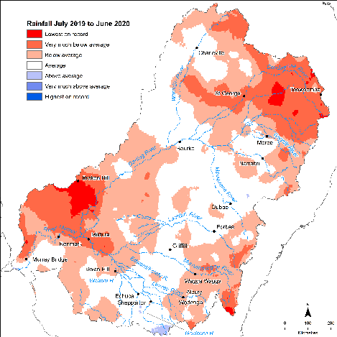

Figure 2.1 Rainfall conditions (lowest to highest on record) in the Basin during 2019–20

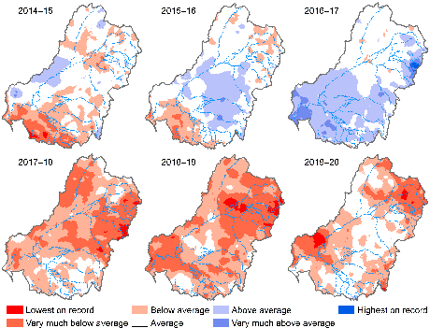

Figure 2.2 Maps of annual rainfall conditions (lowest to highest on record) in the Basin during 2014–20

## Water year 2019–20

Of the 125 watering actions delivered in 2019–20 by the CEWO, 90 actions, comprising a total of 738,207 ML, had expected outcomes[2] associated with vegetation among their listed expected outcomes. Of these, 66 watering actions, comprising a total of 358,302 ML (~48% of the allocation), were delivered for vegetation outcomes in the Selected Areas in which monitoring of vegetation outcomes is undertaken (Appendix A). The majority of Selected Area watering actions were delivered in the Lower Murray River (36) for river red gum woodlands and lignum shrublands, and the Murrumbidgee River System (14) to maintain and improve wetland vegetation condition and resilience. The greatest volume of Commonwealth environment water (>251,000 ML) used to target vegetation outcomes was in the Goulburn River Selected Area.

Of the 90 watering actions delivered in 2019–20 for vegetation outcomes, the majority (61) were delivered to wetlands and 35 to rivers – as freshes (18) and base flows (17). (Note that some watering actions include more than one flow component.) While the largest number of actions were delivered to wetlands, the watering actions involving the greatest volumes of water were freshes and base flows to river systems. The majority of the watering actions implemented in 2019–20 for vegetation outcomes targeted maintenance or improvement of vegetation or vegetation condition, with one-third of the objectives targeting forests and woodlands (which are not included in this evaluation).

## Water years 2014–20

There were 462 watering actions delivered by CEWO from 2014–15 to 2019–20 for expected outcomes associated with vegetation across the Basin[3]. Of these actions, 368 were undertaken in surface water regions represented by Selected Areas, the majority of which were within the Lower Murray River (226) and Murrumbidgee River System (65) Selected Areas. The number of watering actions varies each year in relation to water availability, and local and regional priorities.

# Evaluation approach

This chapter outlines the approach taken to the evaluation, including details of the data and the methods that have been used.

## General approach

### Conceptual framing – vegetation responses to flow regimes

Wetland and floodplain vegetation responds to hydrological conditions such as wetting and drying, with flow regimes being one of the primary, but not the only, drivers influencing the presence, composition and structure of vegetation communities (Capon et al. 2016). Flow regimes influence vegetation responses over multiple temporal and spatial scales (Campbell et al. 2021). The expression of vegetation, such as its presence, condition and composition, are influenced by recent hydrological and climatic conditions, such as season, depth and duration of inundation, time since last inundation, as well as rainfall and temperature (Casanova and Brock 2000; Warwick and Brock 2003; Greet et al. 2013; Capon et al. 2016). The expression or response of vegetation to a flow pulse is influenced by short- to medium-term flow regimes and climatic cycles (e.g. annual to a decade) that influence the condition of vegetation prior to flow (Wassens et al. 2017) and the viability of seed in soil-stored seed banks that may be triggered to germinate (Brock 2011). The response will be further influenced by long-term flow regimes and climatic cycles in the order of decades to centuries, which affect the structure and distribution of long-lived vegetation, which in turn influence the expression of non-woody vegetation (Capon et al. 2016).

There are many different riverine, wetland and floodplain vegetation species in the Murray–Darling Basin; more than 700 species have been recorded as part of the LTIM and Flow-MER programs from 7 Selected Areas alone. These species have a range of growth forms (e.g. forbs, grasses, sedges, shrubs, trees) and form-varying vegetation assemblages (groupings of species) within a range of ecosystem types that have different compositional, structural and functional attributes. Previous Basin-scale evaluation has shown that a great majority of species are unique to particular places in the Basin and the vegetation assemblages are highly variable in both space and time (Capon and Campbell 2019; Capon and James 2020). This means that vegetation responses to flow regimes are complex and expressed across multiple levels of ecological organisation (i.e. individual plants, plant populations and species, vegetation communities and vegetation landscapes or ‘vegscapes’) (Campbell et al. 2019, 2021; Capon and James 2020) (Figure 3.1).

There are, consequently, many ways of describing the vegetation responses to environmental water. We currently lack a unifying vegetation condition framework for vegetation (Gibbons et al. 2006) that could be used to interpret responses or inform the way of describing them. The characterisation of condition for non-woody wetland and floodplain vegetation and the development of condition benchmarks is being investigated through the Flow-MER Program. For now, to address Flow-MER evaluation questions relating to species and community diversity, we have used the conceptual model (Figure 3.1) to identify key explanatory and responses variables to describe the response of vegetation to watering events and regimes (Table 3.1). Descriptions of these responses are framed in terms of species and communities and are described in terms of a range of structural and functional attributes. The attributes are those that have meaning for environmental water managers and those seeking to understand the types of species and communities that may have responded to water.

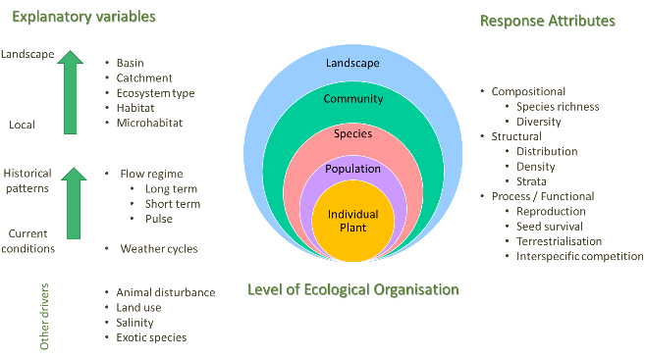

Figure 3.1 Conceptual diagram depicting key explanatory variables and response attributes of vegetation in river-floodplain environments

Source: Adapted from the Environmental Water Knowledge Research (EWKR) project (Campbell et al. 2019)

Table 3.1 Descriptions of the explanatory variables and the vegetation response metrics used in this evaluation

| **Variable** | **Metric** | | | **Description** |
| --- | --- | --- | --- | --- |
| Explanatory variables | | |  |  |
| Flow pulse | Presence/absence of environmental water  Inundation duration with and without environmental water | | | Information from the hydrology and Selected Area teams was used to determine the inundation of sample points |
| Flow history | Recent (6-year) watering history with and without environmental water | | | Information from the hydrology and Selected Area teams was used to determine the inundation history of sample points for the 6 years of the program for floodplain–wetland sample points. These inundation histories were used to establish distinct hydrological groups with and without environmental water |
| Ecosystem type | Australian National Aquatic Ecosystem (ANAE) type | | | ANAE mapping was used to provide a consistent, cross-jurisdictional layer representing different aquatic ecosystem types. While vegetation sampling points are not stratified by ANAE type, the ANAE classification provides the only Basin-wide consistent framework for ecosystem type |
| Habitat | Floodplain–wetland  Riverine | | | Sample points are identified as being from riverine or floodplain–wetland habitats |
| Response variables | |  | |  |
| Species | Presence of specific plant taxa, described in terms of native/exotic water plant functional group and species of interest (rare and threatened species, species known to have Aboriginal use) | | | Composition of species assemblages in terms of structural and functional descriptors |
| Community | Relative proportions and relative cover of species from different growth forms, native/exotic character and functional groups | | | Composition of the community in terms of relative proportions of species from different structural and functional groups |

### Attributing response to environmental water

The evaluation considers responses to all types of environmental water, which includes Commonwealth environmental water as well as state holdings of environmental water. In most cases, Commonwealth environmental water comprises the greater part of the environmental water used, but responses are not able to be attributed solely to Commonwealth environmental water, rather the evaluation reflects the outcomes from the collective management of water to achieve environmental outcomes. Note that the majority of the 2019–20 watering actions with expected outcomes for vegetation comprised only Commonwealth environmental water. Reporting on the outcomes of all environmental water is consistent with the collaborative approach used in the delivery of environmental water across the Basin.

The evaluation uses vegetation monitoring data from each of 7 Selected Areas across the Basin and focuses on describing broad patterns in vegetation responses at sample points with and without environmental water (annual evaluation) and between different hydrological groups that are supported to varying degrees by the delivery of environmental water (6-year evaluation). The focus on broad patterns in responses rather than a more rigorous quantitative (statistical) evaluation is for the following reasons:

* Vegetation monitoring and Basin-scale evaluation as part of LTIM demonstrated the heterogeneity, uniqueness and variability of vegetation assemblages at the Basin scale (based on data from 6 Selected Areas from 2014–20) across multiple years, with vegetation assemblages differing both spatially and temporally (Capon and Campbell 2019; Capon and James 2020). The number of Selected Areas from which we have data are insufficient to be able to detect a generalised response to watering due to the magnitude of the natural differences in vegetation between Selected Areas. A weight-of-evidence approach considering Selected Areas separately then collating the outcomes is a more robust way of assessing responses to environmental watering.
* The monitoring data have been collected to address the needs of the Selected Areas, rather than addressing Basin-wide questions. Aside from differences in sampling approaches within each of the Selected Areas, this means that the sampling design does not take into account the combined influence of habitat/ecosystem type and hydrological regime. Areas and monitoring locations chosen within Selected Areas are not stratified according to ecosystem type or hydrological regime and there is limited replication within these groupings. Both hydrological regime and ecosystem type are now known to be key drivers of vegetation response, and the original sampling design means that these drivers cannot be controlled for in a statistical analysis.
* The surface expression of riverine, floodplain and wetland vegetation is the result of a complex set of interacting factors that includes recent and long-term hydrological conditions, such as season, depth and duration of inundation, time since last inundation, as well as weather conditions (rainfall and temperature), soil types, local geomorphic and landscape position, and land use (see more in Section 3.2.1). The monitoring data available are records of the vegetation species present at points in time. Testing the extant species composition only in relation to recent hydrological conditions (including environmental water) without considering the longer term drivers or other environmental factors is problematic and there are not sufficient data points to be able to do this. Annual evaluation is therefore best presented as descriptions of patterns and observations rather than a more formal statistical analysis.

In this evaluation we use a range of phrases to describe the response of vegetation to the use of environmental water. In the absence of formal statistical evaluation, the logic we have used to attribute response to environmental water is described in Table 3.2. While interacting factors modify the response of vegetation to flow regimes (see third point above and Section 3.2.1), it is well established that riverine, floodplain and wetland vegetation requires inundation from flooding for growth and survival and other life-cycle stages, such as germination and reproduction (Capon et al. 2016; Casanova 2015; Roberts and Marston 2011; Rogers and Ralph 2011). While we are not able to assign statistical causality or definitively predict vegetation responses in the absence of environmental water, we are able to infer responses by:

* comparing monitoring locations with and without environmental water (annual evaluation)
* comparing monitoring locations that are classified into different hydrological groups which reflect varying degrees of environmental water delivery (6-year evaluation).

Differences between sites with different environmental watering regimes are interpreted as being due to environmental water, although direct causation cannot be attributed because of the nature of the study design.

Table 3.2 Logic used to attribute vegetation responses to environmental water

|  |  |
| --- | --- |
| **Response phrase** | **Logic** |
| Supported  *‘Environmental water has supported species …’* | For many of the wetland and floodplain sample points, environmental water has made a substantial contribution to the inundation of the sample point either within the current water year (annual evaluation) or over the last 6 years (see Appendix E) and, in some cases, it is the only source of inundation. As such, we assert that environmental water is part (or all) of the water regime that has resulted in the surface expression of the plants we observe and as such has supported the species that are present. |
| Maintained  *‘Environmental water has maintained species richness …’* | Species that are classified as aquatic, amphibious or damp-loving (see Table 3.4) require inundation to be able to complete part of their life cycle. These species are highly unlikely to be present without water. Thus, if environmental water is part of the inundation regime received by sample points that display aquatic, amphibious or damp-loving species, environmental water is considered to have maintained species richness at those sample points. |

## Data used in this evaluation

### Vegetation data

Vegetation diversity data used in this evaluation were collected under the LTIM and Flow-MER programs from floodplain–wetlands (4 Selected Areas – Gwydir, Lachlan and Murrumbidgee river systems and Junction of Warrego and Darling rivers) and within river channels (3 Selected Areas – Edward/Kolety–Wakool river systems, Goulburn River and Lower Murray River), see Figure 3.2, Table 3.3 and Table B.1. Generally, multiple sampling units (plots and transects) are deployed within a sample point to capture a representative area or other gradient (bathymetric, geomorphic) within the sample point. Summary details are provided in Appendix B and detailed sampling methods are included in individual Selected Area reports.[4]

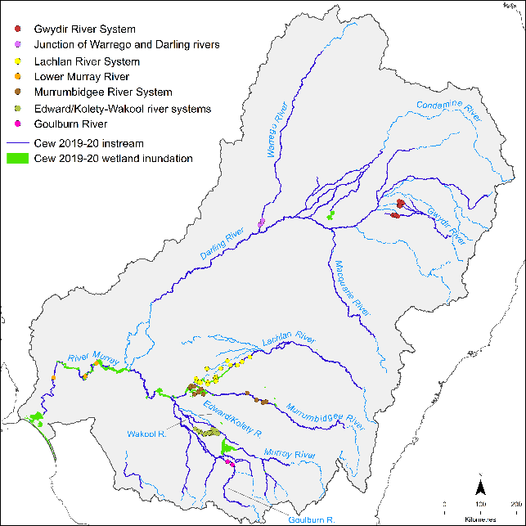

Figure 3.2 Map showing Selected Areas monitored for vegetation under the Flow-MER Program and the area inundated by Commonwealth environmental water (Cew) in 2019–20

Data from the Selected Area vegetation monitoring conducted under the Flow-MER Program were available to evaluate 13 of the 90 individual watering actions where there were expected outcomes for vegetation (14%) (Table 3.1). These included freshes in the Goulburn River and Edward/Kolety–Wakool river systems and flows contributing to wetland inundation in the Gwydir, Lachlan and Murrumbidgee river systems. No wetland inundation supported by Commonwealth environmental water watering actions occurred during 2019–20 at the Junction of the Warrego and Darling rivers.

Vegetation monitoring by the Selected Areas uses fixed monitoring sample points. This means that watering actions that are delivered to the fixed monitoring sample points can be evaluated and the number of watering actions that can be evaluated in each year differs. A small number of watering actions were able to be evaluated in 2019–20 because:

* 24 watering actions that have vegetation outcomes specified occurred outside the Selected Areas and were not monitored
* 36 watering actions were delivered to the Lower Murray River Selected Area and monitoring was conducted to address Selected Area questions, not specific watering actions.

The evaluation considers the responses of the floodplain–wetland vegetation separately from those of riverine vegetation because of distinct differences in the use of environmental water in these 2 habitats: wetlands are usually inundated for a long period by one event; in contrast, bank vegetation is inundated for a short period but may experience multiple inundation events. There are also substantial differences in the spatial and temporal aspects of sampling (Table B.1).

#### Plant names

All plant names used for this evaluation report follow the latest Australian Plant Census (APC)/Australian Plant Name Index (APNI) classification (as of February 2021), to ensure consistent species naming across the Basin.

The species data collected from each Selected Area were linked to a consistently classified species trait database, which includes a variety of different attributes, based on information from BioNet, PlantNET (New South Wales), VicFlora, the State Flora of South Australia, FloraNT, Atlas of Living Australia, and expert knowledge. These are:

* family (and subfamily, only for Fabaceae)
* functional group classifications after Brock and Casanova (1997) and Casanova (2011), short and long descriptions in Table 3.4
* growth form (see Table 3.5)
* life-history information (perennial, annual, variable for genus- or family-level identification and non-vascular, e.g. mosses, liverworts, charophytes, algae)
* strata type (L: ground layer; M: understorey; T: canopy; Canopy: mistletoes; var: variable for genus- or family-level identification)
* nativeness
* rare or threatened status for each state and nationally.

Information on rare or threatened status comes from the following sources, all accessed on 8 February 2021:

* Nationally listed – Environment Protection and Biodiversity Conservation Act 1999 (EPBC Act) List of Threatened Flora[5]
* New South Wales – New South Wales Biodiversity Conservation Act 2016, hosted on the NSW Department of Planning, Industry and Environment (and Office of Environment and Heritage) (online search for threatened species by species type – all plants)[6]
* South Australia – South Australia’s National Parks and Wildlife Act 1972, species list taken from 2008 amendment to the Act – Amendment of Schedules 7, 8 and 9 of Act[7]
* Victoria – Victorian Flora and Fauna Guarantee Act 1988, Threatened List (Vascular Plants), version November 2019[8]
* Victoria – Victorian Department of Environment, Land, Water and Planning (DELWP), Advisory list of rare or threatened plants in Victoria 2014.[9]

Table 3.3 Summary of the 2019–20 Commonwealth environmental watering actions with expected outcomes related to vegetation monitored through the Flow-MER Program

The full list of watering actions related to vegetation outcomes is provided in Table A.1

| **Water action register ID** | **Water action Number** | **Surface water region: asset** | **CEW volume (ML)** | **Total water action volume (ML)** | **Start-end date** | **Flow component** | **Expected ecological outcome\*** | |
| --- | --- | --- | --- | --- | --- | --- | --- | --- |
| Gwydir River System (2 actions) | | | | | | | |
| 1920-GWY-02 | 10100-03 | Gwydir river system | 2,820.0 | 3,448.1 | 14/02/20–16/02/20 | Overbank, wetland | Protect and maintain the condition of permanent and semi-permanent wetland vegetation | |
| 1920-GWY-03 | 10100-04 | Mallowa Wetlands | 250.0 | 250.0 | 12/03/20–13/03/20 | Base flow, fresh, overbank, wetland | Protect and maintain the condition of permanent and semi-permanent wetland vegetation | |
| Lachlan River System (2 actions) | | | | | | | |
| 1920-LCH-01 | 10081-04 | Wyangala Dam to Great Cumbung, including Brewster Weir Pool | 17,028.0 | 17,028.0 | 16/09/19–31/05/20 | Fresh, wetland | Maintain condition of aquatic vegetation  Inundate the core reed bed areas of the Great Cumbung to maintain vegetation condition | |
| 1920-LCH-04 | 10081-07 | Noonamah black box woodlands | 126.2 | 220.2 | 28/10/19–15/11/19 | Wetland | Maintain riparian vegetation | |
| Goulburn River (1 action) | | | | | | | |
| 1920-GLB-04 | 10075-03 | Lower Goulburn River | 101,615.0 | 145,126.0 | 23/09/19–22/10/19 | Fresh | Inundate vegetation on benches and on lower banks to facilitate recruitment, sustain growth and encourage flowering, seed development and distribution | |
| Murrumbidgee River System (6 actions) | | | | | | | |
| 1920-MBG-01 | 10082-18 | Gooragool and Mantangry lagoons | 2,251.3 | 2,451.3 | 09/09/19–16/01/20 | Wetland | Support native aquatic vegetation growth and maintain condition | |
| 1920-MBG-02 | 10082-19 | Wilbriggie (formerly Darlington) Lagoon | 142.2 | 142.2 | 19/09/19–27/09/19 | Wetland | Consolidate improvements in the ecological character, condition and resilience of native vegetation communities | |
| 1920-MBG-03 | 10082-20 | Yarradda Lagoon | 2,000.0 | 2,000.0 | 15/09/19–10/12/19 | Wetland | Support native aquatic vegetation growth and maintain condition | |
| 1920-MBG-04 | 10082-21 | GNC Refuge, SBF Breeding and Tala Creek System Refuge | 18,000.0 | 41,313.0 | 23/10/19–05/02/20 | Wetland, overbank | Consolidate improvements in the ecological character, condition and resilience of native vegetation communities | |
| 1920-MBG-11 | 10082-30 | Yanga National Park | 2,963.0 | 2,963.0 | 29/11/19–18/12/19 | Wetland | Maintain wetland vegetation condition and resilience, including for Mercedes and Pococks which have been dry for several years and may risk vegetation and habitat change if drying continues  Prevent river red gum encroachment/recruitment at Two Bridges Swamp by drowning out these trees | |
| 1920-MBG-12 | 10082-31 | Sunshower Lagoon | 513.5 | 513.5 | 01/12/19–27/01/20 | Wetland | Maintain and improve wetland vegetation condition and resilience | |
| Edward/Kolety–Wakool river systems (2 actions) | | | | | | | |
| 1920-EWK-01 | 10094 | Yallakool–Wakool | 7,622.0 | 7,622.0 | 01/07/19–30/06/20 | Base flow, fresh | Maintain condition of aquatic vegetation | |
| 1920-EWK-02 | 10094 | Colligen–Niemur | 4,487.0 | 4,487.0 | 01/07/19–30/06/20 | Base flow, fresh | Maintain condition of aquatic vegetation | |

* As provided by CEWO to the evaluation teams as a consolidated watering actions table

### Hydrological data

Information about watering regimes and inundation by environmental water was obtained from a range of sources including observations and estimates (of duration and depth) from field teams, advice from Selected Area teams, maps of annual inundation extent developed by the Flow-MER hydrology and ecosystem diversity teams (Brooks 2021; Guarino and Sengupta 2021) and remote-sensing data.[10] A floodplain–wetland sample point was considered inundated if any plot or transect had surface water present in a given time period.[11] Information about watering actions was provided by the CEWO.[12] Inundation was attributed to environmental water or natural flooding (or both) using mapping of inundation extent provided by the hydrology team and augmented by local (field) knowledge. Two inundation datasets were generated: with and without environmental water (Appendix E).

## Analysis

To address the evaluation questions, 2019–20 vegetation data collected from all sample points within the Flow-MER Program were combined with the data collected during 2014–20 and considered in the context of the annual weather patterns and watering history. Vegetation data from floodplains and wetlands (floodplain–wetlands) were considered separately from data collected from riverine sample points. To conduct analyses, plant species cover data recorded from each Selected Area were obtained from the LTIM and Flow-MER Program database and aggregated at the level of sample point for each sampling trip (Table B.1). To standardise the data, mean values for each sample point over each sampling trip and/or year were calculated.

Each floodplain–wetland sample point was assigned to a hydrological group, based on the 6-year watering history from 2014 to 2020 (see Chapter 4). These groups were used to structure the data analysis and interpret the response of the vegetation to the use of environmental water, particularly for the multi-year evaluation.

### Species-level responses

Species-level responses to watering histories, with and without environmental water, were analysed by investigating patterns in the presence and cover of plant taxa[13], and specific species of interest (e.g. species known to be used by Aboriginal people (see Appendix G) and/or rare and threatened) in relation to each time period (i.e. annual and cumulative) and in relation to explanatory variables (i.e. with and without environmental water, hydrology categories, ANAE classes). The plant taxa were described in terms of structural and functional attributes, including growth forms, water plant functional groups and native/exotic classifications. Each attribute is used independently to describe the plant taxa.

Dominant families were determined using Simper analysis (70% contribution to similarity, combining both presence and cover).

The number of groundcover plant species recorded is large and there are regional differences in assemblages that make working with species-level data difficult to interpret at a Basin scale. To interpret patterns in the species data, we grouped species using species traits. The groups that are most commonly reported in this evaluation are the water plant functional groups – after Brock and Casanova (1997) and Casanova (2011) – and species growth forms (e.g. grasses, sedges and rushes, shrubs and so forth).

#### Water plant functional groups

These are based on an adapted version of the classifications of Brock and Casanova (1997) and Casanova (2011) (Table 3.4). The use of functional groups reduces the floristic variability between individual sample points and enables vegetation responses across a large number of plant species to be focussed on groups of species predicted to have similar watering requirements and therefore similar responses to hydrological regimes (Campbell et al. 2014). It is also assumed that species within functional groups play similar functional roles in riverine and floodplain–wetland habitats, particularly in terms of structural function (e.g. amphibious species that are low growing, emergent or have floating leaves).

For the purposes of communication, functional group responses for this report have been assessed largely in relation to 5 high-level categories: submerged, amphibious, damp, woody flood dependent and terrestrial (refer to Table 3.4 for the alignment of these to more detailed functional group categories). Where taxa are unable to be assigned to a particular functional group, they have been classified as ‘other’ and excluded from analyses.

#### Species growth forms

Growth forms are classified based on BioNet and are a structural category consisting of species of the same general habit of growth (e.g. forbs, grasses, sedges and rushes, shrubs and trees) (Table 3.4) but not necessarily related either taxonomically (i.e. in the same family) or functionally (i.e. have the same water requirements). For example, the growth form ‘forb’ includes species that are classified as submerged, amphibious, damp and terrestrial. Supporting a diversity of growth forms is an important component in terms of maintaining compositional, structural and functional attributes of species and community diversity.

Standardised cover for different groupings (e.g. functional group or growth form) is calculated by taking the average cover per sample point per year, then summing across the relevant groups (e.g. functional group) for each year and dividing by the number of sample points surveyed each year.

Table 3.4 Water plant functional group (FG) classifications of Brock and Casanova (1997) and Casanova (2011) with the addition of W-W, W-RF and W-O to separate woody species responses

The amphibious fluctuation tolerator-woody (ATw) classification from Casanova (2011) has been broken into 3 groups: Woody – flow dependent (W-W), Woody – riparian/floodplain (W-RF), and Woody – other (W-O) to distinguish woody species responses according to flooding requirements

| **FG** | **Description** | **Long description** |
| --- | --- | --- |
| Submerged (S) | | |
| Se | Perennial – emergent | Woody and monocotyledonous species that require permanent water in the root zone, but remain emergent. They thrive where water levels do not fluctuate or fluctuate little (i.e. weir pools, dams) |
| S | Submerged | Species that require a site be flooded to >10 cm. Completely water dependent; their habitat is the water column. Some species may persist via a dormant, long-lived seed bank. Sr and Sk species have been combined here. See original descriptions for additional details |
| Amphibious (A) | | |
| ARf | Amphibious fluctuation responder – floating | Species that grow underwater or float on the surface of the water or have floating leaves. They require year-round presence of free water. Many of these can survive and complete their life cycle stranded on the mud, but they reach maximum biomass growing in ‘open’ water all year round |
| ARp | Amphibious fluctuation responder – plastic | A species group occupying a similar habitat to the ATl group, except that they have a morphological response to water-level changes such as rapid shoot elongation or a change in leaf type. They can persist on damp and drying ground because of their morphological flexibility and can flower even if the site does not dry out. They occupy at slightly deeper/wet-for-longer sites than the ATl group |
| ATe | Amphibious fluctuation tolerator – emergent | Emergent monocots and dicots that survive in saturated soil or shallow water but require most of their photosynthetic parts to remain above the water (emergent). They tolerate fluctuations in the depth of water, as well as water presence. They need water to be present for about 8–10 months of the year, and the dry time to be in the cooler times of the year (Note: not sure this part of the description is always met) |
| ATl | Amphibious fluctuation tolerator – low-growing | Species that germinate either on saturated soil or under water and grow totally submerged, as long as they are exposed to air by the time they start to flower and set seed. They require shallow flooding for about 3 months |
| Woody flood dependent (WF) | | |
| W-W | Woody – flow dependent | Woody perennial trees or large shrubs that require water to be present in the root zone all year around, but will germinate in shallow water or on a drying profile. If they grow on floodplains, they require flooding and restoration of the groundwater levels on a regular basis |
| W-RF | Woody – riparian/ floodplain | Woody perennial trees or large shrubs that are frequently associated with riparian, wetland and floodplain habitats. However, their requirements for inundation appear to be less frequent than for species in the W-W group. Their dependence on river-floodplain functions may be unknown |
| Damp (D) | | |
| Tda | Terrestrial – damp | Species that germinate and establish on saturated or damp ground, but cannot tolerate flooding in the vegetative state. As such, they can persist throughout the environment in dry puddles and drains. They grow on bare ground following flooding or in places where floodwater has spread out over the landscape long enough to saturate the soil profile. They require the soil profile to remain damp for about 3 months |
| Terrestrial (T) | | |
| W-O | Woody – other | Woody perennial trees or large shrubs that do not require flooding and occur in a range of habitat types |
| Tdr | Terrestrial –dry | Species with no flooding requirement that persist in damper parts of the landscape because of localised high rainfall. Species in this group can invade or persist in riparian zones and the edges of wetlands, but are essentially terrestrial |
| Other | | |
| var | variable (family level) | Taxa not identified to species level and species within the genus or family that have different functional group responses |
| NV | non-vascular (with the exception of Chara and Nitella) | Non-vascular taxa, with the exception of Chara and Nitella (Charophytes), which have been included in the S - Submerged functional group category |

### Community-level responses

Community-level responses to watering histories, with and without environmental water, were analysed by investigating patterns in community structure (e.g. the richness and cover of functional groups and growth forms) in 2 different habitat types (i.e. riverine and floodplain–wetland) in relation to each time period (i.e. annual and cumulative) and in relation to explanatory variables, such as hydrological groups and ANAE types. For information on functional group classifications and growth form, refer to Table 3.4 and Table 3.5, respectively. For information on the hydrological groups, refer to Section 4.

Table 3.5 Growth form (sourced and altered from BioNet)

| **Growth form** | **Description** | **Examples** |
| --- | --- | --- |
| E | Fern and fern allies | Azolla |
| F | Forbs – herbaceous flowering plants other than grasses, sedges and rushes | Alternanthera denticulata; Centipeda cunninghamii; Mentha australis; Potamogeton tricarinatus; |
| Grass | All grasses (combined tussock, hummock and other grasses) | Hordeum leporinum; Lachnagrostis filiformis; Paspalidium jubiflorum |
| K | Epiphytes | Amyema quandong; Lysiana subfalcata |
| L | Vines | Convovulus erubescens; Cucumis myriocarpus |
| NV | Non-vascular (mosses, liverworts, charophytes, algae) | Bryophyta; Chara; Nitella |
| S | Shrubs | Atriplex nummularia;; Chenopodium nitrareaceum; Duma florulenta |
| S-R | Sedges and rushes | Carex appressa; Eleocharis pallens; Juncaceae; Cyperaceae |
| SubS | Sub-shrubs (woody, lower growing, small shrubs) | Aeschynomene indica; Atriplex semibaccata; Rhagodia spinescens |
| T | Trees | Acacia stenophylla; Eucalyptus camaldulensis; Melaleuca lanceolata |
| var | variable (genus- or family-level identification) | Chenopodiaceae |

### Explanatory variables

The key explanatory variables used in the evaluation were hydrological metrics (patterns in inundation) and ANAE types.

#### Hydrology

For the annual evaluation, all sample points (both riverine and floodplain–wetland sample points) were classed as either having received environmental water (with environmental water) or not (without environmental water). Comparisons were made between the vegetation data from the 2 groups of sample points, noting that:

* The comparison is simple and doesn’t take into account differences in other explanatory variables (see Figure 3.1) that may influence the vegetation assemblage observed (e.g. whether environmental water has been delivered to sample points that were floristically different initially).
* Very few riverine sample points did not receive some form of environmental water and the riverine hydrology data do not account for the complexity of wetting gradients within channel.[14]

For the 6-year evaluation, the inundation regimes of the floodplain–wetland sample points were used to identify hydrological groups. The presence or absence of inundation at each floodplain–wetland sample point was calculated at a quarterly timestep for the 6 years (2014–20) using field-based observations and remote-sensing information. A sample point was considered inundated if any plot or transect had surface water present in that 3-month quarter. Inundation was attributed to environmental water or natural flooding (or both) and 2 inundation datasets were generated: with and without environmental water (Appendix E).

Sample points were grouped according to their actual inundation history (with environmental water). To do this, we undertook a clustering analysis to group sample points into groups (clusters) based on their flooding history (presence or absence of flooding each quarter from 2014–20) using k-means clustering (see Figure 4.1). These flood groupings are used throughout this report.

To predict the grouping of each sample point in the absence of environmental water (the counterfactual), an inundation time series was generated for each sample point using information from Selected Area reports, information from the Hydrology Basin Theme and expert opinion (Appendix E). The ‘without environmental water’ inundation history for each sample point was then allocated to one of the 6 flood groupings that were developed through the k-means clustering process using the actual (with environmental water) flood history.

The hydrological groups ‘with environmental water’ were linked to the observed vegetation assemblage (see Chapter 4) and the resulting hydrology/vegetation associations used to predict the vegetation assemblage that would occur ‘without environmental water’ (Chapter 6).

#### Australian National Aquatic Ecosystem types

The ANAE Classification Framework (Aquatic Ecosystems Task Group 2012) provides a framework for consistently defining aquatic ecosystems across the Murray–Darling Basin. It is used by the Ecosystem Diversity Basin Theme to identify the ecosystem types that receive Commonwealth environmental water (Brooks 2021) and has been used in previous evaluations (Capon and James 2020) to evaluate the outcomes of environmental water in unmonitored areas.

Chapter 7 of the current report identifies the presence of multiple vegetation communities (defined as an assemblage of species within a common area) within a single ANAE type. The current evaluation uses the ANAE types to broadly infer some outcomes from using environmental water in unmonitored areas.

# Hydrological grouping

This chapter describes how the availability of 6 years of monitoring data has allowed us to classify sample points into 6 groupings, based on hydrological regime rather than location. These hydrological groups have been used to establish relationships with vegetation communities.

## Classification method

Previous Basin-scale analyses (Capon and James 2020) have identified that the structure and composition of the floodplain–wetland vegetation community is strongly driven by location within the Basin. As a result, evaluations to date have focussed on responses within each of the monitored Selected Areas. Now, with 6 years of data and the ability to extract hydrological information for each of the monitored floodplain–wetland sample points at a finer than annual temporal resolution, we have classified each of the 66 sample points in the 4 relevant Selected Areas (Gwydir, Lachlan and Murrumbidgee river systems and Junction of Warrego and Darling rivers) into 1 of 6 groups on the basis of their hydrological regime, independent of their spatial location.

The groups were differentiated on the basis of the proportion of time each group was inundated (on a quarterly basis from 2014–20, Table 4.1); there was a gradient from more frequently to less frequently flooded. Group 1 was the group most frequently flooded, being inundated 80% ± 0.02 of observations (quarters). Group 2 was the second most frequently flooded (41% ± 0.03) and Group 3 the next most frequently flooded (31% ± 0.03). Groups 4 and 5 were flooded 29% ± 0.02 and 25% ± 0.03 of the time, respectively, while sample points in Group 6 were flooded the least frequently – only 14% ± 0.02 of the time.

Clustering was not solely based on the proportion of inundation but was also related to timing and duration of flooding events (Table 4.1). Group 1 was characterised by nearly permanent inundation. Group 2 was inundated annually or nearly annually for approximately 6 months each event. Group 3 was inundated most years for 3–6 months and was dry for 6–12 months between events. Group 4 was inundated every few years and floodwater persisted at these sample points for at least a year. Group 5 was inundated every few years for 3–6 months. Group 6 was inundated once or twice for around 6 months at some time during the 6 years, predominantly as a result of natural flooding in 2016.

Table 4.1 Hydrological groups used to structure the floodplain–wetland vegetation data analysis. Inundation duration and dry phase duration are 3-monthly quarters (i.e. 1 = 3 months) during 2014–20

Note: Max = mean maximum number of quarters 2014–20 that were dry or inundated within each hydrological group; ANAE = Australian National Aquatic Ecosystem

| **Group** | **% quarters inundated** | **# inundation events** | **Inundation duration (quarters)** | **Dry phase duration (quarters)** | **Description** |
| --- | --- | --- | --- | --- | --- |
| 1 | 80% | 3.2 ± 0.3 | Mean 6.8 ± 0.7  Max 13.2 ± 1.2 | Mean 1.8 ± 0.2  Max 2.4 ± 0.3 | * Sample points characterised by frequent inundation – near permanent water * Characteristic ANAE classes: permanent wetlands, permanent tall emergent, permanent lowland stream (not occurring in any other groups) and river red gum forest riparian zone or floodplain and temporary river red gum swamps |
| 2 | 41% | 5 ± 0.2 | Mean 2.0 ± 0.2  Max 4.5 ± 0.6 | Mean 2.5 ± 0 .1  Max 4.6 ± 0.3 | * Inundated annually or nearly annually for approx. 6 months * Characteristic ANAE classes: river cooba woodland riparian zone or floodplain (which did not occur in any other hydrological group) and 6 (of 9) freshwater meadows |
| 3 | 31% | 4.6 ± 0.1 | Mean 1.7 ± 0.1  Max 2.4 ± 0.2 | Mean 3.3 ± 0.3  Max 6.3 ± 0.9 | * Inundated most years for 3–6 months * ANAE classes: 7 of 11 coolibah woodland and forest riparian zone or floodplain and 2 freshwater meadows |
| 4 | 29% | 1.7 ± 0.2 | Mean 4.7 ± 0.5  Max 5.6 ± 0.4 | Mean 6.7 ± 0.5  Max 11.4 ± 0.5 | * Inundated every few years flood water retained for >1 year * Characteristic ANAE classes:5 temporary lakes and 1 clay pan (which did not occur in any other hydrological group) |
| 5 | 25% | 3.4 ± 0.5 | Mean 1.8 ± 0.2  Max 2.2 ± 0.2 | Mean 6.3 ± 1.0  Max 9.4 ± 0.8 | * Inundated every 1–2 years for 3–6 months * Characteristic ANAE classes: temporary sedge/grass/forb marsh and a permanent lake (which did not occur in any other hydrological group) |
| 6 | 14% | 1.5 ± 0.2 | Mean 2.4 ± 0.2  Max 2.8 ± 0.3 | Mean 9.3 ± 1.1  Max 14.8 ± 0.6 | * Inundated infrequently (2.5 years) for 6 months * Characteristic ANAE classes: 7 of 15 river red gum forest riparian zone and floodplain, 6 of 8 black box woodland riparian zone or floodplain |

The flooding regime of floodplain–wetlands varies across the Basin. While there is a strong association between Selected Area and flooding regime, there are some exceptions to this, and some groupings share sample points across Selected Areas (Figure 4.2). Groupings are as follows (colours are as used in Figure 4.1 and Figure 4.2):

* Group 1 (red) – 9 sample points from the Murrumbidgee River System as well as 4 from the Lachlan River System; namely, Juanbung (plots and transects), Bunumburt and the reedbeds of the Great Cumbung Swamp. These sample points in the Lachlan River System are the closest (geographically) of all sample points in the Lachlan River System to sample points in the Murrumbidgee River System
* Group 2 (green) – 8 sample points from the Gwydir River System, Sunshower Lagoon in the Murrumbidgee River System and Noonamah in the Lachlan River System
* Group 3 (yellow) – 9 sample points from the Gwydir River System
* Group 4 (blue) – 12 sample points from the Lachlan River System and Mckenna’s Lagoon from the Murrumbidgee River System
* Group 5 (turquoise) – all 8 sample points from the Junction of Warrego and Darling rivers and Avalon Swamp in the Murrumbidgee River System
* Group 6 (pink) – 15 sample points from the Lachlan River System and 2 from the Gwydir River System – Old Dromana Nursery-2 and Westholme Coolibah.

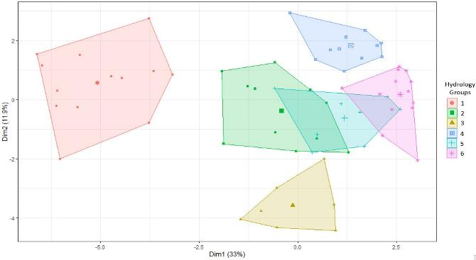

Figure 4.1 k-means clustering of all Flow-MER vegetation sample points into 6 hydrological groups based on observed inundation regime

The larger symbol represents the centroid of each cluster

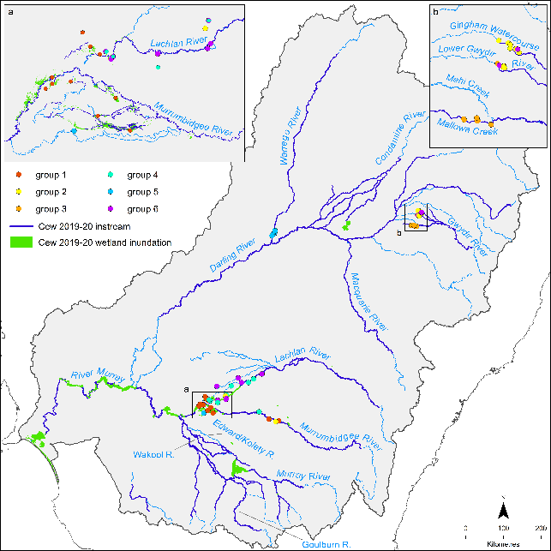

Figure 4.2 Map showing sample points by hydrological group based on the results of k-means cluster analysis of the monitored wetlands

## Relationship to vegetation communities

Each of the hydrological groups displays a distinct vegetation community, particularly in relation to the proportional cover of functional groups (Figure 4.3), but also in terms of the relative number of species in each functional group (Figure 4.4). There is a significant difference in the functional group assemblages (composition and cover) between hydrological groups (p = 0.001) (see Appendix C, Section C.3 for further details on methods and results). These differences are apparent between each pair of hydrological groups (p = 0.001) with the exception of groups 4 and 6 (p = 0.147). Group 2 is characterised by the greatest number and cover of ‘wet’ – i.e. submerged, amphibious and damp-loving species, with relatively little cover of woody and terrestrial species. Groups 1 and 3 also have relatively high numbers of wet species; however, Group 1 has slightly less proportional cover of submerged, and higher terrestrial and woody cover than Group 2, while Group 3 has less submerged cover than both groups 1 and 2 and greater proportion of damp, woody and terrestrial cover. Submerged species are almost absent from groups 4, 5 and 6 and there is lower cover and richness of amphibious species. Groups 4, 5 and 6 are characterised by varying proportions of woody and terrestrial species.

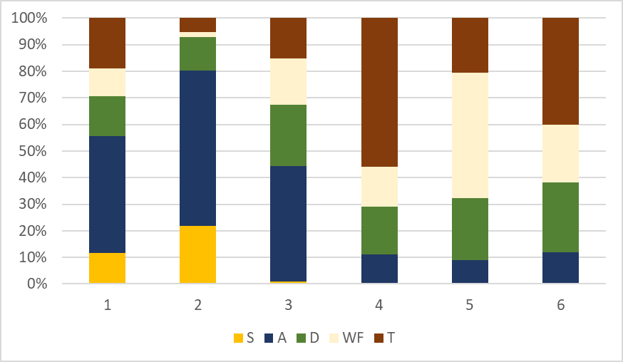

Figure 4.3 Proportional cover of plant functional groups in different floodplain–wetland hydrological groups based on all plant species records pooled across all years (2014–20)

The plant high-level functional groups are: S (submerged); A (amphibious); D (damp); WF (woody flood dependent); T (terrestrial) – see Table 3.4

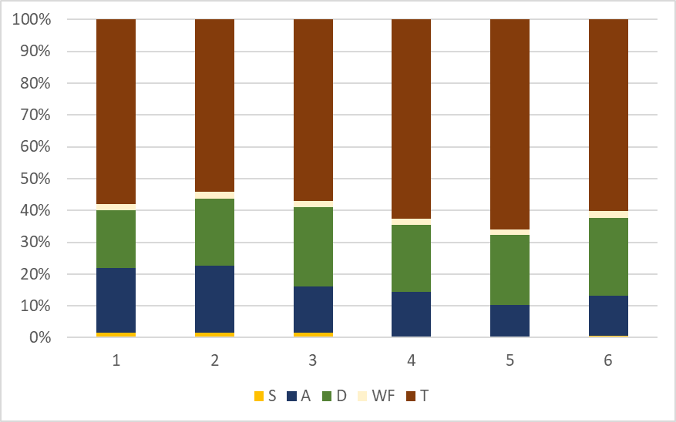

Figure 4.4 Relative species numbers of plant functional groups in different floodplain–wetland hydrological groups based on all species records pooled across all years (2014–20)

The plant high-level functional groups are: S (submerged); A (amphibious); D (damp); WF (woody flood dependent); T (terrestrial) – see Table 3.4

## Analysis

To determine the counterfactual hydrology, we modelled the quarterly inundation regime in the absence of environmental water for each sample point. This dataset was used to reassign each sample point to a hydrological group ‘without environmental water’ (Figure 4.5).

In the absence of environmental water, none of the monitored sample points would have been in groups 1 or 3 and only a single sample point (Bunumburt from the Lachlan River) in Group 2. Group 4 would have comprised 13 sample points from the Lachlan and 2 from the Gwydir. Group 5 would have included 8 sample points from Warrego Darling and Valetta from the Gwydir, with Group 6 taking in the remaining 45 sample points (Figure 4.5).

Group 6 is the driest of the hydrological groups, inundated infrequently and when inundated, is wet for around 6 months. Therefore, just over one-third of the sample points monitored (34 of the 91 sample points) would have experienced a much drier hydrological regime without environmental water, being inundated far less frequently and experiencing extended dry phases.

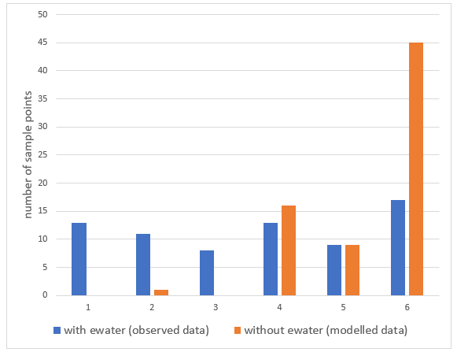

Figure 4. Number of sample points in each of the 6 hydrological groups

Blue bars show the number of sample points in each group based on their experienced watering regime over the past 6 years. Orange bars show the expected grouping of the same sample points based on modelled inundation in the absence of environmental water (ewater)

# Basin-scale evaluation 2019–20

A total of 460 plant species were recorded across all sample points in 2019–20. This is substantially greater than the number of species recorded in 2018–19 and is most similar to the numbers observed in 2015–16 (Table 5.1 and Appendix H). Sixty-one new species were recorded in 2019–20, with new species recorded in all Selected Areas. The same number of observed species per sample point was recorded in the 2019–20 and 2015–16 water years (Table 5.1).

In 2019–20, species were recorded from 66 families across all sample points. The dominant families in floodplain–wetland habitats were Chenopodiaceae, Fabaceae, Cyperaceae, Polygonaceae and Poaceae and in riverine habitats were dominated by Juncaceae, Asteraceae and Poaceae. The total number of families has been consistent over the 6 years of sampling, ranging from 63 in 2016–17 to 66 in both 2019–20 and 2014–15, suggesting that water management across the sample points has contributed to maintaining the richness of plant families. The most dominant families have also been relatively consistent over the 6 years of monitoring in both habitat types, but 2019–20 was the first year in which Fabaceae was one of the dominant families (Table 5.1).

Forty species known to have been used by Aboriginal people (see Appendix G) were recorded. These were predominantly found within wetland sample points and the majority of records were from the Lachlan and Murrumbidgee river systems Selected Areas. The most commonly recorded species known to have been used by Aboriginal people, found across multiple Selected Areas, were Centipeda cunninghamii (common sneezeweed or old man weed), *Duma florulenta* (tangled lignum), *Marsilea drummondii* (common nardoo), *Paspalidium jubiflorum* (Warrego summer grass) and *Phragmites australis* (common reed).

Of the species recorded in 2019–20, 55 are listed under either national or state rare and threatened species listing programs. This includes 51 species recorded from floodplain–wetland sample points and 11 species recorded from riverine sample points. The majority of identifiable plant species recorded in 2019–20 were native, in terms of both numbers of species (~70%) and total cover (~80%). The number of native species is similar over the 6 years of monitoring. The monitored sample points display a consistently high nativeness with more than 80% of cover being of native species (Table 5.2 and Table 5.3).

The majority of plant species recorded in 2019–20 were terrestrial species (~54%), followed by damp-loving species (~22%) and amphibious species (~13%). The dominant growth forms were forbs (~60% of species), followed by grasses (~13%), sub-shrubs (~10%) and sedges and rushes (~6%), with slightly more perennial species (~55%) than annual species recorded.

In relation to cover, the dominant functional group, based on the proportion of total cover, was terrestrial (T) (~28%), followed by damp (D) and amphibious (A) (both with ~21%), woody flood dependent (WF) (~18%) and submerged (S) (~10%). In 2019–20, forbs were dominant (~32% of the total proportion of cover), followed by sedges and rushes (~25%) and grasses (~13%) with moderate cover of shrubs (~9%), sub-shrubs (~8%) and trees (~11%).

For information about species richness, cover and trait responses (e.g. nativeness, functional groups, life history and form) by Selected Area, please refer to the annual evaluation reports from each of the Selected Areas.[15]

Table 5.1 Total number of plant species and dominant families recorded each water year and across all years from all sample points

Plant species excludes ‘no plants’, unknown category, and non-vascular species (with the exception of charophytes)

| **Water year** | **# of sample points* F-W: Floodplain–wetland R: Riverine** | **Total # of species** | **Mean # of species per sample point** | **Total # of families** | **Dominant families**  **Floodplain–wetland** | **Dominant families**  **Riverine** |
| --- | --- | --- | --- | --- | --- | --- |
| All years | 97 | 728 | 7.5 | 74 | Chenopodiaceae  Poaceae  Cyperaceae  Polygonaceae  Asteraceae | Asteraceae  Juncaceae  Poaceae |
| 2019–20 | 91  F-W: 66  R: 25 | 460 | 5.1 | 66 | Chenopodiaceae  Fabaceae  Cyperaceae  Polygonaceae  Poaceae | Juncaceae  Asteraceae  Poaceae |
| 2018–19 | 79  F-W: 65  R: 18 | 359 | 4.5 | 64 | Chenopodiaceae  Cyperaceae  Poaceae | Asteraceae  Juncaceae  Poaceae |
| 2017–18 | 81  F-W: 63  R: 18 | 361 | 4.6 | 65 | Cyperaceae  Polygonaceae  Asteraceae  Chenopodiaceae  Poaceae | Asteraceae  Juncaceae  Poaceae |
| 2016–17 | 82  F-W: 64  R: 18 | 403 | 4.9 | 63 | Cyperaceae  Poaceae  Polygonaceae  Asteraceae | Asteraceae  Poaceae |
| 2015–16 | 83  F-W: 65  R: 18 | 427 | 5.1 | 65 | Chenopodiaceae  Poaceae  Polygonaceae  Asteraceae  Cyperaceae | Juncaceae  Poaceae  Asteraceae  Potamogetonaceae |
| 2014–15 | 60  F-W: 58  R: 2 | 413 | 6.9 | 66 | Poaceae  Chenopodiaceae  Polygonaceae  Asteraceae | Myrtaceae  Polygonaceae  Poaceae  Amaranthaceae |

* Sample point numbers are different, as we excluded single surveyed sample points from the analysis, e.g. BO-IBIS and GWY_ODBOLB

Table 5.2 Numbers of native and exotic species, the proportion of native species and the proportional cover of native species recorded across all sample points for each water year and across all years

| Water year | Native | Exotic | Total | Proportion native species | Proportion native cover |
| --- | --- | --- | --- | --- | --- |
| All years | 484 | 199 | 683 | 0.71 | 0.83 |
| 2019–20 | 304 | 125 | 429 | 0.71 | 0.80 |
| 2018–19 | 240 | 95 | 335 | 0.71 | 0.84 |
| 2017–18 | 243 | 98 | 341 | 0.71 | 0.83 |
| 2016–17 | 269 | 108 | 377 | 0.71 | 0.85 |
| 2015–16 | 282 | 117 | 399 | 0.71 | 0.84 |
| 2014–15 | 274 | 112 | 386 | 0.71 | 0.84 |

Hydrological groupings of floodplain–wetland sample points displayed slightly different numbers of species from each functional group in 2019–20. Groups 1–3 had greater numbers of submerged and amphibious species compared with those in groups 4–6 (Figure 5.1). The differences were more pronounced in the proportional cover of species in each functional group with groups 1 and 2 dominated by submerged, amphibious and damp-loving species, Group 3 by amphibious and damp-loving species and groups 4–6 by terrestrial and woody flood-dependent species (Figure 5.2).

These findings confirm the requirement for wetter regimes (in terms of frequency and duration) to support cover of submerged and amphibious species, with the near absence of cover of submerged species in hydrological groups inundated < 40% of the time and reduced cover of amphibious species in hydrological groups inundated < 30% of the time. There is a significant difference in the functional group assemblages between hydrological groups using just 2019–20 data (p = 0.001). Differences in functional group assemblages are evident between all pairs of hydrological groups (p < 0.033), except for hydrological groups 3 and 5 (p = 0.063) and groups 4 and 6 (p = 0.56) (see Appendix C for more information).

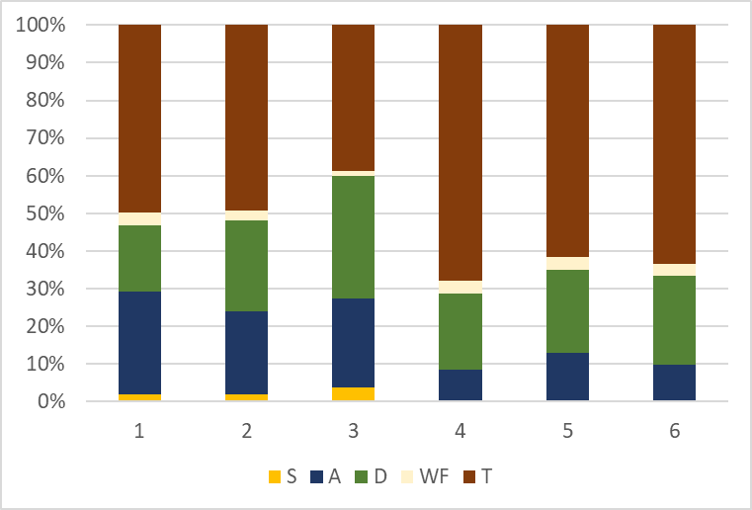

Figure 5.1 Percentage of plant species recorded from different functional groups occurring in the 6 hydrological groups in 2019–20

The plant high-level functional groups are: S (submerged); A (amphibious); D (damp); WF (woody flood dependent); T (terrestrial) – see Table 3.4

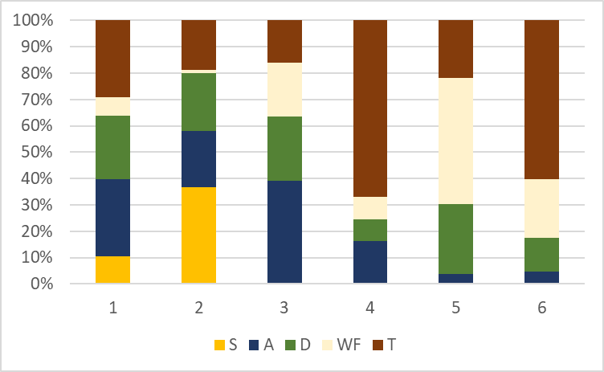

Figure 5.2 Proportional plant cover of functional groups in different hydrological groups in 2019–20

The plant high-level functional groups are: S (submerged); A (amphibious); D (damp); WF (woody flood dependent); T (terrestrial) – see Table 3.4

## Species-level responses to environmental water

Plant functional groups are as follows: S (submerged); A (amphibious); D (damp); WF (woody flood dependent); T (terrestrial) – see Table 3.4.

Thirty-six (40%) of the 91 monitored sample points received environmental water in 2019–20. This includes 15 (23%) of the 66 floodplain-wetland sample points and 21 (84%) of the 25 riverine sample points. Of the total 460 species, 104 (23%) were only recorded at sample points that received environmental water in 2019–20. Taxa only found at sample points receiving environmental water include 50 taxa (from 31 families) from floodplain-wetland sample points and 62 taxa (from 29 families) from riverine sample points (Table 5.3). Eight species – lagoon spurge (Phyllanthus lacunarius),robust water-milfoil(Myriophyllum papillosum), *s*tar thistle (Centaurea calcitrapa),common reed(Phragmites australis),floating pondweed(Potamogeton tricarinatus), river bluebell (Wahlenbergia fluminalis), drain flat-sedge (umbrella sedge) (Cyperus eragrostis),tall flat-sedge(C. exaltatus) – occurred in both riverine and floodplain–wetland sample points and were unique to sample points that received environmental water in 2019–20 (Table 5.3).

The large number of species that occurred only in sample points that received environmental water in 2019–20 suggests that environmental water has been important in maintaining the richness of plant species in the Basin in 2019–20. It is important to note that we do not have a study design that would enable statistical evaluation of this and attribution of causation. It may be that the sample points that were watered were already floristically different before receiving environmental water. However, we believe that environmental water has contributed to the conditions that have resulted in the surface expression of these species.

Species unique to floodplain–wetland sample points that received environmental water in 2019–20 were mainly amphibious and damp-loving species, whereas the species unique to riverine sample points that received environmental water in 2019–20 were a mix of amphibious, damp-loving and terrestrial species. Few species unique to floodplain–wetland sample points that received environmental water in 2019–20 were exotic (only 15 of the 50 taxa). This was slightly greater (26 of the 62 taxa) at riverine samples points.

Fifteen plant species known to be used by Aboriginal people were only recorded at sample points that received environmental water in 2019–20 (Table 5.3):

* bulbine lily(Bulbine bulbosa),cottony saltbush(Chenopodium curvispicatum), water ribbons (Cycnogeton procerum), jagged bitter-cress (Rorippa laciniata),variable (Sida corrugata) and cumbungi (Typhaspp.) – these 6 were unique to floodplain–wetland sample points
* *s*ilver wattle (Acacia dealbata),prickly bottlebrush (Callistemon brachyandrus), river bottlebrush (Callistemon sieberi), basket rush (Carex tereticaulis), moonah (Melaleuca lanceolata), yellow wood-sorrel (Oxalis perennans) and kangaroo grass(Themeda triandra) – these 5 were unique to riverine sample points
* common reed (Phragmites australis) and river bluebell (Wahlenbergia fluminalis)– occurred in both floodplain–wetland and riverine sample points.

Of these 15 plant species known to be used by Aboriginal people, 9 are classed as either submerged, amphibious or damp-loving species and it is likely that environmental water has been important in sustaining these perennial species in 2019–20.

In Chapter 9, we present a case study that investigates the use of environmental water for supporting plant species known to be used by Aboriginal people with a focus on 3 species: nardoo (Marsilea spp.), old man weed (Centipedaspp.) and cumbungi (Typhaspp.). The results of our case study indicate that in 2019–20, environmental water made a significant contribution to maintaining the cover of nardoo and old man weed at sample points where they occur.

Of the species unique to sample points that received environmental water in 2019–20, 3 are species that are either nationally listed or were recorded in states where they are listed as rare or threatened species (Table 5.3). These records include one amphibious species robust water-milfoil (Myriophyllum papillosum), and 2 terrestrial species mossgiel daisy (Brachyscome papillosa)and prickly bottlebrush (Callistemon brachyandrus). (While there are 5 more rare or threatened species noted in Table 5.3, they were not recorded in the same state in which they’re listed.)

Table 5.3 Plant species unique to sample points that received Commonwealth environmental water in 2019–20

See Table 3.4 for details of the functional groups. Species denoted in **bold** occur at both floodplain–wetland and riverine sample points. Species marked with an asterisk (*) are exotic. Species underlined are listed under national Environment Protection and Biodiversity Conservation Act 1999 (EPBC Act) or state rare and threatened species lists. Species that are in green text are known to be used by Aboriginal people

| **Functional group** | **Floodplainwetland sample points** | **Riverine sample points** |
| --- | --- | --- |
| Submerged | ***Phragmites australis***  *Nitella* | *Chara*  ***Phragmites australis***  *Schoenoplectus pungens*  *Schoenoplectus tabernaemontani* |
| Amphibious | *Azolla*  *Azolla rubra*  *Crassula helmsii*  *Cycnogeton procerum*  ***Cyperus eragrostis\****  ***Cyperus exaltatus***  *Elatine gratioloides*  *Juncus flavidus*  *Lemna*  ***Myriophyllum papillosum***  *Myriophyllum verrucosum*  *Ottelia ovalifolia*  *Potamogeton crispus*  ***Potamogeton tricarinatus***  *Ranunculus pentandrus*  *Ranunculus sceleratus\**  *Typha* | *Bolboschoenus caldwellii*  *Carex*  *Carex tereticaulis*  *Cyperus eragrostis\**  *Cyperus exaltatus*  *Isolepis australiensis*  *Juncus amabilis*  *Limosella*  *Limosella australis*  ***Myriophyllum papillosum***  ***Potamogeton tricarinatus*** |
| Damp | *Alopecurus geniculatus\**  *Bulbine bulbosa*  *Epilobium billardiereanum*  *Lysimachia arvensis\**  *Myoporum parvifolium*  *Phalaris paradoxa\**  *Plantago cunninghamii*  *Polygonum arenastrum\**  *Solanum elaeagnifolium\**  *Veronica peregrina\**  ***Wahlenbergia fluminalis*** | *Acacia dealbata*  *Anthosachne kingiana*  *Apium graveolens\**  *Bromus catharticus\**  *Callistemon sieberi*  *Crassula colorata*  *Dittrichia graveolens\**  *Ehrharta longiflora\**  *Fumaria\**  *Glycyrrhiza acanthocarpa*  *Haloragis aspera*  *Hemarthria uncinata*  *Mentha diemenica*  *Oxalis exilis*  *Oxalis perennans*  *Poa labillardierei*  *Rhodanthe pygmaea*  ***Wahlenbergia fluminalis*** |
| Terrestrial | *Arctotheca calendula*  *Asperula geminifolia*  *Brachyscome papillosa*  ***Centaurea calcitrapa\****  *Chenopodium curvispicatum*  *Convolvulus arvensis\**  *Erigeron sumatrensis\**  *Erodium malacoides\**  *Leucochrysum*  *Osteocarpum acropterum*  ***Phyllanthus lacunarius***  *Rorippa laciniata*  *Senecio magnificus*  *Sida corrugata*  *Trifolium repens\**  *Urtica urens\**  *Verbena gaudichaudii* | *Avena*  *Bromus diandrus\**  *Bromus hordeaceus\**  *Callistemon brachyandrus*  *Carduus\**  ***Centaurea calcitrapa\****  *Cerastium glomeratum\**  *Cotula bipinnata*  *Eragrostis elongata*  *Gazania rigens\**  *Isoetopsis graminifolia*  *Lolium perenne\**  *Lolium rigidum\**  *Melaleuca lanceolata*  *Melilotus albus\**  *Oxalis pes-caprae\**  *Panicum coloratum\**  *Paspalum dilatatum\**  ***Phyllanthus lacunarius***  *Picris angustifolia*  *Rumex acetosella\**  *Silene nocturna\**  *Silybum marianum\**  *Stellaria media*  *Themeda triandra*  *Trifolium\** |
| Other | *Bryophyta*  *Cuscuta*  *Epilobium* | *Bromus\**  *Cardamine*  *Euphorbia* |

## Community-level responses to environmental water

At floodplain–wetland sample points, there was a greater proportion of submerged and amphibious species recorded at sample points that received environmental water in 2019–20 compared with sample points that did not receive environmental water (Figure 5‑3). Within riverine habitats, submerged and flood-dependent woody species were only present at sample points that received environmental water in 2019–20 (Figure 5‑3), although it should be noted that only 4 riverine sample points did not receive environmental water in 2019–20 and all were from the Edward/Kolety–Wakool river systems.

These data suggest that environmental water was important for maintaining vegetation communities that include submerged and amphibious species across the Basin in 2019–20 and without environmental water it is likely that these communities would be less prevalent.

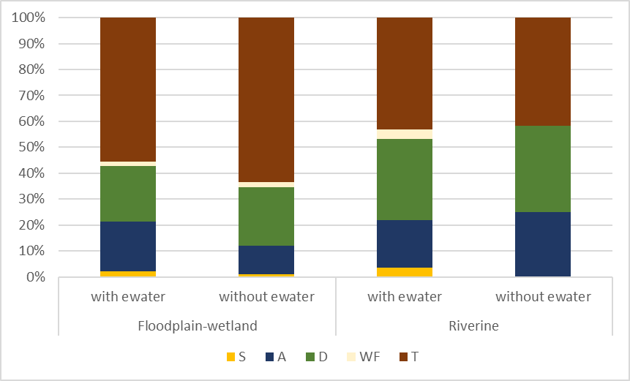

Figure 5‑3 The relative percentage of species numbers in each water plant functional group recorded at floodplain–wetland sample points that and did not receive environmental water (ewater) in 2019–20

The water plant functional groups are: S (submerged); A (amphibious); D (damp); WF (woody flood dependent); T (terrestrial) – see Table 3.4

The cover of plant species from within the water plant functional groups at samples points during 2019–20 tells a more complex story. Floodplain–wetland sample points that received environmental water had lower total cover than those that did not receive environmental water (Figure 5.4), but the vegetation present at sample points that received environmental water had a greater proportion of cover that contained submerged, amphibious and damp-loving species (Figure C.3). In contrast, riverine sample points that received environmental water had a greater total cover (Figure 5.4) and a much more even distribution of species within the cover(Figure C.3) than sample points that did not receive environmental water. While noting that there were very few riverine sample points that did not receive environmental water in 2019–20, these differences are consistent with achieving the objectives of increasing the cover of vegetation at riverine habitats through the use of environmental water. These data also suggest that the use of environmental water within riverine habitats has increased the diversity of water functional groups, with a more even cover of more water functional groups at sample points that receive Commonwealth environmental water compared with sample points that do not receive environmental water.

The role of antecedent conditions adds to the complexity in terms of interpreting annual responses. A large proportion of both richness (~56%) and cover (~67%) recorded in 2019–20 is from perennial species. Perennial species present in 2019–20 may be persisting because of inundation in prior years or may have established in 2019–20. The influence of Commonwealth environmental water across the 6 years of monitoring is described in the multi-year analysis (Chapter 6).

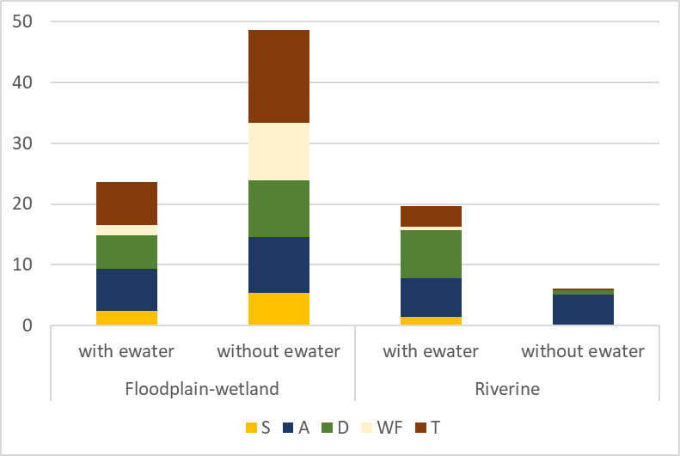

Figure 5.4 Standardised cover of functional groups at sample points that did and did not receive environmental water (ewater) in 2019–20

The water plant functional groups are: S (submerged); A (amphibious); D (damp); WF (woody flood dependent); T (terrestrial) – see Table 3.4

Subtle differences in species numbers were evident in the proportion of species from each of the growth forms present at sample points that received environmental water in 2019–20 compared with those that did not. Within the floodplain–wetland sample points that received environmental water in 2019–20, no epiphytes were recorded and there was a smaller proportion of tree species and slightly greater proportion of forbs than at sample points that did not receive environmental water in 2019–20 (Figure 5.5). At riverine sample points, shrubs and sub-shrubs were present only in sample points that received environmental water in 2019–20 although, again, it is noted that there were only 4 riverine sample points that did not receive environmental water in 2019–20.

Differences in cover between sample points that received environmental water in 2019–20 and those that did not, indicate that in floodplain–wetland habitats, the use of environmental water has contributed to a vegetation community in which a greater proportion of the cover is forbs and there is far less cover of trees (Figure 5.6). This likely reflects the use of water in floodplain–wetland sample points to support specific open water vegetation communities that are devoid of trees. It seems likely that the absence of environmental water management at these sample points would result in encroachment of trees (see Murrumbidgee River System Selected Area annual reports[16]). In riverine habitats, the use of environmental water has also resulted in sample points that have a greater proportional cover of forbs and a reduction in the proportional cover of sedges and rushes.

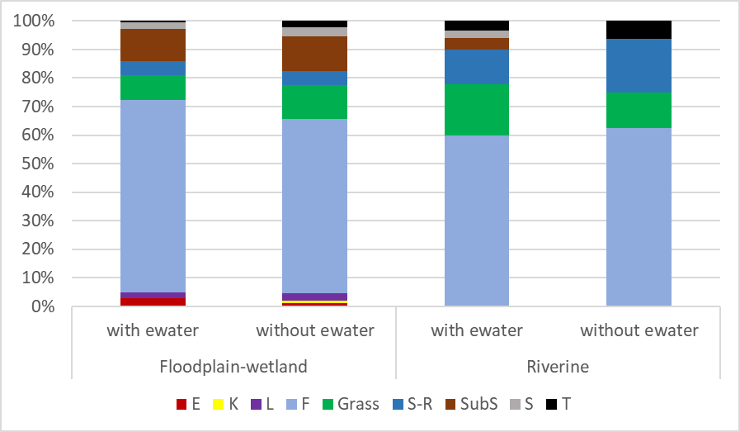

Figure 5.5 Relative species numbers for growth forms at sample points that did and did not receive environmental water (ewater) in 2019–20

The growth forms are: E (ferns and fern allies); K (epiphytes); L (vines); F (forbs); grasses; S-R (sedges and rushes); SubS (sub-shrubs); S (shrubs) and T (trees) – see Table 3.5

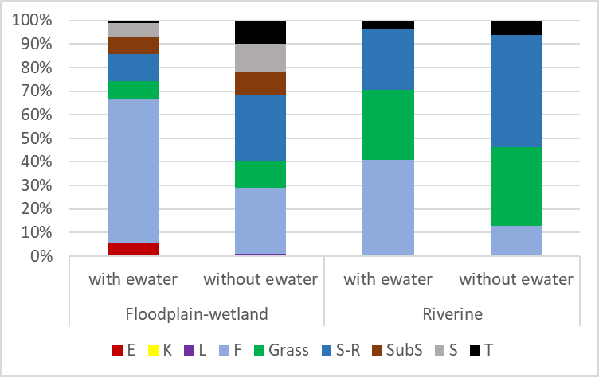

Figure 5.6 Proportional cover of growth forms at sample points that did and did not receive environmental water (ewater) in 2019–20

The growth forms are: E (ferns and fern allies); K (epiphytes); L (vines); F (forbs); grasses; S-R (sedges and rushes); SubS (sub-shrubs); S (shrubs) and T (trees) – see Table 3.5

## 2019–20 responses in unmonitored areas

The 125 watering actions delivered by the CEWO during 2019–20 in the Basin provided water to almost 70,000 ha of lakes, wetlands and floodplains and almost 16,000 km of rivers in the Basin. This included 31 floodplain–wetland ANAE types and 7 riverine types (Brooks 2021). Of these, vegetation data were collected from sample points in all 19 of the 67 ANAE types that received environmental water (comprising 17 floodplain–wetland and 2 riverine types) in 2019–20 (Table 5.4).

While sampling covers only a portion of the ANAE types that received environmental water in 2019–20, the patterns of responses observed at monitored sample points give insight as to what may be expected from the use of environmental water across the Basin in 2019–20. It is likely that the use of environmental water in 2019–20 will have maintained the richness of species at watered sample points and that this will have included a range of plant species known to be used by Aboriginal people as well as species that are listed as rare and threatened. The species that are supported will be dependent on the location in the Basin, but it is highly likely that it will include a range of submerged, amphibious and damp-loving species that are unlikely to be present in the absence of environmental water. Given the number of species recorded as part of the monitoring program has increased as new sample points have been added, it is highly likely that many more species in the Basin are unique to sample points that received environmental water in 2019–20.

Similarly, it is highly likely that the use of environmental water in 2019–20 will have maintained a greater richness of vegetation communities, by supporting the presence of vegetation communities that include submerged, amphibious and damp-loving species.

Table 5.4 The total number of sample points in each ANAE type surveyed as part of the LTIM and Flow-MER programs in each water year, (2014–20

| **Australian National Aquatic Ecosystem (ANAE) type** | **2014–15** | **2015–16** | **2016–17** | **2017–18** | **2018–19** | **2019–20** | **All years** |
| --- | --- | --- | --- | --- | --- | --- | --- |
| **Floodplain type** | | | | | | | |
| F1.2: River red gum forest riparian zone or floodplain | 13 | 20 | 20 | 20 | 20 | 23 | 26 |
| F1.8: Black box woodland riparian zone or floodplain | 7 | 7 | 7 | 7 | 7 | 7 | 8 |
| F1.10: Coolibah woodland and forest riparian zone or floodplain | 4 | 11 | 11 | 11 | 11 | 11 | 11 |
| F1.11: River cooba woodland riparian zone or floodplain | 2 | 2 | 2 | 2 | 2 | 1 | 2 |
| F2.2: Lignum shrubland riparian zone or floodplain | 2 | 2 | 2 | 2 | 2 | 2 | 2 |
| F2.4: Shrubland riparian zone or floodplain | 1 | 1 | 2 | 1 | 1 | 1 | 2 |
| **Wetland type** | | | | | | | |
| Lp1.1: Permanent lake | 1 | 1 | 1 | 1 | 1 | 1 | 1 |
| Lt1.1: Temporary lake | 5 | 5 | 5 | 5 | 5 | 4 | 5 |
| Pp2.1.2: Permanent tall emergent marsh | – | – | – | – | – | 1 | 1 |
| Pp4.2: Permanent wetland | 3 | 3 | 3 | 3 | 3 | 3 | 3 |
| Pt1: Temporary swamp | – | – | – | – | – | 2 | 2 |
| Pt1.1.2: Temporary river red gum swamp | 7 | 7 | 5 | 5 | 5 | 7 | 7 |
| Pt1.2.2: Temporary black box swamp | – | – | – | – | – | 2 | 2 |
| Pt2.1.2: Temporary tall emergent marsh | – | – | – | – | 1 | 1 | 1 |
| Pt2.2.2: Temporary sedge/grass/forb marsh | 3 | 3 | 3 | 3 | 3 | 3 | 3 |
| Pt2.3.2: Freshwater meadow | 9 | 9 | 9 | 9 | 6 | 8 | 9 |
| Pt3.1.2: Clay pan | – | – | – | – | – | 1 | 1 |
| **Riverine type** | | | | | | | |
| Rp1.4: Permanent lowland stream | 3 | 3 | 3 | 3 | 3 | 4 | 4 |
| Rt1.4: Temporary lowland stream | – | 9 | 9 | 9 | 9 | 9 | 9 |
| Total | 60 | 83 | 82 | 81 | 79 | 91 | 99 |

# Basin-scale evaluation 2014–20

In total, 728 taxa were recorded across all Selected Areas from 2014–15 to 2019–20 (Table 5.1 and Appendix H). Previously unrecorded species continue to be found in 2019–20 (Figure 6.1) at both existing sample points and others that are new to the monitoring program. Plant species were recorded from 74 families, with the dominant families in each year remaining almost constant for both floodplain–wetland and riverine habitats (Table 5.1). Average taxon richness recorded at sample points declined from 2014–15 to 2018–19. An increase was observed in the most recent year of monitoring (2019–20) (Figure 6.2), which may be attributable to changes in the location of some sample points monitored in 2019–20.

The pattern for average cover is different. The greatest average cover was observed in 2016–17, following widespread flooding, with a notable decline in 2018–19, as well as comparatively low average cover in 2017–18 and 2019–20 (Figure 6.3). Very dry conditions were experienced across the Basin in 2017–18 and 2018–19 (see Section 2.1 and Guarino and Sengupta 2021), which will have contributed to observed declines in species cover. There is substantial variability in average species richness and average cover.

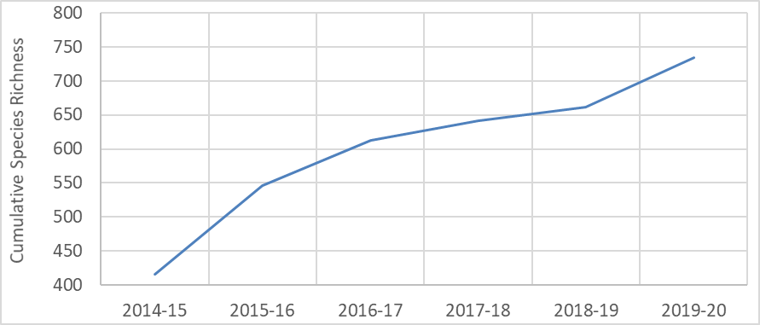

Figure 6.1 Cumulative species richness across the 6 years, 2014–20

The increase observed in 2019–20 largely reflects increases in the number of monitored sample points

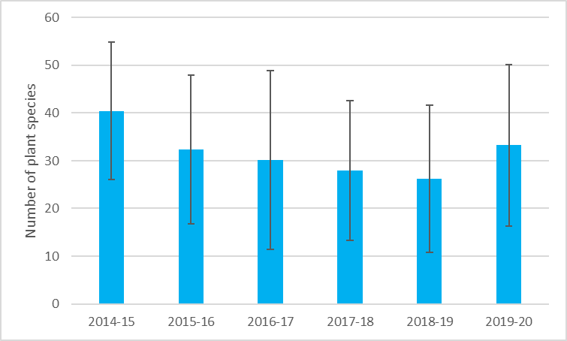

Figure 6.2 Average species richness per sample point per water year across all Selected Areas, ± 1 SD

There is a statistically significant difference between the average number of plant species recorded in 2014–15 and every other year (p<0.04), and between 2018–19 and both 2015–16 (p = 0.04) and 2019–20 (p = 0.019)

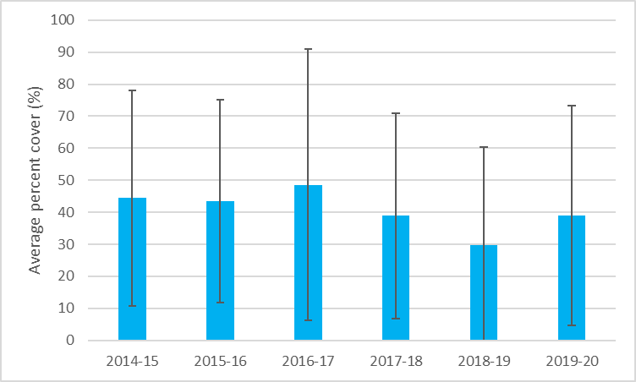

Figure 6.3 Average cover of all species per sample point per year across all Selected Areas, ± 1 SD

There is a statistically significant difference between the average cover in 2018–19 and every other year (p<0.006)

The majority of plant species recorded across all sample points and all years were native, in terms of both numbers of species (~70%) and total cover (~80-85% of the total proportion of cover) (Table 5.2). In terms of species number, the dominant growth form is forbs (~60% of species), followed by grasses (~15%), sub-shrubs (~9%) and sedges and rushes (~5%), with slightly more perennial species (~58%) than annual species recorded. Most plant species recorded belong to the terrestrial plant functional group (T ~59%), followed by damp-loving species (D ~20%), amphibious species (A ~12%) with very small numbers of submerged (S) and woody flood-dependent species (Figure 6.4).

In relation to cover, dominance varies from year to year between forbs (~28–32% of total cover), grasses (~13–32%) and sedges and rushes (~15–29%). Moderate cover is evident for shrubs (~8–12%), sub-shrubs (~4–8%) and trees (~6–11%), and there is limited cover of all other growth forms.

The dominance of plant functional groups also changes when determined using the proportion of total cover (Figure 6.4). Amphibious species were dominant 5 years out of 6 (~21–40%) with cover of terrestrial species dominating in the most recent year (2019–20, ~28%). Damp species had the second most dominant amount of cover in 3 of the 6 years and notably contribute to the total cover (~18–24%) along with woody flood-dependent species (~14–19%). Submerged species have comparatively low proportional cover (~6–10%).

Six species in the 2014–20 dataset fall under rare and threatened species listings either nationally (i.e. EPBC Act listed) or within the state they were recorded (Table 6.1) (e.g. tiny teeth (Dentella minutissima) is listed as endangered in New South Wales and has been recorded in the Junction of the Warrego and Darling rivers Selected Area). In total, 99 species in the 2014–20 dataset are listed on national and/or state (New South Wales, Victorian, South Australian) rare and threatened species lists (see Appendix F) (though the majority of these have not been recorded in the state in which the listing applies).

For tables and graphs detailing species richness, cover and trait values (e.g. nativeness, functional groups, life history and form) by Selected Area, please refer to Appendix C and the annual evaluation reports for each of the Selected Areas.

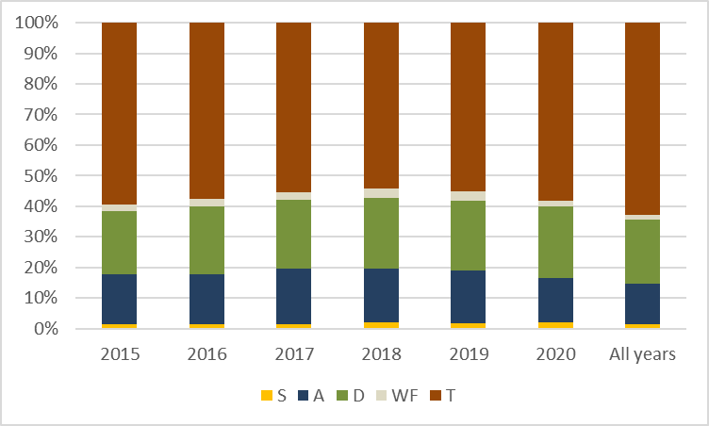

Figure 6.4 Percentage of plant species recorded across all Selected Areas in each water plant functional group for each water year and across all years

The plant functional groups are: S (submerged); A (amphibious); D (damp); WF (woody flood dependent); T (terrestrial) – see Table 3.4

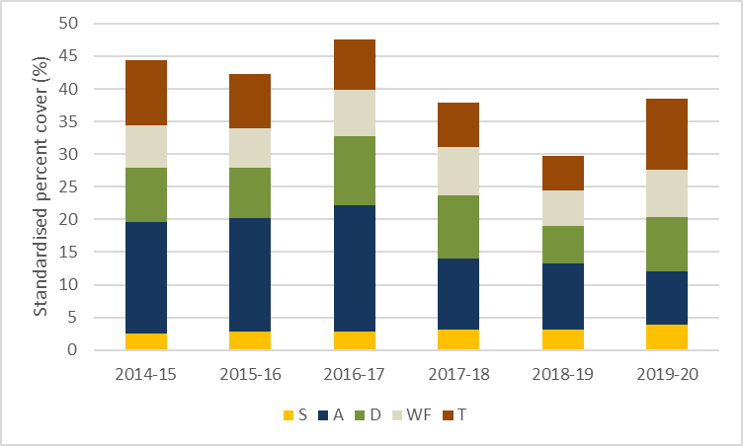

Figure 6.5 Standardised percentage cover of plant functional groups across all Selected Areas, 2014–20

The plant functional groups are: S (submerged); A (amphibious); D (damp); WF (woody flood dependent); T (terrestrial) – see Table 3.2

Table 6.1 Species listed under national (EPBC Act) or state rare and threatened species lists recorded (indicated by X) at sample points in each water year, 2014–20

EPBC Act = Environment Protection and Biodiversity Conservation Act 1999

| **Threatened species** | **Functional group** | **Listing** | **Selected Area** | **Sample point** | **14–15** | **15–16** | **16–17** | **17–18** | **18–19** | **19–20** |
| --- | --- | --- | --- | --- | --- | --- | --- | --- | --- | --- |
| Nationally listed | | | | | | | | | | |
| Brachyscome papillosa | T | EPBC – vulnerable | Lachlan River System | LII-P |  |  | X | X |  |  |
|  |  |  | Murrumbidgee River System | Nap Nap Swamp |  |  |  |  |  | X |
|  |  |  | Murrumbidgee River System | Waugorah Lagoon |  | X |  | X |  |  |
| Lepidium hyssopifolium | T | EPBC – endangered | Gwydir River System | GWY_BUNG1-1 |  |  | X |  |  |  |
|  |  |  | Gwydir River System | GWY_BUNG1-2 |  |  | X |  |  |  |
|  |  |  | Junction of the Warrego and Darling rivers | WD_VEG_4 | X |  |  |  |  |  |
|  |  |  | Lachlan River System | CL-P |  |  | X | X |  |  |
|  |  |  | Lachlan River System | NL-P |  |  |  |  |  | X |
| State listed | | | | | | | | | | |
| Callistemon brachyandrus | T | South Aust – rare | Lower Murray River | Lock1 |  |  |  |  |  | X |
| Cuscuta australis | T | Vic – poorly known (k) | Goulburn River | Loch Garry Gauge |  |  | X |  |  |  |
|  |  |  | Goulburn River | McCoys Bridge |  |  | X |  | X |  |
| Dentella minutissima | D | NSW – endangered | Junction of the Warrego and Darling rivers | WD_VEG_7 |  |  | X | X |  |  |
| Myriophyllum papillosum | A | South Aust – rare | Lower Murray River | Lock4 |  |  |  |  |  | X |

## Species-level responses to environmental water

Between 40% and 70% of monitored sample points were inundated in any one year between 2014 and 2020, with 80% of sample points receiving environmental water in at least one of the 6 years of monitoring. Most of the riverine sample points were influenced by environmental water in every year; the most notable exception was 4 sample points that did not receive environmental water in the Edward/Kolety–Wakool in 2019–20. The numbers of floodplain–wetland sample points that were influenced by environmental water ranged from 15 in 2019–20 to 36 in 2015–16, a function of water availability across the Basin.

Of the more than 700 taxa recorded at sample points since 2014, almost 40% (278) are species that have only occurred at sample points that have received environmental water. The majority of these (197 species) are native and include a number of submerged (4), amphibious (46) and damp-loving species (50) that are unlikely to persist in the absence of water.

Importantly, there are 15 plant species known to be used by Aboriginal people which have only occurred at sample points that have received environmental water. This tells a story that is consistent with those of the current and previous annual evaluations which highlight the number of species that are unique to sample points that receive environmental water (see Chapter 5, and Capon and Campbell 2016, 2017, 2019; Capon and James 2020; Capon and Mynott 2018) and illustrates the very important role that environmental water plays across the Basin in maintaining important native plant species. Of the species unique to sample points that have received environmental water, one – robust water-milfoil (*Myriophyllum papillosum*) – is listed as a rare or threatened species.

## Community-level responses to environmental water

Within floodplain–wetland vegetation communities, the use of environmental water has provided a range of hydrological regimes for sample points across the Basin. These regimes, which we categorise into 6 hydrological groups (see Chapter 4, where Group 1 is most frequently wet and Group 6 is least frequently wet), support different vegetation communities both overall (pooled across all years) (Figure 6.6) and within individual monitoring years (see Appendix C, Figure C.4 and Figure C.5). There is a statistically significant difference between functional group assemblages within hydrological groups, using data pooled across all years (2014–20) (p = 0.001; see Appendix C for more information). Distinct assemblages are evident between all pairs of hydrological groups (p = 0.01) except for groups 4 and 6 (p = 0.147).

Sample points classified as hydrological groups 2 and 3 have the greatest overall vegetation cover (standardised by the number of sample points in each group) which, along with sample points from Group 1, support the greatest proportions of submerged, amphibious and damp-loving species cover (Figure 6.6 and also Figure 4.3). In the absence of environmental water, very few sample points would have experienced the hydrological regimes defined by groups 2 and 3 (see Chapter 4). Groups 4, 5 and 6 represent the drier hydrological regimes and these sample points support lower cover of amphibious and damp-loving species and proportionally more terrestrial and woody flood-dependent species.

Sample points from groups 1 and 5 have very low proportions (< 10%) of exotic species coverage, closely followed by Group 2 sample points, with < 13%. Group 6, the driest group with the lowest frequency of inundation, has sample points with the greatest proportion of exotic species (~26%) (Figure 6.7). The greatest number of native species are recorded from sample points in groups 5 and 6, with an average of 235 native species, whereas in groups 1 to 4 the sample points average is 178 native species (see Figure C.6).

Sample points from groups 2 and 3 support high cover of grasses and sedges/rushes. Forbs are present across all hydrological group sample points (Figure 6.8 and Figure C.7) and contribute to a large proportion of growth form cover in sample points in groups 1 and 4 (Figure 6.8).

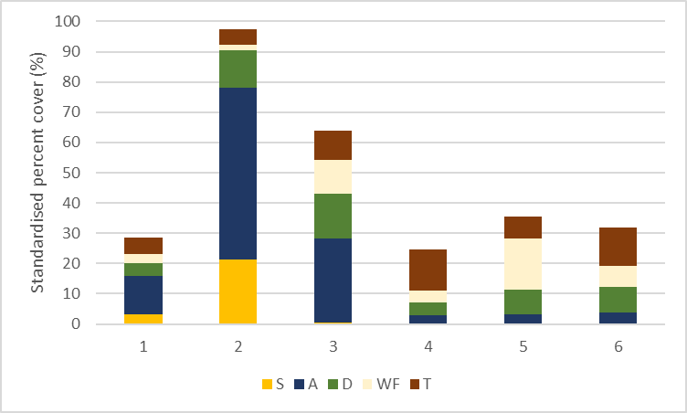

Figure 6.6 Standardised cover of functional groups in each of the 6 hydrological groups (where 1 is the wettest group and 6 the driest) pooled across all water years, 2014–20

For details of the hydrological groups, see Chapter 4. Plant functional groups are: S (submerged); A (amphibious); D (damp); WF (woody flood dependent); T (terrestrial) – see Table 3.4

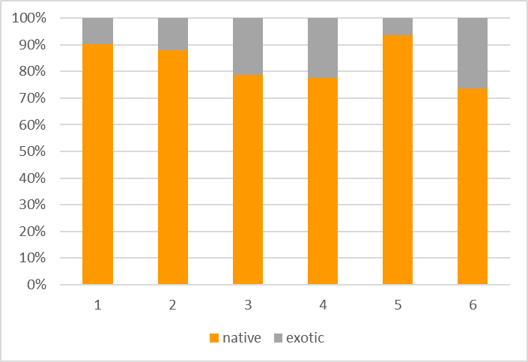

Figure 6.7 Relative proportions of native and exotic cover in each of the 6 hydrological groups (where 1 is wetted and 6 is driest) pooled across all water years, 2014–20

For details of the hydrological groups, see Chapter 4

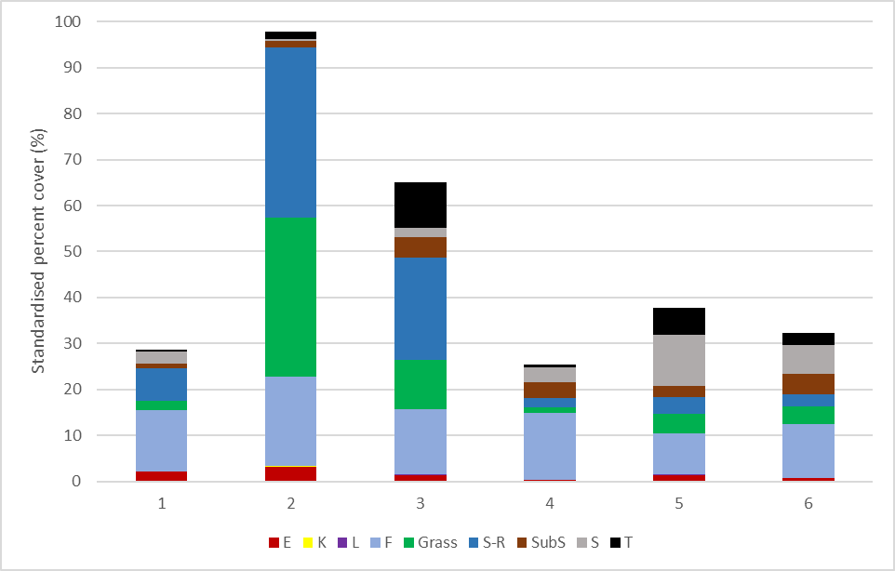

Figure 6.8 Standardised cover of growth forms in each of the 6 hydrological groups pooled across all water years, 2014–20

For details of the hydrological groups, see Chapter 4. The growth forms are: E (ferns and fern allies); K (epiphytes); L (vines); F (forbs); grasses; S-R (sedges and rushes); SubS (sub-shrubs); S (shrubs) and T (trees) – see Table 3.5

## Expected outcomes in the absence of environmental water

In the absence of environmental water, just over one-third of the sample points monitored (34 of the 91 sample points) would have experienced a much drier hydrological regime without environmental water, being inundated far less frequently and experiencing extended dry phases (see Chapter 4 and Figure 4.5, repeated below as Figure 6.9. Given that each of the hydrological groups is associated with a distinct functional and structural vegetation assemblage, it is expected that the absence of environmental water would have meant a corresponding absence of submerged species and a loss of diversity and cover of amphibious and damp-loving species (Figure 6.10). This highlights the importance of environmental water in maintaining a diversity of floodplain–wetland vegetation communities across the Basin.

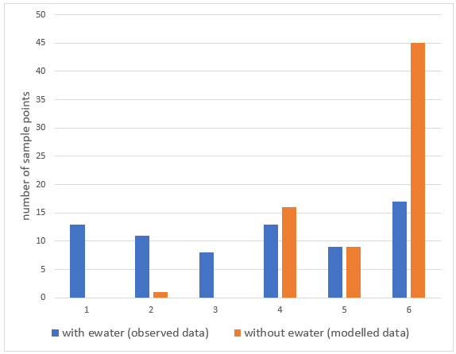

Figure 6.9 Number of sample points in each hydrological group

For details of hydrological groups, see Chapter 4. Blue bars show the number of sample points in each group based on their experienced watering regime over the past 6 years. Orange bars show the expected grouping of the same sample points based on modelled inundation in the absence of environmental water.

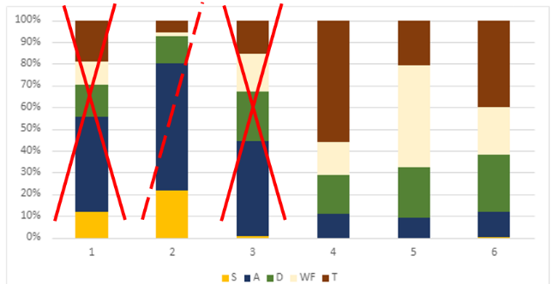

Figure 6.10 Functional group community assemblages associated with each of the hydrological groups

The red crosses indicate the hydrological groups that would be lost in the absence of environmental water and the red dotted line represents the hydrological group that is only maintained by a single sample point in the absence of environmental water

## 2014–20 responses in unmonitored areas

As with the annual evaluation, the patterns of responses observed at monitored sample points over the period of monitoring give insight as to what may be expected from the use of environmental water across the Basin between 2014 and 2020. It is likely that the use of environmental water has maintained the richness of species at watered sample points and that this will have included a range of plant species known to be used by Aboriginal people as well as species that are listed as rare and threatened. The species that are supported will be dependent on their location in the Basin, but it is highly likely that it will include a range of submerged, amphibious and water-loving species that are unlikely to be present in the absence of environmental water.

By making a significant contribution to supporting specific hydrological regimes across the Basin, environmental water has also contributed to vegetation community diversity. As an example, hydrological groups 1, 2 and 3 consist of sample points from a range of floodplain and wetland ANAE classes which do not occur in groups 4, 5 and 6. These include permanent wetlands, permanent tall emergent marsh, and freshwater meadows. Over the past 6 years, Commonwealth environmental water has been used to support around 15% of the permanent wetlands, more than 40% of the permanent tall emergent marsh, and more than 25% of the freshwater meadows on the managed floodplains (Brooks 2021). Without environmental water, these ecosystem types would likely be shifting to different assemblages of vegetation and perhaps transitioning to the ecosystem types that are more common to drier hydrology regimes. The driest of the hydrological groups are predominantly from the black box or river red gum woodland riparian zone or floodplain ANAE classes.

Over the past 6 years, environmental water has made a significant contribution to maintaining the wetter hydrological groups and thus the vegetation assemblages associated with these groups. From this it is inferred, in unmonitored areas for which there is no monitoring data, that the maintenance of wetter hydrological regimes across the Basin using environmental water will be contributing to maintaining the vegetation assemblages associated with those hydrological groups.

In Chapter 7, we present a case study in which we investigate the response of vegetation to environmental water within the ANAE type for which we have the greatest number of sample points (ANAE type F1.2: River red gum forest riparian zone or floodplain), distributed across multiple Selected Areas, multiple hydrological regimes and surveyed across multiple years. In doing so, we demonstrated that there are different and distinct responses within the same ANAE type to different hydrological regimes, indicating the need to combine both ANAE type and hydrological regime in extrapolating responses across the Basin.

The vegetation sample points monitored across the Basin as part of LTIM and Flow-MER programs represent 19 ANAE types but replication of sample points within ANAE types is relatively low, particularly when viewed across multiple geographical regions (i.e. Selected Areas) and hydrological regimes (i.e. hydrological groups) which limits our ability to assess the variability or consistency of responses in relation to these factors. In spite of these limitations, the analysis presented in Chapter 7 again highlighted the role of environmental water in maintaining submerged, amphibious and damp-loving species in the landscape, within the same ANAE type. This has been a consistent finding across the evaluation and provides considerable confidence in extrapolating this finding to unmonitored areas.

The hydrological groups appear to be key to inferring vegetation responses to environmental water in unmonitored areas. At present, inundation data are not available at the temporal resolution that would enable the identification of the relative areas in each hydrological group, but it is expected that as the inundation mapping across the Basin improves, so will our capacity to determine the landscape-level responses more quantitatively.

# Case study: extrapolating to unmonitored areas using ANAE types

## Key findings

* The vegetation sample points monitored across the Basin as part of the LTIM and Flow-MER programs occur in 19 ANAE types. Replication of sample points within ANAE types is relatively low, particularly when viewed across multiple geographical regions (i.e. Selected Areas) and hydrological regimes (i.e. hydrological groups). This limits our ability to assess the variability or consistency of responses in relation to these factors.
* Using ANAE type F1.2 River red gum forest riparian zone or floodplain, for which we have the greatest number of sample points distributed across multiple Selected Areas, multiple hydrological regimes and surveys across multiple years, we investigated the response of vegetation to environmental water. In doing so, we have demonstrated that there are different and distinct responses within the same ANAE type to different hydrological regimes. In particular, the analysis again highlighted the role of environmental water in maintaining submerged, amphibious and damp-loving species in the landscape, within the same ANAE type.
* Information on inundation at a shorter temporal resolution (quarterly or monthly) than annual inundation is required to support the use of hydrological groups in inferring vegetation responses to environmental water in unmonitored areas of the Basin. This information is not currently available to support Basin-scale evaluation.

## Introduction

Extrapolation to unmonitored areas is a pragmatic necessity given the limited resources preventing monitoring of all environmental watering events, at all locations and across multiple time frames. Predicting responses in unmonitored areas is an objective of the Flow-MER Program, but there are a number of challenges and uncertainties. The ability to extrapolate vegetation community responses to unmonitored areas assumes vegetation metrics respond predictably to environmental factors such as hydrological regime for a particular ecosystem type (e.g. ANAE type). As part of building the capacity to extrapolate vegetation community responses to unmonitored areas, we wanted to explore some of these underlying assumptions. As ANAE types are consistently mapped across the Basin and are evaluated in the Basin-scale Ecosystem Diversity report (Brooks 2021), exploring response patterns in relation to ANAE types is a logical place to start.

The LTIM and Flow-MER vegetation sample points occur within 19 ANAE types across the Basin (Table 7.1, see also Table 5.4). Replication of sample points within ANAE types is relatively low, particularly when viewed across multiple geographical regions (i.e. Selected Areas) and hydrological regimes (i.e. hydrological groups) (Table 7.1). This limits our ability to assess the variability or consistency of responses in relation to these categories.

For this case study, we examined the response of vegetation in the ANAE type F1.2: River red gum forest riparian zone or floodplain, largely because of the number of sample points (26) distributed across multiple Selected Areas (4), surveyed across multiple years and representing multiple hydrological regimes (i.e. 4 different hydrological groups) (Table 7.1, Figure 7.9 and Figure 7.10).

## Methods

We identified the sample points and sampling times relevant to ANAE type F1.2: River red gum forest riparian zone or floodplain. Average species cover for each sample point for each sampling year was extracted from the program datasets. We assessed the annual and multi-year response of vegetation to hydrological regimes using average species cover/sample point, standardised and proportional cover of functional groups, and proportional cover of growth form and native/exotic species as response variables. Using permutational multivariate analysis of variance (PERMANOVA) in Primer (V7) (Clarke and Gorley 2015) we tested these responses in relation to hydrological group for individual sampling years as well as pooled across all 6 years of sampling. Cover values were summed across vegetation response categories (e.g. functional group, growth form) then divided by the number of sample points surveyed in each hydrological group (see Table 7.2).

We also plotted the dissimilarities and trajectories of both plant species assemblages and functional group assemblages, averaged by hydrological group and year, using non-metric multidimensional scaling (nMDS) in Primer (V7) (Clarke and Gorley 2015), based on a Bray–Curtis resemblance matrix for both plant species and functional groups. Vector plots were overlaid on the nMDS plots to highlight the plant species and functional groups with the greatest influence on the arrangement of data points. We used a PERMANOVA test for the factors ‘hydrological group’ and ‘year’ to determine whether the composition and cover of plant species and functional group community assemblages were significantly different between hydrological groups and the influence of year. To explore the consistency of responses at sample points within hydrological groups, we also plotted plant species and functional group community assemblages for each sample point for each sampling time using nMDS in Primer (V7), assessed the within group Bray–Curtis similarity, and graphed the standardised cover of functional groups in each sample point.

We considered our results in relation to results of the Basin-scale Ecosystem Diversity evaluation (Brooks 2021), in terms of the proportion of ANAE type F1.2 on the managed floodplain and the frequency of inundation by environmental water (Table 7.2). We highlight limitations and additional knowledge needed to advance the potential to extrapolate to unmonitored areas of the Basin.

Table 7.1 ANAE types surveyed as part of Flow-MER with the number of sample points in each Selected Area and the number and type of hydrological groups represented

Australian National Aquatic Ecosystem (ANAE) type F1.2: River red gum forest riparian zone or floodplain, highlighted in light blue, is the focus for our case study. The key to Selected Area (SA) abbreviations is: EKW: Edward/Kolety–Wakool river systems; GLB: Goulburn River; LM: Lower Murray River; GWY: Gwydir River System; WD: Junction of the Warrego and Darling rivers; LACH: Lachlan River System; MUR: Murrumbidgee River System

|  | **Number of sample point per SA** | | | | | | |  |  |  |
| --- | --- | --- | --- | --- | --- | --- | --- | --- | --- | --- |
| **ANAE habitats and types** | **EKW** | **GLB** | **LM** | **GWY** | **WD** | **LACH** | **MUR** | **Total # sample points** | **# SAs** | **# hydro group^** |
| Lakes and wetlands | | | | | | | | | | |
| Lp1.1: Permanent lake |  |  |  |  | 1 |  |  | 1 | 1 | 1 (5) |
| Lt1.1: Temporary lakes |  |  |  |  |  | 5 |  | 5 | 1 | 1 (4) |
| Pp2.1.2: Permanent tall emergent marsh |  |  |  |  |  | 1 |  | 1 | 1 | 1 (1) |
| Pp4.2: Permanent wetland |  |  |  |  |  |  | 3 | 3 | 1 | 1 (1) |
| Pt1.1.2: Temporary river red gum swamp |  |  |  |  |  | 2 | 5 | 7 | 2 | 4 (1,2,4,6) |
| Pt1.2.2: Temporary black box swamp |  |  |  |  |  | 2 |  | 2 | 1 | 2 (1,4) |
| Pt1: Temporary swamp |  |  | 2 |  |  |  |  | 2 | 1 | riverine |
| Pt2.1.2: Temporary tall emergent marsh |  |  |  | 1 |  |  |  | 1 | 1 | * |
| Pt2.2.2: Temporary sedge/grass/forb marsh |  |  |  |  | 3 |  |  | 3 | 1 | 1 (5) |
| Pt2.3.2: Freshwater meadow |  |  |  | 9 |  |  |  | 9 | 1 | 3 (2,3,6) |
| Pt3.1.2: Clay pan |  |  |  |  |  | 1 |  | 1 | 1 | 1 (4) |
| Floodplains | | | | | | | | | | |
| F1.10: Coolibah woodland and forest riparian zone or floodplain |  |  |  | 9 | 2 |  |  | 11 | 2 | 4 (2,3,5,6) |
| F1.11: River cooba woodland riparian zone or floodplain |  |  |  | 2 |  |  |  | 2 | 1 | 1 (2) |
| F1.2: River red gum forest riparian zone or floodplain | 11 |  |  |  | 2 | 12 | 1 | 26 | 4 | 4 (1,4,5,6) + riverine |
| F1.8: Black box woodland riparian zone or floodplain |  |  |  |  |  | 7 | 1 | 8 | 2 | 3 (2,5,6) |
| F2.2: Lignum shrubland riparian zone or floodplain |  |  |  |  |  | 1 | 1 | 2 | 2 | 2 (1,4) |
| F2.4: Shrubland riparian zone or floodplain |  |  |  |  |  | 2 |  | 2 | 1 | 1 (6) + * |
| River channels | | | | | | | | | | |
| Rp1.4: Permanent lowland stream |  | 2 | 1 |  |  |  | 1 | 4 | 3 | 1 (1) + riverine |
| Rt1.4: Temporary lowland stream | 9 |  |  |  |  |  |  | 9 | 1 | riverine |
| Number of ANAE types | 2 | 1 | 2 | 4 | 4 | 9 | 6 | 19 |  |  |
| Total number of sample points | 20 | 2 | 3 | 21 | 8 | 33 | 12 | 99 |  |  |

^ Number of hydrological group followed by the numeric code for the represented group(s) in brackets, e.g. 4 (2,3,5,6) = 4 different hydrological groups; specifically, groups 2,3,5 and 6. Riverine sample points are classified as ‘riverine’

* Two sample points (GWY_ODBOLD; ANAE type Pt2.1.1) and BO-IBIS (ANAE type F2.4) have not been classified to a hydrological group at this stage as they have only been surveyed on a limited number of occasions. Assignment to a hydrological group will be undertaken in future years

Table 7.2 Number of sample points surveyed each year in each of the hydrological groups for ANAE type F1.2: River red gum forest riparian zone or floodplain

‘All years’ represents the total number of sample points plus sampling times across the total number of sample points (in brackets), i.e. 8 (3) = 8 total data points from 3 sample points

| **Hydrological group** | **Sample points** | **2014–15** | **2015–16** | **2016–17** | **2017–18** | **2018–19** | **2019–20** | **All years** |
| --- | --- | --- | --- | --- | --- | --- | --- | --- |
| 1 | JU-P |  |  |  |  |  | x |  |
|  | JU-T |  |  |  |  |  | x |  |
|  | Nap Nap Swamp | x | x | x | x | x | x |  |
|  |  | 1 | 1 | 1 | 1 | 1 | 3 | 8 (3) |
| 4 | LBU-T | x | x | x | x | x | x |  |
|  | NL-T | x | x | x | x | x | x |  |
|  | WB-T | x | x | x | x | x | x |  |
|  |  | 3 | 3 | 3 | 3 | 3 | 3 | 18 (3) |
| 5 | WD_VEG_2 | x | x | x | x | x | x |  |
|  | WD_VEG_6 | x | x | x | x | x | x |  |
|  |  | 2 | 2 | 2 | 2 | 2 | 2 | 12 (2) |
| 6 | CL-P | x | x | x | x | x |  |  |
|  | HW-P | x | x | x | x | x |  |  |
|  | HW-T | x | x | x | x | x | x |  |
|  | LBU-P | x | x | x | x | x | x |  |
|  | LM-P | x | x | x | x | x | x |  |
|  | NL-P | x | x | x | x | x | x |  |
|  | WB-P | x | x | x | x | x |  |  |
|  |  | 7 | 7 | 7 | 7 | 7 | 4 | 39 (7) |
| Riverine | Bowen Park |  |  |  |  |  | x |  |
|  | Calimo |  |  |  |  |  | x |  |
|  | Calimo Station |  |  |  |  |  | x |  |
|  | Llanos Park2 |  | x | x | x | x | x |  |
|  | Moulamein Road Bridge |  | x | x | x | x | x |  |
|  | Noorong2 |  | x | x | x | x | x |  |
|  | Old Morago Road |  |  |  |  |  | x |  |
|  | Whymoul NP |  | x | x | x | x | x |  |
|  | Widgee2 |  | x | x | x | x | x |  |
|  | Windra Vale2 |  | x | x | x | x | x |  |
|  | Yaloke |  | x | x | x | x | x |  |
|  |  | 0 | 7 | 7 | 7 | 7 | 11 | 39 (11) |

Table 7.3 Hydrological regime experienced by each floodplain–wetland sample points in the ANAE type F1.2: river red gum forest riparian zone or floodplain, showing the extent of environmental water contribution to overall inundation

SA = Selected Area; LACH = Lachlan River System; MUR = Murrumbidgee River System; WD = Junction of the Warrego and Darling rivers

|  |  |  |  |  |  |  |  |  |  |  |  |  |  |  |  |  |  |  |  |  |  |  |  |  |  |  |  |
| --- | --- | --- | --- | --- | --- | --- | --- | --- | --- | --- | --- | --- | --- | --- | --- | --- | --- | --- | --- | --- | --- | --- | --- | --- | --- | --- | --- |
| Hydrological group W/Cew | SA | Sample point |  | 2014–15 | | | | 2015–16 | | | | 2016–17 | | | | 2017–18 | | | | 2018–19 | | | | 2019–20 | | | |
| Code | Q3 | Q4 | Q1 | Q2 | Q3 | Q4 | Q1 | Q2 | Q3 | Q4 | Q1 | Q2 | Q3 | Q4 | Q1 | Q2 | Q3 | Q4 | Q1 | Q2 | Q3 | Q4 | Q1 | Q2 |
| **1** | LACH | Juanbung – P | JU-P | 1 | 1 |  | 1 | 1 | 1 | 1 | 1 | 1 |  | 1 | 1 |  |  | 1 | 1 |  |  | 1 | 1 |  |  | 1 |  |
| Juanbung – T | JU-T | 1 | 1 |  | 1 | 1 | 1 | 1 | 1 | 1 | 1 | 1 | 1 | 1 | 1 | 1 | 1 | 1 | 1 | 1 | 1 | 1 | 1 | 1 |  |
| MUR | Nap Nap Swamp |  | 1 | 1 |  |  |  | 1 |  |  | 1 | 1 | 1 | 1 | 1 | 1 | 1 |  | 1 | 1 | 1 | 1 | 1 | 1 | 1 | 1 |
| **4** | LACH | Lake Bullogal – T | LBU-T |  | 1 |  |  |  |  |  | 1 | 1 | 1 | 1 | 1 | 1 |  |  |  |  |  |  |  |  |  |  |  |
| Nooran Lake – T | NL-T |  |  |  | 1 | 1 | 1 |  | 1 | 1 | 1 | 1 | 1 |  |  |  |  |  |  |  |  |  |  |  |  |
| Whealbah – T | WB-T |  |  |  | 1 | 1 | 1 | 1 | 1 | 1 | 1 | 1 | 1 |  |  |  |  |  |  |  |  |  |  |  |  |
| **5** | WD | WD_Veg – 2 |  |  |  |  |  |  |  |  |  | 1 | 1 |  |  |  |  |  |  |  |  |  | 1 |  |  | 1 | 1 |
| WD_Veg – 6 |  |  | 1 | 1 |  |  | 1 |  |  | 1 | 1 |  |  |  |  |  |  |  |  |  | 1 |  |  | 1 | 1 |
| **6** | LACH | Hazelwood – P | HW-P |  |  |  |  |  |  |  | 1 | 1 | 1 |  |  |  |  |  |  |  |  |  |  |  |  |  |  |
| Clear Lake – P | CL-P |  |  |  |  |  |  |  |  | 1 | 1 |  |  |  |  |  |  |  |  |  |  |  |  |  |  |
| Nooran Lake – P | NL-P |  |  |  |  |  |  |  |  | 1 | 1 |  |  |  |  |  |  |  |  |  |  |  |  |  |  |
| Lake Marool – P | LM-P |  |  |  |  |  |  |  |  |  |  |  |  |  |  |  |  |  |  |  |  |  |  |  |  |
| Whealbah – P | WB-P |  |  |  | 1 |  |  |  | 1 | 1 | 1 |  |  |  |  |  |  |  |  |  |  |  |  |  |  |
| Hazelwood – T | HW-T |  | 1 |  | 1 | 1 | 1 | 1 | 1 | 1 | 1 |  |  |  |  |  |  |  |  |  |  |  |  |  |  |
| Lake Bullogal – P | LBU-P |  |  |  |  |  |  |  | 1 | 1 | 1 | 1 |  |  |  |  |  |  |  |  |  |  |  |  |  |
|  |  |  |  |  |  |  |  |  |  |  |  |  |  |  |  |  |  |  |  |  |  |  |  |  |  |  |  |
|  |  | with environmental water contribution | |  |  |  |  |  |  |  |  |  |  |  |  |  |  |  |  |  |  |  |  |  |  |  |  |
|  |  | without environmental water contribution | |  |  |  |  |  |  |  |  |  |  |  |  |  |  |  |  |  |  |  |  |  |  |  |  |
|  |  | not inundated |  |  |  |  |  |  |  |  |  |  |  |  |  |  |  |  |  |  |  |  |  |  |  |  |  |

## Results

### Are there patterns in the response of vegetation metrics?

There are significant differences in the cover of vegetation across the different hydrological groups in ANAE type F1.2 (one-factor PERMANOVA test for ‘hydrological group’; p = 0.001). Despite the variability evidenced by large standard deviations, the average cover of vegetation was significantly lower at riverine sample points than all other hydrological groups, and significantly higher in hydrological Group 5 compared with all other groups (PERMANOVA pairwise tests; p ≤ 0.021). The cover of vegetation in hydrological groups 1, 4 and 6 did not different significantly (PERMANOVA pairwise tests; p ≥ 0.365) (Figure 7.1). The cover of vegetation within hydrological groups in ANAE type F1.2 varies between years; however, hydrological group was the only significant factor (2-factor PERMANOVA test for ‘hydrological group’ (p = 0.001) and ‘year’ (p = 0.155), with no significant interaction between the factors (p = 0.527), noting the lack of replication in hydrological Group 1 from 2014–15 to 2018–19) (Figure 7.1 and Figure 7.2). Understanding the causes of this variability would be useful in building predictive models.

There are differences in the cover of functional groups across the different hydrological groups. Riverine sample points had the greatest proportion of ‘wet’ and damp species cover with submerged, amphibious and damp-loving species, accounting for more than 90% of the proportional cover (Figure 7.3). Total cover was lower at riverine sample points than at sample points within other hydrological groups (Figure 7.1). Functional group cover within hydrological groups largely followed the patterns observed across all sample points, with Group 1 having a higher proportion of amphibious and damp-loving species cover, Group 6 having the highest proportional cover of dry species and Group 5 being dominated by woody flood-dependent species cover (Figure 7.3).

The likely influence of environmental water can be observed in the annual response of functional group cover in different hydrological groups. In Group 6, with no influence of environmental water in the last 4 years (2016–17 to 2019–20) (see Table 7.3), the response of functional group cover largely follows flooding and weather patterns, with damp-loving and amphibious cover increasing and peaking in 2016–17 and then declining steadily to 2019–20 (Figure 7.4). A similar pattern is observed in Group 4 which has also received no environmental water in the last 4 years, but with slightly longer duration of inundation following 2016–17 flooding (see Table 7.3). This group shows a similar pattern of decline in the cover of amphibious and damp-loving species from 2017–18 to 2019–20 as Group 6 (Figure 7.4). Group 5, while overall has received a slightly drier regime than Group 4, has been inundated more recently, with both sample points in this group being flooded in the last 1–2 years (see Table 7.3). This is reflected in the increase in functional group cover in amphibious and damp-loving species in 2019–20. In contrast to groups 4 and 6 in particular, the functional group cover of amphibious and damp-loving species in Group 1 is proportionally higher in 2018–19 and 2019–20 (Figure 7.4). This is likely because of regular inundation in the last 3 years which is all supported by environmental water (Table 7.3). The high proportional cover of amphibious and damp-loving species in riverine sample points is likely due to regular in-channel freshes.

Riverine sample points are dominated by the cover of forbs, grasses, and sedges and rushes. Group 5 has the highest proportional cover of shrubs and trees, and the only recorded cover of epiphytes, which may be related to the high cover of shrubs and trees. Group 6 has the highest proportional cover of sub-shrubs as well as relatively high proportional cover of grasses. Group 1 has the highest proportional cover of ferns and fern allies (Figure 7.5).

The proportional cover of native species is very high in both Group 5 and riverine sample points across all years. Exotic cover is consistently higher in groups 6 and 4, particularly in drier years such as 2019–20 (Figure 7.6).

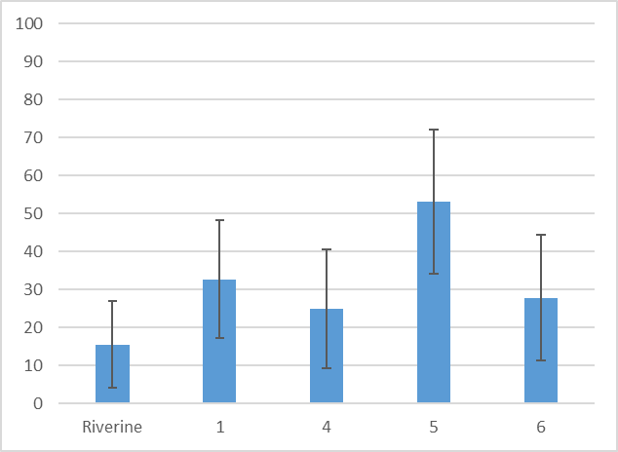

Figure 7.1 Average plant species cover per sample point for different hydrological groups and riverine sample points within the ANAE type F1.2: River red gum forest riparian zone or floodplain, pooled across all years 2014–20, ± 1 SD

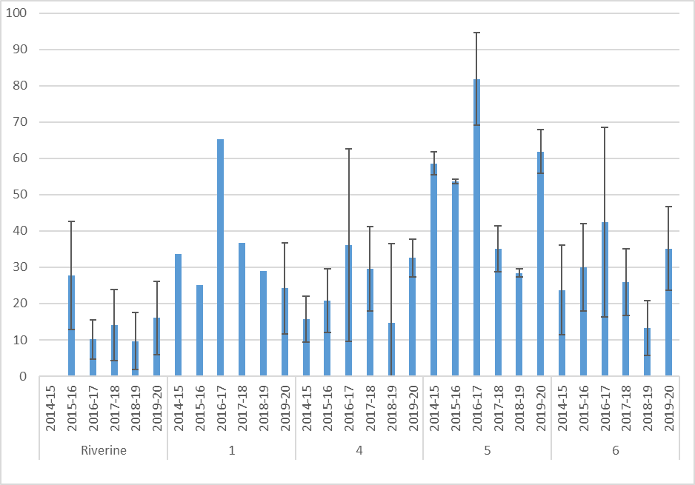

Figure 7.2 Average cover per sample point for different hydrological groups and riverine sample points within the ANAE type F1.2: River red gum forest riparian zone or floodplain, for each sampling year, ± 1 SD

Years without an error bar indicate only one sample point in that hydrological group in that sampling year

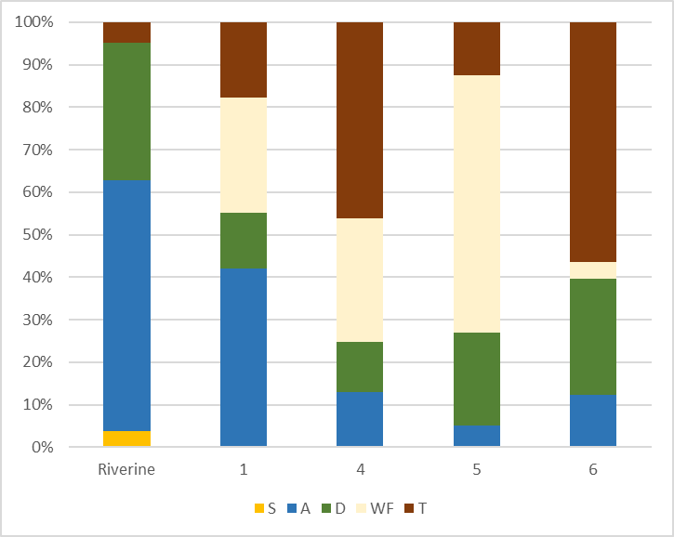

Figure 7.3 Proportional cover of functional groups in hydrological groups and riverine sample points within the ANAE type F1.2: River red gum forest riparian zone or floodplain, pooled across all years, 2014–20

Plant functional groups are: S (submerged); A (amphibious); D (damp); WF (woody flood dependent); T (terrestrial) – see Table 3.4

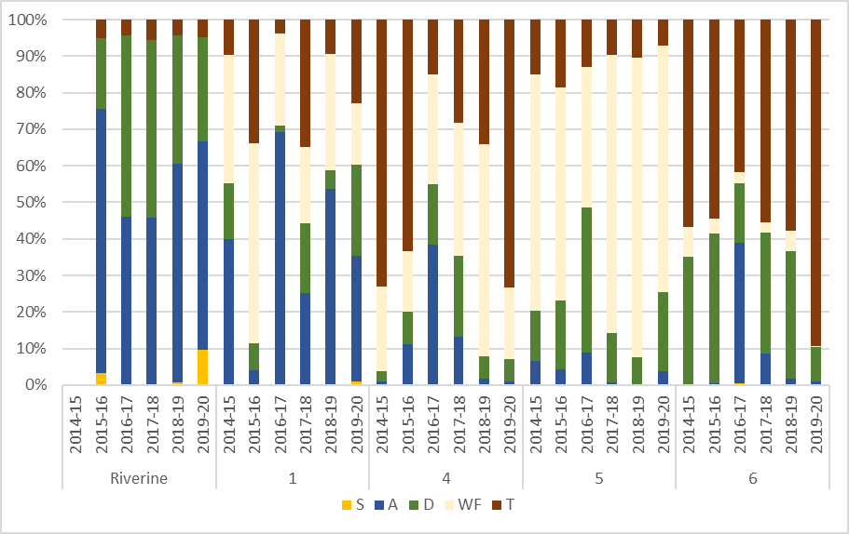

Figure 7.4 Proportional cover of functional groups in hydrological groups and riverine sample points within the ANAE type F1.2: River red gum forest riparian zone or floodplain, for each sampling year, 2014–20

Plant functional groups are: S (submerged); A (amphibious); D (damp); WF (woody flood dependent); T (terrestrial) – see Table 3.4

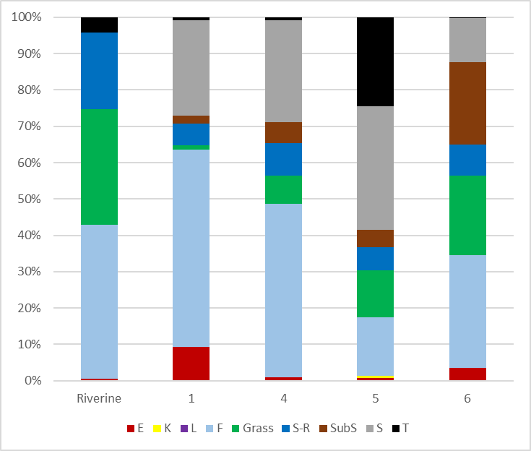

Figure 7.5 Proportional cover of growth forms in hydrological groups and riverine sample points within the ANAE type F1.2: River red gum forest riparian zone or floodplain, pooled across all years (2014–20)

Growth forms are: E (ferns and fern allies); K (epiphytes); L (vines); F (forbs); grasses; S-R (sedges and rushes); SubS (sub-shrubs); S (shrubs) and T (trees) – see Table 3.5

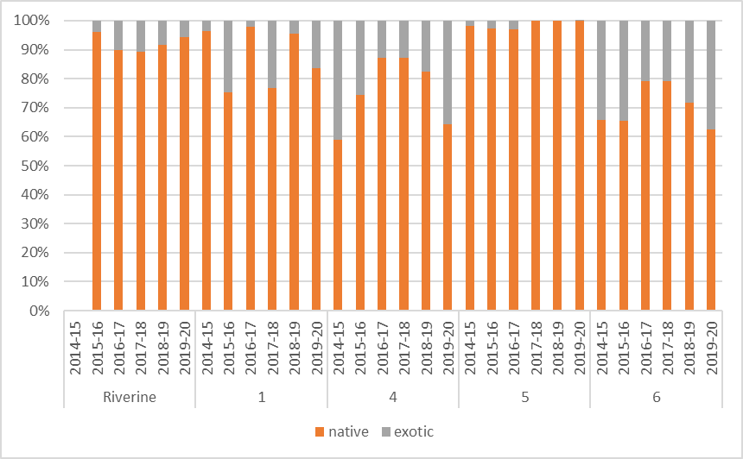

Figure 7.6 Proportional cover of native and exotic species in hydrological groups and riverine sample points within the ANAE type F1.2: River red gum forest riparian zone or floodplain, for each sampling year

### Are community assemblages distinct?

The distribution and trajectories of community assemblages in the nMDS plots indicate that composition and cover differ by both plant species and functional group depending on the hydrological groups, with each group supporting different community assemblages and following a different path over time (Figure 7.7 and Figure 7.8).

Community assemblages are distinct for both plant species and functional group composition. A 2-factor PERMANOVA test for ‘hydrological group’ and ‘year’ indicates a significant influence of hydrological group (p = 0.001 for both species and functional group composition), with no significant influence of year (p = 0.772 for species and p = 0.875 for functional groups) or interaction between hydrological group and year (p = 1 for species and p = 0.984 for functional groups). Pairwise tests between the hydrological groups indicate that composition varies significantly between all hydrological groups for plant species composition (p ≤ 0.031) and between almost all pairs of groups for functional group composition (p ≤ 0.029) with no difference in the functional group composition between hydrological groups 1 and 4 being the only exception (p = 0.068).

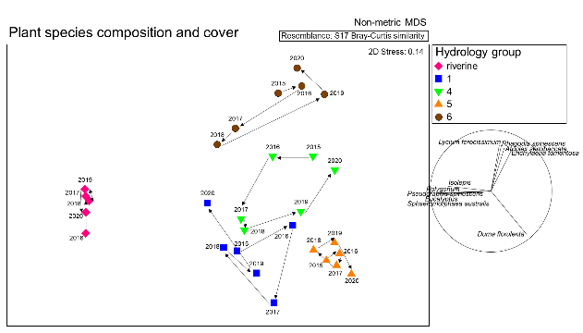

Figure 7.7 nMDS of plant species composition and cover for sample points within the ANAE type F1.2: River red gum forest riparian zone or floodplain

Each point represents the average plant species composition and cover in each hydrological group for each sampling year (i.e. averaged across sample points). Arrows represent the trajectories within hydrological groups between years, with points that are closer together having more similar community assemblages than points that are further apart. The vector plot to the right highlights the plant species that influence the arrangement of points (0.7 correlation). The direction of the line indicates the direction of influence (i.e. the presence and cover of tangled lignum (Duma florulenta) influences the distribution of points towards the bottom right of the plot) and the length of the line represents the strength of the influence of the species (i.e. species with longer lines have a stronger influence)

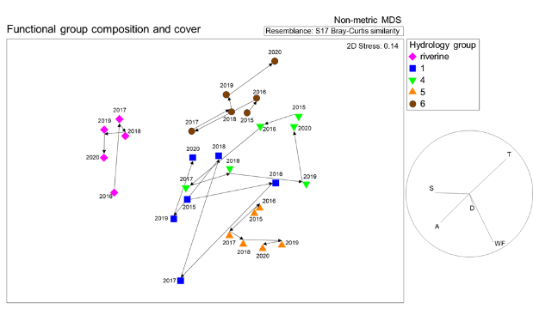

Figure 7.8 nMDS of functional group composition and cover for sample points within the ANAE type F1.2: River red gum forest riparian zone or floodplain

Each point represents the average functional group composition and cover in each hydrological group for each sampling year (i.e. averaged across sample points). Arrows represent the trajectories within hydrological groups between years, with points that are closer together having more similar functional group community assemblages than points that are further apart. The vector plot to the right highlights the functional groups that influence the arrangement of points (all groups displayed). The direction of the line indicates the direction of influence (i.e. the presence and cover of species in the terrestrial (T) functional group influences the distribution of points towards the top right of the plot) and the length of the line represents the strength of the influence of the functional group (i.e. functional groups with longer lines have a stronger influence).

### Are responses consistent across sample points within hydrological groups?

There is a degree of spread in the data points within hydrological groups and overlap between hydrological groups apparent on both the plant species and functional group nMDS plots for all sample points and all sampling times, indicating variability in both species and functional group community assemblages across sample points and years. The average similarity of sample points within hydrological groups, based on a Bray–Curtis similarity matrix, indicates that responses within Group 5 are most similar (82.77% similarity for functional groups; 45.35% for plant species), followed by Group 1 (52.18% for functional groups; 34.46% for plant species), riverine (37.57% for functional groups; 24.70% for plant species), Group 6 (28.61% for functional groups; 13.43% for plant species) and Group 4 (20.23% for functional groups; 12.46% for plant species) (Figure 7.9 and Figure 7.10). Despite this variability, a PERMANOVA test (described in Section 7.3) indicates there are statistically significant differences in the composition and cover of hydrological groups for both species (p = 0.001) and functional groups (p = 0.001). For ANAE type F1.2, some hydrological groups contain only sample points from a single Selected Area (i.e. Group 5 only contains 2 sample points from the Junction of the Warrego and Darling rivers, Group 4 contains 3 sample points from the Lachlan River System and Group 6 contains 7 sample points from the Lachlan River System). With limited replication across Selected Areas, it is difficult to determine whether observed differences in vegetation responses are a result of differences in hydrological regimes or site-based differences between Selected Areas.

Standardised cover of functional groups within sample points (Figure 7.11) indicates a degree of variability in both overall cover and representation of individual functional groups. However, the patterns observed in the data pooled across hydrological groups (Figure 7.3) is evident, with typically greater proportions of amphibious cover in riverine sample points and Group 1, woody flood-dependent cover in Group 5 and terrestrial cover in Group 6.

The consistency of responses across sample points within hydrological groups varies. Variability is most pronounced in relation to plant species composition, with the use of plant functional groups considerably increasing within group similarity (see also Campbell et al 2014). Sources of variability between responses at individual sample points are likely to relate to site-specific differences such as small-scale geomorphology influencing inundation metrics such as depth and duration, grazing pressure and climatic differences, as well as differences in long-term flow regimes, dispersal events and geographical distribution influencing the presence and abundance of propagules in seedbanks. Understanding these sources of variability will improve model predictability.

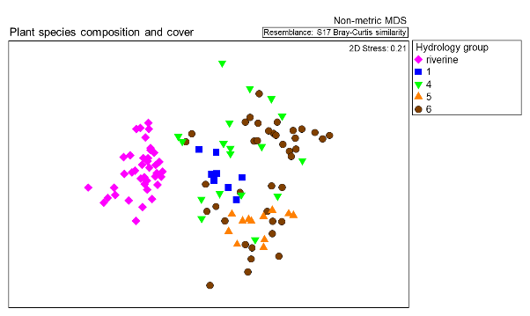

Figure 7.9 nMDS of plant species composition and cover for sample points within the ANAE type F1.2: River red gum forest riparian zone or floodplain

Each point represents the average plant species composition and cover in each sample point in each year coloured according to hydrological group

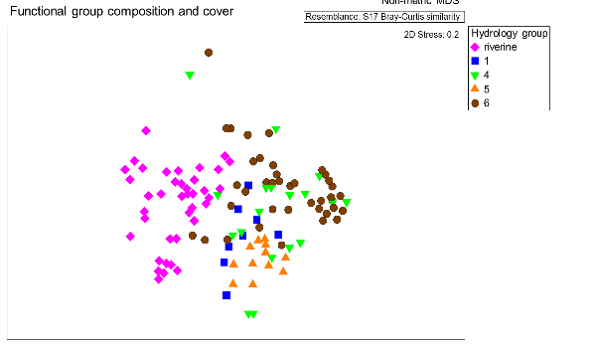

Figure 7.10 nMDS of functional group composition and cover for sample points within the ANAE type F1.2: River red gum forest riparian zone or floodplain

Each point represents the average functional group composition and cover in each sample point in each year coloured according to hydrological group

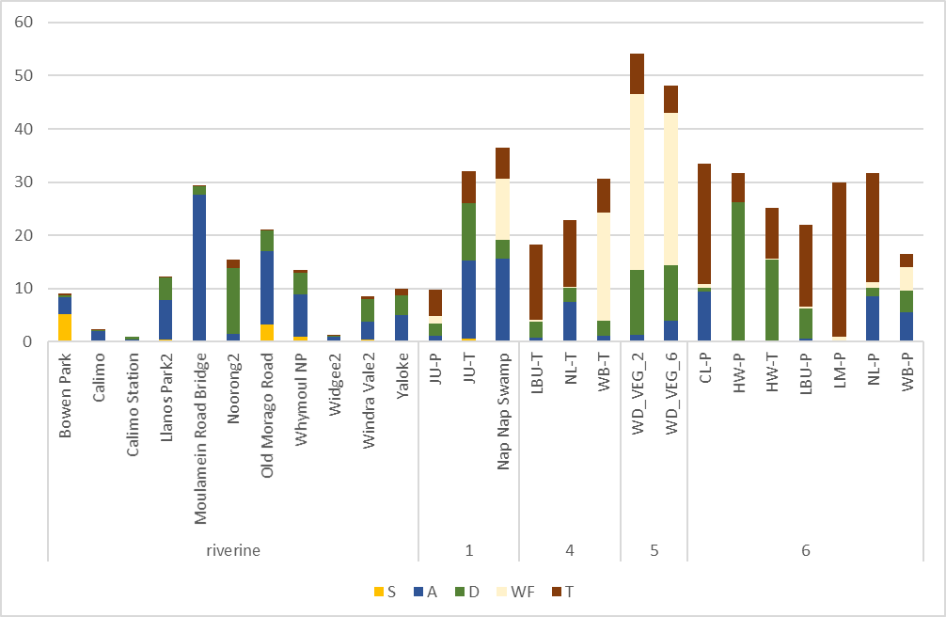

Figure 7.11 Standardised cover of functional groups in each sample point within the ANAE type F1.2: River red gum forest riparian zone or floodplain, pooled across all years, 2014–20, and grouped according to hydrological group

Plant functional groups are: S (submerged); A (amphibious); D (damp); WF (woody flood dependent); T (terrestrial) – see Table 3.4

### Basin-scale context – ANAE type F1.2

Based on analysis undertaken by Brooks (2021), ANAE type F1.2: River red gum forest riparian zone or floodplain was inundated by Commonwealth environmental water to the greatest extent of all floodplain ANAE types. Over the 6 years from 2014–15 to 2019–20,, 49,807 ha was inundated by Commonwealth environmental water, representing 17% of this ecosystem type on the managed floodplain (Table 7.4, Brooks 2021). Almost 60% of this area has only been inundated by Commonwealth environmental water 1 in 6 years, 20% 2 in 6, 12% 3 in 6 and < 5% 4 or 5 in 6, with no areas inundated by Commonwealth environmental water in all 6 years (Figure 7.12). However, note that the Basin-scale analysis undertaken by Brooks (2021) focuses on Commonwealth environmental water, as a result of limitations to input data, and doesn’t include other sources of environmental water or inundation from flooding. Therefore, it does not represent the hydrological regime in exactly the same way as the hydrological groups applied above.

Table 7.4 Area of ANAE type F1.2: River red gum forest riparian zone or floodplain inundated by Commonwealth environmental water in each year and across all years (taken from Brooks 2021)

| **Australian National Aquatic Ecosystem (ANAE) wetland type** | **Total area in Basin (ha)** | **Area on managed floodplain (ha)** | **Area receiving Commonwealth environmental water (ha)** | | | | | | |
| --- | --- | --- | --- | --- | --- | --- | --- | --- | --- |
| **14–15** | **15–16** | **16–17** | **17–18** | **18–19** | **19–20** | **Total all years** | |
| F1.2: River red gum forest riparian zone or floodplain | 625,611 | 294,874 | 12,528 | 24,266 | 4,326 | 25,400 | 17,246 | 4,521 | 49,807 | |
| Proportion of managed floodplain |  |  | 4.25 | 8.23 | 1.47 | 8.61 | 5.85 | 1.53 | 16.89 | |

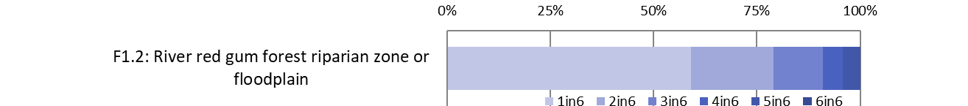

Figure 7.12 Proportion of ANAE type F1.2: River red gum forest riparian zone or floodplain influenced by Commonwealth environmental water at differing frequencies from 2014–15 to 2019–20

Source: taken from Brooks (2021)

## Synthesis

We have demonstrated that there are different and distinct vegetation groupings within the same ANAE type under different hydrological regimes. We have shown that while there will inevitably be sample point variability within ANAE types and hydrological regimes, it is likely that broad, comparative patterns in vegetation response can be discerned in response to hydrological regimes. It is likely that there will be high uncertainty in terms of predicting responses at individual sample points or locations and it is not recommended that extrapolation is used for this purpose. Rather, it can be used to make broad assessments at large spatial scales, such as across the managed floodplain or within river valleys.

While the case study has looked at patterns in vegetation metrics and community assemblages, consensus is required on judgements about good condition or desirable endpoints. ANAE F1.2 River red gum forest riparian zone or floodplain is a woody ecosystem type. Management decisions, based on values and objectives, are required to determine the target outcomes. For example, the cover of woody flood-dependent species has declined at the most frequently watered sample points (Group 1). Is this a good or a bad outcome or an artefact of the way sampling is undertaken (i.e. focussed on understorey vegetation)? Is the high cover of woody species in Group 5 a more desirable structure for this ANAE type? Is the hydrological regime experienced by sample points in Group 1 (i.e. annual inundation for a relatively large proportion of the year) too frequent for a vegetation community that is river red gum forest? The answer to these questions will depend in part on the accuracy of the ANAE mapping, the condition and trajectory of vegetation (i.e. vegetation needing to recover from a degraded state will require more frequent inundation than vegetation being maintained in an already good condition) and specific objectives and values. We need to determine what composition, cover, structure or trajectory we want for sample points within ANAE types and include these within Commonwealth Environmental Water Holder (CEWH) objectives and the Basin-wide environmental watering strategy and desired outcomes.

Our recommendations include:

* prepare inundation/hydrology information across the Basin on a quarterly (or monthly) basis that incorporates all forms of inundation (not just Commonwealth environmental water)
* define condition or desirable attributes for ANAE types. This relates to work being undertaken in the ‘Non-woody Plant Responses’ research project as part of Flow-MER
* test and validate to what extent ANAE types are useful for extrapolation at unmonitored sites
* consider replication of sample points within ANAE types and/or ANAE types which are not represented. Consider how many sample points are required in an ANAE type and hydrological group to be confident in the extrapolated outcomes
* characterise the response of vegetation in other ANAE types for different hydrological regimes.

# Contribution to Basin Plan objectives

The Basin-scale Vegetation Diversity Theme evaluates the contribution of Commonwealth environmental water to achieving the Basin Plan objectives for Biodiversity (Basin Plan Section 8.05) and focuses on the use of environmental water to support the diversity of non-woody vegetation within the Basin. The Basin-scale evaluation of vegetation diversity therefore addresses 2 major questions:

What did Commonwealth environmental water contribute to plant species diversity?

What did Commonwealth environmental water contribute to vegetation community diversity?

## What did Commonwealth environmental water contribute to plant species diversity and vegetation community diversity in 2019–20?

Commonwealth environmental watering actions in 2019–20 contributed to maintaining the richness of plant species in the Basin across both floodplain–wetland and riverine ecosystems. One hundred native taxa, or 25% of all recorded taxa in 2019–20, were only recorded at sample points that received environmental water. This included 15 plants known to be used by Aboriginal people and 3 species listed as rare and threatened plant species. The latter contributes to broader Basin Plan objectives of supporting water-dependent ecosystems that support the life cycles of listed threatened species (specifically S8.05(3)(a)).

The use of Commonwealth environmental water in 2019–20 contributed to maintaining a diversity of vegetation communities; in particular, supporting the persistence of vegetation communities that include submerged, amphibious and damp-loving species. The use of environmental water in floodplain–wetland habitats in 2019–20 supported open water vegetation communities that are devoid of trees.

The active management of Commonwealth environmental water in 2019–20 to promote vegetation cover at riverine sites appeared to generate vegetation communities that had more than double the vegetation cover compared with sites that were not actively managed with Commonwealth environmental water.

## What did Commonwealth environmental water contribute to plant species diversity and vegetation community diversity between 2014–15 and 2019–20?

Commonwealth environmental watering actions delivered between 2014–15 and 2019–20 played a role in maintaining a substantial number of native plant species across the Basin. Of the more than 700 taxa recorded at sample points since 2014, almost 40% (278) are species that have only occurred at sample points that have received environmental water. This includes submerged (4), amphibious (46) and damp-loving species (50) that are unlikely to persist in the absence of environmental water. It also includes 15 plants known to be used by Aboriginal people, highlighting the potential for Commonwealth environmental water to be used in supporting species that are important to Aboriginal people.

The delivery of Commonwealth environmental water has produced distinct hydrological regimes across the Basin that display clear differences in their functional and structural assemblages of vegetation. There is greater diversity and cover of submerged, amphibious and damp-loving species at sample points that have received wetter water regimes supported by environmental water. In the absence of Commonwealth environmental water, many locations across the Basin would have experienced notably drier water regimes. It is very likely this would have resulted in the near absence of submerged species and substantially less diversity and cover of amphibious and damp-loving species.

## Expected outcomes for vegetation

The Basin Plan provides high-level environmental objectives that are directed at protecting and restoring water-dependent ecosystems of the Murray–Darling Basin (Basin Plan Section 8.04). The Basin-wide environmental watering strategy (MDBA 2014, revised 2019) (the Strategy) contains the expected outcome that environmental water will be used to ‘maintain the extent, and maintain or improve the condition of water dependent vegetation in areas that can be managed with environmental water’ (MDBA 2019). Outcomes for vegetation defined within the Strategy are framed within the context of specific vegetation structural groups (forests and woodlands, shrublands and non-woody vegetation) and also provide expected outcomes for specific vegetation communities (e.g. lignum shrublands).

Evaluation under LTIM and the Flow-MER programs is focussed on evaluating the outcomes from using environmental water to support the diversity of non-woody vegetation. This is not well aligned with the expected outcomes defined within the Strategy or the Basin Plan. The disconnect, in part, arises because at the time the LTIM Project was established, the Strategy was still under development. The LTIM Program thus used the objectives of the Basin Plan to develop a suite of expected outcomes for vegetation (Gawne et al. 2013) based on the scientific understanding of flow and ecological responses at the time (MDFRC 2013).

The implications of the poor alignment across multiple aspects of planning and evaluation are that the monitoring has not been designed to evaluate particular outcomes (such as condition or extent). There is also poor alignment of the sampling locations to the specifically targeted vegetation communities. It is recommended that this be revisited in future iterations of both the watering strategies and the evaluation programs.

Further, the individual watering actions[17] reported by the CEWO have a wide range of objectives for vegetation (Appendix A), from ‘maintaining the health of the adult trees and lignum’ to ‘supporting aquatic plants’. Almost no watering action had objectives linked to plant species diversity. The line of sight between the objectives associated with watering actions and the Strategy or the Basin Plan is often poor. Most meet site-specific needs for vegetation outcomes, but it means there is the risk of combining data from watering actions that have almost the opposite objectives – e.g. watering actions designed to promote germination and survival of river red gums and those designed to prevent river red gum encroachment.

Future iterations of the evaluation could consider classifying vegetation objectives to better enable aggregate learning by sharing outcomes from actions with similar objectives. This would require that CEWO watering objectives are more clearly stated and better aligned with the Strategy.

# Case study: the response of plant species known to be used by Aboriginal people

## Key findings

* The Basin is home to a large number of plant species known to be used by Aboriginal people. While Commonwealth environmental watering actions to date have not deliberately targeted plant species of cultural significance, watering actions that support groundcover vegetation have supported a range of plant species known to be used by Aboriginal people:
  + Between 2014–15 and 2019–20, 69 plant species known to be used by Aboriginal people have been recorded within the LTIM and Flow-MER Selected Areas.
  + A total of 23 culturally significant groundcover plant species received environmental water in 2019–20. Fifteen of these were only recorded at sample points that received environmental water. Of these, 9 were either submerged, amphibious or damp-loving species that are likely to be dependent on water to be present in the landscape.
* In a case study of 3 plant species known to be used by Aboriginal people, we demonstrate the role of environmental water in 2019–20 in supporting cover and abundance and highlight the potential to achieve benefits for plant species known to be used by Aboriginal people in the management of environmental water:
  + Nardoo (*Marsilea* spp.) is an important food plant occurring across inland floodplains of Australia. It is observed to occur most frequently at sample points that have been flooded within the past 6 months. Both cover and abundance decline markedly with more than 12 months since flooding.
  + Old man weed (*Centipeda* spp.) is an important medicinal plant, which also occurs across the inland floodplains of Australia. It is observed to occur most frequently at sample points that have been flooded in the past 3–6 months and the presence and abundance declines with more than 12 months since flooding.
  + In 2019–20, environmental water made a significant contribution to maintaining the cover of nardoo and old man weed at sample points where they occur. Between 2014–15 and 2019–20, environmental water has been important for maintaining the hydrological conditions that would support these species.
  + Cumbungi (*Typha* spp.) has a range of cultural uses, including as a fibre, food and ceremonial plant. It is typically found in areas that are regularly flooded and is most likely to occur where it has been flooded in the past 3 months.
  + In 2019–20, environmental water was not used specifically to support cumbungi; however, between 2014–15 and 2019–20, environmental water has been used judiciously to provide the hydrological conditions that support cumbungi’s continued persistence in the landscape.
* This study demonstrates the important role environmental water can make in maintaining plant species known to be used by Aboriginal people in the landscape. There is opportunity to engage with Aboriginal communities across the Basin to identify additional plant species that are known to be used by Aboriginal people and can be supported with environmental water. This can help establish more specific objectives for vegetation outcomes in the Basin and help inform the design of watering actions.

## Introduction

The Basin is home to more than 40 Aboriginal nations (MDBA 2018) and at least 173 plant species known to be used by Aboriginal people (Appendix G; also ACT Government 2014; Conroy et al. 2019; Grant et al. 2010; LLS 2016; Murrumbidgee CMA 2008; Sumner 2009; Yorta Yorta Clans Group Inc. 2003). These plants are used as a source of food, medicine, as fibre and shelter, and for fishing and hunting (see Appendix G). Some plants have ceremonial uses in dreaming and storytelling and others such as *Eucalyptus camaldulensis* (river red gum) are used as message or boundary trees. Of the 173 plant species known to be used by Aboriginal people, 69 have been observed within the Selected Areas as part of the LTIM and Flow-MER programs between 2014–15 and 2019–20 (see Appendix G). These include 46 plants used as food, 17 for medicinal purposes, 20 used as fibre, 8 used for hunting, 2 for cultural purposes and 2 for messages or to define boundaries. Some plants have multiple uses and are included across more than one category.

Rivers and wetlands are important features of the landscape for Aboriginal peoples in the Basin, with rivers providing important pathways across the landscape (Conroy et al. 2019). European colonisation has resulted in extensive water resource developments across the Basin, disrupting the natural flow regime of rivers and their floodplains (Kingsford 2000) as well as the widespread conversion of land for agricultural use. This has had substantial effects on the native vegetation, including many plant species known to be used by Aboriginal people. From interviews with Muthi Muthi and Wiradjuri nation, participants commented that the distribution and abundance of their most valued aquatic plants, e.g. common sneezeweed or old man weed (*Centipeda cunninghamii*) and cumbungi (*Typha domingensis*) have been in decline (Conroy et al. 2019).

Some plant species known to be used by Aboriginal people are widespread, such as marsh cress (*Rorippa* spp*.*)*,* small knot-weed(*Polygonum plebeium*)and bluebells (*Wahlenbergia* spp*.*),and have been observed across all Selected Areas. Common sneezeweed (*Centipeda cunninghamii*)*,* tangled lignum (*Duma florulenta*)and common rush (*Juncus usitatus*) have been observed at 5 of the 7 Selected Areas while others were observed only at a single or few Selected Areas. For example, water ribbons (*Cycnogeton procerum*)*,* spiny flat-sedge (*Cyperus gymnocaulos*) and finger rush (*Juncus subsecundus*) all occurred within a single Selected Area (Appendix G).

Over the 2019–20 water year, a range of watering actions were delivered to achieve expected outcomes related to vegetation (Appendix A). While none of the watering actions had objectives or expected ecological outcomes specifically targeting plants because of their value to or use by Aboriginal people, many objectives (e.g. improve wetland vegetation growth and condition, maintain riparian vegetation, and support aquatic vegetation) resulted in environmental watering actions that provided conditions that would maintain and promote plant species known to be used by Aboriginal people. Additionally, some watering actions targeted species because of their ecological significance (e.g. actions targeting the growth and expansion of littoral vegetation, including rushes (*Juncus* spp.) and spiny flat-sedge (*Cyperus gymnocaulos*), to support river red gum, black box and lignum), and some of those species are plant species known to be used by Aboriginal people (Appendix G).

A total of 15 plant species known to be used by Aboriginal people received Commonwealth environmental water over the 2019–20 water year. These included plants such as tangled lignum (*Duma florulenta*), which is an important fibre plant, at 7 sample points; water ribbons(*Cycnogeton procerum*), an important food plant, at Eulimbah Swamp; and swamp dock (*Rumex brownii*) at 7 sample points. In the next section we highlight the response of 3 plant species known to be used by Aboriginal people which are common across the Basin and were recorded in 2019–20 at sample points that received environmental water during this water year.

## The response to flooding of 3 plant species known to be used by Aboriginal people

Using data collected from the LTIM and Flow-MER programs, it is possible to describe the response to flooding and drying of 3 plant species known to be used by Aboriginal people that occur in the Murray–Darling Basin, including a food plant, a medicinal plant and a plant used for fibre. The selected species include *Marsilea* spp*.* (nardoo) which is an important food plant, *Centipeda* spp. (old man weed), an important medicinal plant, and *Typha* spp. (cumbungi), which has a range of uses including fibre, food and ceremonial (Conroy et al. 2019; LLS 2016; Yorta Yorta Clans Group Inc. 2003). A review of available literature has demonstrated that the species within each genus (i.e. *Marsilea*, *Centipeda* and *Typha*) are important and have similar uses and values. As such, all species within each genus are combined for our analysis.

### Marsilea **spp**. (nardoo)

The genus *Marsilea* comprises small aquatic, subaquatic or palustral annual or perennial rooted ferns forming rhizomatous spreading clumps (Jones 1998). *Marsilea* spp. are a 4-leaf clover-like wetland fern found worldwide with 6 native species across inland Australia. *Marsilea drummondii*,or common nardoo, is the most prevalent in the Basin (see Figure 9.1). Other Basin species include *M. hirsuta* (hairy nardoo) and *M. costulifera* (narrow-leaved nardoo) and all are adapted to Australia’s arid and semi-arid environments. *Marsilea* spp. can form large fields of cover across floodplain regions in response to flooding, producing spores within a hard sporocarp, the part that is eaten by Indigenous communities (ACT Government 2014; Cunningham et al. 1981; PlantNET 2021).

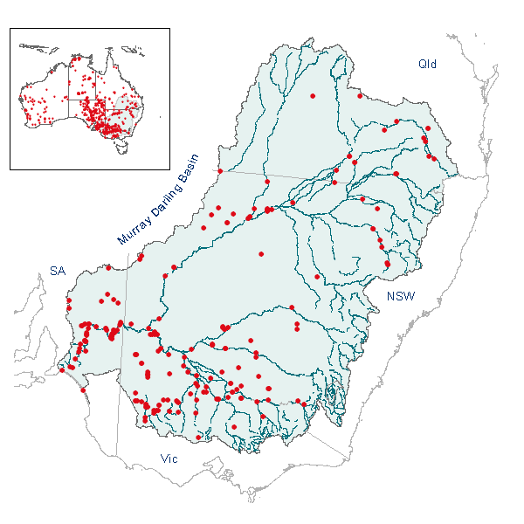

Figure 9.1 Map showing distribution of common nardoo (*Marsilea drummondii*)

Source: CSIRO 2004

Nardoo is famously known as the plant that Burke and Wills consumed, which is likely to have led to their untimely demise while exploring inland Australia in the 1860s. While nardoo is nutritious, with sporocarps that can be ground and consumed as a bread, the sporocarps need to be roasted to break down an enzyme that is toxic to humans in large amounts (thiaminase), a step which Burke and Wills failed to take, leading to a disease referred to as ‘beri-beri’ and slow starvation. Aboriginal communities used nardoo in such large amounts that sets of grinding stones have been found in so-called ‘Nardoo Mills’ (Thomas 2007). These stones were used to grind the roasted sporocarps into a powder (Aston 1973) before mixing to make a dough (Cunningham et al. 1981) which was baked to create bush bread or seedcakes high in protein and carbohydrates. The dough could also be eaten raw.

Nardoo prefers slow-moving or still and low-salinity water (Aston 1973), and bear leaves that float on or rise over the water surface (Figure 9.1). It can become the dominant groundcover after floods when water is receding. Spore production and germination occur in response to changes in moisture related to floods and rainfall. Floods to initiate nardoo germination and expansion have been noted to occur in spring–summer for a duration of > one month with shallow water of < 10 cm required (Roberts and Marston 2011). Shorter term inundation may lead to germination; however, plants are unlikely to establish (CSIRO 2004). Drying mud related to flood recession is required for sporocarps to develop and they will only open after prolonged periods in water. Spores consist of a protective capsule that ensures viability for 20–30 years with sporocarps opening with substantial inundation (Aston 1973), although not all are viable.

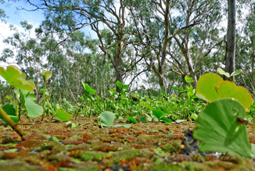

Figure 9.2 Nardoo (emerging above a layer of *Azolla*) during extensive flooding at Yanga National Park, 2010–12

Photo credit: Tanya Doody

### Centipeda spp. (old man weed)

*Centipeda* spp. are annual or short-lived perennial herbs, which grow to a height of approximately 20 cm (see Figure 9.1). *Centipeda* spp. are collectively called babiin (pronounced ba been) in the language of the Wiradjuri people from the northern parts of Wiradjuri nation, which loosely translates to father or old man; hence, it is known as old man weed (A. Shipp, pers. comm. in Higgisson et al. 2021). In the southern Wiradjuri nation, including the lower Lachlan and mid-Murrumbidgee rivers, it is known as budhaany budhaany (Grant et al. 2010).

Old man weed is known as a cure-all and remains an important medicinal plant to many Aboriginal nations in the Basin (Conroy et al. 2019). The plant is used for both external and internal ailments. The leaves are boiled and used for colds, coughs, washing sores and as a contraceptive (LLS 2016; Yorta Yorta Clans Group Inc. 2003). It can be crushed in the hand and sniffed to relieve cold symptoms (ACT Government 2014). The plant is drunk as a health tonic and for upset stomachs (Conroy et al. 2019; Yorta Yorta Clans Group Inc. 2003). It is also used to treat arthritis and tuberculosis(ACT Government 2014).

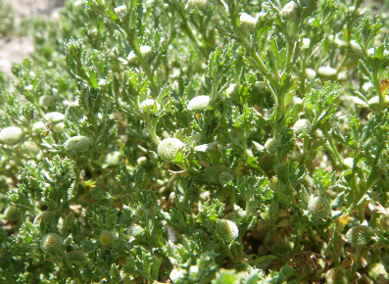

Figure 9‑3 *Centipeda cunninghamii* (common sneezeweed or old man weed) in flower on the Darling Anabranch

Photo credit: Deb Bogenhuber

### *Typha* spp. (cumbungi)

*Typha* spp., including narrow-leaved cumbungi (*Typha domingensis*) (Figure 9.1)and broad-leaved cumbungi (*T. orientalis*),are emergent rhizomatous aquatic perennial macrophytes. Both species occur in wetlands that have permanent or near-permanent water regimes and hydrologically stable conditions. *Typha domingensis* has been described as one of the most valued aquatic plants in the Murrumbidgee catchment (Conroy et al. 2019), and is used across other parts of the Basin, such as Chowilla floodplain (Sumner 2009) and the Murray River (Yorta Yorta Clans Group Inc. 2003). *Typha* is an important fibre plant used to weave baskets and rope (Conroy et al. 2019) and can also be woven into nets used for hunting animals (Yorta Yorta Clans Group Inc. 2003). The seed heads are used in ceremonial decorations (ACT Government 2014).

The abundance and distribution of *Typha* spp. have changed since European settlement, with range expansions attributed to increased available habitat, such as through the development of farm dams and urban wetlands (Roberts and Marston 2011). However, natural wetlands such as the Macquarie Marshes have seen significant reductions in the abundance and cover of *Typha* spp. attributed to a reduction in the frequency and extent of floodplain inundation (Thomas et al. 2010). A Wiradjuri man’s ability to make rope is very important, and constrained availability of *Typha* spp. prevents young boys learning this skill from women, according to Muthi Muthi and Wiradjuri nation participants (Conroy et al. 2019). *Typha* spp. are also important as food plants, and the young shoots can be eaten raw with the root (rhizome) steamed in an oven or roasted (Yorta Yorta Clans Group Inc. 2003).

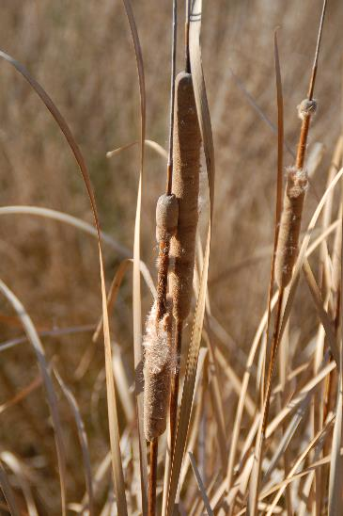

Figure 9.4 Seeding cumbungi (*Typha domingensis*) in 2009

Photo credit: Fiona Dyer

## Methods

For each sampling date at each sample point, the number of days since last flood (duration dry phase) was grouped into 5 categories for nardoo (*Marsilea* spp.) and 4 for both old man weed (*Centipeda* spp.) and cumbungi (*Typha* spp.). The duration dry phase for each sampling date at each sample point was calculated using field-based observations and remote sensing.

For nardoo, the flooding categories were flooded in the last:

* 3 months (<3 months)
* 3–6 months
* 6–12 months
* 1–2 years
* >2 years.

For old man weed and cumbungi, the flooding categories were flooded in the last:

* 3 months (<3 months)
* 3–6 months
* 6–12 months
* > 1 year.

We included an extra flooding treatment (>2 years) for nardoo (*Marsilea* spp.) as it is a perennial species which may respond to flooding on a longer time scale compared with old man weed (*Centipeda* spp.) which is a short-lived herb. Cumbungi (*Typha* spp.) is also a perennial species, but an adequate number of points was not measured to include the extra treatment for this species. This is likely related to this species occurring in near-permanent inundation.

Sample points were only included in this analysis if the species had been observed there at least once. Percentage cover data collected between 2014–15 and 2019–20 were used in the described analyses. The probability of occurrence for each species was assigned as zero for those monitoring trips where it was not observed. The percentage cover data for each species were non-normally distributed, based on a Shapira–Wilks test for normality, and heavily skewed toward 0%, ranging from 0.0% up to 100% cover for each species. The majority of cover records were <5%. Percentage cover data were initially converted to presence/absence data to investigate the influence of time since flooding on the presence of each species. A linear mixed-effects model was undertaken to assess the influence of time since flooding on the probability of occurrence of each species at a sample point. Sample date and sample point were assigned as mixed effects in each model to allow for repeated measures and unexplained variation over time. The time since flooding category was used as the fixed effect.

To analyse the percentage cover data for each species, the cover data at each sample point were initially averaged within each flooding category to reduce the bias associated with surveying effort between Selected Areas. The datasets were non-normally distributed and heavily skewed as a result of the zero percent data and majority of records having low cover values. Therefore, the datasets were log-transformed. As the cover datasets for each species contained zero values (which cannot be log-transformed), a constant was applied to each value of 0.001 that was lower than the lowest value > zero. The log-transformation resulted in near-normal distribution of the data for each species. A linear mixed effects model was undertaken that modelled the (log-transformed) cover of each species at a sample point as a function of time since flooding. The flood category was considered the fixed effect and sample point was considered the random effect to account for the non-independence of the data owing to the repeat measures. The un-transformed average percentage cover (± SE) for each species within each flooding treatment was plotted for simplicity.

For each species, the average percentage cover at each sample point where it was recorded in 2019–20 was compared between sample points that were influenced by environmental water to sample points that were not influenced by environmental water. As the number of sample points that were influenced and were not influenced by environmental water varied for each species, and as the data were non-normally distributed, these data were statistically analysed using a non-parametric Wilcoxon Rank Sum Test.

## Results

### Food plant: *Marsilea* spp.

*Marsilea drummondii* (common nardoo), *M. costulifera* (narrow-leaved nardoo), *M. hirsuta* (short fruit nardoo) and *Marsilea* spp. (nardoo) have been recorded as part of LTIM and Flow-MER programs between 2014–15 and 2019–20. *Marsilea drummondii* is the most widely distributed, occurring at 4 Selected Areas, while *M. costulifera* and *M. hirsuta* occur exclusively in the Murrumbidgee River Selected Area.

The occurrence of *Marsilea* spp. was related to time since flooding (Figure 9.5). It was observed most frequently at sample points flooded in the last 3–6 months (75% of sample point visits), and least at sample points flooded at least 2 years prior to monitoring (52% of sample point visits). *Marsilea* spp., being a perennial plant, persists in the landscape with a relatively high probability of occurrence across all flooding categories (Figure 9.5). The percentage cover of *Marsilea* spp. was greatest at sample points flooded in the previous 3–6 months and lowest at sample points flooded more than 1 year prior to surveys (Figure 9.6). Time since flooding influenced the cover of *Marsilea* spp. at a sample point, with cover of *Marsilea* spp. declining with time since flooding (Figure 9.6). The fixed effects coefficients were −1.048 and −0.089 for the intercept and the slope, respectively, and the estimates of the standard deviation of the random effects were 2.02 and 2.15, respectively. The slope describes how much cover declines, on average, per flooding category. As the analysis was undertaken on cover on the log scale, the model estimated that cover of *Marsilea* spp. declines with time since flooding, on average by 8.5%,i.e. 1 − exp(–0.089), per flooding category (Figure 9.6).

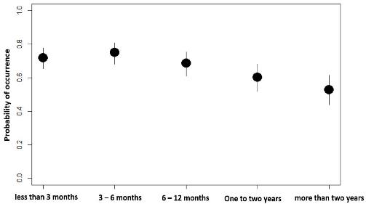

Figure 9.5 The probability of observing *Marsilea* spp. (at sample points where it is has been observed at least once) with time since flooding, based on the output of a Linear Mixed-Effects Model on the presence/absence of *Marsilea* spp.(nardoo)

Black circles represent average probability; error bars represent ± 1 standard error from the mean

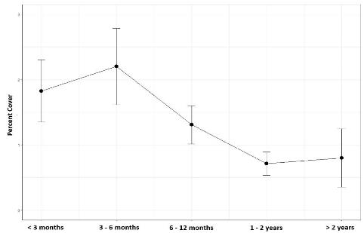

Figure 9.6 Mean percentage cover of *Marsilea* spp. (nardoo) at sample points within time-since-flooding categories

Error bars represent ± standard error from the mean; the line represents the trend in percentage cover with time since flooding

### Medicine: Centipeda spp.

*Centipeda minima* (spreading sneezeweed), *C. cunninghamii* (common sneezeweed) and *C. thespidioides* (desert sneezeweed) have all been recorded during the LTIM Project and Flow-MER Program. *Centipeda minima* has been recorded in the Gwydir and Lachlan river systems and at the Junction of the Warrego and Darling rivers. *Centipeda cunninghamii* has been recorded in the Gwydir, Lachlan and Murrumbidgee river systems, while *C. thespidioides* (desert sneezeweed) was recorded only at the Junction of the Warrego and Darling rivers.

The probability of *Centipeda* spp. (old man weed, sneezeweed) occurring at a sample point was significantly greater at locations flooded 3–6 months prior to monitoring compared with sample points flooded more than 12 months prior (Figure 9.7). The occurrence of *Centipeda* spp. at a sample point increased from 24% at sample points flooded < 3 months prior to monitoring, to nearly 59% at sample points flooded between 3 and 6 months prior, slightly lower at sample points flooded between 6 and 12 months prior (38%), and lowest at sample points flooded at least 12 months prior (14%). The presence and abundance of *Centipeda* spp*.* is therefore strongly dependent on the timing of inundation.

The average percentage cover of *Centipeda* spp. was greatest at sample points flooded 6–12 months prior and lowest at sample points flooded more than a year prior. The cover of *Centipeda* spp. appears to increase in the first 3 months following flooding, then increases slightly over the 12 months following flooding followed by a reduction in cover with more than 12 months without flooding (Figure 9.8). The model suggests that the cover of *Centipeda* spp. reduces with time since flooding. The fixed effects coefficients were −0.521 and −0.118 for the intercept and the slope, respectively, and the estimates of the standard deviation of the random effects (sample points and residuals) were 2.93 and 1.94, respectively. As the analysis was undertaken on cover on the log scale, the model estimated that cover of *Centipeda* spp. declines with time since flooding, on average by 11%, i.e. 1 − exp( 0.118), per flooding category (Figure 9.8).

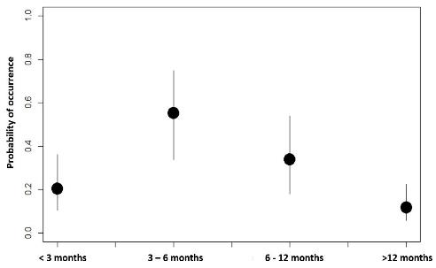

Figure 9.7 The probability of observing *Centipeda* spp. (at sample points where it is has been observed at least once) with time since flooding, based on the output of a linear mixed effects model on the presence/absence of *Centipeda* spp. (old man weed, sneezeweed)

Black circles represent the average; error bars represent ± 1 standard error from the mean.

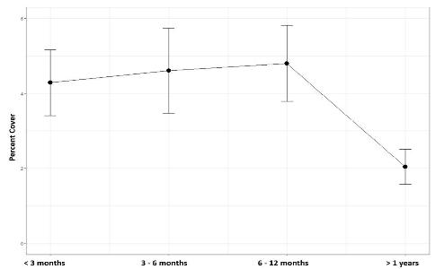

Figure 9.8 Mean percentage cover of *Centipeda* spp. (old man weed, sneezeweed) at sample points with time-since-flooding categories

Error bars represent ± standard error from the mean; the line represents the trend in percentage cover with time since flooding

### Fibre: Typha spp.

*Typha domingensis* (narrow-leaved cumbungi) has been recorded in the Edward/Kolety–Wakool and Gwydir river systems and *Typha* spp. has been recorded in the Murrumbidgee River System. A single observation was made in the Lachlan River System. *Typha* spp. were most likely to occur at sample points flooded < 3 months (occurring in 70% of sample point visits) prior to monitoring and least likely to occur at sample points flooded more than 12 months prior (occurring in 35% of sample points). The occurrence of *Typha* spp. remained fairly consistent across sample points which had flooded within 12 months prior, and were observed on between 63% to 70% of monitoring trips (Figure 9.9). The cover of *Typha* spp. was greatest at sample points flooded 6–12 months prior to monitoring and lowest at sample points flooded more than 12 months prior. The fixed effects coefficients were 0.781 and −0.191 for the intercept and the slope, respectively, and the estimates of the standard deviation of the random effects (sample points and residuals) were 3.12 and 2.03, respectively (Figure 9.10). As the analysis was undertaken on cover on the log scale, the model estimated that cover of *Typha* spp. declines with time since flooding, on average by 17%, i.e. 1 − exp(−0.191), per flooding category (Figure 9.10).

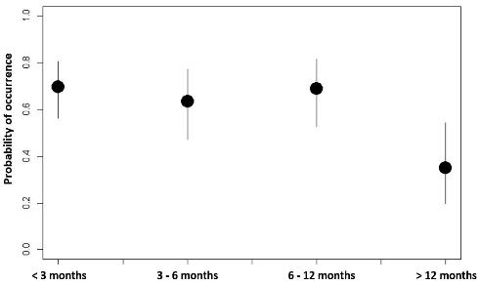

Figure 9.9 The probability of observing *Typha* spp. (at sample points where it is has been observed at least once) within time since flooding.

Classes based on the output of a Linear Mixed-Effects Model on the presence/absence of Typha spp.

Black circles represent the average; error bars represent ± 1 standard error from the mean

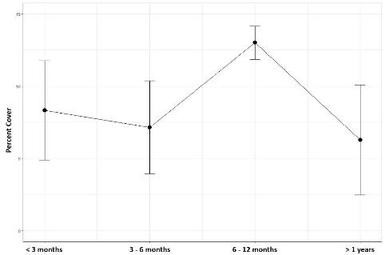

Figure 9.10 Mean percentage cover of Typha spp*.* at sample points within time-since-flooding categories.

Error bars represent ± standard error from the mean; the line represents the trend in percentage cover with time since flooding

## Synthesis

Nardoo (*Marsilea* spp.), old man weed or sneezeweed (*Centipeda* spp.) and cumbungi (*Typha* spp.) were not specifically targeted by the use of environmental water during 2019–20 (Table A.1). No environmental objective specifically targets cultural values. This study demonstrates the important role inundation makes in maintaining these species in the landscape, with higher probability of occurrence with regular inundation.

In the 2019–20 water year, environmental water made a significant contribution to maintaining the cover of *Centipeda* spp. and *Marsilea* spp. In the 2019–20 water year, *Centipeda* spp. was recorded at 46 sample points, of which 38 were influenced by environmental water. *Centipeda* spp. also had an average cover of 8.1% while sample points not influenced by environmental water had a cover of 1.8% (Figure 9.11). This result was statistically significant, with the percentage cover of *Centipeda* spp. at sample points influenced by environmental water significantly > at those not influenced by environmental water in 2019-20 (z = −2.78, p = 0.002). In the 2019–20 water year, *Marsilea* spp. was recorded at 44 sample points of which 10 were influenced by environmental water. These 10 sample points had an average cover of 5.3% compared with those not influenced by environmental water, which had cover of 0.6%. This result was statistically significant, with the percentage cover of *Marsilea* spp. at sample points influenced by environmental water significantly > at those not influenced by environmental water in 2019–20 (z = −3.53, p < 0.001).

*Typha* spp. was recorded at 10 sample points, of which 3 were influenced by environmental water (Eulimbah Swamp and Two Bridges Swamp in the Murrumbidgee River System and Lock 6 in the Lower Murray River). The 7 sample points that were not influenced by environmental water in 2019–20 were inundated by natural flooding during the water year, confounding the evaluation of responses to environmental water in 2019–20. The 3 sample points that were influenced by environmental water had a cover of *Typha* spp. of 2.9% compared with 16.1% at sample points not influenced by environmental water during 2019–20. This result was statistically non-significant (z = −0.95, p = 0.171). However, this simply illustrates the role of natural flooding in supporting species in the landscape and highlights the risk of looking at annual responses in the absence of the watering history at sample points.

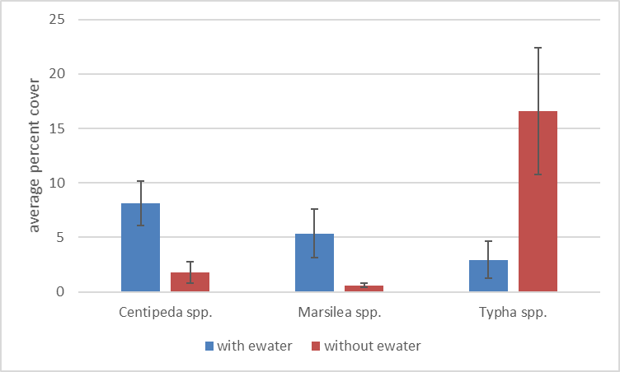

Figure 9.11 Average percentage cover of old man weed or sneezeweed (*Centipeda* spp.), nardoo (*Marsilea* spp.) and cumbungi (*Typha* spp.) at sample points influenced by Commonwealth environmental water (with ewater) or not influenced by Commonwealth environmental water (without ewater) during 2019–20

Note that sample points containing Typha spp. were inundated with natural flooding in the 2019–20 water year and thus the without ewater does not represent an absence of water.

Over the last 6 years (2014–20), *Centipeda* spp. and *Marsilea* spp. were recorded at sample points across all 6 hydrological groups, but most frequently in hydrological Group 1. In contrast, *Typha* spp. was only recorded at sample points in hydrological groups 1, 2 and 3 (Figure 9.12), highlighting the requirements of that plant for regular inundation. Given the role of environmental water in maintaining the hydrological groups 1, 2 and 3 across the monitored regions of the Basin (see Section 6.2), it can be inferred that environmental water has made an important contribution to the occurrence of *Centipeda* spp. and *Marsilea* spp. as well as to the persistence of *Typha* spp. Thus, while the use of environmental water did not directly support *Typha* spp. in 2019–20, environmental water provided the longer term watering regime (the sample points at which *Typha* spp. was recorded had been influenced by environmental water in 4 of the past 6 years and had been supported with natural flooding in the intervening years) has supported the species in the landscape.

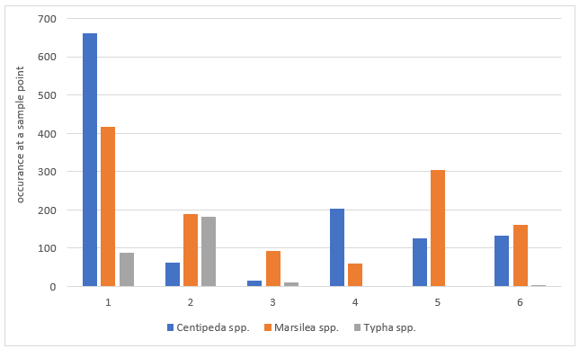

Figure 9.12 Number of times old man weed or sneezeweed (*Centipeda* spp.), nardoo (*Marsilea* spp.) and cumbungi (*Typha* spp.) were recorded from sample points within the hydrological groups during 2014–20

Watering actions that result in outcomes for groundcover vegetation have supported a range of plants known to be used by Aboriginal people. Objectives for vegetation outcomes from the use of environmental water tend to be broad and non-specific, and thus it is difficult to advise on the types of watering actions that are going to achieve the greatest benefit. There is opportunity to engage with the Aboriginal communities across the Basin to identify and document additional plants known to be used by Aboriginal people that could benefit from the use of environmental water. Through advances in our understanding of species water requirements, it is then possible to design watering actions that can be used to support plants known to be used by Aboriginal people.

# Adaptive management

This 2019–20 vegetation diversity evaluation has identified a number of areas in which improvements can be made to the way in which environmental water is managed for vegetation, from the provision of water to the needs for data to support evaluation. These are described below.

Environmental water should continue to be delivered to maintain wetter hydrological regimes at floodplain–wetland sites

Environmental water is important for maintaining a diversity of hydrological regimes across the managed floodplain that in turn support distinct functional and structural assemblages of vegetation. In the absence of environmental water, it is likely that there would be a considerable decline in vegetation communities that include submerged, amphibious and damp-loving species. It is particularly important that the wetter hydrological regimes provided by environmental water are maintained to avoid widespread loss of both species diversity and vegetation community diversity.

There is an opportunity to support plants known to be used by Aboriginal people using environmental water

While Commonwealth environmental watering actions over the past 6 years have not deliberately targeted plant species because of their cultural significance, watering actions that supported groundcover vegetation have concomitantly supported a range of plant species known to be used by Aboriginal people. In a case study of 3 plant species known to be used by Aboriginal people, we infer an important role of environmental water in maintaining plant species known to be used by Aboriginal people in the landscape. There is opportunity to engage with Aboriginal communities across the Basin to identify additional plant species that are culturally important and can be supported with environmental water. This can help establish more specific cultural objectives for vegetation outcomes in the Basin, help inform the design of watering actions and contribute to supporting plant species diversity across the Basin.

There is a need to improve the temporal resolution of available inundation data

The hydrological groups used in our multi-year evaluation may be key in the inference of vegetation responses to environmental water in unmonitored areas. At present, the assessment of inundation associated with unmonitored watering actions across the Basin was only feasible at an annual time scale. The analysis undertaken as part of this evaluation has demonstrated that inundation information at a quarterly timestep (available only for the monitored floodplain–wetland sample points) is strongly associated with the structural and functional composition of vegetation communities. In addition, long-term detailed hydrological data may assist in interpreting lags in longer lived species/community responses to environmental water. Having these data for all watering actions would substantially improve the ability to quantitatively infer vegetation community responses. As better inundation mapping becomes available (e.g. through Geoscience Australia), this approach has significant potential to enable us to extrapolate outcomes in unmonitored locations.

A stronger focus on, and clarity of, vegetation objectives and expected outcomes is needed at all levels of environmental water management

There is generally poor alignment between the Basin Plan objectives for vegetation (directed at protecting and restoring water-dependent ecosystems of the Murray–Darling Basin) and the Basin-wide environmental watering strategy (MDBA 2014) – focus on condition, extent and specific vegetation communities) and which operate at Basin scale and long time frames – with the objectives of individual watering actions delivered in each year (which are frequency not specific or well aligned with either the Strategy or the Basin Plan). It is recommended that specific objectives for vegetation are better aligned with the overarching frameworks and that more specific objectives are defined, including objectives that reflect the functional role of vegetation in supporting other values.

Sample points should be reviewed in future years of monitoring to better support evaluation

The sample points that are monitored as part of the Flow-MER Program have not been established to provide replication across ANAE types, nor to provide data from the key ANAE types or vegetation communities that are a Basin-wide priority for environmental water. In future monitoring programs, the sampling design for vegetation evaluation should be revisited. This will involve an explicit trade-off between the ability to support Selected Area watering and the ability to report on Basin-scale outcomes for vegetation.

Summary of 2019–20 Commonwealth environmental watering actions with expected outcomes related to vegetation

Table A.1 Summary of the 2019–20 Commonwealth environmental watering actions with expected outcomes related to vegetation

Column 1 is the ID from the Water Actions Register (WAR) maintained by the Commonwealth Environmental Water Office (CEWO); Cew = Commonwealth environmental watering; SA = Selected Area

| **Basin-scale Evaluation WAR ID** | **Water Action Number** | **Surface water region: asset** | **Cew volume (ML)** | **Total water action volume (ML)** | **Start–end date** | **Flow component** | **Expected ecological outcome\*** | **Evaluated by Flow-MER in SA** |
| --- | --- | --- | --- | --- | --- | --- | --- | --- |
| Lower Murray River (36 actions) | | | | | | | | |
| 1920-LWM-01 | 10095-06 | Calperum Station – Thookle Thookle | 186.4 | 186.4 | 20/03/20–06/04/20 | Wetland | * Support recovery of river red gum/black box riparian vegetation * Support recovery of lignum floodplain community across inundated areas | No |
| 1920-LWM-02 | 10095-06 | Calperum Station – Amazon floodplain | 149.0 | 149.0 | 08/04/20–23/04/20 | Wetland | * Promote recovery/support for fringing black box woodland | No |
| 1920-LWM-03 | 10095-06 | Calperum Station – Amazon upland woodlands | 5.7 | 5.7 | 20/04/20–28/04/20 | Wetland | * Promote recovery/support for upland black box woodland and community | No |
| 1920-LWM-04 | 10098-01 | Renmark Floodplain Wetlands – Site 14 (Twentysixth Street) | 25.8 | 25.8 | 03/04/20–27/05/20 | Wetland | * Halt the decline and possible death of mature long-lived plant species * Maintain existing regeneration and provide opportunities for future regeneration events of long-lived plant species * Reduce soil salinity to disadvantage samphire and promote regeneration of less-salt-tolerant floodplain and aquatic plant species | No |
| 1920-LWM-05 | 10098-01 | Renmark Floodplain Wetlands – End Begara Street | 34.2 | 34.2 | 02/09/19–05/06/20 | Wetland | * Halt the decline and possible death of mature long-lived plant species * Maintain existing regeneration and provide opportunities for future regeneration events of long-lived plant species | No |
| 1920-LWM-06 | 10098-01 | Renmark Floodplain Wetlands – End Namoi Street | 50.6 | 50.6 | 16/04/20–03/06/20 | Wetland | * Reduce soil salinity to disadvantage samphire and promote regeneration of less-salt-tolerant floodplain and aquatic plant species * Maintain existing vegetation and provide opportunities for future regeneration events of long-lived plant species | No |
| 1920-LWM-07 | 10098-01 | Renmark Floodplain Wetlands – End Paroo Street | 44.1 | 44.1 | 08/08/19–23/08/19 | Wetland | * Halt the decline and possible death of mature long-lived plant species * Maintain existing regeneration and provide opportunities for future regeneration events of long-lived plant species * Reduce soil salinity to disadvantage samphire and promote regeneration of less-salt-tolerant floodplain and aquatic plant species | No |
| 1920-LWM-08 | 10098-01 | Renmark Floodplain Wetlands – Johnson's Waterhole | 0.1 | 0.1 | 09/09/19–13/12/19 | Wetland | * Support survivorship of revegetation project for native trees | No |
| 1920-LWM-09 | 10098-01 | Renmark Floodplain Wetlands – Plush’s Bend | 68.9 | 68.9 | 27/03/20–22/05/20 | Wetland | * Halt the decline and possible death of mature long-lived plant species * Maintain existing regeneration and provide opportunities for future regeneration events of long-lived plant species * Reduce soil salinity to disadvantage samphire and promote regeneration of less-salt-tolerant floodplain and aquatic plant species | No |
| 1920-LWM-14 | 10095-02 | South Australian River Murray and Coorong – Weir Pools Lock 2 (Raising) | 5,639.0 | 5,639.0 | 01/07/19–31/08/19 | Fresh | * Support growth and expansion of littoral vegetation, including *Juncus, Cyperus gymnocaulos, Schoenoplectus validus* * Support sustained and productive understorey plant community | No |
| 1920-LWM-15 | 10095-03 | Lower Murray Wetlands – Morgan East | 170.1 | 170.1 | 04/11/19–17/02/20 | Wetland | * Maintain health of adult river red gum, black box and lignum | No |
| 1920-LWM-16 | 10095-03 | Lower Murray Wetlands – Morgan CP (North Lagoon and South Lagoon) | 343.6 | 343.6 | 18/11/19–24/02/20 | Wetland | * Maintain health of adult river red gum, black box and lignum | No |
| 1920-LWM-19 | 10095-03 | Lower Murray Wetlands – Wiela Temporary Wetlands | 486.6 | 486.6 | 12/12/19–16/04/20 | Wetland | * Support juvenile river red gum and black box * Maintain health of adult river red gum, black box and lignum | No |
| 1920-LWM-20 | 10095-03 | Lower Murray Wetlands – Bookmark Creek | 402.0 | 402.0 | 17/09/19–17/10/20 | Base flow | * Maintain health of adult river red gum, black box and lignum | No |
| 1920-LWM-21 | 10095-03 | Lower Murray Wetlands – Gerard Lignum Basin | 118.8 | 118.8 | 15/01/20–23/01/20 | Wetland | * Maintain health of adult river red gum, black box and lignum | No |
| 1920-LWM-23 | 10095-03 | Lower Murray Wetlands – Katarapko Creek North and South | 43.8 | 43.8 | 17/03/20–19/05/20 | Wetland | * Maintain health of adult river red gum, black box and lignum | No |
| 1920-LWM-24 | 10095-03 | Lower Murray Wetlands – Martin Bend Temporary | 98.9 | 98.9 | 29/04/20–15/05/20 | Wetland | * Maintain health of adult river red gum, black box and lignum | No |
| 1920-LWM-25 | 10095-03 | Lower Murray Wetlands – Yabby Creek | 1,295.5 | 1,295.5 | 22/10/19–07/01/20 | Wetland | * Maintain health of adult river red gum, black box and lignum * Support regent parrot habitat | No |
| 1920-LWM-26 | 10095-03 | Lower Murray Wetlands – Overland Corner Wetlands | 144.8 | 144.8 | 09/10/19–20/02/20 | Wetland | * Support juvenile river red gum and black box * Maintain health of adult river red gum, black box and lignum | No |
| 1920-LWM-28 | 10095-03 | Lower Murray Wetlands – Wigley Reach (all) | 285.9 | 285.9 | 03/12/19–10/03/20 | Wetland | * Maintain health of adult river red gum, black box and lignum | No |
| 1920-LWM-29 | 10095-03 | Lower Murray Wetlands – Hogwash Bend (North and South) | 487.9 | 487.9 | 24/10/19–21/02/20 | Wetland | * Maintain health of adult river red gum, black box and lignum | No |
| 1920-LWM-30 | 10095-03 | Lower Murray Wetlands – Akuna | 157.0 | 157.0 | 28/02/20–12/03/20 | Wetland | * Emergency watering to combat rapid decline in the condition of long-lived vegetation | No |
| 1920-LWM-31 | 10086-02 | Banrock Station – Heron’s Bend and Banrock Bend | 47.5 | 47.5 | 05/12/19–19/02/20 | Wetland | * Improve the condition of red gum woodland vegetation communities that are hosting one of the colonies of regent parrot in South Australia | No |
| 1920-LWM-32 | 10086-02 | Banrock Station – Eastern Lagoon | 1,424.0 | 1,424.0 | 18/12/19–05/06/20 | Wetland | * Protect the extent and condition of black box woodland and native riparian vegetation communities and provide reproduction and recruitment opportunities * Improve cover and condition of understorey vegetation, including lignum * Enhance the survival of seedlings arising from 2011 flood event | No |
| 1920-LWM-33 | 10095-04 | South Australian Murray wetland and floodplain – Cadell Ephemeral Wetlands (CAD2) | 28.3 | 28.3 | 21/03/20–19/04/20 | Wetland | * Temporary aquatic habitat community and riparian vegetation | No |
| 1920-LWM-34 | 10095-04 | South Australian Murray wetland and floodplain – Clarks Floodplain – main flood runner (CFP1) | 75.5 | 75.5 | 10/10/19–22/04/20 | Wetland | * Support stressed river red gum saplings and lignum wetland | No |
| 1920-LWM-35 | 10095-04 | South Australian Murray wetland and floodplain – Clarks Floodplain – flood runner (CFP2) | 7.8 | 7.8 | 07/05/20–28/05/20 | Wetland | * Support lignum wetlands with fringing black box | No |
| 1920-LWM-36 | 10095-04 | South Australian Murray wetland and floodplain – Georges Creek (CFP4) | 19.4 | 19.4 | 13/03/20–25/04/20 | Wetland | * Support red gum saplings, fringing stressed mature red gums | No |
| 1920-LWM-38 | 10095-04 | South Australian Murray wetland and floodplain – Hogwash Bend (HWB1) | 4.1 | 4.1 | 03/09/19–10/12/19 | Wetland | * Support mature river red gums with nesting hollows | No |
| 1920-LWM-40 | 10095-04 | South Australian Murray wetland and floodplain – Paringa Paddock Goat Island (PPK1) | 85.4 | 85.4 | 26/09/19–12/02/20 | Wetland | * Support stressed river red gum saplings, aquatic plants, fringing black box | No |
| 1920-LWM-43 | 10095-04 | South Australian Murray wetland and floodplain – Qualco main temporary lagoon (QLC1) | 378.3 | 378.3 | 10/09/19–26/11/19 | Wetland | * Support aquatic plants | No |
| 1920-LWM-44 | 10095-04 | South Australian Murray wetland and floodplain – Qualco temporary riparian swale wetlands (QLC4) | 51.8 | 51.8 | 10/09/19–19/11/19 | Wetland | * Support aquatic plants | No |
| 1920-LWM-45 | 10095-04 | South Australian Murray wetland and floodplain – Stanitzki flood runner (STA1) | 9.5 | 9.5 | 17/12/19–25/03/20 | Wetland | * Support stressed river red gum saplings | No |
| 1920-LWM-46 | 10095-03 | Lower Murray Wetlands – Molo Flat | 408.0 | 408.0 | 17/10/19–24/03/20 | Wetland | * Maintain health of adult river red gum, black box and lignum | No |
| 1920-LWM-47 | 10095-04 | South Australian Murray wetland and floodplain – Cadell Temporary Wetland (CAD1) | 264.1 | 264.1 | 30/08/19–24/10/19 | Wetland | * Support aquatic plants | No |
| 1920-LWM-48 | 10095-02 | South Australian River Murray and Coorong – Weir Pool Lock 6 (Raising) | 1,502.0 | 1,502.0 | 05/08/19–18/08/19 | Wetland | * Support growth and expansion of littoral vegetation, including *Juncus, Cyperus gymnocaulos, Schoenoplectus validus* * Support sustained and productive understorey plant community | No |
| Gwydir River System (2 actions) | | | | | | | | |
| 1920-GWY-02 | 10100-03 | Gwydir River System | 2,820.0 | 3,448.1 | 14/02/20–16/02/20 | Overbank, wetland | * Protect and maintain the condition of permanent and semi-permanent wetland vegetation | Yes |
| 1920-GWY-03 | 10100-04 | Mallowa Wetlands | 250.0 | 250.0 | 12/03/20–13/03/20 | Base flow, fresh, overbank, wetland | * Protect and maintain the condition of permanent and semi-permanent wetland vegetation | Yes |
| Lachlan River System (5 actions) | | | | | | | | |
| 1920-LCH-01 | 10081-04 | Wyangala Dam to Great Cumbung, including Brewster Weir Pool | 17,028.0 | 17,028.0 | 16/09/19–31/05/20 | Fresh, wetland | * Maintain condition of aquatic vegetation * Inundate the core reed bed areas of the Great Cumbung to maintain vegetation condition | Yes |
| 1920-LCH-02 | 10081-05 | Yarrabandai (formerly Burrawang West Lagoon) | 400.0 | 548.0 | 16/09/19–15/11/19 | Wetland | * Maintain riparian vegetation | No |
| 1920-LCH-03 | 10081-06 | Booberoi Creek | 2,900.0 | 2,900.0 | 01/10/19–30/11/19 | Fresh | * Maintain riparian vegetation | No |
| 1920-LCH-04 | 10081-07 | Noonamah black box woodlands | 126.2 | 220.2 | 28/10/19–15/11/19 | Wetland | * Maintain riparian vegetation | Yes |
| 1920-LCH-05 | 10081-08 | Booberoi Creek | 1,572.0 | 2,100.0 | 17/12/19–30/03/20 | Fresh | * Maintain riparian vegetation | No |
| Goulburn River (5 actions) | | | | | | | | |
| 1920-GLB-01 | 10075-03 | Lower Goulburn River | 2,459.0 | 5,282.0 | 01/07/19–05/07/19 | Base flow | * Maintain aquatic vegetation * Water root zone of plants | No |
| 1920-GLB-02 | 10075-03 | Lower Goulburn River | 136,618.0 | 163,395.0 | 06/07/19–06/08/19 | Fresh | * Remove terrestrial vegetation and re-establish flood-tolerant native vegetation * Inundate benches to encourage plant germination | No |
| 1920-GLB-04 | 10075-03 | Lower Goulburn River | 101,615.0 | 145,126.0 | 23/09/19–22/10/19 | Fresh | * Inundate vegetation on benches and on lower banks to facilitate recruitment, sustain growth and encourage flowering, seed development and distribution | Yes |
| 1920-GLB-05 | 10075-03 | Lower Goulburn River | 794.0 | 25,185.0 | 19/03/20–07/04/20 | Base flow | * Maintain aquatic vegetation * Water root zone of plants | No |
| 1920-GLB-07 | 10075-04 | Mid-Goulburn River | 9,546.7 | 30,783.9 | 07/06/20–30/06/20 | Base flow | * Maintain wetted channel for vegetation | No |
| Murrumbidgee River System (14 actions) | | | | | | | | |
| 1920-MBG-01 | 10082-18 | Gooragool and Mantangry lagoons | 2,251.3 | 2,451.3 | 09/09/19–16/01/20 | Wetland | * Support native aquatic vegetation growth and maintain condition | Yes |
| 1920-MBG-02 | 10082-19 | Wilbriggie (formerly Darlington) Lagoon | 142.2 | 142.2 | 19/09/19–27/09/19 | Wetland | * Consolidate improvements in the ecological character, condition and resilience of native vegetation communities | Yes |
| 1920-MBG-03 | 10082-20 | Yarradda Lagoon | 2,000.0 | 2,000.0 | 15/09/19–10/12/19 | Wetland | * Support native aquatic vegetation growth and maintain condition | Yes |
| 1920-MBG-04 | 10082-21 | GNC Refuge, SBF Breeding and Tala Creek System Refuge | 18,000.0 | 41,313.0 | 23/10/19–05/02/20 | Wetland, overbank | * Consolidate improvements in the ecological character, condition and resilience of native vegetation communities | Yes |
| 1920-MBG-05 | 10082-22 | North Redbank Refuge | 11,010.0 | 11,010.0 | 28/11/19–20/12/19 | Wetland, overbank | * Maintain and improve wetland vegetation condition and resilience | No |
| 1920-MBG-06 | 10082-23 | Waldaira Lagoon | 1,500.0 | 1,500.0 | 04/11/19–23/01/20 | Wetland | * Maintain and improve wetland vegetation condition and resilience | No |
| 1920-MBG-07 | 10082-24 | Mainie Swamp | 2,000.0 | 2,000.0 | 21/10/19–31/01/20 | Wetland | * Maintain and improve wetland vegetation condition and resilience | No |
| 1920-MBG-08 | 10082-25 | Toogimbie IPA | 500.0 | 1,000.0 | 24/02/20–07/06/20 | Wetland | * Maintain and improve wetland vegetation condition and resilience | No |
| 1920-MBG-09 | 10082-26 | Murrumbidgee Irrigation Area Wetlands: Campbell’s Swamp, McCaughey’s Lagoon, Tuckerbil and Turkey Flats | 3,612.0 | 3,612.0 | 14/10/19–15/04/20 | Wetland | * Maintain and improve wetland vegetation condition and resilience | No |
| 1920-MBG-10 | 10082-27 | Wanganella Swamp | 2,250.0 | 2,250.0 | 13/10/19–17/04/20 | Wetland | * Prevent loss of aquatic vegetation species and support the ecological character, condition and resilience of vegetation communities | No |
| 1920-MBG-11 | 10082-30 | Yanga National Park | 2,963.0 | 2,963.0 | 29/11/19–18/12/19 | Wetland | * Maintain wetland vegetation condition and resilience, including for Mercedes and Pococks which have been dry for several years and may risk vegetation and habitat change if drying continues * Prevent river red gum encroachment/recruitment at Two Bridges Swamp by drowning out these trees | Yes |
| 1920-MBG-12 | 10082-31 | Sunshower Lagoon | 513.5 | 513.5 | 01/12/19–27/01/20 | Wetland | * Maintain and improve wetland vegetation condition and resilience | Yes |
| 1920-MBG-13 | 10097-03 | North Redbank Refuge – upper system core wetlands | 1,442.0 | 6,091.0 | 16/05/20–04/06/20 | Wetland | * Maintain and improve wetland vegetation condition and resilience | No |
| 1920-MBG-14 | 10097-04 | Yanga National Park – Shaws Swamp/Waugorah Lake complex | 151.0 | 151.0 | 16/05/20–18/05/20 | Wetland | * Maintain and improve wetland vegetation condition and resilience | No |
| Edward/Kolety–Wakool System (4 actions) | | | | | | | | |
| 1920-EWK-01 | 10094 | Yallakool–Wakool | 7,622.0 | 7,622.0 | 01/07/19–30/06/20 | Base flow, fresh | * Maintain condition of aquatic vegetation | Yes |
| 1920-EWK-02 | 10094 | Colligen–Niemur | 4,487.0 | 4,487.0 | 01/07/19–30/06/20 | Base flow, fresh | * Maintain condition of aquatic vegetation | Yes |
| 1920-EWK-03 | 10094 | Tuppal Creek | 5,185.5 | 10,371.0 | 17/09/19–30/06/20 | Base flow, fresh | * Maintain riparian vegetation | No |
| 1920-EWK-04 | 10094 | The Pollack (Koondrook–Pericoota) | 2,000.0 | 2,000.0 | 16/09/19–07/02/20 | Wetland | * Maintain aquatic vegetation | No |
| Broken River System (3 actions) | | | | | | | | |
| 1920-BRK-01 | 10077-02 | Lower Broken Creek and fringing wetlands | 1,226.0 | 1,226.0 | 01/07/19–19/08/19 | Base flow | * Provide flowing habitat for vegetation |  |
| 1920-BRK-02 | 10077-02 | Lower Broken Creek and fringing wetlands | 13,782.0 | 13,782.0 | 20/08/19–24/10/19 | Base flow | * Contribute to high flows to flush azolla |  |
| 1920-BRK-03 | 10076-02 | Upper Broken Creek | 112.0 | 112.0 | 09/05/20–30/06/20 | Base flow | * Maintain instream vegetation |  |
| Campaspe River (2 actions) | | | | | | | | |
| 1920-CMP-01 | 10091-01 | Campaspe River | 1,141.0 | 1,141.0 | 25/09/19–30/11/19 | Base flow | * Prevent terrestrial plants colonising lower sections of the banks * Maintain soil water in the banks for river red gum and woody shrubs * Help establish littoral vegetation |  |
| 1920-CMP-02 | 10091-01 | Campaspe River | 571.0 | 571.0 | 01/12/19–31/05/20 | Base flow | * Maintain instream habitat along channel edges |  |
| Central Murray River (7 actions) | | | | | | | |  |
| 1920-CNM-02 | 10095-05 | Central Murray: River Murray Channel | 195,834.0 | 195,834.0 | 01/09/19–19/10/19 | Overbank | * Inundate native plants fringing the river and creeks, and in low-lying wetlands |  |
| 1920-CNM-05 | 10073-02 | Central Murray: Wingillie Station | 61.4 | 61.4 | 05/11/19–25/11/19 | Wetland | * Maintain extent and condition of inundation-dependent vegetation |  |
| 1920-CNM-08 | 10095-01 | Lower Murray: Lock 9 (Raising) | 0.0 | 0.0 | 01/08/19–31/01/20 | Wetland | * Control river red gum sapling encroachment |  |
| 1920-CNM-10 | 10095-01 | Lower Murray: Lock 7 (Lowering) | −357.0 | –357.0 | 31/12/19–30/04/20 | Baseflow | * Stabilise sediment and promote growth of vegetation on exposed floodplain and riverbanks |  |
| 1920-CNM-11 | 10095-01 | Lower Murray: Lock 8 (Lowering) | −2,335.0 | –2,335.0 | 01/01/20–31/05/20 | Baseflow | * Stabilise sediment and promote growth of vegetation on exposed floodplain and riverbanks |  |
| 1920-CNM-12 | 10095-01 | Lower Murray: Lock 9 (Lowering) | −1,450.0 | –1,450.0 | 01/02/20–31/05/20 | Base flow | * Stabilise sediment and promote growth of vegetation on exposed floodplain and riverbanks |  |
| 1920-CNM-13 | 10095-01 | Lower Murray: Lock 15 (Lowering) | −568.0 | –568.0 | 01/07/19–01/05/20 | Base flow | * Stabilise sediment and promote growth of vegetation on exposed floodplain and riverbanks |  |
| Condamine–Balonne River System (1 action) | | | | | | | | |
| 1920-CON-01 | 00111-55 | Lower Balonne floodplain system | 165,283.0 | 165,283.0 | 18/12/19–05/06/20 | Base flow | * Inundate/support core lignum rookery habitat (lignum) in Narran Lakes |  |
| Loddon River System (4 actions) | | | | | | | | |
| 1920-LOD-01 | 10092-01 | Loddon River | 431.0 | 431.0 | 28/01/20–02/02/20 | Fresh | * Promote growth of fringing vegetation |  |
| 1920-LOD-02 | 10092-01 | Loddon River | 510.0 | 510.0 | 16/03/20–23/03/20 | Fresh | * Promote growth of fringing vegetation |  |
| 1920-LOD-03 | 10092-01 | Serpentine Creek | 90.5 | 90.5 | 28/01/20–02/02/20 | Fresh | * Provide flow variability to maintain the diversity of fringing vegetation |  |
| 1920-LOD-04 | 10092-01 | Serpentine Creek | 95.1 | 95.1 | 16/03/20–20/03/20 | Fresh | * Provide flow variability to maintain the diversity of fringing vegetation |  |
| Macquarie River System (3 actions) | | | | | | | | |
| 1920-MCQ-01 | 10099-01 | Macquarie Marshes | 1,168.8 | 1,168.8 | 22/02/20–25/02/20 | Fresh, wetland | * Improve wetland vegetation growth and condition (including in the burnt north marsh reedbed) |  |
| 1920-MCQ-02 | 10099-01 | Macquarie Marshes | 1,345.6 | 1,345.6 | 07/04/20–10/04/20 | Fresh, wetland | * Improve wetland vegetation growth and condition (including in the burnt north marsh reedbed) |  |
| 1920-MCQ-03 | 10099-01 | Macquarie Marshes | 1,381.3 | 1,381.3 | 14/04/20–17/04/20 | Fresh, wetland | * Improve wetland vegetation growth and condition (including in the burnt north marsh reedbed) |  |
| Ovens River System (2 actions) | | | | | | | | |
| 1920-OVN-01 | 10090-01 | Mullinmur Billabong | 10.0 | 10.0 | 07/12/19–08/12/19 | Wetland | * Support aquatic vegetation |  |
| 1920-OVN-02 | 10090-01 | Mullinmur Billabong | 10.0 | 10.0 | 21/02/20–21/02/20 | Wetland | * Support aquatic vegetation |  |
| Wimmera River (2 actions) | | | | | | | | |
| 1920-WIM-01 | 10007-03 | Wimmera River | 817.0 | 817.0 | 20/11/19–20/12/19 | Fresh | * Maintain the extent and improve condition of vegetation |  |
| 1920-WIM-02 | 10007-03 | Wimmera River | 745.0 | 745.0 | 06/01/20–30/05/20 | Fresh | * Maintain the extent and improve condition of vegetation |  |

*The CEWO provided the evaluation teams with an unpublished consolidated watering actions table

Vegetation sampling details

Some changes were made to the sampling undertaken in the Selected Areas in 2019–20. Within the Lachlan River System, locations of 6 of the sample points were changed to capture more frequently watered locations. In the Edward/Kolety–Wakool Selected Area, an additional 4 sample points were surveyed in 2019–20. The Lower Murray River Selected Area was included for the first time in December 2019, adding 3 riverine sample points to the total. These data were only included in the evaluation for the 2019–20 water year.

Table B.1 Vegetation sampling design at the Selected Areas monitored for the LTIM and Flow-MER programs from 2019–20 and across all water years 2014–20

| **Selected Area** | | **Water year sampling regime** | **# sample points** | | **# replicate plots/ transects per sample point** | **Sampling unit description** |
| --- | --- | --- | --- | --- | --- | --- |
|  | | | **2014–19** | **2019–20** |
| Riverine Selected Areas | | |  |  |  |  |
| Edward/Kolety–Wakool river systems | Monthly (since Sep 2015, with exception for 1 to 2 (5) months, mostly in winter) | | 16 | 20 | 6 × 20 m long transects parallel to river up the bank | Entire 20 m transect |
| Goulburn River | Twice in Sep and Dec; 3 times (Dec/Feb/Apr) or Sep/(Nov) Dec/Mar) | | 2 | 2 | 14–16 transects perpendicular to the river (7–8 on each side of the bank) | At each transect, there are 4–12 × 2 m long sub-transects parallel to river and up the bank |
| Lower Murray River | Once (Dec) | | 0 | 3 | 6 × 15 m long transects | 15 × 1 m quadrat (sampled as 15, 1 m2 cells) |
| Wetland / floodplain Selected Areas | | |  |  |  |  |
| Gwydir River System | Biannually spring/ autumn in Oct/Nov (Dec) and Mar (Apr/May) | | 13–20 | 19 | 1-4 x 0.04 ha plots | Entire 0.04 ha plot |
| Lachlan River System | Biannually spring/ autumn in Sep–Dec (once Feb) and April–June | | 9–10 | 14 | 2 × 100 m transects or equivalent1 | 1 m2 quadrats every 10 m along transect (sampled as 2 × 10, 1 m2 cells) |
|  |  | | 14–15 | 13 | 2 x 0.1 ha plots (trees) with nested 0.04 ha plots (ground layer) | Entire 0.04 ha plot |
| MurrumbidgeeRiver System | Quarterly in Sep, Nov (Dec), Jan (Feb), Mar (Apr/May) | | 12 | 12 | 3–5 × 90 – 250 m long transects, depending on wetland bathymetry and area | 3–5 × 1 × 10 m2 quadrats along transect |
| Junction of the Warrego andDarling rivers | Biannually spring/ autumn in Sep/Oct/ Dec (Feb/Aug) and Mar–May | | 8 | 8 | 3 × 0.04 ha plots | Entire 0.04 ha plot |

1 Sites in the Great Cumbung Swamp (GCS) were established in a 50 × 50 m square to ensure consistency of watering frequency rather than along a 100 m transect.

Table B.2 Sample points per Selected Area for each water year, 2014–20

|  |  |  |  |  |  |  |
| --- | --- | --- | --- | --- | --- | --- |
| **Selected Area** | **2014–15** | **2015–16** | **2016–17** | **2017–18** | **2018–19** | **2019–20** |
| Edward/Kolety–Wakool river systems |  | 16 | 16 | 16 | 16 | 20 |
| Goulburn River | 2 | 2 | 2 | 2 | 2 | 2 |
| Gwydir River System | 13 | 20 | 20 | 20 | 18 | 19 |
| Junction of the Warrego and Darling rivers | 8 | 8 | 8 | 8 | 8 | 8 |
| Lachlan River System | 25 | 25 | 24 | 23 | 23 | 27 |
| Lower Murray River |  |  |  |  |  | 3 |
| Murrumbidgee River System | 12 | 12 | 12 | 12 | 12 | 12 |
| **Total** | 60 | 83 | 82 | 81 | 79 | 91 |

Table B.3 Sampling per sample point in each Selected Area per water year, 2014–20

| **Selected Area** | **2014–15** | **2015–16** | **2016–17** | **2017–18** | **2018–19** | **2019–20** |
| --- | --- | --- | --- | --- | --- | --- |
| Edward/Kolety–Wakool river systems | **0** | **16** | **16** | **16** | **16** | **20** |
| Bowen Park | – | – | – | – | – | 1 |
| Brassi Bridge | – | 1 | 1 | 1 | 1 | 1 |
| Calimo | – | – | – | – | – | 1 |
| Calimo Station | – | – | – | – | – | 1 |
| Cummins | – | 1 | 1 | 1 | 1 | 1 |
| Cumnock Park | – | 1 | 1 | 1 | 1 | 1 |
| Hopwood | – | 1 | 1 | 1 | 1 | 1 |
| Llanos Park2 | – | 1 | 1 | 1 | 1 | 1 |
| Mascott | – | 1 | 1 | 1 | 1 | 1 |
| Moulamein Road Bridge | – | 1 | 1 | 1 | 1 | 1 |
| Noorong2 | – | 1 | 1 | 1 | 1 | 1 |
| Old Morago Road | – | – | – | – | – | 1 |
| Ramley1 | – | 1 | 1 | 1 | 1 | 1 |
| Talkook | – | 1 | 1 | 1 | 1 | 1 |
| Whymoul NP | – | 1 | 1 | 1 | 1 | 1 |
| Widgee1 | – | 1 | 1 | 1 | 1 | 1 |
| Widgee2 | – | 1 | 1 | 1 | 1 | 1 |
| Windra Vale2 | – | 1 | 1 | 1 | 1 | 1 |
| Yaloke | – | 1 | 1 | 1 | 1 | 1 |
| Yarranvale | – | 1 | 1 | 1 | 1 | 1 |
| Goulburn River | **2** | **2** | **2** | **2** | **2** | **2** |
| Loch Garry Gauge | 1 | 1 | 1 | 1 | 1 | 1 |
| McCoys Bridge | 1 | 1 | 1 | 1 | 1 | 1 |
| Gwydir River System | **13** | **20** | **20** | **20** | **18** | **19** |
| GWY_BUN1 | 1 | 1 | 1 | 1 | 1 | 1 |
| GWY_BUNG1-1 | – | 1 | 1 | 1 | 1 | 1 |
| GWY_BUNG1-2 | – | 1 | 1 | 1 | 1 | 1 |
| GWY_COOM1-1 | – | 1 | 1 | 1 | 1 | 1 |
| GWY_COOM1-2 | – | 1 | 1 | 1 | 1 | 1 |
| GWY_GLR1 | 1 | 1 | 1 | 1 |  | 1 |
| GWY_LYN1 | 1 | 1 | 1 | 1 | 1 | – |
| GWY_LYN3 | 1 | 1 | 1 | 1 | 1 | – |
| GWY_MUNG1 | 1 | 1 | 1 | 1 | 1 | 1 |
| GWY_ODBOLB | – | – | – | – | 1 | 1 |
| GWY_ODE1 | 1 | 1 | 1 | 1 | 1 | 1 |
| GWY_ODN1 | 1 | 1 | 1 | 1 | 1 | 1 |
| GWY_ODN2 | 1 | 1 | 1 | 1 | 1 | 1 |
| GWY_ODR1 | 1 | 1 | 1 | 1 | 1 | 1 |
| GWY_ODR2 | 1 | 1 | 1 | 1 | 1 | 1 |
| GWY_ODR3 | 1 | 1 | 1 | 1 | 1 | 1 |
| GWY_VALW1-1 | – | 1 | 1 | 1 | 1 | 1 |
| GWY_VALW1-2 | – | 1 | 1 | 1 | 1 | 1 |
| GWY_VALW2 | – | 1 | 1 | 1 | 1 | 1 |
| GWY_WEST1 | 1 | 1 | 1 | 1 | – | 1 |
| GWY_WESTCOOL | 1 | 1 | 1 | 1 | – | 1 |
| Junction of the Warrego and Darling rivers | **8** | **8** | **8** | **8** | **8** | **8** |
| WD_VEG_1 | 1 | 1 | 1 | 1 | 1 | 1 |
| WD_VEG_2 | 1 | 1 | 1 | 1 | 1 | 1 |
| WD_VEG_3 | 1 | 1 | 1 | 1 | 1 | 1 |
| WD_VEG_4 | 1 | 1 | 1 | 1 | 1 | 1 |
| WD_VEG_5 | 1 | 1 | 1 | 1 | 1 | 1 |
| WD_VEG_6 | 1 | 1 | 1 | 1 | 1 | 1 |
| WD_VEG_7 | 1 | 1 | 1 | 1 | 1 | 1 |
| WD_VEG_8 | 1 | 1 | 1 | 1 | 1 | 1 |
| Lachlan River System | **25** | **25** | **24** | **23** | **23** | **27** |
| BN-P | – | – | – | – | – | 1 |
| BN-T | – | – | – | – | – | 1 |
| BO-IBIS | – | – | 1 | – | – | – |
| BO-P | 1 | 1 | 1 | 1 | 1 | 1 |
| BO-T | 1 | 1 | 1 | 1 | 1 | 1 |
| CL-P | 1 | 1 | 1 | 1 | 1 | – |
| GCS | – | – | – | – | – | 1 |
| HW-P | 1 | 1 | 1 | 1 | 1 | – |
| HW-T | 1 | 1 | 1 | 1 | 1 | 1 |
| JU-P | – | – | – | – | – | 1 |
| JU-T | – | – | – | – | – | 1 |
| LBU-P | 1 | 1 | 1 | 1 | 1 | 1 |
| LBU-T | 1 | 1 | 1 | 1 | 1 | 1 |
| LII-P | 1 | 1 | 1 | 1 | 1 | – |
| LI-P | 1 | 1 | 1 | 1 | 1 | – |
| LM-P | 1 | 1 | 1 | 1 | 1 | 1 |
| LM-T | 1 | 1 | 1 | 1 | 1 | 1 |
| LT-P-BBX | 1 | 1 | 1 | 1 | 1 | 1 |
| LT-P-RRG | 1 | 1 | 1 | 1 | 1 | 1 |
| LT-T | 1 | 1 | 1 | 1 | 1 | 1 |
| MB-P | 1 | 1 | – | – | – | 1 |
| MB-T | 1 | 1 | – | – | – | 1 |
| MM-P | 1 | 1 | 1 | 1 | 1 | 1 |
| MM-T | 1 | 1 | 1 | 1 | 1 | 1 |
| NL-P | 1 | 1 | 1 | 1 | 1 | 1 |
| NL-T | 1 | 1 | 1 | 1 | 1 | 1 |
| NO-P | – | – | – | – | – | 1 |
| OLM-T | – | – | – | – | – | 1 |
| TL-P | 1 | 1 | 1 | 1 | 1 | 1 |
| TV-P | 1 | 1 | 1 | 1 | 1 | 1 |
| TV-T | 1 | 1 | 1 | 1 | 1 | 1 |
| WB-P | 1 | 1 | 1 | 1 | 1 | – |
| WB-T | 1 | 1 | 1 | 1 | 1 | 1 |
| Lower Murray River | **0** | **0** | **0** | **0** | **0** | **3** |
| Lock 1 |  |  |  |  |  | 1 |
| Lock 4 |  |  |  |  |  | 1 |
| Lock 6 |  |  |  |  |  | 1 |
| Murrumbidgee River System | **12** | **12** | **12** | **12** | **12** | **12** |
| Avalon Swamp | 1 | 1 | 1 | 1 | 1 | 1 |
| Eulimbah Swamp | 1 | 1 | 1 | 1 | 1 | 1 |
| Gooragool | 1 | 1 | 1 | 1 | 1 | 1 |
| McKennas Lagoon | 1 | 1 | 1 | 1 | 1 | 1 |
| Mercedes Swamp | 1 | 1 | 1 | 1 | 1 | 1 |
| Nap Nap Swamp | 1 | 1 | 1 | 1 | 1 | 1 |
| Piggery Lake | 1 | 1 | 1 | 1 | 1 | 1 |
| Sunshower Lagoon | 1 | 1 | 1 | 1 | 1 | 1 |
| Telephone Creek | 1 | 1 | 1 | 1 | 1 | 1 |
| Two Bridges Swamp | 1 | 1 | 1 | 1 | 1 | 1 |
| Waugorah Lagoon | 1 | 1 | 1 | 1 | 1 | 1 |
| Yarradda Lagoon | 1 | 1 | 1 | 1 | 1 | 1 |
| Total across all Selected Areas | 60 | 83 | 82 | 81 | 79 | 91 |

Additional supporting material

* 1. Life history

Table C.1 Number of annual and perennial species and proportion of perennial species and cover recorded across all sample points for each water year

| Watering year | Annual | Perennial | Total species | Proportion (species) | Proportion (cover) |
| --- | --- | --- | --- | --- | --- |
| 2014–15 | 157 | 213 | 370 | 0.58 | 0.84 |
| 2015–16 | 147 | 230 | 377 | 0.61 | 0.85 |
| 2016–17 | 142 | 213 | 355 | 0.60 | 0.84 |
| 2017–18 | 132 | 181 | 313 | 0.58 | 0.87 |
| 2018–19 | 119 | 192 | 311 | 0.62 | 0.86 |
| 2019–20 | 181 | 226 | 407 | 0.56 | 0.67 |
| All years | 268 | 371 | 639 | 0.58 | 0.84 |

* 1. Growth form

Table C.2 Proportional number of species recorded in each growth form category (see Table 3.5) across all Selected Areas for each water year and across all years

| **Code** | **Growth form** | **2014–15** | **2015–16** | **2016–17** | **2017–18** | **2018–19** | **2019–20** | **All years** |
| --- | --- | --- | --- | --- | --- | --- | --- | --- |
| E | Fern and fern allies | 1.21 | 1.17 | 1.49 | 1.39 | 1.39 | 1.30 | 0.82 |
| F | Forb | 61.26 | 63.47 | 63.03 | 60.66 | 60.45 | 59.57 | 61.95 |
| Grass | Grass | 13.56 | 12.88 | 11.91 | 11.08 | 11.42 | 13.04 | 14.56 |
| K | Epiphyte | 0.97 | 0.94 | 0.74 | 1.39 | 0.84 | 0.65 | 1.10 |
| L | Vine | 1.69 | 0.70 | 1.74 | 1.39 | 2.79 | 2.39 | 2.06 |
| S | Shrub | 1.94 | 2.34 | 2.48 | 3.05 | 3.06 | 2.83 | 1.92 |
| S-R | Sedge–rush | 6.78 | 7.26 | 7.20 | 8.31 | 7.80 | 6.30 | 5.36 |
| SubS | Sub-shrub | 9.44 | 7.73 | 7.69 | 9.14 | 8.08 | 9.78 | 9.07 |
| T | Tree | 1.94 | 2.34 | 2.48 | 2.77 | 2.79 | 2.17 | 1.79 |
| var | Variable | 1.21 | 0.94 | 1.24 | 0.55 | 1.11 | 1.52 | 1.10 |
| NV | Non-vascular | 0.00 | 0.23 | 0.00 | 0.28 | 0.28 | 0.43 | 0.27 |
|  |  | 100.00 | 100.00 | 100.00 | 100.00 | 100.00 | 100.00 | 100.00 |

Table C.3 Proportional cover of species recorded in each growth form category (see Table 3.5) across all Selected Areas for each water year

| **Code** | **Growth form** | **2014–15** | **2015–16** | **2016–17** | **2017–18** | **2018–19** | **2019–20** |
| --- | --- | --- | --- | --- | --- | --- | --- |
| E | Fern and fern allies | 2.31 | 3.79 | 4.77 | 1.57 | 2.28 | 0.87 |
| F | Forb | 28.33 | 32.23 | 30.51 | 31.62 | 26.58 | 31.21 |
| Grass | Grass | 32.05 | 20.53 | 16.58 | 17.64 | 16.26 | 13.38 |
| K | Epiphyte | 0.05 | 0.06 | 0.06 | 0.09 | 0.08 | 0.02 |
| L | Vine | 0.12 | 0.05 | 0.08 | 0.04 | 0.20 | 0.37 |
| S | Shrub | 10.29 | 7.50 | 8.24 | 10.77 | 11.89 | 9.25 |
| S-R | Sedge–rush | 14.93 | 21.63 | 27.73 | 22.98 | 29.05 | 24.94 |
| SubS | Sub-shrub | 6.07 | 6.00 | 4.10 | 6.05 | 5.88 | 7.88 |
| T | Tree | 5.73 | 7.57 | 7.90 | 9.19 | 7.60 | 11.34 |
| var | Variable | 0.11 | 0.02 | 0.03 | 0.01 | 0.02 | 0.02 |
| NV | Non-vascular | 0.00 | 0.62 | 0.00 | 0.03 | 0.16 | 0.74 |
|  |  | 100.00 | 100.00 | 100.00 | 100.00 | 100.00 | 100.00 |

* 1. Tests for statistical significance in functional group assemblages between hydrological groups
     1. Methods

Using permutational multivariate analysis of variance (PERMANOVA) in Primer (V7) (Clarke and Gorley 2015) we tested for differences in the functional group assemblages between hydrological groups across the 6 years of available data (2014–15 to 2019–20) as well as using the latest annual water year (2019–20). From the monitoring data, a data matrix was generated with the average cover for every plant species for every sample point for each year. Individual sample points (across each year) were assigned to 1 of 6 hydrological groups based on quarterly patterns of inundation (see Chapter 4) and individual plant species were assigned to functional groups. Where sample points were unable to be assigned to a hydrological group, or individual plant species were unable to be assigned to a functional group, these were excluded. As cover is already a standardised measure (between 0 and 100), no transformation was applied. A data matrix for every sample point for each year for functional group assemblages was generated by summing for functional group. Using a Bray–Curtis similarity resemblance matrix we undertook a PERMANOVA test for the factor ‘hydrological group’ to determine whether the composition and cover of functional group assemblages were significantly different between hydrological groups. To explore the consistency of responses within and between hydrological groups we plotted the functional group assemblages for each sample point and each year using non-metric multidimensional scaling (nMDS) in Primer (V7). We also displayed the influence of functional groups as vectors (where the direction of the vector indicates the direction of influence on the spread of sample points and the length of the vector indicates the strength of the influence) and assessed the within group Bray–Curtis similarity measures. We also undertook the same analysis using a data matrix for just the 2019–20 year.

* + 1. Results

Across all years, 2014–20

There was a significant difference in the functional group assemblages between hydrological groups (p = 0.001). Pairwise tests indicated a significant difference between all hydrological groups (p = 0.001) except for 4 and 6 (p = 0.147). The nMDS showed a gradient from sample points with a greater proportion of submerged and amphibious species to those with a greater proportion of terrestrial species. The nMDS also displayed the amount of variability (degree of spread) in functional group assemblages within hydrological groups. A degree of variability is not surprising given each point represents the functional group assemblage at a sample point within a water year. Therefore, the functional group assemblages within a hydrological group represent responses across 6 separate water years and conditions (thus being indicative of the variable ‘community’ across the 6 years). Despite the variability, there were still distinct assemblages within hydrological groups as evidenced by the significant pair-wise tests, which were all significant except for hydrological groups 4 and 6. Both of these groups had the lowest within-group similarity, indicating they have more variable responses than the other groups.

PERMANOVA main test

*Factors*

|  |  |  |
| --- | --- | --- |
| Name | Type | Levels |
| Hydrology-group | Fixed | 6 |

Table C.4 PERMANOVA table of results across all years, 2014–20

|  |  |  |  |  |  |  |  |
| --- | --- | --- | --- | --- | --- | --- | --- |
| **Source** | **df** | **SS** | **MS** | **Pseudo-F** | **P(perm)** | **Unique perms** | **P(MC)** |
| Hydrology-group | 5 | 2.4553E+05 | 49107 | 25.97 | **0.001** | 997 | **0.001** |
| Res | 366 | 6.9207E+05 | 1890.9 |  |  |  |  |
| Total | 371 | 9.3761E+05 |  |  |  |  |  |

*PAIR-WISE TESTS*

Term ‘Hydrology-group-FINAL’

Table C.5 Pairwise table of results across all years (2014–20)

| **Groups** | **t** | **P(perm)** | **Unique perms** | **P(MC)** |
| --- | --- | --- | --- | --- |
| 1,2 | 5.3158 | **0.001** | 998 | **0.001** |
| 1,3 | 5.3194 | **0.001** | 998 | **0.001** |
| 1,4 | 4.5675 | **0.001** | 997 | **0.001** |
| 1,5 | 5.6557 | **0.001** | 999 | **0.001** |
| 1,6 | 4.7684 | **0.001** | 999 | **0.001** |
| 2,3 | 4.0825 | **0.001** | 998 | **0.001** |
| 2,4 | 6.7314 | **0.001** | 997 | **0.001** |
| 2,5 | 7.2839 | **0.001** | 998 | **0.001** |
| 2,6 | 6.8515 | **0.001** | 999 | **0.001** |
| 3,4 | 5.3947 | **0.001** | 998 | **0.001** |
| 3,5 | 4.2545 | **0.001** | 999 | **0.001** |
| 3,6 | 4.8288 | **0.001** | 999 | **0.001** |
| 4,5 | 4.4472 | **0.001** | 999 | **0.001** |
| 4,6 | 1.2341 | 0.147 | 999 | 0.181 |
| 5,6 | 3.8683 | **0.001** | 999 | **0.001** |

Table C.6 Average Bray–Curtis similarity between/within hydrological groups

|  |  |  |  |  |  |  |
| --- | --- | --- | --- | --- | --- | --- |
|  | 1 | 2 | 3 | 4 | 5 | 6 |
| 1 | 48.474 |  |  |  |  |  |
| 2 | 31.516 | 45.638 |  |  |  |  |
| 3 | 34.772 | 38.86 | 49.85 |  |  |  |
| 4 | 31.405 | 16.299 | 25.91 | 36.346 |  |  |
| 5 | 34.236 | 20.544 | 39.666 | 31.616 | 49.332 |  |
| 6 | 31.892 | 18.663 | 30.41 | 35.923 | 34.627 | 35.994 |

Note a value of 100 would represent groups that are exactly the same (i.e. most similar) and a value of 0 would represent groups that have no similarity (i.e. most dissimilar)

Ordination chart. Detail as per caption

Figure C.1 nMDS plot of functional group assemblages at individual sample points for each water year, 2014–20

Functional groups are displayed as vectors, where the direction of the vector indicates the direction of influence on the spread of sample points and the length of the vector indicates the strength of the influence

Water year 2019–20

There is a significant difference in the functional group assemblages between hydrological groups (p = 0.001) using data only from the most recent water year (2019–20). Pairwise tests indicate a significant difference between all hydrological groups (p < 0.033) except for groups 4 and 6 (p = 0.56) and groups 3 and 5 (p = 0.063). The nMDS shows a gradient from sample points with a greater proportion of submerged and amphibious species to those with a greater proportion of terrestrial species. The nMDS also displays the amount of variability (degree of spread) in functional group assemblages within hydrological groups within 2019–20. The similarity (i.e. no significant difference) between groups 3 and 5 in 2019–20 is of interest. While sample points in hydrological Group 3 have received a wetter regime across the 6 years of monitoring (2014–15 to 2014–20), all 8 sample points in Group 5 were inundated in at least one quarter in 2019–20 (see Appendix E). In contrast, only 5 of the 9 sample points in Group 3 were inundated in one quarter in 2019–20. It is also interesting to note that, based only on 2019–20 data, groups 4 and 6 have comparatively high within-group similarity (51.456 for Group 4 and 42.857 for Group 6), indicating similar responses across sample points within both of these groups. There was no significant difference between groups 4 and 6, also indicating that their responses, in terms of functional group assemblages, are similar and largely influenced by the proportion of terrestrial plants. None of the 15 sample points in Group 6 have been inundated since April 2017 (~3.5 years) (see Appendix E). Similarly, only 5 of the 13 sample points in Group 4 have been inundated since mid-2017 (~3 years), with no sample points inundated since the end of 2018 (~1.5 years) (see Appendix E). This provides some support for a shift in floodplain–wetland community function (based on the expression of extant vegetation) after 3–4 years dry.

PERMANOVA main test

*Factors*

|  |  |  |
| --- | --- | --- |
| Name | Type | Levels |
| Hydrology-group | Fixed | 6 |

Table C.7 PERMANOVA table of results for 2019–20

|  |  |  |  |  |  |  |  |
| --- | --- | --- | --- | --- | --- | --- | --- |
| **Source** | **df** | **SS** | **MS** | **Pseudo-F** | **P(perm)** | **Unique perms** | **P(MC)** |
| Hydrology-group | 5 | 46761 | 9352.2 | 5.2006 | **0.001** | 999 | **0.001** |
| Res | 59 | 1.061E+05 | 1798.3 |  |  |  |  |
| Total | 64 | 1.5286E+05 |  |  |  |  |  |

*PAIR-WISE TESTS*

Term ‘Hydrology-group-FINAL’

Table C.8 Pair-wise table of results for 2019–20

| **Groups** | **t** | **P(perm)** | **Unique perms** | **P(MC)** |
| --- | --- | --- | --- | --- |
| 1,2 | 1.629 | **0.033** | 998 | **0.039** |
| 1,3 | 2.8596 | **0.001** | 997 | **0.001** |
| 1,4 | 2.5473 | **0.001** | 996 | **0.001** |
| 1,5 | 2.6973 | **0.001** | 996 | **0.001** |
| 1,6 | 2.4073 | **0.001** | 998 | **0.004** |
| 2,3 | 1.6861 | **0.022** | 979 | **0.048** |
| 2,4 | 2.4748 | **0.002** | 996 | **0.004** |
| 2,5 | 2.118 | **0.005** | 979 | **0.003** |
| 2,6 | 2.1976 | **0.003** | 998 | **0.004** |
| 3,4 | 3.0645 | **0.001** | 998 | **0.001** |
| 3,5 | 1.5674 | **0.063** | 977 | **0.074** |
| 3,6 | 2.4574 | **0.001** | 998 | **0.01** |
| 4,5 | 2.8394 | **0.002** | 997 | **0.001** |
| 4,6 | 0.87459 | 0.56 | 998 | 0.509 |
| 5,6 | 2.1015 | **0.012** | 998 | **0.014** |

Table C.9 Average Bray-Curtis Similarity between/within hydrological groups

|  | 1 | 2 | 3 | 4 | 5 | 6 |
| --- | --- | --- | --- | --- | --- | --- |
| 1 | 48.75 |  |  |  |  |  |
| 2 | 34.397 | 30.937 |  |  |  |  |
| 3 | 28.79 | 30.365 | 44.754 |  |  |  |
| 4 | 36.89 | 26.99 | 26.612 | 51.456 |  |  |
| 5 | 31.69 | 24.906 | 40.053 | 30.547 | 45.827 |  |
| 6 | 34.114 | 25.854 | 29.04 | 48.038 | 34.013 | 42.857 |

Ordination chart. Detail as per caption

Figure C.2 nMDS plot of functional group assemblages at individual sample points for 2019–20 water year

Functional groups are displayed as vectors, where the direction of the vector indicates the direction of influence on the spread of sample points and the length of the vector indicates the strength of the influence

* 1. Supporting figures – chapters 5 and 6

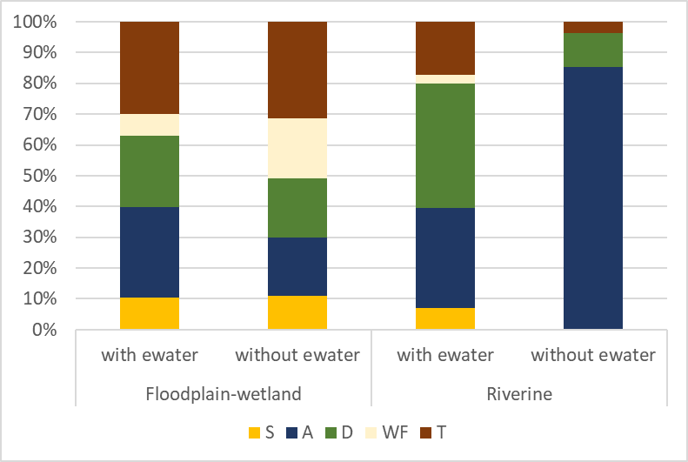

Figure C.3 Proportional cover of plant functional groups at sample points that did and did not receive environmental water in 2019–20

The water plant functional groups are: S (submerged); A (amphibious); D (damp); WF (woody flood dependent); T (terrestrial) – see Table 3.4

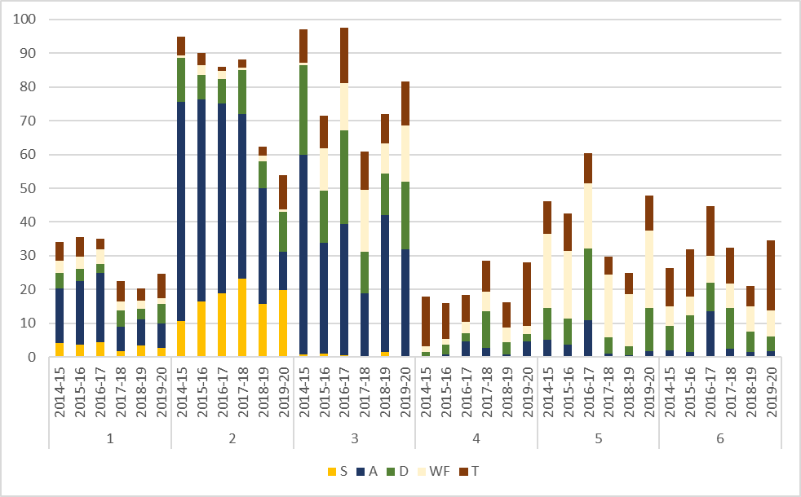

Figure C.4 Standardised cover of plant functional groups in each of the 6 hydrological groups over 2014–20

For details of the hydrological groups, see Chapter 4. The plant functional groups are: S (submerged); A (amphibious); D (damp); WF (woody flood dependent); T (terrestrial) – see Table 3.4

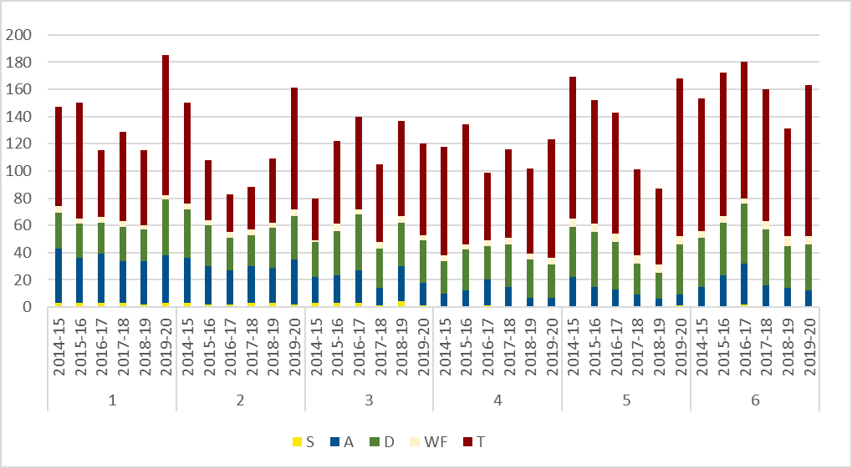

Figure C.5 Species numbers of functional groups in each of the 6 hydrological groups over 2014–20

For details of the hydrological groups, see Chapter 4. The plant functional groups are: S (submerged); A (amphibious); D (damp); WF (woody flood dependent); T (terrestrial) – see Table 3.4

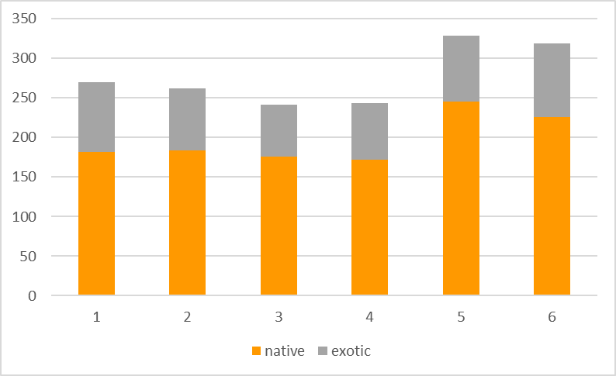

Figure C.6 Native and exotic species numbers in each of the 6 hydrological groups pooled across 2014–20

For details of the hydrological groups, see Chapter 4

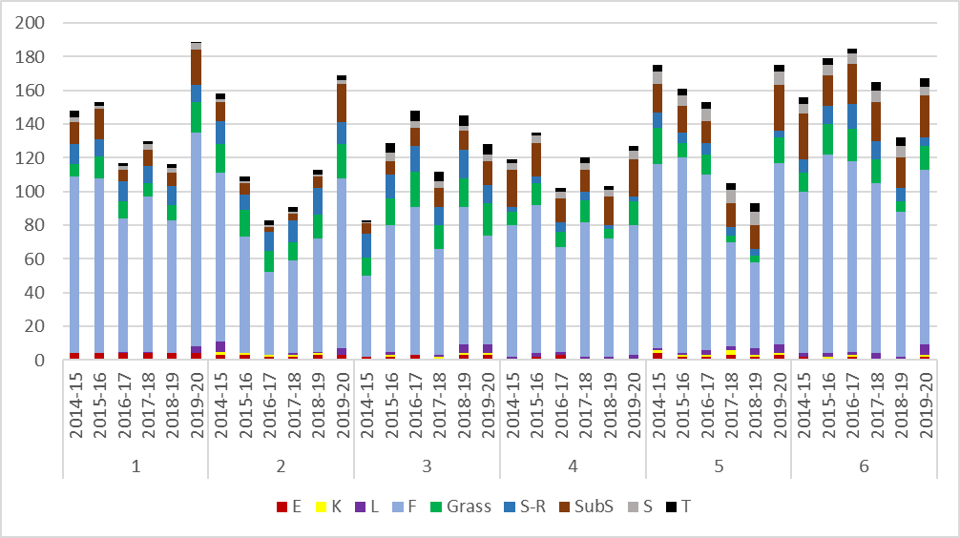

Figure C.7 Species numbers per growth forms in different hydrological groups pooled during 2014–20

For details of the hydrological groups, see Chapter 4. The growth forms are: E (ferns and fern allies); K (epiphytes); L (vines); F (forbs); grasses; S-R (sedges and rushes); SubS (sub-shrubs); S (shrubs) and T (trees) – see Table 3.5

Individual functional group responses

* 1. Patterns within individual functional groups

Responses over time within individual functional groups have been assessed to highlight the response of different groupings of species (Figure D.1) that play distinct structural and functional roles in river-floodplain environments.

Submerged species (S): Submerged species grow under water and are reliant on the presence of water to survive. Submerged species are rarely recorded in the data, with only 3 submerged species present in the dataset: *Chara* and *Nitella,* which are both charophytes, and *Vallisneria australis*. The observed pattern in submerged species is being driven largely by the presence and cover of Chara in the Edward/Kolety–Wakool river systems. Comparatively high cover was recorded in 2015–16, which was largely wiped out in 2016–17 (possibly due to flooding and blackwater), with cover slowly building back up over 2017–18, 2018–19 and particularly 2019–20. The overall number and cover of submerged species in the vegetation dataset is very low.

Submerged-emergent species (Se): This functional group includes species that are tall and emerge above the water but like to have their roots in permanent or near-permanent water. There are 5 species present in this functional group: *Bolboschoenus fluviatilis, Eleocharis sphacelata, Phragmites australis, Typha domingensis* and *Typha* spp.The increase in 2019–20 is likely attributed to: 2 new sample points – one in the Lachlan River System (GCS, *Phragmites australis*) and one in the Gwydir River System (GWY_ODBOLB, *B. fluviatilis*); and increased cover at 3 existing sample points – Goulburn River (McCoys Bridge, *P. australis*, increase in cover on previous years) and the Gwydir River System (GWY_ODR1 and GWY_ODR3, *E. sphacelata*, increase in cover on previous years).

Amphibious-responder floating (ARf): This group consists of species that float on the surface of the water or have floating leaves. They require the year-round presence of free water. Many of these can survive and complete their life cycle stranded on the mud, but they reach maximum biomass growing in ‘open’ water all year round. There are 15 species included in this functional group (*Azolla, A. rubra, Landoltia punctata, Lemna, L. disperma, L. minor, Ludwigia peploides, Marsilea, M. costulifera, M. drummondii, Nymphoides crenata, Ottelia, O. ovalifolia, Spirodela polyrhiza* and *Utricularia gibba*).

There has been a decrease in *A. rubra, Lemna, L. disperma* and *L. minor* since 2018*. Ludwigia peploides, M. drummondii* and *O. ovalifolia* cover in 2019–20 was lower than in 2014–15, 2015–16 and 2016–17, but > in 2017–18 and 2018–19 (for *L. peploides*), 2018–19 (for *Marsilea*) and > 2017–18 and the same as 2018–19 (for *Ottelia*). *Nymphoides crenata* was not recorded in 2019–20 (but was in all other years) and *Utricularia gibba* has been declining since 2014–15 and was not recorded in either 2018–19 or 2019–20.

*Ottelia ovalifolia* was recorded in the Edward/Kolety–Wakool in 2015–16 (3 sample points) but has not been seen in any other year. *Ottelia ovalifolia* was also recorded in the Gwydir in 2014–15 (2 sample points), 2015–16 (1 sample point) and 2016–17 (2 sample points are not the same 2 as in 2014–15 and 2015–16) but has not been seen since 2016–17. In the Murrumbidgee River System, *O. ovalifolia* was recorded every year across 6 sample points in total: 2014–15 (4 sample points), 2015–16 (4 sample points), 2016–17 (3 sample points), 2017–18 (1 sample point), 2018–19 and 2019–20 (2 sample points each; though not the same).

*Nymphoides crenata* has been recorded from both the Gwydir and Murrumbidgee river systems. In the Gwydir River System, it was recorded in 2014–15 (3 sample points) and 2015–16 (1 sample point) but has not been seen since then. In the Murrumbidgee River System, it was recorded in 2014–15 (3 sample points), 2015–16, 2016–17, 2017–18 and 2018–19 (2 sample points each year; though not the same). The species was not recorded in 2019–20.

*Utricularia gibba* has been recorded only in the Murrumbidgee River System and was recorded in 2014–15 (4 sample points), 2015–16 (3 sample points), 2016–17 (2 sample points) and 2017–18 (1 sample point). It was not recorded from any sample points in 2018–19 or 2019–20.

There are some potentially concerning patterns of decline within the ARf functional group which warrant further investigation.

Amphibious-responder plastic (ARp): This group consists of species that respond to inundation with changes to their morphology (e.g. rapid elongation of stems). There are 20 species in this functional group and there has been a general pattern of decline from 2014–15 to 2019–20. Species in this functional group have been recorded from all Selected Areas, with high species richness in the Murrumbidgee River System (15 species), Lachlan River System (9 species), Gwydir River System (8 species), and Edward/Kolety–Wakool river systems (5 species), with the Junction of the Warrego and Darling rivers, Goulburn River and Lower Murray River each recording 2 species. The declining pattern is strongly driven by a decline in *Paspalum distichum* in the Gwydir.

Amphibious-tolerator low-growing (ATl): This group consists of species that tolerate inundation and are low growing in their growth form. Seven species have been recorded in this functional group: *Callitriche sonderi, Cycnogeton, C. dubium, C. procerum, Limosella, L. australis* and *Marsilea hirsuta*. The cover of *C. procerum* in the Murrumbidgee River System increased in 2015–16 and has had limited occurrence and cover since then. *Limosella* had relatively high cover in 2015–16 in the Edward/Kolety–Wakool River System but only limited cover in 2017–18 to 2019–20. *Callitriche sonderi* was recorded only in 2016–17 in the Lachlan River System following flooding.

Amphibious-tolerator emergent (Ate): This group consists of species that tolerate inundation by having part of their structure emerge above the waterline. There are 49 species in this functional group. The cover and distribution of *Eleocharis plana* in the Gwydir River System contributes substantially to the patterns observed, along with notable increases in *E. acuta* and *E. pallens* in 2016–17, particularly in the Lachlan River System (*E. acuta*) and the Junction of the Warrego andDarling rivers (*E. pallens*).

Terrestrial-damp (Tda): Species in this group germinate and establish on saturated or damp ground, but cannot tolerate flooding in the vegetative state. As such, they can persist throughout the environment in dry puddles and drains or where rainfall is sufficient. There are 140 species in this functional group. Species such as *Centipeda cunninghamii, Alternanthera denticulata, Paspalidium jubiflorum* and the exotic *Phyla canescens* contribute to a large proportion of the overall cover of Tda.

Terrestrial-dry (Tdr): Species in this group do not require inundation. This is the largest functional group and contains 407 species. There was a general decrease in the cover of Tdr species from 2014–15 to 2018–19; however, there was a notable increase in 2019–20. This is explained in part by an increase in the cover of the exotic *Medicago polymorpha*; however, hundreds of species contribute to the observed patterns. The largest number of species were recorded in the Tdr functional group in 2019–20.

(W-W): This functional group contains 4 species: Acacia stenophylla, Duma florulenta, Eucalyptus camaldulensis and E. coolabah. It is driven by slight changes in different species in different years.

(W-RF): This functional group contains 6 species: Acacia dealbata, A. salicina, A. victoriae, Callistemon sieberi, Chenopodium nitrariaceum and Eucalyptus largiflorens. There was a gradual decrease in C. nitrariaceum from 2014–15 to 2016–17 with an increase in 2018 that subsequently declined again in 2018–19 and 2019–20. There was a notable increase in A. dealbata in 2018 in the Goulburn River.

(W-O): The woody-other functional group contains 13 species. There was a general decrease in the cover of the exotic Lycium ferocissimum from 2014–15 to 2019–20 (lowest in 2017–18) and variable cover of Casuarina cristata recorded across all years. There was a general increase in the cover of Vachellia farnesiana in the Gwydir River System from 2014–15 to 2019–20.

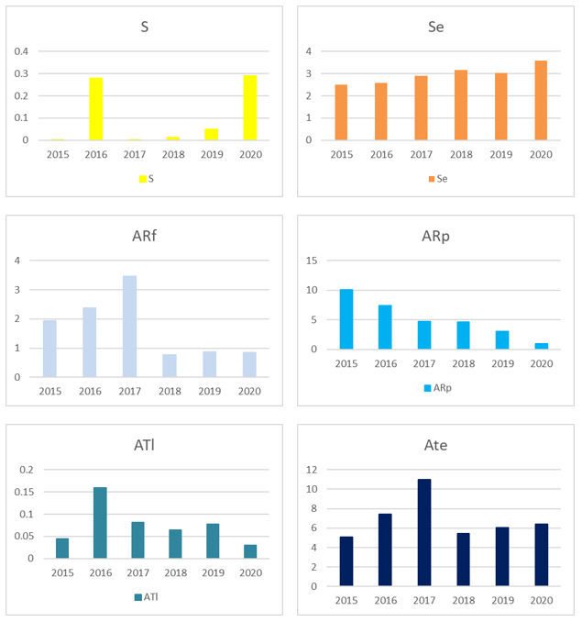

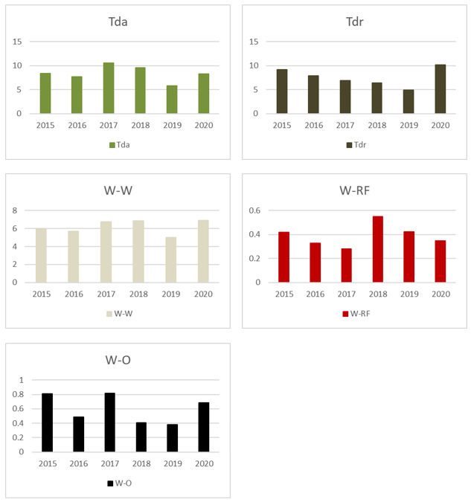

Figure D.1 Standardised proportional cover of individual functional groups across all Selected Areas for each year

Note that y-axis scales vary between the figures

Presence and absence of inundation for all floodplain–wetland sample points for each quarter per water year, 2014–20

Table E.1 Hydrological groups with environmental water via presence/absence of inundation for sample points for each quarter per water year, 2014–20

The Selected Area (SA) abbreviations are: GWY = Gwydir River System; WADA = Junction of the Warrego and Darling rivers; LACH= Lachlan River System; MUR = Murrumbidgee River System; EKW = Edward/Kolety–Wakool river systems; GLB = Goulburn River; LM = Lower Murray River

| SA | **Sample point** | **Hydrological group with ewater** | **2014–15** | | | | **2015–16** | | | | **2016–17** | | | | **2017–18** | | | | **2018–19** | | | | **2019–20** | | | |
| --- | --- | --- | --- | --- | --- | --- | --- | --- | --- | --- | --- | --- | --- | --- | --- | --- | --- | --- | --- | --- | --- | --- | --- | --- | --- | --- |
| Q3 | Q4 | Q1 | Q2 | Q3 | Q4 | Q1 | Q2 | Q3 | Q4 | Q1 | Q2 | Q3 | Q4 | Q1 | Q2 | Q3 | Q4 | Q1 | Q2 | Q3 | Q4 | Q1 | Q2 |
| LACH | Juanbung - P | 1 | 1 | 1 |  | 1 | 1 | 1 | 1 | 1 | 1 |  | 1 | 1 |  |  | 1 | 1 |  |  | 1 | 1 |  |  | 1 |  |
| Bunumburt - T | 1 |  | 1 |  |  | 1 | 1 | 1 | 1 | 1 | 1 | 1 | 1 | 1 | 1 | 1 | 1 | 1 | 1 | 1 | 1 |  |  |  |  |
| GCS - T | 1 |  |  |  | 1 | 1 |  | 1 | 1 | 1 | 1 | 1 | 1 | 1 | 1 | 1 | 1 | 1 |  | 1 | 1 | 1 |  | 1 |  |
| Juanbung - T | 1 | 1 | 1 |  | 1 | 1 | 1 | 1 | 1 | 1 | 1 | 1 | 1 | 1 | 1 | 1 | 1 | 1 | 1 | 1 | 1 | 1 | 1 | 1 |  |
| MUR | Eulimbah Swamp | 1 | 1 | 1 | 1 | 1 |  | 1 | 1 | 1 | 1 | 1 | 1 | 1 | 1 | 1 | 1 |  | 1 | 1 | 1 |  | 1 | 1 | 1 | 1 |
| Gooragool | 1 | 1 |  | 1 | 1 | 1 | 1 | 1 | 1 | 1 | 1 | 1 | 1 | 1 | 1 | 1 |  | 1 | 1 |  |  |  | 1 | 1 | 1 |
| Mercedes Swamp | 1 | 1 | 1 | 1 | 1 | 1 | 1 | 1 | 1 | 1 | 1 | 1 | 1 | 1 | 1 | 1 | 1 | 1 | 1 |  |  |  |  | 1 | 1 |
| Nap Nap Swamp | 1 | 1 | 1 |  |  |  | 1 |  |  | 1 | 1 | 1 | 1 | 1 | 1 | 1 |  | 1 | 1 | 1 | 1 | 1 | 1 | 1 | 1 |
| Piggery Lake | 1 |  | 1 | 1 | 1 | 1 | 1 |  |  | 1 | 1 | 1 | 1 |  |  |  |  | 1 | 1 | 1 | 1 | 1 | 1 | 1 | 1 |
| Telephone Creek | 1 | 1 | 1 | 1 |  |  | 1 | 1 | 1 | 1 |  |  |  | 1 | 1 | 1 | 1 | 1 | 1 | 1 | 1 | 1 | 1 | 1 | 1 |
| Two Bridges Swamp | 1 | 1 | 1 | 1 | 1 | 1 | 1 | 1 | 1 | 1 | 1 | 1 | 1 | 1 | 1 | 1 |  | 1 | 1 | 1 | 1 | 1 |  | 1 | 1 |
| Waugorah Lagoon | 1 | 1 | 1 |  | 1 |  | 1 | 1 | 1 | 1 | 1 | 1 | 1 | 1 | 1 | 1 | 1 | 1 | 1 | 1 | 1 | 1 | 1 | 1 |  |
| Yarradda Lagoon | 1 |  |  | 1 | 1 | 1 | 1 | 1 | 1 | 1 | 1 | 1 | 1 | 1 | 1 | 1 | 1 | 1 |  | 1 | 1 | 1 | 1 | 1 | 1 |
| GWY | Bunnor - 1 | 2 |  |  | 1 |  | 1 |  |  |  | 1 | 1 | 1 | 1 | 1 | 1 |  | 1 | 1 | 1 |  |  |  |  | 1 |  |
| Goddards Lease Ramsar - 1 | 2 |  |  | 1 |  | 1 |  |  |  |  | 1 |  |  | 1 | 1 |  |  | 1 |  |  |  |  |  | 1 |  |
| Lynworth - 1 | 2 |  |  | 1 |  | 1 |  |  |  | 1 | 1 | 1 | 1 |  |  |  | 1 | 1 | 1 |  |  |  |  |  |  |
| Lynworth - 3 | 2 |  |  | 1 |  | 1 |  |  |  | 1 | 1 | 1 |  |  |  |  | 1 | 1 | 1 |  |  |  |  |  |  |
| Munwonga - 1 | 2 |  |  | 1 |  | 1 |  |  |  | 1 | 1 | 1 | 1 | 1 | 1 |  | 1 | 1 | 1 |  |  |  |  |  | 1 |
| Old Dramana Ramsar - 1 | 2 |  | 1 | 1 |  | 1 |  | 1 |  | 1 | 1 | 1 | 1 |  |  |  |  | 1 | 1 |  |  |  |  | 1 |  |
| Old Dramana Ramsar - 2 | 2 |  |  | 1 |  | 1 |  | 1 |  |  | 1 | 1 | 1 |  |  |  |  | 1 | 1 |  |  |  |  | 1 |  |
| Old Dramana Ramsar - 3 | 2 |  | 1 | 1 | 1 |  |  | 1 |  |  | 1 | 1 | 1 | 1 | 1 | 1 |  |  | 1 |  |  |  |  | 1 |  |
| Westholme - 1 | 2 |  |  | 1 |  | 1 |  |  |  |  | 1 | 1 |  |  |  |  |  |  | 1 |  |  |  |  | 1 |  |
| LACH | Noonamah - P | 2 |  | 1 |  |  | 1 |  |  |  | 1 | 1 | 1 | 1 | 1 |  |  | 1 | 1 |  |  |  | 1 |  |  |  |
| MUR | Sunshower Lagoon | 2 |  |  |  |  | 1 | 1 |  |  | 1 | 1 | 1 | 1 | 1 | 1 | 1 | 1 |  | 1 |  |  |  |  | 1 | 1 |
| GWY | Bungunya 1-1 | 3 |  | 1 | 1 |  |  | 1 | 1 |  |  |  |  |  |  |  |  |  |  | 1 |  |  |  |  |  |  |
| Bungunya 1-2 | 3 |  | 1 | 1 |  |  | 1 | 1 |  |  |  |  |  |  |  |  |  |  | 1 |  |  |  |  |  |  |
| Coombah 1-2 | 3 |  | 1 | 1 |  |  | 1 | 1 |  | 1 |  |  |  | 1 |  |  |  |  | 1 | 1 |  |  | 1 |  |  |
| Valetta - 2 | 3 |  |  |  |  |  | 1 | 1 |  |  |  | 1 | 1 | 1 |  |  |  |  | 1 | 1 |  |  |  |  | 1 |
| Coombah 1-1 | 3 |  | 1 | 1 |  |  | 1 | 1 |  |  |  | 1 |  | 1 |  |  |  |  | 1 | 1 |  |  |  |  |  |
| Valletta - 1-1 | 3 |  | 1 | 1 |  |  | 1 | 1 |  |  |  | 1 | 1 | 1 |  |  |  |  | 1 | 1 |  |  |  | 1 |  |
| Valletta - 1-2 | 3 |  | 1 | 1 |  |  | 1 | 1 |  |  |  | 1 | 1 | 1 |  |  |  |  | 1 | 1 |  |  |  | 1 |  |
| Old Dromana Elders - 1 | 3 |  |  | 1 |  | 1 |  | 1 |  |  |  |  |  |  |  |  |  | 1 | 1 |  |  |  |  |  | 1 |
| Old Dromana Nursery -1 | 3 |  | 1 | 1 |  | 1 |  | 1 | 1 | 1 |  |  |  |  |  |  |  | 1 | 1 |  |  |  |  |  |  |
| LACH | Lake Ita - P | 4 |  |  |  |  |  |  |  | 1 | 1 | 1 | 1 | 1 |  |  |  |  |  |  |  |  |  |  |  |  |
| Lake Tarwong RRG - P | 4 |  |  |  |  |  |  |  | 1 | 1 | 1 | 1 | 1 | 1 |  |  |  |  |  |  |  |  |  |  |  |
| Moon Moon -P | 4 |  |  |  | 1 | 1 |  |  | 1 | 1 | 1 | 1 |  |  |  |  |  |  |  |  |  |  |  |  |  |
| Lake Marool - T | 4 |  |  |  | 1 | 1 |  |  | 1 | 1 | 1 | 1 |  |  |  |  |  |  |  |  |  |  |  |  |  |
| Lake Bullogal - T | 4 |  | 1 |  |  |  |  |  | 1 | 1 | 1 | 1 | 1 | 1 |  |  |  |  |  |  |  |  |  |  |  |
| Lake Tarwong - T | 4 |  |  |  |  |  |  |  | 1 | 1 | 1 | 1 | 1 | 1 | 1 |  |  |  |  |  |  |  |  |  |  |
| Murrumbidgal Swamp - T | 4 |  |  |  |  | 1 |  |  | 1 | 1 | 1 | 1 | 1 |  |  |  |  |  |  |  |  |  |  |  |  |
| Nooran Lake - T | 4 |  |  |  | 1 | 1 | 1 |  | 1 | 1 | 1 | 1 | 1 |  |  |  |  |  |  |  |  |  |  |  |  |
| Moon Moon - T | 4 |  |  |  | 1 | 1 | 1 |  | 1 | 1 | 1 | 1 | 1 |  |  |  |  |  |  |  |  |  |  |  |  |
| Open Lake Marool - T | 4 |  |  |  | 1 | 1 |  |  | 1 | 1 | 1 | 1 | 1 |  |  |  |  |  |  |  |  |  |  |  |  |
| Whealbah - T | 4 |  |  |  | 1 | 1 | 1 | 1 | 1 | 1 | 1 | 1 | 1 |  |  |  |  |  |  |  |  |  |  |  |  |
| MUR | McKennas Lagoon | 4 |  |  |  |  |  |  |  |  | 1 | 1 | 1 | 1 | 1 | 1 | 1 |  |  |  |  |  |  |  |  |  |
| LACH | Bunumburt - P | 4 |  |  |  |  | 1 |  |  | 1 | 1 | 1 | 1 | 1 |  | 1 | 1 | 1 | 1 |  |  |  |  |  |  |  |
| MUR | Avalon Swamp | 5 |  | 1 | 1 |  |  |  |  |  | 1 | 1 |  |  |  |  |  |  |  |  |  | 1 | 1 |  | 1 |  |
| WADA | WD_Veg - 1 | 5 |  |  |  |  |  | 1 |  |  |  | 1 |  |  |  |  |  |  |  |  |  | 1 |  |  |  | 1 |
| WD_Veg - 8 | 5 |  |  |  |  |  |  |  |  | 1 | 1 |  |  |  |  |  |  |  |  |  | 1 |  |  | 1 | 1 |
| WD_Veg - 2 | 5 |  |  |  |  |  |  |  |  | 1 | 1 |  |  |  |  |  |  |  |  |  | 1 |  |  | 1 | 1 |
| WD_Veg - 3 | 5 |  |  |  |  |  |  |  |  | 1 | 1 |  |  |  |  |  |  |  |  |  |  |  |  |  | 1 |
| WD_Veg - 4 | 5 |  |  |  |  |  |  |  |  | 1 | 1 | 1 |  |  |  |  |  |  |  |  |  |  |  |  | 1 |
| WD_Veg - 5 | 5 |  |  |  |  |  |  |  |  | 1 | 1 | 1 |  |  |  |  |  |  |  |  |  |  | 1 | 1 | 1 |
| WD_Veg - 6 | 5 |  | 1 | 1 |  |  | 1 |  |  | 1 | 1 |  |  |  |  |  |  |  |  |  | 1 |  |  | 1 | 1 |
| WD_Veg - 7 | 5 |  |  | 1 |  | 1 | 1 |  | 1 | 1 | 1 |  |  |  | 1 | 1 |  |  |  |  | 1 |  |  | 1 | 1 |
| GWY | Old Dramana Nursery - 2 | 6 |  |  |  |  | 1 |  | 1 | 1 | 1 |  |  |  |  |  |  |  |  |  |  |  |  |  |  |  |
| Westholme coolibah | 6 |  |  | 1 |  | 1 |  | 1 | 1 |  | 1 |  |  |  |  |  |  |  |  |  |  |  |  |  |  |
| LACH | Lake Tarwong BBX - P | 6 |  |  |  |  |  |  |  | 1 | 1 | 1 |  |  |  |  |  |  |  |  |  |  |  |  |  |  |
| Booligal - P | 6 |  |  |  |  |  |  |  | 1 | 1 | 1 |  |  |  |  |  |  |  |  |  |  |  |  |  |  |
| Lake Ita Inlet - P | 6 |  |  |  |  |  |  |  | 1 | 1 | 1 |  |  |  |  |  |  |  |  |  |  |  |  |  |  |
| Hazelwood - P | 6 |  |  |  |  |  |  |  | 1 | 1 | 1 |  |  |  |  |  |  |  |  |  |  |  |  |  |  |
| Clear Lake - P | 6 |  |  |  |  |  |  |  |  | 1 | 1 |  |  |  |  |  |  |  |  |  |  |  |  |  |  |
| Nooran Lake - P | 6 |  |  |  |  |  |  |  |  | 1 | 1 |  |  |  |  |  |  |  |  |  |  |  |  |  |  |
| Lake Marool - P | 6 |  |  |  |  |  |  |  |  |  |  |  |  |  |  |  |  |  |  |  |  |  |  |  |  |
| Murrumbidgal Swamp - P | 6 |  |  |  |  | 1 |  |  |  | 1 | 1 |  |  |  |  |  |  |  |  |  |  |  |  |  |  |
| Tom's Lake - P | 6 |  |  |  | 1 | 1 |  |  | 1 | 1 |  |  |  |  |  |  |  |  |  |  |  |  |  |  |  |
| The Ville - P | 6 |  |  |  |  |  |  |  | 1 | 1 |  |  |  |  |  |  |  |  |  |  |  |  |  |  |  |
| Whealbah - P | 6 |  |  |  | 1 |  |  |  | 1 | 1 | 1 |  |  |  |  |  |  |  |  |  |  |  |  |  |  |
| Booligal - T | 6 |  |  |  | 1 | 1 |  | 1 | 1 | 1 |  |  |  |  |  |  |  |  |  |  |  |  |  |  |  |
| Hazelwood - T | 6 |  | 1 |  | 1 | 1 | 1 | 1 | 1 | 1 | 1 |  |  |  |  |  |  |  |  |  |  |  |  |  |  |
| The Ville - T | 6 |  |  |  |  | 1 |  |  | 1 | 1 | 1 |  |  |  |  |  |  |  |  |  |  |  |  |  |  |
| Lake Bullogal - P | 6 |  |  |  |  |  |  |  | 1 | 1 | 1 | 1 |  |  |  |  |  |  |  |  |  |  |  |  |  |

Table E.2 Hydrological groups without environmental water via presence/absence of inundation for sample points for each quarter per water year 2014–20

The Selected Area (SA) abbreviations are: GWY = Gwydir River System; WADA = Junction of the Warrego and Darling rivers; LACH= Lachlan River System; MUR = Murrumbidgee River System; EKW = Edward/Kolety–Wakool river systems; GLB = Goulburn River; LM = Lower Murray River

| **SA** | **Sample point** | **Hydrological group without ewater** | **2014-15** | | | | **2015-16** | | | | | **2016-17** | | | | | **2017-18** | | | | | **2018-19** | | | | | **2019-20** | | | | |
| --- | --- | --- | --- | --- | --- | --- | --- | --- | --- | --- | --- | --- | --- | --- | --- | --- | --- | --- | --- | --- | --- | --- | --- | --- | --- | --- | --- | --- | --- | --- | --- |
| Q3 | Q4 | Q1 | Q2 | | Q3 | Q4 | Q1 | Q2 | | Q3 | Q4 | Q1 | Q2 | | Q3 | Q4 | Q1 | Q2 | | Q3 | Q4 | Q1 | Q2 | | Q3 | Q4 | Q1 | Q2 |
| LACH | Bunumburt - T | 3 |  |  |  |  | |  |  |  |  | | 1 | 1 | 1 | 1 | | 1 | 1 | 1 | 1 | | 1 | 1 | 1 | 1 | |  |  |  |  |
| GWY | Bunnor - 1 | 4 |  |  |  |  | | 1 |  |  |  | | 1 | 1 | 1 | 1 | |  |  |  |  | |  |  |  |  | |  |  | 1 |  |
| Old Dramana Ramsar - 1 | 4 |  |  |  |  | |  |  |  |  | | 1 | 1 | 1 | 1 | |  |  |  |  | |  |  |  |  | |  |  | 1 |  |
| LACH | Bunumburt - P | 4 |  |  |  |  | |  |  |  | 1 | | 1 | 1 | 1 | 1 | |  | 1 | 1 | 1 | | 1 |  |  |  | |  |  |  |  |
| GCS - T | 4 |  |  |  |  | |  |  |  |  | | 1 | 1 | 1 | 1 | | 1 | 1 |  |  | |  |  |  |  | |  |  |  |  |
| Juanbung - P | 4 |  |  |  |  | |  |  |  |  | | 1 |  | 1 | 1 | |  |  |  |  | |  |  |  |  | |  |  |  |  |
| Juanbung - T | 4 |  |  |  |  | |  |  |  |  | | 1 | 1 | 1 | 1 | | 1 | 1 |  |  | |  |  |  |  | |  |  |  |  |
| Lake Bullogal - T | 4 |  | 1 |  |  | |  |  |  | 1 | | 1 | 1 | 1 | 1 | | 1 |  |  |  | |  |  |  |  | |  |  |  |  |
| Lake Ita - P | 4 |  |  |  |  | |  |  |  | 1 | | 1 | 1 | 1 | 1 | |  |  |  |  | |  |  |  |  | |  |  |  |  |
| Lake Tarwong - T | 4 |  |  |  |  | |  |  |  | 1 | | 1 | 1 | 1 | 1 | | 1 | 1 |  |  | |  |  |  |  | |  |  |  |  |
| Lake Tarwong RRG - P | 4 |  |  |  |  | |  |  |  | 1 | | 1 | 1 | 1 | 1 | | 1 |  |  |  | |  |  |  |  | |  |  |  |  |
| Moon Moon - T | 4 |  |  |  |  | |  |  |  | 1 | | 1 | 1 | 1 | 1 | |  |  |  |  | |  |  |  |  | |  |  |  |  |
| Murrumbidgal Swamp - T | 4 |  |  |  |  | |  |  |  | 1 | | 1 | 1 | 1 | 1 | |  |  |  |  | |  |  |  |  | |  |  |  |  |
| Noonamah - P | 4 |  |  |  |  | |  |  |  |  | | 1 | 1 | 1 | 1 | | 1 |  |  |  | |  |  |  |  | |  |  |  |  |
| Nooran Lake - T | 4 |  |  |  |  | |  |  |  | 1 | | 1 | 1 | 1 | 1 | |  |  |  |  | |  |  |  |  | |  |  |  |  |
| Open Lake Marool - T | 4 |  |  |  |  | |  |  |  | 1 | | 1 | 1 | 1 | 1 | |  |  |  |  | |  |  |  |  | |  |  |  |  |
| Whealbah - T | 4 |  |  |  |  | |  |  |  |  | | 1 | 1 | 1 | 1 | |  |  |  |  | |  |  |  |  | |  |  |  |  |
| WADA | WD_Veg - 1 | 5 |  |  |  |  | |  | 1 |  |  | |  |  |  |  | |  |  |  |  | |  |  |  | 1 | |  |  |  | 1 |
| WD_Veg - 3 | 5 |  |  |  |  | |  |  |  |  | |  |  |  |  | |  |  |  |  | |  |  |  |  | |  |  |  | 1 |
| WD_Veg - 4 | 5 |  |  |  |  | |  |  |  |  | |  |  |  |  | |  |  |  |  | |  |  |  |  | |  |  |  | 1 |
| WD_Veg - 5 | 5 |  |  |  |  | |  |  |  |  | |  |  |  |  | |  |  |  |  | |  |  |  |  | |  | 1 | 1 | 1 |
| WD_Veg - 6 | 5 |  | 1 | 1 |  | |  | 1 |  |  | |  |  |  |  | |  |  |  |  | |  |  |  | 1 | |  |  | 1 | 1 |
| WD_Veg - 7 | 5 |  |  | 1 |  | | 1 | 1 |  | 1 | | 1 | 1 |  |  | |  | 1 | 1 |  | |  |  |  | 1 | |  |  | 1 | 1 |
| WD_Veg - 8 | 5 |  |  |  |  | |  |  |  |  | |  |  |  |  | |  |  |  |  | |  |  |  | 1 | |  |  | 1 | 1 |
| WD_Veg - 2 | 5 |  |  |  |  | |  |  |  |  | |  |  |  |  | |  |  |  |  | |  |  |  | 1 | |  |  | 1 | 1 |
| GWY | Valletta - 2 | 5 |  |  |  |  | |  |  |  |  | |  |  |  |  | |  |  |  |  | |  |  |  |  | |  |  |  | 1 |
| MUR | Avalon Swamp | 6 |  | 1 | 1 |  | |  |  |  |  | | 1 | 1 |  |  | |  |  |  |  | |  |  |  |  | |  |  |  |  |
| Eulimbah Swamp | 6 |  |  |  |  | |  |  |  |  | | 1 | 1 | 1 |  | |  |  |  |  | |  |  |  |  | |  |  |  |  |
| Gooragool | 6 |  |  |  |  | |  |  |  |  | | 1 | 1 | 1 |  | |  |  |  |  | |  |  |  |  | |  |  |  |  |
| McKennas Lagoon | 6 |  |  |  |  | |  |  |  |  | | 1 | 1 | 1 |  | |  |  |  |  | |  |  |  |  | |  |  |  |  |
| Mercedes Swamp | 6 |  |  |  |  | |  |  |  |  | | 1 | 1 | 1 |  | |  |  |  |  | |  |  |  |  | |  |  |  |  |
| Nap Nap Swamp | 6 |  |  |  |  | |  |  |  |  | | 1 | 1 | 1 |  | |  |  |  |  | |  |  |  |  | |  |  |  |  |
| Piggery Lake | 6 |  |  |  |  | |  |  |  |  | | 1 | 1 | 1 |  | |  |  |  |  | |  |  |  |  | |  |  |  |  |
| Sunshower Lagoon | 6 |  |  |  |  | |  |  |  |  | | 1 | 1 | 1 |  | |  |  |  |  | |  |  |  |  | |  |  |  |  |
| Telephone Creek | 6 |  |  |  |  | |  |  |  |  | | 1 | 1 |  |  | |  |  |  |  | |  |  |  |  | |  |  |  |  |
| Two Bridges Swamp | 6 |  |  |  |  | |  |  |  |  | | 1 | 1 | 1 |  | |  |  |  |  | |  |  |  |  | |  |  |  |  |
| Waugorah Lagoon | 6 |  |  |  |  | |  |  |  |  | | 1 | 1 | 1 |  | |  |  |  |  | |  |  |  |  | |  |  |  |  |
| Yarradda Lagoon | 6 |  |  |  |  | |  |  |  |  | | 1 | 1 | 1 |  | |  |  |  |  | |  |  |  |  | |  |  |  |  |
| GWY | Bungunya 1-1 | 6 |  |  |  |  | |  |  |  |  | |  |  |  |  | |  |  |  |  | |  |  |  |  | |  |  |  |  |
| Bungunya 1-2 | 6 |  |  |  |  | |  |  |  |  | |  |  |  |  | |  |  |  |  | |  |  |  |  | |  |  |  |  |
| Coombah 1-1 | 6 |  |  |  |  | |  |  |  |  | |  |  | 1 |  | |  |  |  |  | |  |  |  |  | |  |  |  |  |
| Coombah 1-2 | 6 |  |  |  |  | |  |  |  |  | |  |  |  |  | |  |  |  |  | |  |  |  |  | |  | 1 |  |  |
| Goddards Lease Ramsar - 1 | 6 |  |  |  |  | | 1 |  |  |  | |  |  |  |  | |  |  |  |  | |  |  |  |  | |  |  | 1 |  |
| Lynworth - 1 | 6 |  |  |  |  | | 1 |  |  |  | |  |  |  |  | |  |  |  |  | |  |  |  |  | |  |  |  |  |
| Lynworth - 3 | 6 |  |  |  |  | | 1 |  |  |  | |  |  |  |  | |  |  |  |  | |  |  |  |  | |  |  |  |  |
| Munwonga - 1 | 6 |  |  |  |  | | 1 |  |  |  | |  |  |  |  | |  |  |  |  | |  |  |  |  | |  |  |  | 1 |
| Old Dramana Nursery - 2 | 6 |  |  |  |  | |  |  |  | 1 | | 1 |  |  |  | |  |  |  |  | |  |  |  |  | |  |  |  |  |
| Old Dramana Ramsar - 2 | 6 |  |  |  |  | |  |  |  |  | |  |  |  |  | |  |  |  |  | |  |  |  |  | |  |  | 1 |  |
| Old Dramana Ramsar - 3 | 6 |  |  |  |  | |  |  |  |  | |  |  |  |  | |  |  |  |  | |  |  |  |  | |  |  | 1 |  |
| Old Dromana Elders - 1 | 6 |  |  |  |  | | 1 |  | 1 |  | |  |  |  |  | |  |  |  |  | |  |  |  |  | |  |  |  | 1 |
| Old Dromana Nursery -1 | 6 |  |  |  |  | | 1 |  | 1 |  | |  |  |  |  | |  |  |  |  | |  |  |  |  | |  |  |  |  |
| Valletta - 1 | 6 |  |  |  |  | |  |  |  |  | |  |  |  |  | |  |  |  |  | |  |  |  |  | |  |  | 1 |  |
| Valletta - 1 | 6 |  |  |  |  | |  |  |  |  | |  |  |  |  | |  |  |  |  | |  |  |  |  | |  |  | 1 |  |
| Westholme - 1 | 6 |  |  |  |  | |  |  |  |  | |  |  |  |  | |  |  |  |  | |  |  |  |  | |  |  | 1 |  |
| Westholme coolibah | 6 |  |  |  |  | |  |  |  |  | |  |  |  |  | |  |  |  |  | |  |  |  |  | |  |  |  |  |
| LACH | Booligal - P | 6 |  |  |  |  | |  |  |  | 1 | | 1 | 1 |  |  | |  |  |  |  | |  |  |  |  | |  |  |  |  |
| Booligal - T | 6 |  |  |  |  | |  |  |  |  | | 1 |  |  |  | |  |  |  |  | |  |  |  |  | |  |  |  |  |
| Clear Lake - P | 6 |  |  |  |  | |  |  |  |  | | 1 | 1 |  |  | |  |  |  |  | |  |  |  |  | |  |  |  |  |
| Hazelwood - P | 6 |  |  |  |  | |  |  |  | 1 | | 1 | 1 |  |  | |  |  |  |  | |  |  |  |  | |  |  |  |  |
| Hazelwood - T | 6 |  | 1 |  |  | |  |  |  |  | | 1 | 1 |  |  | |  |  |  |  | |  |  |  |  | |  |  |  |  |
| Lake Bullogal - P | 6 |  |  |  |  | |  |  |  | 1 | | 1 | 1 | 1 |  | |  |  |  |  | |  |  |  |  | |  |  |  |  |
| Lake Ita Inlet - P | 6 |  |  |  |  | |  |  |  | 1 | | 1 | 1 |  |  | |  |  |  |  | |  |  |  |  | |  |  |  |  |
| Lake Marool - P | 6 |  |  |  |  | |  |  |  |  | |  |  |  |  | |  |  |  |  | |  |  |  |  | |  |  |  |  |
| Lake Marool - T | 6 |  |  |  |  | |  |  |  |  | | 1 | 1 | 1 |  | |  |  |  |  | |  |  |  |  | |  |  |  |  |
| Moon Moon - P | 6 |  |  |  |  | |  |  |  |  | | 1 | 1 | 1 |  | |  |  |  |  | |  |  |  |  | |  |  |  |  |
| Murrumbidgal Swamp - P | 6 |  |  |  |  | |  |  |  |  | | 1 | 1 |  |  | |  |  |  |  | |  |  |  |  | |  |  |  |  |
| Nooran Lake - P | 6 |  |  |  |  | |  |  |  |  | | 1 | 1 |  |  | |  |  |  |  | |  |  |  |  | |  |  |  |  |
| Lake Tarwong BBX - P | 6 |  |  |  |  | |  |  |  | 1 | | 1 | 1 |  |  | |  |  |  |  | |  |  |  |  | |  |  |  |  |
| The Ville - P | 6 |  |  |  |  | |  |  |  |  | | 1 |  |  |  | |  |  |  |  | |  |  |  |  | |  |  |  |  |
| The Ville - T | 6 |  |  |  |  | |  |  |  | 1 | | 1 | 1 |  |  | |  |  |  |  | |  |  |  |  | |  |  |  |  |
| Tom's Lake - P | 6 |  |  |  |  | |  |  |  |  | | 1 |  |  |  | |  |  |  |  | |  |  |  |  | |  |  |  |  |
| Whealbah - P | 6 |  |  |  |  | |  |  |  |  | | 1 | 1 |  |  | |  |  |  |  | |  |  |  |  | |  |  |  |  |

Plant species recorded in the 2014–20 Flow-MER dataset and listed under national (EPBC Act) or state-based (New South Wales, South Australian or Victorian) rare and threatened species lists

Table F.1 Plant species recorded in the 2014–2020 Flow-MER dataset that are listed under national (EPBC Act) or state-based (New South Wales, South Australian or Victorian) rare and threatened species lists

Records from Selected Areas are marked with an x. EPBC Act = Environment Protection and Biodiversity Conservation Act 1999; FFG = Victorian Flora and Fauna Guarantee Act 1988; DELWP = Victorian Department of Environment, Land, Water and Planning; WADA = Junction of the Warrego and Darling rivers; GWY: Gwydir River System; LACH – Lachlan River System; MUR = Murrumbidgee River System; EKW = Edward/Kolety–Wakool river systems; GLB = Goulburn River; LM = Lower Murray.

Where the record invokes the listing (i.e. the species is nationally listed or the record is within the state of listing) the cell is blue

| Species | EPBC Act | NSW | South Aust. | FFG | Vic DELWP | WADA | GWY | LACH | MUR | EKW | GLB | LM |
| --- | --- | --- | --- | --- | --- | --- | --- | --- | --- | --- | --- | --- |
| Nationally listed | | | | | | | | | | | | |
| *Brachyscome papillosa* | Vulnerable | Vulnerable |  |  |  |  |  | x | x |  |  |  |
| *Lepidium hyssopifolium* | Endangered | Endangered |  | Listed | Endangered | x | x | x |  |  |  |  |
| State listed | | | | | | | | | | | | |
| *Abutilon malvifolium* |  |  |  |  | Endangered | x | x |  |  |  |  |  |
| *Abutilon otocarpum* |  |  |  |  | Vulnerable | x |  |  |  |  |  |  |
| *Alternanthera nodiflora* |  |  |  |  | K-poorly known | x |  | x | x |  |  |  |
| *Ammannia multiflora* |  |  |  |  | Vulnerable | x | x |  | x | x |  | x |
| *Arabidella nasturtium* |  |  |  |  | K-poorly known |  |  | x |  |  |  |  |
| *Asperula gemella* |  |  |  |  | Rare | x | x | x |  |  |  |  |
| *Atriplex angulata* |  |  |  | Listed | Endangered | x |  |  |  |  |  |  |
| *Atriplex holocarpa* |  |  |  | Listed | Vulnerable |  |  | x | x |  |  |  |
| *Atriplex pseudocampanulata* |  |  |  |  | Rare | x |  | x | x |  |  |  |
| *Atriplex spinibractea* |  |  |  |  | Endangered | x |  |  |  |  |  |  |
| *Bergia trimera* |  |  |  |  | Vulnerable | x |  | x |  |  |  |  |
| *Berula erecta* |  |  |  |  | K-poorly known |  |  |  | x |  |  |  |
| *Bolboschoenus fluviatilis* |  |  |  |  | K-poorly known |  | x | x |  |  |  |  |
| *Brachyscome melanocarpa* |  |  | Vulnerable |  | Endangered | x |  |  |  |  |  |  |
| *Callistemon brachyandrus* |  |  | Rare |  | Rare |  |  |  |  |  |  | x |
| *Callitriche sonderi* |  |  | Rare |  |  |  |  | x |  |  |  |  |
| *Callitriche umbonata* |  |  | Vulnerable |  | Rare |  |  |  | x |  |  |  |
| *Calocephalus sonderi* |  |  | Rare |  |  |  |  | x |  |  |  |  |
| *Calotis cuneifolia* |  |  |  |  | Rare | x |  |  | x |  |  |  |
| *Calotis lappulacea* |  |  | Rare |  | Rare | x |  |  |  |  |  |  |
| *Calotis scapigera* |  |  | Rare |  |  |  | x | x | x |  | x |  |
| *Centipeda pleiocephala* |  |  |  |  | Endangered |  | x |  |  |  |  |  |
| *Chloris ventricosa* |  |  |  |  | Vulnerable |  | x |  |  |  |  |  |
| *Commelina cyanea* |  |  |  |  | Endangered |  | x |  |  |  |  |  |
| *Convolvulus graminetinus* |  |  |  |  | Endangered | x | x |  |  |  |  |  |
| *Craspedia haplorrhiza* |  |  |  | Listed | K-poorly known | x |  |  |  |  |  |  |
| *Crinum flaccidum* |  |  |  | Listed | Vulnerable | x | x |  |  |  |  |  |
| *Cullen australasicum* |  |  |  | Listed | Endangered |  |  | x |  |  |  |  |
| *Cullen cinereum* |  |  |  | Listed | Endangered |  |  | x |  |  |  |  |
| *Cullen tenax* |  |  |  | Listed | Endangered |  | x |  |  |  |  |  |
| *Cuscuta australis* |  |  |  |  | K-poorly known |  |  |  |  |  | x |  |
| *Cyperus bifax* |  |  | Rare |  | Vulnerable |  | x | x |  |  |  |  |
| *Cyperus concinnus* |  |  | Rare |  | Vulnerable |  | x |  |  |  |  |  |
| *Cyperus pygmaeus* |  |  |  |  | Vulnerable |  |  |  | x | x |  |  |
| *Dactyloctenium radulans* |  |  |  |  | Rare | x | x |  |  |  |  |  |
| *Dentella minutissima* |  | Endangered |  |  |  | x |  |  |  |  |  |  |
| *Digitaria ammophila* |  |  |  |  | Vulnerable | x |  |  |  |  |  |  |
| *Elatine gratioloides* |  |  | Rare |  |  |  |  |  | x | x | x |  |
| *Eleocharis pallens* |  |  |  |  | K-poorly known | x | x |  | x |  |  |  |
| *Eleocharis plana* |  |  | Rare |  | Vulnerable | x | x | x | x |  |  |  |
| *Eragrostis australasica* |  |  |  |  | Vulnerable | x |  | x | x |  |  |  |
| *Eragrostis lacunaria* |  |  | Rare |  | Vulnerable |  | x |  |  |  |  |  |
| *Eragrostis leptostachya* |  |  |  |  | K-poorly known | x |  |  |  |  |  |  |
| *Eragrostis setifolia* |  |  |  |  | Vulnerable | x |  | x |  |  |  |  |
| *Eremophila debilis* |  |  |  |  | Endangered |  | x |  |  |  |  |  |
| *Eriochloa crebra* |  |  |  |  | K-poorly known | x | x |  |  |  |  |  |
| *Eryngium paludosum* |  |  |  |  | Vulnerable | x |  |  |  |  |  |  |
| *Eryngium rostratum* |  |  | Vulnerable |  |  | x |  |  |  |  |  |  |
| *Geijera parviflora* |  |  | Rare | Listed | Endangered |  | x |  |  |  |  |  |
| *Glycine tabacina* |  |  | Vulnerable |  |  | x | x |  |  |  |  |  |
| *Goodenia heteromera* |  |  | Rare |  |  | x |  | x | x |  |  |  |
| *Gratiola pedunculata* |  |  | Rare |  | K-poorly known |  | x |  |  |  |  |  |
| *Isolepis australiensis* |  |  |  |  | K-poorly known |  |  | x |  |  |  | x |
| *Juncus amabilis* |  |  | Vulnerable |  |  |  |  |  |  |  | x |  |
| *Lepidium fasciculatum* |  |  |  |  | K-poorly known |  |  | x |  |  |  |  |
| *Lepidium pseudohyssopifolium* |  |  |  |  | K-poorly known | x | x | x |  |  |  |  |
| *Lobelia purpurascens* |  |  |  |  | Rare | x |  |  |  |  |  |  |
| *Lythrum salicaria* |  |  | Rare |  |  |  | x | x |  |  |  |  |
| *Maireana aphylla* |  |  |  |  | K-poorly known |  |  |  | x |  |  |  |
| *Maireana decalvans* |  |  | Endangered |  |  |  |  | x | x |  |  |  |
| *Maireana triptera* |  |  |  |  | Rare |  |  |  | x |  |  |  |
| *Mentha diemenica* |  |  | Rare |  |  |  |  |  |  |  | x |  |
| *Minuria denticulata* |  |  |  |  | Rare |  |  | x |  |  |  |  |
| *Minuria integerrima* |  |  |  |  | Rare | x |  |  | x |  |  |  |
| *Myoporum montanum* |  |  |  |  | Rare | x | x | x |  |  |  | x |
| *Myoporum parvifolium* |  |  | Rare |  |  |  |  | x |  |  |  |  |
| *Myriophyllum crispatum* |  |  | Vulnerable |  |  |  | x | x | x |  |  |  |
| *Myriophyllum papillosum* |  |  | Rare |  |  |  |  |  | x |  |  | x |
| *Nicotiana suaveolens* |  |  |  |  | Rare |  |  | x |  |  |  |  |
| *Nymphoides crenata* |  |  | Rare | Listed | Vulnerable |  | x |  | x |  |  |  |
| *Oxalis thompsoniae* |  |  |  |  | K-poorly known |  | x |  |  |  |  |  |
| *Phyllanthus lacunarius* |  |  |  |  | Vulnerable |  |  | x | x |  |  | x |
| *Radyera farragei* |  |  |  |  | Vulnerable |  |  | x |  |  |  |  |
| *Ranunculus inundatus* |  |  | Rare |  |  |  | x |  |  |  |  |  |
| *Ranunculus undosus* |  |  |  |  | Vulnerable |  | x | x | x |  |  |  |
| *Rhodanthe floribunda* |  |  |  |  | Endangered | x |  | x |  |  |  |  |
| *Rhodanthe stricta* |  |  |  | Listed | Endangered | x |  |  |  |  |  |  |
| *Rorippa eustylis* |  |  |  |  | Rare |  | x | x | x |  |  |  |
| *Rorippa laciniata* |  |  | Rare |  |  |  | x | x |  |  |  |  |
| *Sclerolaena birchii* |  |  |  |  | K-poorly known | x | x | x |  |  |  |  |
| *Sclerolaena convexula* |  |  |  |  | Vulnerable |  |  | x |  |  |  |  |
| *Sclerolaena decurrens* |  |  |  |  | Vulnerable |  |  |  | x |  |  |  |
| *Sclerolaena divaricata* |  |  |  |  | K-poorly known | x |  | x | x |  |  | x |
| *Sclerolaena intricata* |  |  |  |  | Vulnerable |  |  | x |  |  |  |  |
| *Sclerolaena lanicuspis* |  |  |  |  | Endangered |  |  | x |  |  |  |  |
| *Sida fibulifera* |  |  |  |  | Vulnerable | x | x | x |  |  |  |  |
| *Sida intricata* |  |  |  |  | Vulnerable |  |  | x |  |  |  |  |
| *Spirodela polyrhiza* |  |  |  |  | K-poorly known |  | x |  |  |  |  |  |
| *Sporobolus caroli* |  |  |  |  | Rare | x | x | x |  |  |  |  |
| *Sporobolus creber* |  |  |  |  | Vulnerable | x |  |  |  |  |  |  |
| *Swainsona procumbens* |  |  | Vulnerable |  |  | x |  |  |  |  |  |  |
| *Tecticornia triandra* |  |  |  |  | Rare | x |  |  |  |  |  |  |
| *Tetragonia moorei* |  |  |  |  | K-poorly known |  |  | x |  |  |  |  |
| *Tragus australianus* |  |  |  |  | Rare | x |  |  |  |  |  |  |
| *Trigonella suavissima* |  |  |  |  | Rare | x |  |  |  |  |  |  |
| *Utricularia gibba* |  |  |  |  | Vulnerable |  |  |  | x |  |  |  |
| *Veronica gracilis* |  |  | Vulnerable |  |  |  |  |  |  |  | x |  |
| 99 | 2 | 3 | 29 | 11 | 79 | 44 | 37 | 44 | 28 | 3 | 6 | 7 |

Plant species that occur within the Basin and known to be used by Aboriginal people

Table G.1 Plant species known to be used by Aboriginal people that occur within the Basin

Key to plant uses: Fo = food; M = medicine; Fi = fibre and shelter (including dye, glue and resin); Me = messages or boundaries; C = Dreaming/story-telling or ceremonial; H = fishing or hunting. NK = specific use not known. WPFG = water plant functional group (see Table 3.4). Data sources: ACT Government 2014; Conroy et al. 2019; LLS 2016; Murrumbidgee CMA 2008; Sumner 2009; Yorta Yorta Clans Group Inc. 2003

| Species name | Common name | Use | Selected areas recorded | WPFG |
| --- | --- | --- | --- | --- |
| *Acacia colletioides* | Spine bush | H | 0 |  |
| *Acacia dealbata* | Silver wattle | Fo, M, Fi | 1 | W-RF |
| *Acacia deanei* | Dean’s wattle | Fi, Fo, M | 0 |  |
| *Acacia doratoxylon* | Currawang | H | 0 |  |
| *Acacia homalophylla* | Yarran | Fi, Fo | 0 |  |
| *Acacia implexa* | Hickory wattle | Fo, Fi, H | 0 |  |
| *Acacia loderi* | Nelia | Fi, Fo, M | 0 |  |
| *Acacia mearsii* | Black wattle | Fo, Fi, M | 0 |  |
| *Acacia melanoxylon* | Blackwood | Fo, M, C, H | 0 |  |
| *Acacia oswaldii* | Miljee | Fo, Fi | 0 |  |
| *Acacia pendula* | Myall | Fo, H | 0 |  |
| *Acacia pycnantha* | Golden wattle | M, Fo | 0 |  |
| *Acacia rigens* | Needle wattle | Fo, M | 0 |  |
| *Acacia salicina* | Cooba | H, M | 2 | W-RF |
| *Acacia stenophylla* | River cooba | Fi, H, Fo | 4 | W-W |
| *Acacia trineura* | Green wattle | H | 0 |  |
| *Ajuga australis* | Austral bugle | M | 0 |  |
| *Allocasuarina luehmannii* | Bull oak | H, M | 0 |  |
| *Allocasuarina vertillata* | Dropping she-oak | H, M | 0 |  |
| *Amyema* spp*.* | Mistletoes | Fo | 2 | Tdr |
| *Angiullaria dioica* | Early nancy | Fo | 0 |  |
| *Anthropodium minus* | Small vanilla-lily | Fo | 0 |  |
| *Atriplex nummularia* | Old man saltbush | M | 2 | W-O |
| *Atriplex semibaccata* | Creeping saltbush | Fo, Fi | 3 | Tdr |
| *Atriplex* spp. | Saltbush | Fo | 4 | var |
| *Banksia marginata* | Silver banksia | H, Fo | 0 |  |
| *Billardiera scandens* | Hairy apple-berry | Fo | 0 |  |
| *Boerhavia diffusa* | Tarvine | Fo | 0 |  |
| *Boerhavia dominii* | Tarvine | Fo | 4 | Tdr |
| *Bolboschoenus fluviatillis* | Marsh club-rush | Fo | 2 | Se |
| *Brachychiton populneus* | Kurrajong | Fo, Fi, M | 0 |  |
| *Bulbine bulbosa* | Bulbine lily | Fo | 4 | Tda |
| *Burchardia umbellata* | Milkmaids | Fo | 0 |  |
| *Caesia calliantha* | Blue grass-lily | Fo | 0 |  |
| *Callistemon brachyandrus* | Prickly bottlebrush | Fo | 0 |  |
| *Callistemon sieberi* | River bottlebrush | Fo | 1 | W-RF |
| *Callitris endlicheri* | Black cypress pine | H, M, C | 0 |  |
| *Callitris glaucophylla* | White cypress pine | H, M | 0 |  |
| *Callitris gracilis* | Slender cypress pine | M, Fi | 0 |  |
| *Calochilus robertsonii* | Purplish beard orchid | Fo, Fi | 0 |  |
| *Calystegia sepium* | Large bindweed | Fo | 0 |  |
| *Cardamine* spp. | Bitter cress | Fo | 3 | var |
| *Carex appressa* | Tall sedge | Fi | 3 | Ate |
| *Carex tereticaulis* | Basket rush | C, NK | 1 | ATe |
| *Cassinia longifolia* | Cauliflower bush | C, Fo | 0 |  |
| *Casuarina cunninghamiana* | River she-oak | Fo, H, C, M | 0 |  |
| *Casuarina pauper* | Belah | Fi, C, M | 0 |  |
| *Casuarina* spp. | Sheoak | Fo | 2 | W-O |
| *Centipeda cunninghamii* | Old man weed | M | 5 | Tda |
| *Centipeda minima* | Old man weed | M | 3 | Tda |
| *Chenopodium curvispicatum* | Cottony saltbush | Fo, M | 1 | Tdr |
| *Chenopodium nitrariaceum* | Nitre goosefoot | H | 3 | W-RF |
| *Chenopodium* spp. | Goosefoot | Fo | 5 | var |
| *Chloris truncata* | Windmill grass | Fo | 1 | Tdr |
| *Clematis leptophylla* | Skeleton vine | Fo | 0 |  |
| *Clematis microphylla* | Old man’s beard | Fo, M | 0 |  |
| *Convolvulus erubescens* | Blushing bindweed | Fo | 3 | Tda |
| *Coprosma quadrifida* | Prickly currant bush | Fo | 0 |  |
| *Cyathea australis* | Rough tree-fern | Fo, | 0 |  |
| *Cycnogeton multifructum* | Water ribbons | Fo | 0 |  |
| *Cycnogeton procerum* | Water ribbons | Fo | 1 | ATl |
| *Cyperus gymnocaulos* | Spiny flat-sedge | Fi | 1 | Ate |
| *Daucus glochidiatus* | Native carrot | Fo | 4 | Tdr |
| *Dianella longifolia* | Pale flax-lily | Fo, Fi | 0 |  |
| *Dianella revoluta* | Spreading flax-lily | Fo, Fi | 0 |  |
| *Dichopogon fimbriatus* | Chocolate lily | Fo | 0 |  |
| *Dichopogon* spp. | Chocolate lily | Fo | 0 |  |
| *Dicksonia antarctica* | Soft tree-fern | Fo | 0 |  |
| *Dipodium punctatum* | Hyacinth orchid | Fo | 0 |  |
| *Dodonaea viscosa* | Hop bush | M, Fi | 1 | W-O |
| *Duboisia hopwoodii* | Pituri | M, H | 0 |  |
| *Duma florulenta* | Tangled lignum | Fo, Fi, H | 5 | W-W |
| *Enchylaena tomentosa* | Ruby saltbush | Fo, Fi | 4 | Tdr |
| *Eremophila* spp. | Berrigan | M | 2 | var |
| *Eucalyptus albens* | White box | Fi, M | 0 |  |
| *Eucalyptus bakelyi* | Blakely’s red gum | Fi, H, | 0 |  |
| *Eucalyptus camaldulensis* | River red gum | M, Fo, Fi, Me, H | 4 | W-W |
| *Eucalyptus cinerea* | Argyle apple | Fi | 0 |  |
| *Eucalyptus coolabah* | Coolabah | Fo | 2 | W-W |
| *Eucalyptus dumosa* | Congoo mallee | NK | 0 |  |
| *Eucalyptus gracilis* | Yorrell | Fi, Fo | 0 |  |
| *Eucalyptus largiflorens* | Black box | Fo, Fi, Me | 4 | W-RF |
| *Eucalyptus macrorhyncha* | Red stringybark | Fi | 0 |  |
| *Eucalyptus melliodora* | Yellow box | Fi, M | 0 |  |
| *Eucalyptus microcarpa* | Grey box | Fi, H | 1 | W-O |
| *Eucalyptus oleosa* | Glossy-leaved red mallee | Fi | 0 |  |
| *Eucalyptus populnea* | Bimble box | Fi | 2 | W-O |
| *Eucalyptus sideroxylon* | Mugga ironbark | Fi, H | 0 |  |
| *Eucalyptus stellulata* | Black sallee | Fi, H | 0 |  |
| *Euphorbia drumondii* | Flat spurge | M | 5 | Tdr |
| *Exocarpus cupressiformis* | Native cherry | M, Fo, Fi | 0 |  |
| *Exocarpus strictus* | Dwarf cherry | Fo, M | 0 |  |
| *Gastrodia sesamoides* | Cinnamon bells orchid | Fo | 0 |  |
| *Geijera parviflora* | Wilga | H, Fi | 1 | W-O |
| *Geranium solanderi* | Cranes bill | M, Fo | 3 | Tdr |
| *Glycine clandestina* | Twining glycine | Fo | 0 |  |
| *Glycine tabacina* | Variable glycine | Fo | 2 | Tdr |
| *Gnaphalium luteo-album* | Jersey cud-weed | M | 1 | Tda |
| *Goodenia* spp. | Goodenia | M | 5 | Tdr |
| *Hakea leucoptera* | Silver needlewood | NK | 0 |  |
| *Hardenburgia violacea* | False sarsparilla | Fo, Fi, M | 0 |  |
| *Hypochaeris glabra* | Smooth cats’ ear | Fo | 1 | Tdr |
| *Hypoxis* spp. | Yellow star | Fo | 0 |  |
| *Indigofera australis* | Austral indigo | H | 0 |  |
| *Juncus subsecundus* | Finger rush | Fi | 1 | Ate |
| *Juncus usitatus* | Common rush | Fi | 5 | Ate |
| *Lepidium* spp. | Pepper cress | Fo | 4 | Tdr |
| *Lepidosperma laterale* | Variable sword-sedge | Fi, Fo | 0 |  |
| *Leptospermum* spp. | Tea-tree | M | 0 |  |
| *Linum marginale* | Native flax | Fi, Fo | 0 |  |
| *Linus marginale* | Native flax | Fo | 0 |  |
| *Lissanthe strigosa* | Peach heath | Fo, H | 0 |  |
| *Lomandra filiformis* | Wattle mat-rush | Fo, M | 0 |  |
| *Lomandra longifolia* | Spiny-headed mat-rush | Fo, Fi | 0 |  |
| *Maireana erioclada* | Rosy bluebush | M | 0 |  |
| *Maireana pyramidata* | Black bluebush | Fo, M | 1 | Tdr |
| *Maireana triptera* | Three-winged bluebush | NK | 1 | Tdr |
| *Maireana villosa* | Silky bluebush | Fo, M | 0 |  |
| *Marsilea drummondii* | Common nardoo | Fo, M | 4 | Arf |
| *Marsilea mutica* | Smooth nardoo | Fo | 0 |  |
| *Melaleuca lanceolata* | Moonah | M, C | 0 |  |
| *Melichrus urceolatus* | Urn heath | Fo, | 0 |  |
| *Mentha australis* | River mint | M, Fo | 3 | Tda |
| *Microseris lanceolata* | Yam daisy | Fo | 0 |  |
| *Microtis* spp. | Onion orchid | Fo | 0 |  |
| *Muellerina eucalyptoides* | Creeping mistletoe | Fo | 0 |  |
| *Myoporum platycarpum* | Sugarwood | M, Fo | 0 |  |
| *Nittraria billardieri* | Dillon bush | Fo | 1 | W-O |
| *Oxalis perennans* | Yellow wood-sorrel | Fo | 3 | Tda |
| *Panicum decompositum* | Native millet | Fo | 3 | Tdr |
| *Paspalidium jubiflorum* | Warrego grass | Fo | 5 | Tda |
| *Persoonia curvifolia* | Gee bung | M, Fo | 0 |  |
| *Persoonia rigida* | Rigid geebung | Fo | 0 |  |
| *Phragmites australis* | Common reed | Fo, Fi, C, H | 2 | Se |
| *Picris hieracioides* | Hawkweed | Fo | 0 |  |
| *Pimelea linifolia* | Bootlace bush | Fi | 0 |  |
| *Pittosporum angustifolium* | Butterbush | Fi, M, C | 0 |  |
| *Pittosporum phylliraeoides* | Native willow | Fo | 0 |  |
| *Poa labillardieri* | Tussock grass | Fi | 1 | Tda |
| *Polygonum hydropiper* | Water pepper | Fo, H | 0 |  |
| *Polygonum plebeium* | Small knot-weed | Fo | 6 | Tda |
| *Portulaca oleraceae* | Common purslane | Fo | 4 | Tdr |
| *Prasophyllum* spp. | Leek orchid | Fo | 0 |  |
| *Prasophyllum tadgellianum* | Small alpine leek-orchid | Fo | 0 |  |
| *Prastanthera lasianthos* | Mint bush | M | 0 |  |
| *Pteridium esculentum* | Bracken fern | Fo, M | 0 |  |
| *Pterostylis nutans* | Parrot-beak greenhood | Fo | 0 |  |
| *Rhagodia spinescens* | Thorny saltbush | Fo, Fi | 4 | Tdr |
| *Rhagodia* spp. | Saltbush | Fo | 4 | Tdr |
| *Rorippa* spp. | Marsh cress | Fo | 6 | var |
| *Rubus parvifolius* | Native raspberry | Fo | 0 |  |
| *Rumex brownii* | Dock | NK | 5 | Tda |
| *Rumex cristallinus* | Dock | NK | 1 | ATe |
| *Salsola australis* | Prickly saltwort | Fo | 4 | Tdr |
| *Sambucus gaudichaudiana* | White elderberry | Fo | 0 |  |
| *Santalum acuminatum* | Quandong | Fo, M, C | 0 |  |
| *Santalum acuminatum* | Sweet quandong | Fo, M, C | 0 |  |
| *Santalum lanceolatum* | Native plum | C, M | 0 |  |
| *Santalum murraynum* | Bitter quandong | Fo, M, C | 0 |  |
| *Sarcozona praecox* | Pig face | Fo, M | 0 |  |
| *Sida corrugata* | Variable sida | Fo | 4 | Tdr |
| *Solanum esuriale* | Quena | Fo | 4 | Tda |
| *Solanum linearifolium* | Kangaroo apple | Fo | 0 |  |
| *Sonchus oleraceus* | Sow thistle | M, Fo | 5 | Tdr |
| *Styphelia triflora* | Five corners | Fo | 0 |  |
| *Tasmannia lanceolata* | Mountain pepper | Fo, | 0 |  |
| *Themeda triandra* | Kangaroo grass | Fi | 2 | Tdr |
| *Thysanthotus tuberosus* | Common fringe-lily | Fo | 0 |  |
| *Typha domingensis* | Cumbungi | Fo, Fi, C | 2 | Se |
| *Typha orientalis* | Cumbungi | Fo, Fi, C | 0 |  |
| *Wahlenbergia* spp. | Bluebells | Fo | 6 | var |
| *Wurmbea dioica* | Early nancy | Fo | 1 | Tdr |
| *Xanthorrhoea glauca* | Southern grass tree | Fo, Fi | 0 |  |

Plant taxa recorded in LTIM and Flow-MER programs from monitored Selected Areas for each year 2014–20

Table H.1 Plant taxa recorded in the LTIM and Flow-MER programs, from monitored Selected Areas for each water year, 2014–20

Species name is in alphabetical order within functional group within growth form

Selected Area abbreviations: Gw: Gwydir River System, WD: Junction of the Warrego and Darling Rivers, L: Lachlan River System, M: Murrumbidgee River, EW: Edward/Kolety–Wakool river systems, G: Goulburn River, LM: Lower Murray

| Species name | exotic | 2014–15 | 2015–16 | 2016–17 | 2017–18 | 2018–19 | 2019–20 |
| --- | --- | --- | --- | --- | --- | --- | --- |
| **Arf – Amphibious fluctuation responder – floating** | | | | | | | |
| E – Ferns and fern allies | | | | | | | |
| *Azolla* |  |  |  | L |  |  | L |
| *Azolla rubra* |  | Gw,M | Gw,L,M,EW | Gw,L,M,EW | Gw,M,EW | Gw,M | M |
| *Marsilea* |  | Gw | Gw | Gw,WD | WD | Gw | Gw |
| *Marsilea costulifera* |  | M | M | M | M | M | WD,M |
| *Marsilea drummondii* |  | Gw,WD,L,M | Gw,WD,L,M | Gw,WD,L,M | Gw,WD,L,M | Gw,WD,L,M | Gw,WD,L,M |
| F – Forbs | | | | | | | |
| *Landoltia punctata* |  | Gw |  |  |  |  |  |
| *Lemna* |  | M | L,M | L,M | M | M | L,M |
| *Lemna disperma* |  | Gw | Gw |  |  | Gw | Gw |
| *Lemna minor* |  |  | L | L |  |  |  |
| *Ludwigia peploides* |  | Gw,M | Gw,M,EW | Gw,WD,L,M | Gw,M,EW | Gw,L,M,EW | Gw,L,M,EW,LM |
| *Nymphoides crenata* |  | Gw,M | Gw,M | M | M | M |  |
| *Ottelia* |  |  | Gw |  |  |  |  |
| *Ottelia ovalifolia* |  | Gw,M | Gw,M,EW | Gw,M | M | Gw,M | M |
| *Spirodela polyrhiza* |  | Gw |  |  |  |  |  |
| *Utricularia gibba* |  | M | M | M | M |  |  |
| **Arp – Amphibious fluctuation responder – plastic** | | | | | | | |
| F – Forbs | | | | | | | |
| *Bergia trimera* |  |  |  | WD,L | WD | WD |  |
| *Callitriche umbonata* |  | M | M |  | M |  |  |
| *Crassula helmsii* |  | M |  | M |  |  | M |
| *Damasonium minus* |  | Gw,M | Gw,M | Gw,L,M | Gw,M | Gw,M | Gw,L,M |
| *Eichhornia crassipes* | * | Gw | Gw |  |  |  | Gw |
| *Elatine gratioloides* |  | M | M | M,G | M | M,EW | M |
| *Glossostigma elatinoides* |  | M |  |  |  |  | Gw |
| *Myriophyllum* |  | Gw | Gw,L,EW | Gw,L,EW | Gw,EW | Gw | Gw,L,EW |
| *Myriophyllum caput-medusae* |  |  |  |  |  | M |  |
| *Myriophyllum crispatum* |  | Gw,M | Gw,M | M |  |  | Gw,L |
| *Myriophyllum papillosum* |  | M | M | M | M | M | M,LM |
| *Myriophyllum propinquum* |  |  | L |  |  |  |  |
| *Myriophyllum verrucosum* |  | M | L,M | M | L,M | M | M |
| *Potamogeton* |  |  |  | Gw |  |  |  |
| *Potamogeton crispus* |  |  |  | M | M | M | M |
| *Potamogeton octandrus* |  |  |  |  |  | M |  |
| *Potamogeton tricarinatus* |  | M | M,EW | L,M,EW | M | M | M,EW |
| *Sagittaria calycina* |  | M | EW |  |  | M |  |
| G – Grasses | | | | | | | |
| *Paspalum distichum* |  | Gw,M,G | Gw,L,M,G | Gw,WD,L,M | Gw | Gw,G | Gw,L,M,G,LM |
| *Pseudoraphis spinescens* |  | L,M | L,M,EW | M,EW | M,EW | Gw,M,EW | M,EW |
| **Ate – Amphibious fluctuation tolerator – emergent** | | | | | | | |
| F – Forbs | | | | | | | |
| *Berula erecta* | * |  |  | M |  |  |  |
| *Cardamine hirsuta* | * | L |  |  |  |  | Gw |
| *Eryngium paludosum* |  |  |  | WD |  |  |  |
| *Lythrum salicaria* |  |  |  | L |  | Gw |  |
| *Persicaria* |  | WD,M | WD | M | L |  | Gw |
| *Persicaria decipiens* |  | Gw,M,G | Gw,L,M,G | Gw,L,M | Gw,M | Gw,M | Gw,L,M |
| *Persicaria hydropiper* |  | Gw |  | G | G | G | Gw,G |
| *Persicaria lapathifolia* |  | Gw,M | Gw,L,M | M | Gw,L,M | Gw | Gw,M,G,LM |
| *Persicaria orientalis* |  | Gw,M | Gw,L,M | Gw | Gw,M | Gw | Gw,M |
| *Ranunculus* |  |  | WD | Gw |  |  | L |
| *Ranunculus inundatus* |  |  |  |  | Gw |  |  |
| *Ranunculus pentandrus* |  |  | M | M | M | M | M |
| *Ranunculus pumilio* |  | M,G | Gw,WD,M | Gw,L | Gw,L,EW | Gw,L | L,EW |
| *Ranunculus sceleratus* | * | Gw | Gw |  |  |  | L |
| *Ranunculus sessiliflorus* |  | M |  | M |  |  |  |
| *Ranunculus undosus* |  | Gw,M | Gw,M | Gw,L,M | Gw,L,M | Gw,L,M | Gw,L,M |
| *Rumex crystallinus* |  | L | L | L | L |  | L |
| *Rumex tenax* |  | Gw,L | Gw,L | Gw,L | Gw,L | Gw,G | Gw,WD,G |
| G – Grasses | | | | | | | |
| *Eragrostis australasica* |  | L | WD,L |  | M | M |  |
| S-R – Sedges and rushes | | | | | | | |
| *Bolboschoenus caldwellii* |  |  |  | Gw |  |  | LM |
| *Carex* |  | G | Gw,G | G | G | Gw,G | G |
| *Carex appressa* |  | Gw,M,G | Gw,M,G | Gw,M | Gw,G | Gw,G | Gw |
| *Carex inversa* |  | Gw | Gw | Gw | Gw | Gw,M | Gw |
| *Carex tereticaulis* |  | G | G | G | G | G | G |
| *Cyperaceae* |  | G |  | L,G | G |  |  |
| *Cyperus alterniflorus* |  |  |  |  | Gw |  |  |
| *Cyperus bifax* |  | Gw | Gw | Gw,L | Gw | Gw | Gw |
| *Cyperus concinnus* |  | Gw | Gw | Gw |  | Gw |  |
| *Cyperus difformis* |  | Gw,M | Gw,L | Gw,L,M | Gw,L,M | Gw,M | Gw,M |
| *Cyperus eragrostis* | * | M,G | M,G | M,G | G | M,G | M,G |
| *Cyperus exaltatus* |  | M,G | G | G | G | G | M,G |
| *Cyperus gymnocaulos* |  | L | L | L | L | L | L,LM |
| *Cyperus pygmaeus* |  |  |  | M | M | M,EW |  |
| *Eleocharis acuta* |  | M | L,M | L,M | Gw,L,M | Gw,L,M | Gw,L,M,LM |
| *Eleocharis pallens* |  | WD,M | WD,M | Gw,WD | Gw,M | Gw,M | Gw,WD,M |
| *Eleocharis plana* |  | Gw | Gw,L | Gw,M | Gw | Gw,WD | Gw |
| *Eleocharis pusilla* |  | L,M | Gw,WD,L,M | Gw,WD,L,M | Gw,L,M | Gw,M | Gw,WD,M |
| *Gahnia* |  |  | Gw |  |  |  |  |
| *Isolepis* |  |  | Gw | Gw,L,EW | Gw,EW | M,EW | EW |
| *Isolepis australiensis* |  |  |  |  | L |  | LM |
| *Juncaceae* |  | L | L |  | L |  |  |
| *Juncus* |  | Gw,WD,L,G | Gw,WD,L, EW,G | Gw,WD,L,M, EW,G | Gw,WD,L,M, EW,G | Gw,WD,L, EW,G | Gw,WD,L, EW,G |
| *Juncus amabilis* |  | G | G | G | G | G | G |
| *Juncus aridicola* |  | Gw,WD | Gw,L,M,G | Gw,G | Gw,G | Gw,G | Gw,L,G |
| *Juncus flavidus* |  | Gw,L,M | L,M,G | L,M | L,M | M | M |
| *Juncus ingens* |  | M |  |  |  | Gw |  |
| *Juncus subsecundus* |  |  | G |  |  |  |  |
| *Juncus usitatus* |  | Gw,M,G | Gw,WD,L,M,G | L,M,G | M,G | Gw,G | Gw,G,LM |
| SubS – Sub-shrubs (woody, lower growing small shrubs) | | | | | | | |
| *Duma horrida* |  |  |  |  |  |  | L |
| **Atl – Amphibious fluctuation tolerator – low-growing** | | | | | | | |
| E – Ferns and fern allies | | | | | | | |
| *Marsilea hirsuta* |  | M | M | M | M | Gw,M | Gw,M |
| F – Forbs | | | | | | | |
| *Callitriche sonderi* |  |  |  | L |  |  |  |
| *Cycnogeton* |  |  | EW | L |  | Gw,L |  |
| *Cycnogeton dubium* |  | Gw | Gw | Gw,L |  |  | Gw |
| *Cycnogeton procerum* |  | M | M | M | M | M | M |
| *Limosella* |  |  | EW |  | EW | EW | EW |
| *Limosella australis* |  | M |  | L | L | L | LM |
| NV – Non-vascular (mosses, liverworts, charophytes, algae) | | | | | | | |
| *Bryophyta* |  |  | EW |  |  | EW | M |
| *Chlorophyta* |  |  | EW | M | EW | EW | EW |
| *Nostoc* |  |  |  |  | EW |  |  |
| *Ricciocarpus* |  | M |  |  |  |  |  |
| **S – Submerged** | | | | | | | |
| F – Forbs | | | | | | | |
| *Vallisneria australis* |  | M | M,EW | M | M |  |  |
| NV – Non-vascular (mosses, liverworts, charophytes, algae) | | | | | | | |
| *Chara* |  |  | EW |  | EW | EW | EW |
| *Nitella* |  |  |  |  |  |  | M |
| **Se – Perennial – emergent** | | | | | | | |
| G – Grasses | | | | | | | |
| *Phragmites australis* |  |  |  | G | G | G | L,G,LM |
| S-R – Sedges and rushes | | | | | | | |
| *Bolboschoenus fluviatilis* |  | Gw | Gw | Gw,L | Gw | Gw | Gw |
| *Eleocharis sphacelata* |  | Gw,M | Gw,M | Gw,M | Gw,M | Gw,M | Gw,M |
| *Schoenoplectus pungens* |  |  |  |  |  |  | LM |
| *Schoenoplectus tabernaemontani* |  |  |  |  |  |  | LM |
| *Typha* |  | Gw,M | M | L,M | M | Gw,M | M |
| *Typha domingensis* |  | Gw | Gw,EW | Gw | Gw | Gw | Gw,LM |
| **Tda – Terrestrial – damp** | | | | | | | |
| F – Forbs | | | | | | | |
| *Alternanthera* |  | L | L | L | Gw | WD,L |  |
| *Alternanthera denticulata* |  | Gw,WD,L,M,G | Gw,WD,L,M, EW,G | Gw,WD,L,M, EW,G | Gw,WD,L,M, EW,G | Gw,WD,L,M, EW,G | Gw,WD,L,M, EW,G,LM |
| *Alternanthera nodiflora* |  | WD,L,M | WD,L |  | WD,L |  |  |
| *Ammannia multiflora* |  | Gw,M | M,EW | Gw,WD,M,EW | WD,M,EW | Gw,M | Gw,M,EW,LM |
| *Apium graveolens* | * |  |  |  |  |  | LM |
| *Asperula gemella* |  | L | L | Gw,WD,L | WD,L | WD,L | WD,L |
| *Brachyscome* |  | Gw,L | Gw,WD,L,EW | Gw,L | Gw,L,M | L | Gw,WD,L |
| *Brachyscome dentata* |  |  | WD | WD |  |  |  |
| *Brachyscome goniocarpa* |  | L |  |  | L |  |  |
| *Brachyscome melanocarpa* |  |  | WD | WD |  |  | WD |
| *Brachyscome paludicola* |  | L,M | L,M | Gw,L,M | L,M | L,M | L,M,LM |
| *Bulbine* |  |  |  | Gw | Gw | L | Gw |
| *Bulbine bulbosa* |  |  | WD | Gw,L | Gw | Gw,L | M |
| *Bulbine semibarbata* |  | Gw,M | Gw,L | M | M |  |  |
| *Calostemma purpureum* |  |  |  |  |  |  | Gw |
| *Calotis latiuscula* |  |  |  | WD | WD | WD |  |
| *Calotis scapigera* |  | Gw,M,G | Gw,L,M,G | Gw,L,M,G | Gw,L,M,G | Gw,L,M,G | Gw,L,M,G |
| *Centipeda* |  |  |  | WD | Gw,WD | Gw | L |
| *Centipeda cunninghamii* |  | L,M,G | Gw,L,M,EW,G | L,M,EW,G | Gw,L,M,EW,G | Gw,L,M,EW,G | L,M,EW,G |
| *Centipeda minima* |  | Gw,WD | Gw,WD | Gw,WD |  | Gw | Gw,WD,L,LM |
| *Centipeda pleiocephala* |  | Gw |  |  |  |  |  |
| *Centipeda thespidioides* |  |  | WD | WD |  |  | WD |
| *Commelina cyanea* |  |  | Gw | Gw |  | Gw | Gw |
| *Craspedia* |  |  | L |  |  |  |  |
| *Craspedia haplorrhiza* |  |  |  |  |  |  | WD |
| *Crassula colorata* |  |  |  |  |  |  | EW |
| *Crinum flaccidum* |  | Gw,WD | Gw,WD | Gw | Gw | Gw | Gw,WD |
| *Cynoglossum suaveolens* |  |  |  | L |  |  |  |
| *Dentella minutissima* |  |  |  | WD | WD |  |  |
| *Dichondra repens* |  | M | M |  | M |  |  |
| *Dittrichia graveolens* | * |  |  |  |  |  | LM |
| *Eclipta* |  |  |  |  |  | G |  |
| *Eclipta platyglossa* |  | Gw,L,M | Gw,L,M,EW,G | Gw,WD,L,M | Gw,WD,L,M, EW | Gw,WD,L,M, EW,G | Gw,WD,L,M, EW |
| *Epilobium billardiereanum* |  |  |  |  |  |  | L |
| *Eryngium rostratum* |  |  | WD |  |  |  | WD |
| *Euchiton involucratus* |  | G |  | G | G | G |  |
| *Euphorbia dallachyana* |  | Gw | Gw |  | Gw | Gw | Gw |
| *Fumaria* | * | L | L | L | G |  | G |
| *Fumaria capreolata* | * | M | L,M |  | L | L | L |
| *Geococcus pusillus* |  | L |  |  |  | L | L |
| *Gnaphalium diamantinense* |  |  |  |  |  |  | WD |
| *Gnaphalium polycaulon* | * |  | G |  |  | G |  |
| *Gratiola* |  |  | EW | EW | EW | EW | EW |
| *Gratiola pedunculata* |  |  | Gw |  |  |  |  |
| *Haloragis* |  | WD |  | L |  |  |  |
| *Haloragis aspera* |  | WD,L,G | G | G |  |  | LM |
| *Haloragis glauca* |  | L | Gw,L,M,EW | Gw,L,M,EW | Gw,L,M,EW | Gw,L,M | Gw,L,M,EW |
| *Haloragis heterophylla* |  | WD,M | L,M,G | G | L | M,G | WD,G |
| *Heliotropium* | * |  |  | L | L |  |  |
| *Heliotropium curassavicum* | * | L | L | L | L | L | L,LM |
| *Heliotropium supinum* | * | Gw,WD,L |  | WD | WD,L | WD | WD,L |
| *Hibiscus trionum* |  | WD,M | WD |  | Gw,M |  | Gw,L |
| *Hibiscus verdcourtii* |  |  |  |  |  |  | Gw |
| *Hydrocotyle trachycarpa* |  | L |  |  |  |  |  |
| *Lobelia darlingensis* |  |  |  |  | WD | WD | WD |
| *Lobelia purpurascens* |  |  | WD | WD |  |  |  |
| *Ludwigia octovalvis* |  | Gw | Gw | Gw | Gw | Gw | Gw |
| *Lysimachia arvensis* | * |  | WD | WD |  |  | L |
| *Lythrum hyssopifolia* |  | Gw,M,G | Gw,L,M,EW,G | Gw,L,M,G | L,M | Gw,M,G | WD,L,M,G,LM |
| *Mentha* |  | WD | G |  |  | EW,G |  |
| *Mentha australis* |  | WD,L,M | WD,L,M | WD,L,M,G | WD,L,M | WD,L,M,G | WD,L,M,G |
| *Mentha diemenica* |  |  |  |  |  |  | G |
| *Mimulus gracilis* |  | M | Gw,M | Gw,L,M | Gw,M | Gw,M | Gw,M |
| *Myosurus australis* |  | L,M | L,M | M | L,M,EW | L,M | WD,L,M,EW |
| *Oxalis exilis* |  | G | G | G | G | G | G |
| *Oxalis perennans* |  | WD,G | WD,G | Gw,WD,G | Gw,G | G | G |
| *Persicaria prostrata* |  | WD,M,G | WD,M,G | WD,L,M,G | WD,L,M,G | WD,L,M,G | WD,L,M,G |
| *Phyla canescens* | * | Gw,M | Gw,WD,M,EW | Gw,WD,M,EW | Gw,WD,M,EW | Gw,WD,M,EW | Gw,WD,M,EW |
| *Phyla nodiflora* | * | WD,L | WD,L | Gw,WD,L | L | Gw,L | L |
| *Physalis lanceifolia* | * |  |  |  |  |  | Gw |
| *Physalis minima* | * | Gw | Gw | Gw,L |  |  | Gw |
| *Plantago cunninghamii* |  | Gw |  | Gw,WD,L,M | M | M | M |
| *Plantago debilis* |  |  | WD | WD |  |  |  |
| *Plantago drummondii* |  |  |  |  |  |  | WD |
| *Plantago turrifera* |  |  |  |  |  |  | WD |
| *Pluchea dentex* |  | M |  |  |  |  |  |
| *Polygonum* | * | Gw | EW | EW | L,EW | Gw,EW | L,EW |
| *Polygonum arenastrum* | * | Gw,M | M | Gw,L,M | M | M | M |
| *Polygonum aviculare* | * | Gw,L,M,G | Gw,L,M,G | Gw,L,M,G | Gw,L,M | Gw,L,M,G | L,M,G |
| *Polygonum plebeium* |  | Gw,L,M | L,M | L,M | L,M | L | WD,L,M,EW, G,LM |
| *Rapistrum rugosum* | * | Gw,M | Gw,L,M | Gw,M | Gw,L,M | Gw,L | Gw,L |
| *Rhodanthe pygmaea* |  |  |  |  |  |  | LM |
| *Rorippa palustris* | * | Gw,G | Gw | L | L,EW | G | Gw,WD,EW,LM |
| *Rumex brownii* |  | L,M,G | Gw,WD,L,M | WD,L,M,G | Gw,M | WD,M,G | Gw,WD,M,G |
| *Salvia reflexa* | * |  |  |  | Gw |  |  |
| *Schenkia australis* |  | Gw | Gw |  | L | L |  |
| *Sisymbrium irio* | * | Gw,L | Gw,WD,L | Gw,WD,L | Gw,L | Gw,WD | Gw,WD,L |
| *Solanum elaeagnifolium* | * |  |  |  |  |  | M |
| *Solanum esuriale* |  | WD,L,M | Gw,L | Gw,L,M | Gw,L | Gw,L,M | Gw,L |
| *Spergularia marina* |  |  |  | M | L |  |  |
| *Sphaeromorphaea australis* |  | L | L,EW | L,M,EW | L,EW | L,EW | L,EW,LM |
| *Stellaria* |  |  | EW |  |  | Gw |  |
| *Stellaria angustifolia* |  | Gw,WD | Gw,WD,L | Gw,WD,L | Gw,WD | Gw,WD | Gw,WD |
| *Stemodia florulenta* |  | L,M | WD,L | L | L | L | L,LM |
| *Stemodia glabella* |  |  |  |  |  |  | L |
| *Swainsona procumbens* |  |  | WD |  |  |  |  |
| *Symphyotrichum subulatum* | * | Gw,G | Gw,WD,G | Gw,L,G | Gw,G | Gw,G | Gw,G,LM |
| *Trigonella suavissima* |  |  | WD | WD |  |  | WD |
| *Urtica incisa* | * |  |  | L | L |  | L |
| *Verbena supina* | * | Gw,L,M | L,M | WD,L,M | WD,L,M | WD,L,M | WD,L,M |
| *Veronica* | * |  |  |  |  | Gw |  |
| *Veronica catenata* | * |  | L |  |  | L |  |
| *Veronica gracilis* |  | G |  |  |  |  |  |
| *Veronica peregrina* | * |  | Gw,L,M | Gw | M | M | M |
| *Wahlenbergia capillaris* |  | WD | WD | WD |  | WD |  |
| *Wahlenbergia fluminalis* |  | M | L,M | Gw,M | M | M | M,LM |
| G – Grasses | | | | | | | |
| *Agrostis parviflora* |  |  | L |  |  |  |  |
| *Alopecurus geniculatus* | * |  | L,M | L |  |  | M |
| *Amphibromus neesii* |  |  |  | Gw |  |  |  |
| *Amphibromus nervosus* |  | Gw | Gw | Gw,L |  |  |  |
| *Anthosachne kingiana* |  | G |  |  |  | G | G |
| *Brachyachne ciliaris* |  |  |  | Gw |  |  |  |
| *Bromus catharticus* | * |  |  |  |  |  | G |
| *Dichanthium sericeum* |  | Gw |  |  |  |  |  |
| *Diplachne fusca* | * | WD | Gw | Gw,WD |  |  | Gw |
| *Echinochloa colona* | * | Gw,WD | Gw | Gw | Gw | Gw | Gw |
| *Echinochloa crus–galli* | * | Gw | Gw | Gw | Gw | Gw | Gw |
| *Echinochloa inundata* |  | Gw,WD | Gw | Gw | Gw |  | Gw |
| *Ehrharta longiflora* | * |  | G |  |  | G | G |
| *Eleusine indica* | * |  |  |  | L |  |  |
| *Eriochloa procera* |  | WD |  |  |  | Gw |  |
| *Eriochloa pseudoacrotricha* |  | Gw | Gw |  |  |  |  |
| *Glyceria* |  | Gw |  |  | Gw |  |  |
| *Hemarthria uncinata* |  |  |  |  |  | G | G |
| *Lachnagrostis* |  |  |  |  |  |  | WD |
| *Lachnagrostis aemula* |  |  |  |  |  |  | WD |
| *Lachnagrostis filiformis* |  | Gw,WD,L,G | Gw,WD,L,G | Gw,WD,L,G | Gw,WD,L,G | Gw,L,G | Gw,WD,L,LM |
| *Paspalidium aversum* |  |  |  |  |  |  | Gw |
| *Paspalidium jubiflorum* |  | Gw,WD,L,M,G | Gw,WD,L,M,G | Gw,WD,L,M,G | Gw,WD,L,M,G | Gw,WD,L,M,G | Gw,WD,L,M, G,LM |
| *Phalaris* | * |  |  | L | L | Gw | L |
| *Phalaris aquatica* | * |  |  | L |  |  | L |
| *Phalaris paradoxa* | * |  | L | L | L | Gw,L,M | M |
| *Piptatherum miliaceum* | * | G | G |  |  |  |  |
| *Poa labillardierei* |  | G | G | G | G | G | G |
| *Polypogon monspeliensis* | * | Gw | L | L | L |  | L |
| *Sporobolus mitchellii* |  | WD | Gw | Gw,L | Gw,L | Gw | L,LM |
| L – Vines | | | | | | | |
| *Convolvulus erubescens* |  | Gw,L | Gw,L |  |  | L | Gw,WD |
| *Cuscuta campestris* | * |  |  |  |  | Gw | L |
| SubS – Sub–shrubs (woody, lower growing small shrubs) | | | | | | | |
| *Aeschynomene indica* |  | Gw | Gw,WD | Gw,WD | Gw | Gw,WD | Gw,WD |
| *Cullen cinereum* |  | L |  | L | L |  |  |
| *Glycyrrhiza acanthocarpa* |  |  | L |  | L | L | LM |
| *Myoporum parvifolium* |  |  |  |  |  |  | L |
| *Sesbania cannabina* |  | Gw,WD | Gw | Gw | Gw | Gw | Gw |
| **Tdr – Terrestrial – dry** | | | | | | | |
| F – Forbs | | | | | | | |
| *Abutilon* |  | WD | WD | Gw |  | Gw | WD |
| *Abutilon malvifolium* |  | WD |  |  |  | WD | Gw,WD |
| *Abutilon otocarpum* |  | WD |  |  |  |  | WD |
| *Abutilon oxycarpum* |  | Gw,WD |  |  |  |  |  |
| *Abutilon theophrasti* | * | L,M | L,M | L,M | L,M | L,M | L |
| *Amaranthus macrocarpus* |  | Gw,L | Gw |  |  | Gw | Gw |
| *Arabidella nasturtium* |  | L |  |  |  |  |  |
| *Arctotheca calendula* | * | M | M,G |  | M |  | M |
| *Argemone ochroleuca* | * | Gw,WD | Gw,WD | WD | Gw,WD | Gw,WD | WD |
| *Asperula* |  |  |  |  |  | Gw |  |
| *Asperula conferta* |  | L,M | M | M | Gw | Gw |  |
| *Asperula geminifolia* |  | M | WD,M | WD,M | M | M | M |
| *Asteraceae* |  | WD,L | WD,L,M,G | L,G | L | Gw,L,EW | Gw,WD,L |
| *Bidens pilosa* | * | M | Gw,L | Gw |  |  |  |
| *Boerhavia* |  |  | L |  | L | Gw |  |
| *Boerhavia dominii* |  | Gw,WD,L | Gw,L | Gw,L,M | Gw,L | Gw,WD,L,M | Gw,WD,L |
| *Brachyscome ciliaris* |  |  | M |  |  |  |  |
| *Brachyscome curvicarpa* |  |  |  |  |  |  | WD |
| *Brachyscome papillosa* |  |  | M | L | L,M |  | M |
| *Brassica* | * |  | WD |  |  |  | Gw |
| *Brassica tournefortii* | * | WD | WD,L |  |  |  | WD |
| *Brassicaceae* |  | WD,L | L | L |  | L | WD,L |
| *Calendula arvensis* | * |  |  |  |  |  | L |
| *Calocephalus sonderi* |  |  |  |  | L |  |  |
| *Calotis cuneata* |  |  |  | WD |  |  |  |
| *Calotis cuneifolia* |  |  | WD,M | M |  | M | WD |
| *Calotis erinacea* |  | WD | M |  |  | WD | WD |
| *Calotis hispidula* |  | Gw | WD | WD | M | Gw | Gw,WD,L |
| *Calotis lappulacea* |  |  | WD | WD |  |  | WD |
| *Calotis plumulifera* |  |  |  |  |  |  | WD |
| *Calotis scabiosifolia* |  | WD | L | L | L | L | L |
| *Capsella bursa–pastoris* | * | L | M | L |  | Gw | L |
| *Carduus* | * |  |  | Gw |  |  | G |
| *Carduus pycnocephalus* | * | G |  |  |  |  |  |
| *Carpobrotus* |  |  | L |  |  |  | L |
| *Carrichtera annua* | * | L | L | L | L | L | L |
| *Carthamus lanatus* | * | M |  | WD |  | Gw |  |
| *Centaurea* |  |  |  |  |  | WD |  |
| *Centaurea calcitrapa* | * |  |  | M | M |  | M,LM |
| *Centaurea melitensis* | * | WD | Gw,L | WD,L | WD,L |  | WD,L |
| *Centaurium tenuiflorum* | * | M |  |  |  | Gw |  |
| *Cerastium glomeratum* | * |  |  |  |  |  | G |
| *Chondrilla juncea* | * | WD |  |  |  | M |  |
| *Chrysocephalum apiculatum* |  |  | WD |  |  |  |  |
| *Cichorium intybus* | * | WD |  | Gw | M | M |  |
| *Cirsium vulgare* | * | Gw,WD,L,M,G | Gw,WD,L,M,G | Gw,WD,L,M,G | Gw,WD,L,M,G | Gw,L,M,G | Gw,L,M,G |
| *Coronidium rutidolepis* |  |  | L |  |  |  |  |
| *Cotula australis* |  | M | M |  | M | M |  |
| *Cotula bipinnata* |  |  |  | M |  | M | EW |
| *Craspedia variabilis* |  |  |  |  | M |  |  |
| *Crassula decumbens* |  |  | G |  |  |  |  |
| *Cullen australasicum* |  |  |  |  |  |  | L |
| *Cullen tenax* |  | Gw | Gw | Gw | Gw | Gw | Gw |
| *Cyclospermum leptophyllum* | * | Gw | Gw | Gw | Gw | Gw | Gw,WD |
| *Cynoglossum australe* |  |  | WD | WD |  |  | WD |
| *Datura ferox* | * |  |  |  |  | Gw |  |
| *Daucus* |  |  | WD |  |  |  |  |
| *Daucus glochidiatus* |  |  | Gw,WD,L | Gw,M | Gw,L | Gw,L | Gw,WD,L |
| *Dichondra* |  |  | L |  |  |  |  |
| *Dysphania* |  |  |  | WD,EW | WD | WD | L |
| *Dysphania ambrosioides* |  | Gw,G | G | G |  |  |  |
| *Dysphania melanocarpa* |  | L | L | WD,L |  |  | WD |
| *Dysphania pumilio* |  | Gw,L,M | Gw,L,M,G | L,M,G | Gw,WD,L,M | Gw,WD,L,M | Gw,WD,L,M |
| *Echium plantagineum* | * | WD,L,M | WD,L,M | WD,L,M | WD,L,M,EW | WD,L,M | WD,L,M |
| *Eremophila debilis* |  |  | Gw | Gw |  |  | Gw |
| *Erigeron* |  | WD,G | L,G | WD | WD,L,G | G | Gw,L |
| *Erigeron bonariensis* | * | Gw,WD,M | Gw,M,G | Gw,WD,L,M,G | Gw,L,M,G | Gw,M | L,M,LM |
| *Erigeron sumatrensis* | * | G | Gw,L,M,G | L | Gw,L,M | Gw | M |
| *Erodium* |  |  |  |  |  |  | L |
| *Erodium botrys* | * |  | L,M |  |  |  |  |
| *Erodium crinitum* |  |  |  |  |  | L | L |
| *Erodium malacoides* | * | L |  |  | M |  | M |
| *Euchiton sphaericus* |  | Gw,M | Gw,L,M | Gw,L,EW | L,M,EW | Gw,M | WD,M |
| *Euphorbia australis* |  | L |  |  |  |  |  |
| *Euphorbia drummondii* |  | WD,L,M | Gw,L,M | Gw,L,M,EW | Gw,WD,L,M, EW | Gw,L,M,EW | Gw,WD,L,M, EW,LM |
| *Euphorbia planitiicola* |  |  |  | L |  |  |  |
| *Euphorbia stevenii* |  |  |  | L |  |  |  |
| *Euphorbia terracina* | * | M |  |  |  |  |  |
| *Flaveria trinervia* |  |  |  | EW |  |  |  |
| *Galium* |  | L |  | L | Gw | Gw | Gw,L |
| *Galium aparine* | * | M,G | Gw,L,M,G | M | M,G | L,G | Gw,L,G |
| *Galium gaudichaudii* |  | L | Gw,L,M | L | L | L | L |
| *Galium murale* | * |  | L | L |  | L | L |
| *Gamochaeta* | * |  | G |  |  |  |  |
| *Gazania rigens* | * |  |  |  |  |  | LM |
| *Geraniaceae* |  | L |  |  |  | Gw | L |
| *Geranium solanderi* |  | L | L |  | L |  | Gw,M |
| *Glinus* |  |  |  | EW |  |  |  |
| *Glinus lotoides* |  | Gw,L,M | Gw,WD,L,M | WD,L,M | Gw,WD,L,M | Gw,L,M | Gw,WD,L,M, LM |
| *Glycine tabacina* |  |  |  | Gw,WD |  |  | WD |
| *Gnaphalium* |  | WD |  | L | L | Gw,G | WD,L |
| *Gnephosis arachnoidea* |  |  |  |  |  |  | WD |
| *Goodenia* |  | WD | EW | EW | Gw | L | WD |
| *Goodenia cycloptera* |  | L |  |  |  |  |  |
| *Goodenia fascicularis* |  |  | L | WD | Gw,WD,L |  |  |
| *Goodenia glauca* |  | WD |  | L | L | L |  |
| *Goodenia heteromera* |  | M | WD,L,M | WD,L,M | WD,L,M | WD,L,M | WD,L,M |
| *Goodenia pinnatifida* |  |  | WD | WD |  |  | WD |
| *Goodenia willisiana* |  |  |  |  |  | M |  |
| *Harmsiodoxa blennodioides* |  | M |  |  |  |  |  |
| *Heliotropium europaeum* | * | L | WD,L,M | L,M | L,M | L,M | L,M,LM |
| *Helminthotheca echioides* | * | L,M | L,G | G |  |  |  |
| *Hibiscus sturtii* |  |  | L |  |  |  |  |
| *Hypericum gramineum* |  |  |  | WD |  |  |  |
| *Hypochaeris albiflora* | * | Gw | Gw | Gw |  | Gw |  |
| *Hypochaeris glabra* | * |  |  | G |  |  |  |
| *Hypochaeris radicata* | * | M | M,G | WD,M,G | M,G | G | M,EW,G |
| *Isoetopsis graminifolia* |  |  |  |  |  |  | LM |
| *Kickxia elatine* | * | M | M | G | G | M,G |  |
| *Lactuca* | * |  | L,G |  |  |  | L,G |
| *Lactuca saligna* | * |  | L | Gw,WD,L | L,EW | Gw,L | L,EW |
| *Lactuca serriola* | * | Gw,M,G | L,M,G | Gw,WD,L,M,G | Gw,L,M,G | Gw,L,M,G | WD,L,M,G |
| *Lamium amplexicaule* | * | M |  |  | M |  | L |
| *Leontodon rhagadioloides* | * |  |  | WD |  |  |  |
| *Leontodon saxatilis* | * |  | G |  |  |  |  |
| *Lepidium* |  | Gw,WD,L,G | Gw,WD | WD | WD | WD | WD,L |
| *Lepidium africanum* | * |  |  |  | G | WD |  |
| *Lepidium bonariense* | * | Gw | Gw | Gw,WD |  |  |  |
| *Lepidium campestre* | * |  | WD | WD |  |  |  |
| *Lepidium fasciculatum* |  |  | L |  |  |  | L |
| *Lepidium hyssopifolium* |  | WD |  | Gw,L | L |  | L |
| *Lepidium pseudohyssopifolium* |  | WD |  | Gw,L |  |  |  |
| *Leptorhynchos* |  |  |  |  |  | M |  |
| *Leptorhynchos squamatus* |  |  | M |  |  |  |  |
| *Leucochrysum* |  |  |  |  |  |  | M |
| *Lobelia concolor* |  | Gw,WD,L,M | Gw,WD,L,M | Gw,WD,L,M | Gw,WD,L,M | Gw,WD,L,M | Gw,WD,L,M |
| *Lotus cruentus* |  |  | M |  |  |  |  |
| *Malva* | * | WD | L |  | L | L | L |
| *Malva parviflora* | * | Gw,WD,L,M | Gw,WD,L,M | Gw | Gw,L,M | Gw,M | Gw,WD,L,M |
| *Malva preissiana* |  | L | L | L |  | Gw,L | L |
| *Malvaceae* | * |  | L | L | L | Gw,L | L |
| *Malvastrum* |  |  |  | Gw |  | Gw |  |
| *Malvastrum americanum* | * | Gw,WD | Gw | Gw | Gw |  | Gw |
| *Marrubium vulgare* | * | WD,L,M | WD,L,M | L,M | L,M | L,M | L,M |
| *Medicago* | * | Gw,L | Gw,WD,EW | L | L | Gw,G | WD,EW,LM |
| *Medicago arabica* | * |  |  | L |  |  |  |
| *Medicago laciniata* | * |  |  |  |  |  | L |
| *Medicago lupulina* | * | M |  |  |  |  |  |
| *Medicago minima* | * | Gw |  |  |  | WD | L |
| *Medicago polymorpha* | * | Gw,L,M | Gw,WD,L,M | Gw,WD,L,M | Gw,L,M | Gw,L,M | Gw,WD,L,M |
| *Medicago praecox* | * | L | L |  |  | L |  |
| *Medicago truncatula* | * | Gw |  |  |  |  |  |
| *Melilotus* | * | Gw |  |  |  |  |  |
| *Melilotus albus* | * |  |  |  |  |  | LM |
| *Melilotus indicus* | * |  | Gw,L | L |  |  | L,LM |
| *Minuria denticulata* |  |  | L |  |  |  |  |
| *Minuria integerrima* |  |  |  | WD |  |  | WD,M |
| *Modiola caroliniana* | * | L |  | L,M |  |  |  |
| *Nicotiana* |  |  |  |  |  |  | L |
| *Nicotiana suaveolens* |  |  |  |  |  |  | L |
| *Nicotiana velutina* |  |  | WD | WD | WD,L | WD,L | WD |
| *Oenothera* | * | WD |  |  |  |  |  |
| *Onopordum acanthium* | * |  | Gw,L | Gw | L | L,EW | L,EW |
| *Opuntia* | * |  |  |  |  |  | Gw |
| *Opuntia stricta* | * |  |  | Gw | Gw | Gw |  |
| *Osteocarpum acropterum* |  | M |  |  |  |  | M |
| *Oxalis chnoodes* |  |  | L | Gw |  |  | Gw |
| *Oxalis corniculata* | * | WD,L,M | L,M | L,M | L,M | L,M,G | L,M |
| *Oxalis pes–caprae* | * | G |  |  |  |  | G |
| *Oxalis thompsoniae* |  | Gw | Gw |  |  |  |  |
| *Petrorhagia nanteuilii* | * |  |  | WD |  |  |  |
| *Phyllanthus* |  |  | WD |  |  | G |  |
| *Phyllanthus fuernrohrii* |  |  |  |  | M |  |  |
| *Phyllanthus lacunarius* |  | M | M | L,M | L,M | M | M,LM |
| *Physalis* | * |  | L | L | M | Gw | Gw,L |
| *Physalis angulata* | * | Gw |  |  |  |  |  |
| *Physalis ixocarpa* | * |  |  |  | Gw | Gw | Gw |
| *Physalis peruviana* | * |  |  |  |  |  | Gw |
| *Picris angustifolia* |  |  | L |  | L |  | LM |
| *Plantago lanceolata* | * | G | G | G | M | M |  |
| *Podolepis capillaris* |  |  |  |  |  |  | WD |
| *Polycarpaea* |  |  |  |  | L |  |  |
| *Polycarpon tetraphyllum* | * | L |  |  |  |  |  |
| *Portulaca oleracea* |  | Gw | Gw,M | Gw,L,M | Gw,WD,M | Gw,M | Gw,WD,M |
| *Pseudognaphalium luteoalbum* |  | Gw,L,M | Gw,WD,M, EW,G | Gw,L,EW,G | L,M,EW | Gw,L,M,EW | WD,L,M,EW, LM |
| *Psilocaulon granulicaule* |  | L | L | L |  |  | L |
| *Pycnosorus chrysanthus* |  | M |  |  | M | M | L,M |
| *Radyera farragei* |  | L |  |  |  |  |  |
| *Raphanus raphanistrum* | * | M | L,M |  | M | L,M |  |
| *Rhaponticum repens* | * |  | M |  |  | M |  |
| *Rhodanthe* |  |  |  |  | WD |  |  |
| *Rhodanthe corymbiflora* |  |  | L,M | Gw | M |  | L,M |
| *Rhodanthe floribunda* |  |  | WD |  |  |  | WD,L |
| *Rhodanthe stricta* |  |  | WD |  |  |  |  |
| *Rhodanthe stuartiana* |  |  |  |  |  |  | WD |
| *Roepera* |  | L |  |  | L |  |  |
| *Roepera ammophila* |  |  |  |  |  |  | L |
| *Roepera apiculata* |  | L | L | L | L | L | L |
| *Roepera iodocarpa* |  |  |  |  |  |  | L |
| *Romulea rosea* | * |  |  |  | G | G |  |
| *Rorippa eustylis* |  | Gw,M | Gw,M | Gw,L,M | Gw,L,M | Gw,L,M | Gw,L,M |
| *Rorippa laciniata* |  |  |  | Gw,L |  |  | L |
| *Rumex acetosella* | * |  |  | G |  |  | G |
| *Rumex crispus* | * | Gw,M | Gw,M | Gw,M | Gw |  | WD,L |
| *Rumex hypogaeus* | * |  | M |  |  |  |  |
| *Salvia verbenaca* | * |  | WD |  |  |  |  |
| *Scleroblitum atriplicinum* |  | L,M | WD,M | L | L | L | L |
| *Senecio* |  | Gw,L,M | WD,L,EW,G | WD,M,EW | L,EW | L,EW | Gw,WD,L,EW |
| *Senecio cunninghamii* |  | L,M | L,M | L | L | L | L,LM |
| *Senecio glossanthus* |  | L | WD,L,M | WD |  |  | WD |
| *Senecio hispidulus* |  | L |  | Gw |  |  |  |
| *Senecio lautus* |  |  | M |  |  |  |  |
| *Senecio magnificus* |  | M | M |  | M | M | M |
| *Senecio pinnatifolius* |  |  | L |  |  |  |  |
| *Senecio quadridentatus* |  | M,G | WD,L,M,G | Gw,WD,M,G | Gw,WD,L,M | WD,M | WD,L,M |
| *Senecio runcinifolius* |  | Gw,L,M | Gw,WD,L,M | Gw,WD,L,M | Gw,WD,L,M | Gw,L,M | WD,L,M,LM |
| *Sida* |  | WD,L | WD | Gw,WD | Gw,WD | Gw,L | Gw,WD,L |
| *Sida corrugata* |  | M | M | Gw,WD,L,M | L,M | L,M | M |
| *Sida cunninghamii* |  | WD |  | WD |  |  |  |
| *Sida fibulifera* |  | WD,L |  |  | Gw | Gw |  |
| *Sida intricata* |  | L |  |  |  |  |  |
| *Sida rhombifolia* |  | WD | L |  |  |  |  |
| *Sida trichopoda* |  | Gw | WD |  |  |  | Gw,WD |
| *Sigesbeckia australiensis* |  |  |  | G |  | G |  |
| *Silene* | * |  |  | WD |  |  |  |
| *Silene nocturna* | * |  |  |  |  |  | LM |
| *Silybum marianum* | * |  |  |  |  | G | G |
| *Sisymbrium* | * | L,M | WD,L,M | WD,L,M | M | Gw,M | M |
| *Sisymbrium erysimoides* | * | L | L,M | L,M | L | L | L |
| *Sisymbrium officinale* | * |  | WD,M |  |  |  |  |
| *Solanum ellipticum* |  | WD |  |  |  |  | WD |
| *Solanum nigrum* | * | Gw,L,M | Gw,L,M | Gw,WD,L,M,G | Gw,WD,L,M | L,M,G | Gw,WD,L,M |
| *Solanum simile* |  |  | L |  |  |  |  |
| *Soliva* | * |  |  |  | Gw |  |  |
| *Soliva anthemifolia* | * | Gw | Gw |  |  | Gw | WD |
| *Sonchus* |  | WD | EW,G | G |  |  | EW,G, |
| *Sonchus asper* | * | G | G | Gw | G |  |  |
| *Sonchus oleraceus* | * | Gw,L,M,G | Gw,WD,L,M,G | Gw,WD,L,M,G | Gw,WD,L,M,G | Gw,L,M,G | Gw,WD,L,M,G |
| *Spergularia rubra* | * |  | Gw |  |  |  |  |
| *Stellaria media* | * | L,G | WD,L,M,G | L |  | G | G |
| *Taraxacum* | * | G |  |  |  |  |  |
| *Taraxacum officinale* | * |  |  | WD | L |  | WD |
| *Tetragonia* |  |  |  | L | L |  |  |
| *Tetragonia eremaea* |  |  | L | L | L | L | L |
| *Tetragonia moorei* |  |  |  |  |  |  | L |
| *Tetragonia tetragonoides* |  | M | Gw,WD,M | M | M |  | Gw,WD |
| *Teucrium racemosum* |  | L | L,M | L | L | L | L,LM |
| *Tragopogon porrifolius* | * | M |  | M |  | M |  |
| *Trianthema triquetrum* |  | Gw |  |  | Gw | WD | Gw,WD |
| *Tribulus micrococcus* |  |  |  |  | Gw | Gw | Gw,WD |
| *Tribulus terrestris* | * | WD | Gw | Gw,WD | Gw | Gw,WD | Gw,WD |
| *Trifolium* | * | WD | WD |  |  |  | G |
| *Trifolium angustifolium* | * | M | M |  |  |  |  |
| *Trifolium arvense* | * | M | M |  |  | M | M,G |
| *Trifolium campestre* | * | M | M |  |  |  |  |
| *Trifolium glomeratum* | * |  | WD |  |  |  |  |
| *Trifolium repens* | * |  |  |  |  |  | M |
| *Trifolium subterraneum* | * | M |  |  |  |  |  |
| *Trifolium tomentosum* | * | M |  |  |  |  |  |
| *Urtica urens* | * | L |  | M |  |  | L |
| *Velleia paradoxa* |  | WD |  |  |  |  |  |
| *Vellereophyton dealbatum* | * |  |  |  | G |  |  |
| *Verbascum* |  | WD |  |  |  |  |  |
| *Verbascum thapsus* |  |  |  |  | L |  |  |
| *Verbascum virgatum* | * | WD | WD | WD | WD | WD |  |
| *Verbena* |  |  | WD,L |  | L | L | L |
| *Verbena bonariensis* | * |  |  | Gw |  |  |  |
| *Verbena gaudichaudii* |  | Gw | Gw,WD,M | Gw,WD | Gw,M |  | M |
| *Verbena officinalis* | * | WD,L,M,G | Gw,WD,L,G | Gw,WD,L,G | Gw,L,G | L,G | WD,L,G |
| *Verbesina encelioides* | * |  |  | WD | WD | WD |  |
| *Vicia* | * |  | L,G |  |  |  |  |
| *Vittadinia* |  | WD | WD |  |  |  |  |
| *Vittadinia cuneata* |  | WD,L,M | Gw,WD,M | WD,L,M | WD,L,M | WD,L,M | L,M |
| *Vittadinia gracilis* |  | M | M |  |  |  |  |
| *Wahlenbergia gracilenta* |  | WD |  | WD | WD |  |  |
| *Wahlenbergia gracilis* |  | WD | G | WD | G | G | WD |
| *Wurmbea dioica* |  | M |  |  |  |  |  |
| *Xanthium* | * |  |  |  |  |  | L |
| *Xanthium occidentale* | * | Gw,WD,L,M | Gw,L,M | Gw,L,M | Gw,L,M | Gw,M | Gw,L,M,LM |
| *Xanthium spinosum* | * | Gw,L,M | Gw,L,M | Gw,WD,L,M,G | Gw,WD,L,M | Gw,WD,L,M | Gw,L,M |
| *Xerochrysum viscosum* |  |  |  |  |  | M |  |
| *Zaleya galericulata* |  |  | Gw,WD |  |  | Gw |  |
| G – Grasses | | | | | | | |
| *Anthosachne scabra* |  |  | G |  |  |  |  |
| *Aristida* |  |  |  |  |  |  | Gw |
| *Aristida leptopoda* |  |  | Gw |  |  |  |  |
| *Austrostipa* |  |  | L | WD |  |  |  |
| *Austrostipa scabra* |  |  |  |  |  |  | L |
| *Avena* | * | G | M,G | M |  | G | G |
| *Avena barbata* | * |  | G |  |  |  |  |
| *Bromus diandrus* | * | G | G |  | G | G | G |
| *Bromus hordeaceus* | * |  |  |  |  |  | G |
| *Cenchrus* |  |  | G |  |  |  |  |
| *Cenchrus ciliaris* | * | WD |  |  |  |  |  |
| *Cenchrus clandestinus* | * | G |  |  |  |  |  |
| *Chloris truncata* |  |  | Gw | Gw |  |  | Gw |
| *Chloris ventricosa* |  |  |  |  |  | Gw |  |
| *Cynodon dactylon* |  | Gw,WD,L,M | Gw,WD,L,M,G | Gw,WD,L,M | Gw,WD,L,M | Gw,WD,L,M,G | Gw,WD,L,M,G |
| *Dactyloctenium radulans* |  |  |  |  |  |  | Gw,WD |
| *Digitaria* |  | WD |  |  |  |  |  |
| *Digitaria ammophila* |  | WD |  |  |  |  |  |
| *Echinochloa crus–pavonis* | * |  |  |  | Gw |  | Gw |
| *Enteropogon* |  |  |  |  | Gw |  |  |
| *Enteropogon acicularis* |  |  |  | Gw | Gw | Gw |  |
| *Eragrostis brownii* |  |  | G |  |  |  |  |
| *Eragrostis dielsii* |  |  |  |  |  |  | L |
| *Eragrostis elongata* |  | G | G | G | G | G | G |
| *Eragrostis lacunaria* |  |  |  |  |  | Gw |  |
| *Eragrostis leptostachya* |  | WD |  |  |  |  |  |
| *Eragrostis parviflora* |  | Gw,G |  |  |  |  |  |
| *Eragrostis setifolia* |  |  | L |  | WD | WD | WD |
| *Eriochloa crebra* |  | WD | Gw |  |  |  | Gw,WD |
| *Holcus* | * |  | G |  |  |  |  |
| *Hordeum* | * | G | M | M |  | M,G | L,M |
| *Hordeum leporinum* | * | L | L | Gw,L | L | L | WD,L |
| *Lolium* | * | G | M,G | M,G | M,G | M,G | M,G |
| *Lolium loliaceum* | * |  | G |  |  |  |  |
| *Lolium perenne* | * | G |  | G | G |  | G |
| *Lolium rigidum* | * | G | L |  | L |  | G |
| *Panicum* |  | G |  | WD,G |  |  | Gw,G |
| *Panicum coloratum* | * | G | G | G | G | G | G |
| *Panicum decompositum* |  | Gw,WD | Gw,L | Gw |  | Gw | Gw |
| *Panicum effusum* |  | L,M | M |  | M | M | Gw,M |
| *Paspalidium constrictum* |  | WD |  | Gw |  |  |  |
| *Paspalum dilatatum* | * | Gw | Gw,G | Gw,G | Gw,G | Gw,G | G |
| *Phalaris minor* | * |  | L | L | L |  |  |
| *Poa annua* | * |  | G |  |  |  |  |
| *Poa fordeana* |  |  |  | L | L | L | L |
| *Poa infirma* | * | G |  |  |  |  |  |
| *Rytidosperma* |  | M,G | M | M,G | M,G | Gw,M,G | M,G |
| *Rytidosperma caespitosum* |  |  | M | Gw |  |  | L |
| *Rytidosperma setaceum* |  |  |  |  |  | G |  |
| *Schismus barbatus* | * |  |  | L | L |  |  |
| *Sorghum halepense* | * |  |  |  | Gw | Gw | Gw |
| *Sporobolus actinocladus* |  |  |  |  |  |  | WD |
| *Sporobolus advenus* |  | WD |  |  |  |  |  |
| *Sporobolus caroli* |  | WD | L | Gw |  |  | Gw,WD |
| *Sporobolus creber* |  | WD |  |  |  |  |  |
| *Themeda triandra* |  | L,G | G | G | G | G | G |
| *Tragus australianus* |  | WD |  |  |  |  |  |
| *Urochloa* |  | Gw |  |  |  |  |  |
| *Urochloa panicoides* | * |  |  |  | Gw |  | WD |
| *Vulpia bromoides* | * | L,G |  |  |  |  |  |
| *Walwhalleya proluta* |  |  | WD | WD |  |  |  |
| K – Epiphytes | | | | | | | |
| *Amyema* |  | WD | Gw |  | WD |  |  |
| *Amyema cambagei* |  |  | Gw | Gw |  |  | Gw |
| *Amyema miquelii* |  | Gw |  |  |  |  | Gw |
| *Amyema quandang* |  | Gw | Gw | Gw | Gw | Gw |  |
| *Dendrophthoe* |  |  |  |  | Gw | Gw |  |
| *Lysiana exocarpi* |  |  | WD |  |  |  |  |
| *Lysiana subfalcata* |  |  |  | WD | WD | WD | WD |
| L – Vines | | | | | | | |
| *Citrullus amarus* | * | Gw |  | M | WD,M | WD | WD,M |
| *Citrullus colocynthis* | * |  |  |  |  | WD |  |
| *Convolvulus arvensis* | * |  |  | L | L |  | M |
| *Convolvulus graminetinus* |  | Gw |  | WD |  |  | Gw,WD |
| *Cucumis* | * |  |  | L | L | Gw |  |
| *Cucumis melo* |  |  |  | WD |  | Gw | Gw,L |
| *Cucumis myriocarpus* | * | WD,L | WD,L | WD,L | Gw,WD,L | Gw,WD | Gw,WD,L |
| *Cuscuta australis* |  |  |  | G |  | G |  |
| *Jasminum didymum* |  |  |  |  |  | Gw |  |
| *Polymeria pusilla* |  | Gw | Gw |  |  |  | Gw |
| S-R – Sedges and rushes | | | | | | | |
| *Juncus tenuis* | * |  | G |  |  |  |  |
| SubS – Sub-shrubs (woody, lower growing small shrubs) | | | | | | | |
| *Atriplex angulata* |  |  | WD | WD |  |  | WD |
| *Atriplex crassipes* |  |  |  |  |  |  | WD |
| *Atriplex eardleyae* |  |  |  |  |  |  | WD,L |
| *Atriplex holocarpa* |  |  |  |  |  |  | L,M |
| *Atriplex leptocarpa* |  | Gw,L,M | WD,L,M | L | L | L | WD,L |
| *Atriplex lindleyi* |  | L |  |  |  |  | WD |
| *Atriplex muelleri* |  | WD |  |  |  |  | WD |
| *Atriplex pseudocampanulata* |  |  | M |  | WD,L,M | M | L,M |
| *Atriplex semibaccata* |  | L,M | L,M | Gw,L,M | L,M | Gw,L,M | L,M |
| *Atriplex spinibractea* |  |  |  |  |  |  | WD |
| *Atriplex suberecta* |  |  | WD |  | L |  | WD,L,LM |
| *Atriplex vesicaria* |  | L | L | L | L | L | WD,L |
| *Chenopodium album* | * | L,M | L,M | L | L,M | L | L,M |
| *Chenopodium auricomum* |  |  |  |  |  | WD |  |
| *Chenopodium curvispicatum* |  | M |  |  |  |  | M |
| *Chenopodium desertorum* |  | M | M |  | WD | WD | WD |
| *Chenopodium murale* | * | Gw,L | Gw,L | L | L | L | WD,L |
| *Dissocarpus paradoxus* |  | L |  |  |  |  |  |
| *Einadia* |  | L |  |  | WD | WD |  |
| *Einadia hastata* |  | M | WD,M |  |  |  |  |
| *Einadia nutans* |  | Gw,WD,L,M | Gw,WD,L,M | Gw,WD,L,M | Gw,WD,L,M | Gw,WD,L,M | Gw,WD,L,M,LM |
| *Einadia polygonoides* |  | Gw | Gw,M | Gw,WD | Gw |  | Gw |
| *Einadia trigonos* |  |  |  | Gw,WD | Gw,WD | Gw,WD |  |
| *Enchylaena* |  |  |  | L |  |  |  |
| *Enchylaena tomentosa* |  | WD,L,M | Gw,WD,L,M | Gw,WD,L,M | Gw,WD,L,M | Gw,WD,L,M | Gw,WD,L,M,LM |
| *Gossypium hirsutum* | * |  |  |  |  |  | Gw |
| *Maireana* |  | L,M | L,M | L | L | Gw,L,EW | Gw,L,LM |
| *Maireana aphylla* |  | M | M | M | M |  |  |
| *Maireana appressa* |  | L |  |  |  |  |  |
| *Maireana brevifolia* |  | L,M | L,M | L | L | L,M | L |
| *Maireana ciliata* |  |  |  |  |  |  | WD |
| *Maireana coronata* |  |  |  |  |  |  | L |
| *Maireana decalvans* |  | L | L,M |  |  | L |  |
| *Maireana enchylaenoides* |  |  |  |  | Gw |  | Gw |
| *Maireana pyramidata* |  |  |  | L |  |  |  |
| *Maireana trichoptera* |  |  | L |  |  |  |  |
| *Maireana triptera* |  | M |  |  |  |  |  |
| *Rhagodia spinescens* |  | WD,L,M | Gw,WD,L,M | Gw,WD,L,M | Gw,WD,L | Gw,WD,L | Gw,WD,L |
| *Salsola australis* |  | Gw,WD,L,M | Gw,L,M | Gw,WD,L | Gw,WD,L | Gw,WD,L | Gw,WD,L,M |
| *Sclerolaena* |  | WD,L | WD,M,EW, | WD |  |  | Gw,WD,L |
| *Sclerolaena bicornis* |  | WD |  |  | L | Gw | Gw |
| *Sclerolaena birchii* |  | Gw,WD,L | Gw,WD | Gw,WD,L | Gw,WD,L | WD,L | Gw,WD,L |
| *Sclerolaena brachyptera* |  | L,M | L,M | L | L,M | L | L,M |
| *Sclerolaena calcarata* |  |  | WD | WD |  |  |  |
| *Sclerolaena constricta* |  |  |  | L |  |  |  |
| *Sclerolaena convexula* |  | L |  |  |  |  |  |
| *Sclerolaena cuneata* |  | WD |  |  |  |  |  |
| *Sclerolaena decurrens* |  | M | M |  | M | M | M |
| *Sclerolaena deserticola* |  |  |  |  |  |  | L |
| *Sclerolaena diacantha* |  |  | M | M | M | WD,M | WD,L,M |
| *Sclerolaena divaricata* |  | WD,L,M | M | M | M | M | M,LM |
| *Sclerolaena eriacantha* |  |  |  |  |  |  | WD,L |
| *Sclerolaena intricata* |  | L |  | L | L | L |  |
| *Sclerolaena lanicuspis* |  |  |  |  |  |  | L |
| *Sclerolaena muricata* |  | Gw,WD,L | Gw,WD,L | Gw,WD,L,M | Gw,WD,L | Gw,WD,L | Gw,WD,L |
| *Sclerolaena obliquicuspis* |  |  |  |  |  |  | L |
| *Sclerolaena parviflora* |  |  | L |  |  |  |  |
| *Sclerolaena stelligera* |  | L |  | L | L |  |  |
| *Sclerolaena tricuspis* |  | WD,L | WD,L | WD,L | WD,L | WD,L | WD,L |
| *Tecticornia triandra* |  | WD |  |  |  |  |  |
| var – variable (genus- or family-level identification) | | | | | | | |
| *Atriplex* |  | WD,L,M | WD,L | L,M | WD,L | L | Gw,WD,L |
| *Chenopodiaceae* |  |  |  |  |  |  | WD |
| *Chenopodium* |  | Gw,WD,L,M | L,M | L,EW |  | L | WD |
| **var – variable** | | | | | | | |
| F – Forbs | | | | | | | |
| *Callitriche* |  |  |  |  | EW |  |  |
| *Calotis* |  | Gw | Gw | Gw | Gw,L | Gw,L | Gw,WD |
| *Cardamine* |  |  | Gw |  | Gw |  | G |
| *Crassula* |  |  |  |  | WD |  |  |
| *Cynoglossum* |  |  |  | WD |  |  |  |
| *Epilobium* |  |  | G |  |  |  | L |
| *Euchiton* |  | G | G | G |  |  |  |
| *Euphorbia* | * |  | WD | Gw,G | Gw |  | G |
| *Hypericum* |  |  | EW | EW | EW |  | Gw,EW |
| *Ixiolaena* |  |  | WD |  |  |  |  |
| *Leiocarpa* |  |  |  | WD |  |  |  |
| *Lobelia* |  | L |  |  |  |  |  |
| *Lysimachia* |  | G | G |  |  |  |  |
| *Lythrum* |  |  |  |  | G |  |  |
| *Oxalis* |  | Gw,WD,L,M,G | Gw,WD,L,G | Gw,WD,G | Gw,WD,G | Gw,WD,G | Gw,WD,G,LM |
| *Plantago* | * |  | WD |  | L |  | WD,L,G |
| *Rorippa* |  |  | L,G | L | Gw,L | Gw | L |
| *Rumex* |  | Gw,L | Gw,L,G | Gw,WD,L,G | Gw,L,G | Gw,WD,L | Gw,WD,L,G |
| *Swainsona* |  |  | WD | WD | WD | WD | WD |
| *Wahlenbergia* |  | WD | WD,L,EW | Gw,WD | L,EW | EW | WD,EW,G |
| G – Grasses | | | | | | | |
| *Anthosachne* |  |  |  |  |  |  | WD |
| *Bromus* | * |  | M,G | M | G | G | G |
| *Chloris* |  | Gw |  |  |  |  |  |
| *Deyeuxia* |  |  |  | WD |  |  |  |
| *Echinochloa* |  |  | Gw |  |  | Gw |  |
| *Eragrostis* |  | WD,G | WD,L | WD,L |  | Gw,WD,G | Gw,G |
| *Leptochloa* |  | Gw | Gw |  |  | Gw |  |
| *Paspalidium* |  | WD |  | Gw,L,G | Gw |  |  |
| *Poa* |  | M | L,M | L |  |  | Gw,WD |
| *Poaceae* |  | Gw,WD,L,M,G | WD,L,M,EW,G | Gw,L,M,EW,G | L,M,EW,G | Gw,L,M,EW,G | L,M,EW,G |
| *Sporobolus* |  |  |  |  |  |  | WD |
| K – Epiphytes | | | | | | | |
| *Lysiana* |  | WD |  |  | WD |  |  |
| L – Vines | | | | | | | |
| *Convolvulus* |  | Gw |  |  | Gw | WD,L | Gw,WD,L, |
| *Cucurbitaceae* |  |  |  |  |  |  | L |
| *Cuscuta* |  | Gw |  |  |  |  | L |
| S – Shrubs | | | | | | | |
| *Eremophila* |  |  |  |  |  |  | Gw |
| S-R – Sedges and rushes | | | | | | | |
| *Cyperus* |  | Gw,WD,G | Gw,EW,G | Gw,WD,L,EW,G | Gw,L,EW,G | Gw,EW,G | Gw,EW,G, |
| *Eleocharis* |  | WD | WD,L,EW | WD,L,EW | WD,EW | WD,EW | WD,EW |
| *Scirpus* |  |  | EW |  |  |  |  |
| T – Trees | | | | | | | |
| *Eucalyptus* |  |  | EW | EW | EW | EW | Gw,EW |
| var – variable (genus- or family-level identification) | | | | | | | |
| *Caryophyllaceae* |  | WD |  |  |  |  | WD |
| *Fabaceae* |  | WD |  | L |  | L | WD |
| *Polygonaceae* |  |  |  |  |  |  | L |
| *Solanaceae* |  |  | L | G |  |  |  |
| *Solanum* |  | L | L,EW | L,EW,G | L | Gw,L,EW | L |
| **W-O – Woody – other** | | | | | | | |
| S – Shrubs | | | | | | | |
| *Atriplex nummularia* |  | L,M | L | L | L,M | L,M | L,M |
| *Callistemon brachyandrus* |  |  |  |  |  |  | LM |
| *Dodonaea viscosa* |  | WD | WD | WD | WD | WD | WD |
| *Eremophila deserti* |  |  |  | WD | WD | WD | WD |
| *Geijera parviflora* |  |  | Gw |  |  |  |  |
| *Lycium ferocissimum* | * | WD,L,M | Gw,WD,L,M | Gw,WD,L,M | Gw,WD,L | Gw,WD,L | Gw,WD,L,M |
| *Myoporum montanum* |  | WD,L | Gw,WD,L | Gw,WD,L | Gw,WD,L | WD,L | WD,LM |
| *Nitraria billardierei* |  |  |  |  | L | L | L |
| *Vachellia farnesiana* |  | Gw | Gw | Gw | Gw | Gw | Gw |
| T – Trees | | | | | | | |
| *Alectryon oleifolius* |  |  | Gw | Gw | Gw | Gw | Gw |
| *Atalaya hemiglauca* |  |  |  | Gw |  |  |  |
| *Casuarina cristata* |  | Gw,M | Gw | Gw | Gw | M | Gw |
| *Eucalyptus microcarpa* |  | G |  |  |  |  |  |
| *Eucalyptus populnea* |  | WD | Gw,WD | Gw,WD | Gw,WD | Gw,WD | Gw,WD |
| *Melaleuca lanceolata* |  |  |  |  |  |  | LM |
| **W-RF – Woody – riparian/ floodplain** | | | | | | | |
| S – Shrubs | | | | | | | |
| *Acacia victoriae* |  | WD | WD | WD | WD | WD | WD |
| *Callistemon sieberi* |  |  | G | G | G | G | G |
| *Chenopodium nitrariaceum* |  | WD,L,M | L,M | L,M | L,M | L,M | L,M |
| T – Trees | | | | | | | |
| *Acacia dealbata* |  | G | G | G | G | G | G |
| *Acacia salicina* |  |  | Gw |  | Gw | Gw,L |  |
| *Eucalyptus largiflorens* |  | WD,M | WD,M | WD,M | Gw,WD,L,M | Gw,WD,L,M | WD,L |
| **W-W – Woody – flow dependent** | | | | | | | |
| S – Shrubs | | | | | | | |
| *Duma florulenta* |  | Gw,WD,L,M | Gw,WD,L,M, EW | Gw,WD,L,M, EW | Gw,WD,L,M, EW | Gw,WD,L,M, EW | Gw,WD,L,M, EW,LM |
| T – Trees | | | | | | | |
| *Acacia stenophylla* |  | Gw,WD,L,M | Gw,WD,L,M | Gw,WD,L,M | Gw,WD,L,M | Gw,WD,L | Gw,WD,L,LM |
| *Eucalyptus camaldulensis* |  | L,M,G | Gw,L,M,G | Gw,L,M,G | Gw,L,M,G | Gw,L,M,G | Gw,L,M,G,LM |
| *Eucalyptus coolabah* |  | Gw,WD | Gw,WD | Gw,WD | Gw,WD | Gw,WD | Gw,WD |

References

ACT Government (2014) Ngunnawal plant use – a traditional Aboriginal plant use guide for the ACT region. ACT Government, Canberra.

Aquatic Ecosystems Task Group 2012

Aston HI (1973) Aquatic plants of Australia: a guide to the identification of the aquatic ferns and flowering plants of Australia, both native and naturalized. Melbourne University Press, Melbourne.

Brock M (2011) Persistence of seed banks in Australian temporary wetlands. Freshwater Biology 56, 1312–1327.

Brock M, Casanova M (1997) Plant life at the edge of wetlands: ecological responses to wetting and drying patterns. In: Klomp N, Lunt I (eds) Chapter 15: Frontiers in ecology: building the links’. (Eds N Klomp, I Lunt). Elsevier Science: Oxford.

Brooks S (2021) Basin-scale evaluation of Commonwealth environmental water: Ecosystem Diversity Flow-MER Program. Commonwealth Environmental Water Office (CEWO): Monitoring, Evaluation and Research Program, Department of Agriculture, Water and the Environment, Canberra (in prep.).

Campbell CJ, Capon SJ, Gehrig SL, James CS, Morris K, Nicol JM, Nielsen DL, Thomas RF (2019) Murray–Darling Basin Environmental Water Knowledge and Research Project – Vegetation Theme Research Report. Report prepared for the Department of the Environment and Energy, Commonwealth Environmental Water Office by La Trobe University, Centre for Freshwater Ecosystems, CFE Publication 226 June 2019, 29pp. [Appendices 519pp.]

Campbell CJ, James CS, Morris K, Nicol JM, Thomas RF, Nielsen DL, Gehrig, SL, Palmer GJ, Wassens S, Dyer F, Southwell M, Watts RJ, Bond NR, Capon SJ (2021) Blue, green and in-between: objectives and approaches for evaluating wetland flow regimes based on vegetation outcomes. Marine and Freshwater Research, doi:10.1071/MF20338.

Campbell CJ, Johns CV, Nielsen DL (2014) The value of plant functional groups in demonstrating and communicating vegetation responses to environmental flows. Freshwater Biology 59, 858–869.

Capon SJ, Campbell CJ (2016) 2014–15 Basin-scale evaluation of Commonwealth environmental water - Vegetation Diversity. Final Report prepared for the CEWO by The Murray–Darling Freshwater Research Centre, MDFRC Publication 107/2016, 85pp.

Capon SJ, Campbell CJ (2017) 2015–16 Basin-scale evaluation of Commonwealth environmental water – Vegetation Diversity. Report prepared for the CEWO by The Murray–Darling Freshwater Research Centre, MDFRC Publication 145/2017, 87pp.

Capon SJ, Campbell CJ (2019) 2017–18 Basin-scale evaluation of Commonwealth environmental water – Vegetation Diversity. Final Report prepared for the CEWO by La Trobe University, La Trobe Publication 235/2019, 96pp.

Capon SJ, James CS (2020) Murray–Darling Basin Long Term Intervention Monitoring Project – 2018–19 Vegetation Diversity Report. Report prepared for the Department of the Agriculture, Environment and Water, CEWO by La Trobe University, Centre for Freshwater Ecosystems, CFE Publication 249/2020, 129pp.

Capon S, James C, Reid M (eds) (2016) Vegetation of Australian riverine landscapes: biology, ecology and management. CSIRO Publishing, Melbourne, 422pp.

Capon SJ, Mynott J (2018) 2016–17 Basin-scale evaluation of Commonwealth environmental water – Vegetation Diversity. Final Report prepared for the CEWO by La Trobe University, La Trobe Publication 193/2018, 55pp.

Casanova M T (2011) Using water plant functional groups to investigate environmental water requirements. Freshwater Biology 56(1), 2637–2652.

Casanova MT (2015) Review of water requirements for key floodplain vegetation for the northern Basin: literature review and expert knowledge assessment. Report for the Murray–Darling Basin Authority, Canberra.

Casanova MT, Brock M (2000) How do depth, duration and frequency of flooding influence the establishment of wetland plant communities? Plant Ecology 147, 237–250.

Clarke KR, Gorley RN (2015) PRIMER v7: User manual/tutorial. PRIMER-E Ltd, Plymouth, UK.

Conroy C, Knight AR, Wassens S, Allan C (2019) Consequences of changed water management for Aboriginal Australians in the Murrumbidgee catchment, NSW. Australian Geographer 50(2), 169–184.

CSIRO (2004) *Marsilea drummondii*, common nardoo A.Braun. Water for a Healthy Country, taxon attribute profile. Viewed 27 June 2021, http://www.cpbr.gov.au/cpbr/WfHC/Marsilea-drummondii/index.html.

Cunningham G, Mulham W, Milthorpe P, Leigh J (1981) Plants of western New South Wales. CSIRO Publishing, Melbourne.

Gawne B, Brooks S, Butcher R, Cottingham P, Everingham P, Hale J, Nielson D, Stewardson M, Stoffels R (2013) Long Term Intervention Monitoring Project Logic and Rational Document, MDFRC Publication 01/2013, 109pp.

Gawne B, Hale J, Butcher R, Roots J, Brooks S, Cottingham P, Stewardson M, Everingham P (2014) Commonwealth Environmental Water Office Long Term Intervention Monitoring Project: Evaluation Plan, MDFRC Publication 29/2014, 61pp.

Gibbons et al. 2006

Grant S, Rudder J (2010) A new Wiradjuri dictionary. Restoration House, O-Connor, ACT.

Greet J, Cousens RD, Webb JA (2013) Seasonal timing of inundation affects riparian plant growth and flowering: implications for riparian vegetation composition. Plant Ecology 214, 87–101.

Guarino F, Sengupta A (2021) Basin-scale evaluation of Commonwealth environmental water: Hydrology. Flow-MER Program. Commonwealth Environmental Water Office (CEWO): Monitoring, Evaluation and Research Program, Department of Agriculture, Water and the Environment, Australia (in prep).

Higgisson W, Doody TM, Campbell C, Dyer FJ (2021) The response to environmental flows of a culturally significant flood-dependent species: Centipeda cunninghamii (Asteraceae)*.* Marine and Freshwater Research (in press).

Jones DL (1998) Marsileaceae*.* In Flora of Australia: ferns, gymnosperms and allied groups (Vol. 48, pp. 166–173). CSIRO Publishing, Melbourne.

Kingsford RT (2000) Ecological impacts of dams, water diversions and river management on floodplain wetlands in Australia. Austral Ecology 25, 109–127.

Lewis D (1973) Causation. Journal of Philosophy 70, 556–567.

LLS (Local Land Services Western Region) (2016) Ecological cultural knowledge – Mutthi Mutthi and Yitha Yitha. Knowledge shared by the Mutthi Mutthi and Yitha Yitha people (unpublished interview)

MDBA (Murray–Darling Basin Authority) (2012) Sustainable Rivers Audit 2: the ecological health of rivers in the Murray–Darling Basin at the end of the Millennium Drought (2008–2010): summary. MDBA, Canberra.

MDBA (2014) Basin-wide environmental watering strategy. MDBA Publication No 20/14. MDBA, Canberra, 112pp.

MDBA (2018) Traditional Owners map land and water use in northern Murray–Darling [Press release]. MDBA, Canberra.

MDBA (2019) Basin-wide environmental watering strategy (second edition). MDBA Publication No 42/19. MDBA, Canberra, 145pp.

MDFRC (Murray–Darling Freshwater Research Centre (2013) Long-term Intervention Monitoring – generic cause and effect diagrams. Report prepared for the Commonwealth Environmental Water Office. MDFRC, Wodonga, Vic.

Murrumbidgee CMA (Catchment Management Authority) (2008) Wiradjuri plant use in the Murrumbidgee catchment [compiled by Williams A, Sides T]. Murrumbidgee CMA, Wagga Wagga, NSW.

Nilsson C, Svedmark M (2002) Basic principles and ecological consequences of changing water regimes: riparian plant communities. Environmental Management 30(4), 468–480.

PlantNET (2021) The NSW Plant Information Network System.

Roberts J, Marston F (2011) Water regime for wetland and floodplain plants: a source book for the Murray–Darling Basin. National Water Commission, Canberra.

Rogers K, Ralph TJ (2011) Floodplain wetland biota in the Murray–Darling Basin: water and habitat requirements. CSIRO Publishing, Melbourne.

Stromberg JC (2001) Restoration of riparian vegetation in the south-western United States: importance of flow regimes and fluvial dynamism. Journal of Arid Environments 49(1), 17–34.

Sumner G (2009) Plants and animals of cultural significance at Chowilla South Australian Murray–Darling Basin. South Australian Natural Resources Management Board, MDBA.

Thomas A (2007) Nardoo – the desert fern. ABC Science. Viewed 27 Mune 2021, <https://www.abc.net.au/science/articles/2008/03/06/2041341.htm>.

Thomas R, Bowen S, Simpson S, Cox S, Sims N, Hunter S, Lu Y (2010). Inundation response of vegetation communities of the Macquarie Marshes in semi-arid Australia. In: Saintilan N, Overton I (eds) Ecosystem response modelling in the Murray–Darling Basin (pp. 137–150). CSIRO Publishing, Melbourne.

Tonkin JD, Merritt DM, Olden JD, Reynolds LV, Lytle DA (2018). Flow regime alteration degrades ecological networks in riparian ecosystems. Nature Ecology and Evolution 2, 86–93.

Warwick and Brock 2003

Wassens S, Ning N, Hardwick J, Bino G, Maguire J (2017) Long-term changes in freshwater aquatic plant communities following extreme drought. Hydrobiologia 799, 233–247.

Yorta Yorta Clans Group Inc. (2003) Management Plan for Yorta Yorta Cultural Environmental Heritage Project.

[**https://flow–mer.org.au**](https://flow-mer.org.au)

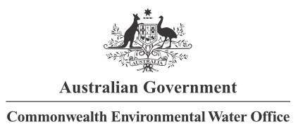

**Partners**

**Collaborators**

1. Currently available inundation information does not distinguish between different types of environmental water.
2. The expected outcomes are specific to each of the watering actions and those relevant to the Selected Areas in which monitoring is undertaken are listed in Appendix A. The specific outcomes for each watering action are not evaluated in this report.
3. The table is available as a separate excel file on request to the authors
4. http://www.environment.gov.au/water/cewo/monitoring/mer-program
5. <https://www.environment.gov.au/cgi-bin/sprat/public/publicthreatenedlist.pl?wanted=flora>
6. <https://www.environment.nsw.gov.au/threatenedSpeciesApp/SpeciesByType.aspx>
7.
8. <https://www.environment.vic.gov.au/conserving-threatened-species/threatened-list>
9. <https://www.environment.vic.gov.au/conserving-threatened-species/threatened-species-advisory-lists>
10. One of the sources for remote-sensing data was Sentinel Hub Playground: https://apps.sentinel-hub.com/sentinel-playground/
11. The reader is referred to the description of the inundation modelling provided in Guarino and Sengupta (2021)
12. The CEWO provided an unpublished, consolidated watering actions table to the evaluation teams
13. The term ‘taxa’ is used to recognise the number of taxonomic records where the lowest level of identification may not always be species (i.e. where a lack of identifying material such as flowers or seeds prevents identification to species level).
14. A more nuanced analysis of the response at riverine sample points can be found in the Selected Area reports.
15. [(https://www.environment.gov.au/water/cewo/monitoring/mer-program](https://www.environment.gov.au/water/cewo/monitoring/mer-program)
16. https://www.environment.gov.au/water/cewo/publications
17. The CEWO provided the evaluation teams with an unpublished, consolidated watering actions table