Before you moor, be sure: Biosecurity reporting requirements for non-commercial vessels
A guide to submitting and editing an electronic non-commercial vessel pre-arrival report (PAR) for arrival in Australian territory
August 2026
Reporting your intention to enter Australian territory is a legal requirement under the Biosecurity Act 2015 and the Biosecurity Regulations 2026. Be aware of what you need to do before arriving in Australian territory and cooperate with our biosecurity officers as they confirm the health of all travellers, conduct an inspection of your vessel and verify required documentation.
Non-commercial vessel pre-arrival reports must be provided in writing (electronically) in accordance with the Biosecurity Regulations 2026. Pre-arrival reporting must be submitted using the non-commercial vessel pre-arrival report (PAR) web portal.

Overview of biosecurity reporting requirements
- Submit a non-commercial vessel pre-arrival report (PAR) accessible from the department’s non-commercial vessel webpage for your impending arrival. A PAR must be submitted no earlier than 90 days and no later than 12 hours before arriving in Australian territory.
- Once you have submitted a PAR you will receive a Biosecurity Status Document (BSD) via email.
  - Ensure all travellers understand the biosecurity requirements and have read the BSD’s directions.
  - Refer to the Starting on the Right Tack checklist for detailed information to help you prepare for arrival in Australian territory.
- Submitting a PAR is a two-stage process: 1. Register your email. 2. Complete the online PAR form and submit.
Prior to arrival in Australian territory
INSTRUCTIONS: Stage 1
1.1 Open the non-commercial vessel arrival biosecurity reporting webpage.
1.2 Select the non-commercial vessel PAR registration web portal, e.g. the box containing text ‘Launch the non-commercial vessel PAR registration web portal ”.
Image: Web portal registration link.
1.3 In the field provided, type the email address, where as an operator, you nominate to receive biosecurity information and directions.
1.4 Select Send Registration Link. An email will be sent to the nominated email address. A message will appear in your web browser confirming an email was sent to your email address.

Non-Commercial Vessel Pre-Arrival Report Registration

A link has been emailed to the address provided, granting access to the Non-Commercial Vessel Pre-Arrival Report (NCV PAR). This link enables users to submit the required biosecurity declaration, specific to your vessel.

The link to the Non-Commercial Vessel Pre-Arrival Report (NCV PAR) will remain active for 30 days.
Image: Web message confirming that an email was sent to the email address entered.
Stage 2
2.1 From an Outlook / email account, open the link from noreply_MARS@aff.gov.au with the subject ‘Department of Agriculture: Biosecurity NCV PAR Link’.
Image: DAFF email and email subject line.
2.2 From the email message, select the NCV PAR LINK to open an editable PAR form, which will display as a page in your web browser.
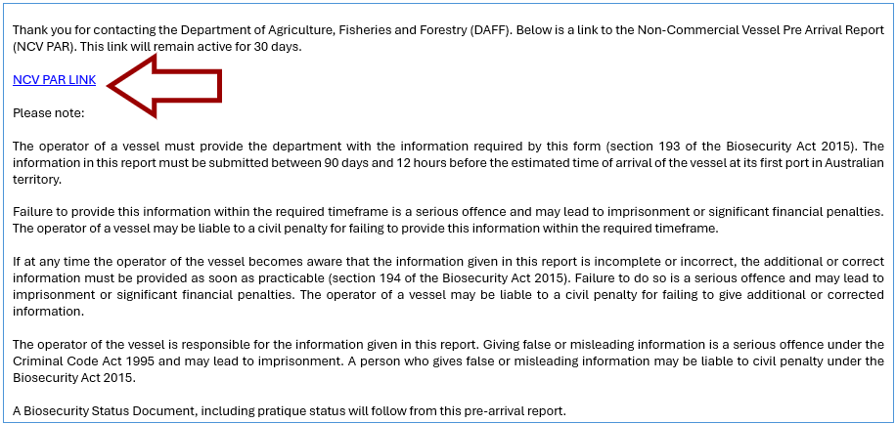
Image: Email text with arrow pointing to the PAR link.
2.3 Accurately complete the PAR fields and questions. Fields with an asterisk * are mandatory. Example: Select a first Australian territory port for arrival and plan to arrive there for the *Intended First Port of Arrival field.
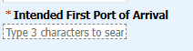
Image: Intended First Port of Arrival field with asterisk next to it, indicating the field is mandatory and must be completed.
If the intended first point of arrival is a Non-First Point of Entry for non-commercial vessels a pop-up message will appear reminding you to submit a Non-First Point Application once you have completed the PAR submission. You cannot arrive at a non-first point of entry unless you have received permission from the department. Ports which are Non-First Points of Entry appear with a hashtag within the PAR.
If you intend to arrive at a non- First Point of Entry, you must apply for permission to do so at least 10 days before arrival. Applying to arrive at a non-First Point of Entry.
You must also inform ABF and AMSA of your arrival intentions and any safety considerations affecting your voyage.
Example: the text above details the pop-up message for non-first point of entry ports.
2.4 Select Submit. Image: example of Submit button as it appears on PAR.
A pop-up confirmation message will display, confirming that the PAR was successfully submitted.
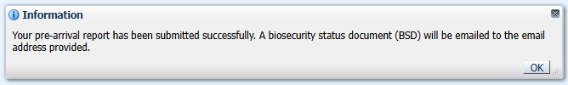
2.5 Check your emails for Biosecurity Status Documents (BSDs), containing biosecurity directions.
- Once a PAR has been submitted, operators should receive a BSD via email.

  - Ensure all travellers read, understand and follow BSD directions and conditions.
  - Multiple BSDs may be issued to a vessel to reflect any reported changes to directions or status occurring during the voyage.
  - Keep copies of BSDs on board the vessel for the duration of the voyage in Australian territory.
  - You may refer to the Quick Reference Guide: Understanding the Biosecurity Status Document (BSD).
Image: The email with the BSD attached will show in your emails as being from noreply_MARS@aff.gov.au with subject ‘Department of Agriculture, Fisheries and Forestry: Biosecurity Status Document” and your vessels name.
What if you do not receive BSDs?
Return to your web browser and select Submit again, check your email inbox and junk mail folder for BSD emails. If you still do not receive BSDs return to your emails. From the initial email with subject “Department of Agriculture: Biosecurity NCV PAR Link”. Select the NCV PAR LINK within your original email again and complete a new editable PAR form, ensuring you select Submit, once all required fields are completed.
If you have any error messages or issues with registering your email or submitting your PAR, email the DAFF office at your intended first port of arrival. Vessel Contacts webpage.
Keeping your PAR up-to-date and reporting changes in circumstances
Vessel operators, masters and shipping agents must, as soon as practicable, report any errors or changes in circumstances occurring after PAR submission and before arrival at the first port of arrival e.g. before inspection with a biosecurity officer.

- Examples of changed circumstances include, but are not limited to:
  - Expected change in arrival time or date at the first port of arrival
  - The first port of arrival has changed e.g. you diverted to another port due to weather conditions. It is an offence to arrive at a port which has not been approved by the department. Vessel operators must choose a port of arrival and plan to arrive there. If voyage plans change or diverting to a different port is necessary, an amended PAR must be provided.
  - Insects were found on-board after the PAR was submitted.
- Where you have previously submitted a PAR for this voyage to visit Australian territory, where your voyage plans change or other circumstances change you are legally required to amend the PAR you submitted.
- A failure to report accurately or comply with requirements under the Biosecurity Act 2015 may result in penalties, including infringement notices, civil penalties or criminal prosecutions.

How to update or amend your PAR submission
- Vessel operators can update their pre-arrival report using the Edit button in the PAR submission email.
Stage 1 Navigating to the Edit button
- Re-open the email with subject heading ‘Department of Agriculture: Biosecurity NCV PAR Link‘
- select the NCV PAR link
- scroll to the bottom of the PAR
- select EDIT. The Edit button is below the Declaration section.

Alternatively, email notification of any changes to a biosecurity officer at the DAFF office of the port you intend to arrive, contacts are listed on the Vessel Contacts webpage.
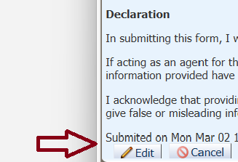
Image: The Edit button is located below the Declaration section of your PAR.
Stage 2 Editing a PAR
- Accurately complete the PAR fields and questions, making any required alterations.
- Select Submit.

If you have any error messages or issues with amending your PAR, notify the DAFF office at the port you intend to arrive, by email. Vessel Contacts webpage. Not arriving at the specific port specified in the PAR and confirmed on the Biosecurity Status Document is an offence.
Reporting human health issues
Where there is an illness on board during your voyage to Australian territory, you must report it to a biosecurity officer in writing, using the email details available on the Vessel contacts.
Contact the port where you intend to arrive, as soon as practicable, where any travellers develop an illness or symptoms of a Listed Human Disease. Report in writing the number of persons with illness or symptoms, and report which symptoms they have or have had.
For detailed information on non-commercial vessel arrival in Australian territory requirements and reducing the introduction and spread of pest and disease into our unique country, visit http://www.agriculture.gov.au/biosecurity-trade/aircraft-vessels-military/vessels/non-commercial-vessels
Any changes to arrival or human health circumstances must be reported to the department as soon as possible.
Do not offer biosecurity officers gifts, inducements or ask officers to overlook issues. Biosecurity officers will reject all offers and are required to report each incident.
It is a serious offence to obstruct, harm, threaten to harm or hinder a Commonwealth Public Official, such as a biosecurity officer, under the Criminal Code Act 1995 and you may be liable to an offence or civil penalty under the Biosecurity Act 2015.
A failure to report accurately or comply with a requirement under the Biosecurity Act 2015 may result in penalties, including infringement notices, civil penalties or criminal prosecutions.

