National Recovery Plan for the
Woylie
Bettongia penicillata ogilbyi

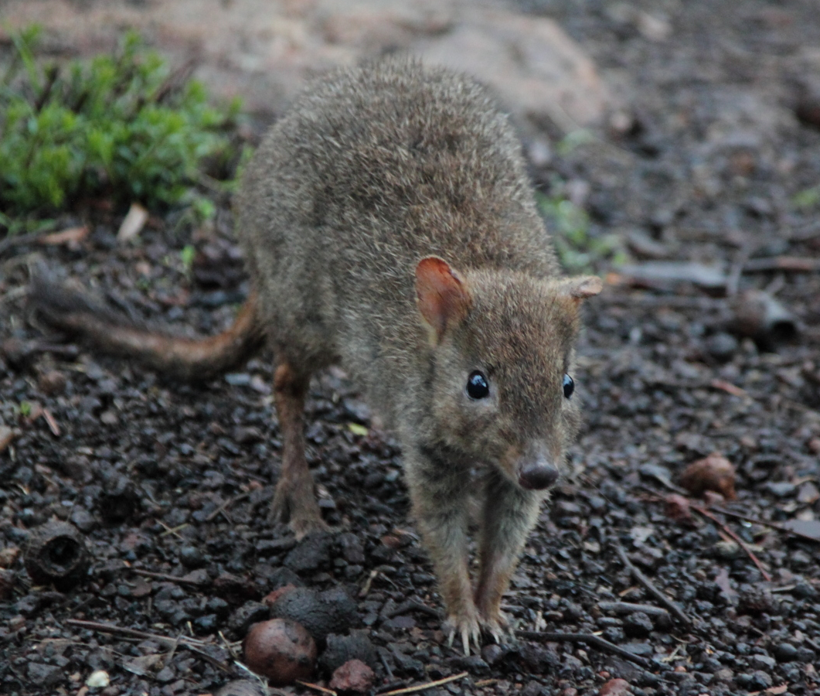
Wildlife Management Program No. 51
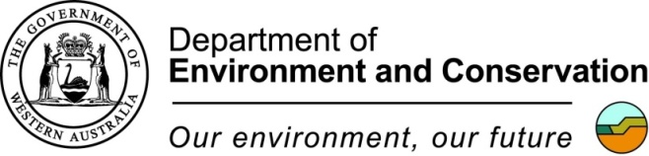

Published by the Western Australian Government Department of Environment and Conservation (DEC) Perth, 2012.
© State of Western Australia, Department of Environment and Conservation, 2012
This publication is copyright. No part may be reproduced by any process except in accordance with the provisions of the Copyright Act 1968.
This is a Recovery Plan prepared under the Commonwealth Environment Protection and Biodiversity Conservation Act 1999, with the assistance of funding provided by the Australian Government.
This Recovery Plan has been developed with the involvement and cooperation of a range of stakeholders, but individual stakeholders have not necessarily committed to undertaking specific actions. The attainment of objectives and the provision of funds may be subject to budgetary and other constraints affecting the parties involved. Proposed actions may be subject to modification over the life of the plan due to changes in knowledge.
Disclaimer
This publication may be of assistance to you but the State of Western Australia and its employees do not guarantee that the publication is without flaw of any kind or is wholly appropriate for your particular purposes and therefore disclaims all liability for any error, loss or other consequence that may arise from you relying on any information in this publication.
Citation: Yeatman, G.J. and Groom, C.J. (2012). National Recovery Plan for the woylie Bettongia penicillata. Wildlife Management Program No. 51. Department of Environment and Conservation, Perth.
Cover photograph: Woylie Bettongia penicillata ogilbyi by Christine Groom.

Contents

Acronyms ii
Summary 1
Recovery plan objectives: 2
Long-term objectives 2
Recovery Actions within the life of this Recovery Plan 2
Species Information 3
Description 3
Biology and Ecology 3
Distribution 4
Habitat 5
Important Populations 6
Decline and Threats 6
Recovery Information 9
Current Conservation Initiatives 9
Strategy for Recovery 9
Program Implementation and Evaluation 10
Recovery Actions 10
Implementation Cost 15
Management Practices 15
Guide for Decision Makers……………………………………………………………………………………………………..……16
Biodiversity Benefits 17
Affected Interests 17
Role and Interests of Indigenous People 18
Social and Economic Impacts 18
Table 4. Implementation Costs and Schedule 22

Acronyms
AWC Australian Wildlife Conservancy
DEC Department of Environment and Conservation, WA (formerly CALM)
DENR SA Department for Environment and Natural Resources, SA
DoP Department of Planning, WA
DSEWPaC Department of Sustainability, Environment, Water, Population and Communities
EPBC Act Commonwealth Environment Protection and Biodiversity Conservation Act 1999
IUCN International Union for the Conservation of Nature
NP National Park
NR Nature Reserve
NSW New South Wales
PVA Population Viability Analysis
SA South Australia
WA Western Australia
WAM Western Australian Museum
WS Wildlife Sanctuary
ZAA Zoos and Aquarium Association (formerly ARAZPA – Australasian Regional Association of Zoological Parks and Aquaria)

Summary

Bettongia penicillata ogilbyi, Woylie

Family: Potoroidae
Common name: Woylie
DEC Region: Midwest, Swan, Wheatbelt, Southwest, Warren
DEC District: Moora, Swan Coastal, Perth Hills, Great Southern, Wellington, Blackwood, Manjimup, Donnelly
Shire: Numerous
Recovery Team: Woylie Recovery Team
Current status of taxa (EPBC Act): Bettongia penicillata ogilbyi, Endangered.
The brush-tailed bettong Bettongia penicillata is a small potoroid marsupial which once occupied most of the Australian mainland. The current distribution of the surviving subspecies, the woylie (B. p. ogilbyi), is concentrated in south west Western Australia but there are also translocated populations in South Australia and New South Wales where it occupies a variety of habitats. Past threats which led to the decline of the species included predation by foxes and feral cats, habitat destruction and altered fire regimes. Efforts made to recover the species led to its removal from threatened fauna lists in 1996 following a review of its conservation status (see Start et al. 1998). Recently there has been a sudden and dramatic decline in the abundance of woylies which resulted in a second review of its conservation status (see Freegard, 2007; Groom, 2010). The exact cause(s) of the recent decline has not been isolated, although predation by feral cats and foxes, and possibly disease, have been implicated. The woylie is currently specially protected under the Western Australian Wildlife Conservation Act 1950 as threatened fauna, with a ranking of Critically Endangered and is also listed as Endangered under the Commonwealth Environment Protection and Biodiversity Conservation Act 1999 (EPBC Act). This is the first national Recovery Plan for the woylie and the third Western Australia recovery plan for the species. It details the woylie’s current distribution, habitat and threats, as well as the recovery objectives and actions necessary to ensure the species’ long-term survival.
Habitat critical for survival of Bettongia penicillata ogilbyi:
Although habitat suitable for the woylie varies across its current range, a number of key habitat requirements appear to be essential for the persistence of the species within this range. Woylies may persist in the following habitats where there is adequate introduced predator (fox and cat) control or exclusion:
- tall eucalypt forest and woodland;
- dense myrtaceous shrubland; or,
- kwongan (proteaceous) or mallee heath.

All habitat meeting the above key requirements within the current range, which is either known to be occupied by woylies or to have the identified potential to be occupied by woylies, is considered habitat critical to the survival of the species.

Recovery plan objectives:

Long-term objectives
- Maintain current distribution and abundance across its current range.
- Increase abundance and range by reducing the impacts of processes that are causing species decline and by establishing new wild populations in suitable habitat within the species former range.

Recovery Actions within the life of this Recovery Plan
- Verify the causes of the decline and suppression of recovery and implement remedial action to address these.
- Minimise predation by introduced foxes and cats at priority sites.
- Maintain or improve the health, genetic diversity, relative value and viability of wild populations.
- Maintain genetic diversity of the insurance captive populations at least at 2012 levels.
- Maintain captive population sizes sufficient to act as source populations for future translocations.
- Undertake targeted translocations as re-introductions (and as introductions where necessary) to achieve an enhanced conservation status for the species.
- Inform and educate the community about, and involve the community in, the recovery actions required to conserve the woylie.

Recovery Team: The Woylie Recovery Team will be made up of representatives from DEC, DENR, AWC, Perth Zoo, Universities (as required) and community representatives (as required). The Recovery Team will report annually to DEC and DENR on progress in recovering the species and will review progress against the recovery actions every five years.
Performance Criteria
Criteria for success
This Recovery Plan will be deemed successful if:
- the four indigenous populations in southwest WA are maintained (as measured by trap success ≥6% or a suitable alternative population measure) with retention of at least 95% of current genetic diversity); and,
- the reintroduced and captive populations in WA, SA and NSW are maintained (as measured by trap success ≥6% or a suitable alternative population measure); and,
- at least four new self-sustaining populations are established through translocations; and
- the conservation threat ranking of the woylie improves sufficient for it to be classified as a Vulnerable species within ten years.
Criteria for failure
This Recovery Plan will be deemed unsuccessful if:
- the four indigenous populations in southwest WA are not maintained or successfully re-established; or,
- any of the reintroduced populations in WA, SA and NSW are lost due to predation effects or lack of adequate management and not successfully re-established or replaced; or,
- the conservation status of the woylie materially declines from its current ranking at the ten year anniversary of the implementation of this plan.

Species Information

Description
The woylie Bettongia penicillata ogilbyi (family Potoroidae) is a small native marsupial 1-1.5 kg in weight. Head and body length is 280-360mm and tail length is between 290-360mm. Their fur can be grey to reddish brown and they have strongly clawed fore feet used for digging for food and nest making. There is a distinctive black brush at the end of their tail and the prehensile tail is sometimes used to carry nesting material (Troughton 1973). They rest during the day in a well-concealed nest, built over a shallow depression that is most commonly constructed of long strands, preferably grasses, but also other material such as strips of bark (in the forest) or dried seagrass and/or triodia (in arid coastal areas) (Christensen and Leftwich 1980; D. Armstrong pers. comm.). When disturbed from the nest, they will move quickly with head low and tail extended, sometimes colliding with obstacles in their haste to flee.

Biology and Ecology
A wide range of food types have been recorded in the diet of the woylie including leaf material, seasonal fruits/berries, roots, tubers, bark and invertebrates (Sampson, 1971; Nelson, 1989; Zosky et al. in prep). In southwest Western Australia, woylies feed extensively on hypogeous fruiting bodies of ectomycorrhizal fungi (Christensen 1980; Lamont et al. 1985; Zosky et al. 2010). While an earlier study found more fungi in the diet of woylies in summer-autumn at Boyicup in Western Australia, (Christensen 1980), more extensive recent research throughout the Upper Warren retgion and Karakamia Wildlife Sanctuary has shown fungi to be the main dietary component throughout the year with a seasonal peak in autumn-winter, corresponding with availability (Zosky et al. in prep). At Venus Bay Conservation Park in South Australia, woylies were found to consume fungi in similar proportions to other bettong populations but there were fewer species available and roots and tubers were eaten when fungi availability was low (Lee 2003). On Venus Bay “Island A” however, fungi were not found to be a significant dietary component (Nelson 1989).
During nocturnal feeding activities, woylies make a large number of small diggings that disturb the soil surface. In a study site at Dryandra Woodland a digging rate of 38 to 115 diggings/bettong/night was recorded which corresponds to approximately 6 tonnes of soil moved per woylie per year (Garkaklis 2001).
Woylies can breed continuously throughout the year (Sampson 1971). It is not uncommon for a large proportion of females at a monitoring site to be either carrying young or suckling a young at heel. The proportion of females caring for young tends to be lower in the drier months when conditions for survival are harsher. Woylies produce a single young at a time, but twins have occasionally been observed (Sampson 1971). Woylies exhibit embryonic diapause, so it is possible for females to carry a blastocyst in the uterus, young in the pouch and have a young at heel (Smith 1989; Smith 1996). They have the potential to breed continuously, producing a maximum of three young in a year (Serventy 1970). A summary of the reproductive characteristics of woylies is contained in Table 1.
Table 1: Reproductive characteristics of the woylie.
Reproductive characteristic | Duration/Number | Reference
Age of female sexual maturity | 170-180 days | Christensen 1995
Gestation | 21.2 days | Smith 1992
Number of pouch young | 1, rarely 2 | Sampson 1971; Christensen 1995
Pouch life | 90 days | Christensen 1995
Maximum number of young produced in a year | 3 | Serventy 1970

Life expectancy for woylies is approximately 4-6 years (Christensen 1995) although there is evidence of individuals reaching 7 years in the Dryandra Woodland population (DEC, unpublished data), 8 years at Karakamia Wildlife Sanctuary, 9 years in the Upper Warren (DEC, unpublished data) and 14 years in captivity (Keynes 1989). They are solitary animals but nest sharing (usually mother and young at heel) has been recorded (Sampson 1971; Christensen and Leftwich 1980; Start et al. 1995). They occupy home ranges, the size of which varies between habitats, sites and according to woylie density. Small home ranges (less than 6ha) are generally observed at high density occurrences (Nelson 1989 in Nelson et al. 1992; Hide 2006). Males tend to have larger home ranges than females (Sampson 1971; Leftwich 1983), although this is not always so when woylies are at higher densities (Yeatman 2010).
Distribution
Past distribution
The brush-tailed bettong, in its various subspecies, once occupied most of the Australian mainland south of the tropics including the arid and semi arid zones of Western Australia, the Northern Territory, South Australia, New South Wales and Victoria (Figure 1). This exceptionally broad habitat tolerance is a feature of the species that sets it apart from many of its marsupial relatives and is indicative of its capacity to survive in a range of habitats in the absence of exotic predators.
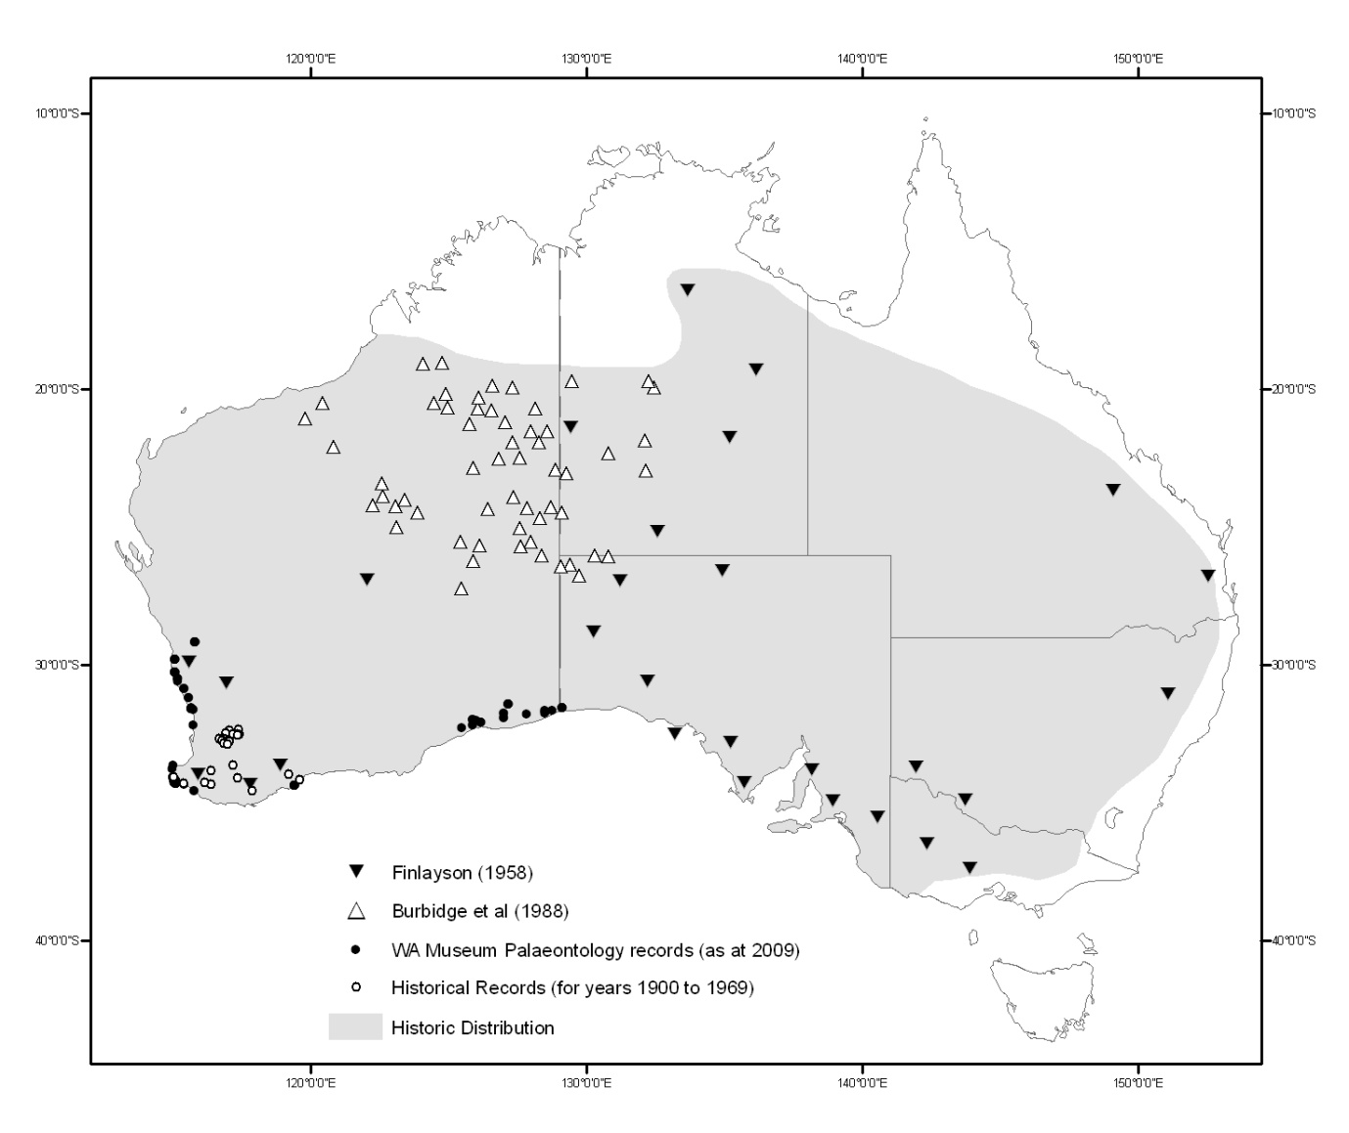
Figure 1. Historical distribution of the woylie (adapted from Nelson et al. 1992 with additions from WAM 2009 and DEC 2011).

Present distribution
The woylie distribution is concentrated in the south west of Western Australia however there are also translocated populations reaching as far north as Shark Bay and as far east as the New South Wales and South Australian border. The last four remaining indigenous populations are all in south west Western Australia (Mawson 2004; Pacioni 2010; Pacioni et al. 2010). These are Perup, Kingston, Dryandra woodland and Tutanning nature reserve. Woylies have been re-established at an additional 22 locations [Western Australia (n = 16), South Australia (n = 5) and New South Wales (n = 1)] where woylies were historically known to occur (Freegard 2007; Figure 2). All of these populations have been established via introductions or reintroductions with animals sourced from one or more of the four indigenous populations. Figure 2 shows the current distribution of the woylie in Australia. ‘Insurance’ populations have been established at Whiteman Park Recreation and Conservation Reserve (near Perth) and Perup Sanctuary (a 420 ha fenced area, east of Manjimup).
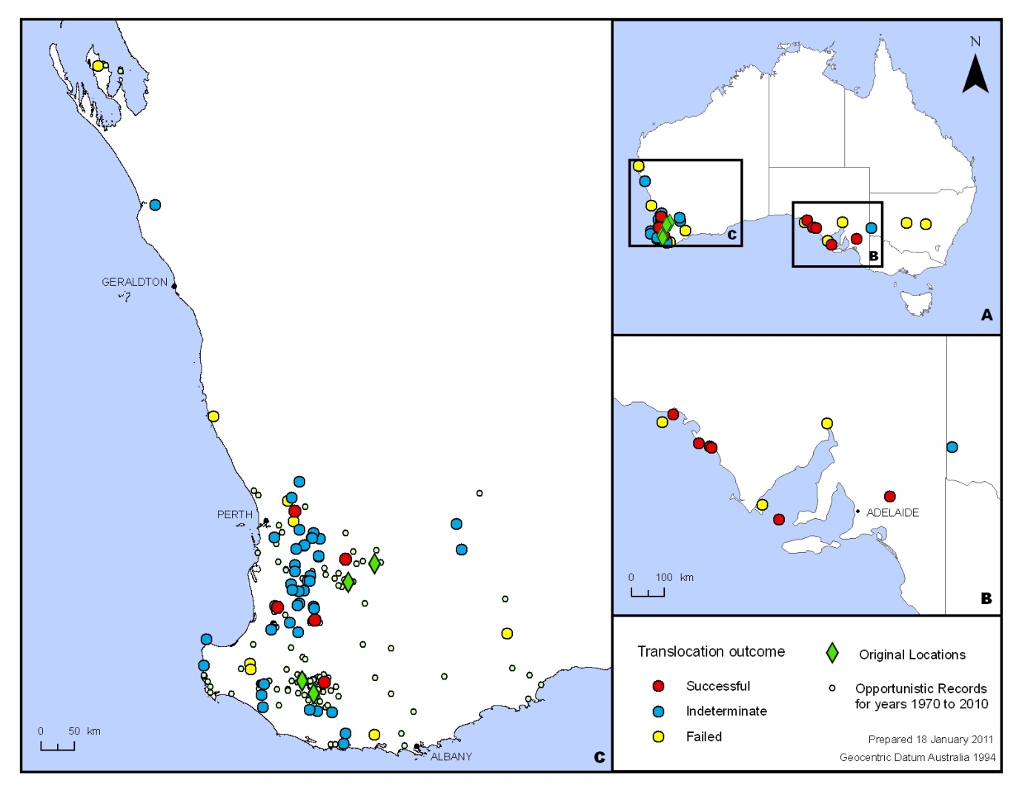
Figure 2. Current distribution of the woylie (as at May 2011).

Habitat
Woylies are currently known from a variety of habitats and historically the broader brush-tailed betting species occupied many more. The current habitat includes tall eucalypt forest and woodland, dense myrtaceous shrubland, kwongan (proteaceous) or mallee heath (Sampson 1971; Christensen and Leftwich 1980). Thickets and other suitable habitat types such as heath, provide refuges for woylies against predators. Prior to widescale fox baiting, the species’ distribution had been reduced to a handfull of locations in Western Australia with the common characteristic of the presence of Gastrolobium thickets (e.g. Gastrolobium biloba). Gastrolobium contains monofluoroacetic acid which is the compound present as sodium monofluoroacetate in the toxin ‘1080’ and hence these are often referred to as ‘poison plants’. It is thought that habitat with Gastrolobium thickets provided the woylie with refuge from introduced predators, partly because of the ability to physically hide in the bushes but also due to the local reduction in predator numbers caused by their secondary poisoning from consumption of native species that have consumed, and are highly tolerant to, the Gastrolobium poison plants (Short et al. 2005).

Habitat critical for survival of Bettongia penicillata ogilbyi:
Although habitat suitable for the woylie varies across its current range a number of key habitat requirements appear to be essential for the persistence of the species within this range. Woylies may persist in the following habitats where there is adequate introduced predator (fox and cat) control or exclusion:
- tall eucalypt forest and woodland;
- dense myrtaceous shrubland; and,
- kwongan (proteaceous) or mallee heath.

All habitat meeting these key requirements within the current range, which is either known to be occupied by woylies or to have the identified potential to be occupied by woylies, is considered habitat critical to the survival of the species.

Important Populations
The most important woylie populations are the four genetically distinct indigenous populations at Dryandra woodland, Tutanning nature reserve, Perup and Kingston (Pacioni et al. 2010). The population at Karakamia Wildlife Sanctuary is also important as it is the only relatively large mainland population that has not shown evidence of a decline. The genetic diversity of the Karakamia population is also representative of the source population from Dryandra woodland (Pacioni et al. 2010) which suggests that Karakamia has the potential to be used as a source population for future reintroductions. The South Australian island populations on Wedge and St Peter’s islands are significant as they are relatively large however they are genetically depauperate (Pacioni, 2010) as they are understood to be founded from the offspring of as few as one female and three males. As yet, more formal assessment of the relative importance of each population has not been undertaken and it is the intention of this Recovery Plan to rank each population as part of the management of the species.

Decline and Threats
Since European settlement, the distribution of the woylie has declined to a tiny portion of its former range. By the 1970s, the species was restricted to only three areas in the south west of Western Australia. These were Tutanning Nature Reserve, Dryandra Woodland and the Upper Warren region (including Perup and Kingston). After the implementation of recovery actions, the woylie was removed from listing under the Commonwealth Endangered Species Protection Act 1992, in 1996. After this, the species’ conservation status continued to improve with increases in population size and a number of translocations undertaken to return the species to areas within its former range. The Upper Warren population peaked at approximately 226,000 (between 187,000-264,000) individuals in 1999 with a secondary peak in 2001 at 222,000. The estimate number of woylies in all other populations at the same time was approximately 45,000 (A. Wayne, pers. comm.). Since then, the species has suffered a severe and dramatic decline in abundance as a result of increased adult mortality. The population has declined by approximately 95% to an estimated population size of 10,845 in the Upper Warren with a further 15,000 woylies in all other populations (A. Wayne, pers. comm.). Preliminary analyses suggests there was a spatial progression of decline in the Perup area within the Upper Warren region (Wayne et al. in prep.). As yet, there has been clear evidence of a decline in the abundance of individuals within these populations but not a decline in the number of occurrences of the species. However, the Batalling Forest population (est of Collie, Western Australia) has been only marginally detectable since 2007, having undergone a 99% decline since 2002 from an estimated poulation peak of 3,000-8,000.
The declines have occurred in most known large woylie populations and are not limited to Western Australia. A translocated population at Venus Bay (South Australia) suffered a dramatic crash in 2006 following a slow decline over the previous 12 months. This may have been a result of the restriction of emigration and subsequent resource limitation exacerbated by a series of six frosts and so the decline of this population may not be associated with that of Western Australian populations. The following sections detail possible causes of the decline as well as additional threats to the persistence of the species (Table 1).
Fox Predation
The fox Vulpes vulpes is likely to have reduced, and will continue to reduce, the distribution and abundance of the species. The woylie is within the critical weight range of species particularly vulnerable to fox predation (Burbidge and McKenzie 1989). Furthermore, a number of woylie populations demonstrated a spectacularly positive response after the implementation of fox control under the Western Shield Program (Orell 2004). Fox predation can reduce the success of management actions aimed at conserving woylies. For example, fox predation was implicated in the failed woylie reintroduction to Baird Bay unnamed island (Department of Environment and Heritage 2006).
Cat Predation
Predation by cats Felis catus is also likely to have reduced the distribution and abundance of the species. Cats were identified as the main cause of mortality of reintroduced woylie populations at Yathong Nature Reserve in New South Wales (Priddel and Wheeler 2004) and Lincoln National Park in South Australia (James et al. 2002). Cats are also the likely cause of the failure of the reintroduction to Francois Peron National Park, since they were the proven cause of the failure of two similar sized species in the park (the banded hare wallaby Lagostrophus fasciatus and rufous hare wallaby Lagorchestes hirsutus (Hardman 2006)). Cat predation of woylies has also been demonstrated to be responsible for the deaths of the majority of radio-collared individuals in the established indigenous populations at Dryandra Woodland and Tutanning Nature Reserve (Marlow et al. 2010). In the Upper Warren cat predation/scavenging has been recorded (Wayne et al. 2008) although whether predation/scavenging occurs on moribund or dead animals, or in the absence of this predation, woylies would survive is unknown. Mesopredator release can occur when a top order predator is controlled or removed. It has been suggested that feral cat activity may be suppressed in the presence of foxes . With the implementation of broad scale fox control, cats could have a greater impact on small native species and this may be one of the causes of the recent woylie decline. Research has confirmed that this is the case in the northern jarrah forest (Western Australia) in areas where fox control occurs (de Tores et al. 2010; Sutherland et al. 2010). As there is currently no proven broad scale control method for cats, the meso-predator release of cats poses a significant threat to the persistence of woylies.
Habitat alteration
There has been considerable habitat change driven by human activity since European settlement. This includes direct land clearing for housing, timber, agricultural production, grazing, as well as, altered fire regimes and landscape scale changes, particularly as a result of pastoral activity in semi-arid environments. These activities have reduced the effective area of habitat that meets all of the food and shelter requirements of woylies and increases their vulnerability to exotic predators.
Vegetation change caused by the root pathogen Phytophthora cinnamomi also has the potential to threaten the persistence of woylie populations. Dense vegetation provides woylies with shelter from predators and changes in the structure of natural habitats can increase predation risks. Phytophthora infection also has a negative impact on fungal community structure and biodiversity (Anderson et al. 2010) potentially impacting directly on the availability of food resources for the woylie. These points considered, the recent declines of many of the Western Australian populations have occurred in structurally intact native vegetation including national parks, nature reserves and State forest and do not appear to be associated with forest harvesting.
Native predators
Native predators may reduce the chances of persistence of small and establishing woylie populations, especially where the ecosystem has been significantly altered to the detriment of woylies. Predation by carpet pythons Morelia spilota imbricata and white-breasted sea-eagles Haliaeetus leucogaster have been implicated in the failed woylie translocation to St Francis Island in South Australia (Department of Environment and Heritage, 2006) and wedgetail eagle Aquila audax predation contributed to the failed reintroduction to the Flinders Ranges in South Australia (Bellchambers 2001). The wedgetail eagle and chuditch (Dasyurus geoffroii) have also been confirmed as predators/scavengers of woylies in the Upper Warren (Wayne et al. 2008). While it is important to consider the potential impact of native predators on small re-introduced woylie populations there is no identified standard requirement to undertake native predator reduction per se in order to ensure the conservation of woylies.
Climate change and associated stochastic events
Climate change, particularly reduced rainfall and increasing temperatures, has the potential to change the structure of woylie habitat and also the availability of food. Woylies primarily feed on the fruiting bodies of ectomycorrhizal fungi and some species of fungi have strong associations with rainfall and temperature (Johnson 1994). Decreases in rainfall could result in a decline in the abundance of fungi as well as other foods that contribute to the woylie’s diet. This has the potential to limit the suitable habitat where woylie populations can persist. This is similar to the threat facing the northern bettong (B. tropica) in the wet tropics of Queensland, with predicted changes in habitat structure caused by climate change likely to influence food availability and further restrict the amount of suitable habitat available for the species (Department of Environment and Resource Management 2009).
A component of climate change predictions is an inceased frquency of extreme weather events (high or low temperatures) which may include shorter intervals between periods of drought. While these events may be important to the future conservation of woylies, they are beyond the scope of targeted recovery actions of this plan.
Disease
The Woylie Conservation Research Project has implicated disease as a possible agent in the recent woylie decline (Wayne 2006; Wayne et al. 2006; Wayne 2008). Monitoring of populations in the Upper Warren region has shown that poor health of woylies may be associated with the decline. This includes fur loss and skin conditions including scabbing and lesions. Trypanosomes and Toxoplasma have also been associated with the Upper Warren populations undergoing decline but are absent or at very low prevalence in Karakamia Wildlife Sanctuary (stable, high density population) (Smith et al. 2008). While the evidence of any actual causal disease agents remains to be verified, it is hypothesised that some form of disease, such as Toxoplasmosa, may predispose animals to predation. Determining rigorously whether disease is a primary contributing factor to the decline will be important in order to effectively manage the recovery of the woylie and potentially the conservation of other sympatric threatened species. Management actions that do not adequately screen for disease could have the potential to threaten populations if disease is a significant factor in species decline.
Areas and Populations Under Threat
Threat assessments for particular areas and populations have generally not been made. Most woylie populations occur on public land, in conservation reserves and state forest. However these populations are still under threat from fox and cat predation, altered fire regimes and P. cinnamomi infection. Isolated populations are at greater risk from catastrophic events and declining genetic diversity (for example Wedge and St Peter’s Islands).
Mining activities
Mining activity in the jarrah forests of south west Western Australia may also threaten woylies as these areas are under lease for gold and bauxite exploration and mining. Extensive areas of the southwest, including siginficant areas (>24,000km²) of jarrah forest in the Darling Range now have bauxite mining tenements over them. In the event the current mineral exploration leads to mining of those mineral resources then critical habitat for existing and potential future populations may be affected. The duration and extent of those impacts will be dependent on the proposed locations and extent of actual mining operations and so will require further investigation and assessment.
Table 2. Listed threats likely to affect the woylie
Threatening Process | Legislation
Predation by feral cats | EPBC
Predation by European red fox | EPBC
Dieback caused by the root-rot fungus (Phytophthora cinnamomi) | EPBC
Predation, Habitat Degradation, Competition and Disease Transmission by Feral Pigs | EPBC
Land clearance | EPBC
Loss of terrestrial climatic habitat caused by anthropogenic emissions of greenhouse gases | EPBC

Recovery Information
There have been two previous Western Australia recovery plans for the woylie which have both expired. The recovery actions were successfully implemented to the extent that woylies were removed from the WA, national and international threatened species lists in 1996. It is not considered necessary to review the relative success of individual recovery actions from either of those recovery plans given that the overall objective of the successful recovery of the woylie was achieved.

Current Conservation Initiatives
A national recovery team for the woylie was re-established in 2008. There are a number of conservation initiatives for the woylie that are part of larger ongoing projects as well as more recent activities directed by the recovery team. These include the following initiatives.
- The management of introduced predators in areas occupied by woylies. Foxes and feral cats are managed in Western Australia and South Australia through various management programs. The private wildlife conservation organisation Australian Wildlife Conservancy (AWC) have fenced “introduced predator-free” environments on mainland Australia where woylies have been translocated.
State | Location | Responsible Agency
WA | Southwest WA via Western Shield fox control program | DEC
 | Karakamia Sanctuary | AWC
 | Wadderin Sanctuary | Shire of Narembeen
 | Whiteman Park | DoP
 | Private properties at Margaret River and Busselton | Private land owners
SA | Bounceback program | DENR
 | Yookamurra Sanctuary | AWC
NSW | Scotia Sanctuary | AWC
- Translocation programs aim to increase the distribution of the species. These have been undertaken in Western Australia, South Australia and New South Wales, primarily through the relevant state government conservation agencies but also involving AWC and other private individuals/organisations (Figure 2).
- Investigation into the cause of the decline in the form of the Woylie Conservation Research Project. Phase 1 of this project, predominantly based in the Upper Warren region of Western Australia, has been completed and the results reported (see Wayne, 2008). The project was explorative in approach and aimed to diagnose the cause of the woylie declines. Phase 2 aims to investigate and scientifically test the most likely causes of the decline identified in Phase 1.
- Exploring the concept of mesopredator release. This is a major project undertaken by DEC, with input from AWC, and supported by the Invasive Animals Cooperative Research Centre. The project investigated the relationship between introduced predators (mostly foxes and cats) and various native species in 1080 baited and unbaited sites. The field component of this project is complete with analyses and write-up nearing completion (as at 2011).

Strategy for Recovery
The initial strategy for recovery of the woylie will focus on identifying the specific agents contributing to the recent decline whilst continuing to mitigate the most likely threats. This approach will directly inform development of improved strategies to alleviate more clearly understood threats to the species. The second major strategic direction will be assigning conservation value to known woylie populations and conducting population focussed risk assessments, the results of which will enable ranking of recovery priority by population. This will help ensure the most valuable populations receive priority attention. Conserving the remaining genetic diversity of the species (in both the wild and captive populations) and establishing ‘insurance’ captive populations for those populations at highest risk will also be necessary components of the overall recovery strategy.
Isolating and ameliorating the most significant threats to the species will of itself help to recover currently declining populations. This recovery will be enhanced by targeted management of priority wild populations and/or by translocating woylies from the insurance and indigenous wild populations to establish new populations, or boost the genetic diversity of extant populations. Recovery actions will be implemented within an adaptive management framework, whereby population monitoring information and any new discoveries related to woylie conservation techniques will be integrated into subsequent actions.

Program Implementation and Evaluation
This Recovery Plan guides the recovery actions for the woylie and will be implemented and managed by the DEC and DENR, supported by other relevant agencies, non-government organisations, educational institutions, regional natural resource management authorities and community groups as appropriate. Technical, scientific, habitat management or education components of the Recovery Plan will be referred to specialist groups as required. Contact will be maintained between the State agencies and key stakeholders on recovery issues concerning the species. The Recovery Plan will run for a maximum of ten years from the date of its adoption under the EPBC Act, or until replaced. The recovery plan will be reviewed by DEC in consultation with the Woylie Recovery Team within five years of the date of its adoption, or sooner if necessary.

Recovery Actions
Specific details for activities needed to achieve each recovery action are described below.
Action 1: Verify the causes of the decline and suppression of recovery and implement remedial actions to address these.
Activity 1 Analyse the spatial, temporal and density characteristics of the decline.
Anecdotal observations and analyses of data have led to speculation that there may have been a pattern to the decline in woylie abundance. In the Upper Warren area there were three central sites (Moopinup, Yackelup and Camelar Forest Blocks) with a recent history of high woylie capture rates and where subsequently no woylies were captured (Wayne 2008). Rigorous analysis of the spatial, temporal and density characteristics of the decline may assist in the identification of key agents of the decline.
Responsibility: DEC
Activity 2 Investigate the role of disease in woylie declines and recovery.
Survey woylie populations and document the range of endo-parasites and ecto-parasites and pathogens particular to each population. A comparison of the parasite and pathogen status of the populations in conjunction with the observed history of recent decline may offer a better understanding of the role (if any) of disease and inform decisions for future management of woylie populations.
Responsibility: DEC, Murdoch University

Activity 3 Target investigations into particular putative agents of disease that may be associated with decline and suppression of recovery.

Research conducted during Phase 1 of the Woylie Conservation Research Project (see Wayne 2008) has identified a number of possible disease agents that may be contributing to the decline in woylie abundance. Investigation into the significance of disease agents in the decline and suppression of recovery is required which should result in a greater understanding of the ecology of the disease(s) and ways to mitigate the impacts of disease on populations.
Responsibility: DEC, Murdoch University
Activity 4 As a precautionary measure, in case disease is found to be a contributing factor in the decline/suppression of recovery, review and update the translocation, trapping and animal handling protocols to ensure management actions avoid the accidental spread of disease or parasites.
Responsibility: DEC, DENR, AWC, DoP, Shire of Narembeen
Activity 5 In the event that disease is confirmed as having a role in the decline of woylies, develop and implement updated disease management protocols for translocation and monitoring of woylies that avoids newly identified risks of disease transmission in species management and related habitat management operations.
Responsibility: DEC, DENR, AWC
Activity 6 Implement a plan to reduce the risk of introduction of Phytophthora infection into important woylie population habitats.
P. cinnamomi is a water mould that causes root-rot disease symptoms and death for a variety of native plant species and also reduces local fungal diversity and abundance (a key food resource for woylies). It has the potential to alter the structure of habitat and reduce biodiversity. As Phytophthora infection has the potential to threaten the success of the recovery of the species, the protection of important areas of woylie habitat from Phytophthora will be necessary. This will include the implementation of protocols to prevent the spread of Phytophthora into key woylie recovery population sites.
Responsibility: DEC, DENR, AWC
Activity 7 Conduct a conservation risk and value assessment of known woylie populations.
A conservation risk and value assessment of each known woylie population is required to facilitate direct recovery efforts. This process will consider the size of individual populations, recent trends in populations and the genetic make-up of each population to determine relative conservation value. These data will then be assessed in conjunction with the current and proposed on-ground activities (fox baiting, influence of Phytophthora and other known threats) to identify where available resources should best be directed to achieve the best possible outcome for the conservation of woylies. The first assessment will be conducted in year one, with a second in year five which will be used to evaluate recovery efforts.
Responsibility: DEC, DENR, AWC
Activity 8 Support post-graduate and other external research that is most relevant to woylie recovery.
The scope of the research required to pursue the recovery of the woylie is significant. Assisting student projects related to woylie recovery will allow for investigation into many areas of interest simultaneously. Current student research projects are focusing on identifying possible diseases which might be affecting woylie populations and determining the mode of transmission. Other research is examining the fungal food resources of woylies and the factors affecting them. Students can provide a valuable resource that increases the efforts directed towards the recovery of the species and so better equips management to achieve conservation goals.
Responsibility: DEC, DENR, AWC, DoP

Action 2: Minimise predation by introduced foxes and cats at priority sites.
Activity 9 Investigate the likely role of introduced predators in the decline and recovery of the woylie using a predator exclusion experiment at Upper Warren (and/or other sites).
Introduced predators are known to impact on woylie populations and therefore it is appropriate to investigate closely their role in recent declines and whether or not predation is limiting the recovery of declined populations. Monitoring the growth of the Perup Sanctuary population in the absence of introduced predators will provide information about their role in the suppression of the recovery of the species. If it is found that introduced predators have/are playing a significant role, development and implementation of improved fox and cat control methods will be required for the recovery of the species.
Responsibility: DEC, DENR, AWC
Activity 10 Continue baiting introduced predators under the relevant state (Western Shield and Whiteman Park in WA, Bounceback in SA) and private management programs (AWC sanctuaries, Shire of Narembeen and private property), enhancing the effectiveness of these, where possible.
Controlling introduced predators is known to have had a beneficial impact on woylie populations in the past. Baiting regimes need to incorporate adaptive management that uses the results of research into baiting effectiveness. This may involve strategies such as:
  - Reducing the variability in time intervals between baiting events;
  - Strategically timing baiting events to increase efficacy of fox control (e.g. when vixens are supporting dependent young or during peak dispersal periods);
  - Avoiding baiting when rainfall is likely to reduce efficacy of baiting; and,
  - Enhancing baits for targeted update by exotic predators.
Baiting under Western Shield and equivalent programs is likely to continue regardless of its inclusion in the Woylie Recovery Plan. It has been included in the Recovery Plan as it is a necessary action for the recovery of the species. Although introduced predator control is likely to benefit other species as well as the woylie, the costs estimated for this recovery action are the costs associated with the implementation of introduced predator control in known woylie locations and are not portioned into the relative cost that will benefit only the woylie.
Responsibility: DEC, DENR, AWC, DoP, Shire of Narembeen, private property owners
Activity 11 Identify and implement an appropriate feral cat control method to achieve enhanced woylie conservation.
Cats pose a significant threat to the persistence of woylie populations. Cats have been responsible for the failure of a number of woylie translocations (e.g. Priddel and Wheeler 2004) and have been identified as a primary cause of mortality in the Dryandra Woodland and Tutanning Nature Reserve populations (Marlow et al. 2010). ERADICAT® and CURIOSITY® are sausage baits developed solely by the Department of Environment and Conservation or in conjunction with partners, which are readily consumed by cats. There is concern regarding the impact the use of these baits may have on non target species as it has been shown that several native species will consume the baits. Trials investigating encapsulating the toxicant within a pellet in the sausage have had mixed results with some suggesting encapsulation of the toxin does reduce the impact on native species (e.g. Hetherington et al. 2007) whereas other non target trials indicate this is not a suitable method for introduced predator control (e.g. de Tores et al. 2010). This disparity must be resolved and an effective and implementable cat control method for use in areas where woylies occur identified.
Responsibility: DEC, DENR, AWC
Activity 12 Investigate the possibility of bait shyness and the efficacy of baits for the control of foxes.
There is some evidence to suggest that foxes persisting in long-term baited areas may be less attracted to, and therefore more likely to persist in the presence of, baits than has been the case with foxes in the past . It is also possible that foxes are developing bait shyness as a result of consuming sub-lethal 1080 doses. In order to maintain baiting that allows for recovery of native fauna it is necessary to implement adaptive management and respond to any new information that indicates baiting is not effective. Investigation into the efficacy of PROBAIT 1080 fox baits should continue by developing a method of testing how long the concentration of 1080 in the sausage remains at a lethal level, modifying baiting practices if necessary based on tests using this method and developing practices to reduce bait uptake by non target species such as possums and birds. This action is likely to occur regardless of its inclusion in the Woylie Recovery Plan however it has been included because it is necessary for the recovery of the species. The estimated cost for this action is the total cost and not apportioned into the relative cost that will benefit the woylie.
Responsibility: DEC, DENR, AWC
Activity 13 Monitor the effectiveness of predator control programs on the activity and/or abundance of target predator species and the responses by woylies.
Monitoring the activity and/or the abundance of introduced predators (foxes and cats), native predators and woylies before and after the implementation of control methods is required. Given what is known about the likely mesopredator release of feral cats in some areas where fox control has occurred, it is possible that control methods could have unintended effects. Activity and/or abundance monitoring of foxes and feral cats is essential as part of an adaptive management plan.
Responsibility: DEC, DENR, AWC

Action 3: Maintain or improve the health, genetic diversity, relative value and viability of wild populations.
Activity 14 Monitor the health, breeding, condition, population abundance and demographics at known mainland woylie populations at least annually and population genetics at least every 5-10 years.
It was through regular monitoring of woylie populations that the decline in woylie abundance was observed and confirmed with statistical rigour (see Groom 2010). Monitoring the health of populations at least annually will provide management agencies with a tool to evaluate the recovery of the species and to make predictions about future changes in abundance. Monitoring effort must be sufficient to reliably detect a 10% annual change in abundance in 1 year. Population surveys will be conducted in known woylie locations at least annually. Data collected must then be analysed in order to track changes in the populations and make future predictions about changes in abundance.
Responsibility: DEC, DENR, AWC
Activity 15 Ensure relevant translocation and population research results are incorporated in improved recovery planning.
Several woylie translocations were undertaken to locations in the northern jarrah forest during 1994-1996, as part of the ‘Operation Fox Glove’ project. The outcomes of this translocation research, along with results of all other work relevant to woylie conservation, should be incorporated into improved recovery planning for woylies.
Responsibility: DEC
Activity 16 Monitor individual health, breeding, condition, survivorship, population abundance, demographics and genetics at Perup Sanctuary.
Intensive monitoring of the Perup Sanctuary population should be continued. The population should then be monitored at least annually. Monitoring to be sufficient to detect a 10% annual change in abundance in 1 year and also adequate enough that between 1 and 5% of the population is encountered. Data collected to be used to track changes in the population and make future predictions about changes in abundance and in better understanding woylie carrying capacity of fenced areas.
Responsibility: DEC
Activity 17 Monitor individual health, breeding, condition, population abundance and demographics within captive populations of woylie at Karakamia Wildlife Sanctuary, Wadderin Sanctuary and Whiteman Park.
Regular (at least twice yearly) trapping surveys to be conducted to monitor the health of the population. Monitoring to be sufficient to detect a 10% annual change in abundance in 1 year. This will involve conducting health assessments of the animals trapped and collecting information on demographic parameters. Data collected to then be analysed in order to track changes in the population and make predictions about future changes in abundance.
Responsibility: AWC, DoP, Shire of Narembeen

Action 4: Maintain genetic diversity of the insurance captive populations at least at 2012 levels.
Activity 18 Improve the genetic diversity of the stable South Australian island populations.
Previous attempts to improve the genetic diversity of the South Australian island populations failed, most likely because there were no available territories for translocated, high genetic value animals to move into. Attempts should be made to introduce new genetic material into the island populations. This may require some of the existing woylies on the island to be translocated to another area/population to make room for new animals. Alternatively, an exclusion fence could be constructed to ‘protect’ the new stock while they integrate into the population.
Responsibility: DENR

Activity 19 Establish and manage a genetically robust captive population at ZAA facilities at the direction of the Recovery Team and by agreement with the ZAA facility. Goals for any captive population to be determined by agreement between the Recovery Team, Australasian Species Management Program (ASMP) Species Coordinator and the participating ZAA facilities.
Zoos South Australia is one ZAA member where a captive woylie population is currently housed. Management of this population, and any other population housed in a ZAA facility to be coordinated by the ASMP Species Coordinator in consultation with the Recovery Team and the holding institutions.
Responsibility: Recovery Team, Perth Zoo, Zoos SA and other ZAA accredited facilities (as required).
Activity 20 Investigate the feasibility of cooperating with licensed private holders of woylies in South Australia to improve the genetic representation within the insurance populations.
There are approximately 700 woylies held in captivity by the public in South Australia. This resource may prove useful in the future if breeding of these captive animals is monitored to ensure their genetic structure is maintained. The practicality and potential benefits from using such animals in genetic conservation for the species should be assessed and, if appropriate, pursued during the life of this plan.
Responsibility: DENR, Zoos SA.

Action 5: Maintain captive population sizes sufficient to act as source populations for future translocations.
Activity 21 Manage captive populations to ensure the potential for captive stock to provide animals of good genetic quality and adequate numbers for translocations.
Captive populations are important because they provide a means of ensuring that the genetic contribution of the four indigenous woylie populations are not lost or effectively unavailable for use in translocations due to very low numbers of woylies in the wild, and they can also provide a cost-effective way of obtaining sufficient numbers of woylies to use as founding stock in any translocations. It is therefore important that captive populations are not only managed for quality of genetics and general health, but are also managed for quantity to maximize their potential value in conserving woylies in the wild.
Responsibility: Perth Zoo, Zoos SA other ZAA accredited facilities (as required).

Action 6: Undertake targeted translocations as re-introductions (and as introductions where necessary) to achieve an enhanced conservation status for the species.
Activity 22 Translocations have been used with great success in the past to re-establish old, or establish new, woylie populations (Groom 2010). Using the information obtained from other recovery actions described above, undertake targeted translocations to the wild, either as re-introductions or introductions (where appropriate) to expand the range of woylies and to increase the number of populations and the total number of animals. Translocations should include a rigorous monitoring component to confirm success or failure and to help identify the cause of any problems that may arise.
Responsibility: DEC, DENR, captive population managers
Action 7: Inform and educate the community about, and involve the community in, the recovery actions required to conserve the woylie.
Activity 23 Inform and educate stakeholders and the community about the need to conserve the woylie.
To have the greatest likelihood of success in conserving the woylie stakeholders and the community need to be informed of the efforts being undertaken to conserve woylies through publications in a wide range of fora, media statements, the use of web-based material and public speaking events.
Responsibility: DEC, DENR, AWC, Perth Zoo
Activity 24 Co-ordinate the recovery actions set out in this plan, involving the community where possible and appropriate.
Co-ordination of the recovery effort will be managed by the Woylie Recovery Team which will meet twice each calendar year and more frequently, if required. The Recovery Team will also be required to develop any new recovery actions that may arise from the first three recovery actions described, above. The Recovery Team will be responsible for reviewing the recovery plan after five years, or sooner if the need arises. Involvement of private landholders in woylie recovery actions will be pursued through involvement of private landowners in on-ground woylie recovery (particularly covenanted or otherwise conservation protected lands), volunteers assisting conservation efforts and through research and conservation partnerships.
Responsibility: Recovery Team, DEC, DENR, AWC, Perth Zoo, and others

Implementation Cost
The indicative cost of implementing the national Recovery Plan is $11,105,000 over ten years (Table 3). Costs have been rounded to the nearest thousand. Organisations involved in the recovery plan implementation will use their best endeavours to complete recovery actions with the resources they have available. For a detailed breakdown of costs for each activity under the various recovery actions see Table 4 at the end of this recovery plan.
Table 3. Summary of estimated costs of implementing the woylie recovery plan over ten years ($000’s).
Year1 | Year2 | Year3 | Year4 | Year5 | Year6 | Year7 | Year8 | Year9 | Year10
$1,234 | $1,344 | $1,314 | $1,073 | $1,159 | $905 | $964 | $1,078 | $994 | $1,040

Management Practices
Many of the issues affecting woylies are currently managed in keeping with specific management planning and implementation documents. These include, but are not limited to: state and national biodiversity strategies, land management plans, threat abatement plans, forest management plans, fire management plans, plant and animal disease hygiene management plans and introduced animal management plans. Amendments to existing management documents and the development of new documents will occur as a result of information arising from the implementation of this recovery plan.
Guide for Decision Makers
Under the Commonwealth Environment Protection and Biodiversity Conservation Act (1999) (EPBC Act), or other national environmental legislation as may apply at the time an activity is proposed, any person proposing to undertake actions which may have a significant impact on any listed threatened species or ecological community should refer the action to the Minister for Sustainability, Environment, Water, Population and Communities. The Minister will determine whether the action requires EPBC Act assessment and approval. Further advice on the EPBC Act is available from the Department of Sustainability, Environment, Water, Population and Communities (SEWPaC, 2010).
Actions that could result in any of the following may result in a significant impact on the Woylie:
- any decrease in, or damage to, available critical habitat;
- any increase in numbers of either feral cats or foxes, or increased impact from introduced predators in critical habitat;
- introduction of Phytophthora cinnamomi into woylie habitat not currently affected by this pathogen;
- significant ongoing habitat damage due to fire or fire regimes;
- any introduction of known or novel diseases that affect the woylie; or,
- significant increase or acceleration of climate change that adversely affects woylie habitat.

Biodiversity Benefits
The implementation of the Recovery Plan for the woylie will have other broader biodiversity benefits. As woylies occupy (or occupied) areas used by many other threatened species, the management of introduced predators in these areas will assist the conservation of a number of species. These include malleefowl Leipoa ocellata, chuditch Dasyurus geoffroii, numbat Myrmecobius fasciatus, greater bilby Macrotis lagotis, western ringtail possum Pseudocheirus occidentalis, brush-tailed phascogale Phascogale tapoatafa, red-tailed phascogale Phascogale calura and greater stick-nest rat Leporillus conditor. Research into methods of improving existing introduced predator management programs and investigation into feral cat control as part of the Recovery Plan for the woylie are also likely to benefit a large number of native species.
Research into the specific agents associated with the decline of the woylie will substantially increase our baseline knowledge of wildlife disease, ecology of declines and recovery of medium-sized mammals that is relevant to fauna conservation in general. The approach taken in diagnosing and investigating the cause(s) of the decline provides an excellent model for diagnosing declines in other species. It is also possible that the causes of decline in this species may be common to other species that have undergone significant and recent declines but for which direct investigation is substantially more problematic than it is for the woylie (for example the western ringtail possum). Also, the detailed analysis and scrutiny of monitoring data collected as part of the fauna monitoring conducted by state and private agencies, undertaken in an attempt to diagnose the woylie decline, will lead to better data collection and management strategies that will benefit many other species.

Affected Interests
The actions in this Recovery Plan will require close collaboration among land managers whose land contains woylie habitat, or is close to woylie habitat. This includes both government land management agencies (primarily national park and state forest managers) and some private land owners and agencies. The captive insurance population within ZAA accredited facilities will require considerable input from the ASMP Species Coordinator who maintains the regional studbook and develops transfer and breeding recommendations in consultation with the Recovery Team and participating facilities. Organisations with an interest in the recovery program for the woylie include:
- DEC;
- DENR;
- AWC;
- DoP;
- Universities;
- Perth Zoo, Zoos SA and other ZAA facilities (as required);
- Private landholders;
- Shire of Narembeen; and,
- Woylie Recovery Team.

Role and Interests of Indigenous People
Woylies do not currently occur on lands managed specifically by indigenous communities. Indigenous communities on whose traditional lands the woylie may occur in the future will be advised, through the relevant regional Indigenous facilitator, of the existence of this Recovery Plan and invited to be involved in the implementation of the plan. The implementation of recovery actions under this plan will continue to include consideration of the role and interests of indigenous communities in the region.
Where indigenous joint management arrangements are put in place in relation to reserves or other lands that contain, or may contain, woylies, the need to manage these lands in a way that is sympathetic to the conservation of the woylie should be brought to the attention of the relevant joint management body.

Social and Economic Impacts
It is not anticipated that the implementation of actions under this Recovery Plan is likely to cause significant adverse social or economic impacts. There may be a potential impact on mining groups in the jarrah forest of Western Australia as some woylie populations persist in areas covered by mining tenements, however, these issues will be addressed during the standard referral and assessment processes under relevant Western Australia and Commonwealth legislative processes. This Recovery Plan will assist in promoting the work that is being done and maintaining support for conservation efforts for the species.
Acknowledgements
The authors would like to thank all the people that provided information and/or comment on the recovery plan. Particular thanks goes to the Woylie Recovery Team including Adrian Wayne (DEC), Manda Page (AWC), Peter Mawson (DEC), Michael Roache (World Wildlife Fund), Peter Copley (DENR), Jason van Weenen (DENR), David Armstrong (DENR), Andrew Thompson (Murdoch University) and Greg Durell (DEC). Amy Mutton (DEC) prepared the distribution maps.

References
Anderson, P., Brundrett, M., Grierson, P. and Robinson, R. (2010). Impact of severe forest dieback caused by Phytophthora cinnamomi on macrofungal diversity in the northern jarrah forest of Western Australia. Forest Ecology and Management 259: 1033-1040.
Bellchambers, K. (2001). Woylie re-introduction and monitoring in the Flinders Ranges National Park and bushbird and emu monitoring in the Flinders Ranges and Gammon Ranges National Parks. Research consultancy prepared for the Department of Environemnt and Heritage, South Australia.
Burbidge, A.A. and McKenzie, N.L. (1989). Patterns in the modern decline of Western Australia’s vertebrate fauna: Causes and conservation implications. Biological Conservation 50: 143-198.
Christensen, P.E.S. (1980). The biology of Bettongia penicillata (Gray 1837) and Macropus eugenii (Demarest 1817) in relation to fire. Forests Department of Western Australia, Bulletin No. 91.
Christensen, P. (1995). Brush-tailed bettong, Bettongia penicillata. In: The Mammals of Australia. Ed: R Strahan. Pp 292-3. Reed Books, Chatswood.
Christensen, P. and Leftwich, T. (1980). Observations on the nest-building habits of the brush-tailed rat-kangaroo or woylie (Bettongia penicillata). Journal of the Royal Society of Western Austrlia 63(2): 33-38.
Department of Environment and Conservation (2011). NatureMap: Mapping Western Australia’s Biodiversity. Department of Environment and Conservation. URL: http://naturemap.dec.wa.gov.au/. Last accessed 11/02/2011.
Department of Environment and Heritage (2006). Island Parks of Western Eyre Peninsula Management Plan, Adelaide, South Australia.
Department of Environment and Resource Management (2009). National Recovery Plan for the northern bettong Bettongia tropica (Draft). Report to the Department of the Environment, Water, Heritage and the Arts, Canberra. Department of Environment and Resource Management, Brisbane.
de Tores, P., Hill, R., Garretson, S., Glen, A., Sutherland, D., Bryant, G. and Cruz, J. (2010). The importance of fox, cat and native predator interactions to sustained fauna recovery in the northern jarrah forest – is there a mesopredator release effect? Science division annual research activity report and management implications. Department of Environment and Conservation, Western Australia.
Freegard, C.J. (2007). Nomination of a Western Australian species for listing as threatened, change of statius or delisting: Woylie, Bettongia penicillata ogilbyi. Report. Department of Environment and Conservation, Kensington.
Garkaklis, M.J. (2001). Diggings by the woylie, Bettongia penicillata (Marsupialia) and its effect upon soil and landscape characteristics in a Western Australia woodland. PhD thesis. Murdoch University.
Groom, C. (2010). Justification for continued conservation efforts following the delisting of a threatened species: a case study of the woylie, Bettongia penicillata ogilbyi (Marsupialia: Potoroidae). Wildlife Research, 37: 183-193.
Hardman, B. (2006). Reintroduction ecology of mala (Lagochestes hirsutus) and merrnine (Lagostrophus fasciatus) at Shark Bay, Western Australia. M.Sc Thesis. Edith Cowan University.
Hetherington, C. A., Algar, D., Mills, H. and Bencini, R. (2007). Increasing the target-specificity of Eradicat® for feral cat (Felis catus) control by encapsulating a toxicant. Wildlife Research, 34: 467-471.
Hide, A. (2006). Survival and dispersal of the threatened woylie Bettongia penicillata after translocation. Honours thesis. University of Western Australia.
James, H., Acharya, A.B., Taylor, J.A. and Freak, M.J. (2002). A case of bitten bettongs. The Journal of Forensic Odonto-Stomatology 20(1): 10-12.
Johnson, C. (1994). Fruiting of hypogeous fungi in dry sclerophyll forest in Tasmania, Australia: seasonal variation and annual production. Mycological Research 98: 1173-1182.
Keynes, T. (1989). Some notes on keeping and breeding of the brush-tailed bettong. http://www.marsupialsociety.org/btbettong.html Last accessed 04/02/2011.
Lamont, B.B., Ralph, C.S. and Christensen, P.E.S. (1985). Mycophagous marsupials as dispersal agents for ectomycorrhizal fungi on Eucalyptus calophylla and Gastrolobium bilobum, New Phytologist 101: 651-656.
Lee, J. (2003). The importance of hypogeous fungi in the diet of the re-introduced woylie (Bettongia penicillata), at Venus Bay Conservation Park, South Australia. Honours Thesis. School of Earth and Environmental Sciences, Adelaide University.
Leftwich, T.D. (1983). The reintroduction of the woylie (Bettongia penicillata) into a forest area. Forests Department, Western Australia.
Marlow, N.J. Williams, A., Thomas, N.,Macmahon, B. and Lawson, J. (2010). Science division annual research activity report and management implications. Department of Environment and Conservation, Western Australia.
Mawson, P. (2004). Translocations and fauna reconstruction sites: Western Shield review – February 2003. Conservation Science W. Aust. 5(2): 108-121.
Nelson, L. (1989). Behavioural ecology of the woylie, Bettongia penicillata Gray, 1837, on Island A, Venus Bay, South Australia. PhD Thesis. Canberra College of Advanced Education.
Nelson, L.S., Storr, R.F. and Robinson, A.C. (1992). Plan of management for the woylie, Bettongia pencillata Gray 1837 (Marsupialia, Potoroidae) in South Australia. Department of Environment and Planning, South Australia.
Orell, P. (2004). Fauna monitoring and staff training: Western Shield review – February 2003. Conservation Science Western Australia 5(2): 51-95.
Pacioni, C (2010). A conservation conundrum: the population and epidemiological dynamics associated with recent decline of woylies (Bettongia penicillata) in Australia. PhD thesis, Murdoch University.
Pacioni, C, Wayne, A.F. and Spencer, P.B.S. (2010). Effects of habitat fragmentation on population structure and long-distance gene flow in an endangered marsupial: the woylie. Journal of Zoology: 1-10.
Priddel, D. and Wheeler, R. (2004). An experimental translocation of woylies (Bettongia penicillata) to western New South Wales. Wildlife Research 31: 421-432.
Sampson, J.C. (1971). The biology of Bettongia penicillata Gray, 1837. PhD thesis, University of Western Australia.
Serventy, V. (1970). Dryandra: The Story of an Australian Forest. AH & AW Reed, Sydney.
Short, J., Atkins, L. and Turner, B. (2005). Diagnosis of mammal declines in Western Australia, with particular emphasis on the possible role of feral cats and poison peas. CSIRO Sustainable Ecosystems.
Smith, M.J. (1989). Release of embryonic diapause in the woylie, Bettongia penicillata. In ‘Kangaroos, Wallabies and Rat-Kangaroos’ Eds: G Grigg, P Jarman and I Hume. Pp 317-21. Surrey Beatty: Sydney.
Smith, M.J. (1992). Evidence from the oestrus cycle for male-induced ovulation in Bettongia penicillata (Marsupialia). Journal of Reproduction and Fertility 95: 283-9.
Smith, M.J. (1996). Duration of embryonic diapause in the brushtailed bettong, Bettongia penicillata (Potoroidae): Effect of age of quiescent corpus luteum. Reproduction, Fertility and Development 8: 807-10.
Smith, A., Clark, P., Averis, S., Lymbery, A.J., Wayne, A.F., Morris, K.D. and Thompson, R.C.A. (2008). Trypanosomes in a declining species of threatened Australian marsupial, the brush-tailed bettong Bettongia penicillata (Marsupialia: Potoroidae). Parasitology, 135: 1329-1335.
Start, A.N., Burbidge, A.A. and Armstrong, D. (1995). Woylie Recovery Plan. Wildlife Management Program No. 16. Western Australian Department of Conservation and Land Management and South Australian Department of Environment and Natural Resources. Perth.
Start, A.N., Burbidge, A.A. and Armstrong, D. (1998). A review of the conservation status of the woylie, Bettongia penicillata ogilbyi (Marsupialia: Potoroidae) using IUCN criteria. CALMScience 2(4): 277-289.
Sutherland, D. R., Glen, A. S. & de Tores, P. J. (2010). Could controlling mammalian carnivores lead to mesopredator release of carnivorous reptiles? Proceedings B, doi:10.1098/rspb.2010.2103.
Troughton, G. (1973). Furred Animals of Australia. Angus and Robertson Pty Ltd, Sydney.
Western Australian Museum (2009). Sub fossil record compiled by A. Baynes. Western Australian Museum, Perth.
Wayne, A. (2006). Interim assessment of the evidence for a decline in woylie abundance in south-western Australia. Department of Environment and Conservation unpublished report.
Wayne, A., Wilson, I., Northin, J., Barton, B., Gillard, J., Morris, K., Orell, P. and Richardson, J. (2006). Situation report and project proposal: Identifying the cause(s) for the recent declines of woylies in south-western Australia. A report to the Department of Conservation and Land Management Corporate Executive.
Wayne, A. (ed) (2008). Progress report of the Woylie Conservation Research Project: diagnosis of recent woylie (Bettongia penicillata ogilbyi) declines in south-western Australia: a report to the Department of Environment and Conservation Corporate Executive. Department of Environment and Conservation, Kensington, WA.

Yeatman, G. (2010). Demographic changes of a woylie (Bettongia penicillata) population: a response to increasing density and climate drying? B.Sc. (Hons) thesis, University of Western Australia, Perth Western Australia.

Zosky, K., K. Bryant, M. Calver, and A. F. Wayne. 2010. Do preservation methods affect the identification of dietary components from faecal samples? A case study using a mycophagous marsupial. Australian Mammalogy 32:173-176.

Table 4. Implementation Costs and Schedule
Cost Estimate ($)

Action | Activity | Responsibility | Year 1 | Year 2 | Year 3 | Year 4 | Year 5 | Year 6 | Year 7 | Year 8 | Year 9 | Year 10 | Total
Spatial analysis | 1 | DEC | $30,000 | $0 | $0 | $0 | $0 | $0 | $0 | $0 | $0 | $0 | $30,000
Disease investigation | 1 | DEC | $145,000 | $149,350 | $153,850 | $158,450 | $163,200 | $0 | $0 | $0 | $0 | $0 | $769,850
Disease management protocol | 1 | DEC, DENR, AWC, DoP, Shire of Narembeen | $10,000 | $30,300 | $31,200 | $32,150 | $33,100 | $22,500 | $23,200 | $23,900 | $24,600 | $25,350 | $256,300
Hygiene | 1 | DEC, DENR, AWC, DoP, Shire of Narembeen | $1,100 | $1,150 | $1,150 | $1,200 | $1,250 | $1,275 | $1,300 | $1,350 | $1,400 | $1,450 | $12,625
Phytophthora plan | 1 | DEC, DENR, AWC | $10,000 | $10,300 | $10,600 | $10,950 | $11,250 | $11,600 | $11,950 | $126,300 | $12,650 | $13,050 | $228,650
Risk assessment | 1 | DEC, DENR, AWC | $6,350 | $0 | $0 | $0 | $7,000 | $0 | $0 | $0 | $0 | $0 | $13,350
Support research | 1 | DEC, DoP | $50,000 | $51,500 | $53,050 | $54,650 | $56,275 | $0 | $0 | $0 | $0 | $0 | $265,475
Control predation
Role of introduced predators | 2 | DEC, DENR | $40,000 | $41,200 | $42,450 | $0 | $0 | $0 | $0 | $0 | $0 | $0 | $123,650
Continue baiting | 2 | DEC, DENR, AWC, DoP | $80,000 | $82,400 | $84,872 | $87,418 | $90,041 | $92,742 | $95,524 | $98,390 | $101,342 | $104,382 | $917,111
Cat control method | 2 | DEC, DENR, AWC | $150,000 | $154,500 | $159,135 | $163,909 | $168,826 | $173,891 | $179,108 | $184,481 | $190,016 | $195,716 | $1,719,582
Bait shyness and efficacy | 2 | DEC, DENR, AWC | $90,000 | $92,700 | $95,500 | $98,350 | $101,300 | $104,500 | $107,500 | $110,700 | $114,000 | $117,450 | $1,032,000
Monitor predator control | 2 | DEC, DENR, AWC | $60,000 | $61,800 | $63,650 | $65,600 | $67,550 | $69,500 | $71,600 | $73,800 | $76,000 | $78,300 | $687,800
Manage non-declining
populations
Annual monitoring | 3 | DEC, DENR, AWC | $58,900 | $60,700 | $62,500 | $64,400 | $66,300 | $68,300 | $70,300 | $72,450 | $74,600 | $76,850 | $675,300
Status of northern jarrah forest | 3 | DEC | $1,000 | $0 | $0 | $0 | $0 | $0 | $0 | $0 | $0 | $0 | $1,000
Perup sanctuary | 3 | DEC | $248,800 | $256,300 | $264,000 | $145,050 | $149,400 | $153,900 | $158,500 | $163,250 | $168,150 | $173,200 | $1,880,550
Karakamia health | 3 | AWC, DOP | $5,300 | $5,400 | $5,500 | $5,625 | $5,750 | $5,850 | $6,000 | $6,150 | $6,350 | $6,525 | $58,450
Manage genetics of
insurance populations
SA genetics | 4 | DENR | $200,000 | $200,000 | $105,750 | $26,500 | $27,300 | $28,150 | $29,000 | $29,850 | $30,750 | $31,700 | $709,000
Captive population | 4 and 5 | DEC, PZ, ZSA | $13,650 | $142,650 | $149,450 | $157,875 | $165,500 | $172,125 | $179,000 | $186,150 | $193,600 | $201,350 | $1,561,350
Investigate licensees | 4 | DENR | $2,500 | $2,575 | $0 | $0 | $0 | $0 | $0 | $0 | $0 | $0 | $5,075

Action | Activity |  |  | Responsibility |  |  | Year 1 | Year 2 |  | Year 3 |  | Year 4 |  | Year 5 |  | Year 6 |  | Year 7 |  | Year 8 |  | Year 9 |  |  | Year 10 | Total
Restoration of declined populations
Establish translocations |  | 6 | DEC |  |  | $30,000 |  |  | $0 |  | $30,000 |  | $0 |  | $30,000 |  | $0 |  | $30,000 |  | $0 |  | $0 | $0 |  | $120,000
Community Education
Inform and educate community |  | 7 |  |  | DEC, DENR, AWC | $0 |  |  | $0 |  | $0 |  | $0 |  | $0 |  | $0 |  | $0 |  | $0 |  | $0 | $0 |  | $0
Implement Management plan |  | 7 |  |  | DEC and Recovery Team | $1,000 |  |  | $1,000 |  | $1,000 |  | $1,000 |  | $15,000 |  | $1,000 |  | $1,000 |  | $1,000 |  | $1,000 | $15,000 |  | $38,000
 |  |  |  |  | Total Cost | $1,233,600 |  |  | $1,343,825 |  | $1,313,657 |  | $1,073,127 |  | $1,159,042 |  | $905,333 |  | $963,982 |  | $1,077,771 |  | $994,458 | $1,040,323 |  | $11,105,118
Abbreviations: DEC= Dept. of Environment and Conservation; DENR= Dept. of Environment and Natural Resources; DoP=Department of Planning; AWC= Australian Wildlife Conservancy; PZ= Perth Zoo; ZSA = Zoos South Australia.

