S U M M E R 2 0 2 1 I S S U E 1 0

THE BIDGEE BULLETIN

Quarterly Newsletter of the Murrumbidgee Monitoring Program

# FIELD MONITORING UPDATE

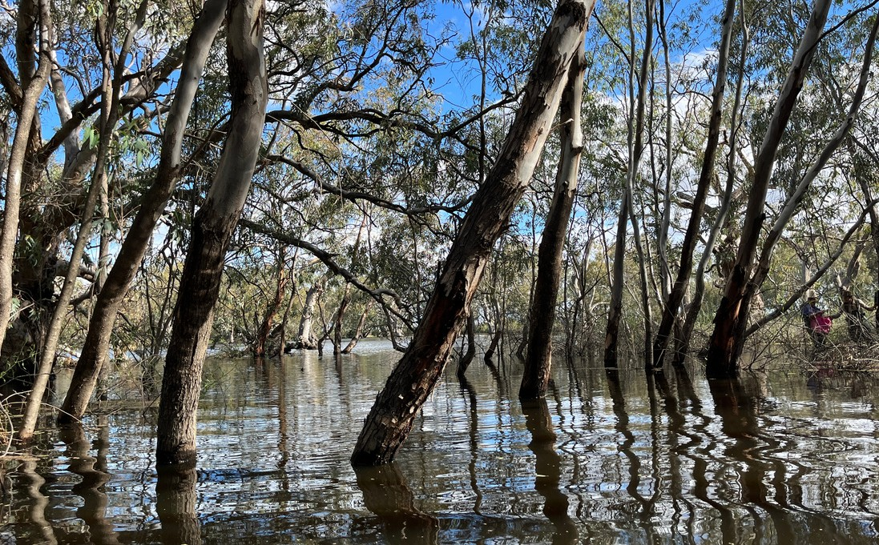

After a restricted start due to COVID-19, flooded access to wetlands

and wet weather delays, the first two rounds of wetland monitoring trips of the season took place in October (overflowing into November) and

again in December. In the mid-Murrumbidgee wetlands surveys were conducted at McKenna's Lagoon, Sunshower Lagoon, Gooragool

Lagoon and Yarradda.

In Yanga National Park access was not possible to Two Bridges Swamp, Piggery Lake and Mercedes, so instead surveys were

conducted at Yanga lake inflow, Uara creek and Shaws wetland. In

Gayini Nimmie-Caira key wetland sites were the fullest they have been since 2016 with water flooding out into the surrounding landscape.

Access and monitoring was conducted at all key sites.

Two weeks of surveys have now been conducted in the Yanco Creek

System (YCS). This includes four wetland sites and nearby 'paired' river sites in order to make a comparison between the two habitat types. Our most exciting catch during December surveys in the YCS was ten

golden perch from one site in Billabong Creek.

Welcome to Issue 10 of The Bidgee Bulletin.

After a wet spring and rainfall continuing into summer, the 2021-22 monitoring

season is in full swing with wetlands filling and floodwaters moving across the

landscape. In this issue we discuss the high numbers of Southern Bell Frog tadpoles

found at Waugorah Lagoon, explore the world of dissolved oxygen and calculating stream metabolism, rejoice over Rakali

sightings, spotlight some shield shrimp and introduce Anna Turner, PhD student and

research assistant for the Murrumbidgee Monitoring, Evaluation and Research

program.

The Bidgee Bulletin is a quarterly newsletter designed to provide updates on our

progress as we monitor the ecological

outcomes of Commonwealth environmental water flows in the Murrumbidgee Selected Area. The 2019-2022 program builds on the previous five year monitoring period (2014- 2019) and uses many of the same methods.

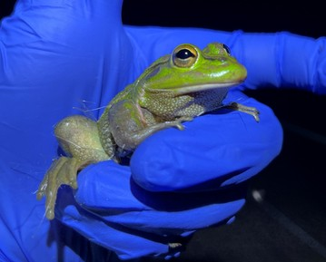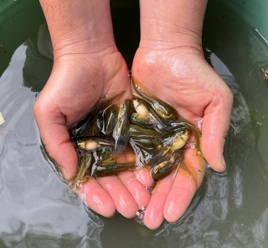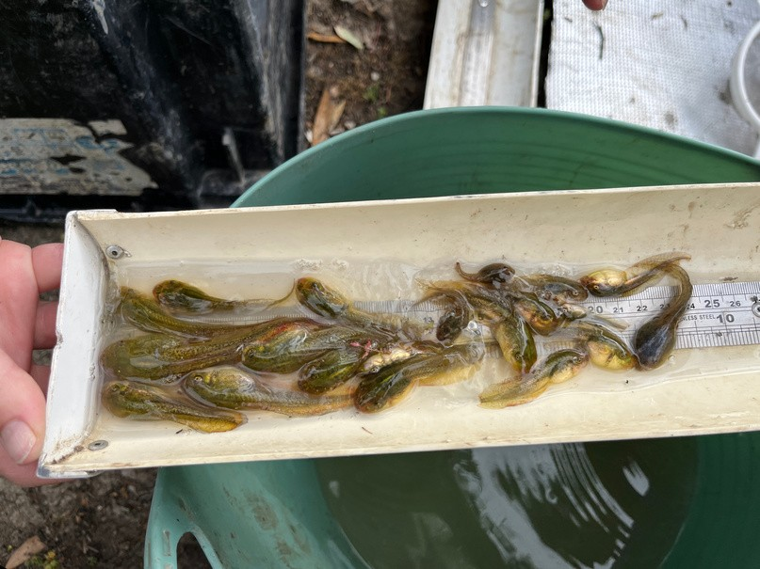

Southern Bell Frogs were seen during spotlight surveys at Bala (Eulimbah) Swamp, Banim (Avalon) Swamp and Nap Nap during November 2021 surveys

Photo credit: Anna Turner

Over 140 Southern Bell Frog tadpoles caught in the fyke nets at Banim (Avalon) Swamp November 2021.

Photo credit: Amy Daeche

Counting and staging (Gosner) Southern Bell Frog tadpoles. November 2021.

Photo credit: Amy Daeche

# BUCKET FULL OF BELL FROGS

With such a wet spring and high-water levels throughout the lower Murrumbidgee system, on the back of large e-water deliveries in 2020/21, there are Southern Bell Frogs, *Litoria raniformis*, breeding in areas in which they have not been previously recorded. Southern Bell Frog tadpoles were found during monitoring surveys at Waugorah swamp in November. This is the first report of tadpoles at this site since surveys commenced in 2008 and is very exciting news!

Breeding at Waugorah was triggered by water spilling out of the main lagoon and inundating the surrounding lignum wetland.

Southern Bell Frog breeding occurs in the spring and is

triggered by rising water levels, tadpoles develop over three to six months. For this reason, it is vital that wetland water levels remain deep enough for frogs to fully metamorphose and stay around long enough for juvenile frogs to build body condition to survive the winter. In some cases, a top up of water is required to achieve successful Bell Frog recruitment.

At Banim (Avalon) Swamp, over 140 Southern Bell Frog tadpoles were caught in November. This large breeding event was the result of planned inundation through the wetland and may also have been assisted by the carp screen installed on the inlet channel. The carp screen prevents large carp from entering the wetland which then prey upon the tadpoles before they have a chance to develop.

We look forward to counting all the young bell frogs that will emerge from the water during our night-time spotlight surveys over the course of the season.

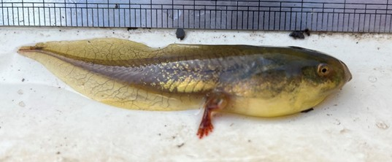

Southern Bell Frog tadpoles caught at Waugorah Lagoon in Redbank, Yanga NP November 2021. Photo credit: Anna Turner

# KIT AND CABOODLE: CALCULATING STREAM METABOLISM

Stream metabolism is a measure of the amount of energy or carbon produced and consumed by the river food webs. Just like on land, during the day photosynthetic algae and aquatic plants capture carbon dioxide and release oxygen via photosynthesis, at night bacteria, algae and plants “breath in” oxygen and release some carbon dioxide via respiration. Maintaining a balance

between oxygen and carbon dioxide production through respiration is critical for a healthy water way.

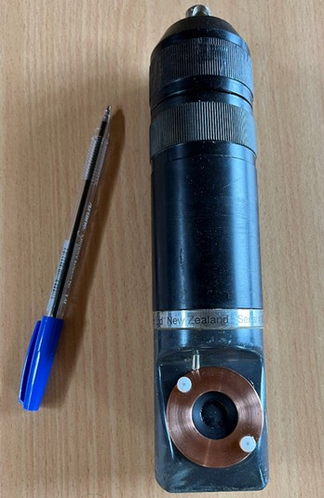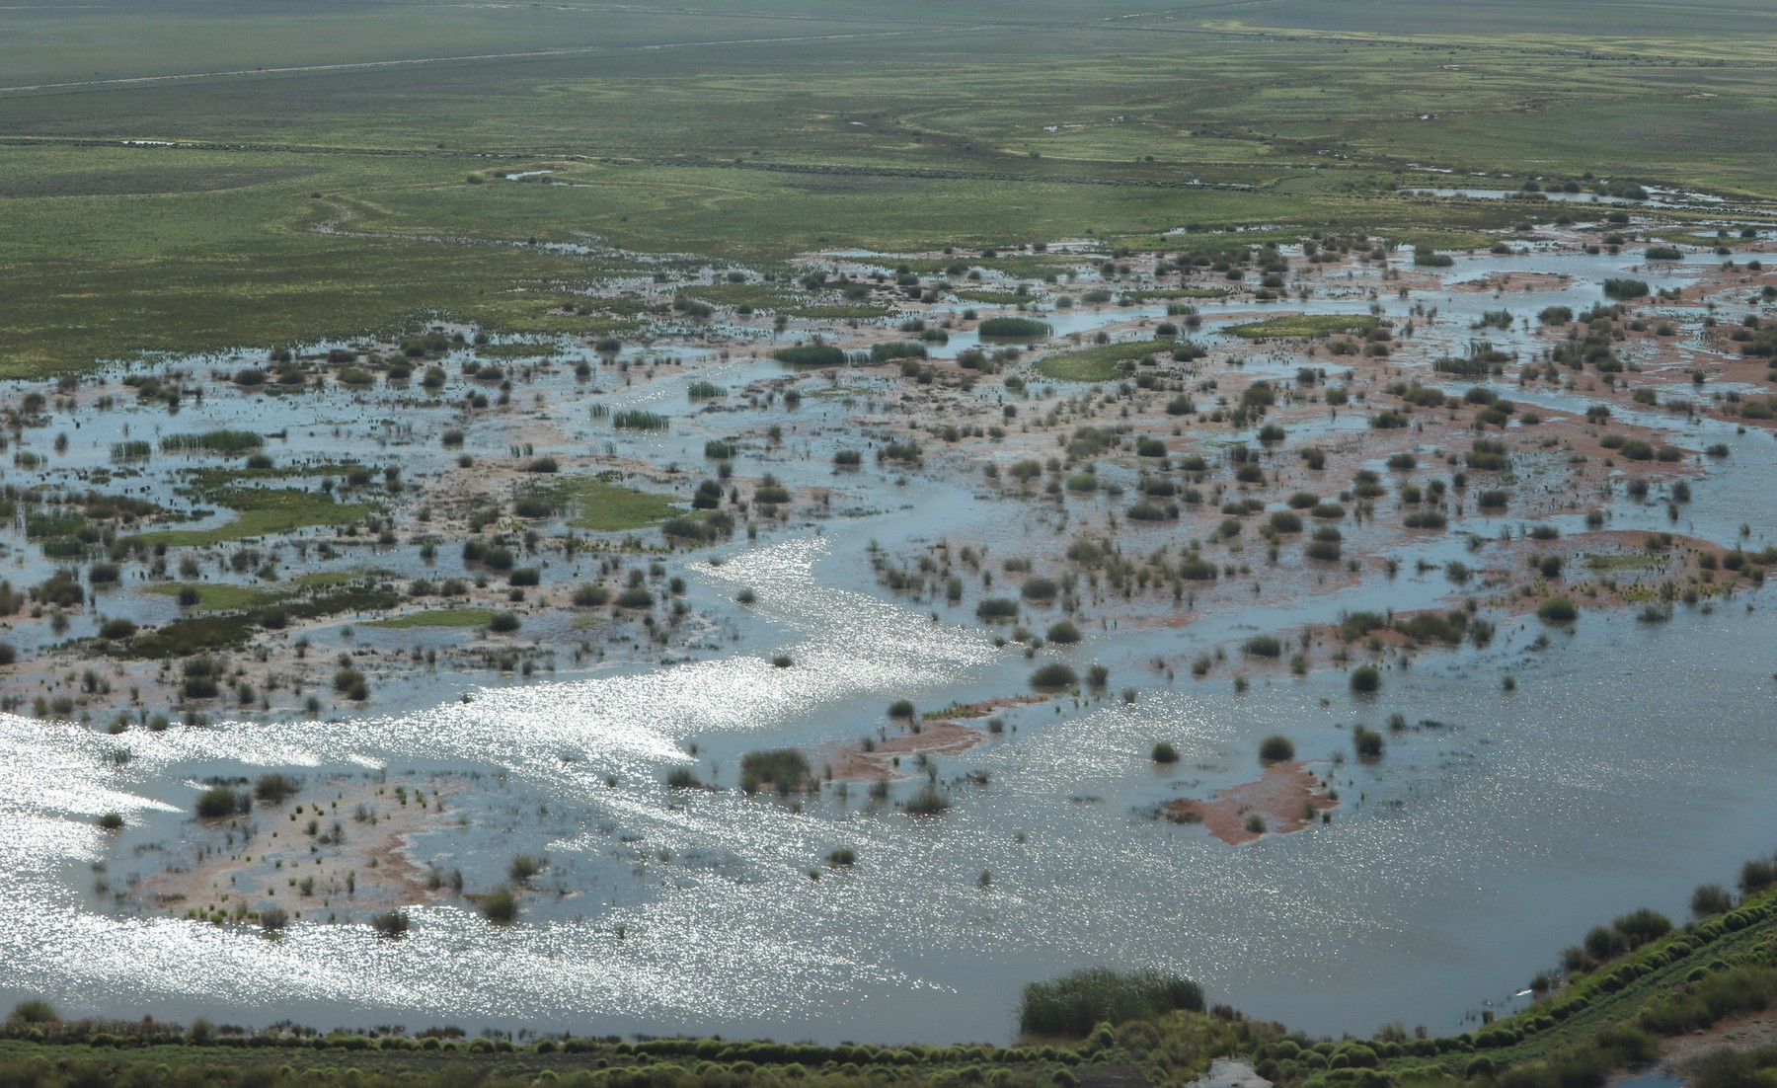

Dissolved oxygen logger with pen for a size reference. Photo credit: Anna Turner

Aerial view of Gayini Nimmie-Caira Photo credit: Damian Michael

Dissolved oxygen (DO) is a measure of the amount of oxygen dissolved in the water. Dissolved Oxygen is critical for the survival of aquatic animals and is monitored closely in both the main river channel and our wetlands. DO loggers (Zebra-Tech Ltd, Nelson, NZ), are deployed in the Murrumbidgee River at Carrathool (also known as McKennas) for the survey season (Sept – April) each year. Secured to a snag mid-stream and

attached to a weighted chain, this logger is suspended in the middle of the water column and records water temperature (°C) and Dissolved oxygen at ten-minute intervals.

The data from the DO logger is downloaded and re-calibrated monthly with some skilful manoeuvres in the kayak against the flow of the current. This data along with several other details

including mean daily discharge rate (ML d-1) obtained from nearby gauge station (Carrathool Bridge) are used to calculate stream metabolism.

# PHOTOGENIC RAKALI - CAMERA TRAP SUCCESS!

Above: Rakali investigating attached rope, remains of a yabby on the bottom right of platform.

Rakali drawn to the tin of sardines off Billabong creek, photographed with a downward facing camera.

Rakali (*Hydromys chrysogaster*), also known as the golden-bellied water rat, is a rather secretive native rodent. However, don’t be misled by this name. With its semi-aquatic habits, the rakali is

the Australian version of an otter, with webbed hind feet, a white-tipped rudder-like tail, small ears, dense whiskers. It even has the ability to eat while floating on its back! Rakali are proving to be a valuable ally in the fight against invasive carp and cane toads and assist in nutrient exchange between the aquatic and terrestrial environments.

Very little is known about this secretive species, its predominantly nocturnal habits and a patchy distribution can make them difficult to monitor.

With motion-sensitive camera traps set at 13 sites across the Yanco Creek System, a new method of detection is being tested and producing promising results. Three cameras are set, one

facing a floating platform, and two cameras close to the water’s edge, one facing forward and one downwards at a sardine lure. During a foraging session rakali usually feed at a single spot, known as a midden or feeding table, which is often on exposed debris within the water or in very close proximity to the water’s edge. There was great excitement when rakali were

photographed using our platform as a feeding table, enjoying their yabbies found in the Colombo creek. Multiple individuals were observed on the platform, checking out the tin of sardines,

grooming themselves or resting between dives.

Motion-sensitive cameras are an extremely useful passive monitoring method used for many species. So far, they have detected a vast diversity of animals, including possums, water and woodland birds, swamp wallabies, kangaroos, emus, a

curious lace monitor and the ever-present fox. The success of the camera traps in detecting rakali will be compared with traditional

trapping surveys and active searches with spotlights at night.

Be sure to keep an eye out the next time you are near a creek, river, lake, dam or even an irrigation channel for our little amphibious critter. Get onboard as all sightings can easily be reported online through the Australian Platypus Conservancy (www.https://platypus.asn.au/) or iNaturalist Australia

(www.https://[www.inaturalist.org/).](http://www.inaturalist.org/))

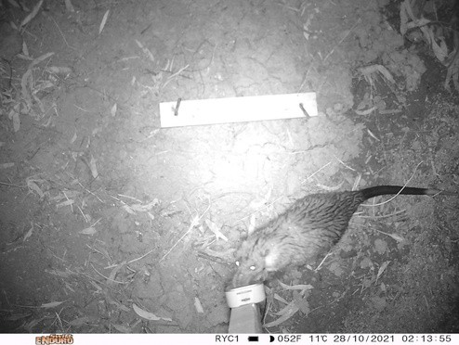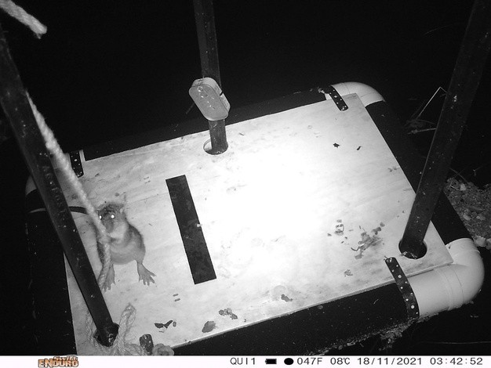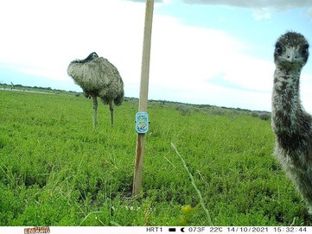

Emu chick at Wanganella Swamp photographed by forward facing cameras.

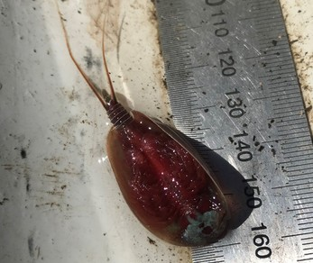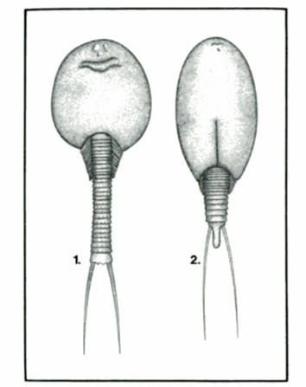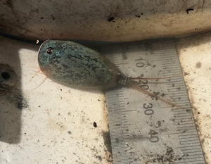

Shield shrimp underside; notice the supra- anal plate at the end of its tail between the two forked furca. October 2021

Photo credit: Eva Moore

Shield shrimp caught at McKennas in the mid-Murrumbidgee. October 2021. Photo credit: Eva Moore

*(1) Triops australiensis australiensis*; supra- anal plate absent. (2) *Lepidurus apus viridis;* arrow indicates supra-anal plate present. Picture credit: Australian Freshwater life, William David Williams

**SPECIES SPOTLIGHT: SHIELD SHRIMP**

Common name: Shield shrimp

Scientific name: *Lepidurus apus viridis*.

There are two species of shield shrimp or tadpole shrimp found in Australia; Triops spp and Lepidurus spp. Lepidurus spp occurs in southern Australia and Tasmania, whereas Triops occurs in the more northern parts of the mainland. The two genera are

differentiated by their different shaped “tails” as indicated by arrow on the bottom left photo. These critters are not usually caught during our surveys and it was quite a surprise to scoop up this individual from McKenna's wetland, even though they are common to all the areas in which our team surveys.

Shield shrimp are hardy critters that have adapted to live anywhere from deserts, to small temporary pools, to flooded wetlands. They are commonly referred to as “living fossils” as they were swimming around when dinosaurs roamed the earth and closely resemble some fossil specimens dating back 250 million years!

Shield shrimp have a large range of body shapes and their

colours range from olive green to dark blue to brown and they can grow up to 90 mm in body length. They are crustaceans, part of a group called “Branchiopods” which translates to “gill feet”. They have lobed, leaf-like feet with a gill plate which enables their breathing. They have a shield-like shell which protects their head and front portion of their segmented body. They have three eyes; two to search for food and avoid predators, and a third to detect

light.

Eggs are carried on the underside of the female’s body and are the hardiest life stage of these creatures. Females will lay hundreds of eggs in shallow soil. The eggs are resistant to both low and high temperatures and can survive for years in clay.

Eggs can be transported in the wind before hatching with the slightest bit of water. Larvae can reach adulthood in just two weeks and will moult multiple times, shedding their shells and gaining a new pair of limbs each moult. Shield shrimp are omnivorous and eat algae, insects, bacteria and microscopic rotifers.

# IN FOCUS

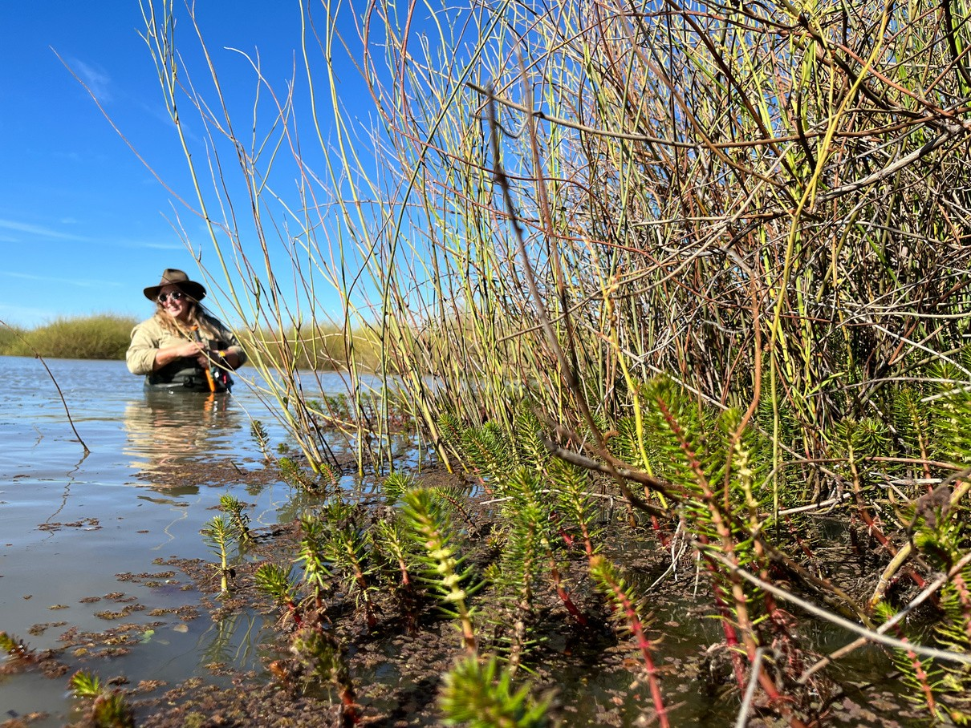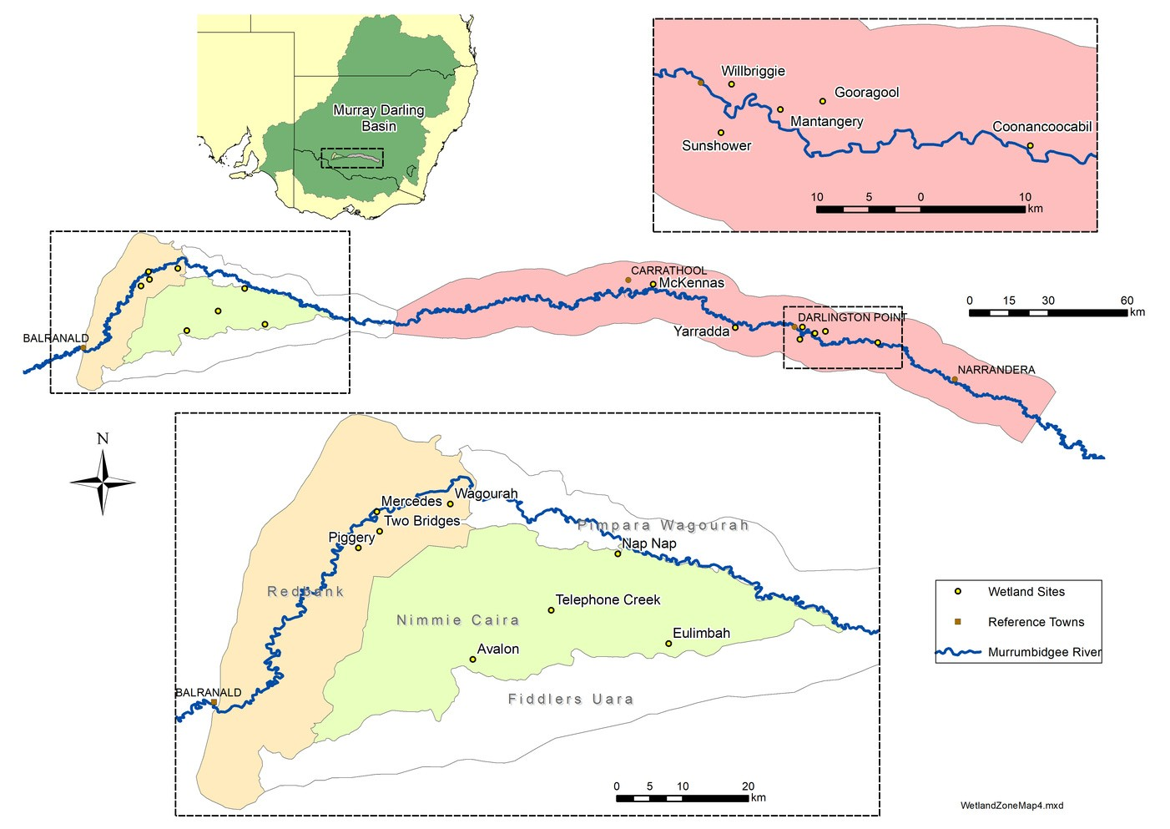

A new segment where we present our favourite recent photo.

Amy Daeche (CSU student) collecting water quality data at Eulimbah swamp in Gayini Nimmie-Caira, Lowbidgee.

Milfoil, azola and lignum in the foreground.

November 2021.

Photo credit: Anna Turner

Map showing monitored wetlands within the three Murrumbidgee zones: Redbank (cream), Gayini Nimmie-Caira (light green) and the mid-Murrumbidgee (pink)

Authors: Anna Turner, Eva Moore, Emmalie Sanders, Dr Damian Michael and Assoc. Prof Skye Wassens

The next issue of The Bidgee Bulletin is out in late March 2022.

For more information or to join the newsletter mailing list please visit: [https://www.csu.edu.au/research/ilws/research/e](http://www.csu.edu.au/research/ilws/research/e) nvironmental-water/murrumbidgee-mer

We're on social media too!

Stay up to date with our adventures on Instagram and Twitter:

**@BidgeeMER**

We still have a few 2021-22 water year calendars available. If you’d like a free copy, contact us and we’ll send one out!

The Murrumbidgee MER team would like to acknowledge the consortium partners and local landholders with whom we work.

# WHO'S WHO IN THE ZOO?

This issue we discover a bit more about Anna Turner, PhD student and research assistant for the Murrumbidgee Monitoring program.

*Name:* Anna Turner

*Organisation:* Charles Sturt University

*Position:* PhD Candidate/ Research assistant

*I studied at:* CSU Wagga Wagga- Animal Science

*In my previous job I:* Have had a diversity of roles! Worked as a Jillaroo on outback station, Ski instructor in Australia and overseas, outdoor education in Vic Alps, vineyard farmhand, waitress, horseback guiding in Kosciusko and more.

*Food attitude:* Eat yummy local produce, grow my own where possible

*Beverage of choice*: Chai Tea

How would you describe your work to a child? I look for frogs in wetlands to check they are doing ok.

*What’s the best thing about your work?* Get to work in the outdoors in some beautiful locations and hopefully contribute to conservation.

*Your work in three words?* Diverse, challenging, sometimes wet

*Is your career your parents fault?* Not directly but my draw to challenge and adventure definitely is.

*It’s now 2030, where are you?* Riding a horse in remote Mongolia with my two best mates, finally having the holiday adventure we planned for 2020.

*Flashback to 1999 – where were you then?* I was 9 year old, my family lived in Brasilia, Brazil from 1997-2001. We could have been on a boat, fishing for Piranha in the Amazon or watching the Capybara in the

Pantanal.

*Given the chance, who would you like to be for a day?* Myself, aged 18 surrounded by family

*What’s your favourite sign off?* Cheers

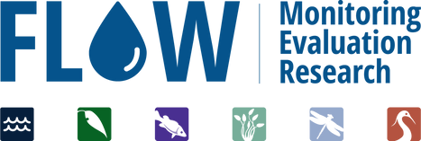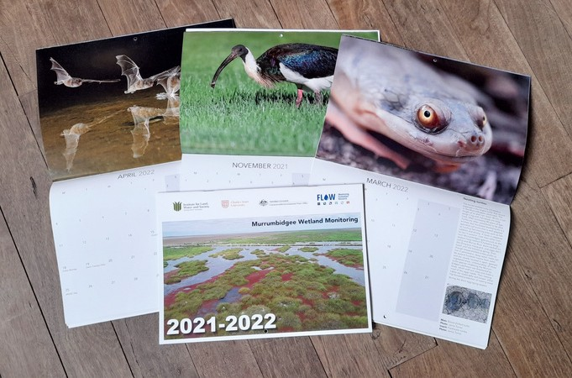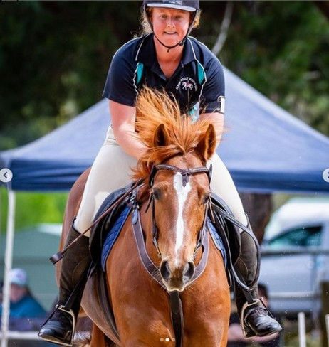

We respectfully acknowledge the Wiradjuri, Nari Nari and Muthi Muthi peoples, traditional owners of the lands on which this publication is focused