A U T U M N 2 0 2 2 I S S U E 1 1

THE BIDGEE BULLETIN

Quarterly Newsletter of the Murrumbidgee Monitoring Program

# FINAL WRAP UP OF 2021/2022 FIELD MONITORING SEASON

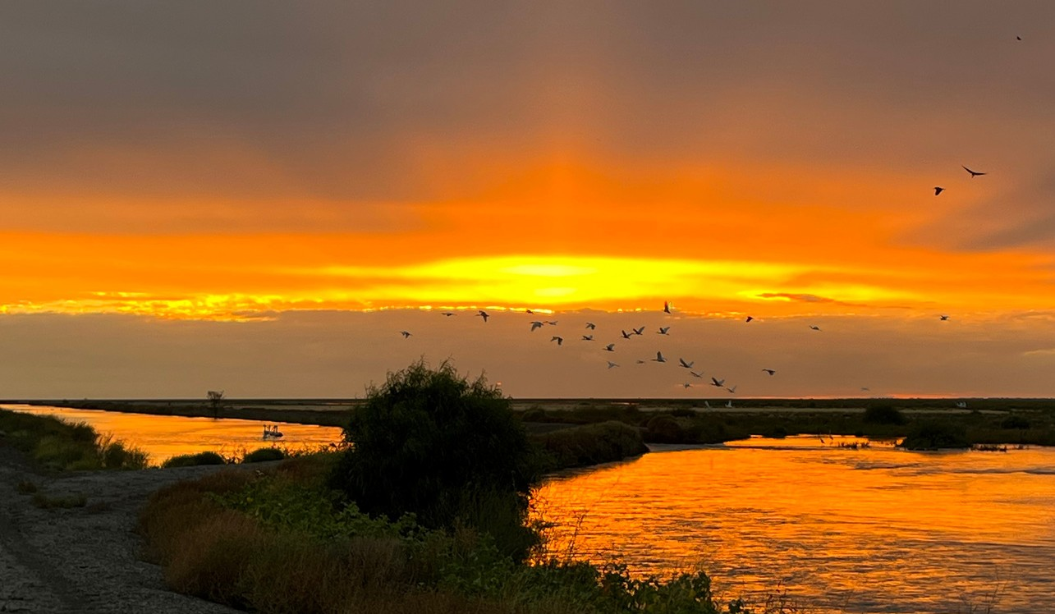

The very wet 2021/22 monitoring season has now drawn to a close. The final three weeks of monitoring were conducted in early April with field

staff returning home in time to welcome the Easter bunny and some well-earned rest over the long weekend. The nets have been cleaned and packed up for winter and the odometer on the vehicles can turn over at a slower rate over the coming months.

We are pleased to have made it to the end of a challenging season.

Covid19 restrictions, flooded sites and staffing changes were overcome in a season that began way back in September last year. By the time

we pulled in the nets and rolled out of our final wetland site in April, it

felt like we were a well-oiled machine once more. Green field staff now have a few more kilometres under their belt, tools in their problem-

solving toolkit and an ever-expanding species list in their mental

guidebooks. Now, it is time to crunch some data for reporting, repair

and replace field equipment and start thinking about the new water year ahead of us.

Welcome to Issue 11 of The Bidgee Bulletin. In this issue we discuss the successful

Yanco Creek Field Day and hear about snake research underway by honours

student, Talia Schlen. We have a close look at frog survey methods and discover the

fascinating blind snake as the ‘Species in Spotlight’. We finish this edition staring

Sarah Talbot, a BidgeeMER team member and current administration allrounder.

The Bidgee Bulletin is a quarterly newsletter designed to provide updates on our

progress as we monitor the ecological

outcomes of Commonwealth environmental water flows in the Murrumbidgee Selected Area. The 2019-2022 program builds on the previous five year monitoring period (2014- 2019) and uses many of the same methods.

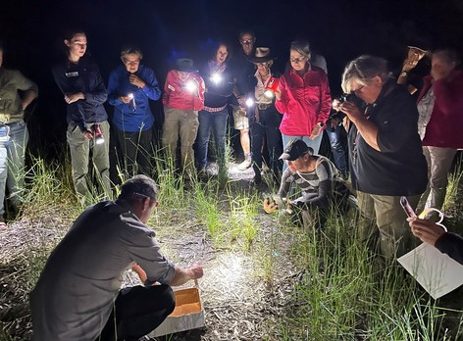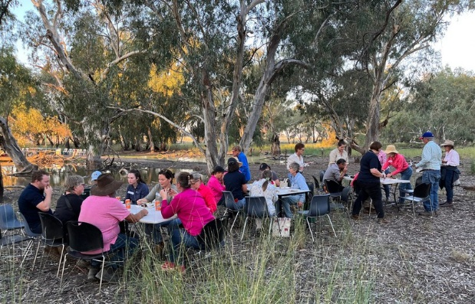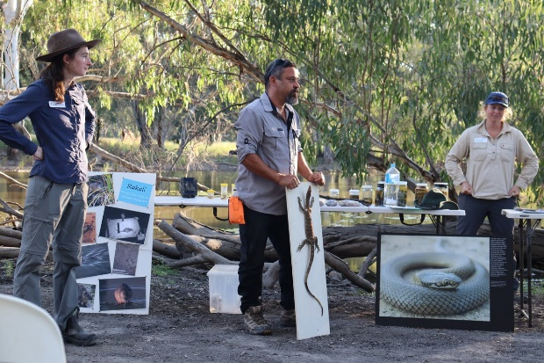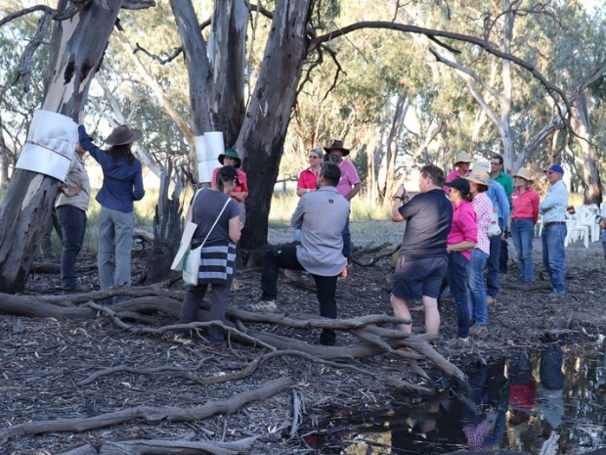

BidgeeMER researchers, Eva Moore, Dr Damien Michael and Anna Turner presenting at the Yanco

field day. Photo credit: Sarah Talbot

Eva Moore demonstrating the use of artifical bark covers for monitoring tree-dwelling skinks and

geckos. Photo credit: Sarah Talbot

Field Day participants enjoying BBQ dinner by the wetland thanks to Jerilderie Fishing Club.

Photo credit: Sarah Talbot

Dr Damien Michael pointing out a curl snake, *Suta suta,* found during spotlight searches. Photo credit:

Anna Turner

# YANCO CREEK FIELD DAY SUCCESS

The frogs and reptiles put on a show and the mosquitos must have been down at the pub as they were not to be seen at the Yanco Creek wetland field day on Friday 25th March. Keen landholders and managers, naturalists, and eager locals gathered on the banks of Broome wetland for a fun evening of activities. We were first welcomed by the landholders Gillian, David and Susie Leeds who kindly opened their property for the evening. We then heard about the Refreshing River Management project from Andrea Mitchel of YACTAC, the current monitoring underway in the Yanco Creek system from Anna Turner (CSU), and the importance of water for the environment and the role of CEWO in its delivery from Michelle Groat (CEWO).

Dr Damian Michael then took the stage and held the audience captivated with his reptile collection and detailed knowledge on these fascinating creatures. From tiny blind snake specimens to larger pythons and even a goanna, there was a chance to examine distinguishing features and gain a better understanding of the diversity of reptiles which may be found around wetlands. Eva Moore demonstrated the use of artificial bark covers for surveying arboreal skinks and geckos and then led us on a walk, around the water’s edge, to spot any reptiles who might be eavesdropping on the event.

The enticing smells wafting across the wetland from the Jerilderie Fishing Club’s BBQ soon had us all feasting on the impressive spread as the evening light, filtered through the trees, creating dancing shadows on the wetland. Kathie Le Busque from Murray Local Land Services brought out the water bugs and sparked an interest for many in the often-overlooked inhabitants of our waterways. All the while the night chorus was increasing and as darkness surrounded the eager crowd, we ventured out into the wetland again, this time with headtorches and spotlights. Anna Turner (CSU) gave us a run-down on how to identify frog species and Emmalie Sanders (CSU) talked to us about Rakali and her research before we headed out.

It was a great night for spotting frogs. Spotted marsh frogs were busy calling amongst the small spike rush, water primrose and milfoil.

Males could be seen with their orange throats extended and large floating foam masses were a display of successful breeding. Eastern sign-bearing froglets could be heard calling, Peron’s tree frogs were found on water-side logs and a juvenile Banjo frog was found to wrap up the evening. Damian demonstrated his expertise in finding snakes, allowing participants to get a good look at a curl snake who was out hunting for a frog feast.

We hope everyone enjoyed the night as much as we did, and that they took home some important messages on the diversity of creatures

that call wetlands home. Spread the word and keep an eye out for future events, even if it’s to get your hands on one of the home-made Southern Bell frog chocolates beautifully crafted by Sarah Talbot (CSU).

Calipers are used to measure from the tip of the nose to base of the spine (SUL). Frogs are handled with gloved hands only to prevent contaminating the frogs skin with sunscreen, mosquito repellant and other potentially toxic oils on our skin. Gloves also reduce the transfer of diseases between frogs such as chytridiomycosis caused by a fungus on the frogs' skin. Photo credit: Anna Turner

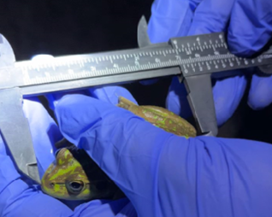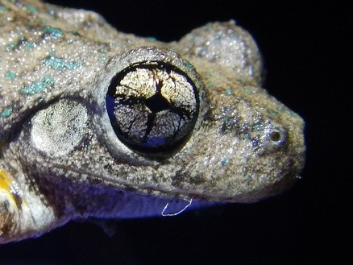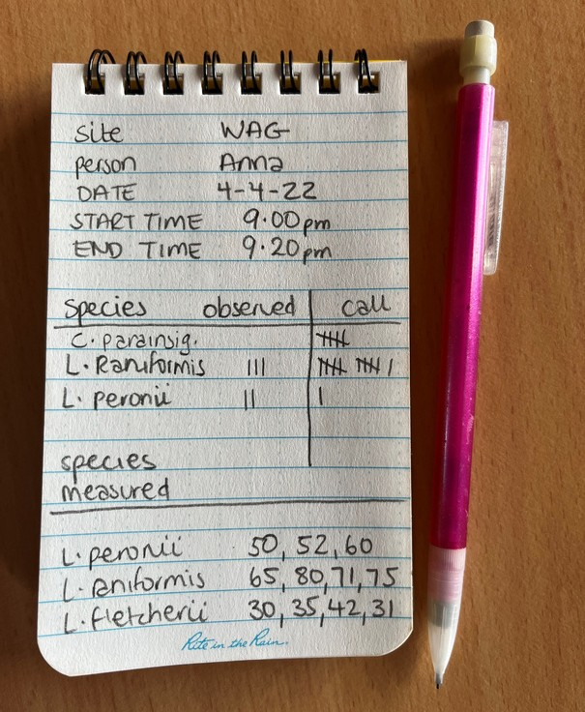

We record details of the frog surveys in waterproof notepads. It is important to note the site name, date and time and who is conducting the survey. We then record species and if they were heard calling or spotted. We record the SUL of any frogs measured. Photo credit: Anna Turner

Peron's tree frog is often found on fallen logs and on trunks of trees around wetlands. They have a cackle-like call, emerald coloured sparkles and a crossed-shaped pupil. Photo credit: Anna Turner

# KIT AND CABOODLE:

The gear and methods we use for **Frog surveys:**

At each wetland site, four times a survey season, we conduct audio and visual searches for frogs. After dark, we commence by listening for frog calls. Frogs can be identified by their unique

calls and we can take note of the species present and the number of individuals calling. We might hear the cackle of the Peron's tree frog from a fallen log hanging over the water or the distinctive 'waa-waa-waa' of the southern bell frog from the

platform of water primrose, similar to a revving motorbike.

We then spotlight for frogs along the water's edge for a total survey effort of 40 minutes per site. We may catch the eyeshine of a spotted marsh frog floating on the water's edge or the

shimmer of a wet barking marsh frog that has just emerged from the water. Eastern sign-bearing froglets are very hard to spot as they can be the size of your thumb nail, whereas the giant banjo frog is hard to miss with some as big as the palm of your hand!

Each frog we encounter, we measure the length from the tip of

the nose to the base of the spine, known as snout-urostyle length or SUL. We record the species and weather it was observed, heard calling, or measured.

Did you know that it is only male frogs that call? Males choose a location to get the best acoustics. Females then make their way to the males to mate (known as amplexus in the frog world). The eggs or frog spawn of each frog species differs. The spotted marsh frog and barking marsh frog lay foam masses of eggs

which float on the surface of the water. In comparison, Peron's

tree frogs lay eggs singularly or in small groups attached to twigs or vegetation under the surface of the water. For this reason, reducing stock access to dams and waterways can improve the vegetation and increase the diversity of frog species that can successfully live and breed there.

Frog eggs need to be under water long enough for development into tadpoles to occur and then metamorphosis into adult frogs. Once on land as adults, frogs can then move from floodplains to permanent water sources as the wetlands dry out. Monitoring by the MER team helps detect where breeding has occurred for endangered species such as the southern bell frog and help

ensure there is enough water for them to develop into adult frogs.

If the wetland were to dry out before metamorphosis, the breeding event would not be successful and could lead to local extinctions were it to occur over multiple years.

If you are interested in which frog species might be around your waterways, wetlands, irrigation channels or farm dams. Download the free FrogID app created by Australia Museum. You can filter

the species to 'frogs near me', listen to call recordings and look at photos. You can also record frog calls and submit them to be identified by experts at Australia Museum.

A curl snake (*Suta suta*) trying to use the dead shrubbery to hide from us. This snake looks very similar to the grey snake. Their appearances differ slightly in that the curl snake is a bit more robust, lacks the distinctive head markings of the grey snake and has a pale creamy belly as opposed to the grey snake’s bright yellow belly. March 2022.

Gilligan the grey snake (*Hemiaspis damelii*) being released after having their measurements taken. Gilligan was almost full size at 51cm long from nose to tail. March 2022

Honours student, Talia Schlen, scouting a new survey site during the day in a swamp in Paul Coates Swamp, North Redbank. March 2022.

# SNAKE SEARCHES TAKEN TO THE NEXT LEVEL

This summer we were on the look out for an endangered

nocturnal snake, the grey snake (*Hemiaspis damelii*). The grey snake has a lot of the hallmarks of a reptile that is vulnerable to extinction: it's poorly studied, hard to detect, a venomous snake

(hence relatively unpopular compared to a koala) and is found in areas with limited human occupation/surveillance. The grey snake was considered locally extinct in the Lowbidgee until 2018, when

the MER team found individuals whilst surveying for southern bell frogs (*Litoria raniformis*). Since then we’ve been progressing

research to better understand where and how the grey snake is persisting across areas subject to Commonwealth environmental watering actions in the lower Murrumbidgee.

Grey snake surveys took place across 5 weeks in the lowbidgee floodplain, with 3 weeks of surveys conducted in November 2021 and 2 weeks in March 2022.

Fifty-eight survey sites were chosen for survey on the basis that they were likely to be representative of the hydrology and

environments that occur across the broader lower Murrumbidgee floodplain. We’d scope out potential sites during the day, then

come back at night to search for grey snakes whilst they’re out and about after dark. The surveys comprised of visually sighting snakes with headtorches during nightly active searches along

waterbody edges, roads and levee banks in areas with predominantly black clay cracking soil.

The next step for grey snake research is to develop a statistical model that will highlight the connection between hydrology and

snake presence and also help us prioritise new unsurveyed areas to find other fragmented sub-populations, should they exist.

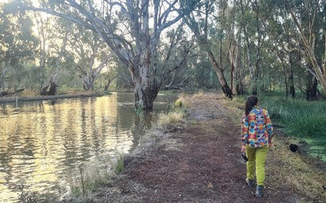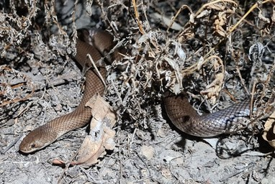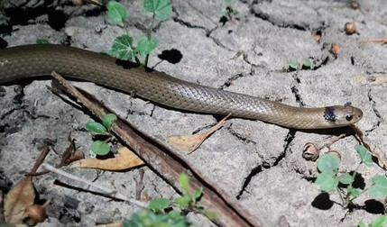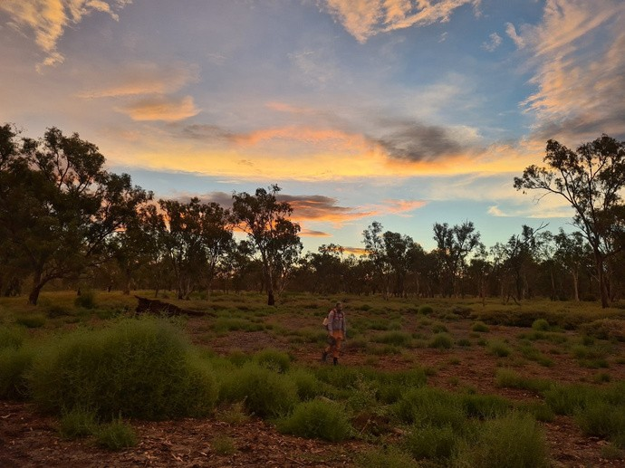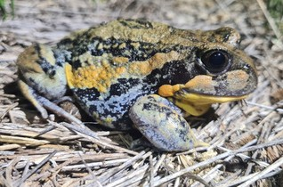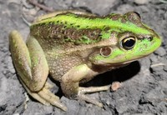

Giant banjo frog (*Limnodynastes interioris*) and southern bell frog (*Litoria raniformis*) detected during snake surveys. Bunumbert lakes, near Oxley. November 2021.

Right: Volunteer Emil Gross walking the first survey transect for the night in the Great Cumbung Swamp, where the Murrumbidgee and Lachlan Rivers meet. This area was completely submerged in November 2021 but bone dry in March 2022. Oxley, NSW.

All photos by Talia Schlen.

Prong-snouted blind snake found at Uara Creek in Yanga National Park. February 2022.

Photo credit: Eva Moore

**SPECIES SPOTLIGHT: BLIND SNAKE**

Common name: Blind snake Scientific name: *Anilios sp*.

Blind snakes are fascinating creatures that can often be mistaken for earthworms as their bodies are uniformly round and end in a

very short, rounded tail. Their colour ranges from pink to black, usually with paler scales along their underside. They are small burrowing snakes with smooth scales around their bodies which

enables their travel through soil. They are called blind snakes as their eyes are reduced and underneath opaque head scales.

A prong-snouted blind snake found during honours project research near Bunumbert Lakes, north of Yanga National Park in November 2021. Photo credit: Talia Schlen

Research volunteer, Emil Gross, dressed ready to search for snakes and frogs. March 2021. Photo credit: Talia Schlen

The field team at Balranald, April 2022. Anna, Will, Amy, Eva and Paul.

Their mouths are small and positioned well below the tips of their snouts. They travel underground via tunnels made by insects.

Blind snakes are non-venomous, harmless, and have limited defences.

Their snout appears strongly tri-lobed when looking from above and they possess 20 mid-body scales. Like the rest of their kin, they are fossorial which means they are a burrowing species.

They emerge after sunset to forage, using their top jaw to rake food such as ant and termite eggs and pupae into their mouths, which they swallow whole. While they do not possess many

defence mechanisms, such as strong jaws or sharp teeth like

other snakes, they can emit a foul odour from well-developed anal glands if they are disturbed.

There are 46 species of blind snakes in Australia. In December 2021, we were lucky enough to come across two Prong-snouted

blind snakes (*Anilios bituberculatus*). Prong-snouted blind snakes are associated with open woodlands and semi-arid areas

throughout the Murray-Darling Basin (MDB). Prong-snouted blind snakes are oviparous, meaning they lays eggs. Their clutch size ranges from two to nine eggs. When the young hatch they are

immediately independent and fend for themselves.

We spotlighted this species during our routine night-time frog

surveys in Yanga National Park near Balranald. The individuals we encountered were so small that we initially mistook them for earthworms. Honours student, Talia Schlen, also detected a

prong-snouted blind snake to the north of Yanga National Park near Bunumbert Lake.

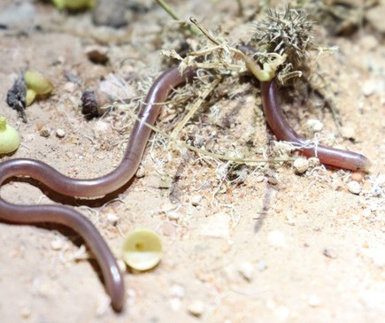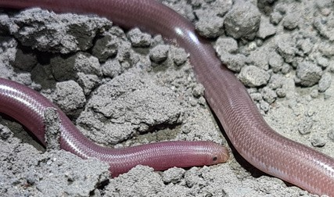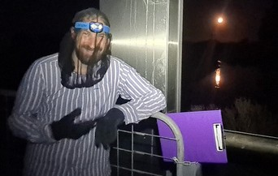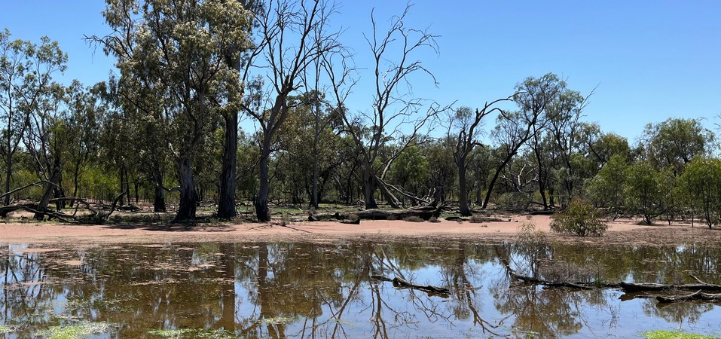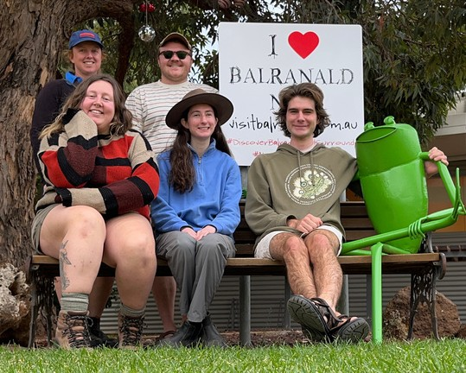

Right: Floodplain wetlands in Yanga National Park where snake surveys have been conducted during the 2021/22 field season.

Photo credit: Anna Turner

# IN FOCUS

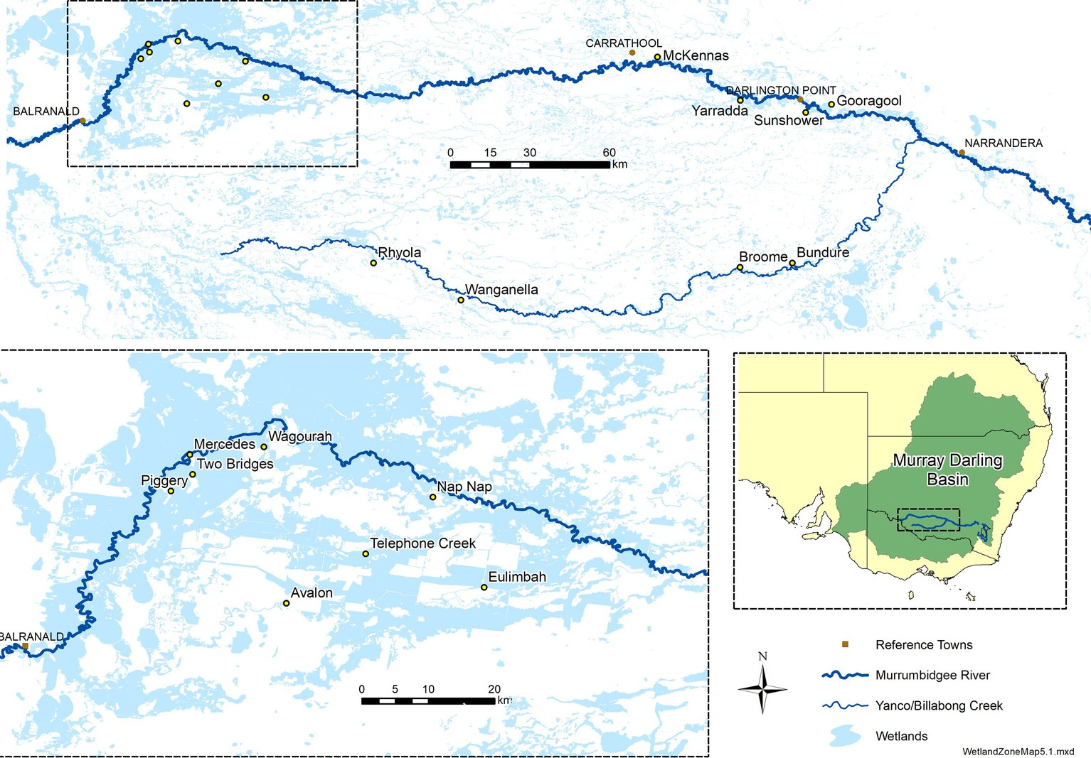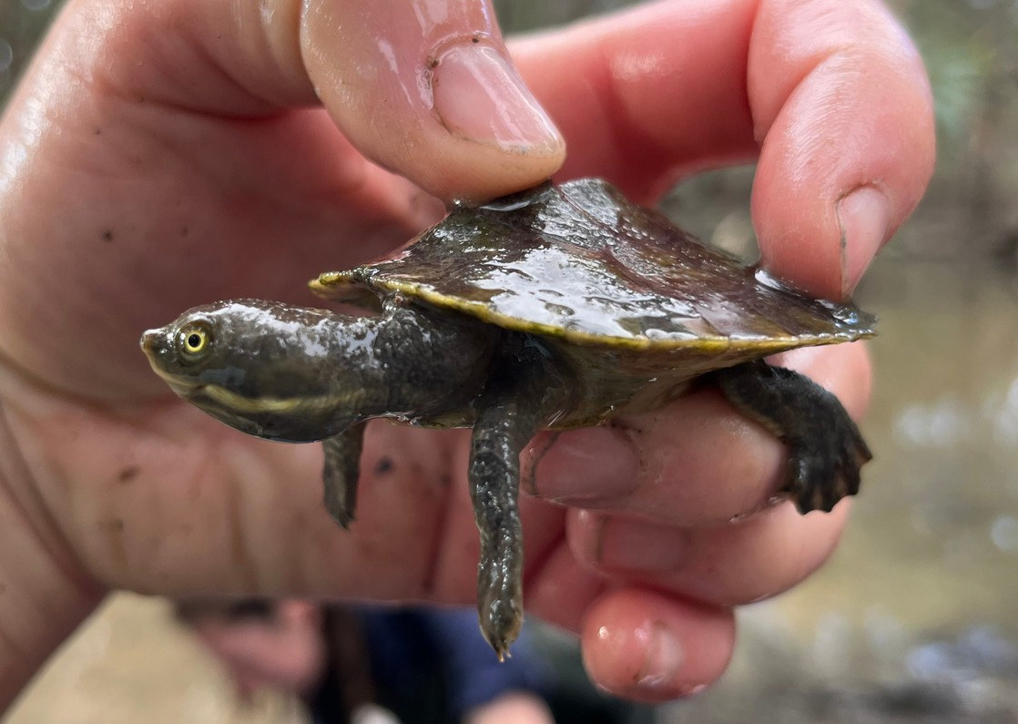

A new segment where we present our favourite recent photo.

Juvenile Murray River turtle, *Emydura macquarii*, captured in fyke nets at Yarradda lagoon in the mid- Murrumbidgee.

April 2021.

Photo credit: Anna Turner

Map showing monitored wetlands within the Murrumbidgee zones; lower- Murrumbidgee, mid- Murrumbidgee and Yanco Creek System

Authors: Anna Turner, Eva Moore, Talia Schlen, Sarah Talbot and Assoc. Prof Skye Wassens

The next issue of The Bidgee Bulletin is out in winter 2022.

For more information or to join the newsletter mailing list please visit: [https://www.csu.edu.au/research/ilws/research/e](http://www.csu.edu.au/research/ilws/research/e) nvironmental-water/murrumbidgee-mer

We're on social media too!

Stay up to date with our adventures on Instagram and Twitter:

**@BidgeeMER**

The new water year calendar for 2022/23 will be out in June. If you’d like a free copy, contact us and we’ll send one out!

The Murrumbidgee MER team would like to acknowledge the consortium partners and local landholders with whom we work.

# WHO'S WHO IN THE ZOO?

This issue we discover a bit more about Sarah Talbot, member of the

BidgeeMER research team and administration staff for the Gulbali Institute.

***Name:*** Sarah Talbot

***Organisation:*** Charles Sturt University/ Gulbali Institute

***Position:*** Research/Administration assistant

***I studied at:*** CSU Wagga Wagga- Animal Science, Albury for PhD in ferret behaviour.

***In my previous job I****:* So many positions to choose from… but I guess the most memorable one would be vet nursing whilst completing my PhD. Those were some of the hardest (and underpaid) days I’ve ever worked, and it made me appreciate veterinary staff on a whole ‘nother level.

***Food attitude:*** Spicy, creamy, or sweet.

***Beverage of choice*:** Coffee or a cheeky Shiraz

***How would you describe your work to a child?*** Sometimes, I watch animals and write down what they are doing. Other times, I catch and measure them. I then copy what I’ve written down into a computer so people can use that information to help make decisions about how to manage animal welfare or things in the environment.

***What’s the best thing about your work?*** That it’s meaningful/impactful.

***Your work in three words?*** Computers. Data. Animals.

***Is your career your parents fault?*** Nope. They thought I’d be a different kind of doctor.

***It’s now 2030, where are you?*** Living in Colorado, working with Black- Footed Ferrets.

***Flashback to 1999 – where were you then?*** In primary school, listening to the Spice Girls! No, but seriously, it was around that time that I realised I

like animals more than most people (and was fascinated by their behaviour). That’s what ultimately led me to this kind of work.

***Given the chance, who would you like to be for a day?*** My cat, Blue. He eats better than I do most days and sleeps 18 hours a day!

***What’s your favourite sign off?*** Cheers!

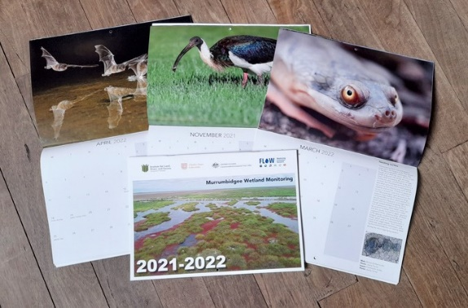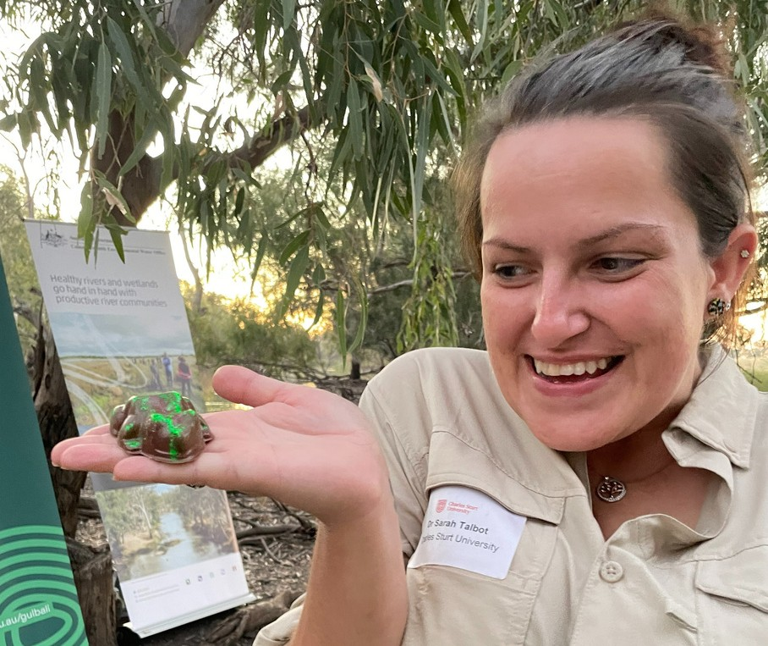

We respectfully acknowledge the Wiradjuri, Nari Nari and Muthi Muthi peoples, traditional owners of the lands on which this publication is focused