S P R I N G 2 0 2 1 I S S U E 9

THE BIDGEE BULLETIN

Quarterly Newsletter of the Murrumbidgee Monitoring Program

# SPRING FLOWS

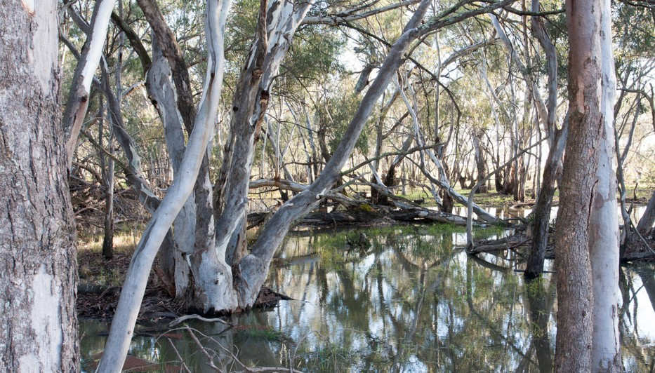

Fyke nets have been mended, equipment is restocked, new staff are itching to get their feet wet and we are all ready to get out in the wetlands for the new 2021-22 field season.

However, the continuing challenge of COVID restrictions are making our start a little trickier but we are adaptable and not afraid of last-minute changes to the schedule. On top of this, it is very wet out there, with above average rainfall over autumn and winter and similar downpours predicted for

spring. Some wetlands are more than full, unfortunately making access to many wetlands very difficult.

The September Mid-Murrumbidgee trip was reduced to a day trip because access to all sites was restricted by the high- water levels. For example, this time last year the daily average water level at Carrathool, one of our core sites, was

2.1 metres and the average discharge rate was 4690.2 ML/day. This year the daily average water level is 5.2 metres and the average discharge rate is 16776.1 ML/day—almost a three-fold increase!

Welcome to Issue 9 of The Bidgee Bulletin. After a wet winter and rainfall continuing into spring, the 2021-22 monitoring season has

commenced with wetlands filling and

floodwaters moving across the landscape. In

this issue we discuss the lead up to the highest water levels since the 2016 floods, we introduce the Yanco Creek monitoring project, talk about all things Horiba (water quality equipment),

focus on the Carp gudgeon, find out what bats

are up to around wetlands and meet Tara Dixon, IPA Coordinator with the Nari Nari Tribal

Council.

The Bidgee Bulletin is a quarterly newsletter

designed to provide updates on our progress as we monitor the ecological outcomes of

Commonwealth environmental water flows in the Murrumbidgee Selected Area. The 2019-2022

program builds on the previous five year

monitoring period (2014-2019) and uses many of the same methods.

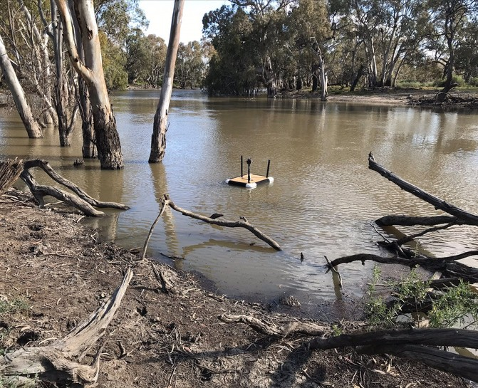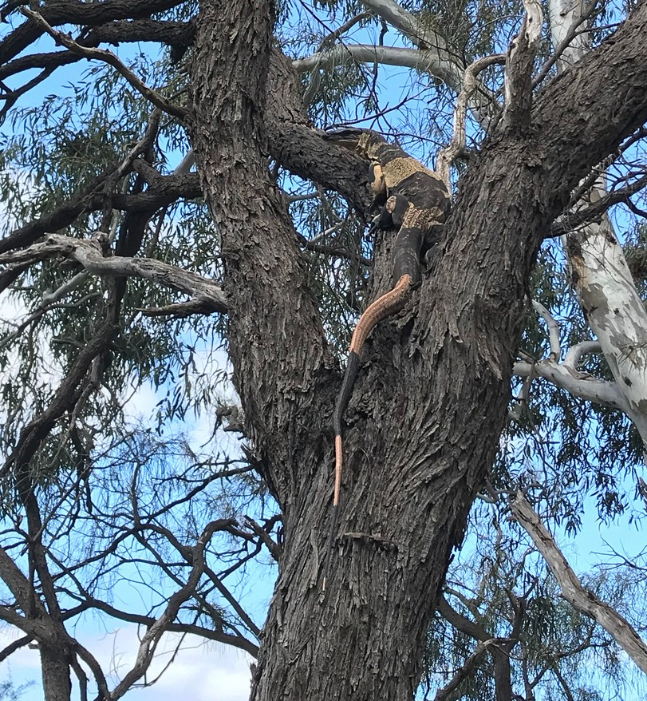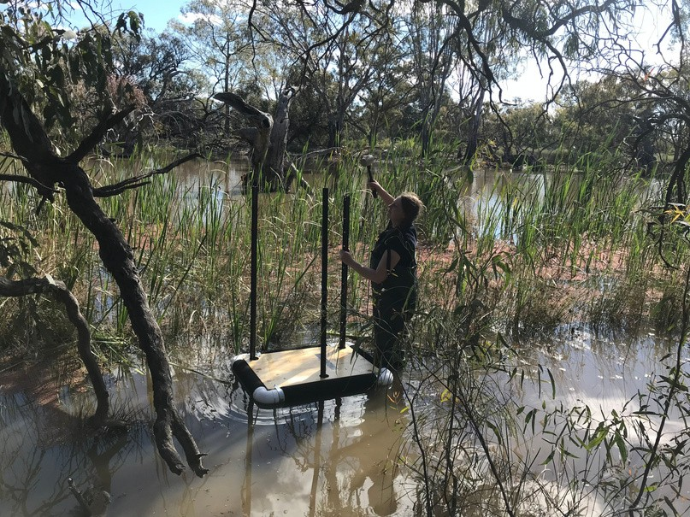

Floating rakali platform at Rhyola September 2021

Photo credit: Eva Moore

Emmalie Sanders setting up a floating rakali

platform at Hartwood in September 2021 Photo credit: Eva Moore

Bell's Phase Lace monitor (*Varanus varius)* up a tree at Rhyola September 2021

Photo credit: Eva Moore

The Yanco Creek System (YCS) was visited over a four-day trip in late September. Call recorders were set at the key monitoring sites to enable remote monitoring of frogs, birds and bats. Water levels were also higher than usual at these sites and are expected to rise further, making waders and gumboots an absolute necessity. Conditions will be closely monitored before we venture out again because high water levels can lead to dangerous travel conditions.

Motion-triggered cameras were set at seven sites along the YCS by PhD student Emmalie Sanders in the hope of capturing images of local rakali (water rats, *Hydromys chrysogaster*). These cameras were deployed on floating

platforms, trees or on wooden posts close to the water with the strong-smelling allure of tins of sardines to help attract rakali, and hopefully many other interesting species.

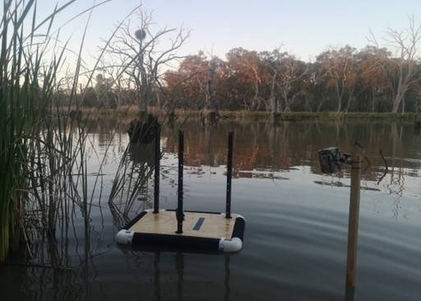Floating platform with sardine lure designed to attract rakali and a camera trap to record rakali visitation. Mundoora, September 2021 Photo credit: Emmalie Sanders

The motion-triggered cameras were attached to inundated trees close to the platforms, on the platforms themselves or on wooden posts in the water. Two more cameras were established on land, close to the water’s edge, with another tin of sardines to attract curious critters.

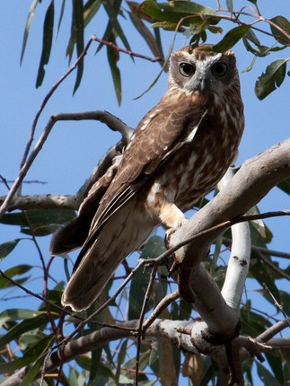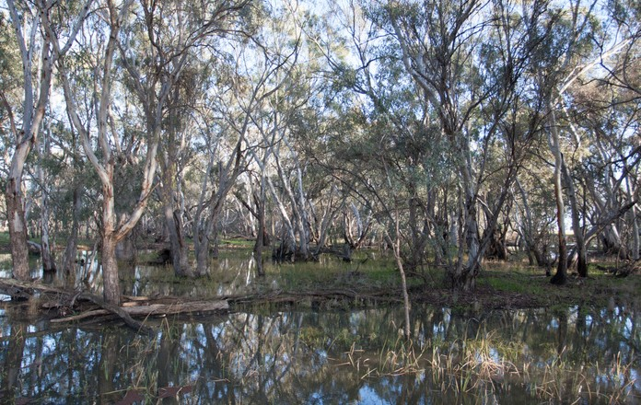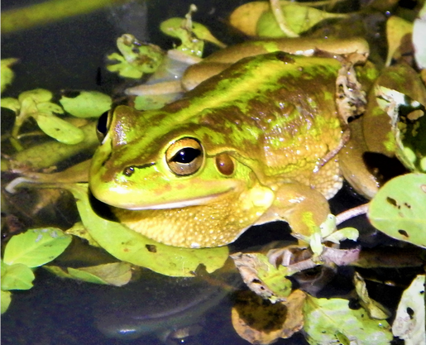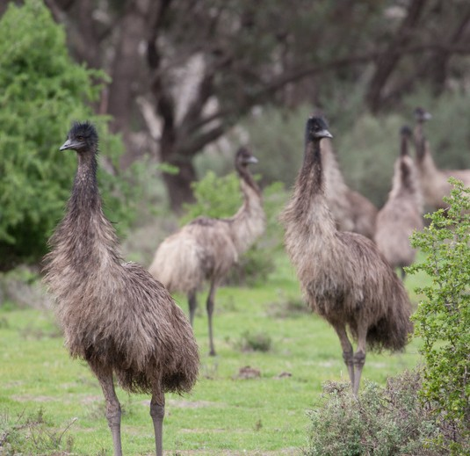

Southern bell frog (*Litoria raniformis*) calling from a platform of aquatic vegetation at Broome (January 2020). Photo credit: Anna Turner

Boobook owl (*Ninox boobook*) at Coonong August 2021. Photo credit: Jamie Turner

Emus at Rhyola August 2021 (left). Bundure wetland (right) Photo credit: Jamie Turner

# NEW MONITORING SITES IN THE YANCO CREEK SYSTEM

Fourteen new monitoring sites have been added to the Murrumbidgee MER program this season to generate a long-term dataset and better understand the ecological communities in the Yanco Creek System (YCS). Sites are centred around Jerilderie and span between Moulamein to the west and Morundah to the east. Surveys encompass Billabong, Yanco, Columbo and Forest creeks.

The YCS supports several species of conservation significance including the threatened southern bell frog, the trout cod, silver perch, and Murray cod. Other water-dependent species that are likely to be present in the YCS include the vulnerable southern myotis (fishing bat), rakali and

platypus.

Eight of the sites, four wetlands and four reaches within nearby Creeks, will be monitored for frogs, fish, tadpoles and turtles in November,

January and March. While PhD student, Emmalie Sanders, will be

investigating the rakali populations in the area. Fish are expected to move between creeks and wetlands when they are connected during high flows. Wetlands can be important nursery habitats for native fish and where high abundances of native fish are detected, management

interventions to create fish passage back into the creek may be required to enable their dispersal. In addition to the more intensively monitored

sites, call recorders to detect frog and bat species have been deployed at 10 other sites so that we can monitor frog and bat activity over the year.

In early 2022, platypus surveys will be conducted in the YCS and we will be holding a field day/night for locals to learn more about who lives in

their creeks and I’m sure we will gain some local knowledge too

Water quality readings including pH, temperature, conductivity, dissolved oxygen and turbidity can be recorded using the Horiba U-52 Water MultiParameter.

Gaye Bourke taking water quality readings

Photo credit: Vince Bucello

Paul Tomczyk, who is part of the indegenous cadetship program, takes water quality readings. Photo credit: Jamie Turner

# KIT AND CABOODLE: THE HORIBA

When we roll up to a wetland monitoring site most of the field team immediately get busy unloading gear, pulling on waders and setting up the fyke nets. One person will reach for the black Horiba case (Photo 1) and wander out into the wetland to record a range of physical and chemical water quality parameters including

temperature, turbidity, pH, dissolved oxygen and conductivity. The Horiba is a portable water monitoring device consisting of multiple probes that hangs beneath the surface of the water, a length of cable, and a handheld unit that displays and records data (Photo 2). Multiple recordings are made at each wetland on each visit, and this information is combined with data from other monitoring

equipment including weather stations and water depth loggers. So, what does all this data tell us, and why does it matter?

While water temperature will naturally vary across seasons, rising water temperature can indicate changing conditions during summer heatwaves, which can be harmful to plants and aquatic life and encourage blue-green algae growth. Blackwater is a naturally occurring process caused by nutrient rich organic material, such as leaves and bark, washing into rivers during a flood. As this organic matter decays, tannins are released, giving the water a blackish appearance. The process can also release chemicals that make water more alkaline or acidic, while the breakdown of organic

matter can deplete dissolved oxygen levels.

Low dissolved oxygen levels can occur under a range of conditions and can kill aquatic life (such as fish and shrimps). Monitoring oxygen levels in wetlands helps us plan management interventions to increase dissolved oxygen levels and reduce the risk to aquatic animals.

Many inland wetlands have naturally high turbidity due to very fine sediments and naturally occurring clays that are suspended in the water. In many cases these sediments eventually settle out, with many wetlands having very clear water. However, disturbance by animals including carp can stir up these sediments making the

water muddy or 'turbid'. Turbidity reduces the penetration of sunlight, affecting plants and aquatic life.

Monitoring water quality can tell us about a spectrum of changes in wetland health that affect the resident animals and plants.

Importantly, this data can be used to inform decision-making for wetland management and watering actions.

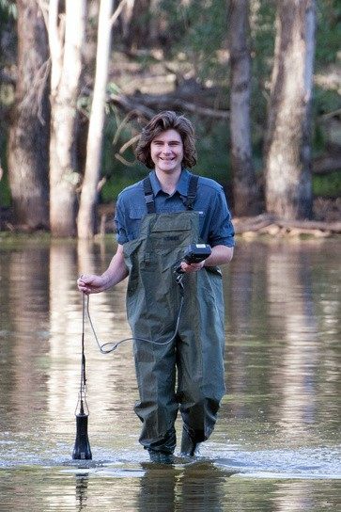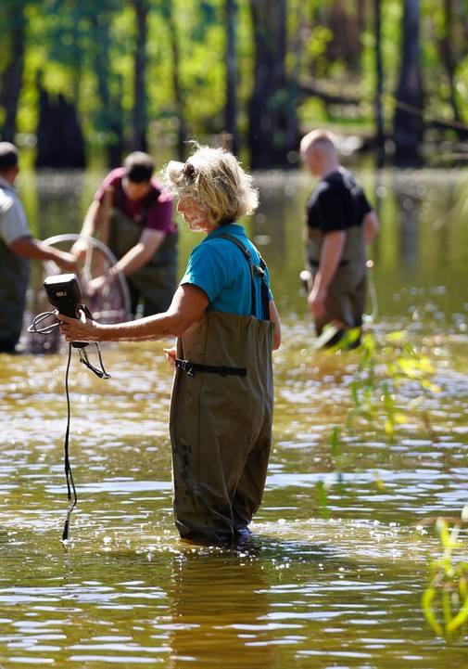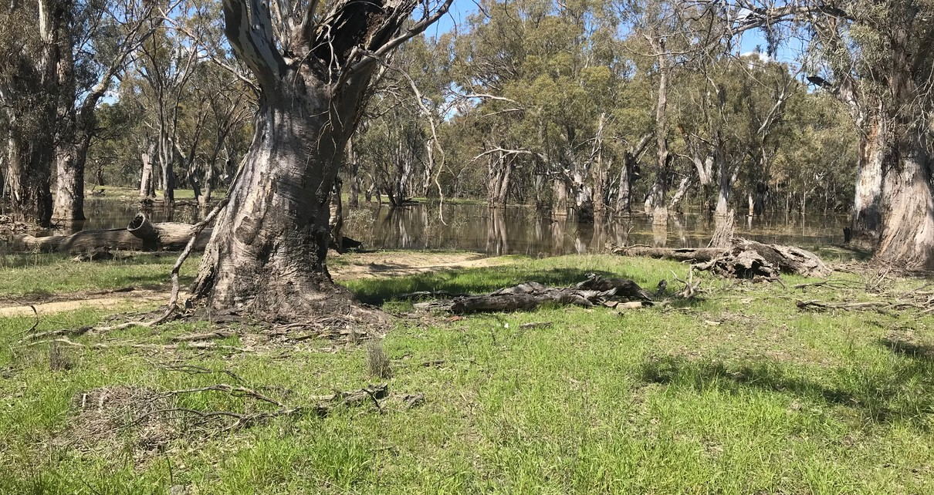

Carrathool Wetland (right), entrance completely flooded and river inaccessible September 2021 Photo credit: Eva Moore

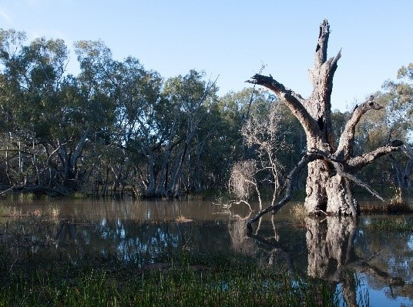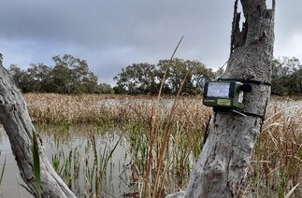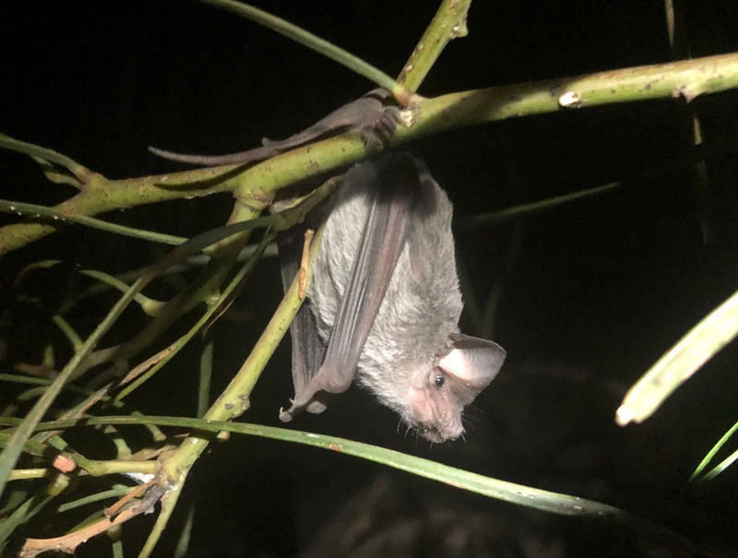

We use ultrasonic bat detectors to monitor microbat species richness and activity Colombo Creek at Cocketgedong (above). Photo credit: Jamie Turner

A Southern Freetail bat (*Mormopterus planiceps)* at Wagourah September 2021 Photo credit: Damian Michael

Large, dead trees are an important habitat resource for microbats (Bundure, August 2021) (below).

Photo credit: Jamie Turner

# BATS IN WETLANDS

There are more than 10 species of microbat that inhabit the

Murrumbidgee catchment. These tiny bats are insectivorous and spend their nights chasing flying insects, spiders and other small invertebrates over water bodies and through riparian vegetation, tracking them using echolocation calls. During the day they roost in tree hollows, under bark or foliage and sometimes even in buildings. Murrumbidgee microbats are highly dependent on water for food to eat—freshwater systems support high insect abundances—and water to drink, especially when

they’re raising young. They also prefer the varied habitat of floodplains compared to surrounding areas and tend to roost near intact and

unpolluted lagoons.

The southern myotis (*Myotis macropus*) is an interesting species that has been recorded in the Lowbidgee and mid-Murrumbidgee and is dependent on wetlands for all aspects of its life cycle. It is sometimes called the “fishing bat” because it uses its exceptionally long toes to

trawl the surface of open water to catch small fish and aquatic insects. If you’re lucky, this behaviour can be seen in the early evening; bats dive towards the water, flatten their flight path and fly close to the

surface, dipping only their feet, before looping up and around to try their luck again.

Four threatened species are present in the Murrumbidgee region: the Southern myotis (Vulnerable, BC Act 2016), Gould’s long-eared bat (*Nyctophilus gouldi*; Endangered, NPW Act 1972), Corben’s long-eared bat (*Nyctophilus corbeni*; Vulnerable, EPBC 1999 and NC Act 1992) and the Yellow-bellied sheath-tailed bat (*Saccolaimus flaviventris*; Near Threatened, NPW Act).

It is thought that the delivery of environmental water into Murrumbidgee wetlands during spring and summer may

improve the reproductive success of lactating female southern myotis via an increase in prey availability and improve foraging habitat by enhancing wetland vegetation. We plan to evaluate how environmental

water flows influence the habitat use of Murrumbidgee bat

species by monitoring calling activity across the catchment, which will be useful for

developing water management actions

Carp gudgeon. Photo credit: Mark Allen (1) diet can include aquatic insects such as: dragonfly nymps. Photo credit: Dave Huth (2) and small crustacians such as copepods.

Photo credit: Graeme Potter (3).

**1**

**2**

**3**

# SPECIES SPOTLIGHT: CARP GUDGEON

Common name: Carp gudgeons Scientific name: *Hypseleotris* spp.

Carp gudgeon are widespread and common at mid to lower altitudes in the central and southern Murray-Darlin Basin. There are at least four species of ‘carp gudgeon’ in south-eastern Australia, often causing a bit of confusion.

However, we treat them as a single group because differentiating them in the field is near impossible. They reach a maximum length of 70 mm but average 40 mm in length, which is relatively small, and are laterally compressed.

They have a truncate to slightly rounded tail and two separate, distinct dorsal fins.

Colouring in breeding males is particularly noticeable with an orange-red tinge to the upper part of the dorsal fin, bordered by a bluish-white stripe.

The back is yellowish-grey vs greenish-brown with an often darker edge to

the scales on the upper back. The head profile is blunt with colour and scale presence varying between taxa.

We find carp gudgeon in slow-flowing or still waters, normally associated

with vegetation beds or other aquatic vegetation. Spawning occurs in shallow water and eggs are deposited on submerged aquatic vegetation or sticks.

Females can lay up to 2,000 small, adhesive eggs about 0.5 mm in diameter. Carp gudgeon are an important food source for larger native species such as Murray cod, golden perch, Macquarie perch and freshwater catfish.

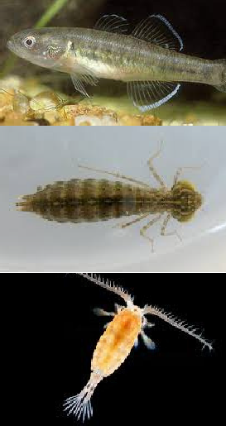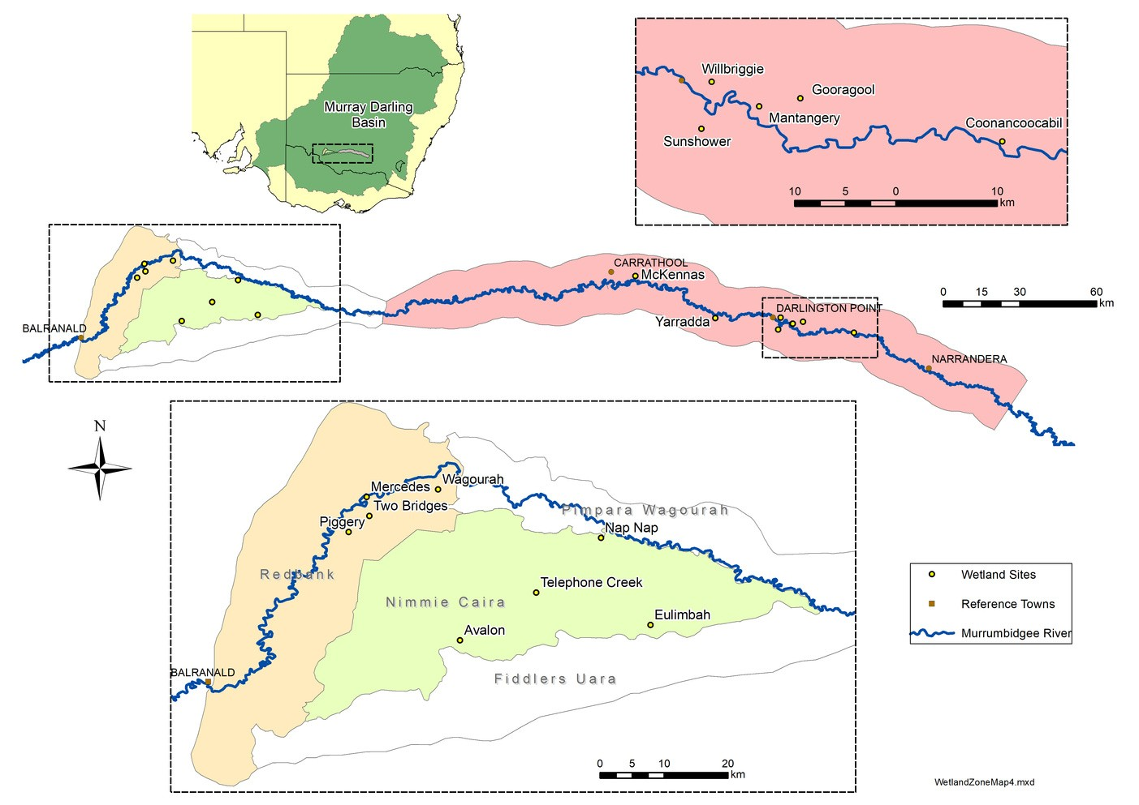

Map showing monitored wetlands within the three Murrumbidgee zones:

Redbank (cream), Gayini Nimmie-Caira (light green) and the mid-Murrumbidgee (pink)

The next issue of The Bidgee Bulletin is out in late December 2021.

For more information or to join the newsletter mailing list please visit: [https://www.csu.edu.au/research/ilws/](http://www.csu.edu.au/research/ilws/) research/environmental- water/murrumbidgee-mer

We're on social media too!

Stay up to date with our adventures on Instagram and Twitter:

**@BidgeeMER**

We still have a few 2021-22 water year calendars available. If you’d like a free copy, contact us and we’ll send one out!

# WHO'S WHO IN THE ZOO?

This issue we discover a bit more about Tara Dixon, the IPA Project Coordinator with the Nari Nari Tribal Council -

Name: Tara Dixon

Organisation: Nari Nari Tribal Council

Position: IPA Project Coordinator and Secretary/Treasurer I studied at: TAFE NSW

In my previous job I: was an Aboriginal Community Facilitator Food attitude: vegetarian

Beverage of choice: Sugar free coke

How would you describe your work to a child? I help look after the environment and special places for Aboriginal people

What’s the best thing about your work? Protecting Aboriginal Culture and Heritage

Your work in three words? I love it

Is your career your parents fault? no

It’s now 2030, where are you? who would know

Flashback to 1999 – where were you then? finishing Yr 12

Given the chance, who would you like to be for a day? no one but myself What’s your favourite sign off? catch ya round like a rissole

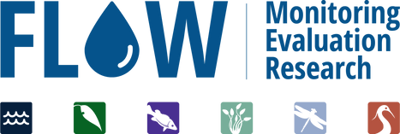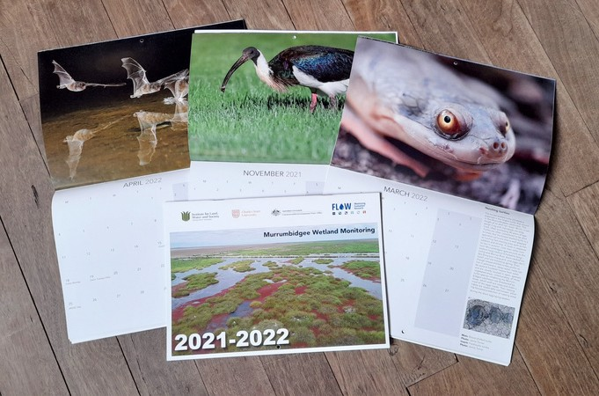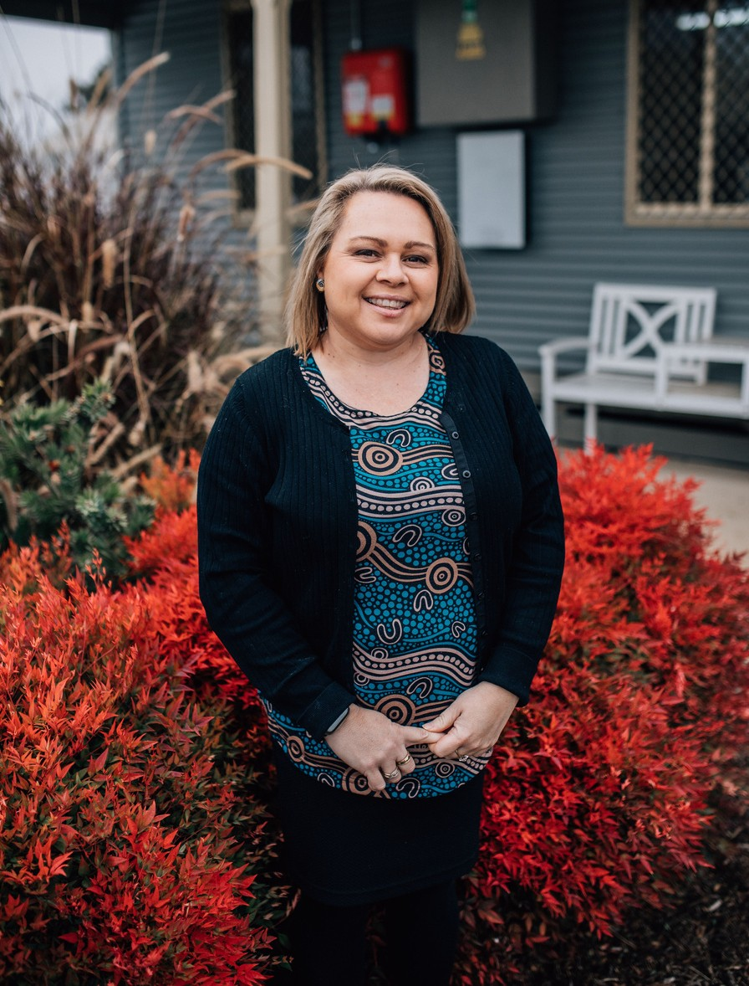

The Murrumbidgee MER team would like to acknowledge the consortium partners and local landholders with whom we work.

We respectfully acknowledge the Wiradjuri, Nari Nari and Muthi Muthi peoples, traditional owners of the lands on which this publication is focused