# Biosecurity funding and expenditure report 2023‒24

Sustainably funding a strong biosecurity system



© Commonwealth of Australia 2024

**Ownership of intellectual property rights**

Unless otherwise noted, copyright (and any other intellectual property rights) in this publication is owned by the Commonwealth of Australia (referred to as the Commonwealth).

**Creative Commons licence**

All material in this publication is licensed under a [Creative Commons Attribution 4.0 International Licence](https://creativecommons.org/licenses/by/4.0/legalcode) except content supplied by third parties, logos and the Commonwealth Coat of Arms.



**Cataloguing data**

This publication (and any material sourced from it) should be attributed as: DAFF 2024, *Biosecurity funding and expenditure report 2023‒24: s*ustainably funding a strong biosecurity system, Department of Agriculture, Fisheries and Forestry, Canberra, October. CC BY 4.0.

This publication is available at [agriculture.gov.au/biosecurity-trade/policy/sustainable-biosecurity-funding](https://deptagriculture.sharepoint.com/teams/AG-SustainableFundingProject/Shared%20Documents/General/09.%20Transparency%20and%20accountability/Annual%20publishing%20report/Funding%20and%20Expenditure%20Report%202023-24/Master/Web%20version/agriculture.gov.au/biosecurity-trade/policy/sustainable-biosecurity-funding)

Department of Agriculture, Fisheries and Forestry

GPO Box 858 Canberra ACT 2601

Telephone 1800 900 090

Web [agriculture.gov.au](https://www.agriculture.gov.au/)

**Disclaimer**

The Australian Government acting through the Department of Agriculture, Fisheries and Forestry has exercised due care and skill in preparing and compiling the information and data in this publication. Notwithstanding, the Department of Agriculture, Fisheries and Forestry, its employees and advisers disclaim all liability, including liability for negligence and for any loss, damage, injury, expense or cost incurred by any person as a result of accessing, using or relying on any of the information or data in this publication to the maximum extent permitted by law.

**Acknowledgement of Country**

We acknowledge the Traditional Custodians of Australia and their continuing connection to land and sea, waters, environment and community. We pay our respects to the Traditional Custodians of the lands we live and work on, their culture, and their Elders past and present.

Contents

Introduction 1

Purpose 1

Biosecurity in action 2

Trade and market access 2

Simplified Targeting and Enhanced Processing System program 3

Indigenous Ranger Biosecurity Program 3

Hitchhiker Pest Program 4

Funding the biosecurity system 5

Overview of funding 5

Cost recovery 6

Biosecurity budget 8

Stable base operating funding 8

Emergency biosecurity response budget 10

Biosecurity expenditure 12

Financial performance 13

****Tables****

Table 1 Biosecurity budget 8

Table 2 Biosecurity funding, 2023–24 to 2027–28, at Budget 2024–25 9

Table 3 Biosecurity funding, 2023–24 to 2026–27, at Budget 2023–24 10

Table 4 Departmental biosecurity expenses, by activity, 2023‒24 13

Table 5 Biosecurity expenditure and budget variance, 2023‒24 13

****Figures****

Figure 1 Cargo volumes, 2019‒20 to 2023‒24 6

Figure 2 Operating base funding, 2023–24 to 2027–28 8

Figure 3 Biosecurity funding, pre- and post-sustainable biosecurity funding 9

## Introduction

### Purpose

The Australian Government’s [sustainable biosecurity funding package](https://www.agriculture.gov.au/biosecurity-trade/policy/sustainable-biosecurity-funding#budget-factsheet) in Budget 2023‒24 committed to annual publication of biosecurity funding and expenditure to provide transparency and accountability. This report delivers on that promise.

This inaugural version of this report has been prepared based on the information available in the Department of Agriculture, Fisheries and Forestry’s reporting systems, and future versions may evolve as this new reporting activity matures.

We will publish the report following the end of each financial year. This will complement existing public reporting, including portfolio budget statements, annual reports and corporate plans. While budget statements and annual reports show aggregated financial information at an outcome (biosecurity and export services) and departmental level, this report shows biosecurity-specific financial information. Biosecurity funding figures provided in this report are represented as budgeted figures up to and including Budget 2024‒25. Expenditure figures are actuals for the 2023‒24 financial year.

## Biosecurity in action

Australia’s biosecurity system is critical to protect our economy, environment and way of life. By reducing the risk of pests and diseases entering Australia and investing in a stronger biosecurity system, we support the sustainability, profitability and competitiveness of Australia’s agriculture, fisheries and forestry industries. This helps drive a stronger Australian economy and preserve our unique natural environment.

The volume of incoming cargo, people, mail and vessels is significant and predicted to continue to grow. In 2023‒24 biosecurity officers supported the biosecurity clearance of more than:

* 113 million imported cargo consignments
* 138,000 containers
* 19 million international travellers
* 19,800 vessels arriving in Australia
* 104,000 international aircraft.

This section showcases examples of the current and future benefits of 2023–24 biosecurity funding use. For analysis and performance results for biosecurity activities, measured against goals and objectives set for 2023‒24 in the portfolio budget statements and corporate plan, see the [Annual report 2023‒24](https://www.agriculture.gov.au/about/reporting/annual-report).

### Trade and market access

A strong biosecurity status plays a significant role in shaping Australia’s export landscape by ensuring product quality, facilitating market access, protecting domestic agriculture, influencing trade negotiations and driving ongoing innovations in biosecurity practice.

Continued and sustained investment in activities that directly or indirectly strengthen the biosecurity system supports export of around two-thirds of Australia’s agricultural, fisheries and forestry products.

In 2023‒24, Australia’s biosecurity status directly helped the department improve, maintain and restore access to international export markets:

* We maintained access for meat and meat products to Taiwan through assurance of Australia’s low-risk freedom status for 3 animal diseases – classical swine fever (CSF), peste des petit ruminants (PPR) and bovine spongiform encephalopathy (BSE). This ensured Australian meat exporters can continue to access a market worth $419 million in 2023.
* We provided revised veterinary health certificates to maintain access for queen bees exported to Canada ‒ Australia exported $2.9 million of live bees to Canada in 2023. This ensured ongoing trade following the changed *Varroa destructor* status in Australia. Conditions for package bees were also updated to recognise resumption of state freedom from small hive beetle (*Aethina tumida*) in Tasmania.
* We successfully negotiated reinstatement of market access for sheep meat to be exported to Brazil. Brazil changed certification requirements in 2020. We negotiated new certificate requirements, including a shorter attestation list based on Australia’s disease status.
* We improved access for horticulture to China through reinstatement of the northern Tasmania Pest Free Area (PFA) after 5 years. Reinstatement of the PFA has been of high interest to Tasmanian horticultural industries because it will help reduce the cost of export to the Chinese market.

### Simplified Targeting and Enhanced Processing System program

In Budget 2023‒24, the government committed $145.2 million over 3 years to the [Simplified Targeting and Enhanced Processing System (STEPS) program](https://www.agriculture.gov.au/biosecurity-trade/import/online-services/steps-program) – a modern digital initiative to create a faster, simpler and more integrated system that will enhance efficiency of biosecurity clearance in the cargo pathway and strengthen biosecurity risk management. STEPS is a multi-year investment that is projected to deliver over $600 million in savings over 10 years. To date, the program has delivered 3 products:

1. **External verification for eCertificates –** allows accredited brokers to view secure digital sanitary and phytosanitary certificates as they assess commodities under an approved arrangement.
2. **Approved Arrangement Management Product –** allows industry participants to update and view their approved arrangements details online, including contact information, notices and classes.
3. Biosecurity Cargo Status Tracker – an interactive, real-time reporting tool that provides reliable visibility to industry of the cargo being managed by the department.

### Indigenous Ranger Biosecurity Program

The essential partnership with First Nations people through the [Indigenous Ranger Biosecurity Program](https://www.agriculture.gov.au/biosecurity-trade/policy/australia/indigenous-ranger-biosecurity-program) provides vital surveillance for the early detection of biosecurity threats along the sparsely populated northern Australian coastline. Indigenous ranger groups are engaged on a fee-for-service basis to undertake biosecurity activities.

In addition to protecting us at the biosecurity frontline, the Indigenous Ranger Biosecurity Program provides skills, employment and economic opportunities on Country for First Nations people in remote and regional communities. In May 2023, the government announced funding of $40.6 million over 4 years from 2023‒24 and ongoing funding of $12 million per year from 2027‒28 to sustainably fund the program.

Key achievements for 2023‒24 were:

* delivery of 1,271 biosecurity surveillance activities by rangers resulting in 4,115 observations across northern Australia
* establishment of 3-year contracts with ranger organisations, including expansion of the network to 67 ranger groups
* continuation of 8 departmental biosecurity engagement officers in Cairns, Darwin and Broome to support ranger groups, and increased visits to ranger groups in the field
* provision of grants to 17 ranger groups to support capability-building activities such as training, purchase of equipment and ranger exchanges
* delivery of hands-on biosecurity fundamentals training to 103 rangers in Cairns, Darwin and Kununurra covering the latest biosecurity threats and surveillance activities
* procurement of essential equipment valued at over $1.2 million (field and IT equipment) for gifting to 63 ranger groups undertaking biosecurity activities, and training valued at over $120,000
* convening of a roundtable with 46 ranger coordinators and managers to gain their input into how the Indigenous Ranger Biosecurity Program can be strengthened and improved.

### Hitchhiker Pest Program

The [Hitchhiker Pest Program](https://www.agriculture.gov.au/biosecurity-trade/pests-diseases-weeds/hitchhiker-pests#sea-container-design-improvements) aims to address the risk of hitchhiker pests that can be carried via sea containers, their cargoes and associated packaging. The program is focused on plant arthropod hitchhiker pests that can arrive via sea containers and the cargo they contain. The program includes the Sea Container Design Improvement Project and the honey bee molecular test.

#### Sea Container Design Improvement Project

Shipping containers have been identified as the source of incursions and invasions of key pest species, including khapra beetle, giant African snail, yellow crazy ant, tropical fire ant and spongy moth. This project aims to improve the design and structure of sea containers, making them less attractive to hitchhiker pests and to reduce soil and plant contamination.

#### Honey bee molecular test

The honey bee is critical to Australia’s agriculture. The industry is worth more than $14 billion annually in the form of honey, honey products and through pollination services. Protecting the industry against pests and pathogens through strict biosecurity policies for honey products and bee genetics is crucial across agricultural industries. This project aims to develop, optimise and validate a single method that can detect 3 key honey bee mite pests in bee swarms at border locations.

Our key achievements and outcomes in 2023‒24 include:

* accelerated ability to identify exotic bee mites and conduct appropriate surveillance activities, potentially increasing the chance of eradication if an incursion occurs
* development of a draft national diagnostic protocol
* development of an additional tool for surveillance and monitoring.

The CSIRO also delivered training on novel honey bee tests at the Annual Diagnostics Workshop.

## Funding the biosecurity system

### Overview of funding

**Funding for the Commonwealth biosecurity system is allocated to meet the department’s statutory responsibilities for managing biosecurity risks.** The secretary of the department is the Director of Biosecurity and is responsible for the general administration of the *Biosecurity Act 2015* (the Biosecurity Act). The Commonwealth biosecurity system is funded through appropriations from government, cost recovery revenue and section 74 revenue.

#### Appropriations from government

**The department receives departmental and administered appropriations from government. Departmental appropriations are funds associated with the day-to-day operations and program-support activities of the department, and over which the secretary usually has control. They typically include salaries, purchase of general goods and services, property costs and other operational expenditure. Administered appropriations are funds administered by the department on behalf of the government. This can include payments to states and territories, grant programs and other expenditure for specific government or public purposes.**

#### Cost recovery revenue

The department also receives revenue through fees and charges for the provision of biosecurity regulatory activities under the biosecurity cost recovery arrangement. The department has authority to recover costs from industry for a range of regulatory activities. The use of cost recovered revenue must align with the rules set under the [Australian Government Charging Framework](https://www.finance.gov.au/government/managing-commonwealth-resources/implementing-charging-framework-rmg-302/australian-government-charging-policy).

The department also receives cost recovered revenue from Australia Post for biosecurity clearance activities undertaken in international mail gateway facilities. This is a statutory fee set in legislation.

#### Section 74 revenue

Section 74 of the [Public Governance, Performance and Accountability Act 2013](https://www.legislation.gov.au/C2013A00123/latest/text) provides a mechanism where funds (revenue) received by the department may be retained to cover the costs of specified activities. This type of revenue mostly relates to amounts likely to be received by the department to meet the cost of providing a good or service. Examples may include application or processing fees or the provision of services to another government entity.

#### Emergency biosecurity response funding

The department leads the Australian Government’s effort in minimising the impact of pests and diseases on Australian agriculture and our environment. This includes contributing to funding for nationally cost-shared emergency biosecurity responses under the emergency response deeds (plant, animal and environment).

Emergency biosecurity response funding is separate to biosecurity operational funding and is outside the scope of this report (see Emergency biosecurity response budget).

### Cost recovery

The [2023‒24 Biosecurity Cost Recovery Implementation Statement](https://www.agriculture.gov.au/about/fees/biosecurity-cris) sets out the fees and charges that applied in 2023‒24 under the biosecurity cost recovery arrangement. In the 2023‒24 financial year, cost recovery revenue from importers was $365.0 million (excluding Australia Post). This was $65.3 million or 21.8% higher than the previous financial year. This is due to a number of factors, including the increased fees and charges applied from 1 July 2023.

The revenue figure of $365.0 million varies slightly from the amount published on 16 July 2024 of $360.1 million, due to the timing of biosecurity-specific accrued revenue (seaports) and appropriation (anti-smuggling) processed after 1 July 2024.

On 1 July 2024, fees and charges were again increased in line with indexation, consistent with the government’s commitment to review biosecurity fees and charges annually. The 4.1% increase ensures the department will continue to recover the cost of providing regulatory activities without drawing on funds allocated for other critical biosecurity functions.

Learn more about the [biosecurity cost recovery arrangement](https://www.agriculture.gov.au/about/fees/biosecurity-cris).

#### Self-assessed clearances (SAC)

As part of the sustainable biosecurity funding package in Budget 2023‒24, the government announced that the industry biosecurity cost recovery arrangement would be extended to low-value ($1,000 or less) goods imported into Australia by sea or air cargo.

In 2023‒24, 119 million self-assessed clearance (SAC) goods valued at $1,000 or less were imported by sea or air cargo into Australia. SAC cargo volumes have steadily increased over the past 5 years by an average of 15% annually (Figure 1).

Figure 1 Cargo volumes, 2019‒20 to 2023‒24

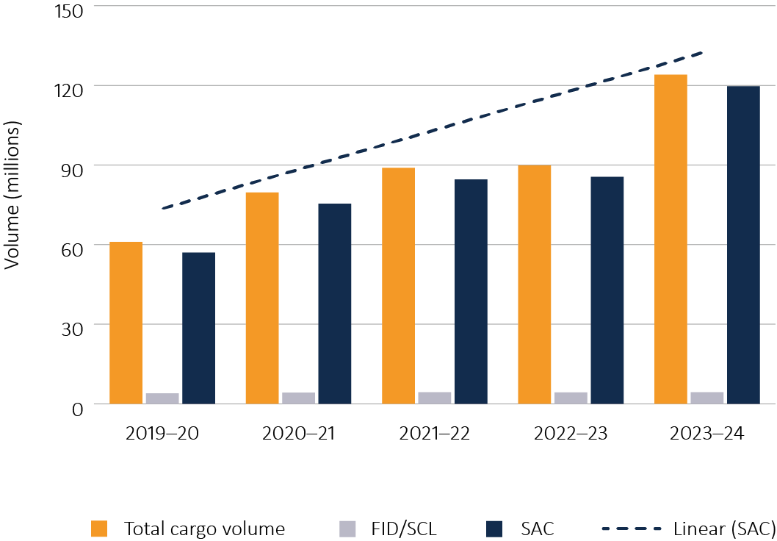

**FID** Full import declaration. **SCL** Cargo reported self-assessed clearance. **SAC** Self-assessed clearance.

The cost of biosecurity clearance in relation to these goods was previously met by taxpayers. The new charge, which will raise approximately $27 million per year, will ensure that risk creators (importers) are meeting this cost. The new charge will commence from 1 October 2024. It will cover the direct and indirect costs incurred by the department in managing the growing volume of low-value items brought into Australia and the biosecurity risks associated with these goods. A SAC-specific cost recovery implementation statement (CRIS) will be published on commencement of the charge for the 2024‒25 financial year. The SAC CRIS will be amalgamated into the Biosecurity CRIS from 2025‒26.

#### International mail

Australia Post pays the department a legislated annual fee of around $15.3 million for biosecurity clearance activities at international mail gateway facilities.

Due to the increased risks of this pathway, the cost of assessing and managing biosecurity risks at international mail gateway facilities has grown. This has created an annual shortfall in funding. Through the 2023‒24 Mid-Year Economic and Fiscal Outlook (MYEFO), the government provided additional ongoing appropriation funding to the department of approximately $7 million per year from 2024‒25 to address the shortfall.

## Biosecurity budget

The department has a biosecurity budget of approximately $800 million per year, which is split relatively evenly between appropriation funding and cost recovered revenue.

Table 1 shows the biosecurity budget by funding source for 2023‒24 and over the forward estimates. Budget numbers include all government decisions made up to and including Budget 2024‒25.

Table 1 Biosecurity budget

| Funding source | 2023‒24 ($m) | 2024‒25 ($m) | 2025‒26 ($m) | 2026‒27 ($m) | 2027‒28 ($m) |
| --- | --- | --- | --- | --- | --- |
| Cost recovery **a** | 379.1 | 417.1 | 420.0 | 435.6 | 443.0 |
| Base appropriation | 366.4 | 366.6 | 375 | 365.2 | 368.3 |
| STEPS program appropriation | 46.5 | 57.4 | 41.3 | n/a | n/a |
| **Total biosecurity funding** | **792.0** | **841.1 b** | **836.3** | **800.8** | **811.3** |

**a** Includes the cost recovery arrangement, Australia Post, Defence and other s74 contract revenue. **b** Includes the self-assessed clearance charge. The delayed commencement date of 1 October 2024 may vary the amount of revenue collected. **n/a Not applicable. STEPS** Simplified Targeting and Enhanced Processing System.

### Stable base operating funding

The sustainable biosecurity funding package delivered long-term certain and stable base operating funding for biosecurity, enabling better planning and resource management.

Figure 2 shows the significant increase in base operating funding and its continuation into the future. Higher levels of total biosecurity funding in 2023‒24 to 2025‒26 reflect the inclusion of the STEPS terminating measure and do not represent a decline in base operating funding in future years.

Figure 2 Operating base funding, 2023–24 to 2027–28

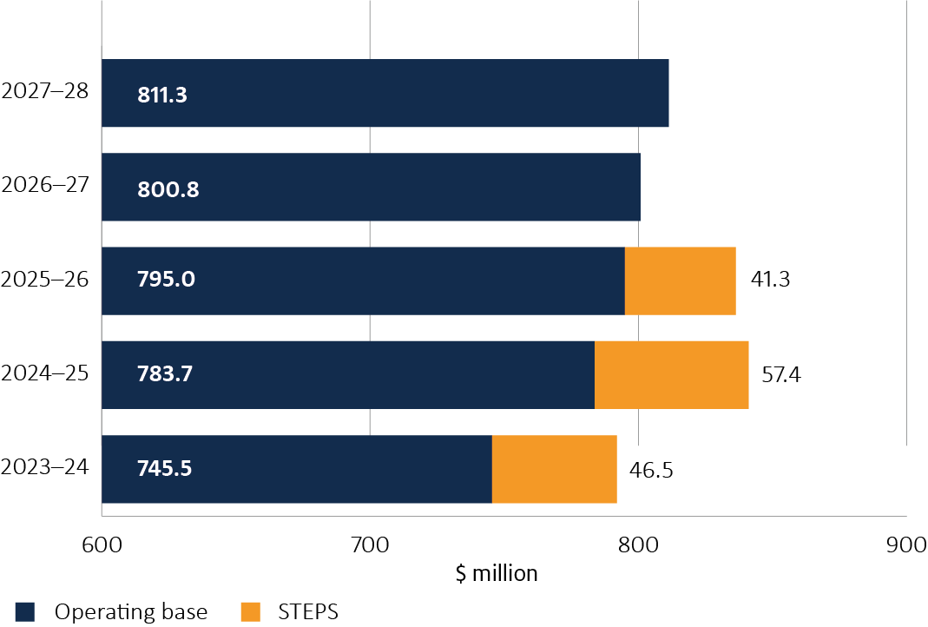

**STEPS** Simplified Targeting and Enhanced Processing System.

Budget 2023‒24 provided significant and permanent increases to funding for biosecurity. Through MYEFO 2023‒24 and Budget 2024‒25, the Australian Government has further increased funding for biosecurity. This increased funding can be seen in comparison to the funding that would have been available for biosecurity prior to these decisions of government, and assuming no further decisions that impact funding (Figure 3).

Figure 3 Biosecurity funding, pre- and post-sustainable biosecurity funding

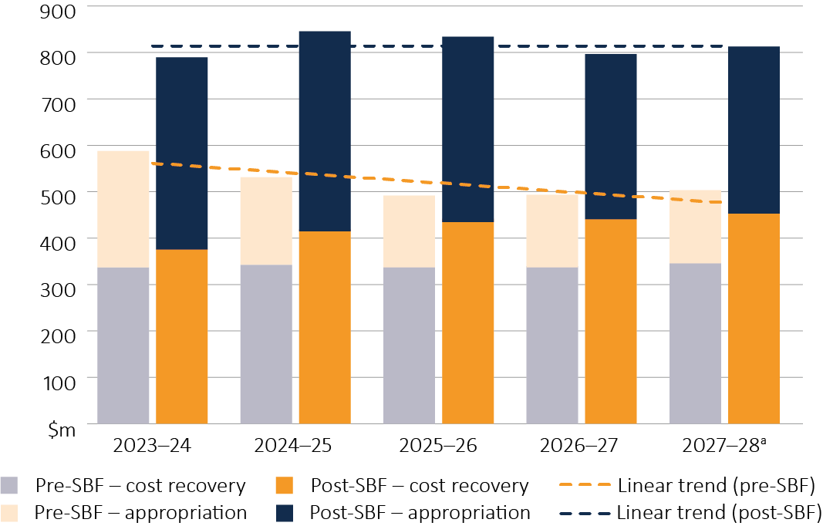

**a** 2027‒28 pre-SBF appropriation and cost recovery amounts are estimates. **SBF** sustainable biosecurity funding.

Table 2 outlines biosecurity funding for 2023‒24 and over the forward estimates, current at Budget 2024‒25. The table incorporates additional funding for biosecurity provided through MYEFO 2023‒24 and Budget 2024‒25. Table 3 shows the biosecurity budget following the announcement of the sustainable biosecurity funding package in Budget 2023‒24.

Table 2 Biosecurity funding, 2023–24 to 2027–28, at Budget 2024–25

| Funding source | Subcategory | 2023‒24 ($m) | 2024‒25 ($m) | 2025‒26 ($m) | 2026‒27 ($m) | 2027‒28 ($m) |
| --- | --- | --- | --- | --- | --- | --- |
| **Cost recovery** | Existing cost recovery arrangement | 350.7 | 365.7 | 373.0 | 388.0 | 395.7 |
| Cost recovery – SACs | 0.0 | 27.1 | 27.1 | 27.1 | 27.1 |
| Australia Post | 15.3 | 15.3 | 15.6 | 15.8 | 16.0 |
| Defence | 0.3 | 1.1 | 0.4 | 1.5 | 1.5 |
| Other s74 revenue | 12.8 | 7.9 | 3.9 | 3.2 | 2.7 |
| **Total cost recovery** | **379.1** | **417.1** | **420.0** | **435.6** | **443.0** |
| **Appropriation** | Departmental appropriation | 373.4 | 377.1 | 377.8 | 337.9 | 341.9 |
| Departmental equity injection | 13.2 | 19.8 | 15.0 | 2.2 | 0.3 |
| Department of Finance gateway review departmental appropriation | 0.1 | 0.1 | 0.1 | 0.0 | 0.0 |
| Administered | 26.2 | 26.9 | 23.4 | 25.1 | 26.1 |
| **Total appropriation** | **412.9** | **424.0** | **416.3** | **365.2** | **368.3** |
| **Total biosecurity funding** | **–** | **792.0** | **841.1 a** | **836.3** | **800.8** | **811.3** |

Note: Total values are rounded. Budget numbers include government decisions made up to and including Budget 2024–25. **a** Includes the self-assessed clearance charge. The delayed commencement date of 1 October 2024 may vary the amount of revenue collected. **SACs** Self-assessed clearances.

Table 3 Biosecurity funding, 2023–24 to 2026–27, at Budget 2023–24

|  |  |  |  |  |  |
| --- | --- | --- | --- | --- | --- |
| Funding source | Subcategory | 2023‒24 ($m) | 2024‒25 ($m) | 2025‒26 ($m) | 2026‒27 ($m) |
| **Cost recovery** | Existing cost recovery arrangement | 312.4 | 314.1 | 315.7 | 317.3 |
| Cost recovery – SACs | 0.0 | 27.1 | 27.1 | 27.1 |
| Australia Post | 15.4 | 15.4 | 15.4 | 15.4 |
| Defence | 1.5 | 1.5 | 1.5 | 1.5 |
| Other s74 revenue | 4.0 | 2.6 | 2.2 | 2.2 |
| **Total cost recovery** | **333.3** | **360.7** | **361.9** | **363.5** |
| **Appropriation** | Departmental appropriation | 410.0 | 400.5 | 393.9 | 370.1 |
| Departmental equity injection | 13.2 | 17.5 | 12.6 | 0.0 |
| Department of Finance gateway review departmental appropriation | 0.1 | 0.1 | 0.1 | 0.0 |
| Administered | 27.5 | 25.7 | 22.7 | 24.9 |
| **Total appropriation** | **450.9** | **443.9** | **429.3** | **395.0** |
| **Total biosecurity funding – sustainable biosecurity funding package** | **–** | **784.2** | **804.6** | **791.2** | **758.5** |

**SACs** Self-assessed clearances.

### Emergency biosecurity response budget

The scope of this report is limited to funding to meet the department’s operational responsibilities for managing biosecurity risks (see Overview of funding). The Australian Government contributes separately to nationally cost-shared emergency biosecurity responses under the:

* Emergency Animal Disease Response Agreement (EADRA)
* Emergency Plant Pest Response Deed (EPPRD)
* National Environmental Biosecurity Response Agreement (NEBRA)
* National Fire Ant Eradication Program (NFAEP)
* other responses established outside of EADRA, EPPRD, NEBRA and NFAEP.

Responses are cost shared between the Commonwealth, states and territories and, where appropriate, industry parties to EADRA and EPPRD. The Project Agreement for Pest and Disease Preparedness and Response Programs provides the mechanism for the Commonwealth to pay its cost-sharing contribution to the responsible jurisdiction on an individual response basis. The impacted state or territory delivers the response activities.

Funding contributions by parties, including industry, are approved by the National Management Group (NMG) as set out in the relevant deed or agreement in response to biosecurity incidents. The NMG is made up of a representative of each cost-sharing party to the individual response.

At Budget 2024‒25, the Commonwealth had committed $471.1 million in funding from 2023‒24 to 2027‒28 under the project agreement ([Budget Paper No. 3](https://budget.gov.au/content/bp3/index.htm), page 98). This includes provision for underwriting industry contributions, which are repaid through levy arrangements prescribed in each deed or agreement, or voluntary means. Because these payments are made to states and territories for specific purposes, the Treasury facilitates the payments in consultation with our department.

## Biosecurity expenditure

**In 2023‒24 the department’s biosecurity expenses totalled $739.7 million. Our activities are largely focused on direct border protection activities, including import clearance, post-entry quarantine (PEQ), seaports program, and biosecurity clearance of international mail and international passengers. Direct border regulatory activities, with the exception of biosecurity clearance of passengers, are typically cost-recovered.**

Appropriation funding supports biosecurity activities that may not be recoverable, including statutory functions, and functions that contribute to enduring planning and effort to prepare and respond to the threat of pests and diseases. These activities include:

* providing scientific and policy analysis and advice – including analysis undertaken to support our biosecurity import conditions and other regulatory controls, forecasting and ongoing reform to the national biosecurity system
* undertaking preparedness and surveillance activities, including the Northern Australia Quarantine Strategy and the Indigenous Ranger Biosecurity Program
* supporting ongoing biosecurity work of the Australian Chief Veterinary Officer, Australian Chief Plant Protection Officer and Chief Environmental Biosecurity Officer, and their offices, to provide technical expertise and advice to government on Australia’s animal and plant health status, and assist continued and expanded overseas market access
* supporting the Commonwealth’s effort towards emergency response functions separate to established cost-sharing and funding arrangements for responses (see Emergency biosecurity response funding)
* meeting international obligations and work to build the capability of other nations (particularly in the Pacific) to reduce biosecurity risk, including providing vaccines, training and development
* delivering communication and engagement activities to build biosecurity awareness in the community, industry and international audiences
* supporting national coordination and engagement mechanisms
* funding the Australian Bureau of Agricultural and Resource Economics and Sciences to support research and analysis of biosecurity science and economics to assist the department and external organisations
* delivering innovation and new technologies to improve biosecurity outcomes, including through the Biosecurity Innovation Program
* continuing investment in system improvements to better manage risk and drive improved diagnostics and data analytics to support the biosecurity system.

All organisations require supporting and enabling services to deliver their outcomes. A portion of the biosecurity expenditure includes payroll, human resources, finance, ICT, legal and communication support, as well as uniforms and operational consumables such as personal protective equipment and scientific equipment. These expenses are disbursed across activities (Table 4).

Table 4 Departmental biosecurity expenses, by activity, 2023‒24

| Activities | Expenses (actuals) ($m) |
| --- | --- |
| Import clearance (international air cargo, sea cargo and containers) | 263.2 |
| Post-entry quarantine (PEQ) | 26.3 |
| Seaports Program (maritime vessels entering Australia) | 30.8 |
| International mail | 17.5 |
| International passengers | 86.6 |
| Total direct border protection activities | 424.4 |
| Administered funding – biosecurity activities programs | 24.3 |
| Government-funded and s74 external revenue (incl. offshore) biosecurity activities **a** | 206.7 |
| Simplified Targeting and Enhanced Processing System | 17.9 |
| Digital capability and business function | 28.1 |
| Indirect costs **b** | 38.3 |
| **Total non-direct border activities** | **315.3** |
| **Total expenses** | **739.7** |

**a Includes surveillance, compliance, risk analysis, workforce management, policy development, international engagement, commodity import forecasting and staff training activities. b Includes asset and/or lease-related expenses such as depreciation and amortisation (e.g. lease expenses from Melbourne Mickleham office are attributable to post-entry quarantine activities within the biosecurity cost recovery arrangements).**

### Financial performance

Table 5 shows a breakdown of the department’s biosecurity budget, expenditure and variance for 2023–24. The biosecurity budget for 2023‒24 was $792.0 million, but expenditure amounted to $739.7 million (Refer to Table 5).

Table 5 Biosecurity expenditure and budget variance, 2023‒24

| Category | Actual ($m) | Budget ($m) | Variance ($m) |
| --- | --- | --- | --- |
| Appropriation and other s74 revenue | 341.4 | 386.2 | 44.8 **a** |
| Existing cost recovery arrangement | 351.2 | 350.7 | −0.52 |
| Australia Post | 19.3 | 15.3 | −4.0 **b** |
| Defence | 0.8 | 0.3 | −0.5 |
| Departmental equity injection | 2.7 | 13.2 | 10.5 **c** |
| Department of Finance gateway review departmental appropriation | 0.1 | 0.1 | 0.0 |
| Administered | 24.3 | 26.2 | 1.9 |
| **Total biosecurity expenditure** | **739.7** | **792.0** | **52.3** |

Note: Variances of less than $1 million have not been noted. **a** The STEPS program incurred a significant operating underspend of $17.9 million in 2023‒24 due to delays in its ICT program of work. Other expenses were also below budget, reflecting slower than anticipated recruitment of front-line staff, which required additional effort by existing staff to meet service standards. Activity is underway to improve staffing levels to decrease service delivery times. The retained funding from the 2023-24 underspend will be used to support the department’s request for a re profiling of the STEPS funding to continue its delivery over the coming financial years, and to support departmental capital expenditure that spans multiple years. **b** Deficit position in 2023‒24 reflected an increasing volume of work. This is expected to continue and will be supplemented by ongoing funding of approximately $7 million per year from 2024‒25. **c** Includes $0.3 m for Modern Seamless Border Clearance and $12.9 m for STEPS. Due to the significant STEPS capital underspend of $10.7 m in 2023–24, the department is exploring options to re-profile this funding to sustain project delivery.