Biosecurity Portal Website Upgrade release

BSDSAdmin@agriculture.gov.au

Contents

BIOSECURITY PORTAL – MYGOVID (Digitial identity) channel 2

Bug Fix 2

Emails being sent to personal email address 2

Booking status not updating 2

BIOSECURITY PORTAL – MYGOVID (Digitial identity) and Other User Channel 3

Enhancement 3

Recognised Offshore Cleaning and Pre-inspection (ROCIP) 3

Bug Fixes 4

Fields not populating on modification confirmation emails 4

Inspection request confirmation email displaying the incorrect time 4

Unable to proceed past the ‘Appointment details’ Tab 5

# BIOSECURITY PORTAL – MYGOVID (Digitial identity) channel

## Bug Fix

### Emails being sent to personal email addresses

System otifications and emails from the Portal were being sent to the personal email address used to register for the Portal through the myGovID Digital Identity channel. Emails are now sent to the business email address entered by users on their *My Profile* page.

*Figure 1: My profile – business email address*

### Booking status not updating

The status of bookings in the *Upcoming Bookings view* were not being updated. The status of the booking will change in the Portal from ‘Booked’ to ‘On our way’ following the inspector indicating they are travelling to the inspection location.

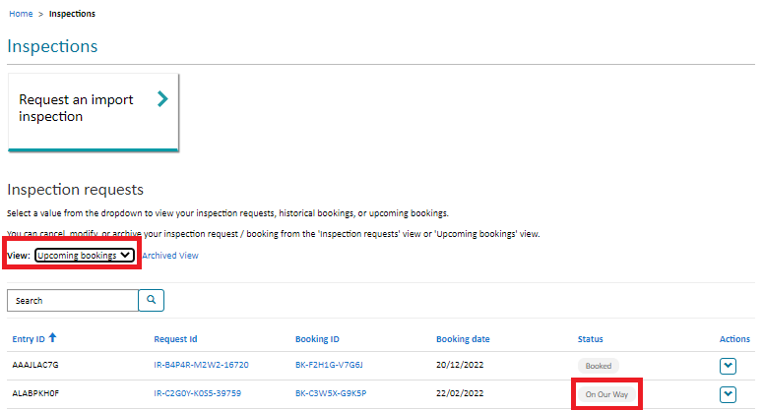

*Figure 2: Upcoming bookings – booking status reflects inspector is “On our Way”*

# BIOSECURITY PORTAL – MYGOVID (Digitial identity) and Other User Channel

## Enhancement

### Recognised Offshore Cleaning and Pre-inspection (ROCIP)

The Portal has been updated to change questions from JEVIC to the Recognised Offshore Cleaning and Pre-inspection (ROCIP) Scheme. On the *Consignment Tab*, enter and select ROCIP as the inspection / consignment type. Additional questions related to the ROCIP inspection will then be displayed for users to complete.

*Figure 3: Inspection / Consignment Type – Recognised Offshore Cleaning and Pre-inspection (ROCIP)*

*Figure 4: Recognised Offshore Cleaning and Pre-inspection (ROCIP) Questions*

## Bug Fixes

### Fields not populating on modification confirmation emails

Auto-confirmation emails for booking modifications requested via the Portal were not populated with all necessary information. Booking modification emails now display all information including:

* Goods will be ready for inspection.
* Preferred inspection period
* Request a to-meet inspection.

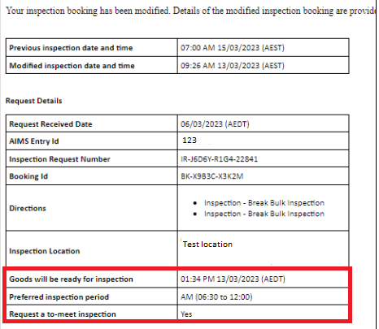

*Figure 5: Booking modification email with information populated*

### Inspection request confirmation email displaying the incorrect time

The date and time entered by users in the ‘Goods availability’ field on the *Appointment Tab* was not displayed correctly on the Inspection Request Confirmation email. Emails now display the correct time and time zone in the ‘Goods ready for inspection field’.

*Figure 5: Goods availability on the Appointment Details tab*

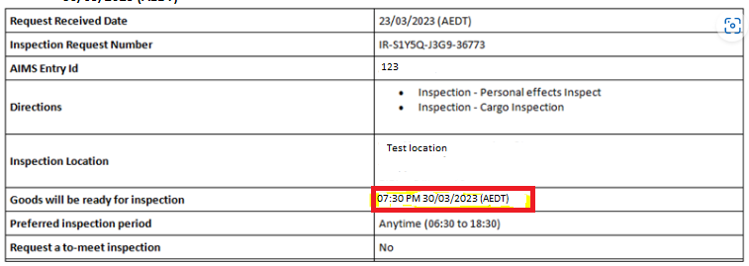

*Figure 6: Goods ready for inspection reflects Goods availability entered by the user*

### Unable to proceed past the ‘Appointment details’ Tab

The issue preventing users from progressing past the *Appointment details* tab has been resolved. Users were receiving an error message indicating mandatory fields had not been completed. Users had to navigate back and forth between tabs to progress the inspection request.

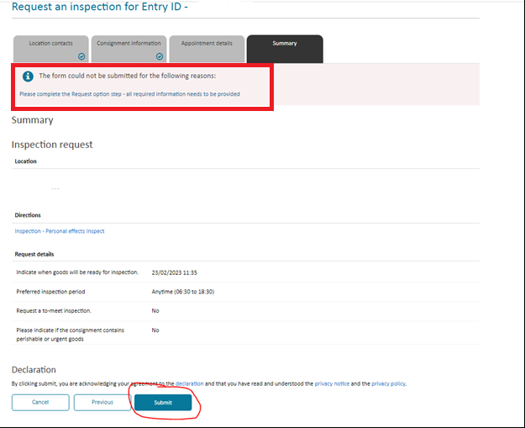

*Figure7: Error preventing users from submitting a Request for Inspection*