ProviderHub – March 2026
BSDSAdmin@aff.gov.au

Providerhub

Enhancement

Introduction of the ProviderHub
The Biosecurity Portal Digital ID (myID) email pathway landing page has been updated to include access for pre-border biosecurity treatment providers to register under AusTreat, and to ensure that relevant import conditions can be met with an increased confidence level of meeting compliance requirements.

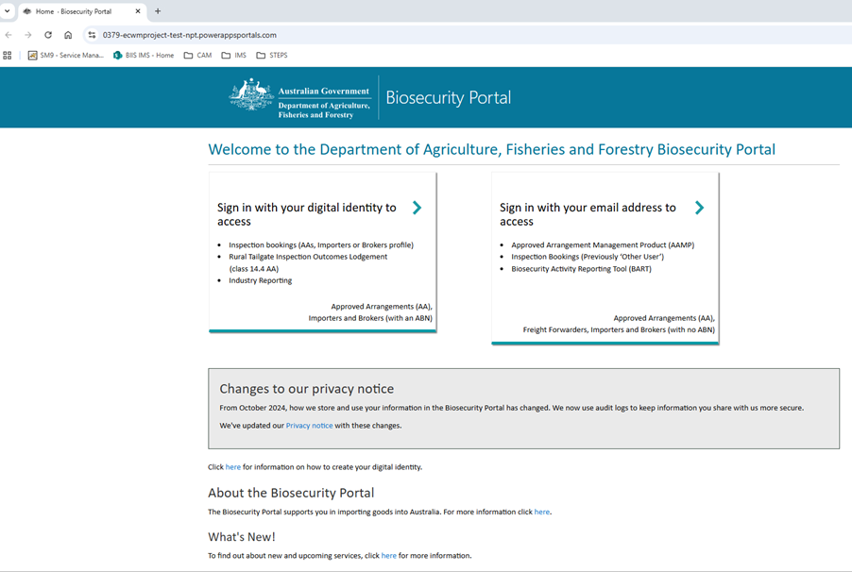
Figure 1: Screenshot of the landing page of the Biosecurity Portal when logged in via the email pathway
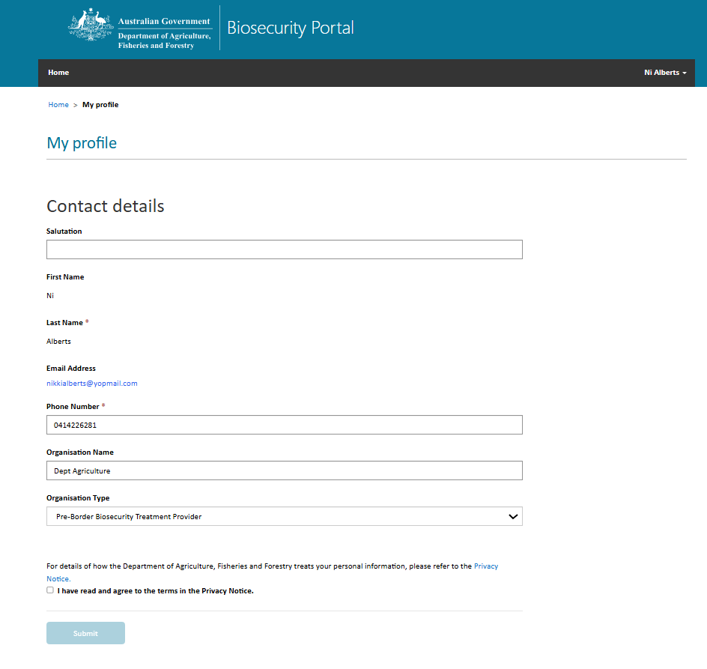
Figure 2: Offshore Treatment Providers My profile screen

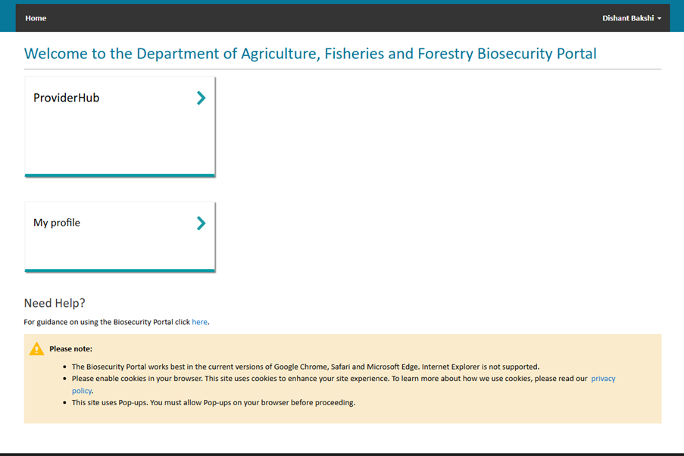
Figure 3: Accessing ProviderHub

