Biosecurity Portal Website Upgrade release

BSDSAdmin@agriculture.gov.au

Contents

BIOSECURITY PORTAL – MYGOVID (Digitial identity) channel 2

Bug Fix 2

Emails being sent to personal email addresses 2

Booking modification notifications 2

BIOSECURITY PORTAL – Other User Channel 3

Bug Fix 3

Unable to lodge a request for Entry Ids with multiple directions of the same type 3

# BIOSECURITY PORTAL – MYGOVID (Digitial identity) channel

## Bug Fix

### Emails being sent to personal email addresses.

System notifications from the Portal were, in some instances, being sent to the personal email address used to register for the Portal through the myGovID Digital Identity channel. Emails will be sent to the business email address entered by users on their *My Profile* page. Note: if the business email address in *My Profile* is not completed, emails from the department may be sent to the email address used to register with myGovID.

*Figure 1: My profile – business email address*

There is one exception to this, the “on our way” notification is sent to the inspection location (site) contact as nominated in the request for inspection.

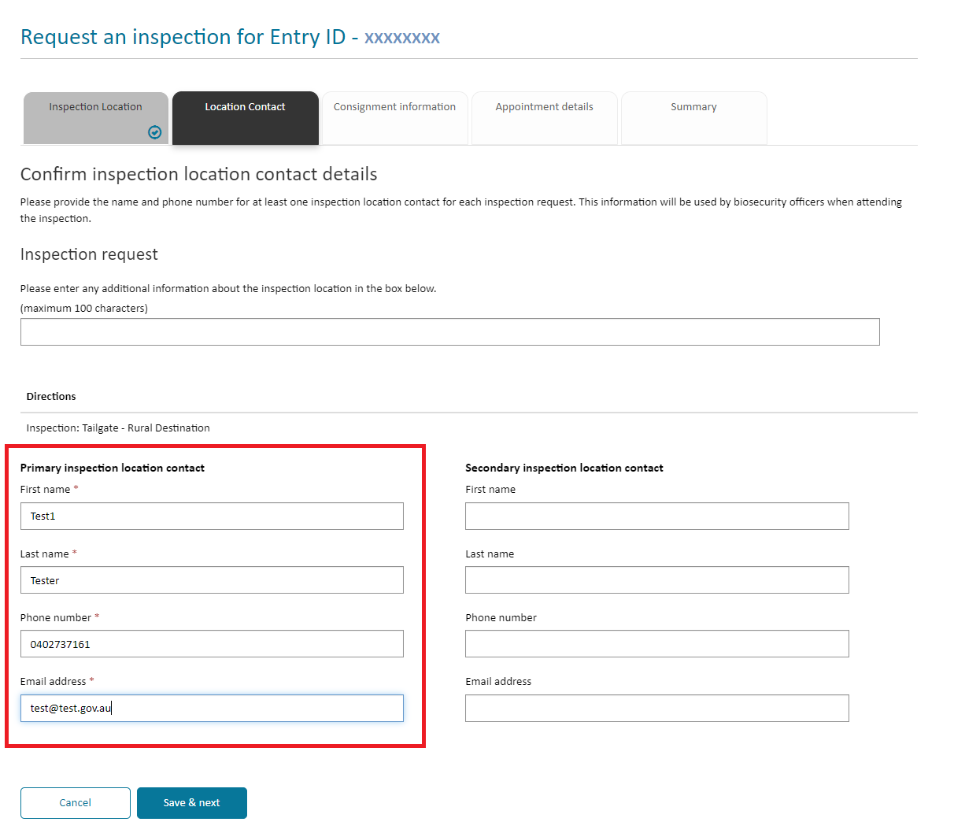

*Figure 2: Location contact details*

### Booking modification notifications

There were several issues with the auto-confirmation email for booking modifications, including:

* Auto-confirmation emails were not being sent in some instances.
* Information in the email was missing, including:
  + Goods will be ready for inspection
  + Preferred inspection period
* Incorrect information in the email:
  + Original booking information was displayed and not the updated booking information.

All requests for modification of a booking will now generate an email with the changed details.

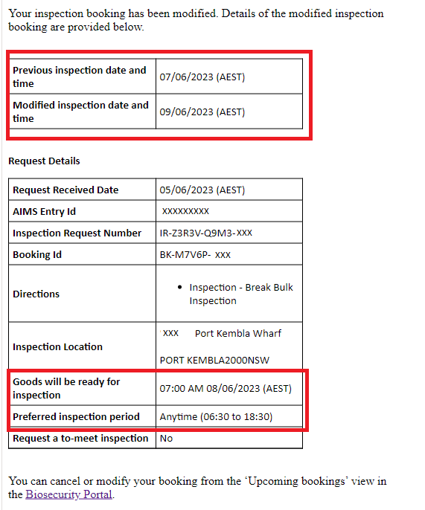

*Figure 3: Booking modification email notification*

# BIOSECURITY PORTAL – Other User Channel

## Bug Fix

### Unable to lodge a request for Entry Ids with multiple directions of the same type.

Clients were unable to lodge a request through the ‘other user’ channel when there were more than three of a single type of inspection. The Portal would recognize the direction entered as valid but would not allow the client to progress further, displaying an error message.

*Figure 4: Direction entry and error message returned when an Entry had more than three of the same inspection types*

Clients can now use the ‘other user’ channel for inspections with multiple directions of the same type.