Biosecurity Portal Website Release – May 2024

BSDSAdmin@aff.gov.au

# Contents

Contents 1

Biosecurity Portal – Home Page 2

Enhancement 2

Login tiles text updated 2

Biosecurity Portal – EMAIL ADDRESS (OTHER USER) Channel 3

Enhancement 3

Introduction of the Approved Arrangement Management Product (AAMP) 3

# Biosecurity Portal – Home Page

## Enhancement

### Login tiles text updated

The login tiles on the Biosecurity Portal home page have been updated to provide additional information on the services available and will assist Biosecurity Portal users in selecting the appropriate login option.

Note: Access to the Biosecurity Portal for users has not changed.

|  |  |
| --- | --- |
| Previous tiles | New tiles |
| AAs, Importers and Brokers (with an ABN)  Sign in here with your digital identity | Sign in with your digital identity to access   * Inspection bookings (AAs, Importers or Brokers profile) * Rural Tailgate Inspection Outcomes Lodgement   Approved Arrangements (AA), Importers and Brokers (with an ABN) |
| Other Users  Sign in here with your email address | Sign in with your email address to access   * Approved Arrangement Management Product (AAMP) * Inspection bookings (Previously ‘Other User’)   Approved Arrangements (AA), Freight Forwarders, Importers and Brokers (with no ABN) |

biosecurity portal homepage with two login options

AA's Importers and Broker (with an ABN)
Sign in here with your digital identity

Other Users
Sign in here with your email address

Figure 2: Previous Biosecurity Portal homepage

Biosecurity portal homepage with two login options

Sign in with your digital identity to access
⦁ Inspection bookings (AAs, Importers or Brokers profile)
⦁ Rural Tailgate Inspection Outcomes Lodgement
Approved Arrangements (AA), Importers and Brokers (with an ABN)

Sign in with your email address to access
⦁ Approved Arrangement Management Product (AAMP)
⦁ Inspection bookings (Previously ‘Other User’)
Approved Arrangements (AA), Feight Forwarders, Importers and Brokers (with no ABN)

Figure 3: Updated Biosecurity Portal homepage

# Biosecurity Portal – EMAIL ADDRESS (OTHER USER) Channel

## Enhancement

### Introduction of the Approved Arrangement Management Product (AAMP)

Approved users logging into the Biosecurity Portal via email will now have access to the Approved Arrangement Management Product (AAMP).  
  
AAMP is being introduced as a new, more convenient way for the staff of biosecurity industry participants to access information about their approved arrangements.

This will allow relevant users access to view information for each of their approved arrangements, including:

* the approved arrangement reference number
* the legal and trading names of the biosecurity industry participant
* the status of the approved arrangement (e.g. approved, suspended)
* details of the different classes under the approved arrangement
* details of approved arrangement physical and postal addresses, ABN/ACN, phone number, email
* names and contact details of the managers and contact persons for the approved arrangement
* whether consent has been given for the department to publish details of the approved arrangement on its web site.

Users will also have access through AAMP to perform the following actions:

* add or remove people associated with the approved arrangement
* update the contact details for people associated with the approved arrangement
* update the trading name for the biosecurity industry participant
* update the contact details for the approved arrangement
* give or withdraw consent for the department to publish details of the approved arrangement on its web site

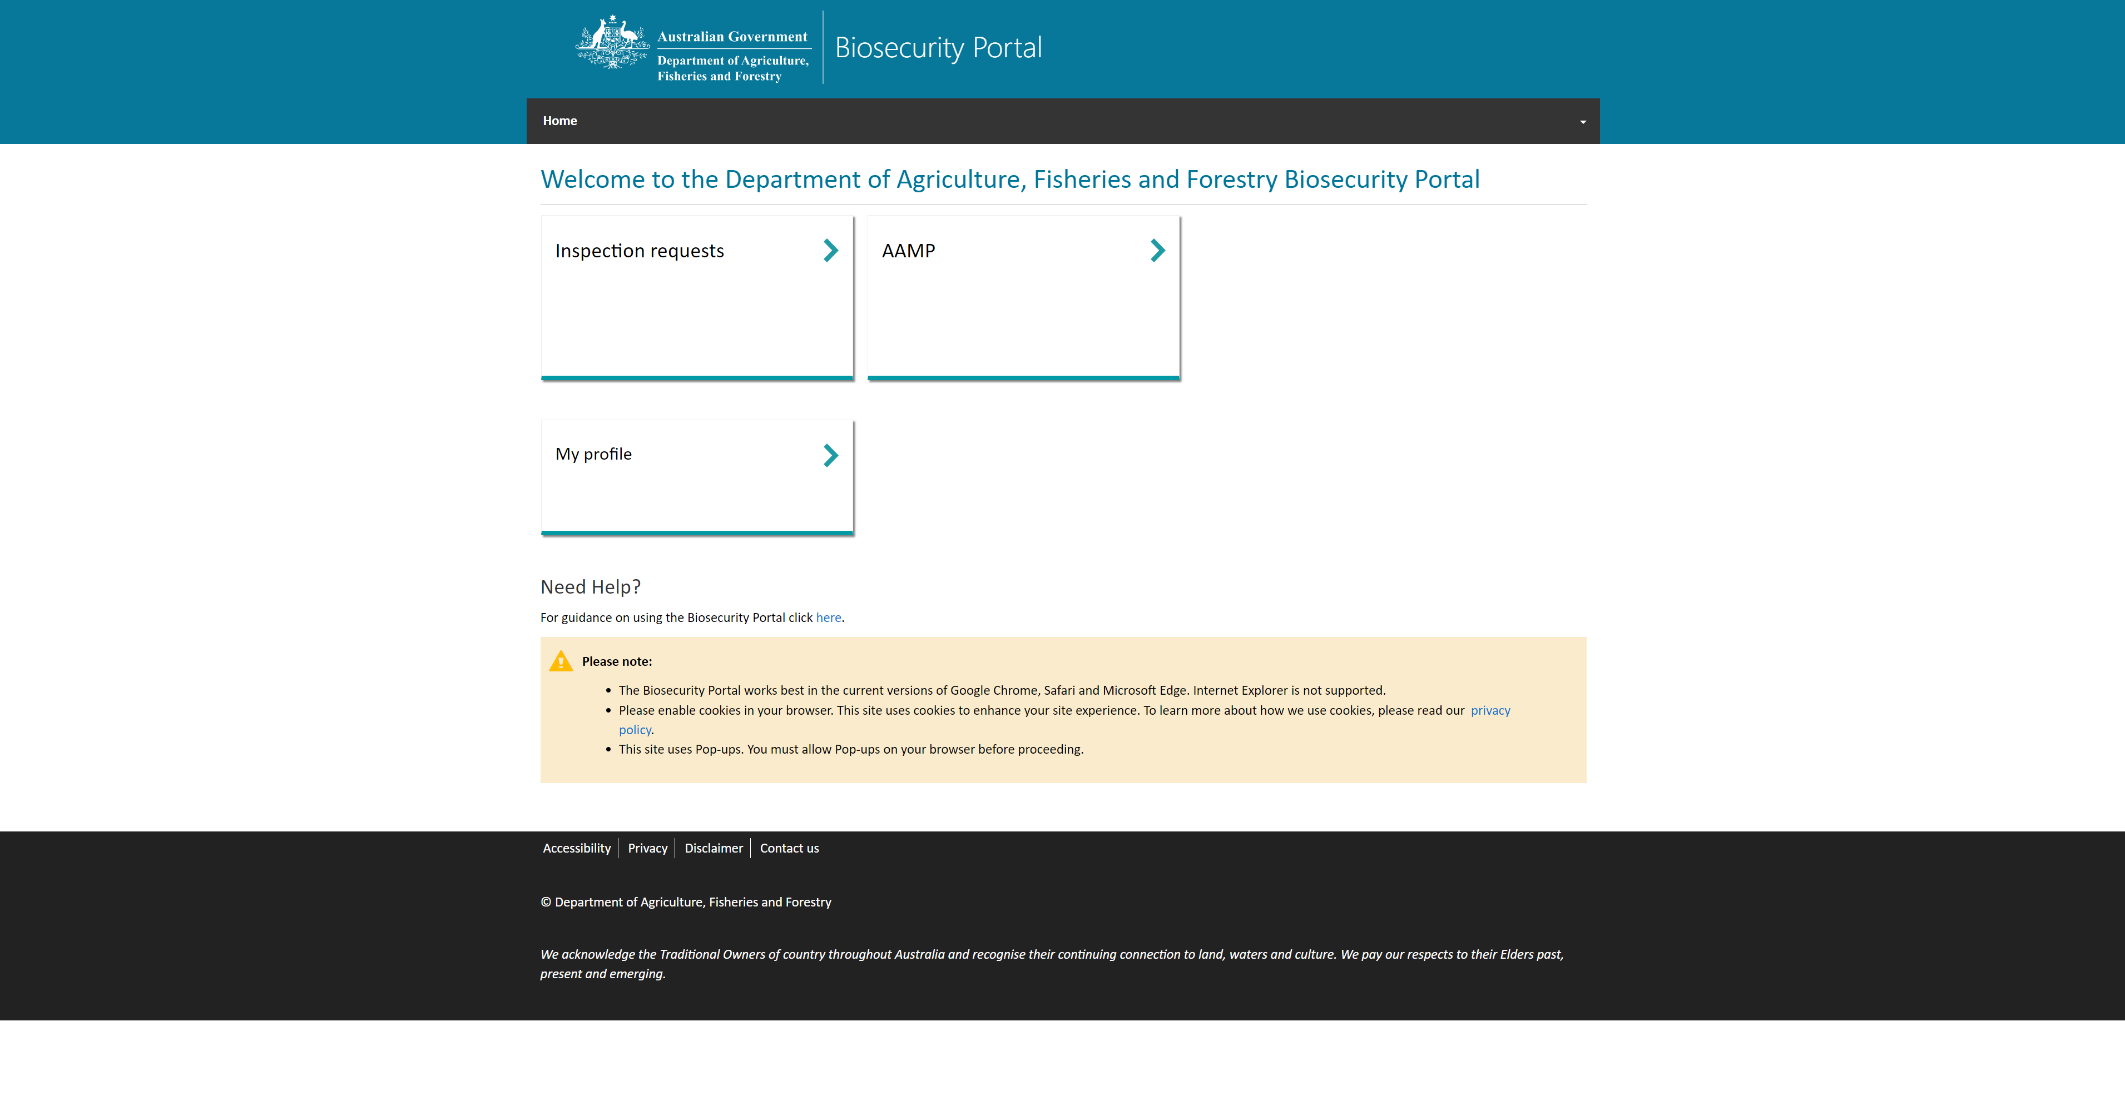

Figure 1: Screenshot of the Biosecurity Portal when logged in via email address (Other User), associated with an Approved Arrangement