Biosecurity Portal

User Guide

Version 2.7

February 2023

Table of Contents

1. ACCESSING THE BIOSECURITY PORTAL 1

1.1. BIOSECURITY PORTAL WEBLINK 1

1.2. SIGN-IN TO THE BIOSECURITY PORTAL USING A DIGITAL IDENTITY 3

1.3. SIGN-IN TO THE BIOSECURITY PORTAL FOR THE FIRST TIME WITH A DIGITIAL IDENTITY 5

1.4. SIGN-IN TO THE BIOSECURITY PORTAL USING AN EMAIL AND PASSWORD 8

1.5 SIGN-IN TO THE BIOSECURITY PORTAL FOR THE FIRST TIME WITH AN EMAIL AND PASSWORD 9

2. USER MANAGEMENT 10

2.1. USER ROLES IN THE BIOSECURITY PORTAL 10

2.2. APPROVE USERS 11

2.3. ADD USERS 11

2.4. REMOVE USERS 12

3. MANAGING AIMS DIRECTIONS 13

3.1. VIEW AND PRINT AIMS DIRECTIONS 13

4. CREATING A NEW INSPECTION REQUEST – DIGITAL IDENTITY 14

5. CREATING A NEW INSPECTION REQUEST – OTHER USERS 27

6. MANAGING INSPECTION REQUESTS AND BOOKINGS 36

6.1. VIEW INSPECTION REQUESTS AND BOOKINGS 36

6.2. CANCEL INSPECTION REQUESTS 37

6.3. CANCEL BOOKINGS 37

6.4. MODIFY BOOKING DATE/TIME 38

7. ARCHIVE INSPECTION REQUESTS AND BOOKINGS 40

7.1. ARCHIVE AN ENTRY ID 40

7.2. RE-INSTATE AN ENTRY ID 41

# ACCESSING THE BIOSECURITY PORTAL

## BIOSECURITY PORTAL WEBLINK

To access the Portal, browse to <http://biosecurity.agriculture.gov.au>.

The Portal home page has links to important information to assist you in registering and using the Portal including:

* How to create your Digital Identity and register for the Portal.
* Information about the Portal.
* Information about new and upcoming features and services.
* User help guides and other helpful information.

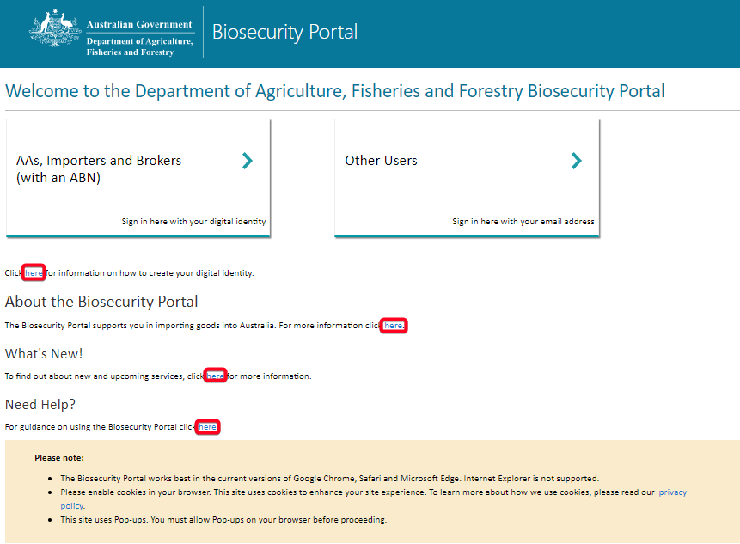

Screen 1: Biosecurity Portal home page

**WHAT CAN I DO/SEE WHEN LOGGED INTO THE PORTAL**

The table below shows what features are available for the kind of access you have signed up for.

*Digital Identity* Access is available by registering via MyGovID.

*Other User* Access is available by signing up using an email and password, providing limited access to portal functionality.

|  |  |  |  |  |
| --- | --- | --- | --- | --- |
|  | Digital Identity  (Registration Option 1) | | | Other User  (Registration Option 2) |
|  | Approved arrangements operators | Customs brokers & importers | Manned depots **(1)** | Other  Users (2) |
| Online request for inspection (RFI) submission | ü | ü | ü | ü |
| Auto pre-population of RFI details | ü | ü | ü |  |
| Viewing and printing of AIMS Direction information(3) | ü | ü | ü |  |
| View / manage inspection requests that I have lodged | ü | ü | ü | ü |
| View / manage inspection requests lodged by any authorised user representing my organisation | ü | ü | ü |  |
| View / manage my upcoming inspection bookings | ü | ü | ü | ü (cancel only) |
| View / manage upcoming bookings lodged by any authorised user representing my organisation | ü | ü | ü |  |
| View my historical inspection bookings made via the Portal | ü | ü | ü | ü |
| View historical inspection bookings lodged by any authorised user representing my organisation | ü | ü | ü |  |
| Receive automatic email notifications. e.g., confirmation of inspection request and confirmed inspection booking details | ü | ü | ü | ü |
| Manage individual profile | ü | ü | ü | ü |
| Manage organisational profile | ü | ü | ü |  |
| Manage user access (who can represent my organisation) | ü | ü | ü |  |

**(1)** Only for one-offs e.g., requesting inspections requiring a different skill set (other than inspections that can be undertaken by onsite officer).

**(2)** Includes freight forwarders, clients with a low volume of import inspection requests, and clients without an ABN.

(3) Import clients will be able to view AIMS Direction information issued by the department if:

* Approved Arrangements – if the AA number is listed against an active AIMS Direction.
* Brokerage – the ABN of the brokerage is listed against the import declaration in the Integrated Cargo System (ICS).
* Importer – the ABN of the importer is listed against the import declaration in the Integrated Cargo System (ICS).

## SIGN-IN TO THE BIOSECURITY PORTAL USING A DIGITAL IDENTITY

The Department of Agriculture, Fisheries and Forestry (DAFF) uses the Digital Identity for authentication and access to the Portal. For more information about Digital Identity, visit <https://digitalidentity.gov.au>.

After selecting the **Sign in here with your digital identity**, a user will be directed to the Digital Identity site to select the myGovID option. This selection only needs to be completed once, by ticking “Remember my choice”.

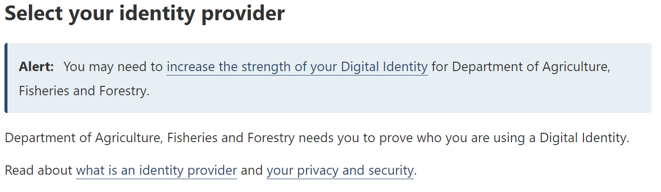

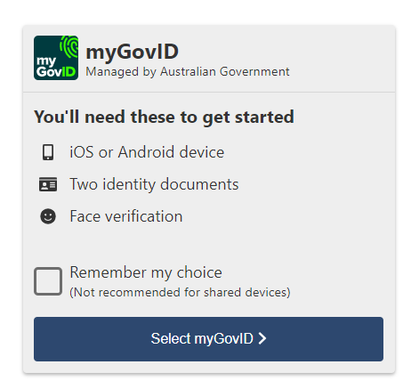

Screen 2: DTA myGovID digital solution selection

* A user will need to indicate their consent to share details with the department in the first session, there answer will be remembered for following sessions.

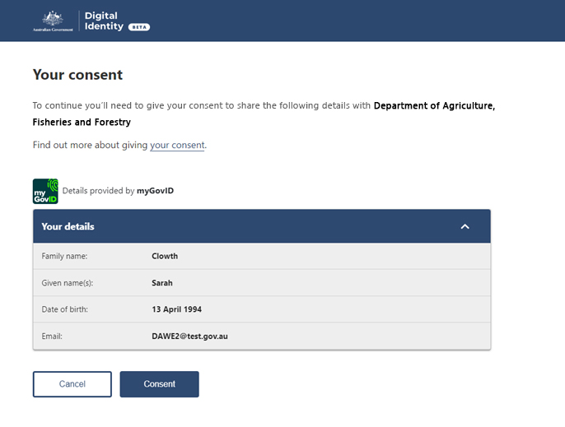

Screen 3: DTA consent to share details with the department

1. **New users**

Currently, you can create a Digital Identity to access government services using the Australian Government’s myGovID. In the future, you will be able to create a Digital Identity to access government services using other identity providers.

You will need a digital identity issued by myGovID (minimum **Standard** identity strength for users and **Strong** for Principal Authorities) and be linked to a business (ABN) in Relationship Authorisation Manager (RAM).

For more information on setting up a Digital Identity and linking a business (ABN) in Relationship Authorisation Manager, refer to the following links:

1. [**About Digital Identify**](https://www.digitalidentity.gov.au/about-digital-identity)  - an overview of digital identify
2. [**Steps to set up your Digital Identity**](https://www.mygovid.gov.au/set-up) – a step by step guide to download the myGovID App and establish your identity.
3. [**Verifying your identify**](https://www.mygovid.gov.au/verifying-your-identity-documents) - a guide on how to verify your identify.
4. [**About the Principal Authority**](https://info.authorisationmanager.gov.au/principal-authority) – information on the Principal Authority and linking a business online in RAM.
5. [**About authorised users and administrators**](https://info.authorisationmanager.gov.au/authorised-users-and-administrators) – Information about roles in RAM.
6. **Existing users**

If you have previously accessed the portal, use your Digital Identity credentials to sign into your account and select the business that you are representing during the session.

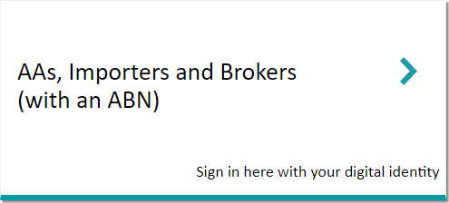

*Screen 4: Digital Identity login*

You can only represent one business in a session. To represent a different business you must log out, close all active sessions of the portal by closing all browsers, and login again.

## SIGN-IN TO THE BIOSECURITY PORTAL FOR THE FIRST TIME WITH A DIGITIAL IDENTITY

The first time you access the portal you will be required to update your profile:

1. Biosecurity Portal Administrators

If you are a Portal Administrator, you will be required to:

1. Complete your individual profile.
2. Complete the business profile. The business profile must be completed before business users can access the portal.

You may be required to approve/reject pending access requests raised by portal users of your business. Refer Section 2 – User Management for more information. Approving a user’s access request will allow them access to conduct transactions on your business’ behalf and view all transactions conducted by other users of your business in the Portal.

1. Biosecurity Portal Users

If you are a Portal User, you will be required to complete your individual profile.

Within the portal, your identity is a combination of who you are and the business that you represent.   
As such, you will be asked to complete your individual profile for each business you represent.

**Individual and Business profile**

1. Completing the Individual profile

The department requires you to provide additional information to make your experience within the portal a smooth and seamless one. The first time you access the portal you will be required to complete information in the My profile section.

1. Complete the requested information on your profile page. Mandatory fields are identified using a * next to the field.

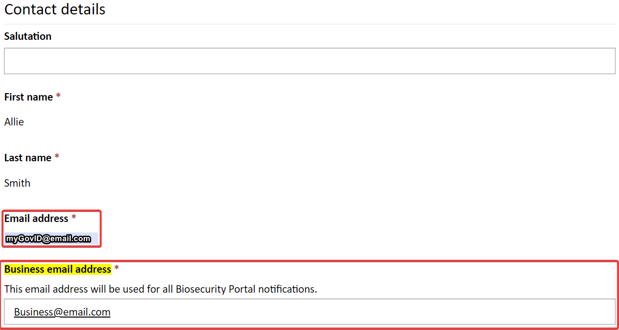

*Screen 5: Update email address*

1. Read the privacy notice, accept the terms in the privacy notice by selecting the checkbox at the bottom.
2. Select the Update button to complete your individual profile.

After you complete your Individual profile, you may find that your access is awaiting approval by the portal administrator of the business (ABN) you represent. Access to the portal will remain ‘awaiting approval’ until the Portal Administrator of your business approves your access request. You will receive an email notification once your access has been approved. Portal Administrators’ profiles are auto approved in the Portal. Your profile can be updated at any time by accessing the My profile page in the portal.

1. Completing the Business profile

If you are a Portal Administrator for your business, you will be required to complete your ‘Business’ profile in the ‘Organisation’ profile section of the portal. You will not be asked to complete the Business profile if another Portal Administrator for your business has already completed this step.

1. Complete all requested information on the Organisation summary page.
2. Select the Update button to complete your organisations Business profile.

The Business’ profile can be updated at any time by accessing the My organisation section of the Portal.

**e) Adding a new Business profile**

Portal Administrators can add a new profile for their business (ABN) using the Add organisation function on the My organisations page.

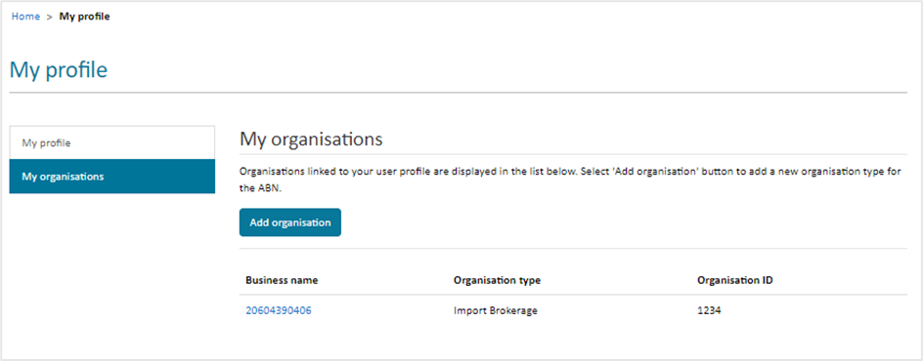

Screen 6: Adding a new Business profile

A business (ABN) can create one or more organisation profiles in the Portal if the ABN operates in different capacities. For example, ABC Pty Ltd with ABN 11123456789 operates as an Import Brokerage with brokerage branch ID B100001, as well as an Approved Arrangement with Registration Number AA123.

ABC Pty Ltd can create two organisation profiles in the Portal, one for the Brokerage operation and one for the Approved Arrangement operation.

Portal Administrators can assign users to one or more of their organisation’s profiles. For example, User A and User B can have access to the Brokerage profile of ABC Pty Ltd, while User C and User D can be provided with access to the Approved Arrangement profile. User E can be provided with access to both.

To add a new Business profile:

1. Sign into the portal and select My organisation.
2. Select Add organisation.
3. Complete required details for the New organisation.
4. Select from the following options:

* Import brokerage organisation
* Importer organisation
* Approved arrangement organisation (this option would be visible only if the business is registered as an approved arrangement with the department).

1. Select the Submit button.

You must be signed into the portal under the required ABN to create an organisation profile.

When creating a new organisation profile, if you cannot find the correct organisation type for your business, please contact the department using the link <https://www.agriculture.gov.au/about/contact>.

## SIGN-IN TO THE BIOSECURITY PORTAL USING AN EMAIL AND PASSWORD

This channel is available to third parties, for example Freight Forwarders, as well as clients without an ABN. Features include:

* Register / login using an email and password.
* Lodge and cancel an RFI.
* View upcoming and historical RFI bookings.
* View real-time updates to the status of an inspection request and booking; and
* Email notifications.

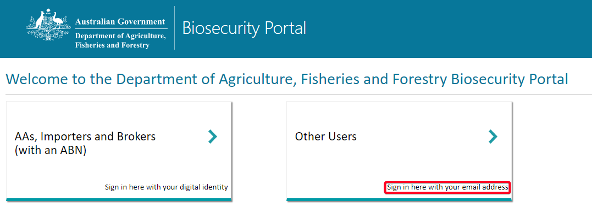

*Screen 7: Other Users login*

**Register with just an email and password**

* Users register with a valid email and password.
* Contact details, including name, email, and phone number, are captured during the registration process.
* Organisation Name and Organisation Type can be supplied but are non-mandatory fields.

## SIGN-IN TO THE BIOSECURITY PORTAL FOR THE FIRST TIME WITH AN EMAIL AND PASSWORD

The first time you access the portal you will be required to update your profile:

**Individual profile**

1. Completing the Individual profile

The department requires additional information about you to make your experience within the portal a smooth and seamless one. The first time you access the portal you will be required to complete information in the My profile section.

1. Complete the requested information on your profile page. Mandatory fields are identified using a * next to the field.

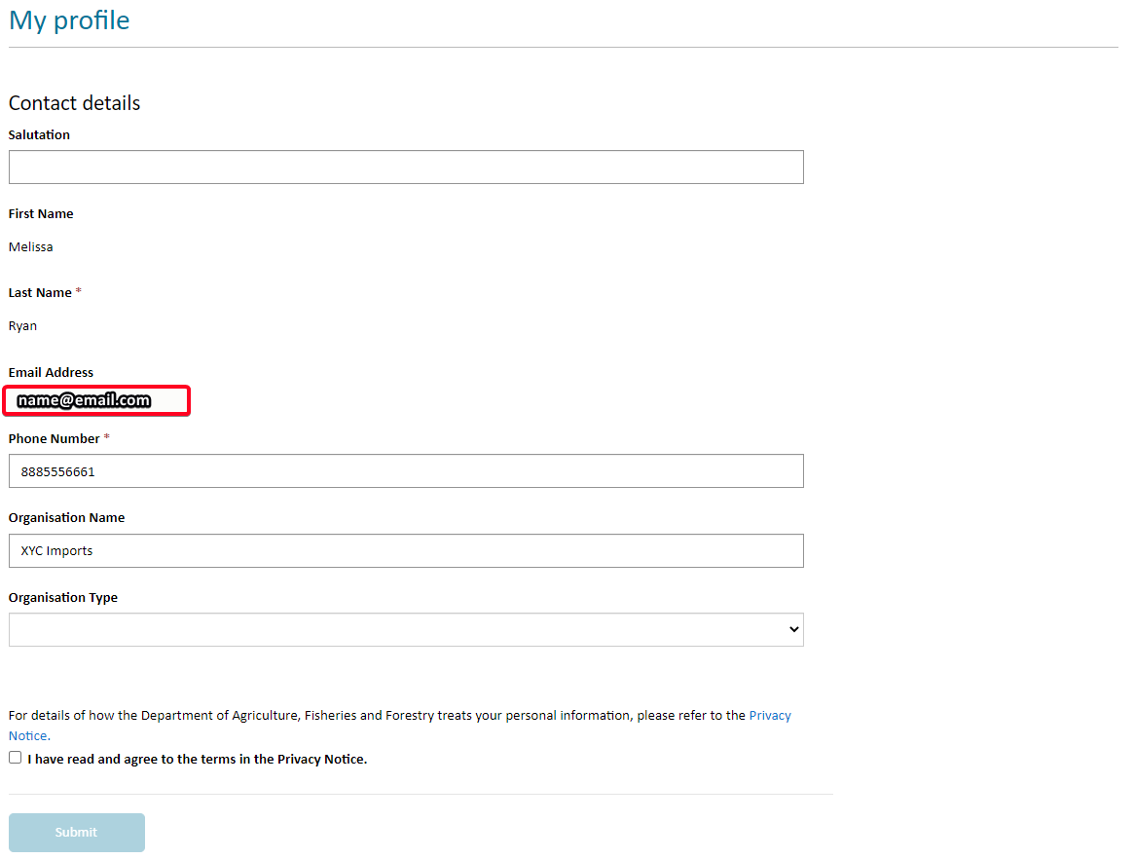

*Screen 8: Update email address*

1. Read the privacy notice, accept the terms in the privacy notice by selecting the checkbox at the bottom.
2. Select the Submit button to complete your individual profile.

# USER MANAGEMENT

This section is intended for use by Portal Administrators signing in using a Digital Identity.

## USER ROLES IN THE BIOSECURITY PORTAL

The portal uses two user-roles.

1. **Biosecurity Portal Administrator:** As a portal administrator for your business, you can perform the following actions in the portal:
2. View and manage your individual profile.
3. View and manage your business’s profile.
4. View and manage users and their access to services.
5. Access secure services.
6. **Biosecurity Portal User:** As a portal user representing a business, you can perform the following actions in the portal:
7. Request access to represent a Business in the portal.
8. View and manage your individual profile.
9. View your linked business’s profile(s).
10. Access services that you are approved for (by the Portal Administrator of your business).

A portal user can be linked and approved to represent one or more organisations within the Portal. This needs to be enabled by the Authorised administrators of each business by linking the standard users Digital Identity to the required ABNs in RAM.

## APPROVE USERS

Portal users will not immediately have access to represent a business in the portal. Their access will remain pending until a Portal Administrator for the business approves their request.

To view and action pending access requests in your queue:

1. Sign into the portal.
2. Select My organisation and select the business name from the list of your associated businesses.
3. Scroll down to the bottom of the page to find the Awaiting approval section.
4. Review pending access requests, and either approve or reject each user by selecting the chevron (down arrow) beside each user. A notification of your decision will be sent to the user by email.

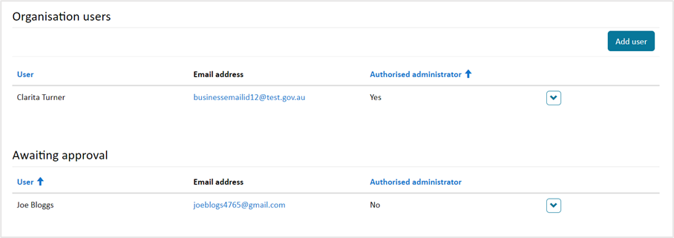

Screen 9: Review pending approval requests

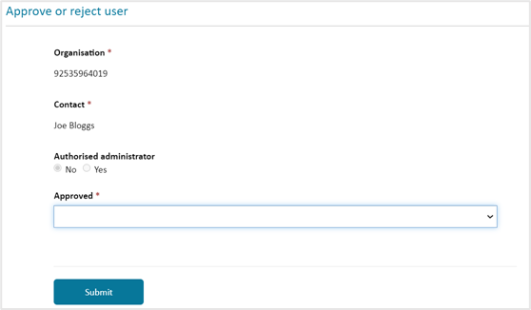

Screen 10: Approve users to represent your business in the Biosecurity Portal

Portal Administrators will receive an email reminder when a user has requested access to represent their business. Portal Users will be notified of the administrator’s decision (approval/rejection) by email.

## ADD USERS

Portal Administrators can add existing users to their business using the Add user functionality.

To add an existing user:

1. Sign into the portal.
2. Select My organisation and select the required business name from the list of your associated businesses.
3. Scroll down and select Add user.
4. On the pop-up window, use the dropdown list to select a linked user you wish to provide access to your business and click Submit button.

*Note: Linked users are users that are already associated with your business ABN and have access to the portal while representing one or more profiles for your business.*

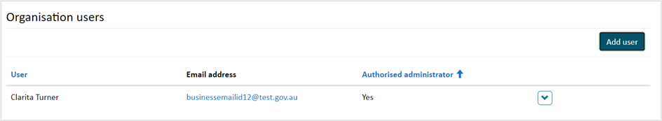

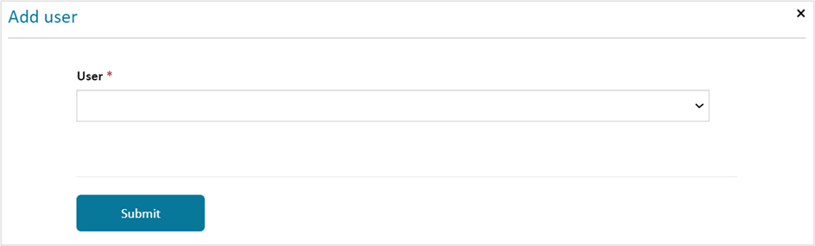

Screen 11: Add user

## REMOVE USERS

Portal Administrators can revoke an existing user’s access by selecting the chevron (down arrow) beside the user’s name and selecting the remove option.

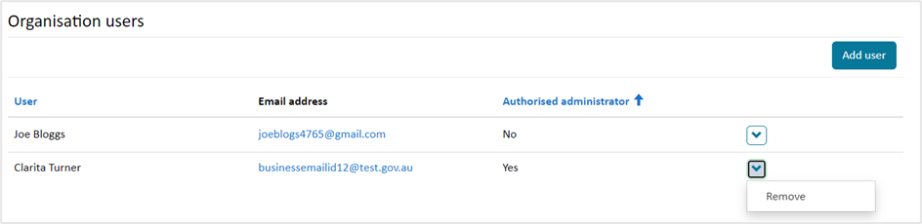

Screen 12: Remove user

# MANAGING AIMS DIRECTIONS

## VIEW AND PRINT AIMS DIRECTIONS

An authenticated user (logged in using their digital identity) can view and print all Directions issued against an AIMS Entry ID. Noting Food Control Certificates cannot be viewed at this stage.

A user will be able to view Directions against an AIMS Entry ID if as a:

* Approved Arrangement – if the AA number is listed against an active Direction.
* Brokerage – the ABN of the brokerage is listed against the import declaration in the Integrated Cargo System (ICS).
* Importer – the ABN of the importer is listed against the import declaration in the Integrated Cargo System (ICS).

From the Home page, select the “View import directions” tile, enter a valid Entry ID and click “Submit”.

Print a page by selecting Ctrl+P.

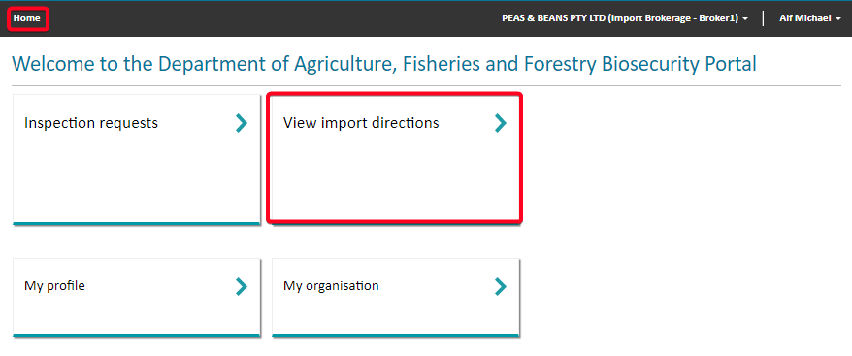

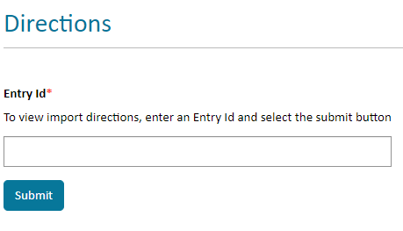

Screen 13: View Import Directions

# CREATING A NEW INSPECTION REQUEST – DIGITAL IDENTITY

When booking inspections via the Portal, please do not attempt to then made modifications to, or cancel the inspection booking via the email channel. Doing so can cause delays to your booking request. Sign into the portal and select Inspection requests.

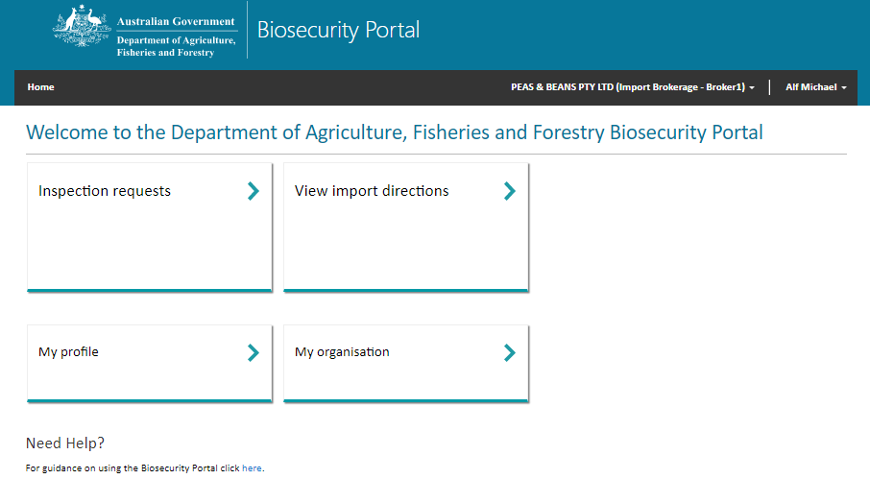

Screen 14: Signed in home page

If you are logged in as an Approved Arrangement you will have a third tile “Approved Arrangement outcomes”.

1. Select Request an import inspection on the Inspections page.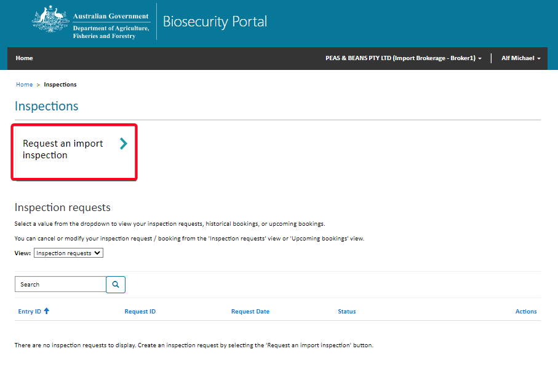

Screen 15: Inspection’s page

A popup window will appear.

If you are a representative of multiple ABNs, please select the organisation you are representing. To represent a different ABN, please log out, close all instances of your browser, and then log back in to select the correct organisation. You can then continue with your booking as normal.

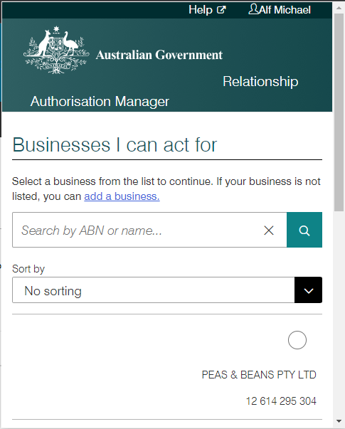If you are a representative of only one ABN, this popup window will pop up and after a few seconds disappear, and you can then continue with your booking as normal.

Screen 16: Pop up display

1. On the Import inspections page, the portal will display all Entry IDs requiring an inspection for your business.

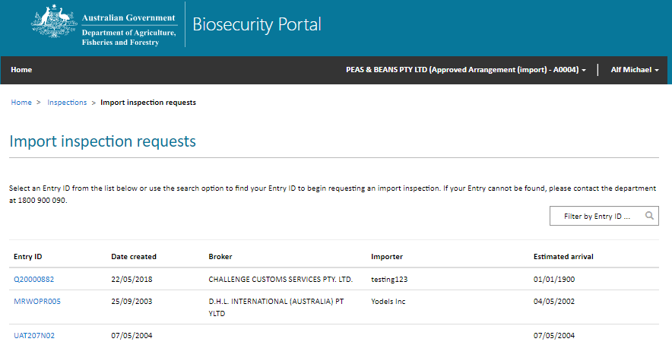

Screen 17: Import inspections page

**Filter options:** Use the Filter by Entry to search for a specific ID. Alternatively, you can also select an Entry ID from the available list. Use the option at the bottom of each page to view up to 15 Entry IDs per page.

Only one Entry ID can be selected per request. If you don’t see the Entry ID that you require, you may need to log out and log in with the appropriate business (ABN) selected. If you are associated with more than one organisation profile, you may need to select the correct profile from My organisations page.

1. Upon selecting an Entry ID, the portal will display all inspection related directions issued for that Entry ID.

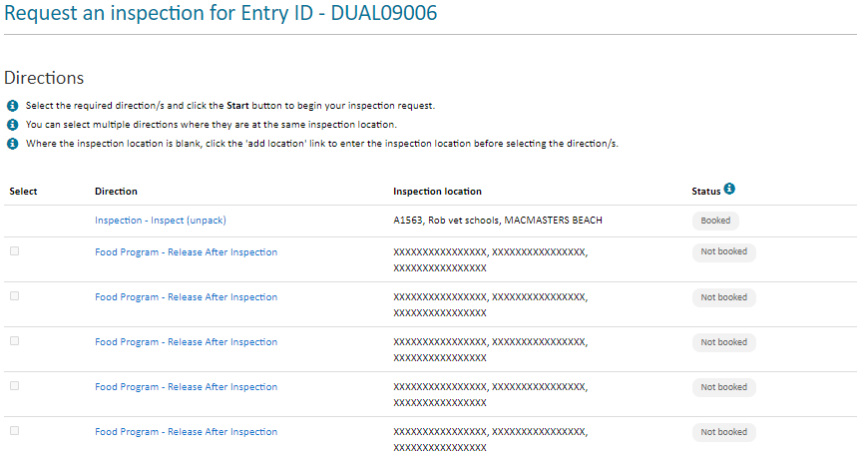

Screen 18: Review directions for the selected Entry ID

The status column displays the status of the direction:

1. Booked – an inspection has been booked for this direction
2. Not booked – an inspection has not been booked for this direction
3. Pending – an inspection request has already been lodged, and is pending booking by the department
4. Selected – the direction has already been selected by you in the current request being lodged
5. Inspection In progress – the inspection for the selected direction is in progress.

Only directions with status Not booked can be selected for requesting an inspection.

To change the Entry ID that you selected in the previous page, you can use the navigation icons at the top of the page to return to the Inspections page.



**Note:** The Portal is designed to provide a secure and confidential operating environment for all users. As such, if you are signed in as a representative of an Approved Arrangement, the inspection location listed against directions issued to other parties in the Entry ID will be hidden with XXXX to retain privacy.

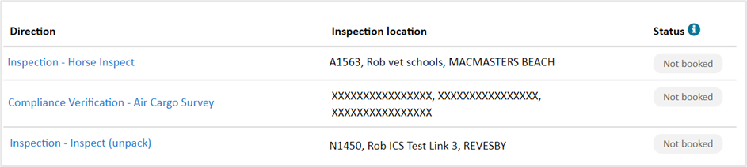

Screen 19: Hidden inspection location against a direction (example)

A RFI cannot be lodged for a direction if there are other directions which need to be completed first.

Upon entering an Entry Id and/or direction, validation against business rules will occur. If an Entry Id and/or direction meets these business rules the following error messages will be displayed:

“*You cannot lodge an inspection request for this entry whilst there are other actions pending. Please contact the broker or provide the information as requested by the Department.*”

1. To create an inspection request for the selected Entry ID, select the ‘Start’ button at the bottom of this page.

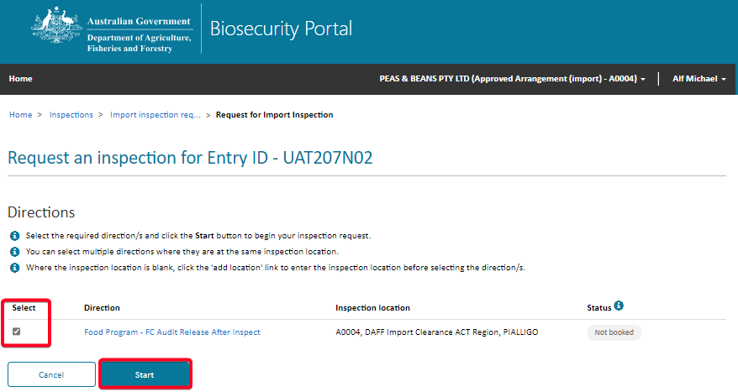

Screen 20: Create inspection request

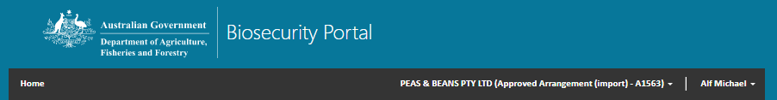When submitting an RFI, if a direction does not have an inspection location, a Portal User can add the address by selecting the add location button. Note: A direction must have a location before it can be booked.

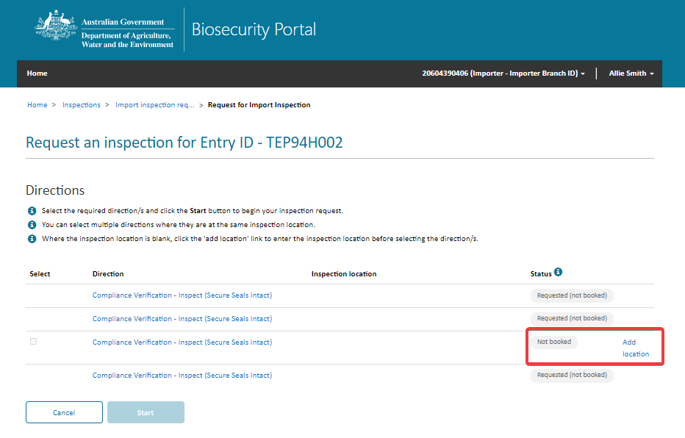

Screen 21: Add location

The inspection location address is checked to ensure it is a valid Australian address. Simply start typing the inspection location address and select from the options presented. If the inspection location address does not appear, select Enter the address manually and type the address in the fields.

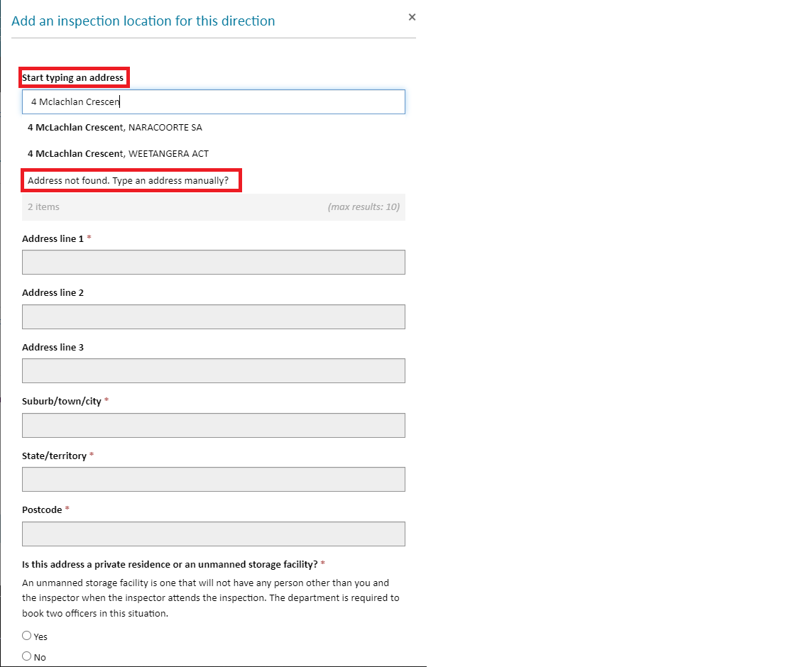

Screen 22: Validating address

Select directions for this Inspection Request by checking the box against required directions.

Multiple directions can be included in a single Inspection Request.

Only directions with the same inspection location can be included in the same Inspection Request. To include a direction with a different inspection location, create a new inspection request.

Select the Start button in Step 5, and then select Yes on the dialogue window to proceed.

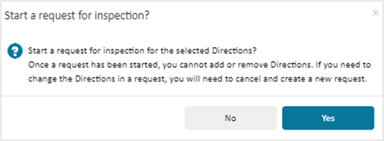

Screen 23: Confirm directions and start the inspection request

Changes to the selected Entry ID or directions will not be possible if you select Yes on the pop-up dialogue box and navigate to the next screen. If any changes need to be made, select No and navigate to previous screens to make the required changes.

1. Complete the primary and secondary inspection location contact information for the inspection request and select the Save & next button at the bottom of this page.

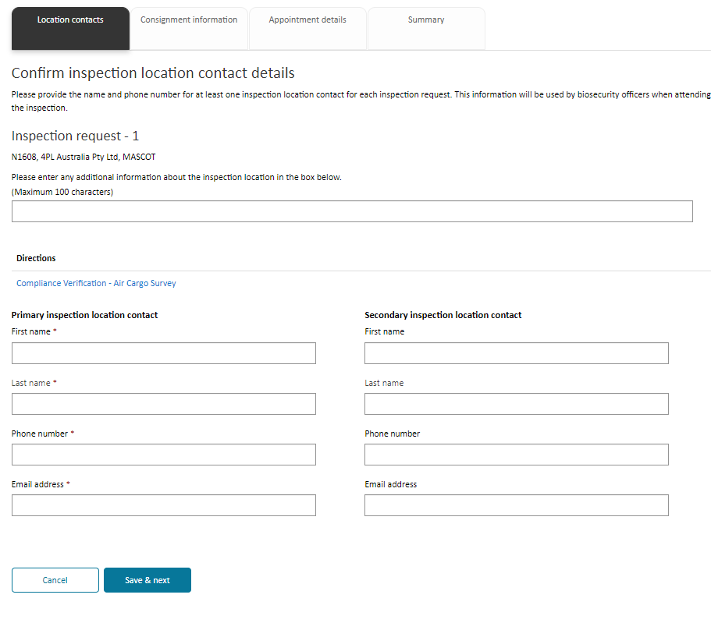

Screen 24: Inspection location contact information

Location contacts will be auto populated for an Approved Arrangement if they have been added in the Organisation summary page in the business’ profile. You can change the inspection location contacts for the current inspection request by changing the auto populated contact details.

To change contact details displayed for the business, the authorised administrator must edit the business’ profile in the Organisation summary page.

1. On the Consignment information tab, complete responses to all related questions. Select Save & 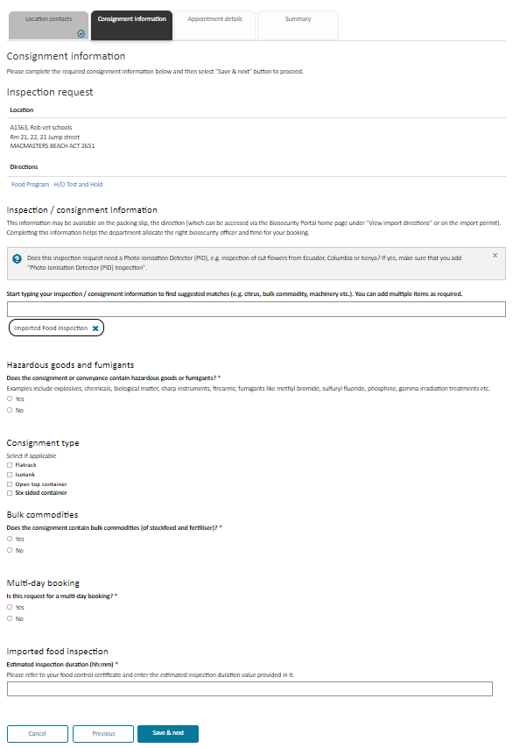next button to proceed.

*Screen 25: Consignment information section*

At least one inspection type must be selected either by a user or automatically applied by the system. A user can select and add more than one inspection / consignment type to the request but cannot add duplicate inspection types.

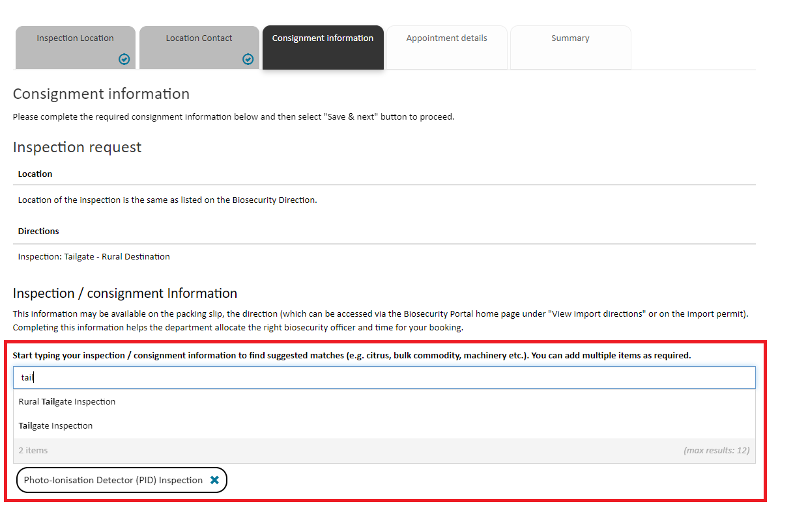

Screen 26: Inspection selection

Simply start typing an inspection / consignment type and the system will suggest values.

Inspection types will be auto populated depending on the direction and can also be manually added. Where an inspection type has been auto populated against a direction, a user cannot remove this entry

When lodging an inspection request for an imported food program direction, the associated inspection types are automatically populated.

1. On the Appointment details tab, complete the required information and select the Save & next button to proceed.

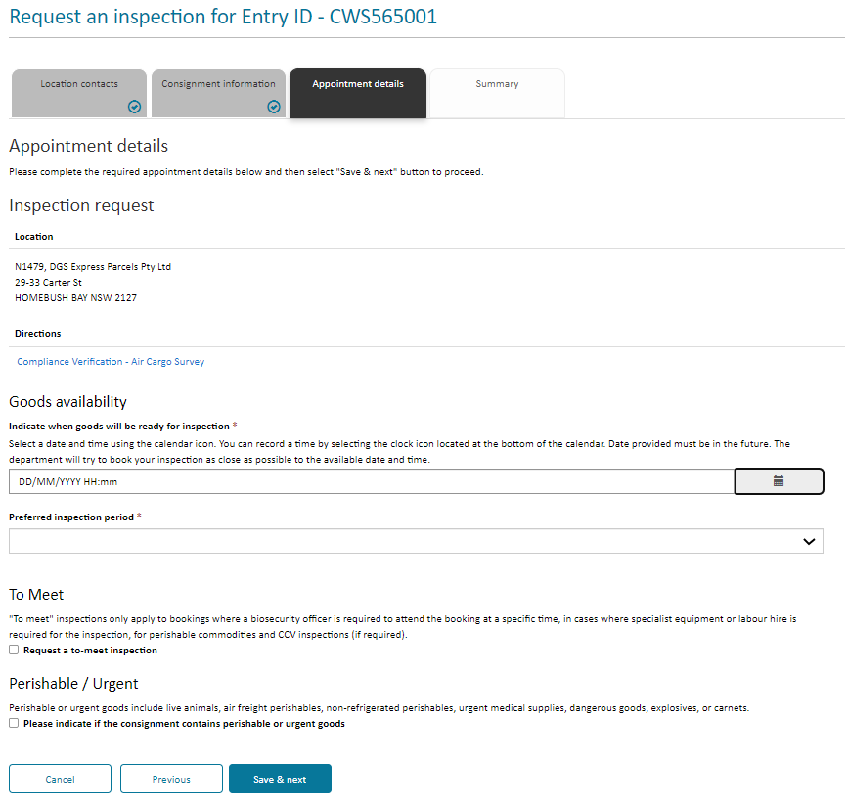

Screen 27: Appointment details section

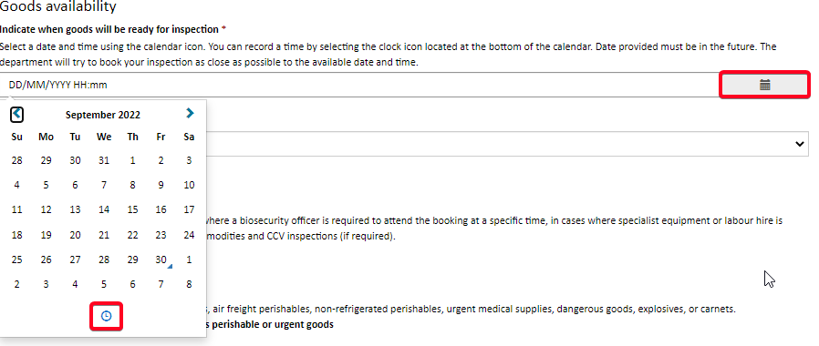

Screen 28: Selecting the date and time

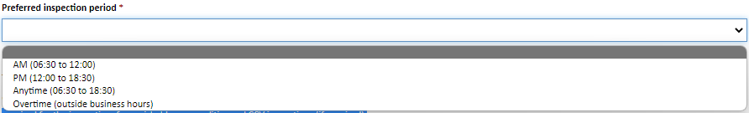

Screen 29: Screen 56: Appointment time slots

* Indicate a date and time when your goods will be ready for inspection. This date must be in the future. You can also specify a time by selecting the clock symbol at the bottom of the calendar icon. The time will default to current time if not changed.
* Select a preferred inspection period from the dropdown list. There are four to choose from AM, PM Anytime and Overtime.
* When you require an inspection outside of departmental core hours i.e., outside 6:30am to 6:30pm Monday to Friday, you can select the overtime option on the appointment details tab. The department will email you with the day/time once the booking has been confirmed.
* Indicate if your inspection contains perishable or urgent goods
* **Further information:** - you can request a ‘To meet’ inspection – you will receive a day and time for the inspection once the booking has been confirmed.
* **Note:** overtime is a form of ‘To meet’, but ‘To meets’ can also be during business hours.

View information on the Summary tab to verify the details entered for your Inspection Request(s.) Should any changes be required, use the Previous button to navigate to the relevant tab. Ensure that all entered information is accurate before submitting the form.

Submit the form by selecting the Submit button.

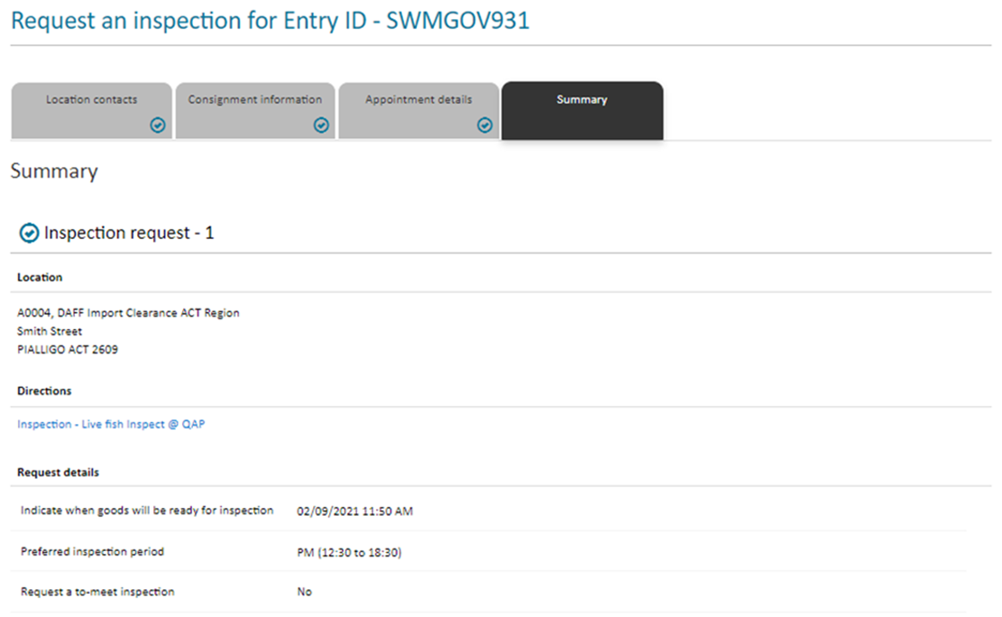

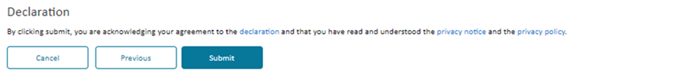

Screen 30: View inspection request summary

Declaration notice, privacy notice and privacy policy can be accessed by selecting the links in the Declaration section. Please read them before submitting your inspection request form.

1. This page confirms your import inspection request and provides you with a unique transaction number for each inspection request that you lodged. An email will also be sent to your registered email address confirming your submission.

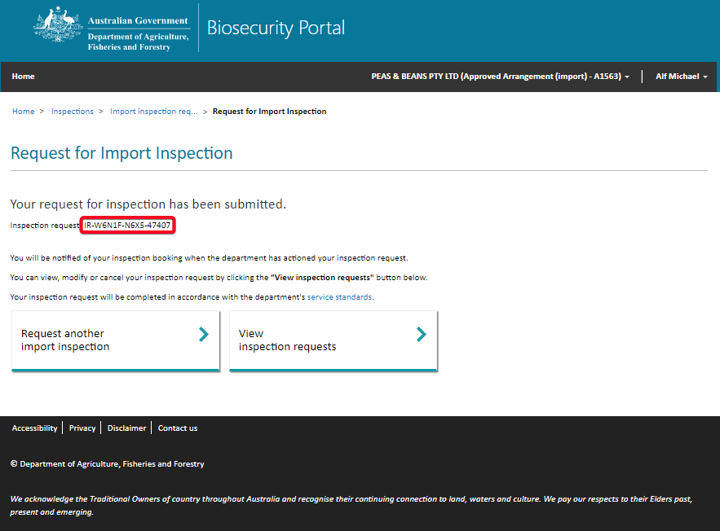

Screen 31: Inspection request confirmation

To request a new inspection, select the Request another import inspection button.

To view your lodged inspection request, select the View inspection requests button.

# CREATING A NEW INSPECTION REQUEST – OTHER USERS

1. Sign into the Portal using your valid email and password combination and select Inspection requests.

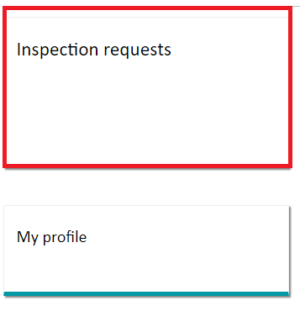

*Screen 32: Lodge a RFI via the email and password channel*

1. Select Request an import inspection

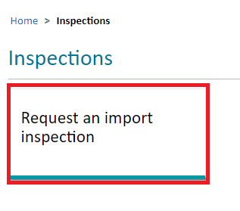

*Screen 33: Lodge a RFI via the email and password channel*

1. Enter a valid AIMS Entry ID. This is an alpha-numeric nine-character.

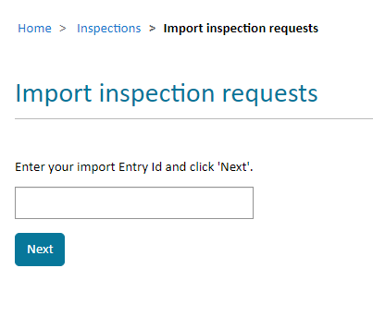

Screen 34: Lodge a RFI via the email and password channel

The system will check to determine if the Entry ID is valid.

If not, an error message will be displayed asking you to check the Entry ID and re-enter.

1. Enter a valid Direction and select Next. Please refer to your Entry ID for valid directions.

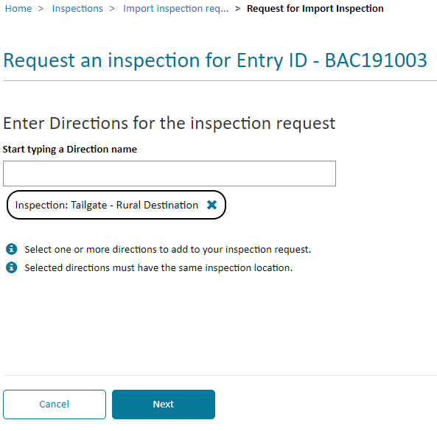

Screen 35: Lodge a RFI via the email and password channel

If a selected direction is not valid (i.e.: is not a direction against the selected Entry ID in AIMS), an error message will be displayed asking you to remove the selected direction.

You can add multiple directions provided they all have the same inspection location.

Two generic directions - “Imported Food: Inspection” and “Imported Food: Failed food inspection” have been introduced to streamline requests for food inspections. You no longer need to enter the exact direction name, noting food directions are not currently displayed on the Food Control Certificate.

You can enter either - “Imported Food: Inspection” and/or “Imported Food: Failed food inspection” and the system will match the request to the direction in the Agriculture Import Management System (AIMS).

1. Confirm the location of your inspection

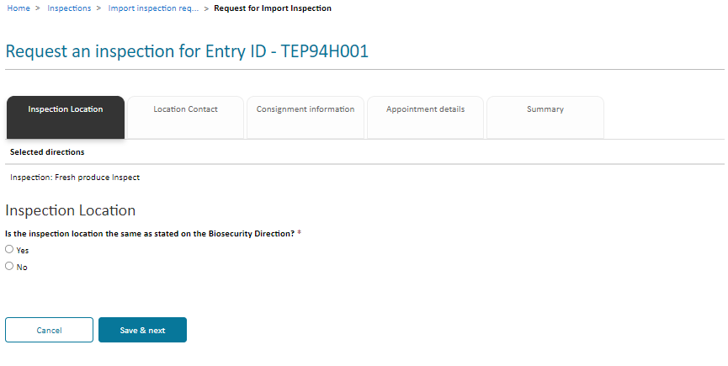

Screen 36: Inspection Location

If the Inspection location is the same as stated on the Biosecurity Direction, select Yes to proceed to the next screen.

The Inspection Location can only be changed for an Imported Food (IF) or Cargo Compliance Verification (CCV) inspections.

If you select No and the inspection is not an IF or CCV, an error message is returned, and you cannot proceed to the next screen.

“*You cannot proceed with this inspection request. To change the inspection location for the selected Entry Id and Biosecurity Direction please go to the Cargo Online Lodgement System (COLS) or contact the department on 1800 900 090. You can lodge your inspection request once the change has been actioned.*”

1. Complete the primary and secondary inspection location contact information for the inspection request and select Save & next button at the bottom of the page.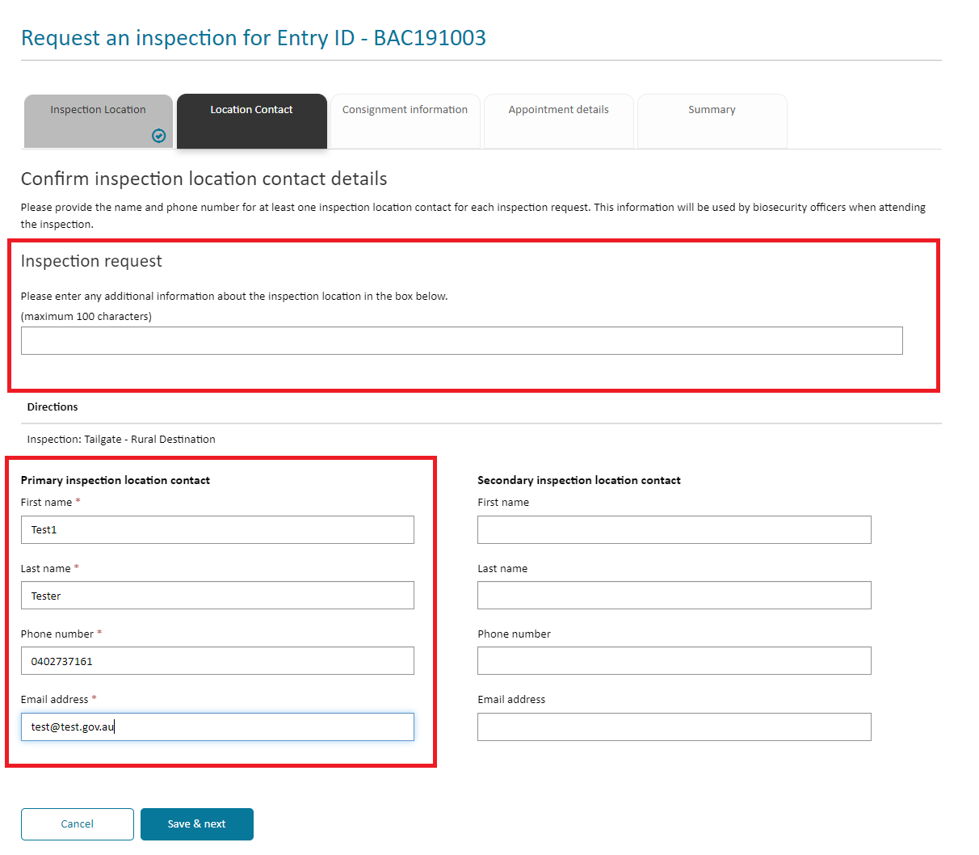

*Screen 37: Location contact details*

1. On the Consignment information tab, complete responses to all related questions. Select Save & next button to proceed.



Screen 38: Consignment Information

A user can select and add more than one inspection / consignment type to the request but cannot add duplicate inspection types.



Screen 39: Inspection / consignment Information

Simply start typing an inspection / consignment type and the system will suggest values.

Inspection types will be auto populated depending on the direction and can also be manually added. Where an inspection type has been auto populated against a direction, a user cannot remove this entry

When lodging an inspection request for an imported food program direction, the associated inspection types are automatically populated.

When lodging an inspection request for an imported food program direction, the associated inspection types are automatically populated

1. On the Appointment details tab, complete responses to all related questions. Select Save &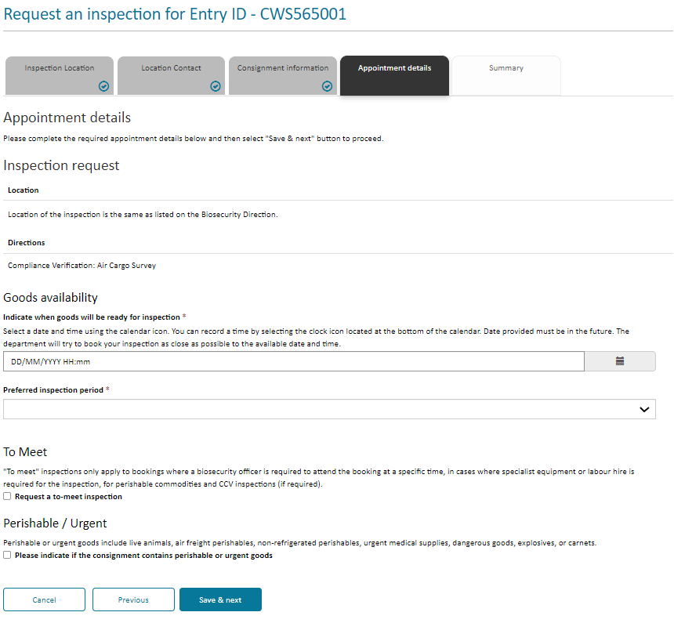 next

Screen 40: Appointment Details



Screen 41: Appointment time slots

* Indicate a date and time when your goods will be ready for inspection. This date must be in the future. You can also specify a time by selecting the clock symbol at the bottom of the calendar icon. The time will default to current time if not changed.
* Select a preferred inspection period from the dropdown list. There are four to choose from AM, PM Anytime and Overtime.
* When you require an inspection outside of departmental core hours i.e., outside 6:30am to 6:30pm Monday to Friday, you can select the overtime option on the appointment details tab. The department will email you with the day/time once the booking has been confirmed.
* Indicate if your inspection contains perishable or urgent goods
* **Further information:** - you can request a To meet inspection – you will receive a day and time for the inspection once the booking has been confirmed.
* **Note:** overtime is a form of To meet, but To meets can also be during business hours.

View information on the Summary tab to verify the details entered for your Inspection Request(s). Should any change be required, use the Previous button to navigate to the relevant tab. Ensure that all entered information is accurate before submitting the form.

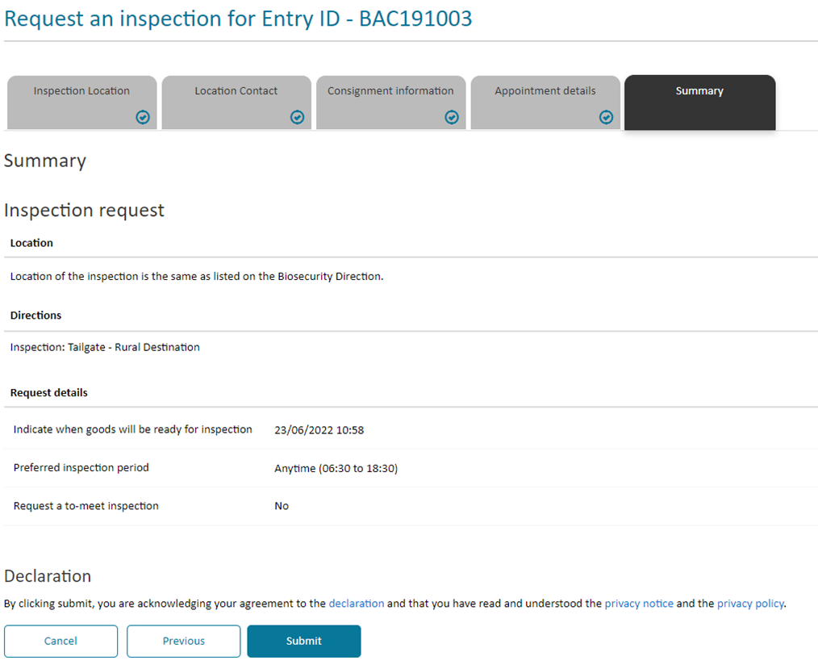Submit the form by selecting the Submit button.

Screen42: RFI Summary details

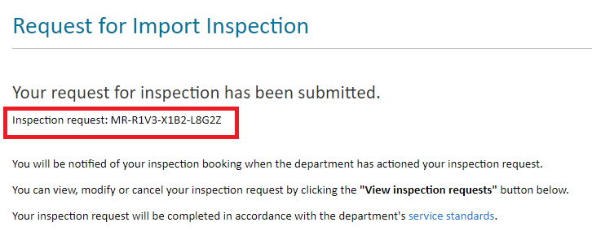

Screen 43: Inspection request unique number id.

# MANAGING INSPECTION REQUESTS AND BOOKINGS

## VIEW INSPECTION REQUESTS AND BOOKINGS

The portal provides three views of your inspection requests:

1. **Inspection requests:** This view displays a list of inspection requests that have been lodged, but not yet booked by the department. It also displays cancelled inspection requests.
2. **Upcoming bookings:** This view displays bookings made by the department against your requests for inspections, including inspections that may be in progress.
3. **Historical bookings:** This view displays cancelled and completed bookings.

Use the dropdown control to select your required view.

In the Inspection Requests, Upcoming Bookings and Historical Bookings views clients can:

* Filter by any column (in-column filtering function)
* Sort by any column
* Search by Entry ID on the Inspection requests view and
* Search by Entry ID or Booking Id in the Upcoming bookings view and Historical bookings view.

Selecting a Request ID in any view allows a drill-down to view details about that specific Inspection Request.

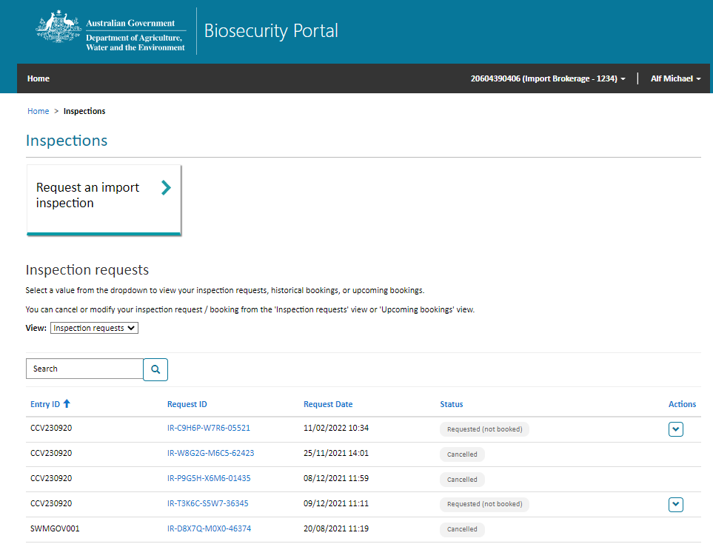

Screen 44: View inspection requests and bookings

## CANCEL INSPECTION REQUESTS

You can cancel an inspection request at any time when the inspection request status is requested (not booked).

To cancel an inspection request:

1. Browse to the Inspections page.
2. Find your inspection request in the ‘Inspection requests’ view.
3. Select the chevron (down arrow) at the right of the list under Actions and click Cancel.
4. Select the Confirm button on the pop-up window to cancel the selected inspection request.

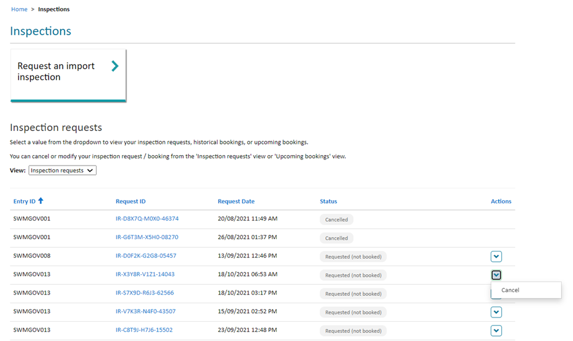

Screen 45: Cancel inspection request

You can request a fresh inspection against a previously cancelled inspection request through the import inspection page by selecting the corresponding AIMS Entry ID again.

## CANCEL BOOKINGS

You can cancel a booking from the Upcoming bookings view when its status is booked. Bookings in the status – In-progress or On our way cannot be cancelled.

To cancel a booking:

1. Go to the Inspections page.
2. Find your booking in the Upcoming bookings view.
3. Select the chevron (down arrow) at the right of the list under Actions and click Cancel.
4. Select the Confirm button on the pop-up window to cancel the selected booking.

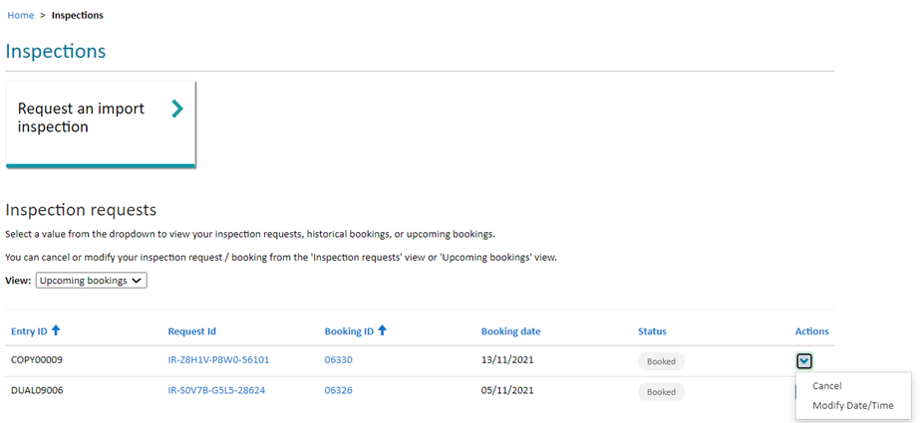

Screen 46: Cancel a booking

When submitting a booking cancellation, a message will advise users to check to see if the cancellation has any dependant bookings, as per the import conditions, and to ensure they also cancel the dependant inspection. Failure to do so may result in a charge.

The cancelled booking will be moved to the Historical bookings view, and its status will be updated as Cancelled.

You may be charged a cancellation fee for modifying/cancelling a booking within 24 hours of the scheduled inspection.

## MODIFY BOOKING DATE/TIME

You cannot modify a booking via the Portal if you have booked an inspection using the Other User (via email and password) method of logging in.

You can request to change the date or time of an existing booking from the Upcoming bookings view when the booking status is booked. Bookings in the status – In-progress or On our way cannot be modified.

To lodge a request to modify date/time of a booking:

1. Go to the Inspections page.
2. Find your booking in the Upcoming bookings view.
3. Select the chevron (down arrow) at the right of the list under ‘Actions’ and click Modify date/time.
4. Enter new date/time information and submit the request.
5. Confirm the request when you see a pop-up window requesting your confirmation.

By submitting the request:

1. Your existing booking will be cancelled and placed in the Historical bookings view with its status updated as Cancelled/rebooked.
2. Your request to modify date/time will be reviewed by the department. A new booking will be made by the Department.

When submitting a booking modification, a message will advise users to check if the booking has any dependant bookings, as per the import conditions, and to modify those dependant bookings. Failure to do so may result in a charge.

You may be charged a cancellation fee for modifying/cancelling a booking within 24 hours of the scheduled inspection.

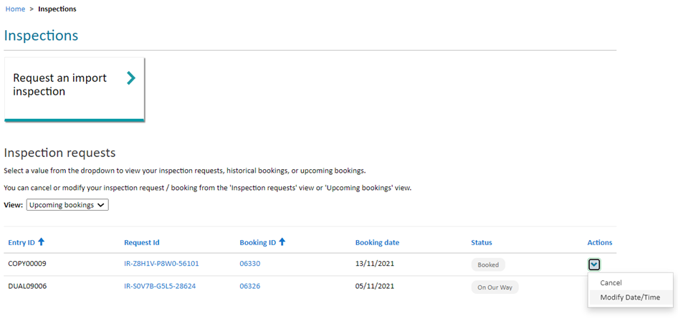

Screen 46: Modify date/time of a booking

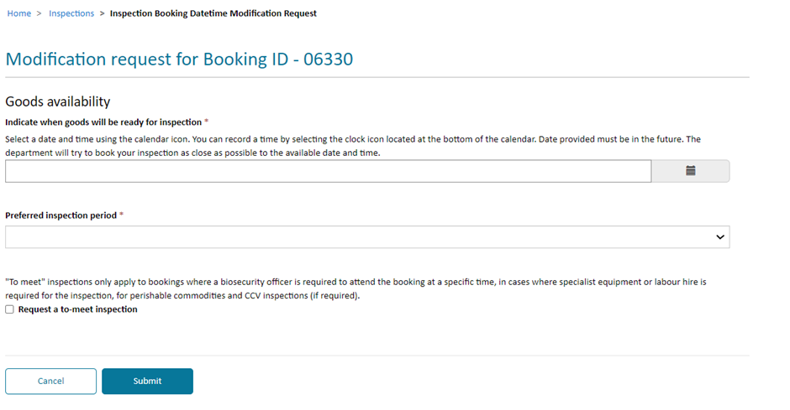

Screen 47: Enter new/modification details and submit

# ARCHIVE INSPECTION REQUESTS AND BOOKINGS

## ARCHIVE AN ENTRY ID

You can archive an inspection request or booking to remove them from your transactional views.

To archive a record:

1. Go to the Inspections page
2. Find your Entry Id in the corresponding view ie: Inspection requests, Upcoming bookings or Historical bookings
3. Select the chevron (down arrow) at the right of the list under ‘Actions’ and click Archive.
4. The Entry Id will be removed to the Archived View: Archives inspection requests or Archive bookings.

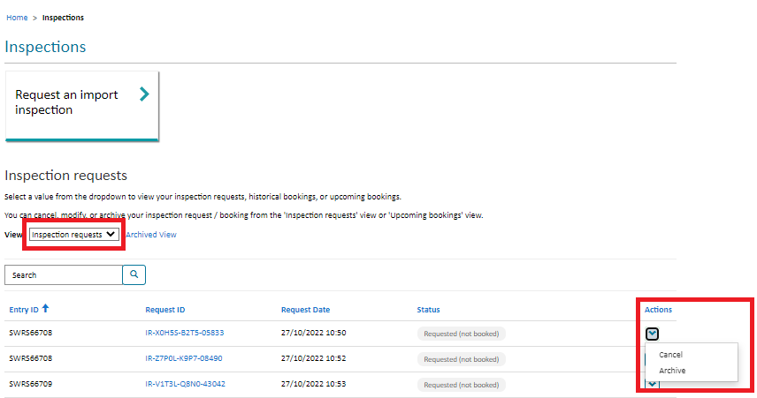

*Screen 48: Entry ID selection for archiving*

## RE-INSTATE AN ENTRY ID

1. Go to the Inspections page
2. Click on the Archived View
3. Find your Entry Id in the corresponding view ie: Archived inspection requests or Archived bookings.
4. Select the chevron (down arrow) at the right list under “Actions” and click Restore
5. The Entry Id will be removed back to the View based on the status of the item when re-instated.

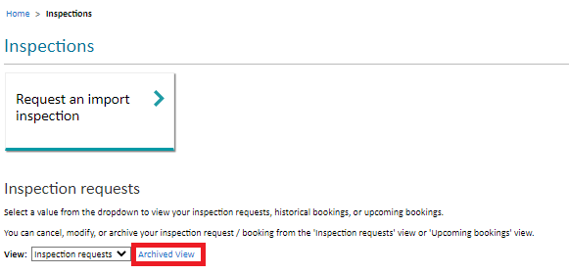

*Screen 49: Archives Views*

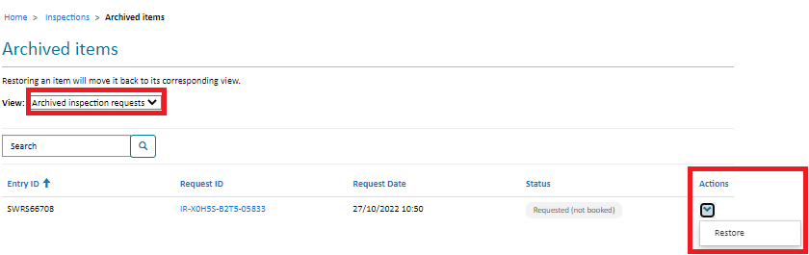

*Screen 50: Restore an Archives Item*