How the National Biosecurity RD&E Strategies Work Together: A Guide for Researchers & Funders
This document brings together Australia’s four national biosecurity research, development and extension (RD&E) strategies to help researchers focus on key priorities and funders to invest strategically.
The strategies highlight national priority areas for investment in RD&E to help manage biosecurity risks and challenges.
You can use this advice to:
- understand how the national RD&E strategies work together
- show how your project contributes to the strategies and priority areas (researchers)
- work with partners to align projects to national priorities (researchers)
- align your program to the priorities and strategies (e.g. include priorities in your grant criteria) (funding bodies, program design).

National Biosecurity RD&E Strategies
- Animal Biosecurity RD&E Strategy (NABRDES) 2023–2028
- Environmental and Community Biosecurity RD&E Strategy 2021–2026
- Marine Pest Research and Development Priorities 2013–2023
- Plant Biosecurity Research Initiative (PBRI) Strategy 2023–2028
These strategies align with the National Biosecurity Strategy 2022–2032 and were shaped through input from industry, NGOs, governments and community groups.
Each of the biosecurity RD&E strategies are aligned to the strategy through shared priority areas. Figure 1 demonstrates where this alignment occurs across the RD&E strategies and shows the five broad priority areas that all the strategies focus on.
Figure 1 Alignment of biosecurity strategies and priorities
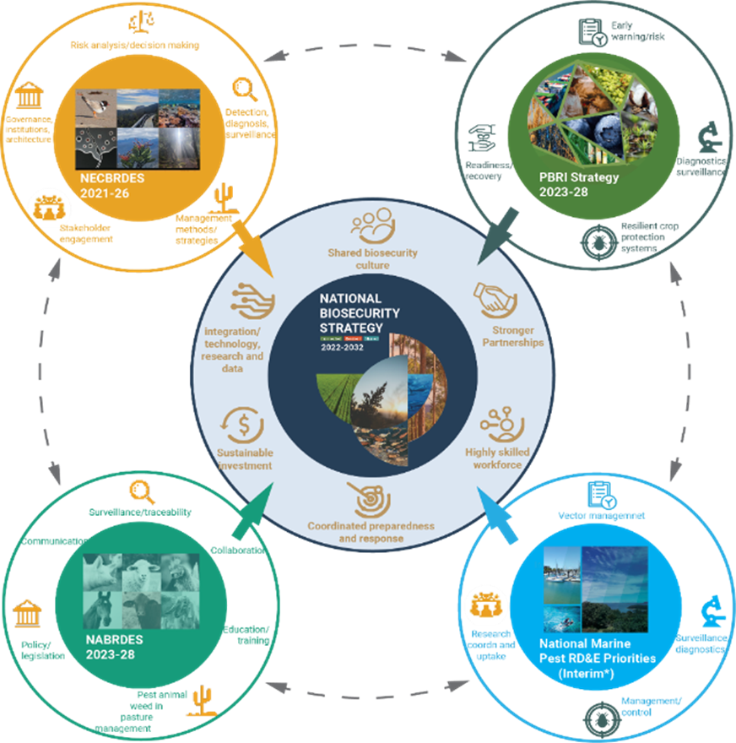
Note: The marine strategy is under review
The 5 priority areas are:
- Risk Assessment and Preparedness – Early warnings, decision tools
- Surveillance, Diagnostics, Detection – Finding, diagnosing, and tracking pests/diseases
- Management and Response – Controlling and recovering from outbreaks
- Collaboration and Knowledge Sharing – Training, communication, and engagement
- Governance and Policy – Improving rules, systems, and decision-making

Cross-sector approach
Working across sectors has many benefits, including improved:
- use of knowledge and funding
- focus of national efforts through coordination
- co-investment and collaboration
- shared responsibility of keeping Australia safe from biosecurity threats.

Growing biosecurity challenges
As described in the National Biosecurity Strategy 2022–2032 and RD&E strategies, managing biosecurity risks is becoming more complicated as we face compounding challenges. RD&E is key to preventing and responding to risks.
These challenges include:
- Changing or increasing risks – Climate change, trade, and global events increase risks, affecting farms, industries, nature, and communities.
- Biodiversity decline – Pests and diseases are a major cause of biodiversity decline.
- People power – There are not enough skilled people across the country to meet the growing need to manage risks.

Investing in biosecurity
- Land and aquatic manager needs
  - Land and aquatic managers need support, guidance and practical tools to handle risks.
- Advances in technology
  - Tools like artificial intelligence, sensors and data platforms help manage pests and diseases better.
- Economic growth and stability
  - Strong biosecurity helps farmers succeed, protects food supply and keeps trade open. It also protects nature and cultural heritage.

Case studies
These case studies provide examples of research projects contributing to the strategies and priorities.
Case study 1 Xylella Preparedness
Xylella is a major global plant disease. It affects over 700 plant species. If it enters Australia, it could cost the grape and wine industry $7.9 billion over 50 years.
A national action plan, diagnostics, and vector ID research are already underway, funded by the department, Hort Innovation and Wine Australia. More work on management tools is planned.
Strategies addressed
- National Biosecurity Strategy 2022–2032
- Plant Biosecurity Research Initiative (PBRI) Strategy 2023–2028
Priorities addressed
- Risk assessment and preparedness
- Surveillance, diagnostics and detection
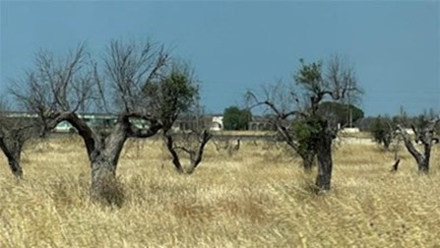
Case study 2 Pheromone Traps for northern Pacific seastar
The Northern Pacific seastar (NPS) is an established marine pest that is listed on the Australian Priority Marine Pest List. This pest threatens native marine species and fisheries. Scientists are isolating pheromones to trap it – a first in marine biosecurity.
Strategies addressed
- Environmental and Community Biosecurity RD&E Strategy (NECBRDES) 2021-2026
- Marine Pest Research and Development Priorities 2013–2023
- National Biosecurity Strategy 2022–2032
Priorities addressed
- Surveillance, diagnostics and detection
- Management and response
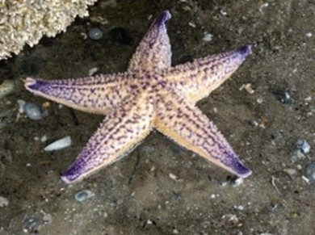
Case study 3 Biosecurity Alerts System – Atlas of Living Australia
The Atlas of Living Australia (ALA) now sends real-time alerts on invasive species reports to agencies through the Biosecurity Alerts Service. Over 1,200 alerts have been issued since 2020, covering more than 1,800 species such as the Asian shore crab and Red imported fire ants, supporting early intervention efforts.
Strategies addressed
- Environmental and Community Biosecurity RD&E Strategy (NECBRDES) 2021–2026
- Marine Pest Research and Development Priorities 2013–2023
- National Biosecurity Strategy 2022–2032
- Plant Biosecurity Research Initiative (PBRI) Strategy 2023–2028
- Animal Biosecurity RD&E Strategy (NABRDES) 2023–2028
Priorities addressed
- Surveillance, diagnostics and detection
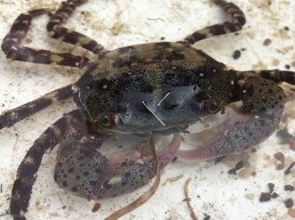
Case study 4 Behavioural Insights for On-Farm Biosecurity
AgriFutures conducted a study Farm-level adoption of biosecurity management – behavioural analysis. The report looked at why biosecurity practices vary across farms. Key factors include trust, sector norms, clarity of messaging, skills, technology access and personal wellbeing. The report offers a framework for improving uptake of biosecurity practices.
Strategies addressed
- Environmental and Community Biosecurity RD&E Strategy (NECBRDES) 2021–2026
- Plant Biosecurity Research Initiative (PBRI) Strategy 2023–2028
- Animal Biosecurity RD&E Strategy (NABRDES) 2023–2028
- National Biosecurity Strategy 2022–2032
Priorities addressed
- Risk Assessment and preparedness
- Collaboration and knowledge sharing
- Governance and policy

Contact details
Animal: aha@animalhealthaustralia.com.au
Marine: MPSC@aff.gov.au
Environmental: EBO@aff.gov.au
Plant: jo.luck@horticulture.com.au
Acknowledgements
Development of this document was led by the custodians of each RD&E strategy in consultation with the department’s National Biosecurity Strategy (NBS) team. We also acknowledge the role of Wild Matters in leading the National Environmental and Community Biosecurity RD&E Strategy (NECBRDES) and for their contribution in developing this product.
We acknowledge the continuous connection of First Nations Traditional Owners and Custodians to the lands, seas and waters of Australia. We recognise their care for and cultivation of Country. We pay respect to Elders past and present, and recognise their knowledge and contribution to the productivity, innovation and sustainability of Australia’s agriculture, fisheries and forestry industries.
© Commonwealth of Australia 2025
Unless otherwise noted, copyright (and any other intellectual property rights) in this publication is owned by the Commonwealth of Australia (referred to as the Commonwealth).
All material in this publication is licensed under a Creative Commons Attribution 4.0 International Licence except content supplied by third parties, logos and the Commonwealth Coat of Arms.
The Australian Government acting through the Department of Agriculture, Fisheries and Forestry has exercised due care and skill in preparing and compiling the information and data in this publication. Notwithstanding, the Department of Agriculture, Fisheries and Forestry, its employees and advisers disclaim all liability, including liability for negligence and for any loss, damage, injury, expense or cost incurred by any person as a result of accessing, using or relying on any of the information or data in this publication to the maximum extent permitted by law.

