# Management of LCL/FAK containers during the brown marmorated stink bug (BMSB) risk season

## Master Consolidator Registration

Less than Container Load (LCL) and Freight All Kinds (FAK) containers with target high risk goods that are shipped from target risk countries between 1 September and 30 April (inclusive) are managed at the container level for BMSB risk prior to deconsolidation.

MCs intending to provide declarations for LCL/FAK containers to the department must register their company as a Master Consolidator (MC) and identify individual users via a unique email address on the MC registration form. A Master Consolidator Identification Number (MC ID) will be generated under the Australian Business Number (ABN) of a company and recorded at a branch level. The department will provide a unique MC ID for each branch upon receipt of a registration form.

### Registration Process

Use the attached spreadsheet to provide your information to the department. MCs are required to provide the requested information via email to [spp@aff.gov.au](mailto:spp@aff.gov.au).

### Registering for an MC ID

MC IDs will be generated under the ABN of a company and will be recorded at a branch level. The department will provide a unique MC ID for each branch upon receipt of the following registration details.

### Company Information:

1. Company Name
2. ABN
3. Company Address
4. Company Phone
5. Company Email Address
6. Comcode (if existing)

### Branch Information:

1. Branch Name
2. Branch Address
3. Branch Phone
4. Branch Email Address

## Registering users for online access to BMSB forms

Each user who intends to submit MC declarations, is required to register as a user under the MC ID for their company. Each individual submitting declarations is required to have their own User ID and login.

Once registered, the department will provide users with an email containing their MC ID User, a temporary password, and a link to the online declaration form to set their own password. Users must use their own unique login to lodge a MC declaration.

### User Information:

1. Given Name
2. Surname
3. User Email Address
4. Branch Name

## Example of MC ID and User Structure

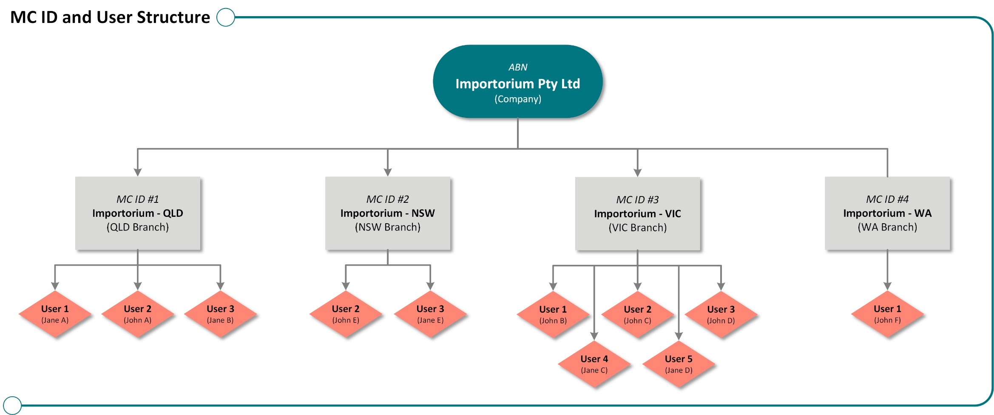

## Master Consolidator Registration Form

### Company registration information

|  |  |  |  |  |  |  |  |  |  |
| --- | --- | --- | --- | --- | --- | --- | --- | --- | --- |
| **COMPANY INFORMATION** | **ABN** | **Name** | **Street Address** | **Suburb/City** | **State** | **Postcode** | **Phone** | **Email** | **Comcode** |
| ***Example*** | *24113085695* | *Department of Agriculture* | *18 Marcus Clarke St* | *Canberra* | *ACT* | *2601* | *1800900090* | *DeptofAgriculture@agriculture.gov.au* | *The Comcode can be found on any invoice.* |
| **Company 1 Information** |  |  |  |  |  |  |  |  |  |
| **Company 2 Information** |  |  |  |  |  |  |  |  |  |

### Branch registration information

|  |  |  |  |  |  |  |  |
| --- | --- | --- | --- | --- | --- | --- | --- |
| **BRANCH INFORMATION** | **Name** | **Street Address** | **Suburb/City** | **State** | **Postcode** | **Phone** | **Email** |
| ***Example*** | *Department of Agriculture - Sydney* | *185 O’Riordan Street* | *Mascot* | *NSW* | *2020* | *02 8334 7444* | *Sydney_DeptofAgriculture@agriculture.gov.au* |
| **Branch 1** |  |  |  |  |  |  |  |
| **Branch 2** |  |  |  |  |  |  |  |
| **Branch 3** |  |  |  |  |  |  |  |
| **Branch 4** |  |  |  |  |  |  |  |

### User registration information

|  |  |  |  |  |
| --- | --- | --- | --- | --- |
| **USER INFORMATION** | **Given Name** | **Surname** | **Email Address** | **Branch Name** |
| ***Example*** | *John* | *Smith* | *john.smith@xyz.com.au* | *Department of Agriculture - Sydney* |
| **User 1** |  |  |  |  |
| **User 2** |  |  |  |  |
| **User 3** |  |  |  |  |
| **User 4** |  |  |  |  |
| **User 5** |  |  |  |  |
| **User 6** |  |  |  |  |

### User registration removal information

|  |  |  |  |  |
| --- | --- | --- | --- | --- |
| **USER INFORMATION** | **Given Name** | **Surname** | **Email Address** | **Branch Name** |
| ***Example*** | *John* | *Smith* | *john.smith@xyz.com.au* | *Department of Agriculture - Sydney* |
| **User 1** |  |  |  |  |
| **User 2** |  |  |  |  |
| **User 3** |  |  |  |  |
| **User 4** |  |  |  |  |
| **User 5** |  |  |  |  |
| **User 6** |  |  |  |  |