The Australian Department of Agriculture (the department) and the New Zealand Ministry for Primary Industries (NZ MPI) have specific requirements to ensure brown marmorated stink bug (BMSB) methyl bromide (MB) treatments are effectively conducted and verified. The full requirements are detailed in the MB fumigation methodology that is published on the department’s website at: [agriculture.gov.au/import/arrival/treatments/treatments-fumigants](http://www.agriculture.gov.au/import/arrival/treatments/treatments-fumigants).

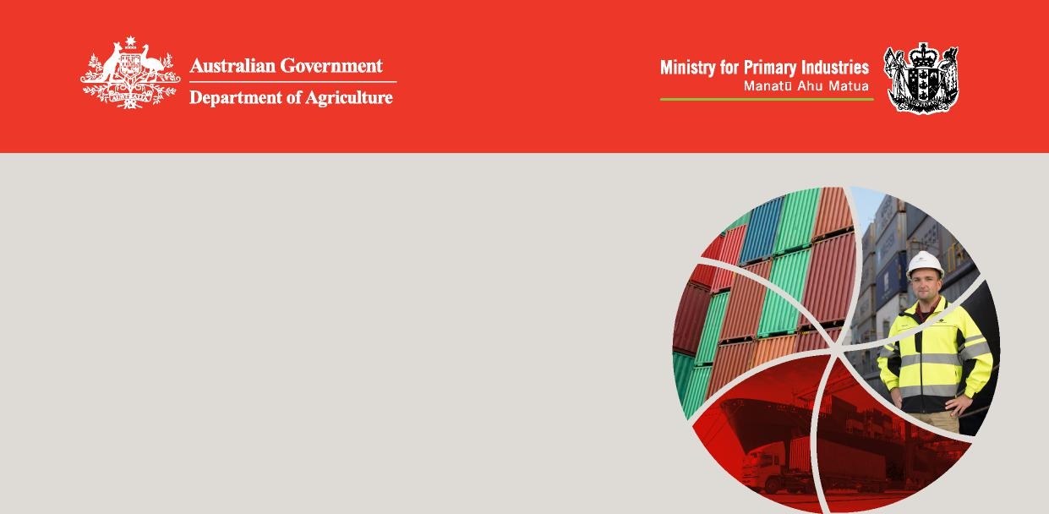

**Version 1.1**

**BMSB Methyl Bromide**

**fumigation compliance**

**requirements**

The following provides a summary of the key compliance requirements.

**Consignment details**

Full consignment details must be recorded on the record of fumigation.

**Consignment suitability (also see *Consignment suitability factsheet*)**

Goods must not be wrapped or covered in a way that stops fumigant from accessing all surfaces of the goods that are accessible to BMSB. Commercial packing/wrapping is not required to be opened, removed or slashed, however all shipping packing/wrapping must be opened, removed or slashed in a way that allows the fumigant to access all surfaces of the goods. If the treatment is conducted in Australia, treatment providers **must** obtain approval from the department prior to making any adjustments to goods or packaging. Contact [SPP@agriculture.gov.au](mailto:SPP@agriculture.gov.au) for details.

**Free airspace/load capacity**

Space must be available in between and around the goods within the treatment enclosure to allow for the fumigant monitoring tubes to be placed in the required locations, the fumigant to be distributed equally throughout the treatment enclosure, and for a fan to be placed within the enclosure to circulate the air.

**Temperature**

The temperature of the consignment must be above 10°C and measured during the treatment period.

**Monitoring tubes**

A minimum of three fumigation monitoring tubes must be placed within fumigation enclosures of 30m3 or above. The monitoring tubes must be placed:

* at the front base of the enclosure on the opposite side to the fumigant supply pipe,
* as close as possible to the very centre of the goods, and
* at the top back of the enclosure on the opposite side to the front base monitoring tube.



|  |
| --- |
| BMSB Methyl Bromide fumigation compliance requirements |

**Dose calculation**

All fumigant enclosure and forecast minimum temperature details and dose calculations must be recorded on the record of fumigation.

**Fumigant application**

The calculated dose must be applied with the fan running to assist in distributing the fumigant throughout the enclosure. The time that the fumigant application is completed must be recorded on the record of fumigation.

**Fumigant monitoring**

Fumigant monitoring is mandatory at the start and end of the fumigation. Additional monitoring is allowed if deemed necessary. All fumigant monitoring readings must be documented on the record of fumigation along with the times the readings were taken.

**Start time**

Fumigation start time is determined when:

* fumigant concentration monitoring from all monitoring tubes are all above 24g/m3, and
* all readings are within equilibrium (15%).

Where these two requirements are not met, if there is enough fumigant in the enclosure, fans must be run to further distribute the fumigant and additional monitoring conducted to verify compliance with the start time requirements.

**End time**

Fumigation end time is determined when:

* fumigant concentration monitoring from all monitoring tubes are all equal to or above the required concentration.

Where this requirement is not met, the fumigation has failed and retreatment is required. Topping up with additional gas at the end of the exposure period is NOT permitted. If concentration of gas falls below the minimum end point reading of the treatment schedule at any point during the fumigation, the treatment has failed.

**Ventilation**

The fumigation enclosure must be ventilated to 5ppm or below before the goods are released back to the client. Threshold Limit Value (TLV) readings must be taken and recorded on the record of fumigation.

**Certification**

Certification must be issued verifying that the fumigation was compliant and effective. Certification details must match the details recorded on the record of fumigation.

**Documentation**

Record of fumigation and treatment certification templates are included in the MB fumigation methodology and on the department’s website. These should be used to ensure all mandatory information is recorded for all BMSB MB fumigation conducted.

**Treatment Failure**

Failures due to poor application of treatments will result in delays, costs, re-treatment, or discharge refusal or reshipment and suspension of treatment providers. Suspension will affect consignments in transit.

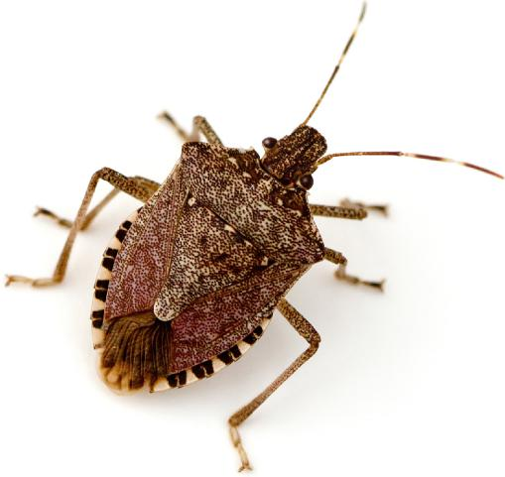



|  |  |  |  |
| --- | --- | --- | --- |
| **Australia** 1800 900 090 or +61 3 8318 6700 (from outside Australia) **NZ** 0800 00 83 33 (NZ only) or +64 4 830 1574 (from outside NZ) |  | [**agriculture.gov.au/bmsb**](http://agriculture.gov.au/bmsb)  [**biosecurity.govt.nz/bmsbrequirements**](https://www.biosecurity.govt.nz/importing/vehicles-and-machinery/requirement-documents-for-importing-vehicles-machinery-or-parts/brown-marmorated-stink-bug-requirements/)  **Facebook:** [Australian Biosecurity](https://www.facebook.com/australianbiosec/) / [MPIgovtnz](https://www.facebook.com/MPIgovtnz) **Twitter:** @[DeptAgNews](https://twitter.com/DeptAgNews) / [@MPI_NZ](https://twitter.com/MPI_NZ) | BIO4074_0919 |