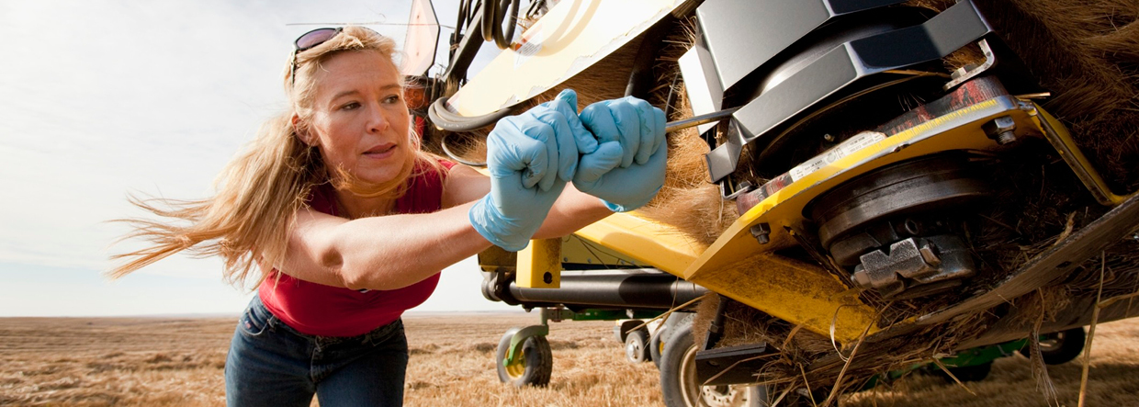

Improving agricultural employment opportunities

**The Australian Government’s initiatives to improve agricultural employment opportunities are a key part of the Agriculture 2030 2021–22 Budget Package. They set the foundations for growing and securing Australia’s future agriculture workforce. This supports the agriculture sector to meet its goal of $100 billion in value by 2030. The initiatives address many of the recommendations of the National Agriculture Workforce Strategy report released in March 2021.**

**What’s in this year’s Budget**

**The 2021–22 Budget delivers on our commitment to work with the agriculture industry to attract, retain and upskill workers and build a sustainable workforce. A key element to growing this workforce is to ensure careers in agriculture are attractive and viewed as modern and sustainable with fair and safe working conditions.**

**We are committing $29.8 million to help the agriculture sector modernise its practices and image to reflect the dynamic, innovative and resilient industry it is today. The package focuses on 2 key programs – AgAttract and AgFair.**

**AgAttract**

**AgAttract lays the foundation for Australia to build a secure and skilled domestic workforce, and position it as providing interesting and rewarding career opportunities through 4 key elements:**

* **Building exposure to, and interest in, opportunities in modern agriculture by investing in a pilot structured employment program – AgCAREERSTART – to help school leavers experience work in agriculture.**
* **Supporting career and skill development in modern agriculture through the AgUP grants program. The program co-funds industry initiatives to develop career progression pathways, and upskill, train and mentor workers.**
* **Building a strong understanding of modern agriculture by researching experiences and perceptions of agriculture work.**
* **Ensuring career advice and agriculture data reflects modern agriculture occupations.**

**AgFair**

**The government has a zero tolerance policy for any exploitation of workers. We are committed to ensuring employers and businesses have the necessary skills to create attractive, fair and safe working conditions. AgFair is a key component of the work being undertaken to build a modern and sustainable agriculture workforce, and will be delivered through 2 key projects:**

* **A program of work that provides practical support to help agricultural employers implement modern workforce planning and management practices, which will help businesses adjust to disruptions and challenges in the labour market, such as planning ahead for labour needs.**
* **Support to fast track uptake of the Fair Farms program by growers and horticultural businesses.**

Why is this important

A sufficient, reliable and suitable workforce is essential to achieving industry’s goal of a $100 billion agriculture industry by 2030. Jobs and careers in the agriculture sector need to be attractive and relevant and provide quality conditions, career prospects, and safe workplaces. Modern agriculture can offer a thriving career for young Australians in a diverse range of occupations and contribute to achieving long-term growth in Australia’s agriculture industry.

How much will this cost

|  |  |  |  |  |  |
| --- | --- | --- | --- | --- | --- |
|  | **2021-22 $million** | **2022-23 $million** | **2023-24 $million** | **2024-25 $million** | **TOTAL $million** |
| Improving employment opportunities – pilot AgCAREERSTART program | 2.2 | 3.1 | 0.002 | 0.0 | 5.3 |
| Improving employment opportunities – pilot AgUP program | 2.6 | 2.3 | 2.6 | 2.7 | 10.1 |
| Improving employment opportunities – research and development corporation to undertake research on the attraction and retention of agriculture sector workers | 1.3 | 0.002 | 0.0 | 0.0 | 1.3 |
| Improving employment opportunities – improve the collection, analysis and forecasting of agricultural labour force data (including other department spend) | 4.6 | 3.6 | 0.2 | 0.2 | 8.5 |
| Improving employment opportunities – develop resources for agricultural employers to implement modern workforce management and planning practices | 0.8 | 0.2 | 0.0 | 0.0 | 1.0 |
| Improving employment opportunities – extend the Fair Farms program | 0.9 | 1.1 | 0.9 | 0.8 | 3.6 |
| **Total: Improving agricultural employment opportunities** | **12.4** | **10.2** | **3.6** | **3.6** | **29.8** |

More information

For more information about our work to support the agriculture workforce and the Agriculture 2030 2021–22 Budget package, visit awe.gov.au/budget. For more information about the 2021–22 Budget visit budget.gov.au