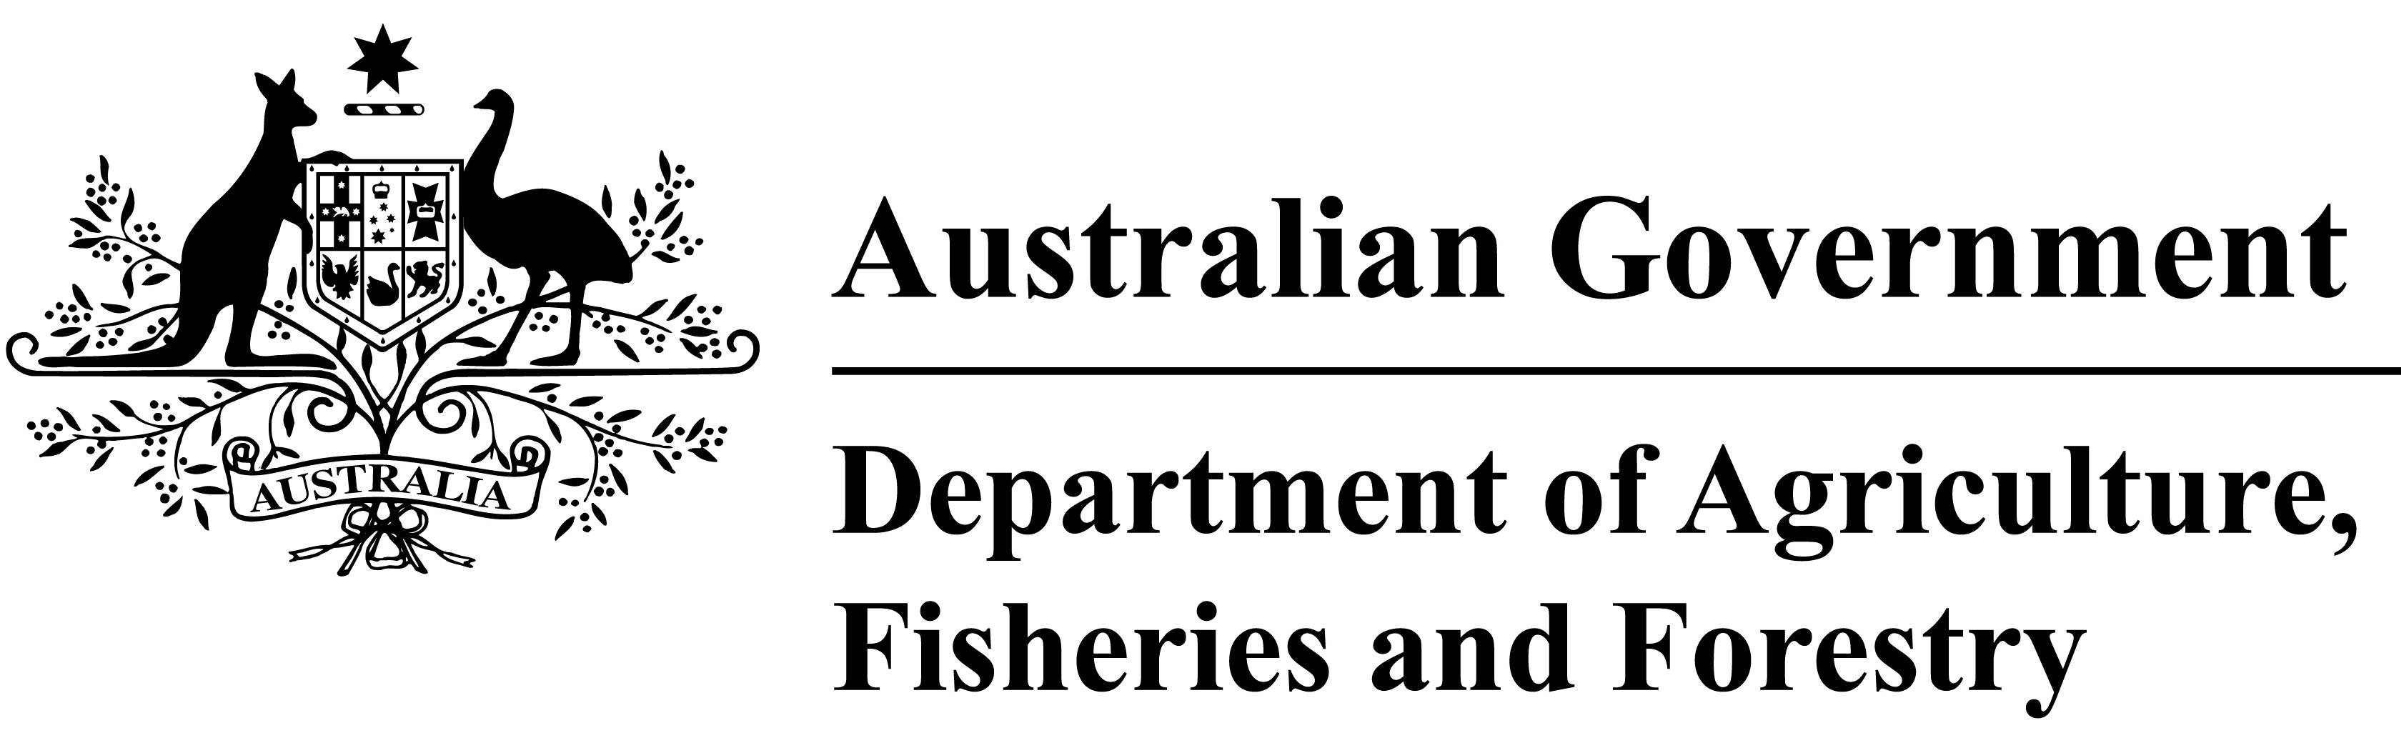
Buffalo - Wild residue testing annual datasets 2023-24

National Residue Survey (NRS), Department of Agriculture, Fisheries and Forestry

Dataset abbreviations

LOR Limit of reporting.
MRL Maximum Residue Limit.
no limit No Australian standard applicable for the contaminant. The ‘as low as reasonably achievable’ principle applies. Detections at low levels are allowable.
not defined Standards are not defined in inedible matrixes (urine, retina and faeces).
not set No Australian standard has been set for the chemical in the edible matrix and any detection is a contravention of the Australia New Zealand Food Standards Code.

Disclaimer

Although the Commonwealth has exercised due care and skill in the preparation and compilation of this publication, it does not warrant its accuracy, completeness, currency or suitability for any purpose. To the maximum extent permitted by law, the department disclaims all liability, including liability in negligence for any loss, damage, cost or expense incurred by persons as a result of accessing, using or relying on any of the information or data set out in this publication. Before relying on the material in any matters, users should carefully evaluate its accuracy, currency, completeness and relevance for the purposes intended, and should obtain any appropriate professional advice relevant to their particular circumstances.

Table 1: METALS
Chemical |  |  |  | Matrix | LOR (mg/kg) | MRL (mg/kg) | Number of samples tested | >LOR to ≤½MRL | >½MRL to ≤MRL |  | >MRL
antimony |  |  |  | Liver | 0.01 | no limit | 11 | 1 | 0 |  | 0
arsenic (total) |  |  |  | Liver | 0.05 | no limit | 11 | 1 | 0 |  | 0
cadmium |  |  |  | Liver | 0.01 | no limit | 11 | 10 | 0 |  | 0
lead |  |  |  | Liver | 0.01 | no limit | 11 | 11 | 0 |  | 0
mercury (total) |  |  |  | Liver | 0.01 | no limit | 11 | 0 | 0 |  | 0

