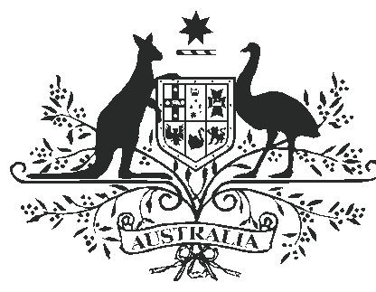

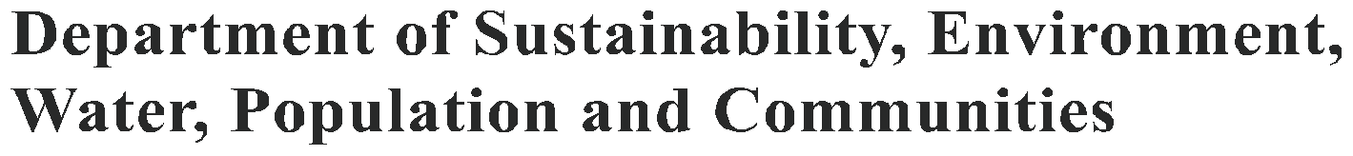

THE FERAL WATER BUFFALO
(BUBALUS BUBALIS)

Water buffalo were imported to Australia in the 19th century to supply meat to remote northern settlements. The settlements and their buffalo were abandoned in 1949 and, despite harvesting for meat, hides and as hunters’ trophies, feral buffalo spread across the northern floodplains. The Brucellosis and Tuberculosis Eradication Campaign reduced feral buffalo numbers significantly in the 1980s and 1990s
but numbers are again very high right across northern Australia causing significant damage to wetlands.

History

Between 1825 and 1843, about 80 buffalo were brought to Melville Island and Cobourg Peninsula for meat. When these settlements were abandoned in the mid-1900s, the buffalo soon colonised the permanent and semi-permanent swamps, and freshwater springs of the top end of the Northern Territory.

Australia has two types of buffalo: the river type from western Asia, with curled horns, and the swamp type from eastern Asia, with swept-back horns.

Prior to extensive culling in the 1980s, as part of the Brucellosis and Tuberculosis Eradication Campaign, there were as many as 350 000 buffalo. Numbers dropped dramatically as a result of the Campaign, but have since recovered to an estimated 150 000 animals across northern Australia in 2008.

A number of small scale industries have developed for live export and meat production.
Ecology

Feral buffalo are large (450–1200 kilogram) herbivores that prefer to live in swamps and floodplains across the wet parts of northern Australia, where they have ready access to food and water. In years with low rainfall, many feral
buffalo die, and the remaining ones are restricted to the northern river plains and associated swamps. After a series of wetter years, feral buffalo can spread again, with populations building to densities of up to 34 animals per kilometre square.

During most of the dry season (May–October), males (bulls) and females (cows) live separately. Females and calves, led by one of the older females, occupy the forested plains where food and shade are most plentiful. Males live in more open plains with little shade, or slopes with dryer
vegetation. When the wet season breaks, the older

Distribution of feral water buffalo in Australia
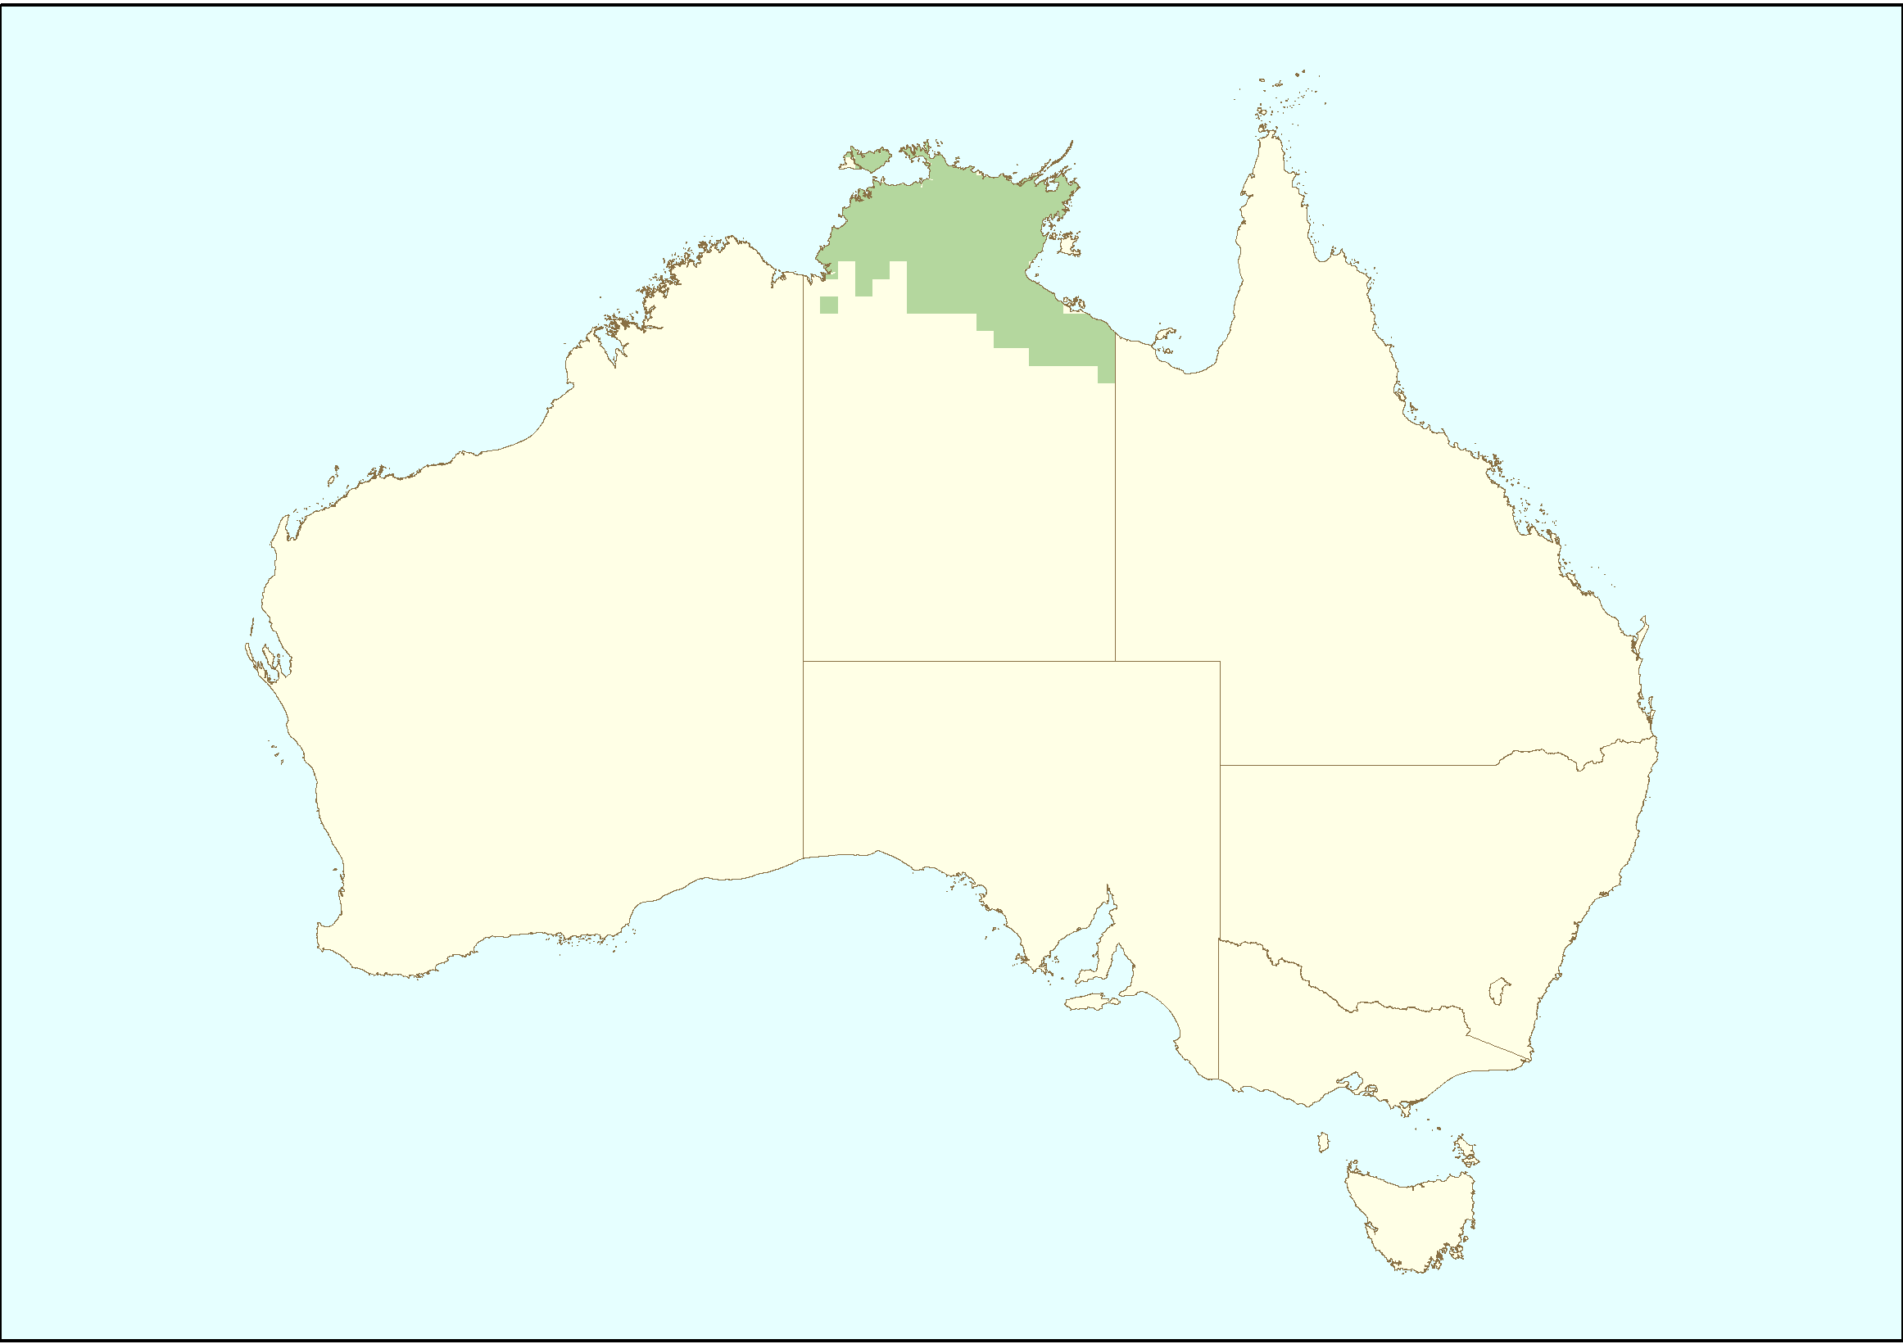

Source: DSEWPaC (2010) Feral animals on offshore islands database at http://www.environment.gov.au/biodiversity/
invasive/ferals/islands/index.html

males join the females and drive away younger males. There is a peak of mating in about March and pregnancy lasts about ten months.

In the wet season (November–April), feral buffalo graze on aquatic grasses and grass-like wetland plants. They eat a broader range of foods in the dry season, feeding on grasses, herbs and the leaves of plants like pandanus. In the wet, feral buffalo groups camp overnight in woodland and move out to feed at dawn, with males eating up to
30 kilograms of dry matter each day. They move to the water mid-morning to drink and wallow, returning to graze from mid-afternoon until dusk.

In drier times, feral buffalo prefer to graze at night, spending most of the day in wallows to escape biting insects and to stay cool.

Dingos and crocodiles prey on younger feral buffalo, but once adulthood is reached individuals may live for 20 years.

Impact

The feral buffalo has been a major environmental disaster in the wetlands of the top end of the Northern Territory. When the population was at
it highest, from the 1960s to the 1980s, the feral buffalo grossly altered the character of the northern floodplains. With its wallows, trails, dung, trampling and disturbance, it caused soil erosion, channelling of floodwaters, increased intrusion of saltwater
into freshwater habitats and destruction of wetland vegetation. These effects were worse during dry periods when animals concentrated at receding water.

Many native wetland flora and fauna failed to thrive in the muddied or salt-polluted water. They also suffered from the disturbance and loss of cover. Crocodiles, barramundi, freshwater turtles and
other native species declined, and many waterbirds, including magpie geese, lost their habitat.

Feral buffalo eat large volumes of grasses and other plants, removing this food source for native wildlife, and they can damage the trees they regularly rub against. Their trampling and soil disturbance also promotes the spread of weeds across the landscape.

Feral buffalo can carry important diseases of cattle, particularly tuberculosis and brucellosis.
Control

Feral buffalo were all but eliminated from Kakadu National Park and the northern wetlands in an extensive eradication program that was part of the Brucellosis and Tuberculosis Eradication Campaign. The program involved culling from expert shooters in helicopters. The program started in 1979 and lasted until 1997. Numbers
were reduced in the Park from 20 000 to under 250 in 1996. The difficult terrain made full eradication impossible.

For many years, the feral buffalo has supported several industries: meat for human consumption (local and international), pet meat, hides, horns, animals for live export and game for hunters. Over nine decades from the 1880s, some 700 000 animals were harvested, on foot, from horseback and eventually from four-wheel drive vehicles, but the feral buffalo continued to multiply and spread. Some Aboriginal communities in Kakadu depend on the buffalo as a food source and have negotiated permission to maintain a domesticated herd. Farming of re-domesticated herds is increasing.

Further information

For further information, contact:

Department of Sustainability, Environment, Water, Population and Communities
GPO Box 787
Canberra ACT 2601
Phone: 1800 803 772
Web site: http://www.environment.gov.au/
biodiversity/invasive/index.html

InvasiveSpecies@environment.gov.au

BIO59.0610

Photo credits in order: Illustration of water buffalo (Sharyn Wragg), Water buffalo (Ken Griffiths), Water Buffalo in mud
(Anna Pickworth).

© Commonwealth of Australia 2011

This work is copyright. You may download, display, print and reproduce this material in unaltered form only (retaining this notice) for your personal, non-commercial use or use within your organisation. Apart from any use as permitted under the Copyright Act 1968, all other rights are reserved. Requests and inquiries concerning reproduction and rights should be addressed to Commonwealth Copyright Administration, Attorney General’s Department, Robert Garran Offices, National Circuit, Barton ACT 2600 or posted at www.ag.gov.au/cca.

Disclaimer

The views and opinions expressed in this publication are those of the authors and do not necessarily reflect those of the Australian Government or the
Minister for Sustainability, Environment, Water, Population and Communities.

