

REFERENCE

# Plant Exports Management System (PEMS) Authorised officer user guide – Bulk Vessel Inspections

**In this document**

This document contains the following topics.

Purpose of this document 2

Initiating a bulk vessel inspection 2

Bulk vessel inspection page 4

Joining a bulk vessel inspection 5

Changing the inspection level 7

Recording reinspection of a bulk vessel 9

Recording supplementary inspection of a bulk vessel 11

Recording hold inspection results where goods only loaded to other parts of vessel 16

Navigating between hold inspection windows 19

Recording inspection results for additional areas 20

Recording marine surveyor certificate details 23

Issuing bulk vessel approval 24

Completing and submitting the inspection record 27

Expiration date for bulk vessel approval 30

Issuing suspension of a bulk vessel 31

Lifting suspension of a bulk vessel 34

Revocation of a bulk vessel 37

Related material 40

Contact information 40

Document information 41

Version history 41

## Purpose of this document

This reference outlines how to use PEMS to record a Bulk Vessel Inspection.

**Note:** An overview of PEMS and general functions can be found in the Reference: *Plant Exports Management System (PEMS) Authorised Officer User Guide – Overview and general functions*.

### Initiating a bulk vessel inspection

To initiate a bulk vessel inspection, click on the **Home1**PEMS menu tab and click the **Bulk vessel2** button.

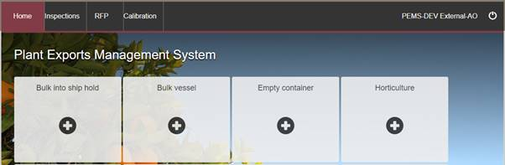

**2**

**1**

The *Create Bulk Vessel Inspection* window will display.

Enter the **IMO number1** of the vessel. The IMO number must consist of the letters ‘IMO’ followed by seven digits; for example, IMO1234567.

Click **Search2**. If an inspection record for the vessel has been recorded in PEMS previously, the name and number of holds will populate automatically. PEMS will allow you to update the name and number of holds. If the vessel’s IMO number is not in PEMS, you should manually enter the vessel’s **Name3** and the **Number of holds4**.

Enter the **Port5** where the inspection is occurring from the auto-search listwhen it displays.

Click **Create6**.

**4**

**3**

**5**

**6**

**1**

**2**

The *bulk vessel inspection* page will display by default.

****The inspection record will remain **Active1** until the record is withdrawn, submitted, or cancelled.

While the record is active, the date provided at the top of the bulk vessel inspection record is the date the inspection record was initiated.

**1**

### Bulk vessel inspection page

The *bulk vessel inspection* page will display the following key sections:

* **Inspection details1** – displays general information relating to the inspection
* **Marine surveyor details2** – where the marine surveyor certificate details are recorded
* **Vessel details3** – read-only information populated based on data provided when the inspection record was created
* **Results4** – where the hold inspection results are recorded
* **Additional areas5** – where you add and record inspection results for additional areas of the vessel
* **Comments6** – where general comments regarding the inspection can be recorded. See Section 3.6 Adding comments to an inspection record of the PEMS AO user guide – Overview and General Functions for more information.

Step-by-step instructions on how to record or change data in these sections is provided below.

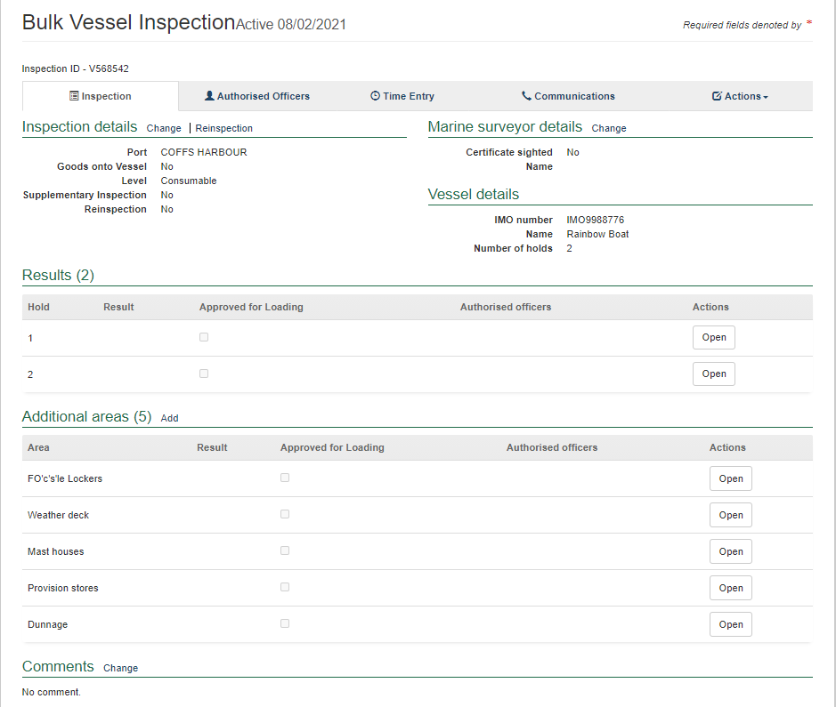

**6**

**5**

**4**

**3**

**1**

**2**

### Joining a bulk vessel inspection

##### **When the inspection record is ‘Active’**

PEMS allows multiple AOs, with the required job function, to join an active bulk vessel inspection record. As a security requirement, any new AO wanting to join an active bulk vessel inspection record must know the AO number of an AO already assigned to the inspection record.

To join an existing bulk vessel inspection record, follow the step-by-step instructions provided above for **‘Initiating a bulk vessel inspection’**. After clicking create on the *Create Bulk Vessel Inspection* window, the *Join bulk vessel inspection* window will display.

Enter the number of an AO already assigned to the inspection record into the **Existing authorised officer number1** field and click **Join2**.

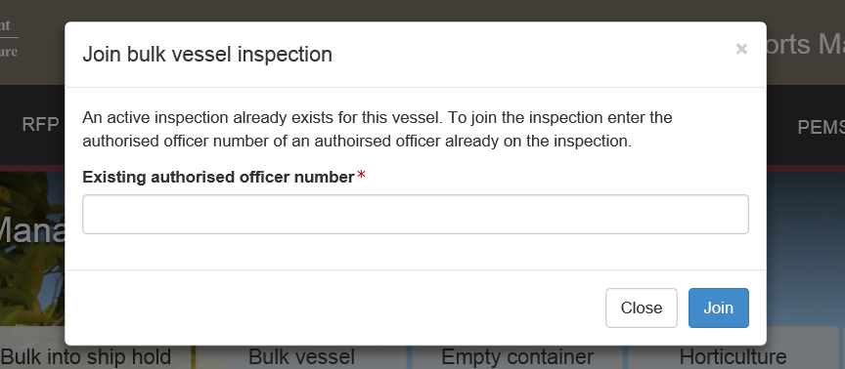

**2**

**1**

Where the wrong AO number is entered an **error message1** will display. You will not be able to join the bulk vessel inspection until a correct existing AO number is entered.

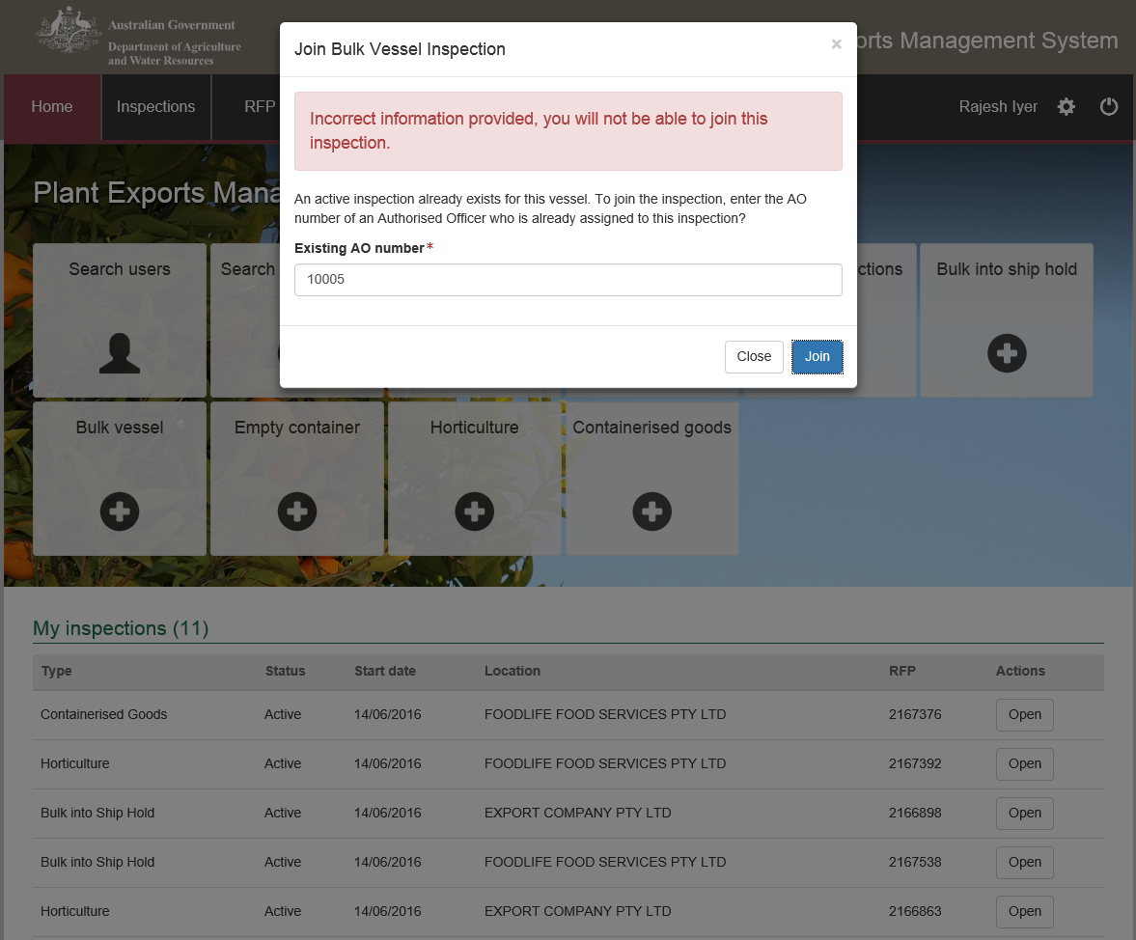

**1**

If the existing AO number entered is correct, the *Bulk Vessel Inspection* page will display.

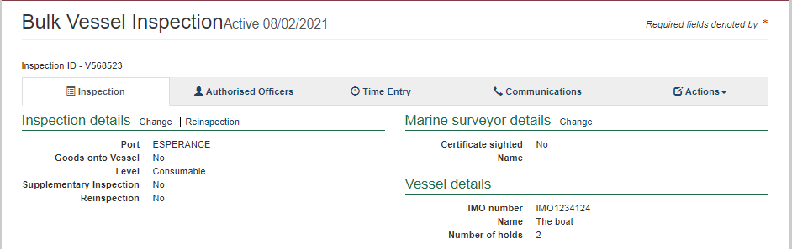

##### **When inspection record is ‘Completed’**

An AO is now able to join a completed inspection, enabling them to reactivate and update the inspection results as detailed above.

To join a completed bulk vessel inspection record, enter the International Martitime Organisation (IMO) number. More information about the Inspection Search function can be found in the Reference: *Plant Exports Management System (PEMS) Authorised Officer User Guide – Overview and general functions section 2.1 Inspection Search*.

Select the **Authorised Officers tab1** and click **Join2**.

The AOs name will appear in the **Assigned authorised officers list3**.

**3**

**2**

**1**

### Changing the inspection level

The default inspection level for a bulk vessel is consumable.

To change the inspection level of the bulk vessel, click the **Inspection**1tab and then click **Change2** under the inspection details section.

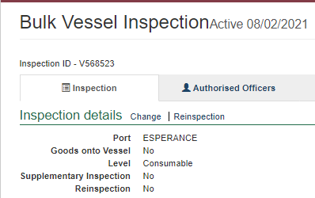

**2**

**1**

The *Inspection details* window will display.

Select the appropriate inspection **Level1** of consumable or non-consumable.

****Click **Save2**.

If the inspection level is set to consumable, the marine surveyor certificate details must be entered. For further information see **‘Recording marine surveyor certificate details’** below.

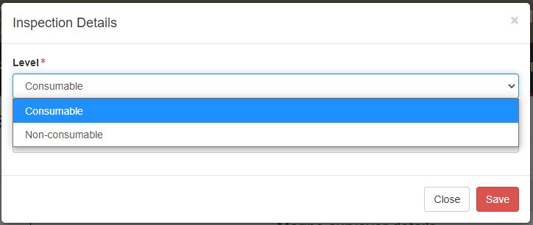

**1**

**2**

The bulk vessel inspection page will display the updated inspection **level1** information.

**1**

### Recording reinspection of a bulk vessel

These steps apply when an AO is required to record a reinspection of a bulk vessel against an existing inspection record.

Enter the **IMO number1** of the vessel and click **Search2**. PEMS will provide a **warning message3**.

Enter the **Port4** where the inspection is occurring.

From the drop down select the **Inspection reason5** as ‘*Re-inspection*’.

Click **Create6**.

**6**

**2**

**1**

**5**

**4**

**3**

The bulk vessel inspection page will display the updated **reinspection1** details

**1**



Reinspection of a hold or additional areas is an inspection following failure and treatment.

If a reinspection is conducted after the detection of *Trogoderma* Sp., PEMS will mandate a fumigation certificate be attached prior to submission of the inspection record.

### Recording supplementary inspection of a bulk vessel

These steps apply when an AO is required to record extra inspection activities against an existing inspection record.

Enter the **IMO number1** of the vessel and click **Search2**. PEMS will provide a **warning message3**.

Enter the **Port4** where the inspection is occurring.

From the drop down select the **Inspection reason5** as ‘*Supplementary inspection*’.

Click **Create6**.

**6**

**5**

**4**

**3**

**2**

**1**

The bulk vessel inspection page will display the updated **supplementary inspection1** details.

Under Previous Results previous inspections can be opened by selecting **Open inspection2**.

**1**

**2**



Supplementary inspection is an inspection of a hold previously passed for cross contamination and is now being inspected for loading prescribed goods; for example, holds previously under ballast.

This function is only available for vessels with a current bulk vessel approval.

**Recording hold inspection results**

Where goods are only being loaded into the holds of the bulk vessel, at least one hold must have a result of passed and all remaining holds (including additional areas) must be passed, passed for any cross-contamination risk or N/A. The hold to be loaded must be identified by selecting the ‘*Approved for loading’* checkbox for bulk vessel approval to be issued.

If any hold (including additional areas) receives a result of failed, the bulk vessel approval cannot be issued, and the AO cannot complete the inspection record without providing results for other holds or additional areas.

Time entry will be mandatory for completing the inspection.

To record or change hold inspection results click **Open1** beside the relevant hold.

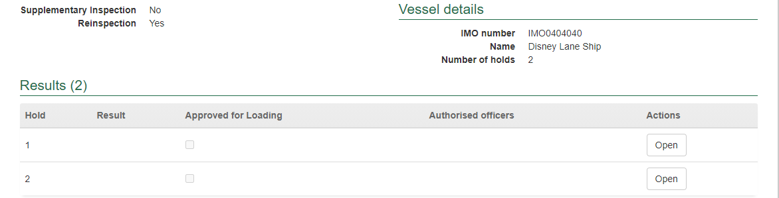

**1**

The *Inspection Result Hold* window will display (next 3 screen shots).

The inspection result window will display the 9 possible sites that must be inspected during a hold inspection (next screen shot). The inspection sites are:

* hatch covers
* bulkheads
* deck beams
* exposed metal surfaces
* cable casings
* tank top ceilings
* pipe casings
* bilges
* ventilation trunking.

If all 9 sites have been cleared for loading, select **clear all hold sites1**. Once the checkbox is selected all 9 sites will be cleared and the default result for the hold will be passed for loading.

When other remarks are selected along with **clear2** for a particular hold, the result will still appear as ‘passed’ by default. However, the user will be required to select one of the remarks.

If any site is not applicable to the hold being inspected, select the **N/A3** checkbox under the relevant heading. Once the N/A checkbox is selected you will be unable to select other checkboxes relating to that inspection site.

For each hold proposed to be loaded, the **clear2** or **N/A3** checkbox for **each inspection site4** will need to be selected for that hold to pass inspection for loading. If any other checkbox is selected for an inspection site, the result for the hold can be failed or passed for risk of cross contamination.

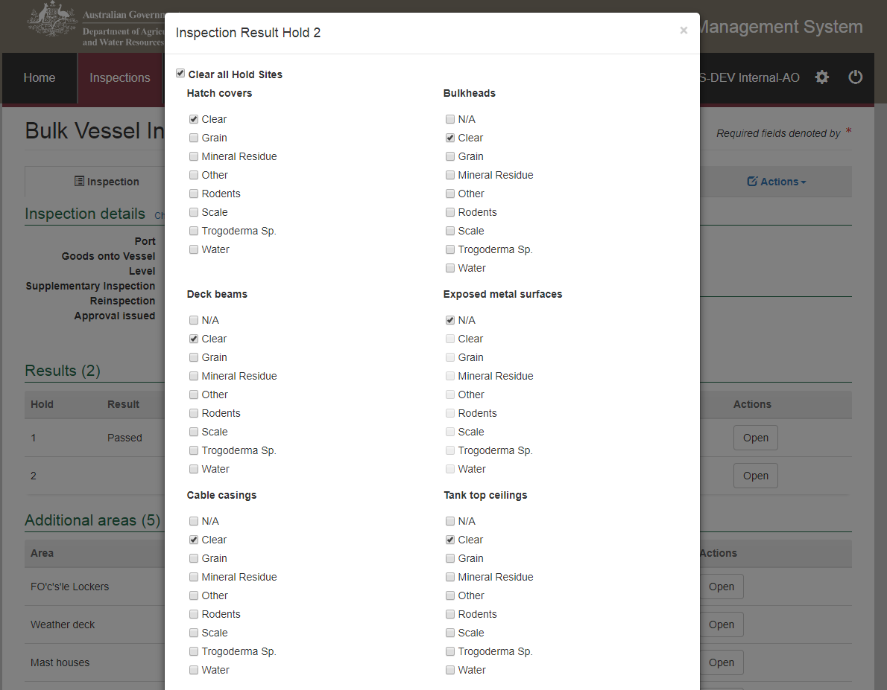

**4**

**3**

**2**

**1**

For each hold proposed to be loaded, results should also be recorded or edited as applicable by:

* selecting a **Total infestation5** level of heavy, light or nil
* selecting the **Number of insects6** detected from one to 50, or 50+ insects
* selecting a **Result7** of passed or failed for the hold
* adding **Result comments8** if applicable (**Note:** there is a limit of 500 characters for this field)
* selecting one or more **Remarks9** checkbox for the hold   
  (**Important:** This ismandatory if the hold is failed or any other checkbox other than *Clear* or *N/A* or in addition to *Clear* or *N/A* is selected for hold sites)
* selecting checkboxes for all **Authorised officers10** who inspected the hold   
  (see Section 3.1 Assigning authorised officers of the PEMS AO user guide – Overview and General Functions for more information).

For all remaining holds inspected for risk of cross contamination, results should be recorded or edited by:

* selecting a **Result7** of passed for cross contamination or failed for the hold
* as applicable, selecting one or more **Remarks9** checkbox   
  (**Important:** This mandatory if the hold is failed or any other checbox other than *Clear* or *N/A* or in addition to *Clear* or *N/A* is selected for hold sites)
* ****selecting checkboxes for all **Authorised officer10** who inspected the hold (see Section 3.1 Assigning authorised officers of the PEMS AO user guide – Overview and General Functions for more information).

If *Trogoderma* Sp. is selected for any of the inspection sites the only option will be to fail the hold.

To record a hold under ballast water, the inspection result can be recorded as passed for cross contamination and the *hold under ballast water* remark checkbox selected.

**5**

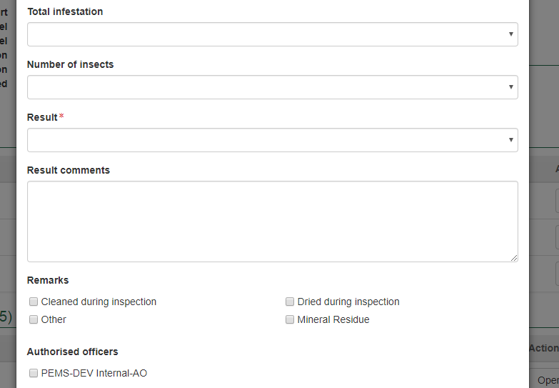

**10**

**9**

**8**

**7**

**6**

Once the inspection results have been entered appropriately, click **Save1** to save the record and exit the inspection result window.

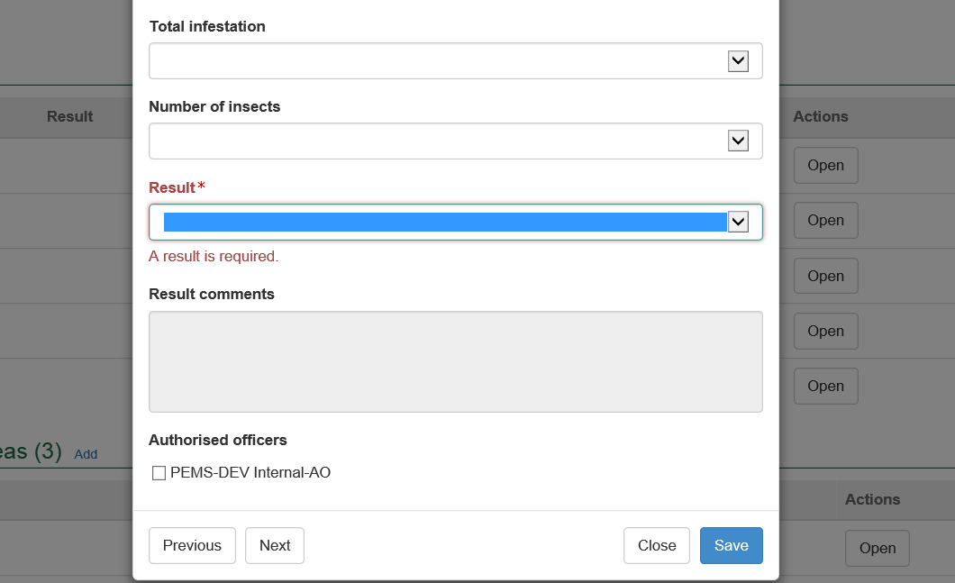

**1**

The bulk vessel inspection page will display the **hold inspection results1**.

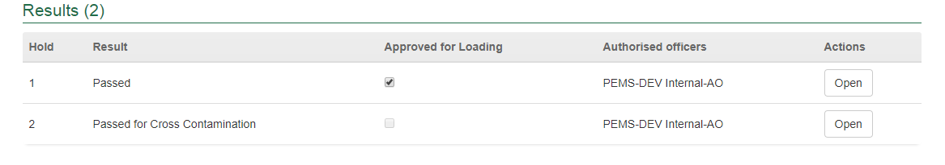

**1**

### Recording hold inspection results where goods only loaded to other parts of vessel

****To record or change hold inspection results for hold inspections where goods are only going to be loaded on to other parts of the vessel, click **Open1** beside the relevant hold.

Where goods are being loaded onto other parts of the bulk vessel, at least one additional area must have a result of passed and all additional areas (including holds) must be passed for the risk of cross-contamination or N/A. The additional area to be loaded must be identified by selecting the ‘*Approved for loading’* checkbox for bulk vessel approval to be issued.

If any hold or additional area receives a result of failed, the bulk vessel approval cannot be issued, and the AO cannot complete the inspection record without providing results for other holds or additional areas.

Time entry will be mandatory for completing the inspection.

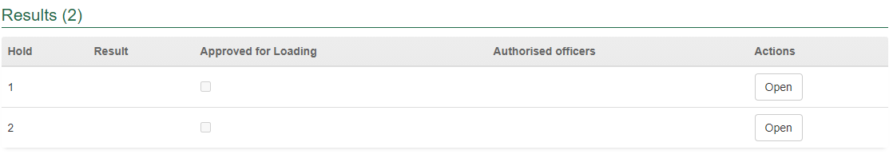

**1**

The *Inspection Result Hold* window will display.

The only site of a hold(s) that is mandatory for inspection is the hatch cover. Select the **Clear1** checkbox if the hatch cover is clear and to record that a hold has passed for risk of cross contamination. If applicable, you can select any **other2** hatch cover checkbox.

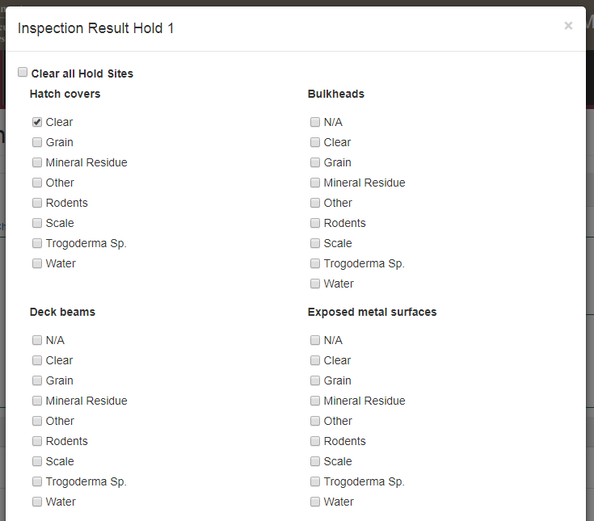

**1**

**2**

Hold inspection results should also be recorded or edited as applicable by:

* selecting a **Total infestation3** level of nil, light or heavy
* selecting the **Number of insects4** detected from one to 50, or 50+ insects
* selecting a **Result5** of passed for cross contamination or failed for cross contamination
* adding **Result comments6** if applicable (there is a limit of 500 characters for the field)
* as applicable, selecting one or more **Remarks7** checkbox (mandatory if the hold is failed or any other checkbox other than Clear or in addition to Clear is selected for hold sites)
* selecting checkboxes for all **Authorised officer8** who inspected the hold   
  (see Section 3.1 Assigning authorised officers of the [PEMS AO user guide – Overview and   
  General Functions for more information](#_Related_material))
* ****Click **Save9.**

If *Trogoderma* Sp. is selected for any of the inspection sites the only option will be to fail the hold.

****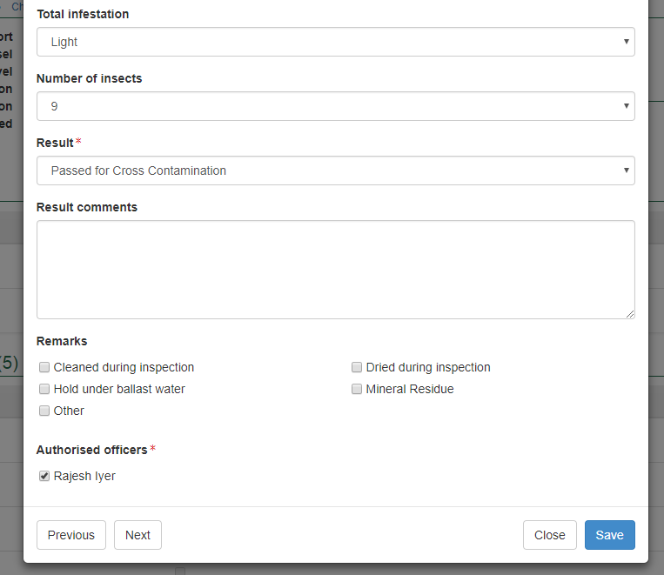

It is mandatory to record a hold under ballast water. The inspection result can be recorded as passed for cross contamination with the *‘hold under ballast water’* remarks checkbox selected.

**6**

**5**

**7**

**3**

**4**

**8**

**9**

****The bulk vessel inspection page will display the hold inspection results. Click **Open1** to make changes to any hold inspection results.

If none of the hold sites have been selected, the inspection result can be recorded as passed for cross contamination and the *‘hold under ballast water’* remarks checkbox must be selected.

Click **Approved for Loading2** checkbox for the hold that will be loaded with prescribed goods.

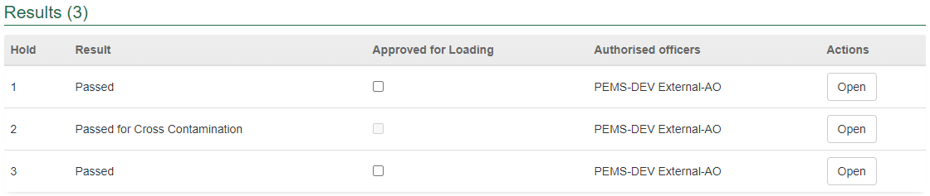

**1**

**2**

### Navigating between hold inspection windows

Click **Previous** or **Next1** at the bottom of the hold inspection windows to navigate quickly between each hold inspection. The inspection results will automatically save when you navigate between the hold inspection windows in this manner.



**1**

### Recording inspection results for additional areas

The 5 additional areas that require mandatory inspection are:

* FO’c’s’le Lockers
* Weather deck
* Mast houses
* Provision stores
* Dunnage.

PEMS allows further additional areas to be added to the bulk vessel inspection record to accommodate variations in the make of vessels. To add an additional area to the inspection record, click **Add1** under the additional areas section.

To enter or edit results for any additional area click **Open2** beside the additional area.

**1**

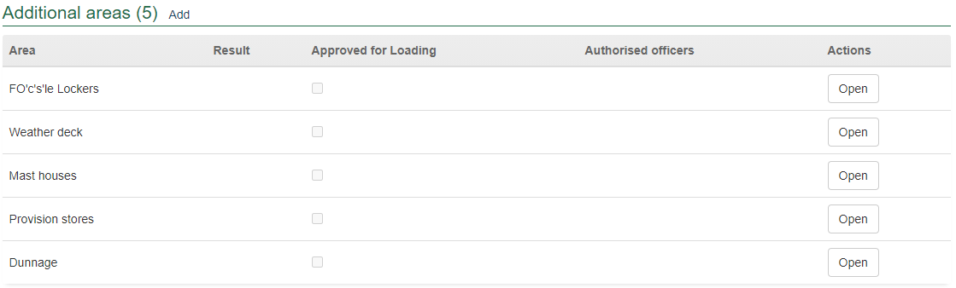

**2**

The *Additional Area* window will display.

The relevant **Area1** name will be populated for all mandatorily inspected additional areas. For any new additional area, you must manually enter the name of the **Area1** being inspected, for example hatch covers where goods will be loaded onto the vessel.

Select a **Result2** of *passed*, *failed*, *N/A* or *passed for cross contamination*, and one or more applicable **Remarks3** checkboxes (mandatory if the additional area has a failed result).

Select the checkbox of all **Authorised officers4** who inspected the additional area. See Section 3.1 Assigning authorised officers of the PEMS AO user guide – Overview and General Functions for more information.

Click **Save5**.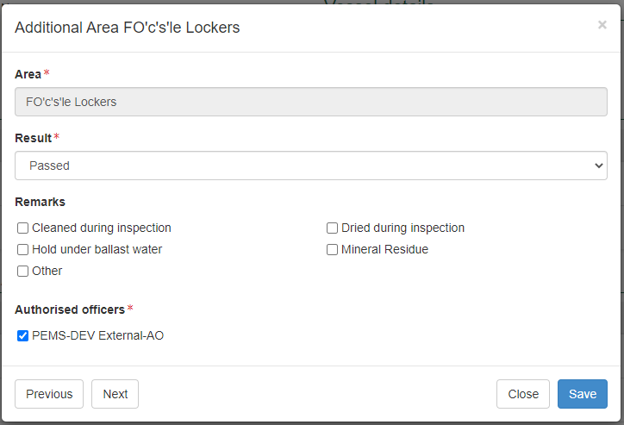

**1**

**5**

**3**

**4**

**2**

The bulk vessel inspection page will display the additional area inspection results. Click **Remove1** to remove any new additional area from the inspection record. Click **Open2** to make changes to any additional area inspection results.

Click **Approved for Loading3** checkbox for the additional area that will be loaded with goods.

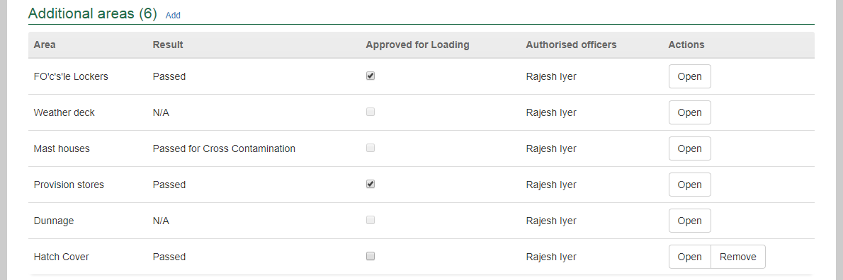

**3**

**2**

**1**



For a bulk vessel where it was specified that goods would be loaded onto other parts of the vessel, the **Approved for Loading3** checkbox must be selected for at least one additional area for bulk vessel approval to be issued.

**Navigating between additional areas inspection windows**

Click **Previous** or **Next1** at the bottom of the additional area inspection window to navigate quickly between each additional area inspection. The inspection results will automatically save when you navigate between the additional area inspection windows in this manner.



**1**

### Recording marine surveyor certificate details

When the bulk vessel inspection level is set to consumable, marine surveyor certificate must be sighted before *‘Approved for Loading’* is checked for holds that will be loaded with prescribed goods. If any hold or additional area receives a result of failed, the AO can complete the inspection record without recording marine surveyor certificate details.

To record the details of marine surveyor certificate that has been sighted, click **Change1** under the marine surveyor details section.

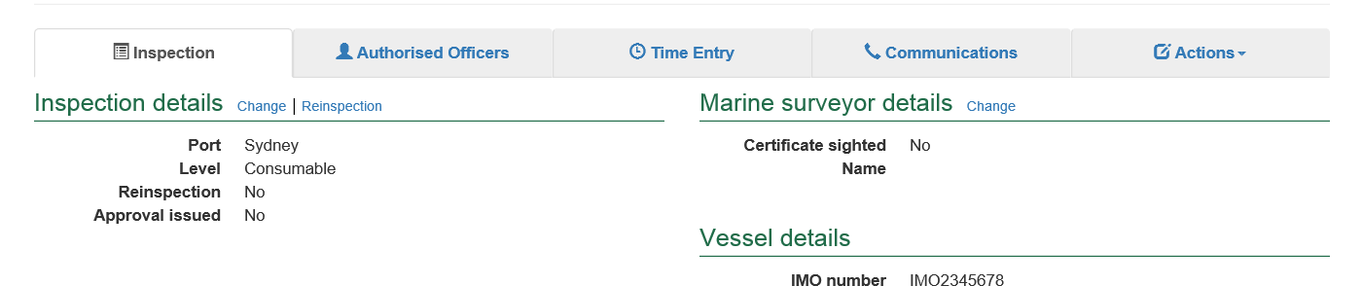

**1**

The *Marine Surveyor Details* window will display.

Select the **Declarations1** checkboxes and enter the **Name2** of the marine surveyor who issued the certificate. Click **Save3**.

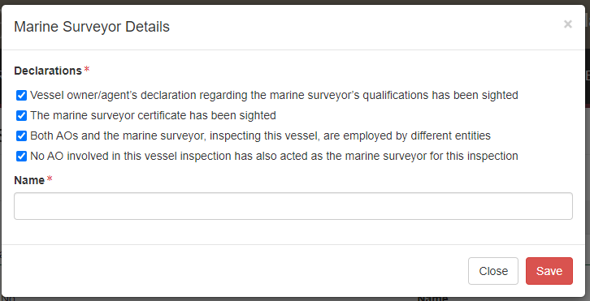

**3**

**2**

**1**

The bulk vessel inspection page will display the **updated marine surveyor details1**.

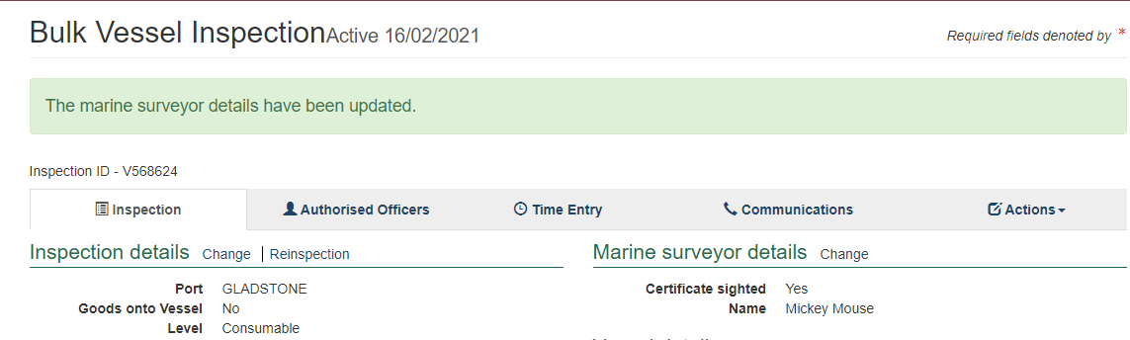

**1**

### Issuing bulk vessel approval

Bulk vessel approval cannot be issued until the following requirements are met:

* Bulk vessels where goods will only be loaded into the holds of the vessel
* one or more holds must have passed inspection
* all other holds must be passed for risk of cross contamination
* holds that have passed, at least one of the holds must be approved for loading
* Bulk vessels where goods will be loaded onto other parts of the vessel
* holds must be passed for risk of cross contamination
* one or more additional areas must have passed inspection
* additional areas that have passed, the area must be approved for loading
* other additional areas must have passed the risk of cross contamination or N/A.

To issue an approval for the bulk vessel click on the **Inspection1** tab and then click **Change2** under the inspection details section.

**2**

**1**

The *Inspection details* window will display.

From the **Vessel approval status1** drop down, select approved. The window will expand requiring an approval date and time. The current date and time will be provided by default.

To change the **Approval time2** enter the appropriate time in 24-hour format (hh:mm). Approval time must be within the first and the last time entry recorded by the AO.

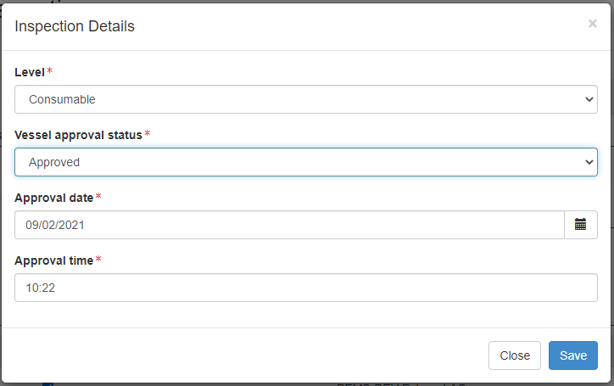

**2**

**1**

To change the approval date, click on the **calendar icon1** and select the **approval date2** from the calendar. The approval date cannot be in the future.

Once all approval data is recorded, click **Save3**.

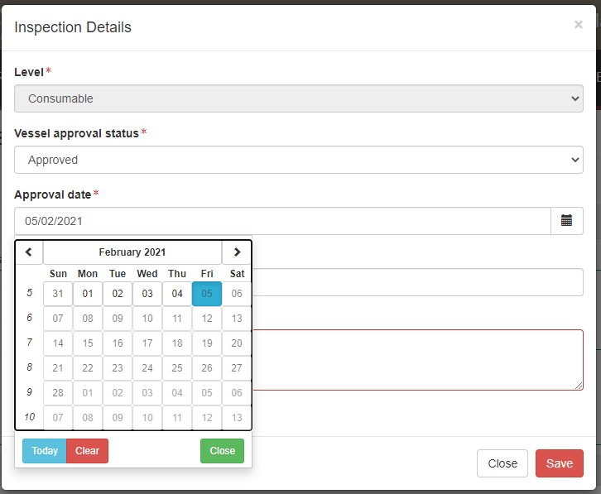

**2**

**3**

**1**

The bulk vessel inspection page will display the **updated approval details1**.

***

Vessel approval time must not be in the future and must be within the start and end time of the inspection record.

**1**

### Completing and submitting the inspection record

The inspection record can only be submitted in PEMS after:

* all inspection results are recorded
* marine surveyor certificate details are recorded, if applicable
* bulk vessel approval is issued, if applicable
* a **Time Entry1** is provided for all AOs who recorded inspection results.   
  **Note:** Each AO **must** record their own time entry into PEMS. You cannot complete this on behalf of another AO.
* all attachments and correspondence are added under the **Communications2** tab.

****The Take 5 assessment should be performed by each AO; however, the checklist can be attached by any AO involved in inspecting the vessel. When an AO selects the Take 5 Assessment checklist checkbox, a dropdown menu with the list of AOs will appear. This drop down prepopulates all AOs inspecting the vessel and allows the Take 5 checklist to be allocated to the appropriate AO.

From the Communications tab, you must add all documents relevant to the inspection. When attaching documents, select the correct document type.

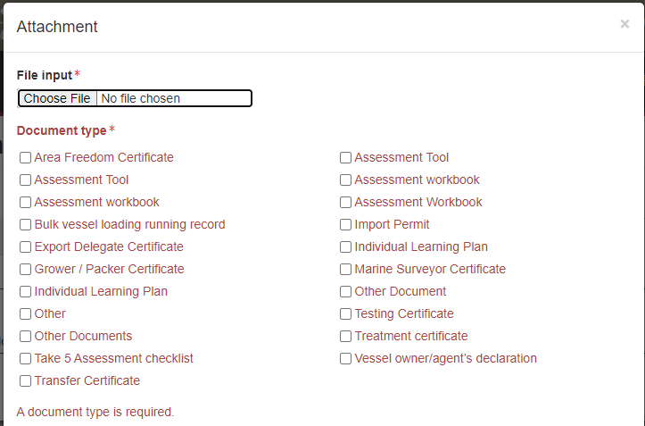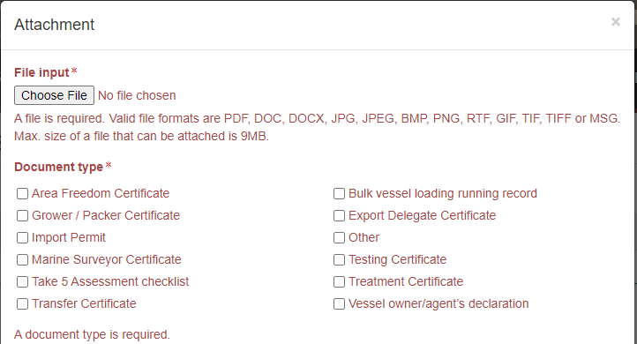

If a required piece of correspondence is missing an error message will be generated.

Details on the Time Entry and Communications tabs can be found in Section 3: General PEMS functions in the PEMS AO user guide – Overview and General Functions.

When you are ready to submit the inspection record, click the **Actions3**tab and then click **Submit4**.

****For more information on **Downloading** the inspection report, **Cancelling** the inspection and **Withdrawing5** from the inspection see Section 3.6 Actions tab of the PEMS AO user guide - Overview and General Functions.

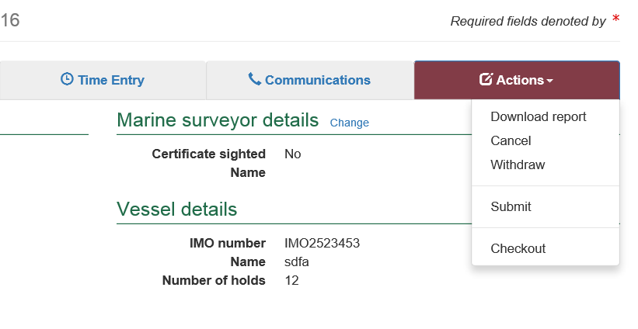

**4**

**3**

**1**

**2**

**5**

Once the inspection record is submitted the record will become read-only and you will be unable to make changes to the data provided.

A pop-up window will ask you to confirm that you want to **submit this inspection1**.

It will also ask if you want to **email the exporter/EDI user on the submission of the inspection2.** When selecting this option, the Inspection submit confirmation box will expand.

Enter the **email address3**, this can be multiple email addresses each separated by a comma.

Enter in any **Comments4** that are to be included in the email.

Click **Save5**.

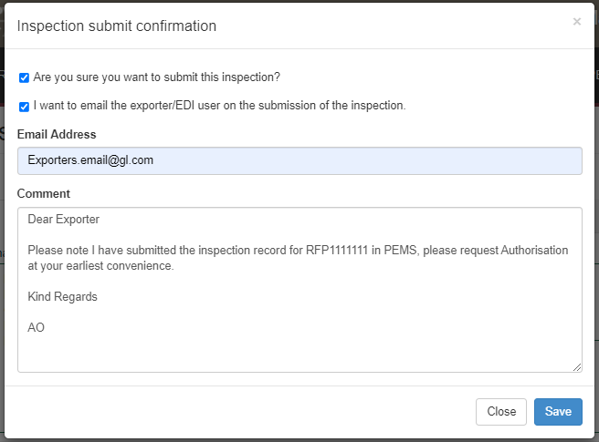

**5**

**4**

**3**

**2**

**1**

The bulk vessel inspection record will display as **Completed1.**

****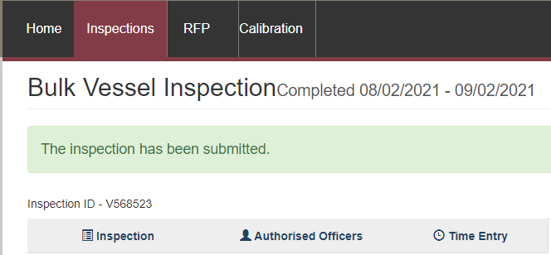

**1**

The date(s) specified on the completed inspection record will be the start date and end date for the inspection. The inspection record date corresponds with the earliest and latest time entry across all AOs for the inspection.

### Expiration date for bulk vessel approval

After vessel approval has been issued and the inspection record has been submitted the bulk vessel will be assigned an inspection validity expiry date. This date is automatically calculated as 28 days from the date of the first-time entry. To view the expiry date, click the **Inspection1** tab and the **Expiry date2** will display under the Inspection validity section.

If the bulk vessel expiry date is extended, the reason for the expiry date extension can be viewed by clicking **History3** under the Inspection validity section.

**3**

**2**

**1**

If you click history, the *Expiry History* window will display.

Click **Close1** to exit the window.

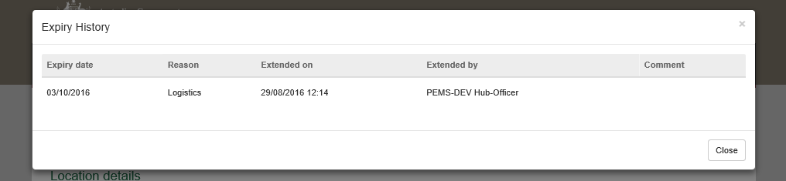

**1**

### Issuing suspension of a bulk vessel

The bulk vessel can be suspended, after it has been approved, if it is deemed to no longer meet the requirements for loading. This Vessel Approval Status can only be changed once the vessel approval has been submitted.

See Section 2.1 Inspection search of the PEMS AO user guide – Overview and General Functions for more information on how to search for records with the IMO number.

To suspend the bulk vessel, click on the **Inspection1** tab and then click **Change2** under the inspection details section.

**1**

**2**

The *Inspection details* window will display.

From the **Vessel approval status1** drop down, select suspended. The window will expand, requiring a suspension date and time and reason. The current date and time will be provided by default.

To change the **Suspension time2** enter the appropriate time in 24-hour format (hh:mm).

Enter a **Reason3** stating why the status of the vessel was changed to suspended. This field is mandatory and will appear on the Bulk Vessel Inspection Record.

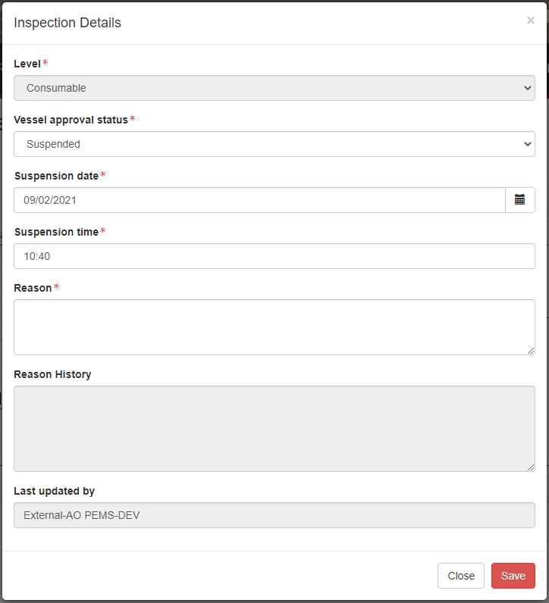

**2**

**3**

**1**

To change the date, click on the **calendar icon1** and select the **suspension date2** from the calendar. The date cannot be in the future.

Once all suspended information is recorded, select **Save3**.

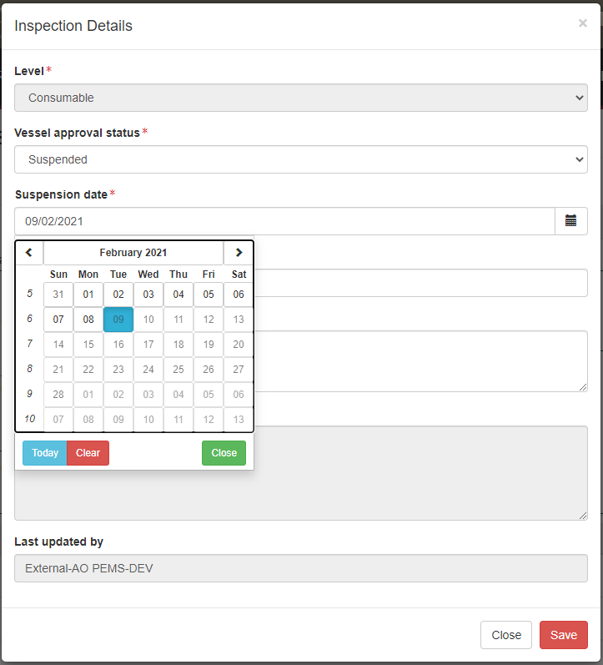

**2**

**1**

**3**

Confirmation of the update to the inspection details will appear. The record will now show the suspension date and who issued the suspension under **Last updated by1**.

**1**

### Lifting suspension of a bulk vessel

Where a vessel approval has been suspended, but the issue is able to be rectified the suspension can be lifted. To lift suspension for the bulk vessel, click on the **Inspection1** tab and then click **Change2** under the inspection details section.

**2**

**1**

The *Inspection details* window will display.

From the **Vessel approval status1** drop down, select **Lift suspension**. The window will expand, requiring a lift suspension date, time, and reason. The current date and time will be provided by default.

To change the **Lift Suspension time2** enter the appropriate time in 24-hour format (hh:mm).

Enter a **Reason3** stating why the status of the vessel was changed to lift the suspension. This field is mandatory and will appear on the Bulk Vessel Inspection Record.

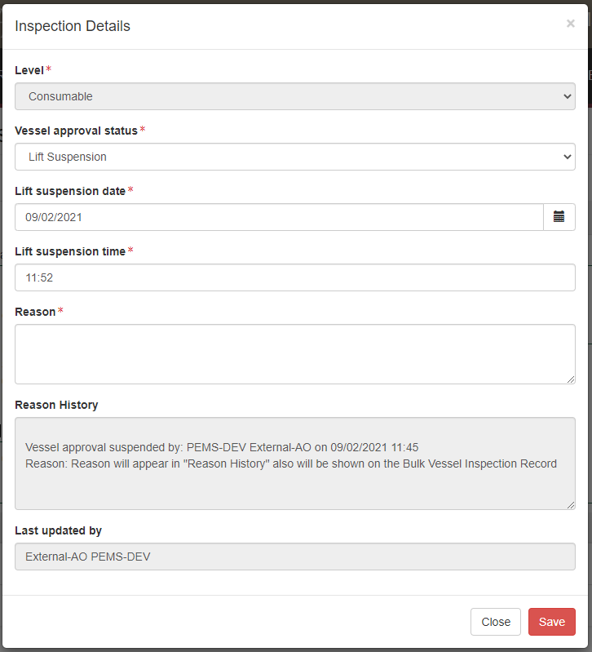

**3**

**2**

**1**

To change the date, click on the **calendar icon1** and select the **lift suspension date2** from the calendar. The date cannot be in the future.

Once all information is recorded, click **Save3**.

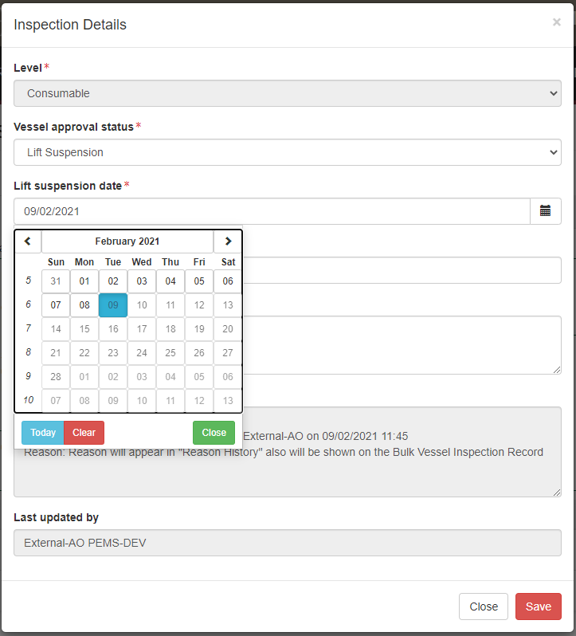

**2**

**1**

**3**

Confirmation of the update to the inspection details will appear. As the suspension has been lifted, the vessel approval status will revert to **Approved**1.

**1**

### Revocation of a bulk vessel

Where a vessel approval has been suspended, and the issue cannot be rectified the suspension will not be lifted and the vessel approval will be revoked.

Once this action takes place the record can no longer be altered.

To revoke the approval for the bulk vessel, click on the **Inspection1** tab and then click **Change2** under the inspection details section.

**2**

**1**

The *Inspection details* window will display.

From the **Vessel approval status1** drop down, select **Revoked**. The window will expand, requiring a revocation date and time and reason. The current date and time will be provided by default.

To change the **Revocation time2** enter the appropriate time in 24-hour format (hh:mm).

Enter a **Reason3** stating why the status of the vessel was altered to Revoked. This field is mandatory and will appear on the Bulk Vessel Inspection Record.

Once a vessel approval is revoked it cannot be re-approved unless a new bulk vessel inspection is completed.

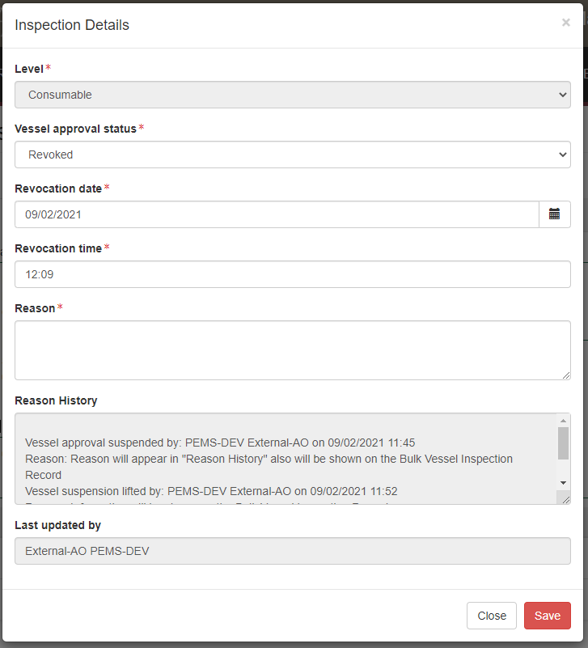

**1**

**3**

**2**

To change the date, click on the **calendar icon1** and select the **approval date2** from the calendar. The date cannot be in the future.

Once all approval data is recorded, click **Save3**.



**3**

**2**

**1**

Confirmation of the update to the inspection details will appear. As the suspension has not been lifted, the vessel approval status will revert to **Revoked**1.

**1**

## Related material

The following related material is available on the [website](http://iml.agdaff.gov.au/Draft/General/agriculture.gov.au):

* Manual of Importing Country Requirements (Micor)
* Protocols and Work Plans
* [Plant Export Operations Manual](http://www.agriculture.gov.au/export/controlled-goods/plants-plant-products/plantexportsmanual)
* Reference: PEMS AO user guide – Overview and General Functions
* *Empty container inspections*
* *Grain and Plant Product Inspection*
* *Horticulture inspections*
* *Bulk into ship hold inspections*
* *Quality systems recognition inspection*
* *In-transit cold treatment calibration records*

The following related material is available on the [Learnhub](https://learnhub.ssc.gov.au/login/):

* Plant Exports Management System (PEMS) video tutorials

## Contact information

* Authorised Officer Hotline: 1800 851 305
* Authorised Officer Program: PlantExportTraining@agriculture.gov.au
* PEMS Administration: [PEMS@agriculture.gov.au](mailto:PEMS@agriculture.gov.au)

## Document information

The following table contains administrative metadata.

| Instructional Material Library document ID | Instructional material owner |
| --- | --- |
| IMLS-9-7598 | Director, Change Management, Digital Clearance Service, Digital Trade Initiative |

## Version history

The following table details the published date and amendment details for this document.

| Version | Date | Amendment details |
| --- | --- | --- |
| 1.0 | 08/07/2016 | New user guide. |
| 1.1 | 12/07/2016 | Minor variations for accuracy and clarity. |
| 2.0 | 30/09/2016 | * Complete document restructure. * Addition of sections on: * Logging into PEMS * Calibration records * Calibration search. |
| 2.1 | 16/12/2016 | * Minor variations for accuracy and clarity * Removal of Appendix F – Calibrations and loading * Removal of Section 2.3 – Calibration search |
| 3.0 | 09/10/2018 | AO user guide updated with PEMS v2.1 enhancements. |
| 4.0 | 23/05/2019 | AO user guide updated with PEMS v3.1 and v3.2 enhancements. |
| 5.0 | 4/11/2019 | Updated with PEMS v.3.3 and 3.4 enhancements. |
| 6.0 | 3/06/2020 | Updated with PEMS 3.5 enhancements. |
| 7.0 | 28/08/2020 | Removal of appendices from *Plant Exports Management System (PEMS) Authorised Officer user guide* to make each its own user guide. |
| 8.0 | 10/12/2020 | Update with PEMS v3.9a enhancements. |
| 9.0 | 18/01/2021 | Update with PEMS January 2021 release. |
| 10 | 28/03/2021 | Updated for commencement of the *Export Control Act 2020* and associated Plant Rules. |
| 11 | 7/06/2021 | Remove reference to CGI. |
| 12 | 13/09/2021 | Updated with PEMS September 2021 release. |
| 13 | 26/07/2022 | Updated with PEMS June 2022 release. |