Lotfeeding for the long haul: strengthening Australia’s beef supply chain through climate extremes
Caitlin Herbert, 2024 Nuffield Drought Resilience Scholar, New South Wales
Nuffield Australia project number 2410
August 2026
© Commonwealth of Australia 2026
Ownership of intellectual property rights
Unless otherwise noted, copyright (and any other intellectual property rights) in this publication is owned by the Commonwealth of Australia (referred to as the Commonwealth).
Creative Commons licence
All material in this publication is licensed under a Creative Commons Attribution 4.0 International Licence except content supplied by third parties, logos and the Commonwealth Coat of Arms.

Cataloguing data
This publication (and any material sourced from it) should be attributed as: Herbert, C 2026, Lotfeeding for the long haul: strengthening Australia’s beef supply chain through climate extremes, report prepared for Nuffield Australia and Department of Agriculture, Fisheries and Forestry, Canberra. CC BY 4.0.
This publication is available at Nuffield Australia Scholar Reports and at agriculture.gov.au/Drought Resilience Scholarship Program.
Drought Resilience Scholarship Program
The program is funded by the Australian Government’s Future Drought Fund. In submitting this report, the 2024 Nuffield scholar Caitlin Herbert has agreed to Nuffield Australia and Department of Agriculture, Fisheries and Forestry publishing this material in its edited form.
Caitlin Herbert
Eugowra NSW 2806
Email caitlin_herbert@gundamain.com.au
Nuffield Australia
38 Walker Drive, Worongary QLD 4213
Web Nuffield.com.au
Email enquiries@nuffield.com.au
Department of Agriculture, Fisheries and Forestry
GPO Box 858 Canberra ACT 2601
Telephone 1800 900 090
Web agriculture.gov.au
Disclaimer
The views and opinions expressed in this publication are those of the authors and do not necessarily represent the views of Nuffield Australia, the Australian Government or the portfolio ministers for the Department of Agriculture, Fisheries and Forestry.
The content of this publication does not constitute advice to any third party. Although due care and skill have been applied in the preparation and compilation of the information and data in this publication, no reliance may be placed on it by any other party. No representation expressed or implied is made by Nuffield Australia or the Australian Government as to the currency, accuracy, reliability, completeness or fitness for purpose of the information contained in this publication. The reader should rely on its own inquiries to independently confirm any information and comment on which they may intend to act.
Nuffield Australia, the Commonwealth of Australia, its officers, employees, agents and the other parties involved in creating this report disclaim, to the maximum extent permitted by law, responsibility to any other party for any liability, including liability for negligence and for any loss, damage, injury, expense or cost incurred by any person as a result of accessing, using or relying upon any of the information or data in the publication.
Acknowledgement of Country
We acknowledge the continuous connection of First Nations Traditional Owners and Custodians to the lands, seas and waters of Australia. We recognise their care for and cultivation of Country. We pay respect to Elders past and present, and recognise their knowledge and contribution to the productivity, innovation and sustainability of Australia’s agriculture, fisheries and forestry industries.

Executive summary
This report investigates the role of feedlots in supporting the resilience of Australia’s beef supply chain, particularly during drought. As climate variability intensifies, producers face increasing challenges in maintaining consistent production, market access, and animal welfare. Feedlots have emerged as a vital tool to buffer the effects of these disruptions, helping absorb drought-affected cattle, stabilise prices, and ensure continuity for processors and consumers alike.
The Australian feedlot industry has expanded rapidly over the past decade, with cattle on feed more than doubling since 2010. This growth reflects not only changing seasonal conditions, but also structural shifts in the red meat supply chain. Feedlots now provide flexibility for producers to finish cattle when pasture availability is low, and they underpin high-value export programs that demand regular turnoff and product consistency.
Feeding systems vary across regions and are shaped by local conditions, infrastructure, and supply dynamics. The ability of feedlots to adapt their operations in response to changing seasonal and market pressures is critical. This adaptability is a core feature of resilient production, but resilience also relies on trust and systems that underpin continuity, especially during drought.
Certification and compliance frameworks are essential to maintaining market confidence in this environment. They ensure animal welfare, traceability, and contingency planning are upheld, even under pressure. International comparisons show that systems built around flexibility, coordination, and investment recover faster and maintain throughput during climatic extremes.
This report concludes that feedlots are not just finishing systems, they are resilience infrastructure. They provide a stabilising function in Australia’s beef sector, allowing the industry to navigate drought and other shocks while maintaining market confidence and supply continuity. Recognising their role in national drought planning, strengthening producer-feedlot relationships, and supporting adaptable feeding systems are key steps to safeguarding the future of Australian beef.

Contents
Executive summary iii
Foreword 1
Acknowledgements 3
Abbreviations 4
Objectives 5
Introduction 6
The Australian feedlot industry’s fast growth in capacity and significance 7
Australia as a global leader 7
Feeding systems and resilience 10
Feeding infrastructure as drought strategy 10
Flexible ration design during feed scarcity 10
Feed conversion and performance under pressure 12
Case Study: Climate flexibility and ration design – Alberta, Canada 12
Certification, ethics and market access 14
NFAS as Australia’s assurance backbone 14
Global certification and ethical expectation 15
Pasture-fed feedlots and animal raising claims 16
When does feeding cattle become lotfeeding? 17
Case Study: Pasture-fed feedlot program – Colorado, USA 18
Integration through the supply chain 20
Continuity and stabilisation 20
Case Study: Integrated drought resilience – Jandaia, Brazil 22
Drought as a catalyst for change 24
Comparative responses across continents 24
Investment in resilience and recovery 25
Infrastructure’s return on investment 25
Conclusions 27
Recommendations 28
References 30

Tables
Table 1 Travel Itinerary 2
Table 2 Common ration ingredients and substitutions 11
Table 3 Comparison of common grain processing methods used in feedlot rations, including typical digestibility, feed efficiency, and infrastructure considerations (Owens et al., 1997; Zinn et al., 2011; Beauchemin et al; 2001; Moya et al; 2011) 12
Table 4 Cattle price changes over recorded drought periods. 21
Figures
Figure 1 Caitlin Herbert, the author 1
Figure 2 Cattle on feed numbers in Australia from 2010 to 2024 (ALFA, 2025) 7
Figure 3 Australian Feedlot Cattle Turnoff by Days on Feed (2014–2025) 8
Figure 4 Canadian feedlot showing infrastructure to reduce effects form climate. Including wind breaks, sprinklers and in-pen mounding 13
Figure 5 Feedyard in Colorado feeding a pasture-based ration (Source: Author) 19
Figure 6 Cattle prices represented via the National Young Cattle indicated with highlighted drought periods (MLA NLRS, 2024). 21
Figure 7 Farm in Brazil feeding a ration based around whole corn. (Source: Author) 23

Foreword
I am an eighth-generation Australian farmer, and the sixth generation of my family to live and work at Gundamain, our mixed cattle and sheep operation in Central West New South Wales where we operate a feedlot and backgrounding enterprise focused on performance, welfare and continuity. Like many in agriculture, my path home wasn’t direct. But in early 2020, as one of the worst droughts in living memory was beginning to break, I made the decision to return full-time to Gundamain. It was a moment that clarified not only how vulnerable our production systems can be, but also how adaptive they must become.
Two years later, the 2022 Eugowra floods delivered a different kind of challenge. Our town was devastated, our community displaced, and our property severely impacted. Yet through this disruption, I witnessed firsthand the resilience of our business, our people, and our local industry. It prompted a deeper question: what are the systems and decisions that allow a business to not just survive these shocks, but to recover, recalibrate, and continue supplying food with integrity?
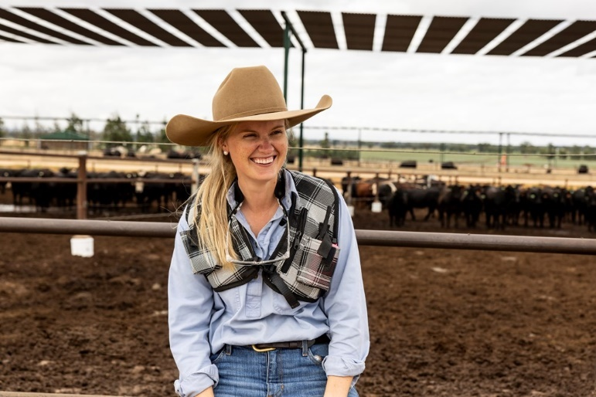
Figure 1 Caitlin Herbert, the author
Over the past decade, I’ve seen how a variable climate doesn’t just test feed availability, it tests systems. It reveals the weak points in our infrastructure, planning, and even language. And yet, amid these challenges, feedlots often serve as the stabilising mechanism that keeps the supply chain turning. Despite this, their role in drought response is still misunderstood or under-acknowledged by those outside the sector.
The answer to resilience against our climate’s variability, I found, is layered. It involves certification frameworks, ration design, market access, policy alignment, and global trade, all shaped by environmental extremes. I chose this topic because I believe feedlots are not the end of the beef supply chain, they are a safeguard within it. By understanding how they contribute to resilience, both during and beyond drought, we can position Australian beef to remain trusted, efficient, and sustainable in a changing world.
Table 1 Travel Itinerary
Travel date | Location | Visits or contacts
3 to 7 March 2024 | Canberra, Australia | Pre-Contemporary Scholars Conference
8 to 17 March 2024 | Campo-Grade and Bonito, Brazil | Contemporary Scholars Conference
17 to 21 March 2024 | Rio Grande do Sul, Brazil | Post-Contemporary Scholars Conference tour
21 to 30 March 2024 | Texas, USA | Global Focus Program
1 to 7 April 2024 | Germany | Global Focus Program
8 to 14 April 2024 | Ireland | Global Focus Program
7 to 13 May 2024 | Rockhampton, Australia | Beef Australia
21 to 31 May 2024 | Sao Paulo state, Mato Grosso du Sul state, Brazil | Individual travel
3 to 8 June 2024 | Buenos Aires province, Argentina | Individual travel
9 to 11 June 2024 | Santiago, Chile | Individual travel
10 to 17 July 2024 | Alberta, Canada | Individual travel
1 to 23 July 2024 | Texas, USA | Individual travel
23 to 26 July 2024 | Kansas, USA | Individual travel
26 to 28 July 2024 | Nebraska, USA | Individual travel
29 July 2024 | Wyoming, USA | Individual travel
30 to 31 July 2024 | Colorado, USA | Individual travel
15 to 17 October 2024 | Brisbane, Australia | BeefEx
4 to 6 February 2025 | Texas, USA | NCBA CattleCon
7 to 13 February 2025 | Mexico | Individual travel

Acknowledgements
This Nuffield Scholarship was proudly supported by the Future Drought Fund, an Australian Government initiative investing in long-term, drought resilience planning and capability across rural industries. I am deeply grateful for their support, and hope the insights shared in this report contribute meaningfully to their objective of strengthening the preparedness and adaptability of Australian agriculture.
To the Nuffield Australia team, thank you for the opportunities this program has made possible. The access, connections, and inspiration it provides are unmatched. This experience has allowed me to explore the cattle industry with a depth and perspective that would not otherwise have been achievable.
I extend my sincere appreciation to the many people and organisations, across Brazil, Argentina, Chile, Canada, the United States, and Australia, who generously gave their time and insights during my travels. Your openness and hospitality enriched every part of this learning voyage.
To the Australian Lot Feeders’ Association (ALFA) and the wider Australian feedlot industry, thank you for your continued willingness to engage with my questions, and for providing access to data, technical guidance, and industry context throughout the research process.
To everyone at Gundamain, thank you for your ongoing support and commitment during this process. Your flexibility and encouragement allowed me to step away from daily operations to explore this research fully.
To my family- Ed, Andrew, Tess, Siobhan, Lachie, and Penny. Thank you for your patience, encouragement, and support. Your belief in the value of this opportunity has been unwavering.
Finally, thank you to the producers, processors, researchers, and policymakers who continue to drive innovation in our industry. This report is built on your progress, and it is intended to contribute back to the ongoing conversation about resilience in Australian agriculture.
I don’t want my thoughts to die with me, I want to have done something. I’m not interested in power, or piles of money. I want to leave something behind. I want to make a positive contribution — know that my life has meaning (Temple Grandin).

Abbreviations
Term | Definition
ABARES | Australian Bureau of Agricultural and Resource Economics and Sciences
ADG | Average Daily Gain
ALFA | Australian Lot Feeders’ Association
AUS-MEAT | Australian Meat Industry Language and Standards Committee
CAR | Corrective Action Request
CSIRO | Commonwealth Scientific and Industrial Research Organisation
DDG | Dried Distillers’ Grain
EYCI | Eastern Young Cattle Indicator
FCR | Feed Conversion Ratio
FDF | Future Drought Fund
FLIAC | Feedlot Industry Accreditation Committee
GAP | Global Animal Partnership
EPA | Environment Protection Authority (NSW)
ERS | Economic Research Service (USDA)
ESG | Environmental, Social, and Governance
GDP | Gross Domestic Product
GFF | Grain Fed Finished (AUS-MEAT classification)
GF | Grain Fed (AUS-MEAT classification)
GFYG | Grain Fed Young Beef (AUS-MEAT classification)
IBGE | Brazilian Institute of Geography and Statistics
IMI Global | Independent Meat Identification Global Certification Program
MLA | Meat & Livestock Australia
MSA | Meat Standards Australia
NFAS | National Feedlot Accreditation Scheme
NSW | New South Wales
NYCI | National Young Cattle Indicator
QA | Quality Assurance
ROI | Return on Investment
SCU | Standard Cattle Unit
USDA | United States Department of Agriculture

Objectives
The following objectives guided the focus and structure of this report. They reflect the key areas of investigation identified during travel, research, and industry consultation.
- To investigate how feedlots contribute to the resilience of Australia’s beef supply chain during periods of drought and climatic volatility.
- To examine the adaptability and innovation within feedlot systems- focusing on feeding infrastructure, ration design, and regional strategies.
- To evaluate the role of certification, market access standards, and ethical frameworks in supporting continuity, credibility, and flexibility within lotfeeding systems.
- To compare international feedlot responses to drought and identify infrastructure and supply chain models that offer value for Australian adaptation.

Introduction
Australia’s beef industry is fundamentally shaped by its variable climate. As one of the most drought-prone countries globally, Australia faces ongoing challenges in maintaining consistent livestock production and market supply amid increasingly frequent and severe climate extremes (ABARES, 2024). Nowhere is this pressure more visible than in the cattle sector, where rainfall volatility, pasture decline, and resource competition test the resilience of traditional extensive systems. In this context, feedlots have emerged not only as finishing systems but as critical infrastructure for supply chain stability and drought response.
Since 2010, Australia’s feedlot sector has expanded rapidly, with cattle on feed more than doubling to reach a record 1.45 million head in December 2024 (ALFA, 2025). This growth reflects a structural shift in production, where lotfeeding is no longer a tactical response to surplus cattle or high grain availability but a strategic tool for managing climatic risk, securing market access, and delivering consistent carcase quality. Importantly, feedlots now underpin key domestic and export programs, particularly to markets such as Japan, South Korea, China, and the United States, where product specifications and volume requirements demand a degree of control that pasture systems alone cannot offer (ABARES, 2024).
Resilience in red meat production is increasingly defined by the ability to operate under stress. Lotfeeding systems offer this capability through infrastructure, feed security, ration flexibility, and verified assurance frameworks such as the National Feedlot Accreditation Scheme (NFAS). Introduced in 1994 and governed by the Feedlot Industry Accreditation Committee (FLIAC), NFAS mandates contingency planning, quality assurance, and traceability features that proved crucial during recent drought periods, enabling continuity of supply even under strained environmental conditions (NFAS, 2024; MLA, 2024).
Internationally, feedlot industries have responded to climate and market volatility in diverse ways. In Brazil, drought and deforestation concerns have driven processor-backed traceability and confined feeding programs that build continuity into export supply chains (ABIEC, 2023). In Canada, extreme cold and drought have pushed investment in infrastructure designed for climatic extremes, while the U.S. sector has refined procurement and ration flexibility to manage feed scarcity and throughput (ERS, 2024; CanFax, 2022). These case studies provide valuable benchmarks, highlighting both the uniqueness and shared challenges of Australia's feedlot sector.
At a policy and market level, feedlots also play a growing role in upholding Australia’s food security and market reputation. During drought, they act as buffers that absorb excess cattle and stabilise prices. Without them, the risk of market oversupply and processing disruption would be significantly higher, with cascading impacts across producers, processors, retailers, and consumers (MLA, 2024). Furthermore, their role in supporting certified claims such as “grain-fed” under Australia’s Export Control Rules positions feedlots as central actors in maintaining compliance and trust in global trade (Commonwealth of Australia, 2021).
This report explores how feedlots contribute to the resilience of Australia’s beef supply chain, with a particular focus on their role in drought mitigation. Through analysis of feeding systems, certification frameworks, economic integration, and international case studies, the report examines how the industry has evolved, and what further adaptation is needed to meet the challenges of a more volatile climate.

The Australian feedlot industry’s fast growth in capacity and significance

Australia as a global leader
Australia’s feedlot industry has undergone a period of substantial growth, both in operational scale and strategic importance. Since 2010, the number of cattle on feed has more than doubled, reaching a record 1.45 million head in December 2024 (Figure 2; ALFA, 2025). This upward trend reflects the industry's increasing role in managing climatic volatility, stabilising national beef supply, and supporting Australia’s position as a reliable global exporter.
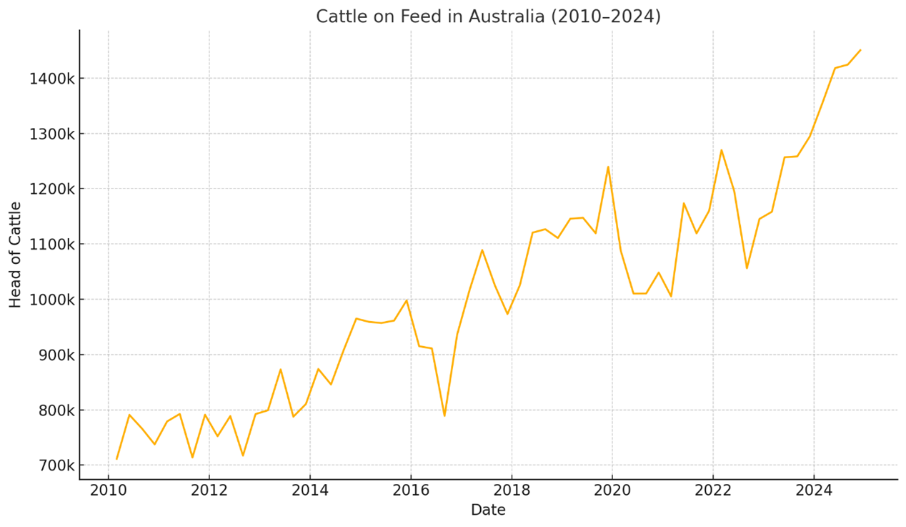
Figure 2 Cattle on feed numbers in Australia from 2010 to 2024 (ALFA, 2025)
Queensland and New South Wales remain the dominant lotfeeding states, accounting for nearly 87% of all cattle on feed nationally (ALFA, 2025). This geographic concentration is closely linked to infrastructure investment, grain availability, and processing proximity. National feedlot capacity has expanded in response to prolonged dry conditions and rising demand for consistent beef supply, both domestically and abroad. ABARES (2024) forecasts ongoing high utilisation rates, particularly as feedlots offer producers flexibility during uncertain pasture conditions.
Feedlots have become an essential resilience mechanism within the broader livestock system. During periods of drought, they serve as a critical buffer, enabling producers to manage feed deficits while maintaining market supply. ALFA and MLA have developed best-practice resources for managing increased cattle volumes under constrained conditions, including guidance on infrastructure planning, ration formulation to cope with weather extremes, and environmental risk mitigation (Beef Central, 2025; ALFA, 2025). These tools were increasingly adopted in response to recent climatic events and form a vital part of Australia’s drought adaptation strategy.
Feedlots also play a key role in enabling Australia to meet its export obligations. In 2024, the United States, China, Japan, and South Korea accounted for the majority of beef exports by value (ABARES, 2024). These markets place significant weight on product consistency, food safety, and carcase quality. Lotfeeding allows producers to manage metabolizable energy (ME) inputs and nutritional density with precision, supporting compliance with processor grid specifications and Meat Standards Australia (MSA) grading thresholds (MLA, 2019). Carcase traits such as marbling and fat coverage can be optimised through ration design and days on feed, particularly where the market demands high-yielding, chilled beef products with verified eating quality.
Analysis of ALFA’s Quarterly Feedlot Survey data shows a notable long-term shift in feeding durations alongside the overall rise in cattle on feed (Figure 3). Since 2014, the proportion of cattle turned off after 300 or more days on feed has more than doubled, increasing from around 3% of national turnoff in 2014 to over 7% in early 2025 (ALFA, 2025). This trend is strongly linked to the expansion of Wagyu and other premium long-fed programs, which typically require 350-450 days on feed to achieve high marbling scores demanded by export markets such as Japan (MLA, 2023; MLA, 2024). Over the same period, the proportion of short-fed cattle, those turned off in under 100 days, has steadily declined, reflecting a structural move away from opportunistic, grain-assisted turnoff toward longer feeding programs that secure higher-value market access (Behrendt & Weeks, 2019; MLA, 2023). Extended feeding programs, while requiring greater feed inputs and operational planning, enable supply chains to deliver highly consistent carcase quality and specification compliance, particularly for chilled beef exports to Japan, Korea, and China (ABARES, 2024; MLA, 2019). Longer-fed cattle could be viewed as contributing to drought resilience by allowing cattle to be inducted and held over extended periods, smoothing supply when pasture production is low or processing schedules are disrupted (MLA, 2024; ALFA, 2023).
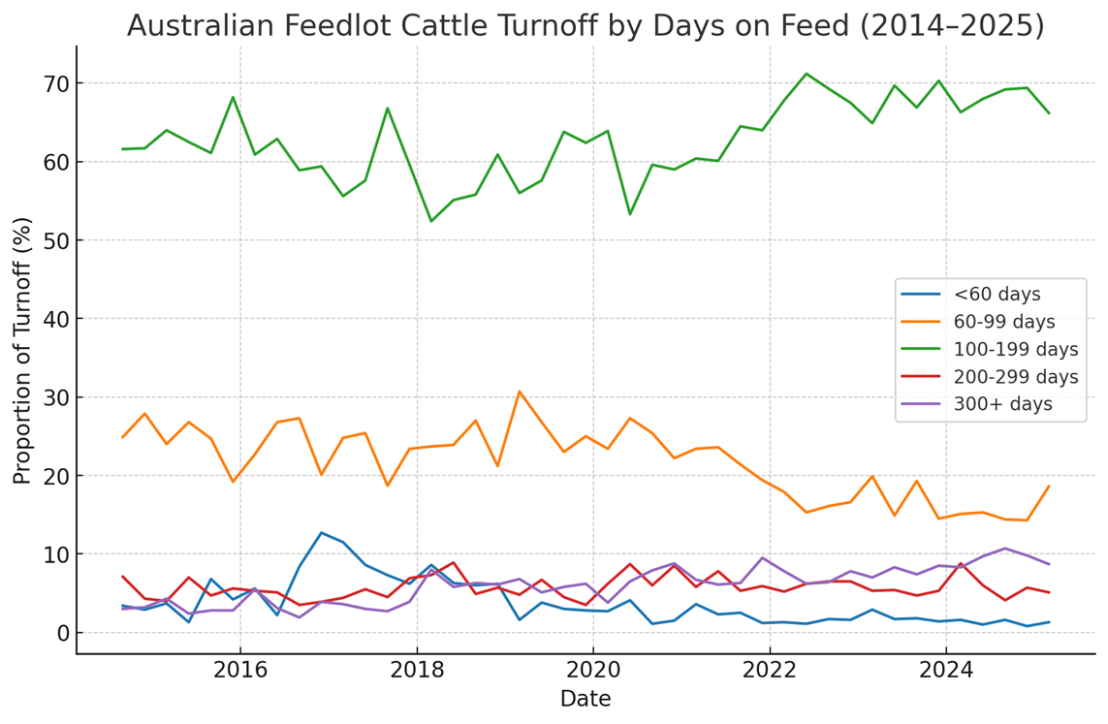
Figure 3 Australian Feedlot Cattle Turnoff by Days on Feed (2014–2025)
To support integrity in production claims and regulatory compliance, commercial Australian feedlots operate under the NFAS. This independently audited system ensures compliance with standards in animal welfare, biosecurity, environmental management, and food safety (ALFA, 2025). The NFAS, together with AUS-MEAT’s certified claims framework, enables feedlots to deliver verified product attributes that align with both domestic and international expectations for transparency and assurance. This alignment means that NFAS is not only an industry assurance program but a formal compliance gateway to the “Grain Fed” and “Grain Fed Finished” trade descriptions recognised under Australia’s Export Control Rules and associated Meat Orders, giving these claims their legal standing in both domestic and export markets.
Internationally, Australia’s lotfeeding sector is relatively small in total capacity compared to systems in the United States or Brazil. However, it remains globally competitive due to its high feed conversion efficiency, well-regulated operating environment, and a strong alignment with market-led production systems. According to MLA’s AgriBenchmark data, Australian feedlots consistently rank favourably in terms of cost of gain and carcase yield per unit of input, despite operating in one of the most variable climates among major exporters (MLA, 2019).
The sustained expansion in national feeding capacity reflects not only commercial responsiveness to climate and supply dynamics but also a deeper structural shift in how red meat is produced in Australia. Lotfeeding is no longer a contingency, it is a strategic platform for supply chain resilience, market alignment, and production efficiency. This positions feedlots as key enablers of the long-term adaptability of Australia’s livestock sector.

Feeding systems and resilience

Feeding infrastructure as drought strategy
Prolonged droughts force rapid and often large-scale livestock turnoff from pasture-based systems, particularly in regions without irrigated forage or standing feed reserves. Feedlots provide the infrastructure and operational scale to absorb this surge, helping maintain liveweight, carcase yield, and continuity of supply to processors. In this way, feedlots act as a stabilising mechanism within Australia’s broader red meat value chain.
Rather than replacing other production systems, feedlots complement them by offering a pathway to manage climate risk. During the 2018–2019 and 2023–2024 droughts, many commercial yards expanded their capacity to accommodate increased cattle placements via upgraded feed storage, adaptable induction systems, and batching infrastructure to handle variable weight classes and ration transitions (MLA, 2024). These adaptations not only protected animal welfare but helped relieve pressure on grass-fed producers who faced tightening pasture and water reserves. Critically, this allowed the supply chain to maintain throughput and meet market commitments, even as weather conditions deteriorated.

Flexible ration design during feed scarcity
During drought, feedlot operators encounter many of the same feed supply pressures as grazing enterprises: roughage becomes limited, grain prices escalate, and regional transport costs fluctuate. However, feedlot systems are designed for ration flexibility, allowing rapid reformulation based on availability, nutritional targets, and cost-of-gain thresholds.
Barley remains the predominant energy source nationally, but inclusion levels are routinely adjusted based on harvest outcomes and commodity market shifts (MLA, 2021). In Queensland and northern NSW, sorghum and wheat are common substitutes; molasses, cottonseed, almond hulls, citrus pulp, and wet distillers’ grains are all incorporated as co-products depending on regional supply and freight economics. During drought, many yards extend silage reserves by incorporating straw or ensiled failed crops as fibre sources.
These shifts are guided by formulation software and real-time batching adjustments but also require practical knowledge of how ingredients interact under stress. During drought, variability in co-product quality and moisture content increases, elevating the risk of digestive issues and ration inconsistency. Feedlots with strong feed testing protocols and bunk management systems are better placed to manage these risks (MLA, 2021).
Table 2 summarises how feedlots across different regions commonly adapt their rations under drought conditions. When pasture-based systems face feed and fibre shortages, feedlots maintain intake and performance by substituting locally available ingredients, integrating co-products, and using silage reserves. This capacity to reconfigure rations is one of the key reasons feedlots remain operational and responsive during drought, helping stabilise the broader beef supply chain.
Table 2 Common ration ingredients and substitutions
Region | Primary Grains | Common Roughage | Common Co-products Used | Adaptation Strategy
Southern NSW/VIC | Barley/ Wheat | Hay/ straw, silage | Almond hulls, citrus pulp, molasses | Formulation based on barley availability and freight
Northern NSW/QLD | Barley/ Wheat/ Sorghum | Silage, hay/ straw, failed crops | Molasses, cottonseed, DDG | High reliance on co-products during dry spells
SA/WA | Barley/ Wheat | Straw, hay | Canola meal, bakery waste, molasses | Increased hay imports during dry years
Central QLD | Barley/ Sorghum/ Wheat | Silage, straw | Molasses, DDG, cottonseed | Ensiled failed crops + local DDG sourcing
Recent adoption of direct-fed microbial technologies such as Lactipro (containing Megasphaera elsdenii) has further improved feedlot flexibility during drought by reducing the need for high roughage inclusion in starter and transition rations. By accelerating ruminal adaptation to starch and enhancing lactic acid utilisation, these probiotics allow smoother step-up programs, lower roughage requirements, and improved bunk stability under feed-constrained conditions (Cabral & Weimer, 2023).
The grain processing method also plays a significant role in determining feedlot performance and ration adaptability under drought conditions. Dry-rolling is a common method in small-to-medium Australian feedlots due to its lower capital and energy requirements. Total starch digestibility of dry-rolled barley is typically around 90%, with ruminal digestion rates of approximately 55–64% (Beauchemin et al., 2001; Black, 2016). Tempering, where grain is moistened prior to rolling, can increase ruminal digestibility modestly by 65–70% (Moya et al., 2011). Tempering also improves uniformity and reduces fines and dust but requires additional water and time. Tempering can offer modest gains in feed efficiency without major infrastructure changes. In contrast, steam-flaking achieves ruminal digestibility by as high as 99% by applying heat and moisture before mechanical flattening, resulting in significantly improved feed conversion ratios (FCR), often by 5–10% compared to dry-rolled grain (Owens et al., 1997; Cozzi et al., 2022). While steam-flaking delivers nutritional advantages, it comes with higher operational costs, labour demands, and energy consumption, factors which can constrain flexibility during feedlot expansions or drought surges. In North America, steam-flaking is widely adopted due to corn’s gelatinisation properties, whereas in Australia, where barley and wheat dominate, feedlots often prefer dry-rolling or tempering due to logistical and cost efficiencies (MLA, 2021). The ability to shift between grain types and processing methods is an important resilience lever, especially when managing variable grain supply or ration reformulation during feed shortages.
Table 3 Comparison of common grain processing methods used in feedlot rations, including typical digestibility, feed efficiency, and infrastructure considerations (Owens et al., 1997; Zinn et al., 2011; Beauchemin et al; 2001; Moya et al; 2011)
Processing Method | Starch Digestibility (Total Tract) | Ruminal Starch Digestion | FCR or ADG Improvement vs DR | Strengths | Limitations
Dry-Rolling | ~91% (corn), ~90% (barley) | ~55–64% | Baseline | Low cost, low infrastructure | Lower digestibility, more fines
Tempering | ~95% (barley with tempering) | ~65–70% | ~3–5% | Improved uniformity, feed flow | Requires water and time
Steam-Flaking | ~99% (corn) | ~84% | 5–10% gain; ~15% energy gain | Maximise starch availability | High cost, energy, labour

Feed conversion and performance under pressure
Maintaining growth rates under climatic stress is a key challenge for feedlot managers. Extended heat events, water quality issues, and ration changeovers all place pressure on dry matter intake and feed efficiency. Energy is increasingly diverted from growth toward thermoregulation, and intake consistency often declines.
Under typical conditions, Australian commercial feedlots achieve average daily gains (ADG) of 1.6–2.2 kg/day with feed conversion ratios (FCR) between 6.5:1 and 8.5:1, depending on animal type, entry weight, and ration phase (CSIRO, 2021). During drought, performance risk is managed through several strategies:
- gradual phase-in of high-starch rations during intake surges
- use of buffers and ionophores to control acidosis risk
- bunk management practices to reduce intake volatility
- water testing and storage system upgrades, especially where surface water quality deteriorates in dry periods.
MLA benchmarking reports suggest that feedlots able to maintain performance in drought years tend to invest in shade structures, consistent ration delivery, and staff training focused on early detection of stress or metabolic disorders (MLA, 2022). These systems are not designed for peak production alone; they are structured to maintain continuity, quality, and animal welfare when the broader cattle system is under strain.

Case Study: Climate flexibility and ration design – Alberta, Canada
Canada’s feedlot industry has evolved under the constant pressure of climatic extremes. In Alberta, feedlots regularly contend with temperature swings of up to 90 degrees, from +40°C in summer to −50°C in winter. Infrastructure across the region has been purpose-built to withstand these challenges, with pen mounding, windbreaks, lighting, snow drains, roller compacted concrete, and storm rations all contributing to year-round operability.
During my visit in June 2024, Alberta was just emerging from a prolonged three-year drought. Despite the pressure on feed and water availability, most yards were operating at full capacity. Unlike in Australia, the Canadian feedlot sector is highly concentrated and industrialised, with many yards finishing upwards of 30,000 head. High stocking densities are common, and operators rely heavily on robust infrastructure and winter-specific feed planning to ensure animal welfare and supply continuity.
Canada’s feedlot sector is heavily reliant on grain-based rations, with statistics showing that about 71% of beef cattle operations across Canada, including 74–76% in Western provinces like Alberta, use grain in their feeding systems at some point during the year and the majority are finished in feedlots out of necessity rather than market preference (CanFax, 2022; Canadian Beef, 2016). As pasture is inaccessible or dormant for much of the year, grain-based rations serve as both a production strategy and a climate adaptation.
One operator I met manages over a dozen yards across Alberta and the northern United States, feeding several hundred thousand cattle annually. Their long-term resilience strategy is grounded in ration flexibility and procurement agility. Ration design is highly responsive to international feed markets and trade tariffs: barley, wheat, sorghum, or corn may all be used depending on availability, price movements, and border access. This capacity to substitute and balance inputs allows for cost control and supply stability, particularly during climatic or geopolitical disruptions.
The Canadian model demonstrates that feeding systems are not just about efficiency, they are about survivability. In a climate where seasonal volatility is both routine and extreme, feedlots must be built not only to feed cattle but to protect business continuity. The ability to adjust rations, withstand environmental pressures, and maintain throughput is central to the long-term resilience of the grain-fed supply chain in northern latitudes.
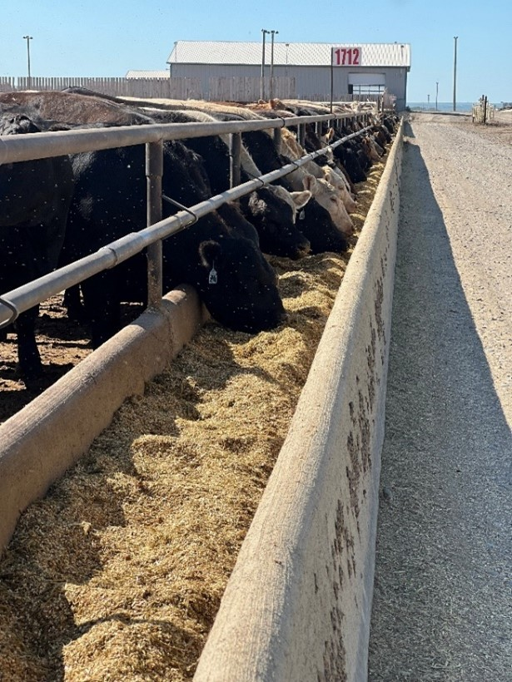
Figure 4 Canadian feedlot showing infrastructure to reduce effects form climate. Including wind breaks, sprinklers and in-pen mounding

Certification, ethics and market access

NFAS as Australia’s assurance backbone
The National Feedlot Accreditation Scheme (NFAS) is the foundation of assurance for Australia’s grain-fed beef sector. Introduced in 1994 and administered by AUS-MEAT, NFAS provides independently audited standards that underpin product integrity, food safety, and animal welfare across all commercial feedlot operations. As of 2024, all licensed feedlots in Australia supplying grain-fed beef to domestic and export markets must be NFAS-accredited.
NFAS is governed by the Feedlot Industry Accreditation Committee (FLIAC), which comprises of State Government representatives from the major lot feeding states along with representatives from AUS-MEAT and ALFA. FLIAC is responsible for ensuring the scheme evolves in step with emerging market requirements and consumer expectations, while maintaining rigorous, evidence-based standards across the industry (NFAS, 2024).
The scheme integrates both prescriptive requirements and outcome-based standards with core components, including:
- documented quality assurance (QA) programs for every aspect of feedlot operation
- animal welfare standards aligned with the Australian Animal Welfare Standards and Guidelines for Cattle
- environmental management plans, including waste handling and effluent control
- mandatory risk registers and contingency plans for events such as drought, fire, flood, disease outbreak, and feed contamination
- traceability systems for livestock movements, feeding regimes, and veterinary treatments.
By embedding contingency planning and operational transparency into baseline accreditation, NFAS enables feedlots to respond quickly and credibly to climate-induced disruptions. For example, during the 2018–2019 and 2023–2024 drought periods, feedlots operating under NFAS were able to maintain certification while adapting rations, increasing cattle throughput, and modifying operational routines to meet welfare and environmental requirements under pressure (ALFA, 2023).
NFAS accreditation is also the gateway to participation in Australia’s grain-fed beef programs, most notably the Meat Standards Australia (MSA) grading system and grain-fed certification claims for export. All NFAS feedlots are assigned an AUS-MEAT establishment number and are subject to audits at least once per year. Compliance is enforced through Corrective Action Requests (CARs), and repeated breaches can result in suspension or removal from the scheme.
Importantly, NFAS integrates with the Meat Language and Standards system, ensuring that grain-fed product descriptions (such as “grain-fed” and “grain-fed finished”) are standardised across the supply chain and verifiable through AUS-MEAT records. Claims such as “grass-fed” or “pasture-raised” fall outside the scope of NFAS and are governed under separate frameworks, such as the AUS-MEAT Animal Raising Claims Standard.
In addition to underpinning industry credibility, NFAS accreditation is directly tied to legal market access under Australia's export legislation. The Export Control (Meat and Meat Products) Rules 2021 stipulate that the trade description “Grain Fed” must not be applied to prescribed beef or lamb products unless they meet the specific carcase and meat quality criteria set out in the Australian Meat Industry Classification System. This includes classifications such as Grain Fed (GF), Grain Fed Finished (GFF), and Grain Fed Young Beef (GFYG) for beef, and Grain Fed Lamb (GF) for lamb (Commonwealth of Australia, 2021). As such, NFAS serves as both a certification and a compliance mechanism, ensuring that grain-fed claims are legally defensible and export-eligible.
In short, NFAS functions as more than a compliance tool. It is a resilience mechanism, ensuring that Australia’s grain-fed sector remains market-ready, even under environmental pressure. The ability to scale up cattle intake, modify ration design, or respond to feed and weather shocks while maintaining third-party accreditation is a core reason that feedlots are trusted to deliver continuity when other parts of the production system are constrained.

Global certification and ethical expectation
Certification programs serve a critical role in maintaining market access and supply chain trust, particularly during periods of disruption such as drought. For feedlot operators, they provide not only a framework for welfare and food safety, but a mechanism to demonstrate continuity and compliance under pressure. Australia’s National Feedlot Accreditation Scheme (NFAS) is globally distinctive in this regard.
While many countries operate assurance systems for animal welfare, sustainability, or natural claims, NFAS remains one of the only nationally coordinated, independently audited certification schemes dedicated specifically to grain-fed beef. It is integrated into AUS-MEAT’s product description language and underpins grain-fed claims for both domestic and export markets. Although not mandatory for all feedlots, NFAS accreditation is required for any operation wishing to market beef as “grain-fed” or “grain-fed finished” under AUS-MEAT standards. As such, it functions as a de facto requirement for participation in the commercial grain-fed beef supply chain.
By contrast, most international certification systems focus on broader or different claims. For example:
- IMI Global (USA) offers voluntary verification for source, age, hormone-free, and non-GMO programs. While widely used by branded beef programs, participation is elective and scoped to specific claims and none tied explicitly to grain-fed production
- G.A.P. (Global Animal Partnership, USA) provides animal welfare tiers for retailers and consumers, but its higher certification levels prohibit confinement feeding. This makes it largely incompatible with commercial grain-fed operations
- Red Tractor (UK) and GLOBALG.A.P. (EU/international) offer integrated assurance across food safety, traceability, and environmental standards. While robust, they are not grain-specific and are generally tailored to whole-of-farm retail assurance, not product-specific market access.
These comparisons highlight the uniqueness of NFAS, not only in its technical scope, but in its integration with national meat standards and its role as a prerequisite for verified grain-fed beef exports. Where other schemes serve as brand enablers or voluntary differentiation tools, NFAS is embedded in the regulatory and commercial framework of Australia’s grain-fed beef sector.
From a drought resilience perspective, the value of certification is not in the label itself, but in the assurance it provides under pressure. During drought, NFAS-accredited feedlots demonstrated the ability to manage increased cattle intake, shift rations, and maintain animal welfare standards, all while upholding third-party compliance. This consistency enabled processors to meet export commitments and sustained market confidence despite widespread seasonal disruptions.
In this way, certification systems like NFAS act as stabilising infrastructure within the Australian beef industry. They codify expectations, reinforce credibility, and support the ability of feedlots to operate as a dependable, drought-resilient arm of Australia’s red meat supply chain.

Pasture-fed feedlots and animal raising claims
In response to shifting consumer preferences and export market opportunities, some beef producers and supply chains have explored hybrid models that incorporate aspects of both extensive grazing and intensive finishing. One such model is the pasture-fed feedlot system, where cattle are managed in open paddocks but receive controlled rations to meet performance or specification targets, typically with minimal or no grain inclusion.
These systems often arise from market demand for beef that is both traceable and ethically positioned, yet more consistent and scalable than purely grass-fed or regenerative programs. While uncommon in Australia, examples exist internationally, most notably in parts of the United States, where cattle are backgrounded and finished on silage or forage-based diets in paddock-like feedlot systems for export into niche markets in Europe and the U.S.
In Australia, formal recognition of these production systems falls under AUS-MEAT’s Animal Raising Claims Framework, which outlines the conditions under which claims such as "pasture-raised," "no grain ever," "free-range," and "grain-assisted" may be used. The framework requires that any animal raising claim be:
- substantiated by verifiable records
- auditable through a recognised third-party certification process
- traceable from birth to slaughter
- defined clearly enough to ensure consistent interpretation and consumer understanding.
(Source: AUS-MEAT Animal Raising Claims Framework for Beef Production, 2022)
While traditional feedlots do not fall within pasture-fed definitions, the emergence of intermediate systems raises valid questions about the role of finishing environments in claim-based beef marketing. For example, in a pasture-fed feedlot system with low-grain or grain-free rations, the claim “no grain ever” could still apply so long as the animals meet the criteria outlined in the AUS-MEAT standard and the supply chain maintains the appropriate documentation.
Such programs are typically vertically integrated or controlled by processors, as claim verification and continuity of supply require close oversight. They also face clear trade-offs: extended feeding periods, higher roughage requirements, and increased labour and waste handling compared to conventional grain-fed operations.
From a resilience standpoint, the existence of such systems reinforces the value of feedlots, not just as finishing facilities, but as controlled environments that can deliver consistency and traceability when pasture production is unreliable. Whether grain-free or grain-assisted, the use of infrastructure, feeding regimes, and certified record-keeping enables operators to meet premium market expectations even during seasonal disruption.
In a drought-prone country like Australia, this flexibility, combined with verifiable transparency, is a competitive strength. It allows supply chains to adapt to weather, market, or policy pressures without compromising product claims or market eligibility. As consumer demand continues to evolve, the feedlot sector’s ability to operate within certified, auditable claim frameworks will become increasingly central to maintaining access, trust, and continuity.

When does feeding cattle become lotfeeding?
The definition of a feedlot in Australia is complex, spanning legal, operational, and ethical dimensions. At its core, a feedlot is generally understood as a confined facility where cattle are hand or mechanically fed for the purpose of beef production, without reliance on grazing. However, the distinction between lotfeeding and other feeding systems such as confinement or drought feeding is not always straightforward.
In Queensland, a feedlot is defined as an intensive animal industry where more than 150 standard cattle units (SCU) are confined and entirely hand or mechanically fed without access to pasture. These operations are regulated under the Environmental Protection Act 1994 and require development approval and an environmental authority (Queensland Government, 2022). In New South Wales, feedlots are classified as “intensive livestock agriculture” under the State Environmental Planning Policy (Primary Production and Rural Development) 2021. Facilities with more than 1,000 SCU must undergo formal development assessment and meet environmental standards relating to odour, dust, effluent, and waste management, under the Protection of the Environment Operations Act 1997 (EPA NSW, 2024).
Not all Australian states and territories define feedlots with the same level of legal clarity, and there is no nationally harmonised definition. This creates grey areas, particularly when it comes to temporary drought feeding systems or confinement pens that may appear visually similar to feedlots but do not meet formal criteria for licensing or environmental regulation. These inconsistencies also have implications for how industry, regulators, and the public perceive the role of confined feeding during seasonal hardship.
The National Feedlot Accreditation Scheme (NFAS) defines a feedlot as a constructed facility with defined boundaries, permanent water points, and a stocking density of 25 square metres per SCU or less, where cattle are fed only a prepared ration for production purposes (MLA, 2019). Confinement feeding, by contrast, is widely used across Australia during drought periods. These systems are often installed as temporary holding areas and may involve the provision of silage, hay or mixed rations. While they share some features with feedlots, they are typically not managed under a quality assurance scheme and are not licensed as intensive animal industries. As a result, they occupy a regulatory and ethical grey zone.
The lack of consistency across jurisdictions has raised concerns about both oversight and public trust. It also introduces complexity in discussions about animal welfare, natural behaviour, and production system transparency. These tensions are particularly relevant in drought response, where emergency management strategies such as confinement feeding are increasingly common but not uniformly regulated.
Staging facilities offer another important tool within this landscape. Used to temporarily hold and manage cattle prior to entry into a feedlot, they serve as a buffer between paddock systems and full confinement. During drought, these facilities help producers manage large intakes, stabilise animal condition, and improve transition outcomes through early adaptation to bunk feeding and socialisation. According to MLA’s best practice guide, staging facilities also assist in mitigating price shocks, smoothing logistics, and maintaining supply chain flow during periods of climatic stress (MLA, 2023).
Understanding the definitional boundaries of lotfeeding is essential to accurately describe the role of feedlots in drought resilience. Licensed, accredited feedlots are designed to maintain throughput, feed efficiency, and market access during seasonal volatility. However, not all confined feeding systems operate within this regulatory framework. For this reason, language matters, particularly when discussing drought strategies, certification, and the ethical positioning of Australian beef.
In Australia, the evolution of the feedlot sector has been shaped as much by climate as by culture. Periodic droughts have driven structural investment in confinement feeding and certification, yet public perceptions continue to frame grain-fed and grass-fed systems as opposites rather than complements. During drought, feedlots often enable animal welfare and business continuity when pasture systems collapse, but this nuance is sometimes lost in consumer debate. Industry efforts, through ALFA and MLA, have increasingly focused on communicating that grain-fed production is not a substitute for grazing, but a strategic extension of it; one that supports resilience, market continuity, and the integrity of Australia’s beef supply chain.

Case Study: Pasture-fed feedlot program – Colorado, USA
In northern Colorado, a unique feedlot project is operating at the intersection of niche market access, animal raising claims, and drought-adapted feeding systems. Established by majority owners from Nebraska, the operation was initially developed as a values-driven venture to produce pasture-fed beef for the premium export market.
Cattle are finished in open paddocks under a feeding regime that limits grain inclusion to less than 5% of the ration. The diet is composed of triticale silage, rye silage, lucerne hay, peas, distillers' dried grains (DDG), molasses supplement, and wheat pellets. While not grain-free, the ration qualifies under “grass-fed” or “no grain ever” claims when coupled with strict certification and traceability protocols.
At its peak, demand for this product was strong, particularly from European restaurant chains seeking ethically positioned, forage-based beef. Most of the output is exported to France and Italy under IMI Global certification, with claim verification forming a central pillar of market access. The program has demonstrated that a low-grain feedlot system can maintain continuity of supply, even under climatic pressure, while still meeting stringent export protocols.
However, this model is not without trade-offs. Average daily gain is relatively low, between 1.17 and 1.27 kg/day, and the total feeding period can exceed 300 days. The high-roughage diet also contributes to higher manure volumes, requiring greater labour and environmental management. Perhaps most critically, market interest has waned in recent years as consumer price sensitivity increases and the ethical narrative around “feedlot pasture-fed” models become more contested.
This case illustrates both the potential and the fragility of claim-based supply chains. It also highlights the role of certification in enabling market continuity during dry seasons. While this program is not a model for broad replication, it reinforces the idea that feedlots when integrated into a certified, transparent supply chain can deliver both production resilience and ethical market access, even under constrained conditions.
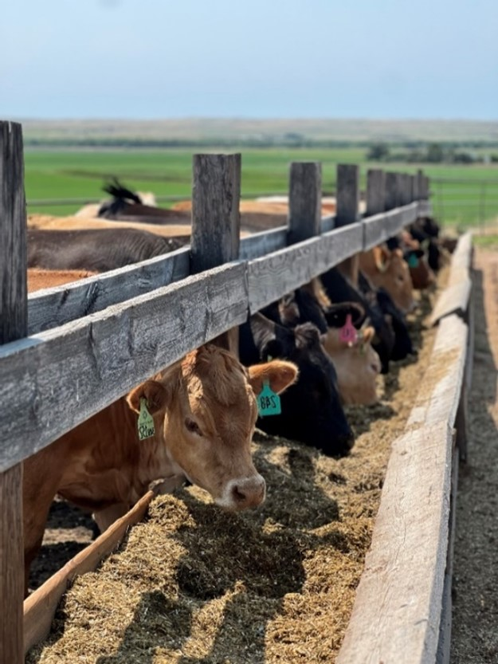
Figure 5 Feedyard in Colorado feeding a pasture-based ration (Source: Author)

Integration through the supply chain

Continuity and stabilisation
Australia’s feedlot industry plays a vital role in maintaining continuity across the beef supply chain, particularly during climatic extremes. In a production landscape dominated by seasonality, variable pasture conditions, and export-oriented throughput requirements, feedlots offer consistency in both volume and timing of turnoff. This stabilising function not only supports processors and exporters but underpins broader national food security and economic resilience.
The importance of this buffer becomes most visible during drought. In the absence of adequate rainfall, large volumes of cattle are often turned off prematurely, overwhelming traditional markets and placing downward pressure on prices. Feedlots provide an essential circuit-breaker by absorbing these surpluses and maintaining a flow of finished cattle. This helps prevent over-supply at saleyards and ensures that processors can maintain throughput, thereby protecting jobs, preserving infrastructure efficiency, and honouring Australia’s international market commitments. According to ALFA and MLA, cattle on feed surged past 1.45 million head during the 2024 drought, a record that reflected both strategic expansion and a reliance on feedlots to maintain market flow (ALFA, 2025; ABARES, 2024).
Without feedlots, the economic consequences of drought would likely be more severe. Historical market data from MLA's National Young Cattle Indicator (NYCI) shows how drought periods have influenced saleyard prices over time. During the 2002–2003 drought, average prices hovered around 149 c/kg, with a modest overall decline of 5.4%. By 2018–2019, average prices were considerably higher (258 c/kg) but still fell by 13.1% over the course of the drought. In the most recent drought affecting large parts of southern Australia (2023–2024), prices started from a historically high base of 462 c/kg but declined steeply by 28.0% as widespread destocking occurred. This, combined with the slow recovery from the previous drought, underscores the increasing volatility in the system and the critical role feedlots play in softening the supply shock. The ability of feedlots to take on large intakes during these periods is one of the few structural tools available to prevent total market collapse for young cattle.
This trend is illustrated in Figure 3 and Table 4, which show NYCI price trends across three major drought events. While prices fell in all periods, the presence of feedlot capacity, particularly in 2018–2019 and 2023–2024, contributed to buffering some of the economic fallout, especially by providing an outlet for unfinished or early weaned cattle that may otherwise have inundated saleyards. At face value, the percentage declines during the 2018–2019 and 2023–2024 droughts appear larger than in 2002–2003. However, this must be viewed in context. In 2002–2003, prices were already at a low base (around 180 c/kg), with limited room to fall. More recent droughts began with significantly higher baselines, reflecting stronger demand, global positioning, and structural improvements across the supply chain. Despite a 28% decline during the 2023–2024 drought, prices remained well above historical levels, with averages holding at 325 c/kg. This suggests that feedlot demand helped maintain price support, even amid severe seasonal destocking and market uncertainty.
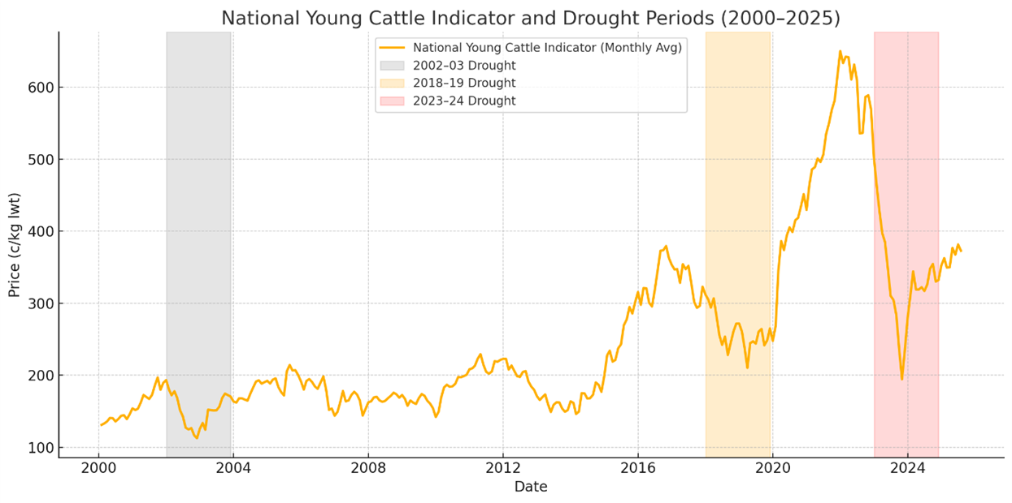
Figure 6 Cattle prices represented via the National Young Cattle indicated with highlighted drought periods (MLA NLRS, 2024).
Table 4 Cattle price changes over recorded drought periods.
Drought Period | Start Price (c/kg) | End Price (c/kg) | Average Price (c/kg) | Percent Change (%)
2002–2003 Drought | 180.2 | 170.5 | 149.4 | −5.4%
2018–2019 Drought | 305.1 | 265.1 | 258.4 | −13.1%
2023–2024 Drought | 461.6 | 332.2 | 325.6 | −28.0%
In parallel, feedlots have become a central element of vertically integrated beef supply chains. Many major processors and exporters now rely on contracted or owned feedlots to ensure supply continuity. This is especially important for chilled beef exports to premium markets such as Japan, Korea, and China, which demand consistent volumes regardless of pasture conditions. Integration of feedlots into these models reduces exposure to on-farm climate variability and ensures that supply commitments are met- even during drought. This not only supports processor operations but strengthens Australia's reputation as a reliable supplier at times when global competitors face similar seasonal constraints.
Feedlots also enhance supply chain flexibility. In drought-affected years, they offer producers an alternative to selling light or unfinished cattle. Custom feeding programs and backgrounding arrangements allow animals to be fed to target specifications and marketed with greater control. The use of staging facilities adds further resilience, helping to manage bottlenecks and regulate cattle flow. MLA’s best practice guidance emphasises how these systems contribute to smoothing saleyard demand, reducing volatility, and maintaining processor continuity during climate-induced supply fluctuations.
Viewed through the lens of drought resilience, feedlots serve not merely as finishing systems but as key infrastructure for economic and supply chain stability. They reduce volatility, offer producers marketing options, and allow processors to manage throughput and quality control. These are functions that are increasingly critical in a variable and resource-constrained climate.

Case Study: Integrated drought resilience – Jandaia, Brazil
Brazil’s beef industry is increasingly reliant on feedlots to maintain supply chain continuity under variable climate conditions. In 2023, Brazil processed approximately 34.06 million head of cattle, its second-highest volume ever, and exported a record 2.01 million tonnes of fresh beef, maintaining its position as the world’s largest beef supplier by export tonnage (IBGE, 2023). Roughly 6.9 million cattle (about 16.6% of total slaughter) were finished in feedlots in 2023, illustrating the growing role of intensive finishing systems in Brazil’s export strategy (IBGE & ABIEC, 2023).
During my visit to central-west Brazil in May 2024, drought conditions were prevalent, and feedlots were operating at near capacity. A leading Brazilian packer had established a “transparent livestock platform” to ensure continuity of supply, traceability and avoid sourcing from deforestation-linked regions. Producers participating in the program were supported in meeting weight specifications through on-farm finishing and lotfeeding, benchmarked against peer performance.
At Jandaia Farms, cattle were finished using a regionally developed ration consisting of whole corn, sugarcane silage, and a liquid supplement. This mix allowed Nelore cattle to achieve an average daily gain of 1.4 kg/day without needing a milling system. Remarkably efficient, the system reduced capital dependency and provided strong returns even during dry conditions. The main operational risk on the farm was predation, by jaguars and cougars, not nutritional stress, underscoring resilience built into the system.
This vertically integrated model provided the packer with a reliable supply stream and strengthened producer resilience. Participating farms were benchmarked for performance and feed conversion, helping to professionalise finishing practices in a traditionally extensive grazing context. The approach helped maintain both productivity and export flow during drought, reinforcing the effectiveness of integrated feedlot systems in buffering seasonal supply shocks.
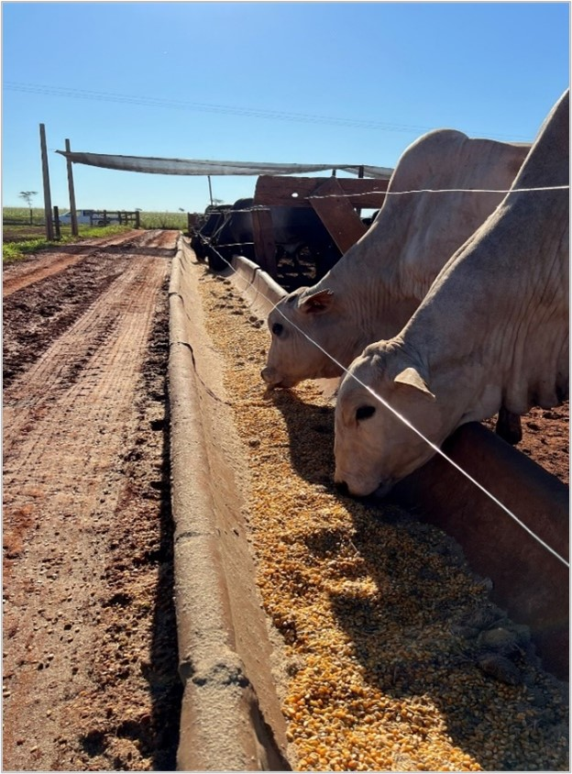
Figure 7 Farm in Brazil feeding a ration based around whole corn. (Source: Author)

Drought as a catalyst for change

Comparative responses across continents
Drought has become a recurring trigger for transformation in beef supply chains worldwide. While the impacts are shared, the responses by producers, feedlots, and policy makers vary considerably across regions, shaped by climate, market structure, government policy, and risk appetite. Comparing how Australia, Canada, Brazil, and the United States have responded to recent droughts highlights the diversity of adaptation strategies and offers insight into where feedlot systems have accelerated investment and reform.
In Australia, drought has consistently acted as a catalyst for operational change. The feedlot industry has grown in direct response to climatic volatility, with cattle on feed doubling since 2010 and surging again during the 2024 drought (ALFA, 2025). Australian feedlots responded to recent droughts by expanding intake capacity, investing in silage infrastructure, and shifting procurement to lighter, unfinished cattle. Tools such as staging facilities and custom feeding programs have become more common. Unlike North America, Australian responses are predominantly industry-led, with limited direct government intervention beyond drought relief and infrastructure rebates. The National Feedlot Accreditation Scheme (NFAS) also formalises contingency planning, requiring feedlots to maintain risk registers and response protocols for events such as drought and flood.
In Canada, climatic extremes are more predictable but no less disruptive. Alberta’s feedlot sector, which finishes the majority of Canadian cattle, has evolved to withstand both severe cold and extended dry spells. During the 2021–2023 drought period, Canadian feedlots deployed a combination of physical and procurement strategies: pen mounding to reduce surface runoff, roller compacted concrete to preserve yard stability, and strategic purchasing across provincial lines. Large operations cited “flexibility as their core resilience strategy” regularly adjusting between barley, corn, and wheat-based rations based on global tariffs and feed grain pricing. Government-backed drought insurance and access to concessional loans supported liquidity during periods of elevated feed costs.
In Brazil, drought has historically affected the extensive grazing sector more than intensive systems. However, recent years have seen drought stimulate a rise in confined feeding and grain-assisted systems, particularly in the central-west. An observed response on multiple cattle-farming properties to the 2024 drought was to adopt a fully confined system based on whole corn and sugarcane silage, a ration developed based on easily available ingredients. This pivot, supported by processor investment, allowed continuity of supply into premium beef programs despite widespread pasture failure. Notably, Brazil’s drought response is increasingly market-driven with packers co-investing in feed infrastructure and long-term supply agreements to secure product consistency.
In the United States, feedlots are embedded in an industrialised beef supply chain and often vertically integrated with packers. Drought response tends to focus on feed access and throughput management. During the 2022–2023 western drought, U.S. feedlots adapted by increasing their reliance on co-products (e.g. DDG, almond hulls), altering intake weights, and reducing days on feed. However, the burden of drought in cow-calf regions was often passed down the chain, leading to increased placements in commercial yards as pastureland failed. Policy support in the United States has been largely indirect, via subsidised crop insurance and infrastructure financing. Programs such as the Federal Crop Insurance Program (FCIP), the Livestock Forage Disaster Program (LFP), and the Emergency Conservation Program (ECP) provide financial support during drought but are not feedlot-specific and often operate downstream from intensive production systems (USDA, 2024; ERS, 2024; Farmers.gov, 2024).
What distinguishes these responses is the trigger for adaptation. In Brazil and Australia, drought has driven structural expansion of the feedlot sector itself. In Canada and the U.S., it has prompted refinement within an already mature feedlot infrastructure. Public-private alignment varies: Australia and Brazil rely heavily on processor or producer investment, while North America features stronger safety nets and subsidised financing mechanisms.
Across all systems, feedlots have proven to be essential not just in finishing cattle, but in sustaining supply chain continuity through drought. Their ability to buffer seasonal disruption, support regional economies, and adapt ration strategies in response to feed scarcity positions them as a cornerstone of drought resilience in the beef sector globally.

Investment in resilience and recovery
Drought events, while disruptive, have historically served as inflection points for capital investment and strategic reform within Australia's feedlot sector. As seasonal volatility increases, feedlots have emerged as key sites of adaptation, channelling investment into infrastructure, procurement systems, and operational continuity. This investment is not only reactive, but increasingly anticipatory: aiming to reduce future exposure and capture market opportunity in a more uncertain climate.
In response to the 2018–2019 and 2023–2024 droughts, many Australian feedlots prioritised infrastructure upgrades including permanent shade, covered pens, effluent management, and dedicated silage storage to secure feed and reduce heat stress risks (ALFA, 2023; MLA, 2024). These site-level investments were often accompanied by internal workforce retention strategies and more flexible, long-term procurement models such as backgrounding partnerships and forward supply agreements with breeders. On a broader scale, co-investment between processors and lotfeeders has grown, with some exporters offering deferred pricing and custom feeding options to support continuity during seasonal destocking. Access to government rebates and grants through ALFA, MLA, and state drought support schemes further accelerated investment in water security and feed handling infrastructure (NSW Government, 2021; ALFA, 2023).
What distinguishes recent drought periods is not only the scale of impact but the speed at which feedlots have responded with capital upgrades and operational shifts. These responses reflect a maturing view of resilience, not as a one-off adaptation, but as an ongoing investment in system integrity, market stability, and social license. In this way, drought has become both a test and a trigger for innovation across Australia's grain-fed beef sector.

Infrastructure’s return on investment
Drought has accelerated the reclassification of feedlot infrastructure from optional to essential. As climate volatility increases, operators are prioritising systems that mitigate risk and protect operational continuity, particularly during heat, wet weather, and feed shortages. According to the MLA’s Regional Feedlot Investment Study Update (2018), the national feedlot industry’s direct and indirect contribution to Australia’s GDP in 2017 was approximately $4.4 billion, and modelling indicated that the economy without feedlots would experience a GDP reduction of $10.3 billion. This demonstrates that investment in feedlot infrastructure not only supports on-farm and processing efficiency but also underpins substantial regional economic value and national resilience.
Shade structures have seen the most widespread adoption. MLA-supported studies indicate that shade can improve average daily gain (ADG) by up to 0.2 kg/day in summer and reduce mortality during heat events, particularly in high-density pens (MLA, 2017). Some vertically integrated processors now require shade in supply chains during high-risk periods, recognising its impact on carcase quality and welfare compliance (ALFA Shade Policy, 2023). Covered pens, though higher in capital cost, are increasingly used in wetter or winter-dominant regions. They improve pen hygiene, reduce bedding costs, and support animal performance during rain events. ALFA case studies suggest they are particularly cost-effective where environmental regulations or high stocking densities apply (ALFA, 2023).
Increased capacity of on-site feed storage, primarily silage bunkers have also gained traction, particularly since the 2018–2019 drought. On-site storage allows operators to secure bulk roughage and grain during harvest, mitigate exposure to freight surges, and maintain ration flexibility. These investments also contribute to NFAS audit compliance, especially where contingency feed reserves must be demonstrable (MLA, 2024).
The return on these investments is not always immediate, but their value becomes clear during climatic shocks. Feedlots that invested early in infrastructure upgrades were better positioned to absorb increased cattle during the southern 2023–2024 drought, maintain compliance with NFAS and environmental standards, and continue meeting export program specifications with minimal disruption. In this context, ROI is best measured not in year-on-year margin gains, but in sustained throughput, avoided losses, and system reliability.
As droughts become more frequent and intense, infrastructure planning is no longer a contingency exercise, it is central to business continuity. The feedlot sector’s ability to operate under stress increasingly depends on these embedded systems, and the broader beef supply chain relies on them to uphold market access and production certainty.

Conclusions
As Australia’s climate becomes increasingly variable and unforgiving, the ability of the red meat industry to maintain throughput, market access, and consumer confidence depends on infrastructure and systems that can operate under pressure. Feedlots have demonstrated their value not only as efficient finishing facilities, but as integral tools of drought resilience, economic stability, and supply chain continuity.
This report has shown that feedlots provide more than just grain-fed beef, they offer strategic flexibility across regions, breeds, and ration designs. Their capacity to absorb market shocks during drought, smooth price volatility, and uphold Australia’s export commitments makes them essential infrastructure in a supply chain exposed to seasonal extremes. Programs such as the National Feedlot Accreditation Scheme (NFAS) ensure that this resilience is underpinned by integrity, animal welfare, and verified traceability, building trust in both domestic and global markets.
Globally, countries have taken different approaches to climate adaptation in beef production. However, a common thread is the importance of vertically integrated systems, flexible feeding strategies, and certification frameworks that can operate in crisis. Australia's feedlot industry already exhibits these strengths but will need to continue evolving in response to public scrutiny, policy shifts, and trade expectations.
Looking forward, resilience will not be achieved through a single intervention, but through the continued refinement of systems that connect on-farm decisions to end-market demands (Recommendations: For Producers refers). In this context, feedlots are not the problem, they are part of the solution. When well-managed, transparent, and responsive, feedlots are a cornerstone of a drought-ready, market-driven Australian beef sector.
In the early days of the Australian feedlot industry there were secrets. It wasn’t until neighbouring lot feeders started talking that they realised they all had the same secrets (Andrew Herbert).

Recommendations
For producers:
- Prioritise drought preparedness – Invest in scalable strategies such as grain-on-hand programs, water security audits, or backgrounding arrangements that offer flexibility during seasonal volatility.
- Engage with certification schemes – Participation in verified supply chain programs builds long-term market access and trust.
- Leverage co-products and alternative feed sources – Monitor regional availability of cost-effective ration additions such as DDGs, silage, or locally grown pulses to manage input volatility.
- Invest in infrastructure where ROI is proven – Covered pens, silage pits, and feed efficiency systems show clear returns in drought periods.
- Share learnings – Participate in benchmarking initiatives and supply chain platforms that improve industry transparency and resilience.
For feedlot operators:
- Maintain and adapt NFAS standards – Continue to evolve quality assurance systems to encompass emerging demands such as scope 3 emissions, biosecurity, natural capital, climate resilience, and digital traceability.
- Improve integration with producers and processors – Collaborate upstream and downstream to enhance supply coordination, particularly during climatic extremes.
- Enhance data capture and analysis – Invest in technologies that monitor animal health, feed conversion efficiency, and supply continuity to inform decision-making in dry times.
- Explore differentiated market access – Feedlots can explore value-based supply chains, diversification is resilience.
For industry organisations:
- Champion feedlots as resilience infrastructure – Reinforce the role feedlots play in smoothing drought shocks, stabilising supply, and protecting Australia’s beef brand.
- Invest in cross-sector knowledge exchange – Encourage collaboration between pasture-based and feedlot-based operations to share drought mitigation tools and rotational feeding systems.
- Ensure consistency in messaging – Promote facts about environmental impact, welfare outcomes, and feed efficiency to counter misinformation and align with shifting consumer expectations.
- Facilitate market-driven innovation – Support research into sustainable finishing systems, circular economy feed inputs, and climate-adapted breeds.
For policymakers:
- Support infrastructure investment – Recognise feedlots as essential supply chain nodes and offer incentives for shovel-ready upgrades such as shelter, water reuse, and regional feed hubs.
- Incentivise drought-ready systems – Ensure public grants, finance products, and resilience plans acknowledge both feedlots and pasture systems that proactively mitigate climate risk.
- Enable flexible land use planning – Support feedlot expansion or adaptive approvals during declared drought to ensure timely market absorption of turn-off cattle.
- Improve alignment between commercial certification and national sustainability goals – Encourage greater communication and collaboration between feedlot operations and industry-wide sustainability frameworks to ensure feeding systems are represented in food security, climate resilience, and environmental reporting discussions. This includes better integration with commodity-specific ESG metrics and whole-of-sector sustainability commitments.
For consumers and retailers:
- Recognise drought impact on supply chains – Support transparency around supply challenges and maintain trust during market volatility.
- Champion whole-of-chain programs – Source from suppliers engaged in recognised welfare, environmental and traceability programs - grain-fed, pasture-fed or integrated.
- Avoid false dichotomies – Encourage evidence-based understanding that both pasture and grain-based systems have a role in a resilient, climate-adapted food system.

References
ABARES 2024, Agricultural commodities: March 2024, Australian Bureau of Agricultural and Resource Economics and Sciences, Canberra, accessed 2 June 2025.
ALFA 2023, ALFA drought policy and infrastructure case studies, Australian Lot Feeders’ Association, Brisbane, accessed 2 June 2025.
ALFA 2025, Quarterly cattle on feed statistics, Australian Lot Feeders’ Association, Brisbane, accessed 2 June 2025.
AUS-MEAT 2022, Animal raising claims framework for beef production in Australia, AUS-MEAT Limited, Murarrie, Queensland, accessed 2 June 2025.
AUS-MEAT n.d., Australian meat industry classification system, AUS-MEAT Limited, Murarrie, Queensland, accessed 3 June 2025.
Beauchemin, KA, McGinn, SM & Rode, LM 2001, ‘Effects of barley grain processing on the site and extent of digestion in beef feedlot finishing diets’, Animal Feed Science and Technology, vol. 95, nos 1–2, pp. 23–38.
Behrendt, K & Weeks, P 2019, How are global and Australian beef feedlots performing? Global agribenchmark network results 2018, Meat & Livestock Australia Limited, North Sydney, accessed 2 June 2025.
Beef Central 2025, ‘Lotfeeders developing best practice guidelines for managing extra cattle during droughts’, Beef Central, 30 June, accessed 15 June 2025.
Black, JL 2016, Nutritional strategies to improve feed conversion efficiency in cattle, report B.FLT.0391, Meat & Livestock Australia, North Sydney.
Cabral, LDS & Weimer, PJ 2023, ‘Megasphaera elsdenii: its role in ruminant nutrition and its potential industrial application for organic acid biosynthesis’, Microorganisms, vol. 12, no. 1, article 219, DOI: 10.3390/microorganisms12010219.
CanFax 2022, Statistics and insights on Canadian cattle feeding, CanFax, Calgary, accessed 2 June 2025.
Canadian Beef 2016, Canada’s beef advantage, Canada Beef, Calgary, accessed 2 June 2025.
Cozzi, G et al. 2022, ‘Comparative evaluation of grain processing technologies in feedlot rations’, Animal Feed Science and Technology, vol. 290, article 115344.
CSIRO 2021, Performance metrics in commercial feedlot systems, CSIRO, Canberra.
Economic Research Service 2024, USDA drought response programs, United States Department of Agriculture, Washington DC, accessed 15 June 2025.
IBGE & ABIEC 2023, Brazilian beef industry statistics 2023, Instituto Brasileiro de Geografia e Estatística and Associação Brasileira das Indústrias Exportadoras de Carnes, accessed 15 June 2025.
Meat & Livestock Australia 2017, Feedlot shade structures: performance and cost-benefit analysis, report B.FLT.0540, Meat & Livestock Australia, North Sydney, accessed 3 June 2025.
Meat & Livestock Australia 2018, Regional feedlot investment study update, Meat & Livestock Australia, North Sydney, accessed 2 June 2025.
Meat & Livestock Australia 2019, NFAS standards manual, Meat & Livestock Australia, North Sydney, accessed 3 June 2025.
Meat & Livestock Australia 2021a, Co-product use in Australian feedlots, Meat & Livestock Australia, North Sydney, accessed 2 June 2025.
Meat & Livestock Australia 2021b, Feedlot finishing systems: nutrition and infrastructure, Meat & Livestock Australia, North Sydney, accessed 2 June 2025.
Meat & Livestock Australia 2022, Feedlot benchmarking insights, Meat & Livestock Australia, North Sydney, accessed 15 June 2025.
Meat & Livestock Australia 2023, Best practice guide for staging facilities, Meat & Livestock Australia, North Sydney, accessed 26 June 2025.
Meat & Livestock Australia 2024, Drought adaptation in lotfeeding systems, Meat & Livestock Australia, North Sydney, accessed 3 June 2025.
Meat & Livestock Australia n.d., Market information: National Livestock Reporting Service, Meat & Livestock Australia, North Sydney, accessed 2 June 2025.
Moya, D et al. 2011, ‘Effects of tempering barley grain on feedlot performance and digestibility’, Journal of Animal Science, vol. 89, no. 7, pp. 2517–2523.
NFAS 2024, National Feedlot Accreditation Scheme overview, National Feedlot Accreditation Scheme, accessed 3 June 2025.
NSW Environment Protection Authority 2024, Local government air quality toolkit – beef cattle feedlots, NSW Environment Protection Authority, Sydney, accessed 15 June 2025.
NSW Government 2021, Managing drought, fire and flood, NSW Government, Sydney, accessed 26 June 2025.
Owens, FN, Secrist, DS, Hill, WJ & Gill, DR 1997, ‘The effect of grain processing on performance of feedlot cattle’, Journal of Animal Science, vol. 75, no. 4, pp. 868–879.
Queensland Government 2022, Environmental Protection Act 1994, Queensland Government, Brisbane, accessed 26 June 2025.
US Department of Agriculture 2024, Federal crop insurance and livestock programs, United States Department of Agriculture, Washington DC, accessed 3 June 2025.
Zinn, RA, Barreras, A, Owens, FN & Plascencia, A 2011, ‘Performance by feedlot steers fed flaked corn versus whole shelled corn’, Professional Animal Scientist, vol. 27, no. 5, pp. 449–455.

