**Carbon Farming Outreach Program   
training package**

Topic 1

© Commonwealth of Australia 2025

**Ownership of intellectual property rights**

Unless otherwise noted, copyright (and any other intellectual property rights) in this publication is owned by the Commonwealth of Australia (referred to as the Commonwealth).

**Creative Commons licence**

All material in this publication is licensed under a [Creative Commons Attribution 4.0 International Licence](https://creativecommons.org/licenses/by/4.0/legalcode) except content supplied by third parties, logos and the Commonwealth Coat of Arms.

Inquiries about the licence and any use of this document should be emailed to [copyright@dcceew.gov.au](mailto:copyright@dcceew.gov.au).



**Cataloguing data**

This publication (and any material sourced from it) should be attributed as: DCCEEW 2025, *Carbon Farming Outreach Program training package: Topic 1*, Department of Climate Change, Energy, the Environment and Water, Canberra. CC BY 4.0.

This publication is available at <https://www.dcceew.gov.au/climate-change/emissions-reduction/agricultural-land-sectors/carbon-farming-outreach-program-training-package>.

Department of Climate Change, Energy, the Environment and Water

GPO Box 3090 Canberra ACT 2601

Telephone 1800 920 528

Web [dcceew.gov.au](https://www.dcceew.gov.au)

**Disclaimer**

The Australian Government acting through the Department of Climate Change, Energy, the Environment and Water has exercised due care and skill in preparing and compiling the information and data in this publication. Notwithstanding, the Department of Climate Change, Energy, the Environment and Water, its employees and advisers disclaim all liability, including liability for negligence and for any loss, damage, injury, expense or cost incurred by any person as a result of accessing, using or relying on any of the information or data in this publication to the maximum extent permitted by law.

Contents

Carbon Farming Outreach Program training package 4

Topic 1: Introducing carbon farming 9

1.1 Overview and learning outcomes 10

1.2 Carbon farming reduces emissions, stores carbon 14

1.3 Carbon farming is good for business, good for the environment and Country 15

1.4 How carbon farming responds to climate change 22

1.5 Reducing emissions 24

1.6 Increasing carbon storage 32

1.7 Key concepts 35

1.8 Case study 37

1.9 Actions: What might you do? 40

1.10 Other resources 41

# Carbon Farming Outreach Program training package

The Carbon Farming Outreach Program training package provides information to help farmers and land managers make decisions about reducing greenhouse gas (GHG) emissions and storing carbon.

The training package comprises 5 topics:

Topic 1: introducing carbon farming
Topic 2: What carbon farming means for farmers and land managers
Topic 3: Your greenhouse gas account
Topic 4: Planning carbon farming activities
Topic 5: The Australian Carbon Credit Unit Scheme

## Watch these videos

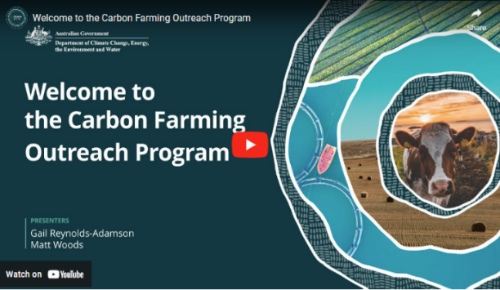In this video (4:38 minutes), presenters Gail Reynolds-Adamson and Matt Woods introduce the Carbon Farming Outreach Program, and the training package structure and content.

Video: [Welcome to the Carbon Farming Outreach Program (youtube.com)](https://www.youtube.com/watch?v=CmsO5OI_53U)

|  |
| --- |
| **Transcript** |
| GAIL REYNOLDS-ADAMSON: Hi, and welcome to Carbon Farming Outreach Training package.  Kaya Kepa Kurl Noongar Boodja. My name is Gail Reynolds-Adamson, and I'm a proud Noongar woman from Wudjari Country, on the eastern border of the Noongar nation in Kepa Kurl, also known as Esperance. 'Kepa' is water, 'Kurl' is boomerang, and its where the waters lie like a boomerang.  MATT WOODS: Hi, Gail, and welcome, everyone. I'm Matt Woods, an agricultural and science journalist.  Today, we're at my home, outside Bacchus Marsh, on the border of Wurundjeri, Woiwurrung, and Wathaurong Country of the Kulin Nation, and I pay my respects to Elders past, present, and future.  In the valley below me is the Bacchus Marsh agricultural district, where market gardeners and orchardists farm some of the deepest top soil in Australia.  I've been on hundreds of farms and spoken to thousands of farmers from one end of Australia to the other. And if there's one subject top of mind for every farmer, it's profitability.  And that's actually what this training package is about. Because, in most cases, good carbon farming practices will improve the profitability and health of your land. Whether you want to enter the carbon market or not, the truly great outcome with carbon farming is that it can be a win-win: good for your farm business, land, and the environment.  REYNOLDS-ADAMSON: Thanks, Matt. It's great to be part of this Carbon Farming Outreach Program training package, and to be able to share with farmers and land managers from all over Australia some of the who, what, when, where, and why, of carbon farming.  This includes evidence-based knowledge and practices both from Western and traditional Aboriginal Torres Strait Islander culture.  I'm the chairperson of Esperance Tjaltjraak Native Title Aboriginal Corporation in Western Australia. I'll be sharing more about the tree rejuvenation project we are running at Kardutjaanup to show you the many benefits, but also the risk requirements involved with this type of carbon farming.  WOODS: The aim of this package, through five short topics, is to give you the carbon farming essentials from expert practitioners, farmers, and land managers in all Ag (agriculture) sectors across Australia, like Gail, who've already embarked on carbon farming projects.  They'll share some tips and tricks with you, including why and how they did it, what technology and techniques they used, what worked, what didn't and who helped them along the way. We've also carefully researched and selected resources, materials, and tools that may benefit you and presented them by Ag (agriculture) sector and location for your convenience.  We know that you don't have loads of time to spend sitting in front of a computer. And that you need your learning to be relevant, targeted, accessible, and practical.  Each of the five topics should take you no more than one hour individually.  But we've also provided additional content and case studies if you want to find out more.  Short videos like this, as well as interviews and explainers, will allow you to access this package anywhere, anytime.  REYNOLDS-ADAMSON: The Carbon Farming Outreach Program training package won't make you an expert in carbon farming, but it will teach you the essential things you should know before embarking on carbon farming.  This includes benefits and risks, potential pathways to action, and the decision you will need to make, including whether or not to trade carbon credits, and some resources you can refer to for your location and type of practice. Importantly, we will help you to understand who you should talk to, what you should look out for when you are choosing advisors, and to ensure that you are getting quality, trusted, independent advice.  WOODS: Finally, each topic concludes with some relevant focusing questions, for you to consider in relation to your own circumstances.  Whether you're just learning about carbon farming for the first time and are exploring your options or had some experience and want to find out more, this package can help you. Think of it as like having a yarn with your neighbours over the fence about their carbon farming project. |

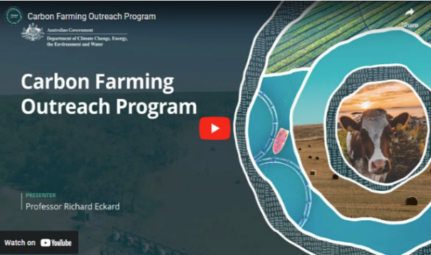

In this video (4:03 minutes), Professor Richard Eckard discusses the need for carbon farming.

Video: [Carbon Farming Outreach Program (youtube.com)](https://www.youtube.com/watch?v=TwaAPwsxYHY&t=25s)

|  |
| --- |
| **Transcript** |
| PROFESSOR RICHARD ECKARD: For farmers and land managers to meet the goal of reduced emissions starting in 2030 through to 2050, they need to know what to do next, what steps to do next, and they need to know where the policy environment is coming from, who's asking them to be low emissions, what the targets are, and then what the options are for them to start responding.  Hi. I'm Richard Eckard, professor in the Faculty of Science at the University of Melbourne. I lead the Primary Industries Climate Challenges Centre, which researches the impact of climate change on agriculture and agriculture on climate.  What we're seeing is all the multinational supply chain companies that deal with agricultural produce have set targets, targets for reduced greenhouse gas emissions. And they average somewhere around 30 percent less emissions by 2030 and net zero by 2050. What we also know is about 70 percent of Australian agricultural produce is exported down these multinational supply chain targets. And so how does Australia perform on the global stage when those companies start buying globally to meet their target?  So it's really imperative that farmers and land managers get on board to know how do they gear their system to deliver the low emissions product that the supply chain will want to buy by 2030. What we're trying to do is just bring up the knowledge that carbon farming is a part of their future.  There is this trajectory towards lower emissions. So making them aware of the policy environment, of the supply chain constraints, of how they need a partnership with their supply chain, to achieve this. And then some awareness of what is their number, how do they get their number, and how do they move down the track towards improving that number. And what are the technologies they can bring to bear to reduce their number, their greenhouse gas footprint?  So these will be things to start with are just best practice. Best practice that we've known for the last 40 years. Things like nitrogen use efficiency, better crop yields, better soil testing, better growth rates in livestock, feeding animals better, bringing legumes into agriculture. These are all things we've known for a long time that improve efficiency, but also reduce the greenhouse gas footprint.  Australia is already 22 percent more rainfall variable than any other country in the world, and the historic management of the land took that into account. Now we're becoming aware of this in how we do carbon farming, that we have to actually change from strictly European farming systems to systems that are more attuned to this high variability we're encountering. And so there's a lot to be learned from the Indigenous land management practices that we need to then incorporate into traditional farming, non Indigenous farming, so that it actually is a bit more in tune with the high variability we have in Australia.  Now the world needs to go net zero by 2050. What we haven't really reconciled is where does the big emission reduction take place? Obviously, it has to happen in the fossil fuel sector.  But we need to move towards, well, what can agriculture contribute to that inevitable net zero? And what can they contribute towards the 2030 goal? Now not every agricultural sector has the identical opportunity. We've got some intensive horticulture for example that have very low emissions and almost nothing to do to get to net zero apart from renewable energy. But you've got an extensive livestock sector where a lot of northern cattle stations, we don't even know how many cattle are there. So the challenges are vastly different, and this is what the program is trying to address is who has what options to move forward and what are those options. |

## Using this training package

This training package provides introductory information, and sources of further information and advice. References to third-party material, information or products or services do not represent endorsements. This training package does not provide detailed information that farmers and land managers may need when making decisions about carbon farming for their own particular circumstances. This training package is not a substitute for independent professional advice. Before making decisions about carbon farming, you may need to obtain more information and independent advice relevant to your particular circumstances.

**Acknowledgement of C****ountry**

The Australian Government acknowledges the Traditional Owners and custodians of all the lands across Australia. We pay respect to all Aboriginal and Torres Strait Islanders, including elders, past and present. We also express our gratitude and appreciation for the ongoing stewardship of Country that Aboriginal and Torres Strait Islanders have practised for thousands of years. We understand that we all have much to learn from traditional ways of knowing, being and doing.

**Statement of intent**

This training package has been developed in consultation and collaboration with an Aboriginal and Torres Strait Islander reference group. We thank them for their generosity with time, expertise, and patience. We recognise Aboriginal and Torres Strait Islanders as rights holders and value the opportunity for Aboriginal and Torres Strait Islanders to engage with farmers and land managers in meaningful dialogue to weave traditional practices into carbon farming. Aboriginal and Torres Strait Islanders offer invaluable traditional ecological knowledge that complements the expertise of other farmers and land managers. Together, farmers, land managers and Aboriginal and Torres Strait Islanders are practising carbon farming methods that respect traditional insights and modern science. As co-innovators, we are exploring new pathways to reduce carbon footprints through joint carbon farming initiatives and preserving the land for future generations.

Aboriginal and Torres Strait Islander people should be aware that this website, the videos it contains and links to First Nations resources may contain images, voices and names of deceased persons.

# Topic 1: Introducing carbon farming

## Time to complete this topic

About 60 minutes to read the information in this topic. Additional content includes videos, activities and links to other resources which may require extra time to complete.

In this topic:

### Overview and learning outcomes

## Overview

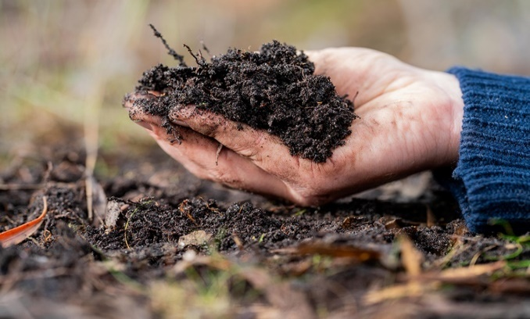Topic 1 introduces carbon farming, carbon farming activities, and their purposes, which include:

* reducing emissions
* storing more carbon
* delivering economic and other co-benefits to farmers and land managers, the environment and communities.

This topic introduces key concepts from the farmer’s and land manager’s viewpoint: how increasing carbon storage on their land and reducing emissions from their operations helps reduce their carbon footprint. It introduces carbon accounting, tools and calculators to estimate a carbon footprint.

The topic explains how Aboriginal and Torres Strait Islander people (Australia’s First Peoples, referred to in this program as First Nations people) have cared for Country for over 60,000 years and that carbon farming activities can potentially align First Nations peoples’ traditional knowledge and recent science-based farming and land management methods.

The topic drills down into increasing carbon storage (sequestration) by explaining the carbon cycle, soil organic carbon, the greenhouse effect, and climate change. It examines the agriculture sector’s emissions profile, which is mostly methane and nitrous oxide emissions.

The topic concludes by explaining ‘carbon neutral’, ‘net zero emissions’ and possible pathways for action — earning Australian Carbon Credit Units (ACCUs) under the Australian Carbon Credit Unit Scheme (ACCU Scheme) and gaining Climate Active certification — while recognising some farmers and land managers will choose to do neither.

## Learning outcomes

After completing this topic, you will be able to:

* describe carbon farming and carbon farming activities
* classify greenhouse gas (GHG) emissions and carbon sinks relevant to agriculture and land management
* explain how carbon farming can potentially align First Nations peoples’ traditional knowledge with recent science based farming and land management methods
* acknowledge the carbon cycle and nitrogen cycle, their relationship to GHGs, and their role in climate change
* outline key carbon farming-related concepts, including carbon neutrality, net zero emissions, Australian Carbon Credit Units (ACCUs), and Climate Active certification.

## Watch these videos

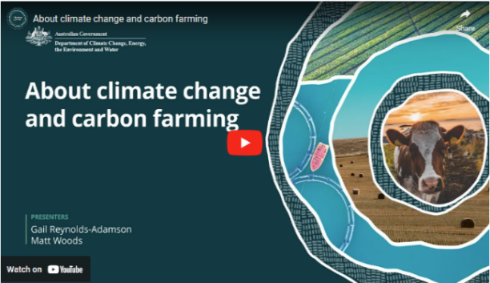In this video (3:59 minutes), presenters Gail Reynolds-Adamson and Matt Woods introduce Topic 1 and provide important context.

Video: [About climate change and carbon farming (youtube.com)](https://www.youtube.com/watch?v=7jSK94a-EZ8&t=1s).

|  |
| --- |
| **Transcript** |
| GAIL REYNOLDS-ADAMSON: In this first topic, we'll look at the basics of carbon farming, what it is, and why we need it. There are many different reasons why you might choose to carbon farm, and we will cover these benefits in the next topic.  But there's one reason why carbon farming is important, and it affects all of us. Yep. Climate change.  MATT WOODS: Now we know that we don't need to tell you how a warming planet, because of carbon and other emissions in the atmosphere, is playing havoc with our climate.  As farmers, you're experiencing firsthand increasingly severe and frequent extreme weather events like drought, fire, and floods that are negatively affecting your livelihoods.  The hard reality is that farming is part of the problem, with agriculture accounting for about 17 per cent of total greenhouse gas emissions in Australia.  The good news is that farmers can also be a big part of the solution, and carbon farming helps with this.  REYNOLDS-ADAMSON: Aboriginal and Torres Strait Islander people, like all First Nations people around the world, have been caring for our land for tens of thousands of years. We are connected to Country. We are part of the Country, and Country is part of us.  We take a holistic approach and acknowledge the importance of sustainable land management, emphasising health of our land, the well-being of the ecosystem, and the preservation of cultural heritage.  In short, through traditional land management practices, we care for Country and Country cares for us.  Of course, it's not only First Nations people who have a connection to this land and a desire to care for it. The beauty of carbon farming is it allows us to combine the best of both worlds, applying ancient cultural practices such as savanna burning with the Western scientific knowledge system.  Modern day technologies can help Indigenous and non-Indigenous farmers alike to reduce carbon emissions.  We've learned in our tree rejuvenation project there are different approaches that you can use to gain both financial and non-financial benefits.  WOODS: Carbon farming is also usually good for business.  Sequestering carbon and reducing greenhouse gas emissions can increase profitability.  Climate change and carbon credits aside, carbon farming can make sense for farmers and land managers if they want to improve their bottom line and the environment.  Selling carbon credits is a further option for land managers and farmers.  However, making money from carbon credits is complex and, like most ventures, has risks.  In this topic, we'll look at some basic climate science and the impact of agricultural greenhouse gas emissions.  We'll also explore carbon farming in more detail and the types of activities you can do to reduce greenhouse gas emissions in your sector.  In addition, we'll see some traditional First Nations practices, and finally, look at the difference between carbon credits and carbon neutral accreditation.  REYNOLDS-ADAMSON: We all have a connection to this land. For Aboriginal and Torres Strait Islander people, we know this is caring for Country, which we have done since time immemorial.  Now with climate change, we need to look at repairing Country for future generations.  Mother Earth does not see colour.  Collectively, we have a responsibility to repair our environment.  Let us share our knowledge and experiences to support each other to have a mutually beneficial outcome and leave this Country better than how we received it. |

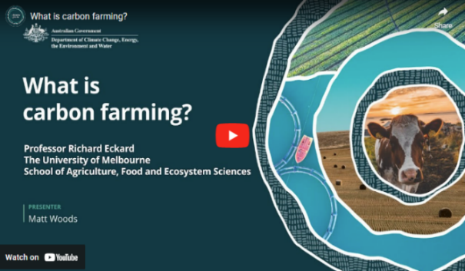In this video (2:13 minutes), Matt Woods and Professor Richard Eckard of the University of Melbourne discuss carbon farming in relation to carbon capture in plants through photosynthesis.

Video: [What is carbon farming? (youtube.com)](https://www.youtube.com/watch?v=YQ5dDtEb1y8)

|  |
| --- |
| **Transcript** |
| MATT WOODS: Hello. I'm Matt Woods, and I'm here with Professor Richard Eckard. Richard has been working for over 20 years on addressing the impacts of a changing climate on agriculture.  How would you describe what carbon farming actually is?  PROFESSOR RICHARD ECKARD: Well, ironically, carbon farming all farmers are in the carbon business because what most people don't realise is that almost half of all organic vegetation, this is wheat, pastures, any crops that we produce, almost half of it is carbon. So, actually, we're in the game of carbon conversion. We capture carbon out of the atmosphere through photosynthesis.  It takes CO2 out of the atmosphere, carbon dioxide, locks it into plants in carbohydrates. We either feed that to humans or feed it to animals. So, actually, all farmers are in the carbon business. We've just never asked the question, how do you be more efficient at that conversion process? How do we capture more carbon out the atmosphere into a better wheat crop, into a better pasture?  And then how efficient are we at converting that into a product that goes through to humans?  But also how are we efficient at capturing or leaving excess carbon in the soil to end up with a greater soil health? |

### 

### 1.2 Carbon farming reduces emissions, stores carbon

## Carbon farming activities reduce GHG emissions, sequester (store) carbon and provide co-benefits for farmers/land managers, the environment and communitiesCarbon farming

'Carbon farming' describes agricultural and land management activities that help mitigate climate change by:

* reducing emissions of the main GHGs: methane, nitrous oxide and carbon dioxide, by avoiding or minimising them
* storing more carbon — also called sequestering carbon — which means capturing and removing carbon dioxide from the atmosphere and storing carbon in 'carbon sinks': vegetation and soil. Carbon is stored in land and coastal ecosystems (such as mangroves).

Each carbon sink stores carbon differently. For example:

* in vegetation (such as trees and grasslands), carbon is stored in the stems, trunks and roots
* in soil, carbon is stored in living and dead organic material.

Topic 2 looks at the carbon farming activities in the following table.

**Carbon farming activities**

|  |  |
| --- | --- |
| **Group** | **Activity** |
| Soil | Conservation and strategic tillage Crop and pasture management Efficient fertiliser use |
| Livestock | Reduce beef and dairy cattle and sheep methane emissions Manage piggery and dairy effluent Grazing management |
| Vegetation | Afforestation  Reforestation Agroforestry Retain existing native vegetation |
| Blue carbon | Restore wetlands, saltmarsh and seagrass Remove or modify barriers to tidal flow |
| First Nations traditional ecological practices | Cultural burning, including savanna fire management |

### 1.3 Carbon farming is good for business, good for the environment and Country

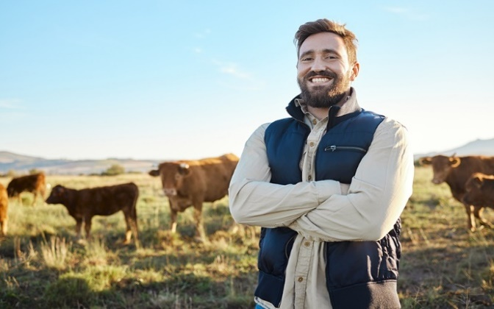Carbon farming not only benefits the climate by reducing GHG emissions and storing more carbon. It can also provide other benefits — called co-benefits — including:

* healthier and more productive soils, better managed and more productive livestock and pasture, better use of water
* more diversified income streams, increased income and the ability to deliver products for environmentally conscious supply chains, consumers and overseas markets pursuing emissions reduction or nature positive policies
* improved biodiversity and ecosystems, such as connected habitat and traditional ecological practices that maintain a balance between human activities and the natural environment
* stronger, more resilient communities, better quality food, more jobs, better-protected settlements and infrastructure, and better community health
* direct benefits for First Nations people, including meaningful jobs on Country, independent revenue, getting back to and caring for Country and protecting cultural sites, and indirect benefits, including meeting cultural obligations, strong governance, community cohesion, self-determination, pride in community, and healthy Country.

Industry and government sustainability plans

Agriculture industry bodies have developed or are developing sustainability plans, as the following table shows. These plans include reducing GHG emissions, increasing carbon storage, and achieving carbon neutrality.

**Agriculture sector sustainability plans**

| **Sector** | **Plan** |
| --- | --- |
| Beef, sheep | [Red Meat 2030](https://www.rmac.com.au/_files/ugd/50d783_c60d1519d2e34d609eff5830c7124450.pdf) (PDF 8.3 MB)  [Carbon Neutral by 2030 Roadmap](https://www.mla.com.au/globalassets/mla-corporate/research-and-development/program-areas/environment-and-sustainability/2689-mla-cn30-roadmap_d3.pdf) (PDF 2.9 MB)  [The Australian Beef Sustainability Framework](https://www.sustainableaustralianbeef.com.au/)  [Sheep Sustainability Framework](https://www.sheepsustainabilityframework.com.au/) |
| Cotton | [Australian Cotton Sustainability Framework](https://www.crdc.com.au/growers/sustainability) |
| Dairy | [Australian Dairy Sustainability Framework](https://www.dairy.com.au/sustainability/australian-dairy-sustainability-framework) |
| Grain | [Grains Research & Development Corporation Sustainability Initiative 2023](https://grdc.com.au/__data/assets/pdf_file/0039/587856/GRDC_SustainabilityInitiative_May2023.pdf) (PDF 4.6 MB) |
| Horticulture | [2023/24 Australian-Grown Horticulture Sustainability Framework](https://www.horticulture.com.au/contentassets/f629a21ab8514f16882f40764927d09f/2023-horticulture-sustainability-framework-003.pdf) (PDF 12.6 MB) |
| Pork | [Australian Pork Ltd Strategic Plan 2020–2025](https://australianpork.com.au/sites/default/files/2021-06/APL-Strategic-Plan-2020-2025.pdf) (PDF 4.4 MB) |
| Poultry | [Sustainability Framework Report 2020](https://www.australianeggs.org.au/assets/sustainability/Sustainability-Framework-Report-2020.pdf) (PDF 2.8 MB) (Australian Eggs)  [Chicken Meat Sustainability Strategy](https://chicken.org.au/our-sustainability/) (being developed by the Australian Chicken Meat Federation) |
| Rice | [AgriFutures Rice Program Strategic RD&E Plan 2021-2026](https://agrifutures.com.au/product/agrifutures-rice-program-strategic-rde-plan-2021-2026/?_ga=2.264660047.1742473296.1665961958-18030758.1652138167) |
| Sugar | [Sugar Research Australia Strategic Plan 2021–2026](https://sugarresearch.com.au/sugar_files/2021/07/210428_SRA-Strategic-Plan-2021-2026_Final-web_V2-spreads.pdf) (PDF 1.9 MB) |
| Wine | [Wine Australia Emissions Reductions Roadmap](https://www.wineaustralia.com/getmedia/409219da-5883-41db-a492-8534eb7cdc1f/WineAustralia_EmissionsReductionRoadmap.pdf) (PDF 8.6 MB) |

These industry initiatives complement efforts by Australian, state and territory governments to help farmers and land managers respond to climate change. These efforts include:

* Australian Government [climate change strategies](https://www.dcceew.gov.au/climate-change/strategies#annual-climate-change-statement), including a Net Zero 2050 plan currently being developed and the ACCU Scheme
* state and territory policies (such as [Cutting Victoria’s Emissions 2021–2025: Agriculture sector emissions reduction pledge](https://www.climatechange.vic.gov.au/victorian-government-action-on-climate-change/Agriculture-sector-pledge-accessible.pdf) (PDF 3.8 MB) and the New South Wales [Net Zero Plan](https://www.energy.nsw.gov.au/nsw-plans-and-progress/government-strategies-and-frameworks/reaching-net-zero-emissions/net-zero) and [Climate Change (Net Zero Future) Act 2023](https://www.energy.nsw.gov.au/nsw-plans-and-progress/government-strategies-and-frameworks/climate-change-net-zero-future-act-2023)
* state and territory programs (such as Queensland’s [Land Restoration Fund](https://www.qld.gov.au/environment/climate/climate-change/land-restoration-fund/about)).

Actions taken by governments are consistent with the [United Nations Framework Convention on Climate Change](https://unfccc.int/process-and-meetings/what-is-the-united-nations-framework-convention-on-climate-change), a framework for international cooperation and action to reduce GHG emissions and adapt to climate change impacts.

[First Nations communities protecting culture and Country](https://www.dcceew.gov.au/climate-change/emissions-reduction/agricultural-land-sectors/carbon-farming-outreach-program/training-package/topic-1/4-first-nations-traditional-ecological-practices)

Indigenous-owned carbon projects across Australia are making a huge difference to our lives through creating jobs and supporting opportunities for Indigenous people to care for country.

Cissy Gore-Birch and Dean Yibarbuk,  
 Indigenous Carbon Industry Network Co-Chairs

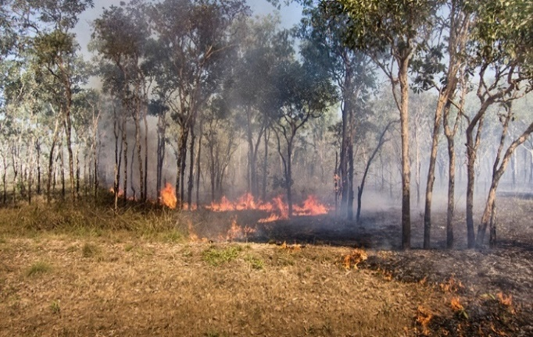First Nations traditional ecological practices are deeply ingrained with cultural, spiritual, and ecological knowledge, and they focus on sustainability, ecosystem balance, and health.

For example, cultural burning — lighting slow, ‘cool’ fires early in the dry season — reduces the risk of hot summer bushfires that produce greater quantities of GHGs. Cultural burning, which is just one of many such traditional practices, also improves the richness of species.

Carbon farming activities can potentially align First Nations peoples’ traditional knowledge and recent science-based farming and land management methods by:

* focusing on efficient water use and sustainable irrigation practices, which is important in our dry continent and increasingly necessary to adapt to climate change impacts
* emphasising the interconnectedness of people, land and ecosystems (such as regenerative agriculture, which integrates economic, social and environmental considerations)
* using low-intensity planned burning to create firebreaks and a mosaic of burnt and unburnt land.

Carbon projects offer First Nations land managers the opportunity to generate income to support the carbon project and/or other community initiatives. So far, this opportunity has been accessed mainly by First Nations groups undertaking savanna fire management in northern Australia. Topics 2 and 5 provide information on savanna fire management.

There are further opportunities for First Nations land managers around Australia to participate in carbon projects. Carbon projects must follow approved ACCU Scheme methods. Land sector management activities (covered by methods) most relevant to First Nations groups can include:

* Savanna fire management (emissions avoidance method, or sequestration and emissions avoidance method)
* seed or tubestock planting to re-establish native vegetation (Reforestation by environmental or mallee plantings method)
* removal of tidal restrictions (Tidal restoration of blue carbon ecosystems method).

The Indigenous Carbon Industry Network’s 2022 [Indigenous Carbon Projects Guide](https://www.icin.org.au/indigenous_carbon_projects_guide_downloads)(PDF 8.5 MB) provides more information about the carbon industry for First Nations people. It covers the carbon market, ACCU Scheme method and project requirements and planning, and running a carbon project. It also has information specific to First Nations people, including Indigenous rights and interests, co-benefits and the power of story.

## Watch these videos

[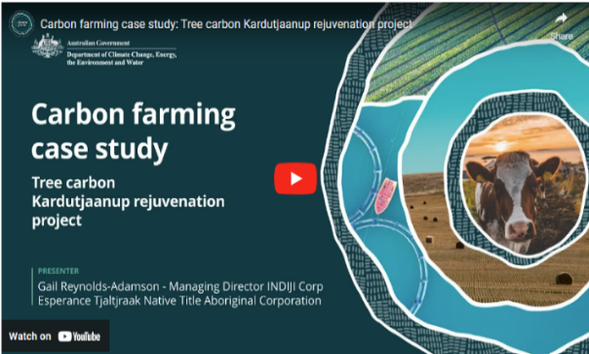](https://www.youtube.com/watch?v=KOfA8Mywkuk)In this video, (6:10 minutes), Gail Reynolds-Adamson shares her insights into some of the traditional practices and benefits for First Nations farmers and land managers.

Video: [Carbon farming case study: Tree carbon Kardutjaanup rejuvenation project (youtube.com)](https://www.youtube.com/watch?v=KOfA8Mywkuk)

|  |
| --- |
| **Transcript** |
| GAIL REYNOLDS-ADAMSON: So my name is Gail Reynolds-Adamson, I'm the chairperson for Esperance Tjaltjraak Native Title Aboriginal Corporation, and we're currently standing at Kardutjaanup, which is a property that we purchased a couple of years ago to look at carbon farming.  Our people have been doing carbon farming for millennia. We just didn't call it carbon farming back then. So where we are today is taking an ancient culture and applying modern technology to do the carbon farming and do it in different ways. So Tjaltjraak is a PBC and the PBC is a prescribed body corp, which once native title has been determined you set up a PBC for the organisation.  One of the issues that we found, with the organisation is that whilst we get a bundle of rights, there's nothing else that we get and so we had to look at innovative ways on how we can generate income into the future. Also, not only looking at generating income, but how do we look at it- do it in a sustainable way, and we do it in a way, which is, in line with us looking after Country and a part of our healthy Country plan. So the marriage between us and doing work in the carbon farming area was an area which we were interested in and certainly were like everything in the carbon farming, it's new. Each farm that we look at or each location that we look at, the technique that our specialists have to apply is quite different. But it's a way of us as an organisation to generate income into the future, and it's about self-determination.  And Esperance is a huge farming community. So if you're not in farming, you're not in the local economy.  This property here, we purchased it, and behind me is you'll see a peak, which is called Peak Charles, but we know it as Aboriginal people as Kardutjaanup. And when we purchased this property as Esperance Tjaltjraak to commence our journey into the carbon farming world, we decided that it was more appropriate to rename this property and call it Kardutjaanup, which is linking us to not only the Peak Charles or the peak behind us, but also to the UCL, the unallocated crown land, which is the land which we're trying to mimic back on Country here.  So Tjaltjraak are actually engaged in doing a number of different carbon farming products.  This one here at Kardutjaanup is actually broad acre. And then we've got another property, which is, Cocanarup, which is another property closer to to the coastline.  And that property there hasn't been as farmed as extensively as this one and other projects that we're involved in is around our healthy Country plan, which is planting our trees for carbon, but as part of restoration of Country at the same time. So it's just not one size fits all for us it's about looking at each of those locations. And as you saw with Kardutjaanup the harshness of this area, the low rainfall means that the technique that we applied last year hasn't quite worked.  We didn't get the growth that we wanted to. So we're gonna be trying a different technique each year. So each year, we're learning more. And it's like any piece of land it's about understanding your land, it's about applying different techniques, and what will have worked here may not work in another location.  How do we improve and how do we do something different from last year to have a better outcome next year? And if that doesn't work, then what do we need to do from the two years that we've learned, to then have something different the following year? So we're looking at the long term game here and sustainability into the future for future generations.  We employed our experts in this area who approached us in relation to an innovative way of looking at creating a sustainable income for us as an organisation, but doing one that's in line with our philosophy around caring for Country. And so carbon farming meets that, its about us generating income from selling the the carbon units, but also rejuvenation of our Country, you know, replanting Country and generating an income off that. So it's this holistic approach to how we actually look after Country, not just the traditional way that we've gone, on the coastal areas where we're actually funded by the government to do the rehabilitation. Here, it's a sustainable way that we're actually looking at as a private industry and a private company that we've actually entered into a business arrangement with to do carbon farming.  We have, you know, employment outcomes for our people. You know, we've got a large young Aboriginal population in our community, and 50 per cent of our population is under the age of 25. So it means that we've gotta find creative ways to employ, to train, and also the carbon farming and the different types of skills and techniques that required from both, you know, going out there and farming, planting trees, manually opposed to planting with the tractors.  All of those elements, elements of skills that we're teaching our mob and it's a different way of caring for Country. So it's restoration, it's carbon farming, and we're generating an income for us so that we're sustainable into the future as an organisation.  We're a year into carbon farming. It is so new, and we have so much to learn in this space. We don't know what the future holds for us in relation to if this is going to be successful.  But what we see is there's a glimmer of hope and part of that is the seedlings that, have broken through and and the resistance that some of them had in such a harsh environment. And then we also the outcomes, the employment outcomes for our mob is just so important. You know, they're learning things outside of just being a ranger. They're coming out and learning to be farmers.  And along the way, we grow the knowledge with our community with our mob. It’s about, you know, self-determination for us is about looking at how do we actually do farming in a different way, today, but a way in which we have been doing for thousands of years, but applying different techniques today to be able to have the same outcomes on caring for Country. |

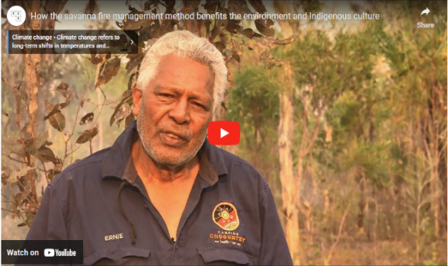This video from the Clean Energy Regulator (6:48 minutes) explains how First Nations savanna burning works in Northern Australia and its many benefits, including reducing emissions.

Video: [How the savanna fire management method benefits the environment and Indigenous culture (youtube.com)](https://www.youtube.com/watch?v=_hMvgYP1ny8)

|  |
| --- |
| **Transcript** |
| With its vast and rugged landscapes, immense beauty, wildlife, scenery, history, lore, culture and ancient art. Northern Australia is one of the most spectacular places on earth. However, like all our natural treasures it remains vulnerable to the impacts of climate change. The good news though, there's some amazing work happening right here on these impressive landscapes to help combat it. G’day, Ernie Dingo here. I'm sharing a story of how fire management across the top half of Australia is helping to reduce emissions, benefit community and businesses, and help the environment. That fire has been part of our lives since the beginning of time. We probably invented fire. Healthy Country, healthy people, and fire played a big part in that.  Embedded in the culture and in the land, traditional fire management has been more recently reinvigorated with the support of the Australian Government's Emissions Reduction Fund. The fund supports farmers, Indigenous Australians, and other businesses to reduce greenhouse gas emissions. It's the ways of burning country so we have green grass to grow again. And it's more like burning a bit earlier than having a late fire.  Our Country is better looked after when savanna fire management projects are underway. These projects restore the similar fire regime that was used for tens of thousands of years by Indigenous Australians. These projects are creating healthier ecosystems with benefits for plants and animals. We've seen all the tracks for wallabies, big kangaroo and the small one, they just came back, when we had a fire. All our old people, they were telling the story about you do 'right way' fire, you will get good rain, animal will come back, a lot of good flower, good honey. Savanna fire management reduces emissions by reducing frequency and extent of destructive late dry season wildfires. these huge wildfires are bad for the climate, damaging our atmosphere. Savanna projects use the latest science to track fire management activity and estimate emission reductions. This translates into Australian carbon credit units. So far savanna projects have already reduces more than 7 million tonnes in emissions.  This story of savanna fire management isn't a new one. These techniques have been used for tens of thousands of years but it's the 'right way' fire mob who's been combining modern science and traditional knowledge to build an industry and make a big difference in our Country. Projects are generating income by selling carbon credits to the Government and businesses. With the extra income, project participants are able to spend money on more important projects to look after their community and Country.  It brings in more opportunities, more jobs for local people and our people as well, so that, you know, people can continue what we're doing today - is keep on looking after the land and our Country. We're using helicopter because we're earning good income from a carbon program. And the money that we bring from carbon, we distribute to the community, and we get rangers and TO's more salary, and getting more equipment. Fire was there for many reasons. Cleaning up Country, cleaning spirit, so that families can go back and use that Country. Paying respect for that Country. We've got that fire, it brings life. And them old people living, they say you do 'right way' fire, you get em good fish, you get em good rain, you get em, Country it reward you.  Being a woman ranger, it's just great. You get to go around and see a lot of other places and you know what's happening on their land and we know and they know what's happening on their land.  Being a ranger is my dream job and it's really great, taking kids around country and learning about culture and stuff Carbon farming is good for us cause we have a ranger job. Wunambal Gaambera has our rangers. It’s good for, like, it's good for like, to get people back out on Country, and keep their Country strong and healthy.  Well it helps, it helps to employ more young people and then you know it helps us to buy more equipment. Saving the planet, making money, but something we've been doing for centuries.  Our ancestors have been using fire for hunting, gathering, even using fire for getting 'right way' married. So fire it's a big stuff for us.  Savanna fire mob have been combining modern science and traditional knowledge to build an industry and make a big difference in our Country.  This film was produced by bush TV Enterprises on behalf of the Australian Government. Bush TV. |

## Activity: Your land and First Nations people

Reflect on your connection to your land and consider the following questions.

1. What is its history?
2. Do you know which Aboriginal or Torres Strait Islander group are the Traditional Owners of your land?

There is more information on the [Map of Indigenous Australia](https://aiatsis.gov.au/explore/map-indigenous-australia).

 Caring for Country practices we want, such as fire management, weed management, feral animal management, revegetation programs, traditional food harvesting, cultural mapping and ecological surveys, provide an opportunity for Aboriginal and Torres Strait Islander people to reestablish or strengthen their connection to Country.

For such a long time, people lived on Country, managing fire and the Country for thousands and thousands of years. But nobody lives here and walks here like the old people did. Now, fires have become too fierce because we haven't been managing fire, so destructive fires have come. The ways of the old people have passed, we need to make new ways to make this land healthy.

*Dean Yibarbuk, Warddeken Land Management Ltd (Co-chair) and Co-Chair,*  
*Indigenous Carbon Industry Network*

### How carbon farming responds to climate change

## Carbon farming helps reduce your carbon footprint

Carbon farming, as we have seen, reduces GHG emissions and stores carbon, which are essential to Australia’s response to climate change.

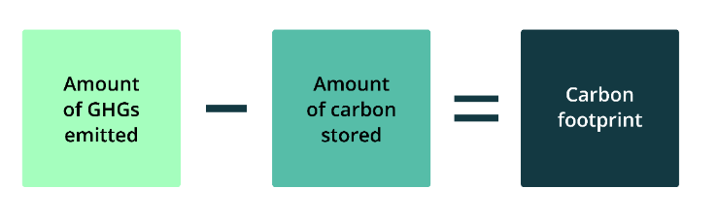A ‘carbon footprint’ or ‘greenhouse gas footprint’ is the amount of GHGs emitted minus the amount of carbon stored by, for example, a farm, region or country.

Reducing your carbon footprint

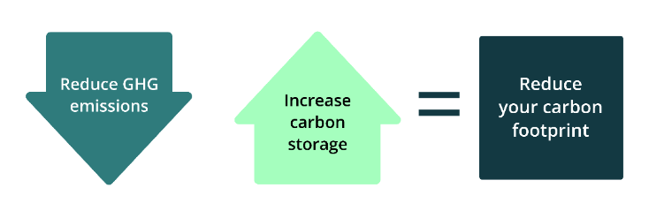Reducing GHG emissions, storing more carbon or both helps reduce a farm’s or land area’s carbon footprint.

Knowing your carbon footprint

Getting serious about carbon farming means drilling down into detail to calculate your GHG emissions and carbon stored.

Topic 3 looks at some of the many calculators and tools available from governments, industry bodies and others to estimate GHG emissions and carbon storage.

Climate change and Earth’s increasing emissions

Human activities are causing increasing amounts of GHGs in the atmosphere.

Earth’s GHG emissions are mainly the result of:

* the burning of fossil fuels — the ancient remains of plants and animals that geological processes have transformed into carbon-rich coal, oil and gas — releasing carbon stored for millions of years into the air as carbon dioxide
* a range of human activities that release methane and nitrous oxide into the atmosphere.

The clearing of forests contributes to emissions and reduces Earth’s capacity to absorb carbon dioxide.

The greenhouse effect

The greenhouse effect
Step 1: solar radiation reaches the Earth's atmosphere - some of this is reflected back into space.
Step 2: the rest of the sun's energy is absorbed by the land and the oceans, heating the Earth.
Step 3: Heat radiates from Earth towards space
Step 4: some of this heat is trapped by greenhouse gases in the atmosphere, keeping the Earth warm enough to sustain life.
Step 5: human activities such as burning fossil fuels, agriculture and land clearing are increasing the amount of greenhouse gases released into the atmosphere.
Step 6: this is trapping extra heat, and causing the Earth's temperature to rise.

The Earth is heated by the sun, and some solar energy is reflected from its surface. GHGs prevent the loss or escape of heat into space, just as glass traps heat inside a greenhouse. This warming is essential for life on Earth. However, an increasing blanket of GHGs is trapping too much heat, preventing it from radiating back into space. This results in excessive global heating, which has consequences including changing climate patterns, upward-trending temperatures, melting ice, rising sea levels and extreme weather events, including droughts, floods, cyclones, and bushfires.

To learn more about climate change, read [Understanding climate change](https://www.dcceew.gov.au/climate-change/policy/climate-science/understanding-climate-change).

Two resources for farmers to better understand how climate change is likely to affect their area and products are:

* [My Climate View](https://myclimateview.com.au/), which provides tailored climate overviews about what to expect from the climate at the user’s nominated location in the future and the climate impact on selected commodities
* [Climate change impacts and adaptation on Australian farms](https://www.agriculture.gov.au/abares/products/insights/climate-change-impacts-and-adaptation#recent-changes-in-seasonal-conditions-have-affected-the-profitability-of-australian-farms), which presents the latest modelling by the Australian Bureau of Agricultural and Resource Economics and Sciences (ABARES) that examines the effect of recent and possible future climate changes on the profitability of Australian farms.

Other resources about climate change include:

* the Australian Government Department of Climate Change, Energy, the Environment and Water (DCCEEW) [Climate change website](https://www.dcceew.gov.au/climate-change) which has information about climate science and adaptation, Australia’s climate change strategies, emissions reduction and reporting and other climate change topics.
* [Climate Change in Australia](https://www.climatechangeinaustralia.gov.au/en/) which provides climate information, projections, tools and data to help in understanding and planning how to adapt to the impacts of climate change.
* Some states also have climate change adaptation plans. An example is the [AdaptNSW website](https://www.climatechange.environment.nsw.gov.au/home), which has information about actions to adapt to climate change by region.

### Reducing emissions

Agricultural production, including livestock and crops, contributed 17.9% of Australia's total GHG emissions in 2021-22 in Australia’s National Greenhouse Accounts. This does not include emissions associated with electricity, energy and fuel use in agriculture.

Emissions and sequestration associated with land management are accounted for under a separate category called land use, land use change and forestry (LULUCF). This category includes forests, land clearing, savanna fires and changes in soil carbon levels. As shown below, in 2021-22 this category was a net sink, reducing Australia’s overall emissions by 20.4%.

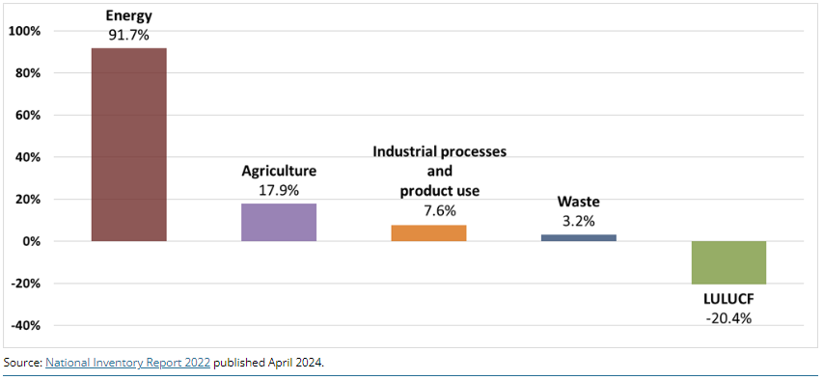The following figure shows the share of total emissions by sector for 2021-22.

Source: [National Inventory Report 2022](https://www.dcceew.gov.au/climate-change/publications/national-inventory-report-2022) published April 2024.

|  |
| --- |
| **About this data** |
| The sectors and their shares of total emissions in 2021-22 were: energy (91.7%), agriculture (17.9%), industrial processes and product use (7.6%), waste (3.2%) and LULUCF (-20.4%). |

## Watch this video

In this video (9:14 minutes), Professor Richard Eckard of the University of Melbourne gives an overview of the GHGs emitted by the agriculture sector.

Video: [Agricultural greenhouse gas emissions (youtube.com)](https://www.youtube.com/watch?v=pjPowQOkJFg)

|  |
| --- |
| **Transcript** |
| PROFESSOR RICHARD ECKARD: We introduce what are greenhouse gases.  Now what we know from two separate studies, and there's a number around the world you can find, they don't vary that much, that agriculture globally contributes somewhere between 13 and 14 per cent of greenhouse gas emissions. This is just the on farm emissions, not the supply chain emissions, which would include some, transport, some of the energy consumption.  So overall agriculture, food supply chain is responsible for about 22 to 25 per cent of greenhouse gas emissions globally.  Now, what makes a greenhouse gas?  A disclaimer on this slide first up is I used to run a course where a climate science expert would spend an entire day explaining what's on this slide, so forgive me when I try to do it in two minutes.  But essentially, if you think of the atmosphere, the air that you breathe, the majority of it is made up of oxygen, O2, so double bond, and nitrogen, 78 per cent of the atmosphere is nitrogen, dinitrogen, two nitrogen bonds.  That effectively makes the baseline of the vibrational frequency of the atmosphere, because those bonds are vibrating at a certain frequency.  So they would absorb a certain amount of heat and re-radiate it. Because that's the majority of the atmosphere, then that forms the baseline of the atmosphere, as I said.  Greenhouse gas emissions tend to be any molecule, any gas that has more than the baseline number of bonds. In other words, CO2’s got an oxygen, carbon and two oxygens. Methane's got a carbon and four hydrogens.  So there's four bonds involved there. So the moment you go from the baseline and you start adding more of these other gases into the atmosphere, you've got molecules that can hold more temperature, more radiation, that can absorb more wavelength radiated from the sun, and therefore re-radiate it back to the Earth. So hopefully that explains why water vapour, carbon dioxide, methane, and nitrous oxide can hold, absorb, and re-radiate more than the baseline of the atmosphere. So even though their concentration is right quite small in the atmosphere, that's where the change from the baseline is occurring.  Now, what is the effect of these major greenhouse gases? On the left, you've got the radiative forcing, and on the right, you've got the concentration in carbon dioxide equivalents.  And so you can see that the majority of the problem in the climate system is carbon dioxide from industrial fossil fuel emissions, But methane makes a fair contribution to the radiative forcing in the atmosphere, so we can't ignore it. Nitrous oxide also makes its contribution, and synthetic gases will be like sulphur hexafluoride, completely synthetic gas, but has a global warming of well over a thousand that times of CO2.  So they all make a contribution, but if we had to really address the core problem, it is industrial emissions.  On the right, you've got the difference in the global mean CO2 concentration from just CO2. So that's the blue on the left, and on the right you've got the concentration, but what the equivalent CO2 emissions would be if we added all the gases together. So clearly the other agricultural gases make their contribution as well.  Now we know that methane continues to increase in the atmosphere. This is data from the Cape Grim Research Station, which is on the northwest point of Cape Grim in Tasmania.  If you look due west from that point, there's nothing but ocean until you get to the southern tip of South America.  So it's one of the stations in the world that would be completely fully mixed air, unaffected by local pollution, and so this is where we get these results from. You can download them yourself from the CSIRO website.  The fluctuations annually is because we've got a larger landmass in the northern hemisphere than the southern, and so during the northern summer, a lot of the Siberian ice fields would melt somewhat, and you would get more methane produced from peat bogs in those extensive lands in the north.  Because the Southern Ocean dominates the southern hemisphere, there's more ocean than land, then in the southern summer we don't get as much of a pulse of methane, so we get this oscillation, but the bottom line is it continues to increase in the atmosphere.  Now we know that methane has a shorter lifetime in the atmosphere, somewhere around a half life of 11.8 years of lifetime, and the concentrations continue to increase relative to pre-industrial. On the right hand side I have given you the IPCC assessment reports from the second assessment report through to the sixth assessment report and what they published as the global warming potential either of a 20 year period or a 100 year period. These are the global warming potentials for methane. So the latest methane multiplier is 27 times that of carbon dioxide on a 100 year timescale.  Now for those of you wondering whether there is a difference between biogenic and fossil methane, there is.  It is already accounted for in the IPCC guidelines, as I have in the table there. A lot of people make a lot of fuss about this, but it doesn't actually make a big difference. Just to explain, methane is methane while it is in the atmosphere for 12 years.  The atmosphere doesn't see a difference in the methane molecule depending on where it came from. So for the duration that it's in the atmosphere, its warming is identical.  It therefore only comes back to what the original carbon molecule was before it became methane and where that came from. Was that a recent molecule from photosynthesis in the case of biogenic?  It would be in photosynthesis that went into a plant in the last 12 months and then went through the animal, came out as methane for 12 years, and then went back to the atmosphere as the original CO2 that was there 12 years prior.  Whereas fossil methane would be ancient photosynthesis that went into an ancient forest that got buried deep under the earth for millions of years and therefore when that methane breaks down, it's technically releasing a CO2 molecule that is new to the atmosphere in millions of years timescale.  So it only matters the original breakdown products of CO2 and water vapour once methane breaks down, and that's what's accounted in the difference between 27 times methane or 29.8 times methane.  Hopefully, that makes sense.  So here is the trend in nitrous oxide emissions from the Cape Grim weather station as well. You can see it is a lot more consistent because we don’t have the northern southern hemisphere issue. It is mainly driven by the expansion of food production around the world and the use of fossil fuel fertilisers.  Some of that would be legumes and the increase in livestock, but majority by the Haber Bosch process, one would argue.  Now we know that nitrous oxide has a longer residence time in the atmosphere than other greenhouse gases, so well over 110 years, somewhere around there.  But it has two actions in the atmosphere. One, it is inert in the troposphere, but it absorbs infrared radiation.  But secondly, it also causes ozone depletion in the stratosphere. So, two points of action.  Concentrations are fairly modest in the atmosphere, but it’s a very powerful greenhouse gas. And you can see from the various assessment reports that because it's a long lived greenhouse gas, 20 years versus 100 years doesn't make much of a difference to its global warming, and the multiplier has been fairly consistent over time, so 273 times that of CO2.  The average emissions from a grain farm might only be 250 grams of nitrous oxide nitrogen per hectare per year, but you have to multiply that by 273 to get the actual warming effect. |

## Agricultural emissions

The main sources of emissions from agriculture are:

* methane emissions from livestock (enteric fermentation) — mainly beef and dairy cattle and sheep, but also pigs — which together accounted for 71% of the agriculture sector’s emissions in 2021-22
* nitrous oxide emissions from soils — including from applying fertilisers and incorporating crop residues in soil — which totalled 15% of sector emissions in 2021-22
* methane and nitrous oxide emissions from managing manure (primarily from cattle, sheep and pigs), which represented 9% of the sector’s emissions in 2021-22.

Sources of agricultural GHG emissions

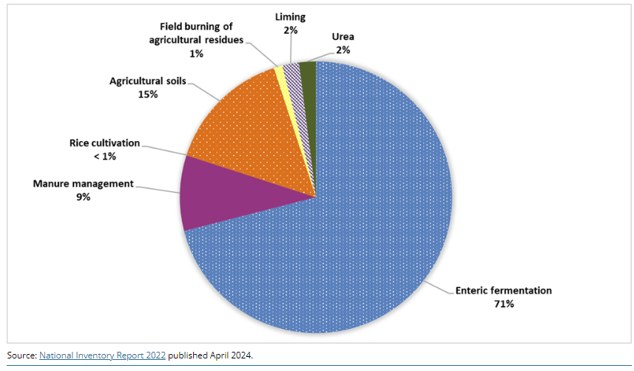The following figure shows the contribution of each emissions source to total agricultural production emissions.

Source: [National Inventory Report 2022](https://www.dcceew.gov.au/climate-change/publications/national-inventory-report-2022) published April 2024.

|  |
| --- |
| **About this data** |
| Sources of emissions from agriculture in 2021-22 were: enteric fermentation (71%), agricultural soils (15%), manure management (9%), urea application (2%), liming (2%), field burning of agricultural residues (1%) and rice cultivation (less than 1%). |

For more information about methane emissions through enteric fermentation and nitrous oxide and how volumes of these emissions have changed over the last 3 decades, click a heading of interest below.

|  |
| --- |
| **Methane emissions** |
| Methane emissions from livestock in Australia through enteric fermentation have dropped steadily in the past 32 years to 55 million tonnes of carbon dioxide equivalent (CO2-e, as explained in section 8) in 2021–22. The reduction is mainly due to the declining numbers of beef and dairy cattle in Australia.  Enteric fermentation is the process by which microbes in the digestive system of ruminant livestock decompose and ferment food, producing methane which the animal then belches. About 6–10% of gross energy intake is lost as methane, which is energy lost from the production system that could be converted to income-generating milk or meat.  Almost all of these emissions are from cattle and sheep. The proportion of emissions coming from sheep has steadily declined since 1990, reflecting reductions in the number of sheep. |

|  |
| --- |
| **Nitrous oxide emissions** |
| |  | | --- | | **About this data** | | In 2021-22, nitrous oxide emissions from each sector were (in millions of tonnes CO2-e): energy (2.5), industrial processes and product use (1.5), agriculture (12.4) and waste (0.4). |   Over the 32 years to 2021–22, agriculture contributed most of Australia’s nitrous oxide emissions, which totalled 16.7 million tonnes CO2-e in 2021–22. Nitrous oxide has 265 times the global warming potential of carbon dioxide.  The following figure shows sources of nitrous oxide emissions from 1989-90 to 2021-22.  Source: [National Inventory Report 2022](https://www.dcceew.gov.au/climate-change/publications/national-inventory-report-2022) published April 2024.  Certain bacteria produce nitrous oxide as part of the nitrogen cycle, the process by which nitrogen moves from the atmosphere into the soil, to plants and animals and back to the atmosphere. Nitrous oxide is produced:   * through the nitrification process; some soil bacteria convert ammonium to nitrate via nitrite, producing nitrous oxide as a by-product * through the denitrification process; some soil bacteria convert nitrate and nitrite back into nitrogen gas and nitrous oxide.   The excess nitrogen from inefficient use of fertiliser can increase nitrous oxide emissions by enhancing nitrification and making more nitrate available for denitrification. |

## Watch this video

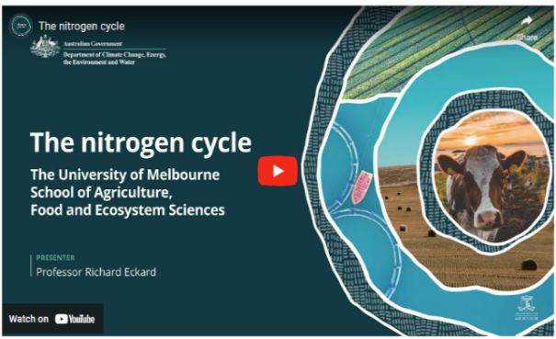In this video (2:50 minutes), Professor Richard Eckard of the University of Melbourne explains the nitrogen cycle.

Video: [The nitrogen cycle (youtube.com)](https://www.youtube.com/watch?v=VdGvtBuSmto)

|  |
| --- |
| **Transcript** |
| PROFESSOR RICHARD ECKARD: This is an animation of the nitrogen cycle in agriculture. Although this includes a grazing animal, the principles for cropping systems is much the same. While most of the nitrogen cycling in agriculture comes out of the microbial breakdown of a soil organic matter, the left-hand side of this diagram explains some of the primary input sources. Small amounts of nitrogen can come from rainfall and possibly volcanic events.  But the majority of nitrogen entering our agricultural systems comes from synthetic fertiliser, legumes fixing nitrogen from the atmosphere, or from animal dung and urine recycling nitrogen. Nitrogen can enter the soil in many forms, but would mainly be in either the ammonium form or the nitrate form. In most aerobic soils, the ammonium is then converted fairly quickly to nitrate. In cold, wet soils, common in Southern Australia, that conversion can be much slower and plants might preferentially take up ammonium.  Whereas in Northern Australia, in drier, hotter, warmer conditions, less anaerobic conditions, the conversion of ammonium to nitrate can complete in a few days. The other input of nitrogen into the soil is obviously from animal excreta in the form of dung or urine, which would largely be in the ammonium form. Plants then take up the nitrogen, either in the ammonium or nitrate form. In colder weather conditions, common in Southern Australia wet winters there could be preferential uptake of ammonia. In drier soils, there may be preferential uptake of nitrate. In the case of a livestock system, the animal then consumes the nitrogen in the plant and recycles some of this back to the soil through their excreta. Unfortunately, in most of our agricultural systems, the nitrogen is exported out of the system, down the supply chain, instead of being returned in more of a circular, closed loop nutrient cycle.  Nitrogen can be lost from the soil in three main processes. Nitrate in the soil moves readily with water. So if there's leaching of water beyond the root zone, this will carry nitrate with it into the groundwater. In waterlogged soils, nitrate can be denitrified and lost as a gas of either nitrous oxide or dinitrogen.  Nitrogen can be lost as ammonia gas, either directly from urea fertiliser being applied to soils, or livestock urine volatilising as ammonia gas. |

Scope 1, 2 and 3 emissions

So far, this topic has looked at on-farm emissions, mainly methane and nitrous oxide. However, as we delve deeper into calculating emissions, we see that there are different types of emission sources of importance to farmers and land managers.

There are 3 types of emissions — called ‘scopes’ — that are part of a business’s total emissions but may not be evident at first sight. They are:

* scope 1 emissions: emissions from operations a business owns or controls; for a farm, this could include methane from livestock digestion and manure management and nitrous oxide from fertiliser use
* scope 2 emissions: indirect (off-farm) emissions from generating electricity, steam, heat or cooling the business buys
* scope 3 emissions: all indirect (off-farm) emissions (other than scope 2 emissions) that occur in the business’ value chain for a farm. This could include upstream emissions from producing and transporting fertilisers and pesticides and downstream emissions from transporting, processing and consumption of the farming business’ products, including waste disposal.

These are important distinctions. Farmers and land managers serious about calculating their carbon footprint must follow the conventions of carbon accounting — the quantification of emissions and storage — which Topic 3 examines.

### Increasing carbon storage

## About carbon

Carbon is an amazing atom. It loves to bond with other atoms, which is why it has been called 'the glue of life'. Carbon is the fourth most abundant element in the universe. It is found in all organic matter, and makes up a large proportion of all living material. Diamonds and graphite are both examples of pure carbon.

## The carbon cycle

The carbon cycle includes the movement of carbon between the soil, the things that live on it and the atmosphere.

Plants — trees, shrubs, grasses, crops and other vegetation — take carbon dioxide from the air through their leaves and use sunlight — the photosynthesis process — to transform carbon dioxide and water into oxygen, and into the sugars and starches the plants use to grow. Plants store carbon in their wood, leaves and roots.

Plants shed organic matter as they decay and die, which microorganisms (like bacteria and fungi) break down. This releases the plants' carbon back into the soil, increasing soil organic carbon and releasing carbon dioxide into the atmosphere.

Animals similarly contribute to the carbon cycle. When they breathe, they release carbon dioxide; when they die in the natural environment, their decaying remains release carbon back into the soil.

Oceans also absorb carbon dioxide from the atmosphere. Rocks and other geological deposits (such as coal) store carbon. Burning coal and other fossil fuels releases the stored carbon into the atmosphere.

## Watch this video

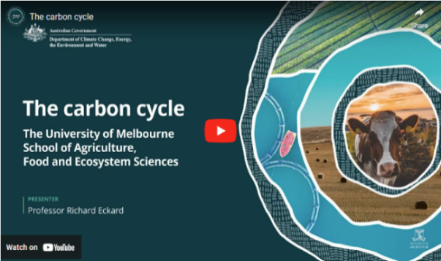In this video (4:15 minutes), Professor Richard Eckard of the University of Melbourne discusses how the carbon cycle works in agriculture.

Video: [The carbon cycle (youtube.com)](https://www.youtube.com/watch?v=qJBqsKnyDIM)

|  |
| --- |
| **Transcript** |
| PROFESSOR RICHARD ECKARD: This is an explanation of the carbon cycle in agriculture.  It's based on a grazing system, but the same principles apply to a cropping system.  It all starts with sunlight energy and the process of photosynthesis in plants, which allows plants to capture carbon dioxide from the atmosphere and lock it away into a plant.  You will notice that we've highlighted the letter c in its various forms of carbon, showing that carbon in CO2 is a gas, but carbon in the plant is CHO, which is a sugar, not a gas. The key point is that carbon takes many forms as it cycles through our agricultural systems.  In a cropping system, we would then harvest that plant. In a grazing system, an animal will graze the pasture and convert the carbohydrate into animal products.  The majority of the carbon consumed by the animal is belched out or breathed out as CO2 back to the atmosphere.  The majority of the animal products or crop products, eaten by humans is also respired back to the atmosphere within 12 months as CO2.  If that was all that happened, the carbon cycle would be completely balanced, with all inputs returning to the atmosphere in the same form within a short period of time.  However, a small amount of carbon entering the rumen of the animal is converted into methane, CH4, which is carbon in another gaseous form. Methane is fundamentally different to CO2 and has a far higher warming potential in the atmosphere for the duration that it's there.  The animal defecates, and so there's faecal carbon in an organic form going back to the soil.  Plants will leave litter on the soil surface as a form of organic carbon.  As the plant grows, it produces roots, and these roots leave carbon behind either as root fragments or as root exudates of sugars.  This organic form of carbon in the soil can either be in a larger fraction, which we call the particulate organic carbon, and turns over fairly fast through microbial action, perhaps in hours through to a few years.  The smaller, more resistant fractions of organic carbon in the soil are called humus.  These are the more resistant fractions that last for decades through to hundreds of years.  In the soil, there are billions of microbes that then work actively on this organic carbon as their food source, actively breaking down the carbon to release the stored nutrients back to the soil to allow the crop or pasture to grow.  In the process, these microbes then release the carbon stored in the organic material as carbon dioxide back to the atmosphere, and the carbon cycle completes itself.  In a cropping system, this process of mineralization may release 30 to 50 kilograms of nitrogen per hectare per year out of the soil organic matter. In a dairy pasture system, it can be as much as 250 kilograms of nitrogen per hectare per year from the organic matter.  The point of carbon farming is to capture and make that cycle as efficient as possible so that we can transfer as much of the carbon from the atmosphere into product that we're interested in producing, which could be meat, wool, milk, grain, and crops.  Carbon farming is therefore focused on maximising the carbon from photosynthesis through to a product that goes to market as efficiently as possible.  In the process, good carbon farming would aim to leave as much carbon in the soil as possible, capture some of the carbon in trees growing in the landscape, and minimise the amount of carbon lost as methane and as a nitrogen gas. |

## About soil organic carbon

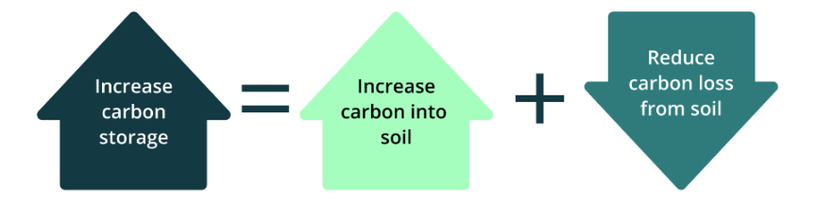To increase carbon storage in soil, you need to increase carbon content in the soil, reduce carbon lost from the soil, and preferably both.

Along with air, water and inorganic matter, soils naturally contain a small proportion of soil organic matter. Soil organic matter is all the living and dead organic material — plants, soil organisms and animal materials — in various stages of decomposition, but not the fresh, undecomposed organic material on the surface. Soil organic matter:

* binds soils together, increasing their resistance to erosion
* provides nutrients for vegetation
* supports soil microbiology and cycling of nutrients (reducing the need for fertilisers) and improves water infiltration and water-holding capacity and the soil's ability to retain nutrients.

Soil organic carbon (SOC) makes up a large component of soil organic matter. The amount of SOC can vary depending on soil type, environmental conditions (including rainfall) and land management practices. It is generally high in clay soils under pasture, and it can be the highest in peat soils. Soil organic matter and SOC are usually expressed as a percentage of the soil by weight. Carbon farming activities that can increase SOC include cover cropping, no-till farming and agroforestry. Carbon farming activities that can reduce carbon loss include avoiding land management practices like over-grazing, over-tilling and stubble burning.

### Key concepts

Finally, let’s look at key concepts that flow from this initial topic to all topics:

* carbon neutral
* net zero emissions
* ACCUs
* Climate Active certification
* carbon dioxide equivalent (CO2-e).

|  |
| --- |
| **‘Carbon neutral’ and ‘net zero emissions’** |
| The terms ‘carbon neutral’ and ‘net zero emissions’ are commonly used to describe taking action to reduce GHG emissions and increase carbon storage and taking other steps, such as use of offsets, to balance the remaining emissions.  Carbon neutrality is commonly described in terms of balancing all GHG emissions and carbon storage. It is sometimes described only in terms of carbon dioxide rather than all GHGs. Net zero is commonly described as taking steps to reduce all GHG emissions as much as possible and to use carbon storage to balance remaining emissions.  For a farmer or land manager, attaining carbon neutrality or net zero emissions may involve:   * insetting: doing carbon farming activities that reduce or avoid emissions or store carbon within their value chain, which could include their land and their supply chain * offsetting: buying and cancelling carbon credits derived from projects that reduce or avoid emissions or store carbon elsewhere.   The concept of insetting is gaining increased focus in Australia and overseas. In some cases, it is considered to refer to carbon storage activities only. While insetting is a developing concept, typical features include:   * accounting for carbon storage or emissions reduction or avoidance when it occurs, without needing to demonstrate that it is additional to normal practice (as is required for generating carbon credits for offsets) * accounting for any losses of stored carbon where those stores have previously been claimed.   Farmers and land managers interested in insetting as an option may need to consider its suitability for their purposes. If participating in a reporting system, you may need to check whether insetting is eligible. If it is eligible, you may also need to check for any rules on insetting. These might include rules for measurement, monitoring, verification, reporting, maintaining stored carbon over time and accounting for losses of stored carbon. Insetting may preclude claiming carbon storage, emissions reduction or avoidance benefits for other purposes (such as offsetting).  Topic 5 explains offsetting in more detail.  Any carbon neutral or net zero claims need to be robust and meet any applicable regulatory requirements. The Australian Competition & Consumer Commission monitors [environmental and sustainability claims](https://www.accc.gov.au/consumers/advertising-and-promotions/environmental-and-sustainability-claims#toc-about-environmental-and-sustainability-claims). |

|  |
| --- |
| **Australian Carbon Credit Units** |
| Australian Carbon Credit Units (ACCUs) are also known as carbon credits. Some people think carbon farming is the same as earning ACCUs, but that’s not the case.  The farmer or land manager might decide to do carbon farming activities:   * to earn ACCUs they can sell to generate income * to reduce their carbon footprint * to get a lower-interest sustainability loan from a financier * to meet requirements from their supply chain * for productivity and profitability gains.   We will return to these options throughout the course, and Topic 5 looks in detail at the requirements for the ACCU Scheme, previously known as the Emissions Reduction Fund. Participation in the ACCU Scheme is voluntary. Farmers and land managers can earn ACCUs by reducing emissions or storing more carbon in soil and vegetation. To earn ACCUs, they must follow detailed rules administered by the Clean Energy Regulator. |

|  |
| --- |
| **Climate Active Certification** |
| [Climate Active](https://www.climateactive.org.au/) is a voluntary Australian Government program that certifies credible voluntary climate action by businesses. Certification is available for organisations, products, services and other categories. Businesses seeking certification must set their emissions boundary (all sources of emissions that would be considered under a certification) and measure emissions in accordance with Climate Active’s rules and guidance material available on the [Climate Active website](https://www.climateactive.org.au/be-climate-active/tools-and-resources/technical-assessment-carbon-neutral-certification).  Farmers can use Climate Active certification in marketing their products, appealing to environmentally conscious consumers and potentially commanding price premiums. |

|  |
| --- |
| **Carbon dioxide equivalent (CO2-e)** |
| The main GHGs, as we have seen, are carbon dioxide, methane and nitrous oxide. We have also seen how these gases are all added up to indicate the percentage contribution of agriculture sector GHGs to national totals. Which raises the question: how do you add quantities of entirely different gases?  The answer is to calculate the ‘global warming potential’ (GWP) of a gas based on its ability to trap the sun’s heat and how long it stays in the atmosphere. Using its GWP, any GHGs can be converted to a 'carbon dioxide equivalent' (CO2-e) amount of gas. Using the values in the following table, we can see, for example, that one tonne of nitrous oxide is equivalent to 265 tonnes of carbon dioxide.  Looked at another way, 1 tonne of methane has a 28 times greater contribution to global warming than 1 tonne of carbon dioxide.  **Global warming potential of main greenhouse gases\***   |  |  | | --- | --- | | **Greenhouse gas** | **Global warming potential (GWPs)** | | Carbon dioxide | 1 | | Methane | 28 | | Nitrous oxide | 265 |   * [The Intergovernmental Panel on Climate Change](https://www.ipcc.ch/) periodically updates these values as understanding of the physical properties of these gases improves. |

### Case study

## Watch this video

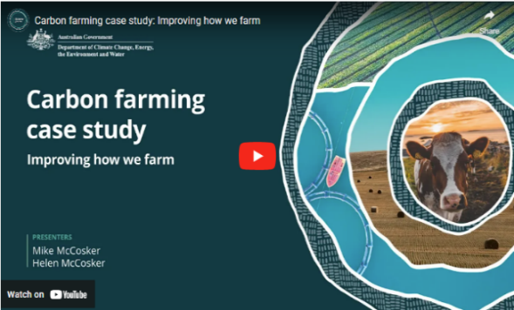In this video (7:11 minutes), New South Wales graziers Mike and Helen McCosker explain how they improved their farm.

Video: [Carbon farming case study: Improving how we farm (youtube.com)](https://www.youtube.com/watch?v=iTozl1px_PI)

|  |
| --- |
| **Transcript** |
| MIKE MCCOSKER: Hi. I'm Mike McCosker. I'm actually a fourth generation farmer on this farm.  HELEN MCCOSKER: And I'm Helen McCosker. I'm a first generation farmer.  M. MCCOSKER: Our farm is largely a mixed livestock and cropping operation, and we focus on beef cattle. I think the journey really started back in the late 90s – 97, 98.  H. MCCOSKER: Yeah. And I think from there, that really, like, started the momentum of, like, really understanding what is it that we wanted to change on our farm. So we had a feedlot business, and it was, it was 24/7. It was a really hard slog.  And part of that process was, like, really understanding, you know, from a farm planning perspective, what are the things that you know, the opportunity cost? What are the things that we're doing that's not working? And what are the things that we think we should be doing? So there was a real, like, you know, navel-gazing process, wasn't there?  M. MCCOSKER: Those changes were about making the best food that we can make, ensuring that our farm was in excellent health to hand on to the kids because we wanted a generational legacy.  And lastly, it it had to be profitable as well.  Yeah. So a bit of a change of focus, you know, rather than lock the cattle into a small area and grow crops to feed to the cattle, how could we use the cattle differently out on the farm to help regenerate the the pasture land? So the spade test is where we actually get into the soil to see what's going on.  And when we're thinking of soil carbon, what we need is good active biology, and good biological activity will show up as this beautiful crumbly soil structure.  This is what lets the water get into the soil, the rainfall get into the soil. This is what creates the space that holds the moisture in the soil for the plants.  This is what the end result becomes soil carbon in the soil. So the smell should be alive and sweet and earthy.  If this smells like a sewer or even if this smells bland, then the biology is not healthy and not doing its thing of storing carbon.  If the soil is tight and compacted, when the soil carbon is missing, the structure of the soil collapses. So we don't have the pore spaces. This is why the water can't get into the soil.  So some of this, carbon is actually living and cycling in the soil biology, and some of it has been stored and is more stable.  Now I think the chemical model, you know, the cost of inputs just continues to go up and up and up and up. And getting control of that process was actually about coming back to the principles, the underlying principles of soil health.  Do you need an adviser in this? I think you need to work out what works on your own farm, and I think you need a trusted person to talk to.  That trusted person may not be the chemical sales agronomist in town. It might be an agronomist that knows more about soil health or about alternative ways of farming.  That trusted person may be a farmer next door that's trying a few different things and talking to them and seeing what has worked for them and what hasn't worked for them. And I think that's where the communication at a community level comes in. You know, don't be frightened of being a little bit different, and don't be frightened of talking to your neighbours about different ideas.  H. MCCOSKER: Yeah. And I think even from a carbon farming perspective, there is actually, extraordinary value in farmers in an area coming together and working together and you know, understanding the things that aren't working, the things that are working in a mentoring space. Because it's actually farmers that come up with the solutions. You know? So when you're able to be in dialogue with other farmers, then we're actually the perfect advisers, really, aren't we?  M. MCCOSKER: I suppose in the last five years, even though we've been doing this for some time, you know, the the focus has started to come in on to soil carbon, and, you know, there's opportunities there potentially.  What we're doing in our farm plan to build back resilience could give us an extra source of income by actually, you know, being paid for the carbon that we're taking out of the atmosphere and putting back into the soil.  One piece of advice that I would give to people is hasten slowly and that, don't be afraid to fail.  But if you do fail, make sure you've failed on just a little bit of the farm and work that out before you try and do it over the whole farm.  So the transition period is actually the hardest. It's transitioning your knowledge bank into practical profitable farm ability. That transition can be a little tricky, and don't give up on it.  H. MCCOSKER: Yeah. And I think that you talk about risks. It is a risky you know, the change in mindset is the hardest one. So when you're talking about the risk aspect, like, if you sort of feel like, I'm I'm just gonna keep on doing it this way because I know what's in front of me, you need that mindset change of, well, if I keep on doing the same thing, I'm gonna get the same result over and over again.  So what is it that you need to change, as of-  M. MCCOSKER: So if I want a different future for my children, then I have to make a change here.  And how do we take the risk out of the change? Well, we educate ourselves, and we talk about the ideas, and we plan carefully. We implement slowly, but we make sure that we're always moving forward.  So our costs have gone down. You know, we're using a fraction of the chemical that we used to use. We're under five per cent of what we used to use.  The animal performance with, you know, shelter farming. We've improved our calving percentages, and our weaning weights have gone up.  Possibly 40 to 50 kilos per head on you know, across 200 head is a lot of extra kilos of beef that we're producing on the farm.  H. MCCOSKER: And that affects his direct bottom line.  M. MCCOSKER: Absolutely. Yep. |

### Actions: What might you do?

## Activity: Respond to the following questions

Think about how what is covered in this topic might apply to your land management or farming practice.

Consider the following questions and make notes about carbon farming activities that might suit your enterprise.

The following points will help you have informed discussions with advisers.

Please note that the next topic explores the risks and requirements of various carbon farming activities, which should be considered before starting a project.

1. Why are you interested in carbon farming?
2. What are your main emission contributions? (Are they scope 1, 2 and/or 3?)
3. Go to [My Climate View](https://myclimateview.com.au/) and note any projected changes based on your location and commodity. (Note: these are projections only, not necessarily the reality of your situation)
4. Learn about carbon targets in your supply chain.
5. Based on the information provided in this topic, what else is important for you to note for future reference?

### Other resources

## Annual Climate Change Statement 2024

The [Annual Climate Change Statement 2024](https://www.dcceew.gov.au/climate-change/strategies/annual-climate-change-statement-2024), published by DCCEEW, explains Australian and state and territory government climate change policies, adapting to climate change and progress towards achieving Australia’s targets for reducing GHG emissions.

## Low Emissions Agriculture (New South Wales Department of Primary Industries and Regional Development)

The New South Wales Department of Primary Industries and Regional Development [Low Emissions Agriculture](https://www.dpi.nsw.gov.au/dpi/climate/Low-emissions-agriculture) webpage provides information about GHG emissions and carbon sinks, and carbon farming opportunities for farmers.

## Making cent$ of carbon and emissions on-farm (Agriculture Victoria)

The Agriculture Victoria [Making cent$ of carbon and emissions on-farm](https://agriculture.vic.gov.au/__data/assets/pdf_file/0010/578719/Cents-of-Carbon.pdf) booklet focuses on practical actions that farm businesses can take to improve their emissions performance.

## Building a world-leading, climate-smart agriculture industry (Department of Agriculture, Fisheries and Forestry)

This [Australian Government Department of Agriculture, Fisheries and Forestry website](https://www.agriculture.gov.au/about/news/national-statement-climate-agriculture) has examples of:

* a New South Wales orchardist who has used new technologies to improve water efficiency
* producing drought resilience plans that recognise and represent the needs of Aboriginal communities who speak for Country.