**Carbon Farming Outreach Program   
training package**

Topic 2

© Commonwealth of Australia 2025

**Ownership of intellectual property rights**

Unless otherwise noted, copyright (and any other intellectual property rights) in this publication is owned by the Commonwealth of Australia (referred to as the Commonwealth).

**Creative Commons licence**

All material in this publication is licensed under a [Creative Commons Attribution 4.0 International Licence](https://creativecommons.org/licenses/by/4.0/legalcode) except content supplied by third parties, logos and the Commonwealth Coat of Arms.

Inquiries about the licence and any use of this document should be emailed to [copyright@dcceew.gov.au](mailto:copyright@dcceew.gov.au).



**Cataloguing data**

This publication (and any material sourced from it) should be attributed as: DCCEEW 2025, *Carbon Farming Outreach Program training package: Topic 2*, Department of Climate Change, Energy, the Environment and Water, Canberra. CC BY 4.0.

This publication is available at <https://www.dcceew.gov.au/climate-change/emissions-reduction/agricultural-land-sectors/carbon-farming-outreach-program-training-package>.

Department of Climate Change, Energy, the Environment and Water

GPO Box 3090 Canberra ACT 2601

Telephone 1800 920 528

Web [dcceew.gov.au](https://www.dcceew.gov.au)

**Disclaimer**

The Australian Government acting through the Department of Climate Change, Energy, the Environment and Water has exercised due care and skill in preparing and compiling the information and data in this publication. Notwithstanding, the Department of Climate Change, Energy, the Environment and Water, its employees and advisers disclaim all liability, including liability for negligence and for any loss, damage, injury, expense or cost incurred by any person as a result of accessing, using or relying on any of the information or data in this publication to the maximum extent permitted by law.

Contents

Carbon Farming Outreach Program training package 4

Topic 2: What carbon farming means for farmers and land managers 9

2.1 Overview and learning outcomes 9

2.2 Why you might undertake carbon farming 13

2.3 Carbon farming activities and co-benefits 13

2.4 Potential trade-offs and risks 24

2.5 Expert interviews and case study 25

2.6 Activity 35

2.7 Other resources 36

# Carbon Farming Outreach Program training package

The Carbon Farming Outreach Program training package provides information to help farmers and land managers make decisions about reducing greenhouse gas (GHG) emissions and storing carbon.

The training package comprises 5 topics:

Topic 1: introducing carbon farming
Topic 2: What carbon farming means for farmers and land managers
Topic 3: Your greenhouse gas account
Topic 4: Planning carbon farming activities
Topic 5: The Australian Carbon Credit Unit Scheme

## Watch these videos

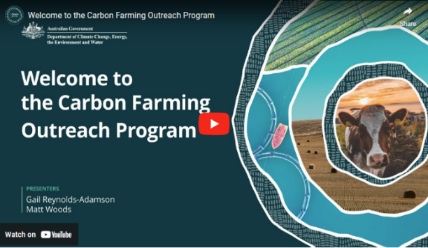In this video (4:38 minutes), presenters Gail Reynolds-Adamson and Matt Woods introduce the Carbon Farming Outreach Program, and the training package structure and content.

Video: [Welcome to the Carbon Farming Outreach Program (youtube.com)](https://www.youtube.com/watch?v=CmsO5OI_53U)

|  |
| --- |
| **Transcript** |
| GAIL REYNOLDS-ADAMSON: Hi, and welcome to Carbon Farming Outreach Training package.  Kaya Kepa Kurl Noongar Boodja. My name is Gail Reynolds-Adamson, and I'm a proud Noongar woman from Wudjari Country, on the eastern border of the Noongar nation in Kepa Kurl, also known as Esperance. 'Kepa' is water, 'Kurl' is boomerang, and its where the waters lie like a boomerang.  MATT WOODS: Hi, Gail, and welcome, everyone. I'm Matt Woods, an agricultural and science journalist.  Today, we're at my home, outside Bacchus Marsh, on the border of Wurundjeri, Woiwurrung, and Wathaurong Country of the Kulin Nation, and I pay my respects to Elders past, present, and future.  In the valley below me is the Bacchus Marsh agricultural district, where market gardeners and orchardists farm some of the deepest top soil in Australia.  I've been on hundreds of farms and spoken to thousands of farmers from one end of Australia to the other. And if there's one subject top of mind for every farmer, it's profitability.  And that's actually what this training package is about. Because, in most cases, good carbon farming practices will improve the profitability and health of your land. Whether you want to enter the carbon market or not, the truly great outcome with carbon farming is that it can be a win-win: good for your farm business, land, and the environment.  REYNOLDS-ADAMSON: Thanks, Matt. It's great to be part of this Carbon Farming Outreach Program training package, and to be able to share with farmers and land managers from all over Australia some of the who, what, when, where, and why, of carbon farming.  This includes evidence-based knowledge and practices both from Western and traditional Aboriginal Torres Strait Islander culture.  I'm the chairperson of Esperance Tjaltjraak Native Title Aboriginal Corporation in Western Australia. I'll be sharing more about the tree rejuvenation project we are running at Kardutjaanup to show you the many benefits, but also the risk requirements involved with this type of carbon farming.  WOODS: The aim of this package, through five short topics, is to give you the carbon farming essentials from expert practitioners, farmers, and land managers in all Ag (agriculture) sectors across Australia, like Gail, who've already embarked on carbon farming projects.  They'll share some tips and tricks with you, including why and how they did it, what technology and techniques they used, what worked, what didn't and who helped them along the way. We've also carefully researched and selected resources, materials, and tools that may benefit you and presented them by Ag (agriculture) sector and location for your convenience.  We know that you don't have loads of time to spend sitting in front of a computer. And that you need your learning to be relevant, targeted, accessible, and practical.  Each of the five topics should take you no more than one hour individually.  But we've also provided additional content and case studies if you want to find out more.  Short videos like this, as well as interviews and explainers, will allow you to access this package anywhere, anytime.  REYNOLDS-ADAMSON: The Carbon Farming Outreach Program training package won't make you an expert in carbon farming, but it will teach you the essential things you should know before embarking on carbon farming.  This includes benefits and risks, potential pathways to action, and the decision you will need to make, including whether or not to trade carbon credits, and some resources you can refer to for your location and type of practice. Importantly, we will help you to understand who you should talk to, what you should look out for when you are choosing advisors, and to ensure that you are getting quality, trusted, independent advice.  WOODS: Finally, each topic concludes with some relevant focusing questions, for you to consider in relation to your own circumstances.  Whether you're just learning about carbon farming for the first time and are exploring your options or had some experience and want to find out more, this package can help you. Think of it as like having a yarn with your neighbours over the fence about their carbon farming project. |

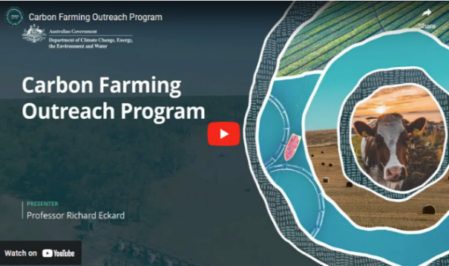

In this video (4:03 minutes), Professor Richard Eckard discusses the need for carbon farming.

Video: [Carbon Farming Outreach Program (youtube.com)](https://www.youtube.com/watch?v=TwaAPwsxYHY&t=25s)

|  |
| --- |
| **Transcript** |
| PROFESSOR RICHARD ECKARD: For farmers and land managers to meet the goal of reduced emissions starting in 2030 through to 2050, they need to know what to do next, what steps to do next, and they need to know where the policy environment is coming from, who's asking them to be low emissions, what the targets are, and then what the options are for them to start responding.  Hi. I'm Richard Eckard, professor in the Faculty of Science at the University of Melbourne. I lead the Primary Industries Climate Challenges Centre, which researches the impact of climate change on agriculture and agriculture on climate.  What we're seeing is all the multinational supply chain companies that deal with agricultural produce have set targets, targets for reduced greenhouse gas emissions. And they average somewhere around 30 percent less emissions by 2030 and net zero by 2050. What we also know is about 70 percent of Australian agricultural produce is exported down these multinational supply chain targets. And so how does Australia perform on the global stage when those companies start buying globally to meet their target?  So it's really imperative that farmers and land managers get on board to know how do they gear their system to deliver the low emissions product that the supply chain will want to buy by 2030. What we're trying to do is just bring up the knowledge that carbon farming is a part of their future.  There is this trajectory towards lower emissions. So making them aware of the policy environment, of the supply chain constraints, of how they need a partnership with their supply chain, to achieve this. And then some awareness of what is their number, how do they get their number, and how do they move down the track towards improving that number. And what are the technologies they can bring to bear to reduce their number, their greenhouse gas footprint?  So these will be things to start with are just best practice. Best practice that we've known for the last 40 years. Things like nitrogen use efficiency, better crop yields, better soil testing, better growth rates in livestock, feeding animals better, bringing legumes into agriculture. These are all things we've known for a long time that improve efficiency, but also reduce the greenhouse gas footprint.  Australia is already 22 percent more rainfall variable than any other country in the world, and the historic management of the land took that into account. Now we're becoming aware of this in how we do carbon farming, that we have to actually change from strictly European farming systems to systems that are more attuned to this high variability we're encountering. And so there's a lot to be learned from the Indigenous land management practices that we need to then incorporate into traditional farming, non Indigenous farming, so that it actually is a bit more in tune with the high variability we have in Australia.  Now the world needs to go net zero by 2050. What we haven't really reconciled is where does the big emission reduction take place? Obviously, it has to happen in the fossil fuel sector.  But we need to move towards, well, what can agriculture contribute to that inevitable net zero? And what can they contribute towards the 2030 goal? Now not every agricultural sector has the identical opportunity. We've got some intensive horticulture for example that have very low emissions and almost nothing to do to get to net zero apart from renewable energy. But you've got an extensive livestock sector where a lot of northern cattle stations, we don't even know how many cattle are there. So the challenges are vastly different, and this is what the program is trying to address is who has what options to move forward and what are those options. |

## Using this training package

This training package provides introductory information, and sources of further information and advice. References to third-party material, information or products or services do not represent endorsements. This training package does not provide detailed information that farmers and land managers may need when making decisions about carbon farming for their own particular circumstances. This training package is not a substitute for independent professional advice. Before making decisions about carbon farming, you may need to obtain more information and independent advice relevant to your particular circumstances.

**Acknowledgement of C****ountry**

The Australian Government acknowledges the Traditional Owners and custodians of all the lands across Australia. We pay respect to all Aboriginal and Torres Strait Islanders, including elders, past and present. We also express our gratitude and appreciation for the ongoing stewardship of Country that Aboriginal and Torres Strait Islanders have practised for thousands of years. We understand that we all have much to learn from traditional ways of knowing, being and doing.

**Statement of intent**

This training package has been developed in consultation and collaboration with an Aboriginal and Torres Strait Islander reference group. We thank them for their generosity with time, expertise, and patience. We recognise Aboriginal and Torres Strait Islanders as rights holders and value the opportunity for Aboriginal and Torres Strait Islanders to engage with farmers and land managers in meaningful dialogue to weave traditional practices into carbon farming. Aboriginal and Torres Strait Islanders offer invaluable traditional ecological knowledge that complements the expertise of other farmers and land managers. Together, farmers, land managers and Aboriginal and Torres Strait Islanders are practising carbon farming methods that respect traditional insights and modern science. As co-innovators, we are exploring new pathways to reduce carbon footprints through joint carbon farming initiatives and preserving the land for future generations.

Aboriginal and Torres Strait Islander people should be aware that this website, the videos it contains and links to First Nations resources may contain images, voices and names of deceased persons.

# 

# Topic 2: What carbon farming means for farmers and land managers

## Time to complete this topic

About 60 minutes to read the information in this topic. Additional content includes videos, activities and links to other resources which may require extra time to complete.

In this topic:

### 2.1 Overview and learning outcomes

## Overview

In this topic, you will learn about the carbon farming activities introduced in Topic 1 and their potential co-benefits: benefits beyond reducing emissions and storing more carbon.

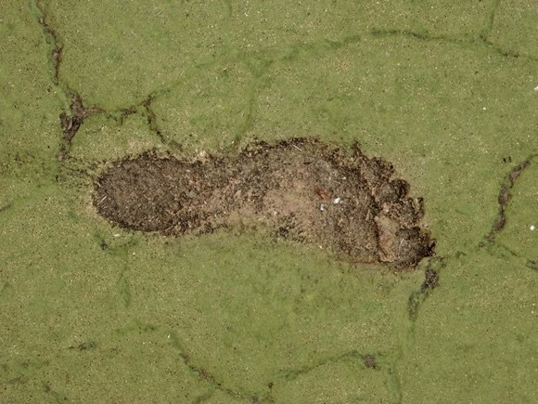Farmers and land managers can be attracted to carbon farming because of the co-benefits, which include:

* more productive, better-preserved assets (such as soil, crops, livestock and Country)
* better water cycle
* protected and enhanced biodiversity and ecosystem function and resilience
* restored wetlands and salt-affected land
* reduced input costs and increased income, including from diversified income sources
* earning Australian Carbon Credit Units (ACCUs) and gaining Climate Active certification, although many farmers and land managers do carbon farming without being involved in the ACCU Scheme or Climate Active certification
* meeting requirements from supply chains or markets
* helping First Nations people pass on cultural traditions and knowledge and maintain spiritual connections to Country.

There are also trade-offs and risks involved in carbon farming. The topic also explores these.

## Learning outcomes

After completing this topic, you will be able to:

* describe carbon farming activities and technologies
* explain the co-benefits and risks of carbon farming
* recognise First Nations peoples’ traditional land management practices
* identify the relevance (or not) of carbon market participation.

## Watch this video

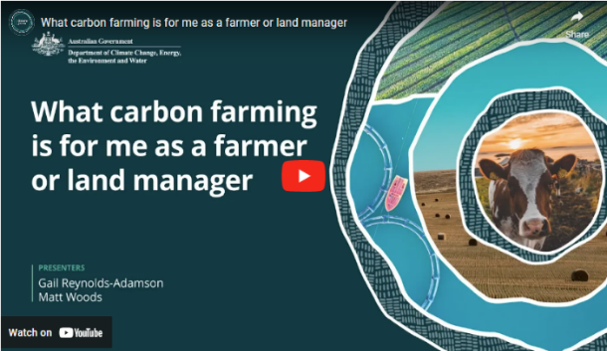In this video (4:27 minutes), presenters Gail Reynolds-Adamson and Matt Woods introduce Topic 2 and provide important context.

Video: [What carbon farming is for me as a farmer or land manager (youtube.com)](https://www.youtube.com/watch?v=p4LqmDePsgc)

|  |
| --- |
| **Transcript** |
| GAIL REYNOLDS-ADAMSON: Welcome to topic two. What carbon farming is for me as a farmer or land manager.  This is where we look more deeply into the types of carbon farming activities you can undertake to help you think about the different options that suit your sector.  MATT WOODS: We'll also drill down more specifically into benefits for particular categories of farmers and landholders.  In addition, we'll explore options and opportunities through technology and practices to manage emissions and sequester or store carbon.  Touching on the pros and cons also.  REYNOLDS-ADAMSON: In topic one, we discussed climate change as the main reason why carbon farming is so important.  We also looked at how Aboriginal and Torres Strait Islander peoples have been using traditional practices to care for Country for a millennia.  These along with some Western agricultural practices allow farmers and land managers to not only manage emissions, but to care for their land more sustainably.  One of the most important things is to think about time.  Many First Nations people think in cyclical, not linear time. We also consider what generations both past and present will think about our decisions.  This helps us to think about long term, not just short term rewards.  This is a helpful perspective to consider for carbon farming as the benefits are not always immediate.  WOODS: Now let's look more specifically at your own reasons for considering carbon farming.  Chances are you're considering the economic benefits that it can bring, whether directly through carbon credits or indirectly by meeting the increasing expectations of supply chains and customers that you are reducing emissions.  Perhaps you're also interested in the many environmental benefits it can bring to your land, including habitat restoration, increasing biodiversity, and creating healthier soils and waterways.  There is no right or wrong reason, and no matter what's your original motivation, before embarking on a carbon farming project, it's important that you're aware of all the potential benefits and risks.  It can also be helpful to keep your why in mind when things get tough because at times, they will.  REYNOLDS-ADAMSON: For me, the why is about putting Country first. The Kardutjaanup Tree Rejuvenation Project is an example of this. With commercial partners, Esperance Tjaltjraak Native Title Aboriginal Corporation has bought 4000 hectares of farming land where we will plant 4.5 million trees.  In the longer term, this project will generate income through carbon credits, but there are other benefits such as creating healthy Country, increasing biodiversity, reducing carbon emissions, and giving Wudjari Traditional Owners self determination over their future. I will share more about the Kardutjaanup story in a case study later in this package.  WOODS: There are schemes specifically for Indigenous farmers and land managers to benefit economically from these practices, but Indigenous and non-Indigenous farmers and landholders alike can benefit from collaborative approaches that consider multiple perspectives to ensure that carbon farming projects are not only economically beneficial, but also environmentally sustainable, and culturally and socially equitable. This recognition of diverse values and priorities can lead to more inclusive and effective environmental and land management initiatives.  REYNOLDS-ADAMSON: So, as you work through this topic, you will learn about potential benefits and disbenefits and sources of emissions, i.e., your footprint, both direct and indirect.  We'll look at opportunities for avoidance and or reduction, see some examples, and hear from some experts.  At the end, you'll be again prompted to respond to these focused questions in preparation for informed discussions with the right experts to guide your decisions. |

### 2.2 Why you might undertake carbon farming

First, let’s briefly provide an overview of some of the co-benefits of carbon farming before looking into the co-benefits of particular carbon farming activities.

Carbon farming helps tackle climate change by reducing or avoiding greenhouse gas emissions and storing more carbon in soil and vegetation.

As explained in Topic 1, carbon farming activities also deliver a variety of co-benefits for farmers and land managers, the environment, people and communities.

Depending on the activity, carbon farming can:

* improve soil health, stability and fertility by reducing erosion, minimising soil disturbance, improving soil structure, making better use of water, and improving nutrient retention and cycling.
* introduce efficient farming practices that support emissions reductions and diversify income streams through developing low-emission products that meet value chain demands.
* improve food quality and community health, creating secure jobs, protecting settlements and infrastructure and improving the liveability of spaces.
* protect biodiversity and ecosystems by improving and increasing diverse habitats and through traditional ecological practices that maintain a balance between human activities and the natural environment.
* improve animal productivity, health and welfare by increasing feed quality and managing herds better.
* improve nitrogen use efficiency.
* improve water use efficiency by reducing evaporation and run-off and increasing infiltration of water into the soil.
* support rehabilitation of wetlands and other waterways.

### 2.3 Carbon farming activities and co-benefits

As Topic 1 examined, carbon farming activities aim to reduce greenhouse gas emissions and store carbon. They also deliver economic and other co-benefits for farmers, land managers, environmental values and communities.

These co-benefits include earning ACCUs and gaining Climate Active certification, which Topics 4 and 5 examine. Many people also do carbon farming for its other co-benefits without being involved in the ACCU Scheme or Climate Active certification.

The following table shows the carbon farming activities this topic examines. These activities may deliver economic and other co-benefits.

**Carbon farming activities**

|  |  |
| --- | --- |
| **Group** | **Activity** |
| Soil | Conservation and strategic tillage Crop and pasture management Efficient fertiliser use |
| Livestock | Reduce beef and dairy cattle and sheep methane emissions Manage piggery and dairy effluent Grazing management |
| Vegetation | Afforestation  Reforestation Agroforestry Retain existing native vegetation |
| Blue carbon | Restore wetlands, saltmarsh and seagrass Remove or modify barriers to tidal flow |
| First Nations traditional ecological practices | Cultural burning, including savanna fire management |

## Soil

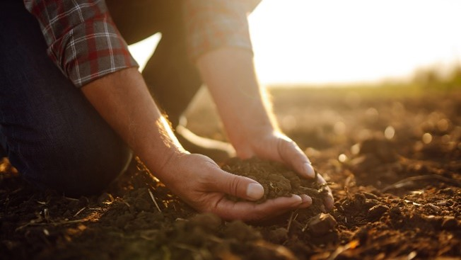Maintaining or increasing soil organic carbon (SOC) helps mitigate climate change and provides many on-farm co-benefits. SOC content can be measured using laboratory techniques or calibrated soil sensors. SOC content values are used with other information to make farm management decisions. The extent to which SOC can be maintained or increased depends mainly on the type of soil, climate, existing SOC level and how the soil is managed. In general, management practices that improve SOC levels will need to be maintained to provide sustained improvements. Soil characteristics and climate will influence the effectiveness of management practices to improve and maintain SOC levels.

|  |
| --- |
| **Maintaining or increasing soil organic carbon** |
| Activities to maintain or increase SOC are explained below. Maintaining good groundcover is a common feature of many of these activities.  Conservation tillage activities include:   * changing from intensive to reduced or no-tillage farming, minimising mechanical cultivation of the soil during sowing and harvesting * retaining stubble after harvesting a crop for ground cover.   Strategic tillage includes remediating land by modifying landscape or landform features (such as by mechanically adding or redistributing soil). Before deciding to strategically manage soil by redistributing it, you must understand soil constraints (such as clay delving or clay spreading in the case of sandy soils).  Crop and pasture management activities include:   * planting and permanently maintaining pasture on land with no or little pasture (such as on cropland or bare fallow land) * using legume species, which add nitrogen to the soil * changing the stocking rate, duration or intensity of grazing.   Grazing management, which the Livestock section below examines, can also help improve pastures and soil.  Planting different crops sequentially on the same paddock (rotational cropping) or growing between main crops (cover cropping) keeps the soil covered. This helps to minimise soil erosion, improve soil fertility, restore SOC and optimise nutrients in the soil.  The [Agriculture Victoria Soil Carbon Snapshot book](https://agriculture.vic.gov.au/__data/assets/pdf_file/0006/857607/Soil-Carbon-Snapshot-updated-May-2022.pdf) (PDF 7.1 MB) introduces soil carbon and its role, overviews recent research and implications for land management practices and has links to sources of further information. |

|  |
| --- |
| **Precision agriculture to manage soil organic carbon** |
| Precision agriculture (also called 'precision farming') involves using technology and data analysis to optimise various aspects of agricultural production, whether it concerns livestock, soil, forests or blue carbon. Applications of precision agriculture to managing SOC include:   * strategic sampling of soil to capture spatial variability and using laboratory and soil-sensing techniques for measurement and analysis * using geographic information system (GIS) technology to store, visualise, analyse and interpret geographic data, including soil properties * using variable rate technology to apply seed and fertiliser or a soil ameliorant at variable rates across a field, depending on the specific soil properties, historical soil performance and crop condition at a particular location. |

|  |
| --- |
| **Benefits of maintaining or increasing soil organic carbon** |
| Activities that maintain or increase SOC may also:   * improve soil health and fertility by using fertilisers appropriately and growing nitrogen-fixing legumes (such as clover) with another crop and making nitrogen available for other plants * improve soil stability by minimising soil disturbance, helping to maintain the soil’s structure, reduce erosion and improve soil health * increase biodiversity and ecosystem function/resilience by growing together or rotating crop and pasture species to provide a diverse habitat for a variety of organisms; or by growing perennial pasture that can suppress weeds and reduce the need for herbicides * reduce evaporation by minimising soil disturbance, resulting in better retention of water and more efficient use of water resources. |

|  |
| --- |
| **Reducing nitrous oxide emissions** |
| Using nitrogen fertilisers more efficiently can help reduce nitrous oxide emissions from soils. This includes using a suitable fertiliser product type and applying fertiliser at a time and rate that meets the needs of particular crops, pastures and soil characteristics. Fertiliser use can be optimised with controlled-release or variable-rate application. GHG emissions can be reduced by using nitrogen inhibitors to slow the rate at which ammonia is converted to nitrate, so plants use nitrogen more efficiently.  There is more information about nitrous oxide, fertilisers and inhibitors on the [Primary Industries Climate Challenges Centre website](https://www.piccc.org.au/research/theme/nitrous-oxide). |

## Livestock

Reducing emissions from livestock can also have productivity benefits. The potential options for reducing emissions vary with types of livestock and production systems.

|  |
| --- |
| **Reducing beef and dairy cattle and sheep methane emissions** |
| These activities aim to reduce emissions from beef and dairy cattle and sheep by:   * improving growth rates and reducing the age of herds, so they produce emissions for fewer days * culling less-productive animals, so fewer are needed for the same output * providing a balanced, optimised diet of high-quality, easily digestible feed and supplements (such as legumes like Leucaena or Desmanthus, tannins, oils, fats and methane inhibitors (like Asparagopsis or 3-NOP)) to improve their growth and reduce methane emissions * substituting urea supplements with nitrate supplements in the form of lick blocks so the cattle produce less methane * improving pasture management, including by grazing management. |

|  |
| --- |
| **Managing piggery and dairy effluent** |
| The main activities that manage piggery and dairy effluent to mitigate methane emissions aim to:   * avoid emissions by promoting aeration, and preventing the generation of methane * generate biogas, which can be used to generate heat or produce electricity.   Some dairy and piggery effluent management activities are eligible to generate ACCUs under the ACCU Scheme [Animal effluent management method](https://cer.gov.au/schemes/australian-carbon-credit-unit-scheme/accu-scheme-methods/animal-effluent-management-method), which is outlined in Topic 5.  Better management of piggery and dairy effluent can:   * reduce nitrous oxide emissions from the application of manure by applying it at the right place, rate and time * reduce methane emissions by using anaerobic digestion systems to capture and use methane to produce energy * by generating electricity on-farm, reduce the need to buy it from the grid * improve soil fertility by using effluent as fertiliser, which also reduces farm costs and the GHG emissions that arise from the production and use of synthetic fertilisers * improve animal welfare by making their living conditions cleaner and healthier * improve water quality by reducing the run-off of nutrient-rich effluent that can cause algal blooms and damage to aquatic ecosystems * help manage effluent odours * protect community and animal health by controlling the spread of pathogens and diseases from poorly managed effluent. |

|  |
| --- |
| **Grazing management** |
| Grazing management activities include:   * systematically moving livestock to different areas to prevent over-grazing * letting the land recover after a short period of intense grazing * monitoring the land, vegetation and livestock and changing plans as necessary.   In the right conditions, grazing management can:   * reduce methane emissions from livestock by improving the digestion and overall health of animals * help maintain soil carbon by improving plant health and root growth * improve soil health, stability and fertility, by allowing organic matter to build up * improve pastures by giving them more time to recover between grazing and minimising overgrazing * increase forage quality by giving livestock access to fresh, young vegetation in each paddock, which also improves the nutritional content of the feed and, therefore, animal health * improve animal productivity, as livestock tend to grow more efficiently on high-quality forage, and there may be less need for supplemental feeding, reducing farm costs * improve water use efficiency by improving water infiltration, reducing run-off, and improving water quality * increase biodiversity and ecosystem function/resilience, as vegetation can recover between grazing periods, providing diverse habitat for a variety of organisms and helping improve ecosystem stability * reduce manure and nutrient run-off into waterways, preventing pollution and protecting aquatic ecosystems. |

## Vegetation

Carbon farming activities to establish and maintain forests — areas with a large number of trees and shrubs — and other vegetation include:

* 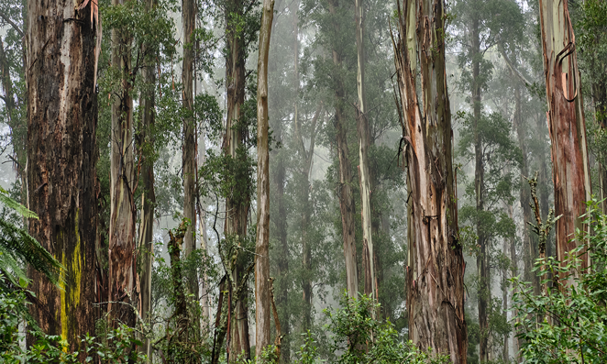afforestation: establishing a forest on land with little or no previous tree cover (such as degraded or barren land)
* reforestation: establishing a forest on land where there has previously been a forest and where there is little or no tree cover
* agroforestry: planting and maintaining trees and shrubs around or on agricultural land, integrating trees and shrubs with crops and livestock
* retaining existing native vegetation rather than clearing it. This includes avoiding clearing native forest that’s regrown on land previously cleared for cropping or grazing, which, as we will see in Topic 5, can earn ACCUs.

|  |
| --- |
| **Vegetation benefits** |
| Vegetation can:   * remove carbon dioxide from the atmosphere and store carbon through photosynthesis in their above-ground biomass and the soil * reduce nutrient run-off and prevent erosion * improve living conditions for livestock and other animals by providing shade, mitigating exposure to extreme temperatures and providing windbreaks * attract pollinators and other beneficial species * absorb and slow down rainwater run-off, increasing groundwater, reducing flooding risks and improving water quality * increase income and diversify income sources by opening up opportunities for timber production, non-timber products (such as fruit, nuts and medicinal plants) and eco-tourism * provide habitat and ecological niches for diverse plant and animal species, including threatened and endangered species, contributing to healthy ecosystems * benefit people and communities by moderating temperatures, increasing humidity, improving air quality, reducing extreme weather impacts and providing green spaces people can enjoy and use to maintain cultural and spiritual connections to the land * create jobs in tree planting, forest management and harvesting. |

## Blue carbon farming activities

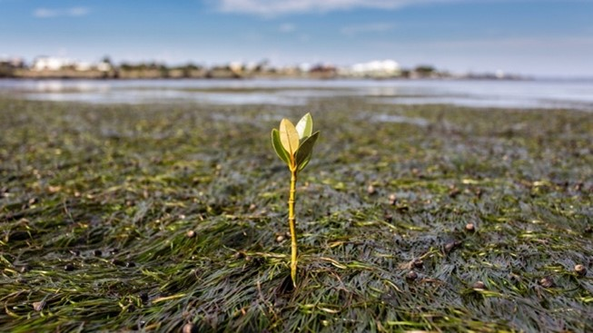Blue carbon farming can occur in coastal wetland and marine ecosystems where management practices can increase carbon stores and, in some cases, reduce emissions. These include:

* mangroves, which store carbon in their above-ground biomass and below-ground sediments, help protect coastlines and offer habitat for diverse species
* seagrasses, which also have root systems that stabilise coastal sediments
* salt marshes, which store carbon by accumulating organic matter in their soils.

The term ‘blue carbon’ draws attention to the importance of these coastal ecosystems in mitigating climate change by storing carbon and avoiding GHG emissions. These and other wetlands provide a broad range of environmental benefits, including filtering water, providing habitat for diverse species and controlling flooding.

Blue carbon farming activities include:

* removing or modifying barriers to tidal flow (such as a sea wall), resulting in the rewetting of drained or partly drained coastal wetlands and converting freshwater wetlands to brackish or saline wetlands
* planting mangrove trees in areas from which they have been removed or degraded and rehabilitating degraded areas of mangrove
* restoring saltmarshes and seagrass.

Blue carbon activities can store carbon in vegetation and soil. Introducing tidal flows to wetlands that have previously been converted to freshwater systems avoids emissions. It does this by reducing the anaerobic (without oxygen) decomposition of organic material in soils, which releases GHGs, in particular methane.

|  |
| --- |
| **Wetland restoration benefits** |
| Restoring wetlands:   * stores carbon in the soil and wetland vegetation * improves soil health by filtering and retaining nutrients * prevents excessive run-off and reduces erosion; particularly important along the coasts as sea levels rise and wetlands are natural barriers against storm surges and tidal erosion * improves water quality by trapping and breaking down pollutants and by reducing sedimentation * protects and improves biodiversity by providing essential habitat for plant and animal species, including to breed, feed and nest, and by being habitat for natural predators — insects, birds, and amphibians — that help control pests on nearby agricultural land * makes better use of salt-affected land, that is, unproductive land * supports diversified income streams from wetland-related activities such as fishing, boating and bird watching * promotes community collaboration, as farmers and land managers collaborate with local communities, environmental organisations and government agencies to restore wetlands, strengthening community bonds and sharing responsibility for environmental stewardship * protects settlements and infrastructure by providing a natural buffer against flooding, absorbing and storing excess water during heavy rainfall, and reducing the risk of downstream flooding, including of nearby agricultural land. |

## First Nations traditional ecological practices

The traditional ecological practices of First Nations people are deeply rooted in millennia-old traditions.

First Nations people have a holistic relationship with the environment that balances land use with conservation, valuing traditional ecological and cultural knowledge and practices passed down through generations.

These practices include cultural burning, sustainable hunting and fishing, and protecting sacred sites and their associated totems. These practices promote ecological balance, reduce the risk of wildfires and contribute to the land's overall health.

First Nations-led carbon farming activities that combine traditional ecological and cultural knowledge with contemporary science are increasingly recognised as effective for environmental sustainability and carbon storage.

|  |
| --- |
| **First Nations traditional ecological practices benefits** |
| First Nations traditional ecological practices:   * preserve and pass on cultural traditions from one generation to the next, including knowledge, stories and rituals * maintain a spiritual connection to Country, with practices often being guided by spiritual beliefs integral to Indigenous identities * build community cohesion, as they involve communal decision-making and cooperation that improves the overall well-being of communities * emphasise the sustainable use of resources so ecosystems continue to provide resources and environmental health for future generations * improve biodiversity and ecosystems, including through traditional ecological practices, by maintaining a balance between human activities and the natural environment * can create secure, long-term jobs, particularly for people living in remote communities * support people and communities by improving spiritual well-being and helping build leadership skills, increasing confidence in working with public sector organisations and building partnerships * potentially align First Nations peoples’ traditional knowledge and recent science-based farming and land management methods while also increasing community awareness about land rights * improve food quality and community health by increasing access to traditional foods for more people * provide economic opportunities for First Nations communities, which can potentially generate income through ACCUs by reducing emissions from uncontrolled intensive fires and enhancing carbon storage. |

|  |
| --- |
| **Cultural burning, including savanna fire management** |
| For thousands of years, First Nations people have done cultural burning, also referred to as fire-stick farming and cool burning. Cultural burning can be of:   * grasslands to promote new growth and reduce fuel loads, helping prevent larger, more destructive wildfires * savanna, which is a mix of grasses and trees, to maintain them and encourage specific plant species * woodlands to maintain their health and promote biodiversity * rainforests to clear undergrowth and reduce the risk of catastrophic fires.   Mimal Women Rangers. Source: Mimal Land Management LtdCultural burning involves small fires lit in a mosaic pattern. This low-intensity burning reduces fuel while protecting the tree canopy, clearing the ground, flushing out animals for hunting and encouraging new growth.  Cultural burning of savanna — savanna fire management — occurs in the Northern Territory, northern Queensland and northern Western Australia. Savanna covers about 1.9 million km2 — about 23% — of the Australian continent. Here, the cycle of wet and dry seasons makes the savanna particularly prone to fire. In particular, savanna fire management involves shifting from late-dry season planned burning to burning early in the dry season, to prevent large, uncontrolled bushfires late in the dry season sweeping across the north of the country.  Mimal Women Rangers. Source: Mimal Land Management Ltd  Cultural burning maintains a traditional method that has worked effectively for tens of thousands of years. Importantly, cultural burning, as a traditional ecological practice, is also deeply intertwined with First Nations peoples' cultural and spiritual heritage. |

|  |
| --- |
| **Cultural burning benefits** |
| Cultural burning:   * reduces GHG emissions and helps store carbon by reducing the frequency and extent of large, intense fires that release large quantities of carbon dioxide and methane. It helps keep the carbon in vegetation and soil * reduces the intensity and risks of bushfires by reducing the build-up of vegetation, and therefore the overall fuel load, slowing the spread of bushfires and decreasing the risk of their intensity and destructiveness * improves soil health, stability and fertility, as ash returning to the soil helps replenish nutrients and helps new vegetation grow * increases biodiversity and ecosystem function and resilience by creating mosaics of vegetation patches of different ages, providing diverse habitats for various plant and animal species * improves habitat quality by preventing shrubs and small trees from encroaching on grasslands, helping preserve savannas as open grasslands * improves pastures by stimulating the growth of fresh, nutritious grasses for livestock and wildlife * helps protect life and property by reducing the intensity of bushfires * delivers direct and indirect benefits for First Nations people, including the direct benefits of meaningful jobs on Country, independent revenue, getting back to and caring for Country and protecting cultural sites, and indirect benefits of meeting cultural obligations, strong governance, community cohesion, self-determination, pride in community and healthy Country. For more information on benefits for First Nations People, see page 65 of the Indigenous Carbon Industry Network’s 2022 [Indigenous Carbon Project Guide](https://www.icin.org.au/indigenous_carbon_projects_guide_downloads) (PDF 8.5 MB). |

## Other ways to reduce the carbon footprint

Other ways a farm can reduce its carbon footprint include using:

* clean, renewable energy (such as solar and wind power and biofuels), reducing reliance on fossil fuels, which can not only reduce farm operating costs but also reduce its scope 2 emissions and, therefore, its carbon footprint
* energy-efficient irrigation systems that make the most efficient use of water and minimise the use of energy, which also reduces farm costs and its carbon footprint
* organic manure from livestock: organic manure is rich in carbon, microbes and other nutrients (such as nitrogen and phosphorus) essential for carbon storage, soil health and plant growth. Using organic manure also reduces reliance on synthetic fertilisers, reducing farm costs and the farm’s carbon footprint.

The Farmers for Climate Action [Climate-Smart Farming Toolkit](https://farmersforclimateaction.org.au/climate-smart-farming-toolkit/) provides information about topics including: drivers for reducing farm emissions; understanding and estimating emissions; and options for reducing emissions, including improving energy efficiency and installing renewable energy systems.

### 2.4 Potential trade-offs and risks

While carbon farming has many co-benefits, it's also essential to consider the trade-offs and risks. Here’s an overview of some potential trade-offs and risks, using examples of carbon farming activities.

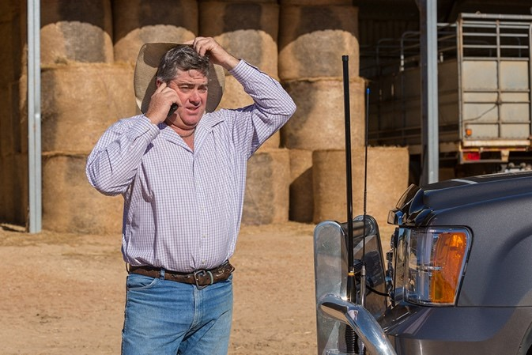**Suitability of location**: features of the location (such as local rainfall and temperature patterns, soil type and land management history) determine the extent to which vegetation can be grown and soil carbon content can be improved and, therefore, the likely success of carbon farming activities. Similarly, there may be locations and practices where achieving improvements in soil carbon levels does not benefit agricultural production.

**Compatibility with agricultural production**: establishing trees on farms may reduce the land available for agricultural production. Carefully positioned plantings can complement agricultural production (such as if they provide windbreaks or are on less-productive land).

**Biodiversity impacts**: decisions about, for example, which trees to plant and their location and layout of tree plantings should consider impacts on biodiversity.

**Water availability**: adopting carbon farming activities that need more water (such as irrigated crops) may depend on water availability.

**Permanence of carbon storage**: storing carbon in vegetation and soil requires ongoing management. Fire, drought or management changes could lead to losses of stored carbon. Managing this risk in carbon markets requires a long-term — many decades — commitment to maintain carbon stores and restore any losses, with implications for land, financial and succession planning.

**Legal considerations**: legal aspects of participating in carbon markets may include land use agreements, complying with legislation and contracts.

**Financial factors**: carbon farming can provide an additional source of income from the sale of ACCUs and on-farm productivity gains. Carbon market participation involves costs in addition to those incurred in investing in new equipment and changing practices. Other costs may include obtaining legal and financial advice, estimating emissions reductions and carbon storage, and monitoring, reporting and auditing. The time commitments involved also need to be considered. There is likely to be a lag between paying initial costs and earning revenue from the sale of ACCUs. This is particularly so for carbon storage activities, where building carbon levels in vegetation and soils takes time and can be subject to variability. Where carbon farming is conducted without participating in the ACCU Scheme, costs of making new purchases and changing practices need to be weighed up against benefits such as improved production.

**Considerations for fire management activities** include:

* the need to provide more detailed knowledge about local ecosystems, appropriate timing, fire behaviour and ecological responses to people undertaking fire management
* the need for community engagement and education about what constitutes ‘good’ and ‘bad’ burning
* getting the timing and intensity of burning right
* the potential for fires to escape
* air quality concerns from smoke
* impacts on non-native species on which cultural burning may have different ecological effects
* the need for expert knowledge about vegetation, weather patterns and fire behaviour.

### Expert interviews and case study

## Watch these videos

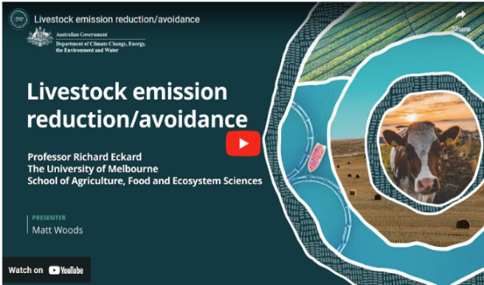In this video (6:20 minutes), Matt Woods and Professor Richard Eckard of the University of Melbourne discuss livestock emission reduction and avoidance.

Video: [Livestock emission reduction/avoidance (youtube.com)](https://www.youtube.com/watch?v=1HqUDeqyfjk)

|  |
| --- |
| **Transcript** |
| MATT WOODS: Hello.  I'm Matt Woods.  And I'm here with Professor Richard Eckard. Richard has been working for over 20 years on addressing the impacts of a changing climate on agriculture.  A big part of the emissions story in Australia is livestock emissions. Can you briefly describe what they are and why they matter?  PROFESSOR RICHARD ECKARD: So the majority of livestock emissions come from what we call ruminants. Ruminants have got four stomachs. We've only got one. So ruminants are your cattle, sheep, goats; they would be your classic ruminants.  And because of the first stomach, so, a ruminant can actually digest cellulose; grass. You and I can't live on grass.  And they can because the first of their four stomachs called the rumen is a microbial digestion vat. So it's a massive vat with microbes that are there to break down the cellulose and turn it into sugars. So they can live on grass when you and I can't. But unfortunately, the moment you put organic material; grass, in an anaerobic environment, so no oxygen, you generate methane as well. We've known that for centuries because we know that when you put organic material or waste into an anaerobic pit, it'll generate a methane gas. Now unfortunately, that's what happens in ruminants as well. They generate this gas, methane. And methane is a powerful greenhouse gas. For every day that methane's in the atmosphere, it warms the planet a hundred times more than carbon dioxide. So it's important.  WOODS: Why is it important to farmers and farm businesses that they know this?  ECKARD: Well, 20 years ago, most farmers would not have even been aware that their cattle are producing methane.  But since climate change is now becoming quite a pressing issue, what we're seeing is not necessarily government policy, but we're seeing the supply chain starting to respond to the Paris Climate Agreement. And so all our multinational supply chain companies have started setting targets based on what we call the Science-Based Targets Initiative. So, you try to sell your meat to one of the major meat companies; by 2030, they'll be looking for 30 per cent less emissions from your meat. Because they're reporting down their supply chain to shareholders who are responding to customers.  And the major banks are on the same trajectory as well, where they are required to report to their - the Central European Bank, for example, on the emissions profile of their loan portfolios.  So, they're concerned about exposure to greenhouse gas emissions, and if you think of Australian agriculture, 70 per cent of what we produce is exported down these multinational supply chains.  And we know that by 2030, they are putting restrictions on what they will buy in terms of greenhouse gas emissions. So it's not got much to do with government targets. It's got to do with our supply chains that are actually wanting lower emissions supply in the future, which is why then it is of concern to farmers, whether they agree or not, it's in place. So we're in that phase right now of doing a lot of the research required to give farmers cost-effective solutions. That's actually really important.  But between now and 2030, raising awareness that you need to know your number; what is your emission, and what can you do about it between now and 2030? So that you remain at the head of the marketing queue when the supply chain come buying for low emissions product.  WOODS: Right. You mentioned cost effective things that farmers can do about it. What are some of those things?  ECKARD: So to answer that question, we need to understand how the supply chain can buy. You see, they can't buy on actual emissions, because then they just buy a small farm rather than a big farm, because a big farm produces more than a small farm. They can only buy on a unitary value, like emissions per unit of production, emissions per kilogram milk solids, emissions per kilogram of wool, or kilogram of meat - which is what we call emissions intensity.  So how do you shift the dial on emissions intensity? You just become more efficient. So you use current best practice of nitrogen use efficiency, fertiliser efficiency using legumes, grazing management, weaning rates.  The reason why a prime lamb operation has a lower emissions intensity. It's just because you get 150 per cent weaning, relative to a beef system that gets a bit somewhat below 100 per cent weaning. So you haven't changed the emissions, you've changed the denominator, which is how much live weight you're producing.  So getting that more efficient by reducing unproductive animal numbers, just current best practice will put you at the head of the queue by 2030.  WOODS: If I'm a farmer sitting here listening to this, and I'm a prime lamb producer, let's say. What's the first cab off the rank for me to try and bring my emissions down?  ECKARD: So your prime lamb is a good example in that you're focusing on a meat product, which means that you can get your weaning rates up to a 150 per cent. You can get them up to maybe, some exceptional producers, up to a 170 per cent.  That means that for every ewe that you have on the farm that is producing methane, you're now dividing it by 1.5 or 1.75 lambs that are coming out of the system that go down the supply chain. So that actually means that per unit of meat produced, you are lower emissions than your neighbour, who might be a 100 per cent weaning or 120 per cent.  So that can be achieved through better genetic selection, feed conversion efficiency, selecting for or reducing health costs... basically anything that reduces every day that the breeder herd is unproductive on the farm. |

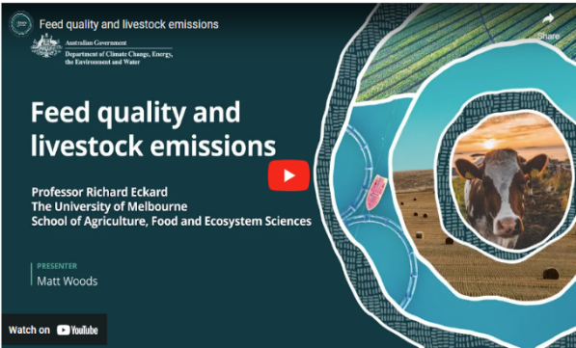In this video (7:42 minutes), Matt Woods and Professor Richard Eckard of the University of Melbourne discuss feed quality and livestock emissions.

Video: [Feed quality and livestock emissions (youtube.com)](https://www.youtube.com/watch?v=vBATeeLisnE)

|  |
| --- |
| **Transcript** |
| MATT WOODS: Hello. I'm Matt Woods, and I'm here with Professor Richard Eckard. Richard has been working for over 20 years on addressing the impacts of a changing climate on agriculture.  A part of methane emissions from ruminants is quality of feed that's going into the animal.  If I feed my prime lambs better quality feed, does that bring emissions down?  PROFESSOR RICHARD ECKARD: Most definitely. So, more so in Northern Australia than Southern Australia because in Northern Australia, the inherent range land is lower quality than some of our temperate grasses in the south. But no doubt if you're a lamb producer in Western Victoria and you bring more legumes into your pasture, the growth rate of the lambs will increase relative to just being a grass based pasture.  The same in Northern Australia, if you've got a beef system and you have a leucaena for example, or desmanthus or some of these these novel legumes, they would have two modes of action. One, they would improve the average quality of the grass, because a lot of the northern grasses are poor quality. So your growth rate would pick up from, say, 0.3 kilograms per day, to about 0.9 kilograms a day. So you're actually finishing animals for market earlier, but some of these legumes also have secondary compounds in them, like tannins that reduce methane for every day they're on the pasture. So you get two effects. One, better feed quality gets the animal growing faster so it gets out to market earlier, and that reduces your emissions intensity.  But the secondary compounds reduce methane for every day they're on the pasture, and that's a completely separate effect.  WOODS: Dairy farmers feed their cows pretty well. Are they going to produce less emissions per cow on a dairy farm than, say, a beef operation?  ECKARD: So here's the unfortunate irony, is that methane is very strongly related to dry matter intake.  And so you've got a Brahman in Northern Australia eating four, five kilos of dry matter a day because it's low quality; it takes longer time to go through the rumen. And you've got a dairy cow in Victoria that's producing 50 litres of milk at peak lactation on high quality pasture, eating 23 kilos of dry matter a day. So the dairy cow is producing more methane per kilogram, for total intake.  But per kilogram dry matter intake, they're actually no different. They're both producing about 20 times methane per kilogram dry matter intake.  The difference is that the emissions intensity of the dairy cow is much better.  Because it's eating 20 kilos, so it's producing more methane, but it's producing more product.  And so the emissions intensity of the dairy cow on better quality forage is much lower than say a beef cow in Northern Queensland growing at 0.3 kilos a day.  WOODS: Now are there some up and coming technologies that might be useful for farmers to to reduce some livestock emissions?  ECKARD: So there's a couple of things that farmers can do. We started off with the 'do now' stuff, which is, reducing unproductive animal numbers, animal health, breeding; breeding better, better genetics, better, faster gain.  There's a bunch of things that we can do around feeding animals.  Better legumes. There's a lot of legume technologies coming through, like desmanthus, leuceana. There's a lot of interest in using the current legumes in Southern Australia like white clover and lucerne, that we can actually express these secondary compounds more in those.  And so, in the pipeline coming through would be: yesterday, you bought white clover tomorrow you buy white clover with tannin in it that reduces methane as well as giving you a boost to production. So that's a space to watch, and it's an actively emerging space.  But stepping into the future, there are technologies like the seaweed option.  We've heard a lot about seaweed. There's another product, 3-NOP Bovaer, which does the same as seaweed.  Those are coming through in the marketplace. The problem is those methane inhibited products really only work where you've got confined animals, and you can feed them every day. Because you think of an inhibitor...  WOODS: So the dairy operation, for instance, it might be useful.  ECKARD: Yeah. In a dairy where you're feeding twice a day, that could work. If you're in a feedlot, it'll obviously work.  If you've got an inhibitor that only lasts for an hour in the rumen and before the rumen breaks it down. You think about that. It's gotta be in every mouthful of every mouthful the animal eats to be effective.  WOODS: Right. Yeah.  ECKARD: So, a feedlot works because you can mix it into every mouthful. And in a dairy might work because you can feed it twice a day, but it would be a lumpy effect.  WOODS: Yes, okay.  ECKARD: But in the end, we've got to move to something a bit more sustainable for the extensive grazing industries because these daily supplements - well, first of all, we don't want to doom farmers to have to pay a feed company every day for a supplement to reduce methane.  WOODS: Just out of interest, what are we talking about, sort of cost to a farmer?  ECKARD: The cheapest of these supplements for dairy would be about 50 cents per cow per day.  WOODS: Right. Okay.  ECKARD: And at the current carbon price of about 34 dollars a tonne, we're talking of seven cents per day as the pain point. So a farmer could afford seven cents a day if they're getting paid a carbon credit for that, and the price is 50; 50 cents.  WOODS: Right.  ECKARD: So we've got a way to go before methane supplements become a viable solution, which is why we're more interested in the legume technology because that's things we can do now. We have farmers using these legumes in across all the grazing industries.  So let's work with what we've got and at least we can get 20 per cent reduction in methane out of that.  But looking forward into the future, there are more speculative technologies coming through like early life programming.  Which is the concept that your and my gut microflora are a product of our upbringing, of our home environment. We inherit that.  It turns out the rumen could be the same. And there's a few papers published now showing that if you feed one of these inhibitors to cows and calves through pre-parturition, and through the birthing phase, and through the weaning phase that the animals can remain lower methane afterwards without supplementation.  And so that gives us hope that -  WOODS: Sorry, just to clarify that -  They get inoculated early in life, and then they wouldn't need any further supplementation.  ECKARD: Correct. That's the aim.  And so you start thinking of the Northern Territory where we don't even know where most of the cattle are, legume technology could work.  But establishing it on, you know, hundreds of square kilometres is a logistical issue.  But if you could come up with a once in a generation intervention, that resulted in all the calves being 20 per cent less methane, that's quite a big breakthrough.  It's not costing the farmer daily, you set them on the right course, and then they just are lower methane. So that has to be the ultimate goal of research, but it is still very speculative. |

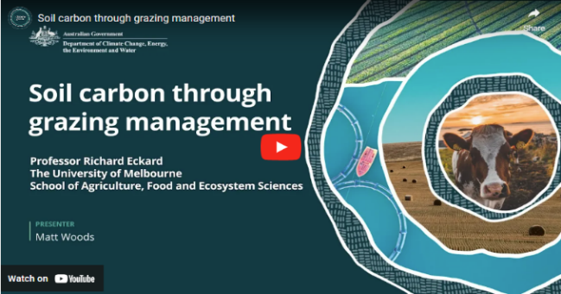In this video (5:14 minutes), Matt Woods and Professor Richard Eckard of the University of Melbourne discuss soil carbon through grazing management.

Video: [Soil carbon through grazing management (youtube.com)](https://www.youtube.com/watch?v=f90_oQxCpR0)

|  |
| --- |
| **Transcript** |
| MATT WOODS: Hello. I'm Matt Woods, and I'm here with Professor Richard Eckard.  Richard has been working for over 20 years on addressing the impacts of a changing climate on agriculture.  I'm going to move now to soil carbon and ask you about grazing management. Can you effectively build soil carbon through grazing management?  PROFESSOR RICHARD ECKARD: So there are a lot of claims around grazing management but the only actual evidence we have in the peer-reviewed literature would be that if you move out of a set stocking environment; a continuous grazing environment, where you might get caught out in a drought period will lead to erosion.  It will lead to the loss of soil organic matter off the surface of the soil through hoof action.  That we know; that we've seen in long term trials.  Once you move beyond that into some form of conservative rotational or adaptive grazing management strategy, there is no data to suggest that one would do soil carbon better than another.  They would all enhance soil carbon relative to the set stocked example.  So the best practice that we can advise farmers to do to build soil carbon in grazing systems is to move out of a set stocking environment into what we would call more adaptive rotational grazing.  Once you're into that environment of rotational grazing, there's no evidence that says one of the ten philosophies that are out there is better than another.  And that's as much as we can say right now.  WOODS: Ten philosophies, ten things to choose from. There must be a system that's going to work better for some farmers than others.  Is that right or is or is it just a bit of pot luck when they go to choose their system?  ECKARD: I think, it's fair to say that 40 years ago we thought there were recipes.  WOODS: Yep.  ECKARD: But then along came more variable climates and along came climate change. And that threw recipes out of the window because a recipe that you stick to religiously is going to get you in trouble when the climate varies.  So where we now say is all ten of those grazing philosophies have some merit at some time.  What we need to do is step back from fixed recipes to understand the principles of: if I overgraze or I have animals in too long and they regraze the same plant twice in a row, they will graze the more productive plants first.  And so I'll get an increase in unproductive plants. And so your grazing management needs to be more adaptive than ever before.  So understanding the principles of grazing management, the need to rest those productive plants; those nutritious plants, the need to balance unproductive versus productive grasses, in the way you manage range land then becomes more critical.  And then you go to those ten philosophies and say, well, for this next three month period, because the El Niño's coming, I need to pick a different strategy. Because the one I'm doing will get me in trouble.  And so adaptive grazing says, understand the principles around how plants are productive and animals interact with the grassland system.  And then apply those principles in some form of conservative rotational resting, allowing plants to recover, allowing productive plants more time to recover, not allowing re-grazing of plants, all become important. But unfortunately, with a variable climate, we can't have fixed recipes.  WOODS: Sounds like what you're saying is that farmers need to be flexible in how they approach their grazing. Understand the concepts and be very flexible depending on what's happening.  Is that right?  ECKARD: Yeah. Most definitely, we need to be adaptive in our grazing management. The only thing we need to be fixed about, and some of the better farmers have figured this out, is have immovable and non-emotive cutoff dates.  So if you haven't got 25 millimetres by the 23rd of February, you need to lighten your stocking rate by x per cent.  Those are more critical rules that have emerged over time is: not having this emotion of "I'll just keep them for another week". Because that's how you get caught out.  WOODS: Okay.  ECKARD: The market's gone by then, and you've lost your opportunity.  So the better farmers have critical cutoff dates to make decisions.  But that decision is really still adaptive grazing. How do I adapt to this condition? I've got to unload a third of the animals and send them down to market, even though I might not get the best price, I now have the right stocking rate for the next three months. |

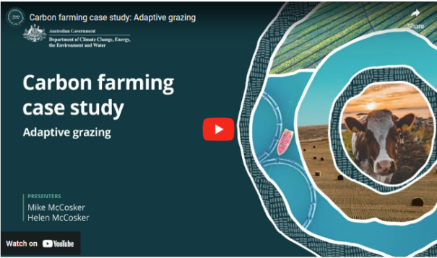In this video (8:39 minutes), New South Wales graziers Mike and Helen McCosker discuss adaptive grazing and soil health.

Video: [Carbon farming case study: Adaptive grazing (youtube.com)](https://www.youtube.com/watch?v=-VKiz-SLCM0&t=2s)

|  |
| --- |
| **Transcript** |
| MIKE MCCOSKER: So the importance of soil carbon in understanding the health of my farm is critical. Soil carbon is the end result of all of the ecosystem functions working properly.  Whatever I'm producing relies on the green plants harvesting sunlight energy, turning that sunlight energy into sugars.  Soil carbon is the end result of all the ecosystems working properly.  So when we look at what's here now, the diversity above the ground indicates that I've got diversity of roots and diversity of biology under the ground. And that's the key to turning the sunlight energy into soil health and soil carbon.  So the greater the diversity of roots, the greater the diversity of biology, and that's what turns sunlight energy into soil carbon forming.  The penetrometer is a great tool to give me an indication of if there is a hardpan in this soil. So after years of planting oats every year and running the cattle across the country, then you know, there would be a hardpan somewhere in the first three or four inches. And the penetrometer shows me that as soon as I hit four hundred, the roots are no longer growing in that soil. So that shows me if the hardpan is just, you know, two inches or four inches under the soil.  So at the moment, I've got half a metre of good functional soil there.  And that means no hardpan for me, no restriction of root growth. I've got the all of the biology and the roots doing exactly what they're meant to be doing under there, and that includes taking in water and holding the water for the crop.  Soil carbon and the ability of this soil to take in water are directly proportional.  So when my soil carbon levels are low and the soil structure has collapsed, this soil can only take a maximum of, you know, 50 millimetres of rain in an hour. If I get more than 50 millimetres of rain in an hour, that water would hit the soil and run away.  When I get my soil carbon up, it makes the soil like a sponge. And so now that I could take in anything up to 500, 700 millimetres of rain in an hour. So I could get my whole annual rainfall in one hour, and it would all go into the soil. So the importance of soil carbon and the ability of the soil to take in water and make my rainfall now efficiently turn into to crops and production directly proportional.  So grazing management for soil carbon and for diversity, it comes back to a planned rotation.  So I pull the cattle together so that my cattle impact when the cattle are in here. It's like a quick mow. So we're a short period of time with high stock density.  And then the other thing that I really plan is the rest period. So how long does this pasture need to then recover from that grazing?  So, we talk about time controlled grazing or planned grazing, but that's all about planning the rest period.  And to get the rest period, I plan the density of the stock and how long that land is impacted for.  I'm looking for indicator species. So I'll be looking for if this is one of my main grasses because it's nice and sweet and it's high in nutrition, then I'm looking for this grass to be fully recovered before I'm bringing those cattle back here.  This gets a little bit counterintuitive because when the growth is happening really quickly, I want to avoid, this grass having to draw from its root reserves to grow. So I'm wanting to avoid the animals coming back and taking a second bite before it's actually fully recovered and replenished the root system.  So when things are growing really quickly, I actually need to move the stock around the farm more quickly. When things are recovering slowly, I actually need a longer rest period because it takes longer for the plant to get away from where it's drawing on the root reserves back up to, what we call a late phase three or early phase four.  That so if things are recovering slowly because we're a bit short of moisture, we just haven't had the rain, then I'll actually slow the cattle down. There's no risk when things are running slowly that the animals will get a second bite, but there is risk that we don't get back to a fully recovered plant if I come back too quickly.  Does the soil carbon level show up as being different if we get dry weather? I would say absolutely.  The ability of the soil to absorb the water when it does rain means that my water cycle efficiency, that actually shows up when it stops raining because I'll have, you know, two times, three times more water held in my soil compared to the neighbour's place.  And, you know, so the pasture will stop growing on my neighbours and still be growing on my place simply because I've got more water held in the soil. 2018 and 2019 were horrendous years. They were bad for everyone.  I can say that we didn't need to feed the cattle for a lot longer into the drought before we had to start feeding.  And then when it did rain at the end of the drought, the land just recovered and regenerated so much more quickly. So the resilience of the farming operation, shows up in the extremes of the weather. When it's dry or even when it's particularly wet, having that soil carbon in the soil just gives this land much more resilience.  M. MCCOSKER: From the point of view of building soil carbon, you know we understand that it's not just one practice that makes that change. And in fact, I would say that we've stacked different practices together. We've changed the management of the cattle, and we've changed to a multispecies cover crops. And we've  HELEN MCCOSKER: And compost.  M. MCCOSKER: Included mineralised compost.  So we've stacked the changes.  When I think back about how the farm has changed, one of the things that is a little more subtle, but you do notice it really quickly, is that the soil gets softer.  And, it's soft when you walk on it. Yeah. It's easy for the tractor, so we actually probably now use less fuel.  And I noticed that because we also contract plant for other farms in the district.  And when we go on to another farm, we're pulling the same equipment, but we -  H. MCCOSKER: Gear  M. MCCOSKER: Gear slower.  H. MCCOSKER: Yeah.  M.MCCOSKER: And using more fuel.  H. MCCOSKER: Yep.  M. MCCOSKER: And then we come back home, and we go, wow. Isn't the soil so soft?  One piece of advice that I would give to people is hasten slowly, that don't be afraid to fail.  But if you do fail, make sure you've failed on just a little bit of the farm and work that out before you try and do it over the whole farm. |

### Activity

## Activity: Respond to the following questions

Think about how what is covered in this topic might apply to your land management or farming practice. Consider the following questions and make notes about carbon farming activities that might suit your enterprise. The following points will help you have informed discussions with advisers.

1. What potential benefits are you hoping to gain from carbon farming? Consider both financial and non-financial potential benefits.
2. Which activities might you undertake?
3. What do you need to consider based on your practice and location?
4. Based on the information provided in this topic, what else is important for you to note for future reference?
5. What further questions do you have?
6. Consider the following risks associated with doing or not doing carbon farming that might apply to you. You may also identify other risks. This can inform your discussion with an adviser.

|  |
| --- |
| **Risk** |
| **… associated with doing carbon farming activities** |
| The location could be unsuitable |
| Land could be lost for production |
| Biodiversity could be harmed |
| There could be insufficient water |
| Meeting any permanence requirements for carbon storage could be difficult |
| There could be too much financial risk |
| **… associated with not doing carbon farming activities** |
| Not mitigating climate change |
| Soil degradation |
| Water cycle degradation |
| Loss of biodiversity and ecosystem function/resilience |
| Not accessing new income opportunities |
| Not meeting emerging supply chain and market requirements |

### Other resources

## Livestock

Reducing methane from livestock (DCCEEW)

This DCCEEW webpage [Reducing methane from livestock](https://www.dcceew.gov.au/climate-change/emissions-reduction/agricultural-land-sectors/livestock) provides information on research into reducing methane emissions through feeding and grazing practices.

Delivering CN30 – Meat & Livestock Australia (MLA)

MLA's [Delivering CN30 website](https://www.mla.com.au/research-and-development/Environment-sustainability/carbon-neutral-2030-rd/delivering-cn30/) provides four key areas of work referring to activities to manage emissions:

* [Greenhouse gas emissions avoidance](https://www.mla.com.au/research-and-development/Environment-sustainability/carbon-neutral-2030-rd/industry-ghg-emissions-avoidance/)
* [Carbon storage on farm](https://www.mla.com.au/research-and-development/Environment-sustainability/carbon-neutral-2030-rd/carbon-storage/)
* [Integrated management systems](https://www.mla.com.au/research-and-development/Environment-sustainability/carbon-neutral-2030-rd/integrated-management-systems/)
* [Industry leadership](https://www.mla.com.au/research-and-development/Environment-sustainability/carbon-neutral-2030-rd/industry-leadership/)

Climate and environment (Dairy Australia)

This Dairy Australia website provides resources on sources of dairy emissions and [Dairy Farm Emissions Reduction Strategies](https://www.dairyaustralia.com.au/resource-repository/2023/08/30/carbon-emissions-reduction-fact-sheet):

* [Reducing dairy's greenhouse gas emissions](https://cdn-prod.dairyaustralia.com.au/-/media/project/dairy-australia-sites/national-home/resources/climate-environment/carbon-emissions-factsheets/reducing-dairys-greenhouse-gas-emissions.pdf?rev=48e04d999fa545b5b93b5e1302e37b2c) (PDF 662 KB)
* [Reducing fossil fuel emissions](https://cdn-prod.dairyaustralia.com.au/-/media/project/dairy-australia-sites/national-home/resources/climate-environment/carbon-emissions-factsheets/reducing-fossil-fuel-emissions.pdf?rev=6b088ccf6b2b45d1b00607a20e7c9ddd) (PDF 615 KB)
* [Reducing manure emissions](https://cdn-prod.dairyaustralia.com.au/-/media/project/dairy-australia-sites/national-home/resources/climate-environment/carbon-emissions-factsheets/reducing-manure-emissions.pdf?rev=d99db2d5b8384203b3f36fc29b7b1f16) (PDF 457 KB)
* [Reducing nitrous oxide emissions](https://cdn-prod.dairyaustralia.com.au/-/media/project/dairy-australia-sites/national-home/resources/climate-environment/carbon-emissions-factsheets/reducing-nitrous-oxide-emissions.pdf?rev=b3d63c7726aa42f9821c205d5caa2d18) (PDF 538 KB)
* [Reducing rumen emissions](https://cdn-prod.dairyaustralia.com.au/-/media/project/dairy-australia-sites/national-home/resources/climate-environment/carbon-emissions-factsheets/reducing-rumen-emission.pdf?rev=708e15e4f5a74fceb2e304360787fd57) (PDF 453 KB)
* [Storing more carbon](https://cdn-prod.dairyaustralia.com.au/-/media/project/dairy-australia-sites/national-home/resources/climate-environment/carbon-emissions-factsheets/storing-more-carbon.pdf?rev=7863d84138d54db78d01251304d6c350) (PDF 796 KB)
* [Dairy shed effluent and biogas](https://cdn-prod.dairyaustralia.com.au/-/media/project/dairy-australia-sites/national-home/resources/ad-hoc/22-04-2022/dairy-shed-effluent-and-biogas/dairy-shed-effluent-and-biogas.pdf?rev=8e52cb5d3d534fe59508aa5f43b6deef) (PDF 521 KB).

Environmental sustainability (Australian Pork)

This Australian Pork website provides information on research and resources for [environmentally sustainable](https://australianpork.com.au/environmental-practices/environmental-sustainability) pork. There are 2 roadmaps for producers:

* [Low Carbon Emission Roadmap](https://australianpork.com.au/sites/default/files/2022-05/031722%20-%20APL%20-%20Low%20GHG%20Emission%20Roadmap%20-%20V3.pdf) (PDF 5 MB): to help understand emissions and learn what practices can be implemented to reduce emissions
* [Closing the Loop](https://australianpork.com.au/sites/default/files/2022-06/031722%20-%20APL%20-%20Closing%20the%20Loop%20Roadmap%20-%20V3.pdf) (PDF 2 MB): to help understand how to minimise feed inputs, improve efficiency to minimise waste, utilise manure nutrients and discover new ways to manage hard waste.

## Cropping, horticulture and forestry

Sustainability Initiative (Grains Research and Development Corporation)

The Grains Research and Development Corporation’s [Sustainability Initiative](https://grdc.com.au/__data/assets/pdf_file/0039/587856/GRDC_SustainabilityInitiative_May2023.pdf) (PDF 4.6 MB) summarises GRDC’s position and plan for ongoing investment in sustainability (including climate mitigation and adaptation). Work stream 2 of the initiative includes information on emissions reduction practices for the sector as well as references to relevant resources and tools.

Sustainability framework for Australian horticulture (Hort Innovation)

This Hort Innovation website provides information on sustainable agricultural practices within the [Horticulture sustainability framework](https://www.horticulture.com.au/hort-innovation/our-work/horticulture-sustainability-framework/) and links to industry-led sustainable production assurance programs (Hort360, EnviroVeg, Banana BMP, Freshcare Environmental and EcoHort).

Emissions Reduction Guide (Wine Australia)

This Wine Australia website provides an [Emissions Reduction Roadmap](https://www.wineaustralia.com/sustainability/emissions-reduction-roadmap), a reference manual containing tools, resources and advice to help Australia’s grapegrowers and winemakers take action in their own businesses.

FWPA Carbon Guides (Forest & Wood Products Australia)

This Forest & Wood Products Australia website provides information including the [Forests & Wood Products and Australia’s Carbon Balance Guide](https://fwpa.com.au/tool/fwpa-carbon-guides-social-media-assets/) that describes the key concepts associated with the life cycle of carbon in forests and forest products and provides guidance on forest management.

## Additional

Accounting for Nature methods

The [Accounting for Nature website](https://www.accountingfornature.org/method-catalogue)has a catalogue of methodologies to measure and report on environmental assets to prepare an environmental account. Accounting for Nature is one approach to measuring environmental conditions.

Zero Net Emissions from Agriculture Cooperative Research Centre

The [Zero Net Emissions from Agriculture Cooperative Research Centre](https://zneagcrc.com.au/) aims to catalyse industry, community and government action to achieve zero net emissions from agriculture from 2040 and below zero net emissions by 2050. Its four research programs focus on:

* low-emissions plant solutions
* towards methane-free cattle and sheep
* whole-farm and mixed enterprise systems analysis
* delivering value from net zero.

Blue Carbon – Opportunities for First Nations Peoples

The [Blue Carbon in Australia, understanding the opportunity for Indigenous People](https://assets.nationbuilder.com/icin/pages/419/attachments/original/1722327686/ICIN_Blue_Carbon_Report.pdf?1722327686) report provides information and mapping related to First Nations participation in Blue Carbon projects.