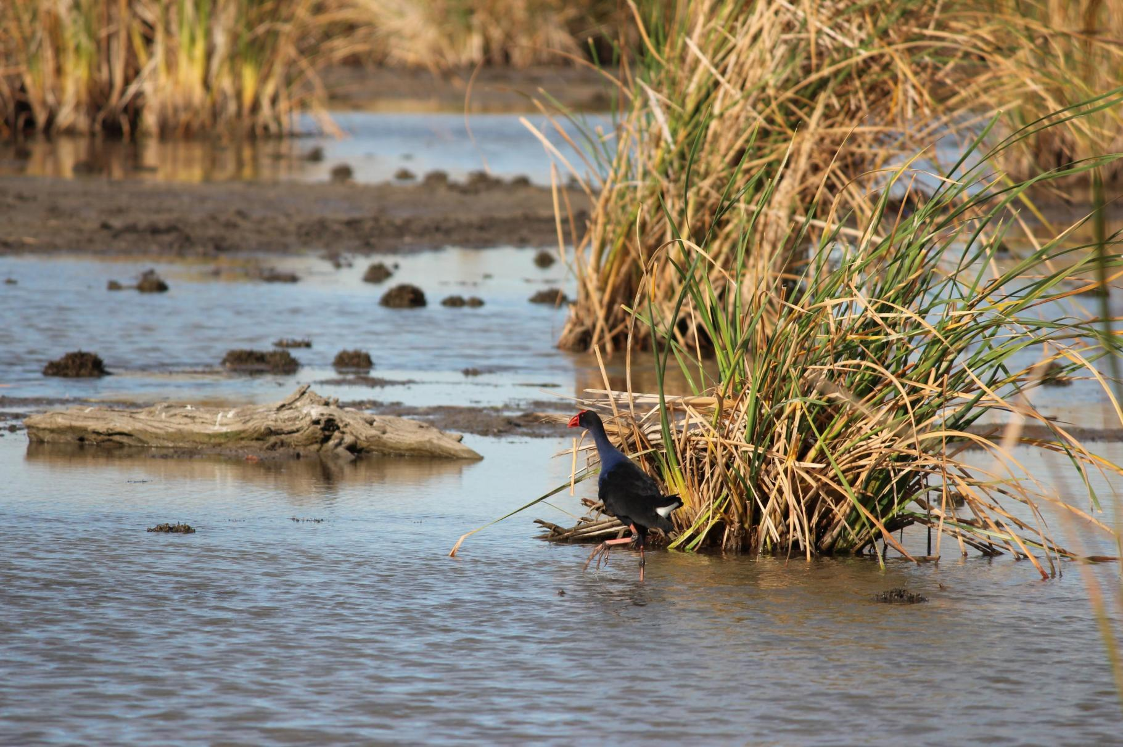

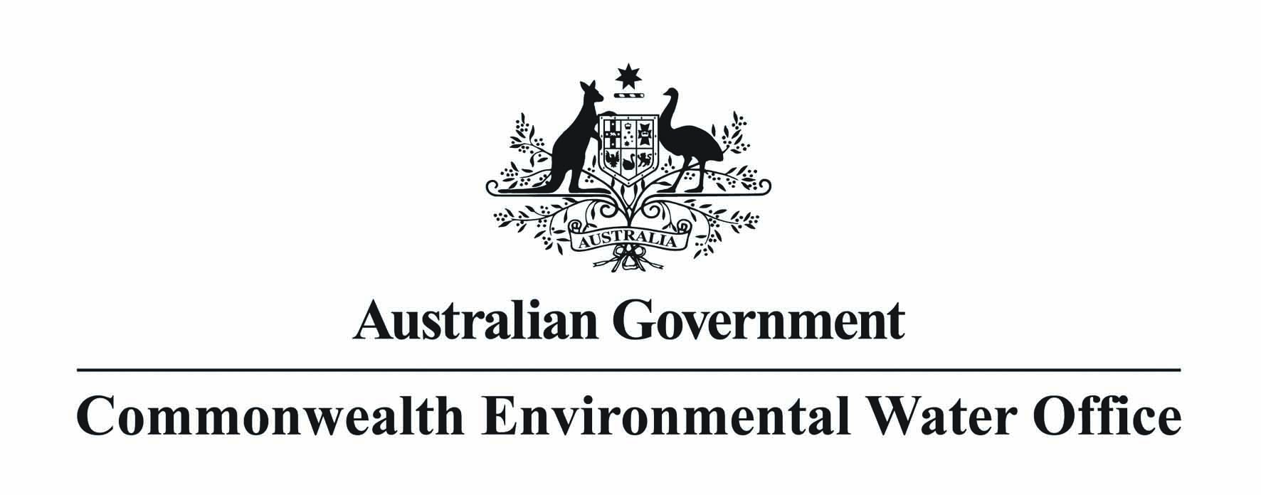

**Commonwealth environmental water carryover from 2012-13 into 2013-14**

**Commonwealth environmental water carryover from 2012-13 into 2013-14**

Table of contents

1. Key points 3

2. Background 3

3. Commonwealth carryover 4

4. Future outlook 6

**Acknowledgement of the Traditional Owners of the Murray-Darling Basin**

The Commonwealth Environmental Water Office respectfully acknowledges the Traditional Owners, their Elders past and present, their Nations of the Murray–Darling Basin, and their cultural, social, environmental, spiritual and economic connection to their lands and waters.

Cover image credit: Purple swamphen, Monkeygar Wetland, Macquarie Marshes, 2013.   
Photo by David Straccione © CEWO

This report should be cited as ‘*Commonwealth environmental water carryover from 2012-13 into 2013-14’*.

Published by the Commonwealth Environmental Water Holder for the Australian Government.  
­­© Commonwealth of Australia 2013.

This work is copyright. Apart from any use as permitted under the Copyright Act 1968, no part may be reproduced by any process without prior written permission from the Commonwealth. Requests and enquiries concerning reproduction and rights should be addressed to Department of Sustainability, Environment, Water, Populations and Communities, Public Affairs, GPO Box 787 Canberra ACT 2601 or email [public.affairs@environment.gov.au](mailto:public.affairs@environment.gov.au)

Information presented in this document may be copied for personal use or published for education purposes, provided that any extracts are fully acknowledged. The views and opinions expressed in this publication are those of the authors and do not necessarily reflect those of the Australian Government or the Minister for Sustainability, Environment, Water, Population and Communities. While reasonable efforts have been made to ensure that the contents of this publication are factually correct, the Commonwealth does not accept responsibility for the accuracy or completeness of the contents, and shall not be liable for any loss or damage that may be occasioned directly or indirectly through the use of, or reliance on, the contents of this publication

# Key points

* The Commonwealth owns water entitlements in the Murray–Darling Basin (the Basin), and receives water allocations against them, in the same way that other entitlement holders do. The rules associated with the water entitlements and allocations are set by the Basin States and apply to all entitlement holders.
* Across the Basin, on a proportional basis, the Commonwealth used more and carried over less of its available water for each of the five years between 2008-09 and 2012-13.
* On 1 July 2013, the Commonwealth had 393 GL of carryover, which is equivalent to 1.8 per cent of public storage capacity across the Basin. Like any other water user, the Commonwealth Environmental Water Office (the office) could not fill up dams disproportionately relative to its holdings.
* Over the longer term it is expected that the percentage of Commonwealth environmental water that is used, or conversely carried over, will be similar to other water users - although like all water users the percentage of utilisation will vary from year to year.

# Background

Under the *Water Act 2007*, Commonwealth environmental water is used to protect and restore environmental assets in the Murray-Darling Basin.

The Commonwealth owns water entitlements in the Basin, and receives water allocations against them, in the same way that other entitlement holders do. The rules associated with the water entitlements and allocations are set by the Basin States and apply to all entitlement holders.

Some of the rules associated with water entitlements relate to carryover. Carryover rules vary markedly for different entitlements and in different water plan areas across the Basin. The carryover limits, account limits and use limits apply to all entitlement holders including the Commonwealth. Carryover provides flexibility in the timing of water delivery across years to all entitlement holders. For environmental water holders, this flexibility can be important when meeting environmental needs. For example, for an environmental manager, carryover provides the opportunity to water wetlands or river red gums in late winter and early spring before most of the seasonal allocations for many entitlement types.

The same choices to manage water are available to the Commonwealth as other entitlement holders, and these choices are to use, to carryover, or to trade. Like any other entitlement holder, the Commonwealth will use the carryover available to it to efficiently manage its water holdings and produce better outcomes from the water available to it.

As a result of the rules and having carryover limits in various forms, no water holder (including the Commonwealth) can fill up dams to the exclusion of other water users [1].

# Commonwealth carryover

Across the Basin, on a proportional basis, the Commonwealth used more and carried over less of its available water than other water users (on average) for the five years between 2008-09 and 2012-13.

Commonwealth carryover on 1 July 2013 was 393 GL (compared to a storage volume across the Basin of over 22,000 GL). Carryover of Commonwealth environmental water in the north of the Basin was 225 GL, and carryover in the south of the Basin was 169 GL. The distribution of carryover across catchments, and the distribution of entitlements on 1 July 2013, are shown in table 1. Carryover from 1 July 2012 to 1 July 2013 decreased in all catchments with the exception of the Goulburn and the Murrumbidgee catchments, where it increased by about 4 GL in each.

**Table 1. Carryover of Commonwealth environmental water (as at 1 July 2013)**

|  |  |  |  |  |
| --- | --- | --- | --- | --- |
| **Catchment** | **Entitlement holding in catchment as at 1 July 2013 a**  **(GL)** | **Carryover total as at 1 July 2013 (GL)** | **Carryover total as at 1 July 2012 (GL) b** | **Carryover limit**  **(%)** |
| Border Rivers (NSW and Queensland) | 12 | 8.7 | 9 | 85 (Queensland)  100 (NSW) |
| Gwydir (NSW) | 89.9 | 121.6 | 134 | 150 |
| Namoi (NSW) | 6.3 | 5.5 | 12 | 100 (Upper Namoi)  200 (Lower Namoi) |
| Macquarie and Cudgegong (NSW) | 116.1 | 23.1 | 94 | 100 |
| Lachlan (NSW) | 87.9 | 65.6 | 116 | 200 |
| Murrumbidgee (NSW) | 213.2 | 45.5 | 42 | 30 |
| Murray (NSW) | 328.0 | 20.1 | 33 | 50 |
| Murray (Victoria) | 255.3 | 87.6 | 163 | 100 + spillable c |
| Goulburn (Victoria) | 216.5 | 15.3 | 11 | 100 |
| **Total** | **1,325.2** | **393.3** | **615** |  |

Notes:

1. Excluding supplementary entitlements
2. Some accounting adjustments were made during 2012-13. This resulted in some water accounted as carryover in the Murrumbidgee catchment being subsequently accounted as new allocations.
3. Spillable Water Account

The Commonwealth used more water in 2012-13 than it received in new allocations. The Commonwealth used some of its carryover reserves, in addition to new allocations, in 2012-13 to achieve environmental outcomes [2]. This led to a reduction in carryover between 1 July 2013 and 1 July 2012, from 615 GL to 393 GL, despite Commonwealth holdings of entitlements increasing.

In 2012-13, the Commonwealth used 79 per cent of its available water (84 per cent in the southern connected Basin). Based on preliminary figures, the use in New South Wales and Victoria in the Murray-Darling Basin by all entitlement holders is likely to be around 67 and 75 per cent respectively. A higher proportion of Commonwealth environmental water was used in the first five years of operations than most other water users as shown on figure 1.

At 30 June 2013, the Commonwealth held 0.2 GL in accounts for which carryover was unavailable, and this water was re-allocated under State rules in the Murrumbidgee, Campaspe and Ovens catchments. This corresponds to 0.01 per cent of Commonwealth environmental water available for management. Whilst a decision was taken to deliver some of this water in the Ovens catchment, it was not possible under current rules given the circumstances of the year (that is, releases from Lake William Hovell in May and June 2013 were not permitted whilst the lake was spilling).

The Commonwealth carryover is equivalent to 1.8 per cent of the public storage capacity across the Basin, compared to 2.8 per cent on 1 July 2012. Whilst this gives a sense of proportion, it is a simplification that overstates the amount of Commonwealth environmental water in storage, because water orders can be supplied by river operators from storages or from tributary inflows downstream of storages.



**Figure 1: Utilisation of allocated water as a percentage of the available volume d**

Note:

d - Data for NSW and Victoria for 2008-09 to 2010-11 are from the MDBA Water Audit Monitoring Report 2010-11. Use in 2011-12 and 2012-13 in NSW and Victoria are estimated based on operational data.

# Future outlook

Over the longer term it is expected that the percentage of Commonwealth environmental water that is carried over will be similar to other water users - although like all water users it will vary from year to year. Use in some years will be higher than others, and peak use by the Commonwealth or other environmental water holders may not necessarily occur in the same years as peak use by irrigators.

The Commonwealth Environmental Water Holder will continue to make decisions on water use in accordance with annual plans and taking account of environmental opportunities from time to time. Carryover provides flexibility to respond to these opportunities. This carryover water could be used in 2013-14 for watering actions including environmental flows in rivers, and wetlands and floodplains, including Ramsar sites across the Basin, and the River Murray, Coorong, Lower Lakes, and Murray mouth. Information about the Commonwealth’s environmental water use options in 2013-14 is available from: <http://www.environment.gov.au/ewater/publications/index.html#annual-use-plans>.

The office welcomes information from the community on how environmental water can best be used and managed. If you have any comments or suggestions, please call 1800 218 478 or send an email to: [ewater@environment.gov.au](mailto:ewater@environment.gov.au).

1. Whether a year is wet or dry is a much more important determinant of whether a dam spills or not rather than the choices of any individual entitlement holder including the Commonwealth.
2. Additionally, there was an accounting adjustment in the Murrumbidgee catchment resulting in some water that was accounted as carryover on 1 July 2012 being subsequently accounted as new allocations, and some carryover spilled in the Macquarie catchment when Burrendong Dam spilled. The remaining carryover on 30 June 2013 was 564 GL.