**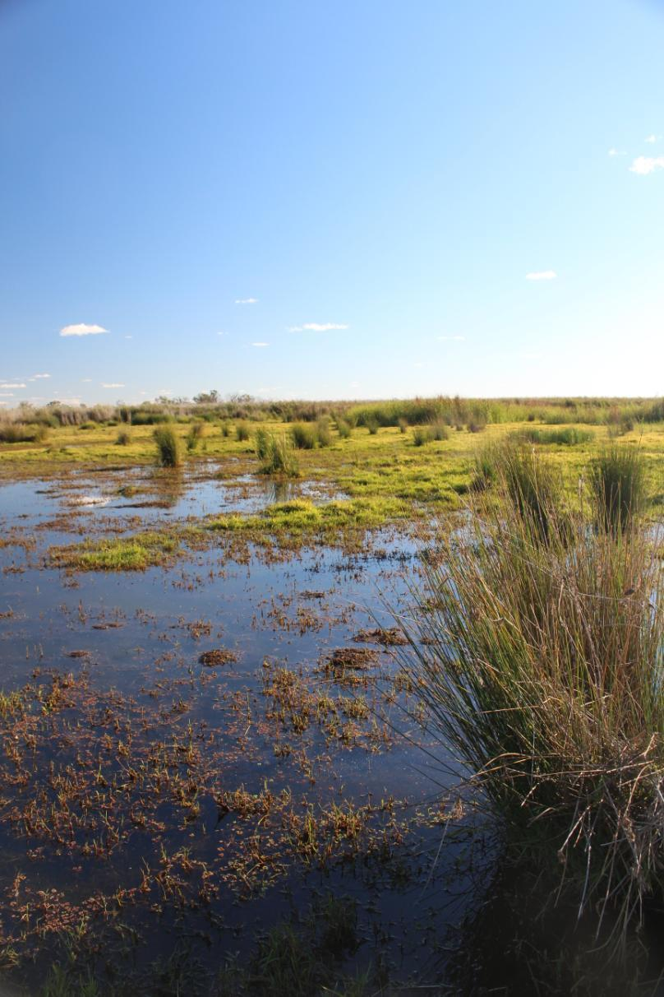**

**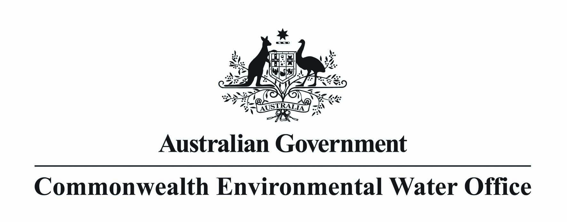**

**Commonwealth environmental water carryover from 2013–14 into 2014–15**

**Commonwealth environmental water carryover from 2013–14 into 2014–15**

Table of contents

[1. Key points 3](#_Toc396996783)

[2. Commonwealth environmental water carryover 2013–14 into 2014–15 3](#_Toc396996784)

[3. Utilisation of Commonwealth environmental water 5](#_Toc396996785)

[4. Background to Commonwealth environmental water carryover 6](#_Toc396996786)

**Acknowledgement of the traditional owners of the Murray-Darling Basin**

The Commonwealth Environmental Water Office, part of the Department of the Environment, acknowledges the traditional owners of country throughout Australia and their continuing connection to land, sea and community. We pay our respects to them and their cultures and to their elders both past and present.

Cover image credit: Buckiinguy Swamp, Macquarie Marshes, 2014.   
Photo by Hayley Behnke © CEWO

© Copyright Commonwealth of Australia, 2014.

creative_commons_licence.jpg

*Commonwealth environmental water carryover from 2013–14 into 2014–15* is licensed by the Commonwealth of Australia for use under a Creative Commons By Attribution 3.0 Australia licence with the exception of the Coat of Arms of the Commonwealth of Australia, the logo of the agency responsible for publishing the report, content supplied by third parties, and any images depicting people. For licence conditions see: <http://creativecommons.org/licenses/by/3.0/au/>

This report should be attributed as ‘Commonwealth environmental water carryover from 2013–14 into 2014–15’.

The views and opinions expressed in this publication are those of the authors and do not necessarily reflect those of the Australian Government or the Minister for the Environment. While reasonable efforts have been made to ensure that the contents of this publication are factually correct, the Commonwealth does not accept responsibility for the accuracy or completeness of the contents, and shall not be liable for any loss or damage that may be occasioned directly or indirectly through the use of, or reliance on, the contents of this publication.

# Key points

* On 1 July 2014, the Commonwealth carried over a total of 449.9 GL of water. This included 448.6 GL in regulated surface water accounts and 1.3 GL in groundwater accounts. The 448.6 GL of surface water carryover is equivalent to 2 per cent of public storage capacity across the Murray-Darling Basin. The 449.9 GL carried over into 2014–15 was greater than the 393.7 GL carried over into 2013–14, predominately due to the increased volume carried over in the NSW and Victorian Murray systems.
* Lower use in 2013–14 was primarily due to delivery constraints in the south of the basin associated with works at Lake Victoria and the relatively dry outlook warranting a more conservative approach to ensure future environmental needs can be met. The water carried over in the southern connected Basin is planned to be used to supply early season demands in the Goulburn and Murrumbidgee catchments.
* The Commonwealth owns water entitlements which retain their original characteristics and are managed in accordance with State government rules that apply to equivalent entitlement holders, including the rules governing carryover and the accrual of annual water allocation. Like any other water user, the Commonwealth is not able to disproportionately fill up dams relative to its entitlement holdings.
* Across the Murray-Darling Basin, on a proportional basis, the Commonwealth had used more and carried over less of its available water since commencing operations in 2008–09. However, this year the Commonwealth has used a slightly lower proportion than other water users.

# Commonwealth environmental water carryover from 2013–14 into 2014–15

Commonwealth carryover on 1 July 2014 was 449.9 GL. This included 448.6 GL carried over in regulated surface water accounts (compared to a storage volume across the Basin of over 22,000 GL) and 1.3 GL in groundwater accounts. The volume of surface water carried over by the Commonwealth in to 2014–15 is equivalent to 2 per cent of the public storage capacity across the Basin. This compares to 1.8 per cent on 1 July 2013[[1]](#footnote-1).

Carryover of Commonwealth surface water in the north of the Basin was 155.3 GL, and carryover in the southern connected Basin was 293.4 GL. The distribution of carryover across catchments, and the distribution of entitlements on 1 July 2014, is shown in Table 1 and Attachment A.

**Table 1. Selected holdings and carryover of Commonwealth environmental water**

| **Catchment** | **Entitlement holding in catchment as at 30 June 2014** 1  (GL) | **Carryover total as at 1 July 2014** (GL) | **Carryover total as at 1 July 2013** (GL) | **Carryover limit**  (%) |
| --- | --- | --- | --- | --- |
| **Surface Water** | | | | |
| Border Rivers (NSW and Queensland) | 14.2 | 6.6 | 9.9 | 85 (Queensland)  100 (NSW) |
| Gwydir (NSW) | 89.9 | 79.7 | 121.6 | 150 |
| Namoi (NSW) | 7.0 | 6.1 | 5.6 | 100 (Upper Namoi)  200 (Lower Namoi) |
| Macquarie and Cudgegong (NSW) | 122.1 | 19.3 | 22.3 | 100 |
| Lachlan (NSW) | 87.9 | 43.5 | 65.6 | 200 |
| ***Total Northern Basin*** | ***321.0*** | ***155.3*** | ***225.0*** |  |
| Murrumbidgee (NSW) | 228.4 | 56.2 | 45.5 | 30 |
| Murray and Lower Darling (NSW) | 345.1 | 104.0 | 20.3 | 50 |
| Murray (Victoria) | 280.4 | 117.9 | 87.6 | 100 |
| Goulburn (Victoria) | 238.3 | 15 | 15.3 | 100 |
| Campaspe (Victoria) | 6.9 | 0.2 | 0 | 100 |
| ***Total Southern Basin*** | ***1,099.2*** | ***293.4*** | ***168.7*** |  |
| **Total Surface Water** | **1,420.2** | **448.6** | **393.7** |  |
| **Groundwater** | | | | |
| Murray (NSW) | 1.2 | 1.3 | 0.0 | Various |
| **Grand Total** | **1,421.4** | **449.9** | **393.7** |  |

***Note 1***: Excluding supplementary and unregulated entitlements.

In 2014-15, the 449.9 GL carried over was an increase on the 393.7 GL carried over into 2013–14. Carryover from 1 July 2013 to 1 July 2014 decreased in the northern catchments (with the exception of a small increase in the Namoi) and increased in the southern catchments (with the exception of a small decrease in the Goulburn). The water carried over in the southern connected Basin is planned to be used to supply early season demands in the Goulburn and Murrumbidgee catchments.

At 30 June 2014, the Commonwealth held 0.2 GL in accounts in the NSW Murray (Groundwater), Peel and Campaspe catchments for which carryover provisions were either unavailable or insufficient to allow for the full carryover of water held in those accounts. This water was re-allocated under State rules. The reallocation corresponds to 0.01 per cent of Commonwealth environmental water available for management in 2013–14.

# Utilisation of Commonwealth environmental water

In 2013-14, the Commonwealth used 68 per cent of its held surface water across the Murray-Darling Basin (including the trade of allocation in the Gwydir and Peel systems), and 72 per cent of its available surface water in the southern connected Basin. Based on operational data provided by New South Wales and Victoria, utilisation across the Murray-Darling Basin by all entitlement holders is likely to be higher, at around 70 and 76 per cent across those two States respectively.

A higher proportion of Commonwealth environmental water was used in the first five years of operations when compared to other water users, as shown on Figure 1, while a slightly lower proportion was used in 2013–14. Lower use in 2013–14 was primarily due to a constrained delivery environment in the south of the basin associated with works at Lake Victoria and the relatively dry outlook warranting a more conservative approach to ensure future environmental needs can be met.

**Figure 1** **– Utilisation of allocated water as a percentage of the available volume.**

***Note*:** Data for NSW and Victoria for 2008–09 to 2010 –11 are from the MDBA Water Audit Monitoring Report 2010 –11, use in 2011–12, 2012–13 and 2013–14 in NSW and Victoria are estimated based on operational data.

# Background to Commonwealth environmental water carryover

Under the *Water Act 2007*, Commonwealth environmental water is used to protect and restore environmental assets in the Murray-Darling Basin.

The Commonwealth owns water entitlements, and receives water allocations against them, in the same way that other entitlement holders do. The rules associated with the water entitlements and allocations are set by States and apply to all entitlement holders. If States change these rules, then the changed rules apply to the Commonwealth environmental water holdings in the same way that they apply to the water holdings of others. As a result of the rules and having carryover limits in various forms, no water holder (including the Commonwealth) can fill up dams to the exclusion of other water users[[2]](#footnote-2).

Some of the rules associated with water entitlements relate to carryover. Carryover rules vary markedly for different entitlements and in different water plan areas across the Murray-Darling Basin. The carryover limits, account limits and use limits apply to all entitlement holders including the Commonwealth. Carryover provides flexibility in the timing of water delivery across years to all entitlement holders. For environmental water holders, this flexibility can be important when meeting environmental needs. For example, for an environmental manager, carryover provides the opportunity to water wetlands or river red gums in late winter and early spring ahead of most of the increases to seasonal allocations for many entitlement types.

The same choices to manage water are available to the Commonwealth as other entitlement holders, and these choices are to use, to carryover, or to trade. Like any other entitlement holder, the Commonwealth will use the carryover available to it to efficiently manage its water holdings and produce better outcomes from the water available to it.

Across the Murray-Darling Basin, on a proportional basis, the Commonwealth has generally used more and carried over less of its available water than other water users (on average) since commencing operations in 2008–09.

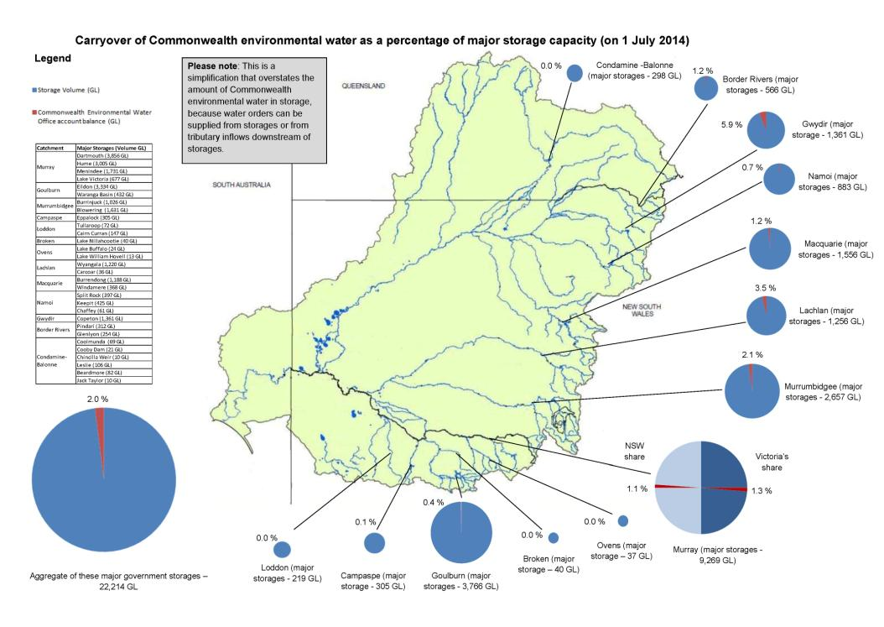

1. Whilst this gives a sense of proportion, it is a simplification that overstates the amount of Commonwealth environmental water in storage, because water orders can be supplied by river operators from storages or from tributary inflows downstream of storages. [↑](#footnote-ref-1)
2. Whether a year is wet or dry is a much more important determinant of whether a dam spills or not rather than the choices of any individual entitlement holder including the Commonwealth. [↑](#footnote-ref-2)