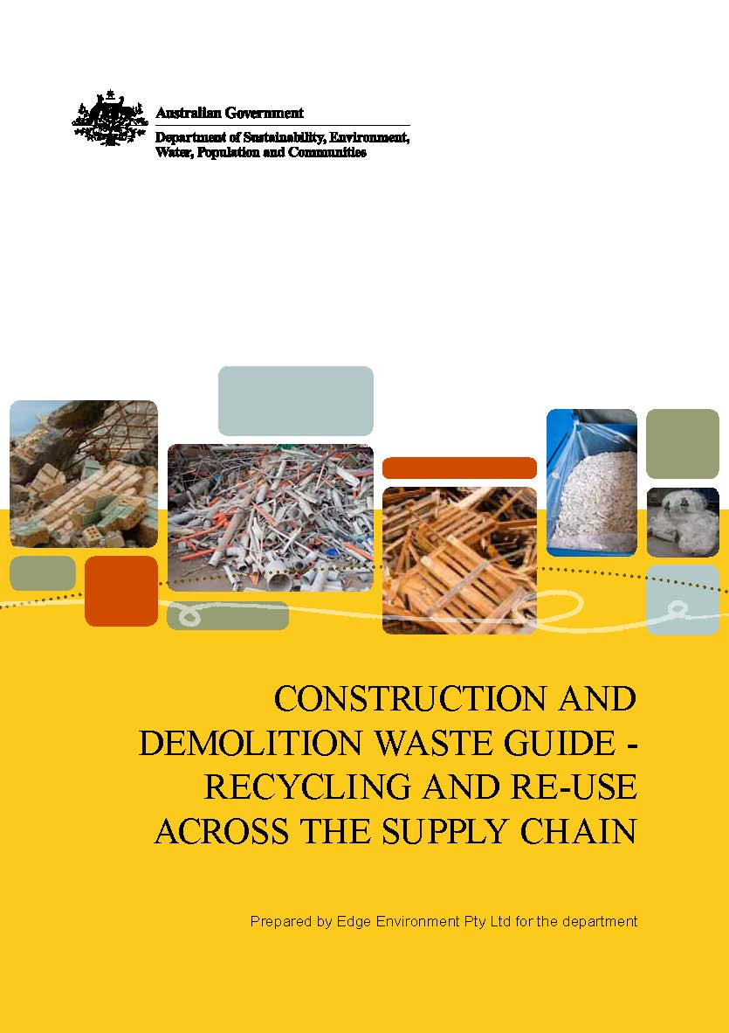
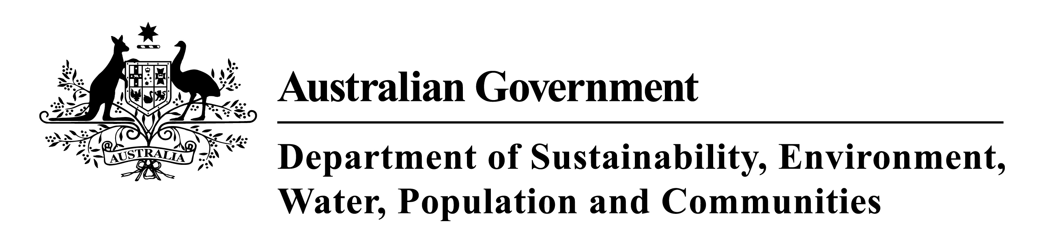

Erratum - 17 January 2012
The case study, Recycling power poles into high-value timber products, on page 34 incorrectly attributes the development of protocols for recycling redundant utility poles and bridge timbers in NSW to Kennedy’s Timber, Energex and the New South Wales Office of Environment and Heritage. The case study should attribute the development of the protocols to the Timber Development Association and the NSW Office of Environment and Heritage.

Photo Credits: Front Cover (L - R): Bricks (Fairfield City Council), Plastic waste (Hazelmere Recycling Centre), Hazelmere Grade 1 Clean Pallets (Hazelmere Recycling Centre), Chips of Vinyl (Tracy Morden), EPS scrap bags (Tracy Morden)
Back Cover (L-R): Bench (Ben Wrigley), Bricks (Fairfield City Council), Plastic waste (Hazelmere Recycling Centre), EPS scrap bags (Tracy Morden)
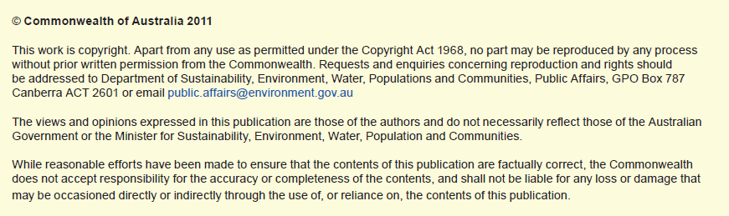
TABLE OF CONTENTS
Introduction | 4
An opportunity | 4
Aim of the guide | 4
Building on research and connecting to the market | 5
National Waste Policy: less waste, more resources | 6
Australian Government approach | 6
Australian Government waste legislation | 6
Drivers | 8
Regulation | 8
Industry self-regulation | 8
Product stewardship initiatives | 9
Green Building Council of Australia’s Green Star building rating tools | 9
Australian Green Infrastructure Council rating tool | 9
Economics | 10
The building supply chain | 10
Innovation | 11
Industrial ecology | 11
National Industrial Symbiosis Programme (United Kingdom) | 11
The materials opportunity | 12
Definition of construction and demolition waste | 12
Construction and demolition recycling and re-use—industry standard practice | 12
Material profiles | 12
Case studies | 16
Introduction—infrastructure and buildings | 16
Fairfield City Council Sustainable Resource Centre | 17
Ontera Modular Carpets: a commitment to life cycle thinking | 19
Vinyl Council of Australia and Armstrong Australia: giving PVC flooring a  new lease of life | 22
Fletcher Insulation: recycling glass into insulation | 24
CSR Gyprock™ take-back scheme for gypsum board product | 26
PIPA recycling PVC pipes into new product | 28
James Hardie industrial ecology initiatives | 30
Eastern Metropolitan Regional Council: wood is too good to waste | 32
Recycling power poles into high-value timber products | 34
Old Leura Dairy: innovating with heritage materials | 36
Waverley Council: recycled glass in roads | 38
Australian Ethical Investment: best practice waste management at Trevor Pearcey House | 40
Built Environs: 100 Hutt Street, Adelaide | 43
Fairfield City Council: a sustainable community building | 45
Recycling waffle pod waste | 47
Challenges | 49
Additional Information | 50

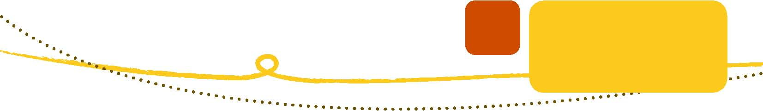INTRODUCTION
An opportunity
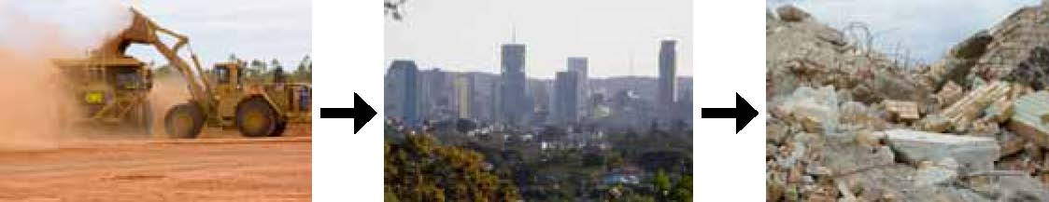Building materials account for about half of all materials used and about half the solid waste generated worldwide. They have an environmental impact at every step of the building process—extraction of raw materials, processing, manufacturing, transportation, construction and disposal at the end of a building’s useful life.

Figure 1 - A simplistic perspective on the building supply chain
Governments worldwide have responded to the need to reduce waste with regulation and legislation that have framed a market for building materials and products derived from the construction and demolition (C&D) waste stream.
There are now, more than ever, clear opportunities for business and industry to invest in activities that will create profit and improve environmental outcomes by extracting valuable resources from the C&D waste stream.
The built environment of the future is being constructed at the beginning of a new ecological era where governments are framing markets with regulation and legislation that respond to the challenges of environmental sustainability, and where industry must respond to the challenges of low-carbon economies and resource depletion.
Businesses that are profiting and growing are adapting to these new challenges and responding with innovations that turn waste into valuable resources to supply the construction industry, which has traditionally been adverse to behavioural change.
This guide outlines the opportunities available for effective markets and presents 15 initiatives where companies are profiting and growing while contributing to a more ecologically sustainable built environment.
Aim of the guide
The aim of this guide is to help develop effective markets for materials diverted or derived from the C&D waste stream.
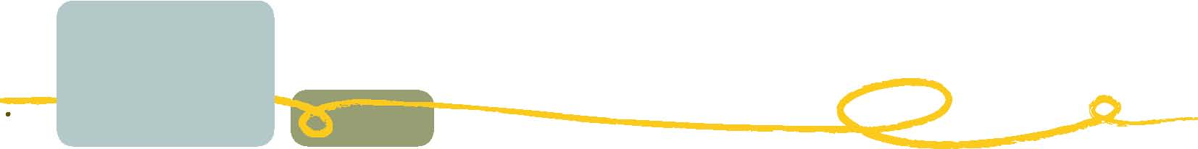Building on research and connecting to the market
The Organisation for Economic Co-operation and Development found that globally buildings are responsible for about 30 per cent of raw materials used, 42 per cent of energy used, 25 per cent of water used, 12 per cent of land use, 40 per cent of atmospheric emissions, 20 per cent of water effluents, 25 per cent of solid waste and 13 per cent of other releases (Centre for Design RMIT, 2003). 2006–07 data from the National Waste Report 2010 showed that 22 707 000 tonnes or 52 per cent of Australia’s waste was recycled. Of this, 42 per cent was from the C&D waste stream.
In 2004–05 C&D waste generation in Australia (The Blue Book—Australian Waste Industry, 2008, p. 8) was 15.1 million tonnes, of which 7.6 million tonnes was recycled materials (timber, steel, concrete, rubble and soil) and 7.5 million tonnes was residual waste to landfill. In 2006–07, 43 777 000 tonnes of waste was generated, 38 per cent of which was from the C&D stream.
Buildings and their users are responsible for almost a quarter of Australia’s greenhouse emissions. The energy embodied in existing building stock in Australia is equivalent to ten years of the nation’s energy consumption. Choice of materials and design principles has a significant, but previously unrecognised, impact on the energy required to construct a building. Embodied energy is one measure of the environmental impact of construction and of the effectiveness of recycling, particularly for CO₂ emissions. The embodied energy of a building is over 30 times the annual operating energy of office buildings. Making buildings more energy efficient usually requires more embodied energy, thus increasing the ratio even further (CSIRO Material Science and Engineering, 2009).
The contribution that the re-use and recycling industry can make to lower the embodied impacts of buildings is significant. Communicating the benefits of re-use and recycling and highlighting how barriers have been overcome will help to address the misperception that re-use of C&D waste in infrastructure is novel, difficult and risky. This will stimulate greater re-use and recycling of C&D waste across the supply chain.
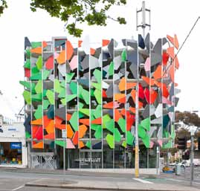Grocon’s Pixel Building; an example of a new breed of innovative buildings, contributing to a built environment for the ecological era.
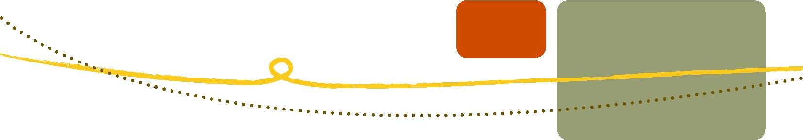
NATIONAL WASTE POLICY:
LESS WASTE, MORE RESOURCES
Endorsed by Australian environment ministers in November 2009, The National Waste Policy: less waste, more resources (National Waste Policy) is a collaborative approach that aims to avoid the generation of waste, reduce the amount of waste for disposal, manage waste as a resource and ensure that waste treatment, disposal, recovery and re-use is undertaken in a safe, scientific and environmentally-sound manner.
The National Waste Policy sets a clear direction for Australia for the next 10 years and will update and integrate Australia’s policy and regulatory framework. Through the National Waste Policy, the Australian Government aims to support development of best practice across all states and territories. The policy includes a strategy specifically focussed on C&D waste, as follows:
Strategy 11: All governments continue to encourage best practice waste management and resource recovery for construction and demolition projects.

AUSTRALIAN GOVERNMENT APPROACH
Australian Government waste legislation
The Australian Government does not directly legislate management of C&D waste. The management of environmental issues, including all waste streams, is largely the responsibility of Australian state and territory governments. Exceptions to this general principle are where international treaties are involved (for example, the Basel Convention on the Control of Transboundary Movements of Hazardous Wastes and their Disposal) or developments that are deemed to be of significant environmental importance to the nation.
Waste management and resource recovery in Australia is dependent on the regulatory framework of the states and territories. Because of this, the approach commonly adopted by the Australian Government is one of multi-stakeholder engagement and multi-party agreements. These may be underpinned by legislative measures where all parties support the need for fall-back legislation at a jurisdictional level (The Blue Book—Australian Waste Industry, 2007–08 Industry Market Report).
Table 1: Waste regulation and legislation across jurisdictions
State | Source of information
New South Wales | NSW Department of Environment, Climate Change and Water (DECCW) website: www.environment.nsw.gov.au  NSW DECCW (2007) Waste Avoidance and Resource Recovery Strategy 2007  NSW Government (2006) State Plan, A New Direction for NSW  NSW DECCW (2010) NSW Waste Avoidance and Resource Recovery Strategy—Discussion Draft: Strategic Directions and Implementation Plan 2011–2015  NSW DECCW (2010) NSW Extended Producer Responsibility Priority Statement 2010  NSW DECCW (2007) Report into the Construction and Demolition Waste Stream Audit 2000–2005 NSW Roads and Traffic Authority Environment website: http://www.rta.nsw.gov.au/environment/index.html
Victoria | Sustainability Victoria website: www.sustainability.vic.gov.au  Environmental Protection Authority Victoria website: www.epa.vic.gov.au  Metropolitan Waste Management Group website: www.mwmg.vic.gov.au  State Government of Victoria (2005) Towards Zero Waste Strategy  Department of Sustainability and Environment (2009) Metropolitan Waste and Resource Recovery Strategic Plan  Sustainability Victoria (2010) Towards Zero Waste Strategy Progress Report for 2008–09  VicRoads contract documents website: http://webapps.vicroads.vic.gov.au/VRNE/csdspeci.nsf/
Queensland | Department of Environment and Resource Management (DERM) website: www.derm.qld.gov.au Department of Environment and Resource Management (2010) Queensland’s Waste Reduction and Recycling Strategy 2010–2020  Department of Transport and Main Roads Standard Specifications Roads website: http://www.tmr.qld.gov.au/
South Australia | Zero Waste SA website: www.zerowaste.sa.gov.au  Environmental Protection Authority South Australia website: www.epa.sa.gov.au  Zero Waste SA (2010) South Australia’s Waste Strategy 2010–2015 Consultation Draft  South Australia Environment Protection (Waste to Resources) Policy 2010, under the Environment Protection Act 1993  Environmental Protection Authority South Australia (2010) Waste Guidelines—Waste Levy Regulations
Western Australia | Department of Environment and Conservation website: www.dec.wa.gov.au  Zero Waste WA website: www.zerowastewa.com.au  Western Australian Waste Authority (2010) Draft II Waste Strategy for Western Australia March 2010
Tasmania | Department of Primary Industries, Parks, Water and Environment website: www.environment.tas.gov.au  Department of Infrastructure, Energy and Resources website: www.dier.tas.gov.au  Taswaste website: www.taswaste.com.au  Department of Environment, Parks, Heritage and the Arts website: www.dpipwe.tas.gov.au
Australian Capital Territory | Department of the Environment, Climate Change, Energy and Water (DECCEW) website: www.environment.act.gov.au  Department of Territory and Municipal Services (TAMS) website: www.tams.act.gov.au/live/recycling-waste  Department of the Environment, Climate Change, Energy and Water (2010) Draft ACT Sustainable Waste Strategy 2010–2025
Northern Territory | Northern Territory Government website: www.territory2030.nt.gov.au  Northern Territory Department of Natural Resources, Environment and the Arts website: www.nt.gov.au/nreta  Environment Protection Authority Northern Territory website: www.epa.nt.gov.au  The Department of the Chief Minister (2009) Territory 2030 Strategic Plan Packaging Stewardship Forum of the Australian Food and Grocery Council website:  www.afgc.org.au/psf/remote-and-indigenous.html

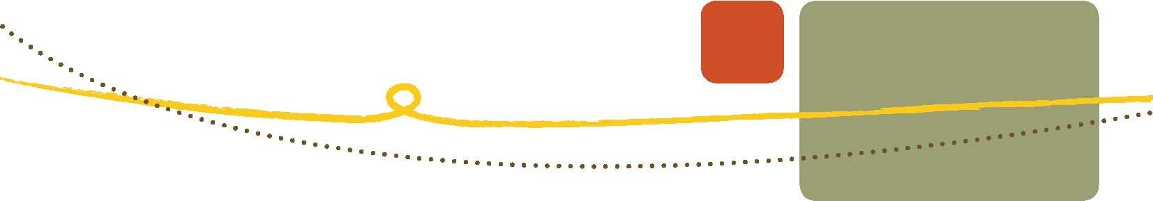DRIVERS
Regulation
Regulation frames markets for C&D waste recycling and re-use. As described in Table 1, state and territory governments are responsible for regulating waste issues. However, regulation and legislation only set minimum standards. To increase the rates of recycling and re-use of C&D waste, new materials and products must be derived, applications for these materials proven, and markets created. In some cases there are significant technical barriers— industry is required to invest in innovation, research and development to create new processes and products that can be sold into the building supply chain. This can take significant effort and often involves business risk. Regulation and legislation alone will never be enough to achieve the required amounts of C&D waste recovery. Regulation and legislation play a key role in setting minimum standards, but other initiatives are required to drive innovation and industry-led activities.
Industry self-regulation
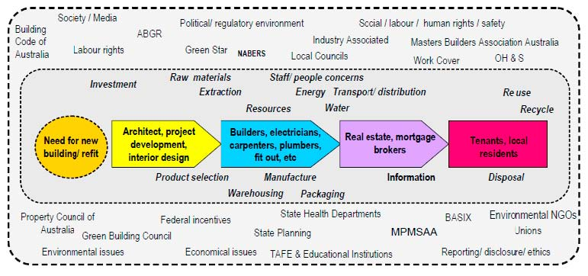Industry self-regulation is a powerful factor driving the development of new materials derived from C&D waste and the use of these products in construction. Many associations in the building products and materials industry are investing in initiatives to help their member companies achieve better production and consumption outcomes by ‘doing more with less’. Delivering improved materials and products to the construction companies, in turn, helps them to achieve green ratings. Green ratings for buildings are well established now—few new commercial buildings are designed and built without a green building rating. Similarly, a green rating scheme for infrastructure is under development and will be delivered in 2011.

The building Roadmap with its complete external environment (TEC, 2009)
Product stewardship initiatives
Australian businesses across a range of sectors have been working to reduce the environmental impacts of their operations and products. In many sectors industries have, or are developing, voluntary product stewardship schemes.
Product stewardship recognises everyone involved in the production, supply and use of products, sharing responsibility for the environmental impacts throughout a product’s life—from production through to disposal. It aims to reduce hazardous substances, avoid and reduce waste, and increase recycling and resource recovery. To date, product stewardship schemes have been driven by industry and are voluntary— several leading initiatives described in the case studies in this guide are driven by industry product stewardship schemes.
Governments are supporting manufacturers and importers of products in these efforts. On 8 August 2011 the Product Stewardship Act 2011 came into effect. This legislation provides the framework to effectively manage the environmental, health and safety impacts of products, particularly impacts associated with the disposal of products. The framework includes voluntary, co-regulatory and mandatory product stewardship. The Act fulfils a commitment by the Australian Government under the National Waste Policy, heralding a new, efficient and environmentally responsible approach to waste management in Australia.
Green Building Council of Australia’s Green Star building rating tools
The Green Building Council of Australia (GBCA) is a national, not-for-profit organisation that has been driving sustainable outcomes in the property sector since 2002. The GBCA have developed a suite of Green Star tools that rate the sustainability of buildings, including materials used in construction and fit-out, and C&D waste reduction credits. Several of the case studies in this guide cite Green Star as a driver for their activities and two (commercial buildings) have Green Star ratings.
The complexity of the Green Star tools has increased since their inception. In February 2011 the GBCA made a commitment to a life cycle approach in rating building products and materials. This will encourage industry to research and develop products with lower embodied impacts and will contribute to the reduction of C&D waste.
Australian Green Infrastructure Council rating tool
The Australian Green Infrastructure Council (AGIC), a member-based industry association established in 2008, has been developing a green rating tool for infrastructure. Like the GBCA’s building rating tool, the AGIC tool will rate aspects of infrastructure and includes a category for materials selection and use. This category gives credit for materials that have low embodied impacts relative to a standard. The materials selection and use category will take a life cycle approach to rating materials—the AGIC tool will rigorously measure a suite of environmental impacts embodied within the materials and give the material a rating. If the material demonstrates lower embodied impacts than its alternative it will be awarded points towards an aggregated score (like Green Star for buildings). The AGIC tool’s materials selection and use category uses the Australian Building Products Life Cycle Inventory and its methodology—an industry agreed approach towards life cycle assessment and methodology which allows the like-for-like comparison of materials on environmental grounds.
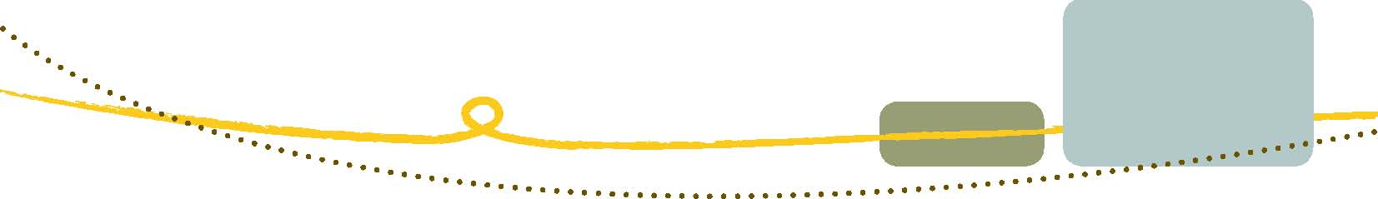The development of the AGIC tool is nearing completion. It is hoped that it will be as successful as the Green Star tools have been for buildings, and that it will drive markets for recycled and re-used materials.
Economics
During the research for this guide, many stakeholders have cited the cost of landfill as a significant driver for re-use and recycling of C&D waste. In 2009 the Commonwealth published a report that identified that landfill costs in Australia ranged from $42 per tonne to $102 per tonne. In addition to the cost of land-filling by operators, there can be an additional charge levied by the state and territory jurisdictions. In New South Wales for example, the government’s Section 88 Landfill Levy applies to regulated areas, and ranges between $20.40 per tonne and $70 per tonne. The lower limit is set to rise by $10 (plus adjustment for the consumer price index) per year until 2015–16. It is expected that this will drive additional re-use and recycling from the construction industry.
There is uncertainty around the cost implications of a carbon tax; however it is certain that energy costs are rising significantly regardless. These rising costs will directly impact the cost of building materials and products. Reusing and recycling C&D waste will in most cases reduce the embodied energy of production, and this will be reflected in the price of products and materials sourced from C&D waste.
The building supply chain
The building supply chain is sophisticated and involves myriad stakeholders each playing their part in the delivery of buildings. The material considerations are implicit across the supply chain as stakeholders play out their roles in delivering a sustainable built environment. This guide is designed to cut through the complexity of the supply chain, and help the growing C&D re-use and recycling industry to identify opportunities to supply materials.
To fully realise the opportunities of integrating new materials and products derived from C&D waste, it is important to focus on the earliest stages of the building supply chain—the earliest stages of design is where the greatest opportunities to affect sustainable outcomes are, as illustrated in Figure 4.
The supply of new materials derived from C&D waste must be publicised, the products specified clearly in terms of their fitness for purpose and how they can be used, and industry educated to adapt and learn how to use new materials.

INNOVATION
Industrial ecology
Industrial ecology, also referred to as industrial symbiosis, is emerging as a powerful source of innovation in Australia. Industrial ecology promotes enhanced sustainability and resource efficiency by stimulating innovations in the re-use of waste materials. The wastes or by-products of one industry are used as inputs in another industry, thereby closing the material loop of industrial systems and minimising waste.
The Waste Management Association of Australia (WMAA), supported by funding from the New South Wales Office of Environment and Heritage, set up an organisation in 2009 called the Australasian Industrial Ecology Network. This group has been working to promote awareness of industrial ecology, and the opportunities that it creates, through industry events and, more recently, industry workshops where manufacturers can exchange by-products with each other, saving landfill costs and offsetting raw material costs. These workshops have been held in New South Wales and Melbourne and are sponsored by state and local governments to catalyse innovation and resource efficiency outcomes in their areas. These workshops have been referred to as ‘speed-dating workshops’ as the focus is on finding an industry match. Often there is a need to change manufacturing processes. Support for this is available through the Australasian Industrial Ecology Network.
National Industrial Symbiosis Programme (United Kingdom)
In 2003 the United Kingdom (UK) Government funded trials of industrial ecology projects. The achievements of these projects in 2004 were outlined in a brochure called the National Industrial Symbiosis Programme: a year of achievement. In 2005 the UK Department for Environment, Food and Rural Affairs injected government funding into what became The National Industrial Symbiosis Programme (NISP). By October 2009 NISP had made a significant contribution to reducing UK carbon emissions and had boosted the UK’s economy by between £1.5 billion to £2.5 billion (A$3 billion to A$5 billion). NISP works on the simple principle of matching companies which have a by-product with companies which can use that by-product. In turn this achieves business cost reduction through avoided waste and more cost-effective raw materials. The environment benefits due to less landfill, raw material extraction and carbon savings. NISP offers Australia a model for the future which Australia has already begun to emulate.
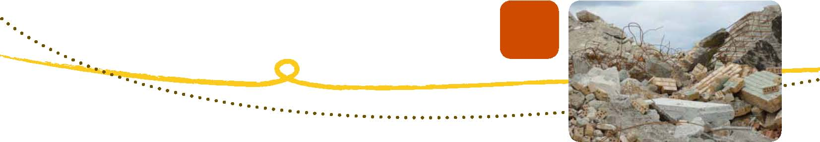
THE MATERIALS OPPORTUNITY
Definition of construction and demolition waste
Construction and demolition (C&D) waste is a general term for a diverse range of materials that, when segregated, can include high-value materials and resources for new construction.
The definition of C&D waste used in this report is from the National Waste Report 2010:
waste produced by demolition and building activities, including road and rail construction and maintenance and excavation of land associated with construction activities. The C&D waste stream usually covers only some of the generation, disposal and recycling of C&D wastes, as these materials can also be found in the Municipal Solid Waste (MSW) and Commercial and Industrial (C&I) streams, or as hazardous wastes.
There are many opportunities to extract value from the C&D waste stream as described within the material profiles below.
Construction and demolition recycling and re-use—industry standard practice
Re-use and recycling of some materials and resources is becoming industry standard practice. For example, landfill charges provide an incentive for high recycling rates of massive materials, such as masonry materials (asphalt, bricks and concrete). Reclamation rates for high-value materials, such as metals and hardwood timbers, have also increased.
Material profiles
The Australian Government recently carried out a study to determine the status of C&D recycling and re-use in Australia. The following sections detail the opportunities for recycling and re-use of C&D materials in Australia.
The level of recovery of a material stream and market demand for associated products is related to geography and pricing. Materials that are heavy and generated in large volumes cost more to dispose of to landfill, especially where there is an appropriate disposal pricing structure, which may include an associated levy. This results in these materials receiving priority attention for recovery and market development in the C&D sector. These materials, such as metals and masonry, are mostly generated from the commercial demolition sector and civil activities such as pavement maintenance or site excavation works.
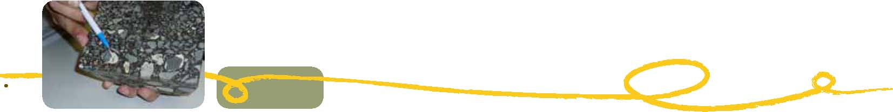Concrete and bricks
Concrete reprocessing involves the use of relatively uncomplicated and well-established crushing techniques. Where high landfill fees exist (including levies), there is a strong incentive to avoid weight-based disposal charges by recovering the heavy components of the C&D waste stream. Diversion also supports significant end markets for the recycled products in some metropolitan locations, where reprocessing sites can produce products that are commercially competitive with quarry products.
Bricks are often presented as ‘mixed masonry’ or ‘builders rubble’ mixed with concrete and, like source-separated concrete, this component of the C&D waste stream is relatively simple to process, with similar end markets for aggregate products.
The key markets for crushed concrete and brick include use in all-weather applications (such as low-grade roads), and in pavement sub-bases (such as roads and non-structural applications) as a substitute for virgin crushed rock.
The advantage of recycled crushed concrete was highlighted as being associated with physical properties. This suggests that for the same product weight as certain crushed quarry rock, the crushed concrete alternative offered an additional 10–15 per cent product volume.
Asphalt
Asphalt material is generated through the civil road construction sector. Asphalt is potentially 100 per cent recyclable. This level of recycling and use of recycled content in pavements has not been fully realised in Australia, however there are efforts to improve this within the industry.
Asphalt pavements on average are 4 per cent bitumen and 96 per cent aggregate. Generally the top layer of asphalt, known as the wearing course (which is generally between 25–40mm), is removed and re-laid every 10 to 15 years. This is done using a milling machine, which removes the wearing course. The recovered material is generally taken to an asphalt plant for sorting and batching to ensure that the physical properties of the mix include but not are limited to: the appropriate ratio of bitumen to aggregate; and the correct proportion of aggregate size and air voids.
Reclaimed or recycled asphalt pavement (RAP) used in new asphalt is allowed in mixes in Australia. Permissible levels vary across jurisdictions. Mixes generally include 10 to 15 per cent recycled asphalt content, however the level can be higher if the mix is appropriately managed. Recycled asphalt can also go into the base course and road base layers but mostly goes back into the wearing course of pavements.
In some jurisdictions there has been trialling not only of the percentage of RAP included in mixes but also of the inclusion of other recycled content such as glass fines (from beverage container recycling). There may also be energy efficiency savings in moving from hot mix to warm mix application of asphalt wearing courses.
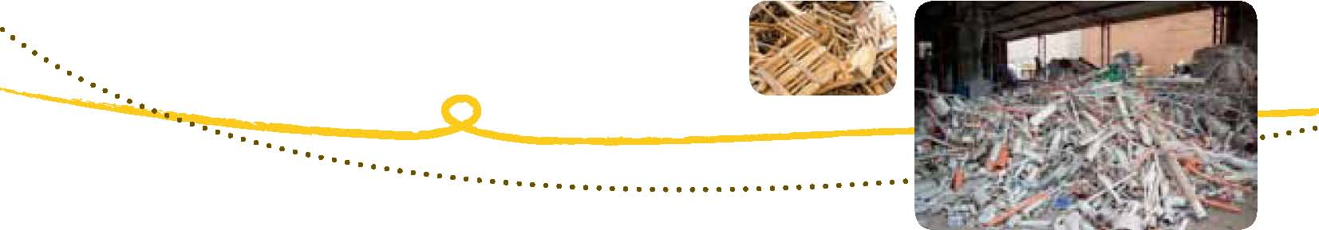Metals
Scrap metal prices are subject to international forces and during the Global Financial Crisis there were reports of serious disruptions to the market for recovered scrap. While the price that re-processors pay for mixed steel scrap is highly variable, the current ballpark figure is around $250 per tonne. Coupled with the value of avoided landfill disposal costs, there is a strong economic incentive to recover this material stream.
The majority (about 90 per cent) of metals recovered from the C&D sector comes from commercial demolition sites. Of this material, up to 95 per cent is steel and the remaining materials (about 5 per cent) are non-ferrous metals. This non-ferrous component mostly includes aluminium (1 to 2 per cent), stainless steel and copper piping or wire. Ferrous metals like steel can be easily recovered from the waste stream using relatively inexpensive magnets.
Timber
Most timber is generated from the demolition sector, and nationally there is lower market demand for recovered timber compared to other components of the C&D waste stream.
There is a high-value market for the re-use of quality hardwood timber, with prices over $1000 per cubic metre for some high-grade Australian timbers, although the volume of material recovered is relatively low. Nationally, the market for re-use of timber is estimated to be around 60 000 cubic metres.
Indications from industry are that the salvage market for reusable timber is generally functioning well due to the potential for high economic returns. A barrier to growing the re-use market is the increasing mechanisation of demolition works (primarily due to time pressures and occupational health and safety requirements), which makes it more difficult for salvage operations to take place, and increases the potential for high-value timbers to be damaged. Another significant source of salvageable hardwood is ‘infrastructure timber’, such as power poles and railway sleepers, for which there is strong demand in landscaping applications.
Plastics
The Plastics and Chemicals Industries Association’s (PACIA) annual recycling survey provides a useful overview for all sectors, including C&D, for plastics recovery, recycling and market outlets.
The PACIA report highlights that the construction (or building) sector is one of the key markets for plastics in Australia. The plastics used in construction fall across two distinct categories: (i) packaging and (ii) durables (non-packaging). This categorisation of plastics is associated with the life-span of the plastic product.
Even though there are broad applications for plastic products in construction, as outlined in Figure 9, the most common products are packaging films, waffle pods and pipes.
The PACIA study highlights that very little material is recovered from the C&D sector, but acknowledges that there is growing activity around recycling of used plastics from the industry.
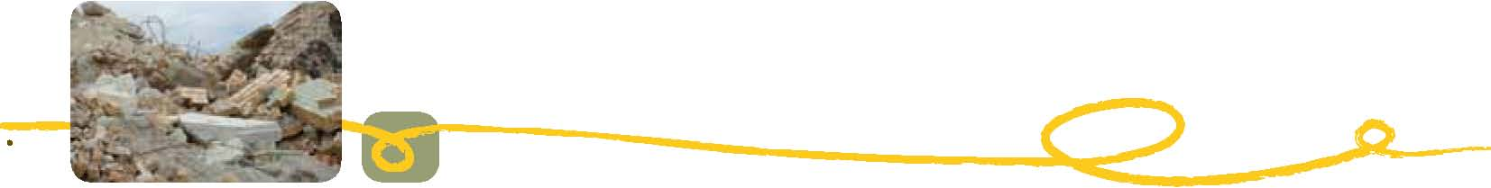Plasterboard
Diversion of plasterboard from landfill is mostly from construction activity because this friable material is not readily separated from mixed loads using mechanised demolition processes. Plasterboard is considered a contaminant when presented in recovered C&D materials. For this reason it is one of the most challenging materials when seeking to improve the recovery of mixed C&D loads, even though plasterboard itself is highly recyclable.
Most plasterboard recovery is from construction sites and is often made through arrangements between the builder or construction company and the material manufacturer or supplier. Plasterboard manufacturers which supply construction sites regularly support the recovery of clean product from sites and support companies which purchase their materials.
Rock and excavation stone
This material is recovered when civil or site preparation works are undertaken. Depending on the geology of an area, a great deal of excavated rock and stone can be produced as a by-product. Excavated rock and stone comes mostly from the construction sector. Again, the level of recovery of these materials and end markets for associated products has much to do with the geography of where the material is generated, the local market outlets for products, and landfill pricing which discourages the disposal of this heavy, voluminous material.
Similar to crushed concrete and brick, excavated rock and stone is a source of inexpensive aggregate for a range of applications in pavement sub-base. In markets, like Melbourne, where there are significant volumes excavated rock and stone competes with recycled C&D concrete and brick products.
Soil and sand
Soil and sand is generated from site preparation and excavation works associated with construction activities. Large volumes of fine materials are generated through these activities and unless the material can be re-used on site it requires treatment and/or disposal. This includes soil and sand as well as other sub-4.75 mm particles from mixed skip-bin waste.
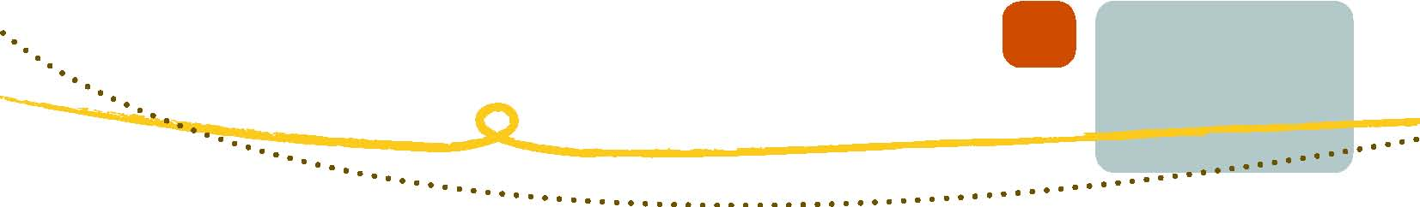
CASE STUDIES
Introduction—infrastructure and buildings
The following 15 case studies have been selected from many to represent a broad range of construction and demolition waste recycling and re-use initiatives across Australia. They demonstrate a cross section of opportunities, using a range of materials at various stages in the building supply chain. Some are driven by small business, others by local government and industry associations. All are benefiting and profiting from innovation and initiative.
 | Case Study Title | Project Category
1 | Fairfield City Council Sustainable Resource Centre | Recycling aggregates
2 | Ontera Modular Carpets: a commitment to life cycle thinking | Floor and wall coverings
3 | Vinyl Council of Australia and Armstrong Australia: giving PVC flooring a new lease of life | Floor and wall coverings
4 | Fletchers Insulation: recycling glass into insulation | Recycling glass
5 | CSR Gyprock TM take-back scheme for gypsum board product | Plasterboard and Gyprock
6 | PIPA recycling PVC pipes into new product | Plastic’s and PVC’s
7 | James Hardie industrial ecology initiatives | Recycling board products
8 | Eastern Metropolitan Regional Council: wood is too good to waste | Recycling timber
9 | Recycling power poles into high-value timber products | Recycling timber
10 | Old Leura Dairy: innovating with heritage materials | Direct reuse
11 | Waverley Council: recycled glass in roads | Glass and infrastructure
12 | Australian Ethical Investment: best practice waste management at Trevor Pearcey House | Commercial building construction
13 | Built Environs: 100 Hutt Street, Adelaide | Commercial building fit-out
14 | Fairfield City Council: a sustainable community building | Public building
15 | Recycling waffle pod waste | Residential building

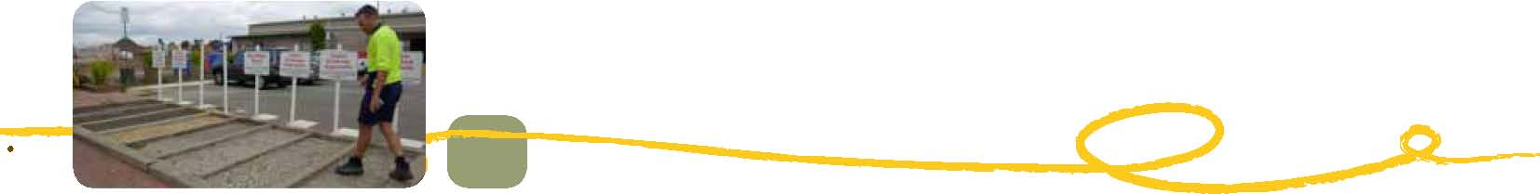Fairfield City Council Sustainable Resource Centre
Description of project
Fairfield City Council established the Sustainable Resource Centre in 1992. It has since developed a stand-alone business unit with Fairfield City Council that returns a dividend to the council. The Sustainable Resource Centre returns C&D waste to the construction industry as new materials.
Use of recycled and re-used material
The Sustainable Resource Centre has recycled over 150 000 tonnes of material already in 2011 and is likely to recycle 170 000 tonnes by the end of the year. The Sustainable Resource Centre produces a series of new materials including crushed concrete products, recycled asphalt products and cement stabilised sands.
The two key products that the Sustainable Resource Centre contributes to are 95 per cent recycled concrete and 65 per cent recycled asphalt.
Drivers for re-use and benefits
Expense into income—before 1992 Fairfield City Council sent all material from its construction and infrastructure upgrades to landfill at a cost to the council. The opportunity to reverse this cost was recognised and the Sustainable Resource Centre was established.
Saving landfill—the Sustainable Resource Centre diverts more than 100 000 tonnes of material from landfill per year. This avoids the use of the same amount of virgin materials and saves valuable land.
Recognition—Fairfield City Council won the local government award for ‘Best Specific Environmental Initiative’ at the United Nations of Australia’s World Environment Day awards.
Problems and challenges
Recycled concrete characteristics—due to the higher cement content of recycled aggregates, recycled products absorb more water, leading to different curing times and different behavioural traits.
Contamination of material—asbestos contamination is an ongoing challenge for the recycling industry. There is currently no alternative to visual inspection at the weighbridge.
Perceptions—negative perceptions by the construction industry of recycled materials include that they are difficult to use and result in inferior constructions. These perceptions are changing as field trials show how to use these materials to their optimum performance and as virgin resources become scarcer.
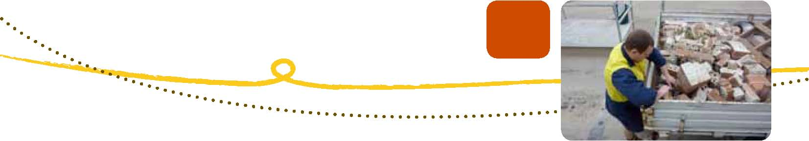Solutions
Fairfield City Council has conducted field trials of both the 95 per cent recycled concrete product and the 65 per cent recycled asphalt. These trials have shown how to achieve optimum results using recycled materials.
With regards to contamination, visual inspection is currently the best available solution.
Specifications and opportunities for other projects
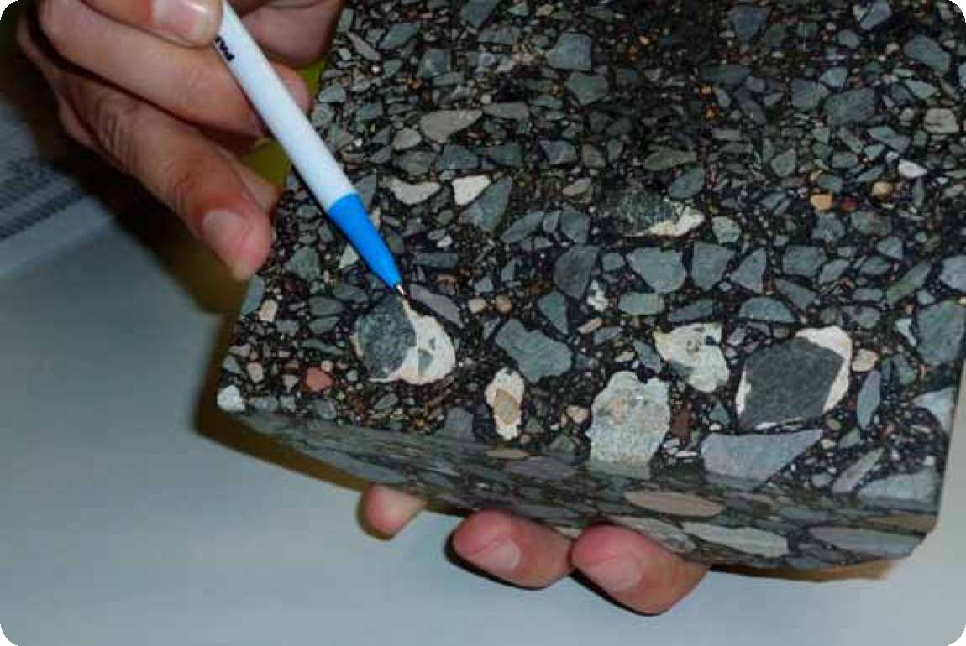Currently Fairfield City Council is using 95 per cent recycled concrete for all non-structural applications in the council area. Results of the field trial will be available from Fairfield City Council on completion of the trial in early 2012.
The 65 per cent recycled asphalt is being used across 30 locations in the Fairfield City Council area.

65% Recycled asphalt showing recycled material aggregate.
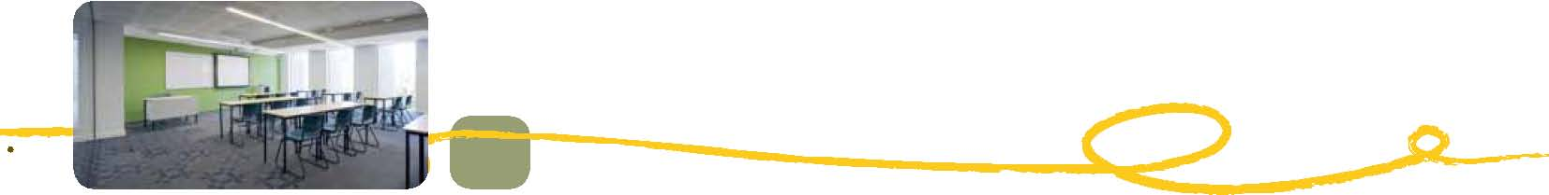Ontera Modular Carpets: a commitment to life cycle thinking
Description of project
Ontera Modular Carpets have been designing and manufacturing modular carpet tiles in Australia since 1985. The product is made of a fibreglass polymer matrix backing with nylon. Sixty-six fibres are embedded in the surface to create the carpet. Ontera implements the principle of ‘precycling’, whereby the original product is made more durable to maximise its first life to ensure that it is able to withstand additional life cycles.
Ontera guarantees to take the product back at the end of its first life for re-use or recycling at no cost to the customer. The tangible benefit, above the direct cost saving, is the reassurance that the product is not ending its life in landfill, but entering a second life.
Use of recycled and re-used material
Ontera’s principle is to retain the energy embodied in their products as far as possible by extending products’ life cycle and by not wasting the energy embodied in the products. Ontera’s EarthPlus® environmental program provides an option to re-use any used Ontera carpet tiles without any destructive processes or measurable additional energy input. Used Ontera carpet tiles can be given a second (and possibly third) life through a proprietary process that ‘supercleans’ the surface, retextures it and superimposes a new design to refresh the appearance. This extends the warranted life of the carpet tile by a further seven years for the same end use.
The EarthPlus® program is a re-use process, not a recycling process. Ontera’s studies have shown this to be the most environmentally benign way to extend product life. All of the embodied energy used in the creation of the original product is retained, enabling the product life to be significantly extended without the need for significant additional energy and resources.
A summary of resource efficiency savings includes:
- take-back and re-use of over 120 000 m² (approximately 600 tonnes) of used carpet tile
- saving of approximately 2000 litres of water per month in dye recycling
- incorporation of post-consumer recycled component of between 5–10 per cent of the backing
  - using polymer component obtained by recycled used or waste carpet tiles
- reduction of energy and water consumption by over 40 per cent per square metre of finished
product
- reduction of waste sent to landfill by 25 per cent
- reduction of on-site CO emissions by over 19 per cent
- increase of recycled content in product by 50 per cent.

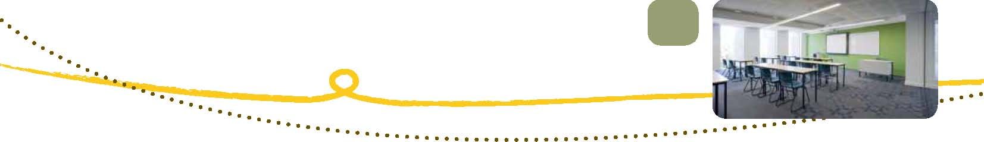Drivers for re-use
Ontera Modular Carpets have founded a business based on supplying a sustainable product to the market, and this is the main driver. Re-use initiatives are recognised by the New South Wales Government through involvement and achievement in the Sustainability Advantage program, and this recognition is good for business. There is also inherent value in a re-used product, leading to worthwhile economic returns.
Ontera have ensured that maximum available credit points can be achieved by specifying their product in the Green Building Council of Australia’s Green Star rating tool. Ontera has a certified Environmental Management System, certified to ISO 14001, which requires ongoing environmental improvement.
Benefits
Each 1000 square metres of modular carpet re-used through the EarthPlus® process results in over 5 tonnes of waste being saved from landfill or incineration.
In terms of product recycling, there will always be some process waste and post-consumer product that is not suitable for re-use. Ontera has developed and implemented a process which recovers all of the components of the product without the need for energy-intensive thermal processes. The yarn is separated from the backing and sold to third-party polymer extruders, and the backing is ground into a fine powder form and re-used by Ontera as a post-consumer recycled component of new carpet tile backing.
Ontera has made significant improvements in resource efficiency through the implementation of a range of programs and processes. As part of its ongoing ISO 14001 certification, it monitors monthly: its consumption of water, electricity and gas; and levels of waste to landfill, waste recycled, and greenhouse gas emissions. It reports its results against annual reduction targets. Ontera is achieving a decreasing trend in all resource areas and is working towards achieving their sustainability targets.
Re-use and recycling delivers the following benefits for Ontera:
- reputation and market stature
- improved economic returns
- increased staff engagement and loyalty
- reduced landfill costs
- reduced utility costs.

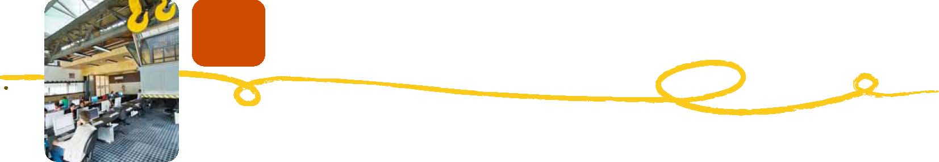Problems and challenges
Challenges remain for greater re-use, which include availability of technical knowledge and expertise for further process improvements, local availability of equipment, and geographic diversity of product to be retuned for re-use or recycling.
Solutions
Ontera routinely uses external consultants to identify production and consumption efficiencies, some of which have been funded and provided through the New South Wales Office of Environment and Heritage Sustainability Advantage Program.
Opportunities for other projects
There are opportunities for Ontera to work with other manufacturers of products that use similar materials and Ontera are willing to explore opportunities for by-product exchanges with other companies. There are opportunities for greater process efficiencies, which include the development and up-scaling of an in-line recycling unit.
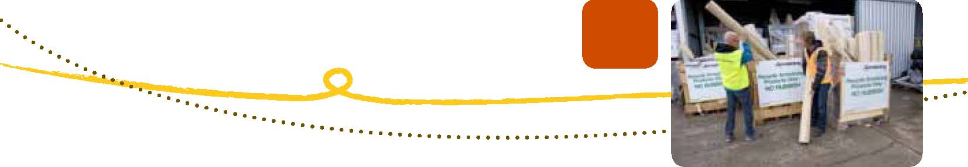Vinyl Council of Australia and Armstrong Australia: giving PVC flooring a new lease of life
Description of project
The Vinyl Council of Australia has been working with its members to increase the recycling rates of polyvinyl chloride (known as PVC or vinyl) flooring products through the Product Stewardship Program since 2002. The Product Stewardship Program is a voluntary initiative which sets out commitments that address environmental and health issues associated with the life cycle of PVC.
The program has 26 signatories who have committed to taking action in areas such as manufacturing emissions, additives, and end-of-life management.
Armstrong Australia, the world’s largest manufacturer of resilient vinyl flooring products, is a signatory to the program. Armstrong Australia’s head office is located in Braeside, Victoria, from where it oversees two Australian manufacturing plants.
Armstrong Australia collects the off-cuts and end-of-life flooring that would have previously gone into landfill from construction sites and factories for recycling and processing into a new product.
This case study details the recycling activities conducted by Armstrong Australia on a project to install new PVC flooring at the Royal Children’s Hospital in Melbourne.
Use of recycled and re-used material
PVC is a thermoplastic, which means it becomes plastic, or softens, upon heating and hardens upon cooling, making it relatively easy to recycle.
There are three main opportunities for recycling in the PVC flooring life cycle:
- factory waste recovery
- installation off-cuts
- end-of-life recovery.

Factory waste recycling rates are very high within the industry, as clean waste can be reprocessed in-house for most applications. The rate of off-cut recycling is the next highest, as it is also relatively clean. However, processes are required for back-loading product.
Recycling end-of life materials can be complex because of:
- contamination by other materials
- hygiene, health and safety issues
- accessibility of collection infrastructure
- dispersion of product rather than concentrations of available waste near collection and recycling
  - infrastructure.

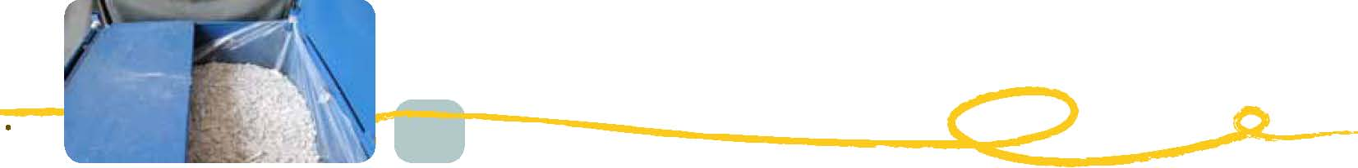In the 12 months to May 2011, 21 tonnes of end-of-life material has been collected from RCH and returned to Armstrong Australia in Braeside for recycling into other flooring applications.
The total end-of-life returns in 2011 are expected to be around 30 tonnes, double that of 2010. As the Vinyl Council’s Product Stewardship Program approaches its 10-year anniversary, it is projected that 300 tonnes per year of PVC material will be returned to the production process from the three waste streams.
The returned PVC material is recycled to make standard Armstrong Australia sheet-flooring products. End-of-life returns are converted into a new 70 per cent recycled material called vinyl composition tile.
Drivers for recycling
The main drivers for recycling are:
- the Vinyl Council of Australia’s PVC Product Stewardship Program
- the need for construction projects to demonstrate good waste management outcomes
- the value of the waste materials through partial material replacement in the production process
- avoiding the cost to construction project managers of landfill charges.

Potential benefits
Benefits include significant life cycle improvements in carbon dioxide emissions, landfill reductions and avoidance of PVC toxicity from landfill disposal.
As the Product Stewardship Program project has evolved, a market for PVC waste has been created. This has increased awareness that PVC can be and is being recycled.
Problems and challenges
The main challenge with PVC flooring product recovery is the contamination of end-of-life material from mixed construction and demolition waste. This will eventually improve as awareness of the Product Stewardship Program grows, construction managers learn to separate waste, and opportunities increase to recycle end-of-life PVC products, avoiding the cost of landfill disposal.
Solutions
The Vinyl Council of Australia is continuing to raise awareness about the Product Stewardship Program and about improving recycling rates.
Opportunities for other projects
The key opportunity is for construction project managers to divert PVC construction and demolition waste from landfill by working with the Vinyl Council of Australia to identify options for achieving success in PVC recycling.

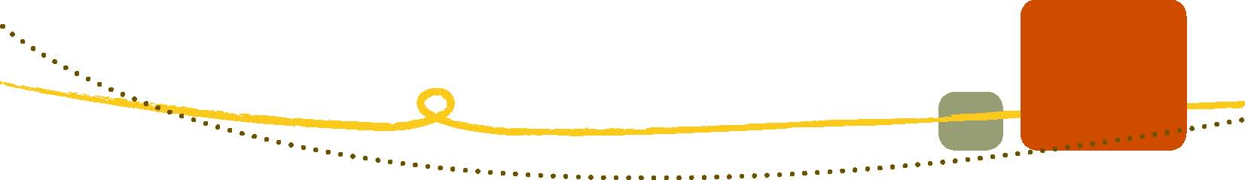Fletcher Insulation: recycling glass into insulation
Description of project
Fletcher Insulation use glass from the waste stream in a glass cullet mix for the production of glass wool insulation. Up to 74 per cent of the total raw materials input is from post-consumer waste sources, such as glass from scrap cars, C&D waste, off-cuts from the glass manufacturing industry and bottle glass from the packaging industry and recycling stream.
Fletcher Insulation has been refining their manufacturing process to be able to input as much recycled glass as possible. The production of glass wool insulation relies on a precise mix of inputs to create the correct conditions in the furnace. The formulation of the raw materials is critical and ultimately dictates the proportion of recycled input that the process will tolerate.
Use of recycled and re-used material
It is estimated that the glass wool insulation industry in Australia produces 80 000 tonnes of insulation per year. Up to 70 per cent of this can be recycled glass, and therefore the industry has the capacity to recycle over 50 000 tonnes of glass per year from the C&D waste stream, bottle glass, scrap car windscreen glass and glass industry production waste.
Drivers for reuse
The main driver for re-use is economics—using post-consumer waste glass is less expensive than virgin glass material and has the added benefit of reducing the process energy for manufacturing glass wool insulation (as described below).
Benefits
- Fletcher’s corporate social responsibility—the ability to deliver a product to the construction
industry that is produced from a high proportion of post-consumer material
- Process efficiency—the energy efficiency gain from the use of recycled glass reduces the
energy required in the furnace. The production of glass from raw materials requires temperatures of 1600 degrees Celsius. Cullet melts at 800–900 degrees Celsius and is
therefore less energy intensive to use.
- Materials cost—the cost of post-consumer glass is less expensive that using virgin material.
Problems and challenges
Only up to 33 per cent of bottle glass can be used in the production of glass wool insulation. Above this percentage, off-white discolouration may occur. This causes problems in the kiln, as the process relies on refraction to spread heat through the glass mix. If the mix is contaminated with too much coloured glass, refraction is inhibited and the kiln will not operate efficiently, increasing the risk of a sub-standard product. There are several types of kiln that can be used to produce glass wool, including electric arc furnaces. Electric arc furnaces have been known to fail in manufacturing due to contamination of the input material.
Solutions
Fletcher Insulation has developed relationships with the recycling industry and has worked with them to create a regular supply of post-consumer glass material that is consistent in quality.
Specifications and opportunities for other projects
More research and development is needed into a glass wool product that itself can be recycled at the end of life. The current product contains acrylic material as a binder that inhibits the ability of the product to be infinitely recycled. It may be possible to develop binders that allow reclamation of glass from glass wool insulation.
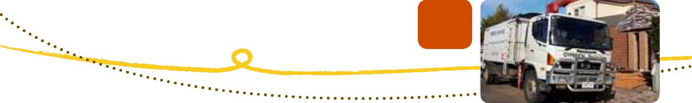CSR Gyprock™ take-back scheme for gypsum board product
Description of project
CSR Gyprock™ has been developing a gypsum board take-back scheme over the last five years and now has a gypsum board waste take-back scheme in operation for offcuts and demolition material. The scheme is being introduced progressively across Australia and is designed to help building contractors minimise plasterboard waste and recycle offcuts during construction. Upon completion of gypsum board installation, the fixing contractor simply leaves all offcut plasterboard material to be recycled just inside the boundary for collection. The fixing contractor arranges collection directly with CSR Gyprock™’s recycling contractor who charges the builder the appropriate fee (depending, for example, on quantity or weight). After collection, the material is guaranteed to be 100 per cent fully recycled.
The CSR Gyprock™ Recycling Service provides builders with important benefits: it helps to ensure that council regulations for recycling building materials are always adhered to; the removal of offcut plasterboard improves occupational health and safety on site; and the collection saves builders time and money.
What started as an experiment in Sydney has been formalised and is becoming an integral part of CSR Gyprock™’s service supply chain.
Use of recycled and re-used material
1400 tonnes of waste product per year is taken back from construction sites, saving the disposal to landfill of offcuts produced during construction.
Gyprock™ plasterboard is manufactured from gypsum, paper and a small amount of additives. Gypsum is a naturally occurring sedimentary rock. It is non-toxic and is also used as a food additive and agricultural soil improver. The liner board used is primarily recycled newspaper and cartons. The additives are benign materials such as starch and foam. The offcuts and waste collected are fed back directly into the production process.
Drivers for re-use
- Reduction in raw material use
- Saving disposal to landfill
- Corporate social responsibility
- Improvement of business offering

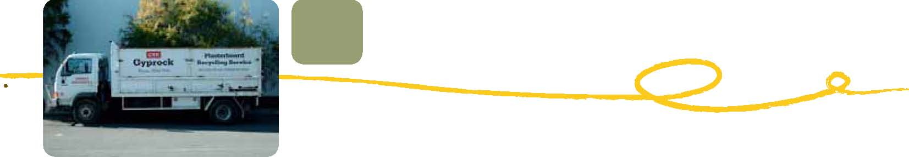Potential benefits
- The CSR Gyprock™ Recycling Service reduces the cost of site clean-up and landfill fees.
- Better on-site resource management produces cleaner, safer, sites. Government authorities are
increasingly insisting on better waste management practices.
- Home-buyers prefer to use builders who recycle and use products with low environmental
impact.

Problems and challenges
Contamination of plasterboard material can make material unrecyclable. Only new clean Gyprock™ plasterboard waste can be accepted. Non-acceptable materials include vinyl-covered panels, non-plasterboard ceiling panels, metal components or fixings, fibre cement, mixing boards with set cement, demolition waste, timber, chemicals, plastic, packaging, paper or general building waste and rubbish.
Rain-dampened plasterboard can be accepted if clean.
Solutions
To meet stringent quality standards, CSR has trained and employed selected contractors who understand Gyprock™’s requirements.
Specifications and opportunities for other projects
If plasterboard material can be separated from demolition waste there is an opportunity for greater recycling.
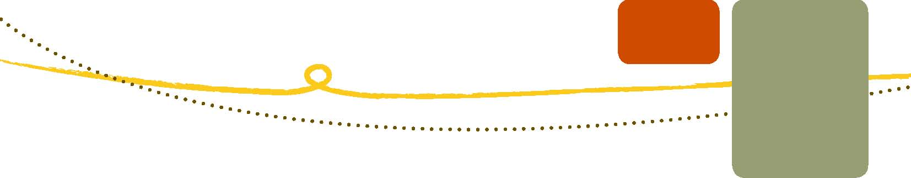PIPA recycling PVC pipes into new product
Description of project
The Plastic Industry Pipe Association (PIPA) has been working with two of its members, Iplex and Vinidex, to increase recycling rates of polyvinyl chloride (PVC) pipes in Australia. The common plastics used for pipe production are PVC and Polyethylene, thermoplastics that can be readily reprocessed. Scrap generated during manufacture is routinely reground and fed back into the manufacturing process, and the industry is now recycling post-consumer waste where pipe is collected from the waste stream and recycled back into pipe products.
Plastic pipes are long-life products with an expected lifespan of over 100 years. Therefore the amount entering the waste stream is relatively small, as the products are largely still in their first life cycle.
Use of recycled and re-used material
The PIPA recycling scheme recycles 300–400 tonnes of demolition and offcut PVC pipe in Sydney and Melbourne from new construction and temporary pipe systems.
Based on the New South Wales Office of Environment and Heritage’s Report into the Construction and Demolition Waste Stream Audit 2000–2005, the total proportion of plastics in C&D waste in New South Wales was 13 000 tonnes per year out of 450 000 tonnes. Breakdown of the proportion of plastics beyond this was not published in the audit report due to the low volume. Anecdotally, the total PVC amount is between 1000 and 3000 tonnes per year. The PVC pipe waste is an undetermined proportion of this.
Drivers for re-use
PVC has been a controversial material over many years due to concerns over the toxicity of additives such as plasticisers that give PVC its flexibility and the dioxins produced when PVC is burnt. The main risk of PVC being burnt is in uncontrolled landfill fires when PVC products reach the end of their life cycle. Avoidance of this risk is a driver for recycling and re-use of PVC products. If the material can be extracted from the waste stream before it arrives at landfill, and is re-used, then the potential hazard is eliminated. This is good product stewardship.
Regulation and industry self-regulation has been a significant incentive for PVC re-use, such as the Green Building Council of Australia’s PVC credits for PVC products that meet best practice guidelines, and other design guidelines that specify standards for PVC products.
The industry continues to strive for best practice, and increasing recycling rates means saving virgin material, a business driver.
Potential benefits
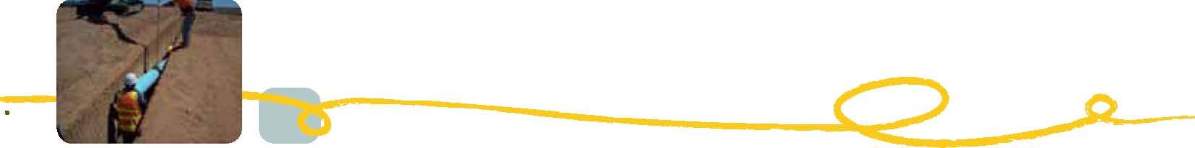
- Avoidance of waste from landfill and the commensurate dioxin releases
- Virgin material savings
- The total life cycle for PVC pipe becomes more sustainable

Challenges and solutions
There are low volumes of PVC pipe waste in the waste stream according to the New South Wales Office of Environment and Heritage waste audit figures and subsequent estimates. This low volume creates scale issues for the recycling process. The cost of recycled material is the same as virgin material. This is mostly due to the cost of transporting materials to the recycling facility. The industry needs greater scale or a higher value for PVC to incentivise more PVC recycling. The industry is working with a small number of recyclers to concentrate volumes into viable quantities.
Ensuring the recycled material is free of contaminants such as dirt and fixings is an issue which is being addressed by industry efforts to source the material before it becomes co-mingled with other building and demolition waste. The use of washing facilities is also being encouraged to deliver a cleaner recycled product to the processors.
Recycled materials are produced from mixed colour PVC pipes, resulting in a brownish colour. PVC pipes are colour-coded for particular applications: water pipes are blue, electrical conduits are orange and stormwater pipes are white. The brownish colour of recycled material makes it most appropriate for multi-layer pipes, where the inside and outside are made from a virgin material and the middle layer is made from recycled material. Multi-layer pipes are more rigid and are used for non-pressure applications, such as electrical conduit pipe.
Opportunities for other projects
Increasing the recycling rates of PVC pipe will increase the life cycle of PVC, reduce the amount of PVC going to landfill, and therefore reduce the health risks of landfill fires.
PVC can be recycled six to seven times. With a product life of 100 years, this means that PVC material could potentially have a lifespan of 600 years. All recycled PVC can be utilised in multi-layer non-pressure pipe.
There is an opportunity to raise awareness of the market for waste PVC pipe—PVC pipe can be extracted from the waste stream and have an extended useful life.
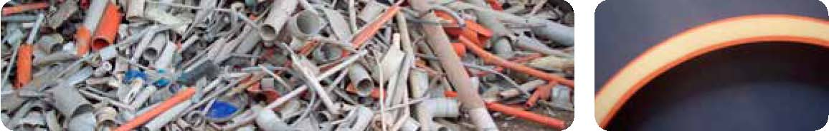Left: Centralised post consumer pipe waiting for processing into new material.
Right: PVC multi layered pipe showing recycled material at the core.
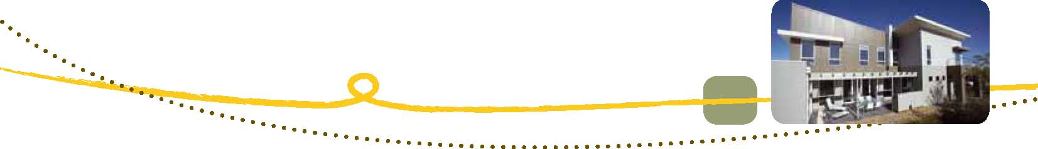James Hardie industrial ecology initiatives
Description of project
James Hardie is a leading international building products company, a global leader in fibre cement technology and supplier of well-known brands of fibre cement products. This case study outlines the initiatives that James Hardie has been taking to reduce waste across their manufacturing process to produce products and materials with a smaller environmental footprint.
The market for fibre cement building products is growing. It is being used increasingly in the exterior and interior of buildings, for example, exterior cladding, internal lining, facades and flooring. James Hardie continues to research and develop products that help to achieve sustainable construction. James Hardie strives to manufacture products that are low in embodied energy (compared to functional alternatives), low maintenance, durable, require lighter frames and construction techniques, do not emit volatile organic compounds, can be put up quickly with few trades and can be used to create energy-efficient buildings in all climates.
A primary focus is to reduce waste. This is achieved by increased plant efficiencies which reduce environmental impact by optimising the conversion of valuable resources and energy into high-value building products.
Yield improvements are achieved by reusing manufacturing by-products in the manufacturing process as raw materials and recycling by-products as resource inputs into other processes. The composition of fibre cement by-products is primarily sand, cement and cellulose. These valuable resource inputs are used in other building materials, enabling recycling and by-product substitutions with other building product manufacturers.
Use of recycled and re-used material
James Hardie reuses several process by-products internally and externally. These include:
- recycling a proportion of by-product into the manufacture of pallets. This by-product, which may otherwise go to landfill, replaces timber components on some pallets and helps to reduce demand for timber
- partnering with a major cement manufacturer where the by-product is reintroduced into the
cement manufacturing process. This helps to reduce the demand for natural quarry materials used for cement manufacture
- partnering of the Rosehill plant with a major producer of road base materials where by-product
fines are reducing the demand for crushed materials. The result of these efforts is that the
James Hardie Rosehill plant has reduced its landfill footprint by over 80 per cent, eliminating
16 000 tonnes of waste to landfill per year.

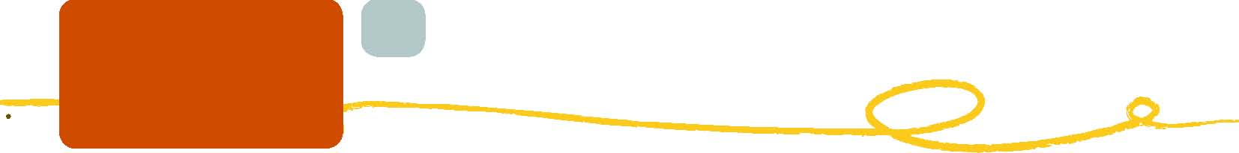Drivers for reuse
- Ongoing research and development into manufacturing process efficiency
- Corporate social responsibility program
- Cement manufacturers initiatives to source alternative materials for cement manufacture and
  - process improvement

Benefits
- Environmental benefits—reduced demand for natural resources and energy by James Hardie
  - and its partners reduces environmental impact. Resource efficiency initiatives are reducing demand for natural forestry and quarry materials such as timber, sand, limestone and other quarry products
- Social benefits—reducing reliance on landfill extends existing landfill capacity. Reducing
demand for natural materials extends available resources for future generations.
- Economic benefits—by maximising efficiency and replacing valuable natural resources with
  - by-products there are commercial benefits for James Hardie and its partners.

In a model for industrial ecology, James Hardie has partnered with a customer for which offcuts of James Hardie products are returned to James Hardie for recycling. This may evolve into a product stewardship scheme.
Problems and challenges
A major challenge in by-product substitution was the reclassification of James Hardie fibre cement by-product as a resource under the New South Wales Protection of the Environment Operations (Waste) Act 2005 (POEO).
Another challenge was identifying opportunities to work with partner organisations for product synergies. The opportunities had to be able to deliver environmental, social and economic benefits for both James Hardie and partner organisations.
Solutions
To deal with the reclassification of the fibre cement by-product as a resource under the POEO, James Hardie worked with the New South Wales Office of Environment and Heritage supported by the Sustainability Advantage Programme. Now it has been achieved the project is yielding the significant environmental benefits described above.
Specifications and opportunities for other projects
There is great opportunity for industrial ecology across the construction supply chain sector. For building materials and products with common raw materials there are many opportunities to exchange by-products. Some of these are being facilitated by the Waste Management Association of Australia through the Australasian Industrial Ecology Network.
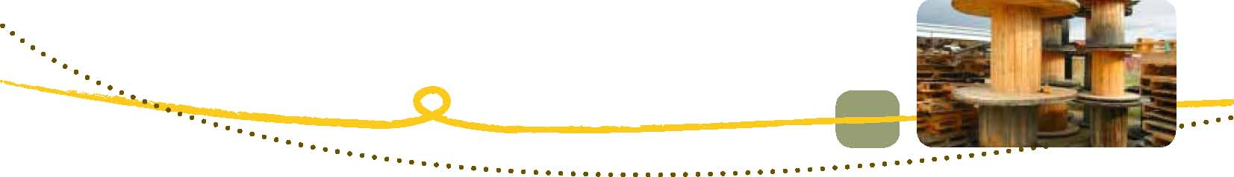Eastern Metropolitan Regional Council: wood is too good to waste
Description of project
The Hazelmere Timber Recycling Centre (Hazelmere) in Perth, Western Australia recovers and processes industrial timber waste so it can be diverted from landfill and recycled as a reusable woodchip. Hazelmere, operated by the Eastern Metropolitan Regional Council (EMRC), opened in 2008 and is the only one of its kind in Western Australia. Hazelmere aims to recycle at least 10 000 tonnes of timber waste per year. Previously the timber processed at Hazelmere was destined for landfill.
Uncontaminated timber waste is sorted and shredded into woodchip. The shredding process removes steel contaminants such nails, nuts and bolts. The recycled woodchip is then used as a raw material for identified end markets including particleboard, manufacture of compost and animal bedding, and as biofilter medium.
Currently, untreated softwood or pine timbers in the form of pallets, packing materials, wooden crates, low-pressure laminated particleboard off-cuts (without plastic edging) and cable drums are accepted for recycling at Hazelmere.
The EMRC has committed to diverting all grades of timber waste from landfill for re-use. Hazelmere is working to establish markets for untreated hardwoods so that they can be accepted and processed in the future.
Use of recycled and re-used material
Hazelmere aims to reclaim and recycle 10 000 tonnes of timber per year. Timber recycled currently includes:
- untreated (including fumigated and sterilised timbers) and unpainted timber
- untreated timber (including fumigated and sterilised timbers) which carry the markings ‘HT’ (heat
  - treatment) or ‘MB’ (methyl bromide: chemical fumigation)
- particleboard timbers with plastic edging removed
- low-pressure laminated board with plastic edging removed
- medium-density fibreboard (MDF)
- timber containing ferrous metal (nails, gang nail plates, and/or bolts)

Hazelmere only accepts timber waste where viable end markets have been established. The EMRC is committed to developing markets for a broad range of timbers and the range of timbers accepted will continue to expand.
Drivers for re-use
- The Government of Western Australia Waste Authority ‘Towards Zero Waste’ initiative
- Saving of airspace in landfill

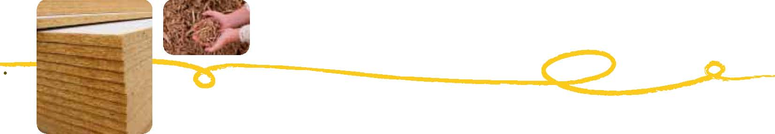Benefits
- Financial savings for the community and councils—disposal fees at Hazelmere are
  - approximately $50 per tonne less than landfill costs
- Diverting timber from Perth’s landfill reduces the burden on the environment and conserves
  - landfill airspace
- Timber disposed at Hazelmere is processed into a reusable woodchip and used in a number of
  - new products. This reduces the reliance on tree harvesting for raw materials

Challenges
Contamination is the main challenge when recycling timber from mixed waste. Contamination in the form of rags, plastic, strapping, and construction waste, (such as concrete) wraps around processing equipment and causes damage to machinery. Contamination in the form of aluminium (such as drink cans), rocks and limestone carries through into the final product which means that market specifications cannot be met. Timber treated with copper chromium arsenic and household waste causes environmental issues when grinding and poses a safety risk to animals when re-used. Contamination in the form of high pressure laminate affects processing as it is too hard and abrasive to break down into a reusable size.
Solutions
Hazelmere staff work hard to identify contamination at the gates, and are constantly looking for more efficient methods of identifying and removing contamination to improve the production process.
A price incentive is given at the gate: mixed loads with potential contamination are more expensive.
Educating and engaging the public is an ongoing initiative—pamphlets, handouts and signage outline Hazelmere’s operation and achievements.
The ultimate solution would be segregation of wastes at source, allowing a clean stream of timber waste to be recycled. The timber industry is working on this, establishing the National Timber Product Stewardship Group in 2007 to address these types of issues.
Opportunities for other projects
On 6 April 2011 the EMRC officially opened a fully automated wood grinding plant at Hazelmere, which is designed to recycle 20 tonnes of wood waste per hour. HAAS-Recycling (Germany) designed and manufactured the plant which turns waste wood usually destined for landfill into two separate streams of chipped and cleaned products that EMRC sells as animal bedding and for particleboard manufacturing.
If markets for treated timber could be found, this case study shows an opportunity to recycle and re-use a new type of timber resource. The industry requires research into markets for treated timber waste.
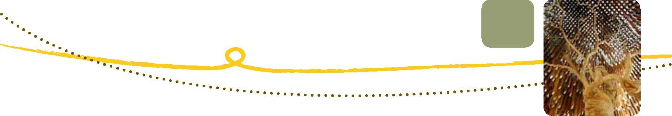Recycling power poles into high-value timber products
Description of project
Kennedy’s Timber in Queensland recycles power poles into valuable hardwood products. Michael Kennedy pioneered the recycling of power poles 17 years ago when he realised that there was a valuable resource going to landfill. The majority of power poles are made from Australian hardwood timbers such as Spotted Gum, Ironbark, Blackbutt, Grey Box, Tallow Wood and Blood Wood. These timbers are increasingly hard to find in length and quantity, and redundant power poles offer a valuable resource for a market where there is an increasing demand for recycled timbers.
An important stakeholder in Kennedy’s quest has been Energex, a Queensland energy company. Energex, the owners of the poles, cooperated with Kennedy’s Timber to reclaim the timber. On 1 April 2011 Kennedy’s Timber was awarded the 2010 Energex Innovation in Sustainability Award. This award is made to the Energex supplier that achieves the most excellent sustainability initiative. It was awarded to Kennedy’s for perseverance, commitment to environmental practices and the development of innovative solutions in helping Energex reduce carbon dioxide emissions. The awards presented at the ceremony were even crafted from a re-used Energex power pole.
Use of recycled and re-used material
Kennedy’s Timber recycles old Energex power poles and cross arms to sell as recycled timber, a process that has now been extended to shorter length poles. The correct protocols for handling the contaminated timber off-cuts and residual product are important to ensure strong environmental compliance. After sawing, drying, docking and dressing, an average of 40 per cent of the wood fibre volume is directed to timber re-use products and beneficial re-use away from landfill. Kennedy’s Timber currently processes approximately 6000 m³ of poles and cross arms per year. Further innovations in processing technology will result in enhanced timber recoveries and a wider range of finished timber products being produced.
Drivers for re-use
Timber power poles have historically been treated with copper chromium and arsenic, boron or creosote to make them more durable to the elements. Treated timber is sent to landfill for disposal, however power poles contain valuable and useful timber that is not affected by treatment. Recovering the value of the untreated components of power pole timber has been one driver for the project.
Redundant power poles also represented a carbon cost to Energex in terms of their Scope 3 emissions as defined by the National Greenhouse and Energy Reporting Scheme. By working with Kennedy’s Timber to recycle the redundant power poles, Energex have eliminated this waste from their carbon emissions profile and turned a liability into an asset on their financial bottom line.
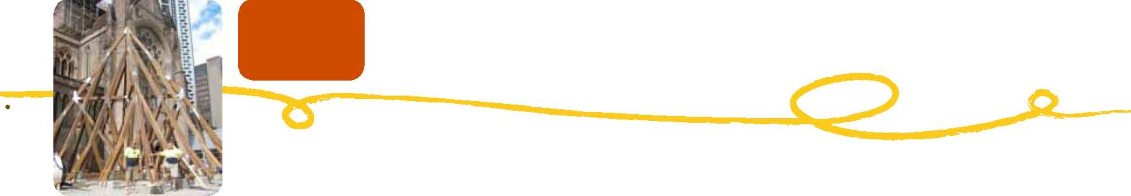Michael Kennedy’s business philosophy contributes to Kennedy’s corporate sustainability profile and drives initiatives to enhance and increase the life cycle of timber products.
Benefits
- Landfill avoidance
- Valuable resource recovery of Australian hard wood timbers
- Carbon savings for Energex
- Problems and challenges

Initially there was significant resistance from Energex and stakeholders in the supply chain to changing existing practice due to concerns about the health risk of processing the power poles. These were valid concerns as there were no protocols or guides for the processes of recycling treated timbers.
Solutions
Kennedy’s Timber, Energex and the New South Wales Office of Environment and Heritage worked together to develop protocols for recycling redundant utility poles and bridge timbers in New South Wales.
Another outcome of this project has been the development of standards for the use of recycled timber. Standards have now been developed under a project supported by Forest and Wood Products Australia and the Queensland Department of Tourism, Regional Development & Infrastructure, with input and development from stakeholders, including industry associations, representatives of the recycled timber industry, government, researchers and specifiers.
Specifications and opportunities for other projects
There is an opportunity for further recovery of timber fibre through research into the use of timber processing waste. Waste that is contaminated with timber treatment systems and is currently going to landfill offers an opportunity for other projects in the future.
The standards and protocols described above are available through timber industry websites.
The protocol for recycling redundant utility poles and bridge timbers in New South Wales is available from the National Timber Product Stewardship Group at:
http://www.timberstewardship.org.au/images/pdf_documents/protocol_recycling_pole_and_ bridge_timber_final.pdf
Standards for recycling timber are available through the Forest and Wood Products Association at:
http://www.timber.org.au/resources/FWPA_Recycled_Structural_WEB.pdf
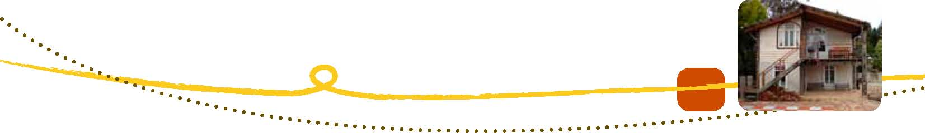Old Leura Dairy: innovating with heritage materials
Description of project
The Old Leura Dairy (OLD) is a development of six luxury eco-friendly buildings built by the Hennessey Family providing corporate retreat and tourist accommodation in the Blue Mountains in New South Wales. Since inception 12 years ago, the OLD buildings have been constructed using the principles of ecologically sustainable development. The buildings use up to 95 per cent (by cost) locally sourced reclaimed and recycled materials. The materials have been incorporated into modern designs that achieve good thermal performance in the temperate climate of the Blue Mountains. The OLD has re-used a range of materials extracted from construction and demolition waste and has used reclaimed timbers from a variety of sources.
Use of recycled and re-used material
When the first two buildings of the OLD were built, re-use and recycling rates of 80 per cent were achieved. By buildings five and six, 95 per cent of all materials (by cost) were recycled building materials. The materials re-used include:
- over 12 lineal kilometres of timber:
- framing timbers from a local recyclers yard
- lining and weather boards
- floorboards
- railway bridge timbers
- decking boards from old woolsheds
- corrugated iron sheets from roofing used for cladding
- sinks and toilets
- windows and doors
- light fittings
- 40 tonnes of bricks from the old Katoomba Ice Works
- carpet used as additional insulation under floor.

Drivers for re-use
Local council regulations, such as waste management plans or local government guidelines, were not the main driver for re-use. Rather the goal was to create interesting buildings with character that would attract people and create a place with unique character. Michael Hennessey describes his principal driver as ‘Mother Nature and my daughter’. The key driver could be said to be a philosophical commitment to ecological sustainability.
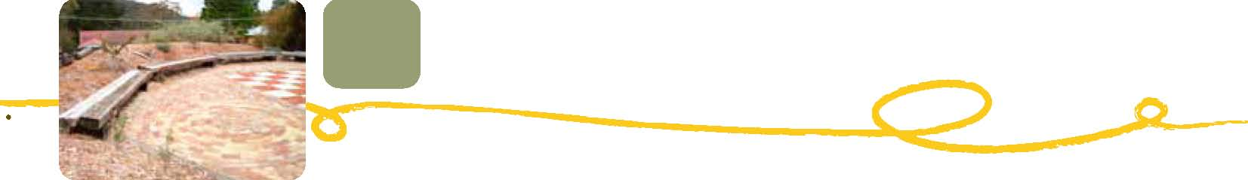Potential benefits
The benefits of reusing materials for OLD relate to the accommodation that is provided. The buildings are unique due to the materials that have been incorporated. Michael Hennessey states that the character of the OLD has been achieved by the assortment of materials bringing with them character from a previous life, and that the OLD buildings benefit from ‘the ghosts’ of their previous lives.
Problems and challenges
Re-using and recycling at the OLD has been a difficult but rewarding task. The Hennessey’s built this way knowing that it would take more effort. The cost of labour to recycle many of the products was equal or more than the cost of using virgin materials or new products. Michael Hennessey estimates that the additional cost of building with recycled materials is between 50–100 per cent.
There are some excellent opportunities to create unique buildings with great character from reclaimed and recycled materials if the problems of quantity and continuity of supply can be dealt with. Achieving the specified design of a house using reclaimed timbers for flooring, weatherboards, framing and other applications where a fixed quantity of consistent material is required can be challenging when relying on a supply of reclaimed product.
Using reclaimed materials can be more difficult from a tradesman’s point of view. There is often an extra dimension to using reclaimed materials, where the tradesman needs to adapt materials or products to fit the purpose. This can take time and requires knowledge and experience. As demonstrated by the OLD’s recycling rates rising from 80 per cent to 95 per cent, experience and knowledge allows greater opportunity for incorporating reclaimed materials into buildings.
Solutions
Increased supply—if the supply of reclaimed materials from demolition could be increased, the continuity of supply would improve and the opportunity for incorporating materials into designs would be greater.
Increased knowledge—as tradesmen gain experience working with reclaimed materials, knowledge in the industry increases, new methods of construction can be tried and tested, and time savings can be achieved. There is a shortage of tradespeople who are able to work with the inconsistencies of reclaimed and recycled materials; training is required.
Specifications and opportunities for other projects
Reclaiming and re-using materials in the way that the OLD has, provides the opportunity to create unique buildings that benefit from the style that reclaimed and re-used building materials offer.
The OLD demonstrates how valuable hardwood timbers can be reclaimed and how their life cycle can be extended in new applications.
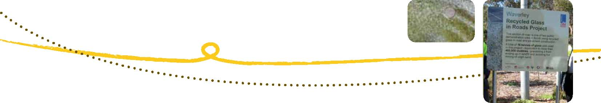Waverley Council: recycled glass in roads
Description of project
In 2010, Waverley Council, in partnership with New South Wales Department of Environment, Climate Change and Water, New South Wales Roads and Traffic Authority, Institute of Public Works Engineering Australia and the Packaging Stewardship Forum, provided the first site within New South Wales to demonstrate alternate use of crushed glass in pavement construction as an accepted product in New South Wales roads.
Two 100-metre sections of pavement containing glass product were constructed. The first site at Blair Street, Bondi used glass product in asphalt and the second site at O’Brien Street, Bondi used glass product in concrete pavements.
Use of recycled and re-used material
Waverley Council substituted 15 tonnes of glass cullet into the road projects, 7.5 tonnes into asphalt and 7.5 tonnes into concrete.
Drivers for re-use and benefits
There is an estimated 75 000 tonnes of crushed glass fines in New South Wales. There is currently a stockpile in Sydney of an estimated 60 000 tonnes. This material is destined for landfill unless an alternative use can be found.
If the concrete industry was to use the crushed glass fines they would not use 75 000 tonnes of natural sand at $30 per tonne. This would save them $2.25 million.
The project partners contributed to the participants’ recycling and sustainability targets by demonstrating the use of glass in pavement construction and reporting the tonnes of recycled glass material used.
In the last 12 months the Southern Sydney Regional Organisation of Councils have used approximately 9000 m³ of concrete. If this concrete used the 56 per cent glass-sand replacement used in the Waverley case study, approximately 4000 tonnes of virgin sand could be replaced with glass.
Problems and challenges
Behavioural change—there was reluctance by local road engineers to move towards recycled glass as an alternative to virgin material.
Broad stakeholder involvement—the business case identified the need to establish interest groups incorporating stakeholders from industry, Local Government Associations and associations such as the ARRB Group, APPA, Institute of Public Works Engineering Australia to confirm the status of existing testing and research and develop specifications for further testing to increase acceptance of the crushed glass product.
Solutions
Behavioural change—the Institute of Public Works Engineering Australia has created a course to educate road engineers in how to use alternative materials in construction projects.
Collaboration—this project was conceived and delivered by a group of ‘champions’ from organisations in different sectors whose goals aligned.
Specifications and opportunities for other projects
Before this project there was no general acceptance of crushed glass use in road construction. In August 2008, the Packaging Stewardship Forum of the Australian Food and Grocery Council commissioned a report by GHD entitled The Use of Crushed Glass as both an Aggregate Substitute in Road Base and in Asphalt.
The GHD report identified that to gain acceptance for the use of crushed glass in pavement applications it must be demonstrated that an asphalt or road base mix can meet required properties and performance measures.
The list of opportunities for crushed glass includes:
- aggregate in road base and sub-base
- aggregate in asphalt, including ‘glassphalt’
- aggregate in tiles
- aggregate in decorative concrete for architectural facades
- alternative to mulch
- filtration material
- alternative to sand in golf courses
- alternative to fill and bedding material
- aggregate in concrete and cement

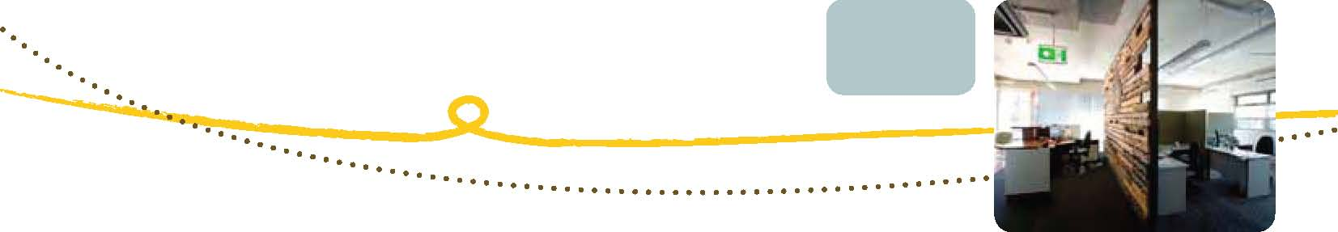Australian Ethical Investment: best practice waste management at Trevor Pearcey House
Description of project
Trevor Pearcey House is a 19-year-old building in the Fern Hill Technology Park, Bruce, in the Australian Capital Territory. The refurbished block has become the new head office for Australian Ethical Investment and has been designed to be an exemplary green building.
Australian Ethical Investment (AEI) is an Australian investment company which specialises in environmental and socially responsible investment. AEI’s philosophy is to promote ecologically sustainable and socially just enterprises through careful investment and to improve the ethics of corporate Australia.
Trevor Pearcey House is rated by the Green Building Council of Australia (GBCA) as a six-star Green Star building, the first to achieve a six-star rating in the Australian Capital Territory and the third in Australia. One aspect of the project that resulted in a six-star rating was the commitment to re-use and recycle materials from the demolition phase of the project in the fit-out of the building. A recycling rate of greater than 80 per cent by weight was achieved and there was additional recognition for innovative ways of incorporating re-used and recycled materials into the building.
Use of recycled and re-used material
The architects and construction managers Cobul Constructions worked collaboratively to ensure as many materials as possible were re-used in the construction. This included:
- electrical wiring
- ducted skirting
- power point and switch face plates
- partition wall studs
- plasterboard and frames for windows and doors
- internal doors, door handles, door stops and internal glass blocks
- carpet tiles, which were re-used and supplemented with more recycled carpet tiles (Ontera
  - Carpets)
- steel hanging frames and mesh found in the ceiling space which were re-used to make a bike
  - enclosure
- 90 per cent of the joinery cupboards being made from old cupboards found in the building
- recycled timber used for feature floors and walls.

Some of the recycling led to inspired elements within the building such as two walls made from old timber palettes and, most notably, art work made from old computer mother boards.
Drivers for re-use
The key driver for the sustainability of the building was the overall philosophy of the client, Australian Ethical Investment. The GBCA’s Green Star tool was used both as a driver and as a measure of achievement. Although the Australian Capital Territory Government does implement the ‘No Waste by 2010’ regulation as part of the development application process, the Green Star requirements were more stringent, set a higher standard and superseded the Australian Capital Territory Government regulation. The main drivers for achieving high recycling and reuse rates were:
- Australian Ethical Investment’s business philosophy and commitment to sustainability
- a target of six stars on GBCA’s Green Star rating tool
- the Australian Capital Territory Government’s ‘No Waste by 2010’ policy

Benefits
The main benefits for Australian Ethical Investment have been demonstrating their commitment to their philosophy and the attention they have received for being early adopters and innovators. Reclaiming and recycling materials is intuitively less costly, however the extra labour cost balances out the savings. The material cost savings, particularly from the carpet, were spent on other aspects of the sustainable design.
Challenges
The client’s brief stipulated that costs must be balanced and that the cost must not exceed that of a conventional fit-out. In this way the challenge was to balance how far to go with recycling and re-use without affecting the budget.
From the architect’s point of view, specifying recycling of materials can be seen as a risk as it is hard to define the extent of recycling that can take place until the project is underway. Specifying recycled materials from the demolition requires that the design team accurately documents the demolition material as it comes out of the building, and that it is carefully handled and stored for re-use. This requires careful management of the project and close cooperation between the client, design team and contractors.
Solutions
Collard Clarke and Jackson Architects are experienced in recycling and re-using materials from demolition. It has become standard practice for them to consider the opportunity for recycling and re-using materials from demolition. Commitment to recycling and re-use across the project team is key to delivering high recycling and re-use rates. Having an experienced and motivated project team who are willing to collaborate and apply innovative thinking delivers optimal recycling and re-use rates.
Specifications and opportunities for other projects
Every building fit-out project is different, with different construction and demolition waste products offering new opportunities for innovative re-use. The lessons learned by the project team responsible for this project will carry forward to future projects and enable the architects and builders to consistently achieve high construction and demolition recycling and re-use rates and to reduce costs and time during the design, specification and construction of a building.
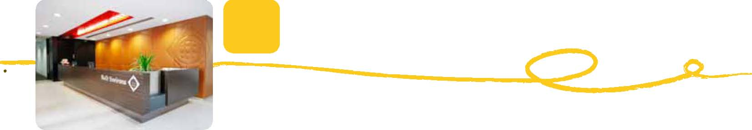Built Environs: 100 Hutt Street, Adelaide
Description of project
100 Hutt Street is a commercial office building and the head office of Built Environs, the national building brand of McConnell Dowell. 100 Hutt Street was refurbished between 2007 and 2008 using the Green Building Council of Australia’s (GBCA) Green Star building rating tool to demonstrate leading practice. The refurbishment achieved an overall rating of five green stars. During the construction, 100 Hutt Street implemented a waste management plan and recycled or re-used 95.1 per cent of construction waste (by weight) from the construction activities, far exceeding the Green Star credit criterion.
As well as showcasing Built Environs’ environmental and sustainability credentials, the new head office has been designed to provide employees with a real time sense of their impact on the environment. The completed project is a showcase for the company’s capabilities in design and construction management and has been completed to a high level of detail.
Use of recycled and re-used material
The project re-used 95.1 per cent by weight of all construction waste. This included:
- black caesar stone removed from a prominent South Australian public building as part of a
  - previous refurbishment project
- recycled mechanical spiral ductwork re-used for 295 pot plant sleeves
- recycled timber used for all wall noggins for partition walls
- recycled fire sprinkler pipework used for the PPE display
- timber palettes used to deliver and store mechanical ductwork to create partitioning in the
  - ‘palette room’
- surplus concrete reinforcing mesh which was powder coated and installed as part of the
  - reception area
- re-used 40-gallon steel drums salvaged from Built Environs’ plant yard used for seating in the
  - break-out area
- re-used wire mesh from surplus stock on previous projects used in the stair balustrade design.

Drivers for recycling and re-use
A flagship project—a key driver for the construction and demolition waste recycling and reuse was for Built Environs to demonstrate what their company could do. Lessons learned and experiences gained are being applied across their projects for clients.
Pursuing a philosophy—the 100 Hutt Street project was founded on environmental design solutions and sustainable methodologies. The team ensured readily accessible waste materials would be re-used within the fit-out as an alternative to conventional materials. This commitment was taken as a corporate social responsibility and to increase knowledge among their employees, future project consultancy teams, visiting subcontractors and general visitors.
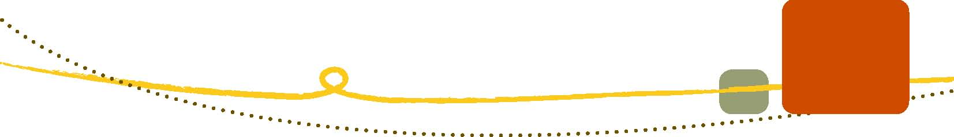The team pursued this vision knowing that maximising the recycling of surplus or discarded items would ensure this project could:
- reduce landfill and waste generation
- conserve resources
- reduce pollution
- conserve energy (turning recycled material into new material takes less energy than turning raw
  - material into new material)
- create further jobs

Competition—the industry benchmark for levels of recycled and re-used construction waste is was 80 per cent (by weight). Built Environs exceeded this benchmark, demonstrating leading practice.
Benefits
Operational waste management—Built Environs has increased experience and knowledge within their company by striving to achieve leading practice. This will flow on to economic benefit as clients choose the company to repeat their good work for clients.
Staff engagement—there has been flow-on effect of the commitment to leading practice waste management to the daily operations of Built Environs staff. The project has instilled an ethic within the company of waste minimisation which has become a core part of the culture.
Problems, challenges and solutions
During the project Built Environs engaged staff by holding information sessions and stakeholder engagement workshops. This enabled them to anticipate and address challenges as, or even before, they occurred.
The design team worked with the construction team to optimise opportunities for recycling and re-use.
Specifications and opportunities for other projects
- Implement a waste management plan for all construction works, no matter how minor
- When specifying products within a new build or refurbishment, the designer has the opportunity
  - to nominate cladding and materials to be obtained from a reclaimed source within finishes schedule and specification requirements. The head contractor then can present opportunities to the designer and client that may enable materials and products to be re-used and diverted from landfill or elimination of use of virgin materials
- All offices should develop a recycling and waste management plan to encourage improvements
  - and waste minimisation
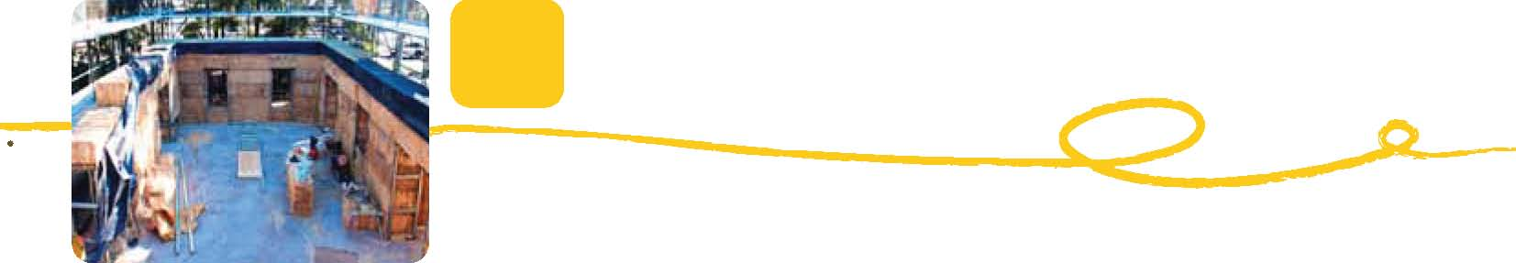Fairfield City Council: a sustainable community building
Description of project
The Nalawala Hall, Fairfield City Council’s Sustainability Hub, is Australia’s largest straw bale community building and was designed with environmental sustainability as its core value. The hall and small seed shed containing an Indigenous plant nursery were constructed bale-by-bale by local residents and other volunteers from Sydney. The main body of the hall was built from straw bales and rendered with mud. The building uses recycled materials for doors, frames and fittings. Paints and finishes are also environmentally friendly. Nalawala Hall incorporates the world’s first concrete load-bearing foundation slab which is 95 per cent recycled. The recycled concrete used for the Nalawala Hall and seed shed has been produced by the council’s own in-house construction material recycling operation in partnership with local concrete supply company Metromix. The hall has been in use since 2008 and the concrete slab is performing well.
Use of recycled and re-used material
The Nalawala Hall (‘nalawala’ is an Indigenous word for ‘sit down’) exemplifies the re-use of recycled concrete among other construction and demolition waste re-use. Recycled materials used in the project include:
- a 95 per cent recycled concrete load-bearing foundation slab, never before implemented
  - anywhere in the world
- recycled window frames and doors
- Five tonnes of waste straw for the straw bale construction
- 800 milk bottles of plastic waste re-used as toilet partitions.

Drivers for re-use
The main driver for re-use was for Fairfield City Council to deliver on its commitment to sustainability and its work on Local Agenda 21 and Cities for Climate Protection. Fairfield City Council aimed to deliver a community building that would inspire the community to make more environmentally sustainable choices in their day-to-day routines.
Potential benefits
The environmental benefits of the Nalawala Hall straw bale construction include:
- converting waste straw into a valuable building resource
- avoiding greenhouse gas generation, as straw is often burned
- 10 times the insulation factor of double-brick cavity wall
- an increase in the efficiency of solar-passive design
- walls that are estimated to be 30 times less energy intensive than wood frame walls.

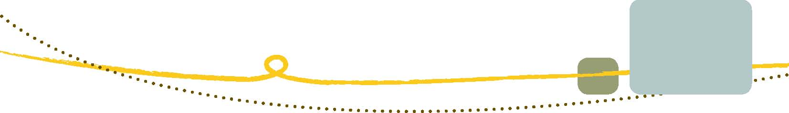The benefits associated with local government leadership include a demonstration to the community and other local councils on what can be done with recycled and re-used construction materials, and how it will promote further initiatives across community, industry and other local government areas.
Challenges and solutions
Pioneering the use of recycled concrete presented challenges. Since the mid-1990s the construction industry was aware that concrete foundation slabs may provide the widest and most economical field of application for recycled concrete. In a 1999 CSIRO report for the building industry, a recommendation noted that a 30 per cent recycled concrete replacement of virgin aggregates might be trialled for domestic slab construction. Fairfield City Council reported that ‘the psychological barrier of ‘who’s first’ presented a challenge for greater recycled concrete mixes being used in slab construction. However in the Nalawala project an environmental decision was made to specify a 95 per cent recycled concrete content in the foundation slab, and a calculated level of risk accepted.’
The use of recycled concrete at such a high level has the capacity to give architects, builders, building inspectors and various stakeholders within the construction industry the confidence to move ahead with high recycled concrete content for foundation slab specification, knowing that benefits have been proven.
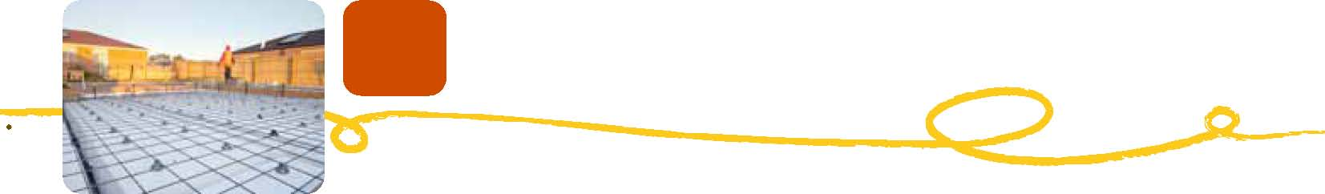Recycling waffle pod waste
Description of project
This project demonstrates industry best practice in the development and delivery of a product stewardship scheme targeting the reduction of expanded polystyrene (EPS) litter from waffle pod offcuts on building sites and the diversion of this material from landfill. The introduction of the Pod Scrap Bag Program has been an industry initiative of Expanded Polystyrene Australia (EPSA) and its Pod Group members. Scrap bags are supplied with all pod deliveries to building sites to assist with the separation of EPS offcuts from the general waste stream. The filled scrap bags are then collected and taken back to the EPS manufacturer where it can be granulated and recycled in new waffle pods and other building and construction products.
Use of recycled and re-used material
EPS pods have become an important part of building concrete slabs, particularly for domestic dwellings. The lightweight and superior compressive strength of EPS pods deliver formwork for slabs that is uniform and consistent with ease, thereby reducing construction time and costs. In addition, the thermal properties of EPS provide significant insulation benefits, making waffle pods popular in new-home construction where concrete slabs are used.
The size of the waffle pod market in Australia is around 7000 tonnes per year. From this, around 600 tonnes of EPS pod offcuts are generated on building sites. It is estimated that where the Pod Scrap Bag Program has been implemented, the collection and recycling rate of EPS pod offcuts is extremely effective—around 90 per cent.
Drivers for re-use
As a result of the persistent waste on and around building sites from the use of waffle pods, there has been a threat to regulate against their use. The industry responded with the introduction of the Pod Scrap Bag Program.
Potential benefits
EPS pod manufacturers can incorporate up to 40 per cent recycled materials in the production of waffle pods—this offers significant economic benefits through the reduction of virgin material required to manufacture the pods and environmental benefits, with all scrap and offcuts able to be recycled and re-used in new pods rather than going to landfill.
Problems and challenges
One challenge is to educate end users of waffle pods, such as builders and concreters, on the correct use of the pod scrap bags to ensure the EPS offcuts are segregated without contamination from other building site waste.
Another challenge is to promote the benefits of this product stewardship industry initiative to local councils to ensure EPS pods are not deselected due to their propensity to enter the litter stream if offcuts are not handled properly on site.
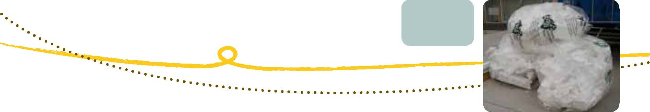
Solutions
The EPSA Pod Group has participated in the Keep Australia Beautiful (Victoria) Clean Site Program to showcase their efforts in addressing EPS scrap from building sites.
Specifications and opportunities for other projects
There are currently significant quantities of other EPS products being collected and recycled through the National Collection Network established by EPSA. The long-term goal of EPSA is to establish a national closed-loop recycling network for all EPS products.

CHALLENGES
During research for this guide many stakeholders involved in projects related to re-use and recycling of construction and demolition waste were interviewed and asked about their views on the key challenges and barriers to markets. Four main challenges were ubiquitous. They are detailed below to highlight the need for time and resources to address these challenges.
Knowledge across industry and requirement for training
The Institute of Public Works Engineering Australia Limited have been developing a specifications course designed to help project managers and engineers responsible for public works understand the specifications of new materials such as recycled aggregates and substitute materials, and to learn how to incorporate them into projects. As the range of products and materials increases there will be a greater need for such courses to provide awareness of materials and, more importantly, knowledge of how to use them successfully in projects.
Cross-contamination of wastes
The recovery rate of useful material is hampered by cross-contamination with other materials, particularly in the mixed construction and demolition waste stream. Asbestos contamination is a well-documented problem and still presents a significant issue in waste derived from demolition and renovation works, not new construction. High recovery rates for materials are achieved when materials are captured closer to the source, before there is opportunity for mixing with other wastes. This is clearly demonstrated in the case studies, where greatest recycling rates are achieved when the waste materials are captured early and segregated.
Technological barriers
There remain opportunities to recycle and re-use significant volumes of materials that are still being sent to landfill due to the inability to identify markets for the material as it is presented, or due to the lack of technology and/or equipment to sufficiently clean or segregate materials. This is particularly the case with the timber waste stream where there is contamination from treated timber products. There is a clear need for investment in research and development to overcome technological barriers.
Design for deconstruction
Designing for deconstruction, a practice that is gaining prominence, offers an opportunity for greater resource recovery at the end of a building’s life. A building that is designed to be taken apart at the end of its life offers greater opportunities for resource recovery and, with time, design for deconstruction principles may be applied further up the supply chain to materials and building components. A link to resources on design for deconstruction is given in the resources section of this guide.

ADDITIONAL INFORMATION
Guide:
Consultation
Robin Mellon, Executive Director, Advocacy and International, Green Building Council of Australia

Rick Walters, Technical Manager, Australian Green Infrastructure Council

Ylva Engqvist, Environmental Consultant, Hyder Consulting Pty Ltd

Melissa Roesler, Senior Policy Officer, National Waste Policy Implementation Section,
Department of Sustainability, Environment, Water, Population and Communities

John Street, Senior Project Officer, Resource Recovery, NSW Office of Environment and Heritage

Vanessa Dullens, Manager, Member Services WMAA

Helen Prifti, Senior Policy Advisor, Waste Reform and Implementation Unit, NSW Office of Environment and Heritage

Chris McElwain, Manager Waste Management, Waste Reform and Implementation Unit, NSW Office of Environment and Heritage

Rod Clare, Senior Project Officer, Sustainable Programs Division, NSW Office of Environment and Heritage

Murray Hall, Environmental Scientist, CSIRO Future Cities

Matthew Inman, Program Leader, Urban Systems Program

Peter Layborn, Chief Executive, International Synergies (NISP), UK

Dave Berrill, NISP UK Performance Director

Gilli Hobbs, Director of Resource Efficiency, BRE UK

Veena Sahajwalla, Director, Centre for Sustainable Materials Research and Technology (SMaRT@UNSW)

Bob Andrews, Chairman, National C&D working Group Chair, WMAA
Photo attributions
Grocon’s Pixel Building; an example of a new breed of innovative buildings, contributing to a built environment for the ecological era.
Photo courtesy of Grocon.

The building Roadmap with its complete external environment - courtesy of Total Environment Centre.

Mine site at Weipa (Dragi Markovic)

Urban buildings (Jenny Tomkins)

Tom Davies, Director, Edge Environment

Hazelmere Recycling Centre

Fairfield City Council Sustainable Resource Centre:
Consultation
Ross Smith, Manager Environment and Waste Operations, Fairfield City Council

Daniel Begnell, Safety Quality & Environment Coordinator, Fairfield City Council

Kerrie Whitehead, Operations Manager, Civil and Open Space, Sustainable Resource Centre

Contacts and links
Fairfield City Council Sustainable Resource Centre:
www.fairfieldcity.nsw.gov.au/default.asp?iSubCatID=288&iNavCatID=67

Photo attributions
Tom Davies, Edge Environment

Ontera Modular Carpets: a commitment to life cycle thinking:
Consultation
David Rowlinson, CEO, Ontera Modular Carpets Pty Ltd

Contacts and links Ontera:
www.ontera.com.au

New South Wales Office of Environment and Heritage Sustainability Advantage Program:
http://www.environment.nsw.gov.au/sustainbus/sustainabilityadvantage

Photo attributions
Ontera Carpets
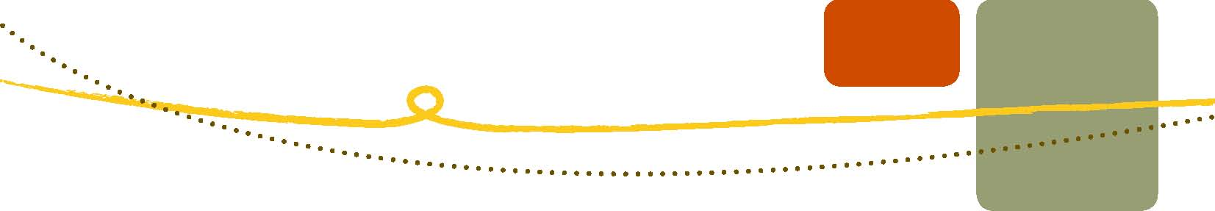Vinyl Council of Australia and Armstrong Australia: giving PVC flooring a
new lease of life:
Consultation
Sophi McMillan, CEO, Vinyl Council of Australia

Tracy Morden, Communications Co-ordinator, Vinyl Council of Australia

Contacts and links
Vinyl Council of Australia:
www.vinyl.org.au

Vinyl Council of Australia Product Stewardship Program:
http://www.vinyl.org.au/ProductStewardship

Armstrong Australia:
http://www.armstrong-aust.com.au

Photo attributions
Tracey Morden, Vinyl Council of Australia

Fletchers Insulation: recycling glass into insulation:
Consultation
Jeff Goldstone, Production Manager, Fletcher Insulation

Mangala Siriwardana, Marketing Manager, Fletcher Insulation

Dennis Darcy, CEO Insurance Council of Australia and New Zealand (ICANZ)

Ray Thompson, General manager, Innovation and Market Development, CSR Limited

Contacts and links
Fletcher Insulation Green Manufacturing website:
http://www.insulation.com.au/sustainability/green-manufacturing

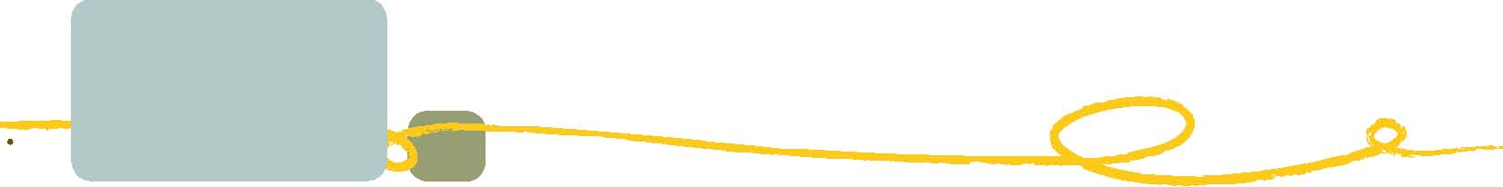CSR Gyprock TM:
Consultation
Linden Birch, Group Environment Manager, CSR Limited

Scott Clarkson, Manager CSR Innovation

Contacts and links
CSR Gyprock website:
http://www.gyprock.com.au/

CSR Gyprock Recycling Service Case Study:
http://www.gyprock.com.au/resources/gyprock™-recycling-service.aspx

Taylor Woodrow case study from UK:
http://www.article13.com/A13_ContentList.asp?strAction=GetPublication&PNID=1358

Photo attributions
CSR

PIPA recycling PVC pipes into new product:
Consultation
Mark Heathcote, Technical Marketing Manager, Plastics Industry Pipe Association (PIPA)

George Stavrou, Safety Health and Environment Manager, Vinidex

Contacts and links
Plastics Industry Pipe Association:
www.pipa.com.au

Photo attributions
Mark Heathcote, Plastics Pipe Industry Association

James Hardie industrial ecology initiatives:
Consultation
Mat Skembes, Strategic Sourcing Manager, James Hardie

Contacts and links
James Hardie:
www.jameshardie.com.au

Cement Industry Federation:
www.cement.org.au

Industrial Ecology Network:
http://www.austindustrialecology.com.au

Photo attributions
James Hardie
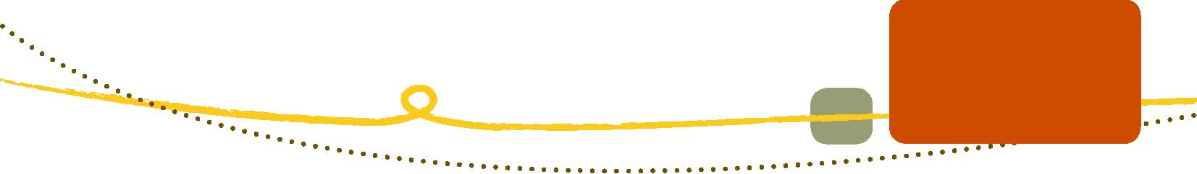
Eastern Metropolitan Regional Council: wood is too good to waste:
Consultation
Johan Leroux, Manager, EMRC

Contacts and links
Eastern Metropolitan Regional Council’s Hazelmere Timber Recycling Centre:
http://www.emrc.org.au/hazelmere-recycling-centre

Timber Product Stewardship Group:
www.timberstewardship.org.au

Photo attributions
Hazelmere Recycling Centre

Recycling power poles into high-value timber products:
Consultation
Michael Kennedy, Owner, Kennedy’s Timber

Stephen Mitchell, Sustainability Program Manager, Timber Development Association

Andrew Dunn, General Manager, Timber Development Association

Contacts and links
Kennedy’s Timber:
www.kennedystimber.com.au

Energex:
www.energex.com.au

Forest and Wood Products Australia:
www.timber.org.au

Timber Development Association and National Timber Product Stewardship Group:
www.timber.net.au

Photo attributions
Michael Kennedy
Old Leura Dairy: innovating with heritage materials:
Consultation
Michael Hennessey, Owner, Old Leura Dairy

Shaina Hennessey, Owner, Old Leura Dairy

Contacts and links
Old Leura Dairy:
www.oldleuradiary.com.au

Photo attributions
Tom Davies

Waverley Council – recycled glass in roads:
Consultation
Mark Wood, Director Public Works and Services, Waverley City Council

Chris Jeffreys, Program Manager, Glass Recovery and Recycling, Packaging Stewardship Forum, Australian Food and Grocery Council

Peter Richardson, General Manager, Recycling Industries, Alex Fraser

Contacts and links
Waverley Council:
www.waverley.nsw.gov.au/

Australian Food and Grocery Council:
www.afgc.org.au/

Report: Specifications for Recycled Crushed Glass as an Engineering Material:
http://www.arrb.com.au/Home/News.aspx?newsID=29

Photo attributions
Waverley Council
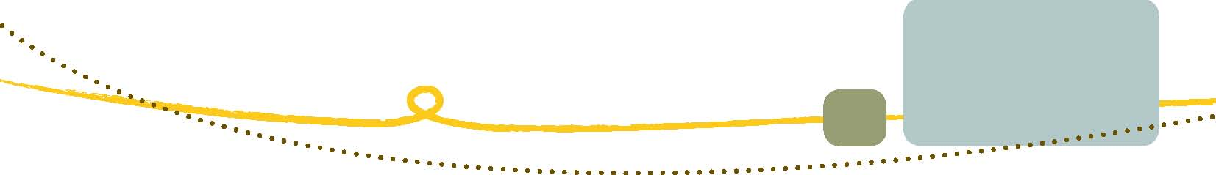Australian Ethical Investment: best practice waste management at Trevor Pearcey House:
Consultation
Howard Pender, Director, Australian Ethical Investments

Kevin Miller, Director, Collard Clarke and Jackson Architects

Robin Mellon, Executive Director, Advocacy and International, Green Building Council of Australia

Contacts and links Australian Ethical Investment Ltd. Contact: Howard Pender, Executive Director
www.australianethical.com.au

Architect: Kevin Miller, Collard Clarke Jackson
www.ccj.com.au

References:
Much of the information in this case study has been taken from the Environment Design Guide, an initiative of the Australian Institute of Architects
http://www.environmentdesignguide.com.au/pages//content/cas--case-studies/cas-50australian-ethical-investment-headquarters-6-star-green-star-office-refurbishment-canberra.php

Photo attributions
Ben Wrigley, Collard Clarke and Jackson

Built Environs: 100 Hutt Street, Adelaide:
Consultation
Rocky Slater, Design Manager, Built Environs

Robin Mellon, Executive Director, Advocacy and International, Green Building Council of Australia

Contacts and links
Built Environs:
http://www.builtenvirons.com.au/

McConnell Dowell:
http://www.macdow.com.au/

GBCA Interiors rating:
http://www.gbca.org.au/green-star/rating-tools/green-star-office-interiors-v1-1/1530.htm

Veolia Environmental Services:
http://www.veoliaes.com.au/

Photo attributions
Rocky Slater, Built Environs
Fairfield City Council: a sustainable community building:
Consultation
Ross Smith, Manager Environment and Waste Operations, Fairfield City Council

Daniel Begnell, Safety Quality & Environment Coordinator, Fairfield City Council

Kerrie Whitehead, Operations Manager, Civil and Open Space, Sustainable Resource Centre

Contacts and links
Fairfield City Council Sustainable Resource Centre:
http://www.fairfieldcity.nsw.gov.au/default.asp?iSubCatID=288&iNavCatID=67

CSIRO report: Demonstration Project, Construction of Building and Recreational Facilities with
Recycled Concrete:
http://www.ecorecycle.vic.gov.au/resources/documents/Field_Demonstration_Project_Const_ of_building_and_recreation.pdf

United Nations Local Agenda 21:
http://www.un.org/esa/dsd/agenda21/res_agenda21_00.shtml

Photo attributions
Tom Davies, Edge Environment

Recycling waffle pod waste:
Consultation
Kin-Chun Ip, Manager, Industry Development, Expanded Polystyrene Australia (EPSA)

Contacts and links
Expanded Polystyrene Australia (03) 9611 5400

info@epsa.or.au or www.epsa.org.au (from August 2011)

Photo attributions
Kin Chun Ip, EPSA


