Field trial to compare baiting efficacy of Eradicat® and Curiosity® baits

D. Algar, N. Hamilton, M. Onus and S. Hilmer (Science Division, Woodvale)
S. Comer, C. Tiller, L. Bell and J. Pinder (South Coast Region, Albany)

E. Adams and S. Butler (South Coast Region, Esperance)

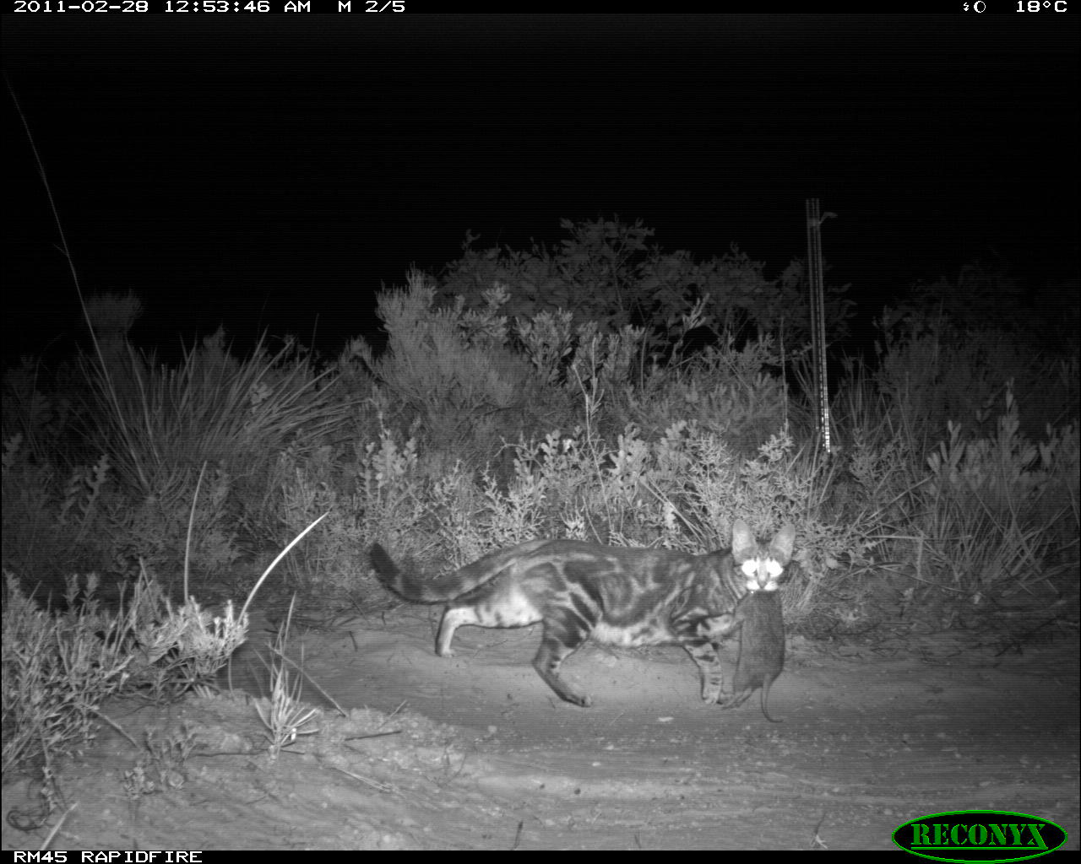
Plate 1. Feral cat walking across a monitoring plot at Cape Arid National Park with a predated Southern Brown Bandicoot

INTRODUCTION

Baiting is recognised as the most effective method for controlling feral cats (Short et al. 1997; EA. 1999; Algar et al. 2002; Algar and Burrows 2004; Algar et al. 2007; Algar and Brazell 2008) when there is no risk posed to non-target species. The preferred feral cat bait medium (Algar et al. 2007) is similar to a chipolata sausage in appearance — it is approximately 20 g wet-weight, dried to 15 g, blanched and then frozen. The bait is composed of 70 % kangaroo meat mince, 20 % chicken fat and 10 % digest and flavour enhancers that are highly attractive to feral cats (Patent No. AU 781829) (see detailed description in Algar and Burrows 2004).

There are two poison bait products intended for the management of feral cat populations in Australia. When the above bait medium (pH 5-6) is dosed with sodium monofluoroacetate (compound 1080), the bait product is known as Eradicat®. When the above bait medium is buffered with sodium bicarbonate to pH neutral-alkaline and dosed with para-aminopropiophenone (PAPP) it is known as Curiosity®. Eradicat and Curiosity are registered trademarks of the Western Australian and Commonwealth governments respectively.

A collaborative project between the Department of Sustainability, Environment, Water, Population and Communities (DSEWPaC), the Department of Sustainability and Environment (DSE) and the Department of Environment and Conservation (DEC) has been developing the Curiosity® bait product. The project involves bringing together the buffered feral cat bait medium and an encapsulated pellet known as the ‘Hard Shell Delivery Vehicle’ (HSDV), which contains the toxicant PAPP. The use of the acid-soluble HSDV, in a buffered bait, ensures that the toxin does not disperse throughout the bait but releases in the cat’s stomach where it quickly overwhelms the cat’s physiological processes (Johnston et al. in press). This method of delivering the toxicant also plays a key role in reducing the potential exposure of non-target species. When feeding, feral cats simply shear food items into manageable portions and swallow those portions whole. Thus, they will reliably swallow a pellet that is implanted into a bait. Conversely, most wildlife species process food items more thoroughly in the mouth. This means most animals other than cats tend to reject the HSDV as they eat whereas it is reliably consumed by feral cats (Marks et al. 2006; Hetherington et al. 2007; Forster 2009; Johnston unpub. data). Direct injection of PAPP toxin into the bait (i.e. without the pellet delivery device) is not appropriate because it would significantly increase the amount of toxin required and hence significantly increase the risk of non-target poisoning. The pellet delivery device contains about 78 mg of PAPP toxin in pellet form (Johnston et al. in press).

A number of cafeteria pen trials have been conducted to test for differences in acceptability of the two bait mediums. These pen trials were conducted at the Perth Cat Haven that provided an opportunity to work with essentially semi-feral cats rather than domestic cats in catteries. Cats in the Haven were housed in individual cages. The cats were offered a choice of the two non-toxic bait mediums. The baits were randomly placed, approximately 20 cm apart. Bait preference was assessed by the medium first selected and consumed by an individual. The baits were offered at the normal time of feeding. All available cats were offered the bait mediums and those which showed interest, initially sniffed each bait type and then selected their choice thus; the experimental design offered a bait choice. Baits were only offered once to any individual cat to avoid any learned behaviour that may have confounded the trial and also to simulate toxic bait delivery in the field. Those cats that did not consume a bait were generally shy and remained in their sleeping boxes. Stress of recent capture and their new surroundings most likely accounted for their behaviour. A number of individuals consumed more than one bait type and the order of preference was also recorded.

A total of 43 cats consumed at least one bait. Analysis of cats’ preferences for the two bait mediums, indicated a significant difference in their choice for bait mediums (Chi² = 31.8, 1df, P<0.001) with 40 of the cats consuming Eradicat® first. The Eradicat® bait was the most preferred while the Curiosity® bait was the least preferred. However, in 40% of the occasions when the Eradicat® bait was consumed first, cats then also chose to eat the Curiosity® bait. To test whether this difference is real or an artefact common to cafeteria trials, a trial is required under normal field conditions where bait consumption is assessed in the absence of choice.

The objective of this trial was to compare the efficacy of Eradicat® and Curiosity® baits in the field to see whether there was any significant difference in baiting efficacy between the two bait types during an operational baiting campaign.

METHODOLOGY

Study area
The trial was conducted in Cape Arid National Park (CANP) and in the adjoining Nuytsland Nature Reserve (NNR). This broad area is located on the south coast of Western Australia (see Figure 1) at 33º 47’ 21”S, 123º 24’ 47”E (CANP centroid) and 33º 45’ 0”S, 123º 41’ 24”E (NNR centroid). The area of conservation estate and baiting cells are described below and provided in Table 1.
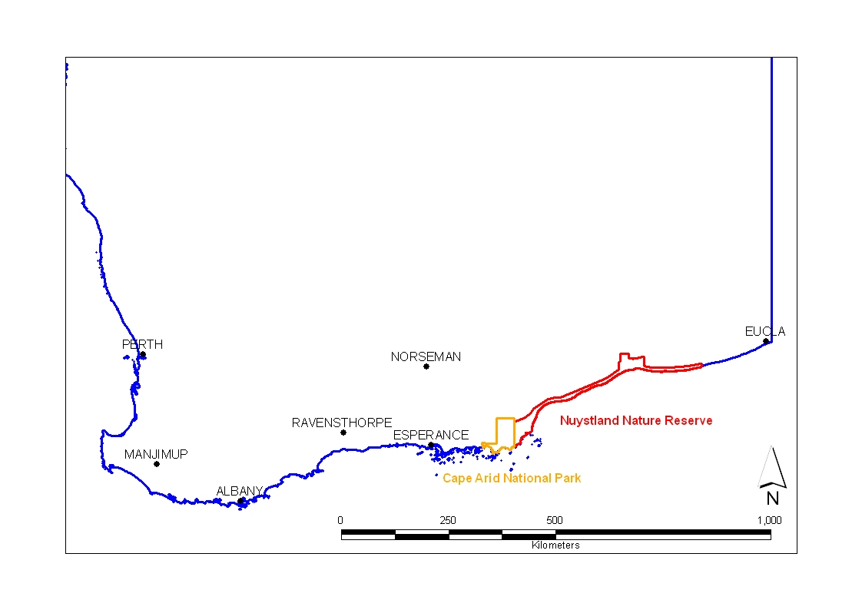
Figure 1. Location of Cape Arid National Park and Nuytsland Nature Reserve

CANP Park experiences a typical Mediterranean climate, with pronounced winter rainfall and frequently long dry summers with years of high summer rainfall associated with trough movement and thunderstorm activity. Average annual rainfall for CANP (Bureau of Meteorology Station 009879) is 596 mm.

Vegetation of the study area is largely Eucalyptus incrassata and E. tetragona mallee-heath with large patches of proteaceous shrublands. Water courses are dominated by E. occidentalis woodlands, and smaller incursions of E. redunca mallee scrub occur in the vicinity of Thomas River.

Table 1. Location and size of baited cells
National Park/Nature Reserve | Area (km²) | Eradicat® baiting cell (km²) | Curiosity® baiting cell (km²) | % National Park/Nature Reserve baited
CANP | 2,781 | 973 | 259 | 44
NNR | 6,079 | 227 | - | 4
Total | 8,860 | 1,200 | 259 | 16

This location was selected for the following reasons:-
- This location has not been baited for feral cats in the past and surveys have indicted an abundant feral cat population (Comer and Tiller unpub. data);
- There are no non-target species at risk from the proposed baiting program. A complete mammal, reptile and bird species list present in CANP/NNR is provided in Appendix 1;
- The program will assist in the research and recovery efforts for the Critically Endangered Western Ground Parrot (Pezoporus [wallicus] flaviventris). The South Coast Threatened Birds Recovery Team identified feral cat predation as likely to be the primary key threatening process for the survival of the species (Comer et al. 2010);
- Financial support for the overarching program has been provided by DEC’s Nature Conservation Service Special Projects funds, DSEWPaC, South Coast NRM and the State NRM funds directed through the department. DEC has also provided considerable ‘in-kind’ support through Regional, District, and Science Division resources.

CANP/NNR was divided into two study areas. The larger area (1,200 km²) was baited with Eradicat® baits as financial resources were limited and these baits are currently less expensive and easier to manufacture in large volumes. The smaller area (259 km²) was baited with Curiosity® baits. The two sites were selected to provide an area of sufficient size to allow enough cats to be trapped (see below) and their activity to be monitored pre- and post-baiting. The trapping locations and monitoring transects are sufficiently distant from the other baiting application, such that mortality of animals can only be ascribed to the one bait type. The study areas are shown in Figure 2.

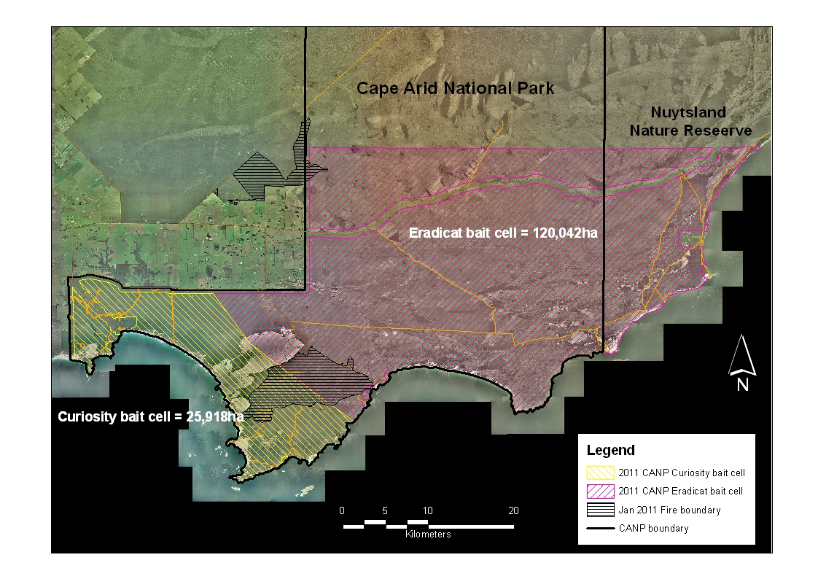
Figure 2. CANP and adjacent NNR baiting cells, Curiosity® versus Eradicat® bait trial

Cat trapping and radio-collaring
Feral cats were trapped several weeks prior to the baiting program, at locations around the track network, in both study areas (see Figure 3 for trap locations). The trapping technique involved the use of padded leg-hold traps Victor ‘Soft Catch’® traps No. 3 (Woodstream Corp., Lititz, Pa.; U.S.A.) with a mixture of cat faeces/urine and a olfactory lure (Cat-astrophic, Outfoxed, Victoria) as the attractant. Trap sets were parallel to the track along the verge at 0.5 km intervals. Open-ended trap sets were employed with two traps positioned lengthwise (adjoining springs touching) and vegetation/sticks used as a barrier along the trap sides. The dates of commissioning and decommissioning traps are provided in Table 2.

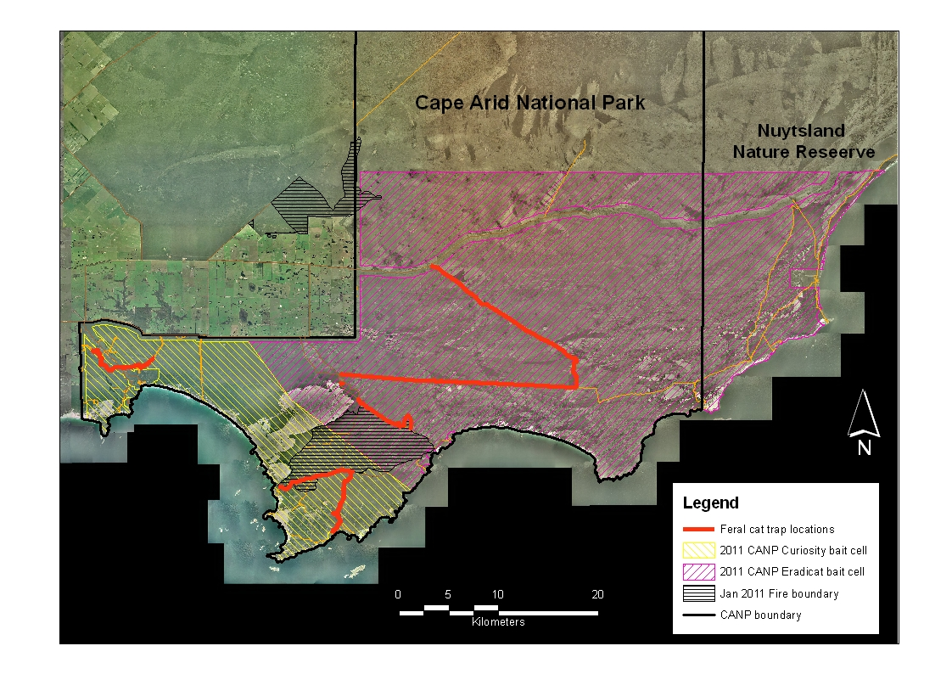

Figure 3. Location of feral cat trap sites in CANP during 2011

Table 2. Dates of commissioning and decommissioning traps
Trap No. | Commissioned | Decommissioned | No. trap nights
TT 1-40 | 15/2 | 24/2 | 360
TT 41-42 | 16/2 | 24/2 | 16
TT 43-48 | 20/2 | 24/2 | 24
P 49-53, P 79-86 | 20/2 | 24/2, *P 83 | 51
P 54-66, P 72-78 | 21/2 | 24/2 | 60
P 67-71 | 22/2 | 24/2 | 10
TR 1-19 | 15/2 | 21/2 | 114
GAB 1-12 | 15/2 | 21/2 | 72
GAB 13-31 | 16/2 | 21/2 | 95
GAB 32-34 | 20/2 | 21/2 | 3
PC 1-17 | 22/2 | 24/2, *PC 16 | 33
TOTAL |  |  | 838
*both traps retrieved 21/2 because of non-target activity

Trapped cats were sedated with an intramuscular injection 4 mg/kg Zoletil 100® (Virbac, Milperra; Australia). All animals captured were sexed and weighed and coat colour recorded; a broad estimation of age (as either kitten, juvenile or adult) was registered using weight as a proxy for age. A VHF radio-telemetry collar with mortality signal (Sirtrack Ltd, New Zealand) was fitted to trapped cats. Cats were released at the site of capture.

Baiting program
To optimise baiting efficacy, it is essential that the baiting campaign was conducted prior to the onset of late autumn/winter rainfall, which long-term weather records suggested began in April/May (Bureau of Meteorology). A dedicated baiting aircraft deployed the baits at previously designated bait drop points. The baiting aircraft flew at a nominal speed of 130 kt and 500 ft (Above Ground Level) and a GPS point is recorded on the flight plan each time bait leaves the aircraft. The bombardier releases a bag of 50 baits into each 1 km map grid, along flight transects 1 km apart (see Figures 4a and b), to achieve an application rate of 50 baits km⁻². The ground spread of 50 baits is approximately 250 x 150 m (D. Algar, unpub. data). Under this regime, a total of 60,000 Eradicat® baits and 12,950 Curiosity® baits were deployed.

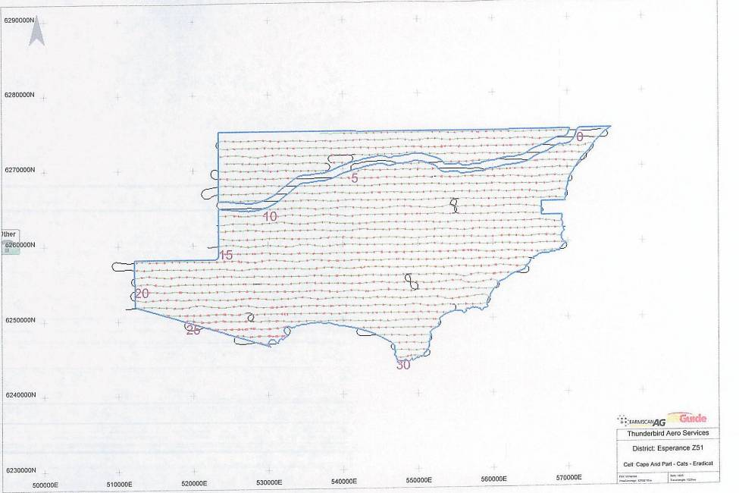

Figure 4a. Bait drop locations in the Eradicat® cell

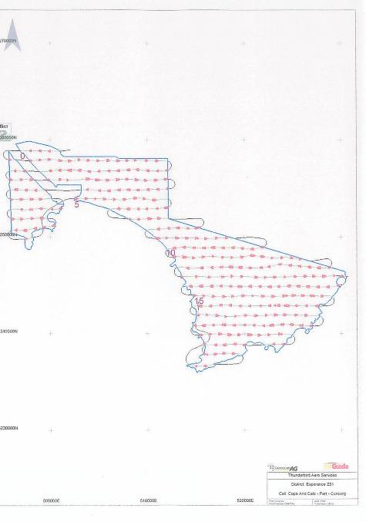

Figure 4b. Bait drop locations in the Curiosity® cell

Surveys of cat activity
Two independent methods were used to monitor baiting efficacy. Baiting efficacy was firstly determined from the percentage of radio-collared cats found dead following the baiting program. The second method involved surveys of cat activity at sand plots to derive indices of activity. The difference in indices pre- and post-baiting was then used as a measure of baiting efficacy.

A track survey transect was established along the Thomas River track in the Curiosity baited site and along the Pasley track in the Eradicat baited zone. The Thomas River transect was 10.0 km in length and in the larger Eradicat baited zone, Pasley transect was 15 km long. These two transects provided a broad coverage of the entire area and an efficient and representative sampling of the population using the surrounding habitat. As multiple indexing assessments were to be made through time on the same area, then the same locations were used (Engeman et al. 2002).

The Thomas River and Pasley transects comprised 20 and 30 permanently marked sand pads respectively located at 0.5 km intervals (see Figure 5). Each sand pad was constructed from a 1 m patch of sand that covered the width of the road/track; either end of the sand pad was blocked by vegetation that forced animals to walk across the pad. Two types of plots, passive and active plots, were employed to monitor animal presence/absence. Passive plots have no attracting lure and detect animals during the normal course of their movements. These plots often generate sample sizes that are too low to adequately monitor population changes (Fleming et al. 2001). The active plots contained a lure to attract animals to the plot and thereby increase the likelihood of detecting animals particularly at low density.
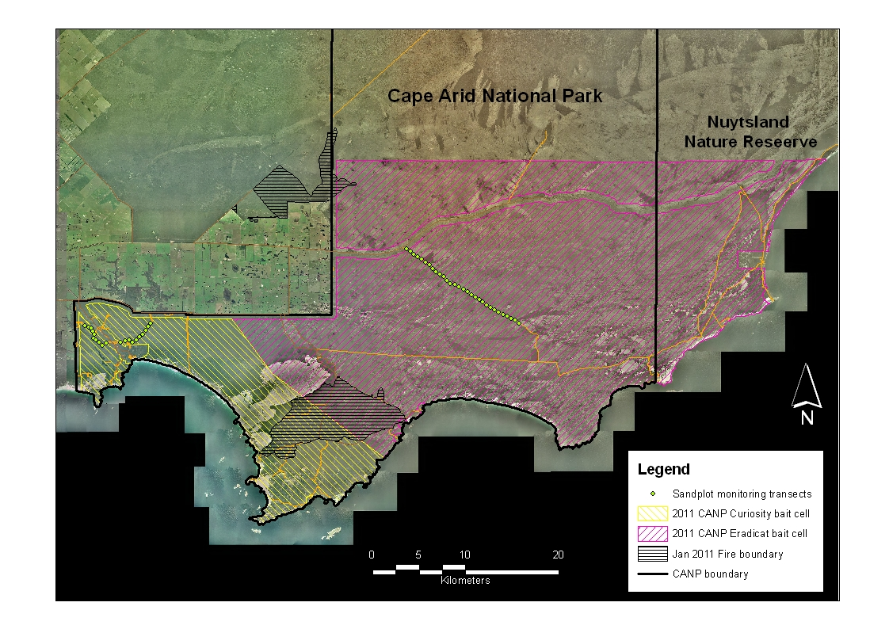

Figure 5. Location of sand plot monitoring transects in CANP

To limit potential short comings of using either plot method, a combination of both plot types was employed. The passive plots were located at the 0.5 km sand pads and the active plots were placed at the 1.0 km sand pads. At the active plots an audio lure (Felid Attracting Phonic, Westcare Industries, Western Australia) was used to attract cats to the sand plots during the two survey periods. The audio lures were removed outside the survey periods.

Each plot was observed for the presence or absence of tracks, as it is not possible to determine the number of intrusions by individual animals onto the plot. Each day, the plots were swept to clear evidence of previous activity. Cat activity at the sand plots was recorded over five nights during two survey periods; these were not consecutive nights because of interruption by rain.

Calculation of indices and analyses
Because individuals typically cannot be identified on the basis of track characteristics, it is customary to ignore the number of detections and simply record whether an animal was detected at the station (Ray and Zielinski 2008). The presence/absence data are more robust to statistical analysis than the total number of detections recorded at a station or multiple-station sample units. Thus in this case, sand plot stations have an index of usage expressed as the mean number of positive plots per night. The ‘Plot Activity Index’ (PAI) is formed by calculating an overall mean from the daily means (Engeman et al. 1998; Engeman 2005). The VARCOMP procedure within the SAS statistical software package produced the variance component estimates.

The efficacy of individual baiting programs for both feral cats and foxes was then assessed by comparing these indices immediately prior to and following individual baiting programs. Data were analysed for significant differences using a ‘z’-test Elzinga et al. 2001).

RESULTS

Cat trapping and radio-collaring
Twenty-one cats were trapped comprising 12 male and nine females (Table 3). Eleven of these animals were trapped within the Curiosity® baiting cell and ten within the Eradicat® baiting cell. The location of cat captures is provided in Figure 6. Bodyweight (mean ± s.e.) for males was 4.5 ± 0.2 kg and 3.0 ± 0.1 kg for females. Nineteen radio-collars were available; ten cats were collared in the Curiosity® baiting cell, the eleventh cat died in a trap, cause unknown. Nine cats were collared in the Eradicat® baiting cell, the tenth cat was released without a collar following processing. All cats appeared to be in excellent body condition and searches for ectoparasites proved negative.

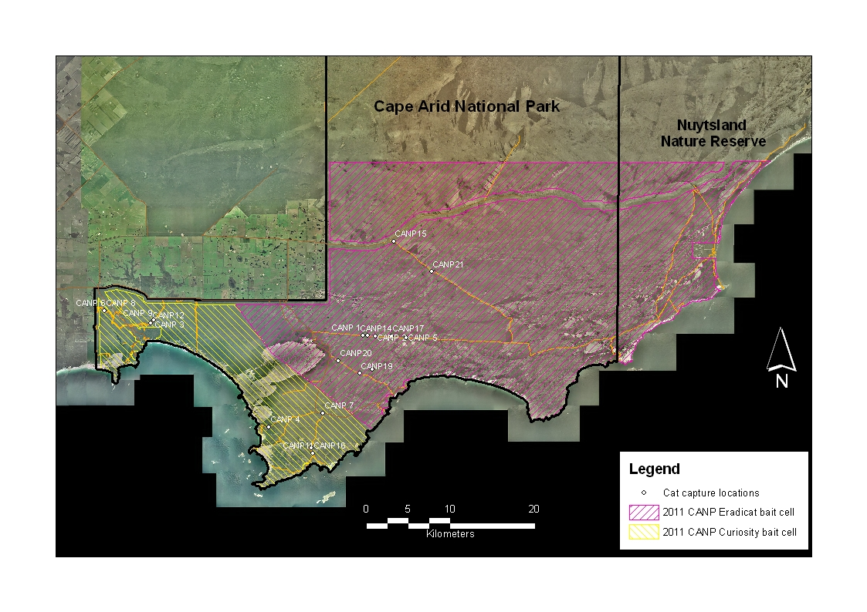

Figure 6. Location of cat captures

Table 3. Capture records of trapped cats
Date | Sample No | Trap No | Sex (M/F) | Weight (kg) | Coat colour | Age | Radio-collar frequency (Mg Htz)
16/2/2011 | CANP 1 | TT 13 | M | 4.6 | Tabby | Adult | 151.5470
16/2/2011 | CANP 2 | TT 16 | F | 3.2 | Tabby | Adult | 151.3480
16/2/2011 | CANP 3 | TR 18 | M | 3.9 | Tabby | Adult | 151.0482
16/2/2011 | CANP 4 | G 03 | F | 2.6 | Tabby | Sub-adult | 151.5292
17/2/2011 | CANP 5 | TT 28 | F | 3.3 | Tabby | Adult | 151.0097
17/2/2011 | CANP 6 | TR 01 | M | 4.8 | Tabby | Adult | 151.4887
17/2/2011 | CANP 7 | G 17 | M | 5.2 | Tabby | Adult | 151.4666
18/2/2011 | CANP 8 | TR 01 | M | 3.6 | Tabby | Adult | 151.0281
18/2/2011 | CANP 9 | TR 18 | F | 2.8 | Tabby | Adult | 151.5087
18/2/2011 | CANP10 | G 27 | M | 4.5 | Tabby | Adult | 151.4480
20/2/2011 | CANP11 | G 29 | M | 5.0 | Tabby | Adult | 151.3893
20/2/2011 | CANP12 | TR 17 | F | 2.8 | Tabby | Adult | 151.3084
20/2/2011 | CANP13 | TR 18 | M | 6.0 | Tabby | Adult | Died in trap
21/2/2011 | CANP14 | TT 14 | M | 4.5 | Tabby | Adult | 151.3272
21/2/2011 | CANP15 | P 01 | M | 4.2 | Tabby | Adult | 151.0662
21/2/2011 | CANP16 | G 29 | M | 4.5 | Black | Adult | 151.0880
23/2/2011 | CANP17 | TT 19 | F | 2.9 | Tabby | Adult | 151.4093
23/2/2011 | CANP18 | PC 15 | F | 2.9 | Tabby | Adult | 151.4268
23/2/2011 | CANP19 | PC 10 | F | 3.4 | Tabby | Adult | 151.3673
24/2/2011 | CANP20 | PC 04 | M | 2.6 | Tabby | Sub-adult | 151.5885
24/2/2011 | CANP21 | P 12 | F | 2.9 | Tabby | Adult | No collar

Baits, baiting program and impact
The production of Eradicat® baits was completed in November 2010 at the DEC Harvey bait factory and consisted of 60,000 toxic baits for CANP. A further 13,000 Curiosity® baits were produced in Victoria by Scientec Research Pty Ltd for the trial comparison between the effectiveness of each bait type. All toxic baits contained Rhodamine B to facilitate the non-target uptake trials.

Eradicat® baits and Curiosity® baits were sweated on 18 March. The two flights required to deliver all Curiosity® baits were conducted on 20 March. Prior to baiting, the plane was experiencing problems with the GPS program (i.e. not identifying exclusion zones for the cell). On 21 March, rain and low cloud was experienced at CANP during the first bait flight. This reached the Esperance airstrip and delayed the second flight by several hours, in total, only three flights were completed this day. The final two flights to complete delivery of Eradicat® baits to CANP were conducted on 22 March. Rainfall (2.0 mm) was recorded on the 20 March and 0.2 mm on 21 March, no rainfall was recorded over the following five days.

The status of radio-collared cats was assessed three weeks after the baiting program and is presented in Table 4. Two of the ten radio-collared cats in the Curiosity® bait cell and two of the eight found radio-collared cats in the Eradicat® bait cell are presumed to have died from baiting.

Table 4. The status of radio-collared cats following the aerial baiting program
Bait cell | Sample No. | Status
Curiosity® | CANP 3 | Alive
“ | CANP 4 | Dead
“ | CANP 6 | Alive
“ | CANP 7 | Alive
“ | CANP 8 | Alive
“ | CANP 9 | Alive
“ | CANP10 | Alive
“ | CANP11 | Alive
“ | CANP12 | Alive
“ | CANP16 | *Not found initially, later found dead
Eradicat® | CANP 1 | Alive
“ | CANP 2 | Alive
“ | CANP 5 | Alive
“ | CANP14 | Dead
“ | CANP15 | Alive
“ | CANP17 | Dead
“ | CANP18 | Alive
“ | CANP19 | Alive
“ | CANP20 | **Not found
“ | CANP21 (no collar) | Unknown
*Mortality date to be checked to confirm death due to baiting
**Radio-collar presumed to have malfunctioned

The activity indices for cats, foxes and varanids before and after baiting are presented in Table 5. The only major impact of the baiting program was on cat activity indices in the Eradicat® baiting cell where a significant reduction in activity was recorded (z = 3.391, P<0.001). Interestingly, cat activity indices increased in the Curiosity® baiting cell following baiting although this was not significant (z = -1.152, P=0.125).

Table 5. Activity indices (mean ± s.e.)
Species | Site | PAI (pooled across active and passive plots)
 |  | Pre-bait | Post-bait | Significance
Cat | Curiosity® | 0.080 ± 0.027 | 0.140 ± 0.045 | z = -1.152, P=0.125
 | Eradicat® | 0.180 ± 0.043 | 0.027 ± 0.013 | z = 3.391, P<0.001
Fox | Curiosity® | 0.010 ± 0.010 | 0.010 ± 0.010 | z = 0.000, P=0.500
 | Eradicat® | 0.007 ± 0.007 | 0.000 ± 0.000 | z = 0.999, P=0.159
Varanid | Curiosity® | 0.020 ± 0.020 | 0.010 ± 0.010 | z = 0.447, P=0.372
 | Eradicat® | 0.053 ± 0.020 | 0.007 ± 0.006 | z = 0.554, P=0.290

DISCUSSION

Results from this trial are inconclusive with regard to differences in field acceptability of Eradicat® and Curiosity® baits. Mortality of radio-collared cats in both baiting cells was low at 25% and 20% in Eradicat® and Curiosity® zones respectively. Despite this, cat activity indices indicated that baiting had a significant impact in the Eradicat® cell with a decline in cat activity following baiting. Conversely, although not significant, cat activity increased in the Curiosity® cell post-baiting. The relocation of the sand plot survey transect in the Curiosity® bait cell because of fire, see below, was not ideal because of its proximity to the unbaited boundary but limited access prevented placement elsewhere. As a consequence, cats at either end of this transect probably had less opportunity to encounter baits, particularly in the short-term following deployment.

To be able to make valid statistical comparisons of cat activity index scores, it is better to have data from a number of transects across the site, rather than a single continuous circuit. In this way, potential variability in activity across the site is accounted for. When using multiple transects to generate an activity index it is necessary to separate the transects by sufficient distance such that the probability of a single animal being recorded on more than one transect in any single survey period is minimized and therefore the transects are independent sampling units. Unfortunately, a fire within the study area several weeks prior to the commencement of this trial (see Figure 2) with subsequent re-alignment of the baiting cells and the lack of track access across the entire study area precluded the use of multiple transect use. As such, comparison of activity scores pre- and post-baiting within and between baiting cells should be made with caution.

Poor bait uptake by cats in either cell, in comparison with previous trials, was most likely a result of reduced bait attractiveness/palatability. Both feral cat bait types require preparation by thawing and sweating prior to deployment in the field. To have sufficient baits prepared to suit the timing of flights necessitates that many baits are prepared the day prior to delivery. However, poor weather conditions (i.e. wind > 25 kts, rain and low cloud) or issues with the plane or equipment can delay bait delivery which may require storage of prepared baits for a number of days. When this occurs, sweated baits are stored in the Western Shield Bait Truck, which contains a sealed refrigeration unit on the tray. Over a period of a number of days, the lack of air movement in this refrigeration unit can cause mould to develop on the surface of the baits and/or rancidity to commence. In this trial, the longest period between sweating and bait delivery for some baits was four days (the final flights of Eradicat® to CANP).

The problem with deploying baits that are developing mould and/or rancidity is exacerbated when baits reach the ground. The dense vegetation and cool and damp conditions produce a micro-climate that increases the rate of bait decay. Decaying baits are not attractive/palatable to cats and bait uptake is significantly reduced. Bait longevity in the field is also compromised and thus quality bait availability over time is condensed.

To improve baiting efficacy in the more temperate regions it is recommended that: -

- An efficient artificial method to sweat baits in the field is developed. Reliance on environmental conditions to sweat baits is likely to result in poor quality baits being distributed;
- A test for bait stability/longevity is undertaken in all future trials to gain some measure of bait availability over time;
- Trials to assess baiting efficiency during late summer are conducted. Despite the prey resource likely to be more abundant during these warmer months, bait integrity and longevity will be improved and therefore potentially bait uptake.

ACKNOWLEDGEMENTS

We would like to thank Esperance District support staff: - Klaus Tiedemann; Rob Jose; Nigel Johnstone, Dave Thornberg, and Steve Owen and conservation employees Ben Kremlins and Tracey Klinger. Finally, we gratefully acknowledge the financial support and encouragement from Julie Quinn (Department of Sustainability, Environment, Water, Population and Communities) and financial support from the Department of Environment and Conservation’s Special Nature Conservation Program and South Coast NRM Inc.

REFERENCES

Algar, D., Angus, G.J., Williams, M.R. and Mellican A.E. (2007). Influence of bait type, weather and prey abundance on bait uptake by feral cats (Felis catus) on Peron Peninsula, Western Australia. Conservation Science Western Australia 6(1), 109-149.

Algar, D. and Brazell, R.I. (2008). A bait-suspension device for the control of feral cats. Wildlife Research 35, 471-476.

Algar, D., Burbidge, A.A. and Angus, G.J. (2002). Cat Eradication on the Montebello Islands. In ‘Turning the Tide: the eradication of invasive species’. (Eds. C.R. Veitch and M.N. Clout) pp 14-18. Invasive Species Specialist Group of the World Conservation Union (IUCN, Auckland.)

Algar, D. and Burrows, N.D. (2004). A review of Western Shield: feral cat control research. Conservation Science Western Australia 5(2), 131-163.

Buckmaster, A.J. (2009). Risk assessment of the likelihood of consumption of the Curiosity® cat bait and the encapsulated toxicant by all Australian terrestrial vertebrate animals: A desktop analysis. Report to the Victorian Government, Department of Sustainability and Environment, Arthur Rylah Institute for Environmental Research.

Calver, M.C., King, D.R., Bradley, J.S., Gardner, J.L., and Martin G.R. (1989a). Assessment of the potential target specificity of 1080 predator baiting in Western Australia. Australian Wildlife Research 16, 625-638.

Comer, S., Burbidge, A.H., Tiller, C., Berryman, A., and Utber, D (2010). Heeding Kylorings warning: south coast species under threat. Landscope 26, 48-53.

Elzinga, C.L., Salzer, D.W., Willougby, J.W. and Gibbs, J.P. (2001). Monitoring Plant and Animal Populations. Blackwell Science Inc. USA.

Engeman, R.M., Allen, L. and Zerbe, G.O. (1998). Variance estimate for the Allen activity index. Wildlife Research 25, 643–648.

Engeman, R.M. (2005). Indexing principles and a widely applicable paradigm for indexing animal populations. Wildlife Research 32, 203–210.

Engeman, R.M., Pipas, M.J., Gruver, K.S., Bourassa, J. and Allen, L. (2002). Plot placement when using a passive tracking index to simultaneously monitor multiple species of animals. Wildlife Research 29, 85-90.

EA (Environment Australia) (1999). Threat Abatement Plan for Predation by Feral Cats. Environment Australia, Biodiversity Group, Canberra.

Fleming, P.J.S., Corbett, L., Harden, B. and Thomson, P. (2001). Managing the Impacts of Dingoes and Other Wild Dogs. Bureau of Rural Sciences, Australian Government Publishing Service, Canberra.

Forster, G. (2009). Non-target species uptake of feral cat baits containing Rhodamine B. Unpublished B.Sc. (Hons) thesis. Department of Agricultural Sciences, Latrobe University, Bundoora.

Hetherington, C.A., Algar, D., Mills, H. and Bencini, R. (2007). Increasing the target-specificity of Eradicat® for feral cat (Felis catus) control by encapsulating a toxicant. Wildlife Research 34, 467–471.

Johnston, M.; Algar, D.; O’Donoghue, M. and Morris, J. (in press). Field efficacy of the Curiosity feral cat bait on three Australian islands. In: Veitch, C.R.; Clout, M.N. and Towns, D.R. (eds.). Island invasives: Eradication and management, IUCN, (International Union for Conservation of Nature), Gland, Switzerland.

King, D.R. (1990). 1080 and Australian fauna. Agriculture Protection Board Technical Series No. 8.

Marks, C.A., Johnston, M.J., Fisher, P.M., Pontin, K. and Shaw, M.J. (2006). Differential particle size: promoting target-specific baiting of feral cats. Journal of Wildlife Management 70, 1119-1124.

McIlroy, J. C. (1984). The sensitivity of Australian animals to 1080 poison. VII. Native and introduced birds. Australian Wildlife Research 11, 373-85.

Mcllroy, J. C., King, D. R., and Oliver, A. J. (1985). The sensitivity of Australian animals to 1080 poison. VIII. Amphibians and reptiles. Australian Wildlife Research 12, 113-18.

Ray, J.C. and Zeilinski, W.J. (2008). Track stations. In: Noninvasive Survey Methods for Carnivores (eds R. A. Long, P. MacKay, W. J. Zielinski and J. C. Ray) pp 75-109. Island Press, Washington.

Short, J., Turner, B., Risbey, D.A. and Carnamah, R. (1997). Control of feral cats for nature conservation. II. Population reduction by poisoning. Wildlife Research 24, 703–714.

Appendix 1

Definitions

Sensitivity to 1080
Approximate Lethal Dose50 data (LD₅₀) where LD₅₀ is the amount of toxin theoretically required to kill 50% of test animals are standardized to mg pure 1080 kg⁻¹, have been taken from Anon. (2002)^{A}, Twigg et al. (2003)^{B} and Martin et al. (2002)^{C}. Approximate Lethal Dose (ALD) the dose which causes 10% of deaths are provided, in parenthesis, where known from the above references. ALD₅₀ data are greater than the ALD by a factor of less than or equal to 1.5 in approximately 80% of species. LD₅₀ and ALD data are taken from the most recent source and referenced to the above authors by superscript, rather than from the original work. Where data for different populations differ, they are presented as a range, if unknown, they are left blank. Only data from Western Australian populations have been cited.

Sensitivity to PAPP
Sensitivity of Australian vertebrates included in this analysis was obtained from available literature or from personal comments from past and present researchers investigating this toxicant (eg. IA CRC). Additionally Savarie et al. (1983) undertook PAPP studies on several North American species that also exist in Australia. Data for these species is also shown. There is large variation in sensitivity to PAPP both intra and inter genus. As a result no extrapolation of sensitivity levels was made between species that had been tested and those that had not, except to note that similar species had been tested.

References

Algar, D. (2006). A summary of research undertaken to identify non-target risks in the use of the feral cat bait Eradicat®and encapsulation of the toxin. Unpublished Report, Department of Environment and Conservation.

Anon. (2002). 1080 Summary Information. Miscellaneous Publication No. 011/2002, ISSN1326-4168. Government of Western Australia.

Hetherington, C.A., Algar, D., Mills, H. and Bencini, R. (2007). Increasing the target-specificity of Eradicat® for feral cat (Felis catus) control by encapsulating a toxicant. Wildlife Research 34, 467–471.

Marks, C.A., Johnston, M.J., Fisher, P.M., Pontin, K. and Shaw, M.J. (2006). Differential particle size: promoting target-specific baiting of feral cats. Journal of Wildlife Management 70, 1119-1124.

Martin, G.R., Twigg, L.E., Marlow, N.J., Kirkpatrick, W.E., King, D.R. and Gaikhorst, G. (2002). The acceptability of three types of predator baits to captive non-target animals. Wildlife Research 29, 489-502.

Savarie, P.J., Pan, H.P., Hayes, D.J., Roberts, J.D., Dasch, G.J., Felton, R., and Schafer, Jr. E.W. (1983). Comparative acute oral toxicity of para-aminopropiophenone (PAPP) in mammals and birds. Bulletin of Environmental Contamination and Toxicology 30, 122-126.

Twigg, L.E., Martin, G.R., Eastman, A.F., King, D.R. and Kirkpatrick, W.E. (2003). Sensitivity of some Australian animals to sodium fluoroacetate (1080): additional species and populations, and some ecological considerations. Australian Journal of Zoology 51, 515-31.

MAMMALS
Common Name | Scientific name | Size (g) | 1080 Sensitivity (mg/kg) | PAPP Sensitivity (mg/kg) | Potential for bait consumption | Potential for pellet consumption | Reason for risk assessment / Risk mitigation
Western Grey Kangaroo | Macropus fuliginosus | 54000 |  | Unknown | No | No | Herbivorous
Gould's Wattled Bat | Chalinolobus gouldii | 16 |  | Unknown | No | No | Insectivorous
Southern Brown Bandicoot subsp fusciventer | Isoodon obesulus fusciventer | 1000 | 18.8 ^{A}, (14.1) ^{C} | 6 CRC | Yes | No | Baits consumed in pen trials WA Non-target bait acceptance study (Algar 2006). 100% pellet rejection Hetherington et al. (2007)
Bush Rat | Rattus fuscipes | 225 | 17-43 ^{B} (27.6) ^{C} | 696 CRC | Yes | Limited | Baits consumed in RB trials. 14% animals had low RB exposure on encapsulated RB trials. Marks et al 2006. 1 animal tested Nil pellets consumed. WA ball bearing data-1
Grey-bellied Dunnart subsp griseoventer | Sminthopsis griseoventer griseoventer | 25 | 4.2 ^{B}, (2.82) ^{B} | Unknown | Yes | No | Too small
Honey-possum | Tarsipes rostratus | 10 |  | Unknown | No | No | Specialist feeder on pollen and nectar
BIRDS
Common Name | Scientific name | Length (cm) | 1080 Sensitivity (mg/kg) | PAPP Sensitivity (mg/kg) | Potential for bait consumption | Potential for pellet consumption | Reason for risk assessment / Risk mitigation
Inland Thornbill | Acanthiza apicalis | 11.5 |  | unknown | No | No | Too small
Yellow-rumped Thornbill | Acanthiza chrysorrhoa | 13 |  | unknown | No | No | Too small
Rufous Fieldwren Subsp campestris | Calamanthus campestris campestris | 13 |  | unknown | No | No | Too small
Shy Heathwren | Hylacola cautus | 14 |  | unknown | No | No | Too small
Redthroat | Pyrrholaemus brunneus | 11.5 |  | unknown | No | No | Too small
White-browed Scrubwren | Sericornis frontalis | 13 |  | unknown | No | No | Too small
Weebill | Smicrornis brevirostris | 9 |  | unknown | No | No | Too small
Brown Goshawk | Accipiter fasciatus | 50 |  | unknown | No | No | Live prey only
Wedge-tailed Eagle | Aquila audax | 101 | 9.1^{A} | unknown | No | No | Live prey and carrion, unlikely to recognise bait as food (Algar et al. 2007) only
Swamp Harrier | Circus approximans | 61 |  | unknown | No | No | Live prey only
Spotted Harrier | Circus assimilis | 61 |  | unknown | No | No | Live prey only
Black-shouldered Kite | Elanus axillaris | 38 |  | unknown | No | No | Live prey only
Little Eagle | Hieraaetus morphnoides | 55 |  | unknown | No | No | Live prey only
Square-tailed Kite | Lophoictinia isura | 56 |  | unknown | No | No | Live prey only
White-bellied Sea-eagle | Haliaeetus leucogaster | 90 |  | unknown | No | No | Live prey only
Osprey | Pandion haliaetus | 65 |  | unknown | No | No | Live prey only
Australian Owlet-nightjar | Aegotheles cristatus | 24 |  | Unknown | No | No | insectivorous
Sacred Kingfisher | Todiramphus sanctus | 23 |  | Unknown | No | No | Live prey only
Chestnut Teal | Anas castanea | 48 |  | Unknown | No | No | Water filter feeder
Grey Teal | Anas gracilis | 67 |  | Unknown | No | No | Water filter feeder
Australasian Shoveler | Anas rhynchotis | 53 |  | Unknown | No | No | Water filter feeder
Pacific Black Duck | Anas superciliosa | 60 | 11.8^{A} | Unknown | No | No | Water filter feeder
Musk Duck | Biziura lobata | 72 |  | Unknown | No | No | Water filter feeder
Cape Barren Goose | Cereopsis novaehollandiae | 90 |  | Unknown | No | No | Water filter feeder
Australian Wood/Maned Duck | Chenonetta jubata | 30 | 11.8^{A} | Unknown | No | No | Water filter feeder
Black Swan | Cygnus atratus | 140 |  | Unknown | Unlikely | Unlikely | Water filter feeder. Don't bait near watercourses / lakes
Pink-eared Duck | Malacorhynchus membranaceus | 45 |  | Unknown | No | No | Unlikely to recognise bait as a food source
Australian Shelduck | Tadorna tadornoides | 74 |  | Unknown | No | No | Water filter feeder / grain
Australasian Darter | Anhinga novaehollandiae | 94 |  | Unknown | Unlikely | Unlikely | Feeds on fish and crustaceans. Unlikely to recognise bait as food. Don't bait near waterways
Fork-tailed Swift | Apus pacificus | 19 |  | Unknown | No | No | Insectivorous
Great Egret | Ardea alba | 100 |  | Unknown | Possible | Possible | May recognise the bait as a food source
White-necked Heron | Ardea pacifica | 106 |  | Unknown | Possible | Possible | May recognise the bait as a food source
White-faced Heron | Egretta novaehollandiae | 70 |  | Unknown | Possible | Possible | May recognise the bait as a food source
Nankeen Night Heron | Nycticorax caledonicus | 64 |  | Unknown | Possible | Possible | May recognise the bait as a food source
Dusky Woodswallow | Artamus cyanopterus | 18 |  | Unknown | No | No | Insect / nectar feeders
Pied Butcherbird | Cracticus nigrogularis | 36 |  | Unknown | Possible | Possible | Carrion eaters
Australian Magpie | Cracticus tibicen | 44 |  | Unknown | Possible | Possible | Carrion eaters
Grey Butcherbird | Cracticus torquatus | 30 |  | Unknown | Possible | Possible | Carrion eaters
Grey Currawong | Strepera versicolor | 50 |  | Unknown | Possible | Possible | Carrion eaters
Short-billed Black-cockatoo | Calyptorhynchus latirostris | 60 |  | Unknown | Unlikely | Unlikely | Feeds on seeds fruit and occasional invertebrates. Unlikely to recognise bait as food source
Black-faced Cuckoo-shrike | Coracina novaehollandiae | 36 |  | Unknown | Unlikely | unlikely | Unlikely to recognise bait as a food source
White-winged Triller | Lalage sueurii | 18.5 |  | Unknown | Unlikely | unlikely | Too small. Unlikely to recognise bait as a food source
Spotted Nightjar | Eurostopodus argus | 33 |  | Unknown | No | No | Aerial insectivore.
Emu | Dromaius novaehollandiae | 200 | 102.0^{A} | Unknown | Possible | Possible | Eats some carrion. May see bait as food source (Algar et al. 2007), PAPP tolerance (Johnston unpub. data)
Red-capped Plover | Charadrius ruficapillus | 16 |  | Unknown | No | No | Too small
Hooded Dotterel/Hooded Plover | Thinornis rubricollis | 23 |  | Unknown | Possible | Possible | Includes invertebrates and small animals in diet. May recognise bait as food
Red-kneed Dotterel | Erythrogonys cinctus | 19 |  | Unknown | No | No | Too small
Banded Lapwing | Vanellus tricolor | 28 |  | Unknown | Possible | Possible | Includes invertebrates and small animals in diet. May recognise bait as food
Rufous Treecreeper | Climacteris rufa | 17.5 |  | Unknown | No | No | Insectivore. Too small
Crested Pigeon | Ocyphaps lophotes | 34 | 23.5^{A} | Unknown | No | No | Granivore
Common Bronzewing | Phaps chalcoptera | 36 | 37.6^{A} | Unknown | No | No | Granivore
Brush Bronzewing | Phaps elegans | 31 |  | Unknown | No | No | Granivore
Little Crow | Corvus bennetti | 48 | 12.8^{A} | Unknown | Yes | Unlikely | Omnivorous carrion eater. May reject pellet if similar to C. coronoides
Australian Raven | Corvus coronoides | 52 |  | 129 CRC *** | Yes | Unlikely | Pellet rejected 37/40 Pellet consumed 3/40. (Johnston unpub. data)
Fan-tailed Cuckoo | Cacomantis flabelliformis | 27 |  | Unknown | Possible | Possible | Predominant insectivore but may take small vertebrates.
Pallid Cuckoo | Cacomantis pallidus | 33 |  | Unknown | Possible | Possible | Predominant insectivore but may take small vertebrates.
Horsfield's Bronze-cuckoo | Chalcites basalis | 17 |  | Unknown | Possible | Possible | Predominant insectivore but may take small vertebrates.
Shining Bronze-cuckoo | Chalcites lucidus | 18 |  | Unknown | No | No | Too small
Black-eared Cuckoo | Chalcites osculans | 21 |  | Unknown | No | No | Too small
Wandering Albatross | Diomedea exulans | 135 |  | Unknown | No | No | Eats at and from the sea. Don't bait on shoreline
Yellow-nosed Albatross | Thalassarche chlororhynchos | 82 |  | Unknown | No | No | Eats at and from the sea. Don't bait on shoreline
Red-eared Firetail | Stagonopleura oculata | 13 |  | Unknown | No | No | Too small
Zebra Finch | Taeniopygia guttata | 10 |  | Unknown | No | No | Too small
Brown Falcon | Falco berigora | 50 | 30.1^{A} | Unknown | Unlikely | Unlikely | Unlikely to recognise bait as a food source
Nankeen Kestrel/Australian Kestrel | Falco cenchroides | 35 |  | Unknown | Unlikely | Unlikely | Unlikely to recognise bait as a food source
Australian Hobby | Falco longipennis | 35 |  | Unknown | Unlikely | Unlikely | Unlikely to recognise bait as a food source
Sooty Oystercatcher | Haematopus fuliginosus | 52 |  | Unknown | No | No | Unlikely to recognise bait as a food source. Feeds on shoreline. Don't bait shoreline
Pied Oystercatcher | Haematopus longirostris | 51 |  | Unknown | No | No | Unlikely to recognise bait as a food source. Feeds on shoreline. Don't bait shoreline
White-backed Swallow | Cheramoeca leucosterna | 15 |  | Unknown | No | No | Aerial insectivore.
Welcome Swallow | Hirundo neoxena | 15 |  | Unknown | No | No | Aerial insectivore.
Tree Martin | Petrochelidon nigricans | 14 |  | Unknown | No | No | Aerial insectivore.
Crested Tern | Thalasseus bergii | 48 |  | Unknown | possible | Possible | May recognise bait as a food source
Caspian Tern | Hydroprogne caspia | 55 |  | Unknown | possible | Possible | May recognise bait as a food source
Kelp Gull | Larus dominicanus | 60 |  | Unknown | possible | Possible | May recognise bait as a food source
Pacific Gull | Larus pacificus | 66 |  | Unknown | possible | Possible | May recognise bait as a food source
Silver Gull | Chroicocephalus novaehollandiae | 43 |  | Unknown | possible | Possible | May recognise bait as a food source
Blue-breasted Fairy-wren | Malurus pulcherrimus | 15 |  | Unknown | No | No | too small
Southern Emu-wren | Stipiturus malachurus | 19 |  | Unknown | No | No | too small
Rufous Songlark | Cincloramphus mathewsi | 17 |  | Unknown | No | No | too small
Malleefowl | Leipoa ocellata | 61 | 94.0^{A} | Unknown | Possible | Possible | Ground forager. May see bait as a food source
Western Spinebill | Acanthorhynchus superciliosus | 15 |  | Unknown | No | No | Frugivore, Nectivore
Spiny-cheeked Honeyeater | Acanthagenys rufogularis | 26 |  | Unknown | No | No | Frugivore, Nectivore
Red Wattlebird | Anthochaera carunculata | 36 |  | Unknown | No | No | Frugivore, Nectivore
Western Wattlebird | Anthochaera lunulata | 31 |  | Unknown | No | No | Frugivore, Nectivore
White-fronted Chat | Epthianura albifrons | 13 |  | Unknown | No | No | Frugivore, Nectivore
Purple-gaped Honeyeater | Lichenostomus cratitius | 19 |  | Unknown | No | No | Frugivore, Nectivore
White-eared Honeyeater | Lichenostomus leucotis | 22 |  | Unknown | No | No | Frugivore, Nectivore
Yellow-plumed Honeyeater | Lichenostomus ornatus | 16 |  | Unknown | No | No | Frugivore, Nectivore
Singing Honeyeater | Lichenostomus virescens | 22 |  | Unknown | No | No | Frugivore, Nectivore
Brown Honeyeater | Lichmera indistincta | 15 |  | Unknown | No | No | Frugivore, Nectivore
Yellow-throated Miner | Manorina flavigula | 27.5 |  | Unknown | No | No | Frugivore, Nectivore
Brown-headed Honeyeater | Melithreptus brevirostris | 14 |  | Unknown | No | No | Frugivore, Nectivore
White-naped Honeyeater | Melithreptus lunatus | 15 |  | Unknown | No | No | Frugivore, Nectivore
White-cheeked Honeyeater | Phylidonyris niger | 18 |  | Unknown | No | No | Frugivore, Nectivore
New Holland Honeyeater | Phylidonyris novaehollandiae | 18 |  | Unknown | No | No | Frugivore, Nectivore
White-fronted Honeyeater | Purnella albifrons | 18 |  | Unknown | No | No | Frugivore, Nectivore
Tawny-crowned Honeyeater | Gliciphila melanops | 17 |  | Unknown | No | No | Frugivore, Nectivore
Rainbow Bee-eater | Merops ornatus | 28 |  | Unknown | No | No | Insectivore
Magpie-lark | Grallina cyanoleuca | 30 |  | Unknown | Possible | Possible | May recognise bait as a food source
Restless Flycatcher | Myiagra inquieta | 21 |  | Unknown | No | No | Too small
Australian Pipit/Richard's Pipit/Groundlark | Anthus novaeseelandiae | 19 |  | Unknown | No | No | Too small
Varied Sittella | Daphoenositta chrysoptera | 12.5 |  | Unknown | No | No | Too small
Australian Bustard | Ardeotis australis | 150 |  | Unknown | Yes | Yes | May recognise bait as a food source
Grey Shrike-thrush | Colluricincla harmonica | 26 |  | Unknown | Possible | Possible | May recognise bait as a food source
Crested Bellbird | Oreoica gutturalis | 23 |  | Unknown | Possible, but unlikely due to size | Possible, but unlikely due to size | May recognise bait as a food source
Golden Whistler | Pachycephala pectoralis | 18.5 |  | Unknown | No | No | Predominantly insectivorous
Spotted Pardalote | Pardalotus punctatus | 10 |  | Unknown | No | No | Too small
Striated Pardalote | Pardalotus striatus | 11.5 |  | Unknown | No | No | Too small
Australian Pelican | Pelecanus conspicillatus | 190 |  | Unknown | Possible | Possible | May recognise bait as a food source. Don't bait near water bodies
Southern Scrub-robin | Drymodes brunneopygia | 23 |  | Unknown | No | No | Too small
Eastern Yellow Robin | Eopsaltria australis | 16 |  | Unknown | No | No | Too small
Jacky Winter | Microeca fascinans | 14 |  | Unknown | No | No | Too small
Hooded Robin | Melanodryas cucullata | 17 |  | Unknown | No | No | Too small
Red-capped Robin | Petroica goodenovii | 12 |  | Unknown | No | No | Too small
Scarlet Robin/Pacific Robin | Petroica multicolor | 14 |  | Unknown | No | No | Too small
Great Cormorant | Phalacrocorax carbo | 92 |  | Unknown | Unlikely | Unlikely | Predominant fish eater. Don't bait near waterways
Black-faced Cormorant | Phalacrocorax fuscescens | 70 |  | Unknown | Unlikely | Unlikely | Predominant fish eater. Don't bait near waterways
Pied Cormorant | Phalacrocorax varius | 80 |  | Unknown | Unlikely | Unlikely | Predominant fish eater. Don't bait near waterways
Little Pied Cormorant | Microcarbo melanoleucos | 64 |  | Unknown | Unlikely | Unlikely | Predominant fish eater. Don't bait near waterways
Brown Quail | Coturnix ypsilophora | 22 |  | Unknown | No | No | Too small
Tawny Frogmouth | Podargus strigoides | 50 |  | Unknown | No | No | Unlikely to recognise the bait as a food source
Great Crested Grebe | Podiceps cristatus | 61 |  | Unknown | No | No | Feeds on fish and tadpoles. Don't bait near water
Hoary-headed Grebe | Poliocephalus poliocephalus | 30 |  | Unknown | No | No | Feeds on fish and tadpoles. Don't bait near water
Australasian Grebe | Tachybaptus novaehollandiae | 26 |  | Unknown | No | No | Feeds on fish and tadpoles. Don't bait near water
White-browed Babbler | Pomatostomus superciliosus | 22 |  | Unknown | Possible | Possible | Ground feeder - invertebrates spiders reptiles. May recognise bait as a food
Cape Petrel | Daption capense | 40 |  | Unknown | No | No | Feeds at sea. Don't bait on shoreline
Great-winged Petrel | Pterodroma macroptera | 43 |  | Unknown | No | No | Feeds at sea. Don't bait on shoreline
Soft-plumaged Petrel | Pterodroma mollis | 36 |  | Unknown | No | No | Feeds at sea. Don't bait on shoreline
Western or Australian Ringneck | Barnardius zonarius | 37 | 10.8^{A} | Unknown | No | No | Granivorous
Purple-crowned Lorikeet | Glossopsitta porphyrocephala | 17 |  | Unknown | No | No | Granivorous
Budgerigar | Melopsittacus undulatus | 20 |  | Unknown | No | No | Granivorous
Elegant Parrot | Neophema elegans | 24 |  | Unknown | No | No | Granivorous
Rock Parrot | Neophema petrophila | 23 |  | Unknown | No | No | Granivorous
Scarlet-chested Parrot | Neophema splendida | 22 |  | Unknown | No | No | Granivorous
Ground Parrot Subsp flaviventris | Pezoporus wallicus flaviventris | 32 |  | Unknown | No | No | Granivorous
Mulga Parrot | Psephotus varius | 31 |  | Unknown | No | No | Granivorous
Regent Parrot | Polytelis anthopeplus | 41 | 11.8^{A} | Unknown | No | No | Granivorous
Chestnut-backed Quail-thrush | Cinclosoma castanotum | 24 |  | Unknown | No | No | Insectivore
Eurasian Coot | Fulica atra | 38 |  | Unknown | Unlikely | Unlikely | Water bird. Don't bait near watercourses
Purple Swamphen | Porphyrio porphyrio | 48 |  | Unknown | Unlikely | Unlikely | Water bird. Don't bait near watercourses
Australian Spotted Crake | Porzana fluminea | 23 |  | Unknown | Unlikely | Unlikely | Water bird. Don't bait near watercourses
Spotless Crake | Porzana tabuensis | 21 |  | Unknown | Unlikely | Unlikely | Water bird. Don't bait near watercourses
Banded Stilt | Cladorhynchus leucocephalus | 45 |  | Unknown | Unlikely | Unlikely | Predominantly water feeders. Don't bait near water bodies.
Black-winged Stilt | Himantopus himantopus | 38 |  | Unknown | Unlikely | Unlikely | Predominantly water feeders. Don't bait near water bodies.
Red-necked Avocet | Recurvirostra novaehollandiae | 48 |  | Unknown | Unlikely | Unlikely | Predominantly water feeders. Don't bait near water bodies.
Grey or New Zealand Fantail | Rhipidura fuliginosa | 17 |  | Unknown | No | No | Aerial insectivore
Willie Wagtail | Rhipidura leucophrys | 22 |  | Unknown | No | No | Aerial insectivore
Red-necked Stint | Calidris ruficollis | 16 |  | Unknown | Unlikely | Unlikely | Predominantly beach / mudflat feeders. Don't bait near water bodies or beaches
Sanderling | Calidris alba | 21 |  | Unknown | Unlikely | Unlikely | Predominantly beach / mudflat feeders. Don't bait near water bodies or beaches
Sharp-tailed Sandpiper | Calidris acuminata | 21 |  | Unknown | Unlikely | Unlikely | Predominantly beach / mudflat feeders. Don't bait near water bodies or beaches
Bar-tailed Godwit | Limosa lapponica | 46 |  | Unknown | Unlikely | Unlikely | Predominantly beach / mudflat feeders. Don't bait near water bodies or beaches
Eastern Curlew | Numenius madagascariensis | 65 |  | Unknown | Unlikely | Unlikely | Predominantly beach / mudflat feeders. Don't bait near water bodies or beaches
Whimbrel | Numenius phaeopus | 43 |  | Unknown | Unlikely | Unlikely | Predominantly beach / mudflat feeders. Don't bait near water bodies or beaches
Grey-tailed Tattler | Tringa brevipes | 27 |  | Unknown | Unlikely | Unlikely | Predominantly beach / mudflat feeders. Don't bait near water bodies or beaches
Common Greenshank | Tringa nebularia | 34 |  | Unknown | Unlikely | Unlikely | Predominantly beach / mudflat feeders. Don't bait near water bodies or beaches
Common Sandpiper | Actitis hypoleucos | 22 |  | Unknown | Unlikely | Unlikely | Predominantly beach / mudflat feeders. Don't bait near water bodies or beaches
Little Penguin | Eudyptula minor | 45 |  | Unknown | No | No | Feeds at sea. Don't bait on shoreline
Southern Boobook / Morepork | Ninox novaeseelandiae | 36 |  | Unknown | Unlikely | Unlikely | May not recognise bait as a food source
Silvereye | Zosterops lateralis | 12.5 |  | Unknown | No | No | insectivore. Frugivore
Painted Button-quail | Turnix varius | 19 |  | Unknown | No | No | Too small
Little Button-quail | Turnix velox | 14 |  | Unknown | No | No | Too small
Barn Owl | Tyto alba | 40 | 21.8^{A} | Unknown | Unlikely | Unlikely | Unlikely to recognise bait as a food source
REPTILES
NAMES VARIOUS | Scientific name | Length (cm) | 1080 Sensitivity (mg/kg) | PAPP Sensitivity (mg/kg) | Potential for bait consumption | Potential for pellet consumption | Reason for risk / Risk mitigiation
Ornate Dragon | Ctenophorus ornatus | 8 |  | Unknown | No | No | Too small
Claypan Dragon | Ctenophorus salinarum | 7 |  | Unknown | No | No | Too small
Bardick | Echiopsis curta | 60 total |  | Unknown | Unlikely | Unlikely | May not recognise bait as food
Dugite Subsp affinis | Pseudonaja affinis affinis | 150 total |  | Unknown | Unlikely | Unlikely | May not recognise bait as food
Western Crowned Snake | Drysdalia coronata | 40 total |  | Unknown | Unlikely | Unlikely | May not recognise bait as food
Marbled Gecko | Christinus marmoratus | 7 |  | Unknown | No | No | Too small
Bynoe's Gecko | Heteronotia binoei | 5 |  | Unknown | No | No | Too small
Three-lined Knob-tail | Nephrurus levis | 8 |  | Unknown | No | No | Too small
Thick-tailed Gecko | Underwoodisaurus milii | 8 |  | Unknown | No | No | Too small
Marble-faced Delma | Delma australis | 8 |  | Unknown | No | No | Too small
Western Three-lined Skink | Acritoscincus trilineata | 6 |  | Unknown | No | No | Too small
Cryptoblepharus pulcher Subsp clarus | Cryptoblepharus pulcher clarus | Unknown
Common South-west Ctenotus | Ctenotus labillardieri | 6 |  | Unknown | No | No | Too small
Barred Wedgesnout Ctenotus | Ctenotus schomburgkii | 4.5 |  | Unknown | No | No | Too small
King's Skink | Egernia kingii | 20 |  | Unknown | No | No | Too small
Southern Sand-skink | Egernia multiscutata | 8 |  | Unknown | No | No | Too small
South-western Crevice-skink | Egernia napoleonis | 12 |  | Unknown | No | No | Too small
Lowlands Earless Skink Subsp peronii | Hemiergis peronii peronii | 5.5 |  | Unknown | No | No | Too small
Southern Slider | Lerista dorsalis | 6.5 |  | Unknown | No | No | Too small
South-western Slider Subsp intermedia | Lerista microtis intermedia | 5 |  | Unknown | No | No | Too small
Shrubland Morethia Skink | Morethia obscura | 4.5 |  | Unknown | No | No | Too small
Bobtail Skink Subsp rugosa | Tiliqua rugosa rugosa | 25 | 800.0A | Unknown | Yes | Possible | Carion eater. Likely to view baits as food source. Lay baits during cooler months when not active
Southern Blind Snake | Ramphotyphlops australis | 50 total |  | Unknown | No | No | Termite / Ant eater. Unlikely to identify bait as food
Heath Monitor / Rosenberg's Monitor | Varanus rosenbergi | 100 total | 235.0A | 3 CRC | Yes | Possible | Carnivore. Ground feeding. May perceive bait as food. Bait in cooler months when less active. Highly tolerant to 1080

